This medicinal product is subject to additional monitoring. This will allow quick identification of new safety information. Healthcare professionals are asked to report any suspected adverse events at www.tga.gov.au/reporting-problems.

Australian PI – AUSTEDO® (Deutetrabenazine) MODIFIED RELEASE TABLETS

Name of the medicine
Deutetrabenazine

Qualitative and quantitative composition
AUSTEDO modified release tablets contain 6 mg, 9 mg, or 12 mg deutetrabenazine.
Contains mannitol. For the full list of excipients, see Section 6.1, List of excipients.

Pharmaceutical form
The appearances of AUSTEDO modified release tablets are as follows:
- 6 mg: Round purple, film coated modified release tablets, with “SD” over “6” printed in black ink on one side and blank on the other side.
- 9 mg: Round blue, film coated modified release tablets, with “SD” over “9” printed in black ink on one side and blank on the other side.
- 12 mg: Round beige, film coated modified release tablets, with “SD” over “12” printed in black ink on one side and blank on the other side.

Clinical particulars

Therapeutic indications
AUSTEDO is indicated for the treatment of:
- chorea associated with Huntington’s disease
- tardive dyskinesia in adults

Dose and method of administration
General Dosing Information:
The dose of AUSTEDO is determined individually for each patient based on reduction of chorea or tardive dyskinesia and tolerability. When first prescribed to patients who are not being switched from tetrabenazine (a related VMAT2 inhibitor), the recommended starting dose of AUSTEDO is 6 mg administered orally once daily for patients with Huntington’s disease and 12 mg per day (6 mg twice daily) for patients with tardive dyskinesia.
- The dose of AUSTEDO may be increased at weekly intervals in increments of 6 mg per day to a maximum recommended daily dosage of 48 mg.
- Administer total daily dosages of 12 mg or above in two divided doses.
- Administer AUSTEDO with food (see Section 5.2, Pharmacokinetic Properties).
- Swallow AUSTEDO whole. Do not chew, crush, or break tablets.
- For patients at risk for QT prolongation, assess the QT interval before and after increasing total AUSTEDO dosage above 24 mg per day (see Section 4.4, Special warnings and precautions for use and Section 4.5, Interactions with other medicines and other forms of interactions.)
Switching Patients from Tetrabenazine to AUSTEDO
Discontinue tetrabenazine and initiate AUSTEDO the following day. The recommended initial dosing regimen of AUSTEDO in patients switching from tetrabenazine to AUSTEDO is shown in Table 1.
Table 1: Recommended Initial Dosing Regimen when Switching from Tetrabenazine to AUSTEDO
Current tetrabenazine  daily dosage | Initial regimen of  AUSTEDO
12.5 mg | 6 mg once daily
25 mg | 6 mg twice daily
37.5 mg | 9 mg twice daily
50 mg | 12 mg twice daily
62.5 mg | 15 mg twice daily
75 mg | 18 mg twice daily
87.5 mg | 21 mg twice daily
100 mg | 24 mg twice daily
After patients are switched to AUSTEDO, the dose may be adjusted at weekly intervals (see Section 4.2, Dose and method of administration). Titration should continue until the most effective and best tolerated dose is achieved, up to the maximum recommended daily dosage of 48 mg.
Dosage Adjustment with Strong CYP2D6 Inhibitors
In patients receiving strong CYP2D6 inhibitors (e.g., quinidine, antidepressants such as paroxetine, fluoxetine, and bupropion), the total daily dosage of AUSTEDO should not exceed 36 mg (maximum single dose of 18 mg) [see Section 4.5, Interactions with other medicines and other forms of interaction and Section 5.2, Pharmacokinetic properties.]
Dosage Adjustment in Poor CYP2D6 Metabolisers
In patients who are poor CYP2D6 metabolisers, the total daily dosage of AUSTEDO should not exceed 36 mg (maximum single dose of 18 mg) [see Section 5.2, Pharmacokinetic properties].
Discontinuation and Interruption of Treatment
Treatment with AUSTEDO can be discontinued without tapering. Following treatment interruption of greater than one week, AUSTEDO therapy should be re-titrated when resumed. For treatment interruption of less than one week, treatment can be resumed at the previous maintenance dose without titration.

Contraindications
AUSTEDO is contraindicated in patients:
- With a hypersensitivity to deutetrabenazine, tetrabenazine and any of the excipients in Section 6.1 List of excipients
- With Huntington’s disease who are suicidal, or have untreated or inadequately treated depression (see Section 4.4, Special warnings and precautions for use)
- With hepatic impairment (see Section 4.4, Use in hepatic impairment)
- Taking reserpine. At least 20 days should elapse after stopping reserpine before starting AUSTEDO (see Section 4.5, Interactions with other medicines and other forms of interaction)
- Taking monoamine oxidase inhibitors (MAOIs). AUSTEDO should not be used in combination with an MAOI, or within 14 days of discontinuing therapy with an MAOI (see Section 4.5, Interactions with other medicines and other forms of interaction)
- Taking tetrabenazine or valbenazine (see Section 4.5, Interactions with other medicines and other forms of interaction)
- Who are breastfeeding (see Section 4.6, Use in lactation)

Special warnings and precautions for use

Identified precautions

Depression and Suicidality in Patients with Huntington’s disease
Patients with Huntington’s disease are at increased risk for depression, and suicidal ideation or behaviours (suicidality). AUSTEDO may increase the risk for suicidality in patients with Huntington’s disease.
In a 12-week, double-blind, placebo-controlled trial, suicidal ideation was reported by 2% of patients treated with AUSTEDO, compared to 0% of patients on placebo; 0% of suicide attempts and 0% of completed suicides were reported. Depression was reported by 4% of patients treated with AUSTEDO. Subjects with active suicidal ideation or history of suicidal thoughts or behaviour including suicidal attempt or preparatory acts, and previous intent to act on suicidal ideation with a specific plan, were excluded from the study.
When considering the use of AUSTEDO, the risk of suicidality should be balanced against the need for treatment of chorea. All patients treated with AUSTEDO should be observed for new or worsening depression or suicidality. If depression or suicidality does not resolve, consider discontinuing treatment with AUSTEDO.
Patients, their caregivers, and families should be informed of the risks of depression, worsening depression, and suicidality associated with AUSTEDO, and should be instructed to report behaviours of concern promptly to the treating physician. Patients with Huntington’s disease who express suicidal ideation should be evaluated immediately.

Clinical Worsening and Adverse Events in Patients with Huntington’s disease
Huntington’s disease is a progressive disorder characterised by changes in mood, cognition, chorea, rigidity, and functional capacity over time. VMAT2 inhibitors, including AUSTEDO, may cause a worsening in mood, cognition, rigidity, and functional capacity.
Prescribers should periodically re-evaluate the need for AUSTEDO in their patients by assessing the effect on chorea and possible adverse effects, including sedation/somnolence, depression and suicidality, parkinsonism, akathisia, restlessness, and cognitive decline. It may be difficult to distinguish between adverse reactions and progression of the underlying disease; decreasing the dose or stopping the drug may help the clinician to distinguish between the two possibilities. In some patients, the underlying chorea itself may improve over time, decreasing the need for AUSTEDO.

QTc Prolongation
Tetrabenazine, a closely related VMAT2 inhibitor, causes an increase (about 8 msec) in the corrected QT (QTc) interval.
A clinically relevant QT prolongation may occur in some patients treated with AUSTEDO who are CYP2D6 poor metabolisers or are co-administered a strong CYP2D6 inhibitor (see Section 5.1, Pharmacodynamic properties and Section 5.2, Pharmacokinetic properties).
For patients who are CYP2D6 poor metabolisers or are taking a strong CYP2D6 inhibitor, dose reduction may be necessary (see Section 4.2, Dose and method of administration). The use of AUSTEDO in combination with other drugs that are known to prolong QTc may result in clinically significant QT prolongations (see Section 4.5, Interactions with other medicines and other forms of interaction).
For patients requiring AUSTEDO doses greater than 24 mg per day who are using AUSTEDO with other drugs known to prolong QTc, assess the QTc interval before and after increasing the dose of AUSTEDO or other medications that are known to prolong QTc.
AUSTEDO should also be avoided in patients with congenital long QT syndrome and in patients with a history of cardiac arrhythmias. Certain circumstances may increase the risk of the occurrence of torsade de pointes and/or sudden death in association with the use of drugs that prolong the QTc interval, including (1) bradycardia; (2) hypokalemia or hypomagnesemia; (3) concomitant use of other drugs that prolong the QTc interval; and (4) presence of congenital prolongation of the QT interval.

Neuroleptic Malignant Syndrome (NMS)
A potentially fatal symptom complex sometimes referred to as Neuroleptic Malignant Syndrome (NMS) has been reported in association with drugs that reduce dopaminergic transmission. While NMS has not been observed in patients receiving AUSTEDO, it has been observed in patients receiving tetrabenazine (a closely related VMAT2 inhibitor). Clinicians should be alerted to the signs and symptoms associated with NMS. Clinical manifestations of NMS are hyperpyrexia, muscle rigidity, altered mental status, and evidence of autonomic instability (irregular pulse or blood pressure, tachycardia, diaphoresis, and cardiac dysrhythmia). Additional signs may include elevated creatinine phosphokinase, myoglobinuria, rhabdomyolysis, and acute renal failure. The diagnosis of NMS can be complicated; other serious medical illness (e.g., pneumonia, systemic infection) and untreated or inadequately treated extrapyramidal disorders can present with similar signs and symptoms. Other important considerations in the differential diagnosis include central anticholinergic toxicity, heat stroke, drug fever, and primary central nervous system pathology.
The management of NMS should include (1) immediate discontinuation of AUSTEDO; (2) intensive symptomatic treatment and medical monitoring; and (3) treatment of any concomitant serious medical problems for which specific treatments are available. There is no general agreement about specific pharmacological treatment regimens for NMS.
Recurrence of NMS has been reported with resumption of drug therapy. If treatment with AUSTEDO is needed after recovery from NMS, patients should be monitored for signs of recurrence.

Akathisia, Agitation, and Restlessness
AUSTEDO may increase the risk of akathisia, agitation, and restlessness in patients with Huntington’s disease and tardive dyskinesia.
In a 12-week, double-blind, placebo-controlled trial in Huntington’s disease patients, akathisia, agitation, or restlessness was reported by 4% of patients treated with AUSTEDO, compared to 2% of patients on placebo; in patients with tardive dyskinesia, 2% of patients treated with AUSTEDO and 1% of patients on placebo experienced these events.
Patients receiving AUSTEDO should be monitored for signs and symptoms of restlessness and agitation, as these may be indicators of developing akathisia. If a patient develops akathisia during treatment with AUSTEDO, the AUSTEDO dose should be reduced; some patients may require discontinuation of therapy.

Parkinsonism in Patients with Huntington’s disease or tardive dyskinesia
AUSTEDO may cause parkinsonism in patients with Huntington’s disease or tardive dyskinesia. Parkinsonism has also been observed with other VMAT2 inhibitors. See Section 4.8 Adverse Effects (Undesirable Effects), Post-Marketing Experience.
Because rigidity can develop as part of the underlying disease process in Huntington’s disease, it may be difficult to distinguish between this potential drug-induced adverse reaction and progression of the underlying disease process. Drug-induced parkinsonism has the potential to cause more functional disability than untreated chorea for some patients with Huntington’s disease. If a patient develops parkinsonism during treatment with AUSTEDO, the AUSTEDO dose should be reduced; some patients may require discontinuation of therapy.

Sedation and Somnolence
Sedation is a common dose-limiting adverse reaction of AUSTEDO. In a 12-week, double-blind, placebo-controlled trial examining patients with Huntington’s disease, 11% of AUSTEDO-treated patients reported somnolence compared with 4% of patients on placebo and 9% of AUSTEDO-treated patients reported fatigue compared with 4% of placebo-treated patients.
Patients should not perform activities requiring mental alertness to maintain the safety of themselves or others, such as operating a motor vehicle or operating hazardous machinery, until they are on a maintenance dose of AUSTEDO and know how the drug affects them.

Hyperprolactinemia
Serum prolactin levels were not evaluated in the AUSTEDO development program. Tetrabenazine, a closely related VMAT2 inhibitor, elevates serum prolactin concentrations in humans. Following administration of 25 mg of tetrabenazine to healthy volunteers, peak plasma prolactin levels increased 4- to 5-fold.
Tissue culture experiments indicate that approximately one-third of human breast cancers are prolactin-dependent in vitro, a factor of potential importance if AUSTEDO is being considered for a patient with previously detected breast cancer. Although amenorrhea, galactorrhea, gynecomastia, and impotence can be caused by elevated serum prolactin concentrations, the clinical significance of elevated serum prolactin concentrations for most patients is unknown.
Chronic increase in serum prolactin levels (although not evaluated in the AUSTEDO or tetrabenazine development programs) has been associated with low levels of estrogen and increased risk of osteoporosis. If there is a clinical suspicion of symptomatic hyperprolactinemia, appropriate laboratory testing should be done and consideration should be given to discontinuation of AUSTEDO.

Binding to Melanin-Containing Tissues
Since deutetrabenazine or its metabolites bind to melanin-containing tissues, it could accumulate in these tissues over time. This raises the possibility that AUSTEDO may cause toxicity in these tissues after extended use. Neither ophthalmologic nor microscopic examination of the eye has been conducted in the chronic toxicity studies in a pigmented species such as dogs. Ophthalmologic monitoring in humans was inadequate to exclude the possibility of injury occurring after long-term exposure.
The clinical relevance of deutetrabenazine’s binding to melanin-containing tissues is unknown. Although there are no specific recommendations for periodic ophthalmologic monitoring, prescribers should be aware of the possibility of long-term ophthalmologic effects (see Section 5, Pharmacological properties).

Poor CYP2D6 Metabolisers
Although the pharmacokinetics of deutetrabenazine and its metabolites have not been systematically evaluated in patients who do not express the drug metabolising enzyme CYP2D6, it is likely that the exposure to α-HTBZ and β-HTBZ would be increased similarly to taking strong CYP2D6 inhibitors (approximately 3-fold) [see Section 4.2, Dose and method of administration and Section 4.5 Interactions with other medicines and other forms of interaction].

Use in hepatic impairment
The effect of hepatic impairment on the pharmacokinetics of deutetrabenazine and its primary metabolites has not been studied; however, in a clinical study conducted with tetrabenazine, a closely related VMAT2 inhibitor, there was a large increase in exposure to tetrabenazine and its active metabolites in patients with hepatic impairment. The clinical significance of this increased exposure has not been assessed, but because of concerns for a greater risk for serious adverse effects, the use of AUSTEDO in patients with hepatic impairment is contraindicated (see Section 4.3 Contraindications and Section 5.2, Pharmacokinetic properties).

Use in the elderly
Clinical studies of AUSTEDO did not include sufficient numbers of subjects aged 65 and over to determine whether they respond differently from younger subjects. Other reported clinical experience has not identified differences in responses between the elderly and younger patients. In general, dose selection for an elderly patient should be cautious, usually starting at the low end of the dosing range, reflecting the greater frequency of hepatic, renal, and cardiac dysfunction, and of concomitant disease or other drug therapy.

Paediatric use
The safety and effectiveness in paediatric patients have not been established.

Effects on laboratory tests
See Section 4.4, Special Warnings and Precautions for Use, Hyperprolactinemia.

Interactions with other medicines and other forms of interactions
Strong CYP2D6 Inhibitors
A reduction in AUSTEDO dose may be necessary when adding a strong CYP2D6 inhibitor in patients maintained on a stable dose of AUSTEDO. Concomitant use of strong CYP2D6 inhibitors (e.g., paroxetine, fluoxetine, quinidine, bupropion) has been shown to increase the systemic exposure to the active dihydro-metabolites of deutetrabenazine by approximately 3-fold. The daily dose of AUSTEDO should not exceed 36 mg per day, and the maximum single dose of AUSTEDO should not exceed 18 mg in patients taking strong CYP2D6 inhibitors (see Section 4.2, Dose and method of administration and Section 5.2, Pharmacokinetic properties).
In vitro studies indicate that the α-HTBZ and β-HTBZ metabolites of deutetrabenazine are substrates for CYP2D6. The effect of CYP2D6 inhibition on the pharmacokinetics of deutetrabenazine and its metabolites was studied in 24 healthy subjects following a single 22.5 mg dose of deutetrabenazine given after 8 days of administration of the strong CYP2D6 inhibitor paroxetine 20 mg daily. In the presence of paroxetine, systemic exposure (AUCinf) of α-HTBZ was 1.9-fold higher and β-HTBZ was 6.5-fold higher, resulting in approximately 3-fold increase in AUCinf for total (α+β)-HTBZ. Paroxetine decreased the clearance of α-HTBZ and β-HTBZ metabolites of AUSTEDO with corresponding increases in mean half-life of approximately 1.5-fold and 2.7-fold, respectively. In the presence of paroxetine, Cmax of α-HTBZ and β-HTBZ were 1.2-fold and 2.2-fold higher, respectively.
The effect of moderate or weak CYP2D6 inhibitors such as duloxetine, terbinafine, amiodarone, or sertraline on the exposure of deutetrabenazine and its metabolites has not been evaluated.
Digoxin
AUSTEDO was not evaluated for interaction with digoxin. Digoxin is a substrate for P-glycoprotein. A study in healthy subjects showed that tetrabenazine (25 mg twice daily for 3 days) did not affect the bioavailability of digoxin, suggesting that at this dose, tetrabenazine does not affect P glycoprotein in the intestinal tract. In vitro studies also do not suggest that tetrabenazine or its metabolites are P-glycoprotein inhibitors.
Drugs that Cause QTc Prolongation
Tetrabenazine, a closely related VMAT2 inhibitor, may cause an increase in the corrected QT (QTc) interval. Clinically relevant QT prolongation may also occur with AUSTEDO (see Section 4.4, Special warnings and precautions for use and Section 5.1 Pharmacodynamic properties).
For patients requiring AUSTEDO doses above 24 mg per day, who are using AUSTEDO in combination with other drugs known to prolong QTc, assess the QTc interval before and after increasing the dose of AUSTEDO or other medications that are known to prolong QTc. Drugs known to prolong QTc include antipsychotic medications (e.g., chlorpromazine, haloperidol, thioridazine, ziprasidone), antibiotics (e.g., moxifloxacin), Class 1A (e.g., quinidine, procainamide), and Class III (e.g., amiodarone, sotalol) antiarrhythmic medications.
Reserpine
Reserpine binds irreversibly to VMAT2 and the duration of its effect is several days. Prescribers should wait for chorea or dyskinesia to re-emerge before administering AUSTEDO to help reduce the risk of overdose and major depletion of serotonin and norepinephrine in the central nervous system. At least 20 days should elapse after stopping reserpine before starting AUSTEDO. AUSTEDO and reserpine should not be used concomitantly (see Section 4.3, Contraindications).
Monoamine Oxidase Inhibitors (MAOIs)
AUSTEDO is contraindicated in patients taking MAOIs. AUSTEDO should not be used in combination with an MAOI, or within 14 days of discontinuing therapy with an MAOI (see Section 4.3, Contraindications).
Neuroleptic Drugs
The risk of parkinsonism, NMS, and akathisia may be increased by concomitant use of AUSTEDO and dopamine antagonists or antipsychotics.
Dopamine agonists and Levodopa
Dopamine agonists and levodopa may decrease the efficacy of deutetrabenazine.
Alcohol or Other Sedating Drugs
Concomitant use of alcohol or other sedating drugs may have additive effects and worsen sedation and somnolence (see Section 4.4, Special warnings and precautions for use).
Concomitant Tetrabenazine or Valbenazine
AUSTEDO is contraindicated in patients currently taking tetrabenazine or valbenazine. AUSTEDO may be initiated the day following discontinuation of tetrabenazine (see Section 4.2, Dose and method of administration.)
In vitro data
Deutetrabenazine, α-HTBZ, and β-HTBZ have not been evaluated in in vitro studies for induction or inhibition of CYP enzymes or interaction with P-glycoprotein. The results of in vitro studies of tetrabenazine do not suggest that tetrabenazine or its α-HTBZ or β-HTBZ metabolites are likely to result in clinically significant inhibition of CYP2D6, CYP1A2, CYP2B6, CYP2C8, CYP2C9, CYP2C19, CYP2E1, or CYP3A. In vitro studies suggest that neither tetrabenazine nor its α-HTBZ or β-HTBZ metabolites are likely to result in clinically significant induction of CYP1A2, CYP3A4, CYP2B6, CYP2C8, CYP2C9, or CYP2C19. Neither tetrabenazine nor its α-HTBZ or β-HTBZ metabolites are likely to be a substrate or inhibitor of P-glycoprotein at clinically relevant concentrations in vivo.
The deutetrabenazine metabolites, 2-methylpropanoic acid of β-HTBZ (M1) and monohydroxy tetrabenazine (M4), have been evaluated in a panel of in vitro drug-drug interaction studies. Neither metabolite showed relevant inhibitory activity against CYP1A2, CYP2B6, CYP2C8, CYP2C9, CYP2C19, CYP2D6, CYP3A4/5, or transporters P-glycoprotein, BCRP, OATP1B1, OATP1B3, OAT1, OAT3 or OCT2. Neither metabolite showed significant CYP induction potential or likely to be a clinically significant substrate of any of the CYPs. Neither M1 nor M4 were substrates for P-glycoprotein, BCRP, OATP1B1, OATP1B3, OAT1 or OCT2 and M4 was not a substrate for OAT3. However, M1 was a substrate for OAT3. The clinical relevance of this finding is low as this metabolite has no obvious pharmacological activity.

Fertility, pregnancy and lactation

Effects on fertility
The effects of deutetrabenazine on fertility in humans has not been evaluated. Oral administration of deutetrabenazine (doses of 5, 10, or 30 mg/kg/day) to female rats for 3 months resulted in oestrous cycle disruption at all doses (at exposures similar or higher relative to those expected in patients).

Use in pregnancy – Pregnancy Category B3
There are no adequate data on the developmental risk associated with the use of AUSTEDO in pregnant women. Administration of deutetrabenazine to rats during organogenesis produced no clear adverse effect on embryofetal development. However, administration of tetrabenazine to rats throughout pregnancy and lactation resulted in an increase in stillbirths and postnatal offspring mortality.
Oral administration of deutetrabenazine (up to 30 mg/kg/day) to pregnant rats during organogenesis had no clear effect on embryofetal development. At the highest dose, exposures to deutetrabenazine were very high, but exposures to its HTBZ metabolites were subclinical.
The effects of deutetrabenazine when administered during organogenesis to rabbits or during pregnancy and lactation to rats have not been assessed.
Tetrabenazine had no effects on embryofetal development when administered to pregnant rabbits during the period of organogenesis at oral doses up to 60 mg/kg/day. When tetrabenazine was administered to female rats (doses of 5, 15, and 30 mg/kg/day) from the beginning of organogenesis through the lactation period, an increase in stillbirths and offspring postnatal mortality was observed at ≥15 mg/kg/day, and delayed pup maturation was observed at all doses.

Use in lactation
Deutetrabenazine is contraindicated during breast-feeding.
There are no data on the presence of deutetrabenazine or its metabolites in human milk, the effects on the breastfed infant, or the effects of the drug on milk production.
Tetrabenazine is excreted in milk. Oral administration to rats from early gestation to weaning was associated with increased stillbirths, hypothermia and neonatal mortality in pups (15 mg/kg/day, twice the clinical dose based on body surface area), and delayed pup development (30 mg/kg/day, 5 fold the clinical dose). The relative contributions of in utero and neonatal exposure and postnatal maternal neglect to these effects are unclear.

Effects on ability to drive and use machines
Patients should not perform activities requiring mental alertness to maintain the safety of themselves or others, such as operating a motor vehicle or operating hazardous machinery, until they are on a maintenance dose of AUSTEDO and know how the drug affects them.
Sleepiness (sedation) is a common side effect of AUSTEDO.
The effects of this medicine on a person's ability to drive and use machines were not assessed as part of its registration.

Adverse effects (Undesirable effects)
Clinical Trial Experience
Because clinical trials are conducted under widely varying conditions, adverse effect rates observed in the clinical trials of a drug cannot be directly compared to rates in the clinical trials of another drug and may not reflect the rates observed in practice.
Patients with Huntington’s disease
Study 1 was a randomised, 12-week, placebo-controlled study in patients with chorea associated with Huntington’s disease. A total of 45 patients received AUSTEDO, and 45 patients received placebo. Patients ranged in age between 23 and 74 years (mean 54 years); 56% were male (44% of patients female), and 92% were Caucasian. The most common adverse effects occurring in greater than 8% of AUSTEDO-treated patients were somnolence, diarrhea, dry mouth, and fatigue. Adverse effects occurring in 4% or more of patients treated with AUSTEDO, and with a greater incidence than in patients on placebo, are summarised in Table 2.
Table 2: Adverse Effects in Patients with Huntington’s disease (Study 1) Experienced by at Least 4% of Patients on AUSTEDO and with a Greater Incidence than on Placebo
Adverse Effect | AUSTEDO  (N = 45)  % | Placebo  (N = 45)  %
Somnolence | 11 | 4
Diarrhea | 9 | 0
Dry mouth | 9 | 7
Fatigue | 9 | 4
Urinary tract infection | 7 | 2
Insomnia | 7 | 4
Anxiety | 4 | 2
Constipation | 4 | 2
Contusion | 4 | 2
One or more adverse effects resulted in a reduction of the dose of study medication in 7% of patients in Study 1. The most common adverse effect resulting in dose reduction in patients receiving AUSTEDO was dizziness (4%).
Agitation led to discontinuation in 2% of patients treated with AUSTEDO in Study 1.
Patients with Tardive Dyskinesia
The data described below reflect 410 tardive dyskinesia patients participating in clinical trials. AUSTEDO was studied primarily in two 12-week, placebo-controlled trials (fixed dose, dose escalation). The population was 18 to 80 years of age, and had a diagnosis of tardive dyskinesia and had concurrent diagnoses of mood disorder (33%) or schizophrenia/schizoaffective disorder (63%). In these studies, AUSTEDO was administered in doses ranging from 12-48 mg per day. All patients continued on previous stable regimens of antipsychotics; 71% and 14% respective atypical and typical antipsychotic medications at study entry.
The most common adverse effects occurring in greater than 3% of AUSTEDO-treated patients and greater than placebo were nasopharyngitis and insomnia. The adverse effects occurring in >2% or more patients treated with AUSTEDO (12-48 mg per day) and greater than in placebo patients in two double-blind, placebo-controlled studies in patients with tardive dyskinesia (Study 1 and Study 2) are summarised in Table 3.
Table 3: Adverse Effects in 2 Placebo-Controlled Tardive Dyskinesia Studies (Study 1 and Study 2) of 12-week Treatment on AUSTEDO Reported in at Least 2% of Patients and Greater than Placebo
Preferred Term | AUSTEDO  (N=279)  (%) | Placebo  (N=131)  (%)
Nasopharyngitis | 4 | 2
Insomnia | 4 | 1
Depression/ Dysthymic disorder | 2 | 1
Akathisia/Agitation/Restlessness | 2 | 1
One or more adverse effects resulted in a reduction of the dose of study medication in 4% of AUSTEDO-treated patients and in 2% of placebo-treated patients.
Description of Serious Adverse Effects
The following serious adverse effects are discussed in greater detail in Section 4.4, Special warnings and precautions for use:
- Depression and Suicidality in Patients with Huntington’s disease
- QTc Prolongation
- Neuroleptic Malignant Syndrome (NMS)
- Akathisia, Agitation, and Restlessness
- Parkinsonism in Patients with Huntington’s disease
- Sedation and Somnolence
- Hyperprolactinemia
- Binding to Melanin-Containing Tissues

Post-Market Experience
Post marketing cases of Parkinsonism in patients treated with AUSTEDO for tardive dyskinesia have been reported. Signs and symptoms in reported cases have included bradykinesia, gait disturbances, which led to falls in some cases, and the emergence or worsening of tremor. In most cases, the development of Parkinsonism occurred within the first two weeks after starting or increasing the dose of AUSTEDO. In cases in which follow-up clinical information was available, parkinsonism was reported to resolve following discontinuation of AUSTEDO therapy.
Reporting suspected adverse events
Reporting suspected adverse effects after registration of the medicinal product is important. It allows continued monitoring of the benefit-risk balance of the medicinal product. Healthcare professionals are asked to report any suspected adverse effects at www.tga.gov.au/reporting-problems.

Overdose
Overdoses ranging from 100 mg to 1 g have been reported in the literature with tetrabenazine, a closely related VMAT2 inhibitor. The following adverse effects occurred with overdosing: acute dystonia, oculogyric crisis, nausea and vomiting, sweating, sedation, hypotension, confusion, diarrhea, hallucinations, rubor, and tremor.
Treatment should consist of those general measures employed in the management of overdose with any central nervous system-active drug. General supportive and symptomatic measures are recommended. Cardiac rhythm and vital signs should be monitored. In managing overdose, the possibility of multiple drug involvement should always be considered.
For information on the management of overdose, contact the Poisons Information Centre on 13 11 26 (Australia).

Pharmacological properties

Pharmacodynamic properties

Mechanism of action
Deutetrabenazine is the deuterated form of tetrabenazine. The precise mechanism by which deutetrabenazine and tetrabenazine exert their effects in the treatment of tardive dyskinesia and chorea in patients with Huntington’s disease is unknown but is believed to be related to the reversible depletion of monoamines (such as dopamine, serotonin, norepinephrine, and histamine) from nerve terminals. The major circulating metabolites (α-dihydrotetrabenazine [HTBZ] and β-HTBZ) of deutetrabenazine, are reversible inhibitors of VMAT2, resulting in decreased uptake of monoamines into synaptic vesicles and depletion of monoamine stores.
Cardiac Electrophysiology
The effect of a single 12-mg or 24-mg dose of AUSTEDO on the QT interval was studied in a randomised, double-blind, placebo-controlled crossover study in healthy male and female subjects with moxifloxacin as a positive control. At 24 mg, AUSTEDO caused an approximately 4.5 msec mean increase in QTc (90% CI: 2.4, 6.5 msec). Effects at higher exposures to AUSTEDO or its metabolites have not been evaluated.
Melanin Binding
Deutetrabenazine or its metabolites bind to melanin-containing tissues (i.e., eye, skin, fur) in pigmented rats. After a single oral dose of radiolabelled deutetrabenazine, radioactivity was still detected in eye and fur at 35 days following dosing (see Section 4.4, Special warnings and precautions for use.)

Clinical trials
Chorea Associated with Huntington’s Disease
Double-Blind, Placebo-Controlled Study
The efficacy of AUSTEDO as a treatment for chorea associated with Huntington's disease was established primarily in Study 1, a randomised, double-blind, placebo-controlled, multi-center trial conducted in 90 ambulatory patients with manifest chorea associated with Huntington’s disease. The diagnosis of Huntington’s disease was based on family history, neurological exam, and genetic testing. Treatment duration was 12 weeks, including an 8-week dose titration period and a 4-week maintenance period, followed by a 1-week washout. AUSTEDO was started at 6 mg per day and titrated upward, at weekly intervals, in 6 mg increments until satisfactory treatment of chorea was achieved, intolerable side effects occurred, or until a maximal dose of 48 mg per day was reached. The primary efficacy endpoint was the Total Maximal Chorea Score, an item of the Unified Huntington's Disease Rating Scale (UHDRS). On this scale, chorea is rated from 0 to 4 (with 0 representing no chorea) for 7 different parts of the body. The total score ranges from 0 to 28.
Of the 90 patients enrolled, 87 patients completed the study. The mean age was 54 years (range 23 to 74). Patients were 56% male (44% female) and 92% Caucasian. The mean dose after titration was 40 mg per day. Table 4 and Figure 1 summarise the effects of AUSTEDO on chorea based on the Total Maximal Chorea Score. Total Maximal Chorea Scores for patients receiving AUSTEDO improved by approximately 4.4 units from baseline to the maintenance period (average of Week 9 and Week 12), compared to approximately 1.9 units in the placebo group. The treatment effect of -2.5 units was statistically significant (p<0.0001). The Maintenance Endpoint is the mean of the Total Maximal Chorea Scores for the Week 9 and Week 12 visits. At the Week 13 follow-up visit (1 week after discontinuation of the study medication), the Total Maximal Chorea Scores of patients who had received AUSTEDO returned to baseline (Figure 1).

Table 4: Change from Baseline to Maintenance Therapy in Total Maximal Chorea (TMC)ª Score in Patients with Huntington’s Disease Treated with AUSTEDO in Study 1
Motor Endpoint | AUSTEDO  N = 45 | Placebo  N = 45 | p value
Change in Total Chorea Scoreª from Baseline to Maintenance Therapy^{b} | -4.4 | -1.9 | <0.0001
ªTMC is a subscale of the Unified Huntington's Disease Rating Scale (UHDRS)
^{b}Primary efficacy endpoint

Figure 1: Total Maximal Chorea Score Over Time in Study 1
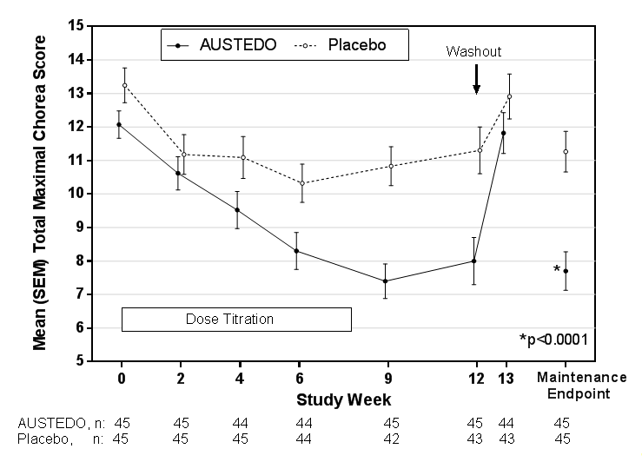

A patient-rated global impression of change assessed how patients rated their overall Huntington’s disease symptoms. 51% percent of patients treated with AUSTEDO rated their symptoms as “Much Improved” or “Very Much Improved” at the end of treatment, compared to 20% of placebo-treated patients.
In a physician-rated clinical global impression of change, physicians rated 42% percent of patients treated with AUSTEDO as “Much Improved” or “Very Much Improved” at the end of treatment compared to 13% of placebo-treated patients.
The treatment difference for both these ratings were statistically significant.
Open-Label, Long-Term Safety Study

The long-term safety and tolerability of AUSTEDO as a treatment for chorea associated with Huntington's disease was established primarily in Study 2, an open-label single-arm, 2-cohort, multi-center trial. This trial consisted of two cohorts, Rollover and Switch Cohorts who were monitored up to 171 weeks. There were 82 patients in the Rollover Cohort, who successfully completed Study 1. Patients were retitrated with AUSTEDO at a starting dose of 6 mg/day, following a 1-week wash out period. There were 37 patients in the Switch Cohort, who had been receiving tetrabenazine for chorea associated with Huntington’s disease. They were converted overnight to an initial dosing regimen of AUSTEDO predicted to provide systemic exposure that was comparable to their tetrabenazine regimen. Dosing in both cohorts occurred twice daily with meals, approximately 10 hours between doses. The AUSTEDO dose was titrated upward through to week 8, at weekly intervals, in 12 mg/day increments until satisfactory treatment of chorea was achieved, intolerable side effects occurred, or until a maximal dose of 72 mg per day was reached (36 mg twice daily).
The efficacy endpoints were the changes from baseline and from week 8 in the Total Maximal Chorea (TMC) Score and Total Motor Score (TMS), items of the UHDRS. The following includes some of the safety endpoints that were assessed:
- Incidence of adverse events, serious adverse events, severe adverse events, drug-related adverse events, and adverse events leading to withdrawal during the following periods:
  - Entire treatment period
  - During the dose-adjustment period in Switch patients (day 1 to end of week 4)
  - During the titration period in Rollover patients and the extended dose-adjustment period in Switch Patients (day 1 to end of week 8)
  - During the stable-dose period (week 8 to end of study)
Of the 82 patients in the Rollover Cohort, 56 completed the study and out of the 37 patients in the Switch Cohort, 25 completed the study. The mean age was 54 years and patients were 56% male (44% female) and 94% Caucasian. The mean dose within the Rollover Cohort and Switch Cohort at week 28 was 40.8 mg and 40.2 mg, respectively.
The mean change from baseline in TMC score over time is presented for the Rollover Cohort in Figure 2. Decreases in the TMC score from baseline were observed as early as week 2 of AUSTEDO titration and persisted through week 145 of treatment.
The mean change from baseline in UHDRS TMS over time is presented for the Rollover Cohort in Figure 3. Decreases in TMS from baseline were observed as early as week 2 of AUSTEDO titration and persisted through week 80 of treatment before reverting back to baseline or worsening beyond baseline.
Figure 2: Total Maximal Chorea Score Change From Baseline for Rollover Patients
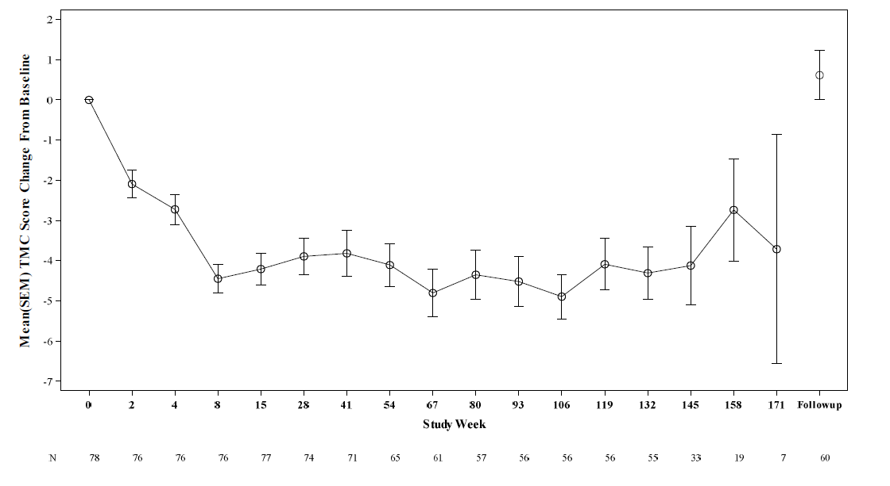
Figure 3: Total Motor Score Change from Baseline for the Rollover Cohort
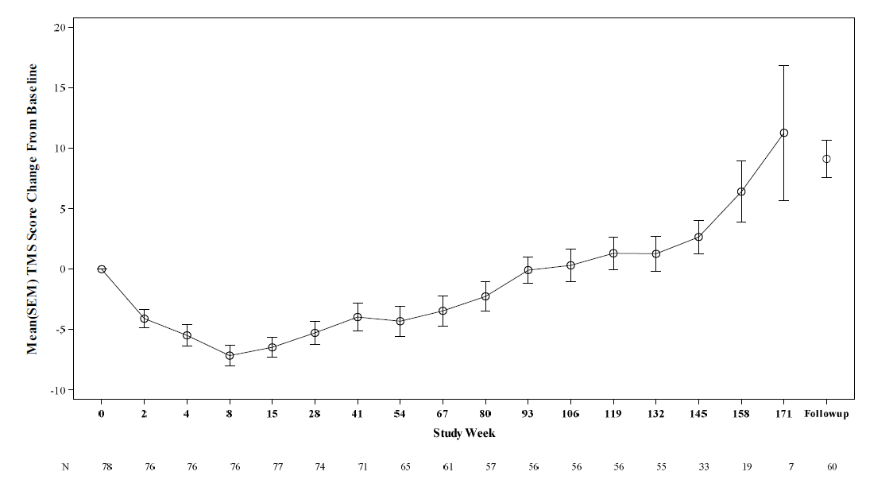
The mean change from baseline in TMC score over time is presented for the Switch Cohort in Figure 4. At week 8, chorea control was maintained and appeared to improve compared with baseline, as the mean (SD) TMC score change from baseline was -2.06 (3.253) units. Chorea control was maintained through week 158.
The mean change in TMS over time is presented for the Switch Cohort in Figure 5. As in the case of the TMC score, the TMS was maintained at week 1, following the overnight switch from tetrabenazine to AUSTEDO on day 1. TMS remained around the baseline through week 67.
Figure 4: Total Maximal Chorea Score Change from Baseline for the Switch Cohort
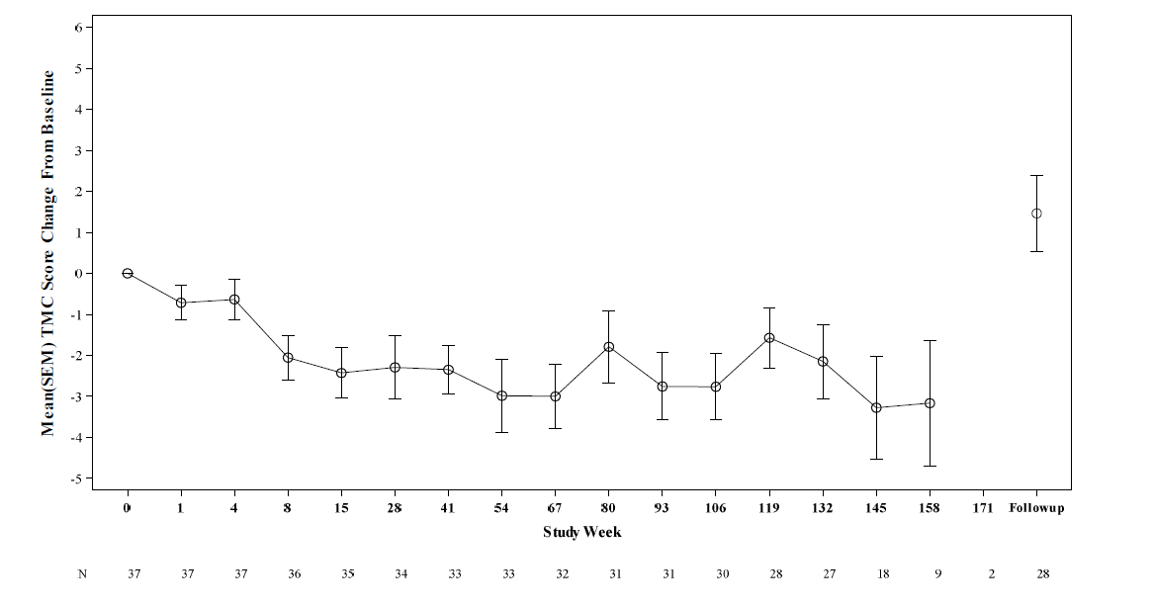

Figure 5: Total Motor Score Change from Baseline for the Switch Cohort
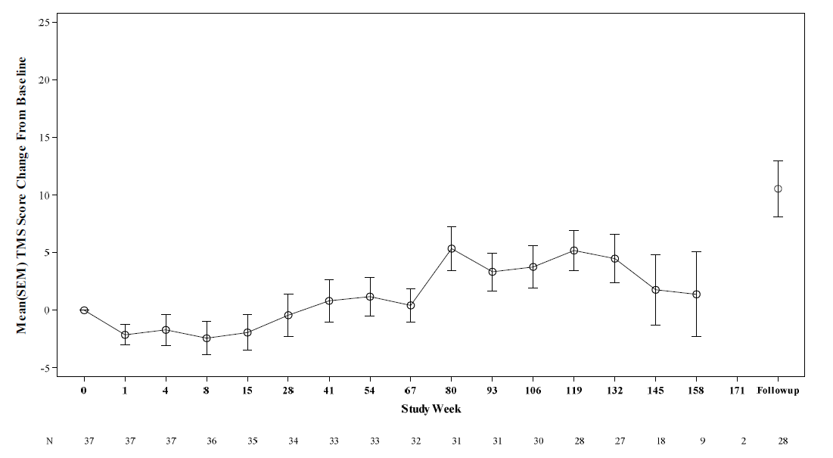

The safety and tolerability experience in Study 2 was consistent with that in Study 1 and showed that AUSTEDO was well tolerated when administered to patients. See Section 4.8 Adverse Effects (Undesirable Effects).
The exposure-adjusted incidence rate (EAIR) for AUSTEDO for any treatment-emergent adverse event for the long-term study was comparable to that of the 12-week double-blind study (Study 1).
Tardive Dyskinesia
The efficacy of AUSTEDO in the treatment for tardive dyskinesia was established in two 12-week, randomised, double-blind, placebo-controlled, multi-center trials conducted in 335 adult ambulatory patients with a diagnosis of tardive dyskinesia caused by use of dopamine receptor antagonists (Study 1 and Study 2). Study 1, consisted of a 12-week, placebo-controlled, fixed-dose trial, in adults with tardive dyskinesia who were randomised 1:1:1:1 to 12 mg AUSTEDO, 24 mg AUSTEDO, 36 mg AUSTEDO, or placebo. Study 2, consisted of a 12-week, placebo-controlled, flexible-dose trial, in adults with tardive dyskinesia (n=113) who received daily doses of placebo or AUSTEDO, starting at 12 mg per day with increases allowed in 6 mg increments at 1-week intervals until satisfactory control of dyskinesia was achieved, until intolerable side effects occurred, or until a maximal dose of 48 mg per day was reached.
In both studies, patients had a history of using a dopamine receptor antagonist (antipsychotics, metoclopramide) for at least 3 months (or 1 month in patients 60 years of age and older). Concurrent diagnoses included schizophrenia/schizoaffective disorder (62%) and mood disorder (33%). With respect to concurrent antipsychotic use, 64% of patients were receiving atypical antipsychotics, 12% were receiving typical or combination antipsychotics, and 24% were not receiving antipsychotics.
The Abnormal Involuntary Movement Scale (AIMS) was the primary efficacy measure for the assessment of tardive dyskinesia severity. The AIMS is a 12-item scale; items 1 to 7 assess the severity of involuntary movements across body regions and these items were used in this study. Each of the 7 items was scored on a 0 to 4 scale, rated as: 0=not present; 1=minimal, may be extreme normal (abnormal movements occur infrequently and/or are difficult to detect); 2=mild (abnormal movements occur infrequently and are easy to detect); 3=moderate (abnormal movements occur frequently and are easy to detect) or 4 =severe (abnormal movements occur almost continuously and/or of extreme intensity). The AIMS total score (sum of items 1 to 7) could thus range from 0 to 28, with a decrease in score indicating improvement. The key secondary endpoints in both studies were tested in a hierarchical manner. The key secondary endpoints for each study are as follows:
Study 1 (AUSTEDO vs Placebo)
- The proportion of patients who were a treatment success at week 12, based on the Clinical Global Impression of Change (CGIC) score.
The primary and secondary endpoints for Study 1 were assessed at three doses with the hierarchy in the order of 36 mg/day, 24 mg/day and 12 mg/day.
Study 2 (AUSTEDO vs Placebo)
- The proportion of patients who were a treatment success at week 12, based on the CGIC score.
- The proportion of patients who were a treatment success at week 12, based on the Patient Global Impression of Change (PGIC) score.
- Change from baseline to week 12 in modified Cervical Dystonia Questionnaire (CDQ-24) score.
In Study 1, treatment duration included a 4-week dose escalation period and an 8-week maintenance period followed by a 1-week washout. The dose of AUSTEDO was started at 12 mg per day and increased at weekly intervals in 6 mg/day increments to a dose target of 12 mg, 24 mg or 36 mg per day. The population (n= 222) was 21 to 81 years old (mean 57 years), 48% male (52% female), and 79% Caucasian. In Study 1, the AIMS total score for patients receiving AUSTEDO demonstrated statistically significant improvement, from baseline to Week 12, of 3.3 and 3.2 units for the 36 mg and 24 mg arms, respectively, compared with 1.4 units in placebo (Study 1 in Table 5). The improvements on the AIMS total score over the course of the study are displayed in Figure 6. Data did not suggest substantial differences in efficacy across various demographic groups.
The mean changes in the AIMS total score by visit are shown in Figure 6.
The first key secondary efficacy endpoint was the proportion of patients who were a treatment success, defined as Much Improved or Very Much Improved, based on the CGIC score at week 12 for AUSTEDO 36 mg/day. A greater proportion of patients (44%) were considered a treatment success at week 12 after treatment with AUSTEDO 36 mg/day than after treatment with placebo (26%, odds ratio=2.11); however, the result was not statistically significant (p=0.059). A greater proportion of patients (49%) were considered a treatment success at week 12 after treatment with AUSTEDO 24 mg/day than treatment with placebo (26%; odds ratio=2.71; p=0.014). The proportion of patients considered a treatment success at week 12 was similar in patients treated with AUSTEDO 12 mg/day (28%) and placebo (26%; odds ratio=1.15; p=0.734). Because of the hierarchical testing approach taken and the lack of statistical significance on the CGIC for 36 mg/day, the CGIC results at the 12- and 24-mg/day doses are considered exploratory.
In Study 2, treatment duration included a 6-week dose titration period and a 6-week maintenance period followed by a 1-week washout. The population was 25 to 75 years old (mean 55 years), 48% male (52 % female), and 70% Caucasian. Patients were titrated to an optimal dose over 6 weeks. The average dose of AUSTEDO after treatment was 38.3 mg per day. There was no evidence suggesting substantial differences in efficacy across various demographic groups. In Study 2, AIMS total score for patients receiving AUSTEDO demonstrated statistically significant improvement by 3.0 units from baseline to endpoint (Week 12), compared with 1.6 units in the placebo group with a treatment effect of -1.4 units. Table 5 summarises the effects of AUSTEDO on tardive dyskinesia based on the AIMS.
The CGIC treatment success was greater for AUSTEDO (48.2%) than for placebo (40.4%), although the difference was not statistically significant (p=0.4001). Because patients with a baseline total motor AIMS score <6 did not meet the intent of the protocol, a post- hoc analysis was performed for patients with a centrally read baseline total motor AIMS score ≥6 (N=97). This analysis showed that efficacy on the CGIC was strengthened, with a difference in treatment success rates between AUSTEDO and placebo of 17.4%, however the result was not statistically significant (p=0.0840).
The PGIC treatment success was greater for AUSTEDO (42.9%) than for placebo (29.8%), although the difference was not statistically significant (p=0.1497). Similar to the above reasoning for CGIC analysis, a post-hoc analysis was performed for patients with a centrally read baseline total motor AIMS score ≥6 (N=97). This analysis showed that efficacy on the PGIC was strengthened, with a difference in treatment success rates between AUSTEDO and placebo of 17.3%, however the result was not statistically significant (p=0.0785).
For the total modified CDQ-24 score, there was a trend of treatment success for AUSTEDO (-11.1 units) versus placebo (-8.3 units) (p=0.3200), but a greater improvement in patients with more severe disease (centrally read AIMS score ≥6) (AUSTEDO, -12.2 units; placebo, -6.6 units [p=0.0616]).
Table 5: Improvement in AIMS Total Score in Patients Treated with AUSTEDO in Study 1 and Study 2
Study | Treatment Group | Primary Efficacy Measure: AIMS Total Score
Study | Treatment Group | Mean Baseline Score (SD) | LS Mean Change from Baseline (SE) | Treatment Effect (95% CI)
Study 1 | AUSTEDO 36 mg*  (n= 55) | 10.1 (3.21) | -3.3 (0.42) | -1.9 (-3.09, -0.79)
Study 1 | AUSTEDO 24 mg  (n= 49) | 9.4 (2.93) | -3.2 (0.45) | -1.8 (-3.00, -0.63)
Study 1 | AUSTEDO 12 mg  (n= 60) | 9.6 (2.40) | -2.1 (0.42) | -0.7 (-1.84, 0.42)
Study 1 | Placebo (n= 58) | 9.5 (2.71) | -1.4 (0.41)
Study 2 | AUSTEDO  (12-48 mg/day)*  (n= 56) | 9.7 (4.14) | -3.0 (0.45) | -1.4 (-2.6, -0.2)
Study 2 | Placebo (n= 57) | 9.6 (3.78) | -1.6 (0.46)
*Dose that was statistically significantly different from placebo after adjusting for multiplicity.
LS Mean = Least-squares mean; SD = Standard deviation; SE = Standard error; CI = 2-sided 95% confidence interval

Figure 6: Least Square Means of Change in AIMS Total Score from Baseline for AUSTEDO Compared to Placebo (Study 1)
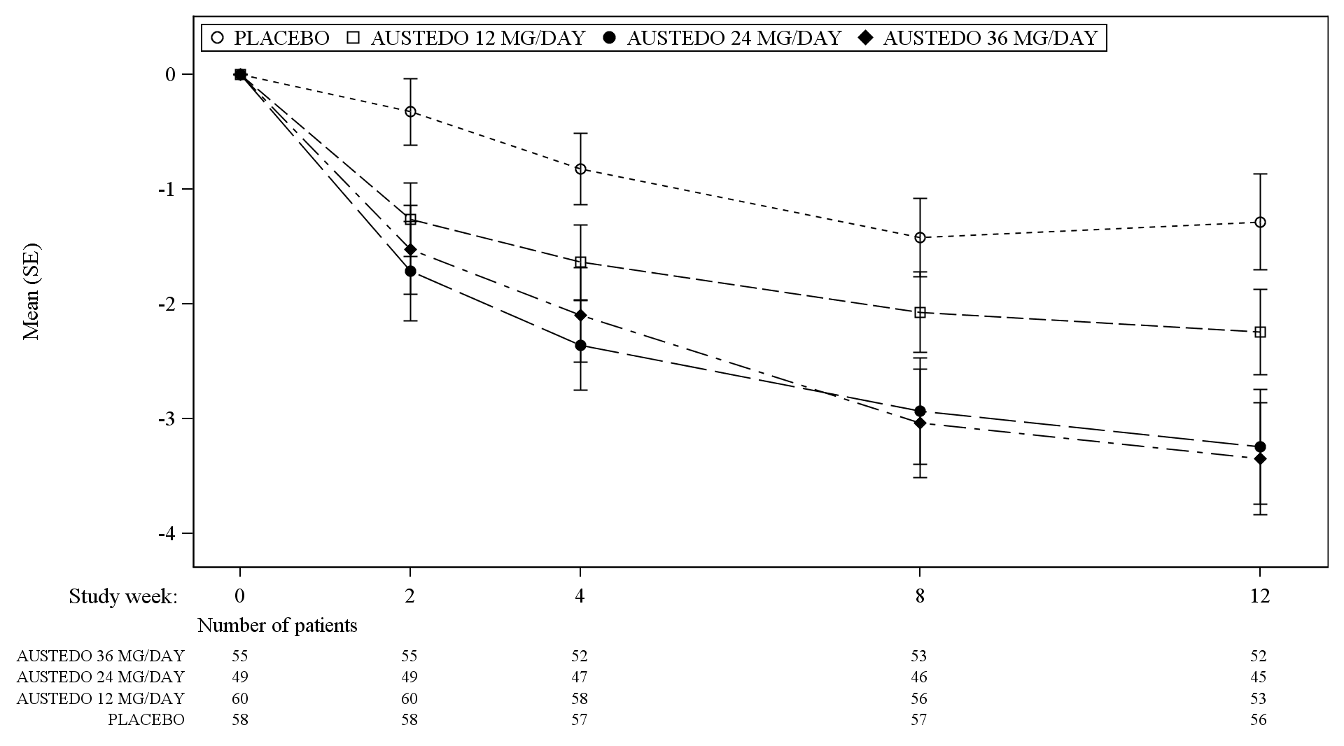
SE = Standard error

Pharmacokinetic properties
After oral dosing up to 25 mg, plasma concentrations of deutetrabenazine are generally below the limit of detection because of the extensive hepatic metabolism of deutetrabenazine to the active deuterated dihydro metabolites (HTBZ), α-HTBZ and β-HTBZ. Linear dose dependence of C_{max} and AUC was observed for the active metabolites following single or multiple doses of deutetrabenazine (6 mg to 24 mg and 7.5 mg twice daily to 22.5 mg twice daily).

Absorption
Following oral administration of deutetrabenazine, the extent of absorption is at least 80%.
Plasma concentrations of deutetrabenazine are generally below the limit of detection after oral dosing. Peak plasma concentrations (C_{max}) of deuterated α-HTBZ and β-HTBZ are reached within 3 to 4 hours after dosing.
Effect of Food
The effects of food on the bioavailability of AUSTEDO were studied in subjects administered a single dose with and without food. Food had no effect on the area under the plasma concentration-time curve (AUC) of α-HTBZ or β-HTBZ, although C_{max} was increased by approximately 50% in the presence of food (see Section 4.2, Dose and method of administration.)

Distribution
The median volume of distribution (Vc/F) of the α-HTBZ, and the β-HTBZ metabolites of AUSTEDO are approximately 500 L and 730 L, respectively.
Results of PET-scan studies in humans show that following intravenous injection of ¹¹C-labeled tetrabenazine or α-HTBZ, radioactivity is rapidly distributed to the brain, with the highest binding in the striatum and lowest binding in the cortex.
The in vitro protein binding of tetrabenazine, α-HTBZ, and β-HTBZ was examined in human plasma for concentrations ranging from 50 to 200 ng/mL. Tetrabenazine binding ranged from 82% to 85%, α-HTBZ binding ranged from 60% to 68%, and β-HTBZ binding ranged from 59% to 63%.

Metabolism
In vitro experiments in human liver microsomes demonstrate that deutetrabenazine is extensively biotransformed, likely by carbonyl reductase, to its major active metabolites, α-HTBZ and β-HTBZ, which are subsequently metabolised primarily by CYP2D6, with very minor contributions of CYP1A2 and CYP3A4/5.
Elimination
AUSTEDO is primarily renally eliminated in the form of metabolites.
The half-life of total (α+β)-HTBZ from deutetrabenazine is approximately 9 to 10 hours.
The median clearance values (CL/F) of the α-HTBZ, and the β-HTBZ metabolites of AUSTEDO are approximately 47 L/hour and 70 L/hour, respectively, in the Huntington’s disease patient population.

Excretion
In a mass balance study in 6 healthy subjects, 75% to 86% of the deutetrabenazine dose was excreted in the urine, and fecal recovery accounted for 8% to 11% of the dose. Urinary excretion of the α-HTBZ and β-HTBZ metabolites from deutetrabenazine each accounted for less than 10% of the administered dose. Sulfate and glucuronide conjugates of the α-HTBZ and β-HTBZ metabolites of deutetrabenazine, as well as products of oxidative metabolism, accounted for the majority of metabolites in the urine.
Specific Populations
Paediatric Use
Safety and effectiveness in paediatric patients have not been established.
Geriatric Use
Clinical studies of AUSTEDO did not include sufficient numbers of subjects aged 65 and over to determine whether they respond differently from younger subjects. Other reported clinical experience has not identified differences in responses between the elderly and younger patients. In general, dose selection for an elderly patient should be cautious, usually starting at the low end of the dosing range, reflecting the greater frequency of hepatic, renal, and cardiac dysfunction, and of concomitant disease or other drug therapy.
Male and Female Patients
There is no apparent effect of gender on the pharmacokinetics of α-HTBZ and β-HTBZ of deutetrabenazine.
Patients with Renal Impairment
No clinical studies have been conducted to assess the effect of renal impairment on the PK of AUSTEDO.
Patients with Hepatic Impairment
The effect of hepatic impairment on the pharmacokinetics of deutetrabenazine and its primary metabolites has not been studied. However, in a clinical study conducted to assess the effect of hepatic impairment on the pharmacokinetics of tetrabenazine, a closely related VMAT2 inhibitor, the exposure to α-HTBZ and β-HTBZ was up to 40% greater in patients with hepatic impairment, and the mean tetrabenazine C_{max} in patients with hepatic impairment was up to 190-fold higher than in healthy subjects (see Section 4.3, Contraindications.)
Poor CYP2D6 Metabolisers
Although the pharmacokinetics of deutetrabenazine and its metabolites have not been systematically evaluated in patients who do not express the drug metabolising enzyme, it is likely that the exposure to α-HTBZ and β-HTBZ would be increased similarly to taking a strong CYP2D6 inhibitor (approximately 3-fold). In patients who are CYP2D6 poor metabolisers, the daily dose of AUSTEDO should not exceed 36 mg (maximum single dose of 18 mg) [see Section 4.2 Dose and method of administration and Section 5.2, Pharmacokinetic properties].

Preclinical safety data

Genotoxicity
The deuterated α-HTBZ and β-HTBZ metabolites of deutetrabenazine were negative in in vitro genotoxicity assays (bacterial reverse mutation and chromosome aberration in human peripheral blood lymphocytes) in the presence or absence of metabolic activation. Deutetrabenazine did not increase the incidence of chromosomal aberrations in a mouse micronucleus study.

Carcinogenicity
No carcinogenicity studies were performed with deutetrabenazine.
No increase in tumours was observed in p53^{+/–} transgenic mice treated orally with tetrabenazine at doses of 0, 5, 15, and 30 mg/kg/day for 26 weeks or male rats treated long term with oral tetrabenazine doses up to 6 mg/kg twice daily, which correspond to exposures approximately 3 to 4 times the clinical exposures based on plasma AUC or dose based on body surface area. Mammary gland hyperplasia was observed in female rats that received twice daily oral doses of 7.5 mg/kg tetrabenazine or greater for 6 months associated with exposures (plasma AUC) similar to the clinical exposure. As the effect of tetrabenazine on prolactin levels is not known, the relevance of this finding is uncertain.

Pharmaceutical particulars

List of excipients
AUSTEDO contains the following inactive ingredients: butylated hydroxyanisole, butylated hydroxytoluene, magnesium stearate, mannitol, microcrystalline cellulose, polyethylene oxide, polysorbate 80, povidone, and the printing ink, Opacode monogramming Ink S-1-17823 Black (ARTG PI No.12108). The 6 mg tablets also contain Opadry II complete film coating system 85F100011 Purple (ARTG PI No. 139971). The 9 mg tablets also contain Opadry II complete film coating system 85F90637 Blue (ARTG PI No. 110161). The 12 mg tablets also contain Opadry II complete film coating system 85F170047 Beige (ARTG PI No. 139973).

Incompatibilities
Incompatibilities were either not assessed or not identified as part of the registration of this medicine.

Shelf life
In Australia, information on the shelf life can be found on the public summary of the Australian Register of Therapeutic Goods (ARTG). The expiry date can be found on the packaging.

Special precautions for storage
Store below 25°C. Keep the bottle tightly closed to protect from light and moisture.

Nature and contents of container
AUSTEDO modified release tablets are available in the following strengths and package configurations:
6 mg: HDPE Bottles of 60 modified release tablets
9 mg: HDPE Bottles of 60 modified release tablets
12mg: HDPE Bottles of 60 modified release tablets

Special precautions for disposal
In Australia, any unused medicine or waste material should be disposed of by taking to your local pharmacy.

Physicochemical properties
The molecular weight of deutetrabenazine is 323.46; the pKa is 6.31.
Deutetrabenazine is a hexahydro-dimethoxybenzoquinolizine derivative and has the following chemical name: (RR, SS)-1, 3, 4, 6, 7, 11b-hexahydro-9, 10-di (methoxy-d3)-3-(2-methylpropyl)-2H-benzo[a]quinolizin-2-one.
Deutetrabenazine is a white to slightly yellow crystalline powder that is sparingly soluble in water and soluble in ethanol.

Chemical structure
Deutetrabenazine is a racemic mixture containing the following structures:
Chemical formula:
C₁₉H₂₁D₆NO₃

CAS number
1392826-25-3

Medicine schedule (Poisons Standard)
Schedule 4 – Prescription Only Medicine.

Sponsor
Teva Pharma Australia Pty Limited
Level 1, 37 Epping Rd
Macquarie Park, NSW, 2113
Ph: 1800 288 382
www.tevapharma.com.au

Date of first approval
2 June 2021

Date of revision

Summary table of changes
Section Changed | Summary of new information

Not all presentations may be marketed.

