May 2022

Australian Public Assessment Report for Deutetrabenazine
  - Proprietary Product Name: Austedo
  - Sponsor: Teva Pharma Australia Pty Ltd

About the Therapeutic Goods Administration (TGA)
- The Therapeutic Goods Administration (TGA) is part of the Australian Government Department of Health and is responsible for regulating medicines and medical devices.
- The TGA administers the Therapeutic Goods Act 1989 (the Act), applying a risk management approach designed to ensure therapeutic goods supplied in Australia meet acceptable standards of quality, safety and efficacy (performance) when necessary.
- The work of the TGA is based on applying scientific and clinical expertise to decision-making, to ensure that the benefits to consumers outweigh any risks associated with the use of medicines and medical devices.
- The TGA relies on the public, healthcare professionals and industry to report problems with medicines or medical devices. TGA investigates reports received by it to determine any necessary regulatory action.
- To report a problem with a medicine or medical device, please see the information on the TGA website <https://www.tga.gov.au>.

About AusPARs
- An Australian Public Assessment Report (AusPAR) provides information about the evaluation of a prescription medicine and the considerations that led the TGA to approve or not approve a prescription medicine submission.
- AusPARs are prepared and published by the TGA.
- An AusPAR is prepared for submissions that relate to new chemical entities, generic medicines, major variations and extensions of indications.
- An AusPAR is a static document; it provides information that relates to a submission at a particular point in time.
- A new AusPAR will be developed to reflect changes to indications and/or major variations to a prescription medicine subject to evaluation by the TGA.

Copyright
© Commonwealth of Australia 2022
This work is copyright. You may reproduce the whole or part of this work in unaltered form for your own personal use or, if you are part of an organisation, for internal use within your organisation, but only if you or your organisation do not use the reproduction for any commercial purpose and retain this copyright notice and all disclaimer notices as part of that reproduction. Apart from rights to use as permitted by the Copyright Act 1968 or allowed by this copyright notice, all other rights are reserved and you are not allowed to reproduce the whole or any part of this work in any way (electronic or otherwise) without first being given specific written permission from the Commonwealth to do so. Requests and inquiries concerning reproduction and rights are to be sent to the TGA Copyright Officer, Therapeutic Goods Administration, PO Box 100, Woden ACT 2606 or emailed to <tga.copyright@tga.gov.au>.

Contents
List of abbreviations 4
I. Introduction to product submission 6
Submission details 6
Product background 7
Regulatory status 9
Product Information 10
II. Registration timeline 10
III. Submission overview and risk/benefit assessment 11
Quality 11
Nonclinical 11
Clinical 13
Risk management plan 32
Risk-benefit analysis 34
Outcome 41
Attachment 1. Product Information 41

List of abbreviations
Abbreviation | Meaning
ACM | Advisory Committee on Medicines
AE | Adverse event
AIMS | Abnormal Involuntary Movement Scale
ARTG | Australian Register of Therapeutic Goods
AUC | Area under the concentration time curve
CAG | Cytosine-adenine-guanine
CGI-C | Clinical Global Impression of Change
CI | Confidence interval
CL/F | Oral clearance
C_{max} | Maximum plasma concentration
CMI | Consumer Medicines Information
C_{min} | Minimum plasma concentration
CYP | Cytochrome P450
DA | Dopamine
DLP | Data lock point
DRA | Dopamine receptor antagonists
FDA | Food and Drug Administration
GVP | Good Pharmacovigilance Practices
HADS | Hospital Anxiety and Depression Scale
HD | Huntington disease
HTT | Huntingtin
LS | Least square
mCDQ-24 | Modified Craniocervical Dystonia Questionnaire
OR | Odds ratio
PD | Pharmacodynamic(s)
PGI-C | Patient Global Impression of Change
PI | Product Information
PK | Pharmacokinetic(s)
PopPK | Population pharmacokinetic(s)
PSUR | Periodic safety update reports
RCT | Randomised controlled trial
RMP | Risk management plan
SAE | Serious adverse event
SD | Standard deviation
SDQ | Swallowing Disturbance Questionnaire
SE | Standard error
SF-36 | 36-Item Short Form Survey
TD | Tardive dyskinesia
TEAE | Treatment-emergent adverse event
TFC | Total functional capacity
TGA | Therapeutic Goods Administration
T_{max} | Time of maximum plasma concentration
TMC | Total maximal chorea score
TMS | Total motor score
UHDRS | Unified Huntington Disease Rating Scale
UPDRS | Unified Parkinson's Disease Rating Scale
USA | United States of America
Vc/F | Volume of distribution (after extravascular administration)
VMAT-2 | Vesicular monoamine transporter type 2
α-HTBZ | Alpha-dihydrotetrabenazine
β-HTBZ | Beta-dihydrotetrabenazine

I. Introduction to product submission

Submission details
Type of submission: | New chemical entity
Product name: | Austedo
Active ingredient: | Deutetrabenazine
Decision: | Approved
Date of decision: | 26 May 2021
Date of entry onto ARTG: | 2 June 2021
ARTG numbers: | 330021, 330022 and 330023
Black Triangle Scheme: | Yes  This product will remain in the scheme for 5 years, starting on the date the product is first supplied in Australia.

Sponsor’s name and address: | Teva Pharma Australia Pty Limited  Level 1, 37 Epping Rd  Macquarie Park, NSW, 2113
Dose form: | Modified released tablet
Strengths: | 6 mg, 9 mg and 12 mg
Container: | Bottle
Pack size: | 60
Approved therapeutic use: | Austedo is indicated for the treatment of:  - chorea associated with Huntington’s disease  - tardive dyskinesia in adults
Route of administration: | Oral
Dosage: | The dose of Austedo is determined individually for each patient based on reduction of chorea or tardive dyskinesia and tolerability. When first prescribed to patients who are not being switched from tetrabenazine (a related vesicular monoamine transporter type 2 (VMAT-2) inhibitor), the recommended starting dose of Austedo is 6 mg administered orally once daily for patients with Huntington’s disease and 12 mg per day (6 mg twice daily) for patients with tardive dyskinesia.  For further information regarding dosage, refer to the Product Information.
Pregnancy category: | B3  Drugs which have been taken by only a limited number of pregnant women and women of childbearing age, without an increase in the frequency of malformation or other direct or indirect harmful effects on the human fetus having been observed.  Studies in animals have shown evidence of an increased occurrence of fetal damage, the significance of which is considered uncertain in humans.  The use of any medicine during pregnancy requires careful consideration of both risks and benefits by the treating health professional. This must not be used as the sole basis of decision making in the use of medicines during pregnancy. The TGA does not provide advice on the use of medicines in pregnancy for specific cases. More information is available from obstetric drug information services in your State or Territory.

Product background
This AusPAR describes the application by Teva Pharma Australia Pty Ltd (the sponsor) to register Austedo (deutetrabenazine) 6 mg, 9 mg and 12 mg, modified released tablet for the following proposed indication:
Austedo is indicated for the treatment of:
- chorea associated with Huntington’s disease
- tardive dyskinesia in adults
Huntington disease (HD) is an inherited progressive neurodegenerative disorder characterised by choreiform movements, psychiatric problems, and dementia., It is caused by a cytosine-adenine-guanine (CAG) trinucleotide repeat expansion in the huntingtin gene (HTT) gene on chromosome 4p and inherited in an autosomal dominant pattern. The pathophysiology of Huntington disease is not fully understood, although it is thought to be related to toxicity of the mutant huntingtin protein. There is no known cure and the overall treatment is symptomatic and supportive.
In Australia, the estimated number of people with Huntington disease is around 1600.
The clinical manifestations of Huntington disease typically begin in midlife and progress leading to complete disability and death, usually 15 to 20 years after the initial onset of symptoms. Chorea is an abnormal involuntary movement characterised by brief, abrupt, irregular, unpredictable, non-stereotyped movements. Chorea is broadly thought to develop as a result of dysfunction in the complex networks connecting the basal ganglia, thalamus and motor cortex.
Tardive dyskinesia is a medication-induced hyperkinetic movement disorder associated with the use of dopamine receptor-blocking agents, including antipsychotic drugs and two antiemetic agents metoclopramide and prochlorperazine. Tardive dyskinesia is characterised by a wide range of abnormal, involuntary movements that often persist after discontinuation of the causative medication. Tardive dyskinesia can be irreversible and lifelong. The condition can be disfiguring and disabling, with major negative impacts on psychologic health and quality of life.
Vesicular monoamine transporter 2 (VMAT-2) is a vital molecule in catecholamine storage and defect of it may cause neurodegeneration. VMAT-2 inhibitors can cause depletion of dopamine (DA) content in the presynaptic vesicles and reduction in the dopaminergic tone. This is the mechanism of action of VMAT inhibitors that leads to improvement in characteristic clinical manifestations (movement disorders) of Huntington disease and tardive dyskinesia.
Figure 1: Mechanism of action of VMAT 2 inhibitors;
Deutetrabenazine is a novel, selective VMAT2 inhibitor that was approved by the United States (US) Food and Drug Administration (FDA) in 2017 for the treatment of chorea associated with Huntington disease and tardive dyskinesia in adults. Deutetrabenazine is a deuterated form of the VMAT2 inhibitor tetrabenazine. Deuteration of the molecule results in a unique pharmacokinetic profile. Deutetrabenazine was developed to provide patients and prescribers with an effective treatment with an improved pharmacokinetic and tolerability profile, reducing the need for frequent dosing, compared with tetrabenazine.
Tetrabenazine is a centrally acting, oral drug that undergoes extensive hepatic metabolism by carbonyl reductase, resulting in a pair of stereoisomeric metabolites alpha-dihydrotetrabenazine (referred to as α-HTBZ) and beta-dihydrotetrabenazine (referred to as β-HTBZ) metabolites. These dihydro- metabolites potently inhibit VMAT-2 and are responsible for efficacy in reducing the chorea associated with Huntington disease and movement disorders in tardive dyskinesia.

Current treatment options
Tetrabenazine was approved by the TGA in 1991 for use in Australia the following indication:
May be useful for the control of chorea, hemiballismus, tardive and buccolingual dyskinesias and certain dystonic syndromes.
There are no other TGA-approved products with specific indications: for the treatment of ‘chorea’ due to Huntington disease and treatment of tardive dyskinesia in adults.
Medicines with the mechanism of action of dopamine receptor antagonists, anti-glutamatergic and anti-epileptics have been used off-label for the symptomatic treatment of chorea.2
Clozapine, amantadine and clonazepam are used off-label for the treatment of tardive dyskinesia.
Valbenazine is a reversible VMAT-2 inhibitor that is approved by the US FDA in 2017 for the treatment of tardive dyskinesia in adults.

Regulatory status
This product is considered a new chemical entity for Australian regulatory purposes.
At the time the TGA considered this application, a similar application had been approved in USA on 30 August 2017 and in China on 12 May 2020. It is under consideration in Israel, South Korea, Brazil and Russia.
Table 1: International regulatory status
Region | Submission date | Status | Approved indications
United States of America | 30 December 2016 | Approved  3 April 2017 (Huntington disease)  30 August 2017 (tardive dyskinesia) | Austedo is a indicated for the treatment of  Chorea associated with Huntington’s disease  Tardive dyskinesia in adults
China | 31 October 2019 | Approved  12 May 2020 | Austedo is a indicated for the treatment of Chorea associated with Huntington’s disease and Tardive dyskinesia in adults.
Israel | 1 July 2019 | Under consideration | Under consideration
South Korea | 27 November 2019 | Under consideration | Under consideration
Brazil | 29 June 2020 | Under consideration | Under consideration
Russia | 16 October 2020 | Under consideration | Under consideration

Product Information
The Product Information (PI) approved with the submission which is described in this AusPAR can be found as Attachment 1. For the most recent PI, please refer to the TGA website at <https://www.tga.gov.au/product-information-pi>.

II. Registration timeline
The following table captures the key steps and dates for this application and which are detailed and discussed in this AusPAR.
Table 2: Timeline for Submission PM-2020-00739-1-1
Description | Date
Submission dossier accepted and first round evaluation commenced | 30 March 2020
First round evaluation completed | 1 September 2020
Sponsor provides responses on questions raised in first round evaluation | 2 November 2020
Second round evaluation completed | 29 April 2021
Delegate’s Overall benefit-risk assessment and request for Advisory Committee advice | 2 March 2021
Sponsor’s pre-Advisory Committee response | 16 March 2021
Advisory Committee meeting | 8 and 9 April 2021
Registration decision (Outcome) | 26 May 2021
Completion of administrative activities and registration on the ARTG | 2 June 2021
Number of working days from submission dossier acceptance to registration decision* | 190
*Statutory timeframe for standard applications is 255 working days

III. Submission overview and risk/benefit assessment
The submission was summarised in the following Delegate’s overview and recommendations.

Quality
Deutetrabenazine is described as a white to slightly yellow crystalline powder. Deutetrabenazine is sparingly soluble in water, and its aqueous solubility is highly dependent upon pH. Deutetrabenazine chemical structure is shown in Figure 2.
All test parameters and limits proposed for deutetrabenazine specifications are considered acceptable. The analytical methods used to analyse deutetrabenazine were adequately described and validated.
The proposed commercial container closure system is a bottle with child resistant cap and a desiccant canister containing 60 tablets. The same pack size is proposed for the 6 mg, 9 mg and 12 mg strengths.
The Product Information (PI) document is finalised from a pharmaceutical chemistry and quality control perspective. The Product Labelling has been finalised from a pharmaceutical chemistry perspective and complies with the requirements of Therapeutic Goods Order No 91.
Approval is recommended from a pharmaceutical chemistry and quality control perspective.
Figure 2: Chemical structure of deutetrabenazine
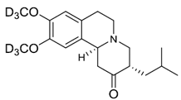

Nonclinical
The nonclinical evaluator has recommended approval for deutetrabenazine.
The overall quality of the nonclinical dossier was generally acceptable. Pivotal safety-related studies were good laboratory practices compliant. Deutetrabenazine is a deuterated form of an existing drug, tetrabenazine, which is registered for the similar indications.
The active metabolites of deutetrabenazine and tetrabenazine (deuterated and non-deuterated α-/β-HTBZ) showed comparable binding affinities for the VMAT-2, the intended pharmacological target of Austedo. The only clinically relevant off target effect for deuterated β-HTBZ was on the non-selective sigma receptor. However, this off target risk also exists for non-deuterated β-HTBZ from tetrabenazine at the maximum recommended dose of this drug.
Inhibition of human Ether-à-go-go-Related Gene K⁺ tail current was observed with deuterated α-/β-HTBZ at concentrations that are not considered clinically relevant; however, prolongation of QTc intervals occurs with tetrabenazine and therefore it was tested for deutetrabenazine in clinical studies.
Inhibitors of cytochrome P450 (CYP) 2D6; may alter deuterated α-HTBZ and deuterated β-HTBZ exposures. Based on in vitro studies with CYP isozymes, deutetrabenazine is not expected to alter exposures to co-administered drugs that are substrates for these enzymes. Neither metabolites M1 nor M4 exhibited significant inhibitory activity against P-gp, BCRP, OATP1B1, OATP1B3, OAT1, OAT3 or OCT2. Metabolite M1 is a substrate for OAT3. The clinical relevance of this finding is considered low as this metabolite has no obvious pharmacological activity.
Deutetrabenazine was shown to have a comparable acute toxicity profile to tetrabenazine and is considered to have a low to moderate order of acute toxicity.
Repeat dose toxicity studies by the oral route were conducted in rats (up to 3 months) using deutetrabenazine and comparator tetrabenazine. Maximum exposures to the parent drug deutetrabenazine were moderate at the high dose but were low and subclinical for the deuterated α-/β-HTBZ active metabolites.
Treatment-related effects of deutetrabenazine corresponded to those of tetrabenazine and were consistent with known toxicities of tetrabenazine.
Reproductive and developmental toxicity studies were limited to embryo-foetal development studies (dose-range finding and main studies) that were conducted in rats. Exposure levels of the parent drug deutetrabenazine were sufficiently high, but those of the active metabolites were subclinical. No adverse effects on embryo-foetal development or evidence of teratogenic effects were observed. Although not assessed, placental transfer of deutetrabenazine and its excretion through milk is expected.
The Pregnancy Category proposed by the sponsor (Category B3); is considered appropriate, based on adverse foetal/neonatal effects seen in a pre/postnatal study conducted with tetrabenazine.

Clinical
The clinical dossier consisted of:
- two Phase III studies for Huntington disease (Studies SD-809-C-15, and SD-809-C16; (abbreviated as Studies C-15 and C-16)
- three Phase III studies for tardive dyskinesia (Studies SD-809-C-18, SD-809-C-20 and SD-809-C-23; abbreviated as Studies C-18, C-20 and C-23)
- six pharmacokinetic studies
- one pharmacokinetic and pharmacodynamic study
- one bioequivalence study
- one bioavailability study

Pharmacology

Pharmacokinetics
Deutetrabenazine is a VMAT-2 inhibitor. Deutetrabenazine is a racemic mixture containing the following structures: RR-deutetrabenazine SS-deutetrabenazine.
When administered at approximately half the dose of tetrabenazine on a milligram basis, both single and twice daily repeated doses of deutetrabenazine achieved comparable systemic exposure with lower maximum plasma concentration (C_{max}) values, longer elimination half-lives, and lower C_{max}/minimum plasma concentration (C_{min}) ratios, compared with their non-deuterated forms.

Absorption
The extent of absorption is around 80%, when deutetrabenazine is administered orally. The time after administration of a drug when the maximum plasma concentration is reached (T_{max}) after oral administration is around 3 to 4 hours.
Presence of food was not found to have an effect on the area under the concentration time curve (AUC) over a dosing interval of deutetrabenazine, however, C_{max} was increased by around 50%.
The Delegate has noted that the Product Information (PI) states to administer deutetrabenazine with food. Based on the pharmacokinetics (PK) findings, this is likely to result in higher C_{max} (approximately 50%) compared to the fasted state.

Bioavailability
In Study C-07, AUC of total (α+β)-HTBZ metabolites of deutetrabenazine 15 mg was 15% to 28% higher to the corresponding levels from tetrabenazine 25 mg tablets. Based on regression model analyses of single-dose and steady-state exposures, a dose of 11.4 mg to 13.2 mg of deutetrabenazine was estimated to provide comparable systemic exposure to that of tetrabenazine 25 mg. Thus, a 12 mg tablet of deutetrabenazine was selected to provide comparable exposure (AUC) to 25 mg of tetrabenazine.
The mean AUC and mean C_{max} of the individual and total (α+β)-HTBZ metabolites of deutetrabenazine was found to increase in a dose proportional manner. After the administration of deutetrabenazine 15 mg and tetrabenazine 25 mg, the AUC for total (α+β)-HTBZ was comparable, whereas the C_{max} for deutetrabenazine was lower. This finding has been attributed to the attenuated metabolism due to the deuteration of tetrabenazine.

Distribution
The median volume of distribution (Vc/F) of the α-HTBZ, and the β-HTBZ metabolites of deutetrabenazine are approximately 500 L and 730 L, respectively.

Metabolism
Deutetrabenazine is metabolised extensively by carbonyl reductase to the major active metabolites deuterated α- and β-HTBZ . These major metabolites are then metabolised in the liver by CYP2D6.

Excretion
Deutetrabenazine is primarily renally eliminated in the form of metabolites (Study C-12). 75% to 86% of a [¹⁴C]-labelled deutetrabenazine dose was excreted in the urine.
Pharmacokinetics in patients with tardive dyskinesia was assessed in Study CP-16-11.
The key findings were:
- oral clearance (CL/F) and volume of distribution (Vc/F) of deuterated α-HTBZ in subjects with a median body weight of 80.4 kg were 11% and 15% higher than typical values in subjects with body weight of 70 kg respectively.
- CL/F of deuterated α-HTBZ decreased in moderate CYP2D6 inhibition and impaired CYP2D6 by approximately 16.7% and 36.5%, respectively.

Pharmacokinetics in subjects with impaired hepatic function
The effect of hepatic impairment on the pharmacokinetics of deutetrabenazine and its primary metabolites has not been studied. In studies with tetrabenazine, the exposure to α-HTBZ and β-HTBZ was up to 40% greater in patients with hepatic impairment, and the mean tetrabenazine C_{max} in patients with hepatic impairment was up to 190 fold higher than in healthy subjects.
The Delegate noted that deutetrabenazine is contraindicated in patients with hepatic impairment.

Effect of age on pharmacokinetics
Effect of age on PK of deutetrabenazine has not been evaluated. Clinical studies with deutetrabenazine did not include sufficient number of subjects > 65 years of age to study the potential effects in this age group.

Effect of CYP2D6 inhibitors on pharmacokinetics
Strong inhibitors of CYP2D6, such as paroxetine, are known to increase (around 3 times) plasma concentrations of the α-HTBZ and β-HTBZ metabolites of tetrabenazine.
The Delegate commented that there are adequate information in the PI to reflect all the above PK findings.

Population pharmacokinetics data
Population pharmacokinetic (popPK) modelling supports the comparable exposure of 48 mg of deutetrabenazine to 100 mg of tetrabenazine.

Pharmacodynamics
A linear relationship between exposures of total deuterated (α+β)-HTBZ metabolites and change from Baseline to Week 12 in total motor Abnormal Involuntary Movement Scale (AIMS) score was reported from the PK/pharmacodynamics (PD) analysis of combined data from Studies C-18 and C-23.

Efficacy (indication: chorea associated with Huntington disease)

Study C-15
Study C-15 was a Phase III double blind parallel group multicentre randomised placebo-controlled trial (RCT) in patients with Huntington's disease. Randomisation was stratified by prior exposure to tetrabenazine. Deutetrabenazine was administered twice daily with food.

Treatment period
Titration phase (eight weeks) and maintenance phase (four weeks), followed by a one week of washout period. The dose of deutetrabenazine was titrated weekly in the increments of 6 mg/day, based on chorea control and tolerability. The maximum dose was 48 mg/day that was administered as 24 mg twice daily. Subjects on strong CYP2D6 inhibitors received a lower max dose of study drug (36 mg/day, 18 mg twice daily), compared to others.
The median dose level at Week 9 (after the completion of titration phase) was 42 mg.

Key inclusion and exclusion criteria
Adult patients with a diagnosis of Huntington disease, defined as having characteristic motor examination features, and a documented expanded CAG repeat (≥ 37) at or before screening and also having the following features:
- Total maximal chorea (TMC) score ≥ 8
- Unified Huntington Disease Rating Scale (UHDRS) Total Functional Capacity (TFC) score ≥ 5;
- No serious untreated, undertreated, or unstable medical or psychiatric illness, history of or active suicidal ideation, or score ≥ 11 on Hospital Anxiety and Depression Scale (HADS);
- Swallowing Disturbance Questionnaire (SDQ) score < 11, Unified Parkinson's Disease Rating Scale (UPDRS) dysarthria score < 3;
Subjects with hepatic impairment and renal impairment were excluded.
Prior use of tetrabenazine was permitted, as long as it was not administered within the previous 6 months.

Enrolment and randomisation
90 subjects were enrolled and randomised in a 1:1 ratio to deutetrabenazine and placebo arms.

Study endpoints
The primary endpoint was change in TMC score from Baseline to maintenance therapy (mean of Week 9 and Week 12 of treatment period) values.
Key secondary endpoints included the proportion of subjects who are a treatment success at the end of the therapy, based on the Patient Global Impression of Change (PGI-C); and Clinical Global Impression of Change (CGI-C).
Treatment success was defined as much or very much improved on the PGI-C/CGI-C at the Week 12 visit.

Statistical methods
A sample size of 80 subjects was calculated to provide 90% power to detect a treatment difference of 2.7 units change in the TMC score. Accounting for a dropout rate of approximately 10%, 90 subjects were planned to be enrolled.
97.8% of subjects in the deutetrabenazine arm and 95.6% of subjects in placebo arm completed the study.

Baseline data
The mean age was 53.7 years. The mean CAG repeat length among the subject population was 43.9. Around 50% of the subjects were males. Around 95% of subjects were ‘not poor metabolisers’ of CYP2D6. The mean standard deviation (SD) TMS score was 12.66 (3.17). Around 57% of subjects used anti-depressants at Baseline.

Results (primary endpoint)
Treatment with deutetrabenazine resulted in a least square (LS) mean change of -4.4 units in TMC score, compared to -1.9 in placebo arm. The treatment difference (-2.5 points) was statistically significant.
The TMC score returned back to baseline values after the study drug was discontinued at Week 12.
The Delegate commented that the study was not designed to evaluate a rebound effect on chorea once treatment with deutetrabenazine was stopped.
Figure 3: Study C-15 Primary endpoint mean change in total maximal chorea score
SD-809 = deutetrabenazine (drug development code)

Results (secondary endpoints)
A higher percentage of subjects in the deutetrabenazine arm (around 30%) achieved ‘treatment success’ in terms of PGI-C and CGI-C scores. The treatment difference was statistically significant. Subjects in deutetrabenazine arm achieved an improvement with physical functioning, measured by 36-Item Short Form Survey (SF-36) score and the treatment difference was statistically significant.
Table 3: Study C-15 Efficacy results
a Change from Baseline to maintenance therapy. Baseline is defined as the mean of values from screening and Day 0. Maintenance therapy was defined as the mean of values from the Week 9 and Week 12 visits.
b Treatment success if defined as ‘much improved’ or ‘very much improved’ at Week 12.
c Change from Baseline to Week 12.
d Nominal p value, due to hierarchical method of analysis for primary and key secondary endpoints.
CGIC = Clinical Global Impression of Change; ITT = intent to treat; LS = least square; N = number of patients; n = number of patients in the subgroup; PGIC = Patient Global impression of Change; SD = standard deviation; SF-36 = Short Form 36 Health Survey; TMC = Total Maximal Chorea; TMS = Total Motor Score; UHDRS = Unified Huntington’s Disease Rating Scale.

Study C-16
Study C-16 is a Phase III, open label, single arm, two cohort study. The primary objective of this study was to evaluate the safety and tolerability of titration and maintenance therapy with deutetrabenazine. Study participation was planned to continue until deutetrabenazine becomes commercially available in the USA. Data collected until 21 August 2017 were provided in the clinical study report.

Key inclusion and exclusion criteria
The key inclusion criteria were identical to Study C-15 and additionally, the subjects were required to have met either of the following criteria:
- successfully completed participation in Study C-15 (rollover cohort); or
- receiving tetrabenazine on a stable dose for ≥ 8 weeks before screening and having a therapeutic benefit for control of chorea (switch cohort).
Subjects with active suicidal ideation or history of suicidal thoughts were excluded from the study.
Subjects with a score ≥ 11 on the depression subscale of the HADS, a score of ≥ 11 on the SDQ, or a UPDRS dysarthria score of ≥ 3 at screening or Baseline were also excluded.

Study population
Subjects in the rollover cohort completed a one week washout at the conclusion of first-Huntington disease, during which mean TMC scores returned to Baseline. These subjects were re-titrated with deutetrabenazine, with a starting dose of 6 mg/day.
The switch cohort consisted of subjects who were on treatment with a stable dose of tetrabenazine and switched overnight from tetrabenazine to deutetrabenazine. There was no dose adjustment during the first week, unless medically indicated due to a loss of chorea control.
Due to the prior treatment differences between rollover and switch subjects, the safety and efficacy data are presented separately for the two cohorts and for the overall safety population.
Table 4: Summary of patient disposition (safety population; N = 119)
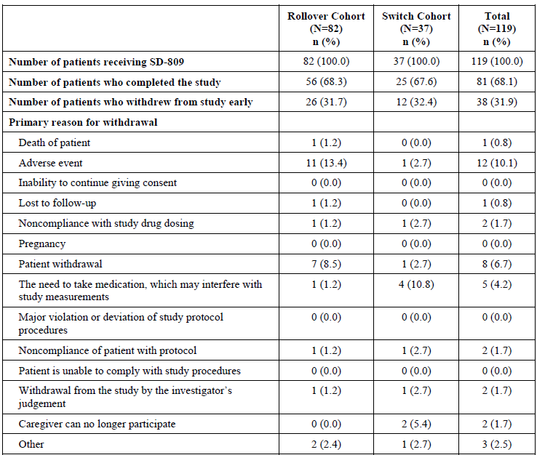
Table 5: Study C-16 Summary of patient participant (safety population; N = 119)
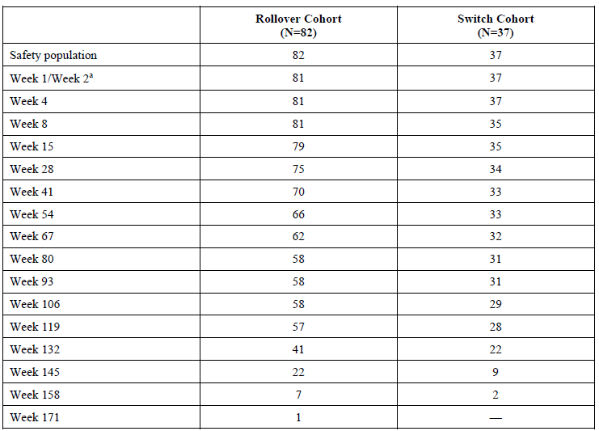
a Week 1 visit for switch cohort; Week 2 visit for rollover cohort
Notes: Patient numbers are based on actual visits. Some patients may have had unscheduled visits in lieu of a scheduled visit.
The Delegate commented that the high attrition rate should be taken into account, when data from this study is considered to ascertain the overall efficacy and safety of deutetrabenazine for the treatment of chorea in patients with Huntington disease. The Delegate has requested clarification from the sponsor (see section: Questions for the sponsor).

Study treatments
Deutetrabenazine tablets at strengths of 6 mg, 9 mg, and 12 mg were used. Doses of 12 mg and higher were administered in two divided doses.
Rollover subjects: The deutetrabenazine dose for these subjects was titrated from a starting dose of 6 mg per day to a dose that controlled chorea and was well tolerated. Dose was titrated to obtain optimal chorea control up to a maximum of 72 mg per day (36 mg per day for subjects receiving a strong CYP2D6 inhibitor).
Switch subjects: The initial dosing regimen of deutetrabenazine was around half of the tetrabenazine dose. This dose was predicted to provide comparable exposure to total deuterated (α+β)-HTBZ relative to the subject’s prior tetrabenazine regimen. It was noted that there was a further increase in the mean deutetrabenazine dose (29.7 to 40.2) from Week 4 to Week 28. It was also noted that there are subjects who required the maximum dose of 48 mg/day at Week 1 after switch.
Table 6: Study C-16 Daily dose of deutetrabenazine (switch cohort = 37)
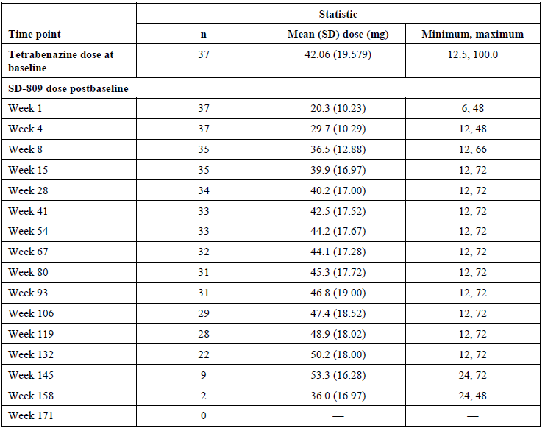
Notes: Review of the dosing for individual subjects revealed that no subject has a dose adjustment during the first week of SD-809 therapy.
Table 7: Study C-16 Daily dose of deutetrabenazine (rollover cohort, n = 82)
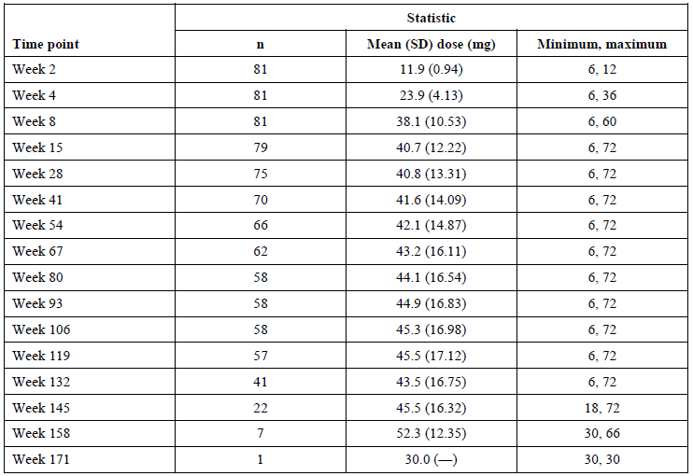

Statistical methods
In line with the open label design of the study, descriptive analyses were performed. However, the sponsor has also stated that paired t test was used to ‘descriptively analyse’ changes from Baseline and p values were estimated.
A pre-specified interim analysis of the safety and open label efficacy data was conducted after the first 12 switch subjects were enrolled and were treated for four weeks. Since no pre-specified confirmatory hypotheses were tested in the study, no statistical adjustments for interim monitoring were applied.
The Delegate commented that the sponsor's rationale of using descriptive analysis contradicts the mentioning of p-values. Moreover, the sponsor has also stated that no pre-specified confirmatory hypotheses were tested in this study. Hence these p-values have not been taken into consideration. The sponsor was requested to clarify in section: Questions for the sponsor (see below).
Changes in the UHDRS TMC score and total motor score (TMS) were efficacy endpoints.

Baseline data
The mean age of the subjects in the switch cohort was 52.4 years. Prior to entry to the study, patients were to be on a stable dose of tetrabenazine with relative chorea control and the average tetrabenazine dose at study entry was 42.06 mg/day. At the initial overnight switch, the average deutetrabenazine daily dose was 20.3 mg. The mean CAG repeat length among the subject population was 44.5. A total of two subjects were CYP2D6 poor metabolisers and 35 subjects were not poor metabolisers.
The mean age of the subjects in the rollover cohort was 53.7 years. These patients initiated treatment with 6 mg deutetrabenazine once daily and subsequently titrated to a mean dose of 38.1 mg at the end of titration (Week 8). At Week 28, the mean dose of study drug was 40.8 mg. The mean CAG repeat length among the subject population was 44. A total of five subjects were CYP2D6 poor metabolisers and 75 subjects were not poor metabolisers.

Results (roll-over cohort)
TMC score: At Week 28, the mean change from Baseline in TMC score was -3.89 (n = 74); see Table 8 (below).
Table 8: Study C-16 Summary of total maximal chorea score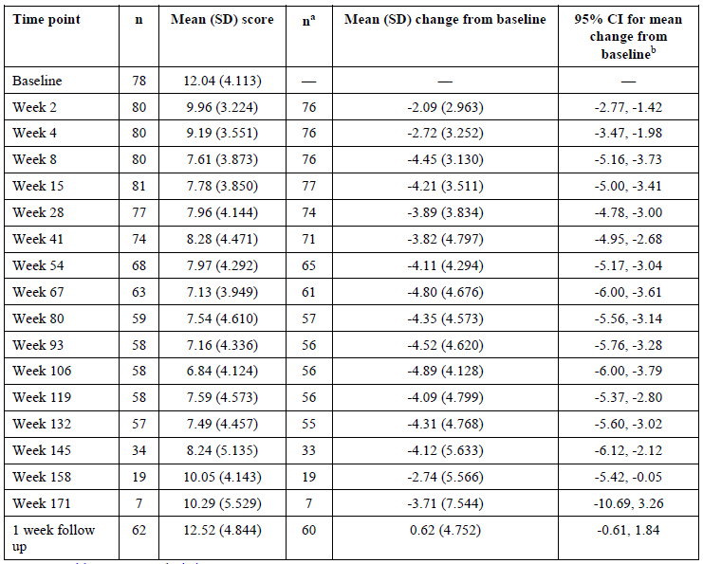
a Change from baseline.
b Confidence interval based on the t-distribution
CI=confidence interval; SD=standard deviation; TMC=total maximal chorea; UHDRS=Unified Huntington’s Disease Rating Scale.
Notes: TMC is determined from Item 12 of the UHDRS. Possible scores range from 0 to 28, with higher scores indicating more chorea. TMC scores assessed at scheduled visits were included in the analysis. For Rollover patients, the baseline value is the last available off-treatment (at least 4 days after the last administration of study drug) value prior to administration of SD-809 on day 1.
UHDRS total motor score: At Week 28, the mean change from Baseline in TMS was -5.27 (n = 82); see Table 9, below.
Table 9: Study C-16 Summary of total motor score
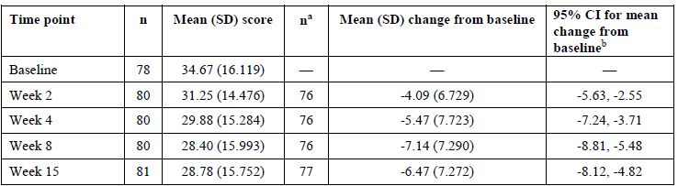
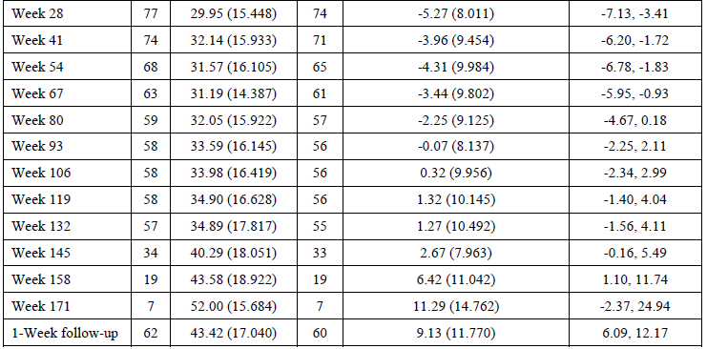
a Change from baseline.
b Confidence interval based on the t-distribution.
CI=confidence interval; SD=standard deviation; TMS=Total Motor Score; UHDRS=Unified Huntington’s Disease Rating Scale.
Notes: TMS is determined from the UHDRS. Possible TMS scores range from 0 to 124, with lower scores indicating better motor function. The baseline value is the last available off-treatment (at least 4 days after the last administration of study drug) value prior to administration of SD-809 on day 1. Four patients (Patients 026-3141, 031-3625, 100-3422, and 119-3461) did not have a baseline value within the required time frame and are therefore excluded from this summary

Results (switch cohort)
TMC score: There was no major worsening of chorea during the switch from tetrabenazine to deutetrabenazine. The mean change from Baseline in TMC at Week 28 was -2.29(n = 37) (see Table 10). At Week 28, the TMS score appears to have worsened, with a mean change of -0.43 from Baseline (see Table 11).
Table 10: Study C-16 total maximal chorea score
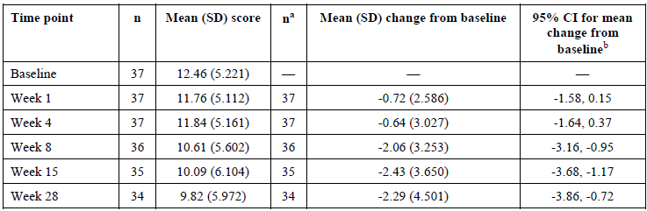
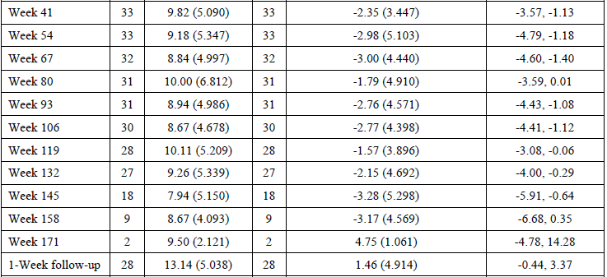
a Change from baseline.
b Confidence interval based on the t-distribution.
CI=confidence interval; SD=standard deviation; TMC=Total Maximal Chorea; UHDRS=Unified Huntington’s Disease Rating Scale.
Notes: TMC is determined from Item 12 of the UHDRS. Higher scores indicate more chorea. TMC scores assessed at scheduled visits were included in the analysis. Only data from scheduled visits are included for analysis. For the Switch Cohort, the baseline value used for calculating the change from baseline is the mean of the available values from the screening and baseline visits.
Table 11: Study C-16 total motor score
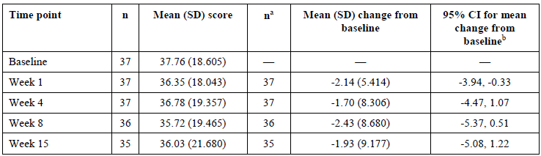
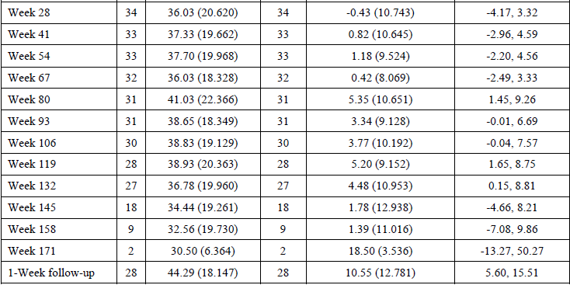
a Change from baseline.
b Confidence interval based on the t-distribution.
CI=confidence interval; SD=standard deviation; TMS=Total Motor Score; UHDRS=Unified Huntington’s Disease Rating Scale.
Notes: TMS is determined from the UHDRS. Possible TMS scores range from 0 to 124, with lower scores indicating better motor function. For the Switch Cohort, the baseline value used for calculating the change from baseline is the mean of the available values from the screening and baseline visits.
Pooled and meta analyses: efficacy data from Studies C-15 (double-blind; active treatment group) and C16 (open-label; roll over cohort that received placebo in the parent study) were included in the pooled analyses. Overall, in the integrated analysis, the mean change of TMC score from Baseline to Week 12/15 was -4.28 (SD 3.693) (n = 83).
Across studies, around 4.60 unit reduction in TMC score was reported over the titration period (eight weeks) and appeared to be subsequently maintained during treatment period.

Efficacy (indication: tardive dyskinesia)

Study C-18
This was a double blind, flexible dose, parallel group, placebo-controlled randomised control trial in adult patients with moderate to severe tardive dyskinesia. Randomisation was stratified by baseline use of dopamine receptor antagonists (DRAs). The study included a screening period of up to four weeks, a six weeks titration period, a six weeks maintenance period, and a one week washout period.

Key inclusion criteria
- Clinical diagnosis of tardive dyskinesia and symptoms for at least three months prior to screening.
- History of using a DRA for at least three months (or one month in patients 60 years of age and older).
- The following findings at the screening:
  - Moderate or severe abnormal movements based on Item 8 of the Abnormal Involuntary Movement Scale (AIMS) and;
  - A total motor AIMS score of ≥ 6.

Study treatments
Deutetrabenazine was administered with food twice daily. The starting dose was 12 mg/day (6 mg twice daily). The dose was titrated once weekly, based on treatment response. The maximum total daily dose was 48 mg/day (24 mg twice daily), unless the patient was on a strong CYP2D6 inhibitor (for example: paroxetine, fluoxetine, bupropion), in which case the maximum daily dose was 36 mg/day. Of note, the mean total daily dose was around 38 mg.

Baseline data
Mean age was around 55 years. Around 52% of subjects were females. Mean total motor AIMS score was 9.6. 80.5% of subjects were on a DRA. 15% of subjects were on a strong CYP2D6 inhibitor.

Results (primary endpoint)
At Week 12, patients receiving deutetrabenazine achieved a 3 unit mean reduction in total motor AIMS score compared to a 1.6 unit mean reduction in placebo. The treatment difference was 1.4 units (p = 0.0188) (see Table 12)
Table 12: Study C-18 Mean change in abnormal involuntary movement scale score

Results (secondary endpoints)
Secondary endpoints includes the PGI-C and the CGI-C. Secondary endpoints were considered successful if the response was ‘much’ or ‘very much’ improved.
For CGI-C, a higher proportion of patients in the deutetrabenazine group than the placebo group achieved treatment success (48.2% versus 40.4%, respectively). The treatment difference did not reach statistical significance (p = 0.4001) (see Table 13).
Since the first key secondary endpoint was not statistically significant, subsequent hypotheses were considered exploratory and all the other presented p-values are nominal.
Table 13: Study C-18 Proportion of subjects with treatment success as per Clinical Global Impression of Change
For PGI-C, a higher proportion of patients in the Study TEV-50717 group than the placebo group achieved treatment success (42.9% versus 29.8%, respectively; difference in proportions of 13%, p = 0.1497).
Table 14: Study C-18 Proportion of subjects with treatment success as per Patient Global Impression of Change
A numerical benefit in the modified Craniocervical Dystonia Questionnaire (mCDQ-24); total score was reported in the deutetrabenazine group at Week 12 (p = 0.3200) (see Table 15).
Table 15: Study C-18 Mean reduction in modified Craniocervical Dystonia Questionnaire score

Study C-23
Study C-23 was a double blind, fixed dose, placebo-controlled randomised control trial in patients with moderate to severe tardive dyskinesia. Randomisation was stratified by the use of dopamine receptor antagonists (DRAs).
The dose of deutetrabenazine was increased over the initial four weeks of treatment to reach the randomised dose, followed by eight weeks of maintenance therapy at that dose. The study period included a screening period (up to four weeks), dose-escalation period (four weeks), maintenance period (eight weeks) and a one week washout period.
The inclusion criteria were identical to Study C-18.
298 patients were randomly assigned in a 1:1:1:1 ratio to receive one of three fixed dose regimens of deutetrabenazine (12 mg/day, 24 mg/day or 36 mg/day) or placebo.
The Delegate commented that the maximum dose was 36 mg/day and not the proposed dose of 48 mg/day.

Baseline data
The mean age was around 56 years. 55% of the subjects were females. Mean total motor AIMS score was 8.4, mean mCDQ-24 score was 36.7. 76% of subjects were on treatment with DRAs. 49% of subjects had schizophrenia at Baseline.

Results (primary endpoint)
At Week 12, the subjects in deutetrabenazine 36 and 24 mg/day groups achieved reduction in AIMS score of -3.3 and -3.2 respectively versus -1.4 in placebo group. The treatment differences were statistically significant. Subjects in the deutetrabenazine 12 mg/day group did not achieve a statistically significant improvement in AIMS score, compared to placebo.
Table 16: Study C-23 Mean change in Abnormal Involuntary Movement Scale score

Results (secondary endpoints)
Key secondary endpoints include CGI-C, PGI-C and mCDQ-24 scores. Since the first key secondary endpoint (CGIC treatment success, deutetrabenazine 36 mg/day vs placebo) was not statistically significant, subsequent hypotheses were considered exploratory and all the other presented p values are nominal 49% of subjects in deutetrabenazine 24 mg/day group achieved ‘treatment success’ for CGI-C. The difference in the percentage of subjects with treatment success in this group was nominally significant, compared to placebo (see Table 17).
No significant difference in the percentage of subjects with treatment success as per CGI-C scores were reported in deutetrabenazine 36 mg/day and 12 mg/day groups versus placebo (see Table 17).
The odds ratio for the 24 and 36 mg/day deutetrabenazine groups to achieve treatment success, compared to placebo was around 2. The wide confidence interval was noted.
Table 17: Study-809-C-23 Mean change in Abnormal Involuntary Movement Scale score, proportion of subjects with treatment success as per Clinical Global Impression of Change
CGI-P = Clinical Global Impression of Change; CI = confidence intervals; OR = odds ratio; SD-809 = deutetrabenazine (drug development code)
For PGI-C readout, around 10% more patients treated with 24 mg/day and 36 mg/day of deutetrabenazine achieved ‘success’, compared to placebo. No significant difference in the proportion of subjects with ‘success’ between deutetrabenazine and placebo groups were reported. The odds ratio (OR) was < 2. The wide confidence interval (CI) was noted (see Table 18).
Table 18: Study-809-C-23 Proportion of subjects with treatment success as per Patient Global Impression of Change
CI = confidence intervals; PGI-C = Patient Global Impression of Change OR = odds ratio; SD-809 = deutetrabenazine (drug development code)
For mCDQ-24 score, a numerically greater improvement in mCDQ-24 score was reported in the deutetrabenazine 24 and 36 mg/day groups and not in the 12 mg /day group, compared to placebo. None of the treatment differences achieved statistical significance (see Table 19).
Table 19: Study-809-C-23 Mean change in mCDQ-24
mCDQ-24 = modified Craniocervical Dystonia Questionnaire (CDQ-24)
CI = confidence interval; LS = least squares; SE = standard error; SD-809 = deutetrabenazine (drug development code)

Study C-20
Study C-20 is an open label long term safety study of deutetrabenazine in patients with moderate to severe tardive dyskinesia. The study also evaluated efficacy of long term maintenance treatment with deutetrabenazine.

Study overview
After completion of a one week washout period, 304 patients who have completed Studies C-18 and C-23 rolled over into this study. The eligible subjects were also required to be on treatment with a dopamine receptor antagonist (DRA) for at least 3 months. 74% of subjects are still ongoing at the time of data analysis of this study.
Figure 4: Study C-20 Subject disposition

Results
Total AIMS score: At Week 145, the mean change (standard error (SE)) from Baseline in the total motor AIMS score was -6.8 (0.44) and the mean daily dose was 39.5 mg.
CGI-C score: At Week 145, 78% of the subjects achieved treatment success.
Similar improvements were also demonstrated for PGI-C endpoint.

Pooled analysis
The sponsor conducted a restricted pooled analysis because of the difference in the dosing methodologies across Studies C-23 and C-18. All patients in the dose group in Study C-18 were included along with the 24 and 36 mg/day dose groups from Study C-23, and these pooled data were compared to pooled placebo data from the two studies. While, the sponsor has provided the reasoning that the 12 mg/day treatment group from Study C-23 was not included in this pooled analysis because it exhibited efficacy only in a subset of patients who were not taking DRAs. The Delegate considered this approach as selection bias as major limitation in the approach for pooling of data, particularly for the assessment of efficacy. Hence, the outcomes of these analyses have not been considered in this overview.

Safety

Indication: chorea associated with Huntington disease
In Study C-15, the most common adverse events (AE), somnolence, dry mouth and diarrhoea were reported by more patients treated with deutetrabenazine than patients treated with placebo. Diarrhoea was reported in 8.9% of subjects in the deutetrabenazine arm, compared to nil subject in the placebo arm.
A low incidence rate of neurologic and psychiatric adverse events, such as depression, anxiety, and akathisia, were reported in deutetrabenazine group .
There were no adverse events of parkinsonism or dysphagia in subjects with Huntington disease in the deutetrabenazine group.
Safety scales were included in the study to monitor for symptoms of depression, suicidality, anxiety, somnolence, parkinsonism, akathisia, and dysphagia. No major safety-related findings were reported.
In Study C-16, the most common adverse events reported in the switch patients were fall (16 patients; 43.2%), anxiety (13 patients; 35.1%), somnolence (11 patients; 29.7%), reduction in weight (9 patients; 24.3%), and depression (8 patients; 21.6%). The most common adverse events reported in the rollover patients were fall (31 patients; 37.8%), depression (26 patients, 31.7%), anxiety (22 patients; 26.8%), insomnia (19 patients; 23.2%), and somnolence (16 patients; 19.5%). The majority of the falls in Study C-16 were considered by the investigator to be unrelated to deutetrabenazine.
The proportion of subjects with serious adverse events (SAEs) were comparable across switch and roll over cohort (around 25 to 30%).
There were eight events of suicidal ideation reported across Studies C-15 and C-16 in subjects in deutetrabenazine group. These events led dose suspension or treatment discontinuation. No events of completed suicide were reported.
Long term safety data was evaluated with Study C-16:
- The frequencies of dose reduction, dose suspension, or withdrawal from the study due to adverse events were relatively higher in the Study C-16 ARC-rollover and ARC-switch patients compared to those in Study C-15, which was consistent with the longer duration of treatment and observation in Study C-16.
- There was no unique pattern of adverse events during the first week of deutetrabenazine therapy following the overnight switch from tetrabenazine to deutetrabenazine.
The Delegate commented that Studies C-15 and C-16 were too short to demonstrate parkinsonism, which is seen most frequently in long term open label follow up studies..

Indication: tardive dyskinesia
In Study C-18, a similar proportion of patients experienced adverse events in the deutetrabenazine group and placebo group (70.7% versus 61).
In Study C-23, in the fixed dose groups, the proportion of subjects who experienced adverse events was comparable (around 43 to 51%) across the 12, 24, and 36 mg deutetrabenazine groups. Events were of mild or moderate severity and severe adverse events were infrequent.
The proportion of subjects with SAEs and with AEs leading to discontinuations were comparable across treatment groups.
Based on the integrated safety analysis, adverse events leading to dose reductions occurred with lower frequency in the placebo group than in deutetrabenazine titration group (3 patients; 2.3% in the placebo group and, 1 patient; 1.4%, 3 patients; 4.1%, and 15 patients (8.9%) in the deutetrabenazine 12, 24, and 36 mg titration groups, respectively). The clinical evaluator has mentioned that a review of these events did not reveal any specific pattern.
In the overall treatment period of the long term safety study (Study C-20), most of the treatment emergent adverse events (TEAEs) were known adverse effects of tetrabenazine. Somnolence adverse events were more frequent during titration/dose escalation (11.2% in Studies C-18 and C-20) than during maintenance (0% in Studies C-18 and C-20 up to week 12/15) as well as in the long-term safety Study C-20 (4.1% up to week 158) for both periods. Anxiety was the most frequently reported adverse event during the maintenance period in Study C-20.
In the fixed dose groups, QTcF values > 450 msec were recorded for 7 patients (10%), 3 patients (4%), and 4 patients (6%) who received deutetrabenazine 12 mg, 24 mg, and 36 mg, respectively. None of these patients had QTcF value > 500 msec and/or > 60 msec prolongation in comparison to baseline value. None of the electrocardiogram findings were considered as clinically relevant.
Ten events of deaths were reported in studies in patients with tardive dyskinesia with deutetrabenazine. One additional patient in Study C-20 died 56 days after the last dose of study drug and 25 days after the patient was withdrawn from the study. These events were not considered as related to study treatment.

Risk management plan
The sponsor has submitted an Australian-risk management plan (RMP) version 1.0 (dated 5 December 2019; data lock point (DLP) 15 September 2019) in support of this application. An updated version was submitted at second round of evaluation (version 1.1, dated 23 October 2020, DLP 15 September 2020).
The summary of safety concerns and their associated risk monitoring and mitigation strategies are summarised in Table 20.
Table 20: Summary of safety concerns and their associated risk monitoring and mitigation strategies
Summary of safety concerns |  | Pharmacovigilance |  | Risk Minimisation
 |  | Routine | Additional | Routine | Additional
Important identified risks | Depression |  | – |  | –
Important identified risks | Suicidality (Huntington disease indication only) |  | – |  | –
Important potential risks | Parkinsonism |  | – |  | –
Important potential risks | Neuroleptic malignant syndrome |  | – |  | –
Important potential risks | QTc prolongation | * | – |  | –
Important potential risks | Drug-Drug Interactions with strong CYP2D6 inhibitors |  | – |  | –
Important potential risks | Use in pregnancy |  | – |  | –
Important potential risks | Hyperprolactinaemia |  | – |  | –
Missing information | None
*Specific follow-up questionnaire
The RMP evaluator deem the summary of safety concerns as acceptable. Routine pharmacovigilance (adverse reaction reporting, signal detection) is in place for all safety concerns. Enhanced routine pharmacovigilance, via a specific follow up questionnaire, will be undertaken for reports of QTc prolongation. Routine risk minimisation has been proposed and is acceptable. The Consumer Medicines Information (CMI) meets the format requirements that apply to registrations after 1 January 2021.

Recommendations regarding condition/s of registration
- The deutetrabenazine RMP (version 1.1, dated 23 October 2020, DLP 15 September 2020), included with submission PM-2020-00739-1-1, and any subsequent revisions, as agreed with the TGA will be implemented in Australia.
- An obligatory component of risk management plans is routine pharmacovigilance. Routine pharmacovigilance includes the submission of periodic safety update reports (PSURs).
Unless agreed separately between the supplier who is the recipient of the approval and the TGA, the first report must be submitted to TGA no later than 15 calendar months after the date of the approval letter. The subsequent reports must be submitted no less frequently than annually from the date of the first submitted report until the period covered by such reports is not less than three years from the date of the approval letter. The annual submission may be made up of two PSURs each covering six months. If the sponsor wishes, the six monthly reports may be submitted separately as they become available.
If the product is approved in the EU during the three years period, reports can be provided in line with the published list of EU reference dates no less frequently than annually from the date of the first submitted report until the period covered by such reports is not less than three years from the date of the approval letter.
The reports are to at least meet the requirements for PSURs as described in the European Medicines Agency’s Guideline on Good Pharmacovigilance Practices (GVP) Module VII-periodic safety update report (Rev 1), Part VII.B Structures and processes. Note that submission of a PSUR does not constitute an application to vary the registration. Each report must have been prepared within ninety calendar days of the data lock point for that report.
- Austedo (deutetrabenazine) is to be included in the Black Triangle Scheme. The PI and CMI for Austedo must include the black triangle symbol and mandatory accompanying text for five years, which starts from the date that the sponsor notifies the TGA of supply of the product.

Risk-benefit analysis

Delegate’s considerations
The submission included a single pivotal placebo controlled study in subjects with Huntington's chorea, including 45 subjects treated with deutetrabenazine. The subjects in deutetrabenazine group achieved statistically significant reductions in observable chorea, compared to placebo. The reduction in chorea by deutetrabenazine was supported by statistically significant improvements in key secondary endpoints. The magnitude of reduction in TMC score (-2.5) in Study C-15 was less than the pre-determined treatment difference (-2.7), for which the study was powered for and with due consideration of the limitations of indirect comparison across studies, it was less than the treatment difference (-3.5) reported in previously conducted TETRA HD study with tetrabenazine. The reduction in chorea severity from Baseline with deutetrabenazine (4.4 units) was also less than the tetrabenazine (5 units).22
In Study C-16, in the switch cohort, on Day 1 of the treatment period, the mean deutetrabenazine daily dose was 20.3 mg (tetrabenazine dose at Baseline: 42.2 mg); however, a steady increase in dose was noted during treatment period, for up to 37.2 mg at Week 28, which was not markedly lower than the tetrabenazine dose at Baseline. This finding raises the question of whether there is sufficient evidence to support the theoretical assumption that half the dose of deutetrabenazine could provide comparable treatment benefit to that achieved by a dose of tetrabenazine and the translationability of PK findings to clinically meaningful outcomes.
In subjects with tardive dyskinesia, across studies, the significant reduction in AIMS was not associated with a similar improvement in patient-reported outcomes such as CGI-C and PGI-C. The significant reduction in AIMS for subjects in 24 mg/day of deutetrabenazine was associated with a similar improvement in CGI-C, but not PGI-C. The clinical relevance of this finding is uncertain.. The mean daily dose of deutetrabenazine in Study C-18 was around 38 mg. These findings suggest that a higher dose of deutetrabenazine was required to achieve a statistically significant improvement in AIMS. It is re-assuring that a numerically higher proportion of subjects in deutetrabenazine group achieved treatment success, as per CGI-C and PGI-C. In subjects with tardive dyskinesia, while higher doses were found to be effective in Study C-18, a 48 mg cohort was not investigated as part of Study C-23 and the mean daily dose in Study C-18 was around 38 mg. While the proposed label suggests daily dosing for up to 48 mg a day, there was limited data to support this dosage regimen from both Studies C-23 and C-18. The clinical evaluator has highlighted the issue of low number of study participants being exposed to the maximum dose and requested the sponsor to clarify the exact number of participants. The sponsor provided this data in the pre-ACM (Advisory Committee on Medicines) response.
A high rate of attrition was noted across both the roll over and switch cohorts in Study C-16 (n = 37 at Baseline and n = 0 at Week 41 in switch cohort and n = 75 at Baseline and n = 5 at Week 41 in roll over cohort) that could have an impact on the long term safety data of deutetrabenazine in subjects with Huntingdon disease. The study duration was potentially too short to demonstrate parkinsonism, which was seen most frequently in long term open label follow up studies. The high attrition rate in Study C-16 might also have contributed to the inability to detect this potential long term treatment-related adverse event.
Diarrhoea was reported in 9% of subjects with Huntington disease in deutetrabenazine group, compared to none in placebo. Diarrhoea was also reported in 1.4%-7.6% of subjects in deutetrabenazine groups with tardive dyskinesia, compared to 3.8% of subjects in placebo. None of these events appear to have resulted in treatment/study withdrawals. With long term use, the most commonly reported side effects were anxiety, somnolence, and depression, which are known adverse events with tetrabenazine and also have a plausible relationship with the underlying condition. There are warnings included in the proposed PI in relation to neuroleptic malignant syndrome, and depression/suicidal ideation.
There were no major findings from the questionnaires that were used to measure suicidality (Columbia-Suicide Severity Rating Scale) and depression (HADS) in studies in subjects with Huntington disease, taking in to account that there are known risks of depression and suicidal thoughts and behaviour (suicidality) in patients with chorea associated with Huntington disease. Taken together, the Delegate considers that there were no evidence to suggest clear association between suicidal ideation/behaviour and treatment with deutetrabenazine. It was noted that subjects with history of suicidal behaviour were excluded from studies. Treatment with deutetrabenazine in patients with suicidal behaviours is contraindicated in the proposed PI.
There were no additional safety concerns with respect to sedation, parkinsonism, and akathisia that were found to lead to tolerability issues with deutetrabenazine. Overall, the QT prolongation associated with use of the drug was not clinically significant. However, the treatment effect on electrocardiogram findings in specific sub-groups such as CYP2D6 poor metabolisers or when co-administered with a strong CYP2D6 inhibitors are not clear in the dossier. The sponsor will be requested provide this information. The precautionary statements related to QT prolongation in the PI were noted.
After the first round evaluation, based on the overall outcomes of efficacy endpoints across Studies C-18 and C-23, the clinical evaluator only recommended approval for the treatment of chorea associated with Huntington disease and not for the treatment of tardive dyskinesia. In response to questions raised by TGA, the sponsor provided comparative efficacy data to valbenazine and a few literature references. Based on these additional information, the clinical evaluator has recommended approval of the full proposed indication.

Limitations of the data
The Delegate listed the following as limitations of the data:
- Single pivotal study for Huntington disease with 45 subjects treated with deutetrabenazine.
- Modest treatment benefit for subjects with Huntington disease and tardive dyskinesia.
- Limited efficacy and safety data in the elderly patient population.
- High dose of deutetrabenazine required for a statistically significant treatment benefit for subjects with tardive dyskinesia and Huntington disease.
- No significantly greater treatment benefit demonstrated by deutetrabenazine compared to tetrabenazine for patients with Huntington disease and tardive dyskinesia.

Proposed action
In summary, based on the data included in the dossier, the Delegate considers that the evidence to support the efficacy of deutetrabenazine for the treatment of both chorea associated with Huntington disease and tardive dyskinesia is modest. It appears that deutetrabenazine have a better tolerability, compared to tetrabenazine.

Questions for the sponsor
The sponsor provided the following response to questions from the Delegate.
- In Study C-16, the sponsor's rationale of using descriptive analysis contradicts the mentioning of p-values. Please clarify.
The analyses in Study SD-809-C-16 were descriptive and no formal statistical analyses were conducted. p-values were included for descriptive purposes only in the interim report and not in the final study report or any of the summary documents; rather, the final report includes 95% confidence intervals for UHDRS TMC and UHDRS Total Motor Score (TMS) change from Baseline and change from Week 8.
- The maximum plasma concentration of deutetrabenazine was found to be increased by around 50% in the presence of food. The Delegate has noted that the PI states to administer deutetrabenazine with food. This is likely to result in high systemic exposure. The sponsor is requested to justify that the method of administration will not compromise patient safety.
The sponsor recognises that in the Phase I Study AUS-SD-809-CPT-07 (Part 1), a food effect was observed with C_{max} approximately 50% higher following single doses in the fed compared to fasted state. In order to optimise efficacy in all clinical program patients, studies were conducted with the recommendation to take deutetrabenazine with a meal. This implies that the safety and efficacy of deutetrabenazine has been well characterised across the entire clinical program in the fed state and the Consumer Medicines Information (CMI) and PI proposed for approval contain appropriate and accurate information regarding deutetrabenazine safety taken with food. If a patient accidentally takes deutetrabenazine on an empty stomach, peak plasma concentrations are expected to be less than what was observed in the clinical trials therefore not posing any additional safety concern. For this reason, the ‘dosing and administration’ section in the proposed deutetrabenazine (Austedo) Australian PI and CMI recommends dose intake with food.
- Please provide safety data related to the treatment effect on electrocardiogram values (QT prolongation) in specific sub groups such as CYP2D6 poor metabolisers or when co-administered with a strong CYP2D6 inhibitors.
The evaluation of ECG findings after deutetrabenazine administration is described in Section 4.7 in CTD 2.7.4 Summary of Clinical Safety. Data from a QT study in healthy subjects that compared the cardiodynamic effects of deutetrabenazine and tetrabenazine (Study C-21), as well as ECG monitoring in subjects with chorea associated with Huntington disease in Study C-15 and Study C-16, demonstrated that deutetrabenazine doses ≤ 48 mg per day do not have a clinically relevant effect on cardiac repolarisation. Treatment-emergent adverse events that could be considered related to prolongation of the QT interval were not reported in any subjects treated with deutetrabenazine in the clinical development program for deutetrabenazine. The data also indicate that the risk of QT interval prolongation when deutetrabenazine is administered to subjects who are taking a concomitant strong CYP2D6 inhibitor is smaller than that for concomitant administration of tetrabenazine and a strong CYP2D6 inhibitor.
In addition, a randomised, double blind, placebo controlled Phase I study (Study TV50717-SAD-10132) was completed after submission of the dossier to TGA. In this study, the primary objectives were to evaluate the ECG effects, PK, safety and tolerability after single escalating doses of deutetrabenazine (24, 48 and 72 mg) or placebo in extensive or CYP2D6 metabolisers (EM) and poor CYP2D6 metabolisers (PM). A total of 36 healthy subjects were randomised; 12 EM (24 mg; n = 9, 48 mg; n = 8, 72 mg; n = 7) and 24 PM (24 mg; n = 9, 48 mg; n = 8, 72 mg; n = 13). Eighteen (18) PK blood samples were obtained over 72 hours post-dose and were time-matched with replicate 12-lead ECGs extracted from continuous ECG recordings for up to 24 hours. A linear mixed-effects concentration-QTc modeling (C-QTc) analysis characterised the relationship between plasma concentrations of deutetrabenazine and α- and β-dihydrotetrabenazine (α-HTBZ and β-HTBZ) metabolites, and ΔQTcF (change from Baseline in QTcF).
Maximum and total exposure (C_{max} and AUC_{0-∞}) for total (α+β)-HTBZ increased in a generally dose proportional manner over the 24 to 72 mg dose range for both the CYP2D6 EM and PM populations. Based on the C-QTc analysis with the primary model for pooled CYP2D6 EM and PM populations, an effect of deutetrabenazine on ΔΔQTcF can be excluded within the observed range of α-HTBZ and β-HTBZ plasma concentrations up to approximately 150000 pg/mL, and 140000 pg/mL, respectively. A QTc effect exceeding 10 ms can be excluded within the observed plasma concentration ranges of deutetrabenazine, α-HTBZ and β-HTBZ in the study, which exceed predicted steady state concentrations at maximum recommended dose.
No deaths or serious adverse events and no treatment-emergent predefined cardiac events occurred during the study.
In conclusion, deutetrabenazine at the studied doses did not have a clinically relevant effect on HR or the PR and QRS intervals. Prolongation of QTcF was seen, in particular with the highest dose (72 mg) in both poor and extensive/intermediate metabolisers. Based on the models in the concentration-QTc analysis, an effect of TEV50717 on ΔΔQTcF can be excluded within the observed range of deutetrabenazine, α-HTBZ, and β-HTBZ plasma concentrations.
- A high rate of attrition was noted in Study C-16 (n = 37 at Baseline and n = 0 at Week 41 in switch cohort and n = 75 at Baseline and n = 5 at Week 41 in roll over cohort). In terms of treatment-emergent adverse events that led to withdrawal from the study, the following statement was noted in the Clinical Study Report (CSR): No subjects in the Switch Cohort were withdrawn from the study due to an adverse event (AE). Four subjects in the Rollover Cohort experienced treatment-emergent AEs leading to withdrawal during the study. The actual events that led to all of the withdrawals are unclear from the data in the CSR. Please provide a table with the events for withdrawals.
The sponsor would like to clarify that these data do not represent the actual drop out rate in the study. The above data for Study C-16 have been extracted from the interim CSR document (cutoff date, November 2014) rather than the final CSR (study ending on 21 August 2017) that was submitted in sponsor submitted dossier. This was previously explained in sponsor’s error of fact or omission report. When reviewing the complete 3 years data, the number of patients who completed Study C-16 is 25 (67.6%) and 56 (68.3%) in the switch cohort and the rollover cohort, respectively. The number of patients who withdrew from the study early is 12 (32.4%) and 26 (31.7%) in the switch cohort and the rollover cohort, respectively.
Please note that duration of participation was not expected to be 3 years for all patients in the study, and the small number of patients reaching Weeks 145, 158, and 171 does not inform on the number of drop outs from the study. The primary reason for withdrawal is listed in the final CSR for Study C-16 [inclusion is beyond the scope of this AusPAR].
The CSR statement quoted in the TGA question has also come from the interim CSR and not the final CSR. Based on the 3 year data, 13 (15.9%) patients in the rollover cohort experienced treatment-emergent adverse events and 3 (8.1%) patients in the switch cohort were withdrawn from the study due to an adverse event. Within the final CSR that was submitted (safety population, n = 119) provides an individual patient listing of treatment-emergent adverse events leading to withdrawal. The summary table is provided in sponsor’s submitted dossier.
- Please provide the exposure data for the maximum dose of 48 mg/day of deutetrabenazine across clinical studies involving subjects with Huntington disease and tardive dyskinesia
In the Huntington disease population studies, exposure to ≥ 48 mg/day at any time was as follows:
- 35 patients in Study C-15, 81 patients in Study C-16.
- Overall (counting each patient once throughout the program), 92 patients were exposed to ≥ 48 mg/day, out of which 67 patients had exposure of ≥ 8 weeks, and 47 patients had exposure of ≥ 52 weeks.
- Total exposure to ≥ 48 mg/day was 117 of Patients years of treatment.
In the tardive dyskinesia population studies, exposure to ≥ 48 mg/day at any time was as follows:
- 19 patients in Study C-18, 161 patients in Study C-20.
- Overall (counting each patient once throughout the program), 174 patients were exposed to ≥ 48 mg/day, out of which 115 patients had exposure of ≥ 8 weeks, 87 patients had exposure of ≥ 52 weeks.
- Total exposure to ≥ 48 mg/day was 214 of patients years of treatment.
- Please provide any available post market safety and efficacy data from the USA.
The sponsor has provided the latest post-marketing safety data in the form of the most recent Periodic Adverse Drug Experience Reports submitted to the USA in sponsor submitted dossier. The sponsor has no additional post-marketing efficacy data to submit at this time.

Advisory Committee considerations
The Advisory Committee on Medicines (ACM), having considered the evaluations and the Delegate’s overview, as well as the sponsor’s response to these documents, advised the following.

Specific advice to the Delegate
- Please comment on the clinical relevance of the magnitude of treatment benefit with deutetrabenazine in subjects with Huntington disease
The ACM noted that Study C-15 demonstrated a change in TMC score from Baseline to Week 12 of 1.9 for the placebo and 4.4 for deutetrabenazine. For Study C-16, the rollover cohort showed improvements in TMC and TMS from Week 2 and the switch cohort demonstrated preserved changes in TMC and TMS, however they required a higher dose than predicted to develop a clinical effect.
The ACM noted that these results generally demonstrated statistical significance for the active treatment arm and agreed that modest benefit over placebo was demonstrated in both the Huntington disease and tardive dyskinesia trials.
The ACM acknowledged that appropriately managing Huntington disease with the available treatment options can be challenging and having an additional symptomatic treatment option would be beneficial for clinical management of patients with this debilitating disease. Overall, they were of the view that the evidence did support the addition of deutetrabenazine as a symptomatic treatment option for Huntington disease.
While the ACM expressed overall support for deutetrabenazine for use in Huntington disease, their discussion did highlight some limitations. The ACM was unable to locate data to demonstrate the minimal clinically important difference for the change in TMC for Huntington disease and, as such, found it difficult to determine if the statically significant difference in TMC of 2.5 for deutetrabenazine against the placebo within Study C-15 equates to clinical meaningfulness. However, the ACM did note the positive efficacy outcomes for the secondary outcomes.
The ACM expressed interest in head to head efficacy studies to directly compare deutetrabenazine with tetrabenazine. They noted that the reduction in TMC score for tetrabenazine in the TETRA-HD trial;²² (-3.5) was greater than that demonstrated for deutetrabenazine within Study C-15.
- Please comment about the adequacy of the evidence provided by the efficacy data to support the proposed indication for treatment of patients with tardive dyskinesia
The ACM noted that Study C-18 demonstrated a change in AIMS from Baseline of -1.6 for placebo and -3.0 for deutetrabenazine. For Study C-23, the change in AIMS at Week 12 was -1.4 for placebo, -2.1 for 12 mg/day, -3.2 for 24 mg/day and -3.3 for 36 mg/day.
The ACM acknowledged the statically significant improvements in AIMS scores within the tardive dyskinesia studies. The ACM were of the view that the AIMS score results should be based on the difference from the placebo result rather than from the Baseline and, as such, they queried whether the differences, while statistically significant (excluding 12 mg), could be considered clinically significant. To assist with this consideration, the ACM presented two papers;, that outlined on average a 3 point decrease in the AIMS score represents a minimal clinically important difference for TD.
The ACM were of the view that while the trial has limitations and the clinical meaningfulness of the improvements in AIMS scores is modest, overall there is a need for additional symptomatic treatment options within this field. As such, they determined that the evidence is sufficient to support the indication.
- Please comment on the adequacy of PI statements to reflect the overall safety profile of deutetrabenazine
Overall, the ACM were satisfied with the safety statements included within the PI.
The ACM noted that deutetrabenazine is metabolised by CYP2D6 to form α- and β-HTBZ. Based on this information they agreed with the PI statements that deutetrabenazine is contraindicated in hepatic impairment and requires dose adjustment with concomitant strong CYP2D6 inhibitors.
The ACM commented that co-administration of deutetrabenazine with anti-psychotics is likely to occur and were reassured to see a statement within the PI regarding the potential for co-administration of both of these types of medications to increase the QT interval.
- The committee is also requested to provide advice on any other issues that it thinks may be relevant to a decision on whether or not to approve this application.
The ACM noted that the lower therapeutic dose of deutetrabenazine compared to tetrabenazine may mean that deutetrabenazine is better tolerated. The ACM cited the paper by Claassens et al. (2017); comparing Study C-15 (deutetrabenazine) and the TETRA-HD trial (tetrabenazine), which suggested a better adverse event profile for deutetrabenazine.
The ACM reiterated that in the absence of disease-modifying treatment options it is important to have a number of symptomatic treatment options available. Based on this, the ACM did not express significant concern regarding the limitations of long term safety data of deutetrabenazine.

Conclusion
The ACM considered this product to have an overall positive benefit-risk profile for the indication:
Austedo is indicated for the treatment of chorea associated with Huntington’s disease and tardive dyskinesia in adults.

Outcome
Based on a review of quality, safety and efficacy, the TGA approved the registration of Austedo (deutetrabenazine) 6 mg, 9 mg and 12 mg, modified released tablet, bottle indicated for:
Austedo is indicated for the treatment of:
- chorea associated with Huntington’s disease
- tardive dyskinesia in adults

Specific conditions of registration applying to these goods
- Austedo (deutetrabenazine) is to be included in the Black Triangle Scheme. The PI and CMI for Austedo must include the black triangle symbol and mandatory accompanying text for five years, which starts from the date that the sponsor notifies the TGA of supply of the product.
- The deutetrabenazine RMP (version 1.1, dated 23 October 2020, DLP 15 September 2020), included with submission PM-2020-00739-1-1, and any subsequent revisions, as agreed with the TGA will be implemented in Australia.
An obligatory component of risk management plans is routine pharmacovigilance. Routine pharmacovigilance includes the submission of periodic safety update reports (PSURs).
Unless agreed separately between the supplier who is the recipient of the approval and the TGA, the first report must be submitted to TGA no later than 15 calendar months after the date of the approval letter. The subsequent reports must be submitted no less frequently than annually from the date of the first submitted report until the period covered by such reports is not less than three years from the date of the approval letter. The annual submission may be made up of two PSURs each covering six months. If the sponsor wishes, the six monthly reports may be submitted separately as they become available.
If the product is approved in the EU during the three years period, reports can be provided in line with the published list of EU reference dates no less frequently than annually from the date of the first submitted report until the period covered by such reports is not less than three years from the date of the approval letter.
The reports are to at least meet the requirements for PSURs as described in the European Medicines Agency’s Guideline on good pharmacovigilance practices (GVP) Module VII-periodic safety update report (Rev 1), Part VII.B Structures and processes. Note that submission of a PSUR does not constitute an application to vary the registration. Each report must have been prepared within ninety calendar days of the data lock point for that report.

Attachment 1. Product Information
The PI for Austedo approved with the submission which is described in this AusPAR is at Attachment 1. For the most recent PI, please refer to the TGA website at <https://www.tga.gov.au/product-information-pi>.

Therapeutic Goods Administration
PO Box 100 Woden ACT 2606 Australia
Email: info@tga.gov.au Phone: 1800 020 653 Fax: 02 6232 8605
https://www.tga.gov.au

The Black Triangle Scheme provides a simple means for practitioners and patients to identify certain types of new prescription medicines, including those being used in new ways and to encourage the reporting of adverse events associated with their use. The Black Triangle does not denote that there are known safety problems, just that the TGA is encouraging adverse event reporting to help us build up the full picture of a medicine's safety profile.
Bachoud-Lévi, A.C., et al., International Guidelines for the Treatment of Huntington's Disease. Front Neurol, 2019. 10: p. 710.
Walker, F.O., Huntington's disease. Lancet, 2007. 369(9557): p. 218-28.
Bashir, H. and J. Jankovic, Treatment options for chorea. Expert Rev Neurother, 2018. 18(1): p. 51-63.
Huntington’s disease and residential aged care submission to senate community affairs references committee.
Ward, K.M. and L. Citrome, Antipsychotic-Related Movement Disorders: Drug-Induced Parkinsonism vs. Tardive Dyskinesia-Key Differences in Pathophysiology and Clinical Management. Neurol Ther, 2018. 7(2): p. 233-248
Niemann, Nicki and J. Jankovic. Treatment of Tardive Dyskinesia: A General Overview with Focus on the Vesicular Monoamine Transporter 2 Inhibitors. Drugs 78 (2018): 525-541.
The QT interval is the time from the start of the QRS wave complex to the end of the corresponding T wave. It approximates to the time taken for ventricular depolarisation and repolarisation, that is to say, the period of ventricular systole from ventricular isovolumetric contraction to isovolumetric relaxation. The corrected QT interval (QTc) estimates the QT interval at a standard heart rate. This allows comparison of QT values over time at different heart rates and improves detection of patients at increased risk of arrhythmias.
Cytochrome P450 (CYP) enzymes: CYPs are the major enzymes involved in drug metabolism, accounting for large part of the total metabolism. Most drugs undergo deactivation by CYPs, either directly or by facilitated excretion from the body. Also, many substances are bioactivated by CYPs to form their active compounds. Many drugs may increase or decrease the activity of various CYP isozymes either by inducing the biosynthesis of an isozyme (enzyme induction) or by directly inhibiting the activity of the CYP (enzyme inhibition). This is a major source of adverse drug interactions, since changes in CYP enzyme activity may affect the metabolism and clearance of various drugs. Such drug interactions are especially important to take into account when using drugs of vital importance to the patient, drugs with important side-effects and drugs with small therapeutic windows, but any drug may be subject to an altered plasma concentration due to altered drug metabolism.
Pregnancy Category B3: Drugs which have been taken by only a limited number of pregnant women and women of childbearing age, without an increase in the frequency of malformation or other direct or indirect harmful effects on the human fetus having been observed. Studies in animals have shown evidence of an increased occurrence of fetal damage, the significance of which is considered uncertain in humans.
The UHDRS Total Functional Capacity scale assesses how people with HD manage their work, finances, daily living, domestic chores, and their care arrangements. The UHDRS also includes an independence scale, and a 25-item yes/no functional assessment.
The Hospital Anxiety and Depression Scale (HADS) is a self-assessment questionnaire that has been found to be a reliable instrument for detecting states of anxiety and depression in the setting of hospital outpatient clinic.
The SDQ is designed and validated for detecting swallowing problems among patients with Parkinson's disease and was now applied for identifying patients with dysphagia associated with various other aetiologies.
Unified Parkinson's Disease Rating Scale (UPDRS) is a rating tool used to gauge the severity and progression of Parkinson’s disease in patients
The PGIC is a 7-point Likert Scale, ranging from very much worse to very much improved
Sponsor clarification: Delegate’s comment is based off the interim data (data cutoff date: November 2014). Refer to Question 4 in Question for the sponsor section for further clarification.
The AIMS is a 12-item clinician-rated scale to assess severity of dyskinesias (specifically, orofacial movements and extremity and truncal movements) in patients taking neuroleptic medications.
The modified Craniocervical Dystonia Questionnaire is a quality of life questionnaire adapted for use in patients with tardive dyskinesia.
Sponsor clarification: Delegate’s comment is based on interim data (data cut-off date: November 2014).
The QT interval is the time from the start of the QRS wave complex to the end of the corresponding T wave. It approximates to the time taken for ventricular depolarisation and repolarisation, that is to say, the period of ventricular systole from ventricular isovolumetric contraction to isovolumetric relaxation. The corrected QT interval (QTc) estimates the QT interval at a standard heart rate. This allows comparison of QT values over time at different heart rates and improves detection of patients at increased risk of arrhythmias. The QTcF is the QT interval corrected for heart rate according to Fridericia’s formula.
Routine risk minimisation activities may be limited to ensuring that suitable warnings are included in the product information or by careful use of labelling and packaging. Routine pharmacovigilance practices involve the following activities: - All suspected adverse reactions that are reported to the personnel of the company are collected and collated in an accessible manner; - Reporting to regulatory authorities; - Continuous monitoring of the safety profiles of approved products including signal detection and updating of labelling; - Submission of PSURs; - Meeting other local regulatory agency requirements.
Tetrabenazine as antichorea therapy in Huntington disease: a randomized controlled trial. Neurology, 2006. 66(3): p. 366-72.
Bashir, H. and J. Jankovic, Treatment options for chorea. Expert Rev Neurother, 2018. 18(1): p. 51-63.
Duma, S.R. and V.S. Fung, Drug-induced movement disorders. Aust Prescr, 2019. 42(2): p. 56-61.
Niemann, N. and J. Jankovic, Treatment of Tardive Dyskinesia: A General Overview with Focus on the Vesicular Monoamine Transporter 2 Inhibitors. Drugs, 2018. 78(5): p. 525-541
Refer to Question for sponsor section for further clarification from sponsor.
Roman, O.C., J. Stovall, and D.O. Claassen, Perseveration and Suicide in Huntington's Disease. J Huntingtons Dis, 2018. 7(2): p. 185-187.
The ACM provides independent medical and scientific advice to the Minister for Health and the Therapeutic Goods Administration (TGA) on issues relating to the safety, quality and efficacy of medicines supplied in Australia including issues relating to pre-market and post-market functions for medicines. The Committee is established under Regulation 35 of the Therapeutic Goods Regulations 1990. Members are appointed by the Minister. The ACM was established in January 2017 replacing Advisory Committee on Prescription Medicines (ACPM) which was formed in January 2010. ACM encompass pre and post-market advice for medicines, following the consolidation of the previous functions of the Advisory Committee on Prescription Medicines (ACPM), the Advisory Committee on the Safety of Medicines (ACSOM) and the Advisory Committee on Non-Prescription Medicines (ACNM). Membership comprises of professionals with specific scientific, medical or clinical expertise, as well as appropriate consumer health issues relating to medicines.
Barkay. H., et al. (2020). Minimal Clinically Important Difference in AIMS Score Based on Clinical and Patient Global Impression of Change in Patients With Tardive Dyskinesia Treated With Deutetrabenazine (1916). Neurology; 94 (15 Supplement).
Kurlan, R., et al (2018). Estimation of an MCID for AIMS Total Score Change in Tardive Dyskinesia (P4.074). Neurology; 90 (15 Supplement).
Claassen DO, Carroll B, De Boer LM, Wu E, Ayyagari R, Gandhi S, Stamler D. (2017). Indirect tolerability comparison of Deutetrabenazine and Tetrabenazine for Huntington disease. J Clin Mov Disord.1;4:3. doi: 10.1186/s40734-017-0051-5. PMID: 28265459; PMCID: PMC5331691.

