May 2022

Australian Public Assessment Report for Finerenone
  - Proprietary Product Name: Kerendia
  - Sponsor: Bayer Australia Limited

About the Therapeutic Goods Administration (TGA)
- The Therapeutic Goods Administration (TGA) is part of the Australian Government Department of Health and is responsible for regulating medicines and medical devices.
- The TGA administers the Therapeutic Goods Act 1989 (the Act), applying a risk management approach designed to ensure therapeutic goods supplied in Australia meet acceptable standards of quality, safety and efficacy (performance) when necessary.
- The work of the TGA is based on applying scientific and clinical expertise to decision-making, to ensure that the benefits to consumers outweigh any risks associated with the use of medicines and medical devices.
- The TGA relies on the public, healthcare professionals and industry to report problems with medicines or medical devices. TGA investigates reports received by it to determine any necessary regulatory action.
- To report a problem with a medicine or medical device, please see the information on the TGA website <https://www.tga.gov.au>.

About AusPARs
- An Australian Public Assessment Report (AusPAR) provides information about the evaluation of a prescription medicine and the considerations that led the TGA to approve or not approve a prescription medicine submission.
- AusPARs are prepared and published by the TGA.
- An AusPAR is prepared for submissions that relate to new chemical entities, generic medicines, major variations and extensions of indications.
- An AusPAR is a static document; it provides information that relates to a submission at a particular point in time.
- A new AusPAR will be developed to reflect changes to indications and/or major variations to a prescription medicine subject to evaluation by the TGA.

Copyright
© Commonwealth of Australia 2022
This work is copyright. You may reproduce the whole or part of this work in unaltered form for your own personal use or, if you are part of an organisation, for internal use within your organisation, but only if you or your organisation do not use the reproduction for any commercial purpose and retain this copyright notice and all disclaimer notices as part of that reproduction. Apart from rights to use as permitted by the Copyright Act 1968 or allowed by this copyright notice, all other rights are reserved and you are not allowed to reproduce the whole or any part of this work in any way (electronic or otherwise) without first being given specific written permission from the Commonwealth to do so. Requests and inquiries concerning reproduction and rights are to be sent to the TGA Copyright Officer, Therapeutic Goods Administration, PO Box 100, Woden ACT 2606 or emailed to <tga.copyright@tga.gov.au>.

Contents
List of abbreviations 4
I. Introduction to product submission 6
Submission details 6
Product background 7
Regulatory status 8
Product Information 9
II. Registration timeline 9
III. Submission overview and risk/benefit assessment 9
Quality 10
Nonclinical 11
Clinical 11
Risk management plan 36
Risk-benefit analysis 37
Outcome 45
Attachment 1. Product Information 45

List of abbreviations
Abbreviation | Meaning
ACEi | Angiotensin-converting enzyme inhibitor
ACM | Advisory Committee on Medicines
AE | Adverse event
ARB | Angiotensin receptor blocker
ARR | Absolute risk reduction
ARTG | Australian Register of Therapeutic Goods
ASA | Australia specific annex
AUC | Area under the concentration-time curve
BCRP | Breast cancer resistance protein
BCS | Biopharmaceutics Classification System
CHMP | Committee for Medicinal Products for Human Use (European Union)
CI | Confidence interval
CKD | Chronic kidney disease
CL/F | Apparent oral clearance
C_{max} | Maximum observed drug concentration
C_{max,md} | Maximum observed drug concentration in measured matrix after multiple dose administration during a dosage interval
CMI | Consumer Medicines Information
C_{trough} | Trough concentration
CPMP | Committee for Proprietary Medicinal Products (European Union)
GFR | Glomerular filtration rate
CYP2C8 | Cytochrome P450 isoenzyme 2C8
CYP3A4 | Cytochrome P450 isoenzyme 3A43A4
DLP | Data lock point
eGFR | Estimated glomerular filtration rate
EMA | European Medicines Agency (European Union)
EMEA | European Medicines Evaluation Agency (European Union)
EU | European Union
GLP-1 | Glucagon-like peptide 1
GVP | Good Pharmacovigilance Practices
HbA1c | Haemoglobin A1c (glycated haemoglobin)
HR | Hazard ratio
MedDRA | Medical Dictionary for Regulatory Activities
MRA | Mineralocorticoid receptor antagonist
OATP | Organic anion transporting polypeptide
PD | Pharmacodynamic(s)
P-gp | P-glycoprotein
PI | Product Information
PK | Pharmacokinetic(s)
PopPK | Population pharmacokinetic(s)
PSUR | Periodic safety update report
RMP | Risk management plan
SGLT-2 | Sodium-glucose co-transporter 2
T2D | Type 2 diabetes
TEAE | Treatment emergent adverse event
T_{max} | Time of maximum concentration
UACR | Urine albumin-to-creatinine ratio
V_{ss} | Volume of distribution at steady state

I. Introduction to product submission

Submission details
Type of submission: | New chemical entity
Product name: | Kerendia
Active ingredient: | Finerenone
Decision: | Approved
Date of decision: | 18 November 2021
Date of entry onto ARTG: | 25 November 2021
ARTG numbers: | 350772 and 350773
Black Triangle Scheme: | Yes.  This product will remain in the scheme for 5 years, starting on the date the product is first supplied in Australia.
Sponsor’s name and address: | Bayer Australia Limited  875 Pacific Highway,  Pymble NSW 2073
Dose form: | Film coated tablets
Strengths: | 10 mg and 20 mg
Container: | Blister pack
Pack sizes: | 14, 28, 98, 100
Approved therapeutic use: | Kerendia is indicated to delay progressive decline of kidney function in adults with chronic kidney disease associated with type 2 diabetes (with albuminuria), in addition to standard of care (see Section 5.1 Pharmacodynamic properties, clinical trials).
Route of administration: | Oral
Dosage: | The recommended target dose of Kerendia is 20 mg once daily.  Dosage is based on multiple factors, including serum potassium level, estimated glomerular filtration rate and pre-existing conditions of the patient (see Section 4.4 Special warnings and precautions for use of the Product Information).  For further information regarding dosage, refer to the Product Information.
Pregnancy category: | D  Drugs which have caused, are suspected to have caused or may be expected to cause, an increased incidence of human fetal malformations or irreversible damage. These drugs may also have adverse pharmacological effects. Accompanying texts should be consulted for further details.  The use of any medicine during pregnancy requires careful consideration of both risks and benefits by the treating health professional. This must not be used as the sole basis of decision making in the use of medicines during pregnancy. The TGA does not provide advice on the use of medicines in pregnancy for specific cases. More information is available from obstetric drug information services in your State or Territory.

Product background
This AusPAR describes the application by Bayer Australia Limited (the sponsor) to register Kerendia (finerenone) 10 mg and 20 mg, film coated tablets for the following proposed indication:
Kerendia is indicated to delay progression of kidney disease and to reduce the risk of major adverse cardiovascular events (cardiovascular death, nonfatal myocardial infarction, non-fatal stroke) and hospitalization for heart failure in adults with chronic kidney disease (CKD) and type 2 diabetes (T2D).
Type 2 diabetes mellitus is a metabolic disorder characterised by insulin resistance and relative insulin deficiency leading to hyperglycaemia. Diabetic kidney disease (that is, chronic kidney disease (CKD) in the context of type 2 diabetes mellitus) is a highly variable condition characterised by albuminuria and/or decreased glomerular filtration rate (GFR). Cardiovascular morbidity and mortality are frequently associated with diabetic kidney disease.
Management of diabetic kidney disease usually employs glycaemic control, management of hypertension (typically angiotensin-converting enzyme inhibitor (ACEi) or angiotensin receptor blockers (ARB), but not both), and lifestyle modification. Additional to agents primarily utilised for glycaemic control, glucagon like peptide 1 (GLP-1) receptor agonists (for example, for cardiovascular and renal benefits), or sodium glucose co-transporter 2 (SGLT-2) inhibitors (for example, for severe albuminuria) are usually given.
Non-steroidal, selective mineralocorticoid receptor antagonists (MRA) such as spironolactone or eplerenone are not currently indicated for diabetic kidney disease.
Finerenone is a nonsteroidal antagonist of the mineralocorticoid receptor that potently attenuates inflammation and fibrosis mediated by mineralocorticoid receptor overactivation. The mineralocorticoid receptor is expressed in the kidneys, heart and blood vessels where finerenone also counteracts sodium retention and hypertrophic processes. Finerenone has high selectivity for the mineralocorticoid receptor due to its nonsteroidal structure and bulky binding mode. Finerenone has no relevant affinity for the androgen, progesterone, oestrogen, or glucocorticoid receptors and therefore does not cause sex hormone-related adverse events (for example, gynecomastia). Its binding to the mineralocorticoid receptor leads to a specific receptor ligand complex that blocks recruitment of transcriptional coactivators implicated in the expression of pro-inflammatory and pro-fibrotic mediators.
This application was evaluated as part of the Australia-Canada-Singapore-Switzerland-United Kingdom (ACCESS) Consortium, with work-sharing between the TGA, Health Sciences Authority Singapore and Swissmedic. Each regulator made independent decisions regarding approval (market authorisation) of the new medicine.

Regulatory status
This product is considered a new chemical entity for Australian regulatory purposes.
At the time the TGA considered this application, a similar application had been approved in the United States of America on 9 July 2021. Similar applications were under consideration in the European Union (EU) (submitted on 6 November 2020), Japan (submitted on 26 November 2020), Switzerland (submitted on 30 November 2020), Singapore (submitted on 30 November 2020) and Canada (submitted on 12 February 2021).
Table 1, shown below, summarises these applications and provides the indications where approved.
Table 1: International regulatory status
Region | Submission date | Status | Approved indications
United States of America | 6 November 2020 | Approved on 9 July 2021 | Kerendia is indicated to reduce the risk of sustained eGFR decline, end-stage kidney disease, cardiovascular death, non-fatal myocardial infarction, and hospitalization for heart failure in adult patients with chronic kidney disease (CKD) associated with type 2 diabetes (T2D).
European Union | 6 November 2020 | Under consideration | Under consideration
Japan | 26 November 2020 | Under consideration | Under consideration
Switzerland | 30 November 2020 | Under consideration | Under consideration
Singapore | 30 November 2020 | Under consideration | Under consideration
Canada | 12 February 2021 | Under consideration | Under consideration

Product Information
The Product Information (PI) approved with the submission which is described in this AusPAR can be found as Attachment 1. For the most recent PI, please refer to the TGA website at <https://www.tga.gov.au/product-information-pi>.

II. Registration timeline
The following table captures the key steps and dates for this application and which are detailed and discussed in this AusPAR.
Table 2: Timeline for Submission PM-2020-05944-1-5
Description | Date
Submission dossier accepted and first round evaluation commenced | 4 January 2021
First round evaluation completed | 30 April 2021
Sponsor provides responses on questions raised in first round evaluation | 28 June 2021
Second round evaluation completed | 19 August 2021
Delegate’s Overall benefit-risk assessment and request for Advisory Committee advice | 2 September 2021
Sponsor’s pre-Advisory Committee response | 14 September 2021
Advisory Committee meeting | 30 September 2021 and 1 October 2021
Registration decision (Outcome) | 18 November 2021
Completion of administrative activities and registration on the ARTG | 25 November 2021
Number of working days from submission dossier acceptance to registration decision* | 181
*Statutory timeframe for standard applications is 255 working days

III. Submission overview and risk/benefit assessment
The submission was summarised in the following Delegate’s overview and recommendations.
This section is a TGA summary of wording used in TGA’s evaluation report, which discussed numerous aspects of overseas evaluation reports and included some information that was commercial-in-confidence.

Relevant guidelines or guidance documents referred to by the Delegate are listed below:
- European Medicines Agency (EMA), Committee for Medicinal Products for Human Use (CHMP), Guideline on the Clinical Investigation of Medicinal Products to Prevent Development/Slow Progression of Chronic Renal Insufficiency, EMA/CHMP/500825/2016, 15 September 2016.
- European Medicines Evaluation Agency (EMEA), Committee for Proprietary Medicinal Products (CPMP), Points to Consider on Application with 1. Meta-Analyses; 2. One Pivotal Study, CPMP/EWP/2330/99, 31 May 2001.

Quality
The administrative, product usage, chemical and pharmaceutical data submitted in support of this application have been evaluated in accordance with the Australian legislation, pharmacopoeial standards and relevant technical guidelines adopted by the TGA.
Chemical structure of the drug substance (finerenone) is shown in Figure 1 below.
Figure 1: Chemical structure of finerenone
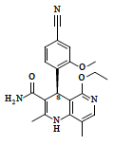
The intended dose and maximum daily dose of Kerendia is one 20 mg tablet taken once daily with water, and with or without food. Tablets may be crushed and taken orally if swallowing the whole tablet is problematic.
The Kerendia 10 mg film-coated tablet is a pink, oval-oblong tablet with a length of 10 mm and a width of 5 mm, marked ‘10’ on one side and ‘FI’ on the other side.
The Kerendia 20 mg film-coated tablet is a yellow, oval-oblong tablet with a length of 10 mm and a width of 5 mm, marked ´20´ on one side and ´FI´ on the other side.
The proposed packaging and pack sizes are polyvinyl chloride/polyvinylidene chloride/aluminium blister strips of 10 or 14 tablets in cardboard cartons in combinations of 14 tablets (1 x 14 tablet strip), 28 tablets (2 x 14 tablet strips), 98 (7 x 14 tablet strips) or 100 tablets (10 x 10 tablet strips). The strips are placed in a cardboard carton primary pack.
The proposed shelf life is 3 years when stored below 30°C.
Approval is recommended from a pharmaceutical chemistry and quality control perspective.

Nonclinical
The nonclinical data submitted by the sponsor are adequate and support the safety of finerenone.
There are no nonclinical objections to the registration of Kerendia for the proposed indication.

Clinical
Clinical development program for patients with chronic kidney disease consists of 35 studies:
- 28 Phase I pharmacology studies
- 5 Phase II studies
- 2 pivotal Phase III studies:
  - Study 16244 (also known as the FIDELIO-DKD trial), a pivotal study submitted with a full dataset; and
  - Study 17530 (also known as the FIGARO-DKD trial), top-line results were only provided at the second round of evaluation).

Pharmacology

Pharmacology study overview
Twenty eight (28) Phase I pharmacology studies supported this application (22 single dose, and 6 multiple dose studies), as listed in Table 3 and Table 4, below. Three relevant population pharmacokinetics (PK)/pharmacodynamics (PD) analyses were conducted.
Table 3: Overview of Phase I development program studies - list of single dose clinical pharmacology studies conducted in healthy subjects and the number of placebo and finerenone (alone or in combination with interaction drug) treatment periods
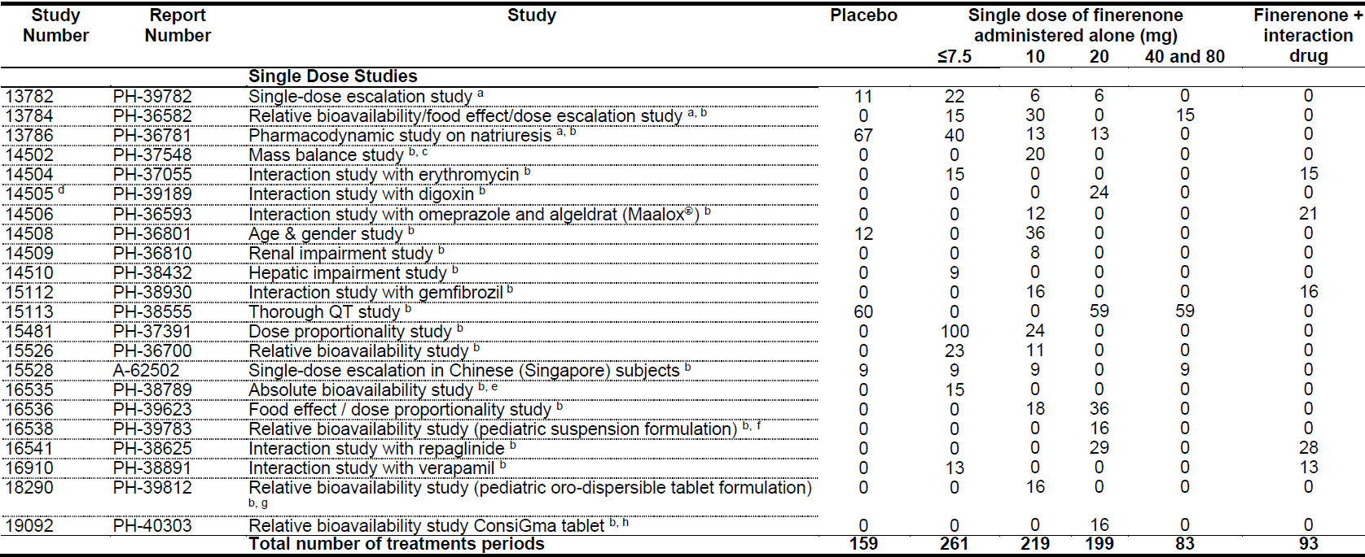
a Study used oral polyethylene glycol solution
b Study used tablet, see further footnotes if other formulations were also included
c Carbon 14 [¹⁴C] finerenone (oral aqueous solution) was administered in Part B following comparison with tablet in part A of study
d Single oral administration of 20 mg finerenone (Treatment A) from multiple dose Study 14505 was included in the single dose integrated safety analysis, multiple dose treatments from the study were included in the multiple dose integrated safety analysis
e 0.25, 0.5 and 1.0 mg were administered intravenously, 5 mg was administered orally as tablet
f Suspension for paediatric use, crushed/resuspended tablet, or tablet was administered
g Study evaluated prototypes of orodispersible tablets for paediatric use
h ConsiGma denotes prototype of continuously manufactured tablet
Dose correction was made for polyethylene glycol solution versus tablet x mg finerenone: polyethylene glycol solution considered as 0.5 x mg finerenone.
10 mg finerenone aqueous solution and 10 mg finerenone aqueous solution blended with 3.33 MBq (90 μCi) [¹⁴C] BAY 94-8862 (sponsor’s drug development code) considered as 10 mg finerenone
Table 4: Overview of Phase I development program studies - list of multiple dose clinical pharmacology studies conducted in healthy subjects and the number of placebo and finerenone (alone or in combination with interaction drug) treatment periods
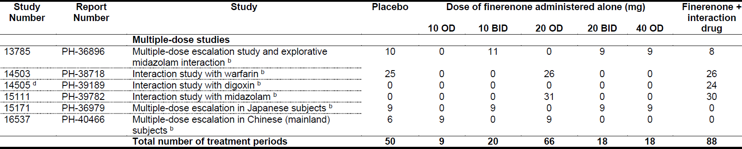
BID = twice daily; OD = once daily.
b Study used tablet
d Single oral administration of 20 mg finerenone (Treatment A) from multiple dose Study 14505 was included in the single dose integrated safety analysis, multiple dose treatments from the study were included in the multiple dose integrated safety analysis

Pharmacokinetics
Only pharmacology data relating to the proposed tablet presentation (not the oral solution or other presentations) are summarised.

Absorption
Finerenone is a Biopharmaceutics Classification System (BCS) II drug (low solubility, high permeability). While fasting, it is rapidly and almost completely absorbed after oral administration with a time of maximum plasma concentration (T_{max}) of 0.5 to 1.25 hours). Intake with high fat, high calorie food increased the area under the concentration-time curve (AUC) by 21%, reduced maximum observed drug concentration (C_{max}) by 18.7%, and increased the T_{max} from 0.75 to 2.5 hours (Study 16536). Intake with apple sauce (thick food) reduced the C_{max} by 11% and AUC by 18.4% (Study 16538). The differences are not likely clinically relevant.
The absolute bioavailability was 43.5% due to first pass metabolism with a hepatic extraction ratio of 0.244 and a gut wall extraction ratio of 0.425 (Study 16535). Finerenone has a plasma half-life of 2 to 3 hours and has no pharmacologically active metabolites. Finerenone is not a substrate of the efflux transporter P-glycoprotein in vivo.
Dose proportionality was demonstrated (for tablets) for the proposed dose range for Caucasian and Asian subjects (Studies 16536, 13785, 15528, 15171 and 16537). There was a low degree of accumulation after multiple dosing (including for metabolites that displayed higher degrees, but with a ratio below 2) (Studies 13785 and 15171).

Distribution
The volume of distribution at steady state (V_{ss}) is 52.6 L (Study 16535).
The proportion bound in human plasma protein in vitro is 91.7% (lower at higher doses due to saturation), with serum albumin being the main binding protein. Renal impairment had no major impact on the plasma protein binding of finerenone and its metabolites (Study 14509). The ex vivo fraction unbound of finerenone was 12.2% higher in subjects with moderate hepatic impairment compared to healthy controls (Study 14510).
The mean blood to plasma ratio based was 0.65, indicating that finerenone mainly distributes in plasma (Study 14502).

Metabolism
Finerenone is administered as a pure S-enantiomer without racemisation detected in plasma.
In vivo, 87% to 89% of metabolic clearance in vivo is attributed to cytochrome P450; isoenzyme 3A43A4 (CYP3A4) and approximately 10% to cytochrome P450 isoenzyme 2C8 (CYP2C8). Finerenone was not a substrate for uridine 5'-diphospho-glucuronosyltransferases.
Four major metabolites were found in plasma which are pharmacologically inactive (Study 13785). Additionally, minor metabolites were detected (Study 14502).

Elimination and excretion
The elimination of finerenone from plasma is rapid with an elimination half-life of approximately 2 to 3 hours (Study 16535). The systemic blood clearance is approximately 25 L/h.
After administration of a single carbon 14 labelled dose, 79.6 % and 21.2 % of the radioactive dose were excreted in urine and faeces, respectively (Study 14502), mostly as metabolites. Excretion of unchanged finerenone is minimal (< 1% of dose in the urine due to glomerular filtration, and < 0.2% in faeces) (Study 16535). Most of finerenone or metabolites in urine and faeces were excreted within 48 hours and 96 hours post-dose, respectively (Study 14502).

Special populations (intrinsic factors)
An overview of intrinsic factor effects is shown in Table 5 and Figure 2 below.
Table 5: Impact of intrinsic factors on finerenone exposure (pharmacokinetics set)
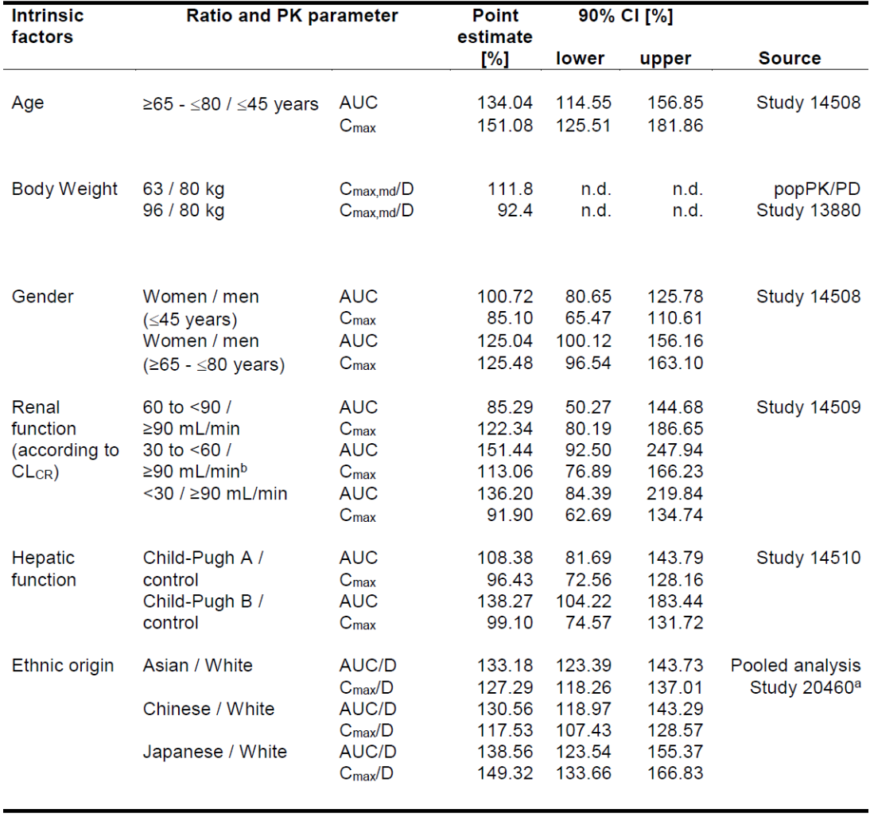
AUC = area under the concentration time curve; CI = confidence interval; CL_{CR} = creatinine clearance; C_{max} = maximum observed drug concentration; C_{max,md} = C_{max} in measured matrix after multiple dose administration during a dosage interval; D = dose; PD = pharmacodynamics; PK = pharmacokinetics.
a The report also contains a comparison of exposure data at steady-state (not included in this table), where the sample-size is much smaller (N_{total} = 96) compared to the single dose dataset (N_{total} = 476).
b Ratios include one moderately impaired subject with unusually high exposure. Point estimates and 90% CIs for ratio of AUC and C_{max} excluding this subject equal 133.68% (83.71%; 213.50%) and 103.77% (71.38%; 150.87%) (moderate impairment/control).
Hepatic function: Child-Pugh classification (prognosis of chronic liver disease, in particular cirrhosis) Child-Pugh A = best prognosis; Child-Pugh B = moderate prognosis.
Figure 2: Study 14563 Effect of extrinsic factors on finerenone exposure
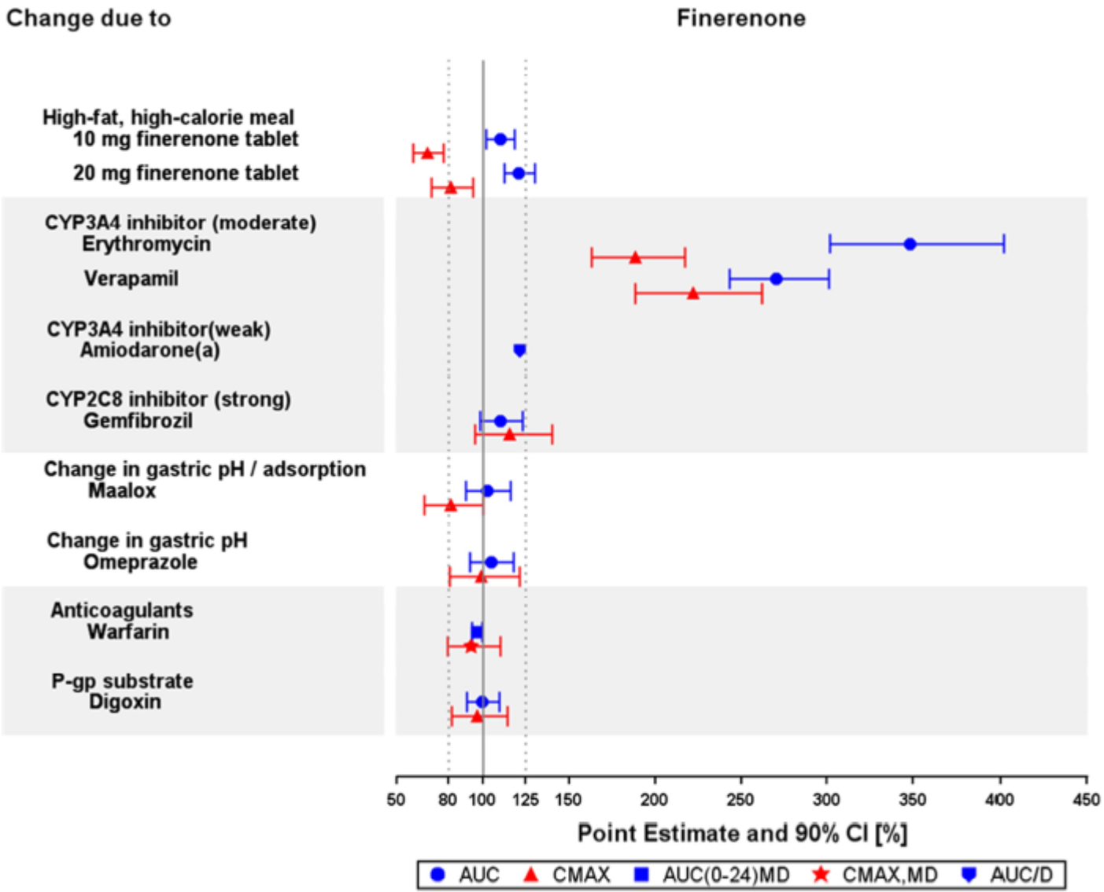
AUC = area under the concentration time curve; AUC(0-24)MD = AUC from time 0 to 24 hour after multiple dose; CI = confidence interval; CMAX = maximum observed drug concentration; CMAX,MD = CMAX in measured matrix after multiple dose administration during a dosage interval; CYP2C8 = cytochrome P450 isoenzyme 2C8; CYP3A4 = cytochrome P450 isoenzyme 3A4; D = dose; P-gp = p-glycoprotein; pH = potential of hydrogen.
a Based on population pharmacokinetic (PopPK) Analysis 13880 of Study 14563, where use of the weak CYP3A4 inhibitor amiodarone resulted in a 17.4% lower apparent oral clearance (CL/F)1 after forward inclusion. However, the inclusion of this covariate effect did not significantly improve model predictions and was, therefore, not included in the final model.

Age and biological sex
Age and biological sex had no major impact on the exposure of finerenone metabolites M1, M2, and M3 (Study 14508; PopPK Analysis 13880; diabetic kidney disease PopPK Analysis 18523).

Ethnicity
There were no major differences in finerenone exposure between Asians and Caucasians after accounting for body weight (in healthy subjects, patients with diabetic nephropathy, and diabetic kidney disease) (diabetic nephropathy PopPK Analysis 17024; diabetic kidney disease PopPK Analysis 18523).

Renal impairment
Mild, moderate or severe renal impairment had no major impact on finerenone C_{max} and AUC. There was a 1.36-fold increase of AUC in subjects with severe renal impairment compared to healthy controls (Study 14509). Despite its relatively small effect on finerenone exposure, renal function (estimated glomerular filtration rate (eGFR) modification of diet in renal disease) was a statistically significant covariate of apparent oral clearance (CL/F) alone or of CL/F and fraction absorbed (bioavailability) in all population pharmacokinetic (PopPK) analyses. The most likely explanation of this finding is an alteration of hepatic CYP activity due to the accumulation of uremic toxins in diabetic kidney disease.

Metabolites
Similar results were observed for finerenone metabolite M1, but the increase of AUC was slightly higher in subjects with moderate (1.74-fold increase) or severe renal impairment (1.63-fold increase). Finerenone metabolites M2 and M3 were subject to a higher degree of renal elimination. Consequently, the impact of renal impairment on their exposure was more pronounced. Renal impairment had the largest impact on finerenone metabolite M3 exposure. In subjects with severe renal impairment, a 2.5-fold and 5.9-fold increase of finerenone metabolite M3 C_{max} and AUC was observed, respectively (Study 14509). The metabolites are not pharmacologically active. The significance of elevated concentrations in renal impairment remains uncertain.

Hepatic impairment
Mild or moderate hepatic impairment had no major effect on total and unbound finerenone/metabolite exposure. The largest effects observed were a 1.38-fold and 1.55-fold increase of total and unbound AUC in subjects with moderate hepatic impairment (Study 14510). Subjects with severe hepatic impairment and the plasma protein binding of the metabolites in subjects with hepatic impairment were not investigated.

Drug-drug interactions

Effects on finerenone due to extrinsic factors
An overview of tested interactions is at Figure 2. Available data suggest that finerenone is a sensitive CYP3A4 substrate. In vivo, 87% to 89% of metabolic clearance is attributed to CYP3A4, and approximately 10% to CYP2C8. CYP3A4 inhibitors or inducers of this enzyme were the only identified extrinsic factors of potential relevance. Co-administration with the following:
- strong CYP3A4 inhibitors is contraindicated;
- moderate or weak CYP3A4 inhibitors requires monitoring of serum potassium levels;
- strong and moderate CYP3A4 inducers should be avoided.

Effects of finerenone on the pharmacokinetics of co-medications
An overview of tested interactions is at Figure 3 below.
Figure 3: Effect of finerenone 20 mg tablet on substrate pharmacokinetics (pharmacokinetics set)
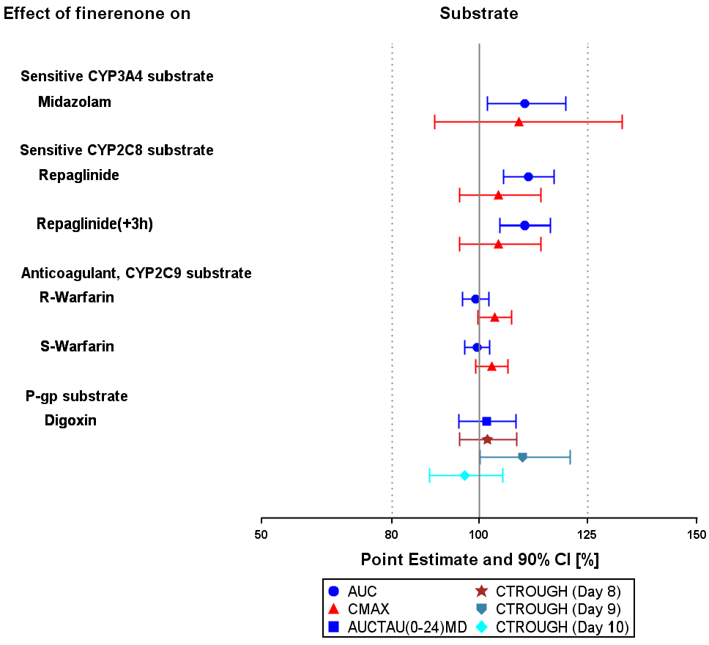
AUC = area under the concentration time curve; AUCTAU(0-24)MD = AUC over dosing interval from time 0 to 24 hour after multiple dose; CI = confidence interval; CMAX = maximum observed drug concentration; CTROUGH =trough concentration; CYP2C8 = cytochrome P450 isoenzyme 2C8; CYP3A4 = cytochrome P450 isoenzyme 3A4; h = hour.
The potentially relevant induction and inhibition of CYP3A4 in vitro by finerenone and/or its metabolites was not confirmed in in vivo studies. The much weaker in vitro effect on CYP2C8 was confirmed in vivo. Finerenone and its metabolites did not inhibit P-glycoprotein at clinically relevant concentrations. Available data indicated a non-significant effect of finerenone on breast cancer resistance protein (BCRP) and organic anion transporting polypeptide (OATP) substrates. Digoxin interactions are discussed separately.

Pharmacodynamics

Cardiac QT interval data
No clinically relevant mineralocorticoid receptor antagonism related PD effects were detected up to the highest single dose of 80 mg and the highest multiple dose treatment of 40 mg for 10 days. No corrected QT interval (QTc) prolongation was detected for clinical doses (Study 15113).

Exposure-response modelling
Exposure-response relationships were investigated based on data from the ARTS-DN trial (Study 16243) and the ARTS-DN Japan trial (Study 16816) using indirect response models for urine albumin-to-creatinine ratio (UACR), eGFR, and serum potassium (PopPK/PD analysis 17024). The dose-exposure-response modelling and simulation indicates that effects were largely saturated at finerenone 20 mg.

Population pharmacokinetics and pharmacodynamics data
Three relevant population PK/PD analyses were conducted:
- PopPK Analysis 13880 (healthy and congestive heart failure patients)
- PopPK Analysis 17024 (diabetic nephropathy patients)
- PopPK Analysis 18523 (diabetic kidney disease patients).
Overall, the finerenone PK profile was similar in healthy subjects, diabetic nephropathy and diabetic kidney disease patients. In the PopPK Analysis 18523, the impact of all investigated covariates on finerenone exposure was low (see Table 6 below).
Table 6: Study 18523 Overview of covariate effects
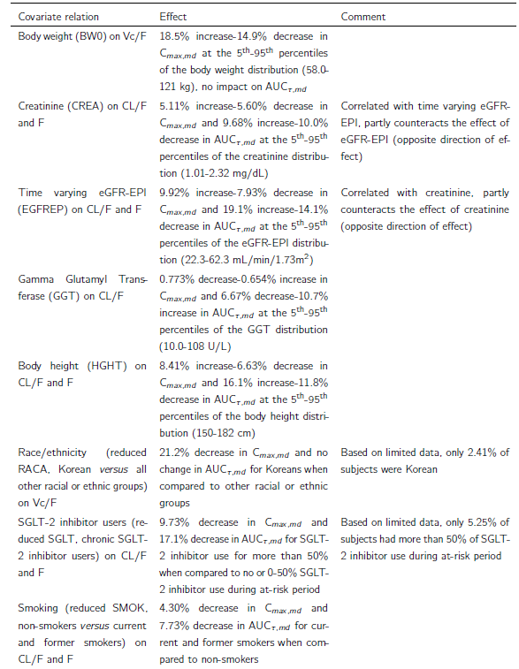
AUC_{τ,md} = AUC during any dose interval after multiple dose; BW0 = body weight; C_{max,md} = maximum observed drug concentration in measured matrix after multiple dose administration during a dosage interval; CREA = creatinine; CL/F = apparent oral clearance; eGFR = estimated glomerular filtration rate; EPI = epidemiology collaboration; ERFREP = time varying eGFR-EPI; F = fraction absorbed (bioavailability); GGT = gamma glutamyl transferase; HGHT = body height; Vc/F = apparent central volume.
In the PopPK analyses of Study 16244, body weight was a statistically significant covariate on apparent volume of distribution (19% increase and 15% decrease in C_{max} in measured matrix after multiple dose administration during a dosage interval (C_{max},_{md}), respectively, at the fifth and ninety fifth percentiles of the body weight distribution (58.0 and 121 kg), compared to the median), but there was no effect on AUC.

Efficacy
Two pivotal Phase III studies (Studies 16244 and 17530) investigated diabetic kidney disease, but only a full dataset from Study 16244 was submitted with this application. The efficacy claims for finerenone in the proposed indication are based on Study 16244.

Study 16244

Study overview
Study 16244 (also known as the FIDELIO-DKD trial) is a Phase III, randomised, double blind, multi-centre (1024 centres in 48 countries), parallel group, placebo controlled study to assess the efficacy and safety of finerenone for the treatment of diabetic kidney disease in patients with type 2 diabetes mellitus in 5674 adult patients.
The trial enrolled adult patients aged ≥ 18 years with type 2 diabetes mellitus and diabetic kidney disease who had already received treatment with an angiotensin-converting enzyme inhibitor (ACEi) or an angiotensin receptor blocker (ARB), and with serum potassium levels of ≤ 4.8 mmol/L. The complete list of inclusion and exclusion criteria are beyond the scope of this AusPAR.

Study endpoints
The primary and secondary endpoints were shown in Table 7 below.
Table 7: Study 16244 Primary and secondary endpoints
Primary | Time to first occurrence of the composite renal endpoint: onset of kidney failure, sustained decrease of eGFR ≥40% from Baseline for ≥4 weeks, or renal death.
Key secondary | Time to first occurrence of the composite cardiovascular endpoint: cardiovascular death or non-fatal cardiovascular events (that is, myocardial infarction, stroke, or hospitalisation for heart failure)
Secondary | Time to all-cause mortality
Secondary | Time to all-cause hospitalisation
Secondary | Change in urine albumin-to-creatinine ratio from Baseline to Month 4
Secondary | Time to first occurrence of the following renal composite endpoint: onset of kidney failure, a sustained decrease in eGFR of ≥ 57% from Baseline over at least 4 weeks or renal death
eGFR = estimated glomerular filtration rate.
Confirmatory statistics were performed in a pre-planned sequential design.

Study design
Figure 4: Study 16244 Study design
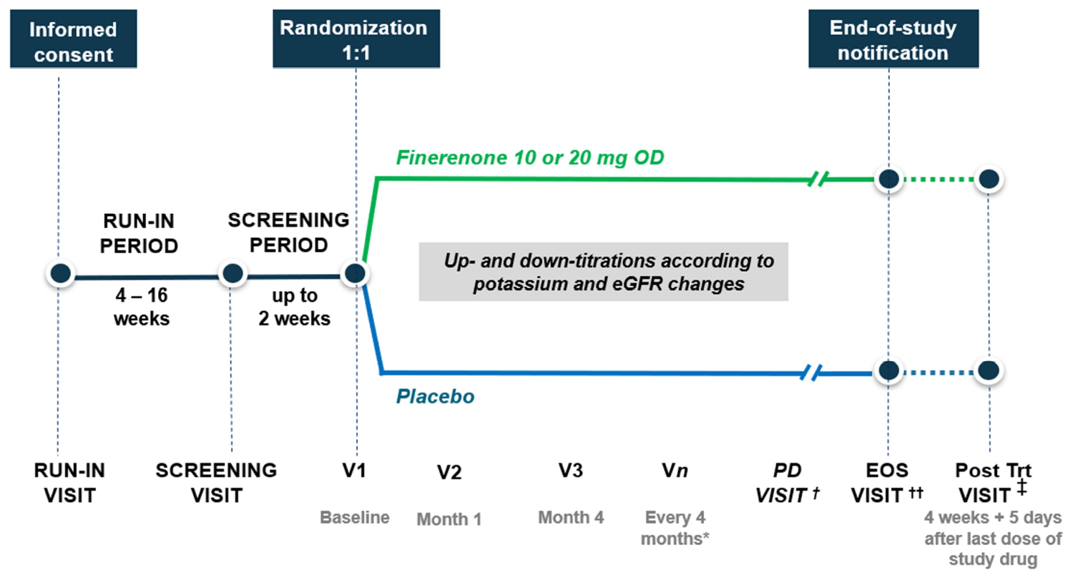
eGFR = estimated glomerular filtration rate; EOS = end-of-study; OD = once daily; PD = permanent discontinuation; Trt = treatment; V = visit.
* Scheduled visits continued even if treatment with study drug was discontinued
† permanent discontinuation visit conducted only after permanent withdrawal from treatment
†† End-of-study visit conducted after notification of end-of-study by the sponsor
‡ Post-treatment visit for all subjects on study drug treatment at end-of-study.

Baseline characteristics
There were no significant differences between treatment arms in age (median approximately 66 years), sex (68.9% males), region, ethnicity (approximately 65% White and approximately 25% Asian; some Australian patients, but no Indigenous Australian patients), cardiovascular disease and co-medications (see Table 8: Study 16244 Baseline demographic characteristics (full analysis set)Error! Reference source not found.). The median haemoglobin A1c or glycated haemoglobin (HbA1c) was approximately 7.7%, the median type 2 diabetes mellitus duration approximately 16 years, > 45% of the enrolled study participants had diabetic retinopathy, and almost two thirds received insulin treatment. For the UACR, there was a marginal imbalance between treatment arms (798.79 mg/g (finerenone) versus 814.73 mg/g (placebo)) (Table 9).
Patients received either finerenone (10 mg or 20 mg) or placebo additional to standard of care for type 2 diabetes mellitus (approximately 97% at Baseline) and other co-morbidities (for example, statins (approximately 74% at Baseline), beta-blockers (approximately 52% at Baseline), ARB (approximately 65% at Baseline), ACEi (approximately 34% at Baseline), and diuretics (approximately 56% at Baseline)). Small numbers were on SGLT-2 inhibitors (approximately 4.5%) and GLP-1 receptor agonists (approximately 7%) (see Table 9 below).
Table 8: Study 16244 Baseline demographic characteristics (full analysis set)
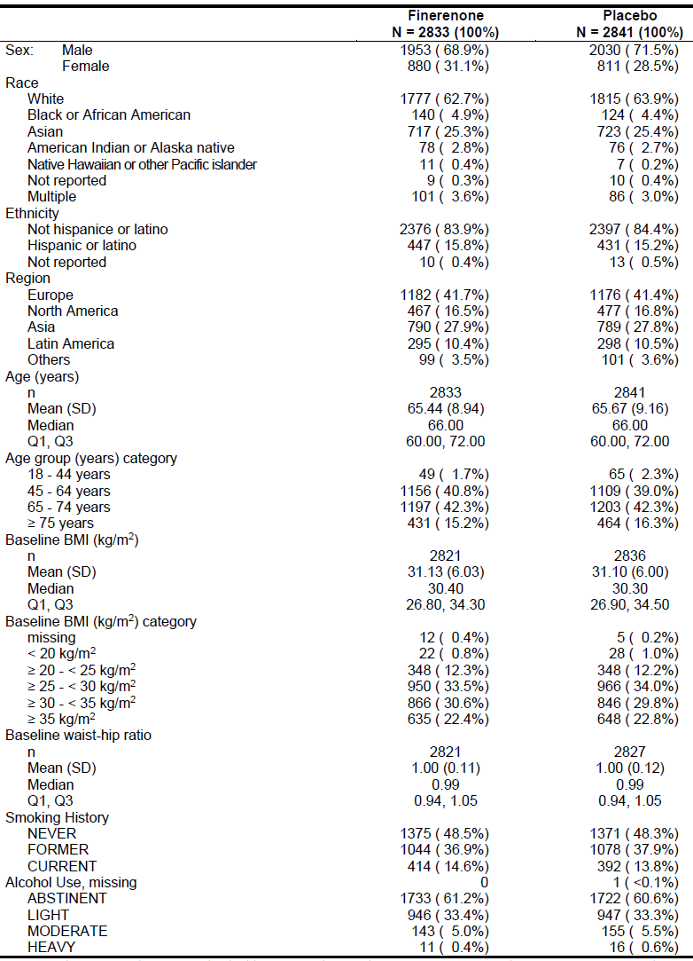
BMI = body mass index; N = number of subjects; n = number of subjects in category; Q = quartile; SD = standard deviation.
Race ‘multiple’: subjects who reported that they belong to more than one race. Region ‘Others’: New Zealand, South Africa, Australia.

Participant flow
The median treatment duration was 27 months accounting to a total exposure of 6346 patient-years (finerenone) and 6431 patient-years (placebo) in the two treatment arms.
13,911 patients were enrolled/screened (8,177 of those were screening failures), 5,734 were randomised (5,674 in full analysis set), and 5,656 completed the study (but not necessarily completed treatment). 1,623 subjects (822 (29.0%) for finerenone arm versus 801 (28.2%) for placebo) did not complete randomised treatment: due to adverse events (AEs) or outcome events (10.9% versus 10.3%), withdrawal by the subject (5.5% versus 5.9%), physicians’ decision (5.2% versus 3.8%), and death (4.6% versus 5.5%).
Table 9: Study 16244 Baseline disease characteristics (full analysis set)
eGFR = estimated glomerular filtration rate; FAS = full analysis set; N = number of subjects; n = number of subjects in category; Q = quartile; SD = standard deviation; UACR = urine albumin-to-creatinine ratio.

Study drug and dose
The starting dose of finerenone depended on the eGFR: eGFR 25 to <60 mL/min/1.73 m² received 10 mg daily, eGFR ≥ 60 mL/min/1.73 m² were assigned to the higher dose of finerenone (20 mg) or placebo.
If on 10 mg, up-titration was possible based on eGFR and potassium levels (Table 10). The study drug was stopped, if potassium levels were > 5.5 mmol/L, and could only be restarted (using the 10 mg daily dose) once the concentration was ≤ 5.0 mmol/L (Table 10 and Table 11).
Table 10: Study 16244 Dosage of study drug
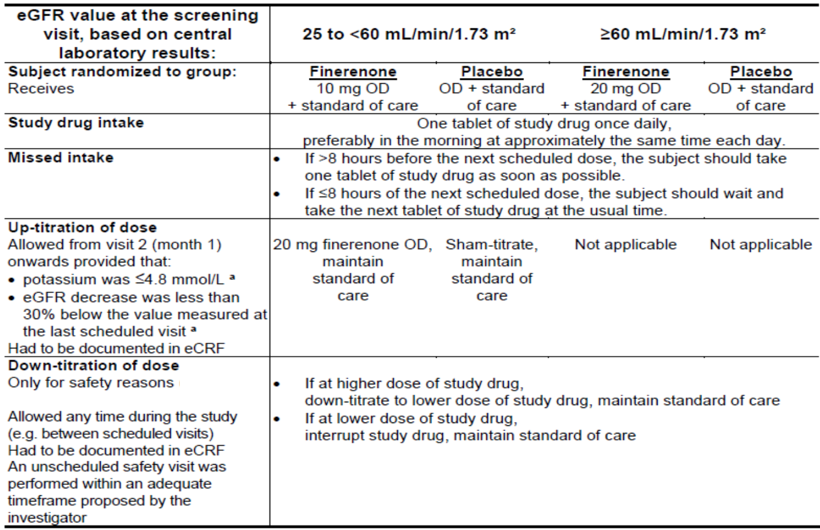
eCRF = electronic case report form; eGFR = estimated glomerular filtration rate; OD = once daily.
a Potassium and eGFR according to local laboratory values.
Table 11: Study 16244 Dosing and titration information (safety analysis set)
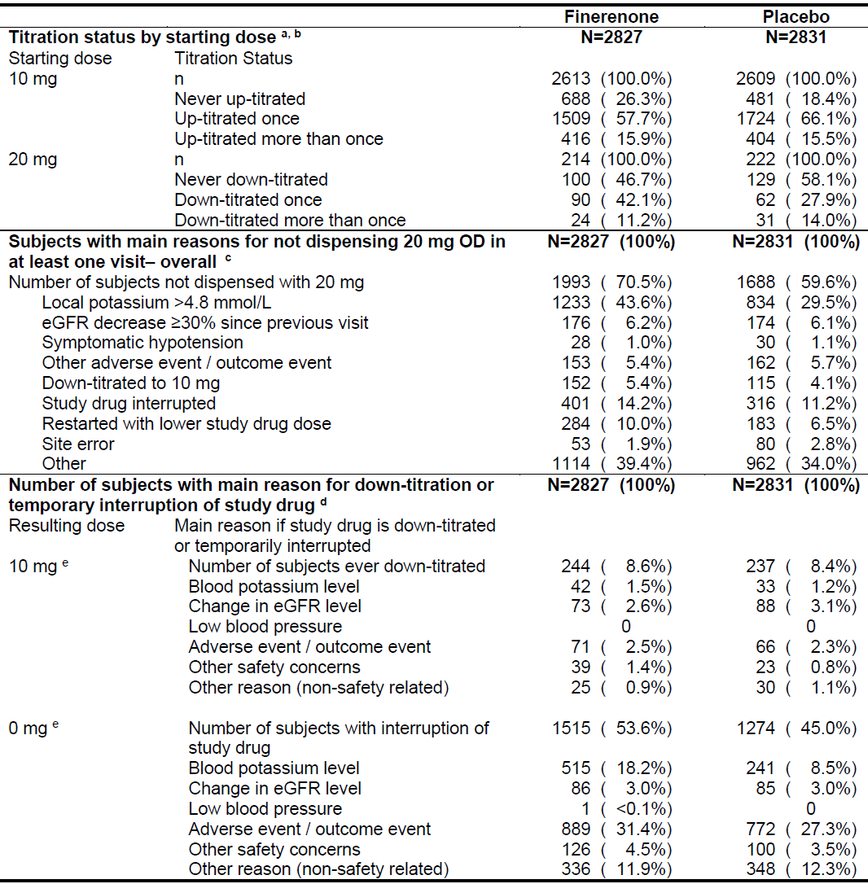
eGFR = estimated glomerular filtration rate; N = number of subjects in the safety analysis set; n = number of subjects in category; OD = once daily.
The titration status includes sham titration.
a The overall summary (never up-titrated) includes subjects discontinued which have not reached the respective visits.
b Up-titration = yes, if local potassium value ≤ 4.8 mmol/L at the respective visit and eGFR decrease (local laboratory value)
is less than 30% below the value measured at the last regular visit.
c The number of subjects not dispensed with 20 mg overall are the number of subjects not treated with 20 mg in at least one visit. One subject can have different reasons for not up-titrating to 20 mg and can thus be counted under different reasons.
d A subject could be down-titrated more than once or have a temporary interruption more than once during the study. In case of multiple down-titrations or interruptions for the same subject, it is possible that the subject had different reasons on the multiple occasions so that the subject was counted under each reason.
e Dose resulting from down-titration or study drug interruption.

Magnitude of the treatment effect and its clinical significance
Primary endpoint results (composite of kidney failure, sustained decrease of eGFR ≥ 40%, or renal death) support superiority of finerenone versus placebo with regard to the progression of diabetic kidney disease: primary endpoint events occurred in 504 subjects (17.8%; 7.59 events per 100 patient-years) in the finerenone arm versus 600 subjects (21.1%, 9.08 events per 100 patient-years) in the placebo arm (hazard ratio (HR) = 0.825; 95% confidence interval (CI) = 0.732, 0.928) (see Table 12).
The absolute risk reduction (ARR) of the primary endpoint was 3.4% (with the number needed to treat over the whole study period being < 30).
Table 12: Study 16244 Primary renal composite endpoint results (full analysis set)
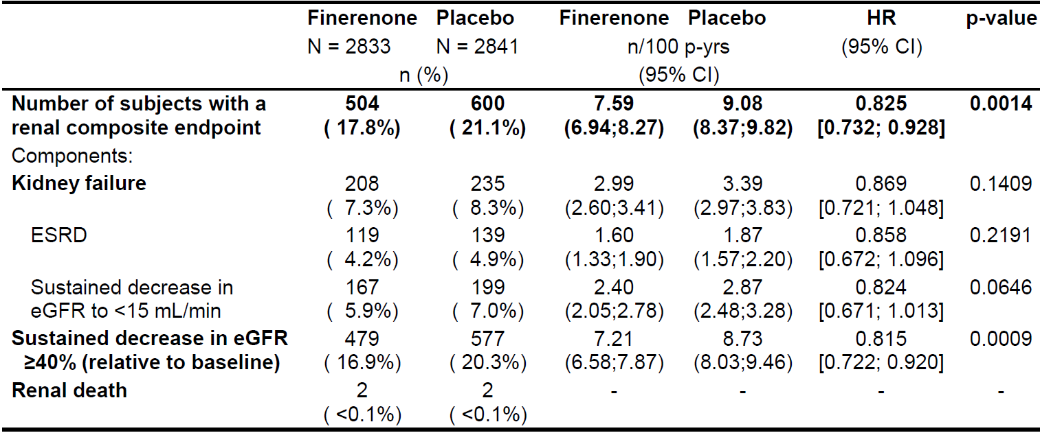
CI = confidence interval; eGFR = estimated glomerular filtration rate; ESRD = end-stage renal disease; HR = hazard ratio for the comparison of finerenone versus placebo; N = number of subjects; n = number of subjects with event; n/100 p-yrs = incidence rate; p-yrs = patient years.
Renal composite endpoint = onset of kidney failure, sustained decrease of eGFR ≥40% from Baseline over at least 4 weeks, or renal death.
For composite outcomes and each component, the first event after randomisation is considered. Subsequent events of the same type are not shown.
P-value: two-sided p-value from log-rank test, stratified.
Sensitivity analyses supported the robustness of the primary endpoint findings. The HR (95% CI) derived from the on-treatment analysis in the per-protocol; population was 0.764 (0.660, 0.885).
Key secondary endpoint results (composite of cardiovascular death, non-fatal myocardial infarction, non-fatal stroke, hospitalisation for heart failure) were favourable overall (HR (95% CI): 0.860 (0.747, 0.989)) (Table 13). However, one component showed an unfavourable effect: ‘non-fatal stroke’ with a HR (95% CI): 1.027 (0.765, 1.380). The overall result was statistically significant, but not the individual components.
The HR (95% CI) derived from the on-treatment analysis in the per-protocol population was 0.819 (0.686, 0.978) (p = 0.0272).
Table 13: Study 16244 Key secondary cardiovascular composite endpoint results (full analysis set)
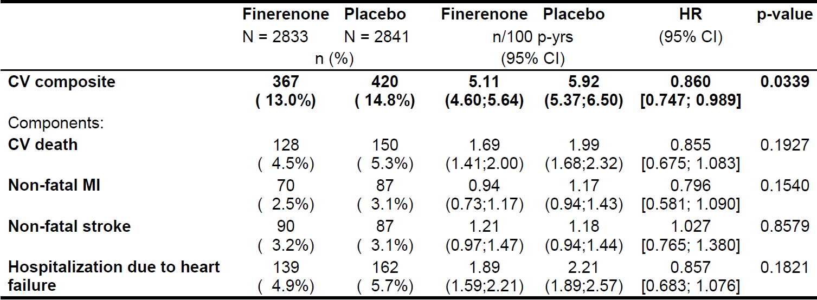
CI = confidence interval; CV = cardiovascular; CV composite endpoint = CV death; non-fatal myocardial infarction, non-fatal stroke, or hospitalisation for heart failure; HR = hazard ratio for the comparison of finerenone versus placebo; MI = myocardial infarction; N = number of subjects; n = number of subjects with event; n/100 p-yrs = incidence rate; p-yrs = patient years.
For composite outcomes and each component, the first event after randomisation is considered. Subsequent events of the same type are not shown.
P-value: two-sided p-value from log-rank test, stratified.
Results from secondary and exploratory renal endpoints were generally comparable to those for the primary endpoint. Finerenone numerically reduced all-cause mortality (HR (95% CI): 0.895 (0.746, 1.075); ARR 0.9%) and all-cause hospitalisations (HR (95% CI): 0.946 (0.876, 1.022); ARR 1.9%), but this was not statistically significant.

Subgroup analysis
The results for the primary endpoint were largely consistent across subgroups, but some findings suggest heterogeneity for the following factors: regions, age, renal function, and concomitant use of SGLT-2 inhibitors and GLP-1 receptor-agonists (see Table 14).
Table 14: Study 16244 Primary endpoint results by subgroup
Subgroup factor | Subgroup level | Hazard ratio (95% confidence intervals) | Interaction p-value
History of CVD | Present  Absent | 0.70 (0.58; 0.84)  0.94 (0.80; 1.09) | 0.0160
Baseline BMI (kg/m²) | < 30  ≥ 30 | 0.68 (0.58; 0.81)  0.98 (0.83; 1.17) | 0.0028
Baseline BMI (kg/m²) | < 20  20 < 25  25 < 30  30 < 35  ≥ 35 | 0.96 (0.28; 3.33)  0.80 (0.59; 1.07)  0.63 (0.51; 0.78)  0.87 (0.70; 1.09)  1.16 (0.90; 1.49) | 0.0091
Baseline waist circumference | normal  increased  substantially increased | 0.84 (0.62; 1.13)  0.60 (0.46; 0.79)  0.91 (0.79; 1.06) | 0.0274
DPP-4 inhibitor use | No  Yes | 0.77 (0.67; 0.88)  0.98 (0.79;1.23) | 0.0680
SGLT-2 inhibitor use | No  Yes | 0.82 (0.72;0.92)  1.38 (0.61;3.10) | 0.2114
GLP-1 receptor agonists use | No  Yes | 0.80 (0.71;0.91)  1.17 (0.71;1.90) | 0.1502
Co-medication  with drug-drug interaction through  CYP3A4 | Inhibitor  strong  unclassified  moderate inhibitor  weak inhibitor  none | 1.32 (0.35-4.93)  0.86 (0.30-2.49)  0.94 (0.43-2.08)  0.80 (0.69-0.92)  0.86 (0.70-1.07) | 0.9094
Co-medication  with drug-drug interaction through  CYP3A4 | Inducer  strong  unclassified  moderate  weak inducer  none | not calculated (no events)  1.80 (0.46-6.98)  3.73 (0.68-20.5)  0.78 (0.43-1.42)  0.82 (0.62-0.92) | not calculated
Potassium supplement use | No  Yes | 0.84 (0.74-0.94)  0.52 (0.27-1.01) | 0.1654
BMI = body mass index; CVD = cardiovascular disease; CYP3A4 = cytochrome P450 isoenzyme 3A4; DPP-4 = dipeptidyl peptidase-4; GLP-1 = glucagon like peptide 1; SGLT-2 = sodium glucose co-transporter 2.

Study 17530
This study (also known as the FIGARO-DKD trial) was not considered, as no data was submitted with this submission.

Phase II studies
The design and dose selection of Study 16244 was informed by the results of the Phase II program (see Table 15). The chosen finerenone dose of 10 mg to 20 mg once daily was informed by data from these Phase II studies. Furthermore, finerenone appeared to be safe in that dose range.
Table 15: Overview of Phase II development program studies
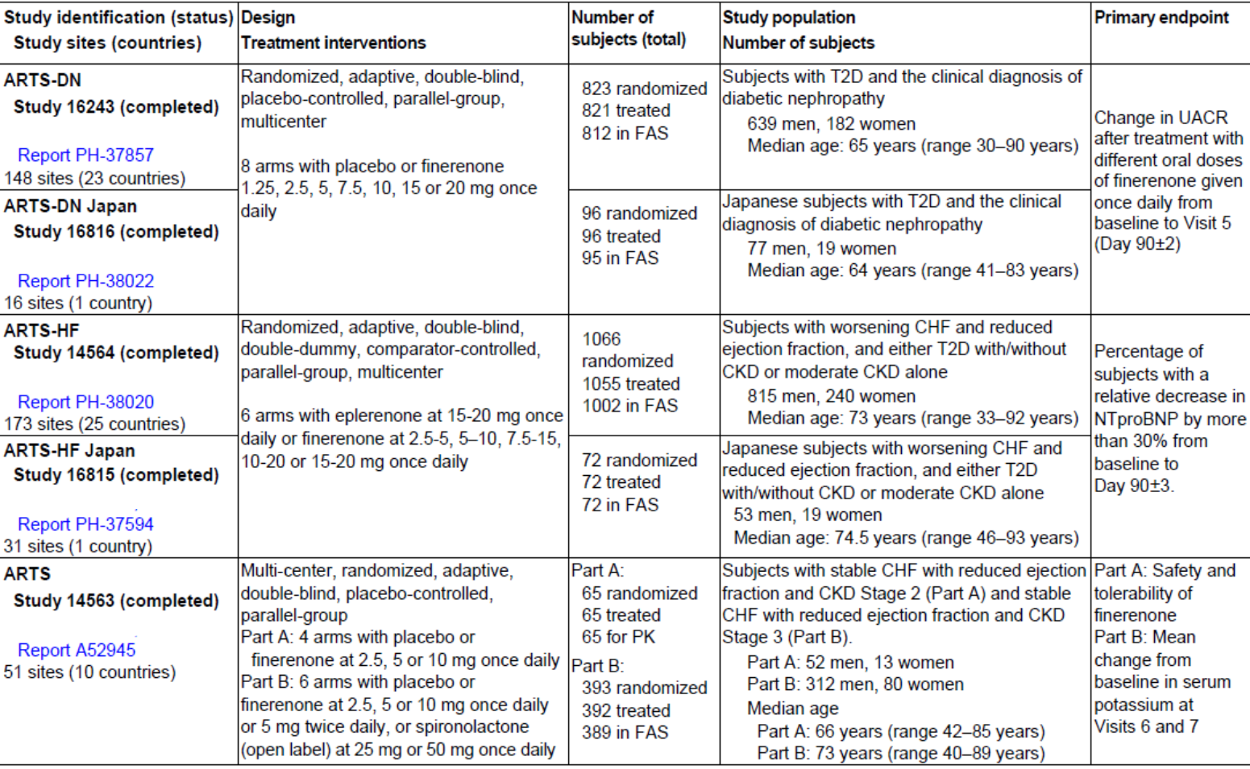
CHF = congestive heart failure; CKD = chronic kidney disease; FAS = full analysis set; NTproBNP = N-terminal B type natriuretic peptide; PK = pharmacokinetics; T2D = type 2 diabetes; UACR = urine albumin-to-creatinine ratio.

Safety
Safety data are mainly based on Study 16244, as this was the largest dataset in the target population at proposed clinical doses. Pooling the safety data from Study 16244 with Phase I or II data was not considered to provide additional insight given major differences in the study size, duration of follow-up, patient populations and in study design.

Exposure
Exposure was balanced between the treatment arms (2827 patients for finerenone versus 2831 patients for placebo) over a median treatment duration of approximately 27 months (87% for ≥ 12 months, 58% for ≥ 24 months, and 25% for ≥ 36 months). Adjustment of study drug dosage was allowed at any time during Study 16244 based on the subject’s eGFR and serum potassium levels with a mean daily dose of 15.14 versus 16.48 mg (sham titration for placebo).
Overall exposure and mean daily dose were lower in both treatment arms in subjects with a hyperkalaemia event during the study compared to those without an event.

Adverse events
Overall, the incidence of treatment-emergent adverse events (TEAEs) was similar between the treatment arms. Finerenone treated patients had a higher TEAE incidence leading to permanent treatment discontinuation (7.3 versus 5.9%), while the incidence of serious TEAEs leading to treatment discontinuation was balanced between treatment arms (2.7 versus 2.8%). Common (≥ 5% in any treatment arm) TEAEs by Preferred Term (safety analysis set) are shown in Table 16. Most subjects (nearly 80%) with TEAEs in the finerenone arm had a maximum intensity of mild or moderate.
Table 16: Study 16244 Common (≥ 5% in any treatment arm) treatment-emergent adverse events by Preferred Term (safety analysis set)
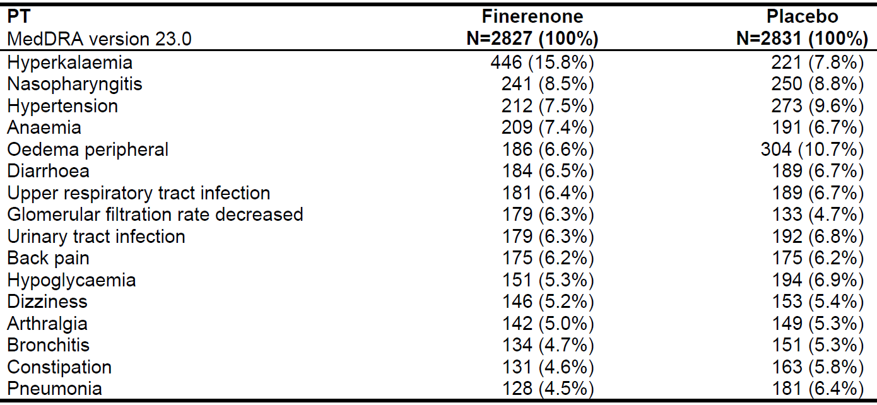
MedDRA = Medical Dictionary for Regulatory Activities; N = number of subjects; PT = Preferred Term.
The events are displayed with descending frequency in the finerenone group.
Treatment-emergent adverse events noticeably more frequent (that is, an increase in incidence ≥ 1%) in finerenone-treated patients versus placebo-treated patients were hyperkalaemia (446 (15.8%) versus 221 (7.8%)); glomerular filtration rate decreased (179 (6.3%) versus 133 (4.7%)); hypotension (126 (4.5%) versus 87 (3.1%)); pruritus (104 (3.7) versus 73 (2.6%)); and blood potassium increased (81 (2.9%) versus 40 (1.4%)) (see Table 17). Consistent with this, the increased overall incidence of study drug related TEAEs (22.9% versus 15.9%) was primarily driven by the Medical Dictionary for Regulatory Activities (MedDRA); Preferred Terms ‘hyperkalaemia’ and ‘blood potassium increased’ (11.8% versus 4.8%).
Treatment emergent adverse events observed less frequently in finerenone-treated subjects included peripheral oedema, hypertension, hypoglycaemia, pneumonia, constipation, hypokalaemia, cardiac failure, and syncope (Table 17).

Treatment related adverse events (adverse drug reactions)
Six hundred and forty-six (646) subjects (22.9%) in the finerenone arm reported study drug related TEAEs (most commonly hyperkalaemia) compared with 449 subjects (15.9%) in the placebo arm (Table 18).
Table 17: Study 16244 Treatment emergent adverse events with a difference of ≥ 1% of subjects between treatment arms by Preferred Term (safety analysis set)
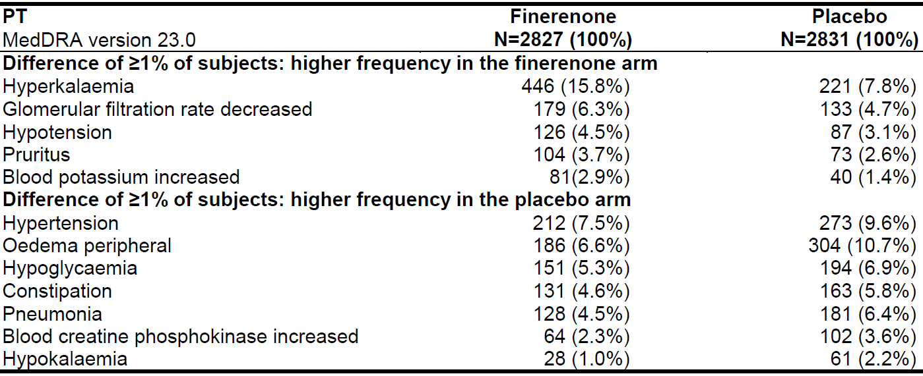
MedDRA = Medical Dictionary for Regulatory Activities; N = number of subjects; PT = Preferred Term.
The events are displayed with descending frequency in the finerenone group.
Table 18: Study 16244 Study drug related treatment emergent adverse events (≥ 0.5%) by most frequent Preferred Term (safety analysis set)
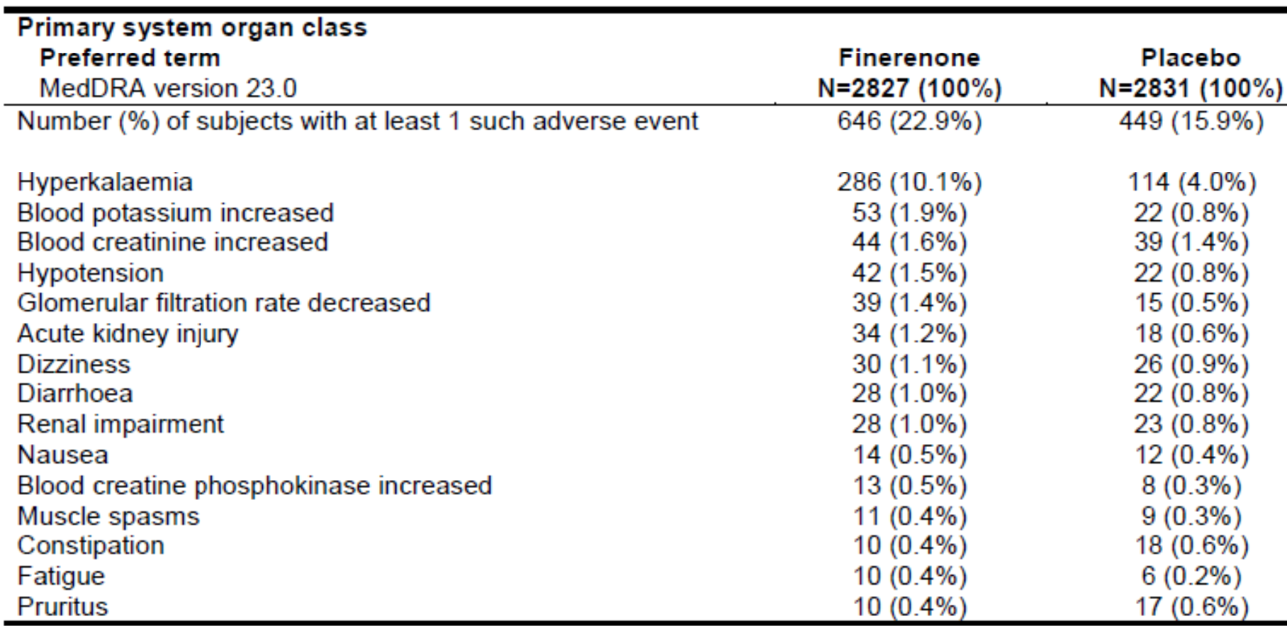
MedDRA = Medical Dictionary for Regulatory Activities; N = number of subjects.
The most common events for either treatment arm is displayed, with the corresponding events in the other treatment arm.
The events are displayed with descending frequency in the finerenone group.
A subject is counted only once within each Preferred Term or any primary System Organ Class.

Deaths
Treatment-emergent adverse events resulting in death (excluding outcome events) were reported in fewer subjects in the finerenone arm compared to the placebo arm (1.1 versus 1.8%). 89 subjects (3.1%) died due to TEAEs or outcome events in the finerenone group and 135 (4.8%) in the placebo arm. Further details are in Table 19, shown below.
Table 19: Study 16244 Adjudicated reasons for death (safety analysis set)
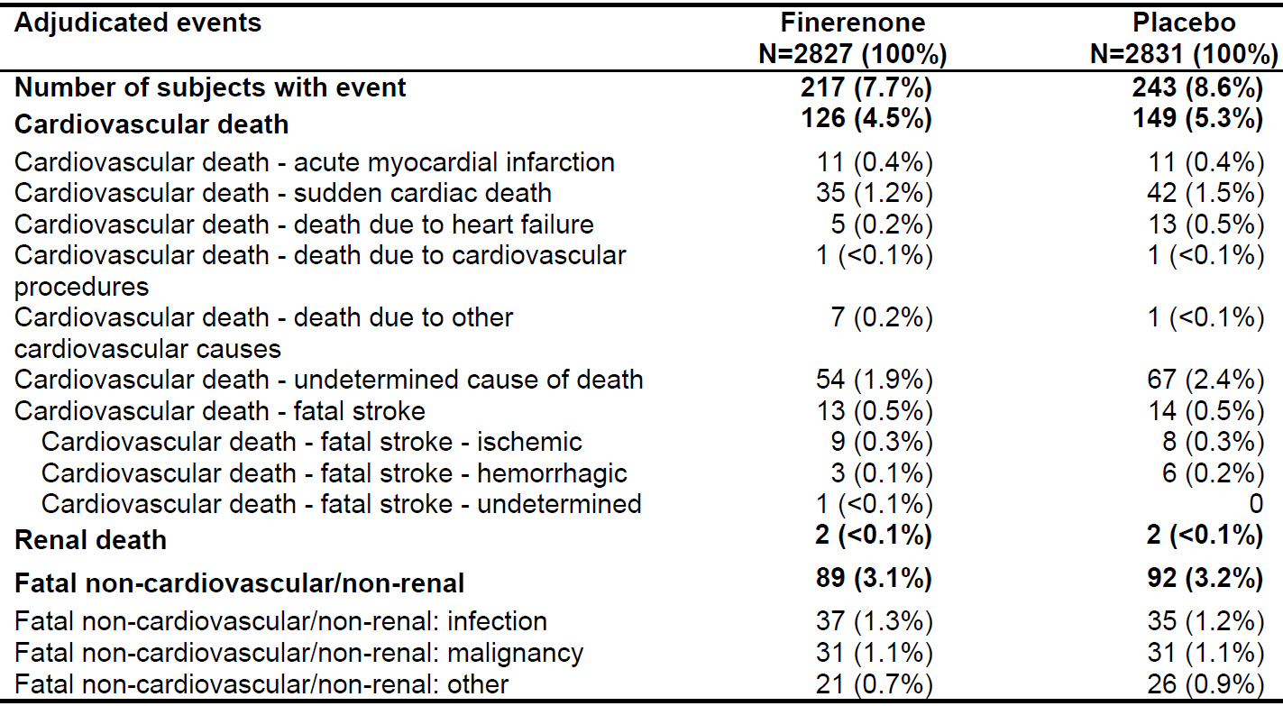
N = number of subjects.
Events were adjudicated by an independent adjudication committee and considered from randomisation up until the end of study visit.

Serious adverse events
The incidence of serious TEAEs was numerically lower in the finerenone arm compared to placebo. Serious TEAEs more frequently reported in the finerenone arm versus placebo arm were acute kidney injury (2.0% versus 1.8%), hyperkalaemia (1.5% versus 0.4%), cellulitis (0.9% versus 0.8%), and cataract (0.7% versus 0.4%). Serious TEAEs assessed as related to study treatment were generally infrequent (1.7% versus 1.2%) with hyperkalaemia (0.8% versus 0.2%) and acute kidney injury (0.3% versus 0.2%) being most common.

Discontinuations
Treatment interruption in at least one visit was more frequent in the finerenone arm (53.6%) compared to placebo (45.0%). The most common reasons were AEs or outcome events (31.4 versus 27.3%) and blood potassium level (18.2 versus 8.5%).

Adverse events of special interest
Hyperkalaemia can occur in advanced CKD and type 2 diabetes and may be aggravated by ACEi, ARB or MRA treatment. There was a nearly 2-fold incidence increase (mean difference approximately 0.2 mmol/L) compared to placebo with approximately two thirds considered to be related to study drug. No hyperkalaemia events resulted in death; most were mild or moderate, and most recovered. There was no imbalance with regard to events related hyperkalaemia (for example, cardiac or neurological disorders; hospitalisations) (see Table 20). Serum potassium of > 5.5 mmol/L (> 6 mmol/L) at any time during treatment was reported for 21.4% and 9.2% (4.5% and 1.4%) of subjects in the finerenone and placebo arms, respectively.
Table 20: Study 16244 Hyperkalaemia treatment-emergent adverse events (safety analysis set)
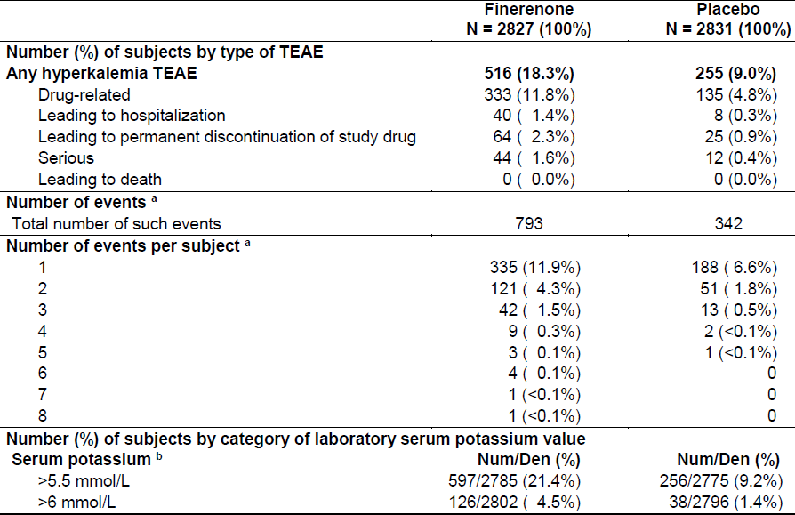
Den = denominator; N = number of subjects; Num = numerator; TEAE = treatment emergent adverse event.
a. All interruptions are excluded from the person-time at risk, that is, for subjects with an interruption, events in the period from interruption start + 3 days until end of interruption are not considered.
All hyperkalaemia adverse events are considered, including events occurring on the same day.
b. The denominator (Den) represents all subjects at risk for a treatment emergent laboratory abnormality. Subjects must have both a baseline and post-baseline treatment emergent value and the baseline value must be in the expected range for that criterion. The numerator (Num) represents the number of subjects at risk with at least one treatment emergent laboratory assessment meeting the criterion. For treatment emergent only assessments from start of treatment until 3 days after any temporary or permanent interruption of study drug are considered.
A post-hoc subgroup analysis suggested that patients with an eGFR ≥ 60 mL/min/1.73 m² at Baseline were less vulnerable (smallest difference between treatment groups), and that the following were more vulnerable: Asian patients, patients with a history of hyperkalaemia, and patients with a higher baseline potassium level.
Worsening of renal function TEAEs resulting in hospitalisation or discontinuation were balanced between treatment arms. Acute decreases in GFR were more frequently observed in the finerenone arm (6.3% versus 4.7%). Serious events (5 (0.2%) versus 4 subjects (0.1%)) or events leading to permanent discontinuation (7 (0.2%) versus 8 (0.3%)) were rare and balanced between treatment groups (see Table 21).
Table 21: Study 16244 Worsening of renal function treatment-emergent adverse events (safety analysis set)
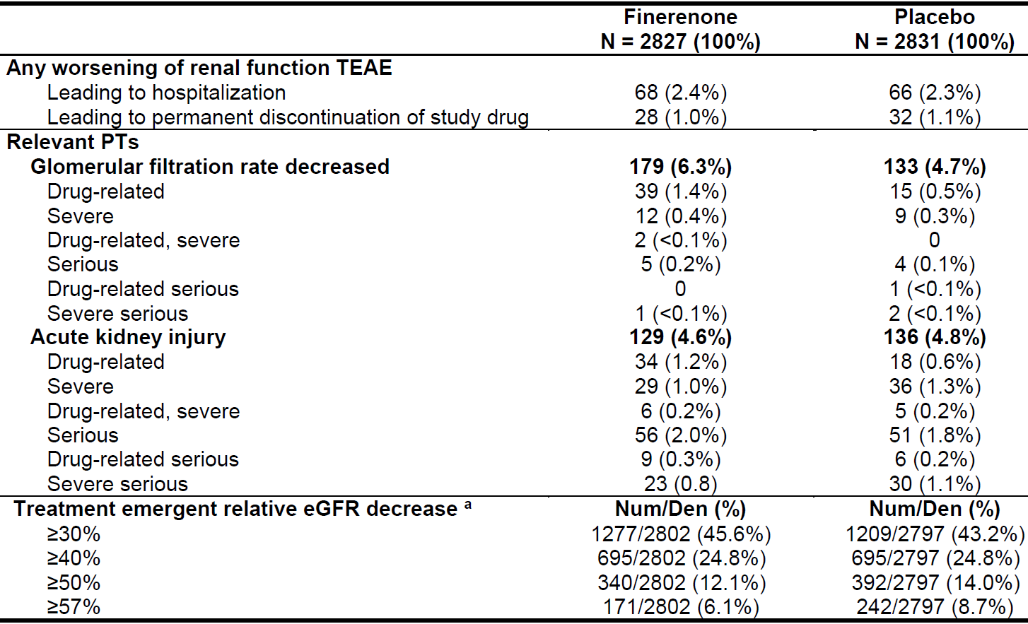
Den = denominator; eGFR = estimated glomerular filtration rate; N = number of subjects; Num = numerator; PT = Preferred Term; TEAE = treatment emergent adverse event.
a The denominator (Den) represents all subjects at risk for a treatment emergent laboratory abnormality. Subjects must have both a baseline and post-baseline treatment emergent value and the baseline value must be in the expected range for that criterion. The numerator (Num) represents the number of subjects at risk with at least one treatment emergent laboratory assessment meeting the criterion. For treatment emergent only assessments from start of treatment until 3 days after any temporary or permanent interruption of study drug are considered.

Other treatment-emergent adverse events associated with mineralocorticoid receptor antagonist mode of action
Hypotension and hyponatraemia (as expected TEAEs) were generally non-serious and manageable. TEAEs related to gynecomastia or breast pain were balanced between the treatment arms.

Safety in special populations

Hepatic impairment
The classification into Child Pugh; A or B was not definite. Only a very small number of patients were classified with certainty, making an interpretation difficult. Patients with severe hepatic impairment (Child Pugh C)⁸ have not been studied.
The proportion of subjects with any TEAE was higher in hepatic impairment compared to without; Child Pugh B patients were usually worse than Child Pugh A. However, the events appeared to be balanced between treatment and placebo groups, except for the imbalances also found in patients without hepatic impairment (Table 22).
Table 22: Study 16244 Overall summary of treatment-emergent adverse events by hepatic impairment (safety analysis set)
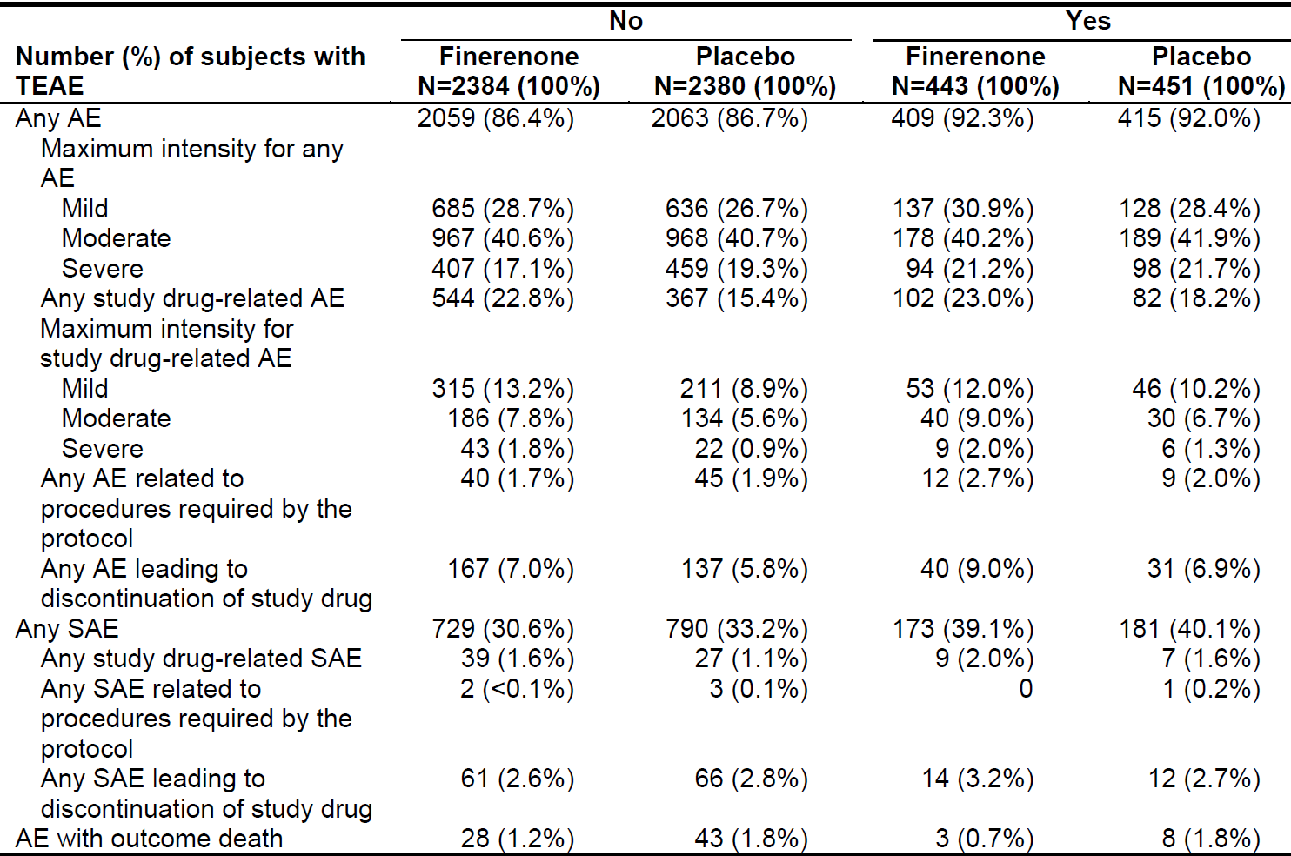
AE = adverse event; N = number of subjects; SAE = serious adverse event; SAF = safety analysis set; TEAE = treatment emergent adverse event

Pregnancy or breast feeding
No clinical data are available.
In the pre-and postnatal developmental toxicity study in rats, adverse effects on fetal and pup development were found. It is unknown if finerenone or its metabolites are excreted into human breast milk. Available data in animals have shown secretion of finerenone and/or metabolites into milk.
Women of childbearing potential should use effective contraception during treatment with finerenone. Breastfeeding should be discontinued if use of finerenone is considered essential.
Pregnancy Category D; is proposed.

Post-market experience
No data is available.

Risk management plan
The sponsor has submitted EU-risk management plan (RMP) version 0.1 (dated 22 October 2020; data lock point (DLP) 15 October 2020) and Australia specific annex (ASA) version 1.0 (dated 6 November 2020) in support of this application.
The summary of safety concerns and their associated risk monitoring and mitigation strategies are summarised in Table 23.
Table 23: Summary of safety concerns
Summary of safety concerns |  | Pharmacovigilance |  | Risk minimisation
 |  | Routine | Additional | Routine | Additional
Important identified risks | Hyperkalaemia |  | – |  | –
Important potential risks | None | – | – | – | –
Missing information | None | – | – | – | –
- The summary of safety concerns is acceptable. No new safety concerns have been identified during evaluation.
- Routine pharmacovigilance activities only are proposed which is acceptable given the safety concerns.
- Routine risk minimisation activities only are proposed which is acceptable as finerenone is an oral formulation and the safety concerns are adequately addressed in the PI/Consumer Medicines Information (CMI).

Risk-benefit analysis

Delegate’s considerations

Efficacy

Clinical trial data
Only one Phase III pivotal study (Study 16244) was presented to support this submission. It investigated 5674 adults with diabetic kidney disease with type 2 diabetes mellitus for a median duration of 27 months. The study was reasonably well planned and conducted. The composite endpoints used were reasonable, but prone to potential multiplicity issues.

Diabetic kidney disease target population and generalisability
Study 16244 investigated relevant clinical doses in a population generalisable to the general Australian type 2 diabetes mellitus diabetic kidney disease population. The median eGFR was 43 mL/min/1.73 m²; nearly 90% of the patients had an eGFR < 60 mL/min/1.73 m²; and the UACR geometric mean was approximately 800 mg/g. However, despite having study centres in Australia, no Indigenous Australian patients were enrolled.
It is important to emphasise that the results only apply to the diabetic kidney disease population, not to all type 2 diabetes mellitus patients.

Diabetic kidney disease treatment effect
All components of the primary renal composite endpoint (composite of kidney failure, sustained decrease of eGFR ≥ 40%, or renal death) had favourable results (combined HR (95% CI) = 0.825 (0.732, 0.928)) (see Table 12), except for ‘renal death’ which did not have sufficient events in either group. ‘Sustained decrease of eGFR ≥ 40% from Baseline for ≥ 4 weeks’ appeared to be the main driver, and was statistically significant on its own, unlike the other components (not necessarily expected for a composite endpoint). Results from secondary and exploratory renal endpoints were generally supportive of the primary result.

Timing of diabetic kidney disease treatment effect
The risk reduction became apparent ≥ 12 months following treatment onset and persisted thereafter (
Figure 5). Patients may suffer from an initial decrease in GFR after having commenced treatment.
Figure 5: Primary renal composite endpoint: Kaplan-Meier plot for time to first occurrence (full analysis set)
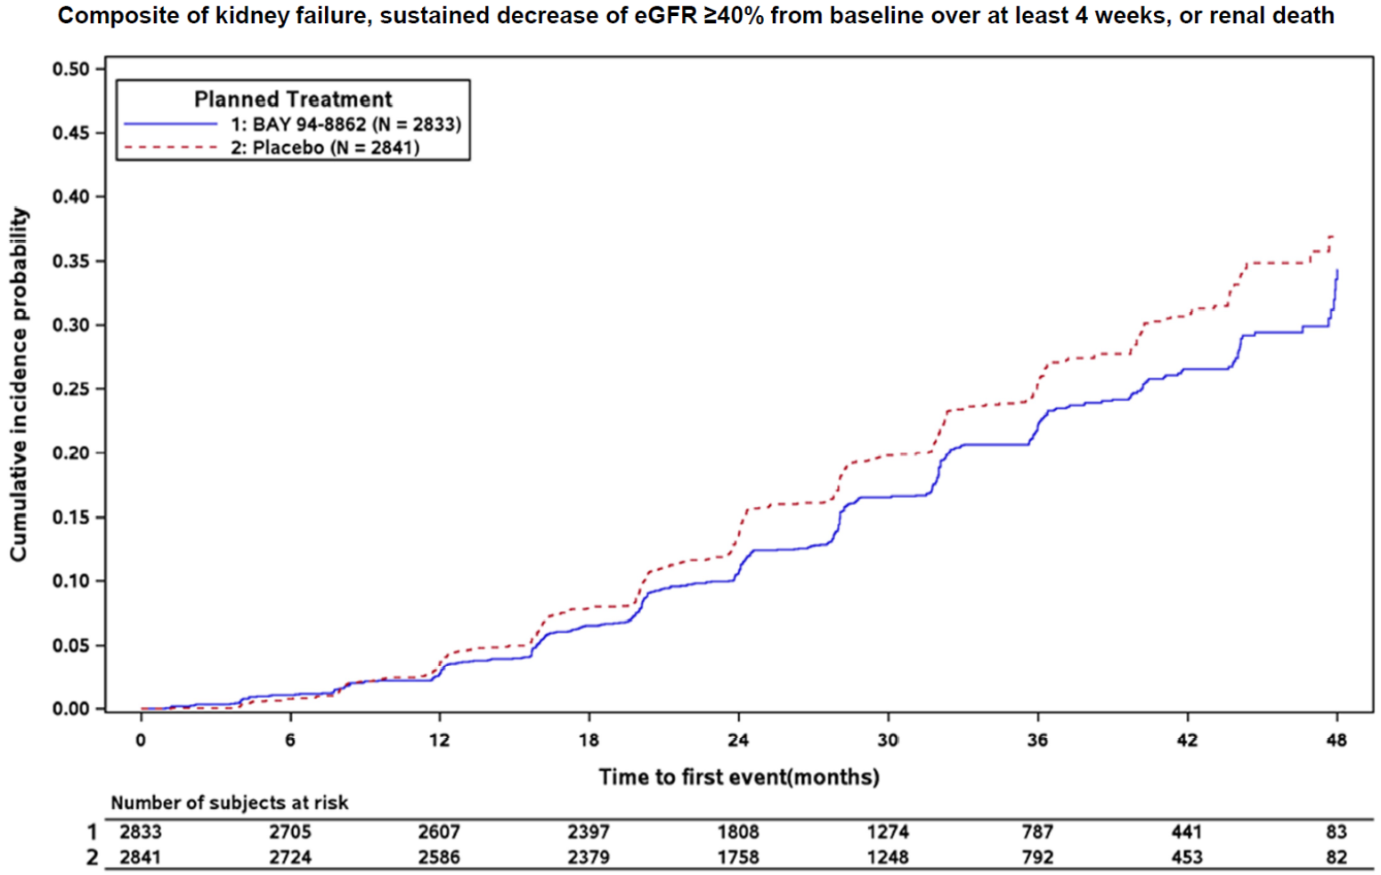
eGFR = estimated glomerular filtration rate; N = number of subjects.

Cardiovascular and other endpoint results
The key secondary endpoint results (composite of cardiovascular death, non-fatal myocardial infarction, non-fatal stroke, hospitalisation for heart failure) were favourable overall (HR (95% CI): 0.860 (0.747, 0.989)) (see Table 13), but not supported by all components. The beneficial overall effect appeared to be driven by all components of the secondary endpoint except for ‘non-fatal stroke’ (see Table 13) and occurred early on. The component that showed an unfavourable effect was ‘non-fatal stroke’ with a HR (95% CI): 1.027 (0.765, 1.380), but this was not statistically significant.
Furthermore, the following also indicated non-significant, but numerically favourable results: all-cause mortality (HR (95% CI): 0.895 (0.746, 1.075)) and all-cause hospitalisations (HR (95% CI): 0.946 (0.876, 1.022)).

Uncertain effect with sodium glucose co-transporter 2 inhibitor and glucagon like peptide 1 receptor-agonist co-administration
Only a small fraction of Study 16244 patient population received treatment with SGLT-2 inhibitors (approximately 4.5%) or GLP-1 receptor-agonists (approximately 7%). The subgroup analysis of the primary endpoint revealed a numerically unfavourable effect for patients on those treatments. The results were not statistically significant, and may be due to heterogeneity, but a true unfavourable effect cannot be excluded with certainty. It would not be unreasonable to include a relevant statement in both the ‘Precautions’ and ‘Clinical trials’ sections of the PI.

Implications for the indication
The originally submitted sponsor proposed indication was:
Kerendia is indicated to delay progression of kidney disease and to reduce the risk of major adverse cardiovascular events (cardiovascular death, nonfatal myocardial infarction, non-fatal stroke) and hospitalization for heart failure in adults with chronic kidney disease (CKD) and type 2 diabetes (T2D).
After receipt of the clinical evaluation report, the sponsor proposed indication was changed to:
Kerendia is indicated to delay progression of kidney disease and to reduce the risk of cardiovascular mortality and morbidity in adults with chronic kidney disease and albuminuria in type 2 diabetes in addition to existing standard of care.

Diabetic kidney disease indication
Evidence from 2 pivotal studies is typically expected to support an indication in a larger population group. Only one pivotal Phase III trial was submitted to support the diabetic kidney disease indication. It is acknowledged that Study 16244 demonstrated a clinically meaningful nephroprotective effect in the studied population, even though the benefits typically only occurred after 12 months of treatment (
Figure 5). There was evidence for an exposure response relationship for the renal composite endpoint. An inclusion of a diabetic kidney disease indication is therefore supported in principle.
The inclusion criteria did not match distinct CKD stages (patients with an eGFR of ≥ 25 to < 75 mL/min/1.73 m², dependent on albuminuria severity) and thus a restriction to certain stages may not be helpful. However, >99% of patients in Study 16244 had albuminuria at Baseline, and this should be reflected in the indication. Furthermore, it is important to emphasise in the indication that the results only apply to the diabetic kidney disease population (that is, to CKD associated with type 2 diabetes mellitus), and not to all type 2 diabetes mellitus patients. All patients in Study 16244 were on either an ACEi or an ARB which should also be reflected in the indication.

Cardiovascular indication
As stated above, evidence from 2 pivotal studies is typically expected to support an indication in a larger population group. The cardiovascular indication wording could be interpreted as secondary claims that are not fully supported by the submitted data.
The cardiovascular indication is based on a secondary (albeit key secondary) composite endpoint in a single pivotal Phase III trial. The presence of an unfavourable component would make it difficult to unequivocally support a specific cardiovascular indication for finerenone in the absence of other submitted Phase III evidence. A potentially unfavourable component is present in this case: the ‘non-fatal stroke’ component with a HR (95% CI): 1.027 (0.765, 1.380), even though not statistically significant. It remains uncertain whether this constitutes a predictor of a negative response, but this cannot be excluded. The presence of an unfavourable component in a composite endpoint has the potential to negate the otherwise favourable overall effect. Furthermore, an exposure response relationship for the cardiovascular composite endpoint has not been definitely established.
It is noted the sponsor has completed another Phase III clinical trial (Study 17530) which includes the same key secondary cardiovascular composite endpoint as a primary endpoint. No study report or other comprehensive documentation was submitted with this application, but only top-line results that are not sufficient for evaluation.
Based on the above, any reference to a cardiovascular benefit in the indication is not supported. It would be more prudent to evaluate whether Study 17530 and/or other evidence supports such an inclusion.

Delegate proposed indication
After careful consideration, the TGA proposed indication is:
Kerendia is indicated to delay progression of kidney disease in adults with chronic kidney disease (with albuminuria) associated with type 2 diabetes in addition to standard of care therapy including an angiotensin-converting enzyme inhibitor (ACEi) or angiotensin receptor blocker (ARB).

Safety
In the presented clinical trials, there was no prohibitive safety signal for finerenone treatment (at both clinical doses of 10 mg or 20 mg once daily) for patients with CKD associated with type 2 diabetes mellitus. Most relevant safety data were generated in Study 16244, in which diabetic kidney disease patients received finerenone additional to standard of care therapy including the maximum tolerated labelled dose of an ACEi or ARB.
The potential safety issues of finerenone are mainly associated with its mechanism of action, for example, increased risk of hyperkalaemia, initial reduction in GFR, hypotension, and hyponatraemia. Major safety concerns with established MRAs (spironolactone and eplerenone) are hyperkalaemia, worsening of renal function, hypotension, and gynecomastia (specifically with spironolactone).

Specific safety concerns

Hyperkalaemia
Treatment-emergent adverse events of clinical significance (for example, permanent study drug discontinuation or hospitalisation) constituted a small proportion of hyperkalaemia events. There were no hyperkalaemia related fatalities nor any evidence for an increased incidence of other severe hyperkalaemia related clinical manifestations (for example, arrhythmic or neurological sequelae). It would be important to document patient characteristics predisposing for hyperkalaemia in the PI.

Reduction in glomerular filtration rate
The typical initial reduction in eGFR in finerenone-treated subjects was followed by long-term preservation of kidney function. Accordingly, events of acute decreases in GFR were more frequent in the finerenone arm compared with placebo (6.3% versus 4.7%). The clinical significance of the initial decline in renal function is uncertain. The incidence of acute kidney injury was balanced between treatment arms. Other clinically relevant worsening of renal function events was infrequent and balanced between treatment arms.

Ongoing monitoring
Finerenone has the potential to increase serum potassium levels, especially with increasing renal or hepatic impairment (recommendation to avoid in severe hepatic impairment). Dose adjustments (based on monitoring of serum potassium and GFR) are crucial and need to be appropriately communicated to prescribers.

Drug interactions
Potential drug-drug interactions with finerenone represent an important potential safety concern, especially when resulting in hyperkalaemia. Co-administration with:
- Strong CYP3A4 inhibitors: contraindicated.
- Moderate or weak CYP3A4 inhibitors: requires monitoring of serum potassium levels, especially during treatment initiation or dose changes of any drug; a 10 mg dose (instead of 20 mg) was recommended by the clinical evaluator, but not implemented by the sponsor (remains unresolved).
- In the clinical trial program, the moderate CYP3A4 inhibitor erythromycin led to an increase in AUC (+248%) and C_{max} (+88%) of finerenone compared to finerenone alone. Another moderate inhibitor (verapamil) increased finerenone AUC (170%) and C_{max} (122%) compared to finerenone alone. The use of concomitant moderate CYP3A4 inhibitors is expected to increase finerenone exposure. The sponsor’s response essentially states that the resultant exposure would still be lower than the exposure associated with 80 mg of finerenone (highest dose tested in the Phase II studies).
- Strong and moderate CYP3A4 inducers: should be avoided. The use of alternative co-medications without or with weaker induction potential should be considered.
- Digoxin: should be avoided in patients with renal impairment in most circumstances. Digoxin interactions were investigated in healthy males in Study 14505. Typically, the 90% CI of the estimated ratios of digoxin AUC fell within 0.9 and 1.11, but the trough concentration (C_{trough}) (day 9) was outside that interval (upper bound at 1.2096) (Table 24). At this stage, the sponsor proposed PI wording is: ‘Lack of mutual pharmacokinetic interaction was demonstrated between finerenone and the CYP2C9 substrate warfarin and between finerenone and the P-gp [P-glycoprotein] substrate digoxin.’ This is based on a 0.80 to 1.25 interval, but for narrow therapeutic index medicines, a narrower interval of 0.9 to 1.11 is typically used.
Table 24: Study 14505 Area under concentration-time curve during any dose interval after multiple dose and trough concentration of digoxin ratios (comparison of digoxin and finerenone to digoxin alone) (pharmacokinetics set)
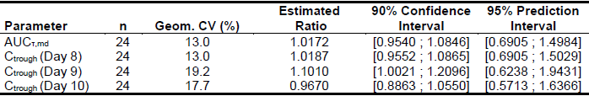
AUC_{T,md} = AUC during any dose interval after multiple dose; C_{trough} = drug concentration in measured matrix at steady state at the end of a dose; CV = coefficient of variation; Geom = geometric.

Deficiencies of data
Deficiencies or lack of data include:
- limited data for co-administration with SGLT-2 inhibitors or GLP-1 receptor-agonists.
- exposure response relationship for renal endpoint: The exposure response analysis of the renal composite endpoint revealed implausible effects of age and body mass index, for which no explanation was found.
- exposure response relationship for cardiovascular endpoint: An exposure response relationship for the cardiovascular composite endpoint has not been definitely established.
- Patients with hepatic impairment: No data in subjects with severe hepatic impairment are available.
- Potential BCRP, OATP1B1 and OATP1B3 inhibition: The signal of a potential inhibition of BCRP, OATP1B1 and OATP1B3 by finerenone and/or its metabolites was not further investigated.
- Pregnancy and lactation: No clinical data available.
- Indigenous Australians: No clinical data available despite considerable prevalence of diabetic kidney disease.

Proposed action
A positive benefit-risk balance will be present for Kerendia (finerenone), if the outstanding issues are resolved favourably. At this stage, this would include:
- Recommendations from the Advisory Committee on Medicines (ACM)
- Indication should be amended to reflect the trial population.
- Appropriate changes of the PI should be made, including acceptable wording in regard to:
  - co-administration with SGLT-2 inhibitors or GLP-1 receptor-agonists;
  - dose adjustments in the context of strong and moderate CYP3A4 inducers; and
  - digoxin interactions.
- Regarding the RMP document
  - The following should be considered as additional safety concerns: hypotension; hyponatraemia; acute worsening of renal function; drug interactions with CYP3A4 inhibitors; drug interactions with digoxin.
  - The following should be considered as additional missing information items: co-administration with SGLT-2 inhibitors or GLP-1 receptor-agonists; Use in pregnancy and lactation; Use in severe hepatic impairment; Use in Indigenous Australians (in the ASA;).

Advisory Committee considerations
The Advisory Committee on Medicines (ACM), having considered the evaluations and the Delegate’s overview, as well as the sponsor’s response to these documents, advised the following.

Specific advice to the Delegate
- Restriction of indication
Can the ACM comment on the proposed indication, in particular in the context of specifying disease characteristics and co-medications used in the pivotal trial?
The ACM were of the view that the indication should reflect the trial inclusion characteristics, major co-medications, and standard of care used in the FIDELIO-DKD trial [Study 16244] and proposed the following indication:
Kerendia is indicated to delay progressive decline of kidney function in adults with chronic kidney disease associated with type 2 diabetes (CKD stage 3 or 4 with albuminuria), in addition to standard of care, where treatment already includes either an angiotensin-converting enzyme inhibitor (ACEi) or angiotensin receptor blocker (ARB).
The ACM noted that approximately 86% of FIDELIO-DKD trial participants had an estimated glomerular filtration rate (eGFR) between 25 and 59 mL/min/1.73 m² (CKD stage 3 or 4), with only a small proportion of participants (11%) classified as CKD stage 2. On balance, the ACM were of the view that based on the disease characteristics of FIDELIO-DKD trial participants the inclusion of CKD 3 or 4 was most appropriate.
The ACM were of the view that the inclusion of ‘in addition to standard of care’ would be appropriate to ensure that current care for this complex disease is not unduly altered.
The ACM agreed that it was important for ‘ACEi or ARB’ to be included within the indication as the study design required patients to be on finerenone with an ACEi or an ARB, and efficacy without an ACEi or an ARB was not established in the study.
The ACM advised that co-medications are widely used within this population and no major restrictions on use will likely result from defining parameters as per the FIDELIO-DKD trial.
- Co-administration with SGLT-2 inhibitors or GLP-1 receptor-agonists
Can the ACM comment on restricting co-administration of finerenone with SGLT-2 inhibitors or GLP-1 receptor-agonists at this stage?
The ACM noted the small numbers for co-administration of finerenone with SGLT-2 inhibitors (FIDELIO-DKD trial [Study 16244] 4.5%; and FIGARO-DKD trial [Study 17530] 8.5%) or GLP-1 receptor-agonists (FIDELIO-DKD 7% and FIGARO-DKD 8.4%). They were of the view that this reflected the prescribing practices and drug availability at the time and noted that SGLT-2 inhibitors or GLP-1 receptor agonists are now more widely prescribed and considered standard of care, where appropriate and indicated.
The ACM referred to a subgroup analysis of the FIDELIO-DKD study presented at the American Diabetes Association in June 2021 which stated that SGLT-2 plus finerenone had reductions in UACR (P < 0.0001) greater among those using SGLT-2 inhibitors at Baseline (p = 0.0024). Additionally, treatment emergent hyperkalaemia events occurred less often in those using SGLT-2 inhibitors compared to those not using an SGLT-2 inhibitor.
The ACM were of the view that there is no requirement to restrict the co-administration of finerenone with SGLT-2 inhibitors or GLP-1 receptor agonists. However, the ACM would be supportive of a statement in the PI highlighting the proportion of trial participants that were co-administered with SGLT-2 inhibitors or GLP-1 receptor-agonists.
- Drug-drug interactions
Can the ACM comment on potential risk minimisation measures for drug-drug interactions with potentially severe effects (for example, for digoxin)?
The ACM were of the view that drug-drug interactions have been appropriately documented within the PI.
The ACM noted that co-administration with moderate or weak CYP3A4 inhibitors requires monitoring of serum potassium levels and strong and moderate CYP3A4 inducers should be avoided. The ACM agreed that the wording within the proposed Australian PI was appropriate.
The ACM advised that co-administration of finerenone with digoxin poses limited risks and is of no particular concern. Furthermore, the ACM advised that digoxin is generally prescribed at a low dose, should renal patients require it.
Based on the totality of trough concentration (C_{trough}) values in this study, the estimated ratio for digoxin and finerenone versus digoxin alone is 1.0274 (95% CI 0.9858, 1.0708), indicating equivalence of digoxin C_{trough} within the narrow interval of 0.9 to 1.11. While the ACM questioned the combining of Day 8, 9 and 10 C_{trough} values, they were satisfied that no additional risk mitigation measures are required for co-administration of digoxin and finerenone versus digoxin alone in this patient group.
- General
The committee is also requested to provide advice on any other issues that it thinks may be relevant to a decision on whether or not to approve this application.
In the context of an indication restriction to CKD stages 3 and 4, the ACM recommended commencement of Kerendia at the 10 mg dose (if serum potassium ≤ 4.8 mmol/L) and an increase to 20 mg as tolerated and with a stable eGFR and controlled serum potassium (≤ 4.8 mmol/L).
The ACM noted that the Dosage and Administration section of the US Prescribing Information included different wording to the Australian PI and were of the view that the US Prescribing Information approach of using tables is much clearer.

Conclusion
The ACM considered this product to have an overall positive benefit-risk profile for the indication:
Kerendia is indicated to delay progressive decline of kidney function in adults with chronic kidney disease associated with type 2 diabetes (CKD stage 3 or 4 with albuminuria), in addition to standard of care, where treatment already includes either an angiotensin-converting enzyme inhibitor (ACEi) or angiotensin receptor blocker (ARB).

Outcome
Based on a review of quality, safety and efficacy, the TGA approved the registration of Kerendia (finerenone) 10 mg and 20 mg, film coated tablets, blister pack, indicated for:
Kerendia is indicated to delay progressive decline of kidney function in adults with chronic kidney disease associated with type 2 diabetes (with albuminuria), in addition to standard of care (see Section 5.1 Pharmacodynamic properties, clinical trials).

Specific conditions of registration applying to these goods
- Kerendia (finerenone) is to be included in the Black Triangle Scheme. The PI and CMI for Kerendia must include the black triangle symbol and mandatory accompanying text for five years, which starts from the date that the sponsor notifies the TGA of supply of the product.
- The Kerendia EU-risk management plan (RMP) (version 0.1, dated 22 October 2020; DLP 15 October 2020) and ASA (version 1.0, dated 6 November 2020) included with Submission PM-2020-05944-1-5, and any subsequent revisions, as agreed with the TGA will be implemented in Australia.
An obligatory component of risk management plans is routine pharmacovigilance. Routine pharmacovigilance includes the submission of periodic safety update reports (PSURs).
Unless agreed separately between the supplier who is the recipient of the approval and the TGA, the first report must be submitted to TGA no later than 15 calendar months after the date of the approval letter. The subsequent reports must be submitted no less frequently than annually from the date of the first submitted report until the period covered by such reports is not less than three years from the date of the approval letter. The annual submission may be made up of two PSURs each covering six months. If the sponsor wishes, the six monthly reports may be submitted separately as they become available.
If the product is approved in the EU during the three years period, reports can be provided in line with the published list of EU reference dates no less frequently than annually from the date of the first submitted report until the period covered by such reports is not less than three years from the date of the approval letter.
The reports are to at least meet the requirements for PSURs as described in the European Medicines Agency’s Guideline on Good Pharmacovigilance Practices (GVP) Module VII-periodic safety update report (Rev 1), Part VII.B Structures and processes. Note that submission of a PSUR does not constitute an application to vary the registration. Each report must have been prepared within ninety calendar days of the data lock point for that report.

Attachment 1. Product Information
The PI for Kerendia approved with the submission which is described in this AusPAR is at Attachment 1. For the most recent PI, please refer to the TGA website at <https://www.tga.gov.au/product-information-pi>.

Therapeutic Goods Administration
PO Box 100 Woden ACT 2606 Australia
Email: info@tga.gov.au Phone: 1800 020 653 Fax: 02 6232 8605
https://www.tga.gov.au

The Black Triangle Scheme provides a simple means for practitioners and patients to identify certain types of new prescription medicines, including those being used in new ways and to encourage the reporting of adverse events associated with their use. The Black Triangle does not denote that there are known safety problems, just that the TGA is encouraging adverse event reporting to help us build up the full picture of a medicine's safety profile.
The Biopharmaceutics Classification System (BCS) is a guidance for predicting the intestinal drug absorption provided by the U.S. Food and Drug Administration. According to the BCS, drug substances are classified as follows: Class I: high permeability, high solubility; Class II: high permeability, low solubility; Class III: low permeability, high solubility; Class IV: low permeability, low solubility.
Cytochrome P450 (CYP) enzymes: CYPs are the major enzymes involved in drug metabolism, accounting for large part of the total metabolism. Most drugs undergo deactivation by CYPs, either directly or by facilitated excretion from the body. Also, many substances are bioactivated by CYPs to form their active compounds. Many drugs may increase or decrease the activity of various CYP isozymes either by inducing the biosynthesis of an isozyme (enzyme induction) or by directly inhibiting the activity of the CYP (enzyme inhibition). This is a major source of adverse drug interactions, since changes in CYP enzyme activity may affect the metabolism and clearance of various drugs. Such drug interactions are especially important to take into account when using drugs of vital importance to the patient, drugs with important side-effects and drugs with small therapeutic windows, but any drug may be subject to an altered plasma concentration due to altered drug metabolism.
The QT interval is the time from the start of the QRS wave complex to the end of the corresponding T wave. It approximates to the time taken for ventricular depolarisation and repolarisation, that is to say, the period of ventricular systole from ventricular isovolumetric contraction to isovolumetric relaxation. The corrected QT interval (QTc) estimates the QT interval at a standard heart rate. This allows comparison of QT values over time at different heart rates and improves detection of patients at increased risk of arrhythmias.
Haemoglobin A1c or glycated haemoglobin (HbA1c) is a minor component of haemoglobin chemically linked to glucose. Levels of HbA1c vary and are relative to the overall blood glucose concentration. Unlike a blood glucose concentration, levels of HbA1c are not influenced by daily fluctuations in the blood glucose concentration but reflect the average glucose levels over the prior 6 to 8 weeks. Measurement of HbA1c is used in the diagnosis of diabetes mellitus and is useful indicator of how well the blood glucose level has been controlled in the recent past and may be used to monitor the effects of diet, exercise, and drug therapy on blood glucose in patients with diabetes. In healthy people without diabetes, the HbA1c level is less than 7 percent of total haemoglobin.
The per-protocol (PP) analysis is restricted to the participants who strictly adhered to the protocol. Also known as ‘on-treatment’ analysis.
The Medical Dictionary for Regulatory Activities (MedDRA) is a single standardised international medical terminology, developed as a project of the International Council for Harmonisation of Technical Requirements for Pharmaceuticals for Human Use (ICH) which can be used for regulatory communication and evaluation of data pertaining to medicinal products for human use. As a result, MedDRA is designed for use in the registration, documentation and safety monitoring of medicinal products through all phases of the development cycle (that is, from clinical trials to post-marketing surveillance). Furthermore, MedDRA supports ICH electronic communication within the ICH’s Electronic Common Technical Document (eCTD) and the E2B Individual Case Safety Report.
The Child-Pugh score is used to assess the prognosis of chronic liver disease. The score employs five clinical measures of liver disease. Each measure is scored 1 to 3, with 3 indicating most severe derangement. Class A: 5 to 6 points, least severe liver disease, one to five year survival rate of 95%. Class B: 7 to 9 points, moderately severe liver disease, one to five year survival of 75%. Class C: 10 to 15 points, most severe liver disease, 1 to 5 year survival rate 50%.
Pregnancy Category D: Drugs which have caused, are suspected to have caused or may be expected to cause, an increased incidence of human fetal malformations or irreversible damage. These drugs may also have adverse pharmacological effects. Accompanying texts should be consulted for further details.
Routine risk minimisation activities may be limited to ensuring that suitable warnings are included in the product information or by careful use of labelling and packaging. Routine pharmacovigilance practices involve the following activities: - All suspected adverse reactions that are reported to the personnel of the company are collected and collated in an accessible manner; - Reporting to regulatory authorities; - Continuous monitoring of the safety profiles of approved products including signal detection and updating of labelling; - Submission of PSURs; - Meeting other local regulatory agency requirements.
The Australia specific annex (ASA) enables the European Union-risk management plan (EU-RMP), or, if no current EU-RMP exists, then a core or global RMP, to be adapted to the Australian context. The ASA is required because global activities proposed in the EU-RMP may differ from those planned for Australia. For example, the sponsor may propose different wording for the Australian PI than that proposed in the EU-RMP for the European Summary of Product Characteristics (SmPC). The ASA should provide Australian‐specific information that is important in assessing the risk in Australia (and therefore appropriateness of proposed plans/activities) and the relevance of product vigilance and risk minimisation activities to Australia, and identify and explain the reasons for any differences from activities planned overseas (this includes product information statements). If an RMP activity to be conducted overseas will not include Australian data, the ASA should address the applicability of that activity to the Australian context.
The ACM provides independent medical and scientific advice to the Minister for Health and the TGA on issues relating to the safety, quality and efficacy of medicines supplied in Australia including issues relating to pre market and post-market functions for medicines. Further information can be found here: https://www.tga.gov.au/committee/advisory-committee-medicines-acm.

