June 2022

Australian Public Assessment Report for Glu-urea-Lys(ahx)-hbed-CC
  - Proprietary Product Name: Illuccix
  - Sponsor: Telix Pharmaceuticals (ANZ) Pty Ltd

About the Therapeutic Goods Administration (TGA)
- The Therapeutic Goods Administration (TGA) is part of the Australian Government Department of Health and is responsible for regulating medicines and medical devices.
- The TGA administers the Therapeutic Goods Act 1989 (the Act), applying a risk management approach designed to ensure therapeutic goods supplied in Australia meet acceptable standards of quality, safety and efficacy (performance) when necessary.
- The work of the TGA is based on applying scientific and clinical expertise to decision-making, to ensure that the benefits to consumers outweigh any risks associated with the use of medicines and medical devices.
- The TGA relies on the public, healthcare professionals and industry to report problems with medicines or medical devices. TGA investigates reports received by it to determine any necessary regulatory action.
- To report a problem with a medicine or medical device, please see the information on the TGA website <https://www.tga.gov.au>.

About AusPARs
- An Australian Public Assessment Report (AusPAR) provides information about the evaluation of a prescription medicine and the considerations that led the TGA to approve or not approve a prescription medicine submission.
- AusPARs are prepared and published by the TGA.
- An AusPAR is prepared for submissions that relate to new chemical entities, generic medicines, major variations and extensions of indications.
- An AusPAR is a static document; it provides information that relates to a submission at a particular point in time.
- A new AusPAR will be developed to reflect changes to indications and/or major variations to a prescription medicine subject to evaluation by the TGA.

Copyright
© Commonwealth of Australia 2022
This work is copyright. You may reproduce the whole or part of this work in unaltered form for your own personal use or, if you are part of an organisation, for internal use within your organisation, but only if you or your organisation do not use the reproduction for any commercial purpose and retain this copyright notice and all disclaimer notices as part of that reproduction. Apart from rights to use as permitted by the Copyright Act 1968 or allowed by this copyright notice, all other rights are reserved and you are not allowed to reproduce the whole or any part of this work in any way (electronic or otherwise) without first being given specific written permission from the Commonwealth to do so. Requests and inquiries concerning reproduction and rights are to be sent to the TGA Copyright Officer, Therapeutic Goods Administration, PO Box 100, Woden ACT 2606 or emailed to <tga.copyright@tga.gov.au>.

Contents
List of abbreviations 4
I. Introduction to product submission 6
Submission details 6
Product background 8
Regulatory status 14
Product Information 15
II. Registration timeline 15
III. Submission overview and risk/benefit assessment 15
Quality 16
Nonclinical 17
Clinical 18
Risk management plan 44
Risk-benefit analysis 44
Outcome 51
Attachment 1. Product Information 52

List of abbreviations
Abbreviation | Meaning
[⁶⁸Ga] | Gallium-68 (isotope)
2-PMPA | 2-(phosphonomethyl)pentanedioic acid
ACM | Advisory Committee on Medicines
AE | Adverse event
ARTG | Australian Register of Therapeutic Goods
AUC | Area under concentration-time curve
BCR PC | Biochemically recurrent prostate cancer
CDR | Correct detection rate
CI | Confidence interval
CLR | Correct localisation rate
CT | Computerised tomography
DCFPyL | 2-(3-{1-carboxy-5-[(6-[(18)F]fluoro-pyridine-3-carbonyl)-amino]-pentyl}-ureido)-pentanedioic acid
Ga-68 | Gallium-68 (isotope)
HED | Human equivalent dose
IV | Intravenous
MBq | Megabecquerel
MBS | Medicare Benefits Schedule
mCi | Millicurie
mCRPC | Metastatic castration resistant prostate cancer
MRI | Magnetic resonance imaging
MSAC | Medicare Services Advisory Committee
MSKCC | Memorial Sloan Kettering Cancer Center
mSv | Millisievert
NPV | Negative predictive value
PET | Positron emission tomography
PI | Product Information
PK | Pharmacokinetic(s)
PPV | Positive predictive value
PSA | Prostate-specific antigen
PSMA | Prostate-specific membrane antigen
PSMA-11 | Prostate-specific membrane antigen-11 (also known as Glu-urea-Lys(ahx)-hbed-CC)
SAE | Serious adverse event
SD | Standard deviation
SUV_{max} | Maximum standardised uptake value
SUV_{mean} | Mean standardised uptake value
t_{1/2} | Half-life
TGA | Therapeutic Goods Administration
US(A) | United States of America
VLR | Verified localisation rate

I. Introduction to product submission

Submission details
Type of submission: | New chemical entity
Product name: | Illuccix
Active ingredient: | Glu-urea-Lys(ahx)-hbed-CC (also known as PSMA 11 (prostate-specific membrane antigen 11)
Decision: | Approved
Date of decision: | 1 November 2021
Date of entry onto ARTG: | 10 November 2021
ARTG number: | 356332 and 356333
Black Triangle Scheme: | No
Sponsor’s name and address: | Telix Pharmaceuticals (ANZ) Pty Ltd  Suite 401 55 Flemington Road,  North Melbourne, VIC, 3051
Dose form: | Powder and diluent for injection
Strength: | 25 µg
Container: | Vial
Pack sizes: | Two kit configurations, each containing 3 vials  Configuration A (for use with gallium-68 [⁶⁸Ga] produced from a cyclotron and purified via GE FASTlab; or Eckert & Ziegler GalliaPharm Ge 68/Ga-68 generator and includes:  - Vial 1 (Glu-urea-Lys(ahx)-hbed-CC Vial): contains 25 microgram Glu-urea-Lys(ahx)-hbed-CC, 10 microgram mannose and water for injections as a lyophilized powder in a sterile 10 mL vial.  - Vial 2 (Buffer Vial, Configuration A): contains 150 mg sodium acetate, 0.077 mL hydrochloric acid and water for injections (2.5 mL volume) in a sterile 10 mL vial.  - Vial 3 (Sterile Vacuumed Vial): an evacuated sterile vial used to collect [⁶⁸Ga] chloride from generators or cyclotron.  Configuration B intended for use with [⁶⁸Ga] (gallium-68) produced from an IRE Galli Eo Ge 68/Ga-68 generator and includes:  - Vial 1: (Glu-urea-Lys(ahx)-hbed-CC Vial): contains 25 microgram Glu-urea-Lys(ahx)-hbed-CC,  10 microgram mannose and water for injections as a lyophilized powder in a sterile 10 mL vial.  - Vial 2 (Buffer Vial, Configuration B): contains 150 mg sodium acetate, 0.15 mL hydrochloric acid and water for injections (6.4 mL volume) in a sterile 10 mL vial.  - Vial 3 (Sterile Vacuumed Vial): an evacuated sterile vial used to collect [⁶⁸Ga] chloride from generator.
Approved therapeutic use: | Illuccix, after radiolabelling with Ga-68, is a radioactive diagnostic agent indicated for use with positron emission tomography (PET) imaging combined with computerised tomography (CT) in patients with prostate cancer:  - who are at risk of metastasis and who are suitable for initial definitive therapy.  - who have suspected recurrence based on elevated serum prostate specific antigen (PSA) level.
Route of administration: | Intravenous bolus
Dosage: | Radiopharmaceuticals should be used by or under the control of physicians who are qualified by specific training and experience in the safe use and handling of radionuclides, and whose experience and training have been approved by the appropriate governmental agency authorised to license the use of radionuclides.  The radionuclide is not part of the kit. Before reconstitution and radiolabelling with gallium-68 [⁶⁸Ga], the contents of this kit are not radioactive.  Illuccix is supplied as 3 vials which allows for direct preparation of Illuccix with eluate from an appropriate gallium-68 source. See Section 4.2 Dose and Method of Administration, Drug Preparation for specific instructions for use with each gallium-68 [⁶⁸Ga] source.  Once prepared, gallium-68 [⁶⁸Ga] Glu-urea-Lys(ahx)-hbed-CC is a radioactive drug and should be handled with appropriate safety measures to minimise radiation exposure. See Section 4.4 Special warnings and precautions for use in the Product Information).  The recommended amount of activity to be administered intravenously is 185 megabecquerel (MBq) (5 millicurie (mCi)) with a range of 166.5 to 203.5 MBq (4.5 to 5.5 mCi) and a maximum dose of 25 µg of Glu-urea-Lys(ahx)-hbed-CC.  After reconstitution gallium-68 [⁶⁸Ga] Glu-urea-Lys(ahx)-hbed-CC is administered by intravenous injection (bolus). The speed of administration depends on the venous tolerance to low pH solution, which is mainly dependent of the blood flow of the vein used for the injection. Tolerance can be increased by diluting gallium-68 [⁶⁸Ga] Glu-urea-Lys(ahx)-hbed-CC Injection in isotonic saline solution.  Before administration to the patient, measure the radioactivity of the vial containing gallium-68 [⁶⁸Ga] Glu-urea-Lys(ahx)-hbed-CC using a dose calibrator and calculate the necessary volume to administer based on calibration date and time. Ensure that the radioactivity to be injected is within ±10% of the recommended dose.  For further information regarding dosage, refer to the Product Information.
Pregnancy category: | This therapeutic good is exempted from pregnancy categorisation (not indicated for use in females).  The use of any medicine during pregnancy requires careful consideration of both risks and benefits by the treating health professional. This must not be used as the sole basis of decision making in the use of medicines during pregnancy. The TGA does not provide advice on the use of medicines in pregnancy for specific cases. More information is available from obstetric drug information services in your State or Territory.

Product background
This AusPAR describes the application by Telix Pharmaceuticals (ANZ) Pty Ltd. (the sponsor) to register Illuccix (Glu-urea-Lys(ahx)-hbed-CC) 25 µg, powder and diluent for injection for the following proposed indication:
Illuccix, after radiolabelling with Ga-68, is a radioactive diagnostic agent indicated for use with positron emission tomography (PET) for the evaluation of prostate cancer
Illuccix is supplied as a kit (in two configurations, Configuration A and B) containing Glu-urea-Lys(ahx)-hbed-CC (also known as prostate-specific membrane antigen 11 (PSMA 11), that when reconstituted and radiolabelled with the radionuclide gallium-68 [⁶⁸Ga] from a suitable source, forms the active radiopharmaceutical gallium-68 [⁶⁸Ga] PSMA 11. [⁶⁸Ga] gallium PSMA 11 is to be administered via intravenous bolus.
Prostate cancer is the third most common cause of cancer death in Australia and the second most common cause of cancer death among males (after lung cancer). Overall 5 year survival is 96%, but for men with metastatic (Stage IV) prostate cancer at diagnosis, the 5 year survival is 36%. Depending on the cancer stage, individual risk stratification, and co-morbidities, management options may include watchful waiting, active surveillance, radical prostatectomy, external beam radiotherapy, brachytherapy, androgen deprivation therapy, androgen receptor antagonists, and chemotherapy. ,
Initial imaging may include multiparametric magnetic resonance imaging (MRI) of the prostate. The need for other staging investigations for clinically localised disease is informed by the initial clinical risk stratification (see Table 1, below). Abdominopelvic CT (or MRI) and bone scan are used to assess for nodal and distant metastases in patients with intermediate- or high-risk prostate cancer, but there are limitations in their sensitivity in detecting metastatic disease. With regard to nodal staging, the 2021 European Association of Urology (EAU) Guideline on Prostate Cancer provide the following guidance:⁵
‘CT and MRI sensitivity is less than 40%., Among 4,264 patients, 654 (15.3%) of whom had positive lymph nodes at lymph node dissection, CT was positive in only 105 patients (2.5%). In a multi-centre database of 1,091 patients who underwent pelvic lymph node dissection, CT sensitivity and specificity were 8.8% and 98%, respectively. Detection of microscopic lymph node invasion by CT is < 1% in patients with International Society of Urological Pathology (ISUP) Grade < 4 cancer, PSA <20 ng/mL, or localised disease.’ ,,
Clinical practice continues to evolve with regard to the role of imaging in the assessment and staging of prostate cancer. The same EAU guideline provides the following summary and guidance on initial N- and M-staging of prostate cancer:⁵
‘The field of non-invasive N- and M-staging of PCa [prostate cancer] patients is evolving very rapidly. Evidence shows that choline PET/CT, PSMA [prostate-specific membrane antigen] PET/CT and MRI provide a more sensitive detection of lymph node- and bone metastases than the classical work-up with bone scan and abdominopelvic CT. In view of the evidence offered by the randomised, multi-centre proPSMA trial, replacing bone scan and abdominopelvic CT by more sensitive imaging modalities may be a consideration in patients with high-risk PCa undergoing initial staging. However, in absence of prospective studies demonstrating survival benefit, caution must be used when taking therapeutic decisions. The prognosis and ideal management of patients diagnosed as metastatic by these more sensitive tests is unknown. In particular, it is unclear whether patients with metastases detectable only with PET/CT or MRI should be managed using systemic therapies, or whether they should be subjected to aggressive local and metastases-directed therapies.
Results from RCTs [randomised control trials] evaluating the management and outcome of patients with (and without) metastases detected by choline PET/CT, PSMA PET/CT and MRI are awaited before a decision can be made to treat patients based on the results of these tests.’
Table 1: Extract of the initial risk stratification and staging workup for clinically localised disease, National Comprehensive Cancer Network Guidelines Version 2.2021 Prostate Cancer
Risk Group | Clinical/Pathologic features |  | Imaging⁴
Very low¹ | Has all of the following:  - T1c  - Grade Group 1  - PSA <10 ng/mL  - Fewer than 3 prostate biopsy fragments/cores positive. < 50% cancer in each fragment /core²  - PSA density < 0.15 ng/mL/g |  | Consider confirmatory prostate biopsy ±mpMRI to establish candidacy for active surveillance
Low¹ | Has all of the following but does not qualify for very low risk:  - T1-T2a  - Grade Group 1  - PSA <10 ng/mL |  | Consider confirmatory prostate biopsy + mpMRI to establish candidacy for active surveillance
Intermed¹ | Has all of the following:  - No high-risk group features  - No very-high-risk group features  Has one or more intermediate risk factors (IRF):  - T2b-T2c  - Grade Group 2 or 3  - PSA 10-20 ng/mL | Favourable intermediate  Has all of the following:  - 1 IRF  - Grade Group 1 or 2  - < 50% biopsy cores positive² | Consider confirmatory prostate biopsy + mpMRI to establish candidacy for active surveillance  Bone imaging:³ not recommended for staging  Pelvic + abdominal imaging:⁵ recommended if nomogram predicts > 10% probability of pelvic lymph node involvement  If regional or distant metastases are found.⁶
Intermed¹ |  | Unfavourable intermediate  Has one or more of the following:  - 2 or 3 IRFs  - Grade Group 3  - > 50% biopsy cores positive² | Bone imaging:³ recommended if T2 and PSA > 10 ng/mL  Pelvic + abdominal imaging:⁵ recommended if nomogram predicts >10% probability of pelvic lymph node involvement  If regional or distant metastases are found.⁶
High | Has no very-high-risk features or exactly one high risk feature:  - T3a OR  - Grade Group 4 or Grade Group 5  - PSA > 20 ng/mL |  | Bone imaging:³ recommended  Pelvic + abdominal imaging:⁵ recommended  If regional or distant metastases are found.⁶
Very high | Has at least one of the following  - T3b-T4  - Primary Gleason pattern 5  - 2 or 3 high-risk features  - > 4 cores with Grade Group 4 or 5 |  | Bone imaging:³ recommended  Pelvic + abdominal imaging:⁵ recommended  If regional or distant metastases are found.⁶
Abbreviations: IRF = NCCN Guidelines intermediate risk factor; PSA = prostate-specific antigen
T staging refers to the American Joint Committee on Cancer (AJCC) TNM system. Grade Groups refer to International Society of Urological Pathology (ISUP) Grade Group system. Gleason
1: For asymptomatic patients in very low, low and intermediate risk group with life expectancy ≤ 5 years, no imaging or treatment is indicated until the patient becomes symptomatic, at which time imaging can be performed and androgen deprivation therapy should be given.
2: An ultrasound or MRI or digital rectal exam targeted lesion that is biopsied more than once and demonstrates cancer (regardless of percentage core involvement or number of cores involved) counts as a single positive core.
3: Plain films, CT, MRI, F-18 sodium fluoride PET/CT or PET/MRI, C-11 choline PET/CT or PET/MRI, or F-18 fluciclovine PET/CT or PET/MRI can be considered for equivocal results on initial bone scan.
4: Bone imaging should be performed for any patient with symptoms consistent with bone metastases.
5: mpMRI is preferred over CT for abdominal/pelvic staging.
6: Coverage beyond the scope of this extract; see the full guideline for further information.
Extracted from: National Comprehensive Cancer Network (NCCN) Clinical Practice Guidelines in Oncology – Prostate Cancer, Version 2.2021; 17 February 2021
The prostate-specific membrane antigen (PSMA) is a transmembrane glycoprotein that is expressed on benign and malignant prostate tissue, as well as on some non-prostate tissues such as the proximal renal tubules, jejunal brush border, salivary glands, and neovasculature of several solid tumours. PSMA is typically overexpressed in prostate cancers compared to benign prostate tissue and other tissues. The physiological role of PSMA in normal cells remains unclear. After a ligand binds to its extracellular portion, PSMA is internalised into the cell.
There are several PSMA targeting molecules that are currently under investigation, including PSMA-11; PSMA-617; and DCFPyL. These have the same molecular moiety that binds to the extracellular component of PSMA (described as the ‘urea motif’) but they differ in the molecular moiety that chelates the radioisotope: PSMA-11 chelates gallium-68 [⁶⁸Ga]; DCFPyl chelates fluorine-18 [¹⁸F], and PSMA-617 chelates lutetium-177 [¹⁷⁷Lu]. [⁶⁸Ga] gallium PSMA-11 and [¹⁸F] DCFPyl are being investigated in diagnostic PET/CT for prostate cancer, whereas [¹⁷⁷Lu] lutetium PSMA-617 is being investigated in prostate cancer treatment.
[⁶⁸Ga] Gallium PSMA-11 for use with PET/CT scanning was originally developed in Germany and shared with the scientific community free of patent in 2012. Labelling of PSMA-11 with Gallium-11 has typically been performed using a synthesiser which incorporates a heating step. Green et al. (2017); reported that the average preparation time for a [⁶⁸Ga] Gallium PSMA-11 solution for injection using a synthesiser was 42 minutes. The sponsor submitted documents indicate that preparation of a [⁶⁸Ga] gallium PSMA-11 solution for injection using the Illuccix kit takes 5 minutes. This preparation time was confirmed by Behesti et al. (2018).
The radioisotope [⁶⁸Ga] gallium-68 undergoes 100% radioactive decay to stable ⁶⁸Zn, with a half-life of 68 minutes. Decay is by release of a positron. Immediate attraction to a nearby electron results in positron/electron annihilation and the release of two photons that shoot off in opposite directions. These photons are detected by the PET scanner, with images showing sites with increased concentration of [⁶⁸Ga] gallium-68 . Scanning is typically commenced about 60 minutes after intravenous administration of [⁶⁸Ga] gallium PSMA-11 .Concurrent PET and CT imaging assists with anatomic localisation and interpretation of the findings.
The clinical evaluation identified widespread use of [⁶⁸Ga] gallium PET/CT in clinical practice in Australia (in public hospitals and private hospitals) and overseas. In Australia, [⁶⁸Ga] gallium PSMA-11 may be supplied to patients as an exempt therapeutic good under specific circumstances. [⁶⁸Ga] gallium PSMA-11 may also be accessed under Category C of the Special Access Scheme; for prostate cancer imaging studies. Category C allows access to specified medicines on the basis of an established history of use within Australia or overseas and no safety concerns raised in a 3-year period.
PSMA PET/CT imaging is under consideration for Medicare Benefits Schedule (MBS) funding. The MBS review taskforce recommended in 2018 that the Medicare Services Advisory Committee (MSAC) consider the inclusion on the MBS of PSMA PET/CT for patients with prostate cancer;, with this reported to be due to ‘the modality’s superiority over conventional imaging for staging and restaging of prostate cancer and its ability to change management intent for newly diagnosed and recurrent prostate cancer patients.’ The MBS review taskforce provided the following rationale for consideration of inclusion of [⁶⁸Ga] gallium-68 PSMA-11 PET/CT on the MBS for patients with prostate cancer:
- PSMA is over-expressed in the majority of patients with prostate cancer. This agent can be labelled with [⁶⁸Ga], and used to detect sites of prostate cancer which are invisible to other conventional imaging techniques. [⁶⁸Ga] gallium PSMA-11 has been demonstrated to have improved diagnostic accuracy compared to conventional imaging for the staging and re-staging of men with prostate cancer, principally through the detection of otherwise unsuspected sites of disease.,
- In Australia, [⁶⁸Ga] gallium PSMA PET/CT has already been shown to have substantial impact on management intent among men with newly diagnosed and recurrent prostate cancer; in a recently published, prospective, multicentre study, [⁶⁸Ga] gallium PSMA-11 PET/CT changed management intent in 21% of men with newly diagnosed prostate cancer (primary staging) and in 62% of men with biochemical relapse following previous definitive therapy (re-staging). In this study [⁶⁸Ga] gallium PSMA-PET/CT revealed sites of unsuspected disease in the prostate bed (27% of patients), locoregional lymph nodes (39%) and at sites of distant metastasis (16%).
- Australia has been an early adopter of [⁶⁸Ga] gallium PSMA PET/CT and the modality is now offered in private practice settings in all states of the Commonwealth but is not yet funded universally, which has resulted in an equity gap, particularly if future research reaffirms the earlier results.
- Without pre-empting the results of current prospective research on the actual management of prostate cancer in Australian men, the Committee is of the view that [⁶⁸Ga] gallium PSMA PET/CT will need to be considered by MSAC for inclusion on the MBS in the near future. Because the radiopharmaceutical is extemporaneously compounded (like [⁶⁸Ga] gallium DOTA-TATE); it is unlikely that there will be a commercial sponsor for an MSAC application and the Committee feels that it would be appropriate for MSAC to begin discussions with relevant stakeholders now, on the optimal approval pathway and evidence required.
- The Committee noted the rapid pace of research in relation to:
  - Fluorine-18-based PSMA ([¹⁸F] PSMA) imaging agents.
  - Phase II trials of Lutetium-177 [¹⁷⁷Lu] PSMA, both in Europe and in Australia, which have demonstrated a significant early response benefit in men with advanced, chemorefractory, castration-resistant prostate cancer. Phase III trials of this agent are now underway.
- The Committee agreed that these issues should be included in the horizon discussions with MSAC in relation to prostate cancer.

Regulatory status
This product is considered a new chemical entity for Australian regulatory purposes.
At the time the TGA considered this application, a similar application was under consideration in United States of America (USA), European Union (EU) and Canada.
United States of America: A New Drug Application (NDA) for Illuccix was submitted to the US Food and Drug Administration (FDA) on 23 September 2020. This application remains under review. The proposed indication is:
Illuccix, after radiolabeling with Ga-68Ga, is a radioactive diagnostic agent indicated for use with positron emission tomography (PET) for the evaluation of prostate cancer.
[⁶⁸Ga] gallium PSMA-11 produced by the University of California Los Angeles (UCLA) and the University of California San Francisco (UCSF) were approved by the FDA on 1 December 2020 for the following indication:,
Ga 68 PSMA-11 Injection is a radioactive diagnostic agent indicated for positron emission tomography (PET) of prostate-specific membrane antigen (PSMA) positive lesions in men with prostate cancer:
    - with suspected metastasis who are candidates for initial definitive therapy.
    - with suspected recurrence based on elevated serum prostate-specific antigen (PSA) level.
European Union: A submission dated 27 April 2020, remains under review. The proposed indication was:
Gallium (⁶⁸Ga) PSMA-11 Injection is indicated for Positron Emission Tomography (PET) imaging combined with Computerised Tomography (CT) scan in case of suspicion of prostate cancer relapse in adult males to detect and localize recurrent cancerous lesions.
Canada: A submission dated 6 December 2020, remains under review. The proposed indication was:
After radiolabeling with ⁶⁸Ga, Illuccix is indicated for:
    - staging and re-staging in intermediate and high risk prostate cancer
    - localizing tumour tissue in recurrent prostate cancer

Product Information
The Product Information (PI) approved with the submission which is described in this AusPAR can be found as Attachment 1. For the most recent PI, please refer to the TGA website at <https://www.tga.gov.au/product-information-pi>.

II. Registration timeline
The following table captures the key steps and dates for this application and which are detailed and discussed in this AusPAR.
Table 2: Timeline for Submission PM-2021-00851-1-4
Description | Date
Designation: Priority; | 4 December 2020
Submission dossier accepted and first round evaluation commenced | 13 April 2021
Evaluation completed | 15 October 2021
Delegate’s Overall benefit-risk assessment and request for Advisory Committee advice | 31 August 2021
Sponsor’s pre-Advisory Committee response | 10 September 2021
Advisory Committee meeting | 30 September and 1 October 2021
Registration decision (Outcome) | 1 November 2021
Completion of administrative activities and registration on the ARTG | 10 November 2021
Number of working days from submission dossier acceptance to registration decision* | 120
*Target timeframe for priority applications is 150 working days from acceptance for evaluation to the decision.

III. Submission overview and risk/benefit assessment
The submission was summarised in the following Delegate’s overview and recommendations.

Quality
Illuccix is supplied as a sterile multi-dose kit intended for the preparation of [⁶⁸Ga] gallium-68 Glu-urea-Lys(ahx)-hbed-CC for intravenous use.
Glu-urea-Lys(ahx)-hbed-CC is also known as PSMA-11. There are two different kit configurations, for use depending on the source of [⁶⁸Ga] gallium-68:
- Illuccix configuration ‘A’ is for use with [⁶⁸Ga] gallium-68 produced from a cyclotron and purified via GE FASTlabTM or Eckert & Ziegler GalliaPharm Ge 68/Ga-68 generator.
- Illuccix configuration ‘B’ is for use with [⁶⁸Ga] gallium-68 produced from an IRE Galli Eo Ge 68/Ga-68 generator.
Note the radionuclide (gallium-68) is not part of the kit.
Each kit contains three 10 mL glass vials and four ancillary components used for the safe transfer of liquids during its reconstitution with the radioisotope gallium-68 [⁶⁸Ga]. The vials are closed with a rubber stopper and capped with a flip-off cap of different colour depending of the vial content. The PSMA-11 sterile vial has a blue cap, the sterile acetate buffer vial has a red cap (Configuration A) or green cap (Configuration B), and the sterile vacuumed vial has a white cap (see Figure 1 below). The two kit configurations differ only with regard to the sterile acetate buffer vial (different concentration and volume of the buffer solution).
Figure 1: Illuccix kit for radiopharmaceutical preparation (configuration A)
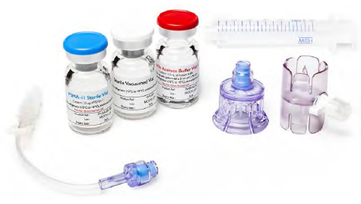
Blue lid vial/Vial 1 (Glu-urea-Lys(ahx)-hbed-CC Vial): contains 25 microgram
Glu-urea-Lys(ahx)-hbed-CC (also known as PSMA-11), 10 microgram mannose and water for injections as a lyophilized powder in a sterile 10 mL vial with a blue flip-off cap.
Red or green lid vial/Vial 2 (Buffer Vial):
Configuration A (green lid, not pictured): contains 150 mg sodium acetate, 0.077 mL hydrochloric acid and water for injections (2.5 mL volume) in a sterile 10 mL vial with a red flip off cap.
Configuration B (blue lid): contains 150 mg sodium acetate, 0.15 mL hydrochloric acid and water for injections (6.4 mL volume) in a sterile 10 mL vial with a green flip off cap.
White lid vial/Vial 3 (Sterile Vacuumed Vial): an evacuated sterile vial with white flip off cap used to collect Ga-68 chloride from generators or cyclotron
Illuccix should be stored upright in the original packaging at 2 to 8°C. Do not freeze. After reconstitution and radiolabelling, keep Ga-68 Glu-urea-Lys(ahx)-hbed-CC upright with appropriate shielding to protect from radiation at room temperature. Illuccix has a shelf-life of up to 12 months. The expiry date can be found on the packaging
Use [⁶⁸Ga] gallium-68 Glu-urea-Lys(ahx)-hbed-CC within 4 hours of preparation.

Conclusions and recommendation
Approval is recommended for registration of the proposed product from a pharmaceutical chemistry perspective.

Nonclinical
The nonclinical dossier was mostly literature based. The search strategy used to source the literature material was acceptable. Two sponsor led studies were submitted that complied with ICH guideline M3(R2) for nonclinical assessment of pharmaceuticals. As a microdose radiopharmaceutical, the non-clinical testing strategy considered recommendations outlined in United States (US) Food and Drug Administration (FDA) guidance on microdose radiopharmaceutical diagnostic drugs, which is not adopted by the TGA but is nevertheless pertinent to the product type. The FDA guidance document includes the following background:
‘For radiopharmaceutical diagnostic drugs, the microdose evaluated during early clinical trials does not differ significantly from the microdose intended for marketing approval and is less than or equal to 100 micrograms (µg). Because these diagnostic drugs are administered using a dose at the low end of the dose-response curve, dose-related adverse events are unlikely to occur. The Agency recommends that sponsors tailor the amount and type of nonclinical supporting data to account for the low potential for adverse events.’
In vitro studies demonstrated nanomolar affinity of [⁶⁸Ga] gallium PSMA-11 for PSMA expressed by human prostate cancer cell lines. Binding was inhibited by the competitive inhibitor of PSMA, 2-(phosphonomethyl) pentanedioic acid (2-PMPA). In vivo studies provided proof of principle demonstration and visualisation of tumour uptake of [⁶⁸Ga] gallium PSMA-11 in mice bearing tumours of the PSMA-positive prostate cancer cell line LNCaP. This uptake was inhibited by 2-PMPA.
Data on plasma kinetic characteristics of [⁶⁸Ga] gallium PSMA-11 were not available in the literature. As an intravenous agent, bioavailability of [⁶⁸Ga] gallium PSMA-11 is assumed to be 100%. In mice, [⁶⁸Ga] gallium PSMA-11 showed high distribution in kidneys, spleen, and to a lesser degree the liver and lung. Similar patterns of tissue distribution were observed in patients. [⁶⁸Ga] gallium PSMA-11 is cleared from the blood in a biphasic manner (half-life (t_{½}): 6.5 mins and 4.4 hour). In vitro assessments using human serum, showed high stability of the chelate, with no observed loss of the [⁶⁸Ga] gallium-68 radioisotope after long incubations at room temperature and at 37°C.
Specialised safety pharmacology studies were not conducted with [⁶⁸Ga] gallium PSMA-11, and no safety pharmacology data were identified in the literature. The absence of organ system safety pharmacology studies is acceptable given the microdose level of [⁶⁸Ga] gallium PSMA-11 intended to be used clinically.
In a single dose toxicity study in Wistar rats, non-labelled PSMA-11 was not associated with any mortalities or adverse findings at a human equivalent dose (HED) of 0.014 mg/kg, intravenous (IV) (based on 60 kg adult; more than 33 times the proposed maximum dose of PSMA-11 of 25 μg). There were no repeat dose toxicity studies, which is acceptable given the proposed product is intended to be used on a single occasion for radiodiagnostic purposes.
The genotoxic and carcinogenic potentials of [⁶⁸Ga] gallium PSMA-11 have not been evaluated. As a product administered in microdose quantities, at single use exposures, this is acceptable. Radiation risk is addressed as a precaution in the Product Information (PI).
Studies that assessed potential developmental and reproductive toxicity of [⁶⁸Ga] gallium PSMA-11 were not conducted. This is acceptable based on the already known developmental risks of fetal exposures to radiation and the microdose levels associated with the radiopharmaceutical.
A pregnancy category was not proposed for [⁶⁸Ga] gallium PSMA-11, nor is one required, as [⁶⁸Ga] gallium PSMA-11 is a diagnostic agent used at microdose levels and is not indicated for use in female patients.
Complexation of [⁶⁸Ga] gallium-68 to HBED-CC (PSMA-11) can form three different diastereomers (R,S; S,S; and R,R), with the R,R configuration described as the most stable. The R,S and S,S diastereomers formed more readily at room temperature will interconvert to R,R over time and be comparable at one hour post-synthesis (Study ANMI-PG01-NC01). Binding properties of [⁶⁸Ga] gallium-68 were not found to be affected by the presence of the less stable diastereomers.

Conclusions and recommendation
There are no objections to registration of Illuccix from a nonclinical perspective.
The recommended changes to the PI have been incorporated in the latest version.

Clinical
This is a hybrid submission which includes studies of the sponsor’s product as well as published literature from a systematic literature search approved by TGA. The clinical dossier included:
- Clinical study reports from 4 studies evaluating the sponsor’s product:
  - Study BCR-RET-01, main efficacy and safety study.
  - Study ANMI-PG01-C301, supportive efficacy and safety study.
  - Study PSMA-617-01 (Endocyte VISION Trial), included for safety data only.
  - Study GA68PSMA-2016-1, biodistribution and pharmacokinetic study in three healthy volunteers.
- Biopharmaceutic study report (Study ANMI-PG01-NC01) investigating in vitro cellular binding and internalisation using two different preparations of [⁶⁸Ga] gallium PSMA-11 (one using the Telix (Anmi) kit and one using the synthesiser method).
- Integrated summary of efficacy, this provides details from the literature review and meta-analysis
- Clinical literature search, this describes part of the literature search methodology
- Approximately 140 literature references. In all of the cited articles, the [⁶⁸Ga] gallium PSMA-11 solution for injection was prepared using manual methods or semi-automated synthesiser methods.

Pharmacology
Information on the clinical pharmacology of [⁶⁸Ga] gallium PSMA-11 was largely derived from published literature. In addition, Study Ga-68PSMA-2016-1 evaluated the pharmacokinetics (PK) profile, dosimetry, and biodistribution of [⁶⁸Ga] gallium PSMA-11 prepared using the sponsor’s kit compared to [⁶⁸Ga] gallium PSMA-11 prepared by a synthesiser.
[⁶⁸Ga] gallium PSMA-11 is administered as an IV injection. As with other radiopharmaceuticals administered as a microdose, conventional PK analyses are not applicable.

Biodistribution of PMSA-11 activity
Sandgren et al. (2019); investigated biodistribution in six patients with low risk prostate cancer who received 133 to178 megabecquerel (MBq) [⁶⁸Ga] gallium PSMA-11 by intravenous injection (see Figure 2). [⁶⁸Ga] gallium PSMA-11 was rapidly cleared from the blood and accumulated preferentially in the liver (15%), kidneys (7%), spleen (2%), and salivary glands (0.5%). The blood activity showed a bi-exponential behaviour, containing a fast component with a t_{1/2} of 6.5 minutes, followed by a slow component t_{1/2} of 4.4 hours, thought to represent biological clearance from blood.
Figure 2: Sandgren et al. (2019) Median activity concentration of the six participants expressed as percent injected activity for a selection of organs
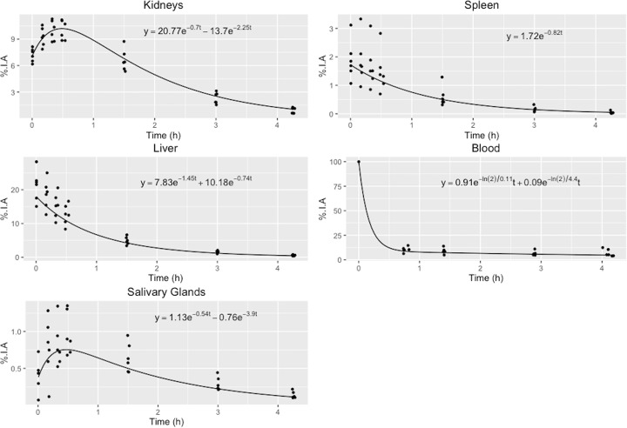
Abbreviations: %IA = Percentage injected activity; h = hours
Organ activity uptake at different time points post-injection of [⁶⁸Ga] gallium PSMA-11 and their fitted curves. The fitted blood curve was calculated on pooled normalised data and forced through the point 100% at time zero. The median activity concentration of the six participants expressed in percent injected activity (%IA) for a selection of organs. The fitted bi-exponential or mono exponential functions used can be seen in each graph.
Source: Sandgren K, et al. Radiation dosimetry of [68Ga] PSMA-11 in low-risk prostate cancer patients. EJNMMI Phys. 2019 Jan;6(1):2
In a 2013 study by Afshar-Oromieh et al;, 37 patients with prostate cancer and rising PSA levels underwent [⁶⁸Ga] gallium PSMA-11 PET/CT one hour and three hours post-injection of a median dose of 121 MBq of Ga-68 PSMA-11. Mean and maximum standardised uptake values (SUV_{mean}/SUV_{max}) for different organs and tumour lesions were calculated at 1 and 3 hours post injection (see Figure 3). The authors concluded that ‘Within healthy organs, kidneys and salivary glands demonstrated the highest radiotracer uptake. Lesions suspicious for prostate carcinoma presented with excellent contrast as early as 1 h post-injection with high detection rates even at low PSA levels.’
Figure 3. Afshar-Oromieh et al (2013); Mean and maximum standardised uptake values at 1 and 3 hours post-injection of [⁶⁸Ga] gallium PSMA-11
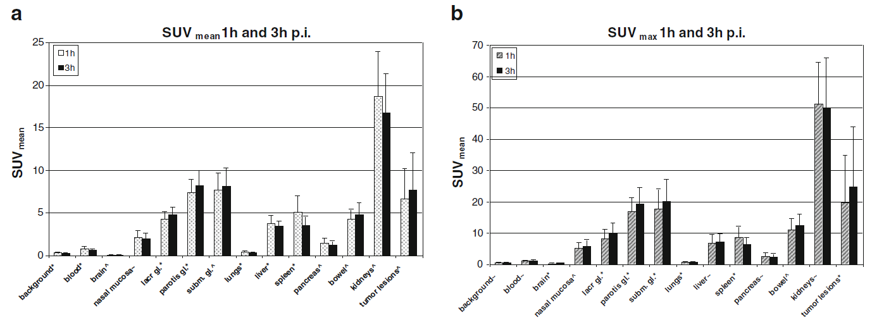
Abbreviations: gl = gland; h = hours; p.i. = post-injection; SUV = standardised uptake values.
Source: Afshar-Oromieh, A., Malcher, A., Eder, M. et al. PET imaging with a [68Ga]gallium-labelled PSMA ligand for the diagnosis of prostate cancer: biodistribution in humans and first evaluation of tumour lesions. Eur J Nucl Med Mol Imaging 40, 486–495 (2013).
Prasad et al (2016); investigated tracer distribution in 101 patients with prostate cancer and quantified [⁶⁸Ga] gallium PSMA-11 uptake in normal organs and presumed tumour deposits by SUV_{max}. The calculated SUV_{max} for primary prostate tumour and metastases was considerably higher than the SUV_{max} for non-pathological tissues (see Figure 4). The median SUV_{max} in normal prostate tissue was 2.2; a cutoff SUV_{max} value of 3.2 for differentiating prostate tumour from normal prostate tissue was calculated to give a sensitivity of 94.3% and a specificity of 100%. The best cut off values for differentiating non-pathological tissue uptake from tumour uptake in lymph nodes and bones were found to be a SUV_{max} of 3.2 and 1.9, respectively. The authors concluded that ‘Both primary tumours and small metastatic lesions were detectable due to their high tracer uptake. Four-times-higher median uptake in primary tumours in comparison to normal prostate stroma resulted in a high diagnostic accuracy.’
Figure 4: Prasad V, et al. (2016) Pathological versus non-pathological uptake in the prostate, lymph nodes and bone
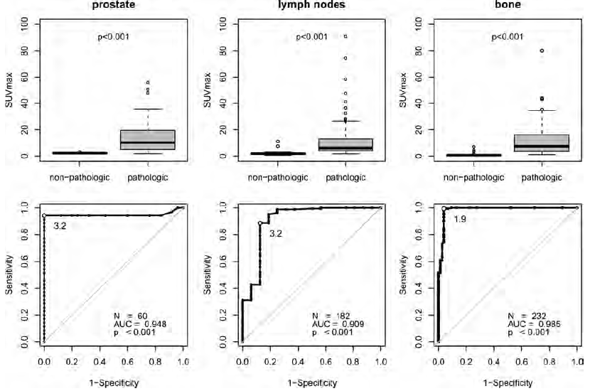
Abbreviations: AUC = area under the concentration-time curve; N = numbers; SUV = standardised uptake values
Boxplots (upper row) and receiver operating curve analysis (lower row) of pathological versus non-pathological uptake in the prostate, lymph nodes and bone. The best diagnostic accuracy was achieved with SUV_{max} cutoff values of 3.2, 3.2 and 1.9 for the prostate, lymph nodes and bone, respectively.
Prasad V, et al. Biodistribution of [(68)Ga]PSMA-HBED-CC in patients with prostate cancer: characterization of uptake in normal organs and tumour lesions. Mol Imaging Biol. 2016 Jun;18(3):428-436
The sponsor’s Study Ga68PSMA-2016-1 assessed the PK, biodistribution, dosimetry and safety of two different preparations of [⁶⁸Ga] gallium PSMA-11 (one prepared using the Telix kit and one prepared using the Scintomics synthesizer with a heating step incorporated in the process) administered at least seven days apart to three healthy volunteers. The doses of [⁶⁸Ga] gallium PSMA-11 received by the three participants ranged from 173 to 188 MBq for doses prepared using the Telix kit and from 162 to 192 MBq for doses prepared using the synthesiser method.
Mean PK parameters (area under concentration-time curve (AUC), rate constants in the tri-exponential model used) were similar for the two preparations, with some inter-individual variation. Comparison of SUV_{max} for the different organs and tissues found that the highest uptake for both preparations was the kidneys, followed by the salivary glands, small bowel, lacrimal glands, spleen, liver, and larynx in descending order. The biodistribution and dosimetry of the two preparations was similar.
This study did not include patients with prostate cancer, so uptake in prostate cancer deposits was not assessed.

Radiation dosimetry
Radiation absorbed doses for organs and tissues were assessed in a number of publications, as well as in Study Ga68PSMA-2016-1. The kidney was consistently identified as the organ with the highest absorbed dose. Estimated radiation absorbed doses from [⁶⁸Ga] gallium PSMA-11 prepared using the Telix kit in Study Ga68PSMA-2016-1 are shown in Table 2. For an administered activity of 185 MBq, the highest magnitude radiation doses were delivered to the kidneys, bladder wall, small intestine wall, and spleen. The reported individual organ absorbed doses and total body effective dose are consistent with those observed with other tracers used in PET/CT scanning.
Table 2: Study Ga68PSMA-2016-1 Estimated mean radiation absorbed doses of Ga-68 PSMA-11 prepared using the Telix kit in various organs/tissues in healthy volunteer
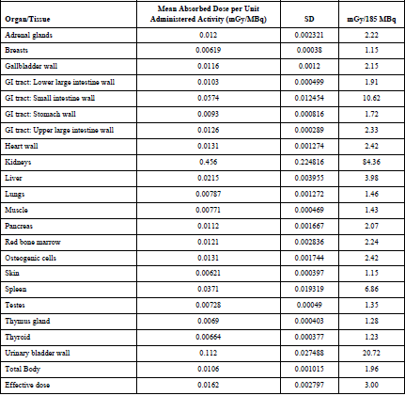
Abbreviations: GI = gastrointestinal; mGy/MBq = milligray/megabecquerel (mean absorbed dose per unit administered activity; SD = standard deviation

Metabolism
The metabolism of [⁶⁸Ga] gallium PSMA-11 has not been defined. It is thought that the internalised peptide is broken down to the constituent amino acids within the cell.

Excretion
The main route of excretion is urinary. Green et al. (2017);21 collected voided urine from participants at 48 and 120 minutes after injection of [⁶⁸Ga] gallium PSMA-11. The radioactivity in the voided urine collected over the 120 minutes accounted for 14% of the injected dose. In Study Ga68PSMA-2016-1, voided urine was collected for 180 minutes post-injection and was found to contain 30 to 50% of the injected dose.

Dosage
The proposed activity of Illuccix (185 MBq ±10%) is based on clinical studies evaluating the Telix kit as well as published experience with [⁶⁸Ga] gallium PSMA-11. Flat dosing and weight-based dosing have both been used in the published literature, and in the clinical studies evaluating the Telix kit. In Study BCR-RET-01, the dose activity was 2.5 MBq/kg Ga-68 PSMA-11 (minimum of 100 MBq, maximum of 300 MBq), whereas Study ANMI-PG01-C301 and Ga68 PSMA-2016-01 evaluated a dose of 185 MBq ±10%. The doses used in the clinical trials are consistent with the doses used in published studies and the recommendations in the 2017 joint European Association of Nuclear Medicine (EANM) and Society of Nuclear Medicine and Molecular Imaging (SNMMI) procedure guideline for prostate cancer imaging. The guideline advises that ‘Currently, the optimal injected activity is still under debate. The majority of published data is based on an injected activity of approximately 1.8–2.2 MBq per kilogram of body weight’.
It is not clear that there is any particular advantage to weight based dosing over a flat dose regimen, and the latter has the advantage of simplifying dosing. The proposed dose of 185 MBq ±10% would encompass the weight based dosing regimen recommended in the 2017 guideline for most patients. Image quality is not solely dependent upon dose but may also vary according to patient, site and scanner characteristics.

Pharmacodynamic interactions
The evaluation assessed whether concurrent androgen deprivation therapy may affect [⁶⁸Ga] gallium PSMA-11 PET/CT imaging. There are variable findings in the literature as to whether androgen deprivation therapy may reduce or increase PSMA expression on prostate cancer cells, but the majority of research suggests that PSMA expression may increase in the short term with androgen deprivation therapy. The effect of androgen deprivation therapy on the reliability of [⁶⁸Ga] gallium PSMA-11 PET/CT imaging has not yet been established. This uncertainty is addressed in Section 4.5 of the PI.

Radiation source and image quality
The in vitro biopharmaceutic study, Study ANMI-PG01-NC01 investigated two different methods of preparation of [⁶⁸Ga] gallium PSMA-11: one prepared using a synthesiser with a heating step, and one prepared using the Telix kit at room temperature. This study was also evaluated in the nonclinical evaluation. The cellular binding and internalisation of the two different [⁶⁸Ga] gallium PSMA-11 preparations were found to be similar, in spite of the difference in the diastereomer profiles of the preparations. The findings from this study suggest that the presence of different patterns of diastereomers arising from the different preparation methods does not alter cell binding and internalisation.
Calderoni et al. (2020); reported that the method of preparation of [⁶⁸Ga] gallium PSMA-11 does not appear to affect image quality. This study retrospectively compared PET/CT image quality with [⁶⁸Ga] gallium PSMA-11 prepared using the Telix kit to [⁶⁸Ga] gallium PSMA-11 prepared using a synthesiser method in 200 patients with prostate cancer. The study concluded that there was no significant difference in the image ratings between the kit and synthesiser module (see Table 3)
Table 3: Calderoni et al. (2020); Rating of images according to preparation method of [⁶⁸Ga] gallium PSMA-11
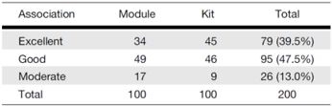
Source: Calderoni et al. Evaluation of an Automated Module Synthesis and a Sterile Cold Kit–Based Preparation of 68Ga-PSMA-11 in Patients with Prostate Cancer. Journal of Nuclear Medicine. 2020; 61 (5) 716-722

Diagnostic efficacy
The evidence of clinical diagnostic efficacy for the Telix kit is based primarily on:
- Study BCR-RET-01, a retrospective analysis of efficacy information collected as part of a prospective study by Memorial Sloan Kettering Cancer Center (MSKCC) in patients with known or suspected biochemically recurrent prostate cancer (BCR PC); and
- Published studies reporting the diagnostic efficacy of Ga-68 PSMA-11 PET/CT in patients with prostate cancer.
The submission also included the sponsor’s Study ANMI-PG01-C301 as a supportive efficacy study. This was a retrospective, observational study conducted in Europe in patients with prostate cancer who had undergone radical treatment by prostatectomy or radiotherapy.
Table 4: Description of clinical efficacy studies conducted by sponsor
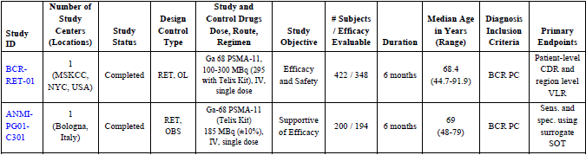
Abbreviations: BCR PC = biochemically recurrent prostate cancer; CDR = correct detection rate; ID = identification; IV = intravenous; MSKCC = Memorial Sloan Kettering Cancer Center; OBS = observational; OL = open label; RET = retrospective; sens = sensitivity; SOT = standard of truth; spec = specificity; VLR = verified localisation rate.

Study BCR-RET-01
This was a retrospective, open-label study evaluating data collected as part of an ongoing prospective study, PSMA PET imaging of recurrent prostate cancer being conducted at seven MSKCC sites in the USA..
The primary objective of the retrospective study was to demonstrate the efficacy of the Telix Kit ([⁶⁸Ga] gallium PSMA-11) as an accurate imaging technique for use with PET for the detection and localisation of prostate cancer in men diagnosed with BCR PC. The secondary objective was to evaluate the diagnostic accuracy of [⁶⁸Ga] gallium PSMA-11 as well as to assess the safety profile of [⁶⁸Ga] gallium PSMA-11 imaging in patients diagnosed with biochemically recurrent prostate cancer.

Inclusion and exclusion criteria
Inclusion criteria for the prospective study included:
- biopsy proven adenocarcinoma of the prostate;
- initially treated with definitive local therapy (surgery and radiation therapy are the most common treatments, but other treatments are also eligible);
- for patients initially treated with surgery, radiation therapy, brachytherapy, or cryotherapy, PSA ≥ 0.2 ng/mL in at least two consecutive tests within six months of date of consent for patients. Note: The most recent PSA value must be within six weeks of consent;
- for patients who have received additional treatment in the recurrent or metastatic setting, PSA ≥ 2 ng/ml above the most recent therapy nadir;
- age ≥ 18 years, and
- patient must be able to tolerate PET/CT or PET/MR imaging.
Additional inclusion criteria for the retrospective study included:
- rising PSA after curative intent therapy with prostatectomy or radiation therapy (external beam, or brachytherapy) or cryotherapy;
  - if post-radical prostatectomy, PSA ≥ 0.2 ng/mL measured > 6 weeks post-operatively and confirmatory persistent PSA > 0.2 ng/mL,
  - if post-radiation therapy, PSA ≥ 2 ng/mL rise above PSA nadir.

Methods
[⁶⁸Ga] gallium PSMA-11 was prepared either by the MSKCC method or by the Telix Kit. Allocation to either preparation method was by convenience. The target dose activity was 2.5 MBq/kg body weight (minimum of 100 MBq, maximum of 300 MBq) via an intravenous catheter. Image acquisition was initiated 60 to 90 minutes after administration.
De-identified [⁶⁸Ga] gallium PSMA-11 PET scan images for each patient were independently interpreted by three readers blinded to clinical data and conventional imaging data. Each reader was to review the images and determine whether the patient was positive or negative for BCR PC, based solely on the [⁶⁸Ga] gallium PSMA-11 PET scan image. The reader was to document the specific location where BCR PC was observed according to pre-defined regions and sub-regions. The four pre-defined regions were prostate bed, pelvic lymph nodes, skeleton, and other distant sites (extra-pelvic lymph nodes and viscera).
[⁶⁸Ga] gallium PSMA-11 PET findings were assessed against the reference standards of histopathology (standard of truth) and conventional imaging. It is noteworthy that positive [⁶⁸Ga] gallium PSMA-11 PET findings were verified by biopsy, surgical procedure, and/or conventional imaging at the discretion of the referring physician, so reference standard data may not be available in all scenarios.
The retrospective study included 422 consecutive patients who had a [⁶⁸Ga] gallium PSMA-11 PET scan between 4 August 2017 (the start of the MSKCC study) and 31 August 2019, which permitted all patients in this window to have at least six months of clinical follow up after the scan. The primary efficacy analyses were originally planned to be conducted on the full analysis set (422 patients), but during the transfer of data from MSKCC, Telix learned that only 348 patients had reference standard data to compare to their PSMA scan result. The FDA had provided advice that the co-primary analysis should be based on a comparison of PSMA scan results to a reference standard, so Telix defined a new primary efficacy population, the efficacy evaluable population, comprising 348 patients who had reference standard data in addition to a PSMA scan (see Table 5). Of these, only 57 patients had histopathology as a reference standard, and the rest had conventional imaging as the reference standard (mostly MRI (252 out of 348), CT (180 out of 348) and radionuclide bone scan (128 out of 348), but also PET (with [¹⁸F]-fluorodeoxyglucose, [¹¹C]- and [¹⁸F]-choline, [¹⁸F]-fluciclovine, [¹⁸F]-sodium fluoride, or other), ultrasound, x-ray, MAG3 (mercaptuacetyltriglycine) renal scan, and DEXA (dual-energy X-ray absorptiometry).
Table 5: Study BCR-RET-01 Reference standards
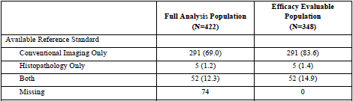
In the full analysis set, the mean age was 68.4 years (range 44.7 to 91.9), and mean weight was 87.3 kg (range 56.4 to 150.5). 81.5% of the patients had undergone prostatectomy. The demographic profile of the patient efficacy evaluable set was similar to the full analysis set. PSA levels at the time of the PSMA scan are shown in Table 6. Nearly half had PSA < 1 ng/mL.
Table 6: Study BCR-RET-01 Prostate specific antigen levels
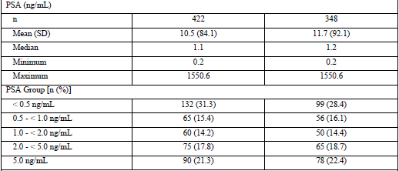
Abbreviations: n = subjects; N = all subjects; PSA = prostate specific antigen; SD = standard deviation.
PSA group is given in number of subjects (n); and as a percentage (%) of all subjects.
The Telix kit was used for 295 patients and the MSKCC method was used for 127 patients. The mean administered dose overall was 6.584 mCi (equivalent to 243.6 MBq).
Table 7: Study BCR-RET-01 Summary of dose overall and by preparation method
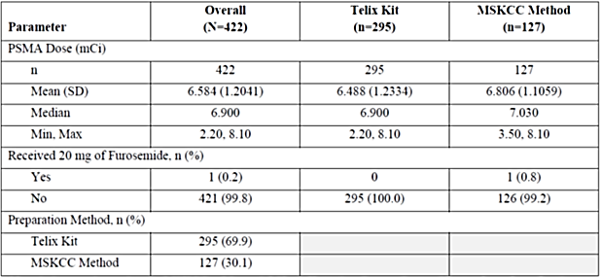
Abbreviations: mCi = millicurie unit; min = minutes; MSKCC = Memorial Sloan Kettering Cancer Center; N = total number of subjects; n = number of subjects in a specific group.

Efficacy endpoints
The co-primary efficacy endpoints of Study BCR-RET-01 were patient level correct detection rate and region level verified localisation rate. Correct detection rate was defined as the percentage of patients who have at least one true positive lesion (exactly localised correspondence between [⁶⁸Ga] gallium PSMA-11 PET imaging and the reference standard), regardless of any co-existent false positive findings, out of all patients who are scanned. Verified localisation rate was defined as the percentage of regions containing at least one true positive lesion, regardless of any co-existent false positive findings within the same region, out of all regions containing at least one PET positive finding.
The selection of correct detection rate and verified localisation rate as co-primary endpoints was based on pre-new drug application advice from the FDA. The FDA recommended that the primary analysis of the diagnostic performance of [⁶⁸Ga] gallium PSMA-11 PET should be measured against a reference standard constructed from histologic confirmation whenever possible and conventional imaging and clinical follow-up when histopathology cannot be obtained. The FDA required lesions be exactly localised with a 1:1 correspondence between the anatomical location of the PSMA scan result and a reference standard, for an observation to be considered positive. At a pre-new drug application meeting on 21 February 2020, the FDA recommended that correct detection rate and verified localisation rate should be co-primary endpoints, and that the thresholds for success should be pre-defined.
The pre-defined thresholds of success for correct detection rate and verified localisation rate were 20% and 10%, respectively, with a successful outcome achieved if the lower bound of the 95% two sided confidence interval (CI) exceeded the threshold for at least two of the three readers. The selection of a 20% threshold for correct detection rate was aligned with the threshold for CDR used in the Phase III CONDOR trial which evaluated the PSMA-directed radiopharmaceutical [¹⁸F]-DCFPyl.
Secondary efficacy endpoints included:
correct detection rate and verified localisation rate for the secondary populations (full patient analysis set, patient composite reference set, and patient histopathology only set).
- Verified localisation rate by region (prostate bed, pelvic lymph nodes, skeleton, and other distant sites).
- Pooled region-level verified localisation rate.
- Region-level mean verified localisation rate.
- Percentage of patients scanned who had at least one false positive finding, regardless of any co-existent transperineal lesions.
- Correct detection rate and verified localisation rate by PSA sub-group (< 0.5, 0.5 to < 1, 1 to < 2, 2 to <5, and ≥ 5 ng/mL) and by nadir subgroup (< 1 and ≥ 1 ng/mL).
- Pairwise patient and region level inter-reader agreement on PSMA PET scan interpretations.

Results
The study was successful in achieving both co-primary endpoints. correct detection rate for the three independent readers ranged from 41.1% to 45.7%, with the lower bound of the 95% CI for each of the three readers exceeding the pre-defined threshold of 20% (see Table 8). verified localisation rate for the three readers ranged from 36.2% to 50%, with the lower bound of the 95% CI for each of the three readers exceeding the pre-defined threshold of 10% (see Table 9).
Table 8: Study BCR-RET-01 Correct detection rate (patient efficacy evaluable population)
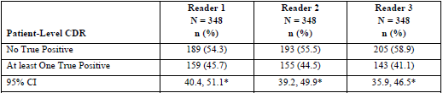
Abbreviations: CDR = correct detection rate; CI = confidence interval; N = total number of subjects; n = number of subjects in a specific group.
* Lower bound of 95% CI for CDR exceeded threshold of 20%.
Table 9: Study BCR-RET-01 Verified localisation rate (region efficacy evaluable population)
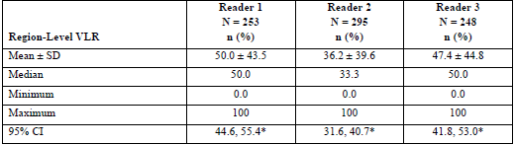
Abbreviations: CI = confidence interval; N = total number of subjects; n = number of subjects in a specific group; SD = standard deviation; VLR = verified localisation rate.
* Lower bound of 95% CI for VLR exceeded threshold of 10%.
Secondary efficacy endpoints included correct detection rate in the full patient analysis set (see Table 10), the patient composite reference set (see Table 11), and the patient histopathology only set (see Table 12), and verified localisation rate in the full region analysis set (see Table 13), the region composite reference set (see Table 14), and the region histopathology only set (see Table 15). Correct detection rates and verified localisation rates were lower in the full analysis set compared to the efficacy evaluable population, as 74 patients in the full analysis set had no reference standard data, but the pre-defined success criteria for correct detection rate and verified localisation rate were still met in the full analysis set. Correct detection rates and verified localisation rates were highest in the histopathology only population, where histopathology (the standard of truth) was available as the reference standard. In this population, correct detection rates for the three readers ranged from 81.3% to 87.9%, and verified localisation rates ranged from 79.7% to 87.9%.
Table 10: Study BCR-RET-01 Correct detection rate by reader (full patient analysis set)
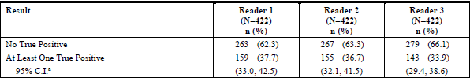
Abbreviations: C.I. = confidence intervals; N = total number of subjects; n = number of subjects in a specific group.
a: 95% two sided exact binomial confidence interval
Table 11: Study BCR-RET-01 Verified localisation rate by reader (full region analysis set)
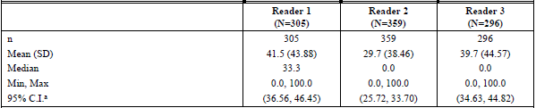
Abbreviations: C.I. = confidence intervals; N = total number of subjects; n = number of subjects in a specific group; SD = standard deviation.
a: 95% two sided t–test confidence interval
Table 12: Study BCR-RET-01 Correct detection rate by reader (patient composite reference set)
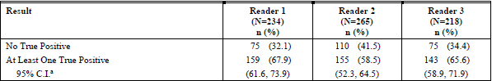
Abbreviations: C.I. = confidence intervals; N = total number of subjects; n = number of subjects in a specific group
a: 95% two sided exact binomial test confidence interval
Table 13: Study BCR-RET-01 Verified localisation rate by reader (region composite reference set)
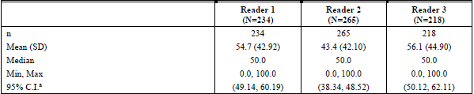
Abbreviations: C.I. = confidence intervals; N = total number of subjects; n = number of subjects in a specific group; SD = standard deviation.
a: 95% two sided t confidence interval
Table 14: Study BCR-RET-01 Correct detection rate by reader (patient histopathology only set)
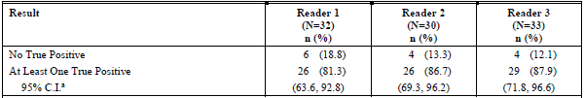
Abbreviations: C.I. = confidence intervals; N = total number of subjects; n = number of subjects in a specific group
a: 95% two sided exact binomial confidence interval
Table 15: Study BCR-RET-01 Verified localisation rate by reader (region histopathology only set)
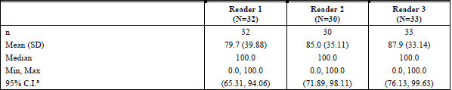
Abbreviations: C.I. = confidence intervals; N = total number of subjects; n = number of subjects in a specific group; SD = standard deviation.
a: 95% two sided t confidence interval
Analyses by PSA Subgroup showed that correct detection rates increased with increasing PSA level (see Table 16).
Table 16: Study BCR-RET-01 Correct detection rate by reader and prostate specific antigen subgroup (patient efficacy evaluation set)
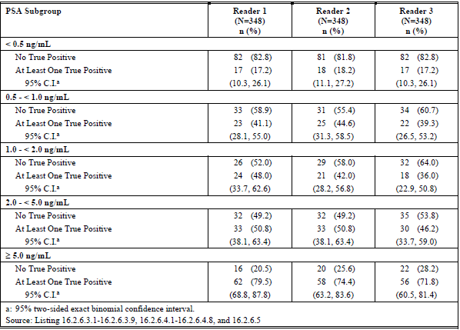
Abbreviations: C.I. = confidence intervals; N = total number of subjects; n = number of subjects in a specific group; PSA = prostate specific antigen.
a: 95% two sided exact binomial confidence interval
Analyses based on the method of preparation of [⁶⁸Ga] gallium PSMA-11 (that is Telix kit versus MSKCC method) showed similar outcomes for correct detection rate (see Table 17) and verified localisation rate (see Table 18).
Table 17: Study BCR-RET-01 Correct detection rate by reader and preparation method (patient efficacy evaluable population)
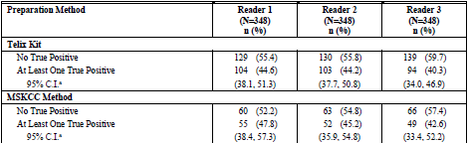
Abbreviations: C.I. = confidence intervals; MSKCC = Memorial Sloan Kettering Cancer Center; N = total number of subjects; n = number of subjects in a specific group.
a: 95% two sided exact binomial confidence interval
Table 18: Study BCR-RET-01 Verified localisation rate by reader and preparation method (region efficacy evaluable population)
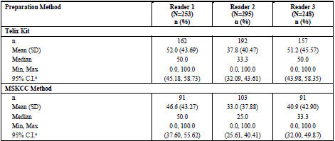
Abbreviations: C.I. = confidence intervals; max = maximum; min = minimum; MSKCC = Memorial Sloan Kettering Cancer Center; N = total number of subjects; n = number of subjects in a specific group; SD = standard deviation.
a: 95% two sided t-test confidence interval
The percentage of patients who had at least one false positive finding, regardless of any co-existent transperineal lesions, was notably higher in the patient efficacy evaluable set (see Table 19) than the histopathology only set (see Table 20), which may be a reflection of the limitations of conventional imaging as a reference standard.
Table 19: Study BCR-RET-01 Patient level false positive rate by reader (patient efficacy evaluable set)
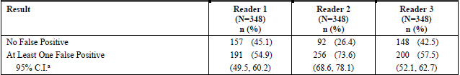
Abbreviations: C.I. = confidence intervals; N = total number of subjects; n = number of subjects in a specific group.
a: 95% two sided exact binomial confidence interval
Table 20: Study BCR-RET-01 Patient level false positive rate by reader (patient histopathology only set)
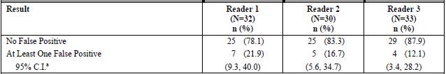
Abbreviations: C.I. = confidence intervals; N = total number of subjects; n = number of subjects in a specific group.
a: 95% two sided exact binomial confidence interval
Analyses based on traditional measures of diagnostic efficacy are shown in Table 21 (full patient analysis set) and Table 22 (patient histopathology only set). Sensitivity ranged from 81% to 90.9% across the three readers, and positive predictive value (PPV) ranged from 71.2% to 78.3% (full patient analysis set).
Table 21: Study BCR-RET-01 Summary of patient level sensitivity, specificity, positive predictive value, negative predictive value, and accuracy (full patient analysis set)
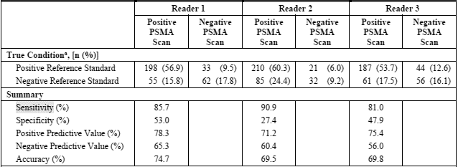
Abbreviations: n = number of subjects in a specific group; PSMA = prostate-specific membrane antigen
True condition given as number of subjects/group and percentage in brackets.
a: According to reference standard.
Table 22: Study BCR-RET-01 Summary of patient level sensitivity, specificity, positive predictive value, negative predictive value, and accuracy (patient histopathology only set)
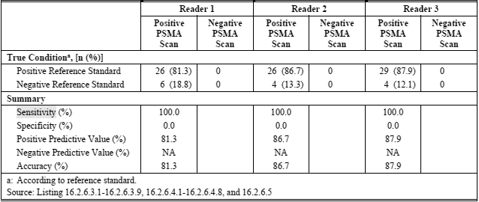
Abbreviations: n = number of subjects in a specific group; PSMA = prostate-specific membrane antigen.
True condition given as number of subjects/group and percentage in brackets.
a: According to reference standard.

Literature review
The evidence of clinical efficacy is also based on published literature describing the diagnostic efficacy of [⁶⁸Ga] gallium PSMA-11 PET/CT in patients with prostate cancer. The sponsor conducted a systematic literature review and presented 56 articles relating to the diagnostic performance of [⁶⁸Ga] gallium PSMA-11 PET/CT in primary staging of prostate cancer and 39 in biochemically recurrent prostate cancer (BCR PC). Most of the published literature relates to [⁶⁸Ga] gallium PSMA-11 generally, not the Telix kit specifically. Diagnostic performance was generally reported in terms of traditional metrics: sensitivity, specificity, positive predictive value (PPV), and negative predictive value (NPV). None of the published studies reported on the novel end points of correct detection rate or verified localisation rate.

Primary staging of prostate cancer using [⁶⁸Ga] gallium PSMA-11 PET/CT
Most of the studies investigated pelvic lymph node spread and used histopathology as the reference standard. 38 of the 56 articles were retrospective studies.
The integrated summary of efficacy presented a summary of the sensitivity and specificity of [68Ga] gallium PSMA-11 PET imaging in primary prostate cancer studies with biopsy/histology as the standard of truth. Sensitivity across the studies ranged from 24% to 100% and specificity ranged from 45% to 100%. PPV and NPV ranged from 60% to 100% and 25% to 100%, respectively. Accuracy ranged from 60% to 100% and AUC ranged from 0.7 to 0.95. Changes in patient management due to [⁶⁸Ga] gallium PSMA-11 PET/CT findings were reported in 19 to 52% of patients across seven studies.
Hofman et al. (2020);14 was an Australian, multicentre, two arms, randomised controlled trial of patients with newly diagnosed biopsy proven prostate cancer with high-risk features (PSA ≥ 20 ng/mL, International Society of Urological Pathology Grade Groups 3 to 5; or clinical stage T3 or worse); and who were being considered for radical prostatectomy or radiotherapy with curative intent.
Patients were randomised to conventional imaging (defined as CT and bone scan) or to [⁶⁸Ga] gallium PSMA-11 PET/CT as first line imaging. Patients underwent crossover imaging within 14 days of the first imaging unless there were ≥ 3 unequivocal distant metastases detected on first-line imaging. Ongoing care was according to usual clinical practice, but any change in patient management due to imaging results was recorded prospectively. For patients with distant metastases, when feasible, biopsy confirmation of disease was strongly encouraged in the clinical protocol. Patients who had surgery underwent pelvic lymph node dissection at the discretion of the treating urologist. At six months, participants underwent repeat imaging as per randomised group with cross over if imaging evidence of N1 or M1 disease;¹³ at Baseline was found, or if there was biochemical or clinical suspicion of residual or recurrent disease.
The primary outcome was the accuracy (as assessed by the area under the curve (AUC) of the receiver operating characteristic curve) of first line imaging for identifying either pelvic nodal or distant metastatic disease. The reference standard was applied at a six month follow up using a predefined composite measure involving histopathology, imaging, clinical and biochemical findings.
A total of 302 subjects were randomised: 152 to first-line CT and bone scan, and 150 to first-line [⁶⁸Ga] gallium PSMA-11 PET/CT. Of these, 150 out of 152 subjects and 145 out of 150 subjects attended the six month follow up and were included in the primary analysis. The reference standard was assessable in 295 (98%) with 87 (30%) subjects positive for nodal or distant metastases.
[⁶⁸Ga] gallium PSMA-11 had greater accuracy than conventional imaging (92% (95% CI: 88, 95) versus 65% (95% CI: 60, 69); p < 0.0001) in detecting pelvic nodal or distant metastatic disease in first line staging of high risk prostate cancer. Sensitivity and specificity for [⁶⁸Ga] gallium PSMA-11 PET/CT were 85% (95% CI: 74, 96) and 98% (95% CI: 95, 100), respectively, compared to 38% (95% CI: 24, 52) and 91% (95% CI: 85, 97) for conventional imaging. Analyses of accuracy, sensitivity, and specificity were also performed for nodal and distant metastatic groups separately (see Figure 5).
First-line [⁶⁸Ga] gallium PSMA-11 PET/CT conferred management change more frequently than first line conventional imaging (28% (95% CI: 21, 36) versus 15% (95% CI: 10, 22)). Following first-line [⁶⁸Ga] gallium PSMA-11 PET/CT, 14% of patients were directed from curative to palliative treatment, 7% had a change in radiotherapy technique, and 7% had a change in surgical technique.
Radiation exposure from first line imaging was higher with conventional imaging than [⁶⁸Ga] gallium PSMA PET/CT (19.2 millisievert (mSv) (95% CI: 18.2, 20.3) versus 8.4 mSv (95% CI: 8.1, 8.7)).
Figure 5: Hofman et al. (2020) Accuracy, sensitivity, and specificity of conventional imaging compared with PSMA PET-CT
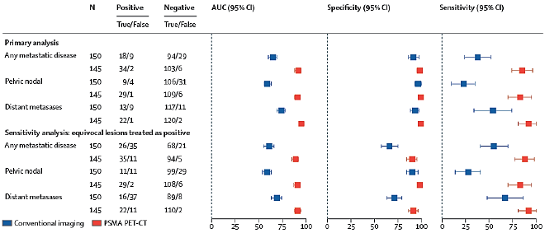
Abbreviations: AUC = area under the concentration-time curve; CI = confidence intervals; N = number of subjects
Source: Hofman et al. Prostate-specific membrane antigen PET-CT in patients with high-risk prostate cancer before curative-intent surgery or radiotherapy (proPSMA): a prospective, randomised, multicentre study. The Lancet Vol 395, Issue 10231, P1208-16, April 2020

[⁶⁸Ga] gallium PSMA-11 PET/CT in biochemically recurrent prostate cancer
Of the 39 articles presented for [⁶⁸Ga] gallium PSMA-11 PET/CT in biochemically recurrent prostate cancer, 27 used histopathology or a composite reference standard which included histopathology. Across these studies, sensitivity and specificity each ranged from 63% to 100%. Sensitivity was similar in the prostate and lymph nodes (63.6% to 98.8% and 77.9% to 100%, respectively). Specificity was also similar in prostate and lymph nodes (31.2% to 100% and 50% to 100%, respectively). Positive predictive values (PPV) and negative predictive values (NPV) ranged from 50% to 100% and 20.6% to 100%, respectively. Accuracy ranged from 71% to 100% and AUC ranged from 0.88 to 0.99.
In the 12 articles which used only conventional imaging as the reference standard, sensitivity of [⁶⁸Ga] gallium PSMA-11 PET/CT ranged from 80% to 100% and specificity, PPV, and NPV ranged from 80% or higher to 100%.
Changes in patient management due to [⁶⁸Ga] gallium PSMA-11 PET/CT findings were reported in seven studies investigating biochemically recurrent prostate cancer. In these studies, 30% to 75% of patients had their treatment plan modified because of the [⁶⁸Ga] gallium PSMA-11 scan result.
Fendler et al. (2019) (PSMA-BCR); was a prospective, single arm, open label study of [⁶⁸Ga] gallium PSMA-11 PET imaging in patients with biochemically recurrent prostate cancer. This study was conducted at University of California Los Angeles (UCLA) and San Francisco (UCSF) and was evaluated by the FDA as part of the recently approved New Drug Application for [⁶⁸Ga] gallium PSMA-11. 635 patients with biochemically recurrent prostate cancer (BCR PC) after prostatectomy (n = 262, 41%), radiation therapy (n = 169, 27%), or both (n = 204, 32%) underwent [⁶⁸Ga] gallium PSMA-11. Presence of prostate cancer was recorded by three blinded readers on a per patient and per region base. Lesions were validated by histopathologic analysis and a composite reference standard. Patient management was in accordance with a local read and follow up was as for usual clinical practice.
Of the 635 patients, 166 had negative scans. Of the 469 patients with positive scans, 87 had data for the primary endpoint of PPV by histopathology, and 215 had data for the secondary endpoint of PPV by composite reference. Outcomes for PPV and sensitivity are shown in Table 23. Analysis of correct detection rate in PSMA biochemically recurrent prostate cancer was also conducted by FDA reviewers (see Table 24).
Table 23: Fendler et al. (2019) Biochemically recurrent prostate cancer prostate specific membrane antigen study, positive predictive value and sensitivity results (histopathology and composite reference standards)
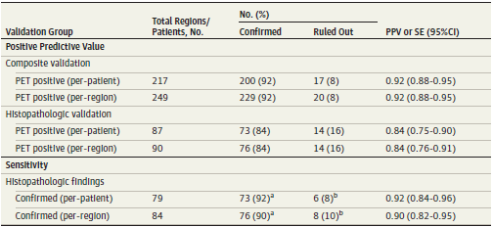
Abbreviations: PET = positron emission tomography; PPV = positive predictive value; SE =sensitivity. ª PET positive. ^{b} PET negative
Source: Fendler WP, Calais J, Eiber M, et al. Assessment of 68Ga-PSMA-11 PET Accuracy in Localizing Recurrent Prostate Cancer: A Prospective Single-Arm Clinical Trial. JAMA Oncol. 2019;5(6):856–863
Table 24: Extract from FDA New Drug Application of Fendler W et al. (2019) study in biochemically recurrent prostate cancer prostate specific membrane antigen study; correct detection rate
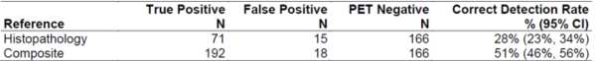
Abbreviations: ⁶⁸Ga = gallium-68, CI = confidence interval, N = number of patients; PET = positron emission tomography; PSMA = prostate specific membrane antigen.
Extracted from: Center for Drug Evaluation and Research 212642Orig1s000 Multi-Discipline Review NDA/BLA Multi-Disciplinary Review and Evaluation NDA 212642 gallium Ga 68 PSMA-11 Injection. United States Food and Drug Administration. 12 October 2018.
Review of data from: Source: Fendler WP, Calais J, Eiber M, et al. Assessment of 68Ga-PSMA-11 PET Accuracy in Localizing Recurrent Prostate Cancer: A Prospective Single-Arm Clinical Trial. JAMA Oncol. 2019;5(6):856–863

Study ANMI-PG01-C301 (supportive study)
This study was presented as a supportive study. It was a retrospective, observational, single centre study conducted in Italy to evaluate the diagnostic performance and safety of [⁶⁸Ga] gallium PSMA-11 PET/CT in the detection of prostate cancer recurrence in patients who had received definitive treatment (prostatectomy or radiotherapy). [⁶⁸Ga] gallium PSMA-11 was prepared using the sponsor’s kit. A dose with activity of 185 MBq (±10%) of ⁶⁸Ga PSMA-11 was to be administered intravenously as a single bolus.
The study included men aged between 18 and 80 years who had been diagnosed with prostate cancer, undergone radical treatment by prostatectomy or radiotherapy, and had [⁶⁸Ga] gallium PSMA-11 PET/CT imaging at the participating centre in the six months prior to the date of approbation for the study. There was no formal sample size calculation.
The images were reviewed by three independent readers in two sequential steps:
- Blinded review: PET/CT images were read without any other information about the patient, and the interpretations were recorded.
- Unblinded review: PET/CT images were then evaluated with access to clinical data (patient clinical information, biological information, and correlative imaging results) that was available at the time the scan was performed. The three independent readers assigned a malignancy status to each lesion: ‘confirmed’, ‘invalidated’, ‘pending’ or ‘inconclusive’.
An algorithm was developed by the study sponsor and applied retrospectively to establish the reference standard (‘surrogate standard of truth’). The standard of truth algorithm included clinical outcome, including response to treatment, and/or histopathology data and/or additional imaging as performed in the first six months following the scan. Lesions identified on the initial [⁶⁸Ga] gallium PSMA-11 PET/CT were re-evaluated retrospectively by the principle investigator using the standard of truth algorithm.
200 patients were enrolled in the study (enrolled set), but six were subsequently determined to be ineligible, so 194 were included in the analysis set. Median age was 69 years (range 48 to 79 years). History of radical prostatectomy was reported for 186 (95.9%) patients, in 115 cases with pelvic lymph node dissection. Eight patients received external beam radiation therapy as primary treatment. Some form of androgen deprivation therapy was reported for 85 patients.
In the blinded review, a total of 226 lesions were identified, 140 of which (61.9%) were considered distant metastases. 108 out of 194 (55.7%) patients had no lesions detected. A single lesion was identified in 44 (22.7%) patients, and 18 (9.3%) patients had two lesions. The remaining 24 patients had three or more lesions (maximum of 17 lesions in one patient). In the unblinded review, the malignancy status of 212 of 226 (93.8%) lesions were assessed as ‘confirmed’, 10 (4.4%) were ‘pending’, and four (1.8%) were ‘inconclusive’. Only four (1.8%) lesions were confirmed with a correlative assessment (one histopathology positive result and three positive lesions on MRI).
The analysis of the diagnostic performance at the lesion level based on the standard of truth algorithm was conducted on 44 evaluable lesions (see Table 25). 19 of the 44 lesions were positive on [⁶⁸Ga] gallium PSMA-11 PET/CT imaging, and 25 were negative on [⁶⁸Ga] gallium PSMA-11 PET/CT but confirmed by other imaging. The sensitivity was 43% (19 out of 44; 95% CI: 30% to 58%), and the modified PPV was 100% (19 out of 19; 95% CI: 83% to 100%).
Table 25: Study ANMI-PG01-C301 Lesion level diagnostic performance based on standard of truth algorithm, evaluable lesions
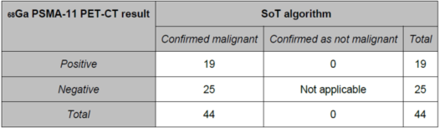
Abbreviation: SoT = standard of truth.
Given the limited number of lesions evaluable under the standard of truth algorithm, other measures of diagnostic performance were presented. Analyses were conducted using information gained during the six month follow up and not restricted to lesions assessed by the standard of truth algorithm. In these analyses, correlative data were not required and lesions were considered ‘confirmed’ malignant unless a clinical finding came against the diagnosis. These analyses reported high sensitivity and specificity at the patient and lesion level, but these findings are of limited value in terms of assessing the diagnostic performance due to the high risk of bias.

Safety
The safety of the proposed product is based on:
- Safety data from clinical trials in which the Telix Kit was used
  - The retrospective efficacy and safety study in patients with known or suspected biochemically recurrent prostate cancer (Study BCR-RET-01).
  - Safety data from the ongoing Phase III Study PSMA-617-01; (also known as the VISION trial) investigating the use of [¹⁷⁷Lu] Lutetium PSMA-617 for the treatment of patients with progressive PSMA-positive metastatic castration resistant prostate cancer (mCRPC). [⁶⁸Ga] gallium PSMA-11 PET was performed at screening to confirm PSMA-positive prostate cancer.
  - The retrospective, observational study conducted by Telix in Europe (Study ANMI-PG01-C301).
  - Safety data from three healthy volunteers in Study Ga68PSMA-2016-1.
- Safety data for Study Ga-68 PSMA-11 reported in published literature.

Clinical studies
All subjects in Studies BCR-RET-01, PSMA-617-01, and ANMI-PG01-C301 received a single dose of [⁶⁸Ga] gallium PSMA-11. Patient exposure in the studies is summarised in Table 26.
Table 26: Overall dose by study
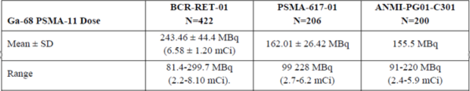
Abbreviations: MBq = megabecquerel; mCi = millicurie; N = total number of subjects; SD = standard deviation.
In the retrospective Study BCR-RET-01, 422 patients received [⁶⁸Ga] gallium PSMA-11, 295 (70%) of whom received [⁶⁸Ga] gallium PSMA-11 prepared using the Telix kit. Patients were monitored during infusion of [⁶⁸Ga] gallium PSMA-11 and for 120 minutes after, and the incidence, nature and severity of adverse events for up to one day following infusion were collected. This one day timeframe was consistent with cancer therapy evaluation program guidelines (for studies using PET investigational new drug application agents, the adverse event reporting period is limited to ten radioactive half-lives, rounded up to the nearest whole day, after the agent/intervention was last administered). There was no per protocol collection of laboratory values, vital signs, or electrocardiogram, but these were analysed if performed as part of usual clinical care.
In the retrospective Study ANMI-PG01-C301, clinical records of 200 patients who received [⁶⁸Ga] gallium PSMA-11 prepared with the Telix kit were reviewed. Any adverse events reported as occurring between the [⁶⁸Ga] gallium PSMA-11 PET/CT and the last follow up and considered by the investigator as related to the [⁶⁸Ga] gallium PSMA-11 product or procedure were to be collected. There was no per protocol collection of laboratory values, vital signs, or electrocardiogram, but these were analysed if performed as part of usual clinical care.
Study PSMA-617-01;⁴⁹ is an ongoing, prospective, open label, international, multicentre, randomised Phase III Study of [¹⁷⁷Lu] Lutetium PSMA-617 for the treatment of patients with progressive PSMA-positive metastatic castration resistant prostate cancer (mCRPC). 206 patients with progressive mCRPC received [⁶⁸Ga] gallium PSMA-11 prepared using the Telix kit to confirm PSMA-positive cancer. Adverse event data were collected from the time of consent to up to six days post-injection of [⁶⁸Ga] gallium PSMA-11 (as long as this was prior to the first dose of [¹⁷⁷Lu] Lutetium PSMA-617) regardless of whether the patient continued in the treatment part of the study. It is noteworthy that this study evaluated patients with progressive mCRPC, in contrast to the majority of safety data presented in this submission which relate to patients with primary prostate cancer or biochemically recurrent prostate cancer.
The number of adverse events reported in each study was:
- Study BCR-RET-01: two adverse events in one participant.
- Study ANMI-PG01-C301: no adverse events reported.
- Study PSMA-617-01: 109 adverse events in 48 participants.
In Study BCR-RET-01, one patient reported two adverse events: an increase in blood bilirubin; and a vascular access complication. Both occurred 26 days after [⁶⁸Ga] gallium PSMA-11 administration. Both were reported as asymptomatic (mild) and were deemed unrelated to [⁶⁸Ga] gallium PSMA-11 by the investigator.
In Study PSMA-617-01, 109 adverse events following administration of [⁶⁸Ga] gallium PSMA-11 were reported in 48 (23.3%) of 206 subjects (Table 27). 11 subjects reported 21 serious adverse events, including bicytopaenia (two subjects reported two events) and constipation (two subjects reported two events). adverse events reported in more than two patients were: anaemia (five subjects reported eight events), asthenia (six subjects reported six events), arthralgia (five subjects reported five events), constipation (five subjects reported five events), haematuria (three subjects reported four events) bone pain (three subjects reported three events), nausea (three subjects reported three events), and acute kidney injury (one subject reported three events). Most of the events were mild in severity and Grade 1 or 2. There were 18 Grade 3 events in 10 patients, no Grade 4 events, and two Grade 5 events. One subject died from cerebral haematoma 48 days following dosing with [⁶⁸Ga] gallium PSMA-11 and the other died from dermatomyositis 53 days following dosing with [⁶⁸Ga] gallium PSMA-11, with neither event deemed related to [⁶⁸Ga] gallium PSMA-11 administration. Of the adverse events assessed as treatment related, all were mild and only one (injection site warmth) occurred within six days of administration.
Table 27: Study PSMA-617-01 Summary of adverse events post-injection of [68Ga] gallium PSMA-11
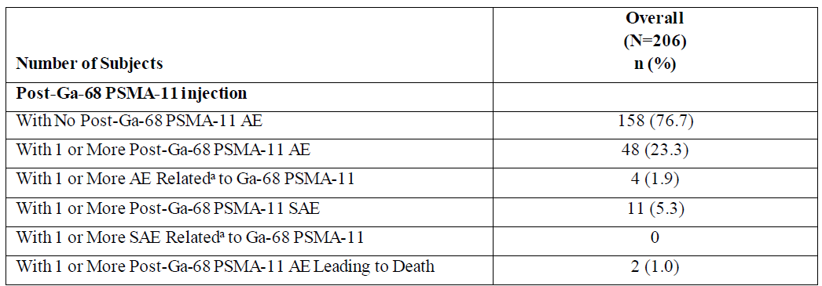
Abbreviations: AE = adverse event; n = number of subjects in a specific group; N = total number of subjects; SAE = serious adverse event.
a: Includes definitely related and possibly related adverse events
Safety was also assessed in the prospective, open label PK/biodistribution study (Study Ga68PSMA-2016-1) comparing [⁶⁸Ga] gallium PSMA-11 prepared by a classical synthesiser method compared to the Telix kit in three healthy volunteers. In Study ⁶⁸GaPSMA-2016-1, the three healthy participants had two separate [⁶⁸Ga] gallium PSMA-11 injections (each prepared by a different method) 7 to 15 days apart. The doses of [⁶⁸Ga] gallium PSMA-11 received by the three participants ranged from 173 to 188 MBq for doses prepared using the kit and from 162 to 192 MBq for doses prepared using the synthesiser method. Safety data included vital signs, laboratory measurements, and adverse events. Adverse events were to be collected through close monitoring during the time in hospital and by phone calls made at 24 hours and one week post-injection. There were three adverse events reported in two subjects, all were assessed as mild. One participant had a minor increase in serum amylase at three hours post-injection with the PSMA-11 scintomics treatment and 14 days after the Telix preparation. The adverse events was assessed by the investigator as likely to be related to [⁶⁸Ga] gallium PSMA-11 . One participant had an episode of abdominal pain, similar to that previously experienced by the participant, together with a minor rise in white cell count. This was thought by the investigator to likely represent chronic bowel inflammation and not to be related to [⁶⁸Ga] gallium PSMA-11.

Published literature
The sponsor presented 11 published studies involving a total of 1,852 patients with primary or biochemically recurrent prostate cancer prostate cancer. The clinical evaluator highlighted limitations in the safety reporting in these studies, as 8 of the 11 studies did not describe the methodology for collection of safety data, and three did not report any safety data.
In the single centre prospective study by Lawnh-Heath et al (2019);, 150 patients with biochemically recurrent prostate cancer prostate cancer received [⁶⁸Ga] gallium PSMA-11 PET/CT or PET/MRI with a dose activity of 199.8 ±48.1 MBq (range 107.3 to 273.8 MBq). 110 of 150 patients received furosemide 20 mg intravenously concurrent with the radiotracer. Four adverse events (dizzy, fall, nausea, constipation) were reported in four (2.7%) patients.
Nielsen et al. (2017); reported the clinical safety profile of the [⁶⁸Ga] gallium PSMA-11 ligand for PET/CT imaging using safety data from two prospective clinical trials conducted by the authors and in which the Danish Medicines Agency had mandated detailed safety monitoring and reporting using standardised criteria. One study was a fully recruited investigation of [⁶⁸Ga] gallium PSMA-11 PET/CT compared to MRI and [¹⁸F] sodium fluoride PET/CT in patients with recurrent prostate cancer; the other study was an ongoing diagnostic test accuracy study for staging of prostate cancer. 88 patients were included in the analysis, 18 with prostate cancer for staging and 78 with recurrent prostate cancer. Mean age was 68 years, mean PSA level was 5.1 ng/ml. The product was administered as an intravenous bolus injection of 2 MBq/kg body weight (mean administered activity, 166 ±27 MBq; range, 91 to 223 MBq). There were no clinical adverse events reported (by interview or spontaneous reporting) in any patients at any time point from the time of [⁶⁸Ga] gallium PSMA-11 injection until the end of the day of the PET/CT. No patients spontaneously reported any late adverse events.
Fendler et al. (2019);47 reported findings from the PSMA-BCR study, which was evaluated by the FDA in the recently approved new drug applications for [⁶⁸Ga] gallium PSMA-11 in the USA. PSMA-BCR was a prospective study evaluating the diagnostic efficacy and safety of Ga-68 PSMA-11 in biochemically recurrent prostate cancer. Patients were observed for two hours post-Ga-68 PSMA-11 administration for adverse events and for blood pressure and heart rate measurements. Patients were contacted after leaving the imaging facility to record any delayed adverse events. A total of 635 patients with biochemically recurrent prostate cancer post-prostatectomy were evaluated. Patients received a single dose of Ga-68 PSMA-11 of 189 ± 40 MBq (mean ± standard deviation) together with 20 mg of furosemide. 15 (2.3%) of 635 patients reported Grade 1 adverse events (see Table 28). No Grade 2 or higher adverse events were reported.
Table 28: Fendler et al. (2019) Number of subjects reporting adverse events by severity and System Organ Class
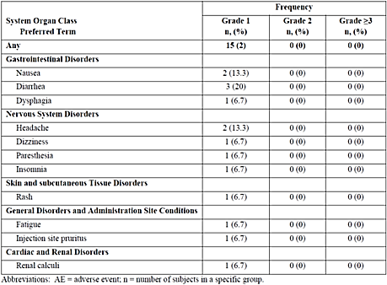
Abbreviations: AE = adverse events; n = number of subjects in a specific group.
Source: Fendler WP, Calais J, Eiber M, et al. Assessment of 68Ga-PSMA-11 PET Accuracy in Localizing Recurrent Prostate Cancer: A Prospective Single-Arm Clinical Trial. JAMA Oncol. 2019;5(6):856–863
In the randomised, controlled study by Hofman et al. (2020);¹⁴ (ProPSMA trial), no adverse events to [⁶⁸Ga] gallium PSMA-11 were reported, though the methodology for collecting safety data was not clearly defined.

Radiation safety
Radiation safety was addressed in the study protocol for the prospective MSKCC study, which was the source of data for the retrospective Study BCR-RET-01:
‘there is radiation delivered from the ⁶⁸Ga and from the low dose CT scan that are performed as part of the PET/CT for attenuation correction and co-registration. Although any exposure to ionizing radiation has the potential to cause some harm to tissue, the radiation exposures in this study are comparable to the low-level exposures associated with common diagnostic procedures such as CT scanning. There remains a low theoretical risk of developing a cancer at some point later in life as a result of the radiation exposure received in this study.’
Hofman et al. (2020);14 reported that radiation exposure from first-line imaging was higher with conventional imaging (19.2 mSv) than [⁶⁸Ga] gallium PSMA-11 PET/CT (8.4 mSv). This is consistent with the estimate made by Nielsen et al. (2017);51 that radiation dose of 200 MBq of Ga-68 PSMA 11 PET/CT to patients would be 6 mSv (3 mSv from [⁶⁸Ga] gallium PSMA-11 PET plus approximately 3 mSv from the low dose CT).

Risk management plan
There was no requirement for a risk management plan evaluation for a submission of this type.

Risk-benefit analysis

Delegate’s considerations

Diagnostic efficacy
The evidence of the diagnostic efficacy of the Telix Kit (that is, the Illuccix Kit submitted for approval in this submission) is based on the sponsor’s own studies as well as published studies reporting the diagnostic efficacy of [⁶⁸Ga] gallium PSMA-11 PET/CT.

Clinical studies
Study BCR-RET-01 was a retrospective, open label study which aimed to demonstrate the diagnostic efficacy of the Telix kit in patients with biochemically recurrent prostate cancer by correlating [⁶⁸Ga] gallium PSMA-11 findings against standards of reference, including histopathology and conventional imaging. The original prospective study conducted by MSKCC was a compassionate use study so clinical investigation of positive [⁶⁸Ga] gallium PSMA-11 PET findings was at the discretion of the treating clinician. Consequently, 74 of 422 (17.5%) patients in the full analysis set had no reference standard data, and only 57 (13.5%) had histopathology data. The rest relied on conventional imaging as the reference standard. Conventional imaging has limitations in detecting prostate cancer in pelvic lymph nodes and distant sites, so the reliance on conventional imaging as the reference standard for many of the patients in this study impacted on the evaluation of diagnostic efficacy.
The assessment of diagnostic efficacy was based on novel co-primary endpoints (correct detection rate and verified localisation rate ) for which the thresholds of success have not been formally validated. The sponsor received pre-new drug application advice from the FDA recommending that the primary analysis of the diagnostic performance of [⁶⁸Ga] gallium PSMA-11 PET should be measured against a reference standard constructed from histologic confirmation whenever possible, that correct detection rate and verified localisation rate should be co-primary endpoints, and that the thresholds of success for these endpoints should be pre-specified.
Correct detection rate has been evaluated by the FDA as part of the assessment of several PSMA-directed radiopharmaceuticals, including [⁶⁸Ga] gallium PSMA-11 products developed by University of California, Los Angeles (UCLA) and University of California, San Francisco (UCSF);^{32,33} and [¹⁸F] piflufolastat., In the prospective, single arm, open label Study PSMA-BCR;⁴⁷ supporting the [⁶⁸Ga] gallium PSMA-11 products developed by University of California, Los Angeles and University of California, San Francisco, correct detection rate was 28% (95% CI 23%, 34%) for histopathological reference standard and 51% (95% CI 46%, 56%) for composite reference standard. The Phase III CONDOR trial;⁴⁴ which evaluated ¹⁸F] piflufolastat had a primary endpoint of correct localisation rate, but the FDA determined, after clarifying the population in which the correct detection rate would be assessed, that correct localisation rate is a patient-level PPV metric. The CONDOR trial also included CDR as an exploratory endpoint. A 20% threshold was pre-defined for both correct localisation rate (PPV) and correct detection rate . The FDA outlined in their published review of Pylarify, [¹⁸F] piflufolastat that:
‘Note that there are concerns regarding the clinical relevance of a 20% threshold for patient-level PPV, however, as will be detailed later, the results far exceeded this threshold. From an FDA perspective, a 20% threshold is considered more appropriate for a CDR endpoint, defined as the fraction of true positive patients among all patients scanned with piflufolastat F 18 PET and evaluated by the central readers’.
The sponsor has advised that correct detection rate and verified localisation rate were selected as co-primary endpoints in Study BCR-RET-01 based on pre-new drug application guidance from the FDA, and that the 20% threshold for correct detection rate in Study BCR-RET-01 was selected based on the correct detection rate threshold in the CONDOR trial.
Study BCR-RET-01 was successful in achieving the pre-defined threshold of success for both co-primary endpoints. Correct detection rates for the three independent readers ranged from 41.1% to 45.7%, with the lower bound of the 95% CI for each of the three readers (35.9%, 39.2%, 40.4%) clearly exceeding the pre-defined threshold of 20%. Verified localisation rates for the three readers ranged from 36.2% to 50%, with the lower bound of the 95% CI for each of the three readers (31.6%, 41.8%, 44.6%) clearly exceeding the pre-defined threshold of 10%.
In terms of traditional measures of diagnostic performance, sensitivity ranged from 81% to 90.9% in the full patient analysis set for the three readers and was 100% in the patient histopathology only set for all three readers. PPV ranged from 71.2% to 78.3% in the full patient analysis set for the three readers, and from 81.3% to 87.9% in the patient histopathology only set.
Correct detection rate and verified localisation rates are novel endpoints which have not been formally validated, so there is some uncertainty regarding clinically relevant thresholds of success for these endpoints. The extent to which the outcomes for correct detection rates and verified localisation rates exceeded the pre-defined thresholds for all three of the independent readers provides some assurance regarding the clinical relevance of the findings.
Correct detection rate and verified localisation rates were highest in the patient histopathology only population, lower in the patient composite population (where many patients had only conventional imaging as the reference standard), and lowest in the full patient analysis population (where 74 of 422 patients had no reference standard data). These findings illustrate the challenge in evaluating [⁶⁸Ga] gallium PSMA-11 PET/CT findings against a reference standard with known limitations in its diagnostic performance. Histopathology is preferred as a reference standard over conventional imaging, but biopsy specimens will not always be available, particularly in retrospective studies. Even in prospective studies, it may not be feasible or ethical to obtain histopathological confirmation of all imaging findings. Whilst histopathology provides a standard of truth for confirmation of prostate cancer, the presence of micro-metastatic disease on histopathology may not be detectable by imaging modalities, contributing to false negative imaging findings.
Study ANMI-PG01-C301 was presented as a supportive study, but the findings from this study are constrained by a lack of reference standard data to substantiate [⁶⁸Ga] gallium PSMA-11 PET-CT findings. The majority of the lesions identified initially on the [⁶⁸Ga] gallium PSMA-11 PET-CT were confirmed by the investigators’ clinical judgment after retrospective evaluation of the medical records, rather than by objective correlative data. Only 44 lesions, 19 of which were positive on [⁶⁸Ga] gallium PSMA-11 PET-CT, were evaluable under the standard of truth algorithm. Additional analyses relied heavily on the clinical interpretation of the investigators, and a default interpretation of ‘confirmed’ malignant unless a clinical finding came against the diagnosis, so the findings are subject to a high risk of bias.

Literature review
The sponsor presented 56 articles relating to the diagnostic efficacy of [⁶⁸Ga] gallium PSMA-11 PET/CT in primary staging of prostate cancer and 39 relating to biochemically recurrent prostate cancer. In studies of primary staging, the sensitivity and specificity of [⁶⁸Ga] gallium PSMA-11 PET/CT ranged from 24% to 100% and 45% to 100%, respectively. PPV and NPV ranged from 60% to 100% and 25% to 100%, respectively. Changes in patient management due to [⁶⁸Ga] gallium PSMA-11 PET/CT findings were reported in 19 to 52% of patients across seven studies. None of the studies presented in the literature search reported on the novel endpoints CDR and VLR. In studies of patients with biochemically recurrent prostate cancer, the sensitivity and specificity of [⁶⁸Ga] gallium PSMA-11 PET/CT ranged from 63% to 100%. PPV and NPV ranged from 50% to 100% and 21% to 100%, respectively. Changes in patient management due to [⁶⁸Ga] gallium PSMA-11 PET/CT findings were reported in 30 to 75% of patients with biochemically recurrent prostate cancer across seven studies.
Most of the published studies involved [⁶⁸Ga] gallium PSMA-11 produced by methods other than the Telix kit, but the submission has provided sufficient evidence to conclude that the diagnostic performance of [⁶⁸Ga] gallium PSMA-11 prepared with the Telix kit is expected to be comparable to that prepared by other methods.
Hofman et al. (2020);14 reported findings from the ProPSMA study, an Australian, multi-centre, randomised controlled trial assessing the diagnostic accuracy of [⁶⁸Ga] gallium PSMA-11 PET/CT compared to conventional imaging (CT and bone scan) in first line imaging of patients with high-risk prostate cancer who were being considered for radical prostatectomy or radiotherapy with curative intent. This study demonstrated that [⁶⁸Ga] gallium PSMA-11 PET/CT had greater accuracy than conventional imaging (92% versus 65%; p < 0.0001) in detecting pelvic nodal or distant metastatic disease in first line staging of high risk prostate cancer. Sensitivity and specificity for [⁶⁸Ga] gallium PSMA-11 PET/CT were 85% and 98%, respectively, compared to 38% and 91% for conventional imaging. First-line imaging with [⁶⁸Ga] gallium PSMA-11 PET/CT conferred change in clinical management more frequently than conventional imaging (28% versus 15%), supporting the clinical utility of [⁶⁸Ga] gallium PSMA-11 PET/CT imaging.
The findings reported by Hofman et al (2020);14 are supported by retrospective studies describing the diagnostic performance of Ga-68 PSMA PET/CT compared to conventional imaging in the staging of pelvic lymph nodes before prostatectomy with histopathology as the standard of reference.,
The prospective PSMA-BCR study by Fendler et al. (2019);47 supports the diagnostic efficacy of [⁶⁸Ga] gallium PSMA-11 in patients with biochemically recurrent prostate cancer. On a per-patient basis, PPV was 0.84 by histopathologic validation (primary endpoint, n = 87) and 0.92 by the composite reference standard (n = 217).

Safety
The safety evaluation included safety data from clinical studies of the sponsor’s product as well as safety data for [⁶⁸Ga] gallium PSMA-11 reported in published literature. The reporting of safety varied substantially across the studies, with much of the safety data derived from retrospective studies which relied on safety data recorded in patients’ clinical records. Many of the published studies did not describe the methodology for adverse event reporting.
Studies BCR-RET-01 and ANMI-PG01-C301 provide limited safety data due to their retrospective design and reliance upon adverse events recorded in the clinical notes. No adverse events were reported in Study ANMI-PG01-C301. Two adverse events were reported in one patient in Study BCR-RET-01, but both events occurred 26 days after [⁶⁸Ga] gallium PSMA-11 administration and were assessed as unrelated to Ga-68 PSMA-11. The adverse event of a minor raise in serum amylase in one of the three healthy volunteers in Study Ga68PSMA-2016 was considered plausibly related to [⁶⁸Ga] gallium PSMA-11 administration.
Study PSMA-617-01 reported safety data for [⁶⁸Ga] gallium PSMA-11 prepared using the Telix kit and administered to patients with progressive, metastatic castration resistant prostate cancer. 109 adverse events were reported in 48 participants, but there was only one treatment related adverse event reported within the six day window post-administration (injection site warmth, mild).
Nielsen et al. (2017);51 reported the clinical safety profile of [⁶⁸Ga] gallium PSMA-11 based on safety data from two prospective clinical trials in which the Danish Medicines Agency had mandated detailed safety monitoring and reporting using standardised criteria. 88 patients were included in the analysis, 18 patients with prostate cancer for staging and 78 patients with recurrent prostate cancer. No adverse events were reported in any patients from the time of [⁶⁸Ga] gallium PSMA-11 injection until the end of the day of the PET/CT, and no patients spontaneously reported any late adverse events.
In the prospective PSMA-BCR study reported by Fendler et al. (2017);41, 635 patients with biochemically recurrent prostate cancerpost-prostatectomy received a single dose of [⁶⁸Ga] gallium PSMA-11 of 189 ±40 MBq (mean ± standard deviation) together with 20 mg of furosemide. 15 (2.3%) patients reported Grade 1 adverse events. Diarrhoea was reported in three patients, and nausea and headache were reported in two patients. No Grade 2 or higher adverse events were reported.
[⁶⁸Ga] gallium PSMA-11 PET/CT involves radiation exposure which would contribute to a patient’s overall long term cumulative radiation exposure. Hofman et al. (2020);14 reported that radiation exposure from [⁶⁸Ga] gallium PSMA-11 PET/CT was less than half that of conventional imaging. [⁶⁸Ga] gallium PSMA-11 PET/CT is performed under the professional supervision of clinical experts in nuclear medicine imaging. Radiation dosimetry and radiation risk are adequately addressed in the proposed Product Information.
There are limitations in the safety dataset, but given the nature of the proposed product, which is administered as a microdose for single-episode PET/CT imaging, the Delegate is satisfied that the clinical safety of the Illuccix kit for radiopharmaceutical preparation is acceptable.

Deficiencies and limitations of the data
The main efficacy study, Study BCR-RET-01, was a retrospective analysis which relied on conventional imaging as the reference standard for the majority of patients. Only 57 (13.5%) patients in the full analysis set had histopathology reference data, and 74 (17.5%) had no reference standard data. The reliance on conventional imaging as a reference standard is likely to have impacted on the assessment of the diagnostic efficacy of [⁶⁸Ga] gallium PSMA-11 PET/CT due to the limitations in conventional imaging in detecting prostate cancer in lymph nodes and distant sites.
Correct detection rate and verified localisation rate are novel endpoints, and the clinical relevance of the pre-defined thresholds of success has not been validated.
There are no data demonstrating the impact of [⁶⁸Ga] gallium PSMA-11 PET/CT imaging on clinical outcomes, such as overall survival.

Proposed Indication
The initially proposed indication was:
Illuccix, after radiolabelling with Ga-68, is a radioactive diagnostic agent indicated for use with positron emission tomography (PET) for the evaluation of prostate cancer.
The clinical evaluator commented that most of the evidence presented in this submission has been limited to two patient groups: patients with newly diagnosed intermediate-high risk prostate cancer, and patients with biochemical recurrence. The clinical evaluator noted that the indications for the recently approved [⁶⁸Ga] gallium PSMA-11 and [¹⁸F] [¹⁸F] piflufolastat products in the USA have been limited to these two populations (see Regulatory status). The evaluator also noted differences in the proposed indications for Illuccix in the EU and Canada (see Regulatory status).
In response to the evaluator’s comments on the proposed indication, the sponsor submitted a revised indication:
Illuccix, after radiolabelling with Ga-68, is a radioactive PSMA diagnostic agent indicated for use with positron emission tomography (PET) imaging combined with Computerised Tomography (CT) scan in men with prostate cancer:
    - who are at risk of metastasis and who are suitable for initial definitive therapy.
    - who have suspected recurrence based on elevated serum prostate specific antigen (PSA) level.
    - who are candidates for PSMA targeted therapy.
The sponsor provided a rationale for specifying these three patient populations, which is summarised in the clinical evaluation report [beyond the scope of this AusPAR]. With regard to the proposed use in patients who are candidates for PSMA targeted therapy, the evaluator commented that the VISION trial (Study PSMA-617-01) is ongoing and no outcome data are available. The evaluator concluded that the benefit of [⁶⁸Ga] gallium PSMA-11 PET/CT in this setting has not been established and recommended that this population should not be included in the indication.
The evaluator was of the opinion that a broad indication should be considered, but also recommended expert advice regarding a broad indication (‘for the evaluation of prostate cancer’) versus an indication limited to the populations for which efficacy and safety data have been evaluated.
Subject to advice from Advisory Committee on Medicines, the Delegate’s preference is for an indication aligned to the populations for which efficacy and safety data have been evaluated. The efficacy of [⁶⁸Ga] gallium PSMA-11 PET/CT in patients who are candidates for PSMA-targeted therapy has not been evaluated in this submission, so the benefit in this population has not been established. Therefore, the Delegate’s view is that the indication should not include patients who are candidates for PSMA-targeted therapy.
Subject to advice from ACM, the Delegate is considering the following indication:
Illuccix, after radiolabelling with Ga-68, is a radioactive diagnostic agent indicated for use with positron emission tomography (PET) imaging combined with Computerised Tomography (CT) in patients with prostate cancer:
    - who are at risk of metastasis and who are suitable for initial definitive therapy.
    - who have suspected recurrence based on elevated serum prostate specific antigen (PSA) level

Proposed action
There are limitations in the clinical data presented in this submission, much of which was derived from retrospective studies, but the evidence overall supports the diagnostic efficacy, clinical utility, and safety of the Illuccix kit for radiopharmaceutical preparation. The diagnostic performance and safety of [⁶⁸Ga] gallium PSMA-11 prepared using the Illuccix kit is expected to be comparable to [⁶⁸Ga] gallium PSMA-11 prepared by traditional synthesiser methods incorporating a heating step. [⁶⁸Ga] gallium PSMA-11 can be prepared in a shorter time using the Illuccix kit compared to traditional methods.
The data presented in this submission support the diagnostic efficacy, clinical utility, and safety of [⁶⁸Ga] gallium PSMA-11 PET/CT for the evaluation of patients with intermediate to high risk prostate cancer who are candidates for initial definitive therapy, and for the evaluation of patients with biochemically recurrent prostate cancer. Conventional imaging has limitations in identifying prostate cancer in pelvic lymph nodes and at distant sites. The submission has provided satisfactory evidence that [⁶⁸Ga] gallium PSMA-11 PET/CT provides useful diagnostic information which can inform treatment decisions for patients with prostate cancer who are being considered for initial definitive therapy, and for patients with suspected recurrence based on elevated PSA. [⁶⁸Ga] gallium PSMA-11 PET/CT imaging can produce false positive and false negative results, as can conventional imaging, and this risk is addressed in precautionary guidance in Sections 4.2 and 4.4 of the proposed Product Information.
The sponsor initially sought a broad indication for the evaluation of prostate cancer, and subsequently submitted a revised indication during the course of the evaluation. The sponsor’s revised indication includes patients who are candidates for PSMA-targeted therapy. The efficacy and safety of PSMA-targeted therapy have not been evaluated by the TGA, so the Delegate do not support sponsor’s proposal to include this in the indication. Subject to advice from ACM, the Delegate is considering the following indication:
Illuccix, after radiolabelling with Ga-68, is a radioactive diagnostic agent indicated for use with positron emission tomography (PET) imaging combined with Computerised Tomography (CT) in patients with prostate cancer:
    - who are at risk of metastasis and who are suitable for initial definitive therapy.
    - who have suspected recurrence based on elevated serum prostate specific antigen (PSA) level.

Advisory Committee considerations
The Advisory Committee on Medicines (ACM), having considered the evaluations and the Delegate’s overview, as well as the sponsor’s response to these documents, advised the following.

Specific advice to the Delegate
- What is ACM’s perspective on the diagnostic performance and clinical utility of [⁶⁸Ga] gallium PSMA-11 PET/CT?
The ACM commented that in the primary staging, the Australian Phase III proPSMA trial;¹⁴ established the superior diagnostic accuracy of PSMA PET CT over conventional CT and bone scan imaging (area under the curve (AUC) of 92% versus 65%, respectively, p < 0.0001) and provided some evidence of superior clinical utility through a greater change in treatment intent, modality or technique compared with conventional imaging (28% versus 15%; p = 0.008).
The ACM additionally commented that in staging of biochemical recurrence, numerous studies have demonstrated the high diagnostic accuracy of PSMA PET CT in restaging with histopathology as the reference standard (AUC ranging between 88% to 99%). Some evidence of clinical utility was demonstrated in this population with multiple studies where 30% to 75% of patients had treatment plans modified by a PSMA PET CT result. However, the ACM noted that there is currently no seminal study demonstrating this.
The ACM were of the view that PSMA PET CT is the imaging modality with the highest diagnostic performance currently available for both primary and post-treatment nodal and distant staging or restaging of prostate cancer. Further noting that PSMA PET CT is now considered standard of care, with many major guidelines now recommending PSMA PET CT over conventional scans.
The ACM agreed that the Australian proPSMA study;¹⁴ which included randomised data of conventional versus PMSA PET CT imaging, has driven clinical usage in Australia and is supportive of good clinical utility, noting it is a whole body scan with high concordance and low radiation dose.
However, the ACM noted that much of evidence that supports diagnostic performance and clinically utility is based on generic PSMA tracers rather than the Illuccix kit. Noting this limitation, the ACM discussed that it is likely that all small molecule ligands targeting PSMA have similar performance and were of the view that the literature on PSMA PET CT appropriately establishes the superiority of [⁶⁸Ga] gallium PSMA-11 compared with conventional imaging.
The ACM advised that some caution is warranted when assessing the diagnostic performance data, as many studies have been retrospective and histopathological data may not have been available or complete as a reference standard. Some caution is also warranted when assessing clinical utility data, as prospective studies regarding survival benefit based on staging using PSMA PET CT remain pending.
- What is ACM’s advice regarding the proposed indication for Illuccix?
The ACM were of the view the indication for Illuccix should be limited to patients with newly diagnosed prostate cancer at risk of metastasis and who are suitable for initial definitive therapy, and patients with biochemical recurrence. While the ACM agreed that there were no safety concerns with a broader indication, they were of the view that the current evidence does not yet adequately demonstrate an open prostate cancer indication, however encouraged the generation of further data. The ACM did not support an indication for patients who are candidates for PSMA-targeted therapy, as data supporting this indication has not been submitted for evaluation.
Overall, the ACM were supportive of the indication:
Illuccix, after radiolabelling with Ga-68, is a radioactive diagnostic agent indicated for use with positron emission tomography (PET) imaging combined with Computerised Tomography (CT) in patients with prostate cancer:
    - who are at risk of metastasis and who are suitable for initial definitive therapy.
    - who have suspected recurrence based on elevated serum prostate specific antigen (PSA) level.
- Other advice.
The ACM expressed concern that having an approved product may impact access and cost of PSMA PET CT. The ACM were strongly supportive that a potential approval of Illuccix should not lead to a decrease in the availability of other agents.

Conclusion
The ACM considered this product to have an overall positive benefit-risk profile for the indication:
Illuccix, after radiolabelling with Ga-68, is a radioactive diagnostic agent indicated for use with positron emission tomography (PET) imaging combined with Computerised Tomography (CT) in patients with prostate cancer:
    - who are at risk of metastasis and who are suitable for initial definitive therapy.
    - who have suspected recurrence based on elevated serum prostate specific antigen (PSA) level.

Outcome
Based on a review of quality, safety and efficacy, the TGA approved the registration of:
- Illuccix Configuration A Kit for the Preparation of Ga-68 Glu-urea-Lys(ahx)-hbed-CC 25 microgram solution for injection Glass Vial
- Illuccix Configuration B Kit for the Preparation of Ga-68 Glu-urea-Lys(ahx)-hbed-CC 25 microgram solution for injection Glass Vial
The approval of the above products is for the following indication:
Illuccix, after radiolabelling with Ga-68, is a radioactive diagnostic agent indicated for use with positron emission tomography (PET) imaging combined with Computerised Tomography (CT) in patients with prostate cancer:
    - who are at risk of metastasis and who are suitable for initial definitive therapy.
    - who have suspected recurrence based on elevated serum prostate specific antigen (PSA) level.

Specific conditions of registration applying to these goods
- This approval does not impose any requirement for the submission of periodic safety update reports (PSURs). The sponsor should note that it is a requirement that all existing requirements for the submission of PSURs as a consequence of the initial registration or subsequent changes must be completed.

Attachment 1. Product Information
The PI for Illuccix approved with the submission which is described in this AusPAR is at Attachment 1. For the most recent PI, please refer to the TGA website at <https://www.tga.gov.au/product-information-pi>.

Therapeutic Goods Administration
PO Box 100 Woden ACT 2606 Australia
Email: info@tga.gov.au Phone: 1800 020 653 Fax: 02 6232 8605
https://www.tga.gov.au

The Black Triangle Scheme provides a simple means for practitioners and patients to identify certain types of new prescription medicines, including those being used in new ways and to encourage the reporting of adverse events associated with their use. The Black Triangle does not denote that there are known safety problems, just that the TGA is encouraging adverse event reporting to help us build up the full picture of a medicine's safety profile.
Stage IV is divided into stages IVA and IVB. In stage IVA, cancer is found in either or both sides of the prostate and may have spread to the seminal vesicles or to nearby tissue or organs, such as the rectum, bladder, or pelvic wall. Cancer has spread to nearby lymph nodes. The prostate-specific antigen (PSA) can be any level and the Grade Group is 1, 2, 3, 4, or 5 (Gleason score is 10 or less). In stage IVB, cancer has spread to other parts of the body, such as the bones or distant lymph nodes.
NCCI: Relative survival by stage at diagnosis (prostate cancer). National Cancer Control Indicators, Cancer Australia. Published 1 April 2019. Available at: https://ncci.canceraustralia.gov.au/outcomes/relative-survival-rate/relative-survival-stage-diagnosis-prostate-cancer
National Comprehensive Cancer Network (NCCN) Clinical Practice Guidelines in Oncology – Prostate Cancer, Version 2.2021; 17 February 2021
2021 EAU-EANM-ESTRO-ESUR-ISUP-SIOG PCa Guidelines publication. European Association of Urology. Updated guidelines are available at: https://uroweb.org/guidelines/prostate-cancer
Harisinghani, M.G., et al. Noninvasive detection of clinically occult lymph-node metastases in prostate cancer. N Engl J Med, 2003. 348: 2491.
Hovels, A.M., et al. The diagnostic accuracy of CT and MRI in the staging of pelvic lymph nodes in patients with prostate cancer: a meta-analysis. Clin Radiol, 2008. 63: 387.
Abuzallouf, S., et al. Baseline staging of newly diagnosed prostate cancer: a summary of the literature. J Urol, 2004. 171: 2122.
Gabriele, D., et al. Is there still a role for computed tomography and bone scintigraphy in prostate cancer staging? An analysis from the EUREKA-1 database. World J Urol, 2016. 34: 517.
Flanigan, R.C., et al. Limited efficacy of preoperative computed tomographic scanning for the evaluation of lymph node metastasis in patients before radical prostatectomy. Urology, 1996. 48: 428.
Tiguert, R., et al. Lymph node size does not correlate with the presence of prostate cancer metastasis. Urology, 1999. 53: 367.
Spevack, L., et al. Predicting the patient at low risk for lymph node metastasis with localized prostate cancer: an analysis of four statistical models. Int J Radiat Oncol Biol Phys, 1996. 34: 543.
TNM staging (or Tumour, Modes and Metastasis staging describe how far the cancer has spread The T-stage describes the size of the tumour and is usually detected using a digital rectal exam and/or an MRI scan. The N-stage describes whether the cancer has spread to the lymph nodes and is usually detected using an MRI or CT scan. Nodes can be N0 (negative) or N1 (positive). N1 indicates that the cancer has spread outside the prostate to one or more local lymph nodes. The M-stage tells you whether the cancer has spread to other areas in the body and it is usually detected using a bone scan. Metastasis can be M0 (negative) or M1 (positive). M1 indicates that the cancer has spread to other parts of the body.
Hofman et al. Prostate-specific membrane antigen PET-CT in patients with high-risk prostate cancer before curative-intent surgery or radiotherapy (proPSMA): a prospective, randomised, multicentre study. The Lancet Vol 395, Issue 10231, P1208-16, April 2020.
PSMA-11 is active ingredient (Glu-urea-Lys(ahx)-hbed-CC) discussed in the his AusPAR.
PSMA-617 is a human prostate-specific membrane antigen (PSMA)-targeting ligand. 177-Lutetium (¹⁷⁷Lu)-PSMA (also known as lutetium vipivotide vetraxetan) is a radioconjugate composed of PSMA-617 conjugated to the beta-emitting radioisotope lutetium-177 (¹⁷⁷Lu), with potential antineoplastic activity against PSMA-expressing tumour cells. It is a radioligand therapy that delivers beta-particle radiation to PSMA-expressing cells and the surrounding microenvironment.
DCFPyL: 2-(3-{1-carboxy-5-[(6-[(18)F]fluoro-pyridine-3-carbonyl)-amino]-pentyl}-ureido)-pentanedioic acid.
Gallium-68 [⁶⁸Ga] is a positron emitter with a half-life of 68 minutes, decaying to stable zinc-68. It is a radiopharmaceutical, generated in situ from the electron capture of germanium-68 (half-life 271 days) owing to its short half-life. This positron-emitting isotope can be imaged efficiently by PET scan.
Also known as [¹⁸F] piflufolastat.
Lutetium-177 [¹⁷⁷ Lu] is a positron emitter with a half-life of about 6.7 days. It is a radioactive isotope of lutetium and is used as a radiopharmaceutical.
Green MA, et al. Estimation of radiation dosimetry for 68Ga-HBED-CC (PSMA-11) in patients with suspected recurrence of prostate cancer. Nucl Med Biol. 2017 Mar; 46:32-35.
Beheshti M, et al. Optimal time-point for 68Ga-PSMA-11 PET/CT imaging in assessment of prostate cancer: feasibility of sterile cold-kit tracer preparation? Eur J Nucl Med Mol Imaging. 2018;45(7):1188-1196.
Radiopharmaceutical cold kits which are manufactured by a radiochemist or pharmacist in a public or private hospital for subsequent extemporaneous compounding and dispensing for use by a patient of that hospital, or a patient of another public or private hospital in the same state or territory, may be an exempt good under item 13 of Schedule 5 of the Therapeutic Goods Regulations 1990.
The Special Access Scheme (SAS) allows certain health practitioners to access therapeutic goods (such as medicines, medical devices or biologicals) that are not included in the Australian Register of Therapeutic Goods (ARTG) for a single patient. Therapeutic goods that are not included in the ARTG (and are not otherwise exempt from being in the ARTG) are described by us as 'unapproved'.
Item 1632 PSMA PET/CT imaging for informing treatment of patients with prostate cancer. Medical Services Advisory Committee meeting 29/30 July 2021; Department of Health, Australia. Available at: http://msac.gov.au/internet/msac/publishing.nsf/Content/MSAC-Meeting-July2021
MBS Review Taskforce 2018, Final Report on the MBS items for Nuclear Medicine. Medicare Benefits Schedule, Australia. Available at: https://www.health.gov.au/resources/publications/taskforce-final-report-mbs-items-for-nuclear-medicine
Ratified PICO for Application 1632: PSMA PET/CT Imaging for informing treatment in patients with prostate cancer, October 2020.
Maurer T, et al. Current use of PSMA-PET in prostate cancer management. Nat Rev Urol; 2016: 13:226-35.
Udovicich C, et al. 68Ga-prostate-specific membrane antigen positron emission tomography/computed tomography in advanced prostate cancer: Current state and future trends. Prostate International. 2017.
Roach PJ, et al. The impact of 68Ga-PSMA PET/CT on management intent in prostate cancer: results of an Australian prospective multicenter study. J Nucl Med. 2017; 59(1):82-88.
[⁶⁸Ga] Gallium DOTA conjugated peptides (including [⁶⁸Ga] DOTA-TATE, and DOTA-TOC) are used in positron emission tomography (PET) imaging of neuroendocrine tumours (NETs). Like SPECT-octreotide scans, an octreotide based somatostatin analogue is used as the radioligand, and the indications and uses are similar to ocreotide scans, however the is significant improvement in image quality. Many NETs have overexpression of somatostatin receptors, so that there is preferential [⁶⁸Ga] Gallium DOTA conjugated peptide take-up in these locations, and visualised on the scan.
FDA News Release: FDA Approves First PSMA-Targeted PET Imaging Drug for Men with Prostate Cancer. United States Food and Drug Administration; 1 December 2020. Available at: https://www.fda.gov/news-events/press-announcements/fda-approves-first-psma-targeted-pet-imaging-drug-men-prostate-cancer
Center For Drug Evaluation And Research Approval Package for: 212642Orig1s000 Gallium Ga 68 PSMA-11 Injection; NDA 212642. United States Food and Drug Administration; 1 December 2020. Available at: https://www.accessdata.fda.gov/drugsatfda_docs/nda/2020/212642Orig1s000Approv.pdf
The TGA has implemented a priority pathway for the registration of novel prescription medicines for Australian patients. The priority pathway provides a formal mechanism for faster assessment of vital and life-saving prescription medicines. The target timeframe of 150 working days is up to three months shorter than the standard prescription medicines registration process.
ICH M3 (R2) Non-clinical safety studies for the conduct of human clinical trials for pharmaceuticals. CPMP/ICH/286/95.
https://www.fda.gov/regulatory-information/search-fda-guidance-documents/microdose-radiopharmaceutical-diagnostic-drugs-nonclinical-study-recommendations
LNCaP cells are a cell line of human androgen-sensitive human prostate adenocarcinoma cells.
Sandgren K, et al. Radiation dosimetry of [68Ga]PSMA-11 in low-risk prostate cancer patients. EJNMMI Phys. 2019 Jan;6(1):2
Afshar-Oromieh, A., Malcher, A., Eder, M. et al. PET imaging with a [68Ga]gallium-labelled PSMA ligand for the diagnosis of prostate cancer: biodistribution in humans and first evaluation of tumour lesions. Eur J Nucl Med Mol Imaging 40, 486–495 (2013).
Prasad V, et al. Biodistribution of [(68)Ga]PSMA-HBED-CC in patients with prostate cancer: characterization of uptake in normal organs and tumour lesions. Mol Imaging Biol. 2016 Jun;18(3):428-436
Fendler et al. 68Ga-PSMA PET/CT: Joint EANM and SNMI procedure guideline for prostate cancer imaging: Version 1.0. Eur j Nuc Med Mol Imaging. 2017.
Calderoni et al. Evaluation of an Automated Module Synthesis and a Sterile Cold Kit–Based Preparation of 68Ga-PSMA-11 in Patients with Prostate Cancer. Journal of Nuclear Medicine. 2020; 61 (5) 716-722.
Official study title: PSMA PET Imaging of Recurrent Prostate Cancer; an open-label, non-randomised, parallel intervention Phase II study. National Clinical Trial ID: 03204123
Morris M, Rowe S, Gorin M, et al. Diagnostic Performance of 18F-DCFPyL-PET/CT in Men with Biochemically Recurrent Prostate Cancer: Results from the CONDOR Phase III, Multicenter Study. Clin Cancer Res. 2021;27(13):3674-3682.
The International Society for Urological Pathology (ISUP) Grade Group system uses five grades. Grade 1 is the least aggressive and Grade 5 is the most aggressive: Grade group 3 (Gleason score 4+3 = 7): Intermediate unfavourable; the cancer is moderately aggressive. Grade group 4 (Gleason score 8): High risk; the cancer is fast growing and aggressive. Grade group 5 (Gleason score 9 or 10): The highest risk; the cancer is fast growing and aggressive.
TNM Stage T3 means the cancer has broken through the capsule (covering) of the prostate gland. It’s divided into T3a and T3b. T3a means the cancer has broken through the capsule (covering) of the prostate gland. T3b means the cancer has spread into the tubes that carry semen (seminal vesicles).
Fendler WP, Calais J, Eiber M, et al. Assessment of ⁶⁸Ga-PSMA-11 PET Accuracy in Localizing Recurrent Prostate Cancer: A Prospective Single-Arm Clinical Trial. JAMA Oncol. 2019;5(6):856–863.
Center for Drug Evaluation and Research 212642Orig1s000 Multi-Discipline Review NDA/BLA Multi-Disciplinary Review and Evaluation NDA 212642 Gallium Ga 68 PSMA-11 Injection. United States Food and Drug Administration. 12 October 2018. Available at: https://www.accessdata.fda.gov/drugsatfda_docs/nda/2020/212642Orig1s000MutlidisciplineR.pdf
Sartor O, de Bono J, Chi KN, et al. Lutetium-177-PSMA-617 for Metastatic Castration-Resistant Prostate Cancer. N Engl J Med. 2021;385(12):1091-1103.
Lawhn-Heath C, et al. Single-center prospective evaluation of 68Ga-PSMA-11 PET in biochemical recurrence of prostate cancer. AJR Am J Roentgenol. 2019 Aug;213(2):266-274.
Nielsen, J. B., et al. A Comprehensive Safety Evaluation of 68Ga-Labeled Ligand Prostate-Specific Membrane Antigen 11 PET/CT in Prostate Cancer: The Results of 2 Prospective, Multicenter Trials. Clinical nuclear medicine. 2017; 42(7), 520–524.
The sponsor must still comply with routine product vigilance and risk minimisation requirements.
Press release: FDA approves second PSMA-targeted PET imaging drug for men with prostate cancer; United States Food and Drug Administration. 27 May 2021. Available at: https://www.fda.gov/drugs/news-events-human-drugs/fda-approves-second-psma-targeted-pet-imaging-drug-men-prostate-cancer
Center for Drug Evaluation And Research Approval Package for 214793Orig1s000, Pylarify piflufolastat F 18 injection. United States Food and Drug Administration. Available at: https://www.accessdata.fda.gov/drugsatfda_docs/nda/2021/214793Orig1s000Approv.pdf
Center for Drug Evaluation and Research: NDA/BLA NDA 214793 / Piflufolastat F 18 (Pylarify):multi-discipline review, (p.68). Available at: https://www.accessdata.fda.gov/drugsatfda_docs/nda/2021/214793Orig1s000MultidisciplineR.pdf
Maurer T, et al. Diagnostic efficacy of (68) gallium-PSMA positron emission tomography compared to conventional imaging for lymph node staging of 130 consecutive patients with intermediate to high risk prostate cancer. J Urol 2016;195: 1436–43.
Herlemann A, Wenter V, Kretschmer A, et al. Ga-PSMA positron emission tomography/computed tomography provides accurate staging of lymph node regions prior to lymph node dissection in patients with prostate cancer. Eur Urol 2016; 70: 553–57.
The ACM provides independent medical and scientific advice to the Minister for Health and the TGA on issues relating to the safety, quality and efficacy of medicines supplied in Australia including issues relating to pre market and post-market functions for medicines. Further information can be found here: https://www.tga.gov.au/committee/advisory-committee-medicines-acm.

