June 2022

Australian Public Assessment Report for Trastuzumab deruxtecan
  - Proprietary Product Name: Enhertu
  - Sponsor: AstraZeneca Pty Ltd

About the Therapeutic Goods Administration (TGA)
- The Therapeutic Goods Administration (TGA) is part of the Australian Government Department of Health and is responsible for regulating medicines and medical devices.
- The TGA administers the Therapeutic Goods Act 1989 (the Act), applying a risk management approach designed to ensure therapeutic goods supplied in Australia meet acceptable standards of quality, safety and efficacy (performance) when necessary.
- The work of the TGA is based on applying scientific and clinical expertise to decision-making, to ensure that the benefits to consumers outweigh any risks associated with the use of medicines and medical devices.
- The TGA relies on the public, healthcare professionals and industry to report problems with medicines or medical devices. TGA investigates reports received by it to determine any necessary regulatory action.
- To report a problem with a medicine or medical device, please see the information on the TGA website <https://www.tga.gov.au>.

About AusPARs
- An Australian Public Assessment Report (AusPAR) provides information about the evaluation of a prescription medicine and the considerations that led the TGA to approve or not approve a prescription medicine submission.
- AusPARs are prepared and published by the TGA.
- An AusPAR is prepared for submissions that relate to new chemical entities, generic medicines, major variations and extensions of indications.
- An AusPAR is a static document; it provides information that relates to a submission at a particular point in time.
- A new AusPAR will be developed to reflect changes to indications and/or major variations to a prescription medicine subject to evaluation by the TGA.

Copyright
© Commonwealth of Australia 2022
This work is copyright. You may reproduce the whole or part of this work in unaltered form for your own personal use or, if you are part of an organisation, for internal use within your organisation, but only if you or your organisation do not use the reproduction for any commercial purpose and retain this copyright notice and all disclaimer notices as part of that reproduction. Apart from rights to use as permitted by the Copyright Act 1968 or allowed by this copyright notice, all other rights are reserved and you are not allowed to reproduce the whole or any part of this work in any way (electronic or otherwise) without first being given specific written permission from the Commonwealth to do so. Requests and inquiries concerning reproduction and rights are to be sent to the TGA Copyright Officer, Therapeutic Goods Administration, PO Box 100, Woden ACT 2606 or emailed to <tga.copyright@tga.gov.au>.

Contents
List of abbreviations 4
I. Introduction to product submission 7
Submission details 7
Product background 8
Regulatory status 11
Product Information 13
II. Registration timeline 13
III. Submission overview and risk/benefit assessment 14
Quality 14
Nonclinical 15
Clinical 16
Risk management plan 32
Risk-benefit analysis 35
Outcome 37
Attachment 1. Product Information 38

List of abbreviations
Abbreviation | Meaning
ADA | Anti-drug antibody
ADCC | Antibody dependent cellular cytotoxic
AE | Adverse event
ARTG | Australian Register of Therapeutic Goods
ASA | Australia specific annex
AUC | Area under the concentration time curve
AUC_{0-21days} | Area under the concentration time curve from time zero to 21 days
AUC_{tau} | Area under the concentration time curve during the dosing interval
BOR | Best overall response
C_{avg} | Average concentration
CI | Confidence interval
C_{max} | Maximum concentration
C_{min} | Minimum concentration
CPD | Certified Product Details
CR | Complete response
CT | Computed tomography
CV | Coefficient of variation
DLP | Data lock point
DOR | Duration of response
ECHO | Echocardiogram
ECOG PS | Eastern Cooperative Oncology Group performance status
EU | European Union
FDA | Food and Drug Administration (United States of America)
FL-DP1 | Frozen liquid drug product 1
FL-DP2 | Frozen liquid drug product 2
HER2 | Human epidermal growth factor receptor 2
HCP | Health Care Professional
IC₅₀ | Half maximal (50%) inhibitory concentration
ICR | Independent central review
ILD | Interstitial lung disease
IRR | Infusion related reaction
LVEF | Left ventricular ejection fraction
Lyo-DP | Lyophilised powder-drug product
MAAA-1181a | Active topoisomerase I inhibitor of Trastuzumab deruxtecan
MAb | Monoclonal antibody
MRI | Magnetic resonance imaging
MTD | Maximum tolerated dose
MUGA | Multigated acquisition
OCE | Oncology Center of Excellence (United States of America)
OR | Overall response
ORR | Objective response rate
PFS | Progression free survival
PI | Product Information
PK | Pharmacokinetic(s)
PopPK | Population pharmacokinetic(s)
PR | Partial response
PT | Preferred Term
RMP | Risk management plan
t_{1/2} | Half-life
TEAE | Treatment-emergent adverse event
TGA | Therapeutic Goods Administration
USA | United States of America

I. Introduction to product submission

Submission details
Type of submission: | New biological entity
Product name: | Enhertu
Active ingredient: | Trastuzumab deruxtecan
Decision: | Approved for provisional registration
Date of decision: | 5 October 2021
Date of entry onto ARTG: | 8 October 2021
ARTG number: | 343262
Black Triangle Scheme: | Yes  As a provisionally registered product, this medicine will remain in the Black Triangle Scheme for the duration of its provisional registration
Sponsor’s name and address: | AstraZeneca Pty Ltd  66 Talavera Road  Macquarie Park, NSW, 2113
Dose form: | Powder for injection
Strength: | 100 mg
Container: | Vial
Pack size: | One
Approved therapeutic use: | Enhertu is indicated for the treatment of adult patients with unresectable or metastatic HER2 positive breast cancer who have received two or more prior anti HER2-based regimens.  This indication is approved via the provisional approval pathway, based on overall response rate and duration of response. Full registration for this indication depends on verification and description of clinical benefit in a confirmatory trial.
Route of administration: | Intravenous infusion
Dosage: | The recommended dose of Enhertu is 5.4 mg/kg given as an intravenous infusion once every 3 weeks (21 day cycle) until disease progression or unacceptable toxicity.  Management of adverse reactions may require temporary interruption, dose reduction, or treatment discontinuation of Enhertu per guidelines provided in the Product Information.  For further information regarding dosage, refer to the Product Information.
Pregnancy category: | D  Drugs which have caused, are suspected to have caused or may be expected to cause, an increased incidence of human fetal malformations or irreversible damage. These drugs may also have adverse pharmacological effects. Accompanying texts should be consulted for further details.  The use of any medicine during pregnancy requires careful consideration of both risks and benefits by the treating health professional. This must not be used as the sole basis of decision making in the use of medicines during pregnancy. The TGA does not provide advice on the use of medicines in pregnancy for specific cases. More information is available from obstetric drug information services in your State or Territory.

Product background
This AusPAR describes the application by AstraZeneca Pty Ltd (the sponsor) to register Enhertu (Trastuzumab deruxtecan) 100 mg, powder for injection, for the following proposed indication:
Enhertu is indicated for the treatment of adult patients with unresectable or metastatic HER2-positive breast cancer who have received two or more prior anti-HER2-based regimens.
Breast cancer is the most commonly diagnosed female cancer and the second most leading cause of cancer death in women., Breast cancer is mainly a female disease, with only 1% of cases occurring in males worldwide, and occurs more frequently in women over 40 years of age.^{2,3} Known risk factors for breast cancer include older age, family history, genetic alterations, hormone therapy, and obesity.
Approximately 20% of patients with breast cancer have human epidermal growth factor receptor 2 (HER2)-positive tumours (that is tumours scored as 3 + by immunohistochemistry or that demonstrate gene amplification by in situ hybridisation). HER2 positivity is associated with a more aggressive disease and a younger patient population. Based on 2010 Surveillance, Epidemiology, and End results (SEER-medicare); data collected in the United States of America (USA), at diagnosis, patients with HER2-positive breast cancer are less likely to be above 65 years old, and more likely to present at Stage III or IV; than either hormone receptor positive/HER2-negative or triple negative breast cancer, with tumours that are 6.4-fold to 16.8-fold more likely to be high grade compared to hormone receptor-positive/HER2-negative tumours.⁶
Metastatic HER2-positive breast cancer remains a fatal disease. Although treatment with anti-HER2 therapies has improved the disease outcomes for patients with unresectable or metastatic HER2-positive breast cancer, patients invariably progress.⁴
There is no standard treatment regimen for patients with unresectable or metastatic HER2-positive breast cancer who have received two or more prior anti-HER2 based regimens. The following HER2-directed therapies are registered in Australia for use in combination with other chemotherapeutic agents in the neoadjuvant, adjuvant and/or follow on treatment of HER2-positive breast cancer:
- Monoclonal antibodies
  - Trastuzumab; pertuzumab;, and a combination of Trastuzumab/pertuzumab;,
- Monoclonal antibody drug conjugates
  - Trastuzumab emtansine;,
- Tyrosine kinase inhibitors
  - neratinib;, tucatinib; and lapatinib.
The standard of care for first line metastatic HER2 positive breast cancer in the USA is the combination of Trastuzumab, pertuzumab, and taxane.
To date there is only one other monoclonal antibody drug conjugate approved for use in the treatment of HER2-positive breast cancer in Australia. Trastuzumab emtansine (Kadcyla)^{13,14} contains the humanised anti-HER2 immunoglobulin G subclass 1 (IgG1) antibody Trastuzumab, covalently linked to the small molecule cytotoxin, DM1. It is the preferred second line treatment option in the USA and is also indicated as a single agent for the treatment of patients with HER2-positive metastatic (Stage IV) breast cancer who have previously received Trastuzumab and a taxane, separately or in combination. Beyond the second line, treatment options are more limited and include lapatinib and capecitabine, or Trastuzumab combined with a chemotherapeutic agent.
Recently, results from two studies evaluating combination therapies in patients with metastatic HER2-positive breast cancer who had received two or more prior regimens of anti-HER2 therapy underlined the poor disease outcomes for this patient population. The SOPHIA trial; was a randomised (1:1), open label, Phase III study comparing margetuximab plus chemotherapy (n = 266) versus Trastuzumab plus chemotherapy (n = 270) in patients with metastatic HER2-positive breast cancer who had received pertuzumab and 1 to 3 prior lines of therapy. Ninety-one percent of patients randomised to the margetuximab plus chemotherapy arm and 92% of patients randomised to the Trastuzumab plus chemotherapy arm had received prior Trastuzumab emtansine. The NALA trial; was a randomised (1:1), open label, Phase III study comparing neratinib plus capecitabine (n = 307) versus. lapatinib plus capecitabine (n = 314) in patients with metastatic HER2 positive breast cancer who had received two or more prior lines of anti-HER2 therapy. In the SOPHIA trial, the objective response rate was 22% (95% confidence interval (CI): 17.3, 27.7) for the margetuximab plus chemotherapy arm and 16% (95% CI: 11.8, 21) for the Trastuzumab plus chemotherapy arm. In the NALA trial, the objective response rate was 32.8% (95% CI: 27.6, 38.1) for the neratinib plus capecitabine arm and 26.7% (95% CI: 21.8, 31.6) for the lapatinib plus capecitabine arm. Across the four arms in these two trials, the median progression free survival was < 6 months.
For Kadcyla (Trastuzumab emtansine);13 the indication referring to metastatic breast cancer is:
Kadcyla, as a single agent, is indicated for the treatment of patients with HER2-positive metastatic (Stage IV) breast cancer who previously received Trastuzumab and a taxane, separately or in combination. Patients should have either:
    - Received prior therapy for metastatic disease, or
    - Developed disease recurrence during or within six months of completing adjuvant therapy.
The above indication was supported primarily by results from the EMILIA trial; in patients with HER2 positive unresectable, locally advanced breast cancer or metastatic breast cancer who had received prior taxane and Trastuzumab based therapy, including patients who received prior therapy with Trastuzumab and a taxane in the adjuvant setting and who relapsed within six months of completing adjuvant therapy. Patients received Kadcyla or lapatinib plus capecitabine. The progression-free survival rate in the Kadcyla arm was 46.5% with a median duration of PFS of 9.6 months. The overall response rate for patients given Kadcyla was determined from patients with detectable disease and was 43.6% with a median duration of overall response of 12.6 months.
For Perjeta (pertuzumab);9^{,10} the indication referring to metastatic breast cancer is:
Perjeta is indicated in combination with Trastuzumab and docetaxel for patients with metastatic HER2-positive breast cancer who have not received prior anti-HER2 therapy or chemotherapy for their metastatic disease.
The above indication was supported by results from the CLEOPATRA trial; in patients with HER2-positive metastatic (n = 789) or locally recurrent unresectable breast cancer (n = 19) and who had not received previous anti-HER2 therapy or chemotherapy for their metastatic disease. Patients received placebo plus Trastuzumab and docetaxel (placebo group) or Perjeta plus Trastuzumab and docetaxel. At the time of the primary progression-free survival analysis, which was after a mean of 16.2 times 3-week cycles for the placebo group and 19.9 cycles for the placebo group the progression-free survival rate was 61% in the placebo group and 52.5% in the Perjeta group. Median progression-free survival was 12.4 months in the placebo treated group versus 18.5 months in the Perjeta treated group. The overall response rate was 69.3% in the placebo group and 80.2% in the Perjeta group with median response durations of 54.5 weeks and 87.6 weeks respectively.
This evaluation was facilitated through Project Orbis, an initiative of the United States Food and Drug Administration (FDA) Oncology Center of Excellence (OCE). Under this project, the FDA and the TGA collaboratively reviewed the application. This innovative evaluation process provided a framework for process alignment and management of evaluation issues in real-time across jurisdictions.
Each regulator agency maintained its regulatory process to make independent decisions about the approval (market authorisation).

Regulatory status
This product is considered a new biological entity for Australian regulatory purposes.
At the time the TGA considered this application, a similar application had been approved European Union (EU) on 18 January 2021, USA on 20 December 2019, Japan on 25 March 2020, Canada on 15 April 2021 and in United Kingdom on 12 February 2021. It was under consideration in Switzerland and Singapore. A summary of the international regulatory status and the wording of indications overseas is available in Table 1 below.
Table 1: International regulatory status
Region | Submission date | Status | Approved indications
European Union via centralised procedure | 22 May 2020 | Approved on 18 January 2021 | Enhertu as monotherapy is indicated for the treatment of adult patients with unresectable or metastatic HER2-positive breast cancer who have received two or more prior anti-HER2-based regimens.
United States of America | 29 August 2019 | Approved on 20 December 2019 | Enhertu is a HER2-directed antibody and topoisomerase inhibitor conjugate indicated for the treatment of adult patients with unresectable or metastatic HER2-positive breast cancer who have received two or more prior anti-HER2-based regimens in the metastatic setting.  This indication is approved under accelerated approval based on tumor response rate and duration of response. Continued approval for this indication may be contingent upon verification and description of clinical benefit in a confirmatory trial.
Japan | 9 September 2019 | Approved on 25 March 2020 | HER2-positive unresectable or recurrent breast cancer after prior chemotherapy (limit the use to patients who are refractory or intolerant to standard treatments)
Canada | 23 July 2020 | Approved on 15 April 2021 | Enhertu (Trastuzumab deruxtecan) as monotherapy is indicated for:  - the treatment of adult patients with unresectable or metastatic HER2-positive breast cancer who have received prior treatment with Trastuzumab emtansine (TDM1).  The indication is authorized based on tumour response rate and durability of response. An improvement in survival has not been established. See Clinical trials
Switzerland | 14 August 2020 | Under consideration | Under consideration
Singapore | 28 September 2020 | Under consideration | Under consideration
United Kingdom | 8 January 2021 | Approved on 12 February 2021 | Enhertu as monotherapy is indicated for the treatment of adult patients with unresectable or metastatic HER2-positive breast cancer who have received two or more prior anti-HER2-based regimens

Product Information
The Product Information (PI) approved with the submission which is described in this AusPAR can be found as Attachment 1. For the most recent PI, please refer to the TGA website at <https://www.tga.gov.au/product-information-pi>.

II. Registration timeline
The following table captures the key steps and dates for this application and which are detailed and discussed in this AusPAR.
Table 2: Timeline for Submission PM-2020-04659-1-4
Description | Date
Designation (Provisional) | 22 July 2020
Submission dossier accepted and first round evaluation commenced | 2 November 2020
First round evaluation completed | 30 April 2021
Sponsor provides responses on questions raised in first round evaluation | 1 June 2021
Second round evaluation completed | 12 July 2021
Delegate’s Overall benefit-risk assessment | 27 August 2021
Registration decision (Outcome) | 5 October 2021
Completion of administrative activities and registration on the ARTG | 8 October 2021
Number of working days from submission dossier acceptance to registration decision* | 190
*Statutory timeframe for standard applications is 255 working days

III. Submission overview and risk/benefit assessment
This section is a TGA summary of wording used in TGA’s evaluation report, which discussed numerous aspects of overseas evaluation reports and included some information that was commercial-in-confidence.

Quality
The quality evaluation was based on the quality reports provided by the US FDA under the auspices of Project Orbis.
Trastuzumab deruxtecan is a HER2-targeted antibody and topoisomerase I inhibitor conjugate (DS-8201a). The antibody-drug conjugate drug substance consists of a humanised anti-HER2 IgG1 monoclonal antibody covalently linked to an active metabolite, topoisomerase I inhibitor (MAAA-1181a) via a tetrapeptide-based cleavable linker.
The antibody portion of the drug substance consists of a recombinant humanised IgG1 kappa monoclonal antibody identical to Trastuzumab that binds specifically to the HER2 extracellular domain. The drug substance has HER2-mediated Akt phosphorylation inhibition and antibody dependent cellular cytotoxic (ADCC) activity.
Figure 1: Schematic structure of Trastuzumab deruxtecan
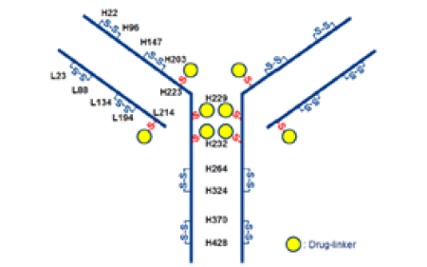
The drug product is supplied as a 100 mg single dose sterile lyophilised powder in a glass vial sealed with a rubber stopper and flip off crimp cap. Prior to use, drug product is reconstituted with 5 mL of water for injection to provide a solution with a drug substance of concentration of 20 mg/mL in 25mM histidine buffer.
The submitted data support a shelf of 36 months at 5°C for the drug product.
There are no objections on quality grounds to the approval of Enhertu.

Proposed conditions of registration
The quality evaluation proposed the following conditions of registration:
- Laboratory testing & compliance with Certified Product Details (CPD)
  - All batches of Enhertu supplied in Australia must comply with the product details and specifications approved during evaluation and detailed in the Certified Product Details (CPD).
  - When requested by the TGA, the sponsor should be prepared to provide product samples, specified reference materials and documentary evidence to enable the TGA to conduct laboratory testing on the product. Outcomes of laboratory testing are published biannually in the TGA Database of Laboratory Testing Results http://www.tga.gov.au/ws-labs-index and periodically in testing reports on the TGA website.

Nonclinical
The nonclinical evaluator noted that there was no major deficiency identified in nonclinical evaluation.
Primary pharmacology studies support the use of Trastuzumab deruxtecan for the proposed indication, having adequately shown in vitro and in vivo anti-tumour activity. Safety pharmacology studies did not identify any clinically relevant hazards.
Drug active MAAA-1181a is a substrate of a number of efflux and uptake transporters (OATP1B1, OATP1B3, MATE2-K, MRP1, P-gp and BCRP) and therefore systemic exposures to MAAA-1181a may be affected by drugs that inhibit these transporters.
Target organs of toxicity were gastrointestinal crypt epithelium, haematopoietic system (bone marrow), kidney, lungs, liver, heart, male reproductive system and skin in monkeys. Adverse effects on dental tissue observed in rats are not considered clinically relevant.
Drug active MAAA-1181a was shown to be clastogenic under in vitro and in vivo conditions.
Pregnancy category D; proposed by the sponsor is considered appropriate based on existing understanding of the effects of Trastuzumab and toxicity profile of other topoisomerase I inhibitors.
In vitro, Trastuzumab deruxtecan bound to its primary pharmacological target, the extracellular domain of HER2, with a similar affinity as unconjugated Trastuzumab. The drug conjugate of Trastuzumab deruxtecan, MAAA-1181a, showed inhibitory effects of the intended intracellular target, topoisomerase I. Anti-tumour activity of Trastuzumab deruxtecan was selective for HER2-positive cancer cell types, with half maximal (50%) inhibitory concentration (IC₅₀) values ranging between 6.65 to 26.8 ng/mL (9- to 37-times unbound clinical minimum concentration (C_{min})). As an IgG1 subtype immunoglobulin, Trastuzumab deruxtecan was shown to elicit moderate ADCC activity under in vitro conditions. In vivo, a single dose of Trastuzumab deruxtecan demonstrated anti-tumour activity in mouse models of HER2-positive cancer types (breast or gastric), and adequately support the proposed indication.
The ratio of the concentration of MAAA-1181a in blood to that in plasma was 0.82 to 0.85 in mice, 0.81 to 0.87 in rats, 0.92 to 0.95 in monkeys, and 0.59 to 0.62 in humans, suggesting that MAAA-1181a distributes into red blood cells.
There are no nonclinical objections to registration of Trastuzumab deruxtecan.

Clinical
The clinical dossier consisted of five clinical studies:
- Four Phase I studies (Studies DS8201-A-J101, DS8201-A-J102, DS8201-A-A103, and DS8201-A-A104) that provided supportive pharmacokinetics (PK) and safety assessments.
  - Study DS8201-AJ102 assessed the effect on the QT interval; in HER2-positive breast cancer in which Trastuzumab was dosed at 6.4 mg/kg.
  - Study DS8201-A-A103 was PK study in HER2-positive gastric, gastroesophageal junction adenocarcinoma, and breast cancer also at a dose of 6.4 mg/kg
  - Study DS8201-AA104 was a drug-drug interaction study of OATP1B/CYP3A inhibitor on the PK of Trastuzumab in patients with HER2-expressing solid tumours.
  - Study DS8201-A-J101 was a dose escalation study followed by dose expansion.
- One Phase II study (Study DS8201-A-U201); a multicentre, open label, multiple dose, two part study.
- Efficacy and safety updates for the pivotal efficacy study providing results to 19 August 2019 were also included in the submission.

Pharmacology

Pharmacokinetics
Five studies contained clinical pharmacology data: four Phase I studies in subjects with breast cancer and other solid malignant tumours and one Phase II study in breast cancer subjects. A population pharmacokinetics (popPK) analysis and exposure response analysis from these studies were also provided.
Trastuzumab deruxtecan undergoes intracellular cleavage by lysosomal enzymes to release the active topoisomerase I inhibitor (MAAA-1181a). Bioanalysis was conducted to determine the serum concentrations of three moieties associated with Trastuzumab deruxtecan: concentrations of the intact drug, Trastuzumab deruxtecan; concentrations of total anti-HER2 antibody were determined in an assay that detected the sum of concentration of recombinant humanised IgG1 kappa monoclonal antibody, Trastuzumab deruxtecan; and the released payload, MAAA-1181a.
The exposure of Trastuzumab deruxtecan, total anti-HER2 antibodiees, and MAAA-1181a increased in a dose related manner, with Trastuzumab deruxtecan exposure proportional to dose in the 3.2 mg/kg to 8 mg/kg dose range. Exposures (maximum concentration (C_{max}) and area under the concentration time curve (AUC)) for MAAA-1181a increased proportional to dose in the 0.8 mg/kg to 8 mg/kg dose range. The area under the concentration time curve during the dosing interval (AUC_{tau}) of Trastuzumab deruxtecan in Cycle 3 after multiple dosing of Trastuzumab deruxtecan at 6.4 mg/kg was approximately 35% higher than that in Cycle 1, suggesting there was some accumulation.
Three drug products of Trastuzumab deruxtecan, FL-DP1, FL-DP2 (frozen liquid drug products 1 and 2), and lyophilised powder drug product (Lyo-DP, the to be marketed formulation), have been administered across the clinical development program. Between FL-DP1 and FL-DP2, there was a change in the monoclonal antibody manufacturing process that included a change in cell line; this also resulted in differences in monoclonal antibody glycosylation. Between FL-DP2 and Lyo-DP, there was only a change in product presentation: from frozen liquid to lyophilised powder.
The exposures to Trastuzumab deruxtecan, total anti-HER2 antibodies, and MAAA-1181a were similar across clinical studies irrespective of the Trastuzumab deruxtecan product based on within study PK comparison as well as integrated PK analysis across studies. These observations were supported by the popPK analysis, where Trastuzumab deruxtecan product was not a significant covariate on human exposure. The rate of anti-drug antibodies (ADA) was low, with no apparent difference in the rate of ADAs between FL-DP2 and Lyo-DP. Based on similar PK and low rate of ADA generation, it was determined that the three drug products used in the Trastuzumab deruxtecan development program are comparable, allowing generalisation of the PK results.
In adult patients with HER2-positive expressing breast cancer who received Trastuzumab deruxtecan 5.4 mg/kg once every three weeks, the popPK approach derived geometric steady state (coefficient of variation, CV%) C_{max} was 122 (20%) μg/mL and area under the concentration time curve from time zero to 21 days (AUC_{0-21days}) was 735 μg*h/mL (31%) for Trastuzumab deruxtecan and geometric steady-state (CV%) C_{max} was 4.4 (40%) ng/mL and AUC_{0-21days} was 28 (37%) ng*h/mL for MAAA-1181a.
The popPK approach derived mean (%CV) apparent central volume of distribution of Trastuzumab deruxtecan at steady state is 2.77 L. In vitro, protein binding of MAAA-1181a is 97%. The ratio of the concentration of MAAA-1181a in blood to that in plasma was 0.82 to 0.85 in mice, 0.81 to 0.87 in rats, 0.92 to 0.95 in monkeys, and 0.59 to 0.62 in humans, suggesting that MAAA-1181a distributes into red blood cells.
Following a single 5.4 mg/kg dose of Trastuzumab deruxtecan, the median elimination half-life (t_{½}) of Trastuzumab deruxtecan was approximately 5.7 days based on non-compartmental analysis. Following a single 5.4 mg/kg dose of Trastuzumab deruxtecan, the median apparent elimination t_{½} of MAAA-1181a was approximately 5.8 days based on non-compartmental analysis. The popPK approach derived mean (%CV) clearance of Trastuzumab deruxtecan is 0.42 L/day.
In vitro, MAAA-1181a is primarily metabolised by cytochrome P450 enzyme CYP3A4. In vitro, MAAA-1181a does not inhibit CYP1A2, CYP2B6, CYP2C8, CYP2C9, CYP2C19, CYP2D6 and CYP3A nor induce CYP1A2, CYP2B6, or CYP3A. At clinically relevant concentrations (steady state C_{max} of about 0.2 μmol/L), MAAA-1181a has a low potential to inhibit OAT1 (IC₅₀ value of 12.7 μmol/L), OAT3, OCT1, OCT2, OATP1B1 (IC₅₀ value of 14.4 μmol/L), OATP1B3, MATE1, MATE2-K, P-gp, BCRP, or BSEP transporters.
No human mass balance study was conducted. In vitro, MAAA-1181a is a substrate of OATP1B1, OATP1B3, MATE2-K, P-gp, MRP1 and BCRP.
No dedicated renal impairment or hepatic impairment studies were conducted. Based on the PopPK analysis the pharmacokinetics of MAAA-1181a was not affected by mild to moderate renal impairment. Higher levels of aspartate transaminase and total bilirubin resulted in lower clearance of MAAA-1181a. The steady state C_{min}, C_{max}, and AUC ratios between subjects with mild hepatic impairment and normal hepatic function are 1.11, 1.03, and 1.07, respectively, and the steady state C_{min}, C_{max}, and AUC ratios between subjects with mild renal impairment and normal renal function are 0.953, 0.911, 0.921, respectively. There are no data available for patients with severe renal impairment or with severe hepatic impairment.

Pharmacodynamics
Trastuzumab deruxtecan is an antibody drug conjugate targeting HER-2 positive expressing cells. The mechanism of action involves the recombinant antibody binding to HER2 receptors on the tumour target cell membrane, and where the antibody drug conjugate gets internalised into the target cells. Drug linker between antibody and MAAA-1181a is metabolised by lysosomal enzymes where it will release the MAAA-1181a, which inhibits the DNA topoisomerase I enzyme.
In Study J101, the maximum tolerated dose (MTD) of Trastuzumab deruxtecan as a single agent treatment in patients with HER2-postive expressing breast cancer was not reached at the dose range of 0.8 to 8 mg/kg once every three weeks.
The incidence of immunogenicity was low with 3.5% and 1.1% of subjects demonstrating ADA positive results at Baseline and post-baseline, respectively. Overall, 4 out of 640 (0.6%) subjects were identified as having treatment emergent ADA. No relationship was identified between the rate of infusion site reactions (as a measure of safety) and the incidence of ADA.
Study DS8201-A-J102 evaluated the effect of Trastuzumab deruxtecan on human cardiac parameters. Results from the study indicated that Trastuzumab deruxtecan 6.4 mg/kg administration was not associated with a clinically meaningful (defined as change from Baseline > 10 milliseconds) prolongation of QT interval corrected for heart rate using Frederica’s formula (QTcF).

Efficacy
The recommended dose of Trastuzumab deruxtecan is 5.4 mg/kg given as an intravenous infusion once every 3 weeks (21-day cycle) until disease progression or unacceptable toxicity. The final dose selection was based on exposure response analyses for efficacy and safety. The efficacy exposure response analyses were conducted using logistic regression modelling for efficacy (objective response rate (ORR), duration of response (DOR), and progression-free survival (PFS)) using data from Study DS8201-A-J101 and Study DS8201-A-U201. The relationship between Trastuzumab deruxtecan average concentration (C_{avg}) from beginning of treatment to the time of ORR was positive and statistically significant (p value = 0.028) and best described by a linear logistic regression model. There was a trend of improved PFS with higher Trastuzumab deruxtecan exposures (both C_{avg} at PFS and minimum observed serum concentration at steady-state), which was not statistically significant (p value > 0.05).
Based on the exposure efficacy models, the mean probability of ORR was predicted to be 0.63 (90% CI: 0.55, 0.70) for the 5.4 mg/kg dose and 0.68 (95% CI: 0.58, 0.76) for the 6.4 mg/kg dose, which agrees with observed data. Results of a covariate search (including baseline demographics, country, and disease status factors) demonstrated that no covariates were significant for exposure ORR relationship.

Study DS8201-A-U201 (DESTINY-Breast01 trial)
This was a Phase II, open label, multicentre, two part study designed to justify the recommended dose of Trastuzumab deruxtecan and investigate its safety and efficacy in subjects with unresectable and/or metastatic HER2-positive breast cancer previously treated with ado-Trastuzumab emtansine, Kadcyla.13 Enrolment commenced on 25 September 2017. Study sites were in the USA, Canada, Japan, South Korea, Belgium, France, Italy, Spain, and the United Kingdom.
The data cut-off date for the clinical study report in the submission was 21 March 2019. At that data cut-off, the median duration of follow up was 7.8 months (range: 0.7 to 17.2) across all doses. An update with the data cut-off of 1 August 2019 was included in the clinical summary of efficacy. A subsequent efficacy update with a median of duration of follow-up of 20.5 months (range 0.7 to 31.4 months) was available to the European Medicines Agency and a subsequent efficacy update with a median of 26.5 months follow-up (data cut-off: 21 March 2021) was made available to the TGA. While not the primary efficacy analysis, that data, being the most recent and giving the most clinically useful information is proposed for inclusion in the PI of Enhertu. The FDA conducted its own analysis using the primary data cut-off date.
Determination of tumour HER2 positivity was according to American Society of Clinical Oncology, College of American Pathologists guidelines. Expression was based on archival tissue tested at a central laboratory prior to enrolment. The study design is depicted below.
Figure 2: Study DS8201-A-U201 Study design
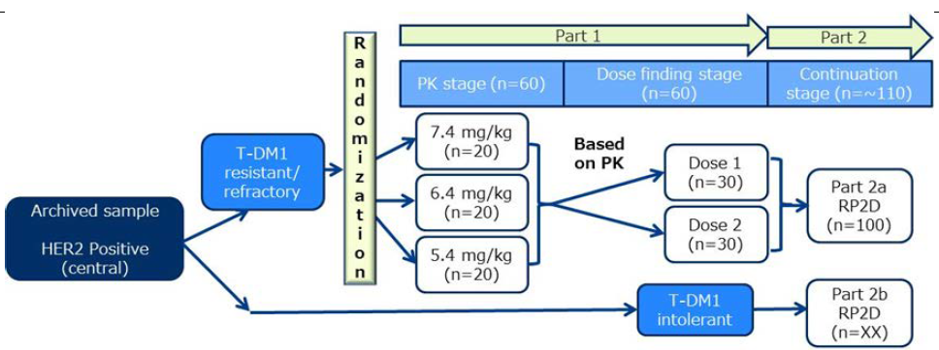
Abbreviations: HER2 = Human epidermal growth factor receptor 2; PK = pharmacokinetic(s); T-DM1 = Trastuzumab emtansine
Note: for Part2b, ‘XX’ indicated the number of subjects was open-ended with no fixed enrolment target.
Part 1 of the study consisted of two stages: a PK stage and a dose finding stage. In the PK stage subjects were randomised in a 1:1:1 ratio to three doses: 5.4 mg/kg, 6.4 mg/kg, and 7.4 mg/kg, designed to provide clinical data to bridge between two dosing formulations, FL-DP2 and Lyo-DP. The dose selection for each stage of the study was based on clinical data from the first in human Study DS8201-A-J101 and on the prespecified interim exposure response analysis during the conduct of Study DS8201-A-U201 itself. After review of the PK findings, subjects were randomised in a 1:1 ratio to 1 of 2 dose levels that were selected for further evaluation in the dose-finding stage: 6.4 mg/kg and 5.4 mg/kg.
Study treatments were given via intravenous infusion once every 3 weeks, over 90 minutes for the first dose and 30 minutes for subsequent doses provided there was no infusion related reaction after the first dose.
Part 2 of the study was not randomised, and all subjects received Trastuzumab deruxtecan at the recommended 5.4 mg/kg dose. Part 2 was subdivided into two cohorts: Part 2a, the main study part, and Part 2b, which was designed to explore the efficacy of Trastuzumab deruxtecan in subjects who discontinued Trastuzumab emtansine for reasons other than progressive disease. The duration of enrolment in Part 2b was determined by the enrolment in Part 2a, with completion of enrolment in Part 2b when the target number of approximately 100 subjects was reached in Part 2a. Study treatment continued until disease progression, death, withdrawal of consent, or unacceptable toxicity.
Key inclusion criteria were:
- Men or women ≥ 18 years old in the USA/Europe or ≥ 20 years old in Japan and South Korea with pathologically documented breast cancer that was unresectable or metastatic and had HER2 positive expression.
- Breast cancer resistant or refractory to Trastuzumab emtansine with documentation of progression during or after Trastuzumab emtansine (for Part 2b, subjects were to have discontinued Trastuzumab emtansine for reasons other than progressive disease).
During the treatment period, the following medications, treatments, and procedures were prohibited: other anticancer therapies or investigational therapeutic agents; radiotherapy (except for palliative radiation to known metastatic sites); chronic systemic corticosteroids or other immunosuppressive medications; CYP3A4 strong inhibitors; and OATP1B inhibitors.
Haematopoietic growth factors could be used for prophylaxis or treatment based on the clinical judgement of the investigator. Prophylactic or supportive treatment of study drug induced adverse events were otherwise to be as per investigator’s discretion and institutional guidelines.
The primary efficacy endpoint was the ORR based on confirmed responses by independent central review (ICR). Objective response rate (ORR) was defined as the proportion of subjects who achieved a best overall response (BOR) of complete response (CR) or partial response (PR), with confirmation of response, based on RECIST 1.1. Tumour assessments were performed at screening and every 6 weeks thereafter.
Assessments were conducted using computed tomography (CT) or magnetic resonance imaging (MRI) (spiral CT or MRI with ≤ 5 mm cuts). Imaging was assessed by the investigators and sent out for ICR assessment. Two trained radiologists read each study subject's images independently, according to the ICR charter. In case of discordance, adjudication was performed by a third radiologist. The adjudication variables were best confirmed response and date of progression.
Secondary efficacy endpoints included:
- Investigator assessed objective response rate (ORR);
- disease control rate, defined as the proportion of subjects who achieved a best overall response (BOR) of complete response (CR), partial response (PR) or stable disease;
- clinical benefit rate (CBR), defined as defined as CR plus PR plus at least 6 month stable disease;
- duration of response (DOR), defined as the time interval between the date of first documentation of objective response (CR or PR) and the date of the first objective documentation of disease progression or death due to any cause;
- progressional-free survival (PFS), defined as the time interval between the date of randomisation/registration and the first documentation of disease progression or death due to any cause; and
- best percentage change in sum of diameters of tumour lesions, all based on ICR; and overall survival (OS). Exploratory efficacy endpoints included time to response (for responders only) and duration of stable disease.
Tumour assessments were performed at screening and every 6 weeks thereafter. Assessments were conducted using CT or MRI (spiral CT or MRI with ≤ 5 mm cuts). Imaging was assessed by the investigators and sent out for ICR assessment. The primary efficacy analyses were based on ICR review of tumour scans of the intent to treat population. The ORR was summarised through descriptive statistics (n, %) and using exact binomial confidence intervals (Clopper-Pearson method). The efficacy evaluation was based on the magnitude of response rate and adequate duration of response. No statistical inference for the time to event endpoints of progression free survival and time to response can be made from a single-arm study and results presented are considered descriptive only. Subgroup analysis were performed to evaluate whether the treatment effect was consistent across subgroups and are considered as exploratory.
A total of 253 subjects across all doses were enrolled and treated in Study DS8201-A-U201. Of these, 184 received the proposed dose of 5.4 mg/kg. Demographic characteristics for the total population and the population given 5.4 mg/kg are shown below.
Table 2: Study DS8201-A-U201 Demographic characteristic (enrolled analysis set)
Nearly all patients were Eastern Cooperative Oncology Group (ECOG) performance status (ECOG PS) of 0 or 1, 127 (50.2%) were hormone receptor positive and 237 (93.7%) had metastases. All patients had received prior Trastuzumab, Trastuzumab emtansine and pertuzumab. 152 (60.1%) had received > 5 prior regimens of cancer systemic therapy. For the 184 patients enrolled at the 5.4 mg/kg dose, the median lines of prior systemic therapy was 5 (range 2 to 17); ECOG PS was 0 (55.4%) or 1 (44%); hormone receptor status (positive: 52.7%); presence of visceral disease (91.8%); median number of prior therapies in the metastatic setting: 5 (range: 2 to 17); and prior pertuzumab therapy (65.8%). The sum of diameters of target lesions was < 5 cm for 42.4% and ≥ 5 cm for 50%. Prior cancer therapy (enrolled analysis set) are shown below.
Table 3: Study DS8201-A-U201 Prior cancer therapy (enrolled analysis set)
Table 3: Study DS8201-A-U201 Prior cancer therapy (enrolled analysis set), continued’
BC = breast cancer, CR = complete response; HER2 =epidermal growth factor receptor 2; IHC = immunohistochemistry; ISH = in situ hybridisation; PD = progressive disease; PK = pharmacokinetics; PR = partial response; SD = stable disease; Std Dev = standard deviation
The electronic case report form (eCRF) entry did not specify whether the response to Trastuzumab emtansine was confirmed or not
Data cut off = 21 March 2019
The primary endpoint for this study was confirmed objective response rate (ORR) by ICR based on RECIST 1.1.24 The sponsor reported the results of the confirmed ORR and subgroup analyses primarily based on the patients enrolled in Part 1 and Part 2a (n = 180).
The US FDA’s efficacy analysis was based on the 184 patients who received 5.4 mg/kg dose in Part 1, Parts 2a and 2b (n = 184). That analysis included four additional patients from Part 2b in the efficacy analysis as they had all received prior Trastuzumab emtansine even though they had not progressed on Trastuzumab emtansine. From a clinical perspective these four patients were anticipated to have similar clinical outcomes compared to patients who progressed on Trastuzumab emtansine. The sponsor’s confirmed ORR based on ICR in these 184 patients was 60.3% (95% CI: 52.9, 67.4). The median duration of response (DOR) at that time was not evaluable.
Table 4: Study DS8201-A-U201 Objective response rate in the 5.4 mg/kg cohort (enrolled analysis set)
The two sided 95% CI were based on the exact (Clopper-Pearson) binomial distribution
Percentages were based on the number of subjects in the enrolled analysis set,
Data cutoff = 21 March 2019
Table 5: Study DS8201-A-U201 Best overall response (enrolled analysis set)
BOR = best objective response; CR = complete response; ICR = independent central review; NE = not evaluable; PD = progressive disease; PK = pharmacokinetics; PR = partial response; SD = stable disease
Percentages were based on the number of subjects in the enrolled analysis set.
Data cut-off = 21 March 2019
Subgroup analyses by baseline disease characteristics and baseline demographics for the primary 5.4 mg/kg dose cohort showed a confirmed ORR by ICR of at least 50% in most subgroups including hormone receptor positive and negative patients and patients with and without brain metastases.
Figure 3: Study DS8201-A-U201 Forest plot of objective response rate by independent central review for the primary 5.4 mg/kg dose cohort by subgroup (enrolled analysis set)
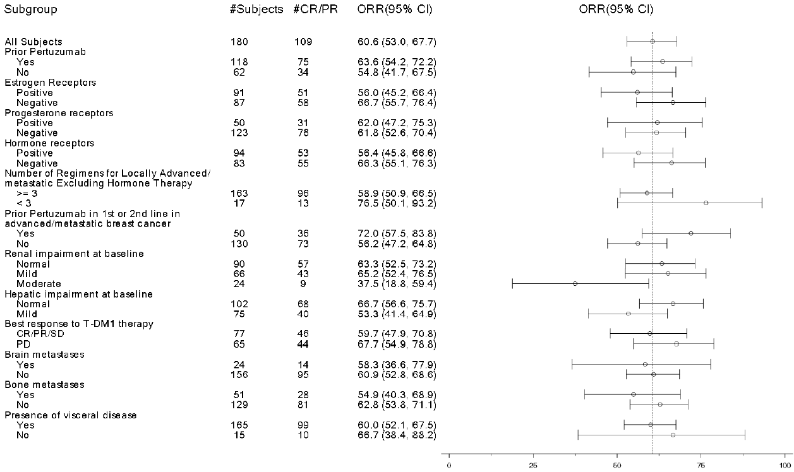
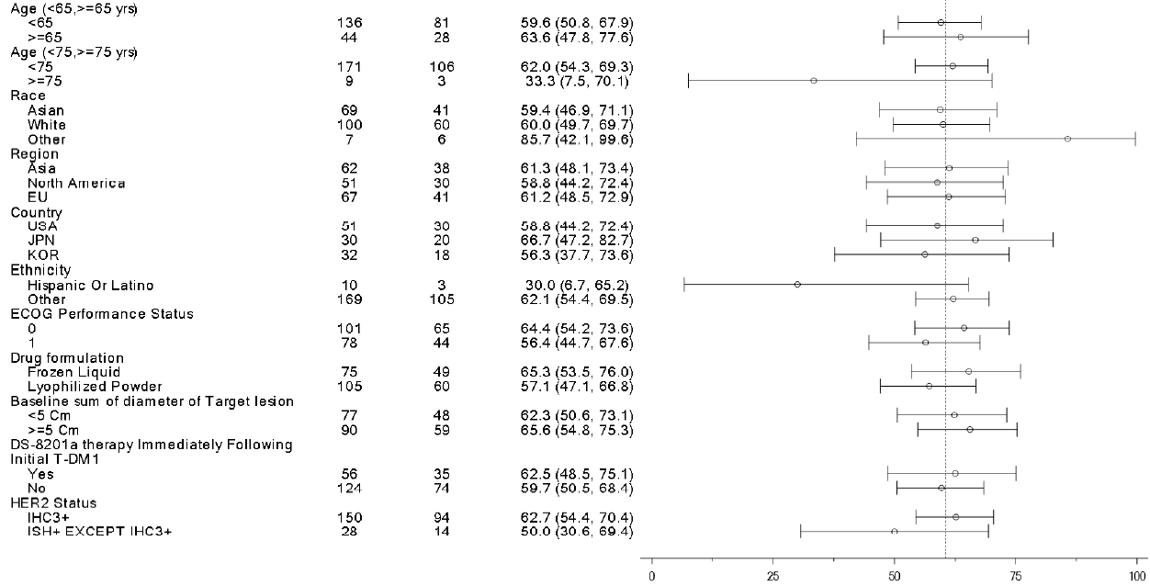
Abbreviations: BOR = best objective response; CI = confidence intervals; CR = complete response; ICR = independent central review; IHC = immunohistochemistry; ISH = in situ hybridisation; JPN = Japan; KOR = Korea; NE = not evaluable; ORR = objective response rate; PD = progressive disease; PK = pharmacokinetics; PR = partial response; SD = stable disease; T-DM1 = Trastuzumab emtansine; USA = United States of America.
For the 184 subjects assigned to 5.4 mg/kg Trastuzumab deruxtecan the confirmed clinical benefit rate by ICR was 76.1% for the 184 subjects assigned to 5.4 mg/kg.
There have been three efficacy updates following the analysis in the clinical study report. There were performed with data cutoff dates of 21 March 2019, 1 August 2019 and 26 March 2021. The median duration of followup for these analyses were 11.1 months, 20.5 months and 26.5 months respectively. Table 6 shows results from these analyses.
Table 6: Study DS8201-A-U201 Best overall response, overall response rate, duration of response, progression free survival, and overall survival in by data cutoff (enrolled analysis set)
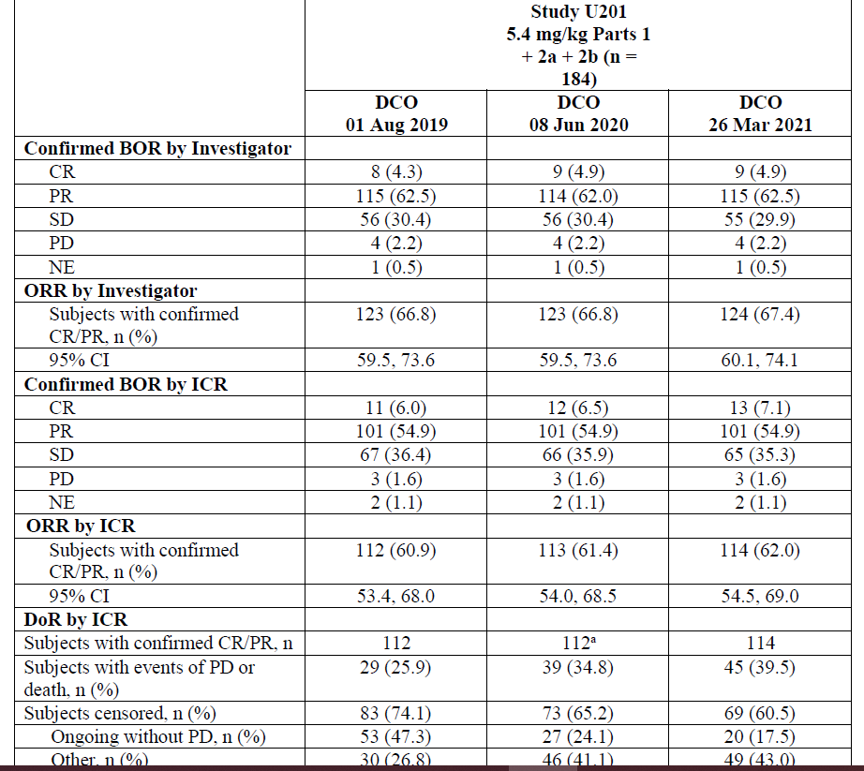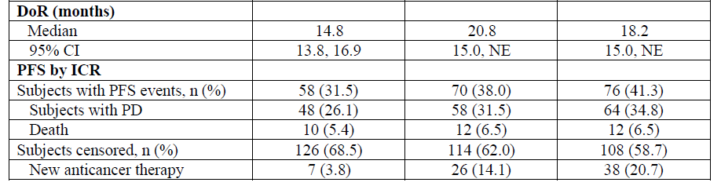
Table 6: Study DS8201-A-U201 Best overall response, overall response rate, duration of response, progression free survival, and overall survival in by data cutoff (enrolled analysis set), continued
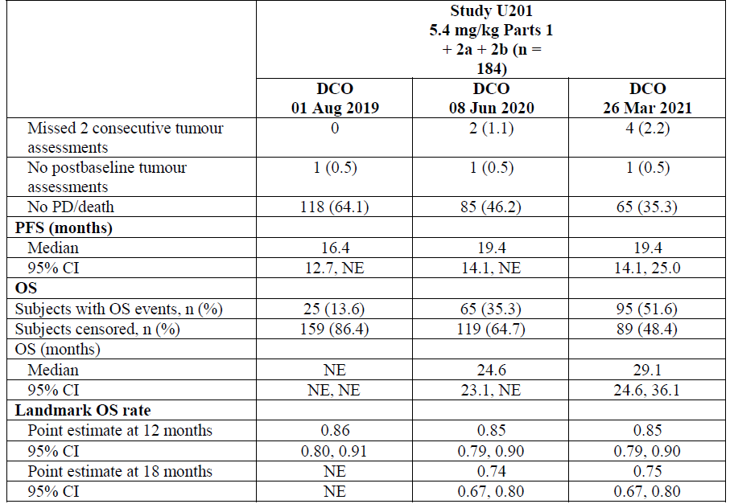
BOR = best overall response; CI = confidence interval; CR = complete response; DOC = data cutoff; DoR= duration of response; ICR = independent central review; NE = not evaluable or not estimable; ORR = objective response rate; OS = overall survival; PD = progressive disease; PFS = progression-free survival; PR = partial response; SD = stable disease.
a One subject had a PR prior to the 8 June 2020 cutoff date that was confirmed after the cutoff date. The subject has a confirmed COR of PR on the first PR date in the central data but was not included in the analysis of DoR.
The Delegate noted that the results of progression-free survival and time to response are uninterpretable due to lack of a comparator arm in a single arm study.

Study DS8201-A-J101
This was a Phase I, two part, multicentre, non-randomised, open label, multiple dose, first in human study of Trastuzumab deruxtecan. Part 1 (dose escalation) was intended to identify the maximum tolerated dose or the recommended dose of Trastuzumab deruxtecan and evaluated doses ranging from 0.8 mg/kg to 8 mg/kg. Part 2 (dose expansion) was intended to further assess the safety, tolerability, and efficacy of Trastuzumab deruxtecan at the maximum tolerated/recommended doses of 5.4 mg/kg and 6.4 mg/kg. Dose expansion was conducted in five cohorts of subjects with various tumour types (breast cancer, gastric or gastroesophageal junction adenocarcinoma) and levels of HER2 expression. The target population of subjects with unresectable or metastatic HER2-positive breast cancer was enrolled in Part 1 and Part 2a and all subjects in the target population were administered Trastuzumab deruxtecan as the FL-DP1 formulation.
Unlike Study DS8201-A-U201, HER2 expression status was based on local laboratory reports of archival tissue samples. Local immunohistochemistry score and in situ hybridisation positivity were based on investigator’s discretion and test method was not recorded on the electronic case report form. Otherwise, eligibility criteria for the HER2-positive breast cancer patient population, study treatments, dose modifications, schedule of events, and overall study conduct were similar across the two studies. Similar to Study DS8201-A-U201, ORR assessed by ICR and based on RECIST v1.1;24 was the primary efficacy endpoint.
Efficacy analyses were to be performed on the enrolled analysis set, with analyses of ORR, disease control rate, and clinical benefit rate also performed on the response evaluable set. The sample size in each of the dose expansion cohorts was based on hypothesised ORR for each cohort. Since it is important to maximise the precision of the estimated treatment effect for a given tumour type at the recommended Phase II dose, for data analysis purposes, efficacy data from subjects dosed at the recommended Phase II dose in the dose escalation phase was pooled with the efficacy data from the corresponding tumour type cohorts in the dose expansion phase to calculate the overall efficacy estimates. Efficacy analyses were performed based on both ICR and investigator review, with ICR based response rates in the enrolled analysis set considered to be the main efficacy variables of interest.
A total of 51 subjects with unresectable or metastatic HER2 positive breast cancer were enrolled in the 5.4 mg/kg dose cohort in Part 1 or Part 2a of the study with 50 of these patients receiving study drug. At data cut-off 1 August 2019 the median duration of treatment for this cohort was 8.54 months. The median DOR of the 26 responders was 10.8 months (95% CI: 6.7, not estimable). The study report grouped the efficacy results for the HER2-positive breast cancer groups given 5.4 mg/kg and 6.4 mg/kg. For these 118 patients the ORR by investigator was 71 (60.2%) and by ICR was 62 (52.5%).

Safety
Exposure response analyses for safety were conducted using data across all doses tested (0.8 mg/kg to 8 mg/kg) across the five clinical studies included in the submission. In these multivariate analyses, all evaluated safety endpoints showed a statistically significant (p ≤ 0.05) exposure resposne relationship with one or more of the exposure parameters evaluated for Trastuzumab deruxtecan or MAAA-1181a. Trastuzumab deruxtecan AUC at steady state was a statistically significant predictor for discontinuation associated with adverse events (p < 0.001) and interstitial lung disease of any grade (p value < 0.001); Trastuzumab deruxtecan C_{max} at steady-state was a statistically significant predictor for interstitial lung disease ≥ Grade 3 (p < 0.001) and ≥ Grade 2 left ventricular ejection fraction (LVEF) decrease (p value < 0.001), while C_{avg} through the event cycle for MAAA-1181a was a significant predictor for all other evaluated safety endpoints.
The integrated safety analyses focused primarily on safety data from the target indication of HER2-positive breast cancer and the target dosing regimen of 5.4 mg/kg once every 3 weeks, derived from the pooled data in Study DS8201-A-J101 or DS8201-A-U201 (hereafter referred to as the HER2-positive breast cancer 5.4 mg/kg pool). Three additional completed studies were not included in the pooled safety analyses due to the heterogeneity of study design and study population, and relatively short duration of exposure (median 4.6 to 5.5 months).
The safety database for this submission included 645 subjects who received at least one dose of Trastuzumab deruxtecan from the five completed studies, including 234 subjects with HER2-positive breast cancer who were treated with 5.4 mg/kg. The median duration of exposure to study drug was 6.96 months in the HER2-positive breast cancer 5.4 mg/kg pool, compared to 8.97 months in the HER2-positive breast cancer ≥ 6.4 mg/kg pool.
In subjects in the HER2-positive breast cancer 5.4 mg/kg pool the median age was 56 years (range: 28 to 96); 99.6% were female; 50.9% were White, 41.5% were Asian, 3% were Black or African American; and 57.7% had an ECOG PS of 0 and 41.9% had an ECOG PS of 1. There was only one male in the 5.4 mg/kg pool. Patients with a history of treated interstitial lung disease or disease at screening and patients with a history of clinically significant cardiac disease were excluded from the studies.
The following safety assessment results are from the safety update of August 2019 for the HER2 positive breast cancer pool given 5.4 mg/kg Trastuzumab deruxtecan. The median duration of exposure was 9.82 months (range 0.7 to 37.1 months) for these 234 subjects. At that time 148 (63.2%) of these patients had discontinued treatment. The most frequent reasons for discontinuations were adverse events (AE) (16.2%), clinical progression (2.1%), death (3.4%) and progressive disease (32.1%).
The most commonly reported (≥ 10% in the HER2-positive breast cancer 5.4 mg/kg pool) treatment emergent adverse events (TEAE) are shown in Table 7, Table 8 and Table 9 below with the initial safety analysis results from the clinical study report and the Data Safety Update results for 1 August 2019.
Table 7: Treatment-emergent adverse events (≥ 10% in the HER2-positive breast cancer pool)
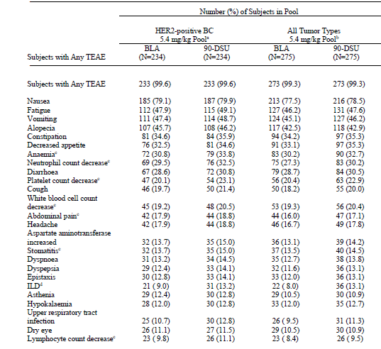
Abbreviations: BC = breast cancer; CSR = clinical study report; DCO = data cut-off; HER2 = human epidermal growth factor receptor 2; ILD = interstitial lung disease; MedDRA = Medical Dictionary for Regulatory Activities, v20.1; N = total number of subjects in the study or pool; PT = Preferred Term; TEAE = treatment-emergent adverse event.
Percentages were calculated using the number of subjects in the Safety Analysis Set as the denominator. CSR DCO = 1 February 2019 for Study J101 and 21 March 2019 for Study U201; Safety Update DCO = 1 August 2019 If a subject had multiple occurrences of the same preferred term, the subject was counted once for that preferred term. The 2 pooled analysis groups were based on tumour type and assigned dose for subjects in Study J101 and Study U201. The individual studies include all treated subjects with HER2-positive BC who were assigned to receive 5.4 mg/kg in Study J101 or Study U201.
a) Anaemia (grouped term) includes PTs of haemoglobin decreased, red blood cell count decreased, anaemia, and haematocrit decreased. b) Neutrophil count decrease (grouped term) includes PTs of neutrophil count decreased and neutropenia. c) Platelet count decrease (grouped term) includes PTs of platelet count decreased and thrombocytopenia. d) White blood cell count decrease (grouped term) includes PTs of white blood cell count decreased and leukopenia.
Table 8: Most commonly reported treatment-emergent adverse events frequent laboratory abnormalities (≥ 10% in the HER2-positive breast cancer 5.4 mg/kg pool)
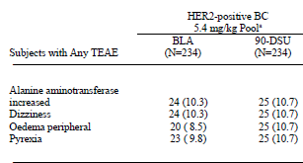
Abbreviations: HER2 = human epidermal growth factor receptor 2; TEAE = treatment-emergent adverse event
Table 9: Most commonly reported ≥ Grade 3 treatment-emergent adverse events (≥ 5% in the HER2-positive breast cancer 5.4 mg/kg pool)
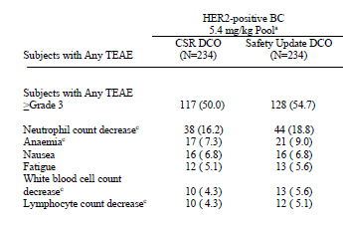
Abbreviations: HER2 = human epidermal growth factor receptor 2; TEAE = treatment-emergent adverse event.
Platelet count decrease (grouped term) includes PTs of platelet count decreased and thrombocytopenia
Deaths were reported in 39 (16.7%) of subjects. There were 10 (4.3%) deaths that occurred on study. On study death is defined as any death that occurs from the date of first dose up to 47 days (for Study DS8201-A-U201) or 28 days (for Study DS8201-A-J101) after last dose of study drug. The following TEAEs associated with death.
Table 10: Treatment-emergent adverse events associated with death (HER2-positive breast cancer 5.4 mg/kg pool)
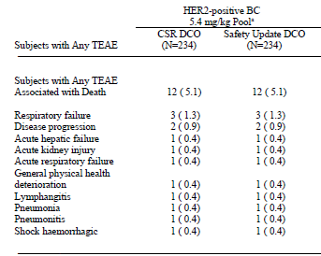
Abbreviations: HER2 = human epidermal growth factor receptor 2; TEAE = treatment-emergent adverse event.
The AEs of special interest identified given the known effects of Trastuzumab, the mechanism of action and nonclinical safety profile were initially identified as: Interstitial lung disease/pneumonitis, QT prolongation, left ventricular ejection fraction decrease, and infusion related reactions (IRR). Additional data on left ventricular ejection fraction (LVEF) decreased, QT interval, and interstitial lung disease were collected via targeted questionnaires built into the electronic data capture. An independent interstitial lung disease adjudication committee was established to adjudicate all potential interstitial lung disease cases which included an extensive list of 42 Preferred Terms (PT) from the Medical Dictionary for Regulatory Activities interstitial lung disease standardised MedDRA queries plus the PTs of respiratory failure and acute respiratory failure. Among the 234 subjects in the HER2-positive breast cancer 5.4 mg/kg pool, 22 (9.4%) had events adjudicated as drug related interstitial lung disease; 16 out of 22 were Grade 1 or Grade 2, and 6 (2.6%) subjects had events associated with a fatal outcome.
Interstitial lung disease/pneumonitis was reported in 32 (13.7%) subjects in the HER2-positive breast cancer 5.4 mg/kg pool with 7 (3%) having ≥ Grade 3 interstitial lung disease and interstitial lung disease occurred in association with subject’s death in six cases. The frequency of ILD was higher in other dose groups with 32 out of 137 (23.4%) subjects given Trastuzumab deruxtecan doses of 6.4 mg/ kg, 7.4mg/kg and 6 mg/kg having adjudicated cases of interstitial lung disease.
Cardiotoxicity in association with Trastuzumab deruxtecan is considered to be an important potential risk based on the available nonclinical data, literature, and available safety information for drugs of similar class. Therefore, in addition to routine clinical safety assessment, troponin was measured after each infusion, and an echocardiogram (ECHO)/multigated acquisition (MUGA) scan was done to evaluate LVEF every two cycles in Study DS8201-A-J101 and every four cycles in Study DS8201-A-U201.
Events of congestive heart failure have been reported in clinical trials of Trastuzumab emtansine, with asymptomatic LVEF decline reported in 1.7% to 6.5% patients. Because of the differences in study population and duration of exposure, a direct comparison of these data to those for Trastuzumab deruxtecan was not feasible. Anthracycline therapies are known to cause cardiotoxicity and have been shown to have a synergistic effect of cardiotoxicity with Trastuzumab. In the HER2-positive breast cancer 5.4 mg/kg pool, 28.6% and 20.1% of subjects received prior therapy of doxorubicin and epirubicin, respectively.
Left ventricular ejection fraction decrease has been observed with anti-HER2 therapies. In the 234 patients in the HER2-positive breast cancer 5.4 mg/kg three cases (1.3%) of asymptomatic LVEF decrease, of which two (0.9%) were Grade 2 and one (0.4%) was Grade 3, were reported. Observed frequency of LVEF decreased based on laboratory parameters (ECHO or MUGA scanning) was 37 (16.9%); all were Grade 2. No decreases of LVEF to less than 40% or absolute decrease from Baseline of greater than 20% were observed. Treatment with Enhertu has not been studied in patients with LVEF less than 50% prior to initiation of treatment.
Based on electrocardiogram data, 8 out of 234 (3.4%) subjects in the HER2-positive breast cancer 5.4 mg/kg pool had a maximum change from Baseline in QT interval;20 corrected for heart rate by Fridericia’s formula (QTcF);22 > 60 msec, which was unchanged from the results seen at the individual data cut-off.
A total of 18 out of 234 (7.7%) subjects in the HER2-positive breast cancer 5.4 mg/kg pool had events of potential IRR. After review, events of potential IRR in 12 of the 18 cases were considered not to be IRR, due to alternative aetiologies. Of the other six cases, one was attributed to hypersensitivity. One subject had dose interruption due to IRR.
Table 11: Laboratory abnormality adverse drug reactions in the HER2-positive breast cancer 5.4 mg/kg pool (n = 234)
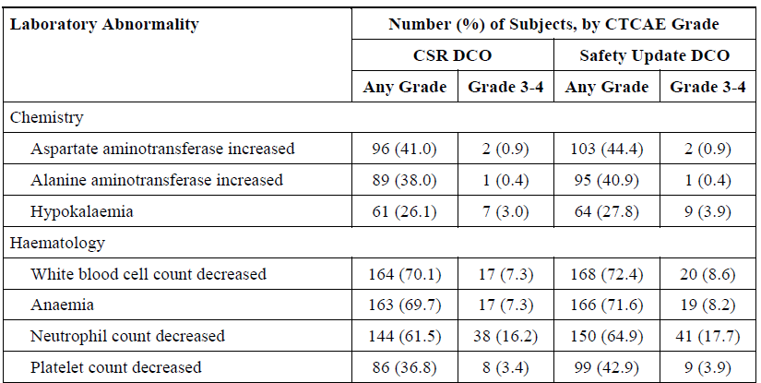
BC = breast cancer; CSR = clinical study report; CTCAE = common terminology criteria for adverse events, version 4.03; DCO = data cut-off; HER2 = human epidermal growth factor receptor 2
Percentages were calculated using the number of subjects with both baseline and post-treatment measurement as the denominator, based on CTCAE version 4.03 grade-derived laboratory abnormalities
CSR DCO = 1 February 2019 for Study J101 and 21 March 2019 for Study U201; Safety Update DCO = 1 August 2019
In the initial safety report the incidence of haemoglobin decreased was dose related with higher incidences of anaemia in patients given 6.4 mg/kg compared with 5.4 mg/kg. In the HER2-positive breast cancer 5.4 mg/kg pool, a shift of 1 grade (toward worsening common terminology criteria for adverse events grade) for anaemia (haemoglobin decreased) was reported in 32 out of 232 (56.9%) patients, with 29 out of 232 (12.5%) shifting by 2 grades and 5 out of 232 (2.2%) shifting by 3 grades. Shifts of 1 grade were reported in 73 out of 136 (53.7%) patients in the HER2-positive ≥ 6.4 mg/kg pool, with 29 out of 136 (21.3%) shifting 2 grades, and 9 out of 136 (6.6%) shifting 3 grades.
Similarly dose related reductions were seen in platelet counts. In the HER2-positive breast cancer 5.4 mg/kg pool, shifts of 1 grade (toward worsening common terminology criteria for adverse events grade) for platelet count (decrease) were reported in 79 out of 231 (34.2%) subjects, with 14 out of 231 (6.1%) shifting 2 grades, and 6 out of 231 (2.6%) shifting 3 grades. In contrast, shifts of 1 grade were reported in 59 out of 136 (43.4%) subjects in the HER2 positive ≥ 6.4 mg/kg pool, with 12 out of 136 (8.8%) shifting 2 grades, 11 out of 136 (8.1%) shifting 3 grades, and 2 out of 136 (1.5%) shifting 4 grades.
The most frequent shifts in blood chemistry parameters following treatment were in liver function tests.
The proportion of ADA positive subjects in the HER2-positive breast cancer 5.4 mg/kg pool was low, and there was no association between positive ADA and allergic type reactions. Trastuzumab deruxtecan was not associated with severe IRRs.

Risk management plan
AstraZeneca Pty Ltd has submitted EU-risk management plan (RMP) version 0.1 (date 4 May 2020; data lock point (DLP) 1 August 2019) and Australia specific annex (ASA) version 1.0 (date 2 September 2020) in support of this application. In response to TGA’s questions, the sponsor submitted updated EU-RMP version 1.0 (date 22 January 2021; DLP 1 August 2019) and ASA version 1.0 succession 2 (date 17 May 2021). As requested by the RMP evaluator, the sponsor has submitted an updated ASA version 1.0 Succession 3 (dated 16 July 2021).
The summary of safety concerns and their associated risk monitoring and mitigation strategies are summarised in Table 12.
Table 12: Summary of safety concerns and their associated risk monitoring and mitigation strategies
Summary of safety concerns |  | Pharmacovigilance |  | Risk Minimisation
 |  | Routine | Additional | Routine | Additional
Important identified risks | Interstitial lung disease/Pneumonitis | ✓¹ | ✓² | ✓ | ✓³
Important identified risks | Left ventricular dysfunction | ✓¹ | – | ✓ | –
Important potential risks | Embryofetal toxicity | ✓ | – | ✓ | –
Missing Information | Use in patients with moderate or severe hepatic impairment | ✓ | ✓⁴ | ✓ | –
Missing Information | Long-term safety | ✓ | – | – | –
¹ Targeted follow-up questionnaires
² Prescriber survey (in the European Union)
³ Healthcare Professional Guide and Patient Card
⁴Phase II or III clinical trial (overseas)
The sponsor has updated the ASA to reclassify ‘left ventricular dysfunction’ as an important identified risk.
Data collection from ongoing Phase II or III clinical trial is added to gather clinical evidence for ‘use in patients with moderate or severe hepatic impairment’. This activity does not include Australian patients. However, the study outcomes will be applicable to Australian patients.
Additional risk minimisation materials, a Health Care Professional (HCP) Guide and Patient Card have been proposed for the important identified risk ‘Interstitial lung disease/Pneumonitis’.
During the evaluation, the Delegate noted that the sponsor has not agreed to a boxed warning in the PI that is like the statement in place in the Kadcyla (Trastuzumab emtansine) PI which states: ‘Do not substitute Kadcyla for or with Trastuzumab. In order to prevent medication errors, check the vial labels to ensure the medicine being prepared and administered is Kadcyla (Trastuzumab emtansine) and not Trastuzumab.’
The sponsor has argued that the draft PI already contains warning ‘Do not substitute Enhertu for or with Trastuzumab or Trastuzumab emtansine’ under section 4.2 ‘Dose and method of administration’.

Wording for conditions of registration
Any changes to which the sponsor has agreed should be included in a revised RMP and ASA. However, irrespective of whether or not they are included in the currently available version of the RMP document, the agreed changes become part of the risk management system.
The suggested wording is:
The Enhertu EU-Risk Management Plan (RMP) (version 1.0, dated 22 January 2021, data lock point 1 August 2019), with Australian Specific Annex (version 1.0 Succession 3, dated 16 July 2021), included with submission PM-2020-04659-1-4, and any subsequent revisions, as agreed with the TGA will be implemented in Australia.
The following wording is recommended for the PSUR requirement:
An obligatory component of risk management plans is routine pharmacovigilance. Routine pharmacovigilance includes the submission of periodic safety update reports (PSURs).
Unless agreed separately between the supplier who is the recipient of the approval and the TGA, the first report must be submitted to TGA no later than 15 calendar months after the date of the approval letter. The subsequent reports must be submitted no less frequently than annually from the date of the first submitted report until the period covered by such reports is not less than three years from the date of the approval letter, or the entire period of provisional registration, whichever is longer.
The reports are to at least meet the requirements for PSURs as described in the European Medicines Agency’s Guideline on good pharmacovigilance practices (GVP) Module VII-periodic safety update report (Rev 1), Part VII.B Structures and processes. Note that submission of a PSUR does not constitute an application to vary the registration. Each report must have been prepared within ninety calendar days of the data lock point for that report.
As Enhertu is being considered for a provisional registration it should be included in the Black Triangle Scheme as a condition of registration.
The following wording is recommended for the condition of registration:
Trastuzumab deruxtecan (Enhertu) is to be included in the Black Triangle Scheme. The PI and CMI for Enhertu must include the black triangle symbol and mandatory accompanying text for the product’s entire period of provisional registration.
As Enhertu is being considered for a provisional registration, confirmatory trial data is recommended for the condition of registration. The following wording based on the proposed clinical study plan in the ASA version 1.0 Succession 3 is provided as a preliminary suggestion for the TGA Delegate to consider. The final condition of registration is to be determined by the TGA Delegate:
Confirmatory trial data (as identified in the sponsor’s plan to submit comprehensive clinical data on the safety and efficacy of the medicine before the end of the 6 years that would start on the day that registration would commence) must be provided.
Specifically the sponsor must conduct studies as described in the clinical study plan in version 1.0 Succession 3 dated 16 July 2021 of the Australia-Specific Annex. The following study report(s) should be submitted to TGA:
- DS8201-AU301, Study U301/DESTINY-Breast02, second half in 2022
- DS8201-AU302, Study U302/DESTINYBreast03, fourth quarter in 2021

Risk-benefit analysis

Delegate’s considerations
There are no data on use in patients with severe hepatic or renal impairment. Based on the PopPK analysis, no dose adjustment is required for intrinsic factors (age, sex, race/ethnicity, body weight, baseline albumin, baseline tumour size, and tumour type) and for patients with mild or moderate renal impairment and for patients with mild hepatic impairment. There was only one patient with moderate hepatic impairment in the PopPK dataset. This patient received five cycles of 5.4 mg/kg with one dose interruption and no dose adjustments. The FDA concluded that the proposed dose can be administered to patients with moderate hepatic impairment with closely safety monitoring, based on the following rationales: There is no human mass balance study to determine the main elimination pathway of MAAA-118a. However, based on rat study, over 70% of MAAA-1181a is eliminated in the liver, suggesting that the liver is the main eliminating pathway. However, in the drug drug interaction study (Study A104), co-administration of itraconazole (strong CYP3A inhibitor) or ritonavir (CYP3A and OATP1B inhibitor) did not increase the exposure of MAAA-1181a. The data indirectly suggests that the risk of increased MAAA-1181a exposure in patients with moderate hepatic impairment is low.
The FDA recommended that the applicant collect safety data in at least 10 patients with moderate hepatic impairment in ongoing trials and submit the data in the final analysis reports. I concur with this recommendation. Limited data preclude a recommendation for patients with severe hepatic impairment and severe renal impairment.
Human biomaterial studies indicated that released drug, MAAA-1181a, is a substrate of P-gp, MATE2-K, OATP1B1, OATP1B3, BCRP, MRP1, and CYP3A4. Based on in vitro data, MAAA-1181a is not a reversible or time dependent inhibitor of CYP isoforms, and also did not show induction potential on mRNA expression or metabolic activity of CYP isoforms.
The DDI study indicated that there was no clinically meaningful effect of OATP1B/CYP3A inhibition (with ritonavir) or from strong inhibition of CYP3A (with itraconazole) on the exposures of Trastuzumab deruxtecan or MAAA-1181a. MAAA-1181a did not inhibit OAT3, OCT1, OCT2, OATP1B3, MATE1, MATE2-K, P-gp, BCRP, or BSEP. Drug interaction assessments have adequately demonstrated that no dose adjustments is required for Trastuzumab deruxtecan with drugs that are inhibitors of P-gp, OATP1B1, OATP1B3, BCRP, and CYP3A4.
The optimal dose regimen has not been identified due to lack of assessment of efficacy and safety of doses < 5.4 mg/kg once every 3 weeks, however the safety and efficacy of the proposed 5.4 mg/kg once every 3 weeks dose has been adequately demonstrated and the benefits are clinically significant for a majority of recipients.
Due to differences in the determination of tumour HER2-positivity between Study U201 (testing of archival tissue tested at a central laboratory prior to enrolment) and Study J101 (not centralised testing of archived tissue) pooling of results for the 5.4 mg/kg dose groups in these studies was not accepted by the FDA. Adequate numbers of patients were assessed in the pivotal trial such that pooling of efficacy data is not necessary to adequately assess the efficacy of Trastuzumab deruxtecan.
The primary efficacy analysis in the pivotal study was that of the independent review committee rather than the investigator. The discordance rate between the IRC and the investigators was 22.3%.
The pivotal study. Study DS8201-A-U201 was a single arm trial and because there was no comparator arm, time-to-event endpoints (for example, progression-free survival, stable disease, overall survival, and time to response) results are not interpretable. The evaluation of efficacy has relied on the demonstration of an improvement over available therapy based on the magnitude of the response rate and an adequate duration of response. There were multiple efficacy updates for this study and a separate efficacy assessment on the initial efficacy report performed by the FDA. The most recently available efficacy update showed a median duration of response in responders of 18.2 months after a median of 26.5 months follow up. That duration of response is a substantial increase in the duration of response reported in the clinical study report after shorter follow up periods and is a major improvement. While not statistically evaluable an additional 55 (29.9%) of patients had stable disease. As noted by the FDA, progression-free survival, time to response and overall survival are uninterpretable due to the lack of a comparator arm in a single arm study.
While 24 patients with brain metastases were included in the intent to treat analysis for efficacy there was no specific assessment of the response for brain metastases. The subgroup analysis suggests that patients with brain metastases have a similar objective response rate to those without brain metastases. There was no information on a specific effect on brain metastases.
Cross study comparisons with available alternative treatments for metastatic HER2 positive breast cancer are limited due in large part to differences in patients’ exposure to prior treatments and to the number of prior lines of therapy. The population in the pivotal trial had a median of six prior lines of therapy and all patients had previous exposure to Trastuzumab emtansine. The best objective response rate to previous Trastuzumab emtansine was only 21.7% suggesting Enhertu would be effective in many patients who have a poor response to Trastuzumab emtansine. Additionally 65.8% of patients were previously exposed to pertuzumab. For those patients the exploratory subgroup analysis suggested that patients who received pertuzumab as first or second line therapy did better on Enhertu than patients who had not previously received pertuzumab as first or second line therapy. The comparisons available suggest that Enhertu will be effective in patients who had at least two prior lines of therapy, including Trastuzumab-emtansine and pertuzumab.
The forest plot objective response rate for various subgroups given Trastuzumab deruxtecan in Study U201 suggests that patients with < 3 prior lines of therapy in the metastatic setting are likely to have a higher likelihood of response than patients who’ve received ≥ 3 prior lines of therapy. It should be noted that only 17 out of 184 (9.2%) of patients in that study had received < 3 lines of prior therapy.
The safety issues of most concern are interstitial lung disease, left ventricular dysfunction, thrombocytopenia and neutropenia. These can be managed with monitoring and dose adjustment as needed. A table for dose adjustments for these events is to be included in the PI.
Enhertu is fetotoxic and patients should be advised to avoid pregnancy. Given the proposed indication for Enhertu, pregnancy is unlikely to be a significant factor requiring management.

Proposed action
The Delegate proposed to approve Enhertu (Trastuzumab deruxtecan) for the following indication:
Enhertu is indicated for the treatment of adult patients with unresectable or metastatic HER2-positive breast cancer who have received two or more prior anti-HER2-based regimens.
This indication is approved via the provisional approval pathway, based on overall response rate and duration of response. Full registration for this indication depends on verification and description of clinical benefit in a confirmatory trial.

Outcome
Based on a review of quality, safety and efficacy, the TGA approved the registration of Enhertu (Trastuzumab deruxtecan) 100 mg, powder for injection, vial, indicated for:
Disease and setting
Enhertu is indicated for the treatment of adult patients with unresectable or metastatic HER2-positive breast cancer who have received two or more prior anti-HER2-based regimens.
This indication is approved via the provisional approval pathway, based on overall response rate and duration of response. Full registration for this indication depends on verification and description of clinical benefit in a confirmatory trial.

Specific conditions of registration applying to these goods
- Trastuzumab deruxtecan (Enhertu) is to be included in the Black Triangle Scheme. The PI and CMI for Enhertu must include the black triangle symbol and mandatory accompanying text for the product’s entire period of provisional registration.
- The Enhertu EU-RMP (version 1.0, dated 22 January 2021, data lock point 1 August 2019), with ASA (version 1.0 Succession 3, dated 16 July 2021), included with submission PM-2020-04659-1-4, and any subsequent revisions, as agreed with the TGA will be implemented in Australia.
An obligatory component of risk management plans is routine pharmacovigilance. Routine pharmacovigilance includes the submission of periodic safety update reports (PSURs). Unless agreed separately between the supplier who is the recipient of the approval and the TGA, the first report must be submitted to TGA no later than 15 calendar months after the date of the approval letter. The subsequent reports must be submitted no less frequently than annually from the date of the first submitted report until the period covered by such reports is not less than three years from the date of the approval letter, or the entire period of provisional registration, whichever is longer.
The reports are to at least meet the requirements for PSURs as described in the European Medicines Agency’s Guideline on good pharmacovigilance practices (GVP) Module VII-periodic safety update report (Rev 1), Part VII.B Structures and processes. Note that submission of a PSUR does not constitute an application to vary the registration. Each report must have been prepared within ninety calendar days of the data lock point for that report.
- Laboratory testing & compliance with Certified Product Details (CPD)
- All batches of Enhertu supplied in Australia must comply with the product details and specifications approved during evaluation and detailed in the Certified Product Details (CPD).
- When requested by the TGA, the sponsor should be prepared to provide product samples, specified reference materials and documentary evidence to enable the TGA to conduct laboratory testing on the Product. Outcomes of laboratory testing are published biannually in the TGA Database of Laboratory Testing Results http://www.tga.gov.au/ws-labs-index and periodically in testing reports on the TGA website.
- Certified Product Details
The Certified Product Details (CPD), as described in Guidance 7: Certified Product Details of the Australian Regulatory Guidelines for Prescription Medicines (ARGPM) [http://www.tga.gov.au/industry/pm-argpm-guidance-7.htm], in PDF format, for the above products should be provided upon registration of these therapeutic goods. In addition, an updated CPD should be provided when changes to finished product specifications and test methods are approved in a Category 3 application or notified through a self-assessable change.
- Confirmatory trial data (as identified in the sponsor’s plan to submit comprehensive clinical data on the safety and efficacy of the medicine before the end of the 6 years that would start on the day that registration would commence) must be provided.
Specifically the sponsor must conduct studies as described in the clinical study plan in version 1.0 Succession 3 dated 16 July 2021 of the Australian-Specific Annex. The following study report(s) should be submitted to TGA:
  - DS8201-AU301, Study U301/DESTINY-Breast02, second half in 2022
  - DS8201-AU302, Study U302/DESTINYBreast03, fourth quarter in 2021

Attachment 1. Product Information
The PI for Enhertu approved with the submission which is described in this AusPAR is at Attachment 1. For the most recent PI, please refer to the TGA website at <https://www.tga.gov.au/product-information-pi>.

Therapeutic Goods Administration
PO Box 100 Woden ACT 2606 Australia
Email: info@tga.gov.au Phone: 1800 020 653 Fax: 02 6232 8605
https://www.tga.gov.au

The Black Triangle Scheme provides a simple means for practitioners and patients to identify certain types of new prescription medicines, including those being used in new ways and to encourage the reporting of adverse events associated with their use. The Black Triangle does not denote that there are known safety problems, just that the TGA is encouraging adverse event reporting to help us build up the full picture of a medicine's safety profile.
Australian Institute of Health and Welfare (2021) Cancer in Australia 2021, AIHW, Australian Government.
Australian Institute of Health and Welfare (2021) BreastScreen Australia monitoring report 2021, AIHW, Australian Government.
Cancer Australia, 2018. Risk factors for breast cancer: A review of the evidence, Cancer Australia, Surry Hills, NSW. Available at Cancer Australia
An immunohistochemistry (IHC) test or fluorescence in situ hybridisation (FISH) test is used to find out if cancer cells have a high level of the HER2 protein. If the IHC result is 0 or 1+, the cancer is considered HER2-negative. If the IHC result is 3+, the cancer is HER2-positive. If the IHC result is 2+, the HER2 status of the tumour is not clear and is called ‘equivocal’. IHC 2+ tumours may need further testing to clarify the result.
The Surveillance, Epidemiology, and End Results (SEER) Program provides information on cancer statistics in an effort to reduce the cancer burden among the U.S. population. SEER is supported by the Surveillance Research Program (SRP) in NCI's Division of Cancer Control and Population Sciences (DCCPS). Available on https://seer.cancer.gov/
Breast cancer stage is usually expressed as a number on a scale of Stage 0 through IV. Stage 0 describes non-invasive cancers remaining within the original location. Stage IV describes invasive (metastatic) cancers that have spread outside the breast to other parts of the body.
Transtuzumab was first registered on ARTG on 22 November 2000, ARTG number: 73229.
Pertuzumab was first registered on ARTG on 6 May 2013, ARTG number: 196218.
AusPAR for Perjeta (pertuzumab) Roche Products Pty Ltd; PM-2012-00311-3-4. Available at: AusPAR: Pertuzumab (rch)
Phesgo SC (pertuzumab/trasuzumab) was first registered on the ARTG on 6 July 2021, ARTG numbers: 332180 and 332181
AusPAR for Phesgo SC (pertuzumab/trastuzumab) Roche Products Pty Ltd; PM-2020-01326-1-4. Available at: AusPAR: Pertuzumab/trastuzumab
Trastuzumab emtansine was first registered on 3 September 2013, ARTG number: 201621.
AusPAR for Kadcyla (trastuzumab emtansine) Roche Products Pty Ltd PM-2012-02734-3-4. Available at: AusPAR: Trastuzumab emtansine
Neratinib was first registered on ARTG on 15 March 2019, ARTG number: 301129.
AusPAR for Nerlynx (neratinib maleate) Specialised Therapeutics PM Pty Ltd; PM-2018-00968-1-4. Available at: AusPAR: Neratinib (as maleate)
Tucatinib was first registered on ARTG on 13 August 2020, ARTG number: 328525, 328526.
AusPAR for Tukysa (tucatinib) AA-Med Pty Limited; PM-2020-00066-1-4 Available at: AusPAR: Tucatinib
Lapatinib was first registered on ARTG on 20 September 2011, ARTG number: 185997, 132305.
Giordano SH, Franzoi MAB, Temin S, et al. Systemic Therapy for Advanced Human Epidermal Growth Factor Receptor 2-Positive Breast Cancer: ASCO Guideline Update. J Clin Oncol. 2022
Rugo, HS. et al. SOPHIA primary analysis: A phase 3 (P3) study of margetuximab (M) + chemotherapy (C) versus trastuzumab (T) + C in patients (pts) with HER2+ metastatic (met) breast cancer (MBC) after prior anti-HER2 therapies (Tx). Journal of Clinical Oncology, 2019, 37.
Saura, C. et al. Neratinib + capecitabine versus lapatinib + capecitabine in patients with HER2+ metastatic breast cancer previously treated with ≥ 2 HER2-directed regimens: Findings from the multinational, randomized, phase III NALA trial. Journal of Clinical Oncology, 2019, 37.
Note: The 95% CIs were not reported for the NALA trial but were approximated by the sponsor based on available published data and using normal approximation for binomial data
Sunil Verma, M.D. et al. Trastuzumab Emtansine for HER2-Positive Advanced Breast Cancer. N Engl J Med, 2012, 367:1783-1791.
Swain A.M, et al. Pertuzumab, Trastuzumab, and Docetaxel in HER2-Positive Metastatic Breast Cancer. N Engl J Med, 2015, 372:724-734.
Note: CLEOPATRA trial reported some different results in its description in the US Product Information. This may be due to the FDA conducting a review of individual patient data.
Project Orbis is an initiative of the United States Food and Drug Administration’s Oncology Center of Excellence that provides a framework for the collaborative review of promising new cancer treatments among international regulatory partners. It aims to give patients faster access to promising cancer treatments across the globe. Further information is available on the TGA website at https://www.tga.gov.au/project-orbis
Provisional determination ensures that access to the Provisional approval pathway is only available to medicines that meet the eligibility criteria. Determination provides a consistent and transparent process for making this assessment. The Provisional approval pathway allows for provisional registration of medicines on the basis of preliminary clinical data where the benefit of early availability of the medicine outweighs the risk inherent in the fact that additional data are still required. However, the TGA requires comprehensive non-clinical data on safety, quality and compliance with Good Manufacturing Practice. These requirements are the same as in the standard registration process for prescription medicines.
DS-8201 was a drug development code for trastuzumab deruxtecan.
Drugs which have caused, are suspected to have caused or may be expected to cause, an increased incidence of human fetal malformations or irreversible damage. These drugs may also have adverse pharmacological effects. Accompanying texts should be consulted for further details.
The QT interval is the time from the start of the QRS wave complex to the end of the corresponding T wave. It approximates to the time taken for ventricular depolarisation and repolarisation, that is to say, the period of ventricular systole from ventricular isovolumetric contraction to isovolumetric relaxation. The corrected QT interval (QTc) estimates the QT interval at a standard heart rate. This allows comparison of QT values over time at different heart rates and improves detection of patients at increased risk of arrhythmias.
Cytochrome P450 (CYP) enzymes: CYPs are the major enzymes involved in drug metabolism, accounting for large part of the total metabolism. Most drugs undergo deactivation by CYPs, either directly or by facilitated excretion from the body. Also, many substances are bioactivated by CYPs to form their active compounds. Many drugs may increase or decrease the activity of various CYP isozymes either by inducing the biosynthesis of an isozyme (enzyme induction) or by directly inhibiting the activity of the CYP (enzyme inhibition). This is a major source of adverse drug interactions, since changes in CYP enzyme activity may affect the metabolism and clearance of various drugs. Such drug interactions are especially important to take into account when using drugs of vital importance to the patient, drugs with important side-effects and drugs with small therapeutic windows, but any drug may be subject to an altered plasma concentration due to altered drug metabolism.
The QT interval is the time from the start of the QRS wave complex to the end of the corresponding T wave. It approximates to the time taken for ventricular depolarisation and repolarisation, that is to say, the period of ventricular systole from ventricular isovolumetric contraction to isovolumetric relaxation. The corrected QT interval (QTc) estimates the QT interval at a standard heart rate. This allows comparison of QT values over time at different heart rates and improves detection of patients at increased risk of arrhythmias. The QTcF is the QT interval corrected for heart rate according to Fridericia’s formula.
Wolff, A. C, et al. (2018). Human Epidermal Growth Factor Receptor 2 Testing in Breast Cancer: American Society of Clinical Oncology/College of American Pathologists Clinical Practice Guideline Focused Update. Journal of clinical oncology : official journal of the American Society of Clinical Oncology, 36(20), 2105–2122.
The Response Evaluation Criteria In Solid Tumours (RECIST) is a voluntary international standard with unified and easily applicable criteria to define when a patient's tumour has improved ('respond'), stayed the same ('stabilise'), or worsened ('progress') during treatment. The criteria were published in February 2000 by an international collaboration including the European Organisation for Research and Treatment of Cancer (EORTC), National Cancer Institute (NCI) of the United States, and the National Cancer Institute of Canada Clinical Trials Group. Today, the majority of clinical trials evaluating cancer treatments for objective response in solid tumours use RECIST. These criteria were developed and published in February 2000, and subsequently updated in 2009.
ECOG PS 0 =Fully active, able to carry on all pre-disease performance without restriction. ECOG PS 1 = Restricted in physically strenuous activity but ambulatory and able to carry out work of a light or sedentary nature, for example, light house work, office work.
Routine risk minimisation activities may be limited to ensuring that suitable warnings are included in the product information or by careful use of labelling and packaging. Routine pharmacovigilance practices involve the following activities: - All suspected adverse reactions that are reported to the personnel of the company are collected and collated in an accessible manner; - Reporting to regulatory authorities; - Continuous monitoring of the safety profiles of approved products including signal detection and updating of labelling; - Submission of PSURs; - Meeting other local regulatory agency requirements.
Note: The issue of a boxed warning in relation to product confusion was resolved prior to approval of Enhertu. The Delegate agreed that there was no requirement for a boxed warning in the Enhertu Product Information.

