Six monthly report - supply of unapproved therapeutic goods

A step-by-step guide to completing the form

Version 2.0, June 2024

**Copyright**

© Commonwealth of Australia 2024  
This work is copyright. You may reproduce the whole or part of this work in unaltered form for your own personal use or, if you are part of an organisation, for internal use within your organisation, but only if you or your organisation do not use the reproduction for any commercial purpose and retain this copyright notice and all disclaimer notices as part of that reproduction. Apart from rights to use as permitted by the *Copyright Act 1968* or allowed by this copyright notice, all other rights are reserved and you are not allowed to reproduce the whole or any part of this work in any way (electronic or otherwise) without first being given specific written permission from the Commonwealth to do so. Requests and inquiries concerning reproduction and rights are to be sent to the TGA Copyright Officer, Therapeutic Goods Administration, PO Box 100, Woden ACT 2606 or emailed to <[**tga.copyright@tga.gov.au**](mailto:tga.copyright@tga.gov.au)>.

Contents

Overview of the submission process 4

General information regarding the form 4

Step-by-step guide to completing the form 4

Details of Sponsor 4

Reporting period 4

Product Details 5

Step 1: Active ingredient/s (name and strength) 6

Step 2: Full cannabinoid profile / Category of cannabinoid content (medicinal cannabis products only) 6

Step 3: Dosage form 6

Step 4: Pack size / total volume 6

Step 5: Quantity of packs supplied by pathway 6

## Overview of the submission process

### General information regarding the form

It is a **legal** requirement for sponsors of therapeutic goods supplied under the Special Access Scheme (SAS) and Authorised Prescriber (AP) scheme to provide six monthly reports to the Secretary of the Therapeutic Goods Administration (TGA) under paragraph 47B(1)(c) of the [*Therapeutic Goods Regulations 1990*](https://www.legislation.gov.au/Series/F1996B00406).

Sponsors must provide the report using the approved [Six monthly report – supply of unapproved therapeutic goods by a sponsor](https://www.tga.gov.au/resources/resource/forms/sponsor-six-monthly-reporting-form) form following the supply of therapeutic goods exempt, approved or authorised under the SAS and AP schemes. Specified reporting periods are outlined below.

This form is not a requirement for products exempt or approved under the clinical trials schemes.

It is an offence to provide false or misleading information to a Government agency.

|  |  |
| --- | --- |
| Information | The information in this document is provided for guidance only. It should not be relied on to address every aspect of the relevant legislation. You should seek your own independent legal advice to ensure that all of the legal requirements are met. |

## Step-by-step guide to completing the form

### Details of Sponsor

The *Therapeutic Goods Act 1989*, Chapter 1, Section 3, defines a sponsor, in relation to therapeutic goods as:

(a) a person who exports, or arranges the exportation of, the goods from Australia; or

(b) a person who imports, or arranges the importation of, the goods into Australia; or

(c) a person who, in Australia, manufactures the goods, or arranges for another person to manufacture the goods, for supply (whether in Australia or elsewhere);

Please include the name of the sponsor and sufficient information to allow the sponsor to be uniquely identified. The contact details must include information such as the city or suburb of the sponsor’s principal place of business in Australia. The Australian telephone number and email address must also be included.

### Reporting period

Reporting periods are 1 January - 30 June (inclusive) and 1 July - 31 December (inclusive). Reports must be submitted within 1 month of the end of the relevant reporting period.

|  |  |
| --- | --- |
| Information | **Medicinal cannabis products**  The TGA publishes a list of [medicinal cannabis products by active ingredient](https://www.tga.gov.au/medicinal-cannabis-products-active-ingredients) on our website to support healthcare professionals in safe prescribing and dispensing of 'unapproved' medicinal cannabis products.  This information is captured from sponsor six-monthly usage reports and represents all unapproved medicinal cannabis products supplied in Australia via the Special Access Scheme and Authorised Prescriber scheme during the most recent six-month reporting period.  Products included in reports received by the TGA over 1 month after the reporting period’s closure will not be included in website publishing. |

### Product Details

* Relevant product tabs are included on the bottom of the excel document. Please navigate to all relevant tabs and enter the details as per the examples provided.



* Medicinal Cannabis products have an additional requirement of the [“Full Cannabinoid Profile”](https://www.tga.gov.au/sites/default/files/active_ingredient_categories_for_medicinal_cannabis_products.pdf)

#### Medicinal Cannabis Example

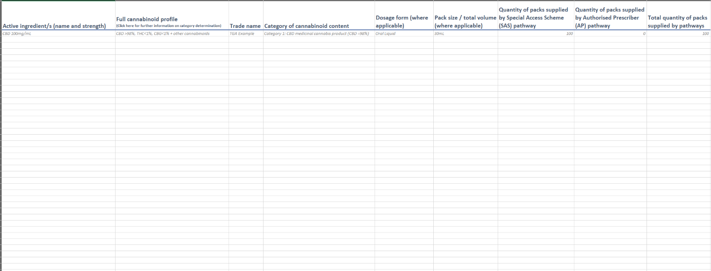

#### Other Product Example

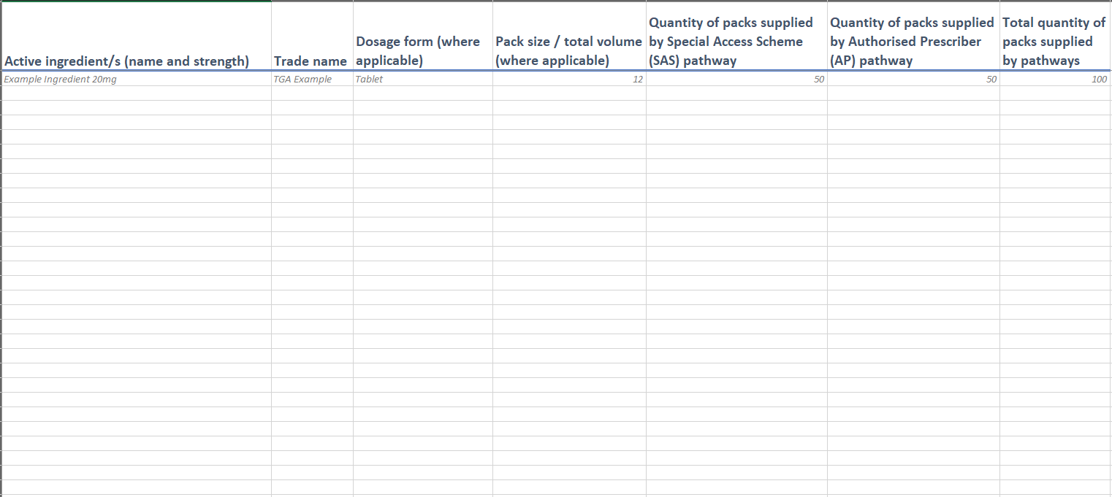

### Step 1: Active ingredient/s (name and strength)

**Active ingredients** are the therapeutically active components in a product responsible for its physiological or pharmacological action. This includes ingredients such as cannabinoids, vitamins and amino acids that have a physiological or pharmacological effect in the final formulation.

For medical devices, the device name corresponds to the device category such as shoulder replacement system, pacemaker lead or hip replacement system.

**Trade/ product names** for prescription medicines clearly identify the product. For both medicines and devices, trade names should be unique, and clearly identify the product but be neither promotional nor offensive in relation to general community standards.

### Step 2: Full cannabinoid profile / Category of cannabinoid content (medicinal cannabis products only)

Please provide the full cannabinoid profile of the product and use the guide [Active ingredient categories for medicinal cannabis products](https://www.tga.gov.au/sites/default/files/active_ingredient_categories_for_medicinal_cannabis_products.pdf) to determine the relevant category of the medicinal cannabis product. The category determination of medicinal cannabis products is based on the proportion of cannabidiol (CBD) content compared with the total cannabinoid content of the medicine.

### Step 3: Dosage form

Please use approved [dosage form](https://www.ebs.tga.gov.au/) terminology in the TGA code tables, except for novel or new dosage forms

### Step 4: Pack size / total volume

Please provide the **pack size** of the unapproved good supplied i.e. 20 tablets/box or 2 inhalers/box

### Step 5: Quantity of packs supplied by pathway

**Quantity of units** supplied is the number of times the unapproved therapeutic good has been supplied under the SAS and AP scheme over the six-month reporting period.

The **total quantity** supplied is the sum of the quantity supplied under the SAS and AP scheme.

|  |  |
| --- | --- |
| Information | **Medicinal cannabis products**  The six-monthly reports must be an accurate representation of the therapeutic goods supplied by the sponsor under the SAS and AP scheme in the preceding six-month period.  Please include only unapproved products that have been supplied in Australia under the SAS or AP schemes during the defined six month reporting period. |

Version history

|  |  |  |  |
| --- | --- | --- | --- |
| Version | Description of change | Author | Effective date |
| V1.0 | Original publication | Special Access Section | 20 June 2022 |
| V2.0 | Updated information for medicinal cannabis category of cannabinoid content. | Business Improvement and Compliance Section | June 2024 |