June 2022

Australian Public Assessment Report for Nuvaxovid heterologous booster
  - Active ingredient: SARS-CoV-2 rS vaccine with Matrix-M1 adjuvant
  - Sponsor: Biocelect Pty Ltd

About the Therapeutic Goods Administration (TGA)
- The Therapeutic Goods Administration (TGA) is part of the Australian Government Department of Health and is responsible for regulating medicines and medical devices.
- The TGA administers the Therapeutic Goods Act 1989 (the Act), applying a risk management approach designed to ensure therapeutic goods supplied in Australia meet acceptable standards of quality, safety and efficacy (performance) when necessary.
- The work of the TGA is based on applying scientific and clinical expertise to decision-making, to ensure that the benefits to consumers outweigh any risks associated with the use of medicines and medical devices.
- The TGA relies on the public, healthcare professionals and industry to report problems with medicines or medical devices. TGA investigates reports received by it to determine any necessary regulatory action.
- To report a problem with a medicine or medical device, please see the information on the TGA website <https://www.tga.gov.au>.

About AusPARs
- An Australian Public Assessment Report (AusPAR) provides information about the evaluation of a prescription medicine and the considerations that led the TGA to approve or not approve a prescription medicine submission.
- AusPARs are prepared and published by the TGA.
- An AusPAR is prepared for submissions that relate to new chemical entities, generic medicines, major variations and extensions of indications.
- An AusPAR is a static document; it provides information that relates to a submission at a particular point in time.
- A new AusPAR will be developed to reflect changes to indications and/or major variations to a prescription medicine subject to evaluation by the TGA.

Copyright
© Commonwealth of Australia 2022
This work is copyright. You may reproduce the whole or part of this work in unaltered form for your own personal use or, if you are part of an organisation, for internal use within your organisation, but only if you or your organisation do not use the reproduction for any commercial purpose and retain this copyright notice and all disclaimer notices as part of that reproduction. Apart from rights to use as permitted by the Copyright Act 1968 or allowed by this copyright notice, all other rights are reserved and you are not allowed to reproduce the whole or any part of this work in any way (electronic or otherwise) without first being given specific written permission from the Commonwealth to do so. Requests and inquiries concerning reproduction and rights are to be sent to the TGA Copyright Officer, Therapeutic Goods Administration, PO Box 100, Woden ACT 2606 or emailed to <tga.copyright@tga.gov.au>.

Contents
List of abbreviations 4
I. Introduction to product submission 6
Submission details 6
Product background 8
Regulatory status 9
Product Information 10
II. Registration timeline 10
III. Submission overview and risk/benefit assessment 11
Quality 11
Nonclinical 11
Clinical 11
Risk management plan 27
Risk-benefit analysis 29
Outcome 39
Attachment 1. Product Information 41

List of abbreviations
Abbreviation | Meaning
ACV | Advisory Committee on Vaccines
AE | Adverse event
AESI | Adverse events of special interest
ARTG | Australian Register of Therapeutic Goods
ASA | Australia specific annex
ATAGI | Australian Technical Advisory Group on Immunisation
BNT | Comirnaty (tozinameran) (mRNA) COVID-19 vaccine
ChAd | Vaxzevria
CI | Confidence interval
COVID-19 | Coronavirus disease 2019
DLP | Data lock point
ELISA | Enzyme linked immunosorbent assay
EU | European Union
GM | Geometric mean
GMC | Geometric mean concentration
GMR | Geometric mean ratio
IgG | Immunoglobin G
ITT | Intention to treat
m1273 | Spikevax (elasomeran) COVID-19 vaccine
MedDRA | Medical Dictionary for Regulatory Activities
MenACWY | Quadrivalent meningococcal conjugate vaccine
mITT | Modified intention to treat
mRNA | Messenger ribonucleic acid
NVX | Nuvaxovid (SARS-CoV-2 rS with Matrix-M1 adjuvant) COVID-19 vaccine
PI | Product Information
RMP | Risk management plan
SAE | Serious adverse event
SARS-CoV-2 | Severe acute respiratory syndrome coronavirus 2
SARS-CoV-2 rS | Severe acute respiratory syndrome coronavirus 2 recombinant spike protein nanoparticle vaccine
SOC | System Organ Class
TGA | Therapeutic Goods Administration
UK | United Kingdom
VLA | Valneva (VLA2001) COVID-19 vaccine
WHO | World Health Organization

I. Introduction to product submission

Submission details
Type of submission: | Major variation (change in dose regimen)
Product name: | Nuvaxovid
Active ingredient: | Severe acute respiratory syndrome coronavirus 2 (SARS-CoV-2) recombinant spike protein (rS) with Matrix M adjuvant
Decision: | Approved for provisional registration
Date of decision: | 9 June 2022
Date of entry onto ARTG: | 10 June 2022
ARTG number: | 351139
Black Triangle Scheme: | Yes  As a provisionally registered product, this medicine will remain in the Black Triangle Scheme for the duration of its provisional registration
Sponsor’s name and address: | Biocelect Pty Ltd  Suite 502 Level 5  139 Macquarie Street, NSW 2000
Dose form: | Suspension for injection
Strength: | 5 µg/0.5mL
Container: | Multidose vial
Pack size: | Ten vials
Approved therapeutic use: | Active immunisation to prevent coronavirus disease 2019 (COVID-19) caused by SARS-CoV-2 in individuals 18 years of age and older.  The use of this vaccine should be in accordance with official recommendations.  The decision has been made on the basis of short-term efficacy and safety data. Continued approval depends on the evidence of longer term efficacy and safety from ongoing clinical trials and post-market assessment.
Route of administration: | Intramuscular injection
Dosage: | Primary vaccination course:  Nuvaxovid is administered intramuscularly as a course of 2 doses of 0.5 mL each. It is recommended that the second dose is to be administered 3 weeks after the first dose (see section 5.1 Pharmacodynamic Properties of the Product Information for further details).  Booster vaccination dose:  A booster dose of Nuvaxovid (0.5 mL) may be administered intramuscularly approximately 6 months after completion of a primary series in individuals 18 years of age and older.  The decision when and for whom to implement a booster dose of Nuvaxovid should be made based on available vaccine safety and effectiveness data, in accordance with official recommendations (see sections 4.8 Adverse Effects; and 5.1 Pharmacodynamic Properties of the Product Information for further details).  Interchangeability with other vaccines:  There are no data available on the interchangeability of Nuvaxovid with other COVID-19 vaccines to complete the primary vaccination course. Individuals who have received a first dose of Nuvaxovid should receive the second dose of Nuvaxovid to complete the vaccination course (see section 4.4 Special Warnings and Precautions for Use of the Product Information for further details).  Precautions for administering the vaccine can be found in section 4.4 Special Warnings and Precautions for Use of the Product Information.
Pregnancy category: | B1  Drugs which have been taken by only a limited number of pregnant women and women of childbearing age, without an increase in the frequency of malformation or other direct or indirect harmful effects on the human fetus having been observed.  Studies in animals have not shown evidence of an increased occurrence of fetal damage.  The use of any medicine during pregnancy requires careful consideration of both risks and benefits by the treating health professional. This must not be used as the sole basis of decision making in the use of medicines during pregnancy. The TGA does not provide advice on the use of medicines in pregnancy for specific cases. More information is available from obstetric drug information services in your State or Territory.

Product background
This AusPAR describes the application by Biocelect Pty Ltd (the sponsor) to register Nuvaxovid (SARS-CoV-2 rS with matrix M adjuvant) 5 µg/0.5mL, suspension for injection, multidose vials, for the following change in dose regimen:
Booster Dose
Nuvaxovid is administered intramuscularly as a single booster dose (0.5 mL) at least 10 weeks after completing a primary series.
The decision when and for whom to implement a booster dose of Nuvaxovid should be made based on available vaccine safety and effectiveness data (see sections 4.8 and 5.1), in accordance with official recommendations.
Severe acute respiratory syndrome coronavirus 2 (SARS-CoV-2) has spread rapidly and globally since its emergence, causing coronavirus disease 2019 (COVID-19). The World Health Organization (WHO) declared that the outbreak constituted a public health emergency of international concern on 30 January 2020 and declared the outbreak to be a pandemic on 11 March 2020., As of 21 June 2022, approximately 537 million cases and 6.3 million deaths from COVID-19 have been reported worldwide. Of these, approximately 7.8 million cases and almost 9400 deaths have been reported in Australia.
Respiratory symptoms of COVID-19 typically appear 5 to 6 days following exposure to the virus but may appear from 2 to 14 days following exposure, with the clinical manifestations ranging from mild symptoms to rarely severe illness or death. Viral SARS-CoV-2 RNA has been detected in upper respiratory samples from asymptomatic or pre-symptomatic individuals, with an increasing number of studies demonstrating that asymptomatic individuals can transmit SARS-CoV-2. Although the extent to which asymptomatic transmission occurs remains unknown, it may significantly contribute to the transmission within the community.
In the absence of highly effective prophylactic or therapeutic medicines, active immunisation through vaccination represents the best means of preventing hospitalisation and deaths at an individual level and controlling the pandemic at a societal level.
Currently circulating mutated SARS-CoV-2 variants are posing challenges for current vaccination strategies, which are generally based on inducing immunity to the non-mutated spike protein that was sequenced in the original wild-type virus. Reported immune escape by the latest circulating variants are Omicron BA.1 and BA.2 has posed significant challenges in controlling the pandemic. The finding from in vitro assay suggest that Omicron variant may lead to more significant escape from immune protection elicited by previous SARS-CoV-2 infection and perhaps even by existing COVID-19 vaccines.

Nuvaxovid coronavirus disease vaccine
Nuvaxovid (NVX-CoV2373 SARS-CoV-2 rS protein) nanoparticle vaccine suspension for injection is a recombinant spike protein vaccine. It is based on the full length, wild-type SARS-CoV-2 spike glycoprotein. It is formulated in a sterile, preservative free, aqueous buffered suspension of the SARS-CoV-2 rS protein that is co-formulated with Matrix-M1 adjuvant; and formulation buffer and presented in a multi-dose vial containing ten doses. A single human dose of Nuvaxovid is 0.5 mL. Nuvaxovid induces active immunity to the spike protein of SARS-CoV-2, which is the causative virus of COVID-19.

Current options for COVID-19 vaccine booster
Currently provisionally approved COVID-19 vaccines for booster doses with their approved indications include the following:
- Comirnaty (tozinameran):
A booster dose of Comirnaty may be administered intramuscularly at least 6 months after the completion of a COVID-19 vaccine primary series in individuals 16 years of age and older.
- Spikevax (elasomeran):
Booster Dose
Individuals 18 years of age and older
Spikevax is administered intramuscularly as a single booster dose (0.25 mL; 50 micrograms) at least 6 months after completing a primary series.
- Vaxzevria (ChAdOx-1-S):
A third (booster) dose of 0.5 mL may be given if clinically indicated with reference to official guidance regarding the use of a heterologous third dose (e.g. mRNA vaccine)

Regulatory status
The product received initial registration on the Australian Register of Therapeutic Goods (ARTG) on 20 January 2022 for the following indication:
Active immunisation to prevent coronavirus disease 2019 (COVID-19) caused by SARS-CoV-2 in individuals 18 years of age and older.
The use of this vaccine should be in accordance with official recommendations.
The decision has been made on the basis of short-term efficacy and safety data. Continued approval depends on the evidence of longer term efficacy and safety from ongoing clinical trials post-market assessment.
At the time the TGA considered this application, a similar application for a third dose (booster) was under consideration in New Zealand (submitted on 28 February 2022). There has been no deferral or delay, withdrawal, rejection or ‘refusal to approve’ a submission for Nuvaxovid heterologous booster dose

Product Information
The Product Information (PI) approved with the submission which is described in this AusPAR can be found as Attachment 1. For the most recent PI, please refer to the TGA website at <https://www.tga.gov.au/product-information-pi>.

II. Registration timeline
Data were provided as a rolling submission. Under normal circumstances, the TGA's assessment (for both provisional and general registration) begins once all information to support registration is available. As part of the Department of Health's response to the pandemic, the TGA has agreed to accept rolling data for COVID-19 vaccines and treatments, to enable early evaluation of data as it becomes available. The following table captures the key steps and dates for this submission.
Table 1: Timeline for Submission PM-2021-00638-1-2
Description | Date
Submission dossier accepted and first round evaluation commenced | 3 March 2022
Evaluation completed | 7 June 2022
Delegate’s Overall benefit-risk assessment and request for Advisory Committee advice | 18 March 2022
Sponsor’s pre-Advisory Committee response | 21 March 2022
Advisory Committee meeting | 22 March 2022
Second Advisory Committee meeting | 20 May 2022
Registration decision (Outcome) | 9 June 2022
Completion of administrative activities and registration on the ARTG | 10 June 2022
Number of working days from submission dossier acceptance to registration decision* | 66
*Statutory timeframe for standard applications is 255 working days

III. Submission overview and risk/benefit assessment
The submission was summarised in the following Delegate’s overview and recommendations.
TGA guidance at pre-submission meetings is nonbinding and without prejudice.

Quality
There was no requirement for a quality evaluation in a submission of this type.
This product received a full quality evaluation at the time of initial registration.

Nonclinical
There was no requirement for a nonclinical evaluation in a submission of this type.
This product received a full nonclinical evaluation at the time of initial registration.

Clinical
Clinical data to support the use of Nuvaxovid as heterologous booster is provided from the COV-BOOST trial. The full clinical study report is not available, as this trial was not conducted by the sponsor. The published article for the COV-BOOST trial (Munro et al. 2021) and its two supplements are provided with the submission to support the proposed variation to dosage regimen.
Further information about the COV-BOOST trial is available online.

Immunogenicity
The sponsor has provided the publication (Munro et al. 2021)),12 based on the COV-BOOST trial as the only supportive data to this literature based submission. In this AusPAR the relevant data related to the use of Nuvaxovid as heterologous booster after Comirnaty and Vaxzevria priming dose (Group A of the study) is discussed and a reference to the Group B is made (mainly for comparison with Comirnaty homologous booster) where relevant.

Dose finding
No dose finding study was conducted for use of Nuvaxovid as booster. The COV-BOOST trial used Nuvaxovid full dose (0.5 mL) and Nuvaxovid half dose (0.25ml) in the trial. The sponsor is proposing use of full dose (0.5ml) for heterologous booster dose. There is no rationale provided by the sponsor for selection of the Nuvaxovid full dose.

Immunogenicity outcome
The COV-BOOST trial is a multicentre, randomised, controlled, Phase II trial of third dose booster vaccination against COVID-19. The study was conducted at 18 United Kingdom (UK) sites between 1 June 2021 to 30 June 2021, at which time the Delta variant was dominant in the UK.
To reduce the risk of vaccine administration error and delays, if there were problems in the supply of one or more vaccines, the ten experimental vaccine and control groups (seven vaccines with three also at half dose and controls) were split into three groups with six sites per group. Vaccines used in the trial were Nuvaxovid (NVX-CoV2373; NVX), Vaxzevria, (ChAdOx1 nCov-19; ChAd), Comirnaty (tozinameran/BNT162b2, BNT), Valneva (VLA2001, VLA), COVID-19 Janssen vaccine (Ad26.COV2.S), Spikevax (elasomeran/mRNA1273; m1273), CureVac (CVnCov), three of which were also used as half doses (Comirnaty, Nuvaxovid and Valneva) and a quadrivalent meningococcal conjugate vaccine (MenACWY) as a control. Nuvaxovid (full and half dose) was used as a heterologous booster following Vaxzevria or Comirnaty as the primary course in Group A of the trial.
Participants were aged older than 30 years and were at least 70 days post two doses of Vaxzevria or at least 84 days post two doses of Comirnaty primary COVID-19 immunisation course, with no history of laboratory confirmed SARS-CoV-2 infection.

Study objectives
The co-primary outcomes were safety and immunogenicity of anti-spike protein immunoglobin G (IgG) measured by enzyme linked immunosorbent assay (ELISA) at Day 28. The primary analysis for immunogenicity was on a modified intention to treat (mITT) basis; safety and reactogenicity were assessed in the intention to treat (ITT) population.
Secondary outcomes included assessment of viral neutralisation and cellular responses.

Main inclusion criteria
The main inclusion criteria were:
- Male or female, aged 30 years or above and in good health as determined by a trial clinician. Participants may have well controlled or mild to moderate comorbidity.
- Received priming dose of COVID-19 vaccination in December 2020, January or February 2021 and is at least 84 days post second vaccination. Due to the National Health Service UK deployment timelines, some sites may need to invite people who have been prime boosted with their second dose of Vaxzevria with a minimum of 70 days from their second dose. Sites need sponsor approval for this prior to enrolment of people with a 70 to 83 days gap since their second dose in any study arm.

Main exclusion criteria
The main exclusion criteria were:
- Receipt of any vaccine (licensed or investigational) other than the study intervention vaccines within 30 days before and after each study vaccination (one week for licensed seasonal influenza vaccine or pneumococcal vaccine).
- Prior or planned receipt of any other investigational or licensed vaccine or product likely to impact on interpretation of the trial data (for example, adenovirus vectored vaccines, any coronavirus vaccines).
- Participants who are pregnant at enrolment or planning to become pregnant during the first three months following vaccination.
- Administration of immunoglobulins and/or any blood products within the three months preceding the planned administration of the vaccines.
- Any confirmed or suspected immunosuppressive or immunodeficient state.
- History of allergic disease or reactions (for example, hypersensitivity to the active substance or any of the summary of product characteristics-listed ingredients of the Comirnaty vaccine).
- Any history of anaphylaxis.
- Current diagnosis of or treatment for cancer (except basal cell carcinoma of the skin and cervical carcinoma in situ)
- Bleeding disorder, continuous use of anticoagulants.
- History of cerebral venous sinus thrombosis, antiphospholipid syndrome or heparin induced thrombocytopenia and thrombosis (HITT or HIT type 2).
- Severe and/or uncontrolled cardiovascular disease, respiratory disease, gastrointestinal disease, liver disease, renal disease, endocrine disorder and neurological illness (mild/moderate well controlled comorbidities are allowed).
- History of active or previous auto-immune neurological disorders (for example, multiple sclerosis, Guillain-Barre syndrome, transverse myelitis). Bell’s palsy was not an exclusion criterion.
- Significant renal or hepatic impairment
- Participants who have participated in another research trial involving an investigational product in the past 12 weeks. This does not exclude participants in trials of Vaxzevria who were originally recipients of placebo and who received Vaxzevria or BNT162b2 (Comirnaty) as part of the National Health Service ‘national schedule with Vaxzevria or BNT162b2 (Comirnaty) first dose from middle of December 2020 through to end February 2021 and then Vaxzevria or BNT162b2 (Comirnaty) second dose twelve weeks later (this is allowed by the COV001 trial; and COV002 trial; protocols).

Randomisation and masking
Unblinded statistician created the computer generated randomisation list. Randomisation schedules were prepared separately for participants primed with Vaxzevria/Vaxzevria and Comirnaty/Comirnaty and stratified by study site, age (< 70 years and ≥ 70 years) and subgroup (general and immunology). Permuted random blocks were used, and participants were randomly assigned to the study groups with equal probability within Groups A to C.
- Group A received full dose of Nuvaxovid (0.5 mL), a half dose of Nuvaxovid (0.25 mL), Vaxzevria, or control MenACWY at ratio of 1:1:1:1 randomisation;
- Group B received Comirnaty, Valneva, a half dose of Valneva, COVID-19 Janssen vaccine or control MenACWY at ratio of 1:1:1:1:1 randomisation;
- Group C received Spikevax, CVnCov, a half dose of Comirnaty, or control MenACWY at ratio of 1:1:1:1 randomisation.
Each group (A, B, and C) had their own control group and recruited two separate populations, those receiving Vaxzevria/Vaxzevria and those receiving Comirnaty/Comirnaty. Randomisation was done in the electronic data capture system REDCap, version 10.6.13.
Participants, laboratory staff, and the clinical study team not delivering the vaccines were blind to treatment allocation, including those undertaking adverse event assessments. Participant blinding to vaccines was maintained by concealing randomisation pages, preparing vaccines out of sight, and applying masking tape to vaccine syringes to conceal dose, volume, and appearance. The analysing statisticians remained blind until the statistical analysis plan was signed off.

Study procedure
Participants who met the inclusion and exclusion criteria via the online screening or the telephone screening (or both) were invited to a baseline visit (Day 0). Participants who passed the final eligibility assessment were randomly assigned to a study group.
Seven COVID-19 vaccines, and three with a half dose, were used; all vaccines were administered via intramuscular injection into the upper arm.
Participants attended screening and vaccination at Day 0. Blood was taken for immunogenicity analyses at Day 28, 84, and 365 respectively. A separate immunology subgroup comprised of 25 individuals from each treatment group (n = 650 participants) attended additional visits to have blood taken at Day 7 (to detect evidence of previous immunological priming via rapid spike IgG responses) and Day 14 (to detect the peak T-cell response). The cellular immunology samples were collected from nine sites based on logistical reasons (proximity to external laboratory). The immunology subgroup was allocated at six of these sites, including three sites recruiting immunology subgroup only and the other three sites enrolling participants up to the required number.
During the baseline visit, participants were given an oral thermometer, tape measure, and diary card (electronic or paper) to record solicited adverse events on Day 7, unsolicited adverse events (AE) on Day 28, and medically attended AEs on Day 84. During the study visits, AEs, adverse events of special interest (AESI), and serious adverse events (SAE) that had not been recorded in the diary card were also collected.

Statistical analysis
Immunogenicity outcome was powered and designed to have 90% power to compare the geometric mean concentration (GMC) of anti-spike protein IgG between each COVID-19 vaccine group with the MenACWY group within each of the three groups (Group A and C (three comparisons), and B (four comparisons)) and populations (Vaxzevria/Vaxzevria and Comirnaty/Comirnaty). Since at most, four comparisons were made within a cohort, using a Bonferroni correction; would need to adjust for a significance level of 0.05/4 = 0.0125. To account for multiple testing within each cohort a conservative two sided significance level of 0.01 was used. 83 participants per group were required to detect an established minimum clinically important difference of 1.75 times difference in GMC assuming a log₁₀-SD of 0.4. The minimum clinical important difference was chosen based on the discussions with UK policy makers and regulatory agency. The required sample size was inflated by 25% to take account of participants who would be seropositive at Baseline or lost to follow up, recruiting n = 111 per group. A subset of n = 25 per group were included in the immunology sub-study, as the purpose of this sub-study was descriptive, a power calculation was not undertaken.
All analyses were stratified by prime series of vaccination (Vaxzevria/Vaxzevria and Comirnaty/Comirnaty). The primary analysis for immunogenicity outcomes was on a mITT basis to include all participants who were seronegative at Baseline (defined by the Roche Elecsys anti-Sars-CoV-2 assay); with no confirmed SARS-CoV-2 infection within 14 days post third dose, and with endpoint data available. The primary immunogenicity outcome of anti-spike protein IgG at Day 28 in each group was reported as GMC and 95% confidence interval (CI). The geometric mean ratio (GMR) and 99% CIs (to account for multiple comparisons) of anti-spike protein IgG between each experimental group and the corresponding control group was also reported. The GMR was calculated as the antilogarithm of the difference between the mean of the log₁₀ transformed anti-spike protein IgG in the experimental group and that in the control group. The original analysis plan included use of a linear mixed effect model with site as a random effect, but due to model convergence, a linear regression with site as a fixed effect was used. The model computed the difference of log₁₀ transformed anti-spike protein IgG after adjusting for baseline immunogenicity and randomisation design variables (that is, study site and age group), duration between first and second vaccine, and the duration between second to third dose vaccine. Residual analysis was done to examine model assumptions.
The analysis population for reactogenicity and safety included all randomly assigned participants who received a study vaccine, including both seronegative and seropositive populations at Baseline. The primary outcome of reactogenicity examined solicited adverse events (local and systemic) within the first seven days. The proportion with at least one severe episode (Grade 3 and Grade 4) are presented for each of the groups (Group A, B, and C) and priming vaccine by vaccine group. An additional view of reactogenicity outcomes displays severity of the event by vaccine group and stratified by priming vaccine and age group. Unsolicited adverse events reported within 28 days post third dose were coded according to the Medical Dictionary for Regulatory Activities (MedDRA) and tabulated at System Organ Class (SOC) level across vaccine groups. AESI and SAEs were reported until the data lock date of 19 August 2021, by line listing.
Secondary immunogenicity outcomes were analysed with the same approach as for the primary immunogenicity outcome. The analyses for primary and secondary outcomes were repeated in the group aged 30 to 69 years and the group aged 70 years and older separately, as subgroup analysis. For descriptive statistics, secondary outcomes, and subgroup analysis, GMRs were reported with 95% CIs.
Figure 1: COV-BOOST trial Participant flow
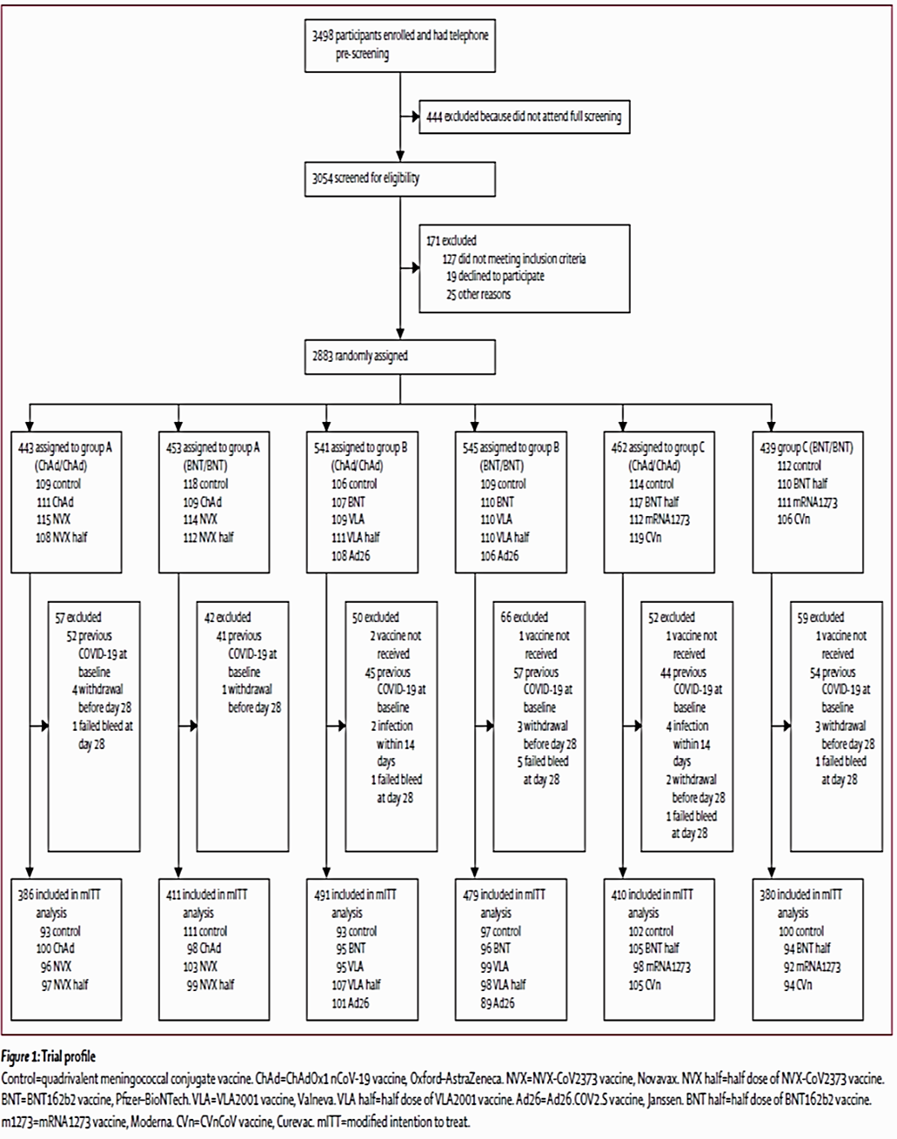
Control=quadrivalent meningococcal conjugate vaccine. ChAd = Vaxzevria. NVX = Nuvaxovid. NVX half = half dose of Nuvaxovid. BNT = Comirnaty. VLA = Valneva. VLA half=half dose of Valneva. Ad26=COVID-19 Janssen vaccine. BNT half = half dose of Comirnaty. m1273=Spikevax. CVn=CVnCoV vaccine. mITT = modified intention to treat.

Results

Baseline characteristics
Within the Vaxzevria/Vaxzevria primed or Comirnaty/Comirnaty primed populations, the baseline characteristics including co-morbidities and ethnicities, were well balanced between the randomly assigned groups for Group A.
Table 2: COV-BOOST trial Baseline characteristics
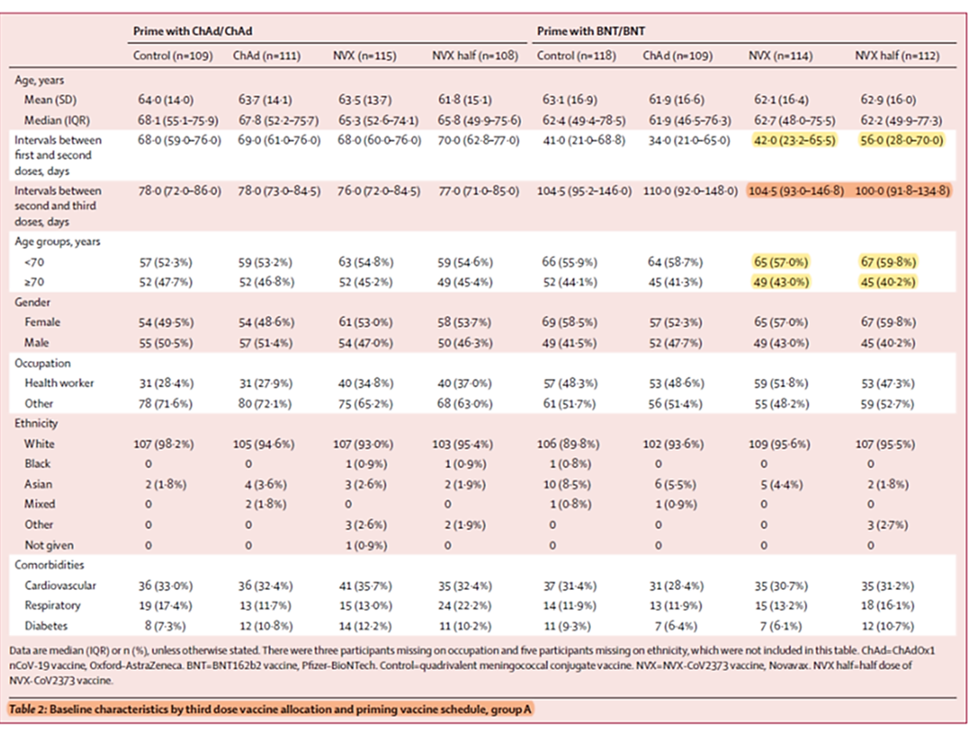
Data are median (IQR) or n (%), unless otherwise stated. There were three participants missing on occupation and five participants missing on ethnicity, which were not included in this table. ChAd = Vaxzevria vaccine, Oxford-Astra Zenca; BNT = Comirnaty, Pfizer-BioNTech; control = quadrivalent meningococcal conjugate vaccine; NVX = Nuvavoxid, Novovax; NVX half = half dose of Nuvavoxid, Novovax.
Source: Table 2 of Munro et al., Safety and immunogenicity of seven COVID-19 vaccines as a third dose (booster) following two doses of ChAdOx1 nCov-19 or BNT162b2 in the UK (COV-BOOST): a blinded, multicentre, randomised, controlled, phase 2 trial, The Lancet, 2021; 398:2258-2276. https://www.thelancet.com/journals/lancet/article/PIIS0140-6736(21)02717-3/fulltext

Immunogenicity
The co-primary immunogenicity outcome was anti-spike protein IgG geometric mean (GM) concentrations at Day 28 after boosting.
Nuvaxovid at two dose levels (full and half dose) was included in the COV-BOOST trial. The vaccines were given as heterologous boosting doses following primary series with either the Vaxzevria or Comirnaty vaccines which were also administered as third homologous boosting doses.
A heterologous booster dose of Nuvaxovid (both half dose and full dose) induced levels of SARS-CoV-2 anti-spike protein IgG significantly higher than the control, and higher than those induced by Vaxzevria homologous third dose. For Nuvaxovid full dose GMR was 8.75 and 5.82 for Nuvaxovid half dose, as compared to GMR of 3.25 for Vaxzevria homologous third dose (Table 3).
For Comirnaty primed subjects, a heterologous booster dose of Nuvaxovid full dose induced increases in IgG antibody titres with a GMR of 4.78 and Nuvaxovid half dose induced a GMR of 3.07, as compared to the control. However, Nuvaxovid GMR responses (both full and half doses) were lower than those seen with a homologous booster dose of Comirnaty in Group B (GMR 8.11) (Table 4), heterologous booster dose of Vaxzevria with Comirnaty primed (GMR 5.33).
Similar findings were noted when live virus neutralising antibody titres were evaluated (Table 5)
Table 3: COV-BOOST trial Immune responses by third dose vaccine allocation and priming vaccine schedule at 28 days post boost dose among the COVID-19-naive modified intention-to-treat population, Group A
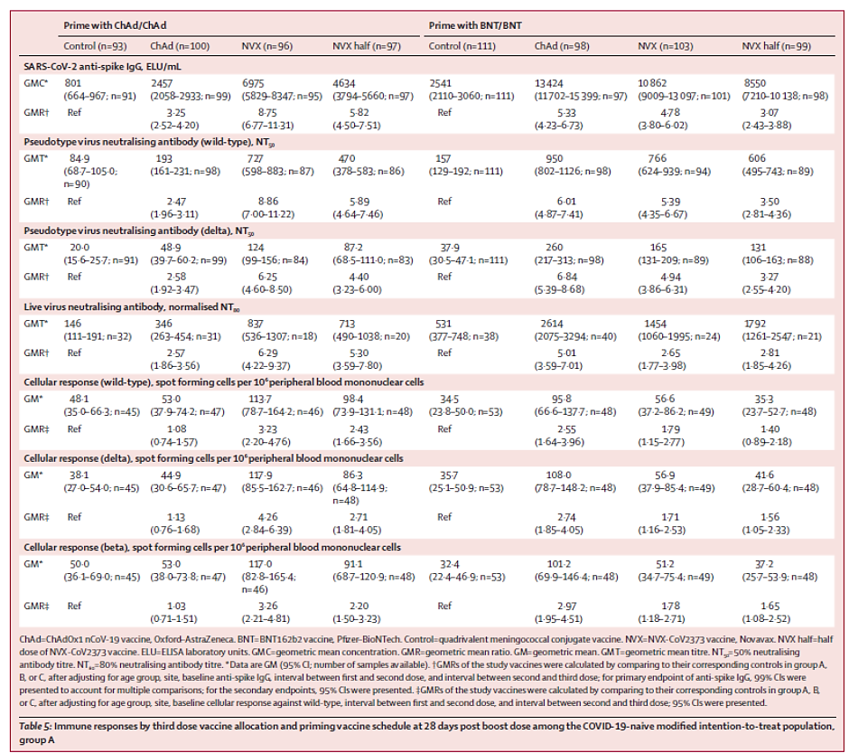
ChAd = Vaxzevria vaccine, Oxford-Astra Zenca; BNT = Comirnaty, Pfizer-BioNTech; control = quadrivalent meningococcal conjugate vaccine; NVX = Nuvavoxid, Novovax; NVX half = half dose of Nuvavoxid, Novovax; ELU = ELISA laboratory units; GMC = geometric mean concentration; GMR = geometric mean ratio; GM = geometric mean; GMT = geometric mean titre; NT₅₀ = 50% neutralising antibody titre; NT₈₀ = 80% of neutralising antibody titre * Data are GM (95% CI; number of samples available). † GMRs of the study vaccines were calculated by comparing to their corresponding controls in Group A, B, or C, after adjusting for age group, site, baseline anti-spike IgG, interval between first and second dose, and interval between second and third dose; for primary endpoint of anti-spike IgG, 99% CIs were presented to account for multiple comparisons; for the secondary endpoints, 95% CIs were presented. ‡ GMRs of the study vaccines were calculated by comparing to their corresponding controls in Group A, B, or C, after adjusting for age group, site, baseline cellular response against wild-type, interval between first and second dose, and interval between second and third dose; 95% CIs were presented.
Source: Table 5 of Munro et al., Safety and immunogenicity of seven COVID-19 vaccines as a third dose (booster) following two doses of ChAdOx1 nCov-19 or BNT162b2 in the UK (COV-BOOST): a blinded, multicentre, randomised, controlled, phase 2 trial, The Lancet, 2021; 398:2258-2276. https://www.thelancet.com/journals/lancet/article/PIIS0140-6736(21)02717-3/fulltext
Table 4: COV-BOOST trial Primary endpoint immune response, SARS-CoV-2 anti-spike IgG at 28 days post dose boost, by geometric mean concentration and geometric mean ratio
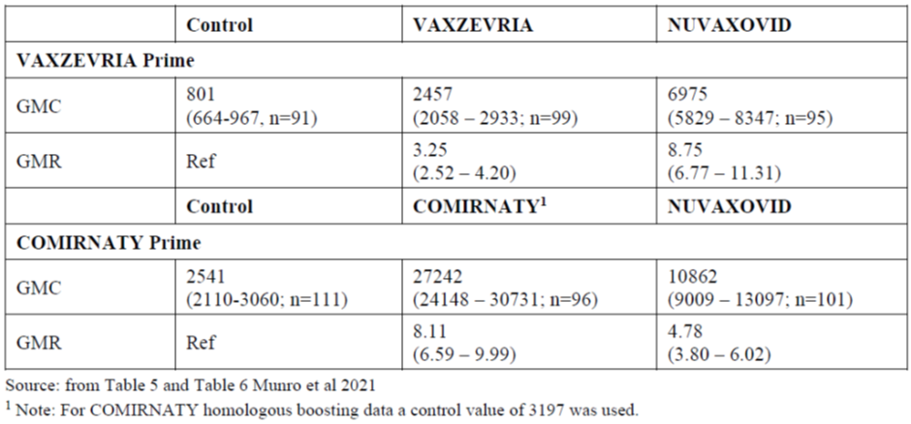
Adapted from Table 5 and Table 6 from Munro et al., Safety and immunogenicity of seven COVID-19 vaccines as a third dose (booster) following two doses of ChAdOx1 nCov-19 or BNT162b2 in the UK (COV-BOOST): a blinded, multicentre, randomised, controlled, phase 2 trial, The Lancet, 2021; 398:2258-2276. https://www.thelancet.com/journals/lancet/article/PIIS0140-6736(21)02717-3/fulltext
¹ Note: For Comirnaty homologous boosting data a control value of 3197 was used.
Geometric mean concentration (GMC) = 95% CI; no. of samples available
Geometric mean ratio (GMR) = 99.9% CI for multiple comparisons
Table 5: COV-BOOST trial Secondary endpoint immune response, live virus neutralising antibody, (NT₈₀) at 28 days post dose boost, by geometric mean titre and geometric mean ratio
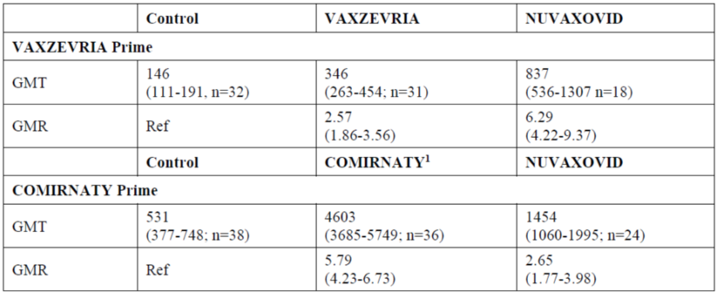
Adapted from Table 5 and Table 6 from Munro et al., Safety and immunogenicity of seven COVID-19 vaccines as a third dose (booster) following two doses of ChAdOx1 nCov-19 or BNT162b2 in the UK (COV-BOOST): a blinded, multicentre, randomised, controlled, phase 2 trial, The Lancet, 2021; 398:2258-2276. https://www.thelancet.com/journals/lancet/article/PIIS0140-6736(21)02717-3/fulltext
¹ Note: For Comirnaty homologous boosting data a control value of 756 was used.
Geometric mean concentration (GMC) = 95% CI; no. of samples available
Geometric mean ratio (GMR) = 95% CI for secondary endpoints
Table 6 (see below) shows the progressive immune response for anti-spike protein IgG and cellular response from Baseline to Day 7 and Day 28.
Table 6: COV-BOOST trial Kinetics of immune responses post third dose by study vaccine and priming vaccine schedule among the modified intention-to-treat population of immunology cohort, Group A
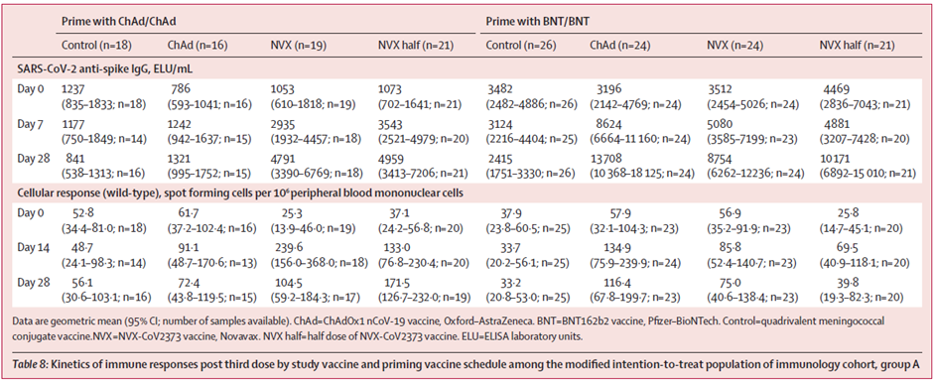
Data are geometric mean (95% CI; number of samples available). ChAd = Vaxzevria vaccine, Oxford-Astra Zeneca; BNT = Comirnaty, Pfizer-BioNTech; control = quadrivalent meningococcal conjugate vaccine; NVX = Nuvavoxid, Novovax; NVX half = half dose of Nuvavoxid, Novovax; ELU = ELISA laboratory units.
Source: Table 8 of Munro et al., Safety and immunogenicity of seven COVID-19 vaccines as a third dose (booster) following two doses of ChAdOx1 nCov-19 or BNT162b2 in the UK (COV-BOOST): a blinded, multicentre, randomised, controlled, phase 2 trial, The Lancet, 2021; 398:2258-2276. https://www.thelancet.com/journals/lancet/article/PIIS0140-6736(21)02717-3/fulltext
As expected, younger age group (< 70 years) mounted better immunogenic response across the groups.
The T-cell boosting effects of Nuvaxovid and half dose of Nuvaxovid were lower in people who had received Comirnaty prime dose, as compared with those who previously received Vaxzevria. In the Comirnaty primed subjects, the GM of T-cell responses in the subjects over 70 years in Nuvaxovid full dose (1.3, 95% CI = 0.66 to 2.7) and across both age groups in half dose of Nuvaxovid, was not significantly higher than control (1.4, 95% CI 0.89 to 2.2).
Following is a Forest plot for Vaxzevria primed (Figure 2) and Comirnaty primed subjects (Figure 3) showing anti-spike protein IgG and cellular response at 28 days post third dose.
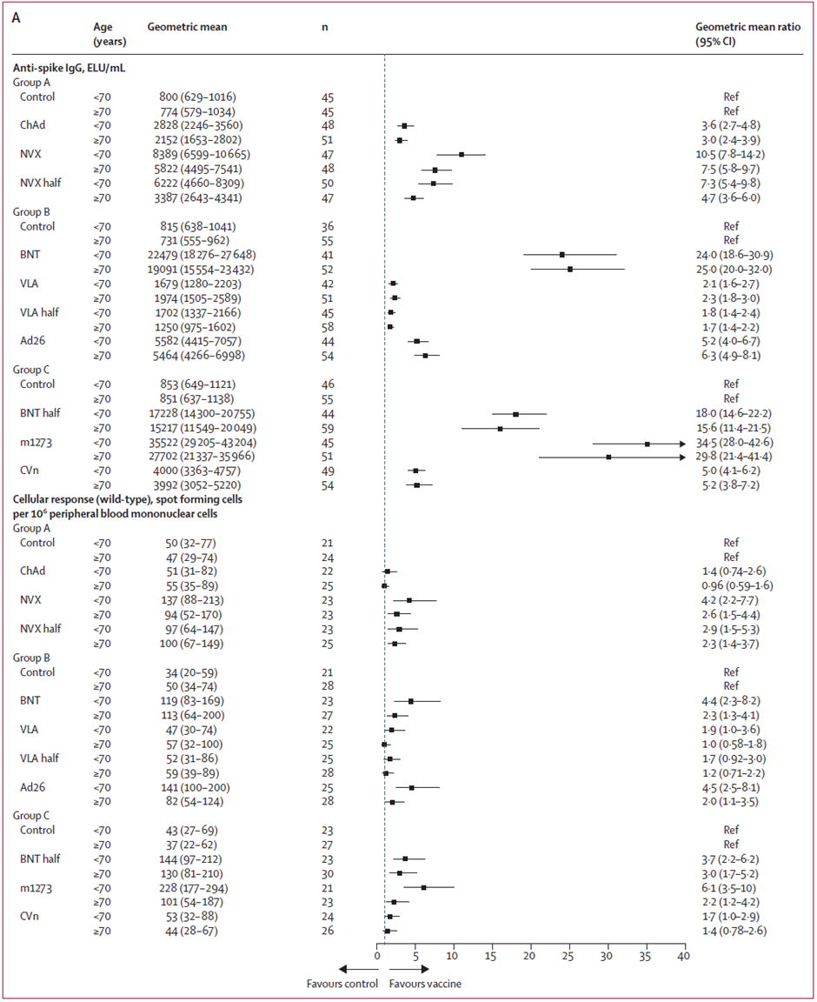
Figure 2: COV-BOOST trial Subgroup immunogenicity analyses by age for anti-spike protein IgG and cellular response at 28 days post third dose between study vaccines and controls for the Vaxzevria/Vaxzevria primed population
ELU=ELISA laboratory units. Control=quadrivalent meningococcal conjugate vaccine. ChAd = Vaxzevria vaccine, Oxford-Astra Zeneca; NVX = Nuvavoxid, Novovax; NVX half = half dose of Nuvavoxid; Novovax. BNT = Comirnaty, Pfizer-BioNTech; VLA = VLA2001 vaccine, Valneva. VLA half = half dose of VLA2001 vaccine, Valneva. Ad26 =COVID-19 Janssen vaccine; BNT half = half dose of Comirnaty; m1273 = Spikevax, Moderna; CVn = CVnCoV vaccine, Curevac.
Source: Figure 3 of Munro et al., Safety and immunogenicity of seven COVID-19 vaccines as a third dose (booster) following two doses of ChAdOx1 nCov-19 or BNT162b2 in the UK (COV-BOOST): a blinded, multicentre, randomised, controlled, phase 2 trial, The Lancet, 2021; 398:2258-2276. https://www.thelancet.com/journals/lancet/article/PIIS0140-6736(21)02717-3/fulltext
Figure 3: Subgroup immunogenicity analyses by age for anti-spike protein IgG and cellular response at 28 days post third dose between study vaccines and controls for the Comirnaty/Comirnaty primed population
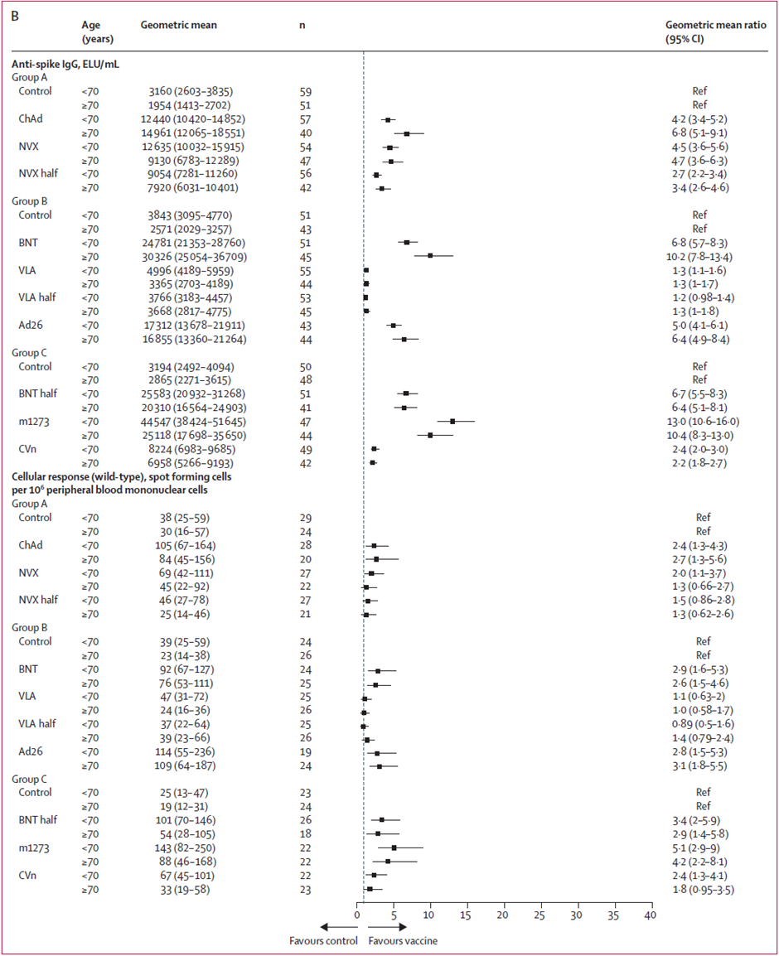
ELU=ELISA laboratory units. Control=quadrivalent meningococcal conjugate vaccine. ChAd = Vaxzevria vaccine, Oxford-Astra Zeneca; NVX = Nuvavoxid, Novovax; NVX half = half dose of Nuvavoxid; Novovax. BNT = Comirnaty, Pfizer-BioNTech; VLA = VLA2001 vaccine, Valneva. VLA half = half dose of VLA2001 vaccine, Valneva. Ad26 =COVID-19 Janssen vaccine; BNT half = half dose of Comirnaty; m1273 = Spikevax, Moderna; CVn = CVnCoV vaccine, Curevac.
Source: Figure 3 of Munro et al., Safety and immunogenicity of seven COVID-19 vaccines as a third dose (booster) following two doses of ChAdOx1 nCov-19 or BNT162b2 in the UK (COV-BOOST): a blinded, multicentre, randomised, controlled, phase 2 trial, The Lancet, 2021; 398:2258-2276. https://www.thelancet.com/journals/lancet/article/PIIS0140-6736(21)02717-3/fulltext

Correlation between pseudovirus neutralisation assay for wild type and Delta variants of SARS-CoV-2
Figure 4 shows reduced neutralisation after the booster dose against the delta variant as compared to the wild type SARS-CoV-2.
Figure 4: Correlation between pseudovirus neutralisation assay against wild type and pseudovirus neutralisation assay against Delta strain at 28 days post third dose in participants with A) Vaxzevria/Vaxzevria primed in Group A; B) Comirnaty/Comirnaty primed in Group A
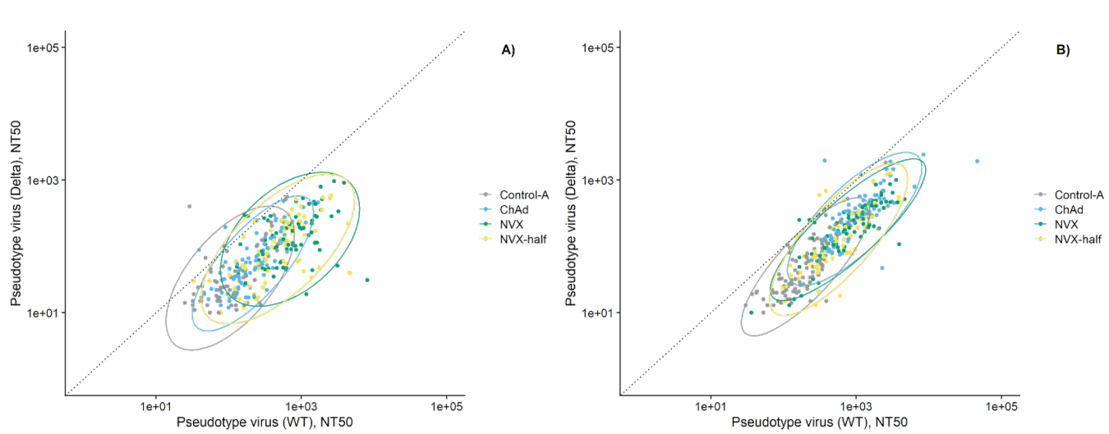
The dotted diagonal line shows the situation when the immunogenicity to a variant of concern (VOC) is the same as that to the wild type (the vaccines were designed for). Ellipses show the 95% CIs for different vaccine schedules, assuming multivariate normal distributions. NT₅₀=50% neutralising antibody titre. Control A/B/C = quadrivalent meningococcal conjugate vaccine; ChAd=Vaxzevria, Oxford–AstraZeneca; NVX = Nuvaxovid, Novavax; NVX half = half dose of Nuvaxovid, Novavax; BNT =Comirnaty, Pfizer–BioNTech.
Note: Pseudovirus neutralisation assay (PNA) correlation between wild type and Beta variant is not provided.

Correlation between cellular response for wild type and Beta variant
Figure 5 shows comparable T-cell response after the booster dose against the Beta variant, as compared to the wild type SARS-CoV-2.
Figure 5: Correlation between cellular response against wild type and cellular response against Beta strain at 28 days post third dose in participants (Group A) with A) Vaxzevria/Vaxzevria primed B) Comirnaty/Comirnaty primed
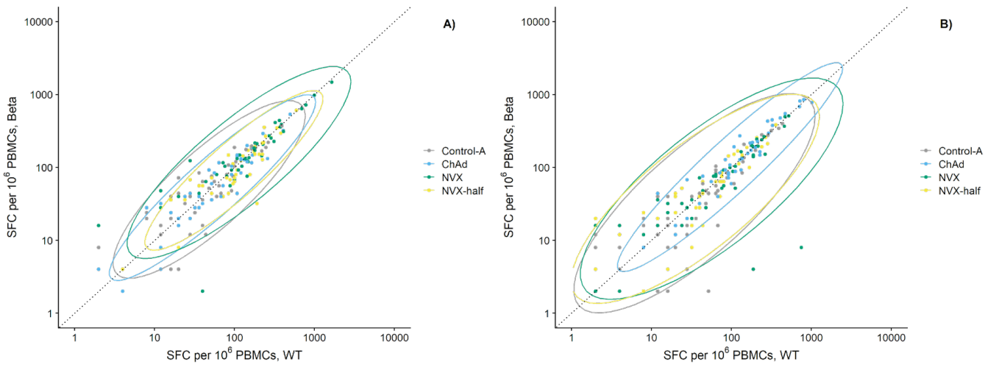
The dotted diagonal line shows the situation when the immunogenicity to a variant of concern (VOC) is the same as that to the wild type (the vaccines were designed for). Ellipses show the 95% CIs for different vaccine schedules, assuming multivariate normal distributions. PBMC = peripheral blood mononuclear cell. SFC = spot-forming units. Control A/B/C = quadrivalent meningococcal conjugate vaccine; ChAd=Vaxzevria, Oxford–AstraZeneca; NVX = Nuvaxovid, Novavax; NVX half = half dose of Nuvaxovid, Novavax; BNT =Comirnaty, Pfizer–BioNTech.

Correlation between cellular response for wild type and Delta variant
Figure 6 shows comparable T-cell response after the booster dose against the Delta variant, as compared to the wild type of SARS-CoV-2.
Figure 6: Correlation between cellular response against wild type and cellular response against Delta strain at 28 days post third dose in participants with A) Vaxzevria/Vaxzevria primed in Group A; B) Comirnaty/Comirnaty primed in Group A 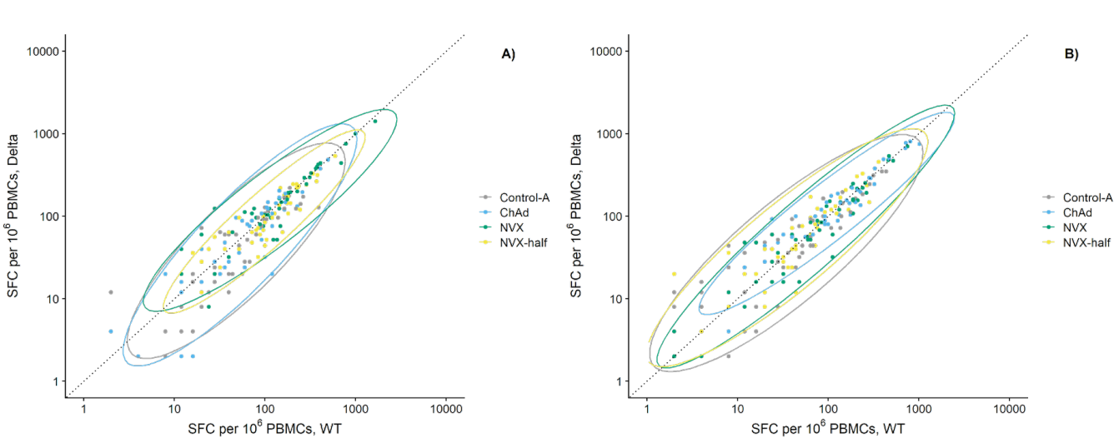
The dotted diagonal line shows the situation when the immunogenicity to a variant of concern (VOC) is the same as that to the WT (the vaccines were designed for). Ellipses show the 95% CIs for different vaccine schedules, assuming multivariate normal distributions. PBMC = peripheral blood mononuclear cell. SFC = spot-forming units. Control A/B/C = quadrivalent meningococcal conjugate vaccine; ChAd=Vaxzevria, Oxford–AstraZeneca; NVX = Nuvaxovid, Novavax; NVX half = half dose of Nuvaxovid, Novavax; BNT =Comirnaty, Pfizer–BioNTech.

Efficacy
Clinical efficacy was not assessed in the COV-BOOST trial. Two COVID-19 cases were reported in the subjects receiving Nuvaxovid half dose (n = 97); onset reported as at 57- and 30-days post third booster dose. One case was reported in Nuvaxovid full dose group (n = 96) and two cases in control group (n = 93).

Safety
Clinical safety was not assessed specifically for the Nuvaxovid group (Group A). Relevant data from the published article is separated and discussed here.
The COV-BOOST trial safety database for Group A included 229 participants at the proposed full Nuvaxovid dose (0.5 mL) with a further 220 participants receiving a Nuvaxovid half dose (0.25 mL).
The primary outcome for reactogenicity was solicited adverse events (local and systemic) within the first seven days following vaccination. Unsolicited adverse events reported within 28 days of the booster dose were collected, coded, and tabulated.

Solicited adverse events (local and systemic)
The profiles of any grade local and systemic reactions within seven days after all vaccines were similar, with fatigue and headache the most common systemic reactions, and pain the most frequent local reaction (see Table 7). Overall, reactogenicity was greater in people aged 30 to 69 years compared with older participants regardless of the first vaccines received.
Participants primed with Comirnaty/Comirnaty reported more frequent local and systemic reactions after receiving Spikevax, CVn, Vaxzevria, and COVID-19 Janssen vaccine as a third dose, compared with other vaccines and control.
Following spike axis data represents the proportion of severe (see Figure 7) and moderate (Figure 7) local and solicited AEs among the participants with self-reported diary data. For each AE, the maximum severity recorded across seven days post vaccination. The area defined by each vaccine provides a visual representation of reactogenicity burden, where greater area indicates greater burden. Separate subgroup data for Nuvaxovid/Nuvaxovid half dose as a booster is not provided.
Figure 7: Comirnaty/Vaxzevria primed, severe local and solicited adverse events (Group A)
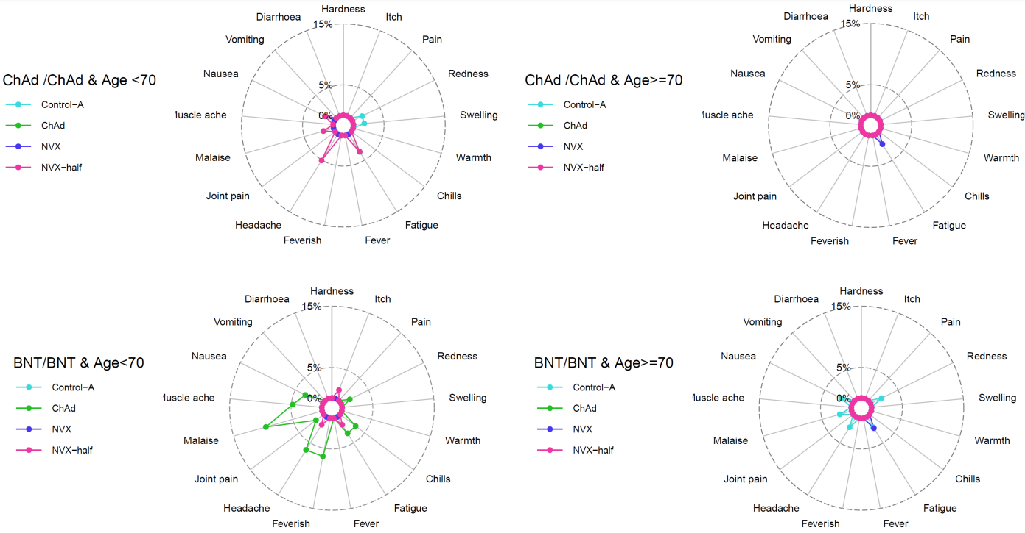
Figure 8: Comirnaty/Vaxzevria primed, moderate local and solicited adverse events (Group A)
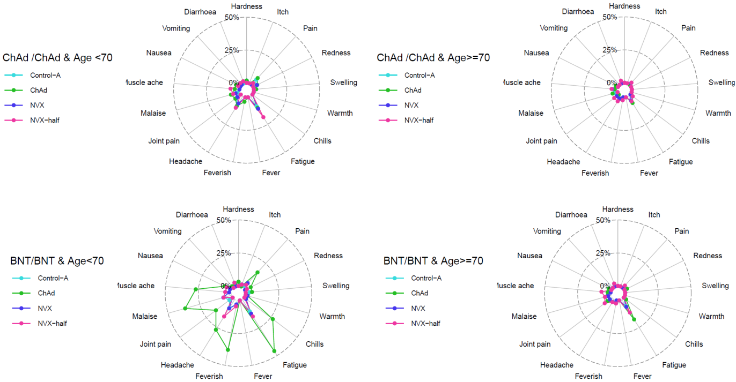
Table 7: Summary of adverse events by third dose vaccine allocation and priming vaccine schedule in Group A by severity, causality and System Organ Class
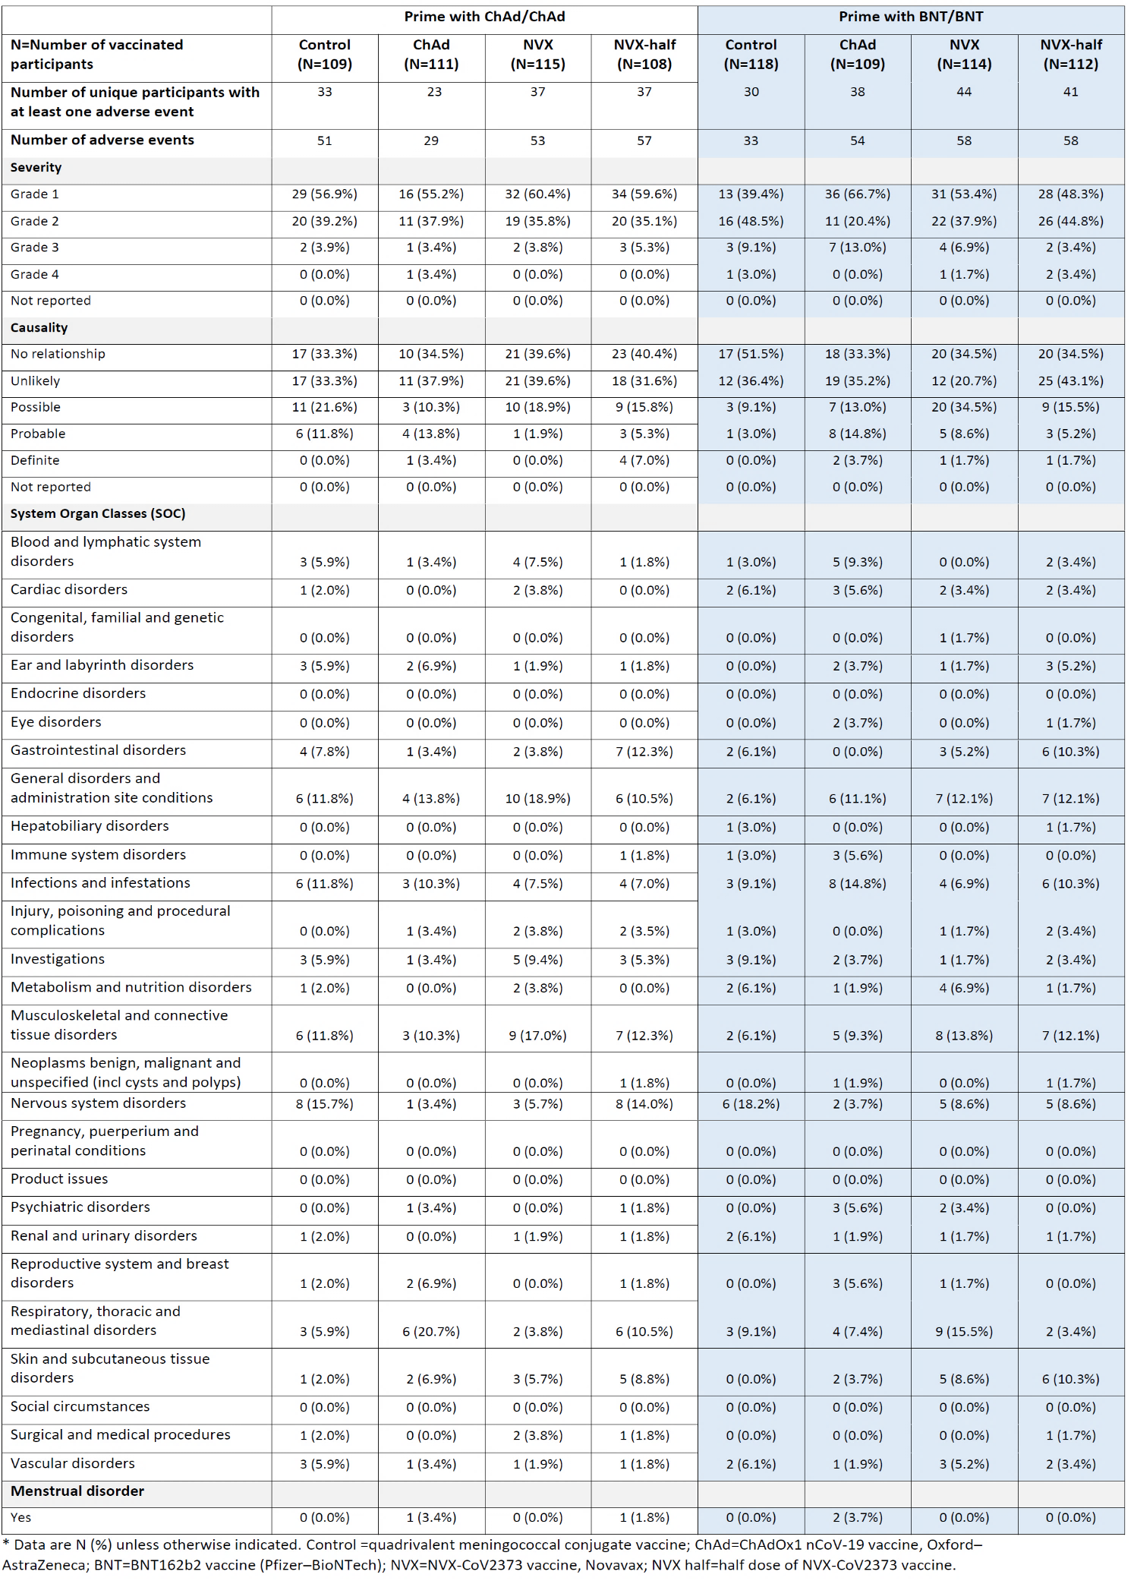* Data are N (%) unless otherwise indicated. Control = quadrivalent meningococcal conjugate vaccine; ChAd=Vaxzevria, Oxford–AstraZeneca; NVX = Nuvaxovid, Novavax; NVX half = half dose of Nuvaxovid, Novavax; BNT =Comirnaty, Pfizer–BioNTech.

Unsolicited adverse events
Unsolicited AEs were recorded within 28 days of the booster dose.
Four SAE were reported, two for the Nuvaxovid full dose (urinary tract infection onset 58 days after third dose and ovarian cancer 13 days after third dose) and two for the Nuvaxovid half dose (gastrointestinal carcinoma onset at 51 days post third dose and a case of pericarditis with onset 31 days after the third dose). From additional information provided by the COV-BOOST trial group to the sponsor, the event of pericarditis occurred in an 82 year old male who was making a good recovery at the time of the report. No SAE for Nuvaxovid (at 0.5 mL or at 0.25 mL) was considered to be related to the study drug.

Adverse event of special interest and serious adverse event
Data for AESI and SAEs were collected until data lock point 19 August 2021.
No AESI (excluding COVID-19) was reported for any participant receiving Nuvaxovid (at either dose level).

Covid-19 cases in Nuvaxovid arm (Group A)
Two COVID-19 cases were reported in the subjects receiving Nuvaxovid half dose (n = 97) with an onset reported as at 57 and 30 days post third booster dose. One case was reported in Nuvaxovid group (n = 96) and two cases in control group (n = 93).

Risk management plan
The most recently evaluated European Union (EU)-Risk management plan (RMP) was version 1.1 (23 March 2022; data lock point (DLP) 18 February 2022) and Australia specific annex (ASA) version 1.2 (18 April 2022) with submission PM-2022-01431-1-2. In support of the extended indications, the sponsor has submitted EU-RMP version 1.2 (9 May 2022; DLP 03 May 2022) and ASA version 1.4 (23 May 2022).
The summary of safety concerns and their associated risk monitoring and mitigation strategies are summarised in Table 8. Further information regarding the TGA’s risk management approach can be found in risk management plans for medicines and biologicals and the TGA's risk management approach.
Table 8: Summary of safety concerns and their associated risk monitoring and mitigation strategies
Summary of safety concerns |  | Pharmacovigilance |  | Risk Minimisation
 |  | Routine | Additional | Routine | Additional
Important identified risks | None | – | – | – | –
Important potential risks | Vaccine-associated enhanced disease (VAED), including vaccine-associated enhanced respiratory disease (VAERD) | * | ‡≠ | – | –
Important potential risks | Myocarditis and pericarditis | * | ‡≠ | – | –
Missing information | Use in pregnancy and while breastfeeding |  | ¶ |  | –
Missing information | Use in immunocompromised patients |  | ‡≠ |  | –
Missing information | Use in frail patients with comorbidities (e.g., chronic obstructive pulmonary disease (COPD), diabetes, chronic neurological disease, cardiovascular disorders) |  | ≠ | – | –
Missing information | Use in patients with autoimmune or inflammatory disorders |  | ≠ |  | –
Missing information | Interaction with other vaccines |  | ‡≠ |  | –
Missing information | Long-term safety |  | ‡≠ | – | –
*Follow-up questionnaire; ‡Clinical trials; ≠Post-authorisation safety study;
¶Pregnancy registry (C-VIPER)
This summary of safety concerns is the same as the summary that was evaluated and considered acceptable for the previous submission PM-2022-01431-1-2. The changes proposed by the current submission are not expected to change the summary of safety concerns from an RMP perspective. The summary of safety concerns remains acceptable. Reports from the TGA’s clinical evaluators, the Delegate’s overview and the Advisory Committee on Vacines’s (ACV) advice have been considered when making this conclusion.
The sponsor has proposed routine and additional pharmacovigilance measures. Routine pharmacovigilance includes the submission of monthly summary safety reports for the first six months, post registration, and thereafter at intervals specified by the TGA. The ACV emphasised the importance of monitoring events of myopericarditis especially in the 18 to 30 years age group. The pharmacovigilance plan was deemed acceptable during the previous evaluation and continues to be acceptable for the current submission. The acceptability of the clinical study plan will be assessed by the clinical evaluator and/or Delegate.
Only routine risk minimisation measures are proposed by the sponsor. This approach was deemed acceptable during the previous evaluations as there are risk minimisation measures are implemented by the Australian Government Department of Health. The changes proposed by the current submission are not expected to require additional risk minimisation measures as part of the RMP.

Risk-benefit analysis

Delegate’s considerations

Overview
Detailed data on variability in immunogenicity and safety profiles by vaccine type are valuable to make informed decisions on booster regimens, alongside considerations of vaccine availability and population primary vaccine course regimens. The COV-BOOST trial provides important insight regarding this.

Public health need
Australia is currently experiencing a major COVID-19 outbreak, which is causing significant disruption to normal life. The states of New South Wales and Victoria are having high numbers of COVID-19 cases, caused by the currently dominant Omicron variant. Currently, homologous boosters are recommended for Vaxzevria, Comirnaty and Spikevax. There is still a need for heterologous booster for the of Australian population who cannot receive currently registered vaccines for medical or personal reasons.

Immunogenicity and safety
The COV-BOOST trial was a well conducted blinded, multicentre, randomised, controlled, Phase II trial study which provides acceptable evidence that the studied vaccine boosters are immunogenic and safe, in a trial context, among healthy adult participants older than 30 years. The inclusion of seven different COVID-19 vaccines provides options for adapting regimens according to supply and ensures the findings are relevant to varied global communities. However, only Nuvaxovid as a booster after Comirnaty and Vaxzevria priming doses, is relevant in Australian context and scope of this submission.
There is currently no widely accepted immunological correlate of protection for vaccine-induced immunity to SARS-CoV-2. Available data and guidelines suggest a preference for neutralising antibody to spike protein over anti-spike protein IgG binding responses. However, in the COV-BOOST trial, anti-spike protein IgG measured by ELISA was chosen as primary end point and neutralisation assay was performed as a secondary end point.
The sponsor has proposed to use the full Nuvaxovid dose as the booster. No rationale is provided for selection of this dose.

Immunogenicity
With the current submission, the sponsor has provided a published report;12 of an independently conducted study (COV-BOOST trial). The COV-BOOST trial has assessed the safety and immunogenicity of seven COVID-19 vaccines as a third dose (booster) following two doses of Vaxzevria or Comirnaty. Group A of this study provided data for immunogenicity (humoral and cellular) and safety of full dose and half dose of Nuvaxovid when used as a booster dose in people who either received two doses of Comirnaty or Vaxzevria as primary series.
Apart from some differences in the dose interval between second dose and third dose (booster) between the Vaxzevria and Comirnaty primed populations, baseline details were similar in different groups.

Humoral immunogenicity
The Nuvaxovid subgroup (Vaxzevria and Comirnaty primed populations) showed significantly higher levels of SARS-CoV-2 anti-spike protein IgG (shown by GMC and GMR) following a booster dose with Nuvaxovid, as compared to the control group. In the Vaxzevria primed population, the increase in the GMC was greater than that of the homologous Vaxzevria booster subgroup. In Comirnaty primed groups, a heterologous booster dose of Nuvaxovid full dose induced increases in IgG antibody titres with a GMR of 4.78 and Nuvaxovid half dose induced a GMR of 3.07, as compared to the control. However, Nuvaxovid GMR responses (both full and half doses) were lower than those seen with a homologous booster dose of Comirnaty in Group B (GMR 8.11) and to the heterologous booster dose of Vaxzevria with Comirnaty primed (GMR 5.33).
Similar trends as the anti-spike protein IgG were also observed for the live virus neutralising antibody titre. The Vaxzevria primed Nuvaxovid subgroup showed higher GMTs and GMRs than the Vaxzevria homologous group. However, in the Comirnaty primed population, Nuvaxovid showed significantly lower GMT than the Vaxzevria subgroup. Again, the Comirnaty homologous subgroups showed significantly higher GMTs and GMRs than the Nuvaxovid heterologous subgroup (Comirnaty primed).
In terms of the pseudo-type virus neutralising antibody titre, a similar trend as the primary endpoint was seen in the Nuvaxovid subgroups.
Reduced neutralisation was observed after the booster dose against the Delta variant as compared to the wild-type. No neutralisation data for the Beta variant was provided.

T-cell response
Cellular responses also showed similar trends as humoral responses. The Nuvaxovid subgroup showed significantly higher GM and GMR than the Vaxzevria homologous subgroup but generally lower GM and GMR in the Comirnaty primed group when compared to Vaxzevria primed or homologous Comirnaty subgroups. The Nuvaxovid subgroup also showed proportionately larger decreases in the cellular response between Day 14 and Day 28 when compared with the Comirnaty subgroups. T-cell responses from Beta and Delta variants were comparable with wild-type.
In the subgroup analyses by age (< 70 years of age and ≥ 70 years of age) the anti-spike protein IgG showed significant increase in both age groups of the Nuvaxovid subgroups in the Vaxzevria and Comirnaty primed participants.

Immunogenicity data limitations
While these results provide some useful information for the use of Nuvaxovid as a heterologous booster vaccine, there are several issues/limitations with the COV-BOOST trial.
It should also be noted that as this is a literature based submission, the Delegate is unable to obtain further details of the study from the sponsor.
It is noted that the study size was quite small. As the secondary endpoints were not powered, certain endpoints (especially cellular response) had very wide 95% CI and therefore statistical comparison between the treatments were often not significant. A similar point could be made for the subgroup analyses made for those < 70 years of age and ≥ 70 years of age, where statistical comparison between the age groups and across the treatment subgroups were not possible after further reduction of the sample size.
The follow up period for immunogenicity in the currently published data was rather short. A complete time course of the immunogenicity is pending. For Nuvaxovid, it was shown that a timepoint for the anti-spike protein IgG level was not established, as the IgG level was continuing to rise by Day 28.
The choice of primary endpoint for the COV-BOOST trial is not as per the currently available guidance. Available guidelines; recommend neutralising antibody as a preferred primary endpoint for COVID-19 vaccines, the investigators have chosen anti-spike protein IgG as the primary endpoint. However, there is no confirmed immunological correlate of protection yet. It is also not well known as how do these humoral and cellular immunogenicity result translate into clinical efficacy (that is protection against SARS-CoV-2 infection, especially against SARS-CoV-2 variants). However, based on the immunogenicity data provided, Nuvaxovid appears to be numerically inferior to the Comirnaty homologous and Comirnaty booster (following Vaxzevria primed). Nuvaxovid heterologous (Vaxzevria primed) appears numerically superior to the Vaxzevria homologous population. The comparatively higher immunogenicity of Vaxzevria in those primed with Comirnaty than Vaxzevria is in line with the result from the Com-COV study, which showed much higher immunogenicity when Vaxzevria was given as a second dose after Comirnaty compared to two doses of Vaxzevria alone.
There is no data against the currently circulating BA.1 And BA.2 Omicron variants which reduces the applicability of the result in today's pandemic situation. The sponsor has stated in the clinical overview that currently they are planning a study (Study 2019nCoV-311) which will evaluate heterologous boosting against Omicron variants. The sponsor has provided a list of other studies that will assess the use of Nuvaxovid as a heterologous booster (Table 9), however these will not be available anytime soon.
Table 9: Heterologous studies involving Nuvaxovid as booster (not sponsored by Novavax)
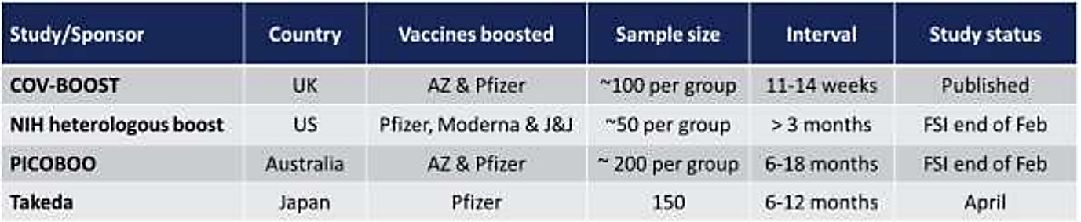
The study excluded those with certain conditions including significant comorbidities. As a result, no immunogenicity data is available for the following populations: immunosuppressed, immunocompromised, pregnant, people on anticoagulation, those with history of anaphylaxis, cancer, autoimmune neurological disorders, severe and/or uncontrolled cardiovascular, respiratory, gastrointestinal, liver, renal, endocrine, and neurological illness. While the exclusion of these populations would likely have been to increase the feasibility of study completion, it should be noted that these individuals are likely to be at an increased risk of severe disease/death from SARS-CoV-2 infection, and therefore need the COVID-19 booster vaccination the most.
The COV-BOOST trial limitations also include the lack of generalisability of findings beyond the trial setting, particularly to younger populations, those with previous SARS-CoV-2 infection, and to recipients of different primary course regimens, and in assessing impacts, of both safety and effectiveness, at scale and longer follow up. The latter point highlights the complementarity between clinical trials, observational studies, and surveillance, with large cohort studies well placed to determine whether the immunogenicity generated after boosters translates to real world protection from SARS-CoV-2 infection, and ongoing surveillance essential to detect potential rare adverse events. More time and evidence is required to gain a fuller understanding of the performance of COVID-19 vaccines against currently circulating and emerging variants. As discussed earlier, it is still not known as how the increase in immunogenicity response translates into protection, especially against serious disease and transmission.
The COV-BOOST trial did not provide any clinical efficacy data. However, five breakthrough cases were reported in the Nuvaxovid group, two each for Nuvaxovid half dose and control respectively, and one case in Nuvaxovid full dose group.
There is a significant percentage of the population, who received only two doses of COVID-19 vaccines, and then got infected with SARS-CoV-2 virus during the current Omicron surge.

Safety
Based on the COV-BOOST trial published data, Nuvaxovid heterologous booster (full and half dose) does not raise any new safety concern. The proportion of individuals with AEs, the severity of AEs and likelihood of association with the treatment for those that received Nuvaxovid were comparable to other treatment subgroups within Group A. The AEs by System Organ Class (SOC) also did not identify any obvious safety concerns in those who received Nuvaxovid.
With regards to severe AEs, Nuvaxovid showed low AE rates, especially when compared to Vaxzevria. The Vaxzevria subgroup showed little or no cases of severe AEs in the homologous group population, but relatively high rates of severe SAEs in the Comirnaty primed population. While in a separate group (and therefore direct comparison with the Vaxzevria and Nuvaxovid subgroups are difficult), Spikevax appeared to show highest rate of severe AEs.
In case of SAEs, there were two cases each in the Nuvaxovid and Nuvaxovid half dose subgroups, none of which was reported to be associated with the booster vaccines. There was no AESI identified in the Nuvaxovid and Nuvaxovid half dose subgroups.
With respect to positive COVID-19 diagnoses post-booster vaccination, there was one case in the Nuvaxovid subgroup and two cases in the Nuvaxovid half dose subgroups, all of which occurred ≥ 4 weeks after the booster dose. The number of positive COVID-19 cases does not constitute a viable clinical efficacy data, as the study was not powered to objectively assess any association between booster vaccines and COVID-19 cases.
Due to the small sample size for each treatment group, it is not possible for the study to be sufficiently powered to detect rare adverse outcomes.
As mentioned in the exclusion criteria, the study excluded those with certain conditions including significant medical comorbidities. As a result, no safety data is available for these individuals. The safety assessment was performed in relatively healthy individuals, which may underestimate the overall risk associated with the booster vaccines tested.

Efficacy
Efficacy was not assessed in the COV-BOOST trial. However, there were a total five breakthrough case noted in the Group A. Two cases were noted in control and Nuvaxovid half dose group each and one case was recorded in Nuvaxovid (full) group. The sample size is very small to draw any conclusion on efficacy.

Overall data limitations
- No data on administration of Nuvaxovid as a booster with other vaccines except Comirnaty and Vazevria.
- Immunogenicity data from booster dose against the currently circulating variants (for example BA.1 and BA.2 Omicron) is not available.
- Data related to the persistence of an immune response was not available in the submitted study.
- Safety sample size was very small.
- No safety and immunogenicity data in young adults under 30 years of age.
- No safety and immunogenicity data in immunocompromised patients or patients with background autoimmune disease.
- No safety data on pregnant women and breastfeeding women.
- Short-term safety data (28 days), which may not provide information on rare AEs, risk of vaccine associated enhanced disease or vaccine associated enhanced respiratory disease as the antibodies wane over time, and there may be AEs that have a long latency period including AEs of special interest.
- Data on vaccine efficacy of the booster are lacking.
- Data in frail elderly with unstable health conditions and co-morbidities are not available.

Proposed action
Considering the existing public health need for a vaccine which can be used in people who cannot have currently approved vaccines as a booster (medical reasons or personal choice) and noting the boosting effect of Nuvaxovid heterologous booster, with acceptable safety demonstrated in the submitted COV-BOOST trial publication. The Delegate is primarily of the view that provisional approval for Nuvaxovid to be used as heterologous booster (primed with Vaxzevria or Comirnaty) is appropriate. However, there are multiple issues raised in this overview, which will be discussed with Advisory Committee on Vaccines (ACV) and a final decision will be taken only after that.

Proposed amendment in dose and administration section
Following was the initial proposed amendment to the dosing section for booster dose:
Booster Dose
Nuvaxovid is administered intramuscularly as a single booster dose (0.5 mL) at least 10 weeks after completing a primary series.
The decision when and for whom to implement a booster dose of Nuvaxovid should be made based on available vaccine safety and effectiveness data (see sections 4.8 and 5.1), in accordance with official recommendations.

Recommended amendment in dose and administration section
The heterologous booster dose for Nuvaxovid was studied only in subjects completing the primary series with Comirnaty and Vaxzevria.
The duration between second dose and booster dose should be in accordance with official recommendations and deleted from the proposed wordings.
Following is the amended recommendation to the dosing section for booster dose:
Please amend the proposed variation in section 4.2 in the Product Information (PI) as following:
Booster Dose
Nuvaxovid is administered intramuscularly as a single booster dose (0.5 mL) at least 10 weeks after completing a primary series with registered covid-19 vaccines, other than the Nuvaxovid.
The decision when and for whom to implement a booster dose of Nuvaxovid should be made based on available vaccine safety and effectiveness data (see sections 4.8 and 5.1), in accordance with official recommendations.
Or;
Booster Dose
Nuvaxovid is administered intramuscularly as a single booster dose (0.5 mL) at least 10 weeks after completing a primary series with Comirnaty or Vaxzevria.
The decision when and for whom to implement a booster dose of Nuvaxovid should be made based on available vaccine safety and effectiveness data (see sections 4.8 and 5.1), in accordance with official recommendations.

Questions for the sponsor
The sponsor provided the following response to questions from the Delegate.
- Please provide the rationale behind choosing Nuvaxovid full dose (0.5 mL) for the booster, especially when Nuvaxovid half dose (0.25 mL) produced acceptable immunogenicity and safety.
Novavax’ clinical development program for Nuvaxovid has utilised a full dose (0.5 mL, providing 5 μg of the active antigen SARS-CoV-2 rS (NVX-CoV2373)) in all clinical trials from Phase II through to Phase III. This includes the studies in which homologous booster doses have been studied (Study 2019nCoV-101 (Part 2), 2019nCoV-501) and their adolescent primary vaccination series study (Study 2019nCoV-301 paediatric expansion in 12 to 17 years old). In all studies Nuvaxovid was shown to be well tolerated at the full dose, with an acceptable safety profile and acceptable level of reactogenicity.
The decision to include a half dose (0.25 mL) was made by the independent COV-BOOST trial group, with an interest to potentially ‘reduce the reactogenicity for third dose recipients and increase the global reach of finite vaccine supply’ (Munro et al., 2021).12 Their data indicated that the frequencies of adverse reactions were slightly (numerically) higher in the Nuvaxovid half dose group than in the Nuvaxovid full dose group.
- Please provide rationale for the use of Nuvaxovid heterologous booster with any COVID-19 vaccine primary series (as proposed), as against only the two COVID-19 vaccines which were used in the trial (Vaxzevria and Comirnaty).
The COV-BOOST trial was conducted relatively early in the COVID-19 pandemic at a time that the number of approved vaccines in the UK was limited to Comirnaty and Vaxzevria for primary vaccination series. A similar situation occurred in the USA where the NIH [National Institutes of Health] study of heterologous boosters was conducted at a time that only Comirnaty and the Janssen COVID-19 vaccine had been approved, again for primary vaccination series. In both situations at the time that these independent academic groups began their trials of heterologous boosting, there were additional COVID-19 vaccines in late stage development (including Nuvaxovid) which are now available to be used as heterologous boosters. Thus, the data reflect the real world situation, that increasing availability of COVID-19 vaccines made possible the likelihood that many vaccinees would have access to a heterologous booster.
In Australia, the timing of approval of the Spikevax vaccine increased the available COVID-19 vaccines to three over the period that the bulk of the Australian population took up the call to receive vaccination.
It is worth noting that the additional vaccines that are authorised for use in Australia are based on very similar platform technologies. Spikevax, like Comirnaty, is an messenger ribonucleic acid (mRNA) based vaccine and while a higher dose is administered both vaccines have similar high levels of efficacy. While the COVID-19 Vaccine (Janssen) uses a different vector than the Vaxzevria, they are both based on non-replicating adenovirus platforms and have been shown to have acceptable safety and efficacy profiles. Based on the similarities across the vaccines, the safety and immunogenicity profile of a booster dose of Nuvaxovid is expected to be consistent for both of the mRNA based vaccines and for both of the adenovirus based vaccines.
The precedent in Australia to date, is that all vaccines with a booster dose recommendation are unrestricted with respect to the primary vaccination series received, and reference official recommendations.
The Australian Technical Advisory Group on Immunisation (ATAGI) have published the recommendation: ‘ATAGI considers Novavax to be acceptable as a booster in an individual 18 years and older if no other COVID-19 vaccine is suitable for that individual’. Thus, ATAGI does not restrict Nuvaxovid to specific brands of vaccine.
To date the TGA have not chosen to restrict any other COVID-19 vaccine in this way. The same approach should be applied for Nuvaxovid.
- If available, please provide any data generated using a neutralising antibody assay against currently circulating variants of concern viz. BA.1 and BA.2. Is there any plan to include the subvariant BA.2 to the planned 2019nCoV-311 study?
Clinical data for the Omicron BA.1 subvariant are available in the medRxiv pre-publication previously submitted to the TGA (initial ACV response) and indicate that the vaccine induces robust immune responses for this strain following a primary vaccination series that are further increased following a 6 month booster dose. Clinical data are not yet available for the two Omicron subvariants, however, data recently published NIH heterologous study (New England Medical Journal, March 16th) for the Pfizer vaccine indicate that the level of immune responses to these subvariants are very similar. An Omicron BA.2 based vaccine is being developed and the decision about whether to clinically evaluate it will be based on the circulation of the subvariant as well as the immune responses seen for it.
- Can the sponsor provide information if Nuvaxovid is part of the COV-BOOST trial: Young Adults Fractional Dosing Sub-study, being conducted in the 18 to 30 years of age population (excluded in the COV-BOOST study)?
Based on the published protocol for the COV-BOOST Young Adults Fractional Dosing Substudy (Version 9.1 February 2022), young adults whose primary series was either Comirnaty or Spikevax are eligible for enrolment into the trial. These participants will be randomised to receive one of the same vaccines at either of two doses: Comirnaty at 10 μg or 30 μg and Spikevax at 25 μg or 50 μg.
(The approved booster dose in Australia for Comirnaty is 30 μg and for Spikevax is 50 μg (half the primary series dose of 100 μg)).
Nuvaxovid is not currently one of the vaccines being evaluated in the COV-BOOST trial Young Adults Fractional Dosing Sub-study. [Information redacted]
- What is the current status of overseas submission for Nuvaxovid booster indication?
The current status of the heterologous booster dose submission is provided in sponsor submitted dossier (not in scope of this AusPAR).
The sponsor has submitted a changed medicine notification for the Nuvaxovid heterologous booster dose in New Zealand (submitted 28 February 2021) in parallel with the Australian clinical variation.
- Please provide post market monthly safety data for Nuvaxovid, if available.
The first monthly report of post market safety data was submitted to TGA on 15 March 2022. The report covers the period from 20 December 2021 to 28 February 2022. The required SUSAR update is provided in sponsor submitted safety report (not in scope of this AusPAR).

Advisory Committee considerations
The Advisory Committee on Vaccines (ACV), having considered the evaluations and the Delegate’s overview, as well as the sponsor’s response to these documents, advised the following.

Specific advice to the Delegate
- Based on the overall evidence from COV-BOOST trial, can the ACV advise whether the benefits-risks balance of Nuvaxovid as heterologous booster in individuals 18 years and older is positive in the current pandemic situation?
The ACV noted that the relevant arm of the COV-BOOST trial included participants aged 30 years and over who had received Nuvaxovid as a heterologous booster following either Vaxzevria or Comirnaty as a primary course. The ACV highlighted the small numbers of participants in each arm (primed with Vaxzevria: 115 full dose Nuvaxovid, 108 half dose Nuvaxovid; primed with Comirnaty: 114 full dose Nuvaxovid, 112 half dose Nuvaxovid).
The ACV commented that the data appear to be generally positive in adults 30 years and older, however expressed concern on the absence of data in 18 ≤ 30-year olds.
The ACV highlighted that limited safety data are available following boosting, including the short follow-up period of 28 days.
The ACV commented that available data suggest inferior immunogenicity compared to mRNA COVID-19 vaccine boosters.
The ACV was of the view that the material available to the committee at this meeting does not meet the threshold of evidence to make a positive recommendation. The ACV supported deferral of a recommendation until data relating to homologous booster dosing were evaluated by the TGA and provided to the committee.
- Does the ACV agree with the proposed age group of 18 years and older for the booster dose? Of note, subject between 18 year to 30 years were excluded from the study. This is important in view of the stronger immune response in young adults with potential to cause increase in severity/frequency of the adverse events and a lower dose may be required in this age group.
The ACV noted that there are no data in 18 ≤ 30-year olds, a key age group for the proposed indication. The ACV expressed concerns that there is a theoretical risk of increased reactogenicity in this age group.
The ACV commented that Nuvaxovid will not be included in the planned COV-BOOST trial sub-study in participants aged 18 ≤ 30 years. Thus, it is anticipated that only post-market observational safety data will become available over time.
- Does the ACV agree with the proposed full dose (0.5 mL) of Nuvaxovid to be used as a booster, as against the half dose (0.25 mL), which was also studied and has shown acceptable immunologic response?
The ACV commented that use of a half dose is based on very small numbers in the COV-BOOST trial. The initial registration study used a full dose regime. The ACV was of the view that there are more data for safety and immunogenicity for the full dose.
The ACV noted that full dose Nuvaxovid has been used in studies on homologous boosting, as provided to the TGA but not yet provided to the committee.
- Does the ACV agree with use of Nuvaxovid as heterologous booster for general population, based on provided immunogenicity data, notably in the absence of data against currently circulating variants?
The ACV advised that Nuvaxovid heterologous booster shows adequate immunogenicity against wild-type, Delta and Beta strains of SARS-CoV-2.
The ACV commented that no efficacy data were presented, and the relationship between spike IgG antibody levels at Day 28 and long-term protection and immunological memory is unknown.
The ACV noted the ongoing challenges with collecting data on other strains, such as Omicron, which should be reviewed when available.
- Does the ACV agree that Nuvaxovid use as heterologous booster should be restricted to the population who are primed with Vaxzevria and Comirnaty only, as the Nuvaxovid was not studied against other currently TGA registered COVID-19 vaccines, which are currently rolled out in Australia?
The ACV noted that the data provided to the meeting are exclusively on the use of Nuvaxovid as a heterologous booster following Vaxzevria and Comirnaty primary series.
On balance, the ACV decided to defer their recommendation on this issue awaiting the provision of data on homologous boosting.
- Does the ACV agree with the proposed minimum interval of 70 days between second dose and the booster?
The ACV advised that the dosing instructions for the booster should state that the interval between primary and booster dose ‘should be in accordance with official recommendations’.
- Can the ACV comment if overall safety is acceptable as the sample size was very small and follow up was only 4 weeks? There is currently no post-market data available for Nuvaxovid COVID-19 vaccine (primary doses).
The ACV commented that while the overall safety profile in COV-BOOST trial appears acceptable in people 30 years and older, the sample size is small and follow-up is limited to 4 weeks.
The ACV advised that further safety data should be provided, including post-market myopericarditis data, particularly in young adults who could be at higher risk of this adverse event.
The ACV advised that the provision of homologous booster data would help inform the safety profile of the booster dose.
- At this stage the risk management plan report is not available. However, can the ACV comment on any specific risk mitigation strategies required for the booster dose?
The ACV advised that a critical inclusion in the RMP should be surveillance for myopericarditis.
- The committee is also requested to provide advice on any other issues that it thinks may be relevant to a decision on whether or not to approve this application.
The ACV was of the view that it would be appropriate to defer a regulatory decision on heterologous boosting until homologous boosting data is reviewed.
The ACV noted that while use of Nuvaxovid as primary series was quite limited in Australia at this time, it would be hard to explain to patients why a booster dose of the same brand was not permitted.

Conclusion
The ACV was of the view that there are currently insufficient data to make a recommendation on the overall benefit-risk balance of Nuvaxovid at the 5 microgram dose for use as a heterologous booster dose in individuals 18 years and older.
In providing this advice the ACV cited the limited safety and immunogenicity data, particularly in younger adults aged 18 to < 30 years old. The ACV recommended that further data should be provided to inform the benefit-risk balance, including data on homologous use.

Further considerations
Following deferral on making a regulatory decision as described above, the TGA further considered the data submitted by sponsor for Nuvaxovid as a homologous booster and evaluations on new data.
The ACV, having further considered this data and related evaluations, advised the following:

Specific advice to the Delegate
The ACV advised that Nuvaxovid will likely be used both as a booster in a homologous series (that is following a primary series of Nuvaxovid) and in a heterologous series (for example, for persons who had an adverse reaction in the primary series of another type of COVID-19 vaccine). While less data were submitted for the heterologous booster, clinical trial information for both uses should be detailed in the PI.
Limitations of the COV-BOOST trial should be highlighted: participants were aged 30 years and over (that is not 18 years and over) and had received Nuvaxovid as a heterologous booster following either Vaxzevria or Comirnaty as a primary series (that is no data on primary series of Spikevax).
Information about the interval between primary series and booster dose should be included in the clinical trial section of the PI. The ACV noted that the booster dose interval may be the subject of ATAGI guidelines.
The ACV noted that the proposed Product Information dosage information relates to a single booster dose following any primary course but does not support repeated booster doses at 6-month intervals.
Lastly, as discussed at previous ACV meeting, Nuvaxovid heterologous boosting doses were not as immunogenic as boosting doses with mRNA COVID-19 vaccine, following prime series vaccination with either Vaxzevria or Comirnaty. Such data from the COV-Boost trial should be included in the Product Information.

Outcome
Based on a review of quality, safety, and efficacy, the TGA approved the registration of Nuvaxovid (SARS-CoV-2 rS with Matrix-M adjuvant) 5 µg/0.5mL, suspension for injection, multidose vials, for the following change in dose regimen:
Dosage
Primary series
Nuvaxovid is administered intramuscularly as a course of 2 doses of 0.5 mL each. It is recommended that the second dose is to be administered 3 weeks after the first dose, see section 5.1 Pharmacodynamic Properties.
Booster Dose
A booster dose of Nuvaxovid (0.5 mL) may be administered intramuscularly approximately 6 months after completion of a primary series in individuals 18 years of age and older.
The decision when and for whom to implement a booster dose of Nuvaxovid should be made based on available vaccine safety and effectiveness data (see sections 4.8 Adverse Effects and 5.1 Pharmacodynamic Properties), in accordance with official recommendations.
Interchangeability
There are no data available on the interchangeability of Nuvaxovid with other COVID-19 vaccines to complete the primary vaccination course. Individuals who have received a first dose of Nuvaxovid should receive the second dose of Nuvaxovid to complete the vaccination course, see section 4.4 Special Warnings and Precautions for Use.
For precautions for administering the vaccine, see section 4.4 Special Warnings and Precautions for Use.

Specific conditions of registration applying to these goods
[The Delegate of the Secretary of the Department of Health imposed the following conditions in relation to the new Nuvaxovid medicine:]
- conditions applicable to all registered therapeutic goods as specified in the document Standard Conditions Applying to Registered or Listed Therapeutic Goods under Section 28 of the Therapeutic Goods Act 1989 effective 1 July 1995, with the exception of Condition 11;
- conditions applicable to specific classes of registered therapeutic goods as specified in the Standard Conditions Applying to Registered or Listed Therapeutic Goods under Section 28 of the Therapeutic Goods Act 1989 effective 1 July 1995;
- subject to [the paragraph below], all conditions that have previously been imposed on the provisional registration of the existing Nuvaxovid medicine, as in force at the date of this decision;
- The Nuvaxovid COVID-19 Vaccine (adjuvanted) EU-Risk Management Plan (RMP) (version 1.2, dated 09 May 2022; DLP 03 May 2022), with Australian specific annex (version 1.4, dated 23 May 2022), included with submission PM-2022-00638-1-2, and any subsequent revisions, as agreed with the TGA will be implemented in Australia.
An obligatory component of risk management plans is routine pharmacovigilance. Routine pharmacovigilance includes the submission of periodic safety update reports (PSURs).
Reports are to be provided in line with the current published list of EU reference dates and frequency of submission of PSURs until the period covered by such reports is not less than three years from the date of [the] approval letter, or the entire period of provisional registration, whichever is longer.
The reports are to at least meet the requirements for PSURs as described in the European Medicines Agency’s Guideline on good pharmacovigilance practices (GVP) Module VII-periodic safety update report (Rev 1), Part VII.B Structures and processes. Note that submission of a PSUR does not constitute an application to vary the registration. Each report must have been prepared within ninety calendar days of the data lock point for that report.
Additional to the routine submission of the routine PSURs, expedited monthly Nuvaxovid COVID-19 Vaccine (adjuvanted) safety summary reports (including both global safety data and safety data for patients in Australia) are to be provided for the first 6 months post registration, and thereafter at intervals specified by the TGA.
Nuvaxovid COVID-19 Vaccine (adjuvanted) is to be included in the Black Triangle Scheme. The PI and CMI for Nuvaxovid COVID-19 Vaccine (adjuvanted) must include the black triangle symbol and mandatory accompanying text for the products entire period of provisional registration.
- In addition to the currently existing conditions, the following data will have to be submitted for ongoing provisional approval (if granted):
- In addition to the submission of the routine PSURs, expedited monthly Nuvaxovid COVID-19 Vaccine safety summary reports (including safety data for patients in Australia) are to be provided for the population using of Nuvaxovid as booster dose, for the first 6 months post approval of the booster dose, and thereafter at intervals specified by the TGA.
- The following reports/data will have to be submitted before a definitive authorisation for the booster dose can be considered:
  - Immunogenicity and safety data from COV-BOOST completed study, when available.
  - Final CSR for Study 2019nCov-101 and Study 2019nCov-501, when available.
  - The sponsor should investigate BA.2 immunogenicity after homologous booster dose and submit data when available.
  - The sponsor should investigate BA.1 and BA.2 immunogenicity after heterologous booster dose and submit data from Study 2019nCoV-311, when available.
  - The sponsor should investigate and provide results on the ability of the vaccine booster to neutralise emerging SARS-CoV-2 variants of concern.
  - Please also provide real world post market global/local efficacy data for the booster dose when available.
  - Studies addressing important safety concerns/important missing information (use in immunocompromised individual, pregnant women) related to the booster dose, will need to be submitted. However, this should be submitted as additional submissions (with payment to TGA), not as “conditions of original submission”.
As part of the standard conditions of registration applying to all registered therapeutic goods, it should be noted that, no changes can be made to the goods without the prior approval of the Secretary.
Under paragraph 30(2)(c) of the Act, refusal or failure to comply with a condition of registration to which inclusion of the medicine in the ARTG is subject may result in the suspension or cancellation of registration.

Attachment 1. Product Information
The PI for Nuvaxovid approved with the submission which is described in this AusPAR is at Attachment 1. For the most recent PI, please refer to the TGA PI/CMI search facility.

Therapeutic Goods Administration
PO Box 100 Woden ACT 2606 Australia
Email: info@tga.gov.au Phone: 1800 020 653 Fax: 02 6232 8605
https://www.tga.gov.au

The Black Triangle Scheme provides a simple means for practitioners and patients to identify certain types of new prescription medicines, including those being used in new ways and to encourage the reporting of adverse events associated with their use. The Black Triangle does not denote that there are known safety problems, just that the TGA is encouraging adverse event reporting to help us build up the full picture of a medicine's safety profile.
World Health Organization: Statement on the second meeting of the International Health Regulations (2005) Emergency Committee regarding the outbreak of novel coronavirus (2019-nCoV). 30 January 2020. Available at: https://www.who.int/news/item/30-01-2020-statement-on-the-second-meeting-of-the-international-health-regulations-(2005)-emergency-committee-regarding-the-outbreak-of-novel-coronavirus-(2019-ncov)
World Health Organization: WHO Director-General's opening remarks at the media briefing on COVID-19. 11 March 2020. Available at: https://www.who.int/director-general/speeches/detail/who-director-general-s-opening-remarks-at-the-media-briefing-on-covid-19---11-march-2020
World Health Organization: WHO COVID-19 Dashboard (as of 21 June 2022). Available at: https://covid19.who.int/
Australian Government Department of Health: Coronavirus (COVID-19) case numbers and statistics (as of 21 June 2022. Available at: https://www.health.gov.au/health-alerts/covid-19/case-numbers-and-statistics#total-covid19-cases-by-source-of-infection
World Health Organization: WHO news - Classification of Omicron (B.1.1.529): SARS-CoV-2 Variant of Concern. Available at https://www.who.int/news/item/26-11-2021-classification-of-omicron-(b.1.1.529)-sars-cov-2-variant-of-concern
Wuhan-Hu-1 isolate.
Matrix-M is a saponin-based adjuvant. Matrix-M adjuvant is composed of a mixture of Matrix-A (85%) and Matrix-C (15%), each produced from saponin materials Fraction-A or Fraction-C, respectively.
AusPAR for Comirnaty BNT162b2 (mRNA) Pfizer Australia Pty Ltd PM-2021-04582-1-2 available at: https://www.tga.gov.au/auspar/auspar-tozinameran
AusPAR for Spikevax elasomeran Moderna Australia Pty Ltd PM-2021-05131-1-2 available at: https://www.tga.gov.au/auspar/auspar-elasomeran-mrna-1273
AusPAR for Vaxzevria ChAdOx-1-S AstraZeneca Pty Ltd PM-2021-05173-1-2 available at: https://www.tga.gov.au/auspar/auspar-chadox-1-s
Munro et al., Safety and immunogenicity of seven COVID-19 vaccines as a third dose (booster) following two doses of ChAdOx1 nCov-19 or BNT162b2 in the UK (COV-BOOST): a blinded, multicentre, randomised, controlled, phase 2 trial, The Lancet, 2021; 398:2258-2276. https://www.thelancet.com/journals/lancet/article/PIIS0140-6736(21)02717-3/fulltext
COV-BOOST, Evaluating COVID-19 vaccine boosters. Available at: https://www.covboost.org.uk/about
The COV001 trial is a Phase I/II study to determine efficacy, safety and immunogenicity of the candidate coronavirus disease (COVID-19) vaccine ChAdOx1 nCoV-19 in healthy adults 18 to 55 years of age in the United Kingdom.
The COV002 trial is a Phase II/III study to determine efficacy, safety and immunogenicity of the candidate coronavirus disease (COVID-19) vaccine ChAdOx1 nCoV-19 in healthy adults ≥ 18 years of age (including the elderly) in the United Kingdom.
The Bonferroni correction adjusts probability values because of the increased risk of a Type I error when making multiple statistical tests.
Elecsys anti-SARS-CoV-2 is an immunoassay for the in vitro qualitative detection of antibodies (including IgG) to SARS-CoV-2 in human serum and plasma. The assay uses a recombinant protein representing the nucleocapsid (N) antigen in a double-antigen sandwich assay format, which favors detection of high affinity antibodies against SARS-CoV-2
TGA statement on Access Consortium: Alignment with ICMRA consensus on immunobridging for authorising new COVID-19 vaccines. Available at https://www.tga.gov.au/access-consortium-alignment-icmra-consensus-immunobridging-authorising-new-covid-19-vaccines.
Pharmaceuticals and Medical Devices Agency (Japan), Principles for the Evaluation of Vaccines Against the Novel Coronavirus SARS-CoV-2 (Appendix 3): Evaluation of the vaccines based on Immunogenicity. Available at https://www.pmda.go.jp/files/000237021.pdf.
Liu X, et al. Safety and immunogenicity of heterologous versus homologous prime-boost schedules with an adenoviral vectored and mRNA COVID-19 vaccine (Com-COV): a single-blind, randomised, non-inferiority trial. Lancet. 2021;398(10303):856-869.
Atmar et al. Homologous and Heterologous Covid-19 Booster Vaccinations. New England Journal of Medicine 2022; 386: 1046-57.
For Comirnaty ‘the median duration of blinded follow up after booster vaccination was 2.5 months’. https://www.tga.gov.au/sites/default/files/auspar-tozinameran-220128.pdf
For example, ATAGI recommends an additional booster dose of COVID-19 vaccine to increase vaccine protection before winter for selected population groups who have received their primary vaccination and first booster dose. https://www.health.govau/news/atagi-statement-on-recommendations-on-a-winter-booster-dose-of-covid-19-vaccine (published 25 March 2022)

