June 2022

Australian Public Assessment Report for Nuvaxovid homologous booster
  - Active ingredient: SARS-CoV-2 rS vaccine with Matrix-M1 adjuvant
  - Sponsor: Biocelect Pty Ltd

About the Therapeutic Goods Administration (TGA)
- The Therapeutic Goods Administration (TGA) is part of the Australian Government Department of Health and is responsible for regulating therapeutic goods, including medicines, medical devices, and biologicals.
- The TGA administers the Therapeutic Goods Act 1989 (the Act), applying a risk management approach designed to ensure therapeutic goods supplied in Australia meet acceptable standards of quality, safety, and efficacy.
- The work of the TGA is based on applying scientific and clinical expertise to decision-making, to ensure that the benefits to the Australian public outweigh any risks associated with the use of therapeutic goods.
- The TGA relies on the public, healthcare professionals and industry to report problems with therapeutic goods. The TGA investigates reports received to determine any necessary regulatory action.
- To report a problem with a therapeutic good, please see the information on the TGA website.

About AusPARs
- The Australian Public Assessment Report (AusPAR) provides information about the evaluation of a prescription medicine and the considerations that led the TGA to approve or not approve a prescription medicine submission. Further information can be found in Australian Public Assessment Report (AusPAR) guidance.
- AusPARs are prepared and published by the TGA.
- AusPARs are static documents that provide information that relates to a submission at a particular point in time. The publication of an AusPAR is an important part of the transparency of the TGA’s decision-making process.
- A new AusPAR may be provided to reflect changes to indications or major variations to a prescription medicine subject to evaluation by the TGA.

Copyright
© Commonwealth of Australia 2022
This work is copyright. You may reproduce the whole or part of this work in unaltered form for your own personal use or, if you are part of an organisation, for internal use within your organisation, but only if you or your organisation do not use the reproduction for any commercial purpose and retain this copyright notice and all disclaimer notices as part of that reproduction. Apart from rights to use as permitted by the Copyright Act 1968 or allowed by this copyright notice, all other rights are reserved and you are not allowed to reproduce the whole or any part of this work in any way (electronic or otherwise) without first being given specific written permission from the Commonwealth to do so. Requests and inquiries concerning reproduction and rights are to be sent to the TGA Copyright Officer, Therapeutic Goods Administration, PO Box 100, Woden ACT 2606 or emailed to <tga.copyright@tga.gov.au>.

Contents
List of abbreviations 4
Product submission 6
Submission details 6
Product background 8
Regulatory status 9
Product Information 10
Registration timeline 10
Submission overview and risk/benefit assessment 11
Quality 11
Nonclinical 11
Clinical 11
Risk management plan 45
Risk-benefit analysis 46
Outcome 53
Specific conditions of registration applying to these goods 53
Attachment 1. Product Information 55

List of abbreviations
Abbreviation |  | Meaning
ACE2 | Angiotensin converting enzyme 2
ACV | Advisory Committee on Vaccines
AE | Adverse event
AESI | Adverse events of special interest
ANCOVA | Analysis of covariance
ARTG | Australian Register of Therapeutic Goods
ASA | Australia specific annex
BMI | Body mass index
CI | Confidence interval
COVID-19 | Coronavirus disease 2019
CSR | Clinical study report
DLP | Data lock point
EC₅₀ | Half maximal (50%) effective concentration
ELISA | Enzyme linked immunosorbent assay
FAS | Full analysis set
GMEU | Geometric mean ELISA unit
GMFR | Geometric mean fold rise
GMT | Geometric mean titre
HIV | Human immunodeficiency virus
IC₅₀ | Half maximal (50%) inhibitory concentration
IgG | Immunoglobin G
LLOQ | Lower limit of quantification
MAAE | Medically attended adverse event
MedDRA | Medical Dictionary for Regulatory Affairs
MN | Microneutralisation
PI | Product Information
PIMMC | Potential immune-mediated medical conditions
PT | Preferred Term
RMP | Risk management plan
SAE | Serious adverse event
SARS-CoV-2 | Severe acute respiratory syndrome coronavirus 2
SARS-CoV-2 rS | Severe acute respiratory syndrome coronavirus 2 recombinant spike protein nanoparticle vaccine
SCR | Seroconversion rate
SD | Standard deviation
SOC | System Organ Class
SRR | Seroreversion rate
TEAE | Treatment emergent adverse event
TGA | Therapeutic Goods Administration
VAED | Vaccine associated enhanced disease
VAERD | Vaccine associated enhanced respiratory disease
VE | Vaccine efficacy
VEAIR | Vaccine exposure-adjusted incidence rate
VoC | Variant of concern
WHO | World Health Organization

Product submission

Submission details
Type of submission: | Major variation (change in dose regimen)
Product name: | Nuvaxovid
Active ingredient: | Severe acute respiratory syndrome coronavirus 2 (SARS-CoV-2) recombinant spike protein (rS) with Matrix-M adjuvant
Decision: | Approved for provisional registration
Date of decision: | 9 June 2022
Date of entry onto ARTG: | 10 June 2022
ARTG number: | 351139
Black Triangle Scheme: | Yes  As a provisionally registered product, this medicine will remain in the Black Triangle Scheme for the duration of its provisional registration
Sponsor’s name and address: | Biocelect Pty Ltd  Suite 502 Level 5  139 Macquarie Street, NSW 2000
Dose form: | Suspension for injection
Strength: | 5 µg/0.5mL
Container: | Multidose vial
Pack size: | Ten vials
Approved therapeutic use: | Active immunisation to prevent coronavirus disease 2019 (COVID-19) caused by SARS-CoV-2 in individuals 18 years of age and older.  The use of this vaccine should be in accordance with official recommendations.  The decision has been made on the basis of short-term efficacy and safety data. Continued approval depends on the evidence of longer term efficacy and safety from ongoing clinical trials and post-market assessment.
Route of administration: | Intramuscular injection
Dosage: | Primary vaccination course:  Nuvaxovid is administered intramuscularly as a course of 2 doses of 0.5 mL each. It is recommended that the second dose is to be administered 3 weeks after the first dose (see section 5.1 Pharmacodynamic Properties of the Product Information for further details).  Booster vaccination dose:  A booster dose of Nuvaxovid (0.5 mL) may be administered intramuscularly approximately 6 months after completion of a primary series in individuals 18 years of age and older.  The decision when and for whom to implement a booster dose of Nuvaxovid should be made based on available vaccine safety and effectiveness data, in accordance with official recommendations (see sections 4.8 Adverse Effects; and 5.1 Pharmacodynamic Properties of the Product Information for further details).  Interchangeability with other vaccines:  There are no data available on the interchangeability of Nuvaxovid with other COVID-19 vaccines to complete the primary vaccination course. Individuals who have received a first dose of Nuvaxovid should receive the second dose of Nuvaxovid to complete the vaccination course (see section 4.4 Special Warnings and Precautions for Use of the Product Information for further details).  Precautions for administering the vaccine can be found in section 4.4 Special Warnings and Precautions for Use of the Product Information.
Pregnancy category: | B1  Drugs which have been taken by only a limited number of pregnant women and women of childbearing age, without an increase in the frequency of malformation or other direct or indirect harmful effects on the human fetus having been observed.  Studies in animals have not shown evidence of an increased occurrence of fetal damage.  The use of any medicine during pregnancy requires careful consideration of both risks and benefits by the treating health professional. This must not be used as the sole basis of decision making in the use of medicines during pregnancy. The TGA does not provide advice on the use of medicines in pregnancy for specific cases. More information is available from obstetric drug information services in your State or Territory.

Product background
This AusPAR describes the application by Biocelect Pty Ltd (the sponsor) to register Nuvaxovid (SARS-CoV-2 rS with matrix M adjuvant) 5 µg/0.5mL, suspension for injection, multidose vials, for the following change in dose regimen:
Booster Dose
Nuvaxovid is administered intramuscularly as a single booster dose (0.5 mL) at least 10 weeks after completing a primary series.
The decision when and for whom to implement a booster dose of Nuvaxovid should be made based on available vaccine safety and effectiveness data (see sections 4.8 and 5.1), in accordance with official recommendations.
Severe acute respiratory syndrome coronavirus 2 (SARS-CoV-2) has spread rapidly and globally since its emergence, causing coronavirus disease 2019 (COVID-19). The World Health Organization (WHO) declared that the outbreak constituted a public health emergency of international concern on 30 January 2020 and declared the outbreak to be a pandemic on 11 March 2020., As of 12 June 2022, approximately 532 million cases and 6.3 million deaths from COVID-19 have been reported worldwide. Of these, approximately 7.6 million cases and 9000 deaths have been reported in Australia.
Respiratory symptoms of COVID-19 typically appear 5 to 6 days following exposure to the virus but may appear from 2 to 14 days following exposure, with the clinical manifestations ranging from mild symptoms to rarely severe illness or death. Viral SARS-CoV-2 RNA has been detected in upper respiratory samples from asymptomatic or pre-symptomatic individuals, with an increasing number of studies demonstrating that asymptomatic individuals can transmit SARS-CoV-2. Although the extent to which asymptomatic transmission occurs remains unknown, it may significantly contribute to the transmission within the community.
In the absence of highly effective prophylactic or therapeutic medicines, active immunisation through vaccination represents the best means of preventing hospitalisation and deaths at an individual level and controlling the pandemic at a societal level.
Currently circulating mutated SARS-CoV-2 variants are posing challenges for current vaccination strategies, which are generally based on inducing immunity to the non-mutated spike protein that was sequenced in the original wild-type virus. Reported immune escape by the latest circulating variants are Omicron BA.1 and BA.2 has posed significant challenges in controlling the pandemic. The finding from in vitro assay suggest that Omicron variant may lead to more significant escape from immune protection elicited by previous SARS-CoV-2 infection and perhaps even by existing COVID-19 vaccines.

Nuvaxovid coronavirus disease vaccine
Nuvaxovid (NVX-CoV2373 SARS-CoV-2 rS protein) nanoparticle vaccine suspension for injection is a recombinant spike protein vaccine. It is based on the full length, wild-type SARS-CoV-2 spike glycoprotein. It is formulated in a sterile, preservative free, aqueous buffered suspension of the SARS-CoV-2 rS protein that is co-formulated with Matrix-M1 adjuvant; and formulation buffer and presented in a multi-dose vial containing ten doses. A single human dose of Nuvaxovid is 0.5 mL. Nuvaxovid induces active immunity to the spike protein of SARS-CoV-2, which is the causative virus of COVID-19.

Current options for COVID-19 vaccine booster
Currently provisionally approved COVID-19 vaccines for booster doses with their approved indications include the following:
- Comirnaty:
A booster dose of Comirnaty may be administered intramuscularly at least 6 months after the completion of a COVID-19 vaccine primary series in individuals 16 years of age and older.
- Spikevax:
Booster Dose
Individuals 18 years of age and older
Spikevax is administered intramuscularly as a single booster dose (0.25 mL; 50 micrograms) at least 6 months after completing a primary series.
- Vaxzevria:
A third (booster) dose of 0.5 mL may be given if clinically indicated with reference to official guidance regarding the use of a heterologous third dose (e.g. mRNA vaccine)

Regulatory status
The product received initial registration on the Australian Register of Therapeutic Goods (ARTG) on 20 January 2022 for the following indication:
Active immunisation to prevent coronavirus disease 2019 (COVID-19) caused by SARS-CoV-2 in individuals 18 years of age and older.
The use of this vaccine should be in accordance with official recommendations.
The decision has been made on the basis of short-term efficacy and safety data. Continued approval depends on the evidence of longer term efficacy and safety from ongoing clinical trials post-market assessment.
At the time the TGA considered this application, a similar application for a third dose (booster) was under consideration in New Zealand (submitted on 28 February 2022). There has been no deferral or delay, withdrawal, rejection or ‘refusal to approve’ any submission for Nuvaxovid homologous booster dose

Product Information
The Product Information (PI) approved with the submission which is described in this AusPAR can be found as Attachment 1. For the most recent PI, please refer to the TGA PI/CMI search facility.

Registration timeline
Data were provided as a rolling submission. Under normal circumstances, the TGA's assessment (for both provisional and general registration) begins once all information to support registration is available. As part of the Department of Health's response to the pandemic, the TGA has agreed to accept rolling data for COVID-19 vaccines and treatments, to enable early evaluation of data as it becomes available. The following table captures the key steps and dates for this submission.
Table 1: Timeline for Submission PM-2022-00638-1-2
Description | Date
Submission dossier accepted and first round evaluation commenced | 3 March 2022
Evaluation completed | 7 June 2022
Delegate’s Overall benefit-risk assessment and request for Advisory Committee advice | 13 May 2022
Sponsor’s pre-Advisory Committee response | 17 May 2022
Advisory Committee meeting | 20 May 2022
Registration decision (Outcome) | 9 June 2022
Completion of administrative activities and registration on the ARTG | 10 June 2022
Number of working days from submission dossier acceptance to registration decision* | 66
*Statutory timeframe for standard submissions is 255 working days

Submission overview and risk/benefit assessment
A summary of the TGA’s assessment for this submission is provided below.

Quality
A full quality evaluation was conducted at the time this product received initial registration.

Nonclinical
A full nonclinical evaluation was conducted at the time this product received initial registration.

Clinical
Clinical data to support the use of Nuvaxovid as homologous booster is provided from the Studies 2019nCoV-101 (Part 2) and 2019nCoV-501 (booster study). Interim clinical study reports (CSR) were provided with the submission, as the studies are ongoing.

Immunogenicity
The sponsor submitted the immunogenicity data generated from Study 2019nCoV-101 (part 2) and Study 2019nCoV-501 (booster study).

Dose finding studies
No dose finding study was conducted for use of Nuvaxovid as a homologous booster. Studies 2019nCoV-101 (part 2) and 2019nCoV-501 used Nuvaxovid 0.5 mL in the trials.

Study 2019nCoV-101

Study overview
Study 2019nCoV-101 is a two parts, Phase I/II, randomised, observer-blinded study to evaluate the safety and immunogenicity of a SARS-CoV-2 recombinant spike protein nanoparticle vaccine (SARS-CoV-2 rS) with or without Matrix-M adjuvant in healthy subjects. The study is currently ongoing.
Part 2 of Study 2019nCoV-101 is a Phase II, randomised, placebo-controlled, observer-blinded study evaluating the safety and immunogenicity of SARS-CoV-2 rS with Matrix M adjuvant in healthy adult subjects. The initial design of the study was to have up to 1500 healthy male and female subjects between 18 and 84 years of age inclusive. Subjects who met the criteria for study entry were to be randomised in an equal ratio into 5 vaccine groups (labelled Group A, B, C, D and E). However, to gain additional immunogenicity and safety data for subjects who received one or two doses of 5 μg SARS-CoV-2 rS/50 μg Matrix M adjuvant on Days 0 and 21 (that is, the approved dose), the protocol was amended during the course of the study. Subjects initially randomised to Group B and C were re-randomised in a 1:1 ratio to receive either a booster dose of vaccine (labelled Groups B2 and C2) or placebo (Groups B1 or C1) at Day 189 (see Table 2 below). In addition, subjects in Group E who were initially scheduled to receive a booster dose of vaccine at Day 189, received placebo. For the proposed homologous booster indication, the most relevant comparison would be between Group B1 (control) and Group B2 (treatment).
Table 2: Study 2019nCoV-101 Phase II (part 2) Amended trial design
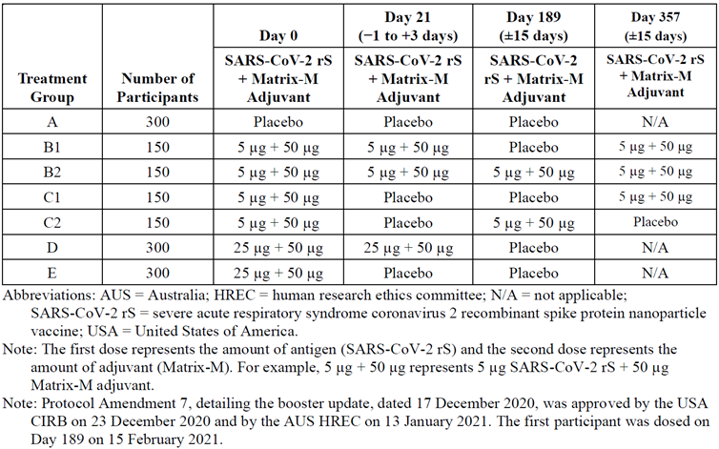
Abbreviationa: N/A = not applicable; SARS-CoV-2 rS = severe acute respiratory syndrome coronavirus 2 recombinant spike protein nanoparticle vaccine.
Note: The first dose represents the amount of antigen (SARS-CoV-2 rS) and the second dose represent the amount of adjuvant (Matrix-M). For example, 5 µg + 50 µg represents 5 µg SARS-CoV-2 rS + 50 µg Matrix M adjuvant.
Note: Protocol Amendment 7, detailing the booster update, dated 17 December 2020, was approved by the Central Institutional Review Board (USA) on 23 December 2020 and by the Australian Human Research Ethics Committee on 13 January 2021. The first participant was dosed on Day 189 on 15 February 2021.

Objectives and endpoints
The booster objectives and endpoints of Study 2019nCoV-101 (Part 2) are presented below.
Secondary objectives:
- To define the optimal dosing regimen in participants who are naïve and those with pre-existing antibodies to SARS-CoV-2 (if enough participants are identified with pre-existing antibodies) as assessed by the immune response (immunoglobulin G (IgG) antibody to SARS-CoV-2 rS and angiotensin converting enzyme 2 (ACE2) receptor binding inhibition) to the various regiments at Day 21 (post first dose), Day 35 (post-second dose), and Day 217. Optimal dosing regimen to be assessed across full age spectrum and age strata (18 to 59 years, and 60 to 84 years).
- To describe the amplitude, kinetics, and durability of immune responses to the various regiments in terms of ELISA units of serum IgG antibodies to SARS-CoV-2 rS and titres of ACE2 receptor binding inhibition at selected time points and relative to whether participants had pre-existing antibodies to SARS-CoV-2. To include reverse cumulative distribution curves.
- To describe the immune responses to the various regimens in terms of titres of neutralising antibody at selected time points and relative to whether participants had pre-existing antibodies to SARS-CoV-2 (subset of participants). Optimal dosing regimen to be assessed across full age spectrum and by age strata (18 to 59 years and 60 to 84 years).
- To access immune responses to the various regimens at 6 months and whether a boost at 6 months for a subset of the participants enrolled in the 5 µg dose regimens (Treatment Groups B and C) induces immune memory and is beneficial to maintain immune response in terms of IgG and neutralising antibodies to SARS-CoV-2 rS and ACE2 receptor binding inhibition.
- To assess overall safety through 35 days after prime vaccination is initiated (1 or 2 doses) for all adverse events; from 6 month boost (Day 189) through 28 days after 6 month boost (Day 217); and, for participants in Treatment Groups B and C, from 12 month boost (Day 357) through 28 days after 12 month boost (Day 385) for all adverse events; and through the end-of-study for any medically attended adverse event attributed to vaccine, adverse event of special interest or serious adverse event.
Secondary endpoints:
- Serum IgG antibody levels specific for SARS-CoV-2 rS protein antigen as detected by ELISA, described across study time points with derived/calculated endpoints to include geometric mean ELISA units (GMEU), geometric mean fold rise (GMFR), and seroconversion rate (SCR) (≥ 4 fold change) for the single dose regimens compared to the two dose regimens and to placebo, stratified by baseline immune response.
- Epitope specific immune responses to SARS-CoV-2 rS protein receptor binding domain measure by serum titres in ACE2 receptor binding inhibition assay to include geometric mean titre (GMT) or concentration, GMFR, and SCR (≥ 4 fold change) for the single dose regimens compared to the two dose regimens and to placebo.
- Neutralising antibody activity at Days 35, 189. 217 and at 357 for all treatment group, and additionally at Day 371 and 546 for treatment groups B and C relative to baseline in a subset of participants by absolute titres and change from Baseline, including the SCR (≥ 4 fold change). Analysis to include participants by treatment group, by age (18 to 59 years, 60 to 84 years) and relative to whether participants had pre-existing antibodies to SARS-CoV-2. A sampling scheme to identify a subset of such participants will be deployed.
- Serum IgG antibody levels specific for the SARS-CoV-2 rS protein antigens(s) as detected by ELISA using GMT or GMFR at Day 189, 217 and 357 for all treatment groups and additionally at Day 371 and 546 for treatment Groups B and C for boosting assessment with either placebo or active boost.
- All medically attended adverse events through Day 217, and then related medically attended adverse events until end of study, and all adverse events of special interest, or serious adverse events through the end-of-study by MedDRA classification, severity score, and relatedness.
- Vital sign measurement before vaccination and as clinically needed during the 30 minute post-vaccination observation period. Vital sign measurements at all other time points to be classified by descriptive statistics (for example mean, median, standard deviation (SD)) by visit.
Exploratory objective:
- To assess immune responses to the various regiments at 12 months and whether a boost at 12 months for participants enrolled in the 5 µg dose regimens (treatment Groups B and C) induces immune memory and is beneficial to maintain immune responses in terms of IgG and neutralising antibodies to SARS-CoV-2 rS and ACE2 receptor binding inhibition for new variants, including, but not limited to, the SARS CoV variant B.1.351.
Exploratory endpoint:
- Assessment of immune responses to the various regimens at 6 and 12 months for all treatment groups and at 18 months for treatment Groups B and C and whether a boost at 6 months (all treatment groups) and again at 12 months (treatment Groups B and C) induces immune memory and is beneficial to maintain immune response to the SARS-CoV-2 rS vaccine in terms of IgG and neutralising antibodies and ACE2 receptor binding inhibition for new variants, including, but not limited to, the variant B.1.351.

Inclusion and exclusion criteria
The study included healthy male and female subjects between 18 and 84 years of age inclusive. The study report does not provide detailed selection criteria.

Immunogenicity assessments
Blood samples for immunogenicity assessments were collected before vaccination and at Days 0, 21, 35, 105, 189, and 217 (with cell mediated immunity collected on Days 7 and 28). Immune measurements (that is enzyme linked immunosorbent assay (ELISA)) were conducted on serum (IgG antibody) for SARS-CoV-2 rS protein antigens. Additional immunogenicity assessments specific to SARS-CoV-2 (or related variants) included a human angiotensin converting enzyme 2 (ACE2) receptor binding inhibition assay and a neutralising antibody assay. Additional testing occurred with further assay development. Immunogenicity testing was performed for the original strain and the B.1.1.7 (Alpha), B.1.351 (Beta), B.1.1.529 (Omicron) variants.

Safety assessments
Safety assessments included monitoring and recording of solicited (local and systemic reactogenicity events) and unsolicited adverse events (AEs); medically attended adverse events (MAAEs), adverse events of special interest (AESIs), serious adverse events (SAEs); vital sign measurements; and targeted physical examination findings.

Statistical methods for immunogenicity assessment
Immunogenicity analyses for the Day 217 analyses were performed using the per protocol analysis set for the applicable visit, and all immunogenicity data were listed for the full analysis set (FAS) population. Ratios of geometric least-square means and associated 95% confidence intervals (CIs) from the analysis of covariance (ANCOVA) model were used to compare treatment groups.
The following evaluations were performed for serum IgG antibody levels and serum human ACE2 receptor binding inhibition specific for the SARS-CoV-2 rS protein antigens, as detected by ELISA separately:
- Geometric mean titres (GMTs) reported in geometric mean ELISA units (GMEUs), with 95% CIs, at each immunogenicity visit. The 95% CI was calculated based on the t-distribution of the log transformed values for GMTs, then back transformed to the original scale for presentation. An ANCOVA model was constructed at each post-vaccination immunogenicity visit on the log transformed titre, including the treatment group, site, and age strata (18 to 59 and 60 to 84 years) as fixed effects and the baseline log transformed titre as a covariate. No adjustments for multiplicity were carried out.
- Geometric mean fold rise (GMFR) compared to Baseline (Day 0), with 95% CIs at each post-vaccination immunogenicity visit. The 95% CI was calculated based on the t-distribution of the log transformed fold rise values for GMFRs, then back transformed to the original scale for presentation. Comparisons of GMFR between selected treatment groups were also performed within each post-vaccination visit. Similar analyses were performed with GMFR comparing post-Day 217 to pre-Day 189; however, only across time points included based on the re-randomised treatment groups on or after Day 189 (as new reference time point).
- Seroconversion rates (SCRs) with 95% CI based on the exact Clopper-Pearson method at each post-vaccination immunogenicity visit prior to Day 189. Seroconversion was defined as ≥ 4 fold increases in titres at each post-vaccination immunogenicity visit. Comparisons of SCR between selected treatment groups were also performed at each visit.

Participant flow

Priming dose vaccination period (pre-Day 189)
A total of 1609 subjects were screened with 1288 initially randomly assigned to treatment in the priming dose vaccination period (pre-Day 189). There were 322 screen failures. Screen failures comprised 295 subjects who failed to meet inclusion/exclusion criteria, 23 subjects for ‘other reasons’, 3 subjects for ‘withdrawal by subject’, and one subject for ‘lost to follow up’. Of the 1288 subjects initially randomised, 1283 (99.6%) received at least one dose of trial vaccine in the priming dose vaccination period.

Six-month booster vaccination period (post-Day 189)
A total of 983 subjects were re-randomised into the six-month booster vaccination period (post-Day 189) and 976 (99.3%) subjects were treated in the six-month booster dose vaccination period. Six re-randomised subjects did not receive a third dose, of which three were in Group B1; one in Group D, and two in Group E.
At the time of the Day 217 analysis, 473 (36.9%) subjects had completed the study and 651 (50.7%) subjects were still part of the ongoing study (see Table 3). A total of 159 (12.4%) subjects were discontinued in total; 81 (6.3%) due to ‘withdrawal by subject’, 61 (4.8%) were ‘lost to follow up’, eight (0.6%) due to an adverse event, five (0.4%) due to ‘physician decision’, two (0.2%) due to pregnancy, and two (0.2%) for reasons stated as ‘other’. Eighteen (1.4%) subjects discontinued trial vaccine due to an adverse event, of which two (colitis and pyrexia) were considered to be vaccine related by the investigator.
Table 3: Study 2019nCoV-101 (Part 2) Subject disposition across the entire study (full analysis set)
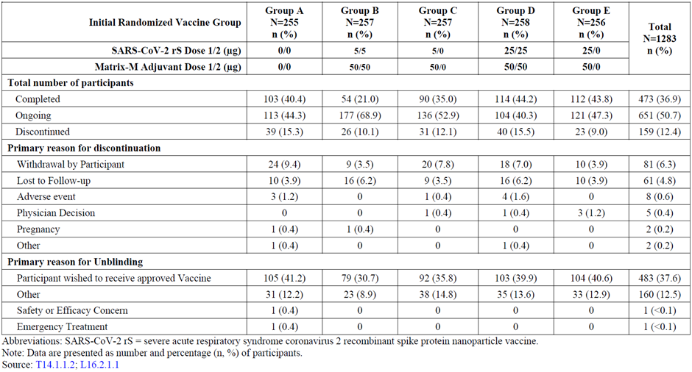
Abbreviations: SARS-CoV-2 rS = severe acute respiratory syndrome coronavirus 2 recombinant spike protein nanoparticle vaccine.
Note: Data are presented as number and percentage (n, %) of participants.
Of the 983 subjects in the FAS of the six-month booster vaccination period (post-Day 189), 976 (99.3%) were included in the safety analysis set and at least 979 (99.6%) were included in the per protocol analysis set. For the safety analysis set, six re-randomised subjects did not receive third dose and seven re-randomised subjects received a different trial vaccine than they were randomised to receive.
A total of 344 (35%) subjects were excluded from the per protocol analysis set at various time points up to the Day 217 visit; reasons for exclusion at a particular visit included study discontinuation, missed assessments/visits, and/or major protocol violations that impacted immunogenicity response.
Overall, the data analysis sets in the six-month booster vaccination period (post-Day 189) were well balanced across the treatment groups.
The number of subjects excluded in the per protocol set is noted to be quite high. By Day 217, 35% of subjects were lost from the per protocol set, with the retention ranging from 58.1% (Group D) to 74.6% (Group A). However, they are fairly balanced across the groups (especially between Groups B1 (65.1%) and B2 (71.2%)).

Major protocol deviations
Major protocol deviations were documented for 758 subjects (58.9%). The most common were visit scheduling (446 subjects (34.6%)), missing endpoint assessments (327 subjects (25.4%)), study treatment compliance (115 subjects (8.9%)), and study procedures/assessments (97 subjects (7.5%)). While the rates of the protocol deviations are high, they were balanced across the groups.

Results

Baseline characteristics
Demographics and baseline characteristics of subjects in the 6-month booster vaccination period (post-Day 189) were generally well balanced between the treatment groups (see Table 4) and consistent with those in the priming dose vaccination period. The median age was 57 years (range: 18 to 84 years) and the mean body mass index (BMI) was 26.99 kg/m² (range between 17.3 and 35 kg/m²). A total of 531 (54.4%) subjects were 18 to 59 years of age and 445 (45.6%) subjects were 60 to 84 years of age. Approximately half (51.7%) the subjects were male, and the majority (85.6%) were White and not of Hispanic or Latino origin (95.6%). Most subjects (97.6%) had a negative or indeterminate SAR-CoV-2 baseline serostatus. Overall, the baseline characteristics were balanced.
Table 4: Study 2019nCoV-101 (Part 2) Subject demographics and baseline characteristics for the six month booster vaccination period (post-Day 189) (safety analysis set)
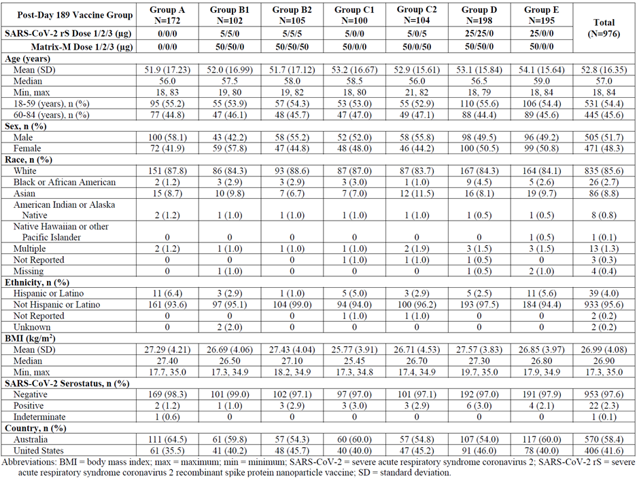
Abbreviations: BMI = body mass index; max = maximum; min = minimum; SARS-CoV-2 rS = severe acute respiratory syndrome coronavirus 2 recombinant spike protein nanoparticle vaccine; SD = standard deviation.
Note: Data are presented as number and percentage (n, %) of participants.

Results for the secondary immunogenicity outcomes

Serum IgG Antibody Levels
- Serum IgG antibody GMTs specific for the SARS-CoV-2 rS protein antigen at Day 217 in Group B2 subjects (vaccine group) were 204366.7 ELISA units, which was an approximate 33.7-fold increase from the GMTs at Day 189 (6064.3 ELISA units) and an approximate 4.7-fold increase from peak GMTs at Day 35 (43904.7 ELISA units). Seroconversion rates versus Baseline (Day 189 or Day 0) were 93.2% at Day 217 and 98.3% at Day 35 (Table 5).
- Serum IgG antibody GMTs at Day 217 in Group B2 (booster group) subjects of 18 to 59 years of age were 270224.2 ELISA units, an approximate 31.4-fold increase from the GMTs at Day 189 (8102.1 ELISA units) and an approximate 4.1 fold increase from peak GMTs at Day 35 (65255.1 ELISA units). Seroconversion rates versus Baseline (Day 189 or Day 0) were 95.1% at Day 217 and 99.2% at Day 35 (see Table 6). Serum IgG antibody GMTs at Day 217 in subjects 60 to 84 years of age were 144439.6 ELISA units, which was an approximate 34.1-fold increase from the GMTs at Day 189 (4238.1 ELISA units) and an approximate 5.1-fold increase from peak GMTs at Day 35 (28,136.6 ELISA units). Seroconversion rates versus baseline (Day 189 or Day 0) were 90.9% at Day 217 and 97.4% at Day 35 (see Table 6).
Table 5: Study 2019nCoV-101 (Part 2) Overall summary of serum IgG antibody levels following vaccination (per protocol analysis set)
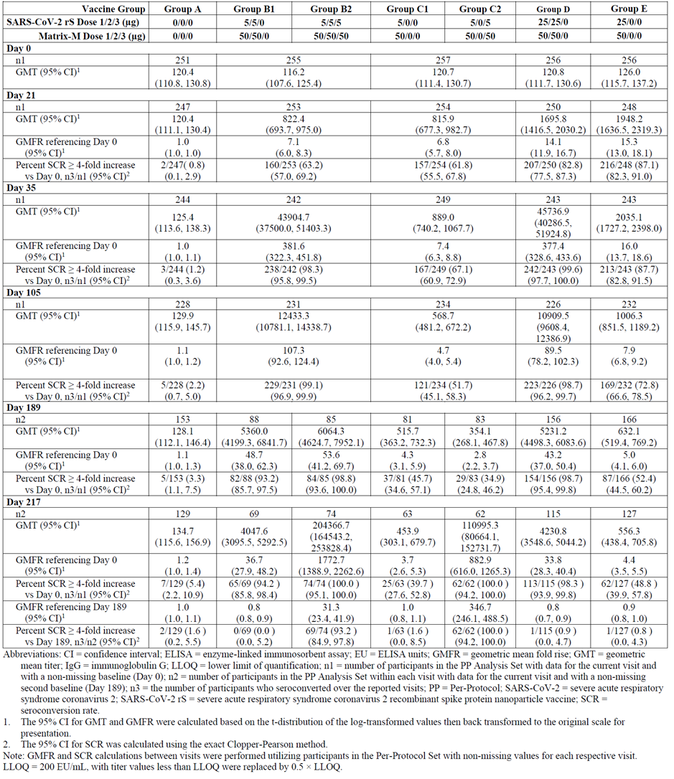
Abbreviations: CI = confidence interval; ELISA = enzyme linked immunosorbent assay; EU = ELISA unit; GMFR = geometric mean fold rise; GMT = geometric mean titre; IgG = immunoglobin G; LLOQ = lower limit of quantification; n1 = number of participants in the per protocol analysis set with data for the current visit and with a non-missing baseline (Day 0); n2 = participants in the per protocol analysis set within each visit with data for the current visit and with a non-missing second baseline (Day 189); n3 = the number of participants who seroconverted over the reported visits; P = per protocol; SARS-CoV-2 rS = severe acute respiratory syndrome coronavirus 2 recombinant spike protein nanoparticle vaccine; SCR = seroconversion rate.
1 The 95% CI for GMT and GMFR were calculated based on the t-distribution of the log transformed values then back transformed to the original scale for presentation.
2 The 95% CI for SCR was calculated using the exact Clopper-Pearson method.
Note: GMFR and SCR calculations between visits were performed utilising participants in the per protocol set with non-missing values for each respective visit.
Lower limit of quantification (LLOQ) = 200 ELISA units/mL, with titre values less than LLOQ were replaced by 0.5 x LLOQ.
Table 6: Study 2019nCoV-101 (Part 2) Summary of serum IgG antibody levels following vaccination stratified by age group (per protocol analysis set)
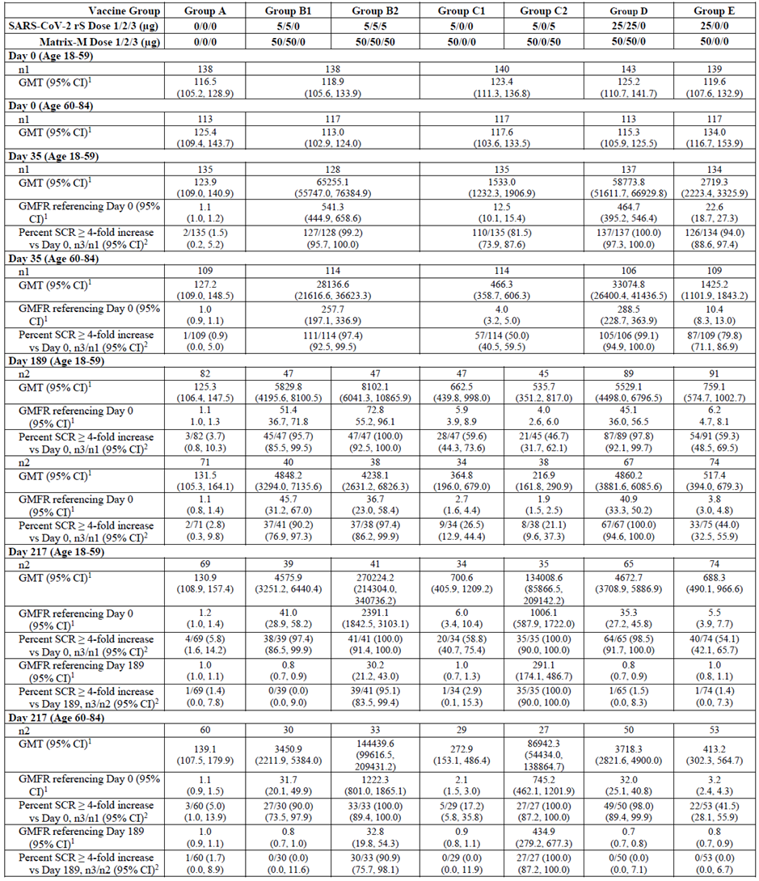
Abbreviations: CI = confidence interval; ELISA = enzyme linked immunosorbent assay; EU = ELISA unit; GMFR = geometric mean fold rise; GMT = geometric mean titre; IgG = immunoglobin G; LLOQ = lower limit of quantification; n1 = number of participants in the per protocol analysis set with data for the current visit and with a non-missing baseline (Day 0); n2 = participants in the per protocol analysis set within each visit with data for the current visit and with a non-missing second baseline (Day 189); n3 = the number of participants who seroconverted over the reported visits; P = per protocol; SARS-CoV-2 rS = severe acute respiratory syndrome coronavirus 2 recombinant spike protein nanoparticle vaccine; SCR = seroconversion rate.
1 The 95% CI for GMT and GMFR were calculated based on the t-distribution of the log transformed values then back transformed to the original scale for presentation.
2 The 95% CI for SCR was calculated using the exact Clopper-Pearson method.
Note: GMFR and SCR calculations between visits were performed utilising participants in the per protocol set with non-missing values for each respective visit.
Lower limit of quantification (LLOQ) = 200 ELISA units/mL, with titre values less than LLOQ were replaced by 0.5 x LLOQ.

Human angiotensin converting enzyme 2 receptor binding inhibition
Serum human angiotensin converting enzyme 2 (ACE2) receptor binding inhibition specific for the SARS-CoV-2 rS protein antigen was measured at Days 0 (at Baseline), 21, 35, and 105 in the priming dose vaccination period (pre-Day 189) and at Days 189 and 217 in the six month booster vaccination period (post-Day 189) using a qualified IgG ELISA for the original strain. The lower limits of quantification (LLOQ) for this assay was 10 titre units, and samples with serum human ACE2 receptor binding inhibition < LLOQ were assigned a value of 5 titre units for calculation purposes. Serum human ACE2 receptor binding inhibition titres over time are shown for the post-Day 189 treatment groups in Figure 1 (see below). During the priming dose vaccination period (pre-Day 189), peak human ACE2 receptor binding GMTs were observed at Day 35 in the two dose 5 μg and 25 μg adjuvanted treatment groups (Groups B and D, respectively) with declining concentrations through Day 189 for both age strata. Thereafter, serum human ACE2 receptor binding inhibition peaked after the six month booster dose in Groups B2 and C2 to levels higher than those seen after priming vaccination.
Figure 1: Study 2019nCoV-101 (Part 2) Line plot of geometric mean titre for overall human ACE2 receptor binding inhibition titres following vaccination (per protocol analysis set)
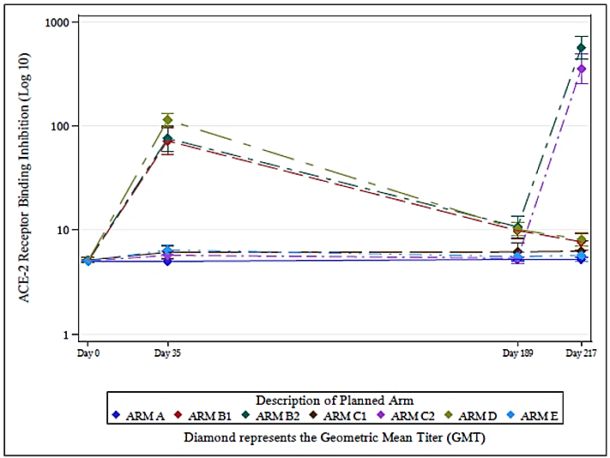
Abbreviations: ACE2 (ACE-2) = Angiotensin converting enzyme 2.
Note: Horizontal lines denote 95% confidence intervals. Arms refer to treatment groups (Groups A to E)
For Group B2 subjects, serum human ACE2 receptor binding inhibition GMTs decreased from the earlier peak seen at Day 35 (78.4 ELISA units) down to 10.7 ELISA units at Day 189. Over this period, GMFR versus Baseline (Day 0) reduced from 15.6 to 2.1 and SCR reduced from 80.8 to 21.2% (for Day 35 and Day 189, respectively). Twenty-eight days following booster vaccinations at Day 217, human ACE2 receptor binding inhibition GMTs observed in Group B2 (567.8 ELISA units) were 50.1-fold greater than Day 189 titres and about 7.2-fold greater than titres reported following the primary vaccination series (Day 35).

Neutralising antibody activity
The neutralising antibody activity GMT at Day 217 in all Group B2 subjects was 6023.2 ELISA units, which was an approximate 95.6-fold increase from the GMT at Day 189 (63 ELISA units) and an approximate 4.1 fold increase from peak GMT at Day 35 (1470.3 ELISA units). SCRs versus Baseline (Day 189 or Day 0) were 95.3% at Day 217 and 100% at Day 35 (see Table 7).
Neutralising antibody activity GMT at Day 217 in B2 group subjects of 18 to 59 years of age were 8568.3 ELISA units, which was an approximate 107.1-fold increase from the GMTs at Day 189 (80 ELISA units) and an approximate 3.8-fold increase from peak GMTs at Day 35 (2280.7 ELISA units). Seroconversion rates versus Baseline (Day 189 or Day 0) were 97.1% at Day 217 and 100% at Day 35 (Table 8). Neutralising antibody activity GMT at Day 217 in subjects 60 to 84 years of age were 3936.3 ELISA units, which was an approximate 84.7-fold increase from the GMT at Day 189 (46.5 ELISA units) and an approximate 4-fold increase from peak GMT at Day 35 (980.5 ELISA units). Seroconversion rates versus Baseline (Day 189 or Day 0) were 93.1% at Day 217 and 100% at Day 35 (see Table 8).
Table 7: Study 2019nCoV-101 (Part 2) Overall summary of neutralising antibody activity (microneutralisation at 50%) following vaccination (per protocol analysis set)
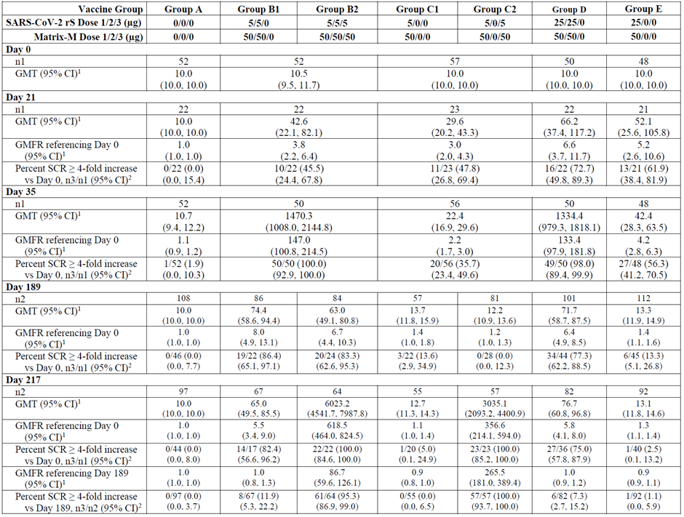
Abbreviations: CI = confidence interval; ELISA = enzyme linked immunosorbent assay; EU = ELISA unit; GMFR = geometric mean fold rise; GMT = geometric mean titre; IgG = immunoglobin G; LLOQ = lower limit of quantification; n1 = number of participants in the per protocol analysis set with data for the current visit and with a non-missing baseline (Day 0); n2 = participants in the per protocol analysis set within each visit with data for the current visit and with a non-missing second baseline (Day 189); n3 = the number of participants who seroconverted over the reported visits; P = per protocol; SARS-CoV-2 rS = severe acute respiratory syndrome coronavirus 2 recombinant spike protein nanoparticle vaccine; SCR = seroconversion rate.
1 The 95% CI for GMT and GMFR were calculated based on the t-distribution of the log transformed values then back transformed to the original scale for presentation.
2 The 95% CI for SCR was calculated using the exact Clopper-Pearson method.
Note: GMFR and SCR calculations between visits were performed utilising participants in the per protocol set with non-missing values for each respective visit.
Lower limit of quantification (LLOQ) = 200 ELISA units/mL, with titre values less than LLOQ were replaced by 0.5 x LLOQ.
Table 8: Study 2019nCoV-101 (Part 2) Summary of neutralizing antibody levels following vaccination stratified by age group (per protocol analysis set)
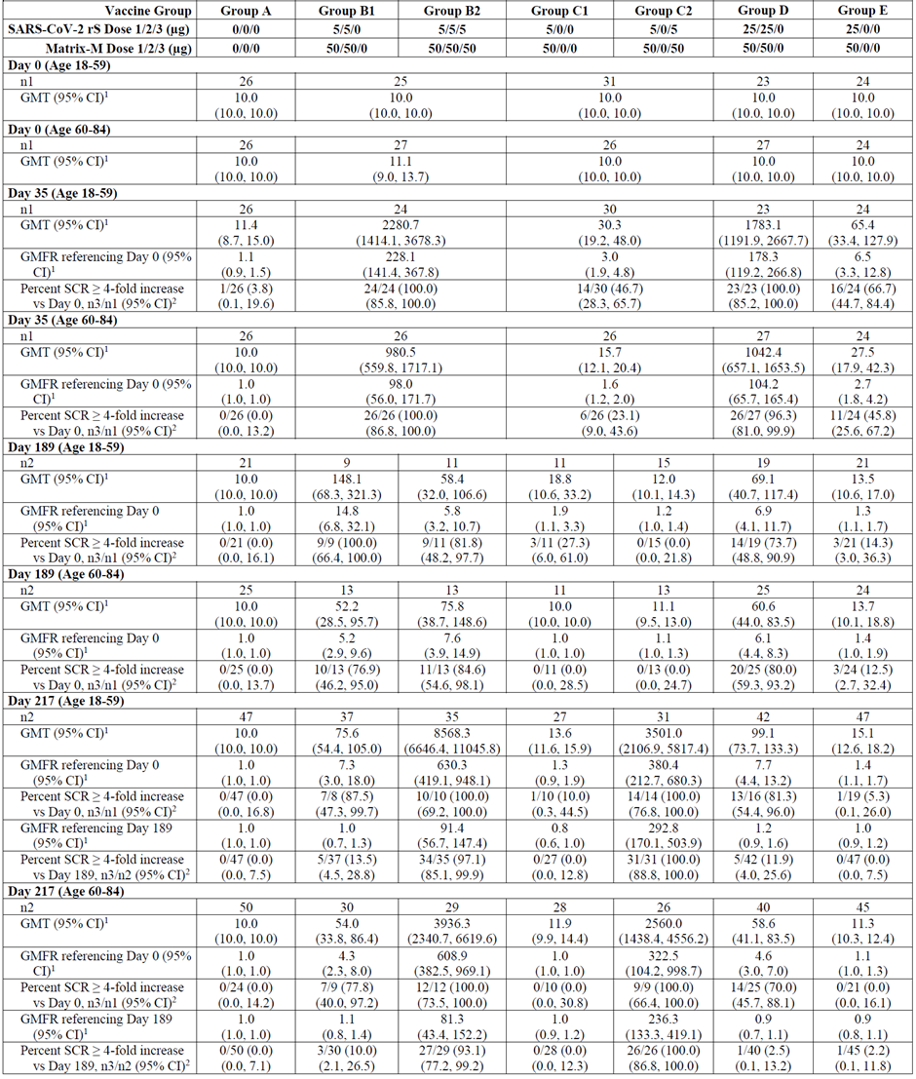
Abbreviations: CI = confidence interval; ELISA = enzyme linked immunosorbent assay; EU = ELISA unit; GMFR = geometric mean fold rise; GMT = geometric mean titre; IgG = immunoglobin G; LLOQ = lower limit of quantification; n1 = number of participants in the per protocol analysis set with data for the current visit and with a non-missing baseline (Day 0); n2 = participants in the per protocol analysis set within each visit with data for the current visit and with a non-missing second baseline (Day 189); n3 = the number of participants who seroconverted over the reported visits; P = per protocol; SARS-CoV-2 rS = severe acute respiratory syndrome coronavirus 2 recombinant spike protein nanoparticle vaccine; SCR = seroconversion rate.
1 The 95% CI for GMT and GMFR were calculated based on the t-distribution of the log transformed values then back transformed to the original scale for presentation.
2 The 95% CI for SCR was calculated using the exact Clopper-Pearson method.
Note: GMFR and SCR calculations between visits were performed utilising participants in the per protocol set with non-missing values for each respective visit.
Lower limit of quantification (LLOQ) = 200 ELISA units/mL, with titre values less than LLOQ were replaced by 0.5 x LLOQ.

Exploratory immunogenicity outcomes: immunogenicity markets for the SARS-CoV-2 B.1.351 (Beta) variant
For the Beta variant, serum IgG antibody GMTs in Group B2 subjects (six-month booster following a two dose priming series on Days 0 and 21) increased from 4317.2 ELISA units at Day 189 pre-booster to 175190.3 ELISA units at Day 217 reflecting a post-booster increase of about 40.6-fold (see Table 9). These titres were 4-fold higher than those observed at Day 35 (post-priming) for the original strain (GMT 175190.3 ELISA units versus 43904.7 ELISA units). Beta variant neutralising antibody activity assay data showed a similar fold increase in titres from pre-booster (Day 189) to post-booster (Day 217) of about 50.8-fold (GMT 13 versus 660.8 ELISA units), though titres were lower than those seen for the ancestral strain at Day 35 (GMT 660.8 versus 1470.3 ELISA units) (Table 10). Comparing peak serum IgG and neutralising antibody activity titres at Day 217 for the Beta variant and the ancestral strain (175190.3 versus 204366.7 ELISA units for serum IgG antibody activity; and 660.8 versus 6023.2 ELISA units for neutralising antibody activity) demonstrates serum IgG antibody titres that are somewhat comparable whereas neutralising antibody activity is reduced by about 9.1-fold for the Beta variant.
Stratified by age group (18 to 59, and 60 to 84 years of age), the younger cohort of subjects had consistently higher serum IgG antibody and neutralising antibody activity titres than the older cohort. In Group B2, peak serum IgG antibody and neutralising antibody activity titres at Day 217 were about 1.8-fold higher (226102.9 versus 127601 ELISA units) and about 1.9-fold higher (870.9 versus 469.1 ELISA units) in younger versus older subjects, respectively.
Table 9: Study 2019nCoV-101 (Part 2) Summary of serum IgG antibody levels for the SARS-CoV-2 Beta variant following vaccination (per protocol analysis set)
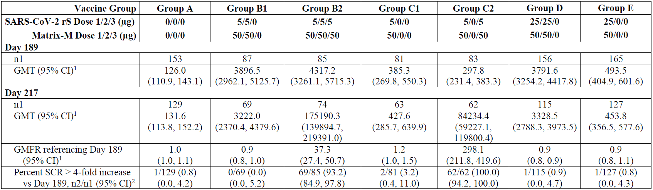
Abbreviations: CI = confidence interval; GMFR = geometric mean fold rise; GMT = geometric mean titre; IgG = immunoglobin G; n1 = number of participants in the per protocol analysis set with data for the current visit and with a non-missing baseline (Day 0); n2 = participants in the per protocol analysis set within each visit with data for the current visit and with a non-missing second baseline (Day 189); P = per protocol; SARS-CoV-2 rS = severe acute respiratory syndrome coronavirus 2 recombinant spike protein nanoparticle vaccine; SCR = seroconversion rate.
1 The 95% CI for GMT and GMFR were calculated based on the t-distribution of the log transformed values then back transformed to the original scale for presentation.
2 The 95% CI for SCR was calculated using the exact Clopper-Pearson method.
Note: GMFR and SCR calculations between visits were performed utilising participants in the per protocol set with non-missing values for each respective visit.
Table 10: Study 2019nCoV-101 (Part 2) Summary of neutralising antibody levels for the SARS-CoV-2 Beta variant following vaccination group (per protocol analysis set)
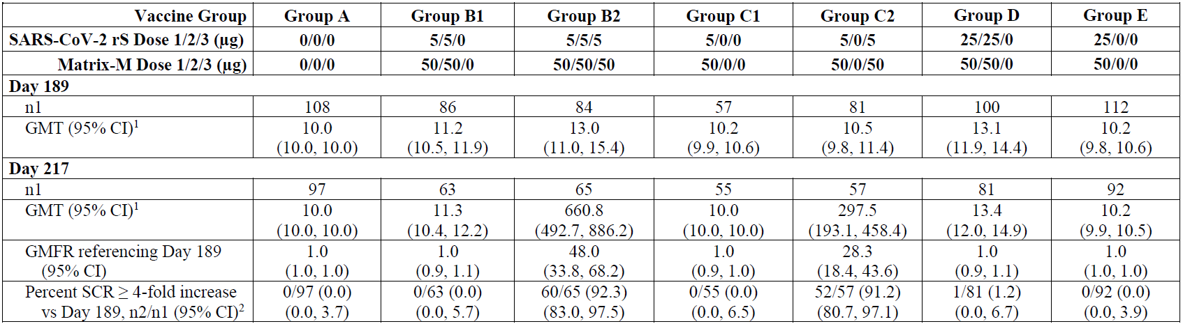
Abbreviations: CI = confidence interval; GMFR = geometric mean fold rise; GMT = geometric mean titre; IgG = immunoglobin G; n1 = number of participants in the per protocol analysis set with data for the current visit and with a non-missing baseline (Day 0); n2 = participants in the per protocol analysis set within each visit with data for the current visit and with a non-missing second baseline (Day 189); P = per protocol; SARS-CoV-2 rS = severe acute respiratory syndrome coronavirus 2 recombinant spike protein nanoparticle vaccine; SCR = seroconversion rate.
1 The 95% CI for GMT and GMFR were calculated based on the t-distribution of the log transformed values then back transformed to the original scale for presentation.
2 The 95% CI for SCR was calculated using the exact Clopper-Pearson method.
Note: GMFR and SCR calculations between visits were performed utilising participants in the per protocol set with non-missing values for each respective visit.

Exploratory immunogenicity outcomes: Immunogenicity against additional SARS-CoV-2 variants
Additional fit for purpose immunoassays were developed to explore the effect of a booster dose of Nuvaxovid on immune responses generated against additional variants of SARS-CoV-2. Sera collected from 29 subjects in Group B2 was used in this exploratory analysis. Anti-rS (anti-recombinant spike) serum IgG antibody and functional human ACE2 receptor binding inhibition activity assays were used to analyse responses against the ancestral, B.1.351 (Beta), B.1.1.7 (Alpha), B.1.617.2 (Delta), and B1.1.529 (Omicron) variant strains of SARS-CoV-2. An additional microneutralisation assay was performed to evaluate microneutralisation at an inhibitory concentration > 99% (inhibitory concentration > 99%; microneutralisation 99).
The first assay comparing anti-rS serum IgG antibody levels across the ancestral (that is original or wild-type) strain and the Alpha, Beta, Delta, and Omicron variants of SARS-CoV-2 found that 61.1-fold (Ancestral), 85.8-fold (Alpha), 65-fold (Beta), 92.5-fold (Delta), and 73.4-fold (Omicron) higher titres were observed were observed from Day 189 to Day 217, and 5.4-fold, 9.7-fold, 6.5-fold, 11.1-fold, and 9.3-fold higher titres were observed from Day 35 to Day 217 (see Table 11). A functional human ACE2 receptor binding inhibition assay was utilised to compare activity against the same strains of SARS-CoV-2, and found 54.4-fold, 21.9-fold, 24.5-fold, 24.4-fold, and 20-fold increases in human ACE2 receptor binding inhibition titres were observed from Day 189 (immediately pre-booster) to Day 217, and 6-fold, 8.2-fold, 10.8-fold, 6.6-fold and 14.4-fold from Day 35 to Day 217 (see Table 12).
A third assay comparing neutralising antibody activity titres demonstrated 15.4-fold (Ancestral, that is original or wild-type strain), 14.fold (Delta), and 3.5 fold (Omicron) higher titres after the booster (Table 13).
Table 11: Study 2019nCoV-101 (Part 2) Anti-recombinant spike serum IgG antibody geometric mean titres after primary and booster vaccination for the ancestral (wild-type) and variant SARS-CoV-2 strains by study day for subjects receiving Nuvaxovid
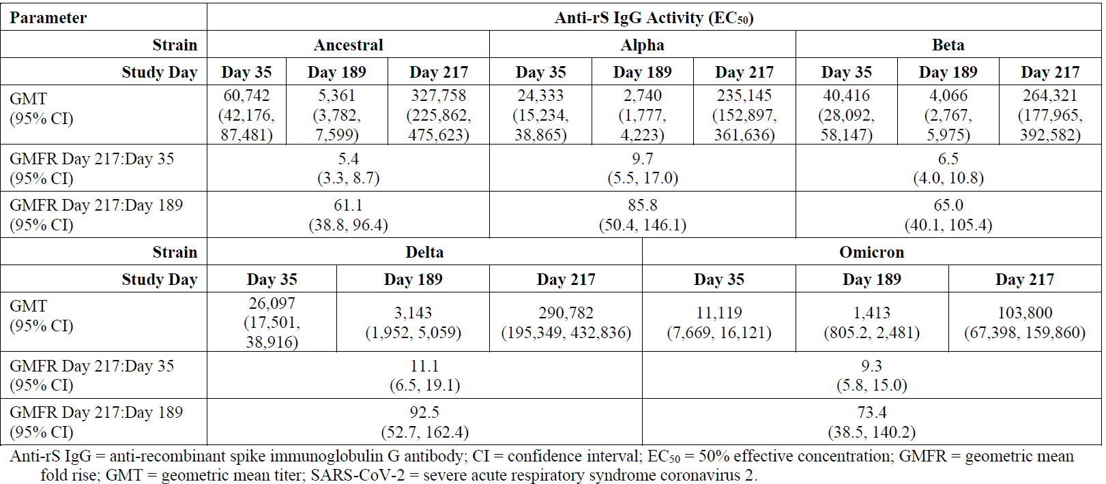
Abbreviations: Anti-rS IgG = anti-recombinant spike immunoglobulin G antibody; CI = confidence interval; D35 = Day 35; D189 = Day 189; D217 = Day 217; EC₅₀ = half maximal (50%) effective concentration; GMFR = geometric mean fold rise; GMT = geometric mean titre; SARS-CoV-2 = severe acute respiratory syndrome coronavirus 2.
Table 12: Study 2019nCoV-101 (Part 2) Human angiotensin converting enzyme 2 receptor binding inhibition geometric mean titres after primary and booster vaccination for ancestral and variant SARS-CoV-2 strains by study day for subjects receiving Nuvaxovid
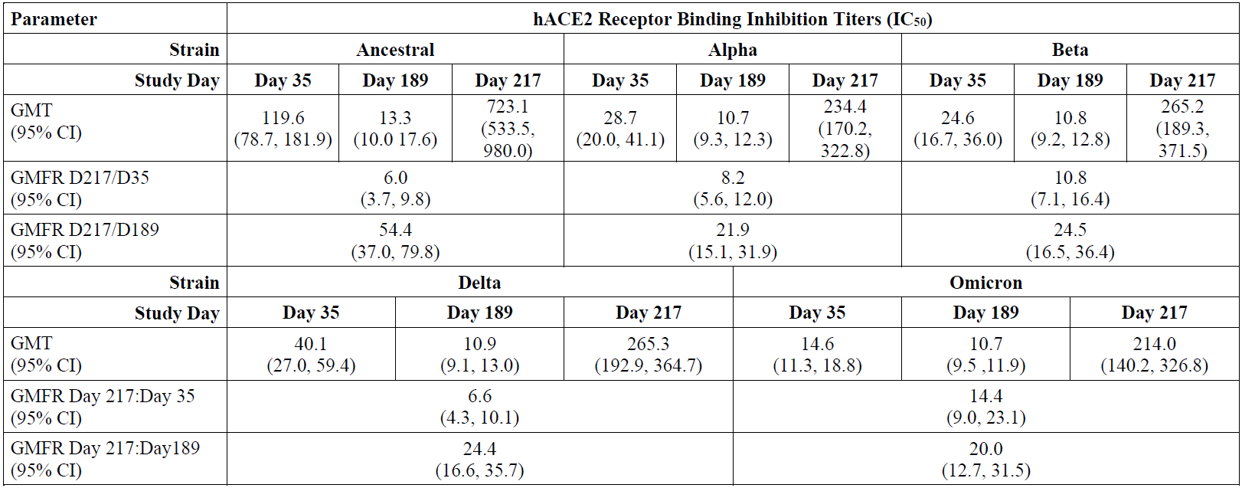
Abbreviations: CI = confidence interval; D35 = Day 35; D189 = Day 189; D217 = Day 217; GMFR = geometric mean fold rise; GMT = geometric mean titre; hACE2 = human angiotensin converting enzyme 2; IC₅₀ = half maximal (50%) inhibitory concentration SARS-CoV-2 = severe acute respiratory syndrome coronavirus 2.
Table 13: Study 2019nCoV-101 (Part 2) Microneutralisation geometric mean titres after primary and booster vaccination for the ancestral and select variant SARS-CoV-2 strains by study day for subjects receiving Nuvaxovid
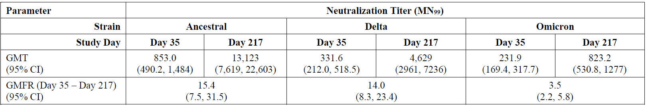
Abbreviations: GMFR = geometric mean fold rise; GMT = geometric mean titre; MN99 = microneutralisation 99 (MN99) assay

Study 2019nCoV-501

Study overview
Study 2019nCOV-501 is a Phase IIa/b, randomised, observer-blinded, placebo-controlled study to evaluate the efficacy, immunogenicity, and safety of a SARS-CoV-2 recombinant spike protein nanoparticle vaccine (SARS-CoV-2 rS) With Matrix-M adjuvant in South African adult subjects living without human immunodeficiency virus (HIV); and safety and immunogenicity in adults living with HIV.
At six months (± 15 days) post end of the initial vaccination period (Day 201), subjects were given the option to be reconsented and enter the blinded crossover vaccination period. The crossover vaccination period consisted of two vaccination days (Days 201 and 222), and a Day 236 visit for a specified subset of approximately 1500 subjects enrolled at a subset of sites (undergoing additional blood sampling), and a Day 386/end-of-study visit. The blinded crossover period involved two injections of either the active vaccine or the placebo was to be administered 21 days apart. Subjects who received two doses of the active vaccine in the initial vaccination period were to receive one booster injection (third dose) of the active vaccine and a second injection of placebo, while those subjects who initially received placebo would receive two injections of the active vaccine during the crossover period (blinded). The duration of the study, excluding screening, was to be approximately 12 months after the last vaccination in the initial vaccination period (386 days after the second initial vaccination).
Unlike in Study 2019nCoV-101 (part 2), there is no placebo/control group to compare with for booster vaccination, as placebo was not given to anyone who received primary series of vaccine.
The blinded crossover period of Study 2019nCoV-501 was initiated on 26 March 2021. Enrolment into the blinded crossover period was completed on 4 May 2021 at 16 sites across South Africa. A planned analysis on the effect of booster dosing on immunogenicity and safety results was conducted after all subjects in the blinded crossover period were followed for at least 35 days after active vaccination (data cut-off 15 September 2021).

Objective and endpoints
The objective and endpoints for Study 2019nCoV-501 are listed as follows:
Booster objective:
- To assess the immune response (IgG antibody to SARS-CoV-2 rS protein and human ACE2 receptor binding inhibition) for SARS-CoV-2 rS with Matrix M adjuvant at Day 21 (post first dose), Day 35 (post second dose), and across later study time points in serologically naïve (to SARS-CoV-2) healthy HIV negative and medically stable people living with HIV adult participants, regardless of baseline serostatus and stratified by baseline serostatus (to SARS-CoV-2) for all participants in the initial vaccination period and in a subset of participant in the crossover vaccination period.
- To describe the amplitude, kinetics, and durability of immune response in terms of ELISA units of serum IgG antibodies and titers of hACE2 receptor binding inhibition to SARS-CoV-2 rS protein(s) at selected time points and relative to whether participants had pre-existing antibodies to SARS-CoV-2, regardless of baseline serostatus and stratified by baseline serostatus (to SAR-CoV-2). To include reverse cumulative distribution curves.
- To describe the immune response to the primary two dose regimen plus booster vaccination of SARS-CoV-2 rS with Matrix M adjuvant in terms of titers of neutralising antibody at selected study time points in a subset of healthy HIV negative and medically stable people living with HIV adult participants, regardless of baseline serostatus and stratified by baseline serostatus (to SARS-CoV-2) in the crossover vaccination period.
- To assess overall safety through Day 35 for all unsolicited adverse events and all medically attended adverse events and safety through 6 months following the initial vaccination period, 6 months following the crossover vaccination period, and 12 months following initial vaccination period for any medically attended adverse event attributed to vaccine, adverse event of special interest, or serious adverse event in healthy HIV negative and medically stable people living with HIV adult participants, regardless of baseline serostatus and stratified by baseline serostatus.
Booster endpoints:
- Serum IgG antibody levels specific for the SARS-CoV-2 rS protein antigen(s) as detected by ELISA using geometric mean titre (GMT) or seroconversion rate at Day 21 (post first dose), Day 35 (post second dose), and across later study time points in healthy HIV negative and medically stable people living with HIV adult participants, for all participants in the initial vaccination period and for a subset of participants in the crossover vaccination period, regardless of baseline serostatus and stratified by baseline serostatus (to SARS-CoV-2). Derived/calculated endpoints based on these data will include geometric mean ELISA units (GMEUs), geometric mean fold rise (GMFR) and SCR. Seroconversion rate (SCR) is defined as the percentage of participants with a post-vaccination titre ≥ 4 fold over naïve background and ≥ 2-fold over pre-existing titre. Positive baseline status (positive versus negative) using GMT and/or a positive polymerase chain reaction (PCR) test at Baseline.
- Epitope specific immune responses to the SARS-CoV-2 rS protein receptor binding domain measured by serum titres in an human ACE2 receptor binding inhibition assay, described across study time points, to include GMT, GMFR, SCR and seroresponse rate (SRR) in healthy HIV negative and medically stable people living with HIV adult participants, regardless of baseline serostatus and stratified by baseline serostatus (to SARS-CoV-2). Seroresponse rate (SRR) is defined as the proportion of participants with rises in titres exceeding the 95th percentile of placebo participants at the same time point and based on prior SARS-CoV-2 exposure.
- Neutralising antibody activity relative to baseline in healthy HIV negative and medically stable people living with HIV adult participants in the initial vaccination period and in a subset of participants in the crossover vaccination period, combined, by absolute titres and change from Baseline, including SCR (≥ 4 fold change) and SRR, regardless of baseline serostatus and stratified by baseline serostatus (to SARS-CoV-2) to investigate whether baseline status (+/-) impacts response.
- Numbers and percentages (with 95% CI) of participants with medically attended adverse events, adverse events of special interest, or serious adverse events through end of study/Day 386 by MedDRA classification,¹² severity score, and relatedness in healthy HIV negative and medically stable people living with HIV adult participants, regardless of baseline serostatus and stratified by baseline serostatus.

Inclusion and exclusion criteria
The selection criteria define a relatively healthy population of adults with some key exclusions of subjects based on comorbidities that would be relevant to COVID-19 severity. The key inclusion and exclusion criteria are as follows:
Key inclusion criteria:
- Adults aged ≥ 18 to < 85 year of age (cohort 1) or ≥ 18 to < 65 (cohort 2)
- Body mass index of 17 to 40 kg/m²
- Healthy at screening (in opinion of investigator)
- HIV-positive subjects: medically stable, free of opportunistic infections in preceding year, HIV-1 viral load < 1000 copies/mL
Key exclusion criteria:
- History of confirmed or suspected prior COVID-19
- Symptomatic acute and/or unstable illness
- Chronic diseases inclusive of:
  - Congestive cardiac failure or chronic obstructive pulmonary disease with history of exacerbation in previous two years
  - Asthma requiring regular short or any long acting therapy, or recent exacerbation within three months
  - Diabetes requiring of insulin
  - Chronic kidney disease or insufficiency
  - Other gastroenterological, hepatic, autoimmune, immunosuppressive (disease or therapy) or neurological disease

Immunogenicity assessments
Blood samples for immunogenicity assessments were collected before vaccination and at Day 111 (three months post last vaccination), Day 201 (six months post), and Day 236. Immune measurements (anti-spike protein IgG) were conducted using ELISA on serum samples for SARS-CoV-2 rS protein antigens. Additional immunogenicity assessments specific to SARS-CoV-2 (or related variants) were to include human ACE2 receptor binding inhibition assay and a neutralising antibody assay.

Safety assessments
Safety assessments were performed during all clinic visits in the crossover period, on Day 111, Day 201, Day 222, and Day 236. Safety assessments (initial and crossover vaccination periods) included the monitoring and recording of unsolicited treatment emergent adverse events (TEAEs), medically attended adverse events (MAAEs), adverse events of special interest (AESI), serious adverse events (SAEs), vital signs measurements on day of vaccination; physical examination findings; and occurrence of SARS-CoV-2 infection as measured by nasal mid-turbinate swab and using qualitative polymerase chain reaction following subject reported symptoms. COVID-19 severity was categorised as virologically confirmed, mild, moderate, or severe according to protocol specified criteria. Recording of solicited and unsolicited adverse events was conducted by electronic data capture/reporting. Monitoring for potential immune-mediated medical conditions (PIMMC) and AESIs specific to potential disease enhancement for COVID-19 was also monitored. Reactogenicity was not collected during the crossover vaccination period.

Immunogenicity analysis
The immunogenicity analyses were performed using the per protocol immunogenicity and FAS analysis sets. The following evaluations were to be performed for the serum IgG antibody levels human ACE2 receptor binding inhibition specific for the SARS-CoV-2 rS protein antigens as detected by ELISA. Similar method was used to assess the microneutralisation levels.
- Geometric mean titres (GMTs) (reported in geometric mean ELISA units) by treatment and overall, with 95% CI. The 95% CI were calculated based on the t-distribution of the log transformed values for GMTs, then back transformed to the original scale. Plots of the reverse cumulative distribution curves were provided by treatment and overall.
- Geometric mean fold rise (GMFR) (compared to Day 0) by treatment and overall, with 95% CI. The 95% CI was calculated based on the t-distribution of the log transformed fold rise values for GMFRs, then back transformed to the original scale.
- Seroconversion rate (SCR) by treatment and overall, or SCR with 95% CI referencing the Month 6 value by treatment with 95% CI based on the exact Clopper-Pearson method.
- Seroconversion based on baseline value was defined as the percentage of subjects with a post-vaccination titre ≥ 4-fold over naïve background and ≥ 2-fold over pre-existing titre. Seroconversion based on Month 6 value was defined as the percentage of subjects with a post-crossover titre ≥ 4-fold and ≥ 2-fold over Month 6 titre.
- Seroresponse rates (SRRs) with 95% CI based on the exact Clopper-Pearson method. SRR, except for the post-crossover summary, was defined as the proportion of subjects with rises in ELISA titre units exceeding the 95th percentile of placebo subjects at that time. SRR for the post-crossover summary, was defined as the proportion of subjects with rises in ELISA titre units exceeding the 95th percentile of placebo subjects at Month 6.

Participant flow
A total of 3791 subjects entered the crossover period (3558 HIV-negative and 233 people living with HIV). Of the 3791 subjects randomised, 3730 (98.4%) were continuing in follow up and 54 (1.4%) discontinued the study (see Table 14: Study 2019nCoV-501 Subject disposition for immunogenicity (intent to treat analysis set)) at the time of the data cut-off. Of the 54 subjects (53 HIV-negative and one person living with HIV) who discontinued the study, 20 (1.1%) were in the Nuvaxovid group and 34 (1.8%) in the placebo group. The most frequent reason for study discontinuation was lost to follow up, with 11 (0.6%) subjects in the Nuvaxovid group and 21 (1.1%) subjects in the placebo group. Two subjects, all of whom were HIV negative and from the placebo group, had treatment-emergent adverse events that resulted in study discontinuation.
All 3791 subjects received third dose of Nuvaxovid or placebo as per protocol after entering the crossover period. Small number subjects were not administered fourth dose, with 41 (2.2%) in the Nuvaxovid group and 48 (2.5%) in the placebo group.
Table 14: Study 2019nCoV-501 Subject disposition for immunogenicity (intent to treat analysis set)
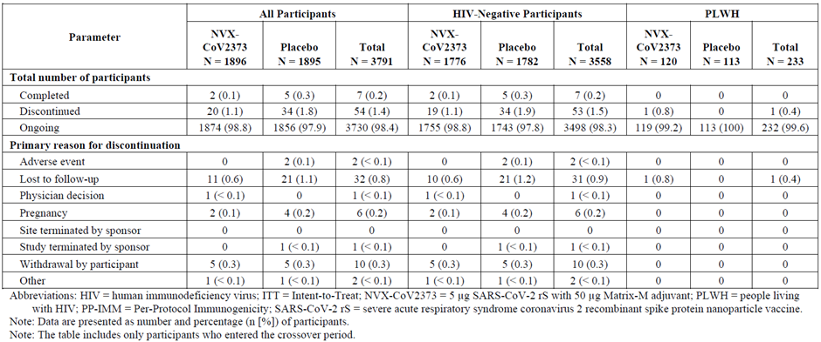
Abbreviation: HIV = human immunodeficiency virus; ITT = intent to treat; NVX-CoV2373 = Nuvaxoid vaccine(5 µg SARS-CoV-2 rS + 50 µg Matrix M adjuvant); PLWH = people living with HIV; PP-IMM = per protocol immunogenicity; SARS-CoV-2 rS = severe acute respiratory syndrome coronavirus 2 recombinant spike protein nanoparticle vaccine
Note: Data are presented as number and percentage (n [%]) of participants.
Note: The table includes only participants who entered the crossover period.
Overall, data analysis sets were well balanced between the two study vaccine groups within HIV negative subjects and people living with HIV.
The proportion of subjects sharply decreased between Visit 6 (Month 6) and Visit 8 (Day 236). This is more noticeable in the HIV negative subjects, where the total proportion decreased from 95.3% to 37.1%. It is unclear as why this significant drop took place.
Following is the per protocol immunogenicity analysis set in healthy HIV negative subjects and medically stable people living with HIV (Table 15).
Table 15: Study 2019nCoV-501 Per protocol immunogenicity analysis set in healthy HIV negative subjects and medically stable people living with HIV
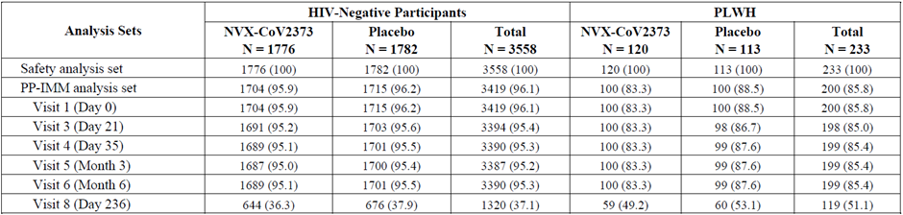

Major protocol violations/deviations
There were 174 (9.8%) subjects with at least one significant protocol deviation in the Nuvaxovid group, and 178 (10%) in the placebo group. In the people living with HIV population, there were 16 (13.3%) subjects in the vaccine group and 16 (14.2%) in the placebo group with at least one significant protocol deviation. Reasons for these deviations are not explained in the clinical study report.
Among HIV-negative subjects, major protocol deviations leading to exclusion from the per protocol immunogenicity analysis set occurred in 16 (0.4%) subjects, with nine (0.5%) in the Nuvaxovid group and seven (0.4%) in the placebo group. Across all the study visits, 45 (1.3%) HIV-negative subjects had at least one important protocol deviation excluding them from the per protocol immunogenicity analysis set, with 24 (1.4%) in the Nuvaxovid group and 21 (1.2%) in the placebo group.
Among people living with HIV, major protocol deviations leading to exclusion from the per protocol immunogenicity analysis set occurred in four (1.7%) subjects, with one (0.8%) in the Nuvaxovid group and three (2.7%) in the placebo group. Across all the study visits, four (1.7%) people living with HIV had at least one important protocol deviation excluding them from the per protocol immunogenicity analysis set, with one (0.8%) in the Nuvaxovid group and three (2.7%) in the placebo group.

Results

Baseline characteristics
Approximately 94% of subjects were HIV-negative, with a median age of 27 years and 3.9% were 65 years of age and older. Most HIV-negative subjects were male (59.9%), Black or African American (95.4%). Median baseline BMI was 23.3 mg/kg²; approximately 19.4% of subjects had a BMI > 30 mg/kg². Hypertension and diabetes were reported in 5.6% and 1.6% subjects respectively. A negative baseline hepatitis B and hepatitis C status was reported for approximately 99% of subjects. Most subjects (77.8%) had no co-morbidities. 66% subjects were seronegative 34% seropositive at Baseline.
Median age of people living with HIV was 38 years (range 20 to 60 years). Most people living with HIV were female (73.8%) and all people living with HIV being Black or African American (100%). Median baseline BMI was 26.6 mg/kg²; 33% had a BMI > 30 mg/kg². Hypertension and diabetes were reported in medical history, respectively, for 6.9% and 0.9% of people living with HIV. A negative baseline hepatitis B and hepatitis C status was reported, respectively, for 92.7% and 99.1% of people living with HIV. The majority of people living with HIV (63.5%) had no co-morbidities. Median baseline CD4 level was 747 cells/μL (range 80 to 2076 cells/μL) and median baseline HIV viral load was 63 copies/mL (range 20 to 735 copies/mL). Negative and positive baseline serostatus for SARS-CoV-2 was established, respectively, for 65.2% and 34.8% of people living with HIV.
Demographic and baseline characteristics were well balanced between the groups, overall and by the HIV status.

Results for the immunogenicity outcomes

Serum anti-spike protein IgG antibody geometric mean titres
Serum anti-spike protein binding IgG levels specific to SARS-CoV-2 rS protein antigen were measured at Day 0 (baseline), Day 21, Day 35, Month 3 (Day 111), Month 6 (Day 201), and Day 236, using a qualified anti-spike protein IgG ELISA.
At Day 236 in baseline SARS-CoV-2 seronegative subjects, anti-spike protein IgG antibody level was 111066.1 ELISA units, which was an approximate 30.6-fold increase from the GMT at Day 201 (3632 ELISA units) and an approximate 3.6-fold increase from peak GMT at Day 35 (30755.8 ELISA units). The SCR (≥ 4-fold increase) for Nuvaxovid was 99.8%; for Nuvaxovid was 98.5%. (Table 16 and Table 17: Study 2019nCoV-501 Summary of serum IgG antibody levels for SARS-CoV-2 rS protein antigen by time point from Day 111 (Month 3) to Day 201 (pre-crossover) and through Day 236 (post-crossover) in all subjects stratified by baseline serostatus and regardless of baseline serostatus, comparison of vaccine and placebo groups (per protocol immunogenicity analysis set)).
Serum IgG antibody GMT at Day 236 in subjects regardless of baseline SARS-CoV-2 serostatus was 114990.4 ELISA units, which was an approximate 19.4 fold increase from the GMT at Day 201 (5917.5 ELISA units) and an approximate 2.5 fold increase from peak GMT at Day 35 (46285.3 ELISA units). The SCR (≥ 4 fold increase) for Nuvaxovid was 99.3%.
Table 16: Study 2019nCoV-501 Summary of serum IgG antibody levels for SARS-CoV-2 rS protein antigen by time point from Baseline (Day 0) through to Day 35 Day in all subjects stratified by baseline serostatus and regardless of baseline serostatus, comparison of vaccine and placebo groups (per protocol immunogenicity analysis set)
Abbreviations: CI = confidence interval; ELISA = enzyme immunosorbent assay; EU = ELISA units; GMFR = geometric mean fold rise; GMT = geometric mean titer; HIV = human immunodeficiency virus; IgG = immunoglobin G; LLOQ = lower limit of quantification; n1 = number of participants in the per protocol immunogenicity analysis set within each visit with non-missing data; n2 = the number of participants who reported the event, NVX-CoV2373 = 5 µg SARS-CoV-2 rS + 50 µg Matrix M adjuvant; PCR = polymerase chain reaction; PP = per protocol; SARS-CoV-2 rS = severe acute respiratory syndrome coronavirus 2 recombinant spike protein nanoparticle vaccine; SCR = seroconversion rate; SRR = seroresponse rate.
1 The 95% CI for GMT and GMFR were calculated based on the t-distribution of the log transformed values then back transformed to the original scale for presentation.
2 Percentages were calculated as (n2/1) x 100
3 The 95% CIs for SCR. SRR were calculated using the exact Clopper-Pearson method.
4 The 95th percentile was calculated from the associated baseline value of all participants in each treatment column.
Note: LLOQ = 200 ELISA units/ml, with titre values less than LLOQ were replaced by 0.5 x LLOQ.
Note: ‘Seronegative’ excluded any Day 0 IgG + and/or any PCR + between Day 0 through Visit 4 (that is Day 35); and ‘seropositive’ included anyone who is Day 0 IgG and/or any PCR + between Day 0 through Visit 4 (that is Day 35). The table includes only those participants who entered the crossover period
Table 17: Study 2019nCoV-501 Summary of serum IgG antibody levels for SARS-CoV-2 rS protein antigen by time point from Day 111 (Month 3) to Day 201 (pre-crossover) and through Day 236 (post-crossover) in all subjects stratified by baseline serostatus and regardless of baseline serostatus, comparison of vaccine and placebo groups (per protocol immunogenicity analysis set)
Abbreviations: CI = confidence interval; ELISA = enzyme immunosorbent assay; EU = ELISA units; GMFR = geometric mean fold rise; GMT = geometric mean titre; HIV = human immunodeficiency virus; IgG = immunoglobin G; LLOQ = lower limit of quantification; n1 = number of participants in the per protocol immunogenicity analysis set within each visit with non-missing data; n2 = the number of participants who reported the event, NVX-CoV2373 = 5 µg SARS-CoV-2 rS + 50 µg Matrix M adjuvant; PCR = polymerase chain reaction; PP = per protocol; SARS-CoV-2 rS = severe acute respiratory syndrome coronavirus 2 recombinant spike protein nanoparticle vaccine; SCR = seroconversion rate; SRR = seroresponse rate.
1 The 95% CI for GMT and GMFR were calculated based on the t-distribution of the log transformed values then back transformed to the original scale for presentation.
2 Percentages were calculated as (n2/1) x 100
3 The 95% CIs for SCR. SRR were calculated using the exact Clopper-Pearson method.
4 The 95th percentile was calculated from the associated baseline value of all participants in each treatment column.
Note: LLOQ = 200 EU/ml, with titre values less than LLOQ were replaced by 0.5 x LLOQ.
Note: ‘Seronegative’ excluded any Day 0 IgG + and/or any PCR + between Day 0 through Visit 4 (that is Day 35); and ‘seropositive’ included anyone who is Day 0 IgG and/or any PCR + between Day 0 through Visit 4 (that is Day 35).
Note: The table includes only those participants who entered the crossover period
Note: Month 6 is the time point 6 months after second vaccination in the initial vaccination period (that is Day 201); Month 3 is the time point 3 months after second vaccination in the initial vaccination period (that is Day 111).

Human angiotensin converting enzyme 2 inhibition
Human ACE2 levels specific to SARS-CoV-2 rS protein antigen were measured at Day 0 (Baseline), Day 21, Day 35, Month 3 (Day 111), Month 6 (Day 201), and Day 236 using a validated human ACE2 binding inhibition ELISA assay.
In all subjects, seronegative at Baseline, at Day 236 (that is 35 days following third vaccination (booster) for the Nuvaxovid to booster group and 14 days following second active vaccination for the placebo to Nuvaxovid group post-crossover, the reverse cumulative distribution curve and box plot of the human ACE2 receptor binding inhibition for Nuvaxovid to booster showed stronger responses, in terms of amplitude and kinetics, than did those for placebo to Nuvaxovid and these immune responses at Day 236 were stronger than they were at Day 201. The human ACE2 receptor binding inhibition GMT at Day 236 was greater for Nuvaxovid (357.14 ELISA units/mL) than it was for placebo (250.73 ELISA units/mL and the increased immune response resulted in a GMFR relative to Day 0 of 71.43 for Nuvaxovid (versus that of 50.02 for placebo). The SCR (≥ 4-fold increase) for Nuvaxovid (99.5%) was slightly greater than that for placebo (96.2%).
In all subjects, seropositive at Baseline, at Day 236 (that is 35 days following third vaccination (booster) for the Nuvaxovid to booster group and 14 day following second active vaccination for the placebo to Nuvaxovid group post-crossover), the reverse cumulative distribution curve and box plot of the human ACE2 receptor binding inhibition for Nuvaxovid to booster showed slightly lower responses, in terms of amplitude and kinetics, than did those for placebo to Nuvaxovid and these immune responses at Day 236 were stronger than they were at Day 201. The human ACE2 receptor binding inhibition GMT at Day 236 was less for Nuvaxovid (373.91 ELISA units/mL) than it was for placebo (499.41 ELISA units/mL) and the decreased immune response resulted in a GMFR relative to Day 0 of 43.1 for Nuvaxoxid (versus that of 60.90 for placebo). The SCR (≥ 4-fold increase) for Nuvaxovid (97.4%) was slightly less than that for placebo (99.6%).
In all subjects, regardless of baseline SARS-CoV-2 serostatus, at Day 236 (that is 35 days following third vaccination (booster) for the Nuvaxovid to booster group and 14 day following second active vaccination for the placebo to Nuvaxovid group post-crossover), the reverse cumulative distribution curve and box plot of the human ACE2 receptor binding inhibition for Nuvaxovid to booster showed slightly stronger responses, in terms of amplitude and kinetics, than did those for placebo to Nuvaxovid and these immune responses at Day 236 were stronger than they were at Day 201. The human ACE2 receptor binding inhibition GMT at Day 236 was greater for Nuvaxovid (363.49 ELISA units/mL) than it was for placebo (327.28 ELISA units/mL) and the increased immune response resulted in a GMFR relative to Day 0 of 58.84 for Nuvaxovid (versus that of 54 for placebo). The SCR (≥ 4 fold increase) for Nuvaxovid (98.7%) was slightly greater than that for placebo (97.5%).

SARS-CoV-2 neutralising antibodies (wild-type/original strain)
SARS-CoV-2 wild-type virus micro-neutralisation was measured at Day 0 (Baseline), Day 35, Month 3 (Day 111), Month 6 (Day 201), and Day 236 using a qualified wild-type virus micro-neutralisation assay with an inhibitory concentration of 50%.
- Neutralising antibody activity GMT at Day 236 in baseline SARS-CoV-2 seronegative subjects was 3599.8, which was an approximate 52.6 fold increase from the GMT at Day 201 (68.5) and an approximate 5.2 fold increase from peak GMT at Day 35 (694.4). The SCR (≥ 4-fold increase) for Nuvaxovid was 99.5% (see Table 18: Study 2019nCoV-501 Summary of SARS-CoV-2 wild type virus micro neutralisation (entire study) by time point through Day 201 (pre-crossover) and through Day 236 (post-crossover) in all subjects stratified by baseline serostatus and regardless of baseline serostatus, comparison of vaccine and placebo groups (per protocol immunogenicity analysis set).
- Neutralising antibody activity GMT at Day 236 in baseline SARS-CoV-2 seropositive subjects was 3941.6, which was an approximate 6.8 fold increase from the GMT at Day 201 (582.5) and an approximate 1.3 fold increase from peak GMT at Day 35 (3116.6). The SCR (≥ 4-fold increase) for Nuvaxovid was 99.6% (see Table 18: Study 2019nCoV-501 Summary of SARS-CoV-2 wild type virus micro neutralisation (entire study) by time point through Day 201 (pre-crossover) and through Day 236 (post-crossover) in all subjects stratified by baseline serostatus and regardless of baseline serostatus, comparison of vaccine and placebo groups (per protocol immunogenicity analysis set).
- Neutralising antibody activity GMT at Day 236 in subjects regardless of baseline SARS-CoV-2 serostatus was 3727.4, which was an approximate 25.7 fold increase from the GMT at Day 201 (145.2) and an approximate 3.2 fold increase from peak GMT at Day 35 (1166.6). The SCR (≥4-fold increase) for Nuvaxovid was 99.6% (see Table 18: Study 2019nCoV-501 Summary of SARS-CoV-2 wild type virus micro neutralisation (entire study) by time point through Day 201 (pre-crossover) and through Day 236 (post-crossover) in all subjects stratified by baseline serostatus and regardless of baseline serostatus, comparison of vaccine and placebo groups (per protocol immunogenicity analysis set).
Table 18: Study 2019nCoV-501 Summary of SARS-CoV-2 wild type virus micro neutralisation (entire study) by time point through Day 201 (pre-crossover) and through Day 236 (post-crossover) in all subjects stratified by baseline serostatus and regardless of baseline serostatus, comparison of vaccine and placebo groups (per protocol immunogenicity analysis set)
Abbreviations: CI = confidence interval; GMFR = geometric mean fold rise; GMT = geometric mean titre; HIV = human immunodeficiency virus; IgG = immunoglobin G; LLOQ = lower limit of quantification; n1 = number of participants in the per protocol immunogenicity analysis set within each visit with non-missing data; n2 = the number of participants who reported the event, NVX-CoV2373 = 5 µg SARS-CoV-2 rS + 50 µg Matrix M adjuvant; PCR = polymerase chain reaction; PP = per protocol; SARS-CoV-2 rS = severe acute respiratory syndrome coronavirus 2 recombinant spike protein nanoparticle vaccine; SCR = seroconversion rate; SRR = seroresponse rate.
1 The 95% CI for GMT and GMFR were calculated based on the t-distribution of the log transformed values then back transformed to the original scale for presentation.
2 Percentages were calculated as (n2/1) x 100
3 The 95% CIs for SCR. SRR were calculated using the exact Clopper-Pearson method.
4 The 95th percentile was calculated from the associated baseline value of all participants in each treatment column.
Note: LLOQ = 200 EU/ml, with titer values less than LLOQ were replaced by 0.5 x LLOQ.
Note: ‘Seronegative’ excluded any Day 0 IgG + and/or any PCR + between Day 0 through Visit 4 (that is Day 35); and ‘seropositive’ included anyone who is Day 0 IgG and/or any PCR + between Day 0 through Visit 4 (that is Day 35).
Note: The table includes only those participants who entered the crossover period
Note: Month 6 is the time point 6 months after second vaccination in the initial vaccination period (that is Day 201); Month 3 is the time point 3 months after second vaccination in the initial vaccination period (that is Day 111).

Efficacy
Clinical efficacy for the booster dose was not assessed in any of the submitted studies (that is, Study 2019nCoV-101-part-2 or Study 2019nCoV-501).

Safety

Total exposure, homologous boosting vaccination
Table 19 summarises the extent of exposure of adult subjects who received primary vaccination with Nuvaxovid on Days 0 and 21 followed by homologous boosting vaccination (5 μg SARS-CoV-2 rS plus 50 μg Matrix M adjuvant) approximately six months in clinical Study 2019nCoV-101 (Part 2) and Study 2019nCoV-501. A total of 1983 subjects received the two doses primary vaccination series plus homologous boosting vaccination across the two studies.
Table 19: Studies 2019nCov-101(Part 2) And 2019nCov-501 Extent of exposure following homologous boosting vaccination in clinical studies
Abbreviations: n = number of participants exposed to the two dose primary vaccination series plus booster dose; NVX-CoV2373 = 5 µg SARS-CoV-2 rS + 50 µg Matrix M adjuvant (Nuvaxovid); SARS-CoV-2 rS = severe acute respiratory syndrome coronavirus 2 recombinant spike protein nanoparticle vaccine.
1 All participants completed the two dose primary vaccination series (placebo) on Days 0 and 21 and the booster dose (placebo) on Day 189.
2 All participants completed the two dose primary vaccination series (active vaccine) on Days 0 and 21 and the booster dose (active vaccine) on Day 189.
3 All participants completed the two dose primary vaccination series (active vaccine) on Day 0 and 21 and received NVX-CoV2373 during the crossover period on Days 201 and 222.
4 All participants completed the two dose primary vaccination series (active vaccine) on Day 0 and 21 and received NVX-CoV2373 on Days 201 and placebo on 222 to maintain participant blinding.

Study 2019nCov-101 (Part 2)

Solicited local and systemic adverse events
Table 20 and Table 21 respectively, summarise the solicited local and systemic treatment-emergent adverse events (TEAEs) in Study 2019nCoV-101 (Part 2) after primary vaccination (both first and second dose Nuvaxovid) and homologous boosting vaccination (third dose Nuvaxovid). Group B1 received placebo as the third dose whereas Group B2 received the vaccine (homologous booster).

Solicited local adverse events
Frequencies of solicited local TEAEs (any grade and Grade 3 or higher) were higher in subjects in the active treatment booster groups (Groups B2: 82.5% (any grade) and 13.4% (Grade 3 or higher)) than in the other treatment groups. Most solicited local TEAEs were Grade 1 or Grade 2 in intensity. There was one Grade 4 case from Group B2 (TEAE: tenderness and pain). Tenderness and pain were the most frequent solicited local TEAEs and were of short median duration (2 days for both tenderness; and for pain). Grade 3 solicited local TEAEs that extended beyond Day 6 in B2 group, were tenderness (one case), erythema (one case), and swelling (2 cases). Higher frequencies of solicited local TEAEs were observed in the younger age cohort (18 to 59 years) than in the older age cohort (60 to 84 years).
Table 20: Study 2019nCoV-101 (Part 2) All solicited local adverse events for seven days following each vaccination in all subjects (safety analysis set)
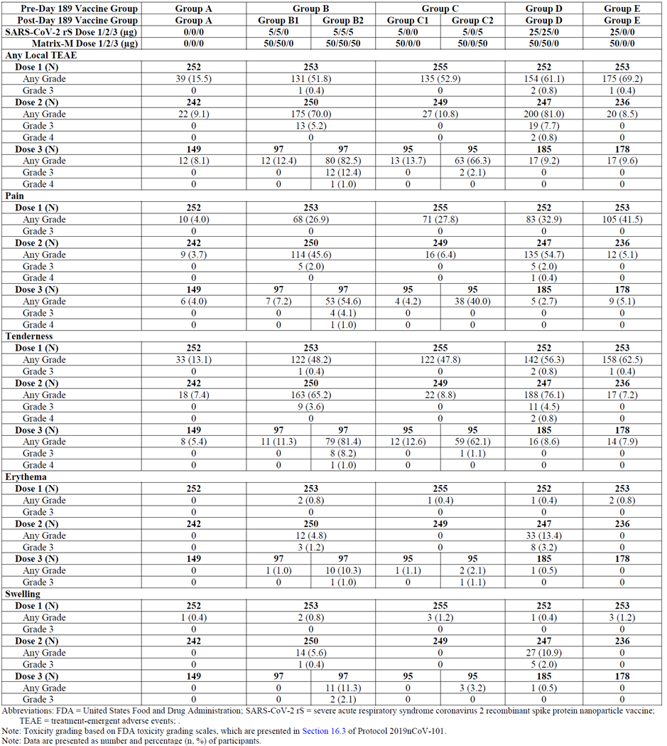
Abbreviations: FDA = United States Food and Drug administration; SARS-CoV-1 rS = severe respiratory syndrome coronavirus 2 recombinant spike protein nanoparticle vaccine (Nuvaxovid); TEAE = treatment-emergent adverse events.
Note: Toxicity grading based on FDA toxicity grading scales, which are presented in protocol of Study 2019nCoV-101.
Note: Data are presented as number and percentage (n, %) of participants.

Solicited systemic adverse events
Frequencies of solicited systemic TEAEs (any grade and Grade 3 or higher) were higher in subjects in the active treatment booster groups (Groups B2: 76.5% (any grade) and 15.3% (Grade 3 or higher)) than in the other treatment groups. The highest frequency was seen in Group B2 (76.5% for any grade TEAEs). Most solicited systemic TEAEs were Grade 1 or Grade 2 in intensity, with one Grade 4 event (TEAE: headache). In Group B, the most frequent solicited systemic TEAEs were of short median duration and included muscle pain (2 days); fatigue, headache, and malaise all of one day duration. Solicited systemic TEAEs of Grade 3 and higher in Group B2 included headache (5 events), fatigue (12 events), malaise (7 events), and joint pain (4 events). There were higher frequencies of solicited systemic TEAEs in the younger age cohort (18 to 59 years) than in the older age cohort (60 to 84 years).
Table 21: Study 2019nCoV-101 (Part 2) All solicited local adverse events for seven days following each vaccination in all subjects (safety analysis set)
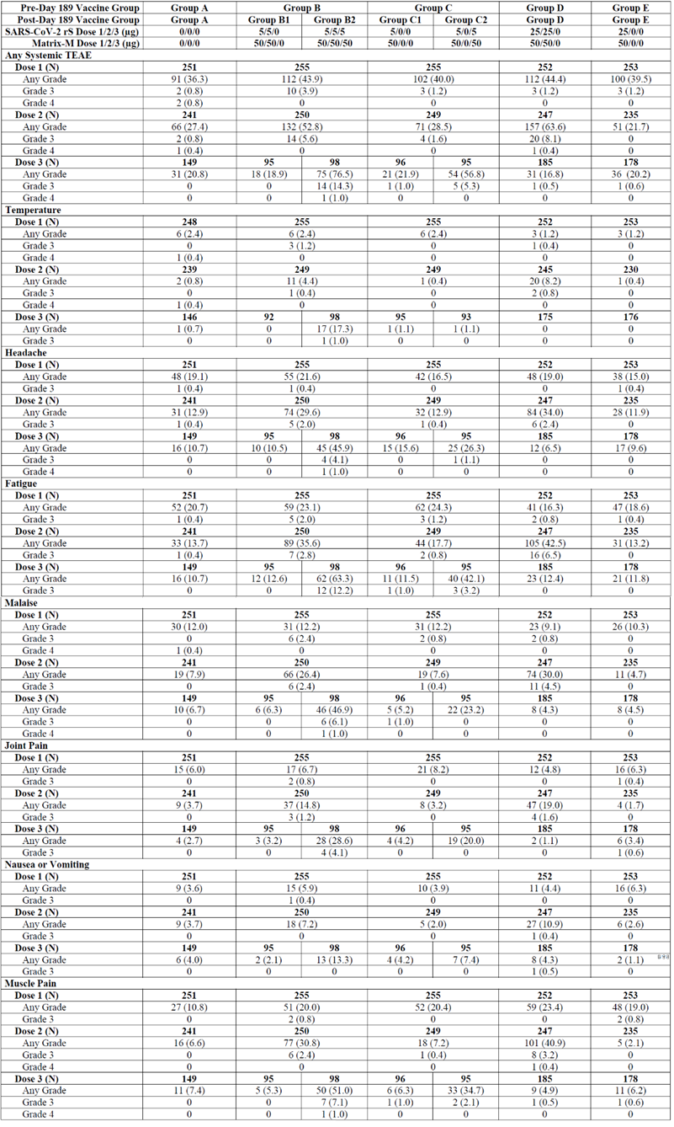

Unsolicited adverse events and other serious adverse events
From booster vaccination through 28 days after the vaccination, there was a higher vaccine exposure adjusted incidence rate (VEAIR) of unsolicited TEAEs in the two dose priming vaccination plus active treatment booster group (that is, in treatment Group B2) than in any of the other trial vaccine group (see Table 22). Unsolicited TEAEs of the System Organ Classes (SOC) ‘Infections and Infestations’, and ‘Musculoskeletal and Connective Tissue Disorders’ were the most frequent. In Group B2, the frequency/VEAIR of unsolicited TEAEs in the SOC Musculoskeletal and Connective Tissue Disorders was the highest compared to the other trial vaccine groups. The number of unsolicited AEs considered to be related to the vaccine was slightly higher in Group B2 than in other groups, but without any noticeable pattern (see Table 23).
No severe unsolicited TEAEs were reported in B2 group. In Group B1, 1 (1%) of 102 subjects reported an unsolicited severe TEAE of atrial fibrillation.
In Group B2, the serious adverse events by Preferred Term (PT) included one case each of lower limb fracture, gastro-oesophageal reflux, pancreatitis, abscess bacterial, viral pericarditis, and benign prostatic hyperplasia; none were considered to be related to trial vaccine. The case of viral pericarditis occurred approximately 119 days after the second dose; while no viral testing was performed, the aetiology was presumed to be viral. Only one of these serious adverse events occurred after receiving a third dose, one subject developed Staphylococcus aureus skin abscess in the abdomen region 7 days after the third dose; this was assessed to be from an ingrown hair.
Table 22: Study 2019nCoV-101 (Part 2) Summary of unsolicited treatment emergent adverse events by System Organ Class and Preferred Term reported from booster vaccination through 28 days after booster vaccination in two or more subjects in any treatment group (safety analysis set)
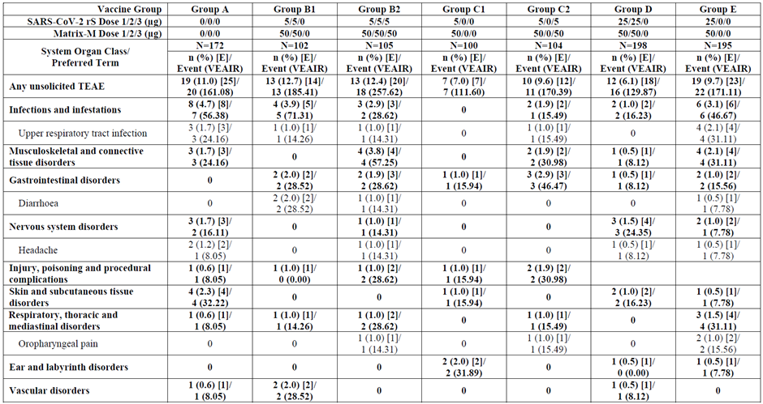
Table 23: Study 2019nCoV-101 (Part 2) Summary of treatment related unsolicited treatment emergent adverse events by System Organ Class and Preferred Term reported from booster vaccination through 28 Days after booster vaccination in all subjects (safety analysis set)
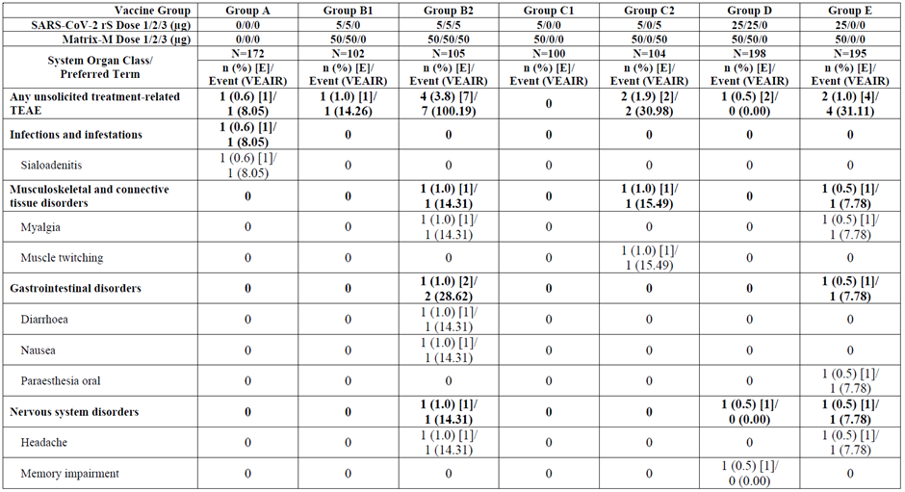

Deaths
No deaths were reported in Study 2019nCoV-101 (Part 2).

Adverse events of special interest
Four subjects reported the adverse event of special interest of potentially immune-mediated medical conditions (PIMMC) across the treatment groups, with one subject (1%) from Group B2 reporting polymyalgia rheumatica.

Study 2019nCoV-501
Solicited TEAEs after homologous boosting in clinical Study 2019nCoV-501 were assessed but not provided with the clinical study report.
Following safety assessment for unsolicited adverse events is based on all subjects regardless of the HIV status and baseline SARS-CoV-2 serostatus of subjects.

Unsolicited adverse events
Table 24 summarises the unsolicited adverse event profile of Nuvaxovid following primary and homologous boosting vaccination in clinical Study 2019nCoV-501. The unsolicited adverse event profiles were similar between the two vaccination periods, but there was a higher frequency of subjects reporting TEAEs after the primary vaccination series than after boosting vaccination. Regardless of vaccination period, most unsolicited TEAEs were mild or moderate in severity and not related to active vaccine.
Table 24: Study 2019nCoV-501 Overall summary of unsolicited adverse events following primary and homologous boosting vaccination
Abbreviations: AESI = adverse events of special interest; COVID-19 = coronavirus disease 2019; MAAE = medically-attended adverse event; NVX-CoV2373 = 5 µg SARS-CoV-2 rS + 50 µg Matrix M adjuvant (Nuvaxovid); PIMMC = potential immune mediated medical conditions; SARS-CoV-2 rS = severe acute respiratory syndrome coronavirus 2 recombinant spike protein nanoparticle vaccine; TEAE = treatment emergent adverse event.
1 From first vaccination through 201 days after first vaccination for those participants who were treated across both vaccination periods.
2 From booster/first crossover vaccination through 35 days after booster/first crossover vaccination for those participants who were treated across both vaccination periods.
3 Relationship and severity were based on the data reported by site, that is missing information was not imputed.
Note: At each level of participant summarization, a participant was counted once if the participant reported ≥ 1 events.
Note: Data are presented as number and percentage (n, %) of participants.
Overall, rates of subjects with unsolicited TEAEs (including severe TEAEs, treatment-related TEAEs, severe treatment-related TEAEs, treatment-emergent medically attended adverse events, all medically attended adverse events, and adverse events of special interest: potentially immune-mediated medical conditions (PIMMC) and AESIs after the third vaccination (that is booster post-crossover) that were suspected, probable, or confirmed related to COVID-19) were higher for the Nuvaxovid to booster group versus placebo to Nuvaxovid group treatment groups, except for that for subjects with serious adverse events, which was lower (< 0.1% versus 0.2%, respectively). However, these were based on very small incidence overall, due to the nature of the safety monitoring (unsolicited AEs only).
Most (about 99.8%) unsolicited TEAEs were mild or moderate in severity and most (about 99.6%) were not related to Nuvaxovid. Severe TEAEs were reported in three (0.2%) subjects; treatment-related TEAEs in eight (0.4%) subjects; and severe treatment related TEAEs in two (0.1%) in the Nuvaxovid to booster group.

Deaths and other serious adverse events
There were no reports of death, related SAEs, or TEAEs resulting in vaccine or study discontinuation.

Adverse events of special interest
Through 35 days after third vaccination, four (0.2%) of 1898 subjects from booster group and four (0.2%) of 1893 subjects from placebo to Nuvaxovid group developed COVID-19.
No subjects reported PIMMCs following boosting vaccination.

Risk management plan
The most recently evaluated EU-RMP was version 1.1 (23 March 2022; data lock point (DLP) 18 February 2022) and Australia specific annex (ASA) version 1.2 (18 April 2022) with submission PM-2022-01431-1-2. In support of the extended indications, the sponsor has submitted EU-RMP version 1.2 (09 May 2022; DLP 03 May 2022) and ASA version 1.4 (23 May 2022).
The summary of safety concerns and their associated risk monitoring and mitigation strategies are summarised in Table 25 Further information regarding the TGA’s risk management approach can be found in risk management plans for medicines and biologicals and the TGA's risk management approach.
Table 25: Summary of safety concerns and their associated risk monitoring and mitigation strategies
Summary of safety concerns |  | Pharmacovigilance |  | Risk Minimisation
 |  | Routine | Additional | Routine | Additional
Important identified risks | None | – | – | – | –
Important potential risks | Vaccine-associated enhanced disease (VAED), including vaccine-associated enhanced respiratory disease (VAERD) | * | ‡≠ | – | –
Important potential risks | Myocarditis and pericarditis | * | ‡≠ | – | –
Missing information | Use in pregnancy and while breastfeeding |  | ¶ |  | –
Missing information | Use in immunocompromised patients |  | ‡≠ |  | –
Missing information | Use in frail patients with comorbidities (e.g., chronic obstructive pulmonary disease (COPD), diabetes, chronic neurological disease, cardiovascular disorders) |  | ≠ | – | –
Missing information | Use in patients with autoimmune or inflammatory disorders |  | ≠ |  | –
Missing information | Interaction with other vaccines |  | ‡≠ |  | –
Missing information | Long-term safety |  | ‡≠ | – | –
*Follow-up questionnaire; ‡Clinical trials; ≠Post-authorisation safety study;
¶Pregnancy registry (C-VIPER)
This summary of safety concerns is the same as the summary that was evaluated and considered acceptable for the previous submission PM-2022-01431-1-2. The changes proposed by the current submission are not expected to change the summary of safety concerns from an RMP perspective. The summary of safety concerns remains acceptable. Reports from the TGA’s clinical evaluators, the delegate’s overview and ACV advice have been considered when making this conclusion.
The sponsor has proposed routine and additional pharmacovigilance measures. Routine pharmacovigilance includes the submission of monthly summary safety reports for the first 6 months, post registration, and thereafter at intervals specified by the TGA. The ACV emphasised the importance of monitoring events of myopericarditis especially in the 18 to 30 years age group. The pharmacovigilance plan was deemed acceptable during the previous evaluation and continues to be acceptable for the current submission. The acceptability of the clinical study plan will be assessed by the clinical evaluator and/or Delegate.
Only routine risk minimisation measures are proposed by the sponsor. This approach was deemed acceptable during the previous evaluations as there are risk minimisation measures are implemented by the Australian Government Department of Health. The changes proposed by the current submission are not expected to require additional risk minimisation measures as part of the RMP.

Risk-benefit analysis

Delegate’s considerations
Detailed data on variability in immunogenicity and safety profiles by vaccine type are valuable to make informed decisions on booster regimens, alongside considerations of vaccine availability and population primary vaccine course regimens. Immunogenicity and safety data from Study 2019nCoV-101 (Part 2) and Study 2019nCoV-501 provides important insight regarding this.

Public health need
Australia is currently experiencing ongoing major COVID-19 outbreak, which is causing significant disruption to the normal life. NSW and Victoria states are having high number of COVID-19 cases, caused by the currently dominant Omicron variant and its subvariants BA.1 and BA.2.
Currently provisionally approved COVID-19 vaccines for booster dose are Comirnaty (≥ 12 year of age);⁸ Spikevax (≥ 18 year of age);⁹ and Vaxzevria (≥ 18 year of age).¹⁰ There is a need for homologous booster for the of Australian population who have received Nuvaxovid as the primary series.

Immunogenicity and safety
Study 2019nCoV-101 (Part2) and Study 2019nCoV-501 were well conducted, blinded, multicentre, randomised, controlled, Phase II trials, providing acceptable evidence that studied vaccine booster dose for Nuvaxovid is immunogenic and safe, in a trial context, among relatively healthy adult subjects.
There is currently no widely accepted immunological correlate of protection for vaccine induced immunity to SARS-CoV-2. Available data and guidelines suggest a preference for neutralising antibody to spike protein over anti-spike IgG binding responses. Study 2019nCoV-101 (Part2) and Study 2019nCoV-501 chose anti-spike IgG, human ACE2 receptor binding inhibition titres and neutralisation assay as the end points. Similar endpoints were studied in exploratory analysis against the new variants in the Study 2019nCoV-101 (Part2).

Immunogenicity
With the current submission, the sponsor has submitted clinical study reports for Study 2019nCoV-101 (Part2) and Study 2019nCoV-501.Both these studies have assessed the safety and immunogenicity of Nuvaxovid vaccine as a third dose (booster), following two doses of primary vaccination. Study 2019nCoV-101 (Part 2) compared immunogenicity against placebo whereas Study 2019nCoV-501 provides immunogenicity only in numerical form.

Humoral immunogenicity
Both Studies 2019nCoV-101 (Part2) and 2019nCoV-501 demonstrated that a third dose of Nuvaxovid administered approximately six months after the primary series significantly boosts the humoral immune response (Anti-spike protein IgG, human ACE2 receptor binding inhibition and neutralisation). The rises were noted to be greater than the pre-booster levels, and the peak responses seen after the primary series. The post-booster immune responses in general, appear to be comparable, regardless of the baseline serostatus.

Exploratory analysis for variant of concern
The sponsor conducted exploratory analysis (Study 2019nCoV-101, Part 2) to assess immunogenicity against B.1.1.7 (Alpha), B.1.351 (Beta), B.1.617.2 (Delta), and B1.1.529 (Omicron) variant strains.
Immunogenicity for the Beta, Delta and Omicron variants showed significant increased after the booster dose. However, the post-booster neutralising antibody activity against Beta variant was about 9-fold lower compared to the original/wild-type strain. Similarly, a significantly lower immunogenicity response was seen for the Omicron variant against the original/wild-type strain (anti-spike protein IgG about 3-fold lower, human ACE2 receptor binding about 3-fold lower, and neutralisation about 16-fold lower).
The Omicron variant tested for in Study 2019nCoV-101 is the BA.1 subvariant, which limits the applicability in the current pandemic situation, as it is the BA.2 subvariant is becoming dominant. The clinical study report reports that, a separate fit for purpose immunoassays had been developed for Delta and Omicron variants. Therefore, validity of direct comparison of immunogenicity for the variant of concerns (VoCs) against the wild-type strain is not certain.
There was no statistical significance/comparison (non-inferiority or superiority) performed for these immunological outcomes.
On March 31, the United States Food and Drug Administration (FDA) revised its guidance, Emergency Use Authorization for Vaccines to Prevent COVID-19. The revised guidance updates recommendations for the clinical data to support effectiveness of a COVID-19 vaccine that has been modified to target a particular SARS-CoV-2 variant of concern. Following are main (nonbinding) recommendations for booster trials:
‘The primary analysis should be a comparison of GMTs against the particular VOC, elicited by the modified and prototype vaccine. The study should be designed and adequately powered to demonstrate statistical superiority of the GMT elicited by the modified vaccine as compared to the prototype vaccine. Ideally, the primary analysis would test for ‘super’ superiority (margin of >1.5 fold for GMT ratio) to statistically exclude non-inferiority of the prototype vaccine compared with the modified vaccine. However, it would be acceptable to test for ‘simple’ superiority (margin of >1 fold for GMT ratio) in the primary analysis and to test for ‘super’ superiority as a secondary immunogenicity analysis.
A second co-primary analysis should be a comparison of seroresponse rates against the particular VOC, elicited by the modified and prototype vaccine. The study should be designed and adequately powered to demonstrate non-inferiority of the seroresponse rate elicited by the modified vaccine as compared to the prototype vaccine, using a non-inferiority margin of < 5% for seroresponse rate difference. Alternatively, the co-primary analysis of seroresponse rates could test for superiority (‘simple’ superiority margin of > 0% or ‘super’ superiority margin of > 10% for seroresponse rate difference). If the co-primary analysis of seroresponse rates will test for non-inferiority, FDA would expect that additional descriptive analyses of seroresponses against clinically relevant variants, including the particular VOC, support the benefit of the modified vaccine over the prototype vaccine. Determination of an appropriate seroresponse definition for a first booster dose should be based on available data.’

T-cell response
A cellular immune response was not studied during any of the two submitted booster trials.

Immunogenicity data limitations
Whilst the results from both Studies 2019nCoV-101 (Part 2) and 2019nCoV-501 provide some useful information for the use of Nuvaxovid as a homologous booster, there are several issues/limitations with the presented data.
It is noted that the study size was quite small for the Study 2019nCoV-101 (Part 2) and the secondary endpoints were not powered. Study 2019nCoV-501 did not have a comparator placebo group. Cell mediated immune response plays a major role in protection against SARS-Cov-2 infection but none of these two studies provide any data on T-cell booster response.
The follow up period for immunogenicity in the currently submitted data was short and was assessed at Day 28 only. Because of this reason it is not possible to assess the persistence of booster response.
The choice of primary endpoint for Studies 2019nCoV-101 (Part 2) and 2019nCoV-501 is as per currently available guidance. However, no statistical analysis for significance/comparison was performed, and only numerical data is presented. However, based on the immunogenicity data provided, Nuvaxovid appears to illicit significant boosting response, measured by IgG and neutralising response.
Exploratory analysis provided immunogenicity data against the Delta and Omicron (BA.1) but not against the currently circulating Omicron subvariant BA.2, which reduces the applicability of the result in current pandemic situation in Australia.
Studies 2019nCoV-101 (Part2) and 2019nCoV-501 excluded those with certain conditions including significant comorbidities. Study 2019nCoV-501 did include medically stable HIV positive subjects though. As a result, no immunogenicity data for the booster is available for immunosuppressed, immunocompromised, pregnant, people on anticoagulation, those with history of anaphylaxis, cancer, autoimmune neurological disorders, severe and/or uncontrolled cardiovascular, respiratory, gastrointestinal, liver, renal, endocrine, and neurological illness. While the exclusion of these populations would likely have been to increase the feasibility of the study completion, it should be noted that these individuals are likely to be at an increased risk of severe disease/death from SARS-CoV2 infection, and therefore need COVID-19 booster vaccination the most.
Data limitations also include the lack of generalisability of findings beyond the trial setting, particularly to the populations, those with previous SARS-CoV-2 infection, and in assessing impacts, of both safety and effectiveness, at scale and longer follow up. The latter point highlights the complementarity between clinical trials, observational studies, and surveillance, with large cohort studies well placed to determine whether the immunogenicity generated after boosters translates to real world protection from SARS-CoV-2 infection, and ongoing surveillance essential to detect potential rare adverse events. More time and evidence are required to gain a fuller understanding of the performance of COVID-19 vaccine boosters against currently circulating and emerging variants. As discussed earlier, it is still not known as how the increase in the immunogenicity response translates into protection, especially against serious disease and the infection transmission.
There is a significant percentage of population, who received only two doses of COVID-19 vaccines, and then got infected with SARS-CoV-2 virus during current Omicron surge, before receiving the booster. There is no data to support booster recommendation for this population.

Efficacy
Clinical efficacy was not assessed in any of the submitted studies (Study 2019nCoV-101-part 2 and Study 2019nCoV-501).

Safety
Based on the data from Studies 2019nCoV-101 (part 2) and 2019nCoV-501, Nuvaxovid homologous booster does not raise any new safety concerns. The proportion of individuals with adverse events, the severity of adverse events and likelihood of association with the treatment for those that received Nuvaxovid were comparable to the primary doses.
Majority of solicited local and systemic adverse events were of Grade 1 or Grade 2 severity and of short duration (median duration ≤ 2.0 days for local events and ≤ 1 day for systemic events (2 days for muscle pain)). Across the two age strata, older subjects reported a lower frequency and intensity of solicited local and systemic treatment-emergent adverse events (TEAEs) than younger subjects. Tenderness and pain were the most frequent solicited local TEAEs and fatigue, headache, muscle pain, malaise, and joint pain were the most frequent solicited systemic TEAEs. In general, the frequency of solicited local and systemic adverse events was more frequent in the booster group subjects, as compared to the primary vaccination subjects. Notably Grade 3 local and systemic solicited AEs were more frequent in booster group. However, it is difficult to draw any conclusion on increased frequency of solicited adverse events noted with the booster dose as the sample size is very small for the booster group.
The adverse events by System Organ Class also did not identify any obvious safety concerns in those who received Nuvaxovid booster.
Unsolicited TEAE profiles were similar between the two vaccination periods, but there was a higher frequency of subjects reporting TEAEs after the primary vaccination series than after boosting vaccination. Most unsolicited TEAEs were mild or moderate in severity. There were no reports of death, related SAEs, TEAEs resulting in vaccine or study discontinuation, and potentially immune-mediated medical conditions following homologous boosting vaccination.
Due to the small sample size of safety group, it is not possible for to be sufficiently powered to detect rare adverse outcomes.
The sponsor has not submitted solicited safety data for Study 2019nCoV-501. This essentially limits the sample size collecting the solicited adverse events to 172 subjects only (from Group B2 of Study 2019nCoV-101 (Part 2).
As mentioned in the exclusion criteria, the study excluded those with certain conditions including significant medical comorbidities. As a result, no safety data is available for these individuals. The safety assessment was performed in relatively healthy individuals, which may underestimate the overall risk associated with the booster vaccines tested.

Overall Data limitations
- Immunogenicity data from booster dose against the currently circulating variants in only available for the Omicron BA.1 (not BA.2) variant. Of note, the IgG and neutralisation assays for the variants that were used in both booster trials, are not validated at this stage.
- Data related to persistence of immune response was not available in the submitted study.
- Safety sample size was small. Especially for the solicited adverse events which included only 172 subjects.
- Insufficient safety and immunogenicity data in immunocompromised patients or patients with background autoimmune disease.
- No safety data on pregnant women and breastfeeding women.
- Short-term safety data, which may not provide information on rare adverse events, risk of vaccine associated enhanced disease (VAED) or vaccine associated enhanced respiratory disease (VAERD) as the antibodies wane over time, and there may be AEs that have a long latency period including AEs of special interest.
- Data on vaccine efficacy of the booster are lacking. Booster efficacy in the real world cannot be extrapolated with certainty, especially in view of currently circulating Omicron variant and its subvariants exhibiting significant change in the viral morphology and clinical presentation.
- Data in frail elderly with unstable health conditions and co-morbidities are not available.

Proposed action
There is existing public health need for Nuvaxovid homologous booster, particularly for use in the individuals completing the primary series with Nuvaxovid. Based on the acceptable immunogenicity and safety demonstrated by the submitted data, delegate is primarily of the view that provisional approval for Nuvaxovid to be used as homologous booster (primed with Nuvaxovid) is appropriate. However, there are issues raised in this overview, which will be discussed with ACV and a final decision will be taken only after that.

Proposed amendments in dose and administration section of the Product Information
The following is the Delegate’s proposed amendment to the dosing section for the booster dose:
Booster Dose
A booster dose of Nuvaxovid (0.5 mL) may be administered intramuscularly approximately 6 months after completion of a primary series in individuals 18 years of age and older.
The decision when and for whom to implement a booster dose of Nuvaxovid should be made based on available vaccine safety and effectiveness data (see sections 4.8 and 5.1), in accordance with official recommendations.

Delegate’s recommendation for the proposed booster indication
The Delegate recommended the following amendment to the indication:
Booster Dose
A booster dose of Nuvaxovid (0.5 mL) may be administered intramuscularly approximately 6 months after completion of a primary series in individuals 18 years of age and older.
The decision when and for whom to implement a booster dose of Nuvaxovid should be made based on available vaccine safety and effectiveness data (see sections 4.8 Adverse effects and 5.1 Pharmacodynamic properties), in accordance with official recommendations.

Advisory Committee considerations
The Advisory Committee on Vaccines (ACV), having considered the evaluations and the Delegate’s overview, as well as the sponsor’s response to these documents, advised the following.

Specific advice to the Delegate
- Based on the overall evidence from Study 2019nCoV-101(Part 2) and Study 2019nCoV-501, can the ACV advise whether the benefit-risk balance of Nuvaxovid as homologous booster in individuals 18 years and older is positive in the current pandemic situation?
The ACV advised the benefit-risk balance of Nuvaxovid as a homologous booster in individuals 18 years and older is favourable based on currently available data on rise in IgG and neutralising antibody titres to SARS-CoV-2.
The ACV highlighted that immunogenicity data are being used as a surrogate for vaccine efficacy.
- Does the ACV agree with use of Nuvaxovid as homologous booster for the general population, based on the submitted immunogenicity data, notably in view of lower immunogenicity against BA.1 variant and no data on subvariant BA.2? There is still no established correlate of protection and with significant changes in the virus characteristics and its clinical presentation, whether immunogenicity against the wild-type strain is still relevant to establish clinical protection?
Nuvaxovid homologous booster doses produced a large increase in antibody and neutralising antibody titres, supporting its use in the general population.
The ACV noted the lower immunogenicity against the BA.1 subvariant compared to immunogenicity against the wild-type strain, and absence of data on subvariant BA.2 as is now in wide circulation in Australia. The ACV discussed the lack of data for more recent variants. The ACV acknowledged the challenges associated with testing against emerging variants.
- Can the ACV comment if overall safety is acceptable as the sample size was small and the follow up was only 4 weeks?
The ACV advised that the safety was adequate as assessed from the 1983 participants in the homologous booster trials and 229 in the published heterologous booster trial. Late-occurring serious adverse events would be unlikely to be detected due to the sample size of the trial rather than its 4-week observation window.
The ACV noted the progressive increase in reactogenicity (local and systemic reactions) with rising dose number.
A cautious approach should be considered if the booster interval is to be reduced from the 6-month interval used in clinical trials. The ACV suggested ‘Potential to vary the booster interval should be in line with local guidelines’ be included in the PI.
- Does the ACV agree with proposed indication?
The ACV agreed with the proposed dosage information for the booster dose.
The ACV advised that Nuvaxovid will likely be used both as a booster in a homologous series (that is, following a primary series of Nuvaxovid) and in a heterologous series (that is, for persons who had an adverse reaction in the primary series of another type of COVID-19 vaccine). While less data were submitted for the heterologous booster, clinical trial information for both uses should be detailed in the Product Information.
Limitations of the COV-BOOST trial¹⁴ should be highlighted: participants were aged 30 years and over (i.e., not 18 years and over) and had received Nuvaxovid as a heterologous booster following either Vaxzevria or Comirnaty as a primary series (that is, no data on primary series of Spikevax).
Information about the interval between primary series and booster dose should be included in the clinical trial section of the PI. The ACV noted that the booster dose interval may be the subject of Australian ATAGI guidelines.
The ACV noted that the proposed PI dosage information relates to a single booster dose following any primary course but does not support repeated booster doses at 6-month intervals.
- At this stage the RMP report is not available. However, can the ACV comment on any specific risk mitigation strategies required for the booster dose?
The ACV advised given uncertainty around whether the dose interval between primary series and booster dose will affect adverse reactions to the booster dose, analysis of AEFI should also consider the dose interval.
Myocarditis should be monitored within the RMP, noting that frequency of this adverse event may change with the dose interval.
Data on the efficacy of homologous boosting against infection with variants of concern (Alpha, Beta, Delta, and Omicron) should be presented when available.
- The committee is also requested to provide advice on any other issues that it thinks may be relevant to a decision on whether or not to approve this application.
As discussed at the ACV meeting 32, the Nuvaxovid heterologous boosting doses were not as immunogenic as boosting doses with mRNA COVID-19 vaccine, following prime series vaccination with either Vaxzevria or Comirnaty. Such data from the COV-Boost study should be included in the Product Information.¹⁴

Conclusion
The ACV advised that it supported the approval of changes to the Product Information of Nuvaxovid to include a booster (third) dose for persons 18 years and older.
The use and timing of a Nuvaxovid booster in adults, following homologous primary series and heterologous primary series as used in Australia, should be in accordance with official recommendations.

Outcome
Based on a review of quality, safety, and efficacy, the TGA approved the registration of Nuvaxovid (SARS-CoV-2 rS with Matrix-M adjuvant) 5 µg/0.5mL, suspension for injection, multidose vials, for the following change in dose regimen:
Dosage
Primary series
Nuvaxovid is administered intramuscularly as a course of 2 doses of 0.5 mL each. It is recommended that the second dose is to be administered 3 weeks after the first dose, see section 5.1 Pharmacodynamic Properties.
Booster Dose
A booster dose of Nuvaxovid (0.5 mL) may be administered intramuscularly approximately 6 months after completion of a primary series in individuals 18 years of age and older.
The decision when and for whom to implement a booster dose of Nuvaxovid should be made based on available vaccine safety and effectiveness data (see sections 4.8 Adverse Effects and 5.1 Pharmacodynamic Properties), in accordance with official recommendations.
Interchangeability
There are no data available on the interchangeability of Nuvaxovid with other COVID-19 vaccines to complete the primary vaccination course. Individuals who have received a first dose of Nuvaxovid should receive the second dose of Nuvaxovid to complete the vaccination course, see section 4.4 Special Warnings and Precautions for Use.
For precautions for administering the vaccine, see section 4.4 Special Warnings and Precautions for Use.

Specific conditions of registration applying to these goods
[The Delegate of the Secretary of the Department of Health imposed the following conditions in relation to the new Nuvaxovid medicine:]
- conditions applicable to all registered therapeutic goods as specified in the document Standard Conditions Applying to Registered or Listed Therapeutic Goods under Section 28 of the Therapeutic Goods Act 1989 effective 1 July 1995, with the exception of Condition 11;
- conditions applicable to specific classes of registered therapeutic goods as specified in the Standard Conditions Applying to Registered or Listed Therapeutic Goods under Section 28 of the Therapeutic Goods Act 1989 effective 1 July 1995;
- subject to [the paragraph below], all conditions that have previously been imposed on the provisional registration of the existing Nuvaxovid medicine, as in force at the date of this decision;
- The Nuvaxovid COVID-19 Vaccine (adjuvanted) EU-Risk Management Plan (RMP) (version 1.2, dated 09 May 2022; DLP 03 May 2022), with Australian specific annex (version 1.4, dated 23 May 2022), included with submission PM-2022-00638-1-2, and any subsequent revisions, as agreed with the TGA will be implemented in Australia.
An obligatory component of risk management plans is routine pharmacovigilance. Routine pharmacovigilance includes the submission of periodic safety update reports (PSURs).
Reports are to be provided in line with the current published list of EU reference dates and frequency of submission of PSURs until the period covered by such reports is not less than three years from the date of [the] approval letter, or the entire period of provisional registration, whichever is longer.
The reports are to at least meet the requirements for PSURs as described in the European Medicines Agency’s Guideline on good pharmacovigilance practices (GVP) Module VII-periodic safety update report (Rev 1), Part VII.B Structures and processes. Note that submission of a PSUR does not constitute an application to vary the registration. Each report must have been prepared within ninety calendar days of the data lock point for that report.
Additional to the routine submission of the routine PSURs, expedited monthly Nuvaxovid COVID-19 Vaccine (adjuvanted) safety summary reports (including both global safety data and safety data for patients in Australia) are to be provided for the first 6 months post registration, and thereafter at intervals specified by the TGA.
Nuvaxovid COVID-19 Vaccine (adjuvanted) is to be included in the Black Triangle Scheme. The PI and CMI for Nuvaxovid COVID-19 Vaccine (adjuvanted) must include the black triangle symbol and mandatory accompanying text for the products entire period of provisional registration.
- In addition to the currently existing conditions, the following data will have to be submitted for ongoing provisional approval (if granted):
- In addition to the submission of the routine PSURs, expedited monthly Nuvaxovid COVID-19 Vaccine safety summary reports (including safety data for patients in Australia) are to be provided for the population using of Nuvaxovid as booster dose, for the first 6 months post approval of the booster dose, and thereafter at intervals specified by the TGA.
- The following reports/data will have to be submitted before a definitive authorization for the booster dose can be considered:
  - Immunogenicity and safety data from COV-BOOST completed study, when available.
  - Final CSR for Study 2019nCov-101 and Study 2019nCov-501, when available.
  - The sponsor should investigate BA.2 immunogenicity after homologous booster dose and submit data when available.
  - The sponsor should investigate BA.1 and BA.2 immunogenicity after heterologous booster dose and submit data from Study 2019nCoV-311, when available.
  - The sponsor should investigate and provide results on the ability of the vaccine booster to neutralise emerging SARS-CoV-2 variants of concern.
  - Please also provide real world post market global/local efficacy data for the booster dose when available.
  - Studies addressing important safety concerns/important missing information (use in immunocompromised individual, pregnant women) related to the booster dose, will need to be submitted. However, this should be submitted as additional submissions (with payment to TGA), not as “conditions of original submission”.
As part of the standard conditions of registration applying to all registered therapeutic goods, it should be noted that, no changes can be made to the goods without the prior approval of the Secretary.
Under paragraph 30(2)(c) of the Act, refusal or failure to comply with a condition of registration to which inclusion of the medicine in the ARTG is subject may result in the suspension or cancellation of registration.

Attachment 1. Product Information
The PI for Nuvaxovid approved with the submission which is described in this AusPAR is at Attachment 1. For the most recent PI, please refer to the TGA PI/CMI search facility.

Therapeutic Goods Administration
PO Box 100 Woden ACT 2606 Australia
Email: info@tga.gov.au Phone: 1800 020 653 Fax: 02 6232 8605
https://www.tga.gov.au

World Health Organization: Statement on the second meeting of the International Health Regulations (2005) Emergency Committee regarding the outbreak of novel coronavirus (2019-nCoV). 30 January 2020. Available at: https://www.who.int/news/item/30-01-2020-statement-on-the-second-meeting-of-the-international-health-regulations-(2005)-emergency-committee-regarding-the-outbreak-of-novel-coronavirus-(2019-ncov)
World Health Organization: WHO Director-General's opening remarks at the media briefing on COVID-19. 11 March 2020. Available at: https://www.who.int/director-general/speeches/detail/who-director-general-s-opening-remarks-at-the-media-briefing-on-covid-19---11-march-2020
World Health Organization: WHO COVID-19 Dashboard (last viewed 12 June 2022). Available at: https://covid19.who.int/
Australian Government Department of Health: Coronavirus (COVID-19) case numbers and statistics (as of 10 June 2022. Available at: https://www.health.gov.au/health-alerts/covid-19/case-numbers-and-statistics#total-covid19-cases-by-source-of-infection
World Health Organization: WHO news - Classification of Omicron (B.1.1.529): SARS-CoV-2 Variant of Concern. Available at https://www.who.int/news/item/26-11-2021-classification-of-omicron-(b.1.1.529)-sars-cov-2-variant-of-concern
Wuhan-Hu-1 isolate.
Matrix-M is a saponin-based adjuvant. Matrix-M adjuvant is composed of a mixture of Matrix-A (85%) and Matrix-C (15%), each produced from saponin materials Fraction-A or Fraction-C, respectively.
AusPAR for Comirnaty BNT162b2 (mRNA) Pfizer Australia Pty Ltd PM-2021-04582-1-2 available at: https://www.tga.gov.au/auspar/auspar-tozinameran
AusPAR for Spikevax elasomeran Moderna Australia Pty Ltd PM-2021-05131-1-2 available at: https://www.tga.gov.au/auspar/auspar-elasomeran-mrna-1273
AusPAR for Vaxzevria ChAdOx-1-S AstraZeneca Pty Ltd PM-2021-05173-1-2 available at: https://www.tga.gov.au/auspar/auspar-chadox-1-s
ELISA = Enzyme linked immunosorbent assay
The Medical Dictionary for Regulatory Activities (MedDRA) is an internationally used set of terms relating to medical conditions, medicines and medical devices. It was created to assist regulators with sharing information. It is also used by industry, academics, health professionals and other organisations that communicate medical information.
Emergency Use Authorization for Vaccines to Prevent COVID-19 | FDA
Munro, A, Janani, L, Cornelius, V et al, Safety and Immunogenicity of seven COVID-19 vaccines as third dose (booster) following two doses of ChAdOx1 nCov-19 or BTN162b2 in the UK (COV-BOOST): a blinded, multicentre, randomised, controlled phase 2 trial, Lancet 2021:398:2258-76
Australian Technical Advisory Group on Immunisation (ATAGI) | Australian Government Department of Health
For example, ATAGI recommends an additional booster dose of COVID-19 vaccine to increase vaccine protection before winter for selected population groups who have received their primary vaccination and first booster dose. https://www.health.govau/news/atagi-statement-on-recommendations-on-a-winter-booster-dose-of-covid-19-vaccine (published 25 March 2022)

