August 2022

Australian Public Assessment Report for Tecentriq
  - Active ingredient: Atezolizumab
  - Sponsor: Roche Products Australia Pty Ltd

About the Therapeutic Goods Administration (TGA)
- The Therapeutic Goods Administration (TGA) is part of the Australian Government Department of Health and is responsible for regulating therapeutic goods, including medicines, medical devices, and biologicals.
- The TGA administers the Therapeutic Goods Act 1989 (the Act), applying a risk management approach designed to ensure therapeutic goods supplied in Australia meet acceptable standards of quality, safety, and efficacy.
- The work of the TGA is based on applying scientific and clinical expertise to decision-making, to ensure that the benefits to the Australian public outweigh any risks associated with the use of therapeutic goods.
- The TGA relies on the public, healthcare professionals and industry to report problems with therapeutic goods. The TGA investigates reports received to determine any necessary regulatory action.
- To report a problem with a therapeutic good, please see the information on the TGA website.

About AusPARs
- The Australian Public Assessment Report (AusPAR) provides information about the evaluation of a prescription medicine and the considerations that led the TGA to approve or not approve a prescription medicine submission. Further information can be found in Australian Public Assessment Report (AusPAR) guidance.
- AusPARs are prepared and published by the TGA.
- AusPARs are static documents that provide information that relates to a submission at a particular point in time. The publication of an AusPAR is an important part of the transparency of the TGA’s decision-making process.
- A new AusPAR may be provided to reflect changes to indications or major variations to a prescription medicine subject to evaluation by the TGA.

Copyright
© Commonwealth of Australia 2022
This work is copyright. You may reproduce the whole or part of this work in unaltered form for your own personal use or, if you are part of an organisation, for internal use within your organisation, but only if you or your organisation do not use the reproduction for any commercial purpose and retain this copyright notice and all disclaimer notices as part of that reproduction. Apart from rights to use as permitted by the Copyright Act 1968 or allowed by this copyright notice, all other rights are reserved and you are not allowed to reproduce the whole or any part of this work in any way (electronic or otherwise) without first being given specific written permission from the Commonwealth to do so. Requests and inquiries concerning reproduction and rights are to be sent to the TGA Copyright Officer, Therapeutic Goods Administration, PO Box 100, Woden ACT 2606 or emailed to <tga.copyright@tga.gov.au>.

Contents
List of abbreviations 4
Product submission 6
Submission details 6
Product background 7
Regulatory status 9
Registration timeline 11
Submission overview and risk/benefit assessment 11
Quality 11
Nonclinical 11
Clinical 12
Risk management plan 44
Risk-benefit analysis 45
Outcome 59

List of abbreviations
Abbreviation |  | Meaning
ACM | Advisory Committee on Medicines
ADA | Antidrug antibody
AE | Adverse event
AESI | Adverse event of special interest
ALK | Anaplastic lymphoma kinase
ARTG | Australian Register of Therapeutic Goods
ASA | Australia specific annex
AST | Alanine aminotransferase
CHMP | Committee for Medicinal Products for Human Use (European Medicines Agency, European Union)
CI | Confidence interval
C_{min} | Minimum concentration
DHMA | Danish Health and Medicines Agency (Denmark)
CSR | Clinical study report
DLP | Data lock point
DOR | Duration of response
ECOG | Eastern Cooperative Oncology Group
EGFR | Epidermal growth factor receptor
EMA | European Medicines Agency (European Union)
FDA | Food and Drug Administration (United States of America)
GCP | Good Clinical Practice
IC | Immune cell
ICI | Immune-checkpoint inhibitor
IHC | Immunohistochemistry
ITT | Intention-to-treat
IxRS | Interactive web/voice response system
MAH | Market authorisation holder (European Medicines Agency, European Union)
NSCLC | Non-small cell lung cancer
ORR | Objective response rate
OS | Overall survival
PD-(L)1 | Programmed death-ligand 1
PEI | Paul-Ehrlich-Institut (Germany)
PFS | Progression-free survival
PI | Product Information
PK | Pharmacokinetic(s)
PopPK | Population pharmacokinetic(s)
PS | Performance status score
RECIST | Response Evaluation Criteria in Solid Tumours
RMP | Risk management plan
RSE | Relative standard error
SD | Standard deviation
SmPC | Summary of Product Characteristics (European Medicines Agency, European Union)
TC | Tumour cell
TGA | Therapeutic Goods Administration
TPS | Tumour progression score
US(A) | United States (of America)

Product submission

Submission details
Type of submission: | Extension of indications
Product name: | Tecentriq
Active ingredient: | Atezolizumab
Decision: | Withdrawn
Date of decision: | Not applicable
Date of entry onto ARTG: | Not applicable
ARTG numbers: | 277120 and 310681
Black Triangle Scheme: | Not applicable
Sponsor’s name and address: | Roche Products Australia Pty Limited  Level 8, 30 - 34 Hickson Road  Sydney NSW 2000
Dose form: | Injection
Strengths: | 840 mg/14 mL  1200 mg/20 mL
Container: | Vial
Pack size: | Single vial
Approved therapeutic use: | Not applicable
Route of administration: | Intravenous
Dosage: | Not applicable
Pregnancy category: | Category D  Drugs which have caused, are suspected to have caused or may be expected to cause, an increased incidence of human fetal malformations or irreversible damage. These drugs may also have adverse pharmacological effects. Accompanying texts should be consulted for further details.  The use of any medicine during pregnancy requires careful consideration of both risks and benefits by the treating health professional. This must not be used as the sole basis of decision making in the use of medicines during pregnancy. The TGA does not provide advice on the use of medicines in pregnancy for specific cases. More information is available from obstetric drug information services in your State or Territory.

Product background
This AusPAR describes the submission by Roche Products Australia Pty Ltd (the sponsor) to register Tecentriq (atezolizumab) 840 mg/14 mL and 1200 mg/20 mL injection concentrated vial for the following proposed extension of indications:
Tecentriq as monotherapy is indicated for the first-line treatment of patients with metastatic NSCLC whose tumours have a PD-L1 expression ≥ 50% tumour cells (TC) or ≥ 10% tumour-infiltrating immune cells (IC) as determined by a validated test, and who do not have EGFR or ALK genomic tumour aberrations.
Lung cancer is the most common and most deadly cancer worldwide, with an annual global incidence of over 2 million, and an annual global mortality of 1.8 million. Non-small cell lung cancer (NSCLC) is the most common type of lung cancer (approximately 80% to 85% of lung cancers in Australia); and incorporates squamous cell carcinoma and non-squamous cell carcinoma.
Patients with Stage I, II, or III NSCLC are usually treated with curative intent with surgery, chemotherapy, radiation therapy, or a combined-modality approach (which can include consolidation immunotherapy for some patients with unresectable Stage III disease).
Systemic therapy is indicated for patients with advanced disease, including with metastases (Stage IV) or recurrence following initial definitive treatment. Around half of patients in Australia present with metastatic disease.¹
Systemic treatment of metastatic NSCLC is guided by molecular testing. In the absence of a ‘driver’ mutation for which a targeted therapy is available (such as epidermal growth factor receptor (EGFR), anaplastic lymphoma kinase (ALK), ROS1 or BRAF).
International guidelines recommend:
- an anti-PD-(L)1 antibody in combination with histology-directed platinum doublet chemotherapy as standard-of-care first-line treatment for patients whose tumours have PD-L1 expression according to the 22C3 assay (tumour progression score (TPS)) of < 50%;,
- pembrolizumab monotherapy for patients whose tumours have PD-L1 expression according to the 22C3 assay (TPS) of ≥ 50%, unless they have rapidly progressing or very extensive disease.
Direct comparisons between pembrolizumab and pembrolizumab plus chemotherapy or between different PD-(L)1 inhibitors are not available.⁴
Programmed death ligand 1 (PD-L1) protein expression is determined by use of the tumour proportion score (TPS). The TPS is the percentage of viable tumour cells showing partial or complete membrane staining at any intensity.
Pembrolizumab as monotherapy was registered for patients with a tumour PD-L1 score (TPS) ≥ 50% based on the KEYNOTE-024 trial, or as low as 1% according to the 22C3 assay based on the KEYNOTE-042 trial. Whilst it is a treatment option with relatively lower toxicity, clinical guidelines only recommend it over an anti-PD-(L)1 plus chemotherapy combination for patients with a TPS score of ≥ 50%. The efficacy benefit of anti-PD(L)1 monotherapy in patients with a TPS 1 to 49% is less clear, and cross-trial comparison suggests it is less efficacious than anti-PD-(L)1 plus chemotherapy combinations. There is also a risk of early mortality compared to chemotherapy-containing regimens (seen in the KEYNOTE-042 but not the KEYNOTE-024 trial, see Section: Early mortality, below).
The combination immunotherapy-chemotherapy regimens superseded histology-directed platinum doublet chemotherapy alone as standard-of-care in patients without driver mutations with the approval of pembrolizumab plus chemotherapy based on the KEYNOTE-189 trial (non-squamous) and KEYNOTE-407 trial (squamous) in December 2018 and March 2019, respectively.
Subsequently, the TGA have approved other anti-PD-(L)1 based regimens within this new standard-of-care. These include atezolizumab (for patients with non-squamous histology only; in combination with bevacizumab plus chemotherapy; approved in April 2019) and nivolumab (in combination with ipilimumab plus chemotherapy; approved in July 2020).

Regulatory status
The product received initial registration on the Australian Register of Therapeutic Goods (ARTG) on 27 July 2017 for the following indication:
Tecentriq is indicated for the treatment of patients with locally advanced or metastatic non-small cell lung cancer (NSCLC) with progression on or after prior chemotherapy. In patients with tumour EGFR or ALK genomic aberrations, Tecentriq should be used after progression on or after targeted therapy.
At the time of this submission Tecentriq (atezolizumab) had received approval for three NSCLC-related indications, as follows:
Tecentriq, in combination with bevacizumab, paclitaxel and carboplatin, is indicated for the first-line treatment of adult patients with metastatic non-squamous non-small cell lung cancer (NSCLC). In patients with EGFR mutant or ALK-positive NSCLC, Tecentriq, in combination with bevacizumab, paclitaxel and carboplatin, is indicated only after failure of appropriate targeted therapies.
Tecentriq, in combination with nanoparticle albumin-bound paclitaxel (nab-paclitaxel) and carboplatin, is indicated for first-line treatment of patients with metastatic non-squamous NSCLC who do not have tumour EGFR or ALK genomic aberrations.
Tecentriq as monotherapy is indicated for the treatment of adult patients with locally advanced or metastatic NSCLC after prior chemotherapy. Patients with EGFR mutant or ALK-positive NSCLC should also have received targeted therapies before receiving Tecentriq.
At the time the TGA considered this submission, a similar submission had been approved in the United States of America (USA) on 18 May 2020; Canada on 1 March 2021; European Union (EU) on 30 April 2021; Singapore on 12 March 2021; and New Zealand on 6 August 2021.
A similar submission had been rejected in Switzerland on 22 March 2021.
The following table summarises these submissions and provides the indications where approved.
Table 1: International regulatory status
Region | Status | Approved indications
United States of America | Approved on 18 May 2020 | Tecentriq, as a single agent, is indicated for the first-line treatment of adult patients with metastatic non-small cell lung cancer (NSCLC) whose tumors have high PD-L1 expression (PD-L1 stained ≥ 50% of tumor cells (TC ≥ 50%) or PD-L1 stained tumor infiltrating immune cells (IC) covering ≥ 10% of the tumor area (IC ≥ 10%)), as determined by an FDA approved test, with no EGFR or ALK genomic tumor aberrations.
European Union | Approved on 30 April 2021 | Tecentriq as monotherapy is indicated for the first-line treatment of adult patients with metastatic non-small cell lung cancer (NSCLC) whose tumours have a PD-L1 expression ≥ 50% tumour cells (TC) or ≥ 10% tumour-infiltrating immune cells (IC) and who do not have EGFR mutant or ALK-positive NSCLC.
Canada | Approved on 1 March 2021 | Tecentriq as monotherapy, is indicated for the first-line treatment of patients with metastatic non-small cell lung cancer (NSCLC) whose tumours have high PD-L1 expression (PD-L1 stained ≥ 50% of tumour cells (TCs) or PD-L1 stained tumour infiltrating immune cells (ICs) covering ≥ 10% of the tumour area), as determined by a validated test and who do not have EGFR or ALK genomic tumour aberrations.
New Zealand | Approved on 6 August 2021 | Tecentriq as monotherapy is indicated for the first-line treatment of adults with metastatic NSCLC whose tumours have high PD-L1 expression (PD-L1 stained ≥ 50% of tumour cells (TC ≥ 50%) or PD-L1 stained tumour infiltrating immune cells (IC) covering ≥ 10% of the tumour area (IC ≥ 10%)) as determined by a validated test, and who do not have EGFR or ALK genomic tumour aberrations.
Singapore | Approved on 12 March 2021 | Tecentriq as monotherapy is indicated for the first-line treatment of patients with metastatic NSCLC whose tumors have a PD-L1 expression ≥ 50% tumor cells (TC) or ≥ 10% tumor-infiltrating immune cells (IC) and who do not have EGFR or ALK genomic tumor aberrations

Registration timeline
The following table captures the key steps and dates for this submission.
Table 2: Timeline for Submission PM-2019-05906-1-4
Description | Date
Submission dossier accepted and first round evaluation commenced | 31 January 2020
First round evaluation completed | 25 June 2020
Sponsor provides responses on questions raised in first round evaluation | 23 July 2020
Second round evaluation completed | 31 August 2020
Delegate’s Overall benefit-risk assessment and request for Advisory Committee advice | 22 April 2021
Sponsor’s pre-Advisory Committee response | 18 May 2021
Advisory Committee meeting | 18 June 2021
Registration decision (Withdrawal) | 22 July 2021

Submission overview and risk/benefit assessment
A summary of the TGA’s assessment for this submission is provided below.

Quality
A full quality evaluation was conducted at the time this product received initial registration.

Nonclinical
A full nonclinical evaluation was conducted at the time this product received initial registration.

Clinical

Summary of clinical studies
The clinical dossier consisted of:
- one Phase III study: Study GO29431 (also known as the IMPOWER110 trial),
- a population pharmacokinetic (popPK) of the pivotal study data in comparison to the previously reviewed popPK model was also included as well as proposed device documentation for the companion diagnostic: the Ventana PD-L1 SP142 assay.

Terminology used in this AusPAR
Across the documents submitted by the sponsor, the the suffix ‘-WT’ in describing all the efficacy analysis populations in the IMPOWER110 trial (Study GO29431) and elsewhere (for example ‘TC1/2/3’ or ‘IC1/2/3-WT’), to notate that these populations excluded EGFR+/ALK+ patients, but in this AusPAR the addition of ‘-WT’ has been dropped for simplicity. All populations described in this document henceforth should be assumed to be wild-type for EGFR and ALK.
For simplicity of discussion throughout this AusPAR, the informal terms of ‘high’, ‘intermediate’, ‘low’ or ‘negative’ to describe PD-L1 expression levels in a sample tested by SP142 (as defined in Table 3 and Table 4 below).
Table 3: IMPOWER110 trial (Study GO29431) Informal terms for levels of PD-L1 expression that used in this AusPAR for ease of reading
Term |  | Intended meaning per SP142 test in this AusPAR
PD-L1 positive | PD-L1 high | TC3/IC3
PD-L1 positive | PD-L1 intermediate | TC2/IC2 (and not TC3 or IC3)
PD-L1 positive | PD-L1 low | TC1/IC1 (and not TC2/3 or IC2/3)
PD-L1 negative |  | TC0 and IC0
Abbreviations: AusPAR = Australian Public Assessment Report; IC = immune cell; PD-L1 = programmed death-ligand 1; TC = tumour cell.
Table 4: IMPOWER110 trial (Study GO29431) Diagrammatic representation of the scope of informal terms for levels of PD-L1 expression used in this AusPAR for ease of reading
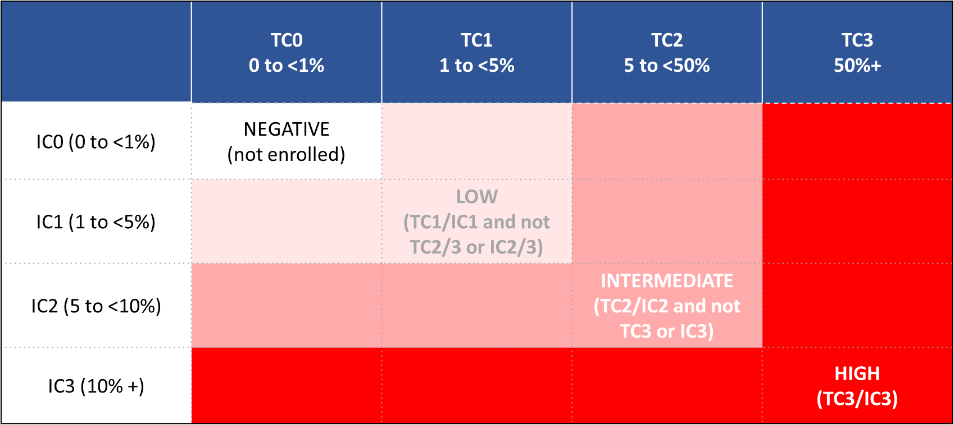
Abbreviations: AusPAR = Australian Public Assessment Report; IC = immune cell; PD-L1 = programmed death-ligand 1; TC = tumour cell.
TC = discernible PD-L1 staining of any intensity in x% of tumour cells.
IC = discernible PD-L1 staining of any intensity in immune infiltrating tumour cells covering x% of ‘tumour area occupied by tumour cells, associated intra-tumoural, and contiguous peri-tumoural desmoplastic stroma’.

IMPOWER110 trial (Study GO29431)
Figure 1: IMPOWER110 trial (Study GO29431) Overview of study design.
Figure 1: IMPOWER110 trial (Study GO29431) Overview of study design
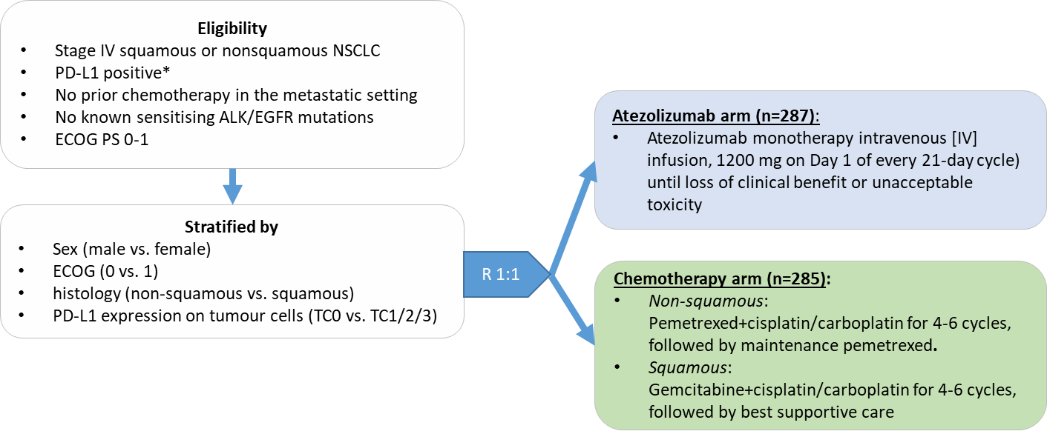
Abbreviations: ALK = anaplastic lymphoma kinase (gene); ECOG = Eastern Cooperative Oncology Group; EGFR = epidermal growth factor receptor (gene); PS = Performance Status; n = numbers of subjects in group; NSCLC = non-small cell lung cancer; PD-L1 = programmed death-ligand 1; TC = tumour cell.
Eligibility: Eligible patients were 18 years of age or older; had Stage IV non-squamous or squamous non-small cell lung cancer (NSCLC), measurable by Response Evaluation Criteria in Solid Tumours (RECIST), version 1.1; had a baseline ECOG PS score of 0 or 1 (on a 5-point scale in which higher scores indicate greater disability); and had not previously received chemotherapy. PD-L1 expression on at least 1% of tumour cells or tumour-infiltrating immune cells covering at least 1% of the tumour area as determined by the SP142 assay was required.
Immunohistochemical analyses were conducted by a central laboratory on archival tumour tissue or tissue obtained through biopsy at the time of screening. Initially, patients with a known sensitising EGFR mutation or ALK translocation were eligible provided they had received previous targeted therapy.
The protocol was subsequently amended to exclude these patients from the analysis (18 patients) because emerging data suggested that they may not benefit from immune-checkpoint inhibitor monotherapy. All the patients were evaluated for central nervous system (CNS) metastasis at the time of screening with the use of computed tomography, magnetic resonance imaging, or both; patients with active or untreated CNS metastases were ineligible for enrolment in the trial.
Patients were randomly assigned in a 1:1 ratio to receive atezolizumab (1200 mg intravenously) or platinum-based chemotherapy (4 or 6 cycles) once every 3 weeks. In the chemotherapy group, patients with non-squamous NSCLC received either cisplatin (75 mg per square meter of body-surface area) or carboplatin (area under the concentration−time curve (AUC, 6)) in addition to pemetrexed (500 mg/m²) intravenously; patients with squamous NSCLC received a regimen of cisplatin (75 mg/m²) plus gemcitabine (1250 mg/m²) or a regimen of carboplatin (AUC, 5) plus gemcitabine (1000 mg/m²) intravenously. Randomisation was stratified according to sex (male versus female), ECOG performance-status score (0 versus 1), histologic type (non-squamous versus squamous), and PD-L1 status (≥ 1% PD-L1 expression on tumour cells and any level of PD-L1 expression on tumour-infiltrating immune cells versus < 1% PD-L1 expression on tumour cells and ≥ 1% PD-L1 expression on tumour-infiltrating immune cells). Continuation of atezolizumab after disease progression was allowed in patients who had continued clinical benefit. No crossover to the atezolizumab group was permitted.
* Programmed death-ligand 1 (PD-L1) positivity in tumour cells and infiltrating immune cells in tumour tissue samples was assessed by central laboratories using the Ventana PD-L1 (SP142) in vitro diagnostic device, with categories of positivity defined per the footnote to Table 4.
The main comparator in the study, platinum-based chemotherapy, was an appropriate first line standard-of-care option at the time of study design (the first patient was randomised on 21 July 2015).
Patients with a sensitising mutation in the EGFR gene or an ALK fusion oncogene were initially allowed to enrol, however, emerging data (from the OAK trial, CHECKMATE-057 trial and KEYNOTE-010 trial);,, indicated no survival benefit over docetaxel when these patients were treated with immune checkpoint inhibitors. Version 6 of the protocol was therefore changed to exclude further enrolment of such patients, and 18 patients who had already enrolled were excluded from the populations for all efficacy analyses (9 of these patients were in the primary efficacy population, 4 in the chemotherapy and 5 in the atezolizumab arm).
Tumour assessments were conducted every 6 weeks for 48 weeks, then every 9 weeks thereafter, using the Response Evaluation Criteria in Solid Tumours (RECIST)¹¹ version 1.1.
Continuation of atezolizumab treatment despite radiographic progression was allowed for patients with evidence of clinical benefit and no clinical evidence of progression (including ECOG Performance Status score decline). Atezolizumab dose reduction and crossover from comparator to atezolizumab were not allowed. However, follow-up data indicates a high proportion of the comparator arm received an immunotherapy subsequent to discontinuing in the trial (see Section: Confounding by subsequent therapy, below)).
There are a number of complexities to the interpretation of this study that are related to the SP142 diagnostic test. See Section: Companion diagnostic considerations, below. For simplicity of discussion throughout this overview, the informal terms of ‘high’, ‘intermediate’, ‘low’ or ‘negative’ to describe PD-L1 expression levels in a sample tested by SP142 (as defined previously in Table 3 and Table 4).
The primary efficacy endpoint was overall survival (OS) in the PD-L1 high (TC3 or IC3) population, with sequential testing in the PD-L1 intermediate or high group, and then in the PD-L1 positive group overall.
Secondary endpoints included investigator-assessed (RECIST version 1.1) progression-free survival (PFS), objective response rate (ORR), landmark OS analyses at one and two years, and duration of response (DOR). Patient-reported outcomes were collected, and for a number of reasons including the open-label design of the trial, are considered exploratory.

Population
Baseline characteristics were balanced between arms in the overall (PD-L1 positive) population. However, the primary endpoint was not tested in the overall population but in a subgroup of the intention-to-treat (ITT) population.
Table 5 summarises selected baseline demographics and disease characteristics for the primary efficacy population: the PD-L1 high (TC3 and/or IC3). Characteristics are noted to be somewhat imbalanced between the two arms (see Section: Imbalances in baseline characteristics, below. The median age was 66 years in the chemotherapy arm and 63 years in the atezolizumab arm.
Table 5: IMPOWER110 trial (Study GO29431) Overview of baseline characteristics in the primary efficacy population (‘PD-L1 high’ (TC3/IC3 score))
 |  | Chemotherapy  (n = 98) % | Atezolizumab  (n = 107) %
Age group | < 65 years, %  ≥ 65 years, % | 44  56 | 55  45
Sex | Female | 35 | 26
ECOG (electronic case report form) | 0  1 | 39  61 | 33  67
ECOG (interactive response system) | 0  1 | 39  61 | 31  69
Tobacco use history | Never  Current  Previous | 15  30  55 | 8  19  73
PD-L1 status by SP 142 | TC3  IC3, not TC3 | 64  36 | 58  42
Stage at initial diagnosis | IA  IB  IIA  IIB  IIIA  IIIB  IV  Unknown | 2  5  4  6  4  2  77  0 | 3  7  9  2  7  2  68  2
Histology at initial diagnosis | Squamous  Non-squamous | 23  77 | 25  75
Baseline SLD | <86  86+ | 37  63 | 50  50
Metastatic sites at enrolment | Mean (SD)  Median  Range | 3.3 (1.4)  3  1 to 9 | 2.9 (1.3)  3  1 to 7
Hepatic metastases at Baseline | Yes | 17 | 17
Time from first diagnosis of metastatic disease until first dose of trial medication (months) | Mean (SD)  Median  Range | 1.7 (1.3)  1.48  0.1 to 9.9 | 2.9 (6.2)  1.64  0.1 to 50.8
KRAS mutation status | Positive  Negative  Unknown | 7  6  87 | 3  12  85
EGFR mutation status | Positive  Negative  Unknown | 0  80  20 | 0  77  23
Abbreviations: ECOG = Eastern Cooperative Oncology Group; EGFR = epidermal growth factor receptor; IC = immune cell; N = total number of subjects; PD-L1 = programmed death-ligand 1; SD = standard deviation; SLD = sum of longest diameters; TC = tumour cell.
TC3 or IC3 denotes PD-L1 expression on ≥ 50% of tumour cells or on ≥ 10% of immune cells (PD-L1 expression ‘high’).

Results

Population pharmacokinetics
A decrease in clearance tends to occur over time during therapy with PD-(L)1 inhibitors.,, Although the decrease is not considered clinically relevant, the magnitude of decrease in clearance has been found to be associated with best overall response.^{17,18} That is, patients with more reduction in tumour size also seem to clear less drug (one hypothesis is that as the tumour shrinks, clearance decreases due to reduced tumour-related catabolism). This correlation between a patients’ response category and change of clearance has important implications for exposure–response analyses. In a typical exposure–response analysis, the drug exposure is assumed to be the cause and the response is considered the outcome. But if disease status influences clearance over time, the steady state drug exposure will be increased by the response, rather than the other way around. To minimise confounding due to response-related time-varying clearance, it is recommended that only the pharmacokinetic (PK) data from Cycle 1 are used to estimate exposure.¹⁷ This is the approach taken in the submitted population pharmacokinetic (popPK) analysis, and is considered appropriate.
The submitted popPK analysis considers the PK data from the pivotal Phase III IMPOWER110 trial in context of the existing atezolizumab Phase I popPK model.
The Phase I popPK model and analyses were evaluated previously by the TGA and Pharmacometrics Working Group for Submissions PM-2016-02087-1-4;⁹ and PM-2018-02962-1-4, and were considered appropriate and fit for purpose. In the Phase I popPK model, body weight, albumin, tumour burden, and treatment-emergent anti-drug antibodies (ADA) were statistically significant covariates for clearance. Unexplained inter-individual variability for clearance was moderate for (29%). In treatment-emergent ADA positive patients, clearance was estimated to be 16% higher than in ADA negative patients. None of the covariates induced more than 27% change from the typical PK model parameter for extreme values.
The new popPK report concludes that the IMPOWER110 trial PK was adequately predicted by the Phase I popPK model, and the co-variate effects were consistent.
The analysis of data from the IMPOWER110 trial found a significant difference (p < 0.001) between atezolizumab clearance in ADA positive patients (mean = 0.316 L/day; standard deviation (SD) = 0.139) and ADA negative patients (mean = 0.218 L/day; SD = 0.0801). However, the mean minimum concentration (C_{min}) in ADA-positive subjects of 62 µg/mL (SD = 23) still appears to be above the target trough concentration of 6 µg/mL
The Phase I model was re-run by the sponsor based on the IMPOWER110 trial PK data at the European Medicines Agency’s (EMA) request; to assess the impact of ADA on clearance when adjusted for baseline covariates. The increase in clearance was slightly higher and very similar to that predicted using the Phase I data:
- 18.5% (relative standard error (RSE) of 30.7%) increase in ADA-positive patients compared to ADA-negative ones based on the IMPOWER110 trial
- 15.9% (RSE: 25%) increase based on the Phase I data
The relevance of ADAs is discussed further under Section: Immunogenicity, below.

Efficacy
Efficacy results for the IMPOWER110 trial are summarised in Table 6 and Figure 2. Survival was compared using a stratified log-rank test. It was pre-specified that results would only be stratified by PD-L1 status for the PD-L1 positive (all enrolled patients) population (tested third in the hierarchy) and not for the PD-L1 high and PD-L1 intermediate-or-high populations (which are both subgroups of all-enrolled patients), to avoid over-stratification in the latter analyses. The following is from the clinical study report for the IMPOWER110 trial:
For the TC3 or IC3-WT subpopulation and the TC2/3 or IC2/3-WT subpopulation, the stratification factors were those that were used during randomisation (that is, sex (male versus female), ECOG Performance Status (0 versus 1), histology (non-squamous versus squamous)).
For the TC1/2/3 or IC1/2/3-WT population, the stratification factors were those that were used during randomisation (that is, sex (male versus female), ECOG Performance Status (0 versus 1), histology (non-squamous versus squamous), and PD-L1 tumour expression status (TC1/2/3 and any IC versus TC0 and IC1/2/3)) as recorded in the interactive web/voice response system (IxRS).
Table 6: IMPOWER110 trial (Study GO29431) Overview of efficacy (median follow up 15.7 months)
 | PD-L1  High (TC3/IC3) |  | PD-L1  Intermediate-or-High |  | PD-L1  Positive
 | Chemo  (n = 98) | Atez  (n = 107) | Chemo  (n = 162) | Atez  (n = 166) | Chemo  (n = 287) | Atez  (n = 285)
Overall survival
Patients with event,  n (%) | 57 (58) | 44 (41) | 83 (51) | 71 (43) | 132 (48) | 121 (44)
Median, months  (95% CI) | 13.1  (7.4, 16.5) | 20.2  (16.5, NE) | 14.9  (10.8, 16.6) | 18.2  (13.3, NE) | 14.1  (11.0, 16.6) | 17.5  (12.8, 23.1)
HR  (95% CI) | 0.59 (0.40, 0.89) |  | 0.72 (0.52, 0.99) |  | 0.83 (0.65, 1.07)
p-value | 0.0106 |  | 0.0416* |  | 0.1481 (descriptive)
Progression-free survival
Patients with event,  n (%) | 79 (81) | 67 (63) | 127 (78) | 110 (66) | 216 (78) | 193 (70)
Median, months  (95% CI) | 5.0  (4.2, 5.7) | 8.1  (6.8, 11.0) | 5.5  (4.4, 5.7) | 7.2  (5.6, 8.7) | 5.5  (4.6, 5.7) | 5.7  (5.5, 7.2)
HR  (95% CI) | 0.63 (0.45, 0.88) |  | 0.67 (0.52, 0.88) |  | 0.77 (0.63, 0.94)
p-value | 0.0070 (descriptive) |  | 0.003 (descriptive) |  | 0.0104 (descriptive)
Objective response rate (ORR, confirmed)
ORR, % (95% CI) | 29 (20, 39) | 38 (29, 48) | 32 (25, 40) | 31 (24, 38) | 32 (26, 38) | 29 (24, 35)
Duration of response (confirmed)
responders, n | 28 | 41 | 52 | 51 | 88 | 81
Median, months  (95% CI) | 6.7  (5.5, 17.3) | NE  (11.8, NE) | 5.8  (5.1, 9.9) | NE  (11.8, NE) | 5.7  (4.8, 9.7) | NE (11.8, NE)
Abbreviations: Atezo = atezolizumab; Chemo = chemotherapy; CI = confidence interval; HR = hazard ratio; N = total number of subjects; n = numbers of subjects in group; NE = not estimable; ORR = objective response rate; PD-L1 = programmed death-ligand 1; TC = tumour cell.
TC3 or IC3 denotes PD-L1 expression on ≥ 50% of tumour cells or on ≥ 10% of immune cells (PD-L1 expression ‘high’).
Immune cell scoring (PD-L1 expression): IC0 (0 to < 1%); IC1 (1 to < 5%); IC2 (5 to <10%); IC3 (10%+).
Tumour cell scoring (PD-L1 expression): TC0 (0 to <1%); TC1 (1 to < 5%); TC2 (5 to < 50%); TC3 (50%+).
Hazard ratios: stratified Cox regression. P-values: stratified log-rank test.
* Not statistically significant: the pre-specified overall survival interim analysis alpha boundary was 0.0400.
Figure 2: IMPOWER110 trial (Study GO29431) Kaplan-Meier curve for overall survival for the primary efficacy population (TC3 or IC3, intent-to treat population)
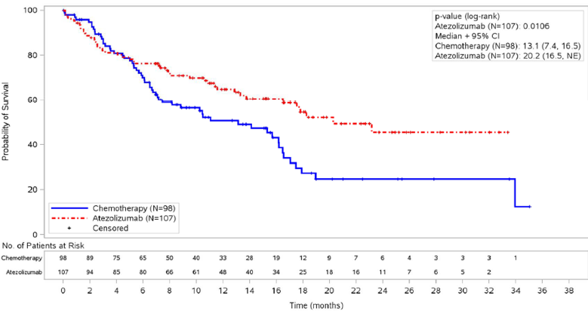
Abbreviations: CI = confidence interval; IC = immune cell; N = numbers of patients; NE = not estimable; TC = tumour cell.
TC3 or IC3 denotes PD-L1 expression on ≥ 50% of tumour cells or on ≥ 10% of immune cells (PD-L1 expression ‘high’).
Immune cell scoring (PD-L1 expression): IC0 (0 to < 1%); IC1 (1 to < 5%); IC2 (5 to <10%); IC3 (10%+).
Tumour cell scoring (PD-L1 expression): TC0 (0 to <1%); TC1 (1 to < 5%); TC2 (5 to < 50%); TC3 (50%+).
Randomised treatments are displayed.
Stratification factors are: sex (male versus female) and Eastern Cooperative Oncology Group performance Status score (0 versus 1). Intent-to-treat wild-type patients are populations excluding patients with a sensitizing epidermal growth factor receptor mutation or anaplastic lymphoma kinase translocation).
Data extraction date: 31 August 2019; data cut-off date: 10 September 2018.
Crossing of the overall survival curve in the early months of therapy indicates that there is a higher risk of early mortality with atezolizumab treatment compared to chemotherapy (see Section: Early mortality, below).

Subgroup analyses
Table 7: IMPOWER110 trial (Study GO29431) Overall survival in selected subgroups (TC3/IC3 population)
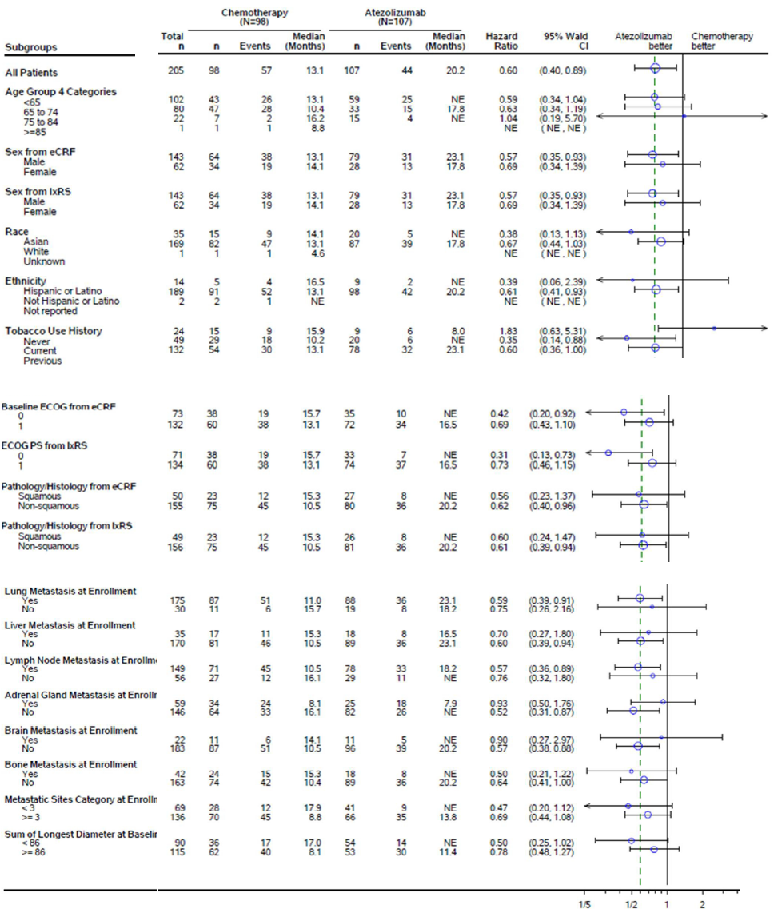
Abbreviations: CI = confidence interval; ECOG = Eastern Cooperative Oncology Group; eCRF = electronic case report form; IC = immune cell; IxRS = interactive web/voice response system; N = total number of subjects; n = numbers of subjects in group; NE = not estimable; PS = Performance Status; TC = tumour cell.
TC3 or IC3 denotes PD-L1 expression on ≥ 50% of tumour cells or on ≥ 10% of immune cells (PD-L1 expression ‘high’).

Exploratory efficacy according to other programmed death-ligand 1 tests
Other PD-L1 immunohistochemistry (IHC) diagnostic assays using different antibody clones (for example, Dako 22C3, Dako 28-8, and Ventana SP263) have been developed in parallel to the Ventana SP142 assay by other pharmaceutical companies. Each assay and their associated cut-offs have been analytically validated, clinically validated in Phase III trials, and are commercially marketed for use with specific molecules in the anti-PD-1/ PD-L1 class.
The 22C3 and the SP263 assays are extensively used in clinical practice, and samples from IMPOWER110 trial were retested using both of these assays to provide exploratory comparability data, which is summarised in Table 9, Table 10 and Table 11. The sponsor states that the exploratory efficacy data from the IMPOWER110 trial by PD-L1 status according to 22C3 and SP263 was included in the clinical study report with the intent to support the overall risk/benefit profile of atezolizumab in first-line treatment of NSCLC. Due to missing data (for patients who tested negative on SP142 and therefore were not enrolled in the IMPOWER110 trial, but who would have been positive if tested using 22C3 or SP263), the comparability data is not sufficiently robust to facilitate a direct comparison of the assays.
Results for the 22C3 and SP263 assay were available for most, but not all, enrolled patients due to tissue availability (for 22C3: 534 out of 554, and for SP263: 546 out of 554).
Table 8: IMPOWER110 trial (Study GO29431) showing exploratory analysis of overall survival in the intent-to-treat population according to PD-L1 status tested by Ventana SP263 or Dako 22C3 assays
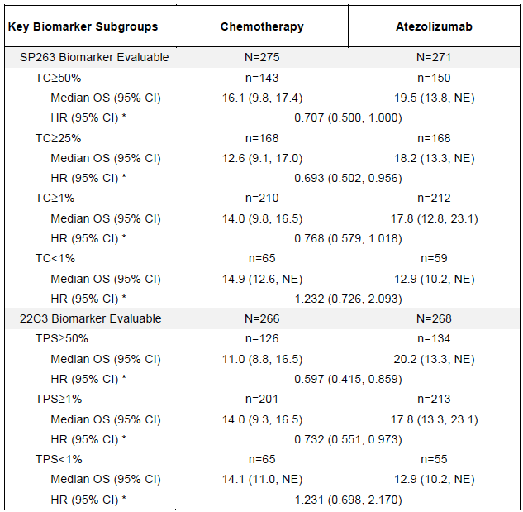
Abbreviations: CI = confidence interval; HR = hazard ratio; OS = overall survival; N = total number of subjects; n = numbers of subjects in group; NE = non-estimable; PD-L1 = programmed death-ligand 1; TC = tumour cell; TPS = tumour progression score.
TC3 or IC3 denotes PD-L1 expression on ≥ 50% of tumour cells or on ≥ 10% of immune cells (PD-L1 expression ‘high’).
Immune cell scoring (PD-L1 expression): IC0 (0 to < 1%); IC1 (1 to < 5%); IC2 (5 to <10%); IC3 (10%+).
Tumour cell scoring (PD-L1 expression): TC0 (0 to <1%); TC1 (1 to < 5%); TC2 (5 to < 50%); TC3 (50%+).
Table 9: IMPOWER110 trial (Study GO29431) Exploratory analysis of overall survival in the TC3/IC3 population according to PD-L1 status tested by Ventana SP263 or Dako 22C3 assay
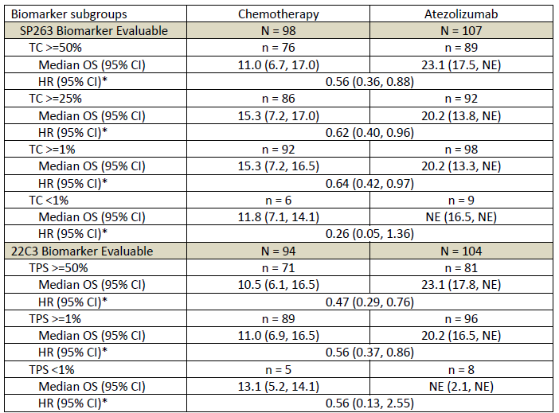
Abbreviations: CI = confidence interval; HR = hazard ratio; IC = immune cell; OS = overall survival; N = total number of subjects; n = numbers of subjects in group; NE = non-estimable; PD-L1 = programmed death ligand 1; TC = tumour cell; TPS = tumour progression score.
* Unstratified analysis
TC3 or IC3 denotes PD-L1 expression on ≥ 50% of tumour cells or on ≥ 10% of immune cells (PD-L1 expression ‘high’).
Immune cell scoring (PD-L1 expression): IC0 (0 to < 1%); IC1 (1 to < 5%); IC2 (5 to <10%); IC3 (10%+).
Tumour cell scoring (PD-L1 expression): TC0 (0 to <1%); TC1 (1 to < 5%); TC2 (5 to < 50%); TC3 (50%+).
Table 10: IMPOWER110 trial (Study GO29431) Exploratory analyses of overall survival in patients who were not TC3 or IC3 per SP142, but on retesting with another programmed death-ligand 1 assay had tumour programmed death-ligand 1 expression of at least 50%
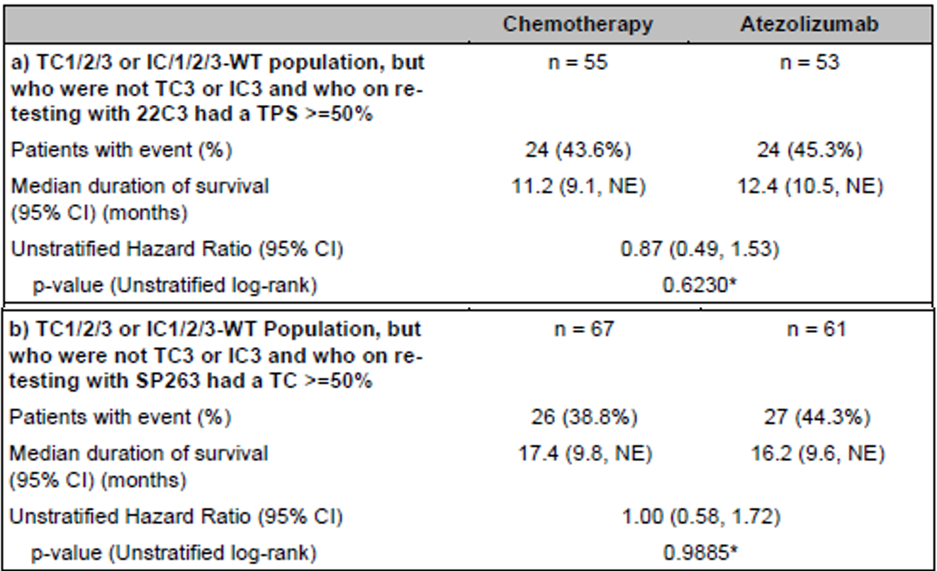
Abbreviations: CI = confidence interval; HR = hazard ratio; IC = immune cell; OS = overall survival; N = total number of subjects; n = numbers of subjects in group; NE = non-estimable; TC = tumour cell; TPS = tumour progression score.
TC3 or IC3 denotes PD-L1 expression on ≥ 50% of tumour cells or on ≥ 10% of immune cells (PD-L1 expression ‘high’).
Immune cell scoring (PD-L1 expression): IC0 (0 to < 1%); IC1 (1 to < 5%); IC2 (5 to <10%); IC3 (10%+).
Tumour cell scoring (PD-L1 expression): TC0 (0 to <1%); TC1 (1 to < 5%); TC2 (5 to < 50%); TC3 (50%+).
* P-value is descriptive only.

Safety

Adverse events
Safety in the IMPOWER110 trial (Study GO29431) safety population is the focus of this overview. The safety profile of atezolizumab monotherapy is reasonably well described in the setting of previously treated advanced NSCLC (and in other tumour settings), and is considered supportive (see currently approved Australian PI).
Overall safety in IMPOWER110 is summarised in Table 11. The median duration of treatment was longer in the atezolizumab arm (5.3 months) than the chemotherapy arm (3.5 months pemetrexed, 2.1 months cisplatin, 2.3 months carboplatin, 2.6 months gemcitabine).
Adverse events (AEs) that were reported at least 5% more frequently with atezolizumab than chemotherapy were elevated alanine aminotransferase, pruritus and hypothyroidism.
Adverse events that were reported at least 5% more frequently with chemotherapy than atezolizumab were nausea, constipation, vomiting, blood creatinine increased, platelet count decreased, neutrophil count decreased, anaemia, thrombocytopaenia, neutropaenia and leukopaenia.
Table 11: IMPOWER110 trial (Study GO29431) Selected summary safety parameters
 | Chemotherapy  (n=263) | Atezolizumab  (n=286)
Exposure
Median duration of exposure, months | 2.1 to 3.5 | 5.3
Deaths
Patients who had a fatal (treatment-emergent) adverse event, n (%) | 11 (4.2%) | 11 (3.8%)
Treatment-emergent adverse events
Subjects with at least one treatment-emergent adverse event, % | 95 | 90
Most common treatment-emergent adverse events (≥ 10% in either arm):
anaemia, % | 48 | 15
nausea, % | 34 | 14
neutropaenia, % | 28 | 1
constipation, % | 22 | 12
decreased appetite, % | 19 | 15
fatigue (same number of events for asthenia), % | 18 | 13
thrombocytopaenia, % | 17 | 2
vomiting, % | 13 | 6
diarrhoea, % | 12 | 11
dyspnoea, % | 10 | 14
pyrexia, % | 9 | 14
cough, % | 10 | 12
alanine aminotransferase increased, % | 6 | 11
Serious treatment-emergent adverse events
Subjects with at least one serious adverse events, % | 29 | 28
Most common serious adverse events (≥ 2% in either arm):
pneumonia, % | 4.2 | 2.8
anaemia, % | 3.4 | 0.3
thrombocytopaenia, % | 3.4 | 0.3
pneumonitis, % | 0.4 | 2.1
chronic obstructive pulmonary disease (COPD), % | 0 | 2.1
Higher grade treatment-emergent adverse event
Subjects with at least 1 ≥ Grade 3 adverse events, % | 57 | 34
Most common Grade 3-4 adverse events (≥ 5% in either arm)
anaemia, % | 48 (18.3) | 5 (1.7)
neutropaenia, % | 46 (17.5) | 2 (0.7)
thrombocytopaenia, % | 19 (7.2) | 1 (0.3)
Abbreviation: n = numbers of subjects in group.
Database cut-off date: 10 September 2018.

Deaths
Fatal adverse events reported in IMPOWER110 trial (Study GO29431) are summarised in Table 12. The only event considered related to study treatment by the investigator was the case of pancytopaenia in the chemotherapy arm.
No common toxicity cause of death was apparent amongst AEs reported as fatal events in the atezolizumab arm.
Table 12: IMPOWER110 trial (Study GO29431) Adverse events reported as Grade 5 (fatal)
Chemotherapy arm (total = 11) | Atezolizumab arm (total = 11)
Acute pulmonary oedema  Cardiac arrest (x2)  Cardiac failure  Death (x3)  Pneumonia  Respiratory tract infection  Tuberculosis  Pancytopaenia | Aspiration  Cardiac arrest  Acute myocardial infarction  Death (x2)  Chronic obstructive pulmonary disease  Pulmonary embolism  Mechanical ileus  Sepsis  Cerebral infarction  Device occlusion

Discontinuations, dose interruptions and dose modifications
Adverse events led to treatment modification/interruption in 26% of the atezolizumab and 44% of the chemotherapy arm.

Adverse events of special interest
A list of adverse events of special interest (AESIs) were predefined by the sponsor consistent with the identified risks of atezolizumab and events potentially associated with an immune aetiology. Adverse events of special interest occurred in 40% of the atezolizumab arm and 17% of the chemotherapy arm, and led to discontinuation in 2% of atezolizumab recipients and 1% of chemotherapy recipients.
There were no fatal AESIs. Grade 3 to 4 AESIs occurred in 19 (7%) subjects who received atezolizumab and 4 (2%) subjects who received chemotherapy.
Serious AESIs occurred in 5% of subjects who received atezolizumab and 1% of subjects who received standard of care.
The most common AESIs (≥ 2% incidence) in the atezolizumab group were immune-related hepatitis, rash, hypothyroidism, hyperthyroidism and pneumonitis.
One case of haemophagocytic lymphohistiocytosis occurred (in a patient who was antidrug antibody-positive). Based on the biological plausibility, this event is highly likely to be related to atezolizumab treatment and should be noted in the adverse effects section of the PI.

Safety-related conclusions
The safety profile seen in IMPOWER110 trial (Study GO29431) is generally consistent with the previously safety profile of atezolizumab monotherapy. The toxicity profile is different to that of chemotherapy, and the overall risk of higher grade and serious adverse events in this study was lower with atezolizumab monotherapy than chemotherapy.
Regardless of whether the new indication is approved, haemophagocytic lymphohistiocytosis should be added to the adverse effects section of the Australian PI.

Immunogenicity results
Treatment-emergent anti-drug antibodies (ADA) occurred in 65 (24%) of the patients who received atezolizumab in the IMPOWER110 trial. This is within the range of ADA-positive incidences observed across atezolizumab studies. Within the TC3/IC3 population, 23 (24%) patients were ADA-positive, and 75 patients were ADA-negative.
ADA-positive patients received a median of two fewer cycles of atezolizumab than ADA-negative patients (8 versus 10 cycles, respectively), and had a shorter median duration of exposure (4.9 versus 6.8 months, respectively).Abbreviations: ADA = antidrug antibody; CI = confidence interval; IC = immune cell; n = numbers of subjects in group; N/A = not applicable; NE = non-estimable; ORR = overall response rate; TC = tumour cell.
TC3 or IC3 denotes PD-L1 expression on ≥ 50% of tumour cells or on ≥ 10% of immune cells (PD-L1 expression ‘high’).
Table 14 and Table 19 suggest that efficacy is no better with atezolizumab than with platinum-doublet chemotherapy in patients who develop treatment-emergent ADAs. However, prognostic factors were not balanced between the ADA +/- subgroups, confounding interpretation:
- 16% more of the ADA-positive subgroup had no smoking history (better prognosis)
- 18% more of the ADA-positive subgroup had squamous NSCLC histology (worse prognosis)
- 16% more of the ADA-positive subgroup had an ECOG PS of 1 than ECOG PS 0 (worse prognosis)
- 23% more of the ADA-positive subgroup had bone metastases (worse prognosis)
A summary of safety by ADA subgroup is given in Table 15.
Table 13: IMPOWER110 trial (Study GO29431) Exploratory efficacy analyses by treatment-emergent antidrug antibody status subgroups of the atezolizumab and chemotherapy arms (TC3/IC3, interim analysis (median follow-up 15.7 months; minimum follow-up of 7 months)
 | Atezolizumab (n = 107) |  | Chemotherapy (n = 98)
ADA status | ADA- (n=75) | ADA+ (n=23) | N/A
Overall survival
Patients with event, n (%) | 24 (32%) | 13 (57%) | 57 (58%)
Median, months (95% CI) | NE (17.8, NE) | 13.8 (4.9, NE) | 13.1 (7.4, 16.5)
Progression-free survival
Patients with event, n (%) | 42 (56%) | 18 (78%) | 79 (81%)
Median, months (95% CI) | 9.6 (7.7, 17.5) | 4.5 (2.3, 8.2) | 5.0 (4.2, 5.7)
Objective response rate
Patients with event, n | 34 | 7 | 28
ORR, % (95% CI) | 45 (34, 57) | 30 (13, 53) | 29 (20, 39)
Abbreviations: ADA = antidrug antibody; CI = confidence interval; IC = immune cell; n = numbers of subjects in group; N/A = not applicable; NE = non-estimable; ORR = overall response rate; TC = tumour cell.
TC3 or IC3 denotes PD-L1 expression on ≥ 50% of tumour cells or on ≥ 10% of immune cells (PD-L1 expression ‘high’).
Table 14: IMPOWER110 trial (Study GO29431) Exploratory overall survival analysis with a further 17 months follow-up (above; clinical cut-off date 4 February 2020) by treatment-emergent antidrug antibody status (cut-off date 10 September 2018) for patients in the atezolizumab arm, compared to patients in the chemotherapy arm, in the TC3/IC3 population
 | Atezolizumab (n=107) |  | Chemo (n=92)
ADA status | ADA- (n=75) | ADA+ (n=23) | N/A
Overall survival
Patients with event, n (%) | 39 (52%) | 17 (74%) | 60 (65%)
Median, months (95% CI) | 27.1 (20.2, NE) | 13.8 (4.9, 23.1) | 14.7 (7.4, 17.7)
Abbreviations: ADA = antidrug antibody; chemo = chemotherapy; CI = confidence interval; n = numbers of subjects in group; IC = immune cell; NE = non-estimable; TC = tumour cell.
TC3 or IC3 denotes PD-L1 expression on ≥ 50% of tumour cells or on ≥ 10% of immune cells (PD-L1 expression ‘high’).
Extract from European Medicines Agency (EMA) Committee for Medicinal Products for Human Use (CHMP) rapporteurs joint assessment report, after two rounds of questions and answers, supplied by sponsor to TGA for reference.²⁰
Note: Further follow up 17 months compared to data presented in Table 13.
Figure 3: IMPOWER110 trial (Study GO29431) Kaplan-Meier plot of updated overall survival exploratory analysis by treatment-emergent antidrug antibody status in the TC3/IC3 population (intent-to-treat population, wild-type)
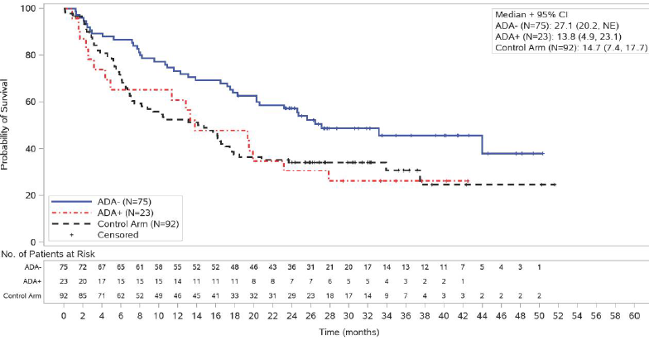
Abbreviations: ADA = antidrug antibodies; ADA+ = antidrug antibody positive; ADA- = antidrug antibody negative; CI = confidence interval; IC = immune cell; N = numbers of patients; n = numbers of subjects in group; NE = not estimable; TC = tumour cell.
TC3 or IC3 denotes PD-L1 expression on ≥ 50% of tumour cells or on ≥ 10% of immune cells (PD-L1 expression ‘high’).
Note: from same dataset as shown in Table 14.
Randomised treatments are displayed.
Stratification factors are: Sex (male versus female) and ECOG performance-status score (0 versus 1). Intent-to-treat wild-type patients are populations excluding patients with a sensitizing EGFR mutation or ALK translocation).
Data extraction date: 24 March 2020; data cut-off date: 4 February 2020.
Table 15: IMPOWER110 trial (Study GO29431) Summary of exploratory safety analysis by antidrug antibody subgroups in the safety evaluable population
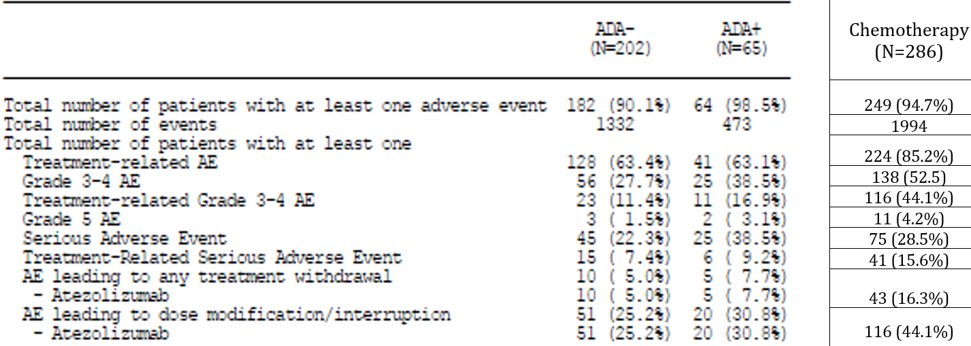
Abbreviations: ADA = antidrug antibody; AE = adverse event; N = total number of subjects.
Only events reported in the Adverse Events Form are included.
Investigator text for AEs encoded using Medical Dictionary for Regulatory Activities (MedDRA); version 22.0. Percentages are based on N in the column headings. Multiple occurrences of the same AE in one individual are counted only once except for ‘total number of events’ row in which multiple occurrences of the same AE are counted separately.
Counts in ‘Grade 3 to 4 AE’ are number of patients whose highest grades of AE are 3 or 4.
Data extraction date: 31 august 2019; data cut-off date: 10 September 2018.
The relevance of ADAs is discussed under Section: Immunogenicity, below.

Companion diagnostic considerations
A range of assays for PD-L1 have been developed simultaneously by competing companies, each using different antibody clones (such as the Dako 22C3, Dako 28-8 and Ventana SP263), and with different proprietary testing platforms and reagents to the others. Numerous studies have been performed to compare the analytical features of each PD-L1 assay in an effort to potentially harmonise the PD-L1 testing landscape in NSCLC.
There are a number of complexities around the use of the Ventana SP142 assay test as a companion diagnostic assay, which are outlined below.

Complexity 1: faulty dispenser lots
Faulty dispenser lots were deployed during the course of the IMPOWER110 trial (Study GO29431) (as a component of the investigational PD-L1 Ventana SP263 assay) and were used to determine the PD-L1 status of 103 patients enrolled in the IMPOWER110 trial (Study GO29431) (18% of the TC1/2/3 or IC1/2/3 population):
Analyses were performed to evaluate the impact of the detection dispenser issue on the enrollment and stratification of patients as well as patient-level concordance analyses. Sensitivity analyses were performed for OS (overall survival) based on PD-L1 status defined by the highest PD-L1 level measures in the original or re-tested sample. (…) Tissue heterogeneity and the considerable distance (≥ 80 µm) between sections of original and re-test samples may have contributed to the observed TC0 and IC0 results at re-testing. Only a directional change of PD-L1 status from PD-L1 positive (for example, TC1/2/3 or IC1/2/3) to TC0 and IC0 could be evaluated, as patients with an original PD-L1 score of TC0 and IC0 would have screen failed and samples were not available for re-testing and analysis.
Table 16: IMPOWER110 trial (Study GO29431) Concordance between Ventana SP142 result at enrolment (with faulty dispenser lots) and on retesting
 | Original test result using faulty kit
 | High (N = 22) | Intermediate (N = 17) | Low (N = 64) | TOTAL (N = 103)
High on re-test | 16 (73%) | 4 (24%) | 0 | 20 (19%)
Intermediate on re-test | 3 (14%) | 5 (29%) | 4 (6%) | 12 (12%)
Low on re-test | 0 | 1 (6%) | 24 (38%) | 25 (24%)
Negative on re-test | 0 | 2 (12%) | 12 (19%) | 14 (14%)
Not Evaluable | 1 (5%) | 2 (12%) | 7 (11%) | 10 (10%)
Not Tested | 2 (9%) | 3 (18%) | 17 (27%) | 22 (21%)
Abbreviations: High = tumour cell (TC)3 or immune cell (IC)3; Intermediate = TC2/3 or IC2/3 excluding TC3 or IC3; Low = TC1/2/3 or IC1/2/3 excluding TC2/3 or IC2/3; N = total number of subjects; Negative = TC0 and IC0.
TC3 or IC3 denotes PD-L1 expression on ≥ 50% of tumour cells or on ≥ 10% of immune cells (PD-L1 expression ‘high’).
Immune cell scoring (PD-L1 expression): IC0 (0 to < 1%); IC1 (1 to < 5%); IC2 (5 to <10%); IC3 (10%+).
Tumour cell scoring (PD-L1 expression): TC0 (0 to <1%); TC1 (1 to < 5%); TC2 (5 to < 50%); TC3 (50%+).
Note: Blue highlighted boxes indicate concordance.
Retesting was not carried out or was not evaluable for around 31% of patients with faulty kit results:
- Three patients were PD-L1 high according to the faulty kits and may have been re-classified out of the primary efficacy population if a retest had been conducted/was evaluable.
- In total, 29 patients were either PD-L1 intermediate (5 patients) or low (24 patients) according to the faulty kits and may have been reclassified into the primary analysis population if a retest had been conducted/was evaluable
  - This seems less likely for the low category, because 40 out of 64 samples that were low per the faulty kit were re-tested, and none of those came back as high on re-test.
Given the primary efficacy analysis was conducted in a reasonably small population (n = 98 versus n = 107), the sponsor was requested to perform additional exploratory overall survival sensitivity analyses in the TC3/IC3 population, to reduce uncertainty caused by use of the faulty test kit for patients’ enrolment and stratification.
The analyses were provided by the sponsor as follows:
- based on the highest PD-L1 level measures in the original or re-tested sample, that is, moving the four additional newly ‘high’ patients into the TC3 or IC3 category
  - Stratified hazard ratio for overall survival (95% confidence interval (CI)) atezolizumab versus chemotherapy = 0.61 (0.41, 0.91)
- including in the TC3/IC3 population the 4 patients who re-tested high and excluding the 3 patients who were confirmed intermediate on re-test
  - Stratified hazard ratio for overall survival (95% CI) atezolizumab versus chemotherapy = 0.60 (0.41, 0.89)
- including in the TC3/IC3 population the 4 patients who re-tested high and excluding all 6 patients who were not confirmed to be high on re-test
  - Stratified hazard ratio for overall survival (95% CI) atezolizumab versus chemotherapy = 0.62 (0.42, 0.92)
- including in the TC3/IC3 population the 4 patients who re-tested high and also including all 5 patients who were initially intermediate and were not re-tested or not evaluable on re-test
  - Stratified hazard ratio for overall survival (95% CI) atezolizumab versus chemotherapy = 0.58 (0.40, 0.86)
- including in the TC3/IC3 population the 4 patients who re-tested high and also including all 5 patients who were initially intermediate and were not re-tested or not evaluable on re-test and also excluding all 6 patients who were not confirmed to be high on re-test
  - Stratified hazard ratio for overall survival (95% CI) atezolizumab versus chemotherapy = 0.59 (0.40, 0.88)
For comparison, the primary overall survival analysis, gave a hazard ratio (95% CI) for overall survival of 0.59 (0.40, 0.89).
The misclassification of patients’ Ventana SP142 PD-L1 status due to the deployment of faulty dispenser lots is not likely to have significantly affected the primary efficacy endpoint.

Complexity 2: compound nature of the scoring system
Ventana SP142 is the only US Food and Drug Administration (FDA)-approved assay for PD-L1 assessment in NSCLC that incorporates immune cell (IC) staining. The scoring system used for SP142 in the IMPOWER110 trial is compound in that it takes into account both immune (IC) and tumour cell (TC) staining, and prevents the assessment of outcomes in the IMPOWER110 trial based on IC or TC expression separately.
The sponsor states:
While there has been debate over the predictive value and utility of TC versus IC in NSCLC, the collective data from atezolizumab studies indicates that both TC and IC, defined by the SP142 assay, independently enriches for clinical benefit in patients treated with atezolizumab monotherapy.,
The first study referenced by the sponsor is a Phase I study of atezolizumab in advanced NSCLC, and does not describe any findings in patients based on IC positivity distinct from TC positivity.²³
The second study describes the molecular and cellular characteristics associated with PD-L1 expression in TC and IC in 4549 cases of NSCLC, as well as efficacy in a cohort of 938 patients with advanced NSCLC treated across 4 Phase I/II studies.²⁴ This publication indicates that the IC3 population and the TC3 population were demonstrated to be almost mutually exclusive (1% overlap), with differing cellular and molecular features, and the authors speculated that they appear to represent two distinct patient populations. The efficacy of atezolizumab also appeared to differ between these populations, with an objective response rate of 40% in TC3-IC0 patients, and an objective response rate of 22% in IC3-TC0 patients (Table 17).
Table 17: Kowanetz et al. (2018) Clinical outcomes were those recorded for a cohort of 938 patients with non-small cell lung cancer across 4 Phase I/II studies
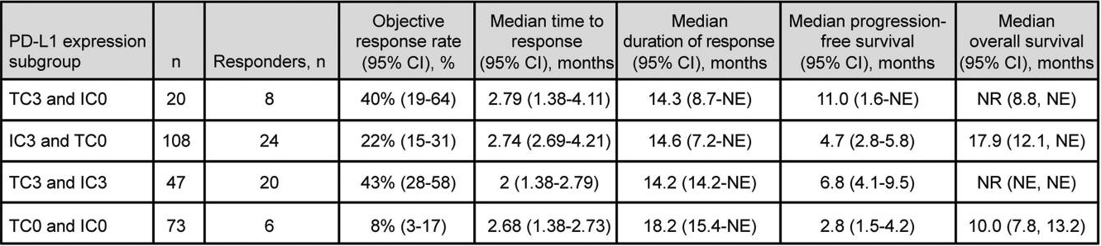
Abbreviations: CI = confidence interval; IC = immune cell; n = numbers of subjects in group; NE = not estimable; NR = not reached; PD-L1 = programmed death-ligand 1; TC = tumour cell.
Immune cell scoring (PD-L1 expression): IC0 (0 to < 1%); IC1 (1 to < 5%); IC2 (5 to <10%); IC3 (10%+).
Tumour cell scoring (PD-L1 expression): TC0 (0 to <1%); TC1 (1 to < 5%); TC2 (5 to < 50%); TC3 (50%+).
Extract of Figure 4 ‘Clinical outcomes from atezolizumab treatment in PD-L1 TC and IC tumor subgroups’.
Due to the compound scoring approach and the definitions selected for efficacy populations, it was not clear whether efficacy in the IMPOWER110 trial (Study GO29431) was being driven by patients with high TC. Based on the above, it was unclear whether there could be poorer efficacy for patients included in the primary efficacy population based on their IC score only, that is, those with TC0/1/2 and IC3, and particularly those with TC0 and IC3.
The sponsor was therefore asked to provide exploratory analyses of efficacy in TC0 + IC3 patients, which are reproduced in Table 18 and Figure 4. The sponsor also provided another requested post-hoc exploratory analysis of overall survival within subgroups of the TC3/IC3 population that indicated similar efficacy to the primary endpoint for patients included in the TC3/IC3 population based on an IC3 score (‘IC3, not TC’ in Table 19).
Table 18: IMPOWER110 trial (Study GO29431) Sponsor’s post-hoc exploratory sensitivity analysis of efficacy in the TC0 and IC3 population
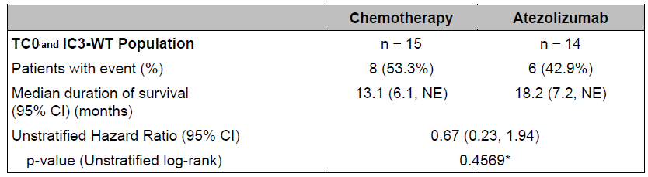
Abbreviations: CI = confidence interval; IC = immune cell; n = number of subjects in group; NE = not estimable; TC = tumour cell; WT = wild type.
Immune cell scoring (PD-L1 expression): IC0 (0 to < 1%); IC1 (1 to < 5%); IC2 (5 to <10%); IC3 (10%+).
Tumour cell scoring (PD-L1 expression): TC0 (0 to <1%); TC1 (1 to < 5%); TC2 (5 to < 50%); TC3 (50%+).
Figure 4: IMPOWER110 trial (Study GO29431) Kaplan-Meier plot of overall survival, TC0 and IC3 (intent-to-treat patients)
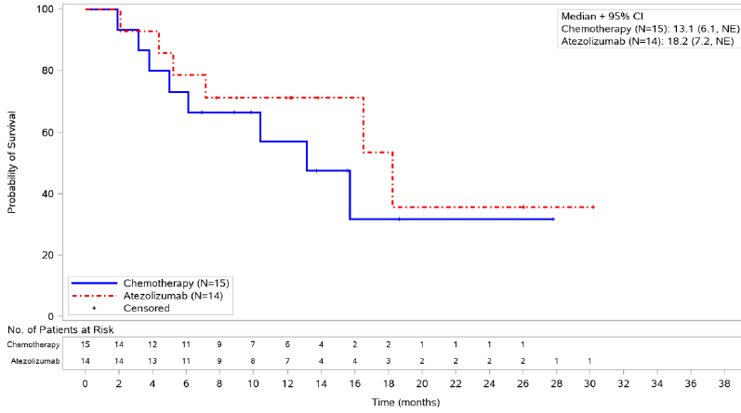
Abbreviations: CI = confidence interval; IC = immune cell; N = numbers of patients; NE = not estimable; TC = tumour cell.
Randomised treatments are displayed.
Immune cell scoring (PD-L1 expression): IC0 (0 to < 1%); IC1 (1 to < 5%); IC2 (5 to <10%); IC3 (10%+).
Tumour cell scoring (PD-L1 expression): TC0 (0 to <1%); TC1 (1 to < 5%); TC2 (5 to < 50%); TC3 (50%+).
Data extraction date: 31 August 2019; data cut-off date: 10 September 2018
Table 19: IMPOWER110 trial (Study GO29431) Sponsor’s post-hoc exploratory analysis, forest plot of overall survival in the TC3/IC3 (intention-to-treat population)
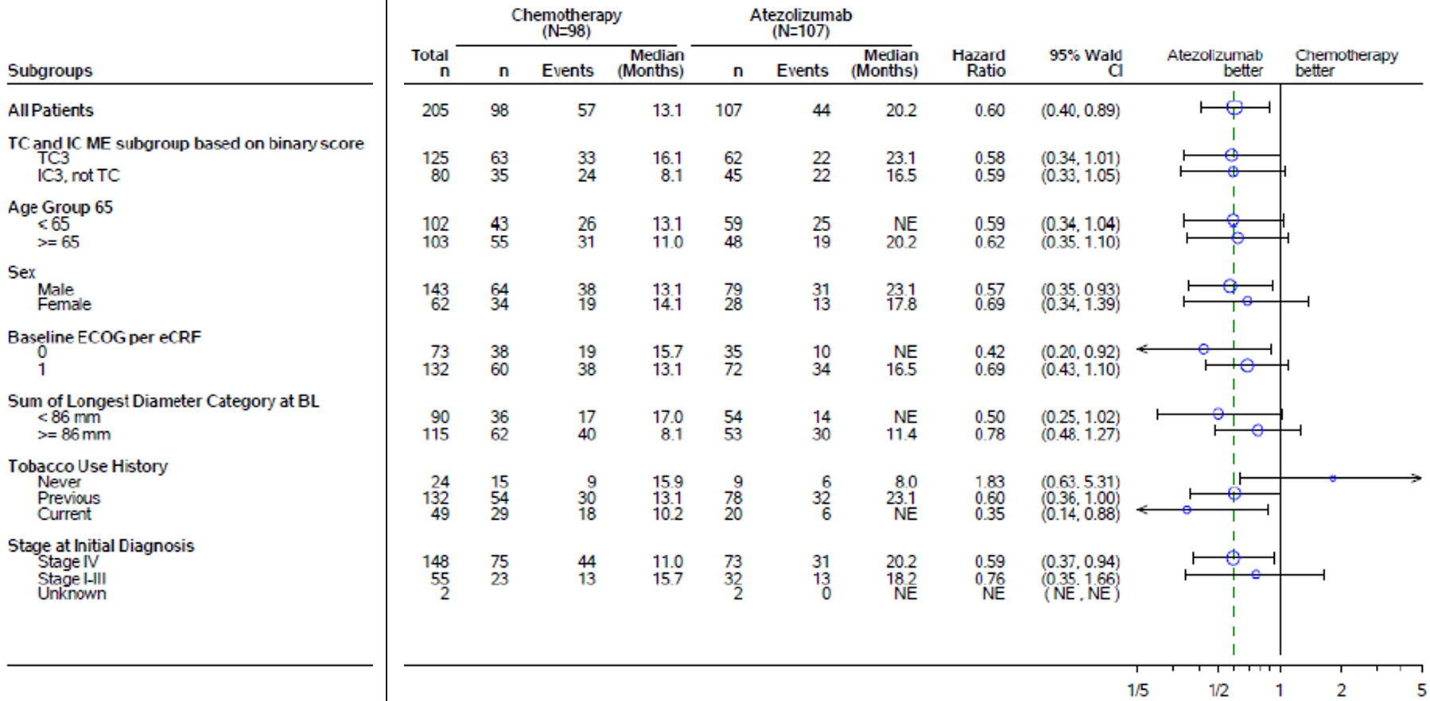
Abbreviations: BL = Baseline; CI = confidence interval; IC = immune cell; ECOG = Eastern Cooperative Oncology Group; eCRF = electronic case report form; ME = mutually exclusive; N = total number of subjects; n = numbers of subjects in group; NE = not estimable; TC = tumour cell.
TC3 or IC3 denotes PD-L1 expression on ≥ 50% of tumour cells or on ≥ 10% of immune cells (PD-L1 expression ‘high’).
Probability of survival was estimated from Kaplan-Meier method. Unstratified hazard ratio relative to chemotherapy and 95% confidence intervals for the hazard ratio were estimated using Cox regression. The vertical dashed line indicates the hazard ratio for all patients. The diameter of the circle is proportional to the square root of the total number of events. Randomised treatments are displayed.
Intent to treat wild type patients are populations excluding patients with a sensitizing epidermal growth factor receptor mutation or anaplastic lymphoma kinase translocation.
Data extraction date: 31 August 2019; data cut-off date 10 September 2018.

Complexity 3: changing definitions of programmed death-ligand 1 levels for both enrolment eligibility and stratification, and timing of this change
The PD-L1 requirements for enrolment eligibility were changed during the study to include patients with lower categories of PD-L1 expression (see Table 20, below), and the randomisation strata were also adjusted at that time:
- For protocol versions 1 through 4:
  - Only patients with high PD-L1 expression were eligible to enrol.
  - During this time, the PD-L1 randomisation strata were TC3 (and any IC) versus IC3 (and TC0/1/2)
- From protocol version 5 (29 June 2016) onwards:
  - Enrolment eligibility was expanded to include lower levels of TC or IC PD-L1 expression.
  - The randomisation strata were also adjusted to TC1/2/3 (and any IC) versus IC1/2/3 (and TC0).
Both these stratification approaches prioritise the TC score over IC, in keeping with the stepwise approach to scoring using the Ventana SP142 assay algorithm (first check TC, and only if sample is not positive at that TC cut-off, then check IC).
There were 71 patients enrolled under protocol versions 1 to 4 (that is, all PD-L1 high): these patients make up 35% of the primary efficacy population.
Subsequently, in statistical analysis plan version 3 (2 April 2019), the analysis plan was changed to introduce a hierarchical approach to testing survival (see Table 21, shown below) in the following populations (in sequential order of testing):
- PD-L1 high (TC3 or IC3)
- PD-L1 high or intermediate (TC2/3 or IC2/3)
- PD-L1 positive at all (TC1/2/3 or IC1/2/3)
It is noted that this change in the statistical analysis plan occurred around 6 months after the clinical cut-off date for the clinical study report (dated 10 September 2018). The sponsor states the change was based on new external data that indicated that the majority of clinical benefit was likely to be restricted to the PD-L1 high population;,, and that the company did not have access to the unblinded data at that time. Although an European Medicines Agency (EMA) inspection for Good Clinical Practice (GCP) raised concerns regarding sponsor responsibilities (see Section: Good Clinical Practice), the EMA Committee for Medicinal Products for Human Use (CHMP) have given a positive opinion regarding authorisation; indicating that the study data is considered of adequate integrity to supporting regulatory decision-making.
Table 20: IMPOWER110 trial (Study GO29431) PD-L1 requirements for enrolment eligibility, categories of PD-L1 expression and randomisation strata (Protocol versions 1 to 4 and protocol version 5 onwards)
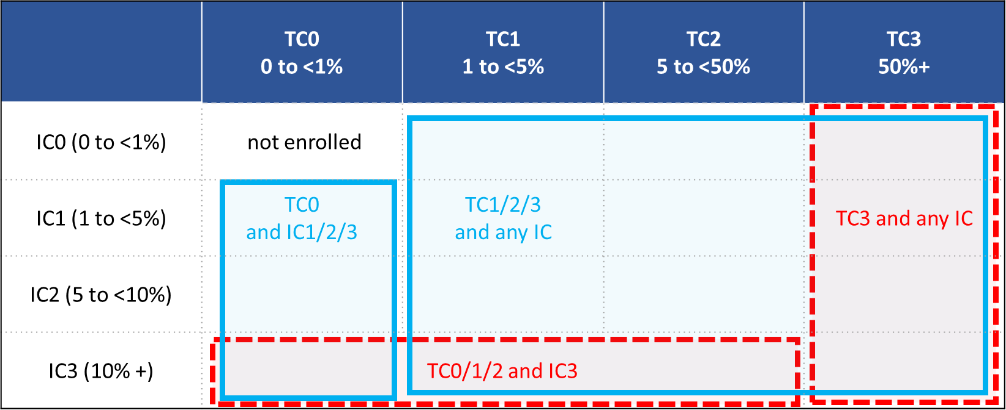
Abbreviations: IC = immune cell; PD-L1 = programmed death-ligand 1; TC = tumour cell.
Tumour cell definitions = discernible PD-L1 staining of any intensity in x% of tumour cells.
Immune cell definitions = discernible PD-L1 staining of any intensity in immune infiltrating tumour cells covering x% of ‘tumour area occupied by tumour cells, associated intra-tumoural, and contiguous peri-tumoural desmoplastic stroma’.
For protocol versions 1 to 4 (red, dashed edge) and from protocol version 5 onwards (blue, solid edge): PD-L1 TC and IC eligibility requirements (combined area of boxes) and randomisation strata (each box is one stratum).
Table 21: IMPOWER110 trial (Study GO29431) Changes to statistical analysis plan to introduce a hierarchical approach to testing survival (Statistical analysis plan version 3 dated 2 April 2019)
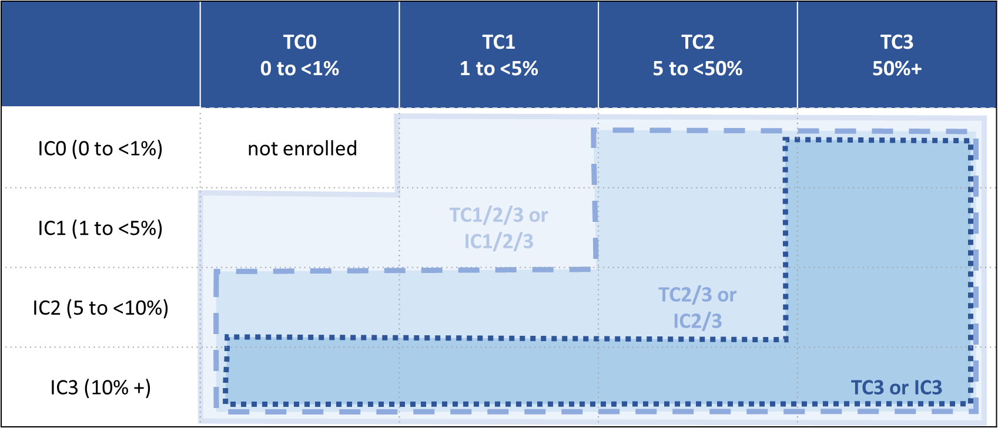
Abbreviations: IC = immune cell; TC = tumour cell.
Tumour cell definitions = discernible PD-L1 staining of any intensity in x% of tumour cells.
Immune cell definitions = discernible PD-L1 staining of any intensity in immune infiltrating tumour cells covering x% of ‘tumour area occupied by tumour cells, associated intra-tumoural, and contiguous peri-tumoural desmoplastic stroma’
The PD-L1 TC and IC positivity category groupings in which efficacy was analysed.
Comparing Table 20 and Table 21, it can be seen that the subgroup in whom the primary endpoint was tested (TC3 or IC3) is not congruent with a PD-L1 randomisation stratum. This is discussed further under Section: Primary efficacy population, above.

Complexity 4: stepwise scoring methodology
The Ventana SP142 assay-scoring algorithm employs a stepwise approach.
The pathologist first scores the TC status of the sample (positive or negative) at the relevant cut-off. If the TC status is positive, then the sample is considered positive at that cut-off (for example ‘TC3/IC3 positive’). If the TC status is negative, then the pathologist subsequently scores the sample for IC status (positive or negative) at that cut-off. Upon completion of the binary scoring, the pathologist also records an exploratory ‘raw’ percentage for both TC and IC.
As noted above, the cut-off used during the IMPOWER110 trial (Study GO29431) entry screening was initially TC3/IC3, and then from protocol version 5 onwards the cut-off for screening was reduced to TC1/IC1.
The binary (positive or negative) score at a particular cut-off defined the efficacy analysis populations. The raw, numerical percentage score(s) that were recorded at the same time as the binary scores were considered exploratory in nature in this study, and were not used in defining analysis populations.
From protocol version 5 onwards, the enrolment screening result (either positive or negative at the TC1/IC1 cut-off) did not provide information as to whether the sample was positive at the TC2/IC2 or TC3/IC3 cut-offs. Therefore, the sample was retrospectively scored (after the patient was enrolled in the study) to capture this information. For enrolled patients that were TC1/IC1 positive in protocol version 5 onward, the sample was next scored at the TC2/IC2 cut-off. If the sample was TC2/IC2 positive, then the sample was next scored to the TC3/IC3 cut-off.
As an exploratory raw score was recorded each time a sample was scored at a new TC/IC cut-off, a single sample (for a patient enrolled according to protocol version 5 or later) could have two or three exploratory raw TC and IC scores. This is relevant to the tables presented in Section: Complexity 5: sensitivity of Ventana Sp142 assay, as follows.

Complexity 5: sensitivity of Ventana SP142 assay
The Ventana PD-L1 SP142 antibody is known to be less sensitive than Dako PD-L1 IHC 22C3, Dako D-L1 IHC 28-8 pharmDx, and Ventana PD-L1 SP263 for the detection of PD-L1 on tumour cells and immune cells in NSCLC.,,
Exploratory analyses of tissue PD-L1 status according to Dako 22C3 and Ventana SP263, and of overall survival according to that re-assessed PD-L1 status were performed within the IMPOWER110 trial (Study GO29431), as noted in Section: Subgroup analyses, above.
To further explore the correlation between tests, the sponsor was asked to provide the breakdown of TC and IC (exploratory) raw scores in the IMPOWER110 trial (Study GO29431), and then the number of them that corresponded to each category of PD-L1 result according to the other two tests.
The data are summarised in Table 22 through 25.
The sponsor provided the following clarifications along with the requested data:
In the analysis provided (…) SP142 TC and IC status was defined using the highest raw TC and IC percentages recorded (per sample). As a consequence, the number of patients in this exploratory analysis may not exactly reflect the total number of patients in the primary analyses that were defined by the binary stepwise scoring method.
The applicant notes that if a sample was re-tested for SP142 due to the dispenser issue, the re-test result was used for this analysis. If a sample was tested with an impacted dispenser and a re-test result was not available, then the original SP142 result was used.
The patterns seen in these tables are in keeping with the lower sensitivity of SP142 for tumour cell PD-L1 staining. The possible implications of lower SP142 sensitivity are discussed under Section: Sensitivity of the Ventana SP142, above.
Table 22: IMPOWER110 trial (Study GO29431) Sponsor-supplied breakdown of number and percentage of patients in each tumour cell category according to SP142 testing at enrolment (all-randomised population)
 | Chemotherapy (N = 287) |  |  |  | Atezolizumab (N = 285)
Absolute number of patients
 | TC0  N=127 | TC1  N=32 | TC2  N=55 | TC3  N=73 | TC0  N=120 | TC1  N=32 | TC2  N=59 | TC3  N=74
IC0 | 10 | 2 | 0 | 7 | 4 | 1 | 1 | 11
IC1 | 84 | 16 | 21 | 26 | 81 | 15 | 12 | 34
IC2 | 19 | 8 | 20 | 32 | 20 | 8 | 19 | 15
IC3 | 14 | 6 | 14 | 8 | 15 | 8 | 27 | 14
Percentage (of TC category)
IC0 | 8% | 6% | 0% | 10% | 3% | 3% | 2% | 15%
IC1 | 66% | 50% | 38% | 36% | 68% | 47% | 20% | 46%
IC2 | 15% | 25% | 36% | 44% | 17% | 25% | 32% | 20%
IC3 | 11% | 19% | 25% | 11% | 13% | 25% | 46% | 19%
Abbreviations: IC = immune cell; N = total number of subjects; TC = tumour cell.
Absolute number (top) and percentage of patients (bottom) in each TC category according to SP142 at enrolment in the all-randomised population, with each corresponding IC category.
Immune cell scoring (PD-L1 expression): IC0 (0 to < 1%); IC1 (1 to < 5%); IC2 (5 to <10%); IC3 (10%+).
Tumour cell scoring (PD-L1 expression): TC0 (0 to <1%); TC1 (1 to < 5%); TC2 (5 to < 50%); TC3 (50%+).
Red text = approximately corresponding to the primary efficacy population (TC3/IC3). Colour gradient for percentages: white = 0, dark yellow = 100.
Table 23: IMPOWER110 trial (Study GO29431) Sponsor-supplied breakdown of number and percentage of patients in each immune cell category according to SP142 at enrolment (all-randomised population) with each corresponding tumour cell category
 | Chemotherapy  N=287 |  |  |  | Atezolizumab  N=285
Absolute number of patients
 | IC0  N=19 | IC1  N=147 | IC2  N=79 | IC3  N=42 | IC0  N=17 | IC1  N=142 | IC2  N=62 | IC3  N=64
TC0 | 10 | 84 | 19 | 14 | 4 | 81 | 20 | 15
TC1 | 2 | 16 | 8 | 6 | 1 | 15 | 8 | 8
TC2 | 0 | 21 | 20 | 14 | 1 | 12 | 19 | 27
TC3 | 7 | 26 | 32 | 8 | 11 | 34 | 15 | 14
Percentage (of IC category)
TC0 | 53% | 57% | 24% | 33% | 24% | 57% | 32% | 23%
TC1 | 11% | 11% | 10% | 14% | 6% | 11% | 13% | 13%
TC2 | 0% | 14% | 25% | 33% | 6% | 8% | 31% | 42%
TC3 | 37% | 18% | 41% | 19% | 65% | 24% | 24% | 22%
Abbreviations: IC = immune cell; N = total number of subjects; TC = tumour cell.
Number of patients (top), and percentage of patients (bottom) in each IC category according to SP142 at enrolment in the all-randomised population, with each corresponding TC category.
Immune cell scoring (PD-L1 expression): IC0 (0 to < 1%); IC1 (1 to < 5%); IC2 (5 to <10%); IC3 (10%+).
Tumour cell scoring (PD-L1 expression): TC0 (0 to <1%); TC1 (1 to < 5%); TC2 (5 to < 50%); TC3 (50%+).
Red text = approximately corresponding to the primary efficacy population (TC3/IC3). Colour gradient for percentages: white = 0, dark yellow = 100.
Table 24: IMPOWER110 trial (Study GO29431) Sponsor-supplied breakdown of number and percentage of patients in each tumour cell category according to SP142 at enrolment who had each corresponding re-test category according to SP263 or 22C3 (all randomised population)
 | Chemotherapy (N = 287) |  |  |  | Atezolizumab (N = 285)
Absolute number of patients
 | TC0  N=127 | TC1  N=32 | TC2  N=55 | TC3  N=73 | TC0  N=120 | TC1  N=32 | TC2  N=59 | TC3  N=74
SP263 evaluable | n=285 (99%) |  |  |  | n=279 (98%)
TC ≥ 50% | 18 | 15 | 43 | 70 | 18 | 18 | 49 | 70
TC ≥ 25% | 31 | 20 | 50 | 72 | 26 | 22 | 54 | 71
TC ≥ 1% | 65 | 28 | 52 | 72 | 63 | 27 | 57 | 71
TC < 1% | 61 | 3 | 3 | 1 | 54 | 5 | 0 | 2
22C3 evaluable | n=276 (96%) |  |  |  | n=276 (97%)
TPS ≥ 50% | 14 | 13 | 36 | 66 | 12 | 15 | 44 | 68
TPS ≥ 1% | 61 | 25 | 53 | 67 | 63 | 31 | 54 | 71
TPS < 1% | 62 | 6 | 1 | 1 | 53 | 1 | 1 | 2
Percentage (of TC category)
SP263 evaluable | n=285 (99%) |  |  |  | n=279 (98%)
TC ≥ 50% | 14% | 47% | 78% | 96% | 15% | 56% | 83% | 95%
TC ≥ 25% | 24% | 63% | 91% | 99% | 22% | 69% | 92% | 96%
TC ≥ 1% | 51% | 88% | 95% | 99% | 53% | 84% | 97% | 96%
TC < 1% | 48% | 9% | 5% | 1% | 45% | 16% | 0% | 3%
22C3 evaluable | n=276 (96%) |  |  |  | n=276 (97%)
TPS ≥ 50% | 11% | 41% | 65% | 90% | 10% | 47% | 75% | 92%
TPS ≥ 1% | 48% | 78% | 96% | 92% | 53% | 97% | 92% | 96%
TPS < 1% | 49% | 19% | 2% | 1% | 44% | 3% | 2% | 3%
Abbreviations: IC = immune cell; N = total number of subjects; n = numbers of subjects in group; TC = tumour cell; TPS = tumour progression score.
Number of patients (top), and percentage of patients (bottom) in each TC category according to SP142 at enrolment in the all-randomised population, who had each corresponding re-test category according to SP263 or 22C3.
Immune cell scoring (PD-L1 expression): IC0 (0 to < 1%); IC1 (1 to < 5%); IC2 (5 to <10%); IC3 (10%+).
Tumour cell scoring (PD-L1 expression): TC0 (0 to <1%); TC1 (1 to < 5%); TC2 (5 to < 50%); TC3 (50%+).
Colour gradient for percentages: white = 0, dark yellow = 100. Note that retest categories are non-discrete/cumulative.
Table 25: IMPOWER110 trial (Study GO29431) Sponsor-supplied breakdown of number and percentage of patients in each immune cell category according to SP142 at enrolment in the who had each corresponding re-test category according to SP263 or 22C3 (all randomised population)
 | Chemotherapy (N = 287) |  |  |  | Atezolizumab (N = 285)
Absolute number of patients
 | IC0  N = 19 | IC1  N = 147 | IC2  N = 79 | IC3  N=42 | IC0  N = 17 | IC1  N = 142 | IC2  N = 62 | IC3  N = 64
SP263 evaluable | N = 285 (99%) |  |  |  | N = 279 (98%)
TC ≥ 50% | 10 | 61 | 53 | 22 | 14 | 62 | 35 | 44
TC ≥ 25% | 11 | 71 | 61 | 30 | 15 | 71 | 41 | 46
TC ≥ 1% | 15 | 101 | 65 | 36 | 16 | 101 | 49 | 52
TC < 1% | 3 | 45 | 14 | 6 | 1 | 40 | 9 | 11
22C3 evaluable | N = 276 (96%) |  |  |  | N = 276 (97%)
TPS ≥ 50% | 8 | 51 | 51 | 19 | 12 | 57 | 32 | 38
TPS ≥ 1% | 10 | 92 | 68 | 36 | 15 | 103 | 50 | 51
TPS < 1% | 5 | 50 | 10 | 5 | 2 | 38 | 8 | 9
Percentage (of IC category)
SP263 evaluable | N = 285 (99%) |  |  |  | N = 279 (98%)
TC ≥ 50% | 53% | 41% | 67% | 52% | 82% | 44% | 56% | 69%
TC ≥ 25% | 58% | 48% | 77% | 71% | 88% | 50% | 66% | 72%
TC ≥ 1% | 79% | 69% | 82% | 86% | 94% | 71% | 79% | 81%
TC < 1% | 16% | 31% | 18% | 14% | 6% | 28% | 15% | 17%
22C3 evaluable | N = 276 (96%) |  |  |  | N = 276 (97%)
TPS ≥ 50% | 42% | 35% | 65% | 45% | 71% | 40% | 52% | 59%
TPS ≥ 1% | 53% | 63% | 86% | 86% | 88% | 73% | 81% | 80%
TPS < 1% | 26% | 34% | 13% | 12% | 12% | 27% | 13% | 14%
Abbreviations: IC = immune cell; N = total number of subjects; TC = tumour cell; TPS = tumour progression score.
Number of patients (top), and percentage of patients (bottom) in each IC category according to SP142 at enrolment in the all-randomised population, who had each corresponding re-test category according to SP263 or 22C3.
Colour gradient for percentages: white = 0, dark yellow = 100. Note that retest categories are non-discrete/cumulative.
Immune cell scoring (PD-L1 expression): IC0 (0 to < 1%); IC1 (1 to < 5%); IC2 (5 to <10%); IC3 (10%+).
Tumour cell scoring (PD-L1 expression): TC0 (0 to <1%); TC1 (1 to < 5%); TC2 (5 to < 50%); TC3 (50%+).

Complexity 6: inter-reader precision of tumour and immune cell scoring
All three SP142 cut-offs (TC3 or IC3, TC2/3 or IC2/3, and TC1/2/3 or IC1/2/3) have completed full analytical validation and inter-laboratory reproducibility studies by the diagnostic manufacturer (Ventana). The full results of these studies are available in the Australian Ventana SP142 package insert.
However, the validation studies described do not address the precision of IC or TC separately and the assessment of inter-reader variability was limited to comparing readings from three pathologists.
The package insert outlines the reader precision study that was carried out using non-small cell lung cancer tissue (NSCLC) by 3 pathologists, as follows:.
To assess inter- and intra-reader precision, three pathologists evaluated 80 unique NSCLC cases, with a range of PD-L1 expression, that were stained with Ventana PD-L1 (SP142) assay. Specimens were blinded and randomised prior to evaluation for PD-L1 status using the Ventana PD-L1 (SP142) assay scoring algorithm for NSCLC (Table 14 for NSCLC ≥ 50% TC or ≥ 10% IC and Table 15 for NSCLC ≥ 1% TC or ≥ 1% IC; from the Australian Ventana SP142 package insert). Readers scored all specimens twice, with a minimum of two weeks between reads. The agreement rates between the readers and between each pathologist’s reads are summarised in Table 26 and Table 27.
Table 26: Reader precision of Ventana PD-L1 (SP142) assay staining of non-small cell lung cancer specimens (PD-L1 expression ≥ 50% tumour cell or 10% immune cell)
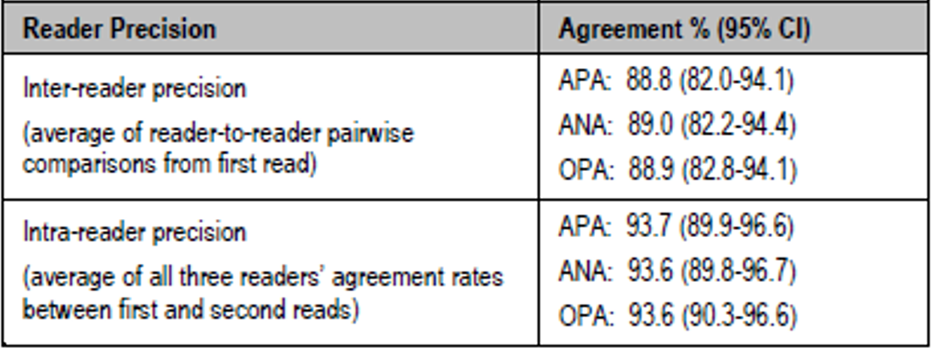
Abbreviations: ANA = average negative agreement; APA = average positive agreement; CI = confidence interval; OPA = overall positive agreement; PD-L1 = programmed death-ligand 1.
Source: Extract of Australian Ventana SP142 package insert.
Table 27: Reader precision of Ventana PD-L1 (SP142) assay staining of non-small cell lung cancer specimens (PD-L1 expression ≥ 1% tumour cell or 1% immune cell)
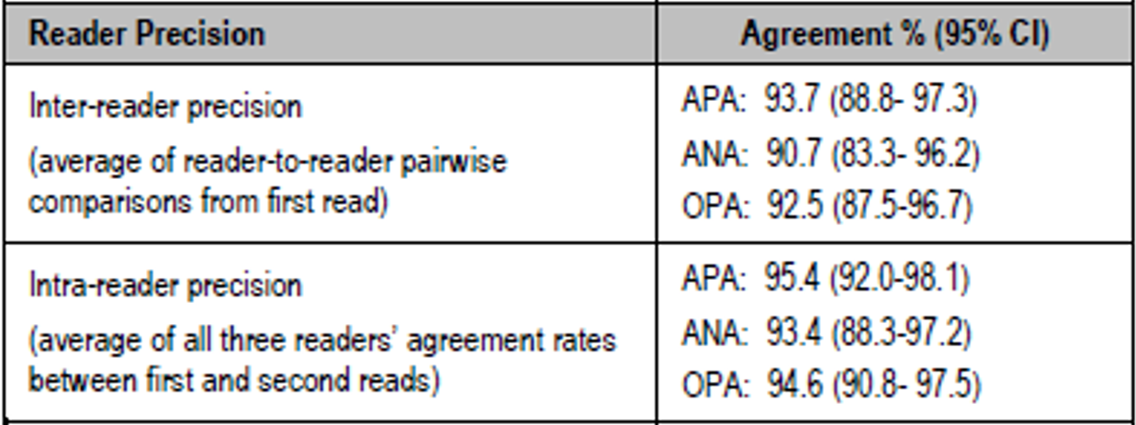
Abbreviations: ANA = average negative agreement; APA = average positive agreement; CI = confidence interval; OPA = overall positive agreement; PD-L1 = programmed death-ligand 1.
Source: Extract of Australian Ventana SP142 package insert.
The Blueprint study was a larger PD-L1 scoring reliability study of 24 experienced pulmonary pathologists (International Association for the Study of Lung Cancer Pathology Committee members) from 15 countries across five continents, who were all given additional training that was particularly focussed on IC scoring using SP142–stained cases and the SP142 IC scoring algorithm. This study found that scoring IC staining remains challenging, even for such experienced pathologists, after specific additional training. It demonstrated poor rates of interobserver agreement for assessment of PD-L1 staining on ICs, particularly between the non-zero IC categories. The authors concluded that the results ‘emphasize the significant challenges in incorporating IC score into routine clinical testing’.
This complexity raises concerns about the reliability of the SP142 diagnostic in the community for identification of IC3 scoring. As this is a co-dependent technology for the proposed indication, it is not clear that the SP142 test has sufficient real world inter-observer reliability to be considered an acceptable companion diagnostic for IC scoring in NSCLC. Expert advisory committee advice is sought on this subject (see Section: Advisory Committee considerations, below).

Risk management plan
The sponsor is required to comply with product vigilance and risk minimisation requirements.
Further information regarding the TGA’s risk management approach can be found in risk management plans for medicines and biologicals and the TGA's risk management approach.

Risk-benefit analysis

Delegate’s considerations

Confounding by subsequent therapy
For all three efficacy populations (PD-L1 high, PD-L1 high-or-intermediate, and all-comers); the rates of follow-up immunotherapy received in the chemotherapy and atezolizumab arms were around 30% and around 3%, respectively.
The much higher rate of post-study immunotherapy in the chemotherapy arm than the atezolizumab arm, regardless of PD-L1 status, may have confounded the primary efficacy endpoint and underestimation of the benefit of atezolizumab compared to chemotherapy.

Primary efficacy population
The primary endpoint has been measured in a subgroup of the ITT that does not match stratification: the TC3 and/or IC3 population. See Section: Complexity 3: changing definitions of programmed death-ligand 1 levels for both enrolment eligibility and stratification, and timing of this change.
The clinical evaluator expressed concern that this invalidates the primary efficacy endpoint. However, whilst it is not best practice, a subgroup analysis is not necessarily invalidated just because randomisation has not been stratified in alignment with that subgroup (from Tanniou et al. (2016)):
‘In general, the consensus is that the validity of a subgroup finding is improved when stratified for at randomisation (8–10, 16, 20, 21, 49, 61). Kaiser (84), on the contrary, argued that even when randomization is not stratified for the subgroup of interest, the treatment group sample sizes in a pre-specified subgroup on average attain the desired allocation fraction of the study overall.’
As outlined by Grouin et al. (2005):
‘One issue that frequently arises in regulatory work is the questionable validity of a subgroup analysis when the randomization is not stratified with respect to that subgroup (…) even when randomization is stratified with respect to the subgroup, moderate treatment imbalance within the subgroup may still be observed post hoc. Indeed, some small degree of imbalance is quite likely.
In this respect, the advantage of stratified randomization, compared with simple randomization, is to reduce the risk of getting a large imbalance that could affect irremediably the interpretation of the results and undermine their credibility. Hence, stratification is most likely to be worthwhile in subgroups of low or even moderate size rather than in large subgroups for which the risk of getting a large imbalance is lower.
It should also be added that stratification is of less interest if the subgroups are not prognostic of the primary efficacy criterion. However, many trials have multiple efficacy objectives for any of which stratification could be appropriate. In addition, when safety in subgroups is a specific major consideration, stratification could be appropriate even if it does not provide any advantage for the evaluation of efficacy.
However, in no case is stratified randomization a necessary condition for the results of a subgroup analysis to be valid. (…) A valid randomization is a necessary condition for the validity of a subgroup analysis. Stratified randomization with respect to the subgroup is not a necessary condition for the validity of the subgroup analysis, but enhances the credibility of the findings. In practice, the need for stratified randomization is less obvious for large subgroups.’
In conclusion, testing of the primary efficacy endpoint in a subgroup of the ITT population can be credible where the subgroup is clinically and scientifically justifiable, pre-specified and alpha controlled.
Further, testing of the primary endpoint in a subgroup that was not a randomisation stratum does not invalidate the result per se. However, the findings may be less credible in a subgroup in which there is imbalance of prognostic baseline characteristic due to chance, which is more likely to occur if the subgroup is small, and was not congruent with a randomisation stratum.

Imbalances in baseline characteristics
Regarding imbalances in measured characteristics in the IMPOWER110 trial (Study GO29431) more broadly, the TGA’s clinical evaluation noted:
Several of these factors potentially favour the investigational arm. While less important in large, randomised studies, when the analysis relies on a smaller subpopulation, such imbalances may lead to an overestimate of the treatment effect.
In the sponsor’s response to the TGA’s second round of clinical evaluation, the sponsor stated:
After the changes introduced in protocol version 5 (June 2016) and in the proposed protocol version 6, the sponsor sought scientific advice from the Danish Health and Medicines Agency (DHMA) (EU rapporteur) and Paul-Ehrlich-Institut (PEI) (EU co- rapporteur) in December 2016 and sought feedback from the US FDA in February 2017 on the atezolizumab 1 L NSCLC program, including on the impact assessment of change in stratification levels of PD-L1 status for the IMPOWER110 trial. DHMA and PEI did not see any major risks or express concerns about potential inconsistency between the biomarker stratification factors and primary analysis population due to changes in the biomarker definition. FDA noted that, in general, the primary analysis should be based on randomization and suggested that the sponsor conduct sensitivity analyses to assess whether there were any biases due to exclusion of a subset of the randomized patients.
The objective of stratified randomization is to ensure the balance of clinical prognostic factors between the treatment arms. Although from Protocol version 5 onward, the enrolled patient population in the IMPOWER110 study was expanded from TC3 or IC3 patients to TC1/2/3 or IC1/2/3, and the stratification levels of PD-L1 status were changed accordingly, the demographics and key baseline characteristics were generally balanced between treatment arms in the TC3 or IC3-WT subpopulation. Given this balanced distribution, the sponsor did not conduct sensitivity analyses to evaluate the impact of the change in stratification levels, and FDA did not request such analyses during the filing.
Grouin et al. (2005) observe:³⁷
‘Whether or not a trial is stratified by subgroup (and other factors), and whatever approach to the analysis is planned in the protocol, the occurrence of baseline imbalance within a subgroup is frequently a major concern for investigators or regulatory assessors. Of course, this issue is not specific to this context and applies also to the overall analysis. Once again, it is worth recalling that one of the aims of randomization is to balance treatment groups across all known and unknown prognostic factors. However, balance is achieved only on the average overall possible randomizations, and given the randomization that has actually taken place, perfect balance is never (or almost never) observed post hoc. The post hoc observation of imbalances is natural and does not affect the validity of the analyses. Baseline imbalances only affect the efficiency of the statistical analyses; the larger the imbalance, the less efficient the analysis.
Obviously, if the randomization has worked properly, one should normally expect to observe, at most, moderate imbalances. But, even more severe imbalances with respect to one or more key covariates may be due to pure chance. Such severe imbalances are more likely to occur in smaller subgroups and, in some cases, the confounding between the prognostic factor and the treatment may be so great that even the adjusted results remain ambiguous or uninterpretable.
However, it should be mentioned that when there are several independent prognostic factors, random imbalances are often off-setting. This means that a random imbalance for one covariate may favor one treatment, while that for another covariate may favor another treatment. For this reason, the imbalances can offset one another and thereby lead to overall estimates which do not differ greatly from what might be expected with balance.
Thus, checking baseline balance of treatment in key subgroups is important, whether or not the randomization is stratified. The homogeneity of the treatment group baseline characteristics within the subgroup should be assessed in a way similar to that in the randomized sample, [that is], it should be based essentially on clinical judgement (CPMP [Committee for Proprietary Medicinal Products]) and not on the p-value from a statistical test. The correct response to the latter would be to question the validity of the randomization process itself [Senn]. Particular attention should be paid to the most important prognostic factors (in particular, those whose adjustment is planned in the primary analysis); [that is], those for which a baseline imbalance is likely to bias the treatment effect.’
There were nine more patients (approximately 10%) treated with atezolizumab than chemotherapy in the TC3/IC3 subgroup. There were a number of imbalances of more than 5% between arms in predefined categories of baseline demographics and disease characteristics for the TC3/IC3 population (see
Table 5, above).
Imbalances potentially favouring a better prognosis for the atezolizumab arm were:
- the chemotherapy arm population were older (median age of 66 versus 63 years): 11% more of the chemotherapy arm were 65 years or older;
- 9% more of the chemotherapy arm were Stage IV at diagnosis;
- 11% more of the chemotherapy arm were current smokers;
- the chemotherapy arm had a higher baseline burden of disease: 13% more of the chemotherapy arm had a baseline sum of the longest diameters (SLD) of at least 86 cm;
- the chemotherapy arm had a higher number of metastatic sites at enrolment (mean 3.3 versus 2.9 metastatic sites); and
- the atezolizumab arm had a longer maximum time between diagnosis of metastatic disease and first dose of trial medication (51 months versus 10 months).
Imbalances potentially favouring a worse prognosis for the atezolizumab arm were:
- 9% more of the atezolizumab arm were males;
- 6% more of the atezolizumab arm were ECOG Performance Status score of 1 rather than ECOG PS of 0; and
- 7% fewer of the atezolizumab arm had never smoked.
In response to the clinical evaluator’s concerns around baseline imbalances, the sponsor provided the table reproduced below in Table 28. The table lists p-values obtained by ad hoc multivariate Cox regression analysis, for pre-specified baseline factors that were imbalanced by at least 5% between treatment arms.
Table 28: IMPOWER110 trial (Study GO29431) Sponsor’s ad hoc sensitivity analysis; ‘p-value for interaction with treatment by unstratified multivariate Cox regression’
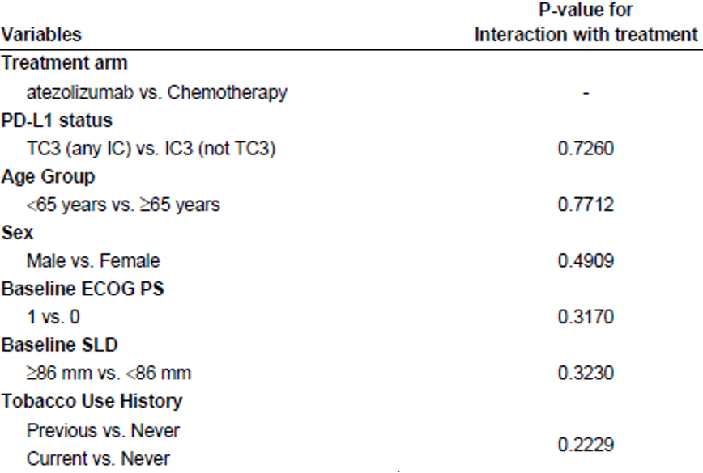
Abbreviations: ECOG = Eastern Cooperative Oncology Group; IC = immune cell; PD-L1 = programmed death-ligand 1; PS = Performance Status; SLD = sum of longest diameters; TC = tumour cell; vs = versus.
Whilst the p-values indicate that analysis of this dataset could not detect treatment effects for these co-variates, it does not mean that the co-variates are not correlated with survival. Indeed, as above, many of these co-variates such as ECOG Performance Status, age and smoking cessation, are known to correlate with survival.
The failure of this dataset to demonstrate the relationship is not surprising, given its limited size. As Bradburn et al. (2003) note:
‘Any estimate based on a small number of individuals will be less reliable than one based on a larger number, and when multivariate models are fitted to small datasets, the estimated impact of the covariates is too imprecise to give reliable answers.
…smaller data sets may not have sufficient power to detect a covariate that has a significant impact on survival.’
Stage at presentation is the strongest predictor of prognosis in NSCLC;³⁸ and was not included in the Cox regression analysis. Baseline burden of disease was also not included.
To address whether the results could have been skewed by patients with a long time between diagnosis of metastatic disease and first dose of trial medication (who might have more indolent disease), a line listing of patients with longer than 6 months duration between time of metastatic diagnosis and time of first study treatment was provided (see Table 29, below). There were more of these patients in the atezolizumab arm than the chemotherapy arm, but a long overall survival time was not a consistent finding for all of these patients. That is, there was not a clear correlation with long overall survival time and long duration between metastatic diagnosis and first study treatment dose.
Table 29: IMPOWER110 trial (Study GO29431) Line listing of patients in the TC3/IC3 population who had their first dose of study treatment later than 6 months after their diagnosis with metastatic disease.
PID | Time between metastatic disease diagnosis and first dose in trial (months) | Confirmed best overall response | Progression free survival (months) | Progression free survival event (yes/no) | Overall survival (months) | Overall survival event (yes/no)
Chemotherapy arm
P1 | 9.9 | SD | 4.2 | Yes | 18.6 | No
Atezolizumab arm
P2 | 6.4 | PR | 17.5 | Yes | 17.5 | Yes
P3 | 9.5 | NE | 2.4 | Yes | 2.4 | Yes
P4 | 33.8 | PD | 2.6 | Yes | 18.0 | No
P5 | 23.2 | SD | 2.8 | Yes | 2.8 | Yes
P6 | 6.5 | SD | 5.6 | Yes | 18.2 | Yes
P7 | 50.8 | SD | 15.2 | No | 16.6 | No
P8 | 7.7 | PD | 1.4 | Yes | 5.2 | Yes
Abbreviations: IC = immune cell; NE = not evaluable; P = Patient; PD = progressive disease; PID = patient identification; PR = partial response; SD = stable disease; TC = tumour cell.
Patient IDs have been anonymised.
Immune cell scoring (PD-L1 expression): IC0 (0 to < 1%); IC1 (1 to < 5%); IC2 (5 to <10%); IC3 (10%+).
Tumour cell scoring (PD-L1 expression): TC0 (0 to <1%); TC1 (1 to < 5%); TC2 (5 to < 50%); TC3 (50%+).
An exploratory sensitivity analysis of overall survival was performed, excluding the three patients (all in the atezolizumab arm) who had durations longer than 10 months between diagnosis of metastatic disease and time of first study treatment (reproduced in Table 30, below).
Table 30: IMPOWER110 trial (Study GO29431) A sensitivity analysis of overall survival in the TC3/IC3 population, excluding patients with more than 10 months between diagnosis of metastatic disease and start of study medication
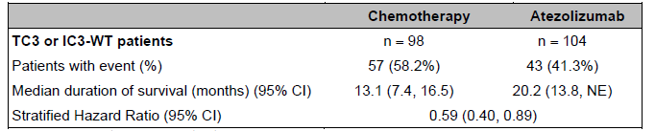
Abbreviations: CI = confidence interval; IC = immune cell; N = total number of subjects; n = numbers of subjects in group; NE = not estimable; TC = tumour cell.
Immune cell scoring (PD-L1 expression): IC0 (0 to < 1%); IC1 (1 to < 5%); IC2 (5 to <10%); IC3 (10%+).
Tumour cell scoring (PD-L1 expression): TC0 (0 to <1%); TC1 (1 to < 5%); TC2 (5 to < 50%); TC3 (50%+).
Overall, the observed baseline imbalances in the TC3/IC3 population are in the realm of what could be expected to occur by chance in what is a reasonably small subgroup of a larger randomised population (approximately 100 in each arm). The imbalances are not of a magnitude that would call into question the integrity of the randomisation process. Individually, they are not likely to entirely explain the difference between the two arms. However, cumulatively they do add uncertainty to the interpretation of the study results. Stage at presentation and baseline burden of disease have not been addressed.

Good Clinical Practice
Due to the timing and scope of major protocol amendments that changed the primary efficacy population of the IMPOWER110 trial (Study GO29431), the European Medicines Agency (EMA) undertook a triggered Good Clinical Practice (GCP) inspection. The inspection reports were provided by the sponsor at TGA’s request, for consideration. A number of concerns were raised by the inspectors in their inspection report, which stated:
‘Based on the pattern of major and critical findings in the study, which revealed violations of fundamental principles of ICH-GCP, articles 2.10; 2.13; and 8; in particular, the study overall is not considered GCP compliant, especially when it comes to sponsors’ responsibilities (…)
During the sponsor inspection a number of serious deviations from GCP compliance have been detected, especially concerning TMF and production of essential documents, clinical data management, computer systems and sponsor oversight.’
However, the concerns relating to the sponsor’s responsibilities were not considered to apply to the investigator sites:
‘The clinical conduct at the inspected investigator sites is considered GCP compliant (…) it is the opinion of the inspection team that both investigator sites have worked relatively well in compliance with GCP and it is unlikely that the observed deviations or inconsistencies between the source data and the data in the CSR would have a major negative impact on the reliability of the data from the inspected clinical sites.’
In March 2021, the EMA CHMP issued a positive opinion for the application to be authorised for marketing. In the CHMP rapporteurs joint assessment report, the rapporteurs concluded:²⁰
‘The MAH (market authorisation holder) has provided an explanation and clarification for the chain of events that led to the changes of the testing hierarchy of the results of IMPOWER110. This now seems overall plausible and scientifically based that external data did lead to the decision to introduce the changes to the protocol etc. The practice of changing the primary endpoint and hierarchical testing in an ongoing open-label study is still criticized and the MAH should refrain from this approach in future open-label clinical studies. GCP issues should also be addressed as recommended in the GCP inspection report and the MAH can expect that in future applications, there will be continued focus on GCP compliance.’
In alignment with the CHMP’s final position, the Delegate does not consider the GCP concerns a barrier to Australian registration of this indication.

Early mortality
In the IMPOWER110 trial (Study GO29431), early crossing of the Kaplan-Meier overall survival curves demonstrates that there is a survival detriment for patients treated with atezolizumab compared to chemotherapy during the first few months of therapy. This phenomenon has been seen in a number of trials in which monotherapy or immunotherapy-only arms were compared to a chemotherapy-containing regimen, and may be related to a slower onset of effect with immunotherapy.
Interestingly, whilst this was seen in the pembrolizumab KEYNOTE-042 trial; in patients with a tumour proportion score ≥ 1% (per 22C3), it was not demonstrated in the KEYNOTE-024 trial (as per the approved pembrolizumab PI) in patients with a tumour proportion score of ≥ 50% (per 22C3). The reason that early mortality was not seen in this PD-L1 high population in KEYNOTE-024, but was demonstrated in the PD-L1 high (defined as TC3/IC3) population in the IMPOWER110 trial (Study GO29431) is not clear.
The current standard-of-care first line regimens for NSCLC without driver mutations (such as EGFR/ALK) are not associated with a higher risk of early mortality, as the regimens include a short course of chemotherapy along with the immunotherapy agent(s) (see Figure 5). These regimens were not standard-of-care at the time of trial design of the IMPOWER110 trial.
Figure 5: IMPOWER130 trial Kaplan-Meier plot for overall survival with atezolizumab (Tecentriq) plus platinum-based chemotherapy versus chemotherapy alone
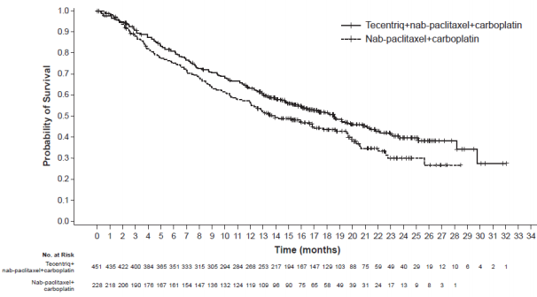
Extract from the current (as of 27 October 2020) Tecentriq (atezolizumab) Roche Products Australia Pty Ltd Australian Product Information.
As is the case for other regimens with which this phenomenon has been seen, there is no way to determine a priori which patients are at risk of early death with atezolizumab monotherapy treatment compared to a chemotherapy-containing protocol. Attempts at identifying the group of patients who are subject to a survival detriment with immunotherapy-alone regimens have found some trends but have been non-definitive.
Clinically, the presence of the early mortality signal in the IMPOWER110 trial (Study GO29431) does not necessarily mean atezolizumab could not be considered a reasonable treatment option for some patients, because although the standard-of-care regimens do not demonstrate risk of early mortality, there may be patients who are not be eligible for or do not accept the chemotherapy component (usually for toxicity reasons). The safety profile of atezolizumab monotherapy in the IMPOWER110 trial (Study GO29431) indicates it to be a regimen with a different safety profile and overall less toxicity than platinum-based chemotherapy. For patients seeking a low-toxicity option, or considered not candidates to receive chemotherapy, the improved safety profile of atezolizumab monotherapy over chemotherapy could render it an acceptable option, despite an initial risk of early mortality (relative to chemotherapy-containing regimens).
The external validity of the IMPOWER110 trial (Study GO29431) data to describe treatment of patients who refuse (or are considered unfit for) a standard-of-care immunotherapy-plus-chemotherapy regimen is limited in that all enrolled patients were considered suitable candidates for chemotherapy treatment. Additionally, the median age of patients enrolled was 63 to 66. The median age of lung cancer diagnosis in Australia, by contrast, is around 71 years. The safety profile of atezolizumab monotherapy in Australian clinical practice may be worse in a real-world, less clinically robust population than what was observed in the IMPOWER110 trial (Study GO29431).
Overall, the risk of early mortality for a poorly defined group of patients is considered a risk of this regimen by comparison to chemotherapy and should be noted in the clinical trials section of the PI, if approved.

Immunogenicity
As described in the current atezolizumab PI, anti-drug antibodies (ADAs) against atezolizumab are known to occur with treatment in reasonably large proportions of patients (usually around 30%, with a range of 13% to 48%), in the pivotal trials that have supported approved indications.
The question of the relevance of ADAs to the safe and effective use of atezolizumab across indications is an ongoing issue. Exploratory analyses have been conducted with multiple atezolizumab datasets, and a number of these are currently being assessed through a separate submission to the TGA (Submission PM-2020-01859-1-4). At the time of writing a final decision on PI content is pending. To date, firm conclusions have been prevented by the nature of the analyses, including their exploratory, post-hoc nature, the attendant baseline imbalances that come with such subgroup analyses, and a lack of power.
Associations remain unconfirmed, but concerns have been sufficiently strong to support inclusion of the exploratory results in the Product Information (under ‘Immunogenicity’, in Section 4.8 Adverse effects) in the case of two clinical trials (the OAK trial (Study GO28915);, and the IMbrave150 trial (Study YO40245);, noting a suggested association in these two trials between poorer survival and the presence of ADAs at Weeks 4 and 6, respectively. In all five registration pivotal trials (the above two, plus the IMPOWER150 trial (Study GO29436); IMvigor210 trial (Study GO29293 (Cohorts 1 and 2));, and IMpassion130 (Study WO29522); an association was seen between ADAs and decreased systemic drug exposure. However, an association with toxicity differences has not been drawn by TGA for any of the five studies.
The current (as of April 2021) EMA Summary of Product Characteristics (SmPC) includes the following text:
Across multiple Phase III studies, 13.1 % to 36.4% of patients developed treatment-emergent anti-drug antibodies (ADAs). Across pooled datasets for patients treated with atezolizumab monotherapy (N=2705) and with combination therapies (N = 2285), the following rates of adverse events (AEs) have been observed for the ADA-positive population compared to the ADA-negative population, respectively: Grade 3-4 AEs 49.1% vs. 44.3%, Serious Adverse Events (SAEs) 42.4% vs. 37.6%, AEs leading to treatment withdrawal 6.1% vs 6.7% (for monotherapy); Grade 3-4 AEs 63.9% vs. 60.9%, SAEs 43.9% vs. 35.6%, AEs leading to treatment withdrawal 22.8% vs 18.4% (for combination therapy). However, available data do not allow firm conclusions to be drawn on possible patterns of adverse drug reactions.
As noted in Section: Population pharmacokinetics, in the pivotal trial for the current submission (IMPOWER110 trial (Study GO29431)), exposure in ADA-positive patients was statistically significantly lower than in ADA-negative patients, according to the popPK analysis. However, the mean minimum concentration (C_{min}) in the ADA-positive subjects appeared to be above the target trough concentration of 6 µg/mL (mean 62 µg/mL (standard deviation, 23), geometric mean 57 µg/mL (coefficient of variance (CV) 50%).
Regarding efficacy, the clinical study report for the IMPOWER110 trial (Study GO29431) concludes (page 208):
For both PFS-INV (progression free survival per investigator) and OS (overall survival), the percentage of patients with events was numerically higher for ADA-positive patients, and the median time to event was shorter (Table 66). The proportion of responders was numerically lower in the ADA-positive subgroup compared with ADA-negative. The small number of ADA-positive patients in the TC3 or IC3-WT ADA evaluable population and the observed baseline demographic and disease characteristics imbalances between the ADA subgroups for this population confound the interpretation of the data and preclude a definitive conclusion on the impact of ADA on efficacy.
Definitive conclusions are precluded by the very small size of the ADA-positive subgroup (n = 23) and the post-randomisation nature of the analysis, with attendant imbalances in baseline characteristics (see Section: Immunogenicity results). The EMA requested an adjusted analysis to account for baseline characteristics, but the sponsor’s response was “
‘Given the limited number of ADA positive patients, no adjusted analyses were performed.’
Despite shorter exposure, exploratory analysis indicates higher rates of toxicity appear to have occurred in the ADA-positive subgroup than the ADA-negative subgroup (see Table 15, above). However, the toxicity profile of atezolizumab in the ADA-positive patients still appears to be favourable compared to the toxicity profile of chemotherapy.
It is noted that mean C_{min} was above the target trough concentration for both ADA subgroups, but whether the statistically significant difference in clearance between ADA-positive and ADA-negative patients is clinically meaningful can’t be determined from the available data. There is biological plausibility for ADAs to alter drug efficacy, and there have been previous signals for altered efficacy with ADA positivity in other studies of atezolizumab (OAK, and IMbrave150 trials).^{51,53} The lack of ability to draw definitive conclusions from this exploratory analysis is therefore not reassuring, and generates a signal of concern, that contributes to uncertainty around the benefit-risk balance for this indication.
Consideration should to be given to better ways to assess the effect of ADAs on efficacy in future trials, knowing that sample sizes may preclude meaningful conclusions and that this is a recurring concern for this drug.
The Delegate agreed with the EMA rapporteurs’ conclusion that, if this indication is to be approved, the incidence of ADAs in the IMPOWER110 trial and the exploratory data suggesting a possible effect on efficacy should be adequately reflected in product information documents.²⁰ Advisory committee advice is sought as to whether the current communication of this information is adequate.

Sensitivity of the Ventana SP142 assay
The Ventana SP142 assay has lower sensitivity than other PD-L1 tests on the market.
A statistically significant efficacy benefit was only demonstrated in the IMPOWER110 trial (Study GO29431) for the population with PD-L1 expression at the highest (TC3/IC3) level.
Patients with a tumour proportion score of > 1% according to 22C3 are eligible for a TGA approved anti-PD(L)1 monotherapy treatment, although the efficacy in patients with tumour proportion score of 1 to 49% (compared to platinum-based chemotherapy) is less clear than for those with tumour proportion score > 50%.
Given the above three statements, the implication of SP142 being the companion diagnostic for the proposed indication is that there will be a subset of tumour samples that are not considered TC3/IC3 by SP142, but that would have been considered PD-L1 positive if their sample had been tested using 22C3. The patients from whom these samples were taken would miss out on the treatment option of a monotherapy PD-(L)1 inhibitor.
From the ITT population in the IMPOWER110 trial (Study GO29431 (n = 572)), 205 patients were TC3/IC3, leaving 367 patients whose tumour samples were not scored positive at the TC3/IC3 cut-off. Of these patients, 108 (29%) would have been classified as PD-L1 high if tested by 22C3 instead of SP142 and 128 (35%) would have been classified as PD-L1 high if tested by SP263 instead of SP142 (see Table 10). The exploratory efficacy analysis in Table 10 was requested to explore efficacy in such patients, but the small numbers and wide confidence intervals prevent meaningful conclusions. Additionally, a subset of patients that are 22C3 positive, but SP142 negative (TC0/1/2 or IC0/1/2 during protocol version 1-4; TC0 and IC0 during protocol versions 5+) would not have been enrolled in the study, as SP142 was used as the entry test. The size of this ‘missing’ population, their 22C3 positivity rates and the efficacy of atezolizumab in this population are unknown, and prevent meaningful inference of the analysis in Table 10.
Conversely, a patient could miss out on the treatment option of a monotherapy PD-(L)1 inhibitor if their tumour sample was tested with 22C3 and was not positive (tumour proportion score ≥ 1%), but would have been TC3 or IC3 on SP142. All such patients should have been enrolled in the IMPOWER110 trial (Study GO29431), so there is no missing population. However, the numbers of patients is very small: 13 patients out of 198 across both arms (less than one percent), preventing meaningful interpretation of this subgroup result (see tumour proportion score (TPS) < 1% row, of Table 9).
The data presented in Table 18 and Figure 4 do not raise an overt signal for lack of efficacy in TC3/IC3 positive patients whose tumours were only positive based on IC staining per SP142 (TC0 and IC3). Again, though, small numbers (n = 29 across both arms) hamper meaningful interpretation, and it is not clear whether these patients would have been positive on 22C3.
The use of SP142 as a companion diagnostic is likely to exclude a group of patients from falling within the registered Australian indications for a monotherapy PD-(L)1 inhibitor, but the size of the group and what clinical detriment would be conferred by this is not able to be determined from the available data.

Delegate’s conclusions
The treatment landscape has changed since the IMPOWER110 trial (Study GO29431) was designed, and a direct comparison to current standard-of-care therapy (pembrolizumab monotherapy in patients with high PD-L1, or immunotherapy plus chemotherapy for others without driver mutations) is not available.
For patients judged to be TC3/IC3 according to SP142 in the IMPOWER110 trial, treatment with atezolizumab monotherapy was associated with longer survival and a favourable toxicity profile, compared to platinum doublet chemotherapy. Uncertainty in interpreting the findings of IMPOWER110 is introduced by:
- Imbalances of prognostic baseline characteristics between arms: these have not been entirely addressed and may have somewhat biased the findings, though they are probably not of sufficient magnitude to entirely explain the primary efficacy outcome of the study.
- A risk of early mortality compared to chemotherapy, which is not a barrier to registration but is not present for the current preferred standard-of-care therapy for patients with high PD-L1 expression according to 22C3 testing, and would require labelling.
A number of more significant issues complicate the interpretation of the benefit-risk balance for approval of this indication on the basis of the findings of the IMPOWER110 trial:
- Exploratory analyses raise concerns around poorer efficacy and safety for patients who develop anti-drug antibodies. These trends have been seen repeatedly across trials, and this remains an unresolved concern.
- Published data indicates poor inter-observer reliability of IC3 assessment using the proposed SP142 companion diagnostic in real-world circumstances.³⁴
- As SP142 is less sensitive than 22C3, approval of an atezolizumab monotherapy indication with the SP142 companion diagnostic would exclude a cohort of patients from eligibility for PD-(L)1 inhibitor monotherapy as a treatment option. The excluded cohort is made up of three groups:
  - Patients who would have been tumour proportion score ≥ 50% based on 22C3:
    - These patients would possibly be over-treated with addition of chemotherapy, and subjected to unnecessary toxicity.
    - The data in Table 10 is not sufficiently robust to assess this uncertainty.
  - Patients who would have been classified as tumour proportion score between 1% and 50% based on 22C3 or another PD-L1 test:
    - There is not likely to be a clinical detriment to such patients, as PD-(L)1 inhibitor monotherapy is not considered the preferred standard-of-care regimen in this space: it entails a risk of early mortality and the clinical benefit is not as clear compared to chemotherapy + immunotherapy regimens.
  - Patients in either of the above categories who are not eligible or willing to have a standard-of-care treatment that includes platinum-based chemotherapy:
    - These patients could miss out on the opportunity for treatment altogether, being unable/unwilling to have chemotherapy and being considered ineligible for immunotherapy.
  - Use of monotherapy anti-PD(L)1 in such patients has not been directly studied but would expect to be supported by the data from trials enrolling chemo-eligible/willing patients.
  - It remains unknown whether patients with the lowest level of PD-L1 expression (according to staining intensity) derive the same level of benefit from anti-PD-1/PD-L1 checkpoint inhibitors compared to the patients with higher PD-L1 expression levels.
These uncertainties, collectively, are clinically meaningful in considering the risk-benefit balance for this indication.

Proposed action
While a decision is yet to be made, at this stage the Delegate was inclined to approve the registration of the product if the uncertainties around the risk-benefit balance can be adequately managed, for example, through sufficient communication in the PI.

Advisory Committee considerations
The Advisory Committee on Medicines (ACM) having considered the evaluations and the Delegate’s overview, as well as the sponsor’s response to these documents, advised the following.

Specific advice to the Delegate
- Regarding anti-drug-antibodies (ADAs):
- Does the scope and location of text in the current Australian atezolizumab Product Information document adequately convey the uncertainty around the risk-benefit balance for patients with anti-drug antibodies?
The ACM considered the text proposed in the sponsor’s pre-ACM response to be reasonable, with the exception of the statement that ‘the ADA-positive subgroup derives meaningful overall survival benefit from atezolizumab treatment compared to control.’ The ACM did not discuss removal of the existing study-specific text.
- If not, can the committee comment on alternative approaches to communication of this uncertainty in the regulatory context?
The ACM supported inclusion of a warning or precaution statement regarding ADAs. The ACM also advised that further investigation by the sponsor should be requested, as ADAs are not adequately characterised.
- The IMPOWER110 trial (Study GO29431) used the companion diagnostic SP142 test to identify a population in whom this medicine was effective. Published data indicate poor inter-observer precision for higher levels of IC PD-L1 staining (that is, IC3) amongst specifically trained pathologists (see Hirsch et al. (2017); and Tsao et al. (2018))?
- Does the IMPOWER110 trial (Study GO29431) have adequate external validity in terms of being able to predict benefit for patients with IC3 according to the SP142 assay in the Australian clinical setting (including rural and remote settings)?
The ACM was of the view that the competence and processes within Australian laboratories are high across multiple settings and are not of specific concern. However, the major concern is about the quality of the test, rather than the settings.
The ACM advised that the SP142 assay demonstrated poor concordance between pathologists; even between expert pulmonary pathologists with specific training in scoring IC using SP142 and hence determining IC3. Therefore, SP142 provides poor reliability to predict response to treatment. The ACM considered that there is no evidence that training can be used to overcome this poor reproducibility. The ACM advised that other PD-L1 assays cannot be used interchangeably with SP142, as this usage is not supported by robust trial data and they identify different populations.
The ACM noted that 22C3 and SP263 are widely used for testing of PD-L1 in Australian NSCLC samples, and identify a larger PD-L1-positive population for checkpoint inhibitor monotherapy as a treatment option than SP142 would. Presumably, using these tests rather than SP142 would give oncologists more flexibility in treatment decisions regarding monotherapy versus combined chemotherapy/immune-checkpoint inhibitor (ICI) in the absence of a direct comparison between atezolizumab and pembrolizumab monotherapy. The ACM therefore considered the proposed indication to have minimal clinical relevance in Australia.
- Do the validation and precision studies described in the SP142 device documentation provide reassurance regarding inter-observer reproducibility?
The ACM advised that the PI for the Ventana SP142 PD-L1 assay only provides data on the Ventana Reader Precision Study, which assessed the overall assay but did not provide data on TC and IC reproducibility separately. The data provided is reassuring in that overall concordance is similar to concordance of other PD-L1 immunohistochemistry (IHC) assays in clinical use, but insufficient to address concerns raised from all other independent studies in NSCLC regarding reproducibility of IC scoring. The ACM was of the view that the SP142 test gives inferior results and should be avoided.

Conclusion
The proposed indication considered by the ACM was:
Tecentriq as monotherapy is indicated for the first-line treatment of patients with metastatic NSCLC whose tumours have a PD-L1 expression ≥ 50% tumour cells (TC) or ≥ 10% tumour-infiltrating immune cells (IC) and who do not have EGFR or ALK genomic tumour aberrations.
The ACM concluded that Tecentriq had an overall negative benefit-risk profile for the proposed indication as the evidence submitted did not satisfactorily establish the quality and safety of the product for the proposed usage.
The ACM expressed significant concerns regarding the uncertainty of PD-L1 diagnostic testing using the SP142 antibody (particularly the reliability of the immune cell component), which is a companion diagnostic in this medicine application.

Outcome
The sponsor withdrew their submission on 22 July 2021 before a decision had been made by the TGA.

Therapeutic Goods Administration
PO Box 100 Woden ACT 2606 Australia
Email: info@tga.gov.au Phone: 1800 020 653 Fax: 02 6232 8605
https://www.tga.gov.au

World Health Organization - Globocan (2018). Factsheet for lung cancer. Available at: https://gco.iarc.fr/today/data/factsheets/cancers/15-Lung-fact-sheet.pdf.
Walters, S. et al. Lung Cancer Survival and Stage at Diagnosis in Australia, Canada, Denmark, Norway, Sweden and the UK: a Population-Based Study, 2004-2007, Thorax, 2013; 68(6): 551-564.
Lilenbaum, R.C. (2020) Systemic Chemotherapy for Advanced Non-small Cell Lung Cancer. Last updated 4 February 2020. Available at: https://www.uptodate.com/contents/systemic-chemotherapy-for-advanced-non-small-cell-lung-cancer.
Hellman, M. and West, H.J. (2020). Management of Advanced Non-small Cell Lung Cancer Lacking a Driver Mutation: Immunotherapy, Last updated 25 June 2020. Available at: https://www.uptodate.com/contents/management-of-advanced-non-small-cell-lung-cancer-lacking-a-driver-mutation-immunotherapy.
Wagner, G. et al. Efficacy and Safety of Immune Checkpoint Inhibitors in Patients with Advanced Non-small Cell Lung Cancer (NSCLC): A Systematic Literature Review, Oncoimmunology, 2020; 9(1): 1774314.
The Dako PD-L1 IHC 22C3 pharmDx is a qualitative immunohistochemical assay using monoclonal mouse anti-PD-L1, Clone 22C3, intended for use in the detection of PD-L1 protein in formalin-fixed, paraffin-embedded (FFPE) non-small cell lung cancer (NSCLC), urothelial carcinoma, esophageal cancer, head and neck squamous cell carcinoma (HNSCC), triple-negative breast cancer (TNBC), cervical cancer, and melanoma tissues using EnVision FLEX visualization system on Autostainer Link 48. PD-L1 IHC 22C3 pharmDx (Instructions for Use). Santa Clara, CA: Agilent Technologies, Inc.; 2022.
Hanna, N.H. et al. Therapy for Stage IV Non-small-cell Lung Cancer without Driver Alterations: ASCO and OH (CCO) Joint Guideline Update, J Clin Oncol, 2020; 38(14): 1608-1632.
Approved Australian Product Information for pembrolizumab (Keytruda), dated February 2021.
AusPAR for Tecentriq (atezolizumab) new biological entity, published on 3 October 2018. Available at: https://www.tga.gov.au/auspar/auspar-atezolizumab.
A Study of Atezolizumab (MPDL3280A) Compared with a Platinum Agent (Cisplatin or Carboplatin) + (Pemetrexed or Gemcitabine) in Participants with Stage IV Non-squamous or Squamous Non-small Cell Lung Cancer (NSCLC) (IMpower110). ClinicalTrials.gov Identifier: NCT02409342; Study ID: GO29431; EudraCT Number: 2014-003083-21. Available at: https://clinicaltrials.gov/ct2/show/NCT02409342.
The Response Evaluation Criteria In Solid Tumours (RECIST) is a voluntary international standard with unified and easily applicable criteria to define when a patient's tumour has improved ('respond'), stayed the same ('stabilise'), or worsened ('progress') during treatment. The criteria were published in February 2000 by an international collaboration including the European Organisation for Research and Treatment of Cancer (EORTC), National Cancer Institute (NCI) of the United States, and the National Cancer Institute of Canada Clinical Trials Group. Today, the majority of clinical trials evaluating cancer treatments for objective response in solid tumours use RECIST. These criteria were developed and published in February 2000, and subsequently updated in 2009.
Barlesi, F. et al. Primary Analysis from OAK, a Randomized Phase III Study Comparing Atezolizumab with Docetaxel in 2L/3L NSCLC (abstract). European Society of Medical Oncology Meeting 2016: abstract LBA44 PR.
Borghaei, H. et al. Nivolumab Versus Docetaxel in Advanced Nonsquamous Non-small-cell Lung Cancer, N Engl J Med, 2015; 373: 1627-1639.
Herbst, R.S. et al. Pembrolizumab Versus Docetaxel for Previously Treated, PD-L1-Positive, Advanced Non-small-cell Lung Cancer (KEYNOTE-010): a Randomized Controlled Trial, Lancet, 2016; 387: 1540-1550.
Eastern Cooperative Oncology Group (ECOG) Performance Status: The ECOG has developed criteria used by doctors and researchers to assess how a patient's disease is progressing, assess how the disease affects the daily living abilities of the patient, and determine appropriate treatment and prognosis. The following are used: 0 - Fully active, able to carry on all pre-disease performance without restriction 1- Restricted in physically strenuous activity but ambulatory and able to carry out work of a light or sedentary nature, for example, light house work, office work 2 - Ambulatory and capable of all selfcare but unable to carry out any work activities. Up and about more than 50% of waking hours 3 - Capable of only limited selfcare, confined to bed or chair more than 50% of waking hours 4 - Completely disabled. Cannot carry on any selfcare. Totally confined to bed or chair 5 – Dead
Randomised clinical trials analysed by the intent-to-treat (ITT) approach provide the unbiased comparisons among the treatment groups. In the ITT population, none of the patients are excluded and the patients are analysed according to the randomisation scheme.
Liu, C. et al. Association of Time-varying Clearance of Nivolumab with Disease Dynamics and Its Implications on Exposure Response Analysis, Clin Pharmacol Ther, 2017; 101(5): 657-666.
Li, H. et al. Time Dependent Pharmacokinetics of Pembrolizumab in Patients with Solid Yumor and Its Correlation with Best Overall Response, J Pharmacokinet Pharmacodyn, 2017; 44(5): 403-414.
Tecentriq (atezolizumab) label, revised December 2020. Available at: https://www.accessdata.fda.gov/drugsatfda_docs/label/2020/761034s031s032lbl.pdf.
European Medicines Agency (EMA), Committee for Medicinal Products for Human Use (CHMP) rapporteurs joint assessment report, after two rounds of questions and answers, supplied by sponsor to TGA for reference.
Akazawa, K. et al. Power of Logrank Test and Cox Regression Model in Clinical Trials with Heterogeneous Samples, Stat Med, 1997; 16: 583-597.
The Medical Dictionary for Regulatory Activities (MedDRA) is a single standardised international medical terminology, developed as a project of the International Council for Harmonisation of Technical Requirements for Pharmaceuticals for Human Use (ICH) which can be used for regulatory communication and evaluation of data pertaining to medicinal products for human use. As a result, MedDRA is designed for use in the registration, documentation and safety monitoring of medicinal products through all phases of the development cycle (that is, from clinical trials to post-marketing surveillance). Furthermore, MedDRA supports ICH electronic communication within the ICH’s Electronic Common Technical Document (eCTD) and the E2B Individual Case Safety Report.
Horn, L. et al. Safety and Clinical Activity of Atezolizumab Monotherapy in Metastatic Non-small-cell Lung Cancer: Final Results from a Phase I Study, Eur J Cancer, 2018; 101: 201-209.
Kowanetz, M. et al. Differential Regulation of PD-L1 Expression by Immune and Tumor Cells in NSCLC and the Response to Treatment with Atezolizumab (Anti-PD-L1), Proc Natl Acad Sci USA, 2018; 115(43): E10119-E10126.
Kowanetz, M. et al. Differential Regulation of PD-L1 Expression by Immune and Tumor Cells in NSCLC and the Response to Treatment with Atezolizumab (Anti-PD-L1), Proc Natl Acad Sci USA, 2018; 115(43): E10119-E10126.
Carbone, D.P. et al. First-line Nivolumab in Stage IV or Recurrent Non-small-cell Lung Cancer, N Engl J Med, 2017; 376(25): 2415-2426.
Mok, T.S.K. et al. Pembrolizumab versus Chemotherapy for Previously Untreated, PD-L1-expressing, Locally Advanced or Metastatic Non-small-cell lung Cancer (KEYNOTE-042): a Randomised, Open-label, Controlled, Phase 3 Trial, Lancet, 2019; 393(10183): 1819-1830.
Rizvi, N.A. et al. Durvalumab with or without Tremelimumab vs Standard Chemotherapy in First-line Treatment of Metastatic Non-small Cell Lung Cancer: The MYSTIC Phase 3 Randomized Clinical Trial, JAMA Oncol, 2020; 6(5): 661-674.
Good Clinical Practice (GCP) is a code of international standards and guidance following the International Council on Harmonisation (ICH) concerning the design, conduct, performance, monitoring, auditing, recording, analysis and reporting of clinical trials. Good Clinical Practice provides assurance that a study’s results are credible and accurate and that the rights and confidentiality of the study subjects are protected.
Since updated. See Table 1: International regulatory status, above.
Hirsch, F.R. et al. PD-L1 Immunohistochemistry Assays for Lung Cancer: Results from Phase 1 of the Blueprint PD-L1 IHC Assay Comparison Project, J Thorac Oncol, 2017; 12: 208-222.
Xu, H., et al. Assessment of Concordance between 22C3 and SP142 Immunohistochemistry Assays Regarding PD-L1 Expression in Non-small Cell Lung Cancer, Sci Rep, 2017; 7(1): 16956.
Torlakovic, E. et al. “Interchangeability” of PD-L1 Immunohistochemistry Assays: a Meta-analysis of Diagnostic Accuracy, Mod Pathol, 2020; 33(1): 4-17.
Tsao, M.S. et al. PD-L1 Immunohistochemistry Comparability Study in Real-life Clinical Samples: Results of Blueprint Phase 2 Project, J Thorac Oncol, 2018; 13(9): 1302-1311.
Programmed death-ligand 1 (PD-L1) positive subgroup definitions: PD-L1 high = TC3/IC3; PD-L1 intermediate = TC2/IC2 (and not TC3 or IC3); PD-L1 low = TC1/IC1 (and not TC2/3 or IC2/3). PD-L1 negative: TC0 and IC0. Immune cell scoring (PD-L1 expression): IC0 (0 to < 1%); IC1 (1 to < 5%); IC2 (5 to <10%); IC3 (10%+). Tumour cell scoring (PD-L1 expression): TC0 (0 to <1%); TC1 (1 to < 5%); TC2 (5 to < 50%); TC3 (50%+).
Tanniou, J. et al. Subgroup Analyses in Confirmatory Clinical Trials: Time to be Specific about Their Purposes, BMC Med Res Methodol, 2016; 16: 20.
Grouin, J.M. et al. Subgroup Analyses in Randomized Clinical Trials: Statistical and Regulatory Issues, J Biopharm Stat, 2005; 15(5): 869-882.
Midthun, D.E. Overview of the Initial Treatment and Prognosis of Lung Cancer (UpToDate topic). Last updated 6 January 2021. Available at: https://www.uptodate.com/contents/overview-of-the-initial-treatment-and-prognosis-of-lung-cancer.
Bradburn, M.J. et al. Survival Analysis Part III: Multivariate Data Analysis - Choosing a Model and Assessing Its Adequacy and Fit, Br J Cancer, 2003; 89(4): 605-611.
European Medicines Agency (EMA) GCP integrated inspection report (IIR) for inspections GCP/2020/007 and GCP/2020/014, supplied by sponsor to TGA for reference; European Medicines Agency.
ICH GCP Article 2.10: All clinical trial information should be recorded, handled, and stored in a way that allows its accurate reporting, interpretation and verification. Addendum: This principle applies to all records referenced in this guideline, irrespective of the type of media used.
ICH GCP Article 2.13: Systems with procedures that assure the quality of every aspect of the trial should be implemented. Addendum: Aspects of the trial that are essential to ensure human subject protection and reliability of trial results should be the focus of such systems.
ICH GCP Article 8: Essential documents for the conduct of a clinical trial.
Mok, T.S.K. et al. Pembrolizumab versus Chemotherapy for Previously Untreated, PD-L1-expressing, Locally Advanced or Metastatic Non-small-cell lung cancer (KEYNOTE-042): a Randomised, Open-label, Controlled, Phase 3 trial, Lancet, 2019; 393(10183): 1819-1830.
Tecentriq atezolizumab Australian Product Information. Roche Products Australia Pty Ltd. Version dated 27 October 2020.
Mulkey, F. et al. Analysis of Early Mortality in Randomized Clinical Trials Evaluating Anti-PD-1/PD-L1 Antibodies: a Systematic Analysis by the United States Food and Drug Administration (FDA), Journal of Clinical Oncology, 2019; 37 (15_suppl): 2516.
TGA internal document: clinical evaluation report Submission PM-2020-01859-1-4 Tecentriq (atezolizumab) Roche Products Australia Pty Ltd.
Submission PM-2020-01859-1-4: a submission to make changes to the product information (PI) to amend the immunogenicity sections and to include updated paediatric information. The purpose of this application is to fulfil a commitment to the TGA to submit cross-indication analyses of atezolizumab anti-drug antibodies (ADA) and neutralising antibodies (NAb). In addition, the sponsor proposes an update to paediatric information in the PI based on a pharmacokinetic and safety Study GO29664.
Submission PM-2020-01859-1-4; changes to the Australian Product Information (as discussed here) were approved by the TGA on 17 September 2021.
Rittmeyer, A. et al. Atezolizumab versus Docetaxel in Patients with Previously Treated Non-small-cell Lung Cancer (OAK): a Phase 3, Open-label, Multicentre Randomised Controlled Trial, Lancet, 2017; 389(10066): 255-265.
ClinicalTrials.gov (last updated 20 December 2019) A Study of Atezolizumab Compared with Docetaxel in Participants with Locally Advanced or Metastatic Non-Small Cell Lung Cancer Who Have Failed Platinum-Containing Therapy (OAK). Available at: https://clinicaltrials.gov/ct2/show/NCT02008227.
Finn, R.S. et al. Atezolizumab Plus Bevacizumab in Unresectable Hepatocellular Carcinoma, N Engl J Med, 2020; 382(20): 1894-1905.
ClinicalTrials.gov (last updated 8 July 2022) A Study of Atezolizumab in Combination with Bevacizumab Compared with Sorafenib in Patients with Untreated Locally Advanced or Metastatic Hepatocellular Carcinoma (IMbrave150). Available at: https://clinicaltrials.gov/ct2/show/NCT03434379?term=IMbrave150&draw=2&rank=1.
ClinicalTrials.gov (last updated 23 September 2021) A Study of Atezolizumab in Combination with Carboplatin Plus (+) Paclitaxel with or without Bevacizumab Compared with Carboplatin+Paclitaxel+Bevacizumab in Participants with Stage IV Non-Squamous Non-Small Cell Lung Cancer (NSCLC) (IMpower150). Available at: https://clinicaltrials.gov/ct2/show/NCT02366143?term=IMpower150&draw=2&rank=1.
ClinicalTrials.gov (last updated 28 June 2022) A Study of Atezolizumab in Participants with Locally Advanced or Metastatic Urothelial Bladder Cancer (Cohort 1). Available at: https://clinicaltrials.gov/ct2/show/NCT02951767?term=IMvigor210&draw=2&rank=1.
ClinicalTrials.gov (last updated 28 June 2022) A Study of Atezolizumab in Participants with Locally Advanced or Metastatic Urothelial Bladder Cancer (Cohort 2). Available at: https://clinicaltrials.gov/ct2/show/NCT02108652?term=IMvigor210&draw=2&rank=2.
ClinicalTrials.gov (last updated 18 October 2021) A Study of Atezolizumab in Combination with Nab-Paclitaxel Compared with Placebo with Nab-Paclitaxel for Participants with Previously Untreated Metastatic Triple-Negative Breast Cancer (IMpassion130). Available at: https://clinicaltrials.gov/ct2/show/NCT02425891?term=IMpassion130&draw=2&rank=1.
European Medicines Agency (EMA) Summary of product characteristics - atezolizumab. Available at: https://www.ema.europa.eu/en/documents/product-information/tecentriq-epar-product-information_en.pdf/.
Approved Australian Product Information for Keytruda pembrolizumab, Merck Sharp & Dohme (Australia) Pty Ltd (dated February 2021).
Hirsch, F.R. et al. PD-L1 Immunohistochemistry Assays for Lung Cancer: Results from Phase 1 of the Blueprint PD-L1 IHC Assay Comparison Project, J Thorac Oncol, 2017; 12: 208–222.
Tsao, M.S. et al. PD-L1 Immunohistochemistry Comparability Study in Real-life Clinical Samples: Results of Blueprint Phase 2 Project, J Thorac Oncol, 2018; 13(9): 1302-1311.

