▼This medicinal product is subject to additional monitoring in Australia. This will allow quick identification of new safety information. Healthcare professionals are asked to report any suspected adverse events at [www.tga.gov.au/reporting-problems](http://www.tga.gov.au/reporting-problems).

# Australian Product Information

# Veraseal™ solutions for sealant (human fibrinogen, human thrombin)

|  |
| --- |
| **WARNINGS**   * Life-threatening thromboembolic complications may occur if VeraSeal is administered intravascularly (see section 4.4.). * VeraSeal is made from pooled human plasma which may contain infectious agents, such as viruses, that can cause disease (see section 4.4.). |

# Name of the medicine

Human fibrinogen, Human thrombin

# Qualitative and quantitative composition

Component 1:

Human fibrinogen 80 mg/mL

Component 2:

Human thrombin 500 IU/mL

For the full list of excipients, see Section 6.1 List of excipients.

VeraSeal is a two-component fibrin sealant made of frozen sterile solutions of human fibrinogen and human thrombin produced from the plasma of human donors.

Cohn’s plasma fractionation method is used to obtain Fraction I, which is the starting material for the production of fibrinogen, and the prothrombin complex isolated from supernatant of Fraction I, which is the starting material for the production of thrombin. The purification process of fibrinogen includes solvent/detergent treatment, three glycine precipitation steps, and double nanofiltration using 35-nm and 20-nm filters. The purification process of thrombin includes solvent/detergent treatment, ion exchange chromatography, and double nanofiltration through 15-nm filters. After nanofiltration, the fibrinogen and thrombin solutions are formulated, sterile filtered, aseptically filled in syringes, packaged, sterilized, and frozen.

# Pharmaceutical form

Solutions for sealant.

Frozen solutions. After thawing, the solutions are clear or slightly opalescent and colourless or pale yellow.

# Clinical particulars

## 4.1 Therapeutic indications

VeraSeal is used as supportive treatment in adults where standard surgical techniques are insufficient, for improvement of hemostasis.

## 4.2 Dose and method of administration

The use of VeraSeal is restricted to experienced surgeons who have been trained in the use of this medicinal product. Educational materials for health professionals are available via Johnson & Johnson Medical product specialists. Please call 1800 252 194 and select Johnson & Johnson Medical from the menu options.

**Dose**

The volume of VeraSeal to be applied and the frequency of application should always be oriented towards the underlying clinical needs for the patient.

The dose to be applied is governed by variables including, but not limited to, the type of surgical intervention, the size of the area and the mode of intended application, and the number of applications.

Application of the product must be individualised by the treating physician. In clinical trials, the individual dosages have typically ranged from 0.3 to 12 mL. For other procedures, larger volumes may be required.

The initial volume of the product to be applied at a chosen anatomic site or target surface area should be sufficient to entirely cover the intended application area. The application can be repeated, if necessary.

*Paediatric population*

The safety and efficacy of VeraSeal in children aged 0 to 18 years has not yet been established. Currently available data are described in section 5.1, but no recommendation on a posology can be made.

**Method of administration**

For epilesional use.

VeraSeal must not be administered with gas assistance. The product should only be administered according to the instructions and with the devices recommended for this product, VeraSeal Dual Applicator and associated accessory tips (ARTG 322483 and ARTG 322484).

Prior to applying VeraSeal, the surface area of the wound needs to be dried by standard techniques (e.g. intermittent application of compresses, swabs, use of suction devices).

For spray application, allow for at least 2 cm between end of the Airless Spray Tip and the visible tissue surface.

Instructions for use

VeraSeal comes ready to use in sterilized packages and must be handled using sterile technique in aseptic conditions. Discard damaged packages as re-sterilisation is not possible.

Remove carton from freezer, open it and take out the two blisters.

Place the blister containing the Dual Applicator at room temperature until the fibrin sealant is ready to use.

* **Room temperature thawing**

Thaw blister with VeraSeal pre-filled syringes at room temperature using the following steps:

1. Place the blister containing the syringe holder with pre-filled syringes on a surface at room temperature (20 °C – 25 °C)

for approximately 70 minutes for the 2 mL and the 4 mL package sizes

for approximately 90 minutes for the 6 mL and the 10 mL package sizes

After thawing, it is not necessary to warm the product for its use.

After thawing the solutions must be clear to slightly opalescent and colourless to pale yellow. Solutions that are cloudy or have deposits should not be used.

*Post-Thawing Storage*

After thawing, the kit containing the VeraSeal syringe holder with pre-filled syringes and Dual Applicator can be stored before use for not more than 48 hours in the refrigerator at 2 - 8 °C or 24 hours at room temperature (20 - 25 °C) if it remains sealed in the original packaging. Once the blisters are opened, use VeraSeal immediately and discard any unused contents.

Once thawed, do not refreeze.

*Transferring instruction*

1. After thawing, remove the blister from surface at room temperature or from the refrigerator at 2 °C ‑ 8 °C.

2. Open the blister and make the VeraSeal syringe holder with pre-filled syringes available to a second person for transfer to the sterile field. The outside of the blister should not come in contact with the sterile field. See Figure 1.

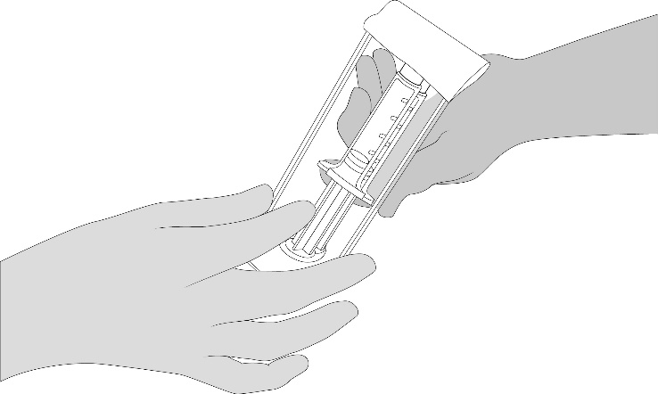

Figure 1

* **Sterile Water Bath (Quick Thawing)**

Thaw VeraSeal pre-filled syringes inside the sterile field in a sterile thermostatic water bath at a temperature not higher than 37 °C using the following steps:

NOTE: Once the VeraSeal blisters are opened, use the product immediately. Use sterile technique to avoid the possibility of contamination due to improper handling, and follow the steps below accurately. Do not remove the syringe luer cap until thawing is complete and the Dual Applicator is ready to be attached.

1. Open the blister and make the VeraSeal syringe holder with pre-filled syringes available to a second person for transfer to the sterile field. The outside of the blister should not come in contact with the sterile field. See Figure 1.

2. Place the syringe holder with pre-filled syringes directly into the sterile water bath ensuring that it is completely immersed in the water.  See Figure 2.

3. At 37 °C, the time needed is approximately 5 minutes for the 2 mL, 4 mL, 6 mL, and 10 mL package sizes, but must not be left at this temperature for longer than 10 minutes.

The temperature of the water bath must not exceed 37 °C.

4. Dry the syringe holder with pre-filled syringes after thawing, using a sterile surgical gauze.

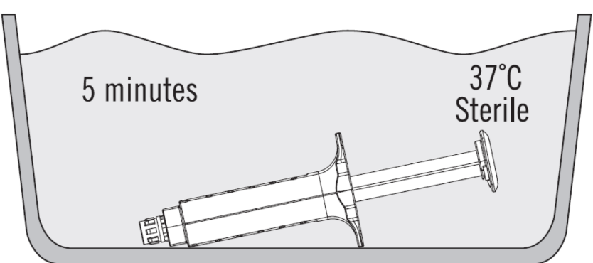

Figure 2

After thawing, the solutions must be clear to slightly opalescent and colorless to pale yellow. Do not use solutions that are cloudy or have deposits.

Use VeraSeal immediately and discard any unused contents.

* **Connection instructions**

1.Open the blister and make the VeraSeal Dual Applicator and two additional Airless Spray Tips available to a second person for transfer to the sterile field. The outside of the blister should not come in contact with the sterile field.

2.Hold the VeraSeal syringe holder with syringe luer caps pointed upward. See Figure 3.

3. Unscrew and discard the syringe luer cap of both fibrinogen and thrombin syringes. See Figure 3.

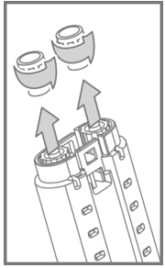

Figure 3

4.Hold the syringe holder with the luers pointed upward.To remove air bubbles from syringes, strike gently the side of the syringe holder one or two times while keeping the syringe holder in an upright position and lightly depress the plunger to eject air. See Figure 4.

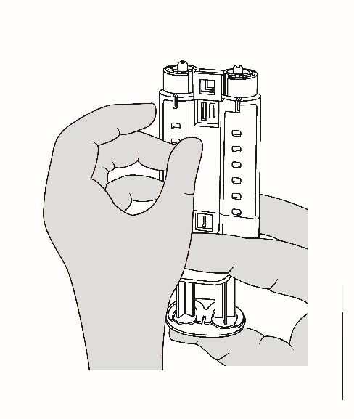

Figure 4

5. Attach the Dual Applicator. See Figure 5.

NOTE: Do not depress plunger during attachment or prior to intended use because the two biologic components will pre-mix in the Airless Spray Tip, forming a fibrin clot that prevents dispensing. See Figure 6.

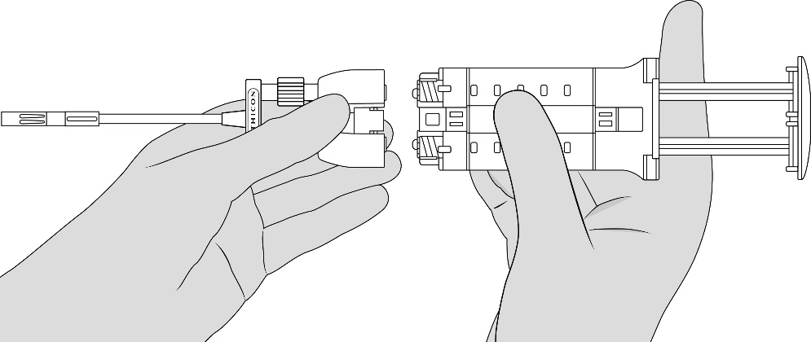

Figure 5

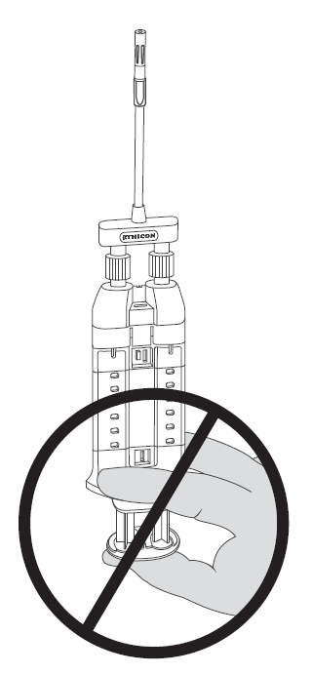

Figure 6

6. Tighten luer locks and ensure the Dual Applicator is firmly attached. The device is now ready to use.

**• Administration**

Apply VeraSeal using the syringe holder and plunger supplied.

Apply VeraSeal using the Dual Applicator provided with the product. This product should only be administered with the devices recommended for this product, VeraSeal Dual Applicator and associated accessory tips (ARTG 322483 and ARTG 322484). When using the provided Dual Applicator, follow the connection instructions described above. When using other applicator tips, follow the instructions for use that are provided with the applicator tips.

The initial volume of the product to be applied at a chosen anatomic site or target surface area should be sufficient to entirely cover the intended application area with a thin (1 mm thick) layer. The application can be repeated, if necessary. The approximate surface area coverage for each VeraSeal package size is provided in Table 1.

**Table 1. Surface Area Coverage**

|  |  |
| --- | --- |
| **VeraSeal package size** | **Surface area coverage (cm2)**  **Application by dripping or spray**  **(1 mm thick layer)** |
| 2 mL | 16 - 22 |
| 4 mL | 32 - 44 |
| 6 mL | 48 - 66 |
| 10 mL | 80 - 110 |

Application by spraying

Only spray VeraSeal if it is possible to accurately judge the required minimum distance of 2 cm from the Airless Spray Tip to the open and visible tissue surface.

1. Grasp and bend the Dual Applicator to the desired position. Tip will retain its shape.

2 Position the Airless Spray Tip at least 2 cm away from the target tissue. Apply firm even pressure to the plunger to spray the fibrin sealant. Increase distance accordingly to achieve desired coverage of the target area.

3. If expression is stopped for any reason, change the Airless Spray Tip. To change the Airless Spray Tip, remove the device from the patient and unscrew the used Airless Spray Tip. See Figure 7. Place the used Airless Spray Tip away from the spare Airless Spray Tips. Wipe the end of the applicator using dry or moist sterile surgical gauze. Then, connect a new Airless Spray Tip provided in the package and ensure it is firmly connected before use.

NOTE: Red indicator will not be visible if Airless Spray Tip is properly connected. See Figure 8.

NOTE: Do not continue pushing the plunger in an attempt to clear the fibrin clot within the Airless Spray Tip; otherwise the applicator may become unusable.

NOTE: Do not trim the Dual Applicator to avoid exposing internal wire.

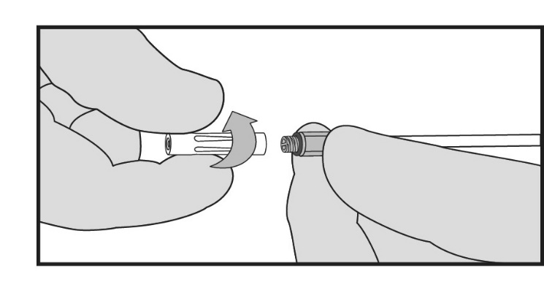

Figure 7

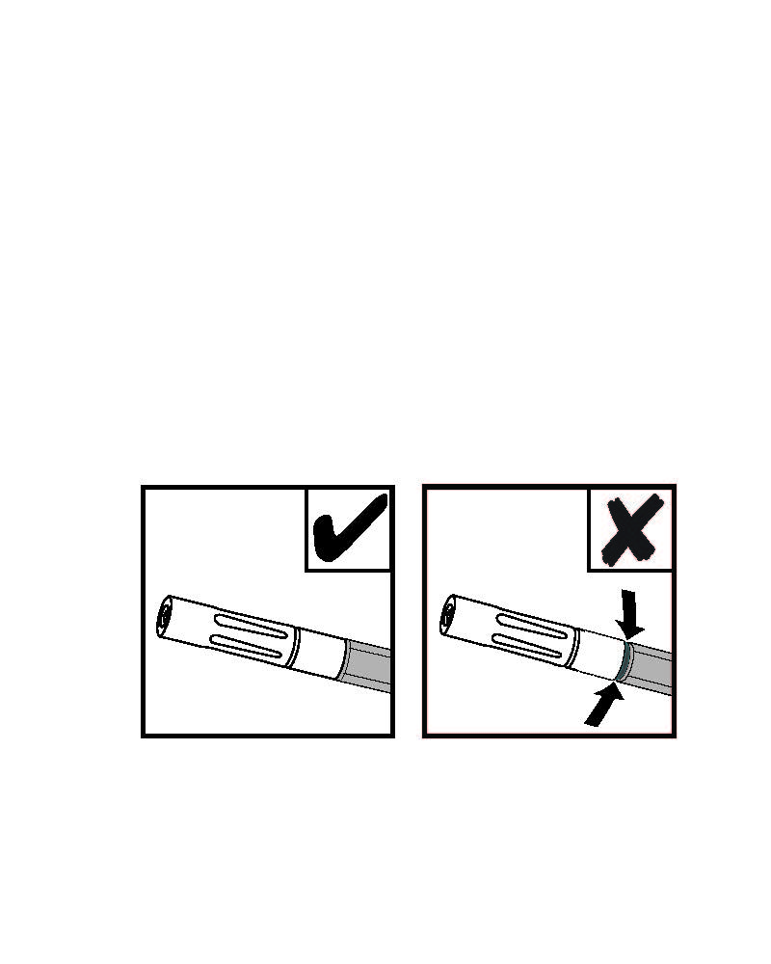

Figure 8

Application by dripping

1. Remove the Airless Spray Tip portion of the spray and drip tip by unscrewing the Airless Spray Tip. See Figure 7.

2. Grasp and bend the drip tip to the desired position. Tip will retain its shape.

3. During dripping, keep the end of the drip tip as close to the tissue surface as possible without touching the tissue during application.

4. Apply individual drops to the surface area to be treated. To prevent uncontrolled clotting, allow the drops to separate from each other and from the end of the drip tip.

NOTE: Do not reconnect a used drip tip after it has been removed from the adapter; otherwise a clot may form inside the drip tip and the applicator may become unusable.

## 4.3 Contraindications

VeraSeal must not be applied intravascularly.

Hypersensitivity to the active substance or to any of the excipients listed in section 6.1.

VeraSeal must not be used for the treatment of severe or brisk arterial bleeding.

## 4.4 Special warnings and precautions for use

Please see BOXED WARNINGS.

Precautions for use

For epilesional use only. Do not apply intravascularly.

VeraSeal must not be administered with gas assistance.

VeraSeal alone is not indicated for the treatment of severe or brisk arterial or venous bleeding. When used in these situations, VeraSeal is likely to be washed away in the flow of blood before hemostasis can be attained.

Injection into the nasal mucosa must be avoided, as severe allergic/anaphylactoid reactions have been observed and thromboembolic complications may occur in the area of the ophthalmic artery.

VeraSeal spray application should only be used if it is possible to accurately judge the spray distance, especially during laparoscopy. Spray distance from tissue should be at least 2 cm away from the target (see section 4.2).

When using accessory tips, the instructions for use of the tips should be followed.

Before administration of VeraSeal, care must be taken that the parts of the body outside the desired application area are sufficiently protected (covered) to prevent tissue adhesion at undesired sites.

VeraSeal should be applied as a thin layer. Excessive clot thickness may negatively interfere with the product’s efficacy and the wound healing process.

Adequate data are not available to support the use of this product in tissue gluing, neurosurgery, application through a flexible endoscope for treatment of bleeding or in gastrointestinal anastomoses.

Cardiovascular

Inadvertent intravascular injection of VeraSeal could lead to thromboembolic events and disseminated intravascular coagulation (DIC).

Hypersensitivity reactions

As with any protein product, allergic type hypersensitivity reactions are possible. Signs of hypersensitivity reactions include hives, generalised urticaria, tightness of the chest, wheezing, hypotension, and anaphylaxis. If these symptoms occur, the administration must be discontinued immediately. In case of shock, standard medical treatment for shock should be implemented.

Antibodies against components of fibrin sealant/hemostatic products may occur rarely.

Transmissible agents

This product is prepared from large pools of human plasma. Thus, it may carry a risk of transmitting infectious agents, e.g., viruses, the variant Creutzfeldt-Jakob disease (vCJD) agent and theoretically, the Creutzfeldt-Jakob (CJD) agent. This also applies to unknown or emerging viruses and other pathogens (see BOXED WARNINGS).

The risk that VeraSeal will transmit an infectious agent has been reduced by screening plasma donors for prior exposure to certain viruses, by testing for the presence of certain current virus infections, and by inactivating and/or removing certain viruses. The measures taken are considered effective for enveloped viruses such as human immunodeficiency virus (HIV), hepatitis B virus and hepatitis C virus, and for the non-enveloped hepatitis A virus.

Despite these measures, VeraSeal can still potentially transmit disease. The measures taken may be of limited value against non-enveloped viruses such as parvovirus B19. Parvovirus B19 infection may be serious for pregnant women (fetal infection) and for individuals with immunodeficiency or increased erythropoiesis (e.g. haemolytic anemia). There is also the possibility that unknown infectious agents may be present in VeraSeal. Individuals who receive VeraSeal may develop signs and/or symptoms of some viral infections. ALL infections thought by a physician possibly to have been transmitted by this product should be reported by the physician or other healthcare provider to Grifols Australia and the TGA.

Patients should be instructed to consult their clinician if symptoms of B19 virus infection appear (fever, drowsiness, chills and runny nose, followed about two weeks later by a rash and joint pain).

Traceability

In order to improve the traceability of biological medicinal products, the name and the batch number of the administered product should be clearly recorded in the patient notes/medical record.

### Use in the elderly

Clinical trials included 172 subjects aged 65 years or older treated with VeraSeal. No differences in safety or effectiveness were observed between these subjects and younger subjects.

### Paediatric use

The safety and efficacy of VeraSeal in children aged 0 to 18 years has not yet been established.

### Effects on laboratory tests

No data available.

## 4.5 Interactions with other medicines and other forms of interactions

No formal interaction studies have been performed. Similar to comparable products or thrombin solutions, the product may be denatured after exposure to solutions containing alcohol, iodine or heavy metals (e.g. antiseptic solutions). Such substances should be removed to the greatest possible extent before applying the product.

## 4.6 Fertility, pregnancy and lactation

### Effects on fertility

The effect of VeraSeal on fertility has not been evaluated.

### Use in pregnancy (Category B2)

The safety of fibrin sealant/hemostatic products for use in human pregnancy has not been established in controlled clinical trials. Experimental animal studies are insufficient to assess the safety with respect to reproduction, development of the embryo or fetus, the course of gestation and peri- and post-natal development. Therefore, the product should be administered to pregnant women only if clearly needed.

### Use in lactation

The safety of fibrin sealant/hemostatic products for use in human breast-feeding has not been established in controlled clinical trials. Therefore, the product should be administered to breast-feeding women only if clearly needed.

## 4.7 Effects on ability to drive and use machines

## The effects of this medicine on a person’s ability to drive and use machines were not assessed as part of its registration.

## 4.8 Adverse effects (Undesirable effects)

**Adverse Reaction Overview**

The most common adverse reactions reported during clinical trials were nausea, procedural pain and pruritus.

The most serious adverse drug reactions during clinical trials were abdominal and liver abscess, abdominal wound dehiscence, cellulitis, parvovirus B19 test positive, peritonitis, postoperative wound infection, postprocedural bile leak, pulmonary embolism and deep vein thrombosis.

As with any protein product, allergic type hypersensitivity reactions are possible.

**Clinical Trial Adverse Reactions**

Clinical trials are conducted under very specific conditions. The adverse reaction rates observed in the clinical trials therefore, may not reflect the rates observed in practice and should not be compared to the rates in the clinical trials of another drug. Adverse reaction information from clinical trials may be useful in identifying and approximating rates of adverse drug reactions in real-world use.

Three single-blind, randomized, active controlled clinical studies were conducted with VeraSeal in patients undergoing non-laparoscopic open surgical procedures using Fibrijet® drip or gas-assisted spray applicators. Control treatments included manual compression (MC) during peripheral vascular surgeries (Study IG1101), or oxidized regenerated cellulose during parenchymal hepatic resection (Study IG1102) and general soft tissue surgeries, e.g. retroperitoneal or pelvic surgery, abdominoplasties, or mastopexies (Study IG1103).

There were 500 patients treated with VeraSeal and 377 control patients, involved in 26% vascular (graft) surgeries, 37% parenchymal tissue surgeries, and 37% soft tissue surgeries. Across all trials, the mean age was 57 years (range: 0.3 to 86 years); with 87% White patients, 49% female patients and 51% male patients. There were 11 pediatric patients aged less than 18 years old.

In the VeraSeal treatment group, 13% of patients experienced one or more adverse reactions, compared with 8% of control patients in the oxidized regenerated cellulose treatment group and 5% in the MC treatment group.

Tables 2 to 4 summarise the adverse drug reactions that occurred in ≥1% of patients for each study.

|  |  |  |
| --- | --- | --- |
| **Table 2. Adverse Reactions Occurring in ≥1% of Patients in Vascular Surgery** | | |
| **SURGICAL PROCEDURE**  **MedDRA preferred term** | **VeraSeal** | **Manual Compression** |
| **VASCULAR SURGERY (Study IG1101)** | **N=168**  **n (%)** | **N=57**  **n (%)** |
| Procedural pain | 4 (2.4) | 1 (1.8) |
| Nausea | 2 (1.2) | 0 |
| Pyrexia | 2 (1.2) | 0 |
| Vascular graft complication | 2 (1.2) | 0 |
| Parvovirus B19 test positive | 2 (1.2) | 0 |
| Urinary retention | 2 (1.2) | 0 |
| Coagulopathy | 0 | 1 (1.8) |
| Sepsis | 0 | 1 (1.8) |
| Urinary tract infection | 0 | 1 (1.8) |
| Agitation | 0 | 1 (1.8) |

|  |  |  |
| --- | --- | --- |
| **Table 3. Adverse Reactions Occurring in ≥1% of Patients in Parenchyma Surgery** | | |
| **SURGICAL PROCEDURE**  **MedDRA preferred term** | **VeraSeal** | **Oxidized regenerated cellulose** |
| **PARENCHYMAL TISSUE SURGERY (Study IG1102)** | **N=163**  **n (%)** | **N=162**  **n (%)** |
| Procedural pain | 2 (1.2) | 2 (1.2) |
| Postprocedural bile leak | 2 (1.2) | 0 |
| Pulmonary embolism | 2 (1.2) | 0 |
| Deep vein thrombosis | 2 (1.2) | 0 |

|  |  |  |
| --- | --- | --- |
| **Table 4. Adverse Reactions Occurring in ≥1% of Patients in Soft Tissue Surgery** | | |
| **SURGICAL PROCEDURE**  **MedDRA preferred term** | **VeraSeal** | **Oxidized regenerated cellulose** |
| **SOFT TISSUE SURGERY (Study IG1103)** | **N=169**  **n (%)** | **N=158**  **n (%)** |
| Procedural pain | 4 (2.4) | 4 (2.5) |
| Pruritus | 4 (2.4) | 2 (1.3) |
| Nausea | 4 (2.4) | 1 (0.6) |
| Anemia | 2 (1.2) | 5 (3.2) |
| Insomnia | 2 (1.2) | 2 (1.3) |
| Hypertension | 2 (1.2) | 2 (1.3) |
| Leukocytosis | 2 (1.2) | 1 (0.6) |
| Ileus | 2 (1.2) | 1 (0.6) |
| Prothrombin time prolonged | 2 (1.2) | 1 (0.6) |
| Alanine aminotransferase increased | 2 (1.2) | 0 |
| Aspartate aminotransferase increased | 2 (1.2) | 0 |
| Hypercalcemia | 2 (1.2) | 0 |
| Hypokalemia | 2 (1.2) | 0 |
| Hyponatremia | 2 (1.2) | 0 |
| Headache | 2 (1.2) | 0 |
| Pyrexia | 1 (0.6) | 5 (3.2) |
| Constipation | 1 (0.6) | 3 (1.9) |
| Wheezing | 1 (0.6) | 2 (1.3) |

In the vascular surgery study, in the VeraSeal group, 21/168 (12.5%) patients experienced an ADR compared with 3/57 (5.3%) patients in the Manual Compression group.

In the parenchymal tissue study, in the VeraSeal group, 11/163 (6.7%) patients experienced an ADR compared with 3/162 (1.9%) patients in the Oxidized Regenerated Cellulose group.

In the soft tissue surgery study, in the VeraSeal treatment group, 32/169 (18.9%) patients experienced an ADR compared with 24/158 (15.2%) subjects in the Oxidized Regenerated Cellulose group.

**Less Common Clinical Trial Adverse Reactions**

The less common clinical trial adverse reactions are the following, classified by System Organ Class and in alphabetical order:

• Blood and lymphatic system disorders: hemorrhagic anemia, leukopenia, neutropenia.

• Cardiac disorders: atrial fibrillation, tachycardia, ventricular tachycardia.

• Eye disorders: conjunctival irritation.

• Gastrointestinal disorders: abdominal distension, pancreatitis, procedural nausea, retroperitoneal hematoma, vomiting, flatulence.

• General disorders and administration site conditions: asthenia, chills, hyperthermia, edema peripheral, pain, vessel puncture site hematoma.

• Infections and infestations: abdominal abscess, cellulitis, liver abscess, peritonitis, postoperative wound infection, wound infection incision site infection, urinary tract infection, postprocedural infection, vaginal cellulitis, parvovirus B19 test positive.

• Injury, poisoning and procedural complications: abdominal wound dehiscence, contusion, incision site erythema, incision site pain, postprocedural hemorrhage, procedural hypotension, vascular graft thrombosis, wound secretion.

• Investigations: parvovirus B19 test positive, activated partial thromboplastin time prolonged, blood bilirubin increase, blood glucose increase, body temperature increased, hematocrit decreased, hemoglobin decreased, international normalised ratio increased, transaminases increased, urine output decreased, weight decreased, white blood cell count increased.

• Metabolism and nutrition disorders: hyperglycemia, hyperkalemia, hypoglycemia, hypomagnesemia.

• Musculoskeletal and connective tissue disorders: back pain, joint swelling, pain in extremity.

• Neoplasms benign, malignant and unspecified (including cysts and polyps): plasma cell myeloma.

• Nervous system disorders: disturbance in attention, hypoesthesia, somnolence.

• Psychiatric disorders: anxiety.

• Renal and urinary disorders: bladder spasm, dysuria, renal failure, urethral pain, urinary incontinence.

• Respiratory, thoracic and mediastinal disorders: cough, dyspnea, hypoxia, laryngeal edema, pleural effusion, pleurisy, pulmonary edema, rhonchi, wheezing.

• Skin and subcutaneous tissue disorders: ecchymosis, erythema, skin irritation, pruritus.

• Vascular disorders: hypotension.

### Reporting suspected adverse effects

Reporting suspected adverse reactions after registration of the medicinal product is important. It allows continued monitoring of the benefit-risk balance of the medicinal product. Healthcare professionals are asked to report any suspected adverse reactions at [www.tga.gov.au/reporting-problems](http://www.tga.gov.au/reporting-problems).

## 4.9 Overdose

Only apply as much VeraSeal as necessary to achieve hemostasis to avoid the formation of excess granulation tissue and to ensure gradual absorption of the solidified fibrin sealant. Excessive clot thickness may interfere with the wound healing process (see section 4.4.).

For information on the management of overdose, contact the Poisons Information Centre on 13 11 26 (Australia).

# Pharmacological properties

## 5.1 Pharmacodynamic properties

Pharmacotherapeutic group: Antihaemorrhagics, local hemostatics, ATC code: B02BC.

### Mechanism of action

The fibrin adhesion system initiates the last phase of physiological blood coagulation. Thrombin cleaves fibrinogen into fibrin monomers and fibrinopeptides. The fibrin monomers aggregate and form a fibrin clot. Factor XIIIa, which is activated from factor XIII by thrombin, crosslinks fibrin. Calcium ions are required for both the conversion of fibrinogen and the crosslinkage of fibrin.

As wound healing progresses, increased fibrinolytic activity is induced by plasmin and decomposition of fibrin to fibrin degradation products is initiated.

### Clinical trials

Clinical trials have not been conducted in laparoscopy surgery or with the laparoscopic device.

Three multicentre, randomized, controlled, prospective Phase III trials were conducted using the same general two part design with VeraSeal and Fibrijet® drip or gas-assisted spray applicators. Distance between the spray applicator and the surface of the target area was at least 10 cm and the gas pressure set between 1 to 1.75 bar.

Preliminary Part I consisted of an open label treatment of the first 2 patients randomized to the treatment groups (except for manual compression, MC) at each centre site, to familiarize the study teams with application of VeraSeal and intra-operative procedures as well as for safety assessment. The Primary Part II involved safety and efficacy assessment in patients randomized to VeraSeal or an active control treatment (MC or oxidized regenerated cellulose). In both parts of the studies, patients underwent an elective (non-emergency), open (non-laparoscopic) surgical procedure, wherein a target bleeding site (TBS) of moderate intensity was identified. The TBS was determined by the investigator (the surgeon), if the control of bleeding by conventional surgical techniques (including suture, ligature, and cautery) was ineffective or impractical, and required an adjunct treatment to achieve hemostasis.

In all three studies, the primary efficacy endpoint was the proportion of patients achieving hemostasis at the TBS by four minutes (T4) following treatment application, without re-bleeding until completion of the surgical closure within a 10 minutes observation period. Re-application of treatment was permitted within the first 4 minutes of hemostasis assessment, after which persistent bleeding or re-bleeding was considered treatment failure.

**Study IG1101**

Study IG1101 was a superiority trial where patients were randomized to VeraSeal or manual compression (gauzes or laparotomy pads) at a 2:1 ratio during Part II. A total of 225 adult patients were enrolled and underwent vascular surgical procedures utilizing polytetrafluoroethylene graft material on end-to-side arterial anastomosis or on upper extremity vascular access arterial anastomosis. Anticoagulation treatment with heparin was required before arterial clamping. The most frequent surgery types were femoral-popliteal bypass grafting, upper extremity vascular access for hemodialysis, and ilio-femoral bypass grafting. These 3 surgery types accounted for about 80% of all protocol eligible surgery types. The frequencies for all 3 surgery types were consistent between the 2 treatment groups. No pediatric patients were enrolled in this study.

**Study IG1102**

Study IG1102 was a non-inferiority trial where patients were randomized to VeraSeal or oxidized regenerated cellulose at a 1:1 ratio during both Parts I and II. A total of 325 patients were enrolled and underwent an hepatic resection surgical procedure, including 5 pediatric patients ≤ 16 years enrolled only in Part I (2 VeraSeal and 3 Control patients). No pediatric patients were enrolled in the Primary Part (II) of the study.

**Study IG1103**

Study IG1103 was a non-inferiority trial where patients were randomized to VeraSeal or oxidized regenerated cellulose at a 1:1 ratio during both Parts I and II. A total of 327 patients were enrolled and underwent pelvic and retroperitoneal surgical procedures, and abdominoplasties and mastopexies. The most frequent surgery types were simple or radical hysterectomies, abdominoplasties, and radical cystectomies. There were 9 pediatric patients in the VeraSeal treatment group and 9 pediatrics in the control group. All were included in the safety assessment (i.e. Parts I and II), however only one adolescent aged 15 years was enrolled during Part II.

**Table 5 - Results of studies IG1101, IG1102 and IG1103 in Vascular Surgery, Parenchymal Tissue Surgery and Soft Tissue Surgery (ITT Population)\***

|  |  |  |  |  |  |
| --- | --- | --- | --- | --- | --- |
| **Primary**  **Endpoint** | **Study #** | **VeraSeal %**  **(n/N)** | **Active Control %**  **(n/N)** | **RRa**  **(95% CI)b** | **P-valuec** |
| Proportion of patients in Part II of the study achieving hemostasis at the TBS by T4 | IG1101 | 76.1  (83/109) | 22.8  (13/57) | 3.3  (2.0, 5.4) | <0.001 |
| IG1102 | 92.8  (103/111) | 80.5  (91/113) | 1.2  (1.0, 1.3) |  |
| IG1103 | 82.8  (96/116) | 77.8  (84/108) | 1.1  (0.9, 1.2) |  |

*Intent-to-treat (ITT) population: includes all patients randomized to VeraSeal or control.

T4: hemostatic assessment at 4 minutes following TStart (start of treatment application).

a: Risk ratio (RR) was the estimated ratio of the proportion of patients meeting the primary efficacy endpoint in the 2 treatment groups in Part II (VeraSeal relative to control).

b: In Studies IG1102 and IG1103, VeraSeal was deemed non-inferior to oxidized regenerated cellulose if the lower limit of the 95% confidence interval (CI) for the RR exceeded 0.8.

c: P-value was calculated from Fisher Exact Test in Study IG1101.

In Study **IG1101**, the rate of hemostasis at the TBS by T4 was significantly higher in the VeraSeal treatment group (76.1%) compared to manual compression (22.8%).

In Study **IG1102**, the rate of hemostasis at the TBS by T4 was non-inferior in the VeraSeal treatment group compared to oxidized regenerated cellulose. The estimated ratio of proportion achieving hemostasis by T4 in patients receiving VeraSeal relative to the control was 1.2 (95% CI: 1.0, 1.3).

In Study **IG1103**, the rate of hemostasis at the TBS by T4 was non-inferior in the VeraSeal treatment group compared to oxidized regenerated cellulose. The estimated ratio of proportion achieving hemostasis by T4 in patients receiving VeraSeal relative to the control was 1.1 (95% CI: 0.9, 1.2).

## 5.2 Pharmacokinetic properties

VeraSeal is intended for epilesional use only. Intravascular administration is contraindicated. Consequently, intravascular pharmacokinetic studies were not performed in humans.

Fibrin sealant/hemostatic products are metabolised in the same way as endogenous fibrin by fibrinolysis and phagocytosis.

## 5.3 Preclinical safety data

Conventional studies of toxicity with intravenously applied fibrinogen did not indicate a special hazard for humans.

# Pharmaceutical particulars

## 6.1 List of excipients

Human fibrinogen syringe

Sodium citrate dihydrate

Sodium chloride

Arginine

Isoleucine

Monosodium glutamate monohydrate

Water for injections

Human thrombin syringe

Calcium chloride

Human albumin

Sodium chloride

Glycine

Water for injections

## 6.2 Incompatibilities

This medicinal product must not be mixed with other medicinal products.

## 6.3 Shelf life

In Australia, information on the shelf life can be found on the public summary of the Australian Register of Therapeutic Goods (ARTG). The expiry date can be found on the packaging.

## 6.4 Special precautions for storage

Store and transport in a freezer (at -18 °C or colder). The cold storage chain (-18 °C or colder) must not be interrupted until use. Keep the sterilized blister in the outer carton to protect from light.

Thaw completely before use. Once thawed, do not refreeze. After thawing, it can be maintained not more than 48 hours at 2 °C – 8 °C or 24 hours at room temperature (20 °C – 25 °C) before use if it remains sealed in the original packaging.

Once the blister is opened, VeraSeal should be used immediately.

Use in one patient on one occasion only.

## 6.5 Nature and contents of container

VeraSeal is supplied as a single-use kit containing two pre-filled syringes (glass type I) with rubber stoppers, each with a sterile frozen solution, assembled in a syringe holder.

One Dual Applicator with two additional Airless Spray Tips is supplied with the product, for application by spraying or dripping. The Airless Spray Tips are radiopaque. See Figure 9.

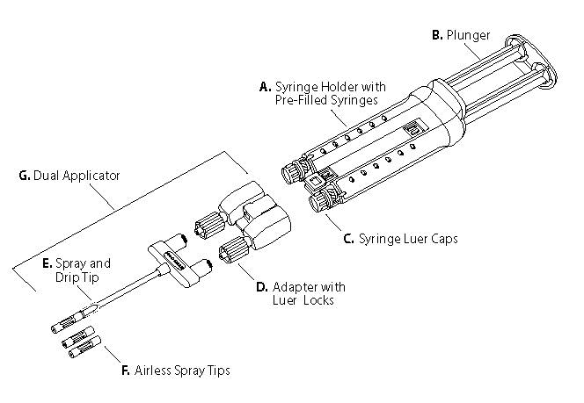

Figure 9

VeraSeal is available in the following pack sizes:

- VeraSeal 2 mL (containing 1 mL of human fibrinogen and 1 mL of human thrombin)

- VeraSeal 4 mL (containing 2 mL of human fibrinogen and 2 mL of human thrombin)

- VeraSeal 6 mL (containing 3 mL of human fibrinogen and 3 mL of human thrombin)

- VeraSeal 10 mL (containing 5 mL of human fibrinogen and 5 mL of human thrombin)

## 6.6 Special precautions for disposal

In Australia, any unused medicinal product or waste material should be disposed of in accordance with local requirements.

## 6.7 Physicochemical properties

### Chemical structure

Since the components are complex compositions, chemical structure is not applicable.

### CAS number

The CAS number for human fibrinogen is 9001-32-5.

The CAS number for human thrombin is 9002-04-4.

# Medicine schedule (Poisons Standard)

Exempt from scheduling.

# Sponsor

**Grifols Australia Pty Ltd**

5/80 Fairbank Road,

Clayton South,

Victoria, Australia

3169

**For Medical/Technical Enquiries**

TOLL FREE: 1800 339 479

# Date of first approval

2 November 2021

# Date of revision

11 February 2022

## Summary table of changes

|  |  |
| --- | --- |
| Section Changed | Summary of new information |
| All | Minor editorial changes |