August 2022

Australian Public Assessment Report for Libtayo
  - Active ingredients: Cemiplimab
  - Sponsor: Sanofi-Aventis Australia Pty Ltd

About the Therapeutic Goods Administration (TGA)
- The Therapeutic Goods Administration (TGA) is part of the Australian Government Department of Health and Aged Cared, and is responsible for regulating therapeutic goods, including medicines, medical devices, and biologicals.
- The TGA administers the Therapeutic Goods Act 1989 (the Act), applying a risk management approach designed to ensure therapeutic goods supplied in Australia meet acceptable standards of quality, safety, and efficacy.
- The work of the TGA is based on applying scientific and clinical expertise to decision-making, to ensure that the benefits to the Australian public outweigh any risks associated with the use of therapeutic goods.
- The TGA relies on the public, healthcare professionals and industry to report problems with therapeutic goods. The TGA investigates reports received to determine any necessary regulatory action.
- To report a problem with a therapeutic good, please see the information on the TGA website.

About AusPARs
- The Australian Public Assessment Report (AusPAR) provides information about the evaluation of a prescription medicine and the considerations that led the TGA to approve or not approve a prescription medicine submission. Further information can be found in Australian Public Assessment Report (AusPAR) guidance.
- AusPARs are prepared and published by the TGA.
- AusPARs are static documents that provide information that relates to a submission at a particular point in time. The publication of an AusPAR is an important part of the transparency of the TGA’s decision-making process.
- A new AusPAR may be provided to reflect changes to indications or major variations to a prescription medicine subject to evaluation by the TGA.

Copyright
© Commonwealth of Australia 2022
This work is copyright. You may reproduce the whole or part of this work in unaltered form for your own personal use or, if you are part of an organisation, for internal use within your organisation, but only if you or your organisation do not use the reproduction for any commercial purpose and retain this copyright notice and all disclaimer notices as part of that reproduction. Apart from rights to use as permitted by the Copyright Act 1968 or allowed by this copyright notice, all other rights are reserved, and you are not allowed to reproduce the whole or any part of this work in any way (electronic or otherwise) without first being given specific written permission from the Commonwealth to do so. Requests and inquiries concerning reproduction and rights are to be sent to the TGA Copyright Officer, Therapeutic Goods Administration, PO Box 100, Woden ACT 2606 or emailed to <tga.copyright@tga.gov.au>.

Contents
List of abbreviations 4
Product submission 6
Submission details 6
Product background 7
Regulatory status 9
Product Information 10
Registration timeline 10
Submission overview and risk/benefit assessment 11
Quality 11
Nonclinical 11
Clinical 11
Risk management plan 26
Risk-benefit analysis 27
Outcome 29
Specific conditions of registration applying to these goods 30
Attachment 1. Product Information 31

List of abbreviations
Abbreviation |  | Meaning
ACM | Advisory Committee on Medicines
ADA | Anti-drug antibody
ALK | Anaplastic lymphoma kinase
ARTG | Australian Register of Therapeutic Goods
ASA | Australia specific annex
BOR | Best overall response
CI | Confidence interval
CR | Complete response
DLP | Data lock point
DOR | Duration of response
ECOG PS | Eastern Cooperative Oncology Group performance score
EGFR | Epidermal growth factor receptor
EU | European Union
HR | Hazard ratio
ICR | Independent central review
irAE | Immune-related adverse event
IRC | Independent review committee
NCCN | National Comprehensive Cancer Network (United States of America)
NSCLC | Non-small cell lung cancer
OS | Overall survival
PD-1 | Programmed cell death protein 1
PD-L1 | Programmed death ligand 1
PFS | Progression free survival
PI | Product Information
PK | Pharmacokinetic(s)
PK | Pharmacokinetic(s)
RECIST | Response Evaluation Criteria in Solid Tumours
RMP | Risk management plan
ROS-1 | c-ROS oncogene 1
TEAE | Treatment emergent adverse event
TGA | Therapeutic Goods Administration
TPS | Tumour proportion score
US(A) | United States (of America)

Product submission

Submission details
Type of submission: | Extension of indications
Product name: | Libtayo
Active ingredient: | Cemiplimab
Decision: | Approved
Date of decision: | 25 November 2021
Date of entry onto ARTG: | 9 December 2021
ARTG number: | 320609
Black Triangle Scheme: | Yes  This product will remain in the scheme for 5 years, starting on the date the new indication was approved.
Sponsor’s name and address: | Sanofi-Aventis Australia Pty Ltd  12-24 Talavera Road,  Macquarie Park, NSW, 2113
Dose form: | Concentrate for solution for infusion
Strength: | 350 mg
Container: | Vial
Pack size: | One vial
Approved therapeutic use: | Non-small cell lung cancer  Libtayo as monotherapy is indicated for the first-line treatment of adult patients with non-small cell lung cancer (NSCLC) expressing PD-L1 tumour proportion score (TPS) ≥ 50% as determined by a validated test, with no EGFR, ALK or ROS1 aberrations, who have:  - locally advanced NSCLC and who are not candidates for surgical resection or definitive chemoradiation, or  - metastatic NSCLC.
Route of administration: | Intravenous infusion
Dosage: | Treatment must be initiated and supervised by physicians experienced in the treatment of cancer.  Patients should be selected for treatment with cemiplimab based on PD-L1 expression confirmed by a validated test in locally advanced or metastatic NSCLC. See Section 5.1 of the Product information for further information.  The recommended dose is 350 mg Libtayo once every 3 weeks administered as an intravenous infusion over 30 minutes. Treatment may be continued until disease progression or unacceptable toxicity.  Libtayo is administered by intravenous infusion over 30 minutes through an intravenous line containing a sterile, non-pyrogenic, low-protein binding, in-line or add-on filter (0.2 micron to 5 micron pore size). Other medicinal products should not be co-administered through the same infusion line. For instructions on dilution of the medicinal product before administration, see Section 6.6 of the Product Information.  For further information regarding dosage, refer to the Product Information.
Pregnancy category: | D  Drugs which have caused, are suspected to have caused or may be expected to cause, an increased incidence of human fetal malformations or irreversible damage. These drugs may also have adverse pharmacological effects. Accompanying texts should be consulted for further details.  The use of any medicine during pregnancy requires careful consideration of both risks and benefits by the treating health professional. This must not be used as the sole basis of decision making in the use of medicines during pregnancy. The TGA does not provide advice on the use of medicines in pregnancy for specific cases. More information is available from obstetric drug information services in your State or Territory.

Product background
This AusPAR describes the submission by Sanofi-Aventis Australia Pty Ltd (the sponsor) to register Libtayo (cemiplimab) 350 mg, concentrate for solution for infusion for the following extension of indications:
The treatment of adult patients with non-small cell lung cancer (NSCLC) expressing programmed death ligand 1 (PD-L1) (in ≥ 50% tumour cells) with no epidermal growth factor receptor (EGFR), anaplastic lymphoma kinase (ALK) or c-ROS oncogene 1 (ROS1) aberrations, who have
  - locally advanced NSCLC and who are not candidates for surgical resection or definitive chemoradiation, or have progressed after treatment with definitive chemoradiation, or
  - metastatic NSCLC.
Lung cancer is the most commonly diagnosed cancer. Lung cancer is divided into two main subtypes, non-small cell lung cancer (NSCLC) and small cell lung cancer. Approximately 80% to 90% of lung cancers are classified as NSCLC. NSCLC is further classified into three main histologic subtypes: adenocarcinoma, squamous cell carcinoma and large cell carcinoma. Adenocarcinomas account from 40 to 60% of NSCLC and squamous cell carcinomas approximately 30%.² The overall survival for patients with NSCLC varies with disease Stage. Generally, the earlier the disease stage at diagnosis and earlier treatment, the better the survival outcome. The approximate 5 year survival for patients with Stage III disease ranges from 13% to 36%, and for Stage IV is up to 10%.
Advanced non-small cell lung cancer is the most common type of lung cancer, with a poor prognosis and no known cure. Advanced NSCLC includes those who present with metastatic disease (Stage IV); or patients with inoperable disease and are unable to receive, or recur following initial, definitive treatment. The goal of treatment of locally advanced or metastatic NSCLC is not curative and focused on extending survival.
Treatment guidelines for NSCLC consider patient related and disease related characteristics in treatment decisions for patients with advanced or metastatic NSCLC, including patient age, Eastern Cooperative Oncology Group performance score status (ECOG PS), tumour location and histology, disease stage and the presence of tumour mutations. Genetic analysis of NSCLC has identified specific gene mutations that have become integral in treatment decisions, and the use effective of targeted therapies. These have included, mutations in the EGFR, ALK and ROS1 genes. In addition, expression of programmed cell death ligand 1 (PD-L1) in NSCLC influences whether checkpoint inhibitors are used alone or in combination with chemotherapy.

Current treatment options for non-small cell lung cancer
Until recently, first line treatment recommendations for patients with advanced or metastatic NSCLC without treatment targeting mutations included several combination chemotherapy regimens, where platinum based doublets were preferred (cisplatin plus one of docetaxel, paclitaxel, pemetrexed, vinorelbine or gemcitabine; carboplatin plus one of paclitaxel, pemetrexed, docetaxel or gemcitabine). Variations in regimen were determined based on tumour histology, non-squamous or squamous cell carcinoma. Bevacizumab plus carboplatin and paclitaxel is an option if there are no contraindications. Recently, first line treatment recommendations for patients with advanced NSCLC have been evolving with the authorisation of programmed cell death protein 1 (PD-1)/PD-L1 targeting agents.
The Australian clinical guidelines for treatment of inoperable NSCLC are currently being updated. There is no specific target therapy recommended currently. The National Comprehensive Cancer Network (NCCN), a not for profit alliance of 31 leading cancer centres in the United States of America (USA) recommends the following: for patients with metastatic (Stage IV) NSCLC; who are PD-L1 expression positive (> 50%) and negative for epidermal growth factor receptor (EGFR), anaplastic lymphoma kinase (ALK), or (ROS1) genomic aberrations the preferred treatment is monotherapy with pembrolizumab or atezolizumab, or pembrolizumab in combination with platinum based doublet chemotherapy. The recommended treatment for patients with inoperable locally advanced Stage IIIB and IIIC NSCLC; is concomitant chemoradiation. However, patients who are ineligible for chemoradiation and have PD-L1 expression > 50% are commonly treated with systemic therapy including a PD-1/PD-L1 inhibitor.
In Australia the targeted agents with indications for treatment of NSCLC are as follows:
- pembrolizumab:
  - in combination with pemetrexed and platinum chemotherapy, for first line treatment of patients with metastatic non-squamous NSCLC, with no EGFR or ALK genomic tumour aberrations;
  - in combination with carboplatin and either paclitaxel or nab-paclitaxel, is indicated for the first-line treatment of patients with metastatic squamous NSCLC;
  - as monotherapy for the first-line treatment of patients with NSCLC expressing PD-L1 (TPS ≥ 1%) as determined by a validated test, with no EGFR or ALK genomic tumour aberrations, and is Stage III where patients are not candidates for surgical resection or definitive chemoradiation, or metastatic;
  - as monotherapy for second line treatment of patients with advanced NSCLC whose tumours express PD-L1 with a ≥ 1% tumour proportion score (TPS) as determined by a validated test and who have received platinum containing chemotherapy. Patients with EGFR or ALK genomic tumour aberrations should have received prior therapy for these aberrations prior to receiving pembrolizumab.
- nivolumab: approved as monotherapy for second line or with ipilimumab and platinum doublet chemotherapy as first line for NSCLC with no EGFR or ALK;
- atezolizumab: approved for first line therapy in combination with other treatments and monotherapy as second line treatment.
- ipilimumab: approved in combination with nivolumab and two cycles of platinum doublet chemotherapy, for first line treatment of patients with metastatic or recurrent NSCLC with no EGFR or ALK genomic tumour aberrations.
Of the above approved targeted agents only pembrolizumab has a specific level of PD-L1 expression in tumours required for its use as monotherapy for first line treatment of NSCLC.
This submission was evaluated as part of the Australia-Canada-Singapore-Switzerland-United Kingdom (ACCESS) Consortium with work-sharing for this submission between the TGA and Health Canada. Each regulator made independent decisions regarding approval (market authorisation) of the new medicine.

Regulatory status
The product received initial provisional registration on the Australian Register of Therapeutic Goods (ARTG) on 14 July 2020; for the following indications:
Libtayo as monotherapy has provisional approval in Australia for the treatment of adult patients with metastatic or locally advanced cutaneous squamous cell carcinoma (mCSCC or laCSCC) who are not candidates for curative surgery or curative radiation.
The decision to approve this indication has been made on the basis of objective response rate (ORR) and duration of response from single arm clinical studies. The sponsor is required to submit further clinical data to confirm the clinical benefit of the medicine.
At the time the TGA considered this submission, indications had been approved in USA and the European Union (EU). A similar submission was under consideration in Canada.
The following table summarises these submissions and provides the indications where approved.
Table 1: International regulatory status
Region | Submission date | Status | Approved indications
European Union | 21 August 2020 | Approved on 21 June 2021 | Libtayo as monotherapy is indicated for the first-line treatment of adult patients with non-small cell lung cancer (NSCLC) expressing PD-L1 (in ≥ 50% tumour cells), with no EGFR, ALK or ROS1 aberrations, who have:  • locally advanced NSCLC who are not candidates for definitive chemoradiation, or  • metastatic NSCLC.
United States of America | 28 August 2020 | Approved on 22 February 2021 | Libtayo is indicated for the first-line treatment of patients with non-small cell lung cancer (NSCLC) whose tumors have high PD-L1 expression (Tumor Proportion Score (TPS) ≥ 50%) as determined by an FDA-approved test [see Dosage and Administration (2.1))), with no EGFR, ALK or ROS1 aberrations, and is:  • locally advanced where patients are not candidates for surgical resection or definitive chemoradiation or  • metastatic.
Canada | 30 November 2020 | Under consideration | Under consideration

Product Information
The Product Information (PI) approved with the submission which is described in this AusPAR can be found as Attachment 1. For the most recent PI, please refer to the TGA PI/CMI search facility.

Registration timeline
The following table captures the key steps and dates for this submission.
Table 2: Timeline for Submission PM-2020-06003-1-4
Description | Date
Submission dossier accepted and first round evaluation commenced | 4 January 2021
First round evaluation completed | 7 June 2021
Sponsor provides responses on questions raised in first round evaluation | 23 April 2021
Second round evaluation completed | 18 August 2021
Delegate’s Overall benefit-risk assessment and request for Advisory Committee advice | 25 August 2021
Sponsor’s pre-Advisory Committee response | 14 September 2021
Advisory Committee meeting | 7 and 8 October 2021
Registration decision (Outcome) | 25 November 2021
Completion of administrative activities and registration on the ARTG | 9 December 2021
Number of working days from submission dossier acceptance to registration decision* | 203
*Statutory timeframe for standard submissions is 255 working days

Submission overview and risk/benefit assessment
This section is a TGA summary of wording used in TGA’s evaluation report, which discussed numerous aspects of overseas evaluation reports and included some information that was commercial-in-confidence.

Quality
A full quality evaluation was conducted at the time this product received initial registration.⁹

Nonclinical
A full nonclinical evaluation was conducted at the time this product received initial registration. ⁹

Clinical

Study R2810-ONC-1624

Study overview
Study R2810-ONC-1624 is the pivotal study to support the NSCLC indication. It is an ongoing, randomised, global, open label, Phase III study of cemiplimab monotherapy versus platinum based doublet chemotherapy of physician’s choice.
The study had two primary efficacy objectives, overall survival (OS) and progression free survival (PFS) as assessed by blinded independent review committee (IRC) per response evaluation criteria in solid tumours (RECIST) 1.1. The key secondary efficacy objective was assessment of overall response rate by blinded IRC per RECIST 1.1. Due to the open label design of Study R2810-ONC-1624, the IRC was blinded to the treatment assignment of patients in order to address potential bias. In addition, secondary objectives included safety, anti-drug antibody (ADA) and pharmacokinetics assessments.
This primary analysis clinical study report was prompted by the pre-specified interim analysis conducted by the independent statistical group and reviewed by the data monitoring committee which demonstrated a survival benefit in patients randomised to cemiplimab treatment.
Study subjects were patients with locally advanced or metastatic, squamous or non-squamous NSCLC. Additional requirements were:
- tumour expression of PD-L1 in ≥ 50% of tumour cells as determined using a test performed according to instructions for use;
- tumour with no EGFR, ALK, or ROS1 aberrations,
- no prior systemic treatment for their advanced disease, and/or
- not candidates for surgical resection or definitive chemoradiation.
Patients who received adjuvant or neoadjuvant platinum doublet chemotherapy (after surgery and/or radiation therapy) and developed recurrent or metastatic disease more than six months after completing therapy were eligible.
Exclusion criteria of note were patients who had never smoked and patients with active or untreated brain metastases or spinal cord compression. Patients were eligible if central nervous system metastases are adequately treated and patients have neurologically returned to baseline (except for residual signs or symptoms related to the central nervous system treatment) for at least two weeks prior to randomisation. Patients must be off (immunosuppressive doses of) corticosteroid therapy.
Patients were randomised equally to one of the following two arms: cemiplimab 350 mg monotherapy or platinum based doublet chemotherapy. Randomisation was stratified by histology (squamous versus non-squamous) and geographic region (Europe, Asia, or rest of the world). Patients assigned to the cemiplimab arm received cemiplimab 350 mg as an intravenous infusion infusion on Day 1 of every treatment cycle (once every 3 weeks) for up to 108 weeks or until RECIST 1.1 defined progressive disease, unacceptable toxicity, death, or withdrawal of consent.
Patients who experienced progressive disease on cemiplimab were given the option to continue cemiplimab 350 mg once every 3 weeks for up to 108 additional weeks, with the addition of histology specific platinum based doublet chemotherapy for four cycles, provided they met specific treatment criteria and had not completed the 108 week treatment period with cemiplimab. Patients who experienced progressive disease on chemotherapy were given the option to cross over to cemiplimab monotherapy 350 mg once every 3 weeks for up to 108 weeks, provided they met treatment criteria. These criteria were subsequently amended after the primary analysis and all patients randomised to platinum based chemotherapy were permitted to receive cemiplimab for up to 108 weeks prior to disease progression.
The primary endpoints were overall survival and progression-free survival assessed by the independent review committee (IRC). Overall response rate was the key secondary endpoint and duration of response and quality of life measures were other secondary endpoints. Pre-specified sensitivity analyses were performed for overall survival and progression-free survival for patients whose tumours express PD-L1 ≥ 50% of tumour cells based on PD-L1 assay in accordance with assay instructions, including results from PD-L1 retesting.
The cemiplimab dose of 350 mg once every 3 weeks was selected based on preliminary evidence of efficacy in the first in human Study R2810-ONC 1423 for cemiplimab 3 mg/kg once every 2 weeks intravenously and on population pharmacokinetic (PopPK) modelling and simulation that a 350 mg once every 3 weeks regimen provided exposure that closely replicated that observed in patients treated with the 3 mg/kg once every 2 weeks intravenously regimen. Dose modifications of cemiplimab were not permitted, though dose interruptions were allowed.
Patients randomised to chemotherapy received one of the following histology-specific regimens:
- Paclitaxel; plus cisplatin; or carboplatin;
- Gemcitabine; plus cisplatin or carboplatin
- Pemetrexed; plus cisplatin or carboplatin followed by optional pemetrexed maintenance (it was strongly recommended that patients with squamous NSCLC do not receive pemetrexed-containing regimens).
The investigator was permitted to choose from one of the above regimens provided that it was consistent with the local standard of care and permitted by local regulations. The dosing regimens for these regimens are in Table 3.
Table 3: Study R2810-ONC-1624 Platinum doublet chemotherapy regimens
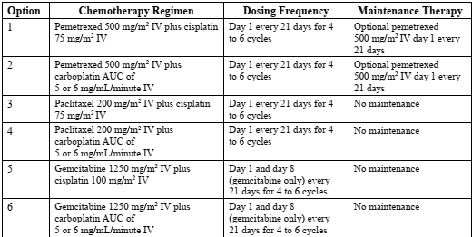
Abbreviations: AUC = area under the concentration time curve; IV = intravenous.
Programmed death-ligand 1 testing was performed with both investigational and commercial kits of the PD-L1 IHC 22C3 PharmDx assay. These kits where identical except for labelling.
There were quality issues with the PD-L1 expression testing, which impacted the enrolment of patients who met the pre-specified expression level (PD-L1 ≥ 50%). A total of 235 patients were tested during the period when the issues were occurring. The sponsor has identified to additional efficacy populations (intent to treat-1; and intent to treat-2) to address the impact of this issue on efficacy.
It is a superiority trial with five interim analyses for overall survival initially planned. The study report in the submission was of the second interim analysis and is the primary analysis. Of note, overall survival was promoted to a primary endpoint from a secondary endpoint after the study had commenced. For the two primary endpoints, the two sided alpha value of 0.05 is initially split between the analyses of overall survival and progression-free survival, with 0.04 to OS analysis and 0.01 to progression-free survival analysis. The alpha allocated to progression-free survival (0.01) is subject to be reallocated to overall survival if the progression-free survival test is positive. The alpha allocated to overall survival (0.04) is subject to be reallocated to progression-free survival if the overall survival test is positive.

Efficacy

Results
A total of 3662 patients were screened with 710 randomised (356 patients to cemiplimab and 354 patients to chemotherapy, see Table 4) and 697 were treated (355 patients in the cemiplimab arm and 342 patients in the chemotherapy arm) at 138 sites in 24 countries.
Of the 710 patients that form the intent to treat population, at the time of data cut off of 1 March 2020, treatment was ongoing for 184 patients (25.9%), 513 patients (72.3%) were off treatment and 13 (one in the cemiplimab arm and 12 in the chemotherapy arm) were randomised but not treated (see Table 4). Study treatment was completed as per protocol in 155 (21.8%) of the patients, 6 (1.7%) in the cemiplimab arm and 149 (42.1%) in the chemotherapy arm. The difference in treatment completion between the two treatment arms is explained by the different duration of study treatment in the cemiplimab arm (administered every 3 weeks up to 108 weeks) compared with the chemotherapy arm (administered for 4 to 6 cycles every 3 weeks). The most common reason for treatment discontinuation was disease progression in 217 patients (30.6%). Table 4 displays patient disposition. Due to quality issues with the PD-L1 testing there were three efficacy analyses populations (intent to treat populations), and two modified intent to treat populations based on subsequent PD-L1 testing (see Figure 1).
Table 4: Study R2810-ONC-1624 Patient disposition (intent to treat population)
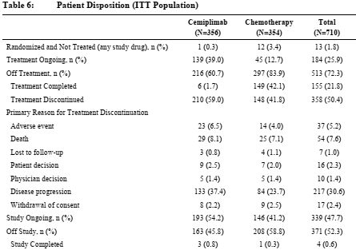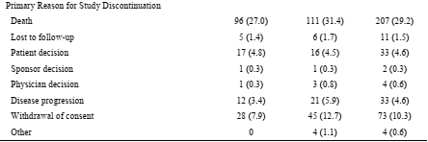
Figure 1: Study R2810-ONC-1624 Patient disposition by programmed death-ligand 1 (PD-L1) testing status and retesting
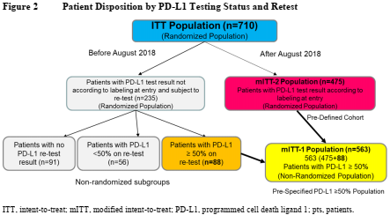
Abbreviations: ITT = intent to treat, mITT = modified intent to treat; PD-L1 = programmed cell death ligand 1; pts = patients.
For the intent to treat population, the median age was 63 years, 85.4% were male, 85.4% were White and 64.4% were past smokers. The majority (73%) had an ECOG PS of 1. The majority were under 65 years of age (45.1% of patients were aged ≥ 65 years). The majority of patients (77.9%) enrolled were from Europe with 10.8% from Asia. Demographic characteristics were similar between the treatment arms and were also similar to the ‘modified intent to treat-1’ population and ‘modified intent to treat-2’ population.
Disease characteristics are summarised in Table 5, shown below. The majority (84%) had metastatic disease and 16% had Stage IIIB or IIIC disease;¹ and were not candidates for surgical resection or definitive chemoradiation per investigator assessment; 56% had non-squamous and 44% had squamous histology; and 12% had history of treated brain metastases at Baseline. The intent to treat population included 56 patients (29 in the cemiplimab arm and 27 in the chemotherapy arm) with PD-L1 expression levels < 50% and 91 patients (cemiplimab arm: 44 patients, chemotherapy arm: 47 patients) with an unknown PD-L1 expression status. These patients were included in the study because of a PD-L1 expression testing error. Overall, 23.1% (164 out of 710) of patients in the intent to treat population received prior cancer related therapy, mostly in the form of radiotherapy (122 out of 710 (17.2%)) (see Table 6 below).
Table 5: Study R2810-ONC-1624 Summary of baseline disease characteristics (full analysis set)
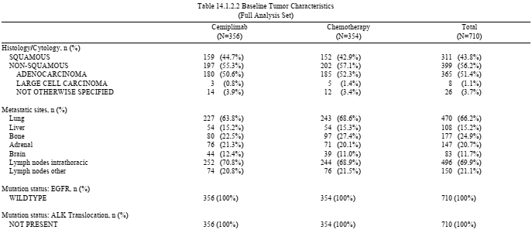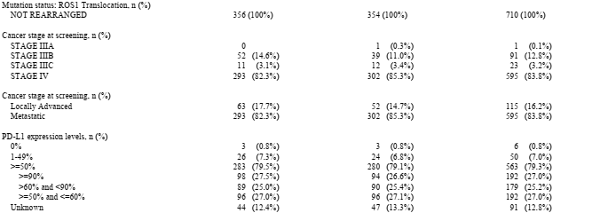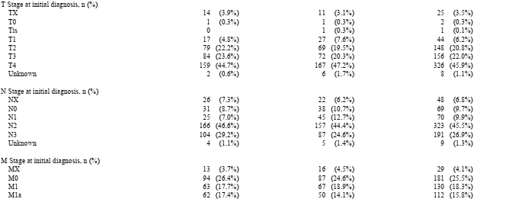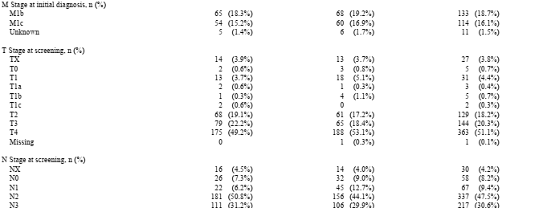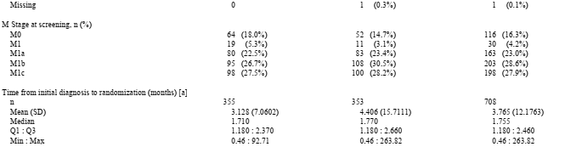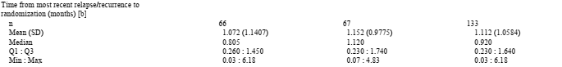
Data cut-off as of 1 March 2020.
Abbreviations: M = metastases; min = minimum; max = maximum; N = (lymph) node; Q1 = first quartile; Q3 = third quartile; SD = standard deviation; T = tumour;
a) Time from initial diagnosis to randomisation (months) = (Date of randomisation – Date of initial diagnosis)/30.4375
b) Time from most recent relapse/recurrence to randomisation (months) = (date of randomisation – date of most recent relapse/recurrence)/30.4375
Table 6: Study R2810-ONC-1624 Summary of prior therapy for the intent to treat population
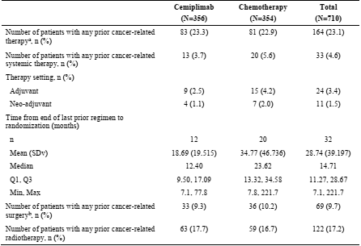
Abbreviations: ITT = intent to treat, max = maximum, min = minimum, SDv = standard deviation.
a Any prior cancer related therapy includes patients who have had systemic therapy, surgery (excluding diagnostic procedures) or radiotherapy.
b Prior cancer related surgery excludes diagnostic procedures.
The median duration of follow up, as of the data cut-off, was 13.09 months in the cemiplimab arm and 13.08 months in the chemotherapy arm. The Kaplan-Meier curve for overall survival is shown in Figure 2. At the data cut-off of 1 March 2020 a total of 249 deaths had occurred, 108 (30.3%) in the cemiplimab arm and 141 (39.8%) in the chemotherapy arm. The median duration of survival was 22.1 (95% confidence interval (CI): 17.7, not evaluable) months in the cemiplimab arm versus 14.3 (95% CI: 11.7, 19.2) months in the chemotherapy arm. The estimated hazard ratio was 0.676 (95% CI: 0.525, 0.870), representing a 32% reduction in the risk of death. The p-value was 0.0022, which crossed the pre-specified statistical alpha-boundary for threshold (0.00255).
Figure 2: Study R2810-ONC-1624 Kaplan-Meier plot for the primary analysis of overall survival in the intent to treat population
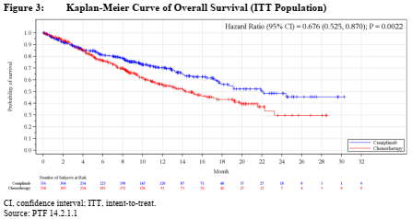
Therefore, the co-primary endpoint of overall survival was met, demonstrating both a statistically and clinically meaningful improvement in overall survival for the intent to treat population.
Overall survival was assessed in both the modified intent to treat-1 population and the modified intent to treat-2 population. The results were consistent with those observed for the intent to treat population. For the modified intent to treat-1 population, the non-randomised and confirmed PD-L1 expression of ≥ 50% population, the hazard ratio was 0.566 (95% CI: 0.418, 0.767) in favour of cemiplimab. The median survival was not reached for patient in the cemiplimab arm and 14.2 months for patients in the chemotherapy arm. For the modified intent to treat-2 population, the randomised patients unaffected by the PD-L1 testing, the hazard ratio was 0.569 (95% CI: 0.403, 0.804). The median survival was not reached for patient in the cemiplimab arm and 12.1 months for patients in the chemotherapy arm.
A total of 463 progression-free survival events occurred, 201 (57%) in the cemiplimab arm and 262 (74%) in the chemotherapy arm, hazard ratio 0.59 (95% CI 0.49, 0.72), p < 0.0001. The median time to an event was 6.2 months in the cemiplimab arm and 5.6 months in the chemotherapy arm. Figure 3 (shown below) shows the Kaplan-Meier curve for progression-free survival. The progression-free survival results for the modified intent to treat-1 population and the modified intent to treat-2 population were consistent with those observed for the intent to treat population.
Figure 3: Study R2810-ONC-1624 Kaplan-Meier plot for the primary analysis of overall survival in the intent to treat population
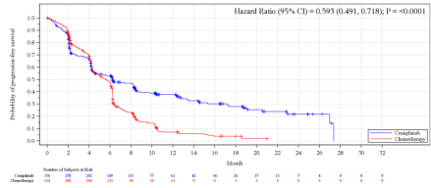
The overall response rate was 37% (95% CI: 32, 42) in the cemiplimab arm and 21% (95% CI: 17, 25) in the chemotherapy arm. The median duration of response was 21 months in the cemiplimab arm and 6 months in the chemotherapy arm.
Pre-specified subgroup efficacy analyses were conducted based on gender (male, female), age (< 65, ≥ 65), race (White, Non-white), geographical region (European Union, Asia, rest of the world), ECOG PS (0, 1),¹ and histology (squamous, non-squamous). Post-hoc subgroup analyses were also conducted by disease stage (Stage IIIB, IIIC, IV), history of brain metastases, and by age intervals (< 65 years, ≥ 65 to < 75 years, or > 75 years). Overall survival results for these subgroups are shown in Figure 4 (see below). Trends towards greater efficacy of cemiplimab over chemotherapy were seen in all the subgroups assessed. Similarly progression-free survival by subgroup is shown in Figure 5 (see below) and trends towards greater progression-free survivalare shown for each of the subgroups examined.
Figure 4: Study R2810-ONC-1624 Forest plot of subgroup analysis of overall survival in the intent to treat population
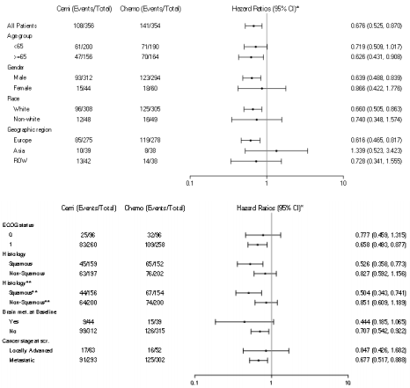
* Stratified by histology (squamous, non-squamous) accordingly to IWRS except for histology subgroups.
** According to IWRS
Abbreviations: Cemi = cemiplimab; Chemo = chemotherapy; CI = confidence interval; ECOG = Eastern Cooperative Oncology Group; HR = hazard ratio; ITT = intent to treat; IWRS = interactive web response system; ROW = rest of the world.
Figure 5: Study R2810-ONC-1624 Forest plot of subgroup analysis of progression free survival in the intent to treat
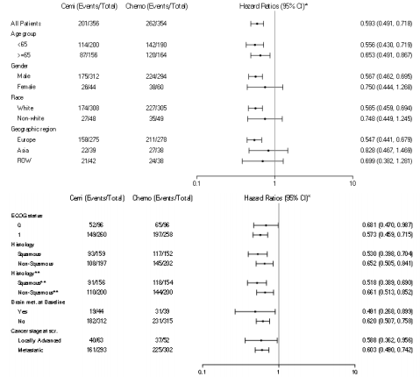
* Stratified by histology (squamous, non-squamous) accordingly to IWRS except for histology subgroups.
** According to IWRS
Abbreviations: Cemi = cemiplimab; Chemo = chemotherapy; CI = confidence interval; ECOG = Eastern Cooperative Oncology Group; IRC = independent review committee; ITT = intent to treat; IWRS = interactive web response system; ROW = rest of the world.
Table 7 and Table 8 show the subgroup analyses by extent of tumour PD-L1 positivity in the modified intent to treat-1 and 2 populations respectively. While there appeared to be a clear trend towards increased survival and PFS with increasing PD-L1 positivity the high PD-L1 group given chemotherapy also had better outcomes than the groups with lower levels of PD-L1 positivity, though not nearly as high as the cemiplimab treated groups.
Table 7: Study R2810-ONC-1624 Analysis of overall survival and professional free survival by programmed death ligand 1 expression in the modified intent to treat-1 population
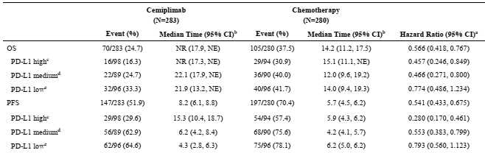
a Based on Kaplan-Meier method
b Based on stratified proportional hazards model (cemiplimab versus chemotherapy).
c PD-L1 expression ≥ 90%
d PD-L1 expression > 60% and < 90%
e PD-L1 expression ≥ 50% and ≤ 60%
Abbreviations: CI = confidence interval; mITT = modified intent to treat; NE = not evaluable; OS = overall survival; PD-L1 = programmed cell death ligand 1; PFS = progression-free survival.
Table 8: Study R2810-ONC-1624 Analysis of overall survival and professional free survival by programmed death ligand 1 expression in the modified intent to treat-2 population
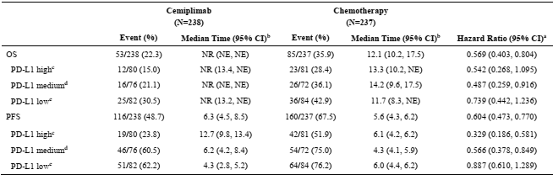
a Based on Kaplan-Meier method
b Based on stratified proportional hazards model (cemiplimab versus chemotherapy).
c PD-L1 expression ≥ 90%
d PD-L1 expression > 60% and < 90%
e PD-L1 expression ≥ 50% and ≤ 60%
Abbreviations: CI = confidence interval; mITT = modified intent to treat; NE = not evaluable; OS = overall survival; PD-L1 = programmed cell death ligand 1; PFS = progression free survival.

Safety
The safety population for Study R2810-ONC-1624 consisted of 697 patients who received at least one dose of any study treatment, 355 patients in the cemiplimab arm and 342 patients in the chemotherapy arm. Patients received cemiplimab treatment for longer than those who received chemotherapy. The shorter duration of exposure for the chemotherapy arm was mostly due to the majority of patients completing study treatment after 4 or 6 cycles (equal to 12 to 18 weeks), compared to those in the cemiplimab arm (108 weeks). The overall median duration of exposure was 27.3 weeks (range: 0.3 to 115 weeks) for cemiplimab and 17.7 weeks (range: 0.6 to 86.7 weeks) for chemotherapy. At the time of data cutoff, 197 (55.5%) patients had been treated with cemiplimab for ≥ 24 weeks and 84 (23.7%) patients had been treated for ≥ 48 weeks. In the chemotherapy arm, 54 (15.8%) patients had been treated with cemiplimab for ≥ 24 weeks and 10 (2.9%) patients had been treated for ≥ 48 weeks.
Overall, patients in the cemiplimab arm experienced a lower number of treatment emergent adverse events (TEAEs), including Grade ≥ 3 and serious TEAEs, compared to patients in the chemotherapy arm. The proportion of patients that experienced any TEAEs was 88.2% for patients in the cemiplimab arm and 94.2% in the chemotherapy arm.
In addition, a lower proportion of patients in the cemiplimab arm compared to the chemotherapy arm experienced a Grade ≥ 3 TEAE, 37.2% versus 48.5% respectively. Specifically, the incidence of Grade 3 to 4 events was 27.6% in the cemiplimab arm and 39.5% in the chemotherapy arm.
A similar proportion of patients in the treatment arms experienced a serious TEAE, discontinued study treatment due to a TEAE, or had a dose delay/interruption due to a TEAE. The proportions of deaths due to a TEAE (Grade 5) was similar between the treatment arms, 9.6% in the cemiplimab arm and 9.1% in the chemotherapy arm. Table 9 (see below) lists TEAEs with incidence ≥ 5%. The most common (≥ 10%) TEAEs in patients treated with cemiplimab were: anaemia (14.6%), decreased appetite (11.8%), and fatigue (10.1%). The most common (≥ 10%) TEAEs in patients treated with chemotherapy were: anaemia (50%), nausea (28.4%), alopecia (24%), decreased appetite (18.4%), neutropenia (18.4%), fatigue (17%), constipation (15.2%), thrombocytopenia (15.2%), vomiting (14.3%), neutrophil count decreased (12.3%), pneumonia (10.8%), peripheral neuropathy (10.8%), and platelet count decreased (10.5%).
Table 9: Study R2810-ONC-1624 Summary of treatment emergence adverse events with an incidence of ≥ 5%
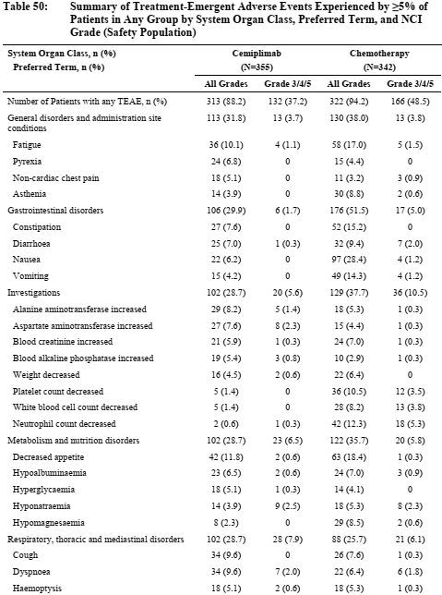
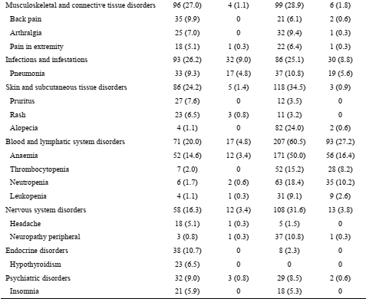Abbreviations: AE = adverse event; CTCAE = Common Terminology Criteria for Adverse Events; MedDRA = Medical Dictionary for Regulatory Activities. NCL = National Cancer Institute; TEAE = treatment emergent adverse event
This table presents TEAEs irrespective of relationship to study treatment.
All adverse events were coded using the MedDRA version 22.1. NCI grade were coded using CTCAE version 4.03.
A patient is counted only once for multiple occurrences within a System Organ Class/Preferred Term.
For System Organ Class, the table was sorted by decreasing frequency of all grades in cemiplimab arm. Within each System Organ Class, Preferred Terms are sorted by decreasing frequency of all grades in the cemiplimab arm.
The following Grade ≥ 3 TEAEs occurred at a higher incidence (≥ 1% difference) in the cemiplimab arm compared to the chemotherapy arm, aspartate aminotransferase increased (2.3% versus 0.3%), alkaline phosphatase (ALT) increased (1.4% versus 0.3%), hyperkalaemia (4.2% versus 1.9%), death (1.4% versus 0.3%), and pericardial effusion (1.1% versus 0%).
Infusion reaction were reported in 20 (5.6%) patients given cemiplimab, none of these were ≥ Grade 3. Table 10 lists immune-related adverse events. A total of 62 (17.5%) patients given cemiplimab had an immune-related adverse event with 13 (3.7%) having such an event of ≥ Grade 3. These events included hyper- and hypo-thyroidism, pneumonitis, colitis, and rash. This compares with 8 (2.3%) of patients given chemotherapy having immune-related adverse event and only one of these was ≥ Grade 3.
Table 10: Study R2810-ONC-1624 Summary of immune related adverse events per sponsor assessment
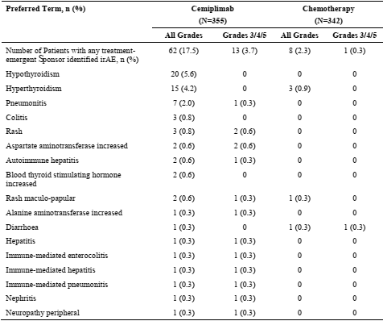
Abbreviations: CTCAE = Common Terminology Criteria for Adverse Events; irAE = immune related adverse event; MedDRA = Medical Dictionary for Regulatory Activities. NCL = National Cancer Institute
All adverse events were coded using the MedDRA vesion 22.1. NCI grade were coded using CTCAE version 4.03.
A patient is counted only once for multiple occurrences within a preferred term.
The table was sorted by decreasing frequency of all grades in the cemiplimab arm.

Risk management plan
The sponsor has submitted European Union (EU)-risk management plan (RMP) version 1.0 (26 April 2019; data lock point (DLP) 10 October) and Australia specific annex (ASA) version 1.0 (31 July 2019) at first round evaluation and an updated ASA, version 1.1 (28 February 2020) at second round evaluation in support of this application.
The summary of safety concerns and their associated risk monitoring and mitigation strategies are summarised in Table 11. Further information regarding the TGA’s risk management approach can be found in risk management plans for medicines and biologicals and the TGA's risk management approach.
Table 11: Summary of safety concerns
Summary of safety concerns |  | Pharmacovigilance |  | Risk Minimisation
 |  | Routine | Additional | Routine | Additional
Important identified risks | Immune-related adverse reactions (irARs) (such as immune-related pneumonitis, colitis, hepatitis, endocrinopathies, immune-related skin adverse reactions, nephritis, and other irARs) | * | † |  | ‡
Important identified risks | Infusion-related reactions (IRRs) | * | † |  | ‡
Important potential risks | Lack of effect due to anti-drug antibodies |  | † |  | –
Missing information | Long-term safety data |  | † | – | –
Abbreviations: irAR = immune-related adverse reaction; IRR = infusion-related reaction.
* Specific adverse reaction follow up questionnaires
† Study R2813-ONC-1540
‡ Patient Guide and Patient Alert Card
Routine risk minimisation activities have been proposed for important identified and potential risks. Additional risk minimisation materials, a patient guide and patient alert card, have been proposed for important identified risks. This is acceptable to the RMP evaluator who has advised that the sponsor should submit the draft additional risk minimisation materials to the TGA for review at least 6 weeks prior to the planned supply date of Libtayo in Australia.

Risk-benefit analysis

Delegate’s considerations
There was a clear survival and progression-free survival advantage for monotherapy cemiplimab over the various platinum doublet combinations given as comparators for adult patients with non-small cell lung cancer (NSCLC) expressing PD-L1 (in ≥ 50% tumour cells) with no EGFR, ALK or ROS1 genomic aberrations, who have either locally advanced NSCLC and who are not candidates for surgical resection or definitive chemoradiation, or have progressed after treatment with definitive chemo-radiation, or who have metastatic NSCLC. Efficacy was demonstrated for both squamous cell and adenocarcinoma. The issues regarding efficacy of most concern are the relatively few patients with locally advanced NSCLC included in the study and the use of kits to identify PD-L1 expression.
Some consideration should also be given to time to response, though this was not formally assessed in the study it is apparent from the Kaplan-Meier plots of overall survival and progression-free survival that responses are apparent in the first 4 to 6 months of treatment. To date statements regarding duration of treatment in patients with no response have not been included in the Product Information (PI). Given the safety and quality of life concerns with continuing treatment it may be that the PI should include a specific statement regarding when treatment should be ceased in patients who are not responding.
Concerning NSCLC tumour histology, there was some effect in patients with squamous cell carcinomas having proportionally fewer deaths and progression events than patients with adenocarcinoma. Age had minimal effect on relative efficacy. There were few females included in this study and efficacy in that group was somewhat less than for males however given the small sample size and that this was an exploratory analysis, conclusions can’t be drawn from those results.
The approach to tumour PD-L1 testing in Australia is evolving. It has been the practice to not identify a specific test method for identification of the presence of PD-L1. Given this study required tumours to have at least 50% PD-L1 positivity in the tumour sample, the Delegate considers that this should be a requirement for use of cemiplimab as monotherapy in the first line setting. Use of therapies as neo-adjuvants and adjuvants to surgery/ radiotherapy is not precluded.

Conclusion
The Delegate proposes to approve the following indication for monotherapy first-line NSCLC:
Non-Small Cell Lung Cancer (NSCLC)
For the first-line treatment of patients with NSCLC whose tumours have high PD-L1 expression [Tumour Proportion Score (TPS) ≥ 50%] as determined by a validated test, with no EGFR, ALK or ROS1 aberrations, and is:
- locally advanced where patients are not candidates for surgical resection or definitive chemoradiation or
- metastatic.

Advisory Committee considerations
The Advisory Committee on Medicines (ACM) having considered the evaluations and the Delegate’s overview, as well as the sponsor’s response to these documents, advised the following.

Specific advice to the Delegate
- The proposed indication for non-small cell lung cancer (NSCLC) requires testing of tumour for quantification of PD-L1 expression. In the pivotal trial for this indication, 3662 patients were screened with 710 patients randomised. Does the Committee have concerns regarding identification of patients in Australia who are likely to benefit from Libtayo for this indication?
The ACM did not express concerns regarding identification of patients in Australia who are likely to benefit from Libtayo for the NSCLC identification.
The ACM advised that PD-L1 expression is a continuum and that PD-L1 ≥ 50% on NSCLC cells is a reasonable cut off, noting that the higher the PD-L1 the better the response in general.
- Please comment on the availability of tumour PD-L1 testing in Australia.
The ACM advised that identification of patients with PD-L1 ≥ 50% on tumour cells in NSCLC is already widely available in Australia using assays equivalent to PD-L1 IHC 22C3 pharmDx;¹⁶ the assay used in the trials. Additionally, the ACM advised that pathologists are adequately trained in these assays, and there are quality assurance processes in place.
The ACM elaborated that it is likely that most laboratories use the Ventana SP263 PD-L1 assay; or a 22C3 laboratory determined test (LDT) rather than ‘PD-L1 IHC 22C3 pharmDx’ as the latter requires a specific Dako IHC platform [autostainer] (Dako Link 48) that few laboratories in Australia have.
The ACM commented that since the PD-L1 22C3 pharmDx test is less available, it would be beneficial to have Ventana SP263 IHC labelled for use in cemiplimab as this assay is widely used in Australia.
Pertaining to both indications
- While it is not usual to specify a duration of treatment prior to observing a response to treatment nearly all patients who responded did so within 6 months of commencing cemiplimab. Does the Committee consider the PI should include a statement recommending cessation of treatment if a response is not observed in the first 6 months of treatment?
The ACM was of the opinion that a statement in the PI recommending cessation of treatment if a response is not observed in the first 6 months of treatment is not needed for use in NSCLC. While the ACM acknowledged that most patients who are going to have a response to cemiplimab do so in the first 6 months, they agreed that some patients are late responders and that the toxicity/benefit profile over time should be left to a clinical decision.

Conclusion
The ACM considered this product to have an overall positive benefit-risk profile for the following indication indication:
Non-Small Cell Lung Cancer (NSCLC)
Treatment of adult patients with non-small cell lung cancer (NSCLC) expressing PD-L1 (in ≥ 50% tumour cells) as determined by a validated test and with no EGFR, ALK or ROS1 aberrations, who have
  - locally advanced NSCLC and who are not candidates for surgical resection or definitive chemoradiation, or have progressed after treatment with definitive chemo-radiation, or
  - metastatic NSCLC

Outcome
Based on a review of quality, safety, and efficacy, the TGA approved the registration of Libtayo (cemiplimab) 350 mg, concentrate for solution for infusion, vial, for the following extension of indications:
Non-Small Cell Lung Cancer
Libtayo as monotherapy is indicated for the first-line treatment of adult patients with non-small cell lung cancer (NSCLC) expressing PD-L1 tumour proportion score (TPS) ≥ 50% as determined by a validated test, with no EGFR, ALK or ROS1 aberrations, who have:
- locally advanced NSCLC and who are not candidates for surgical resection or definitive chemoradiation, or
- metastatic NSCLC.
As such, the full indications at this time were:
Cutaneous Squamous Cell Carcinoma
Libtayo as monotherapy has provisional approval in Australia for the treatment of adult patients with metastatic or locally advanced cutaneous squamous cell carcinoma (mCSCC or laCSCC) who are not candidates for curative surgery or curative radiation.
The decision to approve this indication has been made on the basis of objective response rate (ORR) and duration of response from single arm clinical studies. The sponsor is required to submit further clinical data to confirm the clinical benefit of the medicine.
Basal Cell Carcinoma
Libtayo as monotherapy is indicated for the treatment of adult patients with locally advanced basal cell carcinoma (BCC) previously treated with a hedgehog pathway inhibitor or for whom a hedgehog pathway inhibitor is not appropriate.
Libtayo as monotherapy has provisional approval in Australia for the treatment of adult patients with metastatic BCC (mBCC) previously treated with a hedgehog pathway inhibitor or for whom a hedgehog pathway inhibitor is not appropriate.
The decision to approve the mBCC indication has been made on the basis of objective response rate (ORR) and duration of response from a single arm clinical study. The sponsor is required to submit further clinical data to confirm the clinical benefit of the medicine.
Non-Small Cell Lung Cancer
Libtayo as monotherapy is indicated for the first-line treatment of adult patients with non-small cell lung cancer (NSCLC) expressing PD-L1 tumour proportion score (TPS) ≥50% as determined by a validated test, with no EGFR, ALK or ROS1 aberrations, who have:
- locally advanced NSCLC and who are not candidates for surgical resection or definitive chemoradiation, or
- metastatic NSCLC.

Specific conditions of registration applying to these goods
- Libtayo (cemiplimab) is to be included in the Black Triangle Scheme. The PI and CMI forLibtayo must include the black triangle symbol and mandatory accompanying text forthe products entire period of provisional registration.
- The Libtayo EU-Risk Management Plan (RMP) (version 2.0, dated 19 August 2020, data lock point 1 March 2020), with Australian Specific Annex (version 3.1, dated October 2021), included with submission PM-2021-03735-1-4, and any subsequent revisions, as agreed with the TGA will be implemented in Australia.
An obligatory component of risk management plans is routine pharmacovigilance. Routine pharmacovigilance includes the submission of periodic safety update reports (PSURs).
Unless agreed separately between the supplier who is the recipient of the approval and the TGA, the first report must be submitted to the TGA no later than 15 calendar months after the date of the approval letter. The subsequent reports must be submitted no less frequently than annually from the date of the first submitted report until the period covered by such reports is not less than three years from the date of the approval letter, or the entire period of provisional registration, whichever is longer.
The reports are to at least meet the requirements for PSURs as described in the European Medicines Agency’s Guideline on good pharmacovigilance practices (GVP) Module VII-periodic safety update report (Rev 1), Part VII.B Structures and processes. Note that submission of a PSUR does not constitute an application to vary the registration. Each report must have been prepared within ninety calendar days of the data lock point for that report.
- Confirmatory trial data (as identified in the sponsor’s plan to submit comprehensive clinical data on the safety and efficacy of the medicine before the end of the 6 years that would start on the day that registration would commence) must be provided.
Specifically, the sponsor must conduct studies as described in the clinical study plan in annex version 3.1 (date October 2021) of the Australia specific annex. The following study report(s) should be submitted to TGA:
  - Study R2810-ONC-1620 (Group 1), Phase II, by February 2022
Further guidance for sponsors is available on the TGA website.

Attachment 1. Product Information
The PI for Libtayo approved with the submission which is described in this AusPAR is at Attachment 1. For the most recent PI, please refer to the TGA PI/CMI search facility.

Therapeutic Goods Administration
PO Box 100 Woden ACT 2606 Australia
Email: info@tga.gov.au Phone: 1800 020 653 Fax: 02 6232 8605
https://www.tga.gov.au

Bray F, Ferlay J, Soerjomataram I, Siegel RL, Torre LA, Jemal A. Global cancer statistics 2018: GLOBOCAN estimates of incidence and mortality worldwide for 36 cancers in 185 countries. CA Cancer J Clin 2018; 68(6):394-424.
Dela Cruz C, Tanoue L, Matthay R. Lung cancer, epidemiology, etiology, and prevention. Clin Chest Med 2011;32(4):605-611.
ECOG Performance Status: The Eastern Cooperative Oncology Group (ECOG) has developed criteria used by doctors and researchers to assess how a patient's disease is progressing, assess how the disease affects the daily living abilities of the patient, and determine appropriate treatment and prognosis. The following are used: 0 - Fully active, able to carry on all pre-disease performance without restriction 1- Restricted in physically strenuous activity but ambulatory and able to carry out work of a light or sedentary nature, for example, light house work, office work 2 - Ambulatory and capable of all self-care but unable to carry out any work activities. Up and about more than 50% of waking hours 3 - Capable of only limited self-care, confined to bed or chair more than 50% of waking hours 4 - Completely disabled. Cannot carry on any self-care. Totally confined to bed or chair 5 – Dead
National Comprehensive Cancer Network guidelines on non-small cell lung cancer. Available on www.nccn.org. Latest version: Ettinger DS, Wood DE, Aisner DL, et al. Non-Small Cell Lung Cancer, Version 3.2022, NCCN Clinical Practice Guidelines in Oncology. J Natl Compr Canc Netw. 2022;20(5):497-530.
Further information about the approval, registration and indications of these medicines is available by searching for the respective AusPARs at https://www.tga.gov.au/ws-auspar-index
Pembrolizumab is registered in Australia as of 8 March 2016. ARTG number: 263932.
Nivolumab is registered in Australia as of 11 January 2016. ARTG number: 231867, 231868, 318057.
Atezolizumab is registered in Australia as of 31 July 2019. ARTG number: 277120, 310681.
Ipilimumab is registered in Australia as of 4 July 2011. ARTG number: 174319, 174322, 174326, 174327.
9 For further information on this submission, See the AusPAR for Libtayo cemiplimab Sanofi-Aventis Australia Pty Ltd, submission PM-2019-03270-1-4; available at: https://www.tga.gov.au/auspar/auspar-cemiplimab
The Response Evaluation Criteria in Solid Tumors (RECIST) is a voluntary, international standard using unified, easily applicable criteria for measuring tumor response using X-ray, CT and MRI.
Paclitaxel was first registered in Australia on 17 October 2008. ARTG number: 133500.
Cisplatin was first registered in Australia on 13 August 1991. ARTG number:11349
Carboplatin was first registered in Australia on 13 August 1991.ARTG number:12880
Gemcitabine was first registered in Australia on 2 December 2008. ARTG number: 146760
Pemetrexed was first registered in Australia on 8 November 2007.ARTG number 146828
PD-L1 IHC 22C3 pharmDx (by Agilent Technologies, Inc., USA); The PD-L1 IHC 22C3 pharmDx is a qualitative immunohistochemical assay for in vitro diagnostic using using monoclonal mouse anti-PD-L1, Clone 22C3 intended for use in the detection of PD-L1 protein in formalin-fixed, paraffin-embedded (FFPE) non-small cell lung cancer (NSCLC), gastric or gastroesophageal junction (GEJ) adenocarcinoma, oesophageal squamous cell carcinoma (ESCC), cervical cancer, urothelial carcinoma and head and neck squamous cell carcinoma (HNSCC) tissues.
The Ventana PD-L1 SP263 Assay (by Roche/F. Hoffmann-La Roche, Switzerland) is a qualitative immunohistochemistry assay using rabbit monoclonal anti-PD-L1 Clone SP263 intended for use in the assessment of the programmed death ligand-1 (PD-L1) protein in formalin-fixed, paraffin-embedded (FFPE) non-small cell lung carcinoma (NSCLC) tissue specimens by light microscopy. The Ventana PD-L1 (SP263) Assay is used with the OptiView DAB IHC Detection Kit for staining on the BenchMark ULTRA instrument.

