|  |
| --- |
| September 2022 |

|  |
| --- |
| Australian Public Assessment Report for Comirnaty COVID-19 Vaccine |
| Active ingredients: tozinameran |
| Sponsor: Pfizer Australia Pty Ltd |

About the Therapeutic Goods Administration (TGA)

* The Therapeutic Goods Administration (TGA) is part of the Australian Government Department of Health and is responsible for regulating therapeutic goods, including medicines, medical devices, and biologicals.
* The TGA administers the *Therapeutic Goods Act 1989* (the Act), applying a risk management approach designed to ensure therapeutic goods supplied in Australia meet acceptable standards of quality, safety, and efficacy.
* The work of the TGA is based on applying scientific and clinical expertise to decision-making, to ensure that the benefits to the Australian public outweigh any risks associated with the use of therapeutic goods.
* The TGA relies on the public, healthcare professionals and industry to report problems with therapeutic goods. The TGA investigates reports received to determine any necessary regulatory action.
* To report a problem with a therapeutic good, please see the information on the [TGA website](https://www.tga.gov.au).

About AusPARs

* The Australian Public Assessment Report (AusPAR) provides information about the evaluation of a prescription medicine and the considerations that led the TGA to approve or not approve a prescription medicine submission. Further information can be found in [Australian Public Assessment Report (AusPAR) guidance](https://www.tga.gov.au/australian-public-assessment-report-auspar-guidance).
* AusPARs are prepared and published by the TGA.
* AusPARs are static documents that provide information that relates to a submission at a particular point in time. The publication of an AusPAR is an important part of the transparency of the TGA’s decision-making process.
* A new AusPAR may be provided to reflect changes to indications or major variations to a prescription medicine subject to evaluation by the TGA.

Copyright

© Commonwealth of Australia 2022  
This work is copyright. You may reproduce the whole or part of this work in unaltered form for your own personal use or, if you are part of an organisation, for internal use within your organisation, but only if you or your organisation do not use the reproduction for any commercial purpose and retain this copyright notice and all disclaimer notices as part of that reproduction. Apart from rights to use as permitted by the *Copyright Act 1968* or allowed by this copyright notice, all other rights are reserved, and you are not allowed to reproduce the whole or any part of this work in any way (electronic or otherwise) without first being given specific written permission from the Commonwealth to do so. Requests and inquiries concerning reproduction and rights are to be sent to the TGA Copyright Officer, Therapeutic Goods Administration, PO Box 100, Woden ACT 2606 or emailed to <[tga.copyright@tga.gov.au](mailto:tga.copyright@tga.gov.au)>.

Contents

List of abbreviations 4

Product submission 6

Submission details 6

Product background 8

Regulatory status 13

Product Information 15

Registration timeline 15

Submission overview and risk/benefit assessment 15

Quality 16

Nonclinical 16

Clinical 16

Risk management plan 49

Risk-benefit analysis 50

Outcome 55

Specific conditions of registration applying to these goods 56

Attachment 1. Product Information 57

## List of abbreviations

|  |  |
| --- | --- |
| Abbreviation | Meaning |
| AE | Adverse event |
| AESI | Adverse event of special interest |
| CI | Confidence interval |
| COVID-19 | Coronavirus disease 2019 |
| EMA | European Medicines Agency (European Union) |
| EU | European Union |
| FDA | Food and Drug Administration (United States of America) |
| FFRNT | Fluorescent focus reduction neutralisation test |
| GMFR | Geometric mean fold rise |
| GMR | Geometric mean ratio |
| GMT | Geometric mean titre |
| LLOQ | Lower limit of quantitation |
| MedDRA | Medical Dictionary for Regulatory Activities |
| MIS-C | Multisystem inflammatory syndrome in children |
| NAAT | Nucleic acid amplification test |
| N-binding | SARS-CoV-2 nucleoprotein binding |
| NNDSS | National Notifiable Disease Surveillance System (Australia) |
| NT50 | 50% neutralising titre |
| PIMS-TS | Paediatric inflammatory multisystem syndrome temporally associated with SARS-CoV-2 |
| PRNT | Plaque-reduction neutralisation test |
| PT | Preferred Term |
| RAT | Rapid antigen test |
| RNA | Ribonucleic acid |
| SARS-CoV-2 | Severe acute respiratory syndrome coronavirus 2 |
| SMQ | Standardised MedDRA queries |
| SOC | System Organ Class |
| WHO | World Health Organization |
| ACV | Advisory Committee on Vaccines |
| ARTG | Australian Register of Therapeutic Goods |
| ASA | Australia specific annex |
| DLP | Data lock point |
| RMP | Risk management plan |
| TGA | Therapeutic Goods Administration |

## Product submission

### Submission details

|  |  |
| --- | --- |
| *Type of submission:* | Major variation |
| *Product name:* | Comirnaty |
| *Active ingredient:* | Tozinameran (formerly BNT162b2 [mRNA]) |
| *Decision:* | Approved |
| *Date of decision:* | 20 September 2022 |
| *Date of entry onto ARTG:* | 29 September 2022 |
| *ARTG number:* | 377111 |
| [*Black Triangle Scheme*](https://www.tga.gov.au/black-triangle-scheme)*:* | Yes  As a provisionally registered product, this medicine will remain in the Black Triangle Scheme for the duration of its provisional registration |
| *Sponsor’s name and address:* | Pfizer Australia Pty Ltd  Level 17, 151 Clarence Street  Sydney, NSW, 2000 |
| *Dose form:* | Concentrated suspension for injection (dilute to use) |
| *Strength:* | 10 µg/0.2 mL |
| *Container:* | Multidose glass vial, orange cap |
| *Pack sizes:* | Packs of 10, and 195 vials |
| *Approved therapeutic use:* | *Comirnaty (tozinameran) COVID-19 Vaccine has provisional approval for the indication below:*  *Active immunisation to prevent coronavirus disease 2019 (COVID-19) caused by SARS CoV-2, in individuals 5 years of age and older.*  *The use of this vaccine should be in accordance with official recommendations.*  *The decision has been made on the basis of short term efficacy and safety data. Continued approval depends on the evidence of longer term efficacy and safety from ongoing clinical trials and post-market assessment.* |
| *Route of administration:* | Intramuscular injection |
| *Dosage:* | *Booster dose in individuals from 5 to under 12 years of age*  A booster dose of Comirnaty COVID-19 vaccine (dilute to use, multidose) may be administered intramuscularly at least 6 months after the second dose in individuals from 5 to under 12 years of age.  *Comirnaty (tozinameran) concentrate for injection (dilute to use) multidose vial (for age 5 to less than 12 Years):*   * This is a multidose vial with an orange cap. It must be diluted before use. * One vial (1.3 mL) contains 10 doses of 0.2 mL after dilution (see Section 4.2 Dose and method of administration, of the Product Information (PI)). * One dose (0.2 mL) contains 10 µg of vaccine (tozinameran, embedded in lipid nanoparticles).   *Method of administration:*   * Comirnaty should be administered intramuscularly. The preferred site of administration is the deltoid muscle of the upper arm. * Do not inject Comirnaty intravascularly, subcutaneously or intradermally. Comirnaty should not be mixed in the same syringe with any other vaccines or medicinal products. * For precautions to be taken before administering Comirnaty, see Section 4.4 Special warnings and precautions for use of the Product Information.   *Handling, dilution and dose preparation of vaccine:*   * For instructions on the handling, dilution and dose preparation of the vaccine before administration see *Handling instructions* in the Product Information.   For further information regarding dosage, refer to the Product Information. |
| *Pregnancy category:* | B1  Drugs which have been taken by only a limited number of pregnant women and women of childbearing age, without an increase in the frequency of malformation or other direct or indirect harmful effects on the human fetus having been observed.  Studies in animals have not shown evidence of an increased occurrence of fetal damage.  The use of any medicine during pregnancy requires careful consideration of both risks and benefits by the treating health professional. This must not be used as the sole basis of decision making in the use of medicines during pregnancy. The TGA does not provide advice on the use of medicines in pregnancy for specific cases. More information is available from obstetric drug information services in your State or Territory. |

### Product background

This AusPAR describes the submission by Pfizer Australia Pty Ltd (the sponsor) to change the dosage regimen for the following provisionally registered medicine:

* Comirnaty (tozinameran) COVID-19 vaccine 10 µg/0.2 mL concentrated suspension for injection, multidose vial.

The proposed change to the current dose regimen is to allow for use of a booster dose in individuals from 5 to less than 12 years of age who have previously completed a primary series of vaccination.

Comirnaty (tozinameran) COVID-19 vaccine was first provisionally registered on the Australian Register of Therapeutic Goods (ARTG) for use as a primary series for immunisation against COVID-19 for individuals from 5 to less than 12 years of age on 6 December 2021.[1]

At the time the TGA considered this submission, similar submissions to change the dosage regiment for this provisionally approval product had been approved by the TGA. These approvals have included: allowing for use of a booster dose of Comirnaty (tozinameran) COVID‑19 vaccine following completion of a primary series of vaccination, firstly in adults (that is, individuals aged 18 and older);[2] followed by 16 and 17 year olds;[3] and those aged from 12 to 15 years.[4] In this submission, the sponsor has proposed a change in the dosage regimen to allow the use of a booster dose in those aged from 5 to under 12 years.

Table 1, shown below, is a summary of the Product Information that was current at the time this submission was considered. It highlights the dosage regimen for that was provisionally approved at the time this submission was included, for both those 12 years of age and above, and those of 5 to less than 12 years of age. The text in bold represents the proposed changes to the dosage regimen contained in this submission.

Table 1: Current Comirnaty Product Information, with proposed changes in dosage regimen to individuals aged from 5 to less than 12 years

|  |  |  |
| --- | --- | --- |
|  | Dosage in individuals 12 years of age and older | Individuals 5 to < 12 years of age |
| **Primary series** | Comirnaty Ready to use, multidose (for age 12 years and above, do not dilute);a is administered intramuscularly as a primary course of 2 doses (30 µg/0.3 mL) at least 21 days apart. | Comirnaty Dilute to use, multidose (for age 5 to < 12 years)b is administered intramuscularly as a primary course of 2 doses (10 µg/0.2 mL each) at least 21 days apart. |
| **Booster doses** | Booster dose in individuals 12 years of age and older  A booster dose of Comirnaty Ready to use multidose (for age 12 years and above, do not dilute);a may be administered intramuscularly at least 6 months after the completion of a COVID-19 vaccine primary series in individuals 12 years of age and older.  The decision when and for whom to implement a booster dose of Comirnaty Ready To Use Multidose (For Age 12 Years and Above, Do Not Dilute) should be made based on available vaccine safety and effectiveness data (see Sections 4.4 Special warnings and precautions for use and 5.1 Pharmacodynamic properties), in accordance with official recommendations. | **(Proposed change to dosage regimen:)**  **Booster dose in individuals 5 to < 12 years of age**  **A booster dose of Comirnaty Dilute to use multidose (for age 5 to < 12 years);b may be administered intramuscularly at least 6 months after the second dose in individuals 5 to < 12 years of age.** |

a) Comirnaty (tozinameran) COVID-19 vaccine, 30 µg/0.3 mL suspension for injection, multidose vial. This is ready to use (do not dilute) tris/sucrose buffered formulation. AUST R 377110.

b) Comirnaty (tozinameran) COVID-19 vaccine, 10 µg/0.2 mL concentrated suspension for injection, multidose vial. This is a dilute to use tris/sucrose buffered formulation. AUST R 377111.

#### COVID-19 overview

Coronavirus disease 2019 (COVID-19) is an infectious disease caused by SARS-CoV-2 (severe acute respiratory syndrome coronavirus 2). SARS-CoV-2 is an enveloped, positive‑sense, single-stranded RNA virus that first appeared circulating in late 2019. It is predominantly a respiratory illness that also affects other organs. People with COVID-19 have reported a wide range of symptoms, and illness severity. Symptoms may appear between 2 to 14 days after exposure to the virus. Symptoms may include fever or chills; cough; shortness of breath; fatigue; muscle or body aches; headache; new loss of taste or smell; sore throat; congestion/runny nose; nausea, vomiting; and diarrhoea.

Since the beginning of the COVID-19 outbreak, the disease has spread worldwide affecting more than 200 countries and territories, with an unprecedented effect on public health, as well as on social and economic activities. It was officially declared a pandemic by the World Health Organization (WHO) on 11 March 2020.[5] As of 7 September 2022, there have been almost 604 million confirmed cases globally, and just under 6.5 million deaths.[6] In Australia, there have been over 10.1 million confirmed cases and 14,288 deaths reported.[7] Effective COVID-19 vaccines have been developed and approved and treatments for COVID-19 infections are becoming more available. The emergence of variants continues to fuel the pandemic.

All ages may present with COVID-19 illness, but notably, case fatality rates are elevated in persons over 60 years of age. Comorbidities are also associated with increased case fatalities including cardiovascular disease, diabetes, hypertension, and chronic respiratory disease.

#### COVID-19 in children

The sponsor provided clinical rationale for the proposed booster dose in the context of the epidemiology of COVID-19 in Australian children aged from 5 to less than 12 years.

There has been a significant incidence of COVID-19 cases in children, including in children aged from 5 to less than 12 years, as shown below (noting limitations in available rapid antigen testing data in different states and territories).

Figure 1: Polymerase chain reaction-confirmed and rapid antigen testing‑probable COVID-19 case rates for children, by age group by week in Australia; time period: 29 November 2021 to 3 July 2022

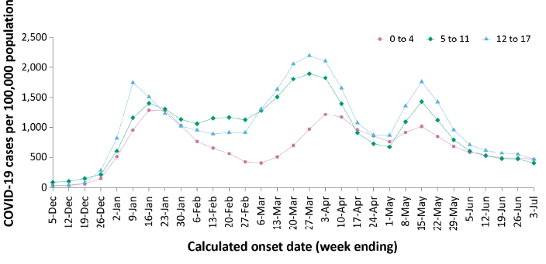

Source: Figure 1, sponsor response to TGA Comirnaty Query, pp 5 (data source provided with sponsor response - COVID-19 Australia: Epidemiology Report 63, reporting period ending 3 July 2022. *Commun Dis Intell*; 2022: 46:1-22

Severe COVID-19 illness is less common in children in Australia than in adults, but severe illness can and does occur. Data from the National Notifiable Diseases Surveillance System (NNDSS)[8] shows that there was a spike during peak transmission of the notification rate of severe illness (defined as cases admitted to intensive care units (ICU) or cases resulting in death) and this rate has remained higher during the current wave than during the Delta COVID-19 variant wave.

Figure 2: Age-specific rates of COVID-19 cases admitted to intensive care or cases with death as the outcome in Australia, by date of diagnosis; time period: 31 May 2021 to 19 June 2022

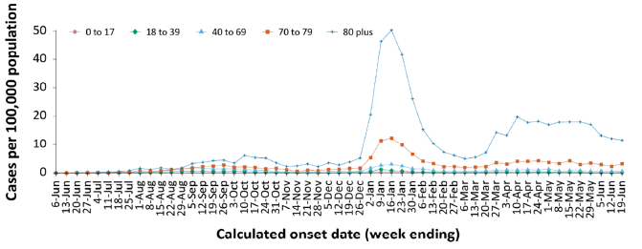

Source: Figure 2, sponsor response to TGA Comirnaty Query, pp 6 (data source provided with sponsor response - COVID-19 Australia: Epidemiology Report 63, reporting period ending 3 July 2022. *Commun Dis Intell*; 2022: 46 –22

Since the start of the pandemic to 30 July 2022, there have been 144 cases of PIMS-TS (or paediatric inflammatory multisystem syndrome temporally associated with SARS-CoV-2) reported to Paediatric Active Enhanced Disease Surveillance (PAEDS) in Australia.[9] The majority of PIMS-TS cases to date have occurred in those aged from 5 to less than 12 years (53%; 76/144). To date, there have been no PIMS-TS-associated deaths.

As of 3 July 2022, there has been open COVID-19 associated death notified to the NNDSS in the age group from 5 to 11 years.

#### Current vaccine options

There are currently six vaccines on the Australian Register of Therapeutic Goods (ARTG), and all are approved under the provisional pathway.[10],[11]:

* Comirnaty (tozinameran, previously known at BNT162b2 (mRNA));[12] also commonly known as the Pfizer/BioNTech (mRNA) vaccine is provisionally approved for active immunisation to prevent COVID-19 caused by SARS-CoV-2, in individuals 5 years of age and older.[13],[14],[15],[16],[17],[18],[19]
* COVID-19 Vaccine AstraZeneca (ChAdOx1-S), an adenoviral vectored vaccine, is provisionally approved for active immunisation to prevent COVID-19 caused by SARS-CoV-2, in individuals 18 years of age and older.[20],[21]
* Janssen (Ad26.COV2.S), an adenoviral vectored vaccine, is provisionally approved for active immunisation to prevent COVID-19 caused by SARS-CoV-2, in individuals 18 years of age and older.[22],[23]
* Spikevax (elasomeran) COVID-19 vaccine, also known as the Moderna (mRNA) vaccine, is provisionally approved for active immunisation to prevent COVID-19 caused by SARS-CoV-2, in individuals 6 months of age and older.[24],[25],[26],[27],[28]
* Spikevax Bivalent Original/Omicron COVID-19 Vaccine (elasomeran and imelasomeran), is provisionally approved as a booster dose for active immunisation to prevent coronavirus disease 2019 (COVID-19) caused by SARS-CoV-2 in individuals 18 years of age and older.[29]
* Nuvaxovid (SARS-CoV-2 recombinant spike protein with Matrix-M adjuvant) COVID-19 vaccine, also known as the Novavax recombinant spike protein vaccine, is provisionally approved for active immunisation to prevent COVID-19 caused by SARS-CoV-2 in individuals 12 years of age and older.[30],[31],[32]

### Regulatory status

The product received initial provisional registration on the Australian Register of Therapeutic Goods (ARTG) on 6 December 2021;8,9 for the following indication:

*Active immunisation to prevent coronavirus disease 2019 (COVID-19) caused by SARS-CoV-2, in individuals 16 years of age and older.*

Over time, the initial provisional registration has been expanded to include a wider population (specifically children and adolescents) and to include booster vaccine doses. A chronological history of the regulatory status of Comirnaty is shown in Table 2 below.

Table 2: Regulatory history of Comirnaty in Australia

|  |  |
| --- | --- |
| Date | Regulatory changes |
| 25 January 2021 | Initial provisional registration.  Primary series, for active immunisation for individuals aged 16 years and over.12,13 |
| 22 July 2021 | Extension of provisional registration.  Primary series, for active immunisation for individuals aged 12 years and over.14 |
| 26 October 2021 | Extension of provisional registration.  Booster dose, for active immunisation for individuals aged 18 years and over, following previous immunisation.15 |
| 3 December 2021 | Extension of provisional registration.  Introduction of tris/sucrose-buffered formulation.  Primary series, for active immunisation for individuals aged 5 years and over.16 |
| 27 January 2022 | Extension of provisional registration.  Booster dose, for active immunisation for individuals aged 16 and 17 years, following previous immunisation.17 |
| 7 April 2022 | Extension of provisional registration.  Booster dose, for active immunisation for individuals aged 12 to 15 years, following previous immunisation (primary series).18 |

At the time the TGA considered this submission, a similar submission had been approved in the United States of America (USA) in the form of an amended Emergency Use Authorization (EUA) on 17 May 2022, and in Canada (approved 19 August 2022). The sponsor also stated that similar submissions were underway in the European Union (EU), New Zealand, Singapore and Switzerland.

The following table summarises these submissions and provides the indications where approved.

Table 3: International regulatory status

|  |  |  |  |
| --- | --- | --- | --- |
| Region | Submission date | Status | Approved indications |
| United States of America | 26 April 2022 | Approved on 17 May 2022 | (Amendment to Emergency Use Authorization)  Changes to indication: None.  Changes to dosage: *Use of a single booster dose for administration to children aged 5 through 11 at least five months after completion of a primary series with Pfizer and BioNTech’s vaccine.* |
| European Union | 12 May 2022 | Under evaluation | Changes to indication: None. |
| United Kingdom | 22 September 2022 | Under evaluation | Linked to EU centralised process  Changes to indication: None. |
| New Zealand | 30 June 2022 | Under evaluation | Changes to indication: None. |
| Canada | 27 May 2022 | 19 August 2022 | Changes to indication: None.  Changes to dosage: *A single booster dose of the vaccine may be administered in individuals 5 years of age and older at least 6 months after completing their primary vaccine series (30 mcg each for ages 12 and older or 10 mcg each for ages 5 to 11).* |
| Singapore | 8 July 2022 | Under evaluation | Changes to indication: None. |
| Switzerland | 20 May 2022 | Under evaluation | Changes to indication: None. |

The sponsor stated a similar application has not been deferred, withdrawn or rejected in any of these countries/jurisdictions. The data submitted is stated to be identical to that submitted in the European Union (EU), with the exception of country-specific information.

### Product Information

The Product Information (PI) approved with the submission which is described in this AusPAR can be found as Attachment 1. For the most recent PI, please refer to the TGA [PI/CMI search facility.](https://www.tga.gov.au/picmi-search-facility)

## Registration timeline

Data were provided as a rolling submission. Under normal circumstances, the TGA's assessment (for both provisional and general registration) begins once all information to support registration is available. As part of the Department of Health's response to the pandemic, the TGA has agreed to accept rolling data for COVID-19 vaccines and treatments, to enable early evaluation of data as it becomes available.

The following table captures the key steps and dates for this submission.

Table 4: Timeline for Submission PM-2022-02476-1-2

|  |  |
| --- | --- |
| Description | Date |
| Submission dossier accepted and first round evaluation commenced | 6 July 2022 |
| Evaluation completed | 25 August 2022 |
| Delegate’s Overall benefit-risk assessment and request for Advisory Committee advice | 26 August 2022 |
| Sponsor’s pre-Advisory Committee response | 31 August 2022 |
| Advisory Committee meeting | 7 September 2022 |
| Registration decision (Outcome) | 20 September 2022 |
| Completion of administrative activities and registration on the ARTG | 29 September 2022 |
| Number of working days from submission dossier acceptance to registration decision* | 55 |

*Statutory timeframe for standard submissions is 255 working days

## Submission overview and risk/benefit assessment

A summary of the TGA’s assessment for this submission is provided below.

### Quality

A full quality evaluation was conducted at the time this product received initial registration.

For further information please refer to the AusPAR describing the relevant quality evaluation.17

### Nonclinical

A full nonclinical evaluation was conducted at the time this product received initial registration.

For further information please refer to past AusPARs describing the relevant nonclinical evaluations.14,17

### Clinical

#### Guidance

Relevant guidance documents for this submission include:

TGA guidance:

* Guidance 8: [Product information](https://www.tga.gov.au/guidance-8-product-information).
* [Form for providing product information](https://www.tga.gov.au/form-providing-product-information).

TGA-adopted guidance:

* ACCESS Consortium: [Access consortium statement on COVID-19 vaccines evidence](https://www.tga.gov.au/access-consortium-statement-covid-19-vaccines-evidence) (4 December 2020)
* ACCESS Consortium: Access Consortium: [Alignment with ICMRA consensus on immunobridging for authorising new COVID-19 vaccines](https://www.tga.gov.au/access-consortium-alignment-icmra-consensus-immunobridging-authorising-new-covid-19-vaccines) (14 September 2021)
* EMEA: [Guidelines on clinical evaluation of new vaccines (EMEA/CHMP/VWP/164653/2005)](https://www.ema.europa.eu/en/documents/scientific-guideline/guideline-clinical-evaluation-new-vaccines_en.pdf) (18 October 2006).

Additional guidance useful for this submission:

* European Medicines Agency (EMA): [EMA considerations on COVID-19 vaccine approval (EMA/592928/2020)](https://www.ema.europa.eu/en/documents/other/ema-considerations-covid-19-vaccine-approval_en.pdf) (19 November 2020)
* United States Food and Drug Administration (US FDA): [Development and licensure of vaccines to prevent COVID-19: guidance for industry](https://www.fda.gov/media/139638/download) (June 2020)
* US FDA: [Emergency use authorization for vaccines to prevent COVID-19: guidance for industry](https://www.fda.gov/media/142749/download) (25 May 2021)
* US FDA: [COVID-19: developing drugs and biological products for treatment or prevention: guidance for industry](https://www.fda.gov/media/137926/download) (February 2021)
* WHO: [Design of vaccine efficacy trials to be used during public health emergencies – points of consideration and key principles](https://www.who.int/docs/default-source/blue-print/working-group-for-vaccine-evaluation-(4th-consultation)/ap1-guidelines-online-consultation.pdf) (not dated).

#### Summary of clinical studies

The clinical dossier consisted of the Study C4591007 interim clinical study report, and post‑market data providing safety data related to this submission.

There are no clinical efficacy data. The sponsor stated the basis of demonstrating Comirnaty (tozinameran) vaccine effectiveness in children is immune response data. The interim clinical study report for Study C4591007 included immune response data for children aged from 5 to under 12 years following a booster (third) dose of Comirnaty 10 µg.

#### Study C4591007 overview

Study C4591007 is an ongoing, Phase I, II and III, randomised, placebo-controlled study in healthy paediatric participants aged from 6 months to under 12 years of age. The study was designed to evaluate the safety, tolerability, and immunogenicity of Comirnaty vaccination in an age de-escalation Phase I dose finding part and Phase II/III selected dose part, in protocol defined age groups (from 5 to under 12 years; from 2 to under 5 years and from 6 months to under 2 years). Participants aged from 5 to under 12 years in Phase II/III of the study were randomised in 2:1 ratio to active vaccine (Comirnaty (tozinameran) 10 µg) or matching saline placebo and administered study treatment in a two dose schedule given 21 days apart as a primary series. Phase I and Phase II/III data from this study were evaluated in a previous submission;16 to support the extension of indication to individuals aged from 5 to under 12 years. This is considered acceptable.

The sponsor stated the primary series of Comirnaty (tozinameran) was initially planned as a two-dose series; however, based on emerging clinical and real-world data, the protocol was amended to add a third dose at the selected dose level for each age group. The current clinical study report includes interim safety and immunogenicity data up to one month after a booster (third) dose of Comirnaty 10 µg administered to Phase II/III study participants aged from 5 to under 12 years. Note that the protocol specified timing of booster vaccination for participants aged from 5 to under 12 years was at least 6 months after Dose 2); therefore, booster (third) doses have been administered to participants in this age group in an open-label manner. The sponsor confirmed the formulation of Comirnaty (tozinameran) 10 µg used for the booster dose was the same formulation used for the 2-dose primary series. The PBS/sucrose-buffered formulation was used rather than the marketed tris/sucrose-buffered formulation; it is noted that issues relating to formulation were addressed previously in a previous submission to the TGA.16

The study was conducted at 68 centres as of the data cut-off, located in four countries (Finland, Poland, Spain and United States of America). The Phase II/III study commenced on 7June 2021 and is ongoing. Data cut-off for the interim clinical study report was 22 March 2022.

##### Major inclusion and exclusion criteria

Major inclusion criteria included:

* healthy female and male participants aged from 6 months to under 12 years of age at the time of randomisation;
* healthy participants with pre-existing stable disease (defined as disease not requiring significant change in the therapy or hospitalisation for worsening disease during the 6 weeks before enrolment);
* past clinical or microbiological diagnosis of COVID-19 and stable HIV, hepatitis B or C (HBV, HBV) infection were eligible.

Major exclusion criteria included:

* previous vaccination with any coronavirus vaccine;
* use of medications intended to prevent COVID-19;
* severe reaction associated with any vaccine or severe allergic reaction to any component of the study intervention;
* immunocompromised individuals with known or suspected immunodeficiency;
* individuals with a history of autoimmune disease or an active autoimmune disease requiring therapeutic intervention (stable type 1 diabetes and hypothyroidism were permitted);
* previous or current diagnosis of multisystem inflammatory syndrome in children (MIS-C) and other medical or psychiatric condition or laboratory abnormality that may increase the risk of study participation.

Concomitant therapies prohibited during the study included any:

* non-live vaccine;
* seasonal or pandemic influenza vaccine;
* rotavirus vaccine within 14 days;
* live vaccine (excluding live influenza and rotavirus vaccines) within 28 days, before study intervention administration; or
* use of systemic corticosteroids (> 2 mg/kg/dose of prednisone or equivalent) for ≥ 14 days from 28 days prior to enrolment through the one month follow-up after Dose 3 and prophylactic anti-pyretics and other pain medication to prevent symptoms associated with study intervention administration.

##### Primary and secondary objectives, estimands, and endpoints

The Phase II/III primary and secondary objectives, estimands and endpoints of relevance to the current submission are provided below.

Table 5: Study C4591007 Phase II/III Objectives, estimands, and endpoints (primary safety)

|  |  |
| --- | --- |
| Study C4591007 Phase II/III – primary safety | |
| **Objectives** | To define the safety profile of prophylactic Comirnaty vaccine in *all participants* (selected dose, lower dose, and obtaining serum samples for potential troponin I testing portions of the study) in Phase II/III in each age group. |
| **Estimands** | In participants receiving at least one dose of study intervention from each vaccine group, the percentage of participants in each age group reporting:   * local reactions for up to 7 days following each dose * systemic events for up to 7 days following each dose * adverse events from Dose 1 to one month after Dose 2 * serious adverse events from Dose 1 to 6 months after Dose 2 * adverse events from Dose 3 to one month after Dose 3 * serious adverse events from Dose 3 to 6 months after Dose 3 |
| **Endpoints** | In participants from 16 to under 18 years of age; 12 to under 16 years of age, 5 to under 12 years of age, and 2 to under 5 years of age:   * local reactions (pain at the injection site, redness, and swelling); * systemic events (fever, fatigue, headache, chills, vomiting, diarrhoea, new or worsened muscle pain, and new or worsened joint pain); * adverse events; and * serious adverse events   In participants from 6 months to under 2 years of age:   * local reactions (tenderness at the injection site, redness, and swelling); * systemic events (fever, decreased appetite, drowsiness, and irritability); * adverse events; and * serious adverse events. |
| **Comments** | *Data from 5 to under 12 years of age group previously reported in Study C4591007 interim clinical study report date: 30 September 2021*  **Post-Dose 3 data for 5 to under 12 years of age group included in this clinical study report.**  Other age groups, lower-dose, and troponin data to be reported at a later time |

Extract from Study C4591007 interim clinical study report

Table 6: Study C4591007 Phase II, III Objectives, estimands, and endpoints (secondary; immunogenicity/efficacy)

|  |  |
| --- | --- |
| Study C4591007 Phase II/III – immunogenicity/efficacy | |
| **Objectives** | To describe the immune responses elicited by prophylactic Comirnaty vaccination at the dose level selected in each age group and persistence of immune response in Phase II/III participants without serological or virological evidence of past SARS-CoV-2 infection. |
| **Estimands** | In evaluable participants with no serological or virological evidence of past SARS-CoV-2 infection from each vaccine and age group:   * geometric mean titres (GMTs) at each time point * geometric mean fold rise (GMFRs) from before Dose 1 to each subsequent time point after Dose 2 or Dose 3 |
| **Endpoints** | SARS-CoV-2 neutralising titres |
| **Comments** | *Data from 5 to under 12 years of age group previously reported in Study C4591007 interim clinical study report date: 30 September 2021*  **Post-Dose 3 data for 5 to under 12 years of age group included in this clinical study report.**  Other age groups to be reported at a later time |

Extract from Study C4591007 interim clinical study report

Table 7: Study C4591007 Phase II/III Objectives, estimands, and endpoints (exploratory)

|  |  |  |
| --- | --- | --- |
| Study C4591007 Phase II/III – exploratory | | |
| **Objectives** | To evaluate the immune response over time to prophylactic Comirnaty vaccination at the dose level selected in each age group and persistence of immune response in Phase II/III participants with and without serological or virological evidence of past SARS-CoV-2 infection. | To describe immune response to emerging variants of concern (VOC) |
| **Estimands** | In evaluable participants with or without serological or virological evidence of past SARS-CoV-2 infection from each vaccine group:   * GMCs and/or GMTs at each time point; * GMFRs from before Dose 1 to each subsequent time point after Dose 2 or Dose 3. |  |
| **Endpoints** | Full length S-binding IgG levels and/or SARS-CoV-2 neutralising titres | SARS-CoV-2 neutralising titres to VOCs. |
| **Comments** | **Post-Dose 3 data for 5 to under 12 years of age group included in this clinical study report.**  Other age groups to be reported at a later time. | |

Extract from Study C4591007 interim clinical study report

Immunogenicity data include SARS-CoV-2 neutralising titres against the wild-type virus strain and Omicron variant after a booster (third) dose of Comirnaty (tozinameran) 10 µg, up to one month post-Dose 3.

As per the protocol amendment 6 (schedule of assessments) serum sampling for immunogenicity was to be conducted at the following time points:

* before Dose 1 (Visit 1);
* one month after Dose 2 (Visit 4);
* before Dose 3 (Visit 5A); and
* one month after Dose 3 (Visit 5B).

For immunogenicity analyses, a validated SARS-CoV-2 neutralisation assay was used to detect the wild-type reference strain at the central laboratory. All samples to test for SARS-CoV-2 exposure (serum for *N*-binding assay or nasal swab for nucleic acid amplification test (NAAT)) were analysed at a central laboratory.

The fluorescent focus reduction neutralisation test (FFRNT) is a non-validated assay used to detect the Omicron variant in the Omicron neutralisation subset. These analyses were conducted at the University of Texas Medical Branch. The sponsor stated that:

*The FFRNT is a non-validated assay similar to the 50% plaque-reduction neutralisation test (PRNT) assay which has been used to generate confirmatory data against the reference strain and other variants. The FFRNT assay has higher throughput and correlates well with the PRNT assay. All samples were tested at the same time to ensure comparability of results.*

The immunogenicity and safety estimands and endpoints used in the study were stated to be consistent with those used in Comirnaty (tozinameran) vaccine studies (Studies C4591001, and C4591007).

The sponsor clarified serum sampling for immunogenicity at the one month post-Dose 2 (Visit 4) time point was only planned for a certain number of participants as per protocol.

##### Study populations

Immunogenicity analyses were conducted for an immunogenicity set of participants based on all-available and evaluable immunogenicity populations. The immunogenicity set was comprised of:

* *three dose set*: included up to 130 participants who received Dose 3 and completed the one month post-Dose 3 visit prior to 15 March 2022. Up to 30 participants within this set had blood sample collection at one month post-Dose 2, with sera from these participants also analysed for Omicron variant neutralisation.
* *two dose set:* included up to 70 additional participants randomly selected from the previously analysed Dose 2 evaluable immunogenicity population who were without evidence of prior infection up to one month post-Dose 2 (that is, included in the two‑dose immunobridging analysis).

The Dose 2 and Dose 3 evaluable immunogenicity populations included participants who received all doses of vaccine at the same dose level as randomised (that is, either 2 or 3 doses) within the protocol specified window for each dose, had ≥ 1 valid and determinate immunogenicity result within 28 to 42 days after vaccination, and did not have any important protocol deviations impacting evaluability.

Immunogenicity results were reported as:

* SARS-CoV-2 50% neutralising geometric mean titres (GMTs);
* geometric mean ratio (GMR) of SARS-CoV-2 50% neutralising titres;
* percentages/difference in percentages of participants who achieved seroresponse; and
* geometric mean-fold rises (GMFRs) of SARS-CoV-2 50% neutralising titres.

The safety population included all participants who received a third dose of Comirnaty (tozinameran) 10 µg by 22 February 2022.

##### Statistical methods

Immunogenicity analyses were based on immune responses at each time point with descriptive comparison of immune responses at one month post-Dose 3 compared with immune responses at one month post-Dose 2.

Results were reported as SARS-CoV-2 50% neutralising GMTs, the GMR of the two time points, percentages of children with seroresponse, and as the difference in percentages of children with seroresponse between the two time points, as follows:

* *Geometric mean titres (GMTs):* 2-sided 95% confidence intervals (CI) for GMTs were obtained by taking log transforms of assay results, calculating the 95% CI with reference to Student’s t-distribution, then exponentiating the confidence limits. Titres below the lower limit of quantification (LLOQ) were set to 0.5 × LLOQ.
* *Seroresponse*: Defined as achieving a ≥ 4-fold rise in SARS-CoV-2 neutralising titres from baseline (before Dose 1). If the baseline measurement was below the LLOQ, the post-vaccination measure of ≥ 4 × LLOQ was considered seroresponse. The exact 2‑sided 95% CI for percentage of participants with seroresponse was computed using the F distribution (Clopper-Pearson).

*Comparison using two different groups of participants:*

Comparisons were made using data at one month post-Dose 3 (only participants in the 3‑dose set contributed data to this time point) versus all available data at one month post‑Dose 2 (all participants in the 2-dose set and the approximately 30 participants in the 3-dose set who had blood sample collection at one month post-Dose 2 contributed data to this time point).

* *Geometric mean ratio (GMR)*: Calculated as the mean of the difference of logarithmically transformed titres between the two groups of participants at the two time points and exponentiating the mean. The associated 2-sided 95% CIs were obtained by constructing CIs using Student’s t-distribution for the mean difference on the logarithm scale and exponentiating the confidence limits.
* *Difference in seroresponse rate*: The difference in percentages of participants who achieved seroresponse and the associated 2-sided 95% CI calculated using the Miettinen and Nurminen method were provided.

*Comparison within same set of participants (3-dose set with assay results at both time points):*

* *Geometric mean ratio (GMR*): Calculated as the mean of the difference of logarithmically transformed titres at the two time points and exponentiating the mean. The associated 2-sided 95% CIs were obtained by constructing CIs using one-sample Student’s t-distribution for the mean difference on the logarithm scale and exponentiating the confidence limits.
* *Difference in seroresponse rate*: The 2-sided 95% CI for the difference in percentages of participants who achieved seroresponse was calculated using an adjusted Wald interval as described by Agresti and Min (2005).[33]

Data were analysed combining the available assay results from the 2-dose set and 3-dose set to evaluate immune responses at each time point. A separate summary for participants in the 3-dose set with assay results at both one month post-Dose 2, and one month post‑Dose 3 was also provided. Analyses were conducted for participants either without, or with or without, evidence of prior SARS-CoV-2 infection up to one month post-Dose 2 or one month post-Dose 3. Prior infection was determined by N-binding assay (at Baseline, one month post-Dose 2, Dose 3, and one month post-Dose 3) and by nucleic acid amplification test (NAAT) at Baseline, Dose 2 and at Dose 3 visits, and any unscheduled illness visits.

Analyses were conducted on the Omicron neutralisation subset, comprising up to approximately 30 participants in the 3-dose set who had blood sample collection at both one month post-Dose 2- and one month post-Dose 3. Analyses were conducted for participants either without, or with or without, evidence of prior SARS-CoV-2 infection up to one month post-Dose 3 as determined by N-binding antibody or NAAT results.

#### Study C4591007 immunogenicity results

##### Patient flow

In the 3-dose set, 123 (94.6%) participants received Dose 3 of Comirnaty (tozinameran) 10 µg. There were 7 (5.4%) participants who received Comirnaty (tozinameran) Dose 3 at the age-appropriate dose level of 30 µg (that is, turned 12 years of age during or after the two-dose primary series vaccination period) and excluded from further analyses. All participants received the booster dose 7 to 9 months after Dose 2.

The Dose 3 evaluable immunogenicity population included 115 participants 5 to under 12 years of age who received a booster (third) dose of Comirnaty (tozinameran) 10 µg.

Eight (6.5%) participants were excluded from the Dose 3 evaluable immunogenicity population, most commonly due to lack of a valid and determinate assay immunogenicity result 28 to 42 days after Dose 3 (4.9%). There were 67 (54.5%) participants without prior evidence of SARS-CoV-2 infection up to one month after Dose 3; the sponsor stated the number of participants without prior infection was impacted by the Omicron variant wave that overlapped with Dose 3 administration.

In the 3-dose Set, the majority of participants (74.0%) did not have a blood draw at one month post-Dose 2, resulting in a much smaller sample size of participants in the Dose 2 evaluable immunogenicity population. In response to questions the sponsor clarified as per protocol, blood collection at one month post-Dose 2 was only planned for a certain number of participants in each age group for assessment of 2-dose immunobridging objective at the time.

Table 8: Study C4591007 (Phase II/III) Immunogenicity populations (immunogenicity set, from 5 to under 12 years of age)

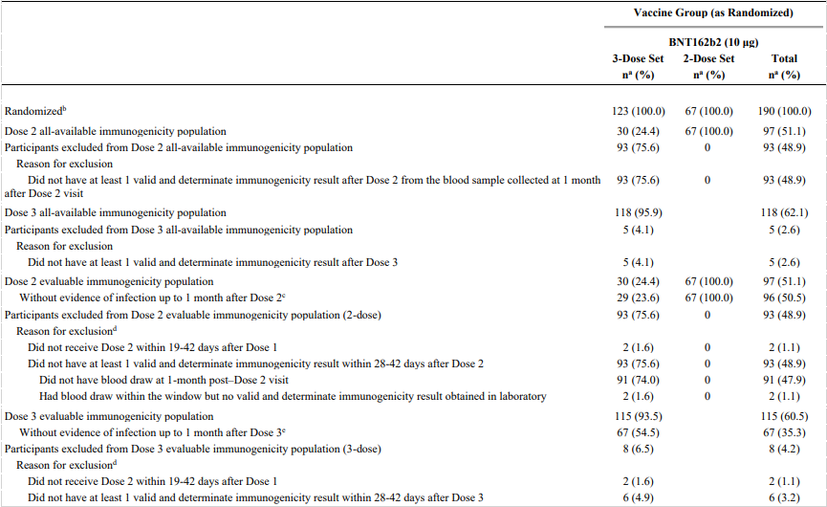

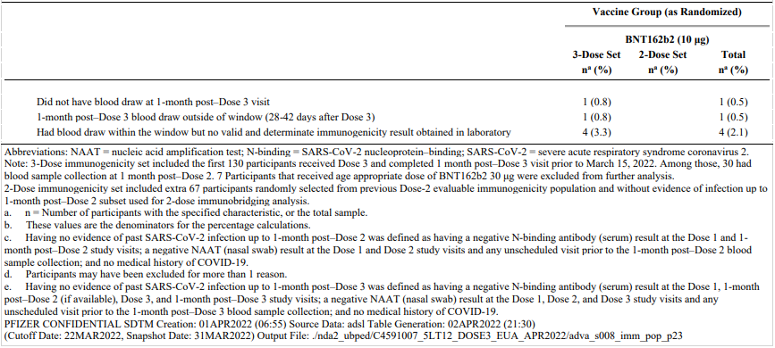

Abbreviations: NAAT = nucleic acid amplification test; N-binding = SARS-CoV-2 nucleoprotein–binding; SARS-CoV-2 = severe acute respiratory syndrome coronavirus 2.

Note: 3-Dose immunogenicity set included the first 130 participants received Dose 3 and completed one month post–Dose 3 visit prior to March 15, 2022. Among those, 30 had blood sample collection at one month post–Dose 2. Seven Participants that received age appropriate dose of Comirnaty 30 μg were excluded from further analysis. 2-Dose immunogenicity set included extra 67 participants randomly selected from previous Dose-2 evaluable immunogenicity population and without evidence of infection up to one-month post–Dose 2 subset used for 2-dose immunobridging analysis.

a. n = Number of participants with the specified characteristic, or the total sample.

b. These values are the denominators for the percentage calculations.

c. Having no evidence of past SARS-CoV-2 infection up to one month post–Dose 2 was defined as having a negative N-binding antibody (serum) result at the Dose 1 and one month post–Dose 2 study visits; a negative NAAT (nasal swab) result at the Dose 1 and Dose 2 study visits and any unscheduled visit prior to the one month post–Dose 2 blood sample collection; and no medical history of COVID-19.

d. Participants may have been excluded for more than one reason.

e. Having no evidence of past SARS-CoV-2 infection up to one month post–Dose 3 was defined as having a negative N-binding antibody (serum) result at the Dose 1, one month post–Dose 2 (if available), Dose 3, and one month post–Dose 3 study visits; a negative NAAT (nasal swab) result at the Dose 1, Dose 2, and Dose 3 study visits and any unscheduled visit prior to the one month post–Dose 3 blood sample collection; and no medical history of COVID-19.

##### Baseline data

Among the 67 participants of the Dose 3 evaluable immunogenicity population without prior evidence of SARS-CoV-2 infection up to 1 month after Dose 3, 52.2% were male, 74.6% were White and all were from the USA. The median age at Dose 1 was 8.0 years. There were 4.5% participants reported as obese and 25.4% participants with comorbidities that increase the risk of severe COVID-19 disease (including obesity).

Demographic characteristics in the Dose 3 evaluable immunogenicity population were similar. There were 4.3% participants SARS-CoV-2 positive at Baseline.

##### SARS-CoV-2 neutralising titres

Secondary objectives of Study C4591007 included assessment of immunogenicity endpoints in participants without evidence of past SARS-CoV-2 infection to the reference SARS‑CoV-2 strain. Immune responses in participants with or without evidence of past SARS-CoV-2 infection were exploratory.

Of note, the total evaluable immunogenicity population comprises the combined 2-dose set (participants who completed the one month post-Dose 2 visit) and 3-dose set (participants who completed the one month post-Dose 3 visit). Analyses of GMFR, GMR, and differences in seroresponse rates were based on the total of available titres across the combined 3-dose and 2-dose sets.

##### Geometric mean titres

Among the total evaluable immunogenicity population without prior evidence of SARS‑CoV-2 infection, observed GMTs increased from pre-vaccination of 20.5 (95% CI: 20.5, 20.5; n = 146) to 1253.9 (95% CI: 1116.0, 1408.9) at one month post-Dose 2 (n = 96). Observed GMTs had waned to 271.0 (95% CI: 229.1, 320.6) prior to Dose 3, increasing to 2720.9 (95% CI: 2280.1, 3247.0) at one month post-Dose 3 (n = 67).

Table 9: Study C4591007 Phase II/III Summary of geometric mean titres (NT50) in participants without evidence of infection aged from 5 to under 12 years of age (immunogenicity set, evaluable immunogenicity population)

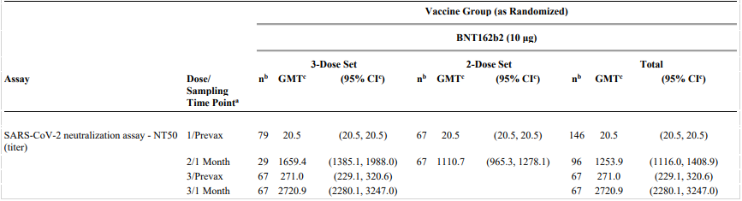

Abbreviations: GMT = geometric mean titre; LLOQ = lower limit of quantitation; NAAT = nucleic acid amplification test; N-binding = SARS-CoV-2 nucleoprotein–binding; NT50 = 50% neutralising titre; Prevax = before vaccination; SARS-CoV-2 = severe acute respiratory syndrome coronavirus 2.

Note: 3-Dose immunogenicity set included the first 130 participants received Dose 3 and completed one month post–Dose 3 visit prior to March 15, 2022. Among those, 30 had blood sample collection at one month post–Dose 2. 2-Dose immunogenicity set included extra 67 participants randomly selected from previous Dose-2 evaluable immunogenicity population and without evidence of infection up to one month post–Dose 2 subset used for 2-dose immunobridging analysis.

Note: Participants included in this analysis had no serological or virological evidence of past SARS-CoV-2 infection up to the one month post–Dose 2 (for one month post–Dose 2 time point) or one month post‑Dose 3 (for pre–Dose 3 and one month post–Dose 3 time points) study blood sample collection.

Having no evidence of past SARS-CoV-2 infection up to one month post–Dose 2 was defined as having a negative N-binding antibody (serum) result at the Dose 1 and one month post–Dose 2 study visits; a negative NAAT (nasal swab) result at the Dose 1 and Dose 2 study visits and any unscheduled visit prior to the one month post–Dose 2 blood sample collection; and no medical history of COVID-19. Having no evidence of past SARS-CoV-2 infection up to one month post–Dose 3 was defined as having a negative N‑binding antibody (serum) result at the Dose 1, one month post–Dose 2 (if available), Dose 3, and one month post–Dose 3 study visits; a negative NAAT (nasal swab) result at the Dose 1, Dose 2, and Dose 3 study visits and any unscheduled visit prior to the one month post–Dose 3 blood sample collection; and no medical history of COVID-19.

a. Protocol-specified timing for blood sample collection.

b. n = Number of participants with valid and determinate assay results for the specified assay at the given dose/sampling time point.

c. GMTs and 2-sided 95% CIs were calculated by exponentiating the mean logarithm of the titres and the corresponding CIs (based on the Student t distribution). Assay results below the LLOQ were set to 0.5 × LLOQ.

The difference in observed GMTs at one month post-Dose 2 for the 3-dose set and 2-dose set is noted; 1659.4 (95% CI: 1385.1, 1988.0) versus 1110.7 (95% CI: 965.3, 1278.1). In response to questions the sponsor noted the small proportion of Dose 3 Set subjects with one month post-Dose 2 data and considered the difference in observed GMTs at one month post-Dose 2 time point for the small subset of Dose 3 set and Dose 2 set could be a chance observation due to sampling variability. This is considered acceptable.

Figure 3: Study C4591007 Phase II/III Reverse cumulative distribution curves, SARS-CoV-2 neutralisation assay (NT50) in participants without evidence of infection, who received Dose 3 of Comirnaty vaccine, aged from 5 to under 12 years of age (evaluable immunogenicity population)

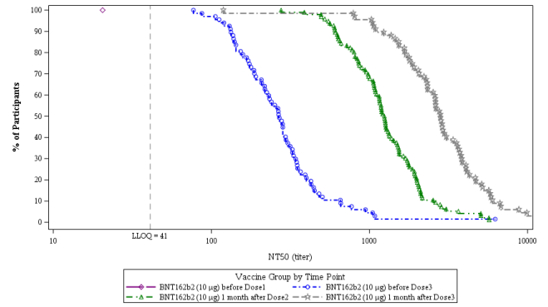

Abbreviations: LLOQ = lower limit of quantification; NT50 = 50% neutralising titre.

BNT162b2 refers to Comirnaty (tozinameran) COVID-19 vaccine.

Similar results were observed for the 17 participants in the 3-dose set with assay results at both one month post-Dose 2, and one month post-Dose 3 time points, without prior evidence of SARS-CoV-2 infection.

Table 10: Study C4591007 Phase II/III Summary of geometric mean titres (NT50) in participants without evidence of infection, with assay result at both one month post-Dose 2 and one month post-Dose 3, aged from 5 to under 12 years of age (evaluable immunogenicity population)

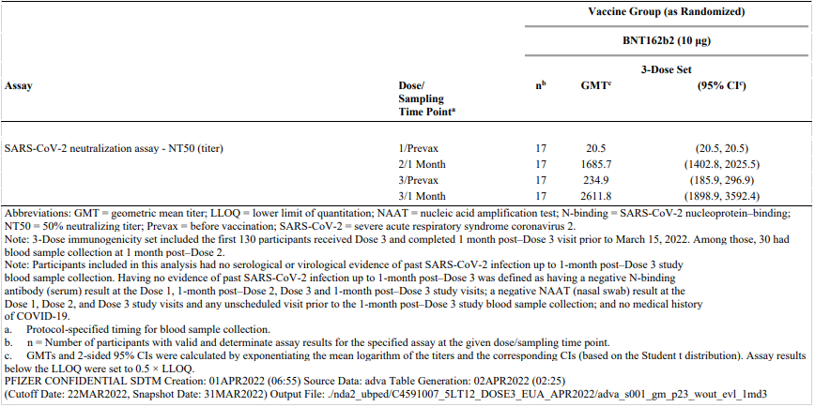

Abbreviations: CI = confidence interval(s); GMT = geometric mean titre; LLOQ = lower limit of quantitation; NAAT = nucleic acid amplification test; N-binding = SARS-CoV-2 nucleoprotein–binding; NT50 = 50% neutralising titre; Prevax = before vaccination; SARS-CoV-2 = severe acute respiratory syndrome coronavirus 2.

Note: 3-Dose immunogenicity set included the first 130 participants received Dose 3 and completed one month post–Dose 3 visit prior to 15 March 2022. Among those, 30 had blood sample collection at one month post–Dose 2.

Note: Participants included in this analysis had no serological or virological evidence of past SARS-CoV-2 infection up to one month post–Dose 3 study blood sample collection. Having no evidence of past SARS-CoV-2 infection up to one month post–Dose 3 was defined as having a negative N-binding antibody (serum) result at the Dose 1, one month post–Dose 2, Dose 3 and one month post–Dose 3 study visits; a negative NAAT (nasal swab) result at the Dose 1, Dose 2, and Dose 3 study visits and any unscheduled visit prior to the one month post–Dose 3 study blood sample collection; and no medical history of COVID-19.

a. Protocol-specified timing for blood sample collection.

b. n = Number of participants with valid and determinate assay results for the specified assay at the given dose/sampling time point.

c. GMTs and 2-sided 95% CIs were calculated by exponentiating the mean logarithm of the titres and the corresponding CIs (based on the Student t distribution). Assay results

below the LLOQ were set to 0.5 × LLOQ.

##### Geometric mean ratio of neutralising titres

The GMR of neutralising titres against the reference SARS‑CoV-2 strain available at one month post-Dose 3 versus titres available at one month post-Dose 2 in the evaluable immunogenicity population without evidence of prior SARS-CoV-2 infection was 2.17 (95% CI: 1.76, 2.68). GMR results were comparable for the evaluable immunogenicity population (2.53 (95% CI: 2.11, 3.04)) and the all-available immunogenicity population (2.52 (95% CI: 2.10, 3.02)).

Table 11: Study C4591007 Phase II/III Summary of geometric mean ratios (NT50), comparison of one month post-Dose 2 and one month post-Dose 3, in participants without evidence of infection aged from 5 to under 12 years of age (immunogenicity set, evaluable immunogenicity population)

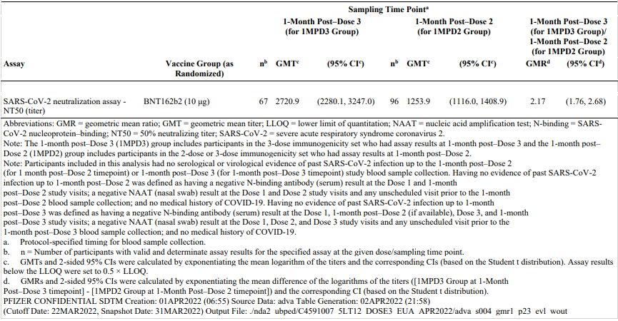

Abbreviations: 1MPD2 = one month post-Dose 2; 1MPD3 = one month post-Dose 3; GMR = geometric mean ratio; GMT = geometric mean titre; LLOQ = lower limit of quantitation; NAAT = nucleic acid amplification test; N-binding = SARS-CoV-2 nucleoprotein–binding; NT50 = 50% neutralising titre; SARS‑CoV-2 = severe acute respiratory syndrome coronavirus 2.

Note: The one month post–Dose 3 (1MPD3) group includes participants in the 3-dose immunogenicity set who had assay results at one month post–Dose 3 and the one month post–Dose 2 (1MPD2) group includes participants in the 2-dose or 3-dose immunogenicity set who had assay results at one month post–Dose 2.

Note: Participants included in this analysis had no serological or virological evidence of past SARS-CoV-2 infection up to the one month post–Dose 2 (for one month post–Dose 2 time point) or one month post‑Dose 3 (for one month post–Dose 3 time point) study blood sample collection. Having no evidence of past SARS‑CoV-2 infection up to one month post–Dose 2 was defined as having a negative N-binding antibody (serum) result at the Dose 1 and one month post–Dose 2 study visits; a negative NAAT (nasal swab) result at the Dose 1 and Dose 2 study visits and any unscheduled visit prior to the one month post–Dose 2 blood sample collection; and no medical history of COVID-19. Having no evidence of past SARS-CoV-2 infection up to one month post–Dose 3 was defined as having a negative N-binding antibody (serum) result at the Dose 1, one month post–Dose 2 (if available), Dose 3, and one month post–Dose 3 study visits; a negative NAAT (nasal swab) result at the Dose 1, Dose 2, and Dose 3 study visits and any unscheduled visit prior to the one month post–Dose 3 blood sample collection; and no medical history of COVID-19.

a. Protocol-specified timing for blood sample collection.

b. n = Number of participants with valid and determinate assay results for the specified assay at the given dose/sampling time point.

c. GMTs and 2-sided 95% CIs were calculated by exponentiating the mean logarithm of the titres and the corresponding CIs (based on the Student t distribution). Assay results below the LLOQ were set to 0.5 × LLOQ.

d. GMRs and 2-sided 95% CIs were calculated by exponentiating the mean difference of the logarithms of the titres ((1MPD3 Group at one month Post–Dose 3 time point) minus (1MPD2 Group at one month post‑Dose 2 time point)) and the corresponding CI (based on the Student t distribution).

Among the 17 participants without prior evidence of SARS-CoV-2 infection in the 3-dose set with assay results at both one month post-Dose 2 and at one month post-Dose 3, the GMR was 1.55 (95% CI: 1.11, 2.17).

Table 12: Study C4591007 Phase II/III Summary of geometric mean ratios (NT50), comparison of one month post-Dose 2 and one month post-Dose 3, in participants without evidence of infection with assay results at both one month post-Dose 2 and one month post-Dose 3, aged from 5 to under 12 years of age (immunogenicity set, evaluable immunogenicity population)

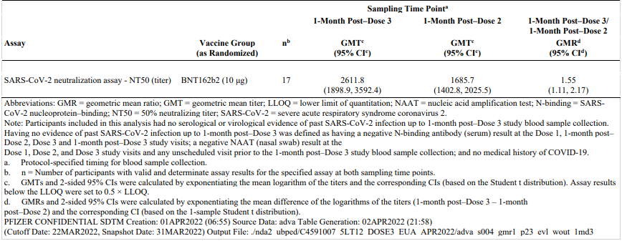

Abbreviations: GMR = geometric mean ratio; GMT = geometric mean titre; LLOQ = lower limit of quantitation; NAAT = nucleic acid amplification test; N-binding = SARS-CoV-2 nucleoprotein–binding; NT50 = 50% neutralising titre; SARS-CoV-2 = severe acute respiratory syndrome coronavirus 2.

Note: Participants included in this analysis had no serological or virological evidence of past SARS-CoV-2 infection up to one month post–Dose 3 study blood sample collection. Having no evidence of past SARS-CoV-2 infection up to one month post–Dose 3 was defined as having a negative N-binding antibody (serum) result at the Dose 1, one month post–Dose 2, Dose 3 and one month post–Dose 3 study visits; a negative NAAT (nasal swab) result at the Dose 1, Dose 2, and Dose 3 study visits and any unscheduled visit prior to the one month post–Dose 3 study blood sample collection; and no medical history of COVID-19.

a. Protocol-specified timing for blood sample collection.

b. n = Number of participants with valid and determinate assay results for the specified assay at both sampling time points.

c. GMTs and 2-sided 95% CIs were calculated by exponentiating the mean logarithm of the titres and the corresponding CIs (based on the Student t distribution). Assay results below the LLOQ were set to 0.5 × LLOQ.

d. GMRs and 2-sided 95% CIs were calculated by exponentiating the mean difference of the logarithms of the titres (one month post-Dose 3 minus one month post–Dose 2) and the corresponding CI (based on the 1-sample Student t distribution).

##### Geometric mean fold rise in titres

The geometric mean fold rise (GMFR) of SARS-CoV-2 50% serum neutralising titres (for the reference SARS-CoV-2 strain) from Dose 3 to one month after Dose 3 was 10.0 (95% CI: 8.1, 12.4) among the 67 participants in the evaluable immunogenicity population without prior evidence of SARS-CoV-2 infection. Results in populations including participants with prior SARS-CoV-2 infection also demonstrated increased fold-rise in titres after Dose 3, albeit of a smaller magnitude than that observed in participants without previous infection.

Table 13: Study C4591007 Phase II/III Summary of geometric mean fold ratios (NT50), in participants aged from 5 to under 12 years of age (immunogenicity set, evaluable immunogenicity population)

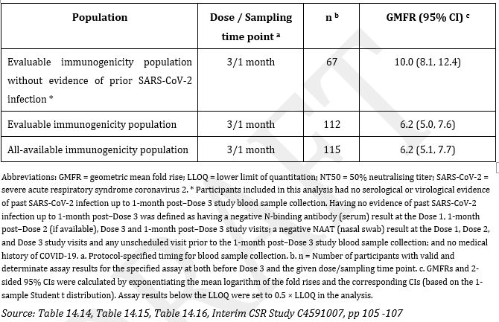

Abbreviations: GMFR = geometric mean fold rise; LLOQ = lower limit of quantitation; NT50 = 50% neutralising titre; SARS-CoV-severe acute respiratory syndrome coronavirus 2.

* Participants included in this analysis had no serological or virological evidence of past SARS-CoV-2 infection up to one month post-Dose 3 study blood sample collection, Having no evidence of past SARS-CoV-2 infection up to one month post-Dose 3 was defined as having a negative N-binding antibody (serum) result at the Dose 1, one month post-Dose 2 (if available), Dose 3 and one month post-Dose 3 study visits; a negative NAAT (nasal swab) result at the Dose 1, Dose 2, and Dose 8 study visits and any unscheduled visit prior to the one month post-Dose 3 study blood sample collection; and no medical history of COVID‑19.

a, Protocol-specified timing for blood sample collection.

b. n= Number of participants with valid and determinate assay results for the specified assay at both before Dose 3 and the given dose /sampling time point.

c. GMFRs and 2-sided 95% CIs were calculated by exponentiating the mean logarithm of the fold rises and the corresponding Cis (based on the 1-sample Student t distribution). Assay results below the LLOQ were set to 0.5 x LLOQ in the analysis.

##### Seroresponse rate

Among the total set of participants in the evaluable immunogenicity population without prior evidence of SARS-CoV-2 infection, the observed proportion of participants who achieved seroresponse at one month after Dose 2 (n = 96) was 100.0% (95% CI: 96.2, 100.0). The seroresponse rate had waned to 77.6% (95% CI: 65.8, 86.9) in this population prior to Dose 3, and increased to 98.5% (95% CI: 92.0, 100.0) at one month post-Dose 3. The difference in seroresponse rates (one month after Dose 3 minus one month after Dose 2) in this population was -1.5% (95% CI: -8.0, 2.4).

The observed proportion of participants with seroresponse at one month post-Dose 2, pre-Dose 3, and one month post-Dose 3 were 100.0% (95% CI: 80.5, 100.0), 70.6% (95% CI: 44.0, 89.7), and 100.0% (95% CI: 80.5, 100.0) respectively among the 17 participants without prior evidence of SARS-CoV-2 infection in the 3-dose set with assay results at both one month post-Dose 2 and at one month post-Dose 3. The difference in seroresponse rates (one month after Dose 3 minus one month after Dose 2) in this population was 0.0% (95% CI: -10.3, 10.3).

Similar trends were observed for seroresponse rates in the evaluable immunogenicity population regardless of SARS-CoV-2 infection and all-available immunogenicity population.

Table 14: Study C4591007 Number (%) of participants with seroresponse (NT50), in participants without evidence of infection aged from 5 to under 12 years of age (immunogenicity set, evaluable immunogenicity population)

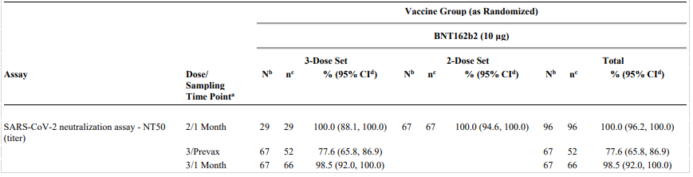

Abbreviations: LLOQ = lower limit of quantitation; NAAT = nucleic acid amplification test; N‑binding = SARS-CoV-2 nucleoprotein–binding; NT50 = 50% neutralising titre; Prevax = before vaccination; SARS-CoV-2 = severe acute respiratory syndrome coronavirus 2.

Note: Seroresponse is defined as achieving a ≥4-fold rise from baseline (before Dose 1). If the baseline measurement is below the LLOQ, a post-vaccination assay result ≥4 × LLOQ is considered a seroresponse.

Note: 3-Dose immunogenicity set included the first 130 participants received Dose 3 and completed one month post–Dose 3 visit prior to 15 March 2022. Among those, 30 had blood sample collection at one month post–Dose 2. 2-Dose immunogenicity set included extra 67 participants randomly selected from previous Dose-2 evaluable immunogenicity population and without evidence of infection up to one month post–Dose 2 subset used for 2-dose immunobridging analysis.

Note: Participants included in this analysis had no serological or virological evidence of past SARS-CoV-2 infection up to the one month post‑Dose 2 (for one month post‑Dose 2 time point) or one month post‑Dose 3 (for pre‑Dose 3 and one month post–Dose 3 time points) study blood sample collection. Having no evidence of past SARS-CoV-2 infection up to one month post–Dose 2 was defined as having a negative N-binding antibody (serum) result at the Dose 1 and one month post–Dose 2 study visits; a negative NAAT (nasal swab) result at the Dose 1 and Dose 2 study visits and any unscheduled visit prior to the one month post–Dose 2 blood sample collection; and no medical history of COVID-19. Having no evidence of past SARS-CoV-2 infection up to one month post-Dose 3 was defined as having a negative N‑binding antibody (serum) result at the Dose 1, one month post-Dose 2 (if available), Dose 3, and one month post–Dose 3 study visits; a negative NAAT (nasal swab) result at the Dose 1, Dose 2, and Dose 3 study visits and any unscheduled visit prior to the one month post–Dose 3 blood sample collection; and no medical history of COVID-19.

a. Protocol-specified timing for blood sample collection.

b. N = number of participants with valid and determinate assay results for the specified assay both at baseline (before Dose 1) and at the given dose/sampling time point. These values are the denominators for the percentage calculations.

c. n = Number of participants with seroresponse for the given assay at the given dose/sampling time point.

d. Exact 2-sided CI based on the Clopper and Pearson method.

##### SARS-CoV-2 neutralising titres for the Omicron variant

Immune responses to emerging variants of concern was an exploratory objective of Study C4591007.

Fluorescent focus reduction neutralisation test (FFRNT) assay (non-validated) data were provided for the evaluable immunogenicity population of participants without prior evidence of SARS-CoV-2 infection who received a third dose of Comirnaty vaccine 10 µg; 29 participants had assay results available at one month post-Dose 2 and without evidence of infection up to one month after Dose 2, and n = 17 with assay results and without evidence of infection up to one month post-Dose 3.

The GMR of neutralising titres obtained in the FFRNT assay against Omicron versus the reference strain was 0.09 (95% CI: 0.07, 0.10) at one month post-Dose 2, and 0.36 (95% CI: 0.28, 0.47) at one month post-Dose 3.

These data are however interpreted with caution given the small participant numbers and use of a non-validated assay.

Table 15: Study C4591007 Phase II/III Summary of geometric mean titres (NT50) for Omicron neutralisation subset, in participants without evidence of infection aged from 5 to under 12 years of age (immunogenicity set, evaluable immunogenicity population)

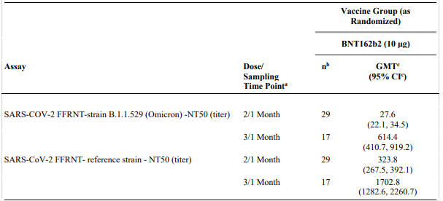

Abbreviations: FFRNT=fluorescence focus reduction neutralisation test; GMT = geometric mean titre; LLOQ = lower limit of quantitation; NAAT = nucleic acid amplification test; N-binding = SARS-CoV-2 nucleoprotein–binding; NT50 = 50% neutralising titre; SARS-CoV-2 = severe acute respiratory syndrome coronavirus 2.

Note: Participants included in this analysis had no serological or virological evidence of past SARS-CoV-2 infection up to the one month post–Dose 2 (for one month post–Dose 2 time point) or one month post‑Dose 3 (for one month post–Dose 3 time point) study blood sample collection. Having no evidence of past SARS-CoV-2 infection up to one month post–Dose 2 was defined as having a negative N-binding antibody (serum) result at the Dose 1 and one month post–Dose 2 study visits; a negative NAAT (nasal swab) result at the Dose 1 and Dose 2 study visits and any unscheduled visit prior to the one month post–Dose 2 blood sample collection; and no medical history of COVID-19. Having no evidence of past SARS-CoV-2 infection up to one month post–Dose 3 was defined as having a negative N-binding antibody (serum) result at the Dose 1, one month post–Dose 2 (if available), Dose 3, and one month post–Dose 3 study visits; a negative NAAT (nasal swab) result at the Dose 1, Dose 2, and Dose 3 study visits and any unscheduled visit prior to the one month post–Dose 3 blood sample collection; and no medical history of COVID-19.

a. Protocol-specified timing for blood sample collection.

b. n = Number of participants with valid and determinate assay results for the specified assays at the given dose/sampling time point.

c. GMTs and 2-sided 95% CIs were calculated by exponentiating the mean logarithm of the titres and the corresponding CIs (based on the Student t distribution). Assay results below the LLOQ were set to 0.5 × LLOQ.

#### Study C4591007 safety data

Safety data were provided in the interim clinical study report for Study C4591007, along with post-marketing data. Safety analyses were conducted based on the safety population which was comprised of participants who received Dose 3 of Comirnaty (tozinameran) 10 µg by 22 February 2022 (n = 401).

Safety assessments included reactogenicity, adverse events (AEs), serious adverse events (SAEs), and adverse events of special interest (AESIs).

* Reactogenicity: local reactions, systemic events (including fever) and use of antipyretic medication were recorded each evening by the participant or participant’s parent/guardian for 7 days after administration of Dose 3 in the reactogenicity e‑diary. The grading scales used to assess local reactions and systemic event were based on the US Food and Drug Administration (FDA) Centers for Biologics Evaluation and Research (CBER) guidelines).[34]
* Adverse events were collected from Dose 3 to one month after Dose 3, and to the data cut-off date (22 March 2022). Serious adverse events were to be collected from Dose 3 to 6 months after Dose 3. Adverse events were coded using Medical Dictionary for Regulatory Affairs (MedDRA) Version 24.1.[35]
* Myocarditis and pericarditis were protocol designated adverse events of special interest in Study C4591007.

Safety data were reported as descriptive summary statistics.

Missing reactogenicity e‑diary data were not imputed.

##### Patient flow (safety population)

Comirnaty (tozinameran) vaccine was administered to 425 participants. There were 24 (5.6%) subjects who turned 12 years of age during or after the Comirnaty (tozinameran) vaccine 10 µg two-dose primary series vaccination period and thus received Dose 3 at the age-appropriate dose level of Comirnaty (tozinameran) vaccine 30 µg; these subjects were excluded from further analyses. Overall, n = 401 (94.4%) received Dose 1, Dose 2, and Dose 3 of Comirnaty (tozinameran) 10 µg (safety population). No participants were excluded from the safety population for any reason and, as of the data cut-off date (22March 2022), no participants discontinued from the vaccination period or were withdrawn from the study.

As of the data cut-off date, 311 (77.6%) participants who received Dose 3 of Comirnaty (tozinameran) 10 µg completed the visit at one month after Dose 3.

Table 16: Study C4591007 Phase II/III Disposition of participants who received Dose 3 of Comirnaty (tozinameran) vaccine, aged from 5 to under 12 years (safety population)

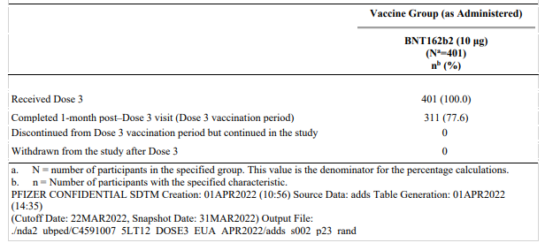

Note: BNT162b2 refers to Comirnaty (tozinameran) vaccine.

a. N = number of participants in the specified group. This value is the dominator for the percentage calculations.

b. n = number of participants with the specified characteristic.

Data cut-off date: 22 March 2022.

##### Baseline data

The majority of subjects were male (52.4%), White (70.1%), and negative baseline SARS‑CoV-2 status at Baseline (94.5%). The median age at Dose 1 was 8.0 years. All participants were from the USA. See Table 17 below, for further data.

Table 17: Study C4591007 Phase II/III Demographic characteristics of participants who received Dose 3 of Comirnaty (tozinameran) aged from 5 to under 12 years of age (safety population)

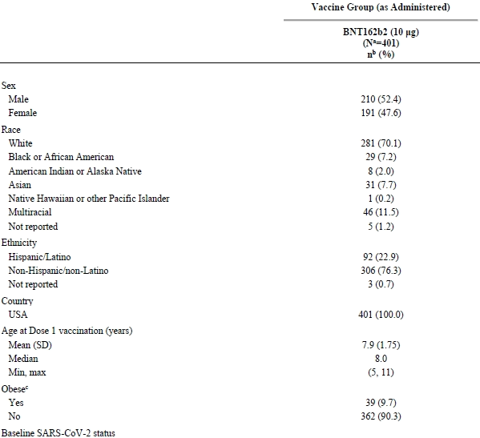

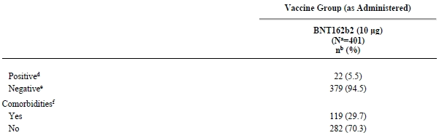

Abbreviations: CDC = Centers for Disease Control and Prevention; MMWR = Morbidity and Mortality Weekly Report; NAAT = nucleic acid amplification test; N-binding = SARS-CoV-2 nucleoprotein-binding; SARS-CoV-2 = severe acute respiratory syndrome coronavirus 2.

a. N = number of participants in the specified group. This value is the denominator for the percentage calculations.

b. n = Number of participants with the specified characteristic.

c. Obese is defined as a body mass index (BMI) at or above the 95th percentile according to the growth chart. Refer to the CDC growth charts at <https://www.cdc.gov/growthcharts/html_charts/bmiagerev.htm>

d. Positive N-binding antibody result at Dose 1, positive NAAT result at Dose 1, or medical history of COVID-19.

e. Negative N-binding antibody result at Dose 1, negative NAAT result at Dose 1, and no medical history of COVID-19.

f. Number of participants who have one or more comorbidities that increase the risk of severe COVID-19 disease: defined as participants who had at least one of the prespecified comorbidities based on MMWR Morb Mortal Wkly Rep. 2020;69(32):1081-8 and/or obesity (BMI ≥ 95th percentile).

Obesity was reported for 9.7% participants and there were 29.7% participants with co-morbidities that increase the risk of severe COVID-19 disease (including obesity). The sponsor was requested to provide the table of co-morbidities, however, stated the clinical study report did not include additional tables of co-morbidities that increase the risk of severe COVID-19 disease.

In terms of medical history, the most commonly reported System Organ Classes (SOCs) and Preferred Terms (PTs), reported in ≥ 2% of participants, were:

* *Immune systems disorders* (25.4%): seasonal allergy (19.7%), food allergy (3.0%), drug hypersensitivity (2.5%)
* *Respiratory, thoracic, and mediastinal disorders* (13.0%): asthma (7.7%)
* *Psychiatric disorders* (12.7%): attention deficit hyperactivity disorder (8.5%)
* *Skin and subcutaneous tissue disorders* (9.7%): eczema (7.0%)

No participants in the safety population were HIV positive. One (0.2%) participant received a concomitant vaccine (influenza vaccine) after receiving Dose 3 of Comirnaty (tozinameran) vaccine 10 µg.

##### Exposure

The median (range) follow-up time after Dose 3 was 1.3 (1.0, 1.8) months.

The technical issue on Day 1 is noted, with reactogenicity eDiary data available for 60.8% participants on Day 1 compared to 86.3% participants after Dose 1 and 92.0% after Dose 2.

In response to TGA questions, the sponsor did not specifically address the reasons for the observed differences in proportion of participants with eDiary data at all time points following Dose 3 versus the first 2 doses. However, the sponsor did clarify for those participants who did not have events recorded in the eDiary at least through Day 2, events were reported as adverse events. This is considered acceptable.

##### Reactogenicity (events within 7 days after dosing)

###### Local reactions

Pain at the injection site was the most common local reaction within 7 days of each dose. The majority of these reactions were mild or moderate in severity, with the proportion of subjects with moderate pain at the injection site higher after Dose 3 than the first two doses.

Swelling and redness at the injection site were less common, with the incidence after Dose 3 comparable to Dose 2. There were three (0.8%) participants with severe local reactions after Dose 3; 2 (0.5%) participants with severe pain at the injection site and one participant (0.3%) with severe redness at the injection site. No Grade 4 local reactions were reported after any dose.

The median onset for all local reactions after any dose of Comirnaty (tozinameran) vaccine (10 µg) was 1 to 2 days, and all events resolved within a median duration of 1 to 2 days after onset.

Figure 4: Study C4591007 Phase II/III Local reactions, by maximum severity, occurring within 7 days after each dose, in participants who received Dose 3 of Comirnaty (tozinameran) vaccine aged from 5 to under 12 years (safety population)

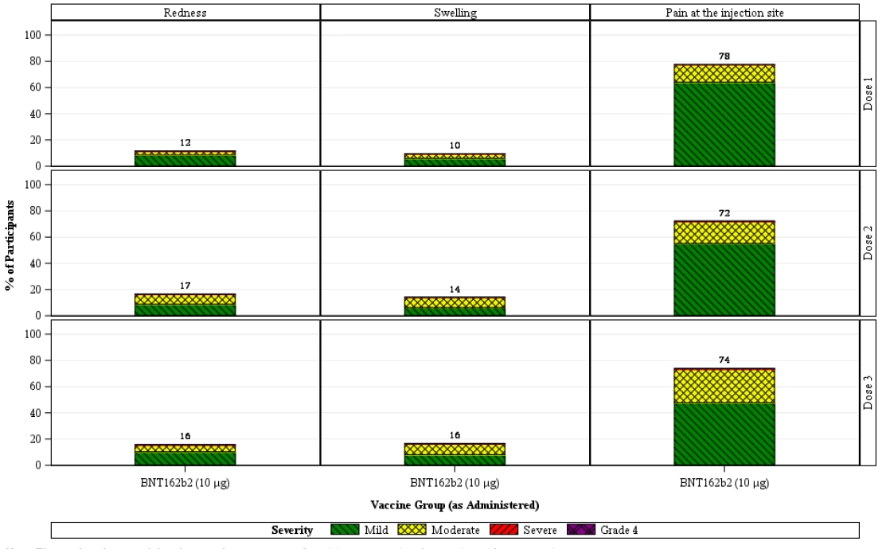



Numbers above each bar denotes the percentage of participants reporting the reaction with any severity.

###### Systemic events

The most common systemic events within 7 days after Dose 3 were fatigue (45.6%) and headache (34.0%). The incidence of headache and muscle pain increased after each dose, as did the use of anti-pyretic/pain medication.

Table 18: Study C4591007 Phase II/III Percentage of reported systemic events occurring within 7 days after each dose, in participants who received 3 doses of Comirnaty (tozinameran) vaccine, aged from 5 to under 12 years (safety population)

|  |  |  |  |
| --- | --- | --- | --- |
| Reported system event | Dose 1 | Dose 2 | Dose 3 |
| Fatigue | 37.4% | 46.6% | 45.6% |
| Headache | 23.6% | 30.1% | 34.0% |
| Muscle pain | 8.0% | 12.5% | 18.3% |
| Chills | 6.0% | 10.3% | 10.5% |
| Joint pain | 3.8% | 5.5% | 6.7% |
| Fever | 3.5% | 8.8% | 6.7% |
| Diarrhoea | 6.8% | 6.5% | 4.9% |
| Vomiting | 2.0% | 1.8% | 2.4% |
| Antipyretic/pain medication use | 13.3% | 21.8% | 30.7% |

Figure 5: Study C4591007 Phase II/III Systemic events, by maximum severity, occurring within 7 days after each dose, in participants who received Dose 3 of Comirnaty (tozinameran) vaccine aged from 5 to under 12 years (safety population)

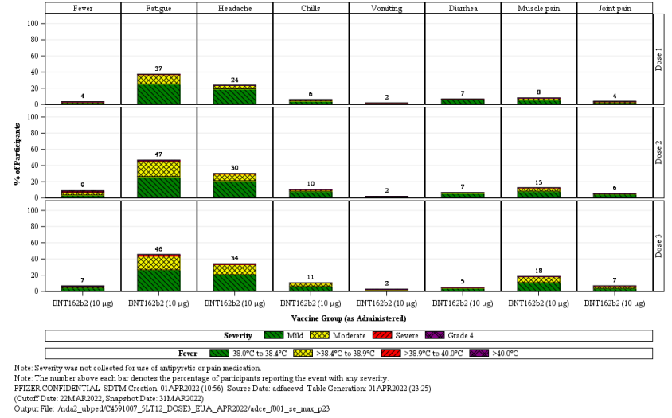

Severity was not collected for use of antipyretic or pain medication. The number above each bar denotes the percentage of participants reporting the severity with any severity.

The majority of systemic events were mild or moderate in severity. Severe events were infrequent although reported more commonly after Dose 3.

Table 19: Study C4591007 Phase II/III Systemic events rated as severe (Grade 3) in severity, occurring within 7 days after each dose, in participants who received Dose 3 of Comirnaty (tozinameran) vaccine aged from 5 to under 12 years (safety population)

|  |  |  |  |  |  |  |
| --- | --- | --- | --- | --- | --- | --- |
| Specified systemic event | Dose 1 398 participants a | | Dose 2 399 participants a | | Dose 3 371 participants a | |
| Number of events **b** | % | Number of events **b** | % | Number of events **b** | % |
| Fatigue | 1 | 0.3% | 4 | 1.0% | 7 | 1.9% |
| Headache |  |  | 2 | 0.5% | 3 | 0.8% |
| Chills |  |  | 1 | 0.3% | 1 | 0.3% |
| Diarrhoea |  |  | - | - | 1 | 0.3% |
| New or worsened muscle pain |  |  | 1 | 0.3% | - | - |
| All systemic events | 1 | 0.3% | 8 | 2.0% | 12 | 3.2% |

a. Number of participants reporting at least one yes or no response for the specified event after the specified dose.

b. Number of participants with the specified systemic event graded as severe.

The incidence of fever was lower following Dose 3 (6.7%) compared with Dose 2 (8.8%). One participant had a fever above 40.0 C after Dose 2. There were no adverse events of febrile convulsion based on review of adverse events presented..

There were no Grade 4 systemic events. The median onset for most systemic events after any dose of Comirnaty (tozinameran) vaccine 10 µg was 1 to 2 days, and most events resolved within a median duration of one day after onset.

##### Adverse events (events within one month after dosing)

There were 9.0% participants reporting any adverse event. Of these, there were no serious adverse events, deaths or withdrawals due to adverse events. Cumulatively, no additional participants reported adverse events up to data cut-off date (22 March 2022).

Table 20, shown below, summarises the adverse event profile in the one month period following Dose 3.

Table 20: Study C4591007 Phase II/III Number (%) of participants aged from 5 to under 12 years reporting at least one adverse event within one month after receiving Dose 3 of Comirnaty (tozinameran) vaccine (safety population)

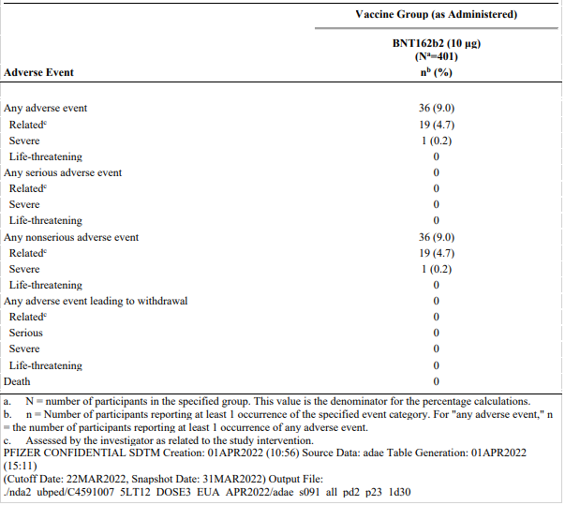

a. N = number of participants in the specified group. This value is the denominator for the percentage calculations.

b. n = Number of participants reporting at least one occurrence of the specified event category. For ‘any adverse event’, n = the number of participants reporting at least one occurrence of any adverse event.

c. Assessed by the investigator as related to the study intervention.

Adverse events from Dose 3 to one month after Dose 3 were reported most frequently in SOC: General disorders and administration site conditions (2.2%), SOC: Gastrointestinal disorders (1.5%) and SOC: Nervous system disorders (1.0%). The most common adverse event by PTs were lymphadenopathy (2.0%), injection site pain (1.7%) and headache (0.7%).

Table 21: Study C4591007 Phase II/III Number (%) of participants aged from 5 to under 12 years reporting at least one adverse event within one month after receiving Dose 3 of Comirnaty (tozinameran) vaccine; events reported by System Organ Class and Preferred Term (safety population)

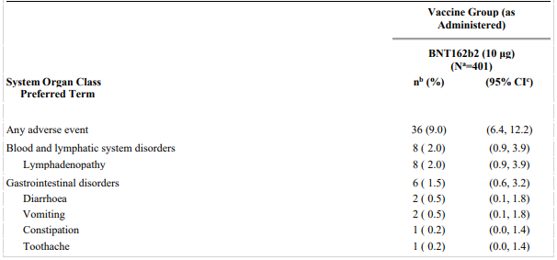

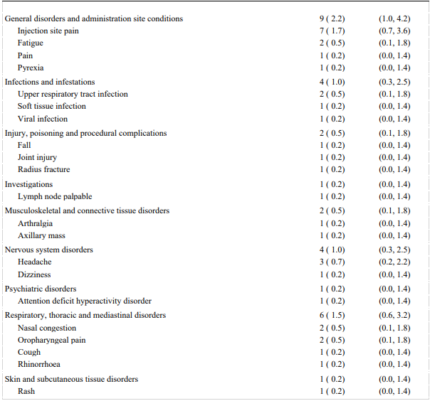

Note: MedDRA (v24.1) coding dictionary applied.

a. N = number of participants in the specified group. This value is the denominator for the percentage calculations.

b. n = Number of participants reporting at least one occurrence of the specified event. For "any adverse event," n = number of participants reporting at least one occurrence of any adverse event.

c. Exact 2-sided CI based on the Clopper and Pearson method.

There were no immediate adverse events reported within 30 minutes of receiving Dose 3 of Comirnaty (tozinameran) vaccine 10 µg, and no Grade 4 adverse events.

One participant had a Grade 3 (severe) event of pyrexia (fever). The participant was a 5 year old White female with fever of 39.0 C and mild adverse events of dizziness and arthralgia (bilateral legs), all with onset on Day 1 post-Dose 3. The narrative was reviewed; fever and joint pain were reported as adverse events, as the participant did not record them in the eDiary. The participant received treatment for pyrexia. All events resolved by Day 3 post-Dose 3. The sponsor stated the participant had fevers reported in the eDiary after Dose 2 (39.7 C and 40.3 C on Days 2 and 3 post-Dose 2 respectively).

###### Adverse events of special interest

*Lymphadenopathy (swollen lymph nodes):*

* There were 10 (2.5%) cases of lymphadenopathy (including the PTs palpable lymph node or axillary mass) identified from Dose 3 to one month after Dose 3.
* Most events occurred in the cervical or axillary nodes. The onset was within 2 days of Dose 3, and resolution within approximately 1 week of onset. All cases were mild.
* The sponsor noted the incidence of lymphadenopathy after Dose 3 was higher compared to Dose 2 (0.9%) in children from 5 to under 12 years of age, although lower than the observed incidence following Dose 3 in adult participants ≥ 18 years of age (5.2%).

*Rashes*:

* The sponsor conducted searches of the safety data for the MedDRA Standardised MedDRA Queries (SMQs) as presented below, based on FDA requests in previous submissions. There was one (0.2%) participant with the adverse event of rash, which occurred 11 days after Dose 3 and resolved within 4 days of onset. The event was mild and considered unrelated to study intervention by the investigator (attributed to face mask wearing).

*Other events*:

The sponsor noted there were no cases of adverse events of interest as of the data cut-off date including: anaphylaxis, myocarditis, pericarditis, Bell’s palsy (or facial paralysis/paresis), appendicitis, arthritis, thrombocytopenic events, thromboembolic or intravascular coagulation events, autoimmune or demyelination events, meningitis, encephalitis, neuritis, peripheral neuropathy, vasculitis, Kawasaki disease, MIS-C, or acute respiratory distress syndrome.

Table 22: Study C4591007 Phase II/III Selected Standardised MedDRA Queries within one month after Dose 3 in participants aged from 5 to under 12 years (safety population)

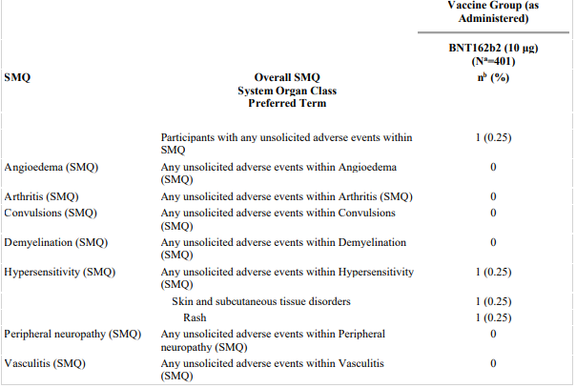

Abbreviation: MedDRA = Medical Dictionary for Regulatory Activities; SMQ = Standardised MedDRA query.

Note: MedDRA (v24.1) coding dictionary applied.

a. N = number of participants in the specified group. This value is the denominator for the percentage calculations.

b. n = Number of participants reporting at least one occurrence of the specified event category. For ‘any unsolicited adverse events within SMQ’, n = the number of participants reporting at least 1 occurrence of any unsolicited adverse events within SMQ.

###### Treatment-related adverse events (adverse drug reactions)

There were 19 (4.7%) participants with adverse events considered related to study treatment as assessed by the investigator. Lymphadenopathy (2.0%), injection site pain (1.7%) and headache (0.7%) were the most frequently reported related adverse events.

Table 23: Study C4591007 Number (%) of participants aged from 5 to under 12 years reporting at least one related adverse event within one month after Dose 3 of Comirnaty (tozinameran) vaccine, by System Organ Class and Preferred Term (safety population)

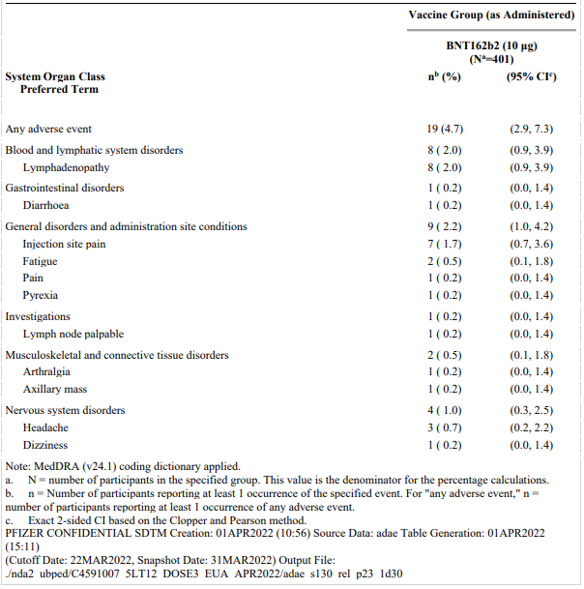

Abbreviation: CI = confidence interval; MedDRA = Medical Dictionary for Regulatory Activities; SMQ = Standardised MedDRA query.

Note: MedDRA (v24.1) coding dictionary applied.

a. N = number of participants in the specified group. This value is the denominator for the percentage calculations.

b. n = Number of participants reporting at least one occurrence of the specified event. For ‘any adverse event’, n = number of participants reporting at least one occurrence of any adverse event.

c. Exact 2-sided CI based on the Clopper and Pearson method.

###### Serious adverse events, or adverse events leading to withdrawal

There were no serious adverse events or deaths within one month of receiving Dose 3, or from Dose 3 to the data cut-off date (22 March 2022).

There were no adverse events leading to withdrawal within one month of receiving Dose 3, or from Dose 3 to the data cut-off date (22 March 2022).

#### Post-marketing experience

The sponsor was requested to provide available post-marketing data following the Emergency Use Authorization for the booster dose in children from 5 to under 12 years of age issued by the US FDA in May 2022.

The sponsor’s response included an overview of post-marketing data for all individuals aged from 5 to under 12 years. The sponsor stated cumulatively of 1,474,818 total reports received through 10 June 2022, there were a total of 10,679 post-marketing reports containing 24,947 adverse events that occurred in individuals aged from 5 to under 12 years.

Among the 10,679 case reports, there were 10,560 cases with adverse events occurring after non-booster doses (that is, after receiving Dose 1, or Dose 2 of the primary vaccination series; or from Dose ‘unknown’) and 119 cases with adverse events occurring after the booster dose. The number of doses of Comirnaty vaccine administered was not stated. Overall, case reports were most commonly from the USA (31.5%) and Australia (13.1%).

For all cases, the System Organ Classes (SOCs) with the greatest number of adverse events were ‘Injury, poisoning and procedural complications’ (total of 6947 events) and ‘General disorders and administration site conditions’ (5627 events); see Figure 6, below. Of note, there were 388 adverse events in the ‘Cardiac disorders/ SOC. By Preferred Term (PT), the most common adverse events were product administered to patient of inappropriate age (16.1%), pyrexia (12.5%), vaccination site pain (11.6%), poor quality product administered (11.1%) and headache (9.7%).

Figure 6: Post-marketing reports; total number of adverse events by System Organ Class, and event seriousness, in individuals aged from 5 years to under 12 years

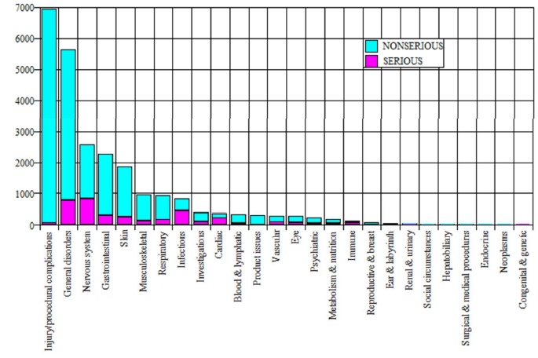

Table 24: Post-marketing reports; adverse events making up at least 2% of all reported cases in individuals aged from 5 to under 12 years, by decreasing reporting proportion with each System Organ Class (total case reports = 10,679)

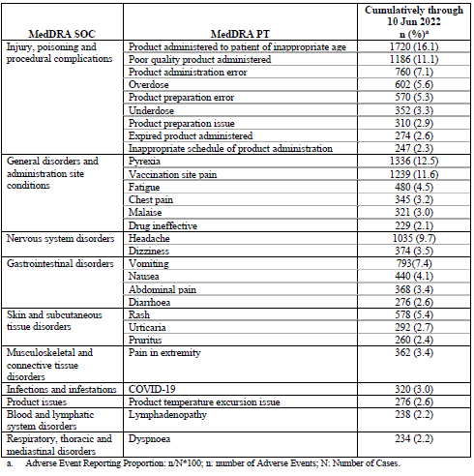

Abbreviations: MedDRA = Medical Dictionary for Regulatory Activities; PT = Preferred Term; SOC = System Organ Class.

a. Adverse event reporting proportion: (n/N) x 100; n = number of adverse events; N = number of cases.

Of the 10,560 non-booster cases, 15.5% events were serious. There were 67.1% cases medically confirmed. Outcome was ‘recovered/recovering’ for 44.6% cases and ‘unknown’ for 41.3% cases. There were 22 (0.2%) cases with fatal outcome. No information was provided regarding these cases. Adverse events reported by Preferred Term in non‑booster cases are in line with the adverse events described for all cases as above.

Of the 119 cases with adverse events occurring after the booster dose, 18.5% were serious. There were 63.0% cases medically confirmed. Outcome was unknown for the majority of cases (74.8%) and recovered/recovering for 15.1% cases. There was one case (0.8%) with a fatal outcome; no information was provided regarding this case.

Table 25: Post-marketing reports, Characteristics of all booster cases reported in individuals aged from 5 to under 12 years. Cumulative data up to 10 June 2022 (all booster cases = 119 cases)

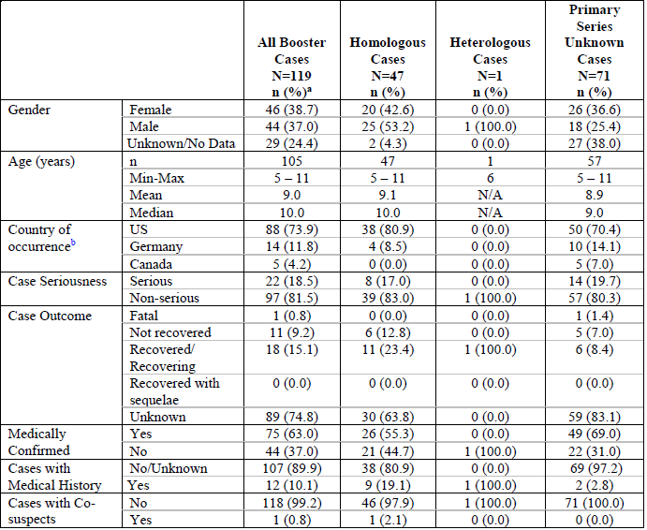

Abbreviations: MedDRA = Medical dictionary for Regulatory Affairs; n = number of adverse events; N = number of cases; PT = Preferred Term; SOC = System Organ Class; US = United States of America.

a) The sum of percentages may not exactly match 100% due to rounding in calculations.

b) 2% or more of all booster cases.

The most common adverse events among the 119 booster cases were in the System Organ Class ‘Injury, poisoning and procedural complications’: poor quality product administered (28.6%), product administration error (24.4%), overdose (19.3%), product administered to patient of inappropriate age (16.8%), off-label use (13.5%) and product preparation error (12.6%).

Table 26: Post-marketing reports; adverse events reported in at least 2% of all booster cases, in individuals aged from 5 to under 12 years, by decreasing reporting proportion within each System Organ Class (all booster cases = 119 cases)

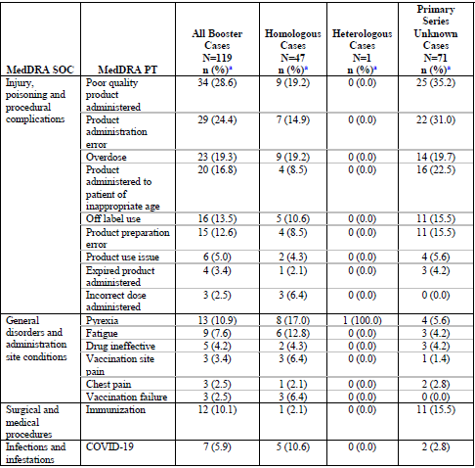

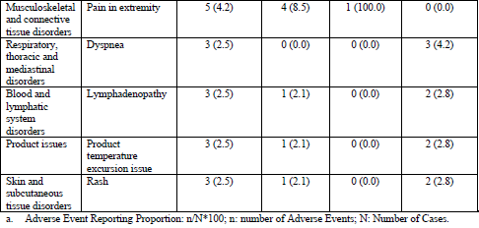

Abbreviations: MedDRA = Medical dictionary for Regulatory Affairs; n = number of adverse events; N = number of cases; PT = Preferred Term; SOC = System Organ Class.

a) Adverse event reporting proportion: n/N x 100.

The sponsor noted the most frequently reported Preferred Terms in children aged from 5 to under 12 years ‘*are potentially indicative of medication errors/overdose pertaining to the tris-sucrose paediatric presentation (Orange Cap (10 micrograms/dose))*’, stating further medication error cases were routinely reviewed and no new significant safety information was identified.

The sponsor considers the potential for medication errors with the new presentation is mitigated through the information in the vaccine labelling and educational materials for healthcare providers, acknowledging some medication errors will occur despite these measures. Based on the number and seriousness of medication errors in children from 5 to under 12 years of age, the sponsor does not consider additional mitigation activity is required.

Overall, the types of common adverse events presented in the post-marketing data appear consistent with the known safety profile of Comirnaty (tozinameran) in this age group. It is noted 18.5% case reports following the booster dose were considered serious and one fatal outcome was reported. A synthesised review of serious adverse events following the booster dose in children aged from 5 to under 12 years in the post-market setting was not available. Of the 21 case reports (as in the line listings of adverse event reports) the most common Preferred Terms related to testing positive to COVID-19 (7 cases), and product administration error (4 cases). Of note, there were two case reports with Preferred Terms of myocarditis, and single case reports of multisystem inflammatory syndrome in children (MIS-C), Guillain-Barre syndrome and 2 cases with Preferred Terms elating to axillary pain/swelling. The information available on the fatal outcome case was limited to analysis and comment.

The sponsor provided some additional past-market data/information in response to TGA questions arising from the clinical evaluation.

Table 27: Post-marketing reports; reports of myocarditis in individuals aged from 5 to under 12 years (total = 48 cases)

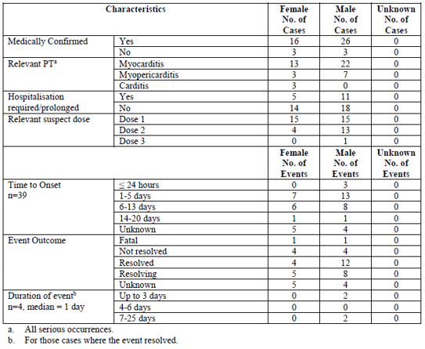

Abbreviations: n = number of adverse events; N = number of cases; No. = number; PT = Preferred Term.

a) All serious occurrences

b) For those cases where the event resolved or resolved with sequelae.

Table 28: Post-marketing reports; reports of pericarditis in individuals aged from 5 to under 12 years (total = 30 cases)

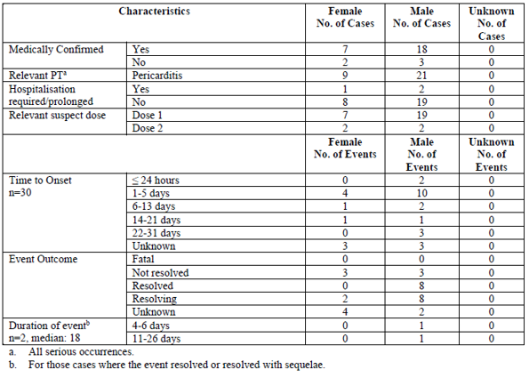

Abbreviations: n = number of adverse events; N = number of cases; No. = number PT = Preferred Term.

a) All serious occurrences

b) For those cases where the event resolved or resolved with sequelae.

### Risk management plan

The sponsor has submitted a submission for tozinameran (Comirnaty COVID-19 vaccine), seeking approval to introduce a booster dose for children aged 5 to under 12 years through the provisional approval pathway. Comirnaty is currently approved to be used for active immunisation to prevent coronavirus disease 2019 (COVID-19) caused by SARS‑CoV-2, in individuals 12 years of age and older as a primary course and a booster dose.

The sponsor did not submit a risk management plan (RMP) for this submission and stated that the *‘EU‑RMP remains unchanged from last submitted version’*.

The most recently evaluated EU-RMP was version 4.1 (date 2 February 2022);[36] and Australian-specific annex (ASA) version 0.4 (date 11 November 2021).

This summary of safety concerns is the same as the summary that was evaluated and considered acceptable during the most recently evaluated RMP, in a submission for the use of booster in individuals aged from 12 to 15 years.4 The changes proposed by the current submission do not warrant changes to the summary of safety concerns from an RMP perspective.

The current summary of safety concerns and their associated risk monitoring and mitigation strategies are summarised below in Table 29.

Table 29: Summary of safety concerns

|  |  |  |  |  |  |
| --- | --- | --- | --- | --- | --- |
| Summary of safety concerns | | Pharmacovigilance | | Risk Minimisation | |
| Routine | Additional | Routine | Additional |
| **Important identified risks** | Anaphylaxis | ✓† | ✓* | ✓ | – |
| Myocarditis and pericarditis | ✓ | ✓* | ✓ | – |
| **Important potential risks** | Vaccine-associated enhanced disease (VAED) including Vaccine-associated enhanced respiratory disease (VAERD) | ✓† | ✓* | – | – |
| **Missing information** | Use in pregnancy and while breast feeding | ✓ | ✓* | ✓ | – |
| Use in immunocompromised patients | ✓ | ✓* | ✓ | – |
| Use in frail patients with co-morbidities (e.g. chronic obstructive pulmonary disease (COPD), diabetes, chronic neurological disease, cardiovascular disorders) | ✓ | ✓* | ✓ | – |
| Use in patients with autoimmune or inflammatory disorders | ✓ | ✓* | – | – |
| Interaction with other vaccines | ✓ | ✓* | ✓ | – |
| Long term safety data | ✓ | ✓* | – |  |

† Data capture Aid (Adverse drug reaction follow-up forms)

* Clinical trial

The pharmacovigilance plan was deemed acceptable during the previous evaluations and continues to be acceptable for the current submission. The acceptability of the clinical study plan was assessed by the Delegate.

Only routine risk minimisation measures are proposed by the sponsor. This approach was deemed acceptable during the previous evaluations. The changes proposed by the current submission are not expected to require additional risk minimisation measures as part of the RMP.

### Risk-benefit analysis

#### Delegate’s considerations

##### Immunogenicity/efficacy

Data provided to support the proposed booster (third) dose of Comirnaty (tozinameran) vaccine 10 μg in children aged 5 to under 12 years comprise of immunogenicity data in a subset of children aged 5 to under 12 years in the ongoing Phase II/III Study C4591007. The secondary immunogenicity objective was to assess immune responses elicited by Comirnaty (tozinameran) 10 μg in participants without serological or virological evidence of past SARS-CoV-2 infection. The basis of demonstrating Comirnaty (tozinameran) effectiveness in children is immune response data which is considered acceptable.

The number of participants with a blood sample collection at one month post-Dose 2 was limited, with the Sponsor including additional participants from the 2 dose set to ensure sufficient post-Dose 2 data for analyses. Immunogenicity analyses were based on immune responses at each time point with descriptive comparison of immune responses at one month post-Dose 3 compared with immune responses at one month post-Dose 2. Results were reported as SARS-CoV-2 50% neutralising GMTs, the GMR of the two time points, percentages of children with seroresponse, and as the difference in percentages of children with seroresponse between the two time points.

The Dose 2 and Dose 3 evaluable immunogenicity populations included participants who received all doses of vaccine at the same dose level as randomised (that is, 2 or 3 doses) within the protocol specified window for each dose, had at least one valid and determinate immunogenicity result within 28 to 42 days after vaccination, and did not have any important protocol deviations impacting evaluability.

The total evaluable immunogenicity population comprises the combined 2-dose set (participants who completed the one month post-Dose 2 visit) and 3-dose set (participants who completed the one month post-Dose 3 visit). Analyses of GMFR, GMR, and differences in seroresponse rates were based on the total of available titres across the combined 3-dose and 2-dose sets. Overall, there were only 17 participants without prior evidence of SARS-CoV-2 infection in the 3-dose set with assay results at both one month post-Dose 2 and at one month post-Dose 3. As the pandemic continues and new variants emerge the number of participants without previous SARS-CoV-2 infection will understandably decrease.

The statistical methods are considered acceptable.

Among the 67 participants of the Dose 3 evaluable immunogenicity population without prior evidence of SARS-CoV-2 infection up to one month after Dose 3, observed GMTs to the wild-type reference strain had waned prior to Dose 3 (271.0), however increased following the booster dose of Comirnaty (tozinameran) 10 μg to levels higher than those observed following Dose 2 (2720.9 versus 1253.9). The GMR of neutralising titres available at one month post-Dose 3 versus one month post-Dose 2 in this population was 2.17 (95% CI: 1.76, 2.68). The proportion of participants with seroresponse was high (100.0%) one month after Dose 2, waning to 77.6% prior to Dose 3, and increasing to 98.5% at one month post-Dose 3.

Similar results for GMTs were demonstrated among the 17 participants without prior evidence of infection in the 3-dose set with assay results at both one month post-Dose 2 and at one month post-Dose 3, noting the GMR in this cohort was lower (1.55 (95% CI: 1.11, 2.17)). Seroresponse rates were 100% at one month post-Dose 2 and post-Dose 3.

Although exploratory, trends in immune responses observed in the populations including participants with evidence of past infection were comparable to those of the Dose 3 evaluable immunogenicity population without prior evidence of SARS-CoV-2 infection up to one month after Dose 3. These data are considered relevant.

The sponsor proposes the booster dose to be administered at least 6 months after Dose 2. The total range for timing of Dose 3 administration after Dose 2 (in Study C4591007) was 5 to 9 months however, almost all participants (399 of 401) received the booster dose 7 to 9 months after Dose 2, the majority at 8 to 9 months (86.8%). The timing of the booster dose after Dose 2 will be discussed at the Advisory Committee on Vaccines (ACV) meeting.

Overall, the interim immunogenicity data are limited by the small sample sizes, however, demonstrate a booster dose of Comirnaty (tozinameran) 10 μg administered 7 to 9 months following Dose 2 in children aged 5 to under 12 years increased waning neutralising titres against the wild-type reference strain of SARS-CoV-2 to levels above those observed after the 2-dose primary series.

##### Safety

Safety data included interim data available for 401 participants in the safety population aged from 5 to under 12 years who received a booster (third) dose of Comirnaty (tozinameran) 10 µg, with median duration of follow-up 1.3 months.

Reactogenicity e-diary data were available for 371 participants.

Amongst local reactions, pain at the injection site was the most common local reaction within 7 days following Dose 3 (73.9%), with swelling and redness at the injection site less common (16.4% and 15.6% respectively). These trends are generally in line with local reactions observed following previous doses. The incidence of fever was lower after Dose 3 than Dose 2 (6.7% versus 8.8%). Most local reactions were mild or moderate in severity, with severe events infrequent (0.8%). No Grade 4 local reactions were reported after any dose. The median onset for all local reactions after any dose of Comirnaty (tozinameran) 10 μg was 1 to 2 days and all events resolved within a median duration of 1 to 2 days after onset.

The most common reported systemic events within 7 days after Dose 3 included Fatigue (45.6%), headache (34.0%) and muscle pain (18.3%). Headache, muscle pain and use of anti-pyretic/pain medication occurred more frequently after each dose. The majority of systemic events were mild or moderate in severity. No Grade 4 events were reported after any dose. The median onset for most systemic events after any dose of Comirnaty (tozinameran) 10 μg was 1 to 2 days, and most events resolved within a median duration of 1 day after onset.

Overall, any adverse events were reported by 9.0% of participants from Dose 3 to one month after Dose 3. Most commonly in the System Organ Classes of Blood and lymphatic system disorders (Preferred Term, lymphadenopathy), General disorders and administration site conditions (Preferred Terms of local and systemic reactogenicity events) and Nervous system disorders (Preferred Term, headache). There was one severe adverse event of pyrexia in a 5 year old female occurring Day 1 post-Dose 3. The participant received treatment for pyrexia and the event resolved by Day 3. Adverse events considered related to study treatment were reported by 4.7% of participants, with the types of adverse events consistent with reactogenicity events.

Lymphadenopathy (swollen lymph nodes) is an adverse event of special interest with 10 cases (2.5%) reported, all considered mild. The incidence of lymphadenopathy was higher following Dose 3 compared with Dose 2 (0.9%) of Comirnaty (tozinameran) 10 µg. One participant (0.3%) experienced an adverse event of rash, which was not considered related to study treatment by the investigator. Myocarditis and pericarditis are important identified risks of Comirnaty. There were no cases of myocarditis or pericarditis reported in the Study C4591007, following the booster dose of Comirnaty (tozinameran) 10 µg, however the sample size is considered too small to detect these events. Thus, the risk of myocarditis or pericarditis following a booster dose of Comirnaty (tozinameran) 10 µg in children aged from 5 to under 12 years is uncertain.

There were no immediate adverse events within 30 minutes of administration of the booster dose of Comirnaty (tozinameran) 10 µg, and no serious adverse events, deaths or withdrawals due to adverse events.

Overall, there were no new safety concerns for Comirnaty (tozinameran) 10 µg identified from available safety data in children aged 5 to under 12 years administered a booster dose of Comirnaty (tozinameran) 10 µg, 7 to under 9 months after the 2-dose primary series, taking into consideration the small sample size and short duration of follow-up.

Overall, the types of common adverse events presented in the post-marketing data appear consistent with the known safety profile of Comirnaty in this age group. It is noted 18.5% case reports following the booster dose were considered serious and one fatal outcome was reported. A synthesised review of serious adverse event following the booster dose in children aged 5 to under 12 years in the post-market setting was not available. Of the 21 case reports (as in the line listings of adverse event reports) the most common Preferred Terms related to testing positive to COVID-19 (7 cases), and product administration error (4 cases). Of note, there were 2 case reports with Preferred Terms of myocarditis, and single case reports of multisystem inflammatory syndrome in children (MIS-C), and Guillain-Barre syndrome, and 2 cases with Preferred Terms relating to axillary pain/swelling. The information available, as per the clinical evaluation, on the fatal outcome case was limited to analysis and comment.

#### Conclusions

Interim immunogenicity data demonstrate a booster dose of Comirnaty (tozinameran) vaccine 10 μg administered from 7 to under 9 months following Dose 2 in children aged from 5 to under 12 years increased waning neutralising titres against the wild-type reference strain of SARS-CoV-2 to levels above those observed after the two-dose primary series.

The reactogenicity was mostly mild to moderate with short median duration of 1 to 2 days after onset and was generally comparable to that observed after the two-dose series. Overall, there were no new safety concerns for Comirnaty (tozinameran) 10 µg identified from available safety data in children aged 5 to under 12 years administered a booster dose of Comirnaty (tozinameran) 10 µg, 7 to under 9 months after the two-dose primary series, taking into consideration the small sample size and short duration of follow-up. Overall, the types of common adverse events presented in the post-marketing data appear consistent with the known safety profile of Comirnaty in this age group. It is noted 18.5% case reports following the booster dose were considered serious and one fatal outcome was reported.

The benefit-risk balance of Comirnaty COVID-19 vaccine 10 µg, in this submission, as a booster following Dose 2 in children aged from 5 to under 12 years appears positive for provisional registration. The timing of the booster dose after Dose 2 will be discussed at the Advisory Committee on Vaccines (ACV) meeting.

#### Proposed action

At this stage, whilst a decision was yet to be made, the Delegate was inclined to approve the registration of the product.

The final decision will be made following the ACV discussion.

#### Advisory Committee considerations

The [Advisory Committee on Vaccines (ACV)](https://www.tga.gov.au/committee/advisory-committee-vaccines-acv), having considered the evaluations and the Delegate’s overview, as well as the sponsor’s response to these documents, advised the following.

##### Specific advice to the Delegate

1. ***Please advise on the sponsors’ proposal that the booster dose be administered at least 6 months after Dose 2***

The ACV supported changes to the Product Information (PI) to allow a 10 µg booster dose to be administered at least 6 months after Dose 2 for children from 5 to under 12 years of age, based on limited immunogenicity and safety data.

This broadly aligns with USA and Canadian requirements and the clinical study criteria. The ACV noted that in the clinical study (Study C4591007) the booster dose (third dose) was administered between 5 and 9 months after Dose 2. However, almost all participants received the booster dose 7 to 9 months post primary series.

The ACV highlighted that the proposed booster timeframe for children aged from 5 to under 12 years aligns with the current PI advice for the Comirnaty booster for 12 to 15 year olds. The ACV stated that alignment of administration timeframes / dosage intervals is an important consideration as the current differences can cause confusion for consumers and healthcare professionals using various COVID-19 vaccines across different age groups.

The clinical relevance of booster doses for this age group is unclear but may become important in the event of emergence of more transmissible/severe variants.

1. ***Please comment on the benefit risk balance of Comirnaty COVID-19 vaccine 10 µg (in this submission) as a booster following Dose 2 in children aged from 5 to under 12 years for provisional registration***

The ACV was of the view that overall there is a positive benefit risk profile for Comirnaty COVID-19 vaccine 10 µas a booster following Dose 2 in children aged 5 to less than 12 years of age when considered for provisional registration.

The ACV agreed that the demonstrated immunogenicity supports use in the population aged from 5 to under 12 years, although noted that an immunological correlate of protection is yet to be well defined.

The ACV acknowledged the limited data set, particularly for participants without prior evidence of COVID-19. However, the committee noted the increasing difficulties in recruiting participants without prior evidence of COVID-19.

The ACV highlighted that the USA post marketing data indicated that the most frequent safety reports following the booster within this age range were product preparation and administration errors. The ACV agreed that ongoing mitigation of these errors is important and noted that the Canadian PI provides some useful administration explanations. In addition, the ACV noted some confusion within the PI in regard to diluted and non-diluted preparations. The ACV discussed the potential for administration errors and reiterated the importance of post marketing surveillance and risk migration activities broadly to address administration errors for COVID-19 vaccines.

##### Conclusion

The ACV considered the following proposal for a major variation to the currently approved dosage regimen, for the inclusion of a booster dose of Comirnaty (tozinameran) 10 µg per 0.2 mL dose, as concentrated suspension for injection (tris/sucrose formulation) for individuals aged 5 to less than 12 years.

The provisionally approved indication is as follows:

*Comirnaty (tozinameran) COVID-19 Vaccine has provisional approval for the indication below:*

*Active immunisation to prevent coronavirus disease 2019 (COVID-19) caused by SARS-CoV-2, in individuals 5 years of age and older.*

*The use of this vaccine should be in accordance with official recommendations.*

*The decision has been made on the basis of short term efficacy and safety data. Continued approval depends on the evidence of longer term efficacy and safety from ongoing clinical trials and post-market assessment.*

The currently approved dosage (abridged), is as follows:

***Booster dose in individuals 12 years of age and older***

*A booster dose of Comirnaty may be administered intramuscularly at least 6 months after the completion of a COVID-19 vaccine primary series in individuals 12 years of age and older.*

*The decision when and for whom to implement a booster dose of Comirnaty should be made based on available vaccine safety and effectiveness data (see sections 4.4 Special warnings and precautions for use and 5.1 Pharmacodynamic properties* [of the Product Information]*), in accordance with official recommendations*.

*The proposed wording for booster dosing sought is:*

The proposed wording for booster dosing sought by the sponsor with this submission, is as follows:

***Booster dose in individuals 5 to < 12 years of age***

*A booster dose of Comirnaty may be administered intramuscularly at least 6 months after the completion of a COVID-19 vaccine primary series in individuals 5 to < 12 years of age.*

The ACV considered this product to have an overall positive benefit-risk profile for use as a booster (third) dose in children aged 5 to less than 12 years of age when considered for provisional registration. This does not imply a booster dose is necessary or desirable for use across the Australian population aged from 5 to 11 year olds.

The use and timing of Comirnaty booster in 5 to 11 year olds should be in accordance with official recommendations.

## Outcome

Based on a review of quality, safety, and efficacy, the TGA approved a change in dosage regimen for the following provisionally registered medicine:

Comirnaty (tozinameran) COVID-19 vaccine 10 µg/0.2 mL concentrated suspension for injection, multidose vial.

For the medicine listed above, the TGA has approved a dosage regimen that allows for the following:

*A ‘booster’ dose administered at least 6 months following the primary vaccination series to individuals from 5 to under 12 years of age.*

Additionally, the TGA has approved new Product Information for this medicine that reflect the new dosage regimen and other amendments. The text in the new Product Information reflecting this change in dosage regimen is as follows:

***Booster dose in individuals 5 to < 12 years of age***

*A booster dose of Comirnaty Dilute To Use Multidose (For Age 5 to < 12 Years) may be administered intramuscularly at least 6 months after the second dose in individuals 5 to < 12 years of age.*

The provisionally approved indication for the above medicine is unchanged from the existing indication. As such, the full indications at this time remain as follows:

*Comirnaty (tozinameran) COVID-19 Vaccine has provisional approval for the indication below:*

*Active immunisation to prevent coronavirus disease 2019 (COVID-19) caused by SARS‑CoV-2, in individuals 5 years of age and older.*

*The use of this vaccine should be in accordance with official recommendations.*

*The decision has been made on the basis of short term efficacy and safety data. Continued approval depends on the evidence of longer term efficacy and safety from ongoing clinical trials and post-market assessment.*

### Specific conditions of registration applying to these goods

Subject to specific conditions (below), all conditions that have previously been imposed on the provisional registration of the existing Comirnaty medicine, as in force at the date of this decision:

* The risk management plan condition of the notice of the provisional registration decision relating to the existing Comirnaty medicine, varied as below:
  + The Comirnaty EU-Risk Management Plan (RMP) (version 4.1, dated 2 February 2022, data lock point 30 September 2021, for 5 to < 12 years of age: Module SIII – 6 September 2021; Module SVII.3 - 6 September 2021- Pfizer clinical database, 18 June 2021 - Pfizer safety database), with Australian Specific Annex (version 0.4, dated 11 November 2021), and any subsequent revisions, as agreed with the TGA will be implemented in Australia.
* Comirnaty is to be included in the Black Triangle Scheme. The PI and CMI for Comirnaty must include the black triangle symbol and mandatory accompanying text for the products entire period of provisional registration.
* The following additional specific conditions apply:
  + Submit the final analysis of the pivotal Phase II/III Study C4591007 and the clinical study report) when available.
  + Confirmatory trial data (as identified in the sponsor’s plan to submit comprehensive clinical data on the safety and efficacy of the medicine before the end of the 6 years that would start on the day that registration would commence) must be provided.

## Attachment 1. Product Information

The PI for Comirnaty approved with the submission which is described in this AusPAR is at Attachment 1. For the most recent PI, please refer to the TGA [PI/CMI search facility.](https://www.tga.gov.au/picmi-search-facility)

|  |
| --- |
| Therapeutic Goods Administration |
| PO Box 100 Woden ACT 2606 Australia  Email: [info@tga.gov.au](mailto:info@tga.gov.au) Phone: 1800 020 653 Fax: 02 6232 8605  [**https://www.tga.gov.au**](https://www.tga.gov.au) |

1. AusPAR for Comirnaty (tozinameran) extension of indications, published on 1 November 2021.

   Available at: https://www.tga.gov.au/resources/auspar/auspar-bnt162b2-mrna-0
2. AusPAR for Comirnaty (tozinameran) major variation (change of dose regimen), published on 12 April 2022. Available at: <https://www.tga.gov.au/resources/auspar/auspar-tozinameran-0>
3. AusPAR for Comirnaty (tozinameran) major variation (change of dose regimen), published on 8 February 2022. Available at: <https://www.tga.gov.au/resources/auspar/auspar-tozinameran>
4. AusPAR for Comirnaty (tozinameran) major variation (change of dose regimen), published on 12 April 2022. Available at: <https://www.tga.gov.au/resources/auspar/auspar-tozinameran-0>
5. World Health Organization (2020) WHO Director-General speeches: WHO Director-General's opening remarks at the media briefing on COVID-19 - 11 March 2020. Available from the WHO website.
6. WHO COVID-19 (coronavirus) dashboard. World Health Organization. Available at: <https://covid19.who.int/>
7. Coronavirus (COVID-19) case numbers and statistics. Australian Government Department of Health and Aged Care. Available at: <https://www.health.gov.au/health-alerts/covid-19/case-numbers-and-statistics>
8. National Notifiable Diseases Surveillance System (NNDSS). Australian Government Department of Health and Aged Care. Available at: <https://www.health.gov.au/initiatives-and-programs/nndss>
9. Paediatric inflammatory multisystem syndrome (PIMS-TS) in Australia; case data. Paediatric Active Enhanced Disease Surveillance. Available at: <https://paeds.org.au/pims-ts/paeds-pims-ts-case-data>
10. Available at: [COVID-19 vaccine: Provisional registrations | Therapeutic Goods Administration (TGA)](https://www.tga.gov.au/covid-19-vaccine-provisional-registrations). Last accessed on 19/08/2022.
11. As part of the **provisional approval pathway**, the provisional registration process will allow certain medicines to be provisionally registered in the Australian Register of Therapeutic Goods (ARTG) for a limited duration. These medicines are registered on the basis of preliminary clinical data, where there is the potential for a substantial benefit to Australian patients. The TGA will re-assess risks related to the absence of evidence through data provided at a later stage, as part of the confirmatory data. Confirmatory data should confirm the relationship between outcomes predicted by the surrogate endpoint, or other preliminary data, and the clinical benefit as demonstrated by direct clinical outcomes.

    The sponsor may apply to transition to full registration at any time up until the provisional registration lapse date, once they have completed the obligations outlined for the provisional registration period and complete confirmatory data on safety and efficacy are available.
12. Tozinameran, the active ingredient in the Comirnaty COVID-19 Vaccine was previously registered in Australia and overseas by the provisional drug name BNT162b2. Both the International non-proprietary name (INN) and the Australian Approved Name (AAN) is accepted as being tozinameran, and it is therefore referred to as Comirnaty (tozinameran) COVID-19 vaccine throughout this AusPAR. This is in contrast to the use of BNT162b2 as the name of the active ingredient in earlier AusPARs. The change is in name only; the composition of the active ingredient is unchanged in any way.
13. Comirnaty was first registered on the ARTG on 25 January 2021 (ARTG number: 346290).
14. AusPAR for Comirnaty (BNT162b2 (mRNA)) new biological entity, published on 25 January 2021. Available at: <https://www.tga.gov.au/auspar/auspar-bnt162b2-mrna-comirnaty>.
15. AusPAR for Comirnaty (BNT162b2 (mRNA)) extension of indications, published on 23 July 2021. Available at: <https://www.tga.gov.au/auspar/auspar-bnt162b2-mrna>.
16. AusPAR for Comirnaty (tozinameran) extension of indications, published on 1 November 2021.

    Available at: https://www.tga.gov.au/resources/auspar/auspar-bnt162b2-mrna-0
17. AusPAR for Comirnaty (tozinameran) extension of indications; change to formulation (excipients), published on 13 December 2021. Available at: <https://www.tga.gov.au/auspar/auspar-tozinameran-mrna-covid-19-vaccine>.
18. AusPAR for Comirnaty (tozinameran) major variation (change of dose regimen), published on 8 February 2022. Available at: <https://www.tga.gov.au/resources/auspar/auspar-tozinameran>
19. AusPAR for Comirnaty (tozinameran) major variation (change of dose regimen), published on 12 April 2022. Available at: <https://www.tga.gov.au/resources/auspar/auspar-tozinameran-0>
20. COVID-19 Vaccine AstraZeneca was first registered on the ARTG on 16 February 2021 (ARTG number: 349072).
21. AusPAR for COVID-19 Vaccine AstraZeneca (ChAdOx1-S) new biological entity, published on 16 February 2021. Available at: <https://www.tga.gov.au/auspar/auspar-chadox1-s>.
22. COVID-19 Vaccine Janssen was first registered on the ARTG on 25 June 2021 (ARTG number: 350150).
23. AusPAR for COVID-19 Vaccine Janssen (Ad26.COV2.S) new biological entity, published on 25 June 2021. Available at: <https://www.tga.gov.au/auspar/auspar-ad26cov2s>.
24. Spikevax was first registered on the ARTG on 9 August 2021 (ARTG number: 370599).
25. AusPAR for Spikevax (elasomeran) new biological entity, adult indication, published on 9 August 2021. Available at: <https://www.tga.gov.au/auspar/auspar-elasomeran>.
26. AusPAR for Spikevax (elasomeran) new biological entity, paediatric indication, published on 4 September 2021. Available at: <https://www.tga.gov.au/auspar/auspar-elasomeran-0>.
27. AusPAR for Spikevax (elasomeran) extension of indications, published on 23 February 2022. Available at: <https://www.tga.gov.au/auspar/auspar-elasomeran-1>.
28. AusPAR for Spikevax (elasomeran) extension of indications and major variation, paediatric indication for 6 months of age and above, published on 4 August 2022. Available at <https://www.tga.gov.au/auspar/auspar-elasomeran-2>
29. AusPAR for Spikevax Bivalent Original/Omicron (elasomeran and imelasomeran). Available at: https://www.tga.gov.au/resources/auspar/auspar-spikevax-bivalent-originalomicron
30. Nuvaxovid was first registered on the ARTG on 20 January 2022 (ARTG number: 355139).
31. AusPAR for Nuvaxovid (SARS-CoV-2 recombinant spike protein with Matrix-M adjuvant) new biological entity, published on 21 January 2022. Available at: <https://www.tga.gov.au/auspar/auspar-sars-cov-2-rs-matrix-m-adjuvant>.
32. AusPAR for Nuavxovid (SARS-CoV-2 recombinant spike protein with Matrix-M adjuvant) extension of indications, published on 29 July 2022. Available at <https://www.tga.gov.au/auspar/auspar-sars-cov-2-rs-matrix-m-adjuvant-nvx-cov2373>
33. Min Y, Agresti A. Random effect models for repeated measures of zero-inflated count data. *Statistical Modelling*. 2005;5(1):1-19.
34. Food and Drug Administration (FDA). Toxicity Grading Scale for Healthy Adult and Adolescent

    Volunteers Enrolled in Preventive Vaccine Clinical Trial. Guidance for Industry. September 2007.

    Available from: <https://www.fda.gov/media/73679/download>.
35. The **Medical Dictionary for Regulatory Activities** (**MedDRA**) is an internationally used set of terms relating to medical conditions, medicines and medical devices. It was created to assist regulators with sharing information. It is also used by industry, academics, health professionals and other organisations that communicate medical information.
36. Data lock point (DLP) 5 to < 12 years: 6 September 2021 (Pfizer clinical database); 18 June 2021 (Pfizer safety database), 12 to 15 years: 30 Sep 2021 (Pfizer Safety Database, for both CT and non-CT datasets), Booster in severely immunocompromised aged 12 to 15 years (30 September 2021 (Pfizer Safety Database, non-CT dataset), 16 yrs and older (30 September 2021 (Pfizer Safety Database, for both CT and non-CT datasets), Booster in 16 yrs and older a, including immunocompromised (30 September 2021 (Pfizer Safety Database, for both CT and non-CT datasets)