August 2022

Australian Public Assessment Report for Libtayo
  - Active ingredients: Cemiplimab
  - Sponsor: Sanofi-Aventis Australia Pty Ltd

About the Therapeutic Goods Administration (TGA)
- The Therapeutic Goods Administration (TGA) is part of the Australian Government Department of Health and is responsible for regulating therapeutic goods, including medicines, medical devices, and biologicals.
- The TGA administers the Therapeutic Goods Act 1989 (the Act), applying a risk management approach designed to ensure therapeutic goods supplied in Australia meet acceptable standards of quality, safety, and efficacy.
- The work of the TGA is based on applying scientific and clinical expertise to decision-making, to ensure that the benefits to the Australian public outweigh any risks associated with the use of therapeutic goods.
- The TGA relies on the public, healthcare professionals and industry to report problems with therapeutic goods. The TGA investigates reports received to determine any necessary regulatory action.
- To report a problem with a therapeutic good, please see the information on the TGA website.

About AusPARs
- The Australian Public Assessment Report (AusPAR) provides information about the evaluation of a prescription medicine and the considerations that led the TGA to approve or not approve a prescription medicine submission. Further information can be found in Australian Public Assessment Report (AusPAR) guidance.
- AusPARs are prepared and published by the TGA.
- AusPARs are static documents that provide information that relates to a submission at a particular point in time. The publication of an AusPAR is an important part of the transparency of the TGA’s decision-making process.
- A new AusPAR may be provided to reflect changes to indications or major variations to a prescription medicine subject to evaluation by the TGA.

Copyright
© Commonwealth of Australia 2022
This work is copyright. You may reproduce the whole or part of this work in unaltered form for your own personal use or, if you are part of an organisation, for internal use within your organisation, but only if you or your organisation do not use the reproduction for any commercial purpose and retain this copyright notice and all disclaimer notices as part of that reproduction. Apart from rights to use as permitted by the Copyright Act 1968 or allowed by this copyright notice, all other rights are reserved, and you are not allowed to reproduce the whole or any part of this work in any way (electronic or otherwise) without first being given specific written permission from the Commonwealth to do so. Requests and inquiries concerning reproduction and rights are to be sent to the TGA Copyright Officer, Therapeutic Goods Administration, PO Box 100, Woden ACT 2606 or emailed to <tga.copyright@tga.gov.au>.

Contents
List of abbreviations 4
Product submission 6
Submission details 6
Product background 7
Regulatory status 9
Product Information 10
Registration timeline 11
Submission overview and risk/benefit assessment 11
Quality 11
Nonclinical 12
Clinical 12
Risk management plan 21
Risk-benefit analysis 22
Outcome 24
Specific conditions of registration applying to these goods 25
Attachment 1. Product Information 26

List of abbreviations
Abbreviation |  | Meaning
ACM | Advisory Committee on Medicines
ADA | Anti-drug antibody
ALK | Anaplastic lymphoma kinase
ARTG | Australian Register of Therapeutic Goods
ASA | Australia specific annex
AUC | Area under the concentration time curve
AUC_{0-3weeks,ss} | Area under the plasma concentration-time curve over a 3 weeks interval after first dose and at steady state
AUC_{0-6weeks,ss} | Area under the plasma concentration-time curve over a 6 weeks interval after first dose and at steady state
BCC | Basal cell carcinoma
BOR | Best overall response
CI | Confidence interval
C_{max} | Maximum concentration
CR | Complete response
C_{trough} | Trough concentration
DLP | Data lock point
DOR | Duration of response
ECOG PS | Eastern Cooperative Oncology Group performance score
EGFR | Epidermal growth factor receptor
EU | European Union
HHI | Hedgehog inhibitor
ICR | Independent central review
laBCC | Locally advanced basal cell carcinoma
mBCC | Metastatic basal cell carcinoma
NAb | Neutralising antibody
NCCN | National Comprehensive Cancer Network (United States)
ORR | Objective response rate
OS | Overall survival
PD | Pharmacodynamic(s)
PD-1 | Programmed cell death protein 1
PD-L1 | Programmed death ligand 1
PD-L2 | Programmed death ligand 2
PFS | Progression free survival
PI | Product Information
PK | Pharmacokinetic(s)
RECIST | Response Evaluation Criteria in Solid Tumours
RMP | Risk management plan
ROS-1 | c-ROS oncogene 1
SD | Standard deviation
TGA | Therapeutic Goods Administration
US(A) | United States (of America)

Product submission

Submission details
Type of submission: | Extension of indications
Product name: | Libtayo
Active ingredient: | Cemiplimab
Decision: | Locally advanced basal cell carcinoma (BCC) indications approved.  Metastatic basal cell carcinoma (mBCC) indication approved for provisional registration.
Date of decision: | 25 November 2021
Date of entry onto ARTG: | 9 December 2021
ARTG number: | 320609
Black Triangle Scheme: | Yes  This product will remain in the scheme for 5 years, starting on the date the new indication was approved.  For the provisionally registered indication, this medicine will remain in the Black Triangle Scheme for the duration of its provisional registration
Sponsor’s name and address: | Sanofi-aventis Australia Pty Ltd  12-24 Talavera Road  Macquarie Park, NSW, 2113
Dose form: | Concentrate for solution for infusion
Strength: | 350 mg
Container: | Vial
Pack size: | One vial
Approved therapeutic use: | Locally advanced basal cell carcinoma  Libtayo as monotherapy is indicated for the treatment of adult patients with locally advanced basal cell carcinoma (BCC) previously treated with a hedgehog pathway inhibitor or for whom a hedgehog pathway inhibitor is not appropriate  Metastatic basal cell carcinoma  Libtayo as monotherapy has provisional approval in Australia for the treatment of adult patients with metastatic BCC (mBCC) previously treated with a hedgehog pathway inhibitor or for whom a hedgehog pathway inhibitor is not appropriate.  The decision to approve the mBCC indication has been made on the basis of objective response rate (ORR) and duration of response from a single arm clinical study. The sponsor is required to submit further clinical data to confirm the clinical benefit of the medicine.
Route of administration: | Intravenous infusion
Dosage: | The recommended dose is 350 mg Libtayo once every 3 weeks administered as an intravenous infusion over 30 minutes. Treatment may be continued until disease progression or unacceptable toxicity.  Libtayo is for intravenous use. It is administered by intravenous infusion over 30 minutes through an intravenous line containing a sterile, non-pyrogenic, low-protein binding, in-line or add-on filter (0.2 micron to 5 micron pore size).  Other medicinal products should not be co-administered through the same infusion line.  For instructions on dilution of the medicinal product before administration, see Section 6.6 of the Product Information.  For further information regarding dosage, refer to the Product Information.
Pregnancy category: | D  Drugs which have caused, are suspected to have caused or may be expected to cause, an increased incidence of human fetal malformations or irreversible damage. These drugs may also have adverse pharmacological effects. Accompanying texts should be consulted for further details.  The use of any medicine during pregnancy requires careful consideration of both risks and benefits by the treating health professional. This must not be used as the sole basis of decision making in the use of medicines during pregnancy. The TGA does not provide advice on the use of medicines in pregnancy for specific cases. More information is available from obstetric drug information services in your State or Territory.

Product background
This AusPAR describes the submission by Sanofi-Aventis Australia Pty Ltd (the sponsor) to register Libtayo (cemiplimab) 350 mg, concentrate for solution for infusion for the following extension of indications:
The treatment of adult patients with locally advanced or metastatic BCC previously treated with a hedgehog inhibitor (HHI).
Basal cell carcinoma (BCC) is a malignant proliferation of the basal layer of the epidermis and its appendages. There is a strong relationship between the incidence of BCC and country geographic latitude combined with pigment status; with the highest rates in Australia followed by the United States and Europe. Risk factors for the development of BCCs include ultraviolet light exposure, immunosuppression, photosensitising drugs and ionising radiation., Consistent with sun exposure, 80% of basal cell carcinomas arise in the head and neck area.
More than 95% of BCCs are curable by surgery. A small percentage of BCCs follow a more aggressive course and are not amenable to radiation, surgery, or other local modality treatments. Metastatic disease is an ultra-rare manifestation, arising from 0.0028% to 0.5% of all basal cell carcinomas., The most common site of metastatic spread is the lymph nodes and a median survival has been reported as 87 (95% confidence interval (CI): 63, upper bound not evaluable) months for such patients; however, distant spread to other sites such as bone, liver, and lungs is associated with a much poorer median overall survival of 24 months (95% CI: 12, 35 months).⁸

Current treatment options
The hedgehog inhibitor (HHI) vismodegib; was approved (for the treatment of adult patients with metastatic basal cell carcinoma, or with locally advanced BCC where surgery and/or radiation therapy are not appropriate in 2013. , Sonidegib, another HHI was approved for a similar indication in 2015. , For advanced BCC patients who no longer benefit from first-line HHI therapy, there are no approved or efficacious second-line therapies. A substantial proportion of patients’ tumours do not respond to these therapies or respond for only a short period and the side effect profile, particularly the gastrointestinal and musculoskeletal adverse events, may require early discontinuation.
Other palliative systemic therapies include platinum based chemotherapy, either single agent or in combination.
This submission was evaluated as part of the Australia-Canada-Singapore-Switzerland-United Kingdom (ACCESS) Consortium with work-sharing between the TGA and Health Canada. Each regulator made independent decisions regarding approval (market authorisation) of the new medicine.

Regulatory status
The product received initial provisional registration on the Australian Register of Therapeutic Goods (ARTG) on 17 July 2020; for the following indications:
Libtayo as monotherapy has provisional approval in Australia for the treatment of adult patients with metastatic or locally advanced cutaneous squamous cell carcinoma (mCSCC or laCSCC) who are not candidates for curative surgery or curative radiation.
The decision to approve this indication has been made on the basis of objective response rate (ORR) and duration of response from single arm clinical studies. The sponsor is required to submit further clinical data to confirm the clinical benefit of the medicine.
At the time the TGA considered this submission, submissions with similar indications to the submission in this current submission had been approved in United States of America (USA) and the European Union (EU). A similar submission was under consideration in Canada.
The following table summarises these submissions and provides the indications where approved.
Table 1: International regulatory status
Region | Submission date | Status | Approved indications
European Union | 25 August 2020 | Approved on 21 June 2021 | Libtayo as monotherapy is indicated for the treatment of adult patients with locally advanced or metastatic basal cell carcinoma (laBCC or mBCC) who have progressed on or are intolerant to a hedgehog pathway inhibitor (HHI).
United States of America | 3 September 2020 | Locally advanced BCC indication approved on 9 February 2021.  Metastatic BCC indication granted accelerated approval on 9 February 2021. | Libtayo is indicated for the treatment of patients:  • with locally advanced basal cell carcinoma (laBCC) previously treated with a hedgehog pathway inhibitor or for whom a hedgehog pathway inhibitor is not appropriate.  • with metastatic BCC (mBCC) previously treated with a hedgehog pathway inhibitor or for whom a hedgehog pathway inhibitor is not appropriate. The mBCC indication is approved under accelerated approval based on tumor response rate and durability of response. Continued approval for the mBCC indication may be contingent upon verification and description of clinical benefit.
Canada | November 2020 | Under consideration | Under consideration

Product Information
The Product Information (PI) approved with the submission which is described in this AusPAR can be found as Attachment 1. For the most recent PI, please refer to the TGA PI/CMI search facility.

Registration timeline
The following table captures the key steps and dates for this submission.
Table 2: Timeline for Submission PM-2021-03735-1-4;
Description | Date
Submission dossier accepted and first round evaluation commenced | 27 September 2021
First round evaluation completed | 27 September 2021
Sponsor provides responses on questions raised in first round evaluation | 25 October 2021
Second round evaluation completed | 8 November 2021
Delegate’s Overall benefit-risk assessment and request for Advisory Committee advice | 25 August 2021
Sponsor’s pre-Advisory Committee response | 14 September 2021
Advisory Committee meeting | 7 and 8 October 2021
Registration decision (Outcome) | 25 November 2021
Completion of administrative activities and registration on the ARTG | 9 December 2021
Number of working days from submission dossier acceptance to registration decision* | 203
*Statutory timeframe for standard submissions is 255 working days

Submission overview and risk/benefit assessment
This section is a TGA summary of wording used in TGA’s evaluation report, which discussed numerous aspects of overseas evaluation reports and included some information that was commercial-in-confidence.

Quality
A full quality evaluation was conducted at the time this product received initial registration.¹⁴

Nonclinical
A full nonclinical evaluation was conducted at the time this product received initial registration.¹⁴

Clinical

Pharmacology

Pharmacokinetics
Pharmacokinetic (PK) data were available from 132 patients in Study R2810-0NC-1620. All patients received cemiplimab 350 mg once every 3 weeks. Cemiplimab trough concentration (C_{trough}) and maximum concentration (C_{max}) values in patients with mBCC and locally advanced BCC were similar. With repeat dosing, cemiplimab concentrations (C_{trough} and C_{max}) increased approximately 2-fold compared to after the first dose, but there was still considerable inter-individual variability in the concentrations. After about 18 weeks of treatment (Cycle 3, Day 1), a steady state was reached with C_{max}/C_{trough} ratio of approximately 3-fold. In the total population of patients with advanced BCC, cemiplimab C_{trough} and C_{max} mean (standard deviation (SD)) values at steady state were 66.2 (32.1) mg/L and 184 (84.3) g/L, respectively.
An exposure efficacy analysis from Study R2810-0NC-1620 was performed from 112 patients who had both post-dose concentration data and at least one efficacy assessment. C_{trough} and C_{max} after the first dose and area under the concentration time curve (AUC) over a 3 week interval after the first dose (AUC_{0-3weeks}) and at steady state (AUC_{3weeks,ss}) were explored as predictors of efficacy. Similarly, an exposure safety analysis was performed with additional Week 6 assessments of AUC. The safety analysis included patients from all four studies included in the submission with subgroup analyses of the Study R2810-0NC-1620 population. No relationship between exposure and efficacy or exposure and safety was established.
The TGA’s clinical evaluation noted the following:
‘No conclusions about the impact of PK exposure on the observed efficacy can be drawn due to the small sample size and potential for other factors to influence the PK exposure variables and the observed response rates which have not been taken into account. The clinical validity of dividing patients into quartiles and considering efficacy by PK exposure quartile only is not established. Due to the slow onset of action/responses observed in some patients, patients who subsequently developed an objective response were included in these analyses as non-responders, adding further uncertainty to the validity of these analyses and any conclusions that can be drawn.
Additionally, overall, C_{max} has little relevance on efficacy outcomes, and the AUC over the first 3 weeks is unlikely to be informative in terms of predicting efficacy given this reflects only the first dose and there was a very slow time to response reported in this population, suggesting later timepoints and steady state concentrations are more likely to be relevant. The sponsor is requested to present the timepoints that defined the 3-week interval ‘AUC_{3weeks,ss}’ steady state.’
Only 15 patients with advanced BCC were reported to experience immune-related adverse events of Grade 3 or more severity so the numbers are too small to draw any firm conclusions. However, in the BCC subgroup, patients at higher exposure to cemiplimab were more likely to develop a treatment-emergent immune-related adverse event. Graphs of AUC over a 6 weeks interval (in plasma) after the first dose (AUC_{0-6weeks}) and at steady state (AUC_{6weeks,ss}) after the first dose and at steady state for each of the three safety groups suggest strongly that when examining patients exposed to a higher concentration for a period of time, there is a higher risk of a severe (≥ Grade 3) immune-mediated adverse event (Figure 1).
Figure 1: Study R2810-0NC-1620 Kaplan-Meier curves of Grade 3 or higher severity immune-mediated treatment-emergent adverse events stratified by quartiles of individual predicted cemiplimab exposure (AUC_{0-6weeks}) after the first dose in patients with advanced basal cell carcinoma
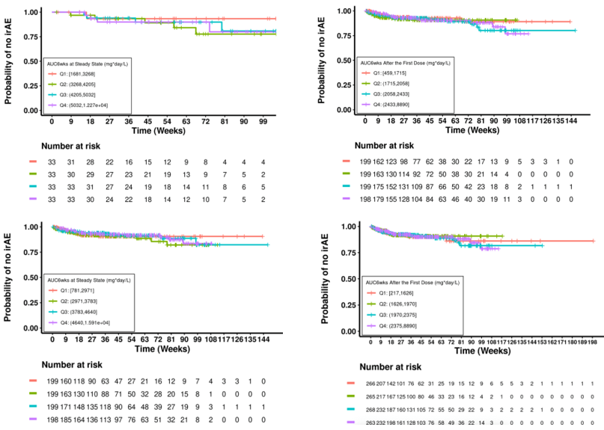
Abbreviation: AUC_{0-6weeks} = area under the concentration time curve from time zero (first dose) to 6 weeks; IrAE = immune-related adverse event
The exposure treatment-emergent immune-related adverse events for any grade at steady state (AUC_{6weeks,ss}) shows more clearly a relationship between exposure and immune-related adverse events (see Figure 2). This relationship is not as apparent in the total safety exposure safety analysis with the larger patient group which included patients given concurrent therapies.
Figure 2: Study R2810-0NC-1620 Kaplan-Meier curves of immune-mediated treatment-emergent adverse events stratified by quartiles of individual predicted cemiplimab exposures at steady state (AUC_{6weeks,ss}) in patients with advanced basal cell carcinoma
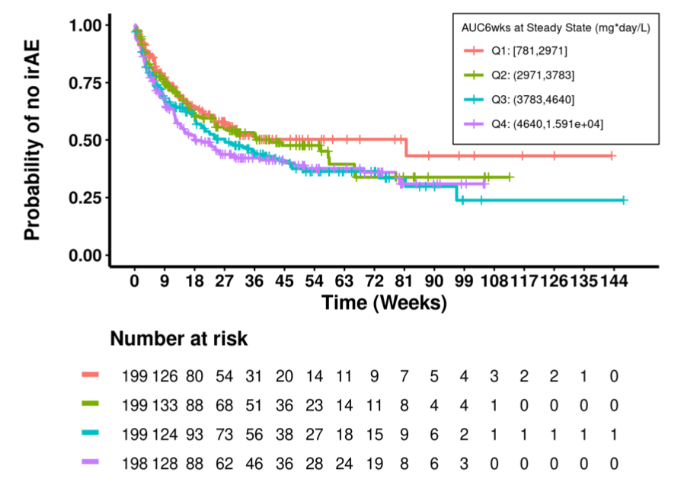
Abbreviations: AUC_{6weeks,ss} = area under the concentration time curve over 6 weeks at steady state; irAE = immune-related adverse event.
The TGA’s clinical evaluation was not in agreement with the sponsor’s conclusions that ‘… no E-R [exposure-response] relationships were found in BCC patients for both efficacy and safety.’

Pharmacodynamics
Cemiplimab is a fully human immunoglobulin G4 monoclonal antibody that binds to the programmed cell death protein-1 (PD-1) receptor and blocks its interaction with its ligands, programmed death-ligands 1 and 2 (PD-L1 and PD-L2). Engagement of PD-1 with its ligands PD-L1 and PD-L2, which are expressed by antigen presenting cells and may be expressed by tumour cells and/or other cells in the tumour microenvironment, results in inhibition of T-cell function such as proliferation, cytokine secretion, and cytotoxic activity. Cemiplimab potentiates T-cell responses, including anti-tumour responses, through blockade of PD-1 binding to PD-L1 and PD-L2 ligands.
In this submission new data on anti-cemiplimab antibodies/neutralising antibodies (NAbs) in serum were obtained from patients in Study R2810-0NC-1620 with 638 samples obtained from 125 patients. A total of 117 (93.6%) of patients were negative for anti-drug antibodies (ADA), four (3.2%) patients had pre-existing ADA, four (3.2%) patients developed a treatment emergent response. No patients developed NAbs.
The detection of antibodies was uncommon in this small study population, and the impact on cemiplimab PK cannot be determined from the data provided. Importantly, no information has been presented or discussed regarding any potential correlation between the detection of ADAs and events related to immunogenicity. The sponsor was been requested to address this deficiency.
The clinical evaluation noted that due to the small sample size, and lack of clinical correlation, there has not been adequate characterisation of these ADAs. Furthermore, large, pooled analysis using samples from all clinical studies would be required given adverse events are likely to be relatively uncommon, and noting that to date, that a total of only 1062 patients are included in the safety analyses to date. ADAs remain an important potential risk until results from a large analysis are available.

Efficacy
Study R2810-0NC-1620 is an ongoing Phase II, non-randomised, open label, two group, multicentre study evaluating efficacy, safety, and PK of cemiplimab in patients with metastatic BCC or with locally advanced BCC who experienced either progression of disease on HHI therapy, or a response no better than stable disease for at least nine months or were intolerant of prior HHI therapy.
The combined patient population of metastatic BCC and locally advanced BCC is referred to as advanced BCC. The patient population, with numbers enrolled as of the data cut-off date of 17 February 2020, for Groups 1 and 2 were as follows:
- Group 1 (metastatic BCC) includes 48 patients with histological confirmation of nodal disease and/or distant metastatic disease
- Group 2 (locally advanced BCC) enrolled 84 patients with locally advanced disease who were not candidates for surgery or radiation therapy, or for whom disease control has not been achieved with these treatments, per multidisciplinary assessment
The study excluded patients with autoimmune disease that required systemic therapy with immunosuppressant agents within five years; history of solid organ transplant; prior treatment with anti–PD-1/PD-L1 therapy or other immune checkpoint inhibitor therapy; infection with human immunodeficiency virus, hepatitis B or hepatitis C; or Eastern Cooperative Oncology Group performance status scores (ECOG PS) ≥ 2.
Patients received cemiplimab 350 mg once every 3 weeks for up to 93 weeks until disease progression, unacceptable toxicity, or completion of planned treatment. Tumour assessments were performed every nine weeks for the first 45 weeks of treatment and every 12 weeks thereafter. Dosing was administered over approximately 30 minutes. Dose reductions were permitted on discussion and agreement between investigator and sponsor. The reduced dose levels were 120 mg cemiplimab once every 3 weeks and 60 mg cemiplimab once every 3 weeks. Any patient who required dose reduction below 60 mg once every 3 weeks was removed from the study. Temporary discontinuations, delays and interruptions and permanent discontinuations for toxicity are shown in Table 3, below. The clinical evaluator has commented that it is very unusual that a dose reduction was permitted for a monoclonal antibody and this will be closely examined to determine how often this happened in the course of the study.
Table 3: Study R2810-0NC-1620 Accounting of samples for pharmacokinetics analysis (pharmacokinetics analysis set)
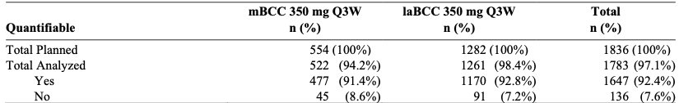
Abbreviations/information: N = number of samples from patient in the pharmacokinetics analysis set; mBCC = metastatic basal cell cancer; laBCC = locally advanced basal cell cancer; Yes = samples with quantifable concentrations; No = samples with no quantifiable concentration (BLQ)
Notes: ‘Total Planned’ is the total numbers of samples collected per protocol. ‘Total analyzed’ is the total number of samples analysed.
The efficacy assessments for the locally advanced BCC and metastatic BCC patients were presented separately because the efficacy analyses are independent for each group in the statistical design of the protocol. The primary efficacy endpoint was the overall response rate for metastatic BCC (Group 1) or locally advanced BCC (Group 2), according to central review, when treated with cemiplimab monotherapy in patients who have progressed on HHI therapy or were intolerant of prior HHI therapy. Secondary efficacy objectives were: overall response rate according to investigator review; duration of response (DOR); progression free survival (PFS), overall survival (OS) and complete response (CR) rate by central review.
The primary analysis of efficacy (overall response rate) for each group was based on the exact binomial confidence interval (CI) approach. Thresholds for this second line study were set based on the first line pivotal study of vismodegib, which had been designed to exclude overall response rates of 20% and 10% at the lower bounds of the 95% CIs intervals for locally advanced BCC and metastatic BCC, respectively.
In Study R2810-0NC-1620, if the lower limit of the two sided 95% exact binomial CI of observed overall response rate excluded 20% for locally advanced BCC (Group 2) or excluded 15% for metastatic BCC (Group 1), the statistical threshold was met for that group. These thresholds were selected as a guide to assess meaningful benefit, as there are no approved treatments available in the second line setting.
For time to event variables, median time to event (and the estimated survival rate at a fixed time point) and two sided 95% CI were summarised by the Kaplan-Meier method, unless otherwise specified.
At the time of the planned efficacy analysis for locally advanced BCC patients (approximately 57 weeks after last patient, first dose), an interim analysis of metastatic BCC patients was also performed. Only 28 patients with metastatic BCC had approximately 57 weeks at the time of the interim analysis. This prespecified analysis provides an overall response rate for metastatic BCC patients with adequate follow up. For this interim analysis on metastatic BCC patients, the overall response rate and associated 95% confidence interval were summarised. As the primary objective of this interim analysis was point estimation on overall response rate and characterising the precision of point estimation, there was no hypothesis testing associated with this interim analysis. Therefore, Type I error adjustment was not applicable. At the time of the final analysis for metastatic BCC patients, 95% exact confidence intervals will be reported.
The criteria for assessment of overall response rate in the locally advanced BCC and metastatic BCC groups are comprehensively discussed in the below:
The primary efficacy endpoint for this study was the overall response rate as determined by independent central review. The overall response rate was assessed separately for patients with metastatic BCC (Group 1) and unresectable locally advanced BCC (Group 2):
- Metastatic basal cell cancer
  - RECIST version 1.1; was used to determine overall response rate from radiological scans; for those patients with externally visible lesions, digital medical photography was performed and composite response criteria were used for the central response assessment.
- Locally advanced basal cell cancer
  - Clinical response criteria generally were used to determine overall response rate. Composite response criteria were used for patients who have both target lesions measurable by clinical response criteria and by RECIST 1.1.
Clinical response criteria for externally visible tumour(s) require bi-dimensional measurements according to World Health Organization (WHO) criteria; and are as follows:
- Complete response of externally visible disease: all target lesion and non-target lesion no longer visible. Any time point may be considered complete response of externally visible disease, but best overall response can only be complete response if it is maintained for at least four weeks. Documentation of complete response of externally visible disease requires confirmation by biopsy of site of externally visible target lesion with histologic confirmation of no residual malignancy per central pathology review. In the absence of such histologic confirmation, a subject cannot be deemed to have experienced complete response of externally visible disease and the best overall response would be partial response. Once pathologic demonstration of complete response of externally visible disease is obtained for a lesion at a given time point, it is not mandatory to repeat the biopsy for subsequent time points to document maintenance of complete response of externally visible disease.
- Partial response of externally visible disease: decrease of fifty percent (50%) or greater in the sum the products of perpendicular longest dimensions of target lesion. Any time point may be considered partial response of externally visible disease, but best overall response can only be partial response of externally visible disease if it is maintained for at least four weeks.
- Stable externally visible disease : not meeting criteria for complete response of externally visible disease, partial response of externally visible disease, or progressive disease.
- Progression of visible disease: increase of greater than twenty five percent (≥ 25%) in the sum of the products of perpendicular longest dimensions of target lesion. In rare cases, unequivocal progression on non-target lesions may be considered progression of visible disease.
RECIST v1.1 (Radiology)
- The best overall response is the best response recorded from the start of the treatment until disease progression/recurrence (taking as reference for progressive disease the smallest measurements recorded since the treatment started). The subject’s best response assignment will depend on the achievement of both measurement and confirmation criteria.

Results
As of the data cut off for this interim clinical study report, a total of 165 patients were screened, of whom 132 were enrolled and treated.
Treatment in the study overall (safety analysis set) was ongoing for 32 patients (24.2%). The most common reason for premature treatment discontinuation was disease progression (40.2% (53 out of 132)), with 12% discontinuing due to an adverse event overall (see Table 4). In the metastatic BCC cohort, three quarters were no longer receiving treatment and 16 out of 28 (57.1%) had discontinued due to progressive disease.
Table 4: Study R2810-0NC-1620 Patient disposition (safety analysis set)
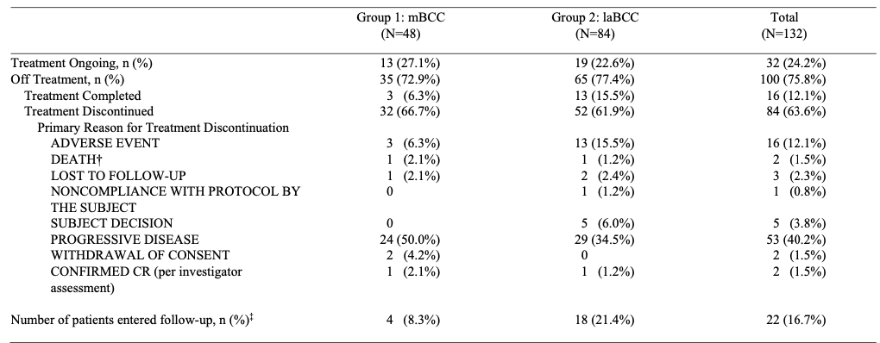
† Two patients discontinued treatment due to death.
‡ Patients who completed treatment of discontinued treatment due to an adverse event generally entered the non-treatment follow up phase of the study, unless the adverse event prevent them from doing so or they were treated past progression during the treatment phase of the study.
Data cut-off as of 17 February 2020.
A total of 112 patients with advanced BCC were included in the efficacy analysis. Of these, 28 (25%) had metastatic BCC and 84 (75%) had locally advanced BCC. In patients with locally advanced BCC, the median age was 70 years (42 to 89 years); 67% were male; 68% were White; 61% had ECOG PS 0 and 39% had ECOG PS 1;17 83% had received at least one prior cancer related surgery; and 50% had received prior radiotherapy. In patients with metastatic BCC, the median age was 65.5 years (38 to 90 years); 82% were male; 79% were White; 57% had ECOG PS 0 and 43% had ECOG PS 1;17 82% had received at least one prior cancer related surgery; and 61% had received prior radiotherapy. Among patients with metastatic BCC, 32% had distant metastases only, 14% had nodal disease only, and 54% had both distant and nodal disease.
Median duration of followup was 15.44 months (range: 0.6 to 30.8) in the metastatic BCC group and 20.29 months (range: 13.4 to 27.1) in the locally advanced BCC group.
For locally advanced BCC patients (primary analysis for locally advanced BCC) the overall response rate (intent to treat analysis) was 28.6% (24 out of 84; 95% CI: 19.2% to 39.5%). There were five patients with complete responses and 19 with partial responses. The overall response rate exceeded the 15% overall response rate required to accept the hypothesis that cemiplimab treatment results in a meaningful response rate in patients with locally advanced BCC.
For metastatic BCC patients (interim analysis), the overall response rate was 21.4% (6 out of 28; 95% CI: 8.3% to 41%). All responses were response partial responses. As noted in the TGA’s clinical evaluation, although in this interim analysis it was not intended that these figures be used to formally determine whether there has been a clinically significant response to cemiplimab, this overall response rate is very close to the pre-specified cut-off of an overall response rate of 15%, required to accept or reject that cemiplimab results in a clinically meaningful response rate among patients with metastatic BCC.
Subgroup analyses by prior HHI therapy, histological subtype and presence of Gorlin-Goltz syndrome were performed however the patient numbers in the subgroups were small and preclude meaningful conclusions.
The observed duration of response ranged from 9 to 23 plus months for the six responding patients metastatic BCC and from 2.1 to 21.4 plus months for the 24 responding patients with locally advanced BCC. All six responders with metastatic BCC had a duration of response of ≥ 6 months and 19 (79.2%) responders with locally advanced BCC had a duration of response of ≥ 6 months. For locally advanced BCC patients, the Kaplan Meier estimate of median progression-free survival by independent central review (ICR) was 19.3 months and for metastatic BCC was 8.3 months by ICR (see Table 5 and Figure 3). The estimated progression-free survival at 12 months was 56.5% (95% CI: 44.3% to 67.0%) in locally advanced BCC patients and 49.8% (95% CI:29.5% to 67.1%) in metastatic BCC patients. The Delegate noted that progression-free survival and overall survival are not interpretable in a non-comparative study and so will not be further discussed.
Table 5: Study R2810-0NC-1620 Kaplan-Meier estimate of progression free survival by independent central review (full analysis set)
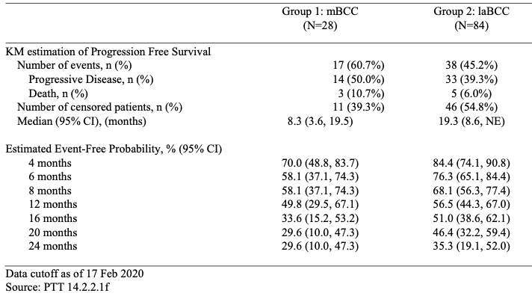
Data cut-off as of 17 February 2020
Figure 3: Study R2810-0NC-1620 Locally advanced basal cell cancer Kaplan-Meier curve for progression free survival by independent central review (full analysis set)
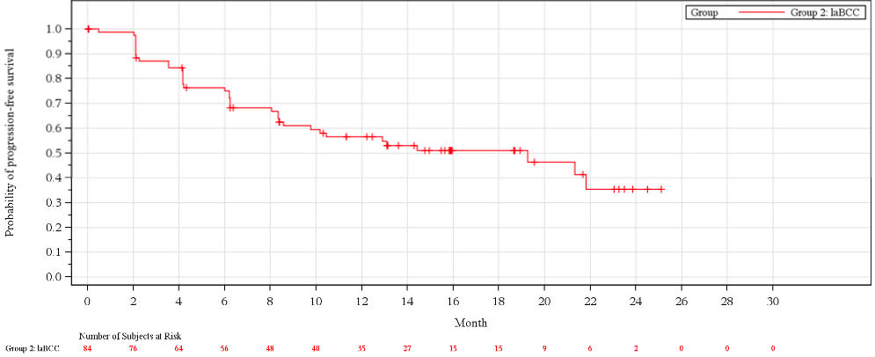
Data cutoff as of 17 February 2020
For locally advanced BCC patients with a confirmed complete or partial response, the median observed time to response according to ICR was 4.21 months (range: 2.1 to 13.4 months) with 29.2% (7 out of 24) of responding patients taking at least six months initially to respond. For metastatic BCC patients with confirmed responses, median observed time to response according to ICR was 3.17 months (range: 2.1 to 10.5 months) with 33.3% (2 out of 6) taking at least six months to respond.

Safety
Safety were primarily from Study R2810-0NC-1620, an open, uncontrolled study in which 132 patients evaluable for safety received cemiplimab 350 mg every three weeks as an intravenous infusion for up to 93 weeks or until disease progression or unacceptable toxicity. The median duration of exposure was 42 weeks (range: 2.1 weeks to 94 weeks).
Serious adverse reactions occurred in 32% of patients. Serious adverse reactions that occurred in > 1.5% (at least two patients) were: urinary tract infection; colitis; acute kidney injury; adrenal Insufficiency; anaemia; infected neoplasm; and somnolence. Fatal adverse reactions occurred in 1.5% of patients and were: acute kidney injury and cachexia.
Permanent discontinuation of cemiplimab due to an adverse reaction occurred in 13% of patients. Adverse reactions resulting in permanent discontinuation were colitis and general physical health deterioration.
Dosage delays of cemiplimab due to an adverse reaction occurred in 34% of patients. Adverse reactions which required dosage delay in > 2% of patients (at least three patients) included: blood creatinine increased; diarrhoea; colitis; fatigue; headache; pneumonitis; and urinary tract infection.
The most common adverse reactions reported in at least 15% of patients were: fatigue; musculoskeletal pain; diarrhoea; rash; pruritus; and upper respiratory tract infection. The most common Grade 3 or 4 adverse reactions (> 2%) were: hypertension; colitis; fatigue; urinary tract infection; pneumonia; increased blood pressure; hypokalaemia; and visual impairment. The most common (> 3%) laboratory abnormality worsening from baseline to Grade 3 or 4 was hyponatremia.
For BCC, 55 out of 132 (41.6%) of patients had an immune-related adverse event with 14 patients (10.6%) having a Grade 3/4/5 event. Per the study investigators, potential immune-related adverse events led to treatment discontinuation in 10 out of 132 (7.6%) patients (see Table 6) and delays or interruptions were reported due to immune-related adverse events in 24 out of 132 (18%) patients. Autoimmune reactions are associated with cemiplimab which is in keeping with adverse drug reactions associated with other PD-1 and PD-L1 inhibitors.
Table 6: Study R2810-0NC-1620 Summary of treatment-emergent immune-related adverse events based on investigator assessment (safety analysis set)
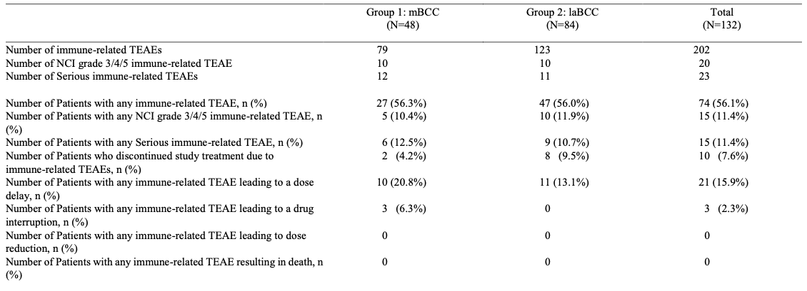Data cut-off as of 17 February 2020
Abbreviations: NCI = National Cancer Institute (United States of America); TEAE = treatment-emergent adverse event
NCI grades were coded using CTCAE Version 4.03
A patient is counted only once for multiple occurrences within a category.

Risk management plan
The sponsor has submitted European Union (EU)-risk management plan (RMP) version 1.0 (26 April 2019; data lock point (DLP) 10 October) and Australia specific annex (ASA) version 1.0 (31 July 2019) at first round evaluation and an updated ASA, version 1.1 (28 February 2020) at second round evaluation in support of this application.
The summary of safety concerns and their associated risk monitoring and mitigation strategies are summarised in Table 7. Further information regarding the TGA’s risk management approach can be found in risk management plans for medicines and biologicals and the TGA's risk management approach.
Table 7: Summary of safety concerns
Summary of safety concerns |  | Pharmacovigilance |  | Risk Minimisation
 |  | Routine | Additional | Routine | Additional
Important identified risks | Immune-related adverse reactions (irARs) (such as immune-related pneumonitis, colitis, hepatitis, endocrinopathies, immune-related skin adverse reactions, nephritis, and other irARs) | * | † |  | ‡
Important identified risks | Infusion-related reactions (IRRs) | * | † |  | ‡
Important potential risks | Lack of effect due to anti-drug antibodies |  | † |  | –
Missing information | Long-term safety data |  | † | – | –
* Specific adverse reaction follow up questionnaires
† Study R2810-ONC-1540
‡ Patient Guide and Patient Alert Card
Routine risk minimisation activities have been proposed for important identified and potential risks. Additional risk minimisation materials, a patient guide and patient alert card, have been proposed for important identified risks. This is acceptable to the RMP evaluator who has advised that the sponsor should submit the draft additional risk minimisation materials to the TGA for review at least 6 weeks prior to the planned supply date of Libtayo in Australia.

Risk-benefit analysis

Delegate’s considerations
There are limited therapeutic options for patients with locally advanced and/or metastatic BCC who have received prior hedgehog inhibitor. This is a relatively small group of patients given how common BCCs are in the Australian population. The data supporting this proposed indication are from an interim analysis of a small, open, uncontrolled study. Despite the small amount of data, efficacy was demonstrated with 28.6% and 21.4% of patients with locally advanced BCC and metastatic BCC respectively obtaining a response. Separate assessment of efficacy in patients with metastatic and locally advanced BCC was necessary due to the difference in duration of follow-up for these two patient groups.
Most patients who responded had a duration of response of ≥ 6 months. All but six patients had a partial response with six patients, all with locally advanced BCC having a complete response. The durability of that response requires further follow up. Assessment of lack of progression is not interpretable in an open study so progression free survival cannot be meaningfully discussed. Similarly, there is no comparator against which to assess differences in overall survival, so it also is not able to be considered in this submission.
Immune-related reactions were quite frequent in the BCC study and due to the longer median duration of treatment in patients with locally advanced BCC appeared to be more frequent in that group. This is a similar pattern to that seen with other PD-1/PD-L1 inhibitors.
There was an exploratory analysis of results by tumour mutation burden. In those analyses there appears to be a trend towards higher tumour mutation burden being associated with a greater likelihood of a response.
At this stage, the Delegate is inclined to agree with the clinical evaluation that there is sufficient evidence of a robust and durable treatment response to recommend authorisation for the population with locally advanced BCC.
Also, as noted in the clinical evaluation, the data for the metastatic population are still very preliminary and require longer term follow up to confirm that the observed response rate of 21% is at least maintained (noting a 15% cut-off was stipulated to reject that there is a clinically significant objective response rate given the single arm study design and small sample size) as well as to understand the durability of any observed responses. Currently, data are provided for only 28 patients, with five of these deemed not to provide efficacy results by independent review. The full planned recruitment in this cohort could include up to 53 patients, and data are needed from these remaining patients to confirm any benefit.
The sponsor has responded to that concern and subsequently applied for a provisional determination for Libtayo (cemiplimab) for the treatment of metastatic BCC. That determination was granted in June 2021 and the subsequent application has been submitted.

Proposed action
The data to support the metastatic BCC component of the BCC indication has too few patients and too short a DOR for full registration to be approved. The Delegate consider that the limited available data suggest efficacy of Libtayo in patients with metastatic BCC is similar or possibly somewhat reduced in compared to the locally advanced BCC population. The Delegate propose to split the indication for BCC into two parts with the locally advanced BCC component to have full registration and the metastatic BCC component to have provisional approval. The following indications for this component of the submission are as follows:
Basal Cell Carcinoma
- treatment of adult patients with locally advanced basal cell carcinoma (BCC) previously treated with a hedgehog inhibitor.
- treatment for the treatment of patients with metastatic BCC (mBCC) previously treated with a hedgehog pathway inhibitor or for whom a hedgehog pathway inhibitor is not appropriate.
The mBCC indication is approved via the provisional approval pathway, based tumour response rate and duration of response. Full registration for this indication depends on verification and description of clinical benefit in a confirmatory trial.

Advisory Committee considerations
The Advisory Committee on Medicines (ACM), having considered the evaluations and the Delegate’s overview, as well as the sponsor’s response to these documents, advised the following.

Specific advice to the Delegate
- The Committee’s advice is requested on whether the paucity of data, both in patient number and duration of follow-up and the open, uncontrolled nature of the study is sufficient to reject full registration for the locally advanced BCC component of the proposed BCC indication.
The ACM discussed that locally advanced BCC is a rare subset of BCC with limited treatment options available to these patients. The almost two years of follow-up in the trial with very little evidence of adverse events was viewed positively by the ACM.
However, the ACM advised that the data provided for the proposed locally advanced BCC indication is not sufficient to support full registration. In providing this opinion, the ACM considered that this is an incomplete study with ongoing data expected. The ACM was of the view that the current early data set would be more appropriate for provisional registration of the locally advanced BCC indication.
- The Committee is requested to consider whether the proposed provisional approval indication for metastatic BCC is acceptable given the quantity and quality of data available.
The ACM agreed that the quantity and quality of data available was appropriate for provisional approval for the metastatic BCC indication.
- While it is not usual to specify a duration of treatment prior to observing a response to treatment nearly all patients who responded did so within 6 months of commencing cemiplimab. Does the Committee consider that the Product Information should include a statement recommending cessation of treatment if a response is not observed in the first 6 months of treatment?
The ACM was of the opinion that a statement in the PI recommending cessation of treatment if a response is not observed in the first 6 months of treatment is not needed for use in BCC. The ACM noted the time-to-response was 4.21 months for the locally advanced BCC group and 3.17 months for the metastatic BCC group. While the ACM acknowledged that most patients who are going to have a response to cemiplimab do so in the first 6 months, they agreed that some patients are late responders and that the toxicity/benefit profile over time should be left to clinical decision.

ACM conclusion

Basal cell carcinoma
The ACM considered Libtayo to have an overall positive benefit-risk profile for the provisional indication as follows:
Basal Cell Carcinoma (BCC)
for the treatment of patients with metastatic BCC (mBCC) previously treated with a hedgehog pathway inhibitor or for whom a hedgehog pathway inhibitor is not appropriate.
The mBCC indication is approved via the provisional approval pathway, based tumour response rate and duration of response. Full registration for this indication depends on verification and description of clinical benefit in a confirmatory trial.
The ACM agreed that Libtayo had an overall negative benefit-risk profile for full registration of the following indication as the evidence submitted did not satisfactorily establish the efficacy of the product:
treatment of adult patients with locally advanced basal cell carcinoma (BCC) previously treated with a hedgehog inhibitor.
The ACM advised that the current data are more supportive of a provisional indication for locally advanced basal cell carcinoma.

Outcome
Based on a review of quality, safety, and efficacy, the TGA approved the registration of Libtayo (cemiplimab) 350 mg, concentrate for solution for infusion, vial, for the following extension of indications:
Basal Cell Carcinoma
Libtayo as monotherapy is indicated for the treatment of adult patients with locally advanced basal cell carcinoma (BCC) previously treated with a hedgehog pathway inhibitor or for whom a hedgehog pathway inhibitor is not appropriate
The provisionally approved new indication for the medicine is:
Libtayo as monotherapy has provisional approval in Australia for the treatment of adult patients with metastatic BCC (mBCC) previously treated with a hedgehog pathway inhibitor or for whom a hedgehog pathway inhibitor is not appropriate.
The decision to approve the mBCC indication has been made on the basis of objective response rate (ORR) and duration of response from a single arm clinical study. The sponsor is required to submit further clinical data to confirm the clinical benefit of the medicine.
As such, the full indications at this time were:
Cutaneous Squamous Cell Carcinoma
Libtayo as monotherapy has provisional approval in Australia for the treatment of adult patients with metastatic or locally advanced cutaneous squamous cell carcinoma (mCSCC or laCSCC) who are not candidates for curative surgery or curative radiation.
The decision to approve this indication has been made on the basis of objective response rate (ORR) and duration of response from single arm clinical studies. The sponsor is required to submit further clinical data to confirm the clinical benefit of the medicine.
Basal Cell Carcinoma
Libtayo as monotherapy is indicated for the treatment of adult patients with locally advanced basal cell carcinoma (BCC) previously treated with a hedgehog pathway inhibitor or for whom a hedgehog pathway inhibitor is not appropriate.
Libtayo as monotherapy has provisional approval in Australia for the treatment of adult patients with metastatic BCC (mBCC) previously treated with a hedgehog pathway inhibitor or for whom a hedgehog pathway inhibitor is not appropriate.
The decision to approve the mBCC indication has been made on the basis of objective response rate (ORR) and duration of response from a single arm clinical study. The sponsor is required to submit further clinical data to confirm the clinical benefit of the medicine.
Non-Small Cell Lung Cancer
Libtayo as monotherapy is indicated for the first-line treatment of adult patients with non-small cell lung cancer (NSCLC) expressing PD-L1 tumour proportion score (TPS) ≥50% as determined by a validated test, with no EGFR, ALK or ROS1 aberrations, who have:
- locally advanced NSCLC and who are not candidates for surgical resection or definitive chemoradiation, or
- metastatic NSCLC.

Specific conditions of registration applying to these goods
- Libtayo (cemiplimab) is to be included in the Black Triangle Scheme. The PI and CMI for Libtayo must include the black triangle symbol and mandatory accompanying text for the products entire period of provisional registration.
- The Libtayo EU-Risk Management Plan (RMP) (version 2.0, dated 19 August 2020, data lock point 1 March 2020), with Australian Specific Annex (version 3.1, dated October 2021), included with submission PM-2021-03735-1-4, and any subsequent revisions, as agreed with the TGA will be implemented in Australia.
An obligatory component of risk management plans is routine pharmacovigilance. Routine pharmacovigilance includes the submission of periodic safety update reports (PSURs).
Unless agreed separately between the supplier who is the recipient of the approval and the TGA, the first report must be submitted to TGA no later than 15 calendar months after the date of the approval letter. The subsequent reports must be submitted no less frequently than annually from the date of the first submitted report until the period covered by such reports is not less than three years from the date of the approval letter, or the entire period of provisional registration, whichever is longer.
The reports are to at least meet the requirements for PSURs as described in the European Medicines Agency’s Guideline on good pharmacovigilance practices (GVP) Module VII-periodic safety update report (Rev 1), Part VII.B Structures and processes. Note that submission of a PSUR does not constitute an application to vary the registration. Each report must have been prepared within ninety calendar days of the data lock point for that report.
- Confirmatory trial data (as identified in the sponsor’s plan to submit comprehensive clinical data on the safety and efficacy of the medicine before the end of the 6 years that would start on the day that registration would commence) must be provided.
Specifically, the sponsor must conduct studies as described in the clinical study plan in annex version 3.1 (date October 2021) of the Australia specific annex. The following study report(s) should be submitted to TGA:
  - R2810-ONC-1620 (Group 1), Phase II, by February 2022
Further guidance for sponsors is available on the TGA website.

Attachment 1. Product Information
The PI for Libtayo approved with the submission which is described in this AusPAR is at Attachment 1. For the most recent PI, please refer to the TGA PI/CMI search facility.

Therapeutic Goods Administration
PO Box 100 Woden ACT 2606 Australia
Email: info@tga.gov.au Phone: 1800 020 653 Fax: 02 6232 8605
https://www.tga.gov.au

Verkouteren JAC, Ramdas KHR, Wakkee M, Nijsten T. Epidemiology of basal cell carcinoma: scholarly review. Br J Dermatol 2017; 177(2):359-72.
Lomas A, Leonardi-Bee J, Bath-Hextall F. A systematic review of worldwide incidence of nonmelanoma skin cancer. Br J Dermatol 2012; 166(5):1069-80.
Guidelines for the Management of Basal Cell Carcinoma (NR Telfer, GB Colver, PW Bowers). BJD, Vol. 159, No.1, July 2008 (p35) — British Association of Dermatologists.
Cameron MC, Lee E, Hibler BP, Barker CA, Mori S, Cordova M, et al. Basal cell carcinoma: Epidemiology; pathophysiology; clinical and histological subtypes; and disease associations. J Am Acad Dermatol 2019; 80(2):303-17.
Nikanjam M, Cohen PR, Kato S, Sicklick JK, Kurzrock R. Advanced basal cell cancer: concise review of molecular characteristics and novel targeted and immune therapeutics. Ann Oncol 2018; 29(11):2192-9.
Peris K, Fargnoli MC, Garbe C, Kaufmann R, Bastholt L, Seguin NB, et al. Diagnosis and treatment of basal cell carcinoma: European consensus-based interdisciplinary guidelines. Eur J Cancer 2019; 118(10-34.
National Comprehensive Cancer Network (NCCN). NCCN Clinical Practice Guidelines in Oncology (NCCN Guidelines). Prevention and Treatment of Cancer-Related Infections, Version 1.2020.
von Domarus H, Stevens PJ. Metastatic basal cell carcinoma. Report of five cases and review of 170 cases in the literature. J Am Acad Dermatol 1984; 10(6):1043-60.
Wysong A, Aasi SZ, Tang JY. Update on metastatic basal cell carcinoma: a summary of published cases from 1981 through 2011. JAMA Dermatol 2013; 149(5):615-6.
Vismodegib was first registered in Australia on the 6 May 2013. ARTG number: 196234.
Further information on the approval of vismodegib can be found in the following: AusPAR for Erivedge (vismodegib) Roche Products Pty Ltd., submission number: PM-2012-00329-3-4. Available at: https://www.tga.gov.au/auspar/auspar-vismodegib
Sonidegib was first registered in Australia on 10 August 2015. ARTG numbers: 226544, 292262.
Further information on the approval of sonidegib can be found in the following: AusPAR for Odomzo (sonidegib) Novartis Pharmaceuticals Australia Pty Ltd., submission number: PM-2014-01865-1-4. Available at: https://www.tga.gov.au/auspar/auspar-odomzo
Further information on the initial provisional approval for cemiplimab can be found in the following: AusPAR for Libtayo (cemiplimab) Sanofi-Aventis Australia Pty Ltd., submission number: PM-2019-03270-1-4. Available at: https://www.tga.gov.au/auspar/auspar-cemiplimab
PM-2021-03735-1-4 is TGA sequence number for evaluation of provisional registration of metastatic basal cell carcinoma.
ECOG Performance Status: The Eastern Cooperative Oncology Group (ECOG) has developed criteria used by doctors and researchers to assess how a patient's disease is progressing, assess how the disease affects the daily living abilities of the patient, and determine appropriate treatment and prognosis. The following are used: 0 - Fully active, able to carry on all pre-disease performance without restriction 1- Restricted in physically strenuous activity but ambulatory and able to carry out work of a light or sedentary nature, for example, light house work, office work 2 - Ambulatory and capable of all self-care but unable to carry out any work activities. Up and about more than 50% of waking hours 3 - Capable of only limited self-care, confined to bed or chair more than 50% of waking hours 4 - Completely disabled. Cannot carry on any self-care. Totally confined to bed or chair 5 – Dead
The Response Evaluation Criteria in Solid Tumours (RECIST) is a voluntary, international standard using unified, easily applicable criteria for measuring tumour response using X-ray, CT and MRI.
World Health Organization. WHO Handbook for Reporting Results of Cancer Treatment. World Health Organization. Published 1979.
Information on the TGA’s provisional determination pathway is available on the TGA website: https://www.tga.gov.au/publication/provisional-determination

