|  |
| --- |
| October 2022 |

|  |
| --- |
| Australian Public Assessment Report for Comirnaty COVID-19 Vaccine |
| Active ingredients: tozinameran |
| Sponsor: Pfizer Australia Pty Ltd |

About the Therapeutic Goods Administration (TGA)

* The Therapeutic Goods Administration (TGA) is part of the Australian Government Department of Health and is responsible for regulating therapeutic goods, including medicines, medical devices, and biologicals.
* The TGA administers the *Therapeutic Goods Act 1989* (the Act), applying a risk management approach designed to ensure therapeutic goods supplied in Australia meet acceptable standards of quality, safety, and efficacy.
* The work of the TGA is based on applying scientific and clinical expertise to decision-making, to ensure that the benefits to the Australian public outweigh any risks associated with the use of therapeutic goods.
* The TGA relies on the public, healthcare professionals and industry to report problems with therapeutic goods. The TGA investigates reports received to determine any necessary regulatory action.
* To report a problem with a therapeutic good, please see the information on the [TGA website](https://www.tga.gov.au).

About AusPARs

* The Australian Public Assessment Report (AusPAR) provides information about the evaluation of a prescription medicine and the considerations that led the TGA to approve or not approve a prescription medicine submission. Further information can be found in [Australian Public Assessment Report (AusPAR) guidance](https://www.tga.gov.au/australian-public-assessment-report-auspar-guidance).
* AusPARs are prepared and published by the TGA.
* AusPARs are static documents that provide information that relates to a submission at a particular point in time. The publication of an AusPAR is an important part of the transparency of the TGA’s decision-making process.
* A new AusPAR may be provided to reflect changes to indications or major variations to a prescription medicine subject to evaluation by the TGA.

Copyright

© Commonwealth of Australia 2022  
This work is copyright. You may reproduce the whole or part of this work in unaltered form for your own personal use or, if you are part of an organisation, for internal use within your organisation, but only if you or your organisation do not use the reproduction for any commercial purpose and retain this copyright notice and all disclaimer notices as part of that reproduction. Apart from rights to use as permitted by the *Copyright Act 1968* or allowed by this copyright notice, all other rights are reserved, and you are not allowed to reproduce the whole or any part of this work in any way (electronic or otherwise) without first being given specific written permission from the Commonwealth to do so. Requests and inquiries concerning reproduction and rights are to be sent to the TGA Copyright Officer, Therapeutic Goods Administration, PO Box 100, Woden ACT 2606 or emailed to <[tga.copyright@tga.gov.au](mailto:tga.copyright@tga.gov.au)>.

Contents

List of abbreviations 4

Product submission 6

Submission details 6

Product background 7

Regulatory status 14

Product Information 16

Registration timeline 16

Submission overview and risk/benefit assessment 16

Quality 17

Nonclinical 20

Clinical 20

Risk management plan 46

Risk-benefit analysis 48

Outcome 52

Specific conditions of registration applying to these goods 52

Attachment 1. Product Information 53

## List of abbreviations

|  |  |  |
| --- | --- | --- |
| Abbreviation | | Meaning |
| ACV | Advisory Committee on Vaccines | |
| ARTG | Australian Register of Therapeutic Goods | |
| ASA | Australia specific annex | |
| ATAGI | Australian Technical Advisory Group on Immunisation | |
| BNT162b2 | Tozinameran (former and interchangeable name) | |
| CDC | Centers for Disease Control and Prevention (United States of America) | |
| CI | Confidence interval | |
| COVID-19 | Coronavirus disease 2019 | |
| DLP | Data lock point | |
| EMA | European Medicines Agency (European Union) | |
| EU | European Union | |
| EUA | Emergency Use Authorization (United States of America) | |
| FDA | Food and Drug Administration (United States of America) | |
| GMFR | Geometric mean fold rise | |
| GMP | Good Manufacturing Practice | |
| GMR | Geometric mean ratio | |
| GMT | Geometric mean titre | |
| ICH | International Council for Harmonisation | |
| LNP | Lipid nanoparticle | |
| MIS | Multisystem inflammatory syndrome | |
| MIS-C | Multisystem inflammatory syndrome in children | |
| mITT | Modified intent-to-treat | |
| ModRNA | (Nucleoside)-modified messenger RNA | |
| NAAT | Nucleic acid amplification test | |
| NNDSS | National Notifiable Diseases Surveillance System (Australia) | |
| NT50 | 50% neutralising titre | |
| PAEDS | Paediatric Active Enhanced Disease Surveillance (Australia) | |
| PIMS-TS | Paediatric inflammatory multisystem syndrome temporally associated with SARS-CoV-2 | |
| RMP | Risk management plan | |
| S | Spike glycoprotein | |
| SARS-CoV-2 | Severe acute respiratory syndrome coronavirus 2 | |
| TGA | Therapeutic Goods Administration | |
| US(A) | United States (of America) | |
| WHO | World Health Organization | |

## Product submission

### Submission details

|  |  |
| --- | --- |
| *Type of submission:* | Extension of indications (new population) and major variation (new strength) |
| *Product name:* | Comirnaty COVID-19 vaccine |
| *Active ingredient:* | Tozinameran |
| *Decision:* | Approved for provisional registration |
| *Date of decision:* | 29 September 2022 |
| *Date of entry onto ARTG:* | 30 September 2022 |
| *ARTG numbers:* | 393433 |
| [*Black Triangle Scheme*](https://www.tga.gov.au/black-triangle-scheme)*:* | Yes  As a provisionally registered product, this medicine will remain in the Black Triangle Scheme for the duration of its provisional registration |
| *Sponsor’s name and address:* | Pfizer Australia Pty Ltd  Level 17, 151 Clarence Street  Sydney, NSW, 2000 |
| *Dose form:* | Concentrated suspension for injection |
| *Strength:* | 3 µg/0.2 mL |
| *Container:* | Multidose vial |
| *Pack sizes:* | 10 and 195 vials |
| *Approved therapeutic use:* | *Comirnaty (tozinameran) COVID-19 vaccine has* ***provisional approval*** *for the indication below:*  *Active immunisation to prevent coronavirus disease 2019 (COVID-19) caused by SARS-CoV-2, in individuals 6 months of age and older.*  *The use of this vaccine should be in accordance with official recommendations.*  *The decision has been made on the basis of short term efficacy and safety data. Continued approval depends on the evidence of longer term efficacy and safety from ongoing clinical trials and post-market assessment.* |
| *Route of administration:* | Intramuscular injection |
| *Dosage:* | **Individuals 6 months to under 5 years of age**  Comirnaty Dilute To Use Multidose (for age 6 months to under 5 years) is administered intramuscularly as a primary course of 3 doses (3 micrograms/0.2 mL each). The initial two doses are administered 3 weeks apart followed by a third dose administered at least 8 weeks after the second dose (see sections 4.4 Special warnings and precautions for use and 5.1 Pharmacodynamic properties).  Children who will turn from 4 years to 5 years of age between their doses in the vaccination series should receive their age-appropriate dose at the time of the vaccination and the interval between doses is determined by the individual’s age at the start of the vaccination series.  Comirnaty Dilute To Use Multidose (For age 6 months to < 5 years) cannot be used in individuals 5 years of age and older.  For further information regarding dosage, refer to the Product Information. |
| *Pregnancy category:* | B1  Drugs which have been taken by only a limited number of pregnant women and women of childbearing age, without an increase in the frequency of malformation or other direct or indirect harmful effects on the human fetus having been observed.  Studies in animals have not shown evidence of an increased occurrence of fetal damage.  The use of any medicine during pregnancy requires careful consideration of both risks and benefits by the treating health professional. This must not be used as the sole basis of decision making in the use of medicines during pregnancy. The TGA does not provide advice on the use of medicines in pregnancy for specific cases. More information is available from obstetric drug information services in your State or Territory. |

### Product background

This AusPAR describes the submission by Pfizer Australia Pty Ltd (the sponsor) to provisionally register Comirnaty (tozinameran) COVID-19 vaccine 3 µg/0.2 mL concentrated suspension for injection, multidose vial for the following proposed indication:

*Active immunisation to prevent coronavirus disease 2019 (COVID-19) caused by SARS-CoV-2, in individuals 6 months of age and older.*

*The use of this vaccine should be in accordance with official recommendations.*

The indication above represents and extension to the current indications, expanding the indication population to include a younger age group of children aged from 6 months to under 5 years.

The indication as approved by the TGA at the time of this submission was as follows:

*Active immunisation to prevent coronavirus disease 2019 (COVID-19) caused by SARS-CoV-2, in individuals 5 years of age and older.*

*The use of this vaccine should be in accordance with official recommendations.*

In addition the sponsor has proposed a new, lower strength presentation of Comirnaty (tozinameran) COVID-19 vaccine specifically for this younger age group, along with a new dosage regimen for this age group.

The new strength proposed is at a dosage of 3 µg/0.2 mL, and is in the form of a tris/sucrose buffered formulation, similar to the following currently approved vaccine formulations:

* Comirnaty (tozinameran) COVID-19 vaccine 30 µg/0.3 mL suspension for injection (do not dilute) multidose vial (AUST R 377110), for use in ages 12 years and above; and
* Comirnaty (tozinameran) COVID-19 vaccine 10 µg/0.2 mL concentrated suspension for injection (dilute to use) multidose vial (AUST R 377111); for use in ages from 5 to under 12 years.

Like the latter 10 µg/0.2 mL per dose presentation, this new proposed presentation is also a dilute to use product.

For this age group a new dosage regimen is proposed with a primary vaccination series consisting of a 3 separate doses given at zero, 3, and 8 weeks.

#### Coronavirus disease 2019

Coronavirus disease 2019 (COVID-19) is an infectious disease caused by SARS-CoV-2 (severe acute respiratory syndrome coronavirus 2). SARS-CoV-2 is an enveloped, positive‑sense, single-stranded RNA virus that first appeared circulating in late 2019. It is predominantly a respiratory illness that also affects other organs. People with COVID-19 have reported a wide range of symptoms, and illness severity. Symptoms may appear between 2 to 14 days after exposure to the virus. Symptoms may include fever or chills; cough; shortness of breath; fatigue; muscle or body aches; headache; new loss of taste or smell; sore throat; congestion/runny nose; nausea, vomiting; and diarrhoea.

Since the beginning of the COVID-19 outbreak, the disease has spread worldwide affecting more than 200 countries and territories, with an unprecedented effect on public health, as well as on social and economic activities. It was officially declared a pandemic by the World Health Organization (WHO) on 11 March 2020.[1] As of 7 September 2022, there have been almost 604 million confirmed cases globally, and just under 6.5 million deaths.[2] In Australia, there have been over 10.1 million confirmed cases and 14,288 deaths reported.[3] Effective COVID-19 vaccines have been developed and approved and treatments for COVID-19 infections are becoming more available. The emergence of variants continues to fuel the pandemic.

All ages may present with COVID-19 illness, but notably, case fatality rates are elevated in persons over 60 years of age. Comorbidities are also associated with increased case fatalities including cardiovascular disease, diabetes, hypertension, and chronic respiratory disease.

Whilst COVID-19 disease in children is often asymptomatic or mild, severe disease and death may occur. Hospitalisation and poorer outcomes are more likely in children with pre-existing health conditions, disadvantage, and low socioeconomic or minority ethnic status. However, during the predominance of the Omicron variant of the virus, in the United States of America (USA), 63% of hospitalised infants/children had no underlying medical conditions; and among children less than 5 years of age, COVID-19 associated hospitalisation was 1.6-times higher than among children between 12 to 17 years of age and 5.4 times higher than children of 5 to 11 years of age.[4]

There has been a significant incidence of COVID-19 cases in children in Australia, including in children aged less than 5 years old. Data from the National Notifiable Diseases Surveillance System (NNDSS)[5] shows that the hospitalisation rate in children less than 5 years of age was more than 1,000 per 100,000 population during recent peaks and currently, the hospitalisation rate is approximately 450 cases per 100,000 population.

As of 8 September 2022 almost over 450,000 Australians aged 9 years or less, have contracted COVID-19, and there have been 12 deaths in this age group in Australia.3 As of the same date, the USA has recorded 527 COVID-19 associated deaths among children under 5 years of age, with more than half due to the Omicron variant.[6]

Persistent symptoms and severe sequelae following COVID 19 infection have been documented in children.[7] Multisystem inflammatory syndrome (MIS) is a rare but serious condition associated with COVID-19 in which different body parts become inflamed, including the heart, lungs, kidneys, brain, skin, eyes, or gastrointestinal organs. In the USA, approximately 25% of cases of multisystem inflammatory syndrome in children (MIS-C) have been reported in children from zero to less than 5 years of age.[8] Since the start of the pandemic to 30 July 2022, there have been 144 cases of PIMS-TS (or paediatric inflammatory multisystem syndrome temporally associated with SARS-CoV-2) reported to Paediatric Active Enhanced Disease Surveillance (PAEDS) in Australia.[9] Approximately 27% of these cases (39 of 144 cases) have been in children aged 6 months to less than 5 years. To date, there have been no PIMS-TS associated deaths.

Recently, the Centers for Disease Control and Prevention (CDC) in the USA documented 3.5 times higher incidence of new-onset diabetes for paediatric COVID-19 patients (those from zero to less than 12 years) than patients without COVID-19.[10] COVID‑19 infection and the pandemic may also impact children's long term physical and mental health.[11]

Reducing the burden of infection will likely lessen the impact of severe, debilitating, and sometimes life-long sequelae. Ensuring children, 6 months to less than 5 years of age, in particular those children with other medical conditions, have access to vaccine will likely be beneficial for children in this age group.

#### Drug class and therapeutic indication

Comirnaty is an mRNA vaccine for prevention of COVID-19. The active ingredient of the vaccine is tozinameran, but may be referred to interchangeably with its former name of BNT162b2 (mRNA); both names refer to the same active ingredient. The vaccine is administered intramuscularly.

The active ingredient, tozinameran, is a nucleoside-modified messenger RNA (modRNA) encoding a mutated form of the full-length spike glycoprotein (S) of SARS-CoV-2. The single-stranded 5’-capped mRNA is produced without using cells using *in vitro* transcription from the corresponding DNA template, encoding the full-length viral spike protein of SARS-CoV-2. The RNA (tozinameran) is encapsulated in lipid nanoparticles, which enables entry into host cells, expression of the S protein, and elicitation of both antibody and cellular immune responses.

#### Dosage forms and strengths

In addition to the proposed new indication, extending the current indication to include individuals from 6 months of age and older, the sponsor also seeks approval of a new, lower strength product of the tris/sucrose drug product line to include a 3 μg mRNA dose presentation for use in young children.

##### Currently registered formulations

The current provisionally registered formulations of Comirnaty vaccine are currently presented in multidose vials that are stored frozen, and then thawed prior to use.

The current presentations are detailed as follows in Table 1: Comirnaty presentations

Table 1: Comirnaty presentations as currently approved

|  |  |  |  |
| --- | --- | --- | --- |
| Comirnaty presentations as currently approved | | | |
|  | **Dilute to use, multidose vial (for age 12 years and above)** | **Ready to use, multidose vial (for age 12 years and above, do not dilute)** | **Dilute to use, multidose vial (for age 5 to < 12 years)** |
| AUST R | 346290 | 377110 | 377111 |
| Age | 12 years of age and older | 12 years of age and older | 5 to less than 12 years of age |
| Cap colour | Purple | Grey | Orange |
| Label colour | Purple | Grey | Orange |
| Strength | 30 µg/0.3 mL | 30 µg/0.3 mL | 10 µg/0.2 mL |
| Fill volume | 0.45 mL | 2.25 mL | 1.3 mL |
| Number of doses | 6 | 6 | 10 |
| Dilution | Requires dilution (1.8 mL sodium chloride 0.9%) | Do not dilute | Requires dilution (1.3 mL sodium chloride 0.9%) |
| Presentation | PBS/sucrose | Tris/sucrose | Tris/sucrose |

##### New proposed formulation

For administration to children from 6 months to under 5 years of age, a new strength of Comirnaty is proposed to be registered providing 3 µg per 0.2 mL dose. The new 3 µg mRNA presentation is also supplied in a multiuse vial, to be thawed before use. It requires dilution with 2.2 mL 0.9% sodium chloride (normal saline) prior to administration and once diluted provides 10 doses, each containing a 3 μg RNA dose in 0.2 mL injection volume.

It is in the same tris/sucrose-buffered product line, that includes the 30 µg /0.3 mL ready to use, multidose vial (AUST R 377110) and 10 µg/0.2 mL, dilute to use, multidose vial (AUST R 377111) presentations. Unlike the former and similar to only the latter 10 µg/0.2 mL presentation (AUST R 377111), it must also be diluted with a volume of normal saline (sodium chloride 0.9%) prior to use.

Further details of the new 3 µg/0.2 mL dose presentation are given in Table 2, below.

Table 2: New proposed formulation/strength of Comirnaty in this submission

|  |  |
| --- | --- |
| 3 µg/0.2 mL dose presentation | |
|  | **Dilute to use, multidose vial (for age 6 months to < 5 years)** |
| AUST R | Proposed1 |
| Age | 6 months of age to < 5 years |
| Cap colour | Maroon |
| Label colour | Maroon |
| Strength | 3 µg/0.2 mL |
| Fill volume | 0.4 mL |
| Number of doses | 10 |
| Dilution | Dilute to use (2.2 mL sodium chloride 0.9%) |
| Presentation | Tris/sucrose |

1. AUST R 393433 (following approval and registration).

##### Proposed vaccination schedule

The paediatric vaccination series for children from 6 months to less than 5 years of age was initially planned as a two-dose program (3 µg mRNA each dose) but this was amended include a third dose to be given at least 8 weeks after the second dose.

A summary of Comirnaty dosing schedules of primary vaccination is shown in the following table.

Table 3: Comirnaty dosing for primary vaccination

|  |  |  |
| --- | --- | --- |
| Age group | Dose of mRNA (volume of vaccine) | Regimen |
| From 16 years | 30 µg (0.3 mL) | 2 doses (0 and 3 weeks) |
| Between 12 and 15 years | 30 µg (0.3 mL) | 2 doses (0 and 3 weeks) |
| Between 5 and 11 years | 10 µg (0.2 mL) | 2 doses (0 and 3 weeks) |
| From 6 months and under 5 years | 3 µg (0.2 mL) | 3 doses (0, 3 and 8+ weeks) |

Note, the pale blue shaded row represents the new age group, new strength and new dosage regimen proposed in this submission.

#### Current vaccine options

There are currently six vaccines on the Australian Register of Therapeutic Goods (ARTG), and all are approved under the provisional pathway. [12],[13] Note that at the time this submission was considered for approval, only one COVID-19 vaccine (Spikevax (elasomeran) COVID-19 vaccine), also known as the Moderna (mRNA) vaccine, had been approved for use in individuals below the age of 5 years.

All vaccines are listed as follows:

* + Comirnaty (tozinameran, previously known at BNT162b2 (mRNA));[14] also commonly known as the Pfizer/BioNTech (mRNA) vaccine is provisionally approved for active immunisation to prevent COVID-19 caused by SARS-CoV-2, in individuals 5 years of age and older.[15],[16],[17],[18],[19],[20],[21]
  + COVID-19 Vaccine AstraZeneca (ChAdOx1-S), an adenoviral vectored vaccine, is provisionally approved for active immunisation to prevent COVID-19 caused by SARS-CoV-2, in individuals 18 years of age and older.[22],[23]
  + COVID-19 Vaccine Janssen (Ad26.COV2.S), an adenoviral vectored vaccine, is provisionally approved for active immunisation to prevent COVID-19 caused by SARS-CoV-2, in individuals 18 years of age and older.[24],[25]
  + Spikevax (elasomeran) COVID-19 vaccine, also known as the Moderna (mRNA) vaccine, is provisionally approved for active immunisation to prevent COVID-19 caused by SARS-CoV-2, in individuals 6 months of age and older.[26],[27],[28],[29],[30]
  + Spikevax Bivalent Original/Omicron COVID-19 Vaccine (elasomeran and imelasomeran), is provisionally approved as a booster dose for active immunisation to prevent coronavirus disease 2019 (COVID-19) caused by SARS-CoV-2 in individuals 18 years of age and older.[31]
  + Nuvaxovid (SARS-CoV-2 recombinant spike protein with Matrix-M adjuvant) COVID-19 vaccine, also known as the Novavax recombinant spike protein vaccine, is provisionally approved for active immunisation to prevent COVID-19 caused by SARS-CoV-2 in individuals 12 years of age and older.[32],[33],[34]

### Regulatory status

The product received initial provisional registration on the Australian Register of Therapeutic Goods (ARTG) on 25 January 2021;15,16 for the following indication:

*Active immunisation to prevent coronavirus disease 2019 (COVID-19) caused by SARS-CoV-2, in individuals 16 years of age and older.*

Over time, the initial provisional registration has been expanded to include a wider population (specifically children and adolescents) and to include booster vaccine doses. A chronological history of the regulatory status of Comirnaty is shown in Table 4: Regulatory history of Comirnaty in Australia

Table 4: Regulatory history of Comirnaty in Australia

|  |  |
| --- | --- |
| Date | Regulatory changes |
| 25 January 2021 | Initial provisional registration.  Primary series, for active immunisation for individuals aged 16 years and over.15,16 |
| 22 July 2021 | Extension of provisional registration.  Primary series, for active immunisation for individuals aged 12 years and over.17 |
| 26 October 2021 | Extension of provisional registration.  Booster dose, for active immunisation for individuals aged 18 years and over, following previous immunisation.18 |
| 3 December 2021 | Extension of provisional registration.  Introduction of tris/sucrose-buffered formulation.  Primary series, for active immunisation for individuals aged 5 years and over.19 |
| 27 January 2022 | Extension of provisional registration.  Booster dose, for active immunisation for individuals aged 16 and 17 years, following previous immunisation.20 |
| 7 April 2022 | Extension of provisional registration.  Booster dose, for active immunisation for individuals aged 12 to 15 years, following previous immunisation (primary series).21 |

#### Overseas regulatory status

Comirnaty (tozinameran) COVID-19 vaccine has received temporary authorisation for emergency use, conditional marketing approval, or full approval in more than 100 countries globally. Indications have included as a primary series, for a range of age groups and for use as a booster dose.

Submissions specifically relevant to this submission, for the extension of indications to include individuals from 6 months to under 5 years of age for Comirnaty have been filed in other jurisdictions. The following table provide dates of closely related submissions and the regulatory status of these submissions, in countries/jurisdictions of interest to the TGA.

The sponsor has stated that a parallel application has not been rejected or deferred by any overseas regulatory authorities.

Table 5: International regulatory status

|  |  |  |  |
| --- | --- | --- | --- |
| Region | Submission date | Status | Approved indications |
| United States of America | Rolling submission (Q2 2022)a | Approved 17 June 2022a | *[…] for active immunization to prevent COVID-19 in individuals 6 months of age and older* |
| European Union | 8 July 2022 | Under consideration | Under consideration |
| New Zealand | 29 July 2022 | Under consideration | Under consideration |
| Canada | 23 June 2022 | Approved 9 September 2022 | *[…] for active immunization to prevent coronavirus disease 2019 (COVID-19) caused by severe acute respiratory syndrome coronavirus 2 (SARS-CoV-2) in individuals 6 months of age and older* |
| Singapore | 11 July 2022 | Approved 28 September 2022 | *[…] for active immunisation to prevent COVID-19 caused by SARS-CoV-2 virus, in individuals 6 months of age and older* |
| Switzerland | 23 August 2022 | Under consideration |  |

a. Emergency Use Authorization (EUA)

### Product Information

The Product Information (PI) approved with the submission which is described in this AusPAR can be found as Attachment 1. For the most recent PI, please refer to the TGA [PI/CMI search facility.](https://www.tga.gov.au/picmi-search-facility)

## Registration timeline

The following table captures the key steps and dates for this submission.

Data were provided as a rolling submission. Under normal circumstances, TGA's assessment (for both provisional and general registration) begins once all information to support registration is available. As part of the Department of Health's response to the pandemic, the TGA has agreed to accept rolling data for COVID-19 vaccines and treatments, to enable early evaluation of data as it becomes available.

Table 6: Timeline for Submission PM-2022-03129-1-2

|  |  |
| --- | --- |
| Description | Date |
| Determination (Provisional) | 28 June 2022 |
| Submission dossier accepted and first round evaluation commenced | 2 August 2022 |
| Evaluation completed | 1 September 2022 |
| Delegate’s Overall benefit-risk assessment and request for Advisory Committee advice | 30 August 2022 |
| Sponsor’s pre-Advisory Committee response | 2 September 2022 |
| Advisory Committee meeting | 7 September 2022 |
| Registration decision (Outcome) | 29 September 2022 |
| Completion of administrative activities and registration on the ARTG | 30 September 2022 |
| Number of working days from submission dossier acceptance to registration decision* | 42 |

*Statutory timeframe for standard submissions is 255 working days

## Submission overview and risk/benefit assessment

A summary of the TGA’s assessment for this submission is provided below.

### Quality

The sponsor in this submission for the provisional registration of a new strength of the previously approved Comirnaty COVID-19 vaccine containing tozinameran for active immunisation to prevent COVID-19 caused by SARS-CoV-2, in individuals 6 months of age and older, in accordance with official recommendations.

The submission contains requests for the extension of indications with a new dosage for individuals 6 months to less than 5 years of age, and a new strength vial presentation (3 µg tozinameran (mRNA) per 0.2 mL dose) aimed at this younger population.

#### Comirnaty (tozinameran) vaccine

The Comirnaty vaccine is based on the SARS‑CoV-2 spike (S) glycoprotein antigens encoded in RNA and formulated in lipid nanoparticles. The active drug substance in this vaccine is tozinameran, a single-stranded, 5'-capped nucleoside-modified mRNA (modRNA) that is translated into a mutated form of the viral spike protein (S1S2 protein) of the SARS-CoV-2 virus, triggering an immune response against future infection by the SARS-CoV-2 virus.

The tozinameran drug substance is encapsulated in lipid nanoparticles (LNPs). The RNA‑LNP mixture is formulated in a tris/sucrose buffer to form the drug product (that is, the finished vaccine).

The new strength proposed is a concentrated suspension for injection at 3 µg /0.2 mL concentration per dose. The drug product is formulated in tris/sucrose buffer at a concentration of 0.1 mg/mL tozinameran filled at 0.4 mL per vial. It is required to dilute the content of the vial with 2.2 mL 0.9% sodium chloride prior to administration. A total of 10 doses can be extracted from each vial. Each dose contains 3 µg RNA in 0.2 mL injection volume.

The proposed strength is different to the currently registered products formulated in tris/sucrose buffer in that:[35]

* The 30 μg RNA dosage presentation (AUST R 377110) is filled at 2.25 mL per vial and is administered without dilution, providing 6 doses, each containing a 30 μg RNA dose in 0.3 mL injection volume for individuals 12 years of age and older.
* The 10 μg RNA dosage presentation (AUST R 377111) is filled at 1.3 mL per vial and requires dilution with 1.3 mL 0.9% sodium chloride prior to administration, providing 10 doses, each containing a 10 μg RNA dose in 0.2 mL injection volume for individuals 5 to under 12 years of age.

The TGA evaluation stated that the release specifications for the 3 µg dose presentation is the same as the 30 µg and 10 µg dose presentations except for the vial content.

The stability specifications for the 3 µg dose presentation are identical to those of the 30 µg and 10 µg doses.

The physicochemical and biological properties of the tris/sucrose drug product relevant to the safety, clinical performance and manufacturability of the drug product were identified and appropriately characterised or controlled in accordance to ICH guidelines.[36] This was acceptable for the TGA evaluation.

#### Formulation

Table 7: Comirnaty vaccine contents, shown below lists the contents of the finished Comirnaty vaccine, along with the function of its excipients.

Table 7: Comirnaty vaccine contents

|  |  |
| --- | --- |
| Ingredient | Function |
|
| Tozinameran/BNT162b2 | Active ingredient |
| ALC-0315 | Functional lipid |
| ALC-0159 |
| DSPC | Structural lipid |
| Cholesterol |
| Sucrose | Cryoprotectant |
| Tromethamine (Tris base) a | Buffer component |
| Tris hydrochloride b |
| Water for Injection (WFI) | Solvent/vehicle |

a The Australian Approved Name (AAN) is trometamol

b Also known as tromethamine HCl and trometamol HCl. The Australian Approved Name (AAN) is trometamol hydrochloride.

Abbreviations: ALC-0315: ((4-hydroxybutyl)azanediyl)bis(hexane-6,1-diyl)bis(2-hexyldecanoate); ALC‑0159: 2-[(polyethylene glycol)-2000]-N,N-ditetradecylacetamide;  
DSPC: 1,2-distearoyl-sn-glycero-3-phosphocholine.

The four lipid excipients (ALC-0315, ALC-0159, DSPC, cholesterol) and the sucrose cryoprotectant used in the proposed 3 µg dose will be the same as those used for the current approved tris/sucrose vaccine presentations. The buffer components and water for injection also remains unchanged. With respect to the excipients, data from these have been considered previously for the registration of 30 µg and 10 µg dose presentations, which is acceptable.

#### Container

The container (vial) and closure system are the same as that established for the 10 µg dose including the vial size (2 mL borosilicate or aluminosilicate glass vial and a 13 mm bromobutyl elastomeric closure).

The 3 µg dose presentation vials are distinguished from the 30 µg and 10 µg vials by the colour coded flip-off caps. The cap colours are as follows:

* 30 µg presentation: **purple** flip-off plastic cap (AUST R346290)
  + PBS/sucrose-buffered presentation, dilute to use, multidose vial
* 30 µg presentation: **grey** flip-off plastic cap (AUST R 377110)
  + Tris/sucrose-buffered presentation, ready to use (do not dilute), multidose vial
* 10 µg presentation: **orange** flip-off plastic cap (AUST R 377111)
  + Tris/sucrose-buffered presentation, dilute to use, multidose vial
* 3 µg presentation: **maroon** flip-off plastic cap (proposed)
  + Tris/sucrose-buffered presentation, dilute to use, multidose vial

The quality evaluation recommended that Comirnaty (tozinameran) COVID-19 Vaccine 3 µg/0.2 mL concentrated suspension for injection vial is acceptable for registration with respect to container safety.

#### Stability

A proposed shelf life of 12 months when stored at the recommended long term storage condition of -90°C to -60°C is acceptable for the proposed 3 µg dose presentation. Additionally, the proposal to allow storage of the vaccine at the point of use for a maximum of 10 weeks at 2°C to 8°C within the 12 months shelf-life is acceptable. These proposals and testing are based on ICH Q5C guidance.[37] Stability was shown based on real time stability data, as well as compatibility data supplied from the previously approved 30 µg and 10 µg presentations.

##### Proposed storage and shelf life

The TGA evaluation has found the following proposed storage and shelf life conditions acceptable:

* Unopened vials:
  + have a shelf life of 12 months when stored at -90°C to -60°C.
  + once removed from frozen storage, the unopened vial may be stored refrigerated at 2°C to 8°C for a single period of up to 10 weeks within the 12-month shelf life.
* When stored frozen at -90°C to -60°C, the vaccine can be thawed at either 2°C to 8°C or at temperatures up to 30°C.
* Vaccine may be stored at temperatures between 8°C to 30°C for up to 24 hours, including any time within these temperatures following first puncture.

#### Infectious disease/viral safety

A secondary TGA evaluation was conducted to evaluate the infectious disease safety of the active drug substance (tozinameran) and drug product (Comirnaty finished vaccine). The evalution concluded that considering the Comirnaty vaccine is produced using a cell free *in-vitro* transcription method and that there is no change to the raw materials of human or animal origin, the risk of adventitious agent contamination is negligible for this product.

#### Microbiology (sterility)

A secondary TGA evaluation was conducted to evaluate sterility aspect. The following sterility aspects were taken into consideration: Good Manufacturing Practice (GMP) status; sterile manufacturing process and process validation; drug product filling; container closure integrity and stopper self-sealing; sterile testing; multidose use; and labelling, PI and CMI.

All outstanding questions are addressed, and the TGA evaluation recommended Comirnaty (tozinameran) COVID-19 vaccine 3 µg/0.2 mL for provisional registration from sterility perspective

#### Conclusions and recommendations

There are no significant issues identified from the quality evaluation of the submitted data that would indicate the product should not be provisionally registered on the basis of quality, or safety-related issues arising from the quality of the product.

The manufacturing quality information submitted by the sponsor support the provisional registration of Comirnaty (tozinameran) 3 μg/0.2 mL concentrated suspension for injection vial.

There were no outstanding recommendations from a viral/infectious safety, container safety or a microbiology (sterility) perspective.

The 3 µg dose vaccine product release and stability acceptance criteria are consistent with those previously established for the 30 µg and 10 µg dose presentations. The sponsor has provided adequate justification for the updated specifications. There are no outstanding issues regarding the specifications and justification of specifications.

### Nonclinical

A full nonclinical evaluation was conducted at the time this product received initial registration.

### Clinical

#### Guidance

The Delegate referred to the following TGA-adopted guidance as applicable to this submission:

* ACCESS Consortium: [Access consortium statement on COVID-19 vaccines evidence](https://www.tga.gov.au/access-consortium-statement-covid-19-vaccines-evidence) (4 December 2020)
* European Medicines Evaluation Agency (EMEA): [Guidelines on clinical evaluation of new vaccines (EMEA/CHMP/VWP/164653/2005)](https://www.ema.europa.eu/en/documents/scientific-guideline/guideline-clinical-evaluation-new-vaccines_en.pdf) (6 January 2009).

The Delegate referred to the following as additional guidance useful for this submission:

* European Medicines Agency (EMA): [EMA considerations on COVID-19 vaccine approval (EMA/592928/2020)](https://www.ema.europa.eu/en/documents/other/ema-considerations-covid-19-vaccine-approval_en.pdf) (19 November 2020)
* United States Food and Drug Administration (US FDA): [Development and licensure of vaccines to prevent COVID-19: guidance for industry](https://www.fda.gov/media/139638/download) (June 2020)
* US FDA: [Emergency use authorization for vaccines to prevent COVID-19: guidance for industry](https://www.fda.gov/media/142749/download) (25 May 2021)
* US FDA: [COVID-19: developing drugs and biological products for treatment or prevention: guidance for industry](https://www.fda.gov/media/137926/download) (February 2021)
* World Health Organization (WHO): [Design of vaccine efficacy trials to be used during public health emergencies – points of consideration and key principles](https://www.who.int/docs/default-source/blue-print/working-group-for-vaccine-evaluation-(4th-consultation)/ap1-guidelines-online-consultation.pdf) (not dated).

#### Summary of clinical studies

The clinical dossier consisted of Study C4591001 and Study C4591007. These are briefly summarised here. Study C4591007, pivotal for evaluation of this submission, is discussed in further detail across the following sections of this document.

##### Study C4591001

Study C4591001 is an ongoing, randomised, placebo-controlled, Phase I/II/III global registrationstudy in adolescent and adult participants from 12 years of age. Details of this study have been submitted previously to the TGA. Study C4591001 contributes only immunogenicity data from Study C4591001 Phase II/III participants of 16 to 25 years of age for immunobridging analyses. Study C4591001 has been previously evaluated with other Comirnaty vaccine submissions; further information on this study can be found in the relevant AusPARs.16,17,18

##### Study C4591007

This is ongoing paediatric study in healthy children from 6 months up to 12 years of age.

It is a randomised, placebo-controlled, Phase I, and II/III study, designed to evaluate Comirnaty vaccination in an age de-escalation Phase I dose finding part of study, and Phase II/III selected dose part. The protocol defined age groups are: 5 to under 12 years, 2 to under 5 years, and 6 months to under 2 years of age.

This submission reports Phase I and Phase II/III data from the interim clinical study reports for Study C4591007 for participants aged 6 months to under 2 years and 2 to under 5 years of age.

The evaluation of data for participants aged from 5 to under 12 years of age can be found in the relevant AusPAR for that submission.18

#### Study C4591007 overview, all phases

The submitted interim clinical study reports on the Phase I and Phase II/III Study C4591007 data for study participants of 6 months to under 5 years of age.

The Phase II/III study is ongoing. The data cut-off date for Phase I is 16 July 2021 and Phase II/III is 29 April 2022.

The paediatric vaccination series for children of 6 months to under 5 years of age was initially planned as a two-dose series given 3 weeks apart; however, based on emerging clinical and real-world data (including emergence of the Omicron variant), the protocol was amended to add a third dose given at least 8 weeks after the second dose at the age‑appropriate dose level.

The immunogenicity, efficacy, and safety estimates and endpoints used in this study were consistent with those used in Comirnaty vaccine Study C4591001. This information has been previously submitted to the TGA in prior applications involving Comirnaty.16,17,18 The basis of demonstrating Comirnaty effectiveness in children is immune response data, via immunobridging to young adults in the efficacy Study C4591001. In Study C4591007, efficacy against confirmed COVID-19 is assessed by continuous surveillance for potential cases of COVID-19 (overall and those meeting criteria as severe or multisystem inflammatory system in children (MIS-C)).

Figure 1: Study C4591007 Study schema of Phase I (dose finding) and Phase II/III selected dose study parts

Study C4591007 (Phase I) consisted of 3 age-based groups: 5 to under 12 years of age, 2 to under 5 years of age, and 6 months to under 2 years of age. All study participants were to recieve Comirnaty vaccine. Partipicants (16 planned) in each age group were to recieve vaccine in at the low dose level, before mid-dose level could be commenced, and mid-dose before high-dose.
In each age group, if the low-dose level was considered not acceptable based on safety assessment after Dose 1, the mid-dose or high level dose level would not commence. In this case, an optional lower dose level may have commenced.
b The independent review committee reviewed safety data (e-diary and adverse events) acquired up to 7 days after Dose 1 in the low-dose level group, and dosing could commence at the low-dose level in the next age group based upon confirmation of an acceptable safety assessment at this review.
c Independent review committee choice of dose level for each age group. Dependent on safety, tolerability and immunogenicity data from 7 days after Dose 2 in each age group.

Note: BNT162b2 is alternate name for Comirnaty (tozinameran) vaccine.

Abbreviation: IRC = independent review committee.

a In each age group, if the low-dose level was considered not acceptable based on safety assessment after Dose 1, the mid-dose or high level dose level would not commence. In this case, an optional lower dose level may have commenced.

b The independent review committee reviewed safety data (e-diary and adverse events) acquired up to 7 days after Dose 1 in the low-dose level group, and dosing could commence at the low-dose level in the next age group based upon confirmation of an acceptable safety assessment at this review.

c Independent review committee choice of dose level for each age group. Dependent on safety, tolerability and immunogenicity data from 7 days after Dose 2 in each age group.

For Phase I of Study C4591007, the study was conducted only in the USA, whereas Phases II and III were conducted in five countries: the USA, Brazil, Finland, Poland and Spain.

For Phase I of the study, the enrolment of 32 participants was planned. These were all to receive 3 µg Comirnaty (tozinameran) vaccine.

For Phase II/III, a total of approximately 4500 participants in each paediatric age group were planned, with a planned randomisation ratio for vaccine to placebo of 2:1. The first participant randomised in Phase II/III of the study was on 21 June 2021. As of the data cut-off of 29 April 2022, 3013 participants were randomised to receive 3 µg Comirnaty (tozinameran) vaccine, and 1513 randomised to placebo.

#### Study C4591007, Phase I

Phase I was the dose level-finding part of the study, conducted in the USA. Dose levels were tested in sentinel cohorts of children by age de-escalation, starting with the lowest dose level in the oldest age group, as shown in Figure 1 above. For each age group, the dose level identified as safe, tolerable, and immunogenic in Study C4591007 Phase I was selected for evaluation in Phase II/III.

##### Objectives

The objectives of the Phase I part of this study were as follows:

*Primary objectives*:

* To describe the safety and tolerability profiles of prophylactic Comirnaty vaccination at each dose level in each age group.

*Secondary objectives*:

* To describe the immune responses elicited by prophylactic Comirnaty vaccination at each dose level in each age group.

*Exploratory Objectives:*

* To describe:
  + COVID-19 and severe COVID-19 cases with and without serological or virological evidence of past SARS-CoV-2 infection; and
  + MIS-C cases with and without evidence of past SARS-CoV-2 infection.

##### Participants

Eligibility for enrolment in Phase I included healthy children in the USA. Exclusions included clinically important medical or psychiatric illness or laboratory abnormalities, past diagnosis of MIS-C, serological evidence of prior infection or virological evidence of current infection with SARS-CoV-2.

In Phase I it was planned to enrol 16 participants per dose level tested in each age group. This was a two-dose schedule of up to 3 different dose levels (10, 20 or 30 µg) of Comirnaty (tozinameran) vaccine given 21 days apart as a primary series.

The doses tested in each age group during Phase I were as follows:

* 5 to under 12 years of age:
  + dose levels: 10, 20, 30 μg
  + selected dose level: 10 μg
* 2 to under 5 years of age:
  + dose levels: 3, 10 μg
  + selected dose level: 3 μg
* 6 months to under 2 years of age:
  + dose level: 3 μg
  + selected dose level: 3 μg.

##### Procedures

Serum samples for immunogenicity testing were obtained before Dose 1, before Dose 2 and about one week after Dose 2. Phase I data are presented to the 7 days post-Dose 2 time point.

##### Participant flow

A total of 49 children aged 2 to under 5 years were assigned (in a 1:1 ratio) to receive 3 μg or 10 μg tozinameran. Of these, 48 or 49 children (98%) received both doses (32 in the 10 μg group and 16 in 3 μg group), most receiving Dose 2 between 19 to 23 days after Dose 1.

A total of 16 children aged 6 months to under 2 years of age group were assigned to receive 3 μg tozinameran. All 16 received both doses of tozinameran with all receiving Dose 2 between 19 to 23 days after Dose 1.

No participants were withdrawn; no important protocol deviations occurred in Phase I participants.

##### Demographics

Phase I was conducted only in the USA. Most participants from 2 and under 5 years of age were White (79.2%), with 4.2% Black/African American and 6.3% Asian. There were 2.1% Hispanic/Latino participants. The median age was 3.0 years and 58.3% of participants were male. Similarly, participants 6 months to under 2 years of age were White (87.5%), with 6.3% Asian, and 6.3% multiracial. There were 18.8% Hispanic/Latino participants. The median age was 15.5 months and 62.5% of participants were male. Participants had a medical history profile consistent with that of individuals of the same age in the general population

##### Immunogenicity analysis

###### Children 2 to under 5 years of age

In the Phase I evaluable immunogenicity population of participants 2 to under 5 years of age group who were without evidence of SARS-CoV-2 infection, at Day 7 post-Dose 2 the geometric mean titres (GMTs) were: 1350.4 (2-sided 95% confidence interval (CI): 973.1, 1873.9) in the 3 μg group and 2059.5 (2-sided 95% CI: 1679.1, 2526.0) in the 10 μg group. Results for the all‑available immunogenicity population were similar to those of the evaluable population.

###### Children 6 months to under 2 years of age

In the Phase I evaluable immunogenicity population of participants 6 months to under 2 years of age group who were without evidence of SARS-CoV-2 infection, at Day 7 post‑Dose 2 of Comirnaty vaccine 3 μg dose, the GMTs were 1643.8 (2-sided 95% CI: 1151.3, 2347.1). Results for the all-available immunogenicity population were similar to those of the evaluable population.

##### Safety

Phase I safety data are based on analyses up to one month after Dose 2.

###### Children 2 to under 5 years of age

The incidence and/or severity of local reactions increased in a dose level and dose number-dependent manner at 3 μg and 10 μg dose levels. Local reactions were mostly mild to moderate and short-lived, as shown in Figure 2, below. The most common local reaction was pain at the injection site, followed by redness and swelling. All local reactions were mild or moderate in severity. No Grade 4 events were reported.

Figure 2: Study C4591007 (Phase I) Participants reporting local reactions, by maximum severity within 7 days after each dose; 2 to under 5 years of age group (safety population)

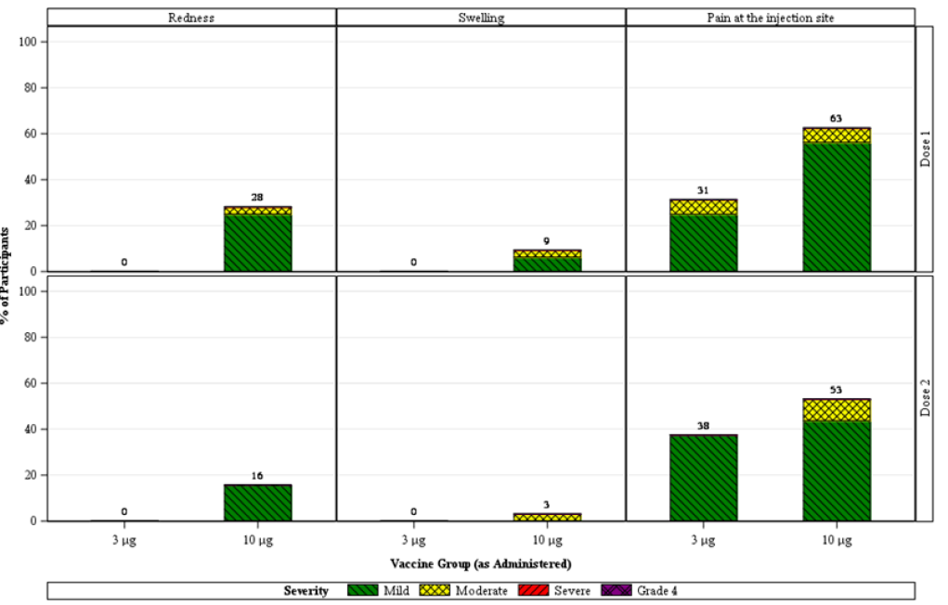

Similarly, with systemic adverse events the incidence and/or severity increased in a dose level- and dose number-dependent manner at 3 μg and 10 μg dose levels. Systemic events were mostly mild to moderate and short-lived as shown in Figure 3, below. The most common systemic event was fatigue. All systemic events were mild or moderate in severity. No Grade 4 events were reported.

No serious adverse events, deaths, or adverse events leading to withdrawal were reported in Phase I participants 2 to under 5 years of age as of the data cut-off date of 16 July 2021 (3 months follow-up.) All adverse events through the data cut-off date were mild to moderate. No Phase I participants 2 to under 5 years of age had any cases reported of anaphylaxis, appendicitis, Bell’s palsy, myocarditis/pericarditis, or multisystem inflammatory syndrome in children (MIS-C). Lymphadenopathy (swollen lymph nodes) was reported in one participant.

Figure 3: Study C4591007 (Phase I) Participants reporting systemic events, by maximum severity, within 7 days after each dose; 2 to under 5 years of age group (safety population)

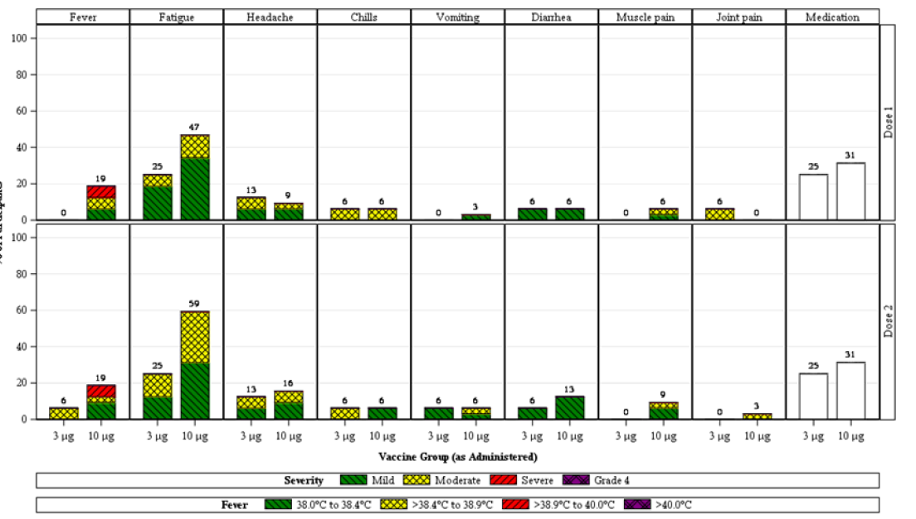

###### Children 6 months to under 2 years of age

Based on the reactogenicity profile observed in the 2 to under 5 years of age group, Comirnaty vaccine (tozinameran) at the 3 μg dose level was the only dose level tested in the 6 months to under 2 years of age group.

In this group, local reactions within 7 days after each dose were mild and short-lived and included mild redness, swelling and tenderness, as shown in Figure 4.

Figure 4: Study C4591007 (Phase I) Participants reporting local reactions, by maximum severity, within 7 days after each dose; 6 months to under 2 years of age group (safety population)

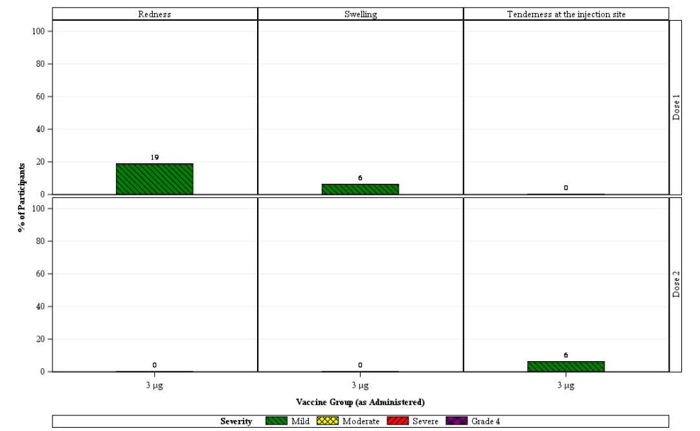

The incidence of systemic events of decreased appetite and fever increased in a dose number-dependent manner, whereas incidence of irritability and drowsiness was higher after Dose 1 and declined after Dose 2. Systemic events were all mild to moderate and short-lived (see Figure 5, below).

Figure 5: Study C4591007 (Phase I) Participants reporting systemic events, by maximum severity, within 7 days after each dose; 6 months to under 2 years of age group (safety population)

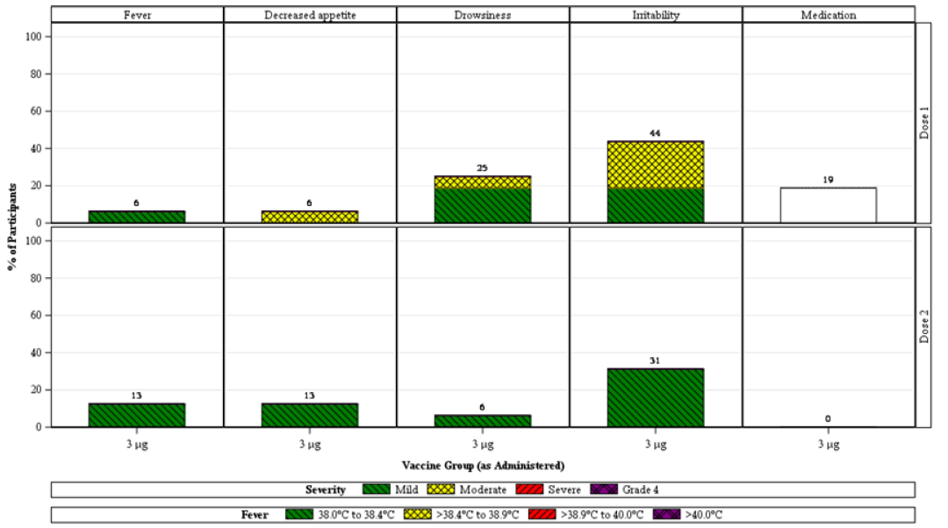

No serious adverse events, deaths, or adverse events leading to withdrawal were reported in Phase I participants from 6 months to under 2 years of age as of the data cut-off date of 16 July 2021 (3 months follow-up.) All adverse events through the data cut-off date were mild to moderate. No Phase I participants from 2 to under 5 years of age had any cases reported of anaphylaxis, appendicitis, Bell’s palsy, myocarditis/pericarditis, or MIS-C.

##### Dose selection for Study C4591007, Phase II/III

For individuals under 5 years of age, safety and immunogenicity data led to the selection of 3 μg to balance the best observed tolerability and robust immune responses. A three‑dose regimen for children under 5 years of age was informed by clinical study and real-world data showing a third dose was likely necessary to provide a high level of protection against Omicron variants.

#### Study C4591007, Phase II/III

A total of 4526 participants aged 6 months to under 5 years of age (1776 participants aged 6 to 23 months, 2750 participants aged 2 to 4 years) were randomised in a 2:1 ratio to receive two doses of 3 µg vaccine or placebo, 3 weeks apart. For the Phase II/III parts of the study participants with medical conditions such as stable type 1 diabetes or hypothyroidism; stable and controlled HIV, hepatitis B or C (HBV, HCV) infection and past serological or microbiological evidence of prior (not active) SARS-CoV-2 infection were included.

All Phase II/III study participants could be unblinded at the 6-month follow-up visit. Participants who received placebo were offered the Comirnaty vaccine (at the age‑appropriate dose at the time of vaccination).

##### Objectives

The primary objective of the Phase II/III study is to define the safety and tolerability profiles of prophylactic Comirnaty vaccination in all participants in each age group, to undertake immunobridging assessments and immunogenicity analyses. Other objectives include the evaluation of the efficacy of prophylactic Comirnaty vaccination against confirmed COVID-19 occurring and to describe the immune response to emerging variants of concern.

##### Methodology

###### Immunogenicity evaluation methodology

The basis of demonstrating Comirnaty vaccine effectiveness in children is immune response data, via immunobridging to young adults in the efficacy-focused Study C4591001. Immunobridging was based on wild-type SARS-CoV-2 neutralising antibody responses at one month post-Dose 2 or Dose 3 among participants in two separate age groups (6 months to under 2 years; and 2 to under 5 years) compared to neutralising antibody responses in a random subset of participants between 16 to 25 years of age at one month post-Dose 2 (Study C4591001, Phase II/III), as measured by 50% neutralising antibody titres against the reference strain.

Immunogenicity analyses of GMTs and seroresponse rates at 1 month after Dose 2 were evaluated for both paediatric age groups, and the pre-specified immunobridging success criteria (see below) were not met for participants of 2 to under 5 years of age. Therefore, a third primary series dose was added for both age groups. The post-Dose 2 immunobridging subset included, approximately 300 participants in the Comirnaty vaccine group and 150 participants in the placebo group for each paediatric age group (Study C4591007). The post-Dose 3 immunobridging subset included the first approximately 200 participants in each paediatric age group (Study C4591007) who received Dose 3 of Comirnaty vaccine 3 μg and 100 participants who received placebo.

The primary analysis for the 3-dose primary series is based on the evaluable immunogenicity population of participants without evidence of prior SARS-CoV-2 infection up to 1 month after Dose 2 (comparator group 16 to 25 years of age) or Dose 3 (participants 6 to 23 months and 2 to 4 years of age).

Primary endpoints and statistical immunobridging success (that is, non-inferiority) criteria were evaluated sequentially in the following order:

* Immunobridging success based on GMT was declared if the lower limit of the 95% CI for the GMT ratio (paediatric age group / 16 to 25 years of age) was > 0.67, and the point estimate of the GMT ratio was ≥ 1.0.
* Immunobridging success based on the seroresponse rate was declared if the lower limit of the 95% CI for the difference in seroresponse rates (paediatric age group minus 16 to 25 years of age) was ≥ 10%.
* Seroresponse was defined as a ≥ 4-fold rise in SARS-CoV-2 50% neutralising titres from before vaccination (pre-Dose 1) to one month after Dose 2 or Dose 3.

###### Comparator group for immunobridging analyses

This consisted of 200 randomly selected participants 16 to 25 years of age who received both doses of Comirnaty vaccine (30 μg) in Phase II/III of Study C4591001. A total of 17 (8.5%) participants were excluded, most due to invalid/indeterminate immunogenicity results after vaccination or because Dose 2 was not administered within the prespecified window. The analysis population for the primary immunogenicity endpoint was the evaluable immunogenicity population of Comirnaty vaccine recipients without evidence of SARS-CoV-2 infection up to one month after Dose 2 (170 participants).

###### Efficacy evaluation methodology

Descriptive efficacy analyses were conducted on the all-available efficacy (modified intent-to-treat (mITT)) populations and the evaluable efficacy populations for each age group. Phase II/III data include COVID-19 cases accrued through a data cut-off date of 29 April 2022.

A vaccine efficacy analysis of Comirnaty vaccine against laboratory-confirmed symptomatic COVID-19 occurring at least 7 days after Dose 3 in participants without evidence of prior SARS-CoV-2 infection and in participants with or without evidence of prior SARS-CoV-2 infection. Hypothesis testing to evaluate vaccine efficacy against a null hypothesis: vaccine efficacy ≤ 30% for the combined age group (6 months to under 2 years and 2 to under 5 years) was to be conducted after at least 21 cases were accrued.

###### Analysis populations

Populations are defined as follows:

* Safety population:
  + All participants who receive at least one dose of the study intervention.
* All available immunogenicity population:
  + All randomised participants who receive at least one dose of the intervention with at least one valid and determinate immunogenicity result after vaccination.
* Dose 3 evaluable immunogenicity population:
  + All eligible randomised participants who receive three doses of the vaccine to which they are randomised, with Dose 2 received within the predefined window (19 to 42 days after Dose 1), and Dose 3 received at least 60 days after Dose 2; and
  + have at least one valid and determinate immunogenicity result from the blood sample collected within an appropriate window (28 to 35 days after the specified dose); and
  + have no other important protocol deviations as determined by the clinician.
* All-available efficacy population:
  + All participants who complete 1, 2 or 3 doses of the study intervention.
* Evaluable efficacy population:
  + All randomised participants who receive all vaccinations as randomised, with Doses 2 and 3 received within the predefined windows and have no other important protocol deviations as determined by the clinician.

###### Variant neutralisation assay methodology

Descriptive analyses of SARS-CoV-2 variant neutralisation were conducted on the Omicron neutralisation subset. For each of the paediatric groups in Phase II/III Study C4591007, this included approximately 40 Comirnaty 3 μg vaccine recipients and 5 placebo recipients randomly selected from the immunobridging subset who had received three doses of study intervention, were without evidence of prior SARS-CoV-2 infection up to one month post-Dose 3 and had sufficient blood volume for testing at Dose 3 and one month post-Dose 3. The adult reference group from Phase III part of Study C4591001 included 40 participants 18 to 55 years of age randomly selected from the Study C4591001 evaluable immunogenicity population who had received a booster (third) dose of Comirnaty 30 μg at least 6 months after the second dose and were without evidence of prior SARS-CoV-2 infection up to one month post-Dose 3.

##### Participant flow

A total of 4,526 participants 6 months to under 5 years of age were randomised in a 2:1 ratio to receive two doses of 3 μg Comirnaty (tozinameran) vaccine or placebo, 3 weeks apart. Based on analyses of post-Dose 2 safety and effectiveness data, the protocol was amended (protocol amendment 6) to add a third primary series dose at least 8 weeks after Dose 2.

Participants enrolled prior to protocol amendment 6 (3,883 participants; as of 1 February 2022), were unblinded at their 6-month post-Dose 2 visit, and those originally randomised to placebo were offered Comirnaty vaccination. Participants enrolled after protocol amendment 6 will be unblinded at their 6-month post-Dose 3 visit, and those randomised to placebo will be offered Comirnaty vaccination.

More than 99% of participants received at least 2 doses. The median timing of Dose 3 administration after Dose 2 of Comirnaty vaccine for those in the 6 to 23 months of age group was 11.0 weeks (range: 8.6 to 20.0 weeks) and for the 2 to 4 years old group was 10.7 weeks (range: 8.6 to 15.6 weeks), and approximately 33% received 3 doses as of the 29 April 2022 data cut-off date.

##### Demographic and baseline characteristics

The overall Phase II/III population included 1,776 (1,178 Comirnaty vaccine, 598 placebo) participants from 6 months to under 2 years of age and 2,750 (1,835 Comirnaty vaccine, 915 placebo) participants 2 to under 5 years of age.

###### Children 2 to under 5 years of age

Demographic characteristics of those between 2 to under 5 years of age were similar in Comirnaty vaccine and placebo groups. Most participants were White (79.6%), with 4.9% Black or African American participants and 7.4% Asian participants, 7.3% multiracial participants, and other race subgroups < 1%. There were 14.0% Hispanic/Latino participants. The median age was 3.0 years and 50% were male. A total of 6.0% were obese, 12.8% had baseline comorbidities and/or obesity and 13.0% had evidence at Baseline of prior SARS-CoV-2 infection. Comorbidities that increase the risk of severe COVID-19 disease were present in similar proportions of participants in the Comirnaty group (6.4%) and placebo group (9.7%).

###### Children 6 months to under 2 years of age

Demographic characteristics of participants 6 months to under 2 years of age were similar in Comirnaty and placebo groups. Most participants were White (78.9%), with 3.7% Black or African American participants and 7.4% Asian participants, 9.3% multiracial participants, and other race subgroups < 1%. There were 12.7% Hispanic/Latino participants. The median age was 16.0 months and 49.5% of participants were male. A total of 4.7% had baseline comorbidities (which did not include obesity for this age group), and 7.5% of participants had evidence at baseline of prior SARS-CoV-2 infection. Comorbidities present at baseline that increase the risk of severe COVID-19 were present in similar proportions of participants in the Comirnaty group (4.2%) and placebo group (5.7%).

Demographics in the immunogenicity, efficacy and safety populations were generally similar to those in the overall Phase II/III populations.

##### Immunogenicity results post-Dose 2

###### Children 2 to under 5 years of age

Among participants without prior SARS-CoV-2 infection up to one month post-Dose 2, the geometric mean ratio (GMR) of neutralising titres against the SARS-CoV-2 wild-type strain comparing children from 2 to less than 5 years of age who received Comirnaty 3 μg to young adults between 16 to 25 years of age who received Comirnaty 30 μg was 0.61 (2‑sided 95% CI: 0.53, 0.70). In this population, 96.7% of children and 97.6% of young adults achieved a seroresponse at one month post-Dose 2 with a difference between age groups (children minus young adults) of -0.9% (2-sided 95% CI: -4.3%, 2.3%)

The lower bound of the 2-sided 95% CI for GMR was below 0.67 and the GMR point estimate was less than 0.8, indicating the prespecified success criteria for the GMR were not met; therefore, immunobridging based on GMR was not achieved for children from 2 to under 5 years of age. The lower limit of the 2-sided 95% CI for the difference in seroresponse rate was -4.3%, which is greater than the prespecified margin of -10%; however, success criteria for the GMR were not met; therefore, immunobridging based on seroresponse was not declared for children 2 to less than 5 years of age.

###### Children 6 months to under 2 years of age

Among participants without prior SARS-CoV-2 infection up to one month post-Dose 2, the GMR of neutralising titres against the SARS-CoV-2 wild-type strain comparing children 6 months to under 2 years of age who received Comirnaty 3 μg to young adults between 16 and 25 years of age who received Comirnaty 30 μg was 1.03 (2-sided 95% CI: 0.90, 1.19). In this population, 98.0% of children 6 months to under 2 years of age and 96.2% of young adults 16 to 25 years of age achieved a seroresponse at one month post-Dose 2 with a difference between age groups (children minus young adults) of 1.7% (2-sided 95% CI: ‑1.4%, 5.2%).

The lower bound of the 2-sided 95% CI for GMR was more than 0.67 and the GMR point estimate was ≥ 0.8 (per protocol) and ≥ 1 (requested by US Food and Drug Administration (FDA)), which meets the prespecified 1.5-fold margin and success criteria for the GMR. Therefore, immunobridging based on GMR was achieved for children 6 months to less than 2 years of age. The lower limit of the 2-sided 95% CI for the difference in seroresponse rate was -1.4%, which is greater than the prespecified margin of -10%. Thus, immunobridging was achieved for those 6 months to less than 2 years of age.

##### Immunogenicity results post-Dose 3

###### Children 2 to under 5 years of age

The Dose 3 evaluable immunogenicity population included 204 children from 2 to under 5 years of age who received three doses of Comirnaty vaccine 3 μg and 92 children who received placebo, of whom 143 and 59 participants, respectively, were without prior evidence of SARS-CoV-2 infection up to one month after Dose 3. The comparator group of young adults 16 to 25 years of age included 183 participants in the Comirnaty vaccine 30 μg group and 45 participants in the placebo group of Study C4591001, of whom 170 and 38, respectively, were without prior evidence of SARS-CoV-2 infection up to 1 month after Dose 2.

Among children 2 to under 5 years of age the observed GMT was 20.7 before vaccination and progressively increased with 2 and 3 doses of vaccination, to be a GMT of 1535 at one month post-Dose 3 (see Figure 6, below).

Figure 6: Study C4591007 (Phase II/III; 2 to under 5 years of age) and Study C4591001 (Phase II/III; 16 to 25 years of age) Geometric mean titres, SARS-CoV-2 neutralisation assay (NT50). Participants without evidence of infection; (immunobridging subset, evaluable immunogenicity population)

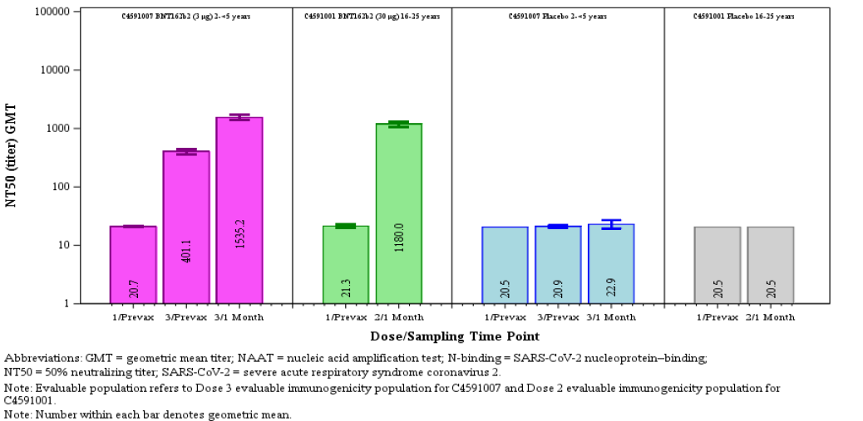

Abbreviations: GMT = geometric mean titre; NAAT = nucleic acidic amplification test; N‑binding = SARS‑CoV-2 nucleoprotein-binding; NT50 = 50% neutralising titre; SARS-CoV-2 = severe acute respiratory syndrome coronavirus 2.

Note: Evaluable population refers to Dose 3 evaluable immunogenicity population for Study C4591007 and Dose 2 for Study C4591001.

Number within each bar denotes geometric mean

The GMR of the 2 to under 5 years of age group relative to those of 16 to 25 years of age was 1.30 (2-sided 95% CI: 1.13, 1.50); see Table 8, below. This met the immunobridging objective for success, with the lower bound of the 95% CI being > 0.67 and the point estimate ≥ 0.8 (it was also ≥ 1.0 as preferred by the US FDA). The difference in seroresponse rates in children aged 2 to under 5 years and young adults aged 16 to 25 years age was 0.2% (2-sided 95% CI: -1.5%, 4.2); see Table 9 below. As the pre-specified criteria for immunobridging based on GMR were met (a prerequisite) and the lower bound of the 95% CI for the difference in seroresponse rates was greater than -10.0%, the criteria for non-inferiority was met.

Table 8: Study C4591007 (Phase II/III, 2 to under 5 years of age (one month after Dose 3) and Study C4591001 (Phase II/III, 16 through 25 years of age (one month after Dose 2). Summary of geometric mean ratios (NT50); participants without evidence of infection (immunobridging subset; evaluable immunogenicity population)

Abbreviations: GMR = geometric mean ratio; GMT = geometric mean titre; LLOQ = lower limit of quantitation; NAAT = nucleic acid amplification test; N-binding = SARS-CoV-2 nucleoprotein-binding; NT50 = 50% neutralising titre; SARS-CoV-2 = severe acute respiratory syndrome coronavirus 2.

Note: Evaluable population refers to Dose 3 evaluable immunogenicity population for Study C4591007 and Dose 2 evaluable immunogenicity population for Study C4591001.

Participants included in this analysis had no serological or virological evidence of past SARS-CoV-2 infection prior to the one month post-Dose 2 (C4591001) or one month post-Dose 3 (C4591007) study blood sample collection. Having no evidence of past SARS-CoV-2 infection was defined as having a negative N-binding antibody (serum) result at the Dose 1, Dose 3 (C4591007), and one-month post-Dose 2 (C4591001) or one-month post-Dose 3 (C4591007) study visits; a negative NAAT (nasal swab) result at the Dose 1, Dose 2, and Dose 3 (C4591007) study visits and any unscheduled visit prior to the one month post-Dose 2 (C4591001) or one month post-Dose 3 (C4591007) study blood sample collection; and no medical history of COVID-19.

a. n = Number of participants with valid and determinate assay results for the specified assay at the given dose/sampling time point.

b. GMTs and 2-sided 95% CIs were calculated by exponentiating the mean logarithm of the titres and the corresponding CIs (based on the Student t distribution). Assay results below the LLOQ were set to 0.5 x LLOQ.

c. GMRs and 2-sided 95% CIs were calculated by exponentiating the mean difference of the logarithms of the titres ((2 years to under 5 years) minus (16 to 25 years)) and the corresponding CI (based on the Student t distribution).

d. Immunobridging is declared if the lower bound of the 2-sided 95% CI for the GMR is > 0.67 and the point estimate of the GMR is ≥ 0.8.

Table 9: Study C4591007 (Phase II/III, 2 to under 5 years of age (one month after Dose 3) and Study C4591001 (Phase II/III, 16 through 25 years of age (one month after Dose 2). Difference in percentages of participants with seroresponse, in participants without evidence of infection (immunobridging subset, evaluable immunogenicity population)

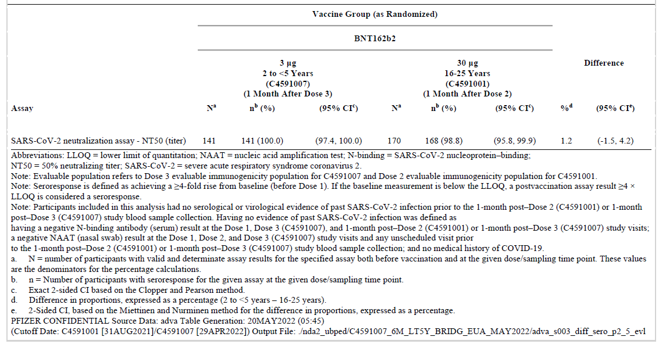

Abbreviations: LLOQ = lower limit of quantitation; NAAT = nucleic acid amplification test; N-binding = SARS-CoV-2 nucleoprotein-binding; NT50 = 50% neutralising titre; SARS-CoV-2 = severe acute respiratory syndrome coronavirus 2.

Note: Evaluable population refers to Dose 3 evaluable immunogenicity population for Study C4591007 and Dose 2 evaluable immunogenicity population for C4591001. Note: Seroresponse is defined as achieving a ≥ 4-fold rise from baseline (before Dose 1). If the baseline measurement is below the LLOQ, a postvaccination assay result ≥ 4 x LLOQ is considered a seroresponse. Note: Participants included in this analysis had no serological or virological evidence of past SARS-CoV-2 infection prior to the one month post-Dose 2 (Study C4591001) or one month post-Dose 3 (Study C4591007) study blood sample collection. Having no evidence of past SARS-CoV-2 infection was defined as having a negative N-binding antibody (serum) result at the Dose 1, Dose 3 (Study C4591007), and one-month post-Dose 2 (Study C4591001) or one month post-Dose 3 (C4591007) study visits; a negative NAAT (nasal swab) result at the Dose 1, Dose 2, and Dose 3 (Study C4591007) study visits and any unscheduled visit prior to the one month post-Dose 2 (Study C4591001) or one month post-Dose 3 (Study C4591007) study blood sample collection; and no medical history of COVID‑19.

a. N = number of participants with valid and determinate assay results for the specified assay both before vaccination and at the given dose/sampling time point. These values are the denominators for the percentage calculations.

b. n = Number of participants with seroresponse for the given assay at the given dose/sampling time point.

c. Exact 2-sided CI based on the Clopper and Pearson method.

d. Difference in proportions, expressed as a percentage (2 to under 5 years minus 16 to 25 years).

e. 2-Sided CI, based on the Miettinen and Nurminen method for the difference in proportions, expressed as a percentage.

###### Children 6 months to under 2 years of age

The Dose 3 evaluable immunogenicity population included 132 children 6 months to under 2 years of age who received three doses of Comirnaty vaccine 3 μg and 67 who received placebo, of whom 82 and 49 participants, respectively, were without prior evidence of SARS-CoV-2 infection up to 1 month after Dose 3. The comparator group of 16 to 25 year olds is the same adult group used for immunobridging analysis for the 2 to under 5 years of age group.

Similar to older children (2 to under 5 years of age) in younger participants the observed GMT progressively increased with 2 and 3 doses of vaccination, to be 1406.5 at one month post-Dose 3 (see Figure 7, below).

Figure 7: Study C4591007 (Phase II/III; 6 months to under 2 years of age) and Study C4591001 (Phase II/III; 16 to 25 years of age) Geometric mean titres, SARS‑CoV-2 neutralisation assay (NT50). Participants without evidence of infection; (immunobridging subset, evaluable immunogenicity population)

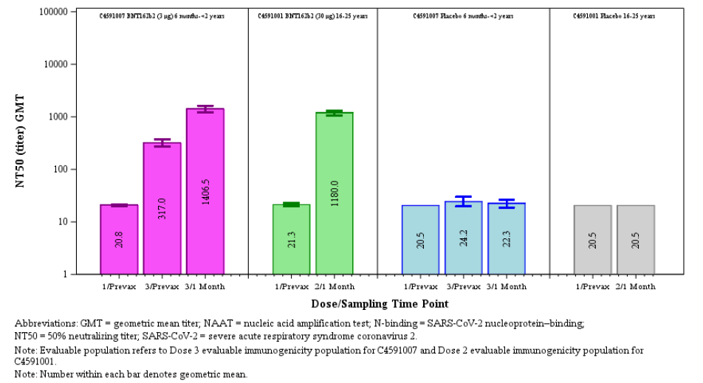

Abbreviations: GMT = geometric mean titre; NAAT = nucleic acid amplification test; N‑binding = SARS‑CoV-2 nucleoprotein-binding; NT50 = 50% neutralising titre; SARS-CoV-2 = severe acute respiratory syndrome coronavirus 2.

Note: Evaluable population refers to Dose 3 evaluable immunogenicity population for Study C4591007 and Dose 2 evaluable immunogenicity population for Study C4591001. Number within each bar denotes geometric mean.

The GMR of subjects aged 6 months to under 2 years relative to those of 16 to 25 years of age group was 1.19 (2-sided 95% CI: 1.00, 1.42) (see Table 10, below). This met the immunobridging objective for success, with the lower bound of the 95% CI being > 0.67 and the point estimate ≥ 0.8 (≥ 1.0 as preferred by the US FDA). The difference in seroresponse rates in children 6 months to < 2 years and young adults 16-25 years age was 1.2% (2-sided 95% CI: -3.4%, 4.2%) (see Table 11Table 10, below). As the pre-specified criteria for immunobridging based on GMR were met (a prerequisite) and the lower bound of the 95% CI for the difference in seroresponse rates was greater than -10.0%, the criteria for non-inferiority was met.

Table 10: Study C4591007 (Phase II/III, 6 months to under 2 years of age (one month after Dose 3) and Study C4591001 (Phase II/III, 16 through 25 years of age (one month after Dose 2). Summary of geometric mean ratios (NT50); participants without evidence of infection (immunobridging subset; evaluable immunogenicity population)

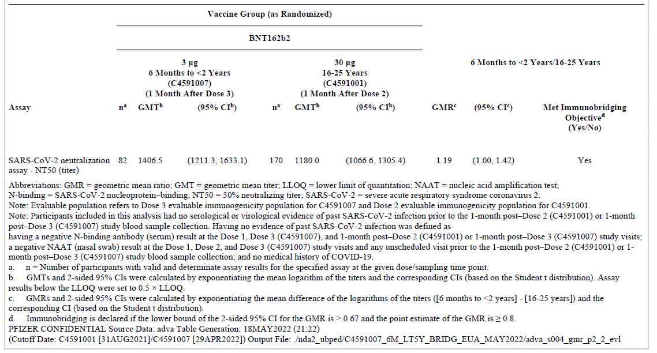

Abbreviations: GMR = geometric mean ratio; GMT = geometric mean titre; LLOQ = lower limit of quantitation; NAAT = nucleic acid amplification test; N-binding = SARS-CoV-2 nucleoprotein-binding; NT50 = 50% neutralising titre; SARS-CoV-2 = severe acute respiratory syndrome coronavirus 2.

Note: Evaluable population refers to Dose 3 evaluable immunogenicity population for Study C4591007 and Dose 2 evaluable immunogenicity population for Study C4591001.

Participants included in this analysis had no serological or virological evidence of past SARS-CoV-2 infection prior to the one month post-Dose 2 (Study C4591001) or one month post-Dose 3 (Study C4591007) study blood sample collection. Having no evidence of past SARS-CoV-2 infection was defined as having a negative N-binding antibody (serum) result at the Dose 1, Dose 3 (Study C4591007), and one-month post-Dose 2 (Study C4591001) or one month post-Dose 3 (C4591007) study visits; a negative NAAT (nasal swab) result at the Dose 1, Dose 2, and Dose 3 (Study C4591007) study visits and any unscheduled visit prior to the one month post-Dose 2 (Study C4591001) or one-month post-Dose 3 (Study C4591007) study blood sample collection; and no medical history of COVID-19.

a. n = Number of participants with valid and determinate assay results for the specified assay at the given dose/sampling time point.

b. GMTs and 2-sided 95% CIs were calculated by exponentiating the mean logarithm of the titres and the corresponding CIs (based on the Student t distribution). Assay results below the LLOQ were set to 0.5 x LLOQ.

c. GMRs and 2-sided 95% CIs were calculated by exponentiating the mean difference of the logarithms of the titres ((2 years to < 5 years) minus (16 to 25 years)) and the corresponding CI (based on the Student t distribution).

d. Immunobridging is declared if the lower bound of the 2-sided 95% CI for the GMR is > 0.67 and the point estimate of the GMR is ≥ 0.8.

Table 11: Study C4591007 (Phase II/III, 6 months to under 2 years of age (one month after Dose 3) and Study C4591001 (Phase II/III, 16 through 25 years of age (one month after Dose 2). Difference in percentages of participants with seroresponse, in participants without evidence of infection (immunobridging subset, evaluable immunogenicity population)

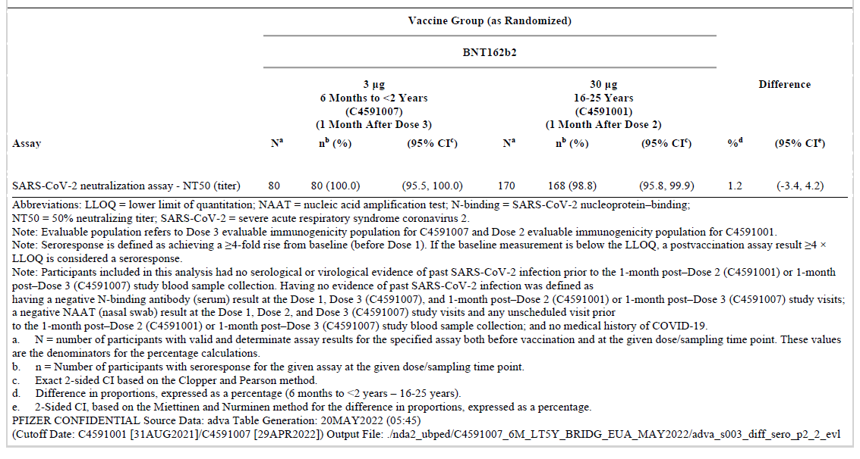

Abbreviations: LLOQ = lower limit of quantitation; NAAT = nucleic acid amplification test; N‑binding = SARS-CoV-2 nucleoprotein-binding; NT50 = 50% neutralising titre; SARS-CoV-2 = severe acute respiratory syndrome coronavirus 2.

Note: Evaluable population refers to Dose 3 evaluable immunogenicity population for Study C4591007 and Dose 2 evaluable immunogenicity population for Study C4591001. Note: Seroresponse is defined as achieving a ≥ 4-fold rise from baseline (before Dose 1). If the baseline measurement is below the LLOQ, a postvaccination assay result ≥ 4 x LLOQ is considered a seroresponse. Note: Participants included in this analysis had no serological or virological evidence of past SARS-CoV-2 infection prior to the one month post-Dose 2 (Study C4591001) or one month post-Dose 3 (Study C4591007) study blood sample collection. Having no evidence of past SARS-CoV-2 infection was defined as having a negative N-binding antibody (serum) result at the Dose 1, Dose 3 (Study C4591007), and one-month post-Dose 2 (Study C4591001) or one month post-Dose 3 (Study C4591007) study visits; a negative NAAT (nasal swab) result at the Dose 1, Dose 2, and Dose 3 (Study C4591007) study visits and any unscheduled visit prior to the one month post-Dose 2 (Study C4591001) or one month post-Dose 3 (Study C4591007) study blood sample collection; and no medical history of COVID‑19.

a. N = number of participants with valid and determinate assay results for the specified assay both before vaccination and at the given dose/sampling time point. These values are the denominators for the percentage calculations.

b. n = Number of participants with seroresponse for the given assay at the given dose/sampling time point.

c. Exact 2-sided CI based on the Clopper and Pearson method.

d. Difference in proportions, expressed as a percentage (2 to under 5 years minus 16 to 25 years).

e. 2-Sided CI, based on the Miettinen and Nurminen method for the difference in proportions, expressed as a percentage.

Subgroup analyses (across both age groups) based on demographic characteristics at baseline generally showed no meaningful differences in the immunogenicity profile. Results from the evaluable immunogenicity population (regardless of prior SARS-CoV-2 infection) and the all-available immunogenicity population were generally similar, noting that inclusion of individuals with prior SARS-CoV-2 infection typically results in elevated baseline (before vaccination) and post-vaccination neutralising titres compared with individuals without evidence of prior infection.

##### SARS-CoV-2 neutralising titres, Omicron and Delta variants

Among 34 children from 2 to under 5 years of age without evidence of prior SARS‑CoV‑2 infection who received three doses of Comirnaty vaccine 3 μg, neutralising GMTs prior to vaccination with Dose 3 against Delta (68.0) and Omicron (14.0) were increased at one month post-Dose 3 with respect to both Delta (471.4) and Omicron (82.5); see Figure 8 and Table 12. Correspondingly, increases were also observed for the reference strain from before Dose 3 (70.1) to one month post-Dose 3 (471.4). There was an observed 6.9-fold increase in Delta and 5.9-fold increase in Omicron neutralising titres from before Dose 3 to one month post-Dose 3 (see Table 12). The geometric mean fold rise (GMFR) for the reference strain from before Dose 3 to one month post-Dose 3 was 6.7.

Similar patterns were observed for 40 adults between 18 to 55 years of age without evidence of prior SARS-CoV-2 infection who received three doses of Comirnaty vaccine 30 μg, for whom neutralising GMTs prior to vaccination with Dose 3 against Delta (36.4) and Omicron (12.7) were increased at one month post-Dose 3 with respect to both Delta (1153.6) and Omicron (340.0) titres. Increases were also observed for the reference strain from before Dose 3 (33.9) to one month post-Dose 3 (1067.1) (see Table 12). There was an observed 31.7-fold increase in Delta and 26.7-fold increase in Omicron neutralising titres.

Figure 8: Study C4591007 (Phase II/III, 2 to under 5 years of age) and Study C4591001 (Phase III booster, 18 through 55 years of age); Summary of geometric mean titres in the Omicron neutralisation subset in participants without evidence of infection (evaluable immunogenicity population)

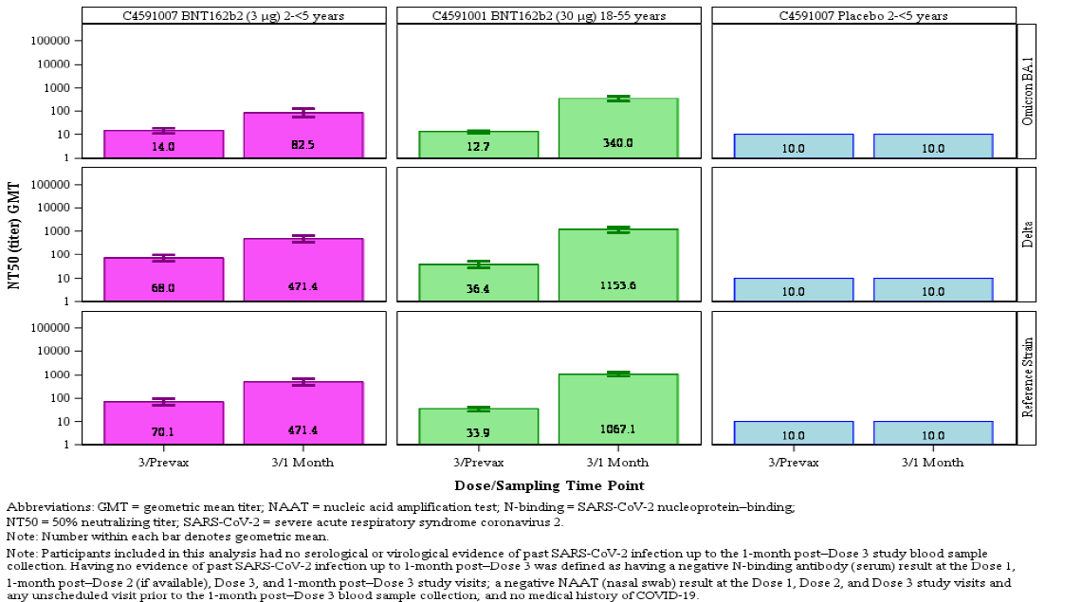

Abbreviations: LLOQ = lower limit of quantitation; NAAT = nucleic acid amplification test; N-binding = SARS-CoV-2 nucleoprotein-binding; NT50 = 50% neutralising titre; SARS-CoV-2 = severe acute respiratory syndrome coronavirus 2.

Note: Number within each bar denotes geometric mean. Participants included in this analysis had no serological or virological evidence of past SARS-CoV-2 infection up to the one month post-Dose 3 study blood sample collection. Having no evidence of past SARS-CoV-2 infection up to one month post-Dose 3 was defined as having a negative N-binding antibody (serum) result at the Dose 1, one month post‑Dose 2 (if available), Dose 3 and one month post-Dose 3 study visits, a negative NAAT (nasal swab) result at the Dose 1, 2 and 3 study visits and any unscheduled visit prior to the one month post-Dose 3 blood sample collection, and no medical history of COVID-19.

Table 12: Study C4591007 (Phase II/III, 2 to under 5 years of age) and Study C4591001 (Phase III booster, 18 through 55 years of age); Summary of geometric mean titres and mean fold rises in the Omicron neutralisation subset in participants without evidence of infection (evaluable immunogenicity population)

|  |
| --- |
| Study C4591007 (Phase II/III, 2 to under 5 years of age) and Study C4591001 (Phase III booster, 18 through 55 years of age); Summary of geometric mean titres and mean fold rises in the Omicron neutralisation subset in participants without evidence of infection (evaluable immunogenicity population) |
| Study C4591007 (Phase II/III, 2 to under 5 years of age) and Study C4591001 (Phase III booster, 18 through 55 years of age); Summary of geometric mean titres and mean fold rises in the Omicron neutralisation subset in participants without evidence of infection (evaluable immunogenicity population) |

Abbreviations: FFRNT = fluorescent focus reduction neutralisation test; GMFR = geometric mean fold rise; LLOQ = lower limit of quantitation; NAAT = nucleic acid amplification test; N-binding = SARS-CoV-2 nucleoprotein-binding; NT50 = 50% neutralising titre; SARS-CoV-2 = severe acute respiratory syndrome coronavirus 2.

Among 32 children of 6 months to under 2 years of age without evidence of prior SARS‑CoV-2 infection who received three doses of Comirnaty vaccine 3 μg, neutralising GMTs prior to vaccination with Dose 3 against Delta (94.1) and Omicron (16.3) were increased at one month post-Dose 3 with respect to both Delta (606.3) and Omicron (127.5) (see Table 13, below). Increases were also observed for the reference strain from before Dose 3 (103.7) to one month post-Dose 3 (640.0). There was a 6.4-fold increase in Delta and 7.8-fold increase in Omicron neutralising titres from before Dose 3 to one month post-Dose 3. The GMFR for the reference strain from before Dose 3 to one month post-Dose 3 was 6.2.

Table 13: Study C4591007 (Phase II/III, 6 months to under 2 years of age) and Study C4591001 (Phase III booster, 18 through 55 years of age); Summary of geometric mean titres in the Omicron neutralisation subset in participants without evidence of infection (evaluable immunogenicity population)

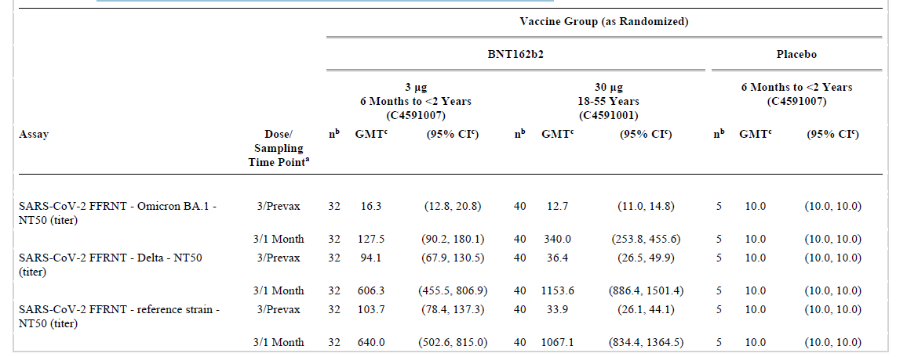

Abbreviations: FFRNT = fluorescent focus reduction neutralisation test; GMFR = geometric mean fold rise; LLOQ = lower limit of quantitation; NAAT = nucleic acid amplification test; N-binding = SARS-CoV-2 nucleoprotein-binding; NT50 = 50% neutralising titre; SARS-CoV-2 = severe acute respiratory syndrome coronavirus 2.

###### Conclusions on SARS-CoV-2 neutralising titres between wild-type and viral variants

In the pivotal Study C4591007, SARS-CoV-2 neutralising GMTs and seroresponse rates at one month post-Dose 2 and 3 were assessed against the reference wild-type strain in the evaluable immunogenicity population without evidence of prior SARS-CoV-2 infection and compared to participants 16 to 25 years of age randomly selected from Study C4591001. Immunobridging success criteria were met post-Dose 3 for both 6 months to under 2 years of age (82 participants) and 2 to under 5 years of age (143 participants) and post‑Dose 2 for 6 months to under 2 years of age (245 participants) groups. For the 2 to under 5 years of age group post-Dose 2, while the primary seroresponse endpoint was met, the primary GMR endpoint was not met, therefore immunobridging criteria were not met.

In the descriptive immunogenicity analyses, neutralising antibody GMTs against the reference (wild-type) strain and Delta variant of SARS-CoV-2 were similar. However, neutralising antibody GMTs against Omicron variant were lower. Post-Dose 3 GMTs were also lower in the 2 to under 5 years of age group compared to the 6 months to under 2 years of age group for all three strains.

##### Vaccine efficacy

Vaccine efficacy was estimated for both age groups (6 months to under 2 years; and 2 to under 5 years of age groups) as well as for the total population of children 6 months to under 5 years of age, as well as well as within each age group based on COVID-19 cases confirmed at least 7 days post-Dose 3 or from Dose 1 to the data cut-off date (29 April 2022).

###### Children 2 to under 5 years of age

Vaccine efficacy was estimated from a population of 1835 Comirnaty vaccine recipients and 915 placebo recipients of whom 606 and 280, respectively, received three doses. The observed vaccine efficacy was 82.3% (2-sided 95% CI: -8.0%, 98.3%) based on 2 cases in the Comirnaty-treated group and 5 cases in the placebo group, adjusted for surveillance time. From Dose 1 onwards, the observed vaccine efficacy was 32.6% (2-sided 95% CI: 10.8%, 48.8%).

###### Children 6 months to under 2 years of age

Vaccine efficacy was estimated from a population of 1178 Comirnaty vaccine recipients and 598 placebo recipients of whom 386 and 184, respectively, received three doses. The observed vaccine efficacy of 75.5% (2-sided 95% CI: -370.1%, 99.6%), based on one case in the Comirnaty-treated group and 2 in the placebo group. From Dose 1 onwards, observed vaccine efficacy was 14.0% (2-sided 95% CI: -21.2%, 38.4%).

###### Combined population (children 6 months to under 5 years)

This was based on cases confirmed among 992 participants in the combined Comirnaty-treated group and 464 participants in the combined placebo group who received all three doses of study intervention during the blinded follow-up period. The observed vaccine efficacy across the total population of children 6 months to under 5 years of age was 80.3% (2‑sided 95% CI: 13.9%, 96.7%) based on 3 cases in the Comirnaty group and 7 cases in the placebo group, adjusted for surveillance time. Based on cases from Dose 1 onwards, observed vaccine efficacy was 25.5% (2-sided 95% CI: 7.7%, 39.6%).

###### Relative vaccine efficacy of three versus two doses of vaccine

Relative vaccine efficacy analysis compared cases confirmed at least 7 days after Dose 3 among participants in the original randomised Comirnaty vaccine treated group who received three doses versus cases reported at least 7 days after Dose 2 among participants originally randomised to placebo who were unblinded and received two doses of Comirnaty vaccine, for cases accrued during the same fixed calendar period. This analysis was based total population of 3013 participants in the combined Comirnaty group and 1513 participants in the combined placebo group who had received at least one dose of study intervention.

For children from 2 to under 5 years of age, relative vaccine efficacy during the calendar interval of 7 February 2022 to 29 April 2022 based on 2 cases reported at least 7 days after Dose 3 (original Comirnaty group) versus 4 cases reported at least 7 days after Dose 2 (original placebo group unblinded to receive Comirnaty vaccine) was 84.0% (2‑sided 95% CI: -11.8%, 98.6%).

For children 6 months to under 2 years of age, relative vaccine efficacy during the calendar interval of 7 February 2022 to 29 April 2022 based on 2 cases reported at least 7 days after Dose 3 (original Comirnaty vaccine group) versus 2 cases reported at least 7 days after Dose 2 (original placebo group unblinded to receive Comirnaty) was 59.4% (2-sided 95% CI: -459.5%, 97.1%).

For all children aged 6 months to under 5 years, the relative vaccine efficacy of Comirnaty 3 μg against symptomatic COVID-19 based on 4 cases reported at least 7 days after Dose 3 (original Comirnaty group who received three doses) compared with 6 cases reported at least 7 days after Dose 2 (original placebo group who were unblinded and received two doses of Comirnaty) during the period of 7 February 2022 to 29 April 2022 was 76.2% (2‑sided 95% CI: -0.5%, 95.1%)

The reported signs and symptoms associated with confirmed COVID-19 cases reflected predominantly mild to moderate illness and were generally similar in the Comirnaty vaccine and placebo groups for both age groups. No MIS-C cases were reported in either age group.

###### Conclusions on efficacy

COVID-19 cases occurring at least 7 days post-Dose 3 among participants with and without evidence of SARS-CoV-2 infection prior to 7 days after Dose 3 included 3 COVID‑19 cases in participants 6 months to under 2 years of age, with one COVID-19 case in the Comirnaty group (386 participants) compared to 2 in the placebo group (184 participants), corresponding to an estimated vaccine efficacy of 75.6% (95% CI: −369.1%, 99.6%), and 7 COVID-19 cases in participants 2 to 4 years of age, with 2 cases in the Comirnaty vaccine group (606 participants) and 5 in the placebo group (280 participants), corresponding to an estimated vaccine efficacy of 82.4% (95% CI: −7.6%, 98.3%).

Interpretation of vaccine efficacy in Study C4591007 is considerably limited and should be approached with caution due to the low number of COVID-19 cases accrued during blinded follow-up. It is noted that there are very wide confidence intervals associated with these data and there is a risk that the vaccine efficacy has been overestimated. The preliminary nature of the data (the protocol-specified 21 cases had not yet been achieved) and the relatively short, blinded follow-up time post-Dose 3 (median of 35 days in the 6 months to under 2 years of age group and median of 40 days in the 2 to under 5 years of age group) further limit meaningful vaccine efficacy interpretation.

##### Safety

Safety was a primary outcome in the Phase II/III component of Study C4591007. The safety analysis population was defined as: all participants who receive at least one dose of the study intervention. Phase II/III safety data are based on analyses up to one month after Dose 3 and up to the data cut-off date of 29 April 2022.

Reactogenicity and antipyretic/pain medication use were recorded daily for 7 days after each dose administration using prompts from an electronic diary (e-diary). Grading scales were based on FDA guidance.[38]

Adverse events included:

Children 2 to under 5 years of age:

* Local reactions: pain, redness, and swelling at the injection site
* Systemic events: fever, fatigue, headache, chills, vomiting, diarrhoea, new or worsened muscle pain, and new or worsened joint pain.

Children 6 months to under 2 years of age:

* Local reactions: tenderness, redness, and swelling at the injection site
* Systemic events: fever, decreased appetite, drowsiness, and irritability.

###### Safety population

The overall Phase II/III safety population included 2,750 (1,835 Comirnaty, 915 placebo) participants aged 2 to under 5 years, and 1,776 (1,178 Comirnaty, 598 placebo) participants 6 to 23 months of age. Of the 1,835 Comirnaty recipients 2 to under 5 years of age, 606 (33.0%) received 3 vaccine doses. Of the 1,178 Comirnaty recipients 6 months to under 5 years of age, 386 (32.8%) received 3 vaccine doses.

The median duration of blinded follow-up after Dose 3 was 1.4 months (range: 0.0 to 3.2 months) for children 2 to under 5 years of age, and 1.3 months (range: 0.0 to 3.2 months) for children 6 months to under 2 years of age. Combining the blinded and open-label periods, the median duration of follow-up after Dose 3 was 2.1 months (range: 0.0 to 3.2 months) for both age groups. The median duration of blinded follow-up after Dose 2 to Dose 3 (or data cut-off) was 4.0 months (range: 0.0 to 10.4 months) and 6.3 months (range: 0.1 to 10.4 months) for the older and younger age cohorts respectively and was similar for both the Comirnaty vaccine and placebo groups. The median duration of follow-up including both blinded and open-label follow-up was 4.3 months (range: 0.0 to 10.4 months) for the older group and 6.3 months (range: 0.1 to 10.4 months) for the younger group and similar for the Comirnaty vaccine and placebo groups.

###### Local reactions

For both the 2 to under 5 year old cohort, and the 6 months to under 2 year old cohort, pain at the injection site was the most frequently reported local reaction within 7 days after each dose, with swelling and redness at the injection site reported much less frequently (see Table 14Table 15, below). Most local reactions were mild or moderate, with severe local reactions reported infrequently after any dose. No Grade 4 local reactions were reported after any dose. The median onset for all local reactions after any dose of Comirnaty vaccine 3 μg was one to 2 days, and all events resolved within a median duration of one day after onset.

Table 14: Incidence of injection site reactions (children 2 to under 5 years of age)

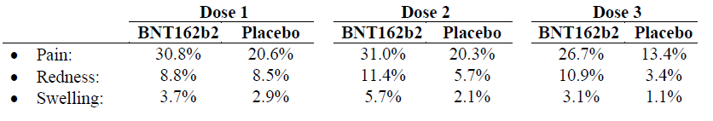

Note: BNT162b2 refers to Comirnaty vaccine (tozinameran)

Table 15: Incidence of injection site reactions (children 6 months to under 2 years of age)

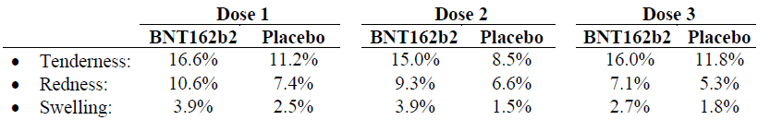

Note: BNT162b2 refers to Comirnaty vaccine (tozinameran)

###### Systemic events

Fatigue was the most frequently reported systemic event in children aged 2 to under 5 years, whilst irritability was most frequently reported in the 6 months to under 2 years of age group. Most systemic events were mild or moderate, with no Grade 4 events reported after any dose. The median onset for most systemic events after any dose of Comirnaty vaccine 3 μg was 2 days (noting that some events had median onset of up to 6 days post-dose, which was similar in Comirnaty and placebo groups), and most events resolved within a median duration of one day after onset.

Table 16: Incidence of any systemic adverse reactions (children 2 to under 5 years of age)

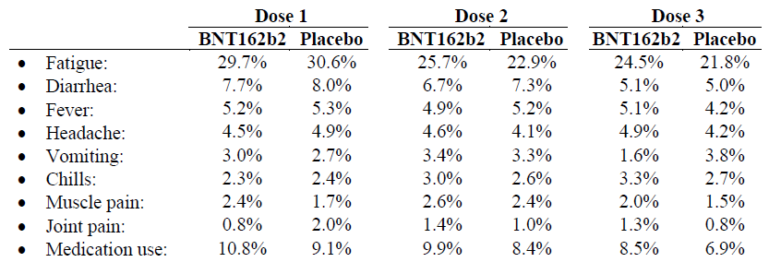

Note: BNT162b2 refers to Comirnaty vaccine (tozinameran)

Table 17: Incidence of any systemic adverse reactions (children 6 months to under 2 years of age)

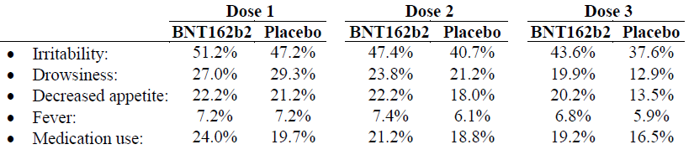

Note: BNT162b2 refers to Comirnaty vaccine (tozinameran)

###### Adverse events

In the children aged 2 years to under 5 years, (see Table 18) the proportions of participants with any adverse events were similar in the Comirnaty vaccine (18.7%) and placebo (18.7%) groups. Any related adverse events, any severe adverse events, and any serious adverse events were reported across the Comirnaty vaccine and placebo groups by ≤ 2.0%, ≤ 0.7%, and ≤ 0.9% of participants, respectively.

In children aged 6 months to under 2 years, proportions of participants with any adverse event were similar in the Comirnaty vaccine (30.1%) and placebo (27.1%) groups (see Table 19, below). Any related adverse events, any severe adverse events, and any serious adverse events were reported across the Comirnaty vaccine and placebo groups by ≤ 4.7%, ≤ 1.7%, and ≤ 2.3% of participants, respectively.

Table 18: Study C4591007 (Phase II/III, children 2 to under 5 years of age); Number (%) of participants reporting at least one adverse event from Dose 1 to one month after Dose 3 (blinded placebo-controlled follow-up, safety population)

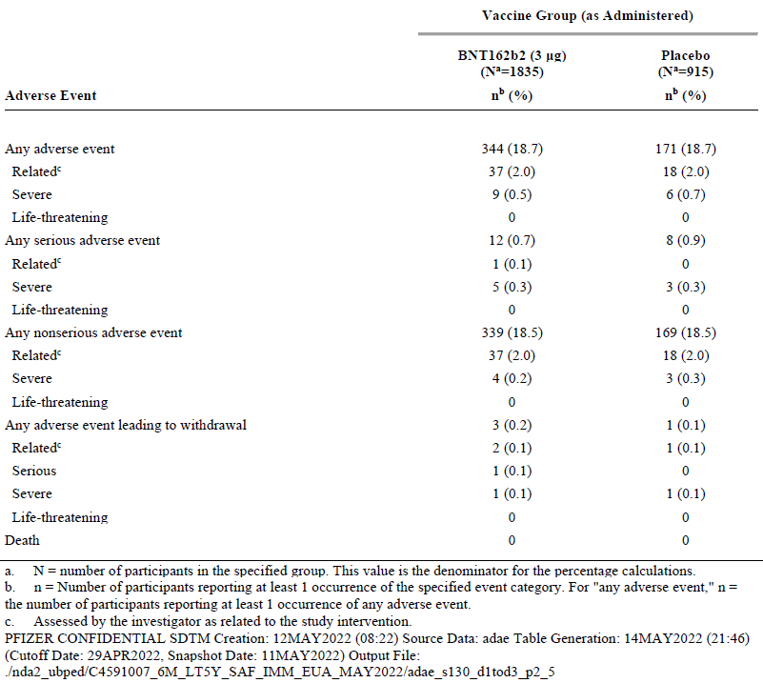

a. N = number of participants in the specified group. This value is the denominator for the percentage calculations.

b. n = number of participants reporting at least one occurrence of the specified event category. For ‘any adverse event’, n = the number of participants reporting at least one occurrence of any adverse event.

c. Assessed by the investigator as related to the study intervention.

Table 19: Study C4591007 (Phase II/III, children 6 months to under 2 years of age); Number (%) of participants reporting at least one adverse event from Dose 1 to one month after Dose 3 (blinded placebo-controlled follow-up, safety population)

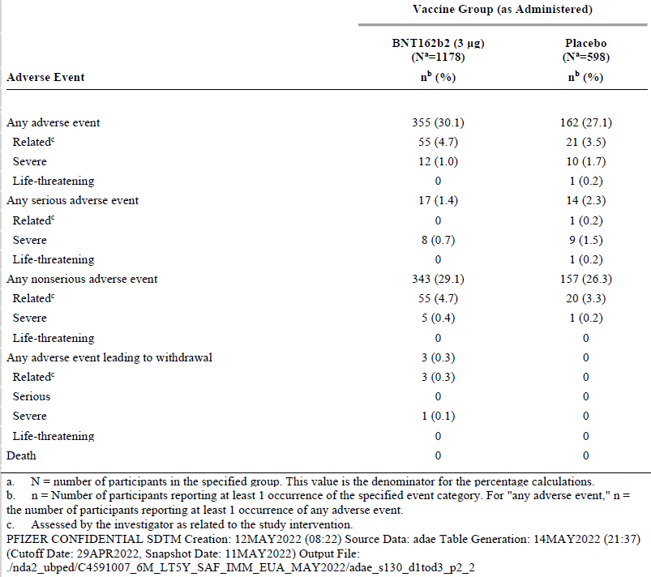

a. N = number of participants in the specified group. This value is the denominator for the percentage calculations.

b. n = number of participants reporting at least one occurrence of the specified event category. For ‘any adverse event’, n = the number of participants reporting at least one occurrence of any adverse event.

c. Assessed by the investigator as related to the study intervention.

There were very few study withdrawals in either age cohort in both Comirnaty vaccine and placebo groups. No study participants died. Immediate adverse events reported within 30 minutes of vaccination were low in frequency after any dose (≤ 0.3% for 2 to under 5 year olds; ≤ 0.5% for 6 months to under 2 year olds) of Comirnaty vaccine or placebo treated participants. No immediate events of anaphylaxis were reported after any vaccination. Severe adverse events were reported infrequently. Most of the events considered as severe were unrelated serious adverse events.

###### Adverse events of special interest

There were no cases reported in either age group as of the data cut-off date of myocarditis/pericarditis, Bell’s palsy (or facial paralysis/paresis), or vaccine related anaphylaxis.

Lymphadenopathy (swollen lymph nodes) was reported by one participant in the Comirnaty vaccine group in the 2 to under 5 year old cohort, and 2 participants in the Comirnaty vaccine group in the younger cohort. No lymphadenopathy was reported in the placebo group.

Two events of appendicitis were reported, both events in the Comirnaty vaccine group in the older cohort, both reported as serious adverse events that were unrelated to the vaccine. Rashes were reported infrequently for all groups, both vaccine and placebo treated groups, and in both age groups. Convulsions were infrequent, and at the same incidence in the vaccine and placebo groups.

###### Conclusions on safety

The observed adverse event profile in this study did not suggest any serious safety concerns for Comirnaty vaccine administered as three doses at the 3 μg dose level in children from 6 months to under 5 years of age. Many adverse events reported up to one month after Dose 3 were consistent with reactogenicity events, or other infections or illnesses that are expected to be observed in a paediatric general population. Few serious adverse events or adverse events leading to withdrawal were reported; and there were zero deaths. There were few adverse events of clinical interest reported, and no cases were observed of vaccine-associated anaphylaxis or myocarditis/pericarditis.

### Risk management plan

The sponsor has applied to extend the indications of Comirnaty (tozinameran) COVID-19 vaccine to include the use of this vaccine for individuals 6 months of age and older, through the provisional approval pathway. Comirnaty is currently approved to be used in individuals 5 years of age and older. The current submission also seeks approval to introduce a new strength, of 3 µg/0.2 mL dose, to be used in the 6 months to under 5 years of age group. Currently approved strengths are 30 µg/0.3 mL dose and 10 µg/0.2 mL dose.

In support of this submission, the sponsor provided EU-risk management plan (RMP) version 5.1 (date 1 July 2022; data lock point (DLP) 6 months to under 5 years (primary series: 16 July 2021 (Phase I), 29 April 2022 (Phase II/III); 29 April 2022 (sponsor clinical database, Study C4591007 Phase II/III) 15 April 2022 (sponsor safety database, non-CT dataset), and Australian-specific annex (ASA) version 0.5 (date 16 August 2022).

The summary of safety concerns and their associated risk monitoring and mitigation strategies are summarised in Table 20, below. Further information regarding the TGA’s risk management approach can be found in [risk management plans for medicines and biologicals](https://www.tga.gov.au/publication/risk-management-plans-medicines-and-biologicals) and [the TGA's risk management approach](https://www.tga.gov.au/tgas-risk-management-approach).

Table 20: Summary of safety concerns

|  |  |  |  |  |  |
| --- | --- | --- | --- | --- | --- |
| Summary of safety concerns | | Pharmacovigilance | | Risk Minimisation | |
| Routine | Additional | Routine | Additional |
| **Important identified risks** | Myocarditis and pericarditis | ✓ | ✓* | ✓ | – |
| **Important potential risks** | Vaccine-associated enhanced disease (VAED) including Vaccine-associated enhanced respiratory disease (VAERD) | ✓† | ✓* | – | – |
| **Missing information** | Use in pregnancy and while breast feeding | ✓ | ✓*≠ | ✓ | – |
| Use in immunocompromised patients | ✓ | ✓* | ✓ | – |
| Use in frail patients with co-morbidities (e.g. chronic obstructive pulmonary disease (COPD), diabetes, chronic neurological disease, cardiovascular disorders) | ✓ | ✓* | ✓ | – |
| Use in patients with autoimmune or inflammatory disorders | ✓ | ✓* | – | – |
| Interaction with other vaccines | ✓ | ✓* | ✓ | – |
| Long term safety data | ✓ | ✓* | – | – |

† Data capture Aid (adverse drug reaction follow-up forms)

* Clinical trial

≠ Post-authorisation safety study (PASS)

Only routine risk minimisation measures are proposed by the sponsor. This approach was deemed acceptable during the previous evaluations. The changes proposed by the current submission are not expected to require additional risk minimisation measures as part of the RMP.

The summary of safety concerns is the same as the safety summary that was evaluated and considered acceptable for the previous submission PM-2022-02476-1-2,[39] apart from the risk of anaphylaxis. Previously, anaphylaxis was included in the safety summary as an important identified risk. The following reason has been proposed ‘*anaphylaxis is a known risk of vaccines that is understood by HCPs [healthcare professionals] who administer vaccines and patients and does not considerably impact the benefit/risk profile of the vaccine’.* This is deemed acceptable from an RMP perspective and by the Delegate.

Routine pharmacovigilance includes the submission of monthly summary safety reports for the first 6 months, post registration, and thereafter at intervals specified by the TGA. The pharmacovigilance plan was deemed acceptable during previous evaluations and continues to be acceptable for the current submission.

### Risk-benefit analysis

#### Delegate’s considerations

Comirnaty (tozinameran, formerly BNT162b2) is an mRNA vaccine, provisionally approved by TGA on 25 January 2021 for active immunisation to prevent COVID-19, in individuals 16 years of age and over on the basis of short-term efficacy and safety data. Since then, there has been expansion into younger populations. A provisional determination for expansion into the paediatric population aged 6 months to under 5 years occurred on 22 June 2022. The sponsor has now submitted the data to support the indication extension to include the paediatric group, aged 6 months to under 5 years old. The submitted data include immunogenicity, efficacy, and safety analysis for infants aged 6 months to under 5 years of age from Study C4591007 to a data cut-off date of 29 April 2022.

To infer efficacy in children, the most relevant objective of primary interest is the immunogenicity objective in which the neutralising antibody response is bridged to the clinical efficacy demonstrated in adults. The primary clinical efficacy objective which aims to demonstrate efficacy against COVID-19 is considered of supportive value, given these analyses were not powered for. These objectives and measures are acceptable for the study of COVID-19 vaccination in the paediatric population.

Immunobridging was based on neutralising antibody levels for SARS-CoV-2 wild-type virus. There is currently no serological correlate of protection for COVID-19. However, given neutralising antibodies are crucial for protection, immunobridging based on this marker to a population where efficacy has been demonstrated is a reasonable strategy for evaluating efficacy in children.

##### Study C4591007 overview

Study C4591007 is an ongoing paediatric study in healthy children from 6 months up to 12 years of age. The sponsor has submitted the short-term results from the pivotal Phase I and Phase II/III Study C4591007, to support the extension of indication to Comirnaty (tozinameran) COVID-19 vaccine for use in children aged 6 months to under 5 years of age. The submitted pivotal study has an overall good study design, including representative study population (in the geographical study location context) and acceptable statistical considerations. The sponsor has previously submitted data from the 5 to 12 year old age group from this study.

For individuals under 5 years of age, safety and immunogenicity data led to the selection of 3 μg to balance the best observed tolerability and robust immune responses. A three‑dose regimen for children under 5 years of age was informed by clinical study and real-world data showing a third dose was likely necessary to provide a high level of protection against Omicron variants.

Based on the data provided by the sponsor in the current submission, to support the COVID-19 vaccine (Comirnaty) for use in 6 months to under 5 years age, a robust immunogenicity response was shown in the target age group. Immunogenicity response was consistent across relevant subgroups.

Overall, Comirnaty appears safe in children 6 months to under 5 years of age with no major safety related issues reported during the study.

##### Immunogenicity

In the pivotal Study C4591007, SARS-CoV-2 neutralising GMTs and seroresponse rates at one month post-Dose 2 and 3 were assessed against the reference wild-type strain in the evaluable immunogenicity population without evidence of prior SARS-CoV-2 infection and compared to participants between 16 and 25 years of age randomly selected from Study C4591001.

Immunobridging success criteria were met post-Dose 3 for both 6 months to under 2 years of age (82 participants) and 2 to under 5 year of age (143 participants) and post‑Dose 2 for 6 months to under 2 years of age (245 participants) groups. For the 2 to under 5 years of age group post Dose 2, while the primary seroresponse endpoint was met, the primary GMR endpoint was not met, therefore immunobridging criteria were not met.

The emergence of the highly transmissible Omicron variant of SARS-CoV-2 in December 2021 resulted in several waves of COVID-19 cases in many parts of the world including Australia and has coincided with a rapid increase in COVID-19-associated hospitalisations among all age groups, including children 6 months through 4 years of age. The confirmed COVID-19 cases in Study C4591007 occurring at least 7 days post-Dose 3 were noted to be during which time of predominant circulation of the Omicron variant of SARS-CoV-2 (February to April 2022). In the descriptive immunogenicity analyses, neutralising antibody GMTs against the reference (wild-type) strain and Delta variant of SARS-CoV-2 were similar. However, neutralising antibody GMTs against Omicron variant were lower. There was an observed 6.9-fold increase in Delta and 5.9-fold increase in Omicron neutralising titres from before Dose 3 to one month post-Dose 3.

The duration of immune persistence is not known, due to the short follow up period.

##### Efficacy

COVID-19 cases occurring at least 7 days post-Dose 3 included 3 COVID-19 cases in participants 6 months to under 2 years of age, with one COVID-19 case in the Comirnaty group (386 participants) compared to 2 in the placebo group (184 participants), corresponding to an estimated vaccine efficacy of 75.6% (95% CI: −369.1%, 99.6%), and 7 COVID-19 cases in participants 2 to under 5 years of age, with 2 cases in the Comirnaty group (606 participants) and 5 in the placebo group (280 participants), corresponding to an estimated vaccine efficacy of 82.4% (95% CI: −7.6%, 98.3%).

Interpretation of vaccine efficacy in Study C4591007 should be approached with caution due to the low number of COVID-19 cases accrued to date. Protection against asymptomatic infection, or impact on viral transmission offered by the vaccine in children is not known.

##### Safety

The observed adverse event profile in this study did not suggest any serious safety concerns for Comirnaty administered as three doses at the 3 μg dose level in children 6 months to under 5 years of age. Many adverse events reported up to one month after Dose 3 were consistent with reactogenicity events, or other infections or illnesses that are expected to be observed in a paediatric general population. Few serious adverse events or adverse events leading to withdrawal, and no deaths, were reported. There were few adverse events of clinical interest reported, and no cases were observed of vaccine-associated anaphylaxis or myocarditis/pericarditis, and no deaths were reported.

Overall, the current safety data presented is reassuring but limited in terms of numbers and length of follow-up. Of the 1,178 Comirnaty recipients 6 months to 2 years of age, only 386 (32.8%) received 3 vaccine doses and of the 1,835 Comirnaty recipients 2 to under 5 years of age, only 606 (33.0%) received 3 vaccine doses. The median duration of blinded follow-up was 1.3 (range: 0 to 3.2 months) for participants between 6 months and under 2 years of age and 1.4 months (range: 1 to 3.2 months) for participants from 2 to under 5 years of age after Dose 3. The median duration of combined blinded and unblinded follow-up after Dose 3 was 2.1 months for each age group. Therefore, rarer adverse events (such as myocarditis/pericarditis) or those that require longer follow-up may potentially have been missed in the current safety profile determined from Study C4591007.

##### Data limitations and uncertainties

The Delegate noted the following data limitations and uncertainties:

* The number of infants studied may not detect less common and rare adverse events
* The longer-term safety is unknown given the limited duration of follow up to date
* Data on vaccine efficacy to prevent asymptomatic infection are lacking
* The impact on transmission is unknown
* There are no data available on the interchangeability of Comirnaty with other COVID‑19 vaccines to complete the vaccination series
* Duration of protection of Comirnaty is uncertain due to limited follow-up duration
* Lack of immunogenicity and safety data in immunocompromised patients or children with background autoimmune disease.

These limitations are similar to those identified in previous Comirnaty submissions, and in other COVID-19 vaccination submissions for adults and children. The submitted efficacy and safety data is short term at this stage, but the data have fulfilled the requirement as set out in the ‘[Access Consortium statement on COVID-19 vaccines evidence](https://www.tga.gov.au/access-consortium-statement-covid-19-vaccines-evidence) ‘ as has been available on the TGA website since 4 December 2020.

##### Conclusion

From the currently available data, it can be concluded that a 3 vaccine course of Comirnaty (tozinameran) COVID-19 vaccine is efficacious in protecting individuals from 6 months to under 5 years of age against symptomatic COVID-19 based on non-inferior immune responses, which is supported by descriptive efficacy analyses. The safety profile is acceptable, and no new safety signals have been identified.

#### Proposed action

Considering the public health need and noting the high short-term efficacy with acceptable safety demonstrated in the submitted studies, the Delegate is of the view that provisional registration of Comirnaty is appropriate for the use of this vaccine to prevent COVID-19 disease caused by SARS-CoV-2 virus in individuals aged from 6 months to under 5 years of age. The longer-term efficacy and safety data are to be submitted to the TGA for evaluation before a full registration can be considered.

Pending the advice from the Advisory Committee on Vaccines (ACV) and further review of the Product Information (PI), the Delegate proposes the provisional approval of this vaccine for the indication below:

*Active immunisation to prevent coronavirus disease 2019 (COVID-19) caused by SARS-CoV-2, in individuals 6 months of age and older. The use of this vaccine should be in accordance with official recommendations.*

*The decision has been made on the basis of short-term efficacy and safety data. Continued approval depends on the evidence of longer-term efficacy and safety from ongoing clinical trials and post market assessment*.

#### Advisory Committee considerations

The [Advisory Committee on Vaccines (ACV)](https://www.tga.gov.au/committee/advisory-committee-vaccines-acv), having considered the evaluations and the Delegate’s overview, as well as the sponsor’s response to these documents, advised the following.

##### Specific advice to the Delegate

1. ***Does the ACV consider that there is a favourable benefit-risk balance for the extension of provisional registration to individuals from 6 months to less than 5 years of age?***

The ACV advised that there is a favourable benefit-risk balance to individuals 6 months to less than 5 years of age. This is based on immunogenicity and preliminary efficacy and safety data from the administration of Comirnaty, compared with the rare risk of hospitalisation and serious outcomes in this age group.

The ACV was of the view that the greatest benefit is anticipated to be in infants and children who are at high risk of developing severe disease (that is, children with severe immunocompromise or significant respiratory/cardiac disease). The ACV further advised that the use of this vaccine should be in line with official guidelines, such as developed by the Australian Technical Advisory Group on Immunisation (ATAGI).

The ACV noted that the study was not powered to detect rare events such as myocarditis and was supportive of robust post-marketing safety monitoring.

1. ***Does the ACV have any advice of the 3-dosing schedule as a primary vaccination course in these age groups?***

The ACV advised that the basis for inclusion of a third dose in this primary schedule was appropriately justified in the application.

The ACV noted that geometric mean titres (GMTs) from the immunobridging subset showed similar (or higher) responses to those achieved in young adults. However, this is not entirely predictive of level of protection.

The ACV noted that the completion rate of a 3-dose primary series may be low. The ACV advised that ongoing studies that are used to provide efficacy estimates should separately address efficacy following 1, 2 and 3 doses.

The ACV noted that a not insignificant proportion of Australian children will have had COVID-19 before receiving vaccination.

The ACV noted that each vaccination is an opportunity for a medication error to occur (such as incorrect dose or product), and so a 3-dose regimen provides a greater challenge to quality use of medicines than a 2-dose regimen.

The ACV highlighted the potential for administration of a COVID-19 vaccine to disrupt the well-established early childhood vaccination schedules for other childhood diseases. In the absence of co-administration trials, studies monitoring potential interactions should be undertaken.

1. ***The committee is also requested to provide advice on any other issues that may be relevant to a decision on whether or not to approve this application***

The ACV noted confusion and medication errors are likely to occur in Australia, and have already been observed in the USA, due to multiple formulations with the same brand names being available concurrently. The ACV strongly emphasised the importance of having robust guidance, labelling, training, communications, and a range of other strategies to clearly convey product differences to both providers and consumers. The ACV highlighted that such risk mitigation strategies will be important to ensure safe program delivery. Further, planning for ascertainment of medication errors is also necessary.

The ACV noted that there was no dose-ranging data available to inform the counselling of parent/carer if a child is administered an overdose of vaccine.

##### Conclusion

The ACV considered this product to have an overall positive benefit-risk profile for the following indication:

*Comirnaty (tozinameran) COVID-19 Vaccine has provisional approval for the indication below:*

*Active immunisation to prevent coronavirus disease 2019 (COVID-19) caused by SARS-CoV-2, in individuals 6 months of age and older.*

*The use of this vaccine should be in accordance with official recommendations.*

*The decision has been made on the basis of short term efficacy and safety data. Continued approval depends on the evidence of longer term efficacy and safety from ongoing clinical trials and post-market assessment.*

## Outcome

Based on a review of quality, safety, and efficacy, the TGA approved the registration of Comirnaty (tozinameran) 3 µg/0.2 mL, concentrated suspension for injection, multidose vial, indicated for the following extension of indications and change in dose regime:

*Comirnaty (tozinameran) COVID-19 Vaccine has provisional approval for the indication below:*

*Active immunisation to prevent coronavirus disease 2019 (COVID-19) caused by SARS-CoV-2, in individuals 6 months of age and older.*

*The use of this vaccine should be in accordance with official recommendations.*

*The decision has been made on the basis of short term efficacy and safety data. Continued approval depends on the evidence of longer term efficacy and safety from ongoing clinical trials and post-market assessment.*

The above extension of indications are inclusive of the previous approved indications.

### Specific conditions of registration applying to these goods

[The Delegate of the Secretary of the Department of Health imposed the following conditions in relation to the new Comirnaty medicine:]

* conditions applicable to all registered therapeutic goods as specified in the document Standard Conditions Applying to Registered or Listed Therapeutic Goods under Section 28 of the Therapeutic Goods Act 1989 effective 1 July 1995, with the exception of Condition 11;
* conditions applicable to specific classes of registered therapeutic goods as specified in the Standard Conditions Applying to Registered or Listed Therapeutic Goods under Section 28 of the Therapeutic Goods Act 1989 effective 1 July 1995; and
* subject to [the paragraph below], all conditions that have previously been imposed on the provisional registration of the existing Comirnaty medicine, as in force at the date of this decision;
* the RMP condition of the provisional registration decision relating to the existing Comirnaty medicines, varied as underlined below:

*The Comirnaty COVID-19 Vaccine EU-Risk Management Plan (RMP) (version 5.1, date 1 July 2022; DLP (6 months to 5 yrs) – Clinical trial exposure: 16 July 2021 (Phase 1) 29 April 2022 (Phase 2/3); Details of important risks: 29 April 2022 (Pfizer Clinical Database – Study C4591007 Phase 2/3) 15 April 2022 (Pfizer Safety Database, non-CT dataset), with Australian Specific Annex (version 0.6, dated 6 September 2022), included with submission number PM-2022-03129-1-2, and any subsequent revisions, as agreed with the TGA will be implemented in Australia.*

*An obligatory component of risk management plans is routine pharmacovigilance. Routine pharmacovigilance includes the submission of periodic safety update reports (PSURs).*

*Unless agreed separately between the supplier who is the recipient of the approval and the TGA, the first report must be submitted to TGA no later than 15 calendar months after the date of the approval letter. The subsequent reports must be submitted no less frequently than annually from the date of the first submitted report until the period covered by such reports is not less than three years from the date of the approval letter, or the entire period of provisional registration, whichever is longer.*

*The reports are to at least meet the requirements for PSURs as described in the European Medicines Agency’s Guideline on good pharmacovigilance practices (GVP) Module VII-periodic safety update report (Rev 1), Part VII.B Structures and processes. Note that submission of a PSUR does not constitute an application to vary the registration. Each report must have been prepared within ninety calendar days of the data lock point for that report.*

*Tozinameran (Comirnaty COVID-19 Vaccine) is to be included in the Black Triangle Scheme. The PI and CMI for Comirnaty COVID-19 Vaccine must include the black triangle symbol and mandatory accompanying text for five years, or the product’s entire period of provisional registration, whichever is longer.*

* the following additional conditions:
  + Submit safety analysis at 6 months post Dose 2 from Phase I, II/III study when available.
  + Submit the final clinical study report for Study C4591007 when ready.

As part of the standard conditions of registration applying to all registered therapeutic goods, it should be noted that, no changes can be made to the goods without the prior approval of the Secretary.

Under paragraph 30(2)(c) of the Act [Therapeutic Goods Act], refusal or failure to comply with a condition of registration to which inclusion of the new medicines in the ARTG is subject may result in the suspension or cancellation of registration.

## Attachment 1. Product Information

The PI for Comirnaty approved with the submission which is described in this AusPAR is at Attachment 1. For the most recent PI, please refer to the TGA [PI/CMI search facility.](https://www.tga.gov.au/picmi-search-facility)

|  |
| --- |
| Therapeutic Goods Administration |
| PO Box 100 Woden ACT 2606 Australia  Email: [info@tga.gov.au](mailto:info@tga.gov.au) Phone: 1800 020 653 Fax: 02 6232 8605  [**https://www.tga.gov.au**](https://www.tga.gov.au) |

1. World Health Organization (2020) WHO Director-General speeches: WHO Director-General's opening remarks at the media briefing on COVID-19 - 11 March 2020. Available from the WHO website.
2. WHO COVID-19 (coronavirus) dashboard. World Health Organization. Available at: <https://covid19.who.int/>
3. Coronavirus (COVID-19) case numbers and statistics. Australian Government Department of Health and Aged Care. Available at: <https://www.health.gov.au/health-alerts/covid-19/case-numbers-and-statistics>
4. Marks KJ, Whitaker M, Agathis NT, et al. Hospitalization of Infants and Children Aged 0–4 Years with Laboratory-Confirmed COVID-19. COVID-NET, 14 US states, March 2020 to February 2022. *MMWR Morb Mortal Wkly Rep* 2022;71:429–436.
5. National Notifiable Diseases Surveillance System (NNDSS). Australian Government Department of Health and Aged Care. Available at: <https://www.health.gov.au/initiatives-and-programs/nndss>
6. Provisional COVID-19 Deaths: Focus on Ages 0-18 (Data). Centers for Disease Control and Prevention. USA. <https://data.cdc.gov/NCHS/Provisional-COVID-19-Deaths-Focus-on-Ages-0-18-Yea/nr4s-juj3>
7. Osmanov IM, Spiridonova E, Bobkova P, et al. Risk factors for post-COVID-19 condition in previously hospitalised children using the ISARIC Global follow-up protocol: a prospective cohort study. Eur Respir J. 2022;59(2):2101341
8. CDC COVID Data Tracker: Multisystem Inflammatory Syndrome in Children (MIS-C) <https://covid.cdc.gov/covid-data-tracker/#mis-national-surveillance>
9. Paediatric inflammatory multisystem syndrome (PIMS-TS) in Australia; case data. Paediatric Active Enhanced Disease Surveillance. Available at: <https://paeds.org.au/pims-ts/paeds-pims-ts-case-data>
10. Barrett CE, Koyama AK, Alvarez P, et al. Risk for newly diagnosed diabetes >30 daysafter SARS-CoV-2 infection among persons aged <18 Years – United States, March 1,2020-June 28, 2021. MMWR Morb Mortal Wkly Rep. 2022;71(2):59-65
11. Theberath M, Bauer D, Chen W, et al. Effects of COVID-19 pandemic on mental health of children and adolescents: A systematic review of survey studies. SAGE Open Med. 2022;10:20503121221086712.
12. Available at: [COVID-19 vaccine: Provisional registrations | Therapeutic Goods Administration (TGA)](https://www.tga.gov.au/covid-19-vaccine-provisional-registrations).
13. As part of the **provisional approval pathway**, the provisional registration process will allow certain medicines to be provisionally registered in the Australian Register of Therapeutic Goods (ARTG) for a limited duration. These medicines are registered on the basis of preliminary clinical data, where there is the potential for a substantial benefit to Australian patients. The TGA will re-assess risks related to the absence of evidence through data provided at a later stage, as part of the confirmatory data. Confirmatory data should confirm the relationship between outcomes predicted by the surrogate endpoint, or other preliminary data, and the clinical benefit as demonstrated by direct clinical outcomes.

    The sponsor may apply to transition to full registration at any time up until the provisional registration lapse date, once they have completed the obligations outlined for the provisional registration period and complete confirmatory data on safety and efficacy are available.
14. Tozinameran, the active ingredient in the Comirnaty COVID-19 Vaccine was previously registered in Australia and overseas by the provisional drug name BNT162b2. Both the International non-proprietary name (INN) and the Australian Approved Name (AAN) is accepted as being tozinameran, and it is therefore referred to as Comirnaty (tozinameran) COVID-19 vaccine throughout this AusPAR. This is in contrast to the use of BNT162b2 as the name of the active ingredient in earlier AusPARs. The change is in name only; the composition of the active ingredient is unchanged in any way.
15. Comirnaty was first registered on the ARTG on 25 January 2021 (ARTG number: 346290).
16. AusPAR for Comirnaty (BNT162b2 (mRNA)) new biological entity, published on 25 January 2021. Available at: <https://www.tga.gov.au/auspar/auspar-bnt162b2-mrna-comirnaty>.
17. AusPAR for Comirnaty (BNT162b2 (mRNA)) extension of indications, published on 23 July 2021. Available at: <https://www.tga.gov.au/auspar/auspar-bnt162b2-mrna>.
18. AusPAR for Comirnaty (tozinameran) extension of indications, published on 1 November 2021.  
    Available at: <https://www.tga.gov.au/resources/auspar/auspar-bnt162b2-mrna-0>
19. AusPAR for Comirnaty (tozinameran) extension of indications; change to formulation (excipients), published on 13 December 2021. Available at: <https://www.tga.gov.au/auspar/auspar-tozinameran-mrna-covid-19-vaccine>.
20. AusPAR for Comirnaty (tozinameran) major variation (change of dose regimen), published on 8 February 2022. Available at: https://www.tga.gov.au/resources/auspar/auspar-tozinameran
21. AusPAR for Comirnaty (tozinameran) major variation (change of dose regimen), published on 12 April 2022. Available at: <https://www.tga.gov.au/resources/auspar/auspar-tozinameran-0>
22. COVID-19 Vaccine AstraZeneca was first registered on the ARTG on 16 February 2021 (ARTG number: 349072).
23. AusPAR for COVID-19 Vaccine AstraZeneca (ChAdOx1-S) new biological entity, published on 16 February 2021. Available at: <https://www.tga.gov.au/auspar/auspar-chadox1-s>.
24. COVID-19 Vaccine Janssen was first registered on the ARTG on 25 June 2021 (ARTG number: 350150).
25. AusPAR for COVID-19 Vaccine Janssen (Ad26.COV2.S) new biological entity, published on 25 June 2021. Available at: <https://www.tga.gov.au/auspar/auspar-ad26cov2s>.
26. Spikevax was first registered on the ARTG on 9 August 2021 (ARTG number: 370599).
27. AusPAR for Spikevax (elasomeran) new biological entity, adult indication, published on 9 August 2021. Available at: <https://www.tga.gov.au/auspar/auspar-elasomeran>.
28. AusPAR for Spikevax (elasomeran) new biological entity, paediatric indication, published on 4 September 2021. Available at: <https://www.tga.gov.au/auspar/auspar-elasomeran-0>.
29. AusPAR for Spikevax (elasomeran) extension of indications, published on 23 February 2022. Available at: <https://www.tga.gov.au/auspar/auspar-elasomeran-1>.
30. AusPAR for Spikevax (elasomeran) extension of indications and major variation, paediatric indication for 6 months of age and above, published on 4 August 2022. Available at <https://www.tga.gov.au/auspar/auspar-elasomeran-2>
31. AusPAR for Spikevax Bivalent Original/Omicron (elasomeran and imelasomeran). Available at: https://www.tga.gov.au/resources/auspar/auspar-spikevax-bivalent-originalomicron
32. Nuvaxovid was first registered on the ARTG on 20 January 2022 (ARTG number: 355139).
33. AusPAR for Nuvaxovid (SARS-CoV-2 recombinant spike protein with Matrix-M adjuvant) new biological entity, published on 21 January 2022. Available at: <https://www.tga.gov.au/auspar/auspar-sars-cov-2-rs-matrix-m-adjuvant>.
34. AusPAR for Nuavxovid (SARS-CoV-2 recombinant spike protein with Matrix-M adjuvant) extension of indications, published on 29 July 2022. Available at <https://www.tga.gov.au/auspar/auspar-sars-cov-2-rs-matrix-m-adjuvant-nvx-cov2373>
35.
36. International Council for Harmonisation (ICH) Guideline Q8 (R2) on Pharmaceutical Development (EMA/CHMP/ICH/167068/2004) <https://www.ema.europa.eu/en/documents/scientific-guideline/international-conference-harmonisation-technical-requirements-registration-pharmaceuticals-human-use_en-11.pdf>
37. International Council for Harmonisation (ICH) Q5C (Quality of biotechnological product: Stability testing of biotechnological/biological products
38. Food and Drug Administration (FDA). Toxicity Grading Scale for Healthy Adult and Adolescent

    Volunteers Enrolled in Preventive Vaccine Clinical Trial. Guidance for Industry. September 2007.

    Available from: <https://www.fda.gov/media/73679/download>.
39. AusPAR for Comirnaty (tozinameran) major variation (change of dose regimen), published on 10 October 2022. Available at: https://www.tga.gov.au/resources/auspar/auspar-comirnaty