|  |
| --- |
| October 2022 |

|  |
| --- |
| Australian Public Assessment Report for Cosentyx |
| Active ingredient: Secukinumab |
| Sponsor: Novartis Pharmaceuticals Australia Pty Limited |

About the Therapeutic Goods Administration (TGA)

* The Therapeutic Goods Administration (TGA) is part of the Australian Government Department of Health and is responsible for regulating therapeutic goods, including medicines, medical devices, and biologicals.
* The TGA administers the *Therapeutic Goods Act 1989* (the Act), applying a risk management approach designed to ensure therapeutic goods supplied in Australia meet acceptable standards of quality, safety, and efficacy.
* The work of the TGA is based on applying scientific and clinical expertise to decision-making, to ensure that the benefits to the Australian public outweigh any risks associated with the use of therapeutic goods.
* The TGA relies on the public, healthcare professionals and industry to report problems with therapeutic goods. The TGA investigates reports received to determine any necessary regulatory action.
* To report a problem with a therapeutic good, please see the information on the [TGA website](https://www.tga.gov.au).

About AusPARs

* The Australian Public Assessment Report (AusPAR) provides information about the evaluation of a prescription medicine and the considerations that led the TGA to approve or not approve a prescription medicine submission. Further information can be found in [Australian Public Assessment Report (AusPAR) guidance](https://www.tga.gov.au/australian-public-assessment-report-auspar-guidance).
* AusPARs are prepared and published by the TGA.
* AusPARs are static documents that provide information that relates to a submission at a particular point in time. The publication of an AusPAR is an important part of the transparency of the TGA’s decision-making process.
* A new AusPAR may be provided to reflect changes to indications or major variations to a prescription medicine subject to evaluation by the TGA.

Copyright

© Commonwealth of Australia 2022  
This work is copyright. You may reproduce the whole or part of this work in unaltered form for your own personal use or, if you are part of an organisation, for internal use within your organisation, but only if you or your organisation do not use the reproduction for any commercial purpose and retain this copyright notice and all disclaimer notices as part of that reproduction. Apart from rights to use as permitted by the *Copyright Act 1968* or allowed by this copyright notice, all other rights are reserved, and you are not allowed to reproduce the whole or any part of this work in any way (electronic or otherwise) without first being given specific written permission from the Commonwealth to do so. Requests and inquiries concerning reproduction and rights are to be sent to the TGA Copyright Officer, Therapeutic Goods Administration, PO Box 100, Woden ACT 2606 or emailed to <[tga.copyright@tga.gov.au](mailto:tga.copyright@tga.gov.au)>.

Contents

List of abbreviations 4

Product submission 6

Submission details 6

Product background 9

Regulatory status 10

Product Information 10

Registration timeline 11

Submission overview and risk/benefit assessment 11

Quality 11

Nonclinical 11

Clinical 12

Risk management plan 37

Risk-benefit analysis 37

Outcome 40

Specific conditions of registration applying to these goods 40

Attachment 1. Product Information 40

## List of abbreviations

|  |  |  |
| --- | --- | --- |
| Abbreviation | | Meaning |
| ACM | Advisory Committee on Medicines | |
| AE | Adverse event | |
| AESI | Adverse event of special interest | |
| AIN457 | Sponsor’s product development code for secukinumab | |
| ARTG | Australian Register of Therapeutic Goods | |
| ASA | Australia specific annex | |
| axSpA | Axial spondyloarthritis | |
| CRP | C-reactive protein | |
| Ctrough | Trough concentration | |
| DLP | Data lock point | |
| DMARD | Disease-modifying anti‐rheumatic drug | |
| FDA | Food and Drug Administration (United States of America) | |
| HLT | High Level Term | |
| IGA | Investigator’s Global Assessment | |
| IR | Inadequate responder | |
| MedDRA | Medical Dictionary for Regulatory Activities | |
| MRI | Magnetic resonance imaging | |
| NMQ | Novartis Medical Dictionary for Regulatory Activities (MedDRA) Query | |
| nr‐axSpA | Non‐radiographic axial spondyloarthritis | |
| NSAID | Non-steroidal anti-inflammatory drug | |
| PASI | Psoriasis Area Severity Index | |
| PI | Product Information | |
| PK | Pharmacokinetic(s) | |
| PopPK | Population pharmacokinetic(s) | |
| PT | Preferred Term | |
| RMP | Risk management plan | |
| SAE | Serious adverse event | |
| SMQ | Standardised Medical Dictionary for Regulatory Activities (MedDRA) Query | |
| SOC | System Organ Class | |
| TGA | Therapeutic Goods Administration | |
| US(A) | United States (of America) | |

## Product submission

### Submission details

|  |  |
| --- | --- |
| *Type of submission:* | Major variation (change in dose regimen) |
| *Product name:* | Cosentyx |
| *Active ingredient:* | Secukinumab |
| *Decision:* | Approved |
| *Date of decision:* | 3 May 2022 |
| *Date of entry onto ARTG:* | 5 May 2022 |
| *ARTG numbers:* | 218798, 218799, 218800, 353254, 353265 and 353266 |
| [*Black Triangle Scheme*](https://www.tga.gov.au/black-triangle-scheme)*:* | Yes.  This product will remain in the scheme for 5 years, starting on the date the product is first supplied in Australia. |
| *Sponsor’s name and address:* | Novartis Pharmaceuticals Australia Pty Limited  54 Waterloo Road  Macquarie Park NSW 2113 |
| *Dose forms:* | Powder for injection and solution for injection |
| *Strengths:* | 150 mg powder for injection  150 mg/mL solution for injection, presented as:   * + 75 mg/0.5 mL (syringe)   + 150 mg/mL (syringe and pen)   + 300 mg/2 mL (syringe and pen) |
| *Containers:* | Vial, pre-filled syringe, and pre-filled pen (auto-injector) |
| *Pack sizes:* | Powder for injection (vial):   * + 150 mg: one and two vial packs   Pre-filled syringe (solution for injection):   * + 75 mg/0.5 mL: one syringe pack   + 150 mg/1 mL: one and two syringe packs   + 300 mg/2 mL: one syringe pack   Pre-filled pen (solution for injection):   * + 150 mg/1 mL: one and two pen packs   + 300 mg/2 mL: one pen pack |
| *Approved therapeutic use:* | ***Plaque psoriasis***  *Cosentyx is indicated for the treatment of moderate to severe plaque psoriasis in patients 6 years and older who are candidates for systemic therapy or phototherapy.*  ***Psoriatic arthritis***  *Cosentyx is indicated for the treatment of adult patients with active psoriatic arthritis including axial manifestations of psoriatic arthritis when the response to previous disease-modifying anti‐rheumatic drug (DMARD) therapy has been inadequate.*  ***Axial spondyloarthritis (axSpA) with or without radiographic damage***  ***Ankylosing spondylitis (axSpA with radiographic damage)***  *Cosentyx is indicated for the treatment of adult patients with active ankylosing spondylitis.*  ***Non‐radiographic axial spondyloarthritis (axSpA without radiographic damage)***  *Cosentyx is indicated for the treatment of adult patients with active non‐radiographic axial spondyloarthritis (nr‐axSpA) with objective signs of inflammation as indicated by elevated C‑reactive protein (CRP) and/or MRI change, who have had an inadequate response to, or are intolerant to, NSAIDs.* |
| *Route of administration:* | Subcutaneous |
| *Dosage:* | Dosage is based on multiple factors, including the condition being treated (see indications below), age and bodyweight of the patient.  Each 75 mg or 150 mg dose is given as one (single) subcutaneous injection of 75 mg or 150 mg, respectively.  Doses of 300 mg may be given as one subcutaneous injection of 300 mg or as two subcutaneous injections of 150 mg.  *Assessment prior to initiation of Cosentyx:* Evaluate patients for tuberculosis infection prior to initiating treatment with Cosentyx (see Section 4.4. Special warnings and precautions for use of the Product Information).  **Plaque psoriasis**  *Adult patients*  The recommended dose is 300 mg by subcutaneous injection with initial dosing at Weeks 0, 1, 2, 3, and 4 followed by the same dose every month. Some patients weighing 90 kg or more may derive an additional benefit from receiving 300 mg every 2 weeks.  *Paediatric patients*  The recommended dose is based on bodyweight (see Table 1 under Section 4.2 Dose and method of administration of the Product Information) and administered by subcutaneous injection with initial dosing at Weeks 0, 1, 2, 3, and 4 followed by the same dose every month.  Cosentyx may be administered with or without methotrexate.  **Psoriatic arthritis**  The recommended dose is 150 mg by subcutaneous injection with initial dosing at Weeks 0, 1, 2, 3, and 4 followed by the same dose every month. Based on clinical response, the dose can be increased to 300 mg.  For patients with concomitant moderate to severe plaque psoriasis, please refer to adult plaque psoriasis recommendation.  For patients who are anti‐TNF‐alpha inadequate responders (IR), the recommended dose is 300 mg by subcutaneous injection with initial dosing at Weeks 0, 1, 2, 3, and 4 followed by the same dose every month.  Cosentyx may be administered with or without methotrexate.  **Axial spondyloarthritis and ankylosing spondylitis**  The recommended dose is 150 mg by subcutaneous injection with initial dosing at Weeks 0, 1, 2, 3, and 4 followed by the same dose every month. Based on clinical response, the dose can be increased to 300 mg.  **Non-radiographic axial spondyloarthritis**  With a loading dose, the recommended dose is 150 mg by subcutaneous injection with initial dosing at Weeks 0, 1, 2, 3, and 4 followed by the same dose every month.  Without a loading dose, the recommended dose is 150 mg by subcutaneous injection every month.  For further information regarding dosage, refer to the Product Information. |
| *Pregnancy category:* | C  Drugs which, owing to their pharmacological effects, have caused or may be suspected of causing, harmful effects on the human fetus or neonate without causing malformations. These effects may be reversible. Accompanying texts should be consulted for further details.  The use of any medicine during pregnancy requires careful consideration of both risks and benefits by the treating health professional. This must not be used as the sole basis of decision making in the use of medicines during pregnancy. The TGA does not provide advice on the use of medicines in pregnancy for specific cases. More information is available from obstetric drug information services in your State or Territory. |

### Product background

This AusPAR describes the submission by Novartis Pharmaceuticals Australia Pty Limited (the sponsor) to register Cosentyx (secukinumab) 150 mg powder for injection (vial) and 150 mg/mL solution for injection (presented as 75 mg/0.5 mL (syringe); 150 mg/mL (syringe and pen); and 300 mg/2 mL (syringe and pen)), for a change in dosage regime for the previously approved indications.

The proposed change in dose regime is as follows (proposed additional text shown in bold italics and proposed removal of text shown in strikethrough):

**Plaque psoriasis**

The recommended dose is 300 mg by subcutaneous injection with initial dosing at Weeks 0, 1, 2, 3, and 4 followed by the same dose every month. ***Some patients may derive an additional benefit from receiving 300 mg every 2 weeks.*** Each 300 mg dose is given as two subcutaneous injections of 150 mg.

**Psoriatic arthritis**

***For patients with concomitant moderate to severe plaque psoriasis, please refer to adult plaque psoriasis recommendation.***

For patients who are anti-TNF-alpha inadequate responders (IR) ~~or patients with concomitant moderate to severe plaque psoriasis~~, the recommended dose is 300 mg by subcutaneous injection with initial dosing at Weeks 0, 1, 2, 3, and 4 followed by the same dose every month. Each 300 mg dose is given as two subcutaneous injections of 150 mg.

In this submission, the sponsor proposes to change the dosage for adult patients with moderate to severe plaque psoriasis, by including the option of a 300 mg every 2 weeks as a maintenance dose as an alternative to the approved maintenance dose of 300 mg every 4 weeks. This submission also proposed other changes to the Product Information (PI).

Psoriasis is a chronic, inflammatory skin disease characterised by epidermal thickening and scaling. Plaque psoriasis affects 80% to 90% of all psoriasis subjects of all age groups. It is estimated that around 80% of sufferers have mild to moderate disease, with 20% having moderate to severe psoriasis affecting more than 5% of the body surface area or crucial body areas such as hands, feet, face or genitalia.

Fluctuations and variations in response observed in some patients may be influenced by disease status, patient characteristics such as obesity and weight, smoking and prior therapy. As therapy for psoriasis has improved, the therapeutic goal of clear or almost clear skin has replaced the PASI 75 response (Psoriasis Area and Severity Index 75% improvement from Baseline score);[1] that was the initial criterion for response in the original registration trials.

Cosentyx (secukinumab, sponsor’s product development code: AIN457) is a recombinant fully human monoclonal antibody selective for interleukin‐17A.

Despite the high level of sustained efficacy achieved with a relatively fixed dose of receiving secukinumab 300 mg once every 4 weeks, there remain patients who do not achieve the desired level of response, or in whom the response may wane or fluctuate over time. These patients may potentially benefit from an increased frequency of dosing or an up‑titration from receiving secukinumab 300 mg every 4 weeks as maintenance therapy, and receive secukinumab every 2 weeks as maintenance. Based on an analysis of psoriasis studies from the sponsor’s database, it is estimated that as many as 20% of patients could benefit from the option of a dose intensification strategy such as an increase of maintenance dosing frequency to 300 mg of secukinumab every 2 weeks.

The main study in this submission, Study A2324, was conducted as a post-approval commitment to the United States (US) Food and Drug Administration (FDA), to evaluate the treatment effect and safety profile of a higher exposure of secukinumab in psoriasis patients with higher bodyweight, and to explore the option of exposure escalation for those who cannot achieve the therapeutic goal with secukinumab 300 mg every 4 weeks. Exposure-response analyses conducted by the FDA in the original plaque psoriasis submission showed that trough concentrations (Ctrough) and clinical response rates were generally higher in patients with a bodyweight of < 90 kg compared to patients ≥ 90 kg, and efficacy and safety were similar for patients ≥ 90 kg receiving 300 mg and patients < 90 kg receiving 150 mg.[2]

### Regulatory status

The product received initial registration on the Australian Register of Therapeutic Goods (ARTG) in January 2015, approved for the treatment of plaque psoriasis.[3] Subsequently the indication was extended to include psoriatic arthritis and ankylosing spondylitis (axial spondyloarthritis with radiographic damage) in May 2016.[4] In May 2020, an application was approved to alter dosage for the ankylosing spondylitis (axial spondyloarthritis with radiographic damage) indication to permit a 300 mg maintenance dose based on clinical response, as opposed to 150 mg. In September 2020, the indication was extended to include non-radiographic axial spondyloarthritis (axial spondyloarthritis without radiographic damage).[5]

At the time the TGA considered this submission, a similar submission had been approved in the European Union on 20 January 2022. Similar submissions were under consideration in the USA (submitted on 31 March 2021), Switzerland (submitted on 18 September 2021) and Canada (submitted on 21 June 2021).

### Product Information

The Product Information (PI) approved with the submission which is described in this AusPAR can be found as Attachment 1. For the most recent PI, please refer to the TGA [PI/CMI search facility.](https://www.tga.gov.au/picmi-search-facility)

## Registration timeline

The following table captures the key steps and dates for this submission.

Table 1: Timeline for Submission PM-2021-01700-1-1

|  |  |
| --- | --- |
| Description | Date |
| Submission dossier accepted and first round evaluation commenced | 1 June 2021 |
| First round evaluation completed | 21 October 2021 |
| Sponsor provides responses on questions raised in first round evaluation | 5 January 2022 |
| Second round evaluation completed | 2 February 2022 |
| Delegate’s Overall benefit-risk assessment and request for Advisory Committee advice | 25 February 2022 |
| Sponsor’s pre-Advisory Committee response | 14 March 2022 |
| Advisory Committee meeting | 1 April 2022 |
| Registration decision (Outcome) | 3 May 2022 |
| Completion of administrative activities and registration on the ARTG | 5 May 2022 |
| Number of working days from submission dossier acceptance to registration decision* | 168 |

*Statutory timeframe for standard submissions is 255 working days

## Submission overview and risk/benefit assessment

A summary of the TGA’s assessment for this submission is provided below.

### Quality

A full quality evaluation was conducted at the time this product received initial registration.3

### Nonclinical

The proposed dosage change does not impact on the original nonclinical safety assessment.3 The proposed changes to nonclinical information in the draft PI (31 March 2021 version) are acceptable.

### Clinical

#### Summary of clinical studies

The clinical dossier consisted of:

* one Phase I study: Study A2110
* one Phase II study: Study A2223
* four Phase III studies: Study A2302E1, Study A2304E1, Study A2318 and Study A2324.

The proposed changes to the dosage guidance for plaque psoriasis are based on the findings from Study A2324, supported by exposure-response (pharmacokinetics (PK)‑ Psoriasis Area and Severity Index (PASI)) modelling based on a data pool of 4,194 patients from 11 adult psoriasis studies.

#### Pharmacology

##### Pharmacokinetics

###### Study A2324

Study A2324 enrolled adults with moderate to severe plaque psoriasis and bodyweight ≥ 90 kg. The details of the study are described in Study A2324

Secukinumab 300 mg was administered subcutaneously as per the dosing schedule in Figure 10. Mean Ctrough at Week 4 were similar in the secukinumab 300 mg once every 2 weeks group and the secukinumab 300 mg once every 4 weeks group due to the same induction regimen in both groups (see Figure 1).

Mean Ctrough concentrations were higher at Week 4 than Week 16 due to weekly loading dosing until Week 4. At Week 16 and Week 24, mean Ctrough were approximately 2-fold higher in the secukinumab 300 mg once every 2 weeks group compared to the secukinumab 300 mg once every 4 weeks group. Mean Ctrough in the 300 mg once every 4 weeks non-responders ‘up’ group (patients that were up-titrated from 300 mg every 4 weeks to 300 mg every 2 weeks at Week 16) were lower than the 300 mg every 2 weeks group at Weeks 24 and 52, which may be attributable to differences in bodyweight between the groups (mean bodyweight 111.5 kg in the 300 mg every 2 weeks group, 117.9 kg in the 300 mg every 4 weeks non‑responders up group). The last dose of secukinumab was administered at Week 48, so steady state levels were not observed at Week 52 in the 300 mg every 2 weeks and 300 mg every 4 weeks non-responders up groups.

Figure 1: Study A2324 Mean trough serum concentration-time profile for secukinumab

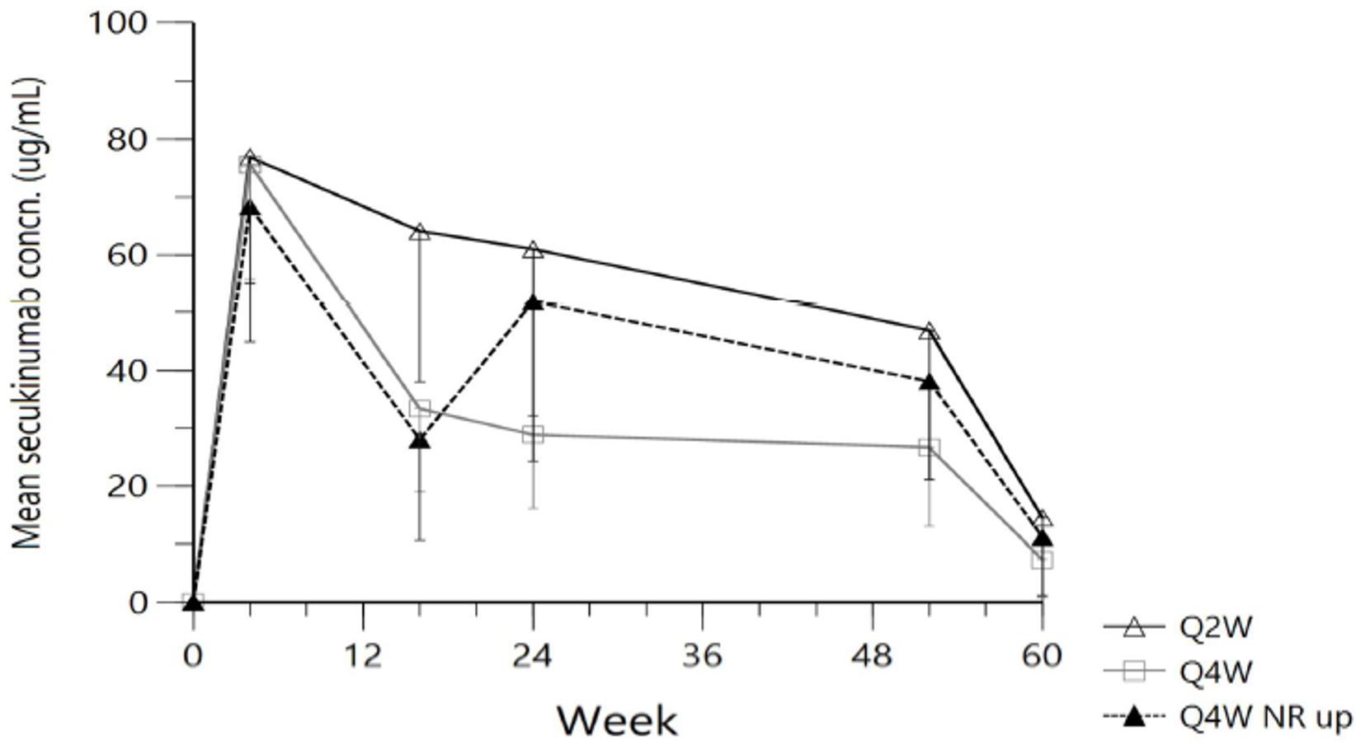

Abbreviations: concn. = concentration; NR = non-responders; Q2W = every 2 weeks; Q4W = every 4 weeks.

The Q4W NR group, were non-responding patients that were up-titrated from 300 mg every 4 weeks to 300 mg every 2 weeks.

The submission did not present PK data for the proposed secukinumab 300 mg once every 2 weeks dosing in patients < 90 kg.

##### Population pharmacokinetic data

Data from 4,194 patients from 11 secukinumab studies in plaque psoriasis (excluding Study A2324) were used for the re-estimation of the population pharmacokinetic (PopPK) model. Figure 2 shows the predicted PK profiles (median and 95% prediction interval) at steady state for secukinumab 300 mg once every 4 weeks and 300 mg once every 2 weeks in patients ≥ 90 kg. The updated model reasonably describes the secukinumab concentration data from Study A2324.

Figure 2: Study A2324 Predicted steady state concentration profile during two consecutive doses for patients ≥ 90 kg treated with secukinumab 300 mg once every 4 weeks, or 300 mg once every 2 weeks (median and 95% prediction interval)

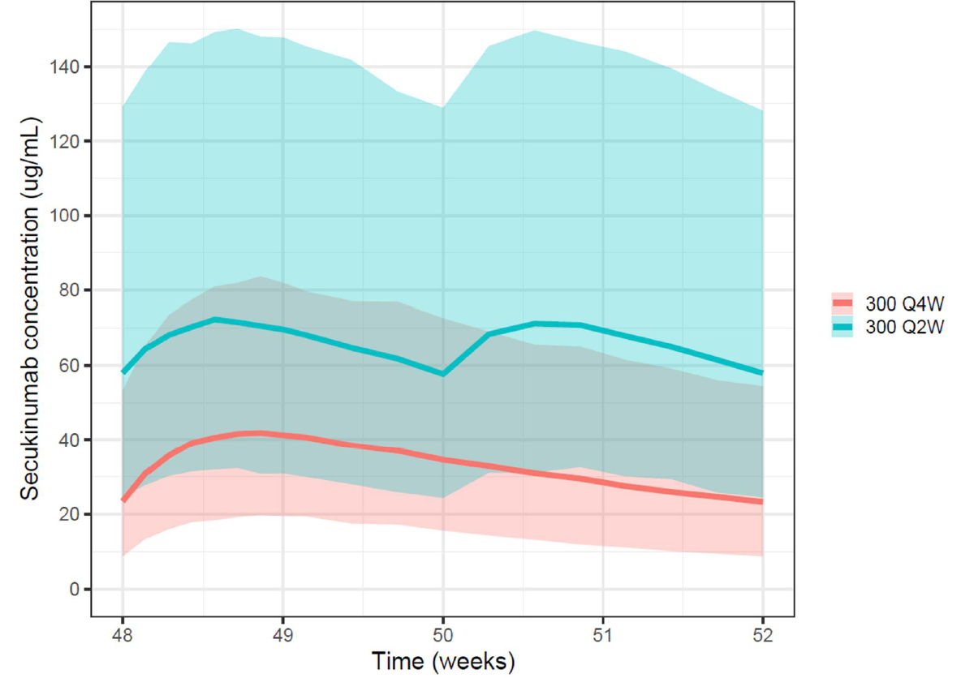

Abbreviations: Q2W = every 2 weeks; Q4W = every 4 weeks.

Secukinumab concentration time course predicted at steady state from the re-estimated population pharmacokinetics model, for two regimens 300 mg every 4 weeks and 300 mg every 2 weeks. The simulation has been performed for 3300 patients with the same weight distribution as in Study A2324 and with random effects randomly drawn from the re-estimated variance-covariance matrix (OMEGA). The figure displays the median predicted time-course (solid line) and the 95% prediction interval (semi‑transparent area).

##### Exposure-response (pharmacokinetics-Psoriasis Area and Severity Index) modelling

The benefit of secukinumab 300 mg once every 2 weeks versus secukinumab 300 mg once every 4 weeks was explored using an exposure-response (PK-PASI) model. This model was an evolution from the previously used PK-PASI model that supported the original submission of secukinumab in psoriasis. The model was used to predict response in patients treated with the same dose of secukinumab for 52 weeks, as well as in patients who did not achieve a PASI 90 response;[6] after 16 weeks of treatment with secukinumab once 300 mg every 4 weeks.

Data from Study A2324 was used for external validation of the PK-PASI model. The performance of the model relative to the PASI 90 response rates observed in Study A2324 is shown in Figure 3. The performance of the model relative to the PASI 90 response rates observed in patients in Study A2324 who were PASI 90 non-responders on 300 mg once every 4 weeks at Week 16 is shown in Figure 4, for patients who continued on 300 mg every 4 weeks and for patients who were up-titrated to 300 mg every 2 weeks.

Figure 3: Study A2324 PASI 90 response rate and its 95% confidence interval (52 weeks) and corresponding prediction interval from the PK‑PASI model; all patients randomised to every 2 weeks or every 4 weeks for 52 weeks (external qualification)

Figure 3: Study A2324 PASI 90 response rate and its 95% confidence interval (52 weeks) and corresponding prediction interval from the PK PASI model; all patients randomised to every 2 weeks or every 4 weeks for 52 weeks (external qualification)

Abbreviations: PASI = Psoriasis Area and Severity Index; PK = pharmacokinetics; Q2W = every 2 weeks; Q4W = every 4 weeks.

PASI 90 (Psoriasis Area and Severity Index 90) response: a 90% or more reduction (improvement) in PASI score from Baseline.

PK-PASI: exposure-response pharmacokinetic-PASI model.

The black line represents the PASI 90 response rate observed in Study A2324 and the vertical error bars are the corresponding 95% confidence intervals. The shaded area represents the 95% prediction interval for PASI 90 response rates over time. The prediction interval is the distribution of PASI 90 response rates in studies similar as Study A2324 in terms of number of patients included in the study, their bodyweights, individual secukinumab pharmacokinetic (PK) parameters, and baseline PASI scores, as calculated from PASI scores simulated from the PK-PASI model.

Figure 4: Study A2324 Comparison of observed and model predicted PASI 90 response rate; subgroup of patients who were PASI 90 non-responders on every 4 weeks at Week 16 (external qualification)

Figure 4: Study A2324 Comparison of observed and model predicted PASI 90 response rate; subgroup of patients who were PASI 90 non-responders on every 4 weeks at Week 16 (external qualification)

Abbreviations: PASI = Psoriasis Area and Severity Index; Q2W = every 2 weeks; Q4W = every 4 weeks.

PASI 90 (Psoriasis Area and Severity Index 90) response: a 90% or more reduction (improvement) in PASI score from Baseline.

The black line represents the PASI 90 response rates observed in Study A2324 and the vertical error bars are the corresponding 95% confidence interval. The shaded area represents the 95% prediction interval for PASI 90 response rates over time for the subgroup of patients who were not PASI 90 responders at Week 16. The prediction interval is the distribution of PASI 90 response rates in studies similar to Study A2324 in terms of number of patients included in the study, their bodyweights, individual secukinumab pharmacokinetics (PK) parameters, and baseline PASI scores, as calculated from PASI scores simulated from the PK-PASI model.

The PK-PASI model was developed from a database of patients covering a broad range of bodyweights (36 to 219 kg), so the model was used to predict PASI 90 response following treatment with secukinumab 300 mg every 2 weeks and 300 mg every 4 weeks in patients with bodyweight ≥ 90 kg, and < 90 kg.

For patients with bodyweight ≥ 90 kg, the modelling predicted:

* an improvement of approximately 15% in PASI 90 response at Week 52 in patients treated with secukinumab 300 mg every 2 weeks for 52 weeks compared with secukinumab 300 mg every 4 weeks for 52 weeks (see Figure 5 below).
* an improvement of approximately 20% in PASI 90 response at Week 52 in patients who do not achieve PASI 90 response at Week 16 on secukinumab 300 mg every 4 weeks and are then up-titrated to secukinumab 300 mg every 2 weeks for the rest of the 52 weeks, compared to non-responders who remain on 300 mg every 4 weeks (see Figure 6 below).

Figure 5: Study A2324 Model-based predicted probability of PASI 90 response following treatment with 300 mg every 4 weeks or every 2 weeks in patients with bodyweight ≥ 90 kg

Figure 5: Study A2324 Model-based predicted probability of PASI 90 response following treatment with 300 mg every 4 weeks or every 2 weeks in patients with bodyweight ≥ 90 kg

Abbreviations: PASI = Psoriasis Area and Severity Index; Q2W = every 2 weeks; Q4W = every 4 weeks.

PASI 90 (Psoriasis Area and Severity Index 90) response: a 90% or more reduction (improvement) in PASI score from Baseline.

The solid lines represent the proportion of PASI 90 response (that is, the expected PASI 90 response rate) over time for a patient ≥ 90 kg treated with every 4 weeks (dark blue) or every 2 weeks (light blue) until Week 52 (last dose). The shaded areas represent the 95% confidence interval for the proportion of PASI 90 response; these intervals account for the uncertainty on the estimated parameters of pharmacokinetics (PK)-PASI model and have been obtained by bootstrapping. The patients used for this simulation are similar to the ≥ 90 kg patients from Study A2302, in terms of bodyweight and baseline PASI.

Figure 6: Study A2324 Model-based predicted proportion of PASI 90 response following treatment with 300 mg every 4 weeks or every 2 weeks in ≥ 90 kg non-responder patients at Week 16 (on every 4 weeks)

Figure 6: Study A2324 Model-based predicted proportion of PASI 90 response following treatment with 300 mg every 4 weeks or every 2 weeks in ≥ 90 kg non-responder patients at Week 16 (on every 4 weeks)

Abbreviations: PASI = Psoriasis Area and Severity Index; Q2W = every 2 weeks; Q4W = every 4 weeks.

PASI 90 (Psoriasis Area and Severity Index 90) response: a 90% or more reduction (improvement) in PASI score from Baseline.

The solid lines represent the proportion of PASI 90 response (that is, the expected PASI 90 response rate) over time for a patient with ≥ 90 kg bodyweight treated with every 4 weeks (dark blue) or every 2 weeks (light blue) until Week 52 (last dose). The shaded areas represent the 95% confidence interval for the proportion of PASI 90 response; these intervals account for the uncertainty on the estimated parameters of pharmacokinetics (PK)-PASI model and have been obtained by bootstrapping. The patients used for this simulation are similar to the ≥ 90 kg patients from Study A2302, in terms of bodyweight and baseline PASI.

For patients with < 90 kg bodyweight, the modelling predicted:

* an improvement of approximately 10% in PASI 90 response at Week 52 in patients treated with secukinumab 300 mg every 2 weeks for 52 weeks compared with secukinumab 300 mg every 4 weeks (see Figure 7 below).
* an improvement of approximately 15% in PASI 90 response at Week 52 in patients who do not achieve PASI 90 response at Week 16 on secukinumab 300 mg every 4 weeks and are then up-titrated to secukinumab 300 mg every 2 weeks for rest of the 52 weeks, compared to non-responders who remain on 300 mg every 4 weeks (see Figure 8 below).

Figure 7: Study A2324 Model-based predicted proportion of PASI 90 response following treatment with 300 mg every 4 weeks or every 2 weeks in patients with < 90 kg bodyweight

Figure 7: Study A2324 Model-based predicted proportion of PASI 90 response following treatment with 300 mg every 4 weeks or every 2 weeks in patients with < 90 kg bodyweight

Abbreviations: PASI = Psoriasis Area and Severity Index; Q2W = every 2 weeks; Q4W = every 4 weeks.

PASI 90 (Psoriasis Area and Severity Index 90) response: a 90% or more reduction (improvement) in PASI score from Baseline.

The solid lines represent the proportion of PASI 90 response (that is, the expected PASI 90 response rate) over time for a patient with bodyweight < 90 kg treated with 300 mg every 4 weeks (dark blue) or 300 mg every 2 weeks (light blue) until Week 52 (last dose). The shaded areas represent the 95% confidence interval for the proportion of PASI 90 response; these intervals account for the uncertainty on the estimated parameters of pharmacokinetics (PK)-PASI model and have been obtained by bootstrapping. The patients used for this simulation are similar to the < 90 kg patients from Study A2302, in terms of bodyweight and baseline PASI.

Figure 8: Study A2324 Model-based predicted probability of PASI 90 response following treatment with 300 mg every 4 weeks or every 2 weeks in non-responder patients with < 90 kg bodyweight at Week 16 (on every 4 weeks)

Figure 8: Study A2324 Model-based predicted probability of PASI 90 response following treatment with 300 mg every 4 weeks or every 2 weeks in non-responder patients with < 90 kg bodyweight at Week 16 (on every 4 weeks)

Abbreviations: PASI = Psoriasis Area and Severity Index; Q2W = every 2 weeks; Q4W = every 4 weeks.

PASI 90 (Psoriasis Area and Severity Index 90) response: a 90% or more reduction (improvement) in PASI score from Baseline.

The solid lines represent the proportion of PASI 90 response (that is, the expected PASI 90 response rate) over time for a patient < 90 kg not responding at Week 16 while treated with every 4 weeks, as predicted from the pharmacokinetics (PK)-PASI model and subsequently treated with every 4 weeks (dark blue) or every 2 weeks (light blue) until Week 52 (last dose). The shaded areas represent the 95% confidence interval for the proportion of PASI 90 response; these intervals account for the uncertainty on the on the estimated parameters of PK-PASI model and have been obtained by bootstrapping. The patients used for this simulation are similar to the < 90 kg patients from Study A2302, in terms of bodyweight and baseline PASI.

For patients with baseline PASI score equal to 18 (the median value in Study A2324), the model predicts an improvement in PASI 90 response ranging from approximately 6% for patients weighing 50 kg to approximately 14% for patients weighing 120 kg with the secukinumab 300 mg every 2 weeks dose regimen.

The concentration-efficacy response relationship was assessed in a pool of 788 patients weighing < 90 kg and 729 patients weighing ≥ 90 kg from plaque psoriasis Studies A2302, A2303, A2308, A2309, and A2324 who were assigned to be treated with secukinumab 150 mg every 4 weeks, 300 mg every 4 weeks, or 300 mg every 2 weeks for 12 months (see Figure 9 below). The model predicted increasing PASI response with increasing secukinumab exposure (steady state average concentration), with the benefit appearing to plateau around 40 µg/mL to 50 µg/mL. These analyses suggest that patients ≥ 90 kg need higher drug concentrations than patients < 90 kg to achieve similar efficacy.

Figure 9: Study A2324 PASI percent changes from Baseline, and PASI 75/90 responses at Week 52 versus secukinumab average concentration at steady state, by bodyweight category (pool of selected Phase III studies)

Figure 9: Study A2324 PASI percent changes from Baseline, and PASI 75/90 responses at Week 52 versus secukinumab average concentration at steady state, by bodyweight category (pool of selected Phase III studies)

Abbreviations: Cavg = average concentration; CI = confidence interval; PASI = Psoriasis Area and Severity Index; Q2W = every 2 weeks; Q4W = every 4 weeks; WT = wildtype.

PASI 75 (Psoriasis Area and Severity Index 75) response: a 75% or more reduction (improvement) in PASI score from Baseline.

PASI 90 (Psoriasis Area and Severity Index 90) response: a 90% or more reduction (improvement) in PASI score from Baseline.

Dots and vertical bars represent the median percentage of PASI 90 responders at Month 12 (left), percentage of PASI 90 responders at Week 52 (middle), and percentage of PASI 75 responders at Week 52 (right), and the associated 66% confidence intervals, obtained by bootstrapping and exact methods. The analysis includes 640, 727, and 150 patients assigned to either of 150 mg every 4 weeks, 300 mg every 4 weeks, or 300 mg every 2 weeks, respectively, in Studies A2302, A2303, A2308, A2309, and A2324. The statistics are calculated by secukinumab pharmacokinetic (PK) metric bin and bodyweight category (< 90 kg and ≥ 90 kg). The PK metric is the individual average steady state secukinumab concentration (Cavg), as predicted for each patient included in the analysis from the population PK model. The bins are specific to the weight category and are determined to cut the sample size in equal numbers in each bin. The statistics are plotted versus the Cavg median in the bin. The horizontal bars at the bottom of the plot represent the Cavg interquartile range (that is, from the twenty fifth to the seventy fifth percentiles) for three relevant groups: 300 mg every 4 weeks for < 90 kg patients, 300 mg every 4 weeks for ≥ 90 kg patients, and 300 mg every 2 weeks for ≥ 90 kg patients obtained for the corresponding patients included in the analysis; the symbols (square for every 4 weeks and diamond for 300 mg every 2 weeks) represent the corresponding Cavg medians.

#### Efficacy

##### Study A2324

Study A2324 was a 52-week, Phase IIIb, multicentre, randomised, double blind, parallel group study to evaluate the short-term (16 weeks) and long-term (up to 52 weeks) efficacy, safety, and tolerability of secukinumab 300 mg every 2 weeks subcutaneously compared with 300 mg every 4 weeks as maintenance treatment in adult patients with moderate to severe chronic plaque psoriasis and bodyweight ≥ 90 kg.

Study A2324 was conducted as a post-approval commitment to the US FDA, to evaluate the treatment effect and safety profile of a higher exposure of secukinumab in psoriasis patients with higher bodyweight, and to explore the option of exposure escalation for those who cannot achieve the therapeutic goal with secukinumab 300 mg every 4 weeks. Exposure-response modelling in the original plaque psoriasis submission showed that Ctrough and clinical response rates were generally higher in patients with bodyweight < 90 kg compared to patients ≥ 90 kg, suggesting the possibility of a greater response rate if secukinumab exposures were increased in patients with bodyweight ≥ 90 kg. In designing Study A2324, the sponsor considered a range of models to predict response rates with higher dosage regimens (450 mg every 4 weeks, 300 mg every 2 weeks or 600 mg every 4 weeks) compared to 300 mg every 4 weeks in patients ≥ 90 kg (and ≥ 100 kg). Based on these analyses, the sponsor selected 300 mg every 2 weeks as the higher dosage regimen for this study evaluating PASI 90 response at Week 16 in patients ≥ 90 kg.

###### Objectives

The primary objective was to demonstrate the efficacy of secukinumab 300 mg every 2 weeks in comparison to secukinumab 300 mg every 4 weeks with respect to PASI 90 response at Week 16.

The secondary objectives were:

* to demonstrate the efficacy of secukinumab 300 mg every 2 weeks in comparison to secukinumab 300 mg every 4 weeks with respect to Investigator’s Global Assessment (IGA) in psoriasis, (modified 2011);[7],[8] score of 0 or 1 response at Week 16.
* to investigate the clinical safety and tolerability of secukinumab 300 mg every 2 weeks as assessed by vital signs, clinical laboratory variables, electrocardiogram and adverse events (AEs) monitoring in comparison to secukinumab 300 mg every 4 weeks.

The study was conducted from 25 June 2018 to 15 July 2020 in the USA (38 centres), Russia (7 centres), Canada (6 centres), Germany (6 centres), Italy (5 centres), Hungary (3 centres), and Czech Republic (2 centres).

###### Study design

The study design is shown in Figure 10 below. Treatment with secukinumab 300 mg subcutaneously (2 injections of secukinumab 150 mg) or matching placebo was administered as per the treatment schedule shown in Figure 10 below.

Figure 10: Study A2324 Study design

Figure 10: Study A2324 Study design

Study A2324 was a 52 week multicenter, randomised, double blind, parallel group study consisting of 4 periods: screening (up to 4 weeks), Treatment Period 1 (16 weeks), Treatment Period 2 (36 weeks) and a post treatment follow up of 8 weeks. To mitigate the risk of randomisation errors at Week 16, a single randomisation process (for both Treatment Period 1 and 2) was performed at the Baseline visit. Patients were randomised at the Baseline visit in a 2:1:1 ratio into one of the treatment groups.

Treatment Period 1: eligible patients were randomised in a 1:1 ratio:
• Secukinumab 300 mg every 2 weeks: Secukinumab 300 mg at Baseline, at Week 1, 2 and 3; and 300 mg every 2 weeks thereafter starting from Week 4.
• Secukinumab 300 mg every 4 weeks: Secukinumab 300 mg at Baseline, at Week 1, 2 and 3; and 300 mg every 4 weeks thereafter starting from Week 4.

Treatment Period 2 (Week 16 post dose to Week 52): At Week 16, all patients were assessed for Psoriasis Area Severity Index (PASI) 90 response status, and allocated to the following groups:
• Secukinumab 300 mg every 2 weeks: patients remained on secukinumab 300 mg every 2 weeks until the end of treatment.
• Secukinumab 300 mg every 4 weeks: patients continued on secukinumab 300 mg every 4 weeks during Treatment Period 2 regardless of their PASI 90 response status (responders and non-responders) at Week 16.
• Secukinumab 300 mg every 4 weeks possible up-titration: patients received secukinumab 300 mg every 4 weeks up to Week 16, and then based on their PASI 90 response status at Week 16:
o PASI 90 responders: remained on secukinumab 300 mg every 4 weeks during Treatment Period 2
o PASI 90 non-responders (every 4 weeks non-responder up): were up-titrated to secukinumab 300 mg every 2 weeks during Treatment Period 2.

Abbreviations: EOT = end of treatment; NR = PASI 90 non-responders; Q2W = every 2 weeks; Q4W = every 4 weeks; R = PASI 90 responders; s.c. = subcutaneous; Wk = Week.

PASI 90 (Psoriasis Area and Severity Index 90) response: a 90% or more reduction (improvement) in PASI score from Baseline.

Key inclusion criteria included:

* bodyweight ≥ 90 kg at randomisation
* aged ≥ 18 years at screening
* chronic plaque type psoriasis present for at least 6 months and diagnosed before randomisation
* moderate to severe psoriasis as defined by:
  + Psoriasis Area Severity Index (PASI) score of 12 or greater, and
  + Investigator’s Global Assessment (IGA) modified 2011 score of 3 or greater (based on a static scale of 0 to 4);7 and
  + body surface area affected by plaque type psoriasis of 10% or greater
* candidate for systemic therapy, which was defined as a subject having moderate to severe chronic plaque type psoriasis that was inadequately controlled by:
  + topical treatment and/or,
  + phototherapy and/or,
  + previous systemic therapy.

###### Study populations

Three hundred and thirty-one (331) patients were randomised in the study, 165 to secukinumab 300 mg every 2 weeks and 166 to secukinumab 300 mg every 4 weeks. Three hundred and twenty (320) patients (96.7%) completed Treatment Period 1 (Week 16), and 293 (88.5%) completed the entire study (Week 52). At Week 16, 71 patients in the 300 mg every 4 weeks group were PASI 90 non-responders. Of these, 40 patients remained on 300 mg every 4 weeks (300 mg every 4 weeks non-responders stay group) and 31 patients were up-titrated to 300 mg every 2 weeks (300 mg every 4 weeks non‑responders up group).

The baseline demographic characteristics were generally well-balanced between the two treatment groups. Overall, 74.9% of subjects were male, and the majority of subjects were White (92.4%) and < 65 years (90.6%). All subjects weighed at least 90 kg at Baseline and had a baseline PASI score of at least 12.

###### Efficacy endpoints

The primary efficacy endpoint was PASI 90 response at Week 16 (percentage of subjects who achieve ≥ 90% reduction in PASI score at Week 16 compared to Baseline). The secondary efficacy endpoint was IGA score of 0 or 1 response at Week 16 (percentage of subjects who achieve IGA modified 2011 score of 0 or 1 and improved by at least 2 points on the IGA scale at Week 16 compared to Baseline). Exploratory efficacy variables included PASI 50, 75, 90 and 100 and IGA modified 2011 responses after up-titration in PASI 90 non-responders at Week 16 receiving secukinumab 300 mg every 4 weeks, at Week 32 and up to Week 52, PASI 50, 75, 90 and 100, and IGA modified 2011 score of 0 or 1 responses over time, PASI score over time, IGA modified 2011 score over time, relapse and rebound. Patient Reported Outcomes;[9] included Dermatology Life Quality Index.[10]

The analysis of efficacy variables was based on the full analysis set. The statistical hypotheses for the primary and secondary endpoints were tested sequentially at an alpha = 2.5% (one-sided).

###### Results

The study met its primary endpoint. PASI 90 response at Week 16 was 73.2% in the 300 mg every 2 weeks group and 55.5% in the 300 mg every 4 weeks group, a difference of 17.7% (see Table 2 below). A sensitivity analysis of the primary endpoint using modified non‑responder imputation was consistent with the primary analysis (multiple imputation).

Table 2: Study A2324 Analysis of PASI 90 response at Week 16 (multiple imputation, full analysis set)

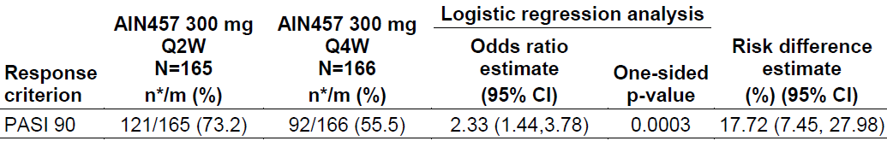

Abbreviations: AIN457 = secukinumab; CI = confidence interval; m = number of patients evaluable. n* = rounded average number of patients with response in 100 imputations; PASI = Psoriasis Area and Severity Index.

PASI 90 (Psoriasis Area and Severity Index 90) response: a 90% or more reduction (improvement) in PASI score from Baseline.

The study did not meet the secondary efficacy endpoint. IGA score of 0 or 1 response at Week 16 was numerically higher in the secukinumab 300 mg every 2 weeks group (74.2%) compared to the secukinumab 300 mg every 4 weeks group (65.9%), but the difference was not statistically significant (see Table 3 below). Exploratory efficacy outcomes are shown in Figure 11 and Figure 12 below.

Table 3: Study A2324 Logistic regression analysis of IGA scores of 0 or 1 responses at Week 16 (multiple imputation, full analysis set)

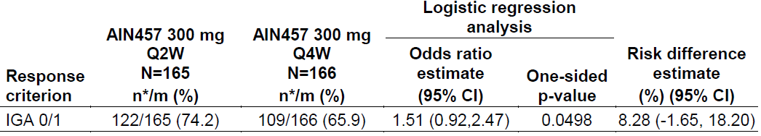

Abbreviations: AIN457 = secukinumab; CI = confidence interval; IGA = Investigator’s Global Assessment (modified 2011); m = number of patients evaluable. n* = rounded average number of patients with response in 100 imputations.

The Investigator’s Global Assessment (IGA) scale (psoriasis) is a five-point scale that provides a point in time global clinical assessment of psoriasis severity ranging from 0 to 4, where:

0 = clear (no signs of psoriasis, some post-inflammatory hyperpigmentation may be present);

1 = almost clear (no thickening, normal or pink coloration);

2 = mild (mild thickening, pink to light red coloration);

3 = moderate (moderate thickening, dull to bright red);

4 = severe (severe thickening, bright to deep red).

Figure 11: Study A2324 Time course of PASI 75, 90, 100; and IGA scores of 0 or 1 responders (estimate and 95% confidence interval, multiple imputation) in PASI 90 non-responders at Week 16 Treatment Period 2

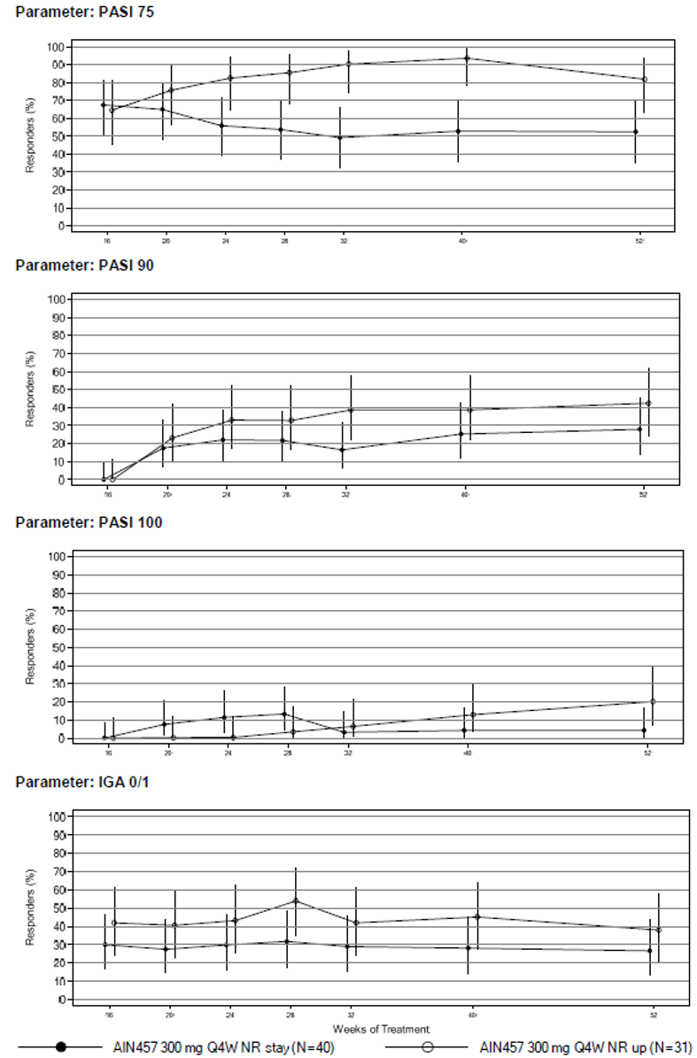

Abbreviations: AIN457 = secukinumab; IGA = Investigator’s Global Assessment (modified 2011); N = number of subjects; NR = non-responders; PASI = Psoriasis Area and Severity Index; Q4W = every 4 weeks.

PASI 75/90/100 (Psoriasis Area and Severity Index 75/90/100) response: a 75%/90%/100% or more reduction (improvement) in PASI score from Baseline.

The Investigator’s Global Assessment (IGA) scale (psoriasis) is a five-point scale that provides a point‑in‑time global clinical assessment of psoriasis severity ranging from 0 to 4, where:

0 = clear (no signs of psoriasis, some post-inflammatory hyperpigmentation may be present);

1 = almost clear (no thickening, normal or pink coloration);

2 = mild (mild thickening, pink to light red coloration);

3 = moderate (moderate thickening, dull to bright red);

4 = severe (severe thickening, bright to deep red).

Figure 12: Study A2324 Time course of PASI 75, 90, 100 responses, and IGA score of 0 or 1 responders (estimate and 95% confidence interval, multiple imputation) of the entire treatment period (full analysis set)

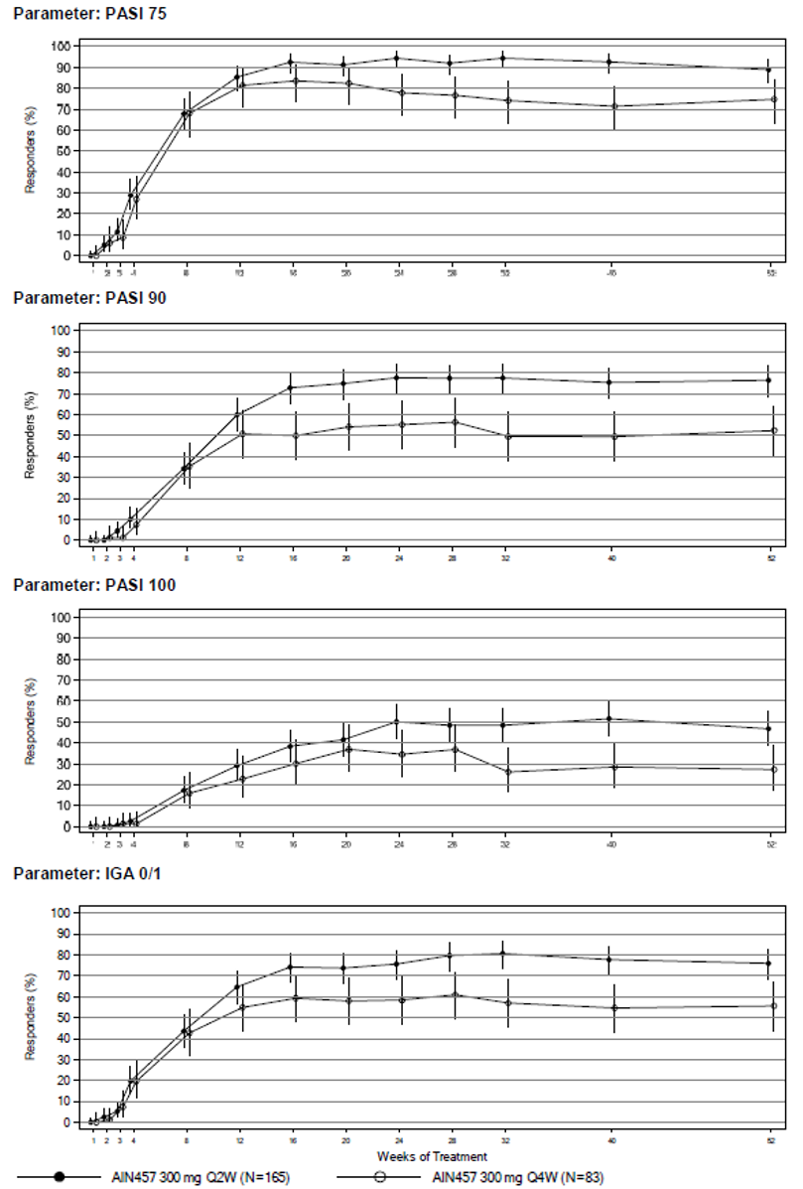

Abbreviations: AIN457 = secukinumab; IGA = Investigator’s Global Assessment (modified 2011); N = number of subjects; NR = non-responders; PASI = Psoriasis Area and Severity Index; Q4W = every 4 weeks.

PASI 75/90/100 (Psoriasis Area and Severity Index 75/90/100) response: a 75%/90%/100% or more reduction (improvement) in PASI score from Baseline.

The Investigator’s Global Assessment (IGA) scale (psoriasis) is a five-point scale that provides a point in time global clinical assessment of psoriasis severity ranging from 0 to 4, where:

0 = clear (no signs of psoriasis, some post-inflammatory hyperpigmentation may be present);

1 = almost clear (no thickening, normal or pink coloration);

2 = mild (mild thickening, pink to light red coloration);

3 = moderate (moderate thickening, dull to bright red);

4 = severe (severe thickening, bright to deep red).

#### Safety

The safety profile of secukinumab 300 mg given once every 4 weeks as maintenance treatment of moderate to severe plaque psoriasis is well-established. Study A2324 evaluated the safety of the proposed 300 mg once every 2 weeks dosing regimen in the treatment moderate to severe plaque psoriasis in patients with baseline bodyweight ≥ 90 kg. The submission did not present safety data for 300 mg every 2 weeks in patients < 90 kg, but included modelling analyses to support the safety of secukinumab 300 mg every 2 weeks in patients < 90 kg.

##### Study A2324

###### Exposure

Exposure to study treatment is shown in Table 4 below.

Table 4: Study A2324 Duration of exposure to study treatment of the entire study period (safety set)

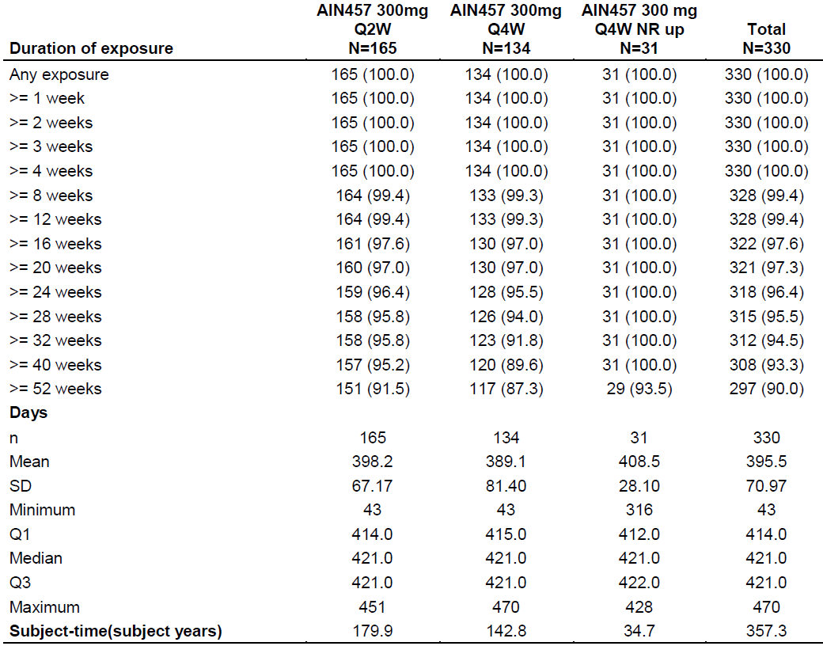

Abbreviations: AIN457 = secukinumab; n = number of subjects; NR = non-responders; Q1 = first quarter; Q3 = third quarter; Q2W = every 2 weeks; Q4W = every 4 weeks; SD = standard deviation.

Duration of exposure to treatment is defined as minimum (end of study period, last dose + 84 days) - start date of study treatment + 1.

Subject time in subject years is calculated as a sum of individual subject durations in days divided by 365.25.

###### Adverse events

The overall incidence of adverse events (AEs) was slightly higher in the once every 2 weeks dosage group than the every 4 weeks group over the entire study period (see Table 5 below). The incidence of AEs assessed as possibly related to the study drug was 20.6% in the every 2 weeks group and 21.6% in the every 4 weeks group. The majority of AEs in the every 2 weeks and every 4 weeks groups were of mild to moderate intensity. Severe AEs were reported for a higher proportion of patients in the every 4 weeks group than in the every 2 weeks group: 13 patients (9.7%) versus 7 patients (4.2%). One patient in the every 4 weeks group died from unrelated causes.

During the entire study period, the incidence of serious adverse events (SAEs) was higher in the every 4 weeks group than the every 2 weeks group (13.4% versus 8.5%). None of the SAEs by Preferred Term (PT) in the every 2 weeks group or every 4 weeks group occurred in more than one patient each except for non-cardiac chest pain (2 patients in the every 2 weeks group) and sepsis (2 patients in the every 4 weeks group). AEs leading to study treatment discontinuation were reported for 9 patients (6.7%) in the every 4 weeks group and 4 patients (2.4%) in the every 2 weeks group during the entire study period.

Table 5: Study A2324 Most frequent (≥ 5 % in any treatment group) treatment emergent adverse event by Preferred Term of the entire study period (safety set)

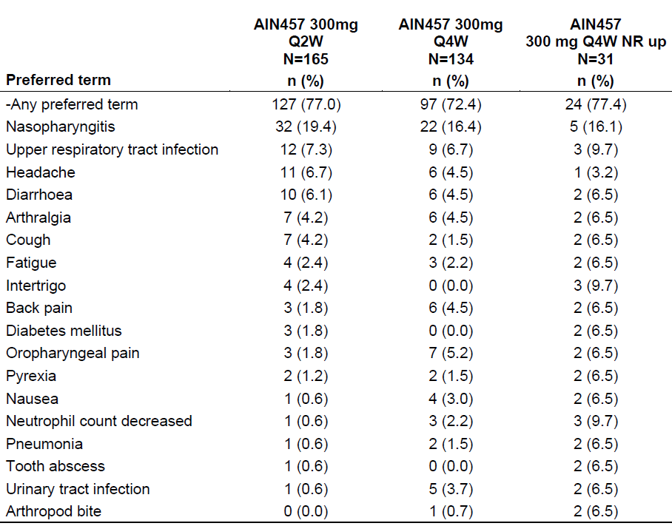

Abbreviations: AIN457 = secukinumab; N = number of subjects; n = number of subjects in group; NR = non-responders; Q2W = every 2 weeks; Q4W = every 4 weeks.

Preferred Terms are sorted in descending frequency of AEs in the secukinumab 300 mg every 2 weeks column.

A subject with multiple adverse events with the same Preferred Term is counted only once for that Preferred Term.

The incidence of important identified and potential risks over the entire study period is shown in Table 6 below. The most frequently reported infections were upper respiratory tract infections (High Level Term (HLT)): every 2 weeks 29.7% versus every 4 weeks 26.9%. Oral herpes (PT) was reported in 3 (1.8%) patients in the every 2 weeks group and one (0.7%) patient in every 4 weeks group, and herpes zoster (PT) was reported in 3 (2.2%) patients in the every 4 weeks group. Candida infections (HLT) were reported in 3 patients (1.8%) in the every 2 weeks group and 6 patients (4.5%) in the every 4 weeks group. The incidence of hypersensitivity (Standardised Medical Dictionary for Regulatory Activities (MedDRA)[11] Query (SMQ))[12] was 8.5% in the once every 2 weeks group and 4.5% in the every 4 weeks group. This difference was mainly driven by the events (PTs) of dermatitis, dermatitis contact and urticaria. The incidence of neutropaenia (Novartis Medical Dictionary for Regulatory Activities (MedDRA) Query (NMQ)) was similar in the every 2 weeks and every 4 weeks groups.

Table 6: Study A2324 Important identified and potential risks based on all adverse events of the entire study period (safety set)

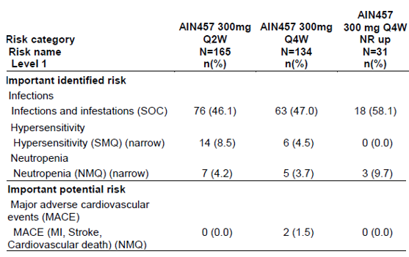

Abbreviations: AIN457 = secukinumab; MACE = major adverse cardiovascular event; MI = myocardial infarction; NMQ = Novartis Medical Dictionary for Regulatory Activities (MedDRA) Query; N = number of subjects; n = number of subjects in group; NR = non-responders; Q2W = every 2 weeks; Q4W = every 4 weeks; SMQ = Standardised Medical Dictionary for Regulatory Activities (MedDRA) Query; SOC = System Organ Class.

Risk levels are not mutually exclusive.

The submission included cross-study comparisons (see Table 7 below) of the incidence of clinically significant AEs observed in Study A2324 and prior pivotal studies (Study A2302, A2303, A2308, and A2309).

Table 7: Study A2324 versus Studies A2302, A2303, A2308 and A2309 Clinically significant safety (exposure adjusted incidence rates and incidence rate ratios) up to Week 52/60 (safety set)

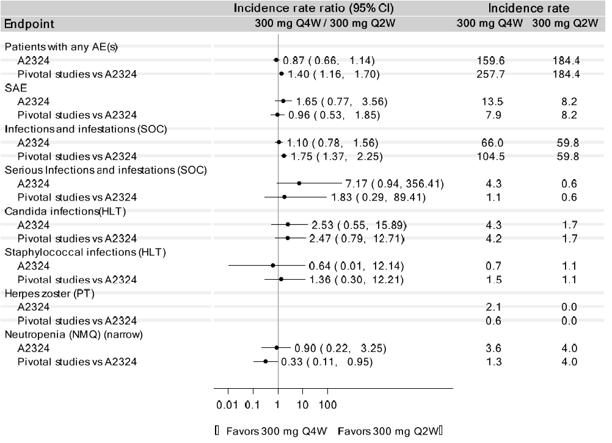

Abbreviations: AE = adverse event; CI = confidence interval; HLT = High Level Term; NMQ = Novartis Medical Dictionary for Regulatory Activities (MedDRA) Query; PT = Preferred Term; Q4W = every 4 weeks; Q2W = every 2 weeks; SAE = serious adverse event; SOC = System Organ Classes; vs = versus.

Duration of exposure was 60 weeks in Study A2324 and 52 weeks in adult pivotal studies.

Adult pivotal studies: Studies A2302, A2303, A2308 and A2309.

The submission did not present safety data for patients with bodyweight < 90 kg treated with 300 mg every 2 weeks, but included modelling analyses to support the safety of 300 mg every 2 weeks in patients < 90 kg. The sponsor used two different methods to model the safety of 300 mg every 2 weeks in patients < 90 kg.

The first method involved 2,639 patients in the secukinumab psoriasis safety data pool who had concentration data and were treated with 150 mg every 4 weeks, 300 mg every 4 weeks, or 300 mg every 2 weeks for one year (noting that all of the patients treated with 300 mg every 2 weeks were from Study A2324, so had baseline bodyweight ≥ 90 kg). Adverse events of special interest (AESIs) were infection-related AEs, including infections and infestations (System Organ Class (SOC)), serious infections and infestations (SOC), Candida infections (HLT) and upper respiratory tract infections (HLT). Table 8 shows the incidence of AESIs by average secukinumab concentration at steady state. The relationship between average secukinumab concentration at steady state and the incidence of AESIs during one year was modelled using logistic regression analysis (see Table 9, Figure 13 below).

Table 8: Study A2324 Incidence rate at one year for adverse event of special interest by average secukinumab concentration (µg/mL) at steady state ranges (safety set)

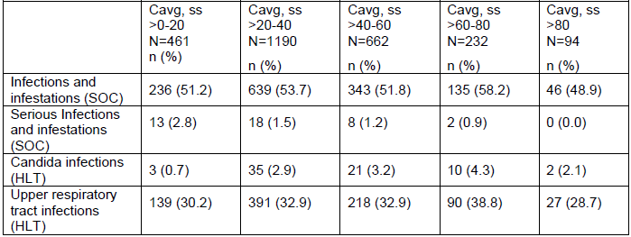

Abbreviations: Cavg,ss = average concentration at steady state; HLT = High Level Term; N = number of subjects; n = number of subjects in group; SOC = System Organ Classes.

The safety data from secukinumab psoriasis Phase III studies: Studies A2302, A2303, A2304, A2308, A2309, A2312, A2313, A2323, A2324 and A2325 were included in the analysis.

Table 9: Study A2324 Predicted incidence rate of adverse event of special interest in one year by logistic regression model (safety set)

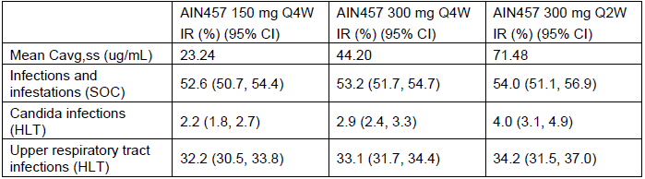

Abbreviations: AIN457 = secukinumab; Cavg,ss = average concentration at steady state; CI = confidence interval; HLT = High Level Term; IR = incidence rate; Q2W = every 2 weeks; Q4W = every 4 weeks; SOC = infections and infestations.

Figure 13: Study A2324 Estimated relationship between secukinumab average concentration at steady state and incidence of specific adverse events

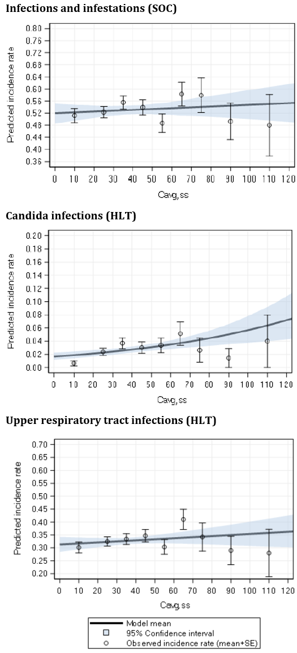

Abbreviations: HLT = High Level Term; SE = standard error; SOC = System Organ Classes.

The dots and the vertical bars represent the observed incidence rate and standard error by range of average secukinumab concentration at steady state (0 to 20, 20 to 30, 30 to 40, 40 to 50, 50 to 60, 60 to 70, 70 to 80, 80 to 100, and ≥ 100 µg/mL). The regression curve and the grey area represent the incidence rate and 95% confidence intervals as a function of the average secukinumab concentration at steady state, as predicted from the logistic regression models. The predicted incidence rate in the figures is expressed as the predicted proportion of patients experiencing the specific adverse events.

The second method included 3,993 patients in the secukinumab psoriasis pooled clinical database with available dose and concentration data. The relationship between time varying metrics of the secukinumab concentration (PK metrics) and the hazard of the first AE (the risk of experiencing a first event on a given day) was analysed using a time‑to‑event semiparametric (Cox proportional hazard model) approach. Two models were used to assess the functional relationship between secukinumab concentration and hazard of AE (see Figure 14 below).

Figure 14: Study A2324 Estimated relationship between secukinumab exposure and incidence of all infections adverse events, upper respiratory tract infections adverse events, Candida infections adverse events, and serious infections adverse events

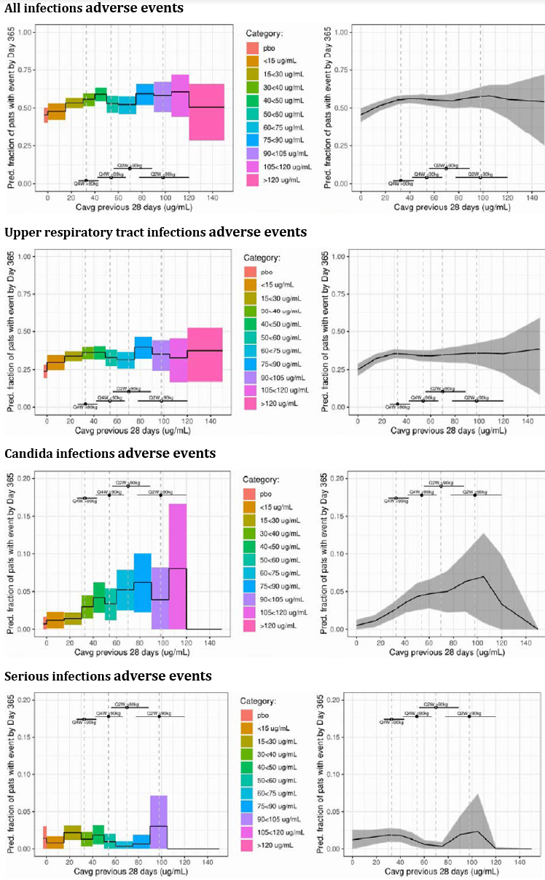

Abbreviations: Cavg = average concentration; pbo = placebo; Q2W = every 2 weeks; Q4W = every 4 weeks.

The figure displays predicted fraction and 95% confidence intervals for all infections adverse events (AEs), upper respiratory tract infections AEs, Candida infections AEs, and serious infections AEs obtained from the model adjusted for secukinumab concentration discretised in 11 bins (Model 2; left), and from the model adjusted for a spline transformation of the secukinumab concentration (Model 1; right). The pharmacokinetic (PK) metric used for the analysis presented in this figure is the running average secukinumab concentration over the last 28 days. The five ranges of concentration displayed in the figures represent the first quartile, median, and third quartile of the PK metric averaged across the one-year period for the following 300 mg secukinumab regimens (all include 300 mg every week till Week 4): every 4 weeks in < 90 and ≥ 90 kg patients and every 2 weeks in < 90 and ≥ 90 kg patients.

### Risk management plan

The sponsor is required to comply with product vigilance and risk minimisation requirements.

### Risk-benefit analysis

#### Delegate’s considerations

##### Efficacy

The efficacy of the proposed 300 mg secukinumab once every 2 weeks maintenance dosing option in patients with plaque psoriasis is based on the findings from Study A2324, supported by exposure‑response (PK-PASI) modelling based on a data pool of 4,194 patients from 11 adult psoriasis studies.

Study A2324 evaluated the proposed higher maintenance dosage only in patients of bodyweight ≥ 90 kg. There are no clinical trial data assessing 300 mg every 2 weeks in patients < 90 kg, so the proposed new dosage for patients < 90 kg bodyweight is based only on modelling.

Study A2324 met its primary endpoint, demonstrating superiority of secukinumab 300 mg every 2 weeks over secukinumab 300 mg every 4 weeks for PASI 90 response at Week 16 in patients ≥ 90 kg bodyweight. PASI 90 response at Week 16 was 73.2% in the 300 mg every 2 weeks group and 55.5% in the 300 mg every 4 weeks group, a difference of 17.7% (95% CI: 7.45, 27.98). The difference in PASI 90 response at Week 16 was statistically significant and clinically meaningful, and the benefit was maintained through to Week 52.

The efficacy findings from Study A2324 were supported by PK-PASI modelling analyses which predicted an improvement of approximately 15% in PASI 90 response at Week 52 in patients with bodyweight ≥ 90 kg treated with secukinumab 300 mg every 2 weeks for 52 weeks compared with secukinumab 300 mg every 4 weeks for 52 weeks. The modelling also predicted an improvement of approximately 20% in PASI 90 response at Week 52 in patients ≥ 90 kg who do not achieve PASI 90 response at Week 16 on secukinumab 300 mg every 4 weeks and are then up-titrated to secukinumab 300 mg every 2 weeks for the rest of the 52 weeks, compared to non-responders who remain on 300 mg every 4 weeks.

No clinical trial data were presented for patients with bodyweight < 90 kg. The evidence for efficacy in this population is derived from PK-PASI modelling. The modelling predicted an improvement of approximately 10% in PASI 90 response at Week 52 in patients < 90 kg treated with secukinumab 300 mg every 2 weeks for 52 weeks compared with secukinumab 300 mg every 4 weeks for 52 weeks. The modelling also predicted an improvement of approximately 15% in PASI 90 response at Week 52 in patients < 90 kg who do not achieve PASI 90 response at Week 16 on secukinumab 300 mg every 4 weeks and are then up-titrated to secukinumab 300 mg every 2 weeks for the rest of the 52 weeks, compared to non-responders who remain on 300 mg every 4 weeks.

The PK-PASI modelling predicted increasing PASI response with increasing secukinumab exposure (steady state average concentration), with the benefit appearing to plateau at approximately 50 µg/mL. This effect was predicted both for patients with bodyweight ≥ 90 kg and < 90 kg, noting that the predicted PASI response at any given concentration was consistently higher for patients < 90 kg compared to patients ≥ 90 kg. The sponsor considers that these analyses support the higher dosage regimen being applied to all patients. However, in my mind, the concentration-response analyses lend support to the higher dosage regimen being applied only for patients ≥ 90 kg (that is, the modelling predicts that patients ≥ 90 kg need a higher concentration to achieve comparable efficacy to patients < 90 kg).

##### Safety

The safety profile of secukinumab 300 mg every 2 weeks in patients with moderate to severe plaque psoriasis and baseline bodyweight ≥ 90 kg was evaluated in Study A2324. The safety profile for patients treated with 300 mg every 2 weeks was similar to 300 mg every 4 weeks, and was consistent with the established safety profile of secukinumab in psoriasis patients. The overall incidence of adverse events (AEs), serious adverse events (SAEs), and discontinuations due to AEs were generally similar in the every 2 weeks and every 4 weeks groups, as were important identified and potential risks. A difference in hypersensitivity events was mainly driven by events of dermatitis, dermatitis contact, and urticaria.

There are no safety data for patients < 90 kg treated with 300 mg every 2 weeks, so modelling analyses were submitted to support safety in this population. The sponsor’s modelling predicts that the incidence of selected adverse events of special interest (AESIs) would be similar for 300 mg every 2 weeks and 300 mg every 4 weeks, both for patients with bodyweight ≥ 90 kg and < 90 kg. The confidence intervals were notably wider at the higher concentration ranges, particularly for Candida infections AEs and serious infections AEs, reflecting greater uncertainty in the predictions due to limited data. The safety modelling addresses only selected AESIs, and does not address the possibility of a weight‑related difference in sensitivity to secukinumab (as was seen in the efficacy modelling). The Delegate is not satisfied that the modelling adequately addresses the safety of the proposed 300 mg every 2 weeks dosage in patients < 90 kg.

##### Deficiencies and Limitations of the data

The 300 mg every 2 weeks maintenance dosing option is proposed for the entire population of patients with plaque psoriasis, but the clinical Study A2324 included only patients with baseline bodyweight ≥ 90 kg. Study A2324 was not designed to address the efficacy and safety of the proposed 300 mg every 2 weeks maintenance dosage in patients < 90 kg. The submission did not include PK, efficacy, or safety data for patients < 90 kg, other than modelling and simulations.

#### Proposed action

This submission initially sought approval of a secukinumab 300 mg once every 2 weeks maintenance dosage option for adults with moderate to severe plaque psoriasis, regardless of bodyweight. Following completion of the evaluation, the sponsor agreed to accept the TGA’s recommendation that the 300 mg every 2 weeks dosing option for plaque psoriasis should apply only for patients with bodyweight ≥ 90 kg.

The data presented in this submission support the efficacy and safety of 300 mg every 2 weeks as a maintenance dosing option for patients with moderate to severe plaque psoriasis and bodyweight ≥ 90 kg.

In patients < 90 kg, the modelling predicts a modest efficacy benefit for 300 mg every 2 weeks compared to 300 mg every 4 weeks. The sponsor asserts that the modelling predicts similar safety for 300 mg every 2 weeks and 300 mg every 4 weeks; however, the Delegate is of the view that the modelling does not satisfactorily establish the safety of the proposed 300 mg every 2 weeks dosing regimen in patients < 90 kg. The lack of efficacy and safety data in patients < 90 kg leads me to conclude that the benefit-risk of secukinumab 300 mg every 2 weeks as maintenance treatment in patients < 90 kg is uncertain.

#### Advisory Committee considerations

The [Advisory Committee on Medicines (ACM)](https://www.tga.gov.au/committee/advisory-committee-medicines-acm), having considered the evaluations and the Delegate’s overview, as well as the sponsor’s response to these documents, advised the following.

##### Specific advice to the Delegate

1. ***What is ACM’s clinical perspective on the evidence supporting*** ***the proposed secukinumab 300 mg once every 2 weeks dosage in patients:***
   1. ***with bodyweight 90 kg or more?***

The ACM discussed how the supplied data is consistent with modelling which suggested that patients with larger body mass (that is, above 90 kg) may derive increased benefit from higher exposure.

The ACM was satisfied that the clinical study, supported by the modelling, adequately demonstrates the efficacy and safety of 300 mg every 2 weeks as a maintenance dosing option in patients ≥ 90 kg. If this dosing regimen was approved, the practical implications were that clinicians may choose to up-titrate the dose in instances of therapeutic failure at the current approved dosage. Given this, the ACM was supportive of specifying a weight cut‑off as part of the guidance in the PI, as this aligns best with the clinical and efficacy data provided in the submission.

On balance, the ACM was supportive of the proposed secukinumab 300 mg once every 2 weeks dosage for patients with a bodyweight of 90 kg or more.

* 1. ***with bodyweight of less than 90 kg?***

The ACM noted there was insufficient data to support patients with a bodyweight of less than 90 kg receiving secukinumab 300 mg once every 2 weeks subcutaneously as a maintenance dose as the population pharmacokinetic modelling demonstrates the proportion of individuals likely to benefit declines in those with lower bodyweight.

The ACM considered the lack of safety data in this cohort at the higher dose and noted that extrapolation of this information from the simulated data alone is uncertain and not appropriate. The ACM was of the view that there is potential for unfavourable outcomes in this group of patients without a clear identifiable clinical need to support a higher dose.

The ACM recommended that the proposed secukinumab 300 mg once every 2 weeks dosage apply only to those weighing 90 kg or more.

The ACM was of the view that the efficacy and safety of the proposed secukinumab 300 mg every 2 weeks dosage have not been adequately established for patients < 90 kg.

##### Conclusion

The ACM considered this product to have an overall positive benefit-risk profile for:

The recommended dose is 300 mg by subcutaneous injection with initial dosing at Weeks 0, 1, 2, 3, and 4 followed by the same dose every month. Some patients ≥ 90 kg may derive an additional benefit from receiving 300 mg every 2 weeks. Each 300 mg dose is given as two subcutaneous injections of 150 mg.

## Outcome

Based on a review of quality, safety, and efficacy, the TGA approved the registration of Cosentyx (secukinumab) 150 mg powder for injection (vials) and 150 mg/mL solution for injection (pre-filled syringe and pens), for the following change in dose regime:

**Plaque psoriasis**

The recommended dose is 300 mg by subcutaneous injection with initial dosing at Weeks 0, 1, 2, 3, and 4 followed by the same dose every month. Some patients ≥ 90 kgs may derive an additional benefit from receiving 300 mg every 2 weeks. Each 300 mg dose is given as one subcutaneous injection of 300 mg or as two subcutaneous injections of 150 mg.

**Psoriatic arthritis**

For patients with concomitant moderate to severe plaque psoriasis, please refer to adult plaque psoriasis recommendation.

For patients who are anti‐TNF‐alpha inadequate responders (IR), the recommended dose is 300 mg by subcutaneous injection with initial dosing at Weeks 0, 1, 2, 3, and 4 followed by the same dose every month. Each 300 mg dose is given as one subcutaneous injection of 300 mg or as two subcutaneous injections of 150 mg.

### Specific conditions of registration applying to these goods

* For all injectable products the Product Information must be included with the product as a package insert.

## Attachment 1. Product Information

The PI for Cosentyx approved with the submission which is described in this AusPAR is at Attachment 1. For the most recent PI, please refer to the TGA [PI/CMI search facility.](https://www.tga.gov.au/picmi-search-facility)

|  |
| --- |
| Therapeutic Goods Administration |
| PO Box 100 Woden ACT 2606 Australia  Email: [info@tga.gov.au](mailto:info@tga.gov.au) Phone: 1800 020 653 Fax: 02 6232 8605  [**https://www.tga.gov.au**](https://www.tga.gov.au) |

1. **Psoriasis Area and Severity Index (PASI)**: Total PASI scores were calculated by multiplying the area of involvement score, the sum of the severity scores for erythema, induration, and scaling, and a weight factor for that body area (0.1, 0.2, 0.3, and 0.4 for head, upper extremities, trunk, and lower extremities, respectively), and then summing across all 4 body areas. The total range of the PASI score is 0 to 72, where 0 = no psoriasis and 72 = severe disease.

   The PASI 75 response indicates a 75% or more reduction (improvement) in PASI score from Baseline.
2. Lee, J.E. et al. Effect of Body Weight on Risk-Benefit and Dosing Regimen Recommendation of Secukinumab for the Treatment of Moderate to Severe Plaque Psoriasis, *Clin Pharmacol Ther*, 2019; 106(1): 78-80.
3. AusPAR for Cosentyx (secukinumab) new chemical entity, published on 26 October 2015. Available at: <https://www.tga.gov.au/resources/auspar/auspar-secukinumab>.
4. AusPAR for Cosentyx (secukinumab) extension of indications, published on 22 November 2016. Available at: <https://www.tga.gov.au/resources/auspar/auspar-secukinumab-0>.
5. AusPAR for Cosentyx (secukinumab) extension of indications, published on 3 February 2021. Available at: <https://www.tga.gov.au/resources/auspar/auspar-secukinumab-1>.
6. **Psoriasis Area and Severity Index 90 (PASI 90) response**: a 90% or more reduction (improvement) in PASI score from Baseline.
7. The **Investigator’s Global Assessment (IGA) scale** (psoriasis) is a five-point scale that provides a point‑in‑time global clinical assessment of psoriasis severity ranging from 0 to 4, where:

   0 = clear (no signs of psoriasis, some post-inflammatory hyperpigmentation may be present);

   1 = almost clear (no thickening, normal or pink coloration);

   2 = mild (mild thickening, pink to light red coloration);

   3 = moderate (moderate thickening, dull to bright red);

   4 = severe (severe thickening, bright to deep red).
8. Langley, R.G. et al. The 5-Point Investigator’s Global Assessment (IGA) Scale: a Modified Tool for Evaluating Plaque Psoriasis Severity in Clinical Trials, *J Dermatolog Treat,* 2015; 26(1): 23–31.
9. **Patient Reported Outcome (PRO)** provides reports from patients about their own health, quality of life, or functional status associated with the health care or treatment they have received.
10. **Dermatology Life Quality Index (DLQI)** is a questionnaire designed to measure the impact of skin disease on the health-related quality of life of adult patients.
11. The **Medical Dictionary for Regulatory Activities (MedDRA)** is a single standardised international medical terminology, developed as a project of the International Council for Harmonisation of Technical Requirements for Pharmaceuticals for Human Use (ICH) which can be used for regulatory communication and evaluation of data pertaining to medicinal products for human use. As a result, MedDRA is designed for use in the registration, documentation and safety monitoring of medicinal products through all phases of the development cycle (that is, from clinical trials to post-marketing surveillance). Furthermore, MedDRA supports ICH electronic communication within the ICH’s Electronic Common Technical Document (eCTD) and the E2B Individual Case Safety Report.
12. **Standardised MedDRA Queries (SMQs)** are groupings of terms from one or more MedDRA System Organ Classes (SOCs) that relate to a defined medical condition or area of interest. They are intended to aid in case identification.