This medicinal product is subject to additional monitoring in Australia. This will allow quick identification of new safety information. Healthcare professionals are asked to report any suspected adverse events at [www.tga.gov.au/reporting-problems](http://www.tga.gov.au/reporting-problems).

▼

# Australian PI – VERZENIO™ (Abemaciclib) tablet

# Name of the medicine

Abemaciclib

# Qualitative and quantitative composition

Abemaciclib (VERZENIO) 50 mg film-coated tablets

Each film-coated tablet contains 50 mg abemaciclib.

*Excipients with known effect*

Each film-coated tablet contains 14 mg of lactose (monohydrate).

Abemaciclib (VERZENIO) 100 mg film-coated tablets

Each film-coated tablet contains 100 mg abemaciclib.

*Excipients with known effect*

Each film-coated tablet contains 28 mg of lactose (monohydrate).

Abemaciclib (VERZENIO) 150 mg film-coated tablets

Each film-coated tablet contains 150 mg abemaciclib.

*Excipients with known effect*

Each film-coated tablet contains 42 mg of lactose (monohydrate).

For the full list of excipients, see Section 6.1 List of excipients.

# Pharmaceutical form

VERZENIO 50 mg film-coated tablets

Beige, modified oval tablet debossed with “Lilly” on one side and “50” on the other.

VERZENIO 100 mg film-coated tablets

White, modified oval tablet debossed with “Lilly” on one side and “100” on the other.

VERZENIO 150 mg film-coated tablets

Yellow, modified oval tablet debossed with “Lilly” on one side and “150” on the other.

# Clinical particulars

## Therapeutic indications

Early Breast Cancer

VERZENIO in combination with endocrine therapy is indicated for the adjuvant treatment of patients with hormone receptor (HR) positive, human epidermal growth factor receptor 2 (HER2) negative, node-positive early breast cancer at high risk of recurrence.

In pre- or peri-menopausal women, endocrine therapy should be combined with a luteinising hormone-releasing hormone (LHRH) agonist.

Advanced or Metastatic Breast Cancer

VERZENIO is indicated for the treatment of hormone receptor (HR) positive, human epidermal growth factor receptor 2 (HER2) negative locally advanced or metastatic breast cancer in combination with an aromatase inhibitor or fulvestrant as initial endocrine-based therapy, or following prior endocrine therapy.

In pre- or peri-menopausal women, the endocrine therapy should be combined with a luteinising hormone-releasing hormone (LHRH) agonist.

## Dose and method of administration

VERZENIO therapy should be initiated and supervised by physicians experienced in the use of anti-cancer therapies.

The recommended dose of VERZENIO is 150 mg orally, twice daily in combination with endocrine therapy. Administer the recommended dose of endocrine therapy when given with VERZENIO.

VERZENIO may be taken with or without food.

Early Breast Cancer

Treatment with VERZENIO plus endocrine therapy should be combined with LHRH agonist for pre-menopausal women.

VERZENIO should be taken continuously for two years, or until disease recurrence or unacceptable toxicity occurs whichever comes first.

Advanced or Metastatic Breast Cancer

Women treated with the combination of VERZENIO plus endocrine therapy should be in a postmenopausal state prior to therapy.

It is recommended that treatment be continued until disease progression or unacceptable toxicity.

**Dose Adjustments**

Management of some adverse reactions may require dose interruption and/or dose reduction. If dose reduction is necessary, decrease the dose by 50 mg at a time. Discontinue VERZENIO for patients unable to tolerate 50 mg twice daily.

**Table 1: Recommended Dose Modification for Adverse Reactions**

|  |  |
| --- | --- |
| **Dose Level** | **VERZENIO dose combination therapy** |
| Recommended starting dose | 150 mg twice daily |
| First dose adjustment | 100 mg twice daily |
| Second dose adjustment | 50 mg twice daily |

**Table 2. Dose Modification and Management — Haematologic Toxicities including neutropenia**

Monitor complete blood counts prior to the start of VERZENIO therapy, every two weeks for the first two months, monthly for the next two months, and as clinically indicated.

|  |  |
| --- | --- |
| **CTCAE Grade** | **VERZENIO Dose Adjustments** |
| Grade 1 or 2 | No dose adjustment required. |
| Grade 3 | Suspend dose until toxicity resolves to Grade 2 or less.  Dose reduction is not required. |
| Grade 3, recurrent; or Grade 4 | Suspend dose until toxicity resolves to Grade 2 or less.  Resume at next lower dose. |
| Patient requires administration of blood cell growth factors | Suspend abemaciclib dose for at least 48 hours after the last dose of blood cell growth factors was administered and until toxicity resolves to Grade 2 or less.  Resume at next lower dose unless the dose was already reduced for the toxicity that led to the use of the growth factor. |

**Table 3. Dose Modification and Management — Diarrhoea**

At the first sign of loose stools, start treatment with antidiarrhoeal agents, such as loperamide.

|  |  |
| --- | --- |
| **CTCAE Grade** | **VERZENIO Dose Adjustments** |
| Grade 1 | No dose adjustment required. |
| Grade 2 | If toxicity does not resolve within 24 hours to Grade 1 or less, suspend dose until resolution.  Dose reduction is not required. |
| Grade 2 that persists or recurs after resuming the same dose despite maximal supportive measures | Suspend dose until toxicity resolves to Grade 1 or less.  Resume at next lower dose. |
| Grade 3 or 4 or requires hospitalisation |

**Table 4. Dose Modification and Management — Increased ALT/AST**

Monitor ALT/AST prior to the start of VERZENIO therapy, every two weeks for the first two months, monthly for the next two months, and as clinically indicated.

|  |  |
| --- | --- |
| **CTCAE Grade** | **VERZENIO Dose Adjustments** |
| Grade 1 (>ULN-3.0 x ULN)  Grade 2 (>3.0-5.0 x ULN) | No dose adjustment required. |
| Persistent or Recurrent Grade 2, or Grade 3 (>5.0-20.0 x ULN) | Suspend dose until toxicity resolves to baseline or Grade 1.  Resume at next lower dose. |
| Elevation in AST and/or ALT >3 x ULN WITH total bilirubin >2 x ULN, in the absence of cholestasis | Discontinue abemaciclib. |
| Grade 4 (>20.0 x ULN) | Discontinue abemaciclib. |

**Table 5. Dose Modification and Management — Interstitial Lung Disease (ILD)/Pneumonitis**

|  |  |
| --- | --- |
| CTCAE Grade | VERZENIO Dose Adjustments |
| Grade 1 or 2 | No dose modification is required. |
| Grade 2 that persists or recurs despite maximal supportive measures and does not return to baseline or Grade 1 within 7 days | Suspend dose until toxicity resolves to baseline or ≤Grade 1.  Resume at next lower dose. |
| Grade 3 or 4 | Discontinue abemaciclib. |

**Table 6. Management Recommendations for Venous Thromboembolic Events (VTEs)**

|  |  |
| --- | --- |
| CTCAE Grade | VERZENIO Dose Adjustments |
| **Early Breast Cancer**  Grade 1, 2, 3 or 4 | Suspend dose and treat as clinically indicated. Abemaciclib may be resumed when the patient is clinically stable. |
| **Metastatic Breast Cancer**  Grade 1 or 2  Grade 3 or 4 | No dose modification is required.  Suspend dose and treat as clinically indicated. Abemaciclib may be resumed when the patient is clinically stable. |

**Table 7. Dose Modification and Management — Non-Haematologic Toxicities Excluding ALT/AST Increased, ILD/Pneumonitis, Diarrhoea and VTEs**

|  |  |
| --- | --- |
| CTCAE Grade | VERZENIO Dose Adjustments |
| Grade 1 or 2 | No dose adjustment required. |
| Persistent or recurrent Grade 2 toxicity that does not resolve with maximal supportive measures to baseline or Grade 1 within 7 days | Suspend dose until toxicity resolves to Grade 1 or less.  Resume at next lower dose. |
| Grade 3 or 4 |

**CYP3A inhibitors**

Avoid concomitant use of strong CYP3A inhibitors (for example, voriconazole) and use caution with coadministration of moderate (for example, ciprofloxacin) or weak (for example, ranitidine) CYP3A inhibitors (see Section 4.5 INTERACTIONS WITH OTHER MEDICINES AND OTHER FORMS OF INTERACTIONS). If coadministration with a CYP3A inhibitor is unavoidable, adjust the abemaciclib dose as described in Table 8.

|  |  |  |
| --- | --- | --- |
| **CYP3A inhibitor** | **Expected increase in exposure** | **VERZENIO dose recommendation** |
| **Specific inhibitors**b | | |
| Ketoconazole | 6.87 fold | 50 mg once daily |
| Itraconazole | 3.78 fold | 50 mg twice daily |
| Clarithromycin | 2.19 fold | 100 mg twice daily |
| Diltiazem | 2.41 fold | 100 mg twice daily |
| Verapamil | 1.63 fold | 100 mg twice daily |
| **For other inhibitors** | | |
| Strong inhibitor |  | 50 mg twice daily |

**Table 8. Dose modification in combination with CYP3A inhibitorsa**

a Based on a 150 twice daily starting dose.

b Based on clinical results and physiologically-based pharmacokinetic simulations

With concomitant use of moderate CYP3A inhibitors, monitor for adverse reactions and consider reducing the VERZENIO dose in 50 mg decrements as demonstrated in Table 1, if necessary.

Avoid grapefruit or grapefruit juice. If a CYP3A inhibitor is discontinued, increase the VERZENIO dose (after 3-5 half-lives of the inhibitor) to the dose that was used before starting the inhibitor (see Section 4.5 INTERACTIONS WITH OTHER MEDICINES AND OTHER FORMS OF INTERACTIONS).

**CYP3A inducers**

Avoid concomitant use of CYP3A inducers. Consider alternative agents without CYP3A induction (see Section 4.5 INTERACTIONS WITH OTHER MEDICINES AND OTHER FORMS OF INTERACTIONS).

**Severe hepatic impairment**

Decrease the dosing frequency to once daily (see Section 5.2 PHARMACOKINETIC PROPERTIES).

## Contraindications

Hypersensitivity to the active substance or to any of the excipients listed in section 6.1.

## Special warnings and precautions for use

*Neutropenia*

Grade ≥3 neutropenia was reported in patients receiving abemaciclib in breast cancer studies. Monitor complete blood counts prior to starting abemaciclib therapy, every 2 weeks for the first 2 months, monthly for the next 2 months, and as clinically indicated. Fatal events of neutropenic sepsis occurred in <1% of patients with metastatic breast cancer. Patients should be instructed to report any episode of fever to their healthcare provider. Dose modification is recommended for patients who develop Grade 3 or 4 neutropenia (see Section 4.2 DOSE AND METHOD OF ADMINISTRATION).

*Infections/infestations*

Infections were reported in patients receiving abemaciclib plus endocrine therapy at a higher rate than in patients treated with endocrine therapy. Lung infection was reported in patients receiving abemaciclib without concurrent neutropenia. Fatal events occurred in <1% of patients with metastatic breast cancer. Patients should be monitored for signs and symptoms of infection and treated as medically appropriate.

*Venous thromboembolism*

VERZENIO has not been studied in patients with early breast cancer who had a history of venous thromboembolism. In early stage breast cancer, venous thromboembolisms of any grade were reported in 2.5% of patients treated with adjuvant abemaciclib plus endocrine therapy and 0.6% with endocrine therapy alone. Careful consideration should be given to the choice of endocrine therapy and known risks associated with VTEs, such as prior history of venous thromboembolic events.

In metastatic breast cancer venous thromboembolic events were reported in 5.3% of patients treated with abemaciclib plus fulvestrant or aromatase inhibitors, compared to 0.8% of patients treated with placebo plus fulvestrant or aromatase inhibitors.

Patients should be monitored for signs and symptoms of deep vein thrombosis and pulmonary embolism and treated as medically appropriate. Abemaciclib dose modification and suspension may be required (see Section 4.2 DOSE AND METHOD OF ADMINISTRATION).

*Increased ALT/AST*

Grade ≥3 increased ALT/AST was reported in patients receiving abemaciclib in breast cancer studies. Monitor ALT/AST prior to the start of abemaciclib therapy, every 2 weeks for the first 2 months, monthly for the next 2 months, and as clinically indicated. Based on the level of ALT/AST elevations, dose modification may be required (see Section 4.2 DOSE AND METHOD OF ADMINISTRATION).

*Interstitial Lung Disease (ILD)/Pneumonitis*

Severe, life threatening or fatal interstitial lung disease (ILD) and/or pneumonitis can occur in patients treated with VERZENIO and other CDK4/6 inhibitors. In VERZENIO treated patients in early breast cancer (monarchE), 3.2% of patients experienced ILD/pneumonitis of any grade: 0.4% were Grade 3 or 4 and there was one fatality (<0.1%). In VERZENIO treated patients in metastatic breast cancer (MONARCH 1, MONARCH 2, MONARCH 3), 3.3% of VERZENIO-treated patients had ILD/pneumonitis of any grade, 0.6% had grade 3 or 4, and 0.4% had fatal outcomes. Additional cases of ILD/pneumonitis have been observed in the postmarketing setting, with fatalities reported.

Monitor patients for pulmonary symptoms indicative of ILD/pneumonitis. Symptoms may include hypoxia, cough, dyspnea, or interstitial infiltrates on radiologic exams. Infectious, neoplastic and other causes for such symptoms should be excluded by means of appropriate investigations.

Dose interruptions or dose reduction is recommended for patients who develop persistent or recurrent Grade 2 ILD/pneumonitis. Permanently discontinue VERZENIO in all patients with Grade 3 or 4 ILD or pneumonitis. (see Section 4.2 DOSE AND METHOD OF ADMINISTRATION for dose modification).

*Diarrhoea*

Diarrhoea is the most common adverse reaction. Across clinical studies, median time to onset of the first diarrhoea event was approximately 6 to 8 days, and median duration of diarrhoea was 7 to 12 days (Grade 2) and 5 to 8 days (Grade 3). Diarrhoea can be associated with dehydration. Patients should start treatment with antidiarrhoeal agents such as loperamide at the first sign of loose stools, increase oral fluids and notify their healthcare provider. Dose modification is recommended for patients who develop ≥ Grade 2 diarrhoea (see Section 4.2 DOSE AND METHOD OF ADMINISTRATION).

### Use in hepatic impairment

Abemaciclib is metabolised in the liver. In subjects with severe hepatic impairment, total abemaciclib unbound exposure increased 2.69-fold, and the abemaciclib half-life increased from 24 to 55 hours. Reduce the abemaciclib dosing frequency to once daily in patients with severe hepatic impairment.

### Use in renal impairment

Abemaciclib and its metabolites are not significantly cleared renally. Dose adjustment is not necessary in patients with mild or moderate renal impairment. There are no data in patients with severe renal impairment, end stage renal disease, or in patients on dialysis.

### Use in the elderly

Age had no effect on the exposure of abemaciclib in a population pharmacokinetic analysis in patients with cancer (135 males and 859 females; age range 24-91 years; and body weight range 36-175 kg).

### Paediatric use

The safety and efficacy of abemaciclib in children aged less than 18 years has not been established. No data are available.

## Interactions with other medicines and other forms of interactions

### Effects of other medicinal products on the pharmacokinetics of abemaciclib

*Abemaciclib is primarily metabolised by CYP3A4.*

*CYP3A4 inhibitors*

Co-administration of abemaciclib with CYP3A4 inhibitors can increase plasma concentrations of abemaciclib. In patients with advanced and/or metastatic cancer, co-administration of the CYP3A4 inhibitor clarithromycin resulted in a 3.4-fold increase in the plasma exposure of abemaciclib and a 2.5-fold increase in the combined unbound potency adjusted plasma exposure of abemaciclib and its active metabolites.

Use of strong CYP3A4 inhibitors together with abemaciclib should be avoided. If strong CYP3A4 inhibitors need to be co-administered, the dose of abemaciclib should be reduced (see Section 4.2 DOSE AND METHOD OF ADMINISTRATION), followed by careful monitoring of toxicity. Examples of strong CYP3A4 inhibitors include, but not limited to: clarithromycin, itraconazole, ketoconazole, lopinavir/ritonavir, posaconazole or voriconazole. Avoid grapefruit or grapefruit juice.

No dose adjustment is necessary for patients treated with moderate or weak CYP3A4 inhibitors. There should, however, be close monitoring for signs of toxicity.

*CYP3A4 inducers*

Co-administration of abemaciclib with the strong CYP3A4 inducer rifampicin decreased the plasma concentration of abemaciclib by 95% and unbound potency adjusted plasma concentration of abemaciclib plus its active metabolites by 77% based on AUC0-∞. Concomitant use of strong CYP3A4 inducers (including, but not limited to: carbamazepine, phenytoin, rifampicin and St. John’s wort) should be avoided due to the risk of decreased efficacy of abemaciclib.

### Effects of abemaciclib on the pharmacokinetics of other medicinal products

***Medicinal products that are substrates of transporters***

Abemaciclib and its major active metabolites inhibit the renal transporters organic cation transporter 2 (OCT2), multidrug and extrusion toxin protein (MATE1), and MATE2-K. *In vivo* interactions of abemaciclib with clinically relevant substrates of these transporters, such as dofetilide or creatinine, may occur (see section 4.8). In a clinical drug interaction study with metformin (substrate of OCT2, MATE1 and 2) co-administered with 400 mg abemaciclib, a small but not clinically relevant increase (37%) in metformin plasma exposure was observed. This was found to be due to reduced renal secretion with unaffected glomerular filtration.

In healthy subjects, co-administration of abemaciclib and the P-glycoprotein (P-gp) substrate loperamide resulted in an increase in loperamide plasma exposure of 9% based on AUC0-∞ and 35% based on Cmax. This was not considered to be clinically relevant. However, based on the *in vitro* inhibition of P-gp and breast cancer resistance protein (BCRP) observed with abemaciclib, *in vivo* interactions of abemaciclib with narrow therapeutic index substrates of these transporters, such as digoxin or dabigatran etexilate, may occur.

In a clinical study in patients with breast cancer, there was no clinically-relevant pharmacokinetic drug interaction between abemaciclib and anastrozole, fulvestrant, exemestane, letrozole or tamoxifen. It is currently unknown whether abemaciclib may reduce the effectiveness of systemically acting hormonal contraceptives, and therefore women using systemically acting hormonal contraceptives are advised to add a barrier method.

## Fertility, pregnancy and lactation

### Effects on fertility

Effects on fertility and early embryonic development were assessed in rats. While no effects on male fertility were seen in rats with abemaciclib up to 10 mg/kg/day (approximately 4 times higher than clinical exposure based on AUC), effects to the male reproductive organs in mice, rats and dogs (see below) indicate that abemaciclib may impair fertility in males. No effects on female fertility and early embryonic development were observed in rats at up to 20 mg/kg/day (approximately 4.5 times the clinical exposure based on AUC).

In toxicity studies in mice (150 mg/kg/day), rats (≥0.3 mg/kg/day) and dogs (≥0.3 mg/kg/day), abemaciclib-related findings in the testis, epididymis, prostate, and seminal vesicle included decreased organ weights, intratubular cellular debris, hypospermia, tubular dilatation, atrophy, and/or degeneration/necrosis. Exposures at these doses in rats and dogs are less than the clinical exposure based on AUC and 11 times higher in mice than clinical exposure. In female mice, decreased number of corpora lutea were observed at ≥30 mg/kg/day, which is approximately 7.9 times higher than clinical exposure based.

Highly effective contraception is recommended for women with reproductive potential during treatment and for 3 weeks after the last dose of abemaciclib.

### Use in pregnancy – Pregnancy Category D

There are no data on the use of VERZENIO in pregnant women. Based on findings in animals, and its mechanism of action, abemaciclib can cause fetal harm when administered to a pregnant woman. When pregnant rats were treated during the period of organogenesis (dose of ≥4 mg/kg/day; approximately equal to the human clinical exposure based on AUC), reduced fetal weights were observed in the absence of maternal toxicity, accompanied by an increased incidence of cardiovascular and skeletal malformations and variations (absent innominate artery and aortic arch, malpositioned subclavian artery, unossified sternebra, bipartite ossification of thoracic centrum, and rudimentary or nodulated ribs).

VERZENIO is not recommended during pregnancy. Highly effective contraception is recommended.

### Use in lactation

There are no data on the presence of abemaciclib in human milk, effects of abemaciclib on the breastfed child, or effects of abemaciclib on milk production. Breastfeeding is not recommended for patients receiving VERZENIO therapy as many drugs are excreted in human milk. There is a potential for serious adverse reactions in nursing infants from abemaciclib and nursing women are advised to discontinue breastfeeding during treatment.

## Effects on ability to drive and use machines

The effects of VERZENIO on a person's ability to drive and use machines were not assessed as part of its registration.

## Adverse effects (Undesirable effects)

Reporting suspected adverse reactions after registration of the medicinal product is important. It allows continued monitoring of the benefit-risk balance of the medicinal product. Healthcare professionals are asked to report any suspected adverse reactions at [www.tga.gov.au/reporting-problems](http://www.tga.gov.au/reporting-problems).

**Summary of the safety profile**

The most commonly occurring adverse reactions are diarrhoea, infections, neutropenia, leukopenia, anaemia, fatigue, nausea, vomiting, decreased appetite and alopecia.

**Tabulated list of adverse reactions**

In the following tables, adverse reactions are listed in order of MedDRA body system organ class and frequency. Frequency gradings are: very common (≥1/10), common (≥1/100 to <1/10), uncommon (≥1/1,000 to <1/100), rare (≥1/10,000 to <1/1,000), very rare (<1/10,000), and not known (cannot be estimated from the available data). Within each frequency grouping, adverse reactions are presented in order of decreasing seriousness.

***Early Breast Cancer***

The safety of VERZENIO was evaluated in monarchE, a study of 2791 adult patients receiving VERZENIO plus endocrine therapy.

The most frequently (≥ 5%) reported Grade ≥ 3 adverse reactions were neutropenia, leukopenia, diarrhoea and lymphopenia.

Fatal adverse reactions occurred in 0.8% of patients who received VERZENIO plus endocrine therapy including: cardiac failure (0.1%), cardiac arrest, myocardial infarction, ventricular fibrillation, cerebral haemorrhage, cerebrovascular accident, pneumonitis, hypoxia, diarrhoea and mesenteric artery thrombosis (0.03% each).

VERZENIO treatment discontinuation due to an adverse reaction was reported in 19% of patients receiving VERZENIO, plus endocrine therapy. The most common adverse reactions leading to VERZENIO discontinuations were diarrhoea (5%), fatigue (2%), and neutropenia (0.9%). Of the patients receiving endocrine therapy, 1% permanently discontinued due to an adverse reaction.

Dose interruption of VERZENIO due to an adverse reaction occurred in 62% of patients receiving VERZENIO plus endocrine therapy. Adverse reactions leading to VERZENIO dose interruptions in ≥3% of patients were diarrhoea (20%), neutropenia (16%), leukopenia (7%), and fatigue (5%).

Dose reductions of VERZENIO due to adverse reaction occurred in 44% of patients receiving VERZENIO plus endocrine therapy. Adverse reactions leading to VERZENIO dose reductions were diarrhoea (17%), neutropenia (8%), fatigue (5%) and leukopenia (4%).

**Table 9. Adverse reactions reported in phase 3 early breast cancer study [monarchE (N = 2791)]**

|  |  |  |  |
| --- | --- | --- | --- |
| System organ class  *Frequency*  Preferred term | Abemaciclib plus endocrine therapya | | |
| All Grades Toxicity  (%) | Grade 3 Toxicity  (%) | Grade 4 Toxicity  (%) |
| **Gastrointestinal disorders**  *Very Common*  Diarrhoeab  Nausea  Vomiting  Stomatitisc  *Common*  Dyspepsia | 83.5  29.5  17.6  13.8  7.8 | 7.8  0.5  0.5  0.1  0 | 0  0  0  0  0 |
| Infections and infestations  *Very Common*  Infectionsd,e | 51.2 | 4.9 | 0.6 |
| **Blood and lymphatic system disorders**  *Very Common*  Neutropenia  Leukopenia  Anaemia  Lymphopenia  Thrombocytopenia | 45.8  37.6  24.4  14.2  13.4 | 18.9  11.2  2.0  5.3  1.0 | 0.7  0.1  <0.1  0.1  0.3 |
| General disorders and administration site conditions  *Very Common*  Fatigue | 40.6 | 2.9 | 0 |
| Nervous system disorders  *Very Common*  Headache  Dizziness  *Common*  Dysgeusiaf | 19.6  10.9  5.4 | 0.3  0.1  0 | 0  0  0 |
| Metabolism and nutrition disorders  *Very Common*  Decreased appetite | 11.8 | 0.6 | 0 |
| Investigations  *Very Common*  Alanine aminotransferase (ALT) increased  Aspartate aminotransferase (AST) increased | 12.3  11.8 | 2.6  1.8 | 0.2  0.1 |
| Skin and subcutaneous tissue disorders  *Very Common*  Rashg  Alopecia  *Common*  Pruritus  Nail disorderh | 11.2  11.2  8.7  5.9 | 0.4  0  <0.1  0 | 0  0  0  0 |
| Eye disorders  *Common*  Lacrimation increased | 5.5 | <0.1 | 0 |
| **Respiratory, thoracic and mediastinal disorders**  *Common*  Interstitial lung disease (ILD)/pneumonitisi,j | 3.2 | 0.4 | 0 |
| Vascular disorders  *Common*  Venous thromboembolismk | 2.5 | 1.1 | 0.2 |

Abbreviations: N = number of patients in the safety population; PT = Preferred Term; SMQ = Standardized MedDRA Query; SOC = System Organ Class; VTE = venous thromboembolic event.

a Abemaciclib in combination with anastrozole, letrozole, exemestane, or tamoxifen.

b Includes 1 Grade 5 event.

c Includes mouth ulceration, mucosal inflammation, oropharyngeal pain, and stomatitis.

d Includes all reported PTs that are part of the Infections and Infestations SOC. Most common infections (>5%) include upper respiratory tract infection, urinary tract infection, and nasopharyngitis.

e Includes 3 Grade 5 events.

f Includes dysgeusia and taste disorder.

g Includes exfoliative rash, mucocutaneous rash, rash, rash erythematous, rash follicular, rash generalized, rash macular, rash maculo-papular, rash maculovesicular, rash morbilliform, rash popular, rash papulosquamous, rash pruritic, rash vesicular, and vulvovaginal rash.

h Includes nail disorder, onychoclasis, onycholysis, onychomadesis, nail ridging, nail discoloration, nail pigmentation, nail bed inflammation, nail dystrophy, nail bed disorder, nail toxicity, and onychalgia.

i ILD/pneumonitis events were defined by SMQ of “interstitial lung disease” this included pneumonitis, radiation pneumonitis, interstitial lung disease, pulmonary fibrosis, lung capacity, organizing pneumonia, radiation fibrosis (lung), pulmonary granuloma, sarcoidosis.

j Includes 1 Grade 5 event.

k VTEs included deep vein thrombosis, device related thrombosis, jugular vein thrombosis, cerebral venous thrombosis, subclavian vein thrombosis, catheter site thrombosis, portal vein thrombosis, venous thrombosis limb, hepatic vein thrombosis, jugular vein occlusion, ovarian vein thrombosis, pulmonary embolism, and embolism.

**Table 10. Adverse reactions reported in phase 3 metastatic breast cancer studies [MONARCH2 and MONARCH3] of abemaciclib in combination with endocrine therapy (N=768)**

|  |  |  |  |
| --- | --- | --- | --- |
| **System organ class**  *Frequency*  Preferred term | **Abemaciclib plus endocrine therapya** | | |
| **All Grades Toxicity**  **(%)** | **Grade 3 Toxicity**  **(%)** | **Grade 4 Toxicity**  **(%)** |
| **Infections and infestations** |  |  |  |
| ***Very common*** |  |  |  |
| Infectionsb | 43.6 | 5.2 | 1.0 |
| **Blood and lymphatic system disorders** |  |  |  |
| *Very common* |  |  |  |
| Neutropenia | 45.1 | 22.9 | 2.5 |
| Leukopenia | 25.7 | 8.5 | 0.3 |
| Anaemia | 30.1 | 7.0 | 0.1 |
| Thrombocytopenia | 14.3 | 2.2 | 1.0 |
| *Common* |  |  |  |
| Lymphopenia | 7.3 | 3.0 | 0.1 |
| *Uncommon* |  |  |  |
| Febrile neutropenia | 0.9 | 0.7 | 0.1 |
| **Metabolism and nutrition disorders** |  |  |  |
| *Very common* |  |  |  |
| Decreased appetite | 26.4 | 1.3 | 0 |
| Nervous system disorders |  |  |  |
| *Very common* |  |  |  |
| Dysgeusia | 14.3 | 0 | 0 |
| Dizziness | 12.9 | 0.5 | 0 |
| Eye disorders |  |  |  |
| *Common* |  |  |  |
| Lacrimation increased | 6.8 | 0.1 | 0 |
| Vascular disorders |  |  |  |
| *Common* |  |  |  |
| Venous thromboembolismc | 5.3 | 1.7 | 0.3 |
| Respiratory, thoracic and mediastinal disorders  *Common*  Interstitial lung disease (ILD)/ pneumonitis | 3.4 | 0.4 | 0.1 |
| Gastrointestinal disorders |  |  |  |
| *Very common* |  |  |  |
| Diarrhoea  Vomiting  Nausea | 84.6 | 11.7 | 0 |
| 27.7 | 1.2 | 0 |
| 43.5 | 2.1 | 0 |
| Skin and subcutaneous tissue disorders |  |  |  |
| *Very common* |  |  |  |
| Alopecia | 20.7 | 0 | 0 |
| Pruritus | 13.5 | 0 | 0 |
| Rash | 12.9 | 1.0 | 0 |
| *Common* |  |  |  |
| Dry skin | 9.0 | 0 | 0 |
| Musculoskeletal and connective tissue disorders |  |  |  |
| *Common* |  |  |  |
| Muscular weakness | 8.3 | 0.5 | 0 |
| General disorders and administration site conditions |  |  |  |
| *Very common* |  |  |  |
| Fatigue | 40.5 | 2.3 | 0 |
| Pyrexia | 10.7 | 0.1 | 0 |
| **Investigations** |  |  |  |
| *Very common* |  |  |  |
| Alanine aminotransferase (ALT) increased | 15.1 | 4.8 | 0.3 |
| Aspartate aminotransferase (AST) increased | 14.2 | 2.9 | 0 |

a Abemaciclib in combination with letrozole, anastrozole, or fulvestrant.

b Infections includes all PTs that are part of the System Organ Class Infections and infestations.

c Venous thromboembolic events include DVT, pulmonary embolism, cerebral venous sinus thrombosis, subclavian, axillary vein thrombosis, DVT inferior vena cava and pelvic venous thrombosis

**Description of selected adverse reactions**

*Neutropenia*

In monarchE study, neutropenia was reported in 45.8 % of patients. Grade ≥3 decrease in neutrophil counts (based on laboratory findings) was reported in 19.1 % of patients receiving abemaciclib in combination with endocrine therapy. The median time to onset of Grade ≥3 neutropenia was 30 days, and median time to resolution was 16 days. Febrile neutropenia was reported in 0.3% patients. In the MONARCH 2 and MONARCH 3 studies, neutropenia was reported frequently (45.1%) and a Grade 3 or 4 decrease in neutrophil counts (based on laboratory findings) was reported in 28.2% of patients receiving abemaciclib in combination with aromatase inhibitors or fulvestrant. The median time to onset of Grade 3 or 4 neutropenia was 29 to 33 days, and median time to resolution was 11 to 15 days. Febrile neutropenia was reported in 0.9% patients. Dose modification is recommended for patients who develop Grade 3 or 4 neutropenia (see Section 4.2 DOSE AND METHOD OF ADMINISTRATION).

*Diarrhoea*

Diarrhoea was the most commonly reported adverse reaction (see Table 9 and 10). Incidence was greatest during the first month of abemaciclib treatment and was lower subsequently. In the monarchE study, the median time to onset of the first diarrhoea event of any grade was 8 days. The median duration of diarrhoea was 7 days for Grade 2 and 5 days for Grade 3. In the MONARCH 2 and MONARCH 3 studies the median time to onset of the first diarrhoea event was approximately 6 to 8 days across studies, and the median duration of diarrhoea was 9 to 12 days (Grade 2) and 6 to 8 days (Grade 3) across studies. Diarrhoea returned to baseline or lesser grade with supportive treatment such as loperamide and/or dose adjustment (see Section 4.2 DOSE AND METHOD OF ADMINISTRATION).

*Increased aminotransferases (ALT/AST)*

In the monarchE study, ALT and AST elevations were reported frequently (12.3 % and 11.8%, respectively) in patients receiving abemaciclib in combination with endocrine therapy. Grade 3 or 4 ALT or AST elevations (based on laboratory findings) were reported in 2.6 % and 1.6 % patients. The median time to onset of Grade ≥3 ALT elevation was 118 days, and median time to resolution was 14.5 days. The median time to onset of Grade ≥3 AST elevation was 90.5 days, and median time to resolution was 11 days. In MONARCH2 and MONARCH3 patients receiving abemaciclib in combination with aromatase inhibitors or fulvestrant, ALT and AST elevations were reported frequently (15.1% and 14.2%, respectively). Grade 3 or 4 ALT or AST elevations (based on laboratory findings) were reported in 6.1% and 4.2% patients. The median time to onset of Grade 3 or 4 ALT elevation was 57 to 61 days, and median time to resolution was 14 days. The median time to onset of Grade 3 or 4 AST elevation was 71 to 185 days, and median time to resolution was 13 to 15 days. Dose modification is recommended for patients who develop Grade 3 or 4 ALT or AST increase (see Section 4.2 DOSE AND METHOD OF ADMINISTRATION).

*Creatinine*

Although not an adverse reaction, abemaciclib has been shown to increase serum creatinine. In the monarchE study, 99.3 % of patients had serum creatinine elevations (based on laboratory findings), and of these, 0.5 % of patients had Grade 3 elevations. In patients receiving endocrine therapy alone, 91.0 % reported an increase in serum creatinine (all laboratory grades). In MONARCH 2 and MONARCH3 studies 98.3% of patients (based on laboratory findings), 1.9% Grade 3 or 4 (based on laboratory findings). In patients receiving an aromatase inhibitor or fulvestrant alone, 78.4% reported an increase in serum creatinine (all laboratory grades). Abemaciclib has been shown to increase serum creatinine due to inhibition of renal tubular secretion transporters without affecting glomerular function (as measured by iohexol clearance) (see section 4.5). In clinical studies, increases in serum creatinine occurred within the first month of abemaciclib dosing, remained elevated but stable through the treatment period, were reversible upon treatment discontinuation, and were not accompanied by changes in markers of renal function, such as blood urea nitrogen (BUN), cystatin C, or calculated glomerular filtration rate based on cystatin C.

**POST-MARKETING EXPERIENCE**

The following adverse drug reactions are based on post-marketing reports.

**Respiratory, thoracic, and mediastinal disorders:** Interstitial lung disease/pneumonitis: Common (≥1.0% - <10%)

## Overdose

There is no known antidote for abemaciclib overdose. In case of overdose, use supportive therapy.

For information on the management of overdose, contact the Poisons Information Centre on 13 11 26 (Australia).

# Pharmacological properties

## Pharmacodynamic properties

In cancer patients, abemaciclib inhibits CDK4 and CDK6 as indicated by inhibition of phosphorylation of Rb and topoisomerase II alpha, which results in cell cycle inhibition upstream of the G1 restriction point at doses of 50 mg to 200 mg twice daily. MONARCH 2 and MONARCH 3 exposure-response analyses support the 150-mg twice daily starting dose in combination with endocrine therapy and support dose reductions as needed for tolerability to a dose as low as 50 mg twice daily. MONARCH 1 exposure-response analysis supports the 200-mg twice daily starting dose when used as a single agent. The effect of abemaciclib on the QTcF interval was evaluated in 144 patients with advanced cancer. No large change (that is, >20 ms) in the QTcF interval was detected at the mean observed maximal steady state abemaciclib concentration following a therapeutic dosing schedule. In an exposure-response analysis in healthy subjects at the highest clinically relevant exposures, abemaciclib did not prolong the QTcF interval to any clinically relevant extent.

### Mechanism of action

Abemaciclib is an inhibitor of cyclin D-dependent kinases 4 and 6 (CDK4 and CDK6) and was most active against cyclin D1/CDK4 in enzymatic assays. In breast cancer, cyclin D1/CDK4 has been shown to promote phosphorylation of the retinoblastoma protein (Rb), cell proliferation, and tumour growth. Abemaciclib prevents Rb phosphorylation, blocking progression from G1 into S phase of the cell cycle, leading to suppression of tumour growth in preclinical models following short duration target inhibition. In oestrogen receptor–positive breast cancer cell lines, sustained target inhibition by abemaciclib prevents rebound of Rb phosphorylation and cell cycle reentry, resulting in senescence and apoptosis. In breast cancer xenograft models, abemaciclib dosed daily without interruption at clinically relevant doses - as a single agent or in combination with antioestrogens - resulted in reduction of tumour size.

### Clinical trials

***Cardiac Electrophysiology***

The effect of abemaciclib on the QTcF interval was evaluated in 144 patients with advanced cancer. No large change (that is, >20 ms) in the QTcF interval was detected at the mean observed maximal steady state abemaciclib concentration following a therapeutic dosing schedule.

In an exposure-response analysis in healthy subjects at exposures comparable to a 200 mg twice-daily dose, abemaciclib did not prolong the QTcF interval to any clinically relevant extent.

***Early Breast Cancer***

**Randomised Phase 3 Study monarchE: VERZENIO in combination with endocrine therapy**

The efficacy and safety of VERZENIO in combination with adjuvant endocrine therapy was evaluated in monarchE a randomised, open-label, multicentre study in adult women and men with HR-positive, HER2-negative, node-positive, resected, early breast cancer (EBC) with clinical and pathological features consistent with a high risk of disease recurrence. To be enrolled, all patients had to have HR positive, HER2-negative EBC with tumour involvement in at least 1 axillary lymph node (pALN). Two cohorts of patients were enrolled. To be enrolled in cohort 1, patients needed to have either ≥4 pALN, or pALN 1-3 and either tumour grade 3 or tumour size ≥ 50 mm. To be enrolled in cohort 2, patients were required to have pALN 1-3 and Ki-67 index of ≥ 20% as measured in untreated breast tumour tissue, using a clinical trial assay at a central laboratory. The intent to treat (ITT) population included patients from both cohort 1 (n=5120) and cohort 2 (n=517). Patients with history of VTEs were excluded from this study. Randomisation to treatment was stratified by prior treatment (neoadjuvant chemotherapy versus adjuvant chemotherapy versus no chemotherapy); menopausal status (premenopausal versus postmenopausal); and region (North America/Europe versus Asia versus other). Men were stratified as postmenopausal.

A total of 5637 patients were randomised in a ratio 1:1 to receive 2 years of VERZENIO 150 mg twice daily plus physician's choice of standard endocrine therapy or standard endocrine therapy alone; with or without LHRH agonist. After the end of the study treatment period, standard adjuvant endocrine therapy is to be continued for a duration of at least 5 years if deemed medically appropriate. Initial endocrine therapy received by patients included letrozole (38.2%), tamoxifen (31.4%), anastrozole (22.0%), or exemestane (8.1%). The use of LHRH analogues during the study was 21.7% and 22.4% in VERZENIO plus endocrine therapy and endocrine therapy arms, respectively. In premenopausal women, (N=2451), aromatase inhibitor and tamoxifen was used in 41.2% and 58.2% patients respectively, and LHRH agonists was used in 74.6% patients on aromatase inhibitor and in 30.1% patients on tamoxifen.

Patient median age was 51 years (range, 22-89 years), 99% were women, 71% were White, and 24% were Asian. Forty-four percent of patients were premenopausal. Most patients received prior chemotherapy (37% neoadjuvant, 62% adjuvant) and prior radiotherapy (95%). Sixty percent of the patients had 4 or more positive lymph nodes with 20% having ≥10 positive lymph nodes, 38% had Grade 3 tumour, and 22% had pathological tumour size ≥50 mm. Most patients were progesterone receptor positive (87%) and 44% had high Ki-67 index as determined by the central clinical trial assay.

The primary end point was invasive disease–free survival (IDFS). IDFS was defined as the time from randomisation to the first occurrence of ipsilateral invasive breast tumour recurrence, regional invasive breast cancer recurrence, distant recurrence, contralateral invasive breast cancer, second primary non-breast invasive cancer, or death attributable to any cause. Secondary end point distant relapse free survival is defined as the time from randomisation to distant recurrence or death from any cause, whichever occurs first.

At the pre‑planned interim analysis (IA2) with a median follow-up time of 15.4 months, the primary objective of the study was met. A statistically significant improvement in IDFS was observed in patients who received VERZENIO plus endocrine therapy versus endocrine therapy alone (HR = 0.747, 95 % CI [0.598, 0.932], p = 0.0096). In addition, a clinically meaningful benefit in DRFS (HR = 0.717, 95 % CI [0.559, 0.920], nominal p=0.00853) was observed with VERZENIO plus endocrine therapy, reflecting a 28.3 % reduction in the risk of distant recurrence or death. Consistent results were observed in patient subgroups including geographic region, prior chemotherapy, and menopausal status.

The efficacy results for the final IDFS analysis are summarised in Table 11. At the final IDFS analysis, with a median follow-up of 19.1 months, a further analysis of IDFS and DRFS in the ITT population was performed (see below).

**Table 11. monarchE: Efficacy Results at Final IDFS Analysis (Intent-to-Treat Population)**

|  |  |  |
| --- | --- | --- |
|  | **VERZENIO**  **Plus Endocrine Therapy**  **N=2808** | **Endocrine Therapy Alone**  **N=2829** |
| **Invasive Disease–Free Survival (IDFS)** | | |
| Number of patients with an event (n, %) | 163 (5.8) | 232 (8.2) |
| Hazard ratio (95% CI) | 0.713 (0.583, 0.871) | |
| Nominal p-value | 0.00089 | |
| IDFS at 24 months (%, 95% CI) | 92.3 (90.9, 93.5) | 89.3 (87.7, 90.7) |
| **Distant Relapse Free Survival (DRFS)a** | | |
| Number of patients with an event (n, %) | 131 (4.7) | 193 (6.8) |
| Hazard ratio (95% CI) | 0.687 (0.551, 0.858) | |
| Nominal p-value | 0.00088 | |
| DRFS at 24 months (%, 95% CI) | 93.8 (92.6, 94.9) | 90.8 (89.3, 92.1) |

Abbreviation: CI = confidence interval.

a Distant relapse free survival is defined as the time from randomisation to distant recurrence or death from any cause, whichever occurs first.

In a subsequent analysis (01 April 2021 data cut off), the median follow-up duration was 27 months in both arms, and 90% of patients were off treatment, including 72% who had completed the 2-year study treatment period. In the ITT population, VERZENIO plus endocrine therapy reduced the hazard of developing an IDFS event by 30.4 % (HR = 0.696, 95 % CI [0.588, 0.823], nominal p=<0.0001) compared to endocrine therapy alone and there was a 5.4% absolute improvement in the 3-year IDFS rate. In addition, the clinically meaningful benefit in DRFS (HR = 0.687, 95 % CI [0.571, 0.826], nominal p=<0.0001) was maintained with VERZENIO plus endocrine therapy.

The overall survival (OS) data were not mature at the time of the first OS interim analysis with a total of 186 (3.3%) deaths. Patients will continue to be followed for the final OS analysis.

Figure 1. monarchE: Kaplan-Meier plot of Invasive Disease–Free Survival (Investigator assessment, intent-to-treat population)at Final IDFS Analysis: VERZENIO plus Endocrine Therapy versus Endocrine Therapy Alone

***Advanced or Metastatic Breast Cancer***

**Randomised Phase 3 Study MONARCH 3: VERZENIO in combination with aromatase inhibitors**

The efficacy and safety of VERZENIO was evaluated in MONARCH 3, a randomised, double-blind, placebo‑controlled phase 3 study in women with HR positive, HER2 negative locally advanced or metastatic breast cancer who had not received prior systemic therapy in this disease setting. Patients were randomised in a 2:1 ratio to receive VERZENIO 150 mg twice daily plus a non-steroidal aromatase inhibitor given daily at the recommended dose. The primary endpoint was investigator-assessed progression-free survival (PFS) evaluated according to RECIST 1.1; key secondary efficacy endpoints included objective response rate (ORR), clinical benefit rate (CBR) and overall survival (OS).

Patients were well matched for baseline demographics and prognostic characteristics between the abemaciclib and aromatase inhibitor arm (AI) and the placebo plus AI arm. The median age of patients enrolled was 63 years (range 32‑88). Approximately 39% of patients had received chemotherapy and 44% had received antihormonal therapy in the (neo)adjuvant setting prior to their diagnosis of advanced breast cancer. The majority of patients (96%) had metastatic disease at baseline. Approximately 22% of patients had bone-only disease, and 53% patients had visceral metastases.

At the pre-planned interim analysis, the study met the primary endpoint demonstrating a statistically significant prolongation in PFS and a clinically meaningful treatment effect. Primary efficacy results are summarised in Table 12 and Figure 2.

**Table 12. MONARCH 3: Summary of efficacy data (Investigator assessment, intent-to-treat population)**

|  |  |  |
| --- | --- | --- |
|  | **VERZENIO plus aromatase inhibitor** | **Placebo plus aromatase inhibitor** |
| **Progression-free survival** | N=328 | N=165 |
| **Investigator assessment, number of events (%)** | 138 (42.1) | 108 (65.5) |
| **Median [months] (95% CI)** | 28.18 (23.51, NR) | 14.76 (11.24, 19.20) |
| Hazard ratio (95% CI) and p-value | 0.540 (0.418, 0.698), p=0.000002 | |
| Independent radiographic review, number of events (%) | 91 (27.7) | 73 (44.2) |
| Median [months] (95% CI) | NR (NR, NR) | 19.36 (16.37, 27.91) |
| Hazard ratio (95% CI) and p-value | 0.465 (0.339, 0.636); p < 0.000001 | |
| **Objective response rate**b [%] (95% CI) | 49.7 (44.3, 55.1) | 37.0 (29.6, 44.3) |
| **Duration of response** [months] (95% CI) | 27.39 (25.74, NR) | 17.46 (11.21, 22.19) |
| **Objective response for patients with measurable diseasea** | **N=267** | **N=132** |
| Objective response rateb [%] (95% CI) | 61.0 (55.2, 66.9) | 45.5 (37.0, 53.9) |
| Complete response, (%) | 3.4 | 0 |
| Partial response, (%) | 57.7 | 45.5 |
| **Clinical benefit rate**c **(measurable disease)**  **[%] (95% CI)** | 79.0 (74.1, 83.9) | 69.7 (61.9, 77.5) |

a Measurable disease defined per RECIST version 1.1

b Complete response + partial response

c Complete response + partial response + stable disease for ≥ 6 months

N=number of patients; CI=confidence interval; NR=not reached.

**Figure 2. MONARCH 3: Kaplan-Meier plot of progression-free survival (Investigator assessment, intent-to-treat population)**

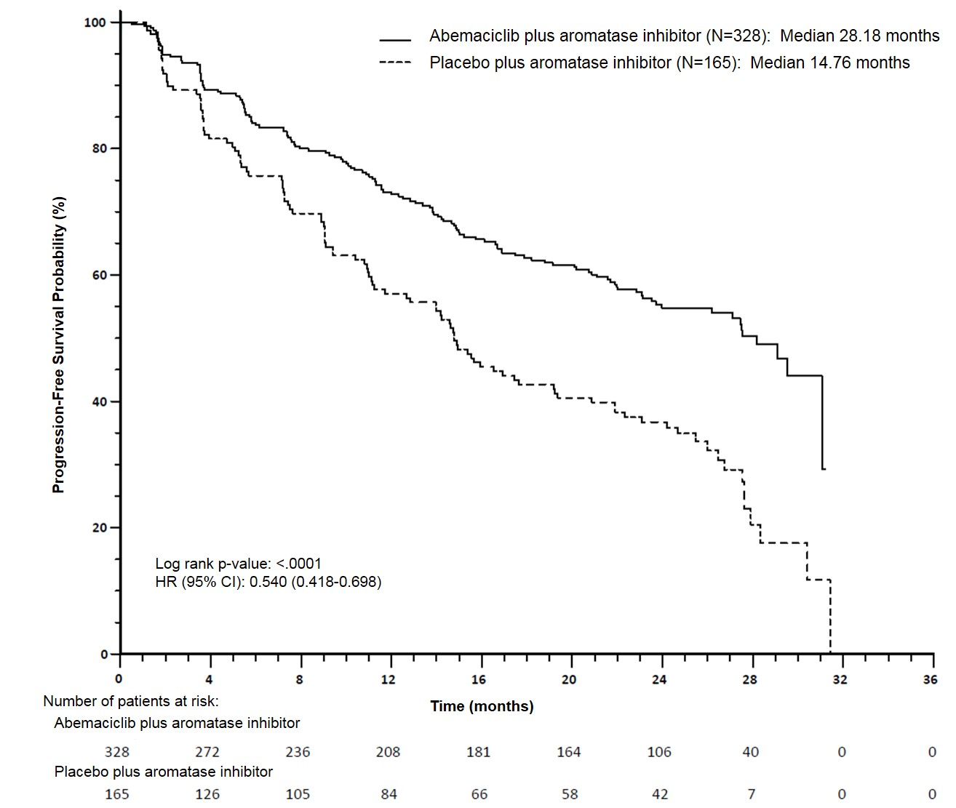

Progression-free survival (PFS) was significantly prolonged in the VERZENIO plus aromatase inhibitor (AI) arm, (Hazard Ratio [HR] of 0.540 [95% CI, 0.418 to 0.698]); median PFS was 28.18 months in the VERZENIO plus AI arm and was 14.76 months in the placebo plus AI arm. These results correspond to a clinically meaningful reduction in the risk of disease progression or death of 46% for patients treated with abemaciclib plus an aromatase inhibitor.

Overall survival was not mature at the final PFS analysis (93 events observed across the two arms). The HR was 1.057 (95% CI: 0.683, 1.633), p=0.8017.

A series of prespecified subgroup PFS analyses showed consistent results across patient subgroups including age (<65 or ≥65 years), disease site, disease setting (de novo metastatic vs recurrent metastatic vs locally advanced recurrent), presence of measurable disease, progesterone receptor status, and baseline ECOG performance status. A reduction in the risk of disease progression or death was observed in patients with visceral disease, (HR of 0.567 [95% CI: 0.407, 0.789]), median PFS 21.6 months versus 14.0 months; in patients with bone-only disease (HR 0.565, [95% CI: 0.306, 1.044]); and in patients with measurable disease (HR 0.517, [95% CI: 0.392, 0.681]).

**Randomised Phase 3 Study MONARCH 2: VERZENIO in combination with fulvestrant**

The efficacy and safety of VERZENIO was evaluated in MONARCH 2, a randomised, double‑blind, placebo‑controlled phase 3 study in women with HR positive, HER2 negative locally advanced or metastatic breast cancer. Patients were randomised in a 2:1 ratio to receive VERZENIO 150 mg twice daily plus fulvestrant 500 mg at intervals of one month, with an additional 500 mg dose given two weeks after the initial dose, versus placebo plus fulvestrant alone according to the same schedule. The primary endpoint was investigator-assessed PFS evaluated according to RECIST 1.1; key secondary efficacy endpoints included objective response rate (ORR), clinical benefit rate (CBR) and overall survival (OS).

Patients were well matched for baseline demographics and prognostic characteristics between the abemaciclib plus fulvestrant arm and the placebo plus fulvestrant arm. The median age of patients enrolled was 60 years (range, 32‑91 years). In each treatment arm the majority of patients were white and had not received chemotherapy or any prior endocrine therapy for metastatic disease. 17% of patients were pre/perimenopausal. Approximately 56% patients had visceral metastases. Approximately 25% patients had primary resistance to endocrine therapy as per ESMO International Consensus Guidelines for Advanced Breast Cancer, with the majority of patients having secondary resistance.

The study met the primary endpoint demonstrating a statistically significant prolongation in PFS and a clinically meaningful treatment effect. Primary efficacy results are summarised in Table 13 and Figure 3.

**Table 13. MONARCH 2: Summary of efficacy data (Investigator assessment, intent-to-treat population)**

|  |  |  |
| --- | --- | --- |
|  | VERZENIO plus fulvestrant | Placebo plus fulvestrant |
| **Progression-free survival** | N=446 | N=223 |
| Investigator assessment, number of events (%) | 222 (49.8) | 157 (70.4) |
| Median [months] (95% CI) | 16.4 (14.4, 19.3) | 9.3 (7.4, 12.7) |
| Difference in PFS (months) | 7.2 | |
| Hazard ratio (95% CI) and p-value | 0.553 (0.449, 0.681), p=0.0000001 | |
| Independent radiographic review, number of events (%) | 164 (36.8) | 124 (55.6) |
| Median [months] (95% CI) | 22.4 (18.3, NR ) | 10.2 (5.8, 14.0) |
| Hazard ratio (95% CI) and p-value | 0.460 (0.363, 0.584); p <.000001 | |
| **Objective response rate**a [%] (95% CI) | 35.2 (30.8, 39.6) | 16.1 **(**11.3, 21.0) |
| Duration of response [months] (95%CI) | NR (18.05, NR) | 25.6 (11.9, 25.6) |
| **Objective response for patients with measurable disease** | **N=318** | **N=164** |
| Objective response ratea [%] (95% CI) | 48.1 (42.6, 53.6) | 21.3 (15.1, 27.6) |
| Complete response, (%) | 3.5 | 0 |
| Partial response, (%) | 44.7 | 21.3 |
| **Disease control rate**b **(measurable disease)** [%] (95% CI) | 82.4 (78.2, 86.6) | 72.6 (65.7, 79.4) |
| **Clinical benefit rate**c **(measurable disease)** | 73.3 (68.4, 78.1) | 51.8 (44.2, 59.5) |

a Complete response + partial response

b Complete response + partial response + stable disease

c Complete response + partial response + stable disease for ≥ 6 months

N=number of patients; CI=confidence interval

**Figure 3. MONARCH 2: Kaplan-Meier plot of progression-free survival (Investigator assessment, intent-to-treat population)**

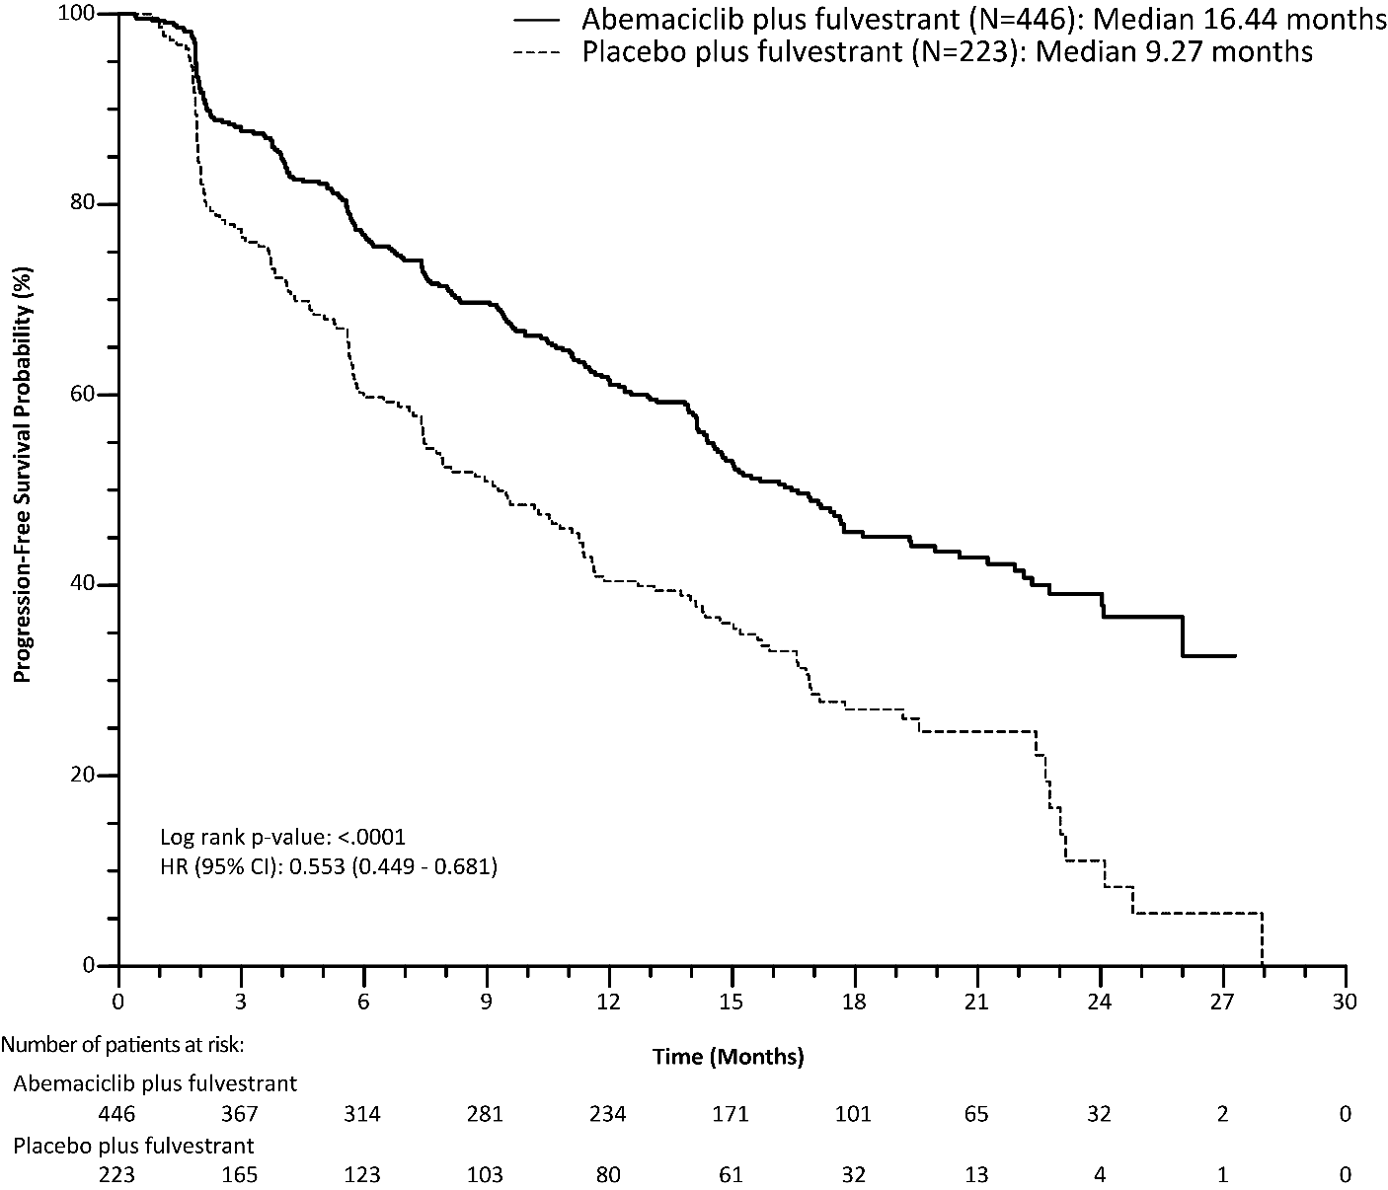

Median PFS was significantly prolonged in the VERZENIO plus fulvestrant arm (HR of 0.553 [95% CI 0.449, 0.681]); median PFS was 16.4 months versus 9.3 months in the placebo plus fulvestrant arm. These results correspond to a clinically meaningful reduction in the risk of disease progression or death of 44.7% and a 7.2 month improvement in median PFS for patients treated with VERZENIO plus fulvestrant. Early and sustained separation by treatment arm was apparent beginning at 8 weeks. VERZENIO plus fulvestrant prolonged progression‑free survival with neither a clinically meaningful or significant detriment to health‑related quality of life.

The addition of VERZENIO to fulvestrant significantly delayed the time to post‑discontinuation chemotherapy, hazard ratio 0.651 (95% CI: 0.502, 0.845). The median time to chemotherapy for the abemaciclib arm was not yet reached and for the placebo plus fulvestrant arm was 26 months.

A series of prespecified subgroup PFS analyses were performed based on prognostic factors and baseline characteristics to confirm consistency of the treatment effect. A reduction in the risk of disease progression or death in favour of the VERZENIO plus fulvestrant arm was observed in all patient subgroups. Consistent results were observed across patient subgroups including age (<65 or ≥65 years), race, geographic region, disease site, endocrine therapy resistance, presence of measurable disease, progesterone receptor status, and menopausal status. A reduction in the risk of disease progression or death was evident in patients with visceral disease, (HR of 0.481 (95% CI: 0.369, 0.627], median PFS 14.7 months versus 6.5 months); in patients with bone‑only disease (HR of 0.543 [95% CI: 0.355, 0.833]); patients with measurable disease (HR of 0.523 [95% CI: 0.412, 0.644]). In patients who were pre/perimenopausal, the hazard ratio was 0.415 (95% CI: 0.246, 0.698); in patients who were progesterone receptor negative, the HR was 0.509 [95% CI: 0.325, 0.797]).

In the population of 44 patients who presented de novo with locally advanced or metastatic disease, and had not received any prior endocrine therapy, the addition of VERZENIO to fulvestrant reduced the risk of disease progression or death in this population by 54.6% (HR of 0.454 [95% CI: 0.179, 1.154]).

Overall survival (OS) analysis in the ITT population showed a statistically significant improvement in patients receiving VERZENIO plus fulvestrant compared with those receiving placebo plus fulvestrant. The overall survival results are summarised in Table 14 and Figure 4.

**Table 14. MONARCH 2: Summary of overall survival data (Intent-to-treat population)**

|  |  |  |
| --- | --- | --- |
|  | VERZENIO plus fulvestrant | Placebo plus fulvestrant |
| **Overall survival** | N = 446 | N = 223 |
| Number of events (n, %) | 211 (47.3) | 127 (57.0) |
| Median OS [months] (95 % CI) | 46.7 (39.2, 52.2) | 37.3 (34.4, 43.2) |
| Hazard ratio (95 % CI) | 0.757 (0.606, 0.945) | |
| p-value | 0.0137 | |

N = number of patients; CI = confidence interval; OS = overall survival

**Figure 4. MONARCH 2: Kaplan-Meier plot of overall survival (Intent-to-treat population)**

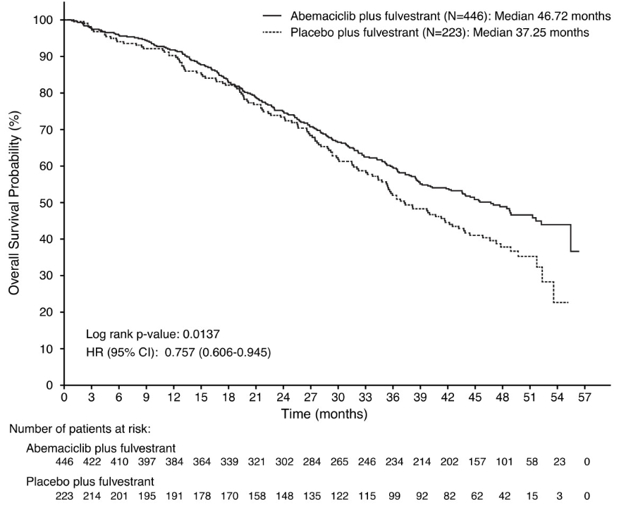

Analyses for OS by stratification factors showed OS HR of 0.675 (95 % CI: 0.511, 0.891) in patients with visceral disease, and 0.686 (95 % CI: 0.451, 1.043) in patients with primary endocrine resistance.

**Phase 2 study MONARCH 1: VERZENIO monotherapy**

The efficacy and safety of VERZENIO was evaluated in MONARCH 1, a single-arm, open-label trial in 132 women with HR positive, HER2 negative metastatic breast cancer who had failed prior endocrine therapies and had received one or 2 prior chemotherapy regimens in the metastatic setting. Patients received VERZENIO 200 mg twice daily. The primary endpoint was objective response rate (ORR). Efficacy results for MONARCH 1 are summarised in Table 15.

**Table 15. MONARCH 1: Summary of efficacy data (Investigator assessment, intent-to-treat population)**

|  |  |
| --- | --- |
|  | VERZENIO  N=132 |
| Objective response ratea, [%] (95% CI) | 19.7 (13.3, 27.5) |
| Median time to response (range) | 3.7 months (1.1-14.2 months) |
| Median duration of response (95% CI) | 8.6 months (5.8, 10.2 months) |
| Clinical benefit rateb, [%] (95% CI) | 42.4 (33.9, 51.3) |

a All responses were partial responses.

b Clinical benefit rate includes all patients who achieved an objective response or who had stable disease for at least 6 months.

N=number of patient, CI=confidence interval.

At the time of the final analysis of survival (minimum of 18 months follow-up), 19 of the 26 responding patients had responses of 6 months or longer, and 6 patients were still on treatment with response durations ranging from 9.5+ to 20.5+ months.

***Visceral crisis***

There are no data on the efficacy and safety of abemaciclib in patients with visceral crisis.

## Pharmacokinetic properties

### Absorption

Abemaciclib absorption is slow, with a median Tmax of 8.0 hours. The absolute bioavailability of abemaciclib is 45% (90% confidence interval: 40-51%). In the therapeutic dose range of 50-200 mg, the increase in plasma exposure (AUC) and Cmax is dose proportional. Steady state was achieved within 5 days following repeated twice daily dosing, and abemaciclib accumulated with a geometric mean accumulation ratio of 3.7 (58% CV) and 5.8 (65% CV) based on Cmax and AUC, respectively.

### Distribution

Abemaciclib was highly bound to plasma proteins in humans (mean bound fraction was approximately 96-98%), and the binding was independent of concentration from 152 ng/mL to 5066 ng/mL. Abemaciclib binds to both human serum albumin and alpha-1-acid glycoprotein. The geometric mean systemic volume of distribution is approximately 747 L (68.6% CV). In patients with advanced cancer, concentrations of abemaciclib and its active metabolites M2 and M20 in cerebrospinal fluid are comparable to unbound plasma concentrations.

### Metabolism

Hepatic metabolism is the main route of clearance for abemaciclib. Abemaciclib is metabolized to several metabolites primarily by cytochrome P450 (CYP) 3A, with formation of N-desethyl abemaciclib (M2) representing the major metabolism pathway. Additional metabolites include hydroxyabemaciclib (M20), hydroxy-N-desethylabemaciclib (M18), and an oxidative metabolite (M1). Metabolites N-desethylabemaciclib (M2) and hydroxyabemaciclib (M20) are active with similar potency as abemaciclib.

### Excretion

The geometric mean hepatic clearance (CL) of abemaciclib was 21.8 L/h (39.8% CV), and the mean plasma elimination half-life for abemaciclib in patients was 24.8 hours (52.1% CV). After a single oral dose of [14C]-abemaciclib, approximately 81% of the dose was excreted in faeces and 3.4% excreted in urine. The majority of the dose eliminated in faeces was metabolites.

### Use in hepatic impairment

Abemaciclib is metabolised in the liver. In subjects with severe hepatic impairment, total abemaciclib unbound exposure increased 2.69-fold, and the abemaciclib half-life increased from 24 to 55 hours. Reduce the abemaciclib dosing frequency to once daily in patients with severe hepatic impairment.

### Use in renal impairment

Abemaciclib and its metabolites are not significantly cleared renally. Dose adjustment is not necessary in patients with mild or moderate renal impairment. There are no data in patients with severe renal impairment, end stage renal disease, or in patients on dialysis.

## Preclinical safety data

### Genotoxicity

Abemaciclib was not mutagenic in a bacterial reverse mutation (Ames) assay and did not induce structural chromosomal aberrations in the in vitro chromosome aberration assay with human lymphocytes, or the in vivo rat micronucleus test. Metabolites M2 and M20 were not mutagenic in the Ames assay, did not induce structural chromosomal aberrations in Chinese Hamster Ovary cells in the in vitro chromosome aberration assay, and were not clastogenic in the rat bone marrow micronucleus assay.

### Carcinogenicity

In male rats treated for 95 weeks with abemaciclib at ≥1mg/kg/day (less than or similar to clinical exposure based on AUC), abemaciclib caused interstitial (Leydig) cell hyperplasia and benign adenomas in testes. It is unknown if this effect will translate to humans. There were no neoplastic findings in mice or female rats.

# Pharmaceutical particulars

## List of excipients

|  |  |
| --- | --- |
| Tablet cores | Film coating |
| croscarmellose sodium | polyvinyl alcohol (E1203) |
| lactose monohydrate | titanium dioxide (E171) |
| microcrystalline cellulose | macrogol 3350 (E1521) |
| silicon dioxide | purified talc (E553b) |
| sodium stearyl fumarate | iron oxide yellow (E172) [50 mg and 150 mg tablets only] |
|  | iron oxide red (E172) [50 mg tablets only] |

## Incompatibilities

Incompatibilities were either not assessed or not identified as part of the registration of this medicine.

## Shelf life

In Australia, information on the shelf life can be found on the public summary of the Australian Register of Therapeutic Goods (ARTG). The expiry date can be found on the packaging.

## Special precautions for storage

Store below 30 °C

## Nature and contents of container

VERZENIO is available as a modified oval immediate-release film-coated tablet with “Lilly” debossed on one side and tablet strength in mg debossed on the other.

The 50 mg tablets are beige in colour, 100 mg is white and 150 mg tablets are yellow.

VERZENIO is supplied in PVC/PE/PCTFE blister packs sealed with aluminum foil lidding.

Pack sizes:

50 mg, 100 mg, 150 mg: 14 tablets*

50 mg, 100 mg, 150 mg: 42 tablets*

50 mg, 100 mg, 150 mg: 56 tablets*

50 mg, 100 mg, 150 mg: 70 tablets*.

*\*Not all pack sizes may be marketed.*

## Special precautions for disposal

In Australia, any unused medicine or waste material should be disposed of by taking to your local pharmacy.

## Physicochemical properties

### Chemical structure

The molecular formula for abemaciclib is C27 H32 F2 N8 and it has the following structural formula



### CAS number

1231929-97-7

# Medicine schedule (Poisons Standard)

Schedule 4

# Sponsor

Eli Lilly Australia Pty Ltd

112 Wharf Road, West Ryde NSW 2114 AUSTRALIA

Phone: 1800 454 559

Email: au_info@lilly.com

Web: www.lilly.com.au

# Date of first approval

08-April-2019

# Date of revision

09-June-2022

## Summary table of changes

|  |  |
| --- | --- |
| Section Changed | Summary of new information |
| 4.2 | Information related to dose modification and management. |
| 5.1 | Update to clinical trial information. |
| 4.1, 4.2, 4.4, 4.6, 4.8 and 5.1 | New Indication |