|  |
| --- |
| November 2022 |

|  |
| --- |
| Australian Public Assessment Report for Verzenio |
| Active ingredient: Abemaciclib |
| Sponsor: Eli Lilly Australia Pty Ltd |

About the Therapeutic Goods Administration (TGA)

* The Therapeutic Goods Administration (TGA) is part of the Australian Government Department of Health and is responsible for regulating therapeutic goods, including medicines, medical devices, and biologicals.
* The TGA administers the *Therapeutic Goods Act 1989* (the Act), applying a risk management approach designed to ensure therapeutic goods supplied in Australia meet acceptable standards of quality, safety, and efficacy.
* The work of the TGA is based on applying scientific and clinical expertise to decision-making, to ensure that the benefits to the Australian public outweigh any risks associated with the use of therapeutic goods.
* The TGA relies on the public, healthcare professionals and industry to report problems with therapeutic goods. The TGA investigates reports received to determine any necessary regulatory action.
* To report a problem with a therapeutic good, please see the information on the [TGA website](https://www.tga.gov.au).

About AusPARs

* The Australian Public Assessment Report (AusPAR) provides information about the evaluation of a prescription medicine and the considerations that led the TGA to approve or not approve a prescription medicine submission. Further information can be found in [Australian Public Assessment Report (AusPAR) guidance](https://www.tga.gov.au/australian-public-assessment-report-auspar-guidance).
* AusPARs are prepared and published by the TGA.
* AusPARs are static documents that provide information that relates to a submission at a particular point in time. The publication of an AusPAR is an important part of the transparency of the TGA’s decision-making process.
* A new AusPAR may be provided to reflect changes to indications or major variations to a prescription medicine subject to evaluation by the TGA.

Copyright

© Commonwealth of Australia 2022  
This work is copyright. You may reproduce the whole or part of this work in unaltered form for your own personal use or, if you are part of an organisation, for internal use within your organisation, but only if you or your organisation do not use the reproduction for any commercial purpose and retain this copyright notice and all disclaimer notices as part of that reproduction. Apart from rights to use as permitted by the *Copyright Act 1968* or allowed by this copyright notice, all other rights are reserved, and you are not allowed to reproduce the whole or any part of this work in any way (electronic or otherwise) without first being given specific written permission from the Commonwealth to do so. Requests and inquiries concerning reproduction and rights are to be sent to the TGA Copyright Officer, Therapeutic Goods Administration, PO Box 100, Woden ACT 2606 or emailed to <[tga.copyright@tga.gov.au](mailto:tga.copyright@tga.gov.au)>.

Contents

List of abbreviations 4

Product submission 6

Submission details 6

Product background 7

Regulatory status 11

Product Information 13

Registration timeline 13

Submission overview and risk/benefit assessment 14

Quality 14

Nonclinical 14

Clinical 15

Risk management plan 39

Risk-benefit analysis 39

Outcome 48

Specific conditions of registration applying to these goods 49

Attachment 1. Product Information 49

## List of abbreviations

|  |  |  |
| --- | --- | --- |
| Abbreviation | | Meaning |
| ACM | Advisory Committee on Medicines | |
| AE | Adverse event | |
| ALN | Axillary lymph node(s) | |
| ALT | Alanine aminotransferase | |
| ARTG | Australian Register of Therapeutic Goods | |
| AST | Aspartate aminotransferase | |
| AUCτ,ss | Area under the concentration-time curve over a dosing interval at steady state | |
| CDK | Cyclin-D dependent kinase | |
| CI | Confidence interval | |
| Cmax,ss | Maximum plasma concentration at steady state | |
| CMI | Consumer Medicine Information | |
| COVID-19 | Coronavirus disease 2019 | |
| CTCAE | Common Terminology Criteria for Adverse Event | |
| DFS | Disease-free survival | |
| DRFS | Distant recurrence-free survival | |
| ECOG | Eastern Cooperative Oncology Group | |
| ESMO | European Society for Medical Oncology | |
| FDA | Food and Drug Administration (United States of America) | |
| GnRH | Gonadotropin-releasing hormone | |
| HCP | Healthcare professional | |
| HER2 | Human epidermal growth factor receptor 2 | |
| HER2-/HER2 neg | Human epidermal growth factor receptor 2 negative | |
| HR | Hormone receptor | |
| HR+/HR pos | Hormone receptor positive | |
| IDFS | Invasive disease-free survival | |
| IHC | Immunohistochemistry | |
| ITT | Intent(ion)-to-treat | |
| Ki-67 | Antigen Ki-67 | |
| LHRH | Luteinising hormone-releasing hormone | |
| M2 | Metabolite M2 | |
| M20 | Metabolite M20 | |
| OS | Overall survival | |
| pALN | Positive axillary lymph node(s) | |
| PD | Pharmacodynamic(s) | |
| PI | Product Information | |
| PK | Pharmacokinetic(s) | |
| PopPK | Population pharmacokinetic(s) | |
| QTcF | QT interval corrected for heart rate according to Fridericia’s formula | |
| SAE | Serious adverse event | |
| STEEP | Standardised definitions for efficacy endpoints | |
| TEAE | Treatment-emergent adverse event | |
| TGA | Therapeutic Goods Administration | |
| TNM | Tumour, Node, Metastasis | |
| ULN | Upper limit of normal | |
| US(A) | United States (of America) | |

## Product submission

### Submission details

|  |  |
| --- | --- |
| *Type of submission:* | Extension of indications |
| *Product name:* | Verzenio |
| *Active ingredient:* | Abemaciclib |
| *Decision:* | Approved |
| *Date of decision:* | 25 May 2022 |
| *Date of entry onto ARTG:* | 9 June 2022 |
| *ARTG numbers:* | 304764, 304765, 304766 and 304767 |
| [*Black Triangle Scheme*](https://www.tga.gov.au/black-triangle-scheme)*:* | Yes.  This product will remain in the scheme for 5 years, starting on the date the new indication was approved. |
| *Sponsor’s name and address:* | Eli Lilly Australia Pty Ltd  112 Wharf Road  West Ryde NSW 2114 |
| *Dose form:* | Film coated tablet |
| *Strengths:* | 50 mg, 100 mg, 150 mg and 200 mg |
| *Container:* | Blister pack |
| *Pack sizes:* | 14, 42, 56 and 70 tablets |
| *Approved therapeutic use:* | ***Early breast cancer***  *Verzenio in combination with endocrine therapy is indicated for the adjuvant treatment of patients with hormone receptor (HR) positive, human epidermal growth factor receptor 2 (HER2) negative, node-positive early breast cancer at high risk of recurrence.*  *In pre- or peri-menopausal women, endocrine therapy should be combined with a luteinising hormone-releasing hormone (LHRH) agonist.* |
| *Route of administration:* | Oral |
| *Dosage:* | Verzenio therapy should be initiated and supervised by physicians experienced in the use of anti-cancer therapies.  The recommended dose of Verzenio is 150 mg orally, twice daily in combination with endocrine therapy. Administer the recommended dose of endocrine therapy when given with Verzenio.  *Early breast cancer*  Treatment with Verzenio plus endocrine therapy should be combined with luteinising hormone-releasing hormone agonist for pre-menopausal women.  Verzenio should be taken continuously for two years, or until disease recurrence or unacceptable toxicity occurs whichever comes first.  *Advanced or metastatic breast cancer*  Women treated with the combination of Verzenio plus endocrine therapy should be in a post-menopausal state prior to therapy.  It is recommended that treatment be continued until disease progression or unacceptable toxicity.  For further information regarding dosage, refer to the Product Information. |
| *Pregnancy category:* | D  Drugs which have caused, are suspected to have caused or may be expected to cause, an increased incidence of human fetal malformations or irreversible damage. These drugs may also have adverse pharmacological effects. Accompanying texts should be consulted for further details.  The use of any medicine during pregnancy requires careful consideration of both risks and benefits by the treating health professional. This must not be used as the sole basis of decision making in the use of medicines during pregnancy. The TGA does not provide advice on the use of medicines in pregnancy for specific cases. More information is available from obstetric drug information services in your State or Territory. |

### Product background

This AusPAR describes the submission by Eli Lilly Australia Pty Ltd (the sponsor) to register Verzenio (abemaciclib) 50 mg, 100 mg, 150 mg and 200 mg film coated tablets for the following proposed extension of indications:

***Early breast cancer***

*Verzenio in combination with endocrine therapy is indicated for the adjuvant treatment of patients with hormone receptor (HR)-positive, human epidermal growth factor receptor 2 (HER2)-negative, node-positive early breast cancer at high risk of recurrence.*

*In pre- or perimenopausal women, aromatase inhibitor endocrine therapy should be combined with a luteinising hormone-releasing hormone (LHRH) agonist.*

#### Breast cancer

Breast cancer is the most frequent cancer among women and a major cause of cancer‑related deaths worldwide. Cancer Australia estimated there would be 20,640 new cases of breast cancer diagnosed in 2022, representing 12.7% of all new cancer diagnosis. Of these around 1% were expected to occur in males. It was estimated breast cancer would comprise 6.4% of all cancer deaths (36 males and 3178 females).[1]

Breast cancer is a heterogeneous disease, comprising several subtypes. Based on US SEER data;[2] hormone receptor positive (HR+), human epidermal growth factor receptor 2 negative (HER2-) breast cancer is the most prevalent subtype, accounting for 73% of all breast cancers.[3]

Approximately 90% of patients with breast cancer are diagnosed at an early stage of their disease and treated with curative intent.[4] Treatment options for early breast cancer include surgery, radiotherapy, chemotherapy (neoadjuvant or adjuvant) and endocrine therapy, with decisions regarding treatment informed by various factors including risk of recurrence.

The tumour, node, metastasis (TNM) staging system,[5] immunohistochemistry (HR or HER2 positivity), tumour grade, biomarker data and surgical findings are considered in the assessment of risk of disease recurrence. Clinical and pathological features that indicate a higher risk of distant disease relapse and the need for adjuvant treatment include large primary tumour size, involvement and degree of involvement of axillary lymph nodes, and high histologic grade. Those patients deemed at higher risk of recurrence often receive more extensive and aggressive primary treatment in the form of chemotherapy (either neoadjuvant or adjuvant), surgery, and/or radiotherapy.

The risk of recurrence of HR+, HER2- breast cancer varies over time. Whilst adjuvant endocrine therapy significantly reduces the risk of recurrence and death, approximately 20% of patients with HR+, HER2- breast cancer will relapse within 10 years of diagnosis.[6] Relapse within the first 2 years of treatment defines primary endocrine resistance.[7] Recurrence of HR+ breast cancer can however occur much later. In a recent meta-analysis of trials including women with HR+ breast cancer disease-free after 5 years of adjuvant endocrine therapy, breast cancer recurrences continued to occur steadily throughout the study period from 5 to 20 years, with risk of distant recurrence strongly correlated with the original tumour diameter and nodal status.[8]

#### Current management options

There are numerous clinical management guidelines for HR+, HER2- early breast cancer in Australia that are constantly evolving. In September 2020, Cancer Australia released a guidance document for the management of early breast cancer, which includes recommendations and practice points on the management of early breast cancer that are of clinical relevance to specialists and general practitioners in Australia.[9] In addition, international guidelines are available to support Australian clinicians in making treatment decisions. These include those produced by the European School of Oncology-European Society for Medical Oncology (ESMO),7 St. Gallen International Consensus Guidelines,[10],[11] American Society of Clinical Oncology,[12],[13] the United States (US) National Comprehensive Cancer Network,[14] the US National Cancer Institute,[15] and the National Institute for Health and Care Excellence in the United Kingdom.[16]

All guidelines have a similar sequential treatment approach as described below:

* Surgical excision followed very often by radiotherapy.
* Some patients may receive neoadjuvant treatment prior to surgery (chemotherapy, endocrine therapy or other).
* The use of adjuvant systemic therapy after surgery is based on estimated individual risk of disease recurrence and predicted sensitivity to available systemic therapies. Patients with node positive disease are most often candidates for chemotherapy in either a neoadjuvant and/or adjuvant setting. Adjuvant endocrine therapy is indicated in all patients with HR+ disease and prescribed for 5 to 10 years following primary treatment. The choice of agent (tamoxifen and/or aromatase inhibitor) is primarily determined by the patient’s menopausal status, ovarian function suppression, and physician preference.

Currently approved endocrine therapy options in Australia for patients with breast cancer or specifically early breast cancer are summarised below:

* Tamoxifen,[17] (a selective estrogen receptor modulator); letrozole,[18] or anastrozole,[19] (both non-steroidal aromatase inhibitors) are approved for their first line indications for the treatment of breast cancer.
* Exemestane,[20] a steroidal aromatase inhibitor is approved for its second line indications in patients who have received prior adjuvant tamoxifen therapy.
* Goserelin,[21] a luteinising hormone-releasing hormone (LHRH) agonist is indicated as adjuvant therapy in early breast cancer, in pre- and peri-menopausal women suitable for hormonal manipulation.

#### Cyclin-D dependent kinase inhibitors

Abemaciclib, palbociclib and ribociclib are inhibitors of cyclin-D dependent kinases 4 and 6 (CDK4 and CDK6), currently registered in Australia for use in the locally advanced/metastatic breast cancer setting.

Via inhibition of inhibition of CDK4 and CDK6, abemaciclib prevents retinoblastoma protein phosphorylation, thereby blocking progression from the gap 1 phase into synthesis phase of the cell cycle. In estrogen receptor positive breast cancer cell lines, sustained target inhibition by abemaciclib prevents rebound of retinoblastoma protein phosphorylation.

Clinical efficacy has been observed for abemaciclib in terms of improved progression-free survival and overall survival (OS) in Phase III studies in patients with metastatic breast cancer treated with abemaciclib plus fulvestrant (the MONARCH 2 trial) or abemaciclib plus aromatase inhibitors (MONARCH 3 trial).

In this submission, the sponsor has submitted results for the Phase III MONARCHE trial (Study I3Y-MC-JPCF) aiming to evaluate abemaciclib in combination with standard adjuvant endocrine therapy in patients with node-positive, early stage, HR+, HER2-, invasive breast cancer at high risk of recurrence as determined by clinical and pathological features.

The sponsor’s rationale for the investigation of abemaciclib in this setting from the submission was due to high percentage (approximately 30%) of patients with HR+ early breast cancer eventually experience disease relapse with metastases following treatment with curative intent with current standard of care adjuvant endocrine therapy. Since the introduction of aromatase inhibitors in the early 2000s in HR+ early breast cancer, little improvement in the outcomes for patients with HR+ early breast cancer has occurred. There continues to be unmet need in patients with HR+ early breast cancer at high risk of recurrence, with reports in the literature of 5-year distant recurrence risks of approximately 20% in patients with high (4 to 9) nodal involvement.

#### Ki-67 as prognostic biomarker

Study I3Y-MC-JPCF (the MONARCHE trial) utilised centrally assessed Ki-67 as a method to identify highly proliferative tumours with a greater risk of recurrence.

The sponsor’s rational for the use of Ki-67;[22] in the management of patients with early breast cancer in Australia are as follows:

In Australia, Ki-67 is not used routinely in the clinical setting. The Clinical Oncology Society of Australia is in agreement with the Early Breast Cancer: ESMO Clinical Practice Guidelines,7 acknowledges the proliferative activity of tumour cells represents an important prognostic marker in the diagnosis of cancer, and recognises that the proliferative biomarker Ki-67 may provide useful information in the diagnoses of cancer, particularly if the assay can be standardised. However, there is currently a lack of a standard method to ascertain the Ki-67 index in a reproducible way in Australia. This lack of standardisation, combined with the heterogeneity in Ki-67 labelling and techniques, leads to inter- and intra-operator variability in the histological assessments, upon which therapeutic options might be determined. The absence of international consensus for Ki-67 scoring and threshold means there are no established guidelines for use of Ki-67 in Australia.

Advice sought from clinical experts and Australian guidance has determined that:

* + Ki-67 indexing is not routinely measured by pathology laboratories in Australia,[23],9 and
  + Ki-67 proliferation rate is also not a standard requirement of the Royal College of Pathologists of Australasia for reporting.[24]

Cancer Australia Early Breast Cancer Guidance, released in 2020,9 cautions against the use of Ki-67 as the sole trigger for the use of adjuvant chemotherapy, without stating a specific cut-off level. The sponsor referred to the Australian expert statement.

As such, Ki-67 indexing is not uniformly available to all oncologists in the public hospitals and has not been incorporated into routine use in Australia.[25]

### Regulatory status

The product received initial registration on the Australian Register of Therapeutic Goods (ARTG) on 8 April 2019 for the following indication:

***Advanced or metastatic breast cancer***

*Verzenio is indicated for the treatment of hormone receptor (HR) positive, human epidermal growth factor receptor 2 (HER2) negative locally advanced or metastatic breast cancer in combination with an aromatase inhibitor or fulvestrant as initial endocrine-based therapy, or following prior endocrine therapy.*

*In pre- or peri-menopausal women, the endocrine therapy should be combined with a luteinising hormone-releasing hormone (LHRH) agonist.*

At the time the TGA considered this submission, similar submissions had been approved in Brazil on 9 August 2021, the USA on 12 October 2021 and Japan on 24 December 2021. A similar submission had been rejected in Switzerland on 11 January 2022. A similar submission was under consideration in the European Union (submitted on 10 November 2020).

The following table summarises these submissions and provides the indications where approved.

Table 1: International regulatory status

|  |  |  |  |
| --- | --- | --- | --- |
| Region | Submission date | Status | Approved indications |
| Brazil | 18 December 2020 | Approved on 9 August 2021 | *Verzenio in combination with endocrine therapy is indicated for the adjuvant treatment of hormone receptor positive (HR+), human epidermal growth factor receptor 2 negative (HER2-), node-positive early breast cancer at high risk of recurrence.* |
| United States of America | 17 December 2020 | Approved on 12 October 2021 | *Verzenio (abemaciclib) is indicated: in combination with endocrine therapy (tamoxifen or an aromatase inhibitor) for the adjuvant treatment of adult patients with hormone receptor (HR)-positive, human epidermal growth factor receptor 2 (HER2)-negative, node-positive, early breast cancer at high risk of recurrence and a Ki-67 score ≥ 20% as determined by an FDA approved test.* |
| Japan | 14 January 2021 | Approved on 24 December 2021 | *Verzenio in combination with endocrine therapy is indicated for the adjuvant treatment of hormone receptor positive (HR+), human epidermal growth factor receptor 2 negative (HER2-), node-positive early breast cancer at high risk* of recurrence.*  *\*The definition of high risk of recurrence is patients with 4 positive axillary lymph nodes (ALN), or 1-3 positive ALN and either Grade 3 disease or tumor size ≥ 5 cm, defined as Cohort 1 in MONARCHE study.* |
| European Union | 10 November 2020 | Under consideration | Under consideration |
| Switzerland | 18 January 2021 | Rejected on 11 January 2022 | Rejected |

Abbreviation: Food and Drug Administration (United States of America).

### Product Information

The Product Information (PI) approved with the submission which is described in this AusPAR can be found as Attachment 1. For the most recent PI, please refer to the TGA [PI/CMI search facility.](https://www.tga.gov.au/picmi-search-facility)

## Registration timeline

The following table captures the key steps and dates for this submission.

Table 2: Timeline for Submission PM-2020-06568-1-4

|  |  |
| --- | --- |
| Description | Date |
| Submission dossier accepted and first round evaluation commenced | 1 February 2021 |
| First round evaluation completed | 24 September 2021 |
| Sponsor provides responses on questions raised in first round evaluation | 24 November 2021 |
| Second round evaluation completed | 22 December 2021 |
| Delegate’s Overall benefit-risk assessment and request for Advisory Committee advice | 4 January 2022 |
| Sponsor’s pre-Advisory Committee response | 17 January 2022 |
| Advisory Committee meeting | 3 and 4 February 2022 |
| Registration decision (Outcome) | 25 May 2022 |
| Completion of administrative activities and registration on the ARTG | 9 June 2022 |
| Number of working days from submission dossier acceptance to registration decision* | 252 |

*Statutory timeframe for standard submissions is 255 working days

## Submission overview and risk/benefit assessment

A summary of the TGA’s assessment for this submission is provided below.

Relevant guidelines or guidance documents referred to by the Delegate are listed below:

* European Medicines Agency (EMA), Committee for Medicinal Products for Human Use (CHMP), Guideline on the Evaluation of Anticancer Medicinal Products in Man, EMA/CHMP/205/95/Rev.4, 13 December 2012.
* European Medicines Agency (EMA), Committee for Medicinal Products for Human Use (CHMP), Appendix 1 to the Guideline on the Evaluation of Anticancer Medicinal Products in man, Methodological Consideration for Using Progression-Free Survival (PFS) or Disease-Free Survival (DFS) in Confirmatory Trials, EMA/CHMP/27994/2008/Rev.1, 13 December 2012.
* European Medicines Agency (EMA), Committee for Medicinal Products for Human Use (CHMP), Appendix 4 to the Guideline on the Evaluation of Anticancer Medicinal Products in Man, EMA/CHMP/703715/2012 Rev. 2, 17 December 2015.
* European Medicines Emulations Agency (EMEA), Committee for Proprietary Medicinal Products (CPMP), ICH Topic E 9 Statistical Principles for Clinical Trials, Note for Guidance on Statistical Principles for Clinical Trials, CPMP/ICH/363/96. September 1998.
* European Medicines Emulations Agency (EMEA), Committee for Proprietary Medicinal Products (CPMP), Points to Consider on Application with 1. Meta-Analyses; 2. One Pivotal Study, CPMP/EWP/2330/99, 31 May 2001.

### Quality

A full quality evaluation was conducted at the time this product received initial registration.

### Nonclinical

The new nonclinical data were provided in this submission included studies in repeat‑dose toxicity, genotoxicity, carcinogenicity, and reproductive and development toxicity studies.

The repeat dose toxicity studies in rats had similar findings to those evaluated in the first application for abemaciclib. New findings in this submission included:

* eye effects (cataract in rats potentially related to hyperglycaemia, and retinopathy in mice and rats),
* cardiac effects (valve macrophage vacuolation and inflammation in rats and cardiomyocyte vacuolation in mice),
* pancreatic effects (atrophy of pancreatic islet cells in the 2-year carcinogenicity study in rats),
* liver effects (Kupffer cell hypertrophy or hyperplasia and basophilic granules and hepatocellular single cell necrosis in mice).

The major human metabolites of abemaciclib, metabolites M2 and M20, were not clastogenic *in vivo* in the rat bone marrow micronucleus test. In the carcinogenicity study, incidence of Leydig cell adenomas (and hyperplasia) outside the historical control data range was observed with abemaciclib. A 2-year carcinogenicity study in mice is currently underway. The sponsor is required to provide the study report to the TGA for evaluation once available.

Fertility was unaffected in male and female rats treated with abemaciclib. The number of corpora lutea was decreased in the repeat dose toxicity study in mice. Given the low exposure margins in the fertility study and published reports that inactivation of both cyclin‑D dependent kinases 4 and 6 (CDK4 and CDK6) leads to late embryonic death, adverse effects on female fertility and embryonic development in patients cannot be excluded.

From a nonclinical perspective there were no objections to the proposed extension of the indications of Verzenio.

### Clinical

#### Summary of clinical studies

The clinical dossier consisted of one pivotal Phase III study (Study I3Y-MC-JPCF, also known as the MONARCHE trial). It a Phase III, randomised, open label, multi-centre, multinational study to evaluate the efficacy and safety of abemaciclib combined with standard adjuvant endocrine therapy versus standard adjuvant endocrine therapy alone in 5637 patients with node positive, invasive, resected, hormone receptor positive (HR+), human epidermal growth factor receptor 2 negative (HER2-) early breast cancer who completed definitive locoregional therapy, with or without neoadjuvant or adjuvant chemotherapy, at high risk of disease recurrence.

#### Pharmacology

The submission included an updated abemaciclib mechanistic population pharmacokinetic (PopPK) model and an updated exposure response analysis, that aimed to characterise the therapeutic window of abemaciclib concentrations to support the recommended starting dose for pivotal study for the submission, the MONARCHE trial, and dose adjustments for adverse events (AEs) neutropaenia and diarrhoea. The MONARCHE trial PopPK/pharmacodynamic (PD) analysis supported the abemaciclib starting dose of 150 mg twice daily in combination with endocrine therapy, with dose adjustments for safety and tolerability.

Pre-defined sparse pharmacokinetic (PK) sampling from 487 patients in the MONARCHE trial contributed 4710 PK concentrations (n = 1567 for abemaciclib, n = 1577 for metabolite M2, n = 1566 for metabolite M20) that were added to the model, without further covariate model development.

Steady state exposures of abemaciclib, the major metabolites M2 and M20, and total active species were simulated for each patient in the PK population using their individual PK model parameter estimates, their individual demographics (body weight and height), and their average abemaciclib dose amounts taken during the study at the time of Interim Analysis 2 data cut-off (mean dose average 130 mg).

Overall, there were no discernible differences identified in the PK model parameter estimates or individual simulated PK exposures for the covariates of interest age, body weight, sex, selected Asian ethnicities (Chinese, Japanese, or other East Asian) and enrolment cohort. Compared to the metastatic breast cancer Phase III MONARCH 3 study, a decrease of 18% and 13% for abemaciclib AUCτ,ss (area under the concentration-time curve within a dosing interval at steady state) and total active species (abemaciclib, metabolite M2 and M20) AUCτ,ss in the MONARCHE trial population was noted but not considered clinically relevant.

Exposure response analyses were conducted to assess the relationships between abemaciclib exposures and the two most frequent treatment-emergent adverse events (TEAEs), diarrhoea and neutropaenia using models previously used to support abemaciclib in metastatic breast cancer, updated with the MONARCHE trial data. Three PK/PD analysis datasets were created by combining the PopPK model predicted individual exposure metrics for abemaciclib, M2, M20, and total active species with neutrophil counts, time of first occurrence of diarrhoea, and maximum Common Terminology Criteria;[26] for Adverse Event (CTCAE) grade of diarrhoea.

##### Diarrhoea

The diarrhoea analysis comprised 2 modelling approaches: a time-to-event analysis for the first occurrence of diarrhoea, and a logistic (ordered categorical) analysis of maximum diarrhoea grade at any time. The final time-to-event diarrhoea analysis dataset included data from 3233 patients (483 patients with exposure metrics) and the final maximum diarrhoea CTCAE grade PK/PD analysis dataset comprised data from 3247 patients (483 patients with exposure metrics). In the data set for analysis opioid use was recorded and included loperamide (μ-opioid receptor agonist) in the calculation. Opioid use was recorded in 66% of the abemaciclib plus endocrine therapy arm and 11% of the endocrine therapy alone arm (loperamide use was reported in 94% and 14%, respectively).

The model predicted probability of developing diarrhoea after one week of study treatment was 19%, 50% and less than 3% for patients receiving abemaciclib plus endocrine therapy, opioids plus abemaciclib plus endocrine therapy, and endocrine therapy alone respectively.

The model predicted probability of diarrhoea of any grade (at any time) on study treatment was 75%, 93%, 6% and 21% for patients receiving abemaciclib plus endocrine therapy, opioids plus abemaciclib plus endocrine therapy, endocrine therapy alone and opioids plus endocrine therapy alone, respectively.

##### Neutropaenia

For neutropaenia, the time course of neutrophil counts in the PK population in the MONARCHE trial was described using a semi-mechanistic model of drug induced myelosuppression.

In the final neutropaenia PK/PD analysis dataset, 483 patients contributed a total of 2397 neutrophil counts. Model evaluation was performed using neutrophil data from all patients in the primary neutropaenia PK/PD dataset (omitting samples taken prior to the day of the first recorded dose and greater than 80 days after start of study treatment); n = 2787 patients and 13842 neutrophil counts.

The final model predicted Grade 3 or higher neutropaenia in 9% (95% confidence interval (CI): 6.4, 11.0) of the MONARCHE trial patients at nadir (28 to 43 days after start of abemaciclib treatment), with no differences in neutropaenia for selected Asian ethnicities, age group, sex or enrolment cohort. An increase in abemaciclib exposure of 30% is predicted to increase inhibition of the neutrophil progenitor pool by 16% to 28% depending on the individual patient’s baseline exposure.

Because the relationship between total active species Cmax,ss (maximum plasma concentration at steady state), total and neutrophil production rate in the MONARCHE trial was similar to the abemaciclib metastatic breast cancer studies, and changes in abemaciclib PK are predicted to result in similar changes to neutrophil counts in both patient populations, the dose adjustment recommendations for neutropaenia management in the metastatic breast cancer population were adopted for the MONARCHE trial population.

#### Efficacy

The MONARCHE trial (Study I3Y-MC-JPCF) is a Phase III, randomised, open-label, multi-centre, multinational study to evaluate the efficacy and safety of abemaciclib combined with standard adjuvant endocrine therapy versus standard adjuvant endocrine therapy alone in patients with node positive, invasive, resected, hormone receptor positive (HR+), human epidermal growth factor receptor 2 negative (HER2-) early breast cancer who completed definitive locoregional therapy, with or without neoadjuvant or adjuvant chemotherapy, at high risk of disease recurrence.

The clinical evaluation did not recommend approval for the requested indication based on the lack of benefit for overall survival (OS) in the intent-to-treat (ITT)[27] population, the toxicities of abemaciclib, and the practical aspects of introducing Ki‑67;22,[28] as a measure of patient risk to characterise a subpopulation of patients that might benefit from abemaciclib plus endocrine therapy in this setting.

Figure 1: Study I3Y-MC-JPCF (MONARCHE trial) Study design

Figure 1: Study I3Y-MC-JPCF (MONARCHE trial) Study design

Study I3Y-MC-JPCF is a Phase III adjuvant study in patients (women and men) with hormone receptor positive, human epidermal growth factor receptor 2 negative, node positive, early breast cancer who completed definitive locoregional therapy (with or without neoadjuvant or adjuvant chemotherapy) and are at high risk for disease recurrence.

Cohort 1: eligible based on clinical and/or pathological features, such as the degree of axillary lymph node involvement, tumour size, grade, or a combination of any of those.

Cohort 2: eligible based on one to three positive axillary lymph node, and high Ki-67 (≥ 20%) expression in untreated breast tumour tissue by central lab. These patients would not have been eligible based on eligibility requirements for Cohort 1.

The intention to treat population included patients from both Cohort 1 and Cohort 2

A total of 5637 patients were enrolled and randomised 1:1 to one of the two treatment arms included in the intention to treat population. Patients randomised to Arm A were treated with abemaciclib 150 mg plus endocrine therapy, and patients randomised to Arm B were treated with endocrine therapy alone.

Eligible patients will then continue with 2 year on study treatment period and then long term follow up period. Arm A patients will receive abemaciclib for up to 2 years or until meeting a discontinuation criteria. All patients will receive standard of care endocrine therapy for at least 5 years or up to 10 years as medically indicated.

Abbreviations: ALN = axillary lymph nodes; BD = twice daily; C = Cohort; CPF = clinical pathological features; HER2- = human epidermal growth factor receptor 2 negative; HR+ = hormone receptor positive; ITT = intent-to-treat; Ki-67 = prognostic parameter; pts = patients; R = randomisation; SOC = standard of care.

Study I3Y-MC-JPCF is a Phase III, randomised, open label, multi-centre, multinational study (611 sites, 38 countries).

First patient first visit: 12 July 2017.

Second interim analysis (Interim Analysis 2) of invasive disease-free survival (IDFS): 16 March 2020.

Final analysis of IDFS: data cut-off date 8 July 2020.

Clinical study report date: 20 May 2020 Interim Analysis 2 report, Clinical study report addendum (final analysis) 25 September 2020.

##### Summary of study schema

* A total of 5637 patients are randomised, stratified by prior chemotherapy (neoadjuvant versus adjuvant versus no prior chemotherapy), menopausal status (pre‑menopausal versus post‑menopausal at time of diagnosed per investigator; male patients classified post‑menopausal), and region (North America and Europe versus Asia versus rest of world (all other regions)).
* Cohort 1: high risk based on clinical or pathological features (see Section: *Key definitions*, below), could be eligible by Ki-67 but this was not a requirement.
* Cohort 2: high risk based on one to three positive axillary lymph nodes (pALN) and high (no less than 20%) Ki-67 status by central lab (Ki-67 IHC [immunohistochemistry] via MIB‑1 pharmDx (Dako Omnis) assay).
  + Treatment:
    - Arm A: abemaciclib 150 mg twice daily (3 x 50 mg capsules or tablets) plus endocrine therapy (standard adjuvant physicians’ choice), or
    - Arm B: endocrine therapy alone (standard adjuvant physicians’ choice).

Endocrine therapy dose adjustment permitted per investigator, switching permitted if no invasive disease-free survival (IDFS) event.

Cross-over is not permitted.

Randomised treatment continued for 2 years; endocrine therapy alone continued from year 3 for 5 and up to 10 years if appropriate.

* Dose adjustments: dose adjustments and guidance for recommencement are summarised in Table 3 below. Each dose level adjustment was a decrement of 50 mg twice daily, for example, one dose adjustment decreased dose to 100 mg twice daily.
* Patient flow:
  + randomised:
    - Arm A: 2808 patients
    - Arm B: 2829 patients
  + randomised but not treated:
    - Arm A: 14 patients
    - Arm B; 32 patients
  + randomised and remain on treatment:
    - Arm A:1628 (58%) patients
    - Arm B: 1653 (58%) patients
  + randomised, completed treatment:
    - Arm A: 701 (25%) patients
    - Arm B: 736 (26%) patients
  + discontinued because died:
    - Arm A: 12 patients
    - Arm B: 9 patients
  + discontinued due to disease relapse:
    - Arm A: 136 patients
    - Arm B: 204 patients
  + discontinued because of adverse event:
    - Arm A: 162 patients
    - Arm B: 16 patients.

Table 3: Study I3Y-MC-JPCF (MONACHE trial) Abemaciclib dose adjustments for treatment-emergent, related, and clinically significant adverse events

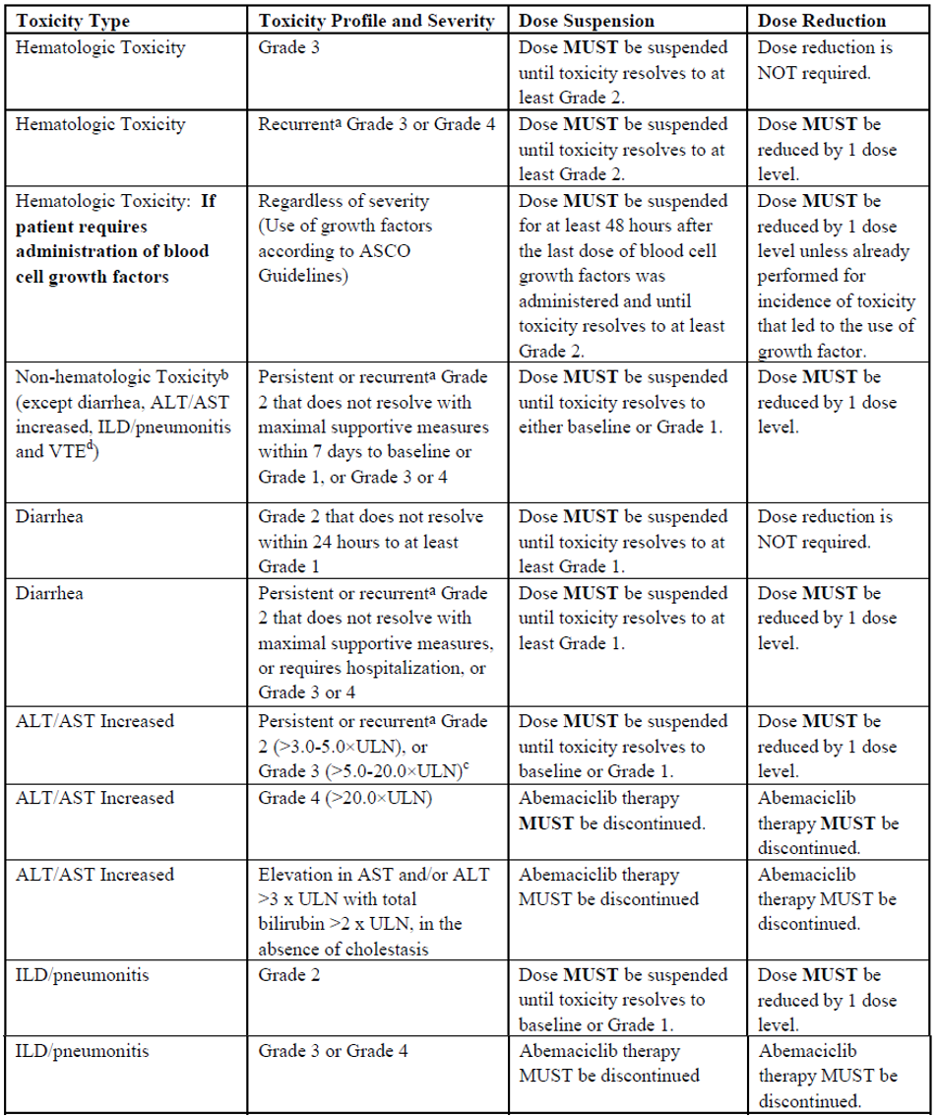

Abbreviations: ALT = alanine transaminase; ASCO = American Society of Clinical Oncology; AST = aspartate transaminase; ILD = interstitial lung disease; ULN = upper limit of normal; VTE = venous thromboembolic event.

Related means there is a reasonable causal relationship with abemaciclib.

a Determination of persistent events will be at the discretion of the investigator. Recurrent toxicity refers to the same event occurring within the next 8 weeks (as measured from the stop date of the preceding event). As a general guidance, based on the risk-benefit balance assessment per the investigator, for a patient who experiences a new episode of Grade 3 haematological toxicity after more than 8 weeks following the last episode of same Grade 3 haematological toxicity, the investigator may consider resuming the patient on the same drug dose should the patient satisfy the following conditions: the patient showed stable haematological counts (Grade 2 or lower) during that timeframe, in the absence of any infectious sign or risk factor, the patient is benefiting from study treatment.

b Additional guidance for renal and hepatic monitoring is beyond the scope of this AusPAR.

c Grade 3 ALT/AST increased is a trigger for additional assessments and possibly hepatic monitoring. Additional guidance for hepatic monitoring is beyond the scope of this AusPAR.

d For VTE, dose reduction of abemaciclib will be at the discretion of the investigator.

##### Key inclusion criteria

Key inclusion criteria were:

* eighteen (18) years and over, male and female;
* confirmed HR+, HER2-, resected invasive early breast cancer without metastases;
* randomised 16 months or less of definitive surgery of primary breast tumour, and either
  + pathological tumour involvement in 4 or more ipsilateral axillary lymph nodes (ALN), or
  + pathological tumour involvement in one to three ipsilateral ALN and Grade 3 disease or primary tumour size no less than 5 cm or Ki-67 index of 20% or higher;
* neoadjuvant chemotherapy permitted;
* adjuvant chemotherapy and radiotherapy permitted with washout periods of 21 days for chemotherapy or 14 days for radiotherapy before randomisation;
* twelve weeks or less endocrine therapy before randomisation after last non‑endocrine therapy;
* adequate organ function:
  + absolute neutrophil count 1.5 x 109/L or higher (without use of granulocyte colony stimulating factor),
  + platelets 100 x 109/L or higher,
  + haemoglobin 8 g/dL or higher,
  + total bilirubin less or equal to 1.5 x upper limit of normal (ULN) (unless known Gilbert’s syndrome),
  + alanine aminotransferase (ALT) and aspartate aminotransferase (AST) less or equal to 3 x ULN;
* Eastern Cooperative Oncology Group (ECOG) Performance Status;[29] 0 to 1.

##### Key exclusion criteria

Key exclusion criteria were:

* metastatic disease;
* node negative breast cancer;
* inflammatory breast cancer;
* previous history of breast cancer (except ipsilateral ductal carcinoma *in situ* treated with locoregional therapy alone no less than 5 years ago);
* previous treatment with endocrine therapy for breast cancer prevention or raloxifene;
* previous exposure to cyclin-D dependent kinases 4 or 6 (CDK4 or CDK6) inhibitors;
* past history of any other cancer (except non-melanoma skin cancer, carcinoma in-situ of the cervix or in complete remission with no therapy for no less than 5 years);
* concurrent exogenous reproductive hormone therapy;
* past history of venous thromboembolic event, syncope of cardiovascular aetiology, ventricular arrhythmia of pathological origin, sudden cardiac arrest, active systemic infection or viral load, serious pre-existing medical condition (for example, severe chronic kidney disease, interstitial lung disease, Inflammatory bowel disease, surgical resection of stomach or small intestine) and pregnancy or breastfeeding.

##### Key definitions

###### High risk patients

* Four or more positive axillary lymph nodes (pALN) or one to three pALN and one or more of: Grade 3 disease, tumour size 5 cm or larger, (Cohort 1).
* One to three pALN and standardised Ki-67 index of 20% (Cohort 2).

###### Invasive disease-free survival events

Standardised definitions for efficacy endpoints (STEEP) criteria:[30]

* Ipsilateral invasive breast tumour recurrence.
* Regional invasive breast cancer recurrence (ipsilateral axilla, regional lymph nodes, chest wall).
* Distant recurrence: metastatic disease biopsy confirmed or clinically diagnosed as recurrent invasive breast cancer.
* Death from any cause.
* Contralateral invasive breast cancer.
* Second primary non-breast invasive cancer.

##### Efficacy endpoints

###### Primary endpoint

Invasive disease-free survival (IDFS) abemaciclib plus endocrine therapy versus endocrine therapy alone with HR+, HER2- early breast cancer (STEEP criteria) at Interim Analysis 2.

###### Secondary endpoints

Secondary endpoints were:

* Invasive disease-free survival (IDFS) abemaciclib plus endocrine therapy versus endocrine therapy alone with HR+, HER2- early breast cancer with pre-treatment Ki‑67 index of 20% or higher by central lab.
* Distant recurrence-free survival (DRFS): abemaciclib plus endocrine therapy versus endocrine therapy alone with HR+, HER2- early breast cancer.
* Overall survival (OS) abemaciclib plus endocrine therapy versus endocrine therapy alone with HR+, HER2- early breast cancer.

###### Exploratory endpoints

Analyses of patient-related outcomes were exploratory.

##### Statistics

Patients were randomised within the 2 cohorts in 1:1 ratio.

###### Statistical analysis plan

The statistical analysis plan was amended 4 time. Futility analysis was added to Interim Analysis 2 (29 May 2020), declared for Interim Analysis 2 if IDFS hazard ratio greater than 0.95.

###### Analyses

There were two planned interim analyses and one planned final analysis, after 195, 293 and 390 events respectively have been observed in the ITT population. Pre-specified criteria for a positive study were met at Interim Analysis 2. Results for final IDFS were included in submission. Missing data were not imputed (except dates).

###### Power

The study was powered to approximately 85% assuming an IDFS hazard ratio of 0.73, cumulative one-sided alpha of 0.025 and approximately 390 events from across Cohort 1 and Cohort 2 by the time of the primary analysis after accounting for the interim efficacy and futility analyses.

###### Sample size

A sample size of 4,580 patients was determined to be required based on enrolment rates, time from randomisation to observation of approximately 390 events of approximately 4 years under the alternative hypothesis (hazard ratio of 0.73), 5-year IDFS rate of 82.5% in the control and 10% drop-out rate over the first 5 years.

###### Statistical methods

Log-rank test was stratified by randomisation factors to test superiority of abemaciclib plus endocrine therapy versus endocrine therapy on IDFS in the ITT population. A stratified Cox‑proportional hazard model with treatment as a factor was used to estimate the hazard ratio between the 2 treatment arms (95% CI) and Wald p-value. Kaplan-Meier method was used to estimate the IDFS curve for each treatment arm.

Fixed alpha spending approach

* Cumulative one-sided alpha was controlled at 0.025, with alpha split of 0.00000001 for futility analysis and 0.02499999 for planned efficacy analyses (Interim Analysis 1, Interim Analysis 2 and final), maintained using the Lan-DeMets method with an O’Brien-Fleming type stopping boundary.
* Sequential gate keeping strategy was utilised to control the family wise type I error at 0.025 (one-sided) for IDFS in ITT, Ki-67 high and Cohort 1 Ki-67 high populations. IDFS was tested hierarchically as follows:
  + Invasive disease-free survival in Ki-67 high population - tested if IDFS in ITT population significant.
  + Invasive disease-free survival in Cohort 1 Ki-67 high population - tested if IDFS in Ki-67 high population significant.
* Overall survival was a gated secondary endpoint tested after IDFS in ITT, Ki67 high, and Cohort 1 Ki67 high populations were all statistically significant.

Subgroup analyses of IDFS were performed for potential prognostic subgroup variables (baseline stratification factors, primary tumour size by pathology following definitive surgery, number of involved axillary lymph nodes, tumour stage, tumour grade, progesterone receptor status, age and race).

Analyses of patient-reported outcomes are no alpha controlled exploratory.

Cohort 2 was not included in the gate keeping strategy for IDFS analyses.

##### Analysis populations

Table 4, shown below, provides a definition of the different analysis populations in this study.

Table 4: Study I3Y-MC-JPCF (MONARCHE trial) Analysis population

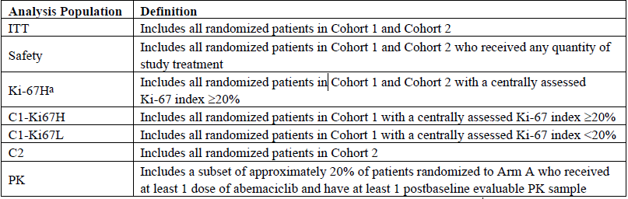

Abbreviations: C1-Ki67H = Cohort 1 patients with Ki-67 index of 20% or higher; C1-Ki67L = Cohort 1 with Ki-67 index of less than 20%; C2 = Cohort 2; Ki67H = Cohort 1 and Cohort 2 patients with Ki-67 index of 20% or higher; ITT = intent-to-treat; PK = pharmacokinetic.

a For patients in Cohort 1, if they had tumour tissue available, this tissue was retrospectively analysed at a central laboratory for Ki-67 index.

##### Protocol amendments and deviations

###### Major amendments

There were 5 major protocol amendments:

* Amendment A (11 October 2017): exclusion of patients with a history of venous thromboembolic event.
* Amendment B (29 June 2018): increased patient numbers for screening and Cohort 1.
* Amendment C (19 December 2018): extended Cohort 2 screening period; included Cohort 2 in the ITT population, removed enrolment cap for Cohort 2 (previously 500 patients) per regulatory recommendation; modified sample size determination text with respect to power, events and enrolment rates (final IDFS events required updated to approximately 390 (Cohort 1 plus Cohort 2), to yield approximately 85% statistical power or higher; updated event numbers to trigger Interim Analysis 1, Interim Analysis 2 and final IDFS analyses; added dose adjustment for ‘AST increased’; added venous thromboembolic event management for Arm A patients.
* Amendment D (25 June 2019): updated dose adjustments and safety monitoring guidance for ‘interstitial lung disease/pneumonitis’; increases to the numbers of events for interim efficacy analyses.
* Amendment E (18 September 2019) ‘capsules’ changed to ‘capsules or tablets’.

###### Major protocol deviations

Major protocol deviations were reported in 2.6% of Arm A and 2.4% of Arm B patients.

##### Baseline demographics and disease characteristics

Table 5, shown below, provides a summary of the baseline demographics and disease characteristics for this study.

Table 5: Study I3Y-MC-JPCF (MONARCHE trial) Baseline demographics and disease characteristics

|  |  |  |  |
| --- | --- | --- | --- |
| Baseline demographics and disease characteristics | | Arm A  (n = 2808) | Arm B  (n = 2829) |
| **Age** | Median (years, range) | 51 (23, 89) | 51 (22, 86) |
| **Age group** | < 40 years  < 65 years  ≥ 65 years | 12.2%  84.4%  15.6% | 13.0%  85.4%  14.6% |
| **Sex** | Male | 0.7% | 0.5% |
| Female | 99.3% | 99.5% |
| **Race** | White  Asian  Multiple | 70.3%  24.4%  0.8% | 71.0%  24.0%  0.9% |
| **Region** | North America/Europe  Asia  Other  (Australia) | 52.4%  20.4%  27.2%  3.8% | 52.3%  20.6%  27.1%  3.9% |
| **Weight** | Median (range) | 68.5 (34.0, 178.7) | 69.0 (35.3, 155.0) |
| **Eastern Cooperative Oncology Group Performance Status** | 0  1  2  3 | 85.7%  14.3%  0  1 patient | 83.8%  16.1%  0.1%  0 |
| **Tumour characteristics** | **Initial pathological diagnosis (> 10% patients)** | | |
| Invasive ductal breast carcinoma  Breast cancer (not otherwise specified)  Invasive lobular breast carcinoma | 67.6%  16.8%  13.2% | 69.2%  16.6%  12.3% |
| **Primary tumour size (pathology at surgery)** | | |
| < 20 mm  > 20 mm, ≤ 50 mm  ≥ 50 mm | 27.8%  48.9%  21.6% | 27.1%  50.2%  21.6% |
| **Number of positive lymph nodes** | | |
| 0  1-3  4-9  ≥ 10  Missing | 0.2%  39.8%  39.4%  20.5%  1 patient | 0.2%  40.4%  39.8%  19.6%  0 |
| **Histopathological diagnosis grade** | | |
| Grade 1  Grade 2  Grade 3  Not accessed  Missing | 7.4%  49.0%  38.7%  4.5%  0.4% | 7.6%  49.3%  37.6%  5%  0.5% |
| **Disease stage at diagnosis** | | |
| IA  IIA  IIB  IIIA  IIIB  IIIC  Missing | 0.1%  11.5%  14.0%  36.6%  3.5%  33.8%  0.4% | 0%  12.5%  13.7%  36.3%  3.1%  34.0%  0.4% |
| **Estrogen receptor status** | | |
| Positive  Negative  Unknown  Missing | 99.2%  0.6%  0.1%  0.1% | 99.3%  0.6%  0.1%  0 |
| **Progesterone receptor status** | | |
| Positive  Negative  unknown  Missing | 86.4%  10.6%  0.8%  2.2% | 86.8%  10.4%  0.7%  0.2% |
| **Human epidermal growth factor receptor 2 status (initial diagnosis)** | | |
| Positive  Negative  Missing | 0  99.95%  1 patient | 0.1%  99.9%  0 |
| **Ki-67 results** | | |
| < 20%  ≥ 20%  Missing  < 200 tumour cells in sample and no test performed  > 200 tumour cells in sample but result not evaluable | 33.9%  44.9%  16.5%  2.6%  2. 0% | 34.4%  43.7%  16.9%  2.5%  2.4% |
| **Prior treatment** | Surgical procedure (with curative intent) | 99.9% | 100% |
| Neoadjuvant radiotherapy  Adjuvant radiotherapy | 2.5%  93.3% | 2.9%  92.9% |
| Neoadjuvant systemic therapy  Chemotherapy  Endocrine therapy  Target | 37.6%  36.5%  3.1%  0.2% | 37.8%  36.4%  36.4%  0.2% |
| Adjuvant systemic therapy  Chemotherapy  Endocrine therapy  Target | 87.1%  61.8%  62.8%  0.1% | 87.3%  61.2%  63.4%  1 patient |
| **Use of bone modifying agents** | Any agent | 22.3% | 24.1% |
| Zoledronic acid | 9.9% | 10.9% |
| **Analysis populations** (number of patients) | Intent-to-treat | 2808 | 2829 |
| Safety | 2791 | 2800 |
| Cohort 1 | 2555 | 2565 |
| Cohort 2 | 253 | 264 |
| Ki-67 high (Cohorts 1 plus 2) | 1262 | 1236 |
| Ki-67 low (Cohorts 1 plus 2) | 953 | 974 |
| Ki-67 measured and high (Cohort 1) | 1017 | 986 |
| Ki-67 measured and low (Cohort 1) | 946 | 986 |

The proportion of subjects receiving aromatase inhibitors and anti-estrogens at the start of the study and any time during the study was comparable between treatment arms. At the start of the study there were 69.1% Arm A patients and 67.6% Arm B patients treated with aromatase inhibitors, and 30.9% and 32.5% patients in these arms respectively treated with anti-estrogens. Gonadotropin-releasing hormone (GnRH) analogues were used by 22.0% and 22.8% patients in Arm A and Arm B respectively any time during the study.

##### Primary efficacy analysis at Interim Analysis 2

The primary analysis for IDFS occurred at Interim Analysis 2. At this analysis, 12.5% had completed the 2-year study period. The findings were:

* 323 IDFS events observed in the ITT population (n = 136 (4.8%) events in Arm A and 187 (6.6%) events in Arm B) with a median follow-up time of 15.4 months in Arm A and 15.5 months in Arm B;
* hazard ratio for Arm A versus Arm B = 0.747, 95% CI: 0.598, 0.932);
* two-year IDFS rate 92.2% (90.4%, 93.7%) versus 88.7% (86.5%, 90.5%); difference 3.5% (95% CI: 0.9%, 1.6.1%), p = 0.0073;
* one-year IDFS rate 96.5% (95.7%, 97.1%) versus 95.7% (94.9%, 96.4%); difference 0.7 % (95% CI: -0.3%, 1.8%), p = 0.163.

Pre-specified sensitivity analyses (unstratified log-rank test and unstratified Cox‑proportional hazards model) were consistent with the primary analysis, mostly favouring Arm A.

Figure 2: Study I3Y-MC-JPCF (MONARCHE trial) Kaplan-Meier plot of invasive disease-free survival by investigator assessment (intent-to-treat population)

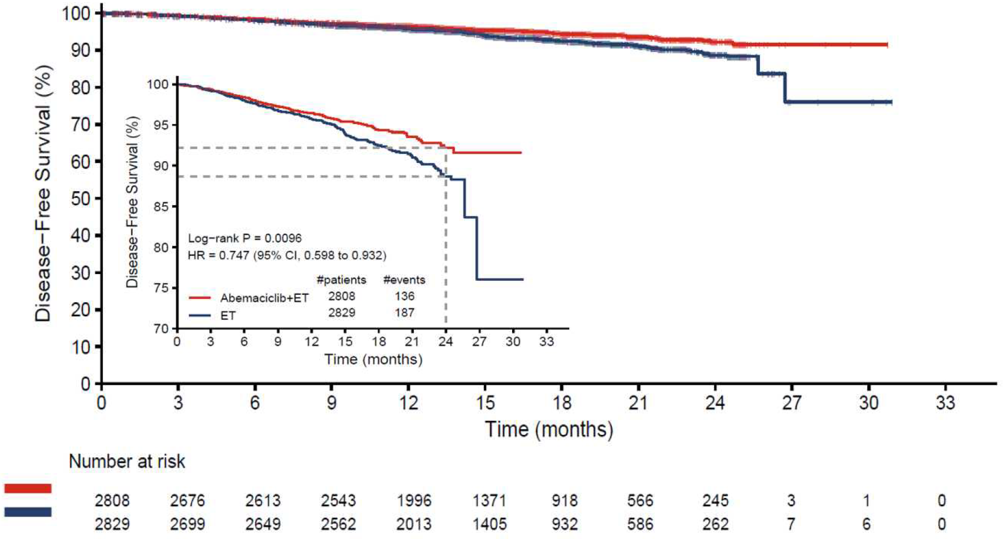

Abbreviations: # = number of; CI = confidence interval; ET = endocrine therapy; HR = hazard ratio.

Data cut-off date: 16 March 2020.

##### Final invasive disease-free survival analysis

At the final (exploratory) IDFS analysis, 25.5% of patients had completed a 2-year study period. At this analysis the findings were:

* 395 IDFS events observed in the ITT population (n = 163 (5.8%) events in Arm A and 232 (8.2%) events in Arm B) with a median follow-up time of 19.1 months in Arm A and 19.2 months in Arm B;
* hazard ratio for Arm A versus Arm B = 0.713, (95% CI: 0.583, 0.871);
* two-year IDFS rate 92.3% (90.9%, 93.5%) versus 89.3% (87.7%, 90.7%); difference 3.5% (95% CI: 0.9%, 1.6.1%) (see Figure 3 below);
* one-year IDFS rate 96.5% (95.7%, 97.1%) versus 95.7% (94.9%, 96.4%); difference 0.8 % (95% CI: -0.2%, 1.8%).

Most of the IDFS events attributed to confirmed invasive disease (n = 151 events in Arm A and n = 225 events in Arm B), were distant recurrence (n = 109 (3.9%) Arm A, n = 170 (6.0%) Arm B). Bone, liver, and lung were the most common sites of distant recurrence overall, with the frequency of recurrence in bone and liver lower in Arm A compared with Arm B.

Figure 3: Study I3Y-MC-JPCF (MONARCHE trial) Kaplan-Meier plot of invasive disease-free survival by investigator assessment at final invasive disease-free survival analysis (intent‑to‑treat population)

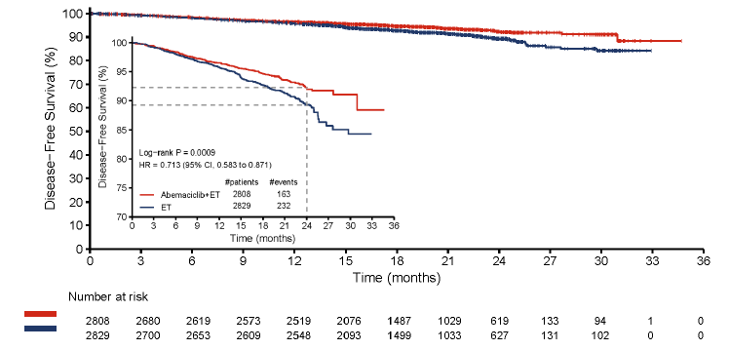

Abbreviations: # = number of; CI = confidence interval; ET = endocrine therapy; HR = hazard ratio.

Data cut-off date: 8 July 2020.

Invasive disease-free survival (IDFS) analyses within pre-specified subgroups within the ITT population is shown below in Figure 4. The numbers of male patients in the study are too small for a meaningful separate subgroup analysis.

Figure 4: Study I3Y-MC-JPCF (MONARCHE trial) Subgroup analysis and forest plot final invasive disease-free survival analysis (intent-to-treat population)

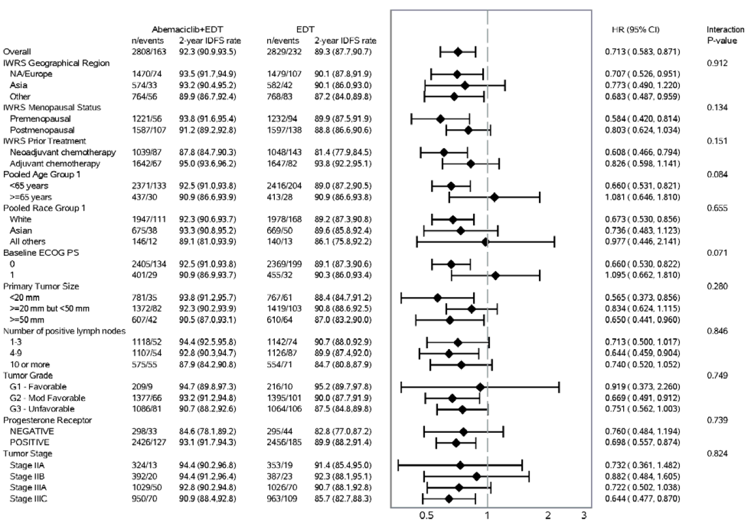

Abbreviations: CI = confidence interval; ECOG PS = Eastern Cooperative Oncology Group Performance Status; EDT = endocrine therapy; G= Grade; HR = hazard ratio; IDFS = invasive disease-free survival; IWRS = interactive web response system; n = number of patients in specific population; NA = North America.

Data cut-off date: 8 July 2020.

##### Secondary endpoints: final invasive disease-free survival analysis

###### Invasive disease-free survival in Ki-67 high population

At the final analysis, the findings for the total Ki-67 high population were:

* 197 IDFS events observed among the 2498 patients in the Ki67 high population; n = 82 (6.5%) events in Arm A and n = 115 (9.3%) events in Arm B;
* hazard ratio for Arm A versus Arm B = 0.691 (95% CI: 0.519, 0.920);
* two-year IDFS rate 91.6% (89.4%, 93.4%) versus 87.1% (84.3%, 89.5%); difference 4.5% (95% CI: 1.2%, 7.7%);
* one-year IDFS 96.1% (94.9%, 97.1%) versus 95.3% (94.0%, 96.4%); difference 0.8 % (95% CI: -0.8%, 2.4%).

Figure 5: Study I3Y-MC-JPCF (MONARCHE trial) Kaplan-Meier plot of invasive disease-free survival by investigator assessment in Ki-67 high population at final Invasive disease-free survival analysis

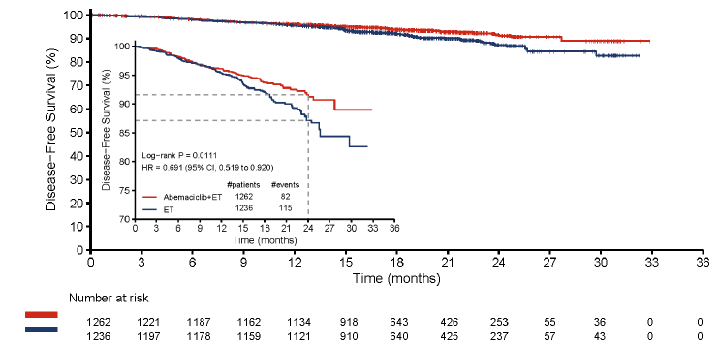

Abbreviations: # = number of; CI = confidence interval; ET = endocrine therapy; HR = hazard ratio.

Data cut-off date: 8 July 2020.

###### Invasive disease-free survival in Cohort 1 Ki-67 high population

At the final analysis, the findings for the Cohort 1 Ki-67 high population were:

* 177 IDFS events observed among the 2003 patients in the Cohort 1 Ki67 high population; n = 71 (7.0%) events in Arm A and n = 106 (10.8%) events in Arm B;
* hazard ratio for Arm A versus Arm B = 0.643 (95% CI: 0.475, 0.872);
* two-year IDFS rate 91.3% (88.9%, 93.2%) versus 86.1% (83.1%, 88.7%); difference 5.2% (95% CI: 1.6%, 8.7%);
* one-year IDFS 96.0% (94.6%, 97.1%) versus 94.4% (92.7%, 95.7%); difference 1.6% (95% CI: -0.3%, 3.5%).

Figure 6: Study I3Y-MC-JPCF (MONARCHE trial) Kaplan-Meier plot of invasive disease-free survival by investigator assessment in Cohort 1 Ki-67 high population at final invasive disease-free survival analysis

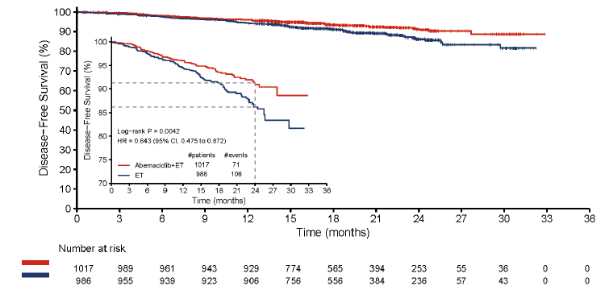

Abbreviations: # = number of; CI = confidence interval; ET = endocrine therapy; HR = hazard ratio.

Data cut-off date: 8 July 2020.

###### Overall survival

Overall survival (OS) in the ITT population was planned to be tested after IDFS in the ITT, Ki-67 high, and Cohort 1 Ki-67 high populations were all statistically significant. At the final IDFS analysis, the OS data were immature. There were 106 deaths (1.9%) in the ITT population (n = 55 (2.0%) Arm A, n = 51 (1.8%) Arm B); estimated OS hazard ratio was 1.093 (95% CI: 0.746, 1.600).

###### Distant recurrence-free survival

Distant recurrence-free survival (DRFS) was not Type I error controlled. At the final IDFS analysis there were 324 DRFS events observed; n = 131 (4.7%) Arm A, n = 193 (6.8%) Arm B; estimated hazard ratio was 0.687 (95% CI: 0.551, 0.858) with 3.0% difference in 2‑year DRFS rates (93.8% versus 90.8%).

###### Patient-reported outcomes

Patient-reported outcome assessments were conducted at Baseline and 3, 6, 12, and 18 months post-Baseline were generally similar between treatment arms. The main difference between treatment arms was in the Functional Assessment of Cancer Therapy Endocrine Subscale;[31] item relating to diarrhoea. The within-group mean change from baseline difference between Arms A and B was greatest at Month 3 (1.18) and lowest at Month 18 (0.86).

##### Exploratory analyses of Cohort 1 with Ki-67 low and Cohort 2 population

Analyses of IDFS results for Cohort 1 with Ki-67 low (index less than 20%) tumours, and Cohort 2 are from the final IDFS analysis report.

Cohort 1 Ki-67 low population (n = 946 Arm A, n = 968 Arm B)

* Invasive disease-free survival: 43 events (4.5%) Arm A versus 63 events (6.5%) Arm B, hazard ratio of 0.685 (0.462, 1.017).
* Two-year IDFS rate 94.7% (92.8%, 96.1%) versus 86.1% (83.1%, 88.7%); difference 5.2% (95% CI: 1.6%, 8.7%).

Cohort 2 population (n = 253 Arm A, n = 264 Arm B)

* Invasive disease-free survival: 11 events (4.3%) Arm A versus 9 events (3.4%) Arm B, hazard ratio of 1.498 (0.6, 3.74).

##### Additional analysis (data cut-off date: 1 April 2021)

An interim OS analysis for the ITT population with a data cut of 1 April 2021 was provided in response to questions raised in the clinical evaluation. An analysis of all results at this data cut-off date were provided. The analysis included additional *post-hoc* analyses of other efficacy endpoints. No statistical inference should be made with these results.

* There were 72.2% patients completed a 2-year study period.
* Overall survival (ITT): 96 events Arm A versus 90 events Arm B; hazard ratio of 1.091 (95% CI: 0.818, 1.455).
* Invasive disease-free survival (ITT): 232 events in Arm A versus 333 events in Arm B; hazard ratio of 0.696 (95% CI: 0.588, 0.823), 2-year IDFS 92.7% Arm A versus 90.0% Arm B.
* Distant recurrence-free survival (ITT): 191 events in Arm A versus 278 events in Arm B; hazard ratio of 0.687 (95% CI: 0.571, 0.826), 2-year DRFS 94.1% Arm A versus 91.6% Arm B.
* Invasive disease-free survival (Ki-67 high): 118 events in Arm A versus 172 events in Arm B; hazard ratio of 0.663 (95% CI: 0.524, 0.839).
* Overall survival (Ki-67 high): 48 events Arm A versus 55 events Arm B; hazard ratio of 0.851 (95% CI: 0.577, 1.255).
* Invasive disease-free survival (Cohort 1 Ki-67 high): 104 events in Arm A versus 158 events in Arm B; hazard ratio of 0.626 (95% CI: 0.488, 0.803).
* Overall survival (Cohort 1 Ki-67 high): 42 events Arm A versus 53 events Arm B; hazard ratio of 0.767 (95% CI: 0.511, 1.152).

#### Safety

This section is a summary of the key safety information presented with, and highlighted through, the TGA’s evaluation of this submission.

##### Exposure

At data cut-off (1 April 2021) for overall survival (OS) Interim Analysis 1, 72.2% of patients had completed the 2-year on-study treatment period (n = 2021 (72.0%) Arm A, n = 2050 (72.5%) Arm B). The median duration of abemaciclib treatment was 23.7 months, and median duration of endocrine therapy received 23.8 months in both arms. The submission also included data from Interim Analysis 2 and the final IDFS analysis.

##### Adverse events

Adverse events (AEs) at the final IDFS analysis and at OS Interim Analysis 1 are summarised in Table 6 below.

Table 6: Study I3Y-MC-JPCF (MONARCHE trial) Overview of safety by analysis data cut-off (safety population)

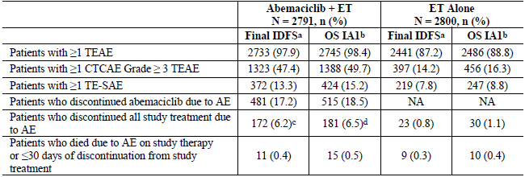

Abbreviations: AE = adverse event; CTCAE = Common Terminology Criteria for Adverse Event; ET = endocrine therapy; IDFS = invasive disease-free survival; N = number of patients in the ITT population; n = number of patients in the specific population; NA= not available; OS IA1 = overall survival Interim Analysis 1; TEAE = treatment-emergent adverse events, TE-SAE = treatment-emergent serious adverse event.

a Data cut-off date: 8 July 2020.

b Data cut-off date: 1 April 2021.

c The 6.2% is included in the 17.2% of patients who discontinued abemaciclib due to AE. Patients could continue their ET as post-discontinuation therapy.

d The 6.5% is included in the 18.5% of patients who discontinued abemaciclib due to AE. Patients could continue their ET as post-discontinuation therapy.

The most frequent TEAEs and Grade 3 or higher TEAEs are summarised in Table 7 below.

Table 7: Study I3Y-MC-JPCF (MONARCHE trial) Incidence by analysis data cut-off of adverse event of special interest and treatment-emergent adverse events 20% or higher in either arm (safety population)

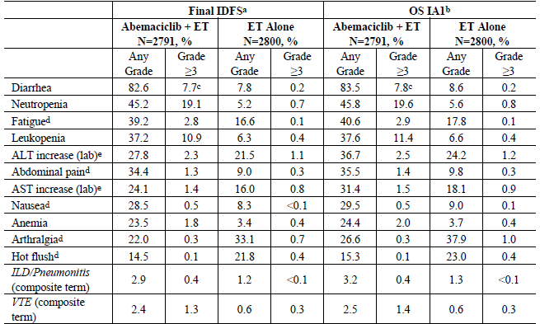

Abbreviations: ALT = alanine aminotransferase; AST = aspartate aminotransferase; ET = endocrine therapy; N = number of patients in the safety population; IDFS = invasive disease-free survival; ILD = interstitial lung disease; OS IA1 = overall survival Interim Analysis 1; VTE = venous thromboembolic event.

a Data cut-off date: 8 July 2020.

b Data cut-off date: 1 April 2021.

c One Grade 5 event of diarrhoea.

d Preferred Term has a maximum Common Terminology Criteria for Adverse Event (CTCAE) Grade of 3.

e Frequencies for ALT increase and AST increase laboratory abnormalities are based on the number of patients with available baseline and post-baseline results.

At OS Interim Analysis 1, there were 144 patients with AEs (all AEs, not just TEAEs) of suspected or confirmed coronavirus disease 2019 (COVID-19), with a higher incidence in Arm A; n = 95 (3.4%, 0.6% Grade 3 or higher) versus n = 49 (1.8%) Arm B (0.1% Grade 3 or higher). The majority events were Grade 2or less.

There were more patients in Arm A with treatment-emergent serious adverse events (SAEs) of COVID-19 infection (n = 15) compared to Arm B (n = 3), with fatal AEs also more common in Arm A (n = 4 versus n = 1).

The evaluation noted the sponsor’s comment that there was no correlation with neutropaenia or lymphopaenia and COVID-19 infection in abemaciclib‑treated patients nor was there any reported events of interstitial lung disease in patients with SAEs related to COVID-19.

##### Discontinuations and dose modifications

At OS Interim Analysis 1, there was a slight increase in the number of patients who discontinued abemaciclib or abemaciclib and endocrine therapy due to AEs; n = 515 (18.5%, versus 17.2% at final IDFS analysis).

The 3 most common reasons for discontinuations were those also reported at final IDFS analysis (see Figure 7 below): diarrhoea (5.3%), fatigue (2.0%), and neutropaenia (0.9%), with these 3 AEs accounting for 44% of all discontinuations due to AEs.

There were 181 (6.5%) patients in Arm A who discontinued all study treatment due to AEs, most commonly due to diarrhoea (2.5%) and fatigue (1.0%). In Arm B, 30 (1.1%) subjects discontinued treatment. Of these 211 patients who discontinued all treatment, 135 (64%) entered the follow-up period, and 106 (91%) Arm A patients and 10 (56%) Arm B patients continued on endocrine therapy as post-discontinuation therapy.

Figure 7: Study I3Y-MC-JPCF (MONARCHE trial) Discontinuation of abemaciclib or all treatment due to adverse event by months of treatment, final invasive disease-free survival analysis

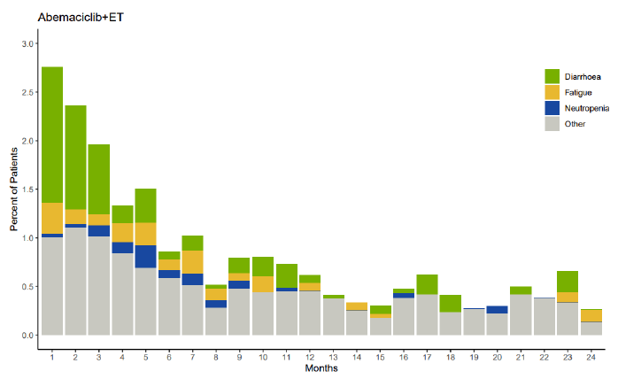

Abbreviation: ET = endocrine therapy.

The denominator is the number of patients exposed to study treatment per month.

Data cut-off date: 8 July 2020.

The incidence of abemaciclib dose modifications and reasons the dose modifications at OS Interim Analysis 1 were comparable with the final IDFS analysis (see Figure 8 below), with 43.4% and 61.7% with at least one dose reduction and dose omission respectively. Diarrhoea, neutropaenia, fatigue, and leukopenia were the most common reasons for abemaciclib dose modifications.

Figure 8: Study I3Y-MC-JPCF (MONARCHE trial) Dose modifications of abemaciclib due to adverse event by months, final invasive disease-free survival analysis

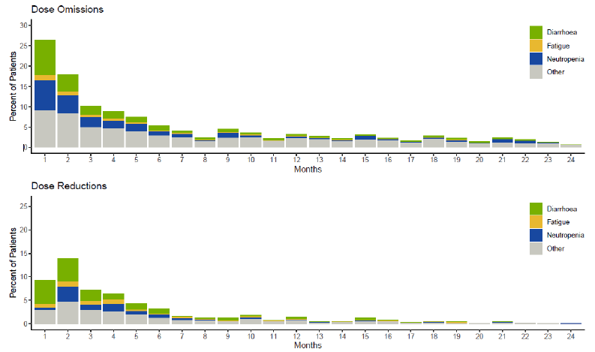

The denominator is the number of patients exposed to study treatment per month.

Data cut-off date: 8 July 2020.

##### Serious adverse events and deaths

More SAEs had accrued at the OS Interim Analysis 1 analysis (15.2% Arm A, 8.8% Arm B) compared with the final IDFS analysis (13.3% Arm A, 7.8% Arm B).

There were 184 deaths at the time of OS Interim Analysis 1; n = 95 (3.4%) Arm A, n = 89 (3.2%) Arm B. The majority of deaths in both treatment arms were due to study disease; n = 71 (2.5%) and n = 75 (2.7%) for Arm A and Arm B respectively.

More fatal AEs that were treatment-emergent or within 30 days of study treatment discontinuation had accrued at the OS Interim Analysis 1 analysis (n = 15 (0.5%) Arm A versus n = 10 (0.4%) Arm B) compared with the final IDFS analysis (n = 11 (0.4%) Arm A, n = 9 (0.3%) Arm B).

Table 8: Study I3Y-MC-JPCF (MONARCHE trial) Summary of serious adverse effects and deaths

|  |  |  |
| --- | --- | --- |
|  | Arm A  Abemaciclib plus endocrine therapy  (n = 2791) | Arm B  Endocrine therapy alone  (n = 2800) |
| **Serious adverse events** | 424 (15.2%) | 247 (8.8%) |
| ***Serious adverse events in ≥ 10 patients in either arm*** | | |
| Pneumonia | 20 (1.0%) | 17 (0.6%) |
| Pulmonary embolism | 18 (0.6%) | 4 (0.1%) |
| Deep vein thrombosis | 16 (0.6%) | 4 (0.1%) |
| Diarrhoea | 15 (0.5%) | 0 |
| Cellulitis | 14 (0.5%) | 10 (0.4%) |
| Urinary tract infection | 14 (0.5%) | 4 (0.1%) |
| Cholecystitis | 10 (0.4%) | 4 (0.1%) |
| Pyrexia | 10 (0.4%) | 0 |
| **Deaths** | 95 (3.4%) | 89 (3.2%) |
| ***Deaths on therapy or ≤ 30 days from study drug discontinuation*** | 21 (0.8%) | 19 (0.7%) |
| Death from study disease | 6 (0.2%) | 9 (0.3%) |
| Death from adverse event | 15 (0.5%) | 10 (0.4%) |
| ***Deaths > 30 days from study drug discontinuation*** | 74 (2.7%) | 70 (2.5%) |
| Death from study disease | 65 (2.3%) | 66 (2.4%) |
| Death from adverse event | 9 (0.3%) | 4 (0.1%) |

Except for cardiac failure in Arm A (n = 2), deaths were reported against a single Preferred Term. Of note there was a single death reported for diarrhoea.

##### Adverse event of special interests

Separate summaries of adverse events of special interest, based on the known safety profile of abemaciclib and the cyclin-D dependent kinases 4 or 6 (CDK4 or CDK6) inhibitors as a class were provided in the submission (See Table 7 above).

###### Diarrhoea

At OS Interim Analysis 1, diarrhoea remained the most frequent TEAE (83.5% Arm A, 8.6% Arm B), the majority of events (greater than 90% Arm A) Grade 2 or lower. At least one abemaciclib dose reduction or omission was required in 17.2 and 19.4%, respectively and abemaciclib or all treatment discontinuation due to diarrhoea in 5.2%. This was similar to the findings in the earlier analyses of the MONARCHE trial data.

###### Neutropaenia

The incidence of neutropaenia was similar to the final IDFS analysis, with neutropaenia TEAEs more common in Arm A (45.8%, 19.6% Grade 3 or higher) versus Arm B (5.6%, 0.8% Grade 3 or higher). There were no additional TEAEs of Grade 3 or higher febrile neutropaenia (0.3%) or SAEs of neutropaenia (0.1%) for Arm A at OS Interim Analysis 1. Discontinuation of abemaciclib or all treatment due to neutropaenia TEAEs remained low (0.8%).

###### Infections

The incidence of infections was slightly higher in both treatment arms at OS Interim Analysis 1 (Arm A 51.2%, 5.6% Grade 3 or higher; Arm B 39.4%, 3.0% Grade 3 or higher) compared to final IDFS analysis (47.7% and 36.4% respectively), although the types of infections were comparable (upper respiratory tract infection and urinary tract infection) and discontinuation of abemaciclib or all treatment due to infection minimal (0.9%).

There were 4 deaths in Arm A (zero at final IDFS analysis) and one additional death in Arm B (total n = 5) due to infection at OS Interim Analysis 1, all due to COVID-19 or suspected COVID-19.

###### Venous thromboembolic event

At least one venous thromboembolic event was reported in both treatment arms:

* Arm A: n = 71 (2.5%) total, n = 49 (1.8%) deep vein thrombosis, n = 28 (1.0%) pulmonary embolism.
* Arm B: n = 17 (0.6%) total, n = 14 (0.5%) deep vein thrombosis, n = 4 (0.1%) pulmonary embolism.

Venous thromboembolic event had been reported in the final IDFS analysis (n = 67 (2.4%) versus n = 16 (0.6%)) with proportions of deep vein thrombosis and pulmonary embolism events in each arm. There is one fatal venous thromboembolic event in the Arm B, and in long-term follow-up the one venous thromboembolic event fatality in Arm A was not considered treatment-emergent.

###### Interstitial lung disease or pneumonitis

At OS Interim Analysis 1, interstitial lung disease or pneumonitis events were reported in 3.2% of Arm A and 1.3% of Arm B versus 2.9% and 1.2% at final IDFS analysis, respectively. Grade 3 or higher events were unchanged from the final IDFS analysis (0.4% Arm A and less than 0.1% Arm B). interstitial lung disease or pneumonitis events were associated with abemaciclib dose omissions (n = 13 (14.6%)), dose reductions (n = 5 (5.6%)) and discontinuations of abemaciclib or all treatment (n = 19 (21.3%)).

###### Elevated transaminases (alanine transaminase and aspartate transaminase)

A summary of the findings for these events is in Table 9.

No cases were considered to meet the definition of drug induced liver injury.[32]

Table 9: Study I3Y-MC-JPCF (MONARCHE trial) Summary of aspartate transaminase and alanine transaminase increased in final invasive disease-free survival analysis and overall survival Interim Analysis 1

|  |  |  |  |  |  |  |
| --- | --- | --- | --- | --- | --- | --- |
| Parameter | Final IDFS analysis | | Overall survival Interim Analysis 1 all Grade | | Overall survival Interim Analysis 1 Grade ≥ 3 | |
| **Arm A** | **Arm B** | **Arm A** | **Arm B** | **Arm A** | **Arm B** |
| **ALT increased** | 10.4% | 4.9% | 12.3% | 5.6% | 2.8% | 0.7% |
| **AST increased** | 10.1% | 4.3% | 11.8% | 4.9% | 1.9% | 0.5% |

Abbreviations: ALT = alanine transaminase; AST = aspartate aminotransferase; IDFS = invasive disease-free survival.

Abemaciclib dose modifications or discontinuations of abemaciclib or all treatment due to aspartate aminotransferase (ALT) or aspartate aminotransferase (AST) increased were reported in 2.4% or less and 0.6% or less, respectively.

##### Laboratory abnormalities

Table 10 is a summary of common laboratory abnormality findings from the OS Interim Analysis 1 data cut.

Table 10: Study I3Y-MC-JPCF (MONARCHE trial) Summary of laboratory abnormalities, all grades and Grades 3 and 4

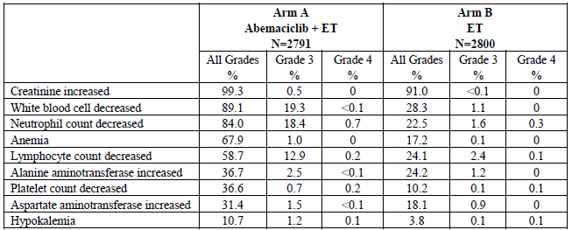

Abbreviations: ET = endocrine therapy; N = number of patients in subpopulation.

### Risk management plan

The sponsor is required to comply with product vigilance and risk minimisation requirements.

### Risk-benefit analysis

#### Delegate’s considerations

This submission seeks to extend the indications of abemaciclib to include its use in combination with endocrine therapy for the adjuvant treatment of high-risk hormone receptor positive (HR+), human epidermal growth factor receptor 2 negative (HER2-) breast cancer.

The submission is supported by Study I3Y-MC-JPCF (the MONARCHE trial), a Phase III, randomised, open label, multi-centre, multinational study to evaluate the efficacy and safety of abemaciclib combined with standard adjuvant endocrine therapy versus standard adjuvant endocrine therapy alone in patients with node positive, invasive, resected, HR+, HER2- early breast cancer who completed definitive locoregional therapy, with or without neoadjuvant or adjuvant chemotherapy, at high risk of disease recurrence.

The study initially included patients identified as high risk based on lymph node positivity, tumour size or histological grade in the intent-to-treat (ITT) analysis. At Protocol Amendment C, Cohort 2 was added to the ITT population. In this population risk was assessed differently, and although Ki-67 was an important factor for inclusion of this cohort, most patients contributing results with Ki-67 proliferation index high tumours were from Cohort 1. A separate analysis for Cohort 2 was not included in the testing hierarchy so based on patient numbers Cohort 1 appears the driver of the results underpinning the efficacy claims.

Most patients were between the ages of 40 and 65 years and were mostly female. While this was a multinational study, Australian patients were among the randomised. Tumour type, histological grade and number of positive lymph nodes, and receptor status were similar between the two groups, and around 44% of each group had a Ki-67 index of 20% or higher. As expected for this age group the ECOG Performance Status;29 was generally low, and, a priori, patients with a low ECOG Performance Status may be better able to tolerate the adverse effects of abemaciclib.

The study was designed to investigate the contribution of abemaciclib in a combination with endocrine therapy. Aromatase inhibitors and anti-estrogens were most commonly prescribed. The use of gonadotropin-releasing hormone (GnRH), in generally reflects the proportion of patients that were pre‑menopausal on commencement of therapy. The choice of agent was not controlled, reflecting the likely use of the combination, but adding a degree of uncertainty with respect to the attribution of adverse events (AEs). The choice of endocrine therapy as a comparator is considered reasonable. Whether or not a GnRH analogue should be used as part of the abemaciclib plus endocrine therapy combination in patients who are pre- and peri-menopausal has not been specifically investigated in the MONARCHE trial.

More than 60% of each treatment arm had received prior adjuvant chemotherapy, raising a level of uncertainty about the contribution of the pre-treatment to the outcome, potentially in each arm. Whether there would be the same difference in invasive disease‑free survival (IDFS) between the two arms in patients with no prior treatment is untested.

The primary efficacy endpoint was IDFS, an acceptable endpoint in an adjuvant setting. The inclusion of a 2-year landmark was accepted by the clinical evaluation and appears reasonably justified. As shown by the Kaplan-Meier curves the hazards are non‑proportional, with the curves for IDFS separating after 7.5 to 12 months (depending on the analysis timepoint), the use of the 2-year landmark to assess differences in risk is considered reasonable.

The IDFS assessment was event driven. The risk of an event as summarised by the hazard ratio was reduced around 30%, consistently across the IDFS Interim Analysis 2 (primary), Final IDFS analysis and overall survival (OS) Interim Analysis 1. Although the ITT population was used for the primary analysis the majority of patients were in Cohort 1, the primary driver of the results.

Over time the reported 2-year absolute difference in IDFS decreases as more patients contribute to the analysis. In considering this difference from an efficacy perspective, the Delegate has considered that this treatment is in the adjuvant setting and therefore preventative after surgery with curative intent. As in many other settings, preventative measures, while associated with a reduction in relative risk of a disease event, the absolute risk difference between interventions in clinical studies is often relatively small. Although not the primary analysis data, at the OS Interim Analysis 2 data cut-off 72.5% of patients had completed the 2-year study treatment the number needed to treat for IDFS is 40. It is recognised this benefit is in addition to the benefit already derived from endocrine therapy in this setting.

Among the subgroups the hazard ratio point estimates for IDFS exceed 1.0 for those aged 65 years or over and ECOG Performance Status 1. The numbers of patients contributing to those estimates is relatively small and the lower bound of the 95% CI for each of these estimates is well below 1, nevertheless there is uncertainty about the benefits in these subgroups.

The sponsor included three-year estimates of IDFS from the 1 April 2021 OS Interim Analysis 1 that include an absolute difference of 5.4% between the treatment arms, however only 9.9% of patients had been followed for disease recurrence for three years, so there is considerable uncertainty, and the interpretation of the results is limited.

In general, a challenge with the studies in the adjuvant setting is the slower maturation of OS data, and for this submission OS was a major point of concern for the clinical evaluation. No survival benefit of abemaciclib plus endocrine therapy over endocrine therapy alone has been demonstrated for the ITT population. The hazard ratio point estimate in all three efficacy analyses is just over 1.0. Considering the precision of the estimate, there is neither a clear benefit or clear detriment for OS in the ITT population, and but a possible OS detriment is a potential issue in the efficacy considerations.

The MONARCHE trial is continuing and the magnitude of disease modification from the addition of abemaciclib will become more apparent over time. There is a potential confounding effect of the choice of next treatment that is not expected to be uniform across the various countries in the study, and as new therapies emerge the impact will be more difficult to interpret. The issue of interpretation of the OS results to data and its implications for the approval of this submission is a matter on which the advice of the Advisory Committee on Medicines (ACM) is sought.

As noted by the clinical evaluation, the addition of abemaciclib to endocrine therapy is associated with clinically significant toxicities. Grade 3 or higher treatment-emergent adverse event (TEAEs) occurred more commonly in the abemaciclib plus endocrine therapy patients; 49.7% versus 16.3% with endocrine therapy alone, and twice as many patients treated with abemaciclib experienced serious adverse events (SAEs) (15.2% versus 8.8%). The incidence of fatal AEs was low across the study. Dose modifications, either reductions or omissions, were required at least once for 43.4 to 61.7% of patients, with 18.5% discontinuing abemaciclib treatment due to AEs. Gastrointestinal and haematological toxicities are most common, with AEs occurring for 20% or more abemaciclib patients including diarrhoea, neutropaenia, leukopenia, fatigue, nausea and anaemia. The proportions of patients discontinuing due to the events of diarrhoea, fatigue and neutropaenia over time are shown in Figure 7 above, and while a higher proportion of patients discontinued due to these effects in the early months of treatment these events remained problematic over the course of treatment.

Venous thromboembolic event, pneumonitis or interstitial lung disease and elevated transaminases have also been previously identified as AEs of concern with abemaciclib, and again occurred in this study.

The toxicities of abemaciclib are likely to limit the patients that would be offered or who would tolerate the treatment.

##### Ki-67 biomarker

The evaluation considered whether the subset of patients identified as ‘Ki-67 high’ would be a patient group for which the benefits versus harms versus uncertainties may be favourable.

The role of Ki-67 in characterising the patient population likely to be most at benefit is a matter on which the advice of the ACM is sought but the Delegate’s preliminary considerations are as follows:

* The expression of the Ki-67 protein is associated with the active phases of the cell cycle and is not present in resting cells. Its expression is not specific to organ or tumour type. It has been used to estimate the growth fraction of a tumour sample and has been considered of prognostic value, including in HR+, HER2- breast cancer.
* It is typically detected by immunohistochemistry stain.
* Tumours are typically heterogeneous in cellular activity, providing challenges for the interpretation.
* It appears sensitive to laboratory techniques used (for example, antibody used) and methods of assessment (for example, digital versus manual). Intra-operator and intra‑laboratory variability are potential issues.
* There is variability in the threshold of increased risk. The sponsor has adopted 20% or higher for the MONARCHE trial based on the St Gallen International Expert Consensus;10,11 however the International Ki-67 in Breast Cancer Working Group;25 considers greater than or equal to 30% and less than 5% are thresholds for use in early breast cancer.
* The MONARCHE trial was not designed to establish a threshold of Ki-67 expression that predicts a responsive population for abemaciclib, independent of other prognostic indicators such as pathological grading and axillary lymph node involvement.
* The sponsor is not planning to register a companion diagnostic in Australia.

The Cohort 1 Ki-67 high population has favourable estimates for IDFS between population difference and for OS than the ITT population, numerically, however no interaction for Ki‑67 index was found in the IDFS, distant recurrence-free survival (DRFS) or OS ITT population analyses (see Table 11 below).

Table 11: Study I3Y-MC-JPCF (MONARCHE trial) Interaction of Ki-67 index with invasive disease-free survival, distant recurrence-free survival, and overall survival (intent-to-treat population overall survival Interim Analysis 1)

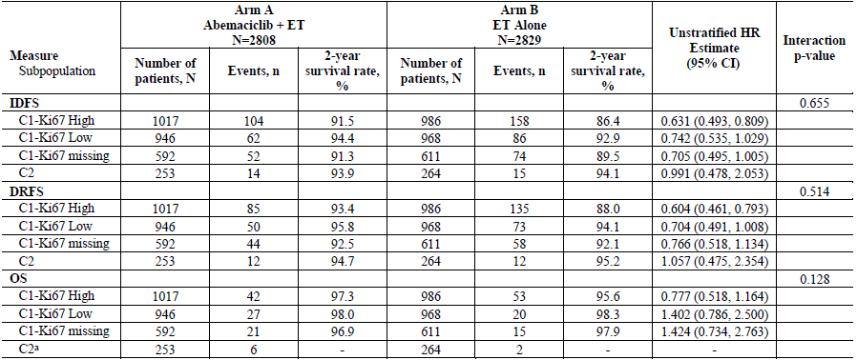

Abbreviations: C1 = Cohort 1; C2 = Cohort 2; CI = confidence interval; DRFS = distant recurrence-free survival; ET = endocrine therapy; HR = hazard ratio; IDFS = invasive disease-free survival; N = number of patients in subpopulation; n = number of survival events in category; OS = overall survival.

a OS data are immature for Cohort 2.

Data cut-off date: 1 April 2021.

##### Dose

The 150 mg twice daily abemaciclib dose used in Study I3Y-MC-JPCF (the MONARCHE trial) is the same as that already approved. The dosing of abemaciclib is not an issue for this submission.

#### Proposed action

As a preliminary finding, and subject to the requested advice the ACM the Delegate is inclined towards approval of adjuvant therapy with abemaciclib plus endocrine therapy in high-risk hormone receptor positive (HR+), human epidermal growth factor receptor 2 negative (HER2-) breast cancer, as a management option.

#### Questions for the sponsor

The sponsor provided the following response to questions from the Delegate.

1. ***Please provide the outcomes for overall survival for the Cohort 1 Ki-67 low population based on data from the Interim Analysis 1 overall survival data cut. It is recognised that this will be a post-hoc exploratory analysis.***

The overall survival (OS) data for the Cohort 1 Ki-67 low population is included in the clinical study report;[33] for OS Interim Analysis 1. Table 12 below summarises the efficacy outcomes in invasive disease-free survival (IDFS), distant recurrence-free survival (DRFS), and OS across subpopulations as defined by Ki-67 index and cohort.

The OS data in all subpopulations remained immature at OS Interim Analysis 1. In the Cohort 1 Ki-67 low population, 47 deaths were observed, with 27 deaths in the abemaciclib arm, and 20 deaths in endocrine therapy (endocrine therapy) alone arm.

The OS hazard ratio estimate was associated with wide confidence (hazard ratio of 1.402; 95% CI = 0.786, 2.500), thus limiting interpretation of survival effect in this subpopulation. Attributed cause of deaths (study disease versus AEs) in the subpopulations are summarised in Table 13 below.

Importantly, Table 12 below demonstrates that the treatment benefit of abemaciclib plus endocrine therapy in IDFS and DRFS at OS Interim Analysis 1 was consistent across subpopulations within Cohort 1 regardless of Ki-67 status. The estimated hazard ratios for IDFS and DRFS were numerically similar across:

* Cohort 1 Ki-67 high,
* Cohort 1 Ki-67 low, and
* Cohort 1 Ki-67 missing populations.

The results also illustrate the prognostic value of Ki-67 index in patients with high risk clinicopathological features. Cohort 1 (endocrine therapy alone, Arm B) estimated 2‑year IDFS and DRFS rates confirm that patients with high Ki-67 index have a higher risk of recurrent disease compared to those with low Ki-67 index. (Table 12).

In summary, Ki-67 index is prognostic for disease recurrence in the MONARCHE trial Cohort 1 population, but it is not predictive of treatment benefit of abemaciclib. Given Cohort 1 patients with a high Ki-67 index represent the subgroup with the absolute highest risk of recurrence, the OS data is most mature in this subgroup and is already trending in a positive direction (OS hazard ratio: 0.767; 95% CI: 0.511, 1.152), and is expected to precede in the entire patient population with high-risk early breast cancer.

Table 12: Study I3Y-MC-JPCF (MONARCHE trial) Interaction of Ki-67 index with invasive disease-free survival, distant recurrence-free survival, and overall survival (intent-to-treat population overall survival Interim Analysis 1)

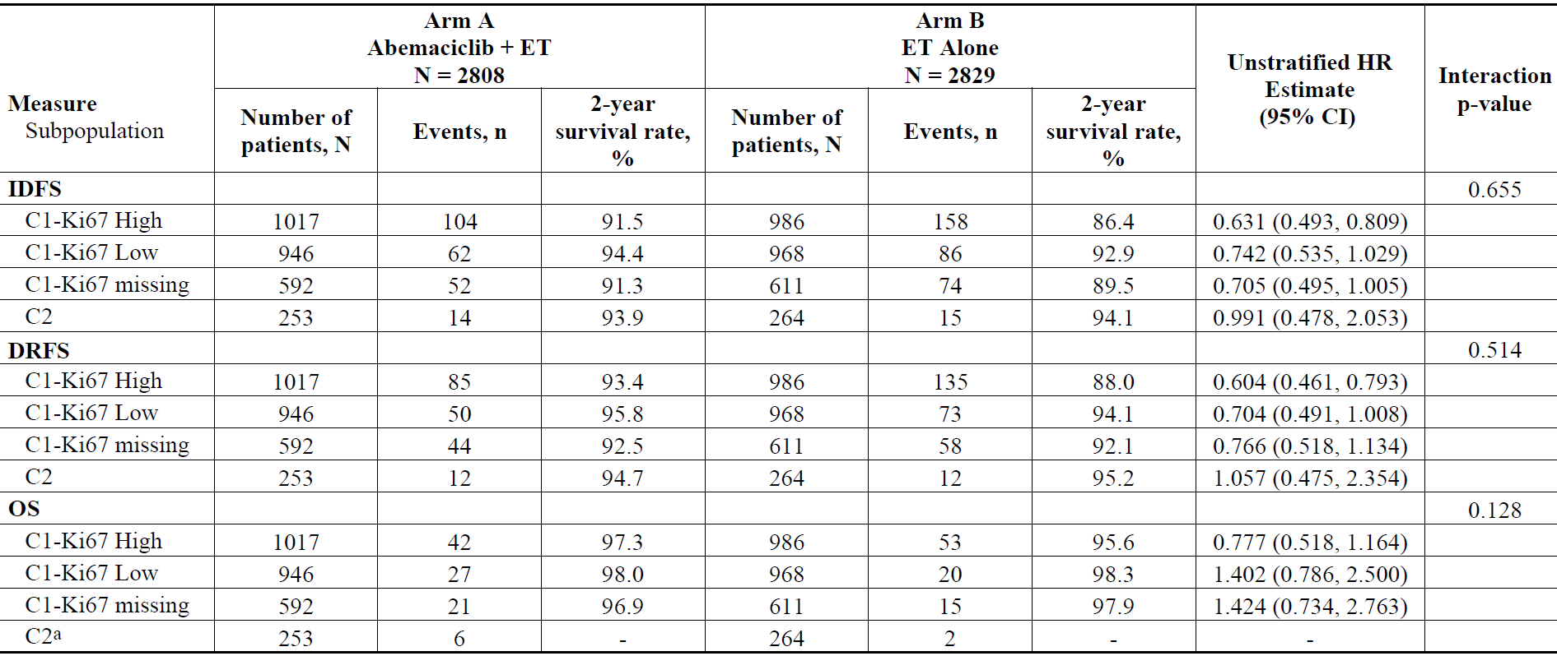

Abbreviations: C1 = Cohort 1; C2 = Cohort 2; CI = confidence interval; DRFS = distant recurrence-free survival; ET = endocrine therapy; HR = hazard ratio; IDFS = invasive disease-free survival; N = number of patients in subpopulation; n = number of survival events in category; OS = overall survival.

a OS data are immature for Cohort 2.

Data cut-off date: 1 April 2021.

Table 13: Study I3Y-MC-JPCF (MONARCHE trial) Deaths and reasons of deaths by subpopulation (intent-to-treat population overall survival Interim Analysis 1)

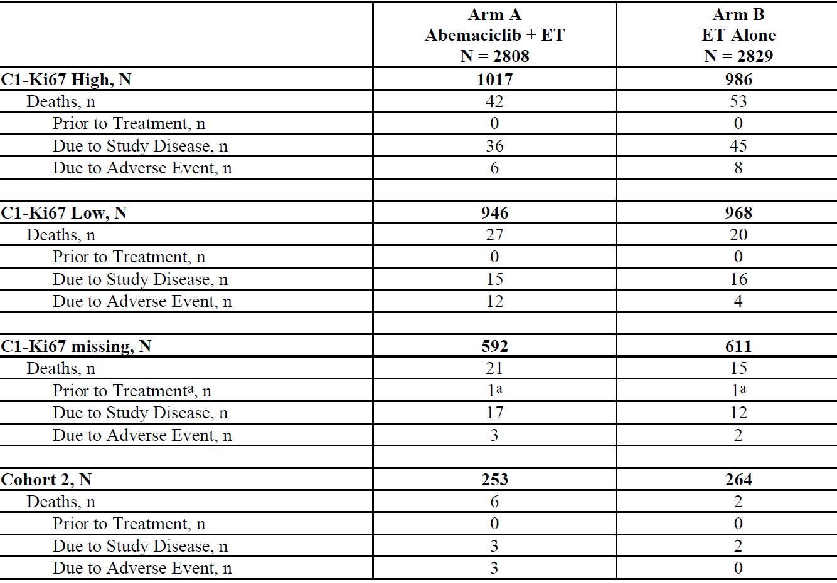

Abbreviations: C1 = Cohort 1; ET = endocrine therapy; N = number of patients in the intent-to-treat population; n = number of-patients in the specific population; OS = overall survival.

a Deaths after randomisation and prior to treatment were due to study disease.

Data cut-off date: 1 April 2021.

#### Advisory Committee considerations

The [Advisory Committee on Medicines (ACM)](https://www.tga.gov.au/committee/advisory-committee-medicines-acm), having considered the evaluations and the Delegate’s overview, as well as the sponsor’s response to these documents, advised the following.

##### Specific advice to the Delegate

1. ***In the high-risk early breast cancer setting is a 2.5% to 3.5% improvement in the invasive disease-free survival rates at 2 years over endocrine therapy alone clinically meaningful?***

The ACM commented that the hazard ratio for invasive disease-free survival (IDFS) was consistently about 30% across the three analyses in Study I3Y-MC-JPCF (the MONARCHE trial), with an absolute benefit for IDFS of 3.5% at Interim Analysis 2, 3.0% at final primary outcome analysis 3.0% and 2.7% at April 2021. The ACM was of the view that this is a clinically meaningful result in the adjuvant setting where the goal is cure (number needed to treat - 40).

The ACM noted that while current data indicates clinical meaningfulness, this must be balanced against the drugs toxicity profile over endocrine therapy alone.

By way of comparison, the ACM noted the BIG 1-98 trial comparing 5 years of letrozole to tamoxifen in early breast cancer showed a 3% benefit in 5-year disease-free survival (DFS), (hazard ratio of 0.81) after a median follow-up of 26 months.[34] At the 8 year follow up there was a 4.4% benefit in 5‑year DFS, hazard ratio of 0.82.[35]

1. ***Is there any concern about the invasive disease-free survival translating to an overall survival benefit, noting concerns about other drugs in this class, and the overall survival findings of the MONARCHE trial?***

The ACM advised that longer follow-up is important to confirm the persistence of the clinical benefit and the proportionality of the hazard ratios of recurrence. It is possible, but unlikely, that the curves could converge with long-term follow-up.

The ACM noted that further data are expected in June 2022 and discussed whether this data would include information on OS that would influence the benefit risk balance for this drug. The ACM expressed interest in the June 2022 data, however noted that it may still be too immature for a clear difference in OS to be seen.

The ACM agreed that based on currently available data it is too early to understand the long-term impact on survival from adjuvant abemaciclib.

By way of comparison, the ACM noted the lack of benefit of adjuvant palbociclib in the PALLAS;[36] and PENELOPE-B trials;[37] (42% discontinued palbociclib in the PALLAS trial). In was also noted that the results of adjuvant ribociclib in the NATALEE trial;[38] are awaited.

1. ***Ki-67 immunohistochemistry is only available in some centres in Australia. If it were readily available is 20% or more sufficiently predictive of high risk such that the indication should be limited to patients from that group?***

The ACM advised that Ki-67 immunohistochemistry (IHC) is widely used for a variety of indications in diagnostic histopathology and would be available in the majority of laboratories in Australia, noting that Ki-67 IHC is not currently required in reporting of breast cancer in Australia.

The ACM noted some caveats with Ki-67, including issues with interpretation, variability in the threshold, and heterogeneity in tumour specimens.

The ACM agreed that Ki-67 is not predictive of response in patients with other high-risk features (Cohort 1: 4 or more positive axillary lymph nodes (ALN), or 1 to 3 positive ALN and either Grade 3 disease or tumour 5 cm or larger). The ACM advised that there was a patient benefit regardless of Ki-67 and high Ki-67 alone is not predictive of IDFS benefit. Therefore, it cannot be concluded that treatment should be limited to high Ki-67 patients.

1. ***Does the ACM consider the evidence of benefits versus harms, noting uncertainties, in this submission support a new indication in early breast cancer for the combination of abemaciclib and endocrine therapy?***

The ACM agreed that a relative risk reduction of approximately 30%, absolute risk reduction of 3%, is clinically meaningful for this cohort, noting that further data are important to fully understand the efficacy profile. The ACM highlighted that this is a drug with significant toxicity, which needs to be considered for the individual benefit risk balance.

The ACM agreed that the patient population enrolled in the trial was representative of Australian patients with early breast cancer and noted that some Australian patients were also enrolled in the trial.

However, the ACM highlighted several concerns with the study design which may have led to inherent bias. The ACM commented that the study randomisation within 16 months of definitive surgery is quite long and was of the view that an imbalance in this timing between the arms could affect the efficacy results, noting significant evidence of inferior results if initial multi-modal treatment is prolonged. The ACM also commented that there could be significant variation in the baseline investigations (imaging) between patients, potentially up to 19 months from baseline imaging versus 6 months for others. Given that the IDFS endpoint is from time of randomisation it is important to demonstrate balance in the trial arms.

The ACM advised that data on baseline characteristics focussing on the previous two considerations should be provided to the TGA and would provide further clarity regarding the benefit risk profile. In addition, the ACM was of the view that Cohorts 1 and 2 are separate parallel populations and should not be combined.

1. ***If a new indication is supported by the evidence, can the ACM comment on the wording of the indication. In particular, should the indication be limited to patients whose risk profile includes a Ki-67 index of 20% or higher?***

The ACM discussed including a definition of ‘high risk’ in the indication, however on balance agreed ‘high risk node positive disease’ is sufficient detail for oncologists who are experienced in managing the treatment of this disease.

Given the issues as outlined in the advice the Question 3 (above), the ACM was of the view that Ki-67 index should not be included in the indication.

1. ***Are the risks adequately characterised from the data? Are the risks and risk mitigation strategies adequately explained in the draft Verzenio Product Information?***

The ACM advised that the risks reported in the MONARCHE trial are adequately characterised, and consistent with the known safety profile of abemaciclib.

The ACM was of the view that the risk mitigation strategies are adequately explained in the Verzenio Product Information (PI).

1. ***The ACM is requested to provide any other advice applicable to this submission.***

The ACM made the following recommended changes to the wording of the Consumer Medicines Information (CMI) and PI.

* Suggested amendments to the wording in the CMI:
  + ‘What Verzenio is used for’
    - Paragraph 2 - omit dot points to make it consistent with the layout of the Verzenio CMI for metastatic breast cancer.
    - Suggested wording ‘Verzenio is used to treat patients with certain types of breast cancer (hormone receptor-positive (HR pos), human epidermal growth factor receptor 2-negative (HER2 neg)). The breast cancer has not spread to other parts of the body apart from the breast and lymph nodes in the armpit. Verzenio is given with aromatase inhibitors or tamoxifen, which are hormonal anticancer therapies (endocrine therapies).’
    - Note that the CMI currently states ‘It is given with aromatase inhibitors or fulvestrant’.
  + ‘How long to take it’ - delete first sentence about metastatic breast cancer.
* Suggested amendments to the PI:
  + Dose adjustments decrease the dose by 50mg twice daily at a time (consistent with Table 1 [of the PI]), also needs to be amended.
  + Diarrhoea - dose modification…recommended for patients who develop recurrent Grade ≥ 2 diarrhoea.
  + Neutropaenia - dose modification…who develop recurrent Grade 3 or Grade 4 neutropaenia, also similar under increase ALT/AST.
  + Section 5.1 delete paragraph about effect on QTcF interval [QT interval corrected for heart rate according to Fridericia’s formula],[39] under incorrect section, repeated.
  + Section on 1 April 2021 analysis reports the 3-year IDFS rate with a 5.4% absolute benefit rather than the 2-year IDFS rate.

##### Conclusion

The ACM advised that there is insufficient data at this time to make a recommendation on the overall risk benefit balance. The ACM awaits the provision of data in support of the baseline characteristics being balanced, namely clarification about the duration of therapy in the up to 16-month interval from surgery to enrolment and the time from imaging to randomisation. Notwithstanding the limitations, the ACM also expressed interest in the provision of the overall survival data to see the direction of the trend, noting that this further data is expected in June 2022.

## Outcome

Based on a review of quality, safety, and efficacy, the TGA approved the registration of Verzenio (abemaciclib) 50 mg, 100 mg, 150 mg and 200 mg, film coated tablet, blister pack, for the following extension of indications:

***Early breast cancer***

*Verzenio in combination with endocrine therapy is indicated for the adjuvant treatment of patients with hormone receptor (HR) positive, human epidermal growth factor receptor 2 (HER2) negative, node-positive early breast cancer at high risk of recurrence.*

*In pre- or peri-menopausal women, endocrine therapy should be combined with a luteinising hormone-releasing hormone (LHRH) agonist.*

As such, the full indications at this time were:

***Early breast cancer***

*Verzenio in combination with endocrine therapy is indicated for the adjuvant treatment of patients with hormone receptor (HR) positive, human epidermal growth factor receptor 2 (HER2) negative, node-positive early breast cancer at high risk of recurrence.*

*In pre- or peri-menopausal women, endocrine therapy should be combined with a luteinising hormone-releasing hormone (LHRH) agonist.*

***Advanced or metastatic breast cancer***

*Verzenio is indicated for the treatment of hormone receptor (HR) positive, human epidermal growth factor receptor 2 (HER2) negative locally advanced or metastatic breast cancer in combination with an aromatase inhibitor or fulvestrant as initial endocrine-based therapy, or following prior endocrine therapy.*

*In pre- or peri-menopausal women, the endocrine therapy should be combined with a luteinising hormone-releasing hormone (LHRH) agonist.*

### Specific conditions of registration applying to these goods

* Related to the MONARCHE study (Study 13Y-MC-JPCF), as the sponsor agreed by email on 29 April 2022, [the sponsor] will:
  + submit the following for evaluation:
    - The updated clinical study findings at the Interim Overall Survival Analysis 2.
    - The updated clinical study findings at the Interim Overall Survival Analysis 3.
    - The final clinical study report.
  + abide by commitments made in writing to TGA on 29 April 2022 regarding PI amendments and the socialising of any major negative findings to HCPs [healthcare professionals].

## Attachment 1. Product Information

The PI for Verzenio approved with the submission which is described in this AusPAR is at Attachment 1. For the most recent PI, please refer to the TGA [PI/CMI search facility.](https://www.tga.gov.au/picmi-search-facility)

|  |
| --- |
| Therapeutic Goods Administration |
| PO Box 100 Woden ACT 2606 Australia  Email: [info@tga.gov.au](mailto:info@tga.gov.au) Phone: 1800 020 653 Fax: 02 6232 8605  [**https://www.tga.gov.au**](https://www.tga.gov.au) |

1. Cancer Australia. Breast Cancer in Australia Statistics, last updated 15 September 2022. Available at: <https://www.canceraustralia.gov.au/cancer-types/breast-cancer/statistics#:~:text=The%20number%20of%20new%20cases,cases%20per%20100%2C000%20in%202018>.
2. The Surveillance, Epidemiology, and End Results (SEER) Program provides information on cancer statistics in an effort to reduce the cancer burden among the American (USA) population. SEER is supported by the Surveillance Research Program (SRP) in National Cancer Institute (NCI’s) Division of Cancer Control and Population Sciences (DCCPS).
3. Howlader et al. US Incidence of Breast Cancer Subtypes Defined by Joint Hormone Receptor and HER2 Status, *J Natl Cancer Inst*, 2014; 106(5): dju055.
4. Howlader, N. et al. (ed.) SEER Cancer Statistics Review, 1975-2013, National Cancer Institute. Bethesda, M.D., based on November 2015 SEER data submission, posted to the SEER web site, April 2016. Available at: <http://seer.cancer.gov/csr/1975_2013/>.
5. The **TNM Staging System** is a widely used cancer staging system, developped and maintained by the AJCC and the Union for Internation Cancer Control (UICC). The TNM Staging System is based on the extent of the tumour (T), extent of spread to lymph nodes (N) and presence of metastasis. The T category describes the original (primary) tumour: TX = Primary tumour cannot be evaluated; T0 = No evidence of primary tumour; Tis = Carcinoma in situ (early cancer that has not spread to neighbouring tissue); T1 to T4: Size and/or extent of the primary tumour. The N category describes whether or not the cancer has reached nearby lymph nodes: NX = Regional lymph nodes cannot be evaluated; N0 = No regional lymph node involvement (no cancer found in the lymph nodes); N1 to N3 = Involvement of regional lymph nodes (number and/or extent of spread). The M category tells whether there are distant metastases (spread of cancer to other parts of the body): M0 = No distant metastasis (cancer has not spread to other parts of the body); M1 = Distant metastasis (cancer has spread to distant parts of the body).
6. Early Breast Cancer Trialists’ Collaborative Group (EBCTCG) Aromatase Inhibitors versus Tamoxifen in Early Breast Cancer: Patient Level Meta-Analysis of the Randomised Controlled Trials, *Lancet,* 2015; 386(10001): 1341-1352.
7. Cardoso, F. et al. 4th ESO-ESMO International Consensus Guidelines for Advanced Breast Cancer (ABC 4), *Ann Oncol*, 2018; 29: 1634-1657.
8. Pan, H. et al. 20-Year Risks of Breast-Cancer Recurrence after Stopping Endocrine Therapy at 5 Years, *N Engl J Med,* 2017; 377(19): 1836-1846.
9. Cancer Australia, Guidance for the management of early breast cancer: Recommendations and practice points, September 2020. Available at: <https://www.canceraustralia.gov.au/sites/default/files/publications/guidance-management-early-breast-cancer-recommendations-and-practice-points/pdf/guidance_for_the_management_of_early_breast_cancer_recommendations_and_pps_2020_0.pdf>.
10. Burstein, H.J. et al. Estimating the Benefits of Therapy for Early-Stage Breast Cancer: the St. Gallen International Consensus Guidelines for the Primary Therapy of Early Breast Cancer, *Ann Oncol*, 2019; 30(10): 1541-1557.
11. Thomssen, C. et al. St. Gallen/Vienna 2021: a brief Summary of the Consensus Discussion on Customizing Therapies for Women with Early Breast Cancer, *Breast Care*, 2021; 16(2): 135-143.
12. Burstein, H.J. et al. Adjuvant Endocrine Therapy for Women with Hormone Receptor-Positive Breast Cancer: ASCO Clinical Practice Guideline Focused Update, *J Clin Oncol*, 2019; 37(5): 423-438.
13. Visvinathan, K. et al. Use of Endocrine Therapy for Breast Cancer Risk Reduction: ASCO Clinical Practice Guideline Update, *J Clin Oncol*, 2019; 37(33): 3152-3165.
14. National Comprehensive Cancer Network (NCCN) NCCN Clinical Practice Guidelines on Oncology (NCCN Guidelines) Breast Cancer Version 5.2021. Available at: <https://www.nccn.org/professionals/physician_gls/pdf/breast.pdf>.
15. National Cancer Institute (NCI) Breast Cancer Treatment (Adult) (PDQ) - Health Professional Version. Updated September 21, 2021. Available at: <https://www.cancer.gov/types/breast/hp/breast-treatment-pdq>.
16. National Institute for Health and Care Excellence (NICE). Early and Locally Advanced Breast Cancer: Diagnosis and Management, Published July 2018. Available at: <https://pubmed.ncbi.nlm.nih.gov/30102508/>.
17. Nolvadex (tamoxifen) was first registered on the ARTG on 11 July 1991 (ARTG numbers: 11232 and 11233).
18. Femara (letrozole) was first registered on the ARTG on 30 October 1997 (ARTG number: 60605).
19. Arimidex (anastrozole) was first registered on the ARTG on 17 December 1996 (ARTG number: 54672).
20. Aromasin (exemestane) was first registered on the ARTG on 30 November 2000 (ARTG number: 76369).
21. Zoladex (goserelin) was first registered on the ARTG on 14 October 1991 (ARTG number: 24368).
22. **Ki-67** is a nuclear non-histone protein present in all active phases (except G0) of cell cycles. It is one of the prospectively selected genes used to predict the risk of recurrence and extent of chemotherapy benefits in women with node negative, estrogen receptor positive breast cancers. The proliferation biomarker function of Ki-67 is also considered a prognostic factor for breast cancer in some scientific studies.
23. Clinical expert opinion, inclusion of this information is beyond the scope of the AusPAR.
24. Royal College of Pathologists of Australia (RCPA) Invasive Breast Cancer Structured Reporting Protocol, 2nd edition, Published November 2012. Available at: <https://www.rcpa.edu.au/getattachment/9c857cb6-6878-4004-bf8a-37761873cf13/Protocolinvasive-breast-cancer.aspx>.
25. Dowsett, M. et al. Assessment of Ki67 in Breast Cancer: Recommendation from the International Ki67 in Breast Cancer working group, *J Natl Cancer Inst*, 2011;103(22):1656-1664.
26. **Common Terminology Criteria (CTC)** is a standardised classification of side effects used in assessing drugs for cancer therapy, in particular. Specific conditions and symptoms may have values or descriptive comment for each level, but the general guideline is 1 - Mild, 2 - Moderate, 3 - Severe, 4 - Life threatening, 5 - Death.
27. The randomised clinical trials analysed by the **intention-to-treat (ITT)** approach provide unbiased comparisons among the treatment groups. In the ITT population, none of the subjects are excluded, regardless of treatment compliance or attrition due to dropout or crossover, and the subjects are analysed according to the randomisation scheme.
28. See Section: *Ki-67 as prognostic biomarker.*
29. **ECOG Performance Status**: The Eastern Cooperative Oncology Group (ECOG) has developed criteria used by doctors and researchers to assess how a patient's disease is progressing, assess how the disease affects the daily living abilities of the patient, and determine appropriate treatment and prognosis. The following are used:

    0 - Fully active, able to carry on all pre-disease performance without restriction

    1- Restricted in physically strenuous activity but ambulatory and able to carry out work of a light or sedentary nature, for example, light house work, office work

    2 - Ambulatory and capable of all selfcare but unable to carry out any work activities. Up and about more than 50% of waking hours

    3 - Capable of only limited selfcare, confined to bed or chair more than 50% of waking hours

    4 - Completely disabled. Cannot carry on any selfcare. Totally confined to bed or chair

    5 – Dead
30. Hudis, C.A. et al. Proposal for Standardized Definitions for Efficacy End Points in Adjuvant Breast Cancer Trials: the STEEP system, *J Clin Oncol*, 2007; 25(15): 2127-2132.
31. The **Functional Assessment of Cancer Therapy-Endocrine Subscale (FACT-ES)** is a 5-point Likert-type scale questionnaire that can be used to measures the side effects and putative benefits of hormonal treatments given (endocrine therapy) in breast cancer. It was developed to accompany the Functional Assessment of Cancer Therapy for patients with Breast cancer (FACT-B), a standardised breast cancer quality of life measure.
32. **Drug induced liver injury (DILI)** also known as drug-induced hepatoxicity, is acute or chronic liver damage caused by a prescription, over the counter (OTC) or complementary medicine. Hepatoxicity due to type A reactions, or intrinsic DILI is typically dose-related and occurs in a large proportion of individuals exposed to the drug, (predictable) and onset is within a short time span (hours to days). Idiosyncratic DILI is not closely dose-related, and occurs in only a small proportion of exposed susceptible individuals (unpredictable) and exhibits a variable latency to onset of days to weeks.
33. Inclusion of this information is beyond the scope of the AusPAR.
34. The Breast International Group (BIG) 1-98 Collaborative Group, A Comparison of Letrozole and Tamoxifen in Postmenopausal Women with Early Breast Cancer, *N Engl J Med,* 2005; 353: 2747-2757.
35. Regan et al. Assessment of Letrozole and Tamoxifen Alone and in Sequence for Postmenopausal Women with Steroid Hormone Receptor-Positive Breast Cancer: the BIG 1-98 Randomised Clinical Trial at 8·1 Years Median Follow-Up, *Lancet Oncol*, 2011; 12(12): 1101-1108.
36. The PALLAS trial: Palbociclib collaborative adjuvant study: A randomised Phase III trial of palbociclib with standard adjuvant endocrine therapy versus standard adjuvant endocrine therapy alone for hormone receptor positive (HR+) / human epidermal growth factor receptor 2 negative (HER2-) early breast cancer.
37. The PENELOPE-B trial: A study of palbociclib in addition to standard endocrine treatment in hormone receptor positive human epidermal growth factor receptor 2 (HER2) normal breast cancer patients with residual disease after neoadjuvant chemotherapy and surgery.
38. The NATALEE trial: A trial to evaluate efficacy and safety of ribociclib with endocrine therapy as adjuvant treatment in patients with hormone receptor positive (HR+) / human epidermal growth factor receptor 2 negative (HER2-) early breast cancer.
39. The QT interval is the time from the start of the QRS wave complex to the end of the corresponding T wave. It approximates to the time taken for ventricular depolarisation and repolarisation, that is to say, the period of ventricular systole from ventricular isovolumetric contraction to isovolumetric relaxation.

    The corrected QT interval (QTc) estimates the QT interval at a standard heart rate. This allows comparison of QT values over time at different heart rates and improves detection of patients at increased risk of arrhythmias. The **QTcF** is the QT interval corrected for heart rate according to Fridericia’s formula.