|  |
| --- |
| October 2022 |

|  |
| --- |
| Australian Public Assessment Report for Xpovio |
| Active ingredients: Selinexor |
| Sponsor: Antengene (Aus) Pty Ltd |

About the Therapeutic Goods Administration (TGA)

* The Therapeutic Goods Administration (TGA) is part of the Australian Government Department of Health and is responsible for regulating therapeutic goods, including medicines, medical devices, and biologicals.
* The TGA administers the *Therapeutic Goods Act 1989* (the Act), applying a risk management approach designed to ensure therapeutic goods supplied in Australia meet acceptable standards of quality, safety, and efficacy.
* The work of the TGA is based on applying scientific and clinical expertise to decision-making, to ensure that the benefits to the Australian public outweigh any risks associated with the use of therapeutic goods.
* The TGA relies on the public, healthcare professionals and industry to report problems with therapeutic goods. The TGA investigates reports received to determine any necessary regulatory action.
* To report a problem with a therapeutic good, please see the information on the [TGA website](https://www.tga.gov.au).

About AusPARs

* The Australian Public Assessment Report (AusPAR) provides information about the evaluation of a prescription medicine and the considerations that led the TGA to approve or not approve a prescription medicine submission. Further information can be found in [Australian Public Assessment Report (AusPAR) guidance](https://www.tga.gov.au/australian-public-assessment-report-auspar-guidance).
* AusPARs are prepared and published by the TGA.
* AusPARs are static documents that provide information that relates to a submission at a particular point in time. The publication of an AusPAR is an important part of the transparency of the TGA’s decision-making process.
* A new AusPAR may be provided to reflect changes to indications or major variations to a prescription medicine subject to evaluation by the TGA.

Copyright

© Commonwealth of Australia 2022  
This work is copyright. You may reproduce the whole or part of this work in unaltered form for your own personal use or, if you are part of an organisation, for internal use within your organisation, but only if you or your organisation do not use the reproduction for any commercial purpose and retain this copyright notice and all disclaimer notices as part of that reproduction. Apart from rights to use as permitted by the *Copyright Act 1968* or allowed by this copyright notice, all other rights are reserved, and you are not allowed to reproduce the whole or any part of this work in any way (electronic or otherwise) without first being given specific written permission from the Commonwealth to do so. Requests and inquiries concerning reproduction and rights are to be sent to the TGA Copyright Officer, Therapeutic Goods Administration, PO Box 100, Woden ACT 2606 or emailed to <[tga.copyright@tga.gov.au](mailto:tga.copyright@tga.gov.au)>.

Contents

List of abbreviations 4

Product submission 7

Submission details 7

Product background 9

Regulatory status 11

Product Information 12

Registration timeline 13

Submission overview and risk/benefit assessment 13

Quality 14

Nonclinical 15

Clinical 16

Risk management plan 58

Risk-benefit analysis 60

Outcome 77

Specific conditions of registration applying to these goods 77

Attachment 1. Product Information 78

## List of abbreviations

|  |  |  |
| --- | --- | --- |
| Abbreviation | | Meaning |
| ACM | Advisory Committee on Medicines | |
| AE | Adverse event | |
| ALT | Alanine aminotransferase | |
| AML | Acute myeloid leukaemia | |
| ARTG | Australian Register of Therapeutic Goods | |
| ASA | Australia specific annex | |
| AST | Aspartate aminotransferase | |
| AUC | Area under the concentration time curve | |
| AUC0-∞ | Area under the concentration time curve from time zero to infinity | |
| AUC0-t | Area under the concentration time curve over the dosing interval | |
| CF/F | Apparent oral clearance | |
| CI | Confidence interval | |
| Cmax | Maximum concentration | |
| CMI | Consumer Medicines Information | |
| CNS | Central nervous system | |
| CR | Complete response | |
| CV | Coefficient of variation | |
| DLP | Data lock point | |
| DOR | Duration of response | |
| ECOG PS | Eastern Cooperative Oncology Group performance status | |
| EoT | End of treatment | |
| EU | European Union | |
| FACT-MM | Functional Assessment of Cancer Therapy–Multiple Myeloma | |
| GLP | Good Laboratory Practice | |
| GMP | Good Manufacturing Practice | |
| HIV | Human immunodeficiency virus | |
| IA | Interim analysis | |
| IC50 | Inhibitory concentration, 50% | |
| IgA | Immunoglobin A | |
| IMiD | Immunomodulatory imide drug / immunomodulatory drug product | |
| IMWG | International Myeloma Working Group | |
| IRC | Independent review committees | |
| ITT | Intent to treat | |
| Ka | Absorption rate constant | |
| mAB | Monoclonal antibody | |
| mITT | Modified intent to treat | |
| MR | Minimal response | |
| mTOR | Mammalian target of rapamycin | |
| NYHA | New York Heart Association | |
| ORR | Overall response rate | |
| OS | Overall survival | |
| PFS | Progression free survival | |
| PI | Product Information | |
| PP | Per-protocol | |
| PR | Partial response | |
| Q/F | Apparent intercompartmental clearance | |
| R-ISS | Revised International Staging System | |
| RMP | Risk management plan | |
| RNA | Ribonucleic acid | |
| RR DLBCL | Relapsed or refractory diffuse large B-cell lymphoma | |
| RRMM | Relapsed or refractory multiple myeloma | |
| SAE | Serious adverse event | |
| sCR | Stringent complete response | |
| Sd | Regimen of selinexor and dexamethasone | |
| SdX | Cross over to regimen of selinexor and dexamethasone | |
| SINE | Selective inhibitor of nuclear export | |
| SVd | Regimen of selinexor, bortezomib and dexamethasone | |
| SVdX | Cross over to regimen of selinexor, bortezomib and dexamethasone | |
| t1/2 | Half life | |
| TEAE | Treatment emergence adverse event | |
| TF1 | Tablet formulation 1 | |
| TF2 | Tablet formulation 2 | |
| TGA | Therapeutic Goods Administration | |
| Tmax | Time to maximum concentration | |
| TRAE | Treatment related adverse events | |
| TRSAE | Treatment related serious adverse event | |
| TSP | Tumour suppressor protein | |
| ULN | Upper limit of normal | |
| USA | United States of America | |
| Vc/F | Apparent central volume | |
| Vd | Regimen of bortezomib and dexamethasone | |
| VGPR | Very good partial response | |
| Vp/F | Apparent peripheral volume | |
| XPO1 | Exportin 1 | |

## Product submission

### Submission details

|  |  |
| --- | --- |
| *Type of submission:* | New chemical entity |
| *Product name:* | Xpovio |
| *Active ingredient:* | Selinexor |
| *Decision:* | Approved |
| *Date of decision:* | 3 March 2022 |
| *Date of entry onto ARTG:* | 8 March 2022 |
| *ARTG number:* | 346589 |
| [*Black Triangle Scheme*](https://www.tga.gov.au/black-triangle-scheme)*:* | Yes  This product will remain in the scheme for 5 years, starting on the date the product is first supplied in Australia |
| *Sponsor’s name and address:* | Antengene (Aus) Pty Ltd  Level 17, 31 Queen Street,  Melbourne, VIC 3000 |
| *Dose form:* | Film coated tablet |
| *Strength:* | 20 mg |
| *Container:* | Blister pack |
| *Pack sizes:* | 16, 20, 24 and 32 tablets |
| *Approved therapeutic use:* | *Xpovio is indicated:*   * *In combination with bortezomib and dexamethasone for the treatment of adult patients with multiple myeloma who have received at least one prior therapy.* * *In combination with dexamethasone for the treatment of adult patients with relapsed or refractory multiple myeloma (RRMM) who have received at least three prior therapies and whose disease is refractory to at least one proteasome inhibitor, at least one immunomodulatory medicinal product (IMiD), and an anti CD38 monoclonal antibody (mAb).* |
| *Route of administration:* | Oral |
| *Dosage:* | Treatment must be initiated and monitored under supervision of physicians experienced in the management of multiple myeloma.  *In combination with bortezomib and dexamethasone (SVd)*  The recommended starting dose of Xpovio in combination with bortezomib and dexamethasone is based on a 35-day cycle as follows:   * Selinexor (Xpovio) 100 mg (5 x 20 mg tablets) is taken orally once weekly on Days 1, 8, 15, 22 and 29. * Bortezomib 1.3 mg/m2 is administered subcutaneously once weekly on Days 1, 8, 15 and 22. * Dexamethasone 20 mg is taken orally on Days 1, 2, 8, 9, 15, 16, 22, 23, 29, and 30.   Treatment is administered until disease progression or unacceptable toxicity, for additional information regarding the administration of bortezomib and dexamethasone, refer to their respective prescribing information.  *In combination with dexamethasone (Sd)*  The recommended starting dose is 80 mg (4 x 20 mg tablets) of Xpovio on Days 1 and 3 of each week.  The recommended starting dose of dexamethasone is 20 mg taken orally on Days 1 and 3 of each week with Xpovio. For additional information regarding the administration of dexamethasone, refer to its Product Information.  Treatment should be continued until disease progression or unacceptable toxicity.  *Method of administration*  The tablet should be swallowed whole with water.  It should not be crushed, chewed, broken or divided in order to prevent risk of skin irritation from the active substance. It can be taken with or without food.  If a Xpovio dose is missed or delayed or a patient vomits after a dose of Xpovio, the patient should not repeat the dose. Patients should take the next dose on the next regularly scheduled day.  Advise patients to maintain adequate fluid and caloric intake throughout treatment. Consider intravenous hydration for patients at risk of dehydration.  For medicinal products administered in combination with Xpovio, the product information of these medicinal products must be consulted prior to initiation of treatment, including for special warnings and precaution for use and recommended concomitant treatments.  For guidance on monitoring before and during treatment, see the Product Information.  *Dose modifications for adverse reactions*  Continued treatment of Xpovio may require appropriate dose modifications (reductions and/or interruptions) in the event of adverse reactions.  See the Product Information for recommended Xpovio dose reduction steps for adverse reactions, including dosage modifications for non-haematologic, and haematologic adverse reactions in patients with multiple myeloma (in combination with bortezomib and/or dexamethasone).  For further information regarding dosage, refer to the Product Information. |
| *Pregnancy category:* | D  Drugs which have caused, are suspected to have caused or may be expected to cause, an increased incidence of human fetal malformations or irreversible damage. These drugs may also have adverse pharmacological effects. Accompanying texts should be consulted for further details.  The use of any medicine during pregnancy requires careful consideration of both risks and benefits by the treating health professional. This must not be used as the sole basis of decision making in the use of medicines during pregnancy. The TGA does not provide advice on the use of medicines in pregnancy for specific cases. More information is available from obstetric drug information services in your State or Territory. |

### Product background

This AusPAR describes the submission by Antengene (Aus) Pty Ltd (the sponsor) to register Xpovio (selinexor) 20 mg, film coated tablet for the following proposed indication:

* + *In combination with dexamethasone for the treatment of adult patients with relapsed or refractory multiple myeloma (RRMM) who have received at least three prior therapies and whose disease is refractory to at least one proteasome inhibitor, at least one immunomodulatory medicinal product (IMiD), and an anti-CD38 monoclonal antibody (mAb).*
  + *In combination with bortezomib and dexamethasone for the treatment of adult patients with multiple myeloma who have received at least one prior therapy.*
  + *For the treatment of adult patients with relapsed or refractory diffuse large B-cell lymphoma (RR DLBCL), not otherwise specified, including DLBCL arising from follicular lymphoma, after at least 2 lines of systemic therapy*

#### Multiple myeloma

Multiple myeloma is a plasma cell malignancy in which a single clone of plasma cells proliferates in the bone marrow. The presence of the clone results in a production and deposition of a monoclonal paraprotein, destruction of bone and replacement of other cell lines in the bone marrow. Clinical presentation may include bone pain and lytic lesions, increased total serum protein and/or monoclonal protein in urine or serum, hypercalcaemia, acute renal failure (rarely nephrotic syndrome), other non-specific symptoms or signs of malignancy.

The median age of disease at diagnosis is 70 years, with 37% patients younger than 65 years.[1] In 2018, there were 2,247 new cases of multiple myeloma diagnosed in Australia (1,336 males and 910 females). In 2018, the age-standardised incidence rate was 7.6 cases per 100,000 persons (9.5 for males and 5.8 for females). The incidence rate for multiple myeloma is expected to increase with age, highest for those aged between 85 and 89 years.[2],[3]

In 2020, there were 1,009 deaths from multiple myeloma in Australia (587 males and 422 females). In 2020, the age-standardised mortality rate in Australia was 3.1 deaths per 100,000 persons (3.9 for males and 2.3 for females).2,3

In 2014 to 2018, individuals diagnosed with multiple myeloma had a 55% chance (54% for males and 56% for females) of surviving for five years compared to their counterparts in the general Australian population. Between 1989 to 1993 and 2014 to 2018, five-year relative survival for multiple myeloma improved from 28% to 55%.2,3

#### Current treatment options

The initial treatment for patients with symptomatic multiple myeloma depends on risk stratification, eligibility for autologous haematopoietic stem cell transplant. Conventional therapy is not curative and most patients who survive the initial treatment for multiple myeloma will relapse, and of the relapsed patients most will experience serial relapse.[4]

A number of medicines on the Australian Register of Therapeutic Goods (ARTG) are used in combinations, although not all of these medicines have specific indications for the condition or the combinations in which they may be used. These include but are not limited to:

* regimens containing anti-CD38 antibodies (for example, daratumumab or isatuximab), elotuzumab containing regimens (anti-SLAMF7 antibodies), proteasome inhibitors (for example, bortezomib or carfilzomib),
* immunomodulatory drugs (for example, lenalidomide or pomalidomide),
* alkylating agents (for example, bendamustine), vincristine, hypomethylating agents and dexamethasone.

These are often described in three agent regimens (with or without monoclonal antibodies), or two agent regimens (more typically reserved for frail patients) although some agents are approved as monotherapy.

#### Selinexor

Xpovio is a new chemical entity containing the active ingredient selinexor. Selinexor is an oral, first in class, potent, slowly reversible covalent selective inhibitor of nuclear export (SINE) compound that specifically blocks exportin 1 (XPO1). This is one of a family of nuclear transport proteins that move large molecules between the nucleus and the cytoplasm through the nuclear membrane pore complex, including tumour suppressor proteins. In cancers such as multiple myeloma, XPO1 is over-expressed and the tumour suppressor proteins that need to be within the nucleus to function. Inhibition of XPO1 leads, amongst other mechanisms, to the nuclear accumulation and activation of tumour suppressor proteins (TSP), which then initiate apoptosis in cancer cells.

Two of the proposed indications include selinexor in combination with dexamethasone. These agents act synergistically to inhibit the mammalian target of rapamycin (mTOR) pathway and to promote cell apoptosis in multiple myeloma cells.

### Regulatory status

This product is considered a new chemical entity for Australian regulatory purposes.

At the time the TGA considered this submission, a similar submission had been approved in European Union (EU) and United Kingdom for the treatment of multiple myeloma indication and in United States of America (USA) for three indications (see Table 1). A similar submission was under consideration in Singapore.

The following table summarises these submissions and provides the indications where approved.

Table 1: International regulatory status of selected countries

|  |  |  |  |
| --- | --- | --- | --- |
| Region | Submission date | Status | Approved indications |
| European Union Centralised  Rapporteur: Spain  Co-rapporteur: Demark | 7 January 2019 | Approved on 26 March 2021 | *Nexpovio is indicated in combination with dexamethasone for the treatment of multiple myeloma in adult patients who have received at least four prior therapies and whose disease is refractory to at least two proteasome inhibitors, two immunomodulatory agents and an anti-CD38 monoclonal antibody, and who have demonstrated disease progression on the last therapy.* |
| 6 April 2021 | Under consideration | Under consideration |
| United States of America | 5 August 2018 | Approved on 3 July 2019 | *Xpovio is indicated in combination with dexamethasone for the treatment of adult patients with relapsed or refractory multiple myeloma (RRMM) who have received at least four prior therapies and whose disease is refractory to at least two proteasome inhibitors, at least two immunomodulatory agents, and an anti-CD38 monoclonal antibody.* |
| 21 December 2019 | Approved on 22 June 2020 | *Xpovio is indicated for the treatment of adult patients with relapsed and refractory diffuse large B-cell lymphoma(DLBCL), not otherwise specified, including DLBCL arising from follicular lymphoma, after at least 2 prior lines of systemic therapy.* |
| 20 May 2020 | Approved on 18 December 2020 | *Xpovio is indicated in combination with bortezomib and dexamethasone for the treatment of adult patients with multiple myeloma who have received at least one prior therapy.* |
| United Kingdom;[5] | 26 February 2021 | Approved on 26 May 2021 | *Nexpovio is indicated in combination with dexamethasone for the treatment of multiple myeloma in adult patients who have received at least four prior therapies and whose disease is refractory to at least two proteasome inhibitors, two immunomodulatory agents and an anti-CD38 monoclonal antibody, and who have demonstrated disease progression on the last therapy.* |
| Singapore | 27 November 2020 | Approved 1 March 2022 | Under consideration |

### Product Information

The Product Information (PI) approved with the submission which is described in this AusPAR can be found as Attachment 1. For the most recent PI, please refer to the TGA [PI/CMI search facility.](https://www.tga.gov.au/picmi-search-facility)

## Registration timeline

The following table captures the key steps and dates for this submission.

Table 2: Timeline for Submission PM-2020-05458-1-6

|  |  |
| --- | --- |
| Description | Date |
| Submission dossier accepted and first round evaluation commenced | 2 December 2020 |
| First round evaluation completed | 19 May 2021 |
| Sponsor provides responses on questions raised in first round evaluation | 30 June 2021 |
| Second round evaluation completed | 16 August 2021 |
| Delegate’s Overall benefit-risk assessment and request for Advisory Committee advice | 2 November 2021 |
| Sponsor’s pre-Advisory Committee response | 17 November 2021 |
| Advisory Committee meeting | 2 and 3 December 2021 |
| Registration decision (Outcome) | 3 March 2022 |
| Completion of administrative activities and registration on the ARTG | 8 March 2022 |
| Number of working days from submission dossier acceptance to registration decision* | 242 |

*Statutory timeframe for standard submissions is 255 working days

## Submission overview and risk/benefit assessment

A summary of the TGA’s assessment for this submission is provided below.

The Delegate referred to the following guidance as being applicable to this submission:

* Guideline on Good Vigilance Practices Module XVI https://www.ema.europa.eu/en/documents/scientific-guideline/guideline-good-pharmacovigilance-practices-module-xvi-risk-minimisation-measures-selection-tools_en-3.pdf
* EMA/CHMP/EWP/520088/2008 Appendix 2 to the Guideline on the Evaluation of Anticancer Medicinal Products in Man (CPMP/EWP/205/95 Rev. 3) on Confirmatory Studies in Haematological Malignancies
* EMA/CHMP/27994/2008/Rev 1 Appendix 1 to the guideline on the evaluation of anticancer medicinal products in man Methodological consideration for using progression-free survival (PFS) or disease-free survival (DFS) in confirmatory trials
* EMA/CPMP/EWP/1776/99 Rev. 1 Guideline on Missing Data in Confirmatory Clinical Trials
* CPMP/EWP/2330/99 Points to Consider on Application with 1. Meta-Analyses; 2. One Pivotal Study

### Quality

Figure 1: Structure of selinexor

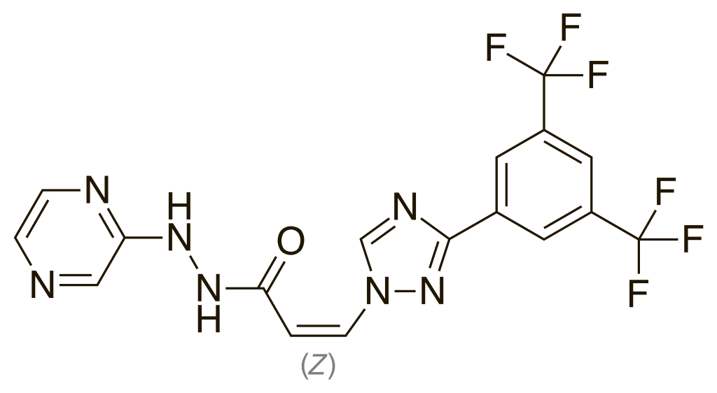

The drug substance is a white to off-white powder or solid. Based on the solubility and permeability data, selinexor is a low solubility, high permeability drug that is BSC class II.

The proposed drug substance specification adequately controls the impurities (including genotoxic impurities) arising from the synthesis and expected degradation products and for particle size. The stability data supports a retest period of 48 months when stored below 25°C for the drug substance.

Selinexor 20 mg tablets are blue, bi-convex, round, film coated tablets with ‘K20’ debossed on one side and nothing on the other. The tablet is comprised of the active selinexor and the excipients microcrystalline cellulose, croscarmellose sodium, povidone, silicon dioxide, magnesium stearate, microcrystalline cellulose and sodium lauryl sulfate.

Formulations developed for clinical studies through to commercial scale included capsules, wet granulated tablets (tablet formulation 1, TF1) and dry granulated tablets (tablet formulation 2, TF2).

The drug product specification adequately controls the quality of the tablets. The dissolution method was demonstrated to be adequately discriminatory under different manufacturing conditions, including changes to particle size and product formulation.

The stability data supports a shelf-life of 48 months when stored below 30˚C in the proposed commercial blister packs.

Overall the quality evalution recommended approval of Xpovio (selinexor) provided a Good Manufacturing Practice (GMP) clearance was available for all manufacturing sites. A manufacturing site without GMP certification has been withdrawn by the sponsor during evaluation of this submission.

### Nonclinical

The nonclinical dossier was of overall high quality and the scope was adequate, consistent with the relevant TGA adopted guideline for the nonclinical evaluation of anticancer pharmaceuticals (ICH S9);[6] although some minor deficiencies are noted. All pivotal safety related studies were Good Laboratory Practice (GLP) compliant except for one.

Selinexor is the first in its pharmacological class, selective inhibitor of nuclear export (SINE), targeting XPO1. Binding of selinexor to XPO1 is covalent, but slowly reversible. Selinexor was shown to potently inhibit XPO1-mediated nuclear export *in vitro* (50% (half maximal) inhibitory concentration (IC50), about 20 nM), leading to accumulation of numerous tumour suppressor proteins and growth regulator proteins within the nucleus (their site of action) and suppression of the expression of several oncoproteins and translation/chaperone proteins. This induced cell cycle arrest and cell death in cancer cell lines. Anti-tumour activity with selinexor treatment was demonstrated *in vivo* in mice bearing multiple myeloma, diffuse large B cell lymphoma (DLBCL), and other tumour xenografts. Synergy in combination with dexamethasone and bortezomib (and various other agents) was shown. These studies offer support for the utility of selinexor in the proposed indications.

Screening assays revealed no notable secondary pharmacological activity for selinexor.

Safety pharmacology studies indicated no likely acute, pharmacologically mediated effects of selinexor on central nervous system (CNS), cardiovascular or respiratory function.

Rapid to moderately rapid absorption of selinexor after oral administration was seen in laboratory animal species and humans. Oral bioavailability was moderately high in mice, rats and monkeys. The plasma half-life was short in all species. Plasma protein binding was high in mice, rats, monkeys and humans. Rapid and wide tissue distribution of 14C‑selinexor derived radioactivity was demonstrated in rats. Considerable penetration of the blood brain barrier was evident in all species studies (mice, rats and monkeys). Metabolism of selinexor was limited, and involved the cytochrome P450 (CYP) isozyme CYP3A4;[7] multiple UDP-glucuronosyltransferases (UGTs) and glutathione S-transferases. Excretion of selinexor and its metabolites was shown to be chiefly via the faeces/bile in rats.

*In vitro* experiments examining the potential for pharmacokinetic drug interactions revealed inhibition of OATP1B3 by selinexor at clinically relevant concentrations. Clinically relevant inhibition of CYPs, UGTs and other transporters, and CYP induction, were not observed.

Repeat dose toxicity studies were performed with selinexor in rats and cynomolgus monkeys. All were conducted by the oral route. The pivotal studies were of 13 weeks duration and involved alternating three times and twice weekly dosing (compare to once or twice weekly dosing in patients). Shorter studies employed three times weekly dosing. The major targets for selinexor toxicity were the bone marrow, lymphoid tissues, gastrointestinal tract and male and female reproductive organs. Effects were typical of a cell cycle inhibitor and occurred at doses yielding systemic exposure levels below that of patients.

Selinexor was negative in the standard battery of tests for genotoxicity. No carcinogenicity studies have been conducted; this is acceptable for a medicine indicated for the treatment of advanced cancer.

Impairment of male and female fertility in patients is suggested by histopathological findings in the general repeat-dose toxicity program. Adverse effects on embryofetal development, including malformations and embryolethality, were observed with selinexor in rats and occurred at subclinical exposure levels. While strong concerns over embryofetal toxicity are held for selinexor, these are not so extreme as to warrant assignment to Category X;[8] as the sponsor proposes. Assignment to Category D;[9] is recommended instead (consistent with the categorisation of similar agents).

Overall, the nonclinical evaluation found no objections to the approval of selinexor.

### Clinical

#### Formulation

The dosage form was initially designed as an immediate release oral capsule formulation and subsequently as two different immediate release oral tablet formulations (first generation tablet and second generation tablet). An oral suspension formulation, prepared from the first generation tablet (TF1), was used during early clinical development and to establish relative bioavailability. The commercial formulation is similar to the tablet used in clinical development (second generation tablet, TF2) except for the removal of tartrazine (pigment) from the outer top coat.

Following oral administration of either the tablet or oral suspension dosage forms, selinexor was rapidly absorbed into systemic circulation, with a median time to maximum concentration (Tmax) ranging from 1.6 to 3 hours across the three treatment groups (Group A: first generation tablets, Group B: second generation tablet and Group C: oral suspension).

The oral suspension was considered bioequivalent to the first and second generation tablets with regards to total drug exposure as measured by area under the concentration time curve over the dosing interval (AUC0-t) and area under the concentration time curve from time zero to infinity (AUC0-∞). The maximum concentration (Cmax) of the oral suspension was estimated to be approximately 87% of the first generation tablet and 84% of the second generation tablet formulation. The excursions observed in Cmax comparisons beyond the 80 to 125% confidence interval (CI) were possibly attributed to intra-patient variability in Cmax (within-subject coefficient of variation (CVwp) = 36%).

#### Pharmacokinetics

The conduct of the studies that were provided in support of the current submission was satisfactory, the data analyses undertaken were appropriate and the analytical methods used to measure exposure levels were validated. The following is a summary of the clinical pharmacology from the clinical and quality perspectives.

##### Absorption, distribution, metabolism and excretion

Selinexor for clinical use is formulated as an immediate release, film coated tablet for oral dosing.

In patients with solid tumour malignancies administered a 60 mg dose of the second tablet formulation (TF2) formulation of selinexor twice weekly for 3 weeks, the median selinexor Tmax was 3 hour and the Ka for selinexor in patients with cancer was 1.03 L/h.

The absolute bioavailability of selinexor in humans is unknown, whereas, the relative bioavailability between the second generation (TF2) tablet formulation (the final commercial product) and an oral suspension is functionally equivalent. The first generation tablet (TF1) and capsule formulations can be considered to be functionally bioequivalence, as can be the oral suspension and the TF1 and TF2 tablet formulations.

AUC0-∞, AUC0-t, and Cmax in fed patients (high and low fat meal) showed an approximate 15 to 25% increase compared to the fasted state. Tmax increased from 1.5 hours (fasted) to 3.4 to 3.8 hours (fed). The fat or caloric content of the meal did not impact area under concentration time curve (AUC) but the ratio for Cmax for the high fat to low fat meal fell outside of the usually accepted 80 to 125% CI (90% CI: 71.5 to 116.7). There was no meaningful difference between the tablet and capsule preparations for the exposure parameters and Cmax. The evaluator found the differences in selinexor exposure under fed and fasted conditions is unlikely to be clinically relevant.

Selinexor AUC0-inf and Cmax values were approximately dose proportional across the dose range of 3 to 80 mg/m2 and 3 to 85 mg/m2 in patients with haematological malignancies and advanced or metastatic solid tumours, respectively. There was no evidence of substantial plasma selinexor accumulation following single and multiple doses of selinexor.

The apparent volume of distribution/bioavailability for patients with cancer was 125 L. Human plasma protein binding of selinexor is 95% and is not concentration dependent. The blood plasma ratio was less than one, suggesting minimal association with red blood cells.

Two isomers of selinexor exist in the circulation; the parent compound and KPT-375, which represents < 5% of the circulating drug levels and has approximately 10% of the XPO1 inhibiting activity of selinexor.

Selinexor undergoes only limited metabolism, which was catalysed by CYP3A4 and multiple UGTs.

No mass balance study has been undertaken in humans; however, selinexor concentrations were approximately 2-fold higher in faeces than in urine. In addition, urinary concentrations of KPT-375 were generally low, ranging from 5% to 18% of parent drug, whereas, in faeces, KPT-375 concentrations were approximately 3.1-fold higher at the 0 to 4 hour collection point. The apparent oral clearance (CL/F) of selinexor was 17.7 L/h and the values for mean CL/F and half life (t1/2) following a 60 mg twice weekly dose of the TF2 tablet (as proposed in this submission) were 0.20 L/h/kg and 6.6 hour, respectively.

#### Population pharmacokinetics

In patients with acute myeloid leukaemia (AML), diffuse large B cell lymphoma (DLBCL), multiple myeloma and other haematologic or solid cancers, selinexor pharmacokinetics was described by a two compartment linear elimination model. Absorption of selinexor was modelled as zero-order release of the drug followed by a first-order absorption into the central compartment. The model was parameterised in terms of apparent oral clearance (CL/F), apparent central volume (Vc/F), apparent intercompartmental clearance (Q/F), apparent peripheral volume (Vp/F), D1 and absorption rate constant (Ka).

Inter-individual variation on selinexor Cmax and AUC ranged from 27% to 31% and intra-patient variability was < 6.6% and 36%, respectively. Estimates of the inter-individual variation on CL/F and Ka were 15.7% and 124.9%, respectively.

Population pharmacokinetics analyses indicated that hepatic- and renal impairment, age, gender and body weight were unlikely to have clinically relevant effects on selinexor pharmacokinetics.

#### Drug-drug interactions

Paracetamol had no apparent effect on selinexor exposure. No clinically significant drug‑drug interactions were reported in > 3200 patients treated with selinexor alone or in combination with other drugs.

Population pharmacokinetics analyses indicated that weak, moderate and potent inhibitors of CYP3A, CYP3A inducers, CYP2D6 inhibitors, CYP2C8 inhibitors and dexamethasone were not significant covariates on selinexor CL/F. Similarly, proton pump inhibitors and histamine H2 blockers were found not to affect selinexor bioavailability.

#### Pharmacodynamics

##### Primary pharmacodynamics

Based on *in vitro* studies, Cmax levels of approximately 1 μM (achieved with 60 mg) were expected to kill most DLBCL cells while sparing normal cells, including lymphocytes.

Following selinexor doses ranging from 3 to 57 mg/m2, XPO1 mRNA induction > 2-fold was observed at all dose levels and generally increased with selinexor dose and exposure reaching maximal induction at doses ≥ 12 mg/m2 (about 30 mg) and mean AUC exposures of ≥ 1662 ng.h/mL. Maximum bioavailability occurred at approximately 4 hours following dosing and XPO1 mRNA remained elevated for up to 48 hours.

The magnitude of XPO1 induction remained uniform between different cancer types including AML, DLBCL and multiple myeloma.

A statistically significant relationship between overall response rate versus Day 1 Cmax was identified in DLBCL patients enrolled in Study KCP-330-009 (p < 0.05) and the predicted absolute loss in overall response rate was 4.7% when the dose was reduced from 60 mg to 40 mg twice weekly, but no exposure-response relationships were identified for overall survival (OS), progression free survival (PFS) or duration of response (DOR) versus selinexor exposure.

In a cohort of patients with heavily pre-treated relapsed or refractory multiple myeloma (RRMM) who received selinexor (with or without dexamethasone), modelling indicated that there was no significant relationship between selinexor AUC and best overall response. Moreover, no significant relationships were identified between AUC or dose and PFS or OS in patients with quad- and/or penta-refractory multiple myeloma.

##### Secondary pharmacodynamics

From linear mixed effect modelling a selinexor concentration of 1200 ng/mL (about 2-fold higher than the anticipated therapeutic concentrations after a 100 mg dose) change from Baseline corrected QT interval (QTcF);[10] increased 7.2 millisecond (90% CI of < 20 msec increase above baseline).

A statistically significant relationship between increasing selinexor exposure and increasing frequency of Grade 3 or higher thrombocytopenia (p < 0.001), hyponatraemia (p = 0.001) and fatigue (p = 0.001).

#### Multiple myeloma

##### Dose finding

The selinexor dose regimen of 100 mg once weekly was based on Study KCP-330-017 (the STOMP trial).[11], In this Phase Ib/II STOMP trial, selinexor was tested at 60, 80, or 100 mg doses with once weekly versus twice weekly dosing. The regimen of selinexor 100 mg, bortezomib 1.3 mg/m2, and dexamethasone 40 mg (SVd), all given once weekly in 35-day cycles was chosen based on its safety and long-term tolerability. overall response rate was 75% in the efficacy evaluable patients.

#### Study KCP-330-023 (BOSTON trial)

##### Efficacy

Study KCP-330-023 (BOSTON trial) is an ongoing, multicentre (n = 161), multinational (n = 21) Phase III, randomised, controlled, open label study of selinexor, bortezomib, and dexamethasone (SVd) versus bortezomib and dexamethasone (Vd) in patients with relapsed or refractory multiple myeloma (RRMM) who had received 1 to 3 prior anti‑multiple myeloma regimens. The study commenced on 7 June 2017 and the data cutoff date for the clinical study report was 18 February 2020.

Patients were randomised in a 1:1 ratio, with stratification based on prior proteasome inhibitor therapies (Yes/No), number of prior anti-multiple myeloma regimens (1 or > 1), and Revised International Staging System (R-ISS);[12] stage at screening (R-ISS Stage III versus R-ISS Stage I or II)[13].

###### Inclusion criteria

Inclusion criteria includes:

* Histologically confirmed multiple myeloma with measurable disease per International Myeloma Working Group (IMWG) guidelines as defined by at least one of the following:
  + Serum M-protein ≥ 0.5 g/dL (> 5 g/L) by serum protein electrophoresis or for immunoglobulin A (IgA) myeloma, by quantitative serum IgA levels; or
  + Urinary M-protein excretion at least 200 mg/24 hours; or
  + Serum free light chain ≥ 100 mg/L, provided that the serum free light chain ratio is abnormal (normal free light chain ratio: 0.26 to 1.65).
* Have at least one prior anti-multiple myeloma regimen and no more than 3 prior anti‑multiple myeloma regimens. Induction therapy followed by stem cell transplant and consolidation/maintenance therapy were considered as 1 anti-multiple myeloma regimen.
* Documented evidence of progressive multiple myeloma (based on the investigator's determination according to the IMWG response criteria) on or after their most recent regimen.
* Prior treatment with bortezomib or other proteasome inhibitor was allowed, provided all of the following criteria were met:
  + Best response achieved with prior bortezomib at any time was ≥ partial response (PR) and with the last proteasome inhibitor therapy (alone or in combination) was ≥ PR; and
  + Participant did not discontinue bortezomib due to Grade ≥ 3 related toxicity; and
  + Must have had at least a 6-month proteasome inhibitor treatment free interval prior to Cycle 1 Day 1 of study treatment.
* Eastern Cooperative Oncology Group (ECOG) performance status (PS) of ≤ 2;[14]
* Adequate hepatic, renal and haematopoietic function.

###### Exclusion criteria

Exclusion criteria includes:

* Prior exposure to a selective inhibitor of nuclear export (SINE) compound, including selinexor.
* Prior malignancy that required treatment or shown evidence of recurrence (except for non‑melanoma skin cancer or adequately treated cervical carcinoma *in situ*) during the 5 years prior to randomisation. Cancer treated with curative intent for > 5 years previously and without evidence of recurrence were allowed.
* Presence of any concurrent medical condition or disease (for example, uncontrolled active hypertension, uncontrolled active diabetes, active systemic infection) that could interfere with study procedures.
* Uncontrolled active infection requiring parenteral antibiotics, antivirals, or antifungals within one week prior to Cycle 1 Day 1. Patients on prophylactic antibiotics or with a controlled infection within 1 week prior to Cycle 1 Day 1 were acceptable.
* Active plasma cell leukemia.
* Documented systemic light chain amyloidosis.
* Multiple myeloma involving the central nervous system.
* Polyneuropathy, organomegaly, endocrinopathy, monoclonal gammopathy, and skin changes syndrome.
* Spinal cord compression.
* Greater than Grade 2 peripheral neuropathy or Grade ≥ 2 peripheral neuropathy with pain at Baseline, regardless of whether or not the patient was currently receiving medication.
* Known intolerance, hypersensitivity, or contraindication to glucocorticoids.
* Radiation, chemotherapy, or immunotherapy or any other anti-cancer therapy (including investigational therapies) ≤ 2 weeks prior to Cycle 1 Day 1. Localised radiation to a single site at least one week before Cycle 1 Day 1 was permitted.
* Glucocorticoids within two weeks of Cycle 1 Day 1 permitted. Patients on long-term glucocorticoids required to tolerate the specified dexamethasone dose in this study.
* Prior autologous stem cell transplantation < 1 month or allogeneic stem cell transplantation < 4 months prior to Cycle 1 Day 1.
* Active graft versus host disease (after allogeneic stem cell transplantation) at Cycle 1 Day 1.
* Pregnant or breastfeeding females.
* Body surface area < 1.4 m2 at Baseline, calculated by the Dubois;[15] or Mosteller;[16] method.
* Life expectancy of < 4 months.
* Major surgery within 4 weeks prior to Cycle 1 Day 1.
* Active, unstable cardiovascular function:
  + Symptomatic ischemia, or
  + Uncontrolled clinically significant conduction abnormalities (for example, patients with ventricular tachycardia on anti-arrhythmics excluded; patients with first-degree atrioventricular block or asymptomatic left anterior fascicular block (LAFB)/right bundle branch block (RBBB) not excluded), or
  + Congestive heart failure of New York Heart Association (NYHA) Class ≥ 3;[17] or known left ventricular ejection fraction < 40%, or
  + Myocardial infarction within 3 months prior to Cycle 1 Day 1.
* Known active human immunodeficiency virus (HIV) infection or HIV seropositivity.
* Known active hepatitis A, B, or C infection; or known to be positive for hepatitis C virus ribonucleic acid (RNA) or hepatitis B virus surface antigen.
* Any active gastrointestinal dysfunction interfering with the patient’s ability to swallow tablets, or that could interfere with absorption of study treatment.
* Any active, serious psychiatric, medical, or other conditions/situations that, in the opinion of the investigator, could interfere with treatment, compliance, or the ability to give informed consent.
* Contraindication to any of the required concomitant drugs or supportive treatments.

###### Treatment regimens

The selinexor, bortezomib, and dexamethasone (SVd) treatment regimen consisted of:

* selinexor: 100 mg oral dose on Days 1, 8, 15, 22, and 29 of each 35-day cycle once weekly
* bortezomib: 1.3 mg/m2 subcutaneously on Days 1, 8, 15, and 22 of each 35-day cycle (that is 4 of every 5 weeks)
* dexamethasone: 20 mg an oral dose on Days 1, 2, 8, 9, 15, 16, 22, 23, 29, and 30 of each 35-day cycle

The bortezomib and dexamethasone (Vd) treatment regimen consisted of:

* bortezomib: 1.3 mg/m2 subcutaneously on Days 1, 4, 8, and 11 of each 21-day cycle for the first 8 cycles and for Cycles ≥ 9 on Days 1, 8, 15, and 22 of each 35-day cycle
* dexamethasone 20 mg oral dose on Days 1, 2, 4, 5, 8, 9, 11, and 12 of each 21-day cycle for the first 8 cycles and for Cycles ≥ 9, dexamethasone on Days 1, 2, 8, 9, 15, 16, 22, 23, 29, and 30 of each 35-day cycle.

There was no maximum treatment duration, and patients remained on study treatment until progressive disease (by independent review committees (IRC)), or they discontinued study treatment.

After progressive disease (by IRC), patients receiving selinexor, bortezomib and dexamethasone (SVd) completed the end of treatment (EoT) visit and were followed for survival; bortezomib and dexamethasone (Vd) patients could:

* cross-over to receive SVd (the cross over to SVd arm),
* cross-over to receive selinexor plus low-dose dexamethasone (the cross over to selinexor plus dexamethasone (Sd) arm if intolerant to bortezomib)
* discontinue study treatment complete the EoT visit and be followed for survival.

###### Assessments

Patients in the SVd and Vd arms underwent 12 multiple myeloma evaluations every three weeks from Baseline multiple myeloma evaluations on Cycle 1 Day 1 then every five weeks for the remainder of the study regardless of cycle length. The cross‑over to SVd or Sd patients underwent multiple myeloma evaluations every five weeks. Responses were measured against the IMWG criteria.[18]

Figure 2: Study KCP-330-023 (BOSTON trial) Patient flow

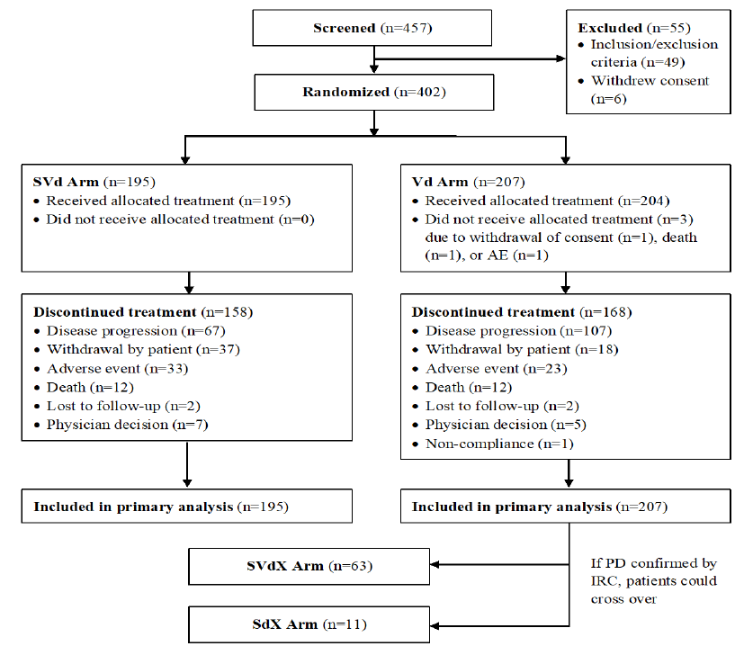

Abbreviations: AE = adverse event; IRC = independent review committee; Sd = selinexor plus dexamethasone regimen; SdX = cross over to selinexor plus dexamethasone regimen; SVd = selinexor, bortezomib and dexamethasone regimen; SVdX = cross over to selinexor, bortezomib and dexamethasone arm.

###### Baseline Characteristics

Table 3 is a summary of the baseline demographic and disease characteristics.

Table 3: Study KCP-330-023 (BOSTON trial) Summary of baseline demographic and disease characteristics

|  |  |  |  |
| --- | --- | --- | --- |
|  |  | Selinexor, bortezomib and dexamethasone (SVd); n = 195) | Bortezomib and dexamethasone regimen (Vd); n = 207) |
| Age | Median, years (range) | 66 (40-87) | 67 (38-90) |
| Age group, years | 18-50  51-64  65-74  ≥75 | 15 (7.7%)  71 (36.4%)  75 (38.5%)  34 (17.4%) | 11(5.3%)  64 (30.9%)  85 (41.1%)  47 (22.7%) |
| Sex | Male | 115 (59.0%) | 115 (55.6%) |
| Female | 80 (41.0%) | 92 (44.4%) |
| Race | White  Asian  Black or African American | 161(82.6%)  25 (12.8%)  4 (2.1%) | 165 (79.7%)  25 (12.1%)  7 (3.4%) |
| ECOG status | 0  1  2 | 69 (35.4%)  106 (54.4%)  20 (10.3%) | 77 (37.2%)  114 (55.1%)  16 (7.7%) |
| Time from initial diagnosis, median (range), years | | 3.81 (0.4, 23.0) | 3.59 (0.4, 22.0) |
| Creatinine Clearance | <30  30-<60  ≥60 | 3 (1.5%)  53 (27.2%)  139 (71.3%) | 10 (4.8%)  60 (29.0%)  137(66.2%) |
| R-ISS Stage at Screening | I  II  III | 56 (28.7%)  117 (60%)  12 (6.2%) | 52 (25.1%)  125 (60.4%)  16 (7.7%) |
| % plasma cells at initial diagnosis | Median, range  < 50%  ≥ 50% | 33.7 (0, 99)  116 (59.5%)  53 (27.2%) | 40 (0,95)  100 (48.3%)  70 (33.8%) |
| Prior anti MM treatment | Prior regimens mean (SD)  1  2  3 | 1.7 (0.74)  99 (50.8%)  65 (33.3%)  31 (15.9%) | 1.7 (0.79)  99 (47.8%)  64 (30.9%)  44 (21.3%) |
| Prior antimyeloma drugs  Bortezomib  Carfilzomib  Ixazomib  Daratumumab  Lenolidomide  Pomalidomide  Prior stem cell transplant  Prior radiotherapy | 134 (68.7%)  20 (10.3%)  6 (3.1%)  11(5.6%)  77 (39.5%)  11(5.6%)  76 (39%)  30 (15.4%) | 145 (70%)  21 (10.1%)  3 (1.4%)  6 (2.9%)  77 (37.2%)  7 (3.4%)  63 (30.4%)  71 (17.7%) |

###### Statistics

Three analysis sets were defined in the study:

* Intent to treat (ITT): all randomised, analysed by randomised treatment arm regardless of treatment received, primary analysis population
* Per-protocol (PP) population: all ITT patients with treatment compliance ≥ 70% and no major protocol violations that affected assessment of efficacy, included patients who progressed or died, analysis by randomised treatment arm, supportive analyses population
* Safety population: all patients who had received at least one dose of the study treatment, according to treatment received.

The sample size of 364 patients (182 per arm) was required for enrolment to allow for an exponential dropout rate of 0.65% per month. The study was designed to have 80% power to detect a median progression-free survival (PFS) for patients treated with selinexor, bortezomib and dexamethasone (SVd) of 13.5 months versus 9.4 months with bortezomib and dexamethasone (Vd) of, using a one sided alpha of 0.025, 15 months accrual, 18 months follow up, 1:1 allocation of treatment to SVd:Vd, and allowing for an interim analysis (IA) of PFS for futility or superiority, with the treatment difference assessed by a log-rank test. Based on these statistical assumptions, a total of 267 PFS events were required for the final analysis.

###### Protocol amendments

Key protocol amendments included:

* Change for overall response rate to PFS as the primary endpoint, removal of overall response rate, PFS and duration of response (DOR) for patients with 1 versus > 1 prior anti-multiple myeloma regimen (now exploratory), overall survival (OS) moved to non-key secondary endpoint
* Changed the point of determination of R-ISS to study entry from initial diagnosis

Major protocol deviations (n = 22) occurred for 21 patients and were balanced between the arms. None were considered by the evaluator to have a significant impact on study conduct, patient safety, or treatment efficacy.

###### Disease measurements

Disease measurements were undertaken according to the IMWG criteria;18 every three weeks from Baseline through Week 37 then every five weeks for the remainder of the study.

###### Result

Table 4 presents the key outcome from BOSTON trial according to the IMWG criteria;18 (database cut of 18 February 2020).

Table 4: Study KCP-330-023 (BOSTON trial) Key outcomes

|  |  |  |
| --- | --- | --- |
|  | Selinexor, bortezomib and dexamethasone regimen (SVd), n = 195 | Bortezomib and dexamethasone regimen (Vd), n = 207) |
| Progression-free survival | Hazard ratio 0.70 (95% CI: 0.53, 0.93) P = 0.0075 | |
| Median, months (95% CI) | 13.9 (11.7, NR) | 9.5 (7.6, 10.8) |
| Overall Response Rate  95% CI | 149 (76.4%)  (55.3%, 68.9%) | 129 (62.3%)  (69.8%, 82.2%) |
| One-sided p-value | P =0.0012 | |
| Stringent complete response (sCR)  Complete Response (CR)  Very Good Partial Response (VGFR)  Partial Response (PR) | 19 (9.7%)  14 (7.2%)  54 (27.7%)  62 (31.8%) | 13 (6.3%)  9 (4.3%)  45 (21.7%)  62 (30.0%) |
| ≥ VGPR Response Rate | 87 (44.6%) | 67 (32.4%) |

The Kaplan-Meier curves were also presented for PFS, showing sustained responses at 12 and 18 months.

Figure 3: Study KCP-330-023 (BOSTON trial) Kaplan-Meier curves of progression free survival for selinexor, bortezomib and dexamethasone versus bortezomib and dexamethasone

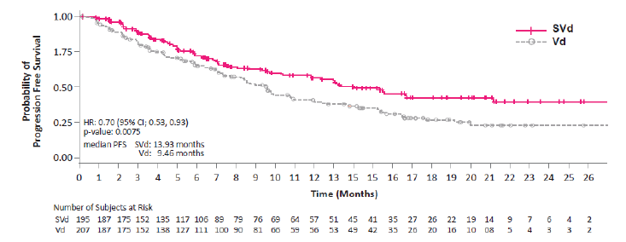

IRC = independent review committee; SVd = selinexor, bortezomib and low dose dexamethasone; Vd = bortezomib and dexamethasone.

Note: Progression free survival is calculated from date of randomisation until first date of IRC-confirmed progressive disease per IMWG response criteria, or death due to any cause, whichever occurred first.

The subgroup analyses show similar effects for age, gender, prior lines of therapy, stem cell transplant, ECOG status and frailty. Outliers included R-ISS stage III, and the presence of translocation (4;16), but small groups of patient limit conclusions that can be drawn.

* Median overall survival: not reached for selinexor, bortezomib and dexamethasone (SVd) versus 24.97 months for (Vd) arm.
* Median duration of response: 20.3 months for SVd arm versus 12.9 months for Vd arm (p = 0.1364 stratified log-rank test).
* Median time to response: 1.41 months shorter in the SVd arm versus 1.61 months in the Vd arm.
* Median time to next treatment: 16.13 months in the SVd arm versus 10.84 months in the Vd arm.

The European Organization for Research and Treatment of Cancer quality of life questionnaire - chemotherapy-induced peripheral neuropathy questionnaire showed that from a similar baseline for sensory, motor and autonomic neuropathy symptoms a lower mean change from Baseline score was observed in the SVd arm compared to the Vd arm for the sensory scale but was similar for the other symptoms.

##### Safety

The safety population included data from 399 patients. The median duration of study treatment was 30 weeks in the selinexor, bortezomib and dexamethasone (SVd) arm and 32 weeks in the bortezomib and dexamethasone (Vd) arm, with 92.3% of the SVd arm and 90.2% of the Sd arm received study treatment for ≥ 8 weeks; 84.6% of the SVd arm and 80.9% of the Sd arm received study treatment for ≥ 12 weeks. The median duration of selinexor exposure was 29 weeks, with 61.5% of patients receiving selinexor for ≥ 24 weeks.

Table 5: Study KCP-330-023 (BOSTON trial) Summary of safety results

|  |  |  |
| --- | --- | --- |
|  | Selinexor, bortezomib and dexamethasone (SVd) | Bortezomib and dexamethasone (Vd) |
| ***Treatment-emergent adverse events*** | | |
| **Any adverse event** | 194 (99.5%) | 198 (97.1%) |
| ***Most common adverse events > 15%*** | | |
| thrombocytopenia | 60.0% | 27.0% |
| nausea | 50.3% | 9.8% |
| fatigue | 42.1% | 18.1% |
| anaemia | 36.4% | 23.0% |
| decreased appetite | 35.4% | 5.4% |
| diarrhoea | 32.3% | 25.0% |
| weight decreased | 26.2% | 12.3% |
| asthenia | 24.6% | 13.2% |
| Neurological toxicitya | 24.1% | 7.8% |
| cataract | 21.5% | 6.4% |
| vomiting | 20.5% | 4.4% |
| pneumonia | 17.9% | 16.7% |
| upper respiratory tract infections | 17.9% | 14.7% |
| cough | 17.9% | 14.7% |
| constipation | 16.9% | 17.2% |
| insomnia | 15.9% | 15.7% |
| back pain | 15.4% | 14.2% |
| pyrexia | 15.4% | 10.8% |
| ***Any treatment-related adverse event*** | 95.4% | 80.9% |
| ***Most common treatment-related adverse events*** | | |
| Thrombocytopenia | 56.4% | 23.0% |
| Nausea | 47.7% | 5.9% |
| Fatigue | 35.4% | 9.3% |
| **Any adverse drug reaction** | 95.4% | 80.9% |
| ***Treatment-emergent adverse event leading to dose modification*** | 88.7% | 76.5% |
| ***Treatment-emergent adverse event leading to dose reduction*** | 72.3% | 51.0% |
| ***Treatment-emergent adverse event leading to treatment discontinuation*** | 21.0% | 15.7% |
| **Fatal adverse event** | 6.2% | 5.4% |
| ***Serious adverse events*** | | |
| **Any serious adverse event** | 51.8% | 37.7% |
| ***Serious adverse events in > 2% of either arm*** | | |
| pneumonia | 14.4% | 12.7% |
| sepsis | 4.1% | 1.0% |
| anaemia | 2.6% | 1.5% |
| vomiting | 3.6% | 0 |
| Lower respiratory tract infection | 2.1% | 1.5% |
| Acute kidney injury | 2.1% | 1.0% |
| Atrial fibrillation | 2.1% | 1.0% |
| gastroenteritis | 2.1% | 0.5% |
| cataract | 2.1% | 0 |
| nausea | 2.1% | 0 |
| urinary tract infection | 2.1% | 0 |

a includes dizziness, confusional state, syncope, amnesia, cognitive disorder, somnolence, delirium, depressed level of consciousness, encephalopathy, and hypersomnia

The most commonly reported treatment emergence adverse events (TEAEs) leading to treatment discontinuation for selinexor, bortezomib and dexamethasone (SVd) versus bortezomib and dexamethasone (Vd) were peripheral neuropathy (4.6% versus 7.4%) and fatigue (3.6% versus 0.5%).

Death due to TEAEs: SVd 6.2% versus Vd 5.4%, most commonly causes of death were septic shock (SVd 1.5% versus Vd 0%) and pneumonia (SVd 1% versus Vd 1.5%).

* Fatigue
  + Adverse events (AEs): SVd 42.1% versus Vd 18.1%
  + Treatment-related adverse events (TRAEs): SVd 35.4% versus Vd 18.1%
  + Serious adverse events (SAEs): SVd 1% versus Vd 0.5%
* Decreased appetite
  + AEs: SVd 35.4% versus Vd 5.4%
  + TRAEs: SVd 32.3% versus Vd 3.4%
  + SAEs: SVd 1.0% versus Vd 0%
* Decreased weight
  + AEs: SVd 26.2% versus Vd 12.3%, no SAEs
  + TRAEs: SVd 19.5% versus Vd 3.9%
* Nausea
  + AEs: SVd 50.3% versus Vd 9.8%
  + TRAEs: SVd 47.7% versus Vd 5.9%
  + SAEs: SVd 2.1% versus Vd 0%
* Vomiting
  + AEs: SVd 20.5% versus Vd 4.4%
  + TRAEs: SVd 17.4% versus Vd 2.5%
  + SAEs: SVd 3.6% versus Vd 0%
* Neurological adverse events
  + Most common AEs: dizziness (SVd 12.3% versus Vd 3.9%); confusional state (SVd 8.2% versus Vd 1 %)
  + TRAEs: dizziness (SVd 5.6% versus Vd 1.0%); confusional state SVd (5.6% versus Vd 0%)
  + SAEs: SVd 1.0% versus. Vd 0.5%, none was fatal
  + Grade ≥ 2 peripheral neuropathy (secondary safety endpoint): SVd arm 21.0% versus Vd 34.3%
* Ophthalmology adverse events
  + Blurred vision AEs: SVd 12.8% versus Vd 6.4%, no SAEs
  + Blurred vision TRAEs: SVd 5.1% versus Vd 3.4%
  + Cataract AEs: SVd 21.5% versus Vd 6.4%, most occurring > 7 months after start of selinexor
  + Cataract TRAEs: SVd 16.4% versus Vd 2.0%
  + Cataract SAEs: SVd 2.1% versus Vd 0%
* Hyponatraemia
  + Baseline to new maximum Grade 3 or 4: SVd (58.5%) versus Vd (24.9%).
  + Considered AE: SVd (8.2%) versus Vd (1.5%)
  + SAE of hyponatraemia: SVd 0.5% versus Vd 0%; none was fatal
* Anaemia
  + Baseline to new maximum Grade 3 or 4: SVd 16.9% versus Vd 11.9%
  + Considered AEs: SVd 36.4% versus Vd 23.0%
  + Considered TRAEs: SVd 22.1% versus Vd 8.3%
  + SAEs: SVd 2.6% versus Vd 1.5%; none was fatal
* Thrombocytopenia
  + Baseline to new maximum Grade 3 or 4: SVd 42.6% versus Vd 19.4%
  + Considered AE: SVd 60.0% versus Vd 27.0%
  + Considered TRAE: SVd 56.4% versus Vd 23.0%
  + SAEs: SVd 1.5% versus Vd 0.5%
* White cells
  + Baseline to new maximum Grade 3 or 4 leukopenia: SVd 10.3% versus Vd 2.5%
  + Baseline to new maximum Grade 3 or 4 lymphocytopenia: SVd 38.3% versus Vd 25.1%
  + Baseline to new maximum Grade 3 or 4 neutropenia: SVd 11.2% versus Vd 6.7%
  + Considered neutropenia AE: SVd 15.4% versus Vd 6.4%
  + Considered Neutropenia TRAE: SVd 13.3% versus Vd 2.9%
  + Neutropenia SAE: SVd 1.0% versus Vd 0.5%, none was fatal
  + Febrile neutropenia: 1 SVd patient

Sepsis was reported in 4.1% with SVd versus 1.0% with Vd, the same proportions as sepsis SAEs, with fatal events in SVd arm (1.5%) versus 0% in Vd arm.

##### Discussion

In this submission Study KCP-330-023 (BOSTON trial) is the only Phase III comparator study presented to support a proposed indication for selinexor.

In this study compared the combination of selinexor, bortezomib and dexamethasone (SVd regimen) in mostly lower to moderate risk (by R-ISS), who were mostly well functioning (ECOG PS 0 or 1), with mostly 1 to 2 prior treatment regimens that could have included stem cell transplant. There were no requisite prior therapies.

The comparator arm was bortezomib and dexamethasone (Vd regimen). In the second line setting there are generally a range of options for patients and prescribers, including triplet and other doublet combinations if stem cell transplant therapy is not considered an option or has failed. It is noted that around 40% of patients had had prior immunomodulator therapy. It is noted the combination of bortezomib and dexamethasone has previously been accepted as a comparator in a registration study but there is some uncertainty about the generalisability of this aspect of the study in the current Australian clinical context and the Advisory Committee of Medicine (ACM) is requested to advise.

Having a comparator arm allows some isolation of the activity of selinexor in this setting of multiple myeloma.

The main analyses were conducted based on randomised treatment arm, however cross-over was permitted for 73 patients with progressive disease in the Vd arm, and this could potentially impact the interpretation of progression free survival and overall survival in subsequent analyses.

Progressive disease events were reported for 35.4% of the SVd arm and 59.9% of the Vd arm, (Hazard ratio = 0.7), with a mean PFS gain of 4.2 months a 12% gain in deep response and a 14.1% overall survival gain. Among responders, benefits appear durable with an additional 7.4 months over Vd and an additional approximately 5 months before the commencement of the next treatment.

While the limitations of cross-study comparisons are noted, the magnitude of benefit was considered by the evaluator who noted the overall response rate of 82.9% of the combination of daratumumab, bortezomib and dexamethasone with 63.2% for Vd in a study supporting registration of that combination.

Selinexor is an oral therapy, that may be an additional benefit, but the regimen includes bortezomib that requires visits to a medical facility, as may the toxicities.

There is a toxicity cost to offset of the combination of selinexor, bortezomib and dexamethasone against the benefits, that include haematological disturbances, electrolyte disturbances, and neurological and ophthalmological toxicities. The most common adverse events were thrombocytopenia 60% (Grade 3 to 4, 39.5%), nausea 50.3% (Grade 3 to 4, 7.7%), fatigue 42.1% (Grade 3 to 4, 13.3%). There are also toxicities with a potential impact on quality of life such as fatigue, and nausea, vomiting and decreased appetite. Serious adverse events were common (51.8%), most commonly pneumonia, sepsis and anaemia. Fatal events occurred in 6.2%, most commonly from pneumonia and septic shock.

The haematological toxicities, electrolyte disturbances and the potential for cataract formation require close monitoring, and as in the clinical trials grade three hyponatraemia was seen (5.1% in the BOSTON trial). In this and other indications, early intervention with dose adjustment or interruption and therapies to counter the adverse effects may be needed but dose interruptions also potentially impact efficacy. Patients will need to be carefully selected for this regimen, because in a broader population the harms are likely to be more impactful.

In the consideration also is the cost of multiple myeloma for the patient including haematological, renal, and bony complications that themselves can be symptomatic and harmful.

Taking these considerations together, there may be benefit in an additional triplet treatment option for consideration by prescribers. The preliminary view, subject to the advice of the ACM, is that selinexor in combination with bortezomib and dexamethasone favourably tips the balance of benefits and harms for the proposed indication.

#### Multiple class refractory myeloma

The selection of the Phase II dose and regimen of selinexor plus low-dose dexamethasone (Sd) for the STORM trial was based on the clinical efficacy and safety data from 81 heavily pre-treated relapsed or refractory multiple myeloma (RRMM) patients from the Phase I trial, Study KCP-330-001. In the dose escalation phase of this study selinexor was administered from 3 mg/m2 (5 mg) to 60 mg/m2 (about 100 mg) twice weekly in patients with RRMM, with 80 mg twice weekly determined to be the optimal dose.

#### Study KCP-330-012 (STORM trial)

##### Efficacy

Study KCP-330-012 (STORM trial) was a Phase IIb, multicentre, open label, single arm study of selinexor plus dexamethasone (Sd) in patients with multiple myeloma previously treated multiple myeloma, refractory to five anti-myeloma agents and refractory to an immunomodulatory imide drug (IMiD), a proteasome inhibitor, glucocorticoids and daratumumab.

###### Study design

The STORM trial is a multi-centre study conducted at 60 sites across six countries. The first patient enrolled on 26 May 2015 and the last patient last visit was 26 July 2019.

The study consisted of an initial screening phase, a treatment phase, and a follow up phase. It was conducted in two parts:

* STORM trial part 1 enrolled patients with both quad-exposed, double class refractory multiple myeloma (defined as multiple myeloma exposed to lenalidomide, pomalidomide, bortezomib and carfilzomib, and refractory to at least one protease inhibitor and at least one immunomodulatory imide drug (IMiD), and steroids) and penta-exposed, triple class refractory multiple myeloma (defined as multiple myeloma exposed to lenalidomide, pomalidomide, bortezomib, carfilzomib, and daratumumab, and refractory to at least one protease inhibitor, at least one IMiD, and the anti-CD38 mAb daratumumab [and glucocorticoids]).
* STORM trial part 2 enrolled patients with penta-exposed (to lenalidomide, pomalidomide, bortezomib, carfilzomib, and daratumumab), and triple-class-refractory (to prior treatment with glucocorticoids, an IMiD, a proteasome inhibitor (PI), and the anti-CD38 mAb daratumumab. Refractory was defined as either ≤ 25% response to therapy or progression during or within 60 days of completion of therapy (per IMWG criteria).18 Hence, the patient population is considered penta-exposed andtriple-class refractory.

###### Inclusion criteria

Key inclusion criteria includes:

* Measurable disease based on IMWG guidelines;18 as defined by at least one of the following:
  + Serum M-protein ≥ 0.5 g/dL by serum protein electrophoresis or quantitative IgA
  + Urinary M-protein excretion ≥ 200 mg/24 hours
  + Free light chain (FLC) ≥ 100 mg/L, provided that the FLC ratio is abnormal
* Previously received ≥ 3 anti-multiple myeloma regimens including: an alkylating agent, lenalidomide, pomalidomide, bortezomib, carfilzomib, daratumumab, and a glucocorticoid
* Refractory to previous anticancer treatments: glucocorticoids, proteasome inhibitor (that is bortezomib and/or carfilzomib), IMiD (that is lenalidomide and/or pomalidomide), and daratumumab
  + Refractory: ≤ 25% response to therapy or progression during or within 60 days after completion of therapy
* Refractory to most recent anti-multiple myeloma regimen
* Adequate hepatic function
  + Total bilirubin <2 × upper limit of normal (ULN) (or in Gilbert’s syndrome, < 3 ×  ULN)
  + AST < 2.5 × ULN
  + ALT < 2.5 × ULN
* Adequate renal function
  + Estimated creatinine clearance of ≥ 20 mL/min per Cockcroft/Gault formula
* ECOG PS ≤ 2;14
* Adequate haematopoietic function
  + total white blood count > 1000/mm3
  + absolute neutrophil count ≥ 1000/mm3
* Platelet count ≥ 75,000/mm3 for patients with < 50% of bone marrow nucleated cells are plasma cells; or ≥ 50,000/mm3 for patients with ≥ 50% of bone marrow nucleated cells are plasma cells
* Haemoglobin ≥ 8.5 g/dL (> 8 g/dL with approval from medical monitor)

###### Exclusion criteria

Key exclusion criteria included:

* Active smouldering multiple myeloma
* Active plasma cell leukaemia
* Documented systemic amyloid light chain amyloidosis
* Active central nervous system multiple myeloma
* Active graft vs host disease (after allogeneic stem cell transplantation) at Cycle 1 Day 1
* Life expectancy of < 4 months
* Active, unstable cardiovascular function
* HIV seropositive
* Known active hepatitis A, B, or C infection; or known to be positive for hepatitis C RNA or hepatitis B surface antigen
* Prior malignancy that required treatment or has shown evidence of recurrence (except for non-melanoma skin cancer or adequately treated cervical carcinoma in situ) within 5 years prior to enrollment
* Grade ≥ 3 peripheral neuropathy or Grade ≥ 2 painful neuropathy
* Participation in an investigational anticancer study within 21 days prior to Cycle 1 Day 1
* Receipt of transfusions as follows:
  + platelet infusion within 1 week prior to Cycle 1 Day 1
  + red blood cells transfusion within 2 weeks prior to Cycle 1 Day 1
* Receipt of the following blood growth factors within 2 weeks prior to Cycle 1 Day 1: Granulocyte colony stimulating factor, granulocyte-macrophage colony stimulating factor, erythropoietin, or megakaryocyte growth factor
* Prior exposure to a SINE compound, including selinexor

###### Treatment regimen

The study drug was selinexor tablet (20 mg). In part 1 of Study KCP-330-012 (STORM trial part 1), selinexor was administered as a fixed oral dose of 80 mg twice weekly on Days 1 and 3 of each week for 3 weeks out of each 4 week cycle or every week continuously.

In STORM trial part 2, selinexor was administered as a fixed oral dose of 80 mg twice weekly on Days 1 and 3 of each week continuously.

Dexamethasone 20 mg was administered with each dose of selinexor. Patients with partial intolerance to glucocorticoids were given a minimum of 10 mg.

Treatment continued until disease progression, death, or unacceptable toxicity. Selinexor treatment modifications for selinexor related toxicities are outlined in Table 6.

Table 6: Study KCP-330-012 (STORM trial) Selinexor related toxicities leading to dose modification

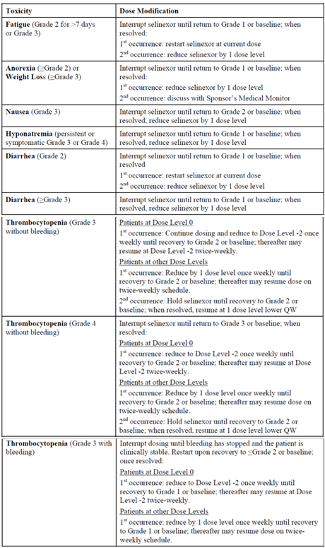

Table 6 (continued): STORM trial Selinexor related toxicities leading to dose modification

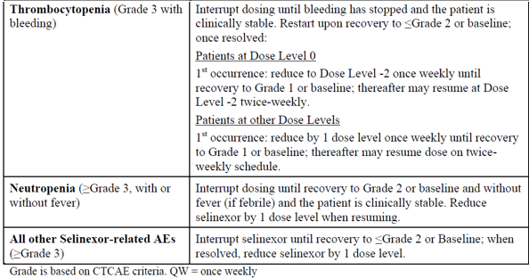

Grade is based on CTCAE criteria. QW = once weekly

Table 7: Study KCP-330-012 (STORM trial) Pre-specified dose/schedule modifications for adverse events related to study drug

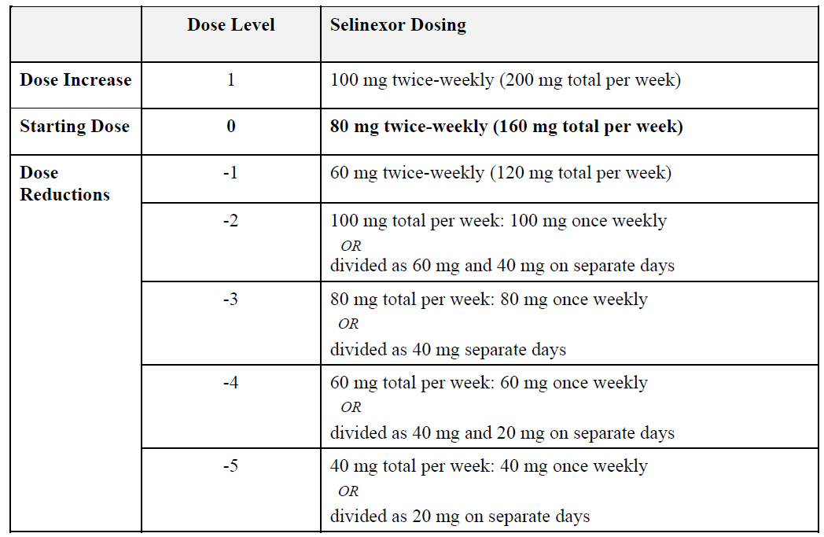

###### Study endpoints

The primary efficacy endpoint was objective/overall response rate per IMWG criteria;18 by the IRC in the modified intent to treat (mITT) population.

The overall response rate included a partial response (PR), very good partial response (VGPR), complete response (CR), or stringent complete response (sCR).

The overall response rate was compared to a minimal threshold level for overall response rate, set to 0.10 (10%), based on preliminary evidence from STORM trial part 1.

Secondary efficacy endpoints included:

* duration of response for patients with a confirmed response, defined as duration from first response (at least partial response) to time of progressive disease or death due to progressive disease (per IRC), whichever occurred first;
* clinical benefit ratio: proportion of patients who achieve a confirmed minimal response or better;
* duration of clinical benefit: duration from first response (at least minimal response) to time of progressive disease or death due to progressive disease (per IRC), whichever occurred first;
* durable clinical response: proportion of patients who achieve stable disease or better for a minimum of 12 weeks;
* Progression free survival: duration from start of study treatment to time of progressive disease (per IRC) or death from any cause, whichever occurred first;
* time to progression: duration from start of study treatment to time of progressive disease or death due to progressive disease (per IRC), whichever occurred first;
* time to next treatment (duration from start of study treatment to start of next anti-multiple myeloma treatment or death due to disease progression, whichever occurred first;
* Overall survival: duration from start of study treatment to death from any cause; or patient censored at date of study discontinuation, or database cut date, whichever was earlier;
* health-related quality of life by Functional Assessment of Cancer Therapy–Multiple Myeloma (FACT-MM) questionnaire.[19]

###### Analysis populations

Modified intent to treat population (mITT): patients with penta-exposed, triple-class-refractory multiple myeloma who received at least one dose of the selinexor + dexamethasone (Sd) treatment regimen.

Per-protocol population: mITT population with ≥ 70% compliance to the Sd regimen with ≥ 1 adequate post-baseline response assessment (unless died/withdrew from study before first assessment), used for supportive efficacy analyses.

###### Statistics

The primary analysis of overall response rate used a two sided, exact 95% CI, in the mITT population. Statistical significance was declared if the lower bound was > 10%. The comparison to the threshold maintained a Type I error rate of 0.025, one sided. A sample size of 122 patients with penta-exposed, triple-class-refractory multiple myeloma would allow a one sided test at α = 0.025 to detect an overall response rate of ≥ 0.20 against the threshold overall response rate of 0.10, with 90% power.

###### Protocol amendments

The protocol was amended five times. At amendment 2 (September 2015) patients were required to have multiple myeloma double refractory to the proteasome inhibitor and immunomodulator classes, the dosing changed from twice weekly for three weeks of every four week cycle to twice weekly for every week of a four week cycle, the exploratory objectives overall response rate, DOR, PFS, and OS in the subgroup of patients with free light chain multiple myeloma.

At amendment 3 (August 2016) the primary efficacy analysis (using overall response rate) was changed from the patients enrolled in part 1 to the part 2 population. Patients in part 1 became a secondary analysis. Other changes to the analysis sub-populations. In part 2 daratumumab was required as a prior therapy, and removal of an exclusion for patients whose multiple myeloma dose not express either M-protein or free light chain, and the central assessment to confirm complete and stringent complete responses.

At amendment 4, among other changes, the karyotyping and fluorescence *in situ* hybridisation were to be performed at a central laboratory, and there was an update to reflect the IMWG18 requirement for a sequential sample.

There were 34 major protocol deviations but only one resulted in exclusion of the patient from the efficacy analysis.

###### Baseline characteristics

Table 8 is a summary of baseline characteristics for Study KCP-330-012 (STORM trial).

Table 8: Study KCP-330-012 ( STORM trial) Baseline characteristics

|  |  |  |
| --- | --- | --- |
|  |  | STORM trial part 2 (n = 123) |
| **Age** | Median (range) | 65.3 (40, 86) |
| **Age group** | 18-50 years  51-64 years  65 – 75 years  >75 years | 8 (6.5%)  52 (42.3%)  44 (35.8%)  19 (15.4%) |
| **Sex** | Male | 71 (57.7%) |
| Female | 52 (42.3%) |
| **Race** | White  Asian  African American | 86 (69.9%)  2 (1.6%)  21 (17.7%) |
| **ECOG status** | 0  1  2 | 37 (30.1%)  72 (58.5%)  11 (8.9%) |
| **Revised ISS at baseline** | I  II  III  Unknown | 20 (16.3%)  79 (64.2%)  23 (18.7%)  1 (0.8%) |
| **Baseline creatinine clearance** | <30  30 to 60  ≥ 60 | 6 (4.9%)  34 (27.6%)  82 (66.7%) |
| **High risk cytogenetics** | Present | 65 (52.8%) |
| **Prior stem cell transplant** | Yes | 102 (82.9%) |
| **Prior therapy** | Median lines of therapy  ≥5 prior regimens  ≥9 prior regimens | 7 (3, 18)  108 (87.8%)  36 (29.3%) |
| **Documented refractory status** | Carfilzomib/pomalidomide/daratumumab (CPD)  Lenalidomide + CPD (CLPD)  Bortezomib + CPD (CBPD)  Lenalidomide + CBPD | 117 (95.1%)  101 (82.1%)  94 (76.4%)  83 (67.5%) |
| **Additional therapies** | Alkylating agents  Anthracyclines  Checkpoint inhibitors  Glucocorticoid-containing regimens  1 – 5  6 – 10  >10 | 123 (100%)  45 (36.6%)  19 (15.4%)  50 (40.7%)  64 (52.0%)  9 (7.3%) |

Most (67.2%) had an immunoglobulin IgG type at Baseline, most (65.5%) had kappa light chains, almost half (53.3%) had a high risk chromosomal abnormality (high-risk multiple myeloma is defined by the presence of translocations/mutations t(4;14), t(14;16), t(14;20), gain 1q, del(17p), or p53 mutation).

###### Study results

Patient flow for the STORM trial part 2**:** 123 patients were treated. All discontinued treatment most commonly because of disease progression (56.9%) and adverse events (31.7%). 35 patients (28.5%) completed one year of survival follow up. One patient was excluded from the mITT population because they had no prior carfilzomib.

Table 9 summaries the key efficacy finding from STORM trial.

Table 9: Study KCP-330-012 (STORM trial) Summary of key efficacy outcomes

|  |  |
| --- | --- |
| Study KCP-330-012 (STORM trial) Key efficacy outcomes (n = 122) | |
| **Overall Response Rate (Primary endpoint)** | |
| Overall response rate % (95% CI)  Stringent complete responders/complete responders, n (%)  Very good partial responders, n (%)  Partial responders, n (%)  Minimal responders, n (%)  Stable disease n (%)  Progressive disease/not evaluable, n(%) | 26.2% (18.7, 35.0)  2 (1.6%)  6 (4.9%)  24 (19.7%)  16 (13.1%)  48 (39.3%)  26 (21.3%) |
| **Progression free survival (PFS)** | |
| Median PFS, months (range)  Number of PFS events, n (%) | 3.7 (2.8, 4.7)  51 (41.8%) |
| **Overall survival (OS)** | |
| Median OS (months, 95% CI)) all Part 2 patients (n=122)  Median OS patients with ≥ partial response (n=32)  Median OS in patients with ≥ minimal response (n=48)  Median OS best response of stable disease (N=48)  Median OS progressive disease or non-evaluable | 8.4 (6.2, 11.2)  NE (15.6, NE)  NE (12.9, NE)  6.3 (4.3, 10.0)  1.7 (1.2, 9.9) |

Other secondary endpoint results:

* Median duration of response (by IRC) in penta-exposed, triple-class refractory multiple myeloma patients with a response (n = 31), the median duration of response: 4.4 months (95% CI: 3.7, 10.8).
* Clinical benefit ratio: 39.3% (95% CI: 30.6, 48.6), consistent across the subgroups (36.6% to 38.5%).
* Duration of clinical benefit (mITT): 44.3% (95% CI: 35.3, 53.5).
* Median duration of clinical benefit (by IRC) in penta-exposed, triple-class refractory multiple myeloma: 3.8 months (95% CI: 3.2, 10.9).
* Median time to progression (IRC): 4.1 months (95% CI: 3.0, 6.2).
* Median time to next treatment from first dose of selinexor + dexamethasone: 3.2 months (95% CI: 2.6, 3.8).

The estimated 6 month and 12 months survival overall for patients was 60.7% and 37.7%, respectively. For responders with partial response or better, the estimated 6 month and 12 month overall survival was 90.3% and 72.2%, respectively. For responders with minimal response or better, the estimated 6 month and 12 month overall survival was 84.9% and 66.1%, respectively. For patients with a best response of stable disease, the estimated 6 month and 12 month overall survival was 51.2% and 20.9%, respectively. For patients with progressive disease or not evaluable, the estimated 6 month and 12 month overall survival was 32.6% and 16.3%, respectively.

Additional analyses were conducted by refractoriness to specific agents. The bortezomib, carfilzomib, lenalidomide, pomalidomide and daratumumab (BCLPD) treated group comprised the 83 patients who were refractory to BCLPD. In this group the results were: overall response rate of 25.3% (95% CI:16.4, 36.0), clinical benefit ratio of 37.3% (95% CI: 27.0, 48.7%), median duration of response of 3.8 (3.7, 10.8) months.

In the quality of life assessment using the FACT-MM questionnaire treatment with selinexor + dexamethasone led to median decreases (-4 to -25) from Baseline in the FACT‑MM total trial outcomes index score starting as early as Cycle 2 and continuing through Cycle 8.

Study KCP-330-00, a Phase I study that included patients with symptomatic disease to ≥ 3 prior regimens that included at least an alkylating agent, an IMiD, a proteasome inhibitor and a steroid contributed data from 12 multiple myeloma patients to the efficacy evidence. Overall response rate was 50% (95% CI: 21%, 79%), including one patient with a stringent complete, or complete response and five patients with a partial response. The median duration of response was 180 days and median progression-free survival was 232 days.

##### Safety

The median duration of study treatment (selinexor plus dexamethasone) was 9 weeks, with 57.7% of patients receiving selinexor ≥ 8 weeks, and 37.4% of patients receiving selinexor ≥ 12 weeks. The median total dose of selinexor received was 920 mg (range: 160 to 6220), with a median of 113.6 mg (range: 22 to 240) received per week (Table 10).

Table 10: Study KCP-330-012 Summary of key safety finding

|  |  |
| --- | --- |
| Study KCP-330-012 (STORM trial) Summary of safety (n = 123) | |
| **Any adverse events** | 100% |
| **Common adverse events (> 20%)** | |
| thrombocytopenia | 74.8% |
| nausea | 71.5% |
| anaemia | 66.7% |
| fatigue | 62.6% |
| decreased appetite | 56.9% |
| weight decreased | 50.4% |
| diarrhoea | 47.2% |
| neutropenia | 39.8% |
| vomiting | 39.0% |
| hyponatraemia | 37.4% |
| leukopenia | 33.3% |
| dyspnoea | 22.8% |
| constipation | 22% |
| **Any CTCAE Grade 3 - 4** | 93.5% |
| Any treatment emergent adverse event leading to dose modification | 78.9% |
| Any treatment emergent adverse event leading to dose hold | 65.0% |
| Any treatment emergent adverse event leading to dose reduction | 58.5% |
| Any treatment emergent adverse event leading to treatment discontinuation | 31.7% |
| **Any treatment-related adverse event** | 98.4% |
| **Most common treatment-related adverse events** | |
| thrombocytopenia | 69.1% |
| nausea | 69.1% |
| fatigue | 55.3% |
| decreased appetite | 52.8% |
| **Any CTCAE Grade 3 -5 treatment-related adverse events** | 89.4% |
| **Any serious adverse events** | 63.4% |
| **Most common serious adverse events (> 5%)** | |
| Pneumonia | 11.4% |
| Sepsis | 9.8% |
| **Any drug-related serious adverse events** | 30.9% |
| **Fatal adverse events** | 9.8% |
| **Fatal treatment-related adverse events** | 2.4% |

The most commonly reported treatment-related adverse events (TRAEs) leading to treatment discontinuation were nausea (5.7%) and fatigue (4.9%).

The fatal events within 30 days of last dose of selinexor occurred in 28 patients, with 12 considered treatment-emergent adverse events (TEAEs) and 3 considered TRAEs (pneumonia, 1 patient; sepsis, 2 patients).

* Hyponatraemia
  + Adverse events in 38.2%, TRAEs in 30.9%, Grade 3 or 4 severity in 26.2%, treatment related serious adverse events (TRSAEs) in 1.6%.
* Anaemia
  + Baseline to new maximum Grade 3 or 4: 47.9%
  + Considered AEs: 66.7%, Considered TRAEs: 48.0%, SAEs: 0.8%; none was fatal
* Thrombocytopenia
  + Baseline to new maximum Grade 3 or 4: 74.8%
  + Considered AE: 74.8%, Considered TRAE: 69.1%, SAEs: 1.6%; none was fatal
* White cells
  + Baseline to new maximum Grade 3 or 4 leukopenia: 33.1%
  + Baseline to new maximum Grade 3 or 4 lymphocytopenia: 43.0%
  + Baseline to new maximum Grade 3 or 4 neutropenia: 26.1%
  + Considered neutropenia AE: 39.8%
  + Considered neutropenia TRAE: 36.6%
  + Neutropenia SAE: 0.8, none was fatal
  + Febrile neutropenia: 1.6% (both Grade 3 but not considered SAEs), none was fatal
* Infection
  + AEs 53.3%, TRAEs 17.8%, TRSAEs 5.6%, 3 were fatal
* Fatigue
  + AE: 65.0%, TRAEs: 56.1%, TRSAEs: 2.4%
* Decreased appetite
  + AEs: 56.9%, TRAEs: 52.8%, TRSAEs: 0.8%
* Decreased weight
  + AEs: 50.4%, TRAEs: 47.2%, TRSAE: 0.8%
* Nausea and vomiting
  + AEs: 74.8%, TRAEs: 71.5%, SAEs: 1.6%
* Confusional state
  + AEs: 17.1%, TRAEs: 10.6%, TRSAEs: 2.4%
* Ophthalmology AEs
  + AES: 24.3%, Contributing AEs: vision blurred, cataract, visual impairment, dry eye, photopsia, visual acuity reduced
  + TRAEs: 14%, no SAEs

##### Discussion

This aspect of the submission seeks an indication for late line relapsed and refractory multiple myeloma with selinexor in combination with dexamethasone. The evidence is from the second part of a single arm open-label study, around 88% of whom were patients who had relapse despite or were refractory to at least five prior regimens and around 30% of whom had received at least nine prior regimens. The majority (about two thirds) had received two immunomodulators, two proteasome inhibitors and daratumumab.

The patients were of median age of around 64 years of age, that appear representative of patients with refractory multiple myeloma, although 30% still has an ECOG performance status 0.

The primary endpoint is overall response rate which of itself is acceptable in a single arm study. The point estimate for overall response rate in STORM trial part 2 is 26%. While cross study comparisons are limited this is the same order of magnitude of benefit in pomalidomide and dexamethasone.[20] The study was underway before amendment 4 of the protocol required assessments were aligned with the IMWG criteria;18 and documentation of response required two consecutive readings of the applicable disease parameter (serum M-protein, urine M-protein, serum free light chain, or quantitative immunoglobulin level).

The European Medicines Agency (EMA’s) European Public Assessment Report for Nexpovio;[21] notes concern about the timing of assessments and raises the issue of initial and confirmatory assessment being conducted on the same day. This is a single arm study so the outcome measurement should be stringently measured to reduce uncertainty and reduce the risk of bias. This issue highlights an area of uncertainty in the true estimate of effect from this study.

Progression free survival and overall survival are more difficult to interpret without a direct comparator within the same study population and are weighted less in these considerations.

In other settings the results may be considered modest however the patient population is very late line and the incremental benefits expected after each line of therapy diminish sequentially.

The isolation of the contributions of each of selinexor and dexamethasone is not permitted in this study. There is evidence of the activity of selinexor from Study KCP-330-023 (BOSTON trial), but in earlier lines of treatment, and this is considered important to support the proposed indication. The incremental benefit derived from dexamethasone has not been demonstrated in this study. There are older literature reports of studies of high dose dexamethasone that report around 20% overall response rate, but this should be interpreted with caution due to issues with cross-study comparisons.

The toxicities are similar to those identified in the BOSTON trial, but in a more heavily treated and potentially more vulnerable population, particularly if treatment broadens beyond the limitations of the STORM trial population. Again, the discontinuations and interruptions to manage toxicity potentially place patients at risk of reduced efficacy.

While the sponsor has undertaken early studies to ascertain a suitable dose for further study and potentially patient treatment, further work is underway to refine the dosing. A Phase IIb, randomised, open label study (Study XPORT-MM-028);[22] is underway to investigate the following in the triple class refractory multiple myeloma setting:

* selinexor 100mg with bortezomib 1.3 mg/m2 and 40 mg dexamethasone, all once weekly,
* selinexor 40 mg with 20 mg dexamethasone, both twice weekly,
* selinexor 80 mg with 20 mg dexamethasone, both twice weekly,
* selinexor 100 mg with 40 mg dexamethasone, both once weekly.

It therefore remains uncertain whether the proposed regimen currently proposed for registration will be modified after this study reports results.

#### Diffuse large B-cell lymphoma

Diffuse large B cell lymphoma (DLBCL) is a diffuse proliferation of medium or large lymphoid B cells typically expressing CD19, CD20, CD22, CD79a, PAX5 and surface or cytoplasmic immunoglobulin.

The activated B cell (ABC) subtype is characterised by chronic B-cell signalling and activation of nuclear factor κB. The germinal center B cell (GCB) subtype expresses genes commonly detected in germinal centre B cells including *BCL6* and *EZH2*. This is relevant because these represent different targets for therapy, and therefore different responses to treatments.

Most patients have no prior history of lymphoma but some result from the transformation of low-grade B cell lymphomas.

The median age of disease is over 60 years, and 30% are older than 75 years.

##### Treatment

Initial therapy is rituximab, cyclophosphamide, hydroxydaunorubicin hydrochloride, vincristine and prednisone (R-CHOP) based with or without radiotherapy. In relapsed or refractory disease, an option may be autologous stem cell transplantation, to which about 50% respond. For those who are not candidates for autologous stem cell transplantation, who relapse after autologous stem cell transplantation or who are refractory to induction therapy available options include immunochemotherapy, CAR-T cell therapy (if eligible), polatuzumab vedotin plus bendamustine and rituximab, allogeneic stem-cell transplantation, investigational agents or best supportive care.

##### Dose finding

The selinexor dose regimen in the pivotal Phase IIb Study KCP-330-009 (SADAL trial) was selinexor 60 mg twice a week as monotherapy, based on data for selinexor monotherapy from 43 non-Hodgkin’s lymphoma patients in the Phase I dose escalation Study KCP‑330‑001. Overall response rate was 25.6% in that study. Responses were observed in all dose groups and there was no clear dose-response relationship in term of efficacy (based on overall response rate).

Doses of 60 mg and 100 mg twice weekly were further studied in Study KCP-330-009 (Protocol version < 6) to determine the optimal dose for selinexor in patients with DLBCL. Based on an interim analysis showing similar overall response rate but better tolerability at the 60 mg dose, the 100 mg dose was discontinued as of protocol version 6.

#### Study KCP-330-009 (SADAL trial)

##### Efficacy

###### Study design

Study KCP-330-009 (SADAL trial) was an ongoing, Phase IIb, multicentre, multinational, single arm, open label study of selinexor in patients with relapsed/refractory diffuse large B-cell lymphoma. The study commenced on 9 December 2014, and the data cut for the primary analysis was 1 August 2019.

The modified intent to treat population consisted of 127 patients who were randomised to 60 mg arm under protocol version 6 or enrolled under protocol versions 7 or higher and received at least one dose of selinexor. This population was the primary analysis population used for efficacy and safety.

###### Inclusion criteria

The key inclusion criteria included:

* Age ≥ 18 years
* ECOG performance status of ≤ 2
* Estimated life expectancy > 3 months at study entry
* Previously treated, pathologically confirmed *de novo* DLBCL, or DLBCL transformed from previously diagnosed indolent lymphoma (for example, follicular lymphoma)
* Patients must had ≥ 2 but ≤ 5 previous systemic regimens for *de novo* or transformed DLBCL including
  + ≥ 1 course of anthracycline-based chemotherapy (unless absolutely contraindicated due to cardiac dysfunction, in which case other active agents such as etoposide, bendamustine or gemcitabine must have been given) and
  + ≥ 1 course of anti-CD20 immunotherapy (for example, rituximab), unless contraindicated due to severe toxicity.
* Patients ineligible for standard multi-agent immunochemotherapy must have received at ≥ 2 and ≤ 5 prior treatment regimens including at ≥ 1 course of anti-CD20 antibodies and must have been approved by the medical monitor. Prior stem cell transplantation was allowed; induction, consolidation, stem cell collection, preparative regimen and transplantation with or without maintenance were considered a single line of therapy
* If recent systemic anti-DLBCL therapy induced a partial response or complete response, ≥ 60 days must have elapsed since the end of that therapy (until first dose of selinexor). For all other patients, ≥ 14 weeks (98 days) must have elapsed since the end of their most recent systemic anti DLBCL therapy. Palliative localised radiation within the therapy-free interval was allowed. Non-chemotherapy maintenance was not considered anti-DLBCL therapy, and therefore was allowed during the therapy-free interval
* Documented clinical or radiographic evidence of progressive DLBCL prior to dosing
* Measurable disease per the revised criteria for response assessment of lymphoma.[23] Lymph nodes were considered abnormal if the long axis was > 1.5 cm, regardless of the short axis. If a lymph node had a long axis of 1.1 to 1.5 cm, it was considered abnormal if its short axis was > 1. Lymph nodes ≤ 1 by ≤ 1 were not considered abnormal for relapse or progressive disease.

###### Exclusion criteria

Key exclusion criteria included:

* Patients who were pregnant or lactating
* DLBCL with mucosa-associated lymphoid tissue (MALT) lymphoma, composite lymphoma (Hodgkin’s lymphoma + non-Hodgkin’s lymphoma (NHL)), or DLBCL transformed from diseases other than indolent NHL
* Patients with primary mediastinal (thymic) large B-cell lymphoma
* Not eligible for high-dose chemotherapy with autologous stem cell transplantation rescue
* Known central nervous system lymphoma or meningeal involvement
* If most recent systemic anti-DLBCL therapy induced a partial or complete response: Radiation, chemotherapy, immunotherapy, radio-immunotherapy, or any other anticancer therapy other than glucocorticoids < 60 days prior to Cycle 1 Day 1
* If most recent systemic anti-DLBCL therapy did not induce a partial or complete response: Radiation, chemotherapy, immunotherapy, radio-immunotherapy, or any other anticancer therapy other than glucocorticoids < 14 weeks prior to Cycle 1 Day 1
* Not recovered to Grade ≤ 1 clinically significant adverse events, or to their baseline, from most recent systemic anti-DLBCL therapy
* Active graft-versus-host disease after allogeneic stem cell transplantation; ≥ 4 months must have elapsed since completion of allogeneic stem cell transplantation
* Major surgery within 2 weeks of first dose of study treatment
* Any life-threatening illness, medical condition or organ system dysfunction which, in the Investigator's opinion, could compromise the patient’s safety
* Unstable cardiovascular function (any of):
  + Symptomatic ischemia
  + Uncontrolled clinically significant conduction abnormalities (ventricular tachycardia on anti-arrhythmia are excluded; first degree atrioventricular (AV) block or asymptomatic left anterior fascicular block or right bundle branch block (RBBB) not excluded)
  + Congestive heart failure of NYHA Class ≥ 3
  + Myocardial infarction within 3 months
* Uncontrolled (clinically unstable) infection requiring parenteral antibiotics, antivirals, or antifungals < 1 week prior to first dose; however, prophylactic use of these agents was acceptable even if parenteral
* Active hepatitis B virus or hepatitis C virus infection
* Known human immunodeficiency virus infection (HIV testing was not required as part of this study)
* Unable to swallow tablets, patients with malabsorption syndrome, or any other gastrointestinal disease or gastrointestinal dysfunction that could have interfered with absorption of study treatment
* Any of the following laboratory abnormalities:
  + Absolute neutrophil count < 1000 cells/mm3 or platelet count < 75,000/mm3 during screening and on Cycle 1 Day 1. Use of granulocyte stimulating factors and platelet growth factors prior to and during the study was acceptable
  + Circulating lymphocyte count of > 50,000/μL
  + Hepatic dysfunction: bilirubin > 2 times the ULN (except patients with Gilbert’s syndrome: total bilirubin of > 3 x ULN) and alanine aminotransferase (ALT) and aspartate aminotransferase (AST) > 2.5 times ULN. In patients with known liver involvement of their DLBCL, AST and ALT > 5 x ULN
  + Severe renal dysfunction: estimated creatinine clearance of < 30 mL/min, measured in 24-hour urine or calculated using the formula of Cockroft and Gault [(140-Age) × mass (kg)/(72 × creatinine mg/dL); multiply by 0.85 if female].
  + Haematopoietic dysfunction: hemoglobin < 10g/dL within 14 days of and including Cycle 1 Day 1 and/or patients receiving red blood cell transfusion within 14 days of and including Cycle 1 Day 1.
* Body surface area < 1.4 m2 (per DuBois or Mosteller methods).

###### Study treatment

The study drug was selinexor tablet (20 mg), administered as a fixed oral dose of 60 mg twice weekly (on Days 1 and 3 of each week) of each 28-day cycle (total of 8 doses per cycle). There was no maximum treatment duration. Patients either remained on study treatment until disease progression was confirmed by the central imaging laboratory, or they discontinued study treatment.

###### Study assessments

Radiographic evidence of disease progression was required on study entry.

Bone marrow aspirates and/or biopsies were taken within one month prior to first dose to confirm complete response if known bone marrow involvement prior to treatment.

Disease assessments by imaging (PET-CT or PET-MRI) on Cycle 3 Day 1 then every 8 weeks until disease progression confirmed by central imaging laboratory. CT or MRI permitted if PET could not be performed for each assessment.

###### Patient flow

Out of 359 patients were screened, 267 patients were enrolled. 175 patients received selinexor 60 mg and 92 received selinexor 100 mg.

Modified intent to treat population: 127 patients randomised to the 60 mg arm under protocol version 6.0, or enrolled under protocol version ≥ 7.0 or higher and received at least one dose of selinexor)

As of 1 August 2019, 92.9% in the modified intent to treat population had discontinued selinexor treatment, and nine remained on treatment. Reasons for discontinuation of selinexor included disease progression (67.8%), withdrawal by patient (11%), and death (7.6%), and 16.5% were in survival follow up.

###### Baseline characteristics

Table 11: Study KCP-330-009 (SADAL trial) Baseline characteristic

|  |  |  |
| --- | --- | --- |
| Study KCP-330-009 (SADAL trial) baseline characteristcs. Selinexor (n = 127) mITT | | |
| **Age** | Median, years (range) | 67 (35-87) |
| **Age group** | ≥ 70 years | 57 (44.9%) |
| **Sex** | Male | 75 (59.1%) |
| Female | 52 (40.9%) |
| **Race** | White  Asian | 100 (78.7%)  10 (7.9%) |
| **ECOG status** | 0  1  2  3 | 55 (43.3%)  58 (45.7%)  13 (10.2%)  1 (0.8%) |
| **Prior systemic treatment regimens for DLBCL, median (range)** | | 2.0 (2.0, 5.0) |
| **Number of prior therapies**  ***2***  ***3***  ***4***  ***5***  ***Refractory to most recent regimen for DLBCL***  ***Relapsed/refractory < 1 year***  ***Prior lenalidomide therapy***  ***Prior radiotherapy*** | | 75 (59.1%)  30 (23.6%)  16 (2.6%)  6 (4.7%)  91 (71.7%)  66 (52.0%)  10 (7.9%)  41 (32.3%) |
| **Prior ASCT therapy for DLBCL** | | 38 (29.9%) |
| ***Relapse/refractory < 1 year*** | | 21 (55.3%) |
| **Creatinine Clearance** | <30  30-<60  ≥60 | 2 (1.6%)  32 (25.2%)  93 (73.2%) |
| **Revised international prognostic index** | Very good (0)  Good (1,2)  Poor (3,4,5) | 3 (2.4%)  62 (48.8%)  55 (4.3%) |
| **DLBCL type** | de novo  transformed | 94 (74%)  31 (24.4%) |
| GCB  Non-GCB  Non-classified  Double Hit/Triple Hit  Double expressor/Triple Expressor | 59 (46.5%)  63 (49.6%)  5 (3.9%)  2(1.6%)  26 (20.5%) |

###### Protocol amendments

There were nine version of the protocol, and are summarised in the submission as follows:

Table 12: Study KCP-330-009 (SADAL trial) Protocol amendments

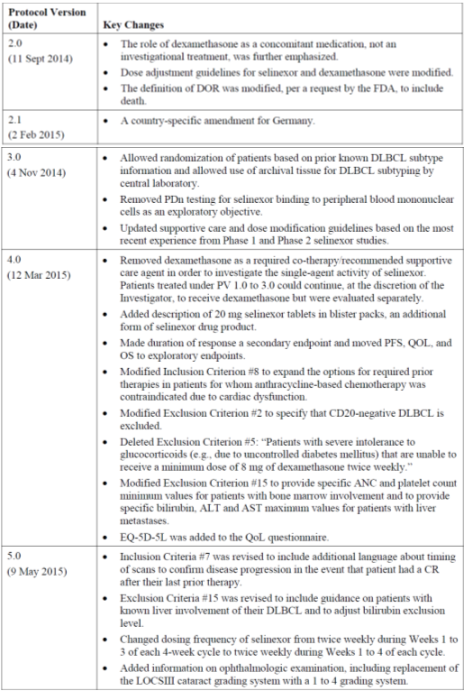

Table 12 (continued): Study KCP-330-009 (SADAL trial) Protocol amendments

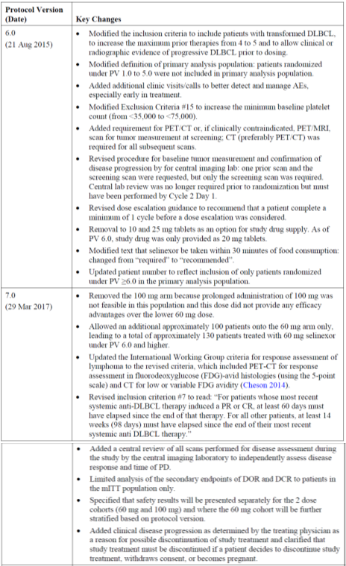

Table 12 (continued): Study KCP-330-009 (SADAL trial) Protocol amendments



ALT = alanine aminotransferase; ANC = absolute neutrophil count; AST = asparate aminotransferase; CT = computed tomography; DCR = disease control rate; DOR = duration of response; FDG = fluorodeoxyglucose; mITT = modified intention to treat; OS = overall survival; PD = progressive disease; PET = positron emission tomography; PFS = progression free survival; PV = protocol version; QoL = quality of life; QW = once per week. TLS = tumor lysis syndrome.

*Major protocol violations*

There were eight major protocol violations in the mITT population, including one patient who was not administered prior anti-CD20 therapy. Protocol violations are unlikely to impact the results of the study.

###### Statistical analysis

Statistical analysis plan version 1 dated 2018 and version 2.0 dated 2019 were included in the submission. A sample size of 127 patients allowed a one sided binomial exact test at α = 0.025 to detect an overall response rate of ≥ 0.25 against the threshold overall response rate of 0.15, with > 80% power.[24] The primary analysis population was planned to include about 130 patients, to allowed for a 2% correction for non-evaluable patients.

The primary endpoint of overall response rate was assessed by constructing a 97.5% lower one sided binomial CI for overall response rate using exact methods. Selinexor was deemed superior to the pre-established minimum threshold level of 15% if the lower bound of this CI was ≥ 15%.

Duration of response, the duration from first occurrence of complete response or partial response until the first date of documented progression, was described using the Kaplan-Meier method, including an estimate of the median, as well as the 25th and 75th percentiles, along with two sided 95% CIs.

Time-to-event analyses (progression free survival and overall survival) were assessed using Kaplan-Meier methods, similar to the analysis for duration of response.

###### Efficacy endpoints

The primary endpoint was overall response rate; complete response plus partial response.

Secondary endpoint was duration of response.

Exploratory endpoints included time to progression, progression free survival and overall survival.

###### Study results

Table 13: KCP-330-009 (SADAL trial) Key study efficacy outcomes

|  |  |
| --- | --- |
| Study KCP-330-009 Efficacy analyses  mITT population (n = 127) | |
| **Response per IRC** | **Selinexor, n (%)** |
| Overall response rate (CR + PR) | 36 (28.3%)  (95% CI: 20.7%, 37.0%) |
| Complete response (CR)  Partial response (PR)  Stable disease (SD)  Progressive disease (PD)/Not evaluable (NE) | 15 (11.8)  21 (16.5)  11 (8.7)  80 (63.0) |
| *Responses adjudicated according to the Lugano 2014 Criteria by an Independent Radiologic Committee (IRC) and confirmed by an Independent Oncologist Reviewer. The Deauville criteria (5 point scale) was used to grade response using PET-CT. PET-CT results were prioritised over CT results | |
| Duration of response (n=36) months, median | 9.3 (95% CI: 4.8, 23.0) |
| Disease control rate (CR + PR + SD) | 37.0% (95% CI: 28.6%, 46.0%) |
| Time to progression, months | 3.5 (95% CI: 2.0, 4.0) |
| Progression-free survival, median, months  Overall Survival, median, months | 2.6 (95% CI: 1.9, 4.0)  9.1 (95% CI: 6.6, 15.1) |

The TGA clinical evaluation found the subgroup analyses showed results generally consistent with those in the overall population.

Overall survival is an exploratory endpoint. Estimated survival probabilities were 60.9% at 6 months, 47.6% at 12 months, 32.3% at 18 months, and 28.1% at 24 months. For patients whose best response was a complete response (n = 15), the median overall survival was not reached; the 6‑month survival probability was 100% and the 12-, 18-, and 24-month survival probabilities were all 93.3%. For patients whose best response was a partial response (n = 21), the median overall survival was also not reached, and the 6-, 12-, 18-, and 24-month survival probabilities were 100%, 81.6%, 62.9%, and 62.9%, respectively. For patients whose best response was stable disease (n = 11), the median overall survival was 18.3 months. For patients whose best response was disease progression or non-evaluable (n = 80), the median overall survival was 4.3 months.

###### Additional analyses

In response to questions the sponsor provided the following comparison between the SADAL study and the SCHOLAR-1 study.[25]

Table 14: Study KCP-330-009 (SADAL trial) and SCHOLAR-1 trial Comparison of baseline characteristics and outcomes studies (sponsor supplied additional analysis)

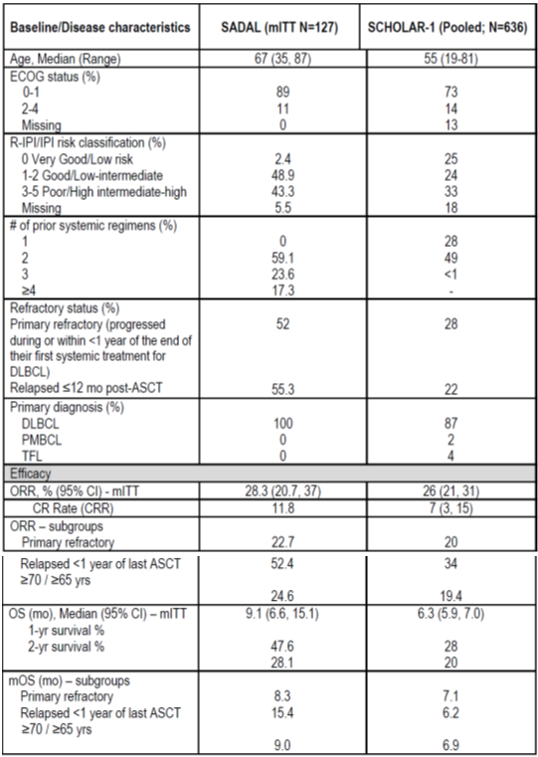

Crump M, et al. Outcomes in refractory diffuse large B-cell lymphoma: results from the international SCHOLAR-1 study. Blood. 2017;130, 1800-1808.

##### Safety

In the SADAL trial (Study KCP-330-009), the median duration of selinexor exposure was eight weeks among patients receiving 60 mg twice a week dose, with 56.6% of patients receiving selinexor ≥ 8 weeks, and 33.1% of patients receiving selinexor ≥ 12 weeks. The median duration of study treatment (selinexor plus dexamethasone) was 9 weeks, with 57.7% of patients receiving selinexor ≥ 8 weeks, and 37.4% of patients receiving selinexor ≥ 12 weeks.

###### Adverse events

Table 15: Study KCP-330-009 (SADAL trial) Summary of safety findings

|  |  |
| --- | --- |
| Study KCP-330-009 (SADAL trial) Summary of safety findings  mITT (n=127) | |
| **Any adverse event** | 98.4% |
| **Common adverse events (> 15%)** | |
| Thrombocytopenia | 61.4% |
| Nausea | 58.3% |
| Fatigue | 47.2% |
| Anaemia | 42.5% |
| Decreased appetite | 37.0% |
| Diarrhoea | 35.4% |
| Constipation | 30.7% |
| Neutropenia | 29.9% |
| Weight decreased | 29.9% |
| Vomiting | 29.1% |
| Pyrexia | 22.0% |
| Asthenia | 21.3% |
| neurological toxicitya | 19.7% |
| Cough | 18.1% |
| **Any CTCAE Grade 3 - 4** | 80.3% |
| **Any treatment-emergent adverse event (TEAE) leading to dose modification** | 70.1% |
| **Any TEAE leading to dose hold** | 60.6% |
| **Any TEAE leading to dose reduction** | 33.9% |
| **Any TEAE leading to treatment discontinuation** | 17.3% |
| **Any treatment-related adverse event (TRAE)** | 90% |
| **Most common TRAEs > 20%** | |
| Thrombocytopenia | 54% |
| Nausea | 53% |
| Fatigue | 39% |
| decreased appetite | 35% |
| Anaemia | 32% |
| Diarrhoea | 21% |
| **Any serious adverse events (SAEs)** | 48% |
| **Most common SAEs** | |
| Pyrexia | 7.1% |
| Pneumonia | 4.7% |
| Sepsis | 4.7% |
| **Any treatment-related SAE** | 20.5% |
| **Fatal AEs** | 3.9% |

a preferred terms of dizziness, confusional state, delirium, syncope, and depressed level of consciousness

The incidence of treatment related AEs leading to treatment discontinuation was 7.9%, most commonly thrombocytopenia (1.6%) and nausea (1.6%).

None of the five deaths (one each of sepsis, pulmonary sepsis, septic shock, cerebrovascular accident, and acute respiratory distress syndrome) was considered to be related to study treatment.

Other adverse events

Fatigue

* AE: 24.7%, TRAEs: 36.2%, no SAEs

Decreased appetite

* AEs: 37.8%, TRAEs: 36.2%, no SAEs

Nausea

* AEs: 58.3%, TRAEs: 52.8%, TRSAEs: 1.6%, none was fatal

Vomiting

* AEs: 29.1%, TRAEs: 26.8%, TRSAEs: 1.6%, non was fatal

Neurological

* TRAEs: 10.2%, TRSAEs: 1.6%, none was fatal

Ophthalmology (total selinexor 60 mg DLBCL data set, n = 181)

* Blurred vision AEs: 11.6%
* Blurred vision TRAEs: 7.7%
* Cataract AEs: 3.3%
* Cataract TRAEs: 2.2%
* Cataract TRSAEs: 0.6%

Laboratory AEs

Hyponatraemia

* Baseline to new maximum Grade 3 or 4: 0.8%
* Considered AE: 11.0%, TRAE: 7.9%
* SAE of hyponatraemia: 0.8%, none was fatal

Haematology

Anaemia

* AEs: 42.5%, TRAEs: 32%, TRSAEs: 1.6%, none was fatal

Thrombocytopenia

* AE: SVd 61.4%, TRAE: 53.5%, TRSAEs: 0.8%, none was fatal

Neutropenia

* Neutropenia or febrile neutropenia AE: 30.7%
* Neutropenia or febrile neutropenia TRAE: 29.9%
* Neutropenia or febrile neutropenia SAE: 4.7%, none was fatal

Sepsis AEs: 5.5%, TRAEs of sepsis 0.8% (1 out of 127), treatment-related serious adverse events (TRSAEs) 0.8%. Three patients (2.4%) died from sepsis considered unrelated to study treatment.

### Risk management plan

The sponsor has submitted EU-risk management plan (RMP) version 0.3 (date 4 September 2020; data lock point (DLP) 7 September 2019) and Australia specific annex (ASA) version 1.0 (date 30 October 2020) in support of this application. At the second round of RMP evaluation, the sponsor submitted ASA version 1.0 (date 31 May 2021). At the third round of RMP evaluation, the sponsor submitted EU-RMP version 1.1 (date 29 March 2021; DLP 18 February 2020) and ASA version 1.0 (date 25 August 2021). At the fourth round of RMP evaluation, the sponsor submitted EU-RMP version 2.0 (date 7 July 2021; DLP 18 February 2020) and ASA version 1.1 (date 1 October 2021). At the fifth round of RMP evaluation, the sponsor submitted ASA version 1.2 (date 1 February 2022).

The summary of safety concerns and their associated risk monitoring and mitigation strategies are summarised in Table 16. Further information regarding the TGA’s risk management approach can be found in [risk management plans for medicines and biologicals](https://www.tga.gov.au/publication/risk-management-plans-medicines-and-biologicals) and [the TGA's risk management approach](https://www.tga.gov.au/tgas-risk-management-approach).

Table 16: Summary of safety concerns

|  |  |  |  |  |  |
| --- | --- | --- | --- | --- | --- |
| Summary of safety concerns | | Pharmacovigilance | | Risk Minimisation | |
| Routine | Additional | Routine | Additional |
| **Important identified risks** | Thrombocytopenia and Bleeding | ✓ | ✓ | ✓ | – |
| Severe infections due to neutropenia | ✓ | ✓ | ✓ | – |
| Fatigue | ✓ | ✓ | ✓ | – |
| Decreased appetite and Weight decreased | ✓ | ✓ | ✓ | – |
| Hyponatraemia | ✓ | ✓ | ✓ | – |
| Confusional state | ✓ | ✓ | ✓ | – |
| **Important potential risks** | Tumour lysis syndrome | ✓ | – | ✓ | – |
| Acute cerebellar syndrome | ✓ | – | – | – |
| Medication error | ✓ | – | ✓ | – |
| **Missing information** | Use in patients with severe renal impairment | ✓ | – | ✓ | – |
| Use in patients with severe hepatic impairment | ✓ | – | ✓ | – |

The summary of safety concerns aligned with the EU-RMP and was acceptable at first and second rounds of evaluation, however at third round of evaluation the sponsor provided an approved EU-RMP which included an additional safety concern, ‘cataract’, which was not included in the ASA. The sponsor was requested to include the risk of ‘cataract’ in the ASA at third round of evaluation in order to align with the EU-RMP, however the updated EU-RMP submitted at fourth round of evaluation no longer included this safety concern. At fourth round of evaluation, the summary of safety concerns in the ASA aligns with the EU‑RMP. This is acceptable.

Routine pharmacovigilance is proposed for all safety concerns. Additional pharmacovigilance was proposed for potential and identified risks at the first round of evaluation, however the sponsor confirmed at the second round of evaluation that the trial had been completed and removed from the ASA. Further clarification on the status of safety updates from this trial have been requested. At the third round of evaluation, the sponsor confirmed that no further additional pharmacovigilance activities are being carried out, and the sponsor has been requested to explain how risks will be characterised.

At the fourth round of evaluation, the sponsor included Study XPORT-DLBCL-030;[26] in the pharmacovigilance plan of the ASA for all important identified risks. At the fifth round of evaluation, Study XPORT-DLBCL-030 has been removed from the pharmacovigilance plan in the ASA as the sponsor is no longer seeking the *relapsed or refractory diffuse large B‑cell lymphoma* indication. The pharmacovigilance plan is acceptable.

Routine risk minimisation is proposed for all safety concerns with the exception of the important potential risk ‘acute cerebellar syndrome’. Additional risk minimisation is not proposed. The CMI has been amended as requested and is acceptable at the third round of evaluation. At fourth round of evaluation, the sponsor has updated the product packaging to include a QR code and appropriate wording informing consumers how the Consumer Medicines Information (CMI) can be accessed. At the fifth round of evaluation, the patient support program, which is not considered an additional risk minimisation activity, was removed from the ASA as requested. The risk minimisation plan is acceptable.

### Risk-benefit analysis

#### Delegate’s considerations

The SADAL trial (Study KCP-330-009) is the main evidence presented to support selinexor in diffuse large B-cell lymphoma (DLBCL).

There were nine versions of the protocol that add complexity to the understanding of the study.

At amendment 6 the inclusion criteria were expanded to include transformed DLBCL to add to the DLBCL not otherwise specified group, and the number of prior therapies expanded from 4 to 5 allowing for a more heavily pre-treated population.

After the preliminary analysis that resulted in the removal of the 100 mg twice weekly treatment arm, the protocol was amendment to increase the time interval between the last treatment and study eligibility for the study. This may have introduced a survivor bias because patients needed to survive the discontinuation for 60 to 98 days from the previous treatment before being eligible for the selinexor. The time interval of 14 weeks in this setting appears longer than is likely to be waited in the clinical setting for a patient that does not have a complete response or partial response to the previous therapy and wishes to pursue further treatment options.

The primary analysis included data from 122 patients who received selinexor 60mg twice weekly (Days 1 and 3 of each week) of each 28 day cycle. The patients were mostly White, aged < 70 years, male and with an ECOG performance status of 0 or 1 (only 11% ECOG PS 2 or 3) whose disease was mostly de novo, but whose disease had similar proportions of germinal centre B cells and non-germinal centre B-cells types.

At the primary analysis overall response rate (by IRC) was 28.3%, with 11.8% with a complete response and 16.5% with a partial response 16.5%. Among the 36 responders, the median duration of response was 9.3 months. Overall survival and progression-free survival are more difficult to interpret in a single arm trial, but the exploratory overall survival data are promising in the responder cohort. The overall response rate is modest but with the duration of the response could be clinical meaningful in this setting, and is similar to that reported from a pooled analysis from two randomised studies and two academic databases of the SCHOLAR-1 trial.24

The activity of selinexor in this setting is difficult to isolate from the activity of the disease. In support of the data from the STORM trial (Study KCP-330-012), the BOSTON trial (Study KCP-330-023) assists with the ascertainment of selinexor efficacy in multiple myeloma that could be extrapolated to the single arm setting. For DLBCL, the submission does not include these data. The BOSTON trial also contributes important safety data in an earlier line of therapy.

Corticosteroids for systemic use was reported for 46.5% of the population. Dexamethasone was used by 22% of the study population as a concomitant medication, with 3.9% of the mITT population using dexamethasone in a prophylactic medication context. The doses taken were not specifically discussed but this raises an uncertainty about a synergistic effect and whether the steroid dosing may have contributed to efficacy in some patients, or whether a choice of other agents for nausea and vomiting prophylaxis may have been disadvantageous.

The study allowed up to five prior therapies, however the indication seeks third line and above and does not seek to limit the indication further by lines of therapy. Around 80% of the participants in the study were receiving selinexor as a third or fourth line therapy.

The safety data illustrate a similar profile to that seen in the other studies haematological, gastroenterological, neurological, and ophthalmological toxicities, together with hyponatraemia. The median duration of exposure was 8 weeks, indicating early toxicity with selinexor. The study benefits from the additional safety data from the BOSTON and STORM trials, with similar types of events and in similar proportions being reported. However long term safety data, including long term post-exposure data are limited.

It is the sponsor’s position that the submission is sufficient to meet the thresholds for full registration. The sponsor points to previous examples of early data, including single arm data in DLBCL and other indications that have led to full registration. Of note the sponsor refers to the registration of polatuzumab vedotin;[27],[28] based on an early phase comparator study with the overall response rate for the combination of around 40%. The consideration for selinexor for this indication is based on the submission, and the concerns that arise are related to the uncertainties outlined above.

In the USA, based on the same study an indication was granted with accelerated approval, similar to provisional registration in Australia. An additional study is to be conducted by the sponsor to fulfill requirements for a confirmatory study following the US Food and Drug Administration’s (FDA) granting of accelerated approval in DLBCL.

Study XPORT-DLBCL-030 is a Phase II/III study to evaluate the efficacy and safety of the combination of selinexor with rituximab, gemcitabine, dexamethasone and platinum in patients with relapsed or refractory DLBCL who are not intended to receive haematopoietic stem cell transplantation or chimeric antigen receptor T-cell therapy (CAR-T). In response to questions the sponsor provided details of the study. It is considered this study will be very useful to isolate the effects of selinexor in DLBCL and to further inform its potential in an earlier line of therapy as a combination therapy option. The comparative study may also address some of the uncertainties that arise from the SADAL trial.

#### Proposed action

There are uncertainties that arise from the study design, and patient selection, that raise doubt about whether efficacy can be established with these data for selinexor sufficient for full registration. Because there is concern about the efficacy it is difficult to reconcile the safety concerns that impact multiple organ systems, have their own morbidity and have a potentially significant impact on quality of life. Subject to the advice of the ACM, it is not clear to the Delegate that for this indication selinexor is supported by sufficiently robust efficacy findings to offset the potential harms.

#### Questions for the sponsor

The sponsor provided the following response to questions from the Delegate.

1. ***Does selinexor have toxicities that are considered maximum concentration‑dependent? If so, what intrinsic or extrinsic factors contribute?***

In the STORM trial (Study KCP-330-012; part of the sponsor’s submitted dossier), exposure response safety analyses in patients with multiple myeloma were conducted to evaluate the effect of exposure (by area under the curve (AUC)) and dose intensity on the common and clinically relevant treatment-emergent adverse events (TEAEs) of Grade 3 or higher during selinexor treatment including hyponatremia, thrombocytopenia, nausea/vomiting, fatigue, diarrhoea, and decreased weight. There were statistically significant trends for Grade 3 and 4 adverse events (AEs) of thrombocytopenia, hyponatremia, and fatigue for both exposure (by AUC) and dose intensity analyses. Maximum concentration (Cmax) was not used as an exposure metric in this evaluation.

Exposure-response safety analyses were also conducted for patients with non-Hodgkin's lymphoma using exposure metrics such as Cmax, AUC, average concentration to the time of event and average concentration to the end of treatment. AUC was found to be the best predictor for decreased appetite (Grade 3+), fatigue (Grade 2+), blurred vision (Grade 1+), vomiting (Grade 2+) and time to event for discontinuations due to TEAE and thrombocytopenia (Grade 3+). For these adverse events, except for dose modifications, Cmax was the best predictor for dose modification.

The exposure-safety response analysis for safety endpoints indicated that for patients with non-Hodgkin's lymphoma, AUC was found to be the best predictor for decreased appetite (Grade 3+), fatigue (Grade 2+), blurred vision (Grade 1+), vomiting (Grade 2+) and time to event for discontinuations due to TEAEs and thrombocytopenia (Grade 3+). Cmax was the best predictor for dose modification only. The selection of the exposure metric as the best predictor was based on results from univariate logistic regression analyses (results with a positive slope and a smallest p-value). For dose modification, the p-value for Cmax was slightly lower than the p-value for AUC (p = 0.003 versus p = 0.006) and Cmax was selected as the predictor. As AUC and Cmax are usually highly correlated, there is a potential for Cmax to be selected as the best predictor although the safety endpoint may be driven by mainly by AUC.

The above exposure-response relationships were found to be relatively flat such that a change in the dose from 60 mg twice weekly to 40 mg twice weekly was predicted to reduce the frequency of the AEs by approximately 5% or less.

In terms of intrinsic factors, lower body weight and to a smaller extent sex were found to have an effect on selinexor pharmacokinetics exposure parameters, such as AUC and Cmax. The effects of body weight and sex on AUC or Cmax were small and the flat exposure safety response relationships were considered to be clinically not relevant. In Report MS-002 (not in scope of this AusPAR), body weight and sex were found not to be a significant covariate for any of the aforementioned relationships.

In terms of extrinsic factors, although selinexor was found to be a substrate of CYP3A in vitro, recent results from Study KCP-330-017 (abbreviated clinical study report, also known as the STOMP trial);11 indicated that co‑administration with a clarithromycin, a strong CYP3A inhibitor had no effect on the PK of selinexor, indicating no potential safety risk in co‑administration with strong inducers as well.

In summary, the PK and the exposure-response relationships of selinexor are not affected by most intrinsic and extrinsic factors and the information provided in the PI related to intrinsic and extrinsic factors is deemed to be adequate.

1. ***A Phase IIb, randomised, open-label study (Study XPORT-MM-028) is underway to investigate the selinexor dosing in the triple class refractory multiple myeloma setting:***
   * *selinexor 100 mg with bortezomib 1.3 mg/m2 and 40mg dexamethasone, all once weekly,*
   * *selinexor 40 mg with 20mg dexamethasone, both twice weekly.*
   * *selinexor 80 mg with 20mg dexamethasone, both twice weekly*
   * *selinexor 100mg with 40mg dexamethasone, both once weekly*
   1. ***What is the rationale for conducting this study when 80 mg twice weekly is requested for full registration for the triple class refractory, partial responder population in the current submission?***

Study XPORT-MM-028;22 is an open label, Phase II study intended to optimise the dose and schedule of Sd [selinexor + dexamethasone] in patients with penta-refractory multiple myeloma.

The aim of this study is to evaluate the efficacy, antitumor activity, and safety and tolerability of three dose levels including selinexor 40 mg twice weekly and dexamethasone 20 mg twice weekly (‘Sd-40’ twice weekly), selinexor 100 mg once weekly and dexamethasone 40 mg once weekly (‘Sd-100’ once weekly) and selinexor 80 mg twice weekly and dexamethasone 20 mg twice weekly (‘Sd-80/ twice weekly).

In our recent exposure-safety analysis (the SADAL trial/Study KCP-330-009), higher Cmax levels were associated with increased dose modifications. The 80 mg and 100 mg once weekly doses have similar Cmax: the mean (standard deviation) is 680 (124) ng/mL and 693 (201) ng/mL for 80 mg once weekly and 100 mg once weekly selinexor, respectively. With the pharmacokinetics variability of this oral agent, the exposure and maximal concentrations (AUC and Cmax) from 80 mg and 100 mg doses overlap significantly. In contrast, the Cmax of the 40 mg dose is 277 (84) ng/mL. Therefore, we proposed to test the 40 mg twice weekly dose (80 mg in a week) in addition to the 100 mg once weekly dose and compare them to the previously tested 80 mg twice weekly dose (160 mg in a week). The use of 40 mg twice weekly may minimise dose reductions and/or interruptions and achieve comparative responses to once weekly dosing as a single agent.

* 1. ***Is there uncertainty about the optimal dose in this setting?***

The sponsor does not consider there to be uncertainty in the optimal dosing in triple class refractory multiple myeloma, based on existing clinical trial data. However, we believe there is value in exploring other dosing regimens that may minimise dose reductions and/or interruptions without compromising clinical activity. This is the objective of this study and explains the study design.

* 1. ***It is noted that 60 mg twice weekly dosing is not under investigation in Study XPORT-MM-028 but it is the dose proposed for the diffuse large B-cell lymphoma indication.***

***What is the rationale for the chosen dosing regimens for investigation in Study XPORT-MM-028?***

The sponsor would like to advise that Karyopharm;[29] evaluates the potential application of a dosing regimen with the aim of maintaining exposures within the range demonstrated to provide maximal efficacy and acceptable safety. It is important to note that dosing for myeloma may not translate to the same dosing for lymphoma.

* 1. ***How will the results be used to inform the dosing regimen in triple class refractory partial responders in the future?***

In general, results are used to inform the dosing regimen; however, dosing may be different based upon the different diseases being treated. At this point, the sponsor considers it premature to assume the implications of future results.

1. ***The SADAL trial (Study KCP-330-009) was ongoing at the time of the drafting of the Clinical Study Report (CSR) (date of report: 13 December 2019; data cut‑off date: 1 August 2019.***

***In this study report 127 patients were included in the primary analysis for overall response rate.***

* 1. ***The sponsor has indicated an intention to report the results for 134 patients based on the US FDA product label. It would appear the USA data set includes additional patients and results that differ from the study results presented in Australia.***

***As the sponsor intends to include the text from the US label in the Australia PI the same data should have be provided for evaluation. Please explain this observation.***

The modified intent-to-treat (mITT) population (N = 127) in the SADAL trial consisted of all patients treated at 60 mg under Protocol Version (PV) 6.0 and onward, which was the primary analysis population for the study and included in the clinical study report (CSR). The FDA subsequently requested to include all patients treated at 60 mg under PV 5.0 and onward, with certain exception (see the request below), which consisted of 134 patients as shown in the US label. The complete analysis of the 134 patients is provided in the publication, Maerevo, et al. (2021)[30] and is included herewith

Figure 4: United States Food and Drug Administration; FDA Request 2: Primary efficacy population

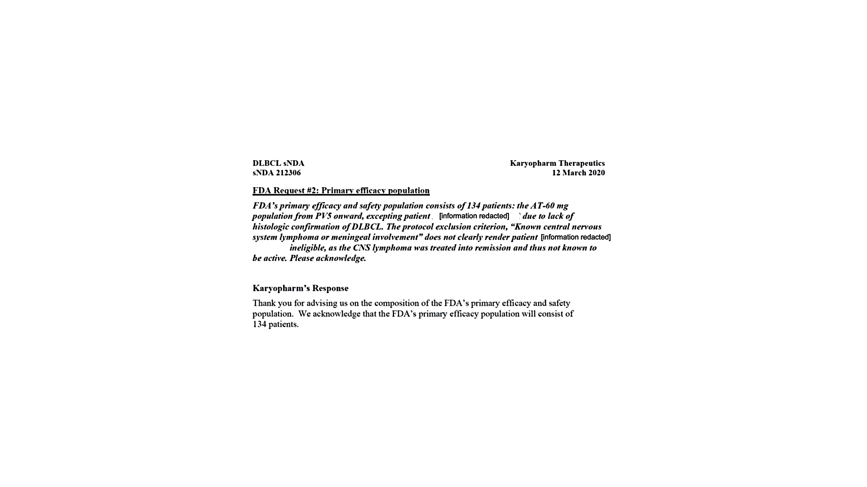

Note: Patient identifiable information has been redacted.

* 1. ***The SADAL trial study report is dated 2019. These data are now two years old and the statement that the median overall survival has not been reached in the complete responder group may no longer be accurate. Is a more contemporaneous analysis available?***

An updated data version extracted on 30 March 2021 for selinexor IB;[31] and DSUR [development safety update report] is provided. An overall survival analysis was performed using this data version for the key updated overall survival results using N = 134, along with the results based on the data cut of 1 August 2019 from the CSR using N = 127.

Table 17: Sponsor provided updated overall survival analysis (date: 30 March 2021)

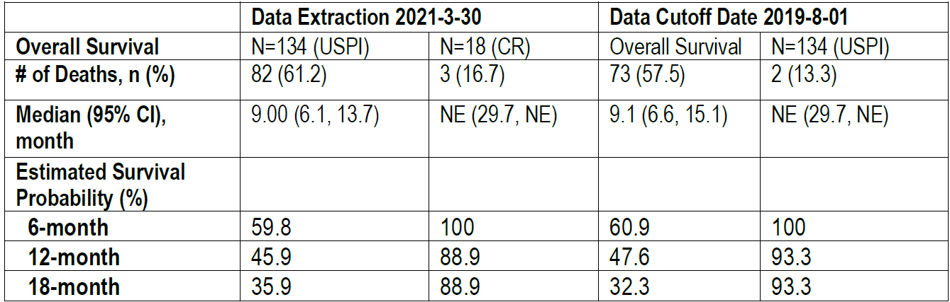 

The updated overall survival results (data extraction 30 March 2021) are generally consistent with the overall survival results in the CSR (data cut-off date 1 August 2019). The median overall survival for complete responders is still not reached in the updated data, with only 16.7% death rate. The 24-month and 36-months estimated survival probability rate is 88.9% and 71.1%, respectively (that is 88.9% and 71.1% of the complete responders are still alive at 24 and 36 months, respectively after the start of treatment).

* 1. ***As the measurement of overall survival is unlikely to be influenced directly by changing imaging techniques, has the sponsor undertaken a sensitivity analysis to assess overall survival for the whole study population and for each of the AT‑60 mg, and AT‑100 mg populations? If so, where is this located in the submission. If this information has not been included in the submission, please provide the overall survival results for the AT‑60 mg population, if available. Please use the most contemporaneous data held for this study for the analysis.***

The sponsor agrees that the measurement of overall survival is unlikely to be influenced directly by changing imaging techniques. However overall survival as a time to event endpoint in a single-arm study is only considered as an exploratory endpoint (due to different factors that may impact the outcome) and not included in the US FDA label, therefore no such sensitivity analysis was performed in the SADAL trial CSR.

The sponsor has performed this analysis using the updated data. Please see below for the overall survival results for the whole study population and for each of the AT‑60 mg and AT‑100 mg populations, regardless of protocol versions or eligibility criteria.

Table 18: Sponsor-supplied updated overall survival analysis (date: 30 March 2021)

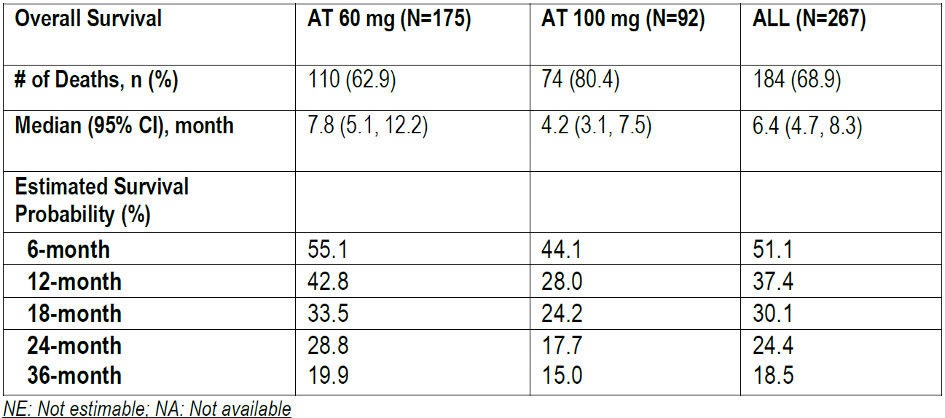

1. ***Study KCP-330-009 (SADAL trial) is a single-arm, open-label study with overall response rate as the primary outcome. This type of evidence is more typically seen to support a request for provisional registration, and accelerated approval was granted in the US.***

***How has the sponsor resolved the data from this study are sufficiently robust to support full registration in Australia?***

***Has the sponsor considered this indication for provisional registration in Australia?***

*Study KCP-330-009 (SADAL trial) study design:*

The sponsor thanks the Delegate for the opportunity to provide a comprehensive narrative to support full registration in Australia. The sponsor considers the data sufficiently robust to support full registration based on the SADAL trial being a well-designed registrational study with patient population, eligibility criteria, study design, and statistical assumptions all agreed to by the FDA. The SADAL trial contains data from a relatively large number of patients (N = 127 in the mITT population and N = 134 included in the US Prescribing Information (USPI)) compared to historical studies in a similar patient population. The study results are both statistically significant and clinically meaningful, demonstrating clear clinical benefit with single agent selinexor treatment for this patient population with highly unmet medical need.

The single arm design is justifiable on the grounds that relapsed/refractory diffuse large B‑cell lymphoma is a rare challenging condition and there is no established standard of care for relapsed or refractory patients in third line, making selection of an appropriate comparator problematic. In addition, the clear single-agent treatment activity of selinexor also justifies the single arm design.

The ongoing randomised Phase II/III study (Study XPORT-DLBCL-030);26 as a post-market requirement for the accelerated approval of selinexor for diffuse large B‑cell lymphoma in the USA, is a combination regimen (R-GDP with or without selinexor) in an earlier relapsed/refractory diffuse large B‑cell lymphoma population and will provide further data to support the treatment effect and use of selinexor in broader patient population. The trial enrolled its first patient in January 2021 and topline results from the Phase III portion are expected after 2025. Further details of Study XPORT-DLBCL-030 are provided in response to the Delegate’s Question 5 (see below).

*Choice of overall response rate as the primary endpoint:*

The choice of overall response rate (ORR) as the primary endpoint is commonly accepted for single-agent single-arm registrational studies in the haematology/oncology setting since disease response (partial response or better) is considered an objective and direct measure of treatment effect, not likely due to other factors. It is also adequate in the context of a continuous therapy approach with novel agents if they demonstrate meaningful ORR supported by durable response therapies. This is evidenced in the SADAL trial by an ORR of 28.3% (in the mITT population) with a median by the duration of response of 9.3 months in patients with partial response or better, which is quite impressive for this patient population. The complete response rate (CRR) is 11.8%.

*Robustness of SADAL trial results*

The results of ORR supported by duration of response as shown above and detailed in the submission have demonstrated clear single-agent treatment effect of selinexor in a very challenging patient population with unmet medical need. The safety profile of selinexor is well characterised and manageable. The benefit risk profile and convenience of oral therapy make selinexor an important new option.

Moreover, the results compare favorably with historical data in similar patient populations, such as those included in SCHOLAR-11;25 which reported the patient-level analysis of outcomes of refractory DLBCL from two large, randomised trails and two academic databases.

Understanding the caveats of cross-study comparisons, the baseline characteristics and key efficacy outcomes based on a few common variables from the two studies are presented below.

As compared with SCHOLAR-1 trial;25 the patients in SADAL trial appear to be older, marginally higher risk, with substantially higher proportion of primary refractory patients. They also look to be more heavily pre-treated. Despite this, efficacy outcomes look comparable, with survival times looking better in SADAL trial.

Table 19: Comparison of baseline and disease characteristics between Study KCP‑330-009 (SADAL trial), and the Scholar-1 trial

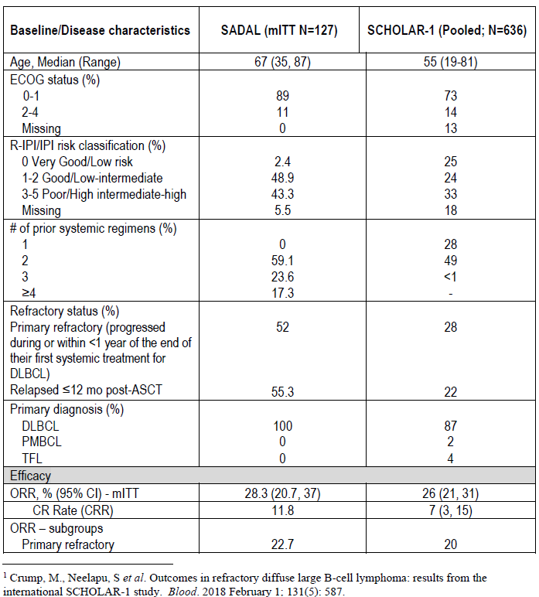 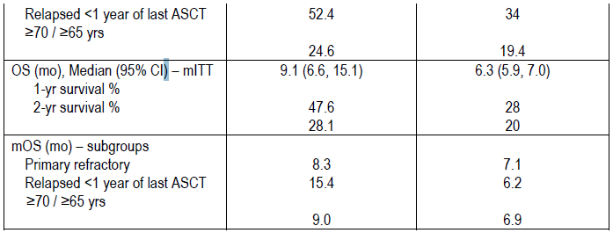

Data derived from: Crump M, et al. Outcomes in refractory diffuse large B-cell lymphoma: results from the international SCHOLAR-1 study. Blood. 2017;130, 1800-1808.

*Regulatory landscape*

In support of the SADAL data being sufficient for full registration, reference is made to Polivy in October 2019;27,28 in which full registration was granted based on a similar dataset. Polivy (polatuzumab vedotin) in combination with bendamustine and rituximab, is indicated for the treatment of previously treated adult patients with diffuse large B-cell lymphoma who are not candidates for haematopoietic stem cell transplant.

The efficacy of Polivy was based on a Phase I/II trial, Study G029365. This compared the efficacy of Polivy + bendamustine + rituximab (Pola + BR) with bendamustine + rituximab (BR) in a total of 80 patients randomised 1:1 to either treatment arm. The primary endpoint of the study was the rate of complete response in the two comparator arms.

In consideration of the application, it was noted that the refractory patient population who are unsuitable to autologous stem cell transplant (ACST) currently has a poor prognosis. Whilst the Delegate considered the immaturity of the data in supporting the efficacy of Polivy to be an issue, also noting that the sponsor did not request provisional registration, approval was granted due in part to the commitment of the confirmatory data from a larger Phase III trial being provided upon availability. Similarly, as outlined in response to Question 5 below, the sponsor of this submission also has a randomised Phase II/III trial to collect confirmatory data on the benefit of selinexor in the relapsed/refractory diffuse large B‑cell lymphoma patient population.

The sponsor also notes the full registration of Keytruda (pembrolizumab) with limited available data.[32] Keytruda is indicated as monotherapy for the treatment of unresectable or metastatic melanoma in adults.

The results of the Study P001 for Keytruda indicate that pembrolizumab produces objective responses in a substantial proportion of patients with advanced melanoma (approximately 33% overall). Meaningful response rates were also observed in the subgroup of subjects who had received 2 or more prior systemic therapies. These responses appear to be long lasting. Median progression free survival was 23.7 weeks (approximately 5.5 months). Overall survival data were not mature. No quality of life data were collected in the study.

Overall, it was considered by the Delegate that the benefits of pembrolizumab outweigh its risks. However, the data submitted with this application were deemed early. Specific limitations of the data were identified as data on the duration of tumour responses was not mature and there were no randomised comparisons of pembrolizumab against other agents registered for use in the proposed patient population.

The Delegate also noted regulatory approval of new anticancer agents usually requires a favourable risk benefit ratio demonstrated in a Phase III study using time-to-event endpoints such as overall survival or progression free survival. However, in situations where the indication is a life threatening condition and there are no other established therapies available, approvals have been granted based on non-comparative Phase III studies which used response rate as an endpoint.

Further, the sponsor also notes the full registration of Istodax (romidepsin);[33],[34] with Phase II single arm trial data. Istodax is indicated for the treatment of peripheral T cell lymphoma (PTCL) in patients who have received at least one prior systemic therapy. During evaluation, the clinical evaluator noted:

‘*a Phase III trial would be more appropriate*’-‘*but recognising the relatively uncommon nature of PTCL and ... variability in histological subtypes as well as responsiveness to therapy such a Phase III trial would have difficulties in being undertaken*’

The sponsor also notes the following product full registrations with the submission of confirmatory data upon availability:

Table 20: Sponsor-identified full TGA-registrations

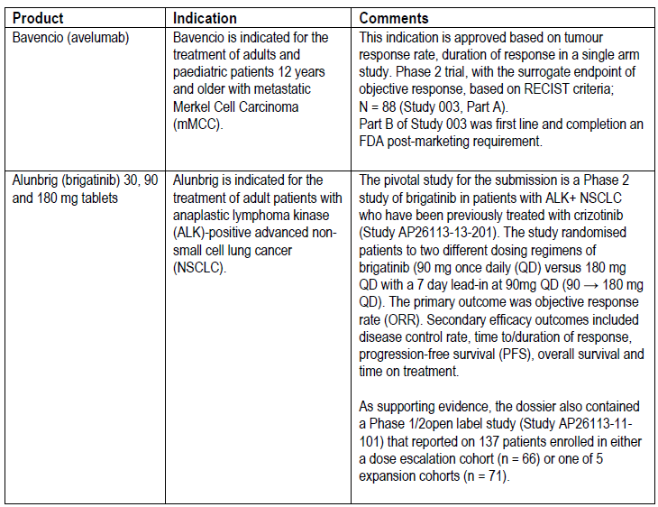

1. ***In published letters, the US FDA has issued an accelerated approval requirement and a post-marketing requirement for selinexor when used in relapsed or refractory diffuse large B‑cell lymphoma.*** 
   1. ***Please provide a brief overview of the trial design, and the key inclusion and exclusion criteria.***

The sponsor would like to confirm the clinical trial, Study XPORT-DLBCL-030;26 is underway as a post-marketing requirement for the US FDA accelerated approval of diffuse large B‑cell lymphoma as follows: A Study of Rituximab-Gemcitabine-Dexamethasone-Platinum (R-GDP) With or Without Selinexor in Patients With Relapsed/Refractory Diffuse Large B-cell Lymphoma.

Table 21: Study XPORT-DLBCL-030 Brief overview of trial design

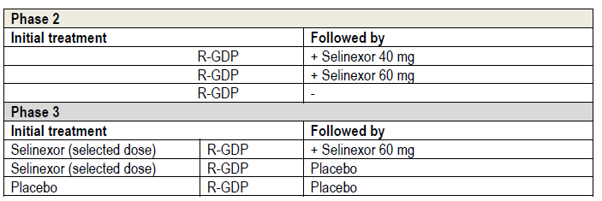

*Trial design details*: Phase II portion.

*Experimental: Phase II:* selinexor 40 mg + R-GDP

Patients with relapsed/refractory diffuse large B‑cell lymphoma will receive combination therapy of selinexor 40 mg orally at Day 1, and Day 8 of each 21-day cycle for up to 6 cycles in combination with R-GDP followed by single-agent continuous therapy with selinexor 60 mg orally once weekly for each 28-day cycle until progressive disease or unacceptable toxicity.

*Experimental: Phase II:* selinexor 60 mg + R-GDP

Patients with relapsed/refractory diffuse large B‑cell lymphoma relapsed/refractory diffuse large B‑cell lymphomawill receive combination therapy of selinexor 60 mg orally at Day 1 and Day 8 of each 21-day cycle for up to 6 cycles in combination with R-GDP followed by single-agent continuous therapy with selinexor 60 mg orally once weekly for each 28-day cycle until progressive disease or unacceptable toxicity.

*Active comparator: Phase II:* R-GDP

Patients with relapsed/refractory diffuse large B‑cell lymphoma will receive R-GDP on specified days (Days 1, 2, 3, 4, and 8) for each 21-day cycle for up to 6 cycles.

*Phase III portion*

*Experimental: Phase III:* selinexor (selected dose) + R-GDP followed by selinexor 60 mg Patients with RR DLBCL will receive combination therapy of selinexor (selected dose from Phase II) at Day 1 and Day 8 of each 21-day cycle for up to 6 cycles in combination with RGDP followed by selinexor 60 mg orally once weekly for each 28-day cycle until progressive disease or unacceptable toxicity.

*Experimental: Phase III:* selinexor (selected dose) + R-GDP followed by placebo

Patients with relapsed/refractory diffuse large B‑cell lymphoma will receive combination therapy of selinexor (selected dose from Phase II) at Day 1 and Day 8 of each 21-day cycle for up to 6 cycles in combination with R‑GDP followed by matching placebo for selinexor orally once weekly for each 28-day cycle until progressive disease or unacceptable toxicity.

*Placebo Comparator: Phase III:* placebo + R-GDP followed by placebo

Patients with relapsed/refractory diffuse large B‑cell lymphoma will receive combination therapy of placebo matching for selinexor (selected dose from Phase II) at Day 1 and Day 8 of each 21-day cycle for up to 6 cycles in combination with R-GDP followed by matching placebo for selinexor orally once weekly for each 28-day cycle until progressive disease or unacceptable toxicity.

*Inclusion criteria*

Patients eligible for inclusion in Study XPORT-DLBCL-030 must meet the following criteria:

* Patients ≥ 18 years of age
* Have pathologically confirmed *de novo* diffuse large B‑cell lymphoma or diffuse large B‑cell lymphoma transformed from previously diagnosed indolent lymphoma (for example, follicular lymphoma). Patients with high grade lymphoma with *c-MYC*, *Bcl-2* and/or *Bcl-6* rearrangements are eligible (for Phase II only)
* Have received at least 1 but no more than 3 prior lines of systemic therapy for the treatment of diffuse large B‑cell lymphoma with relapsed or refractory disease following their most recent regimen
  + Salvage chemoimmunotherapy followed by stem cell transplantation will be considered as 1 line of systemic therapy
  + Maintenance therapy will not be counted as a separate line of systemic therapy
  + Radiation with curative intent for localised diffuse large B‑cell lymphoma will not be counted as 1 line of systemic therapy
* Positron emission tomography (PET) positive measurable disease with at least 1 node having longest diameter (LDi) >1.5 cm or 1 extranodal lesion with LDi > 1 cm (per the Lugano 2014 criteria);23
* Not intended for HSCT or CAR-T therapy based on objective clinical criteria determined by the treating physician. Patients who cannot receive HSCT due to active disease are allowed on study (up to approximately 15% of patients enrolled in each phase). Documentation on lack of intention to proceed to receive HSCT or CAR-T therapy must be provided by the treating physician.
* Adequate bone marrow function at screening, defined as:
  + Absolute neutrophil count ≥ 1 × 109/L
  + Platelet count ≥ 100 × 109/L (without platelet transfusion < 14 days prior to C1D1)
  + Haemoglobin ≥ 8.5g/dL (without red blood cell transfusion < 14 days prior to C1D1)
* Circulating lymphocytes ≤ 50 × 109/L
* Adequate liver and kidney function, defined as (documentation to be provided):
  + AST or ALT ≤ 2.5 × ULN, or ≤ 5 × ULN in cases with known lymphoma involvement in the liver
  + Serum total bilirubin ≤ 2 × ULN, or ≤ 5 ULN if due to Gilbert syndrome or in cases with known lymphoma involvement in the liver
  + Calculated CrCl ≥ 30 mL/min based on Cockcroft-Gault formula
* Eastern Cooperative Oncology Group (ECOG) performance status of ≤ 2
* An estimated life expectancy of > 3 months at screening
* Patients with primary refractory DLBCL defined as no response or relapse within 6 months after ending first line treatment will be allowed on study (up to approximately 25% of patients enrolled in each phase)
* Agree to highly effective contraception during the duration of the study with contraception use continuing for 12 months after the last dose of study treatment
  + Female patients of childbearing potential must have a negative serum pregnancy test at Screening and agree to use highly effective methods of contraception throughout the study and for 12 months following the last dose of study treatment (except patients with non-childbearing potential: Age > 50 years and naturally amenorrhoeic for > 1 year, or previous bilateral salpingo‑oophorectomy, or hysterectomy).
  + Male patients who are sexually active must use highly effective methods of contraception throughout the study and for 12 months following the last dose of study treatment. Male patients must agree not to donate sperm during the study treatment period and for 12 months following the last dose of study treatment.

*Exclusion criteria*

Patients meeting any of the following exclusion criteria are not eligible to enrol in Study XPORT-DLBCL-030:

* diffuse large B‑cell lymphoma with mucosa-associated lymphoid tissue (MALT) lymphoma; composite lymphoma (Hodgkin’s lymphoma + NHL); diffuse large B‑cell lymphoma transformed from diseases other than indolent NHL; primary mediastinal (thymic) large B-cell lymphoma (PMBL); T‑cell rich large B-cell lymphoma
* Previous treatment with selinexor or other XPO1 inhibitors
* Contraindication to any drug contained in the combination therapy regimen (SRGDP)
* Known active central nervous system or meningeal involvement by diffuse large B‑cell lymphoma at time of screening
* Use of any standard or experimental anti-diffuse large B‑cell lymphoma therapy (including non-palliative radiation, chemotherapy, immunotherapy, radio-immunotherapy, or any other anticancer therapy) < 21 days prior to Cycle 1 Day 1 (Prednisone < 30 mg or equivalent are permitted; palliative radiation is permitted only if on non-target lesions)
* Any AE, by Cycle 1 Day 1, which has not recovered to Grade ≤ 1 (Common Terminology Criteria for Adverse Events (CTCAE) v5.0), or returned to baseline, related to the previous DLBCL therapy, except alopecia
* Major surgery < 14 days of C1D1
* Haematopoietic stem cell transplantation/CAR-T therapy as follows:
  + Autologous HSCT < 100 days or allogeneic HSCT < 180 days prior to C1D1
  + Active graft-versus-host disease after allogeneic HSCT (or cannot discontinue
  + graft-versus-host disease treatment or prophylaxis)
  + CAR-T infusion < 90 days prior to Cycle 1
* Neuropathy Grade ≥ 2 (CTCAE version 5.0)
* Any life-threatening illness, medical condition, or organ system dysfunction which, in the Investigator’s opinion, could compromise the patient’s safety, or being compliant with the study procedures
* Uncontrolled (that is clinically unstable) infection requiring parenteral antibiotics, antivirals, or antifungals within 7 days prior to first dose of study treatment; however, prophylactic use of these agents is acceptable (including parenteral)
* Patients with active hepatitis B virus (HBV), hepatitis C virus (HCV), or human immunodeficiency virus (HIV) infections:
  + Patients with active HBV are allowed if antiviral therapy for hepatitis B has been given for > 8 weeks and viral load is < 100 IU/mL prior to first dose of study treatment.
  + Patients with known history of HCV or found to be HCV antibody positive on screening, are allowed if there is documentation of negative viral load per institutional standard.
  + Patients with HIV are allowed if they have a negative viral load per institutional standard, and no history of acquired immune deficiency syndrome (AIDS)-defining opportunistic infections in the last year.
* Inability to swallow tablets, malabsorption syndrome, or any other gastrointestinal disease or dysfunction that could interfere with absorption of study treatment
* Breastfeeding or pregnant women
* Inability or unwillingness to sign an informed consent form
* In the opinion of the Investigator, patients who are significantly below their ideal body weight
* Patients who received a live attenuated vaccine within prior 28 days of the first dose of study treatment
  1. ***Has this trial commenced, and when is it expected to be completed?***

The sponsor would like to confirm that per original plan, the Study XPORT-DLBCL-030 was to commence on 3 September 2020 and the estimated study completion date was to be August 2024. The first patient in Phase II was enrolled in January 2021 and the first patient, first dose was 8 February 2021; based on the adjusted timelines, recruitment of last patient for Phase II is targeted in October 2022, and Phase III will initiate in January 2023.

* 1. ***This study does not appear in the pharmacovigilance plan in the Australian Specific Annex. It would appear information from the study has the potential to inform the understanding of the clinical utility and risks of selinexor that may be generalisable to the Australia context. What was the rationale for its omission from the pharmacovigilance plan?***

The sponsor would like to advise the RMP (ASA) for selinexor has been amended to include Study XPORT-DLBCL-030 as part of the additional pharmacovigilance activities for Australia. Please note Study XPORT-DLBCL-030 was not included in the initial version for submission as no patients had been enrolled at the time. An updated annotated and clean ASA are provided.

1. ***Where does the sponsor consider selinexor would be placed in the treatment algorithm for diffuse large B‑cell lymphoma*** ***if approval was granted?***

The sponsor would like to confirm that selinexor would be placed within the treatment algorithm for relapsed/refractory diffuse large B‑cell lymphoma from third line, as per the SADAL trial criteria which included patients with between 2 to 5 prior lines of systemic therapy who had progressed after or were not candidates for autologous stem cell transplantation.

In support of selinexor as having an important role in the algorithm of treatment for the diffuse large B‑cell lymphoma population, the sponsor submits in this response a full transcript of a meeting held with an expert in the field [information redacted]. The expert is a senior staff specialist at St. Vincent’s Hospital in Sydney and was one of the principal investigators for the SADAL trial looking at Selinexor in relapsed/refractory diffuse large B cell lymphoma [Information redacted].

1. ***An essential component of the establishment of quality for a therapeutic good is Good Manfacturing Practice (GMP) certification for all manufacturing sites. One manufacturing site does not yet have GMP certification and a second is due to expire in December 2021. The sponsor should ensure this matter is addressed. GMP certification must be held for all manufacturing sites prior to approval.***

[Information redacted]

Assurance is provided that the GMP certification will be maintained for all manufacturing sites prior to approval.

#### Advisory Committee considerations

The [Advisory Committee on Medicines (ACM)](https://www.tga.gov.au/committee/advisory-committee-medicines-acm) having considered the evaluations and the Delegate’s overview, as well as the sponsor’s response to these documents, advised the following.

##### Specific advice to the Delegate

The ACM advised the following in response to the Delegate’s specific request for advice:

###### Second line relapsed or refractory multiple myeloma

1. ***Please comment on the external validity of the study in the Australian clinical context, with reference to the comparator chosen and the patient population included?***

The ACM were satisfied with the external validity of the study. The ACM agreed that the BOSTON trial (Study KCP-330-023), including comparator and patient population, was generalisable to the Australian clinical context.

1. ***The combination of bortezomib, dexamethasone and selinexor was not tested in the late line setting. Is an indication for second line and above adequately supported by the data?***

The ACM acknowledged that the BOSTON trial included patients who had received 1 to 3 prior lines of therapies and based on this would be supportive of an indication in the proposed population for those who had received 1 to 3 prior lines of treatment.

The ACM discussed the significant toxicity profile of the ‘triplet’ regimen and agreed that a cautionary approach should be taken by clinicians.

###### Triple class refractory relapsed refractory multiple myeloma

1. ***Please comment on whether the evidence is sufficient to support full registration in the late line relapse/refractory multiple myeloma setting where selinexor is used in combination with dexamethasone?***

The ACM acknowledged that late line relapse/refectory multiple myeloma is difficult to treat, and patients often have an overall survival of 1.3 to 3.5 months. Selinexor and dexamethasone, being an oral therapy with a median overall survival of 8.4 months, provides another reasonable option for this patient group.

On balance, the ACM was of the view that there is sufficient evidence to support full registration in the late line relapse/refractory multiple myeloma setting where selinexor is used in combination with dexamethasone. However, the ACM remained concerned about treatment-related adverse events, particularly severe nausea and fatigue, and indicated that a cautious approach should be utilised.

1. ***Does the evidence support full registration for selinexor in combination with dexamethasone in relapsed or refractory multiple myeloma after four lines of therapy and after at least two proteasome inhibitors and two immunomodulators and an anti-CD38 monoclonal antibody, or is an earlier line of therapy acceptable, as proposed by the sponsor:***

***‘In combination with dexamethasone for the treatment of adult patients with relapsed or refractory multiple myeloma (RRMM) who have received at least three prior therapies and whose disease is refractory to at least one proteasome inhibitor, at least one immunomodulatory drug product (IMiD), and an anti-CD38 monoclonal antibody (mAb)’?***

The ACM acknowledged this is a difficult-to-treat group of patients with poor outcomes. Having an oral treatment option available would offer another option for patients and clinicians in this clinical space.

On balance, the ACM was supportive of the indication:

*In combination with dexamethasone for the treatment of adult patients with relapsed or refractory multiple myeloma (RRMM) who have received at least three prior therapies and whose disease is refractory to at least one proteasome inhibitor, at least one immunomodulatory medicinal product (IMiD), and an anti-CD38 monoclonal antibody (mAb).*

However, the ACM remained concerned about treatment-related adverse events, particularly nausea and fatigue, and indicated that a cautious approach should be utilised.

###### Diffuse large B cell lymphoma

1. ***Please comment on the measurements of disease used in the study.***

The ACM noted the measures of disease used in the SADAL trial (Study KCP-330-009), namely:

‘*Patients had radiological confirmation of disease progression at study entry and bone marrow biopsies within 1 month prior to first dose. Then patients had PET/CT or PET/MRI at Cycle 3 Day 1, then every 8 weeks until disease progression*.’

The ACM agreed that these are reasonable measure of disease.

1. ***This Delegate’s overview includes a question to the sponsor about the concomitant use of dexamethasone and whether it may have a contribution to the patient outcomes. Does the ACM have a view? Is there a dexamethasone dose at which it be considered a contributor to therapy in this setting?***

The ACM discussed whether dexamethasone contributed to the effect and noted that dexamethasone does have an anti-lymphoma effect. Considering the dose of dexamethasone given (12 mg twice weekly), the ACM was of the view that the concomitant use of dexamethasone would likely contribute to the patient outcomes.

1. ***Is an overall response of 28.3% clinically meaningful in the context of use?***

The ACM noted that the SADAL trial is ongoing and that this analysis was performed on a small patient group (n = 127). While there could be a place for this treatment the ACM was of the view that additional data is required to further understand the clinical meaningfulness of this treatment within diffuse large B‑cell lymphoma (see further considerations under the response to Question 4, below).

1. ***Overall, is the evidence to support selinexor as monotherapy in DLBCL sufficient to support full registration for this indication? Would a more restricted indication be supported by the data?***

The ACM was of the view that additional data from the ongoing SADAL trial is required before full registration for this diffuse large B‑cell lymphoma indication is supported.

In making this recommendation the ACM noted that the current data from the ongoing SADAL trial is based on a small population (n = 127) and demonstrates only modest improvements for which clinical meaningfulness cannot yet be determined.

The ACM also expressed concern regarding the number of study protocol amendments and variations and the potential impact this may have on the study outcomes.

On balance, the ACM was not supportive of full registration based on the provided data and noted the SADAL trial is ongoing.

The ACM noted that the provisional registration pathway may be more appropriate for the proposed indication in diffuse large B‑cell lymphoma.

###### General questions

1. ***Does the ACM agree with the sponsor that the risks of selinexor are largely manageable and reversible?***

The ACM highlighted that careful management by a tertiary centre would be required to ensure the early identification and management of risks.

The ACM was of the view that the risk and toxicity profile would need to be discussed with patients and consent to proceed obtained.

Within these parameters the ACM was satisfied that the risks of selinexor could largely be managed.

1. ***Are the potential harms of selinexor adequately characterised in the proposed PI? Are there additional risk minimisation measure that are required to ensure the safe use of the medicine that are not currently captured in the RMP?***

The ACM noted that the PI and RMP should highlight that to achieve duration of benefit there is a need to remain on therapy, as such it is important that toxicities are appropriately managed.

##### Conclusion

The ACM considered this product to have an overall positive benefit-risk profile for the indications:

*In combination with dexamethasone for the treatment of adult patients with relapsed or refractory multiple myeloma (RRMM) who have received at least three prior therapies and whose disease is refractory to at least one proteasome inhibitor, at least one immunomodulatory medicinal product (IMiD), and an anti-CD38 monoclonal antibody (mAb).*

*In combination with bortezomib and dexamethasone for the treatment of adult patients with multiple myeloma who have received one to three prior lines of therapy.*

The ACM agreed that Xpovio had an overall negative benefit-risk profile for the proposed diffuse large B‑cell lymphoma indication (below) as the evidence submitted did not satisfactorily establish the safety and efficacy of the product for full registration, noting that the SADAL trial is ongoing:

*For the treatment of adult patients with relapsed or refractory diffuse large B-cell lymphoma (RR DLBCL), not otherwise specified, including DLBCL arising from follicular lymphoma, after at least 2 lines of systemic therapy.*

## Outcome

Based on a review of quality, safety, and efficacy, the TGA approved the registration of Xpovio (selinexor) 20 mg, film coated tablet, blister pack indicated for:

*Xpovio is indicated:*

* *In combination with bortezomib and dexamethasone for the treatment of adult patients with multiple myeloma who have received at least one prior therapy.*
* *In combination with dexamethasone for the treatment of adult patients with relapsed orrefractory multiple myeloma (RRMM) who have received at least three prior therapiesand whose disease is refractory to at least one proteasome inhibitor, at least one immunomodulatory medicinal product (IMiD), and an anti-CD38 monoclonal antibody (mAb).*

The sponsor withdrew their diffuse large B-cell lymphoma indication from the Xpovio evaluation on 21 January 2022 before a decision had been made by the TGA.

### Specific conditions of registration applying to these goods

* Xpovio (selinexor) is to be included in the Black Triangle Scheme. The PI and CMI for Xpovio must include the black triangle symbol and mandatory accompanying text for five years, which starts from the date that the sponsor notifies the TGA of supply of the product.
* The Xpovio EU‑RMP (version 2.0, dated 7 July 2021, data lock point 18 February 2020), with ASA (version 1.2, dated 1 February 2022), included with Submission PM‑2020‑05458‑1‑6, to be revised to the satisfaction of the TGA, will be implemented in Australia.

An obligatory component of risk management plans is routine pharmacovigilance. Routine pharmacovigilance includes the submission of periodic safety update reports (PSURs).

Reports are to be provided in line with the current published list of EU reference dates and frequency of submission of PSURs until the period covered by such reports is not less than three years from the date of the approval letter.

The reports are to at least meet the requirements for PSURs as described in the European Medicines Agency’s guideline on Good Pharmacovigilance Practices (GVP) Module VII-periodic safety update report (revision 1), Part VII.B structures and processes. Note that submission of a PSUR does not constitute an application to vary the registration.

* Sponsor to submit the final clinical study report for Study XPORT‑MM‑028 for evaluation.
* Sponsor to submit the final clinical study report for Study KCP‑330‑023 for evaluation.

## Attachment 1. Product Information

The PI for Xpovio approved with the submission which is described in this AusPAR is at Attachment 1. For the most recent PI, please refer to the TGA [PI/CMI search facility.](https://www.tga.gov.au/picmi-search-facility)

|  |
| --- |
| Therapeutic Goods Administration |
| PO Box 100 Woden ACT 2606 Australia  Email: [info@tga.gov.au](mailto:info@tga.gov.au) Phone: 1800 020 653 Fax: 02 6232 8605  [**https://www.tga.gov.au**](https://www.tga.gov.au) |

1. Australian Institute of Health and Welfare (AIHW). Australian Cancer Incidence and Mortality (ACIM) books: Multiple myeloma. Canberra: AIHW, 2017.
2. Australian Institute of Health and Welfare. Cancer data in Australia. Cat. no. CAN 122. Available at: <https://www.aihw.gov.au/reports/cancer/cancer-data-in-australia>
3. Multiple myeloma in Australia statistics. Cancer Australia (2022). Available at: <https://www.canceraustralia.gov.au/cancer-types/myeloma/statistics>
4. Medical Scientific Advisory Group to the Myeloma Foundation of Australia (2015). Clinical practice guideline: multiple myeloma. Available at: <https://myeloma.org.au/wp-content/uploads/2017/10/MSAG-Clinical-Practice-Guideline-Myeloma-V4-March-2017.pdf>
5. Nexpovio is the registered tradename for selinexor in United Kingdom
6. International Council for Harmonisation (ICH) Guideline S9 Non-clinical evaluation for anticancer pharmaceuticals.
7. **Cytochrome P450 (CYP)** enzymes: CYPs are the major enzymes involved in drug metabolism, accounting for large part of the total metabolism. Most drugs undergo deactivation by CYPs, either directly or by facilitated excretion from the body. Also, many substances are bioactivated by CYPs to form their active compounds.

   Many drugs may increase or decrease the activity of various CYP isozymes either by inducing the biosynthesis of an isozyme (enzyme induction) or by directly inhibiting the activity of the CYP (enzyme inhibition). This is a major source of adverse drug interactions, since changes in CYP enzyme activity may affect the metabolism and clearance of various drugs. Such drug interactions are especially important to take into account when using drugs of vital importance to the patient, drugs with important side-effects and drugs with small therapeutic windows, but any drug may be subject to an altered plasma concentration due to altered drug metabolism.
8. Drugs which have such a high risk of causing permanent damage to the fetus that they should not be used in pregnancy or when there is a possibility of pregnancy.
9. Drugs which have caused, are suspected to have caused or may be expected to cause, an increased incidence of human fetal malformations or irreversible damage. These drugs may also have adverse pharmacological effects. Accompanying texts should be consulted for further details.
10. The **QT interval** is the time from the start of the QRS wave complex to the end of the corresponding T wave. It approximates to the time taken for ventricular depolarisation and repolarisation, that is to say, the period of ventricular systole from ventricular isovolumetric contraction to isovolumetric relaxation.

    The corrected QT interval (**QTc**) estimates the QT interval at a standard heart rate. This allows comparison of QT values over time at different heart rates and improves detection of patients at increased risk of arrhythmias. The **QTcF** is the QT interval corrected for heart rate according to Fridericia’s formula.
11. Selinexor and Backbone Treatments of Multiple Myeloma Patients (STOMP). This study independently assessed the efficacy and safety of 10 combination therapies (all including selinexor) in 11 arms, in dose-escalation/-evaluation and expansion phases, for the treatment of patients with relapsed/refractory multiple myeloma (RRMM) and newly diagnosed multiple myeloma (NDMM). ClinicalTrials.gov Identifier: NCT02343042.
12. Palumbo A, et al. Revised International Staging System for Multiple Myeloma: A Report From International Myeloma Working Group. *J Clin Oncol*. 2015;33(26):2863-2869.
13. R-ISS Stage I: ISS stage I and standard-risk chromosomal abnormalities by interphase fluorescent in situ hybridisation and normal lactate dehydrogenase;

    R-ISS Stage II: Not R-ISS stage I or III;

    R- ISS Stage III: ISS stage III and either high-risk chromosomal abnormalities by interphase fluorescent in situ hybridisation and high lactate dehydrogenase.
14. **ECOG Performance Status:** The Eastern Cooperative Oncology Group (ECOG) has developed criteria used by doctors and researchers to assess how a patient's disease is progressing, assess how the disease affects the daily living abilities of the patient, and determine appropriate treatment and prognosis. The following are used:

    0 - Fully active, able to carry on all pre-disease performance without restriction

    1- Restricted in physically strenuous activity but ambulatory and able to carry out work of a light or sedentary nature, for example, light house work, office work

    2 - Ambulatory and capable of all self-care but unable to carry out any work activities. Up and about more than 50% of waking hours

    3 - Capable of only limited self-care, confined to bed or chair more than 50% of waking hours

    4 - Completely disabled. Cannot carry on any self-care. Totally confined to bed or chair

    5 – Dead
15. Body surface area = 0.007184 * Height0.725 * Weight0.425
16. Body surface area = Square root ((Ht (cm) x Wt (kg))/3600)
17. The New York Heart Association (NYHA) criteria categorise heart failure into four classes based on patient symptoms and function.

    Class I: No limitation of ordinary physical activity.

    Class II: Slight limitation of ordinary physical activity. No symptoms at rest.

    Class III: Marked limitation of ordinary physical activity. No symptoms at rest.

    Class IV: Symptoms on any physical activity or at rest.
18. IMWG response criteria

    Complete response (CR): negative immunofixation of serum and urine, disappearance of any soft tissue plasmacytomas, and < 5% plasma cells in bone marrow aspirates.

    Stringent complete response (sCR): CR as defined above plus normal FLC ration and absence of clonal cells in bone marrow biopsy by immunohistochemistry.

    Very good partial response (VGPR): Serum and urine M-protein detectable by immunofixation but not on electrophoreais or ≥ 90% reduction in serum M-protein plus urine M-protein level < 100 mg per 24 hour.

    Partial response (PR): ≥ 50% reduction of serum M-protein plus reduction in 24 hour urinary M-protein by ≥ 90% or to < 200 mg/24 hour.
19. This instrument combines the general version of the FACT (FACT-G) questionnaire with a MM-specific subscale (14 items). The subscales for the FACT-G are Physical Well-Being (7 items), Social/Family Well-Being (7 items), Emotional Well-Being (6 items), and Functional Well-Being (7 items). Each item is rated on a 5-point Likert scale, ranging from 0 (“Not at all”) to 4 (“Very much”).
20. Dimopoulos, et al. Elotuzumab plus pomalidomide and dexamethasone for multiple myeloma. *N Engl J Med* 2018; 379:1811-1822.
21. EMA/559316/2022. Nexpovio: EPAR – Medicine overview. Available at www.ema.europa.eu
22. Study XPORT-MM-028: A study of selinexor plus low-dose dexamethasone in participants with penta-refractory multiple myeloma or selinexor and bortezomib plus low-dose dexamethasone in participants with triple-class refractory multiple myeloma. ClinicalTrials.gov Identifier: NCT04414475.
23. Cheson BD, et al. Recommendations for initial evaluation, staging, and response assessment of Hodgkin and non-Hodgkin lymphoma: the Lugano classification. *J Clin Oncol*. 2014;32(27), 3059-3067.
24. *The total of 127 patients included patients who were assigned to the 60 mg arm under protocol Version ≥6.0 (for those enrolled under protocol Version 7.0 or higher, patients also received at least 1 dose of selinexor) and did not include patients treated under protocol versions 1.0-5.0.*
25. Crump M, et al. Outcomes in refractory diffuse large B-cell lymphoma: results from the international SCHOLAR-1 study. *Blood*. 2017;130, 1800-1808.
26. Study XPORT-DLBCL-030: A study of rituximab-gemcitabine-dexamethasone-platinum (R-GDP) with or without selinexor in patients with relapsed/refractory diffuse large B-cell lymphoma. ClinicalTrials.gov Identifier: NCT04442022. See also: Table 21 of this AusPAR.
27. AusPAR for Polivy (polatuzumab vedotin) Roche Products Pty Limited PM-2019-00471-1-6. Published December 2019. Available at: <https://www.tga.gov.au/resources/auspar/auspar-polatuzumab-vedotin>
28. Polivy (polatuzumab vedotin) powder for injection (vial) has been listed on the ARTG since October 2019 (AUST R 314866), and August 2022 (ARTG R 374135).
29. Karyopharm Therapeutics Inc. (USA) is the originator of selinexor. Antengene (Aus) Pty Ltd is the sponsor of this submission and market authorization holder for Xpovio (selinexor) in Australia.
30. Maerevoet, M, et al. Survival among patients with relapsed/refractory diffuse large B cell lymphoma treated with single-agent selinexor in the SADAL study. *J Hematol Oncol* 14, 111 (2021).
31. The **international birth date (IB)** is the date of the first marketing authorisation for a medicine in any country in the world.
32. Keytruda (pembrolizumab) (rch) concentrated injection (vial) (AUST R 263932).
33. AusPAR for Istodax (romidepsin) Celgene Australia Pty Ltd; PM-2012-01446-3-4. Published November 2013. Available at: <https://www.tga.gov.au/resources/auspar/auspar-romidepsin>
34. Istodax (romidepsin) powder for injection vial, and solvent for reconstitution vial (AUST R 198854).