|  |
| --- |
| November 2022 |

|  |
| --- |
| Australian Public Assessment Report for Apretude |
| Active ingredients: Cabotegravir (as sodium), and cabotegravir |
| Sponsor: ViiV Healthcare Pty Ltd |

About the Therapeutic Goods Administration (TGA)

* The Therapeutic Goods Administration (TGA) is part of the Australian Government Department of Health and is responsible for regulating therapeutic goods, including medicines, medical devices, and biologicals.
* The TGA administers the *Therapeutic Goods Act 1989* (the Act), applying a risk management approach designed to ensure therapeutic goods supplied in Australia meet acceptable standards of quality, safety, and efficacy.
* The work of the TGA is based on applying scientific and clinical expertise to decision-making, to ensure that the benefits to the Australian public outweigh any risks associated with the use of therapeutic goods.
* The TGA relies on the public, healthcare professionals and industry to report problems with therapeutic goods. The TGA investigates reports received to determine any necessary regulatory action.
* To report a problem with a therapeutic good, please see the information on the [TGA website](https://www.tga.gov.au).

About AusPARs

* The Australian Public Assessment Report (AusPAR) provides information about the evaluation of a prescription medicine and the considerations that led the TGA to approve or not approve a prescription medicine submission. Further information can be found in [Australian Public Assessment Report (AusPAR) guidance](https://www.tga.gov.au/australian-public-assessment-report-auspar-guidance).
* AusPARs are prepared and published by the TGA.
* AusPARs are static documents that provide information that relates to a submission at a particular point in time. The publication of an AusPAR is an important part of the transparency of the TGA’s decision-making process.
* A new AusPAR may be provided to reflect changes to indications or major variations to a prescription medicine subject to evaluation by the TGA.

Copyright

© Commonwealth of Australia 2022  
This work is copyright. You may reproduce the whole or part of this work in unaltered form for your own personal use or, if you are part of an organisation, for internal use within your organisation, but only if you or your organisation do not use the reproduction for any commercial purpose and retain this copyright notice and all disclaimer notices as part of that reproduction. Apart from rights to use as permitted by the *Copyright Act 1968* or allowed by this copyright notice, all other rights are reserved, and you are not allowed to reproduce the whole or any part of this work in any way (electronic or otherwise) without first being given specific written permission from the Commonwealth to do so. Requests and inquiries concerning reproduction and rights are to be sent to the TGA Copyright Officer, Therapeutic Goods Administration, PO Box 100, Woden ACT 2606 or emailed to <[tga.copyright@tga.gov.au](mailto:tga.copyright@tga.gov.au)>.

Contents

List of abbreviations 4

Product submission 6

Submission details 6

Product background 8

Regulatory status 10

Product Information 11

Registration timeline 11

Submission overview and risk/benefit assessment 12

Quality 12

Nonclinical 12

Clinical 13

Risk management plan 48

Risk-benefit analysis 50

Outcome 56

Specific conditions of registration applying to these goods 56

Attachment 1. Product Information 57

## List of abbreviations

|  |  |  |
| --- | --- | --- |
| Abbreviation | | Meaning |
| 3TC | Lamivudine | |
| ABC | Abacavir | |
| ABC/DTG/3TC | Abacavir/dolutegravir/lamivudine combination therapy | |
| ACM | Advisory Committee on Medicines | |
| AE | Adverse event | |
| AESI | Adverse event of special interest | |
| AIDS | Immunodeficiency disease syndrome | |
| ALT | Alanine aminotransferase | |
| APR | Antiretroviral Pregnancy Registry | |
| ARTG | Australian Register of Therapeutic Goods | |
| ASA | Australia specific annex | |
| AST | Aspartate aminotransferase | |
| CI | Confidence interval | |
| DLP | Data lock point | |
| DNA | Deoxyribonucleic acid | |
| DSMB | Data and Safety Monitoring Board | |
| DTG | Dolutegravir | |
| EU | European Union | |
| GVP | Good Pharmacovigilance Practices | |
| HIV | Human immunodeficiency virus | |
| HIV-1 | Human immunodeficiency virus type 1 | |
| IC90 | 90% maximal inhibitory concentration | |
| ISR | Injection site reaction | |
| ITT | Intent(ion)-to-treat | |
| LA | Long-acting | |
| mITT | Modified intent-to-treat | |
| mRNA | Messenger ribonucleic acid | |
| NDA | New drug application (Food and Drug Administration, United States of America) | |
| NIH-DAIDS | National Institutes of Health Division of Immunodeficiency Disease Syndrome (United States of America) | |
| PI | Product Information | |
| PK | Pharmacokinetic(s) | |
| PopPK | Population pharmacokinetic(s) | |
| PrEP | Pre-exposure prophylaxis | |
| PSUR | Periodic safety update report | |
| PT | Preferred Term | |
| RMP | Risk management plan | |
| RNA | Ribonucleic acid | |
| SAE | Serious adverse event | |
| SMC | Study Monitoring Committee | |
| TAF | Tenofovir alafenamide | |
| TDF | Tenofovir disoproxil fumarate | |
| TGA | Therapeutic Goods Administration | |
| US(A) | United States (of America) | |

## Product submission

### Submission details

|  |  |
| --- | --- |
| *Type of submission:* | Extension of indications |
| *Product name:* | Apretude |
| *Active ingredients:* | Cabotegravir (as sodium (tablet), and as free acid (suspension for injection)) |
| *Decision:* | Approved |
| *Date of decision:* | 8 August 2022 |
| *Date of entry onto ARTG:* | 11 August 2022 |
| *ARTG numbers:* | 377442 and 377474 |
| [*Black Triangle Scheme*](https://www.tga.gov.au/black-triangle-scheme)*:* | Yes.  This product will remain in the scheme for 5 years, starting on the date the new indication was approved. |
| *Sponsor’s name and address:* | ViiV Healthcare Pty Ltd  Level 4, 436 Johnston Street  Abbotsford, VIC, 3067 |
| *Dose forms:* | Film-coated tablet and prolonged-release suspension for injection |
| *Strengths:* | 30 mg (tablet) and 600 mg/3 mL (suspension for injection) |
| *Containers:* | Bottle and vial |
| *Pack sizes:* | 30 tablets  One vial 600 mg/3 mL or pack of 25 x 1 vial 600 mg/3 mL |
| *Approved therapeutic use:* | *Apretude is indicated in at-risk adults and adolescents (at least 12 years of age) and weighing at least 35 kg for pre‑exposure prophylaxis (PrEP) to reduce the risk of sexually acquired HIV-1 infection.*  *Apretude tablets may be used as an oral lead-in to assess tolerability of cabotegravir prior to administration of cabotegravir injections or as short-term oral PrEP in individuals who will miss planned dosing with cabotegravir injections.*  *Individuals must have a documented negative HIV-1 test prior to initiating Apretude for HIV-1 PrEP.* |
| *Routes of administration:* | Oral and intramuscular |
| *Dosage:* | Individuals must have had a documented negative human immunodeficiency virus type 1 (HIV-1) test, in accordance with applicable guidelines, prior to initiating Apretude.  Prior to starting Apretude, healthcare professionals should carefully select individuals who agree to the required injection dosing schedule and counsel individuals about the importance of adherence to scheduled dosing visits to help reduce the risk of acquiring HIV-1 infection (see Section 4.4 Special warnings and precautions for use of the Product Information (PI)).  Dosage is based on multiple factors, including the routes of administration, age and weight of the patient.  **Adults, adolescents weighing at least 35 kg**  Following discussion with the individual, the physician may proceed directly to Apretude injection, (see Table 2 Recommended intramuscular dosing schedule of the PI).  Alternatively, Apretude tablets may be used as an oral lead‑in prior to the initiation of Apretude injection to assess tolerability to cabotegravir (see Table 1 Oral lead-in dosing schedule of the PI).  **Oral lead-in (film-coated tablets)**  When used for oral lead-in, Apretude tablets are recommended for approximately one month (at least 28 days) prior to the initiation of Apretude injection to assess tolerability to cabotegravir.  **Prolonged-release suspension for injection**  *Initiation injections*  The recommended initial Apretude injection dose is a single 3 mL (600 mg) intramuscular injection. If oral lead‑in has been used, the first injection should be planned for the last day of oral lead-in or within 3 days thereafter.  One month later, a second 3 mL (600 mg) intramuscular injection should be administered. Individuals may be given the second 3 mL (600 mg) initiation injection up to 7 days before or after the scheduled dosing date.  *Continuation injections*  After the second initiation injection, the recommended Apretude continuation injection dose is a single 3 mL (600 mg) intramuscular injection administered every 2 months. Individuals may be given injections up to 7 days before or after the scheduled dosing date.  For further information regarding dosage, refer to the PI. |
| *Pregnancy category:* | B1  Drugs which have been taken by only a limited number of pregnant women and women of childbearing age, without an increase in the frequency of malformation or other direct or indirect harmful effects on the human fetus having been observed.  Studies in animals have not shown evidence of an increased occurrence of fetal damage.  The use of any medicine during pregnancy requires careful consideration of both risks and benefits by the treating health professional. This must not be used as the sole basis of decision making in the use of medicines during pregnancy. The TGA does not provide advice on the use of medicines in pregnancy for specific cases. More information is available from obstetric drug information services in your State or Territory. |

### Product background

This AusPAR describes the submission by ViiV Healthcare Pty Ltd (the sponsor) to register Apretude (cabotegravir) 30 mg film-coated tablet and 600 mg/3 mL prolonged-release suspension for injection for the following proposed extension of indications:

*Apretude tablets are indicated for short term pre-exposure prophylaxis (PrEP) to reduce the risk of sexually acquired HIV-1 infection in at-risk individuals weighing at least 35 kg (see 4.2 Dose and method of administration and 4.4 Special warnings and precautions for use).*

*Apretude injections are indicated for PrEP to reduce the risk of sexually acquired HIV-1 infection in at-risk individuals weighing at least 35 kg (see 4.2 Dose and method of administration and 4.4 Special warnings and precautions for use).*

Human immunodeficiency virus (HIV) is a retrovirus which primarily infects CD4+ T‑lymphocytes, causing progressive destruction of CD4+ T-cells, eventually leading to the clinical disease characterised as acquired immunodeficiency disease syndrome (AIDS). Once integrated into the host cells, the HIV deoxyribonucleic acid (DNA) remains forever within the infected cell genome, which makes eradication challenging.

The development of antiretroviral therapy has seen a marked reduction in the incidence of HIV‑AIDS and its associated mortality and morbidity. More recently, pre-exposure prophylaxis (PrEP) has been utilised to reduce the risk of people becoming infected with HIV despite being exposed to the virus. PrEP will only be effective in preventing new infections if it is used correctly and persistently by persons at risk of acquiring HIV.

The HIV pandemic remains a global public health concern, with 37.7 million people living with HIV and an estimated 1.5 million new HIV infections, and 680,000 deaths globally in 2020.[1] While new infections globally have been declining overall, epidemics in specific regions continue to grow. HIV transmission between humans occurs via sexual intercourse, exposure to infected blood, or during pregnancy or childbirth. The probability of acquiring HIV is dependent on the type of exposure.[2] Populations disproportionately affected by the ongoing HIV pandemic vary by region, but include sex workers, persons who inject drugs, prisoners, transgender people, and cisgender men who have sex with men and their sexual partners.1 Other factors, including history of sexually transmitted infections, partner’s viral load and treatment status, and condom use also affects probability of HIV acquisition.

In Australia there were 633 new HIV diagnoses in 2020. Among gay and bisexual men, HIV diagnoses have declined by over 44% in the past five years. In heterosexuals and people born overseas, HIV diagnoses have remained steady between 2016 and 2019, but declined between 2019 and 2020. The number of new HIV diagnoses among Aboriginal and Torres Strait Islander peoples remains higher than Australian born non-indigenous people, by 1.3 to 1.9 times.[3]

Untreated HIV is a progressively fatal disease. The infection can now be managed very effectively with the highly active antiretroviral drugs available, but still represents significant ongoing morbidity and chronic disease costs and monitoring. At present, there is not curative treatment or vaccination against HIV. Thus, prevention of infection remains an important priority.

Pre-exposure prophylaxis (PrEP) is an important component of comprehensive HIV prevention programs. High levels of adherence over long periods of time are required for maximal effectiveness. Oral, fixed dose combination antiretroviral agents requiring daily administration have been approved for PrEP in Australia since 2016. An effective, well tolerated, long-acting PrEP agent, delivered via second monthly injection, could potentially offer advantages over the current daily administered PrEP regimens.[4]

Truvada,[5] an oral, fixed dose combination of antiretroviral agents 300 mg tenofovir disoproxil fumarate (TDF) and 200 mg emtricitabine, requiring daily administration has been approved for PrEP in Australia in high-risk groups since 2016.[6] Both the innovator and generic products are available, and Pharmaceutical Benefits Scheme listed.4 The TDF/emtricitabine combination is the current standard for PrEP worldwide and received first international approval in the United States of America in 2012.

In January 2021, fixed dose combination of the second generation tenofovir, Descovy,[7] 25 mg tenofovir alafenamide (TAF) with 200 mg emtricitabine was approved for PrEP in Australia.[8] The approval was based on clinical trial data which established therapeutic non-inferiority with TDF/emtricitabine for HIV prevention in high-risk groups. The newer TAF/emtricitabine is however considered better with respect to bone mineral density and renal biomarker safety endpoints compared to TDF/emtricitabine.

Cabotegravir is an integrase strand transfer inhibitor and inhibits HIV integrase by binding to the integrase active site and blocking the strand transfer step of retroviral DNA integration, which is essential for the HIV replication cycle. Apretude is proposed to be available as a single agent for HIV PrEP.

### Regulatory status

Cabotegravir (registered under tradenames: Vocabria and Cabenuva) was initially developed for the treatment of human immunodeficiency virus type 1 (HIV-1) infection in adults as one component of a dual antiviral regimen.

The oral form of cabotegravir, Vocabria (30 mg film-coated tablet, Australian Register of Therapeutic Goods (ARTG) number: 323721) received initial registration on the ARTG on 16 February 2021.[9]

The injectable form of cabotegravir, Cabenuva (400 mg/2 mL cabotegravir plus 600 mg/2 mL rilpivirine prolonged-release suspensions for injection, ARTG number: 323784; 600 mg/3 mL cabotegravir plus 900 mg/3 mL rilpivirine prolonged-release suspensions for injection, ARTG number: 323783) received initial registration on the ARTG on 23 February 2021.9

At the time the TGA considered this submission, a similar submission had been approved in the United States of America on 20 December 2021.

The following table summarises these submissions and provides the indications where approved.

Table 1: International regulatory status

|  |  |  |  |
| --- | --- | --- | --- |
| Region | Submission date | Status | Approved indications |
| United States of America | 23 July 2021 | Approved on 20 December 2021 | ***Film-coated tablets***  *Vocabria is indicated in at-risk adults and adolescents weighing at least 35 kg for short-term pre-exposure prophylaxis (PrEP) to reduce the risk of sexually acquired HIV-1 infection. Individuals must have a negative HIV-1 test prior to initiating Vocabria for HIV-1 PrEP. Vocabria may be used as (see Dosage and administration (2.2), Contraindications (4), Warnings and precautions (5.1), Clinical studies (14.2)):*   * *oral lead-in to assess the tolerability of cabotegravir prior to administration of Apretude (cabotegravir extended-release injectable suspension).* * *oral PrEP for patients who will miss planned injection dosing with Apretude.*   ***Prolonged-release suspension for injection***  *Apretude is indicated in at-risk adults and adolescents weighing at least 35 kg for pre-exposure prophylaxis (PrEP) to reduce the risk of sexually acquired HIV-1 infection. Individuals must have a negative HIV-1 test prior to initiating Apretude (with or without an oral lead-in with oral cabotegravir) for HIV-1 PrEP (see Dosage and administration (2.2, 2.4), Contraindications (4), Warnings and precautions (5.1)).* |

### Product Information

The Product Information (PI) approved with the submission which is described in this AusPAR can be found as Attachment 1. For the most recent PI, please refer to the TGA [PI/CMI search facility.](https://www.tga.gov.au/picmi-search-facility)

## Registration timeline

The following table captures the key steps and dates for this submission.

Table 2: Timeline for Submission PM-2021-04853-1-2

[Priority review pathway](https://www.tga.gov.au/priority-review-pathway-prescription-medicines)

|  |  |
| --- | --- |
| Description | Date |
| Determination (Priority) | 6 September 2021 |
| Submission dossier accepted and first round evaluation commenced | 15 October 2021 |
| Evaluation completed | 3 May 2022 |
| Delegate’s Overall benefit-risk assessment and request for Advisory Committee advice | 22 April 2022 |
| Sponsor’s pre-Advisory Committee response | 17 May 2022 |
| Advisory Committee meeting | 2 and 3 June 2022 |
| Registration decision (Outcome) | 8 August 2022 |
| Completion of administrative activities and registration on the ARTG | 11 August 2022 |
| Number of working days from submission dossier acceptance to registration decision* | 144 |

*Target timeframe for priority submissions is 150 working days from acceptance for evaluation to the decision.

## Submission overview and risk/benefit assessment

A summary of the TGA’s assessment for this submission is provided below.

### Quality

The formulation development for the cabotegravir tablet and long-acting (LA) suspension dose forms are identical to that described for the previously evaluated drug Vocabria (Submission PM-2019-04281-1-2).9

In summary, the proposed commercial formulation of cabotegravir LA is a white to light pink, free-flowing suspension containing 200 mg/mL of cabotegravir free acid. The proposed commercial formulation of the oral tablet contains 31.62 mg of micronised cabotegravir sodium, which is equivalent to 30 mg of cabotegravir free acid, with an overall core weight of 500 mg. Both commercial formulations remained unchanged from those used in the Phase III studies.

The film-coated tablet formulation of cabotegravir contains the following excipients: lactose monohydrate; microcrystalline cellulose; hypromellose; sodium starch glycolate type A; magnesium stearate; titanium dioxide; and macrogol.

The prolonged-release suspension for injection formulation of cabotegravir contains the following excipients: mannitol; polysorbate 20; macrogol 3350; and water for injections.

### Nonclinical

In the prior submission for the registration of Cabenuva and Vocabria;9 there were no nonclinical objections to the registration of these products. The new nonclinical data comprised two pharmacokinetic (PK) studies of cabotegravir, an *in vivo* (absorption) study in minipigs and an *in vitro* (cytochrome P450 (CYP)[10] induction) study. These studies confirm previous findings. The nonclinical evaluation recommends there are no proposed changes to the currently registered formulations and dosage regimens for cabotegravir, and that the findings of the submitted nonclinical studies do not affect any safety considerations or the safety-related nonclinical statements in the proposed draft Product Information (PI) for Apretude.

The followings are the key points of the evaluated nonclinical studies:

* *In vivo* intramuscular administration of cabotegravir to minipigs resulted in moderate exposure (based on area under the plasma concentration time curve), with a long half‑life (76 hours) and a delayed time at maximum concentration of 9 days. Minipigs were not used in previous nonclinical studies with cabotegravir for toxicity assessment.
* *In vitro* treatment of human hepatocytes with cabotegravir had no significant effect on CYP1A2 and CYP2B6 messenger ribonucleic acid (mRNA) expression in a CYP enzyme induction study. This study confirms previous findings (Study 2013N166279_01; Submission PM‑2019‑04281‑1‑2;9).
* There are no proposed changes to the currently registered formulations and dosage regimens for cabotegravir.
* The findings of the submitted nonclinical studies do not affect any safety considerations or the safety-related nonclinical statements in the proposed draft PI for Apretude.

### Clinical

#### Summary of clinical studies

The clinical evaluation has recommended approval. The clinical development program was designed to investigate the effectiveness of cabotegravir prolonged-release suspension for injection compared to the currently available standard of care, daily, oral tenofovir disoproxil fumarate (TDF)/emtricitabine for human immunodeficiency virus (HIV) pre-exposure prophylaxis (PrEP), and to investigate the safety, acceptability, tolerability, and pharmacokinetic (PK) data for cabotegravir.

Supportive clinical or clinical pharmacology studies previously evaluated by the TGA in the original approved submission for Vocabria (Submission PM 2019-04281-1-2, approval date 16 February 2021) are relevant.9 The previous application consisted of 23 clinical pharmacology studies, one population pharmacokinetic (PopPK) analysis, a meta-analysis, a physiologically based PK analysis. and two pivotal studies evaluating efficacy, and other studies supporting safety and efficacy in the previous Vocabria application. Further information on these studies and this approval can be found in the related AusPAR.9

The current dossier includes the following new data:

* Two completed Phase I studies providing PK data: in healthy participants (Study 201767) and in adult HIV uninfected Chinese male participants (Study 206898).
* A completed Phase IIa study (Study 201103, also known as the HPTN 077 trial) providing safety, tolerability, and PK data for cabotegravir PrEP in HIV-uninfected men and women at low risk of HIV acquisition.
* Two pivotal Phase IIb/III studies in at-risk individuals to evaluate the safety and efficacy of cabotegravir in comparison to the current standard of care, daily, oral TDF/emtricitabine to prevent HIV acquisition in HIV uninfected cisgender men and transgender women who have sex with men (cisgender men who have sex with men and transgender women) (Study 201738, also known as the HPTN 083 trial) and HIV uninfected women at risk for HIV (Study 201739, also known as the HPTN 084 trial).
* Study 208580 (also known as the MOCHA trial), an ongoing Phase I/II, multicentre, open label, non-comparative study of the safety, acceptability, tolerability, and PK of oral and long-acting (LA) injectable cabotegravir and LA injectable rilpivirine in virologically suppressed HIV‑infected adolescents at least 12 years of age.
* Study 201584 (also known as the FLAIR trial) extension phase, an ongoing Phase III, randomised multicentre, open label, non-inferiority study evaluating the cabotegravir every 4 weeks regimen with or without oral lead-in HIV-infected participants receiving the cabotegravir and rilpivirine every 4 weeks regimen.
* Three PopPK analyses (Studies 2021N467204, 2021N484575 and 2021N462341), which used a previously developed PopPK model to investigate the newly reported PK data.

#### Pharmacology

##### Pharmacokinetics

The absorption, distribution, metabolism and excretion data for injection and tablet formulations have been described in detail in earlier submission (Submission PM‑2019‑04281-1-2)9 and is summarised in Table 3 below.

Table 3: Main pharmacokinetic characteristics for cabotegravir (reference to Submission PM-2019-04281-1-2)

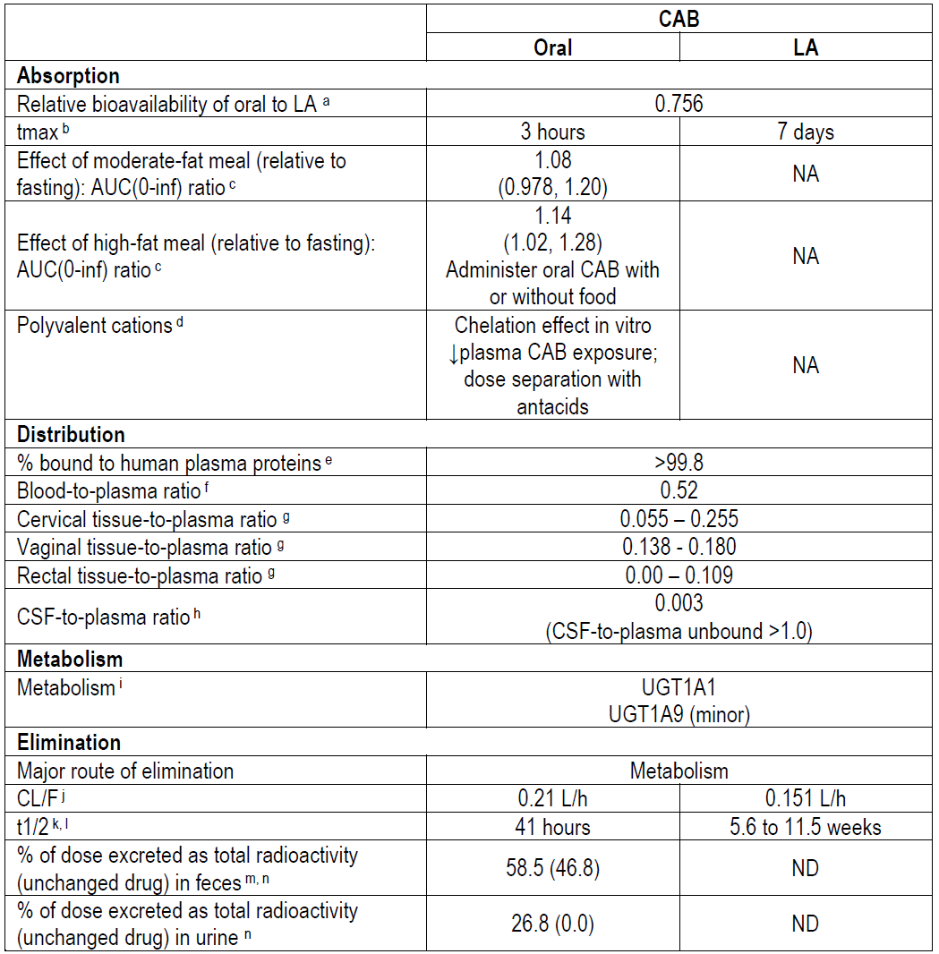

Abbreviations: AUC(0-inf) = area under the concentration-time curve from time zero to infinity; CAB = cabotegravir; CL/F = apparent clearance; CSF = cerebrospinal fluid; LA = long-acting; NA = not applicable; ND = not determined; t1/2 = half-life; tmax = time to reach maximum observed concentration; UGT = UDP-glucuronosyltransferase.

a. Relative bioavailability of oral CAB versus CAB LA is based on population pharmacokinetic estimate (F1).

b. Time to reach maximum observed concentration (tmax) is presented as median.

c. Food effect results presented as geometric mean ratio (90% confidence interval (CI)) of fed versus fasted. The moderate-fat meal was comprised of approximately 670 kcal and 30% fat, and the high-fat meal was comprised of approximately 870 kcal and 53% fat.

d. Polyvalent cation interaction. In Phase III studies, polyvalent cation antacids were administered at least 2 hours before or 4 hours after oral CAB for consistency with the recommendation for oral rilpivirine. Dose separation is not relevant for CAB LA administered intramuscularly because the interaction with oral CAB occurs in the GI tract.

e. Plasma protein binding based on average values for oral CAB 30 mg and CAB LA every 4 weeks intramuscularly and every 8 weeks intramuscularly.

f. Blood-to-plasma ratio represents ratio of geometric mean total radioactivity AUC(0-inf) for blood versus plasma for oral [14C]-CAB.

g. Tissue-to-plasma ratios presented as range of overall median values for single doses of CAB LA 600 mg (1 x 600 mg) intramuscularly (samples collected at Day 3, Day 8, Week 4, Week 8, and Week 12).

h. Cerebrospinal fluid (CSF)-to-plasma ratio presented as median for CAB LA every 4 weeks and every 8 weeks intramuscularly. CSF-to-unbound plasma ratio based on overall median concentration in CSF versus overall median unbound concentration in plasma at corresponding time point.

i. Metabolism.

j. Apparent clearance (CL/F) presented as geometric mean for oral CAB and as estimate from the CAB PopPK analysis for CAB LA.

k. Half-life (t1/2) presented as geometric mean for oral CAB and as PopPK estimates for males and females for CAB LA.

l. Cabotegravir (CAB) LA exhibits absorption-rate limited PK, which is reflected in a long apparent t1/2 following intramuscular administration compared with oral CAB administration.

m. Data obtained following oral CAB human radio-labelled studies

n. The mean total recovery of radioactivity in urine and faeces was 85.3% of the administered dose.

Further information from Submission PM-2019-04281-1-2 can be found in the AusPAR for Vocabria and Cabenuva.9

##### Studies providing additional pharmacokinetic information

Table 4: Pharmacokinetic studies in addition to Submission PM-2019-04281-1-2

|  |  |  |  |
| --- | --- | --- | --- |
| PK Topic | Subtopic | Study ID | Primary PK aim of study |
| PK in healthy adults | Multi-dose | 206898 | PK, safety, tolerability and acceptability of long-acting injections of the HIV integrase inhibitor, cabotegravir in HIV uninfected Chinese men |
| 201103  (HPTN 077 trial) | Safety, tolerability and PK of the investigational injectable HIV integrase inhibitor, cabotegravir, in HIV-uninfected men and women |
| Tissue distribution | 201767 | PK study of cabotegravir long-acting in healthy adult volunteers |
| PK in special populations | HIV infected Adolescent population | 208580  (MOCHA trial) | Safety, acceptability, tolerability and PK of oral and LA injectable cabotegravir and LA injectable rilpivirine in virologically suppressed HIV-infected children and adolescents - Cohort 1, Week 16 interim report |
| HIV Infected adults | 201584  (FLAIR trial) extension phase | Safety, efficacy and PK switching to cabotegravir/rilpivirine with or without an oral lead-in |
| PK in PrEP pivotal studies | HIV-uninfected cisgender men and transgender women who have sex with men | 201738  (HPTN 083 trial) | PK of participants, including longitudinal PK population. |
| HIV-uninfected women | 201739  (HPTN 084 trial) | PK of participants, including longitudinal PK population. |
| Population PK analyses | Healthy subjects | 2021N467204 | Population PK Evaluation of Cabotegravir in Asian populations |
| 2021N484575 | PopPK evaluation of cabotegravir for pre-exposure prophylaxis in at-risk HIV-1-uninfected participants in Phase III studies |
| Adolescent population | 2021N462341 | PopPK evaluation of cabotegravir in adolescents using data from MOCHA trial (Study 208580) |

Abbreviations: HIV = human immunodeficiency virus; LA = long-acting; PK = pharmacokinetics.

Further information from Submission PM-2019-04281-1-2 can be found in the AusPAR for Vocabria and Cabenuva.9

###### Study 206898

Study 206898 is a Phase I open label multisite study investigated the pharmacokinetics (PK), safety, tolerability, and acceptability of cabotegravir long-acting (LA) in 48 adult (aged 18 to 65 years) HIV uninfected Chinese male subjects at low risk for HIV infection. Subjects received oral cabotegravir (30 mg tablets) once daily for 4 weeks followed by followed by the injection phase (Weeks 5 to 41) in which 600 mg of injectable cabotegravir LA was administered every 4 weeks for 2 doses followed by every 8 weeks for 3 doses. Starting at 8 weeks post final injection, subjects were followed for 48 weeks.

Cabotegravir LA PK was consistent in adult Chinese male participants, and in prior studies using the same dosing schedule.

###### Study 201767

Study 201767 is a Phase I, open label study in 15 (8 males, 7 females) healthy adult subjects assessed the PK of cabotegravir following daily dose tablets (30 mg) and a single intramuscular dose of cabotegravir LA administration (600 mg) in blood plasma, anatomical tissues, and secretions associated with sexual HIV-1 transmission being vaginal tissue, cervical tissue, cervicovaginal fluid, rectal tissue, and rectal fluid. The study involved a 28-day oral lead-in phase at a cabotegravir dose of 30 mg once per day followed by a 14 to 42 days washout period, and a single intramuscular dose of cabotegravir LA 600 mg with compartmental PK sampling for up to 12 weeks. Subjects returned for assessments at Weeks 24, 36 and 52.

Plasma cabotegravir PK was consistent with prior studies, and cabotegravir concentrations in tissue and fluid were proportional to plasma over time. cabotegravir distribution into various tissues and fluids appeared to be similar between oral and intramuscular dose. Median cabotegravir plasma concentrations following a single intramuscular dose of 600 mg were above 4 times Protein adjusted 90% maximal inhibitory concentration (IC90) (0.664 µg/mL) at Week 8 and above one time protein adjusted IC90 (0.166 µg/mL) at Week 12. Correlations with plasma correlations were stronger for mucosal tissue (rectal, cervical and vaginal tissue) than for luminal fluids (cervicovaginal and rectal fluid). Tissue concentrations were one sixth (cervical and vaginal tissue) to one tenth (rectal tissue) of plasma concentrations. There were differences in cabotegravir exposures observed between male and females, lower maximum plasma concentration in females, and a longer half-life in females than males.

###### Study 201103 (HPTN 077 trial)

Study 201103 (the HPTN 077 trial) is a Phase IIa, multisite, double blind randomised placebo-controlled trial investigated the PK, safety, tolerability and acceptability of cabotegravir LA HIV-uninfected men and women. Adult male and female participants were divided into 2-dose cohorts and within cohorts were randomised to active treatment or placebo in a ratio of 3:1. All subjects in the intervention groups (n = 82 in Cohort 1, 69 in Cohort 2) received daily oral cabotegravir (30 mg tablets) for 4 weeks followed by a one‑week washout period. They then received PrEP doses of 800 mg (Cohort 1) or 600 mg (Cohort 2) by intra-muscular injections (Cohort 1) at Weeks 5, 17, and 29. There were 28 and 21 placebo participants in Cohorts 1 and 2 respectively that received daily oral placebo and intramuscular injections of placebo (sodium chloride for injection United States pharmacopeia, 0.9%) on the same schedule as the intervention groups.

Cabotegravir 800 mg every 12 weeks (Cohort 1) did not achieve target cabotegravir concentrations in male participants, cabotegravir 600 mg every 8 weeks (Cohort 2) achieved target cabotegravir concentrations in both male and female participants. There was no impact of injectable hormonal contraceptives on cabotegravir PrEP PK. Apparent half-life was approximately 6.5 to 7 weeks in males, and 8 to 9 weeks in females. cabotegravir was quantifiable in 11 to 17% of male participants and 37 to 42% of female participants 1.5 years following final injections.

###### Study 208580 (MOCHA trial)

Study 208580 (the MOCHA trial) is an ongoing Phase I/II multicentre, open label, non‑comparative study to evaluate the safety, acceptability, tolerability, and PK of oral and long-acting injectable cabotegravir (Cohort 1C) and long‑acting injectable rilpivirine (Cohort 1R) or both (Cohort 2) in virologically suppressed HIV-infected children and adolescents, at least 12 years of age and weighing at least 35 kg. who were receiving stable antiretroviral therapy consisting of 2 or more drugs from 2 or more classes. This is being conducted in 19 centres in the United States of America (USA). A Week 16 interim report provides information regarding 8 patients (6 males) with a mean age (range) of 14.9 years (12 to 17) who were enrolled in cabotegravir Cohort 1C. The study is ongoing and aims to enrol 20 adolescents in Cohort 1C. Four of the subjects weighed 30 to less than 50 kg. Treatment comprised 30 mg oral cabotegravir for 4 to 6 weeks followed by 3 intramuscular injections of cabotegravir LA, each separated by 4 weeks (600 mg for the first injection and 400 mg for the second and third injections). cabotegravir treatments were provided in addition to their usual combined antiretroviral therapy.

The observed PK profiles met the desired exposure targets based on adult data for cabotegravir (oral and intramuscular administrations).

###### Study 201584 (FLAIR trial)

Study 201584 (the FLAIR trial and extension switch phase) is a Phase III randomised, multicentre, active controlled, parallel group open label non-inferiority trial. It was conducted in in HIV-1, antiretroviral therapy-naïve adult subjects. It aimed to assess to the antiviral activity of switching to cabotegravir LA in combination with rilpivirine LA compared with remaining on a combined antiretroviral regimen being ABC/DTG/3TC (abacavir/dolutegravir/lamivudine combination therapy) over 48 weeks. (4 weeks oral lead-in, 44 weeks cabotegravir/rilpivirine LA). This study was a pivotal study for the initial approval of Vocabria and Cabenuva (Submission PM-2019-04281-1-2).9

The FLAIR trial also evaluated the long-term comparative data on antiviral activity, safety, and tolerability of these regimens through Week 96 of the maintenance phase of the study. In the extension phase of the FLAIR trial, the subjects who were initially randomised to the ABC/DTC/3TC arm and successfully completed Week 100 were given the option to switch to intramuscular cabotegravir LA plus rilpivirine LA (direct to injection or oral lead-in) in the extension phase (extension switch population). Those participants randomised were given the option to switch to cabotegravir/rilpivirine LA at 100 weeks and followed to Week 124. Of 283 subjects randomised to the ABC/DTC/3TC group at Baseline, 253 completed the maintenance phase. Of the 253 subjects, 232 subjects entered the extension phase with cabotegravir plus rilpivirine direct to injection (n = 111) or oral lead-in (n = 121). At Week 124, 4 (4%) subjects in the direct to injection group and 8 (7%) subjects in the oral lead-in group had withdrawn and leaving the remaining 220 subjects in the extension switch population.

When compared cabotegravir trough concentrations with oral lead-in from Studies 201584 (the FLAIR trial), and 201585 (the ATLAS trial), and 207966 (the ATLAS‑2M trial, Submission PM-2019-04281-1-2)9 the range of cabotegravir concentrations one week following initiation injections and 4 weeks following 4 weeks following the initiation injections were similar across studies, regardless of use of oral lead-in or not.

###### Study 201738 (HPTN 083 trial)

Details of this pivotal efficacy study (Study 201738 or the HPTN 083 trial) are in the Efficacy section.

Cabotegravir LA 8 weekly delivers target plasma cabotegravir concentrations predicted to provide protection against HIV infection. There are no clinically relevant differences in plasma cabotegravir concentrations were observed between cisgender men who have sex with men, transgender women with or without hormone use, participants less than 25 years of age, or by region in a subset of samples from pre-selected participants.

###### Study 201739 (HPTN 084 trial)

Details of this pivotal efficacy study (Study 201739 or the HPTN 084 trial) are in the Efficacy section.

Cabotegravir LA 8 weekly delivers sufficient plasma cabotegravir concentrations to provide protection against HIV infection. No clinically relevant differences in plasma cabotegravir concentrations were observed between participants less than 25 years of age or weight less than 50 kg (n = 9) in a subset of samples from pre-selected participants.

##### Population pharmacokinetic data

A population pharmacokinetic (PopPK) model, named ‘treatment new drug application’ was previously built based on a total of 23,926 cabotegravir plasma concentrations collected from 1647 HIV-1-uninfected (28%) and HIV-1-infected (72%) adult participants (age 18 to 74 years) in 16 studies at 7 dose levels (10 mg to 60 mg for oral tablet; 100 mg to 800 mg for LA) following various dosing schedules (daily dosing for oral tablet; every 4 weeks, every 8 weeks and every 12 weeks dosing for LA). The PopPK model was a general two-compartment model with first‑order oral and intramuscular absorption and elimination. cabotegravir PK variability was explained by gender, body mass index, needle length, split injection, current smoker status, and body weight; however, the effects of these covariates are not considered clinically relevant. Age and race had no effect on cabotegravir PK. No cabotegravir dose adjustment is necessary for the covariates evaluated (see the AusPAR for Submission PM-2019-04281-1-2).9

Further PopPK analysis is provided in Studies 2021N467204, 2021N484575 and 2021N462341).

###### Study 2021N467204

The aim of Study 2021N467204 was to assess the adequacy and predictive performance of the cabotegravir PopPK model for participants in Northeast Asia. cabotegravir PK data of Northeast Asian and non-Northeast Asian participants were collected from Studies 206898 (in this submission), 201584 (the FLAIR trial), 201585 (the ATLAS trial) and 207966 (the ATLAS-2M trial) from the previous submission and included 82 (80 males) participants. The final PopPK model was deemed appropriate and able to reliably describe and predict cabotegravir PK of Northeast Asian participants. cabotegravir dosing regimens for the Northeast Asian population are recommended to be the same as other populations.

###### Study 2021N484575

The aim of Study 2021N484575 was to compare observed cabotegravir plasma concentrations following cabotegravir every 8 weeks regimen across studies; to assess the adequacy and predictive performance of the cabotegravir PopPK model for describing and predicting cabotegravir PK in the pivotal efficacy study (the HPTN 083 trial) and Study 201739 (the HPTN 084 trial) for PrEP in HIV-uninfected cisgender men who have sex with men (n = 127), transgender women (n = 55) who have sex with men, and cisgender women (n = 152), to compare cabotegravir PK parameters and exposure across various subgroups and to evaluate alternative dosing options by performing cabotegravir PK simulations and describe the time to reach cabotegravir target concentrations and steady state. Transgender women were evaluated both as males and females.

The final PopPK model was deemed appropriate and able to reliably describe and predict cabotegravir PK in the PrEP populations and was similar between cisgender men who have sex with men and transgender women; in HIV-1-infected and -uninfected participants, across risk levels of acquiring HIV-1 regardless of sex at birth; in transgender women with or without hormone therapy; in participants younger or older than 25 years old; and similar across race subgroups in general.

###### Study 2021N462341

The aim of Study 2021N462341 was to assess the adequacy and predictive performance of the cabotegravir treatment new drug application PopPK model for describing and predicting cabotegravir PK of the adolescents in the MOCHA trial, to compare cabotegravir exposure between these adolescents and adults from historical cabotegravir studies and to evaluate the adequacy of cabotegravir every 4 weeks and every 8 weeks dosing regimens in adolescents. A total of 8 adolescents (6 males) in the MOCHA trial received cabotegravir every 4 weeks regimen. The final PopPK model was deemed appropriate and able to reliably to describe and predict cabotegravir PK of the 8 adolescents in the MOCHA trial. cabotegravir exposure was similar between the adolescents in the MOCHA trial and adults from historical cabotegravir studies. Cabotegravir every 4 weeks and every 8 weeks regimens predicted to provide adequate cabotegravir exposure in adolescents aged 12 to less than 18 years with body weight of 35 kg or more.

Plasma cabotegravir PK parameters for the proposed dosing regimen are summarised in Table 5 below and are based on PopPK model-derived parameters from the cabotegravir treatment program. Population (healthy versus HIV-infected participants) had no effect on cabotegravir PK based on the PopPK analysis from the cabotegravir treatment program, and PK parameters between healthy and HIV-infected individuals are comparable. Observed plasma cabotegravir exposures following administration of cabotegravir LA every 8 weeks regimen are similar between high-risk participants from the HPTN 083 and HPTN 084 trials and healthy and HIV-1-infected participants.

Table 5: Study 201738 (HPTN 083 trial) and Study 201739 (HPTN 084 trial) Summary cabotegravir pharmacokinetic parameters following administration of proposed cabotegravir regimens

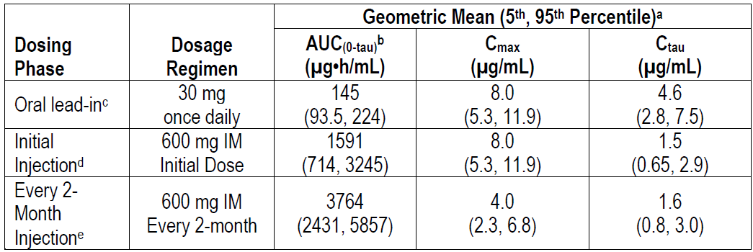

Abbreviations: AUC(0-tau) = area under the concentration-time curve from time 0 to the end of the dosing interval; Cmax = maximum plasma concentration; Ctau = trough plasma concentrations at the end of the dosing; IM = intramuscular.

a. Pharmacokinetic (PK) parameter values were based on individual post-hoc estimates from population PK models for patients in Phase III treatment studies of human immunodeficiency virus (HIV) treatment studies.

b. Tau is dosing interval: 24 hours for oral administration; one month for monthly and 2 months for every 2 months for intramuscular injections of extended-release injectable suspension.

c. Oral lead-in (OLI) PK parameter values represent steady state.

d. Initial injection Cmax values primarily reflect oral dosing because the initial injection was administered on the same day as the last oral dose; however, the AUC(0-tau) and Ctau values reflect the initial injection. When administered without OLI to HIV infected recipients (n = 110), the observed cabotegravir geometric mean (fifth, ninety fifth percentile) Cmax (one-week post-initial injection) was 1.89 µg/mL (0.438, 5.69) and Ctau was 1.43 µg/mL (0.403, 3.90).

e. Pharmacokinetic (PK) parameter values represent steady state.

##### Dose justification

The dose rationale is based on the objective to deliver cabotegravir drug concentrations to prevent acquisition of sexually transmitted HIV. The concentrations in plasma may not be directly relevant to the efficacy of cabotegravir PrEP, but plasma cabotegravir concentrations provide context for concentrations in mucosal tissues at sites of sexual transmission for PrEP. This is important for efficacy as the primary site of action is believed to be within CD4 cells in the tissues at sites of sexual transmission. The dose schedule for evaluation in humans was based on maintaining cabotegravir plasma concentrations of 0.664 µg/mL (4 times protein adjusted IC90), a concentration range shown to have significant antiviral activity *in vitro*, in rectal and vaginal simian immunodeficiency virus or simian/HIV challenge models in monkeys receiving cabotegravir PrEP, in Phase IIa oral cabotegravir monotherapy studies in HIV-1 infected participants, in achieving and maintaining virologic suppression with cabotegravir plus rilpivirine treatment and demonstrated in Phase IIb/III PrEP studies.

No cabotegravir dose adjustment is required based on age, gender (at birth), race, body mass index or HIV-1 infection as these factors were not associated with clinically relevant changes in cabotegravir PK. cabotegravir may be administered without dose adjustment in people with mild, moderate, or severe renal impairment. cabotegravir has not been studied in people with end-stage renal disease on renal replacement therapy. No dosage adjustment of cabotegravir is required for people with mild or moderate hepatic impairment. The effect of severe hepatic impairment on cabotegravir PK has not been studied.

##### Dosing regimen

The proposed cabotegravir LA regimen is cabotegravir LA 600 mg given via an intramuscular injection monthly for the first 2 injections and every 2 months thereafter. Cabotegravir tablets (30 mg) may be used as an optional oral lead-in for one month to assess tolerability of cabotegravir prior to administration of cabotegravir LA and as oral PrEP in individuals who will miss planned dosing with cabotegravir LA injection. Cabotegravir tablets may be taken with or without food. Oral lead-in is not required for the achievement of therapeutic cabotegravir concentrations on initiation of cabotegravir LA injections or steady state.

##### Pharmacodynamics

Cabotegravir inhibits HIV integrase by binding to the integrase active site and blocking the strand transfer step of retroviral deoxyribonucleic acid (DNA) integration, which is essential for the HIV replication cycle. No new information was provided (see Table 6 below).

Table 6: Summary of effects of intrinsic and extrinsic factors, and pharmacokinetics/pharmacodynamics of cabotegravir

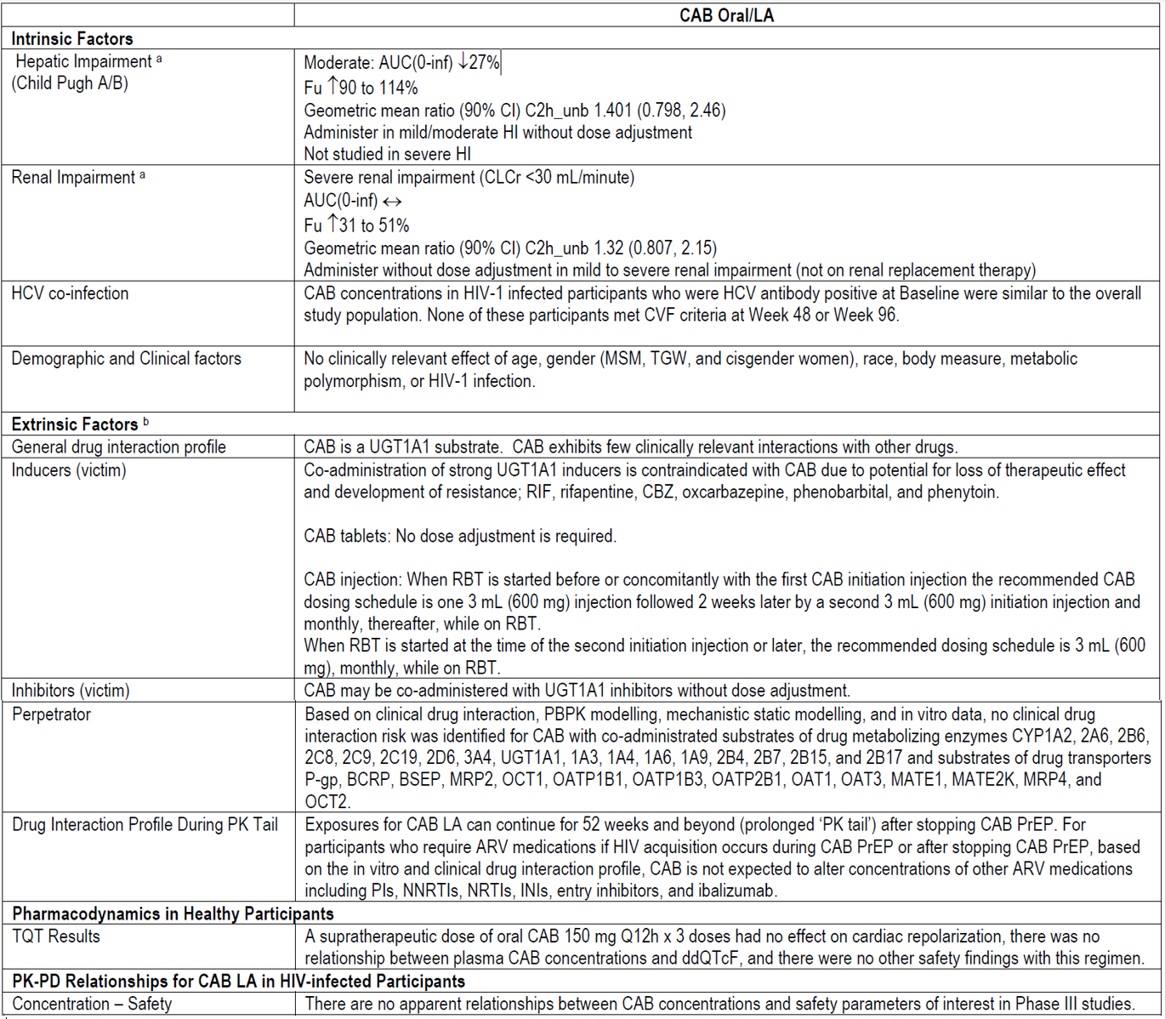

Abbreviations: AUC(0-inf) = area under the concentration-time curve from time zero to infinity; BCRP = breast cancer resistance protein; BSEP = bile salt export pump; CAB = cabotegravir; CBZ = carbamazepine; CI = confidence interval; CLCr = creatinine clearance; CVF = cervicovaginal fluid; CYP = cytochrome P450; Fu = unbound fraction; HCV = hepatitis C virus; HI = hepatic impairment; HIV-1 = human immunodeficiency virus type 1; INI = integrase inhibitor; LA = long-acting; MATE = multidrug and toxin extrusion transporter ;MRP = multidrug resistance protein; MSM = men who have sex with men; NNRTI = non-nucleoside reverse transcriptase inhibitor; NRTI = nucleoside reverse transcriptase inhibitor; OATP = organic anion transporter polypeptide; OCT = organic cation transporter; PBPK = Physiologically-based pharmacokinetics; PD = pharmacodynamics; P-gp = P-glycoprotein; PI = prediction interval; PK = pharmacokinetics; PrEP = pre-exposure prophylaxis; RBT = rifabutin; RIF = rifampin; TGW = transgender women who have sex with men; TQT = Thorough QT; UGT = UDP-glucuronosyltransferase.

a. Elimination pathways of CAB are independent of formulation and route of administration; therefore, results from HI and renal impairment studies evaluated following oral administration inform the recommendations for the CAB LA regimen.

b. Metabolic pathways of CAB are independent of formulation and route of administration, and exposures are similar following oral CAB and CAB LA administration; therefore, results from oral drug‑drug interaction studies inform the recommendations for the CAB LA regimen.

#### Efficacy

The cabotegravir PrEP clinical efficacy program includes:

* 2 pivotal studies: Study 201738 (the HPTN 083 trial) and Study 201739 (the HPTN 084 trial) to assess the safety and efficacy of cabotegravir PrEP compared to the active comparator daily oral tenofovir disoproxil fumarate (TDF)/emtricitabine for HIV PrEP in the most key affected populations globally being cisgender men who have sex with men and transgender women (the HPTN 083 trial) and cisgender women (the HPTN 084);
* 2 supportive studies: Study 201120 (also known as the ÉCLAIR trial) and Study 201103 (the HPTN 077 trial) to evaluate the safety, tolerability, and pharmacokinetics (PK) of cabotegravir PrEP in HIV‑negative, adult men at low risk of acquiring HIV infection (the ÉCLAIR trial) and HIV-negative adult men and women at low risk of acquiring HIV infection (the HPTN 077 trial). The cabotegravir injection dosing regime was selected based on these studies; and
* Study 201584 (the FLAIR extension study).

##### Pivotal studies

###### Study 201738 (HPTN 083 trial) and Study 201739 (HPTN 084 trial) overview

Treatment schedules for the Study 201738 (the HPTN 083 trial) and Study 201739 (the HPTN 084 trial) are identical. Treatment arms A and B are summarised below.

###### Arm A (cabotegravir)

In Step 1 (oral lead-in phase), participants received daily oral active cabotegravir (30 mg tablets) and oral placebo TDF/emtricitabine for 4 weeks (up to 5 weeks allowed for any delays in testing results); then in Step 2 (injection phase), participants received active cabotegravir long-acting (LA) (600 mg as a single intramuscular injection at 2 timepoints 4 weeks apart and every 8 weeks thereafter) and daily oral placebo TDF/emtricitabine to Week 153.

###### Arm B (tenofovir disoproxil fumarate/emtricitabine)

In Step 1 (oral lead-in phase), participants received daily oral active TDF/emtricitabine (300 mg/200 mg fixed-dose combination tablets) and oral placebo cabotegravir for 4 weeks (up to 5 weeks allowed for any delays in testing results); then in Step 2 (injection phase), participants received daily oral active TDF/emtricitabine (300 mg/200 mg fixed‑dose combination tablets) and intramuscular placebo (at 2 timepoints 4 weeks apart and every 8 weeks thereafter) to Week 153.

In pivotal studies the primary efficacy end point was the rate of incident HIV infections in Steps 1 and 2.

Participants enrolled across the pivotal studies comprised adult, HIV-negative cisgender men who have sex with men, transgender women, and cisgender women who were in general good health and able to provide written informed consent. For the studies that included cisgender women (the HPTN 084 and HPTN 077 trials), women of child-bearing potential were eligible for enrolment if using a reliable method of contraception. Each of the studies recruited individuals at risk of acquiring HIV infection.

Formal interim statistical analyses were planned to be conducted at specified time points during the pivotal trials. These analysis times corresponded to when approximately 25%, 50%, and 75% of the estimated maximum number of HIV infections had been observed for the HPTN 083 trial and 22%, 39%, 59%, and 78% for the HPTN 084 trial. The blinded portion of both pivotal studies was stopped early, based on data safety monitoring board review of available interim data at the first analysis time points given meeting the pre‑specified stopping criteria in both studies, and the demonstration of efficacy of cabotegravir LA when compared to daily oral TDF/emtricitabine. Participants randomised to the active TDF/emtricitabine group were offered cabotegravir LA.

###### Study 201738 (HPTN 083 trial)

Study 201738 (the HPTN 083 trial) is a Phase IIb/III, multicentre double blind, randomised 1:1, active controlled, non-inferiority efficacy study of long-acting injectable cabotegravir versus daily oral TDF/emtricitabine for the prevention of incident HIV infection in uninfected adult cisgender men and transgender women who have sex with men. The primary objectives were to compare HIV incidence and safety among participants randomised to oral cabotegravir/cabotegravir LA (oral lead-in and injections) versus oral TDF/emtricitabine.

The trial was initiated in December 2016, recruited adults aged 18 years or older, and conducted at 43 centres in Argentina, Brazil, Peru, United States, South Africa, Thailand, and Vietnam (N = 4,570) between 2016 and 2020. Participants were cisgender men who have sex with men or transgender women (see Figure 1 below for the study design).

Figure 1: Study 201738 (HPTN 083 trial) Study design

Figure 1: Study 201738 (HPTN 083 trial) Study design

Study 201738 is an ongoing Phase IIb/III, multicenter, double blind, two arm, randomised, controlled non-inferiority study evaluating the efficacy, safety, and acceptability of cabotegravir pre-exposure prophylaxis.

Eligible participants were randomised 1:1 (cabotegravir: tenofovir disoproxil fumarate (TDF) / emtricitabine) and were treated as follows:

Arm A (cabotegravir):
In Step 1 (oral lead in phase), participants received daily oral active cabotegravir (30 mg tablets) and oral placebo TDF / emtricitabine for 4 weeks (up to 5 weeks allowed for any delays in testing results); then in Step 2 (injection phase), participants received active cabotegravir long lasting (600 mg as a single intramuscular injection at 2 timepoints 4 weeks apart and every 8 weeks thereafter) and daily oral placebo TDF / emtricitabine to Week 153.

Arm B (TDF/ emtricitabine):
In Step 1 (oral lead in phase), participants received daily oral active TDF / emtricitabine (300 mg/200 mg fix dose combination tablets) and oral placebo cabotegravir for 4 weeks (up to 5 weeks allowed for any delays in testing results); then in Step 2 (injection phase), participants received daily oral active TDF / emtricitabine (300 mg/200 mg fix dose combination tablets) and intramuscular placebo (at 2 timepoints 4 weeks apart and every 8 weeks thereafter) to Week 153.

Participants who became human immunodeficiency virus (HIV) infected during Step 1 were to permanently discontinue study drug, terminate from the study, and be referred for HIV-related care.

Participants who became HIV-infected during Step 2 were to permanently discontinue study drug, be placed on immediate suppressive antiretroviral therapy, and be followed at quarterly intervals for 52 weeks after their last injection prior to diagnosis of HIV in order to test for safety parameters, as well as CD4+ cell count and HIV viral load. After 52 weeks, the participants were to be terminated from the study and transitioned to continued HIV related care.

Participants who did not become HIV-infected during Step 1 or 2, could enter the protocol planned transition to Step 3 in which open label daily oral TDF / emtricitabine was offered at Week 153 (last day of Step 2 / first day of Step 3) and continued for 48 weeks. In instances where the participant discontinued study drug during Step 2 (prior to Week 153) and began open label TDF / emtricitabine, this was referred to as entering early Step 3.

Abbreviations: CAB = cabotegravir; FTC = emtricitabine; IM = intramuscular; LA = long-acting; PK = pharmacokinetics; PO = orally; Q8 = every 8; QD = once a day; TDF = tenofovir disoproxil fumarate; w = week.

The HPTN 083 trial enrolled cisgender men who have sex with men and transgender women, with a total of 4,570 participants randomised (2,283 in cabotegravir group and 2,287 in TDF/emtricitabine group); of these 4566 were treated with at least one dose of the study drug (2,282 participants in the cabotegravir group and 2,284 participants in the TDF/emtricitabine group. Demographic characteristics were similar between the 2 groups. The baseline characteristics show two thirds of study participants were under 30 years of age and 12% were transgender women. Participants identifying as Black or African American comprised 25% of the total population, and the study met the pre‑specified goal to enrol 50% Black cisgender men who have sex with men among participants in the USA. Pre-specified recruitment goals of this study were also to enrol a majority of participants 30 years of age or younger and to ensure that at least 10% of participants were transgender women; both of these recruitment goals were also met.

The independent Data Safety Monitoring Board (DSMB) recommended early termination of the blinded portion of the HPTN 083 trial on 14 May 2020 at the first planned interim analysis (that is 25% of the planned events) after the pre-specified stopping criteria had been met. Results indicated that a PrEP regimen containing cabotegravir LA dosed every 2 months is superior (p = 0.0005) to the daily oral regimen of TDF/emtricitabine in preventing acquisition of HIV-1 infection in at-risk cisgender men who have sex with men and transgender women.

###### Study 201739 (HPTN 084 trial)

Study 201739 (the HPTN 084 trial) is a Phase III, double blind, randomised, active controlled, superiority study of efficacy of long-acting cabotegravir injection versus daily oral TDF/emtricitabine for the prevention of incident HIV infection in a population of sexually active HIV-uninfected adult women at risk for HIV. The primary objectives were to evaluate the relative efficacy and safety of oral cabotegravir/cabotegravir LA versus daily oral TDF/emtricitabine for HIV prevention.

The study initiated in November 2017, recruited cisgender females age 18 to 45 years, (n = 3224) and was conducted in Botswana, Eswatini (formerly Swaziland), Kenya, Malawi, South Africa, Uganda and Zimbabwe (N = 3,224) between 2017 and 2020 (see Figure 2 below for the study design).

Figure 2: Study 201739 (HPTN 084 trial) Study design

Figure 2: Study 201739 (HPTN 084 trial) Study design

Study 201739 is an ongoing Phase III, multicenter, double blind, two arm, randomised, controlled superiority study evaluating the safety and efficacy of cabotegravir pre-exposure prophylaxis.

Eligible participants were randomised 1:1 (cabotegravir: TDF / emtricitabine) and were treated as follows:

Arm A (cabotegravir):
In Step 1 (oral lead in phase), participants received daily oral active cabotegravir (30 mg tablets) and oral placebo TDF / emtricitabine for 4 weeks (up to 5 weeks allowed for any delays in testing results); then in Step 2 (injection phase), participants received active cabotegravir long acting (600 mg as a single intramuscular injection at 2 timepoints 4 weeks apart and every 8 weeks thereafter) and daily oral placebo TDF/ emtricitabine until the required number of incident human immunodeficiency virus (HIV) endpoints (114) was accrued.

Arm B (TDF/ emtricitabine):
In Step 1 (oral lead in phase), participants received daily oral active TDF/ emtricitabine (300 mg/200 mg fix dose combination tablets) and oral placebo cabotegravir for 4 weeks (up to 5 weeks allowed for any delays in testing results); then in Step 2 (injection phase), participants received daily oral active TDF / emtricitabine (300 mg/200 mg dix dose combination tablets) and intramuscular placebo (at 2 timepoints 4 weeks apart and every 8 weeks thereafter) until the required number of incident HIV endpoints (114) was accrued.

The study was originally designed to include a Step 3 (in which participants were to receive open-label daily oral TDF/ emtricitabine for up to 48 weeks), and after completion of Step 3, all participants were to be transitioned to local HIV prevention services. However, due to meeting pre-specified stopping criteria for superiority of cabotegravir long acting to TDF / emtricitabine, the blinded, randomised portion of the study was stopped early. No participants reached Step 3.

For any participants with a positive pregnancy test during the study, confirmation of pregnancy at a subsequent visit at least 4 weeks later was required. All pregnant participants with a confirmed positive pregnancy test (at least 4 weeks after the initial pregnancy test) were unblinded and followed on study every 12 weeks. Regardless of the randomisation assignment or point in the study, all pregnant participants were to be placed on open label TDF / emtricitabine for the duration of the pregnancy. No participant with a positive pregnancy test was to be administered cabotegravir, cabotegravir long acting, or cabotegravir long acting placebo.

Once a pregnancy outcome was reached, if the participant was not breastfeeding, she was allowed to resume taking study product and continue study visits/assessments according to the protocol’s schedule of events. For any participant who delivered a child during the study and then elected to breastfeed, she was to stay on open label TDF/ emtricitabine and was followed per the schedule of events. Once the participant finished breastfeeding, she was allowed to resume study product and continue study visits/assessments according to the schedule of events. Unblinded participants had the option to return to open-label study product in their original randomisation arm (either cabotegravir long acting or oral TDF / emtricitabine).

Abbreviations: CAB = cabotegravir; FTC = emtricitabine; LA = long-acting; TDF = tenofovir disoproxil fumarate.

The HPTN 084 trial enrolled cisgender women, with a total of 3,224 participants randomised (1,614 in the cabotegravir group and 1,610 in the TDF/emtricitabine group); all 3,224 randomised participants received at least one dose of study drug. Of the study population 49% of participants were under 25 years of age. Participants identifying as Black comprised over 99% of the total population, and demographics were similar between the two treatment groups.

An independent DSMB recommended early termination of the blinded, randomised portion of the study on 5 November 2020 after an interim analysis indicated that the prespecified stopping criteria for superiority was met. The primary efficacy analysis demonstrated that the PrEP regimen of cabotegravir LA dosed every 2 months is superior (p < 0.0001) to the daily oral regimen of TDF/emtricitabine in preventing acquisition of HIV-1 infection based on incident HIV infection rate in at risk women.

###### Primary efficacy in pivotal studies (HPTN 083 and HPTN 084 trials) incident human immunodeficiency virus type 1 infection in Steps 1 and 2

At blinded study termination in the HPTN 083 trial there were 52 incident HIV-1 infections reported in the modified intent-to-treat (ITT)[11] population based on 6,405 person years of follow‑up. The overall incidence of HIV in the trial participants was 0.81 per 100 person years. Of the 52 incident HIV-1 infections, 13 occurred in the cabotegravir group (0.40 per 100 person years) and 39 occurred in the TDF/emtricitabine group (1.22 per 100 person years). The adjusted hazard ratio for cabotegravir/TDF-emtricitabine comparison was 0.34 (95% confidence interval (CI): 0.18, 0.62), p = 0.0005 (see Table 7 below).

At blinded study termination in the HPTN 084 trial there were 40 incident HIV‑1 infections reported in the modified intent-to-treat (mITT)11 population based on 3,907 person years of follow‑up. The overall incidence of HIV in the trial participants was 1.02 per 100 person years. Of the 40 incident HIV-1 infections, 4 occurred in the cabotegravir group (0.20 per 100 person years) and 36 occurred in the TDF/emtricitabine group (1.85 per 100 person years). The adjusted hazard ratio for the cabotegravir/TDF-emtricitabine comparison was 0.12 (95% CI: 0.05, 0.31), p < 0.0001 (see Table 8 below).

Table 7: Study 201738 (HPTN 083 trial) Summary of Cox proportional hazards regression model for time to infection

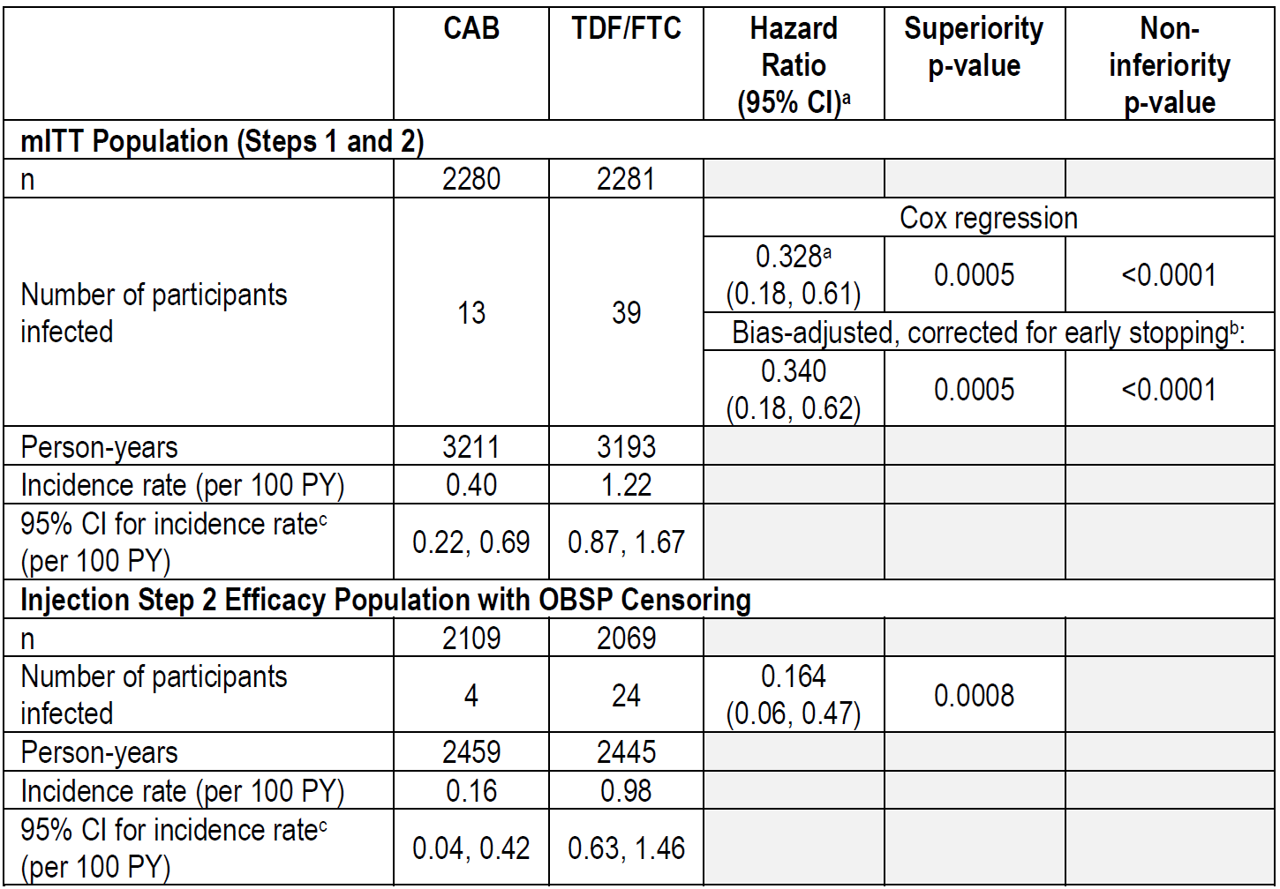

Abbreviations: CAB = cabotegravir; CI = confidence interval; FTC = emtricitabine; mITT = modified intent-to-treat; n = number of subjects in group; OBSP = on blinded study product; PY = person years; TDF = tenofovir disoproxil fumarate.

Hazard ratio less than 1.0 indicates a lower risk on CAB as compared to TDF/FTC.

The p-values are two-sided.

The trial was stopped based on a breach of the first interim stopping bound (z = -4.00, p = 0.000063), which was derived from an O'Brien-Fleming design with three planed interim analysis plus one final analysis.

a. The unadjusted hazard ratio is based on a Cox proportional hazards model stratified by region.

b. The bias-adjusted hazard ratio, CI, and p-value account for the group-sequential trial design and the early stopping time. The adjusted point estimate is the median unbiased estimate, and the confidence interval and p-value are based on the maximum likelihood estimate ordering of the sample space.

c. The 95% CI for incidence rate is calculated using the exact Poisson method.

Table 8: Study 201739 (HPTN 084 trial) Summary of Cox proportional hazards regression model for time to infection in Steps 1 and 2

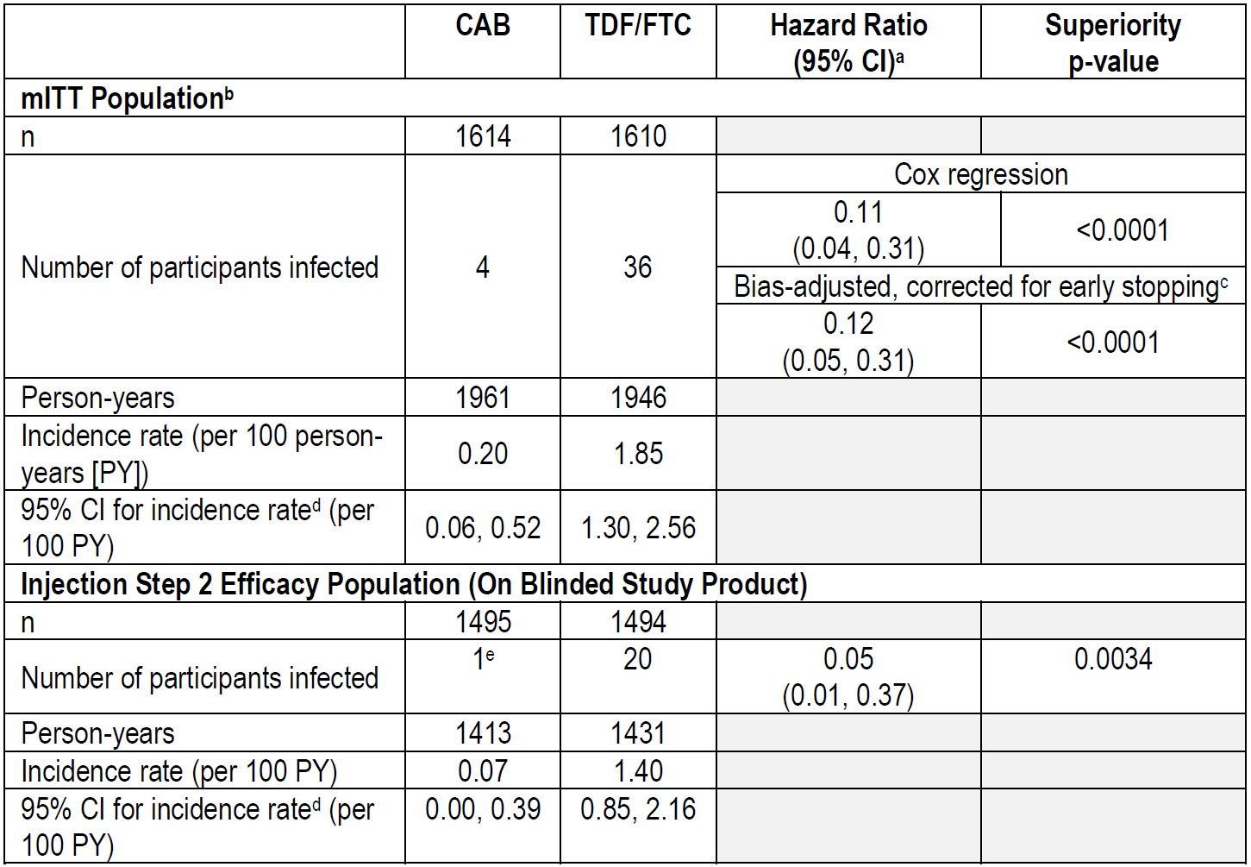

Abbreviations: CAB = cabotegravir; CI = confidence interval; FTC = emtricitabine; mITT = modified intent-to-treat; n = number of subjects in group; PY = person years; TDF = tenofovir disoproxil fumarate.

The p-values are two-sided.

a. Hazard ratio less than 1.0 indicates a lower risk on CAB as compared to TDF/FTC. The hazard ratio is based on a Cox proportional hazards model stratified by site.

b. Efficacy analyses using the mITT population include data from Steps 1 and 2 as well as from participants who discontinued study product altogether and moved to annual follow-up in Step 1 or 2.

c. The bias-adjusted hazard ratio, CI, and p-value account for the group sequential trial design and the decision to stop the trial at the second interim analysis. This was calculated outside of this report using additional data from the first interim analysis that is not part of the submission data package used for this report.

d. The 95% CI for incidence rate was calculated using the exact Poisson method.

e. The analysis with on blinded study product (OBSP) censoring did not count one of two total participants who seroconverted during Step 2; one of these participants had several delayed injections outside of the protocol allowance windows, and the OBSP analysis follow-up time was censored at the last non-delayed injection, resulting in the seroconversion event for this participant not being counted in the OBSP analysis.

Of the 13 incident HIV-1 infections reported in the HPTN 083 trial for the cabotegravir group, 3 occurred while the participant was receiving oral lead-in cabotegravir, 5 occurred while the participant was receiving active cabotegravir LA injections, and 5 occurred following prolonged periods when off cabotegravir (oral cabotegravir or cabotegravir LA) due to product non-adherence or a study-related discontinuation.

For the TDF/emtricitabine group, seroconversion events were largely due to low adherence to the daily PrEP regimen based on PK assessments of tenofovir diphosphate concentrations in dried blood spot samples. A graphical representation of the cumulative rates of acquired HIV-1 infections in the mITT population (Steps 1 and 2) by randomisation group for the HPTN 083 trial is provided in (see Figure 3 below) This plot shows that the cumulative number of incident HIV-1 infections is higher in the TDF/emtricitabine group compared with the cabotegravir group.

Figure 3: Study 201738 (HPTN 083 trial) Cumulative rates of acquired human immunodeficiency virus type 1 infections by group (modified intent-to-treat population)

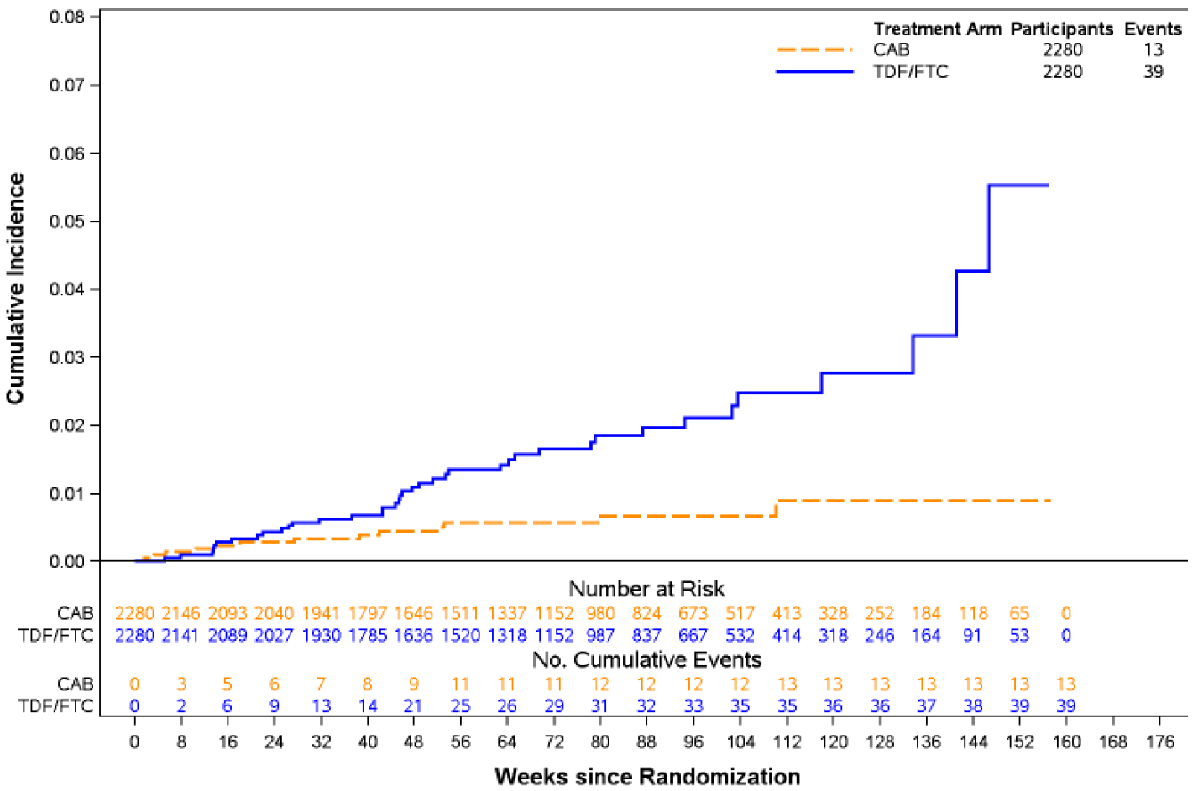

Abbreviations: CAB = cabotegravir; FTC = emtricitabine; TDF = tenofovir disoproxil fumarate.

Of the 4 incident HIV-1 infections in the HPTN 084 trial reported for the cabotegravir group, 2 HIV infections occurred in women with no recent oral cabotegravir exposure and no injections (one of whom became pregnant; thus, cabotegravir was discontinued, and she was offered TDF/emtricitabine) and 2 seroconversions were detected during Step 2 while the participants were receiving cabotegravir injections. For the TDF/emtricitabine group, seroconversion events were largely due to low adherence to the daily PrEP regimen based on PK findings. A graphical representation of the cumulative rates of acquired HIV‑1 infections in the mITT population by randomisation group for the HPTN 084 trial is provided in Figure 4 below. This plot shows that the cumulative number of incident HIV‑1 infections is consistently higher in the TDF/emtricitabine group compared with the cabotegravir group.

Figure 4: Study 201739 (HPTN 084 trial) Cumulative rates of acquired human immunodeficiency virus type 1 infections by group (modified intent-to-treat population)

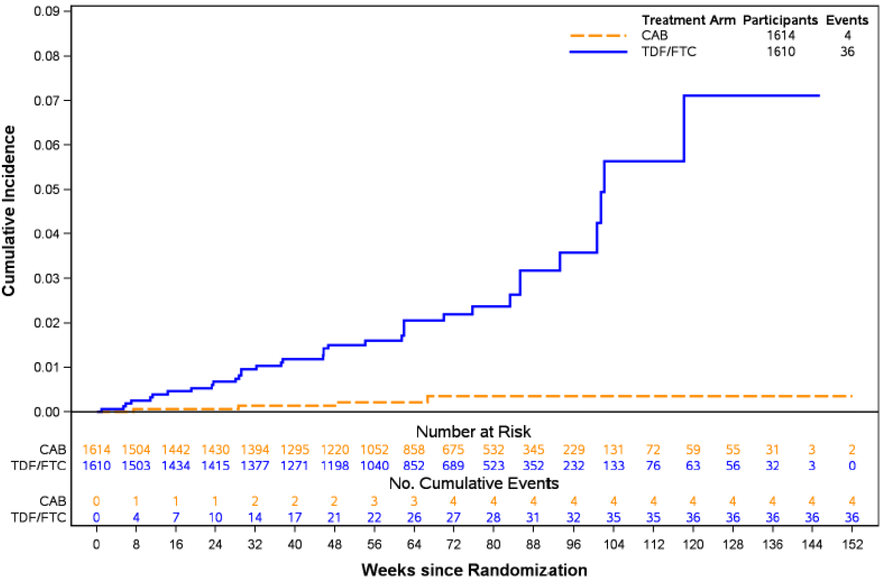

Abbreviations: CAB = cabotegravir; FTC = emtricitabine; TDF = tenofovir disoproxil fumarate.

There were very few seroconversions in the HPTN 083 and HPTN 084 trials limiting ability to perform PK/PD analysis. Exposures in participants with seroconversion while receiving cabotegravir LA injections (n = 4 in the HPTN 083 trial, n = 2 in the HPTN 084 trial) were overlapping of those in non-seroconverters. The seroconversion rate was 0.27% per 100 person years during the Injection Phase of the HPTN 083 trial and 0.20 per 100 person years in the HPTN 084 trial.

###### Incidence of human immunodeficiency virus type 1 infections in a subgroup of participants less than 25 years of age

To explore the activity of cabotegravir PrEP in participants less than 25 years old (that is from 18 to less than 25 years of age), subgroup analyses were conducted for the mITT populations of the HPTN 083 trial (as a non-pre-specified analysis) and the HPTN 084 trial (as a pre-specified analysis). For both studies, findings from subgroup analyses in participants less than 25 years of age (from 18 to less than 25 years) were consistent with findings from the primary analyses of the respective study, demonstrating the efficacy of cabotegravir regimen for the prevention of HIV-1 acquisition in younger individuals compared to those randomised to the TDF/emtricitabine group (see Table 9 and Table 10 below).

Table 9: Study 201738 (HPTN 083 trial) Summary of Cox proportional hazards regression model for time to infection for participants less than 25 years of age in Steps 1 and 2 (modified intent-to-treat population)

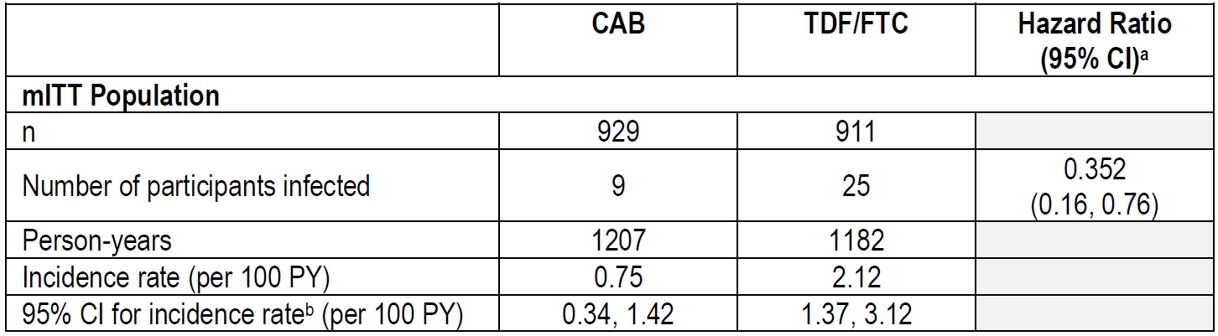

Abbreviations: CAB = cabotegravir; CI = confidence interval; FTC = emtricitabine; mITT = modified intent-to-treat; n = number of subjects in group; PY = person years; TDF = tenofovir disoproxil fumarate.

a. Hazard ratio less than 1.0 indicates a lower risk on CAB as compared to TDF/FTC. The unadjusted hazard ratio is based on a Cox proportional hazards model stratified by region.

b. The 95% CI for incidence rate is calculated using the exact Poisson method.

Table 10: Study 201739 (HPTN 084 trial) Summary of Cox proportional hazards regression model for time to-infection for participants less than 25 years of age (modified intent-to-treat population)

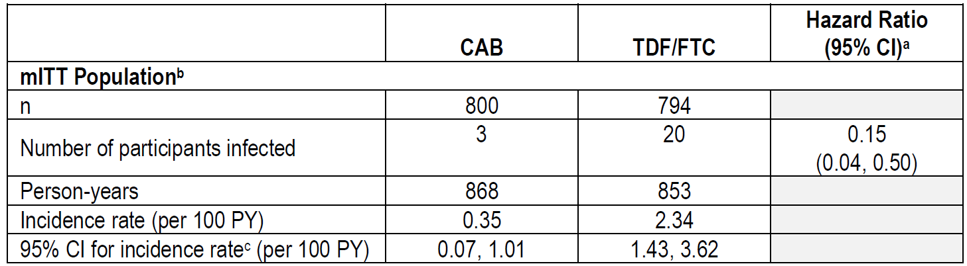

Abbreviations: CAB = cabotegravir; CI = confidence interval; FTC = emtricitabine; mITT = modified intent-to-treat; n = number of subjects in group; PY = person years; TDF = tenofovir disoproxil fumarate

a. Hazard ratio less than 1.0 indicates a lower risk on CAB as compared to TDF/FTC. The hazard ratio is based on a Cox proportional hazards model stratified by site.

b. Efficacy analyses using the mITT population include data from Steps 1 and 2 as well as from participants who discontinued study product altogether and moved to annual follow-up in Step 1 or 2.

c. The 95% CI for incidence rate is calculated using the exact Poisson method.

##### Supportive studies

###### Study 201120 (ÉCLAIR trial)

Study 201120 (the ÉCLAIR trial) was submitted as part of the Vocabria submission (Submission PM 2019-04281-1-2).9

This was a Phase IIa, randomised, multicentre, two arm, double blind study to evaluate the safety, tolerability, and acceptability of cabotegravir PrEP, in HIV uninfected men (n = 127), median age 31 years of age, and was conducted at 10 centres in the US between 27 March 2014 to 15 May 2015. The study recruited adult men (based on sex at birth), aged 18 to 65 years, who were HIV negative but were at risk (but not at ‘high risk’) of acquiring HIV infection. Participants were randomised 5:1 (cabotegravir to placebo). The treatment arm involved daily oral cabotegravir (30 mg) for 4 weeks followed by a one‑week washout period. Participants then received cabotegravir 800 mg intramuscular injections at Weeks 5,17 and 29. The placebo arm received matching oral and intramuscular placebo and intramuscular injections on the same schedule (see Figure 5 below for the study design).

Figure 5: Study 201120 (ÉCLAIR trial) Study design

Figure 5: Study 201120 (ÉCLAIR trial) Study design

Study 201120 is a Phase IIa, randomised, multicenter, two arm, double blind study to evaluate the safety, tolerability, and acceptability of cabotegravir pre-exposure prophylaxis.

Participants were randomised 5:1 (cabotegravir: placebo) and were treated as follows:

Arm 1 (cabotegravir): Daily oral cabotegravir (30 mg tablets) for 4 weeks during the oral phase of the study, followed by a one week washout period, to assess for safety and tolerability prior to receiving cabotegravir injections. Following safety laboratory assessments from the oral phase, participants entered the injection phase and received intramuscular injections of cabotegravir (800 mg) at 3 visits at 12-week intervals (Weeks 5, 17, and 29).

Arm 2 (placebo): Daily oral matching placebo and intramuscular injections of placebo (0.9% saline) on the same schedule as Arm 1.

Participants in the cabotegravir group (Arm 1) were followed for 52 weeks following their last injection. Participants in the placebo group (Arm 2) were followed until all participants completed Week 41 and the database was cleaned, at which time the study was unblinded and placebo participants were discontinued.

Abbreviations: CAB = cabotegravir; D = Day; IM = intramuscular; n= number of subjects in group; PO = orally; QD= once a day; Q12 = every 12; W = Week.

Although efficacy was not analysed in Study 201120, there was one incident HIV-1 seroconversion (a participant in the placebo group during the injection phase at Week 23).

###### Study 201103 (HPTN 077 trial)

Study 201103 (the HPTN 077 trial) is a Phase IIa, multicentre, randomised, two arm, placebo controlled, double blind study to evaluate safety, tolerability, PK and acceptability of cabotegravir in adult HIV-uninfected men and women (n = 200). Eligible participants were randomised to 1 of 2 study arms with an active cabotegravir to placebo ratio of 3:1 in 2 cohorts. The study was conducted from 9 February 2015 to 13 July 2018 at 8 centres in Brazil, sub-Saharan Africa and the USA (see Figure 6 and Figure 7 below for the study design).

Figure 6: Study 201103 (HPTN 077 trial) Cohort 1 Study design

Figure 6: Study 201103 (HPTN 077 trial) Cohort 1 Study design

Study 201103 is a Phase IIa, randomised, multicenter, two  arm, double blind study of the safety, tolerability, pharmacokinetics, and acceptability of cabotegravir.

Eligible participants were divided into 2 dose cohorts (Cohort 1 or 2), which were enrolled sequentially. Cohort 1 study design is demonstrated in Figure 6 and Cohort 2 study design is demonstrated in Figure 7.

Cohort 1 Arm 1 (cabotegravir): Participants received daily oral cabotegravir (30 mg tablets) for 4 weeks (to assess safety and tolerability prior to receiving cabotegravir long acting), followed by a one week washout period, followed by intramuscular gluteal injections of 800 mg of cabotegravir long acting (administered as 2 sequential 400 mg gluteal injections) at 3 visits at 12 week intervals (Weeks 5, 17, and 29) over 24 weeks.
Cohort 1 Arm 2 (placebo): Participants received daily oral placebo and intramuscular injections of placebo on the same schedule as Cohort 1 Arm 1.

Cohort 2 Arm 1 (cabotegravir): Participants received daily oral cabotegravir (30 mg tablets) for 4 weeks (to assess safety and tolerability prior to receiving cabotegravir long acting), followed by a one week washout period, followed by intramuscular gluteal injections of 600 mg of cabotegravir long acting (administered as one 600-mg gluteal injection) at 5 visits at 4 and 8 week intervals (Weeks 5, 9, 17, 25, and 33) over 28 weeks.
Cohort 2 Arm 2 (placebo): Participants received daily oral placebo and intramuscular injections of placebo on the same schedule as Cohort 2 Arm 1.

Participants in the active study drug arms were followed for 52 weeks after their last injection (later amended to 76 weeks for participants on study who consented to additional visits). Participants in the placebo arms were followed until 52 (or 76) weeks after their last injection or until the last participant in the active study drug arm of Cohort 2 completed their Week 41 visit, whichever came first.

Abbreviations: IM = intramuscular; LA = long-acting; n = number of subjects in group; W = Week.

744 participants were given cabotegravir.

For participants who remained in the study and consented to the additional visits included clinical study report, the following revisions to the overview of the study design and randomisation scheme applied: for Cohort 1, starting at Week 65, the updated visit schedule was: Weeks 65, 77, 89, 101, and 105.

Figure 7: Study 201103 (HPTN 077 trial) Cohort 2 Study design

Figure 7: Study 201103 (HPTN 077 trial) Cohort 2 Study design

Study 201103 is a Phase IIa, randomised, multicenter, two  arm, double blind study of the safety, tolerability, pharmacokinetics, and acceptability of cabotegravir.

Eligible participants were divided into 2 dose cohorts (Cohort 1 or 2), which were enrolled sequentially. Cohort 1 study design is demonstrated in Figure 6 and Cohort 2 study design is demonstrated in Figure 7.

Cohort 1 Arm 1 (cabotegravir): Participants received daily oral cabotegravir (30 mg tablets) for 4 weeks (to assess safety and tolerability prior to receiving cabotegravir long acting), followed by a one week washout period, followed by intramuscular gluteal injections of 800 mg of cabotegravir long acting (administered as 2 sequential 400 mg gluteal injections) at 3 visits at 12 week intervals (Weeks 5, 17, and 29) over 24 weeks.
Cohort 1 Arm 2 (placebo): Participants received daily oral placebo and intramuscular injections of placebo on the same schedule as Cohort 1 Arm 1.

Cohort 2 Arm 1 (cabotegravir): Participants received daily oral cabotegravir (30 mg tablets) for 4 weeks (to assess safety and tolerability prior to receiving cabotegravir long acting), followed by a one week washout period, followed by intramuscular gluteal injections of 600 mg of cabotegravir long acting (administered as one 600-mg gluteal injection) at 5 visits at 4 and 8 week intervals (Weeks 5, 9, 17, 25, and 33) over 28 weeks.
Cohort 2 Arm 2 (placebo): Participants received daily oral placebo and intramuscular injections of placebo on the same schedule as Cohort 2 Arm 1.

Participants in the active study drug arms were followed for 52 weeks after their last injection (later amended to 76 weeks for participants on study who consented to additional visits). Participants in the placebo arms were followed until 52 (or 76) weeks after their last injection or until the last participant in the active study drug arm of Cohort 2 completed their Week 41 visit, whichever came first.

Abbreviations: IM = intramuscular; LA = long-acting; n = number of subjects in group; W = Week.

744 participants were given cabotegravir.

For participants who remained in the study and consented to the additional visits included in the clinical study report, the following revisions to the overview of the study design and randomisation scheme applied: for Cohort 2, starting at Week 65, the updated visit schedule was: Weeks 65, 77, 89, 101, and 109.

There were no notable differences between the cabotegravir and placebo groups in exposure to or compliance with study drug. For both groups and overall, the majority of participants had higher than 90% adherence to oral study drug, and the majority of participants received the protocol specified number of injections (3 injections for Cohort 1 and 5 injections for Cohort 2). The study had one incident HIV infection (cabotegravir group). This participant was female at birth and tested positive for HIV at study Week 77 visit, 48 weeks after the final injection of active cabotegravir. The participant’s plasma cabotegravir concentration was below the lower limit of quantification (0.025 µg/mL) at study Week 77 and at the prior study visit at Week 65.

###### Study 201584

Study 201584 (the FLAIR trial) is a Phase III randomised, multicentre, active controlled, parallel group open label non-inferiority trial. was conducted in in HIV-1, antiretroviral therapy-naïve adult subjects. It aimed to assess to the antiviral activity of switching to cabotegravir LA in combination with rilpivirine LA compared with remaining on a combined antiretroviral regimen being ABC/DTG/3TC (abacavir/dolutegravir/lamivudine combination therapy) over 48 weeks.

Assessments were also made at Week 96, and of those participants on ABC/DTG/3TC at Week 100, they were given the option to switch to cabotegravir/rilpivirine with or without an oral lead-in (extension switch phase) (see Figure 7 below for the study design).

Figure 8: Study 201584 (FLAIR trial) Study design

Figure 8: Study 201584 (FLAIR trial) Study design

Study 201584 is a Phase III, multiphase, randomised, open label, active controlled, multicenter, parallel group, non-inferiority study in human immunodeficiency virus type 1 (HIV-1), antiretroviral therapy naïve adult participants.

Participants who fulfill eligibility requirements will enrol into the induction phase of the study and receive abacavir / dolutegravir / lamivudine (ABC/DTG/3TC) for 20 weeks (from Week -20 to Day 1).

Participants who have an HIV-1 ribonucleic acid less than 50 c/mL at Week -4 will be randomised 1:1 into the maintenance phase at Day 1 to either continue ABC/DTG/3TC or to discontinue ABC/DTG/3TC and begin oral therapy with cabotegravir 30 mg plus rilpivirine 25 mg once daily. Participants who are not eligible to continue into the maintenance phase will be withdrawn from the study.

At the Week 4a visit, assessments will be performed. At visit Week 4b, participants will return to the clinic, take the last dose of oral cabotegravir plus rilpivirine, and receive the first cabotegravir long acting (600 mg) plus rilpivirine long acting (900 mg) injections. 

The second and third intramuscular injections (cabotegravir long acting 400 mg plus rilpivirine long acting 600 mg) will be performed at Weeks 8 and 12. Subsequent injections will occur every 4 weeks thereafter, with a plus or minus 7 day dosing window being allowed (but not preferred).

Participants randomised to ABC/DTG/3TC during the maintenance phase will continue ABC/DTG/3TC for at least an additional 100 weeks. Participants who successfully complete Week 100 will be given the option to switch to the long acting arm in the extension phase or be withdrawn from the study.

Any participant who receives at least a single dose of cabotegravir long acting and/or rilpivirine long acting and discontinues the cabotegravir long acting plus rilpivirine long acting regimen for any reason will enter a 52 week long term follow up phase.

Abbreviations: ABC/DTG/3TC = abacavir/dolutegravir/lamivudine; CAB = cabotegravir; HIV-1 = human immunodeficiency virus type 1; LA = long-acting; N = number of subjects; RNA = ribonucleic acid; RPV = rilpivirine; Wk = Week.

† Optional switch to CAB LA plus RPV LA at Week 100 for subjects randomised to ABC/DTG/3TC.

¥ Subjects who withdraw from intramuscular CAB LA plus RPV LA treatment must enter the 52-week long term follow up phase.

The aims of the extension switch study were to:

* evaluate the antiviral and immunologic effects, safety and tolerability for subjects switching from ABC/DTG/3TC (combined antiretroviral regimen) to cabotegravir plus rilpivirine in the extension phase, with and without oral lead-in, and
* evaluate the pharmacokinetics of cabotegravir and rilpivirine in the setting of no oral lead-in for subjects switching from ABC/DTG/3TC to cabotegravir plus rilpivirine in the extension phase.

A total of 232 subjects entered the extension phase and were treated with cabotegravir plus rilpivirine direct to injection (n = 111) or oral lead-in (n = 121). At Week 124, 4 (4%) subjects in the direct to injection group and 8 (7%) subjects in the oral lead-in group had withdrawn and leaving the remaining 220 subjects in the extension switch population. Most subjects (more than 93% in each group) remained suppressed with HIV-1 ribonucleic acid (RNA) less than 50 copies/mL in the Week 124 snapshot analysis. One (0.9%) subject in the direct to injection group and one (0.8%) subject in the oral lead-in group had HIV-1 RNA is greater than or equal to 50 copies/mL at Week 124. This represents 0.9% of the direct to injection population and 0.4% of the overall extension switch population. Low trough concentrations following cabotegravir and rilpivirine injections preceded cervicovaginal fluid in this subject.

###### Patient-reported outcomes across studies

In the HPTN 083 and HPTN 084 trials participants attitudes towards PrEP were assessed at Baseline and during the injection phase. In both studies baseline attitudes toward PrEP were comparable in both treatment groups. In both studies, a greater proportion of study participants in both treatment groups rated the injectable method easier to use compared with the oral PrEP method. Similar proportions of participants rated both methods as protective against HIV. Nearly half of all study participants in the HPTN 083 trial indicated concern with the daily pill requirement with the oral PrEP method and a greater proportion indicated concerns about the discretion of the oral PrEP compared to the injectable method.

In the HPTN 084 trial, overall treatment satisfaction was assessed by asking participants about inconvenience and pain or discomfort experienced with receiving the oral and injectable study medication. For the oral product, 59% of participants in both groups reported ‘none’ for inconvenience or difficulty in receiving oral medication across all visits, and for the injectable study product, 68% of participants in both groups reported no inconvenience or difficulty. There were small differences between the groups in participants who reported no pain or discomfort with the injection (43% in cabotegravir group and 52% in TDF/emtricitabine group).

In the ÉCLAIR trial, participant tolerability was assessed in terms of participant withdrawal from the study due to injection intolerability. During the injection phase, 4 of 94 (4%) participants from the cabotegravir group withdrew from the study due to injection intolerability compared with no participants in the placebo group. Most participants were satisfied with the cabotegravir injection at Week 30, reporting a willingness to recommend the medication, a willingness to continue with study medication, and were satisfied with the side effects associated with the cabotegravir injections.

In the HPTN 077 trial, most participants in the cabotegravir and placebo groups rated overall acceptability of injections using the follow-up acceptability item with a score of 5 or 6 (5 = somewhat agree, 6 = agree a lot) across both cohorts. In Cohorts 1 and 2, most participants in both groups rated the injections as acceptable at Weeks 30 and 34, respectively. In the cabotegravir treatment group, satisfaction with study medication was consistent for the duration of the injection phase with similar overall scores.

In Study 206898, most subjects were much more satisfied with cabotegravir LA injections compared to tablets administered during the oral phase of the study. Considering overall satisfaction, 84% and 87% subjects (score of 1 to 3) reported being willing to recommend the medication and were willing to continue with the study medication, respectively. Tolerability of cabotegravir LA injections showed that 92% subjects were satisfied with side effects and 78% tolerated the pain or discomfort (score of 1 to 3). Most subjects (97%) were satisfied with their HIV-prevention treatment. While cabotegravir injection site pain was common, results suggest subjects experienced a high level of overall satisfaction and preference for a long-acting injectable, with dimensions such as convenience, flexibility, and ease of use as important factors.

#### Safety

Safety data is provided in this submission from the two pivotal studies (the HPTN 083 and HPTN 084 trials), the two supportive studies (the HPTN 077 and ÉCLAIR trials), Study 206898, and 2 other studies (the FLAIR trial Week 96 and extension phases, and the MOCHA trial) provided safety data for the use of cabotegravir tablets and long-acting (LA) extended‑release injection for PrEP to reduce risk of sexually acquired HIV-1 infection in at-risk individuals. Summary of safety data from cabotegravir plus rilpivirine treatment in HIV-infected people already evaluated as part of Submission PM-2019-04281-1-2;9 also provided safety data for cabotegravir tablets and injections. Previous evaluations have not identified any significant safety issue of concern.

##### Patient exposure

Study status and safety population in the cabotegravir groups for the 4 cabotegravir PrEP studies described is provided in Table 11 below. In the HPTN 083 trial, overall exposure to study drugs was similar between the 2 groups; the median (range) exposure was 457 (1 to 1093) days for the cabotegravir group and 471 (1 to 1131) days for the tenofovir disoproxil fumarate (TDF)/emtricitabine group. Overall exposure to study drug in the HPTN 084 trial was similar between the 2 groups; the median (range) exposure (including participants with confirmed pregnancy) was 452.5 (1 to 1072) days for the cabotegravir group and 452.5 (1 to 1018) days for the TDF/emtricitabine group. Cumulatively, 4,151 individuals up to 5 November 2020 were exposed to cabotegravir PrEP in Phase II and III clinical trials (see Table 12 below).

Table 11: Study 201738 (HPTN 083 trial), Study 201739 (HPTN 084 trial), Study 201120 (ÉCLAIR trial) and Study 201103 (HPTN 077 trial); cabotegravir pre‑exposure prophylaxis study status and size (safety population)

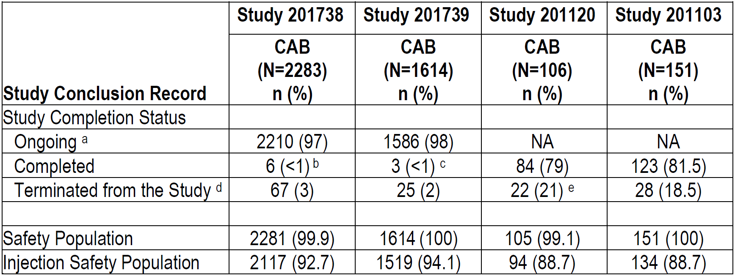

Abbreviations: CAB = cabotegravir; N = number of subjects; n = number of subjects in group; NA = not applicable.

a. Ongoing in the study indicates the participant has not terminated or completed the study.

b. Completed the study indicates a participant has seroconverted or has entered Step 3 after reaching Week 145 visit and was subsequently followed for 48 weeks in Step 3 without prior investigational product (IP) discontinuation or study termination or has entered Step 3 after discontinuation of IP and was subsequently followed for 48 weeks and was followed for a total of 3 years from enrolment.

c. Any seroconverters (per site results or Endpoint Adjudication Committee) in Step 1 and seroconverters in Step 2 who have completed 48 weeks of follow-up. No participant reached the Week 185 visit and entered Step 3 in Study 201739.

d. Excludes participants who completed the study or who are still ongoing.

e. A total of 13 participants (12%) terminated from Study 201120 at Week 41 analysis.

Table 12: Study 201739 (HPTN 084 trial) Duration of exposure to cabotegravir pre‑exposure prophylaxis

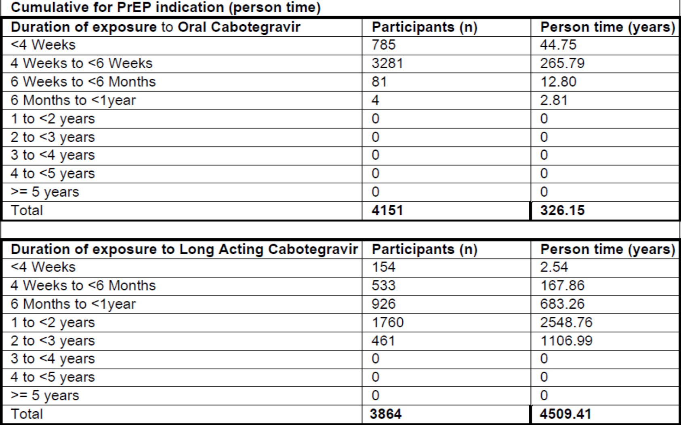

Abbreviations: n = number of subjects in group; PrEP = pre-exposure prophylaxis.

Data available as of 1 August 2021.

##### Adverse events

Most participants in the pivotal and supportive studies reported at least one adverse event (AE), and the proportion of participants were similar between the groups (see Table 13 below). The proportion of participants who reported events considered drug-related by the investigator was higher in the cabotegravir group compared with the TDF/emtricitabine group or placebo, and mostly related to injection site reactions (ISRs). When ISRs were excluded, the proportion of participants with drug-related AEs was similar between the groups in both pivotal studies. ISRs were reported less frequently in the HPTN 084 trial compared to the HPTN 083 trial. Frequencies of AEs in the ÉCLAIR and the HPTN 077 trials are similar to those of the two pivotal studies (see Table 13 below).

In the HPTN 083 trial, the proportion of participants who had AEs leading to discontinuation of the study was 2% higher in the cabotegravir group, mostly due to ISRs compared to the TDF/emtricitabine group. In the HPTN 084 trial, 1% of participants in both groups discontinued the study due to AE, and no participants in either group discontinued due to ISRs. In the ÉCLAIR trial 2% more participants in the cabotegravir group compared to placebo withdrew related to AEs, whilst in the HPTN 077 trial 11.9% in the cabotegravir group, compared to 4.2% in the placebo group withdrew due to AEs.

Table 13: Study 201738 (HPTN 083 trial), Study 201739 (HPTN 084 trial), Study 201120 (ÉCLAIR trial) and Study 201103 (HPTN 077 trial) Summary of all on treatment adverse events across pivotal and supportive cabotegravir pre-exposure prophylaxis studies

|  |  |  |  |  |  |  |  |  |  |
| --- | --- | --- | --- | --- | --- | --- | --- | --- | --- |
|  |  | HPTN 083 | | HPTN 084 | | ÉCLAIR | | HPTN 077 | |
|  | | **CAB**  N=2281  n (%) | **TDF/FTC**  N=2285  n (%) | **CAB**  N=1614  n (%) | **TDF/FTC**  N=1610  n (%) | **CAB**  N=105  n (%) | **Placebo**  N=21  n (%) | **CAB**  N=151  n (%) | **Placebo**  N=48  n (%) |
| **Any AE** | | 2174 (95) | 2157 (94) | 1556 (96) | 1540 (96) | 101 (96) | 20 (95) | 147 (97.4) | 48 (100) |
| Drug-related AEs | | 1874 (82) | 1355 (59) | 1098 (68) | 1014 (63) | 101 (96) | 15 (71) | 138 (91.4) | 39 (81.3) |
| Drug-related AEs, excluding ISRs | | 1075 (47) | 1134 (50) | 980 (61) | 998 (62) | NA | NA | 118 (78) | 38 (79) |
| ISR AE | | 1740 (76) | 726 (32) | 578 (38) | 166 (11) | N=94  87 (93) | N=21  12(57) | N=134  121 (90.3) | N=43  38 (88.4) |
| **Any Grade 2-5 AEs** | | 1022 (48) | 139 (7) | 196 (13) | 27 (2) | 75 (80) | 10 (48) | 121 (90.3) | 38 (88.4) |
| **AEs leading to study drug discontinuation** | | 135 (6) | 91 (4) | 17 (1) | 22 (1) | 7 (7) | 1 (5) | 18 (11.9) | 2 (4.2) |
| **Any SAE** | | 109 (5) | 104 (5) | 25 (2) | 33 (2) | 1 (<1) | 1 (5) | 2 (1) | 0 |
| Drug-related SAEs | | 4 (<1) | 3 (<1) | 1 (<1) | 3 (<1) | 0 | 1 (5) | 2 (1) | 0 |
| Fatal SAEs | | 4 (<1) | 6 (<1) | 2 | 0 | 0 | 0 | 0 | 0 |
| Drug-related fatal SAEs | | 0 | 1 (<1) | 0 | 0 | 0 | 0 | 0 | 0 |

Abbreviations: AE = adverse event; CAB = cabotegravir; FTC = emtricitabine; ISR = injection site reaction; N = number of subjects; n = number of subjects in group; SAE = serious adverse event; TDF = tenofovir disoproxil fumarate.

###### Injection site reactions

As might be expected, a greater proportion of participants in the cabotegravir group experienced ISR AEs compared with participants in the TDF/emtricitabine or placebo groups. Injection site pain was the most frequently reported ISR (81% of cabotegravir participants in the HPTN 083 trial, 34% in the HPTN 084 trial), and other frequently reported ISRs (more than 10% of cabotegravir participants) included injection site nodule, induration, and swelling. All other ISRs were reported in less than 3% of cabotegravir participants. In the HPTN 083 trial 27 participants (1%) discontinued cabotegravir related to injection intolerance, with no participants doing so in the HPTN 084 trial. The majority of the ISRs were Grade 1 (34% in the HPTN 083 trial, 25% in the HPTN 084 trial) or Grade 2 (46% in the HPTN 083 trial and 13% in the HPTN 084 trial) with few Grade 3 ISRs (1% to 3%) and no ISRs had severity higher than Grade 3. Furthermore, the incidence and intensity of ISRs decreased over time and the majority of ISRs recovered or resolved (see Figure 9 below).

Figure 9: Study 201738 (HPTN 083 trial) Plot of incidence of study drug injection site reaction adverse events by visit and intensity (overall) during Step 2 (injection Step 2 safety population)

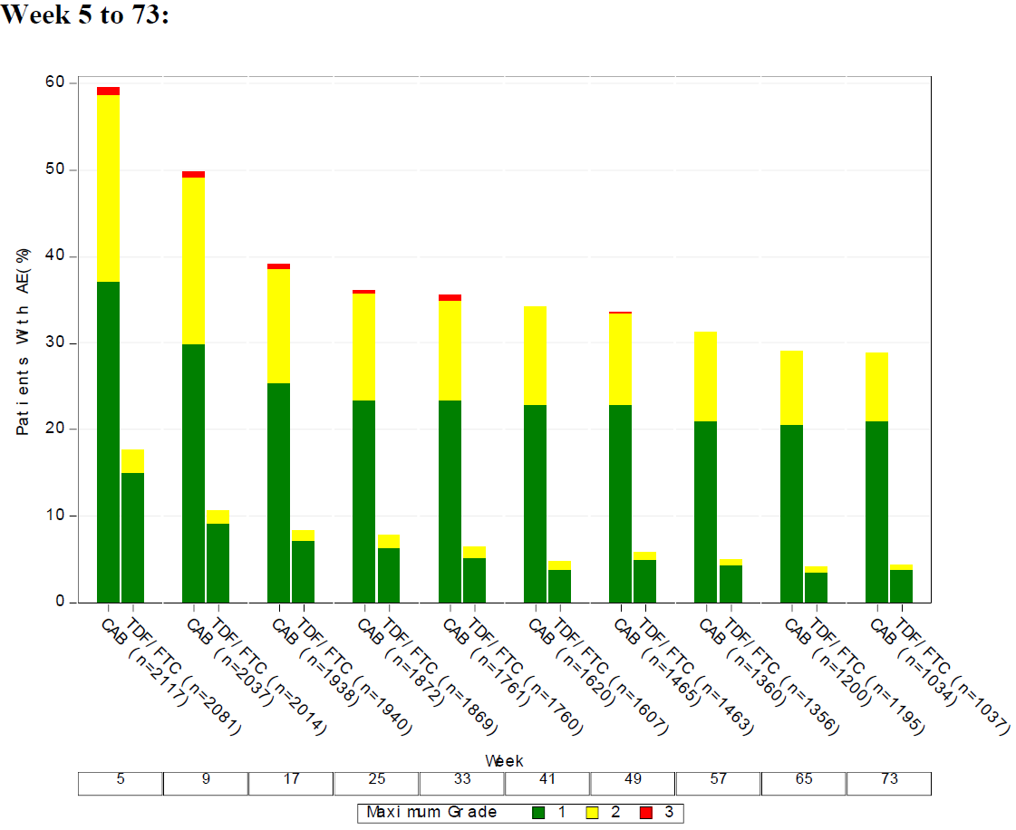

Abbreviations: AE = adverse event; CAB = cabotegravir; FTC = emtricitabine; n = number of subjects in group; TDF = tenofovir disoproxil fumarate.

###### Other common adverse events

The 6 most common AEs in the HPTN 083 trial were the same in both groups and are listed here as Preferred Term (PT) (n (n%) participants) for each group: injection site pain (1713 (75%) in the cabotegravir group, 688 (30%) in the TDF/emtricitabine group), creatinine renal clearance decreased (1576 (69%) in the cabotegravir group, 1661 (73%) in the TDF/emtricitabine group), blood creatinine phosphokinase increased (506 (22%) in the cabotegravir group, 497 (22%) in the TDF/emtricitabine group), blood creatinine increased (379 (17%) in the cabotegravir group, 426 (19%) in the TDF/emtricitabine group), nasopharyngitis (383 (17%) in the cabotegravir group, 379 (17%) in the TDF/emtricitabine group), and headache (377 (17%) in the cabotegravir group, 356 (16%) in the TDF/emtricitabine group).

In the HPTN 084 trial, the most common (more than 10%) AE PTs in both the cabotegravir and TDF/emtricitabine groups were creatinine renal clearance decreased, blood glucose increased, amylase increased, injection site pain, blood glucose decreased, headache, blood creatinine increased, blood phosphorous decreased, upper respiratory tract infection, blood creatine phosphokinase increased, alanine aminotransferase (ALT) increased, urinary tract infection, aspartate aminotransferase (AST) increased, and lipase increased.

The common AEs and relative risk of cabotegravir versus TDF/emtricitabine for the two pivotal studies are shown in Figure 10 and Figure 11 below. Overall, most of the commonly reported AE PTs (reported in at least 5% of participants) in were similar proportions between the 2 treatment groups with a few exceptions (see Table 16).

Figure 10: Study 201737 (HPTN 083 trial) Plot of common (at least 5%) adverse events and relative risk: cabotegravir versus tenofovir disoproxil fumarate / emtricitabine in Steps 1 and 2 (safety population)

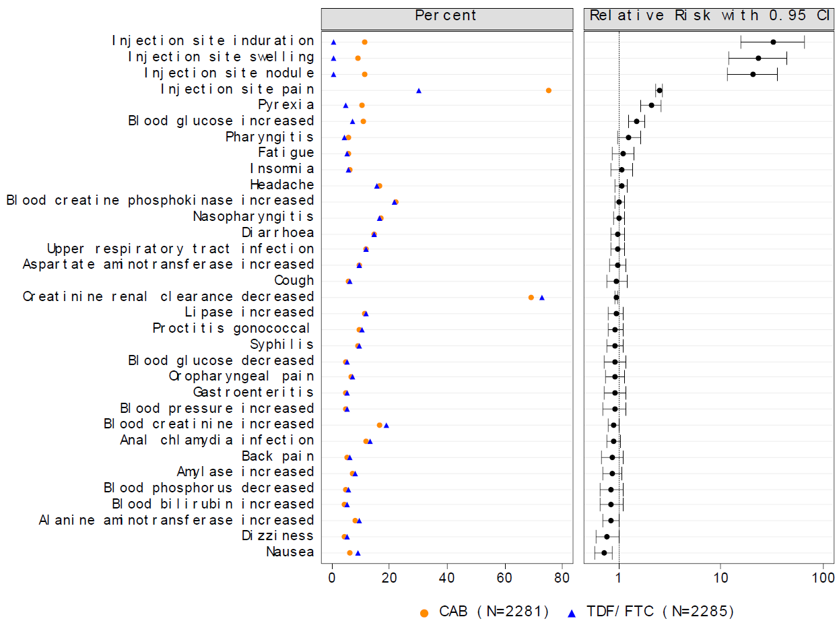

Abbreviations: CAB = cabotegravir; CI = confidence interval; FTC = emtricitabine; TDF = tenofovir disoproxil fumarate.

Figure 11: Study 201737 (HPTN 084 trial) Plot of common (at least 5%) adverse events and relative risk: cabotegravir versus tenofovir disoproxil fumarate / emtricitabine in Steps 1 and 2 (safety population)

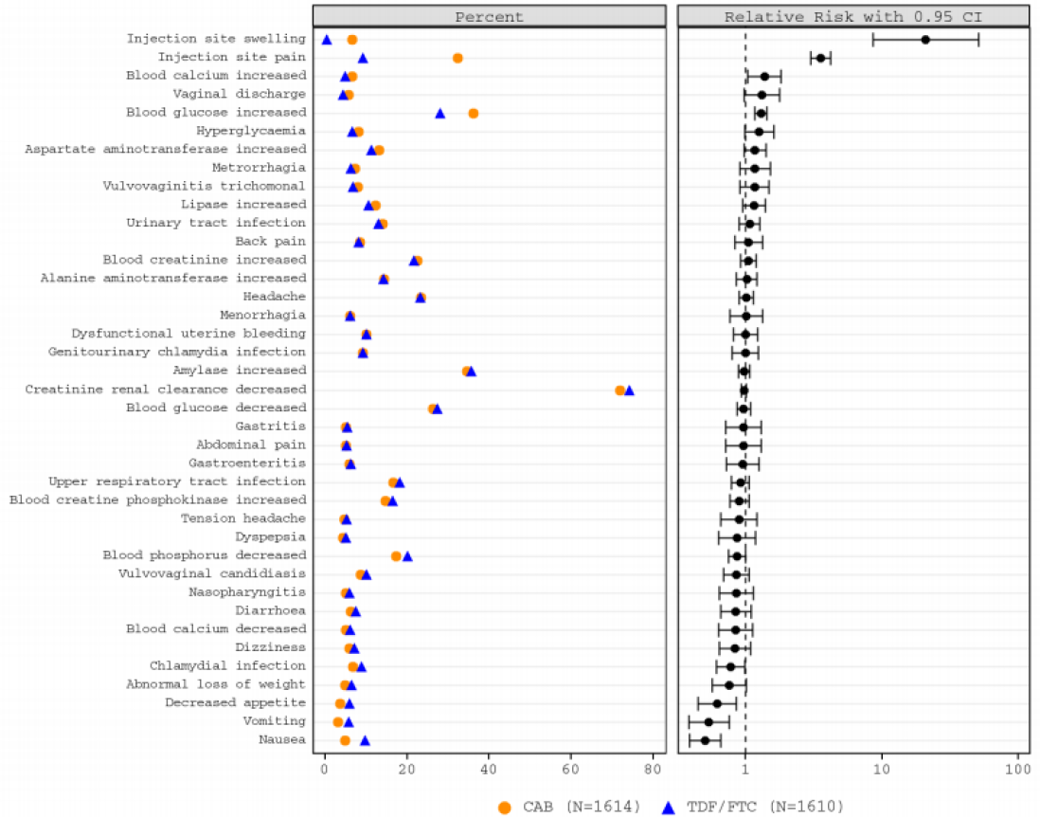

Abbreviations: CAB = cabotegravir; CI = confidence interval; FTC = emtricitabine; TDF = tenofovir disoproxil fumarate.

Several adverse event (AE) terms (including injection site nodule) were not included in this figure because their incidence was 4.X% (which rounded up to 5%). This figure includes AE terms with an unrounded incidence of at least 5.0%.

Table 14: Study 201738 (HPTN 083 trial) and Study 201737 (HPTN 084 trial) Adverse events where proportions were different between cabotegravir and tenofovir disoproxil fumarate / emtricitabine groups

|  |  |  |
| --- | --- | --- |
|  | AEs where proportions higher in cabotegravir compared to TDF/emtricitabine groups | AEs where proportions higher in TDF/emtricitabine compared to cabotegravir groups |
| HPTN 083 | ISR events (injection site pain, nodule*, induration*, and swelling)  Blood glucose increased*  Pyrexia*  Pharyngitis  Hypertension | Creatinine renal clearance decreased  Blood creatinine increased  Alanine aminotransferase increased  Nausea** |
| HPTN 084 | ISR events (injection site pain*, nodule and swelling) *  Blood glucose increased* | Blood phosphorus decreased**  Nausea**  Vomiting** |

Abbreviations: AE = adverse event; ISR = injection site reaction; TDF = tenofovir disoproxil fumarate.

* Relative risk greater than one and the lower limit of the confidence interval is greater than one indicating this event occurred more frequently in cabotegravir compared to TDF/emtricitabine.

** Relative risk lower than one and the upper limit of the confidence interval is less than one indicating this event occurred more frequently in TDF/emtricitabine compared to cabotegravir.

In the HPTN 077 trial, the primary safety end point analyses included Grade 2 or higher clinical AEs. The overall incidence of grade higher than 2 AEs was similar in the cabotegravir and placebo treatment groups (90% (121/134) versus 88% (38/43), see Table 14 above). The most reported on-treatment AEs for both groups included creatinine clearance decreased, blood glucose increased, and headache. Injection site events, including site pain, induration, bruising, swelling, erythema and pyrexia were higher in the cabotegravir group.

The ÉCLAIR trial evaluated the safety cabotegravir LA (800 mg dose administered at 3 time points at 12-week intervals). A larger proportion of participants in the cabotegravir group experienced ISR (Table 13). Other common side effects (more than 10%) were headache, upper respiratory tract infection, pyrexia, diarrhoea, fatigue, nasopharyngitis, and myalgia.

In study 206898, all 48 subjects (48 (100%)) reported at least one AE during the study. Most AEs were reported during injection phase and were Grade 1 or 2. The most commonly reported AE was injection site pain. One subject in oral phase experienced 2 AEs leading to permanent discontinuation of study drug. One subject reported one serious adverse event (SAE) during the injection phase. No deaths were reported. A total of 29 (60%) subjects reported at least one Grade 2 or higher laboratory abnormality. None of these laboratory abnormalities met the withdrawal criteria.

##### Treatment-related adverse events (adverse drug reactions)

A higher proportion of participants in the cabotegravir groups reported events that were considered to be drug-related compared to participants in the TDF/emtricitabine (the HPTN 083 and HPTN 084 trials) or placebo groups (the HPTN 077 and ÉCLAIR trials), and this was mostly related to higher incidence of ISRs (see Table 14) The most frequently reported non-ISR drug-related AEs were blood creatinine increases in cabotegravir and TDF/emtricitabine groups and diarrhoea and nausea in the TDF/emtricitabine group. In the HPTN 077 trial outside of ISRs, the most frequently reported AEs in the cabotegravir treatment group were headache (23%) and creatinine renal clearance decreased (22%), although reduced creatinine clearance was also seen in the placebo group (25%).

##### Deaths and other serious adverse events

In the HPTN 083 trial there were 10 deaths reported in Steps 1 and 2 (4 subjects in the cabotegravir group, 6 in the TDF/emtricitabine group), of which one in the TDF/emtricitabine group was considered to be drug-related by the investigator (cardiac disorder). One death occurred during Step 3 (reported as a stab wound in the TDF/emtricitabine group, see Table 14). In the HPTN 084 trial, three deaths occurred in the cabotegravir group (reported as hypertensive heart disease, headache and cerebrovascular accident). No deaths were reported in the TDF/emtricitabine group. None of the deaths in the cabotegravir group were considered to be related to study treatment. No deaths, and few SAEs were reported during the supportive studies from the cabotegravir PrEP program (the ÉCLAIR and HPTN 077 trials).

The proportion of participants with SAEs was low and similar in both treatment groups (5% in the cabotegravir group and 5% in the TDF/emtricitabine group of the HPTN 083 trial; 2% in the cabotegravir group and 2% in the TDF/emtricitabine group of the HPTN 084 trial) with no concerning trends observed.

In the HPTN 083 trial there were 5 drug-related SAEs in 4 cabotegravir group participants and 4 drug-related SAEs in 3 participants in the TDF/emtricitabine group. In the cabotegravir group these were suicide attempts (n = 2), and one each of affective disorder, a seizure disorder, and an immune thrombocytopenic event. In the TDF/emtricitabine group these were a suicide attempt, one increased ALT and 2 episodes of serious cardiac disorder in the same person.

In the HPTN 084 trial there was one SAE in a cabotegravir participant (respiratory tract infection) and 4 SAEs in 3 participants in the TDF/emtricitabine group (Increased AST, increased ALT, hepatotoxicity and seizure).

In the ÉCLAIR trial, a participant in the cabotegravir group had an SAE of deep vein thrombosis.

In the HPTN 077 trial, 13 participants experienced 14 SAEs (11 participants in the cabotegravir group, 2 in the placebo group). The SAEs were vertigo (one participant), acute kidney injury (one participant), laryngitis (one participant), deep venous thrombosis (one participant), ankle fracture (one participant), GIT motility disorder (one participant), procedural pain (one participant), anorexia nervosa (one participant), asthma (one participant) hypertensive crisis (one participant) and pre-eclampsia (one participant). In the placebo group, these were cholelithiasis (one participant) and spontaneous abortion (one participant). None of these events were thought to be related to the study drug.

##### Discontinuation of medication due to adverse events

In the HPTN 083 trial the proportion of participants with AEs leading to study drug discontinuation was low and similar in the cabotegravir and TDF/emtricitabine treatment groups (6% (n = 135) versus 4% (n = 91)). Of these, 24 participants discontinued during the Step 1 period and never received injections. Most of the discontinuations were due to ISRs in the cabotegravir group (n = 47). There were nine participants who had drug-related Grade 3 and higher non-ISR AEs leading to discontinuation of study drug. In the TDF/emtricitabine group, 17 participants had drug-related Grade 3 or higher AEs leading to discontinuation of study with majority due to laboratory abnormalities.

In the HPTN 084 trial the proportion of participants with AEs leading to study drug discontinuation was low and the same in both treatment groups (1% (n = 17) versus 1% (n = 22). Of these 10 participants discontinued study drug during Step 1 and never received injections. No participants in either group discontinued the study drug due to ISRs. In both groups drug-related Grade 3 reactions were low (lower than 1%) and none of these AEs were serious, with majority due to laboratory abnormalities.

In the ECLAIR trial, 7 participants in the cabotegravir group and one in the placebo group experienced an AE that led to withdrawal or permanent discontinuation of the drug. All AEs that lead to discontinuation in the cabotegravir group were non serious, resolved, and occurred during the oral phase.

In the HPTN 077 trial, 18 participants in the cabotegravir treatment and 2 participants in the placebo group experienced one or more AE(s) that led to withdrawal or permanent discontinuation of study drug. In the cabotegravir treatment group, 6 withdrew due to an AE during the oral lead-in phase, 11 withdrew during the injection phase, and one withdrew during the tail phase. Only 4 participants in the cabotegravir group withdrew from the study due to injection intolerability. Most of the discontinuations occurred in Cohort 1.

##### Adverse events of special interest

###### Liver function and hepatotoxicity

Elevated aminotransferases have been observed with cabotegravir during the cabotegravir treatment program in HIV-infected individuals, and hepatotoxicity is a known adverse drug reaction for cabotegravir. In the HPTN 083 and HPTN 084 trials, the frequency of hepatotoxicity and other potentially associated AEs were low (lower than 1% in either treatment group) and similar between treatment groups with the most common being hepatic steatosis. All hepatotoxicity AEs were Grade 1 or 2 with no serious hepatotoxicity reported in cabotegravir participants. During Steps 1 and 2, maximum intensity of Grade 3 or 4 treatment-emergent liver enzyme abnormality observations was comparable between groups, with many patients having alternate causes for the liver enzyme abnormalities. Possible or probable drug induced liver injury in the HPTN 083 and HPTN 084 trials was observed in 14 and 8 people respectively in the cabotegravir group. In the HPTN 083 trial, one participant in the cabotegravir group had a hepatic event that led to drug discontinuation. In the HPTN 084 trial, there was a single hepatotoxicity adverse event of special interest (AESI) in the cabotegravir group, which was serious, but considered unrelated by the investigator (hepatitis A).

###### Renal function and renal toxicity

There were no pre-specified AESIs (that is, renal failure or impairment, acute kidney injury, anuria and dialysis) reported for those in the cabotegravir group in both the HPTN 083 trial and HPTN 084 trials. The frequencies of blood creatinine increases, and the severity were similar between treatment groups in the HPTN 083 trial (17% in the cabotegravir group, n = 379; 19% in the TDC/emtricitabine group, n = 426) and the HPTN 084 trial (22% in the cabotegravir group, n = 363; 22% in the TDC/emtricitabine group, n = 347;). Similarly, creatinine renal clearance decreases were present and similar in both treatment groups in the HPTN 083 trial (69% in the cabotegravir group, n = 1577; 73% in the TDC/emtricitabine group, n = 1661) and the HPTN 084 trial (72% in the cabotegravir group, n = 1160; 74% in the TDC/emtricitabine group, n = 1192). There were 4 participants where cabotegravir was discontinued a because of renal concerns in the HPTN 083 trial, but no instances in the HPTN 084 trial.

###### Hypersensitivity reactions

Hypersensitivity reactions have been reported with integrase inhibitors other than cabotegravir and are characterised by rash, constitutional findings, and sometimes organ dysfunction, including hepatic failure. There were no cases of immediate or delayed hypersensitivity in either pivotal study, although 2% of patients in both treatment groups in the HPTN 083 trial and 1% in both groups in the HPTN 084 trial had potential hypersensitivity. None of the potential hypersensitivity AESIs in either group were serious or led to study drug discontinuation in either group.

###### Rash

Rash was present in 4% of participants in both the HPTN 083 and HPTN 084 trials. Study drug discontinuations or interruptions were rare. In the HPTN 083 trial there was one Grade 4 SAE of Stevens-Johnson syndrome which was considered unrelated to study medication.

###### Hyperglycaemia and diabetes

There is interest in whether integrase strand transfer inhibitors, impact glycaemic control. In both the HPTN 083 and HPTN 084 trials, there was no evidence of worsening of glycaemic profile of participants receiving cabotegravir. Although there was increase in the proportion of participants reporting AEs of blood glucose increased for participants in the cabotegravir group in the HPTN 083 trial (12% versus 9%) and the HPTN 084 trial (43% versus 34%) all other AEs associated with Hyperglycaemia were lower than 1% and had a similar frequency across both groups. The frequency of AEs of blood glucose increased in the cabotegravir group was greater in study the HPTN 084 trial (43%) compared to the HPTN 083 trial (12%). When the totality of laboratory abnormalities was considered, there was no clinically meaningful difference from Baseline of blood glucose over time.

###### Electrocardiograph findings and cardiovascular safety

No clinically significant findings were observed in the pivotal or supportive studies.

###### Neuropsychiatric events

Neuropsychiatric AEs such as depression, anxiety, and sleep disorders have been reported with cabotegravir treatment in HIV-infected individuals and are considered adverse drug reactions for cabotegravir treatment (see the AusPAR for Submission PM‑2019‑04281‑1‑2).9 In the HPTN 083 and HPTN 084 trials, the proportion of participants with neuropsychiatric AESIs were similar across the treatment groups. The frequency of suicidal ideation and behaviours AESI was low (lower than 1%) and was similar across the cabotegravir and TDF/emtricitabine groups (see Table 15 below).

Table 15: Study 201738 (HPTN 083 trial) and Study 201739 (HPTN 084 trial) Summary of neuropsychiatric adverse event of special interest during Steps 1 and 2 (safety population)

|  |  |  |  |  |
| --- | --- | --- | --- | --- |
| Neuropsychiatric AESI | HPTN 083 | | HPTN 084 | |
|  | **Cabotegravir**  (N=2281)  Number (%) participants | **TDF/emtricitabine**  (N=2285)  Number (%) participants | **Cabotegravir**  (N=1614)  Number (%) participants | **TDF/emtricitabine**  (N=1610)  Number (%) participants |
| Sleep disorders | 217 (10%) | 248 (11%) | 81 (5%) | 76 (5%) |
| Depression | 115 (5%) | 108 (5%) | 16 (<1%) | 11 (<1%) |
| Anxiety | 99 (4%) | 97 (4%) | 9 (<1%) | 6 (<1%) |
| Mood disorders | 30 (1%) | 19 (<1%) | 7 (<1%) | 12 (<1%) |
| Suicidal ideation/ behaviour | 25 (1%) | 23 (1%) | 3 (<1%) | 6 (<1%) |
| Bipolar disorder | 5 (<1%) | 6 (<1%) | 1 (<1%) | 2 (<1%) |
| Psychosis | 3 (<1%) | 4 (<1%) | 0 | 0 |

Abbreviations: AESI = adverse event of special interest; N = number of subjects; TDF = tenofovir disoproxil fumarate.

Number of events: total number of AEs during Steps 1 and 2.

Number (%) participants: total (%) number of unique participants.

Adverse events (AEs) were coded to System Organ Class and Preferred Term using Medical Dictionary for Regulatory Activities (MedDRA)[12] coding dictionary version 23.1.

Sites were instructed to only enter Grade 2 or higher laboratory abnormalities AEs, however all laboratory abnormalities AEs that were entered into the case report form are included in this table even if they are Grade 1

If a participant had more than one AE for a specific term, they are only counted once in the number of participants with AEs for that System Organ Class and Term.

Preferred Terms are listed in the order of decreasing frequency in the cabotegravir group.

###### Seizures and seizure-like events

A small number of seizures (less than 1%) were reported during the cabotegravir development program (for HIV treatment or PrEP), which prompted enhanced reporting of similar events in the HPTN 083 and HPTN 084 trials. A history of seizures, per self‑report, was an exclusion criterion for these two studies. Sites were required to report suspected seizure AEs in an expedited manner as serious reports. The number and proportion of participants with AEs potentially related to seizure or seizure-like events was similar in both treatment groups with less than 1% in each group in the HPTN 083 and HPTN 084 trials. Of those having seizures, one participant in the cabotegravir group in the HPTN 083 trial had a seizure that was considered to be drug related.

###### Weight gain

Weight gain has been reported during cabotegravir treatment in HIV-infected individuals. It is unknown whether weight gain is associated with cabotegravir PrEP administration in HIV‑uninfected individuals. In the pivotal studies (the HPTN 083 and HPTN 084 trials) weight gain AESI was similar in both treatment arms and was low (less than 1% of participants).

###### Rhabdomyolysis

Transient, asymptomatic elevations of creatine phosphokinase levels have been observed in HIV-infected individuals participating in the cabotegravir treatment development program without evidence of rhabdomyolysis. Rhabdomyolysis has been reported with raltegravir, another integrase inhibitor.

###### Pancreatitis

No subjects in either group had an AE potentially associated with pancreatitis.

##### Safety in human immunodeficiency virus infected adolescents from Study 208580 (MOCHA trial)

The safety of adolescents in PrEP receiving cabotegravir is informed by the safety data from the MOCHA trial which enrolled 8 (6 males) participants receiving cabotegravir and in addition to combination antiretroviral therapy. All 8 participants are from the USA, with a median age of 14.5 years. Most participants had AEs. Three of 8 (37.5%) participants in Cohort 1C had Grade 3 AEs (neutropenia and insomnia; n = 1 each) or Grade 4 (n = 1; blood creatine phosphokinase increased) at Week 16 visit (see Table 16 below). There were no deaths or pregnancies in Cohort 1C. There were no SAEs or AEs leading to premature permanent discontinuation in Cohort 1C. No clinically important findings were noted in either Cohort 1C with respect to laboratory assessments, electrocardiograms, or vital signs.

Table 16: Study 208580 (MOCHA trial) Cohort 1C Summary of adverse events

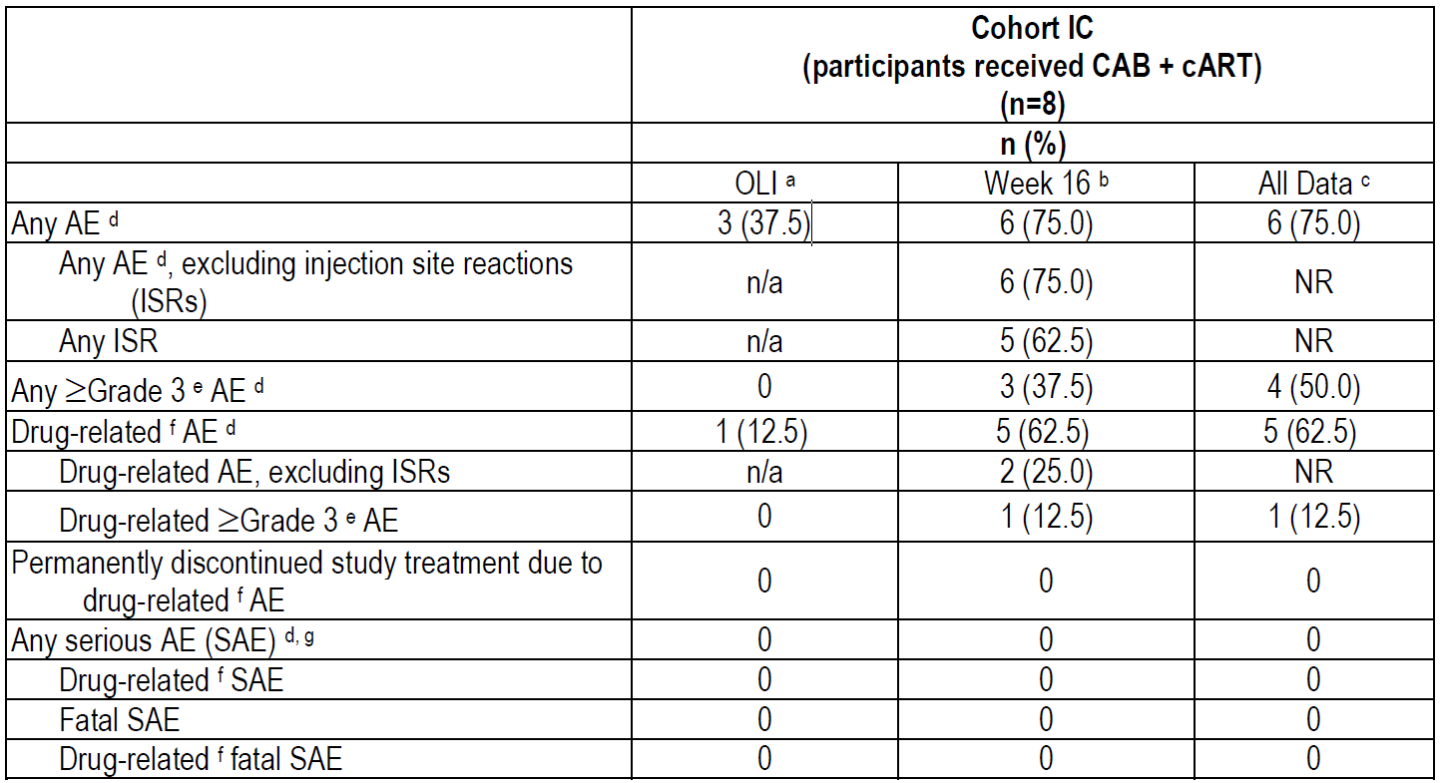

Abbreviations: AE = adverse event; CAB = cabotegravir; cART = combination antiretroviral therapy; ISR = injection site reaction; n = number of subjects in group; N/a = not applicable; NR = not reported; OLI = oral lead-in; SAE = serious adverse event.

a. Adverse events (AEs) after oral treatment end date plus one day for participants who discontinued treatment in OLI and AEs after Week 4b injection date minus one day for participants who received injections have been excluded from the OLI analysis.

b. Adverse events (AEs) after oral treatment end date plus one day for participants who discontinued treatment in OLI and AEs after final injection date plus 42 days for participants who received injections have been excluded from the analysis through Week 16.

c. Includes data from long-term safety and washout PK follow-up (LSFU); no results have been excluded from the analysis for all available data.

d. Includes clinical and laboratory-related AEs.

e. Grade 1 = mild, 2 = moderate, 3 = severe, 4 = potentially life-threatening, 5 = death; no Grade 5 AEs were reported.

f. Drug-relatedness of AEs was determined by the investigator.

g. Serious adverse events (SAEs) included International Conference on Harmonisation of Technical Requirements for Registration of Pharmaceuticals for Human Use (ICH)[13]-defined SAEs and malignancies.

##### Safety in subgroup of participants less than 25 years of age from cabotegravir pre‑exposure prophylaxis pivotal studies

In the HPTN 083 trial, 1,845 participants (930 in the cabotegravir group, 915 in the TDF/emtricitabine group) aged less than 25 years were enrolled. The mean age of this subgroup was 21.4 and 21.3 years, respectively (range 18 to 24 years). In this less than 25 years subgroup, 38 participants (4%) in each treatment group weighed less than 50 kg (mean weight in overall population was 71.18 kg in the cabotegravir group, 71.43 kg in the TDF/emtricitabine group). The most reported AEs in both groups were creatinine renal clearance decreased (66% in the cabotegravir group versus 70% in the TDF/emtricitabine group) and injection site pain (76% versus 28%). As expected, ISRs were reported more frequently in the cabotegravir (76%) compared to the TDF/emtricitabine (28%) group.

In the HPTN 084 trial, 1,594 participants (800 in the cabotegravir group, 794 in the TDF/emtricitabine group) aged less than 25 years were enrolled; the mean age of this subgroup was 21.5 years in both subgroups (range 18 to 24 years). In this less than 25 years subgroup, 82 (10%) and 93 (12%) participants in each treatment group weighed less than 50 kg (mean weight in overall population was 65.7kg in the cabotegravir group, 64.8 kg in the TDF/emtricitabine group). The most reported AEs in both treatment groups were creatinine renal clearance decreased (70% in the cabotegravir group versus 70% in the TDF/emtricitabine group), amylase increased (36% versus 36%). As expected ISRs were more frequent in the cabotegravir group (34%) compared to the TDF/emtricitabine (8%) group.

##### Use in pregnancy and lactation

No studies have been conducted with cabotegravir PrEP in pregnant women, and pregnant women were excluded from the cabotegravir PrEP studies. Women of childbearing potential were enrolled in the HPTN 084 and HPTN 077 trials, were counselled regarding avoiding pregnancy, were required to have a negative pregnancy test at Day 1 and were retested regularly. Women who became pregnant on study during the HPTN 084 trial were placed on open label TDF/emtricitabine and those in the HPTN 077 trial were required to discontinue investigational products. Pregnancy outcome information was sought during follow up of participants who became pregnant on study.

In the HPTN 084 trial, 72 participants (38 in the cabotegravir group, 34 in the TDF/emtricitabine group) had 77 pregnancies at the time of the data cut-off of 5 November 2020. Of these, 49 were confirmed pregnancies (20 full term live births, 9 pregnancy losses and 18 ongoing pregnancies), 20 pregnancies ended before the confirmation test, and 8 pregnancies were pending confirmation. In the HPTN 077 trial three pregnancies were reported, which resulted in two full term births, and one pregnancy loss at about 13 weeks.

The safety of exposure of cabotegravir oral and LA to infants through breastfeeding has not been established. Women who were breastfeeding infants were excluded from the studies. It is expected that cabotegravir will be secreted into human milk based on animal data, although this has not been confirmed in humans. Cabotegravir may be present in human milk for 12 months or longer after the last injection.

### Risk management plan

The sponsor has submitted European Union (EU)-risk management plan (RMP) version 0.1 (dated 29 September 2021; data lock point (DLP) 5 November 2020) and Australia specific annex (ASA) version 1.0 (dated 15 October 2021) in support of this submission for pre-exposure prophylaxis. The most recently evaluated EU-RMP for Vocabria 30 mg tablets (and prolonged-release suspension for injection (no combination injection in the EU)) for the treatment of human immunodeficiency virus type 1 infection was version 0.6 (dated 12 October 2020; DLP 6 June 2019) and ASA version 2.0 (dated 5 October 2021) for Vocabria tablets. For combination treatment (injection), EU-RMP version 3.0 (dated 28 October 2021; DLP 21 February 2020) for Vocabria tablets and prolonged-release suspension for injection (submitted with EU-RMP for rilpivirine EU-RMP version 3.1 (dated 22 October 2021; DLP: 21 February 2020)) and ASA version 2.0 (dated 31 January 2022) for Cabenuva was evaluated.

In response to rolling questions sent on 13 April 2022, the sponsor has submitted ASA version 1.0 (dated 14 April 2022) in support of its submission.

The summary of safety concerns and their associated risk monitoring and mitigation strategies are summarised in Table 17. Further information regarding the TGA’s risk management approach can be found in [risk management plans for medicines and biologicals](https://www.tga.gov.au/publication/risk-management-plans-medicines-and-biologicals) and [the TGA's risk management approach](https://www.tga.gov.au/tgas-risk-management-approach).

Table 17: Summary of safety concerns

|  |  |  |  |  |  |
| --- | --- | --- | --- | --- | --- |
| Summary of safety concerns | | Pharmacovigilance | | Risk minimisation | |
| **Routine** | **Additional** | **Routine** | **Additional** |
| **Important identified risks** | Hepatotoxicity | ✓ | ✓* | ✓ | – |
| Human immunodeficiency virus type 1 (HIV-1) seroconversion | ✓ | ✓* | ✓ | – |
| Development of resistance:   * In participants starting cabotegravir with unrecognised or acute HIV-1 infection * Due to breakthrough HIV-1 infection while on cabotegravir oral lead-in or long-acting and delayed diagnosis * Potential risk of HIV‑1 acquisition occurring during ‘PK [pharmacokinetic] tail’ and diagnosis is delayed, or effective antiretroviral is not started timely | ✓ | ✓* | ✓ | – |
| **Important potential risks** | None | – | – | – | – |
| **Missing information** | Use in pregnancy | ✓ | ✓† | ✓ | – |

* Cabotegravir long-acting pre-exposure prophylaxis cohort study to assess adherence and effectiveness, and monitor for safety and resistance

† Antiretroviral pregnancy registry

* No new safety concerns have been identified by the clinical evaluation and the sponsor has satisfactorily addressed RMP recommendation 1.[14] Therefore, the summary of safety concerns is satisfactory.
* Routine and additional pharmacovigilance activities are proposed. Planned additional pharmacovigilance activities include cabotegravir LA PrEP cohort study to assess adherence and effectiveness and monitor for safety and resistance (EU patients only) and an Antiretroviral Pregnancy Registry (APR) which is multinational. The pharmacovigilance plan is acceptable and will provide further information on the important identified risks and missing information in the summary of safety concerns.
* Routine risk minimisation activities only are proposed which has been previously considered acceptable.

### Risk-benefit analysis

#### Delegate’s considerations

##### Pre-exposure prophylaxis

The human immunodeficiency virus (HIV) pandemic remains a global public health concern, and an ongoing issue in Australia. Whilst HIV infection can now be managed very effectively with antiretroviral drugs, there are significant ongoing morbidity and chronic disease costs and monitoring, and no cure or vaccination is currently available. Thus, prevention of infection including the use of pre-exposure prophylaxis (PrEP), remains an important priority.

The current available HIV PrEP includes 2 tenofovir-based, fixed-dose antiretroviral combination regimens, tenofovir disoproxil fumarate (TDF)/emtricitabine (Truvada)5 and tenofovir alafenamide (TAF)/emtricitabine (Descovy)7 requiring daily oral administration.4 These are indicated for use in combination with safer sex practices and are approved and are available in Australia and internationally.4 When used as instructed these are reasonably effective. However, the use of TDF/emtricitabine and TAF/emtricitabine for PrEP has limitations.

In a systematic review of randomised clinical trials of oral PrEP versus placebo or no oral PrEP, adherence rate of higher than 70% to oral PrEP was associated with 73% effectiveness in the reduction of new HIV-1 infections, while adherences between 40% to 70% or lower than 40% were associated with effectiveness rates of 49% and 7%, respectively.[15] There are substantial data to support acceptance and preference for less frequent dosing.[16],[17],[18] The cabotegravir PrEP long‑acting HIV-1 prophylaxis option has the potential to improve adherence, and thus may provide a more effective option for people at risk of acquiring HIV.

##### Summary of efficacy and safety

In the two large scale multinational prospective randomised clinical trials (the HPTN 083 and HPTN 084 trials) investigating the efficacy of cabotegravir, a long-acting injectable drug for HIV prevention; compared with daily combined oral TDF and emtricitabine there is improved effectiveness of cabotegravir over TDF/emtricitabine. Together these two studies enrolled 7,794 participants, including men who have sex with men, transgender and cisgender women, populations who are at high risk for sexually acquired HIV infection and were conducted in countries where there is a large burden of HIV infection. cabotegravir PrEP demonstrated superior efficacy when compared to a daily oral active TDF/emtricitabine, resulting in 66% and 89% reductions, in the two trials respectively in the rate of HIV incident infections in the high-risk populations undertaking the two studies.

The overall rate of HIV acquisition in all subgroups analysed, including key subgroups (transgender women, age less than 25 years, and African American cisgender men who have sex with men and transgender women in the USA), was consistent with the overall observed treatment effect, demonstrating for all subgroups a lower rate of incident HIV‑1 infections in participants randomised to the cabotegravir group compared with those randomised to the TDF/emtricitabine group.

The long-term cabotegravir PrEP dosing regimen, involving second monthly intramuscular injections, may improve adherence to PrEP as compared to daily oral PrEP regimens by managing key issues of stigma, need for daily oral dosing, and negotiation of protection of HIV infection with partners. Adherence is important for PrEP efficacy, and less frequent dosing may improve this. Most participants receiving cabotegravir favoured intramuscular PrEP injections over daily oral PrEP and most were willing to continue, with cabotegravir long-acting (LA) injections.

In pivotal and supportive studies, cabotegravir PrEP was well-tolerated; injection site reactions (ISRs) were generally mild or moderate and the rate of study drug discontinuation due to ISRs was very low. Other risks of cabotegravir PrEP include the potential for hepatotoxicity, hypersensitivity reactions, rash and neuropsychiatric events and weight gain. Except for ISRs, the majority of adverse drug reactions have occurred in low proportions of participants in pivotal and supportive studies and have generally not been treatment limiting. cabotegravir has a favourable drug interaction profile with few clinically relevant interactions that require a dose separation or contraindication. Cabotegravir LA may be administered and used for PrEP in individuals on concurrent contraception, including injectable LA forms. There were also no substantial differences in the safety profile for HIV-uninfected participants in the cabotegravir PrEP program as compared to HIV‑infected participants in the cabotegravir treatment program.

##### Deficiencies of the data

Overall, the data supplied with this submission has some evidence gaps or outstanding issues as given below.

###### Use in adolescent subjects

Whilst the sponsor is recommending use in adolescents weighing at least 35 kg, there is currently a lack of data in adolescent participants. The current dossier does not include efficacy data for proposed cabotegravir PrEP regimen in HIV-negative at-risk adolescents. Primary analysis of HIV incidence in participants aged less than 25 years (that is 18 to less than 25 years) showed a 65% and 83% reduction in risk of acquiring HIV infection with the cabotegravir PrEP regimen compared to the oral regimen in the two pivotal studies.

To-date, data from 8 adolescents in the USA receiving cabotegravir as part of HIV treatment, and population pharmacokinetic modelling is the totality of evidence provided for this age group. However, data in younger adults (aged less than 25 years), and in people weighing less than 50 kg does not suggest any significant concern. The observed safety data reported for 8 adolescent participants within Study 208580 (the MOCHA trial) do not suggest a different safety profile for cabotegravir in adolescents relative to adults with HIV infection although interpretation is limited by small sample size. The current dossier does not include efficacy data for proposed cabotegravir PrEP regimen in HIV‑negative at-risk adolescents.

###### Lack of comparison with tenofovir alafenamide/emtricitabine

The newer alafenamide form of tenofovir (TAF) has improved pharmacokinetics compared to the earlier disoproxil fumarate form of tenofovir (TDF). Much higher intracellular tenofovir levels are achieved with TAF, thus requiring reduced dosing compared with TDF (25 mg versus 300 mg). This also reduces the severity of off-target renal and bone effects known to be associated with tenofovir. Both forms of tenofovir (as TDF or TAF) need to be given with emtricitabine. However, at present TDF is in wide use and remains the current standard in HIV treatment (backbone antiretroviral therapy) and in HIV PrEP.

Although direct comparison of cabotegravir with TAF/emtricitabine is not available, it is noted that efficacy of TAF/emtricitabine was found to be similar (non-inferior) the efficacy of TDF/emtricitabine when it was granted extension of indication to PrEP. Thus, it can be argued that there is indirect information supporting a higher efficacy of cabotegravir versus TAF/emtricitabine.

###### ‘Optional’ oral lead-in dosing

There is currently no data in the cabotegravir PrEP program that supports removing the oral lead-in component of the dosing schedule. In both PrEP pivotal studies (Study 201738 (the HPTN 083 trial) and Study 201739 (the HPTN 084 trial)), oral lead-in dosing was mandatory. This is similar to the previous cabotegravir treatment studies. (see the AusPAR for Submission PM-2019-04281-1-2).9 In the cabotegravir treatment studies, oral lead-in was utilised as a mitigation against possible acute, severe drug toxicity (for example, hypersensitivity) prior to cabotegravir prolonged-release injection as the cabotegravir-specific safety profile was being characterised. As clinical safety data for cabotegravir have accumulated no significant safety concerns have been identified.

The totality of safety and PK data from both the cabotegravir PrEP and cabotegravir Treatment programs suggest that the efficacy for cabotegravir is not dependent on differences in exposure between dosing regimens with and without oral lead-in. Furthermore, the slightly lower cabotegravir exposures observed with a direct to injection regimen (no oral lead-in) in the FLAIR extension study is not clinically meaningful. Lastly, the tolerability of cabotegravir injections is comparable across participants in whom such injections were preceded by cabotegravir oral lead-in versus those who initiated cabotegravir injections without oral lead-in.

Given that in the HPTN 083 trial of the 8 people who were actively receiving cabotegravir at the time of acquiring their HIV infection, 3 of these people were in the oral lead-in phase of their treatment. Thus, careful consideration of the role of oral lead-in is required, and further investigation would be of benefit.

###### Risk of human immunodeficiency virus acquisition and development of resistance to cabotegravir

Apart from the rare risk of HIV acquisition when PrEP is used correctly, there is an increased risk for seroconversion if the individual at risk of HIV acquisition does not adhere to the cabotegravir PrEP dosing schedule. Thus, if early HIV infection is not recognised whilst on cabotegravir PrEP or before starting treatment, there is an increased risk of resistance to integrase inhibitors developing. This is because cabotegravir alone is inadequate treatment for HIV, and in the individual being treated with an incomplete regimen which is not able to fully suppress the viral replication, leading to possible development of integrase strand transfer inhibitor resistance may occur. The plan to help mitigate this is regular HIV testing, including prior to commencing on treatment. The current recommended frequency is prior to starting treatment and before each injection. There is no data at this stage to show that people will adhere to this scheduling, and whether this testing mitigates this risk. It is noted in the risk management plan that a 5‑year prospective pharmacovigilance study is planned.

#### Proposed action

Whilst there are some limitations in the available data, the overall efficacy and safety profile for cabotegravir as PrEP is positive with a large potential benefit, and minimal risks.

Pending advice from Advisory Committee on Medicines (ACM), the sponsor’s pre-ACM response, and changes to the indication and Product Information as outlined, the delegate considers the benefit-risk profile to be positive and recommends approval.

#### Questions for the sponsor

The sponsor provided the following response to questions from the Delegate.

1. ***Is there any further data from the MOCHA trial (Study 208580) or any other data available for people less than 18 years age either as part of a cabotegravir pre‑exposure prophylaxis or treatment programs?***

The sponsor confirms that no further adolescent data is available at this time. Interim results from the two ongoing pre-exposure prophylaxis (PrEP) studies (the HPTN 083‑01 and HPTN 084-01 trials) in adolescents or additional data from the ongoing adolescent cabotegravir treatment Study 208580 (the MOCHA trial) are not available to the sponsor at this time. The adolescent PrEP studies recently underwent Data and Safety Monitoring Board (DSMB) review on 3 May 2022. While the sponsor is blinded to the content of the closed DSMB reports as this is managed by the study sponsor, the United States National Institutes of Health Division of Immunodeficiency Disease Syndrome (NIH-DAIDS), the DSMB indicated that these 2 PrEP studies can proceed as planned. The MOCHA trial is also sponsored by NIH-DAIDS and recently underwent a planned Study Monitoring Committee (SMC) review. The SMC indicated that the study may proceed and open the treatment cohort (Cohort 2) to participants who were not previously enrolled in Cohort 1 of the study.

1. ***Apart from the FLAIR extension phase (Study 201584), is there any data on utilising cabotegravir and not using an oral lead-in, in particular is there any data regarding pre-exposure prophylaxis?***

The sponsor currently does not have any other data regarding the use of cabotegravir long‑acting (LA) for PrEP without an oral lead-in.

1. ***Please outline the reasoning or data behind the decision to have the first two injections separated by one month, and then two monthly after that. The monthly interval for the second injection is not clear from the data provided.***

For the every 8 weeks regimen, the first monthly injection serves as a loading dose to achieve concentrations consistent with steady state 4 weeks following the initiation injection. Following cabotegravir LA administration, cabotegravir steady state is achieved within approximately 44 weeks; however the monthly loading dose injection achieves concentrations consistent with steady state 4 weeks following the initiation injection for the PrEP regimen. For this reason, the one month first injection interval was included in pivotal PrEP studies and has similarly been included in the every 2 months treatment regimen for cabotegravir plus rilpivirine. The impact of the one month loading injection is shown graphically in the simulation below (Figure 12).

Figure 12: Simulated concentration versus time profile of the standard every 8 weeks regimen through the follow-up period following discontinuation demonstrates how the initial monthly interval achieves steady state concentrations early in dosing

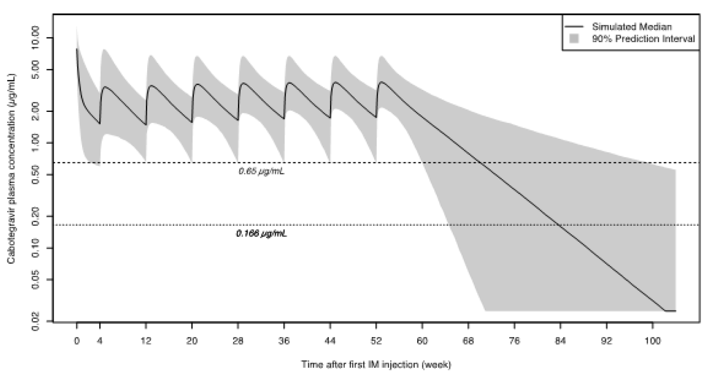

Abbreviation: IM = intramuscular.

Shaded area corresponds to the 90% prediction interval (fifth and ninety fifth percentiles). Simulated concentrations below left lower quadrant of 0.025 µg/mL were converted to 0.025 µg/mL. The last intramuscular injection in this simulation was administered at Week 52.

1. ***Is there any additional data from the ongoing pre-exposure prophylaxis studies?***

Both the HPTN 083 and HPTN 084 trials are in their respective open label extension phases and are ongoing. There are no available additional data from formal planned analysis from the ongoing PrEP studies at this time.

#### Advisory Committee considerations

The [Advisory Committee on Medicines (ACM)](https://www.tga.gov.au/committee/advisory-committee-medicines-acm), having considered the evaluations and the Delegate’s overview, as well as the sponsor’s response to these documents, advised the following.

##### Specific advice to the Delegate

1. ***The committee is asked to provide advice on the use of cabotegravir pre-exposure prophylaxis in at risk adolescents weighing at least 35 kg.***

On balance, the ACM advised that despite having limited data on the adolescent age group and no data for the 12 to 17 years age group, there is limited concern regarding the dosing of cabotegravir in adolescents. The ACM was of view that the advantages of the injection regimen can be expected to outweigh concern that might emerge in the future. The ACM agreed that it is important to increase access to human immunodeficiency virus (HIV) preventing medicines among the adolescent population and it is plausible that injections might suit this population more than tablets due to convenience, privacy, and adherence to treatment.

1. ***The committee is asked to provide advice on the role of oral lead-in given the known safety profile of cabotegravir and the possible increased risk of human immunodeficiency virus acquisition during optional oral lead-in in the HPTN 083 trial. If it is to be used should there be additional warnings regarding possible risk and so on?***

The ACM noted that it is unclear that the oral lead-in increases HIV acquisition. The ACM commented that the increase in HIV diagnoses in early pre-exposure prophylaxis (PrEP) treatment could be due to multiple factors such as the window of testing, HIV exposure occurring before therapeutic drug levels are achieved and changes in risk taking behaviour.

The ACM recommended that an oral lead-in remain optional, as described in the proposed indication. Further noting that the oral lead period might provide opportunity for repeat HIV testing prior to the first dose of long-acting cabotegravir.

1. ***The committee is asked to provide advice on the new wording of the indication for Apretude.***

The ACM agreed with the proposed new wording of the indication by the Delegate as listed below.

*Apretude is indicated in at-risk adults and adolescents weighing at least 35 kg for pre-exposure prophylaxis (PrEP) to reduce the risk of sexually acquired HIV-1 infection.*

*Apretude tablets may be used as an oral lead-in to assess tolerability of cabotegravir prior to administration of cabotegravir injections or as short-term oral PrEP in individuals who will miss planned dosing with cabotegravir injections.*

*Individuals must have a negative HIV-1 test prior to initiating Apretude for HIV‑1 PrEP.*

1. ***Does the committee feel the recommendation for human immunodeficiency virus testing prior to each cabotegravir injection reasonable and achievable? What is the committee’s advice regarding what should be recommended?***

The ACM recommended regular testing while using long-acting PrEP in keeping with current national guidelines. The current Australian clinical guidelines for HIV PrEP;[19] recommend HIV antigen or antibody testing every three months.

The ACM noted that HIV testing usually occurs at or just before the three monthly re‑prescribing of medication. Hence, HIV testing every two months (alongside the long‑acting cabotegravir injection) would be feasible given a clinic visit is needed to administer cabotegravir injection.

1. ***Is there any other advice the committee would like to provide as to how to reduce the risk of emergence of resistance or inadequate treatment if the person becomes human immunodeficiency virus positive?***

The ACM noted that the risk of resistance needs to be balanced against the HIV prevention benefit. The ACM advised that any new HIV diagnosis while on Apretude PrEP would require urgent specialist referral for HIV treatment. In addition, the ACM also recommended frequent on-treatment HIV testing while using long-acting Apretude as PrEP.

1. ***The committee is also requested to provide advice on any other issues that it thinks may be relevant to a decision on whether to approve this application.***

The ACM agreed that long-acting injectables offer opportunities for more frequent risk assessment and opportunistic testing for sexually transmitted infections, blood borne viruses, harm reduction education and vaccination given their mode of administration.

##### Conclusion

The ACM considered this product to have an overall positive benefit-risk profile for the indication:

*Apretude is indicated in at-risk adults and adolescents weighing at least 35 kg for pre-exposure prophylaxis (PrEP) to reduce the risk of sexually acquired HIV-1 infection.*

*Apretude tablets may be used as an oral lead-in to assess tolerability of cabotegravir prior to administration of cabotegravir injections or as short-term oral PrEP in individuals who will miss planned dosing with cabotegravir injections.*

*Individuals must have a negative HIV-1 test prior to initiating Apretude for HIV‑1 PrEP.*

## Outcome

Based on a review of quality, safety, and efficacy, the TGA approved the registration of Apretude (cabotegravir) 30 mg film-coated tablet in bottles and 600 mg/3 mL prolonged‑release suspension for injection in vials, for the following extension of indications:

*Apretude is indicated in at-risk adults and adolescents (at least 12 years of age) and weighing at least 35 kg for pre-exposure prophylaxis (PrEP) to reduce the risk of sexually acquired HIV-1 infection.*

*Apretude tablets may be used as an oral lead-in to assess tolerability of cabotegravir prior to administration of cabotegravir injections or as short-term oral PrEP in individuals who will miss planned dosing with cabotegravir injections.*

*Individuals must have a documented negative HIV-1 test prior to initiating Apretude for HIV-1 PrEP.*

The above extension of indications are inclusive of the previous approved indications.

### Specific conditions of registration applying to these goods

* Apretude (cabotegravir sodium) is to be included in the Black Triangle Scheme. The PI and CMI for [Apretude] must include the black triangle symbol and mandatory accompanying text for five years, which starts from the date the new indication is registered.
* The Apretude EU-risk management plan (RMP) (version 0.1, dated 29 September 2021, data lock point 5 November 2020), with Australian specific annex (version 1.0, dated 14 April 2022), included with Submission PM-2021-04853-1-2, and any subsequent revisions, as agreed with the TGA will be implemented in Australia.

An obligatory component of risk management plans is routine pharmacovigilance. Routine pharmacovigilance includes the submission of periodic safety update reports (PSURs).

Unless agreed separately between the supplier who is the recipient of the approval and the TGA, the first report must be submitted to TGA no later than 15 calendar months after the date of the approval letter. The subsequent reports must be submitted no less frequently than annually from the date of the first submitted report until the period covered by such reports is not less than three years from the date of the approval letter. The annual submission may be made up of two PSURs each covering six months. If the sponsor wishes, the six monthly reports may be submitted separately as they become available.

If the product is approved in the EU during the three years period, reports can be provided in line with the published list of EU reference dates no less frequently than annually from the date of the first submitted report until the period covered by such reports is not less than three years from the date of the approval letter.

The reports are to at least meet the requirements for PSURs as described in the European Medicines Agency’s Guideline on Good Pharmacovigilance Practices (GVP) Module VII-periodic safety update report ([Revision] 1), Part VII.B Structures and processes. Note that submission of a PSUR does not constitute an application to vary the registration. Each report must have been prepared within ninety calendar days of the data lock point for that report.

* Two post-authorisation studies are planned with the aim to evaluate the population receiving CAB [cabotegravir] PrEP [pre-exposure prophylaxis], usage patterns, monitoring for effectiveness, resistance, hepatoxicity and pregnancy occurrence and outcome. Reports must be provided once available.
* Planned additional pharmacovigilance activities include a 5-year CAB LA PrEP cohort study to assess adherence and effectiveness and monitor for safety and resistance (EU patients only) and an Antiretroviral Pregnancy Registry (APR) which is multinational. These reports must be provided once available.
* For all injectable products the Product Information must be included with the product as a package insert.

## Attachment 1. Product Information

The PI for Apretude approved with the submission which is described in this AusPAR is at Attachment 1. For the most recent PI, please refer to the TGA [PI/CMI search facility.](https://www.tga.gov.au/picmi-search-facility)

|  |
| --- |
| Therapeutic Goods Administration |
| PO Box 100 Woden ACT 2606 Australia  Email: [info@tga.gov.au](mailto:info@tga.gov.au) Phone: 1800 020 653 Fax: 02 6232 8605  [**https://www.tga.gov.au**](https://www.tga.gov.au) |

1. Joint United Nations Programme on HIV/AIDS (UNAIDS), UNAIDS Data 2021, 29 November 2021. Available at: <https://www.unaids.org/en/resources/documents/2021/2021_unaids_data> (Accessed on 1 April 2022).
2. World Health Organization (WHO), Policy Brief: Pre-exposure Prophylaxis (‎PrEP)‎: WHO Expands Recommendation on Oral Pre-exposure Prophylaxis of HIV Infection (‎PrEP)‎, WHO/HIV/2015.48, November 2015. Available at: <https://apps.who.int/iris/bitstream/handle/10665/197906/WHO_HIV_2015.48_eng.pdf?sequence=1&isAllowed=y> (Accessed on 1 April 2022).
3. University of New South Walsh (UNSW) Kirby Institute, HIV, 2020. Available at: <https://data.kirby.unsw.edu.au/hiv> (Accessed 1 April 2022).
4. The Australasian Society for HIV, Viral Hepatitis and Sexual Health Medicine (ASHM) National PrEP Guidelines Update. Prevent HIV by Prescribing PrEP. Sydney, 2021. Available at: [ASHM-National-PrEP-Guidelines.pdf (prepguidelines.com.au)](https://prepguidelines.com.au/wp-content/uploads/2021/11/ASHM-National-PrEP-Guidelines.pdf)
5. Truvada (tenofovir disoproxil fumarate/emtricitabine) was first registered on the ARTG on 22 September 2005 (ARTG number: 107072).
6. AusPAR for Truvada (tenofovir disoproxil fumarate/emtricitabine) Gilead Sciences Pty Ltd, extension of indications, published on 17 November 2016. Available at: <https://www.tga.gov.au/resources/auspar/auspar-tenofovir-disoproxil-fumarate-emtricitabine>.
7. Descovy (emtricitabine/tenofovir alafenamide) was first registered on the ARTG on 1 July 2016 (ARTG numbers: 246092 and 246093).
8. TGA website public notification for Descovy (emtricitabine/tenofovir alafenamide) Gilead Sciences Pty Ltd, extension of indications. Available at: <https://www.tga.gov.au/resources/prescription-medicines-registrations/descovy-gilead-sciences-pty-ltd>.
9. AusPAR for Vocabria and Cabenuva (cabotegravir sodium and cabotegravir/rilpivirine) ViiV Healthcare Pty Ltd, new chemical entity and new fixed dose combination, published on 19 May 2021. Available at: https://www.tga.gov.au/resources/auspar/auspar-cabotegravir-sodium-and-cabotegravirrilpivirine.
10. **Cytochrome P450 (CYP)** enzymes: CYPs are the major enzymes involved in drug metabolism, accounting for large part of the total metabolism. Most drugs undergo deactivation by CYPs, either directly or by facilitated excretion from the body. Also, many substances are bioactivated by CYPs to form their active compounds.

    Many drugs may increase or decrease the activity of various CYP isozymes either by inducing the biosynthesis of an isozyme (enzyme induction) or by directly inhibiting the activity of the CYP (enzyme inhibition). This is a major source of adverse drug interactions, since changes in CYP enzyme activity may affect the metabolism and clearance of various drugs. Such drug interactions are especially important to take into account when using drugs of vital importance to the patient, drugs with important side-effects and drugs with small therapeutic windows, but any drug may be subject to an altered plasma concentration due to altered drug metabolism.
11. The randomised clinical trials analysed by the **intention-to-treat (ITT)** approach provide unbiased comparisons among the treatment groups. In the ITT population, none of the subjects are excluded, regardless of treatment compliance or attrition due to dropout or crossover, and the subjects are analysed according to the randomisation scheme. A **modified intention-to-treat analysis (mITT)** may sometimes be conducted excluding subjects post-randomisation.
12. The **Medical Dictionary for Regulatory Activities (MedDRA)** is a single standardised international medical terminology, developed as a project of the International Council for Harmonisation of Technical Requirements for Pharmaceuticals for Human Use (ICH) which can be used for regulatory communication and evaluation of data pertaining to medicinal products for human use. As a result, MedDRA is designed for use in the registration, documentation and safety monitoring of medicinal products through all phases of the development cycle (that is, from clinical trials to post-marketing surveillance). Furthermore, MedDRA supports ICH electronic communication within the ICH’s Electronic Common Technical Document (eCTD) and the E2B Individual Case Safety Report.
13. The **International Council for Harmonisation of Technical Requirements for Registration of Pharmaceuticals for Human Use (ICH)** brings together regulatory authorities and the pharmaceutical industry. It makes recommendations towards achieving greater harmonisation in the interpretation and application of technical guidelines and requirements for pharmaceutical product registration.
14. Inclusion of this information is beyond the scope of the AusPAR.
15. . Chou, R. et al. Pre-Exposure Prophylaxis for the Prevention of HIV Infection: a Systematic Review for the U.S. Preventive Services Task Force, *Evidence Synthesis*, 2019; 178.
16. Tolley, E.E. et al. Acceptability of Long-Acting Injectable Cabotegravir (CAB LA) in HIV-Uninfected Individuals: HPTN 077, *AIDS Behav*, 2020; 24(9): 2520-2531.
17. Minnis, A.M. et al Preferences for Long-Acting Pre-exposure Prophylaxis (PrEP) for HIV Prevention among South African Youth: Results of a Discrete Choice Experiment, *J Int AIDS Soc*, 2020; 23(6): e25528.
18. Parsons, J.T. et al. Familiarity with and Preferences for Oral and Long-Acting Injectable HIV Pre-exposure Prophylaxis (PrEP) in a National Sample of Gay and Bisexual Men in the U.S, *AIDS Behav*, 2016; 20(7): 1390-1399.
19. Australasian Society for HIV, Viral Hepatitis and Sexual Health Medicine (ASHM), National PrEP Guidelines, Clinical Assessment before Starting PrEP, 2019.