|  |
| --- |
| **November 2022** |

|  |
| --- |
| Australian Public Assessment Report for Flucelvax Quad |
| Active ingredient: Quadrivalent influenza vaccine |
| Sponsor: Seqirus Pty Ltd |

About the Therapeutic Goods Administration (TGA)

* The Therapeutic Goods Administration (TGA) is part of the Australian Government Department of Health and is responsible for regulating medicines and medical devices.
* The TGA administers the *Therapeutic Goods Act 1989* (the Act), applying a risk management approach designed to ensure therapeutic goods supplied in Australia meet acceptable standards of quality, safety and efficacy (performance) when necessary.
* The work of the TGA is based on applying scientific and clinical expertise to decision-making, to ensure that the benefits to consumers outweigh any risks associated with the use of medicines and medical devices.
* The TGA relies on the public, healthcare professionals and industry to report problems with medicines or medical devices. TGA investigates reports received by it to determine any necessary regulatory action.
* To report a problem with a medicine or medical device, please see the information on the TGA website <<https://www.tga.gov.au>>.

About AusPARs

* An Australian Public Assessment Report (AusPAR) provides information about the evaluation of a prescription medicine and the considerations that led the TGA to approve or not approve a prescription medicine submission.
* AusPARs are prepared and published by the TGA.
* An AusPAR is prepared for submissions that relate to new chemical entities, generic medicines, major variations and extensions of indications.
* An AusPAR is a static document; it provides information that relates to a submission at a particular point in time.
* A new AusPAR will be developed to reflect changes to indications and/or major variations to a prescription medicine subject to evaluation by the TGA.

Copyright

© Commonwealth of Australia 2022  
This work is copyright. You may reproduce the whole or part of this work in unaltered form for your own personal use or, if you are part of an organisation, for internal use within your organisation, but only if you or your organisation do not use the reproduction for any commercial purpose and retain this copyright notice and all disclaimer notices as part of that reproduction. Apart from rights to use as permitted by the *Copyright Act 1968* or allowed by this copyright notice, all other rights are reserved and you are not allowed to reproduce the whole or any part of this work in any way (electronic or otherwise) without first being given specific written permission from the Commonwealth to do so. Requests and inquiries concerning reproduction and rights are to be sent to the TGA Copyright Officer, Therapeutic Goods Administration, PO Box 100, Woden ACT 2606 or emailed to <[tga.copyright@tga.gov.au](mailto:tga.copyright@tga.gov.au)>.

Contents

[List of abbreviations 4](#_Toc119662214)

[I. Introduction to product submission 6](#_Toc119662215)

[Submission details 6](#_Toc119662216)

[Product background 7](#_Toc119662217)

[Regulatory status 9](#_Toc119662218)

[Product Information 10](#_Toc119662219)

[II. Registration timeline 10](#_Toc119662220)

[III. Submission overview and risk/benefit assessment 11](#_Toc119662221)

[Quality 11](#_Toc119662222)

[Nonclinical 12](#_Toc119662223)

[Clinical 12](#_Toc119662224)

[Risk management plan 33](#_Toc119662225)

[Risk-benefit analysis 35](#_Toc119662226)

[Outcome 38](#_Toc119662227)

[Attachment 1. Product Information 39](#_Toc119662228)

## List of abbreviations

|  |  |
| --- | --- |
| Abbreviation | Meaning |
| ACV | Advisory Committee on Vaccines |
| AE | Adverse event |
| ARTG | Australian Register of Therapeutic Goods |
| ASA | Australia specific annex |
| AusVaxSafety | Australia vaccine safety system |
| CHMP | Committee for Medicinal Products for Human Use (European Union) |
| CI | Confidence interval |
| DLP | Data lock point |
| EMA | European Medicines Agency (European Union) |
| EMEA | European Medicines Evaluation Agency (European Union) |
| EU | European Union |
| FAS | Full analysis set |
| GMR | Geometric mean ratio |
| GMT | Geometric mean titre |
| GVP | Good pharmacovigilance practices |
| HI | Haemagglutination inhibition |
| HR | Hazard ratio |
| MDCK | Madin-Darby canine kidney |
| NIP | National Immunisation Program |
| PI | Product Information |
| PK | Pharmacokinetic(s) |
| PSUR | Periodic safety update report |
| RMP | Risk management plan |
| RT-PCR | Reverse transcription polymerase chain reaction |
| SAE | Serious adverse event |
| SOC | System Organ Class |
| US(A) | United States (of America) |
| VE | Vaccine efficacy |
| WHO | World Health Organization |

## I. Introduction to product submission

### Submission details

|  |  |
| --- | --- |
| *Type of submission:* | Extension of indications |
| *Product name:* | Flucelvax Quad |
| *Active ingredient:* | Quadrivalent influenza vaccine (surface antigen, inactivated) |
| *Decision*: | Approved |
| *Date of decision:* | 10 November 2021 |
| *Date of entry onto ARTG:* | 11 November 2021 |
| *ARTG numbers:* | 319093 and 341450 |
| *Black Triangle Scheme:[[1]](#footnote-2)* | No |
| *Sponsor’s name and address:* | Seqirus Pty Ltd  63 Poplar Road  Parkville, VIC, 3052 |
| *Dose form:* | Suspension for injection |
| *Strengths:* | 60 µg (15 µg x 4) haemagglutinin/0.5 mL dose  Each 0.5 mL dose contains a total of 60 µg influenza virus surface antigens (haemagglutinin), comprised of 15 µg haemagglutinin for each of the four following strains:  A/Wisconsin/588/2019 (H1N1) pdm09-like virus  A/Darwin/6/2021(H3N2)-like virus  B/Austria/1359417/2021-like virus  B/Phuket/3073/2013-like virus |
| *Containers:* | Pre-filled syringe (needle free) and pre-filled syringe (with attached needle) |
| *Pack sizes:* | 1 and 10 syringes |
| *Approved therapeutic use:* | *For the prevention of influenza caused by influenza virus, Types A and B contained in the vaccine. The vaccine is indicated for use in adults and children 2 years of age and older.*  *For full details regarding recommendations for influenza vaccination, please refer to the relevant national immunisation guidelines.* |
| *Route of administration:* | Intramuscular |
| *Dosage:* | Adults and children from 9 years of age should receive a single 0.5 mL dose.  Children from 2 to < 9 years of age should receive one or two 0.5 mL doses. Children less than 9 years of age who have not been previously vaccinated against influenza, should receive a second dose. The two doses should be administered at least 4 weeks apart.  For further information regarding dosage, refer to the Product Information. |
| *Pregnancy category:* | B1  Drugs which have been taken by only a limited number of pregnant women and women of childbearing age, without an increase in the frequency of malformation or other direct or indirect harmful effects on the human fetus having been observed.  Studies in animals have not shown evidence of an increased occurrence of fetal damage.  The use of any medicine during pregnancy requires careful consideration of both risks and benefits by the treating health professional. This must not be used as the sole basis of decision making in the use of medicines during pregnancy. The TGA does not provide advice on the use of medicines in pregnancy for specific cases. More information is available from obstetric drug information services in your State or Territory. |

### Product background

This AusPAR describes the application by Seqirus Pty Ltd (the sponsor) to register Flucelvax Quad (quadrivalent influenza vaccine) 60 µg (15 µg x 4) haemagglutinin/0.5 mL, suspension for injection for the following proposed extension of indications:

*For the prevention of influenza caused by influenza virus, Types A and B contained in the vaccine. The vaccine is indicated for use in adults and children 2 years of age and older.*

*For full details regarding recommendations for influenza vaccination, please refer to the relevant national immunisation guidelines.*

Influenza is caused by transmission of respiratory droplets containing the influenza virus particles and is a seasonal disease that occurs in epidemics primarily throughout the winter months. Influenza illness is characterised by acute onset of respiratory and systemic effects, such as fever, headache, myalgia, malaise, cough, sore throat, and rhinitis. Children may also commonly experience vomiting and diarrhoea. In general, influenza resolves within two to seven days, but can be prolonged in certain individuals. Notably, influenza can exacerbate underlying medical conditions in the elderly and those with chronic diseases. In this population, influenza is also more likely to progress to secondary viral or bacterial pneumonia. Severe and complicated influenza may potentially lead to hospitalisation and death in more vulnerable populations, such as older people (≥ 65 years of age), pregnant women, younger children (especially up to 24 months of age), and patients with chronic underlying diseases.

There are four types of influenza viruses: A, B, C, and D. Types A and B are responsible for most influenza infection in humans.[[2]](#footnote-3) Influenza A viruses are divided into subtypes based on two viral external proteins: haemagglutinin and neuraminidase. Influenza B viruses are separated into two distinct genetic lineages: Yamagata and Victoria. Influenza type A viruses have been isolated from several non-human species, including birds, horses, and swine, whereas influenza type B viruses almost exclusively affect humans. The influenza A or B surface haemagglutinin glycoprotein is the key antigen involved in attachment of the virus to receptors on respiratory epithelial cells, whereas the neuraminidase glycoprotein is involved in release of the virus from the cell surface.

Novel influenza strains arise from antigenic drift due to random accumulation of mutations, particularly in the haemagglutinin gene.[[3]](#footnote-4) These events result in emergence of new strains of the influenza virus capable of causing epidemics, as pre-existing antibodies resulting from previous virus exposure or vaccination are generally not cross protective. For this reason, the World Health Organization (WHO) holds a strain consultation meeting annually to decide on influenza vaccine composition for the Southern Hemisphere. In Australia, the recommendation from WHO is further reviewed by the Australian Influenza Vaccine Committee;[[4]](#footnote-5) to advise the TGA on the composition of the seasonal influenza vaccine.

The public health impact of influenza is profound. In 2016, there were over 12,000 hospital admissions for influenza in Australia.[[5]](#footnote-6) The number of hospital visits rises and falls each year depending on the characteristics of the particular influenza season. Hospitalisation rates are generally highest among children aged under 5 years and adults aged 65 years and over. Between 1997 and 2016, influenza caused 2,316 deaths in Australia, 80% of which were in people aged 65 and over.5 It should be noted however that these data may underestimate the real impact of influenza on deaths in Australia, as many of the people who die may not have been tested for influenza. Worldwide, these annual epidemics are estimated to result in about 3 to 5 million cases of severe illness, and about 290,000 to 650,000 respiratory deaths.2

Clinical management of influenza is based mostly on symptomatic treatment. There are a number of anti-viral medications such as neuraminidase inhibitors (for example, oseltamivir and peramivir) which may reduce disease severity and duration. However, such therapy needs to be started less than 48 to 72 hours after onset of symptoms and may induce drug resistance. Corticosteroids are not routinely used, unless indicated for other respiratory conditions such as asthma.

It is widely accepted that the most effective prevention of the disease is vaccination, with the first vaccine being dated back to over 70 years. Injected inactivated influenza vaccines are most commonly used throughout the world, however, are largely susceptible to antigenic drift of the viral haemagglutinin and neuraminidase. For this reason, vaccines against seasonal influenza may need to be updated annually.

In Australia, those eligible for a free flu shot under the National Immunisation Program (NIP)[[6]](#footnote-7) include children from 6 months to less than 5 years of age, people ≥ 65 years, pregnant women, people who suffer specific medical risk conditions, and all Aboriginal and Torres Strait Islander People from 6 months of age.[[7]](#footnote-8) For those that are not funded by the NIP, annual vaccination is recommended for anyone six months of age and older and are able to purchase the vaccine.

The recommended flu vaccine for 2020 was a quadrivalent vaccine for all age groups, with 6 egg-based quadrivalent influenza vaccine brands: Fluarix Tetra,[[8]](#footnote-9) Afluria Quad,[[9]](#footnote-10) Fluad Quad,[[10]](#footnote-11) Influvac Tetra,[[11]](#footnote-12) FluQuadri,[[12]](#footnote-13) and Vaxigrip Tetra.[[13]](#footnote-14) Of these, Fluad Quad is an adjuvanted vaccine, and is specifically registered for people 65 years and above. Flucelvax Quad was available for 2021 season and is the first cell-based influenza vaccine to be rolled out in Australia. However, the product is not currently funded by the NIP.

Flucelvax Quad is a quadrivalent surface antigen, inactivated, influenza vaccine, prepared in Madin-Darby canine kidney (MDCK) cell cultures (that is, cell-based). At the time of this submission, the product was registered in Australia for prevention of influenza in people who are 9 years and older. In general, cell-based influenza vaccine carries several potential advantages over egg-based vaccines. The vaccine does not have any egg components and is suitable for patients with a true egg allergy. In addition, production of cell-based vaccines does not require a stable supply of high quality eggs, and therefore easier for scaling up of production. Cell-based vaccines are also less susceptible to change in the antigenicity of haemagglutinin.[[14]](#footnote-15) However, cell-based vaccine technology may have several disadvantages, which include potential contamination of the cell lines or cell culture reagents, and theoretical risk of tumourigenicity from immortalised cell lines used in the production. However, several lines of argument have been put forward to dispel concerns about tumorigenicity.14 While undesirable effects from these risks remain unlikely, high level of quality control and monitoring are warranted with cell-based vaccines.

### Regulatory status

The product received initial registration on the Australian Register of Therapeutic Goods (ARTG) on 1 September 2020;[[15]](#footnote-16) for the following indication:

*For the prevention of influenza caused by influenza virus, Types A and B contained in the vaccine. The vaccine is indicated for use in adults and children 9 years of age and older.*

*For full details regarding recommendations for influenza vaccination, please refer to the relevant national immunisation guidelines.*

At the time the TGA considered this application, similar applications had been approved in Brazil on 8 June 2020, Canada on 8 March 2021, the European Union (EU) and Great Britain on 22 October 2020, and United States of America (USA) on 3 March 2021.

Table 1: International regulatory status

|  |  |  |  |
| --- | --- | --- | --- |
| Region | Submission date | Status | Approved indications |
| Brazil | 28 April 2020 | Approved on 8 June 2020 | *For the prevention of influenza disease caused by influenza virus subtypes A and type B contained in the vaccine for persons 2 years of age and older.* |
| Canada | 14 April 2020 | Approved on 8 March 2021 | *For the active immunization of adults and children aged 2 years or older for the prevention of influenza disease caused by influenza virus subtypes A and type B contained in the vaccine.* |
| European Union and Great Britain;[[16]](#footnote-17) | 10 March 2020 | Approved on 22 October 2020 | *Prophylaxis of influenza in adults and children from 2 years of age.* |
| United States of America | 31 March 2020 | Approved on 3 March 2021 | *For the prevention of influenza disease caused by influenza virus subtypes A and type B contained in the vaccine for persons 2 years of age and older.* |

### Product Information

The Product Information (PI) approved with the submission which is described in this AusPAR can be found as Attachment 1. For the most recent PI, please refer to the TGA [PI/CMI search facility.](https://www.tga.gov.au/picmi-search-facility)

## II. Registration timeline

The following table captures the key steps and dates for this application.

Table 2: Timeline for Submission PM-2020-05368-1-2

|  |  |
| --- | --- |
| Description | Date |
| Submission dossier accepted and first round evaluation commenced | 30 November 2020 |
| First round evaluation completed | 3 May 2021 |
| Sponsor provides responses on questions raised in first round evaluation | 7 July 2021 |
| Second round evaluation completed | 10 August 2021 |
| Delegate’s Overall benefit-risk assessment and request for Advisory Committee advice | 30 August 2021 |
| Sponsor’s pre-Advisory Committee response | 9 September 2021 |
| Advisory Committee meeting | 29 September 2021 |
| Registration decision (Outcome) | 10 November 2021 |
| Completion of administrative activities and registration on the ARTG | 11 November 2021 |
| Number of working days from submission dossier acceptance to registration decision\* | 188 |

\*Statutory timeframe for standard applications is 255 working days

## III. Submission overview and risk/benefit assessment

A summary of the TGA’s assessment for this submission is provided below.

Relevant guidelines or guidance documents referred to by the Delegate are listed below:

* European Medicines Agency (EMA), Committee for Medicinal Products for Human Use (CHMP), Guideline on Influenza Vaccines - Non-clinical and Clinical Module, EMA/CHMP/VWP/457259/2014, 21 July 2016.
* European Medicines Evaluation Agency (EMEA), Committee for Medicinal Products for Human Use (CHMP), Guideline on Clinical Evaluation of New Vaccines, EMEA/CHMP/VWP/164653/2005, 18 October 2006.

### Quality

A full quality evaluation was conducted at the time this product received initial registration.15

### Nonclinical

A full nonclinical evaluation was conducted at the time this product received initial registration.15

### Clinical

#### Summary of clinical studies

The clinical dossier contained a Phase III/IV study: Study V130\_12.

#### Pharmacology

##### Pharmacokinetics

No study on clinical pharmacokinetics (PK) was performed for the development of Flucelvax Quad. This is acceptable given that the PK properties would not provide useful information for establishing adequate dosing recommendations.[[17]](#footnote-18) There is no dose adjustment proposed for paediatric population.

##### Population pharmacokinetics

Population pharmacokinetic data are not applicable to this submission.

##### Pharmacodynamics

Flucelvax Quad provides active immunisation against four influenza virus strains (two A subtypes and two B lineages) contained in the vaccine by inducing humoral antibodies against the haemagglutinin proteins. These antibodies neutralise influenza viruses.

The pharmacodynamic profile of vaccines is defined by their immunogenicity profile, as detailed in the CHMP guideline.17

In Study V130\_12, immunogenicity endpoints were assessed by the haemagglutination inhibition (HI) and microneutralisation assay for all strains. The HI assay used for immunogenicity evaluation of influenza vaccines is considered adequate for Study V130\_12, because it is in line with the Guideline on Influenza Vaccines.[[18]](#footnote-19) In light of the technical challenges with the HI assay, particularly with the influenza A/H3N2 strain used in the vaccine in Season 2 (A/Singapore/GP2050/2015), quantification of neutralising antibody titres using the microneutralisation assay against influenza A/H3N2 has been used as an alternative.

##### Study V130\_12 objectives

###### Secondary immunogenicity objective

To characterise the immunogenicity of Flucelvax Quad by HI assay 3 weeks after the last vaccination in a subset of subjects in the age cohort 2 to < 9 years of age.

###### Exploratory immunogenicity objective

To further characterise the immune response in a subset of subjects in the age cohort 2 to < 9 years of age, using other assays, such as microneutralisation.

###### Secondary immunogenicity endpoints

The immunogenicity of study vaccine was assessed 21 days after the last vaccine administration by measuring the HI assay to the 4 viral strains included in the vaccine. The measures for assessing immunogenicity as determined by HI were as follows:

* Haemagglutination inhibition (HI) geometric mean titres (GMTs) on Day 1 (all subjects), Day 22 (all ‘previously vaccinated’ subjects receiving a single vaccine dose) or Days 29 and 50 (all ‘not previously vaccinated’ subjects receiving 2 doses) for all 4 influenza strains.
* Percentage of subjects achieving seroconversion (defined as: either a pre-vaccination HI titre < 1:10 and a post-vaccination HI titre ≥ 1:40 or a pre-vaccination HI titre ≥ 1:10 and a ≥ 4 fold increase in postvaccination HI titre) on Day 22 (all ‘previously vaccinated’ subjects receiving a single vaccine dose) or Days 29 and 50 (all ‘not previously vaccinated’ subjects receiving 2 doses) for all 4 influenza strains.
* Haemagglutination inhibition (HI) geometric mean ratio (GMR): of Day 22/Day 1 (all ‘previously vaccinated’ subjects receiving a single vaccine dose) or Day 29/Day 1 and Day 50/Day 1 (all ‘not previously vaccinated’ subjects receiving 2 doses) for all 4 influenza strains.
* Percentage of subjects with HI titre ≥ 1:40 on Day 22 (all ‘previously vaccinated’ subjects receiving a single vaccine dose) or Days 29 and 50 (all ‘not previously vaccinated’ subjects receiving 2 doses) for all 4 influenza strains.

The immunogenicity of Flucelvax Quad by HI assay 3 weeks after the last vaccination was performed in a subset of 751 subjects 2 to < 9 years of age. From these 721 (422 subjects from Season 2, and 299 subjects from Season 3) were included in the full analysis set (FAS).

Immunogenicity was assessed at Baseline (Day 1, all subjects in immunogenicity subset), at Day 22 (all ‘previously vaccinated’ subjects receiving a single dose of the study vaccine), and at Days 29 and 50 (all ‘not previously vaccinated’ subjects receiving 2 doses) for all 4 influenza strains using the HI assay.

Only the Type A/H1N1 vaccine strain remained consistent between the two seasons. All other vaccine strains (Type A/H3N2, Type B/Yamagata and Type B/Victoria) were updated between Season 2 and 3. For each assay and strain, the following measures were derived: GMT, GMR, seroconversion rates, and the percentages of subjects with HI titres ≥ 1:40. Immunogenicity was analysed descriptively, and no success criteria were applied. The sponsor has mentioned that all sera were tested in a single clinical serology laboratory in line with the recommendations of the current CHMP influenza vaccines guideline.

Table 3: Study V130\_12 Post-vaccination geometric mean titre, geometric mean ratio, and percentage of subjects 2 to < 9 years of age with haemagglutination inhibition titre ≥ 1:40 and seroconversion, with 95% confidence intervals, 21 days after last vaccination (Day 22 or Day 50) (immunogenicity full analysis set, haemagglutination inhibition)

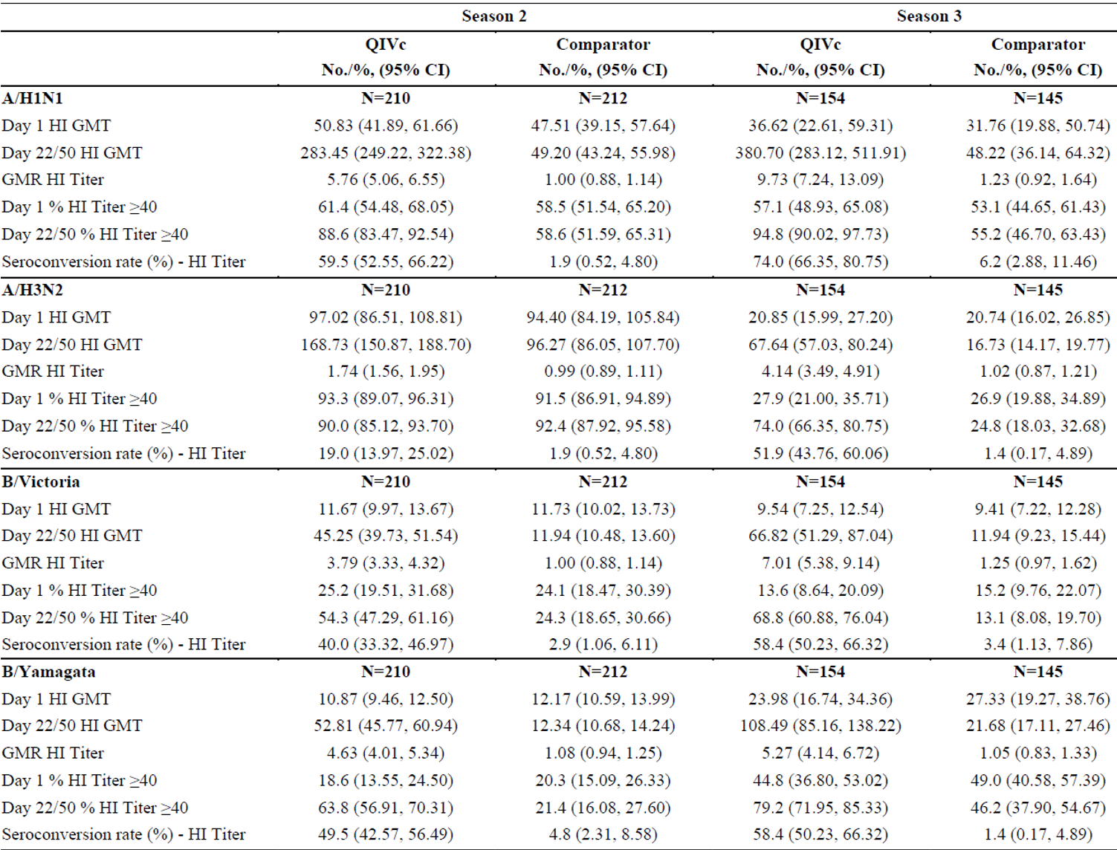

Abbreviations: CI = confidence interval; GMR = geometric mean ratio; GMT = geometric mean titre; HI = haemagglutination inhibition; N = population size; QIVc = Flucelvax Quad.

Table 4: Study V130\_12 Post-vaccination geometric mean titre, geometric mean ratio, and percentage of subjects 2 to < 9 years of age with seroconversion, with 95% confidence intervals, 21 days after last vaccination (Day 22 or Day 50) (immunogenicity full analysis set, microneutralisation)

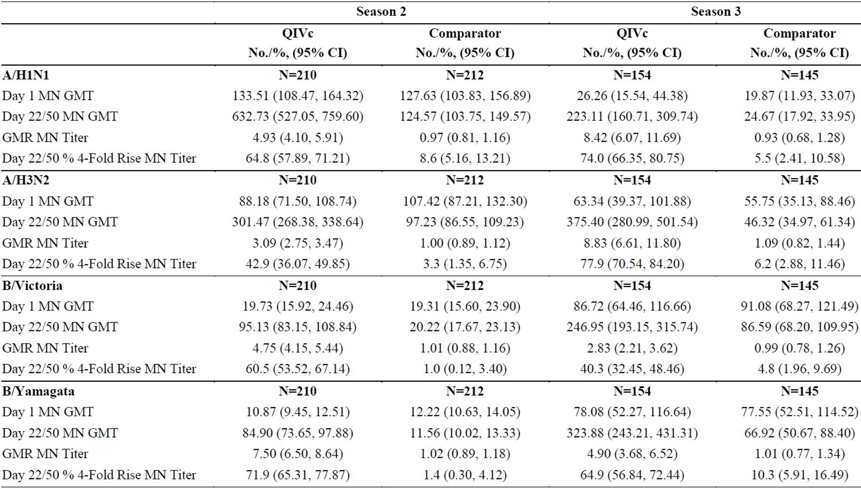

Abbreviations: CI = confidence interval; GMR = geometric mean ratio; GMT = geometric mean titre; MN = microneutralisation; N = population size; QIVc = Flucelvax Quad.

Based on the HI assay, those that received Flucelvax Quad showed increased GMT and % HI titres ≥ 1:40 between the Baseline (Day 1) and 3 weeks post the last dose (Day 22 for those vaccinated previously, and Day 50 for vaccine naïve subjects), whereas the comparator (Menveo,[[19]](#footnote-20) meningococcal ACWY vaccine) group showed no noticeable change in these parameters. In addition, the Flucelvax Quad group also showed higher GMR and seroconversion rate than the comparator group. These increases in the Flucelvax Quad group were consistent for all four strains in both seasons, with the exception of A/H3N2 % HI titre ≥ 1:40 in Season 2 (Day 1 % HI titre ≥ 1:40 was more than 90% for both Flucelvax Quad and comparator groups; Day 22/50 value 90.0% for Flucelvax Quad versus 92.4% for comparator). It was also noted that the Flucelvax Quad group’s seroconversion rate for A/H3N2 strain in Season 2 was also particularly low, but still higher than the comparator group (19.0% versus 1.9%).

The study further characterised the immune response in a subset of subjects 2 to < 9 years of age using microneutralisation assay. This assay was used to measure neutralising antibody titres against each of the 4 strains of virus in the vaccines in Season 2 and 3 in all available serum samples from subjects enrolled in the immunogenicity subset. The microneutralisation assay results are also presented as descriptive statistics. Based on the microneutralisation assay, the change in GMT between Day 1 and Day 22/50 was greater in the Flucelvax Quad group. This was also the case for other parameters such as GMR and percentage of subjects with at least 4-fold rise in the microneutralisation titre between Day 1 and Day 22/50.

#### Efficacy

##### Dose selection

There was no dose selection investigation performed in Study V130\_12. Subjects received either one or two doses (≥ 4 weeks apart) of 0.5 mL of the study vaccine based on their previous influenza vaccine status. This is in accordance with the US Advisory Committee on Immunization Practices paediatric influenza vaccine dosing recommendations and consistent with international guidelines.[[20]](#footnote-21) Such dosing regimen is also consistent with other influenza vaccine products approved for children in this age group.

Study V130\_12 is a Phase III/IV, stratified, randomised, observer blind, multicentre clinical study to evaluate the efficacy, safety and immunogenicity of a cell-based quadrivalent subunit influenza virus vaccine compared to non-influenza comparator vaccine in subjects ≥ 2 years to < 18 years of age.

##### Study participants

###### Planned

Approximately 7692 healthy male and female subjects between 2 and < 18 years of age were planned to be enrolled, randomised 1:1 between Flucelvax Quad and the comparator group (receiving Menveo, a licensed (non-influenza) meningitis vaccine)19, over a minimum of 3 influenza seasons. A subset of subjects was required to provide a blood sample and immunogenicity assessments were to be conducted. The subset was to comprise a total of maximum 444 subjects per season in the 2 to < 9 years of age cohort for the second and for the third season.

###### Analysed

A total of 4514 subjects 2 to < 18 years of age were enrolled and randomised into the study to receive Flucelvax Quad or comparator vaccine. Of these, 4513 subjects were exposed to study treatments (2258 received Flucelvax Quad and 2255 received comparator). In total, 721 subjects 2 to < 9 years of age were included in the immunogenicity analyses (364 received Flucelvax Quad and 357 received comparator).

###### Inclusion criteria

Healthy male and female subjects between 2 to < 18 years of age on the day of the first study vaccination.

###### Exclusion criteria

In order to participate in this study, all subjects must meet none of the exclusion criteria described below.

* Clinical signs of fever and/or an oral temperature of ≥ 38.0°C within 3 days prior to vaccination.
* Received influenza vaccination or had documented influenza disease in the last 6 months.
* Received prior meningococcal ACWY vaccination that conflicted with national recommendations or local practices for the timing of the primary or the booster vaccination.
* A known history of any anaphylaxis, serious vaccine reactions or hypersensitivity to any of the vaccine components.
* Medical conditions or treatments contraindicating intramuscular vaccination.
* Any clinical condition that, in the opinion of the investigator, may have interfered with the results of the study or pose additional risk to the subject due to participation in the study.

###### Treatments

The two treatments consist of an influenza vaccine (Flucelvax Quad) and a non-influenza vaccine (meningococcal ACWY vaccine, Menveo). The placebo for subjects in the non‑influenza comparator group, who were not previously vaccinated and received a second vaccination for blinding purposes, was a 0.9% saline for injection, clear, colourless liquid. The dose administered was 0.5 mL. Vaccination was performed intramuscularly, preferably in the deltoid muscle of the non‑dominant arm.

The active substance consisted of 15 μg of haemagglutinin of each of the four viral strains recommended by the WHO and CHMP for the 2017 season in the Southern Hemisphere, and seasons 2017/2018 and 2018/2019 in the Northern Hemisphere.

###### Objectives

Primary efficacy objective

To demonstrate the absolute vaccine efficacy (VE) of Flucelvax Quad versus a non‑influenza comparator determined by the first occurrence of reverse transcription polymerase chain reaction (RT-PCR) or culture confirmed influenza, due to any influenza Type A and B strain in subjects 2 to < 18 years of age. The success criterion used for this primary objective was as follows: The efficacy of the Flucelvax Quad was demonstrated if the lower limit of the 2-sided 95% confidence interval (CI) for VE was above 20%.

The co-primary efficacy objective was to be assessed on condition that the primary efficacy objective was successfully demonstrated.

Co-primary efficacy objective

To demonstrate the absolute VE of Flucelvax Quad versus a non-influenza comparator determined by the first occurrence of RT-PCR or culture confirmed influenza, due to any influenza Type A and B strain in subjects 3 to < 18 years of age. The success criterion used for this co-primary objective was as follows: The efficacy of the Flucelvax Quad was demonstrated if the lower limit of the 2-sided 95% CI for VE was above 30%.

Secondary efficacy objectives

The following objective was evaluated in the age cohorts: 2 to < 9 years of age, 4 to < 18 years of age, and 9 to < 18 years of age:

* To demonstrate absolute VE of Flucelvax Quad versus a non-influenza comparator determined by the first occurrence of RT-PCR or culture confirmed influenza due to any influenza Type A and B strain.
* To demonstrate absolute VE of Flucelvax Quad versus a non-influenza comparator determined by the first occurrence of RT-PCR confirmed influenza due to any influenza Type A and B strain.
* To demonstrate absolute VE of Flucelvax Quad versus a non-influenza comparator determined by the first occurrence of culture confirmed influenza due to any influenza Type A and B strain.
* To demonstrate absolute VE of Flucelvax Quad versus a non-influenza comparator determined by the first occurrence of culture-confirmed influenza caused by influenza strains antigenically matched to the strains selected for the seasonal vaccine.

Secondary immunogenicity objective

To characterise the immunogenicity of Flucelvax Quad by HI assay 3 weeks after the last vaccination in a subset of subjects in the age cohort 2 to < 9 years of age.

###### Outcomes and endpoints

Primary efficacy endpoints

The primary and co-primary efficacy endpoints were defined as the time from the last study vaccination to the onset of the first occurrence of either RT-PCR or culture confirmed influenza (time to event analyses) due to any influenza Type A or B strain regardless of antigenic match to the strains selected for the seasonal vaccine, that occurred more than 14 days after the last vaccination until the end of the influenza season. An influenza like illness case was defined as body temperature of ≥ 37.8°C (that is, fever) along with any of the following symptoms: cough, sore throat, nasal congestion, or rhinorrhoea. An influenza case was defined as RT-PCR confirmed or culture confirmed influenza in a subject who met the mentioned criteria for influenza like illness.

Secondary efficacy endpoints

* For secondary objective 1, the time from the last study vaccination to the onset of the first occurrence of either RT-PCR or culture confirmed influenza due to any influenza Type A or B strain regardless of antigenic match to the strains selected for the seasonal vaccine, that occurred more than 14 days after the last vaccination until the end of the influenza season.
* For secondary objective 2, the time from the last study vaccination to the onset of the first occurrence of RT-PCR confirmed influenza due to any influenza Type A or B strain regardless of antigenic match to the strains selected for the seasonal vaccine, that occurred more than 14 days after the last vaccination until the end of the influenza season.
* For secondary objective 3, the time from the last study vaccination to the onset of the first occurrence of culture confirmed influenza due to any influenza Type A or B strain regardless of antigenic match to the strains selected for the seasonal vaccine, that occurred more than 14 days after the last vaccination until the end of the influenza season.
* For secondary objective 4, the time from the last study vaccination to the onset of the first occurrence of culture confirmed influenza due to influenza Type A or B strain antigenically matched to the strains selected for the seasonal vaccine, that occurred more than 14 days after the last vaccination until the end of the influenza season.

###### Statistical analysis plan

Analysis of efficacy

Co-primary and primary VE analyses were based on the efficacy FAS and repeated on the efficacy per-protocol;[[21]](#footnote-22) set.

The primary measure of efficacy was the estimate of absolute VE of Flucelvax Quad relative to the non-influenza comparator vaccine for preventing first occurrence influenza confirmed disease by either RT-PCR confirmed or culture confirmed influenza strains contained in Flucelvax Quad and the non-influenza comparator, regardless of antigenic match.

A time to event methodology based on a proportional hazard model was used for all efficacy analyses. Absolute VE against first or only confirmed influenza cases was determined using a standard formula: absolute VE = 1 - hazard ratio (HR) where HR is the hazard ratio for influenza confirmed (either RT-PCR confirmed or culture-confirmed) influenza like illness in the Flucelvax Quad group versus the non-influenza comparator group. The HR was estimated by a proportional hazards regression model for which the following null hypothesis and alternative hypothesis were tested:

Null hypothesis: 1 - HR ≤ 0.2; versus alternative hypothesis: 1 - HR > 0.2 where HR is a hazard ratio of Flucelvax Quad versus non-influenza comparator. The primary objective was achieved if the lower limit of the 2-sided CI of the VE estimate, with at least 95% coverage in a multiple sequential hypothesis testing, exceeded 0.2 in subjects 2 to < 18 years of age.

The co-primary objective was achieved if the lower limit of the 2-sided CI of the VE estimate, with at least 95% coverage in a multiple sequential hypothesis testing, exceeded 0.3 in subjects 3 to < 18 years of age.

The model used to estimate absolute VE for the secondary efficacy objectives was similar to the model used for the primary efficacy objectives.

###### Results

Participant flow

A total of 4514 subjects were enrolled in Study V130\_12. The population used for the efficacy analysis was the efficacy FAS which included all enrolled subjects that were randomised, received at least one study vaccination, and provided efficacy data. Five enrolled subjects were excluded from the efficacy, FAS population. Efficacy analyses were repeated with the efficacy per-protocol set which included all FAS subjects that correctly received the vaccines, had no protocol deviations leading to exclusion and were not excluded due to other reasons defined prior to unblinding or analysis. In total, 9 (0.4%) subjects in the Flucelvax Quad group and 9 (0.4%) subjects in the comparator group were withdrawn from the study.

Figure 1: Study V130\_12 Study participants

Figure 1: Study V130_12 Study participants

A total of 4514 subjects were enrolled in Study V130_12.
One subject was not exposed, 2258 subjects were exposed to Flucelvax Quad, 2255 subjects were exposed to the comparator.

For the Flucelvax Quad group, one subject was excluded prior to the start of the influenza surveillance period. 2257 subjects were included in the efficacy full analysis set. 8 subjects withdrew from the study and 38 subjects were excluded from the per-protocol set, 2219 subjects were included in the efficacy per-protocol set.

For the comparator group, 3 subjects were excluded prior to the start of the influenza surveillance period. 2252 subjects were included in the efficacy full analysis set. 5 subjects withdrew from the study and 43 subjects were excluded from the per-protocol set, 2209 subjects were included in the efficacy per-protocol set.

The population used for the efficacy analysis was the efficacy full analysis set which included all enrolled subjects that were randomised, received at least one study vaccination, and provided efficacy data.

Efficacy analysis were repeated with the efficacy per protocol set which included all full analysis set subjects that correctly received the vaccines, had no protocol deviations leading to exclusion and were not excluded due to other reasons defined prior to unblinding or analysis.

Abbreviation: QIVc = Flucelvax Quad.

\* There was one subject included twice in this category (dosage error at Visit 1, vaccine was not administrated at Visit 2). The total of the subcategories is 44. This subject was counted once in the overall total of subjects excluded from the per-protocol set (n = 43).

Baseline data

Overall, 2395 subjects (53.1%) were enrolled in Southern Hemisphere countries and 2119 (46.9%) in Northern Hemisphere countries. The majority of subjects were enrolled in Season 1 (n = 2395; 53.1%) with most subjects from the Philippines (n = 1800). In Season 2, 919 subjects (20.4%) were enrolled in Estonia and Finland and 1200 (26.6%) in Season 3. Both in Season 2 and 3 the majority of subjects were enrolled in Estonia (Season 2: n = 600; Season 3: n = 598).

The population was well balanced between the sexes (48.5% female and 51.5% male). All subjects were between 2 and 18 years of age in agreement with the intended study population. The overall mean (standard deviation) age was 8.8 (4.1) years. Approximately half of the study population (50.7%) was between 2 to < 9 years of age. The youngest age category (between 2 to < 4 years of age) comprised 9.6% of the study population.

Overall, the majority (65.9%) of subjects (n = 4514) were previously vaccinated against influenza. Of the subjects 2 to < 9 years of age (n = 2289), 32.8% were previously vaccinated against influenza. All of the subjects 9 to < 18 years of age (100%) were categorised as previously vaccinated against influenza as age (9 to < 18 years of age) was used as stratify these subjects to receive one dose of study vaccine. There was no notable difference in the distribution of demographic and baseline characteristics (age, sex, race, ethnic origin or country of enrolment) between the 2 vaccine groups in the all enrolled set, nor was any difference between the 2 to < 18 (n = 4514) and 3 to < 18 years of age (n = 4414) cohorts.

In terms of pre-existing medical disorders, at least one disorder in medical history was reported for 1065 (23.6%) subjects. Overall, the percentages of subjects with medical disorders were similar in the 2 vaccine groups (23.4% versus 23.8% in the Flucelvax Quad and comparator groups, respectively), with some differences between treatment groups under the System Organ Class (SOC) ‘infections and infestations’ (205 (9.1%) versus 229 (10.2%) disorders in the Flucelvax Quad and comparator groups, respectively). This difference in the SOC was largely driven by a difference between treatment groups for upper respiratory tract infections (23 (1.0%) in Flucelvax Quad group versus 39 (1.7%) in comparator group).

The most frequently (≥ 5% overall) reported events were grouped under the SOC of ‘infections and infestations’ (434 (9.6%)), ‘respiratory, thoracic, and mediastinal disorders’ (326 (7.2%)), and ‘skin and subcutaneous tissue disorders (243 (5.4%)). The most common Preferred Terms within these groups were asthma (192 (4.3%)), atopic dermatitis (117 (2.6%)), and upper respiratory tract infection (62 (1.4%)).

##### Efficacy results

###### Primary and co-primary objectives

In the FAS efficacy, for 539 of the 4509 subjects 2 to < 18 years of age RT-PCR or culture confirmed influenza caused by any Type A or Type B strain were observed, that is, in 175 subjects in the Flucelvax Quad group (7.8%) and 364 subjects in the comparator group (16.2%). The primary efficacy objective was successfully demonstrated; therefore, the co-primary efficacy objective was assessed.

The analysis shows that Flucelvax Quad prevented RT-PCR or culture confirmed influenza caused by any Type A or B strain in subjects 2 to < 18 years of age (primary efficacy endpoint) and 3 to < 18 years of age (co-primary endpoint). The VE of Flucelvax Quad in children 2 to < 18 years of age was 54.6% (95% CI: 45.7, 62.1). The success criterion was met as the lower limit of the 2-sided 95% CI was above 20%. The VE of Flucelvax Quad in children 3 to < 18 years of age was 54.0% (95% CI: 44.8, 61.7). The success criterion was met as the lower limit of 95% CI for VE is above 30%.

Table 5: Study V130\_12 Number of subjects with first occurrence reverse transcription polymerase chain reaction confirmed or culture confirmed influenza and absolute vaccine efficacy (95% confidence interval), overall in subjects 2 to < 18 years of age and 3 to < 18 years of age (efficacy full analysis set)

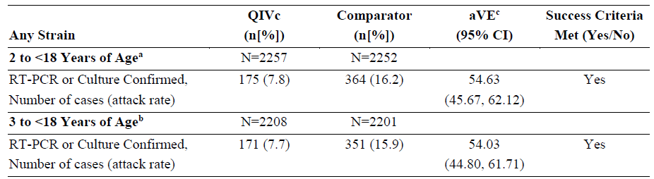

Abbreviations: aVE = absolute vaccine efficacy; CI = confidence interval; N = population size; n = sample size; QIVc = Flucelvax Quad; RT-PCR = reverse transcription polymerase chain reaction.

a. Full analysis set efficacy 1 (FAS-Eff1) included all subjects 2 to < 18 years of age who received at least one dose of study vaccine and were evaluated for efficacy from 14 days after the last vaccination (primary objective).

b. Full analysis set efficacy 2 (FAS-Eff2) included all subjects 3 to < 18 years of age who received at least one dose of study vaccine and were evaluated for efficacy from 14 days after the last vaccination (co‑primary objective).

c. Adjusted aVE is presented.

###### Secondary objectives

These were intended to demonstrate the absolute VE of Flucelvax Quad versus a non-influenza comparator determined by the first occurrence of either RT-PCR and/or culture confirmed influenza due to any Type A and B strain, and culture confirmed antigenically matched to the vaccine strains. These endpoints were evaluated in different age cohorts of 2 to < 4, 4 to < 18, 2 to < 9, and 9 to < 18 years of age.

Subjects 2 to < 4 years of age

In subjects 2 to < 4 years of age, the overall VE of Flucelvax Quad against RT-PCR or culture confirmed influenza was 62.66% (95% CI: 38.06, 77.49).

Subjects 4 to < 18 years of age

In subjects 4 to < 18 years of age, the overall VE of Flucelvax Quad against any RT-PCR or culture- confirmed influenza was 53.33% (95% CI: 43.38, 61.54).

Subjects 2 to < 9 years of age

In subjects 2 to < 9 years of age, the overall VE of Flucelvax Quad against any RT-PCR or culture confirmed influenza was 50.51% (95% CI: 38.43, 60.22).

Subjects 9 to < 18 years of age

In subjects 9 to < 18 years of age, the overall VE of Flucelvax Quad against any RT-PCR or culture confirmed influenza was 61.85% (95% CI: 47.37, 72.34).

Table 6: Study V130\_12 Number of subjects with first occurrence reverse transcription polymerase chain reaction confirmed or culture confirmed influenza and absolute vaccine efficacy (95% confidence interval), overall and by strain, in subjects 2 to < 4 years of age and 4 to <18 years of age (efficacy full analysis set)

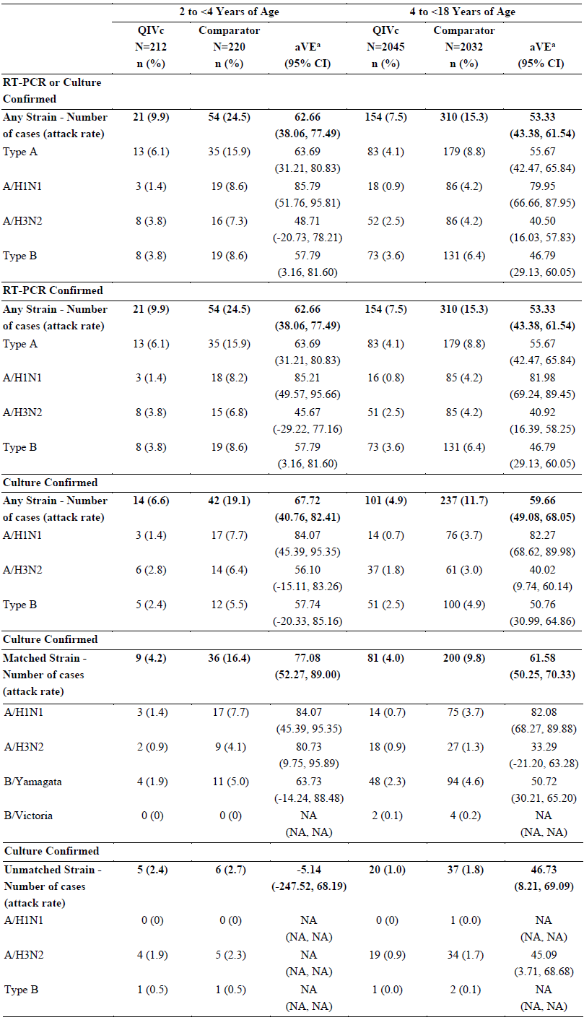

Abbreviations: aVE = absolute vaccine efficacy; CI = confidence interval; N = population size; n = sample size; QIVc = Flucelvax Quad; RT-PCR = reverse transcription polymerase chain reaction.

a. Adjusted aVE is presented.

Table 7: Study V130\_12 Number of subjects with first occurrence reverse transcription polymerase chain reaction confirmed or culture confirmed influenza and absolute vaccine efficacy (95% confidence interval), overall and by strain, in subjects 2 to < 9 years of age and 9 to < 18 years of age (efficacy full analysis set)

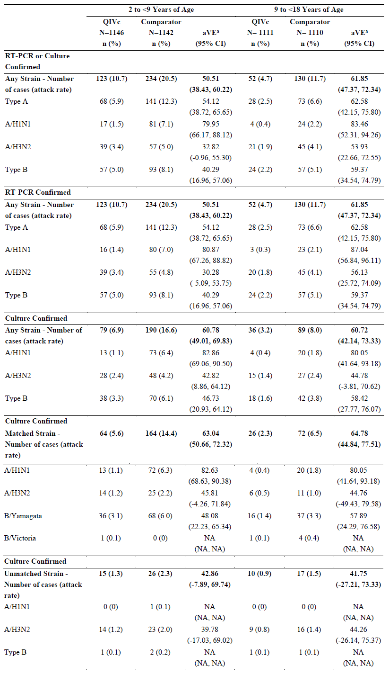

Abbreviations: aVE = absolute vaccine efficacy; CI = confidence interval; N = population size; n = sample size; QIVc = Flucelvax Quad; RT-PCR = reverse transcription polymerase chain reaction.

a. Adjusted aVE is presented.

Table 8: Study V130\_12 Number of subjects with first occurrence reverse transcription polymerase chain reaction confirmed or culture confirmed influenza and absolute vaccine efficacy (95% confidence interval), overall and by strain, in subjects 2 to < 18 years of age and 3 to < 18 years of age (efficacy full analysis set)

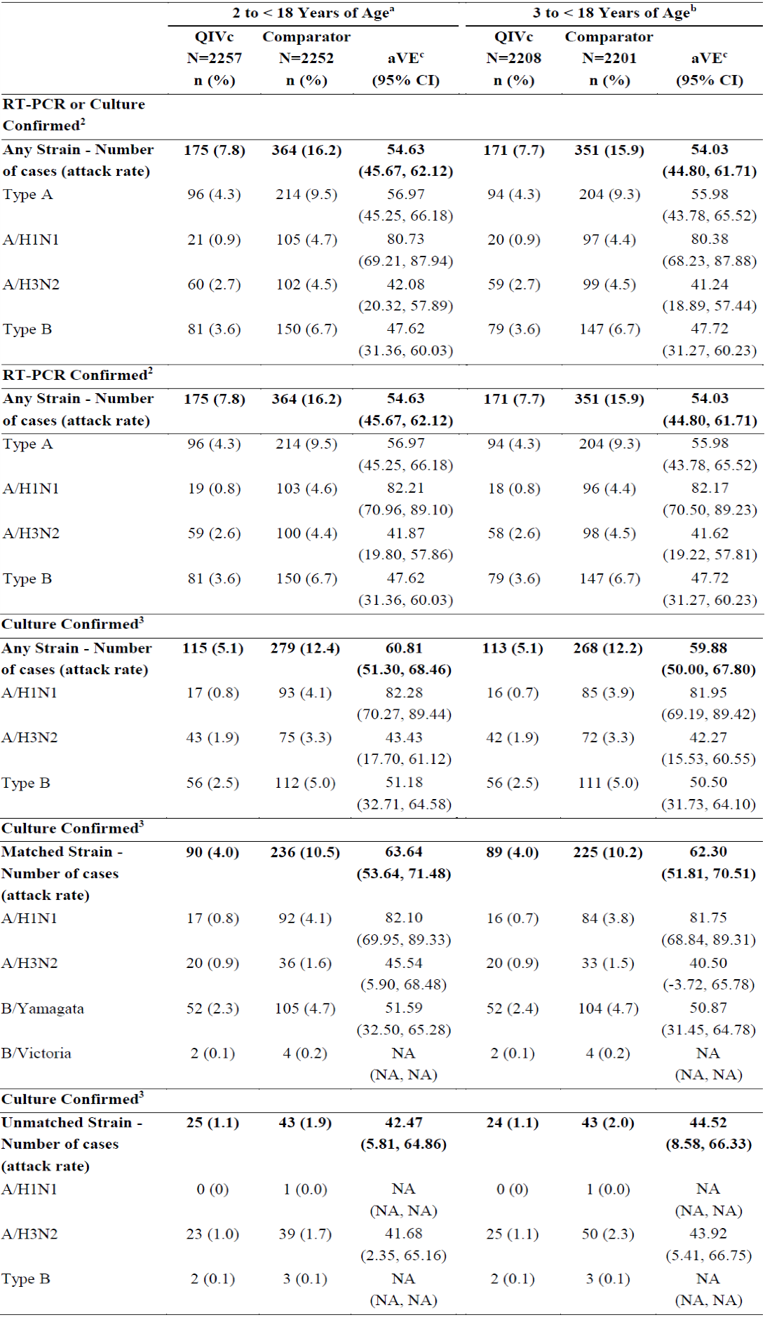

Abbreviations: aVE = absolute vaccine efficacy; N = population size; CI = confidence interval; n = sample size; QIVc = Flucelvax Quad; RT-PCR = reverse transcription polymerase chain reaction.

a. Full analysis set efficacy 1 (FAS-Eff1) included all subjects 2 to < 18 years of age who received at least one dose of study vaccine and were evaluated for efficacy from 14 days after the last vaccination (primary objective).

b. Full analysis set efficacy 2 (FAS-Eff2) included all subjects 3 to < 18 years of age who received at least one dose of study vaccine and were evaluated for efficacy from 14 days after the last vaccination (co‑primary objective).

c. Adjusted aVE is presented.

###### Results for other efficacy outcomes

Vaccine efficacy by season

In Season 1, Flucelvax Quad showed efficacy against any RT-PCR or culture confirmed strains (56.58% (95% CI: 44.18, 66.22)). The efficacy in the Flucelvax Quad group was 44.16% (19.93, 61.05) in Season 2, and 59.49% (41.03, 72.18) in Season 3.

Table 9: Study V130\_12 Number of subjects with first occurrence reverse transcription polymerase chain reaction confirmed or culture confirmed influenza and absolute vaccine efficacy (95% confidence interval), in subjects 2 to < 18 years of age by Seasons 1, 2, and 3 (efficacy full analysis set)

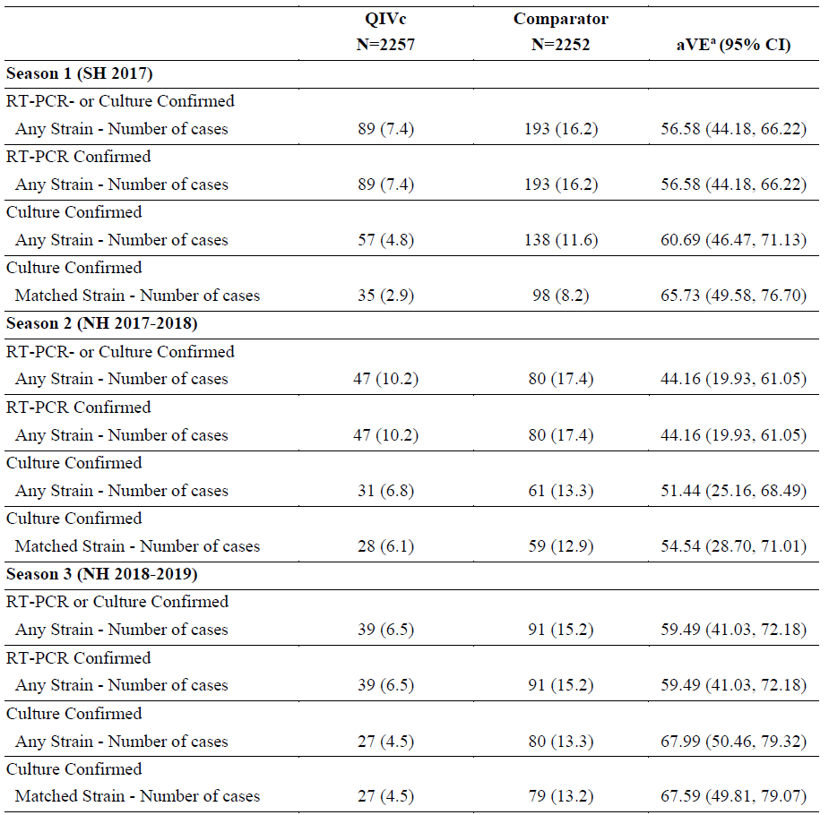

Abbreviations: aVE = absolute vaccine efficacy; CI = confidence interval; N = population size; n = sample size; NH = Northern Hemisphere; QIVc = Flucelvax Quad; RT-PCR = reverse transcription polymerase chain reaction; SH = Southern Hemisphere.

a. Adjusted aVE is presented.

The absolute VE (RT-PCR or culture confirmed, any strain) was also analysed in two other age cohorts (different from the 2 to < 18 years, or 3 to < 18 years for the primary and coprimary efficacy endpoints). The absolute VE observed were similar between in the two cases.

In addition, it is mentioned that the efficacy of Flucelvax Quad in ‘previously vaccinated’ and ‘not previously vaccinated’ including children was comparable and that there was no difference in strain specific efficacy against the different influenza strains between these two groups of influenza vaccinated subjects. This point is considered important, since the youngest children are mostly influenza naïve, and it is a potential concern that they do not respond to influenza vaccines as well as older children.

Regarding to the vaccination status, in subjects 2 to < 18 years of age, the VE of Flucelvax Quad compared with comparator vaccine for any RT-PCR or culture confirmed strain tended to be higher in subjects ‘previously vaccinated’ against influenza 58.67 (47.45, 67.50) as compared to ‘not previously vaccinated’ subjects 48.39 (32.13, 60.75). Overall, there were 314 RT-PCR or culture confirmed (178 Type A and 136 Type B) cases in ‘previously vaccinated’ compared to225 (132 Type A and 95 Type B) in ‘not previously vaccinated’ subjects. There was no difference between ‘previously vaccinated’ and ‘not previously vaccinated’ subjects in strain specific VE.

The analysis showed that VE was similar for White subjects 54.74 (41.54, 64.96) and for Asian subjects 53.70 (40.24, 64.13). There were too few subjects amongst the other racial groups to estimate VE. As expected, the VE was also similar for male subjects 54.70 (42.04, 64.59) and female subjects 54.47 (40.64, 65.08).

The exploratory evaluation of Flucelvax Quad efficacy to prevent the 2 pre-specified complications of influenza, pneumonia, and otitis media, was inconclusive (lower limit of the 2-sided 95% CI encompassing zero). Number of subjects with first occurrence pneumonia and otitis were derived from adverse event (AE) forms and reported as medically attended AE reported within 30 days after influenza like illness onset. The VE of Flucelvax Quad relative to non-influenza comparator to prevent all-cause pneumonia and all-cause otitis media was not statistically significant.

The analysis showed that VE varied across countries and was highest in Australia (VE: 93.70% (95% CI: 52.28, 99.17)). In 5 out of the 7 countries, for which the assessment could be made, Flucelvax Quad showed a statistically significant decrease in RT-PCR or culture confirmed influenza in subjects 2 to < 18 years of age, in 2 countries the VE was not statistically significant, Thailand (VE: 23.85% (95% CI: -53.10, 62.13)) and Finland (VE: 38.30% (95% CI: -2.78, 62.96)). Overall, for every country the VE against Type A was higher than against Type B. The VE against Type A was driven by the VE against Type A/H1N1 strains.

#### Safety

At the time of this submission, the approved indication for Flucelvax Quad was established for children aged 9 years and older, adolescents and adults.15 To support this application, the description of the safety of Flucelvax Quad compared to a non-influenza comparator (Menveo) in children of 2 to < 18 years of age is analysed in the clinical Study V130\_12 as a secondary objective.

The safety dataset for children comprises data derived from 4514 subjects 2 to < 18 years of age enrolled in Study V130\_12. From these, 2258 subjects received Flucelvax Quad. Approximately half of them (57.07%) were children between 2 to < 9 years of age.

In the proportion of subjects 2 to < 9 years of age, 32.8% of them had previously been immunised against influenza and received one dose of the study vaccine. The rest of them, 763 subjects, had not been previously vaccinated against influenza vaccine and received two doses of the study vaccine separated by approximately 28 days.

All of the subjects 9 to < 18 years of age (100%) were categorised as previously vaccinated against influenza and received one dose of the study vaccine or the comparator.

##### Adverse events

###### Solicited adverse events

Solicited local and systemic adverse events (AEs) in subjects 2 to < 18 years of age were recorded at 30 minutes following vaccination and from 6 hours through Day 7 after vaccination. The use of analgesics/antipyretic for prophylaxis or treatment of fever (defined as body temperature ≥ 38ºC, preferably measured orally) was evaluated.

The rates of solicited AEs reported within 30 minutes after any vaccination were low in subjects 2 to < 18 years of age, being reported as slightly higher in the Flucelvax Quad group (9.5%) compared to the comparator group (7.3%).

The percentage of subjects with any solicited AE reported from Day 1 through Day 7 after vaccination was 51.4% in the Flucelvax Quad and 48.6% in the comparator group. The rates of local and systemic solicited AEs were similar in each vaccine group.

Table 10: Study V130\_12 Number (%) of subjects 2 to < 18 years of age with at least one solicited adverse event 30 minutes postvaccination and/or Day 1 (6 hours) through 7 days after any vaccination (solicited safety set)

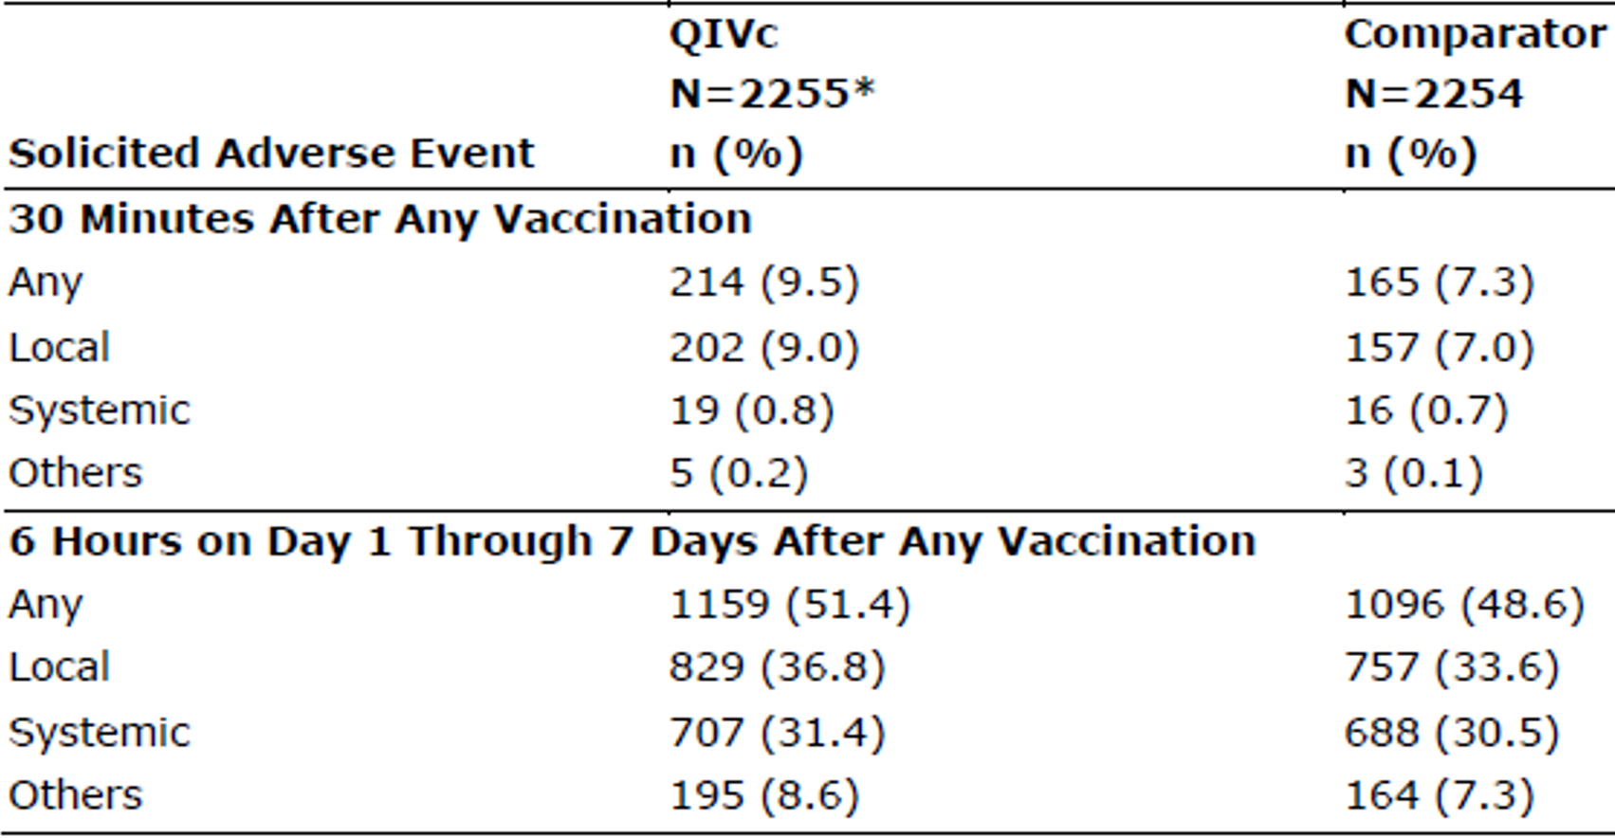

Abbreviations: N = population size; n = sample size; QIVc = Flucelvax Quad.

\* Solicited safety population. Three subjects did not return their diary card, so they were excluded from the exposed population of 2258.

###### Solicited local adverse events

The percentage of subjects with any solicited local AE reported from Day 1 (6 hours) through Day 7 after vaccination was 36.8% in the Flucelvax Quad group and 33.6% in the comparator group (see Table 11 below). No notable differences in the rate of solicited local AEs were observed between the Flucelvax Quad and the comparator, except for a slightly higher rate of pain in the Flucelvax Quad (23.8% in Flucelvax Quad group versus 19.0% in comparator group), but a slightly lower rate of induration and erythema observed in the Flucelvax Quad group versus the comparator. The most commonly reported solicited local AEs were tenderness, pain and erythema; the majority were mild to moderate in severity (the proportion of subjects with severe local AEs in Flucelvax Quad groups was ≤ 1%).

Table 11: Study V130\_12 Number (%) of subjects 2 to < 18 years of age with solicited local adverse event from 6 hours through 7 days after any vaccination (solicited safety set)

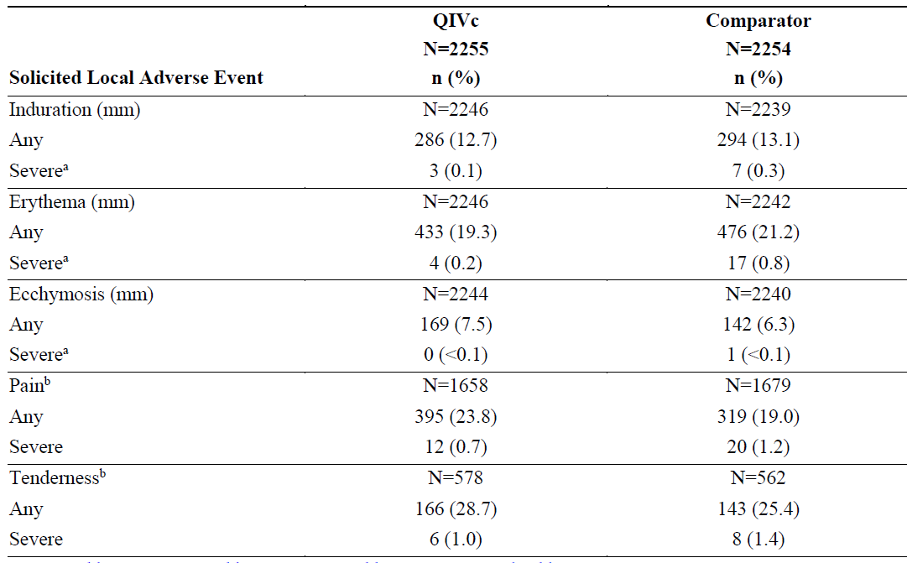

Abbreviations: N = population size; n = sample size; QIVc = Flucelvax Quad.

a. For induration, ecchymosis, and erythema, > 50 mm is severe for subjects 2 to < 6 years of age, and > 100 mm is severe for subjects ≥ 6 years of age.

b. Tenderness was collected on subject diary card for subjects 2 to < 6 years of age, whereas pain was collected on the subject diary card for subjects ≥ 6 years of age.

###### Solicited systemic adverse events

The percentage of subjects 2 to < 18 years of age with any solicited systemic AE reported from Day 1 (6 hours) through Day 7 after vaccination was 31.4% in the Flucelvax Quad group and 30.5% in the comparator group. No notable differences in the rate of solicited systemic AEs were observed between the Flucelvax Quad and the comparator. The most commonly reported solicited systemic AEs were headache, feeling fatigue or tiredness; the majority were mild to moderate in severity (the proportion of subjects with severe systemic AEs in Flucelvax Quad groups was ≤ 1%).

The proportion of subjects reporting solicited systemic AEs after any vaccination was lower in the previously vaccinated subjects, compared to the group that had received two doses of Flucelvax Quad. Additionally, in this group, the solicited systemic AEs were reported as slightly lower after the second dose than after the first dose of Flucelvax Quad.

Fever (≥ 38ºC) was reported by 5.3% and 4.5% in Flucelvax Quad and comparator group, respectively. The proportion of subjects using analgesics/antipyretics after any vaccination for prevention or treatment of pain/fever was similar for the Flucelvax Quad (6.0% and 6.2%, respectively) and for the comparator groups (5.0% and 4.8% respectively).

Table 12: Study V130\_12 Number (%) of subjects 2 to < 18 years of age with solicited systemic adverse events from 6 hours through 7 days after any vaccination (solicited safety set)

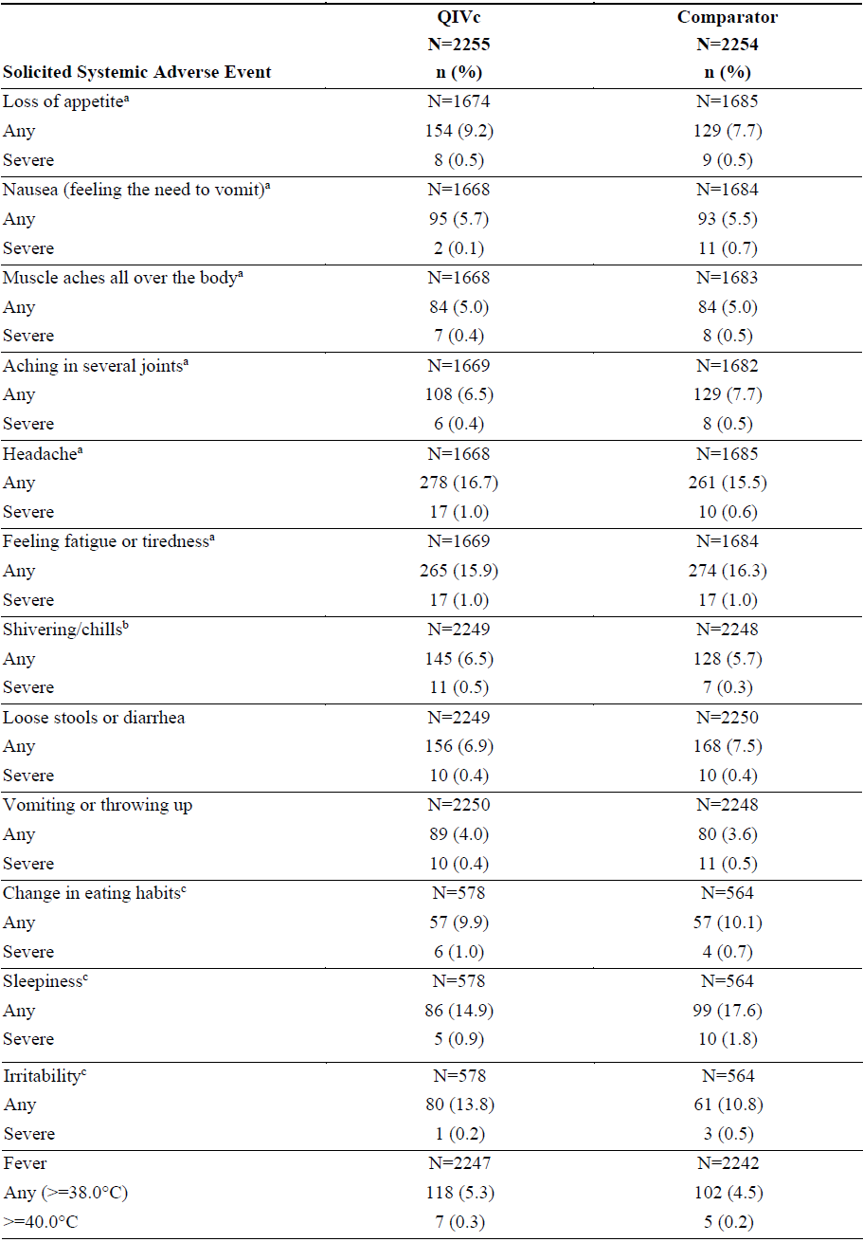

Abbreviations: N = population size; n = sample size; QIVc = Flucelvax Quad.

a. Loss of appetite, nausea (feeling the need to vomit), muscle aches all over the body, aching in several joints, headache, and feeling fatigue or tiredness were collected on the subject diary card for subjects ≥ 6 years of age only.

b. Shivering was collected on the subject diary card for subjects 2 to < 6 years of age, whereas chills was collected on the subject diary card for subjects ≥ 6 years of age.

c. Change in eating habits, sleepiness, and irritability were collected on the subject diary card for subjects 2 to < 6 years of age only.

###### Unsolicited adverse events

Unsolicited AEs were reported spontaneously through Day 22 or Day 50 depending on whether they received one or two vaccinations.

The rates of unsolicited AEs in subjects 2 to < 18 years of age during the treatment period was similar in the Flucelvax Quad group and the comparator group. Only 4.3% and 3.9% were considered to be at least possibly related to the study vaccine and comparator vaccine by the investigator.

The number (%) of subjects 2 to < 18 years of age who reported unsolicited AEs that were considered to be at least possibly related to the study vaccination, observed in > 1% in Flucelvax Quad group, were Influenza like illness (1.1%). Other unsolicited AEs considered as related to the study vaccine were reported as less than 0.7% (upper respiratory tract infection, rhinitis, rhinorrhoea, cough and nasopharyngitis).

Table 13: Study V130\_12 Overall summary of reportable treatment emergent unsolicited adverse events in subjects 2 to < 18 years of age -as treated (overall safety set)

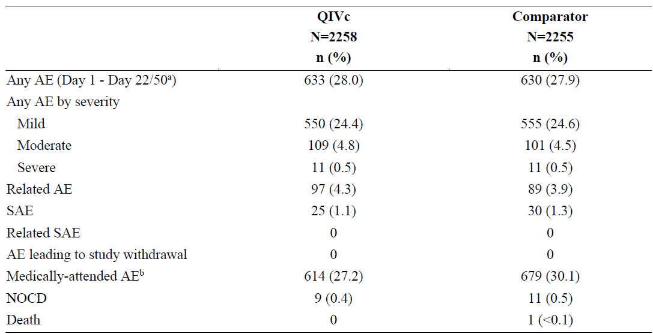

Abbreviations: AE = adverse event; N = population size; n = sample size; NOCD = new onset of chronic diseases; QIVc = Flucelvax Quad; SAE = serious adverse event.

a. Day 22 for all ‘previous vaccinated’ subjects (receiving a single vaccine dose) and Day 50 for all ‘not previously vaccinated’ subjects (receiving 2 doses).

b. Medically attended AEs were collected through the first 30 days after the first occurrence of influenza like illness.

##### Serious adverse events, deaths and other significant events

Serious adverse events (SAEs), deaths and other significant events (new onset of chronic disease, events leading to withdrawal and medically attended AEs within 30 days after the onset) were collected for up 6 months after the last vaccination.

In total, 25 (1.1%) subjects in the Flucelvax Quad group and 30 (1.3%) subjects in the comparator group reported SAEs after any vaccination with onset from Day 1 through end of study. No SAEs were assessed as related to vaccination.

One death occurred in a subject who had received the comparator vaccine.

No AEs leading to withdrawal from the study were reported.

The proportion of subjects who reported medically attended unsolicited AEs and reported AE leading to new onset of chronic disease was similar for both vaccine groups. None of the AEs leading to new onset of chronic disease was considered to be related to the study vaccine.

##### Safety in special populations

###### By age

In the analysis by age subgroups, solicited AEs data were analysed stratified in subjects 2 to < 6, 6 to < 9, and 9 to < 18 years of age. Unsolicited AEs were analysed by age groups of 2 to < 9 and 9 to < 18 years of age.

Solicited adverse events

In the analysis by age subgroups, the proportion of subjects with any solicited local AEs within 30 minutes after any vaccination were low for the Flucelvax Quad (0.4% to 1.4%) and the comparator group (0.7% to 1.4%) in all age subgroups. The most commonly reported local solicited AEs after 7 days following any vaccination for both vaccine groups were tenderness (in the 2 to < 6 years aged group), pain (in the 6 to < 9 years aged group and in 9 to < 18 years aged group) and erythema in all age groups. Additionally, the older children (9 to < 18 years of age) reported overall a slightly lower percentage of solicited AEs compared to the younger children (including pain).

In both vaccine groups, the proportion of subjects (in 2 to < 6, and in 6 to < 9 years of age group) who had not been previously vaccinated with influenza vaccine reported lower solicited local AEs after the second vaccination than after the first vaccination with Flucelvax Quad.

Regarding the solicited systemic AEs, the proportion of subjects with any solicited systemic AEs within 30 minutes after any vaccination were low. No notable differences for the Flucelvax Quad and the comparator group were observed in all age subgroups. The most commonly reported systemic solicited AEs 7 days after any vaccination were sleepiness and irritability in the 2 to < 6 age group; in the other age groups the most commonly reported systemic solicited AEs were headache and feeling fatigue or tiredness. In all age group, the incidence of these solicited AEs was < 1% in the Flucelvax Quad and the comparator group.

Additionally, the older children (9 to < 18 age group) reported slightly lower rates of fever (≥ 38ºC) compared to the younger children (2.8%, 6.4% and 8.8% in 9 to < 18, 6 to < 9 and 2 to < 6 age group, respectively).

Additionally, the older children (9 to < 18 years of age) reported overall a slightly lower percentage of solicited AEs compared to the younger children.

The most common (≥ 10%) local and systemic adverse reactions after any vaccination with Flucelvax Quad in children 6 to less than 9 years of age were pain at the injection site (27.9%), injection site erythema (22.4%), injection site induration (16.3%), fatigue (13.8%), headache (13.8%), injection site ecchymosis (10.9%) and loss of appetite (10.6%).

The most common (≥ 10%) local and systemic adverse reactions after any vaccination in children 2 to less than 6 years of age were tenderness at the injection site (28.7%), injection site erythema (20.2%), sleepiness (14.9%), irritability (13.8%), and injection site induration (13.5%).

Unsolicited adverse events

The proportion of subjects with any unsolicited AEs and any possibly related unsolicited AEs was lower in older subjects (18.1% and 2.6%) compared to the younger subjects (37.7% and 5.9%) in the Flucelvax Quad group.

###### By gender

No notable differences in frequency of subjects 2 to < 18 years of age reporting any local or systemic solicited AEs and unsolicited AEs were found between genders.

###### By vaccination status

In subgroup 2 to 6 years of age and 6 to 9 years of age the vaccine scheme was defined for influenza vaccination status. The previously vaccinated subjects received one dose and the non-previously vaccinated received 2 doses of Flucelvax Quad.

All of the subject 9 to < 18 years of age (100%) were categorised as previously vaccinated against influenza and received one dose of the study vaccine or the comparator. With respect to solicited local and systemic AEs, the proportion of subjects with solicited AEs after any vaccination was lower in the ‘previously vaccinated’ group than in the ‘not previously vaccinated’ group. In both vaccine groups, the proportion of ‘not previously vaccinated’ with any solicited AEs was lower after the second vaccination than after the first vaccination.

Regarding the unsolicited AEs, a lower proportion of subjects reporting unsolicited AEs was found in the ‘previously vaccinated’ subjects than in the ‘not previously vaccinated’ group.

#### Post-marketing experience

Flucelvax Quad was approved in the USA for prevention of influenza in persons 4 years of age and older on 23 May 2016. However, for other jurisdictions such as Europe and Canada, Flucelvax Quad was not approved for children < 2 years of age at the time this submission to extend the current indications was made to the TGA.

The most recent Flucelvax Quad periodic safety update report (PSUR)[[22]](#footnote-23) at the time of the application, dated 18 May 2020 (covers the period 16 March 2019 to 15 March 2020), reported no new safety concern in the post-market setting. Adverse events were reported from post-marketing surveillance. They included: allergic or immediate hypersensitivity reactions, including anaphylactic shock; generalised skin reactions including pruritus, urticaria or nonspecific rash; extensive swelling of injected limb and paraesthesia. These events are continuously monitored per Flucelvax Quad routine pharmacovigilance activities.

### Risk management plan

The most recently evaluated EU-risk management plan (RMP) was version 2.0 (approved 20 December 2018; data lock point (DLP) 30 May 2017) and Australia specific annex (ASA) version 1.1 (dated 7 April 2020). In support of the extended indications, the sponsor has submitted draft EU-RMP version 2.1 (dated 2 June 2020; DLP 30 January 2020) and ASA version 3.0 (dated 12 October 2020). The sponsor has not provided an updated EU‑RMP or ASA at the second round of evaluation.

The summary of safety concerns and their associated risk monitoring and mitigation strategies are summarised in Table 14. Further information regarding the TGA’s risk management approach can be found in [risk management plans for medicines and biologicals](https://www.tga.gov.au/publication/risk-management-plans-medicines-and-biologicals) and [the TGA's risk management approach](https://www.tga.gov.au/tgas-risk-management-approach).

Table 14: Summary of safety concerns

|  |  |  |  |  |  |
| --- | --- | --- | --- | --- | --- |
| Summary of safety concerns | | Pharmacovigilance | | Risk minimisation | |
| **Routine** | **Additional** | **Routine** | **Additional** |
| Important identified risks | Nil |  |  |  |  |
| Important potential risks | Nil |  |  |  |  |
| Missing information | Safety in immunocompromised patients | ✓ | – | ✓ | – |
| Safety in subjects with underlying diseases | ✓ | – | ✓ | – |
| Use in pregnant and breastfeeding women | ✓† | ✓\* | ✓ | – |

\* Pregnancy registry (multinational; no Australian patients)

† Specific follow-up forms for adverse events

* The summary of safety concerns is acceptable.
* Routine and additional pharmacovigilance activities (pregnancy registry) will be undertaken. A follow-up questionnaire is in place for use in pregnant women, as part of enhanced routine pharmacovigilance. This is acceptable. The sponsor has previously provided a commitment relating to undertaking enhanced passive surveillance, if the Australia vaccine safety system (AusVaxSafety)[[23]](#footnote-24) program does not provide this service in any particular influenza season. A condition of registration is recommended to the Delegate to facilitate TGA request for an enhanced safety surveillance study in Australia if required.
* Routine risk minimisation will be undertaken and is acceptable.

### Risk-benefit analysis

#### Delegate’s considerations

##### Efficacy

Flucelvax Quad is a quadrivalent surface antigen, inactivated, influenza vaccine, prepared in MDCK cell cultures (that is, cell-based). The efficacy, immunogenicity and safety for this submission are supported by clinical Study V130\_12 (also known as Study NCT03165617), a Phase III/IV in children 2 to < 18 years of age.

No dedicated studies for the assessment of the pharmacokinetics of the product were performed. This is considered acceptable due to the nature of the product under evaluation.

The pharmacodynamic profile of vaccines is defined by their immunogenicity profile, as detailed in the CHMP guideline. In Study V130\_12, immunogenicity endpoints were assessed by the haemagglutination inhibition (HI) and microneutralisation assay for all strains. The HI assay used for immunogenicity evaluation of influenza vaccines is considered adequate for the Study V130\_12, because it is in line with the Guideline on Influenza Vaccines.18 In light of the technical challenges with the HI assay, particularly with the A/H3N2 strain used in the vaccine in Season 2 (influenza A/Singapore/GP2050/2015), quantification of neutralising antibody titres using the microneutralisation assay against Type A/H3N2 has been used as an alternative. This is considered acceptable.

It should be mentioned that HI and microneutralisation titres are not a true surrogate marker in the sense that there is not a globally accepted cut-off titre that defines clinical protection. Nonetheless, it has been widely shown that higher titres tend to correlate with better protection. Although the immunogenicity data is descriptive and without predetermined criteria for success, the Flucelvax Quad group showed notable increases in the HI parameters. Regardless, the HI assay supports the vaccine's ability to develop immune response. This is further supported by the microneutralisation assay result. Thus, it can be considered that the vaccine induces an adequate immune response in children aged 2 to < 9 years independently on the serostatus at Baseline. As such, these results remain as supportive data for the overall clinical efficacy.

Within this application, no dose finding studies were conducted since the vaccine composition and dosing are based on the Guideline on Influenza Vaccines;18 and is also consistent with other influenza vaccine products approved for children in this age group. This is considered acceptable.

In general, the design of the Phase III/IV study conducted to evaluate clinical efficacy, safety and immunogenicity of the Flucelvax Quad in children 2 to < 18 years of age (Study V130\_12) is considered adequate. The study was carried out as observer blind. Although the optimal design would have been a double blinded trial, it is considered that the observer blind strategy used here is sufficient as it is very unlikely that this design would have affected the study outcomes.

The sample size, as the stratification by age, inclusion, exclusion criteria and statistical methods are considered satisfactory.

There was no notable difference in the distribution of demographic and baseline characteristics between the 2 vaccine groups. The percentages and reason for discontinuation were similar in the two treatment groups.

The predefined success criteria for the 2 co-primary efficacy objectives were met, demonstrating that Flucelvax Quad was efficacious in preventing influenza in children 2 to < 18 years and children 3 to < 18 years of age. The observed VE in subjects 2 to < 18 years of age (primary endpoint) was 54.63%, and the lower bound of the 95% CI was greater than 20% (95% CI: 45.67, 62.12). The observed VE in subjects 3 to < 18 years of age (co‑primary endpoint) was 54.03%, and the lower bound of the 95% CI was greater than 30%. All secondary endpoints were consistent with the primary study endpoint.

An absolute VE analyses was performed by stratifying according to the following subgroups: by age, by vaccination status, by race, by sex, by country or region, and by season/year treated. These sample sizes were not powered to evaluate efficacy and immunogenicity. These analyses supported the superior absolute VE of the vaccine versus the comparator. The study results indicate a consistent performance of Flucelvax Quad vaccine in children from 2 through 18 years of age.

##### Safety

At the time of submission, the approved indication for Flucelvax Quad was established for children aged 9 years and older, adolescents and adults.15 An additional Phase III/IV clinical study (Study V130\_12) has been provided to support the current application and indication for Flucelvax Quad for the prevention of influenza in adults and children from 2 years of age onwards. The safety database in Study V130\_12 was of 4514 subjects 2 to < 18 years of age. From these, 2258 subjects received Flucelvax Quad.

The rates of reported solicited local and systemic AEs during the treatment period (recorded at 30 minutes following vaccination and from 6 hours through Day 7 after vaccination) were comparable between the 2 vaccine groups in subjects 2 to < 18 years of age.

The rates of solicited AEs reported within 30 minutes after any vaccination were low in subjects 2 to < 18 years of age, being reported as slightly higher in the Flucelvax Quad group (9.5%) compared to the comparator group (7.3%). The percentage of subjects with any solicited AE reported from Day 1 through Day 7 after vaccination was 51.4% in the Flucelvax Quad and 48.6% in the comparator group. The most commonly reported solicited local AEs were erythema, pain and tenderness; the majority were mild to moderate in severity.

Regarding the solicited systemic AEs, similar rates were reported in each vaccine group (31.4% in the Flucelvax Quad group and 30.5% in the comparator group) as no notable differences were observed between the Flucelvax Quad and the comparator. The most commonly reported solicited systemic AEs were headache, feeling fatigue or tiredness and the majority were mild to moderate in severity. Fever (≥ 38ºC) was reported by 5.3% and 4.5% in Flucelvax Quad and comparator group, respectively.

The rates of unsolicited AEs were comparable between the 2 vaccine groups in the subjects of 2 to < 18 years of age; 4.3% and 3.9 % were considered to be at least possibly related to the study vaccine and to the comparator vaccine by the investigator.

In the subgroup analysis by age, the proportion of subjects with any solicited local and systemic AEs within the 30 minutes after any vaccination were low and comparable in both vaccine groups in all age subgroups. The solicited AEs (local and systemic) rates from 6 hours through Day 7 after any vaccination, stratified by the different age subgroups (2 to < 6, 6 to < 9 and 9 to < 18), overall had no notable differences. The majority of the reported solicited local and systemic AEs in any age group were mild to moderate in severity.

The proportion of subjects with any unsolicited AEs and any possibly related unsolicited AEs was lower in the older subjects (18.1% and 2.6%) compared to the younger subjects (37.7% and 5.9%) in the Flucelvax Quad group.

By gender, no notable differences in the frequency of solicited or unsolicited AEs were observed. The proportion of subjects with unsolicited AEs was similar in Asian and White subjects. When considering the vaccination status, the proportion of subjects with any solicited and unsolicited AEs after any vaccination was lower in the ‘previously vaccinated’ group than in the ‘not previously vaccinated’ group, in both subgroups 2 to 6 years of age and 6 to 9 years of age.

No SAEs (1.1% and 1.3% in Flucelvax Quad and comparator group, respectively) and deaths (one in comparator group) reported were assessed as related to the vaccination with the study vaccine. No AEs leading to withdrawal from the study were reported after the vaccination with Flucelvax Quad.

The post-marketing data has shown no new safety signals. However, it should be noted that the data on children < 9 years of age would be currently limited (particularly for those 2 to < 4 years of age) due to the product becoming available in this population only recently.

There are no data in certain subgroups, in particular the following, but these are adequately reflected in the PI:

* subjects with underlying diseases (such as immunocompromised) which are representative of the risk groups for influenza vaccine. However, it is noted that immune response of immunosuppressed subjects may not be optimal.
* Concomitant administration with other vaccines was not assessed, particularly those recommended in the childhood immunisation programs.

#### Proposed action

It is considered that all aspects dealing with clinical pharmacology have been well addressed.

There was a robust and substantial immune response across the 2 seasons in subjects who received Flucelvax Quad, even with seasonal differences in vaccine strains and baseline GMTs.

The primary and co-primary efficacy endpoints, absolute VE relative to comparator against any influenza Type A or B strain were achieved. The analysis showed that Flucelvax Quad prevented RT-PCR or culture confirmed influenza caused by any Type A or B strain in subjects 2 to < 18 years of age (primary efficacy endpoint) and 3 to < 18 years of age (co‑primary endpoint). All secondary endpoints were consistent with the primary study endpoint. The secondary efficacy objectives that were efficacy against RT-PCR or culture confirmed influenza in the overall study population 2 to < 18 years of age either due to any influenza type A or B strain or due to influenza type A or B antigenically matched strains were also met. The VE was also analysed in several age cohorts, with similar results to those obtained in the overall study.

The Flucelvax Quad safety profile is in general comparable to that of the non-influenza comparator vaccine. No new safety signal has been observed in the submitted clinical database. It can be concluded that Flucelvax Quad vaccine in subjects 2 to < 9 years of age does not have any clinically relevant safety issue. Therefore, the safety profile of Flucelvax Quad is considered to be adequate to support the indication for prophylaxis of influenza in subjects of 2 years of age and older.

Overall, based on the review of data on safety and efficacy, the Delegate considers that the benefit-risk balance of Flucelvax Quad is favourable in the following indication:

*For the prevention of influenza caused by influenza virus, Types A and B contained in the vaccine. The vaccine is indicated for use in adults and children 2 years of age and older.*

*For full details regarding recommendations for influenza vaccination, please refer to the relevant national immunisation guidelines.*

#### Advisory Committee considerations

The [Advisory Committee on Vaccines (ACV)](https://www.tga.gov.au/committee/advisory-committee-vaccines-acv), having considered the evaluations and the Delegate’s overview, as well as the sponsor’s response to these documents, advised the following.

##### Specific advice to the Delegate

***1. Please comment on the benefit-risk balance of Flucelvax Quad in the following indication:***

***For the prevention of influenza caused by influenza virus, Types A and B contained in the vaccine. The vaccine is indicated for use in adults and children 2 years of age and older.***

***For full details regarding recommendations for influenza vaccination, please refer to the relevant national immunisation guidelines.***

The ACV advised that Flucelvax Quad has an overall positive benefit-risk profile for the proposed indication, reflecting:

* consistent good efficacy results over 3 seasons, based on randomised clinical trial against a non-influenza comparator vaccine
* acceptable safety profile, including that high fever was rare and similar between the two vaccines
* capacity for safety and effectiveness monitoring in Australia.

##### Conclusion

The ACV considered this product to have an overall positive benefit-risk profile for the indication:

*For the prevention of influenza caused by influenza virus, Types A and B contained in the vaccine. The vaccine is indicated for use in adults and children 2 years of age and older.*

*For full details regarding recommendations for influenza vaccination, please refer to the relevant national immunisation guidelines.*

### Outcome

Based on a review of quality, safety and efficacy, the TGA approved the registration of Flucelvax Quad (quadrivalent influenza vaccine) 60 µg (15 µg x 4) haemagglutinin/0.5 mL, suspension for injection, pre-filled syringe (needle free) and pre-filled syringe (with attached needle), for the following extension of indications:

*For the prevention of influenza caused by influenza virus, Types A and B contained in the vaccine. The vaccine is indicated for use in adults and children 2 years of age and older.*

*For full details regarding recommendations for influenza vaccination, please refer to the relevant national immunisation guidelines.*

As such, the full indications at this time were:

*For the prevention of influenza caused by influenza virus, Types A and B contained in the vaccine. The vaccine is indicated for use in adults and children 2 years of age and older.*

*For full details regarding recommendations for influenza vaccination, please refer to the relevant national immunisation guidelines.*

#### Specific conditions of registration applying to these goods

* The Flucelvax Quad EU-risk management plan (RMP) (version 2.1, dated 2 June 2020, data lock point 30 January 2020), with Australian specific annex (version 3.0, dated 12 October 2020), included with Submission PM-2020-05368-1-2, and any subsequent revisions, as agreed with the TGA will be implemented in Australia.

An obligatory component of risk management plans is routine pharmacovigilance. Routine pharmacovigilance includes the submission of periodic safety update reports (PSURs).

Reports are to be provided in line with the current published list of EU reference dates and frequency of submission of PSURs until the period covered by such reports is not less than three years from the date of the approval letter.

The reports are to at least meet the requirements for PSURs as described in the European Medicines Agency’s Guideline on Good Pharmacovigilance Practices (GVP) Module VII periodic safety update report (Rev 1), Part VII.B Structures and processes.

Note that submission of a PSUR does not constitute an application to vary the registration.

* The sponsor must conduct an enhanced safety surveillance study in Australia, if requested by TGA. A protocol for the proposed study will be required to be submitted with the annual strain update variation, if there is inadequate post-market safety data to demonstrate that the reactogenicity of that season’s vaccine has been adequately characterised and the vaccine is not supplied on the National Immunisation Program in that season.
* For all injectable products the Product Information must be included with the product as a package insert.

## Attachment 1. Product Information

The PI for Flucelvax Quad approved with the submission which is described in this AusPAR is at Attachment 1. For the most recent PI, please refer to the TGA [PI/CMI search facility.](https://www.tga.gov.au/picmi-search-facility)

|  |
| --- |
| Therapeutic Goods Administration |
| PO Box 100 Woden ACT 2606 Australia  Email: [info@tga.gov.au](mailto:info@tga.gov.au) Phone: 1800 020 653 Fax: 02 6232 8605  [**https://www.tga.gov.au**](https://www.tga.gov.au) |

1. The **Black Triangle Scheme** provides a simple means for practitioners and patients to identify certain types of new prescription medicines, including those being used in new ways and to encourage the reporting of adverse events associated with their use. The Black Triangle does not denote that there are known safety problems, just that the TGA is encouraging adverse event reporting to help us build up the full picture of a medicine's safety profile. [↑](#footnote-ref-2)
2. World Health Organization (WHO), Influenza (Seasonal), last updated 6 November 2018. Available at: <https://www.who.int/en/news-room/fact-sheets/detail/influenza-(seasonal)>. [↑](#footnote-ref-3)
3. World Health Organization (WHO) Regional office for Europe, How Pandemic Influenza Emerges, 2022. Available at: <https://www.euro.who.int/en/health-topics/communicable-diseases/influenza/pandemic-influenza/how-pandemic-influenza-emerges>. [↑](#footnote-ref-4)
4. The Australian Influenza Vaccine Committee (AIVC) provides advice to the TGA on the composition of the seasonal influenza vaccine to be supplied each year in Australia. For further details, please refer to: <https://www.tga.gov.au/about-tga/advisory-bodies-and-committees/australian-influenza-vaccine-committee-aivc>. [↑](#footnote-ref-5)
5. Australian Institute of Health and Welfare (AIHW) Influenza in Australia, 2018. Available at: <https://www.aihw.gov.au/getmedia/2623df7f-794f-4712-94e4-65442323784e/aihw-phe-236_Influenza.pdf.aspx>. [↑](#footnote-ref-6)
6. The National Immunisation Program (NIP) provides free vaccines to eligible people to help reduce diseases that can be prevented by vaccination. For further details, please refer to: <https://www.health.gov.au/initiatives-and-programs/national-immunisation-program>. [↑](#footnote-ref-7)
7. Australian Government Department of Health, National Immunisation Program Schedule, last updated 14 January 2022. Available at: <https://www.health.gov.au/health-topics/immunisation/immunisation-throughout-life/national-immunisation-program-schedule#flu-influenza-vaccines>. [↑](#footnote-ref-8)
8. Fluarix Tetra was first registered on the ARTG on 28 August 2013 (ARTG number: 200674). [↑](#footnote-ref-9)
9. Afluria Quad was first registered on the ARTG on 22 July 2016 (ARTG number: 262428). [↑](#footnote-ref-10)
10. Fluad Quad was first registered on the ARTG on 1 October 2019 (ARTG number: 316323 and 313724). [↑](#footnote-ref-11)
11. Influvac Tetra was first registered on the ARTG on 2 November 2017 (ARTG number: 281035, 292237 and 292238). [↑](#footnote-ref-12)
12. FluQuadri was first registered on the ARTG on 2 December 2014 (ARTG number: 213963). [↑](#footnote-ref-13)
13. Vaxigrip Tetra was first registered on the ARTG on 20 May 2019 (ARTG number: 299922 and 315082). [↑](#footnote-ref-14)
14. Hegde, N.R. Cell Culture-Based Influenza Vaccines: A Necessary and Indispensable Investment for the Future, *Hum Vaccin Immunother*, 2015; 11(5): 1223-1234. [↑](#footnote-ref-15)
15. AusPAR for Flucelvax Quad (influenza virus haemagglutinin) Seqirus Pty Limited, new biological entity, published on 24 December 2020. Available at: <https://www.tga.gov.au/resources/auspar/auspar-influenza-virus-haemagglutinin-1>. [↑](#footnote-ref-16)
16. The Medicines and Healthcare products Regulatory Agency (MHRA) have granted Flucelvax Quad (QIVc) a license for Great Britain with approval backdated to 1 January 2021 to match the date of the United Kingdom’s exit from the European Union. The license is aligned with the European Union registration, including effective approval dates up to 1 January 2021. [↑](#footnote-ref-17)
17. European Medicines Evaluation Agency (EMEA), Committee for Medicinal Products for Human Use (CHMP), Guideline on Clinical Evaluation of New Vaccines, EMEA/CHMP/VWP/164653/2005, 18 October 2006. [↑](#footnote-ref-18)
18. European Medicines Agency (EMA), Committee for Medicinal Products for Human Use (CHMP), Guideline on Influenza Vaccines - Non-clinical and Clinical Module, EMA/CHMP/VWP/457259/2014, 21 July 2016. [↑](#footnote-ref-19)
19. Menveo was first registered on the ARTG on 6 August 2010 (ARTG number: 158477). [↑](#footnote-ref-20)
20. Grohskopf, L.A. et al. Prevention and Control of Influenza with Vaccines: Recommendations of the Advisory Committee on Immunization Practices, United States, 2015-16 Influenza Season, *MMWR Morb Mortal Wkly Rep*, 2015; 64(30): 818-825. [↑](#footnote-ref-21)
21. The **per-protocol (PP)** analysis is restricted to the participants who strictly adhered to the protocol. Also known as ‘on-treatment’ analysis. [↑](#footnote-ref-22)
22. A **periodic safety update report (PSUR)** is a systematic review of the global safety data of an approved medicine that becomes available during a defined time period. PSURs are also referred to as periodic benefit–risk evaluation reports (PBRERs). [↑](#footnote-ref-23)
23. The Australia vaccine safety system (AusVaxSafety) is a multi-component system, including active surveillance, clinical assessment network, hospital surveillance, and safety investigation using linked data. For further details, please refer to: <https://ausvaxsafety.org.au/about-us>. [↑](#footnote-ref-24)