|  |
| --- |
| **January 2023** |

|  |
| --- |
| Australian Public Assessment Report for Ngenla |
| Active ingredient: Somatrogon |
| Sponsor: Pfizer Australia Pty Ltd |

About the Therapeutic Goods Administration (TGA)

* The Therapeutic Goods Administration (TGA) is part of the Australian Government Department of Health and is responsible for regulating medicines and medical devices.
* The TGA administers the *Therapeutic Goods Act 1989* (the Act), applying a risk management approach designed to ensure therapeutic goods supplied in Australia meet acceptable standards of quality, safety and efficacy (performance) when necessary.
* The work of the TGA is based on applying scientific and clinical expertise to decision-making, to ensure that the benefits to consumers outweigh any risks associated with the use of medicines and medical devices.
* The TGA relies on the public, healthcare professionals and industry to report problems with medicines or medical devices. TGA investigates reports received by it to determine any necessary regulatory action.
* To report a problem with a medicine or medical device, please see the information on the TGA website <<https://www.tga.gov.au>>.

About AusPARs

* An Australian Public Assessment Report (AusPAR) provides information about the evaluation of a prescription medicine and the considerations that led the TGA to approve or not approve a prescription medicine submission.
* AusPARs are prepared and published by the TGA.
* An AusPAR is prepared for submissions that relate to new chemical entities, generic medicines, major variations and extensions of indications.
* An AusPAR is a static document; it provides information that relates to a submission at a particular point in time.
* A new AusPAR will be developed to reflect changes to indications and/or major variations to a prescription medicine subject to evaluation by the TGA.

Copyright

© Commonwealth of Australia 2023  
This work is copyright. You may reproduce the whole or part of this work in unaltered form for your own personal use or, if you are part of an organisation, for internal use within your organisation, but only if you or your organisation do not use the reproduction for any commercial purpose and retain this copyright notice and all disclaimer notices as part of that reproduction. Apart from rights to use as permitted by the *Copyright Act 1968* or allowed by this copyright notice, all other rights are reserved and you are not allowed to reproduce the whole or any part of this work in any way (electronic or otherwise) without first being given specific written permission from the Commonwealth to do so. Requests and inquiries concerning reproduction and rights are to be sent to the TGA Copyright Officer, Therapeutic Goods Administration, PO Box 100, Woden ACT 2606 or emailed to <[tga.copyright@tga.gov.au](mailto:tga.copyright@tga.gov.au)>.

Contents

List of abbreviations 4

I. Introduction to product submission 6

Submission details 6

Product background 8

Regulatory status 9

Product Information 10

II. Registration timeline 10

III. Submission overview and risk/benefit assessment 11

Quality 11

Nonclinical 13

Clinical 15

Risk management plan 27

Risk-benefit analysis 28

Outcome 31

Attachment 1. Product Information 32

## List of abbreviations

|  |  |
| --- | --- |
| Abbreviation | Meaning |
| ACM | Advisory Committee on Medicines |
| ADA | Anti-drug antibody |
| AE | Adverse event |
| ANCOVA | Analysis of covariance |
| ARGPM | Australian Regulatory Guidelines for Prescription Medicines |
| ASA | Australia specific annex |
| ARTG | Australian Register of Therapeutic Goods |
| AUC | Area under the concentration-time curve |
| BMI | Body mass index |
| BP3 | Binding protein 3 |
| CHMP | Committee for Medicinal Products for Human Use (European Medicines Agency, European Union) |
| CI | Confidence interval |
| Cmax | Maximum concentration |
| CMI | Consumer Medicines Information |
| CPD | Certified Product Details |
| CTP | C-terminal peptide |
| CYP3A4 | Cytochrome P450 isozyme 3A4 |
| DLP | Data lock point |
| DNA | Deoxyribonucleic acid |
| EMA | European Medicines Agency (European Union) |
| EU | European Union |
| FDA | Food and Drug Administration (United States of America) |
| GLP | Good Laboratory Practice(s) |
| GVP | Good Pharmacovigilance Practice(s) |
| hGH | Human growth hormone |
| rhGH | Recombinant human growth hormone |
| IGF-1 | Insulin-like growth factor 1 |
| IFU | Instructions for Use |
| LT | Long-term |
| OLE | Open label extension |
| PD | Pharmacodynamic(s) |
| PDF | Portable document format |
| PI | Product Information |
| PK | Pharmacokinetic(s) |
| PopPK | Population pharmacokinetic |
| PSUR | Periodic safety update report |
| RMP | Risk management plan |
| SD | Standard deviation |
| SDS | Standard deviation score |
| SHOX | Short stature homeobox containing |

## I. Introduction to product submission

### Submission details

|  |  |
| --- | --- |
| *Type of submission:* | New biological entity |
| *Product name:* | Ngenla |
| *Active ingredient:* | Somatrogon |
| *Decision*: | Approved |
| *Date of decision:* | 23 November 2021 |
| *Date of entry onto ARTG:* | 30 November 2021 |
| *ARTG numbers:* | 349990 and 350035 |
| *Black Triangle Scheme:[1]* | Yes.  This product will remain in the scheme for 5 years, starting on the date the product is first supplied in Australia. |
| *Sponsor’s name and address:* | Pfizer Australia Pty Ltd  Level 17, 151 Clarence Street  Sydney NSW 2000 |
| *Dose form:* | Solution for injection |
| *Strengths:* | 24 mg and 60 mg |
| *Container:* | Cartridge (prefilled pen) |
| *Pack size:* | One |
| *Approved therapeutic use:* | *Ngenla is indicated for the long-term treatment of paediatric patients with growth disturbance due to insufficient secretion of growth hormone.* |
| *Route of administration:* | Subcutaneous |
| *Dosage:* | Ngenla is presented as a single-patient-use disposable prefilled pen containing either:   * somatrogon 24 mg/1.2 mL that delivers a dose in 0.2 mg increments; or * somatrogon 60 mg/1.2 mL that delivers a dose in 0.5 mg increments.   The prefilled pen is capable of setting and delivering a dose, which is variable, and is determined based on patient body weight.  The recommended dose is 0.66 mg/kg body weight administered once weekly by subcutaneous injection.  For patients switching from daily growth hormone products, weekly therapy with Ngenla may be initiated at a dose of 0.66 mg/kg/week on the day following their last daily injection.  Regular monitoring of insulin-like growth factor-1 (IGF-1) concentrations is recommended during treatment with Ngenla. When monitoring for IGF-1, samples should always be drawn 4 days after the prior dose. The target IGF-1 standard deviation score (SDS) should be the upper normal range not exceeding 2 SDS.  Ngenla dosage may be adjusted as necessary, based on growth velocity, body weight and serum IGF-1 concentration. In patients whose blood IGF-1 concentrations exceed the mean reference value for their age and sex by more than 2 SDS, the dose of Ngenla should be reduced by 15%. More than one dose reduction may be required in some patients. Monitor growth rate closely during the first year of Ngenla treatment. If a patient’s growth rate fails to increase in the first year, assess for treatment adherence and other causes of growth failure (for example, hypothyroidism, undernutrition, advanced bone age) and consider discontinuation of Ngenla treatment.  Treatment should be discontinued when there is evidence of closure of the epiphyseal growth plates.  There is no clinical trial experience with doses of Ngenla above a dose of 0.66 mg/kg/week.  Ngenla must not be given by any other route of administration including intravenous (IV) or intramuscular (IM) injection.  Ngenla can be given via subcutaneous injection in the abdomen, thighs, buttocks, or upper arms. The injection site should be rotated weekly. If more than one injection is required to deliver a complete dose, each injection should be administered at a different injection site.  Administer Ngenla once weekly, on the same day each week, at any time of the day. The day of weekly administration can be changed if necessary, as long as the time between the two doses is at least 3 days (72 hours).  If a dose is missed, administer Ngenla as soon as possible within 3 days after the missed dose. If more than 4 days have passed, skip the missed dose and administer the next dose on the regularly scheduled day. In each case, patients can then resume their regular once weekly dosing schedule.  For further information regarding dosage, refer to the Product Information. |
| *Pregnancy category:* | B1  Drugs which have been taken by only a limited number of pregnant women and women of childbearing age, without an increase in the frequency of malformation or other direct or indirect harmful effects on the human fetus having been observed.  Studies in animals have not shown evidence of an increased occurrence of fetal damage.  The use of any medicine during pregnancy requires careful consideration of both risks and benefits by the treating health professional. This must not be used as the sole basis of decision making in the use of medicines during pregnancy. The TGA does not provide advice on the use of medicines in pregnancy for specific cases. More information is available from obstetric drug information services in your State or Territory. |

### Product background

This AusPAR describes the application by Pfizer Australia Pty Ltd (the sponsor) to register Ngenla (somatrogon) 24 mg and 60 mg, solution for subcutaneous injection via single‑patient-use disposable prefilled pens for the following proposed indication:

*Ngenla is indicated for the long term treatment of paediatric patients with growth disturbance due to insufficient secretion of growth hormone.*

Growth hormone (somatropin) is a peptide hormone that is synthesised and secreted by the somatotropic cells of the anterior pituitary gland. The main action of growth hormone is to stimulate linear growth in children; however, it also fosters a healthy body composition by increasing muscle and reducing fat mass, maintains normal blood glucose levels, and promotes a favourable lipid profile.[2]

Growth hormone (somatropin) is used in children and adults with established growth hormone deficiency to restore growth and metabolic function. Somatropin is also used in a number of other conditions associated with growth failure as clinical studies have shown benefits in these conditions. Somatropin is also used in Prader Willi syndrome to improve growth reverse body composition abnormalities. There are a number of different brands of somatropin registered in Australia. These have been registered as new formulations.

Via the Pharmaceutical Benefit Scheme (PBS) the Australian Government funds treatment with growth hormone in children and adults that fulfil strict criteria.[3] Growth hormone is generally prescribed by specialist adult or paediatric endocrinologists. Replacement growth hormone therapy has been used for over 30 years in the treatment paediatric growth hormone deficiency.

According to a report from the national growth-hormone database (OZGROW);[4] in 2011, 1730 children were receiving growth hormone treatment in Australia.[5] Of these, 49.1% were receiving subsidised growth hormone treatment for short stature and slow growth, 20.6% were receiving growth hormone treatment for biochemical growth hormone deficiency. In Australia, growth hormone is dosed in milligrams per body surface area (mg/m2). Internationally, endocrinologist use milligrams per kilogram bodyweight dosing (mg/kg).

The current treatment options of somatropin preparations includes Genotropin (by Pfizer Australia Pty Ltd),[6] Omnitrope (by Sandoz Pty Ltd),[7] Norditropin (by Novo Nordisk Pharmaceuticals Pty Ltd),[8] Humatrope (by Eli Lilly Australia Pty Ltd),[9] Saizen (by Merck Healthcare Pty Ltd),[10] Nutropin (by Ipsen Pty Ltd),[11] and SciTropin A (by SciGen Australia Pty Ltd).[12]

The sponsor’s rationale for developing this formulation was to improve compliance with treatment.

Somatrogon is a glycoprotein produced in Chinese hamster ovary cells by recombinant deoxyribonucleic acid (DNA) technology. It is comprised of the amino acid sequence of human growth hormone (hGH) with one copy of the of C-terminal peptide (CTP) from the beta chain of human chorionic gonadotropin (hCG) at the N-terminus and two copies of CTP (in tandem) at the C-terminus. The glycosylation and CTP domains account for the half-life of somatrogon, which allows for weekly dosing.

This submission was evaluated as part of the [Australia-Canada-Singapore-Switzerland-United Kingdom (ACCESS) Consortium](https://www.tga.gov.au/australia-canada-singapore-switzerland-united-kingdom-access-consortium) with work-sharing between the TGA and Health Canada. Each regulator made independent decisions regarding approval (market authorisation) of the new medicine.

### Regulatory status

This product is considered a new biological entity for Australian regulatory purposes.

At the time the TGA considered this application, a similar application had been approved in Canada on 26 October 2021 and in the European Union (EU) on 14 February 2022. Similar applications were under consideration in the United States of America (submitted on 22 October 2020), and Switzerland (submitted on 1 March 2021).

The following table summarises these submissions and provides the indications where approved.

Table 1: International regulatory status

|  |  |  |  |
| --- | --- | --- | --- |
| Region | Submission date | Status | Approved indications |
| United States of America | 22 October 2020 | Under consideration | Under consideration |
| Canada | November 2020 | Approved on 26 October 2021 | *Long term treatment of pediatric patients who have growth failure due to an inadequate secretion of endogenous growth hormone (growth hormone deficiency).* |
| European Union | 3 February 2021 | Approved on 14 February 2022 | *Ngenla is indicated for the treatment of children and adolescents from 3 years of age with growth disturbance due to insufficient secretion of growth hormone.* |
| Switzerland | 1 March 2021 | Under consideration | Under consideration |

### Product Information

The Product Information (PI) approved with the submission which is described in this AusPAR can be found as Attachment 1. For the most recent PI, please refer to the TGA [PI/CMI search facility.](https://www.tga.gov.au/picmi-search-facility)

## II. Registration timeline

The following table captures the key steps and dates for this submission.

Table 2: Timeline for Submission PM-2020-05916-1-5

|  |  |
| --- | --- |
| Description | Date |
| Submission dossier accepted and first round evaluation commenced | 4 January 2021 |
| First round evaluation completed | 28 May 2021 |
| Sponsor provides responses on questions raised in first round evaluation | 29 July 2021 |
| Second round evaluation completed | 21 September 2021 |
| Delegate’s Overall benefit-risk assessment | 16 November 2021 |
| Sponsor’s pre-Advisory Committee response | Not applicable |
| Advisory Committee meeting | Not applicable |
| Registration decision (Outcome) | 23 November 2021 |
| Completion of administrative activities and registration on the ARTG | 30 November 2021 |
| Number of working days from submission dossier acceptance to registration decision* | 182 |

*Statutory timeframe for standard applications is 255 working days

## III. Submission overview and risk/benefit assessment

A summary of the TGA’s assessment for this submission is provided below.

This section is a TGA summary of wording used in TGA’s evaluation report, which discussed numerous aspects of overseas evaluation reports and included some information that was commercial-in-confidence.

The following guideline was referred to by the Delegate as being relevant to this submission:

* European Medicines Agency (EMA), Committee for medicinal products for human use (CHMP), ICH guideline S6 (R1) - preclinical safety evaluation of biotechnology-derived pharmaceuticals, EMA/CHMP/ICH/731268/1998, dated June 2011.

### Quality

Somatrogon finished product Ngenla is a solution for subcutaneous injection presented at the concentration of 20 mg/mL or 50 mg/mL. The product is available in a prefilled pen cartridge (type I glass) with a siliconised cartridge plunger stoper that is pre-capped with an aluminium overseal containing the bilayer elastomer disc seal. One cartridge of 1.2 mL Ngenla (Somatrogon) contains 24 mg (20 mg/mL) or 60 mg (50 mg/mL) of somatrogon.

Somatrogon active substance is stored and shipped to the finished product manufacturing facility at controlled conditions. Details of the drug substance container, compatibility of the container and a summary of an extractable and leachable study was presented and concluded that the risk for patients due to substances leaching into somatrogon active substance is negligible.

The overall quality of the active substance was demonstrated via adequate control of the starting material, control of critical steps and intermediates, process validation, extensive characterisation using orthogonal and state of the art analytical methods, control of impurities and contaminants, generation of robust reference materials and batch analyses that covered multiple manufacturing campaigns.

Ngenla prefilled pen is available in two presentations as compared in Table 2, shown below.

Table 2: Comparison between 24 mg and 60 mg prefilled pens

|  |  |  |
| --- | --- | --- |
|  | 24 mg prefilled pen | 60 mg prefilled pen |
| Somatrogon solution concentration | 20 mg/mL | 50 mg/mL |
| Volume | 1.2 mL | 1.2 mL |
| Colour | Lilac pen cap, injection button and label | Blue pen cap, injection button and label |
| Dose increments | 0.2 mg/ 0.01 mL | 0.5 mg/ 0.01 mL |
| Maximum single dose | 12 mg (0.6 mL) | 30 mg (0.6 mL) |

Chemical and physical in-use stability has been demonstrated for 28 days from the date of first use of the prefilled pen, when the prefilled pen has been stored at 2°C to 8°C in between each use.

Ngenla (somatrogon) prefilled pens have the following storage conditions:

* Before first use, Ngenla should be stored at 2°C to 8°C (refrigerate, do not freeze). Store in the original carton and away from direct sunlight.
* Do not freeze Ngenla or expose Ngenla to heat. Do not use Ngenla if it has been frozen.
* Unused prefilled pens may be used until the expiration date printed on the carton, only if the pen has been kept in the refrigerator.
* After first use of Ngenla, the pen can be stored for up to 28 days of use in a refrigerator (2°C to 8°C).
* Always remove and safely discard the needle after each injection and store the Ngenla prefilled pen without an injection needle attached. Always use a new needle for each injection. Replace the cap on the prefilled pen when it is not in use.
* Store the prefilled pen at 2°C to 8°C in between each use.
* Do not expose the Ngenla to temperatures above 32°C, or leave it at room temperature for more than two hours with each use.
* The prefilled pen should not be used more than 28 days after first use and should not be used beyond the expiration date.
* The same prefilled pen should not be used more than 5 times.
* The Ngenla pen should be discarded if it has been more than 28 days after first use or it has been used 5 times, or if it has been exposed to temperatures above 32°C, or left out of the refrigerator for more than two hours with each use.

#### Conclusions and recommendations

There were no objections to the registration of this product on quality grounds. The sponsor adequately demonstrated compliance with all relevant standards.

#### Quality related proposed conditions of registration

Laboratory testing and compliance with Certified Product Details (CPD)

* All batches of Ngenla supplied in Australia must comply with the product details and specifications approved during evaluation and detailed in the Certified Product Details (CPD).
* When requested by the TGA, the Sponsor should be prepared to provide product samples, specified reference materials and documentary evidence to enable the TGA to conduct laboratory testing on the Product. Outcomes of laboratory testing are published biannually in the TGA Database of Laboratory Testing Results <http://www.tga.gov.au/ws-labs-index> and periodically in testing reports on the TGA website.

##### Certified Product Details

The Certified Product Details (CPD), as described in Guidance 7: Certified Product Details of the Australian Regulatory Guidelines for Prescription Medicines (ARGPM) (<http://www.tga.gov.au/industry/pm-argpm-guidance-7.htm>), in portable document format (PDF), for the above products should be provided upon registration of these therapeutic goods. In addition, an updated CPD should be provided when changes to finished product specifications and test methods are approved in a Category 3 application;[13] or notified through a self-assessable change.

### Nonclinical

The scope of the nonclinical program was in accordance with the relevant TGA‑adopted guideline.[14] All pivotal safety related studies were Good Laboratory Practice (GLP)[15] compliant.

*In vitro*, somatrogon was shown to possess nanomolar affinity for the human growth hormone (hGH) receptor (and bind to the rat and monkey forms of the receptor with similar affinity). Activation of the growth hormone receptor was demonstrated in cell-based assays. *In vivo*, somatrogon increased body weight gain and serum insulin-like growth factor‑1 (IGF-1) levels in hypophysectomised rats, supporting utility in the proposed indication. Such pharmacological effects were also apparent in the toxicity studies conducted in (intact) rats and monkeys.

The N-methyl-D-aspartate (NMDA) receptor was identified as a secondary target for somatrogon in screening assays. This was seen for recombinant human growth hormone (rhGH/somatropin) too. The finding does not appear to be clinically relevant. No central nervous system effects were apparent in treated animals, nor on the respiratory system or electrocardiogram.

The pharmacokinetic profile of somatrogon was characterised by slow absorption after subcutaneous administration, and a serum half-life substantially longer than for rhGH (somatropin). A shorter serum half-life of somatrogon in laboratory animal species as compared with humans was accommodated by the use of more frequent dose administration in animals.

Like rhGH (somatropin), somatrogon acted as a weak inducer of the cytochrome P450 isozyme 3A4 (CYP3A4)[16] *in vitro* in experiments with cultured human hepatocytes.

Somatrogon showed a low order of acute toxicity by the subcutaneous route in rats and rhesus monkeys.

Repeat dose toxicity studies by the subcutaneous route were conducted in rats (twice weekly administration for 4 weeks) and rhesus monkeys (administration once every 6 days for 4 weeks, and once every 5 days for 26 weeks). Treatment related histopathological changes were observed at the subcutaneous injection site (local inflammatory reactions) in both laboratory animal species, and rats showed further changes, recognised as exaggerated pharmacological effects, involving the mammary gland (feminisation in males; lobular hyperplasia in females), liver (periportal vacuolation), kidney (tubular mineralisation) and spleen (increased extramedullary haematopoiesis) and slight anaemia. The studies establish that somatrogon has a similar toxicological profile to rhGH (somatropin).

No genotoxicity or carcinogenicity studies were conducted with somatrogon. Somatrogon is not considered to pose a genotoxic hazard given its protein nature. The carcinogenic risk of somatrogon is expected to be comparable to that of rhGH (somatropin).

Male and female fertility indices were unaffected by somatrogon in rats, although treatment did increase oestrus cycle length and had a superovulatory effect (as seen previously with rhGH (somatropin)). Embryofetal development was demonstrated to be unaffected in rats at a high multiple of the clinical exposure, supporting assignment to Pregnancy Category B1;[17] (rather than Pregnancy Category B2;[18] as the sponsor proposes). Effects observed in the offspring of rats treated with somatrogon during gestation and lactation were limited to increased postnatal body weight gain and an apparent increase in oestrus cycle length.

Acceptable local tolerance with subcutaneous injection was shown for somatrogon in the general repeat dose toxicity studies, but the maximum strength administered to animals was not as high as proposed for patients (up to 21 mg/mL in monkeys compared to up to 50 mg/mL for clinical administration in this submission). Local tolerability needs to be addressed from clinical data.

The nonclinical data support that fusion of the CTP domains to hGH in somatrogon only affects the pharmacokinetics (PK) (that is, reduced clearance), and not the pharmacology or toxicity profile of the drug, compared with rhGH (somatropin).

There were no nonclinical objections to the registration of somatrogon for the proposed indication.

### Clinical

#### Summary of clinical studies

The clinical dossier consisted of:

* one Phase I study (Study CP-4-001);
* two Phase II studies (Study CP-4-003 and Study CP-4-004); and
* one Phase III study (Study CP-4-006).

For reference, a Genotropin dose of 0.034mg/kg/day is equivalent to 0.238 mg/kg/week or 5.6 mg/m2/week).

In Australia the recommended dose of somatropin is 4.5 to 7.5 mg/m2/week.

#### Pharmacokinetics

##### Study CP-4-001

Study CP-4-001, in healthy adult participants, showed a more than dose proportional increase in maximum concentration (Cmax) and area under the concentration-time curve (AUC) with increasing dose. Apparent clearance decreased with increasing dose.

Figure 1: Study CP-4-001 Serum somatrogon versus time for 7 mg dose levels

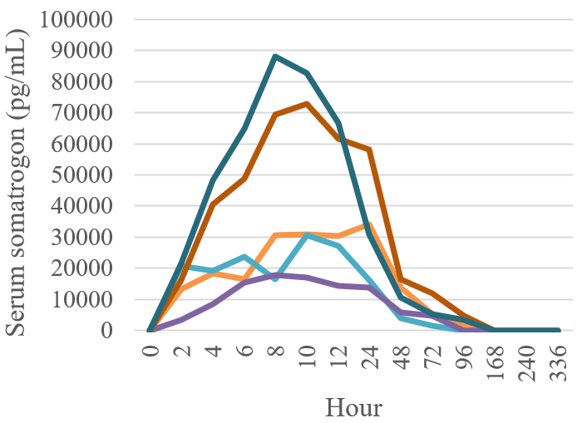

Figure 2: Study CP-4-001 Mean serum somatrogon concentration versus time profile following subcutaneous injection of 4, 7, or 21 mg somatrogon

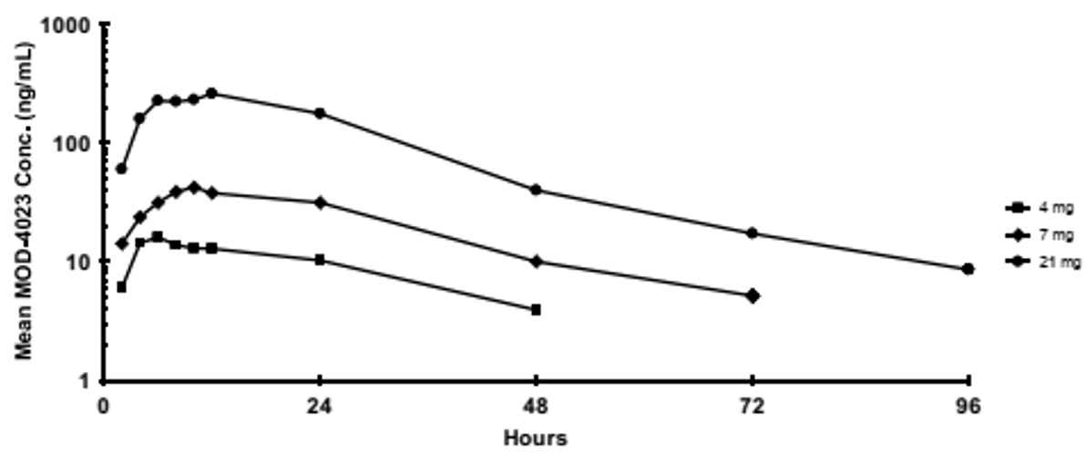

Abbreviation: MOD-4023 = somatrogon.

##### Study CP-4-004

Study CP-4-004 was a safety and dose finding study of different somatrogon doses compared to daily recombinant human growth hormone (rhGH) therapy in pre-pubertal growth hormone deficient children.

Patients were randomised equally to one of four arms, 0.25 mg/kg/week somatrogon subcutaneously, 0.48 mg/kg/week somatrogon subcutaneously, 0.66 mg/kg/week somatrogon subcutaneously, or 0.034 mg/kg/day Genotropin (recombinant human growth hormone (somatropin) subcutaneously. Eligible patients were boys aged 3 to 11 years, or girls aged 3 to 10 years who were diagnosed with either isolated growth hormone deficiency or growth hormone insufficiency as part of multiple pituitary hormone deficiency. Patients had no prior exposure to rhGH therapy, impaired height and height velocity, and baseline IGF-1 level at least one standard deviation (SD) below the mean IGF-1 standardised for age and sex.

There were 56 patients randomised and 53 received at least one dose. The mean age was 6.2 to 6.8 across all cohorts (range 3.0 to 11.2 years) except for females in the Genotropin (rhGH) arm who had a mean age of 4.7 years. Mean baseline weight was 15.3 to 16.9 kg across cohorts (range 9.1 to 26.5 kg), and mean height standard deviation score (SDS) across cohorts was a mean of ‑3.7 to ‑4.3 (range ‑7.5 to ‑2.3).

Although the weekly PK data showed no significant difference in PK profiles between dose levels, the annual PK data shows increase levels in the higher 2 dose cohorts, and increasing levels over the year.

Figure 3: Study CP-4-004 Period I and II Mean weekly trend of serum concentration-time profile of somatrogon (per-protocol population)

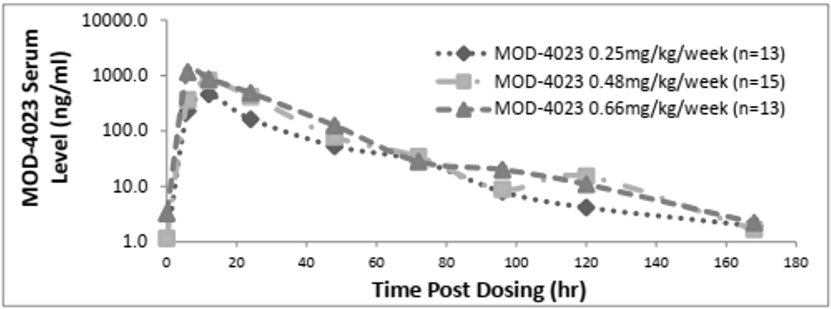

Abbreviations: hr = hour; MOD-4023 = somatrogon; n = number of study participants.

Pharmacokinetic treading data based on bioanalytical report.

Figure 4: Study CP-4-004 Period I and II Mean Day 4 somatrogon drug level for patients completing 12 months of treatment (per-protocol population)

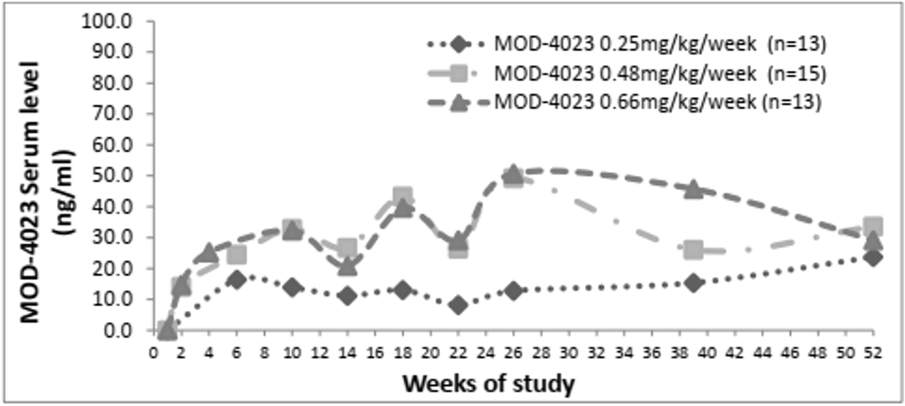

Abbreviations: MOD-4023 = somatrogon; n = number of study participants.

Pharmacokinetic treading data based on bioanalytical report.

The somatrogon PK data from Studies CP-4-004 and CP-4-006 were used as the basis of a population pharmacokinetic (PopPK) report.

##### Study CP-4-003

Study CP-4-003 was a study in adults with growth hormone deficiency. The results were not entirely consistent with the previous Study CP-4-001 conducted in healthy adult participants.

#### Population pharmacokinetic data

Report DP3-853 was a PopPK modelling report for somatrogon. It used data from Study CP‑4‑003 in adults and Study CP-4-004 in children with growth hormone deficiency.

The objectives of this report were:

* to characterise the PopPK of somatrogon in growth hormone deficiency adults and children;
* to identify covariates that influence the PK of somatrogon;
* to derive individual somatrogon exposure for subsequent exposure response analyses.

The base model was a two-compartment model with delayed first order absorption.

#### Pharmacodynamics

##### Study CP-4-001

Study CP-4-001, in healthy adult participants, showed that despite a more than dose proportional increase in somatrogon levels, particularly between the 7 and 21 mg doses, the IGF-1 peaked at the 7 mg dose. Insulin-like growth factor (IGF)-binding protein 3 (BP3) increased but not in a dose proportional way.

##### Study CP-4-004

The IGF-1 response most comparable to response observed with Genotropin (rhGH/somatropin) was with the 0.66 mg/kg/week group.

Figure 5: Study CP-4-004 Insulin-like growth factor standard deviation score versus time

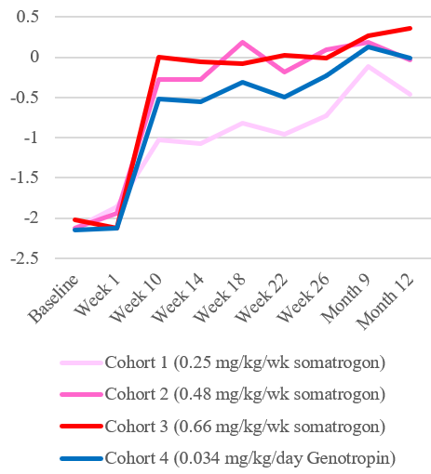

There were 23.8% (10 out of 42) somatrogon treated patients that developed anti‑somatrogon antibodies and 18.2% (2 out of 11) Genotropin treated patients that developed anti-hGH antibodies post-Baseline. Among the somatrogon patients, there were no Cohort 1 patients that developed anti-drug antibodies (ADAs) and 5 patients in each of Cohort 2 and 3 that developed ADAs. All of the positive patients had positive tests at 6 months but only about one-half of those patients remained ADA positive at 12 months.

##### Study CP-4-006

Insulin-like growth factor 1 (IGF-1) pharmacodynamic results were further discussed in the PopPK/pharmacodynamics (PD) Report DP3-1002.

Table 3: Study CP-4-006 Pharmacodynamic results insulin-like growth factor 1 and insulin-like growth factor-binding protein 3

|  |  |  |  |  |  |
| --- | --- | --- | --- | --- | --- |
| IGF-1 (µg/mL) | Somatrogon | Genotropin | IGF-BP3 (ng/mL) | Somatrogon | Genotropin |
| Baseline | 79.9 | 84 | Baseline | 2469 | 2574 |
| Month 1 | 195.1 | 141.7 | Month 1 | 3632 | 3072 |
| Month 3 | 208.1 | 152.8 | Month 3 | 3587 | 3186 |
| Month 6 | 227.5 | 165.2 | Month 6 | 3814 | 3286 |
| Month 9 | 253 | 186.7 | Month 9 | 3814 | 3395 |
| Month 12 | 263.8 | 154.6 | Month 12 | 3879 | 3262 |

IGF = insulin-like growth factor; BP = binding protein

Table 3 above shows that the IGF-1 and IGF-BP3 values met or were greater than those seen with Genotropin (rhGH/somatropin).

#### Efficacy

##### Study CP-4-006

Study CP-4-006 is a Phase III, randomised, open label, multi-centre, 12-month duration efficacy and safety study of weekly somatrogon compared to daily Genotropin therapy (recombinant human growth hormone (rhGH)/somatropin) in pre-pubertal children with growth hormone deficiency

The primary efficacy endpoint was annual height velocity in centimetres per year after 12 months of treatment.

Figure 6: Study CP-4-006 Study design

Figure 6: Study CP-4-006 Study design

Study CP-4-006 enrolled prepubertal children with growth hormone deficiency who had not previously been treated with recombinant human growth hormone therapy.

After screening subjects were randomised 1:1 to receive either 0.66 mg/kg somatrogon administered once
weekly or 0.034 mg/kg Genotropin administered once daily for the 12 month main study period.

Following completion of the main study period, eligible subjects could enter into the open label extension period and continue to receive treatment until registration of somatrogon. Subjects who had received Genotropin in the main study period were switched to a somatrogon dose of 0.66 mg/kg administered once weekly for the open label extension period.

Abbreviation: 1st = first.

###### Inclusion criteria

Inclusion criteria included:

* Pre-pubertal children (boys 3 to 11 years, girls 3 to 10 years) diagnosed with growth hormone deficiency who had no prior exposure to any recombinant hGH therapy, had impaired height and height velocity, and with a baseline IGF-1 level of at least one SD below the mean IGF-1 level standardised for age and sex (IGF-1 SDS ≤ -1) were enrolled in this study.
* Confirmed diagnosis of growth hormone deficiency by 2 different growth hormone provocation tests defined as a peak plasma growth hormone level of ≤ 10 ng/mL, determined by local (if done prior to signed consent) or central laboratory using a validated assay.[19]
* A bone age less than chronological age.
* Girls with normal karyotype.
* Annualised height velocity (taken with 2 measurements at least 6 months apart) were less than the twenty fifth percentile for age.

###### Exclusion criteria

There were a number of exclusion criteria, notable ones included body mass index (BMI) SDS less than ‑2 SDS, children with a history of leukemia, lymphoma, sarcoma, Turner’s syndrome, Laron syndrome, Noonan syndrome, Prader-Willi syndrome, Russell-Silver syndrome, short stature homeobox containing (SHOX) gene deletions and skeletal dysplasia, children born small for gestational age.

###### Study treatments

The dose of somatrogon and Genotropin (rhGH/somatropin) was assessed and adjusted every 3 months based on the subject’s body weight. In addition, for subjects receiving somatrogon, the dose was decreased based on two repeated Day 4(-1) levels of IGF-1 > +2 SDS. For subjects receiving Genotropin, the dose was decreased based on two repeated IGF-1 levels > +2 SDS.

###### Aims and objectives

The aim of the present study was to demonstrate that in terms of the primary efficacy endpoint, annual height velocity at 12 months, weekly somatrogon is non-inferior to daily Genotropin (rhGH/somatropin) by a non-inferiority margin of 1.8 cm/year. The confidence interval (CI) for the difference between means was derived from analysis of covariance (ANCOVA).

The rationale for the non-inferiority margin was as follows: from historical data, height velocity response for the first year of daily growth hormone ranged from 10.2 cm/year, SD = 2.5;[20] to 11.4 cm/year, SD = 2.5.[21] Using the SD of 2.5 from these references, a non-inferiority margin of -1.8 cm/year is within one SD of the expected results, and approximately 23% of the reference treatment response distribution would be below this value.

###### Results

Of the 228 patients that were randomised, 4 did not receive the study drug and a further two discontinued during the main study, 212 patients continued to the open label extension trial.

*Dose modifications/adjustments*: Overall, 29 subjects had an IGF-1 SDS > 2 at any time during the main study (n = 26 in the somatrogon group and n = 3 in the Genotropin (rhGH/somatropin) group). Over time, the incidence of subjects in the somatrogon group with IGF-1 SDS > 2 increased. In the somatrogon group, 14 patients experienced persistent IGF-1 levels > 2 SDS (that is, 2 consecutive IGF-1 SDS > 2 measurements), resulting in dose modification for 12 of these subjects. The other 2 patients had their persistent IGF-1 levels above 2 SDS at 9 and 12 months; therefore, their dose was not reduced during the 12‑month study.

At Baseline, the mean (minimum, maximum) weight was 19 (8, 46) kg. Mean (minimum, maximum) BMI was 16 (12, 26) kg/m2. Mean bone age (minimum, maximum) was 5.3 (1, 11). Mean bone maturation (minimum, maximum) was 0.66 (0.29, 1.06). Mean height SDS (Z-score) (minimum, maximum) was -2.86 (-9.96, -0.47). The baseline height velocity and height velocity SDS were not reported.

At 12 months, the height velocity was 10.1 cm/year in the somatrogon group, and 9.78 cm/year in the Genotropin group. The lower bound of the 95% CI for mean treatment difference in height velocity at 12 months was -0.24 cm/year, which is within the non‑inferiority margin.

Figure 7: Study CP-4-006 Box plot of annualised height velocity over time (full analysis set)

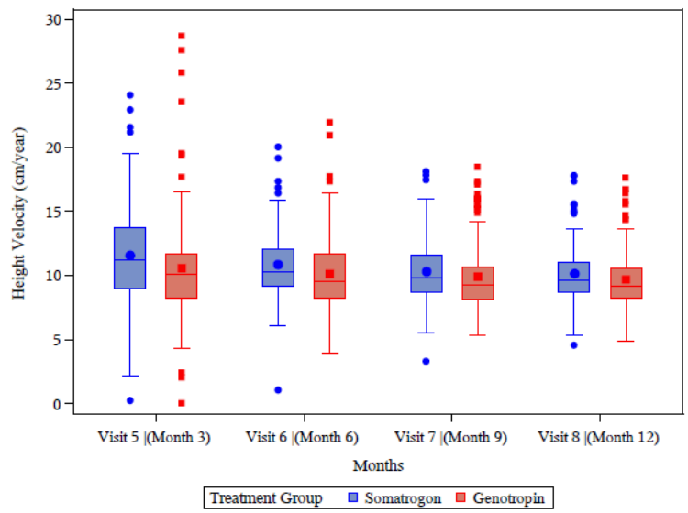

There were 3 non-responders, similar numbers in each treatment group.

Insulin-like growth factor 1 (IGF-1) levels rose from Baseline in both groups. There was a greater increase in IGF-1 in the somatrogon than the Genotropin group.

Figure 8: Study CP-4-006 Box plot of change over time in Insulin-like growth factor 1 standard deviation score (full analysis set)

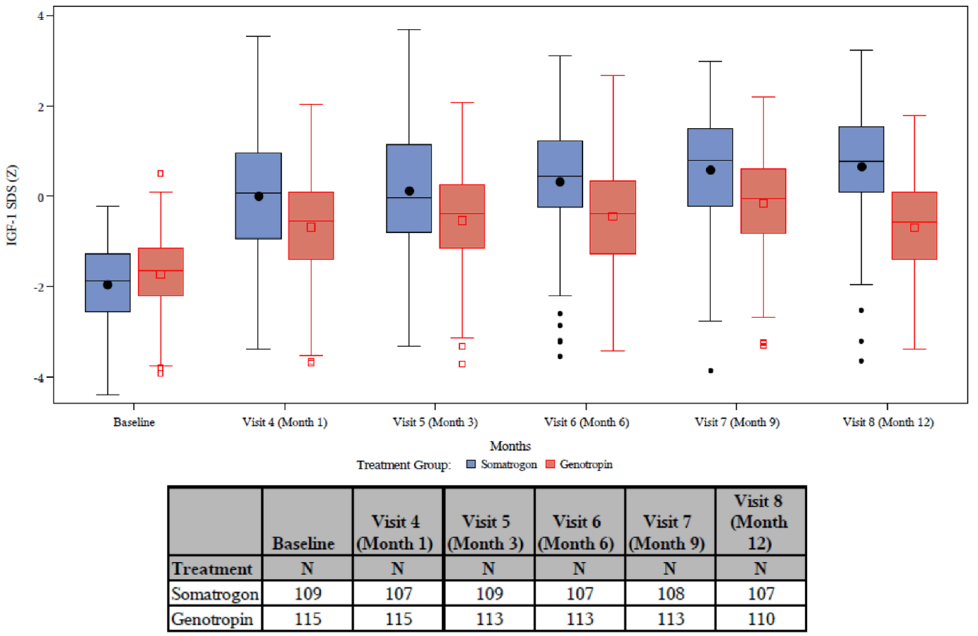

Baseline is defined as the last non-missing measurement prior to the start of study drug.

The closed circles inside boxes are means, lines inside boxes are medians. The ends of each box represent lower and upper quartiles, and bars at the ends of the whiskers represent lower and upper extremes. The individual data points outside the boxes are outliers.

Baseline is defined as the last non-missing measurement prior to the start of study drug.

There was also a similar increase in IGF-BP3 in both groups.

Anti-drug antibodies (ADAs) were identified in approximately 77% of somatrogon treated patients during the study period. The presence of ADA did not affect treatment outcomes.

*Open label extension*: At the data cut-off date of 1 November 2019, efficacy data were available for 94 subjects at Month 18 and 9 subjects at Month 24.

Annualised height velocity with once weekly somatrogon treatment remained above Baseline through the extension period. The annualised height velocity for subjects who switched from Genotropin to somatrogon at the beginning of the extension period was consistent with subjects who received somatrogon during the main study and throughout the extension period. No subject in Study CP-4-006 open-label extension had achieved final adult height as of the data cut-off date of 1 November 2019.

Figure 9: Study CP-4-006 main study and open label extension; annualised height velocity (cm/year) (full analysis set)

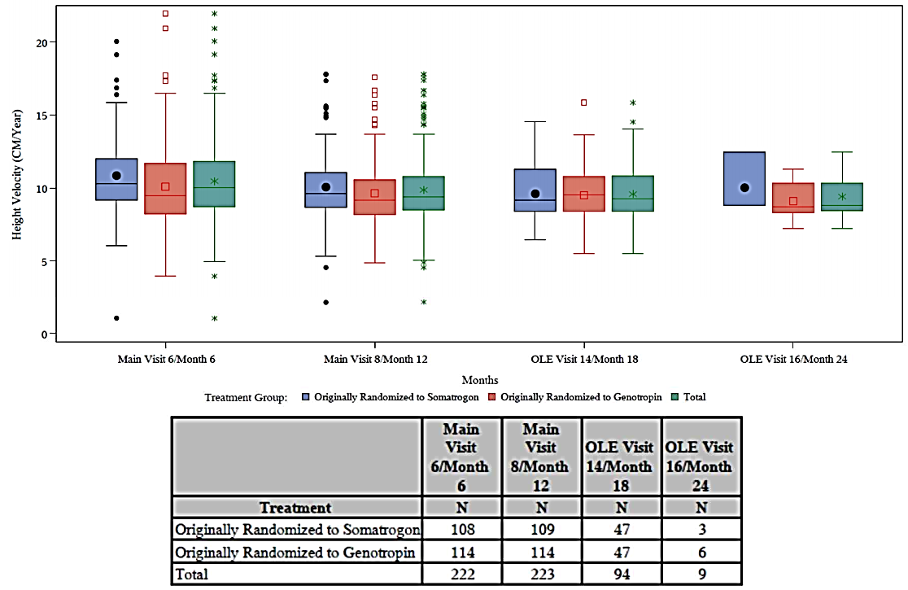

Abbreviation: OLE = open label extension.

The closed circles inside boxes are means, lines inside boxes are medians. The ends of each box represent lower and upper quartiles, and bars at the ends of the whiskers represent lower and upper extremes. The individual data points outside the boxes are outliers.

##### Study CP-4-004

Study CP-4-004 is a safety and dose finding study of different somatrogon dose levels compared to daily recombinant human growth hormone (rhGH/somatropin) therapy in pre-pubertal growth hormone deficient children.

Figure 10: Study CP-4-004 Study design

Figure 10: Study CP-4-004 Study design

Study CP-4-004 was a Phase II, randomised, open label, safety and dose finding clinical trial assessing different somatrogon dose levels compared to daily Genotropin therapy in untreated pre-pubertal children with growth hormone deficiency.

Eligible subjects were enrolled to undergo a screening period. Subjects (Cohort 1, 2 and 3) were randomised to receive either 0.25, 0.48, 0.66 mg/kg somatrogon, or receive 0.034 mg/kg Genotropin (Cohort 4). It followed by two treatment periods (I and II).

Treatment Period I was an open label period of repeated dosing including pharmacokinetics and pharmacodynamics sampling. In Period I, all somatrogon subjects started the treatment with a dose of 0.25 mg/kg/week. Those randomised to the 0.48 and 0.66 mg/kg/week cohorts had their dose titrated upwards in 2-week increments. After interim analysis, subjects entered Period II, which was a second 6 month period of repeated dosing. Final analysis was conducted after completing Period II.

Abbreviations: C = cohort; MOD-4023 = somatrogon; PD = pharmacodynamics; PK = pharmacokinetics.

After 12 months of treatment, mean height velocity in the full analysis set population for the somatrogon cohorts were 10.4 (95% CI: 8.9, 12.0), 11.0 (95% CI: 9.7, 12.2), and 11.4 (95% CI: 9.2, 13.7) cm/year in Cohorts 1, 2, and 3, respectively. The mean height velocity for the Genotropin (rhGH/somatropin) group was 12.5 cm/year (95% CI: 11.0-13.9). The 95% CI for each of the somatrogon cohorts overlap with the CI for Genotropin, with the highest somatrogon dose group.

Figure 11: Study CP-4-004 periods I and II Mean and 95% confidence intervals (dotted lines) of annual height velocity (cm/year) (per-protocol population)

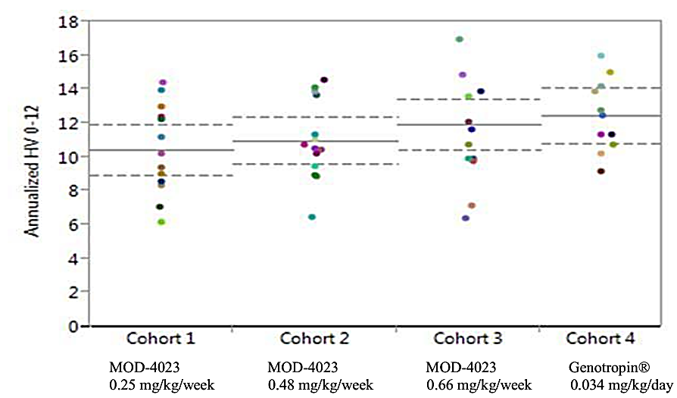

Abbreviations: HV = height velocity; MOD-4023 = somatrogon.

Figure 12: Study CP-4-004 Periods I and II Mean insulin-like growth factor 1 standard deviation score over 12-month trend (per-protocol population)

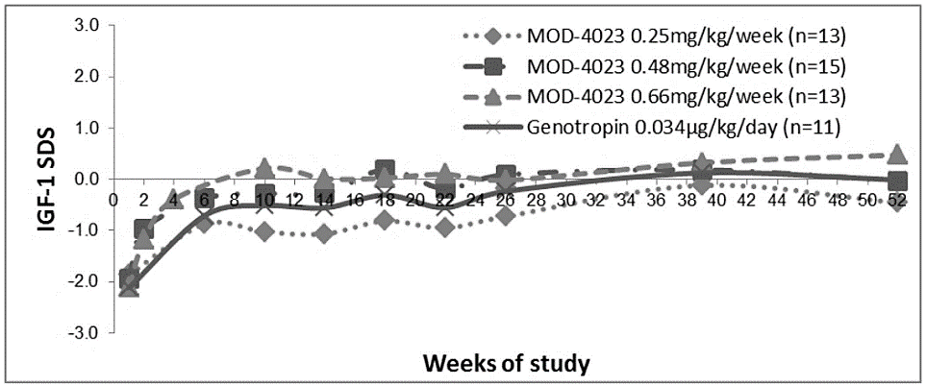

Abbreviations: IGF = insulin-like growth factor; SDS = standard deviation score; MOD-4023 = somatrogon; n = sample size.

The mean change in bone age from Baseline to 12 months for the Genotropin (rhGH/somatropin) group (Cohort 4) was +1.4 years (range +0.3, +3.8). The mean change from Baseline to 12 months for the somatrogon cohort was +1.2 years (range 0.0, +3.2), +1.3 years (range 0.0, +3.3), and +1.2 years (range +0.2, +2.9), for Cohorts 1, 2, and 3, respectively.

##### Study CP-4-004 open label extension

Subjects who completed 12 months of active treatment in the main study period, remained eligible for inclusion in the study, and consented to participate in the open-label extension period study continued with open label treatment until marketing approval. There were 3 defined open-label extension study periods:

* Open label extension period (Period III (Year 1 open label extension)): This period lasted for 12 months post‑completion of the main study. Subjects continued dosing with the 3 originally assigned dose levels of somatrogon (0.25, 0.48, and 0.66 mg/kg/week). Subjects originally assigned to daily Genotropin (rhGH/somatropin) in the main study were randomly re‑assigned to 1 of the 3 somatrogon dose levels.
* Long-term open-label extension period (Period IV (Years 2 to 4 of open-label extension)): This long-term open-label extension period was planned to follow the 12 months in Period III (that is, to start from second year of the open-label extension and third year of the overall study). All eligible subjects entering this long-term extension period from somatrogon 0.25 mg/kg body weight/week and 0.48 mg/kg body weight/week groups were switched to 0.66 mg/kg body weight/week, unless medically inappropriate (for example, drug related adverse events, elevated IGF‑1 SDS).
* Long-term open-label extension PEN period (Period V): Subjects were transitioned to somatrogon 0.66 mg/kg/week subcutaneous administration using a single-subject, multi‑dose, disposable prefilled pen device and formulation. The Period V duration was anticipated to continue until marketing approval. Subjects received the dose of 0.66 mg/kg body weight/week unless medically inappropriate (for example, drug related adverse events, elevated IGF-1 SDS).

During the open-label extension Periods III and IV, somatrogon was provided in single use vials as a solution for injection via needle and syringe, during Period V, somatrogon was provided as a refrigerated solution in a multi-dose single use pen. Forty-eight subjects started Period III, 46 subjects started Period IV, 41 subjects started Period V and 32 completed the study.

Table 4: Study CP-4-004 open-label extension; annualised height velocity during the extension period of study

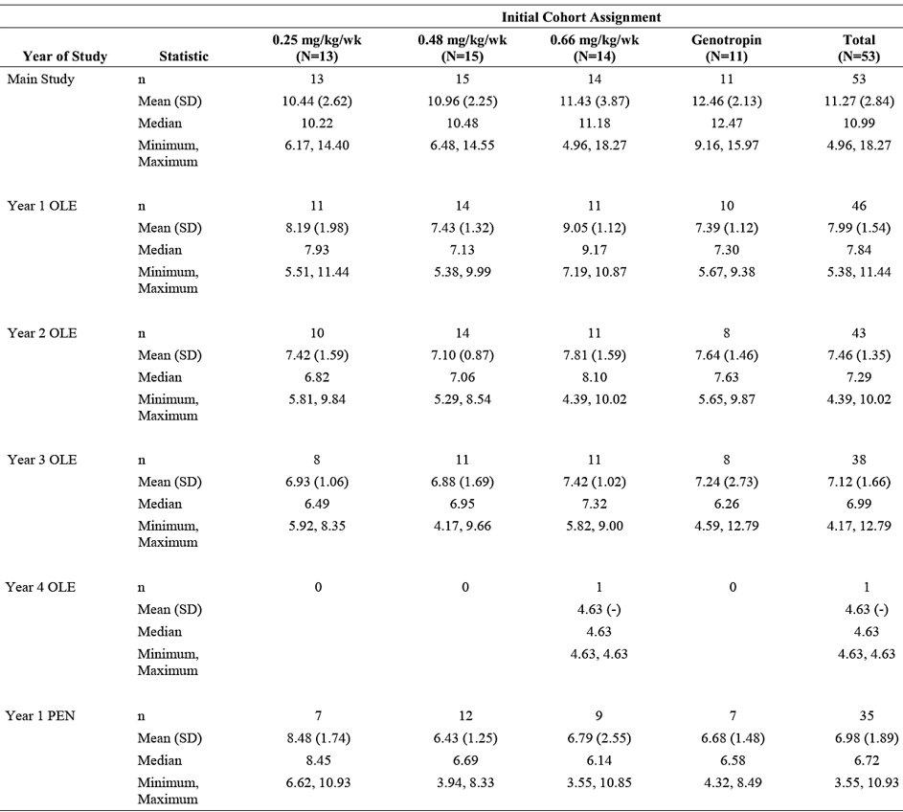

Abbreviations: N = subjects that entered the study period; n = subjects with annual height velocity for the study period; OLE = open label extension; SD = standard deviation.

Height velocity in main study used the measure at the Month 12 visit with the measure the latest vibist before the first injection in main study; height velocity in each tear in open label extension study used the measure at the Month 12 visit in each year with the measure at the Month 12 visit of the prior year as the reference. In case where there was a gap in treatment between years the measure at the restart of treatment (if available) was used as the reference.

#### Safety

***Study CP-4-006***

In the pivotal clinical study, there was a higher incidence of injection site erythema, injection site pain and injection site pruritis in the somatrogon group. Most treatment emergent adverse events were mild (54%) or moderate (24.8%). There were more severe injection site pain reactions in the somatrogon group. One patient in the somatrogon group discontinued due to injection site erythema and induration on Day 57. In Study CP‑4-006, 5 patients withdrew due to adverse events (AEs), which were injection site erythema, pain, pruritis and anxiety.

There were more AEs of special interest due to immunogenicity in the somatrogon group (20) compared to the Genotropin (rhGH/somatropin) group (9). However more patients in the Genotropin group developed a laboratory finding of high creatine kinase.

Anti-drug antibodies (ADAs) were also more common in the somatrogon group. By Month 12, 75 subjects in the somatrogon group and 7 in the Genotropin group had ADAs. Of these, 2 were neutralising. There was no correlation between dose and ADAs, nor in ADAs and AEs. In the open labelled extension studies, there were no patients with new ADAs.

There were 29 subjects with an IGF-1 more than 2-SDS above the mean. Of these, 26 were in the somatrogon group and 3 were in the Genotropin group.

There were 20 subjects in the somatrogon group and 9 in the Genotropin group who had an increase in eosinophils.

Long-term data is available for somatrogon at the current dose for 20 patients studied for 2 years and 11 patients studied for 3 years. In the long-term study, there were no new AE signals identified.

### Risk management plan

The sponsor has submitted EU-risk management plan (RMP) version 0.1 (dated 6 October 2020; data lock point (DLP) 1 November 2019) and Australia specific annex (ASA) version 0.1 (dated 6 October 2020) in support of this application. At the second round of evaluation, the sponsor has submitted EU-RMP version 0.2 (dated 30 August 2021; DLP 21 December 2020) and ASA version 0.2 (dated 26 July 2021). At the third round of evaluation, the sponsor submitted ASA version 0.3 (dated 24 September 2021).

The summary of safety concerns and their associated risk monitoring and mitigation strategies are summarised in Table 5. Further information regarding the TGA’s risk management approach can be found in [risk management plans for medicines and biologicals](https://www.tga.gov.au/publication/risk-management-plans-medicines-and-biologicals) and [the TGA's risk management approach](https://www.tga.gov.au/tgas-risk-management-approach).

Table 5: Summary of safety concerns

|  |  |  |  |  |  |
| --- | --- | --- | --- | --- | --- |
| Summary of safety concerns | | Pharmacovigilance | | Risk minimisation | |
| **Routine** | **Additional** | **Routine** | **Additional** |
| **Important identified risks** | None |  |  |  |  |
| **Important potential risks** | Benign and malignant neoplasia (new first neoplasm, Second neoplasm in childhood cancer survivors, recurrence, or progression of a pre-existing tumour) | ✓ | ✓* | ✓ | – |
| Diabetes mellitus type 2 | ✓ | ✓* | ✓ | – |
| Medication errors (resulting in under or overdosing of this long-acting formulation) | ✓ | ✓* | ✓ | – |
| Immunogenicity specifically related to long-term clinical impact on lack of efficacy and safety occurring after 2 years of treatment | ✓ | ✓* | ✓ | – |
| **Missing information** | None |  |  |  |  |

* Post-authorisation safety studies (PASS)

* The sponsor is requested to add ‘*injection site reactions*’ as an important potential risk, and ‘*hypersensitivity’* and ‘*medication error*’ as missing information in the summary of safety concerns. At the second round of evaluation, the sponsor has added the following important potential risks:
  + Benign and malignant neoplasia (new first neoplasm, second neoplasm in childhood cancer survivors, recurrence or progression of a pre-existing tumour)
  + Diabetes mellitus type 2
  + Medication errors (resulting in under or overdosing of this long-acting formulation)
  + Immunogenicity specifically related to long-term clinical impact on lack of efficacy and safety occurring after 2 years of treatment

Routine risk minimisation is considered adequate to cover the risk of injection site reactions and hypersensitivity has been incorporated into the immunogenicity safety concern. Medication error has been added to the summary of safety concerns. The summary of safety concerns is acceptable from an RMP perspective.

* Routine pharmacovigilance is proposed for all safety concerns. Additional pharmacovigilance for all safety concerns is proposed at round 2. The sponsor has referenced the EU-RMP post-authorisation safety studies in the ASA, and should include these studies in the table of additional pharmacovigilance activities in the next RMP update. The pharmacovigilance plan is acceptable.
* Routine risk minimisation is proposed for all safety concerns. It is anticipated that routine risk minimisation will be adequate to manage the requested safety concerns. At the second round of evaluation, the sponsor confirmed that the Consumer Medicines Information (CMI), PI and Instructions for Use (IFU) will be included in the product packaging. At the third round of evaluation, the CMI and IFU have been revised as requested and the risk minimisation plan is acceptable.

### Risk-benefit analysis

#### Delegate’s considerations

The sponsor has submitted an application to register a new long acting growth hormone preparation for the treatment of growth hormone deficiency in children. This medicine has not been previously registered in other jurisdictions.

The clinical trial in support of this application enrolled children 3 years of age and over with growth hormone deficiency, either congenital or acquired. There is very little data available to describe efficacy in puberty. The sponsor in not proposing to register this product in adults.

The clinical trials showed comparable efficacy to Genotropin (recombinant human growth hormone (rhGH)/somatropin) at a dose of 0.034 mg/kg/day. This is equivalent to a weekly dose on 5.6 mg/m2/week. In the clinical study, around 10% of patients developed an IGF-1 level above the target range and this resulted in a dose reduction. The rate of increased IGF-1 levels increased with increased duration of treatment. In the clinical trials there were more local adverse effects in the somatrogon than the Genotropin group. These were generally mild to moderate. There were similar number of participants drop out of the study in this group.

At this time, there is limited safety data in subjects over 12 years of age since the somatrogon development program evaluated height and growth in subjects between the ages of 3 and 10 years (for girls), and 3 and 11 years (for boys). In Studies CP-4-004 and CP-4-006, subjects at Baseline were prepubertal. Data from Study CP-4-004 suggests that somatrogon administered once weekly at a dose of 0.66 mg/kg/week is safe through 6 years of treatment in subjects of adolescent age who have been treated throughout puberty; however, interpretation of the results is limited by the small sample size with only 14 patients in the 0.66 mg/kg/week somatrogon cohort.  Review of data regarding luteinising hormone, follicle stimulating hormone and testosterone levels in males 13 years and older, and luteinising hormone, follicle stimulating hormone and estradiol data in females 12 years and older for Study CP-4-006 showed no clinically meaningful differences in pubertal development that would be of concern. The safety of somatrogon in patients aged 12 to under 18 years of age will continue to be characterised post-authorisation in the open label extension period of Study CP-4-006.

The proposed dosing regimen differs from the current dosing of short acting growth hormone preparations (somatropin) in Australia. For somatrogon, a flat dosing regime is proposed, with dose modifications for patients where the IGF-1 level rises or falls below the recommended range. Under the Pharmaceutical Benefits Scheme (PBS), patients generally commence treatment on 4.5 mg/m2/day, the dose can be increased (based on poor response) to a dose of 7.5 mg/m2/day, or in some conditions 9 mg/m2/day based on clinical response.3 In current clinical practice, IGF-1 is monitored in patients on growth hormone for safety reasons and to monitor compliance.

The main advantage of this preparation over existing growth hormone preparations is the longer duration of action, and therefore less number of injections and potential for improved compliance. However, this needs to be considered in the context of a greater risk of local AEs, less ability to titrate dosing, and less information about long-term safety.

#### Proposed action

The Delegate sees no reason not to register this product for use in children aged from 3 to 11 years. The PI needs to be updated in relation to the titration of dosing for IGF-1 level, and also to describe the limitations of data in children.

The Delegate will make a further decision about whether or not to restrict use to before puberty based on the sponsor’s response to the questions.

#### Questions for the sponsor

The sponsor provided the following response to questions from the Delegate.

1. ***Please update the TGA on the status of this application with the European Medicines Agency (EMA) and the United States Food and Drug Administration (US FDA).***

Updated information on the status of the somatrogon application in the EMA and FDA is provided to the TGA as part of this response.

1. ***Could you please provide more details about the use of somatrogon during puberty? How many patients were studied during puberty? How long were they treated for? Did they require a change in their dose?***

The sponsor submitted a table which provides a listing of all subjects in Studies CP-4-004 and CP-4-006 that were over 11 years of age (girls) and over 12 years of age (boys). Another two tables submitted by the sponsor provide the progression of the Tanner stage for subjects in Studies CP-4-004 and CP-4-006, respectively.

The table the sponsor provided shows that there were a total of 82 children (28 in Study CP-4-004 and 54 in Study CP-4-006) over 11 years of age (girls) or over 12 years of age (boys). This table also shows how long these children were treated for in each of the studies. The length of treatment ranged from 1,934 days to 2,426 days in Study CP-4-004 and 352 days to 814 days in Study CP-4-006.

All subjects, regardless of age and pubertal status, continued on somatrogon at a dose of 0.66 mg/kg administered once weekly. A change in the weight-based dose was only required if a subject had two consecutive IGF-1 SDS values > 2 or experienced an adverse event that warranted a decrease in dose. The weight-based dose otherwise remained constant although the total dose was increased as required with an increase in subjects’ weights.

1. ***Was there any difference in the risk of developing anti-somatrogon antibodies in patients who received previous treatment with growth hormone compared to those who were not previously treated with growth hormone?***

All subjects had tested negative for anti-drug antibodies (ADA) to hGH prior to enrolment and were treatment naïve, in both Study CP-4-004 as well as in Study CP-4-006. Throughout both studies there was regular assessment of anti-somatrogon ADAs, which continues in the ongoing open label extensions for these studies.

As previously reported, in Study CP-4-004, 10 out of 42 (23.8%) of somatrogon treated subjects tested positive for ADA by the end of the 12 months of the main study. Of the 10 Genotropin (rhGH/somatropin) treated subjects who completed the first year of the open-label extension, 3 subjects (30%) tested positive for anti-somatrogon ADAs.

In main portion of Study CP-4-006, 84 out of 109 (77%) of somatrogon-treated subjects tested positive for ADA by the end of 12 months. Among the 41 subjects who received Genotropin in the main study and for whom ADA results were available at Month 6 of the open-label extension, 8 subjects (19.5%) tested positive for anti-somatrogon ADAs.

#### Advisory Committee considerations[22]

The Delegate did not refer this application to the Advisory Committee on Medicines (ACM) for advice.

### Outcome

Based on a review of quality, safety and efficacy, the TGA approved the registration of Ngenla (somatrogon) 24 mg and 60 mg, solution for injection, cartridge (prefilled pen), indicated for:

*Ngenla is indicated for the long-term treatment of paediatric patients with growth disturbance due to insufficient secretion of growth hormone.*

#### Specific conditions of registration applying to these goods

* Ngenla (somatrogon) is to be included in the Black Triangle Scheme. The PI and CMI for Ngenla must include the black triangle symbol and mandatory accompanying text for five years, which starts from the date that the sponsor notifies the TGA of supply of the product.
* The Ngenla EU-risk management plan (RMP) (version 0.2, dated 30 August 2021, data lock point 21 December 2020), with Australia specific annex (version 0.3, dated 24 September 2021), included with Submission PM-2020-05916-1-5, to be revised to the satisfaction of the TGA, will be implemented in Australia.

An obligatory component of risk management plans is routine pharmacovigilance. Routine pharmacovigilance includes the submission of periodic safety update reports (PSURs).

Unless agreed separately between the supplier who is the recipient of the approval and the TGA, the first report must be submitted to TGA no later than 15 calendar months after the date of the approval letter. The subsequent reports must be submitted no less frequently than annually from the date of the first submitted report until the period covered by such reports is not less than three years from the date of the approval letter. The annual submission may be made up of two PSURs each covering six months. If the sponsor wishes, the six monthly reports may be submitted separately as they become available.

If the product is approved in the EU during the three years period, reports can be provided in line with the published list of EU reference dates no less frequently than annually from the date of the first submitted report until the period covered by such reports is not less than three years from the date of the approval letter.

The reports are to at least meet the requirements for PSURs as described in the European Medicines Agency’s Guideline on Good Pharmacovigilance Practices (GVP) Module VII-periodic safety update report (Rev 1), Part VII.B Structures and processes. Note that submission of a PSUR does not constitute an application to vary the registration. Each report must have been prepared within ninety calendar days of the data lock point for that report.

* Laboratory testing and compliance with Certified Product Details (CPD)
  + All batches of Ngenla (somatrogon) supplied in Australia must comply with the product details and specifications approved during evaluation and detailed in the Certified Product Details (CPD).
  + When requested by the TGA, the Sponsor should be prepared to provide product samples, specified reference materials and documentary evidence to enable the TGA to conduct laboratory testing on the Products. Outcomes of laboratory testing are published biannually in the TGA Database of Laboratory Testing Results <http://www.tga.gov.au/ws-labs-index> and periodically in testing reports on the TGA website.

Certified Product Details

The Certified Product Details (CPD), as described in Guidance 7: Certified Product Details of the Australian Regulatory Guidelines for Prescription Medicines (ARGPM) <http://www.tga.gov.au/industry/pm-argpm-guidance-7.htm>, in PDF, for the above products should be provided upon registration of these therapeutic goods. In addition, an updated CPD should be provided when changes to finished product specifications and test methods are approved in a Category 3 application or notified through a self-assessable change.

* For all injectable products the Product Information must be included with the product as a package insert.

## Attachment 1. Product Information

The PI for Ngenla approved with the submission which is described in this AusPAR is at Attachment 1. For the most recent PI, please refer to the TGA [PI/CMI search facility.](https://www.tga.gov.au/picmi-search-facility)

|  |
| --- |
| Therapeutic Goods Administration |
| PO Box 100 Woden ACT 2606 Australia  Email: [info@tga.gov.au](mailto:info@tga.gov.au) Phone: 1800 020 653 Fax: 02 6232 8605  [**https://www.tga.gov.au**](https://www.tga.gov.au) |

1. The **Black Triangle Scheme** provides a simple means for practitioners and patients to identify certain types of new prescription medicines, including those being used in new ways and to encourage the reporting of adverse events associated with their use. The Black Triangle does not denote that there are known safety problems, just that the TGA is encouraging adverse event reporting to help us build up the full picture of a medicine's safety profile.
2. Reh CS, Geffner ME. Somatotropin in the treatment of growth hormone deficiency and Turner syndrome in pediatric patients: a review. *Clin Pharmacol.* 2010;2:111-122.
3. Australian Government Department of Health Pharmaceutical Benefit Scheme (PBS), Browse by Section 100 Item List, PBS Growth Hormone Program. Available at: <https://www.pbs.gov.au/browse/section100-gh>.
4. The Child and Adolescent Growth Committee of the Australia and New Zeeland Society for Paediatric Endocrinology and Diabetes (ANZSPED) is in current operation, succeeding and building upon the knowledge and experience of the Australasian Growth Hormone Committee and database (OZGROW) and the Growth Hormone Advisory Committee (GHAC). This committee is comprised of paediatric endocrinologists, specialist nurses, and researchers in human growth.
5. OZGROW Annual Report 2011. Available at: <https://d192ha6kdpe15x.cloudfront.net/apeg/assets/uploads/2015/11/ozgrow+annual+report+2011.pdf>.
6. Genotropin was first registered on the ARTG on 2 July 2001 (ARTG number: 78811).
7. Omnitrope was first registered on the ARTG on 29 September 2010 (ARTG number: 162522).
8. Norditropin Flexpro was first registered on the ARTG on 9 May 2011 (ARTG number:173396, 173398 and 173399).
9. Humatrope was first registered on the ARTG on 24 October 1995 (ARTG number: 53364, 53365 and 53423).
10. Saizen was first registered on the ARTG on 22 August 2011 (ARTG number: 166475, 166478 and 166479).
11. Nutropin AQ was first registered on the ARTG on 10 July 2006 (ARTG number: 116678).
12. Scitropin A was first registered on the ARTG on 31 October 2007 (ARTG number: 140322).
13. A **Category 3 application** relates to updates to the quality data of medicines already included on the Australian Register of Therapeutic Goods (ARTG) which, in the opinion of the TGA, do not need to be supported by clinical, non-clinical or bioequivalence data.
14. European Medicines Agency (EMA), Committee for medicinal products for human use (CHMP), ICH guideline S6 (R1) - preclinical safety evaluation of biotechnology-derived pharmaceuticals, EMA/CHMP/ICH/731268/1998, June 2011.
15. **Good Laboratory Practice (GLP)** is a code of standards following the International Council on Harmonisation (ICH) relevant to testing of medicines in laboratories during drug development.
16. **Cytochrome P450 (CYP)** enzymes: CYPs are the major enzymes involved in drug metabolism, accounting for large part of the total metabolism. Most drugs undergo deactivation by CYPs, either directly or by facilitated excretion from the body. Also, many substances are bioactivated by CYPs to form their active compounds.

    Many drugs may increase or decrease the activity of various CYP isozymes either by inducing the biosynthesis of an isozyme (enzyme induction) or by directly inhibiting the activity of the CYP (enzyme inhibition). This is a major source of adverse drug interactions, since changes in CYP enzyme activity may affect the metabolism and clearance of various drugs. Such drug interactions are especially important to take into account when using drugs of vital importance to the patient, drugs with important side-effects and drugs with small therapeutic windows, but any drug may be subject to an altered plasma concentration due to altered drug metabolism.
17. **Pregnancy Category B1:** Drugs which have been taken by only a limited number of pregnant women and women of childbearing age, without an increase in the frequency of malformation or other direct or indirect harmful effects on the human fetus having been observed.

    Studies in animals have not shown evidence of an increased occurrence of fetal damage.
18. **Pregnancy Category B2:** Drugs which have been taken by only a limited number of pregnant women and women of childbearing age, without an increase in the frequency of malformation or other direct or indirect harmful effects on the human fetus having been observed.

    Studies in animals are inadequate or may be lacking, but available data show no evidence of an increased occurrence of fetal damage.
19. Insulin tolerance test, with serum cortisol response to hypoglycaemia if insulin stimulation test is chosen OR Arginine test OR Clonidine test OR Glucagon test OR L-dopa test.
20. Wilton, P. and Gunnarsson, R. Clinical Experience with Genotropin in Growth Hormone Deficient Children, *Acta Paediatr Scand Suppl*, 1988; 343: 95-101.
21. MacGillivray, M.H. et al. Outcome of a Four-Year Randomized Study of Daily Versus Three Times Weekly Somatropin Treatment in Prepubertal Naive Growth Hormone-Deficient Children. Genentech Study Group*, J Clin Endocrinol Metab*, 1996; 81(5): 1806-1809.
22. The ACM provides independent medical and scientific advice to the Minister for Health and the TGA on issues relating to the safety, quality and efficacy of medicines supplied in Australia including issues relating to pre market and post-market functions for medicines. Further information can be found here: <https://www.tga.gov.au/committee/advisory-committee-medicines-acm>.