|  |
| --- |
| February 2023 |

|  |
| --- |
| Australian Public Assessment Report for Spikevax bivalent Original/Omicron BA.4-5 |
| Active ingredients: Elasomeran and davesomeran |
| Sponsor: Moderna Australia Pty Ltd |

About the Therapeutic Goods Administration (TGA)

* The Therapeutic Goods Administration (TGA) is part of the Australian Government Department of Health and is responsible for regulating therapeutic goods, including medicines, medical devices, and biologicals.
* The TGA administers the *Therapeutic Goods Act 1989* (the Act), applying a risk management approach designed to ensure therapeutic goods supplied in Australia meet acceptable standards of quality, safety, and efficacy.
* The work of the TGA is based on applying scientific and clinical expertise to decision-making, to ensure that the benefits to the Australian public outweigh any risks associated with the use of therapeutic goods.
* The TGA relies on the public, healthcare professionals and industry to report problems with therapeutic goods. The TGA investigates reports received to determine any necessary regulatory action.
* To report a problem with a therapeutic good, please see the information on the [TGA website](https://www.tga.gov.au).

About AusPARs

* The Australian Public Assessment Report (AusPAR) provides information about the evaluation of a prescription medicine and the considerations that led the TGA to approve or not approve a prescription medicine submission. Further information can be found in [Australian Public Assessment Report (AusPAR) guidance](https://www.tga.gov.au/australian-public-assessment-report-auspar-guidance).
* AusPARs are prepared and published by the TGA.
* AusPARs are static documents that provide information that relates to a submission at a particular point in time. The publication of an AusPAR is an important part of the transparency of the TGA’s decision-making process.
* A new AusPAR may be provided to reflect changes to indications or major variations to a prescription medicine subject to evaluation by the TGA.

Copyright

© Commonwealth of Australia 2023  
This work is copyright. You may reproduce the whole or part of this work in unaltered form for your own personal use or, if you are part of an organisation, for internal use within your organisation, but only if you or your organisation do not use the reproduction for any commercial purpose and retain this copyright notice and all disclaimer notices as part of that reproduction. Apart from rights to use as permitted by the *Copyright Act 1968* or allowed by this copyright notice, all other rights are reserved, and you are not allowed to reproduce the whole or any part of this work in any way (electronic or otherwise) without first being given specific written permission from the Commonwealth to do so. Requests and inquiries concerning reproduction and rights are to be sent to the TGA Copyright Officer, Therapeutic Goods Administration, PO Box 100, Woden ACT 2606 or emailed to <[tga.copyright@tga.gov.au](mailto:tga.copyright@tga.gov.au)>.

Contents

List of abbreviations 4

Product submission 6

Submission details 6

Product background 7

Regulatory status 11

Product Information 13

Registration timeline 13

Submission overview and risk/benefit assessment 13

Quality 14

Nonclinical 15

Clinical 16

Risk management plan 45

Risk-benefit analysis 47

Outcome 59

Specific conditions of registration applying to these goods 59

Attachment 1. Product Information 62

## List of abbreviations

|  |  |  |
| --- | --- | --- |
| Abbreviation | | Meaning |
| ACV | Advisory Committee on Vaccines | |
| AE | Adverse event | |
| AESI | Adverse event of special interest | |
| aHR | Adjusted hazard ratios | |
| ARTG | Australian Register of Therapeutic Goods | |
| ASA | Australia specific annex | |
| CI | Confidence interval | |
| CMI | Consume Medicines Information | |
| COVID-19 | Coronavirus disease 2019 | |
| DLP | Data lock point | |
| EMA | European Medicine Agency (European Union) | |
| EU | European Union | |
| EUA | Emergency Use Authorization (Food and Drug Administration, United States of America) | |
| GMC | Geometric mean concentration | |
| GMFR | Geometric mean fold rise | |
| GMT | Geometric mean titre | |
| ICU | Intensive care unit | |
| MAAE | Medically attended adverse event | |
| MAH | Marketing authorisation holder | |
| MedDRA | Medical Dictionary for Regulatory Activities | |
| nAb | Neutralising antibodies | |
| PI | Product Information | |
| PSUR | Periodic safety update report | |
| PT | Preferred Term | |
| RMP | Risk management plan | |
| RMP | Risk management plan | |
| rVE | Relative vaccine effectiveness | |
| SAE | Serious adverse event | |
| SARS-CoV-2 | Severe acute respiratory syndrome coronavirus 2 | |
| SmPC | Summary of Product Characteristics | |
| SOC | System Organ Class | |
| SRR | Seroresponse rate | |
| TEAE | Treatment emergent adverse event | |
| TGA | Therapeutic Goods Administration | |
| US(A) | United States (of America) | |
| VoC | Variants of concern | |

## Product submission

### Submission details

|  |  |
| --- | --- |
| *Type of submission:* | New biological entity |
| *Product name:* | Spikevax bivalent Original/Omicron BA.4-5 |
| *Active ingredients:* | Elasomeran and davesomeran |
| *Decision:* | Approved for provisional registration |
| *Date of decision:* | 17 February 2023 |
| *Date of entry onto ARTG:* | 20 February 2023 |
| *ARTG numbers:* | 399552 and 399553 |
| [*Black Triangle Scheme*](https://www.tga.gov.au/black-triangle-scheme)*:* | Yes  As a provisionally registered product, this medicine will remain in the Black Triangle Scheme for the duration of its provisional registration |
| *Sponsor’s name and address:* | Moderna Australia Pty Ltd  Level 6, 60 Martin Place  Sydney, NSW, 2000 |
| *Dose form:* | Suspension for injection |
| *Strength:* | 0.1 mg/mL (50 µg/0.5 mL dose) |
| *Containers:* | Multidose vial and pre-filled syringe |
| *Pack sizes:* | 10 multiple dose vials (5 doses/vial)  10 pre-filled syringes (single use) |
| *Approved therapeutic use:* | *Spikevax bivalent Original/Omicron BA.4-5 (elasomeran and davesomeran) COVID-19 vaccine has* ***provisional approval*** *for the indication below:*  *As a booster dose for active immunisation to prevent coronavirus disease 2019 (COVID-19) caused by SARS-CoV-2 in individuals 12 years of age and older who have previously received at least a primary vaccination course against COVID-19.*  *The use of this vaccine should be in accordance with official recommendations.*  *The decision has been made on the basis of immunogenicity and short-term safety data. Continued approval depends on the evidence of longer term benefits and safety from ongoing clinical trials and post-market assessment.* |
| *Route of administration:* | Intramuscular |
| *Dosage:* | One 0.5 mL dose contains 25 µg elasomeran and 25 µg davesomeran, a COVID-19 mRNA vaccine (embedded in lipid nanoparticles).  *Individuals 12 years of age and older*  One dose of Spikevax bivalent Original/Omicron BA.4-5 (50 µg/0.5 mL) may be given at least 3 months following a primary series and/or previous booster dose with Spikevax (original), Spikevax bivalent Original/Omicron (BA.1) or another authorised/approved COVID-19 vaccine, in accordance with official recommendations.  For further information regarding dosage, refer to the Product Information. |
| *Pregnancy category:* | Category B1  Drugs which have been taken by only a limited number of pregnant women and women of childbearing age, without an increase in the frequency of malformation or other direct or indirect harmful effects on the human fetus having been observed.  Studies in animals have not shown evidence of an increased occurrence of fetal damage.  The use of any medicine during pregnancy requires careful consideration of both risks and benefits by the treating health professional. This must not be used as the sole basis of decision making in the use of medicines during pregnancy. The TGA does not provide advice on the use of medicines in pregnancy for specific cases. More information is available from obstetric drug information services in your State or Territory. |

### Product background

This AusPAR describes the submission by Moderna Australia Pty Ltd (the sponsor) to register Spikevax bivalent Original/Omicron BA.4-5 vaccine (elasomeran and davesomeran) 0.1 mg/mL, suspension for injection for the following proposed indication:

*Spikevax bivalent Original/Omicron BA.4 – 5 (elasomeran/davesomeran) COVID-19 vaccine has provisional approval for the indication below:*

*As a booster dose for active immunisation to prevent coronavirus disease 2019 (COVID-19) caused by SARS-CoV-2 in individuals 6 years of age and older who have previously received at least a primary vaccination course against COVID-19.*

*The use of this vaccine should be in accordance with official recommendations.*

*The decision has been made on the basis of immunogenicity and short-term safety data. Continued approval depends on the evidence of longer term benefits and safety from ongoing clinical trials and post-market assessment.*

#### Condition

Coronavirus disease 2019 (COVID-19) is a disease caused by infection with the pandemic virus severe acute respiratory syndrome coronavirus 2 (SARS-CoV-2), which was first recognised overseas in late 2019 and in Australia by early 2020. It is manifested by respiratory, systemic and other organ-related symptomatology.

Disease severity is mainly related to respiratory presentations, and generally increases with age. Mortality in unvaccinated individuals with untreated disease is rare in childhood but increases steeply beyond 60 years of age.

In the absence of highly effective prophylactic or therapeutic medicines, active immunisation through vaccination represents the best means of preventing hospitalisation and deaths at an individual level and controlling the pandemic at a societal level.

Emerging mutated SARS-CoV-2 variants of concern pose challenges for current vaccination strategies, which until recently have been based on inducing immunity to the non-mutated spike protein that was sequenced in the original wild type virus.

In November 2021, the Omicron variant (B.1.1.529; BA.1) emerged as the most antigenically divergent variant at the time with more than 30 mutations in the spike protein, granting it transmissibility advantages. Soon after its emergence, Omicron rapidly became the dominant SARS-CoV-2 variant worldwide. This was followed by emergence of various Omicron subvariants including BA.2, BA.2.75.2, BA.2.12.1, BA.4, BA.5, BQ.1.1, and XBB.1 amongst others. As of January 2023, the Omicron BA.5 subvariant remains one of the major lineages in the United States of America (USA) but has been largely taken over by the BQ and XBB Omicron subvariants.

COVID-19 continues to be a significant public health issue to Australians. As of 14 February 2023, the 7-day rolling averages for COVID-19 are as follows:[1]

* number of cases identified: 2,587
* number of people hospitalised: 1,432
* number of people in intensive care unit (ICU): 46
* number of deaths: 3

Cumulatively, there have been over 11.3 million confirmed cases and 19,168 deaths in Australia due to COVID-19 as of 21 February 2023.[2]

#### Current vaccine options

Table 1 and Table 2 summarise the approval history of the COVID-19 vaccines provisionally registered on the ARTG for use in Australia. Further information on an approval is available from the associated AusPAR.

Table 1 lists the monovalent COVID-19 vaccines that were provisionally approved for use in Australia at the time that this submission was considered. A monovalent COVID-19 vaccine targets one strain of SARS-CoV-2.

Table : Provisional approvals for monovalent COVID-19 vaccines in Australia

|  |  |
| --- | --- |
| Monovalent COVID-19 vaccines provisionally approved in Australia | |
| **Comirnaty COVID-19 Vaccine**  Active ingredient: tozinameran (mRNA); formerly known as *BNT162b2*  Sponsor: Pfizer Australia Pty Ltd | |
| 25 February 2021 (initial registration) | Primary series: for individuals aged 16 years and over ([AusPAR](https://www.tga.gov.au/resources/auspar/auspar-bnt162b2-mrna-comirnaty)).  New product: 30 µg/0.3 mL concentrated suspension for injection. ARTG number: 346290 |
| 22 July 2021 | Primary series: for individuals aged 12 years and over ([AusPAR](https://www.tga.gov.au/resources/auspar/auspar-bnt162b2-mrna-comirnaty)) |
| 26 October 2021 | Booster dose: for individuals aged 18 years and over ([AusPAR](https://www.tga.gov.au/resources/auspar/auspar-bnt162b2-mrna-0)) |
| 3 December 2021 | Primary series: for individuals aged 5 years and over ([AusPAR](https://www.tga.gov.au/resources/auspar/auspar-tozinameran-mrna-covid-19-vaccine))  New strength/formulation: (Tris/sucrose buffer formulation), 10 µg/0.2 mL, 30 µg/0.3 mL. ARTG numbers: 377110, 377111 |
| 27 January 2022 | Booster dose: for individuals aged 16 to 17 years old ([AusPAR](https://www.tga.gov.au/resources/auspar/auspar-tozinameran-mrna-covid-19-vaccine)) |
| 7 April 2022 | Booster dose: for individuals aged 12 to 15 years old ([AusPAR](https://www.tga.gov.au/resources/auspar/auspar-tozinameran-0)) |
| 20 September 2022 | Booster dose: for individuals aged 5 to 11 years old ([AusPAR](https://www.tga.gov.au/resources/auspar/auspar-comirnaty)) |
| 29 September 2022 | Primary series: individuals aged 6 months to ≤ 5 years old ([AusPAR](https://www.tga.gov.au/resources/auspar/auspar-tozinameran-1))  New strength: 3 µg/0.2 mL concentrated suspension for injection (Tris/sucrose formulation. ARTG number: 393433 |
| **Spikevax COVID-19 vaccine**  Active ingredient: elasomeran (mRNA)  Sponsor: Moderna Australia Pty Ltd | |
| 9 August 2021 (initial registration) | Primary series: for individuals aged 18 years and over ([AusPAR](https://www.tga.gov.au/resources/auspar/auspar-elasomeran))  New product: 0.2 mg/mL, suspension for injection. ARTG number: 370599 |
| 3 September 2021 | Primary series: for individuals aged 12 to 18 years (and over) ([AusPAR](https://www.tga.gov.au/resources/auspar/auspar-elasomeran-0)) |
| 7 December 2021 | Booster dose: for individuals aged 18 years and over ([AusPAR](https://www.tga.gov.au/resources/auspar/auspar-elasomeran-mrna-1273)) |
| 17 February 2022 | Primary series: for individuals aged 6 to 12 years (and over) ([AusPAR](https://www.tga.gov.au/resources/auspar/auspar-elasomeran-1)) |
| 19 July 2022 | Primary series: for individuals aged 6 months to 6 years ([AusPAR](https://www.tga.gov.au/resources/auspar/auspar-spikevax))  New strength: 0.1 mg/mL suspension for injection ARTG numbers: 388244, 388245 |
| 19 October 2022 | Booster dose: for individuals aged 12 years and over ([AusPAR](https://www.tga.gov.au/resources/auspar/auspar-spikevax-0)) |
| **Nuvaxovid COVID-19 vaccine**  Active ingredient: SARS-CoV-2 rS vaccine with Matrix-M1 adjuvant (protein vaccine)  Sponsor: Biocelect Pty Ltd (on behalf of Novavax Inc) | |
| 19 January 2022 (initial registration) | Primary series: for individuals aged 18 years and over ([AusPAR](https://www.tga.gov.au/resources/auspar/auspar-sars-cov-2-rs-matrix-m-adjuvant))  New product: 5 µg/0.5mL, suspension for injection ARTG number: 355139 |
| 9 June 2022 | Booster dose: for individuals aged 18 years and over as homologous vaccination ([AusPAR](https://www.tga.gov.au/resources/auspar/auspar-nuvaxovid-homologous-booster)) |
| 9 June 2022 | Booster dose: for indivudals aged 18 years and over, as heterologous vaccination ([AusPAR](https://www.tga.gov.au/resources/auspar/auspar-nuvaxovid-heterologous-booster)) |
| 22 July 2022 | Primary series: for individuals aged 12 years and over ([AusPAR](https://www.tga.gov.au/resources/auspar/auspar-nuvaxovid-heterologous-booster)) |
| **Vaxzevria COVID-19 vaccine** ([formerly](https://www.tga.gov.au/news/media-releases/tga-approves-name-change-covid-19-vaccine-astrazeneca-vaxzevria) AstraZeneca COVID-19 vaccine)  Active ingredient: ChAdOx1 (viral vector)  Sponsor: AstraZeneca Pty Ltd | |
| 15 February 2021 (initial registration) | Primary series: for individuals aged 18 years and over ([AusPAR](https://www.tga.gov.au/resources/auspar/auspar-chadox1-s))  New product: 1 x 1011 viral particles (vp)/mL, solution for injection. ARTG number: 349072 |
| 8 February 2022 | Booster dose: for individuals aged 18 years and over ([AusPAR](https://www.tga.gov.au/resources/auspar/auspar-chadox-1-s)) |
| **COVID-19 Vaccine Janssen**  Active ingredient: Ad26.COV2.S (viral vector)  Sponsor: Janssen-Cilag Pty Ltd | |
| 25 June 2021 (initial registration) | Primary series: for individuals aged 18 years and over ([AusPAR](https://www.tga.gov.au/resources/auspar/auspar-ad26cov2s))  New product: 5 x 1010 virus particles (VP)/ 0.5 mL, suspension for intramuscular injection. ARTG number: 350150 |

A **primary vaccine series** involves the vaccine doses needed for initial protection against COVID-19 disease. Typically, a primary COVID-19 vaccine series of 2 doses of the vaccine given 8 to 12 weeks apart. In most situations, the primary course consists of two doses of the same vaccine. In certain age groups or situations, the number of vaccine doses in a primary series may vary. For people with severe immunocompromise, a primary course is defined as 3 doses of a COVID-19 vaccine. ‘Third’ doses are not booster doses, but an additional dose given such as to those considered to be severely immunocompromised.

A **booster dose** refers to an additional vaccine dose given after the primary vaccine course. The first booster will refer to the first additional vaccine dose given after completing a 2-dose (or sometimes 3‑dose) primary vaccine course.

Note: The single dose COVID-19 Vaccine Janssen has been provisionally approved, but isn’t currently being used in Australia.

Further information on vaccines can be found on the TGA website at [COVID-19 vaccines](https://www.tga.gov.au/products/covid-19/covid-19-vaccines), [The Australian Immunisation Handbook](https://immunisationhandbook.health.gov.au/) or at the [Australian Government Department of Health and Aged Care](https://www.health.gov.au/initiatives-and-progr%C3%A4ms/covid-19-vaccines) website.

Table 2 lists the bivalent COVID-19 vaccines approved in Australia at the time that this submission was considered. A bivalent vaccine targets two coronavirus strains, as opposed to a monovalent vaccine that targets only one variant.

Table : Provisional approvals for bivalent COVID-19 vaccines in Australia

|  |  |
| --- | --- |
| Bivalent COVID-19 vaccines provisionally approved in Australia | |
| **Spikevax Bivalent Original/Omicron BA.1 COVID-19 vaccine**  Active ingredients: elasomeran and imelasomeran (mRNA)  Sponsor: Moderna Australia Pty Ltd | |
| 29 August 2022 (initial registration) | Booster dose: for individuals aged 18 years and over ([AusPAR](https://www.tga.gov.au/resources/auspar/auspar-spikevax-bivalent-originalomicron))  New product: 0.1 mg/mL suspension for injection. Each 0.5 mL dose contains 25 µg of elasomeran and 25 µg of imelasomeran. ARTG number: 389513 |
| 18 November 2022 | New product: pre-filled syringe. ARTG number: 396452. |
| **Comirnaty Original/Omicron BA.1 COVID-19 vaccine**  Active ingredients: tozinameran and riltozinameran (mRNA)  Sponsor: Pfizer Australia Pty Ltd | |
| 28 October 2022 | Booster dose for individuals aged 18 years and over ([AusPAR](https://www.tga.gov.au/resources/auspar/auspar-comirnaty-original-omicron-ba1-covid-19-vaccine))  New Product: 30 µg/0.3 mL suspension for injection. Each 0.3 mL dose contains 15 µg of tozinameran and 15 µg of riltozinameran. ARTG number: 394890 |
| **Comirnaty Original/Omicron BA.4-5 COVID-19 vaccine**  Active ingredients: tozinameran and famtozinameran (mRNA)  Sponsor: Pfizer Australia Pty Ltd | |
| 20 January 2023 | Booster dose for individuals aged 18 years and over ([AusPAR](https://www.tga.gov.au/resources/auspar/auspar-comirnaty-original-omicron-ba4-5-covid-19-vaccine))  New Product: 30 µg/0.3 mL suspension for injection. Each 0.3 mL dose contains 15 µg of tozinameran and 15 µg of famtozinameran. ARTG number: 400874 |

### Regulatory status

This product is considered a new biological entity for Australian regulatory purposes.

At the time the TGA considered this submission, a similar submission had been granted an Emergency Use Authorization (EUA) in the USA on 31 August 2022 for use in adults aged 18 years old and above, with a subsequent EUA on 12 October 2022 for use in children aged 6 years and older, and a third EUA on 8 December 2020 for use in children aged 6 months of age and older. It was approved in Canada on 4 November 2022, in Japan on 1 November 2022 and a similar submission also received a positive European Commission decision on 20 October 2022 in the European Union (EU).

The following table summarises these submissions and provides the indications where approved.

Table : International regulatory status

|  |  |  |
| --- | --- | --- |
| Region | Status | Approved indications |
| United States of America | Emergency Use Authorization (EUA) on 31 August 2022: for use in adults 18 years of age and older | *For active immunisation to prevent COVID-19.* |
| Emergency Use Authorization (EUA) on 12 October 2022: for use in children from 6 years up to 18 years of age | *For active immunisation to prevent COVID-19.* |
| Emergency Use Authorization (EUA) on 8 December 2022 for use in children from 6 months up | *For active immunisation to prevent COVID-19* |
| Canada | Approved on 4 November 2022 | *As booster dose for active immunization against COVID-19 caused by the SARS-CoV-2 virus in individuals 18 years of age and older.* |
| European Union | Positive European Commission decision received on 20 October 2022 | *For active immunization to prevent COVID-19 caused by SARS-CoV-2 in individual 12 years of age and older, who have previously received at least a primary vaccination course against COVID-19.* |
| Japan | Approved on 1 November 2022 | *As a booster dose for active immunization to prevent COVID-19 caused by SARS-CoV-2 in individuals 18 years of age and older.* |

### Product Information

The Product Information (PI) approved with the submission which is described in this AusPAR can be found as Attachment 1. For the most recent PI, please refer to the TGA [PI/CMI search facility.](https://www.tga.gov.au/picmi-search-facility)

## Registration timeline

The following table captures the key steps and dates for this submission.

Data were provided as a rolling submission. Under normal circumstances, the TGA's assessment (for both provisional and general registration) begins once all information to support registration is available. As part of the Department of Health's response to the pandemic, the TGA has agreed to accept rolling data for COVID-19 vaccines and treatments, to enable early evaluation of data as it becomes available.

Table : Timeline for Submission PM-2022-04824-1-2

|  |  |
| --- | --- |
| Description | Date |
| Determination (Provisional) | 28 September 2022 |
| Submission dossier accepted and first round evaluation commenced | 18 November 2022 |
| Evaluation completed | 31 January 2023 |
| Delegate’s Overall benefit-risk assessment and request for Advisory Committee advice | 2 February 2023 |
| Sponsor’s pre-Advisory Committee response | 6 February 2023 |
| Advisory Committee meeting | 9 February 2023 |
| Registration decision (Outcome) | 17 February 2023 |
| Completion of administrative activities and registration on the ARTG | 20 February 2023 |
| Number of working days from submission dossier acceptance to registration decision* | 59 |

*Statutory timeframe for standard submissions is 255 working days

## Submission overview and risk/benefit assessment

A summary of the TGA’s assessment for this submission is provided below.

The Delegate referred to the following TGA-adopted guidance:

* ACCESS Consortium: [Access consortium statement on COVID-19 vaccines evidence](https://www.tga.gov.au/access-consortium-statement-covid-19-vaccines-evidence) (4 December 2020).
* ACCESS Consortium: [Alignment with ICMRA consensus on immunobridging for authorising new COVID-19 vaccines](https://www.tga.gov.au/access-consortium-alignment-icmra-consensus-immunobridging-authorising-new-covid-19-vaccines) (14 September 2021).
* EMEA: Guidelines on clinical evaluation of new vaccines ([EMEA/CHMP/VWP/164653/2005](https://www.tga.gov.au/resources/resource/international-scientific-guidelines/international-scientific-guideline-guideline-clinical-evaluation-new-vaccines)) (6 January 2009)

The Delegate referred to the following additional guidance:

* European Medicine Agency (EMA): EMA considerations on COVID-19 vaccine approval ([EMA/592928/2020](https://www.ema.europa.eu/en/ema-considerations-covid-19-vaccine-approval-scientific-guideline)) (19 November 2020)
* Food and Drug Administration (FDA), US: [Development and licensure of vaccines to prevent COVID-19: guidance for industry](https://www.fda.gov/regulatory-information/search-fda-guidance-documents/development-and-licensure-vaccines-prevent-covid-19) (June 2020)
* Food and Drug Administration, US: [Emergency use authorization for vaccines to prevent COVID-19: guidance for industry](https://www.fda.gov/regulatory-information/search-fda-guidance-documents/emergency-use-authorization-vaccines-prevent-covid-19) (25 May 2021)
* Food and Drug Administration, US: [COVID-19: developing drugs and biological products for treatment or prevention: guidance for industry](https://www.fda.gov/regulatory-information/search-fda-guidance-documents/covid-19-developing-drugs-and-biological-products-treatment-or-prevention) (February 2021)
* World Health Organization: [Design of vaccine efficacy trials to be used during public health emergencies – points of consideration and key principles](https://www.who.int/docs/default-source/blue-print/working-group-for-vaccine-evaluation-(4th-consultation)/ap1-guidelines-online-consultation.pdf) (2019)

### Quality

The sponsor has applied for the provisional registration of a bivalent COVID-19 vaccine, which was granted provisional determination on 28 September 2022, available in the following container presentations:

* Spikevax bivalent Original/Omicron BA.4-5 (elasomeran/davesomeran) COVID-19 vaccine 0.1 mg/mL suspension for injection vial
* Spikevax bivalent Original/Omicron BA.4-5 (elasomeran/davesomeran) COVID-19 vaccine 0.1 mg/mL suspension for injection pre-filled syringe

The proposed vaccine product is a bivalent version of the Spikevax vaccine, which integrates two mRNA sequences encoding for the pre-fusion stabilised spike protein of

* Ancestral strain of novel Coronavirus 2019 (SARS‑CoV-2), elasomeran
* Omicron BA.4-5 variants of concern (VoC), davesomeran

The Spikevax bivalent vaccine integrates the two mRNA sequences in a ratio of 1 to 1 (25 µg elasomeran and 25 µg davesomeran) formulated together in a 0.1 mg/mL concentration.

The sponsor has indicated that the proposed Spikevax bivalent vaccine is a new drug product (elasomeran and davesomeran) and is the latest generation of the Spikevax vaccine platform, which is supported by the drug product development from the original mRNA-1273;[3] drug product (elasomeran) and the Spikevax bivalent Original/Omicron BA.1 (elasomeran and imelasomeran), which combined sequences for the ancestral and Omicron BA.1 strains.

Spikevax bivalent vaccine is preservative free and supplied frozen at -50°C to -15°C as a ready to use solution and once thawed the vaccine should not be re-frozen, with the following pack presentations:

* 10 x 2.5 mL multidose vials (0.1 mg/mL strength; each blue flip-off cap vial contains 5 doses)
* 10 x 0.5 mL pre-filled syringe (0.1 mg/mL strength; single use only).

There are no significant issues identified from the quality evaluation of the submitted data that would indicate the product should not be provisionally registered on the basis of quality, or safety related issues arising from the quality of the product. The manufacturing quality information submitted by the sponsor support the provisional registration of Spikevax bivalent Original/Omicron BA.4-5 (elasomeran/davesomeran) COVID-19 vaccine.

### Nonclinical

The vaccine dose in adults is 50 µg of mRNA/0.5 mL (25 µg of each mRNA: elasomeran and davesomeran), given intramuscularly at least three months following a primary series and/or previous booster dose with Spikevax (original), Spikevax bivalent Original/Omicron BA.1 or another authorised/approved COVID-19 vaccine, in accordance with official recommendations.

The new bivalent vaccine (Original/Omicron BA.4-5) is manufactured using the same mRNA platform and manufacturing method as the provisionally approved Spikevax Original/Omicron BA.1 bivalent vaccine.

The nonclinical dossier comprised of three pharmacology studies:

* *In vitro* expression of BA.4/BA.5 mRNA in the Spikevax bivalent Original/Omicron BA.4-5 vaccine.
* Evaluation of immunogenicity of the Spikevax bivalent Original/Omicron BA.4-5 vaccine as well as Omicron matched vaccines in mice (primary series).
* Evaluation of protection and immunogenicity from a booster dose of Spikevax bivalent Original/Omicron BA.4-5 vaccine after primary series vaccination with the original monovalent vaccine in mice.

In the mouse studies, the bivalent Original/Omicron BA.1 and monovalent vaccines, Spikevax (original), BA.4-5 monovalent (davesomeran) and/or BA.1 monovalent (imelasomeran) were included for comparison. The following summary and discussion focus on the new Spikevax bivalent Original/Omicron BA.4-5 vaccine (mRNA-1273.222).[4]

Expression of SARS-CoV-2 spike proteins *in vitro* was evident in Expi293 cells transfected with elasomeran and davesomeran based on binding to the N-terminal domain of the spike protein (wild type and variants) and human angiotensin-converting enzyme 2 (ACE2).

A two dose primary series vaccination with the bivalent Original/Omicron vaccine in mice induced high immunoglobin G to the ancestral, BA.1 and BA.4-5 spike proteins. As expected, the immunoglobin G titres were markedly increased after the second dose compared to the titres after the first dose. The bivalent Original/Omicron BA.4-5 vaccine elicited high neutralising antibodies (nAb) against Omicron BA.4/BA.5 based on pseudovirus (vesicular stomatitis virus and lentivirus) assays. However, the bivalent vaccine induced lower nAb against the ancestral strain (WA1/D614G) than elasomeran. This might be related to the lower mRNA dose (0.5 µg elasomeran in the bivalent vaccine compared to 1 µg elasomeran in the Spikevax monovalent vaccine). The davesomeran monovalent vaccine induced nAb against Omicron BA.4-5 similar to that by bivalent Original/Omicron BA.4–5 vaccine.

A booster dose of bivalent Original/Omicron BA.4-5 after primary series vaccination with monovalent Spikevax in *K18-hACE2;[5]* transgenic mice induced nAb against Omicron BA.5, Omicron BA.1, Delta and ancestral strains by the focus reduction neutralisation test using authentic virus. The nAb against Omicron BA.5 were lower than that against ancestral and Delta strains. In comparison, the monovalent Spikevax vaccine elicited no or very low nAb against Omicron BA.5 or BA.1. Thus, the bivalent Original/Omicron vaccine as a booster dose after two primary series of the original vaccine induced greater cross-variant neutralisation than the Spikevax monovalent vaccine. Interestingly, the Original/Omicron BA.1 bivalent vaccine induced nAb against Omicron BA.5 similar to that by Original/Omicron BA4.4–5 bivalent vaccine, and slightly higher nAb against Omicron BA.1 than by Original/Omicron BA4.4–5 bivalent vaccine.

The elasomeran/davesomeran, as well as elasomeran/imelasomeran, and elasomeran significantly reduced lung, nasal wash and nasal turbinate viral load (measured as RNA or infectious virus) in mice challenged with Omicron BA.5, and reduction in lung viral load was greater by elasomeran/davesomeran than by elasomeran, but similar to that by elasomeran/imelasomeran.

Both bivalent vaccines, the Original/Omicron BA.4-5 and Original/Omicron BA.1 vaccines, as a booster dose protected the mice from the development of lung pathology (compare to focal pathology in mice boosted with monovalent Spikevax), although control mice challenged with Omicron BA.5 developed milder lung pathology than that reported with other Omicron subvariants or other SARS-CoV-2 strains. The bivalent vaccines also reduced inflammatory cytokines and chemokines in the lung, compared with monovalent Spikevax.

Overall, boosting with either Spikevax bivalent Original/Omicron BA.4-5 or Spikevax bivalent Original/Omicron BA.1 vaccine enhanced protection against Omicron BA.5 infection compared with protection by boosting with monovalent Spikevax.

No toxicity studies on the bivalent vaccine were submitted. This is acceptable since the new mRNA (davesomeran) uses the same backbone and manufacture platform as elasomeran and there are no changes to vaccine formulation except for the additional mRNA.

There are no nonclinical objections to the provisional approval of the Spikevax bivalent Original/Omicron BA.4-5 vaccine.

### Clinical

#### Clinical data

The following clinical data are to be submitted in a rolling fashion to support the provisional registration of a new Omicron bivalent (Original/Omicron BA.4-5) vaccine, containing elasomeran and davesomeran (also known as mRNA-1273.222):

Table : Clinical studies and rationales

|  |  |  |  |
| --- | --- | --- | --- |
| Age group | Clinical data (booster) | New/existing data | Rationale |
| 18+ years | Study P205 Part G  mRNA-1273.214 | Reprovision of existing adult data already evaluated by the TGA in submission PM‑2022-02203-1-2;1 | The Omicron bivalent vaccine mRNA-1273.214 (Original/BA.1) already has provisional approval as booster dose in individuals 18 years and older based on adult data with mRNA-1273.214 from Study P205 Part G |
| Study P205 Part H  mRNA-1273.222 | New adult data | Clinical data (protocol, statistical analysis plan, tables, figures and listings) with mRNA-1273.222 from Study P205 Part H are used to support the bivalent vaccine mRNA-1273.222 in individuals 18 years and older |
| 12 to 17 years | Study P203 Part C booster  mRNA-1273 prototype | Re-provision of existing adolescent (12 to 17 year olds) data already evaluated by the TGA in submission PM-2022-00685-1-2;2 | Adolescent data with mRNA-1273 prototype booster from Study P203 along with adult bivalent booster data (extrapolation) are used to support the bivalent vaccine mRNA-1273.222 in the 12 to 17 year age group |
| 6 to 11 years | Study P204 booster  mRNA-1273 prototype | New paediatric (6 to 11 year olds) data | Paediatric data with mRNA-1273 prototype booster from Study P204 along with adult bivalent booster data (extrapolation) are used to support the bivalent vaccine mRNA-1273.222 in the 12 to 17 year age group |

Abbreviations: mRNA-1273 = Spikevax COVID-19 vaccine (monovalent elasomeran);  
mRNA-1273.214 = Spikevax Bivalent Original/Omicron BA.1 COVID-19 vaccine (elasomeran and imelasomeran); mRNA-1273.222 = Spikevax Bivalent Omicron Original/Omicron BA.4-5 COVID-19 vaccine (elasomeran and davesomeran)

1; Submission PM-2022-02203-1-2; submission to approve Spikevax Bivalent Original/Omicron BA.1 COVID-19 vaccine (elasomeran and imelasomeran (mRNA)); Booster dose: for individuals aged 18 years and over ([AusPAR](https://www.tga.gov.au/resources/auspar/auspar-spikevax-bivalent-originalomicron)).

2; Submission PM-2022-00685-1-2; submission to approve (extension of indications) Spikevax COVID-19 vaccine (elasomeran (mRNA)); Booster dose: for individuals aged 12 years and over ([AusPAR](https://www.tga.gov.au/resources/auspar/auspar-spikevax-0))

The Delegate noted that Study P205 Part H with Spikevax bivalent Original/Omicron BA.4‑5 vaccine is the main/pivotal study for this submission, while Study P204 booster with original vaccine in 6 to 11 years of age are also new data to support booster dose in individuals aged from 6 to 11 years old.

The Delegate noted that Study P205 Part G (booster with Original/Omicron BA.1 bivalent vaccine) was evaluated previously by TGA.[6] Study P203 Part C (booster with original vaccine in adolescents 12 to 17 years of age) was assessed previously by TGA.[7]

#### Immunogenicity

##### Study P205 Part H

Study P205 is an ongoing open label Phase II/III study with multiple, sequentially enrolled cohorts to evaluate the immunogenicity and safety of variant targeting booster candidate vaccines.

Study P205 Part H, which evaluated the safety, reactogenicity, and immunogenicity of 50 µg of Spikevax bivalent Original/Omicron BA.4–5 vaccine when administered as a second booster dose in adults who previously received two doses of 100 µg of monovalent Spikevax (elasomeran) as a primary series and a first booster dose of 50 µg monovalent Spikevax. The Spikevax bivalent Original/Omicron BA.4-5 booster vaccine that contains 25 µg ancestral SARS-CoV-2 spike mRNA (as elasomeran) and 25 µg Omicron BA.4/BA.5 spike mRNA (as davesomeran).

Study P205 Part F (Cohort 2) serves as the within-study, non-contemporaneous comparator group for Study P205 Part H in the immunogenicity comparison between the two booster vaccines, bivalent Original/Omicron BA.4–5 at 50 µg and monovalent Spikevax (elasomeran) at 50 µg, when administered as second booster doses. Study P205 Part F (Cohort 2) evaluated the safety, reactogenicity, and immunogenicity of 50 µg of Spikevax when administered as a second booster dose in adults who previously received two doses of 100 µg monovalent Spikevax (elasomeran) as a primary series and a first booster dose of 50 µg monovalent Spikevax (elasomeran).

Spikevax bivalent Original/Omicron BA.4-5 at 50 µg was administered as a single dose on Day 1. Additional safety and/or immunogenicity study visits were planned to occur on Days 8, 15, 29, 91, and 181 (end of study). Study visits were to include scheduled safety phone calls at Day 8, and every 2 weeks from Day 43 to Day 169 to collect adverse events (AE), medically attended adverse events (MAAE), adverse events of special interests (AESI), adverse events leading to withdrawal, serious adverse events (SAE), pregnancies, and information about concomitant medications and receipt of non-study vaccinations.

The dosing period for Study P205 Part H was 10 August to 23August 2022, while the dosing period for Study 205 Part F was 18 February 2022 to 8 March 2022.

The clinical study protocol states that Study P205 (from Part A to Part H) is to be conducted in approximately 25 sites in the USA and its territories.

The primary immunogenicity objective assessed in the per-protocol set for immunogenicity, SARS-CoV-2 negative, descriptive summaries of antibody geometric mean titre (GMT), geometric mean fold rise (GMFR), and seroresponse rate (SRR) was provided.

For the primary immunogenicity objective, five hypotheses were tested.

Hypotheses for Part H:

* 50 µg bivalent Original/Omicron BA.4-5 vaccine (elasomeran and davesomeran), as a second booster dose, against Omicron subvariant BA.4/5 is non-inferior to the second booster dose of 50 µg monovalent Spikevax (elasomeran) against Omicron subvariant BA.4/5 based on the GMT ratio of bivalent Original/Omicron BA.4–5 vaccine against Omicron BA.4/5 at Day 29 compared to monovalent Spikevax against Omicron BA.4/5 at Day 29 with a non-inferiority margin of 1.5.
* 50 µg bivalent Original/Omicron BA.4-5 vaccine (elasomeran and davesomeran), as a second booster dose, against Omicron subvariant BA.4/5 is non-inferior to the second booster dose of 50 µg monovalent Spikevax (elasomeran) against Omicron subvariant BA.4/5 based on the difference in seroresponse rates at Day 29 with a non-inferiority margin of 5%.
* 50 µg bivalent Original/Omicron BA.4-5 vaccine (elasomeran and davesomeran), as a second booster dose, against ancestral strain with *D614G* mutation is non-inferior to the second booster dose of 50 µg monovalent Spikevax (elasomeran) against ancestral strain with *D614G* mutation based on the GMT ratio of bivalent Original/Omicron BA.4- 5 vaccine against ancestral strain at Day 29 compared to monovalent Spikevax against ancestral strain at Day 29 with a non-inferiority margin of 1.5.
* 50 µg bivalent Original/Omicron BA.4-5 vaccine (elasomeran and davesomeran), as a second booster dose, against ancestral strain with *D614G* mutation is non-inferior to the second booster dose of 50 µg monovalent Spikevax vaccine (elasomeran) against ancestral strain with *D614G* mutation based on the difference in seroresponse rates at Day 29 with a non‑inferiority margin of 10%.
* 50 µg bivalent Original/Omicron BA.4-5 vaccine (elasomeran and davesomeran), as a second booster dose, against Omicron subvariant BA.4/5 is superior to the second booster dose of 50 µg monovalent Spikevax vaccine (elasomeran) against Omicron subvariant BA.4/5 based on the GMT ratio of bivalent Original/Omicron BA.4-5 vaccine against Omicron BA.4/5 at Day 29 compared to monovalent Spikevax against Omicron BA.4/5 at Day 29.

Figure : Study P205 (Part H) Statistical hypotheses testing

Statistical hypotheses testing for Part H

Abbreviation: BA.4/5 = Omicron subvariant BA.4/5, GMR = geometric mean titre, SRR = seroresponse rate

The primary immunogenicity objective is considered met if non-inferiority against Omicron subvariant BA.4-5 and ancestral strain based on GMR, seroresponse rate difference at Day 29 are demonstrated.

Non-inferiority was considered met when the lower bound of the 95% confidence interval (CI) of GMR is greater than 0.667 (1 divided by 1.5) and of seroresponse rate difference is greater than -10%. Superiority was considered met when the lower bound of the 95% CI of GMR is greater than1 and for the difference in SRR greater than 0.

If non-inferiority was demonstrated for both Omicron BA.4-5 and ancestral strain with *D614G* mutation (based on GMR and seroresponse rate), the lower bound of 95% CI of GMR was compared to 1, and if greater than 1, then superiority against Omicron BA.4-5 was demonstrated.

###### Participant disposition

Table : Study 205 (Parts H and F) Participant disposition, second booster dose: bivalent Original/Omicron BA.4-5 and monovalent Spikevax (full analysis set)

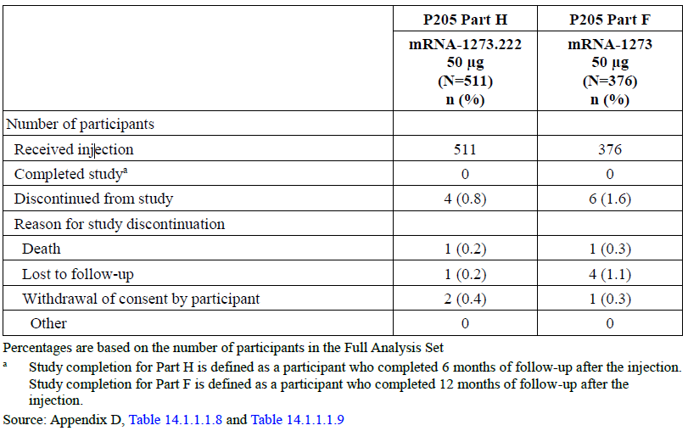

Abbreviations mRNA-1273.222 = Spikevax bivalent Original/Omicron BA.4-5 vaccine (elasomeran and davesomeran); MRNA-1273 = Spikevax (monovalent) vaccine (elasomeran).

Percentages are based on the number of participants in the full analysis set

a Study completion for Part H is defined as a participant who completed 6 months of follow up after the injection. Study completion for Part F is defined at a participant who completed 12 months of follow up after the injection.

In the 50 µg bivalent Original/Omicron BA.4-5 booster dose group, 511 participants received the booster dose. Of these, 305 participants (59.7%) enrolled from Study P301 where they had received the primary series and the first booster dose of monovalent Spikevax and 206 of the 511 participants (40.3%) had received the primary series and the first booster dose of monovalent Spikevax under the EUA in the United States. The median follow-up time from the 50 µg bivalent Original/Omicron BA.4–5 booster dose booster dose injection was 37 days (range 5 to 45 days). Of the 511 participants who received the bivalent Original/Omicron BA.4–5 booster at 50 µg booster dose, four participants discontinued from the study (two withdrawal of consent by participant, one death and one lost to follow up).

In the 50 µg monovalent Spikevax booster dose group, 379 participants enrolled and 376 received the booster dose. Of the 376 participants, 263 participants (69.9%) enrolled from Study P301 where they had received the primary series and the first booster dose of monovalent Spikevax and 113 of the 376 participants (30.1%) had received the primary series and the first booster dose of monovalent Spikevax under the EUA in the United States. The median follow up time from 50 µg monovalent Spikevax booster injection was 127 days (range 64 to 136 days). Of the 376 participants who received the 50 µg monovalent Spikevax booster dose, 98.4% participants were still on study by the data cut-off date (6 July 2022).

###### Demographic and baseline characteristics

In the 50 µg Spikevax bivalent Original/Omicron BA.4-5 booster dose group (dosed between 10 August to 23 August 2022), 316 out of 511 participants (61.8%) were female, most were White (426 out of 511, 83.4%), and the median age was 50 years (range: 19 to 89 years). A total of 105 out of 511 participants (20.5 %) were older or equal to 65 years of age. The median time between second dose of the primary series to the first booster dose was 251 days (range 67 to 533 days) and the median time between the first booster dose to the 50 µg bivalent Original/Omicron BA.4 – 5 booster dose was 289 days (range 103 to 371 days). At Baseline, 286 out of 511 Spikevax bivalent Original/Omicron BA.4-5 vaccine participants (56 %) had evidence of prior SARS-CoV-2 infection.

In the 50 µg monovalent Spikevax booster dose group (dosed between 18 February 2022 to 8 March 2022), 190 out of 376 participants (50.5 %) were female, most were White (322 out of 376, 85.6%), and the median age was 60.5 years (range: 20 to 96 years). A total of 150 out of 376 participants (39.9%) were older or equal to 65 years of age. The median time between second dose of the primary series and the first booster dose was 242 days (range 170 to 438 days) and the median time between the first booster dose and the monovalent Spikevax booster dose was 134 days (range 90 to 310 days). At Baseline, 101 out of 376 monovalent Spikevax participants (26.9%) had evidence of prior SARS-CoV-2 infection.

###### Results

The primary analysis population for primary objective of the comparison of Study P205 Part H versus Study P205 Part F was the per-protocol immunogenicity negative population (participants with no prior infection).

Non-inferiority testing

In the per-protocol immunogenicity negative set population (participants with no prior infection), the observed GMT (95% CI) against Omicron subvariant BA.4/5 at pre-booster was 87.9 (72.2,107.1) and increased to 2324.6 (1921.2, 2812.7) 28 days after the booster dose for Spikevax bivalent Original/Omicron BA.4-5 and the GMFR (95% CI) for the GMTs 28 days after the booster compared to pre-booster was 26.4 (22, 31.9).In the monovalent Spikevax group, the observed GMT (95% CIs) at pre-booster was 136.1 (116.3, 159.3) and increased to 488.5 (427.4, 558.4 28 days after the booster dose and GMFR (95% CI) was 3.6 (3.3, 4) (see Table 7).

Superiority testing

Given that the four conditions of non-inferiority were met (GMR and SRR difference for Omicron subvariant BA.4/BA.5 and GMR and SRR difference for ancestral strain), based on the pre‑specified testing, the lower bound of the CI of the Omicron BA.4/5 GMR was also compared to 1 (pre-specified criterion for superiority) and the superiority criterion was also met (lower bound of CI greater than 1).

Therefore, all primary immunogenicity endpoints were met and 50 µg Spikevax bivalent Original/Omicron BA.4-5 vaccine (elasomeran and davesomeran) elicited superior neutralising antibody responses compared to that of 50 µg monovalent Spikevax vaccine (elasomeran) against Omicron subvariant BA.4/BA.5 (see Table 7).

Table : Study P205 Part H and F; Ancestral strain and Omicron subvariant BA.4/BA.5 neutralising antibody titres (ID50) for 50 µg bivalent Original/Omicron BA.4-5 and 50 µg monovalent Spikevax vaccines administered as second booster doses in participants without infection at pre-booster (per-protocol immunogenicity negative set)

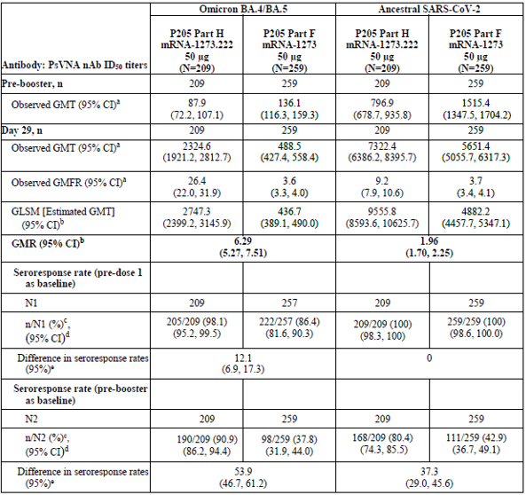

Abbreviations: CI = confidence interval; GLSM = geometric least square mean; GMT = geometric mean titre; GMFR = geometric mean fold rise; ID50 = 50% inhibitory dilution; LLOQ = lower limit of quantification; mRNA -1273.222 = bivalent Original/Omicron BA.4 – 5; mRNA-1273 = monovalent Spikevax; nAb = neutralising antibody; PsVNA = pseudotyped virus neutralisation assay; SAR-COV-2 = severe acute respiratory syndrome 2.

n = number of participants with non-missing data at the corresponding timepoint.

N1 = number of participants with non-missing data at pre-vaccination baseline and the corresponding timepoint.

N2 = number of participants with non-missing data at pre-booster baseline and the corresponding timepoint.

a 95% CI is calculated based on the t-distribution of the log-transformed values or the difference in the log-transformed values for GM values and GM fold-rise, respectively, then back transformed to the original scale for presentation.

b Based on ANCOVA modelling: the model includes adjustment for treatment group, pre-booster antibody titres, and age group.

c Seroresponse at a participant level is defined as a change from below the LLOQ to equal or above 4 x LLOQ if the participant’s baseline (pre-dose 1/pre-booster) is below the LLOQ, or at least a 4 fold rise if the baseline (pre-dose/pre-booster) is equal to or above the LLOQ. For participants without pre-dose 1 antibody titre information, seroresponse (using pre-dose 1 baseline) is defined as ≥ 4 times LLOQ for participants with negative SARS-CoV-2 status at pre-dose 1 of the primary series, and these titres are imputed as < LLOQ at pre-dose 1 of primary series. For participants without SARS-CoV-2 status information at pre-dose 1 of primary series. Their pre-booster SARS-CoV-2 status is used to impute their SARS-CoV-2 status at their pre-dose 1 of primary series.

d 95% CI is calculated using the Clopper-Pearson method

e 95% CI is calculated by stratified Miettinen-Nurminen method adjusted by age group. The SSR difference is a calculated common risk difference using inverse-variance stratum risk differences The stratified Miettinen-Nurminen estimate of the CI cannot be calculated when the seroresponse rate in both groups is 100% absolute difference is reported.

An immunogenicity analysis was also performed to evaluate the neutralising antibody responses in participants with evidence of prior SARS-CoV-2 infection at pre-booster. The GMR and SRR results for the per protocol immunogenicity positive population were consistent with the results of the per protocol immunogenicity negative population. Overall, the results were consistent in participants with prior infection in that the Spikevax bivalent Original/Omicron BA.4-5 at 50 µg booster elicited higher neutralising antibody responses than the monovalent Spikevax at 50 µg booster.

Table : Study P205 Parts H and F; Ancestral strain and Omicron subvariant BA.4/BA.5 neutralising antibody titres (ID50) for 50 µg bivalent Original/Omicron BA.4-5 and 50 µg monovalent Spikevax vaccines administered as second booster doses in participants with infection at pre-booster (per-protocol immunogenicity positive set)

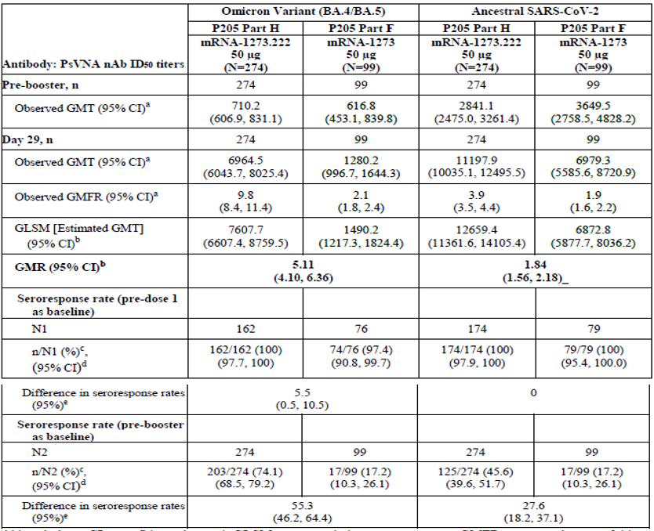

Abbreviations: CI = confidence interval; GLSM = geometric least square mean; GMT = geometric mean titre; GMFR = geometric mean fold rise; ID50 = 50% inhibitory dilution; LLOQ = lower limit of quantification; mRNA -1273.222 = bivalent Original/Omicron BA.4 – 5; mRNA-1273 = monovalent Spikevax; nAb = neutralising antibody; PsVNA = pseudotyped virus neutralisation assay; SAR-COV-2 = severe acute respiratory syndrome 2.

n = number of participants with non-missing data at the corresponding timepoint.

N1 = number of participants with non-missing data at pre-vaccination baseline and the corresponding timepoint.

N2 = number of participants with non-missing data at pre-booster baseline and the corresponding timepoint.

a 95% CI is calculated based on the t-distribution of the log-transformed values or the difference in the log-transformed values for GM values and GM fold-rise, respectively, then back transformed to the original scale for presentation.

b Based on ANCOVA modelling: the model includes adjustment for treatment group, pre-booster antibody titres, and age group.

c Seroresponse at a participant level is defined as a change from below the LLOQ to equal or above 4 x LLOQ if the participant’s baseline (pre-dose 1/pre-booster) is below the LLOQ, or at least a 4 fold rise if the baseline (pre-dose/pre-booster) is equal to or above the LLOQ. For participants without pre-dose 1 antibody titre information, seroresponse (using pre-dose 1 baseline) is defined as ≥ 4 times LLOQ for participants with negative SARS-CoV-2 status at pre-dose 1 of the primary series, and these titres are imputed as < LLOQ at pre-dose 1 of primary series. For participants without SARS-CoV-2 status information at pre-dose 1 of primary series. Their pre-booster SARS-CoV-2 status is used to impute their SARS-CoV-2 status at their pre-dose 1 of primary series.

d 95% CI is calculated using the Clopper-Pearson method

e 95% CI is calculated by stratified Miettinen-Nurminen method adjusted by age group. The SSR difference is a calculated common risk difference using inverse-variance stratum risk differences The stratified Miettinen-Nurminen estimate of the CI cannot be calculated when the seroresponse rate in both groups is 100% absolute difference is reported.

An additional immunogenicity analysis was performed considering all participants regardless of prior SARS-CoV-2 infection (per protocol immunogenicity population regardless of SARS-CoV-2 infection status at pre-booster baseline) (see Table 9)

The GMR and SRR results for the per protocol immunogenicity population (all participants) were consistent with the results of the per protocol immunogenicity negative population. Overall, the results are consistent in all participants in that the Spikevax Bivalent Original/Omicron BA.4-5 at 50 µg booster elicited higher neutralising antibody responses than the monovalent Spikevax at 50 µg booster.

Table : Study P205 Parts H and F Ancestral strain and Omicron subvariant BA,4/5 neutralising antibody titres (ID50) for 50 µg bivalent Original/Omicron BA.4-5 and 50 µg monovalent Spikevax vaccines administered as second booster doses in participants with and without prior SARS-CoV-2 infection (per-protocol immunogenicity set)

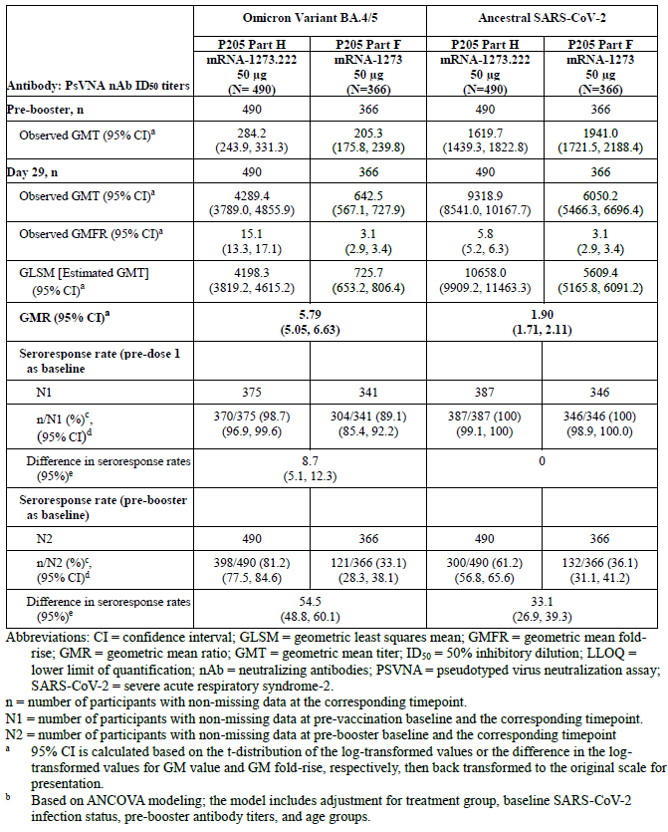

Abbreviations: CI = confidence interval; GLSM = geometric least square mean; GMT = geometric mean titre; GMFR = geometric mean fold rise; ID50 = 50% inhibitory dilution; LLOQ = lower limit of quantification; mRNA -1273.222 = bivalent Original/Omicron BA.4 – 5; mRNA-1273 = monovalent Spikevax; nAb = neutralising antibody; PsVNA = pseudotyped virus neutralisation assay; SAR-COV-2 = severe acute respiratory syndrome 2.

n = number of participants with non-missing data at the corresponding timepoint.

N1 = number of participants with non-missing data at pre-vaccination baseline and the corresponding timepoint.

N2 = number of participants with non-missing data at pre-booster baseline and the corresponding timepoint.

a 95% CI is calculated based on the t-distribution of the log-transformed values or the difference in the log-transformed values for GM values and GM fold-rise, respectively, then back transformed to the original scale for presentation.

b Based on ANCOVA modelling: the model includes adjustment for treatment group,baseline SAR-CoV-2 infection status, pre-booster antibody titres, and age group.

c Seroresponse at a participant level is defined as a change from below the LLOQ to equal or above 4 x LLOQ if the participant’s baseline (pre-dose 1/pre-booster) is below the LLOQ, or at least a 4 fold rise if the baseline (pre-dose/pre-booster) is equal to or above the LLOQ. For participants without pre-dose 1 antibody titre information, seroresponse (using pre-dose 1 baseline) is defined as ≥ 4 times LLOQ for participants with negative SARS-CoV-2 status at pre-dose 1 of the primary series, and these titres are imputed as < LLOQ at pre-dose 1 of primary series. For participants without SARS-CoV-2 status information at pre-dose 1 of primary series, their pre-booster SARS-CoV-2 status is used to impute their SARS-CoV-2 status at their pre-dose 1 of primary series.

d 95% CI is calculated using the Clopper-Pearson method

e 95% CI is calculated by stratified Miettinen-Nurminen method adjusted by age group and baseline SARS-CoV-2 infection status. The SSR difference is a calculated common risk difference using inverse-variance stratum risk differences and middle point of Miettinen-Nurminen confidence limits of each one of the stratum risk differences The stratified Miettinen-Nurminen estimate of the CI cannot be calculated when the seroresponse rate in both groups is 100% absolute difference is reported.

A sensitivity analysis which excluded participants who had SARS-CoV-2 infection after the booster dose and up to Day 29 was also performed in per protocol immunogenicity negative population and the results were consistent with the immunogenicity results in the per protocol immunogenicity negative population.

A subgroup analysis of the per protocol immunogenicity negative population by age group (from 18 to younger than 65 years and from 65 years of age) was performed and the results indicate that the immunogenicity responses were similar between the two age groups (see Table 10)

Table : Study P205 Parts H and F Ancestral strain and Omicron neutralising antibody titres (ID50) for 50 µg Spikevax bivalent Original/Omicron BA.4-5 and 50 µg monovalent Spikevax administered as second booster doses in participants without infection at pre-booster by age group (per-protocol immunogenicity negative set)

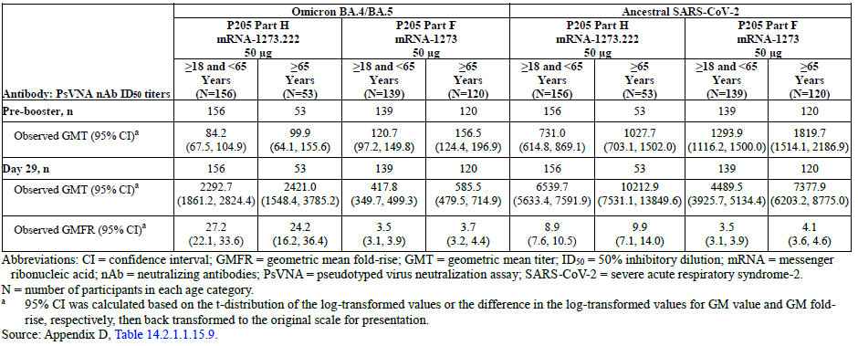

Abbreviations: CI = confidence interval; GMT = geometric mean titre; GMFR = geometric mean fold rise; ID50 = 50% inhibitory dilution; mRNA -1273.222 = bivalent Original/Omicron BA.4 – 5; mRNA-1273 = monovalent Spikevax; nAb = neutralising antibody; PsVNA = pseudotyped virus neutralisation assay; SAR-COV-2 = severe acute respiratory syndrome 2.

N = number of participants in each age group

a 95% CI is calculated based on the t-distribution of the log-transformed values or the difference in the log-transformed values for GM values and GM fold-rise, respectively, then back transformed to the original scale for presentation.

Cross-neutralisation ability of bivalent Original/Omicron BA.4 – 5 vaccine against the emerging Omicron variants BQ.1.1 and XBB.1.

An exploratory analysis was performed to assess the cross-neutralisation ability of Spikevax bivalent Original/Omicron BA.4-5 vaccine against the emerging Omicron variants BQ.1.1 and XBB.1. Table 11 shows the neutralising antibody response against the Omicron BQ.1.1 and XBB.1 variants in a random sample of 40 participants without SARS-CoV-2 infection at pre-booster. For the BQ.1.1, the pre-booster GMT (95% CI) was 31.7 (19.6, 51.3), the post-booster GMT (95% CI) was 621.9 (422.2, 916.2), and the GMFR (95% CI) was 19.6 (11.7, 32.8). For the Omicron XBB.1 variant, the pre-booster GMT (95% CI) was 18.1 (12.0, 27.1), the post-booster GMT (95% CI) was 222.3 (147.4, 335.2), and the GMFR (95% CI) was 12.3 (7.4, 20.5). The observed GMT was 5.4-fold and 15.1-fold lower for the Omicron BQ.1.1 and XBB.1 variants, respectively, than for the BA.4/BA.5 variant (see Table 11).

Table : Study P205 Part H Spikevax bivalent Original/Omicron BA.4-5 vaccine exhibits cross-neutralisation against Omicron BQ.1.1 variant (neutralising antibody titres (ID50)) at Day 29; SARS-CoV-2 negative, random sample)

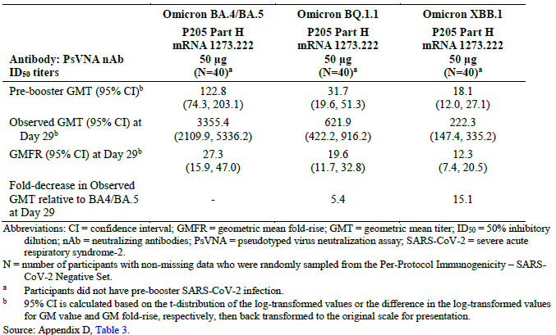

Abbreviations: CI = confidence interval; GMT = geometric mean titre; GMFR = geometric mean fold rise; ID50 = 50% inhibitory dilution; mRNA -1273.222 = bivalent Original/Omicron BA.4 – 5 vaccine; nAb = neutralising antibody; PsVNA = pseudotyped virus neutralisation assay; SAR-COV-2 = severe acute respiratory syndrome 2.

N = number of participants with non-missing data who were randomly sampled from the pre protocol immunogenicity SARS-CoV-2 negative set.

a Participants did not have pre-booster SARS-CoV-2 infection.

b 95% CI is calculated based on the t-distribution of the log-transformed values or the difference in the log-transformed values for GM values and GM fold-rise, respectively, then back transformed to the original scale for presentation.

Table 12 (below) shows the neutralising antibody response against the Omicron BQ.1.1 and XBB.1 variants in a random sample of 20 participants with SARS-CoV-2 infection at pre-booster. For the Omicron BQ.1.1 subvariant, the pre-booster GMT (95% CI) was 124.7 (61.4, 253.2), the post-booster GMT (95% CI) was 1093.5 (536.8, 2227.9), and the GMFR (95% CI) was 8.8 (5.0, 15.5). For the Omicron XBB.1 subvariant, the pre-booster GMT (95% CI) was 55.4 (28.4, 108.0), the post-booster GMT (95% CI) was 381.4 (198.1, 734.4), and the GMFR (95% CI) was 6.9 (4, 11.7). The observed GMT was 8.1-fold and 23.3-fold lower for the Omicron BQ.1.1 and XBB.1 subvariants, respectively, than for the Omicron BA.4/BA.5 subvariant.

These results indicate that Spikevax bivalent Original/Omicron BA.4–5 vaccine exhibited cross-neutralisation against the Omicron BQ.1.1 and XBB.1 subvariants.

Table : Study P205 Part H Spikevax Bivalent Original/Omicron BA.4-5 vaccine exhibits cross-neutralisation against Omicron BQ.1.1 and XBB.1 variants in SARS‑CoV-2 positive participants at Day 29 (neutralising antibody titres, ID50) (N = 20)

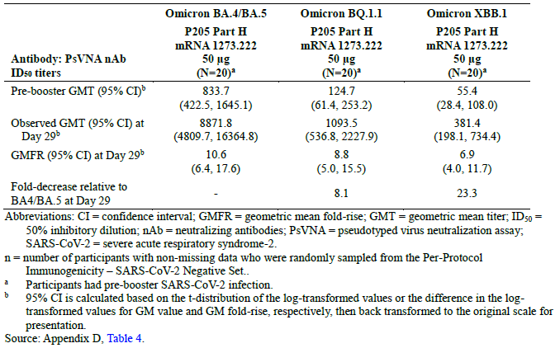

Abbreviations: CI = confidence interval; GMT = geometric mean titre; GMFR = geometric mean fold rise; ID50 = 50% inhibitory dilution; mRNA -1273.222 = bivalent Original/Omicron BA.4 – 5 vaccine; nAb = neutralising antibody; PsVNA = pseudotyped virus neutralisation assay; SAR-COV-2 = severe acute respiratory syndrome 2.

n = number of participants with non-missing data who were randomly sampled from the pre protocol immunogenicity SARS-CoV-2 negative set.

a Participants had pre-booster SARS-CoV-2 infection.

b 95% CI is calculated based on the t-distribution of the log-transformed values or the difference in the log-transformed values for GM values and GM fold-rise, respectively, then back transformed to the original scale for presentation.

##### SARS-CoV-2 infection and symptomatic infection

###### SARS-CoV-2 incidence rates after the bivalent Original/Omicron BA.4-5 and monovalent Spikevax booster vaccines

Study P205 was not designed to evaluate booster vaccine effectiveness and occurrence of infections after the booster doses reflects the epidemiological environment in the US (August through October 2022) for this interim analysis. Infections were counted starting 14 days after the booster dose (Spikevax bivalent Original/Omicron BA.4-5 vaccine at 50 µg) through the follow up time of this interim analysis.

In the 50 µg Spikevax bivalent Original/Omicron BA.4-5 booster dose group of participants without prior infection (per protocol efficacy set) with a median of 37 days of follow up, 12 participants (5.6%) had SARS-CoV-2 infection starting at least 14 days after the 50 µg booster dose. Among the 12 participants with SARS-CoV-2 infection, five participants (2.3%) met the primary case definition of COVID-19 and seven participants (3.2%) met the secondary case definition of COVID-19. The remaining five participants (2.3%) had an asymptomatic infection. No participants with COVID-19 had an emergency room visit or hospitalisation due to the COVID-19 event. Similar results were observed for the full analysis set population.

The Day 29 interim analysis infection rates for monovalent Spikevax (enrolled in February to March 2022) have been previously published.[8] For reference, in the monovalent Spikevax at 50 µg elasomeran booster dose group, with a median of 57 days of follow up duration, nine participants (2.4%) from per protocol efficacy set had SARS-CoV-2 infection starting at least 14 days after the 50 µg booster dose. Among the nine participants with SARS-CoV-2 infection, two participants (0.5%) met both the primary case definition of COVID-19 and the secondary case definition of COVID-19. The remaining seven participants had an asymptomatic infection.

Table : Summary of COVID-19 infections (second booster dose with Spikevax bivalent Original/Omicron BA.4-5 50 µg)

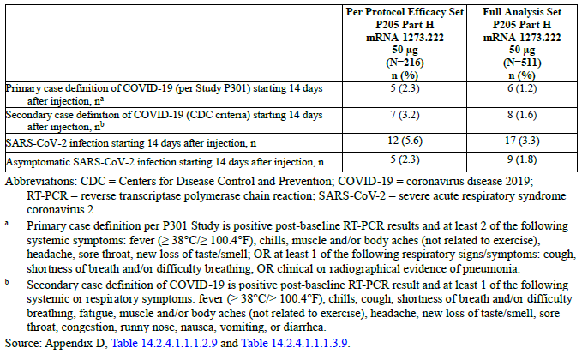

Abbreviations: CDC = Centers for Disease Control and Prevention; COVID-19 = coronavirus disease 2019; mRNA-1273.222 = Spikevax bivalent Original/Omicron BA.4-5 (elasomeran and davesomeran);  
RT-PCR = reverse transcriptase polymerase chain reaction; SARS-CoV-2 = severe acute respiratory syndrome coronavirus 2.

a Primary case definition per Study P301 is positive post-baseline RT-PCR results and at least 2 of the following systemic symptoms: fever ≥ 38oC, chills, muscle and/or body aches (not related to exercise), headache, sore throat, new loss of taste/smell; OR at least 1 of the following respiratory signs/symptoms: cough, shortness of breath and/or difficulty breathing, OR clinical or radiographical evidence of pneumonia

b Secondary case definition of COVID-19 is positive post-baseline, RT-PCR result and at least 1 of the following systemic or respiratory symptoms: fever ≥ 38oC, chills, cough, shortness of breath and/or difficulty breathing, fatigue, muscle and/or body aches (not related to exercise), headaches, new loss of taste/smell, sore throat, congestion, runny nose, nausea, vomiting, or diarrhoea.

##### Study P205 Part G

Study P205 is an ongoing open label Phase II/III study with multiple, sequentially enrolled cohorts to evaluate the immunogenicity and safety of variant-modified booster candidate vaccines.

Study P205 Part G was previously evaluated by TGA,6 and therefore is not fully discussed here.

Study P205 Part G evaluated the safety, reactogenicity, and immunogenicity of 50 µg of Spikevax Original/Omicron BA.1 (elasomeran and imelasomeran) when administered as a second booster dose in adults who previously received two doses of 100 µg monovalent Spikevax (elasomeran) as a primary series and a single booster dose of 50 µg monovalent Spikevax. As is the case with Study P205 Part H, the sponsor provided Study P205 Part F as the within-study, non‑contemporaneous comparator group for Study P205 Part G.

In an analysis of Study P205 Part G versus Part F, the primary immunogenicity objective (pre‑specified) was to compare the immunogenicity of Spikevax bivalent Original/Omicron BA.1 vaccine at 50 µg and monovalent Spikevax at 50 µg as a second booster. The co-primary endpoints were GMT and SRR for serum nAb titres against the SARS-CoV-2 ancestral and Omicron (BA.1) strains. The primary efficacy analysis set was the per-protocol immunogenicity set with negative baseline SARS-CoV-2 status.

Overall, demographic and baseline characteristics were similar between the bivalent Original/Omicron BA.1 vaccine (elasomeran and imelasomeran) at 50 µg and monovalent Spikevax (elasomeran) at 50 µg groups.

In Study P205 Part G, all primary and key secondary immunogenicity objectives were met. Spikevax bivalent Original/Omicron BA.1 at 50 µg elicited a superior neutralising antibody response against Omicron BA.1 strain, and a non-inferior antibody response against the ancestral strain 28 days after booster dose administration as compared to a 50 µg booster dose of monovalent Spikevax. The GMR (97.5% CI) for primary analysis population (participants with no prior infection) against the Omicron variant was 1.75 (1.49, 2.04), meeting the prespecified superiority criterion (lower bound of CI > 1). The GMR (97.5% CI) against the ancestral strain was 1.22 (1.08, 1.37), meeting the prespecified criterion for non-inferiority (lower bound of CI ≥ 0.67). Omicron neutralising antibody responses were higher in participants both with and without prior evidence of SARS-CoV-2 infection in the entire study population (GMR (97.5% CI) 1.79 (1.56, 2.04)).

The seroresponse was calculated relative to baseline titres pre-Dose 1 of the primary series. With an alternative definition of seroresponse which is being ≥ 4-fold increase relative to baseline titres pre-second booster, SRRs were consistent with the GMT results.

In addition, a subgroup analysis in participants with evidence of SARS-CoV-2 infection at Baseline showed that Spikevax bivalent Original/Omicron BA.1 vaccine demonstrated higher immunogenicity against Omicron (B.1.1.529) and ancestral strain with the Day 29 GMR of 1.898 (97.5% CI: 1.499, 2.403) and 1.272 (97.5% CI: 1.070, 1.512), respectively.

Additionally, in the exploratory immunogenicity analysis, 50 µg of Spikevax bivalent Original/Omicron BA.1 vaccine elicited higher neutralising antibody response against the Omicron BA.4 and BA.5 subvariants; Spikevax bivalent Original/Omicron BA.1 vaccine also elicited higher binding antibody responses against multiple variants not contained in the vaccine, including Alpha, Beta, Gamma, and Delta. The sponsor had provided supportive Day 181 data for a bivalent vaccine containing equal amounts of the ancestral strain and Beta variant spike protein sequences, from Part A1 of Study P205. These data suggest some persistence of the neutralising antibodies induced by a bivalent mRNA vaccine against ancestral and variant strains. These data also provide some supportive evidence to extrapolate bivalent Original/Omicron BA.1 vaccine to the first booster setting.

##### Study P203 Part C (booster phase)

Study P203 Part C is an extension of Study P203. Study P203 is a Phase II/III study originally designed as a randomised, observer-blind, placebo controlled study evaluating the safety, reactogenicity, and effectiveness of a two dose monovalent Spikevax vaccine (100 µg elasomeran) primary series in healthy adolescents 12 to 17 years of age. The study later transitioned to an open label phase. This allowed unblinding of study participants and crossover of those participants randomised to placebo to receive the monovalent Spikevax primary series. A protocol amendment (Part 1C-1) was later implemented to evaluate administration of a 50 µg monovalent Spikevax booster dose to ongoing study participants from Study P203. A booster dose was administered at least 5 months after completion of the monovalent Spikevax primary series. This data has been previously assessed by TGA.7 The sponsor has re-submitted this data to support the Spikevax bivalent Original/Omicron BA.4–5 vaccine in the 12 to 17 years age group.

The primary immunogenicity objective of the booster phase of Study P203 was to infer effectiveness of the 50 µg booster of monovalent Spikevax (elasomeran) by comparing post-booster immune responses (Day 29) in adolescents to those obtained post-Dose 2 of the primary series (Day 57) in young adults (18 to 25 years of age) in Study P301.

The result of the Study P203 versus P301 comparison are summarised as follows.

A total of 1346 participants from 12 to 17 years of age who completed the 100 µg monovalent Spikevax (elasomeran) primary series in Study P203 Part 1A, received a 50 µg monovalent Spikevax booster dose. A total of 11 participants (0.8%) in the monovalent Spikevax booster group discontinued the study due to withdrawal of consent by participant (six participants), lost to follow up (four participants), and ‘other’ reasons (one participant). ‘Other’ reasons from withdrawal or discontinuation from study were due to logistical issues with compliance with protocol procedures. No participants discontinued the study due to adverse events.

A total of 327 boosted adolescents were included in the Study P203 per protocol immunogenicity subset, and 295 young adults were included in the Study P301 per protocol immunogenicity subset

###### Immunogenicity

Serum neutralising antibody level was assessed at Day 29 for Study P203 adolescents (per protocol immunogenicity subset pre-booster SARS-CoV-2 status negative) and compared to those following primary series in young adults (Study Day 57; 18 to 25 years of age) in Study P301. The GMR of Study P203 booster dose on Day 29 geometric mean concentration (GMC) compared with young adults in Study P301, Day 57. GMR was 5.1 (95% CI: 4.5, 5.8), meeting the non-inferiority criteria (that is lower bound of the 95% CI > 0.667); point estimate ≥ 0.8); the SRR difference was 0.7% (95% CI: -0.8, 2.4), meeting the non‑inferiority criteria (lower bound of the 95% of the SRR difference > -10%). The sponsor stated that as the pre-specified success criteria for the primary immunogenicity objective were met, thus enabling the inference of vaccine effectiveness from Study P301.This was considered acceptable.

###### Conclusion

In the booster phase (Part 1C-1) of Study P203 it was demonstrated that administration of a 50 µg booster dose of monovalent Spikevax, in adolescents from 12 to 17 years, effectively boosts serum nAb levels, as compared with the pre-booster baseline meeting. The GMR of Study P203 booster dose on Day 29 GMC in adolescents compared with young adults in Study P301, Day 57 GMC was 5.1 (95% CI: 4.5, 5.8), meeting the prespecified non-inferiority criteria.

##### Study P204 booster study

Study P204 is an ongoing Phase II/III, three parts, dose escalation (open label), age de‑escalation and randomised, observer blind, placebo controlled expansion study to evaluate the safety, reactogenicity, and effectiveness of monovalent Spikevax in children from 6 months to 11 years of age.

The study population was evaluated in three discrete age groups (6 years through 11 years, 2 years to less than 6 years, and 6 months to less than 2 years), assessing up to three dosage levels (25, 50, and 100 µg) of monovalent Spikevax in the primary series. For each of the three age groups, an open label dose finding (Part 1) phase preceded a blinded, placebo controlled (Part 2) phase which evaluated the selected dose of monovalent Spikevax (elasomeran) in a placebo controlled fashion.

Following evidence of enhanced effectiveness of the adult booster dose, Study P204 was amended to offer a booster (monovalent Spikevax, 25 µg) to all children enrolled in the 6 through 11 years age group, which could be administered from 6 months post‑Dose 2 of the primary series (monovalent Spikevax, 50 µg). Participants receiving a booster were followed for safety and immunogenicity.

The sponsor claims that the clinical data from the prototype monovalent Spikevax booster dose in children 6 to 11 years old is intended to support the registration of the booster formulation containing Omicron variants.

For immunogenicity, the primary objective of the booster phase of Study P204 is to infer effectiveness of the booster dose by comparing post-booster dose immune responses (booster dose - Day 29) to those obtained post-Dose 2 of the primary series (Day 57) in young adults (18 to 25 years of age) in Study P301, where 93% efficacy was demonstrated. Effectiveness of the 25 µg monovalent Spikevax booster dose is inferred if post-booster dose immune responses (nAb GMC and SRR) meet prespecified non-inferiority criteria (for both GMC and SRR) compared to those measured following completion of the 100 µg monovalent Spikevax primary series among a subset of young adults (18 to 25 years) in the pivotal monovalent Spikevax efficacy trial (Study P301). Demonstration of non-inferiority requires meeting the pre-defined success criteria:

* Geometric mean ratio between the children and the young adults: the lower bound of the 95% CI of the GMR (GMC of Study P204 booster dose-Day 29/GMC Study P301 young adult Day 57) > 0.667
* difference in SRR between these same groups: the lower bound of the 95% of the SRR difference > -10%

A total of 1294 participants 6 through 11 years of age received the monovalent Spikevax 25 µg booster dose. One participant discontinued the study due to withdrawal of consent. Withdrawal for this participant was not related to AEs. The mean age was 8.5 years, with 51.9% being male, and 65.7% being White in ethnicity. The race and ethnicity demographics of the boosted participants were similar to that in the original Study P204 and Study P301. Approximately 33% of participants had evidence of prior SARS-CoV-2 infection at the time of boosting.

In the Study P204 per-protocol immunogenicity subset with pre-booster SARS-CoV-2 negative status group (N = 95), pre-booster (booster dose-Day 1) nAb GMC was 485.6 (95% CI: 423.1, 557.3;); on booster dose-Day 29 the GMC was 5847.5 (95% CI: 5212.3, 6560.1). Post-boost GMC increased approximately 12- fold from pre-booster GMC, demonstrating the ability of the booster dose to recall memory responses in children 6 through 11 years when administered 6 months or more post-completion of the primary series.

Antibody responses (nAb, GMC) were also assessed among the subgroup of participants with evidence of prior SARS-CoV-2 infection at the pre-booster visit (N = 27). Previously infected participants, as expected, had higher nAb titres measured at the pre-booster visit (GMC 4513.3, 95% CI (2979.3, 6837.1)) compared to participants without prior evidence of infection (GMC 485.6, 95% CI (423.1, 557.3)). Administration of the booster dose nonetheless enhanced serum nAb levels (booster dose-Day 29 GMC = 8903.7, 95% CI (6736.9, 11767.6)).

Results supporting the non-inferority analysis are summarised the Table 14. Serum nAb levels (measured by pseudotyped virus neutralisation assay) for children 6 through 11 years in the per-protocol immunogenicity subset with SARS-CoV-2 negative status and the comparison with those from young adults (18 to 25 years of age) in Study P301 are displayed. The GMR of Study P204 booster dose - Day 29 GMC compared to Study P301 young adults Day 57 GMC was 4.2 (95% CI 3.5, 5), meeting the non‑inferiority criteria (that is lower bound of the 95% CI > 0.667); the SRR difference was 0.7% (95% CI: -3.5, 2.4), meeting the non-inferiority criteria (lower bound of the 95% of the SRR difference > ‑10%).

Table : Study P204 Serum neutralising antibody against ancestral strain geometric mean concentration and seroresponse rate among Study P204 booster recipients post-booster dose compared to Study P301 young adults post-primary series

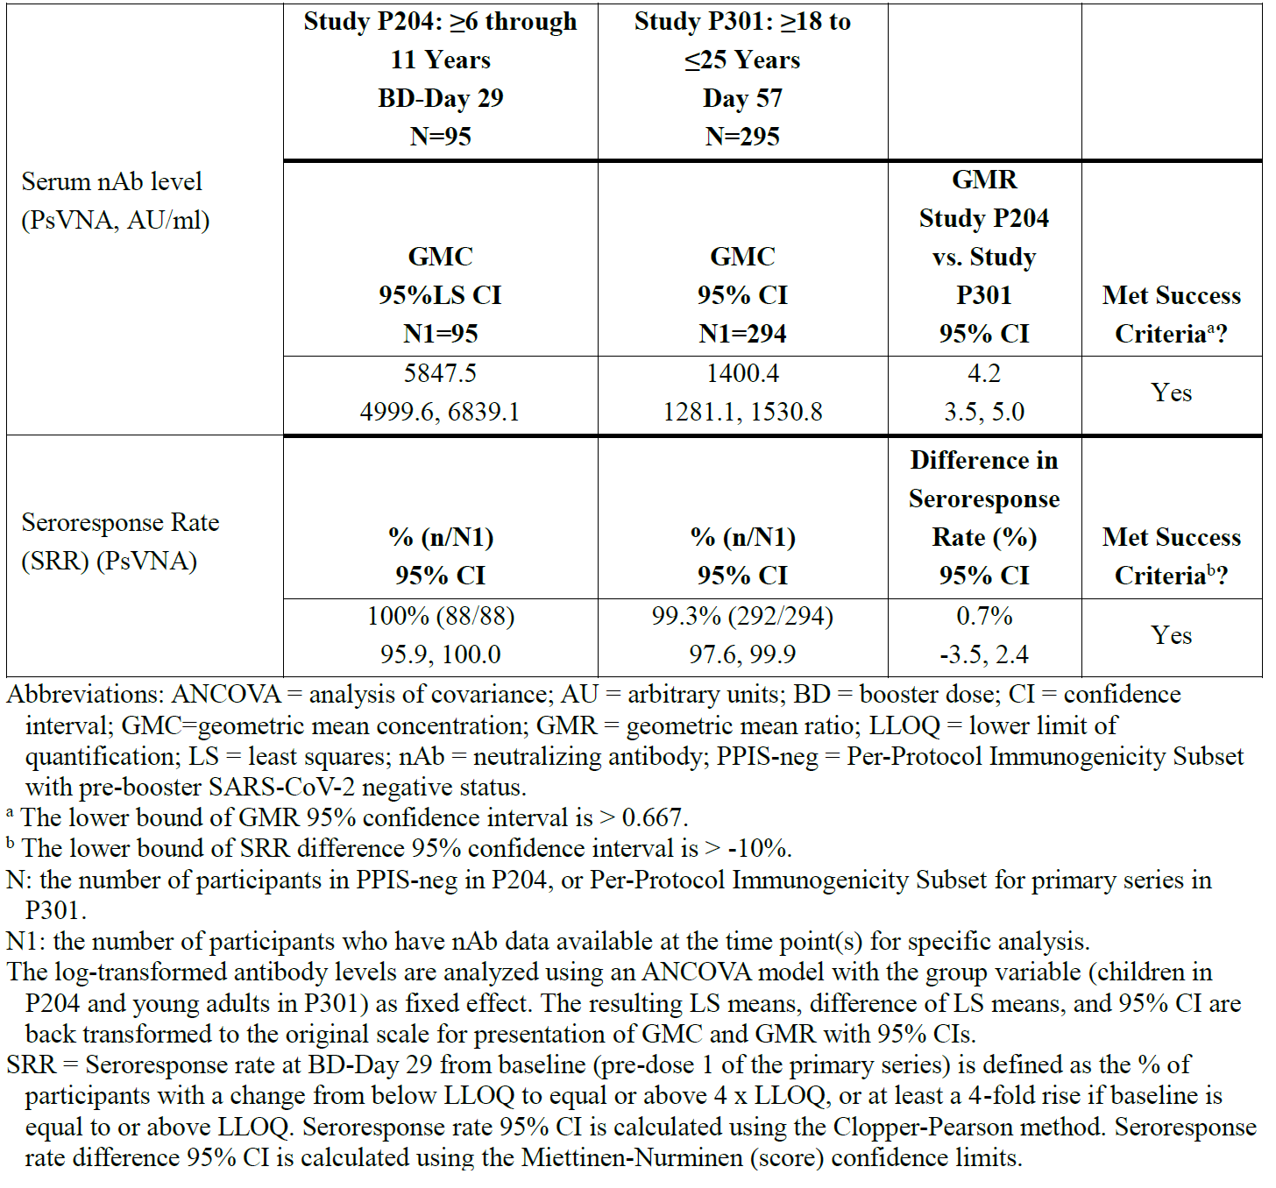

Abbreviations: ANCOVA = analysis of covariance; AU = arbitrary units; BD = booster dose; CI = confidence interval; GMC = geometric mean concentration; GMR = geometric mean ratio; LLOQ = lower limits of quantification; LS = least squares; nAB = neutralising antibody; PPIS-neg = per-protocol immunogenicity subset with pre-booster SARS-CoV-2 negative status.

a The lower bound of GMR 95% confidence interval is ˃ 0.667.

b The lower bound of SRR difference 95% confidence interval is ˃ -10%.

N = the number of participants in PPIS-neg in Study P204, or per-protocol immunogenicity subset for primary series in Study P301.

N1 = the number of participants who have nAb data available at the time point(s) for specific analysis. The log transformed antibody levels are analysed using an ANCOVA model with the group variable (children in Study P204 and young adults in Study P301) as fixed effect. The resulting LS mean, difference of LS means, and 95% CI are back transformed to the original scale for presentation of GMC and GMR with 95% CIs.

SRR = seroresponse rate at booster dose-Day 29 from Baseline (pre-Dose 1 of the primary series) is defined as the % of participants with a change from below LLOQ to equal or above 4 times LLOQ, or at least a 4 fold rise if baseline is equal to or above LLOQ. Seroresponse rate 95% CI is calculated using the Clopper-Pearson method. Seroresponse rate difference 95% CI is calculated using the Miettinen-Nurminen (score) confidence limits.

Neutralising antibody levels against an Omicron subvariant of SARS-CoV-2 (Omicron BA.1, using VAC122 assay) were assessed among booster recipients as well. In the Study P204 per-protocol immunogenicity subset with SARS-CoV-2 negative status participants, booster administration resulted in a rise of GMC from 53 (95% CI: 45.3, 61.9) at Day 1 to 632.6 (95% CI: 546.7, 731.9) at Day 29, a GMFR of 12.1, (95% CI: 9.7, 15.0). Among the pre-booster SARS-CoV-2 positive group, higher nAb titres measured at the Day 1 visit (1360.6, 95% CI: 939.5, 1970.4) were observed. In children with immunity both from monovalent Spikevax priming as well as SARS-CoV-2 infection (hybrid immunity), Omicron nAb responses were higher at Day 29 (GMC 2362.9, 95% CI: 1778.0, 3140.4), with geometric mean fold rise 1.7 (95% CI, (1.3, 2.3)) from administration of the booster dose.

#### Safety

##### Study P205 Part H

The median interval between the first booster dose of 50 µg monovalent Spikevax vaccine (elasomeran) and the 50 µg bivalent Original/Omicron BA.4-5 vaccine (elasomeran and davesomeran) dose was 289 days; the median follow up duration after the bivalent Original/Omicron BA.4-5 vaccine booster dose was 37 days (range 5 to 45 days).

The safety assessments for Study P205, Part H were as follows:

* Solicited local and systemic adverse reactions during the 7 day follow up period after vaccination. Serious adverse reactions that persisted beyond 7 days were also tabulated.
* Unsolicited adverse events (AEs) during the 28 day follow up period after vaccination. This includes any AE reported by the participant that is not specified as a solicited adverse reaction in the protocol or is specified as a solicited adverse reaction but starts outside the protocol defined period for reporting solicited adverse reactions (that is 7 days after vaccination).
* Serious adverse events (SAEs), medically-attended adverse events (MAAEs), AEs leading to withdrawal and adverse events of special interest (AESI) were collected throughout the study.

###### Solicited adverse reactions

For reactogenicity assessments, participants recorded solicited local and systemic adverse reactions in the eDiary on the day of vaccination and during the 7 days after vaccination (that is, the day of injection and six subsequent days). Solicited local adverse reactions assessed were injection site pain, injection site erythema (redness), injection site swelling/induration (hardness), and axillary (underarm) swelling or tenderness ipsilateral to the side of the injection. Solicited systemic adverse reactions assessed were headache, fatigue, myalgia (muscle aches all over the body), arthralgia (joint aches in several joints), nausea/vomiting, chills, and fever (oral temperature). Any solicited adverse reaction that was ongoing beyond Day 7 was to be reported in the eDiary until it resolved.

###### Solicited local adverse reactions

In the Spikevax bivalent Original/Omicron BA.4-5 vaccine (elasomeran and davesomeran) at 50 µg booster dose group, most participants had at least one solicited local adverse reaction (420 out of 507 (82.8%)). The most common solicited local adverse reaction after the bivalent Original/Omicron BA.4-5 vaccine at 50 µg booster dose was injection site pain (418 out of 507 participants (82.4%)), followed by axillary swelling or tenderness (106 out of 507 participants (20.9%)). The majority of solicited local adverse reactions were Grade 1 (329 out of 507 participants (64.9%)) followed by Grade 2 (63 out of 507 participants (12.4%)). Twenty eight participants (28 out of 507 (5.5%)) had a Grade 3 local adverse reaction and the most commonly reported term was injection site pain (20 out of 507 participants (3.9%)). There were no Grade 4 local adverse reaction. Local adverse reactions were transient; the median duration was 3 days (range: 1 to 22 days).

###### Solicited systemic reactions

Most participants had at least one solicited systemic adverse reaction (372 out of 508 (73.2%)). The most common systemic adverse reaction after the bivalent Original/Omicron BA.4-5 vaccine at 50 µg booster dose was fatigue (304 out of 508 participants (59.8%)), followed by headache (249 out of 507 participants (49.1%)), myalgia (235 out of 507 participants (46.4%)), and arthralgia (177 out of 507 participants (34.9%)). Most solicited systemic adverse reactions were Grade 1 (172 out of 508 (33.9%)) or Grade 2 (165 out of 508 [32.5%]). Thirty five participants (35 out of 508 participants (6.9%)) had a Grade 3 systemic adverse reaction, the most common were myalgia (20 out of 507 participants (3.9%)) and fatigue (17 out of 508 participants (3.3%)). No Grade 4 solicited systemic adverse reaction were reported. The median duration of systemic adverse reaction was 3 days (range 1 to 38 days).

###### Solicited adverse reactions by age category

Solicited adverse reaction were analysed by age category (from 18 to younger than 65 years of age and from 65 years of age) and the results are presented in Table 15 for solicited local and systemic adverse reactions.

Table : Study P205 Part H Solicited adverse reactions by age category

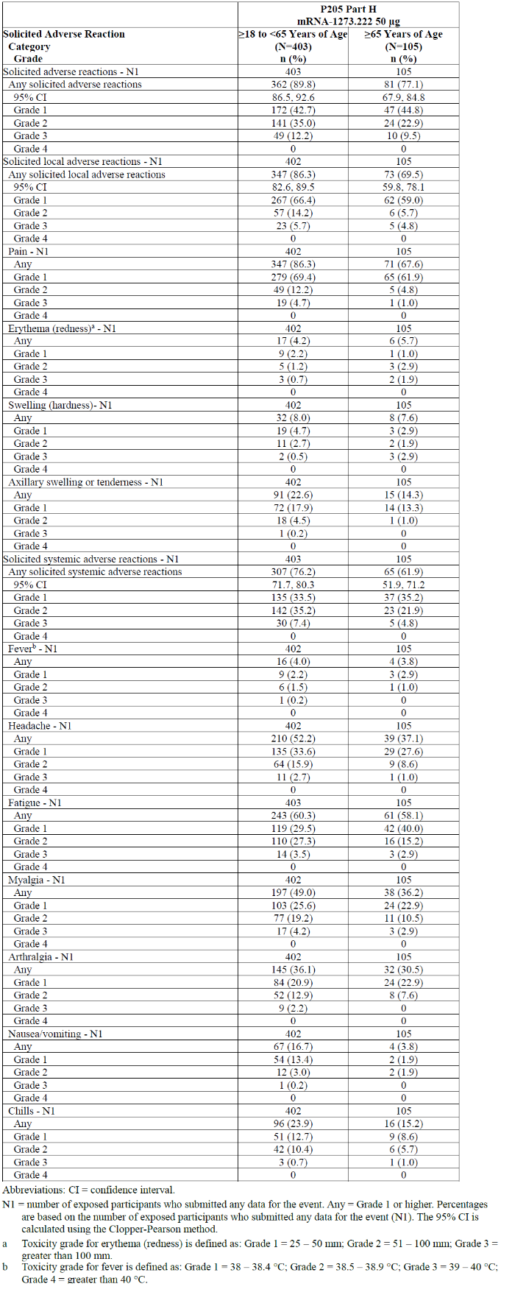

Abbreviations: CI = confidence interval; mRNA-1273.222 = Spikevax Bivalent Original/Omicron BA.4-5 COVID-19 vaccine (elasomeran and davesomeran).

N1 = number of exposed participants who submitted any data for the event. Any = Grade 1 or higher. Percentages are based on the number of exposed participants who submitted any data for the event (N1). The 95% CI is calculated using the Clopper-Pearson method.

a Toxicity grade for erythema (redness) is defined as: Grade 1 = 25 – 50 mm; Grade 2 = 51 – 100 mm; Grade 3 = greater than 100 mm.

b Toxicity grade for fever is defined as: Grade 1 = 38 – 38.4oC; Grade 2 = 38.5 – 38.9oC; Grade 3 = 39 – 40oC; Grade 4 = greater than 40oC.

###### Solicited adverse reactions by pre-booster SARS-CoV-2 status

Overall, there were no safety concerns or differences identified in solicited adverse reactions based on pre-booster SARS-CoV-2 status.

In the Spikevax bivalent Original/Omicron BA.4-5 vaccine (elasomeran and davesomeran) at 50 µg booster dose group (Part H) solicited safety set, over half the participants had evidence of prior SARS-CoV-2 antibodies: 283 out of 508 participants (55.7%) had a positive pre-booster SARS-CoV-2 status, and 216 out of 508 participants (42.5%) had a negative pre-booster SARS-CoV-2 status (nine participants had missing status). No increased reporting of solicited adverse reactions in participants with positive SARS‑CoV2 status was observed.

The frequency of solicited local adverse reaction was similar among participants wit‑h a positive pre-booster SARS-CoV-2 status (229 out of 282 (81.2%)) and participants with a negative pre-booster SARS-CoV-2 status (183 out of 216 (84.7%)). The frequency of solicited systemic adverse reactions was similar among participants with positive pre‑booster SARS-CoV-2 status (197 out of 283 (69.6%)) and participants with negative pre-booster SARS-CoV-2 status (167out of 216 [77.3%]). Grade 3 solicited local adverse reactions in participants with positive pre-booster SARS-CoV-2 status was 10 out of 282 (3.5%) and in participants with negative pre-booster SARS-CoV-2 status was 16 out of 216 (7.4%). Grade 3 systemic adverse reactions were similar in participants with positive pre‑booster SARS-CoV-2 status (19 out of 283 (6.7%)) and participants with negative pre‑booster SARS-CoV-2 status (16 out of 216 (7.4%)).

###### Unsolicited adverse events

In the Spikevax bivalent Original/Omicron BA.4-5 vaccine (elasomeran and davesomeran) at 50 µg booster dose group (Part H) within 28 days after vaccination three participants (0.6%) had four SAEs, and all were assessed by the investigator as not related to study vaccination. One SAE (0.2%) had a fatal outcome (subarachnoid haemorrhage), and the remaining three SAEs were reported in two participants (one participant had SAEs of anginal equivalent and syncope, and one participant had an SAE of anaemia). After the data cut off date (23 September 2022), there was an additional fatal event (death of unknown cause) which occurred on Study Day 40. MAAEs were reported for 70 out of 511 participants (13.7%), and all were assessed by the investigator as not related to study vaccination. No participants had treatment emergent adverse events (TEAEs) leading to study or vaccine discontinuation.

Unsolicited TEAEs within 28 days after the Original/Omicron BA.4-5 vaccine at 50 µg booster dose (Part H), regardless of relationship to study vaccination as assessed by investigators, were reported for 116 out of 511 participants (22.7%) (see Table 16).

The most commonly reported unsolicited TEAEs, regardless of relatedness, within 28 days after the Original/Omicron BA.4-5 vaccine at 50 µg booster dose (Part H) were fatigue (22 out of 511 (4.3%)); headache (15 out of 511 (2.9%)); COVID-19 (11 out of 511 (2.2%)); rhinovirus infection, upper respiratory tract infection (7 out of 511 (1.4%) each); arthralgia, myalgia, and urinary tract infection (5 out of 511 (1.0%) each). All other unsolicited TEAEs in the Spikevax Original/Omicron BA.4-5 vaccine at 50 µg booster dose group were reported in greater than 1% of participants (see Table 16).

Table : Study P205 Part H Summary of unsolicited treatment emergent adverse events up to 28 Days after the injection of second booster dose of Spikevax bivalent Original/Omicron BA.4-5 vaccine (safety set)

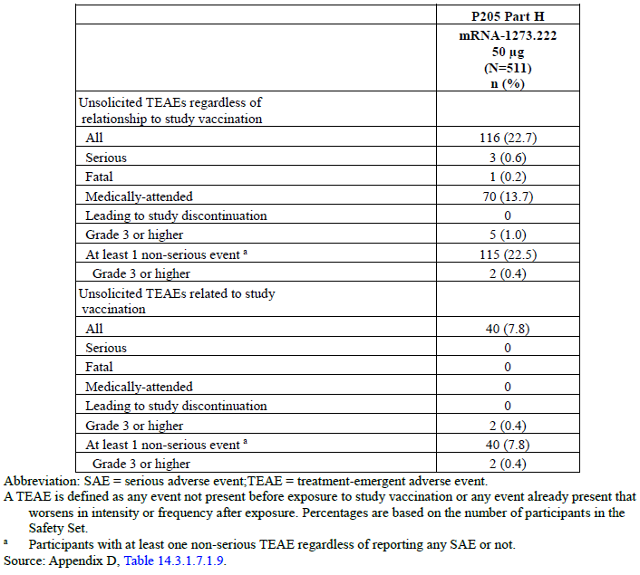

Abbreviation: SAE = serious adverse event; mRNA-1273.222 = Spikevax Bivalent Original/Omicron BA.4-5 COVID-19 vaccine (elasomeran and davesomeran); TEAE = treatment emergent adverse event.

A TEAE is defined as any event not present before exposure to study vaccination or any event already present that worsens in intensity or frequency after exposure. Percentages are based on the number of participants in the safety set.

a Participants with at least one non-serious TEAE regardless of reporting any SAE or not.

Unsolicited TEAEs considered related to vaccination by the investigator were reported in 40 out of 511 participants (7.8%), and most were consistent with symptoms or signs of reactogenicity: fatigue (22 out of 511 (4.3%)), headache (15 out of 511 (2.9%)), arthralgia and myalgia (5 out of 511 (1.0%) each) were the most frequently reported. All other treatment related TEAEs were reported in greater than 1% of participants; these included injection site erythema (two (0.6%) participants), injection site lymphadenopathy (three (0.6%) participants), injection site pain and chills (two (0.4%) participants), and injection site induration, injection site pruritus, dizziness, and vomiting, each reported in one participant. Time to onset for all vaccine related TEAEs was within nine days of the booster dose; in 36 of the 40 participants, onset was within seven days of the booster dose, and in four participants, onset was on Study Day 8. In one of those four participants headache was reported on Study Day 8 and axillary swelling was reported on Study Day 9, which was mild and resolved the same day. Two participants experienced severe TEAEs that were considered related to vaccination, and both were fatigue and were non-serious: a 48-year-old Hispanic female with baseline body mass index of 47 had severe fatigue that began on Study Day 2 and resolved on Study Day 28, and a 57-year-old White female had severe fatigue from Study Day 2 to Study Day 8. Neither event was medically attended.

###### Deaths, other serious adverse events, and other unsolicited adverse events

At the time of the data cut off, one SAE with a fatal outcome was reported, subarachnoid haemorrhage. This report concerns a 70-year-old Black male with a reported medical history of transient ischemic attack, long standing Type 2 diabetes mellitus, atrial fibrillation, hypertension, hyperlipidaemia, and the concomitant use of clopidogrel (labelled for an increase in risk of bleeding and thrombotic thrombocytopenic purpura); atorvastatin (labelled for central nervous system toxicity including haemorrhagic stroke), among other medications, who developed subarachnoid haemorrhage three days after receipt of a booster vaccination. The investigator assessed the fatal event of subarachnoid haemorrhage as not related to vaccination and more likely due to underlying disease.

After the data cut-off date, one SAE with a fatal outcome was reported, death (unknown cause). A 68-year-old White female with a medical history including depression, anxiety, bipolar II disorder, drug and alcohol addiction, hypercholesterolemia, obesity, rheumatoid arthritis, neuralgia and insomnia, received 50 µg Spikevax bivalent Original/Omicron BA.4-5 vaccine (elasomeran and davesomeran) on Study Day 1 and on Study Day 40 the participant died due to an unknown cause. The investigator assessed the death as not related to vaccination (and the sponsor agreed with this assessment) based on available information and considering the time to onset and underlying illnesses.

###### Other serious adverse events

In Study P205 Part H, SAEs were infrequent, and all were assessed by the investigator as unrelated to the booster dose. No new safety concerns were identified based on analysis of these SAEs.

As of the data cut off, four SAEs in three participants were reported. One SAE was associated with a fatal outcome and described above. None of the SAEs were considered related to the vaccine booster.

Table : Study P205 Part H Participant incidence of serious treatment emergent adverse events by System Organ Class and Preferred Term up to the data cut off date, second booster dose with Spikevax bivalent Original/Omicron BA.4-5 vaccine

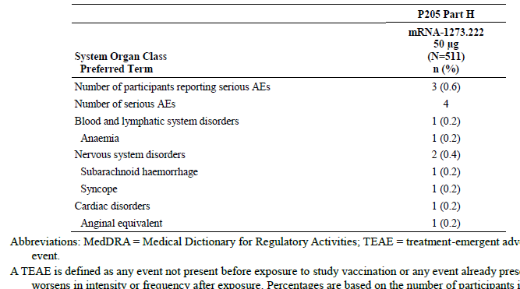

Abbreviations: MedDRA = Medical Dictionary for Regulatory Activities; mRNA-1273.222 = Spikevax Bivalent Original/Omicron BA.4-5 COVID-19 vaccine (elasomeran and davesomeran); TEAE = treatment emergent adverse event.

A TEAE is defined as any event not present before exposure to study vaccination or any event already present worsens in intensity or frequency after exposure. Percentages are based on the number of participants in the safety set.

###### Medically attended adverse events

A medically attended adverse event (MAAE) is an AE that leads to an unscheduled visit to a health care professional. Per protocol, this included visits to a study site for unscheduled assessments (for example, abnormal laboratory follow up, and visits for COVID-19 surveillance) and/or visits to health care professionals external to the study site (for example, urgent care, primary care physician). All confirmed COVID-19 cases were to be recorded as MAAEs.

In the Spikevax bivalent Original/Omicron BA.4-5 vaccine at 50 µg booster dose group (Part H) within 28 days after the booster dose, 70 out of 511 participants (13.7%) had MAAEs (Table 17). None of the MAAEs were considered related to vaccination by the investigator. No safety concerns were identified for bivalent Original/Omicron BA.4 – 5 vaccine based on MAAEs.

No participants in the bivalent Original/Omicron BA.4-5 vaccine group discontinued due to a TEAE (Table 17).

In the Spikevax bivalent Original/Omicron BA.4-5 vaccine at 50 µg booster dose group (Part H) within 28 days after vaccination, no events were captured in the standardised Medical Dictionary for Regulatory Activities (MedDRA) queries (narrow and broad scope) for cardiac failure, embolic and thrombotic events, convulsions, demyelinating disease of central nervous system, thrombophlebitis, or vasculitis. No cases of myocarditis or pericarditis were reported.

No pregnancies were reported in the bivalent Original/Omicron BA.4-5 vaccine at 50 µg booster dose group as of the data cut off date

No new safety concerns were identified in Study P205 Part H, based on the analysis of the deaths, SAEs, and other unsolicited adverse reactions.

##### Study P205 Part G and Part F

Safety data was obtained from Study P205 Part G and Study P205 Part F, with a median follow up duration of 43 days (range 22 to 51 days) for Part G and 57 days (range 51 to 66 days) for Part F. This involved collection of solicited local and systemic AEs during seven day follow up period after vaccination, as well as unsolicited AEs during 28 day follow up period after vaccination. SAEs, MAAEs, and AESIs were also collected until the data cut off.

The reactogenicity profile of Spikevax bivalent Original/Omicron BA.1 vaccine (elasomeran and imelasomeran) at 50 µg dose appeared similar to that of monovalent Spikevax at 50 µg dose when administered as a second booster dose (median of 133 days after a first booster dose of 50 µg of monovalent Spikevax). The reactogenicity profile of bivalent Original/Omicron BA.1 vaccine at 50 µg was similar for participants with and without prior SARS-CoV-2 infection who received bivalent Spikevax bivalent Original/Omicron BA.1 vaccine.

Reactogenicity outcomes for Spikevax bivalent Original/Omicron BA.1 vaccine were comparable to those for the solicited safety set of Study P201 Part B which included 330 participants who received a 50 µg first booster of monovalent Spikevax after the primary series. The sponsor claims that this would suggest that at the 50 µg dose, the reactogenicity profile of Spikevax bivalent Original/Omicron BA.1 vaccine when used as a second booster should be similar to the reactogenicity profile of monovalent Spikevax when used as a first or second booster, in individuals who received monovalent Spikevax as the primary series.

The solicited local and systemic AEs were similar between Part G and Part F. The most common solicited local AE was pain (77% in Part G), followed by axillary swelling or tenderness (17% in Part G). The most common systemic AE was fatigue (55% in Part G), followed by headache, myalgia, and arthralgia. The majority of solicited local and systemic AEs were Grade 1 followed by Grade 2. The median duration of local and systemic AEs was two days, and no Grade 4 local AE was reported in both Part G and F.

Approximately 20% of participants experienced at least one TEAE. Those that were considered by the investigator to be related to vaccination (Part G, 5.7%) were generally consistent with reactogenicity (lymphadenopathy, arthralgia, myalgia, fatigue, and injection site reactions). The incidence of SAEs and severe TEAEs was low, and no SAEs were considered by the investigator to be related to vaccination.

The sponsor had confirmed that review of potential AESI using standardised MedDRA query (including cardiomyopathy, cardiac arrhythmia, and hypersensitivity) did not identify any new safety concerns. One event of tachycardia (in a 53 years old female) and one event of irregular heart rate (in a 71 years old male) ware not considered by the investigator to be related to vaccination.

No cases of myocarditis or pericarditis were reported in Spikevax bivalent Original/Omicron BA.1 vaccine (elasomeran and imelasomeran) and Spikevax bivalent Original/Beta vaccine (elasomeran and a Beta-variant-targeted mRNA) participants enrolled in Study P205. The sponsor confirmed that an enhanced safety analysis has been performed to capture any unrecognised myocarditis or pericarditis events by searching the safety dataset for adverse events compatible with signs, symptoms, laboratory investigations, and procedural findings that might indicate potential events. The myocarditis and pericarditis risk appeared to be consistent with the known safety profile of Spikevax vaccines and the sponsor has confirmed that the monitoring will continue in clinical studies, pharmacovigilance, and post authorisation safety study.

No new safety concerns have been identified in studies of Spikevax bivalent Original/Omicron BA.4- 5 vaccine at 50µg dose given as a second booster dose (N = 437, median of 136 days after a first booster dose of 50 µg of monovalent Spikevax (elasomeran), median follow up of 43 days).

The sponsor believed that, in principle, the use of Spikevax bivalent vaccine as a booster regardless of the dose number, is supported by the data generated as a second booster and can be safely used as a first booster as there is no scientific reason, based on either safety or efficacy to believe that the immunogenicity and safety results would be qualitatively different in other booster settings. The sponsor states that safety and the reactogenicity profile for Spikevax bivalent vaccine is similar with that of Spikevax booster in the clinical study, Study P205. Additionally, the safety of a bivalent vaccine, Spikevax Original/Omicron BA.1 vaccine (elasomeran and imelasomeran), was evaluated as a third dose (first booster dose) in the Study P205 as well. The safety data from bivalent Original/Beta vaccine at 50 µg dose also are similar to that of Spikevax booster at 50 µg. The proposed dose recommendations for Spikevax bivalent Original/Omicron COVID-19 vaccine allows for its use as a booster (at least three months) after completion of a primary series and any number of boosters, and for heterologous boosting. This is also in line with monovalent Spikevax (original (elasomeran)). This was considered acceptable.

Based on a clinical safety database of 437 participants with median follow up of 6 weeks, the safety and reactogenicity profiles of Spikevax bivalent Original/Omicron BA.1 vaccine as a 50 µg second booster appears similar to that of monovalent Spikevax as a 50 µg second booster. No new safety concerns are raised.

##### Study P203 Part C (booster phase)

Study P203 Part C booster investigated administration of monovalent Spikevax vaccine (elasomeran) at 50 µg as booster dose to ongoing study participants from Study P203, which included healthy 12 to 17 years age group who received a two dose primary series with monovalent Spikevax vaccine. This study has been previously assessed by TGA.7

The safety data in adolescents from booster phase (Part 1C-1) of Study P203 was consistent with the known safety profile of monovalent Spikevax and suggests reduced reactogenicity of the 50 µg booster dose in adolescents as compared with the reactogenicity profile post-Dose 2 in the same population. Injection related reactions and infection related events were the most commonly reported AEs, and rates of infection reflected an increase in cases of COVID-19. There were no SAEs, AESIs (including cases of myocarditis/pericarditis), or withdrawal from study participation reported after the booster dose. The sponsor had confirmed that the analyses from recent post-marketing reports also suggest no increased risk (relative to primary series) of myocarditis/pericarditis after booster dosing compared with doses in the primary series. The sponsor confirms that monitoring will continue in clinical studies, pharmacovigilance, and post-authorisation safety studies.

The sponsor had reiterated that the European Medicines Agency (EMA Marketing Authorisation Application filings and approval of Spikevax for use as booster dose in adolescents were based on extrapolation of safety data from adult booster dose studies, with no significant difference expected between the two populations. Successful immuno-bridging for primary vaccination responses in adolescents and young adults based on immunogenicity data from Study P203 (12 to younger than 18 years of age) and Study P301 (from 18 to 25 years of age). Vaccine effectiveness in adolescents aged 12 to younger 18 years was inferred by demonstrating non-inferiority of both serum nAb GMTs and SRR from adolescents compared with those from young adults enrolled in Study P301 (from aged 18 to 25 years of age). This concept/rationale was used to support the basis for the extrapolation of the immune response after applying a booster dose from young adults to adolescents.

##### Study P204 (booster study)

Study P204 assessed the safety of monovalent Spikevax vaccine (elasomeran) at 25 µg when given as a booster in children 6 through 11 years of age, administered from 6 months post-Dose 2 of the primary series.

###### Solicited adverse events

Local and systemic AEs were solicited in the seven days after the booster vaccination. Assessed local AEs included pain, erythema, swelling, and axillary swelling or tenderness. Systemic AEs included fever, headache, fatigue, myalgia, arthralgia, nausea/vomiting, and chills.

Solicited AEs were mostly Grade 1 (45.9%) or Grade 2 (39.4%) and had an overall median onset within one day after vaccination and median duration of three days. A total of 7.9% of participants reported a Grade 3 solicited adverse reaction. Fatigue was the most common Grade 3 solicited AE (3.7% of participants), followed by pain (1.9%), and headache (1.7%). One Grade 4 systemic AE of fever (greater than 40°C) was reported foru days post-booster in a participant who had COVID-19 concurrently.

Pain was the most reported solicited local AE (90.1% of participants), and fatigue was the most reported solicited systemic AE (48.9%) following the booster administration. Fever was reported in 9.5% of participants following the booster.

The incidence and severity of solicited AEs reported after the booster are displayed side-by-side with solicited AEs from the primary series reported after receipt of any primary dose. Lower incidences of solicited AEs were reported after the booster for all categories except for axillary (or groin) swelling or tenderness compared to that reported after primary vaccination. Axillary (or groin) swelling, or tenderness was similar after the booster and after primary dose. The differential between the booster and primary series was particularly evident for Grade 2 and Grade 3 AEs.

Few solicited AEs persisted beyond seven days. Solicited local AEs persisting beyond seven days after the booster administration were reported in 1.3% of participants and most common events were axillary (or groin) swelling or tenderness (0.7%) and pain (0.5%). Solicited systemic AEs persisting beyond seven days after the booster administration were reported in 2% of participants and most common events were fatigue (1.3%) and headache (1.0%).

The incidence of any solicited AEs was higher among participants who were SARS-CoV-2 negative at Baseline prior to the booster (95.8% of 757 participants) compared with participants who were SARS-CoV-2 positive at Baseline prior to the booster (89.5% of 428 participants).

###### Unsolicited adverse events

The reported incidence of any unsolicited AE after the booster was 13.1%. The incidence of unsolicited AEs after the booster assessed by the investigator as related to study treatment was 4 %. These event rates were lower than those in the primary series (after any injection) where unsolicited AEs occurred in 891 of 3007 participants (29.6%) of which 319 (10.6%) were considered treatment related.

The most commonly reported unsolicited AEs were injection site reactions, fatigue and headache, which are consistent with the known reactogenicity profile of the vaccine. Most other AEs were reported in few participants and no specific safety trends were identified. A total of 96 participants (7.4%) experienced a MAAE within 28 days after the monovalent Spikevax booster dose. Ten (less than 1%) participants experienced an MAAE assessed by the investigator as related to study treatment.

One SAE was reported. Seven (0.5%) participants reported severe (Grade 3 or higher) events; the majority of these represented reactogenicity related events, for example, headache, myalgia, injection site pain, and chills. Six of these events were considered by the investigator to be vaccine related. Similarly, 12 of 3007 participants (0.4%) reported severe events in the primary series, nine (0.3%) of which were considered related by the investigator and were also primarily representative of reactogenicity.

No unsolicited AEs caused discontinuation from study participation. One AESI was reported, it was determined by the investigator to be potentially related to vaccination.

The most common System Organ Class (SOC) represented by unsolicited AEs were of Infections and infestations (n = 80, 6.2%), General disorders and administration site conditions (n = 34, 2.6%), and Respiratory, thoracic and mediastinal disorders (n = 23, 1.8%). The most commonly reported unsolicited AE Preferred Term (PT) was COVID-19 (25 participants, 1.9%). Other unsolicited AE PTs were expected for this age group or known aspects of the reactogenicity profile of the vaccine. No new safety concerns were identified.

There were no new trends or patterns observed for MAAEs following the booster administration as compared with the primary series. A total of 116 (9%) participants experienced at least one MAAE after the booster. Two participants (0.2%) reported four MAAEs that were considered severe: abdominal pain (n = 1, < .1%), myalgia (n = 1, < 0.1%), chills (n = 1, < 0.1%), and fatigue (n = 1, < 0.1%). Ten (0.8%) participants had MAAEs considered by the investigator to be related to monovalent Spikevax.

In summary, review of the safety data after booster dose in children between 6 through 11 years of age in the study did not show any new safety concerns. The reactogenicity profile compared favourably to the primary series particularly with Grade 3 and higher events (7.9% in booster group versus 16.8% after any injection in primary series). Similarly, unsolicited AEs were reported less frequently after booster dose than after dosing in the primary series and demonstrated a similar safety profile. Injection related reactions and infection related events were the most commonly reported AEs and similar in profile to unsolicited AEs in the primary series. There was one SAE of abdominal pain occurring 16 days after booster dose of unclear aetiology that resolved in 24 hours and was considered not treatment related by the investigator. There were no cases of multisystem inflammatory syndrome in children or withdrawal from study participation reported after receipt of booster dose. One AESI of chest pain was reported (not meeting protocol specified criteria) and of which cardiac origin was ruled out. No cases suggestive of myocarditis/pericarditis were identified using the cardiomyopathy standardised MedDRA queries and a pre-specified search algorithm to identify potentially missed cases. Overall, the findings were consistent with the known safety profile of Spikevax and events typically observed in a 6 through 11 years old paediatric population during the COVID-19 pandemic.

##### Post-marketing safety data of Spikevax bivalent Original/Omicron BA.4-5 vaccine

Spikevax bivalent Original/Omicron BA.4-5 vaccine (elasomeran and davesomeran) received EUA in the USA for use as a booster dose in individuals 18 years of age and older on 31 August 2022. Cumulatively as of 18 October 2022; a total of 36,729,950 doses of Spikevax bivalent Original/Omicron BA.4-5 vaccine had been delivered to the USA. A limited number of cases have been reported to the marketing authorisation holder (MAH) and are summarised in a consolidated manner. Monthly summary safety reports are submitted to relevant regulatory agencies by the sponsor.

Cumulatively, as of 18 October 2022, 677 cases (1,922 events) involving Spikevax bivalent Original/Omicron BA.4-5 vaccine booster (elasomeran and davesomeran) were reported to the MAH. Of the 677 cases (1,922 events) reported, 376 cases were medically confirmed, 37 cases (69 events) were serious, and two cases were reported with a fatal outcome. The mean age was 60.3 years (standard deviation, 20.1 years) with a median age of 67 years. Most of the cases were reported in females (295 cases, 43.6%) compared to males (183 cases, 27%), and 199 (29.4%) cases had missing sex information. The majority of cases were non-serious (640 non-serious cases, 94.5%). Cumulatively, the most frequently reported clinical events associated with Spikevax bivalent Original/Omicron BA.4-5 vaccine booster included pyrexia (2.7%), fatigue (2.3%), vaccination site pain (2.3%), chills (2.2%), and pain in extremity (2.2%). Events coded as ‘No adverse event’ (18% of all events) were often associated with events involving product administration errors (for example, accidental underdose (9.4%), wrong product administered (2.2%) and others).

The two events (0.1%) with a reported fatal outcome, were both consumer reports and included a female of an unknown age with no medical history reported, and no other information provided by the reported, including vaccine dose, time to onset, clinical course, and cause of death. The second fatal case was reported by a consumer that only mentioned she talked to a gentleman that ended dying and who seems to have blood clot problems. No other information was provided. Upon further review of the report, it was determined the death occurred before EUA of Spikevax bivalent Original/Omicron BA.4-5 vaccine; the case will be corrected and coded to the original monovalent Spikevax vaccine.

Cumulatively, as per the sponsor, based on the review of information received until 18 October 2022, there was no change in the favourable benefit-risk assessment in relation to global safety data referring to Spikevax bivalent Original/Omicron BA.4-5 vaccine booster. Routine pharmacovigilance monitoring will continue.

##### Myocarditis and pericarditis adverse events

As of 18 October 2022, for Spikevax bivalent Original/Omicron BA.4-5 vaccine (elasomeran and davesomeran), there was one reported case of pericarditis concerning a male of unknown age who had a family history of atrial fibrillation and heart rate increased. According to the WHO-Uppsala Monitoring Centre standardised case causality assessment,[9] this case was assessed as ‘unassessable’ due to important missing information including exposure information, time to onset, laboratory values, medical history, and clinical course. The MAH will continue to monitor for reported cases of myocarditis and pericarditis through routine and enhanced surveillance activities.

### Risk management plan

The sponsor has submitted EU-risk management plan (RMP) version 6.1 (dated 30 October 2022; data lock point (DLP) 12 September 2022) and Australia specific annex (ASA) version 1.0 (dated 22 November 2022) in support of this application.

At second of RMP evaluation, sponsor has provided EU-RMP version 6.3 (dated 6 December 2022; DLP 17 September 2022) and ASA version 1.1 (dated 7 December 2022) and version 1.2 (dated 20 December 2022).

The summary of safety concerns and their associated risk monitoring and mitigation strategies are summarised in Table 18. Further information regarding the TGA’s risk management approach can be found in [risk management plans for medicines and biologicals](https://www.tga.gov.au/publication/risk-management-plans-medicines-and-biologicals) and [the TGA's risk management approach](https://www.tga.gov.au/tgas-risk-management-approach).

Table : Summary of safety concerns

|  |  |  |  |  |  |
| --- | --- | --- | --- | --- | --- |
| Summary of safety concerns | | Pharmacovigilance | | Risk Minimisation | |
| Routine | Additional | Routine | Additional |
| **Important identified risks** | Myocarditis | ✓1 | ✓2 | ✓ | – |
| Pericarditis | ✓1 | ✓2 | ✓ | – |
| **Important potential risks** | Vaccine-associated enhanced  disease (VAED) including vaccine associated  enhanced respiratory disease (VAERD) | ✓1 | ✓2 | – | – |
| **Missing information** | Use in pregnancy and while  breastfeeding | ✓ | ✓3 | ✓ | – |
| Long-term safety | ✓ | ✓2 | – | – |
| Use in immunocompromised subjects | ✓ | – | ✓ | – |
| Interaction with other vaccines | ✓ | – | ✓ | – |
| Use in frail subjects with unstable health conditions and co-morbidities (e.g. COPD, diabetes, chronic neurological disease, cardiovascular disorders) | ✓ | ✓2 | ✓ | – |
| Use in subjects with autoimmune or inflammatory disorders | ✓ | ✓2 | ✓ | – |

1. Specific adverse reaction follow-up questionnaires

2. Clinical trials

3. Observational Studies – mRNA-1273-P905 and mRNA-1273-P919

The summary of safety concerns is the same as that most recently evaluated and deemed acceptable for Spikevax bivalent Original/Omicron BA.1 (elasomeran and imelasomeran).6 This summary of safety concerns is acceptable from an RMP perspective.

The sponsor has proposed routine pharmacovigilance for all safety concerns which includes specific adverse reaction follow up questionnaires for the important identified and potential risks. The sponsor was requested to clarify the updates to the additional pharmacovigilance activities in the ASA in the form of clinical trials and in the response to TGA questions, has provided adequate justification for the changes. The pharmacovigilance plan is acceptable at second round of RMP evaluation. A clinical study plan has been provided and the acceptability of this plan is for the Delegate to consider.

Only routine risk minimisation measures are proposed by the sponsor. This approach was deemed acceptable during the previous evaluations as there are risk minimisation measures implemented by the Australian Government Department of Health. The changes proposed by the current submission are not expected to require additional risk minimisation measures as part of the RMP.

The RMP has raised a discrepancy to the attention of the Delegate for consideration.

‘Diarrhoea and erythema multiforme have been removed as adverse reactions from the proposed Australian PI but remain in the SmPC.’

#### Proposed risk management plan wording for conditions of registration

Any changes to which the sponsor has agreed should be included in a revised RMP and ASA. However, irrespective of whether or not they are included in the currently available version of the RMP document, the agreed changes become part of the risk management system.

The suggested wording is:

‘The Spikevax bivalent Original/Omicron BA.4-5 RMP (version 6.3, dated 6 December 2022, data lock point 17 September 2022), with Australian Specific Annex (version 1.2, dated 20 December 2022), included with submission PM-2022-04824-1-2, and any subsequent revisions, as agreed with the TGA will be implemented in Australia.’

The following wording is recommended for the PSUR requirement:

‘An obligatory component of risk management plans is routine pharmacovigilance. Routine pharmacovigilance includes the submission of periodic safety update reports (PSURs).

Unless agreed separately between the supplier who is the recipient of the approval and the TGA, the first report must be submitted to TGA no later than 15 calendar months after the date of the approval letter. The subsequent reports must be submitted no less frequently than annually from the date of the first submitted report until the period covered by such reports is not less than three years from the date of the approval letter, or the entire period of provisional registration, whichever is longer.

The reports are to at least meet the requirements for PSURs as described in the European Medicines Agency’s Guideline on good pharmacovigilance practices (GVP) Module VII-periodic safety update report (Rev 1), Part VII.B Structures and processes. Note that submission of a PSUR does not constitute an application to vary the registration. Each report must have been prepared within ninety calendar days of the data lock point for that report.

Additional to the routine submission of the routine PSURs, expedited monthly safety summary reports (including safety data for patients in Australia) are to be provided for the 6 months from the date of first supply in Australia, and thereafter at intervals specified by the TGA.’

As Spikevax bivalent Original/Omicron BA.4-5 vaccine is being considered for a provisional registration it should be included in the Black Triangle Scheme as a condition of registration. The following wording is recommended for the condition of registration:

‘Spikevax bivalent Original/Omicron BA.4-5 (elasomeran/davesomeran to be included in the Black Triangle Scheme. The PI and Consumer Medicines Information (CMI) for Spikevax bivalent Original/Omicron BA.4-5 must include the black triangle symbol and mandatory accompanying text for five years, or the product’s entire period of provisional registration, whichever is longer.’

### Risk-benefit analysis

#### Delegate’s considerations

The evidence to support this provisional registration of Spikevax bivalent Original/Omicron BA.4-5 vaccine (elasomeran and davesomeran) include the following:

* Study P205 Part H: Spikevax bivalent Original/Omicron BA.4-5 booster dose
* Study P204 prototype monovalent Spikevax (elasomeran) booster dose in children 6 to 11 years old.
* Study P205 Part G and F: Clinical safety and immunogenicity data from a study which evaluated a second booster dose with the Spikevax bivalent Original/Omicron BA.1 vaccine (elasomeran and imelasomeran) following a primary series and first booster with the monovalent Spikevax vaccine (elasomeran).
* Clinical safety, immunogenicity, efficacy from studies which evaluated primary and booster vaccination with the monovalent Spikevax in different age groups.
* Post-marketing safety surveillance data with primary series and booster doses of the monovalent Spikevax vaccine.

Prior to the approval of Omicron targeting bivalent booster vaccines, a decrease in booster vaccine effectiveness had been observed in association with the emergence of the Omicron SARS-CoV-2 variant.[10],[11],[12] The sponsor claims that both Spikevax bivalent Original/Omicron BA.1 (elasomeran and imelasomeran) and the Spikevax bivalent Original/Omicron BA.4-BA.5 (elasomeran and davesomeran) vaccines address the Omicron pandemic wave and more recently, the sponsor has transitioned vaccine manufacturing to the Spikevax bivalent Original/Omicron BA.4-BA.5 containing vaccine to harmonise use of Omicron-containing vaccines globally. The new bivalent vaccine (Original/Omicron BA.4-5) is manufactured using the same mRNA platform and manufacturing method as the provisionally approved Spikevax bivalent Original/Omicron BA.1 vaccine.

Study P205 Part H, evaluated the safety, reactogenicity, and immunogenicity of 50 µg of Spikevax bivalent Original/Omicron BA.4–5 vaccine when administered as a second booster dose in adults (individuals older than 18 years of age) who previously received two doses of 100 µg of monovalent Spikevax as a primary series and a first booster dose of 50 µg monovalent Spikevax. mRNA-1273.222 (elasomeran and davesomeran) is the Spikevax Omicron BA.4/BA.5 bivalent booster vaccine that contains 25 µg ancestral SARS‑CoV-2 spike mRNA (elasomeran) and 25 µg Omicron BA.4/BA.5 spike mRNA (davesomeran).

The Study P205 Part F (Cohort 2) serves as the within study, non-contemporaneous comparator group for the Study P205 Part H in the immunogenicity comparison between the two booster vaccines, Spikevax bivalent Original/Omicron BA.4-5 at 50 µg and monovalent Spikevax at 50 µg, when administered as second booster doses. Study P205 Part F (Cohort 2) evaluated the safety, reactogenicity, and immunogenicity of 50 µg of monovalent Spikevax when administered as a second booster dose in adults who previously received two doses of 100 µg monovalent Spikevax (elasomeran) as a primary series and a first booster dose of 50 µg monovalent Spikevax.

Although not randomised this comparison of the two cohorts is considered acceptable considering similar inclusion criterion, overall demographic and baseline characteristics was similar, with specific primary endpoint. Although there is no immune correlate of protection, the difference in neutralising antibodies against Omicron would be expected to translate into a clinical benefit of the bivalent vaccine compared to the original vaccine. Study P205 was not designed to evaluate booster vaccine effectiveness and the sponsor has stated that they will actively monitor real world effectiveness data including future variants with additional antibody escape mutations, following the use of Spikevax bivalent Original/Omicron BA.4- 5 vaccine, if approved.

In the Study P205 Part H Day 29 interim analysis, in adults (individuals older than 18 years of age), all primary objectives were met in participants without prior SARS-CoV-2 infection, the population pre-specified for the primary analysis. A 50 µg booster dose of Spikevax bivalent Original/Omicron BA.4- 5 vaccine elicited a superior neutralising antibody response to the Omicron BA.4 and BA.5 variants compared to monovalent Spikevax at 50 µg, 28 days after the booster dose regardless of SARS-CoV-2 infection prior to immunisation. The Spikevax bivalent Original/Omicron BA.4-5 vaccine elicited a non-inferior neutralising antibody response against the ancestral strain, compared to monovalent Spikevax. A subgroup analysis of the per-protocol immunogenicity subset with SARS-CoV-2 negative status population by age group (from 18 to younger than 65 years and from 65 years of age) was performed and the results indicate that the immunogenicity responses were similar between the two age groups.

An exploratory analysis was performed to assess the cross-neutralisation ability of Spikevax bivalent Original/Omicron BA.4-5 vaccine against emerging Omicron variants (BQ.1.1 and XBB.1) in a random sample of 40 participants without SARS-CoV-2 infection at pre‑booster and a random sample of 20 participants with infection at pre-booster. For participants without evidence of previous infection, the GMFR (95% CI) was 19.6 (11.7, 32.8) against the BQ.1.1 Omicron subvariant and 12.3 (7.4, 20.5) against the XBB.1 Omicron subvariant from pre-booster antibody titres, and for participants with evidence of pre-booster infection, the GFMR (95% CI) was 8.8 (5, 15.5) against the BQ.1.1 subvariant and 6.9 (4, 11.7) against the XBB.1 subvariant. These results indicate that that Spikevax bivalent Original/Omicron BA.4-5 vaccine exhibited cross-neutralisation against BQ.1.1 and XBB.1, and that antibody titres substantially increased 28 days after administration of the Spikevax bivalent Original/Omicron BA.4-5 vaccine booster dose.

Considering the proposed target population of from 6 years of age and older, while the sponsor has provided Study P203 Part C booster (12 to 17 years of age) and Study P204 booster (6 to 11 years of age) to support the use of bivalent Original/Omicron BA.4-5 vaccine in children, these studies are without davesomeran and therefore do not provide any direct clinical data to support the proposed indication in children.

Upon seeking justification for sponsor’s proposal to lowering the age limit to 6 years of age the sponsor provided the following rationale. The sponsor believed that the appropriateness of extrapolation from adults to younger than 18 years of age is reinforced and that the Spikevax bivalent Original/Omicron BA.4-5 vaccine can be used by persons older than 6 years of age for the prevention of COVID-19:

* Clinical data from the Study P203 in adolescents indicated non-inferior antibody responses of monovalent Spikevax in adolescents compared to adults and previously supported the authorisation of monovalent Spikevax in individuals younger than 18 years old, and
* Immunogenicity and safety data from the booster phase of Study P204 support the administration of monovalent Spikevax booster to children 6 through 11 years, and
* Data from Study P205 Part H indicated superior antibody responses against Omicron BA.4/BA.5 with Spikevax bivalent Original/Omicron BA.4-5 vaccine as a booster compared to monovalent Spikevax.
* Additionally, clinical data from the monovalent Spikevax booster dose is intended to support authorisation of monovalent Spikevax booster formulations most relevant to prevailing public health needs, including Omicron containing formulations.

The Spikevax bivalent Original/Omicron BA.4-5 vaccine has received an Emergency Use Authorization (EUA) in the USA as a booster dose for individuals 18 years and above on 31 August 2022 and from 6 years of age and above on 12 October 2022 and finally in individuals from 6 months of age and older on 8 December 2022. A positive European Commission decision and approval was received on 20 October 2022 for Spikevax bivalent Original/Omicron BA.4-5 vaccine (50 µg elasomeran/50 µg davesomeran per mL, dispersion for injection as a booster dose in individuals 12 years of age and above (equivalent to 25 µg elasomeran/25 µg davesomeran per 0.5 mL dose, as proposed in this submission).

Although there is no direct clinical data available to support the use of Spikevax bivalent Original/Omicron BA.4-5 vaccine in individuals 6 to younger than 18 years of age, there appears to be no strong reason to reject the sponsor’s justification of extrapolation of Spikevax bivalent Original/Omicron BA.4- 5 vaccine results from adults (from 18 years of age and older ) to younger than 18 years of age and from the original vaccine monovalent Spikevax (elasomeran) booster dose in individuals 6 to younger than 18 years of age. The sponsor has been requested to provide any available real world data since approval of Spikevax bivalent Original/Omicron BA.4- 5 vaccine in individuals 6 to younger than 18 years of age in the USA and Europe or any other real world data relevant to this application in individuals from 6 years to younger than 18 years of age.

#### Safety

In Study P 205 Part H, Spikevax bivalent Original/Omicron BA.4-5 vaccine was administered a median of 289 days after a first booster dose of 50 µg monovalent Spikevax and the median follow up duration was 37 days (range 5 to 45 days) in this interim analysis. The occurrence of solicited local adverse reactions within seven days following the Spikevax bivalent Original/Omicron BA.4-5 vaccine booster dose was 420 out of 507 (82.8%). The most commonly reported solicited local adverse reaction was injection site pain (418 out of 507 participants (82.4%)). The majority of solicited local adverse reactions were mild to moderate (Grades 1 to 2) in severity. The frequency of Grade 3 local adverse reaction events was 28 out of 507 participants (5.5%) and adverse reaction that were report for greater or equal to 1% of participants were injection site pain (20 out of 507 [3.9%]) and erythema and swelling (5 out of 507 (1%) each). There were no Grade 4 local adverse reaction reported. The reported incidence of systemic adverse reaction was 372 out of 508 (73.2%) and the most frequent adverse reactions were fatigue (304 out of 508 (59.8%)), headache (249 out of 507 (49.1%)), myalgia (235 out of 507 (46.4%)), and arthralgia (177 out of 507 (34.9%)) in the bivalent Original/Omicron BA.4-5 vaccine group. The majority of solicited systemic adverse reaction were mild to moderate (Grades 1 to 2) in severity. No Grade 4 systemic adverse reaction events occurred after administration of the Spikevax bivalent Original/Omicron BA.4-5 vaccine. Overall, the incidence of adverse reaction did not appear to be increased in participants with prior SARS‑CoV- 2 infection compared to participants with infection at pre-booster.

The sponsor has also highlighted the publications about 50 µg Spikevax bivalent Original/Omicron BA.4-5 vaccine; the incidence of adverse reactions was similar to that of a first booster dose of 50 µg monovalent Spikevax (elasomeran) and relative to the second dose of the 100 µg monovalent Spikevax primary series,[13],[14] as well as similar to monovalent Spikevax at 50 µg dose when given as a second booster dose.8

No new safety signals were identified in the bivalent Original/Omicron BA.4- 5 vaccine interim analysis. The incidence of solicited adverse reactions did not appear to be increased in participants with prior SARS-CoV-2 infection when compared to participants without infection before receipt of the booster dose.

Overall, the incidence of unsolicited TEAEs reported up to 28 days following the 50 µg of Spikevax bivalent Original/Omicron BA.4- 5 vaccine booster dose (Study P205 Part H) was similar to that for the 50 µg monovalent Spikevax vaccine given as a second booster. Approximately 23% of participants experienced at least one unsolicited TEAE. Most events that were considered vaccine related were consistent with signs or symptoms of reactogenicity, which was similar to the established safety profile of monovalent Spikevax. Four SAEs were reported in three participants; none were considered related to the booster by investigator or sponsor. Two severe TEAEs, both fatigue, a known symptom of reactogenicity, were considered related to vaccination. No new safety concerns were identified for the Spikevax bivalent Original/Omicron BA.4–5 vaccine booster dose.

In Study P205 Part H, three participants (0.6%) had four SAEs, and all were assessed by the investigator as not related to study vaccination. One of these was a fatal outcome with subarachnoid haemorrhage in a 70 years old male. The other three SAEs included angina with syncope, and anaemia. There was one further case of death outside the data cut off date in a 68 years old female on Day 40, which was due to an unknown cause but considered to be unrelated to the study vaccine. 13.7% of the participants had MAAEs, none of which was considered to be related to the study vaccine. AESIs were largely sporadic and did not establish a concerning pattern in terms of safety. No case of myocarditis or pericarditis was identified.

Overall, the safety profile of Spikevax bivalent Original/Omicron BA.4-5 vaccine appear consistent with the known reactogenicity of monovalent Spikevax (elasomeran) and bivalent Original/Omicron BA.1 vaccines (elasomeran and imelasomeran), and no particular safety concern is raised.

The sponsor confirms that they will continue to closely monitor and characterise the safety profile of bivalent vaccines in clinical studies and post-authorisation pharmacovigilance activities.

##### Post-market review of bivalent COVID-19 mRNA vaccine booster doses from the US FDA report

Below is an excerpt from safety monitoring report of bivalent COVID-19 mRNA vaccine booster in person above 12 years of age from the US Centers of Disease Control (CDC).[15]

Summary:

‘[The] CDC recommended bivalent COVID-19 booster vaccination for persons aged ≥ 12 years in August 2022; approximately 22.6 million bivalent booster doses (Pfizer and Moderna) were administered during August 31 to October 23 2022.

Among the 211,959 registrants aged ≥ 12 years who reported receiving a bivalent booster dose to v-safe, injection site and systemic reactions were frequently reported in the week after vaccination (60.8% and 54.8%, respectively); fewer than 1% of v-safe registrants reported receiving medical care. Vaccine adverse event reporting system (VAERS) received 5,542 reports of adverse events after bivalent booster vaccination among persons aged ≥ 12 years; 95.5% of reports were nonserious and 4.5% were serious events.

Early safety findings from v-safe and the VAERS for bivalent booster doses administered to persons aged ≥ 12 years during the first 7 weeks of vaccine availability are similar to those previously described for monovalent vaccine booster vaccines.’

Below is an excerpt from safety monitoring of bivalent COVID-19 mRNA vaccine booster doses among children aged 5 to 11 years old from the US CDC.[16]

Summary:

‘After [the[ CDC’s October 2022 recommendation for bivalent COVID-19 booster vaccination for children aged 5 to 11 years, children in this age group received approximately 953,359 bivalent booster doses (Pfizer and Moderna) during October 12 2022 to January 1 2023.

Among 3,259 children aged 5 to 11 years registered in v-safe who received a bivalent booster dose, local (68.7%) and systemic reactions (49.5%) were commonly reported in the week after vaccination. Approximately 99.8% of reports to VAERS for children aged 5 to 11 years after bivalent booster vaccination were nonserious. There were no reports of myocarditis or death after bivalent booster vaccination.

Early safety findings from v-safe and the VAERS for bivalent booster vaccination in children aged 5 to 11 years collected during the first 11 weeks of booster dose administration are similar to those described for monovalent booster vaccination.’

#### Proposed action

Overall, based on review of the immunogenicity and safety data of the Spikevax bivalent Original/Omicron BA.4- 5 vaccine (elasomeran and davesomeran), the benefit-risk profile of Spikevax bivalent Original/Omicron BA.4- 5 vaccine in individuals from 18 years appears favourable to support its intended use as a booster dose against COVID‑19, at least three months after completion of a primary series and/or previous booster dose with monovalent Spikevax or another authorised or approved/registered COVID-19 vaccine.

Although there is no direct clinical data available to support the use of Spikevax bivalent Original/Omicron BA.4- 5 vaccine in individuals 6 to younger than 18 years of age, there appears to be no strong reason to reject the sponsor’s justification of extrapolation as discussed above.

Early safety findings from v-safe and the Vaccine Adverse Event Reporting System (VAERS) in United States has reported that for bivalent booster vaccine doses administered to persons aged from 12 years and older during the first 7 weeks of vaccine availability and in children aged 5 to 11 years collected during the first 11 weeks of vaccine availability are similar to those previously described for monovalent vaccine booster vaccines.

The sponsor has been requested to provide any available real world data since approval of Spikevax bivalent Original/Omicron BA.4-5 vaccine in individuals 6 to younger than 18 years of age in the USA and Europe or any other real world data relevant to this application in individuals 6 to younger than 18 years of age.

The final decision on the benefit-risk profile of Spikevax bivalent Original/Omicron BA.4-5 vaccine in individuals 6 to younger than 18 years of age and overall will be made after review of any further supporting real world data provided by the sponsor (in their pre‑ACV response) and the Advisory Committee on Vaccines (ACV) discussion/advice.

#### Questions for the sponsor

The sponsor provided the following response to questions from the Delegate.

1. ***Please provide any available real world data since approval of Spikevax bivalent Original/Omicron BA.4-5 vaccine in individuals 6 to younger than 18 years of age in the USA and Europe or any other real-world data relevant to this application in individuals 6 to younger than 18 years of age.***

*Global Safety Database:*

Post-authorisation safety data for monovalent Spikevax, bivalent Original/Omicron BA.1 vaccine booster, and Spikevax bivalent Original/Omicron BA.4-5 vaccine booster include cumulative information received worldwide by the sponsor from the IBD [International birthdate] (18 December 2020 to 17 December 2022). In contrast to data obtained in clinical studies, the post-authorisation safety data that have been collected for the monovalent Spikevax vaccines rely on information received from regulatory authorities (76%), and from spontaneous reports from health care providers, consumers, and literature reports (24%).

Cumulatively, as of 17 December 2022, a total of 1,315,589,716 doses of monovalent Spikevax had been delivered to 91 countries and an estimated total of 772,908,958 doses administered (see Table 19). North America, Europe, and Asia accounted for approximately 89% of Spikevax doses distributed and approximately 84% of monovalent Spikevax doses administered. Low- and middle-income countries (The World Bank 2022) are estimated to account for approximately 13% of the doses distributed globally and approximately 13% of doses administered.

Cumulatively, a total of 127,413,973 booster doses of Spikevax bivalent Original/Omicron BA.1 vaccine [elasomeran and imelasomeran] had been delivered to 41 countries and an estimated total of 70,077,685 doses had been administered (see Table 20). Europe [European Union], the United Kingdom, Asia, Canada, and notably Australia accounted for approximately 96% of doses distributed and approximately 96% of doses administered. A total of 110,745,780 booster doses of Spikevax bivalent Original/Omicron BA.4–5 vaccine had been delivered to 25 countries and an estimated total of 60,910,179 doses had been administered (Table 21). The United States [of America], Canada, Europe, and Asia accounted for > 99% of all doses delivered and administered. Extrapolating from the proportion of US vaccine recipients to estimate global use, it is estimated that 408,226,293 individuals received a first dose, 275,197,667 received a second dose, 166,419,347 received a third dose, and 62,984,506 received a fourth dose, with third and fourth doses including both original monovalent Spikevax and Spikevax bivalent booster dose formulations.

Table : Monovalent Spikevax vaccine (elasomeran) doses distributed and administered (Cumulative as of 17 December 2022)

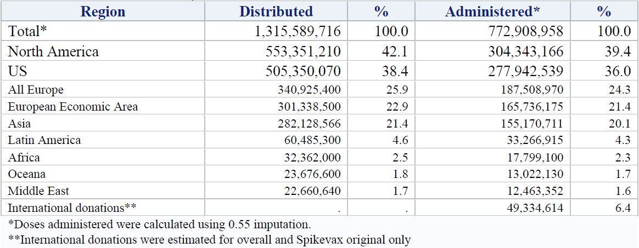

* Doses administered were calculated using 0.55 imputation.

** International donations were estimated for overall and Spikevax original only.

Table : Spikevax bivalent Original/Omicron BA.1 (elasomeran and imelasomeran) vaccine doses distributed and administered (cumulative as of 17 December 2022)

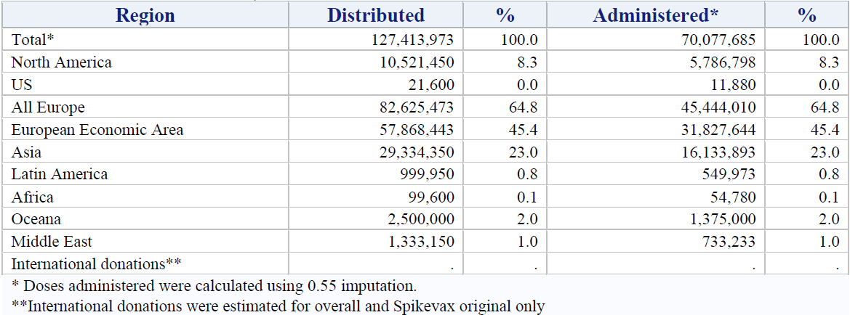

* Doses administered were calculated using 0.55 imputation.

** International donations were estimated for overall and Spikevax original only.

Table : Spikevax bivalent Original/Omicron BA.4–5 (elasomeran and davesomeran) vaccine doses distributed and administered (cumulative as of 17 December 2022)

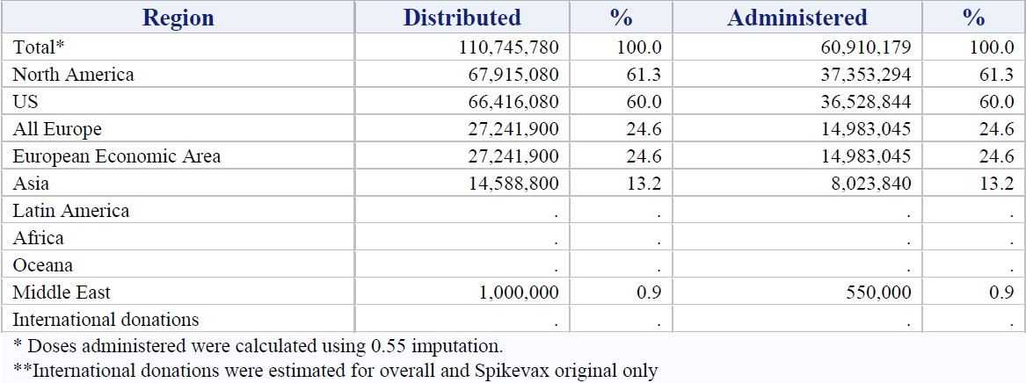

* Doses administered were calculated using 0.55 imputation.

** International donations were estimated for overall and Spikevax original only.

Regarding availability of demographic distribution of doses administered, the sponsor relies completely from information posted on the different health authorities’ websites, worldwide where the Spikevax vaccines (Original and bivalents) have been authorised. The amount of information provided on those websites varies considerable from one country to the next. Given that Spikevax bivalent Original/Omicron BA.4-5 was first authorised in the USA, and that the majority of the doses that have been administered are in the USA, the sponsor is presenting information available from the US CDC as of 14 December 2022. Of relevance for this application the total number of Moderna Spikevax Original/Omicron BA.4-5 booster doses for individuals from 5 to 17 years is presented in Table 22 below.

Table : Demographic information for population with Moderna COVID-19 vaccine doses administered in the USA through 14 December 2022

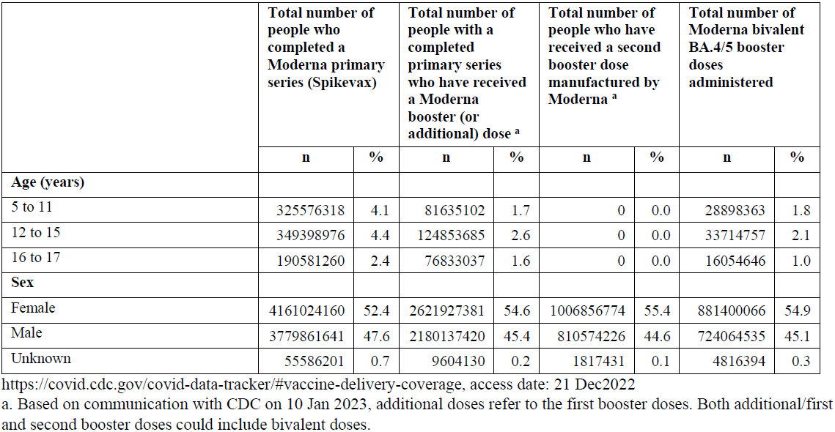

a Based on communication with CDC on 10 January 223, additional doses refer to the first booster doses. Both additional/first and second booster doses could include bivalent doses.

Available from <https://covid.cdc.gov/covid-data-tracker/#vaccine-delivery-coverage>. Access on 21 December 2022

Total number of people who have received COVID-19 vaccine doses manufactured by Moderna and total Moderna BA.4-5 doses were reported by the US CDC. Doses were allocated to demographic categories based on percent of people with the selected exposure category across COVID-19 vaccine brands for the selected demographic category, assuming no brand preference within the demographic category. The exposure categories were defined by US CDC.

*Use in Children (6 to 18 years old)*

Monovalent Spikevax vaccine (elasomeran): Cumulatively as of 17 December 2022, the MAH has received 10,055 cases (21,541 events) with 1,221 serious cases (2,901 serious events) with 39 of these cases reporting a fatal outcome in patients 17 years of age or younger after monovalent Spikevax vaccination.

Out of those 10,055 cases:

* 301 cases (804 events) with 33 serious cases (91 serious events) were in children aged 6 months to younger than 2 years of age; one case had a fatal outcome
* 506 cases (1,353 events) with 37 serious cases (83 serious events) were in children aged 2to 5 year old; one case had fatal outcome
* 475 cases (1,014 events) with 104 serious cases (187 serious events) were reported for 6 to11 year old children; two cases had a fatal outcome.
* 8,545 cases (17,792 events) with 982 serious cases (2,399 serious events) for adolescents (12 to 17 years of age); there were 28 cases reporting a fatal outcome

Spikevax bivalent Original/Omicron BA.1 vaccine: Cumulatively as of 17 December 2022, the MAH has received 26 cases (62 events) with one serious cases (three serious events); there were no cases reporting a fatal outcome in patients 17 years of age or younger after Spikevax bivalent Original/Omicron BA.1 vaccination.

Out of those 27 cases:

* one case (three events) with no reported serious cases in children 6 months to younger than 2 years of age
* two cases (five events) with no reported serious cases in children 2 to 5 years old
* one case (two events) with no reported serious cases in children 6 to11 year old
* 21 cases (51 events) with one serious case (three serious events) for adolescents (12 to17 years of age). The majority of the cases (17 cases, 41 events) were related to product administration issues, with most (15 cases, 36 events) of those not reporting an associated adverse event.

Spikevax bivalent Original/Omicron BA.4–5 vaccine (elasomeran and davesomeran): Cumulatively as of 17 December 2022, the MAH has received 63 cases (155 events) with three serious cases (five serious events) with no fatal outcome reported in patients 17 years of age or younger after Spikevax bivalent Original/Omicron BA.4–5 vaccine vaccination.

Out of those 65 cases:

* three cases (9 events) with no reported serious cases in children aged 6 months to younger than 2 years of age
* 12 cases (33 events) with no reported serious cases in children aged 2 to 5 years old
* 18 cases (44 events) with no reported serious cases in children aged 6 to11 year old
* 29 cases (68 events) with three serious cases (five serious events) for adolescents (12 to 17 years of age). The majority of the reported events were related to product administration issues (54; 75%), with most of those not reporting an associated adverse event.

*Real world evidence studies:*

A preliminary assessment of the vaccine efficacy of Spikevax bivalent Original/Omicron BA.4 – 5 vaccine in preventing COVID-19 hospitalisation and medically attended SARS-CoV-2 infection in the ongoing real world effectiveness study (Study P901) was performed in support of the US Vaccines and Related Biological Products Advisory Committee meeting on 26 January 2023.

A matched cohort study among immunocompetent Kaiser Permanente Southern California members was conducted. The exposed cohort included individuals aged from18 years and older who received Spikevax bivalent Original/Omicron BA.4-5 vaccine during 31 August 2022 through 10 November 2022, and individuals aged 6 to younger than 18 years who received Spikevax bivalent Original/Omicron BA.4-5 vaccine during 12 October 2022 through 10 November 2022. The unexposed cohort included individuals 6 years and older who did not receive any Spikevax bivalent Original/Omicron BA.4-5 vaccine as of 31 December 2022. The outcomes included hospitalisation for severe COVID-19 (identified by a pre-determined algorithm and confirmed by manual chart review) and medically attended SARS-CoV-2 infection (positive SARS-CoV-2 molecular or antigen test, and a COVID-19-related encounter). Cox proportional hazards regression was used to estimate adjusted hazard ratios (aHR) comparing incidence of outcomes between the exposed and the unexposed cohorts. Relative vaccine effectiveness (rVE) (%) was estimated as (1 - aHR) x 100.

The study included 157,435 exposed individuals (mean age 59.3 years; standard deviation 17.4) and 314,870 unexposed individuals (mean age 58.3 years; standard deviation 18.5). A large majority of the study population (99.5%; 156,603 exposed and 313,206 unexposed) were from 18 years of age and older, and the remaining 0.5% (832 exposed and 1,664 unexposed) were 6 to younger than 18 years of age.

Compared to recipients of two or more original mRNA vaccine doses, the rVE of Spikevax bivalent Original/Omicron BA.4-5 vaccine against COVID-19 hospitalisation was 73.1% (95% CI: 63.8 to 80%). The rVE against medically attended SARS-CoV-2 infection was 34.7% (30 to 39.1%) overall, and 56.4% (50.1 to 61.9%) against infection requiring emergency department/urgent care visits. Compared to unvaccinated individuals, the VE of Spikevax bivalent Original/Omicron BA.4-5 vaccine against COVID-19 hospitalisation was 82.9% (75 to 88.3%). The VE against medically attended SARS-CoV-2 infection was 13% (1.9 to 22.8%) overall, and 56.5% (46.5 to 64.6%) against infection requiring emergency department/urgent care visits.

For this preliminary assessment of Study P901 prepared in advance of the main planned analysis of VE for Spikevax bivalent Original/Omicron BA.4-5 vaccine for the Vaccines and Related Biological Products Advisory Committee presentation, age stratification was neither planned nor feasible given the small number of Spikevax bivalent Original/Omicron BA.4-5 vaccine recipients observed in the paediatric population. Monitoring will continue to determine whether these analyses can be performed at a future time.

Concerning real world safety, no new safety concerns related to use of Spikevax bivalent Original/Omicron BA.4-5 vaccine in individuals 6 to 18 years of age have arisen from monitoring of the Moderna Global Safety Database as of 17 December 2022.

Population based studies characterising the safety of Spikevax bivalent Original/Omicron BA.4-5 vaccine are ongoing and in development, however data are not yet available given the lag of the large databases required for their implementation. Studies P903 and P920 are evaluating the safety of Moderna COVID-19 vaccines including Spikevax bivalent Original/Omicron BA.4-5 vaccine in all ages, with subgroup analysis stratified by age, gender, and immunocompromise. Study P903 is an ongoing study to assess the risk of myocarditis, pericarditis, and AESI in a large US administrative healthcare database (HealthVerity). The final report of this study is planned for second quarter of 2023 and will include subgroup analyses as feasible for Spikevax bivalent Original/Omicron BA.4-5 vaccine.

Study P920 will consider the same outcomes and data source as Study P903, however analyses will allow additional follow up time after bivalent vaccine authorisation and quantify any differences in the observed safety of bivalent and original vaccines. Interim analyses are planned for third quarter of 2023 with final analyses planned for third quarter of 2024.

Concerning the important identified risk of myocarditis, a long term safety study with up to 5 years of follow-up (Study P911) will characterise any observed cases of myocarditis in this age group using a hybrid data environment linking the Veradigm Cardiology Registry (developed by the American College of Cardiology) to the Veradigm Network EHR and claims data sourced from HealthVerity. Annual reporting is planned each October with final analyses fourth quarter of 2028. Risk factors and clinical course will additionally be monitored in four European countries via a collaboration with VAC4EU (Study P910), with a final report anticipated in second quarter of 2025.

1. ***Could you please clarify the discrepancy raised by the RMP evaluator to the attention of the Delegate for consideration?***

*‘Diarrhoea and erythema multiforme have been removed as adverse reactions from the proposed Australian PI but remain in the SmPC [Summary of Product Characteristics (European Union)].’*

Diarrhoea is not listed in the Moderna company core data sheet or the current provisionally approved Australian PI for Spikevax Original (elasomeran), Spikevax bivalent Original/Omicron BA.1 (elasomeran/imelasomeran), or the proposed Spikevax bivalent Original/Omicron BA.4-5 (elasomeran/davesomeran) PI.

Erythema multiform is not listed in the Moderna company core data sheet but is listed in the Australian PI for Spikevax Original as this is approved for six months and above. Erythema multiform is not listed in the Spikevax bivalent Original/Omicron BA.1 (elasomeran/imelasomeran) PI (approved for 18 years of age and above) or the proposed Spikevax bivalent Original/Omicron BA.4- 5 vaccine (proposed indication for 6 years of age and above).

In the EU, the Summary of Product Characteristics (SmPC) is presented as one document that consists of three SmPCs and patient information leaflets with one common adverse drug reaction table for all terms for 6 months of age and above. Whereas in Australia the PIs are presented in separate documents and the adverse drug reaction tables have been specific per indication.

#### Advisory Committee considerations

The [Advisory Committee on Vaccines (ACV)](https://www.tga.gov.au/committee/advisory-committee-vaccines-acv), having considered the evaluations and the Delegate’s overview, as well as the sponsor’s response to these documents, advised the following.

##### Specific advice to the Delegate

1. ***Please advise on the proposed indication including age.***

The ACV advised that on balance the Spikevax bivalent Original/Omicron BA.4-5 vaccine (elasomeran and davesomeran) was immunogenic and safe for use as a booster dose in individuals 12 years and over. This was based on immunogenicity data in adults and the absence of a safety signal from post‑marketing data that would indicate a difference between elasomeran and davesomeran as a booster and elasomeran as a booster in individuals 12 years and over. The immunogenicity data indicate cross variant coverage to some of the SARS-CoV-2 strains now circulating (for example, Omicron subvariant XBB.1).

The ACV advised that extension of the indication to individuals 6 years and older was not supported while acknowledging there is a limited but unmet need for a booster dose in the 6 to 12 year group. The ACV advised that there were insufficient data, including no immunogenicity data, presented by the sponsor to support use in the 6 to 12 years age group. The sponsor has no ongoing or planned clinical trial with the bivalent vaccine in the 6 to 12 age group. While the US post-market data do not raise concerns on safety (noting the usual issues with voluntary reporting of known adverse events such as myocarditis), there are insufficient data provided to ACV to extrapolate benefit. The ACV would encourage the presentation of real world data in formats that assist analysis and decision making, for example, by age group, especially when different doses are proposed for use in different age groups, and including more recent data from USA and other post-market contexts.

The ACV has previously highlighted the following points from real world evidence:

* clear benefits with reductions in hospitalisation and death that favour vaccination over natural immunity without vaccination
* emerging evidence on immune imprinting by previous antigenic exposure, which may influence development of robust immunity against future SARS-CoV-2 variants, depending on vaccine composition
* evidence of safety from post-marketing surveillance.

1. ***Please comment on the proposed ‘Dose recommendations’.***

The ACV advised that the proposed dosage was appropriate (25 µg elasomeran/25 µg davesomeran per 0.5 mL dose for individuals 12 years of age and older, at least 3 months following a primary series and/or previous booster dose).

As the ACV did not support use in children 6 to 12 years at this stage, the ACV did not provide advice on the suitable dose for this age group, however the ACV did note the dose in the USA and other countries is a 12.5 µg elasomeran/12.5 µg davesomeran.

##### Conclusion

The ACV considered this product to have an overall positive benefit-risk profile for the indication:

*Spikevax bivalent Original/Omicron BA.4-5 (elasomeran/davesomeran) COVID‑19 Vaccine has provisional approval for the indication below:*

*As a booster dose for active immunisation to prevent coronavirus disease 2019 (COVID-19) caused by SARS-CoV-2 in* ***individuals 12 years of age and older*** *who have previously received at least a primary vaccination course against COVID-19.*

*The use of this vaccine should be in accordance with official recommendations.*

*The decision has been made on the basis of immunogenicity and short-term safety data. Continued approval depends on the evidence of longer-term benefits and safety from ongoing clinical trials and post-market assessment.*

## Outcome

Based on a review of quality, safety, and efficacy, the TGA approved the registration of Spikevax bivalent Original/Omicron BA.4-5 vaccine (elasomeran and davesomeran) 0.1 mg/mL, suspension for injection, indicated for:

*Spikevax bivalent Original/Omicron BA.4-5 (elasomeran and davesomeran) COVID-19 vaccine has* ***provisional approval*** *for the indication below:*

*As a booster dose for active immunisation to prevent coronavirus disease 2019 (COVID-19) caused by SARS-CoV-2 in individuals 12 years of age and older who have previously received at least a primary vaccination course against COVID-19.*

*The use of this vaccine should be in accordance with official recommendations.*

*The decision has been made on the basis of immunogenicity and short-term safety data. Continued approval depends on the evidence of longer term benefits and safety from ongoing clinical trials and post-market assessment.*

### Specific conditions of registration applying to these goods

* Spikevax bivalent Original/ Omicron BA.4-5 (elasomeran/davesomeran) is to be included in the Black Triangle Scheme. The PI and CMI for Spikevax bivalent Original/ Omicron BA.4-5 must include the black triangle symbol and mandatory accompanying text for five years, or the product’s entire period of provisional registration, whichever is longer.
* Any changes to which the sponsor has agreed should be included in a revised RMP and ASA. However, irrespective of whether or not they are included in the currently available version of the RMP document, the agreed changes become part of the risk management system.

The Spikevax bivalent Original/ Omicron BA.4-5 EU-RMP (version 6.3, dated 6 December 2022, data lock point 17 September 2022), with Australia specific annex (version 1.2, dated 20 December 2022), included with Submission PM-2022-04824-1-2, and any subsequent revisions, as agreed with the TGA will be implemented in Australia.

An obligatory component of risk management plans is routine pharmacovigilance. Routine pharmacovigilance includes the submission of periodic safety update reports (PSURs).

Unless agreed separately between the supplier who is the recipient of the approval and the TGA, the first report must be submitted to TGA no later than 15 calendar months after the date of the approval letter. The subsequent reports must be submitted no less frequently than annually from the date of the first submitted report until the period covered by such reports is not less than three years from the date of the approval letter, or the entire period of provisional registration, whichever is longer.

The reports are to at least meet the requirements for PSURs as described in the European Medicines Agency’s Guideline on Good Pharmacovigilance Practices (GVP) Module VII-periodic safety update report (revision 1), Part VII.B Structures and processes. Note that submission of a PSUR does not constitute an application to vary the registration. Each report must have been prepared within ninety calendar days of the data lock point for that report

Additional to the routine submission of the routine PSURs, expedited monthly safety summary reports (including safety data for patients in Australia) are to be provided for the 6 months from the date of first supply in Australia, and thereafter at intervals specified by the TGA.

**Clinical Conditions**

* Submit the interim and final analysis of the pivotal studies mRNA-1273-P205 Part H and mRNA-1273-P205 Part F (cohort 2) and their CSR (Clinical Study Report) when available.
* Data on booster vaccine effectiveness of mRNA-1273.222 when available.
* Existing Conditions for Spikevax remain.

Confirmatory trial data (as identified in the sponsor’s plan to submit comprehensive clinical data on the safety and efficacy of the medicine before the end of the 6 years that would start on the day that registration would commence) must be provided.

**Toxicology Conditions**

* Updated reports of study MOD-045EXP and WASHU-K18-89 are to be provided by the end of April 2023.

**Quality Conditions**

* GMP clearance for listed manufacturers: All relevant manufacturing sites require approved and current GMP [Good Manufacturing Practice] Clearances prior to Australian supply. A commitment is required from the sponsor that they maintain the validity of all manufacturer GMP Clearances for the duration of product supply to Australia. Additionally, that adherence to the conditions of GMP Clearance approval is upheld.
* Post-approval stability protocol and stability commitment: The manufacturer has provided commitment to continue the ongoing stability studies presented in the stability studies protocol. Additionally, 1 batch of DP [drug product] per year for all relevant products will be placed on long-term stability program and on accelerated stability testing where significant changes are made to the manufacturing process. The manufacturer has committed to communicate any out of specifications stability test results to the TGA.
* **Batch Release Testing and Compliance**

It is a condition of registration that all independent batches of Spikevax bivalent (elasomeran and davesomeran) 0.1 mg/mL suspension for injection vial and pre-filled syringe imported into Australia are not released for sale until samples and the manufacturer’s release data have been assessed and the sponsor has received notification acknowledging release from the Laboratories Branch, TGA.

For each independent batch of the product imported into Australia, the sponsor must supply the following:

* + A completed Request for Release Form, available from [vaccines@health.gov.au](mailto:vaccines@health.gov.au).
  + Complete summary protocols for manufacture and QC [quality control], including all steps in production in the agreed format.
  + At least 10 (ten) vials (Samples) of each manufacturing batch of Spikevax bivalent (elasomeran and davesomeran) 0.1 mg/mL suspension for injection vial and pre-filled syringe with the Australian approved labels, PI and packaging (unless an exemption to supply these has been granted) representative of all batches of product seeking distribution in Australia.
  + At least 5 (five) vials (Samples) of any further consignments of a manufacturing batch of Spikevax bivalent (elasomeran and davesomeran) 0.1 mg/mL suspension for injection vial and pre-filled syringe with the Australian approved labels, PI and packaging (unless an exemption to supply these has been granted). Further consignments cover batches previously supplied to TGA for the purposes of batch release testing but are seeking to be supplied again.
  + If the manufacturing batch has been released in Europe or United Kingdom a copy of the EU Official Control Authority Batch Release (OCABR) certificate (or equivalent from the UK) must be provided.
  + Any reagents, reference material and standards required to undertake testing, as requested by Laboratories Branch, TGA.

Sponsors must provide all requested Samples and data in sufficient time (at least 5 business days) prior to any distribution date to allow the TGA to perform testing and review. Distribution of each batch of vaccine is conditional upon fulfilment of these conditions and receipt of a letter from the Laboratories Branch acknowledging release.

Samples and data should be forwarded to the Biotherapeutics Section, Laboratories Branch before release of each batch and with sufficient lead time to allow for Laboratories Branch testing.

The shipments (including reagents) to TGA are the responsibility of the Australian Sponsor/Agent who will be required to facilitate the import and customs clearance process.

* **Certified Product Details**

An electronic copy of the Certified Product Details (CPD) as described in Guidance 7: Certified Product Details of the Australian Regulatory Guidelines for Prescription Medicines (ARGPM) [https://www.tga.gov.au/guidance-7-certified-product-details](https://www.tga.gov.au/guidance-7-certified-product-details%20) should be provided upon registration of the therapeutic good. In addition, an updated CPD, for the above products incorporating the approved changes is to be provided within one (1) month of the date of approval letter. A template for preparation of CPD for biological prescription medicines and Vaccines can be obtained from the TGA website <https://www.tga.gov.au/form/certified-product-details-cpd-biological-prescription-medicines>]. The CPD should be sent as a single bookmarked PDF document to [Vaccines@health.gov.au](mailto:Vaccines@health.gov.au) as soon as possible after registration/approval of the product or any subsequent changes as indicated above.

* For all injectable products the Product Information must be included with the product as a package insert.

## Attachment 1. Product Information

The PI for Spikevax bivalent Original/Omicron BA.4-5 approved with the submission which is described in this AusPAR is at Attachment 1. For the most recent PI, please refer to the TGA [PI/CMI search facility.](https://www.tga.gov.au/picmi-search-facility)

|  |
| --- |
| Therapeutic Goods Administration |
| PO Box 100 Woden ACT 2606 Australia  Email: [info@tga.gov.au](mailto:info@tga.gov.au) Phone: 1800 020 653 Fax: 02 6232 8605  [**https://www.tga.gov.au**](https://www.tga.gov.au) |

1. [Coronavirus (COVID-19) case numbers and statistics | Australian Government Department of Health and Aged Care](https://www.health.gov.au/health-alerts/covid-19/case-numbers-and-statistics) (as of 14 February 2023).
2. [Australia: WHO Coronavirus Disease (COVID-19) Dashboard With Vaccination Data | WHO Coronavirus (COVID-19) Dashboard With Vaccination Data](https://covid19.who.int/region/wpro/country/au) (as of 21 February 2023).
3. mRNA1273 is the drug development code for monovalent Spikevax vaccine (elasomeran).
4. mRNA-1273.222 is the drug development code for bivalent Original/Omicron BA.4 -5 vaccine (elasomeran and davesomeran).
5. *K18-hACE2* transgenic mice express human angiotensin-converting enzyme 2 (ACE2) receptors, the receptor used by severe acute respiratory syndrome coronavirus (SARS-CoV) to gain cellular entry.
6. AusPAR for Spikevax Original/Omicron BA.1 COVID-19 vaccine, available at <https://www.tga.gov.au/resources/auspar/auspar-spikevax-bivalent-originalomicron>
7. AusPAR for Spikevax booster for 12 to 17 years of age, available at <https://www.tga.gov.au/resources/auspar/auspar-spikevax-0>
8. Chalkias, S., et al. A Bivalent Omicron-Containing Booster Vaccine against Covid-19. *N Engl Med,* 2022: 387:1279-1291.
9. WHO-UMC standardised case causality assessment is developed in consultation with the National Centres

   participating in the Programme for International Drug Monitoring and is meant as a practical tool

   for the assessment of case reports. Available at www.who.int
10. Tseng, H.F, et al. Effectiveness of mRNA-1273 against SARS-CoV-2 Omicron and Delta variants. *Nat Med* . 2022: 28, 1063–1071.
11. Butt, A.A, et al. Relative Vaccine Effectiveness of a Severe Acute Respiratory Syndrome Coronavirus 2 Messenger RNA Vaccine Booster Dose Against the Omicron Variant. *Clin Infect Dis*. 2022;75(12):2161-2168
12. Monge, S., et al. Effectiveness of mRNA vaccine boosters against infection with the SARS-CoV-2 omicron (B.1.1.529) variant in Spain: a nationwide cohort study. *The Lancet. Infectious diseases*, 2022: 22(9), 1313–1320.
13. Chu L, et al. Immune response to SARS-CoV-2 after a booster of mRNA-1273: an open-label phase 2 trial. *Nat Med*. 2022;28(5):1042-1049.
14. Baden LR, et al. Efficacy and safety of the mRNA-1273 SARS-CoV-2 vaccine. *N Engl J Med*. 2021a;384(5):403-16
15. Safety Monitoring of Bivalent COVID-19 mRNA Vaccine Booster Doses Among Persons Aged ≥12 Years United States, August 31–October 23, 2022. Available at https://www.cdc.gov/mmwr/volumes/71/wr/mm7144a3.htm#:~:text=VAERS%20received%205%2C542%20reports%20of,and%204.5%25%20were%20serious%20events.
16. Safety Monitoring of Bivalent COVID-19 mRNA Vaccine Booster Doses Among Persons Aged ≥12 Years United States, August 31–October 23, 2022. Available at https://www.cdc.gov/mmwr/volumes/71/wr/mm7144a3.htm#:~:text=VAERS%20received%205%2C542%20reports%20of,and%204.5%25%20were%20serious%20events.