|  |
| --- |
| Australian Public Assessment Report for Vaxelis |
| Active ingredients: Diphtheria, tetanus, pertussis, hepatitis B, poliovirus, and haemophilus influenzae type b conjugate [vaccine] |
| Sponsor: Maxx Pharma Pty Ltd |
| January 2023 |

About the Therapeutic Goods Administration (TGA)

* The Therapeutic Goods Administration (TGA) is part of the Australian Government Department of Health and is responsible for regulating therapeutic goods, including medicines, medical devices, and biologicals.
* The TGA administers the *Therapeutic Goods Act 1989* (the Act), applying a risk management approach designed to ensure therapeutic goods supplied in Australia meet acceptable standards of quality, safety, and efficacy.
* The work of the TGA is based on applying scientific and clinical expertise to decision-making, to ensure that the benefits to the Australian public outweigh any risks associated with the use of therapeutic goods.
* The TGA relies on the public, healthcare professionals and industry to report problems with therapeutic goods. The TGA investigates reports received to determine any necessary regulatory action.
* To report a problem with a therapeutic good, please see the information on the [TGA website](https://www.tga.gov.au).

About AusPARs

* The Australian Public Assessment Report (AusPAR) provides information about the evaluation of a prescription medicine and the considerations that led the TGA to approve or not approve a prescription medicine submission. Further information can be found in [Australian Public Assessment Report (AusPAR) guidance](https://www.tga.gov.au/australian-public-assessment-report-auspar-guidance).
* AusPARs are prepared and published by the TGA.
* AusPARs are static documents that provide information that relates to a submission at a particular point in time. The publication of an AusPAR is an important part of the transparency of the TGA’s decision-making process.
* A new AusPAR may be provided to reflect changes to indications or major variations to a prescription medicine subject to evaluation by the TGA.

Copyright

© Commonwealth of Australia 2023  
This work is copyright. You may reproduce the whole or part of this work in unaltered form for your own personal use or, if you are part of an organisation, for internal use within your organisation, but only if you or your organisation do not use the reproduction for any commercial purpose and retain this copyright notice and all disclaimer notices as part of that reproduction. Apart from rights to use as permitted by the *Copyright Act 1968* or allowed by this copyright notice, all other rights are reserved, and you are not allowed to reproduce the whole or any part of this work in any way (electronic or otherwise) without first being given specific written permission from the Commonwealth to do so. Requests and inquiries concerning reproduction and rights are to be sent to the TGA Copyright Officer, Therapeutic Goods Administration, PO Box 100, Woden ACT 2606 or emailed to <[tga.copyright@tga.gov.au](mailto:tga.copyright@tga.gov.au)>.

Contents

List of abbreviations 4

Product submission 6

Submission details 6

Product background 8

Regulatory status 12

Product Information 13

Registration timeline 13

Submission overview and risk/benefit assessment 14

Guidance 14

Quality 15

Nonclinical 15

Clinical 16

Risk management plan 25

Risk-benefit analysis 26

Outcome 29

Attachment 1. Product Information 30

## List of abbreviations

|  |  |
| --- | --- |
| Abbreviation | Meaning |
| ACV | Advisory Committee on Vaccines |
| ASA | Australian specific Annex |
| CI | Confidence interval |
| DLP | Data lock point |
| DTP | Diphtheria, tetanus, and whole cell pertussis (vaccine) |
| DTPa | Combination (paediatric formulation) vaccine against diphtheria, tetanus, and pertussis (note, uppercase ‘D’ and ‘P’ indicate substantially greater concentrations of diphtheria toxoids and pertussis antigens as compared with dTpa vaccine formulations (see below); ‘a’ in ‘Pa’ indicates that the pertussis toxoids are acellular  Also known as DTaP or TDaP vaccine |
| dTpa | Combination (adult formulation) vaccine against diphtheria, tetanus, and pertussis (note, lowercase ‘d’ and ‘p’ indicate substantially smaller concentrations of diphtheria toxoids and pertussis antigens as compared with DTPa vaccine formulations (see above); ‘a’ in ‘pa’ indicates that the pertussis toxoids are acellular  Also known as dTap vaccine |
| EMA | European Medicines Agency (European Union) |
| EU | European Union |
| EU-RMP | European Union-Risk Management Plan |
| FDA | Food and Drug Administration (United States of America) |
| FHA | Filamentous haemagglutinin |
| HA | Haemagglutinin |
| HBsAg | Hepatitis B surface antigen |
| HBV | Hepatitis B virus |
| Hib | *Haemophilus influenzae* type b |
| IPV | Inactivated Vero Trivalent Polio vaccine |
| IU | International units |
| LBS | Literature based submission |
| PRN | Pertactin |
| PT | Pertussis toxin |
| RMP | Risk management plan |
| USA | United States of America |
| WHO | World Health Organization |

## Product submission

### Submission details

|  |  |
| --- | --- |
| *Type of submission:* | New biological medicine |
| *Product name:* | Vaxelis |
| *Active ingredients:* | Diphtheria, tetanus, pertussis (acellular, component), hepatitis B (rDNA), poliovirus (inactivated) and haemophilus influenzae type b conjugate vaccine (adsorbed) |
| *Decision:* | Approved |
| *Date of decision:* | 22 March 2022 |
| *Date of entry onto ARTG:* | 23 March 2022 |
| *ARTG numbers:* | 363251 and 364413 |
| [*Black Triangle Scheme*](https://www.tga.gov.au/black-triangle-scheme)*:* | Yes  This product will remain in the scheme for 5 years, starting on the date the product is first supplied in Australia. |
| *Sponsor’s name and address:* | |  | | --- | | Maxx Pharma  500 Collins Street  Melbourne VIC 3000 | |
| *Dose form:* | Suspension for injection |
| *Strength:* | Each 0.5 mL dose of vaccine contains the following   |  |  | | --- | --- | | Diphtheria toxoid | ≥ 20 IU | | *Haemophilus influenza* type B polysaccharide |  | | * Polyribosylribitol phosphate | 3 µg | | * Conjugated to meningococcal protein | 50 µg | | Hepatitis B virus surface antigen | 10 µg | | *Bordetella pertussis* antigens |  | | * Pertactin | 3 µg | | * Pertussis filamentous haemagglutinin | 20 µg | | * Pertussis fimbriae types 2 and 3 | 5 µg | | * Pertussis toxoid | 20 µg | | Poliovirus (inactivated) |  | | * Type 1 (Mahoney) | 40 DAgU | | * Type 2 (MEF-1) | 8 DAgU | | * Type 3 (Saukett) | 32 DAgU | | Tetanus toxoid | ≥ 40 IU |   Note: DAgU = D antigen units; IU = International units |
| *Containers:* | Vial and pre-filled syringe |
| *Pack sizes:* | 10 vials  1 or 10 pre-filled syringes |
| *Approved therapeutic use:* | *Vaxelis (DTPa5-HB-IPV-Hib) is indicated for primary and booster vaccination in infants and toddlers from the age of 6 weeks, against diphtheria, tetanus, pertussis, hepatitis B, poliomyelitis and invasive diseases caused by Haemophilus influenzae type b (Hib).*  *The use of Vaxelis should be in accordance with official recommendations.* |
| *Route of administration:* | Intramuscular (IM) injection |
| *Dosage:* | ***Primary vaccination***  The primary vaccination schedule consists of 2 or 3 doses, with an interval of at least one month between doses, and may be given from 6 weeks of age, in accordance with the official recommendations.  Where a dose of hepatitis B vaccine is given at birth, Vaxelis can be used for supplementary doses of hepatitis B vaccine from the age of 6 weeks. If a second dose of hepatitis B vaccine is required before this age, monovalent hepatitis B vaccine should be used. Vaxelis can be used for a mixed hexavalent/ pentavalent/ hexavalent combined vaccine immunisation schedule.  ***Booster vaccination***  After a 3-dose primary series vaccination with Vaxelis, a booster dose may be given. When giving a booster dose, this should be at least 6 months after the last priming dose. After a 2-dose primary series vaccination with Vaxelis, a booster dose should be given at least 6 months after the last priming dose.  Booster doses should be given in accordance with the official recommendations.  ***Method of administration***  Vaxelis should only be administered by intramuscular (IM) injection. The recommended injection sites are the anterolateral area of the thigh (preferred site for infants under one year of age) or the deltoid muscle of the upper arm. Vaxelis is for single use only and must not be used in more than one individual. Discard any remaining unused contents. |
| *Pregnancy category:* | *Note use in pregnancy is not applicable for this product. This vaccine is not intended for administration to women of child‑bearing age.*  Category B2: Drugs which have been taken by only a limited number of pregnant women and women of childbearing age, without an increase in the frequency of malformation or other direct or indirect harmful effects on the human fetus having been observed.  Studies in animals are inadequate or may be lacking, but available data show no evidence of an increased occurrence of fetal damage. |

### Product background

This AusPAR describes the submission by Maxx Pharma Pty Ltd (the sponsor) to register a new biological entity, diphtheria, tetanus, pertussis (acellular, component), hepatitis B (rDNA), poliovirus (inactivated), and Haemophilus influenzae type b conjugate vaccine (DTPa5-Hep B-IPV-Hib) as Vaxelis, for the indication:

*Vaxelis (DTPa5-HB-IPV-Hib) is indicated for primary and booster vaccination in infants and toddlers from the age of 6 weeks, against diphtheria, tetanus, pertussis, hepatitis B, poliomyelitis and invasive diseases caused by Haemophilus influenzae type b (Hib).*

*The use of Vaxelis should be in accordance with official recommendations.*

Vaxelis was co-developed by Sanofi Pasteur and Merck Sharp & Dohme (MSD) for primary and booster immunisation of infants and toddlers. It is a hybrid hexavalent vaccine (that is, targeting 6 different infectious diseases) composed of a 5 acellular pertussis antigen-component DTaP vaccine (Sanofi Pasteur), Vero IPV (Sanofi Pasteur), hepatitis B (MSD) and PRP‑OMPC (MSD).

A summary of the different vaccine components and diseases vaccinated against is provided in Table 1, below.

Table 1: Vaxelis vaccine components

|  |  |  |
| --- | --- | --- |
| Vaccine components | Targeted disease | Form |
| DTPa5 vaccine (Sanofi Pasteur) | Diphtheria | Toxoid |
| Tetanus | Toxoid |
| Pertussis | 5 *Bordetella pertussis* antigens (acellular component) |
| Vero IPV vaccine (Sanofi Pasteur) | Poliovirus | Inactivated, 3 types |
| Hepatitis B vaccine (MSD) | Hepatitis B | rDNA |
| PRP-OMPC (MSD) | *Haemophilus influenzae* type b (HIB) | Conjugated *Haemophilus influenzae* type b polysaccharide |

This submission was submitted through the TGA’s [Comparable Overseas Regulator](https://www.tga.gov.au/comparable-overseas-regulators-cors-timeframes-and-milestones) B (COR-B) process, using evaluation reports from European Medicines Agency (EMA). The full dossier was submitted to the TGA.

#### Vaccination schedules

The primary vaccination schedule consists of two or three doses, with an interval of at least 1 month between doses, and may be given from 6 weeks of age, in accordance with the official recommendations. After a 3-dose primary series vaccination a booster dose may be given. The following table (see Table 1) provides the current Australian National Immunisation Program at the time this submission was considered for approval (modified from the National Centre for Immunisation Research and Surveillance.[1]

Table : Vaccine schedule as per the current Australian National Immunisation Program

|  |  |  |  |  |  |  |  |
| --- | --- | --- | --- | --- | --- | --- | --- |
| Disease/ vaccine antigen (abbreviation) | Age | | | | | | |
| **At birth** | **2 months** | **4 months** | **6 months** | **12 months** | **18 months** | **4 years** |
| Hepatitis B (HepB) | **✓** | **✓1** | **✓1** | **✓1** | **✓2** |  |  |
| Diphtheria, tetanus, pertussis (DTPa) |  | **✓1** | **✓1** | **✓1** |  | **✓** | **✓3** |
| Poliomyelitis (IPV) |  | **✓1** | **✓1** | **✓1** |  |  | **✓3** |
| *Haemophilus influenza* type b |  | **✓1** | **✓1** | **✓1** |  | **✓** |  |

1 Combination vaccine is used. The first dose of the 2, 4, and 6 months schedule may be given from 6 weeks of age. The next schedule dose (second dose) is maintained at Month 4.

2 Hepatitis B booster dose only in preterm babies (less than 32 weeks gestation or birth weight under 2000 g, unless anti-hepatitis B virus surface antigen (anti-HBsAg) antibody titre is ≥ 10 mIU/mL at one month after primary 3-dose series.

3 Appropriate combination vaccine may be used.

Vaxelis is designed to protect against 6 diseases (described below) that are designated as public health priorities by the World Health Organization (WHO).

#### Diphtheria

Diphtheria is an acute disease caused by the exotoxin-producing bacterium, *Corynebacterium diphtheriae*. Humans are the only natural host for *Corynebacterium diphtheriae*. Transmission occurs through droplets and close physical contact. Diphtheria is rare in infants younger than 6 months of age due to the presence of maternal antibodies. In non-immune persons of all ages, symptoms of diphtheria typically occur after an incubation period of 1 to 5 days. The clinical presentation involves an insidious onset of pharyngitis and/or laryngitis associated with a characteristic thick, adherent, grey-white membrane on the pharynx. The case fatality for diphtheria is between 5 and 10%.[2] Diphtheria is extremely rare in developed countries, particularly after introduction of widespread vaccine against the disease.

Between 1997 and 2016, diphtheria caused 3 deaths in Australia. The highest number of deaths reported in a single year in Australia was 898 in 1921, prior to introduction of widespread vaccine in 1932.[3]

#### Tetanus

Tetanus is an infectious bacterial disease caused by *Clostridium tetani*, a ubiquitous spore forming anaerobic bacillus, which can produce a potent neurotoxin, tetanospasmin. The toxin blocks inhibitory neurotransmitters in the central nervous system and causes the muscular stiffness and spasms typical of generalised tetanus. Tetanus can never be eradicated as *Clostridium tetani* spores are prevalent in the environment and may be carried in the intestinal tracts of humans and animals. Tetanus is not transmitted from person to person. Tetanus, with an incubation period varying between 2 days and 2 months, typically presents as trismus (lockjaw) and sudden, generalised tonic seizures.

Tetanus affects all age groups and case-fatality rates can be high even where modern intensive care is available. The overall tetanus case-fatality rate varies from 10% to 70%, depending on treatment, age, and general health of the patient. Without hospitalisation and intensive care, fatality is almost 100% among the oldest and the youngest patients. The tetanus toxoid became a component of routine childhood vaccination in the USA in the 1940s and reported tetanus cases have since declined by > 95%. Since the disease became reportable nationally in 1947, deaths have declined > 99% in the USA.

In Australia, tetanus caused 14 deaths in Australia between 1997 and 2016. The number of deaths has fallen considerably since tetanus vaccination was introduced for children in the early 1950s. Most (90%) of the deaths in the past 30 years have occurred in people aged 65 years and older, who have not been vaccinated at all or only recently.[4]

#### Pertussis

Pertussis, more commonly known as whooping cough, is caused by the bacterium *Bordetella pertussis,* and is transmitted from infected to susceptible individuals through droplets. The incubation period of pertussis ranges from 6 to 21 days and is usually 7 to 10 days. Pertussis begins with mild upper respiratory tract symptoms (catarrhal stage), progresses to cough and then to paroxysms of cough (paroxysmal stage) characterised by an inspiratory whoop commonly followed by vomiting. Fever is absent or minimal. Symptoms wane gradually over weeks to months (convalescent stage). The duration of classic pertussis is 6 to 10 weeks in the paediatric population.

Adolescents and adults can become susceptible to pertussis because of waning immunity approximately 5 to 10 years after booster vaccination.

In Australia, pertussis epidemics occur approximately every 3 to 4 years.[5] Infants under 6 months of age account for the vast majority of pertussis hospitalisations and deaths. In 2016, there were 445 hospital admissions for whooping cough in Australia, with over one‑third (38%) of these in children aged under 1 year. Vaccination against pertussis began in Australia in 1942, after which the deaths fell rapidly. Australian data for the period from 2009 to 2010 indicate a case fatality rate of less than 0.5% in infants too young to be protected by vaccine.[6]

#### Poliomyelitis

Poliomyelitis, or more simply polio, is an acute infectious and communicable disease caused by poliovirus, which occurs only in humans. Polioviruses are single stranded ribonucleic acid (RNA) enteroviruses (*Picornaviridae*). There are three poliovirus serotypes: 1, 2, and 3. Transmission is person-to-person via fecal-to-oral and oral-to-oral routes with an incubation period from exposure to first symptoms (minor illness) of 3 to 6 days, and from infection to onset of paralytic disease of usually 7 to 21 days, with a range of 3 to 35 days. Infection is more common in infants and young children and occurs at an earlier age among children living in poor hygienic conditions. The case fatality rate is variable and depends primarily on the age groups affected. Case fatality rates of 5% and 10% have been reported based on epidemic cases in the early 20th century. Childhood immunisation programs with oral polio vaccine (OPV) or with inactivated polio vaccine (IPV) have been very effective.

Since the widespread introduction of the polio vaccine in the 1950s, polio case has been rare in Australia. Since 1987, there has been no reported case of local transmission of the disease in Australia.[7]

#### Haemophilus influenza type B

*Haemophilus influenzae* is a Gram-negative coccobacillus that enters the body through the nasopharynx. Encapsulated *Haemophilus influenzae* has 6 serological types (types a to f); however most invasive diseases are caused by *Haemophilus influenzae* type b (Hib). The bacteria are transmitted primarily by airborne droplets or by direct contact with respiratory secretions. Humans (asymptomatic carriers) are the only known reservoir. The most important manifestations of Hib infection, namely, meningitis (the most common form of invasive Hib disease), pneumonia and other invasive diseases, occur primarily in infants and toddlers less than 2 years of age. The disease burden is highest among infants 4 to 18 months of age, but invasive Hib disease is occasionally observed in infants aged < 3 months and among those aged > 5 years.

In unvaccinated populations, invasive Hib is the dominant cause of non-epidemic bacterial meningitis during the first year of life. Even with prompt and adequate antibiotic treatment, the case fatality rate of patients with Hib meningitis is 3 to 20%.

Significant associations are found between Hib disease and household crowding and day-care attendance. In Australia, Aboriginal and Torres Strait Islander Australians are at increased risk. There has been a marked reduction in the number of notified Hib cases in Australia since the introduction of Hib vaccine. Invasive disease incidence declined dramatically from 1995 to 2005 and has since remained steady at a rate of 0.1 cases per 100,000 population or less, with the majority of cases in children aged less than 5 years. Before the introduction of Hib vaccines to the routine immunisation schedule in 1993, Hib was the most common cause of bacterial meningitis in Australian children.[8]

#### Hepatitis B

Hepatitis B infection is caused by the hepatitis B virus, a member of the *hepadnaviridae* family, which includes a hepatotropic group of DNA viruses. Most acute cases of hepatitis B infection in children are asymptomatic. Most patients recover, but the chronic carrier state complicates up to 10% of cases acquired in adulthood. The rate of acquisition of chronic infection depends largely on the mode and age of acquisition and is up to 90% in perinatal cases. Individuals with chronic infection of hepatitis B are at increased risk of developing cirrhosis and hepatocellular carcinoma.

The clinical effectiveness is thought to be high for who successfully complete the 3 dose vaccination series. In the USA, since 1990 (coinciding with the implementation of universal hepatitis B vaccination), the number of acute hepatitis B cases has declined 84%, from 8.5 cases per 100,000 in 1990 to 1.1 cases per 100,000 in 2009. During this time, the greatest decline in acute hepatitis B infection has been in children < 15 years of age, the population targeted for routine vaccination. Incidence has declined 98% in children aged < 15 years, from 1.2 per 100,000 in 1990 to 0.02 per 100,000 in 2007. In 2009, the lowest rates of acute hepatitis B infection were in adolescents and children age ≤ 19 years (0.06 cases per 100,000).

#### Hexavalent vaccines in Australia

There are currently two approved hexavalent vaccines in Australia. Hexaxim was approved in September 2014.[9],[10] Infanrix-Hexa was approved in January 2007.[11] Their formulations along with Vaxelis (per 0.5 mL dose) are shown below in Table 3.

Table : Hexavalent vaccines currently approved in Australia

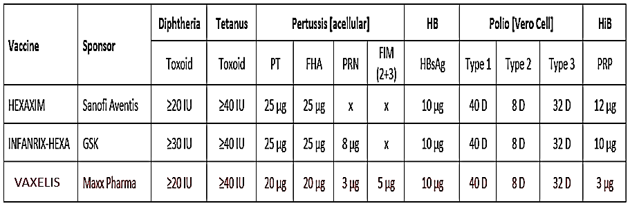

Abbreviations: Vaxelis = Vaxelis vaccine = Hexavalent vaccine (DTPa5-HB-IPV-HiB) contains 3 µg PRP conjugated to 50 µg OMPC Infanrix Hexa = Hexavalent vaccine (DTPa3-HB-IPV-HiB) contains 10 µg PRP conjugated to 20 to 40 µg TT Hexaxim = Hexavalent vaccine (DTPa2-HB-IPV-HiB) contains 12µg PRP conjugated to 22-36 µg TT

Note that Vaxelis and Hexaxim are both liquid preparations, whereas Infanrix Hexa requires reconstitution of its liquid component with a HiB pellet before administration.

### Regulatory status

This product is considered a new biological entity medicine for Australian regulatory purposes.

At the time the TGA considered this submission, similar submissions had been approved in the European Union (EU; 15 February 2016), the United States of America (21 December 2018) and Switzerland (28 August 2019). For details of these approvals see Table 4 below.

Table : International regulatory status

|  |  |  |  |
| --- | --- | --- | --- |
| Region | Submission date | Status | Approved indications |
| EU | 17 December 2014 | 15 February 2016 | *Vaxelis (DTPa5-HB-IPV-HiB) is indicated for primary and booster vaccination in infants and toddlers from the age of 6 weeks, against diphtheria, tetanus, pertussis, hepatitis B, poliomyelitis and invasive diseases caused by Haemophilus influenzae type b (Hib). The use of Vaxelis should be in accordance with official recommendations* |
| USA | 13 August 2014 | 21 December 2018 | *Vaxelis is a vaccine for the active immunisation for prevention of diphtheria, tetanus, pertussis, hepatitis B, poliomyelitis and invasive diseases caused by Haemophilus influenzae type b (Hib). Vaxelis is approved as a 3 dose series in children 6 weeks through 4 years of age (prior to 5th birthdays).* |
| Switzerland | 2 November 2017 | 28 August 2019 | *Vaxelis (DTPa5-HB-IPV-HiB) is indicated for primary and booster vaccination in infants and toddlers from the age of 6 weeks through 4 years (prior to 5th birthdays), against diphtheria, tetanus, pertussis, hepatitis B, poliomyelitis and invasive diseases caused by Haemophilus influenzae type b (Hib). The use of Vaxelis should be in accordance with official recommendations* |

### Product Information

The Product Information (PI) approved with the submission which is described in this AusPAR can be found as Attachment 1. For the most recent PI, please refer to the TGA [PI/CMI search facility.](https://www.tga.gov.au/picmi-search-facility)

## Registration timeline

The following table (Table 5) captures the key steps and dates for this submission.

Table : Timeline for Submission PM-2021-01695-1-2

|  |  |
| --- | --- |
| Description | Date |
| Submission dossier accepted and first round evaluation commenced | 01 June 2021 |
| First round evaluation completed | 26 October 2021 |
| Sponsor provides responses on questions raised in first round evaluation | 23 November 2021 |
| Second round evaluation completed | 23 December 2021 |
| Delegate’s Overall benefit-risk assessment | 24 January 2022 |
| Advisory Committee meeting | Not applicable |
| Registration decision (Outcome) | 22 March 2022 |
| Completion of administrative activities and registration on the ARTG | 23 March 2022 |
| Number of working days from submission dossier acceptance to registration decision* | 158 |

*The COR-B process has a 175 working day evaluation and decision timeframe.

## Submission overview and risk/benefit assessment

This section is a TGA summary of wording used in TGA’s evaluation report, which discussed numerous aspects of overseas evaluation reports and included some information that was commercial-in-confidence.

### Guidance

Guidance documents relevant to clinical aspects of this submission include:

* TGA Form for providing product information[12]
* European Medicines Agency (EMA) [Guideline on Clinical Evaluation of New Vaccines EMEA/CHMP/VWP/164653/2005](https://www.tga.gov.au/resources/resource/international-scientific-guidelines/international-scientific-guideline-guideline-clinical-evaluation-new-vaccines)
* EMA [Guideline on the Choice of the Non-Inferiority Margin EMEA/CPMP/EWP/2158/99](https://www.tga.gov.au/resources/resource/international-scientific-guidelines/international-scientific-guideline-guideline-choice-non-inferiority-margin)
* EMA [Guideline on pharmaceutical development of medicines for paediatric use EMA/CHMP/QWP/805880/2012 Rev. 2](https://www.tga.gov.au/resources/resource/international-scientific-guidelines/international-scientific-guideline-guideline-pharmaceutical-development-medicines-paediatric-use)

### Quality

Vaxelis is a cloudy, white to off-white liquid, ready-to-use formulation presented as a suspension for intramuscular injection adjuvanted onto aluminium phosphate and aluminium in single dose prefilled syringe or glass vial.

Table 6 describes the composition of Vaxelis as a combination of licensed vaccines.

Table : Composition of Vaxelis vaccine as a combination of different licensed vaccines

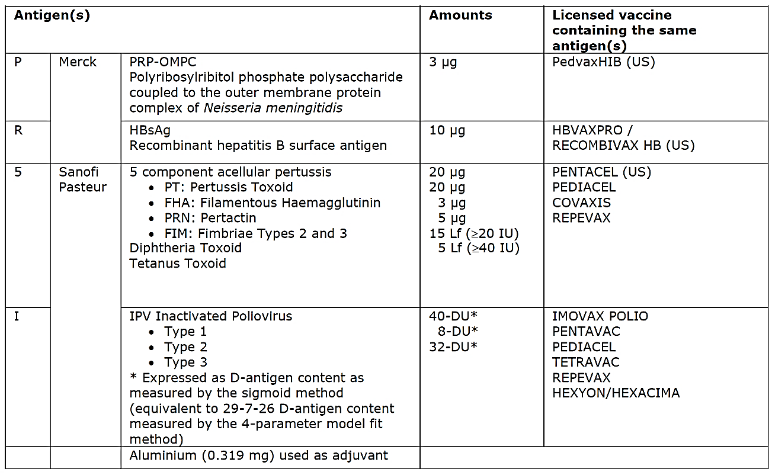

The shelf life is 48 months and must be stored in a refrigerator (2°C to 8°C).

Do not freeze. Keep the pre-filled syringe or vial in the outer carton in order to protect from light.

There were no objections from a quality perspective to the approval of Vaxelis.

### Nonclinical

The nonclinical dossier consisted of a single dose rat study only, which examined local tolerance and specific systemic toxicity endpoints. There were no animal immunogenicity studies. This was considered acceptable by the nonclinical evaluator given the availability of human data.

The single dose study in rats focused on local tolerance and included specific systemic toxicity endpoints (histopathology included site of administration and all gross lesions). The dose administered to each animal matched or exceeded the human dose except for inactivated trivalent polio antigens (29-D, 7-D and 26-D compared to 40-D, 8-D and 32-D antigen units for type 1, 2 and 3 respectively). The human route of administration (IM) and volume of dose (0.5 mL) were used in the study. No booster dose was administered to animals. The proposed vaccine is a combination vaccine containing components that are currently registered in the Australia and the EU and that have a well-established safety profile in humans.

There were no nonclinical objections to approval of Vaxelis.

Nonclinical recommendations for amendments to the PI were noted by the Delegate.

### Clinical

#### Summary of clinical studies

The COR-B submission included clinical evaluations by the European Medicines Agency (EMA) to support the dossier. A (redacted) clinical review by the US Food and Drug Administration (FDA) is also publicly available.[13] Note that approval in the USA is for 3‑dose primary series only, with non-specific advice on booster with respect to Vaxelis.

An abridged TGA clinical evaluation based on EMA reports was completed. The clinical evaluation supports approval.

The clinical dataset comprised 10 studies of which 4 (Studies 001 to 004) were formulation studies. The remaining 6 studies used the final formulation. These were all immunogenicity studies. The Phase III Study 005 (randomised, open label), Study 006 (randomised, partial double blind), Study 007 (randomised, double blind) and Study 008 (randomised, double blind) are considered pivotal.[14] Table 7 describes Studies 005 to 008 as well as Studies PRIO1C and PRIO2C.

Table : Studies submitted in support of this submission

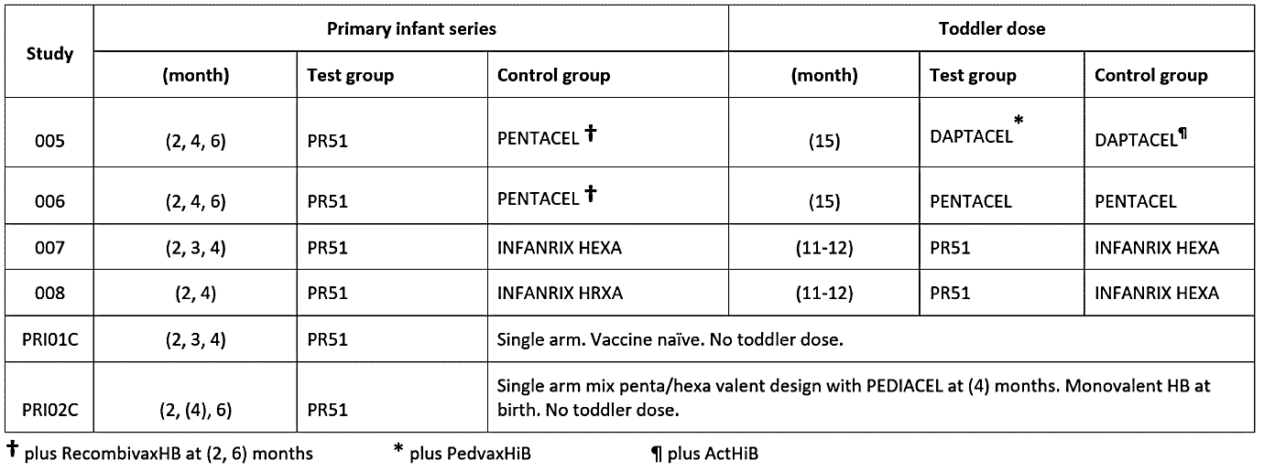

Studies 005 (1,473 subjects) and 006 (2,808 subjects) were USA-based studies, whereas Studies 007 (1,217 subjects) and 008 (1,315 subjects) were EU-based studies. All subjects were healthy and born full term. The participants in Studies 005 and 006 received a birth dose of monovalent hepatitis B vaccine, whereas participants in Studies 007 and 008 were vaccine‑naïve. Study 006 was also a Vaxelis vaccine lot-to-lot consistency study.

The study groups also received other concomitantly administered vaccines based on individual trial designs in addition to the test and control vaccines within each study.

There were no vaccine efficacy studies. However, correlates of protection are established (except in pertussis) and accepted for regulatory purposes for assessment of comparative immunogenicity using non-inferiority designs with the currently approved vaccines (see Table 8).

Table : Immune correlates for Vaxelis studies

Immune correlates

A summary of results for Studies 005, 006, 007 and 008 are presented below. All post‑primary series results are one month after the completion of primary infant series. All post‑toddler dose results are one month after the toddler dose and are referred to as base groups ‘Vaxelis vaccine’ and ‘control’ regardless of the type of booster.

##### Diphtheria

At the completion of primary series, seroprotection rates (% with titre ≥ 0.01 international units (IU)/mL) were high (98 to 100%) and comparable for the Vaxelis vaccine groups and their respective control groups across the 4 studies (Studies 005/006, 007, and 008). The seroprotection rates (% with titre ≥ 0.1 IU/mL) were comparable (Vaxelis vaccine versus respective controls) but found to be higher in Studies 005/006 (84% versus 86%) relative to Studies 007 (45% versus 46%) and 008 (42% versus 39%). The geometric mean titres (GMTs) were comparable (Vaxelis vaccine versus respective controls) but similarly higher in Studies 005/006 (0.36 versus 0.37) relative to Studies 007 (0.11 versus 0.11) and 008 (0.08 versus 0.09).

Pre-toddler levels were not provided.

Post-toddler dose, seroprotection rates (% with titre ≥ 0.1 IU/mL) were high (98 to 100%) and comparable for the Vaxelis vaccine groups and their respective control groups across the 4 studies. The GMTs ranged from 1.46 to 4.73 across the 4 studies and were comparable (Vaxelis vaccine versus respective control) within the studies.

##### Tetanus

At the completion of primary series, seroprotection rates (% with titre ≥ 0.01 or ≥ 0.1 IU/mL) were high (97-100%) and comparable for the Vaxelis vaccine groups and their respective control groups across the 4 studies. The GMTs were also comparable (Vaxelis vaccine versus respective controls) across the 4 studies but found to be higher in Studies 005/006 (1.86 versus 1.07) relative to Study 007 (0.70 versus 0.53) and Study 008 (0.47 versus 0.48).

Pre-toddler levels were not provided.

Post‑toddler dose, seroprotection rates (titre ≥ 0.1 IU/mL) were high (99 to 100%) and comparable for the Vaxelis vaccine groups and their respective control groups across the 4 studies. The GMTs ranged from 2.96 to 8.16 across the 4 studies and were consistently higher with Vaxelis vaccine versus the controls within the studies.

##### Polyribosylribitol phosphate (PRP)

At the completion of primary series, seroprotection rates (% with titre ≥ 0.15 µg/mL) were consistently higher in the Vaxelis vaccine groups compared to their respective control groups in Studies 005/006 (98% versus 94%), 007 (98% versus 86%) and 008 (96% versus 77%). The seroprotection rates (% with titre ≥ 1.0 µg/mL) for the Vaxelis vaccine groups as compared to the respective control groups were 86% versus 77% (Studies 005/006), 83% versus 36% (Study 007) and 72% versus 26% (Study 008). Consistent with this, GMTs for the Vaxelis vaccine groups versus their respective control groups were 5.75 versus 3.42 (Studies 005/006), 3.90 versus 0.65 (Study 007) and 2.38 versus 0.46 (Study 008).

Pre-toddler dose, seroprotection rates (% with titre ≥ 0.15 μg/mL) for the Vaxelis vaccine groups compared to their respective control groups were 93% versus 78% (Study 005), 89% versus 74% (Study 006), 94% versus 64% (Study 007) and 91% versus 48% (Study 008). The seroprotection rates (% with titre ≥ 1.0 μg/mL) were lower but similarly favoured the Vaxelis vaccine over the controls in each study (42% versus 27% in Study 005, 43% versus 29% in Study 006, 57% versus 11% in Study 007 and 50% versus 10% in Study 008. Pre-toddler dose, GMTs were higher (around 2 times or more) with the Vaxelis vaccine versus the control in each study (0.81 versus 0.42 (Study 005), 0.80 versus 0.42 (Study 006), 1.19 versus 0.24 (Study 007) and 0.94 versus 0.17 (Study 008)).

Post-toddler dose, seroprotection rates (% with titre ≥ 0.15 µg/mL) were high (99 to 100%) and comparable for the Vaxelis vaccine and the respective control across the 4 studies. The rates for % titre ≥ 1.0 µg/mL were similarly high (89 to 99%) and comparable within the studies. The GMTs rose but were lower with the Vaxelis vaccine groups compared to their respective control groups in Studies 005 (8.44 versus 17.21), 007 (6.79 versus 21.39) and 008 (4.43 versus 7.76) but higher in the lot-to-lot consistency Study 006 (49.41 versus 19.17).

##### Hepatitis B surface Antigen (HBsAg)

At the completion of primary series, seroprotection rates (% with titre ≥ 10 mIU/mL) were high (96 to 99%) and comparable for the Vaxelis vaccine groups compared to their respective control groups across the 4 studies. Similarly, the GMTs were high (all groups > 225) and comparable for the Vaxelis vaccine groups and their respective control groups across the 4 studies.

Pre-toddler dose, seroprotection rates (% with titre ≥ 10 mIU/mL) remained high (> 85%) in all groups and were comparable for the Vaxelis vaccine groups and their respective control groups across the 4 studies. Pre-toddler dose GMTs also stayed high (all groups > 59) and were comparable within the studies.

Post‑toddler dose, the pre-toddler dose seroprotection rates and GMTs were maintained in Studies 005 and 006 (the booster did not include HBsAg in these studies). There was strong and comparable immune response in Studies 007 and 008 with seroprotection rates for the Vaxelis vaccine groups and their respective control groups ranging from 98 to 99% and very high GMTs. Additional data on antibody persistence at 4 to 5 years and challenge (Study PRI03C) with a 5 µg HBsAg dose in the Studies 007/008 population was satisfactory. Note children in Studies 007/008 did not receive birth dose of hepatitis B vaccine.

##### Pertussis

At the completion of primary series, seroresponse rates (as defined in Table 8) were high (98 to 99%) and comparable for the Vaxelis vaccine and the respective controls. The GMTs were also comparable for the Vaxelis vaccine groups and their respective control groups (102.07 versus 84.73 in Studies 005/006, 129.58 versus 83.66 in Study 006 and 113.10 versus 92.44 in Study 008).

Pre-toddler dose, seroresponse rates (as defined in Table 8) for the Vaxelis vaccine groups and their respective controls groups were 22% versus 30% (Study 005), 22% versus 22% (Study 006) and 79% versus 89% (Study 008) The pre-toddler dose GMTs (Vaxelis vaccine versus respective control) were 9.33 versus 10.71 (Study 005), 8.83 versus 9.38 (Study 006), 12.91 versus 13.49 (Study 007) and 11.21 versus 15.38 (Study 008).

Post-toddler dose, seroresponse rates (as defined in Table 8) were high (97 to 99%) in all groups and comparable for the Vaxelis vaccine groups and their respective control groups across the 4 studies. There was significant rise in GMTs from pre toddler dose levels in both groups. The GMTs were comparable within the studies and consistently higher in the Vaxelis vaccine groups compared to their respective control groups (127.22 versus 91.31 in Study 005, 110.61 versus 102.82 in Study 006, 196.81 versus 90.69 in Study 007 and 157.39 versus 109.96 in Study 008).

##### Purified filamentous haemagglutinin

At the completion of primary series, seroresponse rates (as defined in Table 8) for the Vaxelis vaccine groups compared to their respective control groups were 87% versus 92% (Studies 005/006), 89% versus 96% (Study 007) and 88% versus 96% (Study 008). The GMTs were also consistently lower for the Vaxelis vaccine groups compared to their respective control groups in Studies 005/006 (49.24 versus 73.92), 007 (49.51 versus 96.80) and 008 (44.52 versus 86.55).

Pre-toddler dose, seroresponse rates (as defined in Table 8) for the Vaxelis vaccine groups compared to their respective control groups were 22% versus 48% (Study 005), 21% versus 38% (Study 006) and 58% versus 82% (Study 008). The pre-toddler dose GMTs (Vaxelis vaccine versus respective controls) were also consistently lower with the Vaxelis vaccine (6.26 versus 13.22 in Study 005, 6.10 versus 11.22 in Study 006, 8.63 versus 22.85 in Study 007 and 8.09 versus 22.70 in Study 008).

Post-toddler dose, seroresponse rates (as defined in Table 8) were high (93-99%) and comparable for the Vaxelis vaccine groups and their respective control groups across the 4 studies. There was significant rise in GMTs from pre toddler dose levels in all groups (88.92 versus 89.18 in Study 005, 106.30 versus 121.00 in Study 006, 121.59 versus 196.53 in Study 007 and 120.79 versus 204.21 in Study 008).

##### Pertactin (PRN)

At the completion of primary series, seroresponse rates (as defined in Table 8) for the Vaxelis vaccine groups compared to their respective control groups were 79% versus 79% (Studies 005/006), 86% versus 92% (Study 007) and 80% versus 91% (Study 008). The GMTs were also consistently lower for the Vaxelis vaccine groups compared to their respective control groups in Studies 005/006 (53.78 versus 59.12), 006 (46.76 versus 77.79) and 008 (37.84 versus 78.27).

Pre-toddler dose, seroresponse rates (as defined in Table 8) for the Vaxelis vaccine groups compared to their respective control groups were 17% versus 23% (Study 005), 19% versus 21% (Study 006) and 53% versus 67% (Study 008). The pre-toddler dose GMTs (Vaxelis vaccine versus control) were 7.28 versus 8.97 (Study 005), 8.61 versus 8.80 (Study 006), 11.47 versus 12.09 (Study 007) and 6.53 versus 11.04 (Study 008).

Post-toddler dose, seroresponse rates (as defined in Table 8) were high in all groups (93 to 98%) and comparable for the Vaxelis vaccine groups and their respective control groups across the 4 studies. There was significant rise in GMTs from pre-toddler dose levels in all groups (108.05 versus 139.35 in Study 005, 104.51 versus 142.32 in Study 006, 166.67 versus 182.08 in Study 007 and 104.25 versus 153.50 in Study 008).

##### Fimbriae 2 and 3 (FIM 2+3)

At the completion of primary series, seroresponse rates (as defined in Table 8) and GMTs were comparable for the Vaxelis vaccine and the respective controls in Studies 005/006 combined data. FIM was not a component of the control in Studies 007 and 008.

Pre-toddler dose, seroresponse rates (as defined in Table 8) and GMTs were comparable (Vaxelis vaccine versus control) in Studies 005 and 006.

Post‑toddler dose, seroresponse rates (as defined in Table 8) were high (90 to 99%) in all groups across the 4 studies and comparable for Vaxelis vaccine groups and their respective controls in Studies 005 and 006. There was significant rise in GMTs from pre‑toddler dose levels in all groups and the GMT levels were comparable within the Studies 005 and 006, noting again that the control in Studies 007 and 008 did not contain FIM.

##### Polio Type (1, 2, 3)

At the completion of primary series, seroprotection rates (neutralising antibodies ≥ 1/8 dilution) were high (92 to 100%) and comparable for the Vaxelis vaccine compared to the respective controls across the 4 studies. The GMTs for the 3 polio types were similarly comparable between the Vaxelis vaccine groups and their respective control groups.

Pre-toddler levels were not provided.

Post‑toddler dose, seroprotection rates (neutralising antibodies ≥ 1/8 dilution) were high (99-100%) for the 3 polio types and were comparable for the Vaxelis vaccine groups versus the respective control groups (Studies 006, 007 and 008). There was a marked rise in GMTs in these 3 studies compared to the levels reported at the completion of primary series. Note, toddler boosting in Study 005 did not include IPV component. The seroprotection rates at this timepoint in Study 005 ranged from 83 to 99% for the 3 types in both groups and GMTs were maintained.

The submitted data included around 100 premature babies. At present, there are no data in immunocompromised children or children with chronic conditions.

#### Clinical safety

The Vaxelis vaccine clinical development program included approximately 9,500 subjects who participated in 10 clinical studies. The mean age of the participants at randomisation was 64 days (range 43 to 99 days).

More than 95% of subjects in both vaccination groups reported one or more adverse events (AE) in the six studies combined (Studies 004, 005, 006, 007, 008 and PRI01C). A slightly higher percentage of subjects in the Vaxelis vaccine group as compared to the control group reported at least one AE from Day 1 through Day 15 after any dose (estimated difference 1.2% (95% confidence interval (CI) 0.1, 2.4)). The estimated difference for serious AEs (Day 1 to 15) was 0.2 (95% CI -0.4, 0.8).

Overall, solicited local AEs were reported in similar proportions in both groups (81.9% versus 81.8%) but injection site erythema (55% versus 49.9%) and injection site swelling (44% versus 40.9%) were reported more frequently in the Vaxelis vaccine group as compared to the control group (Table 9).

Table : Solicited injection site-related adverse events (more than 0% in any group); Day 1 to 5 after any dose (as treated population, from Studies 004, 005, 006, 007, 008 and PRIO1C)

Solicited injection site related AEs (>0% in any group) – Day 1 to 5 after any dose (As treated population – Studies 004, 005, 006, 007, 008 and PRIO1C).


These trends were also noticeable in the smaller Studies 007/008 population for Vaxelis vaccine versus Infanrix Hexa (68.8% versus 62.2% for injection site erythema, 73.5% versus 70.8% for injection site pain and 56.8% versus 51.0% for injection site swelling).

Overall, solicited systemic AEs were reported in similar proportions in both groups but pyrexia (56.8% versus 47.4%) was reported more frequently in Vaxelis vaccine versus control (see Table 10).

Table : Solicited systemic adverse events (more than 0% in any group); Day 1 and 5 after any dose (as treated population, from Studies 004, 005, 006, 007, 008 and PRIO1C)

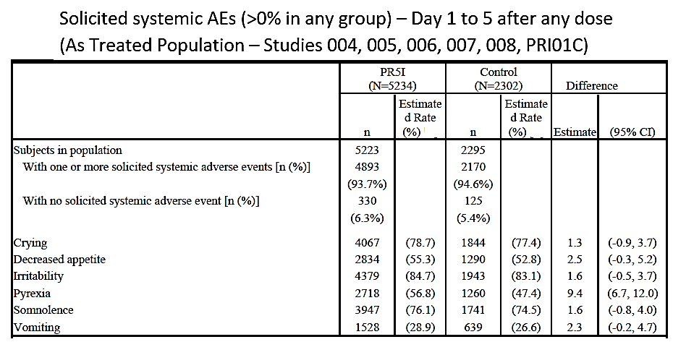

These trends were also noticeable but less pronounced in the smaller Studies 007/008) combined population for Vaxelis vaccine versus Infanrix Hexa. For pyrexia (72.7% versus 70.1) the estimated difference was 2.5% (95% CI: -1.0, 6.1).

Further analysis of pyrexia events in the Studies 005/006/007/008 population confirmed a higher trend of fever ≥ 38 °C in Vaxelis vaccine group versus control group (see Table 11, below).

Table : Subjects with temperature by severity; Day 1 to 5 after any dose (as treated population from Studies 004, 005, 006, 007, 008)

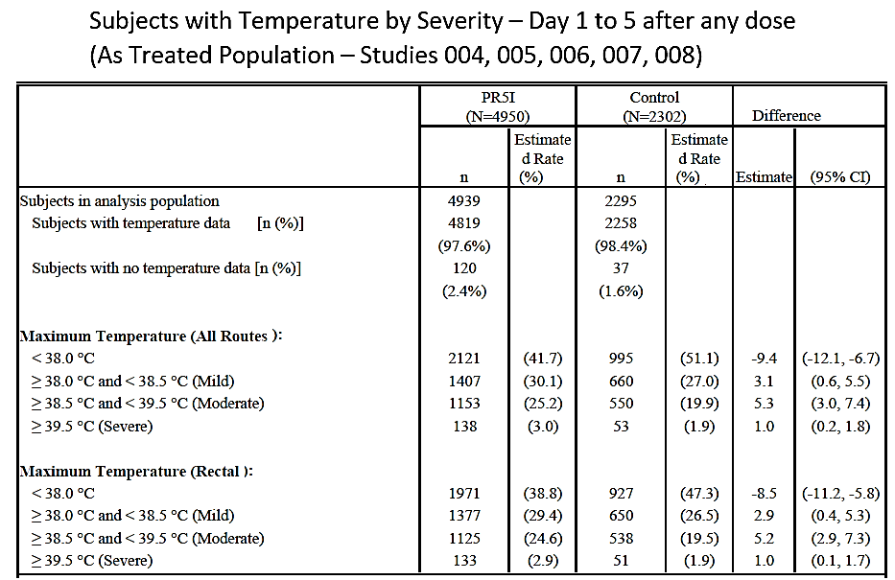

The reported occurrences of pyrexia, febrile convulsion and convulsion events over extended follow up period were as shown in Table 12 below.

Table : Subjects with pyrexia, febrile convulsion, convulsion (more than 0% in any group) after any dose (as treated population from Studies 004, 005, 006, 007, 008 and PRIO1C)

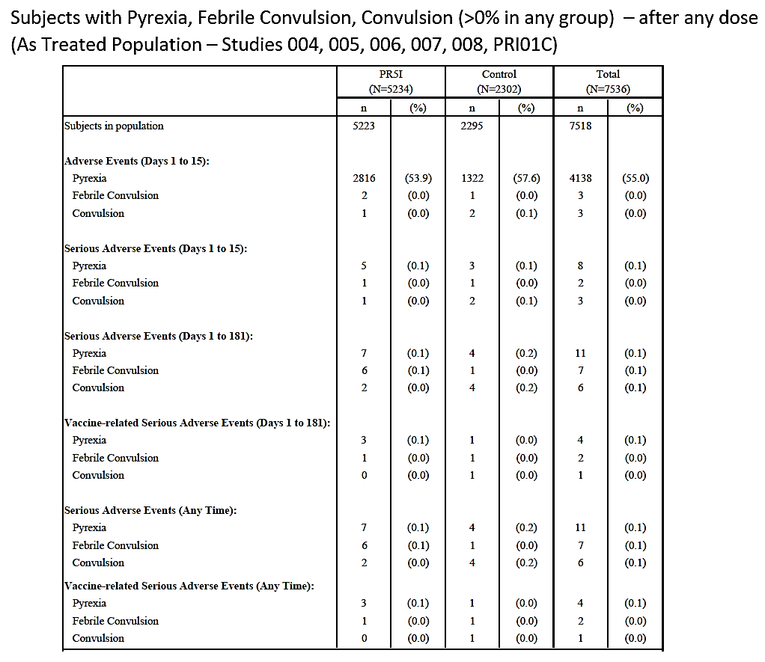

In combined data for Studies 007/008, there were four reports of febrile convulsion or convulsion (2 each in Vaxelis vaccine and Control) that were considered serious within Days 1 to 15 (Table 13). Two of these were considered vaccine related (one in each group).

Table : Subjects with pyrexia, febrile convulsion (more than 0% in any group) after any dose (as treated population from Studies 007 and 008)

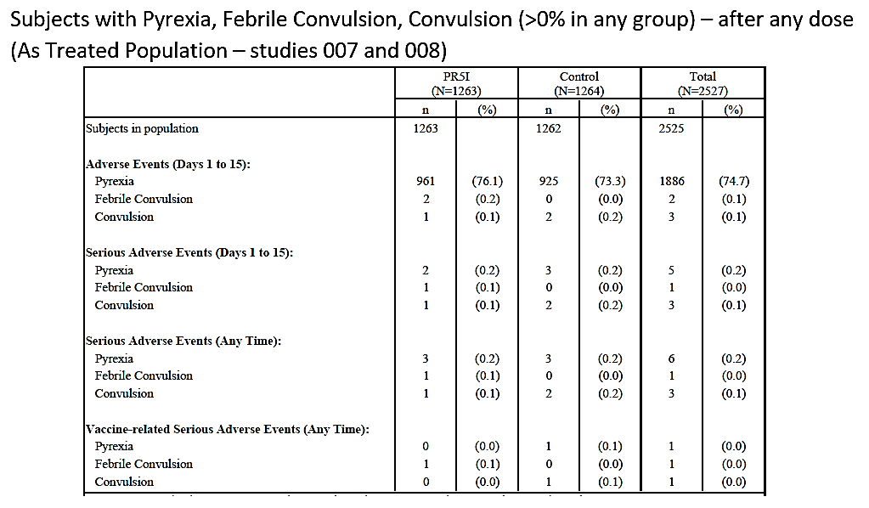

Across Studies 004, 005, 006, 007, 008 and PRI01C, related serious adverse events were reported as shown in Table 14 below.

Table : Related serious adverse events across Studies 004 to 008, and Study PRIO1C and PRIO2C

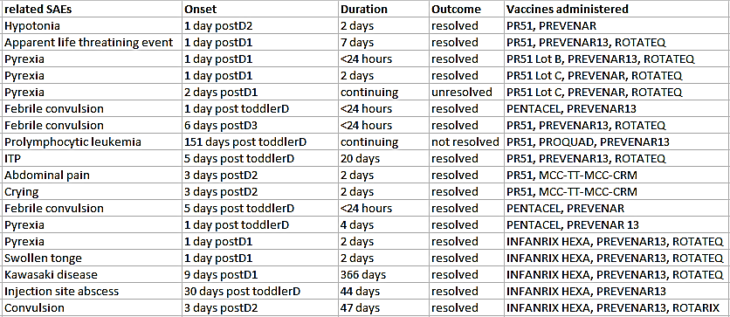

A total of 7 deaths were reported in Studies 005 and 006. No deaths were reported in Studies 004, 007, 008 and PRI01C. No death was considered related to study vaccines.

Of the 12 (Vaxelis vaccine group) and 10 (control group) subjects who discontinued due to an AE in the 6 combined studies dataset, 9 subjects discontinued in Studies 007/008, of which 8 were in Infanrix Hexa group. The one subject in Vaxelis vaccine group discontinued due to an unrelated serious adverse event of congenital heart disease.

Regarding concomitant vaccinations, data across studies indicated that Vaxelis vaccine co‑administered with Prevenar 13;[15] for the toddler dose induces a higher rate of fever than other combinations (Table 15). A statement to this effect is proposed for inclusion in the PI.

Table : Rates of pyrexia at the 2 month dose and the toddler dose in Studies 005, 006, 007 and 008

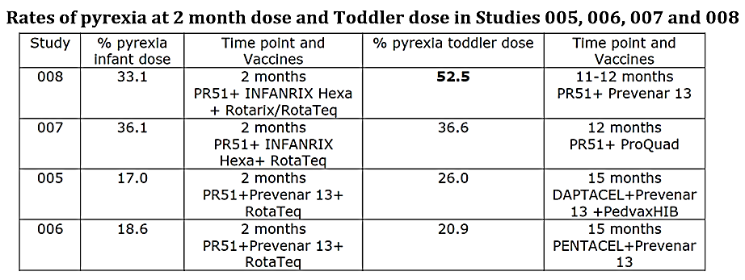

One year of post-market surveillance data are also available. The clinical evaluation concluded that there is no conclusive evidence of vaccine failure in the post-marketing space.

### Risk management plan

The sponsor has provided EU risk management plan (RMP) version 3.1 (dated 25 February 2020; data lock point (DLP) 3 October 2019) and Australian Specific Annex (ASA) version 1.0 (dated April 2021) in support of this submission.

There are no proposed safety concerns and therefore no routine risk minimisation activities. This is consistent with the EU-RMP and is considered acceptable.

Routine pharmacovigilance is proposed to monitor any adverse events and post market safety surveillance. The sponsor proposes to submit Postmarket safety update reports (PSURs)/ Periodic Benefit-Risk Evaluation Report (PBRER) for Vaxelis to the TGA annually for a total of three years post-registration. The timing of the first submission will be aligned with the EU PSUR reporting requirements which is considered acceptable.

The RMP evaluation area is supportive of RMP as proposed. There are no outstanding matters. Post market RMP/PSUR conditions of registration have been provided to the Delegate.

Further information regarding the TGA’s risk management approach can be found in [risk management plans for medicines and biologicals](https://www.tga.gov.au/publication/risk-management-plans-medicines-and-biologicals) and [the TGA's risk management approach](https://www.tga.gov.au/tgas-risk-management-approach).

### Risk-benefit analysis

#### Delegate’s considerations

All predefined acceptability of response targets and non-inferior immunogenicity criteria were satisfactorily met for Vaxelis vaccine. The overall adverse effects profile was consistent with that expected of a hexavalent DTPa-HB-IPV-HiB vaccine.

The results at the completion of post primary infant series allow straightforward conclusions across 4 studies (Studies 005/006, 007, 008) for the (2, 3, 4 months)/ (2, 4, 6 months)/ (2, 4 months) dose schedules. The pre-toddler dose analyses at Month 15 also provides useful information on (2, 4, 6 months) primary series for its proximity to the (2, 4, 6 months) and (18 months) infant schedule in Australia.

Vaxelis vaccine was not used as booster (toddler dose) in any group in either the US studies (Daptacel;[16] was used in both groups in Studies 005 and Pentacel;[17] in both groups in Study 006). This limits the interpretation of post-toddler results in these studies with respect to Vaxelis but enhances the applicability by providing more diverse data. Overall, the comparators used in the USA studies are considered acceptable as equivalent vaccines are approved in Australia (except for PedvaxHiB 7.5 µg PRP-OMPC[18]).

The EU studies (Studies 007 and 008) provide direct comparison of Vaxelis vaccine versus Infanrix Hexa in primary series and as boosters (toddler dose). This is important as Infanrix Hexa is currently being used in Australia for childhood vaccination. However, the vaccine schedules examined were (2, 3, 4 months) (11 to 12 months) in Study 007 and (2, 4 months) and (11 to 12 months) in Study 008.

Noticeable findings amongst the immunogenicity results are described below.

##### Relatively lower Haemophilus influenzae type B response after toddler dose

Although, post-toddler dose seroprotection rates were high (99 to 100% for percentage with titre ≥ 0.15 µg/mL and 89% to 99% for percentage with titre ≥ 1.0 µg/mL) and comparable in the Vaxelis vaccine groups and their respective control groups across the 4 studies, the GMTs were found to be lower with the Vaxelis vaccine compared to the control in Studies 005 (8.44 versus 17.21), 007 (6.79 versus 21.39) and 008 (4.43 versus 7.76) but higher in the lot-to-lot consistency Study 006 (49.41 versus 19.17). This was an unexpected finding given that post-primary seroprotection rates and GMTs (5.75 versus 3.42 (Studies 005/006), 3.90 versus 0.65 (Study 007) and 2.38 versus 0.46 (Study 008)) were higher with Vaxelis vaccine versus respective controls. The antibodies further declined in both groups but the pre toddler dose seroprotection rates (percentage with titre ≥ 1.0 µg/mL) still favoured the Vaxelis vaccine versus the controls (42% versus 27% (Study 005), 43% versus 29% (006), 57% versus 11% (Study 007) and 50% versus 10% (Study 008)) and the pre-toddler dose GMTs were consistently higher with Vaxelis vaccine versus respective controls (0.81 versus 0.42 (Study 005), 0.80 versus 0.42 (Study 006), 1.19 versus 0.24 (Study 007) and 0.94 versus 0.17 (Study (008)).

Overall, however, the anti-polyribosylribitol phosphate (anti-PRP) response with Vaxelis vaccine is considered satisfactory and stronger relatively to the comparators in these studies, particularly post-primary.

Note that PRP antigen in Vaxelis vaccine is conjugated to meningococcal outer membrane carrier protein. The PRP-OMPC18 conjugation imposed a significant reduction in PRP content (3 µg) in the Vaxelis vaccine formulation and exhibits a different immunogenicity profile to the PRP-tetanus toxoid (TT) conjugation.

##### Relatively lower pertussis responses after primary series and waning before toddler dose

Filamentous haemagglutinin (FHA) and pertactin (PRN) seroresponse rates and GMTs were found to be lower than controls.

For FHA, at the completion of primary series, seroresponse rates for the Vaxelis vaccine groups as compared to their respective controls were 87% versus 92% (Studies 005/006), 89% versus 96% (Study 007) and 88% versus 96% (Study 008). The GMTs were also consistently lower with the Vaxelis vaccine as comparted to the control in each of the Studies 005/006 (49.24 versus 73.92), 007 (49.51 versus 96.80) and 008 (44.52 versus 86.55).

For PRN, at the completion of primary series, seroresponse rates for the Vaxelis vaccine groups as compared to their respective controls were 79% versus 79% (Studies 005/006), 86% versus 92% (Study 007) and 80% versus 91% (Study 008). The GMTs were consistently lower with Vaxelis vaccine compared to the controls in Study 005/006 (53.78 versus 59.12), Study 007 (46.76 versus 77.79) and Study 008 (37.84 versus 78.27).

It was further noted that antibodies for these antigens waned rapidly after the primary schedule in both groups but more so in the Vaxelis vaccine groups than in their respective control groups.

For FHA, pre-toddler dose seroresponse rates for the Vaxelis vaccine as compared to the controls were 22% versus 48% (Study 005), 21% versus 38% (Study 006) and 58% versus 82% (Study 008). The pre-toddler dose GMTs were also consistently lower with the Vaxelis vaccine as compared to the controls (6.26 versus 13.22 in Study 005, 6.10 versus 11.22 in Study 006, 8.63 versus 22.85 in Study 007 and 8.09 versus 22.70 in Study 008).

For PRN, pre-toddler dose seroresponse rates for the Vaxelis vaccine as compared to the controls were 17% versus 23% (Study 005), 19% versus 21% (Study 006) and 53% versus 67% (Study 008). The pre-toddler dose GMTs for the Vaxelis vaccine as compared to the controls were 7.28 versus 8.97 (Study 005), 8.61 versus 8.80 (Study 006), 11.47 versus 12.09 (Study 007) and 6.53 versus 11.04 (Study 008).

However, post-toddler dose response rates and GMTs for both FHA and PRN were high and comparable for the Vaxelis vaccine and the respective control groups, indicative of the importance of the toddler dose regardless of homologous or heterologous vaccine product, and irrespective of 2 or 3 dose schedules.

This also highlights the potentially unprotected risk period between third dose at 6 months in the primary schedule (2, 4, 6 months) and booster at 18 months in the Australian vaccination schedule.

Overall, the Vaxelis vaccine produced higher GMTs and similar response rates for the pertussis toxoid antigen compared to the respective control groups.

Fimbriae 2 and 3 (FIM 2+3) response rates and GMTs were comparable for the Vaxelis vaccine/Daptacel group versus the Pentacel/Daptacel group (Study 005) or Vaxelis vaccine/Pentacel group versus Pentacel/Pentacel group (Study 006), whereas FIM 2+3 is not a component of Infanrix Hexa which was used in Studies 007 and 008.

The persistence of pertussis antibodies was measured in Study PRI03C in children at 4 or 5 years of age who had received the Vaxelis vaccine as compared to the Infanrix Hexa vaccine in Study 008 (2, 4, 12 months schedule). After approximately 4 years, the percentages of children with anti-pertussis antibodies above lower limit of quantification (LLOQ) for the Vaxelis vaccine compared to the Infanrix Hexa vaccine were anti-pertussis toxoid 58.4% versus 41.49%, anti-FHA 80.9% versus 88.30%, anti-PRN 66.11% versus 72.63% and anti-FIM 94.3% versus 3.28%. The GMTs at this timepoint were indicative of an overall similar performance of both vaccines (see Table 16).

Table : Summary of pertussis antibodies persistence (GMCs) following a 2+1 schedule (persistence analysis set, pertussis analysis)

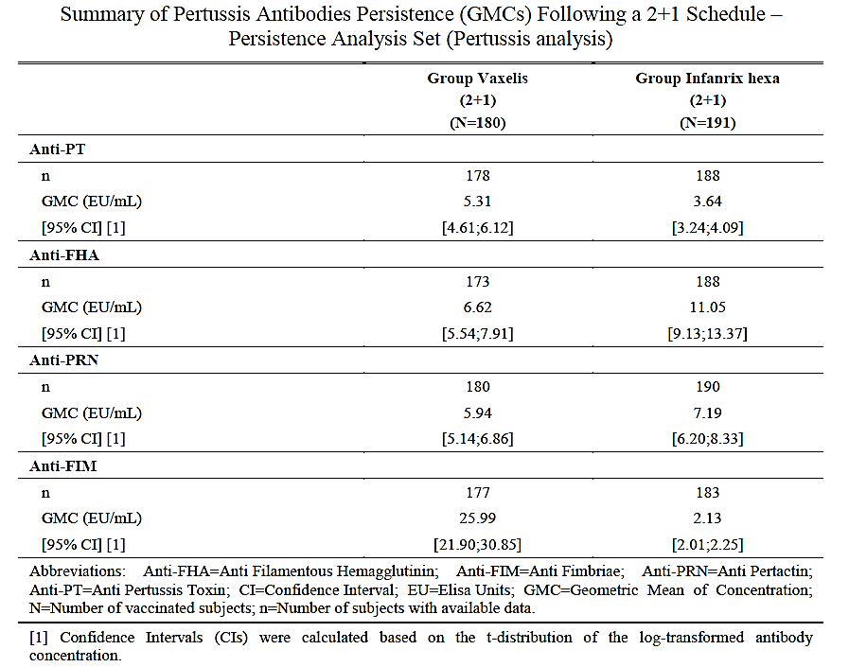

The exact contribution of the individual pertussis antigens to clinical protection and any efficacy advantage of a 5 component (additional FIM 2+3) over a 3 component acellular pertussis vaccine is not clear but may have a role in protection particularly against mild disease.

A further complexity in interpretation of these results arises from the fact the immune correlates of protection are not known, and the interpretation is only relative to the control.

There were no issues with respect to immune responses to diphtheria, tetanus, HBsAg and poliovirus antigens.

##### Relatively more reactogenic than controls

There was a trend towards higher reactogenicity (local and systemic) in the Vaxelis vaccine group compared to the control group. Among the infant doses the first dose seems to give more injection site reactions, while the second dose gives the highest frequency of fever. The rate of solicited injection site reactions and fever are higher after the toddler dose than the infant doses.

The overall adverse effects profile is considered consistent with the current DTPa-HB-IPV-HiB vaccines. There was no unexpected safety signal in the limited clinical trials dataset or the early post market data available at this time with respect to serious related events, or special events of regulatory interest.

None of the 4 pivotal studies (Studies 005, 006, 007 and 008) individually provide direct data to match the recommended (2, 4, 6, 18 month) schedule in the Australian National Immunisation Program (see Table 2, above).

Overall, the studies provide sufficient suitable and complementary information with respect to the Australian National Immunisation schedule. However, this is a program implementation matter for a different forum.

It is noted that the proposed PI includes a statement under *Adverse effects* section that that safety of Vaxelis in children over 15 months of age has not been studied in clinical trials.

The primary basis of regulatory approval are Studies 007 and 008 as pivotal studies and Studies 005 and 006 as supportive studies. The data support the indication as proposed:

*Vaxelis (DTPa5-HB-IPV-HiB) is indicated for primary and booster vaccination in infants and toddlers from the age of 6 weeks, against diphtheria, tetanus, pertussis, hepatitis B, poliomyelitis and invasive diseases caused by Haemophilus influenzae type b (Hib). The use of Vaxelis should be in accordance with official recommendations.*

The data also support the vaccination schedules as proposed:

*The primary vaccination schedule consists of 2 or 3 doses, with an interval of at least 1 month between doses, and may be given from 6 weeks of age, in accordance with the official recommendations.*

and

*After a 3-dose primary series vaccination with Vaxelis, a booster dose may be given. When giving a booster dose, this should be at least 6 months after the last priming dose. After a 2-dose primary series vaccination with Vaxelis, a booster dose should be given at least 6 months after the last priming dose. Booster doses should be given in accordance with the official recommendations.*

#### Proposed action

While a decision was yet to be made, at this stage the Delegate was inclined to approve the registration of Vaxelis.

#### Questions for the sponsor

The Delegate proposed several amendments to the PI which were implemented by the sponsor. The details of these are beyond the scope of this AusPAR.

#### Advisory Committee considerations

The Delegate did not refer this submission to the Advisory Committee on Vaccines (ACV) for advice.

## Outcome

Based on a review of quality, safety, and efficacy, the TGA approved the registration of Vaxelis (DTPa5-HB-IPV-Hib vaccine) single dose (0.5 mL) suspension for intramuscular injection, in a vial or prefilled syringe, indicated for:

*Vaxelis (DTPa5-HB-IPV-Hib) is indicated for primary and booster vaccination in infants and toddlers from the age of 6 weeks, against diphtheria, tetanus, pertussis, hepatitis B, poliomyelitis and invasive diseases caused by Haemophilus influenzae type b (Hib).*

*The use of Vaxelis should be in accordance with official recommendations.*

##### Specific conditions of registration applying to these goods

* Vaxelis (Diphtheria, tetanus, pertussis (acellular, component), hepatitis B (rDNA), poliovirus (inactivated), and Haemophilus influenzae type b conjugate vaccine) is to be included in the Black Triangle Scheme. The PI and CMI for Vaxelis must include the black triangle symbol and mandatory accompanying text for five years, which starts from the date that the sponsor notifies the TGA of supply of the product.
* An obligatory component of risk management plans is routine pharmacovigilance. Routine pharmacovigilance includes the submission of periodic safety update reports (PSURs).

Reports are to be provided in line with the current published list of EU reference dates and frequency of submission of PSURs until the period covered by such reports is not less than three years from the date of this approval letter.

The reports are to at least meet the requirements for PSURs as described in the European Medicines Agency’s Guideline on good pharmacovigilance practices (GVP) Module VII-periodic safety update report (Rev 1), Part VII.B Structures and processes. Note that submission of a PSUR does not constitute an application to vary the registration.

* Good Manufacturing Practice (GMP) clearance for listed manufacturers:All GMP Clearances must be approved prior to registration and supply of product to Australia. A commitment is required from the sponsor that they maintain the validity of all manufacturer GMP Clearances for the duration of product supply to Australia. Additionally, that adherence to the conditions of GMP Clearance approval is upheld.
* Batch Release Testing and Compliance

It is a condition of registration that all independent batches of Vaxelis vaccine imported into Australia are not released for sale until samples and the manufacturer’s release data have been assessed and you have received notification acknowledging release from the Laboratories Branch, TGA.

* Certified Product Details

An electronic copy of the Certified Product Details (CPD) as described in Guidance 7: Certified Product Details of the Australian Regulatory Guidelines for Prescription Medicines (ARGPM) https://www.tga.gov.au/guidance-7-certified-product-details should be provided upon registration of the therapeutic good. In addition, an updated CPD, for the above products incorporating the approved changes is to be provided within one month of the date of approval letter.

## Attachment 1. Product Information

The PI for Vaxelis approved with the submission which is described in this AusPAR is at Attachment 1. For the most recent PI, please refer to the TGA [PI/CMI search facility.](https://www.tga.gov.au/picmi-search-facility)

|  |
| --- |
| Therapeutic Goods Administration |
| PO Box 100 Woden ACT 2606 Australia  Email: [info@tga.gov.au](mailto:info@tga.gov.au) Phone: 1800 020 653 Fax: 02 6232 8605  [**https://www.tga.gov.au**](https://www.tga.gov.au) |

1. Adapted from ‘Immunisation recommendations for Non-Indigenous Australians without risk factors for vaccine-preventable diseases’; NCIRS; last updated: July 2020. Available at: ‘<https://www.ncirs.org.au/sites/default/files/2021-08/NCIRS%20Immunisation%20schedule%20for%20non-Indigenous%20people_1%20July%202020-Final.pdf>
2. [NSW Health diphtheria control guideline](https://www.health.nsw.gov.au/Infectious/controlguideline/Pages/diphtheria.aspx) (last viewed 24/10/2021)
3. Australian Institute of Health and Welfare (2018). Diphtheria in Australia (Vaccine-preventable disease fact sheet). Australian Government.
4. Australian Institute of Health and Welfare (2018). Tetanus in Australia (Vaccine-preventable disease fact sheet). Australian Government.
5. [NSW Health pertussis control guideline](https://www.health.nsw.gov.au/Infectious/controlguideline/Pages/pertussis.aspx) (last viewed 21/10/2021)
6. Australian Institute of Health and Welfare (2018). Pertussis in Australia (Vaccine-preventable disease fact sheet). Australian Government.
7. Australian Institute of Health and Welfare (2018). Polio in Australia (Vaccine-preventable disease fact sheet). Australian Government.
8. [NSW Health *Haemophilus influenzae* type b (Hib) control guideline](https://www.health.nsw.gov.au/Infectious/controlguideline/Pages/haemflu.aspx) (last viewed 21/10/2021)
9. Hexaxim DTPa-hepB-IPV-Hib (vaccine) suspension for injection in pre-filled syringe ARTG R 215536.
10. AusPAR for Hexaxim, diphtheria, tetanus, pertussis (acellular component), hepatitis b (rDNA), poliomyelitis (inactivated) and haemophilus influenzae type b conjugate vaccine (adsorbed); Sanofi-Aventis Pty Ltd, PM‑2013-02800-1-2. Published in January 2015. Available online at: [AusPAR for Hexaxim (DTPa-hepB-IPV-Hib vaccine)](https://www.tga.gov.au/resources/auspar/auspar-diphtheria-toxoid-haemophilus-type-b-polysaccharide-hepatitis-b-surface-antigen-pertussis-filamentous-haemagglutinin-pertussis-toxoid-poliovirus-tetanus-protein-tetanus-toxoid)
11. Infanrix Hexa DTPa-hepB-IPV-Hib conjugate vaccine (adsorbed) injection composite pack (pre-filled syringe and vial), ARTG R 132881.
12. <https://www.tga.gov.au/form-providing-product-information>
13. https://www.fda.gov/media/119740/download
14. DAPTACEL = DTPa5; PENTACEL; PEDIACEL = DTPa5-IPV-HiB (containing 10 µg PRP-TT); PedvaxHiB = 7.5 µg PRP-OMPC; ActHiB = 10 µg PRP-TT; RecombivaxHB = 5 µg HBsAg
15. Prevenar 13 pneumococcal polysaccharide conjugate vaccine (13-valent, adsorbed) is available as a suspension for intramuuscular injection that contains parts from 13 different types of the bacterium *Streptococcus pneumoniae*. Prevenar 13 may be used to protect children aged from 6 weeks and 17 years against invasive disease, pneumonia and acute otitis media (infection of the middle ear) caused by *S. pneumoniae.*
16. Daptacel is an DTaP vaccine immunising against diphtheria, tetanus, and pertussis.
17. Pentacel is a pentavalent DTaP-IPV/Hib combination vaccine that protects against diphtheria, tetanus, pertussis, polio, and *Haemophilus influenzae* type B.
18. PRP-OMPC= *Haemophilus influenzae* type B polysaccharide conjugated to Outer membrane protein complex