|  |
| --- |
| Australian Public Assessment Report for Vumerity |
| Active ingredients: Diroximel fumarate |
| Sponsor: Biogen Australia Pty Ltd |
| February 2023 |

About the Therapeutic Goods Administration (TGA)

* The Therapeutic Goods Administration (TGA) is part of the Australian Government Department of Health and is responsible for regulating therapeutic goods, including medicines, medical devices, and biologicals.
* The TGA administers the *Therapeutic Goods Act 1989* (the Act), applying a risk management approach designed to ensure therapeutic goods supplied in Australia meet acceptable standards of quality, safety, and efficacy.
* The work of the TGA is based on applying scientific and clinical expertise to decision-making, to ensure that the benefits to the Australian public outweigh any risks associated with the use of therapeutic goods.
* The TGA relies on the public, healthcare professionals and industry to report problems with therapeutic goods. The TGA investigates reports received to determine any necessary regulatory action.
* To report a problem with a therapeutic good, please see the information on the [TGA website](https://www.tga.gov.au).

About AusPARs

* The Australian Public Assessment Report (AusPAR) provides information about the evaluation of a prescription medicine and the considerations that led the TGA to approve or not approve a prescription medicine submission. Further information can be found in [Australian Public Assessment Report (AusPAR) guidance](https://www.tga.gov.au/australian-public-assessment-report-auspar-guidance).
* AusPARs are prepared and published by the TGA.
* AusPARs are static documents that provide information that relates to a submission at a particular point in time. The publication of an AusPAR is an important part of the transparency of the TGA’s decision-making process.
* A new AusPAR may be provided to reflect changes to indications or major variations to a prescription medicine subject to evaluation by the TGA.

Copyright

© Commonwealth of Australia 2023  
This work is copyright. You may reproduce the whole or part of this work in unaltered form for your own personal use or, if you are part of an organisation, for internal use within your organisation, but only if you or your organisation do not use the reproduction for any commercial purpose and retain this copyright notice and all disclaimer notices as part of that reproduction. Apart from rights to use as permitted by the *Copyright Act 1968* or allowed by this copyright notice, all other rights are reserved, and you are not allowed to reproduce the whole or any part of this work in any way (electronic or otherwise) without first being given specific written permission from the Commonwealth to do so. Requests and inquiries concerning reproduction and rights are to be sent to the TGA Copyright Officer, Therapeutic Goods Administration, PO Box 100, Woden ACT 2606 or emailed to <[tga.copyright@tga.gov.au](mailto:tga.copyright@tga.gov.au)>.

Contents

List of abbreviations 4

Product submission 6

Submission details 6

Product background 7

Regulatory status 8

Product Information 9

Registration timeline 9

Submission overview and risk/benefit assessment 10

Quality 10

Nonclinical 11

Clinical 12

Risk management plan 30

Risk-benefit analysis 32

Outcome 36

Specific conditions of registration applying to these goods 36

Attachment 1. Product Information 37

## List of abbreviations

|  |  |  |
| --- | --- | --- |
| Abbreviation | | Meaning |
| ACM | Advisory Committee on Medicines | |
| AE | Adverse event | |
| AESI | Adverse event of special interest | |
| ALT | Alanine transaminase | |
| ARR | Annualised relapse rate | |
| ARTG | Australian Register of Therapeutic Goods | |
| ASA | Australia specific annex | |
| AST | Aspartate transaminase | |
| AUC | Area under the concentration‑time curve | |
| AUC0-∞ | Area under the concentration‑time curve from time zero to infinity | |
| AUC0-last | Area under the concentration‑time curve from zero to last measured concentration | |
| AUCtau,ss | Area under the concentration‑time curve from time zero to the end of the dosing interval at steady state | |
| CI | Confidence interval | |
| CL/F | Apparent oral clearance | |
| Cmax | Maximum concentration | |
| CMI | Consumer Medicine Information | |
| CMI | Consumer Medicines Information | |
| CNS | Central nervous system | |
| DLP | Data lock point | |
| DMT | Disease modifying treatment | |
| EDSS | Expanded Disability Status Scale | |
| EMA | European Medicines Agency (European Union) | |
| EPAR | European Public Access Report (European Medicines Agency) | |
| EU | European Union | |
| GGISIS | Global Gastrointestinal Symptom and Impact Scale | |
| GI | Gastrointestinal | |
| IGISIS | Individual Gastrointestinal Symptom and Impact Scale | |
| LLOQ | Lower limit of quantification | |
| MRI | Magnetic resonance imaging | |
| MS | Multiple sclerosis | |
| Nrf2 | Nuclear factor (erythroid-derived 2)-like 2 | |
| OI | Opportunistic infection | |
| PI | Product Information | |
| PK | Pharmacokinetic(s) | |
| PML | Progressive multifocal leukoencephalopathy | |
| PSUR | Periodic safety update report | |
| RMP | Risk management plan | |
| RRMS | Relapsing remitting multiple sclerosis | |
| SAE | Serious adverse event | |
| SmPC | Summary of Product Characteristic (European Union) | |
| t½ | Half-life | |
| TEAE | Treatment emergent adverse events | |
| TGA | Therapeutic Goods Administration | |
| Tmax | Time to reach maximum concentration | |
| USA | United States (of America) | |

## Product submission

### Submission details

|  |  |
| --- | --- |
| *Type of submission:* | New chemical entity |
| *Product name:* | Vumerity |
| *Active ingredient:* | Diroximel fumarate |
| *Decision:* | Approved |
| *Date of decision:* | 18 March 2022 |
| *Date of entry onto ARTG:* | 21 March 2022 |
| *ARTG number:* | 354530 |
| [*Black Triangle Scheme*](https://www.tga.gov.au/black-triangle-scheme)*:* | Yes  This product will remain in the scheme for 5 years, starting on the date the product is first supplied in Australia |
| *Sponsor’s name and address:* | Biogen Australia Pty Ltd  Level 4, 2 Banfield Road  Macquarie Park, NSW 2113 |
| *Dose form:* | Capsule (enteric/gastro-resistant) |
| *Strength:* | 231 mg |
| *Container:* | Bottle |
| *Pack size:* | 120 capsules |
| *Approved therapeutic use:* | *Vumerity is indicated in patients with relapsing multiple sclerosis to reduce the frequency of relapses and to delay the progression of disability.* |
| *Route of administration:* | Oral |
| *Dosage:* | The maximum daily dose is 924 mg (total of four 231 mg capsules/day), administered as two capsules (462 mg) taken twice a day.  Treatment should be started gradually to reduce the occurrence of flushing and gastrointestinal adverse reactions (see Section 4.2 *Dose and method of administration* of the Product Information).  The starting dose for Vumerity is 231 mg twice a day orally. After 7 days, the dose should be increased to the maintenance dose of 462 mg (administered as two 231 mg capsules) twice a day orally.  Temporary dose reductions to 231 mg twice a day may be considered for individuals who do not tolerate the maintenance dose.  Within 4 weeks, the recommended dose of 462 mg twice a day should be resumed. Discontinuation of Vumerity should be considered for patients unable to tolerate return to the maintenance dose.  Vumerity should be swallowed whole and intact. Vumerity should not be crushed or chewed and the capsule contents should not be sprinkled on food.  Vumerity can however be taken with or without food (that is, shortly before, during or after a meal).  If a patient misses a dose, a double dose should not be taken. The patient may take the missed dose only if they leave 4 hours between doses. Otherwise, the patient should wait until the next scheduled dose.  Administration of 325 mg non-enteric coated aspirin prior to Vumerity dosing may reduce the occurrence and severity of flushing (See Section 4.5 *Interactions with other medicines and other forms of interactions* of the Product Information for information).  Vumerity is metabolised to monomethyl fumarate upon oral administration (see Section 4.2 Dose and method of administration of the Product Information). The risks associated with Vumerity are expected to be similar to those reported for dimethyl fumarate, even though not all the risks listed below have been observed specifically with Vumerity. Dimethyl fumarate or fumaric acid derivatives should not be used concomitantly with Vumerity.  Vumerity is contraindicated in patients with known hypersensitivity to diroximel fumarate, any excipients in this product, or other fumaric acid derivatives.  Vumerity is contraindicated in patients with suspected or confirmed progressive multifocal leukoencephalopathy (PML).  For further information regarding dosage, refer to the Product Information. |
| *Pregnancy category:* | B3  Drugs which have been taken by only a limited number of pregnant women and women of childbearing age, without an increase in the frequency of malformation or other direct or indirect harmful effects on the human fetus having been observed.  Studies in animals have shown evidence of an increased occurrence of fetal damage, the significance of which is considered uncertain in humans.  The use of any medicine during pregnancy requires careful consideration of both risks and benefits by the treating health professional. This must not be used as the sole basis of decision making in the use of medicines during pregnancy. The TGA does not provide advice on the use of medicines in pregnancy for specific cases. More information is available from obstetric drug information services in your State or Territory. |

### Product background

This AusPAR describes the submission by Biogen Australia Pty Ltd (the sponsor) to register Vumerity (diroximel fumarate), 231 mg modified release capsules, bottle, for the following proposed indication:

*For the treatment of patients with relapsing multiple sclerosis to reduce the frequency of relapses and to delay the progression of disability.*

Multiple sclerosis (MS) is an immune mediated inflammatory demyelinating disease of the central nervous system.[1] Multiple sclerosis is considered as a leading cause of disability in young adults.[2] The pathophysiology of MS is considered to be driven by the activated immune cells that invade the central nervous system (CNS), causing inflammation, demyelination, axonal loss and gliosis.[3]

Multiple sclerosis is the most common disabling neurological disease of young adults, with initial symptoms manifesting in approximately 70% of patients between the age of 20 and 40 years. The disease is more common in women than men. The prevalence appears to be generally increased with geographic latitude.3 Multiple sclerosis is a significant cause of neurological disease burden, affecting approximately 2.3 million individuals worldwide, with a median global MS prevalence of 33 individuals per 100,000. In 2017, prevalence of MS in Australia was estimated at 95.5 per 100,000. Currently, it is estimated that around 25,600 Australians are living with MS.[4]

Multiple sclerosis may manifest in relapsing and progressive forms. Most patients with MS (85%) initially present with the relapsing remitting form of the disease (relapse-remitting multiple sclerosis; RRMS), with relapses caused by focal demyelinating lesions, or ‘plaques,’ disseminated in time and space in the CNS. It is characterised by alternating exacerbations of neurological dysfunction followed by periods of remission with partial or total recovery and clinical stability, which can last for months or years. Without treatment, patients with RRMS can experience frequent relapses with accumulating disability, evolving to the more severe secondary progressive multiple sclerosis (SPMS).[5] Approximately 10% to 15% of patients with MS present with an insidious progressive course from onset that is termed as primary progressive multiple sclerosis (PPMS) . Physical disability typically manifests within 15 to 20 years after presentation with MS.

#### Current treatment options

There is no curative treatment for multiple sclerosis .[6],[7]

Current therapies for MS generally fall within the following categories:

* treatment for acute relapses
* symptomatic therapies; and
* disease modifying therapies.

Available therapies generally aim to modify the evolution of the disease, alleviate the symptoms, control episodes of neuroinflammation and reduce accumulation of disability over time.[8]

All approved disease modifying treatments (DMTs) show reductions in clinical outcomes, (such as frequency, severity and duration of MS episodes); and reductions in magnetic resonance imaging (MRI) findings. The magnitude of clinical efficacy and safety profile of these agents are quite variable.6,7,8 Immunomodulatory agents have beneficial effects for patients with RRMS, mainly a decreased relapse rate and a slower accumulation of brain lesions on MRI.6

#### Australian regulatory status

This application to register Vumerity (diroximel fumarate) relies on bridging efficacy data and, in part, safety data for the Australian approved medicine for an identical indication of RRMS, Tecfidera (dimethyl fumarate).[9],[10] The rationale for this approach is that the Vumerity and Tecfidera have the same active moiety that is, monomethyl fumarate and a bioequivalence between pharmacokinetics (PK) parameters of diroximel fumarate and dimethyl fumarate has been demonstrated.

Tecfidera 120 mg and 240 mg modified release capsules;9,10 was registered on the ARTG in 2013 and a generic dimethyl fumarate product was registered in 2021.

### Regulatory status

This product is considered a new chemical for Australian regulatory purposes.

At the time the TGA considered this submission, a similar submission had been approved in United States of America (USA) on 19 October 2019 and Switzerland on 20 September 2021. A similar submission was under consideration in European Union (EU) and Canada.

The following table summarises these submissions and provides the indications where approved.

Table 1: International regulatory status

|  |  |  |  |
| --- | --- | --- | --- |
| Region | Submission date | Status | Approved indications |
| European Union  (via centralised procedure)  Rapporteur – Germany  Co-Rapporteur - Sweden | 16 November 2020 | Positive Committee for Medicinal Products for Human Use opinion granted 16 September 2021 | *Vumerity is indicated for the treatment of adult patients with relapsing remitting multiple sclerosis.* |
| USA | 13 December 2018 | Approved on 19 October 2019 | *Vumerity is indicated for the treatment of relapsing forms of multiple sclerosis (MS), to include clinically isolated syndrome, relapsing-remitting disease, and active secondary progressive disease, in adults.* |
| Canada | 29 May 2020 | Under consideration | Under consideration |
| Switzerland | 26 June 2020 | Approved on 20 September 2021 | *Vumerity is indicated for the treatment of patients with relapsing remitting multiple sclerosis (MS) for reducing the frequency of relapses.* |

### Product Information

The Product Information (PI) approved with the submission which is described in this AusPAR can be found as Attachment 1. For the most recent PI, please refer to the TGA [PI/CMI search facility.](https://www.tga.gov.au/picmi-search-facility)

## Registration timeline

The following table captures the key steps and dates for this submission.

Table 2: Timeline for Submission PM-2021-00385-1-1

|  |  |
| --- | --- |
| Description | Date |
| Submission dossier accepted and first round evaluation commenced | 31 March 2021 |
| First round evaluation completed | 31 August 2021 |
| Sponsor provides responses on questions raised in first round evaluation | 28 October 2021 |
| Second round evaluation completed | 22 December 2021 |
| Delegate’s Overall benefit-risk assessment and request for Advisory Committee advice | 22 December 2021 |
| Sponsor’s pre-Advisory Committee response | 14 January 2022 |
| Advisory Committee meeting | 3 and 4 February 2022 |
| Registration decision (Outcome) | 18 March 2022 |
| Completion of administrative activities and registration on the ARTG | 21 March 2022 |
| Number of working days from submission dossier acceptance to registration decision* | 197 |

*Statutory timeframe for standard submissions is 255 working days

## Submission overview and risk/benefit assessment

A summary of the TGA’s assessment for this submission is provided below.

### Quality

Vumerity is a white hypromellose capsule shell containing enteric-coated minitablets containing the drug substance diroximel fumarate. The chemical structure of diroximel fumarate is shown below in Figure 1.

The capsule, once swallowed, dissolves in the stomach releasing the polymer-coated (delayed released) drug substance diroximel fumarate, which are enteric coated and do not dissolve until passing the stomach.

The capsule shells have ‘DRF 231 mg’ printed on the body in black ink. Vumerity is to be supplied as 120 capsules packaged in bottles with child-resistant screw caps.

Vumerity capsules should be stored below 25°C in the original bottle to protect from moisture.

Figure 1: Chemical structure of Vumerity



Following TGA evaluation, approval is recommended for registration of the proposed product from a pharmaceutical chemistry perspective.

### Nonclinical

Diroximel fumarate belongs to the same pharmacological class as dimethyl fumarate. Diroximel fumarate, like dimethyl fumarate, undergoes rapid hydrolysis before reaching the systemic circulation to produce the major active metabolite monomethyl fumarate. The pharmacological action involves activation of nuclear factor (*erythroid-derived-2*)*-like 2* (*Nrf2*), a transcriptional factor that regulates antioxidant responses in a similar manner to dimethyl fumarate. Diroximel fumarate demonstrated similar efficacy to that of monomethyl fumarate (active metabolite of diroximel fumarate and dimethyl fumarate) and dimethyl fumarate *in vivo* when evaluated in the Lewis rat experimental autoimmune encephalomyelitis model.

No clinically relevant inhibition was seen on a set of potential off target sites including receptors, ion channels, enzymes and transporters.

Specialised safety pharmacology with diroximel fumarate (or its metabolites) revealed no clinically relevant effects on central nervous, cardiovascular or respiratory function.

Based on *in vitro* studies, there is limited potential for pharmacokinetic (PK) drug-drug interactions by diroximel fumarate and its metabolites monomethyl fumarate and 2‑hydroxyethyl succinimide involving CYPs P450 enzymes;[11] and transporters. However, a number of limitations in the data were noted and some possible interactions could not be dismissed. Nonetheless, the risks of PK drug interactions with diroximel fumarate are likely to be similar to those with dimethyl fumarate.

Diroximel fumarate metabolite, monomethyl fumarate, had a low order of acute toxicity in mice, rats and monkeys. Metabolite 2-hydroxyethyl succinimide had a moderate order of acute toxicity.

Kidneys were one of the target organs in the assessment for toxicity. Findings suggestive of renal toxicity was more severe with diroximel fumarate than dimethyl fumarate. The nonclinical evaluator has commented that the overall toxicity profile of diroximel fumarate was similar to dimethyl fumarate.

The carcinogenicity related findings were observed in rats treated with the related compound, dimethyl fumarate, and no difference in carcinogenic risk exists between the two compounds.

Fertility was unaffected in male and female rats treated with diroximel fumarate at exposure levels 6 and 7 times the clinical area under concentration-time curve (AUC) for monomethyl fumarate (and 2-hydroxyethyl succinimide) in males and females, respectively.

Diroximel fumarate is not proposed for paediatric use. In studies with diroximel fumarate in juvenile rats, direct effects on bone development were observed (decreased bone mineral density and changes in bone geometry) at 600 mg/kg/day.

There are no nonclinical objections to registration of Vumerity for the proposed indications.

### Clinical

#### Summary of clinical studies

The clinical dossier consisted of:

* ten Phase I studies, including:
  + Studies A103 and A104, two oral bioequivalence studies in healthy adults with the formulation as proposed for approval;
  + Study A109
* two Phase III studies: Study 109MS301 and Study 109MS302; and
* one Phase III non-controlled extension study (Study 109MS303) in participants originally randomised in Studies 109MS301/302.

The two Phase III studies were safety and tolerability studies conducted in individuals with MS. The ten Phase I studies were clinical pharmacology studies conducted in healthy subjects, and one Phase I clinical pharmacology study included subjects with renal impairment in addition to healthy subjects.

Bridging (extrapolation) of dimethyl fumarate clinical (efficacy and safety) data to the diroximel fumarate application was focused primarily on demonstrated bioequivalence between dimethyl fumarate and diroximel fumarate and results of two pivotal Phase III diroximel fumarate studies that is, Studies 109MS301 and 109MS302.

The clinical dossier also included the final study report for the uncontrolled extension Phase III dimethyl fumarate study (Study 109MS303), that assessed the long term safety of dimethyl fumarate. The sponsor has relied on data from this study to extrapolate the long term safety findings of dimethyl fumarate to diroximel fumarate.

#### Pharmacokinetics

##### Absorption

After oral administration, diroximel fumarate was almost completely absorbed. Monomethyl fumarate concentration time profiles displayed high inter- and intra‑individual variability and irregular shape which may in part be due to multiple absorption sites along the gastrointestinal (GI) tract.

The time to reach maximum concentration (Tmax) for diroximel fumarate was dose independent. After single oral diroximel fumarate dose over the range 420 mg in healthy adults in the fasted state, monomethyl fumarate was rapidly absorbed, with a median time to Tmax of 1.75 to 3 hours.

##### Bioavailability

The clinical evaluation highlighted the lack of a study to assess the absolute bioavailability of diroximel fumarate in the dossier and requested the sponsor to clarify. The sponsor’s response was that diroximel fumarate was a prodrug that was rapidly hydrolysed by esterases upon administration to its pharmacologically active moiety monomethyl fumarate and its major inactive metabolite 2-hydroxyethyl succinimide. Monomethyl fumarate is also the active metabolite of dimethyl fumarate (Tecfidera);9,10 and bioequivalence was demonstrated between diroximel fumarate and dimethyl fumarate. The clinical evaluator considered this rationale as acceptable.

Findings of the mass balance study suggested diroximel fumarate had high oral bioavailability, since less than 1% of radiolabelled diroximel fumarate 462 mg was recovered in faeces after 288 hour post-dose, compared to 85.7% of the oral diroximel fumarate dose recovered in urine 288 hour post-dose.

The two Phase I, single dose, oral human bioequivalence studies (Studies A103 and A104) were conducted in healthy adults using the proposed diroximel fumarate 462 mg commercial formulation (as two capsules of 231 mg).

###### Study A103

Subjects were randomised to diroximel fumarate 462 mg or dimethyl fumarate 240 mg in a fasted state and crossed over after a 7 day washout period.

The mean concentration time profiles for diroximel fumarate and dimethyl fumarate were comparable. A delayed absorption of monomethyl fumarate in the plasma and rapid elimination with time following achievement of peak concentrations was noted for both diroximel fumarate and dimethyl fumarate. Mean monomethyl fumarate concentrations were less than the lower limit of quantification (LLOQ) by 8 hours post-dose following both treatments.

Figure 2: Study A103 Concentration time profiles for diroximel fumarate and dimethyl fumarate

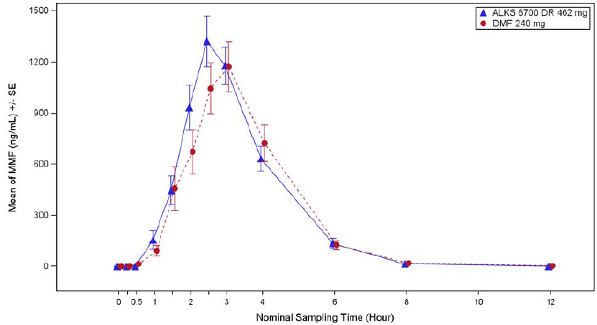

Abbreviations: DR = delayed release; DMF = dimethyl fumaraite; MMF = monomethyl fumarate; PK = pharmacokinetics; SE = standard error

Bioequivalence was adequately demonstrated for mean systemic monomethyl fumarate exposure parameters such as area under concentration time curve from zero to last measured concentration (AUC0-last), area under concentration time curve from zero to infinity (AUC0-∞) and maximum concentration (Cmax).

The mean Cmax was 1.697 and 1.833 µg/mL (Figure 3), with median Tmax of 2.5 and 3 hours for diroximel fumarate and dimethyl fumarate, respectively. The mean AUC last was 3.524 and 3.299 h*µg/mL, and AUC∞ was 3.813 and 3.665 h*µg/mL for diroximel fumarate and dimethyl fumarate, respectively (Figure 4). The median half-life (t½) of monomethyl fumarate in plasma was 0.746 and 0.679 hours for diroximel fumarate and dimethyl fumarate, respectively.

Figure 3: Study A103 Boxplot comparison of diroximel fumarate and dimethyl fumarate maximum concentration

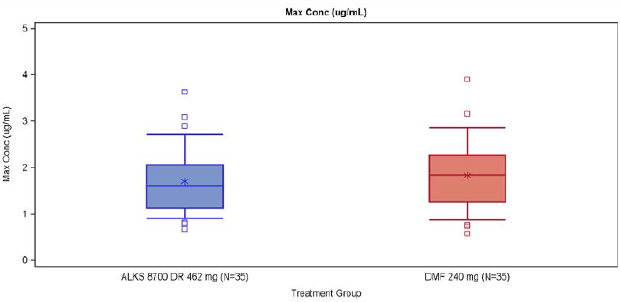

Abbreviations: ALKS 8700 DR = diroximel fumarate; Conc = concentration; DMF = dimethyl fumarate; max = maximum

Figure 4: Study A103 Boxplot comparison of diroximel fumarate and dimethyl fumarate exposure (AUC0-last)

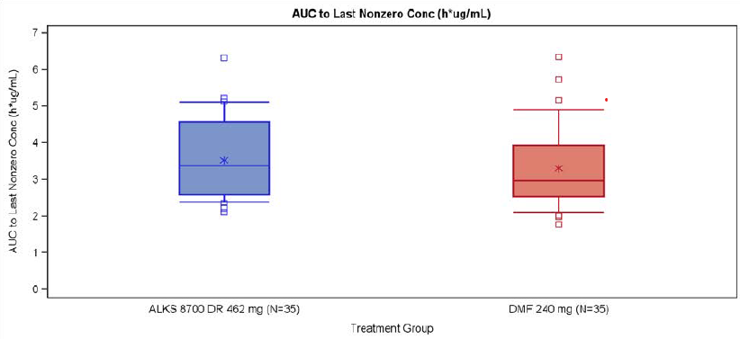

Abbreviations: ALKS 8700 DR = diroximel fumarate; AUC0-last = area under concentration time curve from zero to last measured concentration; DMF = dimethyl fumarate

In the fasted state, the geometric mean ratios for the key PK parameters were close to 1, and the 90% confidence intervals (CIs) were contained within the standard boundaries of 0.8 to 1.25 used to evaluate bioequivalence (Table 3).

Table 3: Study A103 Comparison of geometric mean ratios for key pharmacokinetic parameters of diroximel fumarate and dimethyl fumarate

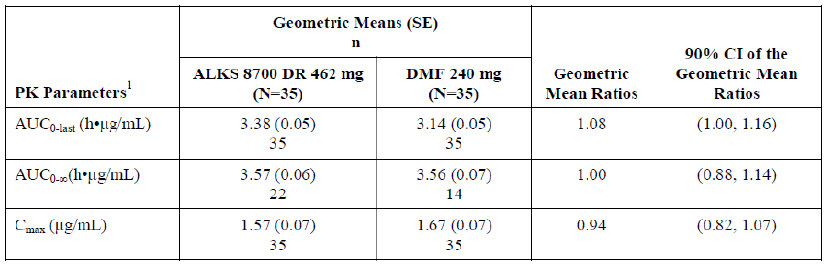

Abbreviation: AUC0-last = area under concentration time curve from zero to last measured concentration; AUC0-∞ = area under concentration time curve from zero to infinity; CI = confidence interval; Cmax = maximum concentration, ALKS 8700 DR = diroximel fumarate; DMF = dimethyl fumarate; PK = pharmacokinetics; SE = standard error.

Inter-individual variability in maximum concentration (Cmax) and AUC parameters for diroximel fumarate in healthy subjects was moderate to high under fasted conditions and ranged from 23.3% to 57.2% for Cmax and from 18.8% to 50.4% for AUC0-last.

###### Study A104

Subjects were randomised to 462 mg of diroximel fumarate or 240 mg of dimethyl fumarate and crossed over after a 24 hour washout period. Subjects consumed a high fat/high calorie (approximately 900 to 1000 calories) morning meal before study drug was administered on Days 1 and 3.

The mean concentration time profiles for diroximel fumarate and dimethyl fumarate were comparable and generally similar to that observed in the fasted state (see Figures 5 and 6, and Table 4, below).

Figure 5: Study A104 Plasma concentration of monomethyl fumarate (mean ± standard error) in linear scale by nominal sampling time

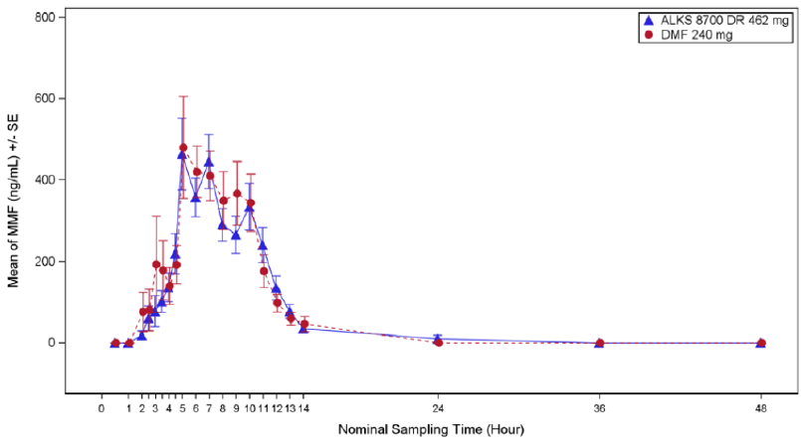

Abbreviations: ALKS 8700 DR = diroximel fumarate; DMF = dimethyl fumarate; PK = pharmacokinetic; SE = standard error.

Table 4: Study A104 Comparison of key pharmacokinetic parameters for diroximel fumarate and dimethyl fumarate

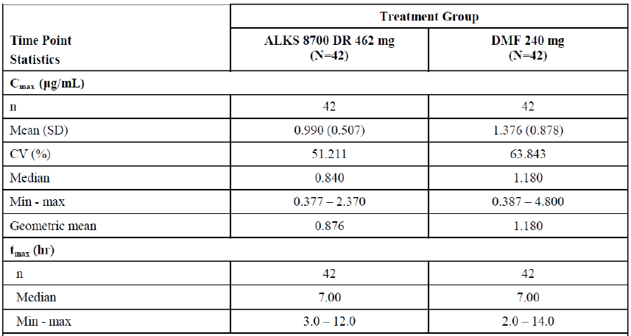

Abbreviations: Cmax = maximum concentration; CV% = coefficient of variance; hr = hours; max = maximum; min = minimum; SD = standard deviation; tmax = time of maximum concentration

Figure 6: Study A104 Boxplot comparison of diroximel fumarate and dimethyl fumarate maximum concentration

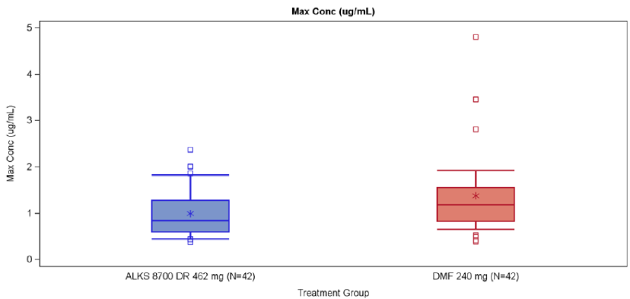

Abbreviations: ALKS 8700 DR = diroximel fumarate; conc = concentration; DMF = dimethyl fumarate; max = maximu

Bioequivalence in the fed state appeared to be demonstrated (as shown above in Figure 6).

Table 5: Study A104 Comparison of geometric mean ratios for key pharmacokinetic parameters of diroximel fumarate and dimethyl fumarate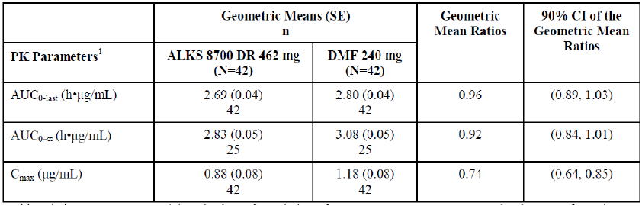

Abbreviation: AUC0-last = area under concentration time curve from zero to last measured concentration; AUC0-∞ = area under concentration time curve from zero to infinity; CI = confidence interval; Cmax = maximum concentration, ALKS 8700 DR = diroximel fumarate; DMF = dimethyl fumarate; PK = pharmacokinetics; SE = standard error.

The monomethyl fumarate median time to maximum concentration (tmax)and lag time (tlag) increased in the presence of food. The impact of meal type on the monomethyl fumarate Cmax was related to the fat or caloric content in an inverse relationship. Hence, low reductions in Cmax occurred following diroximel fumarate co-administration with a low-fat meal (12%) and this compared to 44% with a high-fat meal (44%), respectively. There was no clinically meaningful impact on monomethyl fumarate AUC in the presence of a high-fat/high-calorie, medium-fat/medium-calorie, or low-fat/low-calorie meal in healthy subjects (Studies A102, A104 and A109). The magnitude of the reduction in Cmax following a high-fat/high-calorie meal in the dimethyl fumarate 240 mg application was 41% (from the original submission to the TGA to approve Tecfidera (dimethyl fumurate)9,10); which was comparable to 44% for the proposed diroximel fumarate 462 mg therapeutic dose in this application.

The high variability in PK measurements that was observed across treatments were taken into account. Since the range of diroximel fumarate Cmax (0.38 to 2.37) values fell within the values for dimethyl fumarate Cmax (0.39 to 4.80), and they had similar Tmax values, the evaluator considered that it was reasonable to assume diroximel fumarate and dimethyl fumarate had comparable absorption and acceptable evidence to suggest bioequivalence in the fed state.

Relevant statements related to the lower Cmax are inserted in the proposed PI.

###### Study A109

The primary objective was to compare the PK of monomethyl fumarate following a single dose of diroximel fumarate administered after a low fat/low calorie or medium fat/medium calorie meal, relative to a single dose of dimethyl fumarate administered to fasted healthy adults.

Subjects were randomised in a 1:1:1:1 ratio to one of four treatment sequences. Each sequence was divided into 4 groups of 12 and received a single dose of either 240 mg of dimethyl fumarate under fasted conditions (Group A), or 240 mg of dimethyl fumarate under fed conditions (high fat/high calorie meal; Group B) or 462 mg of diroximel fumarate (2 x 231 mg capsules; commercial formulation) under either of the two fed conditions (low fat/low calorie meal; Group C or a medium fat/medium calorie meal; Group D).

The mean concentration time profiles for dimethyl fumarate and diroximel fumarate were characterised by a delay in the absorption of monomethyl fumarate in the plasma in the fed conditions with the longest lag following administration of a high fat/high calorie meal.

*Relative bioavailability*: A greater degree of overlap in levels of systemic concentration was observed when diroximel fumarate and dimethyl fumarate were administered under both fasted and fed conditions.

Figure 7: Study A109 Plasma concentration (mean ± standard error) in linear scale by nominal sampling time; monomethyl fumarate pharmacokinetics populations excluding samples with incorrect sample preparation

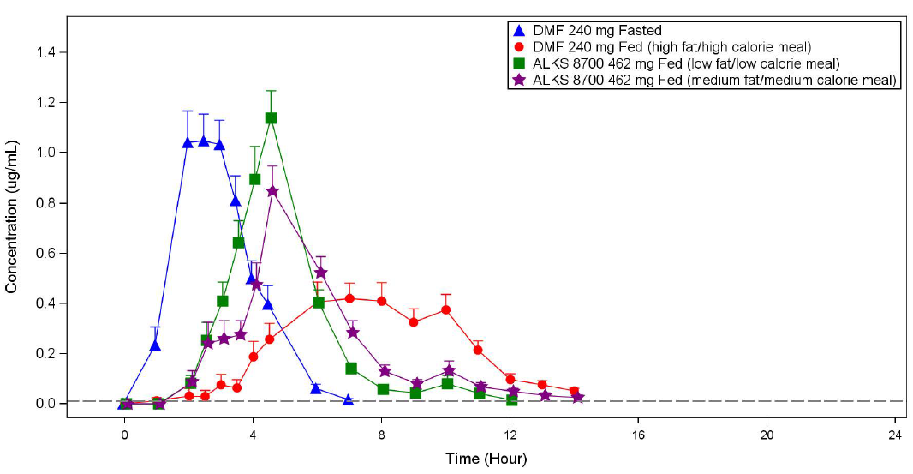

Abbreviations: ALKS 9700 = diroximel fumarate; DMF = dimethyl fumarate.

Figure 8: Study A109 Boxplot of maximum concentration; monomethyl fumarate pharmacokinetics populations

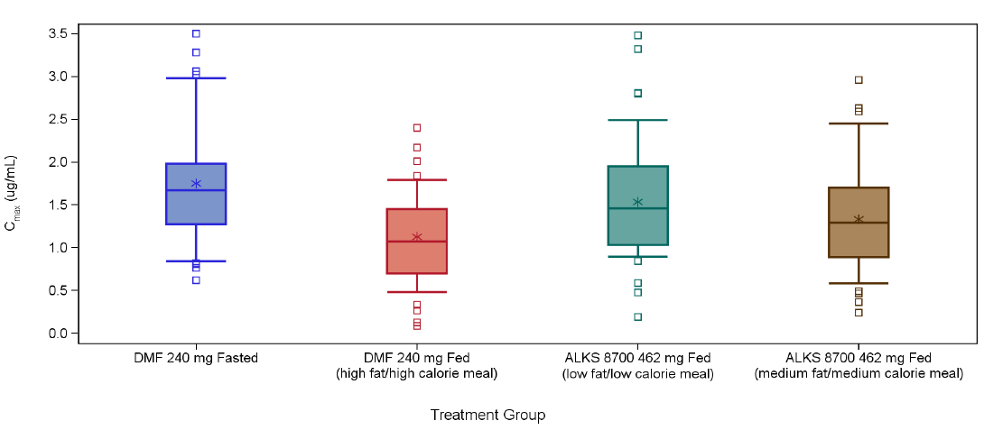

Abbreviation: ALKS 8700 = diroximel fumarate; DMF = dimethyl fumarate. Note: The bottom and top of the box represent the 25th and 75th percentiles, respectively; the whiskers represent the 10th and 90th percentiles; the line within the box represents the median.

The star represents the mean. The squares represent the values smaller than (the 25th percentiles - 1.5 interquartile range (IQR)) or values greater than (the 75th percentile + 1.5 x IQR).

Figure 9: Study A109 Boxplot of exposure (AUC0-last); monomethyl fumarate pharmacokinetics populations

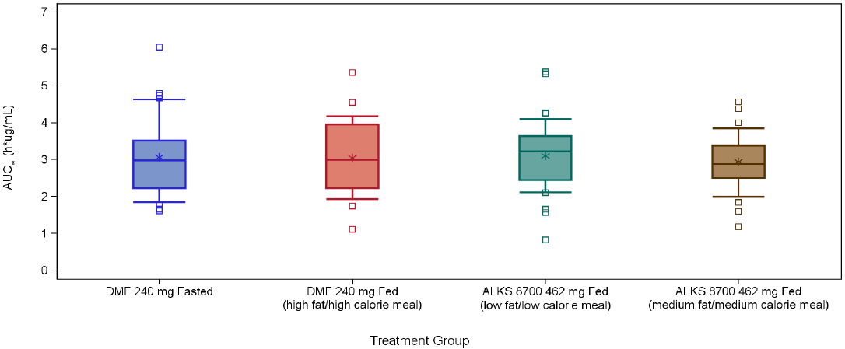

Abbreviation: ALKS 8700 = diroximel fumarate; AUC0-last = area under the concentration-time curve from time zero (dosing) to last measured concentration; DMF = dimethyl fumarate. Note: The bottom and top of the box represent the 25th and 75th percentiles, respectively; the whiskers represent the 10th and 90th percentiles; the line within the box represents the median.

The star represents the mean. The squares represent the values smaller than (the 25th percentiles - 1.5 interquartile range (IQR)) or values greater than (the 75th percentile + 1.5 x IQR).

##### Dose proportionality

Peak monomethyl fumarate plasma concentrations (Cmax) and overall exposure (AUC0-∞) increased in an approximately dose-proportional manner over multiple dose ranges 49 mg to 980 mg dose-range, as single and multiple (twice daily) diroximel fumarate doses, in healthy adult subjects in the fasted state.

Minimal or no monomethyl fumarate accumulation (0.9- to 1.2-fold) was observed after twice daily dosing. Hydroxyethyl succinimide exhibited a half-life in plasma that was greater than the dosing interval, resulting in a 2.1- to 2.5-fold accumulation with twice daily administration of diroximel fumarate. Hydroxyethyl succinimide exposure was 10- to 13-fold greater than monomethyl fumarate exposure at steady state in healthy participants.

##### Distribution

Across studies, mean apparent volume of distribution of monomethyl fumarate after single oral administration of diroximel fumarate to healthy fasted subjects ranged from 63.9 L to 130 L over the dose range 210 mg to 980 mg. The apparent volume of distribution of pooled human plasma results for monomethyl fumarate in the Tecfidera PI;9,10 for an oral dose of dimethyl fumarate 240 mg (60 L to 90 L) was similar to an oral dose of diroximel fumarate 462 mg in this application (72 L to 83 L). Protein binding was not found to be concentration-dependent.

##### Metabolism

Diroximel fumarate is metabolised to the active moiety monomethyl fumarate and the primary, inactive metabolite hydroxyethyl succinimide and to a lesser extent another inactive metabolite, RDC-8439. Metabolism of monomethyl fumarate is well established and occurs via esterases followed by the tricarboxylic acid cycle, and the primary route of monomethyl fumarate elimination is exhalation of carbon dioxide. Monomethyl fumarate was eliminated rapidly from plasma with a mean half-life (t½) of around 0.6 to 0.9 hours. Hydroxyethyl succinimide is primarily excreted unchanged in urine and to a lesser extent further metabolised to two additional minor metabolites. Hydroxyethyl succinimide was eliminated more slowly from plasma with a mean t½ of around 8 to 22 hours.

##### Clearance

Monomethyl fumarate is predominantly excreted as carbon dioxide. Mean apparent oral clearance (CL/F) of monomethyl fumarate following single oral dose of 462 mg diroximel fumarate was 78.1 L/h in healthy subjects compared to 56.4 L/h to 60.3 L/h in the renal impairment groups. The evaluator did not consider renal impairment to have a clinically meaningful impact on monomethyl fumarate clearance. Hence, no dose adjustment is needed in patients with mild-to-severe forms of renal impairment. This finding was further supported by the population pharmacokinetics findings. The evaluator has highlighted that the renal clearance accounted for 15.5% of a radio-labelled 240 mg of dimethyl fumarate.9

The evaluator has highlighted that no studies were undertaken in dialysis patients, diroximel fumarate dose-adjustment should not be necessary for this patient group, provided hydroxyethyl succinimide accumulation is not associated with an unacceptable level of toxicity. In consideration of the fact that hydroxyethyl succinimide is not pharmacologically active, the Delegate considers the occurrence of toxicity with potential high levels of hydroxyethyl succinimide as unlikely.

The sponsor did not specifically assess PK of diroximel fumarate/monomethyl fumarate in hepatic impairment based on the rationale that metabolism of diroximel fumarate and its metabolites do not proceed via hepatic enzymes. Hence, no impact would be anticipated based in patients with impaired hepatic function. The evaluation considered this approach as reasonable.

Age had no clinically meaningful impact on PK of monomethyl fumarate or hydroxyethyl succinimide in the population pharmacokinetics analysis. Median subject age was 35 years (range: 18 to 75 years). There is very limited information about PK of monomethyl fumarate in the elderly subjects.

##### Population pharmacokinetics

The population pharmacokinetics analysis included monomethyl fumarate and hydroxyethyl succinimide concentration-time data from 11 studies, including eight Phase I studies in healthy subjects, one Phase I renal impairment study and two Phase III studies in patients with MS (Studies A301, A302).

Study population: 341 (88%) healthy subjects and 48 (12%) MS patients. Of 389 subjects, 197 (51%) were male. Median age across 11 studies was 35 years (range: 18 to 75 years). Median baseline bodyweight was 78 kg (range: 47.4 kg to 126.3 kg). Most subjects were White (66.3%).

Most (75.5%; n = 294) had normal renal function, 20.0% (n = 78) had mild renal impairment, 2.3% (n = 9) had mild moderate impairment and 2.0% (n = 8) had severe impairment based on estimated glomerular filtration rate (eGFR).

* Pharmacokinetics data were described by a one compartment disposition model with transit compartment absorption for monomethyl fumarate and hydroxyethyl succinimide, and first-order elimination for each metabolite
* Baseline body weight was the main statistically significant covariate for monomethyl fumarate and hydroxyethyl succinimide in the model. The model‑predicted area under the concentration time curve from time zero to the end of the dosing interval at steady state (AUCtau,ss) was 32% higher for monomethyl fumarate and 14% higher for hydroxyethyl succinimide with low body weight (55 kg) and 19% lower for monomethyl fumarate and 8% lower for hydroxyethyl succinimide with high body weight (100 kg), compared with patients with median body weight (78 kg). Overall, the observations were not considered clinically meaningful and hence no dose adjustment based on body weight was recommended by the evaluator.
* The concentration time profiles in multiple sclerosis (MS) patients were broadly consistent with healthy volunteers. Although MS patients displayed statistically significantly higher exposure of monomethyl fumarate and hydroxyethyl succinimide compared to healthy subjects (based on reduced clearance and increased absorption), the results do not suggest dose adjustment is needed for the target population based on disease (MS) status.
* Monomethyl fumarate and hydroxyethyl succinimide absorption rate decreased with increasing dietary fat content (from approximately 30% with low fat meals to approximately 60% with high fat meals for both monomethyl fumarate and hydroxyethyl succinimide). The bioavailability of monomethyl fumarate was reduced up to 30% with dietary fat.
* No clinically significant drug-drug interactions were reported
* In a dedicated clinical drug-drug interaction study in healthy subjects, digoxin systemic exposure decreased 10% to 13.2% in the presence of diroximel fumarate 462 mg. The concentration time PK profiles of diroximel fumarate with or without digoxin were generally consistent. Hence, the evaluator concluded that no dose adjustment would be necessary for either digoxin or diroximel fumarate when this drug combination is used.
* The diroximel fumarate dose is not likely to need adjustment in the setting of hepatic impairment since hepatic enzyme systems are not involved in its metabolism. Also, PK in the MS population does not appear to be clinically meaningfully different to healthy volunteers.

The evaluator has highlighted the hydroxyethyl succinimide accumulation that was reported across diroximel fumarate (and dimethyl fumarate). PK studies at steady state in healthy adults also reported the increasing hydroxyethyl succinimide accumulation with worsening renal function. Although hydroxyethyl succinimide has not demonstrated any clinically meaningful impact on efficacy, the impact of long-term dosing on safety had not been fully characterised in this application.

#### Pharmacodynamics

The exact mechanism by which diroximel fumarate and dimethyl fumarate exerts its therapeutic effect in multiple sclerosis is not fully understood.

The pathophysiology of multiple sclerosis is multifaceted and propagated through ongoing inflammatory and neurodegenerative stimuli, mediated at least in part by toxic oxidative stress. Pre‑clinical studies indicated that diroximel fumarate pharmacodynamics responses appeared to be mediated, at least in part, through activation of the transcriptional pathway that is nuclear factor (erythroid-derived 2)-like 2 (Nrf2). Dimethyl fumarate reduces inflammatory responses in both peripheral and central cells and promotes cytoprotection of CNS cells against toxic oxidative damage, thereby demonstrating effects on pathways known to exacerbate multiple sclerosis pathology. Dimethyl fumarate has also been shown to up regulate Nrf2-dependent antioxidant genes in patients, thereby confirming clinical pharmacodynamics activity in humans.

No clinically significant effects of monomethyl fumarate on cardiac QT interval,[12] heart rate and rhythm were reported.

#### Efficacy

The diroximel fumarate 462 mg twice daily maintenance dose was selected for the Phase III studies based on systemic exposure of monomethyl fumarate observed in three Phase I bioavailability/bioequivalence studies (Studies A103, A104, and A109).

Dose proportionality was demonstrated in the single ascending (Study 001) and multiple ascending (Study A102) dose Phase I studies over the dose range of 49 mg to 980 mg.

In the Phase III diroximel fumarate studies (Studies A301 and A302), subjects received an initial one week dose titration with diroximel fumarate 231 mg administered twice daily for seven days followed by 462 mg of diroximel fumarate, administered as two 231 mg capsules, twice daily. This dose regimen is identical to the currently approved Tecfidera (dimethyl fumarate).9,10

The primary evaluation of diroximel fumarate efficacy is based on PK bridging between diroximel fumarate and dimethyl fumarate with respect to their active metabolite, monomethyl fumarate. Bioequivalence between the 462 mg of diroximel fumarate and the approved dose of 240mg dimethyl fumarate was demonstrated in PK studies. Efficacy for diroximel fumarate was then extrapolated from the efficacy findings of dimethyl fumarate reported in two pivotal Phase III studies from the Tecfidera previous application9,10:

* Study 109MS301
* Study 109MS302

Efficacy data from Study A301 (EVOLVE-MS1 trial) with diroximel fumarate and Study 109MS303 (ENDORSE trial) with dimethyl fumarate were also taken into account.

##### Study 109MS301

A double blind randomised control trial that included a comparison of two dosage regimens of dimethyl fumarate in subjects with relapse-remitting multiple sclerosis (RRMS).

Subject recruitment criteria were based on the 2005 McDonald Criteria.[13] Eligible subjects had active disease, defined as either a relapse within the prior 12 months, or an active MRI.

1417 subjects were randomised 1:1:1 into 240 mg of dimethyl fumarate twice daily (Group 1), 240 mg of dimethyl fumarate thrice daily (Group 2) or to receive placebo (Group 3) for 96 weeks.

*Primary endpoint*: At 96 weeks, dimethyl fumarate twice daily and dimethyl fumarate thrice daily reduced the risk of relapse at 2 years by 49% (p < 0.0001) and 50% (p < 0.0001), respectively.

Key secondary outcomes were supportive of the greater treatment benefit for dimethyl fumarate, compared to placebo.

* Annualised relapse rate (ARR) for subjects in dimethyl fumarate groups was around 50% less than that their counterparts in placebo group.
* Relative reductions of 39% and 35% in sustained progression of disease were reported for twice and thrice daily groups, compared to placebo.
* Significant reduction in the proportion of patients showing sustained progression (for ≥ 12 weeks) in dimethyl fumarate group, compared to placebo.
* 75 to 85% reduction in the mean number of new or newly enlarging lesions detected with MRI imaging in the dimethyl fumarate arms, compared to placebo.

The treatment differences between dimethyl fumarate and placebo arms for all the above secondary endpoints were statistically significant.

##### Study 109MS302

The study design for Study 109MS302 was identical to Study 109MS301 (see above), except that an additional treatment arm with glatiramer-acetate as an active reference comparator was included. Treatment with 240 mg of dimethyl fumarate administered twice and thrice daily reduced the annualised relapse rate (ARR) at 2 years by 44% and 50.5%, respectively, over placebo (p < 0.0001 for both comparisons) (comparable to Study 301).

The relative reduction in 2-year risk for relapse was 29%, 41% and 22% for the three active treatments dimethyl fumarate twice daily, dimethyl fumarate thrice daily and glatiramer-acetate versus placebo respectively.

The mean number of adjusted T2 hyperintensity lesions was 17.4 in the placebo group, compared to 5.1 and 4.7 in the twice and thrice daily groups, respectively, an adjusted reduction of 71% and 73% respectively. The treatment difference was statistically significant.

##### Study 109MS303

Phase III open label extension study with dimethyl fumarate. Assessments of efficacy endpoints (ARR and relapse) were secondary objectives. Subjects who completed either of these Phase III pivotal study (Study 109MS301 or 109MS302), or had received an open labelled approved MS therapy, were enrolled and followed for 8 years. Subjects who were randomised to 240 mg of dimethyl fumarate twice or thrice daily in a pivotal study continued at the same dose in open labelled phase; those randomised to placebo were randomised 1: 1 to dimethyl fumarate twice or thrice daily in the extension phase. The evaluator has highlighted that after a protocol amendment (version 3), all subjects received 240 mg of dimethyl fumarate twice daily (the marketed dose). 992 subjects received open labelled treatment.

* Adjusted relapse rates (objective relapses) generally remained low over time and across subgroups:
  + Year 1: 0.125 to 0.183;
  + Year 8: 0.077 to 0.129; and
  + Overall: 0.126 to 0.185.
* Disability progression (on Expanded Disability Status Scale, EDSS)[14]: The proportion who progressed ranged from 21% to 37% across treatment subgroups. Most subjects remained steady over the duration of the study.
* The adjusted mean and median number of gadolinium enhancing lesions remained low over time and across subgroups.

##### Study A301

Study A301 is an ongoing single arm, Phase III open label study with diroximel fumarate.

Rollover subjects who had completed the treatment period of Study A302 (or had previously received dimethyl fumarate) within 7 days of Visit 2 were enrolled. The study period consisted of 96-weeks of treatment period with diroximel fumarate 462 mg twice daily treatment and 2 weeks follow up.

Treatments consist of:

* *de novo* treatment: diroximel fumarate 231 mg capsules twice daily for one week then diroximel fumarate 462 mg capsules twice daily thereafter; or
* rollover treatment: diroximel fumarate 462 mg capsules twice daily from Day 1.

Subjects were instructed to avoid high fat meals. 1057 participants (593 *De Novo* plus 464 rollover plus 225 previously treated with dimethyl fumarate) were enrolled. Overall mean age was 42.5 years (range: 18 to 65 years), most subjects were female (72%) and Caucasian (92.2%). Overall, mean EDSS score at Baseline was 2.69. Baseline disease characteristics were generally balanced across the three groups.

Table 6: Study A301 Efficacy endpoint at Week 48 and 96 (data cut-off: 7 February 2020; 96 week results: 1041 participants)

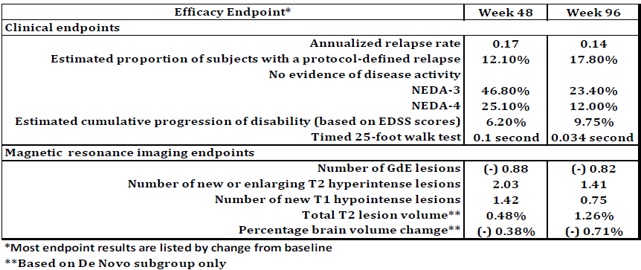

* Most endpoint results are listed by change from Baseline

** Based on *de novo* subgroup only

The clinical evaluation considered that the efficacy analyses conducted in this study as exploratory. The rationale was the single arm, open label study design that lacked a placebo or active control. The clinical evaluator has also highlighted that this study was not designed to provide an efficacy (or safety) analysis by disease severity (low versus high disease activity).

The reported absolute risk reduction and protocol defined relapse rate overall, and in each subgroup, were generally low across a two year period (96 weeks). Most other exploratory endpoints after 462 mg of diroximel fumarate twice daily treatment either showed a reduction in disease activity or stabilisation of their MS.

Overall, the trends and magnitude of the observed treatment effects over the 2-year study period in this study was comparable to the pivotal study findings with dimethyl fumarate.

##### Study A302

Study A302 is a Phase III, double blind, randomised control trial in adults with relapse remitting multiple sclerosis (RRMS), with safety as the primary outcome.

The study was aimed to evaluate the GI tolerability of diroximel fumarate and to compare with dimethyl fumarate. Overall safety of diroximel fumarate was also evaluated during the study period.

The study was conducted in two parts, Parts A and B. Both Parts A and B were identical in study design and included a 5-week, double blind treatment period with two blinded treatment arms (diroximel fumarate and dimethyl fumarate). The study had an adaptive design such that data from Part A could be used to modify the gastrointestinal (GI) tolerability endpoints and sample size in the study. In those aspects, the findings of Part A were considered as exploratory.

The first 120 eligible subjects were randomised to one of the two treatment groups in Part A (n = 60 per group). Once the enrolment for Part A was complete, the next 380 eligible subjects were to be enrolled into one of the two treatment groups in Part B (n = 150 per group). Following completion of Part A, the sponsor conducted a planned, unblinded exploratory analysis of the Part A, GI tolerability and safety data.

Figure 10: Study A302 Design Schematic (Parts A and B)

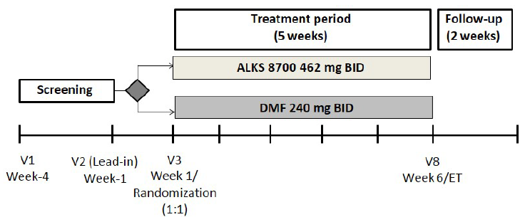

Abbreviations: BID = twice daily; DMF = dimethyl fumarate; ET = early termination; V = visit.

Subjects completing the 5 week treatment period either continued into Study ALK8700-A301, long term safety study or entered the safety follow up period and return for Visit 9.

Adults with RRMS who had an EDSS score at Baseline between 0 to 6;14 were randomised into the study. Subjects with history of significant recurring or active GI symptoms within three months of screening, chronic use (≥ 7 days) of medical therapy to treat any GI symptoms within one month of screening, had 2 or more Individual Gastrointestinal Symptom and Impact Scale (IGISIS);[15] individual symptom intensity scores ≥ 3 during the 1-week lead-in prior to randomisation were excluded.

Gastrointestinal tolerability was assessed using the IGISIS and the Global Gastrointestinal Symptom and Impact Scale (GGISIS).[16]

Following Part A review, cutoff for the primary endpoint (IGISIS) was revised from ≥ 3 to ≥ 2 (and the decision to use pooled Part A and B data rather than Part B data as the primary endpoint). The latter was determined to be more sensitive in detecting differences between treatments. Similarly, IGISIS was determined to be more sensitive than the GGISIS.

*Primary endpoint*: Number of days with any IGISIS individual symptom intensity score ≥ 2 relative to exposure days during study period.

Table 7: Study A302 Drug dosing schedule (Parts A and B)

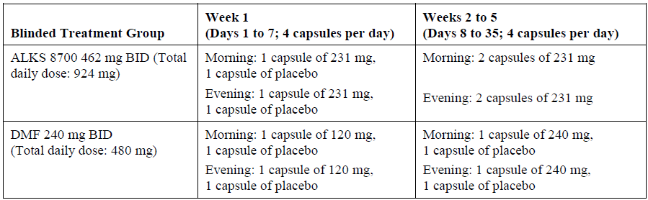

Abbreviations: BID=twice daily; DMF=dimethyl fumarate.

Overall, 504 subjects were enrolled.

A total of 120 subjects in Part A (60 per group) and 386 subjects in Part B (194 in the diroximel fumarate group and 192 in the dimethyl fumarate group) were enrolled. Approximately 92% of subjects who completed the study rolled over into Study A301.

Figure 11:Study A302 Participant flow

Study A320 flow
A total of 854 subjects underwent screening, 506 subjects were enrolled in this study, and 504 subjects received at least one dose of study drug. One hundred twenty subjects in Part A (60 per group) and 386 subjects in Part B (194 subjects in the ALKS 8700 group and 192 subjects in the DMF group) were enrolled in this study. A total of 504 subjects were included in the Safety population. A total of 502 subjects had at least one postbaseline GI tolerability assessment (GGISIS or IGISIS) on or before the last dose date and were included in the FAS population.

Abbreviations: AE=adverse event; ALKS 8700 462 mg = diroximel fumarate; DMF=dimethyl fumarate; n=number of subjects.

It was noted that in the statistical analysis plan, no corrections for multiple comparisons were applied.

At Baseline, the overall median subject age was 44 years, most subjects were female (72.8%), with median body mass index of 26.3 kg/m2. EDSS score was 2.71 (Range: 0 to 6), number of years since MS diagnosis was 7.7 years, number of years since onset of MS was 9.8 years, number of previous DMTs was 1.3 (33.5% had no previous DMT), number of relapses within the 12 months prior to screening was 0.6 (range 0 to 5) and number of gadolinium-enhancing lesions was 1 (70.4% had no lesions).

The study met the primary endpoint. The number of days with any IGISIS symptom intensity score ≥ 2 relative to exposure days in Parts A and B was lower in the diroximel fumarate group (1.5 (2.85) days) compared to the dimethyl fumarate group (2.5 (4.68) days). The treatment difference was statistically significant (p = 0.0003). However, it should be noted that multiplicity has not been addressed in this assessment. The rate ratio was calculated as 0.542 (95% CIs: 0.390, 0.754), which represented a 45.8% relative reduction in the diroximel fumarate group compared to the dimethyl fumarate group.

Most of the secondary endpoints were met, which were measures of IGISIS scores with an intensity score ≥ 1,2 and 3 relative to exposure days in either/or Part A and B. Overall, the results were consistent with the primary outcome.

#### Safety

##### Studies providing safety data

Studies A301 and A302 were Phase III studies that contributed to the safety and tolerability data for diroximel fumarate. The diroximel fumarate safety database includes 1461 participants across 12 clinical studies who received at least one dose of diroximel fumarate. This includes 1071 participants with MS in the Phase III studies, representing around 1500 participant-years of exposure to diroximel fumarate.

Safety for diroximel fumarate was also extrapolated from the two pivotal Phase III studies from the dimethyl fumarate application: Studies 109MS301 and 109MS302.9,10

##### Adverse events and treatment emergent adverse events

The most common treatment-emergent adverse events (TEAEs) in Study A301 were flushing (27.2%), MS relapse (18.3%), upper respiratory tract infection (13.9%), nasopharyngitis (12.6%), diarrhoea (10.1%), and lymphopenia (10.1%).

###### Lymphopenia

In Study A302, adverse event (AE) associated with lymphopenia were reported in four subjects (0.8%). One subject (0.4%) in the diroximel fumarate group and three subjects (1.2%) in the dimethyl fumarate group. All these events were mild and did not lead to change in dose or treatment discontinuation. Two events in the dimethyl fumarate group were reported as not resolved by the end of study period.

Table 8: Study A302 adverse event associated with lymphopenia

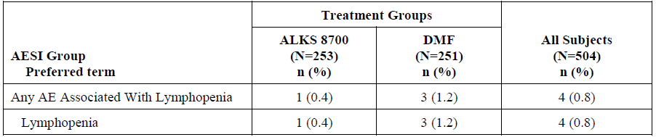

Abbreviations: AE=adverse event; AESI=adverse events of special interest; DMF=dimethyl fumarate; N=total number of subjects; n=number of subjects.

Note: Only lymphocyte-relevant events were counted.

Note: If a subject experiences more than one AE in a category, the subject is counted only once in that category.

###### Progressive multifocal leukoencephalopathy

Rare events of progressive multifocal leukoencephalopathy (PML) have been associated with dimethyl fumarate treatment in patients with lymphopenia. The safety signal for PML arose early after approval of Tecfidera;9,10 following the first confirmed case of PML (a fatal event) in a patient with severe prolonged lymphopenia (> 3.5 years) in a clinical study.

So far, 12 PML cases have been confirmed for dimethyl fumarate, which all occurred in patients with absolute lymphocytes count below lower limits of normal (< 0.91 x 109/L), and 11 of these cases occurred in the post market setting. Following these findings, additional statement as a contraindication (contraindicated in patients with suspected or confirmed PML has been introduced in the EU summary of product characteristic (SmPC) for Tecfidera.[17] The Delegate has recommended to insert a similar statement in the Vumerity PI. Additional warning statements were also inserted. Based on monomethyl fumarate being the same active moiety of dimethyl fumarate and diroximel fumarate, the Delegate considers that the same risk applies to diroximel fumarate.

###### Other adverse events

The proposed PI for diroximel fumarate (Vumerity) and the approved PI for dimethyl fumarate (Tecfidera)9,10 has statements to inform the prescriber to monitor lymphocyte counts and liver function periodically. Events of PML with dimethyl fumarate has mostly been reported in the post‑market setting.

Overall, the incidence of AEs were comparable across subjects treated with dimethyl fumarate and diroximel fumarate in Study A302. GI disorders were the commonest (41.9%), followed by vascular (36.7%) and skin (21.2%) disorders.

In study 302, the incidence of TEAEs were comparable at 65.2% in the diroximel fumarate group versus 72.1% in the dimethyl fumarate group. Flushing was the most frequent event: 32.8% versus 40.2% in diroximel fumarate and dimethyl fumarate respectively.

No events of opportunistic infections and serious infections were reported with diroximel fumarate and dimethyl fumarate in Study A302.

In Study A301, lymphocyte counts were monitored to mitigate the risk for life-threatening infections (including PML). 0.6% of subjects reported opportunistic infections (OIs) (oral candidiasis, three subjects; vulvovaginal candidiasis, two subjects; candida infection, two subjects; oesophageal candidiasis, one subject); one subject had both OIs of oral candidiasis and candida infection, and one subject had both OIs of oesophageal candidiasis and candida infection. OIs were mild (four subjects) or moderate (two subjects), not serious or associated with lymphopenia, and rated not related to study treatment, except for the TEAEs of oral candidiasis and candida infection; all but the TEAE of candida infection resolved by the cut-off date. 22 subjects (2.1%) have been identified with mild to moderate Herpes Zoster and one subject with varicella zoster virus infection in Study A301. Herpes Zoster is a known risk with Tecfidera treatment and labelled in the product information.

Overall, adverse events (AEs) led to study discontinuation in 3.6% of subjects during the treatment period: 1.6% in the diroximel fumarate group versus 5.6% in the dimethyl fumarate group, respectively. Of these, 0.8% of subjects in the diroximel fumarate group and 4.8% of subjects in the dimethyl fumarate group discontinued the study due to GI AEs.

###### Deaths and serious adverse events

No deaths were reported in Study A302. There were four serious adverse events (SAEs) with fatal outcomes as of at the cut-off date in Study A301 (7 February 2020). All events were considered by the investigator as unrelated to the study treatment.

In Study A301, MS relapse was the most commonly reported SAE. 15% of subjects experienced GI TEAEs (diarrhoea, nausea, vomiting, abdominal pain upper, abdominal pain, and constipation. Majority of subjects recovered from the events. 17 participants had severe events that were listed as GI disorders. Discontinuations due to these events were minimal (0.8%) and most of these events recovered during study period.

In the diroximel fumarate clinical studies, there were no SAE reports of lymphopenia or lymphocyte count decreased, and there were no infections associated with lymphopenia or lymphocyte count decreased.

In Study 302, SAEs were reported by 1.4% of subjects, with similar incidence in both the diroximel fumarate and dimethyl fumarate groups. No SAE was considered drug related, and all the events resolved within the study period.

In studies with diroximel fumarate, no adverse events of special interest (AESIs) associated with serious infections were reported in Study A302. Overall, frequency of serious infections at the February 2020 cutoff was low (< 1%). No serious infection led to discontinuation, except one fatal SAE of pneumonia.

###### Gastrointestinal tolerability

In Study A302, the incidence of GI tolerability AESIs was 0.8% of subjects in the diroximel fumarate group versus 4.8% of subjects in the dimethyl fumarate group. 34.8% of subjects in diroximel fumarate group experienced GI related TEAEs, compared to 49% in the diroximel fumarate group. Most AEs resolved by end of study. Median onset of common GI symptoms was similar between groups, except vomiting, which had shorter onset time for diroximel fumarate (7 days) versus dimethyl fumarate (16 days). The hazard ratio of discontinuation rates due to GI AEs was 0.16 (95% CI: 0.04, 0.72), which demonstrated a statistically significant lower rate (p = 0.02) for diroximel fumarate treatment versus dimethyl fumarate treatment.

In Study A302, flushing and related AEs occurred in 45.8% in the diroximel fumarate group versus 55% in the dimethyl fumarate group. Most events occurred on Day 1 of treatment. All five severe AEs occurred in the dimethyl fumarate group: three events resolved by study end, none required dose change or resulted in discontinuation.

###### Malignancy

There were no reports of malignancies or premalignant events in Study A302.

In Study A301, 0.5% of subjects (n = 5) reported malignancies (basal cell carcinoma, Bowen’s disease (squamous cell carcinoma), diffuse large B-cell lymphoma, invasive ductal breast carcinoma, and malignant melanoma). 0.7% of patients (n = 7) reported premalignant conditions (endometrial hyperplasia (three patients), cervical dysplasia, dysplastic naevus, large intestine polyp, laryngeal dysplasia, and leukoplakia).

Overall, the incidence of malignancies was similar to that in the controlled Tecfidera clinical programme.9,10

###### Liver function and toxicity

High post-baseline values were observed mostly for alanine transaminase (ALT) and aspartate transaminase (AST), and more frequently in the diroximel fumarate group (25.9% and 15.8%) versus the dimethyl fumarate group (16.4% and 9%). It was noted that most elevations were < 3 x upper limit of normal.

Diroximel fumarate has not been administered to subjects with MS and comorbid liver impairment. Subjects with ALT or AST values ≥ 2 x upper limit of normal at screening were excluded from Phase III studies. Also, subjects discontinued treatment if ALT or AST values remained > 3× upper limit of normal for ≥ 4 weeks in the 2-year Study A301 and ≥ 2 weeks in the 5-week Study A302. In both studies, transient increases in liver transaminases were observed with treatment initiation, with greater mean increases from baseline in ALT than in AST, which subsided with continued treatment. They were not associated with symptoms of liver injury or disease. As diroximel fumarate metabolism does not involve CYP enzymes,10 the evaluator considered that it is unlikely to cause clinically relevant PK interactions with drugs metabolised by CYP enzymes.

###### Renal function and toxicity

The percentage of subjects with shifts in renal parameters was similar between treatment groups.

However, it was noted that subjects were excluded from Phase III studies if they had an estimated glomerular filtration rate ≤ 60 mL/min/1.73m2 at screening or were discontinued if the estimated glomerular filtration rate remained < 60 mL/min/1.73m2 for ≥ 4 weeks after temporarily withholding study treatment. Hence, there are no data available on long-term use of diroximel fumarate in patients with moderate or severe renal impairment. All TEAEs in the renal injury category were mild or moderate in severity, with most (54.5%) assessed as unrelated to diroximel fumarate. Relevant statements are included in the proposed PI.

There were no clinically meaningful changes in electrolytes, creatine kinase or metabolic parameters overall and across treatments. The percentages of subjects with shifts in electrolytes and creatine kinase (< 6%) were small and similar between groups

Similar to dimethyl fumarate, there are no well controlled studies with diroximel fumarate in pregnant women. Female subjects were excluded from studies with diroximel fumarate if they were pregnant, planning to become pregnant, or breastfeeding.

### Risk management plan

The sponsor has submitted EU-risk management plan (RMP) version 0.1 (date 2 November 2020; data lock point (DLP) 7 February 2020 for Vumerity, 25 June 2020 for Tecfidera) and Australia specific annex (ASA) version 1.0 (date 1 February 2021) in support of this application. At second round of RMP evaluation, the sponsor submitted EU-RMP version 1.0 (date 9 September 2021; DLP 1 September 2020 for Vumerity, 26 March 2021 for Tecfidera) and ASA version 1.0 (date October 2021).

The summary of safety concerns and their associated risk monitoring and mitigation strategies are summarised in Table 9. Further information regarding the TGA’s risk management approach can be found in [risk management plans for medicines and biologicals](https://www.tga.gov.au/publication/risk-management-plans-medicines-and-biologicals) and [the TGA's risk management approach](https://www.tga.gov.au/tgas-risk-management-approach).

Table 9: Summary of safety concerns

|  |  |  |  |  |  |
| --- | --- | --- | --- | --- | --- |
| Summary of safety concerns | | Pharmacovigilance | | Risk Minimisation | |
| Routine | Additional | Routine | Additional |
| **Important identified risks** | Progressive multifocal leukoencephalopathy (PML) | ✓*ǁ | – | ✓ | – |
| Decreases in leukocyte and lymphocyte counts | ✓* | ✓†‡ | ✓ | – |
| Drug induced liver injury | ✓* | ✓†‡ | ✓ | – |
| **Important potential risks** | Serious and opportunistic infections (other than PML and herpes zoster) | ✓* | ✓†‡ | ✓ | – |
| Malignancies | ✓* | ✓†‡ | ✓ | – |
| Effects on pregnancy outcome | ✓ | ✓§† | ✓ | – |
| Interaction with nephrotoxic medications leading  to renal toxicity | ✓ | ✓‡ | ✓ | – |
| **Missing information** | Safety profile in patients over the age of 65 years | ✓ | ✓‡ | ✓ | – |
| Safety profile in patients with moderate to severe  renal impairment | ✓ | ✓‡ | ✓ | – |
| Safety profile in patients with hepatic impairment | ✓ | ✓‡ | ✓ | – |
| Safety profile in patients with severe active GI disease | ✓ | ✓‡ | ✓ | – |
| Increased risk of infection in patients concomitantly taking antineoplastic or  Immunosuppressive therapies | ✓ | ✓‡ | – | – |
| Long-term efficacy and safety | ✓ | ✓†  * | ✓ | – |

* Follow up form

† EVOLVE-MS-1 clinical trial

‡ ESTEEM PASS study (Dimethyl fumarate only)

§ Pregnancy exposure registry

*Registry-based study for long term safety

ǁ Case reports submitted in PSUR

At second round of RMP evaluation, the summary of safety concerns in the EU-RMP and ASA was updated to include the important potential risk of ‘malignancies’ and the missing information ‘long term safety’. The safety concerns included in the ASA for Vumerity align with the EU-RMP and with the safety specification for Tecfidera.9,10 The summary of safety concerns is acceptable.

Routine pharmacovigilance is proposed for all safety concerns. Adverse drug reaction follow up forms are proposed for ‘progressive multifocal leukoencephalopathy’, ‘drug induced liver injury’ and ‘serious and opportunistic infections’. Additional pharmacovigilance is proposed for all safety concerns except PML. At second round of RMP evaluation the sponsor has also included follow up forms for ‘malignancies’ and ‘decreases in leukocyte and lymphocyte counts’ and will submit case reports of PML in periodic safety update reports (PSUR). The sponsor intends to include Australian patients in the pregnancy registry. The pharmacovigilance plan is acceptable.

Routine risk minimisation is proposed for all safety concerns except for the missing information ‘Increased risk of infection in patients concomitantly taking antineoplastic or immunosuppressive therapies’. This corresponds with information provided in the Australian PI but not the EU SmPC, which includes wording relating to this safety concern. This issue, as well as other discrepancies between the warnings and precautions in the SmPC and PI have been referred to the Delegate for consideration. Additional risk minimisation is not proposed. At second round of RMP evaluation, the sponsor has updated the Consumer Medicines Information (CMI) as requested, and the risk minimisation plan is acceptable subject to the Delegate’s consideration of referred PI issues.

#### Proposed wording for conditions of registration

Any changes to which the sponsor has agreed should be included in a revised RMP and ASA. However, irrespective of whether or not they are included in the currently available version of the RMP document, the agreed changes become part of the risk management system.

The suggested wording is:

‘The Vumerity EU-Risk Management Plan (RMP) (version 1.0, dated 9 September 2021, data lock point 1 September 2020 (Vumerity); 26 March 2021 (Tecfidera)), with Australian Specific Annex (version 1.0, dated October 2021), included with submission PM-2021-00385-1-1, and any subsequent revisions, as agreed with the TGA will be implemented in Australia.’

The following wording is recommended for the PSUR requirement:

‘An obligatory component of risk management plans is routine pharmacovigilance. Routine pharmacovigilance includes the submission of periodic safety update reports (PSURs).

Reports are to be provided in line with the current published list of EU reference dates and frequency of submission of PSURs until the period covered by such reports is not less than three years from the date of this approval letter.

The reports are to at least meet the requirements for PSURs as described in the European Medicines Agency’s Guideline on good pharmacovigilance practices (GVP) Module VII-periodic safety update report (Rev 1), Part VII.B Structures and processes. Note that submission of a PSUR does not constitute an application to vary the registration.’

As Vumerity is a new chemical entity it should be included in the Black Triangle Scheme as a condition of registration. The following wording is recommended for the condition of registration:

‘Vumerity (diroximel fumarate) is to be included in the Black Triangle Scheme. The PI and CMI for Vumerity must include the black triangle symbol and mandatory accompanying text for five years, which starts from the date that the sponsor notifies the TGA of supply of the product.’

### Risk-benefit analysis

#### Delegate’s considerations

The sponsor’s proposed dose of 462 mg of diroximel fumarate (as Vumerity) appears to be bioequivalent to 240 mg of dimethyl fumarate (as Tecfidera).9,10 In consideration of the same active moiety that is responsible for the pharmacodynamic effects of both substances, it will be expected that diroximel fumarate and dimethyl fumarate will have comparable efficacy. The mechanistic basis for diroximel fumarate to provide a better gastrointestinal (GI) tolerability for patients with multiple sclerosis (MS) may contribute to increased compliance and patient reported outcomes. The exploratory efficacy and GI tolerability findings are supportive of the demonstrated bioequivalence between pharmacokinetic (PK) parameters of dimethyl fumarate and diroximel fumarate. A high variability and a lower Cmax for diroximel fumarate, compared to dimethyl fumarate was noted in fed conditions, especially with high fat high calorie diet.

The inactive metabolite hydroxyethyl succinimide is only found when diroximel fumarate is administered and not for dimethyl fumarate. A relatively longer half-life (2.1 to 2.5 fold) and greater exposure (10 to 13 fold) of hydroxyethyl succinimide, compared to monomethyl fumarate was noted. Due to its long half-life, it is the primary metabolite found in plasma at exposure 10- to 13-fold greater than monomethyl fumarate exposure at steady state. Hydroxyethyl succinimide metabolism and excretion was characterised in a mass balance study. The potential effects due to cumulative exposure to hydroxyethyl succinimide is unknown. However, it was noted that hydroxyethyl succinimide is an inactive metabolite.

Gastrointestinal adverse events such as nausea, vomiting, abdominal pain, and diarrhoea are known adverse events with the use of dimethyl fumarate. In the single study (Study A302) that compared GI tolerability between dimethyl fumarate and diroximel fumarate, around 45% reduction in the incidence of GI adverse events (AEs) were reported in diroximel fumarate group, compared to dimethyl fumarate group. The sponsor claims that the distinct chemical structure of diroximel fumarate might benefit with less irritation in the GI tract than dimethyl fumarate through lower production of methanol (a GI-irritating promoiety), and less reactivity with pre-systemic off-target proteins or receptors. The five weeks treatment period of Study A302 limits the ability to assess the potential for any GI symptoms associated with longer term treatment with diroximel fumarate. GI events were mostly reported within the 1 to 2 months after commencement of treatment with dimethyl fumarate. In that aspect, the treatment period of 5 weeks with diroximel fumarate is not adequately long to assess the comparability between dimethyl fumarate and diroximel fumarate.

In comparison with dimethyl fumarate, higher incidence and magnitude of increase in liver enzymes were reported with diroximel fumarate. As previously reported with studies involving dimethyl fumarate, flushing was the commonest (around 30% subjects) treatment-emergent adverse event (TEAE) reported across Studies A301 and A302 with diroximel fumarate.

Lymphopenia had an incidence of around 10% in studies with diroximel fumarate. It is a known safety issue with dimethyl fumarate. One fatal event following a serious adverse event (SAE) of pneumonia was noted, which was not considered by the investigator as treatment related. Overall, the incidence of infections, discontinuations and its severity were comparable to studies with dimethyl fumarate. Relevant precautionary statements are inserted in the proposed PI. Risk for opportunistic infections, particularly with prolonged treatment with diroximel fumarate should be weighed against the treatment benefit. Results from ongoing Study A301 might provide safety data in this aspect.

Long term safety data is lacking in this submission. Safety data from Study 302 was limited by the treatment period of 5 weeks and Study 301 was confounded by the open label design and lack of comparator. Safety data is limited for both subjects > 65 years of age (3 subjects) and subjects > 55 years (around 13%) of age. Safety profile of diroximel fumarate in subjects > 65 years of age is listed as a missing information in the proposed RMP.

In contrast to dimethyl fumarate, the proposed pregnancy category B1;[18] has not been considered as acceptable by the nonclinical evaluator. This approach was based on nonclinical findings such as malformations in embryofetal development studies with diroximel fumarate (Vumerity). These events were not observed in studies with dimethyl fumarate (Tecfidera).9,10 The evaluator has recommended pregnancy category B3;[19] for diroximel fumarate. The Delegate agrees with this recommendation.

#### Proposed action

Bioequivalence between therapeutic doses of diroximel fumarate and dimethyl fumarate has been adequately demonstrated. The exploratory efficacy findings with diroximel fumarate and its safety profile are largely comparable with dimethyl fumarate. Better GI tolerability with diroximel fumarate, compared to dimethyl fumarate may contribute to increased treatment compliance.

#### Questions for the sponsor

The sponsor provided the following response to a question from the Delegate.

1. ***It was noted that diroximel fumarate (Vumerity) has not been studied in women who are pregnant or lactating. Female subjects were excluded from studies with diroximel fumarate if they were pregnant, planning to become pregnant, or breastfeeding.***

***The Delegate has also noted in the European Public Access Report (EPAR) describing the diroximel fumarate evaluation;[20] the reporting of 3 cases of congenital malformations; no such cases have been reported with Tecfidera (dimethyl fumarate) in clinical studies so far. Like Tecfidera, Vumerity should be used during pregnancy only if clearly needed and if the potential benefit justifies the potential risk to the fetus.***

***Please provide case narratives and overview of these cases.***

The sponsor has noticed an error in the Vumerity EPAR document. The 3 congenital malformations occurred in the setting of Tecfidera (dimethyl fumarate) in Study 109MS303. There have been no cases of congenital malformations reported in the clinical studies for Vumerity. The statement should read ‘*no such cases have been reported with Vumerity in clinical studies so far.*’ A summary and corresponding narratives for the three cases that occurred in the setting of Tecfidera in Study 109MS303 […were provided as to the Delegate for this submission]. None of these events were considered by the [study] investigator as related to Tecfidera.

Current data from clinical trials and the ongoing Biogen MS Pregnancy Exposure Registry (Study 109MS402) do not suggest that Tecfidera, when taken early in pregnancy, has an adverse or negative effect on pregnancy outcome. Cumulatively, to 26 March 2021, 5104 cases reporting 6913 events involving maternal exposure to Tecfidera during pregnancy were received. The prevalence rate for congenital anomalies with Tecfidera was within the EUROCAT background rate.[21] The observations from these datasets are relevant to Vumerity, given the shared common active metabolite, monomethyl fumarate, with Tecfidera. Therefore, the sponsor proposes that the same pregnancy categorisation apply to Vumerity.

#### Advisory Committee considerations

The [Advisory Committee on Medicines (ACM)](https://www.tga.gov.au/committee/advisory-committee-medicines-acm), having considered the evaluations and the Delegate’s overview, as well as the sponsor’s response to these documents, advised the following.

##### Specific advice to the Delegate

1. ***Please comment on the adequacy of PK data with diroximel fumarate that the sponsor has relied on to extrapolate efficacy and safety of dimethyl fumarate to diroximel fumarate.***

The ACM noted the hybrid nature of this application which relied on efficacy data in support of dimethyl fumarate and some pharmacokinetic (PK) data.

The ACM was of the view that the PK data for diroximel fumarate could be extrapolated to demonstrate sufficient efficacy. This was on the basis that both dimethyl fumarate and diroximel fumarate are converted to monomethyl fumarate and hydroxyethyl succinimide as the active and inactive metabolites respectively.

The ACM discussed that bioequivalence for diroximel fumarate was evident in both the fed and fasted state, as well as confirming appropriate dose equivalence. The ACM noted that while diroximel fumarate demonstrated less inter-patient variability than dimethyl fumarate, the AUC was very similar for both. The ACM also noted that the bridging efficacy data for monomethyl fumarate as the active metabolite was sufficient, with the effects of hydroxyethyl succinimide as the inactive metabolite not reflected by the PK dataset. Despite this, the ACM was of the view that the unknowns associated with hydroxyethyl succinimide was appropriately mitigated by the PI and RMP conditions.

1. ***Please comment on the adequacy of PI statements to reflect the safety data of diroximel fumarate, including the pregnancy category.***

The ACM was of the view that Vumerity should be pregnancy category B3;20 based on the significant unknown potential safety concerns for monomethyl fumarate and hydroxyethyl succinimide accumulation, as well as the lack of human pregnancy data. The ACM noted that this view is consistent with the US Food and Drug Administration (FDA) and the European Medicine Agency (EMA) categorisations.

The ACM was supportive of the PI changes recommended by the Delegate regarding pregnancy, as outlined below:

‘4.6 Fertility, Pregnancy and Lactation

Use in pregnancy – Category B3

There are no adequate and well-controlled studies in pregnant women.

Animal developmental toxicity studies indicated adverse embryofetal effects, likely secondary to maternal toxicity, at monomethyl fumarate (MMF and hydroxyethyl succinimide exposures at least 6 x and 2 x the respective AUC [area under the concentration-time curve] at the MRHD [maximum recommended human dose] of diroximel fumarate.

Oral administration of diroximel fumarate (up to 400 mg/kg/day) to pregnant rats throughout organogenesis resulted in lower fetal body weights and an increase in fetal skeletal variations at the highest dose tested, which was associated with maternal toxicity. Plasma exposures (AUC) for MMF and hydroxyethyl succinimide (the major circulating drug-related compound in humans) at the no effect dose (100 mg/kg/day) for adverse effects on embryofetal development were each approximately 2 times those in humans at the MRHD.

Oral administration of diroximel fumarate (up to 350 mg/kg/day) to pregnant rabbits throughout organogenesis resulted in an increase in fetal skeletal malformations at the mid and high doses and lower fetal body weight and increases in embryofetal death and fetal skeletal variations at the highest dose tested. The mid and high dose was associated with maternal toxicity. Plasma exposures (AUC) for MMF and hydroxyethyl succinimide at the no-effect dose (50 mg/kg/day) for adverse effects on embryofetal development were respectively 2 times and similar to those in humans at the MRHD.

Because animal reproduction studies are not always predictive of human response, this drug should be used during pregnancy only if clearly needed and if the potential benefit justifies the potential risk to the fetus.

The effects of Vumerity on labour and delivery are unknown.’

The ACM noted that multiple sclerosis commonly affects women of childbearing age and stressed the importance of proactively discussing family and pregnancy planning.

1. ***Please comment on the sponsor’s response to the Delegate’s question that was related to congenital malformations.***

The ACM discussed the three cases of congenital malformations reported within Study 109MS303 and noted that these cases related to Tecfidera (dimethyl fumarate) rather than Vumerity (diroximel fumarate) as previously incorrectly reported. The ACM commented that no particular pattern of anomalies was noted and the rate appears consistent with background rates.

The ACM noted that Tecfidera (dimethyl fumarate) is classified as Pregnancy Category B1;19 primarily because no malformations have been observed in either rats or rabbits at any dose. The ACM commented that unlike dimethyl fumarate, malformations were seen in embryofetal development studies with diroximel fumarate. The ACM reiterated that Pregnancy Category B3;20 is appropriate for diroximel fumarate based on the currently available data.

1. ***Please comment on any other aspects of this submission that are relevant for the approval of the proposed indication.***

The ACM noted there is limited knowledge about the excretion of diroximel fumarate and its metabolites into milk. As such, the ACM commented that appropriate advice to breastfeeding women should be included in the PI and CMI.

##### Conclusion

The ACM considered this product to have an overall positive benefit-risk profile for the indication:

*Vumerity is indicated in patients with relapsing multiple sclerosis to reduce the frequency of relapses and to delay the progression of disability*.

## Outcome

Based on a review of quality, safety, and efficacy, the TGA approved the registration of Vumerity (diroximel fumarate), 231 mg modified release capsules, bottle, indicated for:

*Vumerity is indicated in patients with relapsing multiple sclerosis to reduce the frequency of relapses and to delay the progression of disability.*

### Specific conditions of registration applying to these goods

* Vumerity (diroximel fumarate) is to be included in the Black Triangle Scheme. The Product Information (PI) and Consumer Medicines Information (CMI) for Vumerity must include the black triangle symbol and mandatory accompanying text for five years, which starts from the date that the sponsor notifies the TGA of supply of the product.
* The Vumerity European Union (EU)‑risk management plan (RMP) (version 1.0, dated 9 September 2021, data lock point 1 September 2020 (Vumerity); 26 March 2021 (Tecfidera)), with Australian specific annex (version 1.0, dated October 2021), included with Submission PM‑2021‑00385‑1‑1, and any subsequent revisions, as agreed with the TGA will be implemented in Australia.

An obligatory component of risk management plans is routine pharmacovigilance. Routine pharmacovigilance includes the submission of periodic safety update reports (PSURs).

Reports are to be provided in line with the current published list of EU reference dates and frequency of submission of PSURs until the period covered by such reports is not less than three years from the date of the approval letter.

The reports are to at least meet the requirements for PSURs as described in the European Medicines Agency’s guideline on Good Pharmacovigilance Practices (GVP) Module VII-periodic safety update report (revision 1), Part VII.B structures and processes. Note that submission of a PSUR does not constitute an application to vary the registration.

* Sponsor to submit results of the Study A 301 to the TGA, when completed.

## Attachment 1. Product Information

The PI for Vumerity approved with the submission which is described in this AusPAR is at Attachment 1. For the most recent PI, please refer to the TGA [PI/CMI search facility.](https://www.tga.gov.au/picmi-search-facility)

|  |
| --- |
| Therapeutic Goods Administration |
| PO Box 100 Woden ACT 2606 Australia  Email: [info@tga.gov.au](mailto:info@tga.gov.au) Phone: 1800 020 653 Fax: 02 6232 8605  [**https://www.tga.gov.au**](https://www.tga.gov.au) |

1. Owens, B., Multiple sclerosis. *Nature*, 2016. 540(7631): p. S1
2. Oh, J., et al. Multiple sclerosis: clinical aspects. *Curr Opin Neurol*, 2018. 31(6): p. 752-759.
3. Dobson, R. and G. Giovannoni, Multiple sclerosis - a review. *Eur J Neurol*, 2019. 26(1): p. 27-40.
4. Statistics from https://www.msaustralia.org.au/news/ms-rise-australia-still-flying-radar/
5. Karussis, D., The diagnosis of multiple sclerosis and the various related demyelinating syndromes: a critical review. *J Autoimmun*, 2014. 48-49: p. 134-42.
6. Bourque, J. and D. Hawiger, Current and Future Immunotherapies for Multiple Sclerosis. *Mo Med*, 2021. 118(4): p. 334-339.
7. Hart, F.M. and J. Bainbridge, Current and emerging treatment of multiple sclerosis. *Am J Manag Care*, 2016. 22(6 Suppl): p. s159-70.
8. Perrin Ross, A., Management of multiple sclerosis. *Am J Manag Care*, 2013. 19(16 Suppl): p. s301-6.
9. Tecfidera was first registered in Australia on 11 July 2013. ARTG number: 197118, 197119.
10. AusPAR for Tecfidera (dimethyl fumarate), Biogen Idec Australia Pty Ltd. Submission PM-2012-00808-3-1. Published online November 2013. Available at: [AusPAR: Dimethyl fumarate | Therapeutic Goods Administration (TGA)](https://www.tga.gov.au/resources/auspar/auspar-dimethyl-fumarate)
11. **Cytochrome P450** (CYP) enzymes are the major enzymes involved in drug metabolism, accounting for large part of the total metabolism. Most drugs undergo deactivation by CYPs, either directly or by facilitated excretion from the body. Also, many substances are bioactivated by CYPs to form their active compounds.

    Many drugs may increase or decrease the activity of various CYP isozymes either by inducing the biosynthesis of an isozyme (enzyme induction) or by directly inhibiting the activity of the CYP (enzyme inhibition). This is a major source of adverse drug interactions, since changes in CYP enzyme activity may affect the metabolism and clearance of various drugs. Such drug interactions are especially important to take into account when using drugs of vital importance to the patient, drugs with important side-effects and drugs with small therapeutic windows, but any drug may be subject to an altered plasma concentration due to altered drug metabolism.
12. The **QT interval** is the time from the start of the QRS wave complex to the end of the corresponding T wave. It approximates to the time taken for ventricular depolarisation and repolarisation, that is to say, the period of ventricular systole from ventricular isovolumetric contraction to isovolumetric relaxation.
13. McDonald WI, et al. Recommended diagnostic criteria for multiple sclerosis: guidelines from the International Panel on the diagnosis of multiple sclerosis. *Ann Neurol* 2001; 50: 121– 127.
14. The **Expanded Disability Status Scale (EDSS)** is a method of quantifying disability in multiple sclerosis and monitoring changes in the level of disability over time. Scoring is base on neurologist examination and carried out across 8 defined functional systems. The EDSS scale ranges from 0 to 10 in 0.5 unit increments that represent higher levels of disability; score of zero reflects normal neurological status and 10 reflects death due to MS).
15. The Individual Gastrointestinal Symptom and Impact Scale (IGISIS) is sponsor-developed outcome measure designed to assess incidence, intensity, onset, duration and functional impact of 5 individual GI symptoms: nausea, vomiting, diarrhoea and abdominal pain (upper and lower). Participants are asked to rate the intensity of each individual symptom via an 11-point numeric rating scale ranging from 0 (did not have) to 10 (extreme). Subjects rated how much each symptom interfered with their ability to accomplish their regular daily activities using a 5-point Likert scale (‘Not at all’ < ‘Moderately’ < ‘Quite a bit’ < ‘Extremely’). An interference score is not reported for a symptom when the intensity score is 0 or if the symptom is still ongoing.
16. The Global Gastrointestinal Symptom and Impact Scale (GGISIS) is a sponsor developed outcome measure designed as a global scale to assess overall intensity, level of bothersome and functional impact of the GI symptoms experienced within the previous 24 hours (nausea, vomiting, upper abdominal pain, lower abdominal pain, and diarrhoea). Subjects rate the intensity and bothersomeness of GI symptoms via an 11-point numeric rating scale ranging from 0 (did not have) to 10 (extreme). Subjects rate how much each symptom interfered their ability to accomplish their regular daily activities and, if employed, with their work productivity using 5 point Likert scales (‘Not at all’ < ‘Slightly’ < ‘Moderately’ < ‘Quite a bit’ < ‘Extremely’). Subjects also indicated whether they were employed at the time of completing the GGISIS and, if employed, the hours of work missed due to GI symptoms during the past 24 hours
17. Tecfidera summary of productr characteristic available via www.ema.europa.eu.
18. Category B1: Drugs which have been taken by only a limited number of pregnant women and women of childbearing age, without an increase in the frequency of malformation or other direct or indirect harmful effects on the human fetus having been observed.

    Studies in animals have not shown evidence of an increased occurrence of fetal damage.
19. Category B3: Drugs which have been taken by only a limited number of pregnant women and women of childbearing age, without an increase in the frequency of malformation or other direct or indirect harmful effects on the human fetus having been observed.

    Studies in animals have shown evidence of an increased occurrence of fetal damage, the significance of which is considered uncertain in humans.
20. Vumerity : EPAR - Public assessment report (EMA/CHMP/555028/2021). First published 24 February 2021. Available at: [Vumerity, INN-diroximel fumarate (europa.eu)](https://www.ema.europa.eu/en/documents/assessment-report/vumerity-epar-public-assessment-report_en.pdf)
21. EUROCAT is a European network of population-based registries for the epidemiological surveillance of congenital anomalies. The network has 43 member registries from 23 countries covering more than 25% of European births per year. The central registry is part of the European Commission’s (European Union) Joint Research Centre in and it is now an integral part of the European Platform on Rare Disease Registration.