|  |
| --- |
| Australian Public Assessment Report for Vyxeos |
| Active ingredients: Daunorubicin/cytarabine |
| Sponsor: Jazz Pharmaceuticals ANZ Pty Ltd |
| February 2023 |

About the Therapeutic Goods Administration (TGA)

* The Therapeutic Goods Administration (TGA) is part of the Australian Government Department of Health and is responsible for regulating therapeutic goods, including medicines, medical devices, and biologicals.
* The TGA administers the *Therapeutic Goods Act 1989* (the Act), applying a risk management approach designed to ensure therapeutic goods supplied in Australia meet acceptable standards of quality, safety, and efficacy.
* The work of the TGA is based on applying scientific and clinical expertise to decision-making, to ensure that the benefits to the Australian public outweigh any risks associated with the use of therapeutic goods.
* The TGA relies on the public, healthcare professionals and industry to report problems with therapeutic goods. The TGA investigates reports received to determine any necessary regulatory action.
* To report a problem with a therapeutic good, please see the information on the [TGA website](https://www.tga.gov.au).

About AusPARs

* The Australian Public Assessment Report (AusPAR) provides information about the evaluation of a prescription medicine and the considerations that led the TGA to approve or not approve a prescription medicine submission. Further information can be found in [Australian Public Assessment Report (AusPAR) guidance](https://www.tga.gov.au/australian-public-assessment-report-auspar-guidance).
* AusPARs are prepared and published by the TGA.
* AusPARs are static documents that provide information that relates to a submission at a particular point in time. The publication of an AusPAR is an important part of the transparency of the TGA’s decision-making process.
* A new AusPAR may be provided to reflect changes to indications or major variations to a prescription medicine subject to evaluation by the TGA.

Copyright

© Commonwealth of Australia 2023  
This work is copyright. You may reproduce the whole or part of this work in unaltered form for your own personal use or, if you are part of an organisation, for internal use within your organisation, but only if you or your organisation do not use the reproduction for any commercial purpose and retain this copyright notice and all disclaimer notices as part of that reproduction. Apart from rights to use as permitted by the *Copyright Act 1968* or allowed by this copyright notice, all other rights are reserved, and you are not allowed to reproduce the whole or any part of this work in any way (electronic or otherwise) without first being given specific written permission from the Commonwealth to do so. Requests and inquiries concerning reproduction and rights are to be sent to the TGA Copyright Officer, Therapeutic Goods Administration, PO Box 100, Woden ACT 2606 or emailed to <[tga.copyright@tga.gov.au](mailto:tga.copyright@tga.gov.au)>.

Contents

List of abbreviations 4

Product submission 5

Submission details 5

Product background 6

Regulatory status 8

Product Information 9

Registration timeline 9

Submission overview and risk/benefit assessment 9

Quality 10

Nonclinical 11

Clinical 13

Risk management plan 19

Risk-benefit analysis 19

Outcome 20

Specific conditions of registration applying to these goods 21

Attachment 1. Product Information 21

## List of abbreviations

|  |  |  |
| --- | --- | --- |
| Abbreviation | | Meaning |
| 7 + 3 | Chemotherapy regimen of cytarabine (Days 1 to 7) plus an anthracycline (Days 1 to 3) | |
| ACM | Advisory Committee on Medicines | |
| ara-CTP | Cytarabine-5-triphosphate | |
| ARTG | Australian Register of Therapeutic Goods | |
| ASA | Australia specific annex | |
| CI | Confidence interval | |
| COVID-19 | Coronavirus disease 2019 | |
| CPX-351 | Sponsor’s drug development code for Vyxeos | |
| DLP | Data lock point | |
| EMA | European Medicines Agency (European union) | |
| GMP | Good Manufacturing Practice | |
| ICH | International Council for Harmonisation | |
| MRC | Myelodysplasia-related changes | |
| PI | Product Information | |
| PK | Pharmacodynamic(s) | |
| RMP | Risk management plan | |
| RNA | Ribonucleic acid | |
| SAE | Serious adverse event | |
| TGA | Therapeutic Goods Administration | |
| t-AML | Therapy-related acute myeloid leukaemia | |
| US(A) | United States (of America) | |

## Product submission

### Submission details

|  |  |
| --- | --- |
| *Type of submission:* | New fixed dose combination |
| *Product name:* | Vyxeos |
| *Active ingredients:* | Daunorubicin (as hydrochloride) and cytarabine |
| *Decision:* | Approved |
| *Date of decision:* | 27 May 2022 |
| *Date of entry onto ARTG:* | 3 June 2022 |
| *ARTG number:* | 363250 |
| [*Black Triangle Scheme*](https://www.tga.gov.au/black-triangle-scheme)*:* | Yes.  This product will remain in the scheme for 5 years, starting on the date the product is first supplied in Australia. |
| *Sponsor’s name and address:* | Jazz Pharmaceuticals ANZ Pty Ltd  One International Towers Sydney, Watermans Quay  Barangaroo NSW 2000 |
| *Dose form:* | Powder for injection |
| *Strength:* | 44 mgdaunorubicin hydrochloride (2.2 mg/mL) and 100 mg cytarabine (5.0 mg/mL) |
| *Container:* | Vial |
| *Pack sizes:* | One and two vials |
| *Approved therapeutic use:* | *Vyxeos is indicated for the treatment of adults with newly diagnosed, therapy-related acute myeloid leukaemia (t-AML) or AML with myelodysplasia-related changes (AMLMRC)* |
| *Route of administration:* | Intravenous Infusion |
| *Dosage:* | Vyxeos must be initiated and monitored under the supervision of physicians experienced in the use of chemotherapeutic medicinal products.  Vyxeos dosing is based on the patient’s body surface area. Dosage should be administered as a first induction, second induction and consolidation dose.  *Recommended dosing schedule for induction of remission*  The recommended dosing schedule of Vyxeos (44 mg daunorubicin/100 mg cytarabine) per m2 body surface area, administered intravenously over 90 minutes:   * on Days 1, 3, and 5 as the first course of induction therapy. * on Days 1 and 3 as subsequent course of induction therapy, if needed.   A subsequent course of induction may be administered in patients who do not show disease progression or unacceptable toxicity.  *Recommended dosing schedule for consolidation*  The first consolidation cycle should be administered 5 to 8 weeks after the start of the last induction:  The recommended dosing schedule of Vyxeos is 29 mg (daunorubicin)/65 mg (cytarabine) per m2 body surface area administered intravenously over 90 minutes:   * on Days 1 and 3 as subsequent courses of consolidation therapy, if needed.   For further information regarding dosage, refer to the Product Information. |
| *Pregnancy category:* | D  Drugs which have caused, are suspected to have caused or may be expected to cause, an increased incidence of human fetal malformations or irreversible damage. These drugs may also have adverse pharmacological effects. Accompanying texts should be consulted for further details.  The use of any medicine during pregnancy requires careful consideration of both risks and benefits by the treating health professional. This must not be used as the sole basis of decision making in the use of medicines during pregnancy. The TGA does not provide advice on the use of medicines in pregnancy for specific cases. More information is available from obstetric drug information services in your State or Territory. |

### Product background

This AusPAR describes the submission by Jazz Pharmaceuticals ANZ Pty Ltd (the sponsor) to register Vyxeos (44 mg daunorubicin hydrochloride and 100 mg cytarabine), powder for injection for the following proposed indication:

* + *adults with newly diagnosed, therapy-related acute myeloid leukaemia (t-AML) or AML with myelodysplasia-related changes (AML-MRC)*
  + *paediatric and young adult patients aged 1 to 21 years old with relapsed or refractory AML.*

#### Acute myeloid leukaemia

Acute myeloid leukaemia (AML) is a clonal disorder of haematopoietic progenitor cells leading to the proliferation of abnormal myeloid precursor cells (blasts) which fail to differentiate. The accumulation of leukaemic blasts in the bone marrow leads to suppression of normal haematopoiesis, with ensuing cytopaenias. This may lead to sepsis and multi-system organ failure or bleeding events and can be fatal. Prognostic factors for treatment outcome include cytogenetic molecular features, age and AML subtypes.

Acute myeloid leukaemia (AML) is the most common acute leukaemia in adults. AML accounts for approximately 30% of all leukaemias and 80% of acute leukaemia in adults. Global incidence rates vary, with approximately 3.47 cases per 100,000 individuals in Canada, 4.3 cases per 100,000 individuals in the United States of America (USA) and 5 to 8 cases per 100,000 individuals in Europe.[1],[2],[3] The median age of diagnosis of AML is approximately 60 to 68 years and the incidence of AML increases in the population aged over 70 years.

#### Daunorubicin and cytarabine as chemotherapy

The standard therapy for AML is intensive chemotherapy to induce haematological remission, followed by chemotherapy or haematopoietic stem cell transplantation to reduce the very high rate of post‑induction relapse. Intensive therapy after induction is potentially curative, although there is a significant rate of relapse with all available options.

Daunorubicin and cytarabine is a common chemotherapeutic combination for both induction and consolidation therapy.

Cytarabine is a cell cycle phase-specific antineoplastic agent, affecting cells only during the S phase of cell division. Intracellularly, cytarabine is converted into cytarabine‑5‑triphosphate (ara-CTP), which is the active metabolite. The mechanism of action is not completely understood, but it appears that ara-CTP acts primarily through inhibition of DNA synthesis. Incorporation into DNA and ribonucleic acid (RNA) may also contribute to cytarabine cytotoxicity. Cytarabine is cytotoxic to proliferating mammalian cells in culture.

Daunorubicin has antimitotic and cytotoxic activity, which is achieved by forming complexes with deoxyribonucleic acid (DNA), inhibiting topoisomerase II activity, inhibiting DNA polymerase activity, affecting regulation of gene expression, and producing DNA-damaging free radicals.

##### Daunorubicin and cytarabine ‘7 + 3’ regimen

A typical regimen, dosed by body surface area (m2) is cytarabine 100 to 200 mg/m2/day by continuous infusion on Days 1 to 7 together with daunorubicin (60 to 90 mg/m2) on Days 1 to 3, known as the ‘7 + 3’ regimen).[4] Various modifications to the traditional ‘7 + 3’ regimen have been attempted without significant clinical benefit.

##### Vyxeos, daunorubicin/cytarabine as a fixed dose combination treatment

Acute myeloid leukaemia (AML) is an invariably progressive disease with no significant improvements in therapeutics for many years. It is reasonable to seek improved therapeutic approaches as proposed by the sponsor, where the anti-cancer drug combination of cytarabine and daunorubicin is delivered with controlled drug ratios via a liposomal drug carrier in an attempt to improve clinical outcomes.

Vyxeos is a liposomal formulation of a fixed combination of daunorubicin and cytarabine in a 1:5 molar ratio. The 1:5 molar ratio has been shown *in vitro* and *in vivo* to maximise synergistic anti-tumour activity in AML.

Based on data in animals, Vyxeos liposomes accumulate and persist at a higher concentration in the bone marrow, where they are preferentially taken up intact by leukaemia cells. In leukaemia-bearing mice, the liposomes are taken up by leukaemia cells to a greater extent than by normal bone marrow cells. After internalisation, Vyxeos liposomes undergo degradation, releasing daunorubicin and cytarabine within the intracellular environment.

### Regulatory status

This product is considered a new fixed dose combination medicine for Australian regulatory purposes.

At the time the TGA considered this submission, similar submissions had been approved in the USA on 1 August 2017 and the European Union on 23 August 2018. Similar submissions were under consideration in Canada (submitted on 12 August 2020) and Switzerland (submitted on 30 September 2020).

The following table summarises these submissions and provides the indications where approved.

Table : International regulatory status

|  |  |  |  |
| --- | --- | --- | --- |
| Region | Submission date | Status | Approved indications |
| United States of America | 3 October 2016 | Approved on 1 August 2017 | *Vyxeos is a liposomal combination of daunorubicin, an anthracycline topoisomerase inhibitor, and cytarabine, a nucleoside metabolic inhibitor, that is indicated for the treatment of newly-diagnosed therapy-related acute myeloid leukemia (t-AML) or AML with myelodysplasia-related changes (AML-MRC) in adults and pediatric patients 1 year and older.* |
| European Union | 2 November 2017 | Approved on 23 August 2018 | *Vyxeos liposomal is indicated for the treatment of adults with newly diagnosed, therapy-related acute myeloid leukaemia (t-AML) or AML with myelodysplasia-related changes (AML-MRC).* |
| Canada | 12 August 2020 | Under consideration | Under consideration |
| Switzerland | 30 September 2020 | Under consideration | Under consideration |

### Product Information

The Product Information (PI) approved with the submission which is described in this AusPAR can be found as Attachment 1. For the most recent PI, please refer to the TGA [PI/CMI search facility.](https://www.tga.gov.au/picmi-search-facility)

## Registration timeline

The following table captures the key steps and dates for this submission.

Table : Timeline for Submission PM-2021-01677-1-6

|  |  |
| --- | --- |
| Description | Date |
| Submission dossier accepted and first round evaluation commenced | 1 June 2021 |
| First round evaluation completed | 15 November 2021 |
| Sponsor provides responses on questions raised in first round evaluation | 4 February 2022 |
| Second round evaluation completed | 10 February 2022 |
| Delegate’s Overall benefit-risk assessment | 5 April 2022 |
| Sponsor’s pre-Advisory Committee response | Not applicable |
| Advisory Committee meeting | Not applicable |
| Registration decision (Outcome) | 27 May 2022 |
| Completion of administrative activities and registration on the ARTG | 3 June 2022 |
| Number of working days from submission dossier acceptance to registration decision* | 181 |

*Statutory timeframe for standard submissions is 255 working days

## Submission overview and risk/benefit assessment

A summary of the TGA’s assessment for this submission is provided below.

Relevant guidelines or guidance documents referred to by the Delegate are listed below:

* European Medicines Agency (EMA), Committee for Medicinal Products for Human Use (CHMP), Guideline on the Non-clinical Development of Fixed Combinations of Medicinal Products, EMEA/CHMP/SWP/258498/2005, 24 January 2008.
* European Medicines Agency (EMA), Committee for Medicinal Products for Human Use (CHMP), ICH Guideline Q3D (R1) on Elemental Impurities, EMA/CHMP/ICH/353369/2013, 28 March 2019.
* European Medicines Agency (EMA), Committee for Medicinal Products for Human Use (CHMP), ICH Guideline S9 on Nonclinical Evaluation for Anticancer Pharmaceuticals, EMA/CHMP/ICH/646107/2008, May 2010.

### Quality

Vyxeos is a fixed dose combination of daunorubicin hydrochloride and cytarabine powder for injection, within a nanoscale liposomal delivery vehicle;[5] for intravenous administration. The chemical structure of cytarabine and daunorubicin hydrochloride are presented in Figure 1 below.

Figure : Chemical structure of cytarabine and daunorubicin hydrochloride

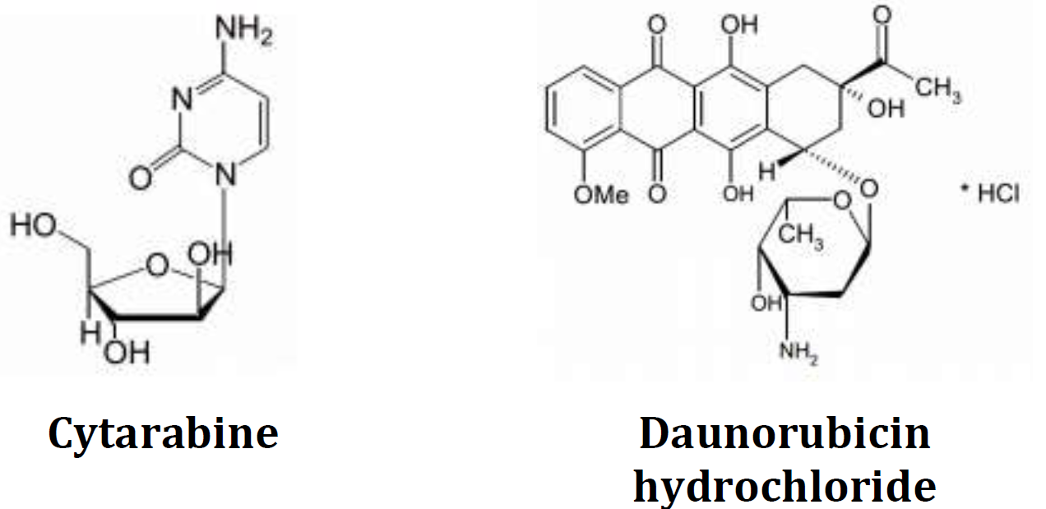

Vyxeos is supplied as a sterile, preservative free, purple lyophilised cake, free from visible particles, in a single patient use 50 mL type I glass vial with a chlorobutyl rubber stopper and an aluminium overseal. Each pack contains either 1, 2 or 5 vials.

The recommended shelf life is 24 months when stored upright in the original container (in order to protect from light) and stored in the refrigerator between 2 to 8°C. The maximum combined storage time for reconstituted product in the vial and reconstituted product diluted into an infusion bag is up to a total of 4 hours at 2 to 8°C.

The quality evaluation has noted the following potential issues:

* The quality evaluation has assessed the PI and Provisional Australian Register of Therapeutic Goods (ARTG) Record on the assumption that the trade name proposed without the strengths of the drug substances being included will be clinically acceptable. If the clinical evaluation does not accept this trade name, the PI, labels and Provisional ARTG Record will need revision.
* The Good Manufacturing Practice (GMP)[6] clearance for the site that manufactures the drug substance daunorubicin hydrochloride, has been updated to have an expiry data of 31 March 2022. However, the GMP clearance has the condition *‘Clearance is issued based on the EMA* [European Medicines Agency] *extended validity under COVID-19* [coronavirus disease 2019] *restrictions. No further extensions - renewal required’*. The expiry date is before the proposed decision date of this submission. This may mean approval cannot be granted until GMP clearance is granted by the TGA.

The sponsor should liaise with the TGA and if necessary, either make a new GMP clearance submission based on a new inspection by an overseas regulatory body or make a request for the TGA to inspect.

* The GMP clearance for the sponsor has been granted by the TGA with an expiry date of 25 April 2022. The expiry date may not be before the decision date. Having said that, the manufacturing step proposed for this site is testing chemical and physical and there are other sites with GMP clearance that can perform this step. Therefore, if GMP clearance is not obtained before the decision date, the site can be removed from the submission.
* It was found that the relative response factors for four impurities of cytarabine are incorrect in the method for cytarabine in the dossier. The sponsor has given an assurance that this will be updated post-approval after further investigation has occurred. This approach is acceptable, but the sponsor should also provide an assurance that the stability results will be reviewed and updated if necessary. Ideally this data should be provided prior to registration.

If the sponsor does not provide this information prior to approval, it should be made a condition of registration that this data be provided within one year.

Note that the change will lead to the same or lower amounts of impurities being present and this does not affect either the release and expiry limits that are acceptable or the shelf life that can be set.

* The quality evaluation has also noted that the sponsor has declined to change the tradename of Vyxeos to Vyxeos 44/100 to indicate the relative strengths of daunorubicin and cytarabine included in the product.

Approval for registration of the proposed product is recommended from a pharmaceutical chemistry perspective as it relates to the quality data.

### Nonclinical

The nonclinical evaluation has raised no issues for the registration of Vyxeos. In summary the nonclinical evaluation has noted the following:

* The sponsor has applied to register Vyxeos (sponsor’s drug development code: CPX‑351) a new fixed dose liposomal combination of daunorubicin hydrochloride and cytarabine, proposed to be used as a treatment for AML or AML-MRC in adults. Both daunorubicin hydrochloride and cytarabine (in solution form) are already approved in free combination for similar indications. The proposed maximum dose of Vyxeos, based on body surface area, is 44 mg/m2 daunorubicin and 100 mg/m2 cytarabine administered intravenously on Days 1, 3 and 5 of the first induction cycle (equivalent to a maximum weekly dose of 132 mg/m2 daunorubicin and 300 mg/m2 cytarabine).
* Vyxeos liposomes are rigid, spherical vesicles with a nominal mean diameter of approximately 100 nm, and a fixed 5:1 molar ratio of cytarabine and daunorubicin is loaded into the liposomes using a copper-based process. The properties of the liposomes structure are proposed to allow for stable encapsulation of drugs under biological conditions and to modulate the drug release characteristics, by decreasing liposome aggregation and prolonging circulation time.
* The nonclinical data was of good quality and adequate scope, including comparisons with non‑liposomal formulations and the appropriate vehicle in the repeat dose toxicity study in dogs (copper containing liposomes).
* Daunorubicin and cytarabine at a molar ratio of 1:5 was shown to provide the optimum synergistic anti-tumour effect *in vitro* against tumour cell lines. Vyxeos demonstrated greater antitumour activity in syngeneic and xenograft mouse leukaemia models *in vivo* than the individual liposomal formulations of cytarabine or daunorubicin or the non-liposomal drug cocktail (cytarabine and daunorubicin), even when the dose levels of cytarabine and/or daunorubicin were greater in the comparator treatment arms.
* No standalone safety pharmacology studies were conducted with Vyxeos. Safety pharmacology parameters were included as part of the repeat dose toxicology studies in rat and dog. Although the safety pharmacology assessment was confounded by poor survival, no unexpected central nervous system or cardiovascular system safety signals were evident.
* Daunorubicin to cytarabine molar ratios in animal plasma and bone marrow were maintained close to 1:5 for at least 24 hours after intravenous administration, due to high retention of the drug cargo within the liposomes. *In vivo* release from Vyxeos liposomes is deduced to be very slow, with less than 1% of the total drug concentration in the circulation present as free daunorubicin and cytarabine. As a result, the liposomes appear to govern tissue distribution, and rates of elimination and values for clearance, volume of distribution, and terminal half-life of the two actives are similar. High and sustained plasma concentrations are achieved with Vyxeos because clearance is approximately 100 times lower than that of the non-liposomal drugs. Very good allometric relationships indicate that excretion, metabolism, and distribution data in animals are likely to translate directly to humans.
* The volume of distribution indicates that the liposomes are mostly confined to the vascular space. Vyxeos demonstrated a higher tissue to plasma drug area under the plasma concentration time curve ratio in spleen, liver, kidney, lungs and bone marrow, and the preferential uptake in leukaemic cells was suggestive of increased delivery of the drug to target tissue, although the mechanism underlying this was not explored. Vyxeos administration to rats was associated with a lower brain to plasma ratio of cytarabine and a lower heart to plasma daunorubicin ratio compared with the non‑liposomal formulations of cytarabine and daunorubicin. While this is supportive of potentially reduced risks for daunorubicin associated cardiotoxicity and cytarabine associated central nervous system toxicity for the liposomal formulation compared with the free actives, this was not able to be confirmed in the toxicity studies.
* The major metabolism and biotransformation pathways in humans are similar to those in animals, and qualitatively similar for Vyxeos versus non-liposomal drugs, the only difference being that the rates of excretion are slower with Vyxeos.
* Two repeat dose toxicity studies of 26-days duration were conducted with Vyxeos, in rats and dogs. As observed clinically, signs of strong myelosuppression and gastrointestinal toxicity were observed. No unexpected toxicities were reported with the liposomal formulation or the liposome vehicle. Small transient increases were noted in whole blood copper levels without evidence of any copper mediated toxicity. The proposal that copper associated with Vyxeos liposomes was slowly released is supported by the copper pharmacodynamic (PK) data.
* Genotoxicity, carcinogenicity and reproductive toxicity studies have not been conducted with Vyxeos. This is acceptable based on the International Council for Harmonisation (ICH);[7] guideline.[8] Cytarabine and daunorubicin are well known compounds and their toxicological properties are well characterised. Both cytarabine and daunorubicin are mutagenic *in vitro* and clastogenic *in vitro* and *in vivo*. Daunorubicin showed carcinogenic potential in rats and is classified by the International Agency for Research on Cancer as ‘possibly carcinogenic to humans’ based on sufficient evidence in animals and inadequate human data.[9],[10]
* Based on animal data, male fertility may be compromised by treatment with Vyxeos. Cytarabine increased sperm head abnormalities and chromosomal aberrations following intraperitoneal administration in mice, and daunorubicin caused testicular atrophy and total aplasia of spermatocytes in the seminiferous tubules in dogs. Both cytarabine and daunorubicin, tested separately, showed teratogenic and embryotoxic effects in animal studies.
* Parenteral exposure to cobalt was sufficiently qualified despite the high amount of cobalt that could potentially be administered at the maximum clinical dose. Similarly, while the theoretical lifetime maximum of copper exceeded the safe doses reported in the ICH guidelines,[11] given the limited number of lifetime doses a patient can receive, the absence of any copper-related toxicity in the repeat dose toxicity study and the potentially slow release of copper from the liposome, the theoretical lifetime maximum copper dose was considered acceptable.

The nonclinical evaluation has requested amendments to the draft PI.

### Clinical

#### Summary of clinical studies

The clinical dossier consisted of:

* three Phase I studies: Study CLTR0305-101, Study CPX-MA-1201 and Study AAML1421;
* three Phase II studies: Study CTLR0310-206, Study CLTR0308-204 and Study AAML1421;
* one Phase III study: Study CLTR0310-301.

The main component of this dossier was the Phase III Study CLTR0310-301, which examined the safety and efficacy of Vyxeos in patients between 60 and 75 years of age with untreated secondary AML. This study also provided population pharmacokinetic data in the target population for Vyxeos.

The submission also contained one Phase I and II study which provided pharmacokinetic and pharmacodynamic (PK) data.

Two studies were submitted in support of the initially proposed paediatric indication however the clinical evaluation did not review these as consideration of this indication was withdrawn by the sponsor.

#### Pharmacology

Table : Pharmacokinetic studies included for evaluation

|  |  |  |  |
| --- | --- | --- | --- |
| PK topic | Subtopic | Study ID | Study description* |
| PK in the target population§ | General PKs | CLTR0305-101 | Phase I; identification of the recommended Phase II dose of CPX-351 that can be given to subjects with advanced haematologic malignancies |
| CTLR0310-206 | Phase II; PK and PD assessment of the potential for QTc;[12] prolongation following first induction treatment with Vyxeos liposome injection in acute leukaemia and myelodysplastic syndrome patients |
| PK in special populations | Older patients | CLTR0310-301 | Phase III; Vyxeos liposome injection versus cytarabine and daunorubicin in patients 60 to 75 years of age with untreated high risk (secondary) acute myeloid leukemia |
| PopPK analyses | Target population | PopPK analysis | PopPK analysis of cytarabine and daunorubicin following administration of Vyxeos to adult subjects with acute leukaemia or myelodysplastic syndrome |

Abbreviations: CPX-351 = sponsor’s drug development code of Vyxeos; PD = pharmacodynamic, PK = pharmacokinetic, PopPK = population pharmacokinetic; QTc = corrected QT interval.

* Indicates the primary PK aim of the study.

§ Subjects who would be eligible to receive the drug if approved for the proposed indication.

The clinical evaluation has reviewed the pharmacokinetics of Vyxeos. Briefly, Vyxeos injection had a time at maximum concentration of 2 hours, which is shortly after the end of the 90-minute infusion. The volume of distribution of Vyxeos was 6.64 L for daunorubicin and 7.11 L for cytarabine respectively. The volume of distribution of Vyxeos was much lower than published values for non‑liposomal daunorubicin (1360 L) and cytarabine (140 L) respectively.

Table : Study CTLR0310-206 Summary comparison on pharmacokinetic parameters for daunorubicin and cytarabine when administered as Vyxeos or as non‑liposomal formulations

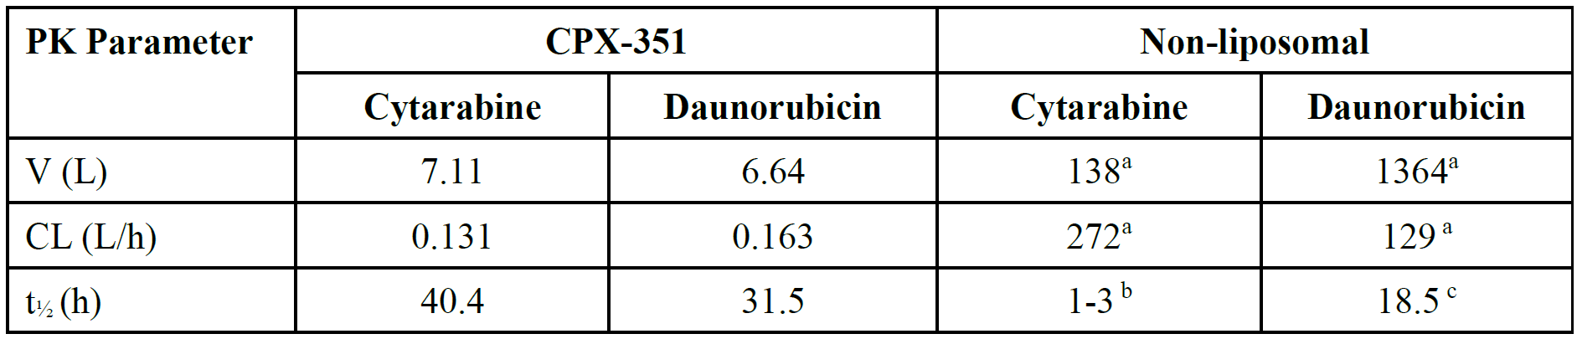

Abbreviations: CL = clearance; CPX-351 = sponsor’s drug development code of Vyxeos; PK = pharmacokinetic; t½ = terminal half-life; V = volume of distribution.

a From Krogh-Madsen et al (2012)[13]

b From overseas Product Labels for cytarabine (2017a),[14] (2017b),[15] (2018);[16] DrugBank for daunorubicin (2020)[17]

c From overseas Product Labels for daunorubicin (2012),[18] (2016)[19]

Values reported are means.

Figure : Study CTLR0310-206 Mean plasma concentration time curves and exposure parameters for total cytarabine and daunorubicin and their major metabolites (daunorubicinol and β-d-arabinofuranosyluracil)

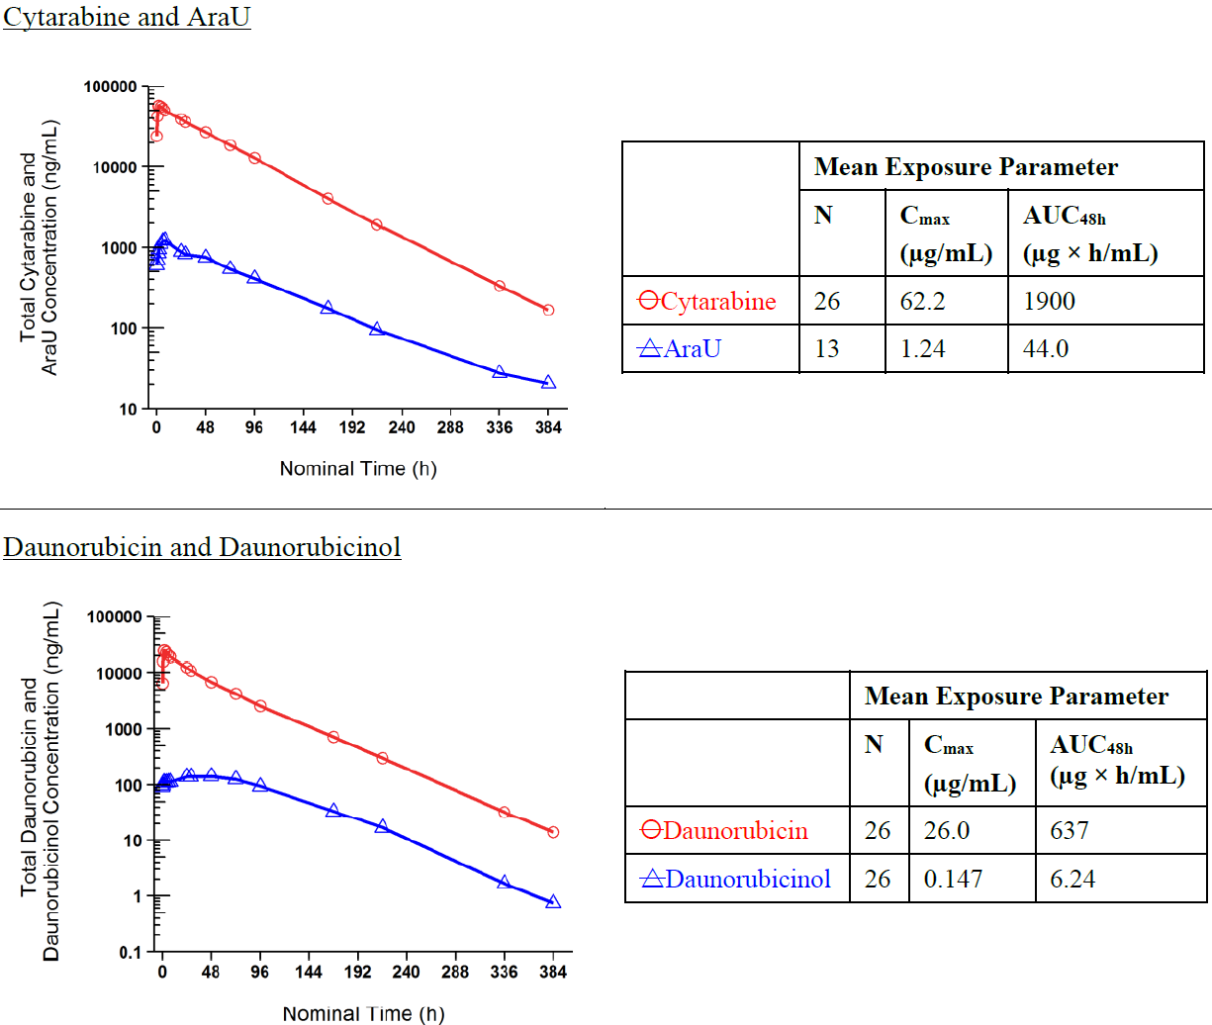

Abbreviations: AraU = β-d-arabinofuranosyluracil; AUC48h = area under the plasma concentration time curve from time zero to 48 hours post-dose; Cmax = maximum observed concentration; N = sample size.

Figure : Study CTLR0310-206 Mean total cytarabine to daunorubicin molar ratio versus time on Days 1 and 5

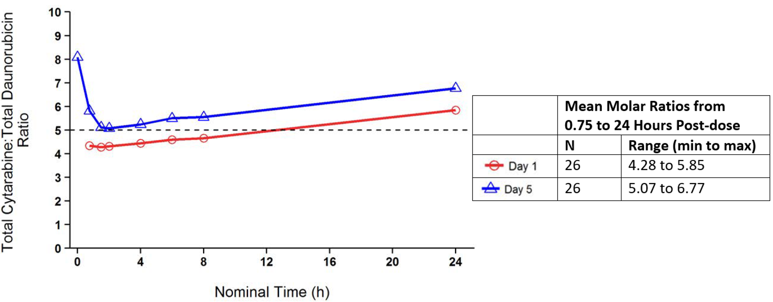

Abbreviations: max = maximum; min = minimum; N = sample size.

Dashed line indicates a molar ratio of 5.0.

Ratios were computed by comparing total concentrations of cytarabine to daunorubicin (in molar units) at each pharmacokinetic sample time for individual subjects; the reported range correspond to lowest to highest mean ratios from 0.75 to 24 hours after the start of the infusion.

The Delegate notes that the ratio of daunorubicin and cytarabine were maintained within a narrow range of ratios over several days.

#### Efficacy

##### Study CLTR0310-301

Study CLTR0310-301 was a Phase III study that compared non-lyophilised formulations of daunorubicin and cytarabine in a ‘7 + 3’ regimen;[20] with Vyxeos in patients 60 to 75 years of age with untreated, high risk, AML. The study consisted of a treatment phase, which could include one or two rounds of induction and consolidation, followed by follow-up studies. There were 153 patients randomised to the Vyxeos arm and 156 patients randomised to the ‘7 + 3’ control arm.

The primary endpoint was overall survival of patients on the two protocols.

Figure : Study CLTR0310-301 Protocol design

Figure 4: Study CLTR0310-301 Protocol design

Subjects 60 to 75 years old with the following acute myeloid leukemia (AML) subtypes were enrolled: therapy related AML, myelodysplastic syndrome AML with and without prior HMA, chronic myelomonocytic leukemia AML, and de novo AML with karyotype changes characteristic of myelodysplasia.

The study comprised 2 phases: a treatment phase and a follow-up phase. Subjects were stratified by age and AML subtype to balance these key prognostic variables of response and survival between the 2 treatment groups.

During the treatment phase, subjects were eligible to receive up to 2 inductions and up to 2 consolidations with either Vyxeos or cytarabine and daunorubicin given as a 7+3 (first induction) or 5 days of continuous infusion of cytarabine at 100 mg/m2/day and 2 days of daunorubicin at 60 mg/m2/day (5+2, second induction, consolidation courses) therapy. The number of inductions and consolidations a subject received depended on response (complete remission or complete remission with incomplete platelet or neutrophil recovery), which was confirmed by bone marrow assessment.

For the first induction:
Vyxeos was administered at 100 units/m2 by 90 minute intravenous infusion on Days 1, 3, 5.
7+3 was administered as: cytarabine at a dose of 100 mg/m2/day on Days 1 through 7 by continuous infusion, and daunorubicin at a dose of 60 mg/m2/day on Days 1, 2, and 3.

If a second induction was administered:
Vyxeos was administered at 100 units/m2 by 90 minute intravenous infusion on Days 1 and 3.
5+2 was administered as: cytarabine at a dose of 100 mg/m2/day on Days 1 through 5 by continuous infusion and daunorubicin at a dose of 60 mg/m2/day on Days 1 and 2.

For consolidation therapy:
Vyxeos was administered at 65 units/m2 by 90 minute intravenous infusion on Days 1 and 3.
5+2 was administered as: cytarabine at a dose of 100 mg/m2/day on Days 1 through 5 by continuous infusion, and daunorubicin at a dose of 60 mg/m2/day on Days 1 and 2.

The follow-up phase began 30 days after the completion of the last induction or consolidation course, and was to last until death or 5 years after randomisation. During this time, subjects were monitored for efficacy (survival, event free survival, response, response duration) and safety.

Abbreviations: AML = acute myeloid leukaemia; Ara-C = cytosine arabinoside; CMML = chronic myelomonocytic leukaemia; CPX-351 = Vyxeos 44 mg daunorubicin/100 mg cytarabine fixed-ratio dosing; MDS = myelodysplastic syndrome; tAML = therapy-related acute myeloid leukaemia.

‘7 + 3’ protocol: regimen consisting of 7 days of standard-dose cytarabine, and 3 days of daunorubicin.

Figure : Study CLTR0310-301 Kaplan-Meier plot of overall survival of patients on ‘7 + 3’ protocol (red) or Vyxeos (blue)

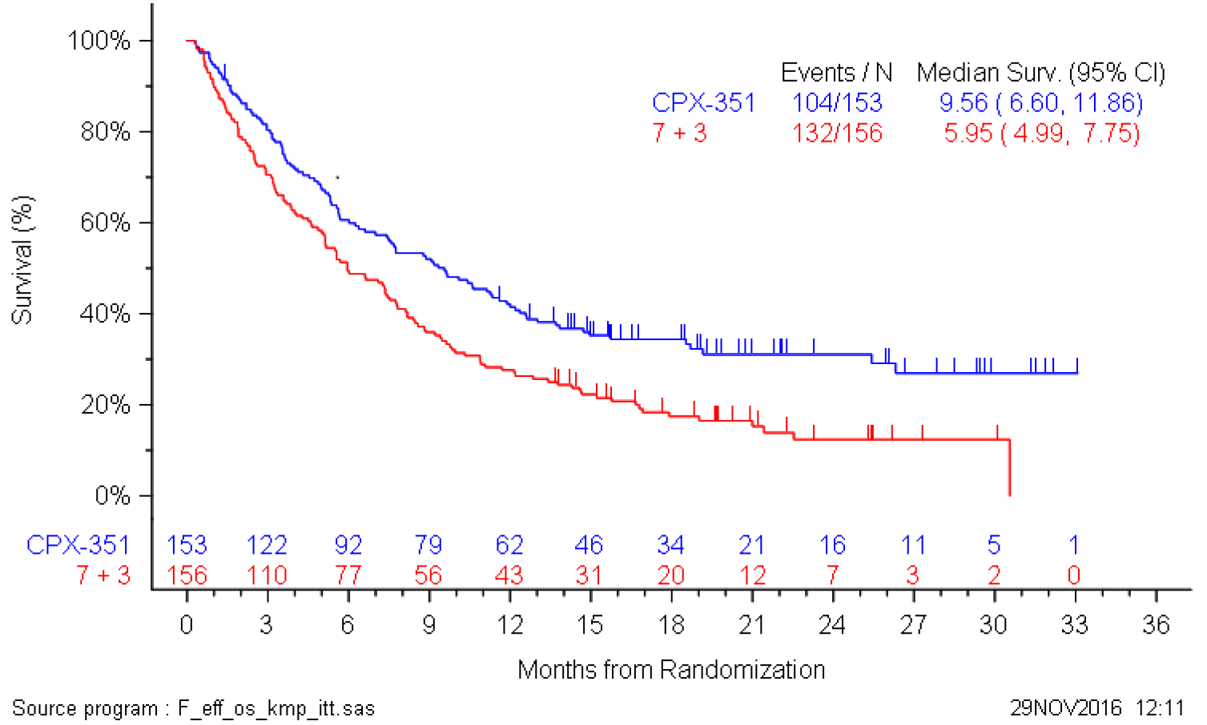

Abbreviations: CI = confidence interval; CPX-351 = Vyxeos 44 mg daunorubicin/100 mg cytarabine fixed-ratio dosing; Surv. = survival.

‘7 + 3’ protocol: regimen consisting of 7 days of standard-dose cytarabine, and 3 days of daunorubicin.

The median survival of the Vyxeos treatment group was 9.56 months compared to 5.95 months for the standard ‘7 + 3’ protocol, a hazard ratio of 0.69 (95% confidence interval (CI): 0.52, 0.90). This was a statistically significant difference at p = 0.003.

#### Safety

The main safety dataset was provided by Study CLTR0310-301.

Table : Study CLTR0310-301 Number of subjects with treatment-emergent adverse events, incidence > 10% by System Organ Class, Grades 3 to 5 (safety population)

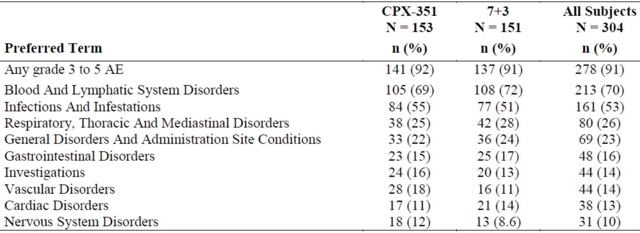

Abbreviations: AE = adverse event; CPX-351 = Vyxeos 44 mg daunorubicin/100 mg cytarabine fixed‑ratio dosing; N = number of subjects; n = number of subjects in group.

‘7 + 3’ protocol: regimen consisting of 7 days of standard-dose cytarabine, and 3 days of daunorubicin.

Table : Study CLTR0310-301 Number of subjects with Grades 3 to 5 treatment-emergent adverse events by Preferred Term, with an incidence > 5% in either treatment arm (safety population)

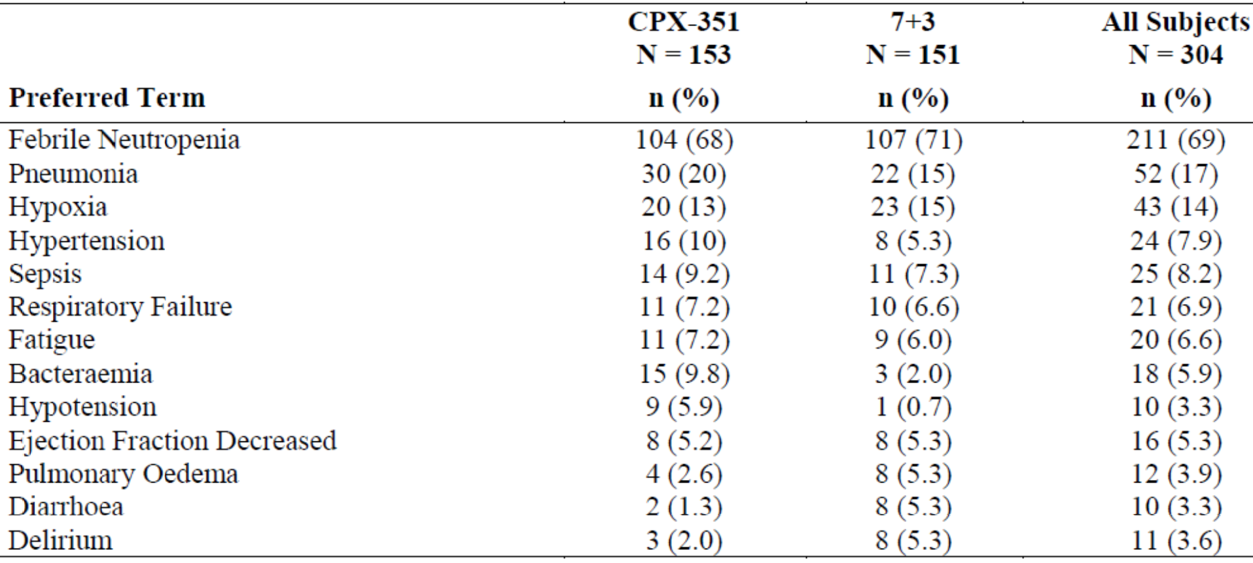

Abbreviations: CPX-351 = Vyxeos 44 mg daunorubicin/100 mg cytarabine fixed-ratio dosing; N = number of subjects; n = number of subjects in group.

‘7 + 3’ protocol: regimen consisting of 7 days of standard-dose cytarabine, and 3 days of daunorubicin.

Almost all patients in either arm of Study CLTR0310-301 experienced at least one severe adverse event (Grade ≥ 3). The most common serious adverse events by Preferred Terms in either the Vyxeos or the ‘7 + 3’ arm were febrile neutropaenia, respiratory failure, ejection fraction decrease, sepsis, pneumonia, disease progression and acute respiratory failure. The overall percentage of patients with serious adverse events of any grade is higher in the Vyxeos than the ‘7 + 3’ arm (59% and 43%, respectively).

Progressive or relapsed AML was the leading cause of death in either arm of the study.

The clinical evaluation has recommended approval of Vyxeos following amendments to the draft PI.

### Risk management plan

The sponsor is required to comply with product vigilance and risk minimisation requirements.

### Risk-benefit analysis

#### Delegate’s considerations

Vyxeos is a novel formulation of daunorubicin and cytarabine that offers some improvement in overall survival among high-risk AML patients undergoing induction or consolidation therapy. This is presumably due to the pharmacokinetic advantages of the liposomal formulation, given that *in vitro* studies have shown that there is an optimal ratio of daunorubicin and cytarabine for cytotoxic activity. The Delegate notes, however, that while ‘7 + 3’ regimen;20 is a common induction treatment is not the only one, and regimens including midostaurin or gemtuzumab may be included for particular types of AML. The superiority of Vyxeos over these regimens has not been examined in this submission.

The clinical evaluation has noted that overall there were no significant clinical safety issues. The Delegate concurs that the adverse event profile observed was consistent with the known toxicities of daunorubicin and cytarabine.

The quality evaluation has noted that fixed dose combinations usually include the dose of each component in the tradename, hence the preference for Vyxeos 44/100 rather Vyxeos. The Delegate acknowledges this is usually the case but notes that Vyxeos is not a fixed dose combination of daunorubicin and cytarabine within a series of incremental doses. It is rather a sole product incorporating a new formulation of daunorubicin and cytarabine within a liposomal carrier. Where there are several strengths of fixed combinations available and these are interchangeable with single component products, as with some blood pressure treatments for example, the inclusion of a products composition in the tradename provides an element of safety to help avoid confusion among similarly named products. The Delegate does not, however, feel this safety issue is relevant with Vyxeos as it is the only example of this formulation and implying it is simply a fixed dose combination of daunorubicin and cytarabine could itself be misleading. The Delegate is minded to accept the proposed tradename, noting that the composition of the product is on the label. The Delegate notes, however, that were another composition of Vyxeos to become available, the tradename would have to be re‑examined in this context.

#### Proposed action

The Delegate currently intends to register Vyxeos containing 44 mg daunorubicin and 100 mg cytarabine for the indication:

*For the treatment of adults with newly diagnosed therapy-related acute myeloid leukaemia (t-AML) or AML with myelodysplasia-related changes (AML-MRC)*

The PI approved with this application will be amended as requested by the nonclinical evaluation.

The Delegate notes that the intention to approve of this application is contingent on acceptable GMP clearance being available for all manufacturing sites at the time of the decision.

The sponsor is requested to provide a PI document annotated to indicate where amendments have been made at the request of the evaluators, and evidence of acceptable GMP for manufacturing sites, to expedite resolution of this application

#### Advisory Committee considerations

The Delegate did not refer this submission to the Advisory Committee on Medicines (ACM) for advice.

## Outcome

Based on a review of quality, safety, and efficacy, the TGA approved the registration of Vyxeos (44 mg daunorubicin hydrochloride and 100 mg cytarabine), powder for injection, vial, indicated for:

*Vyxeos is indicated for the treatment of adults with newly diagnosed, therapy-related acute myeloid leukaemia (t-AML) or AML with myelodysplasia-related changes (AMLMRC)*

### Specific conditions of registration applying to these goods

* Vyxeos (daunorubicin and cytarabine) is to be included in the Black Triangle Scheme. The PI and CMI [Consumer Medicines Information] for Vyxeos must include the black triangle symbol and mandatory accompanying text for five years, which starts from the date that the sponsor notifies the TGA of supply of the product.
* For all injectable products the Product Information must be included with the product as a package insert.

## Attachment 1. Product Information

The PI for Vyxeos approved with the submission which is described in this AusPAR is at Attachment 1. For the most recent PI, please refer to the TGA [PI/CMI search facility.](https://www.tga.gov.au/picmi-search-facility)

|  |
| --- |
| Therapeutic Goods Administration |
| PO Box 100 Woden ACT 2606 Australia  Email: [info@tga.gov.au](mailto:info@tga.gov.au) Phone: 1800 020 653 Fax: 02 6232 8605  [**https://www.tga.gov.au**](https://www.tga.gov.au) |

1. Fey, M.F. et al. Acute Myeloblastic Leukaemias in Adult Patients: ESMO Clinical Practice Guidelines for Diagnosis, Treatment and Follow-Up, *Ann Oncol*, 2013; 24 Suppl 6: vi138-143.
2. National Cancer Institute (NIH) Surveillance, Epidermiology, and End Results Program (SEER), Cancer Stat Facts: Leukemia - Acute Myeloid Leukemia (AML), 2020. Available at: <https://seer.cancer.gov/statfacts/html/amyl.html>.
3. Shysh, A.C et al. The Incidence of Acute Myeloid Leukemia in Calgary, Alberta, Canada: a Retrospective Cohort Study, *BMC Public Health*, 2018; 1: 94.
4. Döhner, H. et al. Diagnosis and Management of AML in Adults: 2017 ELN Recommendations from an International Expert Panel, *Blood*, 2017; 129(4): 424-447.
5. A **vehicle** is the equivalent to the active drug formulation, containing the same relatively inert excipients intended to act as a medium for carrying the active drug component, minus the active drug component itself.
6. **Good Manufacturing Practice (GMP)** describes a set of principles and procedures that when followed helps ensure that therapeutic goods are of high quality.
7. The **International Council for Harmonisation of Technical Requirements for Registration of Pharmaceuticals for Human Use (ICH)** brings together regulatory authorities and the pharmaceutical industry. It makes recommendations towards achieving greater harmonisation in the interpretation and application of technical guidelines and requirements for pharmaceutical product registration.
8. European Medicines Agency (EMA), Committee for Medicinal Products for Human Use (CHMP), ICH Guideline S9 on Nonclinical Evaluation for Anticancer Pharmaceuticals, EMA/CHMP/ICH/646107/2008, May 2010.
9. **International Agency on Cancer Research Group 2B**: The agent (mixture) is possibly carcinogenic to humans. The exposure circumstance entails exposures that are possibly carcinogenic to humans. This category is used for agents, mixtures and exposure circumstances for which there is limited evidence of carcinogenicity in humans and less than sufficient evidence of carcinogenicity in experimental animals. It may also be used when there is inadequate evidence of carcinogenicity in humans but there is sufficient evidence of carcinogenicity in experimental animals. In some instances, an agent, mixture or exposure circumstance for which there is inadequate evidence of carcinogenicity in humans but limited evidence of carcinogenicity in experimental animals together with supporting evidence from other relevant data may be placed in this group.
10. World Health Organization (WHO) Overall Evaluations of Carcinogenicity: an Updating of IARC Monographs Volumes 1 to 42, *IARC Monogr Eval Carcinog Risks Hum Suppl*, 1987; 7: 1-440.
11. European Medicines Agency (EMA), Committee for Medicinal Products for Human Use (CHMP), ICH Guideline Q3D (R1) on Elemental Impurities, EMA/CHMP/ICH/353369/2013, 28 March 2019.
12. The QT interval is the time from the start of the QRS wave complex to the end of the corresponding T wave. It approximates to the time taken for ventricular depolarisation and repolarisation, that is to say, the period of ventricular systole from ventricular isovolumetric contraction to isovolumetric relaxation.

    The **corrected QT interval (QTc)** estimates the QT interval at a standard heart rate. This allows comparison of QT values over time at different heart rates and improves detection of patients at increased risk of arrhythmias.
13. Krogh-Madsen, M. et al. Population Pharmacokinetics of Cytarabine, Etoposide, and Daunorubicin in the Treatment for Acute Myeloid Leukemia, *Cancer Chemother Pharmacol*, 2012; 69: 1155-1163.
14. Cytarabine Product Label - Product Monograph: Cytarabine Injection BP Product Monograph [PM] 100 mg/mL. 6 December 2017a. Sandoz Canada Inc.
15. Cytarabine 100 mg/mL Solution for Injection or Infusion Summary of Product Characteristics (SmPC) 2017b. Pfizer Ltd., Sandwich, Kent UK.
16. Cytarabine Injection, for intravenous, intrathecal and subcutaneous use. US Prescribing Information. 2018. Mylan Institutional LLC. IL, US.
17. DrugBank, Daunorubicin. Available at: <https://www.drugbank.ca/drugs/DB00694>.
18. Daunorubicin hydrochloride injection. US Prescribing Information. Teva Parenteral Medicines, Inc. CA, US. 2012.
19. Daunorubicin 20 mg Powder for IV Injection Summary of Product Characteristics (SmPC) 2016. Winthrop Pharmaceuticals UK Ltd., Guildford, Surrey UK.
20. The ‘**7 + 3’ regimen** is an acronym for a chemotherapy regimen used as induction therapy (to induce remission) in acute myeloid leukaemia. ‘7 + 3’ is derived from the duration of the chemotherapy course, which in the context of cytarabine plus daunorubicin therapy (also known as DA or DAC chemotherapy) consists of 7 days of standard-dose cytarabine, and 3 days of daunorubicin.