This medicinal product is subject to additional monitoring in Australia. This will allow quick identification of new safety information. Healthcare professionals are asked to report any suspected adverse events at <https://www.tga.gov.au/reporting-problems>.

▼

# Australian PRODUCT INFORMATION

# Eligard® (leuprorelin acetate) modified release injection syringe

# Name of the medicine

Leuprorelin acetate

# Qualitative and quantitative composition

ELIGARD is a sterile polymeric matrix formulation of leuprorelin acetate for subcutaneous injection. It is designed to deliver leuprorelin acetate at a controlled rate over a therapeutic period.

Leuprorelin acetate is a synthetic nonapeptide analogue of naturally occurring gonadotropin releasing hormone (GnRH or LH-RH) that, when given continuously, inhibits pituitary gonadotropin secretion and suppresses testicular steroidogenesis. The analogue possesses greater potency than the natural hormone.

ELIGARD 1 month contains 10.6 mg of lyophilised leuprorelin acetate. ELIGARD 1 month delivers 7.5 mg of leuprorelin acetate (equivalent to approximately 7.0 mg leuprorelin free base) dissolved in 160 mg N-methyl-2-pyrrolidone and 82.5 mg polyglactin. The approximate weight of the administered formulation is 250 mg. It is designed to deliver 7.5 mg of leuprorelin acetate at a controlled rate over a 1 month therapeutic period.

ELIGARD 3 month contains 29.2 mg lyophilised leuprorelin acetate. ELIGARD 3 month delivers 22.5 mg of leuprorelin acetate (equivalent to approximately 21 mg leuprorelin free base) dissolved in 193.9 mg N-methyl-2-pyrrolidone and 158.6 mg polyglactin. The approximate weight of the administered formulation is 375 mg. It is designed to deliver 22.5 mg of leuprorelin acetate at a controlled rate over a 3 month therapeutic period.

ELIGARD 4 month contains 37.2 mg lyophilised leuprorelin acetate. ELIGARD 4 month delivers 30 mg of leuprorelin acetate (equivalent to approximately 28 mg leuprorelin free base) dissolved in 258.5 mg N-methyl-2-pyrrolidone and 211.5 mg polyglactin. The approximate weight of the administered formulation is 500 mg. It is designed to deliver 30 mg of leuprorelin acetate at a controlled rate over a 4 month therapeutic period.

ELIGARD 6 month contains 59.2 mg of lyophilised leuprorelin acetate. ELIGARD 6 month delivers 45 mg of leuprorelin acetate (equivalent to approximately 42 mg leuprorelin free base) dissolved in 165 mg N-methyl-2-pyrrolidone and 165 mg polyglactin. The approximate weight of the administered formulation is 375 mg. It is designed to deliver 45 mg of leuprorelin acetate at a controlled rate over a 6 month therapeutic period.

The Atrigel® Delivery System is a polymeric (non-gelatin containing) delivery system consisting of a biodegradable polyglactin. The polymer is dissolved in a biocompatible solvent, N-methyl-2-pyrrolidone. The polyglactin mixture and volume differ with each presentation of ELIGARD.

ELIGARD contains no anti-microbial agent. ELIGARD does not contain: lactose, sucrose, gluten, tartrazine, or any other azo dyes.

# Pharmaceutical form

ELIGARD is a modified release suspension syringe, available in a single use kit.

ELIGARD is prefilled and supplied in two separate, sterile syringes whose contents are mixed immediately prior to administration. The two syringes are joined and the single dose product is mixed until it is homogenous. ELIGARD is administered subcutaneously where it forms a solid drug delivery depot.

# Clinical particulars

## Therapeutic indications

### Prostate cancer

ELIGARD 7.5mg 1 month, ELIGARD 22.5mg 3 month, ELIGARD 30mg 4 month and ELIGARD 45mg 6 month are indicated for the:

* Palliative treatment of advanced prostate cancer.
* Treatment of high-risk localised and locally advanced hormone-dependent prostate cancer in combination with radiotherapy.[1]

### Central precocious puberty (CPP)

ELIGARD 45mg 6 month is indicated for the treatment of children 2 years of age and olderwith central precocious puberty (CPP).

## Dose and method of administration

**IMPORTANT:** Allow the product to reach room temperature before using. **Once mixed, ELIGARD must be administered within 30 minutes.** Discard the constituted product if not administered within 30 minutes.

The two syringes are coupled and the product is mixed by transferring the contents from syringe to syringe immediately before administration to the patient. Refer to the instruction leaflet contained in the packaging titled ELIGARD Mixing Procedure. The syringes are uncoupled and the needle is attached prior to injection. The product is injected subcutaneously into areas with adequate amounts of subcutaneous tissue (such as the abdomen) and that do not have excessive pigment, nodules, lesions, or hair. As with other drugs administered by subcutaneous injection, the injection site should be varied periodically.

ELIGARD must be administered by healthcare professional.

### Prostate Cancer

When thoroughly mixed, the suspension will appear a light tan to tan colour (ELIGARD 1 month) or a colourless to pale yellow colour (ELIGARD 3 month, ELIGARD 4 month and ELIGARD 6 month). The mixed solution colour is not representative of product quality. An occasional slightly grey appearance of the mixed solution may be due to tiny air bubbles and will not affect the product quality.

ELIGARD should not be injected in the arm.

The recommended dose of ELIGARD 7.5mg 1 month is one injection every month.

The recommended dose of ELIGARD 22.5mg 3 month is one injection every three months.

The recommended dose of ELIGARD 30mg 4 month is one injection every four months.

The recommended dose of ELIGARD 45mg 6 month is one injection every six months.

ELIGARD 7.5mg 1 Month,22.5mg 3 Month, 30mg 4 Month and 45mg 6 month presentations have different release characteristics and therefore, fractional, multiple and/or combinational doses are not equivalent to each other and should not be given.

ELIGARD contains no antimicrobial agent and is for single use in one patient only. Discard any residue.

The injection delivers leuprorelin acetate, incorporated in a polymer formulation. It is administered subcutaneously and provides continuous release of leuprorelin for one month for ELIGARD 7.5mg 1 month, three months for ELIGARD 22.5mg 3 month, four months for ELIGARD 30mg 4 month and six months for ELIGARD 45mg 6 month.

### Central Precocious Puberty

Clinical evidence of onset of breast development in girls < 8 years or bilateral testicular enlargement >4ml in boys <9 years plus raised LH/FSH, oestradiol or testosterone.

In paediatric patients monitor response to ELIGARD with a GnRH agonist stimulation test, basal serum luteinizing hormone (LH) levels or serum concentration of sex steroid levels at 1 to 2 months following initiation of therapy and as needed to confirm adequate suppression of pituitary gonadotropins, sex steroids, and progression of secondary sexual characteristics. Measure height (for calculation of growth velocity) every 3 to 6 months and monitor bone age periodically. Noncompliance with drug regimen or inadequate dosing may lead to gonadotropins and/or sex steroids increasing above prepubertal levels resulting in inadequate control of the pubertal process. If the dose of ELIGARD is not adequate, switching to an alternative GnRH agonist for the treatment of CPP with the ability for dose adjustment may be necessary.

## Contraindications

### Prostate Cancer

ELIGARD is contraindicated in patients with hypersensitivity to GnRH, GnRH agonist analogues or any of the components of ELIGARD. Anaphylactic reactions to synthetic GnRH or GnRH agonist analogues have been reported in the literature.

ELIGARD is contraindicated in women who are breastfeeding, pregnant or intending to become pregnant and in paediatric patients. ELIGARD was not studied in women or children. Moreover, leuprorelin acetate can cause foetal harm when administered to a pregnant woman. Major foetal abnormalities were observed in rabbits but not in rats after administration of leuprorelin acetate throughout gestation. There were increased foetal mortality and decreased foetal weights in rats and rabbits. The effects on foetal mortality are expected consequences of the alterations in hormonal levels brought about by this drug. The possibility exists that spontaneous abortion may occur.

ELIGARD is contraindicated in patients who previously underwent orchiectomy (as with other GnRH agonists, ELIGARD does not result in further decrease of serum testosterone in case of surgical castration). ELIGARD is contraindicated as a sole treatment in prostate cancer patients with spinal cord compression or evidence of spinal metastases.

### Central Precocious Puberty

ELIGARD is contraindicated in patients with hypersensitivity to GnRH, GnRH agonist analogues or any of the components of ELIGARD. Anaphylactic reactions to synthetic GnRH or GnRH agonist analogues have been reported in the literature.

ELIGARD is contraindicated in pregnancy (See Section 4.6 Fertility, Pregnancy and Lactation).

## Special warnings and precautions for use

### Prostate Cancer

ELIGARD, like other LH-RH agonists, causes a transient increase in serum concentrations of testosterone during the first week of treatment. Patients may experience worsening of symptoms or onset of new signs and symptoms during the first few weeks of treatment, including bone pain, neuropathy, haematuria, or bladder outlet obstruction. Isolated cases of ureteral obstruction and/or spinal cord compression, which may contribute to paralysis with or without fatal complications, have been observed in the palliative treatment of advanced prostate cancer using LH-RH agonists.

Initiating therapy with a non-steroidal anti-androgen at the same time as leuprorelin acetate therapy has proven benefit in reducing flare reactions in 'at risk' patients (e.g. those with thecal indentation, or at risk of cord compression, and patients with bladder neck obstruction). Additional administration of an appropriate antiandrogen should be considered beginning 3 days prior to leuprorelin therapy and continuing for the first two to three weeks of treatment. This has been reported to prevent the sequelae of an initial rise in serum testosterone.

If spinal cord compression or renal impairment develops, standard treatment of these complications should be instituted.

Long-term administration of leuprorelin will cause suppression of pituitary gonadotropins and gonadal hormone production with clinical symptoms of hypogonadism. These changes have been observed to reverse on discontinuation of therapy. However, whether the clinical symptoms of induced hypogonadism will reverse in all patients has not yet been established.

### General

Patients with metastatic vertebral lesions and/or with urinary tract obstruction should be closely observed during the first few weeks of therapy.

Response to ELIGARD should be monitored by measuring serum concentrations of testosterone and prostate-specific antigen periodically.

Results of testosterone determinations are dependent on assay methodology. It is advisable to be aware of the type and precision of the assay methodology to make appropriate clinical and therapeutic decisions.

Following surgical castration, ELIGARD does not lead to a further decrease in serum testosterone levels in male patients.

A proportion of patients will have tumors which are not sensitive to hormone manipulation. This is termed castrate-resistant prostate cancer. Signs and/or symptoms of tumor progression despite adequate testosterone suppression are diagnostic of this condition. Current treatment paradigms recommend continued GnRH therapy along with other therapeutic regimes for this circumstance.

### Hyperglycemia and Diabetes

Hyperglycemia and an increased risk of developing diabetes have been reported in men receiving GnRH agonists. Hyperglycemia may represent development of diabetes mellitus or worsening of glycemic control in patients with diabetes. Monitor blood glucose and/or glycosylated hemoglobin (HbA1c) periodically in patients receiving a GnRH agonist and manage with current practice for treatment of hyperglycemia or diabetes.

### Cardiovascular Diseases

Increased risk of developing myocardial infarction, sudden cardiac death and stroke has been reported in association with use of GnRH agonists in men. The risk appears low based on the reported odds ratios, and should be evaluated carefully along with cardiovascular risk factors when determining a treatment for patients with prostate cancer. Patients receiving a GnRH agonist should be monitored for symptoms and signs suggestive of development of cardiovascular disease and be managed according to current clinical practice.

### Effect on QT/QTc Interval

Androgen deprivation therapy may prolong the QT interval. Physicians should consider whether the benefits of androgen deprivation therapy outweigh the potential risks in patients with congenital long QT syndrome, congestive heart failure, frequent electrolyte abnormalities, and in patients taking drugs known to prolong the QT interval. Electrolyte abnormities should be corrected. Consider periodic monitoring of electrocardiograms and electrolytes.

### Changes in Bone Density

Bone loss can be expected as part of natural aging and can also be anticipated during the hypo-androgenic state caused by long-term use of leuprorelin acetate. In patients with significant risk factors for decreased bone mineral content and/or bone mass such as family history of osteoporosis, chronic use of corticosteroids or anticonvulsants or chronic abuse of alcohol or tobacco, leuprorelin acetate may pose additional risk. In these patients, risk versus benefit must be weighed carefully before initiation of leuprorelin acetate therapy.

### Convulsions

Post marketing reports of convulsions have been observed in patients on leuprorelin acetate therapy with or without a history of predisposing factors. These included patients in the female and paediatric populations, patients with a history of seizures, epilepsy, cerebrovascular disorders, central nervous system anomalies or tumours, and in patients on concomitant medications that have been associated with convulsions such as bupropion and SSRIs. Convulsions have also been reported in patients in the absence of any of the conditions mentioned above. Convulsions are to be managed according to the current clinical practice.

### Respiratory

There have been post-marketing reports of interstitial pneumonitis associated with leuprorelin use. Treatment should be discontinued immediately if the patient develops any signs or symptoms suggestive of interstitial lung disease.

### Use in hepatic impairment

ELIGARD was not studied in hepatically and renally impaired patients.

### Use in renal impairment

ELIGARD was not studied in hepatically and renally impaired patients.

### Use in the elderly

The majority of the patients (approximately 70%) studied in the clinical trials were age 70 and older.

### Paediatric use

The safety and effectiveness of ELIGARD 7.5mg 1month, 22.5mg 3 Month and 30mg 4 Month in paediatric patients have not been established (see Section 4.3 - Contraindications).

The management of CPP is in the specialist field of paediatric endocrinology

### Central Precocious Puberty

The safety and effectiveness of ELIGARD 45mg 6 month for the treatment of CPP has been established in paediatric patients 2 years of age and older.

#### Psychiatric events:

Psychiatric events have been reported in patients taking GnRH agonists, including leuprorelin acetate. Postmarketing reports with this class of drugs include symptoms of emotional lability, such as crying, irritability, impatience, anger, and aggression. Monitor for development or worsening of psychiatric symptoms during treatment with ELIGARD.

### *Initial Rise of Gonadotropins and Sex Steroid Levels:*

During the early phase of therapy, gonadotropins and sex steroids rise above baseline because of the initial stimulatory effect of the drug. Therefore, an increase in clinical signs and symptoms of puberty including vaginal bleeding may be observed during the first weeks of therapy or after subsequent doses. Instruct patients and caregivers to notify the physician if these symptoms continue beyond the second month after ELIGARD administration.

#### Convulsions

Postmarketing reports of convulsions have been observed in patients receiving GnRH agonists, including leuprorelin acetate. These included patients with a history of seizures, epilepsy, cerebrovascular disorders, central nervous system anomalies or tumours, and patients on concomitant medications that have been associated with convulsions such as bupropion and SSRIs. Convulsions have also been reported in patients in the absence of any of the conditions mentioned above.

*Pseudotumor Cerebri (Idiopathic Intracranial Hypertension)*

Pseudotumor cerebri (idiopathic intracranial hypertension) have been reported in paediatric patients receiving GnRH agonists, including leuprorelin acetate. Monitor patients for signs and symptoms of pseudotumor cerebri, including headache, papilledema, blurred vision, diplopia, loss of vision, pain behind the eye or pain with eye movement, tinnitus, dizziness, and nausea.

### Effects on laboratory tests

In the majority of non-orchiectomised patients, testosterone levels increased during the first week of treatment. They then decreased and by day 14 had returned to baseline levels or below. Castrate levels were reached in 2 to 4 weeks. Once achieved, castrate levels were maintained as long as the patient received their injections. Transient increases in acid phosphatase levels may occur early in the treatment period; however, by the fourth week the elevated levels usually decreased to values at or near normal. Therapy with leuprorelin results in suppression of the pituitary-gonadal system. Results of diagnostic tests of pituitary gonadotropic and gonadal functions conducted during and after leuprorelin therapy may be affected.

## Interactions with other medicines and other forms of interactions

There are no reports of drug interactions with leuprorelin acetate to date.

Since androgen deprivation treatment may prolong the QT interval, the concomitant use of ELIGARD with medicinal products known to prolong the QT interval or medicinal products able to induce Torsade de Pointes such as Class IA (e.g. quinidine, disopyramide) or Class III (e.g. amiodarone, sotalol) antiarrhythmic medicinal products, methadone, moxifloxacin, antipsychotics, etc. should be carefully evaluated (see Section 4.4 Special warnings and precautions for use).

In paediatric use no pharmacokinetic drug-drug interaction studies have been conducted with ELIGARD.

## Fertility, pregnancy and lactation

### Effects on fertility

Preclinical studies with leuprorelin acetate in rats demonstrated reversible, expected effects (given that leuprorelin acetate has known pharmacological effects on reproductive endocrinology) on the reproductive system of both sexes.

Leuprorelin acetate did not show teratogenicity in rats.

Clinical and pharmacological studies in adults (>18 years) with leuprorelin acetate and similar analogues have shown full reversibility of fertility suppression when the drug is discontinued after continuous administration for periods of up to 24 weeks.

### Use in pregnancy – Pregnancy Category D

(See Section 4.3 Contraindications).

Leuprorelin acetate is contraindicated in pregnancy due to its embryotoxic effects.

### Use in lactation

ELIGARD is contraindicated for use in breastfeeding women.

## Effects on ability to drive and use machines

No studies on the effects of ELIGARD on the ability to drive and use machines have been performed. The ability to drive and operate machines may be impaired due to fatigue, dizziness and visual disturbances being possible side effects of treatment or resulting from the underlying disease.

## Adverse effects (Undesirable effects)

### Prostate Cancer

ELIGARD, like other LH-RH analogues, caused a transient increase in serum testosterone concentrations during the first two weeks of treatment. Therefore, potential exacerbations of signs and symptoms of the disease during the first few weeks of treatment are of concern in patients with vertebral metastases and/or urinary obstruction or haematuria. If these conditions are aggravated, it may lead to neurological problems such as weakness and/or paraesthesia of the lower limbs or worsening of urinary symptoms (see Section 4.4 Special warnings and precautions for use).

'Flare' Phenomenon: The initial increase in circulating levels of pituitary gonadotropins and gonadal steroids leads in some patients to a transient exacerbation of symptoms and signs ('flare' phenomenon). The exacerbation may include worsened bone pain, ureteric obstruction and spinal cord compression. This possibility should be taken into account in deciding to initiate leuprorelin acetate therapy in patients with existing obstructive uropathy or vertebral metastases. Early symptoms of spinal cord compression such as paraesthesia should alert the physician to the need for intensive monitoring and possible treatment.

There is no information available on the clinical effects of interrupting leuprorelin acetate therapy and whether this will produce a withdrawal 'flare'.

Initiating therapy with a non-steroidal anti-androgen at the same time as leuprorelin acetate therapy has proven benefit in reducing flare reactions in 'at risk' patients.

The safety of ELIGARD was evaluated in open-label, multicentre studies. In ELIGARD clinical studies conducted, patient injection sites were closely monitored. The adverse reactions from injections sites are summarised in Table 1.

**Table 1:** Summary of adverse reactions from ELIGARD injection sites

|  |  |  |  |  |
| --- | --- | --- | --- | --- |
| **Presentation** | **ELIGARD 1 month** | **ELIGARD 3 month** | **ELIGARD 4 month** | **ELIGARD 6 month** |
| Total number of injections (N=) | 716 | 230 | 175 | 217 |
| Adverse reactions (% of injections) |  |  |  |  |
| Transient burning/stinging | 34.6 | 21.7 | 20 | 16 |
| Pain | 4.3 | 3.5 | 2.3 | 4.6 |
| Erythema | 2.6 | 0.9 | 1.1 | – |
| Mild bruising | 2.5 | 1.7 | – | 2.3 |
| Pruritis | 1.4 | 0.4 | – | – |
| Induration | 0.4 | – | – | – |
| Ulceration | 0.1 | – | – | – |

The majority (84%) of transient burning/stinging events for ELIGARD 1 month were reported as mild. Pain was generally reported as brief in duration and mild in intensity. Erythema were all reported as mild and generally resolved within a few days post-injection.

The majority (86%) of transient burning/stinging events for ELIGARD 3 month were reported as mild. Pain was generally reported as brief in duration and mild in intensity. One of the reports characterized the erythema as mild and resolved within 7 days. The other was moderate and resolved within 15 days. Neither patient experienced erythema at multiple injections.

All (100%) of transient burning/stinging events for ELIGARD 4 month were reported as mild. Pain was generally reported as brief in duration and mild in intensity. Erythema was reported as mild in all cases and generally resolved within a few days post-injection.

The majority (91%) of transient burning/stinging events for ELIGARD 6 month were reported as mild. Pain was generally reported as brief in duration and mild in intensity. Mild bruising was reported following five (2.3%) study injections and moderate bruising was reported following two (<1%) study injections.

The following possibly or probably related systemic adverse events occurred during clinical trials of up to six months of treatment with ELIGARD 1 month and ELIGARD 3 month, up to eight months of treatment with ELIGARD 4 month and up to 12 months of treatment with ELIGARD 6 month, and were reported in ≥ 2% and < 2% of patients (Tables 2 and 3, respectively). Often, causality is difficult to assess in patients with metastatic prostate cancer. Reactions considered not drug- related were excluded.

### More Common Reactions (incidence ≥ 2%)

**Table 2:** Incidence (%) of Possibly Related Systemic Adverse Events Reported by ≥ 2% of Patients Treated with ELIGARD 1 month and ELIGARD 3 month for up to six months, ELIGARD 4 month up to eight months and ELIGARD 6 month up to 12 months

|  | **Adverse Event** | **ELIGARD 1**  **month 1**  **N (%)** | **ELIGARD 3**  **month 2**  **N (%)** | **ELIGARD 4**  **month 2**  **N (%)** | **ELIGARD 6**  **month 2**  **N (%)** |
| --- | --- | --- | --- | --- | --- |
| Body as a Whole | Malaise and Fatigue * | 21 (17.5%) | 7 (6.0 %) | 12 (13.3%) | 13 (11.7) |
| Weakness |  |  |  | 4 (3.6%) |
| Dizziness | 4 (3.3%) | – | 4 (4.4 %) | - |
| Cardiovascular | Hot flashes/sweats* | 68 (56.7%) | 66 (56.4%) | 66 (73.3%) | 64 (57.7) |
| Genitourinary | Atrophy of Testes * | 6 (5.0%) | - | 4 (4.4%) | 8 (7.2) |
| Nocturia | - | – | 2 (2.2 %) | - |
| Urinary frequency | - | 3 (2.6 %) | 2 (2.2 %) | - |
| Digestive | Gastroenteritis/ Colitis | 3 (2.5%) | - | - | - |
| Nausea | - | 4 (3.4 %) | 2 (2.2 %) | - |
| Reproductive | Gynaecomastia * | - | - | 2 (2.2 %) | 4 (3.6) |
| Testicular pain | - | - | 2 (2.2 %) | - |
| Skin | Clamminess * | - | – | 4 (4.4 %) | - |
| Night sweats * | - | – | 3 (3.3 %) | 3 (2.7) |
| Alopecia | - | – | 2 (2.2 %) | - |
| Pruritis | - | 3 (2.6 %) | – | - |
| Psychiatric | Decreased libido * | - | – | 3 (3.3 %) | - |
| Musculoskeletal | Myalgia | - | – | 2 (2.2 %) | 5 (4.5) |
| Arthralgia | - | 4 (3.4 %) | – |  |
| Pain in limb |  |  |  | 3 (2.7) |

1 adverse events are classified using ICD–9 terms

2 adverse events are classified using MedDRA terms

* Expected pharmacological consequences of testosterone suppression.

### Less Common Reactions (incidence < 2%)

**Table 3:** Possibly or Probably Related Systemic Adverse Events Reported by < 2% of Patients Treated with ELIGARD 1 month1 and ELIGARD 3 month2 for up to six months, ELIGARD 4 month2 up to eight months and ELIGARD 6 month2 for up to 12 months

|  |  |
| --- | --- |
| **Body System** | **Adverse** **Event** |
| General | Sweating*, insomnia, syncope, rigors, weakness, lethargy |
| Gastrointestinal | Flatulence, constipation, dyspepsia |
| Haematologic | Decreased red blood cell count, haematocrit and haemoglobin |
| Metabolic | Weight gain |
| Musculoskeletal | Tremor, backache, joint pain, muscle atrophy, limb pain |
| Nervous | Disturbance of smell and taste, depression, vertigo |
| Psychiatric | Insomnia, depression, loss of libido* |
| Skin | Alopecia, clamminess, night sweats*, sweating increased* |
| Urogenital / Reproductive | Decreased libido*, gynaecomastia*, breast tenderness*, testicular atrophy*, testicular pain, erectile dysfunction*, penis disorder*, reduced penile size* |
| Renal and urinary disorders | Difficulties with urination, pain on urination, scanty urination, bladder spasm, blood in urine and urinary retention, urinary urgency, incontinence, nocturia, urinary tract infection |
| Vascular | Hypertension, hypotension |

1 adverse events are classified using ICD–9 terms

2 adverse events are classified using MedDRA terms

* Expected pharmacological consequence of testosterone suppression.

### ELIGARD in combination with radiotherapy

The addition of ADT in the form of leuprorelin acetate to radiotherapy unequivocally resulted in an increased range of acute and late toxicities. Some of these pivotal studies employed half of the currently recommended dose of leuprorelin. Long term safety data on the combination therapy was limited due to long term use of an anti-androgen in some studies, but limited use of leuprorelin.

### Central Precocious Puberty

The following are serious adverse events (see Section 4.4 Special warnings and precautions for use):

* Initial rise in gonadotropin and sex steroid levels.
* Psychiatric Events.
* Convulsions.
* Pseudotumor Cerebri (Idiopathic Intracranial Hypertension)

ELIGARD 6 month was evaluated in an uncontrolled, open-label, single-arm clinical trial in which 64 paediatric patients with CPP received at least one dose of ELIGARD 6 month. The age ranged from 4 to 9 years at start of treatment; 62 patients were female and 2 were male. Adverse events that occurred in ≥ 5% of patients are shown in Table 4.

**Table 4:** Adverse Events Occurring in ≥ 5% of Patients Treated with ELIGARD 6 month in an Open-Label, Single-Arm Trial

|  |  |
| --- | --- |
| **Adverse Event** | **% of Patients**  **(N=64)** |
| Injection site pain | 31 |
| Nasopharyngitis | 22 |
| Pyrexia | 17 |
| Headache | 16 |
| Cough | 13 |
| Abdominal pain | 9 |
| Injection site erythema | 9 |
| Nausea | 8 |
| Constipation | 6 |
| Vomiting | 6 |
| Upper respiratory tract infection | 6 |
| Bronchospasm | 6 |
| Productive cough | 6 |
| Hot flush | 5 |

*Other Adverse Events****:***

Psychiatric:Emotional disorder (2%) and irritability (2%)

### Post-marketing experiences

#### Pituitary Apoplexy

During post-marketing surveillance, rare cases of pituitary apoplexy (a clinical syndrome secondary to infarction of the pituitary gland) have been reported after the administration of gonadotropin releasing hormone agonists, with a majority occurring within two weeks of the first dose, and some within the first hour. In these cases, pituitary apoplexy has presented as a sudden headache, vomiting, visual changes, ophthalmoplegia, altered mental status, and sometimes cardiovascular collapse. Immediate medical attention has been required.

#### Other Adverse Effects

During post-market surveillance with LH-RH agonists; diabetes mellitus, myocardial infarction, cerebrovascular accident and sudden cardiac death have also been reported (see Section 4.4 Special warnings and precautions for use).

Anaphylactic/anaphylactoid reactions have been reported after GnRH agonist analog administration.

Postmarketing reports of convulsions have been observed in patients on leuprorelin acetate with or without a history of predisposing factors. Convulsions are to be managed according to the current clinical practice.

Muscular atrophy has been observed with long term use of products in this class.

Interstitial lung disease has been reported with an unknown frequency.

#### Central Precocious Puberty

The following adverse events have been observed during post-approval use of leuprorelin acetate. Because these reactions are reported voluntarily from a population of uncertain size, it is not always possible to reliably estimate their frequency or establish a causal relationship to drug exposure.

* Allergic Reactions: anaphylactic, rash, urticaria, and photosensitivity reactions.
* General: chest pain, weight increase, weight decrease, decreased appetite, fatigue.
* Laboratory Abnormalities: decreased WBC.
* Metabolic: diabetes mellitus.
* Musculoskeletal and Connective Tissue: arthralgia, epiphysiolysis, muscle spasms, myalgia.
* Neurologic: neuropathy peripheral, convulsion, paralysis, insomnia, pseudotumor cerebri (idiopathic intracranial hypertension).
* Psychiatric: emotional lability, such as crying, irritability, impatience, anger and aggression. Depression, including rare reports of suicidal ideation and attempt. Many, but not all, of these patients had a history of psychiatric illness or other comorbidities with an increased risk of depression.
* Skin and Subcutaneous Tissue: injection site reactions including induration and abscess, flushing, hyperhidrosis.
* Reproductive System: vaginal bleeding, breast enlargement.
* Vascular: hypertension, hypotension.
* Respiratory: dyspnea.

### Reporting suspected adverse effects

Reporting suspected adverse reactions after registration of the medicinal product is important. It allows continued monitoring of the benefit-risk balance of the medicinal product. Healthcare professionals are asked to report any suspected adverse reactions at [www.tga.gov.au/reporting-problems](http://www.tga.gov.au/reporting-problems).

## Overdose

In clinical trials using daily subcutaneous leuprorelin acetate in patients with prostate cancer, doses as high as 20 mg/day for up to two years caused no adverse effects differing from those observed with the 1 mg/day dose.

There is no clinical experience with the effects of an acute overdose. Because the acute animal toxicity of the drug is low, adverse effects are not expected. In the event of an overdose the patient should be monitored and supportive treatment given, if considered necessary.

In paediatric use no specific antidotes for ELIGARD are known.

For information on the management of overdose, contact the Poisons Information Centre on 13 11 26 (Australia).

# Pharmacological properties

## Pharmacodynamic properties

### Mechanism of action

#### Prostate Cancer

Leuprorelin acetate, an LH-RH agonist, acts as a potent inhibitor of gonadotropin secretion when given continuously in therapeutic doses. Animal and human studies indicate that after an initial stimulation, chronic administration of leuprorelin acetate results in suppression of testicular steroidogenesis. This effect is reversible upon discontinuation of drug therapy.

Administration of leuprorelin acetate has resulted in inhibition of the growth of certain hormone-dependent tumours (prostatic tumours in Noble and Dunning male rats and DMBA- induced mammary tumours in female rats) as well as atrophy of the reproductive organs.

In humans, administration of leuprorelin acetate results in an initial increase in circulating levels of luteinizing hormone (LH) and follicle stimulating hormone (FSH), leading to a transient increase in levels of the gonadal steroids (testosterone and dihydrotestosterone in males, and oestrone and oestradiol in premenopausal females). However, continuous administration of leuprorelin acetate results in decreased levels of LH and FSH. In males, testosterone is reduced to below castrate threshold (≤ 50 ng/dL). These decreases occur within two to six weeks after initiation of treatment.

Leuprorelin acetate is not active when given orally.

#### Central Precocious Puberty

In paediatric patients, leuprorelin acetate, a GnRH agonist, acts as a potent inhibitor of gonadotropin secretion (LH and follicle stimulating hormone (FSH)) when given continuously in therapeutic doses. Following an initial stimulation of GnRH receptors, chronic administration of leuprorelin acetate results in downregulation of GnRH receptors, reduction in release of LH, FSH and consequent suppression of ovarian and testicular production of oestradiol and testosterone respectively. This inhibitory effect is reversible upon discontinuation of drug therapy.

In the clinical trial evaluating ELIGARD 6 month in paediatric patients with CPP, there was a transient surge in circulating levels of LH, FSH, oestradiol and testosterone following the first administration. A decrease in basal and GnRH agonist-stimulated LH and FSH levels along with reductions in basal oestradiol and testosterone were observed after repeat administration.

### Clinical trials

#### Prostate Cancer

In the open-label, multicentre studies conducted with ELIGARD patients with advanced prostate cancer were treated with monthly injections of ELIGARD 1 month for 6 months, a single injection of ELIGARD 3 month, given once every three months for 6 months, a single injection of ELIGARD 4 month, given once every four months for 8 months or a single injection of ELIGARD 6 month, given once every six months for 12 months. Patient stages in the open-label, multicentre studies are described in Table 5. The ELIGARD 1 month and ELIGARD 3 month studies evaluated the achievement and maintenance of serum testosterone suppression over six months of therapy. The ELIGARD 4 month study evaluated the achievement and maintenance of serum testosterone suppression over eight months of therapy. The ELIGARD 6 month study evaluated the achievement and maintenance of serum testosterone suppression over twelve months of therapy.

**Table 5:** Description of patients in open-label, multicentre studies for ELIGARD

|  |  |  |  |  |  |
| --- | --- | --- | --- | --- | --- |
| **Presentation** | **Total** | **Stage A disease** | **Stage B disease** | **Stage C disease** | **Stage D disease** |
| ELIGARD 1 month | 120 | 0 | 0 | 89 | 31 |
| ELIGARD 3  month | 117 | 2 | 19 | 60 | 36 |
| ELIGARD 4  month | 90 | 2 | 38 | 16 | 34 |
| ELIGARD 6 month | 111 | 5 | 43 | 19 | 44 |

Patients with brain metastases, spinal cord compression and/or urinary tract obstruction, serum testosterone levels below 150 ng/dL at screening, uncontrolled congestive heart failure, myocardial infarction or a coronary vascular procedure, symptomatic cardiovascular disease, venous thrombosis, uncontrolled hypertension, symptomatic hypotension, insulin dependent diabetes, a history of drug and alcohol abuse, other serious intercurrent illness, (for example, haematological, renal hepatic, respiratory, endocrine) were excluded from the studies.

#### ELIGARD 1 month

The mean testosterone concentration increased from 361.3 ng/dL at baseline to 574.6 ng/dL at day 3 following the initial subcutaneous injection. The mean serum testosterone concentration then decreased to below baseline by day 10 and was 21.8 ng/dL on day 28. At the conclusion of the study (month 6), mean testosterone concentration was 6.1 ng/dL (Figure 1a), comparable to levels following bilateral orchiectomy.

Serum testosterone was suppressed to below the castrate threshold (≤ 50 ng/dL) by day 28 (week 4) in 112 of 119 (94.1%) patients remaining in the study. The remaining seven patients all attained the castrate threshold by day 42. A high proportion of patients (97% at day 42), achieved testosterone suppression levels of ≤ 20 ng/dL, although the full benefit of these low levels has not yet been established. Once testosterone suppression at or below serum concentrations of 50 ng/dL was achieved, no patients (0%) demonstrated breakthrough (concentration above 50 ng/dL) at any time in the study. All 117 evaluable patients in the study at month 6 (two patients withdrew for reasons unrelated to drug) had testosterone concentrations of ≤ 50 ng/dL.

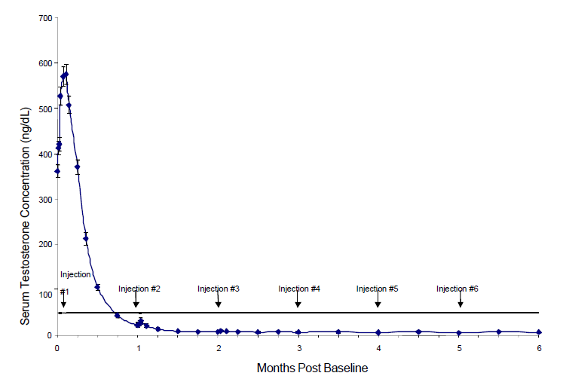

**Figure 1 a:** ELIGARD 1 month mean serum testosterone concentrations (n = 117)

#### ELIGARD 3 month

The mean testosterone concentration increased from 367.1 ng/dL at baseline to 588.0 ng/dL at day 2 following the initial subcutaneous injection. The mean serum testosterone concentration then decreased to below baseline by day 14 and was 27.7 ng/dL on day 21. At the conclusion of the study (month 6), mean testosterone concentration was 10.1 ng/dL (Figure 1b), comparable to levels following bilateral orchiectomy.

Of the original 117 patients, one received less than a full dose of ELIGARD 3 month at baseline, never suppressed, and was withdrawn at day 73 and given an alternate treatment. In the remaining 116 patients who did receive the full dose at baseline, serum testosterone was suppressed to below the castrate threshold (≤ 50 ng/dL) by day 28 (week 4) in 115 of 116 (99%). By day 35, all 116 patients (100%) who received a full dose at baseline attained the castrate threshold. A high proportion of patients (84% at day 28 and 92% at day 42), achieved testosterone suppression levels of ≤ 20 ng/dL, although the full benefit of these low levels has not yet been established. Once testosterone suppression at or below serum concentrations of 50 ng/dL was achieved, only one patient (<1%) demonstrated breakthrough (concentration above 50 ng/dL) following initial injection; that patient remained below the castrate threshold following the second injection. All 111 evaluable patients in the study at month 6 had testosterone concentrations of ≤ 50 ng/dL.

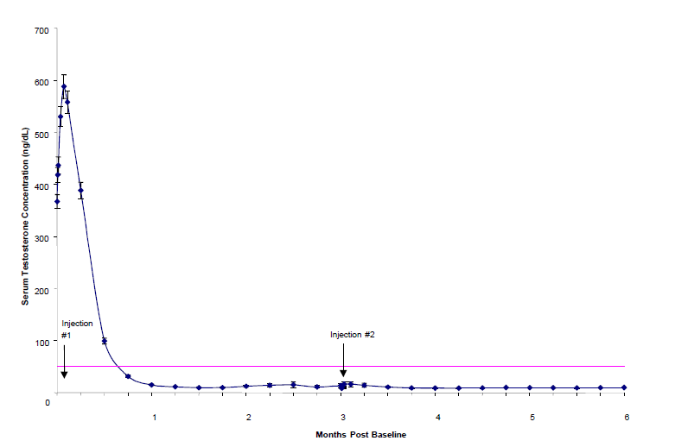

**Figure 1 b:** ELIGARD 3 month mean serum testosterone concentrations (n = 111)

#### ELIGARD 4 month

The mean testosterone concentration increased from 385.5 ng/dL at baseline to 610.0 ng/dL at day 2 following the initial subcutaneous injection. The mean serum testosterone concentration then decreased to below baseline by day 14 and was 17.2 ng/dL on day 28. At the conclusion of the study (month 8), mean testosterone concentration was 12.4 ng/dL (Figure 1c), comparable to levels following bilateral orchiectomy.

Serum testosterone was suppressed to below the castrate threshold (≤ 50 ng/dL) by day 28 in 85 of 89 (96%) patients remaining in the study. All 89 (100%) of patients remaining in the study attained the castrate threshold by day 42. A high proportion of patients (67% at day 28 and 90% at day 42), achieved testosterone suppression levels of ≤ 20 ng/dL, although the full benefit of these low levels has not yet been established. Once testosterone suppression at or below serum concentrations of 50 ng/dL was achieved, three patients (3%) demonstrated breakthrough (concentration above 50 ng/dL) during the study. These patients again reached castrate suppression following the second injection of study drug. Of 82 evaluable patients in the study at month 8, 81 had testosterone concentrations of ≤ 50 ng/dL.

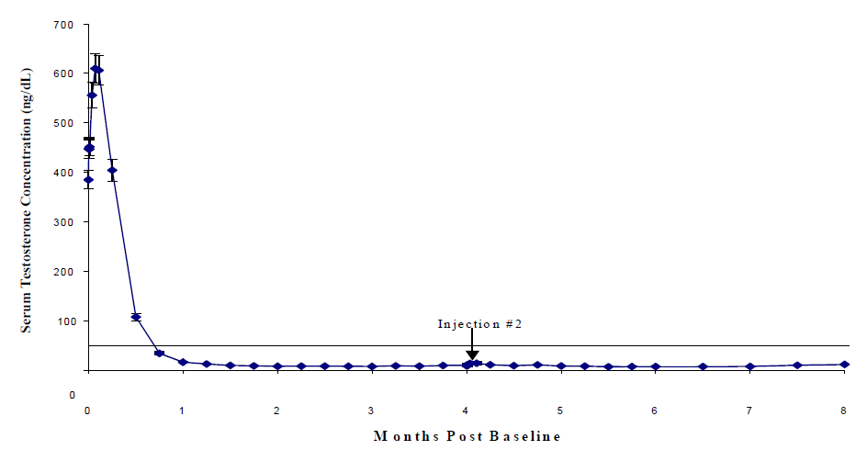

**Figure 1 c**: ELIGARD 4 month mean serum testosterone concentrations (n = 90)

#### ELIGARD 6 month

The mean testosterone concentration increased from 367.7 ng/dL at baseline to 588.6 ng/dL at day 2 following the initial subcutaneous injection. The mean serum testosterone concentration then decreased to below baseline by day 14 and was 16.7 ng/dL on day 28. At the conclusion of the study (month 12), mean testosterone concentration was 12.6 ng/dL (Figure 1d), comparable to levels following bilateral orchiectomy.

Serum testosterone was suppressed to below the castrate threshold (≤ 50 ng/dL) by day 28 in 108 of 109 (99%) patients remaining in the study. One patient (<1%) did not achieve castrate suppression and was withdrawn from the study on day 85. A high proportion of patients remaining in the study (84% at day 28 and 95% at day 42), achieved testosterone suppression levels of ≤ 20 ng/dL, although the full benefit of these low levels has not yet been established. Once testosterone suppression at or below serum concentrations of 50 ng/dL was achieved, one patient (<1%) demonstrated breakthrough (concentration above 50 mg/dL) during the study. This patient reached castrate suppression at day 21 and remained suppressed until day 308 when his testosterone level rose to 112 ng/dL. At month 12, his testosterone was 210 ng/dL. Of 103 evaluable patients in the study at month 12, 102 had testosterone concentrations of ≤ 50 ng/dL.

All five non-evaluable patients who had achieved castration by day 28 maintained castration at each timepoint, up to and including the time of withdrawal.

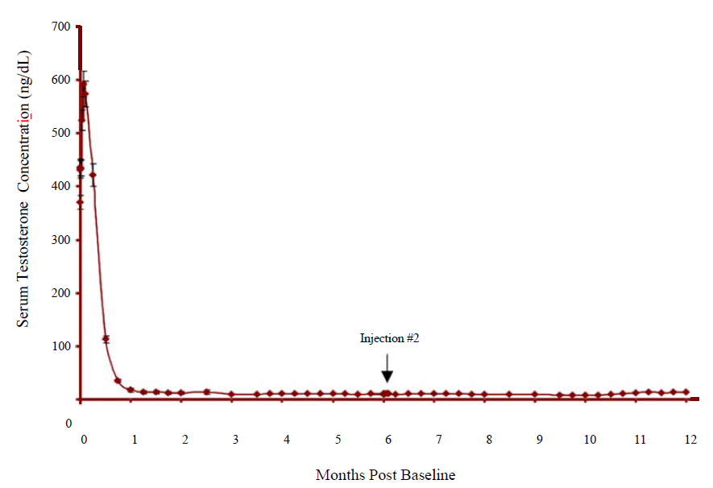

**Figure 1 d:** ELIGARD 6 month mean serum testosterone concentrations (n = 103)

Serum PSA decreased in all patients whose baseline values were elevated above the normal limit. Mean values were reduced 94% from baseline to month 6 for ELIGARD 1 month, 98% from baseline to month 6 for ELIGARD 3 month, 86% from baseline to month 8 for ELIGARD 4 month and 97% from baseline to month 12 for ELIGARD 6 month.

At month 6, PSA levels had decreased to within normal limits in 94% of patients who presented with elevated levels at baseline for ELIGARD 1 month. At month 6, PSA levels had decreased to within normal limits in 91% of patients who presented with elevated levels at baseline for ELIGARD 3 month. At month 8, PSA levels had decreased to within normal limits in 93% of patients who presented with elevated levels at baseline for ELIGARD 4 month. At month 12, PSA levels had decreased to within normal limits in 95% of patients who presented with elevated levels at baseline for ELIGARD 6 month.

Other secondary efficacy endpoints evaluated included WHO performance status, bone pain, urinary pain and urinary signs and symptoms.

At baseline, 88% of patients using ELIGARD 1 month, 94% of patients using ELIGARD 3 month, 90% of patients using ELIGARD 4 month and 90% of patients using ELIGARD 6 month were classified as “fully active” by the WHO performance status scale (Status=0). Eleven percent of patients using ELIGARD 1 month, 6% of patients using ELIGARD 3 month, 10% of patients using ELIGARD 4 month and 7% of patients using ELIGARD 6 month were “restricted in strenuous activity but ambulatory and able to carry out work of a light or sedentary nature” (Status=1). Three percent of patients using ELIGARD 6 month were classified as “ambulatory but unable to carry out work activities” (Status 2).

These percentages were unchanged at month 6 for ELIGARD 1 month. At month 6, 96% of patients using ELIGARD 3 month, 87% of patients using ELIGARD 4 month at month 8 and 94% of patients using ELIGARD 6 month at month 12 were classified as “fully active” by the WHO performance status scale (Status=0). Four percent of patients using ELIGARD 3 month at month 6, 12% of patients using ELIGARD 4 month at month 8 and 5% of patients using ELIGARD 6 month at month 12 were “restricted in strenuous activity but ambulatory and able to carry out work of a light or sedentary nature” (Status=1). One percent of patients using ELIGARD 4 month at month 8 and 1% of patients using ELIGARD 6 month at month 12 were “ambulatory but unable to carry out work activities” (Status 2).

At baseline and at month 6 for ELIGARD 1 month and ELIGARD 3 month, at month 8 for ELIGARD 4 month and at month 12 for ELIGARD 6 month, patients experienced little bone pain. Urinary pain was also low both at baseline and at month 6, 8 or 12, respectively. Urinary signs and symptoms were similarly low at baseline and decreased modestly for ELIGARD 1 month, ELIGARD 4 month, and ELIGARD 6 month at month 6, 8 or 12, respectively. Urinary signs and symptoms were similarly low at baseline and increase modestly for ELIGARD 3 month at month 6. In addition, there was a reduction in patients with prostate abnormalities detected during physical exam from 102 (85%) at Screening to 77 (64%) at month 6 for ELIGARD 1 month, from 96 (82%) at Screening to 76 (65%) at month 6 for ELIGARD 3 month, from 66 (73%) at Screening to 54 (60%) at month 8 for ELIGARD 4 month and from 89 (80%) at Screening to 60 (58%) at month 12 for ELIGARD 6 month.

#### ELIGARD in combination with radiotherapy

Evidence for the indication of high-risk localised prostate cancer is based on published studies of radiotherapy combined with androgen deprivation therapy (ADT). The ADT included LH-RH agonists, including leuprorelin acetate given at various dosing regimens in the neoadjuvant, concomitant and adjuvant settings, but also clinical experience of nonsteroidal antiandrogens as well as surgical castration.

Clinical data from 8 published studies was analysed for efficacy (Mottet et al., Eur Urol. 2012, Widmark et al., Lancet 2009, Heymann et al., J Clin Oncol. 2007, Solberg et al., I J Radiation Oncol. Biol. Phys. 2011, Nguyen et al., Cancer 2013, Stone et al., Mol Urol. 2000, Stone et al., Mol Urol. 1999, Zelefsky et al., Urology 1997) which demonstrated a clinical benefit for the combination of ADT with radiotherapy, compared to ADT alone. Clear differentiation of the respective study populations for the indications of locally advanced prostate cancer and high-risk prostate cancer was not possible in all the published studies.

### *Central Precocious Puberty*

The efficacy of ELIGARD 6 month was evaluated in an uncontrolled, open-label, single arm clinical trial in which 64 paediatric patients (62 females and 2 males, naïve to previous GnRH agonist treatment) with CPP received at least one dose of ELIGARD 6 month at a dosing interval of 24 weeks and were observed for 12 months. The mean age was 7.5 years (range 4 to 9 years) at the start of treatment. In paediatric patients with CPP, ELIGARD reduced stimulated and basal gonadotropins to prepubertal levels. Suppression of peak stimulated LH concentrations to <4 IU/L was achieved in 87% of paediatric patients by month 6 and in 86% of patients by month 12. Suppression of oestradiol or testosterone concentration to prepubertal levels at the 6-month assessment was achieved in 97% and 100% of patients, respectively. Suppression of oestradiol or testosterone was maintained at the 12-month assessment with 98% (55/56 females) and 50% (1/2 males) maintaining suppression. ELIGARD arrested or reversed progression of clinical signs of puberty with reductions in growth velocity and bone age. Mean growth velocity decreased from 8.9 ± 13.1 cm/yr at 1 month to 6.9 ± 3.1 cm/yr at 6 months and to 6.4 ± 1.9 cm/yr at 12 months.

**Table 6:** Reproductive Hormone Levels in Paediatric Patients with CPP Treated with ELIGARD45 mg Every 6 Monthsa

|  |  |  |  |  |
| --- | --- | --- | --- | --- |
| **Endpointb** | **% (n/N) of Patients Achieving Endpoints** | | | |
| **Month 3** | **Month 6** | **Month 9** | **Month 12** |
| LH levels < 4 IU/L | 85 (51/60) | 87 (54/62)c | 85 (50/59) | 86 (50/58) |
| Oestradiol levels < 73.4 pmol/L (< 20 pg/mL) | 98 (56/57) | 97 (58/60) | 98 (56/57) | 98 (55/56) |
| Testosterone levels < 1 nmol/L (< 28.4 ng/dL) | 100 (2/2) | 100 (2/2) | 100 (2/2) | 50 (1/2) |
| FSH levels < 2.5 IU/L | 62 (37/60) | 66 (41/62) | 44 (26/59) | 55(32/58) |

aIntent-to-treat Population (N=62)

bPost GnRH agonist stimulation

cPrimary Efficacy Endpoint

Eight female patients out of 62 did not meet the primary efficacy criteria for LH <4 IU/L at 6 months. In four of the eight patients, the LH level at 6 months was between 4.2 and 4.8 IU/L. The remaining four patients had LH levels >5 IU/L. However, post stimulation oestradiol was suppressed to prepubertal levels (<20 pg/mL) in seven of the eight patients at month 6 and was maintained through month 12.

## Pharmacokinetic properties

### Absorption

The absorption pharmacokinetic parameters determined for ELIGARD are presented in Table 7.

**Table 7:** Absorption pharmacokinetic parameters for ELIGARD

|  |  |  |
| --- | --- | --- |
| **Presentation of ELIGARD** | **Cmax ± SD(ng/mL)** | **Tmax ±** **SD (hours)** |
| 1 month | 25.3 ± 11.3 | 4.7 ± 1.4 |
| 3 month * | 127 ± 39 | 4.6 ± 1.6 |
| 3 month** | 107 ± 50 | 4.5 ± 1.5 |
| 4 month * | 150 ± 77 | 3.3 ± 1.2 |
| 4 month** | 192 ± 107 | 3.0 ± 1.0 |
| 6 month | 102.4 ± 72.1 | 4.75 ± 2.0 |

* first dose

** second dose

After the initial increase following each injection, mean serum concentrations remained relatively constant; 0.28 – 2.0 ng/mL for ELIGARD 1 month, 0.2 – 2.0 ng/mL for ELIGARD 3 month, 0.1 – 1.0 ng/mL for ELIGARD 4 month and 0.2 – 2.0 ng/mL for ELIGARD 6 month. There was no evidence of significant accumulation during repeated dosing. Non-detectable leuprorelin serum concentrations have been observed during chronic ELIGARD administration, but testosterone levels were maintained at castrate levels.

#### Central Precocious Puberty

After an initial subcutaneous injection of ELIGARD 45 mg in paediatric patients 4 to 9 years of age with CPP, leuprorelin levels peaked 4 hours post dose with a mean Cmax of 212.3 ng/mL. Absorption occurred in two phases, a burst phase followed by a plateau phase. The mean plateau serum leuprorelin level from 4 to 48 weeks was approximately 0.37 ng/mL with a range of 0.18 to 0.63 ng/mL. There was no accumulation of leuprorelin after the second dose.

### Distribution

The mean steady-state volume of distribution of leuprorelin following intravenous bolus administration to healthy male volunteers was 27 L.

*In vitro* binding to human plasma proteins ranged from 43% to 49%.

The distribution of leuprorelin following ELIGARD administration was not evaluated in paediatric patients.

### Metabolism

In healthy male volunteers, a 1 mg bolus of leuprorelin administered intravenously revealed that the mean systemic clearance was 7.6 L/h, with a terminal elimination half-life of approximately 3 hours based on a two compartment model.

Drug metabolism studies were not conducted with ELIGARD. Upon administration with different leuprorelin acetate formulations, the major metabolite of leuprorelin acetate is a pentapeptide (M-1) metabolite.

### Excretion

Drug excretion studies were not conducted with ELIGARD.

### Special populations

#### Geriatrics

The majority of the patients (approximately 70%) studied in these clinical trials were age 70 and older.

#### Paediatrics

The safety and effectiveness of ELIGARD 7.5mg 1 Month,22.5mg 3 Month and 30mg 4 Month in paediatric patients have not been established (see Section 4.3 CONTRAINDICATIONS).

#### Renal and hepatic insufficiency

The pharmacokinetics of ELIGARD in hepatically and renally impaired adult and paediatric patients have not been determined.

## Preclinical safety data

### Genotoxicity

Mutagenicity studies have been performed with leuprorelin acetate using bacterial and mammalian systems and with ELIGARD 1 month in bacterial systems. These studies provided no evidence of a genotoxic potential.

### Carcinogenicity

Two-year carcinogenicity studies were conducted with leuprorelin acetate in rats and mice. In rats, a dose-related increase of benign pituitary hyperplasia and benign pituitary adenomas was noted at 24 months when the drug was administered subcutaneously at high daily doses (0.6 to 4 mg/kg). There was a significant but not dose-related increase of pancreatic islet-cell adenomas in females and of testicular interstitial cell adenomas in males (highest incidence in the low dose group). In mice, no leuprorelin acetate-induced tumors or pituitary abnormalities were observed at a dose as high as 60 mg/kg for two years. Patients have been treated with leuprorelin acetate for up to three years with doses as high as 10 mg/day and for two years with doses as high as 20 mg/day without demonstrable pituitary abnormalities.

No carcinogenicity studies have been conducted with ELIGARD in paediatric use.

# Pharmaceutical particulars

## List of excipients

Refer to Section 2 - Qualitative and quantitative composition.

## Incompatibilities

Incompatibilities were either not assessed or not identified as part of the registration of this medicine.

## Shelf life

In Australia, information on the shelf life can be found on the public summary of the Australian Register of Therapeutic Goods (ARTG). The expiry date can be found on the packaging.

## Special precautions for storage

ELIGARD should be stored below 8°C (refrigerate). The patient may store ELIGARD below 25°C in intact packaging for a period of 8 weeks prior to administration.

## Nature and contents of container

ELIGARD is available in a single use kit. The kit consists of a two-syringe mixing system, a 20-gauge 5/8 inch needle (for ELIGARD 1 month, ELIGARD 3 month and ELIGARD 4 month) or a 18-gauge 5/8-inch needle (for ELIGARD 6 month), a silica desiccant pouch to control moisture uptake, and package insert for constitution and administration procedures. Each syringe is individually packaged. Syringe B, made of cyclic olefin copolymer and sealed with a chlorobutyl closure, contains aseptically filled, lyophilized leuprorelin acetate. Syringe A, constructed of polypropylene and sealed with a polypropylene or polyethylene cap, contains the Atrigel® Delivery System.

## Special precautions for disposal

In Australia, any unused medicine or waste material should be disposed of in accordance with local requirements.

## Physicochemical properties

Leuprorelin acetate is a white to near white powder, freely soluble in water and glacial acetic acid.

### Chemical structure

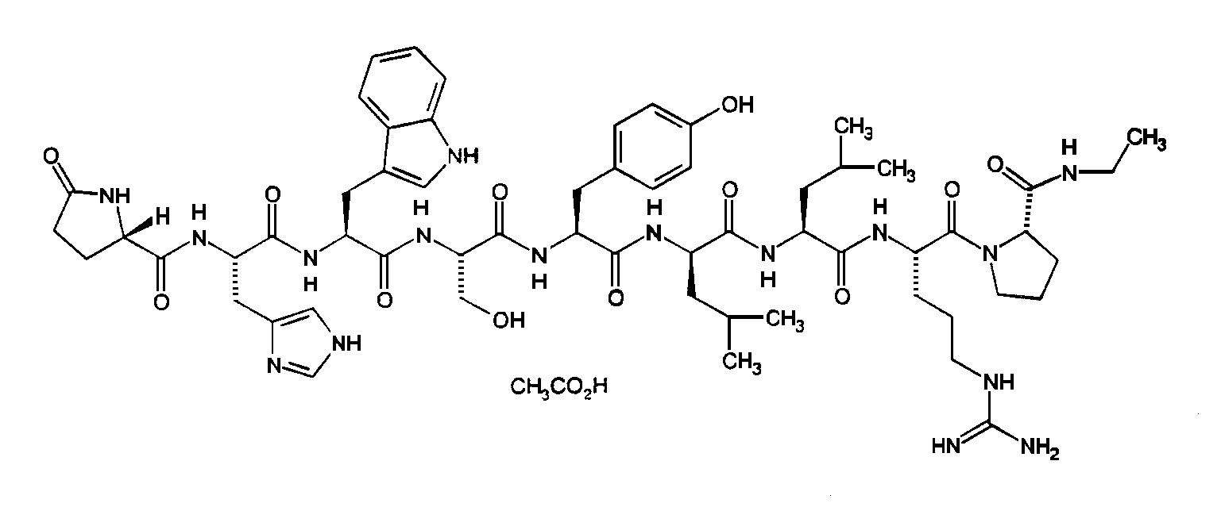

**Chemical name:** 5-oxo-L-prolyl-L-histidyl- L-tryptophyl-L-seryl-L-tyrosyl-D-leucyl-L-leucyl-L-arginyl-N-ethyl-L-prolinamide acetate (salt)

### CAS number

74381-53-6

# Medicine schedule (Poisons Standard)

Schedule 4

# Sponsor

Mundipharma Pty Limited

ABN 87 081 322 509

10 Carrington Street

SYDNEY NSW 2000

Further information may be obtained from Mundipharma’s Medical Information Department 1800 188 009.

# Date of first approval

26 November 2003

# Date of revision

11 July 2022

## Summary table of changes

|  |  |
| --- | --- |
| Section Changed | Summary of new information |
| All | |  | | --- | | Updated with information relating to new indication for Central Precocious Puberty | |

® ELIGARD and ATRIGEL are trademarks of Tolmar Therapeutics, Inc. used under licence.

ELIGARD PI v1 (CCDS 17)

1. Not indicated for BI ELIGARD® CP combination pack