|  |
| --- |
| February 2023 |

|  |
| --- |
| Australian Public Assessment Report for Padcev |
| Active ingredients: Enfortumab vedotin |
| Sponsor: Astellas Pharma Australia Pty Ltd |

About the Therapeutic Goods Administration (TGA)

* The Therapeutic Goods Administration (TGA) is part of the Australian Government Department of Health and Aged Care and is responsible for regulating therapeutic goods, including medicines, medical devices, and biologicals.
* The TGA administers the *Therapeutic Goods Act 1989* (the Act), applying a risk management approach designed to ensure therapeutic goods supplied in Australia meet acceptable standards of quality, safety, and efficacy.
* The work of the TGA is based on applying scientific and clinical expertise to decision-making, to ensure that the benefits to the Australian public outweigh any risks associated with the use of therapeutic goods.
* The TGA relies on the public, healthcare professionals and industry to report problems with therapeutic goods. The TGA investigates reports received to determine any necessary regulatory action.
* To report a problem with a therapeutic good, please see the information on the [TGA website](https://www.tga.gov.au).

About AusPARs

* The Australian Public Assessment Report (AusPAR) provides information about the evaluation of a prescription medicine and the considerations that led the TGA to approve or not approve a prescription medicine submission. Further information can be found in [Australian Public Assessment Report (AusPAR) guidance](https://www.tga.gov.au/australian-public-assessment-report-auspar-guidance).
* AusPARs are prepared and published by the TGA.
* AusPARs are static documents that provide information that relates to a submission at a particular point in time. The publication of an AusPAR is an important part of the transparency of the TGA’s decision-making process.
* A new AusPAR may be provided to reflect changes to indications or major variations to a prescription medicine subject to evaluation by the TGA.

Copyright

© Commonwealth of Australia 2023  
This work is copyright. You may reproduce the whole or part of this work in unaltered form for your own personal use or, if you are part of an organisation, for internal use within your organisation, but only if you or your organisation do not use the reproduction for any commercial purpose and retain this copyright notice and all disclaimer notices as part of that reproduction. Apart from rights to use as permitted by the *Copyright Act 1968* or allowed by this copyright notice, all other rights are reserved, and you are not allowed to reproduce the whole or any part of this work in any way (electronic or otherwise) without first being given specific written permission from the Commonwealth to do so. Requests and inquiries concerning reproduction and rights are to be sent to the TGA Copyright Officer, Therapeutic Goods Administration, PO Box 100, Woden ACT 2606 or emailed to <[tga.copyright@tga.gov.au](mailto:tga.copyright@tga.gov.au)>.

Contents

List of abbreviations 4

Product submission 6

Submission details 6

Product background 7

Regulatory status 9

Product Information 11

Registration timeline 12

Submission overview and risk/benefit assessment 12

Quality 12

Nonclinical 15

Clinical 17

Risk management plan 52

Risk-benefit analysis 53

Outcome 57

Specific conditions of registration applying to these goods 57

Attachment 1. Product Information 58

## List of abbreviations

|  |  |  |
| --- | --- | --- |
| Abbreviation | | Meaning |
| ACM | Advisory Committee on Medicines | |
| AE | Adverse event | |
| ASA | Australia specific annex | |
| CI | Confidence interval | |
| CMI | Consumer Medicines Information | |
| CPI | Checkpoint inhibitor | |
| CPD | Certified product details | |
| CYP3A4 | Cytochrome P450 isoenzyme 3A4 | |
| DLP | Data lock point | |
| ECOG | Eastern Cooperative Oncology Group | |
| ESMO | European Society of Medical Oncology | |
| EU | European Union | |
| HbA1C | Glycated haemoglobin | |
| MMAE | Monomethyl auristatin E | |
| PD-1 | Programmed death receptor 1 | |
| PD-L1 | Programmed death-ligand 1 | |
| PI | Product Information | |
| PK | Pharmacokinetic(s) | |
| PSUR | Periodic safety update reports | |
| RECIST | Response Evaluation Criteria in Solid Tumours | |
| RDI | Relative dose intensity | |
| RMP | Risk management plan | |
| SAE | Serious adverse event | |
| TEAE | Treatment-emergent serious adverse event | |
| TGA | Therapeutic Goods Administration | |
| ULN | Upper limit of normal | |
| USA | United States of America | |

## Product submission

### Submission details

|  |  |
| --- | --- |
| *Type of submission:* | New biological entity |
| *Product name:* | Padcev |
| *Active ingredient:* | Enfortumab vedotin |
| *Decision:* | Approved |
| *Date of decision:* | 30 June 2022 |
| *Date of entry onto ARTG:* | 7 July 2022 |
| *ARTG numbers:* | 355870, 367410 |
| [*Black Triangle Scheme*](https://www.tga.gov.au/black-triangle-scheme)*:* | Yes  This product will remain in the scheme for 5 years, starting on the date the product is first supplied in Australia |
| *Sponsor’s name and address:* | Astellas Pharma Australia Pty Ltd  Suite 2.01, 2 Banfield Road,  Macquarie Park, NSW 2113 |
| *Dose form:* | Powder for injection |
| *Strengths:* | 20 mg and 30 mg (10 mg/mL after reconstitution) |
| *Container:* | Vial |
| *Pack size:* | One |
| *Approved therapeutic use:* | *Padcev as monotherapy is indicated for the treatment of adult patients with locally advanced or metastatic urothelial cancer who have previously received a platinum-containing chemotherapy and a programmed receptor-1 or programmed death-ligand-1 inhibitor.* |
| *Route of administration:* | Intravenous infusion |
| *Dosage:* | The recommended dose of Padcev is 1.25 mg/kg body weight (up to a maximum of 125 mg for patients weighing 100 kg or more) administered as an intravenous infusion over 30 minutes on Days 1, 8 and 15 of a 28 day cycle until disease progression or unacceptable toxicity.  For further information refer to the Product Information. |
| *Pregnancy category:* | D  Drugs which have caused, are suspected to have caused or may be expected to cause, an increased incidence of human fetal malformations or irreversible damage. These drugs may also have adverse pharmacological effects. Accompanying texts should be consulted for further details  The use of any medicine during pregnancy requires careful consideration of both risks and benefits by the treating health professional. This must not be used as the sole basis of decision making in the use of medicines during pregnancy. The TGA does not provide advice on the use of medicines in pregnancy for specific cases. More information is available from obstetric drug information services in your State or Territory. |

### Product background

This AusPAR describes the submission by Astellas Pharma Australia Pty Lt (the sponsor) to register Padcev (enfortumab vedotin) 20 mg and 30 mg powder for injection for the following proposed indication:

*Padcev is indicated for the treatment of adult patients with locally advanced (LA) or metastatic urothelial cancer (mUC) who have received a programmed death receptor-1 (PD-1) or programmed death-ligand 1 (PD-L1) inhibitor and who:*

* *have received a platinum-containing chemotherapy in the neoadjuvant/adjuvant, LA or metastatic setting or*
* *are not eligible for cisplatin-containing chemotherapy.*

#### Condition

The European Society of Medical Oncology (ESMO) clinical practice guidelines;[1] note that urothelial carcinoma is the tenth most common cancer worldwide. The Australian Institute of Health and Welfare estimated 3066 patients would be diagnosed with bladder cancer in 2021. In Australia, the age standardised incidence rate of bladder cancer in 2017 was estimated at 16 cases per 100,000 population in males and 3.9 cases per 100,000 population in females.[2]

More than 90% of urothelial cancers occur in the bladder; 5 to 10% occur in the renal pelvis or the ureters.[3]

Smoking is the most important risk factor for bladder cancer with an attributable risk of approximately 50% of cases. Demographic factors include older age, male sex, White race, occupational exposure to aromatic amines and other environmental exposures, past history and family history (including Lynch syndrome).

The mean age at diagnosis is 73.[4] Approximately 10% to 15% of patients with bladder cancer present with metastasis.[5]

#### Current treatment options

European Society of Medical Oncology guidelines;1 recommend the following approach for advanced metastatic urothelial cancer:

* Cisplatin based chemotherapy combination regimen for those fit enough, followed by maintenance avelumab in those tumours not progressing on chemotherapy.
* Gemcitabine/carboplatin based chemotherapy followed by maintenance avelumab in those tumours not progressing on chemotherapy, for those unfit for cisplatin.[6]
* Atezolizumab or pembrolizumab as alternatives for patients with programmed death ligand 1 (PD-L1) biomarker positive tumours who are not eligible for cisplatin based combination chemotherapy.
* In the relapsed advanced or metastatic urothelial setting after platinum based chemotherapy: options include pembrolizumab (or atezolizumab), erdafitinib (in tumours with fibroblast growth factor receptor alterations,[7] chemotherapy or single agent taxane or vinflunine.

For patients with locally advanced or metastatic disease who have previously received platinum chemotherapy and immunotherapy with PD-L1/ programmed death receptor 1 (PD-1) targeting agents currently have limited treatment options. Vinflunine is mentioned as an option in literature however it is no longer registered in Australia, and taxanes, while registered in Australia, do not have specific indications for use in urothelial cancer.

In this setting enfortumab vedotin had been introduced into the ESMO 2021 guidelines.1

Alternatives to the recommended regimens are provided in other guidelines, for example UpToDate notes gemcitabine/paclitaxel or carboplatin/gemcitabine/paclitaxel are alternative chemotherapy regimens for cisplatin ineligible patients.[8]

#### Enfortumab vedotin

Nectin-4 is one of a family of calcium independent immunoglobulin like cellular adhesion molecules that are important for cell adhesion, differentiation, proliferation, and migration. Weak to moderate expression occurs in a range of normal tissue. Over expression of Nectin-4 is found in a variety of tumours including urothelial, non-small cell lung cancer, pancreatic, breast, ovarian and colorectal cancers.

Enfortumab vedotin is a Nectin-4 targeted antibody drug conjugate comprised of a fully human anti Nectin-4 immunoglobulin G1 kappa monoclonal antibody conjugated to the small molecule microtubule disrupting agent monomethyl auristatin E (MMAE) via a protease cleavable maleimidocaproyl valine citrulline linker. Its mechanism of action is depicted in Figure 1.

Figure 1: Enfortumab vedotin mechanism of action

Source: Seattle Genetics, Inc, 2016. ( Astellas (the sponsor) is developing enfortumab vedotin in collaboration with Seattle Genetics.
Enfortumab vedotin is an antibody drug conjugate composed of an IgG1 anti-Nectin-4 antibody conjugated to a microtubule-disrupting agent monomethyl auristatin E (MMAE). MMAE is attached to the antibody via a protease cleavable linker.
1. Nectin-4 is highly expressed in urothelial carcinoma. The anti-Nectin-4 antibody binds to Nectin-4 antigen on the surface of Nectin-4 expressing cells forming a complex.
2. The complex is internalised within the cell and is trafficked to lysosome.
3. MMAE is released by proteolytic cleavage of the valine-cituline linker.
4. Intracellular release of MMAE. MMAE binds to the microtubules, disrupting the cellular microtubule network by halting tubulin polymerisation.
5. Subsequent arrest of G2/M phase cell cycle and apoptosis of cell. MMAE released from enfortumab vedotin targeted cells can diffuse into nearby Nectin-4 low-expressing cells resulting in cytotoxic cell death


Source: Seattle Genetics, Inc, 2016. (Astellas (the sponsor) is developing enfortumab vedotin in collaboration with Seattle Genetics (SeaGen)).

Enfortumab vedotin is an antibody drug conjugate composed of an IgG1 anti-Nectin-4 antibody conjugated to a microtubule-disrupting agent monomethyl auristatin E (MMAE). MMAE is attached to the antibody via a protease cleavable linker.

1. Nectin-4 is highly expressed in urothelial carcinoma. The anti-Nectin-4 antibody binds to Nectin-4 antigen on the surface of Nectin-4 expressing cells forming a complex.

2. The complex is internalised within the cell and is trafficked to lysosome.

3. MMAE is released by proteolytic cleavage of the valine-citrulline linker.

4. Intracellular release of MMAE. MMAE binds to the microtubules, disrupting the cellular microtubule network by halting tubulin polymerisation.

5. Subsequent arrest of G2/M phase cell cycle and apoptosis of cell. MMAE released from enfortumab vedotin targeted cells can diffuse into nearby Nectin-4 low-expressing cells resulting in cytotoxic cell death

This evaluation was facilitated through [Project Orbis](https://www.tga.gov.au/project-orbis), an initiative of the United States (US) Food and Drug Administration (FDA) Oncology Center of Excellence (OCE). Under this project, the FDA, Health Canada, and the TGA collaboratively reviewed the submission. This evaluation process provided a framework for process alignment and management of evaluation issues in real-time across jurisdictions. Each regulator made independent decisions regarding approval (market authorisation) of the new medicine.

### Regulatory status

This product is considered a new biological entity for Australian regulatory purposes.

At the time the TGA considered this submission, a similar submission had been approved in the United States of America (USA) in December 2019 via the accelerated approval program, and on 9 July 2021 received regular (full) approval in the USA. Submissions were also approved in Canada in October 2021 and in Switzerland in November 2021. In the European Union (EU) the European Medicines Agency (EMA) Committee for Medicinal Products for Human Use positive opinion was adopted by the European Union (EU) in December 2021 and readopted in February 2022. A similar submission was under consideration in the United Kingdom (submitted in December 2021).

The following table summarises these submissions and provides the indications where approved.

Table 1: International regulatory status

|  |  |  |  |
| --- | --- | --- | --- |
| Region | Submission date | Status | Approved indications |
| United States of America | July 2019 | Approved December 2019 (this indication is approved under the FDA’s accelerated approval program based on overall response rate) | *Padcev is a Nectin-4-directed antibody and microtubule inhibitor conjugate indicated for the treatment of adult patients with locally advanced or metastatic urothelial cancer who have previously received a programmed death receptor-1 (PD-1) or programmed death ligand 1 (PD-L1) inhibitor, and a platinum containing chemotherapy in the neoadjuvant/adjuvant, locally advanced or metastatic setting.* |
| United States of America | February 2021 | Approved July 2021 (regular approval) | *Padcev is a Nectin-4 directed antibody and microtubule inhibitor conjugate indicated for the treatment of adult patients with locally advanced or metastatic urothelial cancer who:*   * *have previously received a programmed death receptor-1 (PD-1) or programmed death-ligand 1 (PD-L1) inhibitor and platinum-containing chemotherapy, or* * *are ineligible for cisplatin-containing chemotherapy and have previously received one or more prior lines of therapy.* |
| Canada | April 2021 | Approved October 2021 | *Padcev (enfortumab vedotin for injection) is indicated for the treatment of adult patients with unresectable locally advanced or metastatic urothelial cancer (mUC) who have previously received a platinum containing chemotherapy and programmed death receptor-1 (PD-1) or programmed death ligand 1 (PD-L1) inhibitor therapy.* |
| Switzerland | March 2021 | Approved November 2021 | *Padcev is indicated for the treatment of adults with locally advanced or metastatic urothelial cancer (mUC) who have received a platinum containing chemotherapy in the neoadjuvant/adjuvant locally advanced, or metastatic setting and who have progressed or relapsed during or after treatment with a programmed death receptor-1 (PD-1) or programmed death ligand 1 (PD-L1) inhibitor (see ‘Clinical Efficacy’).* |
| European Union | March 2021 | EMA’s CHMP positive opinion adopted December 2021 and readopted February 2022 | *Padcev as monotherapy is indicated for the treatment of adult patients with locally advanced or metastatic urothelial cancer who have previously received a platinum containing chemotherapy and a programmed death receptor-1 or programmed death-ligand 1 inhibitor (see section 5.1).* |
| United Kingdom | December 2021 | Under consideration | Under consideration |

Abbreviations: CHMP = Committee for Medicinal Products for Human Use; EMA = European Medicines Agency (European Union); FDA = Food and Drug Administration (United States of America).

### Product Information

The Product Information (PI) approved with the submission which is described in this AusPAR can be found as Attachment 1. For the most recent PI, please refer to the TGA [PI/CMI search facility.](https://www.tga.gov.au/picmi-search-facility)

## Registration timeline

The following table captures the key steps and dates for this submission.

Table 2: Timeline for Submission PM-2021-00635-1-4

|  |  |
| --- | --- |
| Description | Date |
| Submission dossier accepted and first round evaluation commenced | 1 April 2021 |
| First round evaluation completed | 31 August 2021 |
| Sponsor provides responses on questions raised in first round evaluation | 30 September 2021 |
| Second round evaluation completed | 22 June 2022 |
| Delegate’s Overall benefit-risk assessment and request for Advisory Committee advice | 5 January 2022 |
| Sponsor’s pre-Advisory Committee response | 17 January 2022 |
| Advisory Committee meeting | 3 and 4 February 2022 |
| Registration decision (Outcome) | 30 June 2022 |
| Completion of administrative activities and registration on the ARTG | 7 July 2022 |
| Number of working days from submission dossier acceptance to registration decision* | 240 |

*Statutory timeframe for standard submissions is 255 working days

## Submission overview and risk/benefit assessment

This section is a TGA summary of wording used in TGA’s evaluation report, which discussed numerous aspects of overseas evaluation reports and included some information that was commercial-in-confidence.

### Quality

#### Enfortumab vedotin drug structure

The enfortumab antibody intermediate is a fully human monoclonal antibody with two heavy chain gamma 1 subclass and two light chain kappa class.

The anti-mitotic agent, monomethyl auristatin E (MMAE), is a synthetic analogue of dolastatin 10, a naturally occurring product originally isolated from the sea hare *Dolabella auricularia*. MMAE is covalently bonded to enfortumab antibody intermediate through a protease cleavable linker (maleimidocaproyl valine-citrulline). The linker was designed to be cleaved by lysosomal proteases, resulting in the release of free MMAE, p-aminobenzyl alcohol, carbon dioxide (CO2), and the antibody containing a fragment of the linker.

The linker drug is bound to the reduced interchain cysteine disulfide bonds of the antibody heavy and light chains through a thioether bond between the linker maleimide and the cysteine thiol group. Enfortumab vedotin has 3.8 linked MMAE moieties per antibody.

A representation of the skeletal structure of enfortumab vedotin is shown in Figure 2, below.

Figure 2: Enfortumab vedotin structure

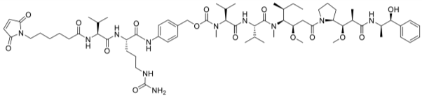

#### Linker drug component

The evaluator concluded the manufacture and control of the valine-citrulline-MMAE drug-linker component (known as SGD‑1006) have been extensively documented and are considered acceptable.

The intermediate SGD-1006 consists of an enzyme cleavable linker and the antimitotic peptide MMAE.

SGD-1006 has 12 chiral carbon centres (10 from MMAE, 2 from the linker). SGD-1006 is defined as a single stereoisomer. The chirality is introduced through chiral starting materials. SGD-1006 is manufactured under non-sterile conditions in a six stage convergent, solution phase, fragment based peptide synthesis.

The starting materials are custom made or commercially available. Specifications for the six starting materials were provided. Synthetic routes were given for preparation of each of the six starting materials.

Manufacturing details, analytical methods and validation, and the product specification were reviewed and considered acceptable.

There are six specified impurities. Limits for impurities were considered acceptable. The synthesis does not include nitrates or nitrites. The nitroaromatic compounds produced during the manufacturing process are not completely eliminated but given the likely lifetime exposure the levels are not considered to pose an additional genotoxic to the overall genotoxicity of the drug substance related to MMAE, a known genotoxin.

Two container closure systems are used:

* Borosilicate amber glass vials with rubber stoppers and aluminium crimp seal closures, 5 mL or 30 mL.
* Soda-lime amber glass jars closed with a polytetrafluoroethylene (on product contact side) lined polypropylene screw cap, 30 mL to 1000 mL.

Inert gas is used to fill the container headspace. The closed vial or jar is placed into secondary packaging, either a clear polyethylene bag sealed with a plastic tie or a heat sealed foil/polyethylene bag containing desiccant. A retest period of 36 months when stored in a freezer at -25 to -15 °C is proposed for SGD‑1006.

Thirty six months primary stability data were provided for six production scale batches stored at -20 °C, packaged in vials and in glass jars. The results of stability studies show the chemical stability of SGD-1006 when stored for up to 36 months at -20 °C/ambient relative humidity, or for up to 6 months at 5 °C/ambient relative humidity or 25 °C/60% relative humidity (accelerated conditions). The only significant change observed was in water content, which increased under accelerated and stressed conditions, but did not cause detectable degradation.

#### Monoclonal antibody component

The drug substance component is manufactured using cells form a working cell bank inoculated into cell growth culture media. The production culture is run in a fed batch culture mode with two nutrient feeds during the cultivation to prolong cell growth and support the generation of AGS-22C3 monoclonal antibody intermediate.

Cell culture fluid is clarified with dual stage depth filtration and monoclonal antibody is captured from the harvest filtrate pool by protein A chromatography. The protein A pool is subjected to low pH for a specified duration to attain viral inactivation and then purified by cation exchange chromatography and anion exchange chromatography to remove process related and product related impurities. To ensure viral safety, anion exchange chromatography pool is filtered with a virus removal membrane. Subsequently, the viral filtration pool is concentrated to the target protein concentration and diafiltered to exchange its matrix into formulation buffer using an ultrafiltration/diafiltration system. The formulated ultrafiltration/diafiltration retentate is pumped through a 0.2 µm filter, and then dispensed into labelled bottles. Bottled monoclonal antibody intermediate is stored at less than or equal to -60 °C.

Enfortumab vedotin drug substance manufacturing is initiated by the thawing, pooling, filtering, and pH adjusting of AGS-22C3 monoclonal antibody intermediate. A limited amount of tris (2-carboxyethyl) phosphine is used to partially reduce the interchain disulfide bonds of the monoclonal antibody intermediate. SGD-1006 drug linker intermediate is then added in excess to react with the monoclonal antibody intermediate thiols to form the covalently bonded antibody-drug conjugate. Excess drug linker intermediate is reacted with N-acetyl-L-cysteine to quench the conjugation reaction by converting excess drug linker intermediate to the more stable hydrophilic adduct SGD‑1427. This quenched conjugation reaction solution is concentrated and then purified by diafiltration to remove small molecule impurities and exchanged into the base buffer for formulation. The diafiltered solution is then formulated, filtered, filled into bottles, and frozen.

The drug substance materials undergo in process control testing and in process acceptance criteria testing. All manufacturing steps and analytical procedures are validated.

The sponsor proposed a shelf life for the drug substance of 60 months at -60 °C. Stability data have been generated under real time and stressed conditions. Stability data were generated under real time conditions to characterise the stability profile of the substance and to establish a shelf life. The real time data submitted support a shelf life of 60 months when stored at less than or equal to -60 °C.

#### Finished drug product

The enfortumab vedotin drug product manufacturing process includes drug substance thawing, drug substance pooling and mixing, sterile filtration, aseptic filling, lyophilisation, capping, external vial wash, visual inspection and bulk vial packaging.

The drug product materials undergo in process control testing and in process acceptance criteria testing. All manufacturing steps and analytical procedures are validated.

The Padcev formulation includes histidine, histidine hydrochloride monohydrate, trehalose dihydrate, and polysorbate 20 as excipients.

It is to be reconstituted in sterile water for injection and diluted into an intravenous infusion bag containing 5% dextrose injection, sterile 0.9% sodium chloride or sterile lactated Ringer’s injection. The final concentration of enfortumab vedotin is 0.3 to 4 mg/mL.

The recommended shelf life is 24 months when stored at 2 to 8 °C. No temperature excursion was requested in the submission.

#### Conclusion

The quality evaluation did not recommend specific conditions of registration based on the primary and secondary evaluations but noted the following regarding laboratory testing and compliance with Certified Product Details (CPD):

* All batches of Padcev supplied in Australia must comply with the product details and specifications approved during evaluation and detailed in the Certified Product Details (CPD).
* When requested by the TGA, the sponsor should be prepared to provide product samples, specified reference materials and documentary evidence to enable the TGA to conduct laboratory testing on the Product. Outcomes of laboratory testing are published biannually in the TGA Database of Laboratory Testing Results <http://www.tga.gov.au/ws-labs-index> and periodically in testing reports on the TGA website.

### Nonclinical

The nonclinical evaluator had no objections on nonclinical grounds to the registration of enfortumab vedotin for the proposed indications.

An adequate set of studies were conducted in general accordance with the relevant guidelines for the nonclinical assessment of anticancer pharmaceuticals and biological medicines (ICH S9 and ICH S6 (R1);[9],[10]).

The sponsor conducted most nonclinical studies with an antibody-drug conjugate produced from an earlier manufacturing process. Based on epitope binding, MMAE to antibody ratio, binding affinity, anti-tumour efficacy and pharmacokinetic parameters, this antibody-drug conjugate was considered acceptable as a surrogate for safety assessments.

*In vitro* enfortumab vedotin bound to human Nectin-4 (but not Nectin-1, 2 or 3) and induced cytotoxicity at clinically relevant concentrations. Cytotoxicity was dependent on the presence of Nectin-4 on target cells and MMAE on the antibody-drug conjugate. Antibody dependent cell mediated cytotoxicity, antibody dependent cellular phagocytosis and complement dependent cytotoxicity are expected to have little to no role in the efficacy of enfortumab vedotin. Based on binding affinity and cytotoxicity, rats and monkeys are considered acceptable species, from a pharmacological perspective, to be used in the toxicity studies. Significant anti-tumour activity was seen in mice bearing human Nectin-4 positive bladder or breast xenografts. These studies offer support for efficacy for the proposed indication.

No adverse effects on the cardiovascular, respiratory, and central nervous systems are predicted during clinical use, based on the available nonclinical data.

Following intravenous administration, the elimination half-life of enfortumab vedotin was long. The clearance of MMAE was affected by its rate of release from enfortumab vedotin. Lower exposures were seen in rats and monkeys in which anti-drug antibodies had been induced. Plasma protein binding by MMAE was moderate in rats and humans and low in monkeys. After cleavage from enfortumab vedotin, MMAE undergoes only limited metabolism, which is predominantly catalysed by cytochrome P450 isoenzyme 3A4 (CYP3A4).[11] Biliary/faecal excretion was the major excretion route of MMAE related material in rats and humans.

Based on *in vitro* studies, MMAE released from enfortumab vedotin is not predicted to alter the pharmacokinetics of co-administered drugs through interactions with cytochrome P450 enzymes or by inhibition of transporters. MMAE is a P‑glycoprotein substrate but is not an *in vitro* substrate for breast cancer resistance protein, multidrug resistance associated protein 2, organic anion transporter family member 1B1, organic anion transporter family member 1B3, organic cation transporter 2, organic anion transporter 1 or organic anion transporter 3. Inhibitors or inducers of CYP3A4/5 and/or P‑glycoprotein may affect MMAE plasma exposure and P-glycoprotein inhibitors may increase the potential for adverse central nervous system effects.

Repeat dose toxicity studies with enfortumab vedotin were examined in rats (up to 13 weeks) and cynomolgus monkeys (4 weeks). As exposures to MMAE in rats and monkeys receiving enfortumab vedotin were significantly lower than those expected in patients, the toxicity of MMAE alone was also examined in monkeys. The major target organs for MMAE were similar to currently registered tubulin acting cytotoxic compounds and included the liver, bone marrow (hypocellularity with consequential effects on most blood cell types), male reproductive organs (seminiferous tubular degeneration and necrosis with hypospermia) and gastrointestinal tract. The toxicity profile of enfortumab vedotin in both rats and monkeys was similar to that for MMAE, but with lower severity, given the lower exposure margins. As these effects occurred at subclinical exposures to MMAE, the findings should be considered as clinically relevant. Pharmacological effects with enfortumab vedotin included skin reactions (scabs, abrasions and/or dry reddened skin, cell necrosis and increased/altered mitosis of epithelial cells), likely due to tissue cross reactivity as Nectin-4 is expressed in the skin. Skin erosion, ulceration, epidermal acanthosis, and subcutaneous mononuclear cell infiltrates were considered secondary to the pharmacological effect of MMAE.

MMAE was not mutagenic in the bacterial mutation assay and the forward mutation assay in mouse lymphoma cells. However, MMAE induced bone marrow toxicity and an increase in micronucleated polychromatic erythrocytes was observed in rats. An aneugenic mode of action was suggested, which is typical for a tubulin acting compound. Parts of the linker are known genotoxins. No carcinogenicity studies were conducted, which is considered acceptable.

Studies on reproductive toxicity were restricted to effects of enfortumab vedotin (pilot) and MMAE (pivotal) on embryofetal developmental in rats. Maximum exposures achieved were below the clinical exposure to MMAE in the pivotal study. Embryofetal lethality (increased incidence of resorptions, pre- and post-implantation loss) and fetal malformations (malrotated limbs, gastroschisis and agnathia) were observed in both studies. The testicular lesions and aneugenic activity of MMAE suggest that enfortumab vedotin may have adverse effects on fertility (both males and females).

The pharmacology studies support the proposed indication for enfortumab vedotin to treat patients with locally advanced or metastatic urothelial cancer. The studies also support the proposed clinical dose.

Inhibitors or inducers of CYP3A4 or P-glycoprotein are likely to alter the plasma kinetics of MMAE, thereby affecting the safety and efficacy profile of the drug.

The toxicity findings with enfortumab vedotin can mostly be attributed to MMAE and are typical for those seen with tubulin acting agents. Notable findings of clinical relevance in the toxicity studies include:

* Reversible myelotoxicity with secondary haematological effects (both anaemia and leukopaenia) associated with MMAE toxicity, indicating a risk for opportunistic infections.
* Gastrointestinal disturbances (diarrhoea, vomiting and nausea).
* Reduced male fertility and effects on the testes, which was not completely reversible after a 24 week treatment free period in rats.
* Reversible hepatotoxicity.
* Embryofetal lethality and fetotoxicity.
* Reversible skin reactions.

Given the effects on the testes, the aneugenic properties of MMAE and the adverse embryofetal effects, together with the long half-life of enfortumab vedotin, a washout period of at least 6 months would be recommended before patients consider becoming pregnant.

### Clinical

#### Summary of clinical studies

The clinical dossier consisted of:

* Three Phase I safety and pharmacokinetic studies (Studies AGS-22M6E-11-1, EV-101, EV-102)
* One Phase II study (Study EV-201)
* One Phase III study (Study EV-301)

#### Pharmacology

##### Pharmacokinetics

Studies AGS-22M6E-11-1, EV-101, EV-102, EV-201 and EV-301 contributed data to the pharmacology analyses.

Key findings from the evaluation of pharmacokinetics include:

* Enfortumab vedotin is given by intravenous infusion.
* The pharmacokinetics (PK) of enfortumab vedotin was characterised by a three compartment model with first order elimination. The PK of free MMAE was characterised by a two compartment model with first order elimination and time varying conversion rate from enfortumab vedotin.
* Population PK analysis indicated that distribution of enfortumab vedotin was limited to the central vascular compartment, with an elimination half-life of approximately 3.6 days (87.2 hours) and minimal accumulation after repeat dosing. The estimated total volume of distribution at steady state (central and peripheral compartments) after a 1.25 mg/kg intravenous dose was 12.8 L, and the estimated clearance was 0.104 L/h.

The model predicted exposures after the first treatment cycle of 1.25 mg/kg enfortumab vedotin dose on Days 1, 8 and 15 in the combined study populations are shown in Table 3.

Table 3: Model predicted exposures Cycle 1 enfortumab vedotin and free monomethyl auristatin E

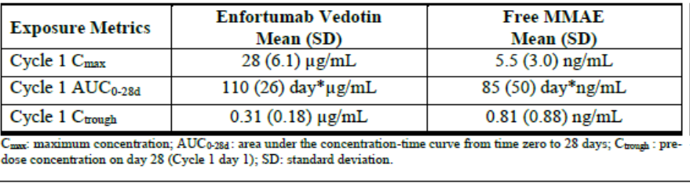

Abbreviations: Cmax = maximum concentration, AUC0-28d = area under the concentration time curve from time zero to 28 days, Ctrough = pre-dose concentration on Day 28 (Cycle 1 Day 1), SD = standard deviation.

Peak enfortumab vedotin concentrations were attained at the end of infusion, and minimal to no accumulation was observed. Enfortumab vedotin has linear dose proportional PK at doses ranging from 0.5 to 1.25 mg/kg when administered as an intravenous infusion over approximately 30 minutes on Days 1, 8, and 15 of a 28 day cycle in subjects with locally advanced or metastatic ulcerative colitis.

Plasma concentrations of free MMAE increased until approximately two days after enfortumab vedotin dosing, and minimal to no accumulation of free MMAE was observed. A small fraction of the MMAE released from enfortumab vedotin is metabolised. *In vitro*, the binding of MMAE to human plasma proteins ranged from 67.9% to 82.2%. It is not likely to displace or to be displaced by highly protein bound drugs. MMAE is metabolised predominantly by CYP3A4;11 and is excreted mainly by hepatobiliary routes.

Monomethyl auristatin E was distributed within central vascular and peripheral tissue compartments with moderate binding to plasma proteins. The PK of MMAE was linear with minimal accumulation after repeat dosing. The elimination of MMAE appeared to be limited by its formation from enfortumab vedotin.

The estimated total volume of distribution at steady state (central and peripheral compartments) after a 1.25 mg/kg intravenous dose of enfortumab vedotin was 183.5 L for MMAE, the estimated free MMAE mean clearance was 2.72 L/h, and the terminal half-life approximately 2.6 days (61.2 hours).

Modelled enfortumab vedotin and MMAE PK in patients with chronic kidney disease were comparable with patients with normal renal function and supported the proposal that no dose adjustment is required. Creatinine clearance was not a significant covariate for enfortumab vedotin PK (see Figure 3).

Figure 3: Comparison of model-predicted Cycle 1 exposures of enfortumab vedotin and free monomethyl auristatin E by renal function categories in the combined population

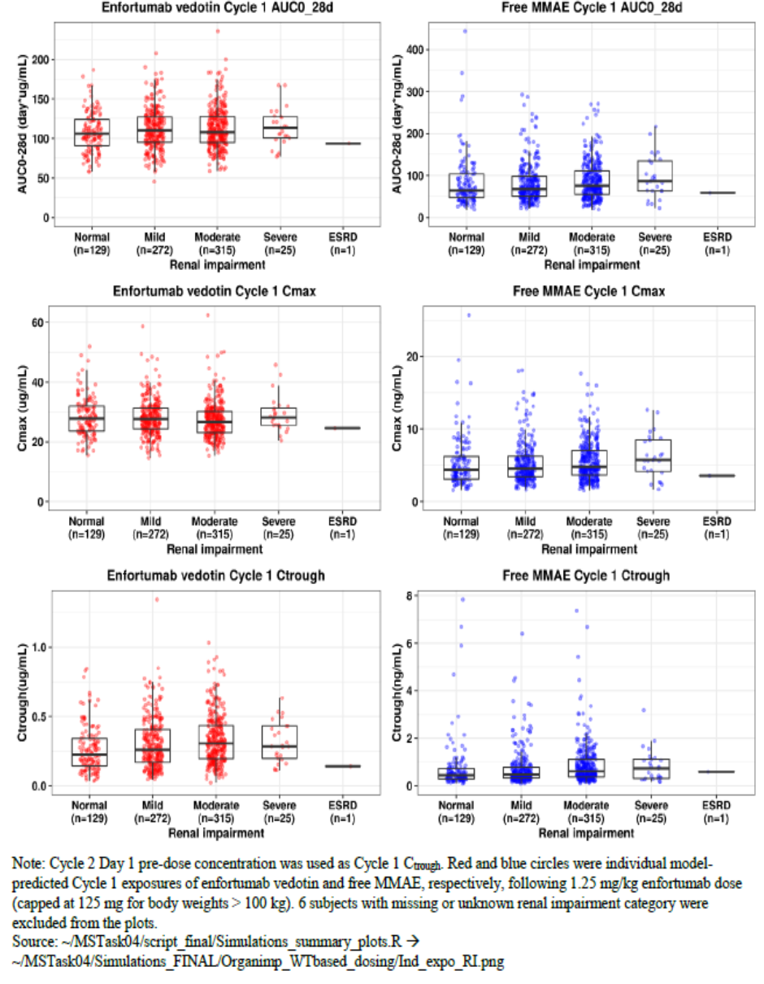

Abbreviations: AUC0-28d = area under the concentration-time curve from time zero (Day 1) to Day 28; Cmax = maximum concentration’ Ctrough = trough (minimum) concentration; ESRF = end stage renal failure; MMAE = Monomethyl auristatin E.

Note: Cycle 2 Day 1 pre-dose concentration was used as Cycle 1 Ctrough. Red and blue circles were individual model predicted Cycle 1 exposures od enfortumab vedotin and free MMAE, respectively, following 1.25 mg/kg enfortumab dose (capped at 125 mg for body weights greater than 100 kg). Six subjects with missing or unknown renal impairment category were excluded from the plots.

Population PK modelling based on data from patients with mild hepatic impairment showed no difference in enfortumab vedotin exposure but a 37% increase in the exposure of free MMAE compared to patients with normal hepatic function. The increased exposure is not considered sufficient to warrant dose reduction (Figure 4). Data from three patients with moderate hepatic impairment and none from patients with severe hepatic impairment limit the conclusions that can be drawn about the kinetics of enfortumab vedotin and MMAE in moderate and severe hepatic impairment.

Figure 4: Comparison of model-predicted Cycle 1 exposures of enfortumab vedotin and free monomethyl auristatin E by hepatic function categories in the combined population

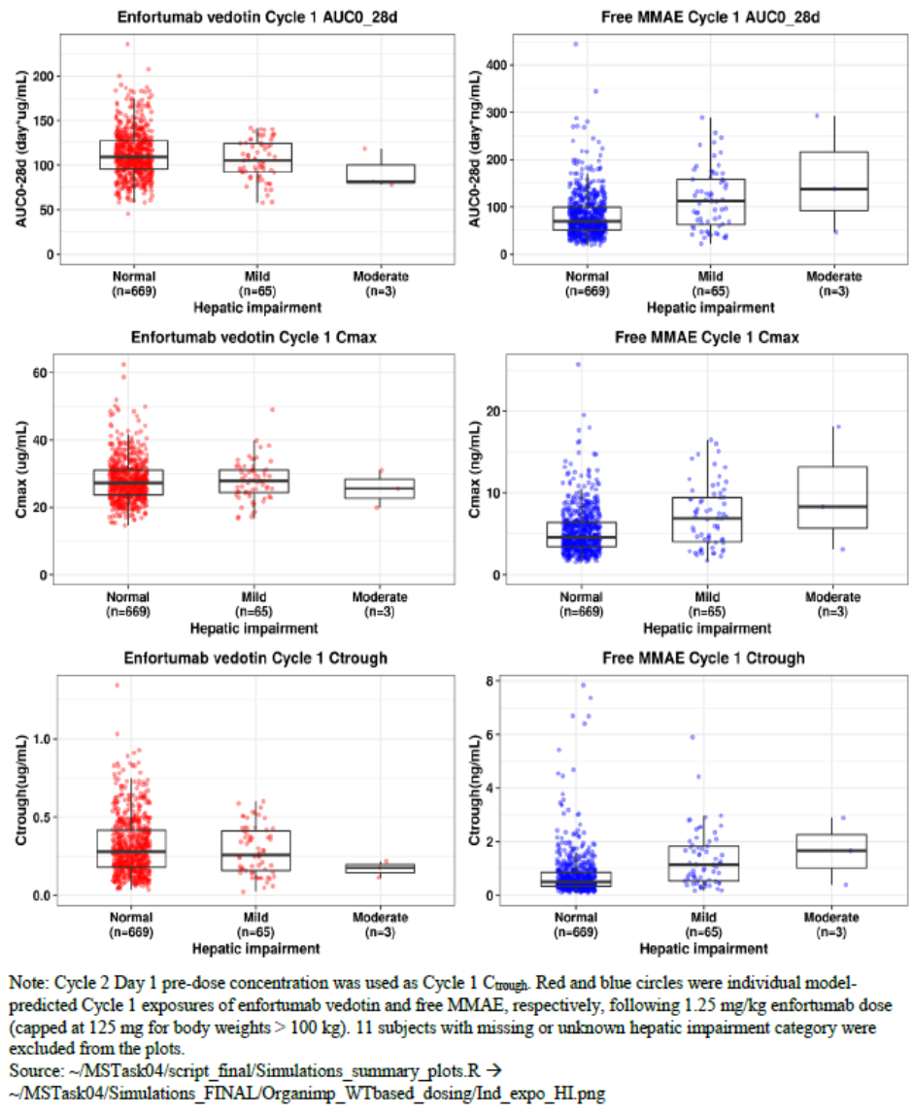

Abbreviations: AUC0-28d = area under the concentration-time curve from time zero (Day 1) to Day 28; Cmax = maximum concentration’ Ctrough = trough (minimum) concentration; ESRF = end stage renal failure; MMAE = Monomethyl auristatin E.

Note: Cycle 2 Day 1 prep-dose concentration was used as Cycle 1 Ctrough. Red and blue circles were individual model predicted Cycle 1 exposures of enfortumab vedotin and free MMAE, respectively, following 1.25 mg/kg enfortumab dose (capped at 125 mg for body weights greater than 100 kg). 11 subjects with missing or unknown hepatic impairment category were excluded from the plots.

No dose adjustment is proposed based on age, race, or sex. Weight based dosing was predicted to result in similar exposures across different body weight quartiles.

Based on physiologically based PK modelling, concomitant use of enfortumab vedotin with ketoconazole (combined P-glycoprotein and strong inhibitor of CYP3A4) is predicted to increase free MMAE exposures by 38%, and the use of strong inducers to reduce free MMAE exposures by 53%. Enfortumab vedotin exposure is not predicted to be impacted by these interactions.

##### Pharmacodynamics

The exposure response relationship is not well established for efficacy for enfortumab vedotin or MMAE, as demonstrated by the efficacy concentration analysis. The linear relationship between the deaths and increasing concentration likely relates to safety. In the lower panels the best overall response does not show a clear exposure response relationship for this measure of efficacy (see Figure 5).

Figure 5: Studies EV-301 and EV-201 Exposure response relationship for efficacy endpoints for enfortumab vedotin and monomethyl auristatin E

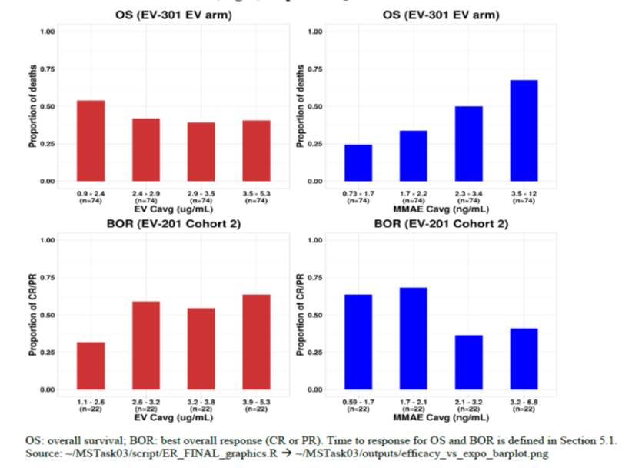

Abbreviations: OS: overall survival, BOR: best overall response (complete response or partial response); Cavg = average concentration; CR: complete response; MMAE: monomethyl auristatin E PR: partial response.

The relationship between overall survival and enfortumab vedotin concentration versus chemotherapy and MMAE concentration versus chemotherapy are illustrated in Figure 6. This shows a similar lack of clarity about the exposure response relationship for enfortumab vedotin concentration but a clear negative relationship between increased MMAE concentration and overall survival.

Figure 6: Modelled probability of overall survival by exposure quartile over time for enfortumab vedotin and monomethyl auristatin E

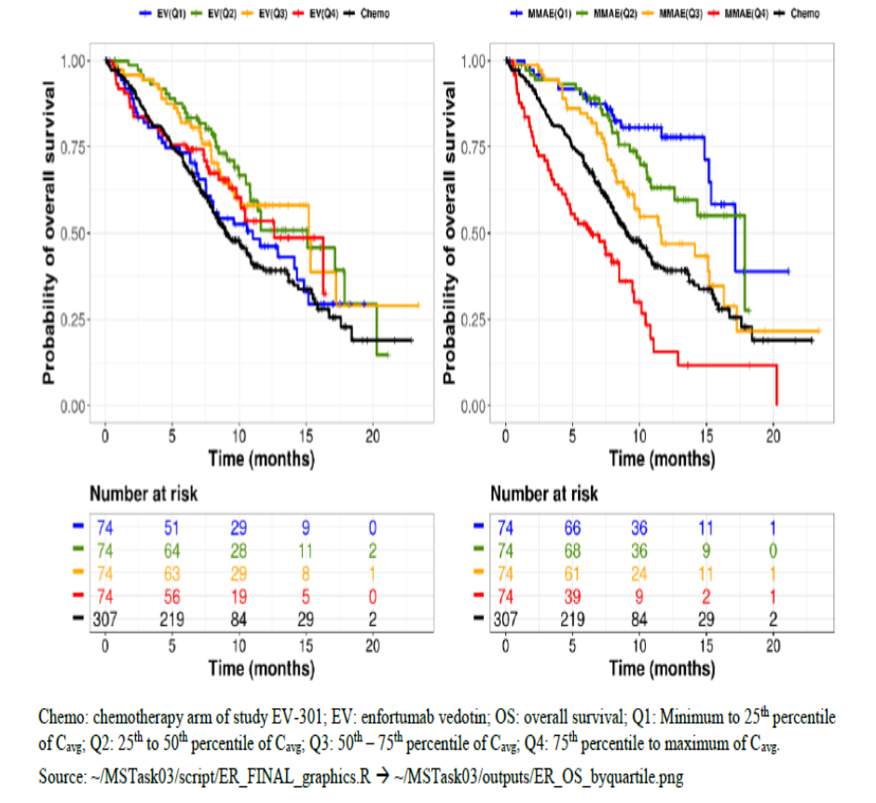

Abbreviations: Cavg = average concentration; Chemo: chemotherapy arm of Study EV-301, EV: enfortumab vedotin, OS: overall survival, Q1: minimum to 25th percentile of Cavg, Q2: 25th to 50th percentile of Cavg, Q3: 50th to 75th percentile of Cavg, Q4: 75th to maximum of Cavg; MMAE: monomethyl auristatin E

There is however a clearer exposure response relationship with safety, with the probability of greater than or equal to Grade 3 events increasing with increasing exposures of enfortumab vedotin,[12] as does the risk of dose interruptions (see Figure 7 and Figure 8). Specific analyses showed the probability of Grade 3 or higher skin reactions and hyperglycaemia increased exponentially with increasing average enfortumab vedotin exposure.

Figure 7: Average exposures of enfortumab vedotin and free monomethyl auristatin E up to the time of event or last dose and the probability of drug related Grade 3 or higher treatment emergent adverse events

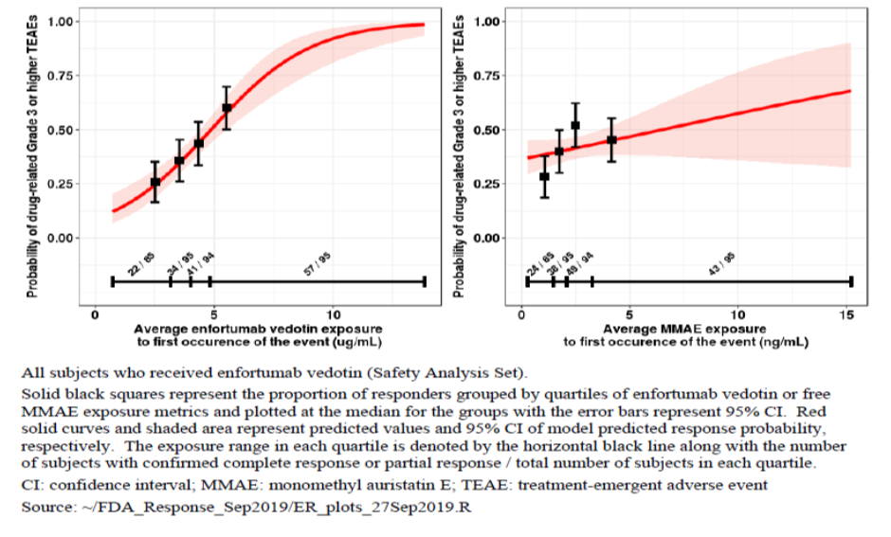

Abbreviations: MMAE = monomethyl auristatin E; TEAE = treatment-emergent adverse event.

Adverse event grading by Common Terminology Criteria for Adverse Events ( CTCAE ), Grade 3 = severe.

All subjects who received enfortumab vedotin (safety analysis set).

Solid black squares represent the proportion of responders grouped by quartiles of enfortumab vedotin or free MMAE exposure metrics and plotted at the median for the groups with the error bars represent 95% confidence interval (CI). Red solid curves and shaded are represent predicted values and 95% CI or model predicted response probability, respectively. The exposure range in each quartile is denoted by horizontal black line along with the number of subjects with confirmed complete response or partial response/ the total number of subjects in each quartile.

Figure 8: Average exposures of enfortumab vedotin and free monomethyl auristatin E up to the time of event or last dose and the probability of dose adjustment due to treatment emergent adverse events

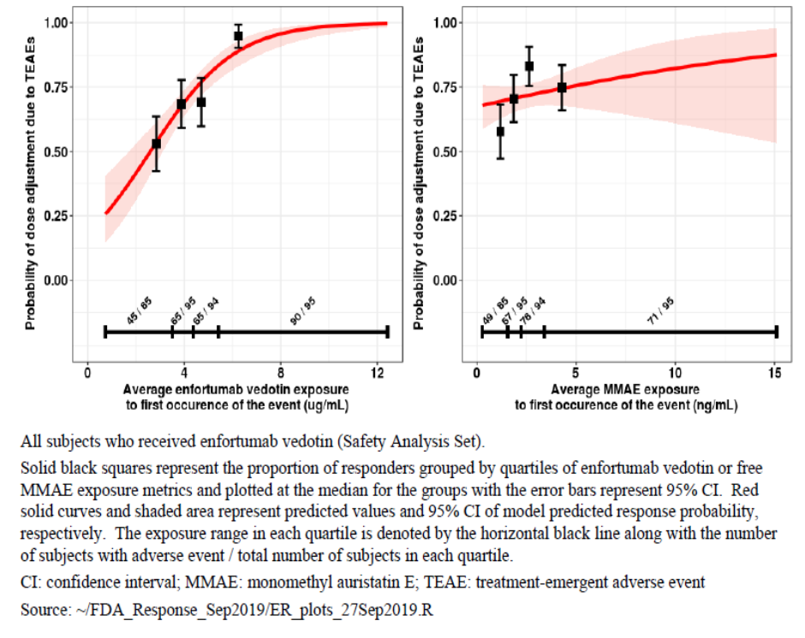

Abbreviations: MMAE = monomethyl auristatin E; TEAE = treatment-emergent adverse event.

All subjects who received enfortumab vedotin (safety analysis set).

Solid black squares represent the proportion of responders grouped by quartiles of enfortumab vedotin or free MMAE exposure metrics and lotted at the median for the groups with the error bars represent 95% confidence intervals (CI). Red solid curves and shaded area represent predicted values and 95% CI of model predicted response probability, respectively. The exposure range in each quartile is denoted by the horizontal black line along with the number or subjects with adverse event/ total number of subjects in each quartile.

##### Immunogenicity

590 subjects were tested for anti-therapeutic antibody to enfortumab vedotin 1.25 mg/kg, with the following results:

* 15 patients were anti-therapeutic antibody positive at Baseline.
* Of the 575 patients negative at Baseline, 16 patients (2.8%) were positive post-Baseline (13 transiently and 3 persistently).

##### QT prolongation

Based on *in vitro* studies interference with the human ether-a-go-go (hERG)-related gene channel is considered unlikely.

QT prolongation was not demonstrated in Study EV-102 in Japanese patients. This is consistent with findings with other drug antibody conjugates to MMAE.[13]

##### Dose in clinical studies

Weight based dosing was supported by Study EV-201. The maximum tolerated dose was not established, however based on the efficacy plateau at higher exposures for Study EV‑201 Cohort 2 demonstrated an efficacy plateau at higher systemic exposure levels, suggesting increases in enfortumab vedotin exposures at doses greater than 1.25 mg/kg may not provide additional efficacy benefit.

The estimates of relative dose intensity (RDI) among subjects treated at 1.25 mg/kg were 79% in Study EV-201 Cohort 2 and 81% in Study EV-301. Dose reductions were more frequently required at 1.25 mg/kg (31.6% for 1.25 mg/kg enfortumab vedotin safety analysis group) than at lower dose levels (0% at 0.75 mg/kg and 10% at 1 mg/kg in Study EV-101).

#### Efficacy

#### Study EV-301

This study is considered the pivotal study for this submission.

Study EV-301 is an ongoing, global, open label, Phase III randomised study of 608 patients with locally advanced or metastatic urothelial cancer who have received a platinum containing chemotherapy and a PD-1/PD-L1 inhibitor. Patients were randomised to receive either enfortumab vedotin or investigators choice of chemotherapy (docetaxel, paclitaxel, or vinflunine). Patients were stratified based on geographic region, Eastern Cooperative Oncology Group (ECOG) performance status, and presence of liver metastases.

Figure 9: Study EV-301 schema

Study EV-301 schema.
Arm A: enfortumab vedotin 1.25 mg/kg intravenous infusion over 30 minutes on Day 1, Day 8 and Day 15 of a 28 day cycle until progressive disease or discontinuation. Arm B: physician’s choice of vinflunine, paclitaxel, or docetaxel (vinflunine capped at approx. 35% of control) until progressive disease or discontinuation

##### Treatment

* Arm A: enfortumab vedotin 1.25 mg/kg intravenous infusion over 30 minutes on Day 1, Day 8 and Day 15 of a 28 day cycle until progressive disease or discontinuation.
* Arm B: physician’s choice of vinflunine, paclitaxel, or docetaxel (vinflunine capped at approximately 35% of control) until progressive disease or discontinuation.

##### Dose adjustments

Enfortumab vedotin dose adjustments to 1.0 mg/kg (dose level 1) and 0.75 mg/kg (dose level 2) permitted unless toxicity triggered discontinuation; chemotherapy dose modification guided by study protocol and local and institutional guidelines.

##### Patient flow

* Randomised total: 608 subjects; 301 to Arm A, 307 Arm B.
* Did not receive study drug: 5 subjects (1.7%) in Arm A; 16 subjects (5.2%) in Arm B.
* Ongoing in study: 56 subjects (18.6%) in Arm A; 22 subjects (7.2%) in Arm B.
* Discontinued because died: 2 subjects (0.7%) in Arm A; 2 subjects (0.7%) in Arm B.
* Discontinued due to progressive disease: 177 subjects (58.8%) in Arm A; 180 (58.6%) subjects in Arm B.
* Discontinued because of adverse event: 42 subjects (14.0%) in Arm A; 46 (15.0%) subjects in Arm B.

##### Key inclusion criteria

* Histologically or cytologically confirmed urothelial carcinoma (that is, cancer of the bladder, renal pelvis, ureter, or urethra). Urothelial carcinoma (transitional cell) with squamous differentiation or mixed cell types were eligible.
* Radiographic progression or relapse during or after a checkpoint inhibitor (CPI) (anti-PD-1 or anti-PD-L1) for locally advanced or metastatic disease. If discontinued CPI treatment because of toxicity, eligible if evidence of disease progression following discontinuation. CPI need not have been the most recent therapy but if most recent therapy non-CPI based regimen must have progressed/relapsed during or after most recent therapy. Locally advanced disease must not have been amenable to resection with curative intent per treating physician.
* Received platinum containing regimen (cisplatin or carboplatin) in metastatic/locally advanced, neoadjuvant or adjuvant setting. If platinum administered in adjuvant/neoadjuvant setting, must have progressed less than or equal to 12 months from completion.
* Radiologically documented metastatic or locally advanced disease at baseline.
* Archival or fresh tissue sample available.
* Eastern Cooperative Oncology Group (ECOG) performance status 0 or 1.[14]
* Laboratory data:
  + Absolute neutrophil count greater than or equal to 1500 per mL.
  + Platelet count greater than or equal to 100 times 109 per L.
  + Haemoglobin greater than or equal to 9 g/dL.
  + Serum total bilirubin less than or equal to 1.5 times upper limit of normal (ULN) or 3 times ULN or less if subject had Gilbert’s disease.[15]
  + Creatinine clearance less than or equal to 30 mL per minute.
  + Alanine aminotransferase and aspartate aminotransferase 2.5 times ULN or less; or 3 times ULN or less for subjects with liver metastases.15

##### Key exclusion criteria

* Pre-existing sensory or motor neuropathy severity of Grade 2 or higher.12
* Active central nervous system metastases. Treated central nervous system metastases permitted on study if:
  + clinically stable for greater than or equal to six weeks before screening
  + on stable steroid dose less than or equal to 20 mg per day of prednisone or equivalent less than or equal to two weeks
  + baseline scans showed no evidence of new or enlarged brain metastasis
  + no leptomeningeal disease
* Ongoing clinically significant toxicity (generally, with exceptions); ongoing greater than or equal to Grade 3 immunotherapy related hypothyroidism or panhypopituitarism excluded; ongoing immunotherapy related colitis, uveitis, myocarditis, or pneumonitis or other immunotherapy related adverse event (AE) requiring greater than 20 mg per day of prednisone or equivalent excluded.
* Prior chemotherapy for urothelial cancer with study therapies in control arm.
* Had received less than one prior chemotherapy regimen for locally advanced or metastatic urothelial cancer, including chemotherapy for adjuvant or neoadjuvant disease if recurrence occurred less than 12 months of therapy. Substitution of carboplatin for cisplatin was not considered a new regimen if no new chemotherapeutic agents were added to the regimen.
* Another malignancy in less than 3 years (except nonmelanoma skin cancer, localised prostate cancer treated with curative intent or under active surveillance, carcinoma-in-situ of any type).
* History of a stroke, transient ischemic attack, unstable angina, myocardial infarction, of symptoms consistent with New York Heart Association class III to IV within six months of first dose of study drug.[16]
* Uncontrolled diabetes with glycated haemoglobin (HbA1C)[17] greater than or equal to 8% or 7 to 8% if symptomatic.
* Active infection.
* Radiotherapy or surgery less than or equal to 4 weeks prior.
* Know hypersensitivity to study drug.

##### Efficacy endpoints

The primary endpoint was overall survival.

Key secondary endpoints (alpha controlled) included:

* Progression free survival per Response Evaluation Criteria in Solid Tumours (RECIST)[18] version 1.1 by investigator
* Objective response rate: (complete response or partial response) per RECIST version 1.1 by investigator
* Disease control rate: (complete response or partial response or stable disease) per RECIST version 1.1 by investigator

Other secondary endpoints (no alpha allocation) included duration of response, quality of life and patient related outcomes.

##### Statistics

A statistical analysis plan was finalised prior to interim analysis. Analysis included one planned interim analysis and one final (primary analysis), after 285 overall survival events (65% total), 439 events respectively. Patients not satisfying response criteria or with insufficient data were considered non-responders.

Approximately 600 patients, assuming hazard ratio 0.75 (median overall survival in Arm A and Arm B are 10.7 months and 8 months, respectively), dropout rate of 10%, would provide 85% power to detect a statistically significant difference at overall type I error rate of 1 sided 0.025.

Sample size (600 patients) was determined by the primary endpoint overall survival and provided more than 90% power to detect statistically significant differences on progression free survival (assuming median progression free survival in Arm A and Arm B were six months and four months, respectively), and objective response rate and disease control rate (assuming 15% treatment difference between Arm A and Arm B for both objective response rate and disease control rate).

Overall survival and progression free survival estimated for each treatment arm using Kaplan-Meier methodology and comparing Arm A and Arm B was conducted using the stratified log rank test controlling for randomisation stratification factors. Stratified Cox proportional hazards model (same stratification factors as used for stratified log rank test) used to estimate the hazard ratio and the corresponding 95% confidence intervals (CI).

###### Multiplicity adjustment

* Interim and final (primary) analysis of the primary endpoint, overall survival, and between the primary and the selected secondary endpoints (progression free survival, objective response rate and disease control rate).
* Family wise type I error rate for this study was controlled at 2.5% (one sided)
  + Overall survival formally tested at interim and final analysis (O’Brien-Fleming boundary per Lan-DeMets method).
  + Formal hypothesis testing on the selected secondary endpoints including progression free survival, objective response rate and disease control rate (in that order) if null hypothesis for overall survival rejected.
  + Progression free survival was planned to be tested at either analysis when the null hypothesis for overall survival was rejected (significance level of progression free survival based on the Pocock boundary per Lan-DeMets method).
  + Objective response rate and disease control rate tested once both the null hypotheses for overall survival and progression free survival were rejected (significance levels of both objective response rate and disease control rate were 0.025 (1 sided) as the information fraction reached 100% at interim analysis).

##### Analysis populations

* Full analysis set: all subjects who were randomised, primary analysis set for efficacy analyses except for response related efficacy endpoints.
* Safety analysis set: consisted of all subjects who received any study drug.
* Response evaluable set: all subjects in the full analysis set with measurable disease (per RECIST version 1.1)18 per investigator at Baseline, used for analysis of response related endpoints (for example, objective response rate, disease control rate).
* Pharmacokinetics analysis set: all subjects who received active drug with greater than or equal to one blood sample collected and assayed for measurement of enfortumab vedotin serum/plasma concentrations and time of sampling and time of dosing on day of sampling known, used for all presentations of PK data.

##### Protocol amendments and deviations

*Amendment one*: numerous including updating exclusion criteria to exclude ongoing immunotherapy related myocarditis, clarify when subjects with immunotherapy related hypothyroidism or panhypopituitarism or superficial punctate keratitis may be enrolled, to allow subjects who required a strong CYP3A4 inhibitor or inducer.

*Amendment two*: increased the targeted number of death events in the final analysis from 384 to 439 to increase power of study from 80 to 85%, increased sample size from 550 to 600 death events in the final analysis to maintain analyses timeline.

*Amendment three*: added a crossover extension to study design.

*Major protocol deviations*: reported in 7% of Arm A and 3.9% of Arm B. 2.7% of Arm A and 0.7% of Arm B had developed criteria that would trigger withdrawal from the study but were not withdrawn, primarily because they were considered to be deriving clinical benefit by the investigator.

Table 4, shown below, summarises the baseline demographics of the patient population in Study EV-301. Table 5 details the baseline disease characteristics for these subjects.

Table 4: Study EV-301 Baseline demographics (full analysis population)

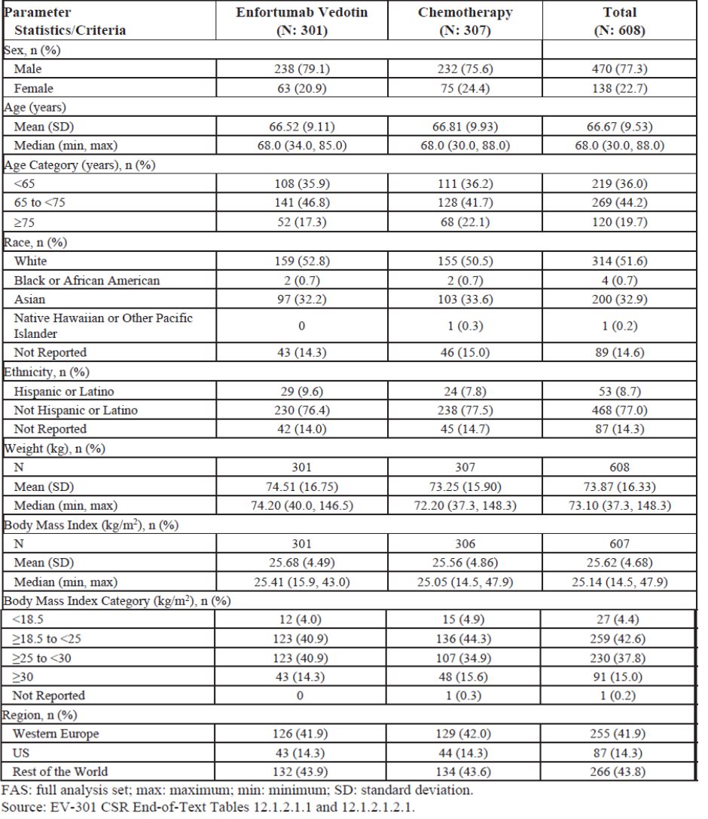

Abbreviations: FAS: full analysis set; max: maximum; min: minimum; SD: standard deviation

Table 5: Study EV-301 Baseline disease characteristics (full analysis population)

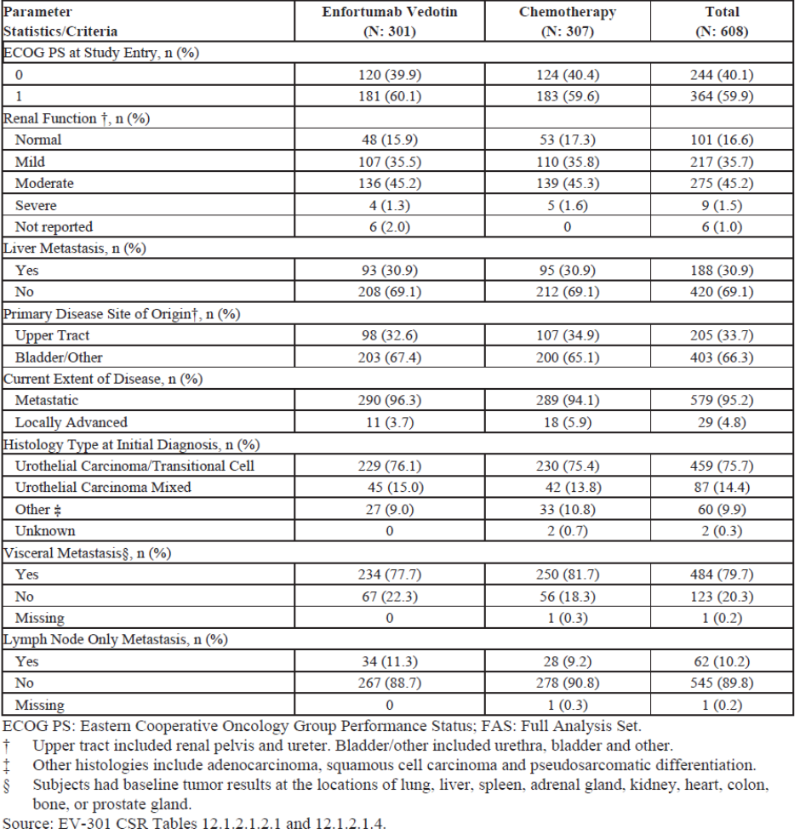

Abbreviations: ECOG PS: Eastern Cooperative Oncology Group Performance Status; FAS: full analysis set.

† Crockfault-Gault formula was used to estimate creatinine clearance. Upper tract included renal pelvis and ureter. Bladder/other included urethra, bladder and other.

‡ Other histologies include adenocarcinoma, squamous cell carcinoma and pseudosarcomatic differentiation.

§ Subjects had baseline tumour results at the locations of lung, liver, spleen, adrenal gland, kidney, heart, colon, bone or prostate gland.

All subjects had prior systemic therapies to be eligible for enrolment. These are summarised in Table 6, shown below.

Table 6: Study EV-301 Prior systemic anticancer therapies (full analysis population)

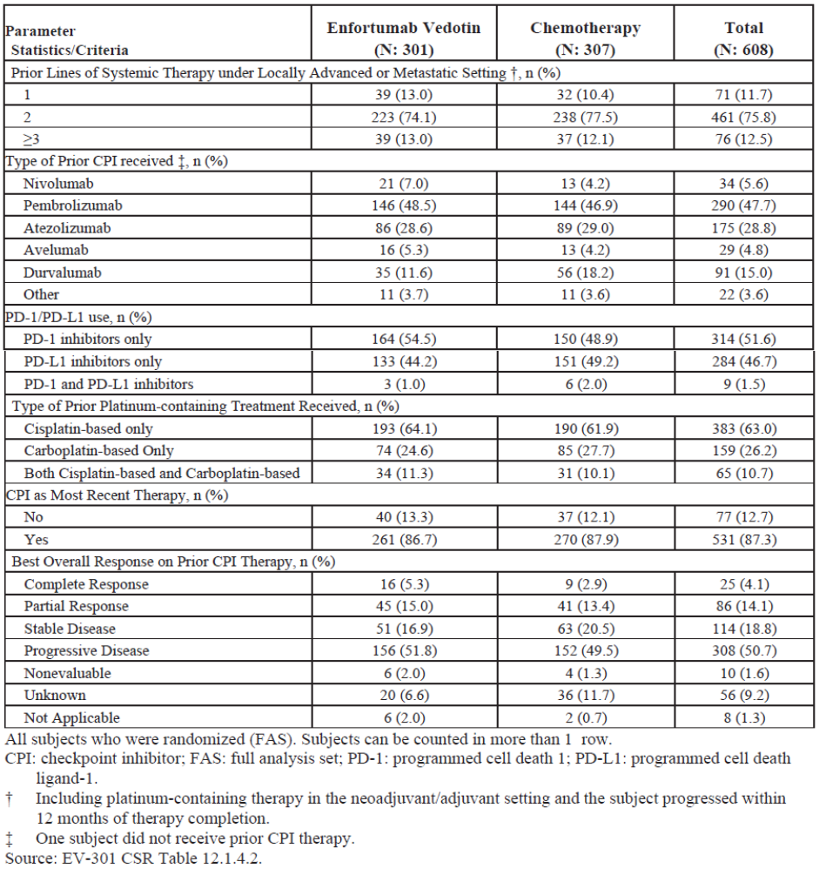

Abbreviations: CPI: checkpoint inhibitor; FAS: full analysis set; PD-1: programmed cell death 1; PD-L1: programmed cell death ligand-1.

All subjects who were randomised (FAS). Subjects can be counted in more than 1 row

† Including platinum containing therapy in the neoadjuvant/adjuvant setting and the subject progressed within 12 months of therapy completion.

‡ One subject did not receive prior CPI therapy.

##### Primary endpoint

The overall survival analysis was conducted after 301 deaths (information fraction = 68.6%) in the full analysis set population, after a median follow up of 11.1 months (around six months from the enrolment of the last patient):

* Hazard ratio: enfortumab vedotin (Arm A) versus chemotherapy (Arm B) was 0.702 (95% CI: 0.56, 0.89, 1 sided p = 0.00142)
* Median (95% CI) overall survival: 12.88 (95% CI: 10.58, 15.21) months for enfortumab vedotin (Arm A); 8.97 (95% CI: 8.05, 10.74) months for chemotherapy (Arm B)
* Six month overall survival: 77.9% enfortumab vedotin (Arm A); 69.5% chemotherapy (Arm B)
* One year overall survival: 51.5% with enfortumab vedotin (Arm A); 39.2% with chemotherapy (Arm B).

Figure 10: Study EV-301 Kaplan-Meier plot of overall survival

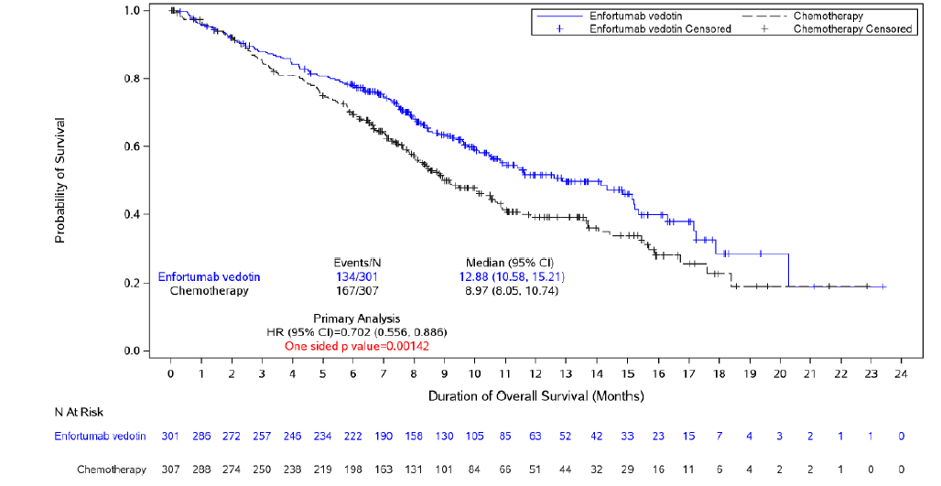

Abbreviations: CI: confidence interval; FAS: full analysis set; HR: hazard ratio.

Analysis based on the full analysis set population.

The subgroup analysis for overall safety for most prespecified subgroups, including age, geographic region, baseline ECOG performance status, liver metastasis, choice of chemotherapy by investigator, primary site of tumour, prior lines of therapy in the locally advanced or metastatic setting; and best response to prior PD-1/PD-L1 inhibitor therapy, is generally supportive of overall survival for the study population as a whole (see Figure 11).

The median overall survival for the subgroup of female subjects was 11.04 months for the 63 Arm A group verves 10.68 months for the 75 Arm B group (hazard ratio of 1.171 (95% CI: 0.724, 1.894).

Figure 11: Study EV-301 Subgroup analysis for the primary endpoint

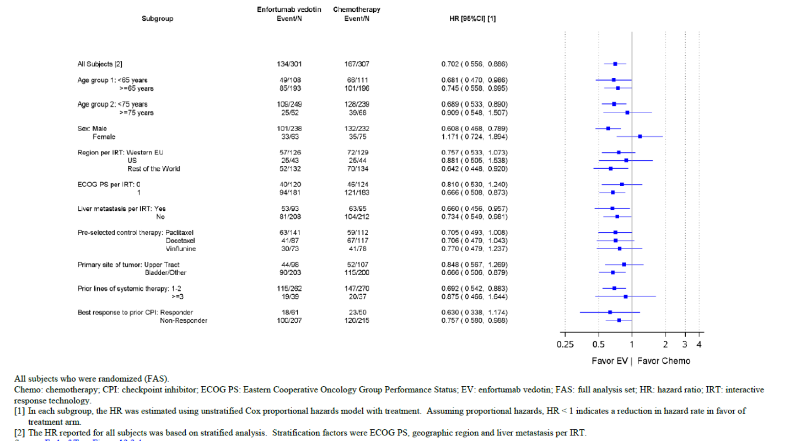

Chemo: chemotherapy; CPI: checkpoint inhibitor; ECOG PS: Eastern Cooperative Oncology Group Performance Status; EV: enfortumab vedotin; FAS: full analysis set; HR: hazard ratio; IRT: interactive response technology.

Based on all subjects who were randomised (FAS)

[1] In each subgroup, the HR was estimated using unstratified COX proportional hazards model with treatment. Assuming proportional hazards, HR less than 1 indicates a reduction in hazard rate in favour of treatment run.

[2] The HR reported for all subjects was based on stratified analysis. Stratification factors were ECOG PG, geographic region, liver metastasis per IRT.

##### Secondary endpoints

At the data cut off, 201 progression free survival events occurred in the enfortumab vedotin group (Arm A) (66.8%) versus 231 progression free survival events chemotherapy group (Arm B). The results of the analysis were:

* Hazard ratio: enfortumab vedotin group (Arm A) versus chemotherapy group (Arm B) was 0.615 (95% CI: 0.505, 0.748, 1 sided p less than 0.00001)
* Median (95% CI) overall survival: 5.55 (95% CI: 5.32, 5.82) months for enfortumab vedotin (Arm A); 3.71 (95% CI: 3.52, 3.94) months for chemotherapy (Arm B)
* Six month overall survival: 44% for enfortumab vedotin (Arm A); 28.2% for chemotherapy (Arm B)
* One year overall survival: 21.7% for enfortumab vedotin (Arm A); 8.3% for chemotherapy (Arm B

Figure 12: Study EV-301 Kaplan-Meier plot of progression free survival

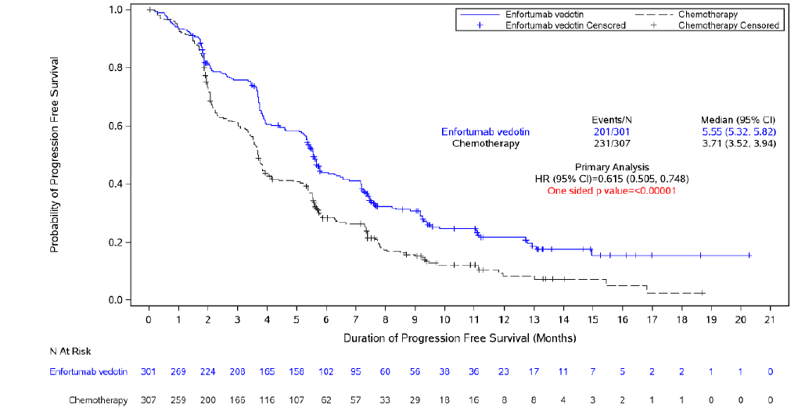

CI: confidence interval; FAS: full analysis set; HR: hazard ratio; PFS: progression free survival.

Based on the full analysis set population.

A summary of the results of other secondary endpoints is provided in Table 7.

Table 7: Study EV-301 other secondary endpoints

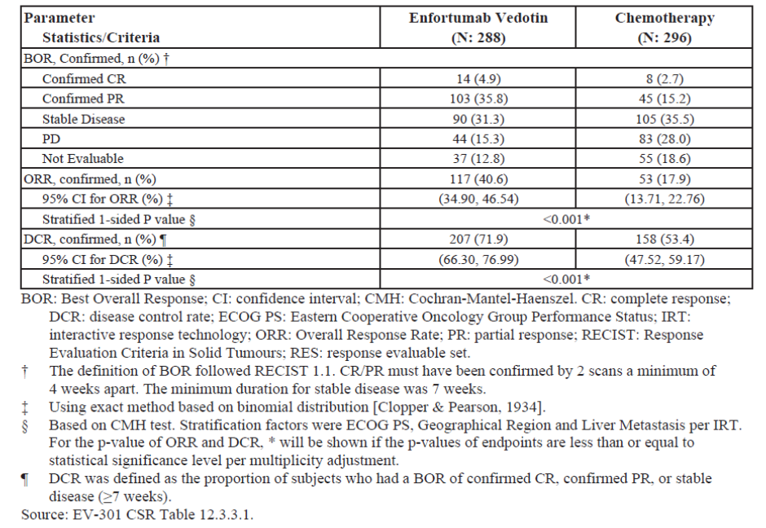

Abbreviations: BOR: best overall response; CI: confidence interval; CMH: Cochran-Mantel-Haenszel; CR: complete response; DCR: disease control rate; ECOG PS: Eastern Cooperative Oncology Group Performance Status; IRT: interactive response technology; ORR: overall response rate; PR: partial response; RECIST: Response Evaluation Criteria in Solid Tumours; RES: response evaluable set.

† The definition of BOR followed RECIST 1.1 CR/PR must have been confirmed by two scans a minimum of four weeks. The minimum duration for stable disease was seven weeks.

‡ Using exact method based on binomial distribution

§ Based on CMH test. Stratification factors were ECOG PS, geographical region and liver metastasis per IRT. For the p-value of ORR and DCR. *will be shown if the p-values of endpoints are less than or equal to statistical significance level per multiplicity adjustment.

¶ DCR was defined as the proportion of subjects who had a BOR of confirmed CR, confirmed PR, or stable disease (greater than or equal to seven weeks).

The median duration of response for all patients with complete response or partial response was 7.39 months (95% CI: 5.59, 9.46) for Arm A and 8.11 months (95% CI: 5.65, 9.56) for Arm B.

Nonurothelial histology was recorded for 9% of patients in the enfortumab vedotin arm (Arm A) and 13% of patients in Arm B. The sponsor provided results for objective response rate for urothelial carcinoma/transitional cell carcinoma, mixed urothelial carcinoma and other histologies.

Table 8: Study EV-301 Best overall response and objective response rate by tumour histology enfortumab vedotin treatment

|  |  | Enfortumab vedotin | | Chemotherapy | | Absolute Difference [1] 95% CI |
| --- | --- | --- | --- | --- | --- | --- |
| Parameter | Value | N  ORR,n (%) | 95% CI | N  ORR,n (%) | 95% CI |
| Histology type at initial diagnosis | Urothelial carcinoma/ transitional Cell | 219  94 (42.9%) | (36.27%, 49.76%) | 224  43 (19.2%) | (14.25%, 24.97%) | 23.7% (14.94%, 32.04%) |
| Urothelial carcinoma mixed | 45  13 (28.9%) | (16.37%, 44.31%) | 39  4 (10.3%) | (2.87%, 24.22%) | 18.6% (0.62%, 35.57%) |
| Other | *24*  10 (41.7%) | (22.11%, 63.36%) | 31  6 (19.4%) | (7.45%, 37.47%) | 22.3% (‑3.75%, 46.71%) |

Abbreviations: N = number of subjects in population; n = number of subjects with specified parameter; ORR = objective response rate.

[1] Enforumab vedotin ORR minus chemotherapy ORR.

#### Study EV-201

Study EV-201 is a Phase II, single arm, open label, multicentre study to investigate enfortumab vedotin treatment in patients with locally advanced or metastatic urothelial cancer.

Cohort 1 (128 subjects enrolled, 125 treated) were patients previously treated with immune checkpoint inhibitor therapy and platinum based chemotherapy. This cohort provided supportive data for the indication in patients who have received both a platinum based and PD-1/PD-L1 inhibitor.

Cohort 2 (91 subjects enrolled, 89 treated) were a cisplatin ineligible population who had only received prior checkpoint inhibitor and provided support for the component of the proposed indication in patients not eligible for cisplatin containing chemotherapy.

Figure 13: Study EV-201 Study schema

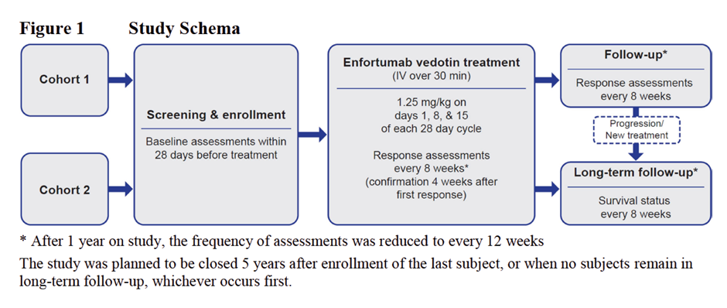

*After 1 year on study, the frequency of assessments was reduced to every 12 weeks.

The study was planned to be closed 5 years after enrolment of the last subject, or when no subjects remain in long term follow up, whichever occurs first.

##### Study population

* *Cohort 1*: patients who received prior treatment with platinum containing chemotherapy in the adjuvant/neoadjuvant setting with recurrent or progressive disease less than 12 months from completion, or in the locally advanced or metastatic setting.
* *Cohort 2*: subjects with no prior platinum containing or other chemotherapy regimens in the locally advanced or metastatic setting, ineligible to receive cisplatin due to at least one of: ECOG performance status of 2, impaired renal function (defined as creatinine clearance greater than or equal to 30 and less than 60 mL per minute) or greater than or equal to a Grade 2 hearing loss. Subjects who received platinum in the adjuvant/neoadjuvant setting and did not progress within 12 months of completion were considered platinum naïve and eligible for this cohort.

##### Treatment

Enfortumab vedotin 1.25 mg/kg intravenous infusion over 30 minutes on Day 1, Day 8 and Day 15 of a 28 day cycle until progressive disease or discontinuation.

##### Dose adjustments

Enfortumab vedotin dose adjustments to 1.0 mg/kg (dose level 1) and 0.75 mg/kg (dose level 2) for haematological and non-haematological toxicities permitted unless toxicity triggered discontinuation.

##### Participant flow

*Cohort 1*:

* Total enrolled: 128 subjects; total treated: 89
* Ongoing in study on treatment: 4
* Discontinued because died: 94
* Discontinued due to progressive disease: 77
* Discontinued because of adverse event: 24

*Cohort 2*:

* Total enrolled: 91 subjects; total treated: 89
* Ongoing in study on treatment: 16
* Discontinued because died: 44
* Discontinued due to progressive disease: 45
* Discontinued because of adverse event: 21

##### Key inclusion criteria

* Histologically or cytologically confirmed urothelial carcinoma (that is, cancer of the bladder, renal pelvis, ureter, or urethra). Urothelial carcinoma (transitional cell) with squamous differentiation or mixed cell types were eligible. Resectable local disease ineligible.
* Received prior treatment with a checkpoint inhibitor in the locally advanced or metastatic urothelial cancer setting. If received checkpoint inhibitor therapy in the neoadjuvant/adjuvant setting and had recurrent or progressive disease either during therapy or less than three months of therapy completion then were eligible.
* setting and had recurrent or progressive disease either during therapy or less than 3 months of therapy completion then were eligible
* Subjects were one of either Cohort 1 or Cohort 2.
* Progression or recurrence of urothelial cancer during or following most recent therapy.
* Tissue sample available.
* Eastern cooperative oncology group performance status of 1 or less (Cohort 1);, 2 or less (Cohort 2).14
* Laboratory data:
  + Absolute neutrophil count greater than or equal to 1000 per mL.
  + Platelet count greater than or equal to 100 x 109 per L.
  + Haemoglobin greater than or equal to 9 g/dL.
  + Serum total bilirubin 1.5 times upper limit of normal (ULN) or less; or 3 times ULN or less if subject had Gilbert’s disease.15
  + Creatinine clearance greater than or equal to 30 mL per minute.
  + Alanine aminotransferase and aspartate aminotransferase 3 times ULN or less for subjects with liver metastases.

##### Key exclusion criteria

* Ongoing sensory or motor neuropathy greater than or equal to Grade 2.
* Active central nervous system metastases. Treated central nervous system metastases permitted on study if:
  + clinically stable for greater than or equal to six weeks before screening
  + on stable steroid dose less than or equal to 20 mg per day of prednisone or equivalent greater than or equal to two weeks
  + baseline scans showed no evidence of new or enlarged brain metastasis
  + no leptomeningeal disease
* Ongoing clinically significant toxicity (generally, with exceptions); ongoing Grade 3 or higher immunotherapy related hypothyroidism or panhypopituitarism excluded; ongoing immunotherapy related colitis, uveitis, myocarditis, or pneumonitis or other immunotherapy related AEs requiring greater than 20 mg per day of prednisone or equivalent excluded.
* Had received greater than one prior chemotherapy regimen for locally advanced or metastatic urothelial cancer, including chemotherapy for adjuvant or neoadjuvant disease if recurrence occurred less than 12 months of therapy. Substitution of carboplatin for cisplatin was not considered a new regimen if no new chemotherapeutic agents were added to the regimen.
* Another malignancy in less than three 3 years (except nonmelanoma skin cancer, localised prostate cancer treated with curative intent or under active surveillance, carcinoma *in-situ* of any type).
* History of a stroke, transient ischemic attack, unstable angina, myocardial infarction, of symptoms consistent with New York Heart Association class III to IV within six months of first dose of study drug.16
* Active infection.
* Uncontrolled diabetes HbA1C greater than or equal to 8% or 7 to 8% if symptomatic.
* Uncontrolled tumour related bone pain or impending spinal cord compression (could be on stable pain medication regimen for greater than or equal to two weeks).
* Radiotherapy or surgery less than or equal to four weeks prior.
* Known hypersensitivity to study drug.

##### Efficacy endpoints

Antitumor effect was assessed with scans every eight weeks after cycle one day one for one year and then every 12 weeks until progression.

Primary endpoint was the overall response rate.

*Key secondary endpoints*:

* Duration or response (time from documented complete response or partial response until disease progression per RECIST version 1.1 by investigator).
* Progression free survival per RECIST version 1.1 by investigator.
* Overall survival.

##### Statistics

The sample size was 200 patients, 100 in each cohort. Using the estimate of approximately 100 subjects in Cohort 1, the study had a 98% power to detect a 15% increase in overall response rate from 10% to 25%, and 81% power to detect a 10% increase in overall response rate from 10% to 20%, at a one sided significant level of 0.025.

Two sided 95% exact CI using the Clopper-Pearson method were calculated for response rates; for time-to-event endpoints, the median survival time was estimated using the Kaplan-Meier method; the associated 95% CI was calculated based on the complementary log-log transformation.

##### Analysis populations

Full analysis set and safety analysis set: all enrolled who received any study drug.

##### Protocol amendments and deviations

There were numerous amendments to study procedures including those relating to ocular examinations.

*Amendment four*: revised study design to consist of two separate cohorts.

*Amendment five*: allowed patients with ECOG 2 to enter Cohort 2.

*Amendment six*: revised timing of Cohort 2 interim analysis to greater than eight months from the first dose of enfortumab vedotin.

*Major protocol deviations*: reported in 6% of Cohort 1 and 2.4% of Arm B.

##### Outcomes for Cohort 2 population

The baseline demographics, tumour characteristics and prior treatments are summarised in Table 9, Table 10 and Table 11.

Table 9: Study EV-201 (Cohort 2) Baseline demographics

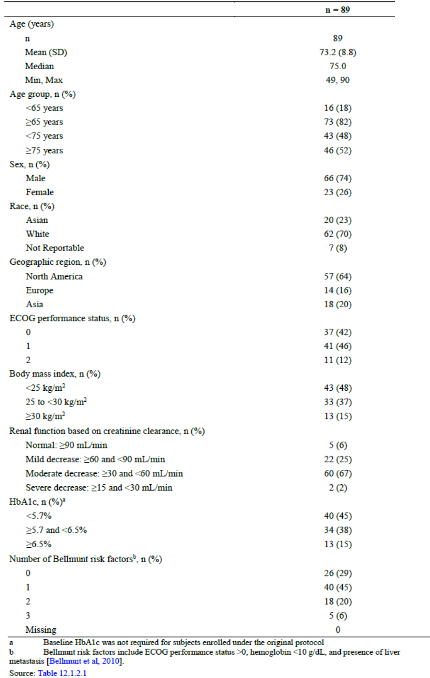

a Baseline HbA1c was not required for subjects enrolled under the original protocol

b Bellmunt risk factors include ECOG performance status greater then 0, haemoglobin less than 10 g/dL, and presence of liver metastasis.[19]

Table 10: Study EV-201 (Cohort 2) Baseline disease characteristics

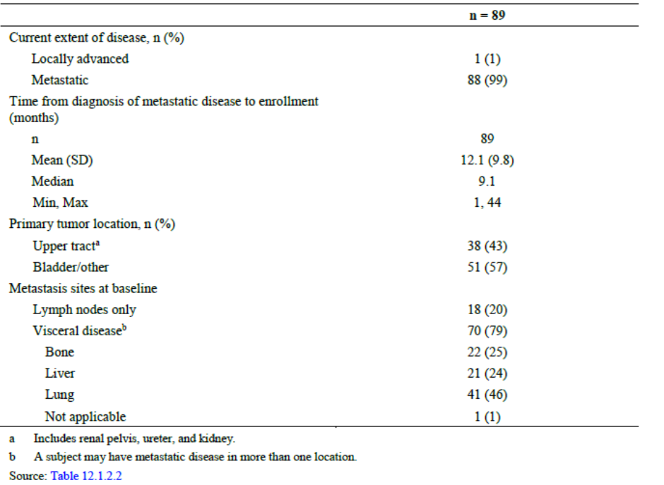

a Includes renal pelvis, ureter and kidney.

b A subject may have metastatic disease in more than one location.

Table 11: Study EV-201 (Cohort 2) Prior systemic treatments

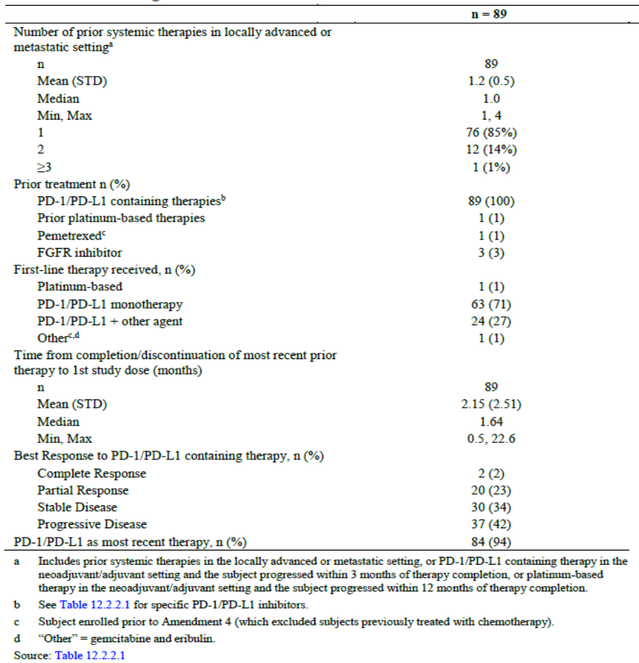

a Includes prior systemic therapies in the locally advanced or metastatic setting, or PD-1/PD-L1 containing therapy in the neoadjuvant/adjuvant setting and the subject progressed within 3 months of therapy completion, or platinum based therapy in the neoadjuvant/adjuvant setting and the subject progressed within 12 months of therapy completion.

b Specific PD-1/PD-L1 inhibitors were provided by the sponsor.

c Subjects enrolled prior to amendment 4 (which excluded subjects previously treated with chemotherapy).

d ‘Other’ is gemcitabine and eribulin.

At the time of data cut off, the median duration of treatment was 5.98 months (range 0.3 to 24.6), with a median of 16 infusions administered per patient (range 1 to 60). Just under half the patients had greater than or equal to 6 months of exposure to study treatment. The median relative dose intensity was 79%, but 67% had any enfortumab vedotin dose modification (dose skipped, cycle delayed, or dose reduced due to adverse events).

The primary endpoint of objective response rate (complete response plus partial response) was reported for 52% (95% CI: 40.8%, 62.4%).

Complete responses were reported for 20% of the Cohort 2 population in Study EV-201; partial responses were reported in 32% and stable disease reported for 30% (see Table 12 below).

In response to questions primarily about Study EV-301 the sponsor presented results for three different tumour histologies: transitional cell carcinoma only, transitional cell carcinoma with squamous differentiation, and transitional cell carcinoma with other histological variants. Because the numbers of patients in the groups that had histologies other than transitional cell carcinoma are small it is difficult to draw meaningful conclusions.

Table 12: Study EV-201 (Cohort 2) Best overall response and objective response rate by tumour histology enfortumab vedotin treatment

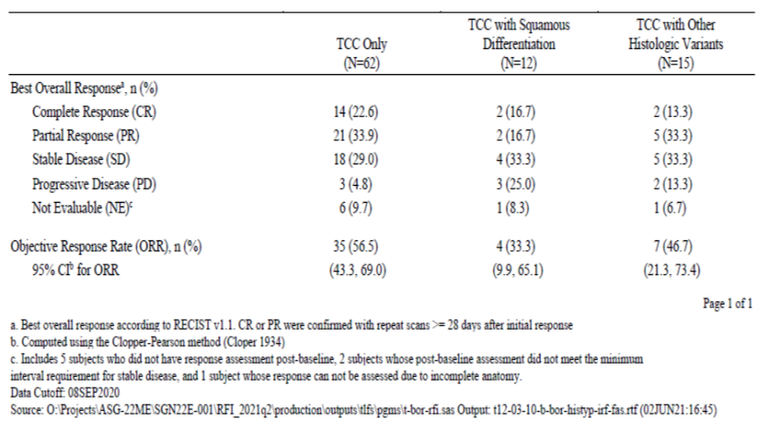

Abbreviation: TCC = transitional cell cancer.

a Best overall response according to RECIST version 1.1 complete response or partial response were confirmed with repeat scans greater than or equal to 28 days after initial response.

b Computed using the Clopper-Pearson method.[20]

c Includes five subjects who did not have response assessment post baseline, two subjects whose post baseline assessment did not meet the minimum interval requirement for stable disease, and one subject whose response cannot be assessed due to incomplete anatomy.

##### Outcomes for Cohort 1 population

The results from Cohort 1 formed the basis of an accelerated approval in the USA of Padcev (enfortumab vedotin) for use in patients with locally advanced and metastatic urothelial cancer who had received a PD-1/PD-L1 and platinum containing chemotherapy in the neoadjuvant/adjuvant, locally advanced or metastatic setting.

The study report in this submission provided an updated dataset.

The baseline demographics, disease characteristics and prior therapies of Cohort 1 are summarised in Table 13, Table 14 and Table 15.

Table 13: Study EV-201 (Cohort 1) Baseline demographics

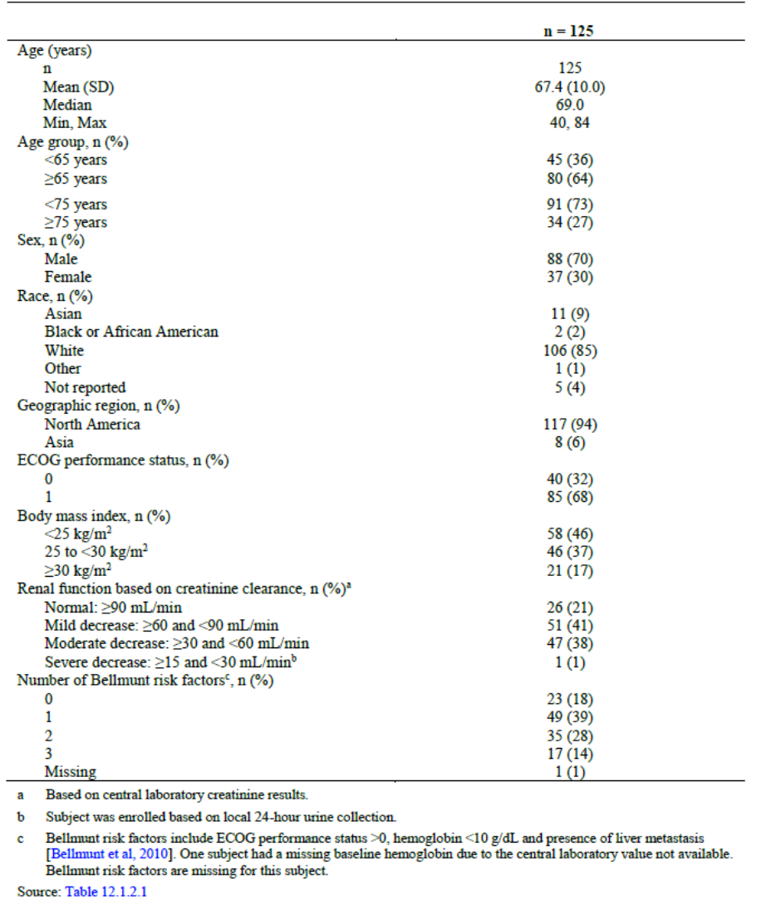

a Based on central laboratory creatinine results.

b Subject was enrolled based on local 24 hour urine collection.

c Bellmunt risk factors include ECOG performance status greater than 0, haemoglobin less than 10 g/dL and presence of liver metastasis.19 One subject had a missing baseline haemoglobin due to the central laboratory value not available. Bellmunt risk factors are missing for this subject.

Table 14: Study EV-201 (Cohort 1) Baseline disease characteristics

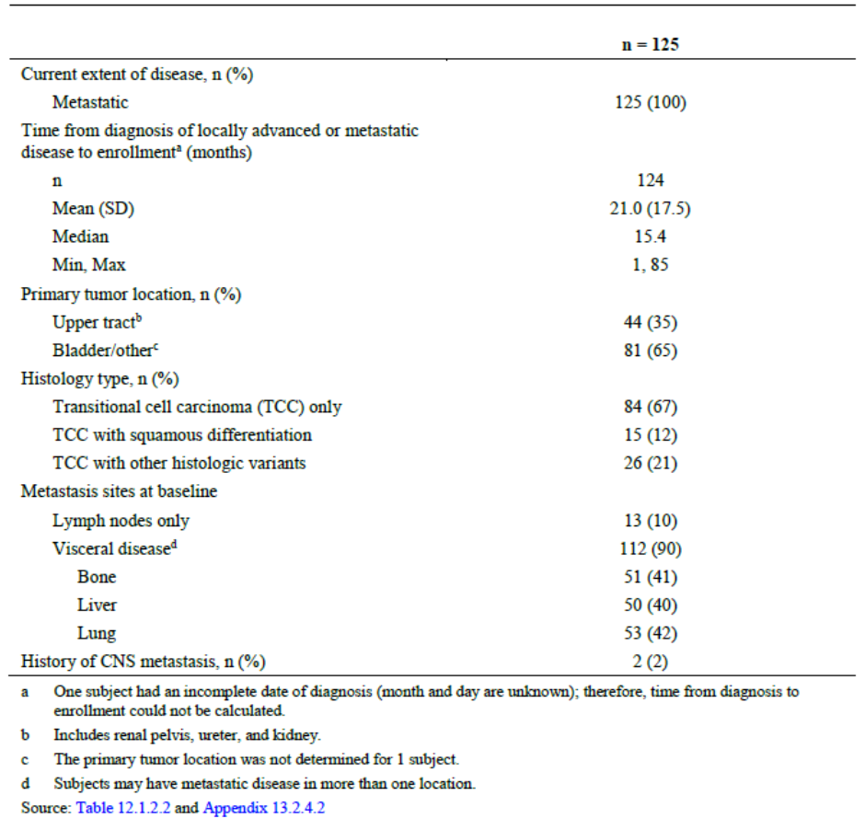

a One subject had an incomplete date of diagnosis (month and day and unknown) therefore, time from diagnosis to enrolment could not be calculated.

b Includes renal pelvis, ureter and kidney.

c The primary tumour location was not determined for one subject.

d Subjects may have metastatic disease in more than one location.

Table 15: Study EV-201 (Cohort 1) Prior systemic therapies

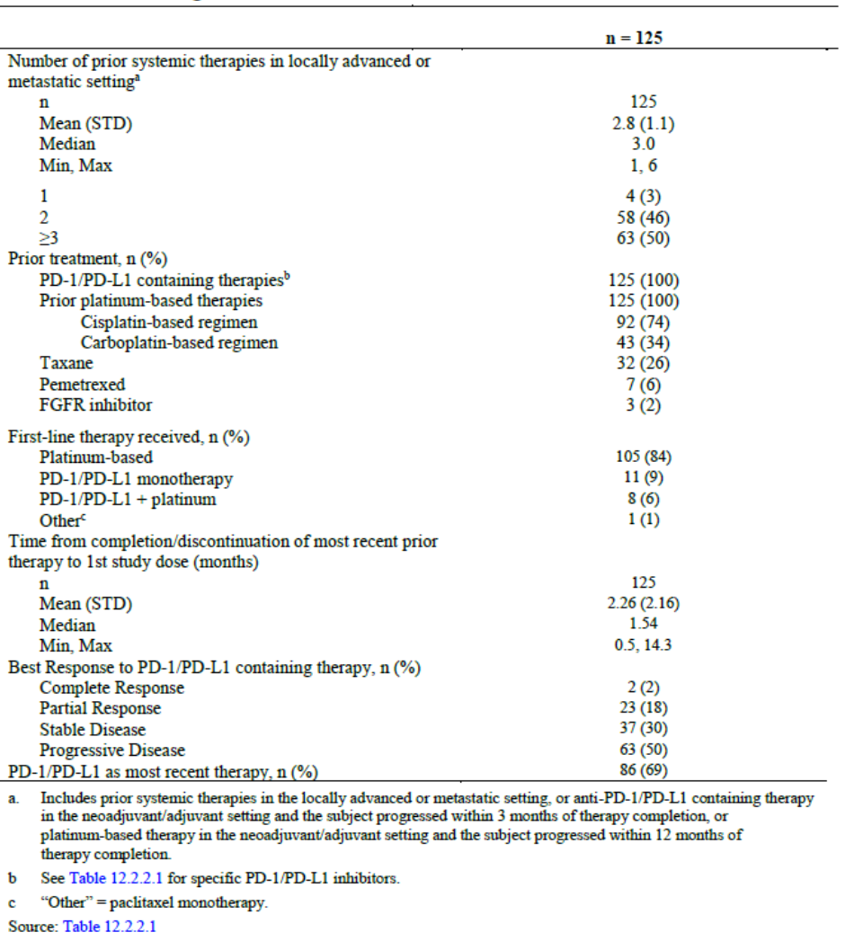

a Includes prior systemic therapies in the locally advanced or metastatic setting, or anti-PD-1/PD-L1 containing therapy in the neoadjuvant/adjuvant setting and the subject progressed within three months of therapy completion, or platinum based therapy in the neoadjuvant/adjuvant setting and the subject progressed within 12 months of therapy completion.

b Specific PD-1/PD-L1 inhibitors were provided by the sponsor.

c ‘Other’ is paclitaxel monotherapy.

At the data cut-off the median follow up time for the 125 treated subjects was 28.4 months (range: 0.49, 32.62). The median duration of treatment was 4.6 months, and the relative dose intensity was 77.8%.

The primary endpoint was overall response rate (complete response plus partial response rate), reported in 44% (95% CI: 35.1%, 53.2%).

Complete responses were reported in 12%, partial responses in 32%, stable disease in 28% and progressive disease in 18% of the Cohort 1 population.

The median duration of response was 7.6 months (95% CI: 6.34), with 66% of responders without progressive disease or death at 6 months. Median time from last dose of study drug to first subsequent therapy was 1.68 months (range 0.3 to 21.9) and median time from last dose to first subsequent therapy for progressive disease was 1.81 months (range 0.3 to 10.9).

Among the 43% who received subsequent systemic therapy, the most common treatments were combinations of antineoplastic agents (10%), pembrolizumab 8%, docetaxel 6%, and sacituzumab govitecan 5%. Palliative radiotherapy was received by 23%.

##### Other studies

###### Study AGS-22M6E-11-1

This Phase I, open label, nonrandomised, multicentre study of the safety and PK of escalating doses of AGS-22M6E (drug development code name for the enfortumab vedotin antibody-drug conjugate) and bridging with enfortumab vedotin as monotherapy in nine patients with malignant solid tumours that expressed Nectin-4 tested doses of 0.6 and 1.2 mg/kg by 20 minute intravenous infusion once every three weeks, until disease progression, intolerability of enfortumab vedotin or other withdrawal from the study. This study contributed PK, safety, and immunogenicity data.

###### Study EV-101

This Phase I, open label, nonrandomised, multicentre study of the safety and PK of escalating doses of enfortumab vedotin as monotherapy in 213 patients with metastatic urothelial cancer and other metastatic solid tumours that express Nectin-4. The main study was followed by an expansion. Doses tested were 0.5, 0.75, 1.0, 1.25 mg/kg by 30 minute intravenous infusion on Days 1, 8 and 15 of a 28 day cycle, until disease progression, intolerability of enfortumab vedotin or other withdrawal from the study. This study contributed PK, safety, and immunogenicity data.

###### Study EV-102

This Phase I, open label, randomised, multicentre study of the safety, tolerability and PK of two doses of enfortumab vedotin as monotherapy in 19 Japanese patients with locally advanced or metastatic urothelial cancer. Doses tested were 1.0, and 1.25 mg/kg by 30 minute intravenous infusion on Days 1, 8 and 15 of a 28 day cycle, until disease progression, intolerability of enfortumab vedotin or other withdrawal from the study. This study contributed PK, safety, and immunogenicity data in Japanese patients.

#### Safety

The safety data were presented in summary form, comprising the two treatment arms of Study EV-301 and the two cohorts of Study EV-201 (Table 16).

Overall, 680 patients received at least one dose of enfortumab vedotin at the 1.25 mg/kg dose.

Table 16: Studies EV-201 and EV-301 Safety summary of enfortumab vedotin

|  |  |  |  |  |
| --- | --- | --- | --- | --- |
|  | Study EV-301 | | Study EV-201 | |
| Arm A; Enfortumab vedotin  (n = 296) | Arm B; chemotherapy  (n = 291) | Cohort 1  (n = 125) | Cohort 2  (n = 89) |
| **Exposure** | | | | |
| Median duration of exposure, months | 4.99 | 3.45 | 4.6 | 5.98 |
| Median relative dose intensity | 80.7% | 97.4% | 78.7% | 79% |
| **Deaths** | | | | |
| Patients who had a fatal (treatment-emergent) adverse event, % | 7.1 | 5.5 | 5.6 | 9.0 |
| Patients who had a fatal drug related adverse event, % | 2.4 | 1.0 | 0 | 3.4 |
| **Treatment-emergent adverse events (TEAEs)** | | | | |
| Subjects with at least one TEAE, % | 98 | 99 | 100 | 100 |
| **Most common TEAEs (>10% in any group)** | | | | |
| Anaemia, % | 19.9 | 29.9 | 35.2 | 38.2 |
| Lacrimation increased, % | 10.1 | 4.1 | 16.8 | 13.5 |
| Dry eye, % | 6.4 | 1.0 | 24.0 | 19.1 |
| Diarrhoea, % | 34.8 | 22.7 | 42.4 | 34.8 |
| Nausea, % | 30.1 | 25.4 | 45.6 | 30.3 |
| Constipation, % | 27.7 | 25.1 | 28.0 | 20.2 |
| Vomiting, % | 14.2 | 15.1 | 20.0 | 13.5 |
| Abdominal pain, % | 13.2 | 9.3 | 20.8 | 6.7 |
| Fatigue, % | 36.1 | 26.8 | 55.2 | 44.9 |
| Pyrexia, % | 22.0 | 14.1 | 13.6 | 16.9 |
| Oedema peripheral, % | 9.1 | 13.4 | 24.8 | 22.5 |
| Urinary tract infection, % | 8.8 | 6.2 | 19.2 | 14.6 |
| Weight decreased, % | 15.9 | 6.9 | 32.0 | 34.8 |
| AST increased, % | 12.2 | 1.7 | 15.2 | 12.4 |
| ALT increased, % | 9.1 | 1.4 | 12.0 | 10.1 |
| Blood creatinine increased, % | 8.8 | 2.4 | 8.0 | 5.6 |
| Decreased appetite, % | 40.9 | 26.8 | 52.0 | 40.4 |
| Hyperglycaemia, % | 10.5 | 2.1 | 15.2 | 15.7 |
| Hyponatraemia, % | 6.4 | 1.4 | 14.4 | 10.1 |
| Back pain, % | 8.8 | 8.9 | 16.0 | 4.5 |
| Peripheral sensory neuropathy, % | 34.5 | 22.7 | 43.2 | 49.4 |
| Dysgeusia, % | 25.0 | 7.9 | 39.2 | 29.2 |
| Dizziness, % | 8.8 | 5.5 | 16.0 | 11.2 |
| Insomnia % | 10.5 | 7.9 | 14.4 | 14.6 |
| Haematuria, % | 11.1 | 8.6 | 9.6 | 11.2 |
| Dyspnoea, % | 9.5 | 9.6 | 16.0 | 15.7 |
| Cough, % | 8.1 | 6.2 | 17.6 | 13.5 |
| Alopecia, % | 47.0 | 37.8 | 51.2 | 52.8 |
| Pruritus, % | 34.5 | 6.9 | 27.2 | 34.8 |
| Rash maculopapular % | 16.9 | 2.1 | 23.2 | 32.6 |
| Dry skin, % | 16.9 | 3.8 | 28.0 | 19.1 |
| Rash, % | 16.9 | 5.5 | 1.6 | 3.4 |
| **Serious treatment-emergent adverse events (serious adverse events)** | | | | |
| Subjects with at least one serious adverse event, % | 46.6 | 44.0 | 47.2 | 39.3 |
| **Most common serious adverse events (≥ 2.5% in any group):** | | | | |
| Febrile neutropenia, % | 1.4 | 5.5 | 4.0 | 1.1 |
| Neutropenia, % | 1.4 | 2.7 | 1.6 | 2.2 |
| Diarrhoea, % | 2.4 | 1.4 | 2.4 | 3.4 |
| Pneumonia, % | 4.1 | 2.4 | 2.4 | 3.4 |
| Urinary tract infection, % | 2.4 | 2.1 | 4.8 | 3.4 |
| Sepsis, % | 1.7 | 1.0 | 3.2 | 4.5 |
| Cellulitis, % | 1.0 | 0.7 | 4.8 | 0 |
| Malignant neoplasm progression, % | 4.1 | 2.4 | 0 | 0 |
| Acute kidney injury, % | 6.4 | 2.4 | 3.2 | 10.1 |
| Dyspnoea, % | 1.4 | 1.0 | 3.2 |  |
| **Higher grade TEAEs** | | | | |
| Subjects with at least one ≥ Grade 3 AE, % | 50.7 | 48.8 | 56.0 | 55.1 |
| **Most common Grade 3 to 4 adverse events (AEs) (≥ 5% in any group)** | | | | |
| Neutropenia, % | 4.7 | 6.2 | 8.0 | 9.0 |
| Anaemia, % | 2.7 | 7.6 | 7.2 | 5.6 |
| Febrile neutropenia % | 0.7 | 5.5 | 4.0 | 1.1 |
| Diarrhoea, % | 3.4 | 1.7 | 2.4 | 5.6 |
| Fatigue, % | 6.4 | 4.5 | 6.4 | 6.7 |
| Neutrophil count decreased, % | 6.1 | 13.4 | 2.4 | 3.4 |
| Lipase increased, % | 2.0 | 1.0 | 4.0 | 5.6 |
| White blood cell decreased, % | 1.4 | 6.9 | 0.8 | 2.2 |
| Rash maculopapular, % | 7.4 | 0 | 4.0 | 7.9 |
| **Adverse events of special interest** | | | | |
| Severe cutaneous adverse reactions, % | 26.0 | 9.3 | 26.4 | 20.2 |
| Peripheral neuropathy, % | 50.3 | 34.4 | 56.0 | 58.4 |
| Hyperglycaemia, % | 11.8 | 2.7 | 16.0 | 18.0 |
| Infusion-related reactions, % | 9.1 | 5.8 | 6 | 6.7 |
| Anaemia, % | 19.9 | 30.2 | 35.2 | 38.2 |
| Neutropenia, % | 18.2 | 29.6 | 16.8 | 18.0 |
| Diarrhoea, % | 34.8 | 22.7 | 42.4 | 34.8 |
| Ocular disorders, % | 28.0 | 7.9 | 47.2 | 34.8 |
| **Adverse events leading to discontinuation (%)** | **17.2** | **17.5** | **16.8** | **20.2** |
| **Adverse events leading to dose reductions (%)** | **34.1** | **27.8** | **49.4** | **33.6** |
| **Adverse events leading to dose interruptions (%)** | **60.8** | **29.2** | **65.6** | **59.6** |

Abbreviations: TEAE: treatment-emergent adverse event, AST: aspartate aminotransferase, ALT: alanine aminotransferase, SAE: serious adverse event, AE: adverse event.

Table 17: Study EV-301 Laboratory anomalies reported in 15% or more subjects; Grade 2 to 4 anomalies in ab5% or more; and Grade 3 to 4 anomalies in any subjects in the enfortumab vedotin arm

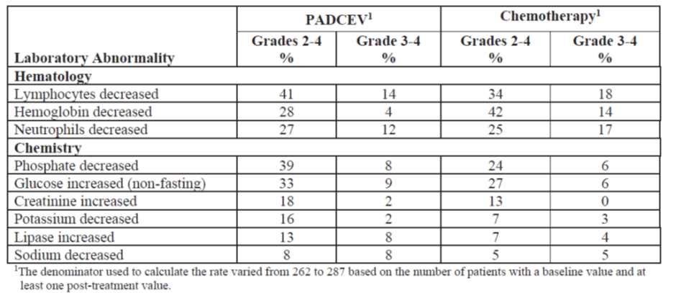

1 The denominator used to calculate the rate varied from 262 to 287 based on the number of patients with a baseline value and at least one post treatment value.

##### Deaths and serious adverse events

In Study EV-301, in the enfortumab vedotin arm 7.1% of subjects and in the chemotherapy arm 5.5% of subjects experienced a treatment-emergent serious adverse event (TEAE) leading to death, of which malignant neoplasm progression (3.4% enfortumab vedotin arm and 2.1% of the chemotherapy arm) was the most common. TEAEs occurring in greater than or equal to two patients in the enfortumab vedotin arm were multiple organ dysfunction and pneumonia, and sepsis in the chemotherapy arm. In Study EV-201 Cohort 2, 9% of patients had a TEAE leading to death, of which the most common (occurring in greater than or equal to two patients) was acute kidney injury. An additional death in each cohort of Study EV-201 occurred after the safety reporting period.

Drug related TEAEs causing death occurred in 2.4%, 1%, and 3.4% of Study EV-301 enfortumab vedotin arm, Study EV-301 chemotherapy arm and Study EV-201 Cohort 2, respectively. The only event occurring in more than one patient was multiple organ dysfunction syndrome in Study EV-301 enfortumab vedotin arm.

A summary of the serious adverse events (SAEs) is included in Table 16, above.

##### Skin reactions

Nectin-4 is expressed in skin. Enfortumab vedotin has been reported to cause a range of reactions, commonly maculopapular or erythematous rash or stomatitis, but one case of Stevens Johnson syndrome/toxic epidermal necrolysis was reported in Cohort 1 of Study EV-201 and it has been reported in the post-marketing setting.

In the pooled safety data (680 patients) skin AEs were reported in 53.7%, 66.3% and 53.6% of enfortumab vedotin patients in Study EV-301, Study EV-201 Cohort 2 and Study EV-201 Cohort 1, respectively. In Study EV-301, reactions occurred at 3.37 events per patient years in the enfortumab vedotin arm and 0.822 events per patient years in the chemotherapy arm. The median onset to onset was 0.46 months (range 0 to 12.7). There were similar findings in Study EV-201. The median time to resolution was 0.92 months (range 0.07 to 19.58).

Severe cutaneous reactions occurred in 26% of the enfortumab vedotin arm and 9.3% of the chemotherapy arm in Study EV-301 (1.05 events per patient years versus 0.375 events per patient years). Of these 5.1% reported Grade 3 events and one patient reported a Grade 4 event of bullous dermatitis. In Cohort 2 of Study EV-201 20.2% had severe cutaneous AEs, there were no Grade 3 or 4 events but 2.2% were SAEs.

Skin AEs resulted in discontinuation of enfortumab vedotin in 2.6%. The evaluation found that among the 59 patients who had a dose interruption because of a skin reaction, 24% restarting at the same dose and 16% of those restarting at a lower dose had a recurrent severe reaction.

Exposure safety analyses suggested that average concentration of enfortumab vedotin and free MMAE were predictors of rash and severe cutaneous AEs greater than or equal to Grade 3 in exposure safety analyses.

##### Hyperglycaemia

No apparent mechanism was found in a review of the nonclinical data. Hyperglycaemia occurred in 11.8% of the enfortumab vedotin arm in Study EV-301, and 18% and 16% in Study EV-201 Cohorts 2 and 1, respectively. In Study EV-301 and Study EV-201 one patient each had fatal events associated hyperglycaemia (the Study EV-201 event was reported as Grade 4 hyperglycaemia and a fatal event of metabolic acidosis).

Pre-existing elevated HbA1C, and obesity appeared to be risk factors. For example, hyperglycaemia with enfortumab vedotin occurred in more patients with pre-existing hyperglycaemia (any grade 37.2%; greater than or equal to Grade 3 19.1%) than with no pre-existing hyperglycaemia (any grade 7.4%; greater than or equal to Grade 3 2.5%).

Events (all events and greater than or equal to Grade 3 events) tend to occur in the first weeks of treatment, in Study EV-301 and both Cohorts of Study EV-201.

Exposure safety analyses suggested that average concentration of enfortumab vedotin was a statistically significant predictor of greater than or equal to Grade 3 hyperglycaemia, although free MMAE average concentration was not.

##### Ocular toxicity

Nectin-4 is expressed in the corneal epithelium. Ocular events occurred in around 40% of enfortumab vedotin treated patients.

Corneal keratitis can give dry eye symptoms and can lead to blurred vision. In Study EV‑301 dry eye events were more common in the enfortumab vedotin arm (24%) than the chemotherapy arm (5.8%). Most were Grade 1 to 2. In Study EV-201 30.3% of Cohort 2 and 40.8% of Cohort 1 experienced dry eye. Blurred vision occurred in 6.1% of the enfortumab vedotin arm in Study EV-301 (2.4% in the chemotherapy arm), and in 10.1% and 16.8% of Study EV-201 Cohorts 2 and 1, respectively.

The time to onset was around 1.64 months for any event and 2.58 months for greater than or equal to Grade 2 event. This was of earlier onset than in the chemotherapy arm (3.78 months and 5.03 months, respectively).

##### Peripheral neuropathy

Peripheral neuropathy is an anticipated adverse effect in antibody drug conjugates that include free MMAE. Muscular weakness and gait disturbance were captured in the peripheral neuropathy events.

In Study EV-301, 50.3% of the enfortumab vedotin arm and 34.4% of the chemotherapy arm experienced peripheral neuropathy (3.54 events per patient years in the enfortumab vedotin arm and 1.67 events per patient years in the chemotherapy arm) and resulted in treatment withdrawal in 4.7% of the enfortumab vedotin arm and 2.7% of the chemotherapy arm. Among patients with no history of peripheral neuropathy, 50.5% experienced events.

The median time to onset was 2.5 months (range: 0 to 12) in the enfortumab vedotin arm and 0.8 months (range: 0 to 9.1) in the chemotherapy arm; median time to first onset for a greater than or equal to Grade 3 event was 5.2 months (range: 1.9 to 12) in the enfortumab vedotin arm and 3.7 months (range: 0.1 to 6.9) in the chemotherapy arm. The events were more likely to be sensory than motor in either treatment arm. Most were Grade 1 or 2 but 5.1% of the enfortumab vedotin arm and 2.7% of the chemotherapy arm reported Grade 3 events.

In Study EV-201, Cohort 2, peripheral neuropathy events were reported in 58.4%, and the median time to first onset of an event was shorter than in Study EV-301, at 2.5 months, and the median time to onset for a greater than or equal to Grade 3 event was 7.6 months. In this study 15% had resolution of all events, and 44% had resolution or improvement. The time to resolution was 1.4 months (0.03 to 12.45) and to improvement was 1.8 months.

Exposure safety analyses suggested that average concentration of enfortumab and free MMAE concentration average were statistically significant predictors of greater than or equal to Grade 2 peripheral neuropathy.

##### Gastrointestinal events

Nectin-4 is expressed in the oesophagus and stomach, and to a lesser extent in the mucosal glands of normal small intestine, colon, and rectum. Gastrointestinal events were expected. More patients experienced diarrhoea in the enfortumab vedotin arm (37.8%) than the chemotherapy arm (22.7%) in Study EV-301, including more Grade 3 to 4 events.

##### Haematological toxicity

Anaemia was common in both studies. It was reported in 19.9% of the enfortumab vedotin arm in Study EV-301 (30.2% in the chemotherapy arm), and in 38.2% and 35.2% of Study EV-201 Cohorts 2 and 1, respectively. Grade 3 events were reported in 6.4% (11.7% in the chemotherapy arm), and in 38.2% and 35.2% of Study EV-201 Cohorts 2 and 1, respectively. None of these events resulted in the withdrawal of enfortumab vedotin treatment.

Neutropenia was also common in both studies. It was reported in 18.2% of the enfortumab arm in Study EV-301 (29.6% in the chemotherapy arm), and in 18.0% and 16.8% of Study EV-201 Cohorts 2 and 1, respectively. Febrile neutropenia was more common in the chemotherapy arm of Study EV-301 (30% versus 14.8%). Greater than or equal to Grade 3 events were reported in 4.7% (7.5% in the chemotherapy arm), and in 10.1% and 6.4% of Study EV-201 Cohorts 2 and 1, respectively. Neutropenia led to the withdrawal of enfortumab vedotin treatment in two patients.

Infections occurring concurrently with neutropenia were reported for 4.1% of the enfortumab vedotin arm in Study EV-301 (6.9% in the chemotherapy arm), and in 5.6% and 4.8% of Study EV-201 Cohorts 2 and 1, respectively. Greater than or equal to Grade 3 infections occurring concurrently with neutropenia were reported for 2.4% of the enfortumab vedotin arm in Study EV-301 (1.7% in the chemotherapy arm), and in 4.5% and 1.6% of Study EV-201 Cohorts 2 and 1, respectively.

### Risk management plan

The sponsor has submitted EU- risk management plan (RMP) version 0.1 (dated 2 February 2021; data lock point (DLP) 15 September 2020) and Australia specific annex (ASA) version 1.0 (dated 4 February 2021) in support of this application. In its response to TGA evaluations, the sponsor has submitted EU-RMP version 0.3 (dated 2 February 2021; DLP 15 September 2020) and ASA version 2.0 (dated 17 September 2021) in support of this application.

The sponsor has submitted approved EU-RMP version 1.0 (dated March 2022; DLP 15 September 2020) and ASA version 3.0 (dated 9 May 2022) in response to changes to the PI/CMI which were requested by the TGA on 4 and 5 May 2022.

The sponsor has submitted ASA version 4.0 (dated 24 May 2022) in response to the outstanding issues identified at the fourth round of RMP evaluation. The sponsor has submitted ASA version 5.0 (dated 13 June 2022) in response to the outstanding issue identified at the fifth round of RMP evaluation.

The summary of safety concerns and their associated risk monitoring and mitigation strategies are summarised in Table 18. Further information regarding the TGA’s risk management approach can be found in [risk management plans for medicines and biologicals](https://www.tga.gov.au/publication/risk-management-plans-medicines-and-biologicals) and [the TGA's risk management approach](https://www.tga.gov.au/tgas-risk-management-approach).

Table 18: Summary of safety concerns

|  |  |  |  |  |  |
| --- | --- | --- | --- | --- | --- |
| **Summary of safety concerns** | | **Pharmacovigilance** | | **Risk Minimisation** | |
| Routine | Additional | Routine | Additional |
| **Important identified risks** | Skin reactions including Stevens-Johnson syndrome (SJS) and Toxic Epidermal Necrolysis (TEN) | ✓ | – | ✓ | ✓† |
| Hyperglycaemia | ✓ | – | ✓ | ✓† |
| **Important potential risks** | None | – | – | – | – |
| **Missing information** | Long term safety | ✓ | ✓* | – | – |

*Final overall survival report based on the prespecified final number of events for the clinical trial EV‑301.

† Educational letter regarding the importance of the CMI to be given to the patient.

The summary of safety concerns in the ASA specify ‘*skin reactions including Stevens-Johnson syndrome and toxic epidermal necrolysis’* as an important identified risk and ‘long terms safety’ is now included as missing information in the ASA. The summary of safety concerns is therefore acceptable.

Routine pharmacovigilance activities only are proposed. A specific follow-up questionnaire form for skin reactions including Stevens-Johnson syndrome and toxic epidermal necrolysis is not considered necessary at this stage as the sponsor is collecting information on all adverse events. This will include additional questions regarding skin events such as information regarding dermatology consultation, biopsy results (if performed) and any associated infection. ‘Long term safety’ for Study EV-301 has been included as additional pharmacovigilance in the ASA (version 4.0), and this now aligns with the approved EU-RMP. The pharmacovigilance plan is acceptable.

Routine risk minimisation activities only are proposed and are adequate at this stage, given that enfortumab vedotin will be administered in specialised settings. The sponsor has outlined in the ASA how the CMI will be distributed to the patients as provision of the CMI is key to the minimisation of risk regarding severe skin reactions. The sponsor states in ASA that the CMI will be attached to the PI and included in the packaging. The CMI can be detached and provided to the patient. The sponsor also proposes an educational letter regarding the importance of providing consumers with the CMI for Padcev as an additional risk minimisation activity. The letter will ensure that health care professionals, including pharmacists, who are expected to prescribe or treat patients with Padcev, are aware of the importance of discussing the CMI with patients before providing it to them. There will also be a quick response (QR) code provided in the educational letter which will allow health care professionals to print additional copies of the CMI as needed for patients. The risk minimisation plan is acceptable.

The RMP evaluation was satisfied with the proposed pharmacovigilance activities. The RMP evaluation made comments about the PI that the Delegate will take into consideration during PI negotiations.

### Risk-benefit analysis

#### Delegate’s considerations

This submission seeks full registration for enfortumab vedotin for locally advanced or metastatic urothelial cancer who have undergone treatment with a PD-1/PD-L1 inhibitor and prior platinum based chemotherapy and in patients who have undergone treatment with a PD-1/PD-L1 inhibitor but who are ineligible for cisplatin.

Enfortumab vedotin is a new antibody drug conjugate with a monomethyl auristatin E (MMAE) payload. The antibody targets Nectin-4 that is highly expressed in most endothelial tumours, the antibody drug conjugate binds, is endocytosed and the MMAE cleaved. MMAE is a microtubulin inhibitor which disrupts cellular activities and cell death. The concept of this mechanism of action has been established with other molecules such as brentuximab vedotin and polatuzumab vedotin.

Efficacy in the PD-1/PD-L1 and platinum exposed population is primarily derived from Study EV-301, an ongoing, global, open label, Phase III randomised study of 608 patients with locally advanced or metastatic urothelial cancer who have received a platinum containing chemotherapy and a PD-1/PD-L1 inhibitor. Patients in this study were randomised 1:1 to receive either enfortumab vedotin or investigators choice of chemotherapy (docetaxel, paclitaxel, or vinflunine). The comparator chemotherapy agents are single agents. Of the three choices for investigators for chemotherapy agents only the taxanes are available in Australia, and while not specifically indicated for locally advanced/metastatic urothelial cancer, are options. There are limited options in this setting, and given the study commenced in 2018 the comparators are not unreasonable.

The patients in this study had a median age of 68, which is younger than the average age at diagnosis of urothelial cancer. Around 20% of the study population was aged over 75 years. Although the racial and ethnic mix represents some parts of the Australian population it is noted there were very few Black/African American patients enrolled.

Around 60% had an ECOG performance status score of one, reflecting advanced disease and previous treatment. The study excluded patients with a number of active conditions, including certain recent manifestations of cardiovascular disease. The exclusion of uncontrolled diabetes is important to highlight and to carefully consider in clinical use given the increased risk of higher grade hyperglycaemia event patients with controlled hyperglycaemia. The patient population offered this treatment is likely to be broader that the trial population, but the limitations of the trial population may reflect those better able to tolerate enfortumab vedotin.

Most patients had received two or more lines of therapy in the locally advanced/metastatic setting. Most patients had had a cisplatin containing chemotherapy regimen, in any setting for urothelial cancer. Around half had the best response of progressive disease on PD-1/PD-L1 inhibitors and around 87% had had a PD-1/PD-L1 inhibitor as the most recent therapy.

The study met its primary endpoint, reducing the risk of an overall survival event by approximately 30% and providing a median additional 3.91 months survival gain over chemotherapy. The subgroup analysis is generally concordant with the main analysis except for women, who represented only around 20% of the trial population. Apart from small numbers leading imprecision in the estimate no other explanation has been identified by the sponsor.

Evidence from Study EV-301 was supplemented by data from Cohort 1 of Study EV-201, a single arm, open label study in patients with locally advanced and metastatic urothelial cancer who had received prior treatment with platinum containing chemotherapy in the adjuvant/neoadjuvant setting with recurrent or progressive disease less than 12 months from completion, or in the locally advanced or metastatic setting. This cohort supported accelerated approval of enfortumab vedotin in the USA in locally advanced and metastatic urothelial cancer.

The patients were of similar age to the Study EV-301 patients, were predominantly White, male and mostly from North America. Almost all had had two prior therapies, 74% had had prior cisplatin and 69% had PD-1/PD-L1 inhibitors as their most recent therapy. Overall response rate was the primary endpoint, which is acceptable in a single arm study as time to event outcomes are difficult to interpret without direct comparative data. The overall response rate was 44% (95% CI: 35.1%, 53.2%) with complete response reported in 12% and partial response in 32%. These findings are consistent with the findings from the main study.

The second population for which the sponsor is seeking approval is cisplatin ineligible patients whose disease has progressed after PD-1/PD-L1 inhibitors. The supportive data are from Cohort 2 of Study EV-201; again, these are single arm data. The study enrolled patients who met some, but not all, of the criteria for cisplatin ineligibility described by Galsky et al. in 2011.[21] Specifically, patients with an ECOG of greater than 2 were not enrolled, the criteria for renal function required a creatinine clearance greater than 30 mL per minute and patients with heart failure and peripheral neuropathy were specifically excluded. The study population was therefore narrower than the population claimed in the proposed indication.

The study included only 89 patients and did not meet its enrolment target, but the results were greater than the prespecified acceptance of efficacy, so this is not a major concern. The overall response rate for Cohort 2 was 52% (95% CI: 40.8%, 62.4%) with complete response in 20%, and partial response in 32%.

Toxicity is an issue for enfortumab vedotin. Almost every patient given enfortumab vedotin in the main trials experienced an adverse event, and over 50% experienced at least one greater than or equal to Grade 3 adverse event, including fatalities from adverse events. Around 60% of patients across the studies had a dose interruption from an adverse event. Patients in Cohort 2 had a higher proportion of deaths, development of sensory neuropathy, neutropenia and ocular toxicities.

Significant toxicities of special interest include severe skin adverse events such as Stevens Johnson syndrome and severe cutaneous adverse reactions. Hyperglycaemia, particularly in patients who were obese and diabetic is also of concern as there were greater than or equal to Grade 3 events and fatalities. Haematological toxicity was common and while neutropenia is a well recognised adverse effect of anticancer agents, in this data set there was an association between neutropenia and an increased rate of infection. Ocular toxicity resulted in dry eye, lacrimal disturbance and blurred vision. This is problematic for all patients, and an impediment in eyesight is of particular concern in patients who have other disabilities such as deafness and gait disturbance from peripheral neuropathies.

For patients who have had disease progression despite PD-1/PD-L1 inhibitors and platinum chemotherapy at some point in their individual treatment algorithm, and who are seeking additional treatment, and who are well enough and prepared for the potential toxicities enfortumab vedotin offers a median of almost four additional months of survival benefit. In the context of use the benefit/risk/uncertainty profile is considered acceptable.

For patients who are cisplatin ineligible Cohort 2 of Study EV-201 is not fully representative of the population usually understood to be cisplatin ineligible. While there is no reason to suspect enfortumab vedotin will behave differently from an efficacy perspective, the safety of enfortumab vedotin has not been characterised in the broader cisplatin ineligible population. There does appear to be some increased risk of toxicities in the subset of cisplatin ineligible patients studied so this lack of data is a significant impediment in the consideration of safety for this aspect of the proposed indication. Additional uncertainties arise from the single arm study from which the data were derived, and the relatively small number of patients studied. In summary, this component of the proposed indication is of concern and the advice of the Advisory Committee on Medicines (ACM) is sought.

##### Proposed indication

The final wording of the indication for this submission will be informed by the advice of the ACM regarding cisplatin-ineligible patients.

##### Proposed dose

The maximum tolerated dose has not been established, doses greater than 1.25 mg per day are unlikely to give greater efficacy based on the current understanding of the exposure response relationships and is likely to give greater toxicity. The clinical evidence is based on two main studies using the dose and dosing regimen of 1.25 mg/kg by intravenous infusion over 30 minutes on Days 1, 8 and 15 of a 28 day cycle. Most of the efficacy and safety evidence in the requested population is derived from patients who commenced on this dosing regimen.

In the absence of a well-studied alternative dosing strategy, this dosing regimen is accepted.

##### Data in special populations

Pharmacokinetic data from patients with mild hepatic impairment contributed to modelling and simulation that did not demonstrate significant differences in enfortumab vedotin or MMAE exposures. There are data from only three patients with moderate hepatic impairment, and no data in patients with severe hepatic impairment. Because of the significant exposure safety relationships for both enfortumab vedotin exposure and free MMAE, the potential for increased exposure is an important consideration and there should be future quantification of risk in this patient subgroup.

In the meantime, the sponsor seeks to include precautionary statements in the Padcev PI. The sponsor proposes the use of enfortumab in these patient groups should be undertaken with caution however the Delegate is of the view that because of an increased number of Grade 3 or higher events and fatal events in patients with moderate and severe hepatic impairment with other products that are conjugated to vedotin, use in these groups is best avoided, in line with the language in the Padcev labelling internationally to date.

Collected PK data, modelling and simulation support the use in patients with chronic kidney disease without dose modification although data are limited in patients with a creatinine clearance (estimated glomerular filtration rate) of less than 30 mL per minute and there are no data from use in patients on any form of dialysis.

#### Advisory Committee considerations

The [Advisory Committee on Medicines (ACM)](https://www.tga.gov.au/committee/advisory-committee-medicines-acm), having considered the evaluations and the Delegate’s overview, as well as the sponsor’s response to these documents, advised the following.

##### Specific advice to the Delegate

The ACM advised the following in response to the Delegate’s specific request for advice:

1. ***Has sufficient evidence been provided to support the specific component of the indication that includes cisplatin ineligible patients?***

The ACM was of the view that sufficient evidence has been provided to support the specific component of the indication that includes cisplatin-ineligible patients.

The ACM noted that the data in support of the cisplatin-ineligible indication is from a single arm Phase II study and that this results in challenges for interpretation of the significance of the overall response rate. However, on balance the ACM considered the 52% overall response rate to be clinically meaningful within this patient population.

The ACM commented that enfortumab vedotin does not appear to induce remission like immune oncology agents can, however that this drug may be of benefit for those who do not obtain a sustained response with immune oncology (approximately 20 to 30% of patients).

The ACM noted the study did not include all patients who might be considered cisplatin-ineligible, such as those who have a greater than or equal to Grade 2 peripheral neuropathy, advanced heart failure, or estimated glomerular filtration rate less than 30 mL/min/1.73m2 but considered oncologists would exercise clinical judgement on the individual patient selection for enfortumab vedotin.

Noting the activity of this drug and the area of unmet clinical need the ACM was supportive of the inclusion of both cisplatin- and carboplatin-ineligible patients for ‘platinum ineligible’ rather than ‘cisplatin ineligible’ within the indication, although there are no clinical trial data specifically for carboplatin-ineligible patients.

1. ***Other advice***

The ACM discussed the significant and severe off-target toxicity associated with enfortumab vedotin, particularly for skin and nerves, and noted that appropriate patient selection and counselling will be critical. Also mentioned in the discussions were the severe skin toxicities that included fatalities. The ACM agreed that a boxed warning would be appropriate in this instance. Additionally, the ACM recommended that an education campaign targeted towards patients and clinicians should be considered to further raise awareness of the off‑target toxicity.

The ACM noted that enfortumab vedotin is not renally excreted and as such commented that there are likely to be limited risks for patients with an estimated glomerular filtration less than 30 mL/min/1.73 m2.

##### Conclusion

The ACM considered this product to have an overall positive benefit-risk profile for the indication:

*Padcev is indicated for the treatment of adult patients with locally advanced (LA) or metastatic urothelial cancer (mUC) who have received a programmed death receptor‑1 (PD-1) or programmed death-ligand 1 (PD-L1) inhibitor and who:*

* *Have received a platinum containing chemotherapy in the neoadjuvant/adjuvant, LA or metastatic setting or*
* *Are not eligible for platinum-containing chemotherapy.*

## Outcome

Based on a review of quality, safety, and efficacy, the TGA approved the registration of Padcev (enfortumab vedotin) 20 mg and 30 mg powder for injection, indicated for:

*Padcev as monotherapy is indicated for the treatment of adult patients with locally advanced or metastatic urothelial cancer who have previously received a platinum-containing chemotherapy and a programmed receptor-1 or programmed death-ligand-1 inhibitor.*

### Specific conditions of registration applying to these goods

* Padcev (enfortumab) is to be included in the Black Triangle Scheme. The PI and CMI [Consumer Medicines Information] for Padcev must include the black triangle symbol and mandatory accompanying text for five years, which starts from the date that the sponsor notifies the TGA of supply of the product.
* The Padcev EU-RMP (version 1.0, dated March 2022; DLP 15 September 2020), with ASA (version 5.0, dated 13 June 2022), included with submission PM-2021-00635-1-4, and any subsequent revisions, as agreed with the TGA will be implemented in Australia.

An obligatory component of risk management plans is routine pharmacovigilance. Routine pharmacovigilance includes the submission of periodic safety update reports (PSURs).

Reports are to be provided in line with the current published list of EU reference dates and frequency of submission of PSURs until the period covered by such reports is not less than three years from the date of the approval letter.

The reports are to at least meet the requirements for PSURs as described in the European Medicines Agency’s Guideline on good pharmacovigilance practices (GVP) Module VII-periodic safety update report (Rev 1), Part VII.B Structures and processes. Note that submission of a PSUR does not constitute an application to vary the registration.

* For all injectable products the Product Information must be included with the product as a package insert.

## Attachment 1. Product Information

The PI for Padcev approved with the submission which is described in this AusPAR is at Attachment 1. For the most recent PI, please refer to the TGA [PI/CMI search facility.](https://www.tga.gov.au/picmi-search-facility)

|  |
| --- |
| Therapeutic Goods Administration |
| PO Box 100 Woden ACT 2606 Australia  Email: [info@tga.gov.au](mailto:info@tga.gov.au) Phone: 1800 020 653 Fax: 02 6232 8605  [**https://www.tga.gov.au**](https://www.tga.gov.au) |

1. European Society of Medical Oncology (ESMO), Bladder cancer: ESMO Clinical Practice Guideline for diagnosis, treatment and follow up, 2021. Available from ESMO.org.
2. Australian Institute of Health and Welfare, Cancer in Australia, 2021. Available from AIHW.gov.au
3. Miyazaki J, Nishiyama H. Epidemiology of urothelial carcinoma. *International journal of urology: official journal of the Japanese Urological Association*. 2017;24(10):730-4.
4. Siegel R.L., Miller K.D., Jemal A. Cancer statistics, 2019*. CA Cancer J. Clin.* 2019; 69:7–34.
5. Chin JL, Siddiqui KM, Tran K-C. Metastatic Bladder Cancer. In: Ahmad A, ed. Introduction to Cancer Metastasis. *Elsevier, Inc*., London, United Kingdom. 2017:177-98.
6. Cisplatin ineligibility was described by Galsky et al in 2011 and defines a group of patients more at risk of toxicity from cisplatin. These criteria include Eastern Cooperative Oncology Group (ECOG) performance status ≥ 2; Creatinine clearance < 60 mL/min; Hearing loss (at audiometry) 25 dB at two contiguous frequencies; Grade ≥ 2 peripheral neuropathy; New York Heart Association Class ≥ III heart failure
7. Erdafitinib is not registered in Australia
8. Bellmunt J. Treatment of metastatic urothelial cancer of the bladder and urinary tract; in Lerner S ed, Shah S ed. *UpToDate.* Waltham, Mass.: UpToDate 2022.
9. European Medicines Agency (EMA), Committee for Medicinal Products for Human Use (CHMP), [Guideline on nonclinical evaluation for anticancer pharmaceuticals EMA/CHMP/ICH/646107/2008](https://www.tga.gov.au/resources/resource/international-scientific-guidelines/international-scientific-guideline-ich-topic-s-9-note-guidance-non-clinical-evaluation-anticancer-pharmaceuticals), May 2010.
10. European Medicines Agency (EMA), Committee for Medicinal Products for Human Use (CHMP), [Guideline on preclinical safety evaluation of biotechnology-derived pharmaceuticals EMA/CHMP/ICH/731268/1998](https://www.tga.gov.au/resources/resource/international-scientific-guidelines/international-scientific-guideline-ich-guideline-s6-r1-preclinical-safety-evaluation-biotechnology-derived-pharmaceuticals), December 2011.
11. Cytochrome P450 (CYP) enzymes are the major enzymes involved in drug metabolism, accounting for large part of the total metabolism. Most drugs undergo deactivation by CYPs, either directly or by facilitated excretion from the body. Also, many substances are bioactivated by CYPs to form their active compounds.

    Many drugs may increase or decrease the activity of various CYP isozymes either by inducing the biosynthesis of an isozyme (enzyme induction) or by directly inhibiting the activity of the CYP (enzyme inhibition). This is a major source of adverse drug interactions, since changes in CYP enzyme activity may affect the metabolism and clearance of various drugs. Such drug interactions are especially important to take into account when using drugs of vital importance to the patient, drugs with important side-effects and drugs with small therapeutic windows, but any drug may be subject to an altered plasma concentration due to altered drug metabolism.
12. Common Terminology Criteria for Adverse Events ( CTCAE ) grading: Grade 1 is mild, Grade 2 is moderate, Grade 3 is severe and Grade 4 is life-threatening.
13. The QT interval is the time from the start of the QRS wave complex to the end of the corresponding T wave. It approximates to the time taken for ventricular depolarisation and repolarisation, that is to say, the period of ventricular systole from ventricular isovolumetric contraction to isovolumetric relaxation.
14. Eastern Cooperative Oncology Group Performance Status (ECOG PS): The ECOG has developed criteria used by doctors and researchers to assess how a patient's disease is progressing, assess how the disease affects the daily living abilities of the patient, and determine appropriate treatment and prognosis. The following are used:

    0 - Fully active, able to carry on all pre-disease performance without restriction

    1- Restricted in physically strenuous activity but ambulatory and able to carry out work of a light or sedentary nature, for example, light house work, office work

    2 - Ambulatory and capable of all selfcare but unable to carry out any work activities. Up and about more than 50% of waking hours

    3 - Capable of only limited selfcare, confined to bed or chair more than 50% of waking hours

    4 - Completely disabled. Cannot carry on any selfcare. Totally confined to bed or chair

    5 – Dead
15. Docetaxel was not to be chosen as a comparator if total bilirubin greater than upper limit of normal (ULN), or aspartate transaminase (AST) and/or alanine transaminase (ALT) greater than 1.5 times ULN with alkaline phosphatase (ALP) greater than 2.5 times ULN.
16. New York Heart Association (NYHA) classification:

    Class I: No limitations. Ordinary physical activity does not cause undue fatigue, dyspnoea or palpitations (asymptomatic left ventricular dysfunction). Metabolic equivalent (MET) > 7.

    Class II: Slight limitation of physical activity. Ordinary physical activity results in fatigue, palpitation, dyspnoea or angina pectoris (mild congestive heart failure). MET = 5.

    Class III: Marked limitation of physical activity. Less than ordinary physical activity leads to symptoms (moderate congestive heart failure). MET = 2–3.

    Class IV: Unable to carry on any physical activity without discomfort. Symptoms of congestive heart failure present at rest (severe congestive heart failure). MET = 1.6.
17. Haemoglobin A1c or glycated haemoglobin (HbA1c) is a minor component of haemoglobin chemically linked to glucose. Levels of HbA1c vary and are relative to the overall blood glucose concentration. Unlike a blood glucose concentration, levels of HbA1c are not influenced by daily fluctuations in the blood glucose concentration but reflect the average glucose levels over the prior 6 to 8 weeks. Measurement of HbA1c is used in the diagnosis of diabetes mellitus and is useful indicator of how well the blood glucose level has been controlled in the recent past and may be used to monitor the effects of diet, exercise, and drug therapy on blood glucose in patients with diabetes. In healthy people without diabetes, the HbA1c level is less than 7 percent of total haemoglobin.
18. The Response Evaluation Criteria in Solid Tumours (RECIST) is a voluntary international standard with unified and easily applicable criteria to define when a patient's tumour has improved ('respond'), stayed the same ('stabilise'), or worsened ('progress') during treatment. The criteria were published in February 2000 by an international collaboration including the European Organisation for Research and Treatment of Cancer (EORTC), National Cancer Institute (NCI) of the United States, and the National Cancer Institute of Canada Clinical Trials Group. Today, the majority of clinical trials evaluating cancer treatments for objective response in solid tumours use RECIST. These criteria were developed and published in February 2000, and subsequently updated in 2009.
19. Bellmunt, J et al. Prognostic factors in patients with advanced transitional cell carcinoma of the urothelial tract experiencing treatment failure with platinum-containing regimens, *Journal of Clinical Oncology*, 2010; 28(11): 1850-1855.
20. Cloper, C.J. et al. The use of confidence of fiducial limits illustrcaptionszated in the case of the binomial, *Biometrika,* 1934; 6(4): 404-413.
21. Galskym M. D. et al. A consensus definition of patients with metastatic urothelial carcinoma who are unfit for cisplatin-based chemotherapy, The Lancet, 2011; 12: 211-214.