AUSTRALIAN PRODUCT INFORMATION - RYALTRIS® (olopatadine hydrochloride and mometasone furoate monohydrate) Nasal Spray

# NAME OF THE MEDICINE

Olopatadine hydrochloride and mometasone furoate monohydrate

# QUALITATIVE AND QUANTITATIVE COMPOSITION

Each spray delivers a volume of 0.1 mL suspension containing 665 micrograms of olopatadine hydrochloride equivalent to 600 micrograms (0.6%w/v) of olopatadine base and mometasone furoate monohydrate equivalent to 25 micrograms (0.025% w/v) of mometasone furoate (665 micrograms / 25 micrograms).

Excipients with known effect: polysorbate 80 and benzalkonium chloride.

For the full list of excipients, see Section 6.1 List of excipients.

# PHARMACEUTICAL FORM

RYALTRIS® is a nasal spray containing an isotonic aqueous white homogenous suspension in a metered dose manual spray unit. It has a pH of approximately 3.7.

# CLINICAL PARTICULARS

## THERAPEUTIC INDICATIONS

RYALTRIS® is indicated for the treatment of symptoms associated with allergic rhinitis and rhinoconjunctivitis in patients 6 years of age and older.

## DOSAGE AND ADMINISTRATION

**Dosage**

**Adults and Adolescents (12 Years of Age and Older)**

The recommended dosage of RYALTRIS® is 2 sprays in each nostril twice daily.

**Children (6 to 11 Years of Age)**

The recommended dosage of RYALTRIS® is 1 spray in each nostril twice daily.

**Method of administration**

Administer RYALTRIS® by the intranasal route only. Shake the bottle well before each use.

Priming: Prime RYALTRIS® before initial use by releasing 6 sprays. One bottle of RYALTRIS® provides either 240, 120 or 56 metered sprays after priming, depending on the bottle presentation. When RYALTRIS® has not been used for ≥14 days, re-prime by releasing 2 sprays or until a fine mist appears.

Depending on the presentation, the bottle should be discarded after 240 sprays (30 days usage for adults and adolescents 12 years and older OR 60 days usage for children 6 to 11 years old), 120 sprays (15 days usage for adults and adolescents 12 years and older OR 30 days usage for children 6 to 11 years old) or 56 sprays (7 days usage for adults and adolescents 12 years and older OR 14 days usage for children 6 to 11 years old). The correct amount of remaining medication in each spray cannot be assured beyond the initial priming and 240, 120 or 56 sprays (depending on the bottle presentation), even though the bottle appears not being completely empty.

Avoid spraying RYALTRIS® into the eyes or mouth.

**Paediatric**

In children 6 to 11 years of age, safety of RYALTRIS® beyond 2 weeks of use has not been assessed (see **4.4 SPECIAL WARNINGS AND PRECAUTIONS FOR USE**).

The safety and effectiveness of RYALTRIS® in paediatric patients below the age of 6 years has not been established.

**Hepatic impairment**

See **Section 4.4 SPECIAL WARNINGS AND PRECAUTIONS FOR USE.**

## CONTRAINDICATIONS

RYALTRIS® is contraindicated in:

* Patients with known hypersensitivity to olopatadine hydrochloride, mometasone furoate, or any ingredients of RYALTRIS®.
* Severe nasal infection, especially candidiasis
* Persons with haemorrhagic diathesis or with a history of recurrent nasal bleeding.

## SPECIAL WARNINGS AND PRECAUTIONS FOR USE

**Local Nasal Effects**

Instances of nasal ulceration and nasal septal perforation have been reported in patients following the intranasal application of antihistamines.

Instances of nasal septal perforation have been reported following the intranasal application of corticosteroids.

Instances of epistaxis have been reported in patients following the intranasal application of antihistamines and corticosteroids (see **4.8 ADVERSE EFFECTS (UNDESIRABLE EFFECTS)**.

Because of the inhibitory effect of corticosteroids on wound healing, patients who have experienced recent nasal septal ulcers, nasal surgery, or nasal trauma should avoid use of RYALTRIS® until healing has occurred.

Mometasone furoate should not be used in the presence of untreated localised infection involving the nasal mucosa. Following 12 months of treatment with mometasone furoate nasal spray, there was no evidence of atrophy of the nasal mucosa. Mometasone furoate tended to reverse the nasal mucosa closer to a normal histological phenotype. As with any long-term treatment, patients using mometasone furoate nasal spray over several months or longer should be examined periodically for possible changes in the nasal mucosa. If localised fungal infection of the nose or pharynx develops, discontinuance of RYALTRIS® therapy or appropriate treatment may be required. Persistence of nasopharyngeal irritation may be an indication for discontinuing RYALTRIS®.

**Visual disturbances, including Glaucoma, Cataract and Chorioretinal disorders**

Visual disturbance may be reported with systemic and topical (including, intranasal, inhaled and intraocular) corticosteroid use. If a patient presents with symptoms such as blurred vision or other visual disturbances, the patient should be considered for referral to an ophthalmologist for evaluation of possible causes of visual disturbances which may include cataract, glaucoma or rare diseases such as central serous chorioretinopathy (CSCR) which have been reported after use of systemic and topical corticosteroids.

**Hypersensitivity Reactions**

Hypersensitivity reactions, including instances of wheezing, may occur after the intranasal administration of mometasone furoate monohydrate. Discontinue RYALTRIS® if such reactions occur (see **Section 4.3 CONTRAINDICATIONS**).

**Immunosuppression**

Patients receiving corticosteroids who are potentially immunosuppressed should be warned of the risk of exposure to certain infections (e.g. chickenpox, measles) and of the importance of obtaining medical advice if such exposure occurs.

Corticosteroids should be used with caution, if at all, in patients with active or quiescent tuberculous infections of the respiratory tract, or in untreated fungal or bacterial infections, systemic viral or parasitic infections, or ocular herpes simplex because of the potential for worsening of these infections.

**Hypothalamic-Pituitary-Adrenal (HPA) Axis Effects**

Intranasal steroid products are designed to deliver drug directly to the nasal mucosa in order to minimise overall systemic glucocorticoid exposure and side effects. When intranasal steroids are used at higher than‑ ‑recommended dosages or in susceptible individuals at recommended dosages, systemic corticosteroid effects such as hypercorticism and adrenal suppression may appear. Physicians should be alert for evidence of systemic effects, especially in chronically treated patients.

However, there is no evidence of hypothalamic-pituitary-adrenal (HPA) axis suppression following prolonged treatment with mometasone furoate nasal spray. Care must be taken while transferring patients from systemic steroid treatment to RYALTRIS® if there is any reason to suppose that their adrenal function is impaired.

During transfer from systemic corticosteroids to intranasal corticosteroids some patients may experience symptoms of withdrawal from systemically active corticosteroids (e.g. joint and/or muscular pain, lassitude, and depression initially) despite relief from nasal symptoms. Such transfer may also unmask pre-existing allergic conditions such as allergic conjunctivitis and eczema, previously suppressed by systemic corticosteroid therapy.

**Somnolence**

Somnolence has been reported as uncommon following administration of RYALTRIS® in the clinical studies (see Section 4.7 **EFFECTS ON ABILITY TO DRIVE AND USE MACHINES**).

**Effect on growth**

Intranasal corticosteroids may cause a reduction in growth velocity when administered to paediatric patients. Routinely monitor the growth of paediatric patients receiving RYALTRIS® (see **5.2 PHARMACOKINETIC PROPERTIES,** **Special Populations**).

**Hepatic Impairment**

No studies have been conducted with RYALTRIS® in patients with hepatic impairment. However, there have been reports of concentrations of mometasone furoate appearing to increase with severity of hepatic impairment. Based on data from the individual components, no adjustment of the dosing regimen of RYALTRIS® is warranted in patients with hepatic impairment (see **5.2 PHARMACOKINETIC PROPERTIES,** **Special Populations**).

**Use in the elderly**

Based on population pharmacokinetic analysis among patients 12 years of age and older, the pharmacokinetics of olopatadine and mometasone furoate with RYALTRIS® was not influenced by age.

No overall differences in safety or efficacy were observed in data collected from 145 patients aged 65 years and older versus younger patients who were treated with RYALTRIS® in placebo- and active-controlled studies.

**Paediatric use**

Safety in children 6 to 11 years of age has not been studied beyond 2 weeks of use or in perennial allergic rhinitis. The safety and effectiveness of RYALTRIS® in patients below the age of 6 years has not been established.

Retardation of growth rate in children may occur with intranasal corticosteroids, particularly at high doses prescribed for prolonged periods of time. Long term glucocorticoid exposure carries particular risks in the 6 to 11 year age group. Routinely monitor the growth of paediatric patients receiving intranasal corticosteroids. A placebo-controlled clinical trial in which paediatric patients were administered 100 micrograms of mometasone furoate nasal spray daily for one year did not observe a reduction in growth velocity. Periods of treatment greater than one year have not been studied (see **5.2 PHARMACOKINETIC PROPERTIES,** **Special Populations**).

Periodic clinical review, pursuit of lowest effective dosing, and consideration of adjunctive treatment modalities are recommended in paediatric patients aged 6 to 11 years.

**Effect on laboratory tests**

No data available.

## INTERACTIONS WITH OTHER MEDICINES AND OTHER FORMS OF INTERACTIONS

No formal drug-drug interaction studies have been performed with RYALTRIS®. The drug interactions of the combination are expected to reflect those of the individual components.

*In vitro* studies with human liver microsomal preparations have shown that olopatadine is not an inhibitor of CYPs 1A2, 2C8/9, 2C19, 2D6, 2E1 or 3A4. Because elimination of olopatadine is predominantly by renal excretion as unchanged drug, co-administered CYP inhibitors are not expected to affect olopatadine exposure. Mometasone furoate is subject to extensive hepatic metabolism. *In vitro* studies have confirmed the primary role of CYP 3A4 in the metabolism of this compound. Co-administration with strong CYP3A4 inhibitors (e.g., ketoconazole, itraconazole, clarithromycin, ritonavir, cobicistat-containing products) may lead to increased plasma concentrations of corticosteroids and potentially increase the risk for systemic corticosteroid side-effects. Consider the benefit of co-administration versus the potential risk of systemic corticosteroid effects, in which case patients should be monitored for systemic corticosteroid side-effects.

## FERTILITY, PREGNANCY AND LACTATION

**Effects on fertility**

No studies on impairment of fertility have been conducted with olopatadine hydrochloride and mometasone furoate in combination; however, studies are available for the individual active components as described below.

Olopatadine hydrochloride: Olopatadine administered orally to male and female rats at dose of 400 mg/kg/day, (approximately 680 times the maximum recommended human dose (MRHD) for adults by intranasal administration on a mg/m2 basis) resulted in decreases in the fertility index, number of corpora lutea and implantation rate. No effects on fertility were observed at a dose of 50 mg/kg/day (approximately 85 times the MRHD for adults by intranasal administration on a mg/m2 basis).

Mometasone furoate: In rats, impairment of fertility was not produced by subcutaneous doses up to 15 microgram/kg/day of mometasone furoate (less than the MRHD in adults by intranasal administration on a microgram/m2 basis). As with other corticosteroids, at exposure levels associated with marked signs of systemic corticosteroid toxicity, mometasone furoate had progestogenic effects on the female reproductive tract and mammary glands.

**Use in Pregnancy (Category B3)**

There are no adequate and well-controlled clinical studies with RYALTRIS®, olopatadine hydrochloride only, or mometasone furoate only in pregnant women. No animal reproductive and developmental studies have been conducted with olopatadine hydrochloride and mometasone furoate in combination. Studies in animals with the individual active components are available and revealed teratogenicity and other adverse effects for mometasone furoate.

Olopatadine hydrochloride: Olopatadine was not teratogenic in rabbits and rats at oral doses of up to 400 or 600 mg/kg/day, respectively (approximately 1400 and 1000 times the MRHD for adults by intranasal administration on a mg/m2 basis, respectively).

Mometasone furoate: In animal studies, small quantities of mometasone furoate were found to cross the placenta barrier. Like other corticosteroids, at doses associated with signs of systemic toxicity, mometasone furoate reduced fetal growth and was teratogenic in mice, rats and rabbits after subcutaneous or topical application. Higher doses had progestogenic effects in pregnant rats, associated with prolonged gestation, dystocia and reduced pup survival.

As with other nasal corticosteroid preparations, RYALTRIS® should be used during pregnancy only if the potential benefit justifies the potential risk to the fetus. Infants born of mothers who received corticosteroids during pregnancy should be observed carefully for hypoadrenalism.

**Use in Lactation**

It is not known whether the active components of RYALTRIS® are excreted in human breast milk after intranasal administration. There are no data from well-controlled human studies on the use of RYALTRIS® by nursing mothers. RYALTRIS® should be used by nursing mothers only if the potential benefit to the patient outweighs the potential risks to the infant. Patients should also be informed that antihistamines may affect the milk production of a nursing mother.

Olopatadine and mometasone furoate (and/or its metabolites) have both been identified in the milk of lactating rats following oral administration. In rats, pups of mothers administered olopatadine at oral doses of 4 mg/kg/day (approximately 7 times the MRHD for adults by intranasal administration on a mg/m2 basis) and above showed decreased bodyweight gain during the nursing period. Pup viability was reduced at 20 mg/kg/day (approximately 35 times the MRHD for adults by intranasal administration on mg/m2 basis) and above, but not at 6 mg/kg/day (approximately 10 times the MRHD for adults by intranasal administration on mg/m2 basis).

## EFFECTS ON ABILITY TO DRIVE AND USE MACHINES

Due to the potential occurrence of somnolence, patients using RYALTRIS® should be cautioned against engaging in hazardous occupations requiring complete mental alertness and motor coordination such as driving or operating machinery after administration of RYALTRIS® until they know how they react to the nasal spray.

Caution is required if RYALTRIS® is used concomitantly with alcohol or other CNS depressants.

Somnolence has been reported following administration of RYALTRIS® in 2 out of 789 subjects taking RYALTRIS® in the clinical studies.

## ADVERSE EFFECTS (UNDESIRABLE EFFECTS)

***Adolescents and Adults (12 years of age and older)***

*Clinical Trials*

The safety of RYALTRIS®in adult and adolescents 12 years of age and older was investigated in 3062 subjects (36.1% male and 63.9% female) with seasonal allergic rhinitis and 593 subjects (31.7% male and 68.3% female) with perennial allergic rhinitis.

In the placebo- and active- controlled, double-blind randomised clinical studies of 2-week duration in subjects with seasonal allergic rhinitis, the overall incidence of treatment emergent adverse events (TEAEs) was 13.9% in the RYALTRIS®treatment group, 13.2% in the olopatadine hydrochloride nasal spray treatment group, 7.9% in the mometasone furoate nasal spray treatment group, and 9.5% in the placebo treatment groups. Overall, <1% of patients in all treatment groups discontinued due to adverse reactions. Table 1 lists treatment-emergent adverse events reported with frequencies ≥1% and more frequently than placebo in patients treated with RYALTRIS® in the 2-week SAR studies.

Table 1: Most Frequently Reported Treatment Emergent Adverse Events with ≥1% Incidence That Were Reported More Frequently with RYALTRIS Than Placebo in the 2-Week Placebo- and Active-controlled Studies in Adult and Adolescent Patients with Seasonal Allergic Rhinitis

| System Organ Class | Adverse Event Preferred Term | RYALTRIS® N = 789a n (%)b | Olopatadine HCl Nasal Spray* N = 751 a  n (%)b | Mometasone Furoate Nasal Spray*  N = 746 a  n (%)b | Placebo N = 776 a  n (%)b |
| --- | --- | --- | --- | --- | --- |
| Nervous system disorder | Dysgeusia | 24 (3.0) | 16 (2.1) | 0 (0) | 2 (0.3) |
| Respiratory, thoracic and mediastinal disorders | Epistaxis | 8(1.0) | 11 (1.5) | 6 (0.8) | 5 (0.6) |
| Nasal discomfort | 8 (1.0) | 4 (0.3) | 4 (0.5) | 6 (0.8) |

a N = Total number of subjects in each treatment group in the safety analysis set

b n = number of subjects with adverse events in each MedDRA term; Number (%) of subjects with adverse events (AEs), sorted on international order for system organ class (SOC) and alphabetically for preferred term (PT). Percentages are based on total number of subjects in the safety set within each treatment group. At each level of summation (overall, SOC, PT), subjects are only counted once.

* Not commercially marketed

The safety data described below reflect exposure to RYALTRIS® in 789 patients with seasonal allergic rhinitis in clinical studies of 2‑week duration. The adverse reactions are listed below by system organ class and frequency.

Frequencies are defined as:

Very common (≥1/10)

Common (≥1/100 to <1/10)

Uncommon (≥1/1,000 to <1/100)

Rare (≥1/10,000 to <1/1,000)

Very rare (<1/10,000)

Not known (cannot be estimated from the available data)

Nervous system disorder

*Common:* dysgeusia (unpleasant taste).

*Uncommon:* dizziness, headaches, lethargy, somnolence, insomnia.

Respiratory, thoracic and mediastinal disorders

*Uncommon:* epistaxis, nasal dryness, nasal discomfort, nasal inflammation, oropharyngeal pain, throat irritation, sneezing.

Gastrointestinal disorders

*Uncommon:* dry mouth, abdominal pain.

General disorders and administration site conditions

*Uncommon:* Fatigue

In the double-blind, placebo-controlled, 52-week study (Study GSP 301-303), subjects with perennial allergic rhinitis were randomised to receive RYALTRIS® (pH 3.7), a placebo nasal spray pH 3.7, or a placebo nasal spray pH 7.0 administered as 2 sprays/nostril twice daily (morning [AM] and evening [PM]). The safety profile in the long-term perennial allergic rhinitis study was comparable with the 2-week seasonal allergic rhinitis studies. Additionally, improvement in nasal symptoms was observed over the 52-week treatment duration.

Overall, the incidence of treatment-related TEAEs was 51.7% in the RYALTRIS® treatment group, 41.4% in the placebo nasal spray pH 3.7 treatment group, and 53.5% in the placebo nasal spray pH 7.0 treatment group. Of the 593 treated patients, 3.8% of patients receiving RYALTRIS® discontinued from the study due to an adverse event, compared with 2.0% and 3.0% of patients receiving placebo nasal spray pH 3.7 and pH 7.0, respectively. Table 2 lists TEAEs reported with frequencies ≥1% that were more frequent for RYALTRIS® than Placebo pH 3.7.

Table 2: Treatment Emergent Adverse Events with ≥1% Incidence that Were Reported More Frequently with RYALTRIS® than Placebo in the 52-Week Study in Adult and Adolescent Patients with Perennial Allergic Rhinitis

|  |  |  |  |  |
| --- | --- | --- | --- | --- |
| **System Organ Class** | **Adverse Event Preferred Term** | **RYALTRIS**® **(N=393)**  **N (%)** | **Placebo Nasal Spray, pH 3.7 N = 99  n (%)** | **Placebo Nasal Spray, pH 7.0 N = 101  n (%)** |
| Infections and infestations | Upper respiratory tract infection | 25 (6.4) | 6 (6.1) | 9 (8.9) |
| Urinary tract infection | 9 (2.3) | 2 (2.0) | 0 (0.0) |
| Viral upper respiratory tract infection | 9 (2.3) | 2 (2.0) | 3 (3.0) |

|  |  |  |  |  |
| --- | --- | --- | --- | --- |
| Respiratory, thoracic and mediastinal disorders | Epistaxis | 18 (4.6) | 2 (2.0) | 2 (2.0) |
| Nasal discomfort | 11 (2.8) | 2 (2.0) | 5 (5.0) |
| Cough | 9 (2.3) | 2 (2.0) | 2 (2.0) |
| Bronchitis | 5 (1.3) | 0 (0.0) | 2 (2.0) |
| Pharyngitis streptococcal | 5 (1.3) | 0 (0.0) | 2 (2.0) |
| Nervous system disorder | Dysgeusia | 8 (2.0) | 0 (0.0) | 1 (1.0) |
|  | Headache | 16 (4.1) | 3 (3.0) | 5 (5.0) |
| Musculoskeletal | Back pain | 5 (1.3) | 0 (0.0) | 3 (3.0) |
| Gastrointestinal | Nausea | 5 (1.3) | 1 (1.0) | 2 (2.0) |
| Injury, poisoning and procedural complications | Procedural pain | 6 (1.5) | 1 (1.0) | 2 (2.0 |

In the RYALTRIS® treatment group of the 52-week study, 16 (4.1%) patients experienced mild epistaxis, and 2 (0.5%) patients experienced moderate epistaxis. In the placebo treatment groups, 2 (2.0%) patients in each placebo treatment group experienced mild epistaxis, and no placebo patients experienced moderate epistaxis. No incidents of severe epistaxis were reported in any treatment group. Focused nasal examinations were performed, and no nasal ulcerations were observed.

***Paediatrics (6 to 11 years of age)***

*Clinical Trials*

The safety of RYALTRIS® in children 6 to 11 years of age was investigated in 225 patients (56% male and 44% female) with seasonal allergic rhinitis treated with 1 spray per nostril twice daily.

In the placebo-controlled, double-blind randomised clinical study of 2-week duration, the overall incidence of treatment emergent adverse events (TEAEs) was 12.0% in the RYALTRIS®treatment group and 10.4% in the placebo treatment groups. Overall, <2% of patients in all treatment groups discontinued due to adverse reactions. Table 3 lists treatment-emergent adverse events reported with frequencies ≥1% and more frequently than placebo in paediatric patients treated with RYALTRIS® in the 2-week SAR study.

Table 3: Most Frequently Reported Treatment Emergent Adverse Events with ≥1% Incidence That Were Reported More Frequently with RYALTRIS Than Placebo in the 2-Week Placebo-controlled Studies in Paediatric Patients with Seasonal Allergic Rhinitis

| System Organ Class | Adverse Event Preferred Term | RYALTRIS® N = 225 (%) | Placebo N = 221(%) |
| --- | --- | --- | --- |
| Nervous system disorder | Dysgeusia | 3 (1.3) | 0 |
| Headache | 3 (1.3) | 1 (0.5) |

**Reporting suspected adverse effects**

Reporting suspected adverse reactions after registration of the medicinal product is important. It allows continued monitoring of the benefit-risk balance of the medicinal product. Healthcare professionals are asked to report any suspected adverse reactions at www.tga.gov.au/reporting-problems.

## OVERDOSE

There have been no reported overdosages with RYALTRIS®. Accordingly, no data on the effects of acute or chronic overdosage with RYALTRIS® are available. RYALTRIS® contains both olopatadine hydrochloride and mometasone furoate; therefore, the risks associated with overdosage for the individual components described below are expected to apply to RYALTRIS®.

Acute overdosage with this dosage form is unlikely since one 30-day (240‑metered doses) bottle of RYALTRIS® contains approximately 160 mg of olopatadine hydrochloride and 6 mg of mometasone furoate.

Olopatadine Hydrochloride: Symptoms of antihistamine overdose may include drowsiness in adults and, initially, agitation and restlessness, followed by drowsiness in children. There is no known specific antidote to olopatadine hydrochloride. Should overdose occur, symptomatic or supportive treatment is recommended, taking into account any concomitantly ingested medications.

No mortality was observed in rats at an intranasal dose of 3.6 mg/kg (approximately 6, 5 and 7 times the MRHD for adults, adolescents ≥12 years of age, and children 6 – 11 years of age, respectively, by intranasal administration on a mg/m2 basis) or in dogs at an oral dose of 5 g/kg (approximately 28000, 24000 and 30000 times the MRHD for adults, adolescents ≥12 years of age, and children 6 -11 years of age, respectively, by intranasal administration on a mg/m2 basis). The oral median lethal dose in mice and rats were 1490 mg/kg (approximately 1200, 1000 and 1300 times the MRHD for adults, adolescents ≥12 years of age, and children 6 – 11 years of age, respectively, by intranasal administration on a mg/m2 basis) and 3870 mg/kg (approximately 6600, 5600 and 7000 times the MRHD for adults, adolescents ≥12 years of age, and children 6 – 11 years of age, respectively, by intranasal administration on a mg/m2 basis).

Mometasone Furoate: Because of low systemic bioavailability (estimated to be <1%) and an absence of acute drug‑related systemic findings in clinical studies, overdose is unlikely to require any therapy other than observation. Treatment can be reinitiated at the usual recommended dose.

Intranasal administration of 1600 micrograms (8 times the recommended daily dose of mometasone furoate from RYALTRIS®) daily for 29 days in healthy human volunteers showed no increased incidence of adverse events. Single intranasal doses up to 4000 micrograms and oral inhalation doses up to 8000 micrograms have been studied in human volunteers, with no adverse effects reported. Chronic overdosage with any corticosteroid may result in signs or symptoms of hypercorticism (see **4.4 SPECIAL WARNINGS AND PRECAUTIONS FOR USE**).

For information on the management of overdose, contact the Poisons Information Centre on 131126 (Australia).

# PHARMACOLOGICAL PROPERTIES

## PHARMACODYNAMIC PROPERTIES

**Mechanism of action**

RYALTRIS® contains both olopatadine hydrochloride and mometasone furoate. These drugs represent 2 different classes of medications (histamine H1‑receptor antagonist and synthetic corticosteroid).

Onset of action has been investigated in a double-blind, double-dummy, randomised parallel, comparative study with RYALTRIS®, Azelastine Hydrochloride and Fluticasone Propionate nasal spray, Olopatadine nasal spray, and placebo in patients with seasonal allergic rhinitis in an environmental exposure chamber setting (EEC). Onset of action was observed within 10 minutes, defined as the first of two consecutive time points after initiation of treatment at which RYALTRIS® demonstrated a statistically significant difference in iTNSS change from baseline compared with placebo (p=0.02) as long as the significant difference was sustainable.

Olopatadine Hydrochloride

Olopatadine is an anti-allergic compound which has been demonstrated to stabilise human conjunctival tissue mast cells, preventing the release of histamine and other inflammatory mediators. Olopatadine is a selective histamine H1-receptor antagonist (*K*i values for histamine H1, H2 and H3 receptors were 32 nM, 100 μM and 79 μM, respectively) that inhibits Type I immediate hypersensitivity reactions. Olopatadine has no significant effects on alpha-adrenergic, dopamine and muscarinic Type 1 and 2 receptors.

Mometasone Furoate

Mometasone furoate is a topical glucocorticosteroid with local anti-inflammatory properties at doses that are not systemically active.

In studies utilising nasal antigen challenge, mometasone furoate nasal spray has shown anti-inflammatory activity in both the early- and late-phase allergic responses. This has been demonstrated by decreases (vs placebo) in histamine and eosinophil activity and reductions (vs baseline) in eosinophils, neutrophils and epithelial cell adhesion proteins.

Corticosteroids have been shown to have a wide range of effects on multiple cell types (e.g., mast cells, eosinophils, neutrophils, macrophages, and lymphocytes) and mediators (e.g., histamine, eicosanoids, leukotrienes, and cytokines) involved in inflammation.

**Clinical Trials**

***Adolescents and Adults (12 years of age and older)***

The efficacy and safety of RYALTRIS® in adults and adolescents 12 years of age and older with allergic rhinitis were evaluated in 4 studies (GSP 301-201, GSP 301-301, GSP 301-303 and GSP 301-304).

**2-week studies**

Three (GSP 301-201, GSP 301-301 and GSP 301-304) studies were similarly designed randomised, multicentre, double‑blind, placebo- and active-controlled studies with a 2 ‑week duration in 2971 seasonal allergic rhinitis subjects. The population of the studies was 12 to 87 years of age (64.3% female, 35.7% male).

Patients were randomized to 1 of 4 treatment groups: 2 sprays per nostril twice daily of RYALTRIS®, olopatadine hydrochloride nasal spray, mometasone furoate nasal spray, and vehicle (pH 3.7) placebo. The olopatadine hydrochloride and mometasone furoate comparators used the same device and vehicle as RYALTRIS but are not commercially marketed. Assessment of efficacy was based on the patient-reported reflective total nasal symptom score (rTNSS), instantaneous total nasal symptom score (iTNSS), and reflective and instantaneous total ocular symptom score (rTOSS and iTOSS, respectively). The rTNSS and iTNSS were calculated as the sum of the patient-reported symptom scores of 4 individual nasal symptoms (rhinorrhea, nasal congestion, sneezing, and nasal itching) on a 0 to 3 categorical severity scale (0=absent, 1=mild, 2=moderate, and 3=severe). Similarly, rTOSS and iTOSS were calculated using the 3 eye‑related, non-nasal symptoms of itching/burning eyes, tearing/watering eyes, and redness of eyes using the same severity scale. Patients were required to record symptom severity daily (morning [AM] and evening [PM]), reflecting over the previous 12 hours (reflective) or at the time of recording (instantaneous). The primary efficacy endpoint was the mean change from baseline in average AM and PM patient-reported 12-hour rTNSS over the 2-week treatment period. The average AM and PM rTNSS (maximum score of 12) was assessed as the change from baseline for each day and then averaged over a 2-week treatment period.

Across the studies, treatment with RYALTRIS® resulted in a statistically significant improvement in rTNSS compared with placebo. Results of the primary efficacy endpoint from the studies are shown in Table 4. Representative results from Study GSP 301-304 and GSP 301-301 are shown in Figure 1 and Figure 2.

Table 4: Mean Change from Baseline in Reflective Total Nasal Symptom Scores Over 2 Weeks* in Adults and Adolescents ≥ 12 Years with Seasonal Allergic Rhinitis

|  |  |  |  |  |  |
| --- | --- | --- | --- | --- | --- |
| **Study** | **Parameters** | **RYALTRIS**® | **Placebo** | **Olopatadine HCl nasal spray‡** | **Mometasone furoate nasal spray‡** |
| GSP 301-201 | N | 157 | 158 | 160 | 159 |
|  | LS mean BL | 10.4 | 10.3 | 10.3 | 10.5 |
|  | LS mean overall change from BL | -2.58 | -1.41 | -2.09 | -1.87 |
|  | p-value† vs RYALTRIS® | -- | <0.0001 | 0.0488 | 0.0043 |
| GSP 301-301 | N | 299 | 283 | 294 | 294 |
|  | LS mean BL | 10.1 | 10.2 | 10.3 | 10.2 |
|  | LS mean overall change from BL | -3.48 | -2.50 | -2.87 | -3.09 |
|  | p-value† vs RYALTRIS® | -- | <0.0001 | 0.0029 | 0.0587 |
| GSP 301-304 | N | 291 | 290 | 290 | 293 |
|  | LS mean BL | 10.09 | 10.32 | 10.16 | 10.20 |
|  | LS mean overall change from BL | ‑3.52 | ‑2.44 | ‑3.08 | ‑3.05 |
|  | p-value† vs RYALTRIS | -- | <0.001 | 0.028 | 0.019 |
| Pooled | N | 747 | 731 | 744 | 746 |
|  | LS mean overall change from BL | -3.30 | -2.36 | -2.93 | -2.89 |
|  | p-value† vs RYALTRIS | -- | <0.0001 | 0.0019 | 0.0005 |

BL (Baseline)

* Average of AM and PM rTNSS for each day (maximum score = 12) and averaged over the 2-week treatment period.

†Statistically significant difference (p<0.05) using a gatekeeping strategy

‡ Not commercially marketed

Least Square (LS) Means and p-values were based on the mixed model repeated measures model, adjusting for covariates that included treatment, site, baseline 12-hour reflective total nasal symptom score, and study day as the within-patient effect.

Figure 1: LS Means of Change from Baseline in Average AM and PM Reflective Total Nasal Symptom Score (Full Analysis Set) (Study GSP 301-304)

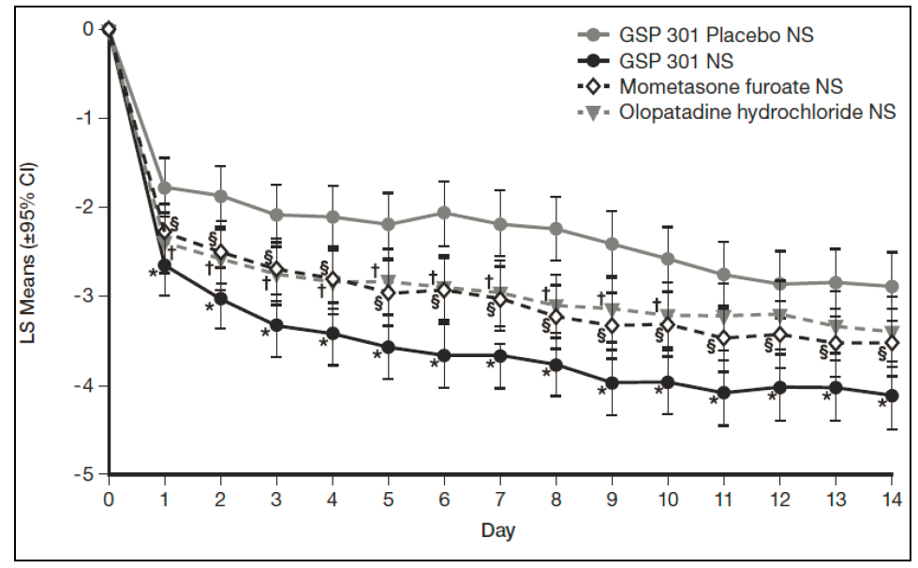

AM = morning; LS = least square; NS = nasal spray; PM = evening.

†§* Indicate a significant difference when compared with placebo (p<0.05)

Figure 2: LS Means of Change from Baseline in Average AM and PM Reflective Total Nasal Symptom Score (Full Analysis Set) (Study GSP 301-301) 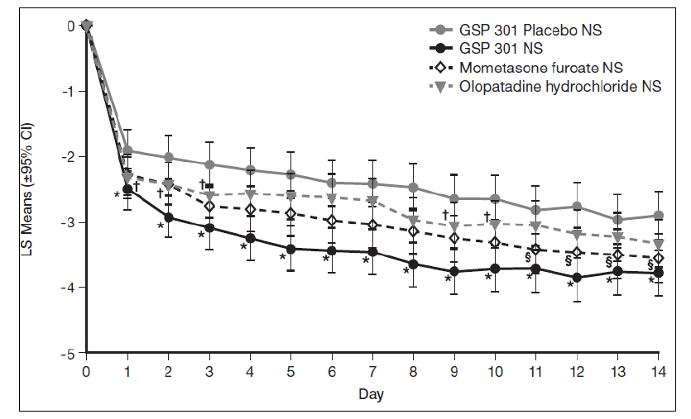

AM = morning; HCl = hydrochloride; LS = least-squares; CI = confidence interval; NS = nasal spray; MMRM = mixed-effect model for repeated measures; PM = evening. †§* Statistically significant difference versus placebo (p<0.05). LS means, 95% CIs, and p values are based on MMRM model with change from baseline as dependent variable, treatment group and site as fixed effect, baseline as covariate, and study day as the within-subject effect.

In these studies, RYALTRIS® also demonstrated statistically significant improvement in iTNSS as compared with placebo and demonstrated statistically significant improvements compared with placebo for each of the 4 individual nasal symptoms evaluated as rTNSS (p<0.05) and iTNSS (p<0.05).

Representative results from Study GSP 301-304 are shown in Figure 3.

Figure 3: LS Means of Change from Baseline in Average AM and PM Instantaneous Total Nasal Symptom Score for Each Day (Full Analysis Set) (Study GSP 301-304)

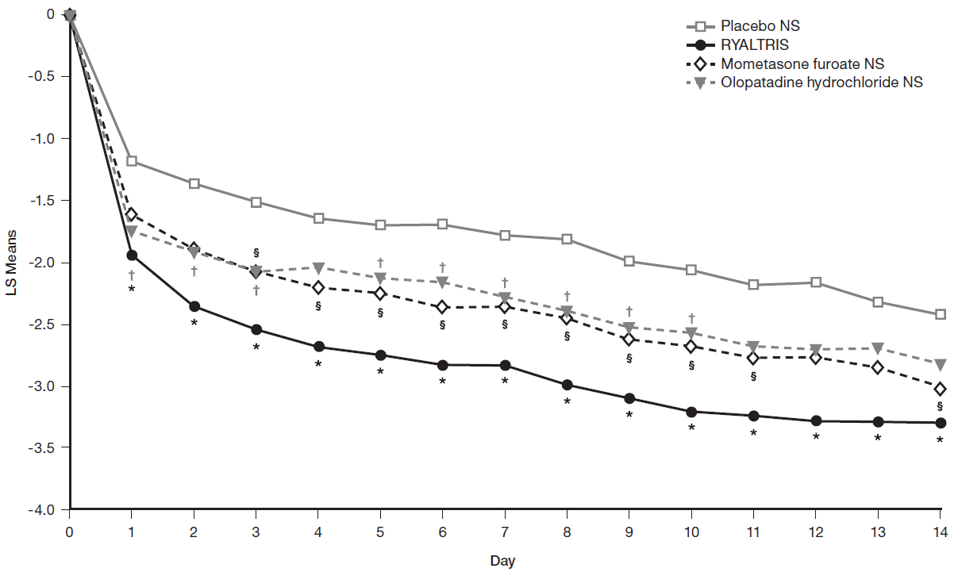

AM = morning; CI = confidence interval; LS = least square; NS = nasal spray; PM = evening.

†§* Indicate a significant difference when compared with placebo (p<0.05).

RYALTRIS® demonstrated statistically significant improvement compared with placebo in the change from baseline in average AM and PM patient-reported 12‑hour rTOSS and iTOSS over a 2‑week treatment period.

Following the initial dose, marked improvement in iTNSS has been observed over the first week and was sustained through two weeks of treatment.

The subjective impact of seasonal allergic rhinitis on a patient’s health-related quality of life was evaluated by the Rhinoconjunctivitis Quality of Life Questionnaire - Standardized Activities (RQLQ[S]) (28 questions in 7 domains [activities, sleep, non-nose/eye symptoms, practical problems, nasal symptoms, eye symptoms, and emotional] evaluated on a 7-point scale, in which 0=no impairment and 6=maximum impairment). An overall RQLQ(S) score is calculated from the mean of all items in the instrument. In each of these studies, treatment with RYALTRIS® reduced the overall RQLQ(S) from baseline by greater, and statistically significant, margin than placebo (Study GSP 301-201 LS mean difference: ‑0.56 [95% CI: ‑0.95, ‑0.18]; Study GSP 301-301 LS mean difference: ‑0.43 [95% CI: ‑0.64, ‑0.21]; Study GSP 301-304 LS mean difference: ‑0.45 [95% CI: ‑0.68, ‑0.22]). In GSP 301-201, the treatment differences between RYALTRIS® and placebo reached the minimum important difference of 0.5 points, which is considered a clinically meaningful improvement. However, the treatment difference between RYALTRIS® and placebo in GSP 301-301 and GSP 301-304 were marginally less than the minimum important difference of 0.5 points.

**52-week study**

The fourth study of RYALTRIS® (GSP 301-303), was a double-blind, randomised, placebo-controlled 52-week safety and efficacy study in subjects with perennial allergic rhinitis. It evaluated 24-hour (AM) rTNSS and iTNSS as secondary endpoints. Compared with placebo nasal spray pH 3.7, treatment with RYALTRIS® (n=391) resulted in statistically significant improvement in the change in average AM patient-reported rTNSS and iTNSS over the first 6, 30, and 52 weeks vs baseline.

Table 5: Mean Change from Baseline in Average AM Reflective Total Nasal Symptom Score over the First 6, 30, and 52 Weeks of Treatment (Full Analysis Set)

|  |  |  |  |  |
| --- | --- | --- | --- | --- |
| Week | Number of subjects (n)  **(RYALTRIS**®**, Placebo)** | RYALTRIS® Treatment Effect Difference vs placebo | | |
|  |  | LS Mean | 95% CI | P-value‡ |
| 6 weeks | 391, 99 | -0.81 | (-1.29, -0.32) | 0.0012 |
| 30 weeks | 391, 99 | -0.96 | (-1.41, -0.50) | <0.0001 |
| 52 weeks | 391, 99 | -0.91 | (-1.35, -0.47) | <0.0001 |

‡Statistically significant difference (p<0.05) using repeated measures analysis

CI = confidence interval; LS = least square; MMRM = mixed model repeated measures; NS = nasal spray LS Means, 95% confidence intervals, and p-values are based on separate MMRM models for each week assessment, with change from baseline as dependent variables, treatment group and site as fixed effect, baseline as covariate, and week as the within-subject effect.

Table 6: Mean Change from Baseline in Average AM Instantaneous Total Nasal Symptom Score over the First 6, 30, and 52 Weeks of Treatment (Full Analysis Set)

|  |  |  |  |  |
| --- | --- | --- | --- | --- |
| Week | Number of subjects (n)  **(RYALTRIS**®**, Placebo)** | RYALTRIS® Treatment Effect Difference vs placebo | | |
|  |  | LS Mean | 95% CI | P-value‡ |
| 6 weeks | 391, 99 | -0.66 | (-1.12, -0.20) | 0.0053 |
| 30 weeks | 391, 99 | -0.83 | (-1.26, -0.39) | 0.0002 |
| 52 weeks | 391, 99 | -0.75 | (-1.17, -0.33) | 0.0005 |

‡Statistically significant difference (p<0.05) using repeated measures analysis

CI = confidence interval; LS = least square; MMRM = mixed model repeated measures; NS = nasal spray LS Means, 95% confidence intervals, and p-values are based on separate MMRM models for each week assessment, with change from baseline as dependent variables, treatment group and site as fixed effect, baseline as covariate, and week as the within-subject effect.

***Paediatrics (6 to 11 years old)***

The safety and efficacy of RYALTRIS® in the treatment of paediatric patients with seasonal allergic rhinitis was investigated in one clinical trial (GSP301-305). This was a double-blind, placebo-controlled study with a 2 week duration in 446 paediatric patients ranging from age 6 to 11 years.

Assessment of efficacy was similar to that for the 2-week studies in adolescents and adults. The primary efficacy endpoint was change from baseline in average AM and PM subject-reported 12-hour rTNSS over the 14-day randomised treatment period. Secondary endpoints were change from baseline in average AM and PM subject-reported 12-hour iTNSS over a 14-day treatment period, change from baseline in average AM and PM subject-reported 12-hour rTOSS over the 14-day treatment period, change from baseline in the overall Paediatric Rhinoconjunctivitis Quality of Life Questionnaire (PRQLQ) score.

Treatment with RYALTRIS® resulted in a statistically significant improvement in rTNSS compared with placebo. Results of the primary efficacy endpoint are shown in Table 7. The numerical improvement (p = 0.527 - 0.010, multiple-test adjusted p>0.05) at days 1 - 3 and the statistically significant improvement in rTNSS from day 4 (p<0.001, multiple-test adjusted p<0.05) for each day is represented in Figure 4.

**Table 7:** **Mean Change from Baseline in Reflective Total Nasal Symptom Scores Over 2 Weeks* in Paediatric Patients 6 to 11 Years with Seasonal Allergic Rhinitis**

|  |  |  |  |
| --- | --- | --- | --- |
| **Study** | **Parameters** | **RYALTRIS**® | **Placebo** |
| GSP 301-305 | N | 222 | 219 |
|  | LS mean BL | 8.83 | 8.84 |
|  | LS mean overall change from BL | -2.2 | -1.6 |
|  | p-value† vs RYALTRIS® | -- | 0.001 |

* Average of AM and PM rTNSS for each day (maximum score = 12) and averaged over the 2-week treatment period.

Figure 4: LS Means of Change from Baseline in Average AM and PM Reflective Total Nasal Symptom Score (Full Analysis Set) (Study GSP 301-305)

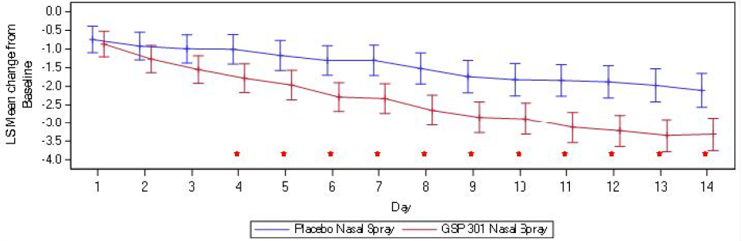

AM = morning; CI = confidence interval; FAS = full analysis set; LS = least square;

PM = evening; rTNSS = Reflective Total Nasal Symptom Score.

*Statistically significant (adjusted *p*<0.05).

RYALTRIS® also demonstrated statistically significant improvement in iTNSS as compared with placebo and demonstrated numerical improvements compared with placebo for each of the 4 individual nasal symptoms evaluated as rTNSS and iTNSS.

RYALTRIS® demonstrated a numerical improvement compared with placebo in the change from baseline in average AM and PM patient-reported 12hour rTOSS and iTOSS over a 2 week treatment period.

The patient’s health-related quality of life was evaluated by the Paediatric Rhinoconjunctivitis Quality of Life Questionnaire (PRQLQ) (23 questions in 5 domains [nose symptoms, eye symptoms, practical problems, activity limitation and other symptoms] evaluated on a 7-point scale, in which 0=not bothered/none of the time and 6= extremely bothered/all of the time). An overall RQLQ(S) score is calculated from the mean of all items in the instrument. Treatment with RYALTRIS® significantly reduced the overall PRQLQ from baseline comparing to placebo (LS mean difference: -0.3 [95% CI: -0.5, -0.1], p<0.001), although the treatment difference between RYALTRIS® and placebo was less than the minimum important difference of 0.5 points.

## PHARMACOKINETIC PROPERTIES

**Absorption**

After repeated intranasal administration of 2 sprays per nostril of RYALTRIS® (2660 micrograms of olopatadine hydrochloride and 100 micrograms of mometasone furoate) twice daily in patients with seasonal allergic rhinitis, the mean (± standard deviation) peak plasma exposure (Cmax) was 19.80 ± 7.01 ng/mL for olopatadine and 9.92 ± 3.74 pg/mL for mometasone furoate, and the mean exposure over the dosing regimen (AUCtau) was 88.77 ± 23.87 ng/mL*hr for olopatadine and 58.40 ± 27.00 pg/mL*hr for mometasone furoate. The median time to peak exposure from a single dose was 1 hour for both olopatadine and mometasone furoate.

The systemic bioavailability of olopatadine and mometasone furoate from RYALTRIS® following intranasal administration was estimated to be comparable with olopatadine hydrochloride and mometasone furoate nasal sprays administered as monotherapies.

**Distribution**

The protein binding of olopatadine was reported as moderate at approximately 55% in human serum and independent of drug concentration over the range of 0.1 to 1000 ng/mL. Olopatadine binds predominately to human serum albumin.

The in vitro protein binding for mometasone furoate was reported to be 98% to 99% in concentration range of 5 to 500 ng/mL.

**Metabolism**

Olopatadine is not extensively metabolized. Based on plasma metabolite profiles following oral administration of [14C] olopatadine, at least 6 minor metabolites circulate in human plasma. Olopatadine accounts for 77% of peak plasma total radioactivity and all metabolites amounted to <6% combined. Two of these have been identified as the olopatadine N-oxide and N-desmethyl olopatadine. In *in vitro* studies with cDNA-expressed human CYP isoenzymes and flavin-containing monooxygenases (FMO), N-desmethyl olopatadine (Ml) formation was catalysed mainly by CYP3A4, while olopatadine N-oxide (M3) was primarily catalysed by FMO1 and FMO3. Olopatadine at concentrations up to 33.9 µg/mL did not inhibit the *in vitro* metabolism of specific substrates for CYP1A2, CYP2C9, CYP2C19, CYP2D6, CYP2E1, and CYP3A4. The potential for olopatadine and its metabolites to act as inducers of CYP enzymes has not been evaluated.

Studies have shown that any portion of a mometasone furoate dose that is swallowed and absorbed undergoes extensive metabolism to multiple metabolites. There are no major metabolites detectable in plasma. Upon *in vitro* incubation, one of the minor metabolites formed is 6ß-hydroxy-mometasone furoate. In human liver microsomes, the formation of this metabolite is mediated by CYP3A4.

**Elimination**

Following single‑dose intranasal administration of a combination of olopatadine hydrochloride (2660micrograms) and mometasone furoate (200 micrograms), the mean elimination half-lives of olopatadine and mometasone furoate were 8.63 and 18.62 hours, respectively in healthy subjects.

Olopatadine is mainly eliminated through urinary excretion. Approximately 70% of a [14C] olopatadine hydrochloride oral dose was recovered in urine with 17% in the faeces. Of the drug‑related material recovered within the first 24 hours in the urine, 86% was unchanged olopatadine, with the balance comprised of olopatadine N-oxide and N-desmethyl olopatadine.

Following intravenous administration, the effective plasma elimination half-life of mometasone furoate was 5.8 hours. Any absorbed drug is excreted as metabolites mostly via the bile, and to a limited extent, into the urine.

**Special populations**

No pharmacokinetic studies were performed in special populations with RYALTRIS®. The pharmacokinetics of the combination of olopatadine and mometasone furoate is expected to reflect that of the individual components, as the pharmacokinetics of the combination was found to be comparable to the individual components.

*Hepatic Impairment:* No specific pharmacokinetic study examining the effect of hepatic impairment was conducted. Metabolism of olopatadine is a minor route of elimination.

Administration of a single inhaled dose of 400 micrograms mometasone furoate to subjects with mild (n=4), moderate (n=4), and severe (n=4) hepatic impairment resulted in only 1 or 2 subjects in each group having detectable peak plasma concentrations of mometasone furoate (ranging from 50 to 105 pcg/mL). The observed peak plasma concentrations appeared to increase with severity of hepatic impairment; however, the numbers of detectable levels were low.

Based on data from the individual components, no adjustment of the dosing regimen of RYALTRIS® is warranted in patients with hepatic impairment.

*Renal Impairment:* The mean Cmax values for olopatadine following single intranasal doses were not markedly different between healthy subjects (18.1 ng/mL) and patients with mild, moderate, and severe renal impairment (ranging from 15.5 to 21.6 ng/mL). Mean plasma AUC0-12 was 2‑fold higher in patients with severe impairment (creatinine clearance <30 mL/min/1.73 m2). In these patients, peak steady-state plasma concentrations of olopatadine were approximately 10‑fold lower than those observed after higher, 20mg oral doses, twice daily, which were well tolerated.

The effects of renal impairment on mometasone furoate pharmacokinetics have not been adequately investigated.

Based on data from the individual components, no adjustment of the dosing regimen of RYALTRIS® is warranted in patients with renal impairment.

*Age:* RYALTRIS® pharmacokinetics has not been investigated in patients under 12 years of age. Based on population pharmacokinetic analysis among patients 12 years of age and older, the pharmacokinetics of olopatadine and mometasone furoate with RYALTRIS® was not influenced by age.

*Gender:* Based on population pharmacokinetic analysis, the pharmacokinetics of olopatadine and mometasone furoate with RYALTRIS® was not influenced by gender.

*Race:* Based on population pharmacokinetic analysis, the pharmacokinetics of olopatadine and mometasone furoate with RYALTRIS® was not influenced by race.

## PRECLINICAL SAFETY

**Genotoxicity**

No genotoxicity was observed when olopatadine was tested in an in vitro bacterial reverse mutation (Ames) test, an in vitro mammalian chromosome aberration assay or an in vivo mouse micronucleus test.

Mometasone furoate is not considered to be genotoxic. There was no evidence of mutagenicity in in vitro tests which included tests for reverse mutation in *Salmonella typhimurium* and *Escherichia coli* and forward gene mutation in a mouse lymphoma cell line. Limited evidence of clastogenicity was obtained in Chinese Hamster ovary cells, although this finding was not confirmed in a second in vitro assay utilising Chinese Hamster lung cells, nor in vivo assays including a mouse spermatogonia chromosomal aberration assay, a mouse micronucleus assay, and a rat bone marrow clastogenicity assay. Mometasone furoate did not cause DNA damage in rat liver cells.

**Carcinogenicity**

No carcinogenicity studies have been conducted with olopatadine hydrochloride and mometasone furoate in combination. Studies performed with the individual active components are described below.

Olopatadine Hydrochloride: Olopatadine administered orally was not carcinogenic in mice and rats at doses of up to 500 and 200 mg/kg/day, respectively (approximately 360 - 420, 290 - 340 and 360 – 450 times the MRHD for adults, adolescents ≥12 years of age and children 6 – 11 years of age, respectively, by intranasal administration on a mg/m2 basis).

Mometasone Furoate: In a 2-year carcinogenicity study in Sprague Dawley rats, mometasone furoate demonstrated no statistically significant increase in the incidence of tumours at inhalational doses up to 67 micrograms/kg/day (approximately 2.6 – 3 times the MHRD for adolescents ≥12 years of age and adults, and 3.2 times for children 6 – 11 years of age, by intranasal administration on a microgram/m2 basis). In a 19‑month carcinogenicity study in Swiss CD-1 mice, mometasone furoate demonstrated no statistically significant increase in the incidence of tumours at inhalational doses up to 160 microgram/kg/day (approximately 3.1 -3.6 times the MRHD for adolescents ≥12 years of age and adults, and 3.8 times for children 6 - 11 years of age, by intranasal administration on a microgram/m2 basis).

# PHYSICOCHEMICAL PROPERTIES

## LIST OF EXCIPIENTS

The nasal spray also contains benzalkonium chloride, carmellose sodium, dibasic sodium phosphate heptahydrate, disodium edetate, hydrochloric acid, dispersible cellulose, polysorbate 80, sodium chloride, sodium hydroxide, and water for injection.

## INCOMPATIBILTIES

See **4.5 INTERACTIONS WITH OTHER MEDICINES AND OTHER FORMS OF INTERACTIONS**.

## SHELF LIFE

In Australia, information on the shelf life can be found on the public summary of the Australian Register of Therapeutic Goods (ARTG). The expiry date can be found on the packaging.

## SPECIAL PRECAUTIONS FOR STORAGE

Store RYALTRIS® upright with the dust cap on below 30C. Do not store in a freezer or refrigerator.

## NATURE AND CONTENTS OF CONTAINER

The 240 metered-dose (MD) presentation of RYALTRIS® nasal spray is supplied in a 30 mL white opaque high-density polyethylene (HDPE) bottle.

The 56 and 120 metered-dose (MD) presentations of RYALTRIS® nasal spray are supplied in a 20 mL white opaque high-density polyethylene (HDPE) bottle.

Both sizes of bottles are crimped with the same spray pump and nasal actuator. A plastic cap covers the nasal actuator.

Not all pack sizes may be marketed.

## SPECIAL PRECAUTIONS FOR DISPOSAL

In Australia, any unused medicine or waste material should be disposed of by taking it to your local pharmacy.

## PHYSICOCHEMICAL PROPERTIES

Olopatadine hydrochloride is (Z)-11-[3-(dimethylamino)propylidene]-6,11-dihydrodibenz[*b,e*]oxepin-2-acetic acid hydrochloride, a dibenzoxepine derivative. The empirical formula is C21H23NO3•HCl. Olopatadine hydrochloride is a white, crystalline, water-soluble powder. It has a molecular weight of 373.88 and a melting point of ~245°C (decomp).

Mometasone furoate monohydrate is 9,21-Dichloro-11ß,17-dihydroxy-16α-methylpregna-1,4- diene-3,20-dione 17-(2-furoate) monohydrate. The empirical formula is C27H30Cl2O6 •H2O. It has a molecular weight of 539.45. Mometasone furoate is a white to off white powder and it is practically insoluble in water; slightly soluble in methanol, ethanol and isopropanol; soluble in acetone.

**Chemical Structure**

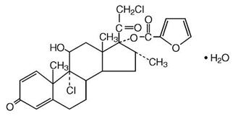 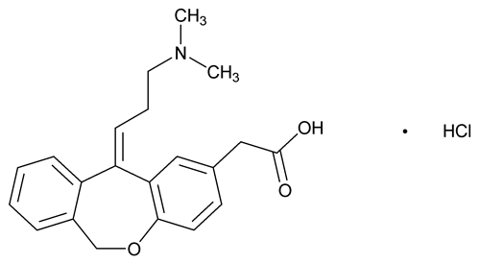

Mometasone furoate monohydrate Olopatadine Hydrochloride

**CAS number**

Mometasone furoate monohydrate: 141646-00-6

Olopatadine hydrochloride: 140462-76-6

# MEDICINE SCHEDULE (POISIONS STANDARD)

Schedule 4 (S4): Prescription Only Medicine

# SPONSOR

Seqirus Pty Ltd

ABN: 26 160 735 035

63 Poplar Road

Parkville VIC 3052

Australia

Telephone: 1800 642 865

www.seqirus.com.au

# DATE OF FIRST APPROVAL

11 December 2019

# DATE OF REVISION

28 January 2022

**Summary table of changes**

|  |  |
| --- | --- |
| **Section Changed** | **Summary of new information** |
| Section 8 SPONSOR | The telephone number has been changed to an 1800 number, as well as adding the company website. |
|  | Update to sections 4.1, 4.2, 4.8, 4.9, 5.1 and 5.3 to include information relating to use in the paediatric population.  Editorial changes to sections 5.2 and 6.5 |

RYALTRIS® is a registered trade mark of Glenmark Specialty SA.