|  |
| --- |
| Australian Public Assessment Report for Ryaltris |
| Active ingredient/s: Olopatadine / mometasone furoate |
| Sponsor: Seqirus Pty Limited |
| March 2023 |

About the Therapeutic Goods Administration (TGA)

* The Therapeutic Goods Administration (TGA) is part of the Australian Government Department of Health and Aged Care and is responsible for regulating therapeutic goods, including medicines, medical devices, and biologicals.
* The TGA administers the *Therapeutic Goods Act 1989* (the Act), applying a risk management approach designed to ensure therapeutic goods supplied in Australia meet acceptable standards of quality, safety, and efficacy.
* The work of the TGA is based on applying scientific and clinical expertise to decision-making, to ensure that the benefits to the Australian public outweigh any risks associated with the use of therapeutic goods.
* The TGA relies on the public, healthcare professionals and industry to report problems with therapeutic goods. The TGA investigates reports received to determine any necessary regulatory action.
* To report a problem with a therapeutic good, please see the information on the [TGA website](https://www.tga.gov.au).

About AusPARs

* The Australian Public Assessment Report (AusPAR) provides information about the evaluation of a prescription medicine and the considerations that led the TGA to approve or not approve a prescription medicine submission. Further information can be found in [Australian Public Assessment Report (AusPAR) guidance](https://www.tga.gov.au/australian-public-assessment-report-auspar-guidance).
* AusPARs are prepared and published by the TGA.
* AusPARs are static documents that provide information that relates to a submission at a particular point in time. The publication of an AusPAR is an important part of the transparency of the TGA’s decision-making process.
* A new AusPAR may be provided to reflect changes to indications or major variations to a prescription medicine subject to evaluation by the TGA.

Copyright

© Commonwealth of Australia 2022  
This work is copyright. You may reproduce the whole or part of this work in unaltered form for your own personal use or, if you are part of an organisation, for internal use within your organisation, but only if you or your organisation do not use the reproduction for any commercial purpose and retain this copyright notice and all disclaimer notices as part of that reproduction. Apart from rights to use as permitted by the *Copyright Act 1968* or allowed by this copyright notice, all other rights are reserved and you are not allowed to reproduce the whole or any part of this work in any way (electronic or otherwise) without first being given specific written permission from the Commonwealth to do so. Requests and inquiries concerning reproduction and rights are to be sent to the TGA Copyright Officer, Therapeutic Goods Administration, PO Box 100, Woden ACT 2606 or emailed to <[tga.copyright@tga.gov.au](mailto:tga.copyright@tga.gov.au)>.

Contents

* List of abbreviations 4
* Product submission 5

Submission details 5

Product background 6

Allergic rhinitis 6

Seasonal versus perennial allergic rhinitis 7

Current treatment options 7

Regulatory status 8

Product Information 9

* Registration timeline 9
* Submission overview and risk/benefit assessment 10

Quality 10

Non-clinical 11

Clinical 11

Summary of clinical studies 11

Pharmacology 12

Efficacy 12

Safety 25

Risk management plan 29

Risk-benefit analysis 30

Delegate’s considerations 30

Proposed action 33

Advisory Committee considerations 34

* Outcome 36

Specific conditions of registration applying to these goods 36

* Attachment 1. Product Information 36

## List of abbreviations

|  |  |
| --- | --- |
| Abbreviation | Meaning |
| ACM | Advisory Committee on Medicines |
| AE | Adverse event |
| AM | Morning |
| ARTG | Australian Register of Therapeutic Goods |
| CMI | Consumer Medicines Information |
| EMA | European Medicines Agency |
| FAS | Full analysis set |
| ICH | International Council for Harmonisation |
| iTNSS | Instantaneous Total Nasal Symptom Score |
| iTOSS | Instantaneous Total Ocular Symptom Score |
| LS | Least squares |
| PI | Product Information |
| PK | Pharmacokinetic(s) |
| PM | Evening |
| PPS | Per protocol set |
| PRQLQ | Paediatric Rhinoconjunctivitis Quality of Life Questionnaire |
| rTNSS | Reflective Total Nasal Symptom Score |
| rTOSS | Reflective Total Ocular Symptom Score |
| SD | Standard deviation |
| TGA | Therapeutic Goods Administration |
| TNNSS | Total non-nasal symptoms score |

## Product submission

### Submission details

|  |  |
| --- | --- |
| *Type of submission:* | Extension of indications |
| *Product name:* | Ryaltris |
| *Active ingredients:* | Olopatadine / mometasone furoate |
| *Decision:* | Approved |
| *Date of decision:* | 28 January 2022 |
| *Date of entry onto ARTG:* | 8 February 2022 |
| *ARTG number:* | 312690 |
| [*Black Triangle Scheme*](https://www.tga.gov.au/black-triangle-scheme)*:[1]* | No |
| *Sponsor’s name and address:* | Seqirus Pty Ltd  63 Poplar Road  Parkville, VIC, 3052 |
| *Dose form:* | Nasal spray |
| *Strength:* | Olopatadine 600 µg/actuation and mometasone furoate 25 µg/actuation;[2] |
| *Container:* | Bottle |
| *Pack sizes:* | 56, 120 and 240 metered doses |
| *Approved therapeutic use:* | *Ryaltris is indicated for the treatment of symptoms associated with allergic rhinitis and rhinoconjunctivitis in patients 6 years of age and older* |
| *Route of administration:* | Nasal |
| *Dosage:* | Administer Ryaltris by the intranasal route only. Shake the bottle well before each use.  See the Product Information for information on priming the product *before* use, re‑priming the product *between* uses and information on the in-use shelf life.  *Adults and adolescents (12 years of age and older)*  The recommended dose is 2 sprays (2 actuations) in each nostril, twice daily.  *Children (6 to 11 years of age)*  The recommended dose is one spray (one actuation) in each nostril twice daily. |
| *Pregnancy category:* | B3  Drugs which have been taken by only a limited number of pregnant women and women of childbearing age, without an increase in the frequency of malformation or other direct or indirect harmful effects on the human fetus having been observed.  Studies in animals have shown evidence of an increased occurrence of fetal damage, the significance of which is considered uncertain in humans.  The use of any medicine during pregnancy requires careful consideration of both risks and benefits by the treating health professional. This must not be used as the sole basis of decision making in the use of medicines during pregnancy. The TGA does not provide advice on the use of medicines in pregnancy for specific cases. More information is available from obstetric drug information services in your State or Territory. |

### Product background

This AusPAR describes the submission by Seqirus Pty Ltd (the sponsor) to register Ryaltris olopatadine 600 µg/actuation and mometasone furoate 25 µg/actuation nasal spray bottle for the following proposed extension of indications:

*Ryaltris is indicated for the treatment of symptoms associated with allergic rhinitis and rhinoconjunctivitis in patients 6 years of age and older.*

#### Allergic rhinitis

Allergic rhinitis has been defined as an immunoglobulin E mediated inflammatory nasal condition resulting from allergen introduction in a sensitised individual.[3] Allergic conjunctivitis is a frequent comorbidity associated with allergic rhinitis, especially in children.[4]

A report from the Australian Institute of Health and Welfare,[5] indicated that allergic rhinitis affected 15% of the Australian population in 2007 to 2008. Peak incidence occurred in the 35 to 44 years of age group and the condition was slightly more common in females. It is also very common in children with prevalence estimates of approximately 2% to 25%.[6]

#### Seasonal versus perennial allergic rhinitis

Seasonal allergic rhinitis is most often caused by outdoor allergens that usually occur in certain seasons, such as pollens or moulds.

Perennial allergic rhinitis is usually caused by indoor allergens that are present throughout the year such as house dust mites, moulds, insects, and animal dander.

#### Current treatment options

Currently registered medicines for the treatment of allergic rhinitis in Australia include the following:

* Topical decongestants such as oxymetazoline, xylometazoline and phenylephrine nasal sprays which are generally only recommended for short term use (less than one week)
* Oral decongestants such as pseudoephedrine and phenylephrine
* Topical antihistamines such as azelastine and levocabastine nasal sprays
* Oral antihistamines, of which there are multiple formulations available in Australia, including first generation (sedating) and second generation (non-sedating) agents
* Topical corticosteroids including budesonide, fluticasone propionate, fluticasone furoate, beclomethasone, mometasone furoate and ciclesonide nasal sprays
* Leukotriene receptor antagonists, namely montelukast, which is indicated for the treatment of seasonal allergic rhinitis
* Short-acting muscarinic antagonists, namely ipratropium (nasal spray) which is indicated for the treatment of rhinorrhoea associated with perennial allergic rhinitis
* Immunotherapy with repeated administration of specific allergen extracts is generally reserved for subjects whose symptoms are not controlled with drug therapy

Most of these products are registered for use in subjects aged from 6 to 11 years, which is the patient population proposed in the current submission. However, the following agents are not approved or registered for this age group:

* Oxymetazoline and xylometazoline nasal sprays
* Fluticasone propionate and beclomethasone nasal sprays
* Ipratropium nasal spray

There is currently one other fixed dose combination nasal spray product containing an antihistamine and a corticosteroid registered for the treatment of allergic rhinitis. This product (Dymista) contains the antihistamine azelastine together with the corticosteroid fluticasone. It is only approved for use in adults and children aged 12 years and older.[7]

### Regulatory status

The product received initial registration on the Australian Register of Therapeutic Goods (ARTG)[8] on 11 December 2019. The approved indication at the time was as follows:

*Ryaltris (nasal spray) is indicated for the treatment of symptoms associated with allergic rhinitis and rhinoconjunctivitis in patients 12 years of age and older.*

Similar submissions have been submitted and approved in the United States of America (USA) (submitted May 2018, approved January 2022); the United Kingdom (submitted December 2019, approved May 2021); several member states of European Union (EU) (submitted December 2019, approved on an individual country-basis between April and July 2021). A further submission had been submitted in Canada (March 2020) and remained under consideration.

The following table summarises these submissions and provides the indications where approved.

Table 1: International regulatory status

|  |  |  |  |
| --- | --- | --- | --- |
| Region | Submission date | Status | Approved indications |
| United States of America | May 2018 | Approved on 13 January 2022 | *Ryaltris is indicated for the treatment of symptoms of seasonal allergic rhinitis in adult and pediatric patients 12 years of age and older.* |
| United Kingdom | December 2019 | Approved on 11 May 2021 | *Ryaltris is indicated in adults and children 12 years of age and older for the treatment of moderate to severe nasal symptoms associated with allergic rhinitis.* |
| European Union (EU)  Approved by several EU countries on an individual basis (decentralised procedure) | December 2019 | Approved on various dates between 26 April 2021 and 9 July 2021 (depending on the country) | *Ryaltris is indicated in adults and children 12 years of age and older for the treatment of moderate to severe nasal symptoms associated with allergic rhinitis.* |
| Canada | 31 March 2020 | Under consideration |  |

### Product Information

The Product Information (PI) approved with the submission which is described in this AusPAR can be found as Attachment 1. For the most recent PI, please refer to the TGA [PI/CMI search facility.](https://www.tga.gov.au/picmi-search-facility)

## Registration timeline

The following table captures the key steps and dates for this submission.

Table 2: Timeline for Submission PM-2022-06532-1-5

|  |  |
| --- | --- |
| Description | Date |
| Submission dossier accepted and first round evaluation commenced | 1 February 2021 |
| First round evaluation completed | 30 June 2021 |
| Sponsor provides responses on questions raised in first round evaluation | 31 August 2021 |
| Second round evaluation completed | 29 September 2021 |
| Delegate’s Overall benefit-risk assessment and request for Advisory Committee advice | 2 November 2021 |
| Sponsor’s pre-Advisory Committee response | 15 November 2021 |
| Advisory Committee meeting | 2 December 2021 |
| Registration decision (Outcome) | 28 January 2022 |
| Completion of administrative activities and registration on the ARTG | 8 February 2022 |
| Number of working days from submission dossier acceptance to registration decision* | 201 |

*Statutory timeframe for standard submissions is 255 working days

## Submission overview and risk/benefit assessment

A summary of the TGA’s assessment for this submission is provided below.

The following guidance was relevant to this submission:

* European Medicines Agency (EMA): [Guideline on the Clinical Development of Medicinal Products for the Treatment of Allergic Rhinoconjunctivitis](https://www.tga.gov.au/resources/resource/international-scientific-guidelines/international-scientific-guideline-guideline-clinical-development-medicinal-products-treatment-allergic-rhino-conjunctivitis) (CHMP/EWP/2455/02). Published 2004; TGA-adopted, effective 28 July 2005.
* EMA: [Guideline on clinical development of fixed combination medicinal products](https://www.tga.gov.au/resources/resource/international-scientific-guidelines/international-scientific-guideline-guideline-clinical-development-fixed-combination-medicinal-products) (EMA/CHMP/158268/2017). Published 2017; TGA-adopted, effective 12 December 2017
* EMA: [ICH topic E; Note for guidance on clinical investigation of medicinal products in the paediatric population](https://www.tga.gov.au/resources/resource/international-scientific-guidelines/international-scientific-guideline-ich-topic-e-11-note-guidance-clinical-investigation-medicinal-products-paediatric-population) (CPMP/ICH/2711/99). TGA-adopted, effective: 19 April 2001
* EMA: [Note for guidance on the clinical requirements for locally applied, locally acting products containing known constituents](https://www.tga.gov.au/resources/resource/international-scientific-guidelines/international-scientific-guideline-note-guidance-clinical-requirements-locally-applied-locally-acting-products-containing-known-constituents) (CPMP/EWP/239/95 final). Published 1995; TGA-adopted, effective 1 August 1997.

### Quality

Quality data is generally not required for this type of submission. A full quality evaluation was conducted at the time this product received initial registration.

Ryaltris contains mometasone furoate monohydrate and olopatadine hydrochloride. Figure 1, shown below, provides a representation of the skeletal formulae for both active ingredients.

Figure 1: Skeletal formulae for mometasone furoate monohydrate and olopatadine hydrochloride

|  |  |
| --- | --- |
| mometasone furoate monohydrate | olopatadine hydrochloride |
| mometasone furoate monohydrate | olopatadine hydrochloride |

The 240 metered dose presentation of Ryaltris nasal spray is supplied in a 30 mL white opaque high-density polyethylene bottle. The 56 and 120 metered dose presentations of Ryaltris nasal spray are supplied in a 20 mL white opaque high density polyethylene bottle.

Both sizes of bottles are crimped with the same spray pump and nasal actuator. A plastic cap covers the nasal actuator.

Each spray (actuation) from the bottle delivers a volume of 0.1 mL suspension containing 665 µg (0.6% w/v) of olopatadine hydrochloride equivalent to 600 µg of olopatadine base, and 25.86 µg mometasone furoate monohydrate equivalent to 25 µg (0.025% w/v) of mometasone furoate.

In addition to the active ingredients olopatadine hydrochloride and mometasone furoate monohydrate, the nasal spray also contains benzalkonium chloride, carmellose sodium, dibasic sodium phosphate heptahydrate, disodium edetate, hydrochloric acid, dispersible cellulose, polysorbate 80, sodium chloride, sodium hydroxide, and water for injection as excipients.

Ryaltris should be stored with the bottle kept upright with the dust cap on below 30 °C. Do not store in a freezer or refrigerator.

The expiry date can be found on the packaging. Depending on the presentation, the bottle should be discarded after 240 sprays (30 days usage for adults and adolescents 12 years and older *or* 60 days usage for children 6 to 11 years old), 120 sprays (15 days usage for adults and adolescents 12 years and older *or* 30 days usage for children 6 to 11 years old) or 56 sprays (7 days usage for adults and adolescents 12 years and older *or* 14 days usage for children 6 to 11 years old). The correct amount of remaining medication in each spray cannot be assured beyond the initial priming and 240, 120 or 56 sprays (depending on the bottle presentation), even though the bottle appears not being completely empty.

### Non-clinical

A full nonclinical evaluation was conducted at the time this product received initial registration.

The sponsor is basing this submission on the original non-clinical data submitted for registration, in which the toxicity profile of olopatadine hydrochloride and mometasone furoate was extensively characterised. While a juvenile toxicity study in rats or dogs is theoretically possible, the sponsor outlined multiple technical issues (dose volume, frequency of dosing, tolerability of high frequency intranasal dosing) that would render such studies impractical. Moreover, the nasal cavity of obligate nose breathers is well developed at birth, with structure similar to that in the adult rat by 21 days of age. Given this, and the fact that negligible systemic exposure is anticipated in rats and dogs when olopatadine and mometasone is administered by the intranasal route, it is acceptable that no additional safety information besides that shown in the adult animals has been provided. The sponsor also conducted clinical studies in which the safety and efficacy of the Ryaltris formulation was evaluated in patients aged 6 to 11 years (Study GSP 301-305) and stated that the safety profile was comparable to that for patients 12 years and over.

Therefore, the safety and efficacy of Ryaltris in the proposed paediatric population will need to be established by the submitted clinical data.

### Clinical

#### Summary of clinical studies

The sponsor submitted the following as evidence for the clinical evaluation of this submission:

* Study GSP 301–305, a Phase III, randomised, double-blind, placebo-controlled trial of Ryaltris in children aged 6 to 11 years. The study provided data on efficacy and safety. The sponsor submitted the full study report, and this study was considered to be pivotal for this submission.
* A population pharmacokinetic report presenting simulations of pharmacokinetic data in children aged 6 to 11 years.
* Two periodic safety update reports (PSURs).
* Literature references.

#### Pharmacology

##### Pharmacokinetics

Pharmacokinetic (PK) sampling was not performed in Study GSP 301–305.

The submission included one report describing simulation of systemic olopatadine and mometasone exposures in children aged 6 to younger than 12 years, using a previously developed population PK model. The model was developed using PK data from adults and adolescents only, and any covariate effects of age younger than 12 years were therefore not explored.

Assuming that the model was applicable to children aged younger than 12 years, the simulations suggested that systemic olopatadine and mometasone exposures obtained in children using the proposed paediatric dosage regimen were similar to those obtained in adults using the approved adult and adolescent regimen.

##### Pharmacodynamics

No new pharmacodynamic data were included in the submission.

#### Efficacy

The pivotal Study GSP 301-305 was the only study submitted to support the proposed extension of indication to treat children aged from 6 to 11 years old.

##### Study GSP 301-305

###### Study overview

The study was a Phase III, randomised, double blind, placebo-controlled trial with two parallel groups (Ryaltris versus placebo).

Subjects attended an initial screening visit (Visit 1; on Day -10 to -7). In eligible subjects this was followed by a single blind, placebo run-in period of 7 to 10 days duration. Subjects were then randomised at Day 0 (Visit 2) to either Ryaltris or placebo for a period of 14 days. An on-treatment visit (Visit 3) was scheduled for Day 8 and a final visit (Visit 4) scheduled on Day 15.

Figure 2: Study GSP 301-305 Study schema

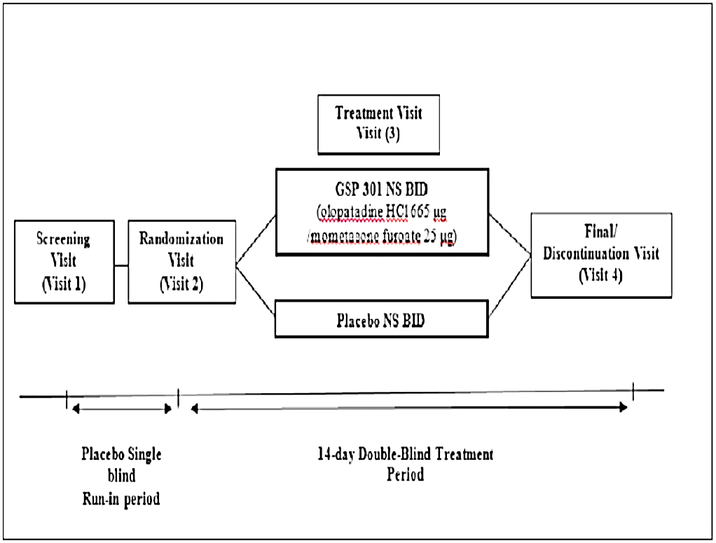Abbreviations: BID = twice daily; HCl = hydrochloride; NS = nasal spray

The study was conducted at 32 centres in the USA between March and November 2018.

The primary objective of the study was to compare the efficacy of Ryaltris (administered as one spray per nostril twice daily with placebo nasal spray over 14 days in paediatric subjects (aged 6 to younger than 12 years) with seasonal allergic rhinitis.

The secondary objective was to assess the safety and tolerability over 14 days of study drug in paediatric subjects (aged 6 to younger than 12 years) with seasonal allergic rhinitis.

###### Primary efficacy endpoint

The primary efficacy endpoint was a change from Baseline in average morning (AM) and evening (PM) 12 hour *reflective* Total Nasal Symptom Score (TNSS) over the 14 day treatment period.[9],[10]

The Baseline reflective TNSS was defined as the average of the last eight consecutive AM and PM assessments during the last four days of the run in period (from the Day 4 PM assessment to the AM assessment on the day of randomisation). At least six out of eight reading scores had to be available in order to calculate the Baseline score.

The Day 1 reflective TNSS was derived as the average of Day 1 PM score and Day 2 AM score. Subsequent daily scores were calculated in the same manner.

###### Secondary efficacy endpoints

The secondary efficacy endpoints were:

* Change from Baseline in average AM and PM *instantaneous* TNSS over the 14 day treatment period.12,[11]
* Change from Baseline in average AM and PM 12 hour *reflective* Total Ocular Symptom Score (TOSS) over the 14 day treatment period.[12],[13]
* Change from Baseline in the Paediatric Rhinoconjunctivitis Quality of Life Questionnaire (PRQLQ) overall score on Day 15 (Visit 4) between treatment groups.[14]

###### Other efficacy endpoints

Most of these endpoints were based on symptom severity scores.

The *physician-assessed* Total Nasal Symptom Score was derived from the combined intensity of the following nasal symptoms, as assessed by the treating investigator: rhinorrhoea, nasal congestion, nasal itching and sneezing. Investigators assessed the severity of each of these symptoms using a four-point scale (0 absent, 1 mild, 2 moderate, 3 severe). The *physician‑assessed* TNSS was to be based on questioning of the subjects (overall feeling since last visit) and on the ear, nose and throat examination and other observations by the physician. The *physician-assessed* TNSS score was the sum of the four individual scores, with a possible range of 0 to 12. In this study the *physician-assessed* TNSS was assessed at randomisation (Day 1) and at the final visit (Day 15).

###### Study treatments

Subjects were randomised (1:1) to receive one of the following treatments:

* Ryaltris nasal spray: one spray in each nostril twice daily (morning and evening) for 14 days
* Placebo nasal spray: one spray in each nostril twice daily (morning and evening) for 14 days

The placebo nasal spray was prepared using the same vehicle as the active product.

###### Diagnosis and main inclusion and exclusion criteria

This study enrolled subjects aged 6 to younger than 12 years with seasonal allergic rhinitis with exacerbations requiring treatment during the allergy season. The subjects had a 12‑hour reflective TNSS greater than or equal to 6 (out of a possible 12) for the AM assessment at the screening visit.

The subjects did not have known failure to show symptom improvement with any approved or marketed monotherapy component of Ryaltris (that is, either olopatadine, or mometasone furoate).

Other key exclusion criteria included dependence on decongestants (nasal, oral, or ocular), nasal topical antihistamine, or nasal steroids, common cold, upper respiratory infections, otitis, lower respiratory infections or acute sinusitis during the screening and placebo run in periods, posterior sub-capsular cataracts, glaucoma or any other ocular disturbances, hypothalamic pituitary adrenal axis impairment and nasal structure defects that would interfere with taking the study medication.

###### Analysis populations

The following analysis populations were defined:

* The run in analysis set consisted of subjects enrolled in the placebo run in period (between the subjects signing informed consent and administration of the first dose of the randomised study medication) and was used for presenting run in period adverse events (AEs), concomitant medications and protocol deviations.
* The full analysis set (FAS) consisted of all subjects who were randomised and received at least one dose of randomised study drug (Ryaltris or placebo) and had at least one post Baseline primary efficacy assessment. This was the primary analysis set for efficacy analyses. The interpretation of results from statistical tests were based on the FAS (see Table 3, below).
* The per protocol set (PPS) consisted of the subset of the FAS who did not meet criteria for PPS exclusion. The PPS exclusion criteria captured relevant non-adherence to the protocol (defined as a major deviation, especially those that affected interpretation of the primary endpoint). The PPS was the secondary analysis set for efficacy analyses (excluding the PRQLQ).16 The PPS was used to assess the robustness of the results from the statistical tests based on the FAS.
* The safety analysis set consisted of all subjects who were randomised and received at least one dose of study drug following randomisation. This was the analysis set used for all safety analyses.

###### Sample size

It was calculated that a sample size of 392 evaluable subjects, randomised in a 1:1 ratio, would provide the study with 90% power to detect a between group mean difference of 1.0 points in the primary endpoint, assuming a 2-sided alpha of 5%. A standard deviation of 3.0 points for the primary endpoint was assumed. Assuming a dropout rate of 15%, a total of approximately 450 subjects were planned to be randomised (225 subjects in each treatment group).

###### Statistical methods

The primary efficacy endpoint was to be analysed using a mixed effect repeated measures model. The model was adjusted for study treatment, site, baseline 12-hour reflective TNSS and study day as the within subject effect. Any missing data were assumed to be missing at random. Site by treatment and Baseline by treatment interactions were investigated separately using two independent models and only included in the final model if they were statistically significant at the alpha = 5% level.

The primary analysis was based on the FAS with a supportive analysis based on the PPS. Efficacy was also analysed in a number of prespecified subgroups of clinical interest.

Similar methods were used for the analysis of the secondary endpoints of instantaneous TNSS;14 and reflective TOSS.15

The other secondary endpoint of change from Baseline in PRQLQ at Day 15 was analysed for the FAS using an analysis of covariance model adjusting for treatment group, site and Baseline PRQLQ.16

Methods used for analysing the other efficacy endpoints were similar to those employed for the primary and secondary endpoints.

A hierarchical testing procedure was employed to maintain the overall alpha at 5% across all comparisons for the primary and secondary endpoints. The primary endpoint (reflective TNSS) was analysed first, followed by the secondary endpoints in the following order of clinical importance: instantaneous TNSS, then PRQLQ and then reflective TOSS. No controls for multiplicity of testing were employed for the other efficacy endpoints.

No interim analyses were performed.

###### Participant flow

A total of 446 subjects were randomised, 221 to placebo and 225 to Ryaltris. 96.6% of subjects completed the study. Table 3, shown below, summarises the participant flow across this study.

Of the 446 randomised subjects, 441 were included in the FAS. The other five subjects did not have at least one post Baseline primary efficacy assessment. 431 subjects were included in the PPS. The 15 subjects excluded from the PPS included the five without a post Baseline assessment and another 10 with major protocol deviations.

Table 3: Study GSP 301-305 Subject disposition (all subjects)

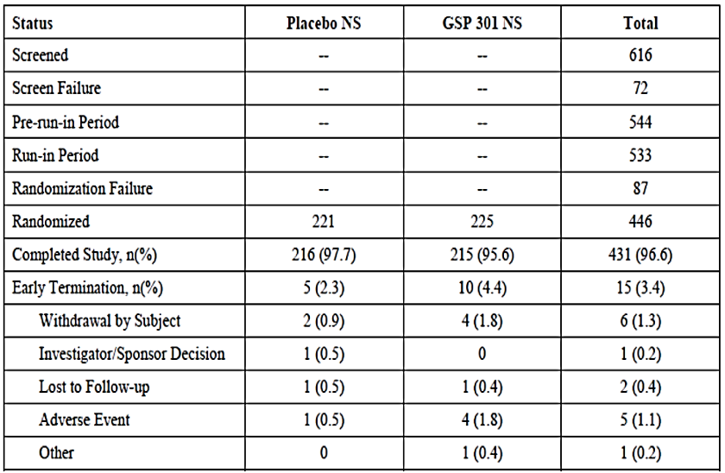

Abbreviation: NS = nasal spray

Note: Percentages are based on the number of randomised subjects

###### Major protocol violations and deviations

Major protocol violations and deviations occurred more frequently in the Ryaltris arm than the placebo arm (3.1% versus 1.4% of subjects); see Table 4, below. The most common type of deviation in the Ryaltris arm was use of a prohibited medication (6 subjects).

Table 4: Study GSP 301-305 Major protocol deviations

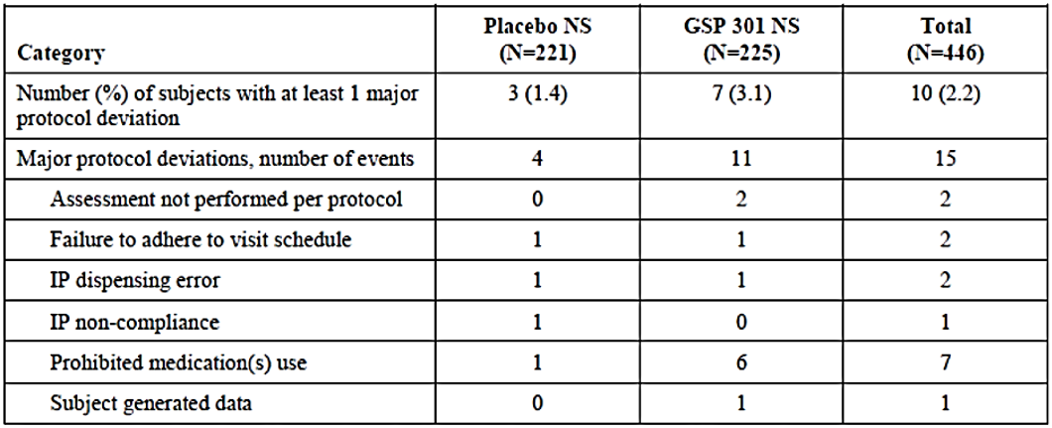

Abbreviations: IP = investigational product; N = number of subjects in the treatment group; NS = nasal spray

Note: The same subject may have had more than one major protocol deviation

###### Baseline data

The mean age for the study population was 8.7 years (range 6 to 11 years). The gender composition was 53.4% were male and 46.6% were female. 76.5% White and 21.1% African American. The two treatment groups were reasonably well balanced with respect to these characteristics. Baseline demographic data is shown in Table 5, below.

Table 5: Study GSP 301-305 Baseline demographic characteristics

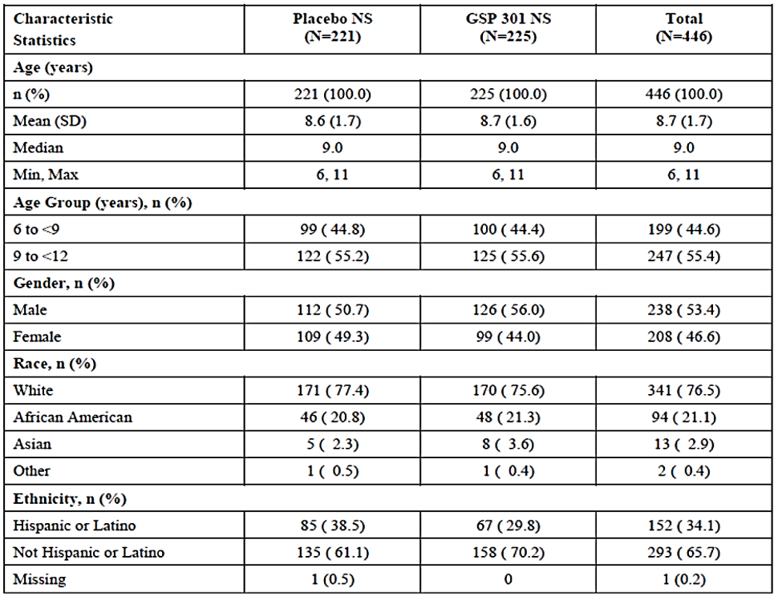

Abbreviations: Max = maximum; Min = minimum; N = number of subjects in the treatment group;  
n (%) = number (percentage) of subjects; NS = nasal spray; SD = standard deviation

###### Results for the primary efficacy endpoint

At Baseline, mean (± standard deviation (SD)) values for the reflective TNSS;13 were similar: 8.84 (± 1.66) in the placebo arm and 8.83 (± 1.41) in the Ryaltris arm. In both arms baseline values ranged from 6.0 to 12.0.

At Day 14 the mean (± SD) change from Baseline was -2.55 (± 3.31) for the placebo group compared with -3.93 (± 3.41) for the Ryaltris group.

The difference between treatments for the average of all AM and PM reflective TNSS measurements over the whole 14 day randomised treatment period is summarised in Table 6 (see below). Compared to placebo treatment, Ryaltris treatment was associated with a significantly greater reduction in least squares (LS) mean reflective TNSS (-2.2 versus -1.6 points, p = 0.001).

Results were similar in the PPS population (-2.3 versus -1.7 points, p = 0.001).

The LS mean difference between treatments in the reduction in reflective TNSS was -0.6 points (95% confidence interval -0.9 to -0.2). The sponsor cited evidence from the literature,[15],[16] to support the minimal clinically important difference for TNSS being as low as 0.23 points.

Subgroup analyses were presented for the following: those aged 6 to younger than 9 years; and aged 9 to younger than 12 years; males and females; White, African American, Asian and ‘other’ race, Hispanic/Latino, and non‑Hispanic/Latino ethnicity. The data generally demonstrated numerically greater improvements with Ryaltris compared to placebo in these subgroups.

Table 6: Study GSP 301-305 Average morning (AM) and evening (PM) reflective total nasal symptom score over the 14-day treatment period for the full analysis set population

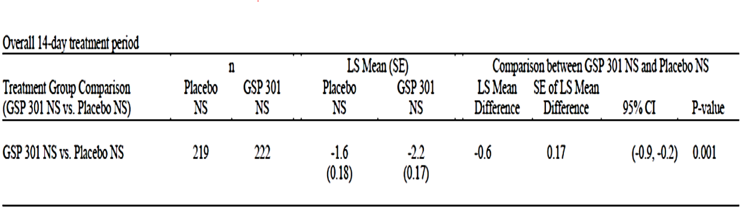

*Note*: Baseline score is derived as the mean of the last eight consecutive reading scores including the AM assessment on the day of randomisation. Day 1 is derived as the average of Day 1 PM and Day 2 AM assessments, and so on for the rest of the treatment period.

Abbreviations: CI = confidence interval; n = number of subjects with data available; NS = nasal spray; LS = least squares; SE = standard error.

*Statistical analysis model*: mixed effect repeated measures model with change from Baseline as the dependent variable, treatment group and site as fixed effects, baseline score as covariate and study day as the within subject effect. Covariance structure ‘unstructured’ (UN) is assumed in the model. Day is an unordered categorical variable and treatment by day interaction is fitted in the model for the Day 1 to Day 14 analyses.

###### Results for the secondary efficacy endpoints

Instantaneous Total Nasal Symptom Score (TNSS)

At Baseline, mean (± SD) values for instantaneous TNSS;14 were also similar: 7.82 (± 2.04) in the placebo arm and 7.89 (± 1.93) in the Ryaltris arm. Baseline values ranged from 3.1 to 12.0 in the placebo arm and from 2.1 to 12.0 in the Ryaltris arm.

At Day 14 the mean (± SD) change from Baseline was -1.96 (± 3.09) in the placebo group compared with -3.44 (± 3.23) for the Ryaltris group.

The difference between treatments for the average AM and PM instantaneous TNSS over the whole 14 day randomised treatment period in the FAS population is summarised in Table 7. Compared to placebo treatment, Ryaltris treatment was associated with a significantly greater reduction in LS mean instantaneous TNSS (-1.8 versus -1.1 points, p < 0.001). Results were similar in the PPS population (-1.9 versus -1.2 points, p < 0.001).

Table 7: Study GSP 301-305 Average morning (AM) and evening (PM) instantaneous Total Nasal Symptom Score over the 14-day treatment period for the full analysis set population

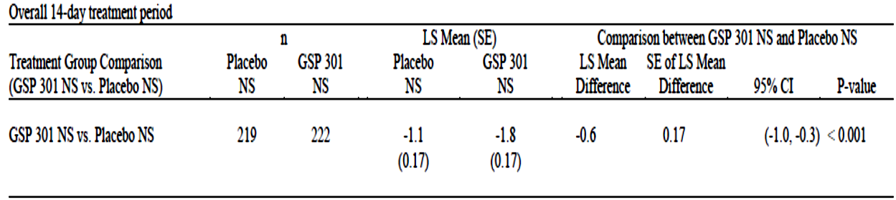

Note: Baseline score is derived as the mean of the last eight consecutive reading scores including the AM assessment on the day of randomisation. Day 1 is derived as the average of Day 1 PM and Day 2 AM assessments, and so on for the rest of the treatment period.

Abbreviations: n = number of subjects with data available; LS = least squares; SE = standard error

Statistical analysis mode: mixed effect repeated measures model with change from Baseline as the dependent variable, treatment group and site as fixed effects, baseline scare as covariate and study day as the within subject effect. Covariance structure ‘unstructured’ (UN) is assumed in the model. Day 1 is an unordered categorical variable and treatment by interaction is fitted in the model for the Day 1 to Day 14 analyses.

12-hour reflective Total Ocular Symptom Score (TOSS)

At Baseline, mean (± SD) values for the reflective TOSS;15 were again similar: 3.59 (± 2.52) in the placebo arm and 3.84 (± 2.45) in the Ryaltris arm. In both arms Baseline values ranged from 0.0 to 9.0.

At Day 14 the mean (± SD) change from Baseline was -0.96 (± 2.16) in the placebo group compared with -1.65 (± 2.22) for the Ryaltris group.

The difference between treatments for the average AM and PM reflective TOSS over the whole 14 day randomised treatment period in the FAS population is summarised in Table 22 in the *Risk-benefit analysi*s section below. There was no significant difference between treatment arms in LS mean reduction in reflective TOSS (-0.8 versus -0.6 points, p = 0.233).

Results were similar in the PPS population (-0.9 versus -0.6 points, p = 0.092).

Change from Baseline in the PRQLQ overall score on Day 15

Mean PRQLQ;16 overall scores at Baseline were similar (2.42 in the placebo arm and 2.51 in the Ryaltris arm). The mean (± SD) change from Baseline on Day 15 in the FAS population was -0.64 (± 1.072) for the placebo arm compared with -0.99 (± 1.242) for the Ryaltris arm. The difference was statistically significant (p < 0.001).

The LS mean difference between treatments for the reduction in overall PRQLQ score was -0.3 points (95% confidence interval -0.5 to -0.1). It appears that a minimal clinically important difference for overall PRQLQ score has not been established, and therefore the clinical significance of this finding is unknown.

Other nasal symptom endpoints

Table 8 and Table 9 show results for the differences between treatment arms in the change from Baseline in TNSS scores for AM assessments only and PM assessments only. The results suggested a beneficial effect of Ryaltris over placebo, as the differences were all greater than the minimal clinically important difference of 0.23 points. P‑values were also presented (all < 0.05) although none of the statistical comparisons were adjusted for multiplicity

Table 8: Study GSP 301-305 Morning (AM) and evening (PM) scores for reflective Total Nasal Symptom Score

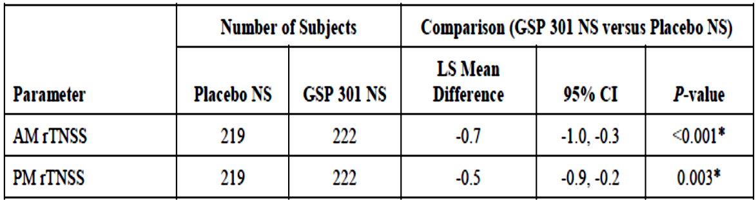

Abbreviations: AM = morning; CI = confidence interval; FAS = full analysis set; LS = least square; NS = nasal spray; PM = evening; rTNSS = reflective total nasal symptom score

*Statistically significant (P < 0.05)

Table 9: Study GSP 301-305 Morning (AM) and evening (PM) scores for instantaneous Total Nasal Symptom Score

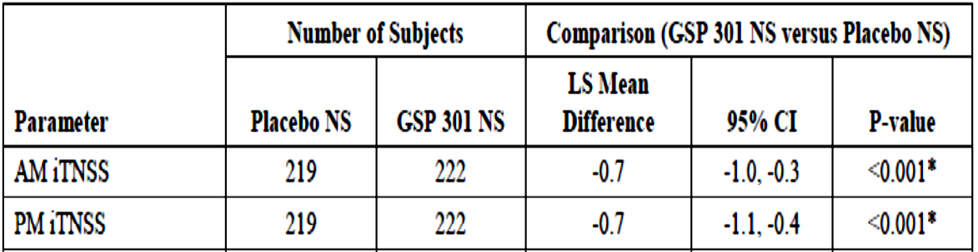

Abbreviations: AM = morning; CI = confidence interval; FAS = full analysis set; LS = least square; NS = nasal spray; PM = evening; iTNSS = instantaneous total nasal symptom score

*Statistically significant (P < 0.05)

Results for individual nasal symptoms showed are shown in Table 10. Reductions from Baseline were greater with Ryaltris than with placebo for all these measurements, and the differences were nominally statistically significant for most comparisons.

Table 10: Study GSP 301-305 Individual nasal symptom scores

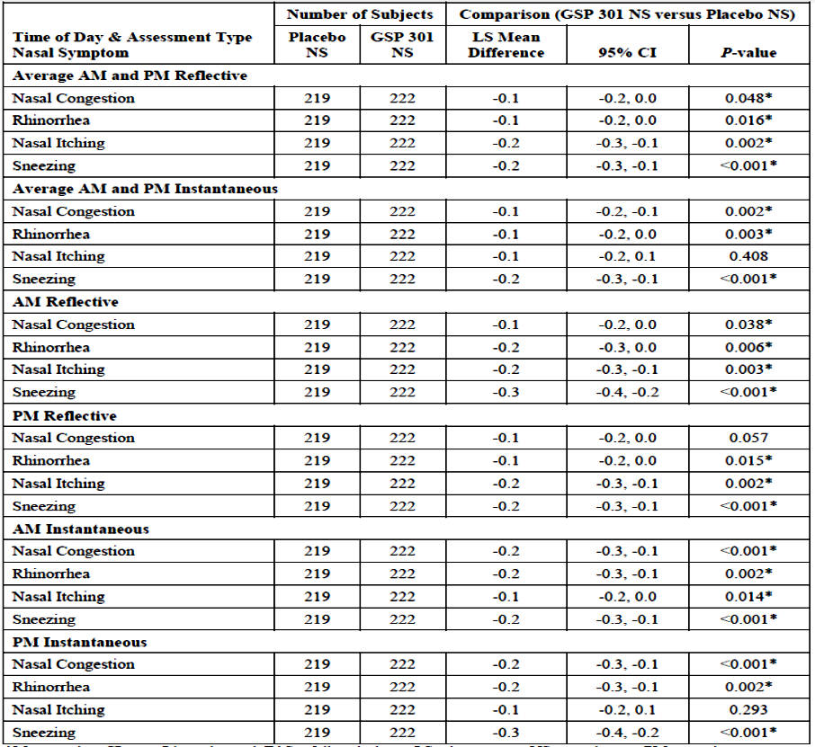

Abbreviations: AM = morning; CI = confidence interval; FAS = full analysis set; LS = least square; NS = nasal spray; PM = evening

*Statistically significant (P < 0.05).

The change from Baseline in the average of AM and PM measurements of reflective TNSS for each day is illustrated in Figure 3. Differences between Ryaltris and placebo were nominally clinically significant by Day 3. Results were similar for daily AM measurements and daily PM measurements of reflective TNSS, and for daily measurements of instantaneous TNSS.

Figure 3: Study GSP 301-305 Daily change from Baseline in average morning (AM) and evening (PM) reflective total nasal symptom score (LS means) for the full analysis set population

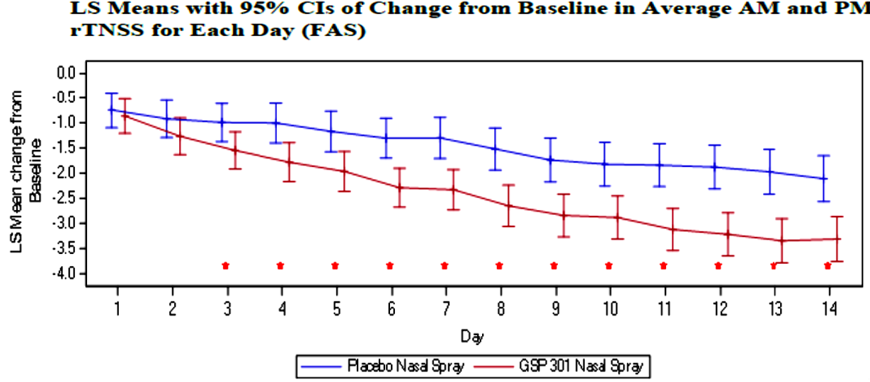

Abbreviations: AM = morning; CI = confidence interval; FAS = full analysis set; LS = least square;  
PM = evening; rTNSS = reflective total nasal symptom score.

*Statistically significant (p < 0.05).

Vertical lines (whiskers) denote upper and lower bounds of 95% confidence interval.

Instantaneous total ocular symptom score

At Baseline, mean (± SD) values for instantaneous TOSS were similar: 3.26 (± 2.46) in the placebo arm and 3.54 (± 2.40) in the Ryaltris arm. In both arms, baseline values ranged from 0.0 to 9.0.

At Day 14 the mean (± SD) change from Baseline was -0.88 (± 1.94) in the placebo group compared with -1.43 (± 2.12) for the Ryaltris group.

The difference between treatments for the average AM and PM reflective TOSS over the whole 14 day randomised treatment period in the FAS population is summarised Table 23. There was no significant difference between treatment arms in LS mean reduction in reflective TOSS (-0.6 versus -0.6 points, p = 0.588).

An analysis for the PPS population was not presented.

Other ocular symptom endpoints

Table 11 and Table 12 show results for the differences between treatment arms in the change from Baseline in TOSS scores for AM assessments only and evening (PM) assessments only. The results did not indicate a beneficial effect of Ryaltris over placebo.

Table 11: Study GSP 301-305 Morning (AM) and evening (PM) reflective Total Ocular Symptom Scores

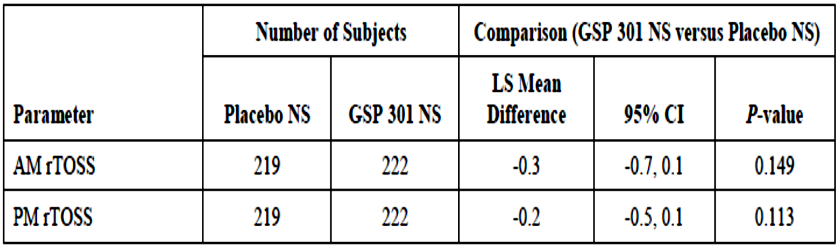

Abbreviations: AM = morning; CI = confidence interval; FAS = full analysis set; LS = least square; NS = nasal spray; PM = evening; rTOSS = reflective total ocular symptom score

Table 12: Study GSP 301-305 Morning (AM) and evening (PM) instantaneous Total Ocular Symptom Scores

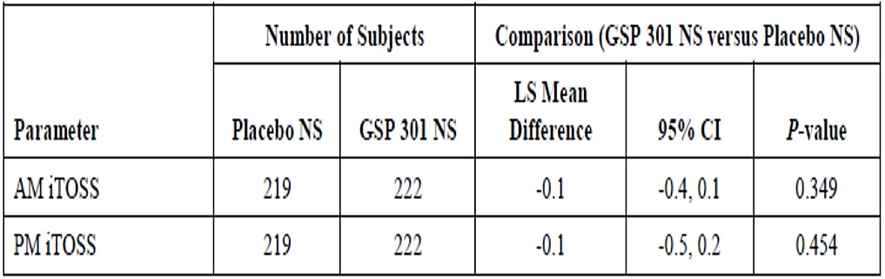

Abbreviations: AM = morning; CI = confidence interval; FAS = full analysis set; LS = least square; NS = nasal spray; PM = evening; iTOSS = instantaneous total ocular symptom score.

Results for individual ocular symptoms are shown in Table 13. Overall, these results may suggest a beneficial effect of Ryaltris on tearing and watering. However, none of the statistical comparisons were adjusted for multiplicity of testing.

Table 13: Study GSP 301-305 Individual ocular symptom scores

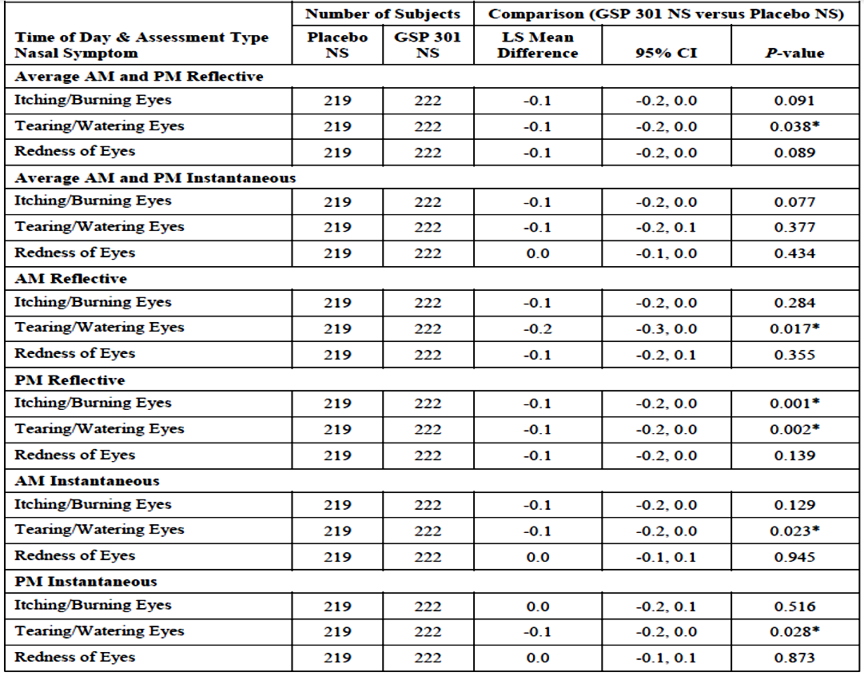

Abbreviations: AM = morning; CI = confidence interval; FAS = full analysis set; LS = least square; NS = nasal spray; PM = evening

*Statistically significant (p < 0.05)

The change from Baseline in the average of AM and PM measurements of reflective TOSS for each day is illustrated in Figure 4. The analysis suggested some benefit of Ryaltris over placebo in the latter half of the 14-day treatment period. No benefit was observed on an analysis of the average of AM and PM measurements of instantaneous TOSS for each day.

Figure 4: Study GSP 301-305 Daily average of morning (AM) and evening (PM) reflective Total Ocular Symptom Score for the full analysis set population

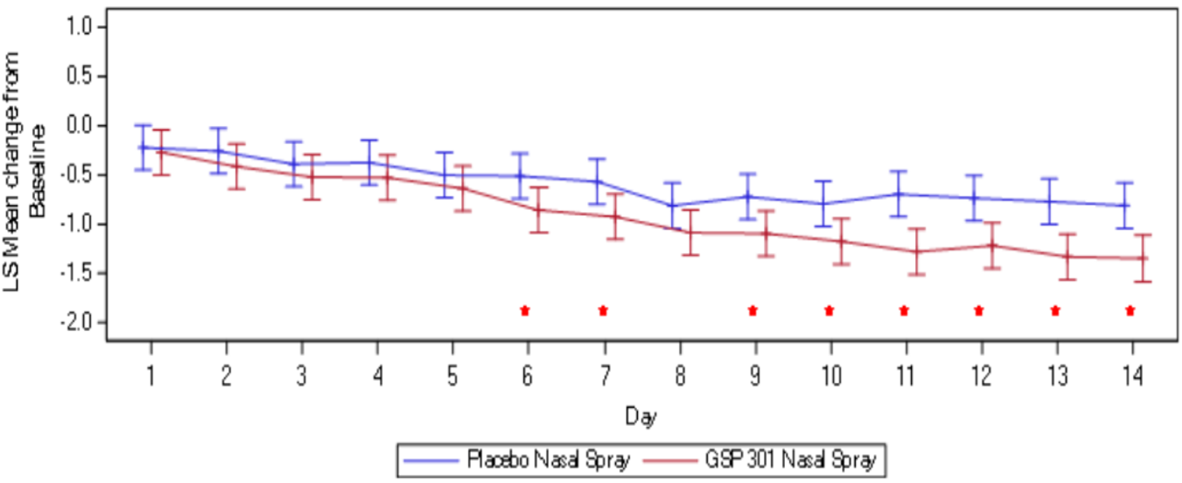

Abbreviations: AM = morning; CI = confidence interval; FAS = full analysis set; LS = least square; PM = evening; rTOSS = reflective total ocular symptom score.

*Statistically significant (p < 0.05)

Non-nasal symptoms scores

Results for total non-nasal symptom scores (TNNSS);[17] are summarised in Table 14, Table 15 and Table 16. Consistent with the findings for ocular symptoms Ryaltris did not demonstrate any significant improvement over placebo treatment. There was no significant benefit for the symptom of itching of the ears or palate.

Daily results for reflective TNNSS and instantaneous TNNSS were similar to those observed for reflective TOSS and instantaneous TOSS respectively.

Table 14: Study GSP 301-305 Average morning (AM) and evening (PM) scores for Total Non-Nasal Symptom Scores

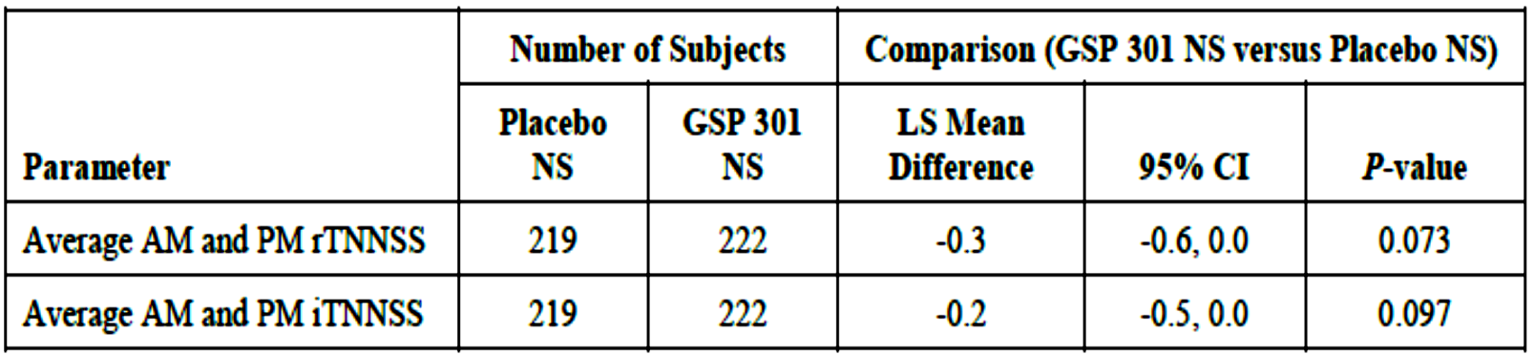

Abbreviations: AM = morning; CI = confidence interval; FAS = full analysis set; iTNNSS = instantaneous total non-nasal symptom score; LS = least square; NS = nasal spray; PM = evening; rTNNSS = reflective total non-nasal symptom score.

Table 15: Study GSP 301-305 Morning (AM) and evening (PM) scores for Total Non‑Nasal Symptom Scores

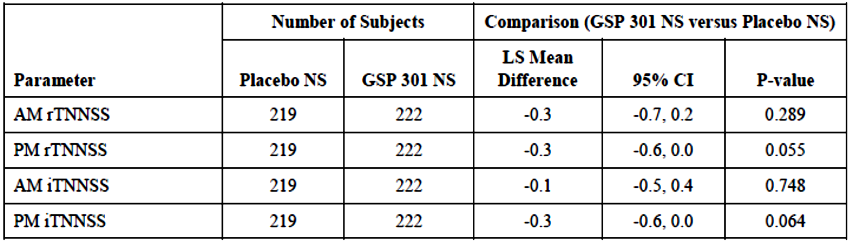

Abbreviations: AM = morning; CI = confidence interval; FAS = full analysis set; iTNNSS = instantaneous total non-nasal symptom score; LS = least square; NS = nasal spray; PM = evening; rTNNSS = reflective total non-nasal symptom score.

Table 16: Study GSP 301-305 Scores for itching of ears and palate

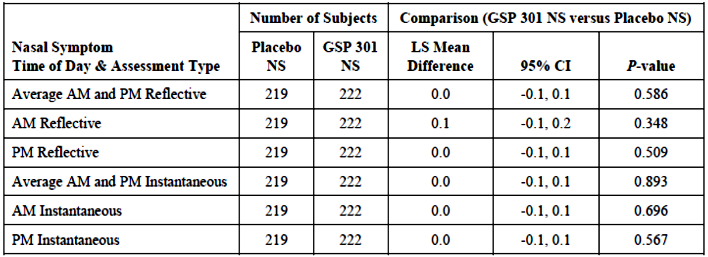Abbreviations: AM = morning; CI = confidence interval; FAS = full analysis set;; LS = least square; NS = nasal spray; PM = evening

###### Results for other endpoints

Physician assessed nasal symptom score

See *Other efficacy endpoints* for more information. The mean overall scores at Baseline were similar (7.8 ± 2.2 in the placebo arm and 7.8 ± 0.23 in the Ryaltris arm). In both groups, Baseline scores ranged from 0 to 12. The mean (±SD) change from Baseline on Day 15 in the FAS population was -2.6 (± 3.3) for the placebo arm compared with –3.7 (± 3.0) for the Ryaltris arm. The difference was nominally statistically significant (p = 0.010).

Individual domain scores for the Paediatric Rhinoconjunctivitis Quality of Life Questionnaire (PRQLQ)

Improvement in PRQLQ;16 from Baseline was significantly greater in the Ryaltris arm for four of the five individual domain scores (see Table 17).

Table 17: Study GSP 301-305 Paediatric Rhinoconjunctivitis Quality of Life Questionnaire (PRQLQ) domain scores

|  |  |  |
| --- | --- | --- |
| Domain score | LS mean | p-value |
| Activities | -0.7 versus -0.5 | p = 0.043 |
| Practical problems | -0.8 versus -0.5 | p = 0.006 |
| Nose symptoms | -1.1 versus -0.4 | p < 0.001 |
| Eye symptoms | -0.5 versus -0.3 | p = 0.203 |
| Other symptoms | -0.7 versus -0.5 | p = 0.025 |

#### Safety

##### Study GSP 301-305

Study GSP 301-305 was the only new trial in the submission that provided evaluable safety data.

##### Exposure

In Study GSP 301-305 a total of 225 subjects were treated with Ryaltris and 221 with placebo. Extent of exposure is summarised in the following table (see Table 18). Extent of exposure was comparable in the two treatment arms.

Table 18: Study GSP 301-305 Exposure to Ryaltris and placebo

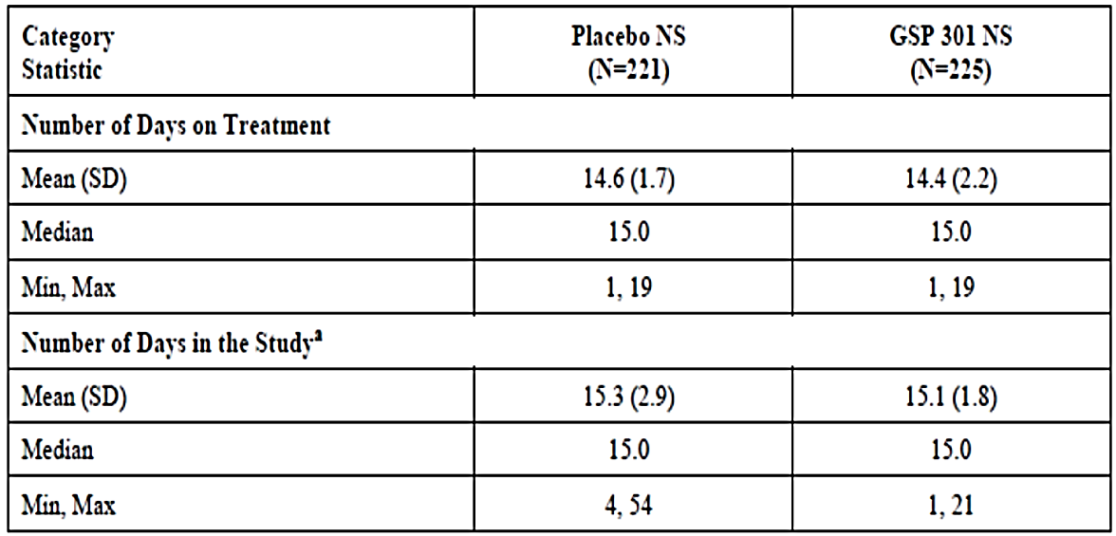

Abbreviations: Max = maximum; N = number of subjects in the treatment group; NS = nasal spray; SD = standard deviation

aNumber of days on study = end of study date – enrolment date (screening visit) + 1

##### All adverse events

The overall incidence of treatment‑emergent adverse events (TEAEs) irrespective of relationship to study treatment, was 10.4% in the placebo arm and 12.0% in the Ryaltris arm. These are summarised in Table 19. Dysgeusia (unpleasant taste) was more common in the Ryaltris arm (1.3% versus 0%) whereas epistaxis (nose bleeds) was more common in the placebo arm (0.9% versus 2.3%). Otherwise there were no notable differences in the incidence of individual adverse event (AE) terms.

Table 19: Study GSP 301-305 Treatment‑emergent adverse events by System Organ Class and Preferred Term (safety population)

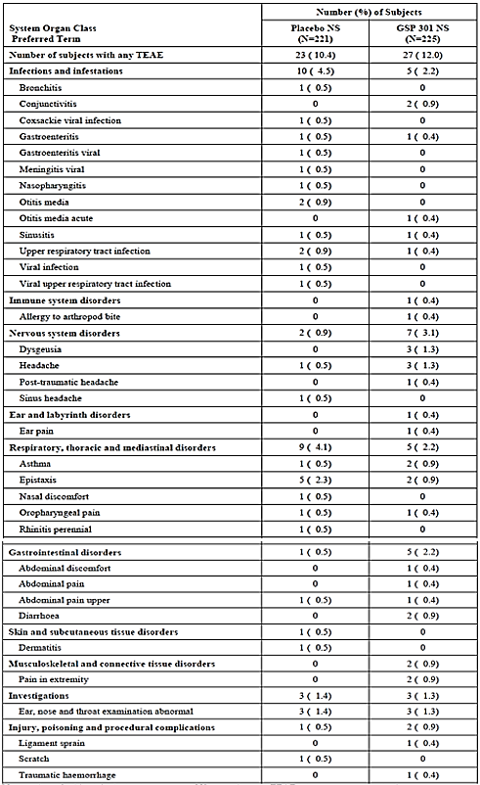

Abbreviations: N = number of subjects in the treatment group; NS = nasal spray; TEAE = treatment emergent adverse event.

##### Treatment-related adverse events

The overall incidence of treatment-related AEs was 2.7% in the placebo arm and 3.1% in the Ryaltris arm (Table 20). Apart from dysgeusia and epistaxis, there were no notable differences between treatment arms in the incidence of individual AE terms.

Table 20: Study GSP 301-305 Treatment-emergent adverse events by System Organ Class and Preferred Terms (safety population)

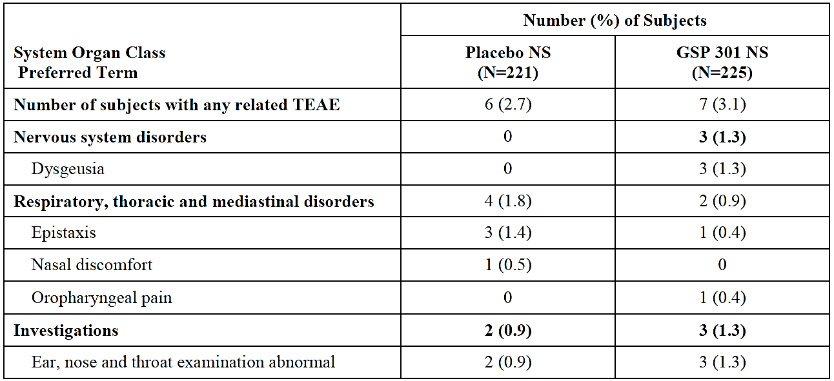

Abbreviations: N = number of subjects in the treatment group; NS = nasal spray; TEAE = treatment emergent adverse event.

##### Deaths and other serious adverse events

There were no deaths in the study.

There was only one serious AE reported which was a case of viral meningitis in an 8 year old boy in the placebo arm. This was also the only severe AE reported in the study.

##### Discontinuations due to adverse events

The overall incidence of AEs leading to discontinuation was 0.5% in the placebo arm and 1.8% in the Ryaltris arm (Table 21). Only one of these AEs (a case of oropharyngeal pain in the Ryaltris arm) was assessed as being related to study treatment.

Table 21: Study GSP 301-305 Adverse events leading to discontinuation by System Organ Class and Preferred Term (safety population)

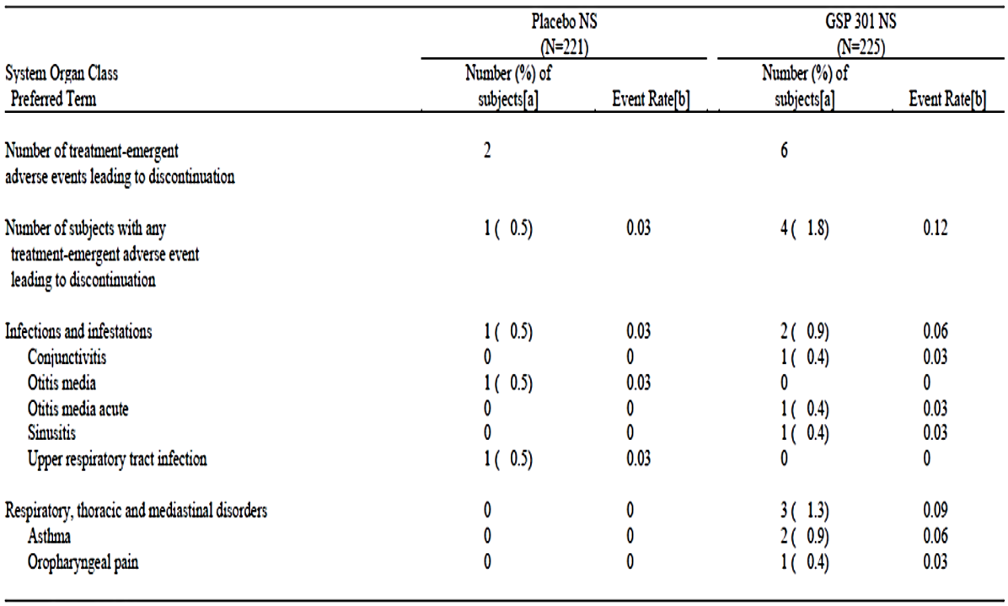

Abbreviations: N = number of subjects in SAS treatment; percentages are based on N

[a] Number (%) of subjects with AEs, sorted on international order for System Organ Class and alphabetically for Preferred Term

[b] Number of subjects with AEs divided by the total duration (day) of treatment across all subjects in given treatment group, multiplied by 100.

The total number of TEAEs counts all TEAEs for subjects. At each level, a subject is counted once if the subject reported one or more events.

##### Other safety issues

###### Safety in special populations

Subgroup analyses, for example, by age groups, sex, race and so on, were not performed on the safety data generated in Study GSP 301-305.

###### Safety related to drug-drug interactions and other interactions

No new data were submitted.

##### Post-marketing experience

The submission included two periodic safety update reports. The international birthdate for the product was 26 February 2019, the date of first marketing approval (in Cambodia).

Although not stated, this post marketing exposure probably reflects use in adults and adolescents and hence is unlikely to be relevant to the current submission.

### Risk management plan

The sponsor is required to comply with agreed product vigilance and risk minimisation requirements.

Further information regarding the TGA’s risk management approach can be found in [risk management plans for medicines and biologicals](https://www.tga.gov.au/publication/risk-management-plans-medicines-and-biologicals) and [the TGA's risk management approach](https://www.tga.gov.au/tgas-risk-management-approach).

### Risk-benefit analysis

#### Delegate’s considerations

##### Efficacy comments

The current submission seeks approval to extend the indications of the product to include children aged 6 to 11 years. As evidence of efficacy the sponsor has submitted a single Phase III, randomised, double blind, placebo controlled trial.

The trial was generally well designed and conducted satisfactorily. There were only two treatment arms in the study: Ryaltris versus placebo. The study was not designed to examine the effect of each of the individual components of Ryaltris (that is, olopatadine and mometasone furoate). However, the original submission to register Ryaltris included two Phase III, randomised controlled trials conducted in adults and adolescents which demonstrated superiority of Ryaltris over both mometasone and olopatadine monotherapies. European Medicines Agency (EMA) / International Council for Harmonisation (ICH) guidance;[18] supports the extrapolation of efficacy data from adults and adolescents to children provided the disease process in question is similar and the outcome of therapy is likely to be comparable. It is therefore reasonable to extrapolate the findings of the Ryaltris adult and adolescent studies to children with respect to superiority of the fixed combination over the individual components.

The study limited enrolment to subjects with seasonal allergic rhinitis, and treatment duration was limited to two weeks. Long-term efficacy in perennial allergic rhinitis has therefore not been studied in the proposed age group. However, the original Ryaltris submission included a 52-week study in adult and adolescent subjects with perennial allergic rhinitis. Extrapolation of efficacy data from this study to children is acceptable.

The study demonstrated statistically and clinically significant benefit for treatment with Ryaltris compared to placebo in terms of nasal symptoms. However, results for ocular symptoms were generally negative, with no benefit demonstrated on the secondary endpoint of average *reflective* Total Ocular Symptom Score (TOSS);15 over the 14 day treatment period (see Table 22) or the ‘other’ endpoint of average *instantaneous* TOSS over the 14 day treatment period (see Table 23). The indication proposed for children is the same as that approved for adults/adolescents, that is, allergic rhinitis and rhinoconjunctivitis, and these findings might suggest that any approval for children be restricted to allergic rhinitis.

Table 22: Study GSP 301-305 Average morning and evening reflective Total Ocular Symptom Score over the 14-day treatment period for the full analysis set population

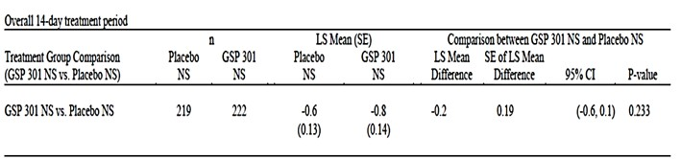

Note: Baseline score is derived as the mean of the last 8 consecutive reading scores including the AM assessment on the day of randomisation. Day 1 is derived as the average of Day 1 PM and Day 2 AM assessments, and so on for the rest of the treatment period.

Abbreviations: CI = confidence interval; n = subjects with data available; LS = least squares; NS = nasal spray; SE = standard error

Statistical analysis model: mixed effect repeated measures model with change from Baseline as the dependent variable, treatment group and site and treatment group by site interaction as fixed effects, Baseline score as covariate and study day as the within subject effect. Covariance structure ‘unstructured’ (UN) is assumed in the model

Table 23: Study GSP 301-305 Average morning and evening instantaneous Total Ocular Symptom Score over the 14-day treatment period for the full analysis set population

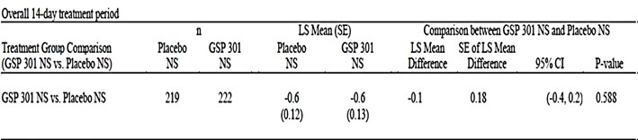

Note: Baseline score is derived as the mean of the last 8 consecutive reading scores including the AM assessment on the day of randomisation. Day 1 is derived as the average of Day 1 PM and Day 2 AM assessments, and so on for the rest of the treatment period.

Abbreviations: CI = confidence interval; n = subjects with data available; LS = least squares; NS = nasal spray; SE = standard error

Statistical analysis model: mixed effect repeated measures model with change from Baseline as the dependent variable, treatment group and site and treatment group by site interaction as fixed effects, Baseline score as covariate and study day as the within subject effect. Covariance structure ‘unstructured’ (UN) is assumed in the model.

The daily measurements for reflective TOSS suggest that Ryaltris might be effective towards the end of a two week treatment period (Figure 4) although this was not confirmed by daily instantaneous TOSS measurements. There was no requirement of a minimum reflective TOSS score at Baseline, and mean scores at Baseline were 3.59 in the placebo arm and 3.84 in the Ryaltris arm (possible range 0 to 9). It was not clear what percentage of subjects had ocular symptoms at Baseline. The lack of a significant effect on ocular symptoms in this study may be due to comparatively low scores at Baseline with limited scope for improvement. However, it would be still reasonable to extrapolate the established ocular symptom efficacy data from adults and adolescents to the children.

The submitted study also demonstrated a statistically significant benefit for Ryaltris over placebo on overall quality of life. However, the clinical significance of this finding appears unknown.

Overall, the efficacy data are sufficient to support the approval for the proposed new patient population. However, the Delegate does acknowledge the study limitations as discussed above.

##### Clinical safety

Study GSP 301-305 provided safety data for the proposed 6 to 11 year old population. In this study a total of 225 subjects were treated with Ryaltris for the duration of two weeks.

Ryaltris was generally well tolerated, and the incidence of adverse events (AEs) was only slightly higher in comparison to the placebo treatment (12.0% versus 10.4%). The only AE that occurred with a notably increased incidence compared to placebo was dysgeusia, which is listed as a common adverse reaction in the current PI. All AEs reported in the Ryaltris arm of the study were assessed as mild or moderate in severity, and there were no serious AEs reported. Discontinuations due to AEs were uncommon.

###### Mometasone furoate safety

There are a number of safety concerns regarding use of intranasal corticosteroid products in children (including hypothalamic pituitary adrenal axis suppression and growth impairment). Safety monitoring for these effects was not included in the submitted study. However, mometasone furoate nasal spray (Nasonex);[19] is registered for use in children aged 3 to 11 years, and these safety issues were studied in that product’s paediatric development program. The proposed dose of 100 µg per day for Ryaltris is same as approved for Nasonex (mometasone furoate). However, in a previously evaluated bioequivalence study conducted in healthy adult volunteers (Study GSP 301-102), systemic absorption of mometasone from Ryaltris was found to be greater than that from Nasonex. The difference was not considered to be clinically significant. Given these findings, it is considered that the paediatric safety data obtained with Nasonex provide adequate reassurance regarding the safety of the mometasone dose delivered with Ryaltris.

###### Olopatadine safety

Olopatadine nasal spray has not been previously registered in Australia. In the USA, olopatadine nasal spray (with the tradename Patanase) is approved for children aged 6 to 11 years, restricted for use in seasonal allergic rhinitis only. According to the US Prescribing Information;[20] the clinical trials conducted in children aged 6 to 11 years were limited to a duration of 14 days. It would appear therefore that there are no available data to establish the long term safety of olopatadine nasal spray in children aged 6 to 11 years.

###### Overall safety

The original submission to register Ryaltris in Australia included a 52-week study in adults and adolescents with perennial allergic rhinitis (Study GSP 301-303). While the relevant EMA/ICH guideline;20 supports the extrapolation of efficacy data from adults and adolescents to children, extrapolation of safety data is not supported.

The following information are the key relevant safety statements in the relevant TGA-adopted EMA guideline on medicines for allergic rhinoconjunctivitis:[21]

Although seasonal allergic rhinitis/perennial allergic rhinitis can alter school performance and work productivity it is not a serious life threatening disease. It is imperative therefore that the agents used in this condition are safe, given their repeated and often long term use.

Safety data are of paramount importance and 1 to 3 months of paediatric safety data are required. Further, special care has to be taken to avoid the side effects including growth effects typical in this age group.

The sponsor has also submitted one report describing simulation of systemic olopatadine and mometasone exposures in children aged 6 to younger than 12 years, using a previously developed population pharmacokinetic model. The model was developed using pharmacokinetic (PK) data from adults and adolescents only, and any covariate effects of age younger than 12 were therefore not explored.

Assuming that the model was applicable to children younger than 12 years, the simulations suggested that systemic olopatadine and mometasone exposures obtained in children using the proposed paediatric dosage regimen were similar to those obtained in adults using the approved adult and adolescent regimen. The conclusion that age has no effect on the PK of olopatadine was based entirely on data collected in adults and adolescents. The PK simulations presented in the current submission were based on an assumption that PK in children aged 6 to 11 would not differ to PK in adults and adolescents. Furthermore, it is possible that with prolonged administration, local side effects may be more prominent in this age group than in adults and adolescents.

Overall, the available safety data are sufficient to support short term use of Ryaltris in children aged 6 and 11 years, for the treatment of seasonal allergic rhinitis. However, due to the absence of long term safety data for intranasal olopatadine, therapeutic indication of Ryaltris for the treatment of perennial allergic rhinitis in proposed age group is not supported, as it requires longer term treatment.

In its response to proposed restriction of the new indication to children with seasonal allergic rhinitis, and the proposed restriction of duration of treatment to two weeks, the sponsor presented summary of adverse event data from an US Food and Drug Administration evaluation report;[22] for olopatadine nasal spray (Patanase) which is approved in the US for the treatment of seasonal allergic rhinitis only. There were no notable differences between in the incidence of common AEs between subjects aged 6 to 11 years and those aged 12 years and older, although bitter taste was more commonly reported in the older age group.

The sponsor also argued that olopatadine hydrochloride belongs to the antihistamine pharmacological drug class and the safety of long term administration of an antihistamine nasal spray is well established, including in children aged over 5 years. For example, azelastine, which is in the same pharmacological class as olopatadine, is approved as a nasal spray for the treatment of both seasonal allergic rhinitis and perennial allergic rhinitis patients aged 6 years and above in Europe and aged 5 years and above in Australia. However, it is not appropriate to extrapolate long-term safety data obtained with one chemical entity to another.

#### Proposed action

At this stage of the assessment, the Delegate was not in a position to say that the application for Ryaltris should be fully approved for the proposed extension of indication.

Safety data in the pivotal study is of only two weeks duration. The EMA guidelines adopted by the TGA requires that long-term safety data should be provided for children and that safety data cannot be extrapolated from older age groups.20

Results for ocular symptoms were generally negative, with no clear benefit demonstrated on the secondary endpoint of average reflective TOSS over the 14-day treatment period (see Table 22) or the ‘other’ endpoint of average instantaneous TOSS over the 14-day treatment period (see Table 23).

Overall, the submitted data and subsequent responses by the sponsor, do not support use of Ryaltris for perennial allergic rhinitis and rhinoconjunctivitis in children aged from 6 to 11 years.

Based on above reasons, approval for use of Ryaltris in 6 to 11 years children can only be granted for use in seasonal allergic rhinitis and restricted for the duration of 2 weeks.

#### Advisory Committee considerations

The [Advisory Committee on Medicines (ACM)](https://www.tga.gov.au/committee/advisory-committee-medicines-acm), having considered the evaluations and the Delegate’s overview, as well as the sponsor’s response to these documents, advised the following.

##### Specific advice to the Delegate

1. ***Does ACM consider that short-term safety data can support the long-term use, including use in perennial allergic rhinitis ?***

The ACM noted that although the short-term data submitted cannot support the long-term safety of Ryaltris in children, there is strong pharmacologic and clinical plausibility for Ryaltris being a safer option for longer-term intranasal corticosteroids use in children which represents a relevant consideration in the decision on this submission.

Overall less than 1% of patients in all treatment groups discontinued due to adverse reactions, indicating that the treatment was well tolerated and effective.

The ACM noted that usage should be at the lowest effective dose and long-term use discouraged, with second or third daily or weekly usage rather than daily.

The ACM recommended that a statement be included in the indications to the effect of:

‘*safety beyond two weeks has not been assessed in children 6 to 11 years of age’*.

The following statements should also be included within the Product Information (PI):

* + Safety in children has not been studied beyond two weeks of use or in perennial rhinitis.
  + The lowest possible maintenance dose should be achieved as safety beyond two weeks has not been assessed in children 6 to 11 years of age.
  + Long term glucocorticoid exposure carries particular risks in this age group.
  + Periodic clinical review, pursuit of lowest effective dosing, and consideration of adjunctive treatment modalities are recommended.

1. ***Does ACM agree on extrapolation of efficacy for seasonal allergic rhinitis to perennial allergic rhinitis in the 6 to 11 years of age group?***

The ACM considered that the efficacy of Ryaltris has been robustly demonstrated in seasonal allergic rhinitis.

The biology of the conditions and the product’s mechanism of action support efficacy across all forms of allergic rhinitis, including perennial allergic rhinitis, and in all age groups. The ACM defined the 6 years and older age group as a target patient group for rhinitis.

1. ***Does ACM consider that use of Ryaltris should be strictly restricted to two weeks?***

The ACM noted that whilst such a restriction may be prudent it does not adequately address the clinical safety concerns or real-world clinical management of the allergic rhinitis condition, both of which should be individualised on the basis of benefit versus risk. There are significant developmental and functional impacts from allergic rhinitis in some patients and some patients appropriately require longer term use of intranasal corticosteroids.

In addition, the ACM noted that mometasone is registered for perennial allergic rhinitis in children as young as 3 years old;21 and olopatadine eye drops;[23] are approved for 14 weeks of treatment in children over 3 years of age in Australia.[24]

On balance, the ACM were supportive of Ryaltris not being strictly restricted to two weeks usage. Rather the ACM proposed that a statement indicating that longer term safety data are limited for children under 12 years of age, and down titration to lowest effective dose (to include periodic, intermittent and less than daily dosing) is recommended to mitigate unresolved safety concerns. It was agreed that this would be a more effective mechanism to assist risk management.

1. ***Does the ACM agree that use of Ryaltris for rhinoconjunctivitis in children from 6 to 11 years of age is supported?***

The ACM noted that rhinitis becomes apparent in children at about 5 years of age, hence the proposed age cohort is an important target group.

While the ACM was of the view that the submitted efficacy data were less robust for allergic conjunctivitis, the allergic rhinitis symptom complex in all its presentations is most appropriately managed by individualised treatment, including with intranasal corticosteroids. Ryaltris is therefore supported for rhinoconjunctivitis in the 6 to 11 years of age group.

The ACM did however note that allergic conjunctivitis, when seen in isolation, can be managed without intranasal treatments.

1. ***The committee is (also) requested to provide advice on any other issues that it thinks may be relevant to a decision on whether or not to approve this application.***

Given the historical variations in indications and access for different intranasal corticosteroids of different potencies, the prevalence of allergic rhinitis in children, and likely widespread use of intranasal corticosteroids in this age group, a systematic attempt towards harmonisation would be useful in addressing safety concerns.

Awareness regarding long-term use could be raised via a statement or warning in the Consumer Medicines Information (CMI) to stress the importance of avoiding or reducing long-term use of this product in children.

##### Conclusion

The ACM ultimately considered this product to have an overall positive benefit risk profile but recommended additional wording be included in the indications in regard to down titration to lowest effective dose and avoiding long-term use. The indication wording recommended by the ACM was:

*[…] for the treatment of symptoms associated with allergic rhinitis and rhino conjunctivitis in patients 6 years of age and older.*

*Safety beyond two weeks has not been assessed in children 6 to 11 years of age.*

## Outcome

Based on a review of quality, safety, and efficacy, the TGA approved the registration of Ryaltris olopatadine 600 µg/actuation and mometasone furoate 25 µg/actuation, nasal spray bottle, for the following extension of indications:

*Ryaltris is indicated for the treatment of symptoms associated with allergic rhinitis and rhinoconjunctivitis in patients 6 years of age and older.*

The above extension of indications is inclusive of the previous approved indications.

### Specific conditions of registration applying to these goods

There were no specific conditions included for this registration. Only standard conditions apply to this registration.

## Attachment 1. Product Information

The PI for Ryaltris approved with the submission which is described in this AusPAR is at Attachment 1. For the most recent PI, please refer to the TGA [PI/CMI search facility.](https://www.tga.gov.au/picmi-search-facility)

|  |
| --- |
| Therapeutic Goods Administration |
| PO Box 100 Woden ACT 2606 Australia  Email: [info@tga.gov.au](mailto:info@tga.gov.au) Phone: 1800 020 653 Fax: 02 6203 1605  [**https://www.tga.gov.au**](https://www.tga.gov.au) |
| Reference/Publication # |

1. The **Black Triangle Scheme** provides a simple means for practitioners and patients to identify certain types of new prescription medicines, including those being used in new ways and to encourage the reporting of adverse events associated with their use. The Black Triangle does not denote that there are known safety problems, just that the TGA is encouraging adverse event reporting to help us build up the full picture of a medicine's safety profile.
2. Each spray (metered dose actuation) delivers a volume of 0.1 mL suspension containing 600 µg (0.6% w/v) olopatadine (equivalent to 665 µg olopatadine hydrochloride) and 25 µg (0.025% w/v) mometasone furoate (equivalent to 25.86 µg mometasone furoate monohydrate).
3. Wise ,SK et al. International consensus statement on allergy and rhinology: allergic rhinitis (ICAR:AR). *Int Forum Allergy Rhinol* 2018; 8(2): 108-352.
4. Wheatley, LM et al. Clinical practice. Allergic rhinitis. *N Engl J Med;* 2015; 372 (5): 456-63.
5. Australian Institute of Health and Welfare 2011. Allergic rhinitis (‘hay fever’) in Australia. Cat. no. ACM 23. Canberra: AIHW
6. Brożek, JL et al. Allergic Rhinitis and its Impact on Asthma (ARIA) guidelines; 2016 revision, J Allergy Clin Immunol 2017; 140 (4): 950-958.
7. AusPAR for Dymistra 125/50 azelastine (as hydrochloride) 125 microgram and fluticasone propionate 50 microgram published 1 September 2014 is available at https://www.tga.gov.au/resources/auspar/auspar-fluticasone-propionate-azelastine-hydrochloride
8. Therapeutic goods must be entered in the Australian Register of Therapeutic Goods (ARTG) before they can be lawfully supplied in or exported from Australia, unless exempt from being entered in the ARTG, or otherwise authorised by the TGA. For further information visit: https://www.tga.gov.au/australian-register-therapeutic-goods.
9. The **Total Nasal Symptom Score** (**TNSS**) is the sum of scores of a brief 4-item questionnaire asking the patient to score the severity of four key symptoms of allergic rhinitis (nasal congestion, sneezing, nasal itching and rhinorrhoea) at a specified time point. Each symptom is scored using a four-point scale (from zero to 3). Zero indicates no symptoms, a score of 1 for mild symptoms that are easily tolerated, 2 for definite awareness of symptoms which are bothersome but tolerable and 3 is reserved for severe symptoms that are hard to tolerate and interfere with daily activity. The TNSS is calculated by adding the score for each of the four symptoms to a total out of 12 points.
10. The ***reflective* Total Nasal Symptom Score** (**TNSS**) refers to where patients were required to record a score for each nasal symptom over the preceding 12 hours (‘reflective score’).
11. The ***instantaneous* Total Nasal Symptom Score** (**TNSS**) refers to where patients were required to record a score for each nasal symptom just before dosing of randomised treatment/placebo (‘instantaneous score’).
12. The **Total Ocular Symptom Score** (**TOSS**) is the sum of scores of a brief 3-item questionnaire asking the patient to score the severity of three ocular symptoms of allergic rhinitis (itching/burning of eyes; tearing/watering of eyes; and redness of eyes) at a specified time point. Each symptom is scored using a four-point scale (from zero to 3). Zero indicates no symptoms, a score of 1 for mild symptoms that are easily tolerated, 2 for definite awareness of symptoms which are bothersome but tolerable and 3 is reserved for severe symptoms that are hard to tolerate and interfere with daily activity. The TOSS is calculated by adding the score for each of the three symptoms to a total out of 9 points.
13. The ***reflective* Total Ocular Symptom Score** (**TNSS**) refers to where patients were required to record a score for each ocular symptom over the preceding 12 hours (‘reflective score’).
14. The **Paediatric Rhinoconjunctivitis Quality of Life Questionnaire** (**PRQLQ**) is a validated questionnaire designed to measure quality of life in children aged 6 to 12 years with seasonal allergic rhinitis. The PRQLQ has 23 questions across 5 domains (nose symptoms, eye symptoms, practical problems, activity limitation and other symptoms). The questions are asked directly to children using age-appropriate language. Children recall how they have been during the previous week and respond to each question on a 7-point scale. The overall PRQLQ score is the mean of all 23 responses and the individual domain scores are the means of the items in the those domains.
15. Barnes ML, Vaidyanathan S, Williamson PA, Lipworth BJ. The minimal clinically important difference in allergic rhinitis. *Clin Exp Allergy* 2010; 40: 242-50.
16. Meltzer EO, Wallace D, Dykewicz M, Shneyer L. Minimal Clinically Important Difference (MCID) in Allergic Rhinitis: Agency for Healthcare Research and Quality or Anchor-Based Thresholds? *J Allergy Clin Immunol Pract* 2016; 4: 682-8.
17. The **Total Non-Nasal Symptom Score** (**TNNSS**) was the sum of the three ocular symptom scores (itching/burning of eyes; tearing/watering of eyes; and redness of eyes) with one other symptom (itching of ears or palate) with a possible range of 0 to 12.
18. EMA: [ICH topic E; Note for guidance on clinical investigation of medicinal products in the paediatric population](https://www.tga.gov.au/resources/resource/international-scientific-guidelines/international-scientific-guideline-ich-topic-e-11-note-guidance-clinical-investigation-medicinal-products-paediatric-population) (CPMP/ICH/2711/99). TGA-adopted, effective: 19 April 2001
19. Nasonex aqueous nasal spray mometasone furoate 50 µg/actuation (as monohydrate) spray bottle (AUST R 77112) was first registered on the ARTG on 14 February 2001. Nasonex (AUST R 77112) is indicated for the following: *For the treatment of symptoms associated with seasonal allergic rhinitis and perennial allergic rhinitis and the prophylaxis of seasonal allergic rhinitis in adults, adolescents and children between the ages of 3 and 11 years..*
20. Patanase USPI (2021). US Prescribing Information: Patanase (olopatadine hydrochloride) Nasal

    Spray; Initial U.S. Approval: 1996; Revised: March 2021. Available at: <https://www.accessdata.fda.gov/drugsatfda_docs/label/2021/021861s015lbl.pdf>
21. European Medicines Agency (EMA): [Guideline on the Clinical Development of Medicinal Products for the Treatment of Allergic Rhinoconjunctivitis](https://www.tga.gov.au/resources/resource/international-scientific-guidelines/international-scientific-guideline-guideline-clinical-development-medicinal-products-treatment-allergic-rhino-conjunctivitis) (CHMP/EWP/2455/02). Published 2004; TGA-adopted, effective 28 July 2005.
22. FDA (2009). Olopatadine (Patanase) nasal spray, NDA 21-861, Supplement 5, Clinical Review. Available at: <https://www.fda.gov/media/83129/download>
23. Patanol 0.1% olopatadine hydrochloride 1.11mg/1mL eye drop bottle (ARTG R 82000) was first registered on the ARTG on 16 May 2002.

    Other olapatadine hydrochloride containing eye drop products are registered on the ARTG.
24. Indicated for the treatment of signs and symptoms of seasonal allergic conjuctivitis. Treatment may be maintained for up to 14 weeks, if considered necessary.