This medicinal product is subject to additional monitoring **in Australia**. This will allow quick identification of new safety information. Healthcare professionals are asked to report any suspected adverse events at <https://www.tga.gov.au/reporting-problems>.

▼

# Australian product information

# Bimzelx® (bimekizumab) 160 mg/ml injection

# Name of the medicine

Bimekizumab

# Qualitative and quantitative composition

Each pre-filled syringe or pen contains 160 mg bimekizumab in 1 ml.

Bimekizumab is a recombinant humanized full-length monoclonal antibody of the IgG1 sub-class, expressed in a genetically engineered Chinese hamster ovary cell line.

For the full list of excipients, see Section 6.1 List of Excipients.

# Pharmaceutical form

Solution for injection.

The solution is clear to slightly opalescent and pale brownish-yellow.

# Clinical particulars

## Therapeutic indications

Bimzelx is indicated for the treatment of moderate to severe plaque psoriasis in adult patients who are candidates for systemic therapy or phototherapy.

## Dose and method of administration

The recommended dose of Bimzelx for adult patients with plaque psoriasis is 320 mg (given as 2 subcutaneous injections of 160 mg each) at Week 0, 4, 8, 12, 16 and every 8 weeks thereafter.

Bimzelx is administered by subcutaneous injection. Suitable areas for injection include thigh, abdomen and upper arm. Injection sites should be rotated and injections should not be given into psoriasis plaques or areas where the skin is tender, bruised, erythematous, or indurated.

Bimzelx is for single use in one patient only. Discard any residue.

### Special populations

*Overweight patients*

For some patients with a body weight ≥ 120 kg, 320 mg every 4 weeks after Week 16 may be considered (see Section 5.1 Pharmacodynamic Properties, Clinical trials).

*Elderly population*

No dose adjustment is required (see Section 5.2 Pharmacokinetic Properties).

*Renal and hepatic impairment*

Bimzelx has not been studied in these patient populations. Dose adjustments are not considered necessary based on pharmacokinetics (see Section 5.2 Pharmacokinetic Properties). No specific PK studies using Bimzelx have been pursued in patients with underlying impaired hepatic function.

*Paediatric population*

The safety and efficacy of Bimzelx in children and adolescents below the age of 18 years has not be established. No data are available.

## Contraindications

Hypersensitivity to the active substance or to any of the excipients (see Section 6.1 List of Excipients).

Live vaccines should not be given in patients treated with Bimzelx. No data are available on the response to live vaccines.

## Special warnings and precautions for use

### Infections

Bimzelx may increase the risk of infections such as upper respiratory tract infections and oral candidiasis (see section 4.8 Adverse effects (Undesirable effects)).

Caution should be exercised when considering the use of Bimzelx in patients with a chronic infection or a history of recurrent infection. Treatment with Bimzelx should not be initiated in patients with any clinically important active infection until the infection resolves or is adequately treated.

Patients treated with Bimzelx should be instructed to seek medical advice if signs or symptoms of clinically important chronic or acute infection occur. If a patient develops a clinically important infection or is not responding to standard therapy, the patient should be closely monitored and Bimzelx should not be administered until the infection resolves.

### Pre-treatment evaluation for tuberculosis (TB)

No increased susceptibility to tuberculosis was reported from clinical studies. Prior to initiating treatment with Bimzelx, patients should be evaluated for TB infection. Bimzelx should not be given in patients with active TB. Patients receiving Bimzelx should be monitored for signs and symptoms of active TB. Anti-TB therapy should be considered prior to initiating Bimzelx in patients with a past history of latent or active TB in whom an adequate course of treatment cannot be confirmed.

### Inflammatory bowel disease

Caution should be exercised when prescribing Bimzelx to patients with inflammatory bowel disease. Patients should be monitored closely. New onset of ulcerative colitis was observed in plaque psoriasis studies. Exacerbation or new onset of Crohn’s disease and ulcerative colitis were observed in Bimzelx treated patients during clinical studies in other diseases.

### Hypersensitivity

If a serious hypersensitivity reaction occurs, administration of Bimzelx should be discontinued immediately and appropriate therapy initiated.

### Vaccinations

Prior to initiating therapy with Bimzelx, consider completion of all age appropriate immunizations according to current immunization guidelines.

Patients treated with Bimzelx may receive inactivated or non-live vaccinations. Healthy individuals who received a single 320 mg dose of Bimzelx two weeks prior to vaccination with an inactivated seasonal influenza vaccine had similar antibody responses compared to individuals who did not receive Bimzelx prior to vaccination.

### Use in hepatic impairment

Bimzelx has not been studied in these patient populations. Dose adjustments are not considered necessary based on pharmacokinetics (see Section 5.2 Pharmacokinetic Properties).

### Use in renal impairment

Bimzelx has not been studied in these patient populations. Dose adjustments are not considered necessary based on pharmacokinetics (see Section 5.2 Pharmacokinetic Properties).

### Use in the elderly

Based on population pharmacokinetic analysis with a limited number of elderly patients (n = 110 for age ≥ 65 years and n = 14 for age ≥ 75 years), apparent clearance (CL/F) in elderly patients and patients less than 65 years of age was similar. No dose adjustment is required.

### Paediatric use

### The safety and efficacy of Bimzelx in children and adolescents below the age of 18 years has not be established. No data are available.

### Effects on laboratory tests

No data available.

## Interactions with other medicines and other forms of interactions

No CYP450 interaction studies have been performed in humans. There is no direct evidence for the role of IL-17A or IL-17F in the expression of CYP450 enzymes. Given that (1) bimekizumab, as an IgG1K mAb, is expected to be degraded into small peptides and amino acids via catabolic pathways in the same manner as endogenous IgG and (2) formation of some CYP450 enzymes which is suppressed by elevated levels of cytokines during inflammation (as in psoriasis), will be reversed by inflammatory suppressors, like IL-17A and IL-17F inhibitor bimekizumab, the resultant outcome will be a normalisation of CYP450 levels/activity. Extrapolation of the latter means that drugs metabolized by the CYP450 system may be co-administered with bimekizumab. However, monitoring of therapeutic plasma level and clinical effect of drugs with narrow therapeutic index (e.g. warfarin) metabolized via CYP450 system should be considered.

## Fertility, pregnancy and lactation

### Fertility

The effect of bimekizumab on human fertility has not been evaluated. In animal studies, bimekizumab did not indicate harmful effects with respect to fertility as assessed by a lack of effects on reproductive organs, menstrual cycles or sperm in sexually mature cynomolgus monkeys that received bimekizumab for 26 weeks at a weekly SC dose of 200 mg/kg (dose resulting in 109 times the human exposure at 320 mg every 4 weeks based on AUC). The monkeys were not mated to evaluate functional fertility.

### Pregnancy (Category C)

There are no adequate and well controlled studies in pregnant women to establish the safety of Bimzelx during pregnancy. Based on the mechanism of action of bimekizumab, the theoretical risk that use during pregnancy may affect neonatal immunity cannot be excluded. In an enhanced pre/postnatal development study in the cynomolgus monkey, bimekizumab showed no effects on gestation, parturition, infant survival, fetal or postnatal development when administered throughout organogenesis until parturition at a maternal dose of 50 mg/kg SC weekly resulting in 27 times the human exposure at 320 mg every 4 weeks based on AUC. At birth, serum bimekizumab concentrations in infant monkeys were comparable to those of mothers indicating placental transfer of bimekizumab. Bimzelx should be used in pregnancy only if the benefits clearly outweigh the potential risks.

### Lactation

It is not known whether bimekizumab is excreted in human milk or absorbed systemically after ingestion. As immunoglobulins can be excreted in human milk, caution should be exercised when Bimzelx is administered to a woman who is breast-feeding and a decision on whether to discontinue breast-feeding during treatment should be made.

## Effects on ability to drive and use machines

Bimekizumab is not anticipated to have any influence on the ability to drive and use machines.

## Adverse effects (Undesirable effects)

A total of 1789 patients have been treated with bimekizumab in blinded and open-label clinical studies in plaque psoriasis representing 1830.4 patient-years of exposure. Of these, over 1000 patients were exposed to bimekizumab for at least one year.

The most frequently reported adverse drug reactions (ADRs) were upper respiratory tract infections (most frequently nasopharyngitis) and oral candidiasis.

**Table 1: Adverse Drug Reactions Occurring in Greater Than 1% of Subjects on BIMZELX through Week 16 in BE-VIVID and BE-READY**

|  |  |  |
| --- | --- | --- |
| **Adverse Drug Reactions** | **BIMZELX**  **320 mg every four weeks**  **N = 670**  **n (%)** | **Placebo**  **N = 169**  **n (%)** |
| Upper respiratory tract infections a | 97 (14.5) | 23 (13.6) |
| Oral Candidiasis | 49 (7.3) | 0 |
| Headache | 22 (3.3) | 0 |
| Injection Site Reactions b | 17 (2.5) | 0 |
| Acne | 8 (1.2) | 0 |
| Oropharyngeal candidiasis | 8 (1.2) | 0 |
| Folliculitis | 8 (1.2) | 0 |
| Gastroenteritis | 8 (1.2) | 0 |
| Tinea pedis | 8 (1.2) | 0 |
| Fatigue | 7 (1.0) | 0 |
| Oral herpes | 7 (1.0) | 0 |

a Includes nasopharyngitis, pharyngitis, upper respiratory tract infection, rhinitis, sinusitis, tonsillitis, and peritonsillar abscess.

b Includes injection site erythema, injection site reaction, injection site oedema, injection site pain, and injection site swelling.

*Other adverse reactions (< 1%)*

Adverse drug reactions that occurred in < 1% but > 0.1% of subjects in the Bimzelx group and at a higher rate than in the placebo group through Week 16 were, tinea infections, herpes simplex, eczema, dermatitis contact, dyshidrotic eczema, intertrigo, dermatitis, otitis externa, otitis media, conjunctivitis and neutropenia.

*Description of selected adverse reactions*

*Infections*

In the placebo-controlled period of Phase III clinical studies in plaque psoriasis, infections were reported in 36.0% of patients treated with bimekizumab for up to 16 weeks compared with 22.5% of patients treated with placebo. The majority of infections consisted of non-serious mild to moderate upper respiratory tract infections such as nasopharyngitis. There were higher rates of oral and oropharyngeal candidiasis in patients treated with bimekizumab consistent with the mechanism of action (7.3% and 1.2% respectively compared to 0% for placebo-treated patients). The vast majority of cases were non-serious, mild or moderate in severity, and did not require treatment discontinuation.

Serious infections occurred in 0.3% of patients treated with bimekizumab and 0% treated with placebo.

Over the entire treatment period of Phase III studies in plaque psoriasis, infections were reported in 63.2% of patients treated with bimekizumab (120.4 per 100 patient-years). Serious infections were reported in 1.5% of patients treated with bimekizumab (1.6 per 100 patient-years) (see section 4.4).

*Neutropenia*

Neutropenia was observed with bimekizumab in phase III clinical studies in plaque psoriasis. In the 16 weeks placebo-controlled period neutropenia grade 3/4 were observed at the same frequency of 0.6% in patients receiving bimekizumab or placebo. Over the entire treatment period of Phase III studies, neutropenia grade 3/4 were observed in 1 % of patients treated with bimekizumab. Most cases were transient and did not require treatment discontinuation.No serious infections were associated with neutropenia.

*Immunogenicity*

As with all therapeutic proteins, there is the potential for immunogenicity with bimekizumab. The detection of anti-drug antibody formation is highly dependent on the sensitivity and specificity of the assay. Additionally, the observed incidence of anti-drug antibody (including neutralizing antibody) positivity in an assay may be influenced by several factors, including assay methodology, sample handling, timing of sample collection, concomitant medications, and underlying disease. For these reasons, comparison of the incidence of antibodies to bimekizumab with the incidence of antibodies to other products may be misleading.

Approximately 45% of plaque psoriasis patients treated with bimekizumab up to 56 weeks at the recommended dosing regimen (320 mg every 4 weeks up to Week 16 and 320 mg every 8 weeks thereafter) developed anti-drug antibodies. Of the patients who developed anti-drug antibodies, approximately 34% (16% of all patients treated with bimekizumab) had antibodies that were classified as neutralizing. No evidence of altered clinical response, or safety profile was associated with development of anti-bimekizumab antibodies or neutralising antibodies.

### Reporting suspected adverse effects

Reporting suspected adverse reactions after registration of the medicinal product is important. It allows continued monitoring of the benefit-risk balance of the medicinal product. Healthcare professionals are asked to report any suspected adverse reactions at <http://www.tga.gov.au/reporting-problems>.

## Overdose

Single doses of 640 mg intravenously or 640 mg subcutaneously, followed by 320 mg subcutaneously every two weeks for five doses have been administered in clinical studies without dose-limiting toxicity. In the event of overdose, it is recommended that the patient be monitored for any signs and symptoms of adverse reactions and appropriate symptomatic treatment be instituted immediately.  
  
For information on the management of overdose, contact the Poisons Information Centre on 131126 (Australia).

# Pharmacological properties

## Pharmacodynamic properties

### Mechanism of action

Bimekizumab is a humanised IgG1/κ monoclonal antibody. It has two identical antigen binding regions that bind and neutralise IL-17A, IL-17F and IL-17AF cytokines. Levels of IL-17A and IL-17F are elevated in several immune mediated inflammatory diseases and drive chronic inflammation and damage across multiple tissues. In human *in vitro* disease models, dual neutralisation of both IL-17A and IL-17F with bimekizumab suppresses the expression of inflammation related genes and proteins to a greater extent than inhibition of IL-17A alone.   
  
**Pharmacodynamic effects**  
No formal pharmacodynamic studies have been conducted with bimekizumab.

### Clinical trials

The safety and efficacy of bimekizumab was evaluated in 1480 patients with moderate to severe plaque psoriasis in three Phase III multicenter, randomized, placebo and/or active comparator-controlled studies. Patients were at least 18 years of age, had a Psoriasis Area and Severity Index (PASI) score ≥12 and Body Surface Area (BSA) affected by PSO ≥10%, an Investigators Global Assessment (IGA) score ≥3 on a 5-point scale and were candidates for systemic psoriasis therapy and/or phototherapy. The efficacy and safety of bimekizumab were evaluated versus placebo and ustekinumab (BE VIVID – PS0009), versus placebo (BE READY – PS0013) and versus adalimumab (BE SURE - PS0008).

The BE VIVID study evaluated 567 patients for 52 weeks where patients were randomized to receive either bimekizumab 320 mg every 4 weeks, ustekinumab (45 mg or 90 mg, depending on patient weight, at baseline and Week 4 and then every 12 weeks), or placebo for an initial 16 weeks followed by bimekizumab 320 mg every 4 weeks.

The BE READY study evaluated 435 patients for 56 weeks. Patients were randomized to receive bimekizumab 320 mg every 4 weeks or placebo. At Week 16, patients who achieved a PASI 90 response entered the 40-week randomized withdrawal period. Patients initially randomized to bimekizumab 320 mg every 4 weeks were re-randomized to either bimekizumab 320 mg every 4 weeks or bimekizumab 320 mg every 8 weeks or placebo (i.e. withdrawal of bimekizumab). Patients initially randomized to placebo continued to receive placebo provided they were PASI 90 responders. Patients who did not achieve a PASI 90 response at Week 16 entered an open-label escape arm and received bimekizumab 320 mg every 4 weeks for 12 weeks. Patients who relapsed (did not achieve PASI 75 response) during the randomized withdrawal period also entered the 12-week escape arm.

The BE SURE study evaluated 478 patients for 56 weeks. Patients were randomized to receive either bimekizumab 320 mg every 4 weeks through Week 56, bimekizumab 320 mg every 4 weeks through Week 16 followed by bimekizumab 320 mg every 8 weeks through Week 56 or adalimumab as per labeling recommendation through Week 24 followed by bimekizumab 320 mg every 4 weeks through Week 56.

Baseline characteristics were consistent across all 3 studies. Among those, the median baseline BSA was 20%, the median baseline PASI score was 18 and the baseline IGA score was severe in 33% of patients. The median baseline scores for Patient Symptoms Diary (PSD) pain, itch and scaling items ranged between 6 and 7 on a 0-10 points scale and the median baseline Dermatology Life Quality Index (DLQI) total score was 9.

Across all 3 studies, 38% of patients had received a prior biologic therapy; 23% had received at least one anti-IL17 agent and 13% had received at least one TNF-antagonist. Twenty-two percent were naïve to any systemic therapy (including non-biologic and biologic) and 39% of patients had received prior phototherapy or chemotherapy.

The efficacy of bimekizumab was evaluated with respect to impact on skin disease overall, specific body locations (scalp, nails and hand and foot), patient reported symptoms and impact on quality of life. The two co-primary end-points in all 3 studies were the proportion of patients who achieved 1) a PASI 90 response and 2) an IGA “clear or almost clear” (IGA 0/1with at least two points improvement from baseline) response at Week 16. PASI 100, IGA 0 response at Week 16 and PASI 75 response at Week 4 were key secondary endpoints in all 3 studies.

**Skin disease overall**

Treatment with bimekizumab resulted in significant improvement in the measures of disease activity compared to placebo, ustekinumab or adalimumab at Week 16. The key efficacy results are shown in Table 2.

**Table 2: Summary of clinical responses in BE VIVID, BE READY and BE SURE**

|  |  |  |  |  |  |  |  |
| --- | --- | --- | --- | --- | --- | --- | --- |
|  | **BE VIVID** | | | **BE READY** | | **BE SURE** | |
|  | **Placebo**  **(N= 83)**  **n (%)** | **BKZ 320 mg Q4W**  **(N= 321)**  **n (%)** | **Ustekinumab**  **(N=163)**  **n (%)** | **Placebo**  **(N= 86)**  **n (%)** | **BKZ 320 mg Q4W**  **(N= 349)**  **n (%)** | **BKZ 320 mg Q4W**  **(N= 319)**  **n (%)** | **Adalimumab**  **(N= 159)**  **n (%)** |
| **PASI 100**  Week 16 | 0 (0.0) | 188 (58.6) a | 34 (20.9) | 1 (1.2) | 238 (68.2) a | 194 (60.8) a | 38 (23.9) |
| **PASI 90**  Week 16 | 4 (4.8) | 273 (85.0) a, b | 81 (49.7) | 1 (1.2) | 317 (90.8) a | 275 (86.2) a | 75 (47.2) |
| **PASI 75**  Week 4  Week 16 | 2 (2.4)  6 (7.2) | 247 (76.9) a, b  296 (92.2) | 25 (15.3)  119 (73.0) | 1 (1.2)  2 (2.3) | 265 (75.9) a  333 (95.4) | 244 (76.5) a  295 (92.5) | 50 (31.4)  110 (69.2) |
| **IGA 0**  Week 16 | 0 (0.0) | 188 (58.6) a | 36 (22.1) | 1 (1.2) | 243 (69.6) a | 197 (61.8) | 39 (24.5) |
| **IGA 0/1**  Week 16 | 4 (4.8) | 270 (84.1) a, b | 87 (53.4) | 1 (1.2) | 323 (92.6) a | 272 (85.3) a | 91 (57.2) |
| **Absolute PASI ≤ 2**  Week 16 | 3 (3.6) | 273 (85.0) | 84 (51.5) | 1 (1.2) | 315 (90.3) | 280 (87.8) | 86 (54.1) |
| **PSD Pain** (N)  Week 16 | (N=54)  9 (16.7) | (N=229)  177 (77.3) a | (N=107)  73 (68.2) | (N=67)  6 (9.0) | (N=255)  201 (78.8) a | (N=252)  180 (71.4) | (N=108)  63 (58.3) |
| **PSD Itch** (N)  Week 16 | (N=61)  8 (13.1) | (N=244)  187 (76.6) a | (N=117)  77 (65.8) | (N=72)  4 (5.6) | (N=278)  210 (75.5) a | (N=262)  179 (68.3) | (N=116)  58 (50.0) |
| **PSD Scaling** (N)  Week 16 | (N=63)  8 (12.7) | (N=246)  193 (78.5) a | (N=116)  69 (59.5) | (N=70)  4 (5.7) | (N=286)  223 (78.0) a | (N=261)  185 (70.9) | (N= 119)  59 (49.6) |

BKZ 320 mg Q4W= bimekizumab every 4 weeks. Non-Responder Imputation (NRI) is used.

IGA 0/1 response was defined as Clear (0) or Almost Clear (1) with at least a 2-category improvement from Baseline at Week 16. IGA 0 response was defined as Clear (0) with at least a 2-category improvement from Baseline at Week 16.

PSD is Patient Symptoms Diary. PSD response is defined as a change from baseline to Week 16 ≥ to a pre-specified threshold (1.98, 2.39, and 2.86 respectively for pain itch and scaling). A pooled supportive analysis of PSD responses in BE VIVID and BE READY using a more stringent threshold for response definition, i.e. a change from baseline to Week 16 ≥ 4, in the 3 PSD item scores (pain, itch, scaling) provided similar results with response rates of 72.2%, 67.0% and 75.8% in the bimekizumab treatment group versus rates of 5.2%, 5.3% and 5.8% in the placebo group.

a) p<0.001 versus placebo (BE VIVID and BE READY), versus adalimumab (BE SURE), adjusted for multiplicity.

b) p<0.001 versus ustekinumab (BE VIVID), adjusted for multiplicity.

Bimekizumab was associated with a rapid onset of efficacy. In BE VIVID, at week 2 and week 4, PASI 90 response rates were significantly higher for bimekizumab-treated patients (12.1% and 43.6% respectively) compared to placebo (1.2% and 2.4% respectively) and ustekinumab (1.2% and 3.1% respectively).

**Figure 1: PASI 90 responder rates over time in BE VIVID**

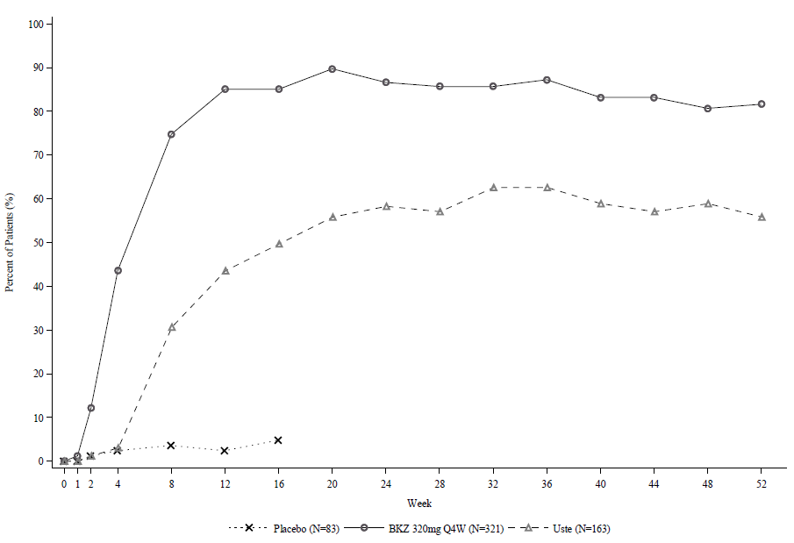

BKZ=bimekizumab; Uste=ustekinumab. NRI is used.

In the BE VIVID study, at Week 52, bimekizumab-treated patients achieved significantly higher response rates than the ustekinumab-treated patients on the endpoints of PASI 90 (81.6% bimekizumab vs 55.8% ustekinumab, p<0.001), IGA 0/1 (77.9% bimekizumab vs 60.7% ustekinumab, p<0.001) and PASI 100 (64.2% bimekizumab vs 38.0% ustekinumab).

In the BE SURE study at Week 24, a significantly higher percentage of patients treated with bimekizumab achieved a PASI 90 and an IGA 0/1 responses as compared with adalimumab (85.6% and 86.5% respectively vs 51.6% and 57.9% respectively, p<0.001). Among the 65 adalimumab non-responders at Week 24 (< PASI 90), 78.5% achieved a PASI 90 response after 16 weeks of treatment with bimekizumab. No new safety findings were observed in patients who switched from adalimumab to bimekizumab. At Week 56, 70.2% of bimekizumab-treated patients achieved a PASI 100 response.

**Figure 2:** **PASI 90 responder rates over time in BE SURE**

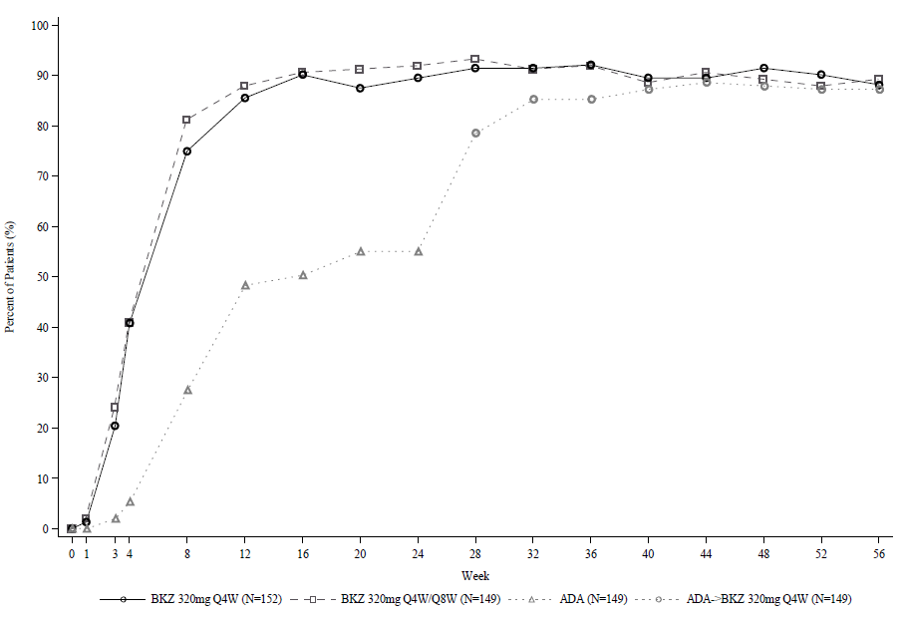

BKZ 320 mg Q4W = bimekizumab every 4 weeks; BKZ 320 mg Q8W = bimekizumab every 8 weeks; ADA= adalimumab.

Note: Only patients who received bimekizumab at Week 24 or later are included. Patients in the BKZ Q4W/Q8W group switched from Q4W to Q8W dosing at Week 16. Patients in the ADA/BKZ 320 mg Q4W group switched from ADA to BKZ Q4W at Week 24. NRI is used.

The efficacy of bimekizumab was demonstrated regardless of age, gender, race, disease duration, body weight, PASI baseline severity and previous treatment with a biologic. Bimekizumab was efficacious in prior biologic exposed patients, including anti-TNF / anti IL-17 and in systemic treatment-naïve patients.

Based on population PK/ PD analysis in patients with moderate to severe plaque psoriasis, some patients with higher body weight (≥120 kg) benefit from Bimzelx 320 mg every four weeks after the initial 16 weeks of treatment.

Across the entire bimekizumab Phase 3 psoriasis program, including 3 pivotal Phase 3 studies (BE SURE, BE VIVID, and BE READY) and the Phase 3b study (BE RADIANT – PS0015), a total of 1362 study participants were randomized to treatment with bimekizumab. Of these, 116 (8.5%) presented with a body weight ≥120kg at Baseline.

A post-hoc analyses of efficacy for the subgroups of study participants weighing <120kg or ≥120kg in the Initial Treatment Period (with bimekizumab 320mg Q4W dosing from Week 0 to Week 16), pooled across all psoriasis Phase 3/3b studies is shown below:

Table 3: Week 16 efficacy outcomes by weight

|  |  |  |  |
| --- | --- | --- | --- |
|  | **BE SURE, BE VIVID, BE READY and BE RADIANT** | | |
|  | **Weight <120kg** | **Weight ≥120kg** | **BKZ Total** |
| **Key outcomes** | **N=1246** | **N=116** | **N=1362** |
| PASI 90 | 87.7% | 78.4% | 86.9% |
| IGA 0/1 | 87.7% | 78.4% | 86.9% |
| PASI 100 | 64.3% | 42.2% | 62.4% |
| IGA 0 | 65.4% | 42.2% | 63.4% |

BKZ = bimekizumab; IGA= Investigator's Global Assessment; PASI 90=90% or greater improvement in the Psoriasis Area and Severity Index; PASI 100= 100% improvement in the Psoriasis Area and Severity Index

Although the number of subjects in the ≥120 kg group is low, the data demonstrate that response rates were lower in patients weighing more than 120kg compared with patients who weighed less and, represents a clinical correlation with the reduction in exposure as predicted by the PK/PD modelling.

The difference with bimekizumab 320mg Q4W dosing between patients <120kg and patients ≥120kg weights, however, is only numerical [ 9.3% for both PASI 90 & IGA 0/1]. There was no statistical analysis.

Based on the pooled analysis, greater increases in PASI 100 and IGA 0 were seen in the patients ≥120kg beyond Week 16 with Q4W maintenance dosing compared to Q8W maintenance dosing. No statistical comparison was performed. Thus, it can be stated that increasing the dosing frequency in heavier patients has not been shown to result in greater statistically significant efficacy but may be used to increase plasma concentrations of bimekizumab in heavier patients.

**Maintenance of response**

**Table 4: Maintenance of responses at Week 52 in responders at Week 16\***

|  |  |  |  |  |  |  |  |
| --- | --- | --- | --- | --- | --- | --- | --- |
| **PASI 100** | | **PASI 90** | | **IGA 0/1** | | **Absolute PASI ≤ 2** | |
| **BKZ 320mg Q4W/Q4W (N=355)**  **n (%)** | **BKZ 320mg Q4W/Q8W (N=182)**  **n (%)** | **BKZ 320mg Q4W/Q4W (N=516)**  **n (%)** | **BKZ 320mg Q4W/Q8W (N=237)**  **n (%)** | **BKZ 320mg Q4W/Q4W (N=511)**  **n (%)** | **BKZ 320mg Q4W/Q8W (N=234)**  **n (%)** | **BKZ 320mg Q4W/Q4W**  **(N=511)**  **n (%)** | **BKZ 320mg Q4W/Q8W (N= 238)**  **n (%)** |
| 295 (83.1) | 161 (88.5) | 464 (89.9) | 214 (90.3) | 447 (87.5) | 214 (91.5) | 460 (90.0) | 215 (90.3) |

* Integrated analysis of BE VIVID, BE READY and BE SURE. NRI is used.

BKZ 320 mg Q4W/Q4W: bimekizumab 320 mg every 4 weeks followed by bimekizumab 320mg every 4 weeks from Week 16. BKZ 320 mg Q4W/Q8W: bimekizumab 320 mg every 4 weeks followed by bimekizumab 320mg every 8 weeks from Week 16.

**Durability of PASI 90 response (after bimekizumab discontinuation)**

**Figure 3: PASI 90 responder rates over time – Randomized withdrawal period in BE READY**

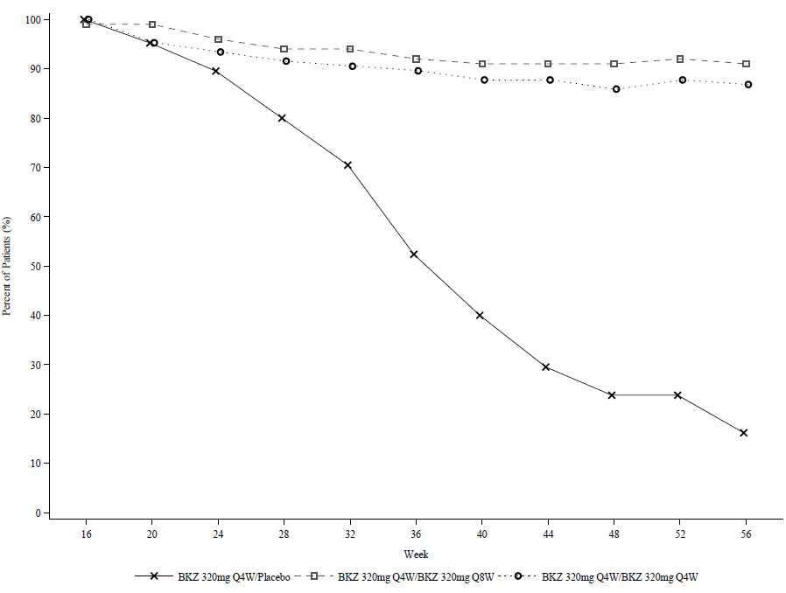

NRI is used.

In BE READY, for PASI 90 responders at Week 16 who were re-randomized to placebo and withdrawn from bimekizumab, the median time to relapse, defined as loss of PASI 75, was approximately 28 weeks (32 weeks after the last bimekizumab dose). Among these patients, 88.1% regained a PASI 90 response within 12 weeks of restarting treatment with bimekizumab 320 mg every 4 weeks.

**Specific body locations**

Significant improvements were observed in psoriasis involving the scalp, nails and hands and feet in patients treated with bimekizumab at Week 16 (see Table 5).

**Table 5: Specific body location responses in BE VIVID, BE READY and BE SURE at Week 16**

|  |  |  |  |  |  |  |  |
| --- | --- | --- | --- | --- | --- | --- | --- |
|  | **BE VIVID** | | | **BE READY** | | **BE SURE** | |
|  | **Placebo** | **BKZ 320 mg Q4W** | **Ustekinumab** | **Placebo** | **BKZ 320 mg Q4W** | **BKZ 320 mg Q4W** | **Adalimumab** |
| **Scalp IGA** (N)a  Scalp IGA 0/1, n (%) | (72)  11 (15.3) | (285)  240 (84.2) b | (146)  103 (70.5) | (74)  5 (6.8) | (310)  286 (92.3) b | (296)  256 (86.5) | (138)  93 (67.4) |
| **pp-IGA** (N)a  pp-IGA 0/1, n (%) | (29)  7 (24.1) | (105)  85 (81.0) | (47)  39 (83.0) | (31)  10 (32.3) | (97)  91 (93.8) | (90)  75 (83.3) | (34)  24 (70.6) |
| **mNAPSI 100** (N)a  mNAPSI 100, n (%) | (51)  4 (7.8) | (194)  57 (29.4) | (109)  15 (13.8) | (50)  3 (6.0) | (210)  73 (34.8) | (181)  54 (29.8) | (95)  21 (22.1) |

NRI is used.

a) Include only patients with a scalp Investigator Global Assessment (IGA) of 2 or greater, a palmoplantar IGA of 2 or greater and a modified Nail Psoriasis and Severity Index (mNAPSI) score > 0 at baseline. Scalp IGA 0/1 and pp-IGA 0/1 responses were defined as Clear (0) or Almost Clear (1) with ≥2 category improvement relative to Baseline.

b) p<0.001 versus placebo, adjusted for multiplicity.

Scalp IGA and palmoplantar IGA responses were maintained through Week 52/56. Nail psoriasis continued to improve beyond Week 16. In BE VIVID, at Week 52, 60.3% of patients treated with bimekizumab 320 mg every 4 weeks achieved complete nail clearance (mNAPSI 100). In BE READY, at Week 56, 67.7% and 69.8% of Week 16 PASI 90 responders achieved complete nail clearance with bimekizumab 320 mg every 8 weeks and bimekizumab 320 mg every 4 weeks respectively.

**Health-related Quality of Life / Patient reported outcomes**

Across all 3 studies, a greater proportion of patients treated with bimekizumab experienced no impact of psoriasis on their quality of life as measured by the Dermatology Life Quality Index (DLQI) compared to placebo and active comparator-treated patients at Week 16 (Table 6).

**Table 6: Quality of life in study BE VIVID, BE READY and BE SURE at Week 16**

|  |  |  |  |  |  |  |  |
| --- | --- | --- | --- | --- | --- | --- | --- |
|  | **BE VIVID** | | | **BE READY** | | **BE SURE** | |
|  | **Placebo**  **(N= 83)**  **n (%)** | **BKZ 320 mg Q4W**  **(N= 321)**  **n (%)** | **Ustekinumab**  **(N= 163)**  **n (%)** | **Placebo**  **(N= 86)**  **n (%)** | **BKZ 320 mg Q4W**  **(N= 349)**  **n (%)** | **BKZ 320 mg Q4W**  **(N= 319)**  **n (%)** | **Adalimumab (N= 159)**  **n (%)** |
| **DLQI 0/1a** | 10 (12.0) | 216 (67.3) | 69 (42.3) | 5 (5.8) | 264 (75.6) | 201 (63.0) | 74 (46.5) |

a) DLQI absolute score of 0 or 1 indicates no impact of the disease on health-related quality of life.

NRI is used.

DLQI 0/1 responses continued to increase beyond Week 16 and then were maintained through Week 52 / 56. In BE VIVID, DLQI 0/1 response rate at Week 52 was higher in bimekizumab-treated patients (74.5%) compared with ustekinumab-treated patients (63.2%).

## Pharmacokinetic properties

Bimekizumab exhibited dose-proportional pharmacokinetics in patients with plaque psoriasis over a dose range from 64 mg to 480 mg following multiple subcutaneous administrations, with apparent clearance being independent of dose.

### Absorption

Based on population pharmacokinetic analysis, following a single subcutaneous dose of 320 mg in plaque psoriasis patients, bimekizumab reached a median (2.5th and 97.5th percentile) peak plasma concentration of 25 (12 -50) μg/ml, between 3 and 4 days post dose.

Population pharmacokinetic analysis showed that bimekizumab was absorbed with an average absolute bioavailability of 70.1% in healthy volunteers.

### Distribution

Based on population pharmacokinetic analyses, the median (coefficient of variation %) volume of distribution (V/F) at steady state was 11.2 (30.5%) L in plaque psoriasis patients.

### Metabolism

Bimekizumab is a monoclonal antibody and is expected to be degraded into small peptides and amino acids via catabolic pathways in the same manner as endogenous immunoglobulins.

### Excretion

Based on population pharmacokinetic analyses, the median (coefficient of variation %) apparent clearance (CL/F) of bimekizumab was 0.337 L/day (32.7%) and the mean terminal elimination half-life of bimekizumab was 23 days in clinical studies in patients with plaque psoriasis.

Based on simulated data, the median (2.5th and 97.5th percentile) peak and trough concentration at steady-state following subcutaneous administration of 320 mg every 4 weeks are 43 (20-91) µg/ml and 20 (7-50) µg/ml respectively and steady-state is reached after approximately 16 weeks with every 4 weeks dosing regimen. Compared with exposure after a single dose, the population pharmacokinetic analysis showed that patients exhibited a 1.74-fold increase in peak plasma concentrations and area under the curve (AUC) following repeated four weekly dosing.

After switching from the 320 mg every 4 weeks dosing regimen to 320 mg every 8 weeks dosing regimen at Week 16, steady-state is achieved approximately 16 weeks after the switch. Median (2.5th and 97.5th percentile) peak and trough plasma concentrations are 30 (14 -60) μg/ml and 5 (1-16) μg/ml respectively.

### Pharmacokinetic/pharmacodynamic relationship

A population pharmacokinetic/pharmacodynamic model was developed using all available data in moderate to severe plaque psoriasis patients. The analysis showed that higher bimekizumab concentrations are related to better Psoriasis Area and Severity Index (PASI) and Investigators Global Assessment (IGA) response and a dose of 320 mg at Week 0, 4, 8, 12, 16 and every 8 weeks thereafter provides maximum benefit to the majority of moderate to severe plaque psoriasis patients (see special population, body weight).

### Special populations

*Elderly*

Based on population pharmacokinetic analysis with a limited number of elderly patients (n = 110 for age ≥ 65 years and n = 14 for age ≥ 75 years), apparent clearance (CL/F) in elderly patients and patients less than 65 years of age was similar. No dose adjustment is required.

*Renal or hepatic impairment*

No specific studies have been conducted to determine the effect of renal or hepatic impairment on the pharmacokinetics of bimekizumab. Caution should be taken in people with hepatic and renal dysfunction, due to the absence of data from these populations in the studies. The renal elimination of intact bimekizumab, an IgG monoclonal antibody, is expected to be low and of minor importance. Similarly, IgGs are mainly eliminated via intracellular catabolism and hepatic impairment is not expected to influence clearance of bimekizumab. Based on population pharmacokinetic analyses, hepatic function markers (ALT/ bilirubin) did not have any impact on bimekizumab clearance in patients with plaque psoriasis.

*Body weight*

Population pharmacokinetic modelling indicated that exposure decreased as body weight increased. The average plasma concentration in adult patients weighing ≥120 kg following a 320 mg subcutaneous injection was predicted to be at least 30% lower than in adult patients weighing 90 kg. Dose adjustment may be appropriate in some patients (see section 4.2 Dose and method of administration).

*Race / Gender*

No clinically meaningful differences in bimekizumab exposure were observed in Japanese subjects compared to Caucasian subjects in a clinical pharmacokinetic study. No dose adjustment is required.

Population pharmacokinetic modelling indicated females may have 9% faster apparent clearance (CL/F) compared to males and it is not clinically meaningful. No dose adjustment is required.

## Preclinical safety data

### Genotoxicity

No genotoxicity studies were conducted with bimekizumab. However monoclonal antibodies are not expected to damage DNA or chromosomes.

### Carcinogenicity

No carcinogenicity studies were conducted with bimekizumab.

# Pharmaceutical particulars

## List of excipients

The inactive ingredients are glycine, sodium acetate trihydrate, acetic acid, polysorbate 80, water for injection

## Incompatibilities

In the absence of compatibility studies, this medicinal product must not be mixed with other medicinal products.

## Shelf life

36 months.

## Special precautions for storage

Store in a refrigerator (2°C – 8°C).

Do not freeze.

Keep the pre-filled syringe or pen in the outer carton in order to protect from light.

The Bimzelx pre-filled syringe and pre-filled pen may be stored at room temperature (up to 25°C) for a single period of maximum 30 days with protection from light. Once removed from the refrigerator and stored under these conditions, discard after 30 days or by the expiry date printed on the container, whichever occurs first. A field for the date is provided on the carton to record the date removed from the refrigerator.

## Nature and contents of container

**Bimzelx 160 mg solution for injections in pre-filled syringe.**

One ml pre-filled syringe (type I glass) with a fluoropolymer-laminated bromobutyl rubber stopper, staked 27G, ½” thin wall needle, and a polypropylene rigid needle shield assembled in a passive safety device.

Pack size of 2 pre-filled syringes.

**Bimzelx 160 mg solution for injections in pre-filled pen.**

One ml pre-filled pen containing a pre-filled syringe (type I glass) with a fluoropolymer-laminated bromobutyl rubber stopper, staked 27G, ½” thin wall needle, and a polypropylene rigid needle shield.

Pack size of 2 pre-filled pens.

## Special precautions for disposal

In Australia, any unused medicine or waste material should be disposed of by taking to your local pharmacy.

## Physicochemical properties

Chemical Name: Immunoglobulin G1, anti-IL17A and anti-IL17F  
Nominal theoretical molecular mass: approximately 149,886 Daa

aTheoretical mass based on presence of G0F glycans and clipped heavy chain C-terminal modifications

### Chemical structure

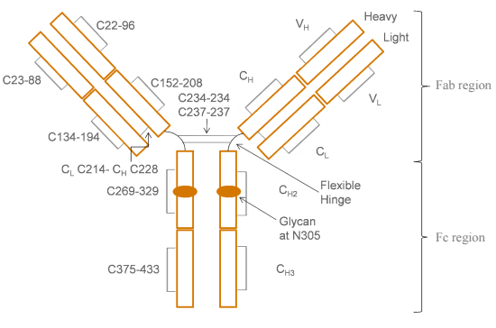

### CAS number

1418205-77-2

# Medicine schedule (Poisons Standard)

S4

# Sponsor

UCB Pharma  
A division of UCB Australia Pty Ltd  
Level 1, 1155 Malvern Road  
Malvern VIC 3144, Australia

Phone: +613 9828 1800

Website: [www.ucbaustralia.com.au](http://www.ucbaustralia.com.au)

E-mail: medicalinformationAU@ucb.com

# Date of first approval

24 March 2022

# Date of revision

N/A

## Summary table of changes

|  |  |
| --- | --- |
| Section Changed | Summary of new information |
| All | Initial Submission |