|  |
| --- |
| April 2023 |

|  |
| --- |
| Australian Public Assessment Report for Scemblix |
| Active ingredients: Asciminib |
| Sponsor: Novartis Pharmaceuticals Australia Pty Ltd |

About the Therapeutic Goods Administration (TGA)

* The Therapeutic Goods Administration (TGA) is part of the Australian Government Department of Health and Aged Care and is responsible for regulating therapeutic goods, including medicines, medical devices, and biologicals.
* The TGA administers the *Therapeutic Goods Act 1989* (the Act), applying a risk management approach designed to ensure therapeutic goods supplied in Australia meet acceptable standards of quality, safety, and efficacy.
* The work of the TGA is based on applying scientific and clinical expertise to decision-making, to ensure that the benefits to the Australian public outweigh any risks associated with the use of therapeutic goods.
* The TGA relies on the public, healthcare professionals and industry to report problems with therapeutic goods. The TGA investigates reports received to determine any necessary regulatory action.
* To report a problem with a therapeutic good, please see the information on the [TGA website](https://www.tga.gov.au).

About AusPARs

* The Australian Public Assessment Report (AusPAR) provides information about the evaluation of a prescription medicine and the considerations that led the TGA to approve or not approve a prescription medicine submission. Further information can be found in [Australian Public Assessment Report (AusPAR) guidance](https://www.tga.gov.au/australian-public-assessment-report-auspar-guidance).
* AusPARs are prepared and published by the TGA.
* AusPARs are static documents that provide information that relates to a submission at a particular point in time. The publication of an AusPAR is an important part of the transparency of the TGA’s decision-making process.
* A new AusPAR may be provided to reflect changes to indications or major variations to a prescription medicine subject to evaluation by the TGA.

Copyright

© Commonwealth of Australia 2023  
This work is copyright. You may reproduce the whole or part of this work in unaltered form for your own personal use or, if you are part of an organisation, for internal use within your organisation, but only if you or your organisation do not use the reproduction for any commercial purpose and retain this copyright notice and all disclaimer notices as part of that reproduction. Apart from rights to use as permitted by the *Copyright Act 1968* or allowed by this copyright notice, all other rights are reserved, and you are not allowed to reproduce the whole or any part of this work in any way (electronic or otherwise) without first being given specific written permission from the Commonwealth to do so. Requests and inquiries concerning reproduction and rights are to be sent to the TGA Copyright Officer, Therapeutic Goods Administration, PO Box 100, Woden ACT 2606 or emailed to <[tga.copyright@tga.gov.au](mailto:tga.copyright@tga.gov.au)>.

Contents

List of abbreviations 4

Product submission 6

Submission details 6

Product background 7

Regulatory status 9

Product Information 12

Registration timeline 12

Submission overview and risk/benefit assessment 12

Quality 13

Nonclinical 13

Clinical 14

Risk management plan 48

Risk-benefit analysis 51

Outcome 54

Specific conditions of registration applying to these goods 54

Attachment 1. Product Information 55

## List of abbreviations

|  |  |  |
| --- | --- | --- |
| Abbreviation | | Meaning |
| ACM | Advisory Committee on Medicines | |
| ASA | Australia specific annex | |
| *ABL1* | Abelson gene | |
| AUC | Area under the concentration time curve | |
| AUC0-inf | Area under the concentration time curve from time zero to infinity | |
| AUC0-last | Area under the concentration time curve from time zero to time of last quantifiable serum concentration | |
| *BCR::ABL1* | Fusion gene (also known as Philadelphia chromosome) | |
| CI | Confidence interval | |
| Cmax | Maximum plasma concentration | |
| Cmin | Minimum plasma concentration | |
| CMI | Consumer Medicines Information | |
| CYP | Cytochrome P450 | |
| DLP | Data lock point | |
| ECOG | Eastern Cooperative Oncology Group | |
| Emax | Maximum effect attributable to the drug | |
| ESMO | European Society of Medical Oncology | |
| EU | European Union | |
| FDA | United States Food and Drug Administration | |
| MR | Molecular response | |
| OATP1B1/3 | Organic anion-transporting polypeptide 1B1 and 1B3 | |
| PCR | Polymerase chain reaction | |
| PI | Product Information | |
| PK | Pharmacokinetic(s) | |
| PopPK | Population pharmacokinetic(s) | |
| PSUR | Periodic safety update reports | |
| QTc | Corrected Q-T interval | |
| QTcF | QT interval corrected using Fridericia’s formula | |
| RMP | Risk management plan | |
| t½) | Half-life | |
| TGA | Therapeutic Goods Administration | |
| UGT | Uridine 5-diphospho-glucuronosyltransferase | |
| US(A) | United States (of America) | |

## Product submission

### Submission details

|  |  |
| --- | --- |
| *Type of submission:* | New chemical entity |
| *Product name:* | Scemblix |
| *Active ingredient:* | Asciminib |
| *Decision:* | Approved |
| *Date of decision:* | 14 July 2022 |
| *Date of entry onto ARTG:* | 15 July 2022 |
| *ARTG numbers:* | 371018, 371019 |
| [*Black Triangle Scheme*](https://www.tga.gov.au/black-triangle-scheme)*:* | Yes  This product will remain in the scheme for 5 years, starting on the date the product is first supplied in Australia |
| *Sponsor’s name and address:* | Novartis Pharmaceuticals Australia Pty Ltd  54 Waterloo Road  Macquarie Park NSW 2113 |
| *Dose form:* | Film coated tablet |
| *Strengths:* | 20 mg and 40 mg |
| *Container:* | Blister pack |
| *Pack sizes:* | 20 and 60 |
| *Approved therapeutic use:* | *Scemblix is indicated for the treatment of patients 18 years of age and above with:*   * *Philadelphia chromosome-positive chronic myeloid leukaemia (Ph+ CML) in chronic phase (CP) previously treated with two or more tyrosine kinase inhibitors (see section 5.1 Clinical trials).* * *Ph+ CML in CP with the T315I mutation.* |
| *Route of administration:* | Oral |
| *Dosage:* | Treatment with Scemblix should be initiated by a physician experienced in the use of anticancer therapies and should be continued as long as clinical benefit is observed or until unacceptable toxicity occurs.  The recommended total daily dose of Scemblix in patients with Philadelphia chromosome positive chronic myeloid leukaemia in chronic phase is 80 mg and in patients with Philadelphia chromosome positive chronic myeloid leukaemia in chronic phase harbouring the T315I mutation is 200 mg, taken orally twice daily at approximately 12 hour intervals.  For further information regarding dosage, refer to the Product Information. |
| *Pregnancy category:* | D  Drugs which have caused, are suspected to have caused or may be expected to cause, an increased incidence of human fetal malformations or irreversible damage. These drugs may also have adverse pharmacological effects. Accompanying texts should be consulted for further details.  The use of any medicine during pregnancy requires careful consideration of both risks and benefits by the treating health professional. This must not be used as the sole basis of decision making in the use of medicines during pregnancy. The TGA does not provide advice on the use of medicines in pregnancy for specific cases. More information is available from obstetric drug information services in your State or Territory. |

### Product background

This AusPAR describes the submission by Novartis Pharmaceuticals Australia Pty Ltd (the sponsor) to register Scemblix (asciminib) 20 mg and 40 mg tablets for the following proposed indication:

*For the treatment of adult patients with Philadelphia chromosome-positive chronic myeloid leukaemia (Ph+ CML) in chronic phase (CP) previously treated with two or more tyrosine kinase inhibitors.*

Chronic myeloid leukaemia is a clonal bone marrow stem cell disorder where there is the transformation of haematopoietic progenitor cells and dysregulated overproduction of immature myeloid cells and mature granulocytes in the spleen, bone marrow, and peripheral blood.

The classic genetic feature chronic myeloid leukaemia is the presence of Philadelphia chromosome found in up to 95% of patients.[1] The Philadelphia chromosome results from a reciprocal translocation, t(9;22)(q34;q11), which fuses a portion of the Abelson gene (*ABL1*) on chromosome 9 with a portion of the breakpoint cluster region gene (*BCR*) on chromosome 22. The resulting fusion gene encodes a chimeric protein (*BCR::ABL1*), resulting in a constitutively active tyrosine kinase domain. This oncoprotein promotes cell growth and replication through downstream signalling pathways such as rat sarcoma virus (RAS), rapidly accelerated fibrosarcoma (RAF), JUN kinase, MYC, and signal transducer and activator of transcription (STAT).[2]

The course of chronic myeloid leukaemia is classified into three phases (chronic, accelerated and blast phase) as opposed to stages largely based upon the number of immature white blood cells (or blasts) in the blood or bone marrow.[3]

In most cases patients are diagnosed whilst in chronic phase which is characterised by overproduction and accumulation of immature myelogenous cells and mature granulocytes in the spleen, bone marrow, and peripheral blood.[4]

When either untreated or not adequately controlled by therapy, chronic myeloid leukaemia may progress into accelerated phase. The accelerated phase is characterised by the proliferation of primitive blast cells in the peripheral blood and bone marrow along with worsening of other haematological findings and splenomegaly.

The blast phase (also known as acute phase or blast crisis) represents a worsening from the accelerate phase and resembles acute leukaemia with uncontrolled proliferation of myeloid or lymphoid blasts.3,4

The prognosis of chronic myeloid leukaemia has changed during the past two decades from a disease with an overall survival of 5 to 7 years to one in which patients responding to tyrosine kinase inhibitor treatment can expect a near to normal life expectancy.4

Some patients do not respond to the treatment. The failure to achieve a major response to tyrosine kinase inhibitor treatment is termed primary resistance.[5] This is further subdivided into primary haematologic resistance, and primary cytogenetic resistance. Secondary resistance is said to occur where a patient responds to treatment followed by the subsequent loss of a haematologic or cytogenetic response.[6] A further number of patients may respond, yet experience problems in tolerating treatment.5,6

Cytogenetically, the detection of *BCR::ABL1* mutations in chronic myeloid leukaemia in the chronic phase, in particular T315I mutation, are associated with a greater likelihood of resistance to tyrosine kinase inhibitor treatment and consequent disease progression.[7]

The incidence of chronic myeloid leukaemia increases exponentially with age with an average age at diagnosis of 65 years. In a 34 year period leading up to the end of 2016, approximately 3,932 people were diagnosed with chronic myeloid leukaemia in Australia. From 2012 to 2016, as many as 1448 new patients were diagnosed in this patient population. This corresponds to a 26 year prevalence of 35 people per 100,000 persons. From 2012 to 2016, 82.6% of persons diagnosed with chronic myeloid leukaemia survived 5 years after diagnosis.[8] Based on the 362 new cases of chronic myeloid leukaemia in 2017, an incidence rate of 1.3 cases per 100,000 persons. In the same year, a total of 101 deaths from chronic myeloid leukaemia were recorded.[9]

In a study of 670 patients with imatinib resistant or imatinib intolerant chronic myeloid leukaemia in chronic phase who received dasatinib and were followed for seven years, *BCR::ABL1* kinase domain mutations were assessed in all patients at Baseline and at the end of treatment. The majority of patients who discontinued because of loss of response did not have a *BCR–ABL1* mutation at Baseline (n = 72) or at end of treatment (n = 71). Of those with mutations, the three most common that emerged while on dasatinib were V299L (n = 10), T315I (n = 19), and F317L (n = 12), each a known dasatinib resistant mutation.[10]

Current approved treatment options for the various stages of chronic myeloid leukaemia include imatinib,[11] nilotinib,[12] dasatinib,[13] bosutinib,[14] and ponatinib.[15] All these products are *BCR::ABL1* tyrosine kinase inhibitors, though the site of action and other actions of each product differ somewhat. The success of these treatments in treating patients and reducing mortality rates have enabled this disease to be managed as a chronic disease over the last 20 or so years. However, patients can develop resistance to these medicines over time, potentially facilitated via mutations of ABL-kinase site. This resistance, and the possible adverse effects associated with these treatments emphasise the need for additional treatment options for these patients. It has been estimated that almost half of this patient population will require a change of therapy in a period of 10 years.

Of the above treatments imatinib has no limitation on when it is given in the treatment sequence for patients with chronic myeloid leukaemia. Nilotinib,12 and dasatinib,13 are approved for newly diagnosed chronic myeloid leukaemia and for chronic myeloid leukaemia resistant to a prior therapy, including imatinib.11 Bosutinib while approved as a third line tyrosine kinase inhibitor for chronic myeloid leukaemia is not marketed at this time.14 Ponatinib is indicated for adult patients with chronic phase, accelerated phase, or blast phase chronic myeloid leukaemia whose disease is resistant to, or who are intolerant of at least two prior tyrosine kinase inhibitors; or where there is a T315I mutation. For patients with chronic myeloid leukaemia in chronic phase with the *BCR::ABL1* T315I mutation, ponatinib is the only specifically approved tyrosine kinase inhibitor.15 While patients with this mutation are not excluded from treatment with the other *BCR::ABL1* tyrosine kinase inhibitors the T315I mutation confers resistance to imatinib,11 dasatinib,13 nilotinib,12 and bosutinib.14 Allogeneic stem cell transplantation may be a treatment alternative in eligible patients with resistance or intolerance to two or more tyrosine kinase inhibitors.

This submission was evaluated as part of the [Australia-Canada-Singapore-Switzerland-United Kingdom (ACCESS) Consortium](https://www.tga.gov.au/australia-canada-singapore-switzerland-united-kingdom-access-consortium) with work-sharing between the TGA, Health Canada, Health Sciences Authority Singapore, Swissmedic and the Medicines and Healthcare Products Regulatory Agency (MHRA) in the United Kingdom. Each regulator made independent decisions regarding approval (market authorisation) of the new medicine.

### Regulatory status

This product is considered a new chemical entity for Australian regulatory purposes.

At the time the TGA considered this submission, similar submissions had been approved in the United States of America (USA) in October 2021 and Japan in March 2022. A similar submission was also under consideration in the European Union (EU) (submitted in June 2021).

Submissions to constituent members of the [ACCESS consortium](https://www.tga.gov.au/australia-canada-singapore-switzerland-united-kingdom-access-consortium) were made as follows: Australia (submitted in August 2021), Switzerland (submitted in July 2021), Singapore (submitted in July 2021), Canada (submitted in August 2021) and the United Kingdom (submitted in July 2021). The following table summarises these submissions and provides the indications where approved.

Table 1: International regulatory status

|  |  |  |  |
| --- | --- | --- | --- |
| Region | Submission date | Status | Approved indications |
| United States of America | June 2021 | Approved October 2021 | *Treatment of adult patients with Philadelphia chromosome-positive chronic myeloid leukaemia (Ph+ CML) in chronic phase (CP), previously treated with two or more tyrosine kinase inhibitors (TKIs) and Ph+ CML-CP harboring the T315I mutation* |
| Japan | August 2021 | Approved March 2022 | *CML with resistance or intolerance to previous therapy* |
| European Union | June 2021 | Under consideration | Under consideration |
| Switzerland | July 2021 | Under consideration as part of ACCESS Consortium | Under consideration |
| Singapore | July 2021 | Under consideration as part of ACCESS Consortium | Under consideration |
| Canada | August 2021 | Under consideration as part of ACCESS Consortium | Under consideration |
| United Kingdom | July 2021 | Under consideration as part of ACCESS Consortium | Under consideration |

Asciminib was evaluated as a priority and orphan drug by the United States Food and Drug Administration (FDA) and was granted an Accelerated Approval in October 2021;[16] for the third and subsequent line of therapy in Philadelphia chromosome positive chronic myeloid leukaemia in chronic phase and full marketing authorisation for treatment of Philadelphia chromosome positive chronic myeloid leukaemia in chronic phase with the T315I mutation without regard to prior lines of therapy. The indications in the USA are as follows:

*Scemblix is a kinase inhibitor indicated for the treatment of adult patients with:*

* *Philadelphia chromosome-positive chronic myeloid leukemia (Ph+ CML) in chronic phase (CP), previously treated with two or more tyrosine kinase inhibitors (TKIs).*

*This indication is approved under accelerated approval based on major molecular response (MMR). Continued approval for this indication may be contingent upon verification and description of clinical benefit in a confirmatory trial(s).*

* *Ph+ CML in CP with the T315I mutation*

The US FDA’s Accelerated Approval (similar to [provisional approval](https://www.tga.gov.au/provisional-approval-pathway-prescription-medicines) in Australia) was due to the lack of Week 96 efficacy data from the pivotal study supporting approval. In its multidisciplinary review, the reviewers recommended that post-market studies in the following areas be conducted:

* Dosage recommendations when asciminib is co-administered with breast cancer resistant protein substrates
* Dosage recommendations when asciminib is co-administered with, organic anion-transporting polypeptide 1B1 and 1B3 (OATP1B1/3) substrates
* Dose recommendation when co-administration of asciminib with strong cytochrome P450’s;[17] CYP3A and uridine 5-diphospho-glucuronosyltransferase (UGT) inducer
* Dosing strategies with concomitant use of asciminib with oral drug products containing hydroxypropyl-β‑cyclodextrin.

The above recommendations were not included in the final conditions of approval by the FDA. A paediatric study was required.

In the EU, the market authorisation application submission was completed on 22 June 2021 and the indication in the EU is the same as has been proposed to the TGA.

### Product Information

The Product Information (PI) approved with the submission which is described in this AusPAR can be found as Attachment 1. For the most recent PI, please refer to the TGA [PI/CMI search facility.](https://www.tga.gov.au/picmi-search-facility)

## Registration timeline

The following table captures the key steps and dates for this submission.

Table 2: Timeline for Submission PM-2021-03048-1-6

|  |  |
| --- | --- |
| Description | Date |
| Submission dossier accepted and first round evaluation commenced | 27 August 2021 |
| First round evaluation completed | 24 December 2021 |
| Sponsor provides responses on questions raised in first round evaluation | 10 February 2022 |
| Second round evaluation completed | 27 June 2022 |
| Delegate’s Overall benefit-risk assessment and request for Advisory Committee advice | 28 April 2022 |
| Sponsor’s pre-Advisory Committee response | 16 May 2022 |
| Advisory Committee meeting | 2 and 3 June 2022 |
| Registration decision (Outcome) | 14 July 2022 |
| Completion of administrative activities and registration on the ARTG | 15 July 2022 |
| Number of working days from submission dossier acceptance to registration decision* | 171 |

*Statutory timeframe for standard submissions is 255 working days

## Submission overview and risk/benefit assessment

A summary of the TGA’s assessment for this submission is provided below.

This section is a TGA summary of wording used in TGA’s evaluation report, which discussed numerous aspects of overseas evaluation reports and included some information that was commercial-in-confidence.

### Quality

Asciminib hydrochloride has a molecular formula C20H18ClF2N5O3.HCl; the free base has a molecular weight of 449.8. Asciminib hydrochloride is a crystalline powder with pKa 3.9 and pH-dependent solubility. The skeletal formula of asciminib hydrochloride is shown in Figure 1, below.

Figure 1: Skeletal formula of asciminib hydrochloride

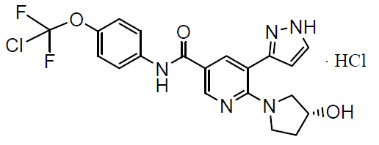

The asciminib drug substance is manufactured following synthesis with chemical transformations in the side chains and chemical transformations in the main chain, followed by hydrochloride salt formation.

Scemblix(asciminib) is to be supplied in the dose form of film-coated oral tablets, in two strengths as follows:

* 20 mg tablets are pale yellow, round, biconvex, film-coated tablets with bevelled edges, approximately 6.2 mm diameter, unscored, debossed with the sponsor’s logo on one side and ‘20’ on the other side.
* 40 mg tablets are violet white, round, biconvex, film-coated tablets with bevelled edges, approximately 8.2 mm in diameter, unscored, debossed with the sponsor’s logo on one side and ’40’ on the other side.

Both strengths of tablets (20 mg and 40 mg) are packaged in polyvinyl chloride/ aluminium blisters in packs of 20 and 60 tablets. Scemblix has a shelf life of 24 months when stored at or below 25 °C.

With respect to submission, all quality and pharmaceutical chemistry requirements have been satisfactorily satisfied in Australia.

### Nonclinical

Asciminib is a small molecule, inhibitor of *BCR::ABL1* tyrosine kinase with the molecular formula C20H18ClF2N5O3. The drug product contains no novel excipients. Asciminib is a first-in-class *BCR::ABL1* inhibitor and is expected to specifically target the ABL myristoyl pocket, with the potential to overcome resistance/intolerance to previously approved tyrosine kinase inhibitors (such as imatinib,11 dasatinib,13 nilotinib,12 bosutinib,14 and ponatinib).15

The primary pharmacology studies support the proposed indication. No relevant off-target effects are predicted based on the secondary pharmacodynamic screens.

No adverse effects on cardiovascular, respiratory and central nervous system function are predicted based on the nonclinical studies. Moderate cardiovascular effects (increased heart rate, decreased systolic pressure, decreased mean arterial pressure, and decreased arterial pulse pressure) were seen in dogs dosed orally at 600 mg/kg, but QT prolongation; [18] (observed clinically) was not observed at doses up to 60 mg/kg (estimated exposure ratio at maximum concentration (Cmax) greater than or equal to 8).

Based on *in vitro* data asciminib has the potential to inhibit cytochrome P450’s (CYPs)17 CYP2C8, CYP2C9 and CYP3A4/5, and uridine 5-diphospho-glucuronosyltransferase (UGT) 1A1 gene (UGT1A1). It was also an inducer of CYP1A2 and CYP3A4 *in vitro* and may reduce the exposure of CYP1A2 and CYP3A4 substrates on co‑administration. Inhibition of breast cancer resistance protein, P-glycoprotein, organic anion-transporting polypeptides 1B1 and 1B3 (OATP1B1/3), organic cation transporter 1, organic cation transporter 3 and multidrug and toxin extrusion protein 2 transporters occurred *in vitro* at clinically relevant concentrations.

Clinically relevant target organs identified in toxicity studies included liver, the haematopoietic system (anaemia), adrenal gland and pancreas. These effects were seen at clinically relevant exposures.

Asciminib is not expected to pose a genotoxic concern. However, an outstanding assurance on the *in vivo* study remains to be provided.

Phototoxicity was observed in mice *in vitro* and *in vivo* (at an exposure ratio at Cmax of about 8), and asciminib and/or its metabolites showed potential for retention in melanin containing tissues.

The sponsor has proposed Pregnancy Category B3.[19] Given that direct drug related embryotoxicity, fetotoxicity and teratogenicity were observed at low exposure ratios, in both rats and rabbits, Pregnancy Category D is recommended for this product.[20]

There are no nonclinical objections to registration.

### Clinical

#### Summary of clinical studies

The clinical dossier consisted of the following studies:

* One bioavailability study:
  + Study E2101, a Phase I open label, single centre, two group study to evaluate the effects of imatinib and food on the pharmacokinetics (PK) of asciminib final market image formulation in healthy subjects.
* Two comparative bioavailability and bioequivalence studies:
  + Study A2101, a Phase I, single centre, two arm, cross over, randomised, open label study in healthy subjects to evaluate relative bioavailability and food effect of asciminib following a single oral dose (40 mg) asciminib.
  + Study A2104, an open label, single dose, randomised cross over study in healthy subjects to characterise relative bioavailability of asciminib final market image formulation tablet in comparison to the capsule (fasted).
* One pharmacokinetic and initial intolerability study in healthy subjects:
  + Study A2102, a Phase I, single centre, open label study to investigate the absorption, distribution, metabolism, and excretion of asciminib after a single oral dose of 80 mg asciminib in healthy subjects.
* One pharmacokinetic and initial tolerability study in patients:
  + Study X2101, a Phase I, multicentre, open label study of oral asciminib in patients with chronic myeloid leukaemia or Philadelphia chromosome positive acute lymphoblastic leukaemia.
* Two intrinsic factor pharmacokinetic studies:
  + Study A2103, a Phase I, open label, multicentre, single dose study to evaluate the pharmacokinetics of asciminib in healthy patients with normal hepatic function and subjects with impaired hepatic function.
  + Study A2105, a Phase I, open label, single dose study to evaluate the pharmacokinetics and safety of a single 40 mg oral dose of asciminib in subjects with impaired renal function compared to matched control subjects with normal renal function.
* Three extrinsic factor pharmacokinetic studies:
  + Study A1101, a Phase I single centre, open label, adaptive, three period, single sequence study to assess the effect of acid reducing agents on the PK of a single dose of asciminib in healthy subjects.
  + Study A2106, a Phase I, single centre, open label, fixed sequence and staged drug-drug interaction study to investigate the effect of asciminib in PK of midazolam;[21] (a sensitive CYP3A substrate), warfarin;[22] (a sensitive CYP2C9 substrate) and repaglinide (a sensitive CYP2C8 substrate) in healthy subjects.
  + Study A2107, a Phase I, open label, two period, single sequence cross over drug-drug interaction study to assess the effect of itraconazole,[23] clarithromycin;[24] (strong CYP3A) inhibitors, quinidine (P glycoprotein inhibitor) and rifampicin;[25] (strong CYP3A inducer) on the pharmacokinetics of asciminib in healthy subjects.
* One active controlled study:
  + Study A2301 (also known as the ASCEMBL trial), a Phase III, multicentre, open label, randomised study or oral asciminib versus bosutinib in patients with chronic myeloid leukaemia in chronic phase previously treated with two or more tyrosine kinase inhibitors.

The first-in-human study (Study X2101) with asciminib is an ongoing, open label dose escalation study primarily to estimate the maximum tolerated dose and/or recommended dose for expansion of single agent asciminib in chronic myeloid leukaemia. The safety, tolerability and PK profile of asciminib and pharmacodynamic changes in peripheral blood mononuclear cells and bone marrow aspirates were assessed. Doses of monotherapy asciminib ranged from 10 mg to 280 mg twice a day and, 40 mg to 200 mg once daily as capsules or tablets.

The pivotal study for the proposed indication is Study CABL001A2301 (abbreviated as Study A2301, and also known as the ASCEMBL trial), an ongoing, randomised, active controlled Phase III study evaluating asciminib versus bosutinib;14 in patients with chronic myeloid leukaemia in chronic phase, previously treated with two or more tyrosine kinase inhibitors.

#### Pharmacology

The clinical pharmacology program for asciminib was built upon studies conducted *in vitro*, in healthy subjects, in non-cancer subjects with renal and hepatic impairment, as well as in patients with chronic myeloid leukaemia. The PK profile of asciminib has been evaluated in patients with chronic myeloid leukaemia at a dose range between 10 mg to 200 mg twice a day and 80 mg to 200 mg once daily and in healthy subjects administered single and multiple doses of 40 mg and a single 80 mg dose (for absorption, distribution, metabolism and excretion evaluation).

##### Pharmacokinetics

The PK of asciminib was evaluated in nine healthy subject studies (n = 310; including 24 subjects with impaired hepatic function and eight subjects with impaired renal function) and in patients in two studies (n = 353). Asciminib was administered as a free form and hydrochloride salt form during development. The capsule formulation (solid dispersion) covering the strengths of 5 mg, 20 mg, and 50 mg and the initial film coated tablet formulation with the strength of 20 mg were manufactured containing asciminib free form.

After extensive polymorphism evaluation and the first relative bioavailability study asciminib hydrochloride drug substance was selected for later phase development of the film coated tablet. The formulation was then optimised to provide the film coated tablet intended for commercialisation at the strengths of 20 mg and 40 mg, and the clinical performance of this formulation was assessed in a second relative bioavailability study (Study CABL001A2104 (Study A2104)). The geometric mean ratio and 90% confidence intervals (CI) of asciminib PK parameters were within the reference range of 0.8 to 1.25. The geometric mean ratio (tablet versus capsule) and 90% CI for area under the concentration-time curve from time zero to infinity (AUC0-inf), area under the concentration time curve from time zero to time of last quantifiable serum concentration (AUC0-last) and maximum concentration (Cmax) were 1 (90% CI: 0.909, 1.1), 1.01 (90% CI: 0.911, 1.11), and 0.909 (90% CI: 0.805, 1.03), respectively.

Study X2101 is an ongoing, Phase I, multicentre, open label study of oral asciminib in patients with chronic myeloid leukaemia or Philadelphia chromosome positive acute lymphoblastic leukaemia. This study has five arms with asciminib given as single agent in Arm 1 and in combination with nilotinib (Arm 2), imatinib (Arm 3), or dasatinib (Arm 4) in patients with chronic myeloid leukaemia in chronic phase and accelerated phase. In Arm 5, asciminib was studied as a single agent in patients with chronic myeloid leukaemia in blast phase and Philadelphia chromosome positive acute lymphoblastic leukaemia. A total of 132 patients in Arm 1 were given doses from 10 mg twice a day to 200 mg once daily (the maximum tolerated dose) and PK data from Arm 1 were included in the PK assessment.

Asciminib, administered orally once or twice daily was rapidly absorbed with a median time after administration of a drug when the maximum plasma concentration is reached at 2 to 3 hours, independent of dose. No time-dependent PK was observed. Maximum concentration and area under the concentration-time curve (AUC) increase in a slightly more than dose proportional manner for the twice a day dosing regimen. Steady state was reached by Day 3. The apparent terminal elimination half-life (t1/2) across studies was estimated to be between 7 and 15 hours, the apparent clearance of asciminib was 4.34 L/hr (based on noncompartmental PK analysis of single dose of 80 mg in human absorption, distribution, metabolism, and excretion study in healthy subjects).

Renal clearance of asciminib was estimated to be 0.108 L/hr which was 2.5% of the total apparent clearance (4.34 L/hr), indicating that renal clearance of asciminib was minimal. Apparent volume of distribution was 89 L. Metabolites detected in human plasma were metabolite M30.5 (SWO996, direct O-glucuronide of asciminib; 4.93%), metabolite M44 (oxidation of the pyrrolidinol ring alcohol to a ketone; 1.88%) and metabolite M29.5 (CRE850, alcohol formed from oxidative opening of the pyrrolidinol ring; 0.39%). Ten radiolabelled metabolites of asciminib were characterised and quantified in the excreta (Study A2102).

The biotransformation of asciminib occurred predominantly by oxidation at the pyrrolidinol ring and direct glucuronidation.

In a dedicated hepatic impairment study, compared to non-cancer subjects with normal hepatic function:

* Mild hepatic impairment resulted in 22% higher AUC0-inf (geometric mean ratio (90% CI) 1.22 (0.964, 1.54)), 21% higher AUC0-last;[26](1.21 (0.96, 1.53)), 26% higher Cmax (1.26 (1.05, 1.52)).
* Moderate hepatic impairment resulted in 3% higher AUC0-inf (geometric mean ratio (90% CI) 1.03 (0.813, 1.3)) and AUC0-last (1.03 (0.812, 1.3)), and 1.7% lower Cmax (0.983 (0.819, 1.18)).
* Severe hepatic impairment resulted in 66% higher AUC0-inf (geometric mean ratio (90% CI) 1.66 (1.3, 2.12)), 55% higher AUC0-last (1.55 (1.22, 1.95)), and 29% (1.29 (1.08, 1.55)) higher Cmax.

In a dedicated renal impairment study compared to the normal renal function cohort, the severe renal impairment cohort had an increase of 56% in AUC0-inf (geometric mean ratio (90% CI); 1.56 (1.05, 2.3)), and 49% in AUC0-last (geometric mean ratio (90% CI); 1.49 (1.01, 2.2)) values with comparable Cmax (plus 8%) (geometric mean ratio (90% CI): 1.08 (0.719,1.61)). The study did not compare PK in patients with mild or moderate renal impairment given the relatively minor differences observed in patients with severe renal impairment.

In drug-drug interaction studies asciminib 40 mg twice a day had no clinically significant CYP-related;17 effects on the PK of midazolam (sensitive CYP3A substrate), warfarin (sensitive CYP2CP substrate) or repaglinide (sensitive CYP2C8 substrate). Asciminib was weakly affected by strong CYP3A4 inducers (rifampicin) and inhibitors (itraconazole, clarithromycin) and not affected by strong P-glycoprotein inhibitor (quinidine). It was incidentally discovered in Study A2107 that cyclodextrin, an excipient in the itraconazole oral solution given in that study, may sequester asciminib, reducing its absorption.

When asciminib was co-administered with imatinib the geometric mean ratios (90% CI) for AUC0-inf and AUC0-last were 2.08 (1.93, 2.24) and 2.07 (1.92, 2.23), respectively, indicating approximately a doubling of the asciminib total systemic exposure compared to when administered alone. Exposure to imatinib was reduced by approximately 27% when co-administered with asciminib compared to when administered alone. Rabeprazole (strong proton pump inhibitor) had no effect on the bioavailability of asciminib.

Food decreases the bioavailability of asciminib. Following low fat and high fat meal, AUC0‑inf was decreased by 30% and 62.3%, respectively.

##### Population pharmacokinetic data

Based on population pharmacokinetic (popPK) modelling and considering first pass extraction in gut and liver in addition to absorption, the absolute bioavailability was estimated to be approximately 73%.

Population pharmacokinetic predictions indicated that approximately 90% of the patients maintained minimum concentration (Cmin) at steady state (302 ng/mL) above the efficacy threshold (121 ng/mL) established in the preclinical studies (90% maximal inhibitory concentration (IC90) of pSTAT5 inhibition in KCL-22 mouse xenograft model). A dose of asciminib 80 mg once daily (popPK mean Cmin estimate at steady state: 255 ng/mL (coefficient of variation (CV): 73%) (that is, 15.3 nM (unbound concentration)) is predicted to achieve efficacious asciminib concentrations as observed for asciminib 40 mg twice a day.

In a modelling analysis of healthy subjects, the asciminib clearance for a typical individual (that is, a 70 kg male, with normal renal function) was 6.31 L/hr for a total daily dose of 80 mg. In Study X2101, the geometric mean average accumulation ratio ranged from 1.65 to 2.29 for the twice a day dosing (1.65 at 40 mg twice a day) and from 1.12 to 1.3 for the once daily dosing (1.3 at 80 mg once daily).

Inter-subject variability (CV%) ranged from approximately 17% to 69% for AUC0-last and from 14% to 74% for Cmax. The inter-subject geometric CV% in Study X2101 Cycle 2 Day 1 at 40 mg twice a day was 49.6% and 48.9% for AUC0-last and Cmax. In line with that, the inter-subject geometric CV% in Study A2301 at 40 mg twice a day was 47.8% and 46.7% for AUC0-last and Cmax.

Pharmacokinetics in patients with cancer was consistent between studies. There was no clinically relevant difference in the PK of asciminib in healthy subjects compared to patients with cancer. No clinically meaningful differences in exposure were associated with age, sex, race (Asian/ non-Asian), or body weight. The popPK model simulation showed an increase in asciminib median steady state area under the concentration-time curve from time zero to 12 hours (AUC0-24h) by 11.5% in subjects with mild-to-moderate renal impairment, compared to subjects with normal renal function.

###### Absorption, distribution, metabolism and excretion

The bioavailability of asciminib was reduced when administered with food. Scemblixshould not be taken with food. Following oral administration, the peak plasma concentration of asciminib was achieved at 2 to 3 hours. Asciminib was the main circulating component in plasma (92.7%), with no major plasma metabolite identified. The fraction of asciminib bound to plasma proteins was 97.3% *in vitro*. The apparent volume of distribution at steady state was estimated to be 111 L.

Asciminib is primarily eliminated by metabolism (mainly mediated by CYP3A4, UGT2B7 and UGT2B17) and biliary excretion (mainly mediated by breast cancer resistance protein), with a minor contribution of the renal route (2.5% as unchanged parent drug). Given the unstable nature of the glucuronide metabolite in the intestine and discrepancies between *in vitro* and *in vivo* data, the relative contributions of different clearance pathways (that is, cytochrome P450;17 and uridine 5'-diphospho-glucuronosyltransferase mediated metabolism and breast cancer resistance protein mediated biliary excretion) to the overall elimination of asciminib cannot be determined. The oral total apparent clearance of asciminib was estimated to be 6.3 L/hour and the terminal elimination half‑life (t1/2) was between 7 and 15 hours.

###### Linearity

At steady state, systemic exposure (by area under the concentration-time curve (AUC) and by Cmax) of asciminib increased slightly more than dose proportionally across the dose range of 10 mg to 200 mg administered once or twice daily. The popPK analyses indicated a dose dependent decrease in clearance. No time dependent PK was observed. The steady state was reached within 3 days.

###### Maximum tolerated dose

The maximum tolerated dose was not reached at 200 mg twice a day in patients with chronic myeloid leukaemia in chronic phase and accelerated phase.

###### Exposure-response relationships

The exposure-response analyses indicated a slightly positive exposure efficacy relationship over a wide dose range from 20 mg to 400 mg daily in chronic myeloid leukaemia in chronic phase patients without T315I mutation. The median predicted major molecular response rates (based on AUC) were 34%, 35%, and 39% for 40 mg twice a day, 80 mg once daily and 200 mg twice a day at 48 weeks, respectively.

The exposure response analyses also demonstrated a relatively flat exposure safety relationship of asciminib across the doses from 20 mg to 400 mg daily. Over this dose range, a higher exposure was associated with slightly higher incidences of Grade 3 or higher haemoglobin decrease, Grade 2 or higher alanine aminotransferase (ALT) increase, Grade 2 or higher aspartate aminotransferase increase, Grade 2 or higher bilirubin increase, and any grade lipase increase in chronic myeloid leukaemia patients.[27]

###### Recommended dosages

The totality of clinical pharmacology data and exposure response analyses supports the sponsor’s proposed doses of 40 mg taken twice a day, or 80 mg once daily;[28] in chronic myeloid leukaemia in chronic phase patients without T315I mutation as discussed below.

* Asciminib exposure at 80 mg once daily and 40 mg twice a day: similar to the reported PK data, the popPK model indicates that the average AUC0-24h values are comparable between the two regimens of 40 mg twice a day and 80 mg once daily while the average Cmax and Cmin of 80 mg once daily are 1.61-fold and 0.72-fold of that of 40 mg twice a day, respectively. The difference in exposure between these two regimens is not considered clinically meaningful based on the relatively flat exposure response relationships as discussed below.
* Efficacy: The exposure response analyses indicated a slightly positive exposure efficacy relationship of asciminib in chronic myeloid leukaemia in chronic phase patients without T315I mutation over a dose range from 20 mg to 400 mg daily. Asciminib regimens of 80 mg twice a day and 40 mg twice a day are expected to have comparable efficacy. In particular, when compared to 40 mg twice a day, a lower Cmin by 30% at 80 mg once daily is predicted to lead to a decrease in drug effect by less than 2% in the pharmacokinetic/pharmacodynamic model.
* Safety: The asciminib maximum tolerated dose was not reached at 200 mg twice a day in patients with chronic myeloid leukaemia in chronic phase/accelerated phase. The exposure response analyses indicated a relatively flat exposure-safety relationship of asciminib over a dose range from 20 mg to 400 mg daily (over approximately 25-fold difference in Cmax). No clinically significant difference in safety is expected between 80 mg once daily and 40 mg twice a day asciminib.
* In the exposure-QT interval corrected using Fridericia’s formula (QTcF) model;17 asciminib is not predicted to cause large mean increases in QTcF interval (that is, greater than 20 ms) following either 40 mg twice a day or 80 mg once daily.18 The estimated mean QTcF at the mean Cmax of 40 mg twice a day was 3.35 ms (upper bound of the 90% CI: 4.43 ms) and at the mean Cmax of 80 mg once daily was 3.64 ms (upper bound of the 90% CI: 4.68 ms).

###### Special populations

In the popPK analyses, no clinically significant differences in asciminib PK were identified based on sex, age (20 to 88 years), race (White 70%, Asian 20%, Black/African American 4%) or body weight (42 to 184 kg). Based on clinical data, the UGT2B7 polymorphism is unlikely to have clinically relevant effect on asciminib PK. The effect of UGT2B17 polymorphism on asciminib PK is unknown.

Based on the dedicated hepatic impairment study, mild, moderate and severe hepatic impairment (either Child-Pugh;[29] or National Cancer Institute criteria[30]) had no clinically meaningful effect on the asciminib PK. No dose adjustment is required for patients with mild to severe hepatic impairment.

Based on the dedicated renal impairment study and popPK analyses, mild, moderate and severe renal impairment not requiring dialysis (glomerular filtration rate greater than or equal to 15 mL/min) had no clinically meaningful effect on asciminib PK. No dose adjustment is required for patients with mild, moderate, or severe renal impairment not requiring dialysis. The asciminib PK has not been studied in subjects with end stage renal disease requiring dialysis.

##### Pharmacodynamics

*BCR::ABL1* is a chimeric oncoprotein with the constitutively active ABL1 tyrosine kinase domain. Asciminib inhibits the ABL1 kinase activity of the *BCR::ABL1* fusion protein, by specifically targeting the ABL myristoyl pocket. It is known that tyrosine kinase inhibitors are not able to kill quiescent leukaemia stem cells. Chronic myeloid leukaemia-leukaemia stem cells cell cycle quiescence, which provided their long term resting capacity, is a critical mechanism of leukaemia stem cell mediated resistance to tyrosine kinase inhibitors. A highly quiescent subpopulation of chronic myeloid leukaemia-leukaemia stem cells are able to persist during prolonged tyrosine kinase inhibitor therapy.

Exposure efficacy and exposure safety analyses were performed. Attention focused on the proposed dose regimens, that is, the similarity in efficacy and safety between 40 mg twice a day and 80 mg once daily regimens, and the rationale for the 200 mg twice a day regimen in patients with chronic myeloid leukaemia in chronic phase with T315I mutation. The population selected for exposure efficacy and exposure safety analyses were patients with chronic myeloid leukaemia in chronic phase from single agent cohorts (Arm 1) in Phase I Study X2101 and asciminib treatment arm in Phase III Study A2301. Patients with chronic myeloid leukaemia in accelerated phase from single agent cohorts (Arm 1) Study X2101 were also included for exposure safety analysis. Data from these studies were pooled.

The exposure efficacy analysis assessed the association between asciminib exposure and the efficacy variable, the *BCR::ABL1* (%) international standard transcripts level. For efficacy exposure, a three compartment model representing quiescent leukemic stem cells, proliferating bone marrow cells, and resistant cells was developed. Drug kill of the proliferating bone marrow cells by asciminib was characterised by either a maximum effect attributable to the drug (Emax) or a power model. An Emax model was applied to the subgroup of patients with chronic myeloid leukaemia in chronic phase withT315I mutation and the power model was used in the patients with chronic myeloid leukaemia in the chronic phase without the T315I mutation, due to a shallow exposure response relationship observed across the asciminib doses tested. The potential influences of demographics, patient characteristics and information of previous tyrosine kinase inhibitor treatments were investigated. The extent of impact of significant covariates on major molecular response rate was evaluated using model simulation. The major molecular response rate in this analysis was defined as the proportion of the simulated profiles that achieved *BCR::ABL1* (%) level of less than or equal to 0.1% at 24 and 48 weeks.

Three sets of models were developed using three PK metrics, that is, AUC, Cmax and Cmin, and the time course of *BCR::ABL1* (%) as the response variable. The data sets were all patients (N = 303), patients treated with an initial dose of 40 mg twice a day or 80 mg once daily (N = 194), and patients with chronic myeloid leukaemia in chronic phase with T315Imutation (N = 67).

These models suggested a slightly positive response for the dose range studied. *BCR::ABL1* (%) was influenced by baseline *BCR::ABL1* (%), the number of prior tyrosine kinase inhibitors, and the time since first chronic myeloid leukaemia diagnosis. Major molecular response rates were predicted to be similar for the proposed 40 mg twice a day and 80 mg once daily dose regimens.

For patients with T315I mutation the models predicted that, compared to a dose of 200 mg twice a day, patients treated with lower dose regimens would be less likely to respond to treatment. This latter prediction was based on data predominantly from patients with the T315I mutation given 200 mg twice a day, only 20 patients were given lower doses. For those given doses less than 200 mg twice a day most of the T315I patients did not experience a decrease in *BCR::ABL1* below -1 log10 value, or equivalently, 0.1%, suggesting lower doses would result in lower efficacy in this patient group, except those who had one prior tyrosine kinase inhibitor treatment.

These covariate relationships were consistent with biological plausibility. The T315I mutation was associated with a greater number of resistant cells and lower number of proliferating leukemic cells, as patients with this mutation tended to exhibit relapse/recurrence. The T315I mutation increased the number of resistant cells by 10‑fold. With a 200 mg twice a day dose, using the popPK model, the predicted median steady state AUC, Cmax and Cmin values were above the derived 90% maximal effective concentration for all three metrics, suggesting an adequate exposure coverage over the 24 hour dosing interval of the 200 mg twice a day dose.

It was noted that the sponsor is not proposing to specifically include patients with the T315I mutation in the indication for Scemblix or the 200 mg twice a day dose regimen in the dose recommendations for Scemblix in the PI.

The number of prior tyrosine kinase inhibitor treatments affected patient’s response, the higher number of prior tyrosine kinase inhibitor treatments tended to decrease drug effect, also a longer duration since diagnosis was associated with higher resistance. Two, three, four and five prior tyrosine kinase inhibitor treatments were associated with respectively 5%, 14%, 18 % and 19% decrease in effect magnitude from the reference, one prior tyrosine kinase inhibitor. For each year since a chronic myeloid leukaemia diagnosis was established the number of resistant cells increased by approximately 3-fold.

Exposure efficacy models using AUC, Cmax and Cmin, adequately described the time course of % *BCR::ABL1*. The resulting models highlighted the existence of a slightly positive exposure efficacy relationship, which did not translate into meaningful difference in median predicted major molecular response rates for the dose range studied. Factors influencing % *BCR::ABL1* were the baseline % *BCR::ABL1*, number of prior tyrosine kinase inhibitors and duration since diagnosis.

The exposure safety relationship was explored using various safety endpoints such as laboratory and vital signs abnormalities and adverse events. The exposure metrics were based on daily predictions of AUC, Cmax and Cmin from the popPK model and a 5‑day‑average prior to safety event. In all safety endpoints analysed (except Grade 2 or higher aspartate aminotransferase increase)27 no significant relationship was found between probability of safety events and increase in exposure within the range of dose levels and regimens investigated. This finding is consistent with the observed proportions of events displayed in tables of summary statistics by starting dose regimens.

While a thorough QT study was not performed, the concentration effect analysis suggested that at therapeutic doses, asciminib does not have a relevant effect on cardiac repolarisation as the estimated mean and upper bound of the 90% CIs QTcF,18 at 40 mg twice a day, 80 mg once daily, 200 mg twice a day and at the highest clinically relevant exposure (highest clinical relevant exposure; which is the worst case scenario for Cmax at 200 mg twice a day) was below 10 ms, the threshold considered clinically significant. Some asymptomatic QTc prolongations and adverse events related to QTc prolongation were observed.18

In Study A2301 a higher proportion of patients in the asciminib treatment group had notable QTcF compared to the bosutinib;14 treatment group, only one patient (0.6%) in the asciminib treatment group was noted with a new greater than 500 ms QTcF value; observed concomitantly with a greater than 60 ms increase from Baseline.

This was a single occurrence on Week 1 Day 1. In Study X2101 QTcF increases greater than 60 ms and absolute QTcF greater than 500 ms were observed in two patients (2%) and three (1.5%) patients, respectively. Increases of greater than 30 ms to less than or equal to 60 ms from Baseline in QTcF were reported in 24 of 199 patients (12.1%).

#### Efficacy

##### Assessment of chronic myeloid leukaemia response to treatment

The following information in 3 on monitoring of chronic myeloid leukaemia responses to treatment was extracted from Chronic myeloid leukaemia: European Society for Medical Oncology (ESMO) Clinical Practice Guidelines for diagnosis, treatment and follow up.[31] This document was provided by the sponsor.

Table 3: European Society for Medical Oncology (ESMO) Clinical Practice Guidelines (2017) on monitoring responses to treatment in chronic myeloid leukaemia

|  |  |
| --- | --- |
| Early molecular response at 3 months (BCR–ABL1IS ≤ 10%) predicts survival and chance of eventually achieving DMR.(1) Intervals can be prolonged from 3 to 6 months after repeated achievement of an MMR (BCR–ABL1IS ≤ 0.1%, 3 log reduction from standardised baseline) or reduced to 4–6 weeks after treatment discontinuation. Significant rises of BCR–ABL1 transcript levels (fivefold accompanied by loss of MMR) during long term therapy are early indicators for treatment failure or nonadherence. The achievement of DMR (MR4, MR4.5, MR5, that is, 4–5 log reduction) during TKI treatment is prerequisite for therapy interruptions within controlled trials [III, A].(2) | |
| Deep molecular responses (DMR): | |
| MR4 | 4 log molecular response  BCR–ABL transcript level ≤ 0.01% on the International Scale; or BCR‑ABL not detectable with at least 10,000 ABL or 24,000 *GUS* transcripts. |
| MR4.5 | 4-5 log molecular response  BCR–ABL transcript level ≤ 0.0032% on the International Scale; or BCR–ABL not detectable with at least 32,000 ABL or 77,000 *GUS* transcripts. |
| MR5 | 5 log molecular response  BCR-ABL transcript level ≤ 0.001% on the International Scale; or BCR-ABL not detectable with at least 100,000 ABL or 240,000 *GUS* transcripts |

Abbreviations: BCR-AMLIS = BCR-AML transcripts on the International Scale; DMR = deep molecular remission; MMR = major molecular response; TKI = tyrosine kinase inhibitor.

Level III, Grade A refers to the Infectious Diseases Society of America-United States Public Health Service Grading System, level of evidence III ‘prospective cohort studies’ and grade of recommendation A ‘strong evidence for efficacy with a substantial clinical benefit, strongly recommended’.

(1): Hanfstein B, Muller MC, Hehlmann R et al. Early molecular and cytogenetic response is predictive for long-term progression-free and overall survival in chronic myeloid leukemia (CML). Leukemia 2012; 26: 2096–2102.

(2): Cross NC, White HE, Colomer D et al. Laboratory recommendations for scoring deep molecular response following treatment for chronic myeloid leukemia. Leukemia 2015; 29: 999–1003.

Table 4: European Society for Medical Oncology (ESMO) Clinical Practice Guidelines (2017) Assessment of response in chronic myeloid leukaemia from European Society for Medical Oncology clinical practice guideline

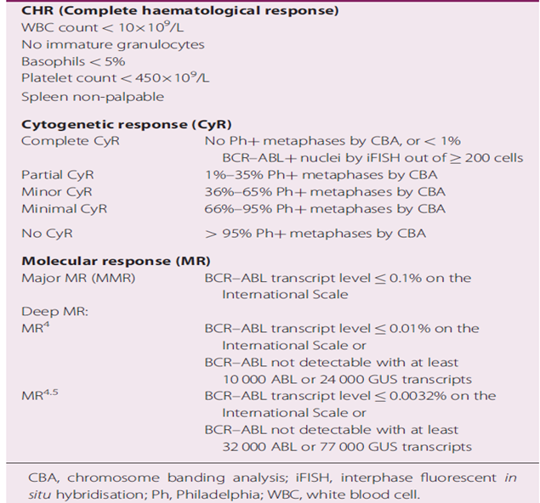

Abbreviations: CBA, chromosome banding analysis; iFISH, interphase fluorescent *in situ* hybridisation; Ph, Philadelphia; WBC, white blood cell.

Cytogenetic response denotes the percentage of residual bone marrow metaphases showing evidence of Philadelphia chromosome. Molecular response (MR) measures the reduction of *BCR::ABL1* fusion transcripts and, as such, has the greatest sensitivity. Once cytogenic response is achieved, only molecular methods make it possible to follow the dynamics of minimal residual disease over time.[32]

There is evidence that achieving a major molecular response predicts superior long term clinical outcomes (progression free survival/event free survival).[33] Achieving major molecular response (*BCR::ABL1* less than or equal to 0.1%) predicts a chronic myeloid leukaemia specific survival close to normal as disease progression is uncommon once this level of cytoreduction has been achieved.[34] Deep molecular response (MR4.5) defines a subgroup of patients with chronic myeloid leukaemia who may stay in unmaintained remission after treatment discontinuation. It is unclear how many patients achieve MR4.5 under different treatment modalities and whether MR4.5 predicts survival.[35]

##### Study CABL001A2301 (ASCEMBL trial)

The pivotal study supporting the proposed indication is Study CABL001A2301 (abbreviated here as Study A2301, but also known as the ASCEMBL trial). It is an ongoing Phase III, multicentre, open label, randomised study of oral asciminib versus bosutinib in patients with chronic myeloid leukaemia in chronic phase, previously treated with two or more tyrosine kinase inhibitors. The study commenced in October 2017 and the data cut‑off date for this submission was 25 May 2020 (the primary endpoint completion date). Patients were enrolled from 87 centres in 25 countries, including Australia.

###### Study design

The primary objective was to compare the major molecular response rate at Week 24 in patients on asciminib versus patients on bosutinib. The primary clinical question of interest was whether the efficacy of asciminib (40 mg twice a day) was superior to bosutinib (500 mg once daily) in patients with chronic myeloid leukaemia in chronic phase, previously treated with two or more tyrosine kinase inhibitors, with regards to achieving major molecular response at 24 weeks while on study treatment and without meeting any treatment failure criteria prior to 24 weeks, regardless of dose modification, dose interruption, or deviation in any intake of concomitant medications.

The key secondary objective was to compare the major molecular response rate at Week 96 between the two treatment arms (asciminib versus bosutinib). Other secondary objectives were comparing additional efficacy parameters; the safety and tolerability profile of the two treatment arms; characterising the PK of asciminib; and assessing the safety of asciminib when administered after bosutinib failure.

The primary efficacy outcome measure was the major molecular response rate at Week 24 in patients on asciminib versus patients on bosutinib. The major molecular response rate at Week 96 was the key secondary endpoint. Other secondary endpoints were: major molecular response rate at all scheduled data collection time points (except 24 and 96 weeks which are already covered by primary and key secondary endpoints); major molecular response rate by all scheduled data collection time points including 24 and 96 weeks; cytogenetic response rate at and by all scheduled data collection time points including 24, 48 and 96 weeks; time to and duration of response (major molecular response and cytogenetic response rate); time to treatment failure; progression free survival; and overall survival. Patient reported outcomes were exploratory endpoints.

Approximately 222 patients were to be randomised in a 2:1 ratio to receive either asciminib 40 mg twice a day, or bosutinib 500 mg once daily. Randomisation was stratified with respect to cytogenetic response status as follows:

* Major cytogenetic response (complete or partial)
* No major cytogenetic response (minor, minimal or none)

For patients who were unable to tolerate the protocol specified dosing schedule, dose interruptions and/or reductions were either recommended or mandated in order to allow the patient to continue the study treatment. For asciminib, only 1-step dose reduction to total daily dose of 40 mg was allowed, and for bosutinib 2-step sequential dose reduction up to total daily dose of 300 mg was allowed (see Table 5 below). Detailed criteria were provided for various grades of cytopenia’s and non-haematological adverse reactions.

Table 5: Study A2301 (ASCEMBL trial) Dose reduction steps for asciminib and bosutinib

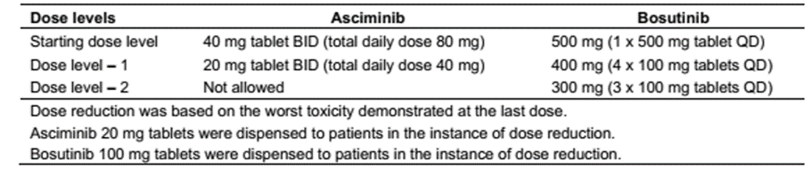

Abbreviations: BID = twice a day; QD = once daily.

Dose reduction was based on the worst toxicity demonstrated at the last dose.

Asciminib 20 mg tablets were dispensed to patients in the instance of dose reduction.

Bosutinib 100 mg tablets were dispensed to patients in the instance of dose reduction.

Dose escalation beyond the standard doses of 40 mg twice a day for asciminib was not permitted. For bosutinib, dose escalation to 600 mg once daily was permitted in patients who were taking 500 mg daily, did not have greater than or equal to Grade 3 adverse events and who:

* did not reach complete haematological response by Week 8
* did not reach complete cytogenetic response by Week 12

Concomitant use of drugs that affect gastric pH, anti-emetics, bisphosphonates, and hormonal contraceptives was allowed for patients on asciminib, whereas CYP3A4/5, CYP2C8 and CYP2C9 substrates with narrow therapeutic index;17 and anticoagulants were allowed with caution. Strong CYP3A4/5 inhibitors/ inducers and strong UGT1A/2B inducers and drugs with a known, possible or conditional risk of *torsade de pointes*;[36] were prohibited for patients given asciminib and strong or moderate CYP3A inhibitors/ inducers and pH altering medications were prohibited for patients given bosutinib. All patients were prohibited from receiving other anticancer drugs.

The study design for Study A2301 is shown below in Figure 2: Study A2301 (ASCEMBL trial) Study design

Figure 2: Study A2301 (ASCEMBL trial) Study design

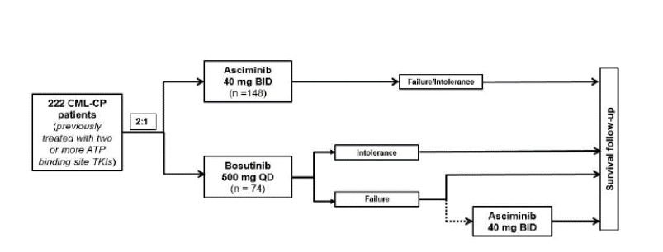

Molecular response was assessed based on levels of *BCR::ABL1* transcripts that were determined by real time quantitative polymerase chain reaction (PCR) testing of peripheral blood and analysed at a central testing laboratory. Log reduction in *BCR::ABL1* transcripts levels from the standardised baseline value, or the percent ratio of *BCR::ABL1* transcripts versus control gene (ABL) transcripts converted to a reference standard, international scale (IS) was calculated for each sample.[37]

Cytogenetic response was assessed locally as the percentage of Philadelphia chromosome positive metaphases in bone marrow and was defined as the following (a review of a minimum of 20 metaphases was required):

* Complete cytogenetic response: 0% Philadelphia chromosome positive metaphases
* Partial cytogenetic response: greater than 0% to 35% Philadelphia chromosome positive metaphases
* Major cytogenetic response: 0% to 35% Philadelphia chromosome positive metaphases
* Minor cytogenetic response: greater than 35% to 65% Philadelphia chromosome positive metaphases
* Minimal cytogenetic response: greater than 65% to 95% Philadelphia chromosome positive metaphases
* None: greater than 95% to 100% Philadelphia chromosome positive metaphases

Haematological responses were also assessed locally. Complete hematologic response was defined as all of the following present for greater than or equal to 4 weeks:

* White blood cell count less than 10 x 109/L
* Platelet count less than 450 x 109/L
* Basophils less than 5%
* No blasts and promyelocytes in peripheral blood
* Myelocytes and metamyelocytes less than 5% in peripheral blood
* No evidence of extramedullary disease, including spleen and liver

The following events constituted ‘treatment failure’, and are based on the European LeukemiaNet criteria defining failure of a second line treatment:[38]

* No complete haematologic response or greater than 95% Philadelphia chromosome positive metaphases at three months after randomisation or thereafter
* *BCR::ABL1* ratio greater than 10% IS and/or greater than 65% Philadelphia chromosome positive metaphases at six months after randomisation or thereafter
* *BCR::ABL1* ratio greater than 10% IS and/or greater than 35% Philadelphia chromosome positive metaphases at 12 months after randomisation or thereafter
* Loss of complete hematologic response, complete cytogenetic response or partial cytogenetic response at any time after randomisation
* Detection of new *BCR::ABL1* mutations at any time after randomisation
* Confirmed loss of major molecular response in two consecutive tests, of which one must have a *BCR::ABL1* ratio greater than or equal to 1% IS six months after randomisation
* New clonal chromosome abnormalities in Philadelphia chromosome positive cells at any time after randomisation

In the event of disease progression, the patient was to be discontinued from the study.

The following events are considered disease progression:

1. Chronic myeloid leukaemia related death (any death during treatment or follow up if the principal cause of death is marked as ‘study indication’ in the electronic case report form by the investigator, or if the death occurred subsequent to documented progression to accelerated phase/blast phase and the cause of death is reported as ‘unknown’ or not reported by the investigator).
2. Accelerated phase as defined by any of the following:
   * 15% or more blasts in the peripheral blood or bone marrow aspirate, but less than 30% blasts in both the peripheral blood and bone marrow aspirate
   * 30% or more blasts plus promyelocytes in peripheral blood or bone marrow aspirate
   * 20% or more basophils in the peripheral blood
   * Thrombocytopenia (less than 100 x 109/L) that is unrelated to therapy

Patients on bosutinib meeting treatment failure criteria are offered the option to switch to asciminib treatment within 96 weeks after the last patient was randomised on study. The patients who switched to asciminib would be able to receive asciminib up to the end of study treatment period. Patients are planned to receive treatment up to the end of study treatment defined as up to 96 weeks after the last patient received the first dose or up to 48 weeks after the last patient had switched to asciminib treatment (whichever was longer, unless the patient had discontinued study treatment earlier).

After the end of study treatment, the assigned study treatment would be made available to patients if the investigator believed they might benefit from therapy. This would be outside of this study through alternative options including, but not limited to, an expanded access/compassionate use/managed access program or access to commercial supplies in applicable countries.

Patients who discontinued study treatment at any time during the study were to be followed up for survival and for progression to accelerated phase/blast phase for up to five years from the date when the last randomised patient received the first dose (irrespective of treatment switch for patients failing bosutinib). No interim analysis was planned. In addition to the analyses at 96 weeks, end of study treatment analysis with a cut off date 30 days after the end of study treatment period and progression free survival and overall survival update analyses at the end of the five year follow up period are planned.

###### Key Inclusion criteria

* Male or female 18 years of age or older with a diagnosis of chronic myeloid leukaemia in chronic phase, who had received prior treatment with two or more ATP binding site tyrosine kinase inhibitors (that is, imatinib,11 nilotinib,12 dasatinib,13 radotinib, or ponatinib),15 and were treatment failure (as per guidelines adapted from European LeukemiaNet 2013)38 or intolerant to the most recent tyrosine kinase inhibitor.
* For patients intolerant to the most recent tyrosine kinase inhibitor therapy, the threshold for *BCR::ABL1* ratio was reduced from one or more, to greater than 0.1% by Amendment 3 to the protocol, in order to ensure that the chronic myeloid leukaemia third line patient population is adequately represented. No more than 66 patients (approximately 30% of the overall study population) that were intolerant to their most recent tyrosine kinase inhibitor therapy with *BCR::ABL1* less than 1% were to be recruited to ensure that the chronic myeloid leukaemia third line patient population is adequately represented.
* Adequate liver and renal function as defined per laboratory values presented in the protocol.
* Eastern Cooperative Oncology Group (ECOG)[39] performance status of 2 or less.
* Electrolytes (as per central laboratory tests) including potassium, total calcium, and magnesium within normal limits or corrected to be within normal limits with supplements prior to first dose of study medication.
* Potassium (potassium increase of up to 6 mmol/L was acceptable at study entry if associated with creatinine clearance within normal limits).
* Total calcium (corrected for serum albumin); (calcium increase of up to 12.5 mg/dl or 3.1 mmol/L was acceptable at study entry if associated with creatinine clearance within normal limits).
* Magnesium, with the exception of magnesium increase greater than upper limit of normal 3 mg/dL; greater than upper limit of normal -1.23 mmol/L associated with creatinine clearance (calculated using Cockcroft-Gault formula) within normal limits.
* Avoiding consumption of grapefruit, Seville oranges or products containing the juice of each during the entire study and preferably seven days before the first dose of study medications, due to potential CYP3A4 interaction with the study medications.17 Orange juice was allowed.
* Provided written informed consent obtained prior to any screening procedures.
* Evidence of typical *BCR::ABL1* transcript (e14a2 and/or e13a2) at the time of screening.

###### Key exclusion criteria

* Known presence of the T315I or V299L mutation at any time prior to study entry.
* Known second chronic phase of chronic myeloid leukaemia after previous progression to accelerated phase/blast phase.
* Previous treatment with a hematopoietic stem cell transplantation or patient planning to undergo allogeneic hematopoietic stem cell transplantation.
* Presence of cardiac or cardiac repolarisation abnormality, including history of myocardial infarction, angina pectoris, coronary artery bypass graft, clinically significant cardiac arrhythmias, risk factors for torsade de pointes, concomitant medication(s) with a ‘known risk of *torsade de pointes’*.36
* Severe and/or uncontrolled concurrent medical disease that in the opinion of the investigator could cause unacceptable safety risks or compromise compliance with the protocol (for example, uncontrolled diabetes, active or uncontrolled infection, pulmonary hypertension).
* History of acute pancreatitis (within one year of study entry or past medical history of chronic pancreatitis), acute or chronic liver disease, infections (including human immunodeficiency virus (HIV), chronic hepatitis B, or chronic hepatitis C), impaired gastrointestinal function or gastrointestinal disease, and other active malignancy within three years prior to study entry with the exception of previous or concomitant basal cell skin cancer and previous carcinoma *in situ* treated curatively.
* Known presence of significant congenital or acquired bleeding disorder unrelated to cancer.
* Treatment with moderate or strong inducers/ inhibitors of CYP3A;17 that cannot be discontinued at least one week prior to the start of treatment with study treatment.
* Previous treatment with or known/ suspected hypersensitivity to asciminib/bosutinib or any of its excipients.
* Participation in a prior investigational study within 30 days prior to randomisation or within five half lives of the investigational product, whichever was longer.
* Pregnant or nursing (lactating) women.
* Women of child bearing potential, unless they are using highly effective methods of contraception during dosing and for three days after last dose of asciminib and one month after last dose of bosutinib.

###### Statistical methods

The major molecular response rate at 24 weeks was calculated based on the full analysis set (that is, all randomised patients) major molecular response rate and its 95% confidence interval based on the Pearson-Clopper method will be presented by treatment group. The confidence interval for the difference in major molecular response rate between treatment groups will be provided using the Wald method.

The null hypothesis is that there is no difference between the treatment groups with respect to major molecular response rate at 24 weeks. The Cochrane-Mantel-Haenszel chi‑square test, stratified by the randomisation stratification factor, that is, major cytogenetic response status (partial cytogenetic response or complete cytogenetic response versus others) at screening, will be used to compare major molecular response rate between the two treatment groups, at the two sided 5% level of significance. The Mantel-Haenszel estimate of the common risk difference and the corresponding 95% confidence interval will also be provided. Various subgroup analyses were to be performed provided that the primary efficacy analysis based on the full analysis set was statistically significant.

Only patients with major molecular response at 24 weeks are considered responders. However, if the Week 24 polymerase chain reaction (PCR) evaluation is missing, but both a PCR evaluation at 16 weeks and 36 weeks indicate major molecular response, the Week 24 assessment is imputed as a ‘response’. Similar statistical methods are planned for the Week 96 major molecular response comparison which is to be performed subject to statistical superiority being demonstrated for the major molecular response at Week 24. No statistical testing was planned for other secondary endpoints, though nominal p values were presented and these analyses were considered exploratory.

To estimate the study sample size it was assumed that asciminib has a 20% higher major molecular response rate at 24 weeks than bosutinib that is, 35% compared to 15% which corresponds to an odds ratio of 3.05. The assumed bosutinib major molecular response rate of 15% at 24 weeks is based on previous trials evaluating bosutinib therapy in patients treated with at least two prior tyrosine kinase inhibitors.[40] To test the null hypothesis that the major molecular response rate at 24 weeks is equal in the two treatment arms, based on two sided 5% level of significance and with 90% power, 222 patients were needed in total (that is, 148 patients in the asciminib arm and 74 patients in the bosutinib arm based on 2:1 randomisation allocation).

###### Patient disposition

Two hundred and thirty three (233) patients with chronic myeloid leukaemia in chronic phase were enrolled and randomised, 157 to treatment with asciminib and 76 to treatment with bosutinib. As of the 25 May 2020 data cut off, 119 patients (51.1%) continued to receive treatment. Twice the proportion of patients were ongoing in the asciminib arm (61.8%) relative to the bosutinib arm (28.9%).

Overall, discontinuations were predominantly due to lack of efficacy, followed by adverse events and physician decision, although all were less frequent in the asciminib arm relative to the bosutinib arm (lack of efficacy: 21% versus 31.6%; adverse events: 5.1% versus 21.1%; physician decision: 6.4% versus 7.9%). The majority of discontinuations before Week 24 were related to adverse events while after Week 24 discontinuations were mainly due to lack of efficacy. Twenty-two patients (28.9%) randomised to bosutinib switched to asciminib treatment after meeting lack of efficacy criteria as per protocol. The median duration of exposure to study drug was approximately 50% longer in the asciminib treatment group (43.4 weeks; range: 0.1 to 129.9) compared to the bosutinib treatment group (29.2 weeks; range: 1 to 117).

Table 6: Study A2301 Patient disposition

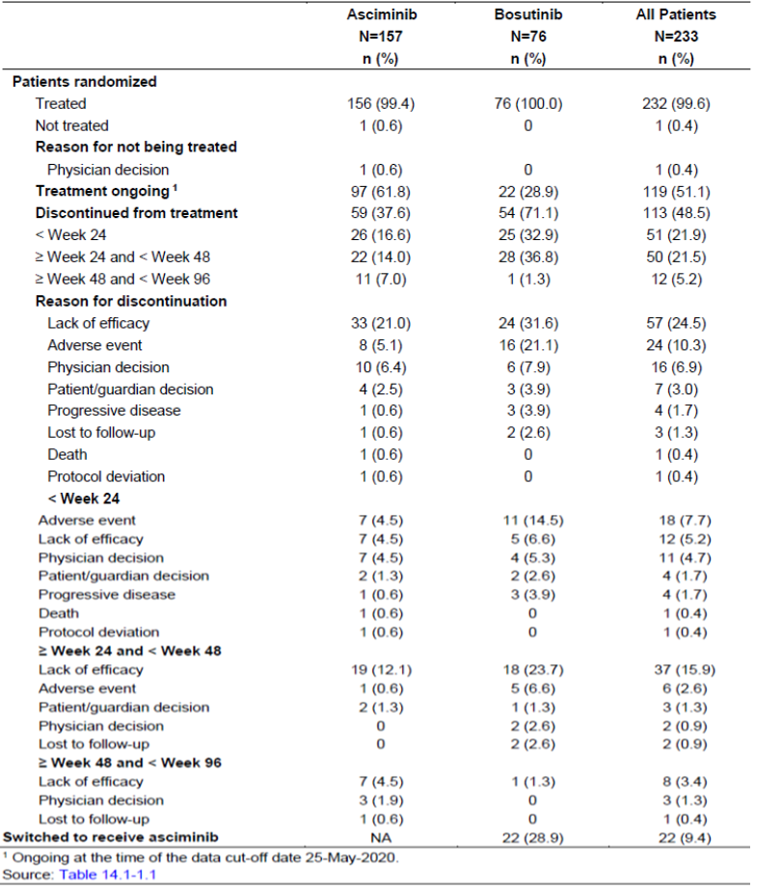

1 Ongoing at the time of the data cut off date 25 May 2020

###### Demographic and disease characteristics at Baseline

The median age of patients was 52 years (range: 19 to 83) with 44 (18.9%) patients aged 65 years or older and six (2.5%) patients aged 75 years or older. The majority of patients were White (74.7%), and 14.2% were Asian. Almost all patients (98.7%) had a baseline ECOG performance status of 0 or 1.39 The median time since diagnosis was 4.2 years (range 1 to 28 years). Twelve patients had extramedullary involvement in the spleen and two of these patients also had involvement in the liver. Forty-four (28%) and 21 (27%) were in major cytogenetic response at Baseline. Patients who had previously received two, three, four, five or more prior lines of tyrosine kinase inhibitors were 48%, 31%, 15%, and 6%, respectively of the total patient population.

The primary objective of this study was met, in that clinically and statistically and significant superiority of asciminib at its proposed dose in comparison with bosutinib (500 mg once daily) was demonstrated in patients with chronic myeloid leukaemia in chronic phase, previously treated with two or more tyrosine kinase inhibitors. A consistent treatment effect, independent of the demographic and prognostic variables tested was apparent, including in those that were not balanced between treatment arms at Baseline (fewer females in the asciminib arm, more patients intolerant to their prior tyrosine kinase inhibitor in the asciminib arm and patients in the asciminib arm were less heavily pre-treated).

Table 7: Study A2301 Major molecular response rate at Week 24

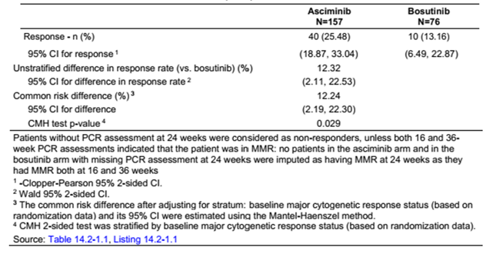

Patients without PCR assessment at 24 weeks were considered as non-responders, unless both 16 and 36 Week PCR assessments indicated that the patient was in major molecular response: no patients in the asciminib arm and in the bosutinib arm with missing PCR assessment at 24 weeks were imputed as having major molecular response at 24 weeks as they had major molecular response both at 16 and 36 weeks.

1 Clopper-Pearson 95% 2-sided CI.

2 Wald 95% 2-sided CI.

3 The common risk difference after adjusting for stratum: baseline major cytogenetic response status (based on randomisation data) and its 95% CI was estimated using the Mantel-Haenszel method.

4 CMH 2-sided test was stratified by baseline major cytogenetic response status (bases on randomisation data).

Subgroup analyses for the major molecular response rate at 24 weeks are shown below.

Table 8: Study A2301 Forest plot of risk difference with 95% confidence interval for major molecular response rate at 24 weeks from subgroup analysis

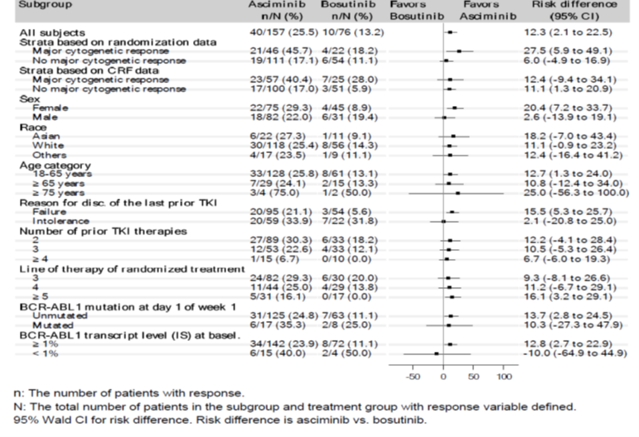

n: The number of patients with response.

N: The total number of patients in the subgroup and treatment group with response variable defined. 95% Wald CI for risk difference. Risk difference is asciminib versus bosutinib.

Secondary endpoints are exploratory and included the following:

* The major molecular response rate at each scheduled time point to Week 24 was higher for the asciminib arm compared to the bosutinib arm, with relevant differences apparent at Week 12 (17.8% in the asciminib arm compared to 9.2% in the bosutinib arm). Data beyond Week 24 are not mature.
* Median time to major molecular response for responders was 12.7 weeks in the asciminib arm compared to 14.3 weeks in the bosutinib arm.
* The majority of patients who achieved major molecular response continued in major molecular response: only three patients (5.6%) in the asciminib arm subsequently lost their response. No loss of response was observed in the bosutinib arm.
* *BCR::ABL1* IS less than or equal to 0.01% (MR4 or better) was observed in 10.8% of patients on asciminib and on 5.3% of patients on bosutinib with the majority on asciminib achieving MR4.5 (8.9% versus 1.3%) (see Table 3 for definitions of MR responses).
* When only patients with *BCR::ABL1* IS greater than 1% at Baseline were included in the analysis (142 in the asciminib arm and 72 in the bosutinib arm), the percentage of patients with *BCR::ABL1* international scale less than or equal to 1% at Week 24 was 44.37% in the asciminib arm and 20.83% in the bosutinib arm.
* The complete cytogenetic response rates at Week 24 and by Week 24 (based on patients who were not in complete cytogenic response at Baseline) were both 40.8% in the asciminib arm compared to 24.2% in the bosutinib arm. The treatment difference in the complete cytogenetic response rate was 17.3% (95%: 3.62, 30.99, nominal p value = 0.019).
* Time to complete cytogenetic response among subjects who achieved complete cytogenetic response was the same between the two treatment arms, with medians of approximately 24 weeks.
* Loss of complete cytogenetic response was reported in one patient each in the asciminib and the bosutinib arm, respectively.
* The probability of treatment failure was higher in the bosutinib arm compared to the asciminib arm (hazard ratio = 0.5; 95% CI: 0.3, 0.7). The Kaplan Meier estimated proportion of patients with treatment failure by the cut off date was higher in the bosutinib arm (73.7%) compared to the asciminib arm (45.2%). The median time to treatment failure was 5.6 months for the bosutinib arm whereas it was 16.6 months for the asciminib arm.
* Progression free survival and overall survival endpoints are immature.
* Patient reported outcomes of MD Anderson Symptom Inventory for chronic myeloid leukaemia, Patient Global Impression of Change along with EQ-5D-5L,[41] and in work productivity and activity impairment (as assessed by work productivity and activity impairment for chronic myeloid leukaemia) suggested that asciminib was associated with better improvement in disease related symptoms and health related quality of life outcomes than bosutinib.

Subsequent efficacy data became available and was submitted during the evaluation process. The key secondary endpoint of major molecular response at 96 weeks and updated progression free survival and overall survival analyses using the most recent available data cut off date are presented below. At Week 96, the major molecular response rate was 37.6% (95% CI: 29.99, 45.65) in the asciminib arm compared to 15.8% (95% CI: 8.43, 25.96) in the bosutinib arm. Clinical superiority of asciminib versus bosutinib increased compared to the primary analysis, as reflected by a more than 2-fold improvement in major molecular response rate with a common treatment difference (after adjusting for baseline major cytogenetic response status) of 21.74% (95% CI: 10.53, 32.95) which was clinically and statistically significant; p = 0.001 (two sided Cochrane-Mantel-Haenszel chi-square test, stratified by the major cytogenetic response status at Baseline).

Table 9: Study A2301 Major molecular response rate at Week 96

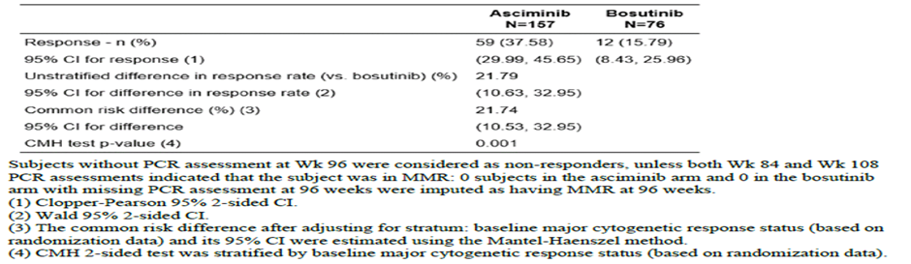

Subjects without PCR assessment at Week 96 were considered as non-responders, unless both Week 84 and Week 108 PCR assessments indicated that the subject was in major molecular response: zero subjects in the asciminib arm and 0 in the bosutinib arm with missing PCR assessment at 96 weeks were imputed as having major molecular response at 96 weeks.

(1) Clopper-Pearson 95% 2-sided CI.

(2) Wald 95% 2-sided CI.

(3) The common risk difference after adjusting for stratum: baseline major cytogenetic response status (based on randomisation data) and its 95% CI were estimated using Mantel-Haenszel method.

(4) CMH 2-sided test was stratified by baseline major cytogenetic response status (based on randomisation data).

Disease progression to accelerated phase/blast phase or death from any cause on treatment was considered as an event in progression free survival analysis. At the Week 96 cut off, a total of nine patients (5.7%) in the asciminib arm and five patients (6.6%) in the bosutinib arm experienced a progression free survival event on study; two additional patients with a progression free survival event on study in the asciminib arm and none in the bosutinib arm after the previous cut off date (6 January 2021). The one year progression free survival was 96.3% (95% CI: 91.4, 98.5) in the asciminib arm and 91.1% (95% CI: 79.5, 96.3) in the bosutinib arm, respectively. The two year progression free survival was 94.4% (95% CI: 88.6, 97.3) in the asciminib arm and 91.1% (95% CI: 79.5, 96.3) in the bosutinib arm, respectively. Median follow up was 21.6 months in the asciminib arm and 13.2 months in the bosutinib arm.

With regard to overall survival events, a total of five patients (3.2%; two on treatment and three during survival follow up) in the asciminib arm and two patients (2.6%, one on treatment and one during survival follow up) in the bosutinib arm died on study, including two additional deaths (one in each treatment arm) during survival follow up reported after the previous cut off date (6 January 2021). The one year survival rates were 98% (95% CI: 93.8, 99.3) in the asciminib arm and 98.6% (95% CI: 90.2, 99.8) in the bosutinib arm and the two year survival rates were 97.3% (95% CI: 92.9, 99) in the asciminib arm and 98.6% (90.2, 99.8) in the bosutinib arm.

##### Study CABL001X2101 (X2101)

Study CABL001X2101 (abbreviated as Study X2101) was a Phase I, multicentre, open label study of oral asciminib in patients with chronic myeloid leukaemia or Philadelphia chromosome positive acute lymphoblastic leukaemia. This study is described in the PK section of this document. This segment considers efficacy of asciminib at various doses, as a single agent. The data cut-off date for the report is 2 April 2020, corresponding to when all patients in Arm 1 and Arm 5 were treated for at least six cycles and had their Week 24 efficacy evaluation performed, or had discontinued treatment earlier. Efficacy in Arms 1 and 5 only is discussed below because these arms contained the key data in support of the primary efficacy analysis of the pivotal trial and efficacy data to support the use of this asciminib in patients harbouring a T315I mutation. Other data that was not evaluated examined the use of asciminib in combination with other tyrosine kinase inhibitors and for other indications. The relationship between dose and efficacy of asciminib is discussed in the exposure efficacy analysis in the pharmacodynamics section of this document.

In this section the following efficacy endpoints were assessed:

* Major molecular response, defined as a value of less than or equal to 0.1% of *BCR::ABL1* ratio on the IS.
* Duration of first major molecular response, defined as the period of time between the time point when the first *BCR::ABL1* ratio less than or equal to 0.1 % (IS) was observed until and the time point of confirmed loss of major molecular response.
* MR4 and MR4.5 was defined as a value of less than or equal to 0.01% and less than or equal to 0.0032% *BCR::ABL1* ratio by IS, respectively.

Molecular response rate by scheduled time point, defined as the proportion of patients who achieved molecular response at or before the specified time point. Molecular response rate at scheduled time point was defined as the proportion of patients who achieved molecular response at or before the specified time point and were able to maintain this response until the specified time point.

Efficacy analyses for each arm were performed using the full analysis set and presented by treatment group. The following analyses were conducted:

* Achievement of major molecular response by scheduled time points (including Week 24 and Week 48, overall and by line of therapy).
* Achievement of major molecular response at scheduled time points (including Week 24 and Week 48, overall and by line of therapy).
* Duration of first major molecular response among patients who achieved major molecular response.
* Time to major molecular response among patients who achieved major molecular response.

For patients with chronic myeloid leukaemia harbouring the T315I mutation from Arm 1, the following additional analyses were conducted:

* Major molecular response rate by 24 weeks (95% CI) in overall T315I mutation analysis set.
* Major molecular response rate at 24 weeks (95% CI) in overall T315I mutation analysis set.

###### Molecular response

Levels of *BCR::ABL1* transcripts were determined by real time quantitative PCR testing of peripheral blood. Samples were analysed at a sponsor designated laboratory with validated PCR technology that has a sensitivity of at least 4.5 logs (IS).

Cytogenetic response was assessed as the percentage of Philadelphia chromosome positive metaphases in the bone marrow. Achievement of cytogenetic response categories was summarised by time points (including Week 24 and Week 48) and treatment group using the full analysis set. In addition, analyses of cytogenetic response by time point were conducted in the subset of patients harbouring the T315I mutation at study entry from Arm 1.

A complete hematologic response was defined when all of the following criteria were present at any assessment, and was confirmed by another assessment at least after four weeks:

• White blood cell count less than 10 x 109 /L

• Platelet count less than 450 x 109 /L

• No extra medullary involvement (spleen, liver, lymph nodes)

• Myelocytes and metamyelocytes less than 5% in peripheral blood

• No evidence of blasts or promyelocytes in the peripheral blood

Achievement of complete hematologic response at and by time points (including Week 24 and Week 48) was summarised by treatment group using the full analysis set.

###### Demographic and baseline characteristics in Arms 1 and 5

Arm 1: Asciminib as single agent in chronic myeloid leukaemia in chronic phase/ accelerated phase

Two hundred (200) patients in Arm 1 with chronic myeloid leukaemia in chronic phase/accelerated phase were treated with asciminib single agent across treatment cohorts, the median age was 55.5 years (min to max: 22 to 88 years) with 72.5% of patients being 18 to less than 65 years old. The majority (60%) of patients were male and White (67.5%). Most of them (98.5%) had ECOG performance status of 0 or 1; three patients had ECOG performance status of 2 and were part of the 40 mg twice a day cohort.

One hundred eighty five (185, or 92.5%) patients had chronic myeloid leukaemia in chronic phase and 15 (7.5%) had chronic myeloid leukaemia in accelerated phase. The majority (60%) of these patients with chronic myeloid leukaemia in chronic phase/accelerated phase did not harbor the T315I mutation.

Of the 185 patients with chronic myeloid leukaemia in chronic phase, 115 had chronic myeloid leukaemia in chronic phase without the T315I mutation and 70 with chronic myeloid leukaemia in chronic phase harboured the T315I mutation with 48 patients enrolled at 200 mg twice a day, which was an enrichment cohort for the patients with chronic myeloid leukaemia in chronic phase harbouring the mutation and was recommended dose for expansion.

Asciminib as single agent in chronic myeloid leukaemia in chronic phase without the T315I mutation at screening

Among the 115 patients with chronic myeloid leukaemia in chronic phase without the T315I mutation treated with asciminib single agent across treatment cohorts, the median age was 56 years (min to max: 25 to 88 years) with 73.9% of patients being 18 to less than 65 years old. The proportion of males was 52.2% and females was 47.8%. The majority of patients were White (77.4%). Most (98.3%) had ECOG performance status of 0 or 1; two patients had ECOG performance status of 2 and were part of the 40 mg twice a day cohort.

Asciminib as single agent in chronic myeloid leukaemia in chronic phase harbouring the T315I mutation at screening

Among 70 patients with chronic myeloid leukaemia in chronic phase harbouring the T315I mutation treated with asciminib single agent across treatment cohorts, the median age was 53.5 years (min to max: 22 to 86 years) with 70% of patients being 18 to less than 65 years old. The majority (74.3) of patients were male and White (51.4%). The ECOG performance status was 0 (78.6%) or 1 (21.4%).

Arm 5: Asciminib as single agent in chronic myeloid leukaemia in blast phase and Philadelphia positive chromosome acute lymphoblastic leukaemia

Among 43 patients with chronic myeloid leukaemia in blast phase or Philadelphia chromosome positive acute lymphoblastic leukaemia treated with asciminib single agent across cohorts, the median age was 56 years (min to max: 20 to 77 years) with 65.1% of patients being 18 to less than 65 years old. The majority of patients were White (67.4%) and ECOG performance status of 0 or 1 (83.7%).

Among 43 patients enrolled across cohorts, 15 (34.9%) had chronic myeloid leukaemia in blast phase and 28 (65.1%) had Philadelphia chromosome positive acute lymphoblastic leukaemia. Of these, 53.5% of patients had chronic myeloid leukaemia in blast phase or Philadelphia chromosome positive acute lymphoblastic leukaemia not harbouring the T315I mutation while 25.6% harboured the T315I mutation. For the remaining 20.9% of patients, T315I mutation status was missing.

###### Efficacy results in Arm 1 and 5

In Arm 1, 200 patients with chronic myeloid leukaemia in chronic phase/accelerated phase were treated with asciminib single agent across treatment cohorts, among those 115 had chronic myeloid leukaemia in chronic phase without T315I mutation and 48 had chronic myeloid leukaemia in chronic phase harbouring the T315I mutation and treated at 200 mg twice a day.

In Arm 5, 43 patients with chronic myeloid leukaemia in blast phase or Philadelphia chromosome positive acute lymphoblastic leukaemia were treated with any dose across cohorts.

###### Patients with chronic myeloid leukaemia in chronic phase/accelerated phase

Table 10: Study X2101 Major molecular response by time point; single agent asciminib in chronic myeloid leukaemia in chronic phase/accelerated phase not in major molecular response at screening (major molecular response evaluable full analysis set)

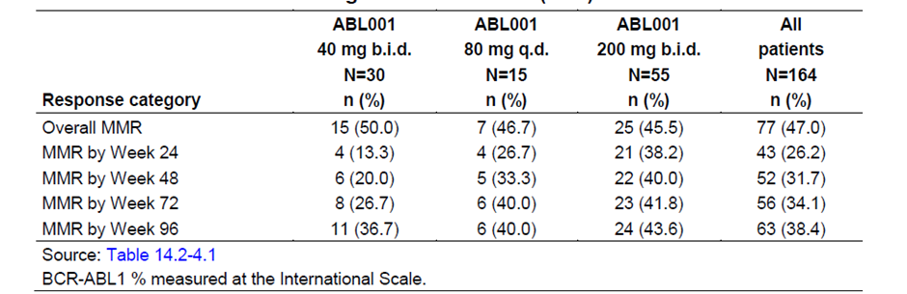

Abbreviations: ABL001 = drug development code for asciminib; b.i.d. = twice a day; MMR = major molecular response; q.d. = once daily

*BCR::ABL1* % measured at the international scale.

Major molecular response was evaluable in 164 out of 200 patients. A clinically meaningful and durable major molecular response rate was observed across all asciminib dose levels greater than or equal to 20 mg twice a day and across all lines of therapy. There was no meaningful difference in major molecular response between the 40 mg twice a day and 80 mg once daily dose groups. Major molecular response was achieved by 77 out of 164 (47%) patients overall and major molecular response by Week 24 by 26.2% patients (25% at Week 24).

There are 71 out of 77 patients who achieved response, maintained this response or improved it to a deeper level of response up to the cut-off date. The responses achieved were highly durable given the median duration of exposure of 124.6 weeks. The Kaplan Meier estimated proportion of patients maintaining their first major molecular response for at least 96 weeks was 92% (95% CI: 85.4%, 98.8%). The median time to first major molecular response among responders was 20.9 weeks.

There are 74 out of 200 patients, who were not in complete cytogenetic response at screening and had at least one valid assessment after screening. Within this group, complete cytogenetic response was achieved by 41 out of 74 (55.4%) patients overall (bone marrow aspirate was not required after screening in patients for whom it was not clinically indicated).

There are 44 out of 200 patients were evaluable for complete haematologic response analysis. Complete haematologic response was achieved by 39 out of 44 (88.6%) overall (37 out of 44 (84.1%) patients by Week 24).

###### Patients with chronic myeloid leukaemia in chronic phase without the T315I mutation at screening

A clinically meaningful and durable major molecular response rate was observed across asciminib dose levels greater than or equal to 20 mg twice a day and across all lines of therapy. One hundred fifteen patients were treated at any dose across cohorts and 86 out of 115 patients were evaluable for major molecular response analysis. Major molecular response was achieved by 50 out of 86 (58.1%) patients overall and the major molecular response rate by Week 24 was 23.3% (same major molecular response rate at Week 24). Forty-six out of 50 patients who achieved response, maintained this response or improved it to a deeper level of response up to the cut-off date. The responses achieved were highly durable given the median duration of exposure of 183.4 weeks. Kaplan Meier estimated proportion of patients maintaining their first major molecular response for at least 96 weeks was 93% (95% CI: 85.7%, 100%). The median time to first major molecular response among responders was 38.3 weeks.

Thirty one out of 115 patients, who were not in complete cytogenetic response at screening and had at least one valid assessment after screening complete cytogenetic response was achieved by 22 out of 31 (71%) patients overall (bone marrow aspirate was not required after screening in patients for whom it was not clinically indicated). Twenty five out of 115 patients were evaluable for complete haematologic response analysis. Complete haematologic response was achieved by 22 out of 25 (88%) overall (21 out of 25 (84%) patients by Week 24).

###### Patients with chronic myeloid leukaemia in chronic phase harbouring the T315I mutation at screening and treated at 200 mg twice a day

A clinically meaningful and durable major molecular response rate was observed in patients with chronic myeloid leukaemia in chronic phase harbouring the T315I mutation treated at 200 mg twice a day and regardless of prior ponatinib treatment. For the 48 patients with T315I mutation the median duration of exposure was 69.8 weeks, including 40 patients (83.3%) who were exposed to study treatment for at least 24 weeks. 48 patients were treated at 200 mg twice a day. Of these, 45 out of 48 patients were evaluable for major molecular response analysis (26 patients were pre-treated with ponatinib and 19 were ponatinib naive). Major molecular response was achieved by 22 out of 45 (48.9%) overall.

* Major molecular response by Week 24 was 42.2% (37.8% at Week 24).
* In 26 ponatinib pre-treated patients, major molecular response was achieved by nine (34.6%) patients overall; major molecular response by Week 24 in eight (30.8%) patients (26.9% at Week 24).
* In 19 ponatinib naive patients, major molecular response was achieved by 13 (68.4%) patients overall; major molecular response by Week 24 in 11 (57.9%) patients (52.6% at Week 24).
* Twenty out of 22 patients who achieved response, maintained this response or improved it to a deeper level of response up to the cut-off date.
* Kaplan Meier estimated proportion of patients maintaining their first major molecular response for at least 96 weeks was 86% (95% CI: 65.9%, 100%).
* Median time to first major molecular response among responders was 12.2 weeks.
* Twenty-three out of 48 patients, who were not in complete cytogenetic response at screening and had at least one valid assessment after screening. Complete cytogenetic response was achieved by 13 out of 23 (56.5%) patients overall (bone marrow aspirate was not required after screening in patients for whom it was not clinically indicated).
* Ten out of 48 patients were evaluable for complete haematologic response analysis. Complete haematologic response was achieved by Week 24 in 90% of patients.

#### Safety

##### Exposure

Safety data for patients with Philadelphia chromosome positive chronic myeloid leukaemia in chronic phase previously treated with two or more tyrosine kinase inhibitors are based on the safety analysis of two studies, the pivotal Study A2301 and supportive Study X2101, with a data cut-off date of 6 January 2021.

All analyses were based on the safety sets which included all patients who received at least one dose of study treatment. Data from both efficacy studies is presented separately and in the safety pools outlined in Table 11.

Table 11: Safety data pools for Study A2301 and Study X2101

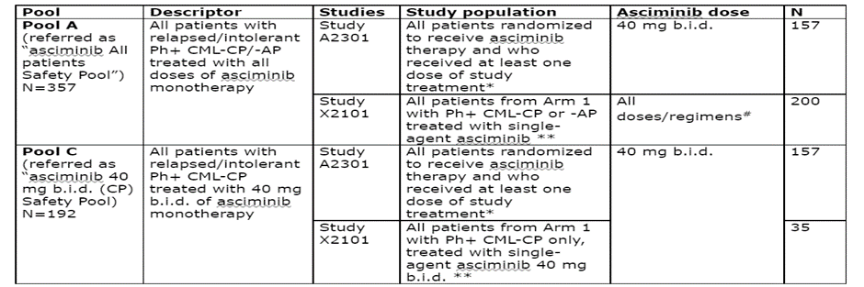

Abbreviations: Ph+ CML-CP/AP: Philadelphia chromosome positive chronic myeloid leukaemia in chronic phase/accelerated phase, b.i.d: twice a day, CP: chronic phase

* Safety data collected during switch-treatment phase in patients who switched to asciminib following treatment failure with bosutinib were not included.

** Patients with Philadelphia chromosome positive chronic myeloid leukaemia in chronic phase (Ph+ CML-CP) T315I mutation were included.

#Doses/regimens included: 10 mg twice a day (n = 1), 20 mg twice a day. (n = 14), 40 mg twice a day (n = 35), 80 mg twice a day (n = 12), 150 mg twice a day (n = 13), 160 mg twice a day (n = 11), 200 mg twice a day (n = 62), 80 mg once daily (n = 18), 120 mg once daily (n = 22), and 200 mg once daily (n = 12).

In addition, results from Study X2101 for patients in the 80 mg once daily dose group are presented.

Safety data were initially based on earlier cut off dates for Study A2301 (25 May 2020) and Study X2101 (2 April 2020) and have been supplemented by an update (cut off 6 January 2021 for both studies). While data based on cut off 6 January 2021 was provided, some parts of the safety review refer to data on the earlier cut off. Safety information included data from 48 patients who received asciminib 200 mg twice a day in Study X2101 however, a dose of 200 mg twice a day is not being proposed by the sponsor.

###### Study A2301

The median duration of exposure to treatment was 67 weeks with asciminib and 30 weeks for bosutinib. The proportion of patients in the bosutinib group continuing treatment (17 patients; 22.4%) was considerably lower than in the asciminib group (89 patients; 56.7%) leading to a substantial difference in duration of treatment between groups. For comparisons between treatment groups, emphasis is given to exposure adjusted incidence rates and cumulative incidence proportions at Week 8, Week 24, and Week 48.

As of 6 January 2021, 106 of the 233 patients (45.5%) were continuing the study treatment with 89 patients (56.7%) and 17 patients (22.4%) still ongoing in the asciminib and bosutinib arms, respectively. Lack of efficacy (35.5% bosutinib versus 23.6% asciminib) and adverse events (23.7% bosutinib versus 5.7% asciminib) were the primary reasons for discontinuation, and both were notably less frequent in the asciminib group compared to bosutinib.

Median dose intensities were 79.8 mg/day (min to max: 33 to 80) and 463.8 mg (min to max: 181 to 566) for the asciminib and bosutinib respectively. The relative dose intensity of greater than 90 to 110% was observed for 70.5% and 53.9% of patients in the asciminib and bosutinib groups, respectively.

Dose reductions were primarily attributable to adverse events in both treatment groups, 23.1% in asciminib and 44.7% in the bosutinib. Dose interruptions were primarily attributable to adverse events (asciminib 40.4% versus bosutinib 60.5%). Permanent discontinuation was primarily due to lack of efficacy in both groups (23.7% asciminib versus 35.5% in the bosutinib). At Baseline a higher proportion of patients had discontinued prior tyrosine kinase inhibitors due to intolerance in the asciminib arm versus the bosutinib arm (37.6% versus 28.9%).

###### Study X2101

As of 6 January 2021, 113 patients (56.5%) were continuing treatment with single agent asciminib and 87 patients (43.5%) had discontinued study treatment. The most frequent reasons for discontinuation of treatment were physician’s decision (16.5%) and adverse events (10%). The majority of patients who discontinued due to physician’s decision were due to lack of efficacy (29 out of 32 patients reported as of initial cut-off date April 2020).

As Study X2101 is a Phase I, dose escalation study to determine maximum tolerated dose/recommended dose for expansion wherein intra-patient dose escalations are allowed as per the protocol, dose modification included both dose escalation and dose reduction in Study X2101. Hence the data on dose modifications and the summary of dose received from Study X2101 are not included in the asciminib safety pools. Dose limiting toxicities reported for asciminib as a single agent included: lipase increase in one patient each at 40 mg twice a day and 200 mg once daily; arthralgia and myalgia in same patient at 80 mg twice a day; acute coronary syndrome in one patient at 150 mg twice a day; thrombocytopenia in one patient at 160 mg twice a day; bronchospasm in one patient at 200 mg twice a day; and two events of pancreatitis in two different patients at 200 mg once daily.

In Arm 3 (asciminib in combination with imatinib in chronic myeloid leukaemia in the chronic phase/accelerated phase) as of April 2020, 25 patients with chronic myeloid leukaemia in chronic phase/accelerated phase dose limiting toxicities were reported in six (24%) patients during the first cycle of treatment with various dose levels of asciminib in combination with imatinib 400 mg once daily. Dose limiting toxicities reported included pancreatitis in one patient each at asciminib 40 mg twice a day and 80 mg once daily, neutrophils count decrease in one patient at asciminib 40 mg one daily, increased lipase in one patient at asciminib 80 mg once daily, abdominal pain and nausea in one patient each both at asciminib 60 mg once daily.

In Arm 4 (asciminib in combination with dasatinib) as of April 2020, 22 patients with chronic myeloid leukaemia in chronic phase/accelerated phase were treated with asciminib (40 mg twice a day or 80 mg and 160 mg once daily) in combination with dasatinib (100 mg once daily). Overall, dose limiting toxicities were reported in two (9.1%) patients during the first cycle of treatment with various dose levels of asciminib in combination with dasatinib 100 mg once daily. Dose limiting toxicities reported included increased lipase in one patient at asciminib 40 mg twice a day, and thrombocytopenia in one patient at asciminib 160 mg once daily.

##### Adverse events

Adverse events occurring in each of these studies are shown in Table 12 and Table 13. There is a higher increase in adverse events related to gastrointestinal, raised alanine aminotransferase/ aspartate aminotransferase and rash with bosutinib in line with its known safety profile while thrombocytopaenia notably occurred at a higher incidence with asciminib (all doses).

Table 12: Study X2101 Overview of adverse events for single agent asciminib in chronic myeloid leukaemia in chronic phase/accelerated phase

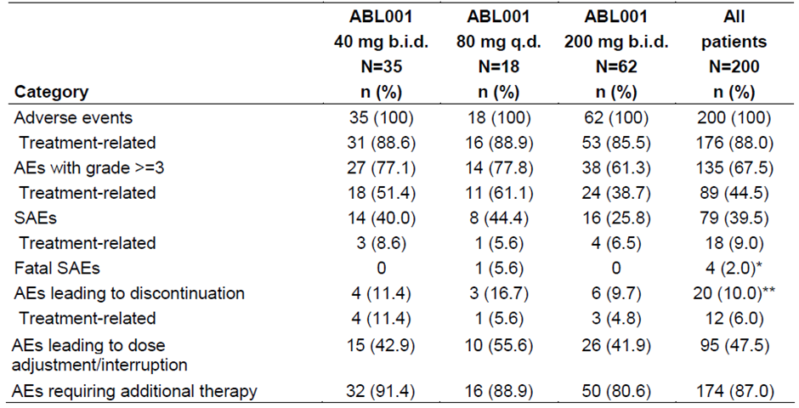

Abbreviations: ABL001 = drug development code for asciminib; AE = adverse event; b.i.d. = twice a day; q.d. = once daily; SAE = serious adverse event

*An additional patient had prolonged interruption (greater than 30 days after last dose) due to serious adverse event (SAE) which was fatal.

Among the 5 patients who has fatal SAEs, three were reported among the patients who discontinued study treatment due to death, and the remaining two were reported among patients who discontinued due to an adverse event (one patient who died due to altered general condition), and due to physician’s decision (one patient who died due to leukaemia and cardiovascular failure as contributing reason for death).

** One patient in the 200 mg twice a day cohort has SAE related to disease progression which led to treatment discontinuation, this was counted under the category of adverse events leading to discontinuation in this table.

In Study A2301 for asciminib 40 mg twice a day dose the first occurrence of an adverse event was primarily within the first 8 weeks of treatment (75.6%). The incidence of adverse events during Weeks 8 to 24 and Weeks 24 to 48 either remained similar or decreased over time. For bosutinib,14 first occurrence of adverse events was also primarily observed within the first 8 weeks of treatment and for most adverse events reduced (or remained similar) during the 8 to 24 weeks of treatment with exception of haematologic toxicity, alanine aminotransferase/ aspartate aminotransferase increase and lipase increase. Table 13 shows adverse events from the 30 day safety update report.

Table 13: Studies A2301 and X2101 Adverse events by Preferred Term and severity grade (including safety pool A population)

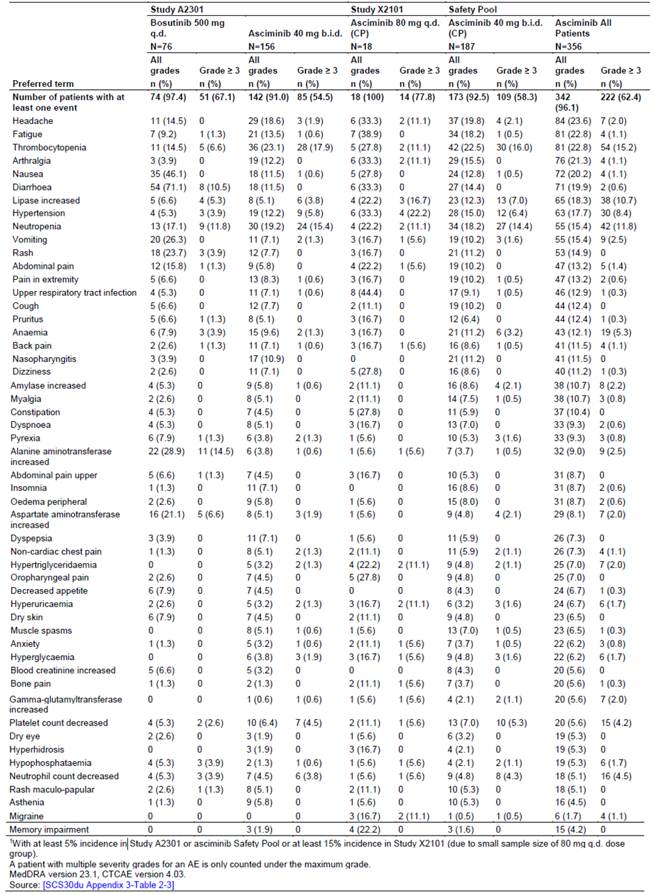

Abbreviations: ABL001 = drug development code for asciminib; b.i.d. = twice a day; q.d. = once daily.

1: With at least 5% incidence in Study A2301 or asciminib safety pool or at least 15% incidence in Study X2101 (due to small sample size of 80 mg once daily dose group).

A patient with multiple severity grades in an adverse event is only counted under the maximum grade.

See Table 11 for descriptions of the safety populations.

Table 14: Studies A2301 and X2101 Serious adverse events (including safety pool A population)

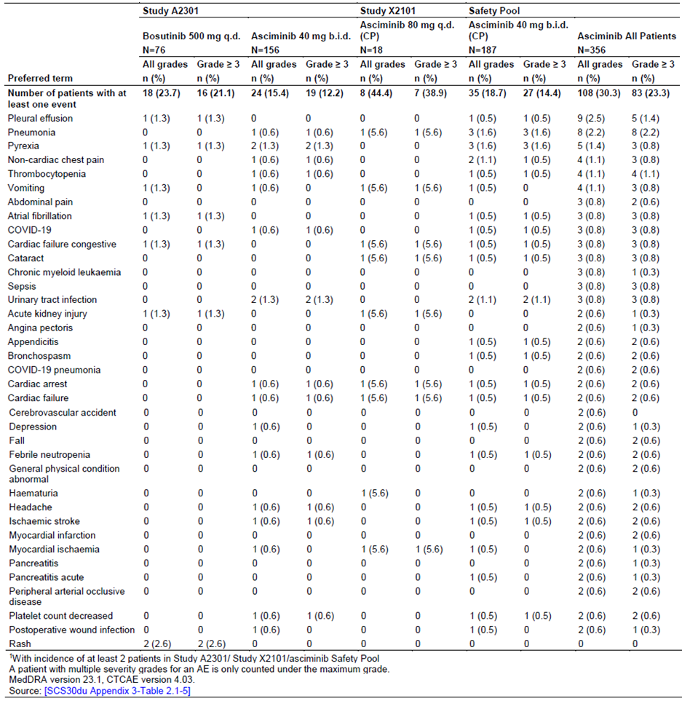

Abbreviations: ABL001 = drug development code for asciminib; b.i.d. = twice a day; q.d. = once daily.

1: With incidence of at least 2 patients in Study A2301/ Study X2101/asciminib safety pool.

A patient with multiple severity grades for an adverse evet is only counted under the maximum grade.

Grades based on common terminology criteria for adverse events (CTCAE) version 4.03.

See Table 11 for descriptions of the safety populations.

While there is a large difference in the proportion of patients given asciminib 40 mg twice a day versus 80 mg once daily (15.4% versus 44.4%) these differences are based on populations with different durations of exposure and sample sizes. There was no concentration of individual serious adverse events in the 80 mg once daily dose group. Neither is there any concentration in the Grade 3 serious adverse events in the 80 mg once daily dose group.

##### Laboratory abnormalities

Table 15: Studies A2301 and X2101 New or worsened haematology abnormalities based on common terminology criteria grades (includes safety pool A population)

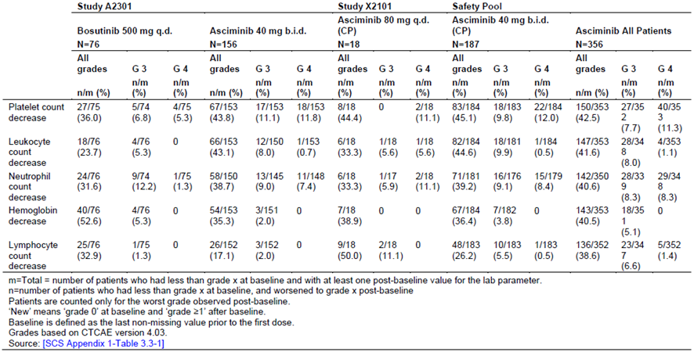

Abbreviations: ABL001 = drug development code for asciminib; b.i.d. = twice a day; q.d. = once daily.

m = Total number of patients who has less than grade x at Baseline and with at least one post-baseline value for the lab parameter; n = Number of patients who had less than grade x at Baseline and worsened to grade x post-baseline.

Patients are counted only for the worst grade observed post-baseline.

‘New’ means ‘grade 0’ at Baseline and ‘greater than or equal to grade 1’ after baseline.

Baseline is defined as the last non-missing value prior to the first dose.

Grades based on common terminology criteria for adverse events (CTCAE) version 4.03.

See Table 11 for descriptions of the safety populations.

Thrombocytopenia, leukopenia, and neutropenia are reported at a higher incidence with asciminib whereas bosutinib has a higher incidence of anaemia and lymphopenia. Data for asciminib was overall consistent across studies and different dosing regimens. Note that much of the difference in haematological abnormalities between the 40 mg twice a day and 80 mg once daily dose groups is due to a higher incidence of reduced lymphocytes in the 80 mg once daily group (17.1% versus 50%) but the 50% was due to only nine patients and the incidence of Grade 3 or 4 lymphocytopenia was much smaller 2% versus 11.1%, with the 11% due to two out of 18 patients given the 80 mg once daily dose regimen.

Table 16 showing chemistry abnormalities is from the data cut off 25 May 2020 dataset. At the update cut-off date of 6 January 2021 there were some numerical increases in the number of new or worsening of any biochemical abnormalities, but no clinically significant changes were observed compared to those previously reported. Additionally, in Study A2301 in the asciminib group, increases (any grade) did not exceed two new patients, with the exception of alanine aminotransferase increase (seven new patients), aspartate aminotransferase increase (five new patients), triglycerides increase (four new patients) and phosphate decrease (four patients), and for greater than or equal to Grade 3 were marginal. In Study X2101 asciminib 80 mg once daily dose amylase increase was observed in one new patient.

Table 16: Studies A2301 and X2101 New or worsening chemistry abnormalities (including safety pool A)

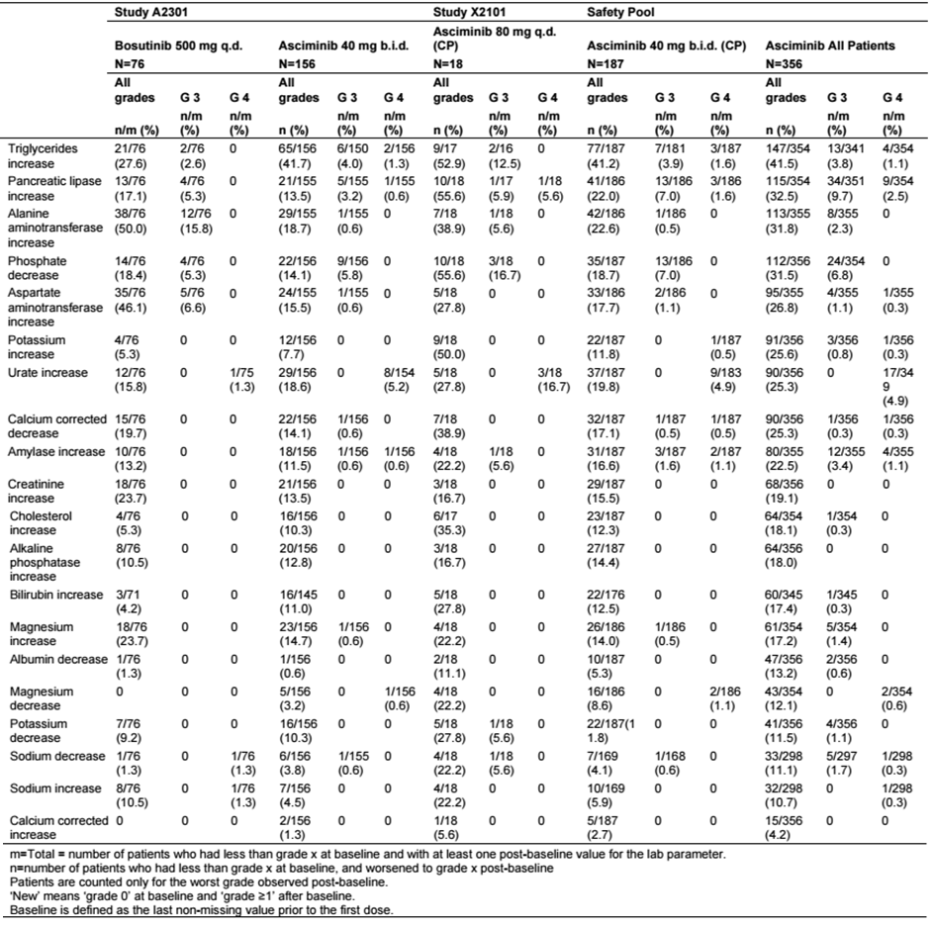

Abbreviations: ABL001 = drug development code for asciminib; b.i.d. = twice a day; q.d. = once daily.

m = Total number of patients who has less than grade x at Baseline and with at least one post-baseline value for the lab parameter; n = Number of patients who had less than grade x at Baseline and worsened to grade x post-baseline.

Patients are counted only for the worst grade observed post-baseline.

‘New’ means ‘grade 0’ at Baseline and ‘greater than or equal to Grade 1’ after baseline.

Baseline is defined as the last non-missing value prior to the first dose.

See Table 11 for descriptions of the safety populations.

The incidence of QTc prolongation adverse events;18 was low in both treatment groups: 4 out of 156; 2.6% in the asciminib group (two of QT prolongation, one syncope, one ventricular tachycardia) and 1 out of 76; 1.3% in the bosutinib (syncope). None of the events in asciminib arm were considered serious adverse events, two out of the four were considered not treatment related and the role of asciminib cannot be fully excluded in the other two patients.

##### Safety analyses in specific subgroups and populations

Exposure safety analyses based on PK safety set indicated a lack of association between exposure and chance of safety events (that is, laboratory abnormalities, vital sign abnormalities, fatigue/asthenia (based on adverse events), adverse events of Grade 3 or higher, adverse events leading to dose reductions) using pooled data from Study X2101 (Arm 1) and Study A2301 (N = 353).

Overall, the various subgroup analyses (age, gender, race, renal impairment at Baseline) showed a consistent pattern of events with those reported for the overall population in Study A2301. The proportion of patients having serious adverse events was higher (+10.7%) in those aged 65 years or older (24.1%) compared to those between the ages of 18 and 65 years (13.4%) and also the adverse events requiring additional therapy was higher (+13.9%) in those 65 years or age or older (79.3%) compared to those between 18 and 65 years (65.4%) of age. The incidence of adverse events in all other adverse event categories was similar (with difference of less than 15%) in all the age categories. There were only four patients aged 75 years or older (already included in the 65 years or older category).

##### Adverse events of special interest

Adverse events of special interest are based on the class effects of other tyrosine kinase inhibitors, mechanism of action and the nonclinical and clinical knowledge of asciminib. They include myelosuppression; pancreatic toxicity; hypersensitivity; hepatotoxicity; hepatitis B virus reactivation; reproductive toxicity; gastrointestinal toxicity; phototoxicity; QTc prolongation; cardiac failure; oedema and fluid retention; ischemic heart disease and ischaemic central nervous system vascular conditions; haemorrhage.

As previously discussed, thrombocytopenia was more frequent in patients given asciminib than bosutinib. In Study A2301 pancreatic toxicity (lipase and/or amylase increase) occurred in 8.3% and 9.2% of patients in the asciminib and bosutinib group respectively. The majority of these events were managed by dose interruption. No events of pancreatitis were reported in either of the treatment groups in Study A2301. In the total asciminib safety pool (Study A2301 on 25 May 2020; Study X2101on 02 Apr 2020) pancreatitis was reported in seven patients including one patient at 80 mg once daily dose.

Overall, pancreatic toxicity events were reported in 63 out of 200 (31.5%) patients with chronic myeloid leukaemia in chronic phase/accelerated phase, with Grade 3/4 events reported in 38 out of 200 (19%) patients. Lipase increase (26%; Grade 3/4: 14.5%), and amylase increase (13.5%; Grade 3/4: 3.5%) were the most frequent pancreatic toxicities (all grades) reported in greater than or equal to 10% of patients. Of note, pancreatitis (all grades) was reported in seven (3.5%) patients including Grade 3 in three (1.5%) patients, pancreatitis acute (all grades) in two (1%) patients including Grade 3 in one (0.5%) patient. These events included events in patients given treatments in addition to asciminib.

In Study A2301, hypersensitivity events were reported in 34.2% and 19.2% of patients in the bosutinib arm and asciminib respectively. Most of these events were skin disorders, primarily rash.

In Study A2301 the incidence of hepatotoxicity events (including laboratory terms) was 9% versus 30.3% for asciminib and bosutinib respectively (1.9% versus 17.1% for greater than or equal to Grade 3 events). Hepatitis B reactivation was not observed in Study A2301 or in the in 80 mg once dose group. One patient in the asciminib all patients safety pool (from Study X2101 at 120 mg once daily dose) had hepatitis B virus infection reactivation.[42]

Reproductive toxicity events occurred in Study A2301. In that study one patient in bosutinib group (congenital cardiovascular anomaly) and three patients in the asciminib group (spontaneous abortion and maternal exposure during pregnancy in one patient, maternal exposure during pregnancy in another patient who opted for termination of pregnancy and a cardiovascular anomaly in one patient) experienced events relative to reproductive toxicity. The diagnosis of both congenital cardiovascular anomalies were diagnosed in adult patients after signing the informed consent form at Baseline visit. In Study X2101, one patient was exposed to the combination of asciminib 40 mg once daily and imatinib 400 mg once daily during the first trimester of pregnancy. No adverse event was reported, and a full term normal neonate was delivered.

Based on updated 6 January 2021 cut off, in Study A2301 gastrointestinal toxicity adverse event occurred in 32.7% of patients given asciminib versus 78.9% given bosutinib (greater than or equal to Grade 3: 2.6% versus 11.8%). Nausea, vomiting and diarrhoea were the most frequent gastrointestinal toxicity events in both treatment groups. In Study A2301 QTc prolongation related events occurred in six patients (3.8 %) in the asciminib group and one patient (1.3%) in the bosutinib. In the asciminib group the events were electrocardiogram QT prolonged (n = 2), cardiac arrest (n = 1), syncope (n = 2) and ventricular tachycardia (n = 1). The single event in the bosutinib group was syncope.

In the all patients safety pool photosensitivity reaction (nine patients), sunburn (three patients) and retinal phototoxicity (one patient) were reported.

In Study A2301 cardiac failure occurred in 1.3% (two patients) and 1.3% (one patient; Grade 3) in the asciminib group and the bosutinib respectively. The events in the asciminib group were cardiac failure and ejection fraction decrease (each in one patient), both Grade 3. Ejection fraction decrease was suspected to be treatment related and led to study discontinuation. In the bosutinib group, one patient experienced cardiac failure congestive (Grade 3), considered a serious adverse event and required study treatment interruption. In Study X2101 asciminib 80 mg once daily dose, three patients had events of cardiac failure, all of greater than or equal to Grade 3 and serious adverse event, and none were considered treatment related or led to discontinuation of study treatment.

In Study A2301 oedema and fluid retention events occurred in 8.3% (13 patients) and 9.2% (seven patients) in the asciminib and bosutinib groups, respectively. There were no greater than or equal to Grade 3 events in the asciminib treatment group. In Study A2301, nine patients (5.8%) in the asciminib group and four patients (5.3%) in the bosutinib had ischemic heart and central nervous system condition events. These events include a patient who died of ischaemic stroke who was given asciminib 40 mg twice a day.

In Study A2301, 18 patients (11.5%) in the asciminib group and eight patients (10.5%) in the bosutinib had haemorrhage events.

#### Other clinical factors

It is not clear at this time whether and when in the course of their chronic myeloid leukaemia that patients should be tested for mutations in *BCR::ABL1*. The T315I mutation is associated with resistance to currently available treatments other than ponatinib. The development program included assessment of the safety and efficacy of asciminib in patients with this mutation however the sponsor is not pursuing that indication at this time. These patients required a higher dose of asciminib than patients without the mutation and the available data were limited. Use of that regimen would require identification of patients with chronic myeloid leukaemia with *BCR::ABL1* with that T315I mutation.

### Risk management plan

The sponsor has submitted European Union (EU) Risk management plan (RMP) version 1.0 (15 June 2021; data lock point (DLP) 6 January 2021) and Australia specific annex (ASA) version 1.0 (8 July 2021) in support of this application. No RMP updates were provided in the questions raised by TGA.

The summary of safety concerns and their associated risk monitoring and mitigation strategies are summarised in Table 17. Further information regarding the TGA’s risk management approach can be found in [risk management plans for medicines and biologicals](https://www.tga.gov.au/publication/risk-management-plans-medicines-and-biologicals) and [the TGA's risk management approach](https://www.tga.gov.au/tgas-risk-management-approach).

Table 17: Summary of safety concerns

|  |  |  |  |  |  |
| --- | --- | --- | --- | --- | --- |
| **Summary of safety concerns** | | **Pharmacovigilance** | | **Risk Minimisation** | |
| Routine | Additional | Routine | Additional |
| **Important identified risks** | Pancreatic Toxicity | ✓ | – | ✓ | – |
| Myelosuppression | ✓ | – | ✓ | – |
| QTc prolongation | ✓ | – | ✓ | – |
| **Important potential risks** | Hepatotoxicity | ✓ | – | ✓ | – |
| Hepatitis B virus infection reactivation | ✓ | – | ✓ | – |
| Reproductive toxicity | ✓ | – | ✓ | – |
| **Missing information†** | Long term safety | ✓ | ✓* | – | – |

* Clinical trials

† ‘Use in paediatric population’ was originally included under ‘Missing information’ in EU-RMP version 1.0 submitted, and was subsequently removed at the request of the TGA following the second round of RMP evaluation.

The summary of safety concerns proposed by the sponsor are generally endorsed. The sponsor was asked to further discuss ‘use in paediatric population’ and noting the elimination pathways for asciminib, whether drug interactions with asciminib warrant inclusion in the RMP summary of safety concerns. The sponsor was requested to include hypertension as an important identified risk. The sponsor has satisfactorily addressed the concerns regarding hypertension and drug interactions in a TGA request for information and inclusion in the summary of safety concerns is not requested at this time. With missing information ‘use in paediatric population’ removed, the summary of safety concerns is considered acceptable from an RMP perspective.

Routine pharmacovigilance activities only are proposed. The sponsor has been asked to discuss the adequacy of routine pharmacovigilance for missing information ‘long term safety’ and consider whether additional pharmacovigilance activities could better characterise this safety concern. The sponsor has advised that additional pharmacovigilance in the form of four ongoing clinical trials to further characterise missing information ‘long term safety’ will be conducted. Once an updated ASA and EU RMP have been provided that include these additional pharmacovigilance activities, the pharmacovigilance plan will be considered acceptable from an RMP perspective.

Routine risk minimisation activities only are proposed which is acceptable as asciminib is an oral formulation prescribed by specialists and the safety concerns can be adequately addressed in the PI and Consumer Medicines Information (CMI). The risk minimisation plan is considered acceptable.

#### RMP evaluation’s recommendations regarding condition/s of registration

Any changes to which the sponsor has agreed should be included in a revised RMP and ASA. However, irrespective of whether or not they are included in the currently available version of the RMP document, the agreed changes become part of the risk management system.

‘The Scemblix EU-Risk Management Plan (RMP) (version 1.0, dated 15 June 2021, data lock point 6 January 2021), with Australian Specific Annex (version 1.0, dated 8 July 2021), included with submission PM-2021-03048-1-6, to be revised to the satisfaction of the TGA, and any subsequent revisions, will be implemented in Australia.’

The following wording is recommended for the periodic safety update report (PSUR) requirement:

‘An obligatory component of risk management plans is routine pharmacovigilance. Routine pharmacovigilance includes the submission of periodic safety update reports (PSURs).

Unless agreed separately between the supplier who is the recipient of the approval and the TGA, the first report must be submitted to TGA no later than 15 calendar months after the date of the approval letter. The subsequent reports must be submitted no less frequently than annually from the date of the first submitted report until the period covered by such reports is not less than three years from the date of the approval letter. The annual submission may be made up of two PSURs each covering six months. If the sponsor wishes, the six monthly reports may be submitted separately as they become available.

If the product is approved in the EU during the three years period, reports can be provided in line with the published list of EU reference dates no less frequently than annually from the date of the first submitted report until the period covered by such reports is not less than three years from the date of the approval letter.

The reports are to at least meet the requirements for PSURs as described in the European Medicines Agency’s Guideline on good pharmacovigilance practices (GVP) Module VII-periodic safety update report (Rev 1), Part VII.B Structures and processes. Note that submission of a PSUR does not constitute an application to vary the registration. Each report must have been prepared within ninety calendar days of the data lock point for that report.’

As Scemblix is a new chemical entity it should be included in the Black Triangle Scheme as a condition of registration. The following wording is recommended for the condition of registration:

‘Scemblix (asciminib hydrochloride) is to be included in the Black Triangle Scheme. The PI and CMI for Scemblix must include the black triangle symbol and mandatory accompanying text for five years, which starts from the date that the sponsor notifies the TGA of supply of the product.’

### Risk-benefit analysis

#### Delegate’s considerations

No absolute bioavailability study has been conducted and the drug-drug interaction studies are not comprehensive. The United States (US) Food and Drug Administration (FDA);[43] recommended the sponsor conduct physiological based pharmacokinetic simulations of asciminib when co-administered with breast cancer resistant protein substrates, organic anion-transporting polypeptide 1B1 and 1B3 (OATP1B1/3) substrates, strong CYP3A;17 and UGT inducers and for concomitant use of asciminib with oral drug products containing hydroxypropyl-β-cyclodextrin. Conduct of these studies was not a condition of approval for marketing in the USA. A paediatric pharmacokinetic (PK), efficacy and safety study was required.

Based on *in vitro* assessments, PK study results, population pharmacokinetic (popPK) modelling and the limited efficacy and safety data from Study X2101, the asciminib dose of 80 mg once daily is expected to provide similar efficacy and safety to that of the 40 mg twice a day dose (refer to Table 10 and Table 12 respectively) that was given in the pivotal study. No dose adjustment is needed for patients with hepatic or renal impairment or for age, body weight or race.

The criteria for dose reduction and interruption that were applied in the pivotal study (Study A2301, also known as the ASCEMBL trial) have been included in the dose modification recommendations in the Product Information (PI).

Study A2301 convincingly demonstrated superiority of efficacy of asciminib over bosutinib (another tyrosine kinase inhibitor) in adult patients with Philadelphia chromosome positive chronic myeloid leukaemia in chronic phase with at least two prior lines of tyrosine kinase inhibitors. The primary efficacy endpoint was the Week 24 major molecular response. While the European Society for Medical Oncology (ESMO);[44] accepts that 3 month data predicts longer term response (see Assessment of chronic myeloid leukaemia response to treatment, above); the 24 week major molecular response has not been fully accepted as a surrogate for long term response by the US FDA, where previously Week 96 major molecular response data were required to confirm efficacy.43 The lack of longer term data was stated to be the reason for the accelerated approval in the USA (see Regulatory status, above).

The major molecular response rate was higher in the asciminib arm than in the bosutinib arm at each timepoint assessed to Week 24. Additionally, the median time to major molecular response was somewhat less with asciminib than bosutinib (12.7 weeks versus 14.3 weeks). The 96 week major molecular response data confirm efficacy of asciminib in the proposed setting and demonstrated durability of response.

Dose reductions and interruptions were more frequent for patients given bosutinib than those given asciminib with dose adjustments primarily due to adverse events. Similarly treatment duration was longer for patients given asciminib than those given bosutinib (median duration of 43.4 weeks; range: 0.1 to 129.9 for asciminib versus median duration of 29.2 weeks; range: 1 to 117 for bosutinib).

Overall, discontinuations in both treatment arms were predominantly due to lack of efficacy, followed by adverse events and physician decision, although all were less frequent in the asciminib arm relative to the bosutinib arm (lack of efficacy: 21% versus 31.6%; adverse events: 5.1% versus 21.1%; physician decision: 6.4% versus 7.9%). Twenty-two patients (28.9%) randomised to bosutinib switched to asciminib treatment after meeting lack of efficacy criteria as per protocol.

Overall, the safety profile of asciminib at 40 mg twice a day appears somewhat more favourable than that of bosutinib.

Some adverse events have been identified with tyrosine kinase inhibitor treatment (myelosuppression, pancreatic toxicity, hypersensitivity, haemorrhage) or in nonclinical studies (QTc prolongation;18 pancreatic toxicity) and these have been identified in the proposed PI and their association with asciminib adequately described.

There are limited long term safety data however patients may receive asciminib for considerably longer periods than data currently support. It is acknowledged this is an important safety issue in a disease like chronic myeloid leukaemia in chronic phase but in the context of a new tyrosine kinase inhibitor with a different mechanism of action that has shown efficacy superiority over bosutinib, the benefit outweighs the risk from lack of longer term data. However, it is important that patients are monitored appropriately, information is adequately described in the PI for both, healthcare professionals and patients, and an appropriate RMP is in place.

The safety profile for asciminib is considered acceptable in the treatment of chronic myeloid leukaemia in chronic phase without T315I mutation at the proposed doses of 40 mg twice a day and 80 mg once daily. There are major safety concerns for the approval of a broad indication including treatment of chronic myeloid leukaemia in chronic phase with T315I mutation using a dose of 200 mg twice a day.

While the pivotal Study A2301 supports an indication in patients with chronic myeloid leukaemia in chronic phase who have received two prior tyrosine kinase inhibitors, the presence of mutation T315I or V299L were an exclusion criterion as they are resistant to bosutinib. The T315I mutation is particularly important as it confers resistance to all available tyrosine kinase inhibitors (imatinib,11 dasatinib,13 nilotinib,12 bosutinib)14 except ponatinib. The proposed indication allows for a broad inclusion of all chronic myeloid leukaemia in chronic phase patients who have received at least two prior tyrosine kinase inhibitor regardless of their mutation status.

##### Summary of questions raised for this submission

The Delegate had the following considerations for this submission:

* Whether to specifically exclude patients with T315I mutations in the indication noting that these patients aren’t excluded from the indication for other chronic myeloid leukaemia treatments which are known to be ineffective against the T315I mutation. Would such an exclusion require testing for T315I mutation for all patients in whom asciminib was being considered?
* Post-market requirements for long term efficacy and safety follow up and submission of the same study as required by the US FDA.

#### Proposed action

The Delegate proposes to approve registration of Scemblix for the treatment of adult patients with Philadelphia chromosome positive chronic myeloid leukaemia in chronic phase previously treated with two or more tyrosine kinase inhibitors.

Approval would be subject to negotiation of the conditions of approval, including the indication.

#### Advisory Committee considerations

The [Advisory Committee on Medicines (ACM)](https://www.tga.gov.au/committee/advisory-committee-medicines-acm), having considered the evaluations and the Delegate’s overview, as well as the sponsor’s response to these documents, advised the following.

##### Specific advice to the Delegate

1. ***Given that the sponsor does not, at this time, intend to pursue an indication for patients harbouring the T315I mutation, does the Committee consider the indication should specifically exclude patients known to have the T315I mutation?***

The ACM agreed that should the sponsor continue to not pursue the indication for patients harbouring the T315I mutation, then referral to the data associated with the mutation should be removed from the Product Information (PI) and a precautionary statement in relation to use in patients harbouring the T315I mutation included.

In providing this recommendation the ACM noted evidence of efficacy and safety has been provided for patients harbouring the T315I mutation when a higher dose of 200 mg twice daily is used. The ACM expressed significant concern regarding underdosing of patients with the T315I mutation given that currently the dosage and administration section of the PI states that the recommended total daily dose of Scemblix is 80 mg.

To ensure appropriate dosing for this population who currently have minimal mutation specific treatment options, the ACM urged the sponsor to include Philadelphia chromosome positive chronic myeloid leukaemia in chronic phase with the T315I mutation in the indication along with specific dosage instructions within the dosage and administration section of the PI. Alternatively, a statement indicating the concerns with the dosage for patients harbouring the mutation should be included within the PI.

The ACM acknowledged the sponsors statement in relation to the T315I mutation testing and agreed that it is not appropriate to request all Philadelphia chromosome positive chronic myeloid leukaemia in chronic phase patients to be tested for the T315I mutation. However, the ACM agreed that should the presence of this mutation become known, dosage consideration in line with the clinical trial findings will be important.

1. ***Is molecular response routinely assessed in patients receiving ongoing treatment for chronic myeloid leukaemia in Australia?***

The ACM advised that major molecular response is routinely assessed in patients receiving ongoing treatment for chronic myeloid leukaemia in Australia. The ACM noted that major molecular response, being a *BCR::ABL1* transcript level of less than or equal to 0.1%, is the goal of treatment and predicts survival, demonstrates treatment failure, progression and resistance. It also determines the need for change or discontinuation of tyrosine kinase inhibitors and/or a need for bone marrow transplant. Treatment may also be discontinued if there is no major molecular response.

1. ***Are the data regarding the subgroup analyses of major molecular response likely to be useful for treating physicians in Australia?***

The ACM advised that the data regarding the subgroup analysis of major molecular response would be useful to treating physicians in Australia and should be included within the PI.

1. ***There is no information on dosing in children and no efficacy or safety data. No age limit is proposed in the indication. Please comment on this omission, including whether you consider the indication should be amended to exclude patients aged less than 18 years as per the pivotal clinical trial.***

The ACM was of the view that the indication should be amended to exclude patients aged less than 18 years. Noting that there is currently no clinical trial data available to support the use of Scemblix within the under 18 years age group. Furthermore, the ACM noted that chronic myeloid leukaemia in children is a very rare event, with the more common clinical scenario being Philadelphia chromosome positive acute lymphoblastic leukaemia.

The ACM did however welcome the news of an ongoing paediatric study for Philadelphia chromosome positive chronic myeloid leukaemia in chronic phase.

The ACM preferred the use of ‘patients 18 years and above’ rather than ‘adults’ within the indication as defining an age range reduces ambiguity.

1. ***Other advice***

The ACM was supportive of a ‘cardiac toxicity’ heading within the PI to list all cardiac complications.

##### Conclusion

The ACM considered this product to have an overall positive benefit-risk profile for the indication:

*For the treatment of patients 18 years of age and above with Philadelphia chromosome-positive chronic myeloid leukaemia (Ph+ CML) in chronic phase (CP) previously treated with two or more tyrosine kinase inhibitors.*

## Outcome

Based on a review of quality, safety, and efficacy, the TGA approved the registration of Scemblix (asciminib) 20 mg and 40 mg tablets for the following proposed indication:

*Scemblix is indicated for the treatment of patients 18 years of age and above with:*

* *Philadelphia chromosome-positive chronic myeloid leukaemia (Ph+ CML) in chronic phase (CP) previously treated with two or more tyrosine kinase inhibitors (see section 5.1 Clinical trials).*
* *Ph+ CML in CP with the T315I mutation.*

### Specific conditions of registration applying to these goods

* Scemblix (asciminib hydrochloride) is to be included in the Black Triangle Scheme. The PI and CMI for Scemblix must include the black triangle symbol and mandatory accompanying text for five years, which starts from the date that the sponsor notifies the TGA of supply of the product.
* The Scemblix EU-Risk Management Plan (RMP) (version 1.0, dated 15 June 2021, data lock point 6 January 2021), with Australia Specific Annex (version 1.0, dated 8 July 2021), included with submission PM-2021-03048-1-6, to be revised to the satisfaction of the TGA, and any subsequent revisions, will be implemented in Australia.

An obligatory component of risk management plans is routine pharmacovigilance. Routine pharmacovigilance includes the submission of periodic safety update reports (PSURs).

Unless agreed separately between the supplier who is the recipient of the approval and the TGA, the first report must be submitted to TGA no later than 15 calendar months after the date of the approval letter. The subsequent reports must be submitted no less frequently than annually from the date of the first submitted report until the period covered by such reports is not less than three years from the date of the approval letter. The annual submission may be made up of two PSURs each covering six months. If the sponsor wishes, the six monthly reports may be submitted separately as they become available.

If the product is approved in the EU during the three years period, reports can be provided in line with the published list of EU reference dates no less frequently than annually from the date of the first submitted report until the period covered by such reports is not less than three years from the date of the approval letter.

The reports are to at least meet the requirements for PSURs as described in the European Medicines Agency’s Guideline on good pharmacovigilance practices (GVP) Module VII-periodic safety update report (Rev 1), Part VII.B Structures and processes. Note that submission of a PSUR does not constitute an application to vary the registration. Each report must have been prepared within ninety calendar days of the data lock point for that report.

## Attachment 1. Product Information

The PI for Scemblix approved with the submission which is described in this AusPAR is at Attachment 1. For the most recent PI, please refer to the TGA [PI/CMI search facility.](https://www.tga.gov.au/picmi-search-facility)

|  |
| --- |
| Therapeutic Goods Administration |
| PO Box 100 Woden ACT 2606 Australia  Email: [info@tga.gov.au](mailto:info@tga.gov.au) Phone: 1800 020 653 Fax: 02 6232 8605  [**https://www.tga.gov.au**](https://www.tga.gov.au) |

1. Zhou T, Medeiros LJ, Hu S. Chronic Myeloid Leukemia: Beyond BCR-ABL1. *Curr Hematol Malig Rep.* 2018;13:435–445.
2. Jabbour E, Kantarjian H. Chronic myeloid leukemia: 2018 update on diagnosis, therapy

   and monitoring. Am J Hematol; 2018; 93(3):442-59.
3. Arber DA, Orazi A, Hasserjian R, Thiele J, Borowitz MJ, Le Beau MM, Bloomfield CD, Cazzola M, Vardiman JW. The 2016 revision to the World Health Organization classification of myeloid neoplasms and acute leukemia. *Blood.* 2016;127:2391–2405.
4. Apperley JF. Chronic myeloid leukaemia. *Lancet*; 2015;385:1447-59.
5. Quintás-Cardama A, Kantarjian HM, Cortes JE. Mechanisms of primary and secondary resistance to imatinib in chronic myeloid leukemia. *Cancer Control.* 2009;16(2):122-131.
6. Jabbour E, Parikh SA, Kantarjian H, Cortes J. Chronic myeloid leukemia: mechanisms of resistance and treatment. *Hematol Oncol Clin North Am*. 2011;25(5):981-v.
7. Soverini S, Martinelli G, Rosti G, et al ABL mutations in late chronic phase chronic myeloid leukemia patients with up-front cytogenetic resistance to imatinib are associated with a greater likelihood of progression to blast crisis and shorter survival: a study by the GIMEMA Working Party on chronic myeloid leukemia. J Clin Oncol; 2005; 23(18):4100-9.
8. Australian Institute of Health and Welfare (AIHW) Cancer Data in Australia 2020, Book 3, Table 3a.
9. Australian Institute of Health and Welfare (AHIW) Cancer Data in Australia 2020, Book 8, Table 8a and 8b.
10. Neil P. Shah et al. Dasatinib in imatinib-resistant or intolerant chronic phase Chronic Myeloid Leukaemia patients: 7-year follow-up of study CA180-034. Am. J. Hematol. 91:869–874, 2016.
11. Imatinib was first registered in Australia on 17 December 2003. ARTG number: 94216
12. Nilotinib was first registered in Australia on 17 January 2008. ARTG number: 133086
13. Dasatinib was first registered in Australia on 15 January 2007. ARTG number: 125557
14. Bosutinib was first registered in Australia on 29 April 2014. ARTG number: 208809
15. Ponatinib was first registered in Australia on 26 November 2014. ARTG number: 212583
16. The United States (US) Food and Drug Administration (FDA) **Accelerated Approval** Program allows for earlier approval of drugs that treat serious conditions, and fill an unmet medical need based on a surrogate endpoint. A surrogate endpoint is a marker, such as a laboratory measurement, radiographic image, physical sign or other measure that is thought to predict clinical benefit but is not itself a measure of clinical benefit. The use of a surrogate endpoint can considerably shorten the time required prior to receiving FDA approval.

    Drug companies are still required to conduct studies to confirm the anticipated clinical benefit. If the confirmatory trial shows that the drug actually provides a clinical benefit, then the FDA grants traditional approval for the drug. If the confirmatory trial does not show that the drug provides clinical benefit, FDA has regulatory procedures in place that could lead to removing the drug from the market.
17. **Cytochrome P450** (**CYP**) **enzymes** are the major enzymes involved in drug metabolism, accounting for large part of the total metabolism. Most drugs undergo deactivation by CYPs, either directly or by facilitated excretion from the body. Also, many substances are bioactivated by CYPs to form their active compounds.

    Many drugs may increase or decrease the activity of various CYP isozymes either by inducing the biosynthesis of an isozyme (enzyme induction) or by directly inhibiting the activity of the CYP (enzyme inhibition). This is a major source of adverse drug interactions, since changes in CYP enzyme activity may affect the metabolism and clearance of various drugs. Such drug interactions are especially important to take into account when using drugs of vital importance to the patient, drugs with important side-effects and drugs with small therapeutic windows, but any drug may be subject to an altered plasma concentration due to altered drug metabolism.
18. The **QT** interval is the time from the start of the QRS wave complex to the end of the corresponding T wave. It approximates to the time taken for ventricular depolarisation and repolarisation, that is to say, the period of ventricular systole from ventricular isovolumetric contraction to isovolumetric relaxation. The corrected QT interval (**QTc**) estimates the QT interval at a standard heart rate. This allows comparison of QT values over time at different heart rates and improves detection of patients at increased risk of arrhythmias.

    The **QTcF** is the QT interval corrected for heart rate according to Fridericia’s formula.
19. Drugs which have been taken by only a limited number of pregnant women and women of childbearing age, without an increase in the frequency of malformation or other direct or indirect harmful effects on the human fetus having been observed. Studies in animals have shown evidence of an increased occurrence of fetal damage, the significance of which is considered uncertain in humans.
20. **Pregnancy Category D**: Drugs which have caused, are suspected to have caused or may be expected to cause, an increased incidence of human fetal malformations or irreversible damage. These drugs may also have adverse pharmacological effects. Accompanying texts should be consulted for further details.
21. Midazolam was first registered in Australia on 23 August 1991. ARTG number: 13726
22. Warfarin was first registered in Australia on 13 August 1991. ARTG number: 12511
23. Itraconazole was first registered in Australia on 2 February 1994. ARTG number: 47012
24. Clarithromycin was first registered in Australia on 13 June 1995. ARTG number: 52473
25. Rifampicin was first registered in Australia on 8 July 1991. ARTG number 10113
26. AUC0-last = area under the concentration-time curve from time zero to the last measurable concentration.
27. Grades are based on National Cancer Institute Common Terminology Criteria for Adverse Events (NCI CTCAE) v 4.03. available from [Common Terminology Criteria for Adverse Events (CTCAE) (nih.gov)](https://evs.nci.nih.gov/ftp1/CTCAE/CTCAE_4.03/CTCAE_4.03_2010-06-14_QuickReference_8.5x11.pdf)
28. Total daily dose of 80 mg as either 40 mg taken twice a day, *or* 80 mg taken once a day.
29. The Modified **Child-Pugh classification of the severity of liver disease** is based on the degree of ascites, the serum concentrations of bilirubin and albumin, the prothrombin time (or International normalised ratio (INR), and the degree of encephalopathy. Each of the five variables is assigned 1 to 3 points depending on the criteria for each. When added together, this produces the total Child-Pugh score. The scoring of the five variables is as follows:

    A total Child-Pugh score of 5 to 6 is considered Child-Pugh class A (well-compensated disease), 7 to 9 is class B (significant functional compromise), and 10 to 15 is class C (decompensated disease). Interpretation varies but these classes correlate with one- and two-year patient survival: class A: 100 and 85%; class B: 80 and 60%; and class C: 45 and 35%.
30. **National Cancer Institute Organ Dysfunction Working Group Criteria for Hepatic Dysfunction**

    has four hepatic function categories of normal and mild, moderate or severe dysfunction, based on a combination of total bilirubin and aspartate transaminase (AST) as markers. The criteria are as follows:

    - Normal function: total bilirubin *and* AST ≤ the upper limit of normal (ULN);

    - Mild dysfunction Group 1: total bilirubin ≤ ULN *and* AST > ULN;

    - Mild dysfunction Group 2: total bilirubin 1.0 to 1.5 x ULN (with or without raised AST)

    - Moderate dysfunction: total bilirubin > 1,5 to 3.0 x ULN (with or without raised AST)

    - Severe dysfunction: total bilirubin > 3.0 x ULN (with or without raised AST).
31. Chronic myeloid leukaemia: ESMO Clinical Practice Guidelines for diagnosis, treatment and follow-up, *Annals of Oncology,* 2017; 28 (supplement 4): iv41-iv51.
32. Soverini S, De Benedittis C, Mancini M, Martinelli G Best Practices in Chronic Myeloid Leukaemia Monitoring and Management. Oncologist; 21(5)626-33.
33. US Food and Drug Administration. Hematologic Malignancies: Regulatory Considerations for Use of Minimal Residual Disease in Development of Drug and Biological Products for Treatment, Guidance for Industry. January 2020. Available from [Hematologic Malignancies: Regulatory Considerations for Use of Minimal Residual Disease in Development of Drug and Biological Products for Treatment Guidance for Industry (fda.gov)](https://www.fda.gov/media/134605/download)
34. Hehlmann R. et al. CML study IV and impact of non-CML determinants. Leukaemia (2017) 31, 2398–2406;
35. Hehlmann R, et al. Deep Molecular Response Is Reached by the Majority of Patients Treated With Imatinib, Predicts Survival, and Is Achieved More Quickly by Optimized High-Dose Imatinib: Results From the Randomized CML-Study (2014) IV. J Clin Oncol 32:415-423.
36. **Polymorphic ventricular tachycardia** is a type of ventricular tachycardia, or an abnormally fast abnormal heart rhythm originating in the ventricles of the heart. On electrocardiogram (ECG), the QRS-complexes (which corresponds to the depolarisation of the right and left ventricles of the heart and contraction of the cardiac ventricular muscles) are irregular in amplitude, axis, and duration.

    **Torsade de pointes** is a specific form of polymorphic ventricular tachycardia occurring in the context of QT‑interval prolongation. It is named from the French meaning ‘twisting on points’ because the QRS-complexes appear to twist on around the baseline on ECG. Torsade de pointes is often short in duration and self-terminating, however can be associated with haemodynamic instability and collapse. Torsade de pointes may also degenerate into ventricular fibrillation, a type of cardiac arrest rhythm with a resulting loss of cardiac output from the heart,

    The underlying QT prolongation behind torsade de pointes may occur due to congenital or acquired causes, including some drugs that prolong the QT interval. Underlying factors may combine in to produce torsade de pointes in susceptible individuals, for example the use of drug that may prolong the QT interval in a patient with congenital long QT syndrome.
37. Hughes, T.P. et al. Asciminib in Chronic Myeloid Leukaemia after ABL Kinase Inhibitor Failure, *New England Journal of Medicine*, 2019; 381: 2315-2326.
38. Baccarani, M. et al. European LeukemiaNet recommendations for the management of chronic myeloid leukemia: 2013, *Blood*, 2013; 122 (6), 872-884.
39. **Eastern Cooperative Oncology Group Performance Status** (**ECOG PS**): The ECOG has developed criteria used by doctors and researchers to assess how a patient's disease is progressing, assess how the disease affects the daily living abilities of the patient, and determine appropriate treatment and prognosis. The following are used:

    0 - Fully active, able to carry on all pre-disease performance without restriction

    1- Restricted in physically strenuous activity but ambulatory and able to carry out work of a light or sedentary nature, for example, light house work, office work

    2 - Ambulatory and capable of all selfcare but unable to carry out any work activities. Up and about more than 50% of waking hours

    3 - Capable of only limited selfcare, confined to bed or chair more than 50% of waking hours

    4 - Completely disabled. Cannot carry on any selfcare. Totally confined to bed or chair

    5 – Dead
40. Khoury, H.J. et al. Bosutinib is active in chronic phase chronic myeloid leukaemia after imatinib and dasatinib and/or nilotinib therapy failure, *Blood*, 2012; 119 (16): 3403-3412.
41. **EQ-5D-5L** is a self-assessed, health related, quality of life questionnaire. The scale measures quality of life on a five component scale including mobility, self-care, usual activities, pain/discomfort and anxiety/depression.
42. Sponsor clarification: this patient was a hepatitis B virus carrier, but never had viral reactivation.
43. United States (US) Food and Drug Administration (FDA) New Drug Application/Biologics License Application (NDA/BLA) Multi-disciplinary Review and Evaluation (NDA 215358) for Scemblix (asciminib), January 2020. Available at: [215358Orig1s000,Orig2s000MultidisciplineR.pdf (fda.gov)](https://www.accessdata.fda.gov/drugsatfda_docs/nda/2021/215358Orig1s000,Orig2s000MultidisciplineR.pdf)
44. Chronic myeloid leukaemia: ESMO Clinical Practice Guidelines for diagnosis, treatment and follow-up, *Annals of Oncology,* 2017; 28 (supplement 4): iv41-iv51.