|  |
| --- |
| April 2023 |

|  |
| --- |
| Australian Public Assessment Report for Byooviz |
| Active ingredient: Ranibizumab |
| Sponsor: Samsung Bioepis AU Pty Ltd |

About the Therapeutic Goods Administration (TGA)

* The Therapeutic Goods Administration (TGA) is part of the Australian Government Department of Health and is responsible for regulating therapeutic goods, including medicines, medical devices, and biologicals.
* The TGA administers the *Therapeutic Goods Act 1989* (the Act), applying a risk management approach designed to ensure therapeutic goods supplied in Australia meet acceptable standards of quality, safety, and efficacy.
* The work of the TGA is based on applying scientific and clinical expertise to decision-making, to ensure that the benefits to the Australian public outweigh any risks associated with the use of therapeutic goods.
* The TGA relies on the public, healthcare professionals and industry to report problems with therapeutic goods. The TGA investigates reports received to determine any necessary regulatory action.
* To report a problem with a therapeutic good, please see the information on the [TGA website](https://www.tga.gov.au).

About AusPARs

* The Australian Public Assessment Report (AusPAR) provides information about the evaluation of a prescription medicine and the considerations that led the TGA to approve or not approve a prescription medicine submission. Further information can be found in [Australian Public Assessment Report (AusPAR) guidance](https://www.tga.gov.au/australian-public-assessment-report-auspar-guidance).
* AusPARs are prepared and published by the TGA.
* AusPARs are static documents that provide information that relates to a submission at a particular point in time. The publication of an AusPAR is an important part of the transparency of the TGA’s decision-making process.
* A new AusPAR may be provided to reflect changes to indications or major variations to a prescription medicine subject to evaluation by the TGA.

Copyright

© Commonwealth of Australia 2023  
This work is copyright. You may reproduce the whole or part of this work in unaltered form for your own personal use or, if you are part of an organisation, for internal use within your organisation, but only if you or your organisation do not use the reproduction for any commercial purpose and retain this copyright notice and all disclaimer notices as part of that reproduction. Apart from rights to use as permitted by the *Copyright Act 1968* or allowed by this copyright notice, all other rights are reserved, and you are not allowed to reproduce the whole or any part of this work in any way (electronic or otherwise) without first being given specific written permission from the Commonwealth to do so. Requests and inquiries concerning reproduction and rights are to be sent to the TGA Copyright Officer, Therapeutic Goods Administration, PO Box 100, Woden ACT 2606 or emailed to <[tga.copyright@tga.gov.au](mailto:tga.copyright@tga.gov.au)>.

Contents

List of abbreviations 4

Product submission 6

Submission details 6

Product background 7

Regulatory status 9

Product Information 10

Registration timeline 11

Submission overview and risk/benefit assessment 11

Quality 12

Nonclinical 13

Clinical 14

Risk management plan 26

Risk-benefit analysis 27

Outcome 28

Specific conditions of registration applying to these goods 29

Attachment 1. Product Information 29

## List of abbreviations

|  |  |  |
| --- | --- | --- |
| Abbreviation | | Meaning |
| ACM | Advisory Committee on Medicines | |
| ADA | Anti-drug antibody | |
| AMD | Age-related macular degeneration | |
| ARGPM | Australian Regulatory Guidelines for Prescription Medicines | |
| ARTG | Australian Register of Therapeutic Goods | |
| ASA | Australia specific annex | |
| BCVA | Best corrected visual acuity | |
| CHMP | Committee for Medicinal Products for Human Use (European Medicines Agency, European Union) | |
| CI | Confidence interval | |
| CNV | Choroidal neovascularisation | |
| COR-B | Comparable Overseas Regulator B | |
| CPD | Certified Product Details | |
| DLP | Data lock point | |
| DME | Diabetic macular oedema | |
| EMA | European Medicines Agency (European Union) | |
| EU | European Union | |
| GVP | Good Pharmacovigilance Practices | |
| PDR | Proliferative diabetic retinopathy | |
| PI | Product Information | |
| PM | Pathologic myopia | |
| RMP | Risk management plan | |
| RVO | Retinal vein occlusion | |
| SAE | Serious adverse event | |
| TGA | Therapeutic Goods Administration | |
| TEAE | Treatment-emergent adverse event | |
| US(A) | United States of (America) | |
| VEGF | Vascular endothelial growth factor | |

## Product submission

### Submission details

|  |  |
| --- | --- |
| *Type of submission:* | Biosimilar medicine |
| *Product name:* | Byooviz |
| *Active ingredient:* | Ranibizumab |
| *Decision:* | Approved |
| *Date of decision:* | 16 August 2022 |
| *Date of entry onto ARTG:* | 24 August 2022 |
| *ARTG number:* | 375304 |
| [*Black Triangle Scheme*](https://www.tga.gov.au/black-triangle-scheme)*:* | No |
| *Sponsor’s name and address:* | Samsung Bioepis AU Pty Ltd  Level 16, 201 Elizabeth Street  Sydney NSW 2000 |
| *Dose form:* | Solution for injection |
| *Strength:* | 10 mg/mL |
| *Container:* | Vial |
| *Pack size:* | One single-use vial |
| *Approved therapeutic use:* | *Byooviz (ranibizumab) is indicated in adults for:*   * *the treatment of neovascular (wet) age-related macular degeneration (AMD),* * *the treatment of visual impairment due to diabetic macular oedema (DME),* * *treatment of proliferative diabetic retinopathy (PDR),* * *the treatment of visual impairment due to choroidal neovascularisation (CNV),* * *the treatment of visual impairment due to choroidal neovascularisation (CNV) secondary to pathologic myopia (PM),* * *the treatment of visual impairment due to macular oedema secondary to retinal vein occlusion (RVO).* |
| *Route of administration:* | Intravitreal (within the vitreous cavity of the eye) |
| *Dosage:* | Single-use vial for intravitreal use only. Use of more than one injection from a vial can lead to product contamination and subsequent ocular infection.  Byooviz must be administered by a qualified ophthalmologist experienced in intravitreal injections.  The recommended dose for Byooviz is 0.5 mg given as a single intravitreal injection. This corresponds to an injection volume of 0.05 mL. The interval between two doses injected into the same eye should be at least four weeks.  The recommended maximal dose (0.5 mg) should not be exceeded. Post-injection monitoring is recommended (see Section 4.4 Special Warnings and Precautions for Use of the Product Information).  For further information regarding dosage, refer to the Product Information. |
| *Pregnancy category:* | D  Drugs which have caused, are suspected to have caused or may be expected to cause, an increased incidence of human fetal malformations or irreversible damage. These drugs may also have adverse pharmacological effects. Accompanying texts should be consulted for further details.  The use of any medicine during pregnancy requires careful consideration of both risks and benefits by the treating health professional. This must not be used as the sole basis of decision making in the use of medicines during pregnancy. The TGA does not provide advice on the use of medicines in pregnancy for specific cases. More information is available from obstetric drug information services in your State or Territory. |

### Product background

This AusPAR describes the submission by Samsung Bioepis AU Pty ltd (the sponsor) to register Byooviz (ranibizumab) 10 mg/mL, solution for injection, vial for the following proposed indication:

*Byooviz (ranibizumab) is indicated in adults for:*

* *the treatment of neovascular (wet) age-related macular degeneration (AMD),*
* *the treatment of visual impairment due to diabetic macular oedema (DME),*
* *treatment of proliferative diabetic retinopathy (PDR),*
* *the treatment of visual impairment due to choroidal neovascularisation (CNV),*
* *the treatment of visual impairment due to choroidal neovascularisation (CNV) secondary to pathologic myopia (PM),*
* *the treatment of visual impairment due to macular oedema secondary to retinal vein occlusion (RVO).*

Angiogenesis is the process of formation and maintenance of new blood vessels formed from pre-existing blood vessels through the migration, growth, and differentiation of endothelial cells lining blood vessel walls. Physiologically, angiogenesis plays a normal and essential role in tissue repair processes such as such as embryonic growth and development, wound healing, post-ischaemic tissue restoration, and the endometrial changes of the menstrual cycle.[1],[2] Pathologically however, angiogenesis is implicated in a range of diseases including some cancers, rheumatoid arthritis, psoriasis, systemic lupus erythematosus and proliferative retinopathy.[3]

Vascular endothelial growth factor A (VEGF-A) is a dimeric glycoprotein and in humans, is encoded for by the *VEGFA* gene. VEGF-A and its receptors VEGFR-1 and VEGFR-2 play major roles in physiological as well as pathological angiogenesis.[4] Binding of VEGF-A to its receptors leads to endothelial cell proliferation and neovascularisation, as well as vascular leakage;[5] all of which are thought to contribute to the progression of the neovascular form of age-related macular degeneration (AMD);[6] the development of choroidal neovascularisation, including choroidal neovascularisation secondary to pathologic myopia;5 and to macular oedema causing visual impairment in diabetes and retinal vein occlusion.[7],[8]

Ranibizumab is a recombinant humanised monoclonal antibody fragment targeted against human VEGF-A. It binds with high affinity to VEGF‑A, thereby inhibiting the binding of VEGF-A to VEGF receptors 1 and 2.[9]

Lucentis (ranibizumab) is approved for use in neovascular (wet) AMD, diabetic macular oedema, proliferative diabetic retinopathy, retinal vein occlusion, and choroidal neovascularisation for adults, and retinopathy of prematurity for preterm infants. It has been widely used in clinical practice since its approval, with a well-characterised pharmacological, efficacy, and safety profile. Lucentis was first registered in Australia on 10 November 2008 for the treatment of neovascular (wet) AMD, with subsequent submissions being approved to extend the indications over time.

Byooviz (ranibizumab) is the first application to register ranibizumab as a biosimilar medicine;[10] that is, it is the first submission in Australia to approve a different version of ranibizumab other than Lucentis (ranibizumab), therefore making Lucentis the reference medicine; to which the new version or biosimilar version (Byooviz (ranibizumab) is being compared. The sponsor claimed the same therapeutic indications for the proposed biosimilar Byooviz as granted for Lucentis in the European Union except for retinopathy of prematurity as it requires low volume high accuracy syringe which the sponsor has not developed yet.

This submission was submitted through the TGA’s [Comparable Overseas Regulator](https://www.tga.gov.au/comparable-overseas-regulators-cors-timeframes-and-milestones) B (COR-B) process, using evaluation reports from European Medicines Agency (EMA). The full dossier was submitted to the TGA.

### Regulatory status

This product is considered a biosimilar medicine for Australian regulatory purposes.10

At the time the TGA considered this submission, a similar submission had been approved in the European Union (EU) on 18 August 2021, the United States of America (USA) on 17 September 2021, Republic of Korea on 13 May 2022 and Canada on 8 March 2022.

The following table summarises these submissions and provides the indications where approved.

Table : International regulatory status

|  |  |  |  |
| --- | --- | --- | --- |
| Region | Submission date | Status | Approved indications |
| European Union | 10 September 2020 | Approved on 18 August 2021 | * *Neovascular (wet) age-related macular degeneration (AMD)* * *Visual impairment due to diabetic macular oedema (DME)* * *Proliferative diabetic retinopathy (PDR)* * *Visual impairment due to macular oedema secondary to retinal vein occlusion (branch RVO or central RVO)* * *Visual impairment due to choroidal neovascularisation (CNV)* |
| United States of America | 17 September 2020 | Approved on 17 September 2021 | * *Neovascular (wet) age-related macular degeneration (AMD)* * *Macular Edema Following Retinal Vein Occlusion (RVO)* * *Myopic Choroidal Neovascularization (mCNV)* |
| Republic of Korea | 7 June 2021 | Approved on 13 May 2022 | * *Neovascular (wet) age-related macular degeneration (AMD)* * *Visual impairment due to diabetic macular oedema (DME)* * *Proliferative diabetic retinopathy (PDR)* * *Visual impairment due to macular oedema secondary to retinal vein occlusion (branch RVO or central RVO)* * *Visual impairment due to choroidal neovascularisation (CNV)* |
| Canada | 26 March 2021 | Approved on 8 March 2022 | * *Neovascular (wet) age-related macular degeneration (AMD)* * *Visual impairment due to diabetic macular edema (DME)* * *Macular edema secondary to retinal vein occlusion (RVO)* * *Choroidal neovascularisation (CNV) secondary to pathologic myopia (PM)* * *Choroidal neovascularisation (CNV) secondary to ocular conditions other than AMD or PM, including but not limited to angioid streaks, post-inflammatory retinochoroidopathy, central serous chorioretinopathy or idiopathic chorioretinopathy* |

### Product Information

The Product Information (PI) approved with the submission which is described in this AusPAR can be found as Attachment 1. For the most recent PI, please refer to the TGA [PI/CMI search facility.](https://www.tga.gov.au/picmi-search-facility)

## Registration timeline

The following table captures the key steps and dates for this submission.

Table : Timeline for Submission PM-2021-04292-1-5

|  |  |
| --- | --- |
| Description | Date |
| Submission dossier accepted and first round evaluation commenced | 1 November 2021 |
| First round evaluation completed | 28 February 2022 |
| Sponsor provides responses on questions raised in first round evaluation | 21 April 2022 |
| Second round evaluation completed | 25 May 2022 |
| Delegate’s Overall benefit-risk assessment | 30 June 2022 |
| Sponsor’s pre-Advisory Committee response | Not applicable |
| Advisory Committee meeting | Not applicable |
| Registration decision (Outcome) | 16 August 2022 |
| Completion of administrative activities and registration on the ARTG | 24 August 2022 |
| Number of working days from submission dossier acceptance to registration decision* | 152 |

*The COR-B process has a 175 working day evaluation and decision timeframe.

## Submission overview and risk/benefit assessment

A summary of the TGA’s assessment for this submission is provided below.

This section is a TGA summary of wording used in TGA’s evaluation reports, which discussed numerous aspects of overseas evaluation reports and included some information that was commercial-in-confidence.

Relevant guidelines referred to by the Delegate or relevant to the submission are listed below:

* European Medicines Agency (EMA), Committee for Medicinal Products for Human Use (CHMP), Guideline on Similar Biological Medicinal Products, CHMP/437/04 Rev 1, 23 October 2014.
* European Medicines Agency (EMA), Committee for Medicinal Products for Human Use (CHMP), Guideline on Similar Biological Medicinal Products Containing Biotechnology‑Derived Proteins as Active Substance: Non-clinical and Clinical Issues, EMEA/CHMP/BMWP/42832/2005 Rev 1, 18 December 2014.
* European Medicines Agency (EMA), Committee for Medicinal Products for Human Use (CHMP), Guideline on Similar Biological Medicinal Products Containing Biotechnology‑Derived Proteins as Active Substance: Quality Issues (Revision 1), EMA/CHMP/BWP/247713/2012, 22 May 2014.
* European Medicines Agency (EMA), Committee for Medicinal Products for Human Use (CHMP), Guideline on Similar Biological Medicinal Products Containing Monoclonal Antibodies - Non-clinical and Clinical Issues, EMA/CHMP/BMWP/403543/2010, 30 May 2012.

See the TGA website for further information for further information on [biosimilar medicines regulation.](https://www.tga.gov.au/resources/resource/guidance/biosimilar-medicines-regulation)

### Quality

The quality dossier that the sponsor submitted in Australia is the same as that submitted to the European Medicines Agency (EMA), except for some differences due to country‑specific requirements, such as labelling order and additional biosimilarity data. The dossier included a bridging study to Australian-sourced Lucentis, in line with the TGA biosimilar guidelines.

The assessment of biosimilarity included a comprehensive comparison of physicochemical and biological quality attributes of ranibizumab in the form of Lucentis (the reference/innovator product) and Byooviz (biosimilar).

First, a three-way comparison was performed between Byooviz, 17 batches of European Union (EU)-sourced Lucentis, and 26 batches of United States (US)-sourced Lucentis with respect to key quality attributes. Subsequently, a side‑by-side comparability study was conducted which included three EU-sourced Lucentis lots, three US-sourced Lucentis lots, as well as three Korean-sourced Lucentis lots as supportive data. These lots were compared against 10 active substance batches (one clinical and 9 process performance qualification batches) and 6 finished product batches (3 clinical and 3 process performance qualification batches) of Byooviz.

The comparative assessments of physicochemical and biological quality attributes show that Byooviz is structurally similar to EU- and US-sourced Lucentis and has similar biological activity. Comparative stability studies showed similar degradation profiles. A bridging study comparing three batches of Australian-sourced Lucentis to one batch of US‑sourced Lucentis showed that Australian-sourced Lucentis is highly similar to US‑sourced Lucentis.

The comprehensive characterisation studies support a conclusion of biosimilarity of Byooviz to Lucentis with respect to physicochemical and biological properties.

The active substance and finished product manufacturing processes were detailed in the pharmaceutical chemistry and quality evaluation reports. There are no outstanding concerns with the manufacturing processes, and no outstanding issues with Good Manufacturing Practice;[11] clearances for the manufacturing sites.

The product labels are acceptable. The Product Information is acceptable from a quality perspective.

There are no objections on quality grounds to the registration of Byooviz (ranibizumab).

#### Quality-related proposed conditions of registration

* Laboratory testing and compliance with Certified Product Details (CPD)
  + All batches of Byooviz ranibizumab supplied in Australia must comply with the product details and specifications approved during evaluation and detailed in the Certified Product Details (CPD).
  + When requested by the TGA, the sponsor should be prepared to provide product samples, specified reference materials and documentary evidence to enable the TGA to conduct laboratory testing on the product. Outcomes of laboratory testing are published biannually in the TGA Database of Laboratory Testing Results <http://www.tga.gov.au/ws-labs-index> and periodically in testing reports on the TGA website.

Certified Product Details

The Certified Product Details (CPD), as described in Guidance 7: Certified Product Details of the Australian Regulatory Guidelines for Prescription Medicines (ARGPM) [<https://www.tga.gov.au/guidance-7-certified-product-details>], in PDF format, for the above products should be provided upon registration of these therapeutic goods. In addition, an updated CPD should be provided when changes to finished product specifications and test methods are approved in a Category 3 application;[12] or notified through a self-assessable change.

### Nonclinical

Ranibizumab is a recombinant humanised immunoglobulin G1κ isotype monoclonal antibody fragment targeted against human vascular endothelial growth factor A (VEGF‑A).

The EMA’s non-clinical guidelines for biosimilar products;[13],[14] indicate that *in vivo* studies are not required provided biosimilarity is adequately demonstrated by *in vitro* quality and pharmacology (pharmacodynamics binding and functional) studies. Nevertheless, for global regulatory purposes, the nonclinical dossier contained one comparative study investigating toxicity in cynomolgus monkeys.

*In vitro* studies (evaluated by the quality evaluation) demonstrated biosimilarity of ranibizumab as Byooviz and Lucentis, with no significant differences observed in physicochemical attributes and binding and cell based activities. In a 4-week monkey study, comparable toxicity after intravitreal administration was observed for Byooviz and US‑sourced Lucentis (no systemic toxicity and no ocular toxicity for either product). Although the duration of this study was short and animal numbers were insufficient for revealing potential subtle differences in toxicity between the two drug products, the results were consistent with Byooviz and US-sourced Lucentis being similar with regard to toxicity. A bridging study showing high similarity of Australian-sourced Lucentis to US‑sourced Lucentis supports extrapolation of these findings to the Australian reference product.

The submitted nonclinical data are adequate for the assessment of biosimilarity. There are no objections on nonclinical grounds to the registration of Byooviz (ranibizumab).

The draft Product Information was acceptable from a nonclinical perspective.

### Clinical

#### Summary of clinical studies

The clinical dossier included one clinical study, Study SB11-G31-AMD. The proposed product (Byooviz) was referred to as SB11 during clinical development.

Study SB11‑G31‑AMD is a Phase III multi-national, multi-centre, randomised, double blind, parallel group study comparing the efficacy, safety, pharmacokinetics, and immunogenicity of Byooviz and Lucentis in subjects with neovascular age-related macular degeneration (AMD). In this study, 705 patients with neovascular AMD were randomised to a 1:1 ratio. All patients received 0.5 mg ranibizumab: 351 patients received 0.5 mg as Byooviz and 354 patients received 0.5 mg as Lucentis. Both treatments were given into the study eye via intravitreal route every 4 weeks up to Week 48. The last assessment was done at Week 52.

#### Pharmacology

##### Pharmacokinetics

A Phase I pharmacokinetic (PK) study was not conducted because of the known low systemic exposure of ranibizumab following intravitreal administration and ethical difficulties with conducting a PK study involving intravitreal injection in healthy volunteers. This is consistent with the European Medicines Agency (EMA)’s scientific advice.

The PK profiles of Byooviz and United States (US)-sourced Lucentis were compared in the Phase III Study SB11-G31-AMD in a subset of patients with neovascular AMD (see Table 3 below).

Table : Study SB11-G31-AMD Overview of the clinical development plan for evaluation of pharmacokinetics and immunogenicity similarity

|  |  |
| --- | --- |
| Study identification | SB11-G31-AMD  Phase III |
| Czech Republic, Germany, Hungary, India, Poland, Republic of Korea, Russia, United Kingdom, and United States of America |
| Study objective | Comparative efficacy, safety, PK, and immunogenicity |
| Patients | Patients with neovascular age-related macular degeneration |
| Randomised:  N = 705 patients  (Byooviz: 351; Lucentis: 354) |
| Safety Set:  N = 704 patients  (Byooviz: 350; Lucentis: 354) |
| Pharmacokinetic Analysis Set:  N = 54 patients  (Byooviz: 25; Lucentis: 29) |
| Study design | Randomised, double-masked, parallel group, multicentre study |
| Treatments/ duration | Byooviz or Lucentis was administered at a dose of 0.5 mg to the study eye via intravitreal route every 4 weeks up to week 48.  (Last assessment was done at Week 52.) |
| PK/ immunogenicity endpoints | PK  Systemic exposure measured pre-dose (trough serum concentration) and 24 to 72 hours post-dose (close to maximum serum concentration) |
| Immunogenicity  Incidence of anti-drug antibodies to ranibizumab  Incidence of neutralising antibodies to ranibizumab |

Abbreviations: N = number of subjects; PK = pharmacokinetics.

In the PK analysis set, pre-dose concentrations were non-quantifiable for the majority of subjects at all time points. There was a tendency to higher systemic exposure of Byooviz compared to Lucentis for post-dose timepoints (see Figure 1 below). The observed variability (coefficient of variation (%)) was high, ranging between 63.61% and 96.03% for Byooviz and between 39.39% and 97.73% for Lucentis. Maximally observed serum concentrations exceeded 3 ng/mL in several Byooviz treated patients, but remained below the concentration range of ranibizumab (11 to 27 ng/mL) that is necessary to inhibit the biological activity of vascular endothelial growth factor A (VEGF-A) by 50% (reported for a human umbilical vein endothelial cells proliferation assay at the time of Lucentis approval). A subgroup analysis of safety in the PK analysis set was limited by small numbers, but did not suggest an imbalance in treatment-emergent adverse events (TEAEs) that could be related to systemic VEGF inhibition. The numerically higher systemic exposure observed with Byooviz is considered unlikely to have a meaningful impact on clinical safety.

Figure : Study SB11-G31-AMD Mean ± standard deviation of serum concentration profiles by treatment up to Week 52 (pharmacokinetic analysis set)

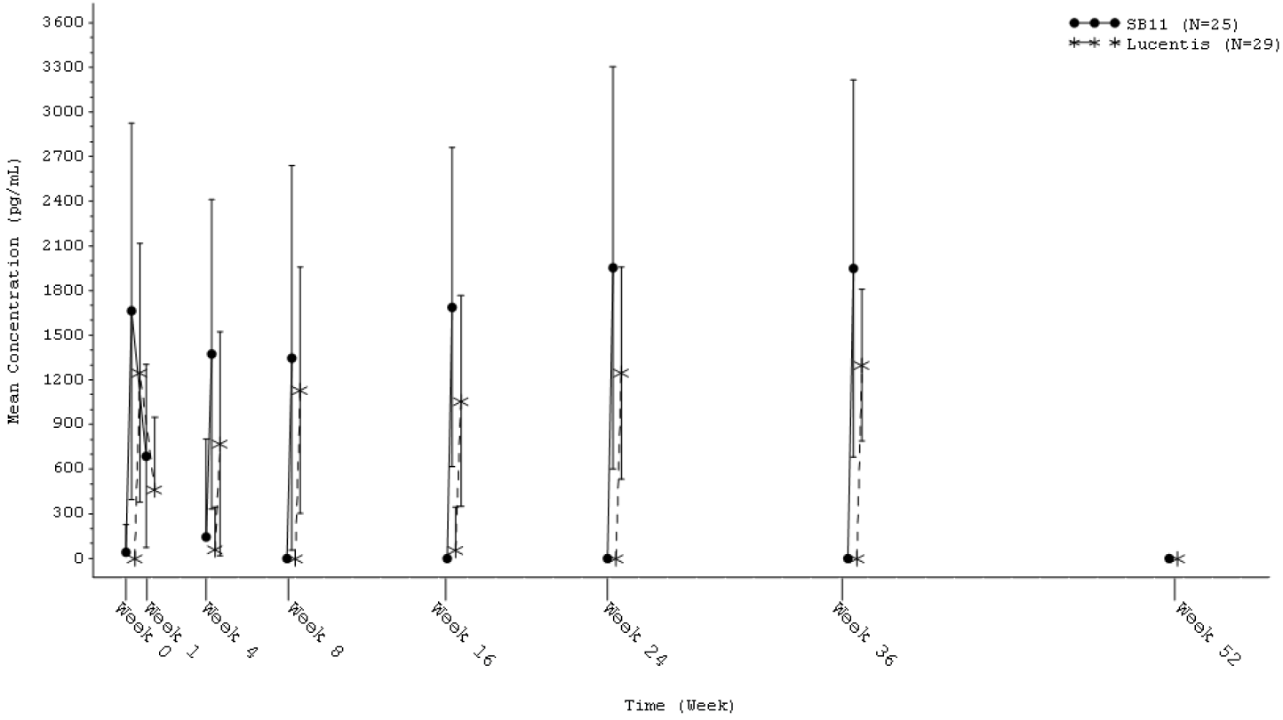

Abbreviations: N = number of subjects; SB11 = Byooviz (ranibizumab).

#### Efficacy

##### Study SB11-G31-AMD

###### Primary and secondary objectives

The primary objective of this study is to demonstrate the equivalence of efficacy of Byooviz to in patients with neovascular age-related macular degeneration (AMD), in terms of the change from Baseline in central subfield thickness at Week 4 and the change from Baseline in best corrected visual acuity (BCVA) at Week 8.

Secondary objectives were to evaluate the safety, immunogenicity, and systemic exposure of Byooviz and Lucentis.

###### Inclusion and exclusion criteria

The inclusion and exclusion criteria were in line with those in the clinical trials for Lucentis. Key inclusion criteria included:

* aged 50 years or higher at screening;
* newly diagnosed active sub-foveal choroidal neovascularisation lesion secondary to AMD in the study eye (active choroidal neovascularisation indicated presence of leakage and intra- or sub-retinal fluid which was confirmed by central reading centre during screening);
* the area of choroidal neovascularisation had to occupy at least 50% of total lesion in the study eye (confirmed by central reading centre during screening);
* total lesion area of less or equals to 9.0 disc areas in size (including blood, scars, and neovascularization) in the study eye (confirmed by central reading centre);
* best corrected visual acuity (BCVA) of 20/40 to 20/200 (letter score of 73 to 34) at screening and at Week 0 (Day 1) prior to randomisation.

Eligible patients were randomised 1:1 to receive either Byooviz or US-sourced Lucentis 0.5 mg by intravitreal injection every 4 weeks up to Week 48. Only one eye was designated as the study eye. For patients who met the eligibility criteria in both eyes, the eye with worse visual acuity was selected as the study eye. If both eyes had equal visual acuity, the eye with a better visual prognosis (for example, clearer lens and ocular media, and less amount of subfoveal scar or geographic atrophy) was selected as the study eye at the investigator’s discretion.

Figure : Study SB11-G31-AMD Overview of study design

Figure 2: Study SB11-G31-AMD Overview of study design

Study SB11-G31-AMD is a randomised, double-masked parallel group, multicenter study to evaluate the efficacy, safety, pharmacokinetics, and immunogenicity of Byooviz compared with Lucentis in patients with neovascular age-related macular degeneration.

Eligible patients were randomly allocated in a 1:1 ratio (352 patients in each group) to receive either 0.5 mg Byooviz or 0.5 mg Lucentis. Patients were administered 0.5 mg Byooviz or 0.5 mg Lucentis via intravitreal route into the study eye every 4 weeks up to Week 48. A total of 13 doses of investigational product were administered in the study and the last assessment was done at Week 52. 
Primary end points were assessed at Weeks 4 and 8.

Abbreviations: BCVA = best corrected visual acuity; D = day; ICF = informed consent form; ITV = intravitreal; n = number of patients; OCT = optical coherence tomography; PK = pharmacokinetics; R = randomisation; SB11 = Byooviz (ranibizumab); W = week

1 Written informed consent was obtained from the patient prior to any study related procedures.

2 Screening was done within 21 days prior to randomisation.

###### Endpoints

Primary endpoint

Internationally, there was differing regulatory guidance regarding the primary endpoint (anatomical parameter versus visual acuity). For the EMA (and some regulatory agencies in favour of the anatomical parameter), the primary endpoint was change from Baseline in central subfield thickness at Week 4. For the US FDA, the Korean Ministry of Food and Drug Safety, and other regulatory agencies in favour of visual acuity, the primary endpoint was change from Baseline in BCVA at Week 8.

Secondary endpoints

Secondary endpoints of this study include:

* change from Baseline in central subfield thickness and central retinal lesion thickness at Week 24 and Week 52 (based on assessment by central reading centre);
* change from Baseline in BCVA over time up to Weeks 24 and Week 52;
* proportion of patients who lost fewer than 15 letters in BCVA compared with Baseline at Week 24 and Week 52;
* proportion of patients who gained 15 letters or more in BCVA compared with Baseline at Week 24 and Week 52;
* change from Baseline in total choroidal neovascularisation size (area of choroidal neovascularisation) at Week 24 and Week 52 (based on assessment by central reading centre);
* proportion of patients with active choroidal neovascularisation leakage at Week 24 and Week 52 (based on assessment by central reading centre).

Exploratory endpoints

* proportion of patients without intra- or sub-retinal fluid at Week 24 and Week 52 (based on assessment by central reading centre);
* change from Baseline in subscale scores and composite score of the National Eye Institute 25-item visual function questionnaire;[15] at Week 24 and Week 52.

Central subfield thickness and central retinal lesion thickness were assessed by optical coherence tomography. Lesion characteristics such as choroidal neovascularisation size and presence of leakage or haemorrhage were evaluated using fundus photography and/or fluorescein angiography.

For the EMA, the primary efficacy analysis was performed for the per-protocol;[16] set for central subfield thickness with the change from Baseline in central subfield thickness at Week 4 using an analysis of covariance model with the baseline central subfield thickness as a covariate and region (country) and treatment group as factors. The equivalence in central subfield thickness was declared if the two-sided 95% confidence interval (CI) of the difference of the central subfield thickness least squares mean change from Baseline in Week 4 between Byooviz and Lucentis lies within the pre-defined equivalence margin of (‑36 µm, 36 µm).

For the FDA, the primary efficacy analysis of BCVA was performed for the full analysis set with the change from Baseline in BCVA at Week 8 using analysis of covariance model with the baseline BCVA as a covariate and region (country) and treatment group as factors. The equivalence in BCVA was declared if the two-sided 90% CI of the difference in terms of BCVA least squares mean change from Baseline at Week 8 between Byooviz and Lucentis lies within the pre-defined equivalence margin of (-3 letters, 3 letters).

The pre-defined equivalence margins (±36 µm for central subfield thickness, ±3 letters for BCVA) were derived based on findings from studies of Lucentis versus placebo in subjects with neovascular AMD. The EMA provided scientific advice that at least 50 µm difference would represent a change in retinal thickness that is clinically relevant.

A total of 705 patients were randomised, 351 to Byooviz and 354 to Lucentis. The treatment groups were well balanced with regard to demographic characteristics. Overall, the mean age was 74.1 years, 57.2% of subjects were female, 84.7% were White and 14.6% were Asian. Baseline disease characteristics were generally similar across the treatment groups. The most common lesion type was ‘occult’ in both study arms, followed by ‘classic and occult’.

Equivalence was demonstrated for the EMA’s primary endpoint, change from Baseline in central subfield thickness at Week 4 (see Table 4 below), as the 95% CI of the adjusted treatment difference was completely contained within the pre-defined equivalence margin of (-36 µm, 36 µm). Sensitivity analyses performed on the full analysis set using various imputation methods for subjects with missing data were supportive of the primary analysis.

Table : Study SB11-G31-AMD Analysis of change from Baseline in central subfield thickness at Week 4 (per‑protocol set for central subfield thickness)

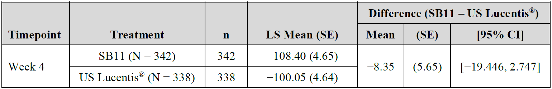

Abbreviations: CI = confidence interval; CST = central subfield thickness (μm); N = total number of patients; LS = least square; n = total number of patients with available data at Week 4; SB11 = Byooviz (ranibizumab); SE = standard error; US = United States.

Inferential statistics were based on analysis of covariance model with the baseline CST as a covariate and region (country) and treatment group as fixed factors.

For CST, therapeutic equivalence is declared if the 2-sided 95% CI of the difference of CST LS mean changes from Baseline at Week 4 between Byooviz and Lucentis lies within the pre-defined equivalence margin of (-36 µm, 36 µm).

Equivalence was also demonstrated for the FDA’s primary endpoint, change from Baseline in BCVA at Week 8 (see Table 5 below), as the 90% CI of the adjusted treatment difference was completely contained within the pre-defined equivalence margin of (-3 letters, 3 letters). *Ad-hoc* analysis showed that the 95% CI (-2.023, 0.415) was also contained within the equivalence margin. Sensitivity analyses performed on the per-protocol set were supportive of the primary analysis.

Table : Study SB11-G31-AMD Analysis of change from Baseline in best corrected visual acuity at Week 8 (full analysis set)

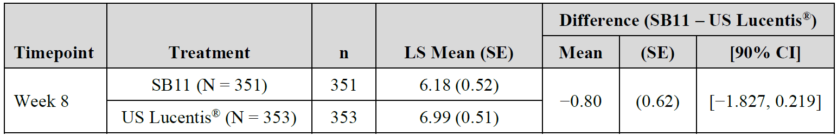

Abbreviations: CI = confidence interval; LS = least square; MAR = missing-at-random; N = total number of patients; n = total number of patients with available data at Week 8; SB11 = Byooviz (ranibizumab); SE = standard error; US = United States.

Imputation method: multiple imputation – missing-at-random

Inferential statistics were based on analysis of covariance model with the baseline best corrected visual acuity (BCVA) as a covariate and region (country) and treatment as fixed factors.

For the BCVA, BCVA letter scores at 4 meter and 1 meter were imputed by multiple imputation method with the assumption of monotone missing pattern and regression method under the missing-at-random.

Therapeutic equivalence is declared if the two-sided 90% CI of the difference of BCVA LS mean changes from Baseline at Week 8 between Byooviz and Lucentis lies within the pre-defined equivalence margin of (‑3 letters, 3 letters).

Secondary efficacy endpoints were supportive of the primary analyses demonstrating no clinically meaningful difference in efficacy. The change from Baseline in central subfield thickness at Week 24 and change from Baseline in central subfield thickness at Week 52 for the per-protocol set were comparable between the two treatment groups (Week 24: Byooviz -135.68 µm, Lucentis -126.09 µm; Week 52: Byooviz -139.55 µm, Lucentis ‑124.46 µm). The point estimate for the difference in change from Baseline in central subfield thickness at Week 24 was -9.59 µm (95% CI: -19.095, -0.091) and at Week 52 was -15.09 µm (95% CI: -25.617, -4.563). Although the upper bound of the 95% CIs did not cover zero, the absolute treatment difference (95% CI) in change from Baseline in central subfield thickness at Weeks 24 and 52 was well below the clinically significant threshold for change in retinal thickness.

The change from Baseline in central retinal lesion thickness at Week 24 and Week 52 for the full analysis set using available cases was comparable between the two treatment groups (Week 24: Byooviz -147.67 µm, Lucentis -138.41 µm; Week 52: Byooviz ‑161.00 µm, Lucentis -149.46 µm). The difference between Byooviz and Lucentis at Week 24 was ‑9.27 µm (95% CI: -20.969, 2.439) and at Week 52 was -11.53 µm (95% CI: -23.211, 0.148).

The proportion of patients who lost fewer than 15/10/5 letters but also gained 5/10/15 letters or more in BCVA at Week 24 and Week 52 in the full analysis set using available cases was comparable between the two treatment arms.

The change from Baseline in total choroidal neovascularisation size (area of choroidal neovascularisation) at Week 24 and Week 52 for the full analysis set using available cases was comparable in the two treatment groups (Week 24: Byooviz -3.98 mm2, Lucentis ‑3.91 mm2; Week 52: Byooviz -5.17 mm2, Lucentis -4.62 mm2). The proportion of subjects with active choroidal neovascularisation leakage at Week 24 and Week 52 for the full analysis set were found to be decreased compared with Baseline and comparable between the 2 treatment groups (Week 24: Byooviz 64.6% (210 out of 325), Lucentis 66.3% (218 out of 329); Week 52: Byooviz 52.1% (158 out of 303), Lucentis 59.1% (185 out of 313)).

Subgroup analyses of central subfield thickness and BCVA based on anti-drug antibody (ADA) result, lesion type at Baseline, total lesion area at Baseline, and country were generally comparable.

#### Safety

The safety of Byooviz compared to Lucentis was assessed in the Phase III Study SB11‑G31‑AMD. 634 of 704 (89.9%) randomised subjects completed the study to Week 52. The proportion of patients who discontinued due to treatment-emergent adverse event (TEAE) was slightly higher in the Byooviz group, but the absolute numbers were low (9 (2.6%) patients in the Byooviz group, 5 (1.4%) patients in the Lucentis group).

Overall, 255 (72.9%) patients in the Byooviz treatment group reported 910 TEAEs (study eye, fellow eye, or non-ocular) and 256 (72.3%) patients in the Lucentis treatment group reported 945 TEAEs at any time after the first dose until the end of study. The nature, incidence and severity of the reported TEAEs were generally comparable between the Byooviz and Lucentis treatment groups.

There were 112 (32.0%) patients in the Byooviz treatment group and 105 (29.7%) patients in the Lucentis treatment group that reported ocular TEAEs in the study eye (see Table 6 below). The most common TEAEs by Preferred Term in the study eye (5% or more of patients in any treatment group) were conjunctival haemorrhage (4.6% of patients in the Byooviz group versus 5.1% of patients in the Lucentis group) and intraocular pressure increased (6.6% of patients in the Byooviz group versus 7.3% of patients in the Lucentis group). The majority of the ocular TEAEs in the study eye were mild or moderate in severity. There were 10 severe ocular TEAEs in the study eye in 7 (2.0%) patients in the Byooviz group and 5 severe ocular TEAEs in the study eye in 4 (1.1%) patients in the Lucentis group. Severe TEAEs are detailed in Table 7 below.

Table : Study SB11‑G31‑AMD Ocular treatment-emergent adverse events in the study eye by System Organ Class and Preferred Term (only eye disorders and other adverse events with incidence of 2% or higher of safety set)

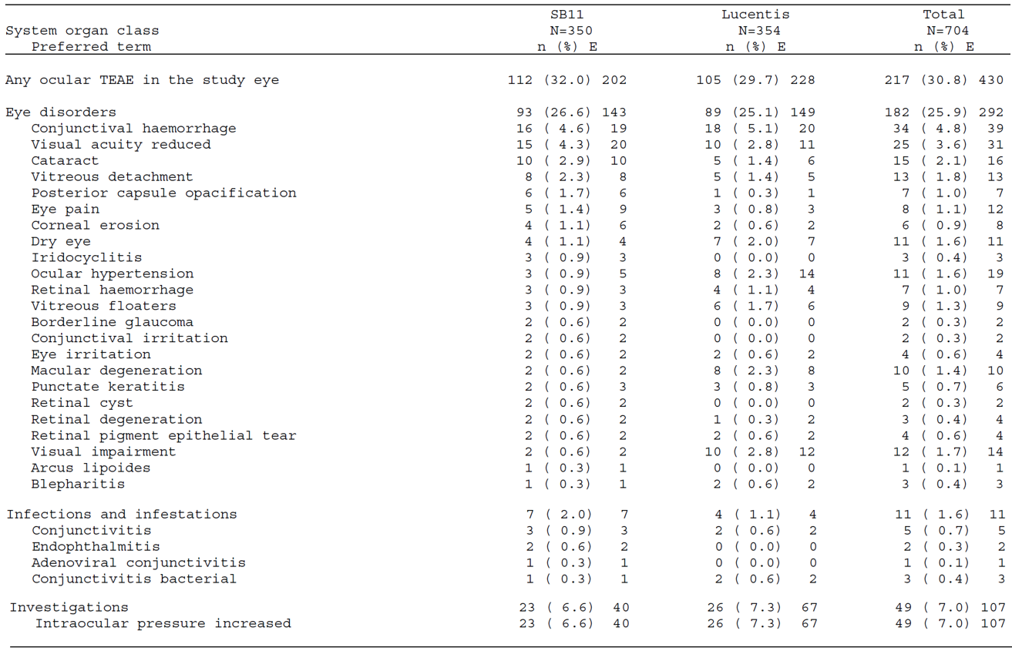

Abbreviations: E = frequency of events; N = total number of subjects; n = number of subjects with event; SB11 = Byooviz (ranibizumab).

Percentages were based on the number of subjects in the safety set.

System Organ Classes were presented alphabetically; Preferred Terms were sorted within each System Organ Class in descending order of subject frequency of Byooviz. If the frequency of the Preferred Terms were tied, the Preferred Terms were ordered alphabetically.

Table : Study SB11‑G31‑AMD *Ad-hoc* analysis on severe treatment-emergent adverse event in the study eye by System Organ Class and Preferred Term (safety set)

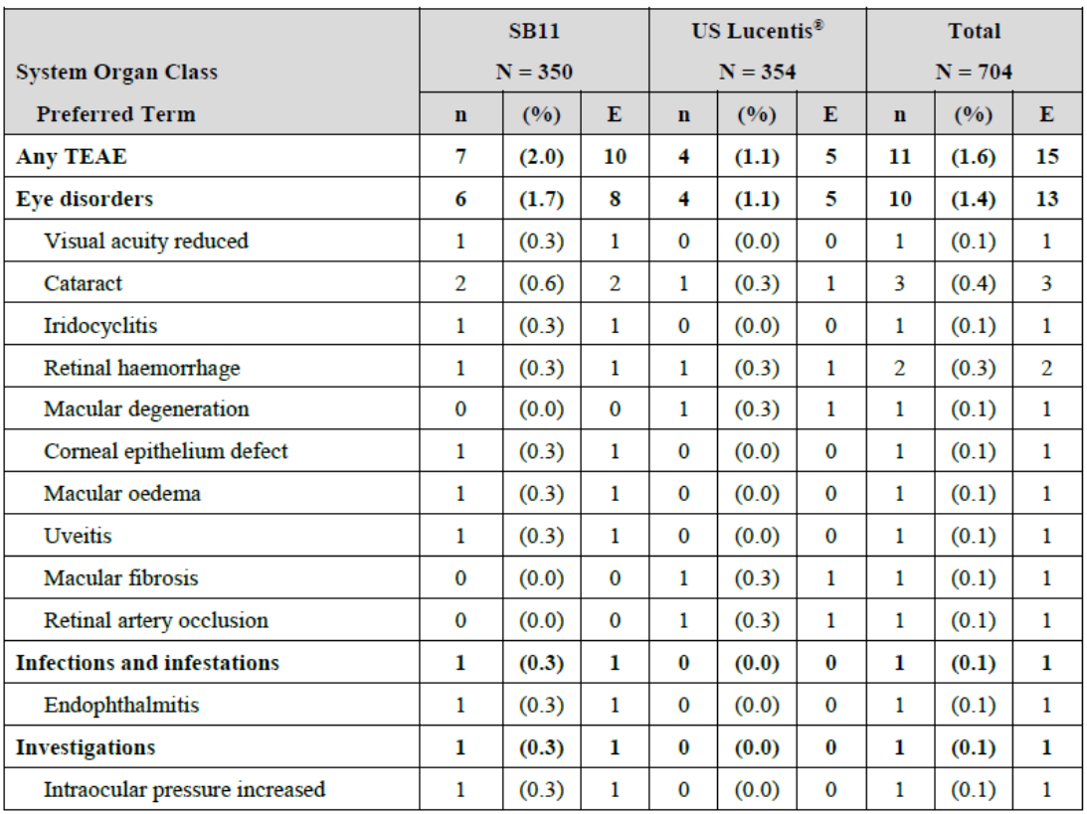

Abbreviations: E = frequency of events; N = number of patients; n = number of patients with event, TEAE = treatment-emergent adverse event; SB11 = Byooviz (ranibizumab); US = United States.

Percentages were bases on the number of patients in the safety set.

Source: this table is extracted from the European Medicines Agency (EMA)’s Assessment Report for Byooviz [17]

Overall, 92 (26.3%) patients in the Byooviz group and 77 (21.8%) patients in the Lucentis group had ocular TEAEs in the fellow eye. The most common (5% or more of patients in any treatment group) TEAE by Preferred Term in the fellow eye was neovascular AMD (25 (7.1%) patients in the Byooviz group versus 22 (6.2%) patients in the Lucentis group).

Overall, 194 (55.4%) patients in the Byooviz group and 205 (57.9%) patients in the Lucentis group had non-ocular TEAEs. The most common non-ocular TEAEs by Preferred Term (5% or more of patients in any treatment group) were nasopharyngitis (37 (10.6%) patients in the Byooviz group versus 35 (9.9%) patients in the Lucentis group) and Hypertension (17 (4.9%) patients in the Byooviz group versus 26 (7.3%) patients in the Lucentis group). The majority of the non-ocular TEAEs were mild or moderate in severity.

The majority of TEAEs (1,761 out of 1,807 (97.5%)) were considered not related to the investigational product. In the Byooviz group, 27 TEAEs were reported to be related to investigational product in 21 (6.0%) patients. In the Lucentis group, 19 TEAEs were reported to be related to investigational product in 10 (2.8%) patients.

Ocular and non-ocular serious adverse events (SAE) were similar across the two treatment groups. SAEs in the study eye were reported in 10 (2.9%) patients in the Byooviz group and 8 (2.3%) patients in the Lucentis group. In terms of causality, 4 (1.1%) patients in the Byooviz group and 3 (0.8%) patients in the Lucentis group reported SAEs in the study eye related to investigational product. For the Byooviz-treated patients these were vitritis, iridocyclitis, subretinal fluid, and visual acuity reduced/macular oedema/retinal pigment epithelial tear. For the Lucentis-treated patients these were retinal haemorrhage, subretinal fluid and macular degeneration. Six (0.9%) patients died during the study: 2 (0.6%) patients in the Byooviz group (primary cause of death reported as chronic obstructive pulmonary disease for one patient and unknown for the other) and 4 (1.1%) patients in the Lucentis group (primary cause of death reported as infection for one patient, pneumonia for one patient, and unknown for the other two patients).

There were 6 pre-defined categories for adverse events of special interest):

* Category 1: Any case of new onset intraocular pressure of greater than 21 mmHg that did not respond to treatment, except the transient pressure rise observed within an hour after intravitreal injection of investigational product.
* Category 2: Any case of intraocular pressure 35 mmHg or higher, at any time, that required treatment.
* Category 3: Any case of intraocular infection such as endophthalmitis.
* Category 4: Any case of intraocular inflammation such as iritis, vitritis, and iridocyclitis.
* Category 5: Iatrogenic traumatic cataract.
* Category 6: Arterial thromboembolic events defined as non-fatal stroke, non-fatal myocardial infarction, or vascular death (including deaths of unknown cause).

Table : Study SB11-G31-AMD Summary of adverse events of special interest (safety set)

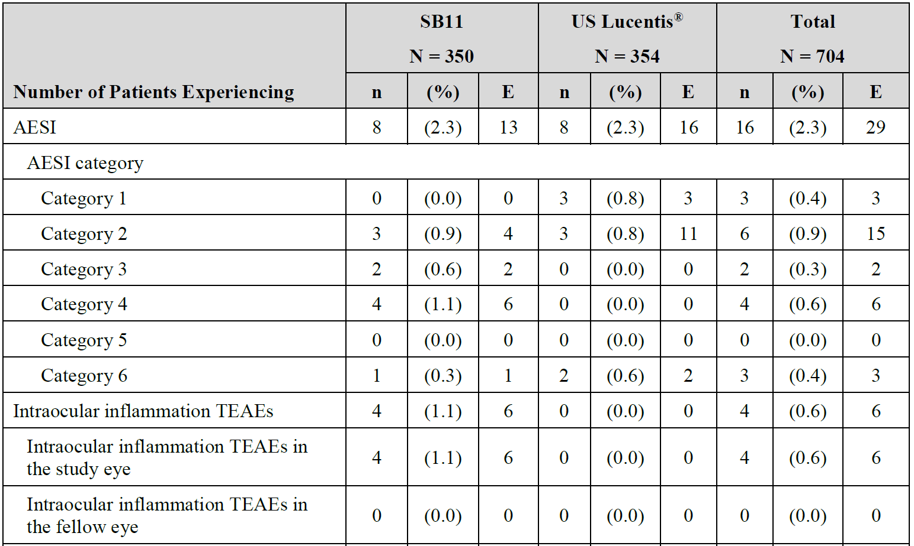

Abbreviations: AESI = adverse event of special interest; E = frequency of events; N = total number of patients; n = number of patients with events; TEAE = treatment-emergent adverse event; SB11 = Byooviz (ranibizumab); US= United States.

Adverse events were coded to System Organ Class and Preferred Term using Medical Dictionary for Regulatory Activities (MedDRA);[18] version 20.1 coding dictionary.

Percentages were based on number of patient in the safety set.

If a patient had the multiple conditions with different severity (or causality), then the patient was counted only once at the worst severity (or worst causality, that is, related).

Adverse events of special interest category:

Category 1: Any case of new onset intraocular pressure of greater than 21 mmHg that does not respond to treatment, except the transient pressure rise observed within an hour after intravitreal injection of investigational product;

Category 2: Any case of intraocular pressure of 35 mmHg or higher, at any time, that required treatment;

Category 3: Any case of intraocular infection such as endophthalmitis;

Category 4: Any case of intraocular inflammation such as iritis, vitritis, and iridocyclitis;

Category 5: Iatrogenic traumatic cataract;

Category 6: Arterial thromboembolic events defined as non-fatal stroke, non-fatal myocardial infarction, or vascular death (including deaths of unknown as cause).

Table : Study SB11-G31-AMD Adverse events of special interest by System Organ Class and Preferred Term (safety set)

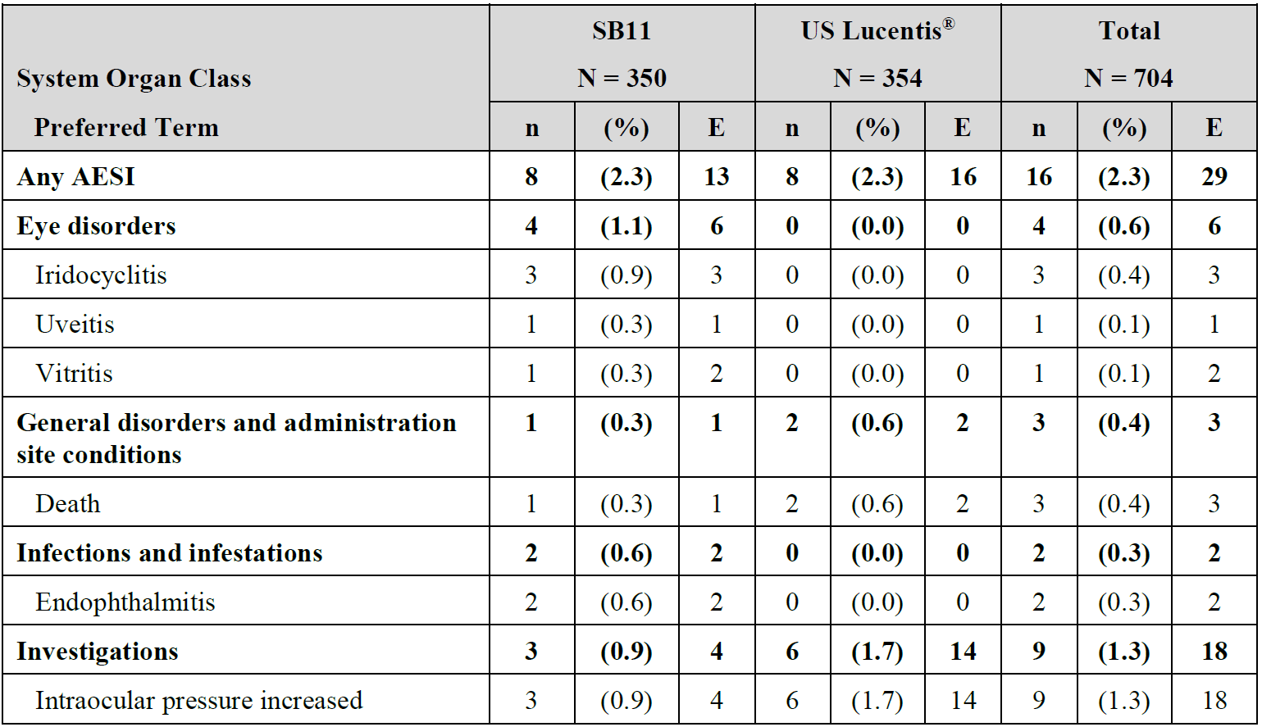

Abbreviations: AESI = adverse event of special interest; E = frequency of events; N = total number of patients; n = number of patients with event; SB11 = Byooviz (ranibizumab); US= United States.

Percentages were based on the number of subjects in the safety set.

Adverse events were coded to System Organ Class and Preferred Term using Medical Dictionary for Regulatory Activities (MedDRA)18 coding dictionary version 20.1.

System organ classes were presented alphabetically; Preferred Terms were sorted within each primary System Organ Class in descending order of subject frequency of Byooviz. If the frequency of the Preferred Terms were tied, the Preferred Terms were ordered alphabetically.

If a patient had multiple conditions with the same Preferred Term and System Organ Class, the subject was counted only once.

There were no notable differences between the treatment groups for laboratory findings and vital signs, including intraocular pressure.

#### Immunogenicity

In Study SB11-G31-AMD, blood samples for immunogenicity were collected prior to intravitreal injection at Week 0 (Day 1), Week 4, Week 8, Week 16, Week 24, and Week 36, and at any time during the visit at Week 1 and Week 52 (end of study visit) or early termination visit. The overall incidence of anti-drug antibody (ADA) and neutralising antibody was low and comparable in the Byooviz and Lucentis treatment groups over the duration of the study (see Table 10 below).

Table : Study SB11-G31-AMD *Ad-hoc* analysis on incidence of overall anti-drug antibody by visit and treatment group (safety set)

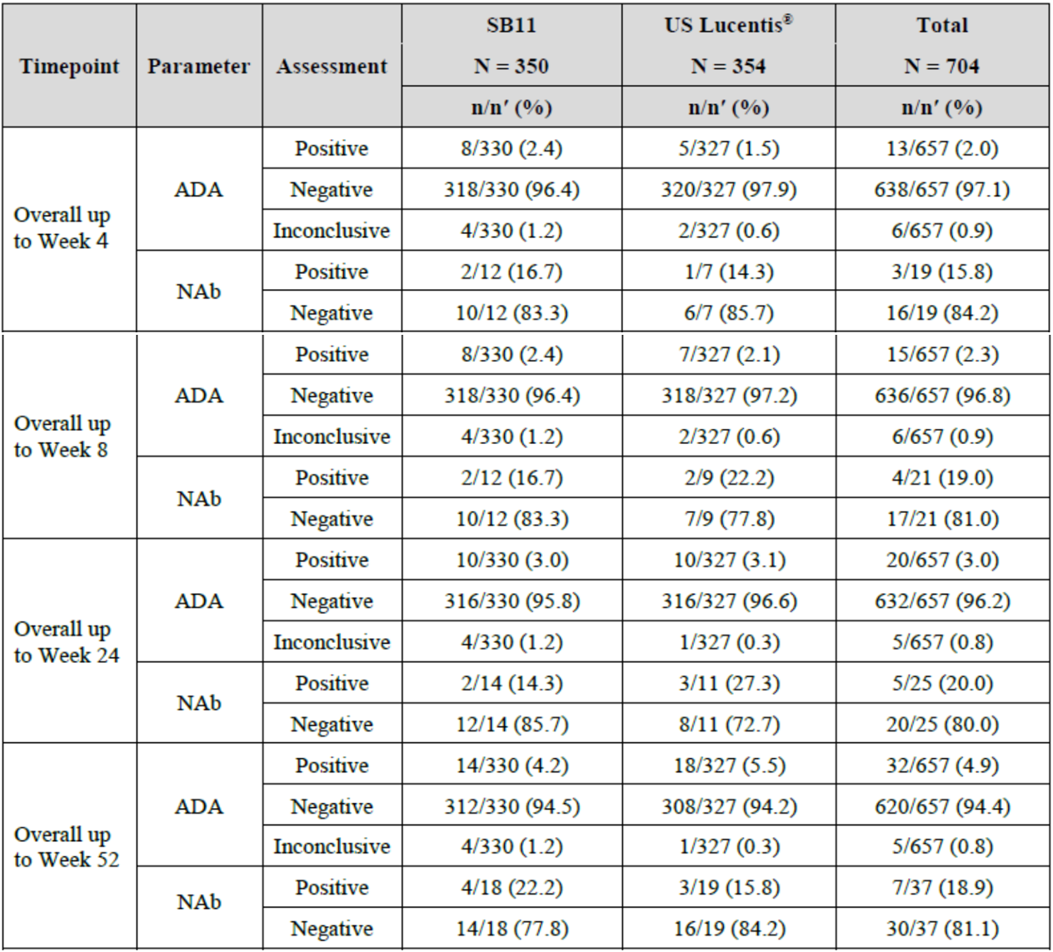

Abbreviations: ADA = anti-drug antibody; NAb = neutralising antibody; N = total number of patients; n = number of patients with event; n' = number of patients with available assessment results at each visit; SB11 = Byooviz (ranibizumab); US= United States.

Percentages are based on n’.

Source: this table is extracted from the European Medicines Agency (EMA)’s Assessment Report for Byooviz [19]

Overall, there were limited number of ADA-positive subjects in both treatment groups. In the PK analysis set, only 3 subjects had positive ADA results (2 subjects in Byooviz group at Week 52, and one subject in Lucentis group at Week 36), so the impact of immunogenicity on PK cannot be evaluated. Subgroup analyses of efficacy endpoints (central subfield thickness and best corrected visual acuity (BCVA)) based on ADA status showed no consistent findings regarding impact of ADA on efficacy. In two patients with the highest ADA titres, no influence of high ADA titre (and its neutralising capacity) on BCVA and central subfield thickness was evident. Subgroup analyses of TEAEs based on ADA status showed no clear imbalance between treatment groups.

### Risk management plan

The sponsor has submitted European Union (EU)-risk management plan (RMP) version 1.1 (dated 17 February 2021; data lock point (DLP) 4 February 2021) and Australia specific annex (ASA) version 1.0 (dated 8 September 2021) in support of this application. In response to questions raised by the TGA, the sponsor has submitted ASA version 1.2 (31 March 2022).

The summary of safety concerns and their associated risk monitoring and mitigation strategies are summarised in Table 11. Further information regarding the TGA’s risk management approach can be found in [risk management plans for medicines and biologicals](https://www.tga.gov.au/publication/risk-management-plans-medicines-and-biologicals) and [the TGA's risk management approach](https://www.tga.gov.au/tgas-risk-management-approach).

Table : Summary of safety concerns

|  |  |  |  |  |  |
| --- | --- | --- | --- | --- | --- |
| Summary of safety concerns | | Pharmacovigilance | | Risk minimisation | |
| **Routine** | **Additional** | **Routine** | **Additional** |
| Important identified risks | Infectious endophthalmitis | ✓* | - | ✓ | - |
| Retinal detachment and retinal tear | ✓ | - | ✓ | ✓† |
| Intraocular inflammation | ✓ | - | ✓ | ✓† |
| Intraocular pressure increase | ✓ | - | ✓ | ✓† |
| Missing information | Visudyne (verteporfin-photodynamic therapy) given in combination with ranibizumab (pathologic myopia) | ✓ | - | ✓ | - |
| Long term effects on the progression of the condition choroidal neovascularisation (other than neovascular age‑related macular degeneration) | ✓ | - | ✓ | - |

* Adverse event follow up form

† Patient education (patient information booklet)

* The ASA summary of safety concerns aligns with approved Byooviz EU-RMP. These also align with currently agreed reference product EU-RMP/ASA, for the same indications. The summary of safety concerns is acceptable from an RMP perspective.
* The sponsor proposes routine pharmacovigilance for all safety concerns listed in the ASA. This aligns with the EU-RMP for Byooviz and the reference product RMP. The sponsor proposes an adverse event follow up form for infectious endophthalmitis to align with the reference product. This is acceptable.
* The sponsor proposes routine risk minimisation activities for all safety concerns listed in the ASA. This aligns with the Byooviz EU-RMP and reference product RMP. The sponsor also proposes additional risk minimisation activities in the form of patient education (patient booklet) to address important identified risks in Table above. This aligns with the additional risk minimisation activities in place for reference product in EU and Australia. The word form of these booklets is acceptable. The sponsor also proposes a Dear Health Care Provider letter for dissemination of the additional risk minimisation materials. The sponsor has committed to providing final draft copies of the additional risk minimisation materials to the TGA for review prior to launch. The additional risk minimisation activities are acceptable.

### Risk-benefit analysis

#### Delegate’s considerations

##### Biosimilarity

###### Quality

Comprehensive comparisons of physicochemical and biological quality attributes were undertaken to demonstrate biosimilarity of Byooviz to Lucentis. These assessments demonstrated high similarity of Byooviz to European Union (EU)-sourced Lucentis, and to to Lucentis sourced in the United States of America (USA). A bridging study demonstrated high similarity of Australian-sourced Lucentis to US-sourced Lucentis, supporting biosimilarity of Byooviz to the Australian reference product.

###### Clinical

A Phase III study (Study SB11-G31-AMD) comparing the efficacy, safety, and immunogenicity of Byooviz to US-sourced Lucentis was conducted in adults with neovascular age related macular degeneration (AMD). The design of the study was acceptable. The findings can be applied to the Australian setting given the demonstrated similarity of Australian- and US‑sourced Lucentis in the bridging study.

Equivalent efficacy was demonstrated for the European Medicines Agency (EMA)’s preferred primary endpoint, *change from Baseline in central subfield thickness at Week 4*, as well as the FDA’s preferred primary endpoint, *change from Baseline in best corrected visual acuity at Week 8*. The secondary efficacy endpoints were supportive of comparable efficacy. The clinical safety findings were similar overall across the treatment groups, with no clear difference in the safety profiles. The incidence of anti-drug antibody and neutralising antibody was low overall and comparable across the treatment groups, with no clinically meaningful impact on pharmacokinetics, efficacy, or safety evident in the clinical study. The clinical findings support a conclusion of biosimilarity.

##### Proposed Indications

The proposed indications are the same as the approved indications for Lucentis, except for the recently approved indication for the treatment of retinopathy of prematurity in preterm infants. This indication is not being sought for Byooviz as the sponsor has not yet developed a low volume high accuracy syringe required for this indication.

Comparable efficacy, safety, and immunogenicity have been demonstrated in adults with neovascular AMD. Neovascular AMD is considered a sensitive condition to detect potential differences between the products. The same mode of action of ranibizumab applies across all the proposed indications. The demonstrated biosimilarity of Byooviz to Lucentis supports the use of Byooviz in the proposed indications.

##### Proposed conditions of registration

* The Byooviz EU-risk management plan (RMP) (version 1.1, dated 17 February 2021, data lock point 4 February 2021), with Australian Specific Annex (version 1.2, dated 31 March 2022), included with Submission PM-2021-04292-1-5, to be revised to the satisfaction of the TGA, and any subsequent revisions, will be implemented in Australia.
* Reports are to be provided in line with the current published list of EU reference dates and frequency of submission of PSURs until the period covered by such reports is not less than three years from the date of the approval letter.

The reports are to at least meet the requirements for PSURs as described in the European Medicines Agency’s Guideline on Good Pharmacovigilance Practices (GVP) Module VII-periodic safety update report [Revision 1], Part VII.B Structures and processes. Note that submission of a PSUR does not constitute an application to vary the registration.

* Laboratory testing and compliance with Certified Product Details (CPD)
  + All batches of Byooviz ranibizumab supplied in Australia must comply with the product details and specifications approved during evaluation and detailed in the Certified Product Details (CPD).
  + When requested by the TGA, the sponsor should be prepared to provide product samples, specified reference materials and documentary evidence to enable the TGA to conduct laboratory testing on the product. Outcomes of laboratory testing are published biannually in the TGA Database of Laboratory Testing Results <http://www.tga.gov.au/ws-labs-index> and periodically in testing reports on the TGA website.

Certified Product Details

The Certified Product Details (CPD), as described in Guidance 7: Certified Product Details of the Australian Regulatory Guidelines for Prescription Medicines (ARGPM) [<https://www.tga.gov.au/guidance-7-certified-product-details>], in PDF format, for the above products should be provided upon registration of these therapeutic goods. In addition, an updated CPD should be provided when changes to finished product specifications and test methods are approved in a Category 3 application or notified through a self-assessable change.

#### Proposed action

Biosimilarity of Byooviz to Lucentis has been satisfactorily demonstrated, supporting a favourable benefit-risk for Byooviz in the proposed indications. There are no outstanding manufacturing quality issues. There are no outstanding clinical issues requiring advice from the Advisory Committee on Medicines.

#### Advisory Committee considerations

The Delegate did not refer this submission to the Advisory Committee on Medicines (ACM) for advice.

## Outcome

Based on a review of quality, safety, and efficacy, the TGA approved the registration of Byooviz (ranibizumab) 10 mg/mL, solution for injection, vial, indicated for:

*Byooviz (ranibizumab) is indicated in adults for:*

* *the treatment of neovascular (wet) age-related macular degeneration (AMD),*
* *the treatment of visual impairment due to diabetic macular oedema (DME),*
* *treatment of proliferative diabetic retinopathy (PDR),*
* *the treatment of visual impairment due to choroidal neovascularisation (CNV),*
* *the treatment of visual impairment due to choroidal neovascularisation (CNV) secondary to pathologic myopia (PM),*
* *the treatment of visual impairment due to macular oedema secondary to retinal vein occlusion (RVO).*

### Specific conditions of registration applying to these goods

* The Byooviz EU-risk management plan (RMP) (version 1.1, dated 17 February 2021, data lock point 4 February 2021), with Australian specific annex (version 1.2, dated 31 March 2022), included with Submission PM-2021-04292-1-5, to be revised to the satisfaction of the TGA, and any subsequent revisions, will be implemented in Australia.

Reports are to be provided in line with the current published list of EU reference dates and frequency of submission of PSURs until the period covered by such reports is not less than three years from the date of the approval letter.

The reports are to at least meet the requirements for PSURs as described in the European Medicines Agency’s Guideline on Good Pharmacovigilance Practices (GVP) Module VII-periodic safety update report [Revision 1], Part VII.B Structures and processes. Note that submission of a PSUR does not constitute an application to vary the registration.

* Laboratory testing and compliance with Certified Product Details (CPD)
  + All batches of Byooviz ranibizumab supplied in Australia must comply with the product details and specifications approved during evaluation and detailed in the Certified Product Details (CPD).
  + When requested by the TGA, the sponsor should be prepared to provide product samples, specified reference materials and documentary evidence to enable the TGA to conduct laboratory testing on the product. Outcomes of laboratory testing are published biannually in the TGA Database of Laboratory Testing Results <http://www.tga.gov.au/ws-labs-index> and periodically in testing reports on the TGA website.

Certified Product Details

The Certified Product Details (CPD), as described in Guidance 7: Certified Product Details of the Australian Regulatory Guidelines for Prescription Medicines (ARGPM) [<https://www.tga.gov.au/guidance-7-certified-product-details>], in PDF format, for the above products should be provided upon registration of these therapeutic goods. In addition, an updated CPD should be provided when changes to finished product specifications and test methods are approved in a Category 3 application or notified through a self-assessable change.

* For all injectable products the Product Information must be included with the product as a package insert.

## Attachment 1. Product Information

The PI for Byooviz approved with the submission which is described in this AusPAR is at Attachment 1. For the most recent PI, please refer to the TGA [PI/CMI search facility.](https://www.tga.gov.au/picmi-search-facility)

|  |
| --- |
| Therapeutic Goods Administration |
| PO Box 100 Woden ACT 2606 Australia  Email: [info@tga.gov.au](mailto:info@tga.gov.au) Phone: 1800 020 653 Fax: 02 6232 8605  [**https://www.tga.gov.au**](https://www.tga.gov.au) |

1. Felmeden,D.C. et al. Angiogenesis: Basic Pathophysiology and Implications for Disease, *Eur Heart J*, 2003; 24(7): 586-603.
2. Adair, T.H. and Montani, J.P. Angiogenesis, *San Rafael (CA): Morgan & Claypool Life Sciences*; 2010. Chapter 1, Overview of Angiogenesis.
3. Carmeliet, P. Angiogenesis in Health and Disease, *Nat Med* , 2003; 9(6): 653-660.
4. Shibuya, M. Vascular Endothelial Growth Factor (VEGF) and Its Receptor (VEGFR) Signaling in Angiogenesis: A Crucial Target for Anti- and Pro-Angiogenic Therapies, *Genes Cancer,* 2011; 2(12): 1097-1105.
5. Penn, J.S., et al. Vascular Endothelial Growth Factor in Eye Disease, *Prog Retin Eye Res,* 2008; 27(4): 331-371.
6. Kvanta, A. et al. Subfoveal Fibrovascular Membranes in Age-Related Macular Degeneration Express Vascular Endothelial Growth Factor, *Invest Ophthalmol Vis Sci,* 1996; 37(9): 1929-1934.
7. Pe'er, J. et al, Vascular Endothelial Growth Factor Upregulation in Human Central Retinal Vein Occlusion, *Ophthalmology,* 1998; 105(3): 412-416.
8. Aiello, L.P. et al. Vascular Endothelial Growth Factor in Ocular Fluid of Patients with Diabetic Retinopathy and Other Retinal Disorders, *N Engl J Med,* 1994; 331(22): 1480-1487.
9. Lien, S. and Lowman, H.B. Therapeutic Anti-VEGF Antibodies, *Handb Exp Pharmacol,* 2008; (181): 131-150.
10. A **biosimilar medicine** is a version of a biological medicine that is already registered and is referred to as the 'reference medicine'.

    Both the biosimilar medicine and its reference medicine will have similar core characteristics such as physicochemical, biological, immunological, efficacy and safety, which are demonstrated using comprehensive comparability studies. Most biosimilar medicines are likely to contain biotechnology-derived proteins as the active substance, but includes other biosimilar medicines, such as those consisting of vaccines, and polysaccharides, such as low molecular weight heparins.

    Further information on biosimilar medicines is available from the TGA website: [Biosimilar medicines regulation | Therapeutic Goods Administration (TGA)](https://www.tga.gov.au/resources/resource/guidance/biosimilar-medicines-regulation)
11. **Good Manufacturing Practice (GMP)** is a code of standards that describes a set of principles and procedures that when followed helps ensure that therapeutic goods are of high quality.
12. A **Category 3 application** relates to updates to the quality data of medicines already included on the Australian Register of Therapeutic Goods (ARTG) which, in the opinion of the TGA, do not need to be supported by clinical, non-clinical or bioequivalence data.
13. European Medicines Agency (EMA), Committee for Medicinal Products for Human Use (CHMP), Guideline on Similar Biological Medicinal Products Containing Monoclonal Antibodies - Non-clinical and Clinical Issues, EMA/CHMP/BMWP/403543/2010, 30 May 2012.
14. European Medicines Agency (EMA), Committee for Medicinal Products for Human Use (CHMP), Guideline on Similar Biological Medicinal Products Containing Biotechnology Derived Proteins as Active Substance: Non-clinical and Clinical Issues, EMEA/CHMP/BMWP/42832/2005 Rev1, 18 December 2014.
15. The **National Eye Institute 25-item visual function questionnaire** is a survey that measures the dimensions of self-reported vision-targeted health status that are most important for persons who have chronic eye diseases. The questionnaire consists of a base set of 25 vision targeted questions representing 11 vision-related constructs, plus an additional single-item general health rating question.
16. The **per-protocol analysis** is restricted to the participants who strictly adhered to the protocol. Also known as ‘on-treatment’ analysis.
17. European Medicines Agency (EMA), Committee for Medicinal Products for Human Use (CHMP), Assessment Report for Byooviz, International Non-proprietary Name: Ranibizumab, EMA/446448/2021, 24 June 2021.
18. The **Medical Dictionary for Regulatory Activities (MedDRA)** is a single standardised international medical terminology, developed as a project of the International Council for Harmonisation of Technical Requirements for Pharmaceuticals for Human Use (ICH) which can be used for regulatory communication and evaluation of data pertaining to medicinal products for human use. As a result, MedDRA is designed for use in the registration, documentation and safety monitoring of medicinal products through all phases of the development cycle (that is, from clinical trials to post-marketing surveillance). Furthermore, MedDRA supports ICH electronic communication within the ICH’s Electronic Common Technical Document (eCTD) and the E2B Individual Case Safety Report.
19. European Medicines Agency (EMA), Committee for Medicinal Products for Human Use (CHMP), Assessment Report for Byooviz, International Non-proprietary Name: Ranibizumab, EMA/446448/2021, 24 June 2021.