|  |
| --- |
| Australian Public Assessment Report for Jakavi |
| Active ingredient: Ruxolitinib phosphate |
| Sponsor: Novartis Pharmaceuticals Australia Pty Ltd |
| May 2023 |

About the Therapeutic Goods Administration (TGA)

* The Therapeutic Goods Administration (TGA) is part of the Australian Government Department of Health and Aged Care and is responsible for regulating therapeutic goods, including medicines, medical devices, and biologicals.
* The TGA administers the *Therapeutic Goods Act 1989* (the Act), applying a risk management approach designed to ensure therapeutic goods supplied in Australia meet acceptable standards of quality, safety, and efficacy.
* The work of the TGA is based on applying scientific and clinical expertise to decision-making, to ensure that the benefits to the Australian public outweigh any risks associated with the use of therapeutic goods.
* The TGA relies on the public, healthcare professionals and industry to report problems with therapeutic goods. The TGA investigates reports received to determine any necessary regulatory action.
* To report a problem with a therapeutic good, please see the information on the [TGA website](https://www.tga.gov.au).

About AusPARs

* The Australian Public Assessment Report (AusPAR) provides information about the evaluation of a prescription medicine and the considerations that led the TGA to approve or not approve a prescription medicine submission. Further information can be found in [Australian Public Assessment Report (AusPAR) guidance](https://www.tga.gov.au/australian-public-assessment-report-auspar-guidance).
* AusPARs are prepared and published by the TGA.
* AusPARs are static documents that provide information that relates to a submission at a particular point in time. The publication of an AusPAR is an important part of the transparency of the TGA’s decision-making process.
* A new AusPAR may be provided to reflect changes to indications or major variations to a prescription medicine subject to evaluation by the TGA.

Copyright

© Commonwealth of Australia 2023  
This work is copyright. You may reproduce the whole or part of this work in unaltered form for your own personal use or, if you are part of an organisation, for internal use within your organisation, but only if you or your organisation do not use the reproduction for any commercial purpose and retain this copyright notice and all disclaimer notices as part of that reproduction. Apart from rights to use as permitted by the *Copyright Act 1968* or allowed by this copyright notice, all other rights are reserved and you are not allowed to reproduce the whole or any part of this work in any way (electronic or otherwise) without first being given specific written permission from the Commonwealth to do so. Requests and inquiries concerning reproduction and rights are to be sent to the TGA Copyright Officer, Therapeutic Goods Administration, PO Box 100, Woden ACT 2606 or emailed to <[tga.copyright@tga.gov.au](mailto:tga.copyright@tga.gov.au)>.

Contents

List of abbreviations 4

Product submission 6

Submission details 6

Product background 7

Current treatment options 8

Regulatory status 10

Product Information 11

Registration timeline 12

Submission overview and risk/benefit assessment 12

Quality 12

Nonclinical 12

Clinical 13

Summary of clinical studies 13

Pharmacology 13

Efficacy 16

Safety 37

Risk management plan 45

Risk-benefit analysis 46

Delegate’s considerations 46

Proposed action 50

Advisory Committee considerations 51

Outcome 53

Specific conditions of registration applying to these goods 54

Attachment 1. Product Information 54

## List of abbreviations

|  |  |
| --- | --- |
| Abbreviation | Meaning |
| ACM | Advisory Committee on Medicines |
| aGVHD | Acute graft-versus-host disease |
| ARTG | Australian Register of Therapeutic Goods |
| ASA | Australia specific annex |
| AUC | Area under the concentration versus time curve |
| AUCinf | Area under the concentration versus time curve to infinity |
| AUClast | Area under the concentration versus time curve to last measured sample |
| BAT | Best available treatment |
| BOR | Best overall response |
| BSA | Body surface area |
| cGVHD | Chronic graft-versus-host disease |
| CI | Confidence interval |
| CL/F | Apparent oral clearance |
| CLss/F | Oral clearance at steady-state |
| Cmax | Maximum concentration |
| CMI | Consumer Medicines Information |
| CR | Complete response |
| CSR | Clinical study report |
| CV | Coefficient of variation |
| DOR | Duration of response |
| FDA | Food and Drug Administration (United States of America) |
| FFS | Failure free survival |
| GVHD | Graft-versus-host disease |
| JAK | Janus kinase |
| Ka | Absorption rate constant |
| MAGIC | Mount Sinai Acute GvHD International Consortium |
| mLSS | Modified Lee Symptom Scale |
| NIH | National Institutes of Health |
| ORR | Overall response rate |
| PK | Pharmacokinetic(s) |
| PI | Product Information |
| PR | Partial response |
| PSUR | Periodic safety update report |
| RMP | Risk management plan |
| t½ | Half-life |
| TGA | Therapeutic Goods Administration |
| TSS | Total symptom score (modified Lee Symptom Score) |
| US(A) | United States (of America) |
| Vc/F | Apparent central volume |
| VGPR | Very good partial response |
| Vp/F | Apparent peripheral volume |

## Product submission

### Submission details

|  |  |
| --- | --- |
| *Type of submission:* | Extension of indications |
| *Product name:* | Jakavi |
| *Active ingredient:* | Ruxolitinib phosphate |
| *Decision:* | Approved |
| *Date of entry onto ARTG:* | 28 January 2022 |
| *ARTG number:* | 198933, 198934, 198936, 232702 |
| [*Black Triangle Scheme*](https://www.tga.gov.au/black-triangle-scheme)  *for the current submission:* | Yes  This product will remain in the scheme for 5 years, starting on the date the new indication was approved. |
| *Sponsor’s name and address:* | Novartis Pharmaceuticals Australia Pty Ltd  54 Waterloo Road  North Ryde NSW 2113 |
| *Dose form:* | Tablet |
| *Strengths:* | 5 mg, 10 mg, 15 mg, 20 mg |
| *Container:* | Blister pack |
| *Pack sizes:* | All strengths are available in pack sizes of 14, 28, 56, 112, 168, and 224 tablets |
| *Approved therapeutic use for the current submission:* | *Jakavi is indicated for the treatment of patients aged 12 years and older with acute graft-versus-host disease who have inadequate response to corticosteroids.*  *Jakavi is indicated for the treatment of patients aged 12 years and older with chronic graft-versus-host disease who have inadequate response to corticosteroids.* |
| *Route of administration:* | Oral |
| *Dosage:* | Doses should be individualised based on safety and efficacy.  A blood cell count must be performed before initiating therapy with Jakavi. For monitoring instructions – see Product Information, Section 4.2 Dose and method of administration.  **Acute graft-versus-host disease** The recommended starting dose of Jakavi in acute graft-versus-host disease is 5 to 10 mg given orally twice daily with or without food.  **Chronic graft-versus-host disease** The recommended starting dose of Jakavi in chronic graft-versus-host disease is 10 mg given orally twice daily with or without food  See Section 4.2 Dose and method of administration for dose modifications instructions of the Product Information for further details.  For further information regarding dosage, refer to the Product Information. |
| *Pregnancy category:* | C  Drugs which, owing to their pharmacological effects, have caused or may be suspected of causing, harmful effects on the human fetus or neonate without causing malformations. These effects may be reversible. Accompanying texts should be consulted for further details.  The use of any medicine during pregnancy requires careful consideration of both risks and benefits by the treating health professional. This must not be used as the sole basis of decision making in the use of medicines during pregnancy. The TGA does not provide advice on the use of medicines in pregnancy for specific cases. More information is available from obstetric drug information services in your State or Territory. |

### Product background

This AusPAR describes the submission by Novartis Pharmaceuticals Australia Pty Ltd (the sponsor) to register Jakavi (ruxolitinib phosphate) 5 mg, 10 mg, 15 mg and 20 mg tablets in blister packs for the following proposed extension of indications:[1]

*Jakavi is indicated for the treatment of patients with Graft versus Host Disease (GVHD) aged 12 years and older who have inadequate response to corticosteroids or other systemic therapies.*

Graft-versus-host disease (GVHD) is a potentially serious complication of allogeneic stem-cell transplantation and reduced intensity allogeneic stem cell transplantation. GVHD is an immunologically mediated disease. It occurs when donor derived immune cells (the graft) recognise the transplant recipient (the host) cells, organs and tissues as non-self, thereby initiating an adverse immune reaction leading to an inflammatory cascade with resultant tissue damage, organ failure, or even death. GVHD is a multi-organ disorder and the major cause of transplant related morbidity and mortality, affecting up to 50% of haematopoietic stem cell transplantation recipients and accounting for 14% to 16% of deaths post-allogeneic stem cell transplant among patients who received human leukocyte antigen (HLA) matched sibling or unrelated donor transplants in 2016 to 2017.[2],[3],[4]

Graft-versus-host disease has been traditionally categorised into two main clinical forms, namely acute GVHD and chronic GVHD using a cut-off of 100 days post‑transplant. However, the signs and symptoms of these two categories may occur outside this period or may occur, although infrequently, simultaneously at the same time in the same patient (referred to as overlap syndrome or overlap GVHD), requiring a complex and comprehensive evaluation of clinical findings rather than a set time period to make an accurate diagnosis. In addition, there are no diagnostic biomarkers established, and the diagnosis is based on the clinical examinations. The diagnosis of chronic GVHD is made with the presence of diagnostic and distinctive clinical features of chronic GVHD, and absence of features of acute GVHD. Overlap syndrome has features of both acute and chronic GVHD.[5]

The clinical manifestations of acute GVHD present primarily in three organs: the skin, the liver, and the lower and upper gastrointestinal tract. Chronic GVHD involves not only the epithelial target tissues gastrointestinal tract, liver, skin, and lungs but also other organ systems including muscles, fascia, joints, genitalia, eyes, nails and potentially any organ.

It had been observed that the clinical staging of GVHD varies greatly between transplant centres and is frequently not agreed upon by independent reviewers. Diagnostic and clinical staging guidelines for GVHD were developed by the Mount Sinai Acute GvHD International Consortium (MAGIC);[6][7] a consortium of bone marrow transplant centres in the United States of America (USA), Europe and Asia that conducts clinical trials to prevent and treat acute GVHD.

The challenges inherent in grading severity and assessing response to treatment of acute GVHD in the context of the complex and variable manifestations of the disease suggested the need for a more standardised and clinically meaningful approach to clinical trial design. To that end severity grading from the MAGIC consortium and response assessment from the American National Institutes of Health Consensus Development Project on criteria for clinical trials in chronic GVHD were developed for use in clinical trials.[8]

#### Current treatment options

Treatment for graft-versus-host disease (GVHD) is based on the severity of the disease and the number of organs affected.

##### Acute graft-versus-host disease

Systemic corticosteroids remain the standard initial treatment of Grade II to IV acute GVHD and remain essential for controlling active disease as first line treatment in chronic GVHD, although high doses and long-term side effects prevent treatment being continued for extensive periods. In acute GVHD, approximately 50% of patients with Grade II to IV acute GVHD do not show an adequate response to corticosteroids and often become steroid resistant, refractory or fail to taper corticosteroids.[9],[10] The likelihood of response to treatment decreases with increasing disease severity. The long-term prognosis for patients with acute GVHD that failed treatment with steroids is very poor, with only one fourth of the patients surviving two years.[11]

Initial therapy for Grade II to IV acute GVHD consists of high-dose glucocorticoid steroids. Steroid treatment is effective in approximately half of the patients; those with more severe acute GVHD are less likely to respond. Treatment is usually started by giving the equivalent of 1 to 2 mg/kg/day of prednisone which is then tapered downwards after a decrease in GVHD signs or symptoms.[12] The transplantation-related mortality rate is high in non-responders in the first five days of steroid use. Several agents have been added to steroids in comparative studies but no evidence supports the use of these in combination for acute GVHD therapy. The best complete response rate was obtained with mycophenolate in combination with other agents (for example, etanercept) with corticosteroids.[13]

##### Chronic graft-versus-host disease

Treatment of chronic GVHD is intended to produce a sustainable benefit by reducing symptom burden, controlling objective manifestations of disease activity, preventing damage and impairment, and improving overall survival without causing disproportionate harms related to the treatment itself. Early experience showed that in the absence of systemic treatment, chronic GVHD progresses inexorably to disability and death. Management of chronic GVHD has relied on corticosteroids as the mainstay of treatment for more than three decades, although treatment regimens vary. Systemic treatment typically begins with prednisone at 0.5 to 1 mg/kg per day, with or without ciclosporin, tacrolimus or sirolimus.12

In Australia there are no medicines with a specific indication for treatment of chronic GVHD. Tacrolimus;[14] is a recommended second-line treatment; however, it is indicated for use as an adjunct to liver, kidney, lung or heart allograft transplantation in adults and children. Its use in chronic GVHD is off-label.

Historically, systemic treatment of chronic GVHD is discontinued in approximately 50% of patients within seven years after starting systemic treatment. Approximately 10% of patients require continued systemic treatment for an indefinite period beyond seven years, and the remaining 40% develop recurrent malignancy or die from non-relapse causes while continuing systemic treatment within seven years after diagnosis.[15] Discontinuation of systemic treatment may be possible for some patients with far advanced chronic GVHD that has persisted despite the use of multiple immunosuppressive agents for many years. In these circumstances, the goals of treatment are to control symptoms and disease activity, to prevent further damage and impairment, whether from the disease itself or from the medications used for management, and to improve survival.

It is not known whether currently available immunosuppressive products shorten or lengthen the time to withdrawal of treatment. In either scenario, they provide clinical benefit by controlling disease activity and preventing impairment until systemic treatment can be discontinued. In this context, new products for treatment of chronic GVHD could increase clinical benefit if they are more effective than currently available treatments without causing a disproportionate burden of side effects or if they are as effective as currently available treatment but cause a lesser burden of side effects.[16]

This evaluation was facilitated through [Project Orbis](https://www.tga.gov.au/project-orbis), an initiative of the United States (US) Food and Drug Administration (FDA) Oncology Center of Excellence. Under this project, the US FDA, Health Canada, Swissmedic (Switzerland), Medicines and Healthcare products Regulatory Agency (United Kingdom), National Health Surveillance Agency (Brazil) and the TGA collaboratively reviewed the submission. This evaluation process provided a framework for process alignment and management of evaluation issues in real-time across jurisdictions. Each regulator made independent decisions regarding approval (market authorisation) of the submission.

In the United States of America (USA), ruxolitinib is approved under the trade name of Jakafi. Jakafi was approved in the USA for the treatment of adolescents and adult patients with steroid refractory steroid resistant acute GVHD based on a Phase II, open uncontrolled study, Study 18424-271 (also known as the REACH 1 trial) on 24 May 2019.[17]

The REACH 3 trial data were submitted in a separate supplemental New Drug Application to the US FDA. The cGVHD indication was approved in the USA in September 2021.

### Regulatory status

The product received initial registration on the [Australian Register of Therapeutic Goods](https://www.tga.gov.au/products/australian-register-therapeutic-goods-artg) ([ARTG](https://www.tga.gov.au/products/australian-register-therapeutic-goods-artg)) on 3 July 2013;[18] for the following indications:

*Jakavi is indicated for the treatment of disease-related splenomegaly or symptoms in patients with primary myelobrosis, post-polycythemia vero myelofibrosis or post-essential thrombocythaemia myelofibrosis*

The approved indications were subsequently extended on 14 December 2015, and at the time the TGA considered this submission the product was approved for the following indications:

*Jakavi is indicated for the treatment of disease-related splenomegaly or symptoms in patients with primary myelofibrosis, post-polycythemia vera myelofibrosis or post-essential thrombocythaemia myelofibrosis.*

*Jakavi is indicated for the treatment of adult patients with polycythemia vera who are resistant to or intolerant of hydroxyurea*.

Related to the current submission, Jakavi received [orphan drug](https://www.tga.gov.au/resources/resource/guidance/orphan-drug-designation-eligibility-criteria#eligibility) designation on 21 December 2020 for the following indication:

*Jakavi is indicated for the treatment of patients with Graft versus Host Disease (GVHD).*

In addition, Jakavi was granted [priority review](https://www.tga.gov.au/resources/publication/publications/priority-registration-process#process) status on the same date for the following indication:

*Jakavi is indicated for the treatment of patients with Graft versus Host Disease (GvHD) 12 years and older who have inadequate response to corticosteroids or other systemic therapies.*

In the United States of America (USA), similar submissions to extend of indications of ruxolitinib phosphate (under the US tradename Jakafi) were approved on 24 May 2019 and 22 September 2021 for the following respective indications:

*Jakafi is indicated for treatment of steroid-refractory acute graft-versus-host disease (aGVHD) in adult and paediatric patients 12 years and older.*

*Jakafi is indicated for treatment of chronic graft versus- host disease (cGVHD) after failure of one or two lines of systemic therapy in adult and paediatric patients 12 years and older*.

A similar submission was under consideration in Canada (submitted 26 February 2021), European Union (3 February 2021), Switzerland (submitted 16 February 2021), United Kingdom (19 February 2021) and Brazil (submitted 26 February 2022).

### Product Information

The [Product Information](https://www.tga.gov.au/products/australian-register-therapeutic-goods-artg/product-information-one) ([PI](https://www.tga.gov.au/products/australian-register-therapeutic-goods-artg/product-information-one)) approved with the submission which is described in this AusPAR can be found as Attachment 1. For the most recent PI and [Consumer Medicines Information](https://www.tga.gov.au/products/australian-register-therapeutic-goods-artg/consumer-medicines-information-cmi) (CMI), please refer to the TGA [PI/CMI search facility.](https://www.tga.gov.au/picmi-search-facility)

## Registration timeline

The following table captures the key steps and dates for this submission.

This submission was evaluated under the [priority registration process](https://www.tga.gov.au/resources/publication/publications/priority-registration-process#process).

Table 1: Timeline for Submission PM-2021-00484-1-6

|  |  |
| --- | --- |
| Description | Date |
| Designation ([Orphan](https://www.tga.gov.au/resources/resource/guidance/orphan-drug-designation-eligibility-criteria#eligibility)) | 21 December 2020 |
| Submission dossier accepted and first round evaluation commenced | 22 March 2021 |
| Second round evaluation completed | 29 September 2021 |
| Delegate’s Overall benefit-risk assessment and request for Advisory Committee advice | 2 November 2021 |
| Sponsor’s pre-Advisory Committee response | 16 November 2021 |
| Advisory Committee meeting | 3 December 2021 |
| Registration decision (Outcome) | 27 January 2022 |
| Completion of administrative activities and registration on the ARTG | 28 January 2022 |
| Number of working days from submission dossier acceptance to registration decision* | 144 |

*Target timeframe for priority submissions is 150 working days from acceptance for evaluation to the decision.

## Submission overview and risk/benefit assessment

This section is a TGA summary of wording used in TGA’s evaluation report, which discussed numerous aspects of overseas evaluation reports and included some information that was commercial-in-confidence.

### Quality

There are no proposed changes to the quality of the currently approved product in Australia. The quality of the currently approved product is suitable for the proposed changes in this submission. A full quality evaluation was conducted at the time this product received initial registration

### Nonclinical

There were no non-clinical objections to the proposed extension of indications for Jakavi to include the treatment of graft-versus-host disease (GVHD).

In support of the new indication, the sponsor submitted two *in vivo* pharmacology studies that used mouse models of GVHD to demonstrate efficacy of the Janus kinases (JAK) JAK1 and JAK2 inhibitor ruxolitinib against GVHD related pathology, which is associated with high levels of circulating cytokines that signal through JAK enzymes.

In summary, the TGA’s nonclinical evaluation of Jakavi noted the following:

* In both acute and chronic GVHD mouse models, ruxolitinib (60 mg/kg given orally twice daily) prevented body weight loss, reduced GVHD severity scores and improved survival. Effects of ruxolitinib were seen when it was given prophylactically (prior to GVHD onset) and therapeutically (during active disease). Switching to ruxolitinib in GVHD mice that were refractory to prednisolone also reduced disease severity and increased mouse survival. Ruxolitinib was also shown to improve skin integrity and reduce lung inflammation.
* Overall, the submitted pharmacology studies adequately support the new indication.
* Data previously evaluated by the TGA (which included juvenile rat toxicity studies) did not identify any clinically relevant toxicities that raise safety concerns about extending the use of ruxolitinib in paediatric and adolescent patient populations aged 12 years and over.
* The proposed updates to statements in the draft Product Information in relation to mechanism of action are acceptable.

### Clinical

#### Summary of clinical studies

The clinical dossier mainly consisted of the following:

* Study CINC424C2301 (REACH 2 trial) – A pivotal Phase III randomised study in patients with acute GVHD.
* Study CINC424D2301 (REACH 3 trial) – A pivotal Phase III randomised study in patients with chronic GVHD.
* Study 18424-271 (REACH 1 trial) – A supportive Phase II study in patients with acute GVHD.

#### Pharmacology

The clinical pharmacology of ruxolitinib phosphate has been characterised in past submissions. This submission included a summary of the observed exposure data from Study CINC424C2301 (the REACH 2 trial) and Study CINC424D2301 (the REACH 3 trial). It also included a population pharmacokinetic (PK) analysis and exposure-response analyses (clinical endpoints and safety) for the GVHD indication and a discussion on the applicability of this knowledge to support the proposed dose of 10 mg twice a day in adolescents and adults with GVHD.

Study 18424-271 was submitted at the beginning of the evaluation process as supportive data for the acute GVHD indication.

##### Pharmacokinetics

No specific clinical pharmacology studies were submitted. Ruxolitinib pharmacokinetics was characterised in patients with GVHD. In addition, exposure-efficacy and exposure-safety analyses were performed to supplement the efficacy and safety results and further provide justification of the proposed dose of 10 mg twice a day for patients with GVHD. Dose reductions and temporary interruptions of treatment may be needed in GVHD patients with thrombocytopenia, neutropenia, or elevated total bilirubin after standard supportive therapy including growth-factors, anti-infective therapies and transfusions. The sponsor recommended one dose level reduction (from 10 mg twice a day to 5 mg twice a day, or from 5 mg twice a day to 5 mg once a day). In patients who are unable to tolerate ruxolitinib at a dose of 5 mg once a day, treatment should be interrupted. Pharmacokinetic parameters from the sampled pharmacokinetic subjects in Study CINC424C2301 and Study CINC424D2301 are given below. The starting dose of ruxolitinib in Study 18424-271 was 5 mg twice a day and it could be increased to 10 mg twice a day if haematologic parameters were stable and no treatment-related toxicity was observed after the first three days of treatment.

Table 2: Comparison of pharmacokinetic parameters in patients with acute and chronic GVHD given ruxolitinib 10 mg twice a day after single and repeat dosing

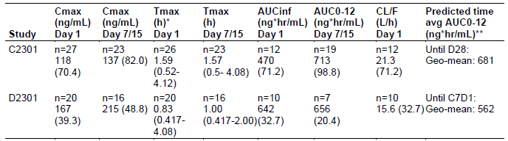

Notes: PK after repeated doses was done on Day 7 in Study C2301 and Day 15 in Study D2301

* Tmax presented in the table are the Median (Min – Max)

** Predicted from PopPK modelling

Abbreviations: Cmax = maximum plasma concentration, Tmax = time to maximum plasma concentration, AUCinf = area under the plasma concentration versus time curve to infinity; AUC0-12 = area under the plasma concentration versus time curve to twelve hours, CL/F = apparent clearance, Geo-mean = geometric mean

##### Population pharmacokinetic data

Pharmacokinetic data were derived from population pharmacokinetic (popPK) analyses of the pooled data from Study CINC424C2301, Study CINC424D2301 and Study 18424-271. Predictors of ruxolitinib pharmacokinetics included gastro-intestinal involvement on absorption rate constant (Ka) and apparent peripheral volume (Vp/F) as well as body surface area (BSA) on apparent central volume (Vc/F) and apparent oral clearance (CL/F). Although there was a positive relationship between BSA and both Vc/F and CL/F, the magnitude of increase in concentration is limited even at the maximum 90th percentile for lower and higher BSA values, suggesting that exposure is comparable between patients with low BSA such as adolescents and adults and no clinically relevant differences are expected.

Pharmacokinetic parameters from patients with ‘extensive pharmacokinetic’ sampling were available from 17 adult patients and three adolescent patients who received a dose of 10 mg ruxolitinib twice a day. After a single dose of 10 mg ruxolitinib, mean plasma concentrations increased rapidly reaching the peak concentration at approximately 0.5 to 1 hour followed by rapid distribution and elimination phases. On Cycle 1 Day 1, the geometric mean peak plasma concentration (Cmax) was 167 (coefficient of variation (CV) 39.3%) ng/mL; AUCinf and AUClast were 642 (CV 32.7%) ng.h/mL and 636 (CV 40.8%) ng.h/mL respectively. After multiple dosing at Day 15, the ruxolitinib pharmacokinetic profile was similar to that at Day 1. A slightly higher peak plasma concentration level was observed in the Day 15 profile however large variability was noted. Oral plasma clearance at steady-state (CLss/F) of ruxolitinib after oral dosing at 10 mg twice a day was estimated at 15.2 L/h, which was comparable to the CL/F obtained from AUCinf after a single 10 mg oral dose on Day 1. This suggested that clearance is not expected to change with time. Similarly, the geometric mean half-life (t½) appeared to be independent of time and ranged from 2.3 h to 2.4 h.

Although there was a positive relationship between BSA and both Vc/F and CL/F, no clinically relevant differences in exposure are expected in patients with low BSA such as adolescents supporting the use of the same dose (10 mg twice a day) in adolescents and adults with chronic GVHD. The effect of race on the pharmacokinetics of ruxolitinib in patients with GVHD did not have a significant impact on any parameter of the population pharmacokinetic model.

The effects of hepatic and renal impairment on the pharmcokinetics of ruxolitinib in patients with GVHD were investigated as covariates but did not have a significant impact on any parameter, however there were few patients with severe hepatic or renal impairment in the studies.

The indication of chronic GVHD rather than acute GVHD had an impact on Ka, Vc/F and CL/F. With log Ka increased by 0.636 h-1 (89% increase compared to acute GVHD), log Vc/F decreased by 0.103 L (a 10% reduction compared to acute GVHD) and log CL/F decreased by 0.286L/h (25% reduction compared to acute GVHD). All of these elements together indicate a higher expected exposure in chronic GVHD patients, compared to acute GVHD patients (increased absorption, reduced volume and clearance).

A higher Cmax is expected in patients with chronic GVHD compared to acute GVHD due to increased absorption, reduced volume and clearance. The sponsor considered these differences modest. No other demographic, disease-related and treatment related covariates have a significant impact on pharmacokinetic parameters.

Data on drug-drug interactions were submitted including relationships with cytochrome P450 (CYP) enzymes.[19] The effect of moderate and/or potent CYP3A4 inhibitors on the pharmacokinetics of ruxolitinib in patients with GVHD was not found to have a significant impact on any parameter in the popPK model. To supplement the popPK analysis, an empirical statistical analysis was performed to compare observed pre-dose concentrations that were impacted by a moderate and/or potent CYP3A4 inhibitor. After considering the actual dose administered, a 49 to 56% increase in pre-dose concentrations was observed in patients with GVHD receiving a moderate and/or potent CYP3A4 inhibitor.

Allogeneic stem cell transplantation patients are routinely treated with concurrent calcineurin inhibitors and azole prophylaxis which can inhibit the metabolism (via CYP3A4) of ruxolitinib, potentially increasing its exposure. Most patients (78%) with acute or chronic GVHD have received at least one moderate or potent CYP3A4 inhibitor within four days of a pharmacokinetic sample and maintained a dose of 10 mg twice a day for ruxolitinib. Although co-administration of moderate and/or potent CYP3A4 inhibitors increased the pre-dose concentrations of ruxolitinib, the increase observed was within the expected variability of the data.

Fluconazole is a dual CYP2C9 and CYP3A4 inhibitor. The median observed exposure in patients who received fluconazole was around two times higher than those who did not. The upper 90th percentile suggested maximum concentrations of 400 ng/mL. An empirical statistical analysis was performed to compare observed pre-dose concentrations that were impacted by fluconazole. After considering the administered dose, a 78% increase in pre-dose concentrations was observed in patients receiving fluconazole. The sponsor has proposed a dose reduction to 5 mg twice a day for patients taking concomitant fluconazole. The US FDA has proposed a dose reduction to 5 mg twice a day for patients taking up to 200 mg fluconazole and that higher doses of fluconazole are not recommended in conjunction with ruxolitinib.

In a dedicated renal impairment study in patients with various degrees of renal impairment including end stage renal disease requiring dialysis, the relative difference in exposures by Cmax and AUC0‑inf of ruxolitinib in all degrees of renal impairment versus patients with normal renal function were less than 25%. However, the total AUC of ruxolitinib and its active metabolites increased by 1.3, 1.5, and 1.9-fold in subjects with mild, moderate, and severe renal impairment, respectively, compared to subjects with normal renal function creatinine clearance (≥ 90 mL/min). Also, the total AUC of ruxolitinib and its active metabolites increased by 1.6-fold in subjects with end stage renal disease after dialysis compared to that in subjects with normal renal function.

In a hepatic impairment study, the mean AUC for ruxolitinib was increased by 87%, 28% and 65%, respectively, in patients with mild (Child-Pugh A), moderate (Child-Pugh B) and severe (Child-Pugh C)[20] hepatic impairment compared to patients with normal hepatic function. Given the higher AUC increase in patients with mild hepatic impairment compared to patients with moderate or severe hepatic impairment, the results from this study based on Child-Pugh scoring should be interpreted with caution. Population pharmacokinetic analysis using pooled data from patients in Study CINC424C2301, Study CINC424D2301 and Study 18424-271 showed that there was no significant difference in the apparent clearance of ruxolitinib in GVHD patients with various mild, moderate, or severe hepatic impairment by NCI criteria;[21] compared to patients with normal hepatic function.

No clinically relevant effect on ruxolitinib pharmacokinetics was observed based on Score 1 or 2 liver involvement chronic GVHD. Only two patients with Score 3 liver involvement chronic GVHD were enrolled in Study CINC424D2301. The effect of Score 3 liver involvement chronic GVHD on the pharmacokinetics of ruxolitinib is unknown.

##### Pharmacodynamics

No clinical pharmacodynamic data were included in the submission. Ruxolitinib is an inhibitor of the Janus kinases (JAKs) JAK1 and JAK2.

#### Efficacy

##### Acute graft-versus-host disease

Two efficacy and safety studies were submitted.

Study 18424-271 was submitted as a supportive study however, given the differences in perspective between the sponsor and the different Project ORBIS partners regarding the collection and analysis of efficacy data in Study CINC424C2301 (the REACH 2 trial), therefore Study 18424-271 will be considered as the pivotal study for this indication.

###### Study 18424-271 (REACH 1 trial)

Study design, objectives, locations and dates

Study 18424-271 (also known as the REACH 1 trial) was a single arm Phase II study of ruxolitinib in combination with corticosteroids for the treatment of steroid-refractory acute GVHD.

It was conducted by the co‑development partner (Incyte Corporation) at 26 centres in the USA during the study period 27 December 2016 to 5 June 2019.

The primary objective was to assess the efficacy of ruxolitinib in combination with corticosteroids in subjects with Grades II to IV steroid-refractory acute GVHD. Assessment of additional response and longer-term efficacy outcomes in the study population was a secondary objective.

Inclusion and exclusion criteria

The inclusion criteria were:

* Male or female participants aged 12 years or older who had undergone first allogeneic haematopoietic stem cell transplantation from any donor source using bone marrow, peripheral blood stem cells or cord blood for haematologic malignancies.

Recipients of nonmyeloablative and myeloablative transplants were eligible.

* Diagnosis of Grades II to IV acute GVHD was in accordance with Mount Sinai Acute GVHD International Consortium (MAGIC) criteria for acute GVHD guidelines (see Table 3).[22] Biopsies were to be obtained to pathologically confirm acute GVHD. In cases where a biopsy was negative or unable to be obtained or was clinically contraindicated clinical suspicion of acute GVHD by the treating physician was considered sufficient provided that alternative diagnoses of drug effects or infection were adequately excluded.
* The steroid-refractory aspects of the inclusion criteria required any of the following:
  + Progressive GVHD (that is, increase in stage in any organ system or any new organ involvement) after three days of primary treatment with methylprednisolone ≥ 2 mg/kg per day (or equivalent).
  + Subjects with GVHD that has not improved (that is, decrease in stage in at least one involved organ system) after seven days of primary treatment with methylprednisolone ≥ 2 mg/kg per day (or equivalent).
  + Subjects who previously began corticosteroid therapy at a lower dose (≥ 1 mg/kg methylprednisolone) for treatment of skin GVHD or skin GVHD accompanied by upper GI GVHD but develop new GVHD in another organ system.
  + Subjects who cannot tolerate a corticosteroid taper, that is, beginning corticosteroids at 2.0 mg/kg per day, demonstrate response, but progress before a 50% decrease from the initial starting dose of corticosteroids is achieved.
* Evidence of myeloid engraftment for example, an absolute neutrophil count (ANC) ≥ 0.5 x 109 /L for three consecutive days if ablative therapy was previously used. Use of growth factor supplementation was allowed.

Table 3: Harris et al. (2016); MAGIC Guidelines for acute graft-versus-host disease staging and grading

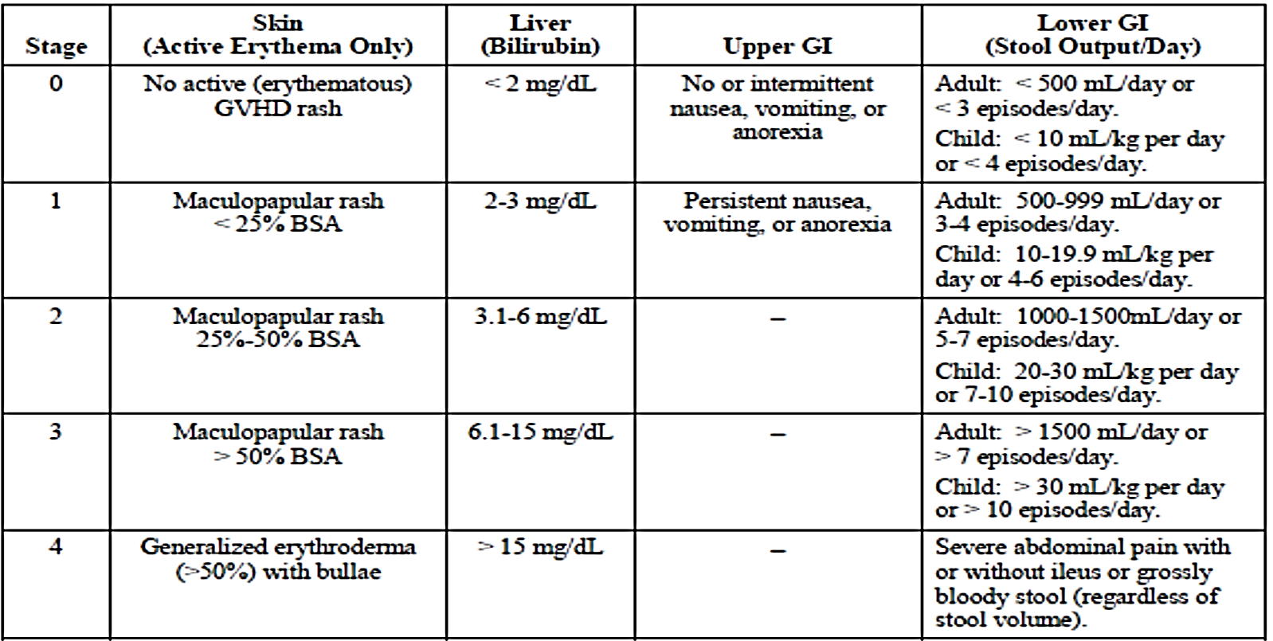

Abbreviations: BSA = body surface area; GI = gastrointestinal; GVHD = graft versus host disease.

Overall clinical grade (based on most severe target organ involvement)

Grade 0: No Stage 1 to 4 of any organs

Grade 1: Stage 1 to 2 skin without liver, upper gastro-intestinal, or lower gastro-intestinal involvement).

Grade II: Stage 3 rash and/or Stage 1 liver and/or Stage 1 upper gastro-intestinal and/or Stage 1 lower gastro-intestinal.

Grade III: Stage 2 to 3 liver and/or Stage 2 to 3 lower gastro-intestinal, with Stage 0 to 3 skin and/or Stage 0 to 1 upper gastro-intestinal.

Grave IV: Stage 4 skin, liver, or gastro-intestinal involvement, with Stage 0 to 1 upper gastro-intestinal

Reproduced from: Harris AC, Young R, Devine S, et al. International, Multicenter Standardization of Acute Graft-versus-Host Disease Clinical Data Collection: A Report from the Mount Sinai Acute GVHD International Consortium. Biol Blood Marrow Transplant. 2016;22(1):4-10.

The major exclusion criteria were:

* More than one allogeneic haematopoietic stem cell transplantation
* More than one systemic treatment in addition to corticosteroids for acute GVHD
* Presence of GVHD overlap syndrome
* Splenectomy
* Uncontrolled infection
* Severe organ dysfunction unrelated to acute GVHD.

Study treatments

All subjects initially received ruxolitinib 5 mg twice a day. If haematologic parameters were stable and no treatment-related toxicity was observed after the first three days of treatment, the dose could be increased to 10 mg twice a day. Stable haematologic parameters were defined as the absence of a ≥ 50% decrease in platelet counts and/or ANC relative to Day 1. Subjects also received prednisone 2.5 mg/kg per day orally or methylprednisolone 2.0 mg/kg per day intravenously (or a previously prescribed corticosteroid dose) on Day 1, and corticosteroids were tapered as appropriate.

Subjects could remain on study treatment until they tapered off of ruxolitinib, or until treatment failure (no response or requiring additional systemic therapy for GVHD progression), progression of underlying malignancy, unacceptable toxicity, withdrawal from therapy by the participant, physician decision, or death. Continued use of anti-infective medications, GVHD prophylaxis medications (including calcineurin inhibitors), transfusion support, and topical steroid therapy was permitted.

All 71 participants (100.0%) received at least one dose of ruxolitinib. A total of 42 participants (59.2%) received ruxolitinib for more than 28 days, and 18 participants (25.4%) received ruxolitinib for more than 180 days. The median duration of ruxolitinib treatment was 46.0 days (range: 4 to 811 days), and the median average reported daily dose was 10.21 mg/day (range: 5.1 to 19.7 mg/day).

On Day 1, 69 participants (97.2%) were receiving ruxolitinib 5 mg twice a day, and two participants (2.8%) were receiving ruxolitinib 5 mg four times a day. By Day 7, more than half of the participants who were still receiving ruxolitinib (35 of 67 participants, 52.2%) had their ruxolitinib dose increased to 10 mg twice a day per the protocol. The remaining participants still receiving ruxolitinib were receiving 5 mg twice a day (28 of 67 participants, 41.8%) or an alternate dose regimen (5 mg four times a day, 10 mg four times a day, or 15 mg once a day; 4 of 67 participants, 6.0%) on Day 7. From Day 28 through Day 180, the majority of participants who were still receiving ruxolitinib treatment were receiving 5 mg twice a day or 10 mg twice a day. At Day 28, nearly half of the participants who were still receiving ruxolitinib (20 of 43; 46.5%) were receiving 10 mg twice a day, and nearly one third of participants (13 of 43; 30.2%) were receiving 5 mg twice a day. One participant (2.3%) was receiving 15 mg daily on Day 28, and the remaining participants (9 of 43; 20.9%) were receiving 5 mg four times a day or less.

If a subject achieved complete response (CR) or very good partial response (VGPR) at Day 180, investigators could begin to taper the dose of ruxolitinib by one dose level provided corticosteroids had been discontinued for at least eight weeks following institutional guidelines. Subjects still receiving calcineurin inhibitors or other agents for GVHD prophylaxis could continue to do so at the treating investigator's discretion. In addition, subjects must not be experiencing any Grade 2 or higher haematologic toxicity related to ruxolitinib or symptoms of an active infection. Subsequent reductions to the dose of ruxolitinib could be made after an additional 56 days had elapsed provided the aforementioned requirements are still being met.

Efficacy variables and outcomes

Efficacy measures were assessed by the investigator only. GVHD response assessments were made with respect to changes in the organ stage relative to Day 1. The primary efficacy endpoint was the overall response rate (ORR) at Day 28, defined as the proportion of participants demonstrating a complete response, very good partial response, or partial response (PR). The definitions for these criteria are listed below.

* Complete response (CR): a score of 0 for the GVHD grading in all evaluable organs. For a response to be scored as CR at Day 28 or later, the participant must still be in CR on that day and have had no intervening additional therapy for an earlier progression, mixed response, or no response.
* Very good partial response (VGPR):
  + Skin: No rash, or residual erythematous rash involving less than 25% of the body surface, without bullae (residual faint erythema and hyperpigmentation do not count).
  + Liver: Total serum bilirubin concentration less than 2 mg/dL or less than 25% of baseline at enrolment.
  + Gut: tolerating food or enteral feeding; predominantly formed stools; no overt gastrointestinal bleeding or abdominal cramping; no more than occasional nausea or vomiting.
* Partial response (PR): improvement in one stage in one or more organs involved with GVHD symptoms without progression in others. For a response to be scored as PR at Day 28 or later, the participant must still be in PR on that day and have had no intervening additional therapy for an earlier progression, mixes response, or no response.
* Mixed response: improvement in one or more organs with deterioration in another organ manifesting symptoms of GVHD or development of symptoms of GVHD in a new organ.
* Progression of disease (PD): deterioration in at least one organ without any improvement in others.
* No response: absence of any improvement or progression as defined. Subjects receiving secondary therapy (including need to re-escalate steroid dose to greater than the Day 1 dose) will be classified as non-responders.

The key secondary endpoint was the six-month duration of response (DOR), defined as the time from first response until GVHD progression or death. DOR will be assessed when all subjects complete the Day 180 visit.

Additional secondary endpoints were analysed as follows:

* Overall response rate (ORR), defined as the proportion of subjects demonstrating a CR, VGPR, or PR response at Days 14, 56, and 100. Summary statistics and applicable 95% CI will be provided.
* Three-month duration of response (DOR), defined as the time from first response until GVHD progression or death when all subjects complete the Day 84 visit.
* Non-relapse mortality, defined as the proportion of subjects who died due to causes other than malignancy relapse at Months 6, 9, 12, and 24. Cumulative incidence rates will be provided. Summary statistics and applicable 95% CI will be provided.
* Relapse rate, defined as the proportion of subjects whose underlying malignancy relapses. The cumulative incidence rate and summary statistics will be provided.
* Relapse-related mortality rate, defined as the proportion of subjects whose malignancy relapses and has a fatal outcome. The cumulative incidence rate and summary statistics will be provided.
* Failure free survival (FFS), defined as the proportion of subjects who are still alive, have not relapsed, have not required additional therapy for acute GVHD, and have not demonstrated signs or symptoms of chronic GVHD, at Month 6.
* Overall survival, defined as the time from study enrolment to death due to any cause.

Acute GVHD grading was performed by the investigator weekly for the first eight weeks after enrolment, then every 28 days thereafter. GVHD staging and grading was to occur on Days 100, 180, and 365 and at the end of treatment visit. Data for quantification of acute GVHD symptoms (extent of skin rash, total bilirubin level, volume of diarrhoea) was to be reported using MAGIC guidelines;22 with response assessed as per the Center for International Blood and Marrow Transplant Research (CIBMTR)[23] modifications to the IBMTR response index.[24],[25]

Sample size and statistical methods:

Approximately 70 subjects are planned for the final analysis of the primary endpoint of overall response rate. A second-line treatment demonstrating a true overall response rate of 60% would be considered clinically meaningful. With the assumed true rate of 60%, a sample size of 70 subjects would provide more than 90% probability to have a 95% CI with lower limit of ≥ 40%.

An interim analysis was to be conducted once 35 subjects completed the Day 28 visit. In this interim analysis, only futility was to be assessed, and the trial terminated if the lower boundary was crossed.

A group sequential design method for one sample binary outcome data was used to calculate the lower boundary of futility. The spending function of HSD (-4) was used. For the null hypothesis, p = 0.4; and for the alternative hypothesis, p = 0.6; and a 1-sided binomial test with alpha of 0.025, if 15 or less subjects respond at the time of the interim analysis, the study would be terminated. This would provide 70.03% probability for the response rate of 40% at the interim analysis.

If 37 or more subjects responded at the time of final analysis, the study outcome was to be considered positive. These assumptions provided 89.88% power for the response rate of 60% in the final analysis with Type I error of 0.0189.

No formal statistical tests were performed.

Subject disposition and baseline characteristics

There were 71 subjects enrolled and 68 subjects (95.8%) discontinued study treatment, with 24 subjects (33.8%) discontinuing on or before Day 28. ‘Adverse event’ and ‘physician decision’ were the most frequently reported reasons for discontinuation on or before Day 28 (8 and 10 participants (11.3% and 14.1%), respectively) and at the end of the study (20 and 23 participants (28.2% and 32.4%), respectively). Of the 23 participants who discontinued ruxolitinib treatment due to physician decision, six participants discontinued because of clinical improvement including 4 participants in complete response, one participant with very good partial response, and one participant with mixed response. At the time of the data cut-off on 5 June 2019, 24 participants (33.8%) remained in the study.

The median age was 58 years, with 13 (18.3%) subjects aged 65 years or greater; 49.3% were male; 38% had an ECOG performance score of 0 or 1 and 51.1% had an Eastern Cooperative Oncology Score of 2 or 3.[26] At baseline, aGVHD was Grade II in 31%, Grade III in 46.5%, and Grade IV in 22.5%. The median duration of prior corticosteroid exposure at Baseline was 16 days (range: 3 to 285 days).

All subjects took at least one medication prior to enrolment. The most frequently prescribed prior medication was tacrolimus (59 subjects, 83.1%). Other prior medications prescribed to greater than 60% of participants within 30 days before study enrolment included: acyclovir (57 subjects, 80.3%); ursodeoxycholic acid (46 subjects, 64.8%); and ondansetron (45 subjects, 63.4%). All 71 subjects had received prior prophylaxis for GVHD, including; calcineurin inhibitors (69 subjects, 97.2%); folic acid analogues (16 participants, 22.5%); and selective Immuno-suppressants (51 subjects, 71.8%).

The most frequently prescribed concomitant medication was tacrolimus (60 subjects, 84.5%). Other concomitant medications prescribed to more than 60% of subjects included: acyclovir (55 subjects, 77.5%); paracetamol (52 subjects, 73.2%), pantoprazole and potassium chloride (47 subjects, 66.2%); ursodeoxycholic acid (46 subjects, 64.8%); diphenhydramine and ondansetron (44 subjects each, 62.0%).

The dose of concomitant corticosteroid was adjusted during the study. The mean initial corticosteroid dose on Day 1 (or Day 2 if the Day 1 dose was missing) was 157.25 mg/day (range: 50.0 to 300.0 mg/day). The mean average corticosteroid dose (that is, the mean of each participant's weekly average dose) decreased to 62.25 mg/day for the week ending on Day 28 for participants who were still receiving ruxolitinib. The mean average corticosteroid doses continued to decrease by approximately 50% at each subsequent timepoint (Days 56, 100, and 180) to 8.57 mg/day by the week ending on Day 180.

Over time, the proportion of participants who were still receiving ruxolitinib and who had at least a 50% decrease in corticosteroid dose relative to the Day 1 or Day 2 dose increased from 23.2% on Day 14 (13 of 56 participants) to 55.8% (24 of 43 participants) on Day 28, 96.3% (26 of 27 participants) on Day 56, and 100.0% (15 of 15 participants) on Day 100. By Day 180, all 7 participants (100.0%) who were still receiving both ruxolitinib and corticosteroids had at least a 75% decrease in corticosteroid dose relative to the Day 1 (or Day 2) dose.

Efficacy results

Forty subjects (56.3% (95% CI: 44.0, 68.1)) demonstrated a response at Day 28, including 19 subjects (26.8%) who achieved a complete response and six who achieved a very good partial response (8.5%). Thus, the study achieved the predetermined threshold for a positive study outcome (lower limit of the 95% CI for Day 28 overall response rate ≥ 40%).

For the 54 participants (76.1%) who had a response (complete response (CR), very good partial response (VGPR), or partial response (PR)) at any timepoint, the median time to first response was 8 days (range: 6 to 49 days) (see *Efficacy variables and outcomes* for response definitions). Forty-four participants (62.0%) achieved their first response before Day 14, and all participants who responded had a response before Day 56.

The key secondary endpoint was the six-month duration of response, defined as the time from first response until GVHD progression or death. Of the 40 subjects who were Day 28 responders, the median duration of response was 669 days (95% CI: 159.0, not evaluable). For the 54 of 71 (76.1%) subjects who responded at any time during the study the median duration of response (DOR) was 345 days (95% CI: 154.0, not evaluable). The three and six month event-free probabilities for DOR based on a response at Day 28, 84.5% (95% CI: 68.7, 92.7) and 68.2% (95% CI: 49.6, 81.2), respectively. Three and six month event-free probabilities for DOR based on a response at any timepoint were 75.6% (95% CI: 61.0, 85.4) and 62.1% (45.8, 74.8), respectively.

Of the subjects who continued to receive both ruxolitinib and corticosteroids, more than half (55.8%) had decreased their corticosteroid dose by 50% or more at Day 28 relative to the initial corticosteroid dose. The proportions of participants who had tapered off corticosteroids were 34.8% (8 of 23 participants) at Day 100 and 61.1% (11 of 18 participants) at Day 180.

Supplementary analyses

An independent regulatory analysis of Study 18424-271 was conducted.

Results were reported for subjects who had failed steroids only and for subjects who had failed steroids with and without other treatments. Of the 71 patients enrolled in the study, 13 did not receive corticosteroids at a minimum of 2 mg/kg (± 10%) prior to study entry. These patients are not considered to have been treated with an adequate dose of steroids and are excluded from the analysis. Forty-nine subjects were evaluated as having failed steroid treatment, 10 subjects were excluded because they did not meet the criteria of steroid refractory based on suboptimal dosing or duration of corticosteroid treatment, and 12 were excluded because of additional prior lines of therapy (that is, were not refractory to steroids alone).

The following analyses were performed for this population:

* Prior anti-GVHD therapy
* Day 28 overall response
* Duration of response, calculated from Day 28 response to progression, new acute GVHD therapy, or death (with progression being defined as worsening by one stage in any organ without improvement in other organs in comparison to prior response assessment)
* Duration of response, calculated as the time from Day 28 response to increase in corticosteroid from baseline, start of new acute GVHD therapy, or death
* Overall response rate by baseline acute GVHD grade
* Corticosteroid use during ruxolitinib treatment

All 49 participants in the steroid refractory evaluable population had received prior systemic therapy with corticosteroids, including methylprednisolone (81.6%), methylprednisolone sodium succinate (10.2%), and prednisone (51.0%), for the treatment of GVHD. The median duration of prior corticosteroid exposure was 15.0 days, and the median average daily dose of corticosteroids at the start of study treatment was 160 mg/day. In addition to prior corticosteroid treatment, 26.5% of participants had received calcineurin inhibitors (predominantly tacrolimus (22.4%), with or without methotrexate). For the majority of participants, the best response to the most recent prior acute GVHD therapy was either progress of disease (40.8%) or no response (22.4%). The most common reasons for discontinuation of the most recent prior acute GVHD therapy were progression of disease and lack of efficacy (26.5% each). At the time of data cut-off date of 2 April 2018, 11 patients (19.0%) remained in the study, 30 patients died during the study (12 due to GVHD progression).

Use of additional post-study treatments were reported for 18 (37%) patients. These included extracorporeal photopheresis in 12 patients, etanercept in three, infliximab in three, vedolizumab in three, antithymocyte globulin (ATG) in two, basiliximab in two, mycophenolate mofetil in two, sirolimus in one and tacrolimus in one patient.

The overall response rate at Day 28 for the 49 participants in the evaluable population was generally similar to that for the investigator’s efficacy evaluable population and when the additional 8 patients who were refractory to steroids with or without other treatments were considered. Overall response rate results for both sub-populations are tabulated below.

Table 4: Study 18424-271 (supplementary regulatory analysis) Overall response rate for two sub‑populations

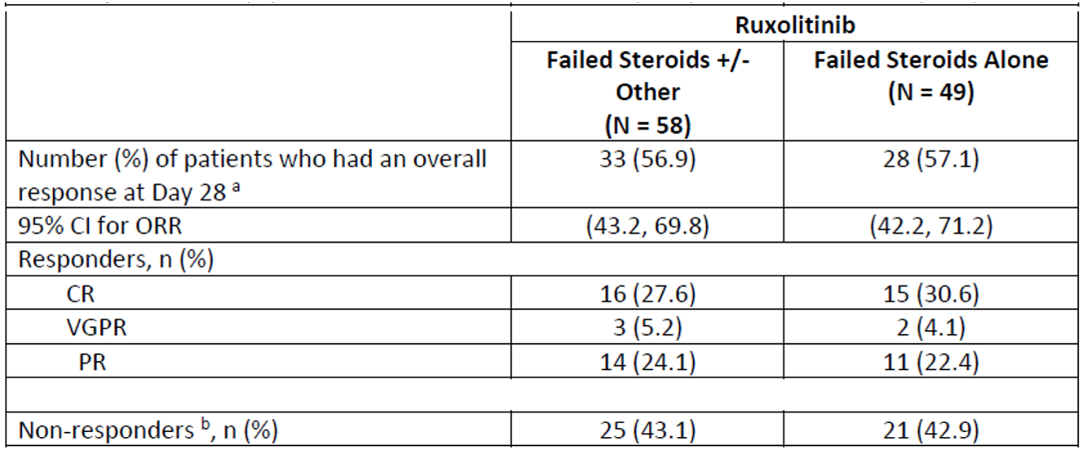

Abbreviations: CI = confidence intervals; CR = complete response; ORR = overall response rate; PR = partial response; VGPR = very good partial response.

See *Efficacy variables and outcomes* for response definitions.

a Patients who had a complete response, very good partial response or partial response at Day 28 response assessment or other response assessments within ± 2 days of Day 28, on or before the start of new anti-GVHD therapy (if applicable).

b Patients with missing assessment were considered non-responders.

The predetermined threshold for a positive outcome (lower limit of the 95% CI for Day 28 overall response ≥ 40%) was also achieved in in both these populations.

For the steroid only refractory population, when evaluated by baseline acute GVHD grade, the Day 28 overall response was 100.0% (13 of 13 participants) for Grade II, 40.7% (11 of 27 participants) for Grade III, and 44.4% (4 of 9 participants) for Grade IV, compared with 57.1% for all grades combined.

For the 28 participants in the evaluator’s steroid refractory evaluable population who had a response at Day 28, the median duration of response, calculated from Day 28 response to progression, new acute GVHD therapy, or death (with progression being defined as worsening by one stage in any organ without improvement in other organs in comparison to prior response assessment) was 16.0 days (95% CI: 9.0, 83.0). The median duration of response when defined as increase in corticosteroid dose from Baseline, start of new acute GVHD therapy, or death for the Day 28 responders, was 173.0 days (95% CI:77.0, 304.0) from the Day 28 response.

There were nine patients who had failed with corticosteroids, with or without other treatments, with five of these being responders. The median duration of response, using the evaluator’s primary definition of duration of response that is, time from Day 28 response to progression, new acute GVHD therapy, or death, was 22 days (95% CI: 15, 132). Six of the nine patients (49.0%) in the failed two or more therapies population died. The median overall survival is 49 days (95% CI: 9, not evaluable). All reported deaths were non-relapse mortality. The cumulative incidence rate of the non relapse mortality at six, nine, and twelve months were 55.6% (95% CI: 21.2, 86.3), 66.7% (95% CI: 29.9, 92.5), and 66.7% (95% CI: 29.9, 92.5), respectively.

Additionally, as this is the first application for a treatment of acute GVHD using the efficacy endpoint of Day 28 overall response rate, an assessment of actual outcome by response was performed to see whether Day 28 overall response rate as defined is associated with longer-term benefit. For the 49 patients who failed steroids alone, the 6 month overall survival was greater in those with Day 28 overall response rate than in those who did not respond (71% versus 24%).

##### Chronic graft-versus-host disease

###### Study CINC424D2301 (REACH 3 trial)

Study CINC424D2301 (also known as the REACH 3 trial);[27] is a Phase III randomised open-label multi-centre study of ruxolitinib versus best available therapy in patients with corticosteroid-refractory chronic graft versus host disease after allogeneic stem cell transplantation. This is an international study that includes centres in Australia.

Study design, objectives, locations and dates

The first patient visit was on 29 June 2017 and the data cut-off date for this submission was 8 May 2020 (data cut-off date for the primary analysis). The study is ongoing. The final analysis will occur when all patients have completed 39 cycles or discontinued from the study or died. The final clinical study report (CSR) is expected in 2023. The end of treatment visit is to occur when the patient permanently discontinues study treatment and enters the long-term survival follow-up, or completes the randomised treatment period (ruxolitinib arm, or best available treatment (BAT) patients not crossing over) or the crossover period (BAT arm only). Patients were stratified by severity of chronic GVHD at the time of randomisation based on cGVHD severity per 2014 National Institutes of Health (USA) consensus criteria shown below.[28]

Table 5: National Institutes of Health (2014) Consensus criteria for global Severity of chronic graft versus host disease

|  |
| --- |
| Mild chronic GVHD |
| 1 or 2 Organs involved with no more than score 1 plus Lung score 0 |
| **Moderate chronic GVHD** |
| 3 or more organs involved with no more than score 1  OR  At least 1 organ (not lung) with a score of 2  OR  Lung score 1 |
| **Severe chronic GVHD** |
| At least 1 organ with a score of 3  OR  Lung score of 2 or 3  Key points:  In skin: higher of the 2 scores to be used for calculating global severity.  In lung: FEV1 is used instead of clinical score for calculating global severity  If the entire abnormality in an organ is noted to be unequivocally explained by a non-GVHD documented cause, that organ is not included for calculation of the global severity.  If the abnormality in an organ is attributed to multifactorial causes (GVHD plus other causes) the scored organ will be used for calculation of the global severity regardless of the contributing causes (no down grading of organ severity score). |

FEV1 refers to the one-second forced expiratory volume on lung function testing.

Reproduced from: Jagasia MH, Greinix HT, Arora M, et al.. National Institutes of Health Consensus Development Project on Criteria for Clinical Trials in Chronic Graft-versus-Host Disease: I. The 2014 Diagnosis and Staging Working Group Report. Biol Blood Marrow Transplant. 2015;21(3):389-401.

Approximately 324 patients were planned to be randomised in a 1:1 ratio to one of the two treatment arms, ruxolitinib or BAT. The study design is outlined below with each cycle comprised of 4 weeks (28 days).

Figure 1: Study CINC424D2301 (REACH 3 trial) Study design

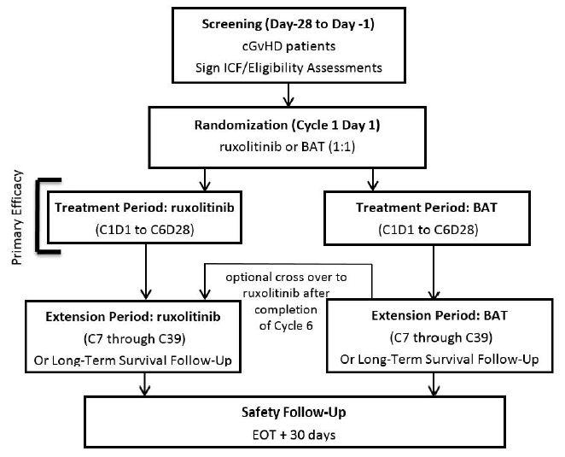

Abbreviations: BAT = best available therapy; cGvHD = chronic graft versus host disease; EOT = end of treatment; ICF = informed consent form.

Note: CxDx refers to Cycle number and Day number; for example C1D1 refers to Cycle 1 Day 1.

Primary objective

The primary objective is to compare the efficacy of ruxolitinib versus investigator’s choice best available therapy in patients with moderate or severe steroid-refractory chronic GVHD assessed by overall response rate (ORR) at the Cycle 7 Day 1 visit.

Key secondary objectives

The key secondary objectives are to:

* compare the rate of failure free survival; and
* compare change in modified Lee Symptom Score.[29],[30],[31]

Failure free survival will be used as the first key secondary endpoint for all regions (rest of world) except the USA. The modified Lee symptom score; will be used as the first key secondary endpoint for the USA.

Other secondary objectives

Other secondary objectives include; to:

* Assess best overall response (BOR)
* Estimate overall response rate at end of Cycle 3
* Assess duration of response
* Assess overall survival
* Assess non-relapse mortality
* Assess proportion of patients with ≥ 50% reduction in daily corticosteroid dose at Cycle 7 Day 1
* Assess proportion of patients successfully tapered off all corticosteroids at Cycle 7 Day 1
* Assess cumulative incidence of Malignancy Relapse/Recurrence (MR)
* Evaluate changes in Functional Assessment of Cancer Therapy - Bone Marrow Transplantation and EuroQol EQ-5D questionnaire
* Assess pharmacokinetics of ruxolitinib in patients
* Evaluate the safety of ruxolitinib and best available therapy
* Assess medical resource utilisation.

Inclusion and exclusion criteria

Eligible patients were ≥ 12 years old with moderate or severe chronic GVHD as defined by NIH Consensus Criteria[32] requiring additional therapy after failure of corticosteroid therapy and no more than one additional salvage treatment.

Patients were excluded if they had an absolute neutrophil count < 1 Gi/L and platelet count < 25 Gi/L, estimated creatinine clearance < 30 mL/min, progressive onset chronic GVHD, oxygen saturation < 90%, total bilirubin > 2 mg/dL, or diarrhoea due to GVHD.

Study treatments

The ruxolitinib dose was 10 mg twice a day. This dose was based on published studies of off‑label use of ruxolitinib in chronic GVHD. Treatments permitted as best available treatment included: extracorporeal photopheresis, low-dose methotrexate, mycophenolate mofetil, everolimus, sirolimus, infliximab, rituximab, pentostatin, imatinib or ibrutinib. The investigator could select any of these as choice of best available treatment before randomisation. Each patient will be treated and/or followed for a total of three years (39 cycles/156 weeks). Patients randomised to best available treatment who did not achieve a complete response or partial response or lost their response thereafter or became intolerant to best available treatment were allowed to crossover to ruxolitinib at or after the start of Cycle 7, after assessments for the primary endpoint. Best available treatment patients who achieved a complete response or partial response on Cycle 7 Day 1 were not allowed to crossover to ruxolitinib until disease progression, mixed response, or occurrence of a toxicity to best available treatment.

Calcineurin inhibitors and systemic corticosteroids could be taken by the patient as per institutional guidelines. Supportive care such as anti-infectives and immunisations could be used as prophylactic therapies.

Efficacy endpoints

The primary efficacy endpoint was overall response rate, defined as the proportion of patients with complete response or partial response, at Cycle 7 Day 1 according to NIH consensus criteria.32

Responses were defined as follows:

* A complete response (CR) was defined as complete resolution of all signs and symptoms of chronic GVHD in all evaluable organs without initiation or addition of new systemic therapy.
* A partial response (PR) was defined as an improvement in at least one organ (for example, improvement of one or more points on a 4 to 7 point scale, or an improvement of two or more points on a 10 to 12 point scale) without progression in other organs or sites, initiation or addition of new systemic therapy.

Lack of response was defined as unchanged, mixed response, or progression.

The key secondary endpoints were failure free survival and the modified Lee Symptom Scale (mLSS).31

* Failure free survival is a composite time to event endpoint incorporating relapse or recurrence of underlying disease or death due of underlying disease, and non-relapse mortality, and the addition or initiation of another systemic therapy for chronic GVHD.
* For the secondary endpoint analysis of mLSS scores, a reduction of seven or more points of the total symptom score of the mLSS at Cycle 7 Day 1 relative to baseline was considered a response.

Other secondary endpoints included:

* Best overall response (BOR) defined as the proportion of patients who achieved overall response (complete response or partial response) at any time point up to and including Cycle 7 Day 1 and before the start of additional systemic therapy for chronic GVHD was also a secondary endpoint.
* Duration of response (DOR) was determined only for responders and was defined as the time from first response until chronic GVHD progression, death, or the date of change/addition of systemic therapies for chronic GVHD.

Chronic GVHD recurrence was defined as the return of chronic GVHD disease after tapering off study treatment due to response. Following completion of a taper of systemic therapy, if worsening of chronic GVHD symptoms occur, the patient was allowed to resume treatment for chronic GVHD as per local institutional practice. The re-starting of treatment for chronic GVHD was handled in the same way as addition or initiation of new systemic treatment.

A patient was not considered a responder at Cycle 7 Day 1 if any of the following events occurred prior to the Cycle 7 Day 1 visit:

* Missing chronic GVHD assessment at Cycle 7 Day 1
* No complete response or partial response at Cycle 7 Day 1
* Addition or start of new systemic therapy for chronic GVHD prior to the current assessments

Statistical methods

The primary analysis comprised analyses of the primary, key secondary endpoints, secondary and some exploratory objectives in all patients who completed the Cycle 7 Day 1 visit or who discontinued from study participation earlier.

An interim analysis based on 196 patients (60.5% of the targeted 324 patients), who completed Cycle 7 Day 1 visit or discontinued earlier, was performed and the results were provided to the Data Monitoring Committee in October 2019. The committee recommended to proceed the study with primary analysis for all 329 randomised patients who completed Cycle 7 Day 1 visit or discontinued earlier (data cut-off on 8 May 2020).

Statistical tests of the primary and the two key secondary endpoints at the interim analysis and the primary analysis were performed according to an overall hierarchical testing procedure in a two-look group sequential study design to hold the overall one-sided family-wise error rate of alpha = 0.025. The significance boundary at the interim analysis based on the alpha-spending function was alpha = 0.01176 and was used for all three endpoints. Hypotheses that were not rejected at the interim analysis were retested at the primary analysis by using the remaining alpha (= 0.01858) according to the group sequential methodology.

Subject disposition and baseline characteristics

Table 6: Study CINC424D2301 (REACH 3 trial) Subject disposition

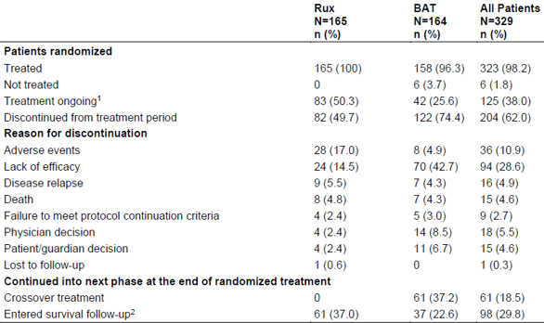

Abbreviations: BAT = best available treatment; Rux = ruxolitinib.

1 Ongoing at the time of the data cut-off date 8 May 2020

2 Survival follow-up: followed approximately every three months by telephone call for survival and reporting of new cGVHD therapies until 39 cycles completed

The median age in the overall population was 49.0 years (range: 12.0 to 76.0). The proportion of male and female patients was 61.1% and 38.9%, respectively. Most patients were White (75.4%). Twelve (3.6%) patients whose age was between 12 to less than 18 years at Baseline were included in the adolescent population.

The majority of enrolled patients had malignant underlying disease including myeloid diseases (73.3% in the ruxolitinib arm, and 74.4% in the ‘best available treatment’ arm). The predominant underlying malignant diseases (in the ruxolitinib arm and in the ‘best available treatment’ arm) were acute myeloid leukaemia (35.8% and 37.2%), acute lymphoblastic leukaemia (17.6% and 14.0%) and myelodysplastic syndromes (14.5% and 12.2%). A small proportion of patients had non-malignant underlying disease.

Across all randomised patients, the proportions of patients with Center for International Blood and Marrow Transplant Registry (CIBMTR)23 risk category to predict mortality in chronic GVHD were 26.7% at low, 27.4% at intermediate, 24.6% at high, and 21.0% with unknown. 67 (41%) of patients randomised to ruxolitinib and 63 (38%) patients randomised to best available treatment had four or more organs involved.

The median time from initial chronic GVHD to steroid-refractory chronic GVHD was 111.00 days (range: 2.0 to 2009.0 days) and was similar in patients between the two arms. The most common reason for steroid-refractory chronic GVHD was lack of response or disease progression after administration of prednisone (or equivalent) ≥ 1 mg/kg/day for at least one week (37.6% in the ruxolitinib arm and 44.5% in the ‘best available treatment’ arm). Steroid dependent patients (defined as increase prednisolone dose to > 0.25 mg/kg/day after two unsuccessful attempts to taper the dose) were 28.6% of the population. The most frequently used prior systemic therapy was steroid alone (42.4% in the ruxolitinib arm and 49.4% in the ‘best available treatment’ arm). A comparable proportion of patients in both treatment arms had prior systemic therapy with steroids with calcineurin inhibitors.

At study entry all 329 (100%) patients met steroid-refractory chronic GVHD criteria. There were 41.2% versus 44.5% of patients with moderate and 58.8% versus 54.9% of patients with severe steroid-refractory chronic GVHD in the ruxolitinib and the ‘best available treatment’ arms, respectively. One patient with mild steroid-refractory chronic GVHD at study entry was randomised into the ‘best available treatment’ arm.

Among the 329 patients randomised, 33.9% of patients in ruxolitinib arm and 31.1% of patients in ‘best available treatment’ arm received prior prophylaxis treatment for chronic GVHD. Calcineurin inhibitors were the most frequently (24.0%) reported prophylactic therapy for chronic GVHD in both arms (23.6% and 24.4%, respectively), including ciclosporin (14.5% and 17.1%) and tacrolimus (9.1% and 7.9%). Use of glucocorticoids in the prophylactic treatment for chronic GVHD was reported in 10.0% of all patients, including prednisone (6.1% and 3.7%) and prednisolone (4.8% and 3.0%).

Concomitant medications on treatment (starting on or after the start of study treatment and no more than 30 days after end of treatment) were taken by 100% and 99.4% of patients in the ruxolitinib and the ‘best available treatment’ arms, respectively. Calcineurin inhibitors were taken in 27.3% patients in the ruxolitinib arm and in 19.0% patients in the ‘best available treatment’ arm. Ciclosporin (17.6% and 12.0% in respective arms) and tacrolimus (10.9% and 8.2% in respective arms) were the commonly used calcineurin inhibitor medications by partial response patients. The overall profile of other concomitant medications was similar between the two treatment arms. The most frequent concomitant medications also included agents for treatment of infections, gastro-intestinal symptoms (for example, bile acid preparations), and sedation (for example, benzodiazepine derivatives).

Efficacy results

The primary objective was to compare the efficacy of ruxolitinib versus investigator’s choice best available therapy in patients with moderate or severe steroid-refractory chronic GVHD assessed by overall response rate (ORR) at the Cycle 7 Day 1 visit.

The results for the full analysis set population are shown in Table 7, below.

Table 7: Study CINC424D2301 (REACH 3 trial) Overall response rate at the Cycle 7 Day 1 visit (full analysis set; primary analysis)

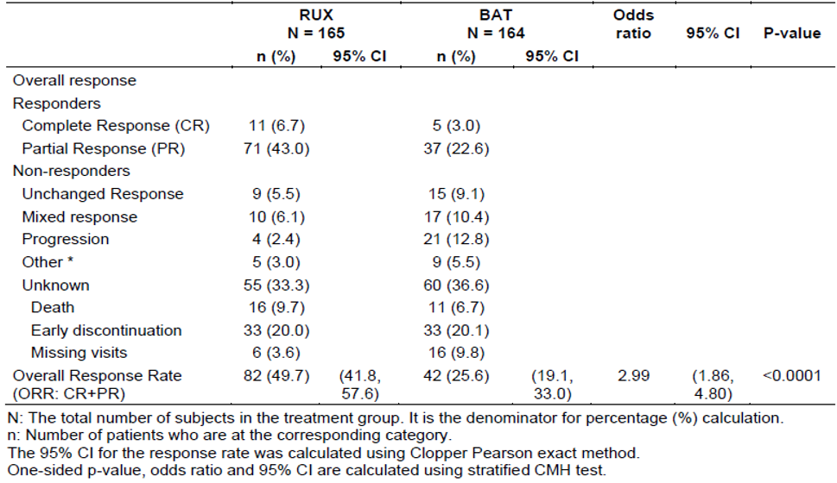

Abbreviations: BAT = best available treatment; Rux = ruxolitinib.

Subgroup analyses compared the odds ratios (ruxolitinib treatment versus best available treatment) of overall response rate in patients by demographics, underlying diseases and medication history, as shown in Figure 2, below.

Figure 2: Study CINC424D2301 (REACH 3 trial) Forest plot of odds ratio with 95% confidence intervals for overall response rate at Cycle 7 Day 1 visit from the subgroup analysis (full analysis set; primary analysis)

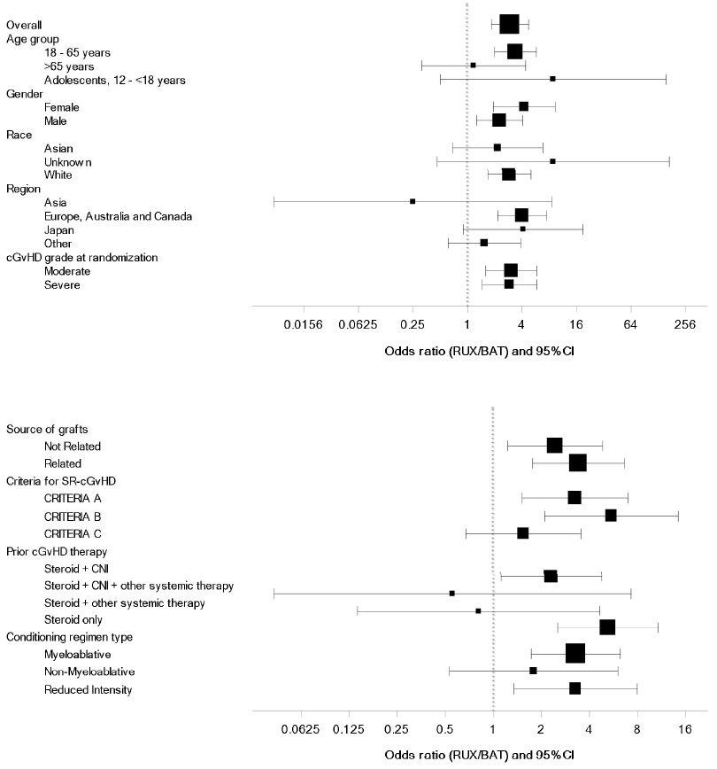

Abbreviations: BAT = best available treatment; CI = confidence interval; SR = steroid refractory; Rux = ruxolitinib.

Notes: X-axis values are represented in natural log scale. Dotted lines show no effect point.

The area of the box indicates the weight of the sub-group, measured by the size of subpopulation.

Criteria for SR-cGvHD:

A. Lack of response or disease progression after administration of minimum prednisone 1 mg/kg/day for at least 1 week.

B. Disease persistence without improvement despite continued treatment with prednisone at >0.5 mg/kg/day or 1 mg/kg/every other day for at least 4 week

C. Increase prednisone dose to >0.25 mg/kg/day after two unsuccessful attempts to taper the dose.

From the above analyses, those patients taking more therapies at Baseline (suggesting having more difficult to control disease) had a lower response rate with ruxolitinib than with best available treatment, though there were few of these patients and the confidence interval was wide. Similarly, patients in the Asian region did better on best available treatment than ruxolitinib. Patient age also appears to be a factor in the relative benefit of ruxolitinib compared with best available treatment in that adolescent patients had higher odds ratios for overall response rate than those older than 65 years, though both groups had odds ratios greater than one. These were exploratory analyses.

A key secondary objective was to compare the rate of failure free survival (shown in Figure 3, below).

Figure 3: Study CINC424D2301 (REACH 3 trial) Kaplan-Meier estimate of failure free survival (full analysis set; primary analysis)

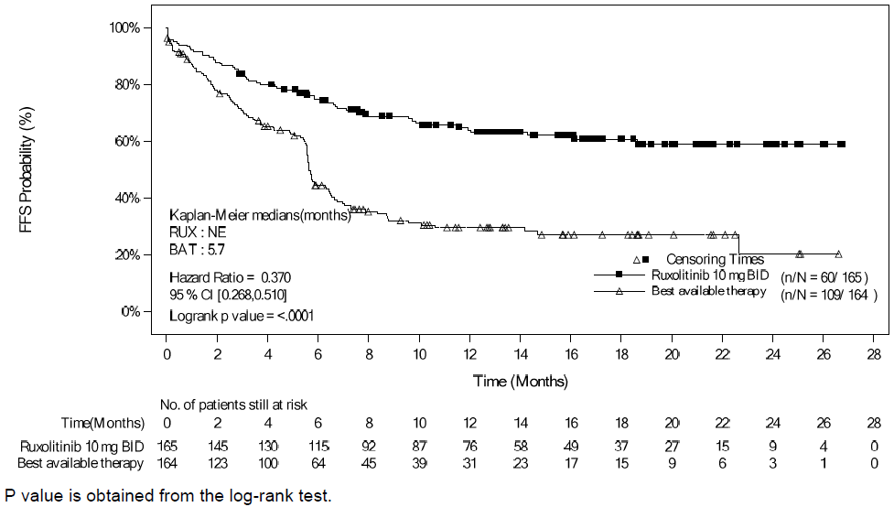

Abbreviations: BAT = best available treatment; BID = twice daily; CI = confidence interval; FFS = failure-free survival; Rux = ruxolitinib.

The second key efficacy endpoint of the rate of responders as per improvement 7 or more points of total symptom score (What is useful/important is things like: what studies are in progress, and when the TGA can expect updates; and things like patient registries. Also thinks like PACS and DHCP letter and patient education within Australia.) of the mLSS from baseline to Cycle 7 Day 1 showed a statistically significant difference between the two treatment arms in the primary analysis, with a responder rate of 24.2% (95% CI: 17.9, 31.5) in the ruxolitinib arm and 11.0% (95% CI: 6.6, 16.8) in the ‘best available treatment’ arm at Cycle 7 Day 1. The odds ratio (ruxolitinib/best available treatment) was 2.62 (95% CI: 1.42, 4.82) with the stratified Cochran-Mantel-Haenszel test;[33] p = 0.0011.

Best overall response up to Cycle 7 Day 1 was higher in the ruxolitinib arm (76.4%, 95% CI: 69.1, 82.6) than in the ‘best available treatment’ arm (60.4%, 95% CI: 52.4, 67.9). There was a statistically significant difference between the ruxolitinib and best available treatment (stratified Cochran-Mantel-Haenszel test p=0.0011, one-sided) with the odds ratio 2.17 (95% CI: 1.34, 3.52) for response in ruxolitinib arm compared to ‘best available treatment’ arm. The primary overall survival analysis was performed with 31 deaths in the ruxolitinib arm and 27 deaths in the ‘best available treatment’ arm based on Cycle 7 Day 1 data. No difference was observed in the risk of death between the ruxolitinib arm and the BAT arm as evidenced by a hazard ratio = 1.086 (95% CI: 0.648, 1.820), and was not statistically significant (log-rank p‑value: 0.3764) between the two arms. The median overall survival estimated by Kaplan-Meier was not reached at time of the analysis in either treatment arm.

Duration of response was evaluated in patients who achieved a complete response (CR) or partial response (PR) at or before Cycle 7 Day 1 as their best overall response (see *Efficacy endpoints* for definitions of response). Duration of response was defined as ‘time from first response until chronic GVHD progression, death, or systemic therapies for chronic GVHD’. Median duration of response was not reached in ruxolitinib arm and was 6.2 months (95% CI: 4.7 to 13.3) in the ‘best available treatment’ arm. The estimated probability of maintaining best overall response with 95% CIs was higher in the ruxolitinib arm (76.58%, 95% CI: 67.87, 88.22) compared to the ‘best available treatment’ arm (52.11%, 95% CI: 41.78, 61.45) at 6 months. Similar trends in probability were observed at 12 months (64.48%, 95% CI: 58.94, 76.26 versus 40.33%, 95% CI: 30.28, 50.15), and 18 months (63.50%, 95% CI: 52.82, 72.38 versus 36.66%, 95% CI: 26.47, 46.88).

Analysis of results for duration of response in the full analysis set population is shown in Figure 4, below.

Figure 4: Study CINC424D2301 (REACH 3 trial) Kaplan-Meier curve of duration of response (full analysis set)

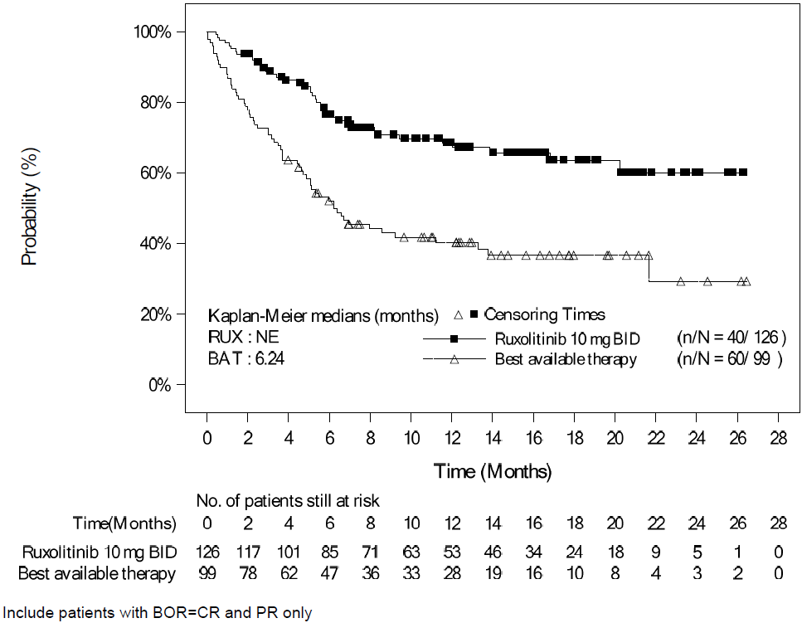

Abbreviations: BAT = best available treatment; BID = twice daily; BOR = best overall response; CI = confidence interval; CR = complete response; NE = not evaluable; PR = partial response; Rux = ruxolitinib.

Supplementary analysis

As in the Study 18424-271, regulatory analyses used alternative definitions and endpoints where they considered the amendments to be better suited to identifying efficacy in chronic GVHD. The table below summarises the similarities and difference in efficacy endpoints.

Table 8: Comparison of (sponsor’s) Study CINC424D2301 definitions versus definitions used in supplementary regulatory analyses for the primary and key secondary endpoints

|  |  |  |
| --- | --- | --- |
|  | **Sponsor** | **Reviewer** |
| Analysis set | All patients who were randomised to study treatments | All patients who were randomised to study treatments |
| Primary endpoint | Overall response rate at Cycle 7 Day 1 visit | Overall response rate at any time up to and including Cycle 7 Day 1 visit |
| Adjudication | By investigator | Algorithmic with manual adjudication for discrepancies with the sponsor’s results |
| Definition of overall response rate | 2014 NIH consensus criteria based on organ response criteria;32 | 2014 NIH consensus criteria based on organ response criteria;32 |
| Definition of duration of response | Time from first response until chronic GVHD progression, death, or systemic therapies for chronic GVHD | Time from first response until organ progression, death, or new systemic therapy |
| Alternative measure of durability | None | Time from first response until death or new systemic therapy |
| **Definition of patient reported outcome** (response using chronic GVHD total symptom score of modified Lee Symptom Scale);31 | At least 7 point reduction from Baseline at Cycle 7 Day 1 visit | At least 7 point reduction from Baseline at any time up to and including Cycle 7 Day 1 visit |
| Definition of failure free survival | Time from randomisation to relapse or recurrence of underlying disease or death due to underlying disease, nonrelapse mortality, or addition or initiation of another systemic therapy for chronic GVHD | Not an acceptable regulatory endpoint for the proposed indication of chronic GVHD |

The major differences concerned when overall survival was assessed, and how the durability of response was assessed. The supplementary regulatory analysis reported that an assessment at the arbitrary time point of the Cycle 7 Day 1 visit has not been determined to be meaningful of any benefit. Instead, the supplementary regulatory analysis considered a complete response or partial response by Cycle 7 Day 1 visit rather than at the Cycle 7 Day 1 visit to be representative of a clinically meaningful response. The supplementary analysis considered that the 6 month window (up to Cycle 7 Day 1) allows sufficient time for development of a response without continuing a treatment that poses risks without efficacy. Furthermore, the overall response results should be supported by the improvement in mLSS score through Cycle 7 Day 1 instead of chronic GVHD total symptom score at Cycle 7 Day 1.

The primary durability of response measure in the study was failure free survival (a key secondary endpoint). The definition of primary measure of durability from the supplementary regulatory analysis, (that is, the first duration of response definition in the above table) considers any progression in any organ after the overall response rate has been determined to be loss of response. This primary measure of durability does not allow for a progression in one organ while responses in other organs are improved. Study CINC424D2301 also included a duration of response assessment, as shown in Figure 4 above, however the definition of that duration of response differed from the definition used in the supplementary regulatory analysis and from the alternative measure of durability in this analysis, as shown in the above table.

Using the supplementary analysis-adjudicated responses, the overall response rate by Cycle 7 Day 1 was 70% (95% CI: 63%, 77%) in the ruxolitinib arm and 57% (95% CI: 49%, 65%) in the ‘best available treatment’ arm with a risk difference of 13% (95% CI: 2.6%, 23.1%). Since the analysis of this endpoint was not alpha‑controlled, no p-value is displayed. The responses in the ruxolitinib arm were considered durable, with a median duration of response of 4.2 months (primary duration of response definition) and median time to new therapy or death of 25 months (2.1 months and 5.6 months, respectively, in the ‘best available treatment’ arm). Since the randomised population included few patients failing two lines of therapy, additional information regarding efficacy in this subgroup was pursued in the crossover population. Of the 61 patients who failed best available treatment and additionally one line of therapy prior to best available treatment (failed two lines of therapy in total) and then crossed over to ruxolitinib, overall response by Cycle 7 Day 1 was achieved by 39 (ORR 64%, 95% CI: 51%, 76%). Thus, the results in totality appear to apply to patients failing one or two lines of therapy.

In the supplemental regulatory analysis, a greater than 7 point reduction in chronic GVHD total symptom score by the Cycle 7 Day 1 visit was observed for 40.0% of patients in the ruxolitinib arm and 28.7% in the ‘best available treatment’ arm, for a difference in proportions of 11.3% with a lower 95% CI of 1.1%. However, patient-reported outcomes may be biased by patients’ knowledge of treatment assignment, and this potential bias cannot be excluded or estimated reliably in an open-label trial. As such, the supplemental analysis acknowledges that the observed chronic GVHD total symptom score results from Study CINC424D2301 may be an overestimate due to the open-label nature of the trial. Additionally, this analysis differed from that planned and is therefore considered exploratory.

#### Safety

The major known adverse effects associated with ruxolitinib are cytopaenias, infections including progressive multifocal leukoencephalopathy, non-melanoma skin cancer, lipid enzyme abnormalities and symptom exacerbation after discontinuation.

A summary of the safety data from the Phase III registration Studies CINC424C2301 and Study CINC424D2301 and from Study 18424-271 were not pooled, due to substantial differences between the studies, including differences in study populations and designs, duration of treatment exposure and frequency, severity and seriousness of adverse events. In addition, the duration of ruxolitinib treatment exposure was longer in subjects with chronic GVHD (median exposure of 41.4 weeks in Study CINC424D2301) compared to acute GVHD (median exposure of 8.9 weeks in Study CINC424C2301 2, 6.6 weeks in Study 18424-271).

##### Exposure

On 16 November 2011 the USA was the first country globally to approve ruxolitinib, indicated for the treatment of myelofibrosis. The estimated cumulative post-marketing exposure until the end of reporting period of recent periodic safety update report (PSUR) (with data cut-off of 22 February 2020) was estimated to be 152,580 patient treatment years.

###### Acute graft-versus-host disease

In Study CINC424C2301, at the time of data cut-off (6 January 2020), the total exposure to ruxolitinib was 51.8 patient years (the median exposure to ruxolitinib was 8.9 weeks, range: 0.3 to 66.1). Duration of exposure to best available treatment varied widely. The overall exposure of best available treatment (total exposure of best available treatment options used in the randomised treatment period) was 19.0 patient years (the median exposure to best available treatment was 29 days; range: 1.0 to 188.0). The best available treatment administered for the longest duration of time was everolimus (median exposure: 133.5 days; range: 103.0 to 164.0), followed by extracorporeal photopheresis (median exposure: 47.5 days; range: 2.0 to 173.0). The total exposure to extracorporeal photopheresis was 7.3 patient years.

In Study 18424-271 (the REACH 1 trial), the total exposure to ruxolitinib was 25.6 patient-years (the median exposure to ruxolitinib was 6.6 weeks, range: 0.6 to 115.9).

###### Chronic graft-versus-host disease

In Study CINC424D2301, the total exposure to ruxolitinib at the time of data cut-off (8 May 2020), was 195.1 patient years in patients with chronic GVHD (the median duration of exposure to ruxolitinib was 41.4 weeks; range: 0.7 to 127.3). The duration of exposure to various regimens of best available treatment varied widely. The overall exposure to best available treatment was 24.1 weeks (range: 0.6 to 108.4) (total exposure of BAT options used in the randomised treatment period). The best available treatment administered the longest was extracorporeal photopheresis (median of 24.8 weeks; range: 1.4 to 100.4) followed by mycophenolate mofetil (MMF) (median of 24.1 weeks; range: 2.1 to 108.4). The total exposure to extracorporeal photopheresis was 432.7 patient years.

##### Adverse events

In order to account for differences in exposure duration of the treatment arms, incidence rates of adverse events (AE), serious adverse events (SAE) and adverse events of special interest (AESI) are adjusted for duration of treatment exposure in patient-years.

###### Overview

Table 9: Overview of adverse events in ruxolitinib-treated patients with acute and chronic GVHD (safety set)

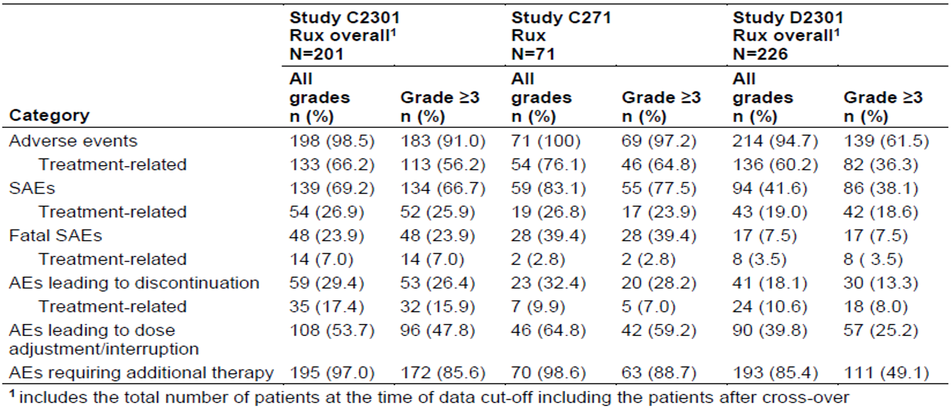

Abbreviations: AE = adverse event; SAE = serious adverse event; Rux = ruxolitinib.

###### Acute graft-versus-host disease

Table 10: Adverse events by System Organ Class in ruxolitinib-treated patients with acute GVHD

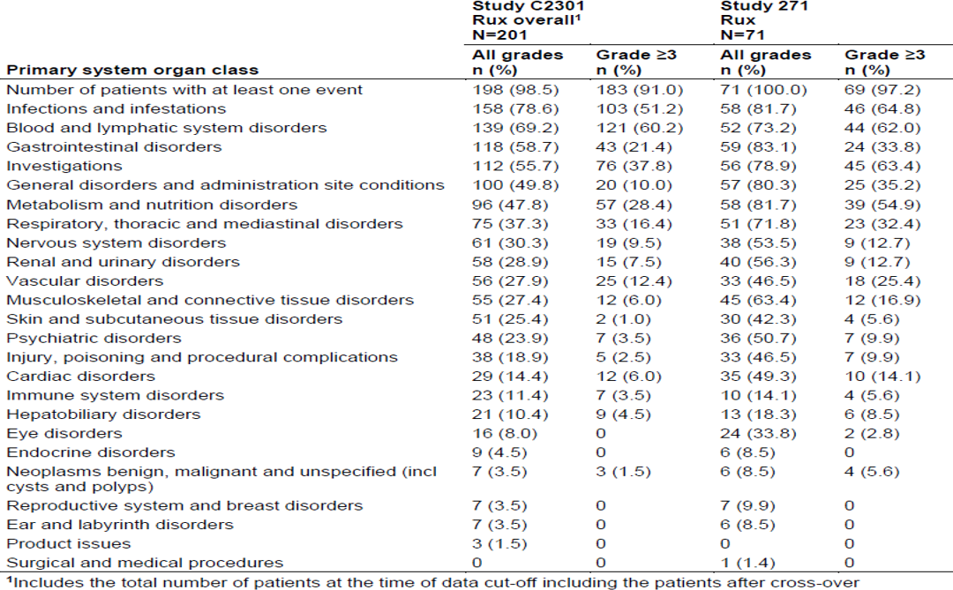

Table 11: Adverse events by Preferred Term in ruxolitinib-treated patients with acute GVHD (adverse events occurring in ≥ 10% of patients)

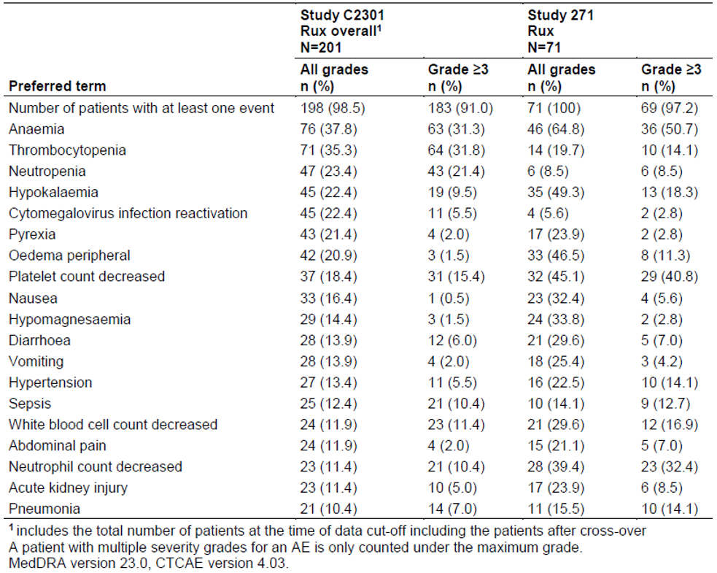

###### Chronic graft-versus-host disease

Table 12: Study CINC424D2301 (REACH 3 trial) Adverse events by System Organ Class in ruxolitinib-treated patients with chronic GVHD

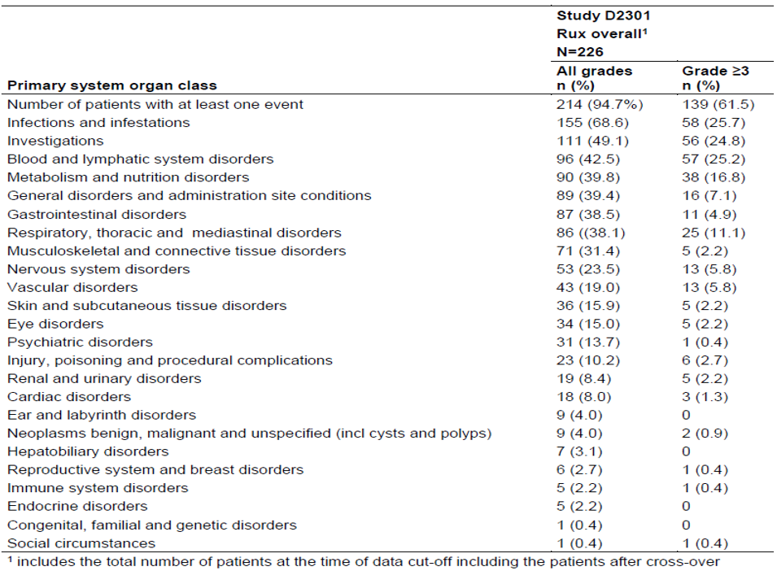

Table 13: Study CINC424D2301 (REACH 3 trial) Adverse events by Preferred Term in ruxolitinib-treated patients with chronic GVHD (adverse events occurring in ≥ 10% of patients)

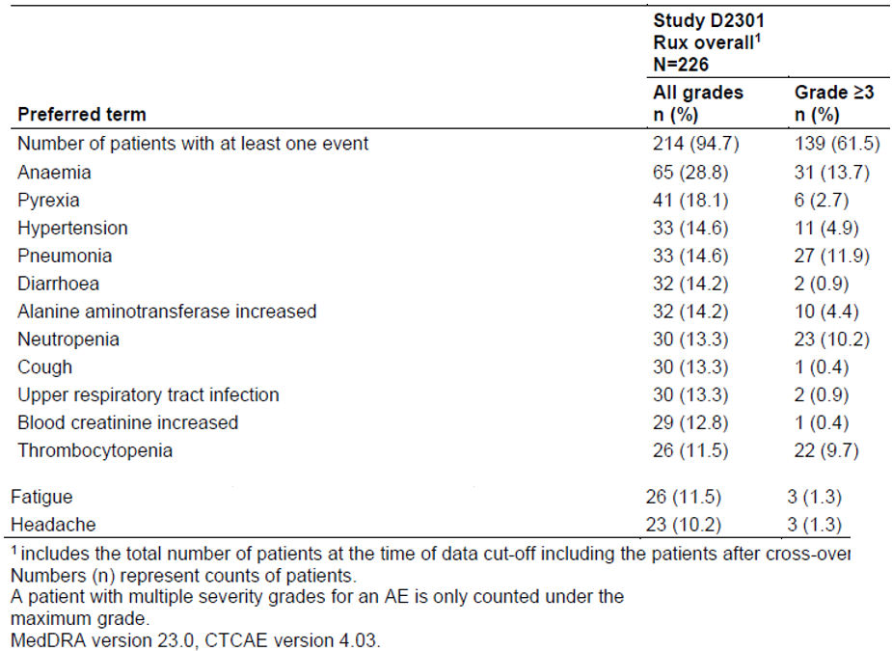

##### Deaths

###### Acute graft-versus-host disease

In Study CINC424C2301, up to data cut-off, there were a total of 168 deaths, 82 (53.9%) deaths in the ruxolitinib arm and 86 (57.3%) deaths in the ‘best available treatment’ arm. Deaths due to acute GVHD occurred in 37 (24.3%) patients in the ruxolitinib arm and 38 (25.3%) patients in the ‘best available treatment’ arm. In the ruxolitinib arm, the other frequent causes of death were sepsis and multiple organ dysfunction syndrome (3.3% each), underlying haematological disease progression (2.6%) and septic shock (2.0%). In the ‘best available treatment’ arm, the other frequent causes of death were sepsis and respiratory failure (2.7% each), multiple organ dysfunction syndrome and septic shock (2.0% each).

In Study 18424-271, a total of 30 deaths (42.3%) occurred in the study, of which 10 (14.1%) were due to the study indication and 20 (28.2%) were due to other causes. Frequent other causes were respiratory failure (three deaths), sepsis (two deaths), multiple organ dysfunction syndrome (two deaths), and pneumonia (two deaths). Of note, for this study, no primary reason for death was collected.

###### Chronic graft-versus-host disease

In Study CINC424D2301, a total of 58 deaths occurred of which 31 (18.8%) were in the ruxolitinib arm and 27 (16.5%) were in the ‘best available treatment’ arm. The primary causes of deaths (in the ruxolitinib arm versus in the ‘best available treatment’ arm) were study indication (including chronic GVHD and/or complications attributed to treatment for chronic GVHD) (22, 13.3% versus 13, 7.9%) and infections (2, 1.2% versus 6, 3.7%). Study indication was a broad definition that included complications of the disease that the investigator attributed to chronic GVHD itself or to its treatments.

##### Adverse events of special interest

Tables 14 and 15 (below) show the incidence and grades of adverse reactions of special interest, including those known to be associated with ruxolitinib in the GVHD studies. It does not include a comparison of incidence with the best available treatment regimens given for acute and chronic GVHD in the Phase III studies (Study CINC424C2301and Study CINC424D2301). Another JAK inhibitor has been associated with an increase in thromboembolic disorders. That association was not apparent from Study CINC424C2301and Study CINC424D2301 in that no relative increase in the incidence of thromboembolic disorders in comparison with best available treatment was observed.

Another JAK inhibitor is associated with an increase in the incidence of secondary malignancies. Given the population in the GVHD studies have had allogenic HSCT prior to receipt of ruxolitinib prior immunosuppressant treatments would confound any assessment of the association in this population.

Table 14: Overview of adverse events of special interest in acute and chronic GVHD studies

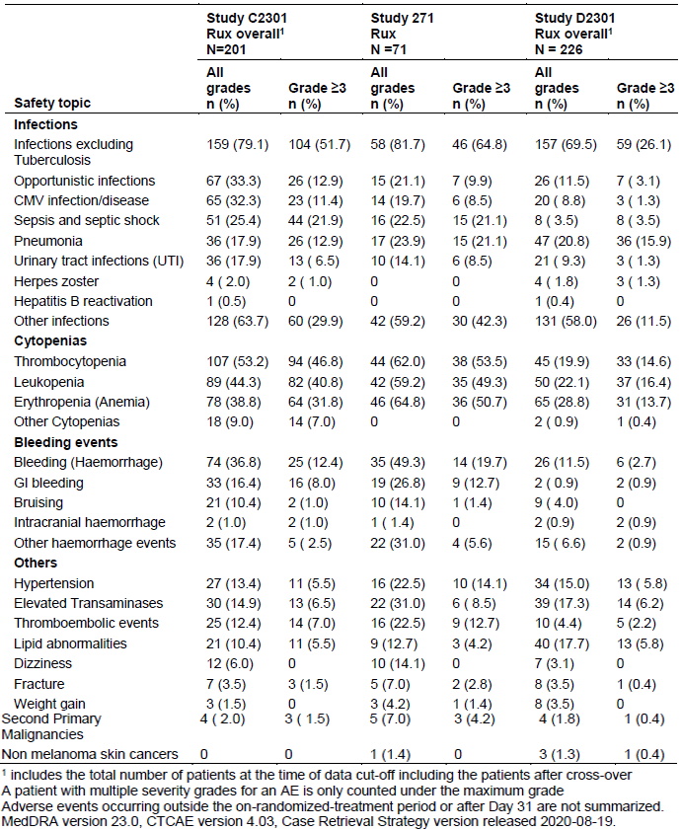

A comparison of events of special interest with best available treatment in Study CINC424D2301 is shown in the table below. Ruxolitinib was associated with higher incidences of anaemia, thrombocytopenia, leukopenia, transaminase elevations and lipid abnormalities than the best available treatment given in that study. These adverse reactions are known to be associated with ruxolitinib. While there was no clear increase in haemorrhagic events this is likely to be due to effective management of the thrombocytopenia within the clinical trial. Regular monitoring and dose adjustment is required for management of cytopaenias and these are already in the Product Information and adjustments for GVHD dose regimens have been proposed to be added to the Product Information. Dose adjustments for other Grade 3 or higher adverse reactions including elevated bilirubin have also been proposed for GVHD indications.

Table 15: Study CINC424D2301 overview of adverse events of special interest for the Main treatment period (Safety set)

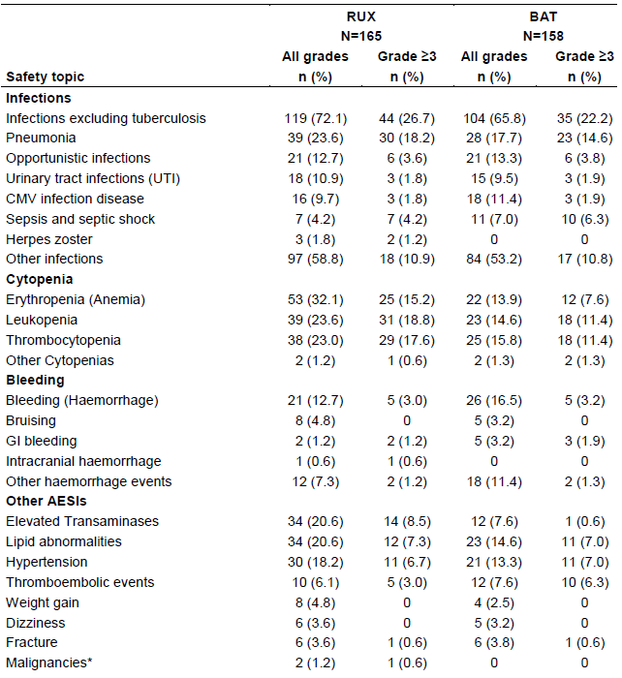

### Risk management plan

The most recently evaluated EU-Risk Management Plan (RMP) was version 11.1 (date 19 December 2019; data lock point 20 June 2018) and Australia Specific Annex version (ASA) 7.0 (date 29 April 2020). In support of the extended indications, the sponsor has submitted EU-RMP version 13.0 (date 9 January 2021; data lock point GVHD 9 May 2020) and ASA version 8.0 (date 11 February 2021).

The sponsor’s proposed summary of safety concerns and their associated risk monitoring and mitigation strategies are outlined in Table 16.

The TGA may request an updated RMP at any stage of a product's life-cycle, during both the pre-approval and post-approval phases.

Table 16: Summary of safety concerns

|  |  |  |  |  |  |
| --- | --- | --- | --- | --- | --- |
| Summary of safety concerns | | Pharmacovigilance | | Risk minimisation | |
| Routine | Additional | Routine | Additional |
| Important identified risks | Infections | ✓ |  | ✓ |  |
| Important potential risks | Progressive multifocal leukoencephalopathy | ✓ |  | ✓ |  |
| Developmental toxicity | ✓ |  | ✓ |  |
| Non-melanoma skin cancer (including basal, squamous and Merkel cell carcinoma) | ✓ |  | ✓ |  |
| Missing information | Safety in patients with a platelet count below 100000/mm3 at Baseline (myelofibrosis patient population) | ✓ |  | ✓ |  |
| Long-term safety data, including secondary malignancies | ✓ |  | ✓ |  |
| Safety in paediatric patients (GvHD only) | ✓ |  | ✓ |  |

Routine pharmacovigilance activities have been proposed for all safety concerns.

The sponsor has proposed routine risk minimisation measures only. Routine risk minimisation measures are considered adequate to manage the risks identified in the summary of safety concerns.

Any new or outstanding recommendations were satisfactorily resolved and wording for conditions of registration was provided to the Delegate prior to approval.

### Risk-benefit analysis

#### Delegate’s considerations

Acute and chronic graft-versus-host disease (GVHD) are different conditions and should not be combined in a single indication. Separate clinical trials were required to investigate these conditions because the patient population, clinical presentations and methods of diagnosis and assessment are different for the two conditions. Combining them in a single indication is not acceptable.

In Australia there are no registered treatments for acute GVHD or chronic GVHD. Corticosteroids are the mainstay of treatment for both conditions. The proposed indication requires that patients with GVHD have an inadequate response to corticosteroids or other systemic therapies. Given there are no other approved systemic therapies the Delegate considers that, after separation into indications for acute GVHD and chronic GVHD, indications should specify an inadequate response to steroids only.

Extensive pharmacokinetic sampling for modelling was obtained from only three adolescents however it is proposed to include patients aged from 12 years in the indication. Given both acute GVHD and chronic GVHD are rare diseases, the physiology of adolescents is similar to that of adults, and that the pharmacokinetic modelling did not identify clinically relevant differences in ruxolitinib pharmacokinetics with regard to age, race, sex, or weight, the Delegate considers that it is appropriate to include patients aged from 12 years in the revised indications. In an exploratory analysis, adolescents with chronic GVHD tended to do better with ruxolitinib than with best available treatment (see Figure 2).

For both the acute GVHD and chronic GVHD development program the evaluators and the sponsor disagreed on the most appropriate methods to assess efficacy. This has resulted in separate analyses being conducted for the accepted studies.

##### Acute graft-versus-host disease

The differences in approach to the analysis of efficacy in Study 18424-271 (the REACH 1 trial) were primarily patient eligibility, the assessment of duration of response and the endpoints used to determine how duration of response would be measured. A supplementary regulatory analysis excluded 22 (31%) patients due to insufficient prior corticosteroid or insufficient response to prior corticosteroid and other treatments. The overall response in the subgroup of patients selected for the evaluator’s analysis had similar overall response rate results to the patients in the study as a whole. This is reassuring and suggests ruxolitinib will have similar efficacy in patients who have had an insufficient response to corticosteroids and other treatments to that of patients with only steroid resistance.

The key secondary endpoint was the six-month duration of response, defined as the time from first response until GVHD progression or death. Of the 40 of 71 (56.3%) subjects who were Day 28 responders, 15 of 40 of these were in response at 6 months. The median duration of response for that population was 669.0 days (95% CI: 159.0, not evaluable) with a median follow-up time of 195.0 days (range: 7 to 805 days). The 3 and 6 month event-free probabilities for duration of response based on a response at Day 28, were 84.5% (95% CI: 68.7, 92.7) and 68.2% (95% CI: 49.6, 81.2), respectively, and were numerically greater for Day 28 responders than those reported for participants who responded at any time. Three month and six-month event-free probabilities for duration of response based on a response at any timepoint were 75.6% (95% CI: 61.0, 85.4) and 62.1% (95% CI: 45.8, 74.8), respectively.

For the 28 participants in the steroid refractory evaluable population (as defined in the supplementary regulatory analysis) who had a response at Day 28, the median duration of response, calculated from Day 28 response to progression, new acute GVHD therapy, or death (with progression being defined as worsening by one stage in any organ without improvement in other organs in comparison to prior response assessment) was 16.0 days (95% CI: 9.0, 83.0). This difference in definition of duration of response has allowed for very large differences in duration of response reported in the clinical study report and in the supplemental analysis. The difference in the primary definition of duration of response between the clinical study report and that used in the supplemental analysis was due to the method of determination of progressive disease and the timepoint from which assessment of duration of response commenced.

Progressive disease was defined as a deterioration in at least one organ without any improvement in others. In the clinical study report, progressive disease was calculated from Baseline whereas the evaluators calculated it from the prior response assessment. The sponsor has noted that progressive disease measurement is complex in both acute and chronic GVHD, that there are no standard guidelines for comparison and cited four publications supporting assessment time against baseline as appropriate in acute GVHD. The supplemental analysis considered that progressive disease would be more appropriately measured from when best response was achieved. The sponsor also noted that the duration of response, defined as the interval from response to progression or death, is used frequently for oncologic trials. However, this definition of duration of response does not account for the inherent tendency of acute GVHD to flare and resolve without additional systemic treatment.

In the supplemental regulatory analysis, the secondary definition of duration of response did not include direct assessment of progress disease. It was defined as an increase in corticosteroid from Baseline, start of new acute GVHD therapy, or death for the Day 28 responders. The median duration of response using that definition was 173.0 days (95% CI:77.0, 304.0) from the Day 28 response.

In Study 18424-271 (the REACH 1 trial) acute GVHD response was measured primarily at Day 28 rather than as the best response at any time point or during a nominated time period such as within the first 28 days. According to the sponsor’s analysis there were 14 subjects who responded during the study but were not in response at Day 28. This suggests that if treatment were ceased for patients not in response at Day 28 that about 20% of patients who would have benefited from ruxolitinib would not be eligible to continue to receive it.

For acute GVHD in Study 18424-271, the supplemental regulatory analysis assessment of the steroid only refractory population, when evaluated by Baseline acute GVHD grade, the Day 28 overall response was 100.0% (13 of 13 participants) for Grade II, 40.7% (11 of 27 participants) for Grade III, and 44.4% (4 of 9 participants) for Grade IV, compared with 57.1% for all grades combined. This suggests that patients with less severe acute GVHD are more likely to respond to ruxolitinib than are patients with more severe disease.

The supplemental analysis compared overall survival in Study 18424-271 as a method of assessment of the value of Day 28 overall response rate in assessing long-term benefit. The difference was large (71% if in response at Day 28 versus 24% if not in response at Day 28) suggesting this is a useful surrogate endpoint for long-term benefit in acute GVHD. However, the Delegate considers its usefulness as a surrogate for long-term benefit should be tested in a randomised, controlled study before it is adopted given the inherent tendency of the severity of acute GVHD to vary over time. Additionally, if being in response at Day 28 was adopted as a surrogate for long-term benefit a significant proportion of patients who would have benefited from continued treatment would not be eligible to continue. Given the absence of registered alternative treatments, this seems overly restrictive.

Although there is disagreement between the sponsor and supplemental regulatory analysis in how to best assess responses to treatment in acute GVHD it is apparent that a clinically meaningful response and duration of response was demonstrated with ruxolitinib in a substantial proportion of patients who have very limited treatment options.

The proposed dose for acute GVHD is 10 mg twice a day, the Delegate considers that should be amended to be consistent with the dose regimen used in Study 18424-271 (REACH 1 trial) that is, 5 mg twice a day then if haematologic parameters are stable and no treatment-related toxicity is observed after the first three days of treatment, the dose could be increased to 10 mg twice a day.

The Delegate proposes that the indication for acute GVHD be:

*Jakavi is indicated for the treatment of patients with acute graft-versus-host disease (aGVHD) aged 12 years and older who have inadequate response to corticosteroids.*

This indication should be supported by a description of the Study 18424-271 (REACH 1 trial) in the Product Information. At this stage my preference would be to provide the overall response rate for the total patient population (n = 71) and show the results for the evaluator’s analysis of overall response rate as a *post hoc* analysis. For the assessment of duration of response, the definition in the clinical study report and its result should be reported. The alternative definitions of the evaluators should then be described and those duration of responses shown for the subgroup in the *post hoc* analysis.

##### Chronic graft-versus-host disease

The primary efficacy endpoint of overall response rate was assessed from Baseline to the Cycle 7 Day 1 visit in the clinical study report, and from Baseline to the period from Baseline to the Cycle 7 Day 1 visit. The clinical study report also included best overall response by the Cycle 7 Day 1 visit and authors of the supplementary regulatory analysis adjudicated those responses and there were minor differences in those results, that, in the view of the Delegate for this submission, do not show a clinically significant difference in efficacy. It is not clear to the Delegate which figures should be accepted; that is, the best overall response in the clinical study report; or, the *post hoc* overall response rate reported in the supplementary analysis.

The supplementary analysis authors were not satisfied with the use of the key secondary endpoint of modified Lee Symptom Score (mLSS);31 as an assessment of clinical outcome, stating that, based on several measurement challenges (for example, open-label study design, the absence or insufficient symptom severity at Baseline, questionable content validity, insufficient evidence to support a total score), there is a limitation to clinical outcome assessment data interpretability. These challenges raise concerns related to whether the data can be interpreted and presented in labelling in a way that is accurate and not misleading.

The major concerns in the supplementary regulatory analysis regarding the mLSS were that a third of the mLSS item content was not endorsed by the majority of participants (< 50%) as related to their experience with chronic GVHD (that is, coloured sputum, shortness of breath at rest, need to use oxygen, fever, nutrition from intravenous/feeding tube, difficulty swallowing solid foods/liquids, joint and muscle aches, limited joint movement, and muscle cramps). Further, there may be important concepts missing in the mLSS; 10 of 22 symptoms reported by participants are not covered by the mLSS and four of 11 impacts reported by participants are not covered by the mLSS. Additionally, based on item-level distributional data from Study CINC424D2301 (REACH 3 trial), many participants endorsed the least severe category response at Baseline across the items in the mLSS (that is, patients reporting ‘*did not have this problem*’ regarding their cGVHD symptoms and impacts; endorsement of this category ranged from 27.9% (Item 25 ‘Loss of energy’) to Item 11 ‘Nutrition from IV’ (94.5%). Mean baseline scores for mLSS items ranged between 0.1 and 1.5 on a 0 to 4 ordinal scale, indicating mild symptoms at Baseline. Given these concerns, it is not appropriate to refer to the mLSS results in the study description.

The authors of the supplementary regulatory analysis did not consider that failure free survival, the other key secondary endpoint in Study CINC424D2301, was an acceptable regulatory endpoint for the proposed indication of chronic GVHD, because a) the endpoint does not include a requirement for a clinical benefit such as response, and b) relapse of the primary malignancy is a major component of the endpoint, but relapse is not an efficacy endpoint for treatments of chronic GVHD, especially in a population that is heterogeneous with regard to the risk of relapse.

While failure free survival was regarded as a measure of durability the duration of response was evaluated in patients who achieved a complete response or partial response during the study. Duration of response was defined as ‘time from first response until chronic GVHD progression, death, or systemic therapies for chronic GVHD’. Median duration of response was not reached in ruxolitinib arm and was 6.2 months (95% CI: 4.7 to 13.3) in the ‘best available treatment’ arm. The estimated probability of maintaining best overall response with 95% CI was higher in the ruxolitinib arm (76.58%, 95% CI: 67.87, 88.22) compared to the ‘best available treatment’ arm (52.11%, 95% CI: 41.78, 61.45) at six months. Similar trends in probability were observed at 12 months (64.48%, 95% CI: 58.94, 76.26 versus 40.33%, 95% CI: 30.28, 50.15), 18 months (63.50%, 95% CI: 52.82, 72.38 versus 36.66%, 95% CI: 26.47, 46.88).

The authors of the supplementary regulatory analysis applied an alternative definition of duration of response in which any reduction in any organ system was considered as loss of response, regardless of changes to other organs. Using that definition the duration of response and applying it to patients who responded during the first six months of treatment, the duration of response was 4.2 months compared with 2.1 months for best available treatment. The median duration of response for the secondary definition of duration of response applied by the evaluators that is, time to or new therapy or death was 25 months for ruxolitinib and 5.6 months for best available treatment. While these durations differ markedly, both show ruxolitinib has a longer median duration of maintenance of response than best available treatment.

At this stage the Delegate is inclined to refer to best overall response and the duration of response as presented in the clinical study report in the Product Information describing Study CINC424D2301 (the REACH 3 trial).

The proposed indication for chronic GVHD is:

*Jakavi is indicated for the treatment of patients with chronic Graft versus Host Disease (cGVHD) aged 12 years and older who have inadequate response to corticosteroids.*

There were no signals for new safety issues associated with ruxolitinib in the acute or chronic GVHD populations. The proposed dose adjustments for adverse reactions are acceptable and consistent with dose adjustments for other indications for ruxolitinib.

#### Proposed action

The Delegate proposes to approve Jakavi (ruxolitinib) for the following indications;

in acute GHVD:

*Jakavi is indicated for the treatment of patients with acute Graft versus Host Disease (aGVHD) aged 12 years and older who have inadequate response to corticosteroids.*

and in chronic GHVD:

*Jakavi is indicated for the treatment of patients with chronic Graft versus Host Disease (cGVHD) aged 12 years and older who have inadequate response to corticosteroids.*

Approval is subject to successful negotiation of the conditions of registration including the Product Information. The sponsor should conduct and submit a safety analysis using data obtained from Study CINC424D2301 (the REACH 3 trial) to further characterise the safety of long-term treatment of chronic graft-versus-host disease with ruxolitinib and determine the rate of infections, hyperlipidaemia, liver toxicity, cytopenias, secondary malignancies and other adverse events. The integrated safety analysis should include all adverse events, major safety events, dose-reductions, dose interruptions, withdrawals, and efficacy analyses when all patients have completed at least three years of treatment with ruxolitinib or withdrew earlier.

#### Advisory Committee considerations

The [Advisory Committee on Medicines (ACM)](https://www.tga.gov.au/committee/advisory-committee-medicines-acm), having considered the evaluations and the Delegate’s overview, as well as the sponsor’s response to these documents, advised the following.

##### Specific advice to the Delegate

1. ***The sponsor has proposed including acute and chronic graft-versus-host disease (GVHD) in a single indication.***

***Does the Committee consider this is justified given that separate studies with different populations with different diagnostic criteria and treatment regimens, other than ruxolitinib were submitted?***

***The proposed dose regimen for ruxolitinib is the same for acute and chronic GVHD.***

The ACM advised that there should be separate indications for acute GVHD and chronic GVHD as they are separate conditions with their own distinct features. In support of this advice, the ACM highlighted that separate clinical trials were required to investigate these conditions because the patient population, clinical presentations and methods of diagnosis and assessment are different for the two conditions. Furthermore, there are differences in the pharmacokinetics (PK) between acute GVHD and chronic GVHD, with a slightly lower exposure to ruxolitinib in acute GVHD. The ACM advised that acute GVHD and chronic GVHD should also have separate dosing instructions.

1. ***The ACM is asked to comment on the following:***

***The sponsor’s proposed ruxolitinib dose for acute GVHD is 10 mg twice a day however in Study 18424-271 (REACH 1 trial) fewer than half the study patients were taking that dose at Day 28, with all patients commencing on ruxolitinib 5 mg twice a day. The optimum dose of ruxolitinib in acute GVHD has not been identified.***

***Pharmacokinetic comparisons showed there was generally somewhat lower exposure to ruxolitinib in acute GVHD patients than in chronic GVHD patients. The dose of ruxolitinib proposed for chronic GVHD patients is 10 mg twice a day.***

The ACM noted that the FDA Prescribing Information states the dosing as 5 mg twice daily for acute GVHD and to increase after 3 days, and 10 mg twice daily for chronic GVHD. The 5 mg dose regimen is consistent with what was used in Study 18424-271 (the REACH 1 trial). Furthermore, allogenic stem cell transplant patients are routinely treated with concurrent calcineurin inhibitors and azole prophylaxis which can inhibit the metabolism (via CYP3A4) of ruxolitinib, increasing its exposure. The ACM was of the view that if haematologic parameters are stable and no treatment-related toxicity is observed after the first 3 days of treatment, the dose could reasonably be increased to 10 mg twice a day.

Based on the data submitted, the ACM was supportive of the dosing regimen being 5 mg twice daily for acute GVHD with the option to increase to 10 mg at clinical discretion, and 10 mg twice daily for chronic GVHD.

1. ***The pharmacokinetics and toxicity of ruxolitinib in patients with hepatic impairment were not examined in patients with acute and chronic GVHD. The pharmacokinetics study in patients with hepatic impairment was inconclusive and no patients with Child-Pugh level 4 hepatic impairment were included in the GVHD studies.***

***It has been proposed that the starting dose of ruxolitinib be reduced to 5 mg twice a day in patients with Child-Pugh level 4 hepatic impairment but this relies on extrapolation from studies in patients given ruxolitinib for other indications and population pharmacokinetic assessments in GVHD patients to support proposed dose amendment.***

***The Committee’s view of such extrapolation is requested.***

The ACM advised that the Product Information should state that the dose for Stage 4 liver acute GVHD should be 5 mg daily as a starting dose and to modify the dose for adverse reactions with chronic GVHD, in line with the US Prescribing Information.

1. ***In Study 18424-271 (the REACH 1 trial) the Project Orbis reviewers excluded 13 out of 71 patients from the efficacy analysis who did not receive at least 2 mg/kg steroids (± 10%) prior to study entry. These patients were not considered to have been treated with an adequate dose of steroids.***

***Does the Committee consider that this was an appropriate cut-off for determination of steroid resistance?***

The ACM was of the view that 2 mg/kg/day of steroids is an appropriate cut-off for determination of steroid resistance. The ACM commented that by excluding patients who did not receive an adequate trial of steroids, overestimation of the efficacy of Jakavi is reduced.

1. ***The supplementary regulatory analysis preferred to measure overall response rate during the first 28 days of treatment as the primary measure of efficacy whereas the primary measure of efficacy in the clinical study report [for Study 18424-271 (REACH 1 trial)] was measured at the Day 28 timepoint.***

***Please comment on which measure you consider to be more useful in assessment of disease progress in acute GVHD.***

The ACM advised that overall response rate is most commonly reported at Day 28 (± 7 days).

The ACM commented that steroid-resistant acute GVHD is defined as progression of acute GVHD after steroids for 4 days (3 days in REACH 1 trial) or no improvement after 7 days.

1. ***Please comment on which of the duration of response methods presented using data from Study 18424-271 (REACH 1 trial) is the most clinically useful.***

There were two duration of response (DOR) methods presented from the REACH 1 trial. The ACM noted that Method 1 was from Day 28 to new therapy/death or worsening of any organ by one stage compared to prior response, with a median DOR of 16 days (95% CI: 9, 83). Method 2 was from Day 28 to new therapy or increase in steroid dose from Baseline, with a DOR of 173 days (95% CI: 66, non-estimable). The ACM commented that Method 2 has a larger participant group and longer DOR.

While the ACM agreed that both methods have utility, they preferred the second method as they were of the view that the criteria were more measurable and verifiable.

1. ***Does the Committee consider the proposed amended description of Study 18424-271 (REACH 1 trial) in the Delegate’s comments on the draft Product Information is an appropriate description of the REACH 1 study? Please recommend aspects of the description that would benefit from amendment.***

The ACM was supportive of the proposed amended description of REACH 1 trial in the PI. The ACM agreed that it should highlight that REACH 1 trial was a Phase II study.

1. ***Does the Committee consider the proposed amended description of Study CINC424D2301 (the REACH 3 trial) in Delegate’s comments on the draft Product Information is an appropriate description of the REACH 3 study? Please recommend aspects of that description that would benefit from amendment.***

The ACM advised that the Delegate’s proposed amended description of REACH 3 is appropriate and was supportive of removing the failure free survival (FFS) data.

1. ***The ACM is requested to provide any other advice pertaining to this submission.***

The ACM commented that the United States PI includes a table for dose modifications for toxicity, concomitant strong CYP3A4 inhibitors or fluconazole, as well as for renal or hepatic impairment in particular. They advised that a similar table should be included in the Australian PI to improve clarity and presentation.

Regarding the Delegate’s proposal to include patients 12 years of age and older, the ACM was supportive of this proposal. While extensive PK sampling for modelling was obtained from only three adolescents, acute GVHD and chronic GVHD are rare diseases and the physiology of adolescents is similar to that of adults. The PK modelling did not identify clinically relevant differences in ruxolitinib pharmacokinetics regarding age, race, sex, or weight.

##### Conclusion

The ACM considered this product to have an overall positive benefit-risk profile for the indications:

*Jakavi is indicated for the treatment of patients with acute Graft versus Host Disease (aGVHD) aged 12 years and older who have inadequate response to corticosteroids.*

*Jakavi is indicated for the treatment of patients with chronic Graft versus Host Disease (cGVHD) aged 12 years and older who have inadequate response to corticosteroids.*

## Outcome

Based on a review of quality, safety, and efficacy, the TGA approved the registration of Jakavi ruxolitinib (as phosphate) 5 mg, 10 mg, 15 mg and 20 mg tablet blister packs indicated for the following extension of indications:

*Jakavi is indicated for the treatment of patients aged 12 years and older with acute graft-versus-host disease who have inadequate response to corticosteroids.*

*Jakavi is indicated for the treatment of patients aged 12 years and older with chronic graft-versus-host disease who have inadequate response to corticosteroids.*

As such, the full indications at this time were:

*Jakavi is indicated for the treatment of disease-related splenomegaly or symptoms in patients with primary myelofibrosis, post-polycythemia vera myelofibrosis or post-essential thrombocythaemia myelofibrosis.*

*Jakavi is indicated for the treatment of adult patients with polycythemia vera who are resistant to or intolerant of hydroxyurea.*

*Jakavi is indicated for the treatment of patients aged 12 years and older with acute graft-versus-host disease who have inadequate response to corticosteroids.*

*Jakavi is indicated for the treatment of patients aged 12 years and older with chronic graft-versus-host disease who have inadequate response to corticosteroids.*

### Specific conditions of registration applying to these goods

* Jakavi (ruxolitinib (as phosphate)) is to be included in the Black Triangle Scheme. The PI and CMI for Jakavi must include the black triangle symbol and mandatory accompanying text for five years, which starts from the date the new indication is registered.
* The Jakavi EU-Risk Management Plan (RMP) (version 13.0, dated 9 January 2021, data-lock point GVHD indication 9 May 2020), with Australian Specific Annex (version 8.0, dated 11 February 2021), included with submission PM-2021-00484-1-6, and any subsequent revisions, as agreed with the TGA will be implemented in Australia.

An obligatory component of risk management plans is routine pharmacovigilance. Routine pharmacovigilance includes the submission of periodic safety update reports (PSURs). Reports are to be provided in line with the current published list of EU reference dates and frequency of submission of PSURs until the period covered by such reports is not less than three years from the date of this approval letter.

The reports are to at least meet the requirements for PSURs as described in the European Medicines Agency’s Guideline on good pharmacovigilance practices (GVP) Module VII Risk periodic safety update report (Rev 1), Part VII.B Structures and processes.

## Attachment 1. Product Information

The PI for JAKAVI approved with the submission which is described in this AusPAR is at Attachment 1. For the most recent PI, please refer to the TGA [PI/CMI search facility.](https://www.tga.gov.au/picmi-search-facility)

|  |
| --- |
| Therapeutic Goods Administration |
| PO Box 100 Woden ACT 2606 Australia  Email: [info@tga.gov.au](mailto:info@tga.gov.au) Phone: 1800 020 653 Fax: 02 6203 1605  [**https://www.tga.gov.au**](https://www.tga.gov.au) |
| Reference/Publication # |

1. This is the original indication proposed by the sponsor when the TGA commenced the evaluation of this submission. It may differ to the final indication approved by the TGA and registered on the Australian Register of Therapeutic Goods.
2. D'Souza A, Fretham C. Current Uses and Outcomes of Hematopoietic Cell Transplantation (HCT): CIBMTR Summary Slides. Center for International Blood & Marrow Transplant Research. A research collaboration between the National Marrow Donor Program (NMDP)/Be the Match and the Medical College of Wisconsin (2019).
3. Hill L, Alousi A, Kebriaei P et al. New and emerging therapies for acute and chronic graft versus host disease. *Ther Adv Hematol*; (2018) 9:21-46.
4. Zeiser R and Blazer RB. Acute graft-versus-host disease biology, prevention and therapy. *N Engl J Med;* (2017) 377:2167-79.
5. Jagasia M, Greinix H, Arora M, et al. National institutes of health consensus development project on criteria for clinical trials in chronic graft-versus-host disease: I. The 2014 diagnosis and staging working group report. *Biol Blood Marrow Transplant;* (2015) 21 (3):389-401.
6. Harris AC, Young R, Devine S, et al. International, Multicenter Standardization of Acute Graft-versus-Host Disease Clinical Data Collection: A Report from the Mount Sinai Acute GVHD International Consortium*. Biol Blood Marrow Transplant.* 2016;22(1):4-10.
7. The Mount Sinai Acute GVHD International Consortium (MAGIC) was established to provide standardised multicentre documentation and monitoring of acute GVHD severity during treatment, as well as to obtain patient samples that could be interrogated for potential predictive biomarkers.
8. Martin PJ et al. (2009) Endpoints for Clinical Trials Testing Treatment of Acute Graft versus host Disease: A Consensus Document. Blood Marrow Transplant;15:777
9. Jamil MO and Mineishi S. State-of-the-art acute and chronic GVHD treatment. *International Journal of Hematolgy*; (2015) 101:452-466.
10. Schoemans HM, Lee SJ, Ferrara JL, et al. EBMT-NIH-CIBMTR task force position statement on standardized terminology & guidance for graft-versus-host disease assessment. *Bone Marrow Transplant;* (2018) 53(11):1401-15.
11. Malard F, Huang XJ, Sim JPY, et al. Treatment and unmet needs in steroid-refractory acute graft-versus-host disease. *Leukemia*; (2020) 34(5):1229-40.
12. Penack O, Marchetti M, Ruutu T, et al. Prophylaxis and management of graft versus host disease after stem-cell transplantation for haematological malignancies: updated consensus recommendations of the European Society for blood and marrow transplantation. *Lancet Haematol;* (2020) 7(2):e157-e167.
13. Aladag E et al. Acute Graft-Versus-Host Disease: A Brief Review. Turk J Haematology 2020 Mar, 37(1): 1-4.
14. Tacrolimus was first registered on the ARTG in Australia in July 1997.
15. Martin PJ, Storer BE, Inamoto Y, et al. An endpoint associated with clinical benefit after initial treatment of chronic graft-versus-host disease. *Blood.* 2017;130(3):360-367.
16. Martin P J et al. National Institutes of health Consensus Development Project on Criteria for Clinical Trials in Chronic Graft-versus-Host Disease: VI. The 2014 Clinical Trial Design Working Group Report.
17. Study INCB 18424-271: A Single-Cohort, Phase 2 Study of Ruxolitinib in Combination With Corticosteroids for the Treatment of Steroid-Refractory Acute Graft-Versus-Host Disease (REACH-1). ClinicalTrials.gov Identifier: NCT02953678
18. An AusPAR for Jakavi Ruxolitinib is available at https://www.tga.gov.au/resources/auspar/auspar-ruxolitinib
19. **Cytochrome P450** (**CYP**) **enzymes**: CYPs are the major enzymes involved in drug metabolism, accounting for large part of the total metabolism. Most drugs undergo deactivation by CYPs, either directly or by facilitated excretion from the body. Also, many substances are bioactivated by CYPs to form their active compounds.

    Many drugs may increase or decrease the activity of various CYP isozymes either by inducing the biosynthesis of an isozyme (enzyme induction) or by directly inhibiting the activity of the CYP (enzyme inhibition). This is a major source of adverse drug interactions, since changes in CYP enzyme activity may affect the metabolism and clearance of various drugs. Such drug interactions are especially important to take into account when using drugs of vital importance to the patient, drugs with important side-effects and drugs with small therapeutic windows, but any drug may be subject to an altered plasma concentration due to altered drug metabolism
20. The **Modified Child-Pugh classification** of the severity of liver disease is based on the degree of ascites, the serum concentrations of bilirubin and albumin, the prothrombin time (or International normalised ratio (INR), and the degree of encephalopathy. A total Child-Pugh score of 5 to 6 is considered Child-Pugh class A (well-compensated disease), 7 to 9 is class B (significant functional compromise), and 10 to 15 is class C (decompensated disease). Interpretation of the scores was originally designed to correlate with the probability of 1-year and 2-year patient survival with chronic liver disease.
21. The **National Cancer Institute (NCI) Organ Dysfunction Working Group Criteria for Hepatic Dysfunction**

    is a set of severity criteria for hepatic dysfunction with four categories (normal and mild, moderate, or severe dysfunction) based on a combination of total bilirubin and aspartate transaminase (AST) as markers.
22. Harris AC, Young R, Devine S, et al. International, Multicenter Standardization of Acute Graft-versus-Host Disease Clinical Data Collection: A Report from the Mount Sinai Acute GVHD International Consortium. Biol Blood Marrow Transplant. 2016;22(1):4-10.
23. The [Center for International Blood and Marrow Transplant Research](http://www.cibmt.org) (CIBMTR) is a collaboration between the National Marrow Donor Program (USA) and the Medical College of Wisconsin's International Bone Marrow Transplant Registry and Autologous Blood and Marrow Transplant Registry.
24. Rowlings PA, Przepiorka D, Klein JP, Gale RP, Passweg JR, Henslee-Downey PJ, et al. IBMTR Severity Index for grading acute graft-versus-host disease: retrospective comparison with Glucksberg grade. *Br J Haematol*. 1997;97:855–64.
25. Schoemans, H.M., Lee, S.J., Ferrara, J.L. et al. EBMT−NIH−CIBMTR Task Force position statement on standardized terminology & guidance for graft-versus-host disease assessment. *Bone Marrow Transplant* 53, 1401–1415 (2018).
26. **Eastern Cooperative Oncology Group Performance Status** (**ECOG PS**): The ECOG has developed criteria used by doctors and researchers to assess how a patient's disease is progressing, assess how the disease affects the daily living abilities of the patient, and determine appropriate treatment and prognosis. The following are used:

    0 - Fully active, able to carry on all pre-disease performance without restriction

    1- Restricted in physically strenuous activity but ambulatory and able to carry out work of a light or sedentary nature, for example, light house work, office work

    2 - Ambulatory and capable of all selfcare but unable to carry out any work activities. Up and about more than 50% of waking hours

    3 - Capable of only limited selfcare, confined to bed or chair more than 50% of waking hours

    4 - Completely disabled. Cannot carry on any selfcare. Totally confined to bed or chair

    5 – Dead
27. Study CINC424D2301 (REACH 3 trial): A Phase III Randomized Open-label Multi-center Study of Ruxolitinib vs. Best Available Therapy in Patients With Corticosteroid-refractory Chronic Graft vs Host Disease After Allogeneic Stem Cell Transplantation. ClinicalTrials.gov Identifier: NCT03112603
28. Jagasia MH, Greinix HT, Arora M, et al.. National Institutes of Health Consensus Development Project on Criteria for Clinical Trials in Chronic Graft-versus-Host Disease: I. The 2014 Diagnosis and Staging Working Group Report. *Biol Blood Marrow Transplant.* 2015;21(3):389-401.
29. Lee SJ, Cook EF, Soiffer R, Antin JH. Development and validation of a scale to measure symptoms of chronic graft-versus-host disease. *Biol Blood Marrow Transplant* 2002; 8:444-452
30. Zeiser R et al, Ruxolitinib for glucocorticoid-refractory chronic graft-versus-host disease. *N Eng J Med* 2021; 385: 228- 238.
31. The **Lee Symptom Scale** is used to assess chronic graft-versus-host disease symptom burden. The original scale contains 30 items in 7 subscales (skin, eye, mouth, lung, nutrition, energy, and psychological). Patients report their level of symptom ‘bother’ over the previous month on a 5-point Likert scale: not at all, slightly, moderately, quite a bit, or extremely. Subscale scores and the summary score range from 0 to 100, with a higher score indicating worse symptoms. The original scale uses the recall period of the past 7 days.

    The **modified Lee Symptom Scale** (**mLSS**) (Zeiser R. et al (2021)) is used in the REACH 3 trial. This modified scale replaces ‘bother’ with ‘severity’ and uses response options of Did not have this problem, Mild, Moderate, Severe, Very severe. It includes all 30 items. The instructions are: ‘Please let us know how severe any of the following problems have been in the past week.’ Scoring is similar to the original scale
32. National Institutes of Health Consensus Development Project on Criteria for Clinical Trials in Chronic Graft-Versus-Host Disease: IV. The 2014 Response Criteria Working Group Report; *Biol Blood Marrow Transplant*. 2015 Jun; 21(6): 984–999.
33. The Cochran–Mantel–Haenszel test is a statistical test used in the analysis of stratified data.