|  |
| --- |
| Australian Public Assessment Report for Prevenar 20 |
| Active ingredient/s: Pneumococcal polysaccharide conjugate vaccine |
| Sponsor: Pfizer Australia Pty Ltd |
| May 2023 |

About the Therapeutic Goods Administration (TGA)

* The Therapeutic Goods Administration (TGA) is part of the Australian Government Department of Health and Aged Care and is responsible for regulating therapeutic goods, including medicines, medical devices, and biologicals.
* The TGA administers the *Therapeutic Goods Act 1989* (the Act), applying a risk management approach designed to ensure therapeutic goods supplied in Australia meet acceptable standards of quality, safety, and efficacy.
* The work of the TGA is based on applying scientific and clinical expertise to decision-making, to ensure that the benefits to the Australian public outweigh any risks associated with the use of therapeutic goods.
* The TGA relies on the public, healthcare professionals and industry to report problems with therapeutic goods. The TGA investigates reports received to determine any necessary regulatory action.
* To report a problem with a therapeutic good, please see the information on the [TGA website](https://www.tga.gov.au).

About AusPARs

* The Australian Public Assessment Report (AusPAR) provides information about the evaluation of a prescription medicine and the considerations that led the TGA to approve or not approve a prescription medicine submission. Further information can be found in [Australian Public Assessment Report (AusPAR) guidance](https://www.tga.gov.au/australian-public-assessment-report-auspar-guidance).
* AusPARs are prepared and published by the TGA.
* AusPARs are static documents that provide information that relates to a submission at a particular point in time. The publication of an AusPAR is an important part of the transparency of the TGA’s decision-making process.
* A new AusPAR may be provided to reflect changes to indications or major variations to a prescription medicine subject to evaluation by the TGA.

Copyright

© Commonwealth of Australia 2023  
This work is copyright. You may reproduce the whole or part of this work in unaltered form for your own personal use or, if you are part of an organisation, for internal use within your organisation, but only if you or your organisation do not use the reproduction for any commercial purpose and retain this copyright notice and all disclaimer notices as part of that reproduction. Apart from rights to use as permitted by the *Copyright Act 1968* or allowed by this copyright notice, all other rights are reserved and you are not allowed to reproduce the whole or any part of this work in any way (electronic or otherwise) without first being given specific written permission from the Commonwealth to do so. Requests and inquiries concerning reproduction and rights are to be sent to the TGA Copyright Officer, Therapeutic Goods Administration, PO Box 100, Woden ACT 2606 or emailed to <[tga.copyright@tga.gov.au](mailto:tga.copyright@tga.gov.au)>.

Contents

List of abbreviations 4

Product submission 6

Submission details 6

Product background 7

Regulatory status 10

Product Information 11

Registration timeline 11

Submission overview and risk/benefit assessment 12

Quality 12

Nonclinical 13

Clinical 13

Summary of clinical studies 13

Pharmacology 14

Safety 26

Review of sponsor’s response to questions raised by the TGA 32

Risk management plan 33

Risk-benefit analysis 34

Delegate’s considerations 34

Proposed action 34

Questions for the sponsor 35

Advisory Committee considerations 35

Outcome 37

Specific conditions of registration applying to these goods 37

Attachment 1. Product Information 38

## List of abbreviations

|  |  |
| --- | --- |
| Abbreviation | Meaning |
| 7vPnC | 7-valent pneumococcal conjugate vaccine (Prevenar) |
| 13vPnC | 13-valent pneumococcal conjugate vaccine (Prevenar 13) |
| 15vPnC | 15-valent pneumococcal conjugate vaccine (Vaxneuvance) |
| 20vPnC | 20-valent pneumococcal conjugate vaccine (Prevenar 20) |
| ACV | Advisory Committee on Vaccines |
| ASA | Australia specific annex |
| ATAGI | Australian Technical Advisory Group on Immunisation |
| ARTG | Australian Register of Therapeutic Goods |
| CHMP | Committee for Medicinal Products for Human Use (European Medicines Agency, European Union) |
| CI | Confidence interval |
| CMI | Consumer Medicines Information |
| COVID‑19 | Coronavirus disease 2019 |
| DLP | Data lock point |
| EMA | European Medicines Agency (European Union) |
| EU | European Union |
| FDA | Food and Drug Administration (United States of America) |
| GMFR | Geometric mean fold rise |
| GMR | Geometric mean ratio |
| GMT | Geometric mean titre |
| GVP | Good Pharmacovigilance Practices |
| LLOQ | Lower limit of quantitation |
| mRNA | Messenger ribonucleic acid |
| OPA | Opsonophagocytic activity |
| PI | Product Information |
| PPSV23 | 23-valent pneumococcal polysaccharide vaccine (Pneumovax 23) |
| PSUR | Periodic safety update report |
| PYO | Person-years of observation |
| RMP | Risk management plan |
| SmPC | Summary of Product Characteristics |
| Tdap | Diphtheria-tetanus-acellular pertussis combination vaccine |
| TGA | Therapeutic Goods Administration |
| US(A) | United States (of America) |

## Product submission

### Submission details

|  |  |
| --- | --- |
| *Type of submission:* | New biological entity |
| *Product name:* | Prevenar 20 |
| *Active ingredient:* | Pneumococcal polysaccharide conjugate vaccine |
| *Decision:* | Approved |
| *Date of decision:* | 30 November 2022 |
| *Date of entry onto ARTG:* | 2 December 2022 |
| *ARTG number:* | 376353 |
| [Black Triangle Scheme](https://www.tga.gov.au/black-triangle-scheme)  *for the current submission:* | Yes. This product will remain in the scheme for 5 years, starting on the date the product is first supplied in Australia. |
| *Sponsor’s name and address:* | Pfizer Australia Pty Ltd  Level 17, 151 Clarence Street  Sydney NSW 2000 |
| *Dose form:* | Suspension for injection |
| *Strengths:* | Each 0.5 mL dose contains 46.2 µg of total pneumococcal polysaccharides.  Each dose contains 2.2 µg of pneumococcal polysaccharides for each of the following serotypes 1, 3, 4, 5, 6A, 7F, 8, 9V, 10A, 11A, 12F, 14, 15B, 18C, 19A, 19F, 22F, 23F, and 33F; and 4.4 µg of serotype 6B. |
| *Container:* | Prefilled syringe |
| *Pack sizes:* | 1 and 10 |
| *Approved therapeutic use for the current submission:* | *Active immunisation for the prevention of pneumococcal disease caused by Streptococcus pneumoniae serotypes 1, 3, 4, 5, 6A, 6B, 7F, 8, 9V, 10A, 11A, 12F, 14, 15B, 18C, 19A, 19F, 22F, 23F, and 33F in adults 18 years of age and older.*  *Prevenar 20 may not prevent disease caused by S. pneumoniae serotypes that are not contained in the vaccine.*  *Prevenar 20 should be used in accordance with official recommendations.* |
| *Route of administration:* | Intramuscular |
| *Dosage:* | Prevenar 20 is to be administered as a single dose to adults 18 years of age and older.  The need for revaccination with a subsequent dose of Prevenar 20 has not been established. Refer to local recommendations.  Based on the clinical experience with a related pneumococcal conjugate vaccine (Prevenar 13), if the use of Pneumovax 23, pneumococcal vaccine polyvalent (23vPPV), is considered appropriate, Prevenar 20 should be given first (see Section 5.1 Pharmacodynamic properties of the Product Information).  For further information regarding dosage, refer to the Product Information. |
| *Pregnancy category:* | B1  Drugs which have been taken by only a limited number of pregnant women and women of childbearing age, without an increase in the frequency of malformation or other direct or indirect harmful effects on the human fetus having been observed.  Studies in animals have not shown evidence of an increased occurrence of fetal damage.  The use of any medicine during pregnancy requires careful consideration of both risks and benefits by the treating health professional. This must not be used as the sole basis of decision making in the use of medicines during pregnancy. The TGA does not provide advice on the use of medicines in pregnancy for specific cases. More information is available from obstetric drug information services in your State or Territory. |

### Product background

This AusPAR describes the submission by Pfizer Australia Pty Ltd (the sponsor) to register Prevenar 20 (pneumococcal polysaccharide conjugate vaccine) 46.2 µg/0.5 mL, suspension for injection, syringe for the following proposed indication:[1]

*Active immunisation for the prevention of pneumococcal disease caused by Streptococcus pneumoniae serotypes 1, 3, 4, 5, 6A, 6B, 7F, 8, 9V, 10A, 11A, 12F, 14, 15B, 18C, 19A, 19F, 22F, 23F, and 33F in adults 18 years of age and older.*

*The use of Prevenar 20 should be guided by official recommendations.*

Pneumococcal disease is caused by the bacterium *Streptococcus pneumoniae*, a significant cause of morbidity and mortality among adults.[2],[3] In a human host, *Streptococcus pneumoniae* colonises the nasopharynx and can cause disease of the respiratory tract, such as pneumonia and sinusitis.2,3 It can also invade the bloodstream directly from the carriage state or site of mucosal disease, resulting in bacteraemia or sepsis, and seed the meninges or other distal anatomic sites, causing a variety of clinical syndromes.3

*Streptococcus pneumoniae* is a leading cause of invasive pneumococcal disease such as bacteraemia or sepsis, bacteraemic pneumonia, meningitis, and septic arthritis, and non‑invasive pneumococcal disease such as non-bacteraemic pneumonia, sinusitis, and acute otitis media.2,[4]

In Australia, pneumococcal disease disproportionately affects the Aboriginal and Torres Strait Islander people.[5] Around 97 different serotypes of pneumococci have been detected to date, with a limited number of serotypes accounting for most cases of pneumococcal disease. The main serotypes that cause disease vary according to geographical region.[6]

In adults, pneumonia is the most common presentation of pneumococcal disease. Among older Australians, pneumococcus the most commonly identified aetiology of community-acquired pneumonia.[7]

Recommendations for pneumococcal vaccines on the [National Immunisation Program](https://www.health.gov.au/topics/immunisation/when-to-get-vaccinated/national-immunisation-program-schedule) schedule were extensively revised with changes coming into effect in July 2020.5,[8] Further information on immunisation in Australia is available via the [Australian Immunisation Handbook](https://immunisationhandbook.health.gov.au/), and ongoing updates on the [National Immunisation Program schedule for pneumococcal disease](https://www.health.gov.au/topics/immunisation/vaccines/pneumococcal-immunisation-service?language=und) are available online.

There are three vaccines currently approved by the [Australian Technical Advisory Group on Immunisation](https://www.health.gov.au/committees-and-groups/australian-technical-advisory-group-on-immunisation-atagi) ([ATAGI](https://www.health.gov.au/committees-and-groups/australian-technical-advisory-group-on-immunisation-atagi)) for the prevention of pneumococcal disease in adults: a 13-valent pneumococcal conjugate vaccine (13vPnC, also known as Prevenar 13);[9] a 23-valent pneumococcal polysaccharide vaccine (PPSV23, also known as Pneumovax 23);[10] and a 15‑valent pneumococcal conjugate vaccine (15vPnC, also known as Vaxneuvance).[11]

Currently, 100 different serotypes of *Streptococcus pneumoniae* have been identified, which vary both in the chemical structure of their sero-reactive capsular polysaccharides and in their ability to cause disease, with the majority of invasive disease caused by a relatively limited number of serotypes.[12],[13]

Pneumococcal conjugate vaccines such as Prevenar 13 were developed to overcome the limitations attributed to unconjugated polysaccharide vaccines. In contrast to plain polysaccharide vaccines, pneumococcal conjugate vaccines are reported to induce an enhanced antibody response due to engagement of T-cells and generation of memory B-cells allowing for an anamnestic (booster) response on re-exposure.[14],[15],[16],[17] Conjugate vaccines are also reported to provide additional clinical benefits over those of plain polysaccharide vaccines such as better protection of at least 4 years duration, including protection of immunocompromised persons (including immunosenescent older adults), protection against mucosal disease such as non-bacteraemic pneumonia, and prevention of carriage acquisition and reduced carriage density leading to indirect protection.[18],[19],[20] According to the sponsor, pneumococcal conjugate vaccines provide an effective means of preventing both invasive and non-invasive pneumococcal disease, reducing the need for treatment (for example, antibiotic use) and associated morbidity and mortality.[21],[22],[23] The sponsor stated that, since its introduction, Prevenar 13 has demonstrated real-world effectiveness against pneumococcal disease in adults.18

Unconjugated polysaccharide vaccines, such as Pneumovax 23, have been reported to elicit a T‑cell independent immune response. As a result, they do not induce robust responses in certain populations (for example, immunocompromised adults and children younger than 2 years of age);[24],[25] and do not generate immunologic memory, so that their protective effect wanes over 2 to 5 years.[26],[27] Another reported limitation is that in several studies, individuals vaccinated with Pneumovax 23 had diminished functional antibody responses following subsequent vaccination with either another dose of pneumococcal polysaccharide vaccine or, to a lesser extent, a dose of pneumococcal conjugate vaccine, compared with the first dose of polysaccharide vaccine.[28],[29] The sponsor notes that published literature indicates that, while Pneumovax 23 is effective against invasive pneumococcal disease, albeit temporarily;[30] studies on the ability of Pneumovax 23 to prevent non-invasive disease, including non-bacteraemic pneumonia, have been inconclusive.[31],[32],[33],[34],[35],[36],

Following the original application to register Prevenar (7-valent pneumococcal conjugate vaccine (7vPnC)) in 2000 and then Prevenar 13 in 2009, the sponsor now seeks registration of Prevenar 20 (20-valent pneumococcal conjugate vaccine (20vPnC), which provides protection against the 13 *Streptococcus pneumoniae* serotypes in Prevenar 13 plus an additional 7 serotypes.

The additional 7 serotypes (8, 10A, 11A, 12F, 15B, 22F, and 33F) included in Prevenar 20 are each individually conjugated to the same carrier protein (nontoxic variant of diphtheria toxin cross-reactive material 197) as currently used in Prevenar 13. Similarly, the formulation and dose level of each capsular polysaccharide conjugate in Prevenar 20 are consistent with those of Prevenar 13. These additional serotypes are responsible for a substantial proportion of the remaining burden of invasive and non-invasive pneumococcal disease in both adult and paediatric populations globally. The sponsor stated that, ‘given the limitations of unconjugated vaccines and the current prevalence of pneumococcal disease due to the additional 7 serotypes not covered by Prevenar 13, a medical need exists for a pneumococcal conjugate vaccine with expanded coverage’.

### Regulatory status

This product is considered a new biological entity medicine for Australian regulatory purposes.

At the time the TGA considered this submission, a similar submission had been approved in Canada on 9 May 2022, European Union (EU) on 14 February 2022, United Kingdom on 11 March 2022, and United States of America (USA) on 8 June 2021. A similar submission was under consideration in Singapore (submitted on 18 May 2022).

The following table summarises these submissions and provides the indications where approved.

Table : International regulatory status

|  |  |  |  |
| --- | --- | --- | --- |
| Region | Submission date | Status | Approved indications |
| Canada | 24 May 2021 | Approved on 9 May 2022 | *Active immunization for the prevention of pneumonia and invasive pneumococcal disease (including sepsis, meningitis, bacteremic pneumonia, pleural empyema and bacteremia) caused by Streptococcus pneumoniae serotypes 1, 3, 4, 5, 6A, 6B, 7F, 8, 9V, 10A, 11A, 12F, 14, 15B, 18C, 19A, 19F, 22F, 23F, and 33F in adults 18 years of age and older.* |
| European Union | 5 February 2021 | Approved on 14 February 2022 | *Active immunisation for the prevention of invasive disease and pneumonia caused by Streptococcus pneumoniae in individuals 18 years of age and older.* |
| Singapore | 18 May 2022 | Under consideration | Under consideration |
| United Kingdom | 22 December 2021 | Approved on 11 March 2022 | *Active immunisation for the prevention of invasive disease and pneumonia caused by Streptococcus pneumoniae in individuals 18 years of age and older.* |
| United States of America | 8 October 2020 | Approved on 8 June 2021 | *Active immunization for the prevention of pneumonia and invasive disease caused by Streptococcus pneumoniae serotypes 1, 3, 4, 5, 6A, 6B, 7F, 8, 9V, 10A, 11A, 12F, 14, 15B, 18C, 19A, 19F, 22F, 23F, and 33F in adults 18 years of age and older.* |

### Product Information

The [Product Information](https://www.tga.gov.au/products/australian-register-therapeutic-goods-artg/product-information-one) ([PI](https://www.tga.gov.au/products/australian-register-therapeutic-goods-artg/product-information-one)) approved with the submission which is described in this AusPAR can be found as Attachment 1. For the most recent PI and [Consumer Medicines Information](https://www.tga.gov.au/products/australian-register-therapeutic-goods-artg/consumer-medicines-information-cmi) (CMI), please refer to the TGA [PI/CMI search facility.](https://www.tga.gov.au/picmi-search-facility)

## Registration timeline

The following table captures the key steps and dates for this submission.

This submission was evaluated under the [standard prescription medicines registration process](https://www.tga.gov.au/how-we-regulate/supply-therapeutic-good-0/supply-prescription-medicine/application-process/prescription-medicines-registration-process).

Table : Timeline for Submission PM-2021-04721-1-2

|  |  |
| --- | --- |
| Description | Date |
| Submission dossier accepted and first round evaluation commenced | 30 November 2021 |
| First round evaluation completed | 2 May 2022 |
| Sponsor provides responses on questions raised in first round evaluation | 1 July 2022 |
| Second round evaluation completed | 5 September 2022 |
| Delegate’s Overall benefit-risk assessment and request for Advisory Committee advice | 14 September 2022 |
| Sponsor’s pre-Advisory Committee response | 21 September 2022 |
| Advisory Committee meeting | 5 October 2022 |
| Registration decision (Outcome) | 30 November 2022 |
| Completion of administrative activities and registration on the ARTG | 2 December 2022 |
| Number of working days from submission dossier acceptance to registration decision* | 204 |

*Statutory timeframe for standard submissions is 255 working days

## Submission overview and risk/benefit assessment

A summary of the TGA’s assessment for this submission is provided below.

The following guideline was referred to by the Delegate as being relevant to this submission:

European Medicines Evaluation Agency (EMEA), Committee for Medicinal Products for Human Use (CHMP), Guideline on Clinical Evaluation of New Vaccines, EMEA/CHMP/VWP/164653/2005, 18 October 2006.

### Quality

Prevenar 20 is a 20-valent pneumococcal polysaccharide conjugate vaccine comprising capsular polysaccharide antigens of *Streptococcus pneumoniae* serotypes 1, 3, 4, 5, 6A, 6B, 7F, 8, 9V, 10A, 11A, 12F, 14, 15B, 18C, 19A, 19F, 22F, 23F, and 33F individually conjugated to CRM197.[37]

The vaccine is a sterile liquid suspension for intramuscular administration. Each prefilled 1 mL syringe is a single dose of the drug product designed to deliver 2.2 μg of each conjugate serotype, except serotype 6B where 4.4 μg of conjugate serotype is delivered, in a 0.5 mL dose of vaccine. The vaccine is supplied as a single dose injection for parenteral administration, with no preservative.

Based upon stability data submitted by the sponsor, the recommended shelf life and storage conditions for the drug product is 24 months at 2°C to 8°C.

The quality evaluation concluded that the sponsor has provided adequate information to ensure the product’s quality is suitable for registration. It is recommended that the product is suitable for approval with regard to manufacturing quality, however there are specific conditions for approval, as outlined below:

The quality evaluation has drawn attention to inconsistencies in regard to the correct expression of the diphtheria conjugate protein on the Product Information (PI) and labels.

There are minor inconsistencies with respect to the product excipient expression for aluminium phosphate on the PI, Consumer Medicine Information (CMI) and product carton labels.

The quality evaluation has confirmed that it is acceptable to address the Australian Approved Name on the PI and CMI and submit the request for an exemption for the labels only.

### Nonclinical

There were no nonclinical objections to the registration of Prevenar 20.

The primary pharmacology studies sufficiently demonstrated immunogenicity of the vaccine.

The repeat-dose toxicity study did not reveal any unexpected adverse effects.

The combined fertility, embryofetal developmental and pre- and post-natal study (which included teratogenicity and postnatal investigations) did not reveal any adverse effects of the vaccine.

Recommendations to the Product Information (PI) were requested. The sponsor has since accepted all PI changes recommended in the first round of nonclinical evaluation report.

### Clinical

#### Summary of clinical studies

The clinical dossier consisted of:

* two Phase I studies: Study B7471001 and Study B7471005;
* one Phase II study: Study B7471002;
* three Phase III studies: Study B7471007 (the pivotal study), Study B7471006, and Study B7471008.

In addition, during evaluation of this submission the sponsor submitted the following Phase III studies providing safety data related to the concomitant administration of Prevenar 20 with other vaccines:

* Study B7471004 (Prevenar 20 + seasonal inactivated influenza vaccine); and
* Study B7471026 (Prevenar 20 + Comirnaty (BNT162b2) COVID‑19 (mRNA-based) vaccine).

#### Pharmacology

##### Pharmacokinetics

No human pharmacokinetic studies have been performed. The sponsor states that no new delivery systems, novel adjuvants, or excipients have been used for Prevenar 20.

##### Pharmacodynamics

The TGA-adopted Guideline;[38] states that pharmacodynamic studies for vaccines are essentially comprised of the immunogenicity studies that characterise the immune response to the vaccine. The sponsor has indicated that the clinical development of Prevenar 20 in adults builds on the record of the safety, immunogenicity, and efficacy established for Prevenar 13.9

##### Immunogenicity

The clinical development program supporting approval of Prevenar 20 included 6 studies with immunogenicity data evaluating single dose Prevenar 20 in immunocompetent adults 18 years of age or older who were either pneumococcal vaccine-naïve or had previously been vaccinated with the conjugated Prevenar 13 vaccine;9 and/or 23-valent unconjugated pneumococcal polysaccharide vaccine (Pneumovax 23).10 Altogether, there were three Phase III studies, one Phase II study, and two Phase I studies.

There were no clinical efficacy studies comparing Prevenar 20 with Prevenar 13, another conjugated polysaccharide vaccine; or comparing Prevenar 20 with the unconjugated polysaccharide vaccine Pneumovax 23 with regards to prevention of invasive disease and pneumonia caused by *Streptococcus pneumoniae* in adults aged 18 years and over. Clinical effectiveness of active vaccination with Prevenar 20 for these indications was inferred based on the comparability of the immune response for the 13 serotypes shared between Prevenar 20 and Prevenar 13 and for the additional 7 serotypes shared between Prevenar 20 and Pneumovax 23.

Following questions raised by the TGA, the sponsor responded with two further studies that have been evaluated in relation to safety with concomitant vaccine administration in adults, including Study B7471004 (Prevenar 20 + seasonal inactivated influenza vaccine) and Study B7471026 (Prevenar 20 + Comirnaty (BNT162b2) COVID‑19 (mRNA-based) vaccine), which resulted in further updates to the Product Information (PI). These studies are also summarised in Table 3 below.

Table : Overview of Phase III studies

|  |  |  |  |  |
| --- | --- | --- | --- | --- |
| Study  Dates  Location | Design | Population | Number of subjects enrolled | Follow up |
| **Study B7471007**  December 2018 to December 2019  USA and Sweden | Randomised, active controlled, double blind | Pneumococcal vaccine-naïve adults ≥ 18 years | 3902 | One month (immunogenicity)  6 months (safety) |
| **Study B7471006**  February 2019 to February 2020  USA and Sweden | Randomised, open label | Adults ≥ 65 years with prior pneumococcal vaccine | 875 | One month (immunogenicity)  6 months (safety) |
| **Study B7471008**  February 2019 to October 2019  USA | Randomised, double blind, lot consistency | Adults aged 18 to 49 years | 1710 | One month (immunogenicity)  6 months (safety) |
| **Study B7471004**  September 2020 to June 2021  USA | Randomised, double blind, co‑administered with seasonal inactivated influenza vaccine (seasonal inactivated influenza vaccine, Fluad Quadrivalent) | Adults ≥ 65 years | 1796 | One month (immunogenicity)  6 months (safety) |
| **Study B7471026**  May 2021 to December 2021  USA | Randomised, double-blind, co‑administered with a booster dose of Comirnaty COVID-19 vaccine | Adults ≥ 65 years of age | 570 | One month (immunogenicity)  6 months (safety) |

Abbreviations: COVID-19 = coronavirus disease 2019; USA = United States of America.

There were two Phase I studies supporting the safety and immunogenicity of single dose Prevenar 20 for the prevention of pneumococcal disease caused by *Streptococcus pneumoniae* serotypes 1, 3, 4, 5, 6A, 6B, 7F, 8, 9V, 10A, 11A, 12F, 14, 15B, 18C, 19A, 19F, 22F, 23F, and 33F in healthy pneumococcal vaccine-naïve adults aged 18 through 49 years. In both studies, functional serotype-specific immune responses to all 20 serotypes anticipated to be associated with protection were observed at one month after vaccination with Prevenar 20.

###### Study B741001

Study B741001 is the first-in-human Phase I study. It provided safety and immunogenicity data supporting continued clinical development of Prevenar 20 in adults. The study was conducted in 66 healthy, pneumococcal vaccine-naïve adults aged 18 through 49 years (33 received Prevenar 20; 33 received Tdap, diphtheria-tetanus-acellular pertussis combination vaccine (reduced antigen formulation, Adacel). Prevenar 20 was well tolerated, and no safety signals were observed.

The data from this first-in-human Phase I study (Study B7471001) were supported by the Phase Ib study (Study B7471005) in healthy Japanese adults 18 through 49 years of age. This study was conducted in the United States of America (USA) in 104 healthy, pneumococcal vaccine-naïve, Japanese adults aged 18 to 49 years (35 received Prevenar 20; 34 received a different investigational pneumococcal conjugate vaccine Prevenar (7vPnC); and 35 received Prevenar 13). In this study, Prevenar 20 was well tolerated and its safety profile was similar to that of Prevenar 13.

###### Study B7471002

This was a Phase II, multicentre, randomised, active controlled, double blind, 2-parallel group clinical trial designed to assess the safety and immunogenicity of Prevenar 20 in healthy pneumococcal-naïve subjects aged 60 through 64 years.

A total of 444 subjects were randomised (in a 1:1 ratio) to receive either a single dose of Prevenar 20 (Vaccination 1) followed one month later by saline placebo (Vaccination 2) (Prevenar 20/saline group), or a single dose of Prevenar 13 (Vaccination 1) followed one month later by a single dose of Pneumovax 23 (Vaccination 2) (Prevenar 13/Pneumovax 23 control group). Prevenar 13 served as control for the 13 vaccine serotypes shared with Prevenar 20, and Pneumovax 23 served as control for the additional 7 serotypes in Prevenar 20.

Results

The immunogenicity data from this Phase II study supported the Phase III development program for Prevenar 20. At Baseline, opsonophagocytic activity (OPA) geometric mean titres (GMTs) for all 20 serotypes were similar in the Prevenar 20/saline and the Prevenar 13/Pneumovax 23 groups in pneumococcal vaccine-naïve subjects aged 60 through 64 years.

Opsonophagocytic activity GMTs for all 20 serotypes increased substantially from Baseline to one month after Prevenar 20, then declined but remained elevated above Baseline at 12 months after vaccination. OPA geometric mean fold rises (GMFRs) from before vaccination to 12 months after vaccination with Prevenar 20 ranged from 1.9 (serotype 3) to 15.6 (serotype 10A).

The serotype comparison at 12 months after vaccination included data for the Prevenar 20 / saline group following Prevenar 20 vaccination at one month after vaccination (Vaccination 1) and saline one month later (Vaccination 2) and data for the Prevenar 13/Pneumovax 23 group following Prevenar 13 at vaccination at one month after vaccination (Vaccination 1) and Pneumovax 23 vaccination one month later (Vaccination 2). There was no direct comparison for the 13 matched serotypes at 12 months after vaccination following Prevenar 20 or Prevenar 13.

###### Study B7471007

Study B7471007 was a randomised, controlled, double blind, pivotal Phase III clinical trial designed to evaluate the safety and immunogenicity of single dose Prevenar 20 in approximately 3880 pneumococcal vaccine-naïve adults 18 years of age and older.

Objectives

* The primary safety objective (all cohorts) was to describe the safety profile of Prevenar 20 in adults 18 years of age and older.
* The primary immunogenicity objectives (Cohort 1 subjects aged 60 years and over) were:
  + to demonstrate that the immune responses to the 13 serotypes in Prevenar 13 induced by Prevenar 20 in subjects in Cohort 1 are non-inferior to the immune response induced by Prevenar 13; and
  + to demonstrate that the immune responses to the 7 additional serotypes induced by Prevenar 20 in subjects in Cohort 1 are non-inferior to the immune response induced by Pneumovax 23.
* The secondary immunogenicity objectives were:
  + to demonstrate that the immune responses to the 20 serotypes induced by Prevenar 20 in adults aged 50 through 59 years in Cohort 2 are non-inferior to the immune responses induced by Prevenar 20 in adults aged 60 through 64 years in a subset of Cohort 1;
  + to demonstrate that the immune responses to the 20 serotypes induced by Prevenar 20 in adults aged 18 through 49 years in Cohort 3 are non-inferior to the immune responses induced by Prevenar 20 in adults aged 60 through 64 years in a subset of Cohort 1; and
  + to further describe the immune responses to Prevenar 20 in subjects aged 60 years and over (Cohort 1), subjects aged 50 through 59 years (Cohort 2), and subjects aged 18 through 49 years (Cohort 3).
* The exploratory objectives (all cohorts) were:
  + to further describe the immune responses to Prevenar 20 in the three adult age cohorts; and
  + to describe the immune responses to Prevenar 20 in adults aged 18 years and over with underlying medical conditions or with other factors that put them at increased risk for serious pneumococcal infection (for example, asthma, diabetes mellitus, chronic lung disease, and cigarette smoking).

Table : Study B7471007 Study design for immunogenicity assessments

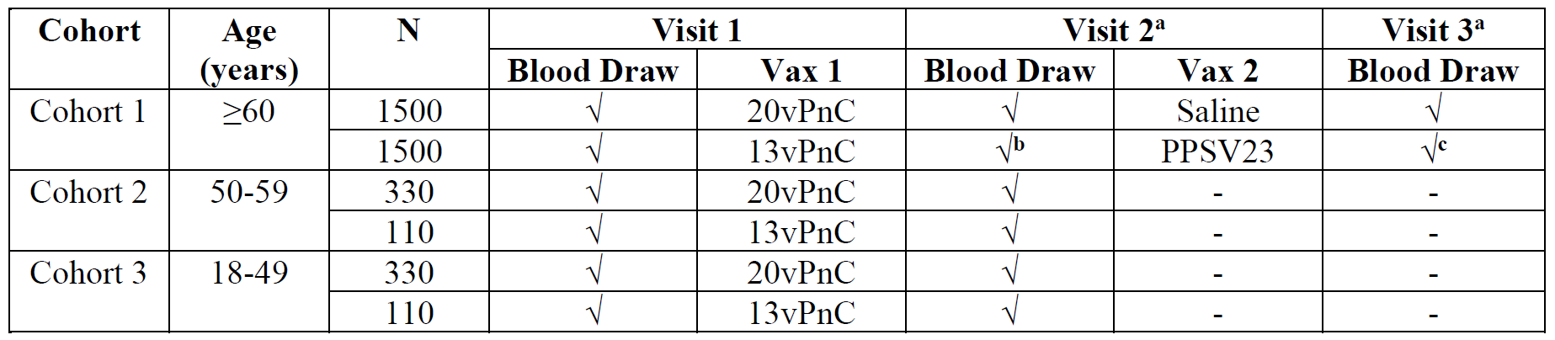

Abbreviations: N = number of subjects; 13vPnC = 13-valent pneumococcal conjugate vaccine; 20vPnC = .20-valent pneumococcal conjugate vaccine.

√ denotes blood samples were taken on specified visit.

a. 28 to 42 days after previous visit

b. Control and key time point for the co-primary objective for the 13 matched serotypes

c. Control and key time point for co-primary objective for the 7 additional serotypes

Primary immunogenicity endpoint in Cohort 1 subjects aged 60 and over

The primary immunogenicity endpoints were serotype-specific OPA GMTs one month after vaccination in subjects aged 60 years and over (Cohort 1) to demonstrate:

* non-inferiority of the 13 serotypes induced by Prevenar 20 compared to the corresponding 13 serotypes induced by Prevenar 13; and
* non-inferiority of the additional 7 serotypes induced by Prevenar 20 compared to the corresponding 7 serotypes induced by Pneumovax 23.

Secondary immunogenicity endpoints in Cohort 2 (50 to 59 years) and Cohort 3 (18 to 49 years)

The secondary immunogenicity endpoints included serotype-specific OPA GMTs one month after vaccination to demonstrate that the immune responses to the 20 serotypes in Prevenar 20 induced in adults aged 50 through 59 years (Cohort 2) and in adults aged 18 through 49 years (Cohort 3) were non-inferior to the immune responses induced by Prevenar 20 in adults aged 60 through 64 years (Cohort 1 subset), and to describe the immune responses to Prevenar 20 in all three-age cohorts in adult subjects.

Results for the primary immunogenicity endpoints in Cohort 1

In the evaluable 13-matched immunogenicity population, Prevenar 20 met the primary immunogenicity endpoint for the 13-matched vaccine serotypes in Cohort 1 (subjects aged 60 years and over). One month after Prevenar 20 or Prevenar 13, the immune responses to all 13‑matched vaccine serotypes induced by Prevenar 20 were non-inferior to those induced by Prevenar 13, as demonstrated by the lower bounds of the 2-sided 95% confidence intervals (CIs) for the primary analysis of model‑based OPA GMRs (Prevenar 20/saline relative to Prevenar 13/Pneumovax 23) > 0.5 (2-fold non‑inferiority margin). The adjusted OPA GMRs for the 13 matched serotypes were between 0.76 (serotype 6A) and 1.00 (serotype 14). The results for the 13 matched serotypes (OPA GMTS and GMRS) are summarised in Table 5 below.

Table : Study B7471007 Pneumococcal opsonophagocytic activity geometric mean titres and geometric mean ratios for the 13-valent pneumococcal conjugate vaccine serotypes one month after vaccination, linear regression model (Cohort 1 (60 years and over), evaluable 13-matched immunogenicity population)

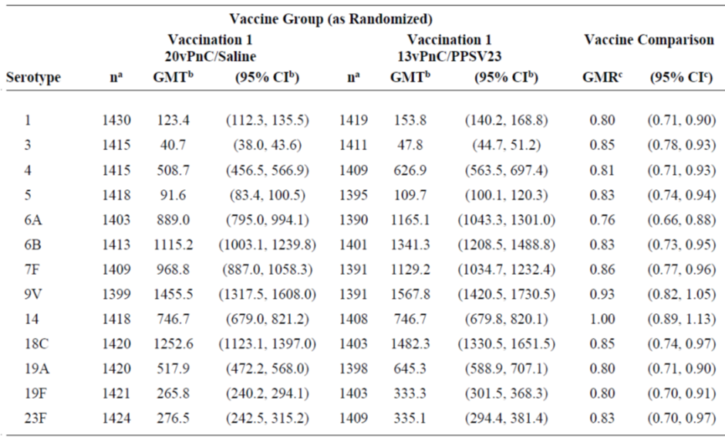

Abbreviations: CI = confidence interval; GMR = geometric mean ratio; GMT = geometric mean titre; LS = least squares; PPSV23 = 23-valent pneumococcal polysaccharide vaccine; 13vPnC = 13-valent pneumococcal conjugate vaccine; 20vPnC = .20-valent pneumococcal conjugate vaccine.

Note: Assay results below the lower limit of quantitation (LLOQ) were set to 0.5 x LLOQ in the analysis.

a. n = Number of subjects with valid and determinate opsonophagocytic activity (OPA) titres for the specified serotype.

b. Geometric mean titres and 2-sided CIs were calculated by exponentiating the LS means and the corresponding CIs based on analysis of log-transformed OPA titres using a regression model with vaccine group, sex, smoking status, age at vaccination in years (continuous), and baseline log transformed OPA titres.

c. Geometric mean ratios (ratio of GMTs Prevenar 20/saline to 13vPnC/Pneumovax 23) and 2-sided CIs were calculated by exponentiating the difference of LS means and the corresponding CIs based on the same regression model as above.

Results from the additional sensitivity analysis of the unadjusted OPA GMRs and the associated 95% CIs for the 13-matched vaccine serotypes for the Prevenar 20/saline group relative to the Prevenar 13/Pneumovax 23 group were consistent with the model-based OPA GMR results. The lower bounds of the 2-sided 95% CIs for the unadjusted OPA GMRs were more than 0.5 for each of the 13-serotypes, and the unadjusted OPA GMRs for the vaccine comparison were between 0.76 (serotype 6A) and 0.96 (serotype 14).

The clinical evaluation highlighted that the GMR was less than 1 for 12 of the 13 matched serotypes, reflecting a consistently lower GMT for Prevenar 20 at one month after vaccination for these 12 serotypes compared to Prevenar 13. The is discussed in sponsor’s repose to TGA’s question and the questions for the Advisory Committee on Vaccines (ACV) (see *Questions for the sponsor* and *Advisory Committee considerations* sections, below).

Seven additional immunogenicity population

In the evaluable 7 additional immunogenicity population, Prevenar 20 met the primary immunogenicity objective for 6 of the 7 additional vaccine serotypes. One month after Prevenar 20 or Pneumovax 23, the immune responses to 6 of the 7 additional vaccine serotypes induced by Prevenar 20 were non-inferior to those induced by Pneumovax 23, as demonstrated by the lower bounds of the 2-sided 95% CIs for the primary analysis of model-based OPA GMRs (Prevenar 20/saline relative to Prevenar 13/Pneumovax 23 group) being > 0.5. The model-based GMR (2‑sided 95% CI) for serotype 8 was 0.55 (95% CI: 0.49, 0.62), with the lower bound 95% CI of 0.49 narrowly missing the statistical non-inferiority criterion of 0.5. The results are summarised below in Table 6, and the OPA GMRs (forest plot) is presented in Figure 1.

Table : Study B7471007 Pneumococcal opsonophagocytic activity geometric mean titres and geometric mean ratios for the 7 additional serotypes one month after vaccination, linear regression model (Cohort 1 (60 years and over), evaluable 7 additional immunogenicity population)

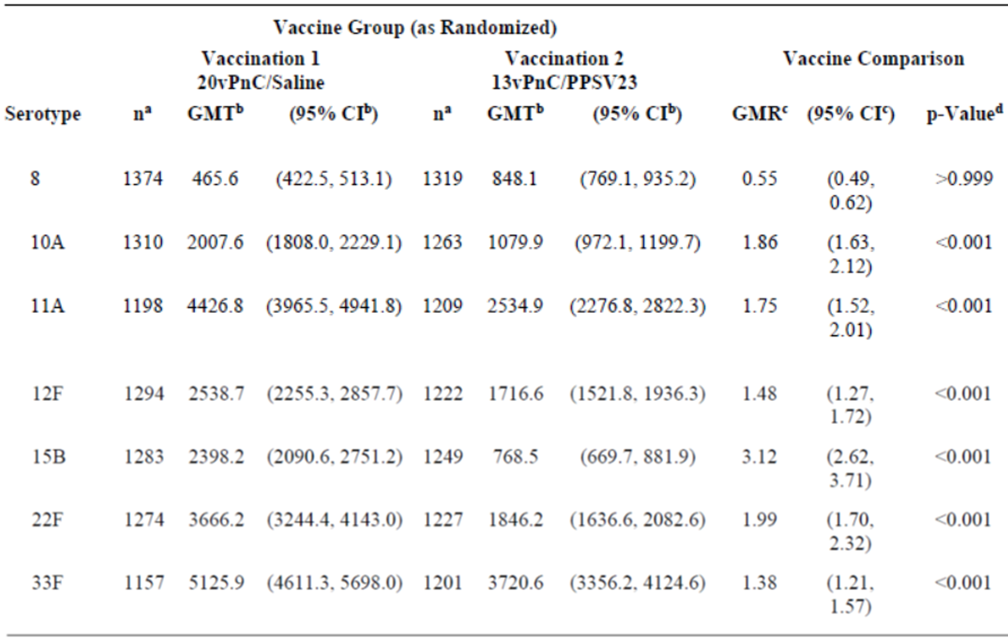

Abbreviations: CI = confidence interval; GMR = geometric mean ratio; GMT = geometric mean titre; LS = least squares; PPSV23 = 23-valent pneumococcal polysaccharide vaccine; 13vPnC = 13-valent pneumococcal conjugate vaccine; 20vPnC = .20-valent pneumococcal conjugate vaccine.

Note: Assay results below the lower limit of quantitation (LLOQ) were set to 0.5 x LLOQ in the analysis.

a. n = Number of subjects with valid and determinate opsonophagocytic activity (OPA) titre for the specified serotype

b. Geometric mean titres and 2-sided CIs were calculated by exponentiating the LS means and the corresponding CIs based on analysis of log-transformed OPA titres using a regression model with vaccine group, sex, smoking status, age at vaccination in years (continuous), and baseline log transformed OPA titres.

c. Geometric mean ratios (ratio of GMTs Prevenar 20/saline to 13vPnC/Pneumovax 23) and 2-sided CIs were calculated by exponentiating the

difference of LS means and the corresponding CIs based on the same regression model as above.

d. Nominal one-sided p-value for superiority based on the same regression model.

Figure : Study B7471007 Model-based opsonophagocytic activity geometric mean ratios of Prevenar 20 to Pneumovax 23 with 95% confidence interval one month after vaccination for 7 additional serotypes in Prevenar 20 (Cohort 1, evaluable 7 additional immunogenicity population)

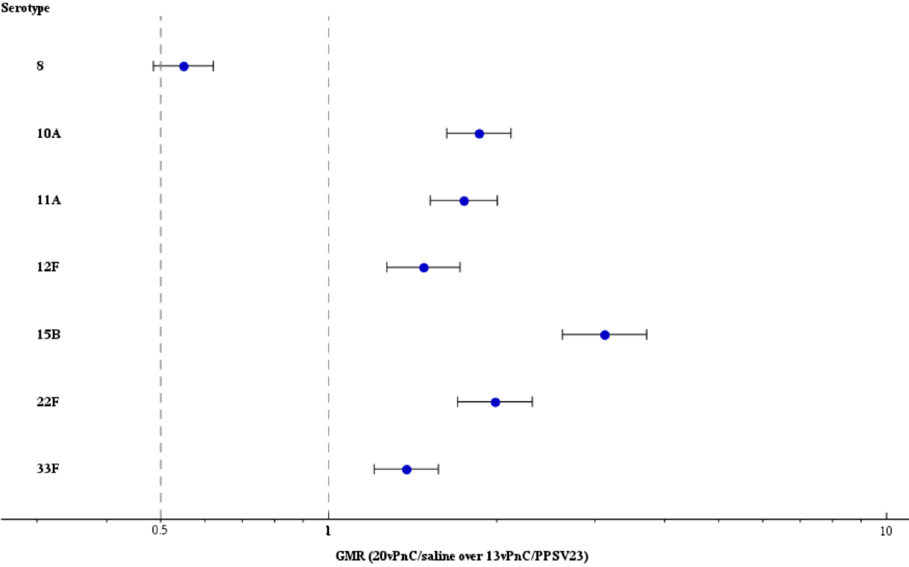

Abbreviations: GMR = geometric mean ratio; PPSV23 = 23-valent pneumococcal polysaccharide vaccine; 13vPnC = 13-valent pneumococcal conjugate vaccine; 20vPnC = .20-valent pneumococcal conjugate vaccine.

Note: Assay results below the lower level of qualification (LLOQ) were set to 0.5 x LLOQ in the analysis.

Note: GMRs (ratios of geometric mean titres 20vPnC/saline to 13vPnC/PPSV23) and confidence intervals (CIs) were calculated by exponentiating the difference of least squares means and the corresponding CIs baseline log transformed opsonophagocytic activity titres.

Results from the additional sensitivity analysis of the unadjusted OPA GMRs and the associated 95% CIs for the 7 additional vaccine serotypes of the Prevenar 20/saline group relative to the Prevenar 13/Pneumovax 23 group were consistent with the model-based OPA GMR results. The lower bounds of the 2-sided 95% CIs were > 0.5 for each of the 7 additional serotypes, apart from serotype 8 where the relevant value was 0.49 (GMR = 0.55; 95% CI: 0.49, 0.63). As for the primary analysis, GMRs for the sensitivity analysis were > 1 for the vaccine comparison for each of the serotypes apart from serotype 8.

The clinical evaluation highlighted that the GMR was > 1 for 6 of the 7 additional matched serotypes, reflecting a higher GMT for Prevenar 20 at one month after vaccination for these 6 serotypes relative to Pneumovax 23. However, the GMR for serotype 8 was < 1 and the lower bound 95% CI was 0.49, which was slightly below the lower bound non-inferiority margin of 0.5. this is also discussed in sponsor’s repose to TGA’s question and the questions for the ACV.

###### Study B7471006

Study B7471006 was a randomised, open-label Phase III clinical trial of single dose Prevenar 20 in adults 65 years of age and over who had previously received pneumococcal vaccination (Pneumovax 23 (unconjugated), Prevenar 13 (conjugated), or both vaccines).

Study objectives

* The primary safety objective was to describe the safety profile of Prevenar 20.
* The primary immunogenicity objective was to describe the immune responses to Prevenar 20 in adults previously vaccinated with Pneumovax 23, Prevenar 13, or with both vaccines.
* The secondary immunogenicity objective was to further describe the immune responses to Prevenar 20 in adults previously vaccinated with Pneumovax 23, Prevenar 13, or with both vaccines.
* The exploratory immunogenicity objective was to further describe the immune responses induced by Prevenar 20.

Study design

Approximately 875 adults aged 65 years and over were targeted to be enrolled into 3 different cohorts (Cohorts A, B and C) based on their prior pneumococcal vaccination history.

* Cohort A: Approximately 375 subjects who had received Pneumovax 23 for one year or longer and no more than five years previously but had not been vaccinated with Prevenar 13 were randomised 2:1 to receive either Prevenar 20 or Prevenar 13.
* Cohort B: Approximately 375 subjects who had received Prevenar 13 for 6 months or longer previously, but had not been vaccinated with Pneumovax 23, were randomised 2:1 to receive either Prevenar 20 or Pneumovax 23.
* Cohort C: Approximately 125 subjects who had previously received Prevenar 13 followed by Pneumovax 23 were vaccinated with Prevenar 20.

Subjects in Cohort A were enrolled at both the US and Swedish sites, while subjects in Cohorts B and C were enrolled only at the US sites, where a routine recommendation for administration of Prevenar 13 followed by Pneumovax 23 one year later for all adults 65 years of age and older was introduced in 2014.

The clinical evaluation highlighted sponsor reports that ‘studies of Pneumovax 23 and Prevenar 13 have suggested prior pneumococcal vaccination of older adults, particularly with Pneumovax 23, may negatively impact immune responses to subsequent doses of pneumococcal vaccine. Therefore, study B7471006 was designed to inform efforts to protect individuals 65 years of age and older with Prevenar 20, and describe the safety and immunogenicity of Prevenar 20 in subjects previously vaccinated with other pneumococcal vaccines.’

Primary immunogenicity endpoint - pneumococcal serotype-specific opsonophagocytic activity titres

The primary immunogenicity endpoints were the 20 pneumococcal serotype-specific OPA titres one month after vaccination in the Prevenar 20 groups.

Secondary immunogenicity endpoints

* Fold rise in serotype-specific OPA titres from before vaccination to one month after vaccination.
* No less than 4-fold rise in serotype-specific OPA titres from before to one month after vaccination.
* Serotype-specific OPA titre ≥ lower limit of quantitation (LLOQ) one month after vaccination.

Exploratory immunogenicity endpoints

* No less than 4-fold rise in pneumococcal serotype 15C OPA titres from before to one month after vaccination.
* Pneumococcal serotype 15C OPA titre ≥ LLOQ one month after vaccination.
* Pneumococcal serotype 15C OPA titre one month after vaccination.
* Fold rise in pneumococcal serotype 15C OPA titre from before to one month after vaccination.

Primary immunogenicity endpoint - pneumococcal serotype-specific OPA GMTs

Immune responses to all 20 vaccine serotypes were observed one month after Prevenar 20, based on OPA GMTs in all 3 cohorts in the evaluable immunogenicity population regardless of prior pneumococcal vaccine (see Table 7 below).

Table : Study B7471006 Pneumococcal opsonophagocytic activity geometric mean titres (evaluable immunogenicity population)

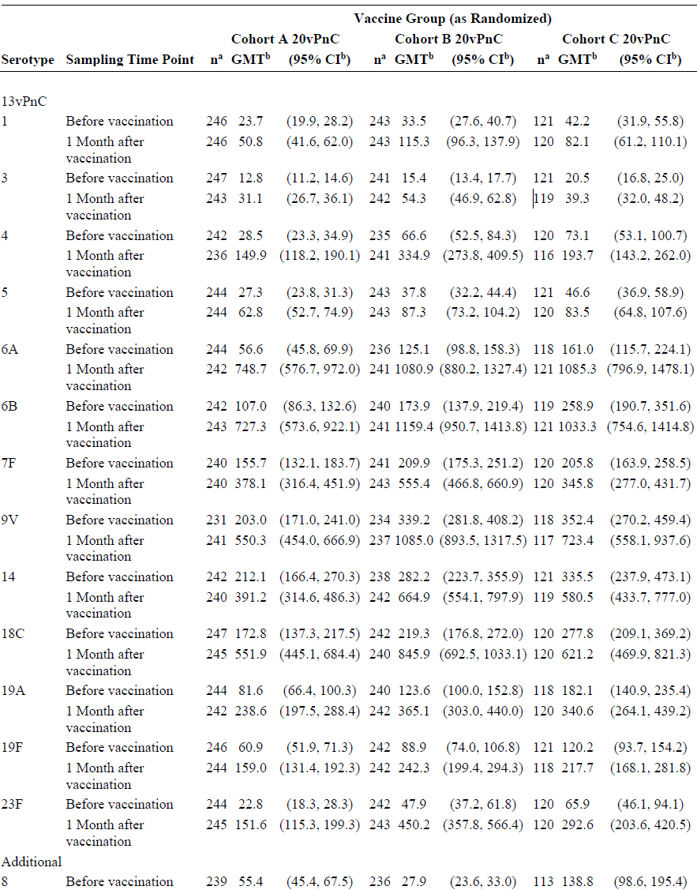

Table 7 (continued): Study B7471006 Pneumococcal opsonophagocytic activity geometric mean titres (evaluable immunogenicity population)

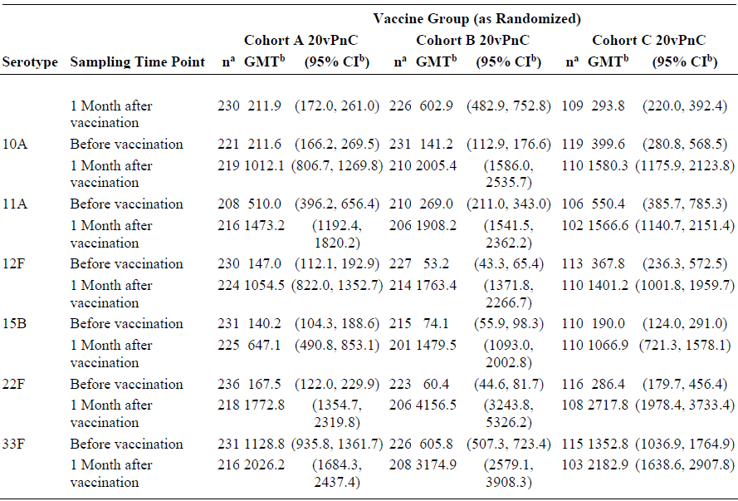

Abbreviations: CI = confidence interval; GMT = geometric mean titre; OPA = opsonophagocytic activity; 20vPnC = 20‑valent pneumococcal conjugate vaccine.

Note: Assay results below the lower limit of quantitation (LLOQ) were set to 0.5 x LLOQ in the analysis.

a. n = Number of subjects with valid and determinate assay results for the given serotype at the specified time point.

b. Geometric mean titres and 2-sided CIs were calculated by exponentiating the mean logarithm of the titres and the corresponding CIs (based on the student t-distribution).

At Baseline, OPA GMTs for the Prevenar 13 serotypes were generally numerically highest in Cohort C (prior Prevenar 13 and Pneumovax 23), ranging from 20.5 (serotype 3) to 352.4 (serotype 9V), followed by Cohort B (prior Prevenar 13 only), ranging from 15.4 (serotype 3) to 339.2 (serotype 9V). Baseline GMTs were lowest in Cohort A (prior Pneumovax 23 only), ranging from 12.8 (serotype 3) to 212.1 (serotype 14).

At Baseline, OPA GMTs for the 7 additional serotypes were generally numerically highest in subjects in Cohort C (prior Prevenar 13 and Pneumovax 23), ranging from 138.8 (serotype 8) to 1352.8 (serotype 33F), followed by subjects in Cohort A (prior Pneumovax 23 only), ranging from 55.4 (serotype 8) to 1128.8 (serotype 33F). Baseline OPA GMTs were lowest in subjects in Cohort B (prior Prevenar 13 only), ranging from 27.9 (serotype 8) to 605.8 (serotype 33F).

At one month after Prevenar 20, OPA GMTs for most of the 20 vaccine serotypes tended to be numerically highest in subjects in Cohort B (prior Prevenar 13 only), ranging from 54.3 (serotype 3) to 4156.5 (serotype 22F) and lowest in subjects in Cohort A (prior Pneumovax 23 only), ranging from 31.1 (serotype 3) to 2026.2 (serotype 33F). OPA GMTs in subjects in Cohort 3 (prior Prevenar 13 and Pneumovax 23) generally fell between the two other cohorts and ranged from 39.3 (serotype 3) to 2717.8 (serotype 22F).

Secondary immunogenicity endpoints in evaluable immunogenicity population

Fold-rise in serotype-specific opsonophagocytic activity titres at one month after vaccination

Increases in OPA titres for all 20 vaccine serotypes were observed based on OPA GMFRs from before to one month after vaccination with Prevenar 20 in all 3 cohorts, regardless of prior pneumococcal vaccination.

For the Prevenar 13 vaccine serotypes, GMFRs appeared to be generally highest in Cohort B (prior Prevenar 13 only), ranging from 2.3 (serotypes 5 and 14) to 9.3 (serotype 23F), followed by Cohort A (prior Pneumovax 23 only), ranging from 1.8 (serotype 14) to 12.6 (serotype 6A), and lowest in Cohort C (prior Prevenar 13 and Pneumovax 23), ranging from 1.6 (serotype 7F) to 6.5 (serotype 6A).

For the 7 additional Pneumovax 23 vaccine serotypes, GMFRs were higher in subjects in Cohort B (prior Prevenar 13 only), who were naïve to these vaccine serotypes prior to receiving Prevenar 20, ranging from 5.4 (serotype 33F) to 66.9 (serotype 22F) than in subjects in Cohort A (prior Pneumovax 23 only), ranging from 1.8 (serotype 33F) to 11.1 (serotype 22F), and in subjects in Cohort C (prior Prevenar 13 and Pneumovax 23), ranging from 1.8 (serotype 33F) to 9.8 (serotype 22F).

Results

* Immune responses to all 20 vaccine serotypes were observed one month after Prevenar 20 in adults 65 years of age and over as assessed by OPA GMTs, GMFRs, proportions of subjects with a no less than 4-fold-rise in OPA titres, and proportions of subjects with OPA titres ≥ LLOQ in all three cohorts.
* Opsonophagocytic activity GMTs to the 20 vaccine serotypes at one month after Prevenar 20 tended to be numerically highest in subjects who had previously received Prevenar 13 only, followed by those who had previously received both Prevenar 13 and Pneumovax 23, and were lowest among those who had previously received Pneumovax 23 only.
* For the Prevenar 13 serotypes, trends towards higher OPA GMFRs and higher proportions of subjects with ≥ 4-fold rise in OPA titres were noted in subjects who had previously received Prevenar 13 only compared to subjects who had previously received Pneumovax 23 only or had previously received both Prevenar 13 and Pneumovax 23.
* For the additional 7 serotypes, GMFRs were larger and proportions of subjects with a ≥ 4-fold rise in OPA titres were higher after Prevenar 20 in subjects in who had previously received Prevenar 13 only (that is, naïve to vaccination with those serotypes) compared to those who had previously received Pneumovax 23 only or both Prevenar 13 and Pneumovax 23.
* Prevenar 20 elicited immune responses to serotype 15C in adults 65 years of age and over in all three cohorts.

###### Study B7471008

Study B7471008 was a Phase III, randomised, double-blind clinical trial designed to evaluate the safety and immunogenicity of 3 lots of Prevenar 20 in pneumococcal-naïve adults aged 18 through 49 years.

Objectives

The primary safety objective was to describe the safety profile of Prevenar 20.

The primary immunogenicity objective was to demonstrate that the immune responses to the 20 serotypes induced by Prevenar 20 were equivalent across the 3 Prevenar 20 lots.

The secondary and exploratory immunogenicity objectives were to further describe the immune responses to Prevenar 20.

Results

The study met its primary immunogenicity objective of demonstrating that the immune responses to the 20 serotypes induced by Prevenar 20 are equivalent across 3 lots. Lot consistency was demonstrated based on a 2-fold equivalence margin comparing the OPA GMTs between each pair of Prevenar 20 lots for each serotype. The 2-sided 95% CIs for the model-based estimate of serotype-specific OPA GMRs one month after vaccination for each pair of lot comparisons (Lot 1/Lot 2, Lot 1/Lot 3, and Lot 2/Lot 3) were contained within the pre-specified interval (0.5, 2.0) for each of the 20 serotypes.

All 3 lots of Prevenar 20 elicited similar immune responses at one month after vaccination for each of the 20 serotypes based on OPA GMFRs, proportions of subjects achieving a no less than 4-fold rise in OPA titres, and proportions of subjects with OPA titres ≥ LLOQ.

###### Concomitant administration studies - Studies B7471004 and B7471026

In response to the risk management plan (RMP) evaluation report, the sponsor provided the final clinical study reports for two recently completed studies not been previously evaluated by the TGA. These two studies were:

* Study B7471004 (final report on 2 November 2021): A Phase III, randomised, double blind trial to evaluate the safety and immunogenicity of a Prevenar 20 when co-administered with seasonal inactivated influenza vaccine in adults 65 years of age and over.
* Study B7471026 (final report on 17 March 2022): A Phase III, randomised, double-blind trial to describe the safety and immunogenicity of Prevenar 20 when co-administered with a booster dose of Comirnaty;[39] COVID-19 vaccine in adults 65 years of age and older.

#### Safety

Safety was assessed in six clinical studies in a total of 7048 adult subjects (4552 subjects received Prevenar 20 and 2496 received control vaccine).

The evaluation of safety provided in the clinical evaluation report focused primarily on the safety data from the three Phase III studies, supplemented by the safety data from the Phase I/II studies. Evaluation of the safety data from the three Phase III studies is based on the integrated data presented in the summary of clinical safety, the tables and figures for the integrated safety summary, and the individual clinical summary reports for each of the Phase III studies.

The safety data for the three Phase I/II studies were considered to provide supportive data for the key safety data from the three Phase III studies.

##### Recommendation following the clinical safety evaluation

The safety of single dose Prevenar 20 was evaluated in 6 clinical studies in adults aged 18 years and over, with a total of 4552 subjects receiving a single dose of Prevenar 20 during clinical development compared to 2496 receiving a single dose of control vaccine.

In the three Phase III studies, 4263 subjects received Prevenar 20, and 2207 received control (Prevenar 13 and/or Pneumovax 23), and in the three Phase I and 2 studies, 289 subjects received Prevenar 20 and 289 subjects received control (Tdap, Prevenar 13, or Prevenar 13 plus Pneumovax 23). In general, the safety profile of single dose Prevenar 20 in adult subjects was consistent with the known safety profile for the approved product Prevenar 13. No new or unexpected safety signals were observed after Prevenar 20.

In the six clinical studies of the 4552 adult subjects aged 18 years and over who received one dose of Prevenar 20, 3414 subjects were aged 18 to 64 years and 1138 were aged 65 years and over. The age and sex distribution of subjects exposed to Prevenar 20 is summarised in Table 8 below.

Table : Exposure to Prevenar 20 by age group and gender

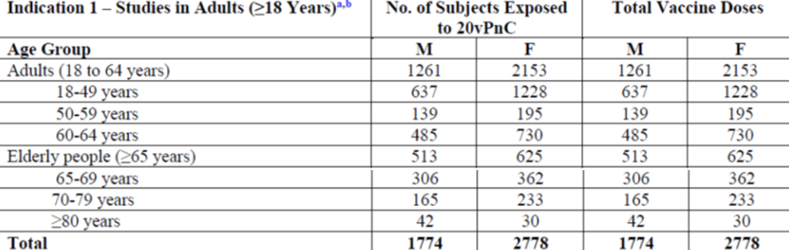

Abbreviations: F = female; M = male; No. = number; 20vPnC = 20‑valent pneumococcal conjugate vaccine.

a Included are Studies B6471001, B7471002, B7471005, B7471006, B7471007 and B7471008.

b All studies in this category received a single dose of 20vPnC.

Most of the subjects in the six clinical studies were healthy adults, and patients with significant comorbidities were not included in the clinical development program for Prevenar 20 (that is, hepatic impairment, renal impairment, cardiovascular disease, and/or immunocompromised). There were no studies in pregnant women and there were no cases reporting Prevenar 20 in breast feeding women.

Overall, the safety profile of single dose Prevenar 20 in adult subjects was generally consistent with the known safety profile for the approved product Prevenar 13. No new or unexpected safety signals were observed after Prevenar 20. The key risks of single dose Prevenar 20 for active immunisation of prevention of pneumonia and invasive pneumococcal disease based on the three Phase III studies are summarised in the Table 9 below.

Table : Summary of strengths and uncertainties relating to the safety data

| Risks | Strengths and Uncertainties |
| --- | --- |
| **1. Prompted local reactions within 10 days after vaccination reported in subjects in the three Phase III studies**  a. Pneumococcal vaccine-naïve subjects (Prevenar 20 versus Prevenar 13, respectively)   * Study B7471007 (Cohort 1) ≥ 60 years:   + Redness (any) = 7.3% versus 6.2%   + Swelling (any) = 7.5% versus 8.0%   + Pain at injection site (any) = 55.4% versus 54.1% * Study B7471007 (Cohort 2) 50 to 59 years:   + Redness (any) = 8.2% versus 5.4%   + Swelling (any) = 8.8% versus 10.8%   + Pain at injection site (any) = 72.5% versus 69.4% * Pooled Study 7471007 (Cohort 3) plus Study B7471008 18 to 49 year old population:   + Redness (any) = 7.4% versus 7.3%   + Swelling (any) = 9.1% versus 9.9%   + Pain at injection site (any) = 79.2% versus 77.7%   b. Subjects aged ≥ 65 years by prior vaccine status   * Study B7471007 (subset Cohort 1) pneumococcal vaccine-naïve (Prevenar 20 versus Prevenar 13, respectively):   + Redness (any) = 7.8% versus 6.1%   + Swelling (any) = 6.6% versus 7.3%   + Pain at injection site (any) = 43.6% versus 44.0% * Study B7471006 prior Pneumovax 23 (Prevenar 20 versus Prevenar 13, respectively):   + Redness (any) = 7.9% versus 2.5%   + Swelling (any) = 9.9% versus 6.6%   + Pain at injection site (any) = 50.2% versus 43.0% * Study B7471006 prior Prevenar 13 (Prevenar 20 versus Pneumovax 23, respectively):   + Redness (any) = 8.6% versus 12.7%   + Swelling (any) = 9.4% versus 14.3%   + Pain at injection site (any) = 61.2% versus 56.3% * Study B7471006 prior Prevenar 13 and Pneumovax 23 (Prevenar 20):   + Redness (any) = 4.8%   + Swelling (any) = 4.0%   + Pain at injection site (any) = 52.8%   **2. Prompted systemic events within 7 days after vaccination reported in subjects in the three Phase III studies**  a. Pneumococcal vaccine-naïve subjects (Prevenar 20 versus Prevenar 13, respectively)   * Study B7471007 (Cohort 1) ≥ 60 years:   + Fever ≥ 38.0℃ = 0.9% versus 0.8%   + Fatigue (any) = 30.2% versus 30.7%   + Headache (any) = 21.5% versus 23.3%   + Muscle pain (any) = 39.1% versus 37.3%   + - Joint pain (any) = 12.6% versus 13.7% * Study B7471007 (Cohort 2) 50-59 years:   + Fever ≥ 38.0℃ = 1.5% versus 0.9%   + Fatigue (any) = 39.3% versus 36.0%   + Headache (any) = 32.3% versus 36.0%   + Muscle pain (any) = 49.8% versus 49.5%   + Joint pain (any) = 15.4% versus 20.7% * Pooled 7471007 (Cohort 3) plus B7471008 18-49 years:   + Fever ≥ 38.0℃ = 1.2% versus 1.1%   + Fatigue (any) = 46.7% versus 43.7%   + Headache (any) = 36.7% versus 36.6%   + Muscle pain (any) = 62.9% versus 64.8%   + Joint pain (any) = 16.2% versus 15.2%   b. Subjects aged ≥ 65 years by prior vaccine status   * Study B7471007 (subset Cohort 1) pneumococcal vaccine-naïve (Prevenar 20 versus Prevenar 13, respectively):   + Fever ≥ 38.0℃ = 1.2% versus 1.6%   + Fatigue (any) = 25.3% versus 27.2%   + Headache (any) = 15.8% versus 19.3%   + Muscle pain (any) =31.9% versus 32.3%   + Joint pain (any) = 13.4% versus 12.0% * Study B7471006 prior Pneumovax 23 (Prevenar 20 versus Prevenar 13, respectively):   + Fever ≥ 38.0℃ = 0.8 versus 0%   + Fatigue (any) = 28.9% versus 22.3%   + Headache (any) = 17.8% versus 18.2%   + Muscle pain (any) = 32.0% versus 31.4%   + Joint pain (any) = 6.7% versus 10.7% * Study B7471006 prior Prevenar 13 (Prevenar 20 versus Pneumovax 23, respectively):   + Fever ≥ 38.0℃ = 0% versus 1.6%   + Fatigue (any) = 31.0% versus 33.3%   + Headache (any) = 13.5% versus 21.4%   + Muscle pain (any) = 33.9% versus 46.0%   + Joint pain (any) = 11.8% versus 15.9% * Study B7471006 prior Prevenar 13 and Pneumovax 23 (Prevenar 20):   + Fever ≥ 38.0℃ = 0%   + Fatigue (any) = 32.8%   + Headache (any) = 19.2%   + Muscle pain (any) = 37.6%   + Joint pain (any) = 16.8%   **3. Immediate AEs within 30 minutes after vaccination reported in subjects in the three Phase III studies**  The proportion of subjects who reported immediate AEs was low, both among subjects naïve to pneumococcal vaccine across age groups (≤ 0.2% after Prevenar 20 versus ≤ 0.9% after Prevenar 13) and among subjects ≥65 years of age by prior pneumococcal vaccination status (≤ 0.4% after Prevenar 20 versus ≤0.8% after control vaccines)  a. Pneumococcal vaccine-naïve subjects (Prevenar 20 versus Prevenar 13, respectively)   * B7471007 (Cohort 1) ≥ 60 years: injection site pain (0.1% versus 0.1%); joint swelling (0.1% versus 0%); musculoskeletal stiffness (0.1% versus 0%); somnolence (0% versus 0.1%). * B7471007 (Cohort 2) 50-59 years: headache (0% versus 0.9%). * Pooled 7471007 (Cohort 3) plus B7471008 18-49 years: nausea (0.1% versus 0%), vomiting (0.1% versus 0%); dizziness (0% versus 0.3%).   b. Subjects aged ≥ 65 years by prior vaccine status   * B7471007 (subset Cohort 1) pneumococcal vaccine- naïve (Prevenar 20 versus Prevenar 13): injection site swelling (0% versus 0.2%). * B7471006 prior Pneumovax 23 (Prevenar 20 versus Prevenar 13, respectively): dehydration (0.4% versus 0%); dizziness (0.4% versus 0%); paraesthesia (0.4% versus 0%); anxiety (0.4% versus 0%); hypotension (0.4% versus 0%). * B7471006 prior Prevenar 13 (Prevenar 20 versus Pneumovax 23): no events in either vaccine group. * B7471006 prior Prevenar 13 and Pneumovax 23 (Prevenar 20): dizziness (0.8% versus 0%).   **4. Vaccine-related AEs within one month after vaccination reported in the three Phase III studies**  The proportion of subjects who reported vaccine-related AEs was low, both among subjects naïve to pneumococcal vaccine across age groups (≤ 0.9% after Prevenar 20 versus ≤ 1.5% after Prevenar 13) and among subjects ≥ 65 years of age by prior pneumococcal vaccination status (≤ 1.6% after Prevenar 20 versus ≤ 2.4% after control vaccines).  a. Pneumococcal vaccine-naïve ≥ 2 subjects (n, %) in the Prevenar 20 versus Prevenar 13 groups, respectively:   * B7471007 (Cohort 1) ≥ 60 years: any (14, 0.9% versus 23, 1.5%); injection site pain (2, 0.1% versus 3, 0.2%); injection site pruritus (1, 0.1% versus 3, 0.2%); fatigue (0% versus 2, 0.1%); headache (0% versus 3, 0.2%); pruritus (2, 0.1% versus 0%). * B7471007 (Cohort 2) 50-59 years: any (3, 0.9% versus 1, 0.9%); no subjects with individual AEs (PT) in ≥ 2 subjects in either vaccine group * Pooled 7471007 (Cohort 3) plus B7471008 18-49 years: any (9, 0.5% versus 3, 0.8%); injection site pain (2, 0.1% versus 0%); rash (2, 0.1% versus 0%).   b. Subjects aged ≥ 65 years by prior vaccine status; ≥ 2 subjects (n, %) in the Prevenar 20 versus control groups, respectively:   * B7471007 (subset Cohort 1) pneumococcal vaccine-naïve (Prevenar 20 versus Prevenar 13, respectively): any (5, 1.0% versus 9, 1.8%); pruritus (2, 0.4% versus 0%); fatigue (0% versus 2, 0.4%); injection site pruritus (0% versus 2, 0.4%). * B7471006 prior Prevenar 13 (Prevenar 20 versus Pneumovax 23, respectively): any (1, 0.4% versus 0%); no vaccine-related AEs in ≥ 2 subjects in either group. * B7471006 prior Prevenar 13 (Prevenar 20 versus Pneumovax 23, respectively): any (4, 1.6% versus 3, 2.4%); no subjects with individual vaccine-related AEs (PT) in either group. * B7471006 prior Prevenar 13 and Pneumovax 23 (Prevenar 20): no subjects in the Prevenar 20 group.   **5. Vaccine-related SAEs within 1 or 6 months after vaccination reported in the three Phase III studies.**   * None reported.   **6. Deaths reported in the three Phase III studies**   * One death reported in a pneumococcal vaccine-naïve subject in Study B7471001 (Cohort 1) due to suicide 48 days after Prevenar 20 considered to be unrelated to the vaccine; no other deaths reported in the three Phase III studies. | * The safety profiles of Prevenar 20 and vaccine controls in the three Phase III studies were similar in pneumococcal vaccine-naïve adult subjects aged ≥ 18 years and in adult subjects aged ≥ 65 years with or without prior pneumococcal vaccination (Prevenar 13 and/or Pneumovax 23). * The safety profiles of Prevenar 20 in the three Phase III studies in adults aged ≥ 18 years across all age and vaccine groups were consistent with the safety profiles in pneumococcal vaccine-naïve subjects aged 18-49 years (two Phase I studies B7471001 and B7471005) and in subjects aged 60-64 years (Phase II study B74701002). * The safety profile in the clinical development program for Prevenar 20 based on the six submitted clinical studies is generally consistent with the known safety profile of Prevenar 13 based on clinical studies and post-marketing safety data. No new safety signals were observed after Prevenar 20 compared to vaccine control (Tdap/Prevenar 13 / Pneumovax 23). * In the three Phase III studies, AEs across all age and vaccine groups primarily comprised prompted local reactions within 10 days after vaccination (predominantly pain at injection site) and prompted systemic events within 7 days after vaccination (predominantly muscle pain). * In the three Phase III studies, prompted local reactions within 10 days after vaccination, prompted systemic events within 7 days after vaccination and AEs within 1 month after vaccination tended to decrease with increasing age and tended to occur more frequently in females than in males and in Whites than in Black or African Americans. * The most noteworthy AE within 10 days after vaccination in the three Phase III studies was the marginally increased frequency of cardiac disorders (SOC) in subjects (n [%]) aged ≥ 60 years in study B7471007 Cohort 1 (n=7, 0.5% versus n=2, 0.1%). The only reports of vaccine-related cardiac disorder AEs (PT) reported 1 month after vaccination in the Phase III studies were palpitations in 1 (0.1%) subject each after Prevenar 20 and Prevenar 13 in Study B7471007 Cohort 1. There were no vaccine-related cardiac disorder SAEs reported in the Phase III studies. Overall, the totality of the non-clinical and clinical data indicates that a causal relationship between Prevenar 20 and cardiac disorders is unlikely. * There were no data with Prevenar 20 in special populations. Most of the subjects in the six clinical studies were healthy adults, and patients with significant comorbidities were not included in the clinical development program for Prevenar 20 (that is, hepatic impairment, renal impairment, cardiovascular disease, and/or immunocompromised). There were no studies in pregnant women. It is unknown whether Prevenar 20 is excreted in human breast milk and there were no data on the use of Prevenar 20 in breast feeding women. |

Abbreviations: AE = adverse event; PT = Preferred Term; SAE = serious adverse event; SOC = System Organ Class; Tdap = diphtheria-tetanus-acellular pertussis combination vaccine.

In the three Phase III studies, adverse events across all age and vaccine groups primarily comprised prompted local reactions within 10 days after vaccination (predominantly pain at injection site) and prompted systemic events within 7 days after vaccination (predominantly muscle pain). The clinical evaluation drew attention to the marginally increased frequency of cardiac disorders in subjects aged 60 years and over in Study B7471007 Cohort 1 (n = 7, 0.5% versus n = 2, 0.1%). The clinical evaluation concluded that the totality of the nonclinical and clinical data indicated that a causal relationship between Prevenar 20 and cardiac disorders was unlikely.

#### Review of sponsor’s response to questions raised by the TGA

The sponsor provided a detailed response to the questions posed by the TGA at the first round of clinical evaluation. The sponsor’s responses were provided to the ACV for consideration.

The sponsor provided overseas evaluations, including the EU Scientific Advice to the sponsor, dated 10 August 2018 with the response to questions raised by TGA and Day 120 CHMP List of Questions to the TGA and the US Food and Drug Administration (FDA) reviews with the initial submission.

### Risk management plan

The sponsor has submitted EU-risk management plan (RMP) version 0.2 (dated 1 September 2021; data lock point (DLP) 4 June 2020) and ASA version 1.0 (dated 4 October 2021) in support of this application.

The clinical development of Prevenar 20 is based on that of Prevenar 13. The vaccines are manufactured and formulated in a similar way and contain 13 of the same polysaccharide conjugates. The most recently evaluated RMP for Prevenar 13 was EU-RMP version 9.0 (dated 3 July 2014; DLP 7 February 2014) and ASA version 4.0 (dated 20 February 2015). Periodic safety update report (PSUR) number 13 for Prevenar 13 is also considered relevant to this submission.

The sponsor has provided overseas evaluation reports for the submission, including the EMA Day 120 CHMP list of questions and the Summary Basis for Regulatory Action.

Prevenar 13 is included on the [National Immunisation Program schedule for pneumococcal disease](https://www.health.gov.au/topics/immunisation/vaccines/pneumococcal-immunisation-service?language=und) for various paediatric and adult age groups and medical conditions.[40]

The summary of safety concerns and their associated risk monitoring and mitigation strategies are summarised in Table 10. The TGA may request an updated RMP at any stage of a product's life‑cycle, during both the pre-approval and post-approval phases.

Table : Summary of safety concerns

|  |  |  |  |  |  |
| --- | --- | --- | --- | --- | --- |
| Summary of safety concerns | | Pharmacovigilance | | Risk minimisation | |
| **Routine** | **Additional** | **Routine** | **Additional** |
| Important identified risks | None |  |  |  |  |
| Important potential risks | None |  |  |  |  |
| Missing information | Use in pregnancy | ✓ | - | ✓ | - |
| Safety in immunocompromised patients | ✓ | - | ✓ | - |

* The summary of safety concerns aligns with the draft EU-RMP. The sponsor is requested to discuss issues relating to effectiveness (as requested by the clinical evaluation), changes in the epidemiology of nonvaccine *Streptococcus pneumoniae* serotypes causing invasive pneumococcal disease, concomitant use of Prevenar 20 with other vaccines and accidental or intentional use in children in response to questions raised by the TGA. At the second round of evaluation, the summary of safety concerns remains unchanged, however an updated EU‑RMP is available, and the sponsor is requested to submit an updated EU-RMP and ASA as a post-market update. The summary of safety concerns is acceptable subject to post-market review of the updated EU-RMP and ASA.
* Routine pharmacovigilance is proposed for all safety concerns. Additional pharmacovigilance is not proposed in the EU-RMP or ASA. The Pharmacovigilance Risk Assessment Committee has recommended that the sponsor outline how missing information concerns will be addressed, and any resulting additional pharmacovigilance activities that are included in the EU-RMP should be added to the ASA. At the second round of evaluation, the sponsor has provided the results of co-administration studies and updated the Product Information (PI) accordingly. How the sponsor will address missing information will be reviewed when the requested post-market RMP update is provided to the TGA.
* Routine risk minimisation is proposed for all safety concerns. Additional risk minimisation is not proposed. The sponsor has been requested to provide the draft European Summary of Product Characteristics (SmPC) in the response, and to make significant changes to the Consumer Medicines Information (CMI). Discrepancies in safety messaging between the Australian PI and the SmPC have been referred to the Delegate for consideration. The risk minimisation plan is acceptable.

### Risk-benefit analysis

#### Delegate’s considerations

This a comprehensive submission, with overseas evaluations and scientific advice substantiating the TGA evaluations in informing registration of Prevenar 20 in adults in Australia.

The sponsor has indicated that paediatric data for Prevenar 20 will be submitted in early 2023.

The lack of efficacy data is a deficiency of the application and the immunobridging strategy has been discussed extensively throughout the evaluation of this submission, as it has been discussed in the evaluations by the FDA and EMA. For the submitted Phase III trials, there is a lack of long-term immunogenicity data, with immune responses described at one month post‑vaccination. The Phase II Study B7471002 included immunogenicity and safety data at 12 months.

There is no immunological threshold level of antibody concentration that correlates with protection against pneumococcal disease, adding further uncertainty in evaluating the protective efficacy of pneumococcal vaccines.

Notwithstanding the limitations described above, the Delegate proposes that the submitted data are sufficient for registration of Prevenar 20 in Australia in adults 18 years and over.

As highlighted overseas,[41],[42] the place of Prevenar 20 in the [National Immunisation Program](https://www.health.gov.au/our-work/national-immunisation-program) will ultimately be recommended by [Australian Technical Advisory Group on Immunisation](https://www.health.gov.au/committees-and-groups/australian-technical-advisory-group-on-immunisation-atagi) ([ATAGI](https://www.health.gov.au/committees-and-groups/australian-technical-advisory-group-on-immunisation-atagi)). Ongoing post-marketing surveillance will be critical, given the lack of efficacy data in the pre‑registration trials.

#### Proposed action

The Delegate proposes that the data are sufficient for registration of Prevenar 20 in Australia in adults 18 years and over. Registration is subject to satisfactory implementation of the risk management plan, resolution of the product information and quality issues.

#### Questions for the sponsor

The sponsor provided the following response to questions from the Delegate.

1. ***Does the sponsor intend to conduct clinical studies with the 15-valent pneumococcal vaccine, as a near market comparator?***

The sponsor has no current plans to conduct clinical studies with Prevenar 20 and the 15-valent pneumococcal vaccine.

#### Advisory Committee considerations

The [Advisory Committee on Vaccines (ACV)](https://www.tga.gov.au/committee/advisory-committee-vaccines-acv), having considered the evaluations and the Delegate’s overview, as well as the sponsor’s response to these documents, advised the following.

##### Specific advice to the Delegate

1. ***The views of the European Medicines Agency (EMA) and the United States (US) Food and Drug Administration (FDA) have been discussed in detail in the response to questions raised by the TGA, including the limitations of the immunobridging strategy and lack of efficacy data. In the USA, the Phase IV post-approval Study B7471015 is a condition of accelerated approval to verify the clinical benefit of Prevenar 20 in preventing pneumococcal pneumonia caused by the 7 new vaccine serotypes in adults 65 years of age*** ***and over.***

***Does the ACV have further comments on these overseas evaluations and their implications for monitoring of efficacy of Prevenar 20 in adults in Australia?***

The ACV agreed that the lack of efficacy data is a deficiency in this application, however previous registrations of Prevenar 13;[43] and Vaxneuvance;[44] endorsed immunobridging, using the opsonophagocytic activity (OPA) response as surrogate.

Efficacy has been demonstrated for 13-valent pneumococcal conjugate vaccine (13vPnC, also known as Prevenar 13) in Study B1851025 (the CAPiTA trial) (n = 84496 patients of 65 years and over).[45]

The ACV noted that the US post-approval Study B7471015 will assess clinical benefit of 20‑valent pneumococcal conjugate vaccine (20vPnC, also known as Prevenar 20) in preventing radiologically confirmed pneumonia adults 65 years and over (planned completion date November 2027). Continued FDA approval is contingent upon demonstration of clinical benefit from this study, while no efficacy study was required for EMA authorisation.

The ACV agreed that it is not feasible to conduct efficacy studies for a new pneumococcal vaccine where uptake of currently approved vaccines is high,

While it is expected that Prevenar 20 will provide similar effectiveness to Prevenar 13 against vaccine-type invasive pneumococcal disease, ongoing post-marketing surveillance will be critical, given the lack of efficacy data.

1. ***Please comment on the proposed indication, in light of the evaluation comments highlighting the more specific indication in the USA and EU.***

***Does the ACV agree with the Delegate’s revised indication and proposal to align with the FDA and EMA?***

***In addressing these two questions, the ACV may wish to refer to [the second round of the clinical evaluation report].***

The ACV advised that in the absence of clinical efficacy data a more general reference to the prevention of pneumococcal disease was preferred over specific mention of pneumonia and invasive disease.

The vaccine induced robust responses to all 20 vaccine serotypes across adult age groups.

The ACV favoured harmonisation of indications with that of the most recently registered comparable vaccine, Vaxneuvance. Additionally, it is expected that the sponsor will propose to register Prevenar 20 for use in children at a later date, and in this group the broader benefits of preventing non-invasive pneumococcal disease, such as otitis media, are of relevance. Reference to vaccination in the context of official recommendations was very important. Inclusion of a statement noting that a vaccine may not prevent all cases of a disease was optional, but would be consistent with wording for Vaxneuvance.

1. ***In regard to the pivotal Study B7471007, please comment on the immunogenicity results discussed in [the second round of the clinical evaluation report].***

The ACV highlighted the following Immunogenicity results from Study B7471007:

* Pre-specified non-inferiority criteria for all 13 matched serotypes was met (noting that meeting or not meeting the sponsor’s non-inferiority of 0.5 is of unknown clinical relevance).
* Opsonophagocytic activity (OPA) geometric mean ratio (GMR) < 1 for 12/13 matched serotypes: 11 of these demonstrated OPA geometric mean titre (GMT) ratios ≥ 0.8; serotype 6A had GMR of 0.76.
* OPA GMTs one month after vaccination were slightly lower following 20-valent pneumococcal conjugate vaccine (20vPnC, also known as Prevenar 20) than following 13vPnC for 13 matched serotypes, although substantial increases in OPA GMTs from Baseline to one month after vaccination were observed in both groups.
* OPA GMR was ≥ 1 for 6 of the 7 additional matched serotypes, reflecting higher OPA GMTs at one month after vaccination with 20vPnC for these 6 serotypes compared to Pneumovax 23 (noting that the mechanism of action and immune response for conjugate and polysaccharide vaccines is significantly different)
* Serotype 8 missed the statistical non-inferiority criterion, which the ACV found somewhat anomalous and difficult to explain; immunogenicity has been demonstrated for this serotype.

The ACV expressed concern regarding the trend of diminishing OPA GMTs with increasing valency, as GMTs were consistently lower for Prevenar 20 compared to Prevenar 13.

It is acknowledged that there are no established minimum threshold OPA titres that predict protection against invasive pneumococcal disease in adults. It is uncertain if reduced OPA GMTs (for example, for serotypes 12/13) are clinically relevant. This adds emphasis to the importance of post-marketing surveillance.

##### Conclusion

The ACV considered Prevenar 20 vaccine (20-valent pneumococcal capsular polysaccharides vaccine) to have an overall positive benefit-risk profile for the indication:

*Active immunisation for the prevention of pneumococcal disease caused by Streptococcus pneumoniae serotypes 1, 3, 4, 5, 6A, 6B, 7F, 8, 9V, 10A, 11A, 12F, 14, 15B, 18C, 19A, 19F, 22F, 23F, and 33F in adults 18 years of age and older.*

*Prevenar 20 may not prevent disease caused by S. pneumonia serotypes that are not contained in the vaccine.*

*Prevenar 20 should be used in accordance with official recommendations.*

## Outcome

Based on a review of quality, safety, and efficacy, the TGA approved the registration of Prevenar 20 (pneumococcal polysaccharide conjugate vaccine) 92.4 μg/mL, suspension for injection, syringe, indicated for:

*Active immunisation for the prevention of pneumococcal disease caused by Streptococcus pneumoniae serotypes 1, 3, 4, 5, 6A, 6B, 7F, 8, 9V, 10A, 11A, 12F, 14, 15B, 18C, 19A, 19F, 22F, 23F, and 33F in adults 18 years of age and older.*

*Prevenar 20 may not prevent disease caused by S. pneumoniae serotypes that are not contained in the vaccine.*

*Prevenar 20 should be used in accordance with official recommendations.*

### Specific conditions of registration applying to these goods

* Prevenar 20 (pneumococcal capsular polysaccharides vaccine) is to be included in the Black Triangle Scheme. The PI and CMI for Prevenar 20 must include the black triangle symbol and mandatory accompanying text for five years, which starts from the date that the sponsor notifies the TGA of supply of the product.
* The Prevenar 20 EU-risk management plan (RMP) (version 0.2, dated 1 September 2021, data lock point 4 June 2020), with Australian specific annex (version 1.0, dated 4 October 2021), included with submission PM-2021-04721-1-2, to be revised to the satisfaction of the TGA, will be implemented in Australia.
* An obligatory component of risk management plans is routine pharmacovigilance. Routine pharmacovigilance includes the submission of periodic safety update reports (PSURs).

Reports are to be provided in line with the current published list of EU reference dates and frequency of submission of PSURs until the period covered by such reports is not less than three years from the date of the approval letter.

The reports are to at least meet the requirements for PSURs as described in the European Medicines Agency’s Guideline on Good Pharmacovigilance Practices (GVP) Module VII periodic safety update report [Revision 1], Part VII.B Structures and processes. Note that submission of a PSUR does not constitute an application to vary the registration.

* For all injectable products the Product Information must be included with the product as a package insert.

## Attachment 1. Product Information

The PI for Prevenar 20 approved with the submission which is described in this AusPAR is at Attachment 1. For the most recent PI, please refer to the TGA [PI/CMI search facility.](https://www.tga.gov.au/picmi-search-facility)

|  |
| --- |
| Therapeutic Goods Administration |
| PO Box 100 Woden ACT 2606 Australia  Email: [info@tga.gov.au](mailto:info@tga.gov.au) Phone: 1800 020 653 Fax: 02 6203 1605  [**https://www.tga.gov.au**](https://www.tga.gov.au) |
| Reference/Publication # |

1. This is the original indication proposed by the sponsor when the TGA commenced the evaluation of this submission. It may differ to the final indication approved by the TGA and registered on the Australian Register of Therapeutic Goods.
2. Janoff, E.N. and Musher, D.M. Streptococcus Pneumoniae in: Bennett, J.E. et al. editors. Mandell, Douglas, and Bennett's Principles and Practice of Infectious Diseases (8th edition), Philadelphia, *Elsevier*; 2015; 2310-2327.
3. Henriques-Normark, B. and Tuomanen, E.I. The Pneumococcus: Epidemiology, Microbiology, and Pathogenesis, *Cold Spring Harb Perspect Med,* 2013; 3(7): a010215.
4. World Health Organization: 23-Valent Pneumococcal Polysaccharide Vaccine, WHO position paper, *Wkly Epidemiol Rec,* 2008; 83(42): 373-384.
5. National Centre for Immunisation Research and Surveillance (NCIRS) (2020) Pneumococcal vaccines for Australians, Last updated July 2020. Available at: <https://www.ncirs.org.au/ncirs-fact-sheets-faqs/pneumococcal-vaccines-australians>
6. Klugman, K.P. et al. Pneumococcal conjugate vaccine and pneumococcal common protein vaccines. In: Plotkin, S.A. et al. eds. Plotkin's vaccines. 7th ed. Philadelphia, PA: Elsevier; 2018.
7. Yin, J.K. et al. Determining the contribution of Streptococcus pneumoniae to community-acquired pneumonia in Australia, *MJA*, 2017; 207:396-400.
8. Department of Health and Aged Care (2020) Australian Immunisation Handbook, Pneumococcal vaccination for all Australians, last updated 5 June 2020. Available at: <https://immunisationhandbook.health.gov.au/resources/publications/pneumococcal-vaccination-for-all-australians>.
9. Prevenar 13 (pneumococcal polysaccharide conjugate vaccine, 13-valent adsorbed) was first registered on the ARTG on 29 March 2010 (ARTG number: 158450).
10. Pneumovax 23 (pneumococcal purified capsular polysaccharides) was first registered on the ARTG on 22 July 1991 (ARTG number: 10507).
11. Vaxneuvance (pneumococcal 15-valent Conjugate Vaccine (CRM197 Protein), adsorbed) was first registered on the ARTG on 17 January 2022 (ARTG number: 350791).
12. Ganaie, F. et al. A New Pneumococcal Capsule Type, 10D, is the 100th Serotype and Has a Large Cps Fragment from an Oral Streptococcus, *mBio,* 2020; 11(3):e00937-20.
13. Geno, K.A. et al. Pneumococcal Capsules and Their Types: Past, Present, and Future, *Clin Microbiol Rev,* 2015; 28(3): 871-899.
14. Stein, K.E. Thymus-Independent and Thymus-Dependent Responses to Polysaccharide Antigens*, J Infect Dis*, 1992; 165 Suppl 1: S49-52.
15. Pilishvili, T. and Bennett NM. Pneumococcal Disease Prevention among Adults: Strategies for the Use of Pneumococcal Vaccines, *Vaccine,* 2015; 33(Suppl 4): D60-65.
16. Clutterbuck, E.A. et al. Pneumococcal Conjugate and Plain Polysaccharide Vaccines Have Divergent Effects on Antigen-Specific B Cells, *J Infect Dis,* 2012; 205(9): 1408-1416.
17. Farmaki, P.F. et al. Immunogenicity and Immunological Memory Induced by the 13-Valent Pneumococcal Conjugate Followed by the 23-Valent Polysaccharide Vaccine in HIV-Infected Adults, *J Infect Dis,* 2018; 218; 26-34.
18. Bonten, M.J. et al. Polysaccharide Conjugate Vaccine against Pneumococcal Pneumonia in Adults, *N Engl J Med,* 2015; 372(12): 1114-1125.
19. Dagan, R. et al. Comparative Immunogenicity and Efficacy Of 13-Valent and 7‑Valent Pneumococcal Conjugate Vaccines in Reducing Nasopharyngeal Colonization: a Randomized Double-Blind Trial, *Clin Infect Dis,* 2013; 57(7): 952-962.
20. German, E.L. et al. Protective Effect of PCV Vaccine against Experimental Pneumococcal Challenge in Adults is Primarily Mediated by Controlling Colonisation Density, *Vaccine,* 2019; 37(30): 3953-3956.
21. Pilishvili, T. et al. Sustained Reductions in Invasive Pneumococcal Disease in the Era of Conjugate Vaccine, *J Infect Dis,* 2010; 201(1): 32-41.
22. Grijalva, C.G. et al. Decline in Pneumonia Admissions after Routine Childhood Immunisation with Pneumococcal Conjugate Vaccine in the USA: a Time-Series Analysis, *Lancet,* 2007; 369(9568): 1179-1186.
23. Zhou, F. et al. Trends in Acute Otitis Media-Related Health Care Utilization by Privately Insured Young Children in the United States, 1997-2004, *Pediatrics,* 2008; 121(2):253-260.
24. Iyer, A.S. et al. Age-Related Immune Response to Pneumococcal Polysaccharide Vaccination: Lessons for the Clinic, *Expert Rev Vaccines,* 2015; 14(1): 85-97.
25. Borrow, R. et al. Use of Pneumococcal Polysaccharide Vaccine in Children: What is the Evidence?, *Curr Opin Infect Dis*, 2012; 25(3): 292-303.
26. Su, W.J. et al. Application of the Screening and Indirect Cohort Methods to Evaluate the Effectiveness Of Pneumococcal Vaccination Program in Adults 75 Years and Older in Taiwan, *BMC Infect Dis,* 2021; 21(1): 45.
27. Djennad, A. et al. Effectiveness of 23-Valent Polysaccharide Pneumococcal Vaccine and Changes in Invasive Pneumococcal Disease Incidence from 2000 to 2017 in Those Aged 65 and over in England and Wales, *EClinicalMedicine,* 2019; 6: 42-50.
28. Jackson, L.A. et al. Influence of Initial Vaccination with 13-Valent Pneumococcal Conjugate Vaccine or 23-Valent Pneumococcal Polysaccharide Vaccine on Anti-pneumococcal Responses Following Subsequent Pneumococcal Vaccination in Adults 50 years and Older, *Vaccine,* 2013; 31(35): 3594-3602.
29. O’Brien, K.L. et al. Combined Schedules of Pneumococcal Conjugate and Polysaccharide Vaccines: is Hyporesponsiveness an Issue?, *Lancet Infect Dis,* 2007; 7(9):597-606.
30. Moberley, S. et al. Vaccines for Preventing Pneumococcal Infection in Adults, *Cochrane Database Syst Rev,* 2013; 2013(1): CD000422.
31. Shapiro, E.D. et al. The Protective Efficacy of Polyvalent Pneumococcal Polysaccharide Vaccine, *N Engl J Med*, 1991; 325(21): 1453-1460.
32. Jackson, L.A. et al. Effectiveness of Pneumococcal Polysaccharide Vaccine in Older Adults, *N Engl J Med,* 2003; 348(18): 1747-1755.
33. Musher, D.M. et al. Effect Of Pneumococcal Vaccination: a Comparison of Vaccination Rates in Patients with Bacteremic and Nonbacteremic Pneumococcal Pneumonia, *Clin Infect Dis,* 2006; 43(8): 1004-1008.
34. Leventer-Roberts, M. et al. Effectiveness of 23-Valent Pneumococcal Polysaccharide Vaccine against Invasive Disease and Hospital-Treated Pneumonia among People Aged > 65 Years: a Retrospective Case-Control Study, *Clin Infect Dis,* 2015; 60(10): 1472-1480.
35. Conaty, S. et al. The Effectiveness of Pneumococcal Polysaccharide Vaccines in Adults: a Systematic Review of Observational Studies and Comparison with Results from Randomised Controlled Trials, *Vaccine*, 2004; 22(23-24): 3214-3224.
36. Huss, A. et al. Efficacy of Pneumococcal Vaccination in Adults: a Meta-analysis, *CMAJ,* 2009; 180: 48-58.
37. CRM197 is used as a carrier protein used in a number of conjugate vaccines for more than 30 years. In this vaccine (Prevenar 20) the 20 pneumococcal polysaccharides are conjugated to CRM197 to make them immunogenic, modifying the immune response to the polysaccharide from a T-cell independent response to a T-cell dependent response. CRM197 is a safe, non-toxic mutant (or genetically detoxified form) of diphtheria toxin.
38. European Medicines Evaluation Agency (EMEA), Committee for Medicinal Products for Human Use (CHMP), Guideline on Clinical Evaluation of New Vaccines, EMEA/CHMP/VWP/164653/2005, 18 October 2006.
39. Comirnaty (tozinameran) was first registered on ARTG on 25 January 2021 (ARTG number: 346290)
40. Department of Health and Aged Care (2023) National Immunisation Program Schedule, last updated 27 February 2023. Available at <https://www.health.gov.au/health-topics/immunisation/when-to-get-vaccinated/national-immunisation-program-schedule>.
41. Kobayashi, M. et al. Use of 15-Valent Pneumococcal Conjugate Vaccine and 20-Valent Pneumococcal Conjugate Vaccine Among U.S. Adults: Updated Recommendations of the Advisory Committee on Immunization Practices - United States, 2022, *MMWR Morb Mortal Wkly Rep*, 2022; 71(4): 109-117.
42. Mugwagwa, T. et al. Public health and budgetary impact of 20-valent pneumococcal conjugate vaccine for adults in England, *Expert Rev Vaccines*, 2022; 21(9): 1331-1341.
43. Therapeutic Goods Administration (TGA) (2011) Australian Public Assessment Report for Prevenar 13 (pneumococcal polysaccharide conjugate vaccine 13 valent).

    Available at: <https://www.tga.gov.au/sites/default/files/auspar-prevenar-13-111215.pdf>.
44. Therapeutic Goods Administration (TGA) (2022) Australian Public Assessment Report for Vaxneuvance (Pneumococcal 15-valent conjugate vaccine (CRM197 protein), adsorbed. Available at: <https://www.tga.gov.au/sites/default/files/2022-10/auspar-vaxneuvance-20221012.pdf>.
45. Study B1851025: Study Evaluating the Efficacy of a 13-Valent Pneumococcal Conjugate Vaccine (13vPnC) in Adults (CAPITA trial). ClinicalTrials.gov Identifier: NCT00744263