|  |
| --- |
| **April 2023** |

|  |
| --- |
| Australian Public Assessment Report for Zyamis |
| Active ingredient: Midazolam maleate |
| Sponsor: Veriton Pharma Pty Ltd |

About the Therapeutic Goods Administration (TGA)

* The Therapeutic Goods Administration (TGA) is part of the Australian Government Department of Health and Aged Care and is responsible for regulating medicines and medical devices.
* The TGA administers the *Therapeutic Goods Act 1989* (the Act), applying a risk management approach designed to ensure therapeutic goods supplied in Australia meet acceptable standards of quality, safety and efficacy (performance) when necessary.
* The work of the TGA is based on applying scientific and clinical expertise to decision-making, to ensure that the benefits to consumers outweigh any risks associated with the use of medicines and medical devices.
* The TGA relies on the public, healthcare professionals and industry to report problems with medicines or medical devices. TGA investigates reports received by it to determine any necessary regulatory action.
* To report a problem with a medicine or medical device, please see the information on the TGA website <<https://www.tga.gov.au>>.

About AusPARs

* An Australian Public Assessment Report (AusPAR) provides information about the evaluation of a prescription medicine and the considerations that led the TGA to approve or not approve a prescription medicine submission.
* AusPARs are prepared and published by the TGA.
* An AusPAR is prepared for submissions that relate to new chemical entities, generic medicines, major variations and extensions of indications.
* An AusPAR is a static document; it provides information that relates to a submission at a particular point in time.
* A new AusPAR will be developed to reflect changes to indications and/or major variations to a prescription medicine subject to evaluation by the TGA.

Copyright

© Commonwealth of Australia 2023  
This work is copyright. You may reproduce the whole or part of this work in unaltered form for your own personal use or, if you are part of an organisation, for internal use within your organisation, but only if you or your organisation do not use the reproduction for any commercial purpose and retain this copyright notice and all disclaimer notices as part of that reproduction. Apart from rights to use as permitted by the *Copyright Act 1968* or allowed by this copyright notice, all other rights are reserved and you are not allowed to reproduce the whole or any part of this work in any way (electronic or otherwise) without first being given specific written permission from the Commonwealth to do so. Requests and inquiries concerning reproduction and rights are to be sent to the TGA Copyright Officer, Therapeutic Goods Administration, PO Box 100, Woden ACT 2606 or emailed to <[tga.copyright@tga.gov.au](mailto:tga.copyright@tga.gov.au)>.

Contents

List of abbreviations 4

I. Introduction to product submission 6

Submission details 6

Product background 8

Regulatory status 11

Product Information 12

II. Registration timeline 13

III. Submission overview and risk/benefit assessment 13

Quality 13

Nonclinical 15

Clinical 16

Risk management plan 59

Risk-benefit analysis 62

Outcome 67

Attachment 1. Product Information 68

## List of abbreviations

|  |  |
| --- | --- |
| Abbreviation | Meaning |
| ACM | Advisory Committee on Medicines |
| AE | Adverse event |
| ARTG | Australian Register of Therapeutic Goods |
| ASA | Australia-specific annex |
| AUC | Area under the concentration-time curve |
| CI | Confidence interval |
| Cmax | Maximum concentration |
| CMI | Consumers Medicines Information |
| CSE | Convulsive status epilepticus |
| CYP | Cytochrome P450 |
| DLP | Data lock point |
| EEG | Electroencephalography |
| EMA | European Medicines Agency (European Union) |
| EU | European Union |
| GABA | Gamma-aminobutyric acid |
| GCSE | Generalised convulsive status epilepticus |
| GCP | Good Clinical Practice |
| IO | Intraosseous |
| IM | Intramuscular |
| IV | Intravenous |
| IQR | Interquartile range |
| LBS | Literature based submission |
| NICE | National Institute for Health and Care Excellence (United Kingdom) |
| NPF | New pharmaceutical formulation |
| PACS | Prolonged acute convulsive seizures |
| PD | Pharmacodynamics |
| Ph. Eur. | European Pharmacopoeia |
| PI | Product Information |
| PK | Pharmacokinetics |
| PSUR | Periodic safety update reports |
| RMP | Risk management plan |
| SmPC | Summary of Product Characteristics |
| Tmax | Time to maximum concentration |
| UK | United Kingdom |
| US(A) | United States (of America) |

## I. Introduction to product submission

### Submission details

|  |  |
| --- | --- |
| *Type of submission:* | Extension of indications (new indication with a new route of administration for a new salt of a registered active ingredient) |
| *Product name:* | Zyamis |
| *Active ingredient:* | Midazolam maleate |
| *Decision*: | Approved |
| *Date of decision:* | 17 September 2021 |
| *Date of entry onto ARTG:* | 22 April 2022 |
| *ARTG numbers:* | 342690, 342691, 342692 and 342693 |
| *Black Triangle Scheme:[1]* | Yes  This product will remain in the scheme for 5 years, starting on the date the new indication was approved. |
| *Sponsor’s name and address:* | Veriton Pharma Pty Ltd  68 Alfred St  Milsons Point NSW 2061 |
| *Dose form:* | Oromucosal solution |
| *Strengths:* | 10 mg/1.0 mL  7.5 mg/0.75 mL  5 mg/0.5 mL  2.5 mg/0.25 mL |
| *Containers:* | Prefilled oral syringe |
| *Pack size:* | Single oral syringe |
| *Approved therapeutic use:* | *Zyamis, as buccal midazolam, is indicated for the treatment of Generalised Convulsive Status Epilepticus (GCSE), in those over 6 months old.* |
| *Route of administration:* | Buccal |
| *Dosage:* | The initial prescription must be initiated by a specialist physician experienced in the treatment of epilepsy.  Zyamis, when used by parents/caregivers, must only be used where the patient has been diagnosed by a medical practitioner to have epilepsy. The medicine is for single use in one patient only. This product is for buccal use. It is only to be used in the mouth.  The standard doses are summarised below:   |  |  |  | | --- | --- | --- | | Age range | Weight range | Dose | | 6 months to < 1 year | 7 kg to < 12 kg | 2.5 mg | | 1 year to < 5 years | 12 kg to < 21 kg | 5 mg | | 5 years to < 10 years | 21 kg to < 29 kg | 7.5 mg | | 10 years and above | ≥ 29 kg | 10 mg |   The recommended dose for adults and children 10 years and above is 10 mg.  A second dose should only be given in accordance with either the patient’s individual written care plan or as authorised by the medical practitioner.  Carers should only administer a single dose of Zyamis. They should seek emergency medical assistance and telephone for an ambulance immediately if the patient’s seizure does not stop shortly after administering Zyamis. Carer’s must be thoroughly trained by the prescriber on how to act if a seizure continues after a single dose of Zyamis. After receiving Zyamis, patients should be kept under supervision by a carer who remains with the patient.  Unless part of the written care plan or previously authorised by the medical care practitioner, a second or repeat dose when seizures re-occur after an initial response should not be given without prior medical advice. The increased possibility of respiratory depression should be considered. |
| *Pregnancy category:* | C  Drugs which, owing to their pharmacological effects, have caused or may be suspected of causing, harmful effects on the human fetus or neonate without causing malformations. These effects may be reversible. Accompanying texts should be consulted for further details.  The use of any medicine during pregnancy requires careful consideration of both risks and benefits by the treating health professional. This must not be used as the sole basis of decision making in the use of medicines during pregnancy. The TGA does not provide advice on the use of medicines in pregnancy for specific cases. More information is available from obstetric drug information services in your State or Territory. |

### Product background

This AusPAR describes the application by Veriton Pharma Pty Ltd (the sponsor) to register Zyamis (midazolam maleate) in prefilled oral syringes containing 10 mg/1 mL, 7.5 mg/0.75 mL, 5 mg/0.5 mL and 2.5 mg/0.25 mL of midazolam maleate for buccal administration for the following indication:

*The treatment of Prolonged Acute Convulsive Seizures (PACS) in infants, children and adolescents aged from 6 months to less than 18 years old when IV Diazepam is not available or inappropriate to use.*

*Zyamis must only be used by parents/caregivers where the patient has been diagnosed to have epilepsy.*

Note that during the evaluation of this submission the proposed tradename was changed by the sponsor from Epistatus to Zyamis.

This is a submission seeking to extend the indications of midazolam using a new salt (midazolam maleate versus midazolam hydrochloride) in a new formulation and via a new route of administration (oromucosal/buccal administration).

Midazolam has not previously been approved for children as young as 6 months old. An intravenous formulation of diazepam, a benzodiazepine related to midazolam, (diazepam injection);[2] is registered for use in Australia for the following indication *‘Intravenous diazepam is useful in controlling status epilepticus’*. This indication is very similar to the one proposed for Zyamis. Notably however, while the sponsor wishes to limit use of their product to certain age groups, diazepam injection is neither contraindicated nor restricted to any age range.

#### Seizure and status epilepticus

A seizure is defined as a transient occurrence of signs and/or symptoms due to abnormal excessive and synchronous neuronal activity in the brain. Traditionally, seizures lasting less than 5 minutes are considered as ‘brief’, while seizures last between 5 and 30 minutes are defined as ‘prolonged’. Status epilepticus is defined as more than 30 minutes of either continuous seizure activity or two or more sequential seizures without full recovery of consciousness between the episodes.[3] The 30-minute definition is based on the duration of convulsive activity that may lead to permanent neuronal injury by itself, as status epilepticus is a potentially life-threatening condition associated with long-term morbidity. The estimated incidence of status epilepticus is up to 61 per 100,000 person years;[4] and is bimodally distributed, occurring most frequently during the first year of life and after the age of 60 years. Generalised convulsive status epilepticus is one of the most common medical emergencies in clinical practice. Status epilepticus occurs not only in people with epilepsy but also in the context of other neurological disorders and systemic illness. Prompt recognition and treatment are required to prevent associated complications.

Convulsive status epilepticus is the most common childhood neurological emergency in developed countries and can lead to neurocognitive sequelae and death.[5]

In Australia, about 8% of children will have at least one seizure by 15 years of age.[6] Infants younger than 12 months have the highest incidence and frequency of the disease.

As a seizure becomes less responsive to treatment with the increased duration of the seizure, it is important to intervene early with antiepileptic medication. Reduction of seizure duration potentially decreases both morbidity and mortality. The majority of seizures are brief and self‑limiting;[7] however, once a convulsive seizure lasts more than 5 minutes, it is likely to be prolonged. Accordingly, treatment protocols have used a 5 minute definition to minimise both the risk of seizures reaching 30 minutes (becoming status epilepticus) and the adverse outcomes associated with needlessly intervening where a seizure might have stopped without intervention.3,4 Thus, treatment should begin when a convulsion lasts longer than five minutes, or when two convulsions occur without full recovery of consciousness in between. The goal of therapy is the rapid termination of both clinical and electrical seizure activity, since appropriate and timely therapy of prolonged acute convulsive seizures (PACS) reduces the risk of progression to status epilepticus with associated mortality and morbidity.3

Treatment protocols recognize a staged approach to treatment with different drugs used for PACS, established, refractory, and super-refractory status epilepticus.4 The pharmacological management of PACS has been the subject of several randomised control trials and critical assessment in systematic reviews and meta-analyses, and included in treatment protocols or practical guidance or clinical guidelines.4

#### Current treatment options

Midazolam and diazepam are two benzodiazepines used routinely for the management of status epilepticus.

In the hospital environment where vascular access may be available, first-line management consists of intravenous midazolam or diazepam.[8],[9]

In Australia, intravenous diazepam is approved for and considered as first-line therapy in the treatment of prolonged convulsive seizures/status epilepticus.[10] Clonazepam (Rivotril) 1 mg/mL IV is also approved for status epilepticus in infants and children.[11] Intravenous midazolam is considered and widely used off-label as first-line therapy.8,9 No other treatments are approved in Australia for this indication in this age-group.

Different benzodiazepines can also be used to manage status epilepticus via the intramuscular, intranasal, buccal, intraosseous and rectal routes.8,9 Intranasal midazolam, or buccal midazolam as proposed in the submission, are also used off-label.8,[12]

Outside hospital, or in the prehospital environment, the traditional treatment of children with a history of prolonged seizures is off-label administration of rectal diazepam, which is provided to families along with an individualised treatment plan to terminate the seizure as soon as possible. Absorption of diazepam from the rectum is variable and this affects subsequent bioavailability. Following a 15 mg dose of diazepam, the half-life of 46 hours (following a 15 mg dose) is not optimal for an acute interventional treatment.[13]

##### Benzodiazepines

Gamma-aminobutyric acid (GABA) is the most common inhibitory neurotransmitter in the brain. When GABA binds to the GABA receptors, it generally makes the neuron less excitable, and less likely to fire action potential or release neurotransmitters. Under normal circumstances it helps control the nerve cells from firing too fast, preventing seizure and muscle spasm. Figure 1, shown below, describes the release and movement of GABA across the neuronal synapse, and the binding of both GABA, and a benzodiazepine to the GABA receptors.

The therapeutic, as well as any adverse effects of benzodiazepines, like midazolam in Zyamis, are due to its effects on the GABAA receptors. Benzodiazepines do not activate GABAA receptors directly but function as a positive allosteric modulator binding to the benzodiazepine-binding site located on the GABAA receptors leading to the enhancement of the effect of the neurotransmitter GABA on the GABAA receptors (increased frequency of chloride channel opening) resulting in neural inhibition. This effect gives benzodiazepines like midazolam a marked anticonvulsant effect. The effects of midazolam on the central nervous system are dependent on the dose administered, the route of administration and the presence or absence of other premedications.

Figure : Benzodiazepine activation of GABAA receptors

Figure 1:
Midazolam does not activate GABAA receptors directly but, as with other benzodiazepines, it binds to the  GABAA receptors  leading, to the enhancement of the effect of the neurotransmitter GABA on the GABAA receptors (increased frequency of chloride channel opening) resulting in neural inhibition.

The green arrow shows the direction of movement of GABA released from the pre-synaptic neuron (above) across the synapse, to the GABAA receptors located on the post-synaptic neuron (below). Binding of GABA to the GABAA receptors results in an increased opening frequency of chloride ion pore, allowing more chloride ions to pass into the neuron, resulting in neural inhibition.

Benzodiazepines bind to a different site on the GABAA receptor known as the benzodiazepine-binding site. Binding of a benzodiazepine to the GABAA receptor results in an enhancement of the effect of GABA, resulting in decreased excitability and more neural inhibition than GABA alone.

By binding to GABAA receptors, midazolam produces sedation, induction of sleep, reduction in anxiety, anterograde amnesia, muscle relaxation and anticonvulsant effects.

#### Clinical rationale

Given that once a convulsive seizure lasts more than 5 minutes it is likely to be prolonged, and as a seizure becomes more refractory to treatment with duration, early intervention is important and potentially decreases both morbidity and mortality. The majority of seizures are brief and self-limiting. The goal of therapy is the rapid termination of both clinical and electrical seizure activity, since appropriate and timely therapy of prolonged acute convulsive seizures (PACS) reduces the risk of progression to status epilepticus with associated mortality and morbidity.

Aside from in hospital use of intravenous benzodiazepines, there are no approved benzodiazepine treatments for the out of hospital or prehospital environment.

### Regulatory status

#### Australian regulatory history

There are many entries for midazolam (as hydrochloride) on the Australian Register of Therapeutic Goods (ARTG), mostly as solution for intravenous (IV) or intramuscular (IM) injection, but also for solution for infusion.

The innovator product Hypnovel (midazolam (hydrochloride) solution for injection);[14] was grandfathered on to the ARTG being first marketed in Australia some 25 years ago. Hypnovel has the approved usages:

*IV as an agent for conscious sedation prior to short surgical, diagnostic, therapeutic or endoscopic procedures, such as bronchoscopy, gastroscopy, cystoscopy, coronary angiography and cardiac catheterisation, either alone or in conjunction with a narcotic;*

*IV for induction of anaesthesia, preliminary to administration of other anaesthetic agents. With the use of a narcotic premedicant, induction of anaesthesia can be attained with a narrower dose range and in a shorter period of time.*

*IV for sedation in intensive care units; intermittent administration or continuous infusion.*

*IM for preoperative sedation (induction of sleepiness or drowsiness and relief of apprehension) and to impair memory of perioperative events*

The approved indications for all other registered midazolam products are the same as above.

Although none of these indications are for intranasal administration, there is a long history in Australia of off-label intranasal use of midazolam in children, for premedication or for control of seizures.

The proposed product is a different salt, maleate, rather than the hydrochloride of the innovator product, Hypnovel.

The submission is here considered as a generic of Hypnovel rather than as a new chemical entity. No difference in properties (other than related to the proposed new indication and route of administration) should thus be claimed.

On 7 April 2017, the same sponsor made a submission (submission PM-2017-00392-1-1) for approval of the same product (midazolam maleate, 10 mg/mL oromucosal solution, prefilled syringe) under the tradename Epistatus. This submission was withdrawn on 18 September 2018 by the sponsor prior to a regulatory decision being made by the TGA. The indication proposed in this submission was as follows:

*‘Epistatus is indicated for the treatment of prolonged, acute, convulsive seizures in children and adolescents aged 10 to less than 18 years.*

*Epistatus must only be used by parents / caregivers where the patient has been diagnosed to have epilepsy.’*

#### Overseas regulatory history

The same formulation under the tradename Epistatus has been approved in the United Kingdom (since April 2017) and the European Union (2019-2020) under the European Medicines Agency’s mutual recognition scheme, for the same indication in children and adolescents:

*Epistatus is indicated for the treatment of prolonged, acute, convulsive seizures in children and adolescents aged 10 to less than 18 years.*

*Epistatus must only be used by parents/carers where the patient has been diagnosed to have epilepsy.*

A comparable product, Buccolam (midazolam hydrochloride) oromucosal solution was approved by the European Union in 2011 also supplied as doses of 2.5 mg, 5 mg, 7.5 mg, and 10 mg, approved for similar indications (from three months to less than 18 years of age) to those applied for in this submission. This product varies from Zyamis in being the hydrochloride versus maleate from of midazolam.[15] This product has not been evaluated by the TGA, nor is it approved for use in Australia. In this submission, many of the studies have used this formulation, as discussed in this document.

### Product Information

The Product Information (PI) approved with the submission which is described in this AusPAR can be found as Attachment 1. For the most recent PI, please refer to the TGA website at <<https://www.tga.gov.au/product-information-pi>>.

## II. Registration timeline

The following table captures the key steps and dates for this application and which are detailed and discussed in this AusPAR.

|  |  |
| --- | --- |
| Table 1: Timeline for Submission PM-2020-04183-1Description | Date |
| Submission dossier accepted and first round evaluation commenced | 30 September 2020 |
| First round evaluation completed | 4 March 2021 |
| Sponsor provides responses on questions raised in first round evaluation | 12 May 2021 |
| Second round evaluation completed | 27 May 2021 |
| Delegate’s Overall benefit-risk assessment and request for Advisory Committee advice | 13 July 2021 |
| Sponsor’s pre-Advisory Committee response | 20 July 2021 |
| Advisory Committee meeting | 5-6 August 2021 |
| Registration decision (Outcome) | 17 September 2021 |
| Completion of administrative activities and registration on the ARTG | 22 April 2022 |
| Number of working days from submission dossier acceptance to registration decision* | 194 |

*Statutory timeframe for standard applications is 255 working days

## III. Submission overview and risk/benefit assessment

The submission was summarised in the following Delegate’s overview and recommendations.

### Quality

#### Chemical structure

The active ingredient of Zyamis is 8-chloro-6-(2-fluorophenyl)-1-methyl-4H-imidazo[1,5-a] [1,4] benzodiazepine maleate (midazolam).

Midazolam is a benzodiazepine from the imidazobenzodiazepine group.

Midazolam is available for use as the maleate salt. The free base is a lipophilic substance with low solubility in water. The basic nitrogen in position 2 of the imidazobenzodiazepine ring enables midazolam to form water-soluble salts with acids. These produce a stable solution suitable for buccal administration.

Midazolam maleate is a white or yellowish crystalline powder, slightly soluble in water, sparingly soluble in ethanol and freely soluble in methanol and 0.1 M hydrochloric acid.

Its structural formula is shown in Figure 2.

Figure : Chemical structure of midazolam maleate

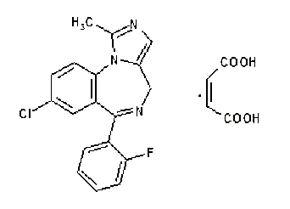

Molecular formula: C18H13CIFN3 · C4H4O4

Relative molecular mass: 441.8 g/mol

CAS number 59467-94-6

#### Drug product

Zyamis (midazolam (as maleate)) oromucosal solution is a slightly viscous, clear colourless to pale yellow solution for buccal administration presented in a pre-filled syringe.

Each pre-filled, oral syringe contains midazolam maleate equivalent to 10 mg midazolam per 1 mL, 7.5 mg per 0.75 mL, 5 mg per 0.5 mL and 0.25 mg per 0.25 mL.

Excipients include ethanol, saccharin sodium, glycerol, purified water, sodium hydroxide (for pH adjustment) and maltitol solution.

The product is supplied as a single dose pack, each containing one pre-filled oral syringe in a polypropylene container.

The different presentations are identified with different colours of the label on the immediate packaging (syringe barrel) and the colour of the tamper evident container as described:

* Each 0.25 mL pre-filled, oral syringe has a yellow syringe label and is packed in a yellow polypropylene container.
* Each 0.5 mL pre-filled, oral syringe has a blue syringe label and is packed in a blue polypropylene container.
* Each 0.75 mL pre-filled, oral syringe has a purple syringe label and is packed in a purple polypropylene container.
* Each 1 mL pre-filled, oral syringe has an orange syringe label and is packed in an orange polypropylene container.

The product should be stored below 25 °C and should not be refrigerated or frozen. It should be stored in the original package in order to protect it from light. Zyamis has a maximum shelf life of 14 months.

#### Recommendation

Approval can be recommended for registration of Zyamis from a pharmaceutical chemistry and quality aspect.

### Nonclinical

Midazolam is not currently approved for use in paediatric patients from 6 months of age; however, the clinical use of oromucosal midazolam to treat prolonged seizures in both adults and children is well established, and midazolam has been used ‘off-label’ via the buccal route for many decades in Australia, UK and other countries. In Australia, buccal or intranasal administration of midazolam is recommended as an emergency treatment for seizures in children;[16],[17],[18] with doses ranging from 0.2 to 0.3 mg/kg, up to a maximum of 10 mg (all paediatric patients) when administered oromucosally or intranasally.17,18 Thus, the proposed Zyamis dosing regimen based on age is consistent with the current Australian ‘off-label’ usage guidelines.12,16 Midazolam (maleate) has been used in the UK via the buccal route in paediatric patients above 7 months of age, in doses comparable to that which has been proposed by the sponsor.[19]

In Australia, the maleate salt, as brompheniramine maleate (Dimetapp Infant Drops; 0.8 mg/mL), has previously been registered on the ARTG, to be administered to children between 6 to 12 months, for temporary relief from blocked nose or sinuses.[20] While renal toxicity is associated with high doses of maleate salts in various animal models;[21] and liver toxicity has been observed in rats and dogs at high doses with midazolam maleate, at the proposed maximum recommended human dose of Zyamis, the maleate salt is unlikely to result in clinically relevant toxicities in paediatric patients.

The bioequivalence of Zyamis (midazolam oromucosal solution 10 mg/mL) and Hypnovel (midazolam parenteral solution 5 mg/mL) was demonstrated in healthy adult subjects when administered oromucosally. However, no bioequivalence data was submitted for the proposed age group.

A nonclinical issue of note is the toxicological qualification of the primary degradant, succinyl midazolam, for which the sponsor proposed a drug product expiry limit of not more than (NMT) 4.0%, which exceeds the ICH Q3B (R2) guidance;[22] qualification limit of NMT 0.5%. Assuming body weights of 10 kg for a 1 year-old child, the maximum therapeutic dose of midazolam will be 0.25 mg/kg. The maximum single daily dose of succinyl midazolam (at maximal 4% impurity) would be 0.1 mg. This is equivalent to 0.01 mg/kg (0.19 mg/m2/day; body surface area factor of 19) for a 1 year-old. At the no observable effect level of 1.0 mg/kg/day (6 mg/m2/day) of succinyl midazolam in the rat 14 day study, the relative exposure to succinyl midazolam was approximately 18 fold that anticipated at the maximum therapeutic dose for a 1 year-old patient. Together, the negative results from the genotoxicity tests (Ames assay and a mammalian *in vitro* clastogenicity assay) and the safety margins of the 14 day repeat toxicity rat study, the impurity, succinyl midazolam, is considered qualified.

#### Recommendation

There are no nonclinical objections to the new indication for the treatment of prolonged acute convulsive seizures (PACS) in infants, children and adolescents aged from 6 months to less than 18 years.

The nonclinical evaluation recommended amendments to the draft Product Information.

### Clinical

#### Guidance

The following were listed as guidance for this submission:

* European Medicines Agence (EMA): PMP/EWP/QWP/1401/98 Rev. 1/ Corr ** [Guideline on the Investigation of Bioequivalence](https://www.tga.gov.au/resources/resource/international-scientific-guidelines/international-scientific-guideline-guideline-investigation-bioequivalence-0).

TGA-adopted, effective date: 16 June 2011

TGA annotation: While this guidance suggests that the design and conduct of the study should follow EU regulations on Good Clinical Practice, sponsors should note that the [EU Note for Guidance on Good Clinical Practice](https://www.tga.gov.au/resources/resource/international-scientific-guidelines/international-scientific-guideline-ich-guideline-good-clinical-practice) (CPMP/ICH/135/95) has been adopted in Australia with TGA annotations.

The procedure for abridged applications claiming essential similarity to a reference product (that is, generics), which allows applications to be made to numerous Member States of the EU, based on bioequivalence with a reference product from one Member State, does not apply in Australia. An application for registration of a generic product in Australia should generally include a bioequivalence study versus a leading brand obtained in Australia

* EMEA/CHMP/EWP/147013/2004 Corr [Guideline on the role of Pharmacokinetics in the Development of Medicinal Products in the Paediatric Population](https://www.tga.gov.au/resources/resource/international-scientific-guidelines/international-scientific-guideline-guideline-role-pharmacokinetics-development-medicinal-products-paediatric-population).

TGA-adopted, effective date: 24 August 2009

* CHMP/EWP/566/98 Rev.2/Corr [Guideline on Clinical Investigation of Medicinal Products in the Treatment of Epileptic Disorders](https://www.tga.gov.au/resources/resource/international-scientific-guidelines/international-guideline-guideline-clinical-investigation-medicinal-products-treatment-epileptic-disorders)

TGA-adopted, effective date: 17 December 2010

Replaces: CPMP/EWP/566/98 Rev 1 (adopted by TGA 19 April 2001)

* EMA/129698/2012 [Concept paper on extrapolation of efficacy and safety in medicine development](https://www.tga.gov.au/resources/resource/international-scientific-guidelines/international-scientific-guideline-concept-paper-extrapolation-efficacy-and-safety-medicine-development).

TGA-adopted, effective date: 1 August 2014

* CPMP/ICH/2711/99 [ICH Topic E 11 Note for Guidance on Clinical Investigation of Medicinal Products in the Paediatric Population](https://www.tga.gov.au/resources/resource/international-scientific-guidelines/international-scientific-guideline-ich-topic-e-11-note-guidance-clinical-investigation-medicinal-products-paediatric-population)

TGA-adopted, effective date: 19 April 2001

* CHMP/EWP/185990/06 [Guideline on Reporting the results of Population Pharmacokinetic Analysis](https://www.tga.gov.au/resources/resource/international-scientific-guidelines/international-scientific-guideline-guideline-reporting-results-population-pharmacokinetic-analysis)

TGA-adopted, effective date: 27 January 2009

* TGA: [Guidance on literature-based submissions](https://www.tga.gov.au/publication/literature-based-submissions)

#### Summary of clinical data

The only paediatric data included in the submission was either in the sourced literature data or in the periodic safety update report (PSUR)

* Clinical pharmacology studies (both previously submitted to and evaluated by the TGA):
  + Study SPL001 (C12023) A single-dose, randomised, open-label, two-period, two-treatment, healthy volunteer, crossover study to compare the pharmacokinetic profiles of Epistatus with the marketed formulation Hypnovel (5mg/mL parenteral solution) via the oromucosal route.
  + Study SPL002 (C13011) A single-dose, randomised, open-label, four-period, two-sequence crossover study to compare the pharmacokinetic profiles and assess bioequivalence of Epistatus and Hypnovel (midazolam parenteral solution 5mg/mL) administered via the oromucosal route in healthy adult subjects.
* Population pharmacokinetic analyses and modelling:
  + Physiologically based pharmacokinetic/pharmacodynamic model for buccal administration of midazolam to adults, with 10 mg dose justification.
  + Predictions for buccal administration of midazolam to paediatric populations (using population pharmacokinetic modelling software) (previously submitted to and evaluated by the TGA).
* Periodic safety update reports (10 September 2016 to 9 September 2019 inclusive).
* A considerable number of journal article study reports from the literature review.

#### Pharmacology

##### Data providing pharmacology data

In evaluation of this submission, the TGA noted that the sponsor has undertaken bioequivalence studies with Hypnovel;14 a product registered in Australia, but not for the proposed indication, nor by the buccal route of administration.

Of the products registered for epilepsy in Australia, diazepam also comes as an oral solution but this carries the contraindication: ‘*Diazepam Elixir is not recommended to control status epilepticus or other acute management situations*.’[23] There is no approved rectal administration.

###### Pharmacokinetics

The following summarises the pharmacokinetic studies submitted and providing evidence for this submission:

* Study SPL001 (C12023): A single-dose, randomised, open-label, two-period, two-treatment, healthy volunteer, crossover study to compare the pharmacokinetic profiles of Zyamis with the as-marketed formulation of Hypnovel (5 mg/mL midazolam parenteral solution) via the oromucosal route.

This study examined the pharmacokinetics (bioequivalence) of Zyamis as a single dose in healthy adults.

* SPL002 (C13011): A single-dose, randomised, open-label, four-period, two-sequence crossover study to compare the pharmacokinetic profiles and assess bioequivalence of Zyamis and Hypnovel (5 mg/mL midazolam parenteral solution) administered via the oromucosal route in healthy adult subjects.

This study examined the pharmacokinetics (bioequivalence) of Zyamis as a single dose in healthy adults and was accompanied by population pharmacokinetic analyses and modelling.

Both pharmacokinetic studies were conducted in compliance with Good Clinical Practice (GCP).

###### Population pharmacokinetic analyses and modelling

The following summarises the population pharmacokinetic data submitted and providing evidence for this submission:

* A physiologically based pharmacokinetic/pharmacodynamics model for buccal administration of midazolam to adults, with 10mg dose justification.
* Predictions for buccal administration of midazolam to paediatric populations (using population pharmacokinetic software) (previously submitted to and evaluated by the TGA).
* Periodic safety update reports (10 September 2016 to 9 September 2019 inclusive).
* Published study reports from the literature review.
* A response from the sponsor’s population PK modelling group to Working Group (apparently addressing the TGA’s population pharmacokinetics working group comments), for the working group and Delegate to consider.
* A document labelled as ‘regulatory response’ (dated 2019) described as from the sponsor’s population PK modelling group addressing comments raised in TGA’s request for information.

##### Pharmacokinetics

Midazolam is a pro-drug and is metabolised into an active metabolite alpha1-hydroxymidazolam. Midazolam is metabolised by cytochrome P450 (CYP) enzymes and by glucuronide conjugation.

Midazolam has poor oral bioavailability, with only 50 percent of the drug reaching the bloodstream. In adults, it has an elimination half-life of 1.5 to 2.5 hours. In the elderly, as well as young children and adolescents, the elimination half-life is longer.

After IV administration of midazolam, relatively low concentrations of the metabolites are found. However, relatively high concentrations of α-hydroxymidazolam were observed after oral administration. The concentration-effect relationship of midazolam based on reaction time measurements was shifted to the left after oral administration compared with IV administration, suggesting that α-hydroxymidazolam contributed significantly to the central nervous system effects of the parent compound. Also, marked central nervous system effects were observed after IV administration of relatively low doses of α‑hydroxymidazolam to healthy volunteers.

###### Bioavailability

* Oral bioavailability:
  + Midazolam is rapidly absorbed and undergoes first-pass metabolism resulting in a bioavailability of approximately 40%.
* Bioavailability of buccal Zyamis relative to an IV solution *administered buccally* (in adults)
  + The sponsor has submitted two studies in adults (Study SPL001 and Study SPL002), attempting to show bioequivalence of Zyamis (midazolam via buccal formulation/buccal route administration) and Hypnovel (a midazolam IV and IM formulation, via buccal route administration). Note Hypnovel is unregistered for the buccal route of administration.14
  + The first Study SPL001 (C12023) failed to show bioequivalence and was described as underpowered.
  + The second Study SPL002 (C13011) did show bioequivalence to the registered IV/IM preparation of midazolam.
* Apart from being conducted in adults, the sponsor’s strategies of establishing comparative pharmacokinetic parameters (relative bioavailability, bioequivalence) between Zyamis (buccal formulation of midazolam) and Hypnovel (parenteral formulation of midazolam, not registered for the buccal route of administration) appear crude in the sense, that an IV midazolam formulation was administered buccally.

###### Bioequivalence of different dosage forms and strengths (in paediatrics)

In a simulation of paediatric buccal versus adults observed intramuscular dosing, the sponsor after creating a model of the pharmacokinetics of paediatric buccal therapy using a population pharmacokinetic programme, referencing literature data and undertaking various simulations claimed that:

* Simulated midazolam exposures (area under the concentration versus time curve (AUC)) in children using fixed dosing after buccal administration were similar to adults receiving 10 mg (approximately 0.18 mg/kg) after IM administration.[24]
* This intramuscular midazolam dose was effective in the treatment of around 450 adults and children with status epilepticus.[25]

Table : Comparison of observed buccal and intramuscular (in adults) versus paediatric simulated buccal mean exposures following 10 mg midazolam

|  |  |  |  |  |  |
| --- | --- | --- | --- | --- | --- |
| Source | Cmax  (ng/mL) | AUClast (h•ng/mL) | AUCinf (h•ng/mL) | Tmax  (h) | Half-life (h) |
| SPL-001 Buccal Adult | 63.94 (19.0) | 201.07 (52.8) | 233.18 (64.8) | 0.67 (0.33, 2.00) | 2.72 (0.68) |
| SPL-002 Buccal Adult | 60.2 (33.4) | 236.2 (26.8) | 244.6 (28.1) | 0.67 (0.25, 4.00) | 5.62 (30.9) |
| Reichard et al.a IM Adult | 114 (18) | 388 (25.6) | 395.1 (24.1) | 0.5 (0.25, 0.50) | 4.2 (1.9) |
| Simulation | 63 (25) |  | 233 (79) |  |  |
| Simulation/IM Adult | 55.2% |  | 59.0% |  |  |

Abbreviations: AUCinf =area under the concentration-time curve from time zero to infinity; AUClast = area under the concentration-time curve to last quantifiable dose; IM = intramuscular; Tmax = time of maximum concentration.

Values given as geometric means (covariance as percentage); Tmax given as median value (range).

a) Reichard DW, Atkinson AJ, Hong SP, Burback BL, Corwin MJ, Johnson JD. Human safety and pharmacokinetic study of intramuscular midazolam administered by autoinjector. J Clin Pharmacol. 2010;50(10):1128-1135.

The clinical evaluation also commented that:

* The results for the simulation were well below the acceptable bioequivalence limits making the above paediatric buccal data claim of simulated bioequivalence with adult IM dosing invalid and hence, leaning towards the declaration of invalid extrapolation of bioequivalence data to document efficacy.
* The study by Schwagmeier et al.,[26] also concluded that the exposure of buccal midazolam relative to IV midazolam was 47.0% for the maximum plasma concentration (Cmax) and 74.54% for AUC; that is below the recognised limits of bioequivalence.
* With reference to the submitted literature:
  + there was use of non-oral midazolam formulation either intranasally, sublingually and directly oral,
  + age range inclusion (7 to 64 months) was outside that proposed,
  + different indications to that proposed were involved,
* In the population pharmacokinetics report, using the results from Study SPL001 (C12023) after allowing for gender, age and weight, the model could only be validated by fitting some combination of oral residence time, stomach residence time, activity of CYP3A4 in gut and liver, and UDP-glucuronosyltransferases (UGT) activity against individual midazolam and 1’‑hydroxymidazolam profiles after administration of two different formulations.

The TGA Delegate therefore concluded that meaningful interpretation of the sponsor’s data to reach a genuine positive simulation outcome, with reference to the simulated paediatric buccal midazolam doses being bioequivalent to adults receiving 10 mg midazolam either IM (or IV), is difficult.

###### Population pharmacokinetics

Using the population PK software, the sponsor has created models of IV and oral pharmacokinetics and tried them against limited IV and oral adult literature data for midazolam.

[Information redacted].

This model was then adjusted to create a buccal model that was tried against the data from Study SPL-001 after individual adjustment.

[Information redacted].

The models for IV and oral midazolam pharmacokinetics were then adjusted by fitting paediatric parameters and tried against the literature.

[Information redacted].

Using the same procedure (fitting paediatric parameters), a paediatric buccal model was created and simulations made with it.

[Information redacted].

The TGA’s clinical evaluation noted that:

* This model does not appear to have been validated, rather relying on the implication that the adjustment for the IV and oral models worked and therefore, should be reasonable for the buccal model.
* The midazolam innovator (Hypnovel) PI has ‘*Pharmacokinetics in children have not been established and may differ from adults.’*14
* The simulations were then used in an effort to show bioequivalence.
* The only correlation given was for adult buccal predicted versus observed;[27] and then those for area under the concentration versus time curve from time zero to 8 hours (AUC0-8h), maximum concentration (Cmax) and time to maximum concentration (Tmax) were the only ones submitted.
* The only correlations and graphs of buccal predicted concentrations versus observed concentrations submitted were in the literature.
* Observed concentrations versus time graphs and predicted concentrations versus time graphs were submitted as overlays for comparison.

###### Clinical evaluation conclusions on pharmacokinetics

* The sponsor has shown bioequivalence in a different population (adults) to that proposed (10 to 18 year old) in Study SPL001 (C12023), to a registered IV/IM formulation of midazolam (Hypnovel);14 administered by an unapproved route (buccal).
* The sponsor has failed to show bioequivalence of the simulation paediatric buccal pharmacokinetics to that of an IM formulation, used as comparator in an apparently unregistered administration (auto injector) in the USA at the time of the literature study.
* The sponsor initially submitted the pharmacokinetic study report with the objective ‘to evaluate midazolam and 1’-hydroxymidazolam (primary metabolite) exposures after buccal administration of midazolam (Zyamis) in children’. In the subsequent sponsor’s ‘regulatory-response-2019’ report however, the objective was stated as: ‘the aim of this piece of work was to link the simulated midazolam levels with the effective brain concentration of midazolam to ensure seizure cessation. This would therefore establish the link between literature data (for efficacy) to the plasma concentrations of midazolam achieved in Studies SPL001 and SPL002’.

##### Pharmacodynamics

The paper by Scott et al. (1998);[28] on the pharmacokinetics and pharmacodynamics of electroencephalography (EEG) data with regard to the buccal absorption of midazolam, revealed EEG changes in the 8 to 30 hertz (Hz) epileptic frequencies as identified by spectral EEG analysis, of between about 5 to 10 minutes in test but not in control subjects. These changes are more rapid than were expected from the venous buccal midazolam absorption data as per Figure 3 and Figure 4, shown below.

Figure : Scott et al. (1998) Box and whisker plot of venous midazolam concentration versus time confirms rapid increase in serum concentration for the first 15 to 20 minutes after administration

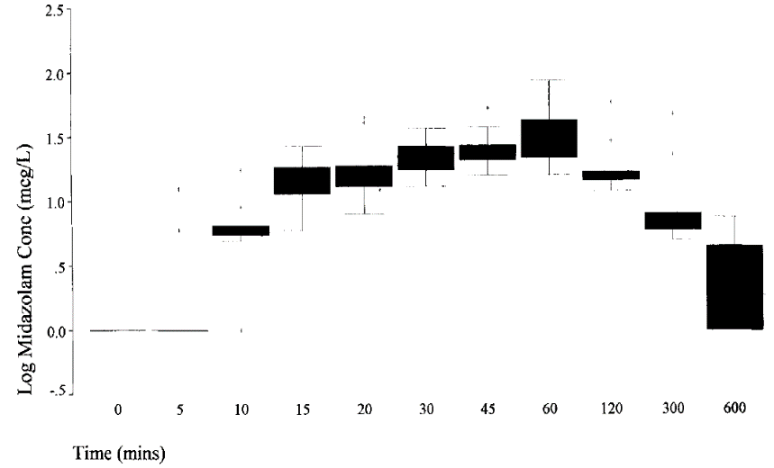

Median (horizontal line), interquartile range (box), and complete range (whiskers). Outliers (> 2 SD from the mean) as+.

Source: Scott RC, Besag FM, Boyd SG, Berry D and Neville BG. Buccal absorption of midazolam: pharmacokinetics and EEG pharmacodynamics. *Epilepsia*. 1998; 39(3):290-294.

Figure : Scott et al. (1998) Venous midazolam concentration versus relative power. Increasing midazolam concentration in serum is associated with an increase in the relative power of the faster EEG frequencies

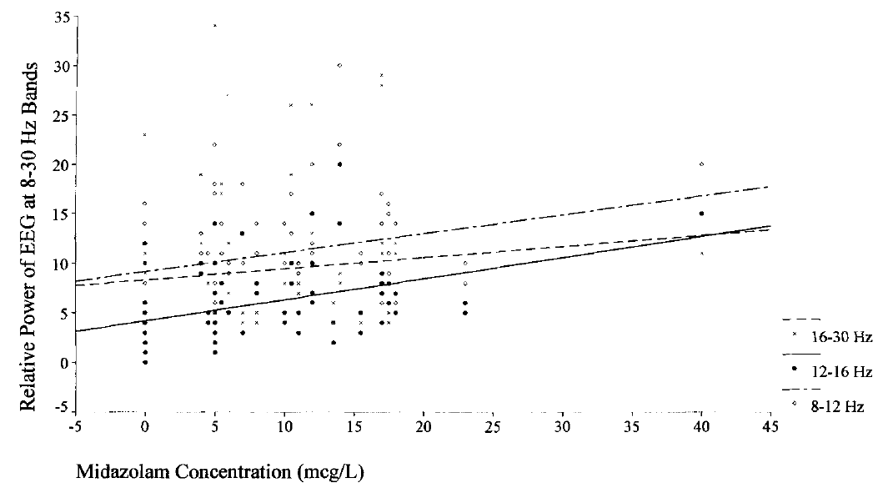

16-30 Hz (dashed line, x), 12-16Hz (solid line, solid circle), 8-12 Hz (dotted/dashed line)

Source: Scott RC, Besag FM, Boyd SG, Berry D and Neville BG. Buccal absorption of midazolam: pharmacokinetics and EEG pharmacodynamics. *Epilepsia*. 1998; 39(3):290-294.

#### Dosage

No studies were identified in the clinical evaluation as providing dosage selection information for the pivotal studies in the submission. There were no pivotal studies submitted as such.

#### Efficacy

The clinical evaluator noted that:

* The sponsor has not specifically reviewed the evidence to support the probable extension of indications for midazolam.
* Efficacy and safety of midazolam administered via IV, IM, intranasal, or buccal route for the treatment of seizures in children and adults have been demonstrated in a body of clinical studies and have been confirmed by extensive use in clinical practice.[29],[30],[31]
* The sponsor submitted clinical evidence for the claimed indication and target population of Zyamis oromucosal solution (buccal use of midazolam for the treatment of PACS in infants, children and adolescents), in accordance with the approved search strategy.

As part of a previous submission;[32] the sponsor submitted a paper by Datar (2017).[33]

‘Intravenous (IV) lorazepam is usually the preferred agent when venous access is immediately available based on data from controlled studies. Intramuscular midazolam can be used as an alternate treatment when venous access is not available. A randomised double-blind non-inferiority trial compared intramuscular midazolam to IV lorazepam for point-of-care use in the field by paramedics. The study showed that the median time to treatment was 1.2 minutes for the midazolam group and 4.8 minutes for lorazepam group; however, duration of convulsions was slightly longer in the midazolam group compared with lorazepam. The investigators concluded that intramuscular midazolam is as safe and effective as IV lorazepam for prehospital seizure cessation. A recent meta-analysis of 16 studies found that time to treatment initiation and time to seizure termination were shorter, with intramuscular midazolam as compared with other non-venous medications, which included sublingual lorazepam, buccal midazolam, and rectal diazepam’.

* The clinical evaluation reported the following two studies, Talukdar and Chakrabarty (2009);34 and Tonekaboni et al. (2012);35 as being pivotal for the submission.

##### Talukdar and Chakrabarty (2009)

Publication:

Talukdar B, Chakrabarty B. Efficacy of buccal midazolam compared to intravenous diazepam in controlling convulsions in children: a randomised controlled trial. Brain Dev. 2009; 31(10)744-9.[34]

This was an open label randomised comparison of either buccal midazolam (0.2 mg/kg) or IV diazepam (0.3 mg/kg) to control seizures. The study was conducted in a single centre in India.

The object was to evaluate the efficacy and usefulness of buccal midazolam in controlling convulsions in children irrespective of cause by comparing with intravenous diazepam.

The primary outcome variable was cessation of all of motor activity (defined as stoppage of all motor activity within or by 5 minutes of administration of the drug signifying complete control of the convulsive episode).

In a child with recurrent convulsions, only the first episode was included in the study. Seizure types included were partial and generalized tonic, clonic, and tonic–clonic. Myoclonic, atonic and absence seizures were excluded.

Statistical analysis was done using chi2-test and Fisher’s exact test for proportions and Student’s t-test for quantitative means.

###### Study populations

* The overall patient population involved 120 children, 60 to receive buccal midazolam and 60 to receive IV diazepam.
* Overall, 64 children (53.3%) were less than 1 year, 24 (20.2%) were 2 to 5 years and 32 (26.7%) were 6 to 12 years of age.
* Of the 32 children between 6 and 12 years of age, 16 children buccal midazolam (26.7**%**) and n 16 children received IV diazepam (26.7%)

The relationship of the diazepam used to the currently Australia registered product is unclear, as is that of the buccal preparation used to the formulation of midazolam proposed for use in Australia.

###### Baseline data

Out of a total of 120 children:

* 64 children (53.3%) were less than 1 year old;
* 24 (20.2%) were between 2 and 5 years old; and
* 32 (26.7%) were between 6 and 12 years old.

Table : Talukdar and Chakrabarty (2009) Population demographic and seizure characteristics

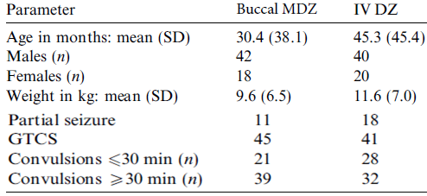

Abbreviations: GTCS = Generalized tonic-clonic seizure; IV DZ = intravenous diazepam; MDZ = midazolam; SD = standard deviation.

Source: Talukdar B, Chakrabarty B. Efficacy of buccal midazolam compared to intravenous diazepam in controlling convulsions in children: a randomised controlled trial. *Brain Dev.* 2009; 31(10)744-9.

###### Primary outcomes

* The patient numbers were small, and the investigators were unable to show any significant difference either for the primary outcome variable or in the subgroups of individual seizure types. The exception was for complex partial seizures, where IV diazepam was statistically superior to buccal midazolam.
* As to be expected, buccal midazolam was statistically superior to IV diazepam in both the time taken to initiate treatment and, the time taken from the decision to initiate treatment to control of seizures (that is, time to administer treatment).
* Intravenous diazepam was statistically superior to buccal midazolam in the effect time (the time to seizure control after drug administration).

Table : Talukdar and Chakrabarty (2009) Control of convulsive episodes

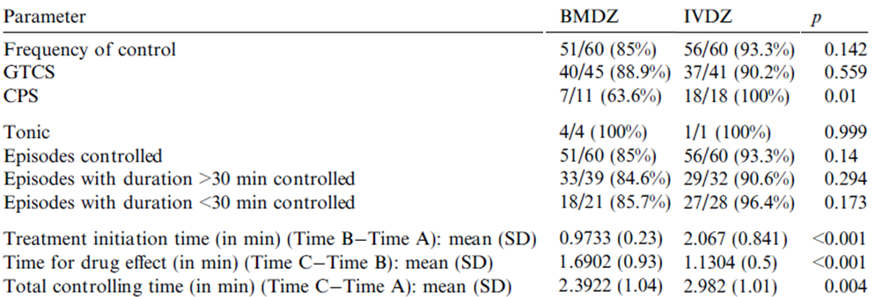

CPS = complex partial seizures; GTCS = generalised tonic-clonic seizure; SD = standard deviation

Source: Talukdar B, Chakrabarty B. Efficacy of buccal midazolam compared to intravenous diazepam in controlling convulsions in children: a randomised controlled trial. *Brain Dev.* 2009; 31(10)744-9.

###### Delegate comments

The Delegate commented that:

* This published study used IV diazepam as comparator which is currently approved for epilepsy via the IV administration. The relationship of the diazepam used to the currently Australian registered product is unclear as is that of the buccal preparation used to the proposed formulation of midazolam.
* Insufficient patient exposure for the proposed age range in the previous withdrawn submission to the TGA.32
* Issues with product identification.
* This was an open label study

##### Tonekaboni et al. (2012)

Publication:

Tonekaboni S., Shamsabadi FM, Anvari S, Mazrooei A, and Ghofrani M. A comparison of buccal midazolam and intravenous diazepam for the acute treatment of seizures in children. *Iran J Pediatr* 2012; 22(3):303-308.[35]

This was an open, randomized, controlled study with the objective:

‘to determine whether buccal midazolam is efficient in control of convulsive episodes in children irrespective of the aetiology of the seizure in comparison with intravenous diazepam, namely, the best accepted way of acute seizure episodes therapy.’

The primary outcome variable was clinical cessation of overt seizure activity. If the seizure was not controlled within five minutes of administration of buccal midazolam or intravenous diazepam, the second dose of the same drug was given to patient.

Study treatments were:

* Buccal midazolam (n = 32 Epistatus/Zyamis midazolam buccal liquid, and midazolam maleate) was used with following doses:
  + 2.5 mg for children aged 6 to 12 months,
  + 5 mg for children aged 1 to 4 years,
  + 7.5 mg for children aged 5 to 9 years, and
  + 10 mg for children aged 10 years or older.
* Intravenous diazepam (n = 60) was administered in a dosage of 0.3 mg/kg/dose.

Inclusion criteria:

* documented seizure persisting at the time of administration of anticonvulsant;
* types of atonic, tonic and tonic/clonic seizures;
* seizure lasting for more than 5 minutes.

The exclusion criteria were:

* patients who received intravenous diazepam or other benzodiazepines within 24 hours prior to presentation of the seizure;
* previous history of narrow angle acute glaucoma.

###### Study population

32 patients received buccal midazolam overall, with an age range: from 6 to 60 months.

* despite the mentioned age-range related-dosing regimen above, the actual population in the study fell outside the proposed age-range (10 to 18 years).

###### Primary efficacy outcome

In the buccal midazolam group, the first administration was effective in controlling the seizures in 13 (40%) versus 24 (40%) (p = 0.9) in the IV diazepam group.

Table 5 (shown below) shows the control of seizures and seizure control time in the two groups.

Table : Tonekaboni et al. (2012) Control of seizures and seizure control time in two groups

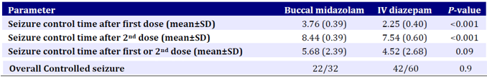

Abbreviations: IV = intravenous; SD = standard deviation.

Source: Tonekaboni S., Shamsabadi FM, Anvari S, Mazrooei A, and Ghofrani M. A comparison of buccal midazolam and intravenous diazepam for the acute treatment of seizures in children. *Iran J Pediatr* 2012; 22(3):303-308.

##### Other efficacy data in children and adolescents aged 10 to less than 18 years

The sponsor submitted the following studies, as shown in Table 6 below. The size of the relevant study population is also given (that is, the study population receiving buccal midazolam) along with the form of midazolam received.

Table : Efficacy data in children aged from 10 to under 18 years of age

| **Reference** | **Buccal Population** |
| --- | --- |
| Ashrafi MR, Khosroshahi N, Karimi P, et al. Efficacy and usability of buccal midazolam in controlling acute prolonged convulsive seizures in children. *Eur J Paediatric Neurol.* 2010. | 43 patients  Median age: 24 months  Used midazolam maleate |
| McIntyre J, Robertson S, Norris E, et al. Safety and efficacy of buccal midazolam versus rectal diazepam for emergency treatment of seizures in children: a randomised controlled. *Lancet* 2005; 366 (9481):205-210. | 92 patients (109 episodes)  Only ages combined arms given.  Used midazolam hydrochloride |
| Scott RC, Besag FM and Neville BG. Buccal midazolam and rectal diazepam for treatment of prolonged seizures in childhood and adolescence: a randomised trial. *Lancet*. 1999; 35 (9153)623-626. | 14 patients (40 episodes)  Included 6 of 18 patients aged 18 and 19 years.  Used midazolam hydrochloride |
| Baysun S, Aydin OF, Atmaca E et.al. Comparison of buccal midazolam and rectal diazepam for the acute treatment of seizures. A *Clin Pediatr. (Plila).* 2005; 44 (9):771-776. | 23 patients  Mean age: 3.87 ± 3.39 years (range: 2 months to 12 years)  Used midazolam hydrochloride |
| Kutlu NO, Dogrul M, Yakinci C et al. Buccal midazolam for treatment of prolonged seizures in children. *Brain Dev.* 2003; 25 (4):275-278. | 19 patients  Mean age: 3.76 ±4.48 years (range: 1 month to 15 years). |
| Frelih J, Zupancic N, Kolenc J, Rogelj M and Neubauer D. Buccal midazolam use for acute treatment of seizures. *Paediatr Croat* 2007; 51(Supl 1):149-151. | 20 patients  Mean age: 8 ± 2.3 years (range: 3 to 24 years) |
| Wilson MT, Macleod S and O’Regan. M. E. Nasal/buccal midazolam use in the community. *Arch. Dis. Child.* 2004; 89:50-51* | 40 patients  Ages: 3 to 21 years |
| Muchohi S, Kokwaro G, Ogutu B, Edwards G, Ward S and Newton C. Pharmacokinetics and clinical efficacy of midazolam in children with severe malaria and convulsions. *British Journal of Clinical Pharmacology,* 2008; 66(4):529-538. | 8 patients  Median age 26 months (range: 7 to 64) months |
| Ahmed R. Low-dose buccal midazolam for aborting seizures in children. *J Pediatr Neurol* 2007; 5:291-293. | 20 patients  Age range: 5.5 months to 6.2 years |
| Mpimbaza A, Ndeeza G, Staedke S, et al. Comparison of buccal midazolam with rectal diazepam in the treatment of prolonged seizures in Ugandan Children: A randomised clinical trial. *Paediatrics*, 2008; 121:e58-e64. | 165 patients  Median age (IQR) 17.0 (10.5 to 30.0) months.  Used midazolam hydrochloride |
| Connolly et al. Exploring carer perceptions of training In out-of-hospital use of buccal midazolam for emergency management of seizures (2008-2012) *Journal of Paediatrics and Child Health* 51 (2015) 704-707 | 21 patients treated  Median age: 4 years (range: 3 months to 15 years) |
| Moretti et al. Buccal Midazolam Compared With Rectal Diazepam Reduces Seizure Duration in Children in the Outpatient Setting. *Paediatric Emergency Care* Volume 35, Number 11, November 2019 p760-764 | 16 patients treated  Mean age: 68.2 months  4 panic episodes or difficult administrations |
| Klimach VJ. The community use of rescue medication for prolonged epileptic seizures in children. *Seizure* 18 (2009) 343–346 | 142 families using buccal midazolam  Ages not given |
| Khan. Carers' express positive views on the acceptability, efficacy and safety of buccal midazolam for paediatric status epilepticus. *Acta Pædiatrica* 2014 Apr;103(4):e165-8. | 34 carers  Ages not given |

*Not included in this submission but in a previous, withdrawn submission.32

###### *Ashrafi et* al. (2010)

Publication:

Ashrafi MR, Khosroshahi N, Karimi P, et al. Efficacy and usability of buccal midazolam in controlling acute prolonged convulsive seizures in children. *Eur J Paediatric Neurol.* 2010.[36]

This was an open label, randomised comparison of either buccal midazolam or rectal diazepam (2.5 mg for children aged 3 to 12 months, 5 mg for 1 to 4 years, 7.5 mg for 5 to 9 years, and 10 mg for ≥ 10 years) to control seizures. The study was conducted between April 2007 and April 2008 in two centres in Iran.

*Note:* *The study report also mentioned the use of midazolam 0.3 to 0.5 mg/kg and diazepam 0.5 mg/kg*.

The main outcome variable was the cessation of all motor activity, achieved in less than 5 minutes without respiratory depression and without another seizure within 1 hour

Based on previous data and by using two-tailed tests, it was calculated that 49 episodes would be needed in each treatment group to detect a difference in efficacy and usability. Statistical analysis was performed by applying the Manne Whitney U-test for continuous data. Categorical variables were analysed by the Chi2-test or Phi and Cramer’s V.

Patients’ age range at Baseline:

* 15 (15%) aged under 1 year
* 59 (60%) were 1 to 5 years
* 24 (25%) were 6 to 12 years.

For the efficacy outcome:

* In the buccal midazolam group, 42 (88%) patients were controlled within 4 minutes of drug administration, and all of the patients were controlled within 5 minutes of drug administration.
* In the rectal diazepam group, 24 (49%) patients were controlled within 4 minutes and 40 (82%) patients were controlled within 5 minutes of drug administration. All the patients were controlled within 8 minutes after drug administration in the rectal diazepam group.
* In both treatment groups, no recurrent seizures were recorded within 1 hour after drug administration.

The Delegate commented that essentially the low patient numbers in the age range of 10 to > 18 years was not supportive of the indication proposed in a previous submission.

###### McIntyre et al. (2005)

Publication:

McIntyre J, Robertson S, Norris E, et al. Safety and efficacy of buccal midazolam versus rectal diazepam for emergency treatment of seizures in children: a randomised controlled. *Lancet* 2005; 366 (9481):205-210.[37]

This was an open, randomised trial comparison of buccal midazolam versus rectal diazepam to control seizures.

The study was conducted in four UK centres from October 2000 to February 2004.

Weekly blocks of treatment with either buccal midazolam or rectal diazepam were randomly selected for each of the four participating centres.

Children who were aged ≥ 6 months and presented to the emergency room still having a seizure, who did not already have established intravenous access were eligible.

The dose of buccal midazolam or rectal diazepam was 2.5 mg for children aged 6 to 12 months; 5 mg for 1 to 4 years, 7.5 mg for 5 to 9 years, and 10 mg for 10 years and older.

The primary outcome measure (therapeutic success):

* was the cessation of visible signs of seizure activity within 10 minutes of administration of the randomised drug without respiratory depression and without another seizure within 1 hour.

By use of two-tailed tests, it was calculated that 107 episodes would be needed in each treatment group to detect a difference in efficacy of 15% (between 79% and 94%) as defined by effective seizure cessation after buccal midazolam or rectal diazepam (90% power, 5% significance level), on the basis of previous data. The trial design allowed for entry of a patient more than once because of the potential delay in treatment if clinicians had to check for prior participation. The results are therefore reported for both the total episodes and for the first presenting episode of a patient to avoid the bias of a patient with multiple entries. To detect a 9% difference in the onset of respiratory depression, 110 episodes in each treatment group would be needed with a baseline value of 9% for diazepam and 0% for midazolam (no rates for midazolam were available from previous studies). Each entry was double checked and entered into a database. Logistic regression analysis was used for the multivariate analysis of the efficacy of the two treatments. Analysis was done at seizure level, and centre was adjusted for in the logistic regression analysis. Analysis was per protocol.

Table : McIntyre et al. (2005) Baseline characteristics

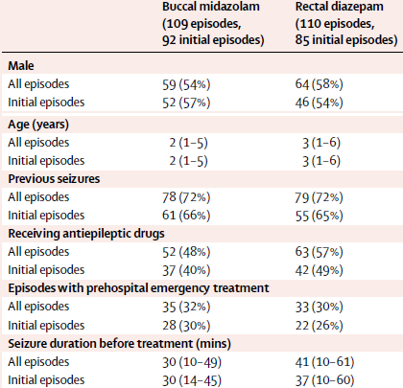

Data are number (%) or median (interquartile range).

Source: McIntyre J, Robertson S, Norris E, et al. Safety and efficacy of buccal midazolam versus rectal diazepam for emergency treatment of seizures in children: a randomised controlled. Lancet 2005; 366 (9481):205-210.

As per the baseline data:

* for initial episode:
  + 109 (62%) children were aged between 1 and 4 years
  + 13 (7%) infants were aged between 6 and 12 months
  + 37 (21%) children between 5 and 9 years
  + 18 (10%) children were 10 years and older
* for all presenting episodes:
  + 135 (62%) children were aged between 1and 4 years
  + 14 (6%) infants were aged between 6 and 12 months
  + 50 (23%) children between 5 and 9 years
  + 20 (9%) children were 10 years and older.
* Efficacy outcome:
* For all episodes, when centre, age, diagnosis of epilepsy, presence of fever, use of antiepileptic drugs, prior treatment, and duration of seizure before treatment were adjusted for in logistic regression, buccal midazolam was more effective than rectal diazepam (p < 0.001; odds ratio 4.1, 95% CI 2.2 to 7.6).
* This finding was similar when only initial admissions were analysed (3.5; p = 0.008, 95% CI 1.8 to 7.0).

The Delegate commented that essentially the low patient numbers between 10 to < 18 years age range was not supportive of the indication proposed in a previous submission.

The following table has been extracted from this paper.

Table : McIntyre et al. (2005) Outcomes after treatment

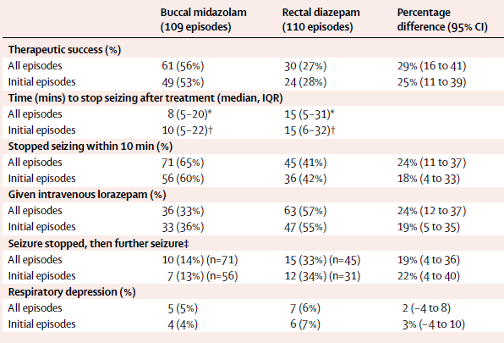

Abbreviations: CI = confidence interval; IQR = interquartile range.

Data are number (%) unless otherwise indicated. * p = 0.01, hazard ratio 0·7 (95% CI 0.5 to 0.9).  
† p = 0.03, hazard ratio 0.7 (0.5 to 0.96). ‡ Seizure stopped within 10 minutes, but further seizure within 1 hour requiring treatment.

###### Scott et al. (1999)

Publication:

Scott RC, Besag FM and Neville BG. Buccal midazolam and rectal diazepam for treatment of prolonged seizures in childhood and adolescence: a randomised trial. *Lancet*. 1999; 35 (9153)623-626.[38]

This was an open label, randomised comparison of 10mg of buccal midazolam or rectal diazepam to control seizures at one UK site.

Comparison by episodes was done in which, episodes were assessed as independent variables by Chi-squared test for binary data and Mann-Whitney U test for continuous data, with times reported as median (IQR). Paired analysis was used to do comparisons by student of the first treatment with midazolam and, the first treatment with diazepam in each student treated at least once with each drug in nine identified pairs. Also analysed consecutive pairs of midazolam and diazepam treatments in individual patients. Used McNemar’s test for binary data and Wilcoxon’s signed rank sum test for continuous data. For drug efficacy in the first seizure treated in all patients, we used the Chi-squared test. Comparisons in individual students and two students, who made up 39 episodes, were analysed separately. Chi-squared test was used for binary data and the Mann-Whitney U test for continuous data. Further statistical analyses of time to drug administration and effect of drug on blood pressure and oxygen saturation, were done with the Mann-Whitney U test.

Table : Scott et al. (1999) Study demographics and clinical information

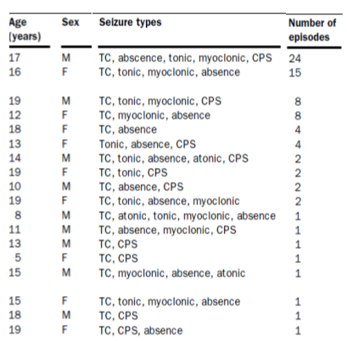

Abbreviations: CPS = complex partial seizures; TC=tonic clonic.

Sex: M = male; F = female.

Source: Scott RC, Besag FM and Neville BG. Buccal midazolam and rectal diazepam for treatment of prolonged seizures in childhood and adolescence: a randomised trial. *Lancet*. 1999; 35 (9153)623-626.

Results:

* 40 episodes in 14 patients were treated with buccal midazolam, and 39 episodes in 14 patients with rectal diazepam.
* For the efficacy outcome:
  + response to midazolam occurred in 30 (75%) of 40 episodes and response to rectal diazepam occurred in 23 (59%) of 39 episodes (p = 0.16).
  + the median time from administration of medication to end of seizure was 6 minutes (IQR 4, 10) for midazolam and 8 min (4, 12) for diazepam (p = 0.31).

Table : Scott et al. (1999) Number of episodes treated by treatment and seizure type

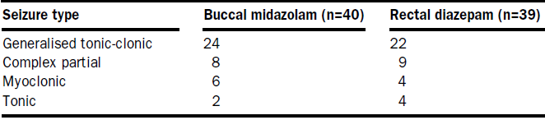

Source: Scott RC, Besag FM and Neville BG. Buccal midazolam and rectal diazepam for treatment of prolonged seizures in childhood and adolescence: a randomised trial. *Lancet*. 1999; 35 (9153)623-626.

The Delegate commented that essentially the low patient numbers between 10 to < 18 years age range was not supportive of the indication proposed in a previous submission.

###### Baysun et al. (2005)

Publication:

Baysun S, Aydin OF, Atmaca E et.al. Comparison of buccal midazolam and rectal diazepam for the acute treatment of seizures. A *Clin Pediatr. (Plila).* 2005; 44 (9):771-776.[39]

This was an open, randomised comparison of 10 mg of buccal midazolam (0.25 mg/kg) or diazepam rectally (an unregistered route) (dose 0.5 mg/kg for ≤ 5 years and 0.3 mg/kg for ≥ 6 years and older) to control seizures at one Turkish centre.

Effectiveness of the drug was defined by observation of the cessation of the convulsive activity within 10 minutes.

Continuous variables were expressed as means ± standard deviation and were compared by Student’s t test. Categorical variables were compared by the Chi-square test.

For efficacy outcome:

* In the midazolam group, the seizure of 18 (78%) patients terminated in 10 minutes; however, 5 (22%) patients did not respond. Among the 18 patients, the response periods were as follows:
  + 12 (67%) patients in 3 minutes,
  + 3 (17%) patients in 3 to 5 minutes,
  + 3 (17%) patients in 5 to 10 minutes.
* in the diazepam group, 17 (85%) patients responded in 10 minutes but 3 (15%) patients did not respond. Amongst the 17 patients, the response periods were as follows:
  + 10 (59%) patients in 3 minutes,
  + 4 (23.5%) patients in 3 to 5 minutes,
  + 3 (18%) patients in 5 to 10 minutes.

Regarding the anticonvulsant effect, midazolam was found to be as effective as diazepam (p > 0.05). Response periods of the two drugs showed no significant difference (p > 0.05).

Table : Baysun et al. (2005) Clinical data for buccal midazolam group

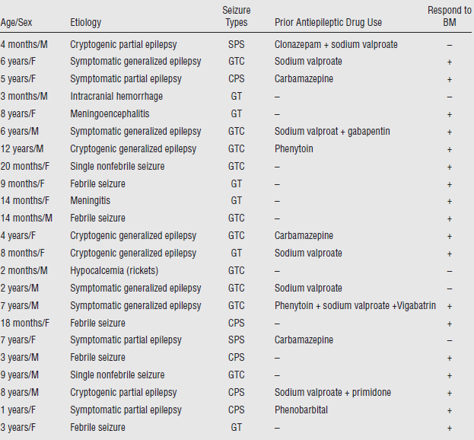

Abbreviations: BM = buccal midazolam; CPS = Complex partial seizures; GT = Generalized tonic; GTC: Generalized tonic clonic; GT: Generalized tonic; SPS: Simple partial seizures.

Sex: M = male; F = female.

Source: Baysun S, Aydin OF, Atmaca E et.al. Comparison of buccal midazolam and rectal diazepam for the acute treatment of seizures. A Clin Pediatr. (Plila). 2005; 44 (9):771-776.

The Delegate commented that essentially the low patient numbers between 10 to < 18 years age range was not supportive of the indication proposed in a previous submission.

###### Kutlu et al. (2003)

Publication:

Kutlu NO, Dogrul M, Yakinci C et al. Buccal midazolam for treatment of prolonged seizures in children. *Brain Dev.* 2003; 25 (4):275-278.[40]

This was an open label study of buccal midazolam (0.3mg/kg) for the treatment of prolonged seizures in children. Study conducted in a single centre in Turkey.

Children were excluded if their seizure activity was lasting less than 5 minutes.

The objective was to determine whether 0.3 mg/kg of buccal midazolam could be enough for children of all ages with prolonged seizures without side effects.

During convulsive attacks, buccal administration was performed at a dosage of 0.3 mg/kg. If the convulsion did not stop within 5 minutes a second dose of midazolam (0.3 mg/kg) was administered.

Effectiveness was defined as the cessation of overt seizure activity medication was judged effective when seizure activity ceased within 10 minutes of administration with no other anticonvulsive drugs having been administered in the interim.

Descriptive variables were compared using the Mann–Whitney U-test for continuous or Fisher’s exact test for categorical variables. Spearman correlation coefficients were computed to examine the associations among all parameters.

The average age of this group was 3.76 ± 4.48 years (range 1 month to 15 years)

Table : Kutlu et al. (2003) Demographic and clinical details

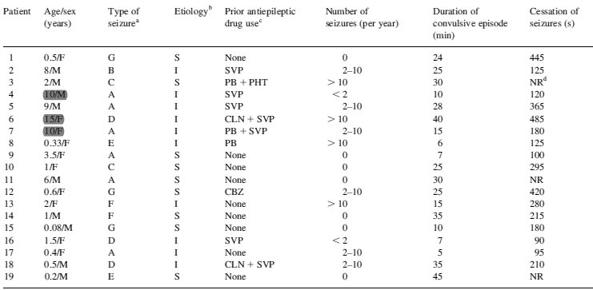

a Type of seizure: Abbreviations: A, generalized tonic-clonic; B, atonic; C, generalized tonic; D, generalized myoclonic; E, generalized clonic; F, secondary generalized; G, complex partial.

b Aetiology, abbreviations: I, idiopathic; S, symptomatic.

c Prior antiepileptic drug use, abbreviations: CBZ, carbamazepine; PHT, phenytoin; SVP, sodium valproate; PB, phenobarbital; CLN, clonazepam.

d Abbreviation NR: no response.

Sex: M = male; F = female.

Source: Kutlu NO, Dogrul M, Yakinci C et al. Buccal midazolam for treatment of prolonged seizures in children. *Brain Dev.* 2003; 25 (4):275-278.

If only patients who responded to medication within 10 minutes were included in the analysis, the mean time to clinical response was 3.89 ± 2.22 minutes (median time 3 minutes) after buccal administration.

Midazolam was effective in 16 of 19 patients (84.2%) within 10 minutes.

The overall success of buccal midazolam in patients with status epilepticus was 50%. However, all patients with convulsions shorter than 30 minutes showed a perfect response (100%).

There was a correlation between seizure duration and cessation of seizures (r = 0.76, p < 0.001). There was also a significant relation between the duration of seizures and drug efficacy (p = 0.05).

In discussion of the paper the authors state ‘*Three patients who did not respond had status epilepticus at the time they were given the drug. On the basis of this experience, the buccal route does not seem to be efficient for status epilepticus*.’

The Delegate commented that essentially the low patient numbers between 10 to < 18 years age range was not supportive of the indication proposed in a previous submission.

The Delegate commented on a lack of product identification.

For efficacy, efficacy was not always guaranteed especially when the seizure is turning into what looks like full blown status epilepticus.

###### Frelih et al. (2007)

Publication:

Frelih J, Zupancic N, Kolenc J, Rogelj M and Neubauer D. Buccal midazolam use for acute treatment of seizures. *Paediatr Croat* 2007; 51(Supl 1):149-151.[41]

This was a publicaction based on a parent questionnaire survey regarding the use of buccal midazolam 0.2 mg/kg, mostly in outpatients (34), but some (8) in inpatients.

Midazolam at 0.4 mg/kg was given to children of less than 20 kg

Ages in the study were in the range of 3 years up to 24 years (mean: 8 years ± 2.3 years).

In the majority of outpatient cases, midazolam was given after 1.5 to 5.0 minutes' duration of seizures (the types of seizures were partial and generalized), while in 4 cases, midazolam was given in response to a series of short duration of seizures.

The parents' reporting was not always given properly and there was high percentage of non-compliance as only 12 of 34 (35%) questionnaires given were returned.

For efficacy:

* the cessation of seizures was observed in 82.5% of all cases and no severe adverse effects were reported.
* in the hospital cases all status epilepticus were successfully stopped by buccal midazolam only.

The Delegate commented that this was a testimonial-like report with:

* poor quality of data;
* sparsity of patient numbers for the proposed indication age range (10 to 18 years)
* was not supportive of the indication proposed in a previous submission;
* lack of proposed product identification.

###### Wilson et al. (2004)

Publication:

Wilson MT, Macleod S and O’Regan. M. E. Nasal/buccal midazolam use in the community. *Arch. Dis. Child.* 2004; 89:50-51.[42]

In this paper, a telephone survey was carried out to evaluate the effectiveness and convenience of nasal/buccal midazolam in terminating prolonged seizures in the community.

A total of 33/40 (83%) families who had used it found it effective and easy to use.

Analysis of the seven (7) families who found it ineffective was as follows:

* two of the children were also unresponsive to rectal diazepam
* one parent had only used it once as a ‘preventative’ and not as recommended
* one mother thought it had been lost in saliva

Note: In all but one case, the midazolam had been given buccally.

Table : Wilson et al. (2004) Demographic and clinical details

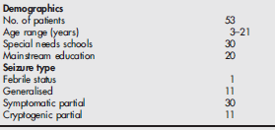

The Delegate commented that this was a testimonial like report with

* poor quality of data;
* sparsity of patient numbers for the proposed indication age range (10 to < 18 years);
* was not supportive of the indication proposed in a previous submission;
* lack of proposed product identification.

###### Muchohi et al. (2008)

Publication:

Muchohi S, Kokwaro G, Ogutu B, Edwards G, Ward S and Newton C. Pharmacokinetics and clinical efficacy of midazolam in children with severe malaria and convulsions. *British Journal of Clinical Pharmacology,* 2008; 66(4):529-538.[43]

In this paper, midazolam 0.3 mg/kg via the IV, IM or buccal route gave a successful seizure control rate of:

* 100% via IV route;
* 75% via IM route;
* 63% via buccal route.

The Delegate commented that this was a testimonial like report with

* sparsity of patient numbers for the proposed indication age range (10 to < 18 years) was not supportive of the indication proposed in a previous submission;
* lack of proposed product identification.

###### Ahmed et al. (2007)

Publication:

Ahmed R. Low-dose buccal midazolam for aborting seizures in children. *J Pediatr Neurol* 2007; 5:291-293.[44]

This paper describes a study that used 0.2 mg/kg of buccal midazolam to get a successful seizure control rate of 64%.

The Delegate commented that this was a testimonial like report with:

* sparsity of patient numbers for the proposed indication age range (10 to < 18 years) was not supportive of the indication proposed in a previous submission;
* lack of proposed product identification.

###### Mpimbaza et al. (2008)

Publication:

Mpimbaza A, Ndeeza G, Staedke S, et al. Comparison of buccal midazolam with rectal diazepam in the treatment of prolonged seizures in Ugandan Children: A randomised clinical trial. *Paediatrics*, 2008; 121:e58-e64.[45]

In this paper there was successful seizure control rate of 70% with buccal midazolam versus 57% with rectal diazepam; both drugs were administered at around 0.5 mg/kg (2.5 mg for 3 to 11 months of age; 5 mg for ages 1 to 4 years; 7.5 mg for ages 5 to 9 years; and 10 mg for ages 10 to 12 years).

The Delegate commented that this was a testimonial like report with

* sparsity of patient numbers for the proposed indication age range (10 to 18 years) was not supportive of the indication proposed in a previous submission;
* lack of proposed product identification.

###### Connolly et al. (2015)

Publication:

Connolly et al. Exploring carer perceptions of training In out-of-hospital use of buccal midazolam for emergency management of seizures (2008-2012) *Journal of Paediatrics and Child Health* 51 (2015) 704-707.[46]

In this paper:

* Out of 63 trained carers, 21 gave buccal midazolam at a median of 5 times with 67% success;
* 10 reported administration problems (difficulties in drawing up the solution (2) or placing the syringe in the buccal space (one carer);
* Side effects (excessive secretions (7), vomiting associated with the seizure (3)).

The Delegate commented that the study details were unknown.

###### Moretti et al. (2019)

Publication:

Moretti et al. Buccal Midazolam Compared With Rectal Diazepam Reduces Seizure Duration in Children in the Outpatient Setting. *Paediatric Emergency Care* Volume 35, Number 11, November 2019 p760-764.[47]

In this paper, out of the 135 enlisted patients with history of further seizure, 42 received buccal midazolam (Buccolam);[48] and 93 received rectal diazepam. Rectal diazepam was effective in 17 patients while the number was 16 with buccal midazolam.

Figure : Moretti et al. (2019) Study design and inclusion flowchart

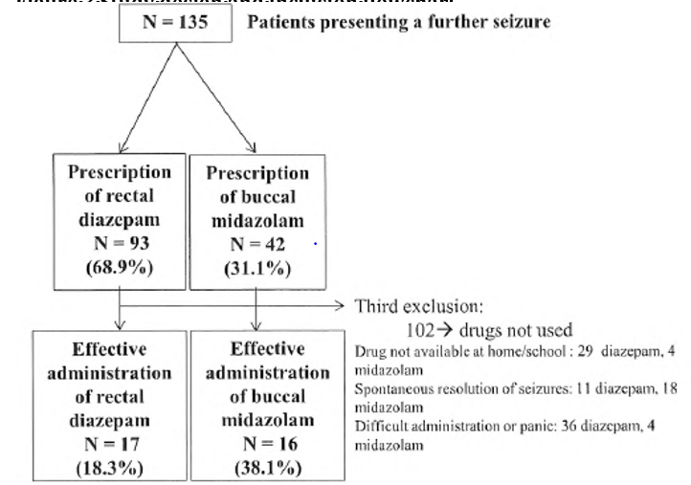

* Mean age for midazolam was 68.2 months versus 34.8 months for rectal diazepam (mean weight 26.9 versus 14.8 kg);
* Mean delay in administration of the drug was 29.7 minutes for midazolam and 36.2 minutes for diazepam;
  + In the midazolam group, mean seizure duration was significantly shorter than in the rectal diazepam (10.3 versus 48.4min p = 0.0004);
* In addition, buccal midazolam significantly reduced the risk to shift toward a status epilepticus, defined as a duration of seizures superior to 30 minutes (6.3% versus 47.1% p = 0.0008);
* Adverse events were not clearly reported in the study.

###### Klimach (2009**)**

Publication:

Klimach VJ. The community use of rescue medication for prolonged epileptic seizures in children. *Seizure* 18 (2009) 343–346.[49]

This study was based on a questionnaire carried out to paediatricians and subsequently to carers. 203 paediatrician and 190 parent/carer questionnaires were returned:

* Buccal midazolam was the most popular rescue medication (buccal midazolam 110, rectal Diazepam 85, paraldehyde 8);
* 142 families reported using buccal midazolam. Ages not given. 55% said it worked ‘always’, 31% ‘usually’, 7% ‘rarely’ and 7% ‘never’;
* Side effects, which caused concern, included four relating to buccal midazolam. The commonest side effects reported were drowsiness followed by respiratory difficulties (seven cases of respiratory depression (7) were due to diazepam, one to midazolam (‘choking’) and two due to a combination of rectal diazepam and buccal midazolam.

The Delegate commented that this study gave testimonial type of evidence.

###### Khan (2014)

Publication:

Khan. Carers' express positive views on the acceptability, efficacy and safety of buccal midazolam for paediatric status epilepticus. *Acta Pædiatrica* 2014 Apr;103(4):e165-8.[50]

In this paper, 34 carers were interviewed. Most had used buccal midazolam for more than once in the previous 12 months:

* 44% of the carers said that it always worked the first time. A further 47% said it worked the first time in more than 75% of cases, and the remaining 9% said the first dose rarely worked;
* 53% of the carers said their child’s seizures stopped within 5 minutes of treatment, 21% said that it took six to 10 minutes, and 26% said it often took between 10 and 30 minutes. Just under two-thirds of the carers (65%) said that the use of buccal midazolam as a rescue therapy for convulsive status epilepticus was always, or usually, effective at preventing admission to hospital, while 24% said it never successfully prevented hospital admission;
* 24% of the carers reported that their child experienced drowsiness after receiving buccal midazolam, and 8% said their child needed to be hospitalised for respiratory depression.

##### Efficacy data for intramuscular midazolam

The clinical evaluator commented that the following studies were outside the proposed age group and except for Silbergleit et al. (2012);51 were not fully evaluated for efficacy. The studies are generally supportive.

###### Silbergleit et al. (2012)

Publication:

R Silbergleit, V Durkalski, D Lowenstein, R Conwit, A Pancioli, Y Palesch, and W Barsan. Intramuscular versus Intravenous Therapy for Prehospital Status Epilepticus. *N Engl J Med* 366;7 February 16, 2012, 591.[51]

This was a multicentred, randomised, double-blind, non-inferiority trial of prehospital IM midazolam 10mg (autoinjector) versus IV lorazepam 2 mg in patients with status epilepticus who had been fitting for > 5 minutes. The study was conducted in the USA.

*Primary outcome:* was termination of seizures before arrival in the emergency department without the need for the paramedics to provide rescue therapy.

*Secondary outcome* measures included:

* the time from study-box opening to termination of convulsions
* the time from initiation of active drug administration to termination of convulsions
* the frequency and duration of hospitalisation
* the frequency and duration of admissions to the intensive care unit
* the frequencies of acute endotracheal intubation
* acute seizure recurrence.

Based on published studies, after an initial dose of intravenous lorazepam had been administered, seizure termination would be expected in 70% of subjects. A non-inferiority margin of 10 percentage points was defined.

Total sample size was calculated as 890 subjects and 893 subjects were enrolled.

Table : Silbergleit et al. (2012) Baseline characteristics and randomisation by age group

Table 12: Characteristics of the Subjects at Baseline 


Abbreviations: IM = intramuscular; IV = intravenous; yr = years.

Source: R Silbergleit, V Durkalski, D Lowenstein, R Conwit, A Pancioli, Y Palesch, and W Barsan. Intramuscular versus Intravenous Therapy for Prehospital Status Epilepticus. N Engl J Med 366;7 February 16, 2012, 591

Figure : Silbergleit et al. (2012) Primary outcome results (non-inferiority)

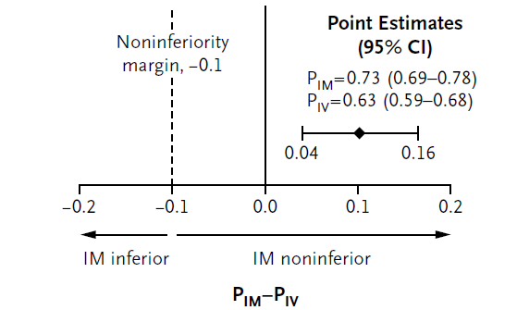

Abbreviations: CI = confidence interaval; IM = intramuscular; IV = intravenous; PIM = point estimate of midazolam (intramuscular); PIV = point estimate of lorazepam (intravenous).

P < 0.001

Source: R Silbergleit, V Durkalski, D Lowenstein, R Conwit, A Pancioli, Y Palesch, and W Barsan. Intramuscular versus Intravenous Therapy for Prehospital Status Epilepticus. N Engl J Med 366;7 February 16, 2012, 591

Table : Silbergleit et al. (2012) Primary and secondary outcomes

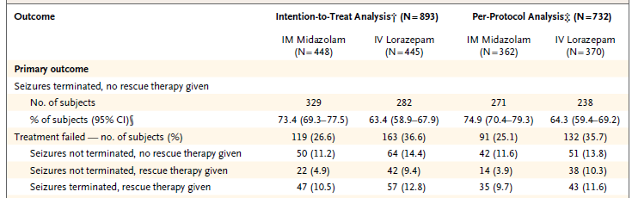

Abbreviations: CI = confidence interval; IM = intramuscular; IV = intravenous; yr = years.

Source: R Silbergleit, V Durkalski, D Lowenstein, R Conwit, A Pancioli, Y Palesch, and W Barsan. Intramuscular versus Intravenous Therapy for Prehospital Status Epilepticus. N Engl J Med 366;7 February 16, 2012, 591

Figure : Silbergleit et al. (2012) Time interval between active treatment and cessation of convulsions

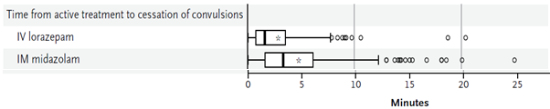

Abbreviations: IM = intramuscular; IV = intravenous.

Source: R Silbergleit, V Durkalski, D Lowenstein, R Conwit, A Pancioli, Y Palesch, and W Barsan. Intramuscular versus Intravenous Therapy for Prehospital Status Epilepticus. N Engl J Med 366;7 February 16, 2012, 591

The Delegate commented on the sparsity of patient number for the proposed indication age range (10 to < 18 years) was not supportive of the previously proposed indication and that midazolam was not used.

###### Nakken and Lossius (2011)

Publication:

Nakken K and Lossius M. Buccal midazolam or rectal diazepam for treatment of residential adult patients with serial seizures or status epilepticus. *Acta Neurol Scand*: 2011; 124:99-103.[52]

This study had a successful seizure control rate of 74.4% with buccal midazolam versus 83.3% with rectal diazepam.

Time to seizure cessation was up to 30 minutes and there were 80 events in 22 patients.

###### Melendez et al. (2006)

Publication:

Melendez R, Batista D, Font D, et al. Prolonged convulsions treated with buccal midazolam in a setting of mentally retarded patients with refractory epilepsy. *Neurologia* 2006; 21 (8):411-413

This paper reported: 52 seizures in 10 patients. A single 5 mg buccal midazolam dose gave 81% response.

##### Analyses performed across trials: pooled and meta–analyses

The following papers were submitted by the sponsor and are described in more detail in the section below:

* McTague A, Martland T, Appleton R. Drug management for acute tonic-clonic convulsions including convulsive status epilepticus in children. *Cochrane Database of Systematic Reviews* 2018, Issue 1. Art. No.: CD001905.
* Arya R, Kothari H, Zhang Z, Han B, Horn P.S, Glauser T.A Efficacy of non-venous medications for acute convulsive seizures: A network meta-analysis. *Neurology*. 2015; 85 (21): 1859-1868*
* Brigo F, Nardone R, Tezzon F, Trinka E. Non-intravenous midazolam versus intravenous or rectal diazepam for the treatment of early status epilepticus: A systematic review with meta-analysis. *Epilepsy Behav.* (2015), 49: 325-336
* Brigo F, Nardone R, Tezzon F, Trinka E. A Common Reference-Based Indirect Comparison Meta-Analysis of Buccal versus Intranasal Midazolam for Early Status Epilepticus. Brigo F, Nardone R, Tezzon F, Trinka E. *CNS Drugs* 2015; 29(9):741-57.
* Doshi D. Controlling Seizures in Children: Diazepam or Midazolam? Systematic Review. *Hong Kong Journal of Emergency Medicine*. 2010;17(2):196-204.
* Glauser et al. Evidence-Based Guideline: Treatment of Convulsive Status Epilepticus in Children and Adults: Report of the Guideline Committee of the American Epilepsy Society. *Epilepsy Currents*, Vol. 16, No. 1 (January/February) 2016 pp. 48–61
* Haut et al. Benzodiazepine use in seizure emergencies: A systematic review. *Epilepsy & Behaviour* 63 (2016) 109-117
* Jain et al. Efficacy and safety of anti-epileptic drugs in patients with active convulsive seizures when no IV access is available: Systematic review and meta-analysis. *Epilepsy Research* 122 (2016) 47-55.
* McMullan J, Sasson C, Pancioli. Midazolam versus diazepam for the treatment of status epilepticus in children and young adults: A meta-analysis*. Academic emergency medicine* 2010; 17:575–582.
* Sofou et al. Management of Prolonged Seizures and Status Epilepticus in Childhood: A Systematic Review *Journal of Child Neurology* Volume 24 Number 8 August 2009 918-926
* Zhao Z.-Y, Wang H.-Y, Wen B, et al. A Comparison of Midazolam, Lorazepam, and Diazepam for the Treatment of Status Epilepticus in Children: A Network Meta-analysis. *Journal of Child Neurology* 2016; 31 (9): 1093-1107*

###### Cochrane Review (McTague et al.) (2018)

Publication:

McTague A, Martland T, Appleton R. Drug management for acute tonic-clonic convulsions including convulsive status epilepticus in children. *Cochrane Database of Systematic Reviews* 2018, Issue 1. Art. No.: CD001905.[53]

The objective of the review was to evaluate the effectiveness and safety of anticonvulsant drugs used to treat any acute tonic-clonic convulsion of any duration, including established convulsive (tonic-clonic) status epilepticus in children who present to a hospital or emergency medical department.

The review involved buccal midazolam versus rectal diazepam as in the papers by Ashrafi et al. (2010);36 Baysun et al. (2005);39 McIntyre et al. (2005);37 and Mpimbaza et al. (2008).45 The doses of the drugs used in the studies were different.

‘This review provides only low- to very low-quality evidence comparing buccal midazolam with rectal diazepam for the treatment of acute tonic-clonic convulsions: (risk ratio (RR) for seizure cessation 1.25, 95% confidence interval (CI) 1.13 to 1.38; 4 trials; 690 children);’

However, there is uncertainty about the effect and therefore, insufficient evidence to support its use;

‘In the absence of intravenous access, buccal midazolam or rectal diazepam are therefore acceptable first-line anticonvulsants for the treatment of an acute tonic‑clonic convulsion that has lasted at least five minutes;’

Across the four trials, 25 of 346 in the buccal midazolam groups experienced respiratory depression

###### Arya et al. (2015)

Publication:

Arya R, Kothari H, Zhang Z, Han B, Horn P.S, Glauser T.A Efficacy of non-venous medications for acute convulsive seizures: A network meta-analysis. *Neurology*. 2015; 85 (21): 1859-1868.

Study participants ranged from newborns to 102 years of age.

The study looked at seizure cessation within 10 minutes of administration rather than 5 minutes.

The Bayesian hierarchical analysis showed:

* buccal midazolam to be the second most efficacious non-venous medication for some of the outcomes; this is to say:
  + notably, whereas the time to initiate treatment was not significantly different for either IM, buccal and intranasal midazolam, these drugs differed regarding time to seizure termination such that IM and intranasal midazolam were not statistically different, but both were superior to buccal midazolam in pairwise comparisons.

The Delegate commented that the age range well outside the proposed indication range of 10 to under 18 years and there was a lack of proposed product identification.

###### Brigo et al. (2005)

Publication:

Brigo F, Nardone R, Tezzon F, Trinka E. Non-intravenous midazolam versus intravenous or rectal diazepam for the treatment of early status epilepticus: A systematic review with meta-analysis. *Epilepsy Behav.* (2015), 49: 325-336.[54]

Nineteen trials contributed to this review and the earliest was published in 1997 and the most recent in 2014.

All studies were conducted in children, except one which included both children and young adults and one which included only adults, resulting in a total of 1573 patients younger than 16 years, many younger than 10 years.

Buccal midazolam:

* was more effective than rectal diazepam in terminating Status epilepticus but only when results were expressed as odds ratio (1.78; 95% confidence intervals (CIs): 1.11 to 2.85; relative risk (RR) 1.15; 95% CIs 0.85 to 1.54)
* The superiority of buccal midazolam over rectal diazepam in terms of seizure control was observed even after performing a sensitivity analysis, by excluding one study that also included adult patients (odds ratio: 1.67; 95% CIs: 0.89 to 3.14). However, this superiority was not evident with results expressed as relative risk (RR 1.12; 95% CIs 0.81 to 1.56)

The Delegate commented that there is poor age range documentation, in terms of the proposed age range, that is, 10 to under 18 years and a lack of proposed product identification.

###### Brigo et al. (2015)

Publication:

Brigo F, Nardone R, Tezzon F, Trinka E. A Common Reference-Based Indirect Comparison Meta-Analysis of Buccal versus Intranasal Midazolam for Early Status Epilepticus. Brigo F, Nardone R, Tezzon F, Trinka E. *CNS Drugs* 2015; 29(9):741-57.[55]

An indirect comparison of buccal and nasal midazolam was made through rectal diazepam.

Fifteen studies, with a total of 1662 seizures in 1331 patients (some studies included patients with more than one episode of status epilepticus) were included; 1303 patients were younger than 16 years.

Indirect comparisons showed no difference between intranasal and buccal midazolam for seizure cessation (odds ratio: 0.98, 95 % CI 0.32 to 3.01, comparator: intravenous diazepam; odds ratio 0.87, 95 % CI 0.46 to 1.64, comparator: rectal diazepam).

The Delegate commented that there was poor age range documentation, in terms of that proposed, that is 10 to under 18 years and a lack of proposed product identification.

###### Doshi, (2010)

Publication:

Doshi D. Controlling Seizures in Children: Diazepam or Midazolam? Systematic Review. *Hong Kong Journal of Emergency Medicine*. 2010;17(2):196-204.[56]

Four randomised, controlled trials were reviewed.

The reviewed trials were via ‘A literature search, performed to identify papers comparing the efficacy and tolerability of midazolam and diazepam in the management of childhood seizures.’

The review found that:

* ‘Intranasal or buccal midazolam are at least as effective as rectal or intravenous diazepam in controlling acute childhood seizures;
* In all of the 4 robust studies reporting a significant difference, time to gain seizure control was shorter in patients treated with midazolam than those treated with diazepam, predominantly due to shorter drug administration time;
* The incidence of seizure recurrence was lower in patients treated with midazolam than diazepam;
* Respiratory depression was uncommon in both groups.’

###### Glauser et al. (2016)

Publication:

Glauser et al. Evidence-Based Guideline: Treatment of Convulsive Status Epilepticus in Children and Adults: Report of the Guideline Committee of the American Epilepsy Society. Epilepsy Currents, Vol. 16, No. 1 (January/February) 2016 pp. 48–61. [57]

This evidence-based guideline recommends the following:

* In children, intranasal lorazepam and intravenous diazepam are established as efficacious at stopping seizures lasting at least 5 minutes (Level A) while recital diazepam, intramuscular midazolam and intranasal midazolam and buccal midazolam are probably effective (Level B evidence);
* For prehospital settings or where the three first-line benzodiazepine options are not available, rectal diazepam, intranasal midazolam, and buccal midazolam are reasonable initial therapy alternatives (level B evidence);
* Time to seizure cessation from identification of the seizure in the emergency department was significantly shorter for buccal midazolam compared with IV diazepam (2.39 minutes versus 2.98 minutes, respectively), with most of the difference driven by more rapid time to initiation of treatment;
* Buccal midazolam is probably effective at stopping seizures lasting at least 5 minutes (level B evidence);
* ‘Two class III studies reported respiratory depression with use of buccal midazolam in children, in contrast to two class III studies, which reported no respiratory depression associated with use of buccal midazolam in the paediatric population.’

###### Haut et al. (2016)

Publication:

Haut et al. Benzodiazepine use in seizure emergencies: A systematic review. *Epilepsy & Behaviour* 63 (2016) 109-117.[58]

This review contained limited specific information mostly tabulated and combined with adults’ data.

###### Jain et al. (2016)

Publication:

Jain et al. Efficacy and safety of anti-epileptic drugs in patients with active convulsive seizures when no IV access is available: Systematic review and meta-analysis. *Epilepsy Research* 122 (2016) 47-55.[59]

The review by Jain et al. (2016) included papers by Ashrafi et al. (2010);36 Baysun et al. (2005);39 McIntyre et al. (2005);37 Mpimbaza et al. (2008);45 Scott et al. (1999);28 and Trajano et al. (2009)[60] in children, but also Nakken and Lossius (2011);52 in adults.

Table : Jain et al. (2016) Details of studies in review

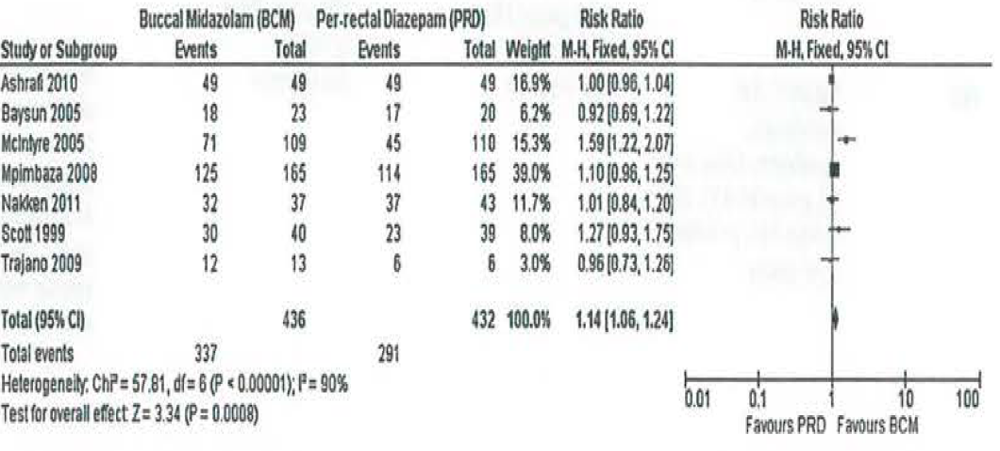

###### McMullen et al. (2010)

Publication:

McMullan J, Sasson C, Pancioli. Midazolam versus diazepam for the treatment of status epilepticus in children and young adults: A meta-analysis*. Academic emergency medicine* 2010; 17:575–582.

McMullen et al reviewed three articles (McIntyre et al. (2005);37 Mpimbaza et al. (2008);45 and Scott et al. (1999);28

The author concluded that buccal midazolam was more successful than rectal diazepam in seizure cessation (relative risk = 1.54; 95% CI 1.29 to 1.85; I2 = 0%.

###### Sofou et al. (2009)

Publication:

Sofou et al. Management of Prolonged Seizures and Status Epilepticus in Childhood: A Systematic Review *Journal of Child Neurology* Volume 24 Number 8 August 2009 918-926.

Included review of only two trials of buccal midazolam;

Buccal midazolam was significantly more effective than rectal diazepam, reaching a seizure control rate of 70% and recurrence rate of 8%;

Buccal midazolam is efficacious and safe and thanks to its convenient route of administration, which may serve as first-line in the treatment of prolonged seizures.

###### Zhao et al. (2016)

Publication:

Zhao Z.-Y, Wang H.-Y, Wen B, et al. A Comparison of Midazolam, Lorazepam, and Diazepam for the Treatment of Status Epilepticus in Children: A Network Meta-analysis. *Journal of Child Neurology* 2016; 31 (9): 1093-1107.

Sixteen randomised controlled trials involving 1821 patients were included; of the three randomised control trials using buccal midazolam, all patients in two of them were under 10 years old and the ages in the third were not given.

No separate finding on buccal midazolam was given.

The Delegate commented that there was poor age range documentation, in terms of that proposed, that is, 10 to under 18 years of age and there was a lack of proposed product identification.

##### Other data

The sponsor has again submitted a collection of retrospective data on the use of Zyamis (previously submitted to the TGA).32 This time round referring to it as a Real World Retrospective Study (2010). This was a collection of data that included 39 subjects (41 episodes) in the proposed population, who received over the previous 10 years unlicensed rescue medication treatment in epilepsy patients with prolonged or repeated seizures.

The clinical evaluator commented that:

* The contribution of this data to assessing efficacy of the proposed product is limited.
* The sponsor has included an unpublished Japanese trial on 25 subjects from the EU trials register.
* The sponsor referred to the Cochrane Database of Systematic Reviews (2018);53 ’buccal midazolam was statistically significantly more effective than rectal diazepam for seizure cessation (relative risk = 1.25, 95% CI 1.13, 1.38; p < 0.001)’;
* There was considerable heterogeneity in the analysis (I2 = 81%), however, and the quality of evidence was considered to be low. When the analysis was repeated with a random-effects model, there was no statistically significant difference between the treatments (relative risk = 1.23, 95% CI 0.98, 1.54; p = 0.08).
* The sponsor referred to trials published in abstract only:
* Trajano et al: ‘Buccal midazolam compared to rectal diazepam and intravenous midazolam as emergent treatment of acute seizures in children: preliminary study Journal of the Neurological Sciences 285 SI (2009) S155-S339 19th World Congress of Neurology, Poster Abstracts;
* Bagale & Chapagain: ‘A comparison of buccal midazolam and intravenous diazepam in acute treatment of seizures in children. Poster Presentations: 12th European Paediatric Neurology Society Congress 20-24 June 2017.

##### Clinical evaluation conclusions on efficacy

The literature provides general support for the use of midazolam to control seizures, the most effective route being IV. The application is specific for use by parents/caregivers, that is, out of hospital use.

The sponsor, after creating a model of the pharmacokinetics of paediatric buccal midazolam therapy using a population pharmacokinetic program and literature data, selected the dose of 10 mg and then claimed bioequivalence (‘similar to’) with the same dose in a study of IM midazolam in adults. Bioequivalence was not shown, as per Table 2 above.

The simulated results (via the buccal route in those between 10 to under 18 years of age) were bioequivalent to the buccal results in adults. These in turn had been shown to be bioequivalent to the buccal results with the Hypnovel product;14

The pharmacokinetic/pharmacodynamic study was interpreted in the regulatory‑response document as:

* The range of predicted maximum midazolam plasma concentrations (90% CI) for 10 to 18 year old subjects ranged from 50 ng/mL (75% swallow) to 61 ng/mL (10% swallow), which is very comparable to adults median Cmax values obtained from Studies SPL001 and SPL002, 64 ng/mL and 60 ng/mL respectively.
* As it was shown, in the population pharmacokinetics report on the 10 mg dose justification in adults, these plasma concentrations yield effective brain concentrations in adult subjects and, thus should produce the desired effect in the 10 to 18 year old population.
* Since efficacy has been reasonably shown for the expanded age group, the result of effective brain concentrations in adults is seen as irrelevant, regardless of this evaluator’s acceptance of the findings of this added pharmacokinetic/pharmacodynamic report.

The studies considered pivotal by the clinical evaluator are:

* Talukdar and Chakrabarty (2009)34: a comparison of IV diazepam (which is a registered use and route of administration) with buccal midazolam. The study was open, total numbers were small;[61] and the investigators failed to show any difference in efficacy (85% versus 93%), however buccal midazolam was statistically superior to IV diazepam in the time taken to initiate treatment and the time taken from the decision to initiate treatment to control of seizures.
* Tonekaboni et al. (2012)35: waslikewise a comparison of IV diazepam with buccal midazolam The study was open, total numbers were small;[62] and the investigators failed to show any difference in efficacy (40% versus 40%) for a single dose at 5 minutes. Unfortunately, failure to respond at 5 minutes meant that a second dose was given.

Based on the available submitted literature, buccal midazolam is as effective as rectal diazepam (an off-label route of administration) in controlling seizures.

The relationship of the proposed formulation to those used in some of the studies is unclear. The sponsor has assumed a positive relationship based on the product concentration for the formulation used in some of the studies, and this has been accepted.

#### Safety

The proposed product (midazolam) is a different salt, midazolam *maleate*, rather than midazolam *hydrochloride* of the innovator. The submission is as a generic of Hypnovel;14 rather than as a new chemical entity. No difference in properties (other than related to the proposed new indication and route of administration) should be claimed.

The sponsor is correct in stating that’ the safety of midazolam derived from decades of use in approved indications in children is well established’ even though the innovator (Hypnovel);14 PI states:

*‘Safety and effectiveness of midazolam in children below the age of 8 have not been established. Pharmacokinetics in children have not been established and may differ from adults’.*

##### Exposure and adverse events recorded in the literature

Adverse events (AEs) in the literature studies providing evaluable safety data are shown in Table 17, below.

Table : Total exposure derived from the literature submitted for this submission

|  |  |  |
| --- | --- | --- |
| Study/publication | Buccal population | Adverse events |
| Talukdar B, Chakrabarty B. Efficacy of buccal midazolam compared to intravenous diazepam in controlling convulsions in children: a randomised controlled trial. *Brain Dev.* 2009; 31(10)744-9  Used midazolam hydrochloride | 60 patients  53.3% were < 1 year of age | Nil |
| Tonekaboni S., Shamsabadi FM, Anvari S, Mazrooei A, and Ghofrani M. A comparison of buccal midazolam and intravenous diazepam for the acute treatment of seizures in children. *Iran J Pediatr* 2012; 22(3):303-308  Used midazolam maleate | 32 patients  Median age was 18.4 months (±10.3 months) | Agitation (11) hypotension (7) |
| Ashrafi MR, Khosroshahi N, Karimi P, et al. Efficacy and usability of buccal midazolam in controlling acute prolonged convulsive seizures in children. *Eur J Paediatric Neurol.* 2010.  Used midazolam maleate. | 43 patients  Median age 24 months | Nil |
| McIntyre J, Robertson S, Norris E, et al. Safety and efficacy of buccal midazolam versus rectal diazepam for emergency treatment of seizures in children: a randomised controlled. *Lancet* 2005; 366 (9481):205-210.  Used midazolam hydrochloride. | 92 patients (109 episodes)  Only ages combined arms given | Respiratory depression (5 events, 5%) |
| Scott RC, Besag FM and Neville BG. Buccal midazolam and rectal diazepam for treatment of prolonged seizures in childhood and adolescence: a randomised trial. *Lancet*. 1999; 35 (9153)623-626.  Used midazolam hydrochloride | 14 patients (40 episodes)  Included 6 of 18 patients aged 18/19 years | No clinically important adverse events |
| Baysun S, Aydin OF, Atmaca E et.al. Comparison of buccal midazolam and rectal diazepam for the acute treatment of seizures. A *Clin Pediatr. (Plila).* 2005; 44 (9):771-776.  Used midazolam hydrochloride | 23 patients.  Mean age 3.87 years (± 3.39).  Range: 2 months to 12 years | Coughing (1) |
| Kutlu NO, Dogrul M, Yakinci C et al. Buccal midazolam for treatment of prolonged seizures in children. *Brain Dev.* 2003; 25 (4):275-278. | 19 patients  Age 3.76 years (± 4.48 years)  Range: 1 month to 15 years | Nil |
| Frelih J, Zupancic N, Kolenc J, Rogelj M and Neubauer D. Buccal midazolam use for acute treatment of seizures. *Paediatr Croat* 2007; 51(Supl 1):149-151. | 20 patients  Age: 3 to 24 years  Mean age: 8 ± 2.3 years | No severe adverse events reported |
| Wilson MT, Macleod S and O’Regan. M. E. Nasal/buccal midazolam use in the community. *Arch. Dis. Child.* 2004; 89:50-51. | 40 patients  Age: 3 to 21 years | Euphoria (1) |
| Muchohi S, Kokwaro G, Ogutu B, Edwards G, Ward S and Newton C. Pharmacokinetics and clinical efficacy of midazolam in children with severe malaria and convulsions. *British Journal of Clinical Pharmacology,* 2008; 66(4):529-538. | 8 patients  Median age: 26 months  Range: 7 to 64 months | Respiratory depression (2)  Hypersalivation (2) |
| Ahmed R. Low-dose buccal midazolam for aborting seizures in children. *J Pediatr Neurol* 2007; 5:291-293. | 20 patients  Age range: 5.5 months to 6.2 years | Nil |
| Mpimbaza A, Ndeeza G, Staedke S, et al. Comparison of buccal midazolam with rectal diazepam in the treatment of prolonged seizures in Ugandan Children: A randomised clinical trial. *Paediatrics*, 2008; 121:e58-e64.  Used midazolam hydrochloride | 165 patients  Median age (IQR): 17.0 months (10.5, 30.0) | Respiratory depression (2; 1%) aphasia, pruritus (possibly related) |
| Connolly et al. Exploring carer perceptions of training In out-of-hospital use of buccal midazolam for emergency management of seizures (2008-2012) *Journal of Paediatrics and Child Health* 51 (2015) 704-707. | 21 patients  Median age: 4 years  Range: 3 months to 15 years | 10 administration problems (excessive secretions (7), vomiting associated with the seizure (3), and difficulties in drawing up the solution (2), or placing the syringe in the buccal space 1) |
| Moretti et al. Buccal Midazolam Compared With Rectal Diazepam Reduces Seizure Duration in Children in the Outpatient Setting. *Paediatric Emergency Care* Volume 35, Number 11, November 2019 p760-764. | 16 patients  4 reporting panic or difficult administration  Mean age: 68.2 months | Adverse events not clearly reported. |
| Klimach VJ. The community use of rescue medication for prolonged epileptic seizures in children. *Seizure* 18 (2009) 343–346 | 142 families reported using buccal midazolam  Ages not given | 4 adverse events; commonest was drowsiness followed by respiratory difficulties, 1 had respiratory depression with midazolam (’choking’) |
| Khan. Carers' express positive views on the acceptability, efficacy and safety of buccal midazolam for paediatric status epilepticus. *Acta Pædiatrica* 2014 Apr;103(4):e165-8 | 34 carers  Ages not given | 24% said that their child experienced drowsiness, and 8% were hospitalised for respiratory depression |

The above table gives a total of 536 patients exposed with an unknown number above or below the proposed age range. Some patients had more than one exposure.

##### Exposure and adverse events recorded in other data

The sponsor has included unpublished studies, a study for another indication and a published abstract in their submission. Papers submitted are detailed below.

Table : Exposure and adverse events from other studies

|  |  |  |
| --- | --- | --- |
| Study details | Participants | Adverse events |
| 2010 Real World Retrospective Study (unpublished) | 39 participants < 18 years  Treated for 41 seizures | Dry/peeling skin* |
| A Phase III, multicenter, open-label study to determine the efficacy, safety, and pharmacokinetics of buccally administered MHOS/SHP615 in pediatric subjects with status epilepticus (convulsive) in the hospital or emergency room in Japan  ClinicalTrials.gov identifier: NCT03336645  EudraCT number: 2020-000226-26 | 25 children | Sedationa Mean change from baseline (N = 23) of 2.2 ± 1.23  Change in oxygen saturation (N = 14) 3.7 ± 10.21%  Respiratory depression (N = 2; 8.0%) |
| Albrecht S, Schwilden H. Pharmacokinetics of oromucosal midazolam hydrochloride in children. *British Journal Of Anaesthesia* 2012; 108 (suppl 2):pp ii307. (premedication) | 53 children  Low-dose buccal midazolam 0.2 mg/kg | 59 adverse events in 39 patients, 2 related: vomiting, nausea.  No respiratory events attributed to buccal midazolam. |
| Bagale & Chapagain: ‘A comparison of buccal midazolam and intravenous diazepam in acute treatment of seizures in children. Poster Presentations: 12th European Paediatric Neurology Society Congress 20-24 June 2017. | 45 children | No significant difference in adverse effects were was noted between two groups |

##### Adverse events from retrospective data on past use of medicine

The clinical evaluation commented that while entry criteria to data entries are described, the criteria for patient selection for treatment are not. Potentially the protocols might vary across the sites. Collection of retrospective data is always a difficult task.

Note, Zyamis, the sponsor’s product described in this submission, is sold under the tradename ‘Epistatus’ overseas.

Table : Summary of treatment-emergent adverse events from data entries

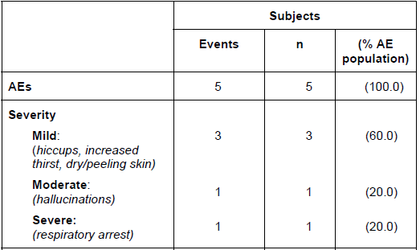

Table : Adverse events from the Summary of Product Characteristics for Epistatus

|  |  |
| --- | --- |
| System Organ Class | Frequency: Adverse drug reaction |
| Nervous system disorders | Common: Sedation, somnolence, depressed levels of consciousness  Respiratory depression |
| Gastrointestinal disorders | Common: Nausea and vomiting |
| Skin and subcutaneous tissue disorders | Uncommon: Pruritus, rash and urticaria |

The major safety concern regarding administration of benzodiazepines, including buccal midazolam, to children experiencing a prolonged seizure is the risk of respiratory depression, especially outside of hospital. In two of the controlled clinical studies, respiratory depression after buccal administration of midazolam was reported with an incidence of 1.2 to 5%.

Specific concern of the new route of administration is the possibility of aspiration, always a possibility with status epilepticus anyway. Regarding the latter:

* only one study (Muchohi et al., 2008);43 mentioned specifically that it did not occur and two of their 8 patients had hypersalivation necessitating suction;
* Baysun et al. (2008);39 had one of 23 patients with a coughing fit, shortly after administration.

The sponsor proposes:

* ‘With respect to the risk of aspiration […] however, the volumes of drug are very small, and are likely to be exceeded significantly by the excess saliva produced during a seizure. In practice, these concerns have not been reported as safety issues’.
* ‘Deaths have been related to the underlying disease state’.

The Delegate gave the following suggestion, that the issue has not been properly explored.

* The review prior to registration of Buccolam (buccal midazolam hydrochloride) showed there has been severe and moderate harm associated with community use that the sponsor suggests is related to overdosing.

##### Potential for abuse

The sponsor has specifically addressed this in the appropriate section of the submission:

* According to the TGA’s national classification system, midazolam is categorised in Schedule 4. Therefore, Zyamis oromucosal solution is a prescription only medicine. Off-label midazolam (IV formula, used intranasally and buccally) has already been available to the parents and carers of patients for home use since 2002 and there is no apparent abuse reported.
* The product will be supplied as 2.5 mg, 5 mg, 7.5 mg and 10 mg midazolam base in 0.25 mL to 1 mL of sugar free syrup with a single use, prefilled syringe for oral administration.
* The sponsor has considered the risk of diversion for illicit use and will address this by the distribution of appropriately limited pack sizes, which will only be available on prescription to individuals in the community who have a specific need for the product by virtue of their propensity for status epilepticus, or available in the prehospital emergency setting or within the hospital environment via the hospital pharmacy.
* In addition, the Australian Product Information (PI) and Australian Consumer Medicine Information (CMI) will include a recommendation that the patient’s or care giver’s past medical history be considered when prescribing or dispensing Zyamis in situations where this is concern about and increase risk of misuse, abuse or diversion;
* All patients treated with benzodiazepines should be carefully monitored for signs of abuse or addiction.

##### Community experience

The previous submission contained the following document ‘Anaesthesia Glare J: Caution: oral/buccal midazolam for serious epileptic seizures, potential for dose confusion’ from the West Midlands (UK) Medicines Information Service 2003.[63]

The sponsor said the following about the above paper in the previous submission:

* An online report of a search of the UK National health Service National Reporting and Learning system following a signal generated by an event involving respiratory depression in the community attributed to buccal midazolam administration revealed 132 reported medication incidents (NHS National Reporting and Learning System., 2012);
* Three of these were associated with severe harm and five with moderate harm. Little further information is provided, but it would appear that these events were associated with ‘wrong dose errors’, for example 10-fold overdosing.

##### Postmarketing experience

The sponsor submitted a periodic safety update report (PSUR) for the period 10 September 2016 to 9 September 2019. Note, Zyamis, the sponsor’s product described here in this submission and the following periodic safety update report, is sold under the tradename ‘Epistatus’ overseas:

* Epistatus 10mg Oromucosal Solution was registered on 7 April 2017 for the treatment of prolonged, acute, convulsive seizures in children and adolescents aged 10 to less than 18 years, in the United Kingdom.
* There were no sponsored ongoing or completed clinical studies.
* The sponsor assumes the above number equates with usage (or underestimates it because of unlicensed forms of Epistatus [Zyamis]). As indicated in some of the studies submitted, units supplied do not equate with usage, for example, for the Moretti et al. (2019) study it was around 50% (or 20 of 42).47
* While there was considerable review of benzodiazepine use and its adverse events, neither was the duration and dosage limited to the proposed single occasional use nor was the age group limited to that proposed.
* The sponsor submitted that there are no further issues arising, which would recommend changes to the reference safety information or additional risk management activities;
* Throughout the PSUR, the statement is found *’48 Epistatus cases in total for the reporting period*’ while, the referenced table (see table below) has the note ‘*As this is the first PBRER* [periodic benefit-risk evaluation report] *for this product, no cumulative data is available, so only interval data has been presented*.’ That table, from which the following Table 21 is derived has 90 non-serious and 83 serious adverse events.

Table : Interval summary tabulation of serious and non-serious adverse reactions reported ≥ 2 times from post-marketing data sources

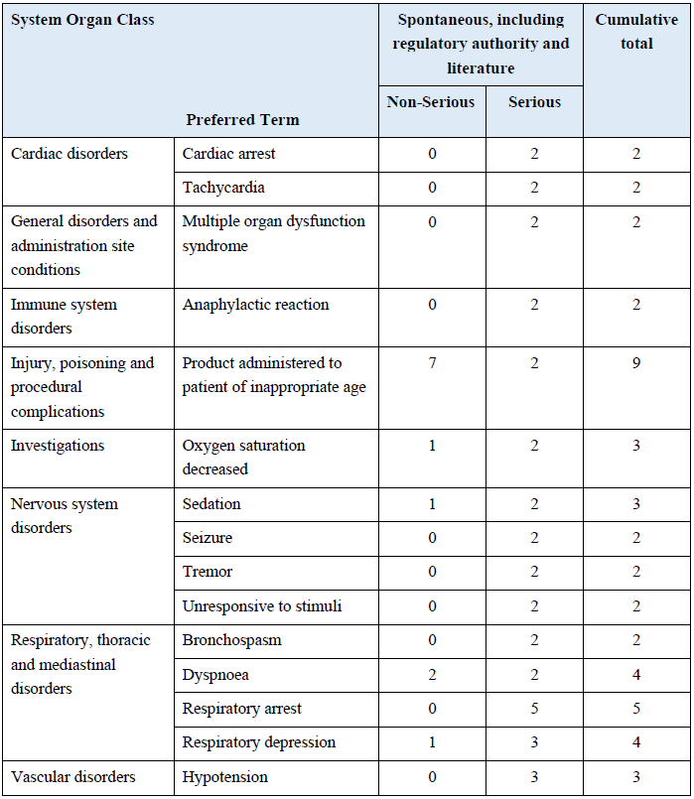

##### **Clinical** **evaluation’s assessment of benefits and risks**

Table : Clinical evaluation’s assessment of the benefits of Zyamis (midazolam maleate) oromucosal solution

|  |  |
| --- | --- |
| Benefits | Strengths and Uncertainties |
| Indication (proposed):  *Treatment of prolonged acute convulsive seizures with midazolam.* | The sponsor has not specifically reviewed the evidence to support this extension of indications. The literature search approval was for a limited search strategy confined to buccal use of midazolam for the treatment of PACS in infants, children and adolescents.  The literature provides general support for the use of midazolam to control seizures, the most effective route being IV.  Midazolam has been registered for this indication in the EU. |
| The use of buccal midazolam to control seizures. | The studies considered pivotal;34,35 by this evaluator are a comparison of IV diazepam (which is a registered use and route of administration) with buccal midazolam. The total numbers were small (60 patients given IV diazepam and 32 patients given buccal midazolam) and the investigators failed to show any difference in efficacy.  Midazolam (under the tradename Buccolam) has been registered for a similar indication in the EU. |
| To control seizures without the need for IV access. | Talukdar and Chakrabarty (2009);34 showed buccal midazolam was statistically superior to IV diazepam in the time taken to initiate treatment and the time taken from the decision to initiate treatment to control of seizures. |

Table : Clinical evaluation’s assessment of the risks of Zyamis (midazolam maleate) oromucosal solution

|  |  |
| --- | --- |
| Risks | Strengths and Uncertainties |
| Zyamis has not been registered anywhere for this age group | The product has been supplied since 2002 but not actually marketed in a process akin to an Australian compounding pharmacist.  Registered in the UK (April 2017) and EU mutual recognition (2019/2020), and only for 10 to less than 18 year olds |
| The use of buccal midazolam in the EU has only been registered for 9 years. | Post marketing reports for Buccolam oromucosal midazolam hydrochloride are not available.  Some other post-marketing data available  A PSUR for Zyamis in the 10 to less than 18 years old was submitted |
| Buccal midazolam was the subject of 132 reported medication incidents in the years prior to Buccolam registration. | Three were associated with severe harm and five with moderate harm. |
| There is comparatively little paediatric and adolescent exposure to buccal midazolam in patients with status in the literature submitted. | The limited literature showed relatively few adverse events.  The incidence reported was generally similar to those for rectal diazepam. |
| The exposure of paediatric and adolescent patients to community treatment is small. | 279 patients of all ages in the literature submitted. |
| Respiratory depression. | Was commonly reported > 1% in the larger studies. |
| Aspiration. | Well recognised complication of status epilepticus.  Only one study mentioned specifically that it did not occur and 2 of their 8 patients had hypersalivation necessitating suction.  Another study had a patient coughing shortly after administration.  The reporting of respiratory depression was often as a fall in pulse oximetry saturation alone, which would not distinguish central depression from aspiration. |

##### Clinical evaluation recommendation regarding authorisation

Authorisation for the proposed indication cannot be recommended. The proposed indication and the PI require modification as in the following section.

Authorisation is however, recommended for the proposed indication:

*The treatment of Prolonged Acute Convulsive Seizures (PACS) in infants, children and adolescents aged from 6 months to less than 18 years old when used by parents/caregivers, must only be used where the patient has been diagnosed by a medical practitioner to have epilepsy*

### Risk management plan

The sponsor has applied to extend the indications of midazolam. Currently, midazolam (as hydrochloride) solution for injection is approved for use in Australia as an agent for sedation (either administered intravenously (IV) or intramuscularly (IM)) or for the induction of anaesthesia (administered IV). The current submission for midazolam (as maleate) oromucosal solution (Zyamis) seeks to include a new route of administration (buccal) and to extend the indications to include the treatment of prolonged acute convulsive seizures (PACS) in infants, children and adolescents aged from 6 months to less than 18 years old.

With this submission the sponsor has submitted EU-risk management plan (RMP) version 1.2 (dated 25 June 2019; data lock point (DLP) 31 December 2018) and Australia-specific Annex (ASA) version 1.0 (dated 2020) in support of this application. At the second round of evaluation the sponsor has submitted ASA version 1.1 (dated 6 May 2021) in support of this application. At the third round of evaluation the sponsor has submitted EU-RMP version 2.0 (dated 23 September 2020; DLP 9 December 2019) and ASA version 1.2 (dated 7 June 2021) in support of this application. At fourth round of evaluation the sponsor has submitted ASA version 1.3 (dated 28 June 2021 in support of this application.

A previous submission to the TGA for midazolam oromucosal solution was withdrawn on 14 September 2018 by the sponsor (formerly Special Products Australia Pty Limited).[64] An RMP evaluation was undertaken for this application (submission PM-2017-00392-1-1) which evaluated EU-RMP version 1.0 (dated 9 November 2015; DLP 11 November 2013) and ASA version 2.0 (dated 30 October 2017 (second round)).

The summary of safety concerns and their associated risk monitoring and mitigation strategies (EU-RMP version 2.0 and ASA version 1.3) are summarised in Table 24.[65]

Table : Summary of safety concerns and pharmacovigilance and risk mitigation activities

|  |  |  |  |  |  |
| --- | --- | --- | --- | --- | --- |
| Summary of safety concerns | | Pharmacovigilance | | Risk Minimisation | |
| Routine | Additional | Routine | Additional |
| **Important Identified Risks** | Sedation (CNS depression) | ✓ | – | ✓ | – |
| Breathing suspended (apnoea) | ✓ | – | ✓ | – |
| Breathing difficult (respiratory arrest) | ✓ | – |  | – |
| Sickness and feeling sick (nausea and vomiting) | ✓ | – | ✓ | – |
| Itch (pruritis) | ✓ | – | ✓ | – |
| **Important Potential Risks** | Physical dependence | ✓ | – | ✓ | ✓* |
| Aspiration/Aspiration pneumonia | ✓ | – | ✓ | ✓* |
| Medication Errors | ✓ | ✓** | ✓ | ✓* |
| Oral/facial trauma | ✓ | – | ✓ | ✓* |
| Drug-facilitated sexual abuse | ✓ | – | ✓ | ✓* |
| **Missing Information** | Limited information on use for seizure control in paediatric population of 6 months to under 10 years age group† | ✓ | ✓** | ✓ | – |
| Pharmacokinetics in children† | ✓ | – | ✓ | – |

* At the second round of evaluation, the educational materials (How to prescribe leaflet, training pack, frequently asked questions leaflet (HCP), patient and carer leaflet, app and video) have been included as additional risk minimisation activities in the updated ASA and apply to all the Important Potential Risks.

** Drug Utilisation Study to assess the additional risk minimisation activities.

† Included in the ASA only

The following specific conditions of registration are recommended:

* The Zyamis EU-Risk Management Plan (RMP) (version 2.0; dated 23 September 2020; DLP 9 December 2019), with Australian Specific Annex (version 1.3, dated 28 June 2021), included with submission PM-2020-04183-1-1, and any subsequent revisions, as agreed with the TGA will be implemented in Australia.
* An obligatory component of risk management plans is routine pharmacovigilance. Routine pharmacovigilance includes the submission of periodic safety update reports (PSURs).

Reports are to be provided in line with the current published list of EU reference dates and frequency of submission of PSURs until the period covered by such reports is not less than three years from the date of this approval letter.

The reports are to at least meet the requirements for PSURs as described in the European Medicines Agency’s Guideline on good pharmacovigilance practices (GVP) Module VII-periodic safety update report (Rev 1), Part VII.B Structures and processes. Note that submission of a PSUR does not constitute an application to vary the registration.

* Zyamis (midazolam maleate) is to be included in the Black Triangle Scheme. The PI and CMI for Zyamis must include the black triangle symbol and mandatory accompanying text for five years, which starts from the date that the sponsor notifies the TGA of supply of the product.

### Risk-benefit analysis

#### Delegate’s considerations

This is a new indication with a new route of administration for this active ingredient. The sponsor is thus the innovator for the new indication and the new route of administration.

* Zyamis also represents a new pharmaceutical formulation (NPF) in Australia and, the sponsor is the innovator for the NPF.
* A benzodiazepine in the parenteral formulation (DBL diazepam, injection);[66] is registered and approved in Australia for status epilepticus, an indication akin to the one proposed for Zyamis. Notably however, while the sponsor wishes to limit use of their product to certain age groups, diazepam injection is neither contraindicated nor restricted to any age range.
* Given that Zyamis is essentially a modified midazolam formulation, for buccal route administration and for an indication different from those of the already registered in Australia midazolam solution for injection (Hypnovel);[67] the current submission could be classified as being extension of indications of new dose form and new salt (midazolam maleate versus midazolam hydrochloride).

In agreement with the clinical evaluation, the Delegate agrees that the submission is as a generic of Hypnovel rather than a new chemical entity. The proposed product is a different salt, maleate, rather than the hydrochloride of the Innovator (Hypnovel). No difference in properties (other than related to the proposed new Indication and route of administration), should thus be claimed.

Clinically, seizures of less than 5 minutes are termed ‘brief’, while seizures of between 5 to 30 minutes are termed ‘prolonged’.

Status epilepticus is defined as more than 30 minutes of either continuous seizure activity; or two or more sequential seizures without full recovery of consciousness between the episodes. The 30 minute definition is based on the duration of convulsive activity that may lead to permanent neuronal injury by itself.

About 8% of children will have at least one seizure by 15 years of age.6

In contemporary clinical practice, it has been customary to treat children with a history of prolonged seizures with ‘off-label’ administration of rectal diazepam. The latter was often provided to families along with an individualised treatment plan to terminate the seizure as soon as possible. Intranasal lorazepam, another benzodiazepine, (not listed on the ARTG) had also been used in status epilepticus.

The goal of therapy in epilepsy is the rapid termination of both clinical and electrical seizure activity, since appropriate and timely therapy of prolonged acute convulsive seizures (PACS) reduces the risk of progression to status epilepticus with associated mortality and morbidity.

The major issues noted with a previous, similar submission were:

* the submitted comparative pharmacokinetic study was in adults as opposed to children;
* the comparative pharmacokinetic parameters study was between buccal midazolam (Zyamis, maleate salt) and parenteral midazolam (Hypnovel; a hydrochloride salt, not registered for the buccal route of administration);67
* the submitted population pharmacokinetic data simulating paediatric buccal midazolam doses to adults receiving 10 mg midazolam either IM (or IV) for the purpose of establishing bioequivalence was negative as well as being invalidated;
* insufficient patient number exposure in the age range 10 years to under 18 years proposed in the indication;
* inadequate identification of the buccal midazolam formulation product used in the bulk of the literature based data submitted, and relationship to the Zyamis proposed for marketing in Australia.

Following pre-submission discussions with the sponsor and the TGA, it was considered that an expansion of the target population for the indication is inherent. The suggestion was to include efficacy/safety data for the lower aged children (infants) with sufficient data in the literature based submission to cater for the small patient number in the literature based submission with regards to the 10 years to under 18 year old population in the indication, when amalgamated. The above approach will not require either pharmacokinetic or population pharmacokinetic data in the consideration of the current submission.

Quality data assessment stated that *’approval can be recommended for registration of the proposed drug product from a pharmaceutical chemistry and quality aspect’*. The latter eases the issue of inadequate identification of the buccal midazolam formulation product used in the bulk of the literature based data submitted and, the relationship to Zyamis (midazolam maleate) proposed for marketing in Australia, as having been insufficiently clarified.

Based on the literature-based submission, the clinical evaluator found the benefit-risk assessment balance of Zyamis midazolam maleate for the proposed indication *‘the treatment of Prolonged Acute Convulsive Seizures (PACS) in infants, children and adolescents aged from 6 months to less than 18 years old’*, to be favourable. The Delegate agrees with the clinical evaluation that efficacy has been reasonably shown for the expanded age group. According to the clinical evaluation, the pivotal studies are those of Talukdar and Chakrabarty (2009);34 and Tonekaboni et al. (2009);35 which suggested that buccal midazolam is as effective as rectal diazepam (an off-label route of administration) in controlling seizures.

##### Indication

###### Initial proposed indication

The proposed indication, as per the sponsor, can be broken down into two parts:

1. ‘*Zyamis is indicated for the treatment of Prolonged Acute Convulsive Seizures (PACS) in infants, children and adolescents aged from 6 months to less than 18 years old when IV Diazepam is not available or inappropriate to use*;
2. *Zyamis, when used by parents / caregivers, must only be used by parents / caregivers where, the patient has been diagnosed by a medical practitioner to have epilepsy’.*

According to the clinical evaluation, the evidence from the pivotal trials in relation IV diazepam versus midazolam does not strictly support the first part of the proposed indication above, as:

* The investigators were unable to show any significant difference in cessation of all of motor activity (defined as stoppage of all motor activity within or by 5 minutes of administration of the drug. Buccal midazolam was statistically superior to IV diazepam in the time taken to initiate treatment and the time taken from the decision to initiate treatment to control of seizures. IV diazepam was statistically superior to buccal midazolam in the effect time (the time to seizure control after drug administration);
* In the buccal midazolam group, the first administration was effective in controlling the seizures in 13 (40%) versus 24 (40%) in the IV diazepam group (p = 0.9). The mean time required to control the convulsive episodes after administration of medications was not statistically significantly different between IV diazepam and buccal midazolam

For the second part of the sponsor’s proposed indication above, the clinical evaluator stated, that it is a grammatical error as it implies that the use of Zyamis is restricted to parents / caregivers.

###### TGA recommended amendments to the proposed indication

The clinical evaluation recommended that the proposed indication be amended to the following:

*‘Zyamis is indicated for the treatment of prolonged, acute, convulsive seizures in children and adolescents aged 10 to less than 18 years; Zyamis must only be used by parents / caregivers where the patient has been diagnosed to have epilepsy’.*

The TGA Delegate recommends the indication to be changed to the following:

‘Zyamis, as buccal midazolam, is indicated for the treatment of prolonged, acute, convulsive seizures in infants, children and adolescents less than 18 year old’.

The Delegate’s rationale for this indication is to propose slight modification to differentiate IV midazolam (Hypnovel) from buccal midazolam (Zyamis); the Delegate believes it is not necessary to particularly specify age when it comes to infants/children, as there is ample evidence in the literature that infants as young as 4 weeks received oral Buccolam/buccal midazolam.

The Delegate recommends the relocation ofthe advice that *‘Zyamis, as buccal midazolam, must only be used by parents / caregivers who have received adequate training in the use of the product, where the patient has been diagnosed to have epilepsy’* be moved to the ‘Administration and Dosage’ section of the PI.

The rationale for this is that it serves as more of a precautionary statement akin to the administration of Zyamis rather than making up part of the indication.

##### Deficiencies of the data

The Delegate states the following as being deficiencies of the data supplied in this submission:

* low level quality data (most are open label, some are testimonial-like); and
* inadequate identification of the buccal midazolam formulation product used in the bulk of the submission and the relationship to the Zyamis proposed for marketing in Australia.

The Delegate stated that the latter point is less confronting given quality and pharmaceutical chemistry evaluation’s positive recommendation.

##### Conditions of registration

If the sponsor continues to contemplate a regulatory decision to approve this product, the Delegate stated the sponsor, for this submission, must:

* be in compliance with the risk management plan (RMP) evaluation’s recommendations regarding risk minimisation towards the safe use of the product in the Australia community, if not already established.

#### Outstanding issues

The Delegate stated that the following are the outstanding issues related to this submission:

* Not defining the duration of prolongation in the proposed indication is a risk concern, given that the product is expected to be distributed and used at large within the community.
* As part of the risk assessment, the clinical evaluation referred to the data on pneumonia (possibly aspiration type, given that aspiration is a well-recognised complication of status epilepticus and aspiration of Zyamis in a coughing fit episode is a strong possibility). This issue needs to be addressed as part of the risk management plan in the use of Zyamis. Use of the product in the community without adequate healthcare training, also poses a serious risk concern.
* Adherence to the recommendations to the draft PI as per the nonclinical evaluation and recommended RMP issues.

#### Conclusion and proposed regulatory action

In as much as the proposed buccal midazolam product (Zyamis) could be useful in PACS, it would have been far better to be able to confirm the veracity of the proposed indication and safety in its entirety, based on high quality data.

The Delegate stated that the submission could be considered approvable.The Delegate was not in a position to say, at this time, that the application for Zyamis should not be approved for registration.

#### Advisory Committee considerations[68]

The Advisory Committee on Medicines (ACM), having considered the evaluations and the Delegate’s overview, as well as the sponsor’s response to these documents, advised the following.

##### Specific advice to the Delegate

The ACM advised the following in response to the Delegate’s specific request for advice:

1. ***Consider the approvability of the submission stated under ‘proposed regulatory action’ below and, the Delegate’s proposed modification to the indication.***
   1. ***Not defining the duration of prolongation in the proposed indication is a risk concern, given that the product is expected to be distributed and used at large within the community.***

The ACM were of the view that any prolongation of therapeutic effect should not pose a significant risk for therapy, as there is limited intention for repeat dosing within 24 hours. The ACM noted that if additional intervention was needed thereafter, this is likely to occur within a hospital setting.

The ACM agreed that in-community use was the appropriate setting for this medication.

* 1. ***As part of the risk assessment, the clinical evaluator referred to the data on pneumonia (possibly aspiration type, given that aspiration is a well-recognised complication of status epilepticus and aspiration of Zyamis in a coughing fit episode is a strong possibility). This issue needs to be addressed as part of the risk management plan in the use of Zyamis. Use of the product in the community without adequate healthcare training, also poses a serious risk concern***

The ACM advised that aspiration is a recognised complication of status epilepticus, and that the aim of midazolam administration is to prevent status epilepticus and therefore lower the risk of aspiration associated with status epilepticus.

The ACM were of the view that aspiration pneumonia is generally uncommon but may occur more commonly in patients who have difficulty swallowing.

While the ACM did acknowledge the risk of aspiration of the medication with a coughing fit, they were of the view that the medication is a very small volume (formulated as 0.25 mL to 1 mL) particularly when compared to volumes of saliva being produced and/or not swallowed during a convulsive seizure.

To mitigate the risk of aspiration the ACM highlighted the importance of good airway positioning and the recovery position.

Given that Zyamis will be used within the community the ACM recommend:

* guided education at the time of prescribing;
* availability of ongoing education;
* encouragement of first aid training; and
* individualised patient plans / epilepsy management plan

The ACM acknowledged that often caregivers are not comfortable administering these treatments in an emergency setting without adequate training. The ACM is therefore very supportive of clear and targeted training and management plans.

The ACM also expressed support for all reasonable mechanisms to collect post-marketing data, encourage training and minimise diversion.

Overall, the ACM were of the view that Zyamis is approvable and in practice, will be a safe and effective treatment that can be administered by trained laypersons.

1. ***Provide any other advice regarding the literature-based submission.***
   1. ***Dose comments***

The ACM noted this formulation of midazolam is at a concentration of 10 mg/mL and this is stronger than other formulations currently available (that is, 5 mg in 1 mL or 5 mg in 5 mL).67 The ACM were of the view that this different formulation must be clearly highlighted to users to avoid dosing errors.

The formulation is packaged as 2.5 mg, 5 mg, 7.5 mg and 10 mg prefilled syringes and dosage advice is based on age. The ACM were of the view that caution is needed when using an age-based dosing regimen alone in order to avoid underdosing or overdosing of children who are either big or small for their age. To address this concern, the ACM advised that weight-based dosing may be appropriate for inclusion within the PI alongside the age-based dosing regimen. The ACM advised that paediatric dosing is often based on weight, with 0.3 mg/kg up to 10 mg as the usual recommendation.

* 1. ***Comments on the indication***

The ACM discussed the age population included within the indication and were of the view, that the need for this type of medication is unlikely to disappear at the age of 18. To allow for continued use into early adulthood, the ACM would be supportive of removing the upper age restriction on the indication.

The ACM noted that the sponsor’s pre-ACM response included a request to limit administration of certain age ranges (3 to 6 months) to within the hospital. The ACM were of the view that there is limited need for this pre-filled syringe within a hospital setting, as weight-based medication is more commonly used within this environment.

* 1. ***Comments on the Product Indication and Consumer Medicines Information***

The ACM noted that some of the wording within the Product Information (PI) appears inappropriate, noting, for example, that the maximum dose of Zyamis is stated as 1 mL. The ACM also questioned the requirement to include statements regarding ethanol content (in alcoholism) and maltitol content (in fructose intolerance).

The ACM noted that the proposed Consumer Medicines Information (CMI) currently uses wording such as:

*‘Do not use … if you …’.*

Given that the person administering Zyamis won’t be the patient, and as such the intended audience for this CMI would likely be the caregiver (rather than the patient), the ACM were of the view that this type of wording should be amended.

Additionally, the ACM were of the view that the proposed CMI outlines a number of different pathways for how to manage status epilepticus including, seeking emergency assistance:

*‘Call ambulance’ / ‘follow your normal plan’ / ‘contact doctor’*

*‘Call ambulance … if … slow or shallow breathing or blue lips’*

Or other advice:

*‘Contact your doctor before taking…’*

To avoid confusion, the ACM were of the view that a *‘following the current epilepsy management plan’* statement should be the key message within the CMI.

##### ACM conclusion

The ACM considered this product to have an overall positive benefit-risk profile for the indication:

*Zyamis, as buccal midazolam, is indicated for the treatment of prolonged, acute, convulsive seizures in those over 6 months old.*

### Outcome

Based on a review of quality, safety and efficacy, the TGA approved the registration of Zyamis (midazolam maleate) 10 mg/mL oromucosal solution, formulated as 2.5 mg/0.25 mL, 5 mg/0.5 mL, 7.5 mg/0.75 mL and 10 mg/1 mL pre-filled oral syringes, indicated for:

*Zyamis, as buccal midazolam, is indicated for the treatment of Generalised Convulsive Status Epilepticus (GCSE), in those over 6 months old.*

#### Specific conditions of registration applying to these goods

1. Zyamis (midazolam) is to be included in the Black Triangle Scheme. The PI and CMI for Zyamis must include the black triangle symbol and mandatory accompanying text for five years, which starts from the date that the sponsor notifies the TGA of supply of the product.
2. The Zyamis EU-Risk Management Plan (RMP) (version 2.0; dated 23 September 2020; DLP 9 December 2019), with Australian Specific Annex (version 1.3, dated 28 June 2021), included with submission PM-2020-04183-1-1, and any subsequent revisions, as agreed with the TGA will be implemented in Australia.
3. An obligatory component of risk management plans is routine pharmacovigilance. Routine pharmacovigilance includes the submission of periodic safety update reports (PSURs).
4. The sponsor is required to provide assurance of strict adherence to the following ACM recommendations:
   1. Guided education at the time of prescribing
   2. Availability of ongoing education
   3. Encouragement of first aid training
   4. Individualised patient plans / epilepsy management plan

## Attachment 1. Product Information

The PI for Zyamis approved with the submission which is described in this AusPAR is at Attachment 1. For the most recent PI, please refer to the TGA website at <<https://www.tga.gov.au/product-information-pi>>.

|  |
| --- |
| Therapeutic Goods Administration |
| PO Box 100 Woden ACT 2606 Australia  Email: [info@tga.gov.au](mailto:info@tga.gov.au) Phone: 1800 020 653 Fax: 02 6232 8605  [**https://www.tga.gov.au**](https://www.tga.gov.au) |

1. The **Black Triangle Scheme** provides a simple means for practitioners and patients to identify certain types of new prescription medicines, including those being used in new ways and to encourage the reporting of adverse events associated with their use. The Black Triangle does not denote that there are known safety problems, just that the TGA is encouraging adverse event reporting to help us build up the full picture of a medicine's safety profile.
2. DBL Diazepam 10mg/2ml injection USP ampoule, Pfizer Australia Pty Ltd. ARTG R 115049; indicated for:   
   *Intravenous diazepam is useful in controlling status epilepticus.*
3. Glauser T, Shinnar S, Gloss D, Alldredge B, et al.. Evidence-Based Guideline: Treatment of Convulsive Status Epilepticus in Children and Adults: Report of the Guideline Committee of the American Epilepsy Society. Epilepsy Curr. 2016; 16(1):48-61.
4. Trinka E, Höfler J, Leitinger M, Rohracher A, Kalss G and Brigo F. Pharmacologic treatment of status epilepticus. Expert Opinion on Pharmacotherapy 2016; 17(4):513-534.
5. Lagae L. The treatment of acute convulsive seizures in children. Eur J Pediatr 2011; 179:413-418.
6. NSW Government Health Guideline. Infants and Children – Acute Management of Seizure, GL2018_015. Agency for Clinical Innovation, Publication date 7 June 2018.
7. Scott RC, Neville BG. Pharmacological management of convulsive status epilepticus in children. Dev Med Child Neurol. 1999; 41(3):207-10.
8. Guideline No: 2014-9103 v3 Guideline: Seizures and Status Epilepticus – Management. Sydney Children’s Hospital Network. Available at: [Seizures and Status Epilepticus Management (nsw.gov.au)](https://www.schn.health.nsw.gov.au/_policies/pdf/2014-9103.pdf)
9. Royal Children’s Hospital Melbourne Clinical Practice Guideline for afebrile seizures. Available at: [Clinical Practice Guidelines : Afebrile seizures (rch.org.au)](https://www.rch.org.au/clinicalguide/guideline_index/Afebrile_seizures/)
10. DBL diazepam 10 mg/2 mL Injection USP. Pfizer Australia Pty Ltd; ARTG R 115049.
11. Rivotril clonazepam 1 mg/1 mL injection ampoule with diluent ampoule. Pharmaco Australia Ltd; ARTG R 13757.
12. Royal Childrens Hospital Melbourne, Fact sheets: Midazolam for seizures. Available at: [Kids Health Information : Midazolam for seizures (rch.org.au)](https://www.rch.org.au/kidsinfo/fact_sheets/Buccal_midazolam/)
13. United States Product Insert Diastat C-IV Diastat AcuDial C-IV (diazepam rectal gel) (diazepam rectal gel) Rectal Delivery system. Available at: www.accessdata.fda.gov/drugsatfda_docs/label/2021/020648s022lbl.pdf
14. Hypnovel midazolam (as hydrochloride) solution for injection, Pharmaco (Australia) Ltd.

    Hypnovel Injection 5 mg in 5 mL, AUST R 13779. Hypnovel Injection 5 mg in 1 ml AUST R 13726.

    Hypnovel Injection 15 mg in 3 mL AUST R 13727.

   
15. European Public Assessment Report (EPAR) for Buccolam (midazolam hydrochloride) oromucosal solution (EMEA/H/C/002267); first published online September 2011. Available at: <https://www.ema.europa.eu/en/documents/assessment-report/buccolam-epar-public-assessment-report_en.pdf>

   
16. The Royal Children’s Hospital Melbourne, Kids Health Information: Midazolam for Seizures
17. eTG 2020: Acute management of seizures.
18. Queensland Ambulance Service: Drug Therapy Protocols: Midazolam (DTP MID 0320)
19. Nottinghamshire Health Community Guideline for the use of Buccal Midazolam (5mg/ml and 10mg/ml) in patients under paediatric care
20. Dimetapp Infant Drops - AUST R 59768; Dimetapp Colour Free Infant Drops - AUST R 59769; containing brompheniramine maleate 0.8 mg/mL, and phenylephrine Hydrochloride 1.0 mg/mL
21. Thackaberry, EA (2012) Non-clinical toxicological considerations for pharmaceutical salt selection. *Expert Opin. Drug Metab. Toxicol.* **8**(11):1419-33.
22. ICH Q3B (R2) Impurities in new drug products. Note for guidance on impurities in new drug products CPMP/ICH/2738/99). https://www.ema.europa.eu/en/documents/scientific-guideline/ich-q-3-b-r2-impurities-new-drug-products-step-5_en.pdf
23. Product Information for Orion diazepam 10 mg/10 mL oral liquid bottle, Orion Laboratories Pty Ltd T/A Perrigo Australia. ARTG R 42852
24. Reichard DW, Atkinson AJ, Hong SP, Burback BL, Corwin MJ, Johnson JD. Human safety and pharmacokinetic study of intramuscular midazolam administered by autoinjector. *J Clin Pharmacol*. 2010;50(10):1128-1135.
25. Silbergleit R, Durkalski V, Lowenstein D, et al. Intramuscular versus intravenous therapy for prehospital status epilepticus. *N Engl J Med.* 2012;366(7):591-600.
26. Schwagmeier R, Alincic S and Striebel HW. Midazolam pharmacokinetics following intravenous and buccal administration. Br. J. Clin. Pharmacol. 1998; 46:203-206
27. This was described both as R2 and r2 (Neither the sponsor-supplied report nor the sponsor’s Clinical Overview contained a list of abbreviations).
28. Scott RC, Besag FM, Boyd SG, Berry D and Neville BG. Buccal absorption of midazolam: pharmacokinetics and EEG pharmacodynamics. *Epilepsia*. 1998; 39(3):290-294.
29. Glauser et al. Evidence-Based Guideline: Treatment of Convulsive Status Epilepticus in Children and Adults: Report of the Guideline Committee of the American Epilepsy Society *Epilepsy Currents,* Vol. 16, No. 1 (January/February) 2016 pp. 48–61
30. McTague et al, 2018 Drug management for acute tonic-clonic convulsions including convulsive status epilepticus in children (*Cochrane Review*, 2018)
31. Brigo F, Nardone R, Tezzon F, Trinka E. Non-intravenous midazolam versus intravenous or rectal diazepam for the treatment of early status epilepticus: A systematic review with meta-analysis. *Epilepsy Behav.* (2015), 49: 325-336
32. On 7 April 2017, the same sponsor made a submission (submission PM-2017-00392-1-1) for approval of the same product (midazolam maleate, 10 mg/mL oromucosal solation, prefilled syringe) under the tradename Epistatus. This submission was withdrawn on 18 September 2018 by the sponsor prior to a regulatory decision being made by the TGA. The indication proposed in this submission was as follows:

    *‘Epistatus is indicated for the treatment of prolonged, acute, convulsive seizures in children and adolescents aged 10 to less than 18 years. Epistatus must only be used by parents / caregivers where the patient has been diagnosed to have epilepsy*.’
33. Sudhir Datar. New Developments in Refractory Status Epilepticus. *Neurol Clin* 35 (2017) 751–760.
34. Talukdar B, Chakrabarty B. Efficacy of buccal midazolam compared to intravenous diazepam in controlling convulsions in children: a randomised controlled trial. *Brain Dev.* 2009; 31(10)744-9.
35. Tonekaboni S., Shamsabadi FM, Anvari S, Mazrooei A, and Ghofrani M. A comparison of buccal midazolam and intravenous diazepam for the acute treatment of seizures in children. Iran J Pediatr 2012; 22(3):303-308.
36. Ashrafi MR, Khosroshahi N, Karimi P, et al. Efficacy and usability of buccal midazolam in controlling acute prolonged convulsive seizures in children. *Eur J Paediatric Neurol.* 2010.
37. McIntyre J, Robertson S, Norris E, et al. Safety and efficacy of buccal midazolam versus rectal diazepam for emergency treatment of seizures in children: a randomised controlled. *Lancet* 2005; 366 (9481):205-210.
38. Scott RC, Besag FM and Neville BG. Buccal midazolam and rectal diazepam for treatment of prolonged seizures in childhood and adolescence: a randomised trial. Lancet. 1999; 35 (9153)623-626.
39. Baysun S, Aydin OF, Atmaca E et.al. Comparison of buccal midazolam and rectal diazepam for the acute treatment of seizures. A Clin Pediatr. (Plila). 2005; 44 (9):771-776.
40. Kutlu NO, Dogrul M, Yakinci C et al. Buccal midazolam for treatment of prolonged seizures in children. Brain Dev. 2003; 25 (4):275-278.
41. Frelih J, Zupancic N, Kolenc J, Rogelj M and Neubauer D. Buccal midazolam use for acute treatment of seizures. Paediatr Croat 2007; 51(Supl 1):149-151.
42. Wilson MT, Macleod S and O’Regan. M. E. Nasal/buccal midazolam use in the community. *Arch. Dis. Child.* 2004; 89:50-51*
43. Muchohi S, Kokwaro G, Ogutu B, Edwards G, Ward S and Newton C. Pharmacokinetics and clinical efficacy of midazolam in children with severe malaria and convulsions. British Journal of Clinical Pharmacology, 2008; 66(4):529-538.
44. Ahmed R. Low-dose buccal midazolam for aborting seizures in children. J Pediatr Neurol 2007; 5:291-293.
45. Mpimbaza A, Ndeeza G, Staedke S, et al. Comparison of buccal midazolam with rectal diazepam in the treatment of prolonged seizures in Ugandan Children: A randomised clinical trial. *Paediatrics*, 2008; 121:e58-e64.
46. Connolly et al. Exploring carer perceptions of training In out-of-hospital use of buccal midazolam for emergency management of seizures (2008-2012) Journal of Paediatrics and Child Health 51 (2015) 704-707
47. Moretti et al. Buccal Midazolam Compared With Rectal Diazepam Reduces Seizure Duration in Children in the Outpatient Setting. *Paediatric Emergency Care* Volume 35, Number 11, November 2019 p760-764
48. Buccolam is a midazolam hydrochloride oromucosal solution not registered in Australia.
49. Klimach VJ. The community use of rescue medication for prolonged epileptic seizures in children. Seizure 18 (2009) 343–346
50. Khan. Carers' express positive views on the acceptability, efficacy and safety of buccal midazolam for paediatric status epilepticus. *Acta Pædiatrica* 2014 Apr;103(4):e165-8.
51. R Silbergleit, V Durkalski, D Lowenstein, R Conwit, A Pancioli, Y Palesch, and W Barsan. Intramuscular versus Intravenous Therapy for Prehospital Status Epilepticus. *N Engl J Med* 366;7 February 16, 2012, 591.
52. Nakken K and Lossius M. Buccal midazolam or rectal diazepam for treatment of residential adult patients with serial seizures or status epilepticus. Acta Neurol Scand: 2011; 124:99-103.
53. McTague A, Martland T, Appleton R. Drug management for acute tonic-clonic convulsions including convulsive status epilepticus in children. Cochrane Database of Systematic Reviews 2018, Issue 1. Art. No.: CD001905.
54. Brigo F, Nardone R, Tezzon F, Trinka E. Non-intravenous midazolam versus intravenous or rectal diazepam for the treatment of early status epilepticus: A systematic review with meta-analysis. *Epilepsy Behav.* (2015), 49: 325-336
55. Brigo F, Nardone R, Tezzon F, Trinka E. A Common Reference-Based Indirect Comparison Meta-Analysis of Buccal versus Intranasal Midazolam for Early Status Epilepticus. Brigo F, Nardone R, Tezzon F, Trinka E. *CNS Drugs* 2015; 29(9):741-57.
56. Doshi D. Controlling Seizures in Children: Diazepam or Midazolam? Systematic Review. *Hong Kong Journal of Emergency Medicine*. 2010;17(2):196-204.
57. Glauser et al Evidence-Based Guideline: Treatment of Convulsive Status Epilepticus in Children and Adults: Report of the Guideline Committee of the American Epilepsy Society. *Epilepsy Currents,* Vol. 16, No. 1 (January/February) 2016 pp. 48–6
58. Haut et al. Benzodiazepine use in seizure emergencies: A systematic review. *Epilepsy & Behaviour* 63 (2016) 109-117
59. Jain et al. Efficacy and safety of anti-epileptic drugs in patients with active convulsive seizures when no IV access is available: Systematic review and meta-analysis. *Epilepsy Research* 122 (2016) 47-55.
60.
61. 32 patients on buccal midazolam
62. 60 patients on buccal midazolam
63. Submitted as part of dossier; no long available online at the time this submission was evaluated.
64. On 7 April 2017, the same sponsor made a submission (submission PM-2017-00392-1-1) for approval of the same product (midazolam maleate, 10 mg/mL oromucosal soluation, prefilled syringe) under the tradename Epistatus. This submission was withdrawn on 18 September 2018 by the sponsor prior to a regulatory decision being made by the TGA. The indication proposed in this submission was as follows:

    ‘Epistatus is indicated for the treatment of prolonged, acute, convulsive seizures in children and adolescents aged 10 to less than 18 years.

    Epistatus must only be used by parents / caregivers where the patient has been diagnosed to have epilepsy.’
65. *Routine risk minimisation* activities may be limited to ensuring that suitable warnings are included in the product information or by careful use of labelling and packaging.

    *Routine pharmacovigilance* practices involve the following activities:

    All suspected adverse reactions that are reported to the personnel of the company are collected and collated in an accessible manner;

    Reporting to regulatory authorities;

    Continuous monitoring of the safety profiles of approved products including signal detection and updating of labelling;

    Submission of PSURs;

    Meeting other local regulatory agency requirements.
66. DBL Diazepam 10 mg/2 mL injection USP ampoule, Pfizer Australia Pty Ltd. ARTG R 115049; indicated for:   
    *Intravenous diazepam is useful in controlling status epilepticus.*
67. Hynovel midazolam (as hydrochloride) injection ampoule 5 mg/1 mL, 5 mg/5 mL. 15 mg/3 mL, Pharmaco Australia Ltd. ARTG R 13726, 13727, 13779.
68. The ACM provides independent medical and scientific advice to the Minister for Health and the TGA on issues relating to the safety, quality and efficacy of medicines supplied in Australia including issues relating to pre market and post-market functions for medicines. Further information can be found here: <https://www.tga.gov.au/committee/advisory-committee-medicines-acm>.