|  |
| --- |
| Australian Public Assessment Report for Aduhelm |
| Active ingredient: Aducanumab |
| Sponsor: Biogen Australia Pty Ltd |
| June 2023 |

About the Therapeutic Goods Administration (TGA)

* The Therapeutic Goods Administration (TGA) is part of the Australian Government Department of Health and Aged Care and is responsible for regulating therapeutic goods, including medicines, medical devices, and biologicals.
* The TGA administers the *Therapeutic Goods Act 1989* (the Act), applying a risk management approach designed to ensure therapeutic goods supplied in Australia meet acceptable standards of quality, safety, and efficacy.
* The work of the TGA is based on applying scientific and clinical expertise to decision-making, to ensure that the benefits to the Australian public outweigh any risks associated with the use of therapeutic goods.
* The TGA relies on the public, healthcare professionals and industry to report problems with therapeutic goods. The TGA investigates reports received to determine any necessary regulatory action.
* To report a problem with a therapeutic good, please see the information on the [TGA website](https://www.tga.gov.au).

About AusPARs

* The Australian Public Assessment Report (AusPAR) provides information about the evaluation of a prescription medicine and the considerations that led the TGA to approve or not approve a prescription medicine submission. Further information can be found in [Australian Public Assessment Report (AusPAR) guidance](https://www.tga.gov.au/australian-public-assessment-report-auspar-guidance).
* AusPARs are prepared and published by the TGA.
* AusPARs are static documents that provide information that relates to a submission at a particular point in time. The publication of an AusPAR is an important part of the transparency of the TGA’s decision-making process.
* A new AusPAR may be provided to reflect changes to indications or major variations to a prescription medicine subject to evaluation by the TGA.

Copyright

© Commonwealth of Australia 2023  
This work is copyright. You may reproduce the whole or part of this work in unaltered form for your own personal use or, if you are part of an organisation, for internal use within your organisation, but only if you or your organisation do not use the reproduction for any commercial purpose and retain this copyright notice and all disclaimer notices as part of that reproduction. Apart from rights to use as permitted by the *Copyright Act 1968* or allowed by this copyright notice, all other rights are reserved and you are not allowed to reproduce the whole or any part of this work in any way (electronic or otherwise) without first being given specific written permission from the Commonwealth to do so. Requests and inquiries concerning reproduction and rights are to be sent to the TGA Copyright Officer, Therapeutic Goods Administration, PO Box 100, Woden ACT 2606 or emailed to <[tga.copyright@tga.gov.au](mailto:tga.copyright@tga.gov.au)>.

Contents

List of abbreviations 4

Product submission 5

Submission details 5

Product background 6

Current treatment options 8

Regulatory status 8

Registration timeline 10

Submission overview and risk/benefit assessment 11

Quality 11

Nonclinical 11

Clinical 12

Summary of clinical studies 12

Pharmacology 14

Efficacy 16

Safety 36

Clinical evaluation recommendation 46

Risk management plan 46

Risk-benefit analysis 47

Delegate’s considerations 47

Proposed action 50

Questions for the sponsor 51

Advisory Committee considerations 51

Outcome 53

## List of abbreviations

|  |  |
| --- | --- |
| Abbreviation | Meaning |
| ACM | Advisory Committee on Medicines |
| ADAS-Cog 13 | Alzheimer’s Disease Assessment Scale–Cognitive Subscale, version 13 (13 items) |
| ADCS-ADL-MCI | Alzheimer’s Disease Cooperative Study Activities of Daily Living scale in Mild Cognitive Impairment |
| ApoE | Apolipoprotein E |
| *ApoE* ε4 | Apolipoprotein E allele 4 |
| ARIA | Amyloid-related imaging abnormalities |
| ASA | Australia specific annex |
| CDR | Clinical dementia rating |
| CDR-SB | Clinical dementia rating sum of boxes |
| CI | Confidence interval |
| DLP | Data lock point |
| EMA | European Medicines Agency |
| EU | European Union |
| FDA | United States Food and Drug Administration |
| MMSE | Mini mental state examination |
| MRI | Magnetic resonance imaging |
| PD | Pharmacodynamic(s) |
| PI | Product Information |
| PK | Pharmacokinetic(s) |
| PopPK | Population pharmacokinetic(s) |
| SD | Standard deviation |
| SUVR | Standardised uptake value ratio |
| TGA | Therapeutic Goods Administration |
| US(A) | United States (of America) |

## Product submission

### Submission details

|  |  |
| --- | --- |
| *Type of submission:* | New biological entity |
| *Product name:* | Aduhelm |
| *Active ingredient:* | Aducanumab |
| *Decision:* | Withdrawn |
| *Date of decision:* | Not applicable |
| *Date of entry onto ARTG:* | Not applicable |
| *ARTG number:* | Not applicable |
| [*Black Triangle Scheme*](https://www.tga.gov.au/black-triangle-scheme)*:* | Not applicable |
| *Sponsor’s name and address:* | Biogen Australia Pty Ltd  Level 4, 2 Banfield Road  Macquarie Park NSW 2113 |
| *Dose form:* | Concentrate solution for intravenous infusion |
| *Strengths:* | 170 mg/1.7 mL  300 mg/3 mL |
| *Container:* | Vial |
| *Pack size:* | One |
| *Approved therapeutic use:* | Not applicable |
| *Route of administration:* | Intravenous infusion |
| *Dosage:* | Not applicable |
| *Pregnancy category:* | B2  Drugs which have been taken by only a limited number of pregnant women and women of childbearing age, without an increase in the frequency of malformation or other direct or indirect harmful effects on the human fetus having been observed.  Studies in animals are inadequate or may be lacking, but available data show no evidence of an increased occurrence of fetal damage.  The use of any medicine during pregnancy requires careful consideration of both risks and benefits by the treating health professional. This must not be used as the sole basis of decision making in the use of medicines during pregnancy. The TGA does not provide advice on the use of medicines in pregnancy for specific cases. More information is available from obstetric drug information services in your State or Territory. |

### Product background

This AusPAR describes the submission by Biogen Australia Pty Ltd (the sponsor) to register Aduhelm (aducanumab) 170 mg and 300 mg solution for intravenous infusion for the following proposed indication:

*Aduhelm is indicated for slowing clinical decline in subjects with Alzheimer’s disease at the mild cognitive impairment (MCI) or mild dementia stage.*

Alzheimer’s disease is an incurable age related neuro degenerative disorder.[1] One of the hypotheses for the pathophysiology of Alzheimer’s disease considers the accumulation of the amyloid beta peptide in the brain as the initial event of the Alzheimer’s disease pathophysiological (preclinical) process and starts 15 to 20 years before clinical symptoms occur.[2] Alzheimer’s disease typically presents as prodromal progressive memory decline initially, which is associated with or followed by other cognitive dysfunctions, such as visuospatial abnormalities, navigation difficulties, executive problems, and language disturbance (or dementia).[3],[4]

Amyloid beta is detectable in the brain of young and elderly individuals with normal cognition.[5] The physiological role of amyloid beta include protecting the body from infections, repairing leaks in the blood-brain barrier, promoting recovery from injury, and regulating synaptic function.[6] The pathophysiology of Alzheimer’s disease, related to the amyloid hypothesis of disease, is shown below in Figure 1.[7] Factors that contribute to increased deposition of amyloid beta include diabetes, hypertension and genetic factors (apolipoprotein E (ApoE) genotype).5

Figure : Amyloid hypothesis and pathophysiological trajectory of Alzheimer's disease

Abbreviations: Aβ = amyloid beta.

The pathophysiology of disease progression in Alzheimer’s disease is multifactorial.6,[8] Neurodegeneration appears to result from the complex interaction of multiple factors involving positive and negative feedback loops, rather than a linear cascade of events after amyloid deposition.6 These factors include beta amyloid aggregates, neurofibrillary tangles composed of hyper-phosphorylated tau, neuronal and synaptic loss, and mechanisms that contribute to amyloid beta deposition induced inflammation and immune dysregulation.6 For these reasons, the European Medicines Agency (EMA) guideline for the medicines for the treatment of Alzheimer’s disease recommends use of a combination of biomarkers.[9] The European Union (EU)/Unites States (US) Alzheimer’s Disease Task Force recommends use of a combination of tau and neurodegeneration biomarkers as an optimal approach to provide evidence of disease modification.[10] The factors that contribute to slowing the clinical decline are also multifactorial.[11] There is some evidence to suggest the positive benefits of exercise;[12] and diet by its effects on modifiable factors and contributing to the delaying of the clinical decline of Alzheimer’s disease.11

Aduhelm (aducanumab) is a human immunoglobulin G1 monoclonal antibody targeting soluble and insoluble aggregated forms of amyloid beta in the brain. The sponsor claims that Aduhelm could modify the disease course by removing amyloid plaques which accumulate in the brains of people with Alzheimer’s disease.

The recommended dose of Aduhelm, after titration, is 10 mg/kg intravenous infusion over approximately 1 hour every 4 weeks. The dosing schedule proposed in the draft Product Information for Aduhelm, including titration, is shown below in Table 1.

Table : Aduhelm (aducanumab) titration and dosing schedule

|  |  |
| --- | --- |
| **Infusion**  **(every 4 weeks)\*** | **Aduhelm Dose** |
| Infusion 1 and 2 | 1 mg/kg |
| Infusion 3 and 4 | 3 mg/kg |
| Infusion 5 and 6 | 6 mg/kg |
| Infusion 7 and beyond | 10 mg/kg |

*If a patient develops Amyloid Related Imaging Abnormalities (ARIA) see section 4.4 Special Warnings and Precautions for Use

#### Current treatment options

To date, there are no disease modifying agents approved by the TGA for the treatment of Alzheimer’s disease.

The treatments that have been approved for Alzheimer’s disease are directed at symptom management. They generally attempt to improve cognition by addressing imbalances in neurotransmitter function. Of note, a few acetylcholinesterase inhibitors have been approved that inhibit cholinesterase and thereby increase cerebral acetylcholine, including donepezil,[13] rivastigmine,[14] and galantamine;[15] as acetylcholine is often deficient in subjects with Alzheimer’s disease because of early loss of cholinergic neurons. Another approach, through the mechanism of the drug memantine,[16] is to antagonise a subtype of glutamate receptors (known as a N‑methyl-D-aspartate (NMDA) antagonist).

Acetylcholinesterase inhibitors approved by TGA for the treatment of Alzheimer’s disease include donepezil;13 indicated for the treatment of mild, moderate and severe Alzheimer’s disease; and galantamine,14 and rivastigmine;15 both indicated for the treatment of mild to moderately severe dementia of the Alzheimer type. Memantine is indicated to treat the symptoms of moderately severe to severe Alzheimer's disease.

The mechanism of action of acetylcholinesterase inhibitors do not prevent disease progression and neuronal death. The analytical findings such as drug-placebo difference at the end of treatment period can be seen with symptomatic treatment agents like donepezil hydrochloride.13

### Regulatory status

This product is considered a new biological entity for Australian regulatory purposes.

At the time the TGA considered this submission, a similar submission had been approved in the United States of America (USA) on 7 June 2021. Similar submissions had been withdrawn in the European Union, Canada, Singapore and Switzerland in April and May 2022.

The following table summarises these submissions and provides the indications where approved.

Table : International regulatory status

|  |  |  |  |
| --- | --- | --- | --- |
| Region | Submission date | Status | Approved indications |
| European Union (via centralised procedure) | 7 October 2020 | Withdrawn on 20 April 2022 |  |
| United States of America | 7 July 2020 (Fast Track designated) | Approved (via accelerated approval pathway) on 7 June 2021 | *Aduhelm is an amyloid beta-directed antibody indicated for the treatment of Alzheimer’s disease. Treatment with Aduhelm should be initiated in patients with mild cognitive impairment or mild dementia stage of disease, the population in which treatment was initiated in clinical trials. There are no safety or effectiveness data on initiating treatment at earlier or later stages of the disease than were studied. This indication is approved under accelerated approval based on reduction in amyloid beta plaques observed in patients treated with Aduhelm.*  *Continued approval for this indication may be contingent upon verification of clinical benefit in confirmatory trial(s).* |
| Canada | 23 March 2021 | Withdrawn in May 2022 |  |
| Singapore | 21 September 2021 | Withdrawn in May 2022 |  |
| Switzerland | 31 March 2021 | Withdrawn in May 2022 |  |

The United States Food and Drug Administration (FDA) granted an accelerated approval for Aduhelm on 7 June 2021.

It should be noted that approval via the US FDA’s accelerated approval pathway can be based on the drug’s effect on a surrogate endpoint that is reasonably likely to predict a clinical benefit to patients, with a required post-approval trial to verify that the drug provides the expected clinical benefit.[17]

‘Under the accelerated approval provisions, which provide patients suffering from the disease earlier access to the treatment, the FDA is requiring the company, Biogen, to conduct a new randomized, controlled clinical trial to verify the drug’s clinical benefit. If the trial fails to verify clinical benefit, the FDA may initiate proceedings to withdraw approval of the drug.17’

On 16 December 2021, the EMA recommended refusal of the marketing authorisation for Aduhelm.[18] The sponsor requested a re-examination and subsequently withdrew the application on 20 April 2022.

## Registration timeline

The following table captures the key steps and dates for this submission.

Table : Timeline for Submission PM-2021-01034-1-1

|  |  |
| --- | --- |
| Description | Date |
| Submission dossier accepted and first round evaluation commenced | 30 April 2021 |
| First round evaluation completed | 5 October 2021 |
| Sponsor provides responses on questions raised in first round evaluation | 3 December 2021 |
| Second round evaluation completed | 9 February 2022 |
| Delegate’s Overall benefit-risk assessment and request for Advisory Committee advice | 3 March 2022 |
| Sponsor’s pre-Advisory Committee response | 17 March 2022 |
| Advisory Committee meeting | 1 April 2022 |
| Registration decision (Outcome) | Sponsor withdrew application on 6 May 2022 |
| Completion of administrative activities and registration on the ARTG | Not applicable |
| Number of working days from submission dossier acceptance to registration decision* | Not applicable |

## Submission overview and risk/benefit assessment

A summary of the TGA’s assessment for this submission is provided below.

### Quality

Aducanumab is a recombinant human immunoglobulin G1 monoclonal antibody that binds to aggregated forms of human amyloid beta. The immunoglobulin structure of aducanumab is shown below in Figure 2.

Figure 2: Aducanumab structure

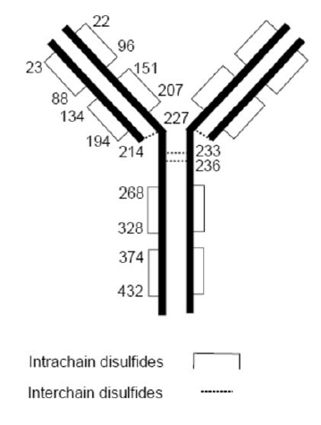

Aducanumab is highly selective for human sequence aggregated amyloid beta. Aducanumab removes aggregated forms of amyloid beta via antibody dependent cell mediated phagocytosis. It also binds and sequesters soluble oligomers that have been shown to be neurotoxic.

Three manufacturing processes were used in the production of aducanumab for the clinical studies. The sponsor included an analytical comparability assessment of products manufactured by these different processes. The TGA’s quality evaluation concluded that these products were comparable from a quality perspective.

In summary, the TGA’s quality evaluation has concluded that there are no objections on quality grounds to the approval of Aduhelm (aducanumab).

### Nonclinical

The primary pharmacology studies lend support for the clearance of aggregated forms of amyloid in the brain at the proposed clinical dose. However, no direct correlation with improvements in cognitive function were demonstrated.

No off-target organs of toxicity were identified in monkeys. In transgenic mice, dosing of aducanumab or a murine surrogate (ch2F6A) showed ‘on-target’ toxicity findings of:

* Murine surrogate (fully functional): brain (reversible) increased incidences and/or severity of meningeal vascular inflammation, thrombosis, acute haemorrhage and perivascular lymphocytic infiltration.
* Aducanumab (less fragment crystallisable (Fc) effector function): no brain findings in mice except slight increases in microhaemorrhages.
* Findings in mice reflect the same amyloid related imaging abnormalities of vascular oedema/brain microhaemorrhages seen in patients with aducanumab dosing.

Examination of safety pharmacology parameters (incorporated into general repeat dose toxicity studies) revealed no adverse effects by aducanumab in monkeys and Tg2576 mice;[19] or the murine analogue in Tg2576 mice on cardiovascular or respiratory function at relatively high exposures in monkeys. There were no clinical signs of adverse central nervous system effects at these exposures.

No clear direct treatment related off target effects were seen in monkeys with aducanumab at less than or equal to 300 mg/kg intravenous given once every week for four weeks (exposure ratio based on area under the concentration time curve 38).

Carcinogenicity studies were not conducted, which was considered as acceptable in the TGA’s nonclinical evaluation in accordance with the relevant TGA adopted guideline.[20]

No genotoxicity studies were conducted. Given the protein nature of the drug this was considered acceptable in the TGA’s nonclinical evaluation in accordance with the relevant TGA adopted guideline.20

The nonclinical evaluation has recommended that the pregnancy category should be revised from B1;[21] to B2.[22]

In summary, the TGA’s nonclinical evaluation has no major objections to the approval of Aduhelm (aducanumab).

### Clinical

#### Summary of clinical studies

The clinical dossier consisted of:

* Two Phase I pharmacokinetic and safety studies
  + Study 221AD101 (abbreviated to Study 101), a Phase I, randomised, double blind, placebo controlled, single ascending dose study to:
    - primarily evaluate the safety and tolerability of a range of aducanumab doses administered as single intravenous infusions; and
    - secondly, to assess the pharmacokinetics and evaluate the immunogenicity of aducanumab.
  + Study 221AD104 (or Study 104), a Phase I, randomised, double blind, placebo controlled, single and multiple ascending dose study to:
    - primarily evaluate the safety and tolerability of single and multiple intravenous infusions of aducanumab; and
    - secondly to evaluate serum pharmacokinetics of single and multiple intravenous infusions of aducanumab and the effect of single and multiple intravenous infusions of aducanumab on immunogenicity.
* One Phase I bioavailability study
  + Study 221AD102 (or Study 102), a Phase I, randomised, open label, parallel arm study to:
    - primarily evaluate the absolute bioavailability of a single fixed subcutaneous dose versus a single weight based intravenous dose of aducanumab and characterise the pharmacokinetic profile of aducanumab; and
    - secondly to evaluate the safety and tolerability of aducanumab and characterise additional pharmacokinetic parameters of a single fixed subcutaneous dose versus a single weight based intravenous dose of aducanumab.
* One Phase Ib safety and pharmacokinetics/pharmacodynamics study
  + Study 221AD103 (or Study 103), a Phase Ib, randomised, double blind, placebo controlled study with staggered parallel group, followed by an optional dose blind long term extension period to:
    - primarily evaluate the safety and tolerability of multiple doses of aducanumab; and
    - secondly, to assess the effect of aducanumab on cerebral amyloid plaque content, assess serum concentrations of aducanumab and evaluate the immunogenicity of aducanumab.
* One Phase II safety study
  + Study 221AD205 (or Study 205), a Phase II, randomised, parallel group, double blind, controlled study followed by a long term extension period to:
    - primarily assess the safety impact of continuing aducanumab dosing in asymptomatic amyloid related imaging abnormalities; and
    - secondly to characterise amyloid related imaging abnormalities and the safety, tolerability, pharmacokinetics and immunogenicity of aducanumab.
* Two Phase III efficacy and safety studies
  + Studies 221AD 301 and 221AD302 (or Studies 301 and 302), two Phase III, randomised, double blind, placebo controlled, parallel group studies, followed by a dose blind long term extension period to:
    - primarily evaluate the efficacy of monthly doses of aducanumab in slowing cognitive and functional impairment; and
    - secondly, to assess the effect of monthly doses of aducanumab as compared with a placebo on clinical progression as measured by various endpoints; and
    - in addition, the studies also aimed to assess the safety and tolerability and immunogenicity of aducanumab.
* One Phase III (b) safety study
  + Study 221AD304 (or Study 304), a Phase III (b), open label, single arm study to evaluate the long term safety of aducanumab in participants who had previously participated in aducanumab studies.

Studies 103, 205, 301 and 302 were terminated on the 21 March 2019.

Study 103 was terminated after the placebo-controlled phase and during the long term extension phase.

Study 205 was planned to recruit 500 subjects. At the time of study termination, 52 subjects were randomised and under treatment in the study. None of the participants were treated with the proposed 10 mg/kg dose of aducanumab, which has limited the availability of safety data at this dose.

Studies 301 and 302 were terminated following the negative outcome of a pre-specified futility analysis.

Figure : Aduhelm (aducanumab) clinical study program

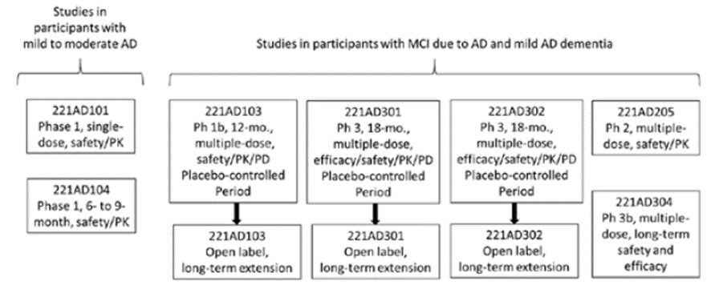

Abbreviations: AD = Alzheimer’s disease, MCI = mild cognitive impairment, mo = months, Ph = phase, PD = pharmacodynamics, PK = pharmacokinetics.

*The aducanumab clinical development program also included a Phase I bioavailability study (Study 221AD102) in healthy participants that is not included in the figure.

**Termination of all ongoing studies was announced on 21 March 2019 based on results of a futility analysis of interim data from Studies 221AD301 and 221AD302. Data collection from these studies continued per protocol through the last safety follow up visit.

#### Pharmacology

##### Absorption

Aducanumab has negligible oral availability and hence it is administered parenterally to avoid enzymatic degradation in the gut. A Phase I bioavailability study (Study 102) assessed absorption from subcutaneous sites, showing that bioavailability was reduced to 54% by this route.

##### Distribution

Based on the pharmacokinetic (PK) population analysis, the mean value (95% confidence interval (CI)) for volume of distribution of aducanumab at steady state is 9.63 L (9.48, 9.79). Study 102 also reported a geometric mean at 10.4 L (coefficient of variation 16.8%). Mean (95% CI) steady state is expected to be reached in 4.05 (2.42, 6.19) months.

##### Metabolism

Aducanumab is broken down to peptides and amino acids and cleared by catabolism (protein metabolism pathway).

##### Excretion

Based on population pharmacokinetic (popPK) modelling, mean (95% CI) aducanumab clearance is 0.0159 L/hr (0.0156, 0.0161). The terminal half-life is 24.8 days (14.8, 37.9).

##### Pharmacokinetics

The proposed four weekly regimen of aducanumab achieved a steady state concentration by 16 weeks. Systemic accumulation with multiple doses was 1.7 fold, relative to single doses. The maximum concentration, minimum concentration and area under the concentration time curve at steady state of aducanumab increased in a roughly dose proportional manner over the dose range of 1 mg/kg to 10 mg/kg every four weeks.

The clinical evaluation concluded that the PK of aducanumab appeared to be linear in the dose range between 1 mg/kg and 10 mg/kg, and it also appeared to be well characterised by the popPK model.

Study 101 assessed the single dose PK of aducanumab. The single dose PK of intravenous aducanumab were compared to subcutaneous aducanumab in Study 102, which revealed a much lower absorption rate.

##### Population pharmacokinetics data

The PK of aducanumab was also assessed in a population pharmacokinetic (popPK) analysis involving concentration data collected from three Phase I and two Phase III studies (Studies 101, 103, 104, 301, and 302). The final popPK model was based on 2,961 subjects with Alzheimer’s disease who received single aducanumab doses of 0.3 to 60 mg/kg, or multiple doses in the range of 1 to 10 mg/kg every four weeks.

All of the studies contributing to the sponsor’s popPK model involved subjects with prodromal or early Alzheimer’s disease. There were no important PK differences between studies in Alzheimer’s disease subjects and studies in healthy volunteers. In general, residual errors were low, and goodness of fit plots did not show major deviations from the modelling assumptions. The standard error of the parameter estimates was also low.

Baseline bodyweight, sex, age, race, and Baseline mini mental state examination (MMSE);[23] were all identified as covariates of exposure. Inclusion of these covariates explained approximately 23% in clearance, 32% in volume of central compartment, and 23% in volume of peripheral compartment. The magnitude of these variations in exposure were not considered as to be clinically important.

##### Pharmacodynamics

###### Study 301

Four treatment groups were included in the study for the purpose to determine and compare the pharmacodynamic effects of high and low doses of aducanumab, when commenced early and late during the study period.

At Week 78 and 132, based on the available data, it appears that the early start of a high dose of aducanumab (proposed dose for registration) enabled to achieve a greater reduction in brain amyloid beta load (standardised uptake value ratio (SUVR)), compared to late start of high dose. The treatment difference was statistically significant. However, a high attrition rate was noted at Week 132 across all dose groups from the commencement of study. At Week 132, almost 50% of subjects had dropped out. This limits the ability to make any conclusions regarding the PD effect of aducanumab.

The clinical evaluation highlighted that the reduction in the SUVR for the high early start high dose group was 0.234 in the first 78 weeks, amounting to 0.00300 per week. After that, the reduction in SUVR was 0.057 (0.291 minus 0.234) over 54 weeks (132 minus 78 weeks), which is 0.00106 per week, about a third (35%) of the initial rate.

Table : Study 301 change from Baseline in amyloid positron emission tomography composite standardised uptake value ratio

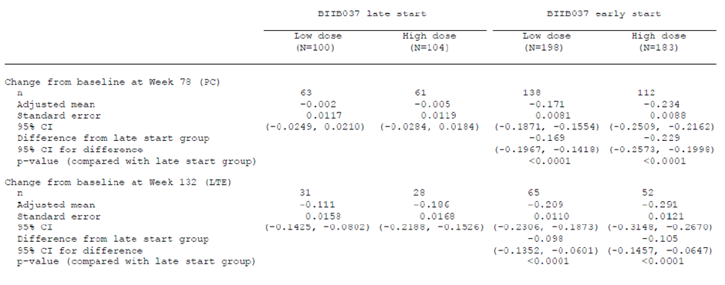

Abbreviations: PC = placebo controlled, LTE = long term extension, CI = confidence interval

Note 1: Early start subjects are those assigned to BIIB037 in both placebo controlled and long term extension period, and late start subjects are those assigned to placebo in placebo controlled period and BIIB037 in long term extension period. The reference group is late start low dose for early start low dose and late start high dose for early start high dose.

Note 2: Results were based on a mixed model for repeated measures model, with change from baseline as dependent variable and with fixed effects of treatment group, categorical visit, treatment by visit interaction, baseline SUVR value, baseline SURV value by visit interaction, baseline MMSE, baseline age and laboratory ApoE status.

#### Efficacy

##### Dosage selection for the pivotal studies

The dosing regimens selected for this Phase III study were based on hypothesis generated based on PK/PD data from the interim analysis of Study 103. Based on the interim data from Study 103, it was hypothesised that aducanumab 10 mg/kg would maximise clearance of brain amyloid beta as well as clinical efficacy. It was also hypothesised that aducanumab titrated to 10 mg/kg (as opposed to fixed dosing) would minimise the incidence of amyloid related imaging abnormality which appeared to be related to aducanumab dose. However, in August 2015 when the Phase III studies began, Study 103 results for the titration arm (which included apolipoprotein E allele 4 (*ApoE* ε4) carriers only, dosed at 10 mg/kg after titration) were not yet available. During the study the sponsor found that the incidence of amyloid related imaging abnormality in the fixed dose arms was observed to be both dose and *ApoE* ε4 carriage dependent.

In August 2016, results from Study 103 for participants titrated to 10 mg/kg in *ApoE* ε4 carriers were available. Analysis of data from this cohort showed that the incidence of amyloid related imaging abnormality oedema, as well as discontinuations from study treatment due to amyloid related imaging abnormality oedema, in *ApoE* ε4 carriers receiving aducanumab titrated to 10 mg/kg appeared to be reduced compared with the previously reported interim results for the 10 mg/kg fixed dose regimen, which was studied in both *ApoE* ε4 carriers and noncarriers. Based on these results, the ongoing Phase III protocol was amended.

It was noted that as per protocol version 4, the dose for *ApoE* ε4 carriers in the high dose group was increased from 6 to 10 mg/kg, titrated over 24 weeks. This is not in line with the proposed dosing regimen. The sponsor was requested to clarify.

The clinical evaluation highlighted the lack of dose ranging Phase II study in the clinical development programme to prospectively explore the optimal dose of aducanumab in Alzheimer’s disease patients with and without Apo E genotype for better treatment outcomes and also to identify the dose that would have minimised the potential to develop amyloid related imaging abnormality as a methodological flaw. In addition to clinical data, the PK/PD data for the removal of brain amyloid beta during interim analysis of the Phase II Study 103 appears to be the only dose related data that was available at the time of that start of the pivotal Studies 301 and 302.

The final proposed dosing regimen was not identified at the start of the pivotal studies, thus leading to shorter treatment exposure than planned as per statistical methods. The sponsor launched the pivotal study program with two different dosing strategies (low dose: 3 mg/kg for *ApoE* ε4 carriers, and 6 mg/kg for noncarriers; high dose: 6 mg/kg for *ApoE* ε4 carriers, and 10 mg/kg for noncarriers). Selection of these doses was considered as hypothetical (rationale explained in above paragraph).

The dose changes via protocol amendments during the pivotal studies led to identifying the optimal dose midway through the studies, rather than confirming the dose at the start of the study and prospectively assessing its treatment benefits. In the dossier, the sponsor claims that the dosing strategy used in the high dose group of protocol version 4 is appropriate. The clinical evaluation highlighted that the pivotal study results led them to this conclusion rather than confirming it. Taken together, the Delegate considers that the issues related to dose selection during the pivotal study and heterogeneity in the treatment exposure within and between groups have led to hypothesis generation and identifying a dose of aducanumab.

The TGA’s clinical evaluation concluded that the clinical benefit of aducanumab 10 mg/kg without dose adjustments for *ApoE* ε4 status still awaits prospective confirmation. The Delegate agrees with this conclusion.

##### Study 103

Phase I (b) randomised control trial with PK and PD parameters as primary endpoints. Efficacy endpoints were exploratory in nature. Multiple doses of aducanumab were administered in participants with prodromal Alzheimer’s disease (mild cognitive impairment) or mild Alzheimer’s disease dementia.

The overall study design was in line with a proof-of-concept Phase I study.

Study treatment:

* Arms 1 to 3: aducanumab 1 mg/kg, 3 mg/kg, or placebo in a 3:3:2 ratio.
* Arms 4 and 5: aducanumab 10 mg/kg or placebo in a 3:1 ratio.
* Arms 6 and 7: aducanumab 6 mg/kg or placebo in a 3:1 ratio.
* Arms 8 and 9: aducanumab, titrated up to 10 mg/kg, or placebo in a 3:1 ratio.

The clinical evaluation highlighted the staggered, parallel group design. The first three treatment arms (Arms 1 to 3) enrolled in parallel, followed by Arms 4 and 5 enrolled in parallel, Arms 6 and 7 enrolled in parallel, and finally Arms 8 and 9 enrolled in parallel. It is noted that the final pooled placebo group was not enrolled or treated concurrently with the 10 mg/kg dose group, and blinding was only maintained across concurrent treatment arms, so the higher active dose groups were compared with subjects who were known to have received either placebo or a low dose of aducanumab. The clinical evaluation considered the lack of concurrent randomisation as a critical methodological deficiency that limits to make any conclusions related to the clinical endpoints. It was considered acceptable for the objective primary pharmacodynamic endpoints and as a rough proof-of-principle exercise.

The primary objective of the study was to evaluate the safety and tolerability of multiple doses of aducanumab in participants with prodromal Alzheimer’s disease or mild Alzheimer’s disease dementia.

The secondary objectives were:

* To assess the effect of aducanumab on cerebral amyloid plaque content as measured by 18F-AV-45 positron emission tomography imaging (at Week 26).
* To assess the multiple dose serum concentrations of aducanumab.
* To evaluate the immunogenicity of aducanumab after multiple dose administration in this population.

Individuals in the prodromal phase of Alzheimer’s disease or having mild Alzheimer’s disease dementia (MMSE 20 to 26, global Clinical Dementia Rating (CDR)[24] score of 0.5 or 1) and a positive positron emission tomography scan for cerebral amyloid plaque content were enrolled. Individuals were screened with brain magnetic resonance imaging (MRI) and those with any signs of acute or sub-acute haemorrhage or prior haemorrhage were excluded.

The study had no formal efficacy endpoints.[25] A number of cognitive assessments were performed during the study period. It was highlighted that the sponsor did not perform any correction for the multiplicity of clinical endpoints or the multiplicity of dose groups. Hence, the TGA’s clinical evaluation considered the efficacy outcomes as nominal. The Delegate agrees with this conclusion.

The study lacked formal definitions of different analysis populations and lacked formal statistical hypothesis relating to cognitive (efficacy) endpoints. A total of 197 subjects were randomised into the study, and 196 received at least one dose of study treatment.

The sponsor performed power estimates based on PD endpoints. The primary PD endpoint was change from Baseline to Week 26 in positron emission tomography signal in designated brain areas that assessed brain amyloid beta load. A sample size of 30 participants per treatment group was estimated to provide over 90% power to detect a treatment difference of 1 standard deviation (SD) with respect to the reduction of amyloid from Baseline, based on a comparison of each aducanumab group with placebo, at a two sided significance level of 0.05, and assuming a dropout rate of 20%.

The mean age was 72.8 years (SD 7.9). At Baseline, the mean MMSE score was 24.3 (mild), the mean clinical dementia rating sum of boxes (CDR-SB)[26] score was 3.2. A total 77% of participants had a global CDR score of 0.5, while 23% had a global CDR score of 1.0 (mild cognitive impairment). The number of subjects with more advanced dementia (MMSE less than or equal to 20) ranged from 9% to 28% across the different active dose groups.

###### Results

At Week 54, five active dose groups achieved numerical superiority over the pooled placebo group for the CDR-SB change (exploratory outcome) from Baseline at Week 54. The adjusted mean change (increase) from Baseline in CDR-SB score was smaller for the 1 mg/kg (1.69), 3 mg/kg (1.33), 6 mg/kg (1.09) and 10 mg/kg (0.63) fixed dose groups, as well as the 10 mg/kg titration group (0.7), in comparison to the pooled placebo group (1.89). The difference relative to placebo was nominally significant for the 10 mg/kg fixed dose group (p = 0.0246) and the titration group (p = 0.0432), without correction for multiplicity.

Mini mental state examination (MMSE) was analysed retrospectively. At Week 52, adjusted mean changes (decreases) from Baseline in MMSE score were numerically smaller in the 1 mg/kg (-2.21), 3 mg/kg (-0.75), 6 mg/kg (-1.99), and 10 mg/kg (-0.55) aducanumab fixed dose groups, compared with the pooled placebo group (-2.45). A nominally significant difference from placebo was noted for the 10 mg/kg fixed dose group (p = 0.043). In the 10 mg/kg titration group, the adjusted mean change from Baseline to Week 52 (-1) was numerically superior, compared to placebo, but nominal significance was not achieved.

###### Limitations of Study 103

* At Week 54, the average dose in the 10 mg/kg titration group was 5.3 mg/kg. This limits the ability to compare efficacy findings between the fixed dose 10 mg/kg group and the titration group and also with the proposed dose of aducanumab.
* This study was not designed as an efficacy study, and it had no formal efficacy related hypotheses.
* The p-values have not been corrected for multiplicity, hence considered as nominal.
* The fixed dose 10 mg/kg group had a higher rate of withdrawal than other groups, potentially enriching this dose group with subjects who had less cognitive decline than would have been found in those who withdrew.
* Blinding was incomplete, potentially leading to bias.

##### Pivotal efficacy studies (overview of Studies 301 and 302)

Pivotal Studies 301 and 302 commenced in August and September 2015 respectively. Both Phase III studies were terminated early on 20 March 2019, following the negative results from the pre-planned interim futility analysis. The interim results suggested that both trials are unlikely to achieve primary endpoint. The analysis was done with pooled data from around 50% of the subjects from both studies (Study 301 and Study 302) who completed the 78 weeks of treatment period. At a later time point, the sponsor repeated the analysis in a larger patient cohort. The results of this analysis showed positive results for Study 302 and not for Study 301.

###### Futility analysis

Futility analysis was pre-specified and blinded. The analysis was based on the data from approximately the first 50% of the participants in both Studies 302 and 301 who completed the Week 78 visit. The futility criteria were primarily based on conditional power, which was the probability that the primary efficacy endpoint analysis would be statistically significant in favour of aducanumab at the planned final analysis, given the data at the futility analysis.

The data cut off date for the futility analysis was 26 December 2018. As of this date, 57% of participants from Study 301 and 49% of participants from Study 302 completed the Week 78 visit.

The studies were to be considered futile if both studies had conditional power for the primary efficacy analysis less than 20% in both the high dose and the low dose groups.

Table : Studies 301 and 301 Comparison of futility and April intention to treat dataset

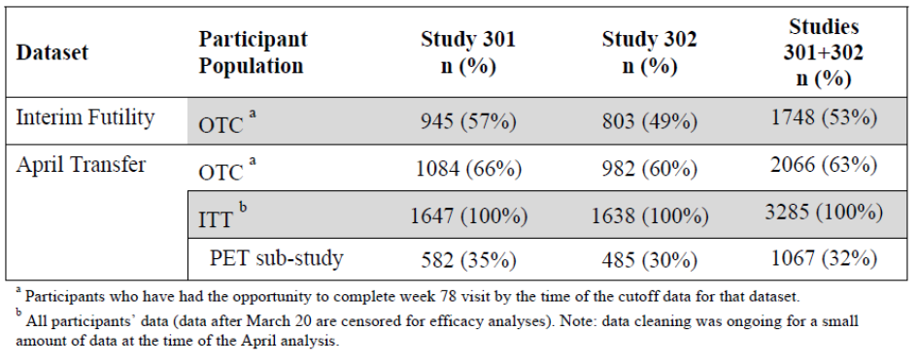

Abbreviations: OTC = opportunity to complete, ITT = intention to treat, PET = positron emission tomography.

a Participants who have had the opportunity to complete Week 78 visit by the time of the cut off data for the dataset.

b All participants data (after March 20 are censored for efficacy analyses). Note: data cleaning was ongoing for a small amount of data at the time of the April analysis.

###### Futility results

With estimated conditional power values of 12% for Study 302 and 0% for Study 301, the probability of a statistically significant difference was below the prespecified cut-off of 20%. Futility criteria were met.

The percent treatment difference favouring aducanumab was -18% on the CDR-SB and ‑20% on both the MMSE and Alzheimer’s Disease Assessment Scale–Cognitive Subscale-13 items (ADAS-Cog 13)[27] in Study 302. In contrast, a treatment difference favouring placebo was reported in Study 301 on the CDR-SB and MMSE (15% and 13%, respectively). The sponsor’s assumption that the treatment effect in the two studies would be equal was not upheld.

Table : Studies 301 and 302 futility results

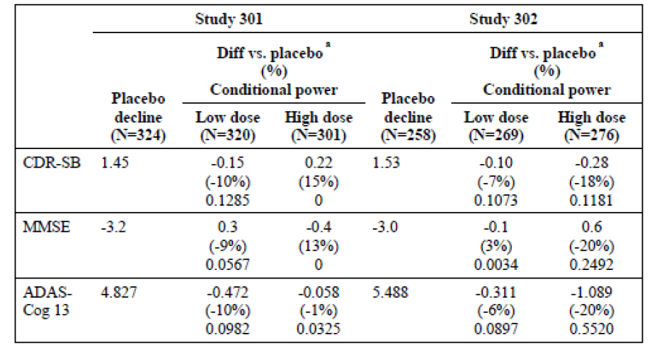

Abbreviations: CDR-SB = clinical dementia rating sum of boxes, MMSE = mini mental state examination, ADAS-Cog 13 = Alzheimer’s Disease Assessment Scale–Cognitive Subscale-13 items.

After the futility announcement, the sponsor re-estimated the conditional power based on a statistical analysis plan addendum, dated 4 November 2019. It should be noted that the re‑estimation was not pre-defined and this addendum was prepared after both studies were terminated. In contrast to the interim analysis, it was assumed that the future unobserved effect would be equal to that estimated from each individual study. Results of the non-pooled futility analysis of the same data set yielded conditional power of 0% and 59% on the primary endpoint for the high dose in Studies 301 and 302, respectively. The non-pooled analysis suggested that the probability that Studies 301 and 302 would end with a statistically significant difference favouring high dose over placebo was 0% and 59%, respectively. Using the non-pooled analysis, given the conditional power of 59% for Study 302, the sponsor’s assumption was that the studies would not have met futility criteria.

Further, repeated evaluation of a larger data set was also conducted following the futility announcement. This analysis included all data available as of 1 April 2019 (April transfer data) from all randomised and dosed participants but with their efficacy data after 20 March 2019 censored.

These statements are excerpts from the sponsor’s ‘Summary of Clinical Efficacy’ included in the dossier:

‘After including the additional participants and all efficacy data through 20 March 2019, which were collected under the protocol specified double blind conditions prior to the futility announcement, the results of the primary analysis showed a statistically significant difference (nominal) favouring the high dose over placebo in Study 302 (treatment difference favouring aducanumab improved from -18% to -23% on the CDR-SB). The results for the high dose group in Study 301 no longer showed a marked worsening versus placebo (treatment difference favouring placebo improved from 15% to 2% on the CDR-SB)’

The sponsor’s assumption for the contrasting outcomes was:

‘The larger treatment effect of the high dose group seen in the April transfer data analysis compared with the futility analysis is possibly due to the anticipated impact from protocol amendment four that gave later participants the opportunity to receive higher dose of aducanumab.’

The sponsor states that the larger data set was analysed as prespecified and it was the same as the method for the futility analysis. However, it should be noted that the dataset, the plan for repeated analysis and the time point for repeated analysis were not prespecified.

The sponsor has stated that all p-values from the April intention to treat analysis are to be considered as nominal.

Table : Studies 301 and 302 results of April intention to treat dataset repeated analysis

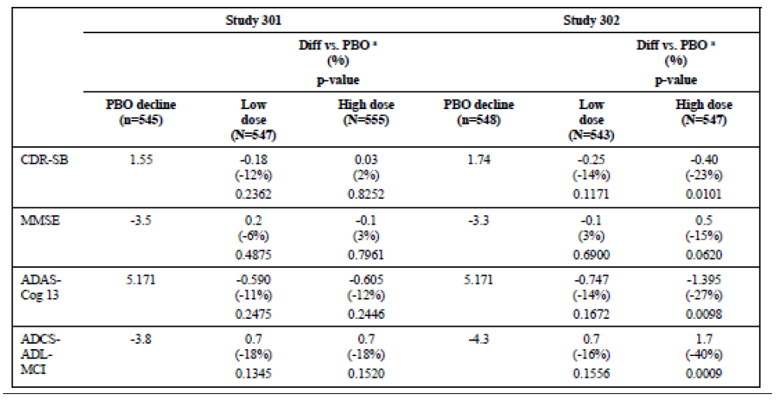

Abbreviations: PBO = placebo, CDR-SB = clinical dementia rating sum of boxes, MMSE = mini mental state examination, ADAS-Cog 13 = Alzheimer’s Disease Assessment Scale–Cognitive Subscale-13 items, ADCS-ADL-MCI = Alzheimer’s Disease Cooperative Study-Activities of Daily Living (Mild Cognitive Impairment).

##### Study 301

Study 301 is a double blind, parallel group randomised controlled trial. The study compared the efficacy of aducanumab at two different dosing levels low dose (3 or 6 mg/kg four weekly) and high dose (6 or 10 mg/kg four weekly) versus placebo in the treatment of subjects with early Alzheimer’s disease, using clinical and cognitive endpoints.

Study subjects had either mild cognitive impairment due to Alzheimer’s disease or mild Alzheimer’s disease dementia. Enrolment was adjusted so that subjects with mild cognitive impairment represented approximately 80% of the total study population.

The study was planned to have an 18 month placebo controlled double blind treatment period, followed by a long term extension period.

The primary objective was to evaluate the efficacy of monthly doses of aducanumab in slowing cognitive and functional impairment as measured by changes in the CDR-SB score as compared with placebo in participants with early Alzheimer’s disease.

The secondary objectives were to assess the treatment effect of aducanumab on clinical progression, measured by MMSE, ADAS-Cog 13, Alzheimer’s Disease Cooperative Study-Activities of Daily Living (Mild Cognitive Impairment) (ADCS-ADL-MCI).[28]

###### Key inclusion criteria

* Positive positron emission tomography brain scan for amyloid beta.
* Clinical Dementia Rating (CDR) scale global score of 0.5.[29]
* Reputable Battery for the Assessment of Neuropsychological Status (RBANS) score of 85 or lower on the Delayed Memory Index score, indicative of objective cognitive impairment.[30]
* Mini Mental State Examination (MMSE) score between 24 and 30 (inclusive): Mild Cognitive Impairment or Mild dementia).
* Aged 50 to 85 years at screening.

###### Study treatments

Low dose aducanumab, high dose, aducanumab, or placebo were administered as intravenous infusion in a 1:1:1 ratio once every four weeks during the planned study period of 18 months.

To reduce the risk of amyloid related imaging abnormalities, the aducanumab dose was titrated for up to six doses prior to reaching the target dose, as follows:

Apolipoprotein E allele 4 (*ApoE* ε4) carriers

* Low dose (3 mg/kg), 1 mg/kg for the first two doses, 3 mg/kg thereafter.
* High dose (6 mg/kg), 1 mg/kg for the first two doses, 3 mg/kg for the next four doses, and 6 mg/kg thereafter (protocol version 1 through to 3).
* High dose (10 mg/kg), 1 mg/kg for the first two doses, 3 mg/kg for the next two doses, 6 mg/kg for the next two doses, and 10 mg/kg thereafter (protocol version 4 and higher).

Apolipoprotein E allele 4 (*ApoE* ε4) non-carriers

* Low dose (6 mg/kg), 1 mg/kg for the first two doses, 3 mg/kg for the next four doses, and 6 mg/kg thereafter.
* High dose (10 mg/kg), 1 mg/kg for the first two doses, 3 mg/kg for the next two doses, 6 mg/kg for the next two doses, and 10 mg/kg thereafter (all protocol versions).

Figure : Study 301 time points for dose titration, clinical assessment, positron emission tomography and magnetic resonance imaging

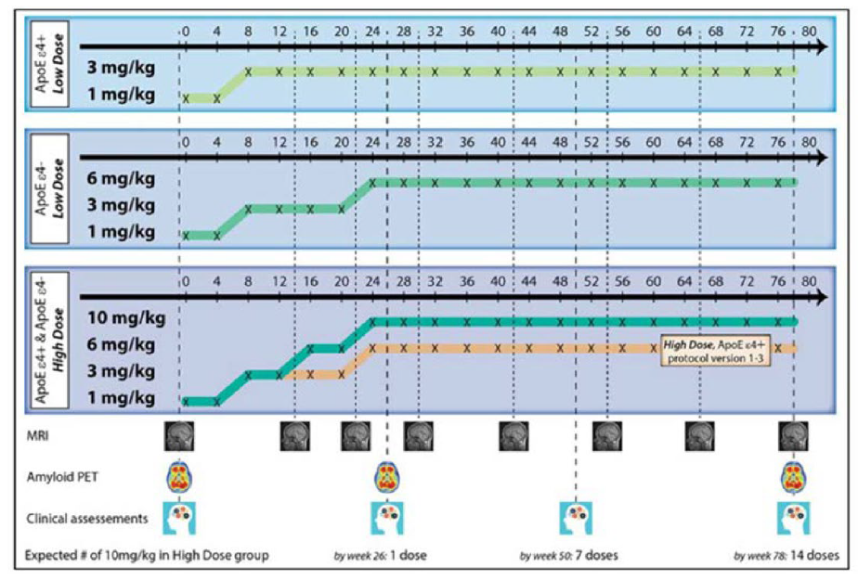

Abbreviations: ApoE ε4 = apolipoprotein E allele 4, MRI = magnetic resonance imaging, PET = positron emission tomography.

The efficacy results for Studies 301 and 302 were categorised as low dose and high dose. The issue is that the exact dose of aducanumab that was defined as low dose and high dose at the time of analysis is different from that defined at the commencement of the study. In contrast to the time of analysis, at the start of the study the patient population was categorised based on *ApoE* ε4 status. *ApoE* ε4 carriers and non-carriers had different doses defined as low and high. Further to protocol amendment, based on protocol version 4 (based on evidence from Study 103), the high dose for *ApoE* ε4 carriers was raised from 6 mg/kg to 10 mg/kg.

The categorisation of subjects based on *ApoE* ε4 status changed midway through the study. At the time of analysis, the intention to treat population was categorised as low dose and high dose. The low dose constituted both (*ApoE* ε4 positive and negative) subjects who received 6 mg/kg and 3 mg/kg. Similarly, the high dose group constitutes both (*ApoE* ε4 positive and negative) subjects who received 10 mg/kg aducanumab for different duration of time during the treatment period. The clinical effects are likely to be heterogeneous in both these groups. This is a critical issue that affects internal and external validity of findings of the repeated analysis.

It should be noted that allocation to the three different doses was not random, but was instead based on *ApoE* ε4 carrier status, which is known to affect prognosis. This approach limited to perform a direct comparison of efficacy for each subject category at different doses.

Dosing was also adjusted in response to radiological abnormalities seen on MRI (amyloid related imaging abnormalities), as summarised in Table 8 below. Amyloid related imaging abnormalities episodes were subdivided into those with oedema and those with haemorrhage. Distinct protocols specified dose interruptions or treatment withdrawal based on the severity of the radiological findings for these subgroups.

Table : Study 301 amyloid related imaging abnormalities management across various versions of study protocols

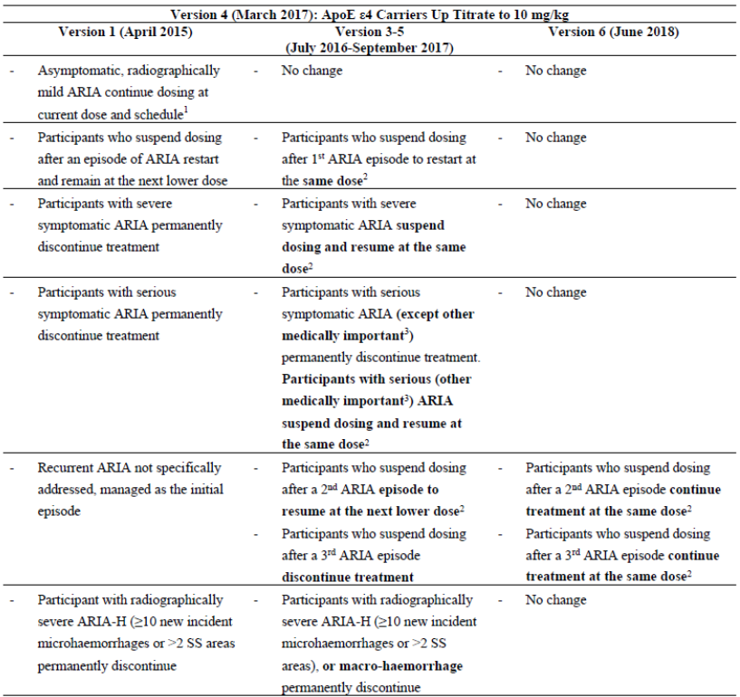

Abbreviations: ApoE ε4 = apolipoprotein E allele 4, ARIA = amyloid related imaging abnormalities, ARIA‑H = amyloid related imaging abnormalities with haemorrhage, SS = superficial siderosis.

1 Suspend dosing only if amyloid related imaging abnormalities become symptomatic or radiographically moderate. Radiographically severe amyloid related imaging abnormalities with oedema also suspends dosing, while severe amyloid related imaging abnormalities with haemorrhage permanently discontinues.

2 Following resumption of dosing, titration to continue (if applicable).

3 ‘Other medically important events’ requiring dose suspension include severe adverse events that are not life threatening (in the opinion of the investigator), do not require inpatient or prolongation of existing hospitalisation, and do not result in significant or permanent disability or congenital abnormalities or fetal defects, but may (in the opinion of the investigator) jeopardise the participant or may require intervention.

###### Statistical methods

The sponsor used a hierarchical approach (sequential closed testing procedure) to address the multiplicity statistical issues created by using two dose groups. The clinical evaluation highlighted that the sponsor did not adjust for the potential multiplicity issues due to the change in dosing that were adopted as the protocols changed. The TGA’s clinical evaluation also highlighted the potential for the numerous *post hoc* analyses leading to multiplicity issues.

The TGA’s clinical evaluation has highlighted the lack of a single hierarchy for statistical hypotheses to test only the high dose comparison and the gated approach for subsequent comparisons. The sponsor’s approach to adopt two parallel hierarchies was considered as inadequately addressing the issue of multiplicity.

The TGA received input from an expert biostatistician regarding the sponsor’s statistical approach.

The key findings from this expert input were:

* Multiplicity within each pivotal study has been adequately addressed for the prespecified interim analysis (futility analysis).
* Multiplicity across pivotal studies not adequately addressed.
* When multiple studies are available, a sequential closed testing procedure applied separately to each study is inadequate. Even with the control of type 1 error within studies, there is still a (5%) chance of a false positive result for each individual study. Thus, when there are multiple studies, some positive and some negative, it is inappropriate to rely only the positive studies.
* Meta-analysis provides a robust approach to the control of false positive rates by aggregating the totality of evidence. This submission has not presented a meta‑analysis of the available studies.
* There is a major risk that relying only on Study 302 in isolation, with no synthesis of the totality of evidence using a meta-analysis, introduces a high likelihood of a false positive result.

The Delegate noted that randomisation was stratified based on *ApoE* ε4 carrier status (carrier or non-carrier). This is not in line with the proposed dosing regimen, which is not based on *ApoE* ε4 status, hence lacking external validity of findings. This also leads to limited data for the proposed dose regimen.

The sample size for Study 301 was partially based on results from an interim analysis of Study 103, which included one year data from the 1, 3, and 10 mg/kg fixed dose treatment groups. It should be noted that the sample size estimation was not aimed at the final proposed titration dosing regimen. It is a limitation that this regimen was not known at the commencement of pivotal studies and hence not able to be utilised for power estimation. It should be noted that sample size was re-estimated during the study period.

The sample size was considered to provide approximately 90% power to detect a true mean difference of 0.5 in change from Baseline CDR-SB at Week 78 between the two treatment groups. The sponsor justified the clinical value of a mean difference of 0.5 between the two treatment groups by noting that, if the mean deterioration in the placebo group from Baseline to Week 78 was expected to be 2 points (based on published longitudinal studies of Alzheimer’s disease), a treatment effect of 0.5 would represent a 25% reduction in cognitive decline. This approach was considered as acceptable.

During the conduct of this study, the sample size was reassessed in a blinded manner, approximately three months before enrolment would have been completed, and the target enrolment was adjusted from 1350 to 1605 subjects (450 to 535 per treatment). The Delegate noted that the rationale/justification for this approach is unclear. The sponsor was requested to clarify.

A total of 1647 subjects constituted the intention to treat population (n = 555 in high dose and n = 547 in low dose of aducanumab treatment groups and n = 545 in the placebo group).

The opportunity to complete population was defined as participants in the intention to treat population who had the opportunity to complete Week 78 by 20 March 2019 (n = 1084: 345 from the aducanumab high dose treatment group, 370 from the aducanumab low dose treatment group, and 369 from the placebo treatment group.) The clinical evaluation considered the opportunity to complete group as important, since a high proportion of intention to treat subjects were prevented from completing the study by the sponsor’s decision to abandon it on the grounds of futility. This population was defined *post hoc*.

The 18F-florbetapir;[31] amyloid beta positron emission tomography analysis population was a subpopulation who received at least one dose of study treatment (aducanumab or placebo), used 18F-florbetapir ligand for an amyloid beta positron emission tomography scan, and had an evaluable Baseline standardised uptake value ratio value for the composite region of interest. The cerebellum was used as the reference region (total of 585 subjects: 183 from the aducanumab high dose treatment group, 198 from the aducanumab low dose treatment group, and 204 from the placebo treatment group).

The sponsor also defined a number of other *post hoc* analysis populations, based on which protocol was current when patients joined the study, and how many doses of 10 mg/kg were received, and whether the primary efficacy variable showed rapid decline. None of these populations were considered by the clinical evaluation as having statistical validity.

The primary analysis was performed in the intention to treat population. A mixed model repeated measures model was utilised to assess change from baseline CDR-SB to Week 78. A similar approach was adopted for secondary endpoints (MMSE, ADAS-Cog 13, and ADCS‑ADL-MCI).

The order of treatment comparisons for the primary endpoint was intended to be: aducanumab high dose versus placebo, and then aducanumab low dose versus placebo. The sponsor stated:

*‘All comparisons after the initial comparison with p > 0.05 will not be considered statistically significant.”*

A total of 1653 participants were randomised and 1647 were treated. At the time of the interim analysis, out of the treated patients, 56.3% completed treatment. Apart from the study termination, occurrence of adverse events was another common reason for discontinuing treatment. Adverse events were more common with active treatment (placebo, 5.1%; low dose, 8.2%; high dose, 11.4%). Differences across treatment groups were also observed in the percentages of participants who withdrew from the study due to adverse events (placebo, 2.9%; low dose, 4.6%; high dose, 5%). The number of subjects who withdrew consent was similar in the placebo and high dose groups, but lower in the low dose group (placebo, 4.8%; low dose, 2.9%; high dose, 4.9%). Subjects on high dose aducanumab were the less likely to complete treatment (completion rates: placebo 59.8%, low dose aducanumab 59.6%, high dose aducanumab 49.5%). The clinical evaluation considered that the unequal withdrawals raised the possibility that this study suffered from withdrawal bias, the impact of which (subjects with adverse events withdrawing) is likely to favour the aducanumab group. The Delegate agrees with this possibility.

###### Baseline characteristics

The mean age was around 70 years, 52.4% of the subjects were females. The treatment groups were fairly well balanced in terms of category of cognitive dysfunction (mild cognitive impairment or mild Alzheimer’s dementia), *ApoE* ε4 carrier status, years since diagnosis and performance on a Baseline cognitive test.

As intended in the protocol design, approximately 80% of subjects were suffering from mild cognitive impairment, and 20% from mild Alzheimer’s dementia. Approximately 70% of subjects were carriers for the *ApoE* ε4 allele, with 50.8% of the total study group being heterozygous, 18.8% being homozygous, and 30.3% being non-carriers. Almost all of the subjects had a CDR global score of 0.5. Mean Baseline MMSE was 26.4. Mean Baseline ADAS-Cog 13 score was around 22. The (mean) number of years since first symptom and diagnosis of Alzheimer’s disease were 3.6 and 1.2 respectively.

###### Results

The results of both Studies 301 and 302 are based on the repeated analysis that was conducted in the April intention to treat dataset and at a later time point that was identified (*ad hoc*) after the futility announcement and the termination of the studies. Considering the statistical and methodological aspects in this analysis, the sponsor considered all p values as nominal.

The study did not achieve the primary objective in the initial interim analysis or the repeated analysis.

The Delegate noted that at Week 78, the change from Baseline in CDR-SB at Week 78, showed a worse outcome for aducanumab high dose arm, compared to placebo (treatment difference: 0.03, +2%, p = 0.8330).

The aducanumab low dose arm achieved a numerically better outcome over the placebo arm for the CDR-SB (-0.18, -12% compared to placebo, p = 0.2250).

Table : Study 301 primary endpoint: change from Baseline in Clinical Dementia Rating (sum of boxes); CDR-SB

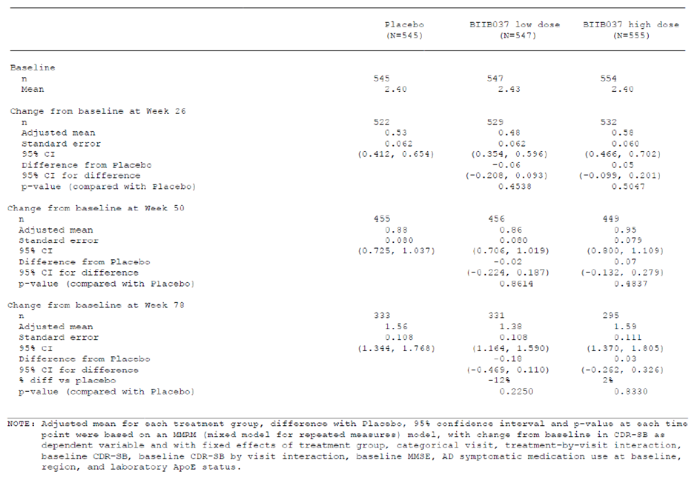

Abbreviations: CI = confidence interval

Note: Adjusted mean for each treatment group, difference with placebo, 95% confidence interval and p-value at each time point were based on a mixed model for repeated measures model, with change from Baseline in clinical dementia rating sum of boxes (CDR-SB) as dependant variable and with fixed effects of treatment group, categorical visit, treatment by visit interaction, Baseline CRD-SB, Baseline CRD-SB by visit interaction, Baseline mini mental state examination (MMSE), Alzheimer’s disease symptomatic medication use at Baseline, region and laboratory Apolipoprotein E (ApoE) status.

###### Sensitivity analyses

The sponsor considered the distribution of the change from Baseline CDR-SB scores as heavily right skewed, indicating that the assumption of normality might have been violated. Hence a sensitivity analysis utilising nonparametric testing was performed.

The nonparametric test p-value based on a rank analysis of covariance (ANCOVA) model was 0.9666 for the aducanumab high dose group and 0.2983 for the aducanumab low dose group. These results are consistent with the primary analysis.

At Week 78, in the per protocol population, the difference between the high dose and placebo groups, based on change from Baseline on the CDR-SB was: 0.09 (+6%) compared to placebo (p = 0.5753). The difference between the aducanumab low dose group and the placebo group was -0.22 (-15%) compared to placebo (p = 0.1515). The Delegate noted the magnitude of worsening of CDR-SB was higher for the per protocol population versus the intention to treat population (6% versus 2%).

###### Secondary endpoints

Mini mental state examination

The difference between the aducanumab high dose group and the placebo group, based on change in MMSE from Baseline to Week 78 was -0.1 (+3% compared to placebo, p = 0.8106), indicating a deterioration on active treatment.

The difference between the aducanumab low dose group and the placebo group was 0.2 (‑6% compared to placebo, p = 0.4795). Additional analyses, including nonparametric testing in the intention to treat population and a mixed model repeated measures analysis in the per protocol population, had similar outcomes.

Table : Study 301 change from Baseline in mini mental state examination (MMSE) by mixed model repeated measures (intention to treat population, placebo controlled period)

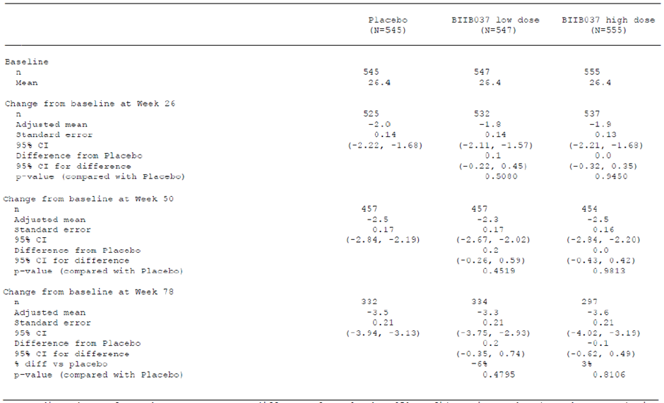

Excluding data added after 20 March 2019

Abbreviations: CI = confidence interval

Note: adjusted mean for each treatment group, difference from placebo, 95% confidence interval and p-value at each time point were based on a mixed model repeated measures model, with change from Baseline in mini mental state examination as dependent variable and with fixed effects of treatment group, categorical visit, treatment by visit interaction, Baseline mini mental state examination, baseline mini mental state examination by visit interaction, Alzheimer’s disease symptomatic medication use at Baseline, region, and laboratory Apolipoprotein E (ApoE) status.

Alzheimer’s Disease Assessment Scale–Cognitive Subscale-13 items

The treatment difference between the aducanumab high dose group and the placebo group, based on change from Baseline on the ADAS-Cog 13 was -0.588 (-11%) (p = 0.2578). A similar treatment difference was reported for the aducanumab low dose group, compared to the placebo group (-0.583 (-11%), p = 0.2536).

Activities of Daily Living (Mild Cognitive Impairment)

The treatment difference between the high dose aducanumab and the placebo groups, based on change from baseline was 0.7 (-18%) compared to placebo (p = 0.1506). A similar outcome was reported for the comparison between the low dose aducanumab and the placebo groups.

Responder analysis

The sponsor assessed the number of subjects who managed to avoid a threshold decline in CDR-SB of 0.5 points or 1.5 points. At 78 weeks, the percentage of responders who experienced a less than 0.5 decline in CDR-SB was lowest (31.5%) in the high dose aducanumab arm. The percentage of responders was comparable across low dose aducanumab and placebo arms (around 37%).

###### Subgroup analyses

No particular subgroup was identified in which there was a strong trend in favour of active treatment. These subgroup analyses were underpowered, and hence the TGA’s clinical evaluation considered that no firm conclusions can be drawn.

The clinical evaluation has noted that the Study 301 had an excess number of subjects whose cognition deteriorated rapidly while receiving high dose aducanumab, and the sponsor has suggested that these ‘rapid progressors’ were over represented in the high dose aducanumab group, masking the efficacy signal. The sponsor defined these subjects as those with a CDR-SB change of greater than 8. There were nine such subjects in the high dose aducanumab group, compared to five with placebo. The clinical evaluation considered that the sponsor was basing this claim on a difference of four rapidly progressing subjects. The sponsor argued that this imbalance put aducanumab at a disadvantage, but the slight excess of ‘rapid progressors’ on aducanumab represents a prospectively obtained efficacy result that raises its own efficacy and safety concerns. It should be considered that these subjects were excluded in the reanalysis, without a valid reason. The sponsor has not defined a method to prospectively identify these ‘rapidly progressing’ subjects. The sponsor has provided no argument to reassure the clinical evaluation that aducanumab did not itself contribute to the excess of rapid progression by causing cerebral inflammation.

In a reanalysis of Study 301 that excluded these ‘rapid progressors’, the treatment effect for high dose aducanumab did not approach nominal statistical significance, and the magnitude of the effect was approximately 0.09 (p = 0.5073), which was below *a priori* estimates of clinical significance (such as the 1 to 2 point difference proposed by Andrews et al., in 2019,[32] and half of a percent of the total score.

##### Study 302

The overall study design, inclusion and exclusion criteria and statistical methods were identical to Study 301.

Approximately 1605 participants were planned after sample size re-estimation (535 per treatment group), and this recruitment target was exceeded during the study period. The clinical evaluation noted that a clear reasoning is lacking in the dossier supplied by the sponsor.

The TGA’s clinical evaluation considered that given each study was independently powered to produce a 90% chance of finding a 0.5 point difference in CDR-SB, the combined statistical power of both studies would be expected to have acceptable power in a pooled analysis for assessing the overall efficacy of aducanumab in this patient population. Such a pooled analysis was not provided in the original submission. The sponsor submitted the analysis, in response to the TGA’s request.

###### Participant disposition

At the time of study termination, 52.2% of subjects completed the planned treatment period. The most common reasons for withdrawing or discontinuing treatment were adverse events.

The higher proportion of subjects discontinued treatment due to adverse events in the high dose arm, compared to low dose and placebo arms (placebo, 3.1%; low dose, 7.7%; high dose, 9%). Similarly, a higher proportion of subjects in the high dose arm withdrew from the study due to adverse events, compared to low dose and placebo arms (placebo, 1.8%; low dose, 2.4%; high dose, 3.7%) The clinical evaluation considered a potential for a withdrawal bias due to the uneven attrition rate and more likely to have an exaggerated apparent treatment benefit, due to the withdrawal of subjects with side effects and suboptimal clinical improvement. The Delegate agrees with this possibility.

A majority of subjects (66.6%) had at least one major protocol deviation. The most common major deviations were related to study procedures (26.9%), and investigational product compliance (23.7%).

###### Baseline characteristics

The mean age was around 70 years, with around 50% of subjects never used an Alzheimer’s disease medication. A total of 66.8% of subjects were *ApoE* ε4 carriers. A total of 81.6% of subjects had mild cognitive impairment due to Alzheimer’s disease and the rest of the study population had mild Alzheimer’s disease. Mean MMSE was around 26. Almost all of the subjects (99.8%) had a CDR global score of 0.5. The mean ADAS-Cog 13 was around 22.

###### Results

The p-values for the outcomes of this study were considered as nominal (considering the multiplicity issues related to the additional *post hoc* analyses).

Based on the repeated additional analysis post study termination, at Week 78, it was noted that change from Baseline in CDR-SB for high dose aducanumab compared with placebo (-0.39, -22% compared to placebo) was nominally significant, p = 0.01. The difference in change from Baseline in CDR-SB between low dose aducanumab and placebo was -0.26 (-15% compared to placebo), which did not reach nominal significance, p = 0.09.

The clinical evaluation highlighted that the magnitude of the clinical benefit in the high dose group (0.39 points) was smaller than anticipated (0.5 points) with power calculations. At the time of the repeated analysis, 54% of the planned intention to treat population in high dose group completed 78 weeks of treatment.

Table : Study 302 Primary endpoint: change from Baseline in Clinical Dementia Rating (sum of boxes; CDR-SB)

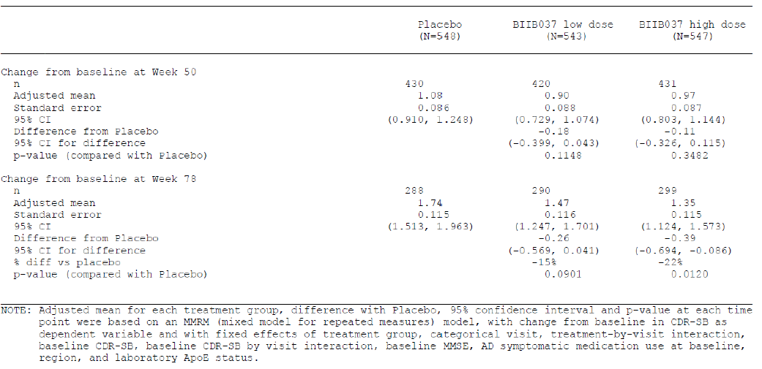

Abbreviation: CI = confidence interval

Note: Adjusted mean for each treatment group, difference with placebo, 95% confidence interval and p-value at each time point were based on a mixed model for repeated measures model, with change from Baseline in clinical dementia rating sum of boxes (CDR-SB) as dependant variable and with fixed effects of treatment group, categorical visit, treatment by visit interaction, Baseline CRD-SB, Baseline CRD-SB by visit interaction, Baseline mini mental state examination (MMSE), Alzheimer’s disease symptomatic medication use at Baseline, region and laboratory Apolipoprotein E (ApoE) status.

Sensitivity and supplemental analyses were generally consistent with the repeated analysis outcomes.

###### Secondary endpoints

Considering the negative results for the primary CDR endpoint in the low dose group, from a statistical perspective, the clinical evaluation considered that the secondary outcomes to be considered as exploratory.

Mini mental state examination

At Week 78, the treatment difference between the high dose aducanumab and the placebo arms, based on change from Baseline on the MMSE, was 0.6 (-18% compared to placebo, p = 0.0493). The difference between the low dose aducanumab group and placebo was ‑0.1(+3% compared to placebo, p = 0.7578).

Alzheimer’s Disease Assessment Scale–Cognitive Subscale-13 items

High dose arm achieved a nominally significant treatment difference in the change from Baseline in ADAS-Cog 13, compared to placebo -1.4 (-27% compared to placebo, p = 0.0097). The difference in the low dose group compared to placebo was -0.701, which was not statistically significant (-14% compared to placebo, p = 0.1962).

Activities of Daily Living (Mild Cognitive Impairment)

High dose arm achieved a nominally significant treatment difference in the change from Baseline to Week 78 in ADCS-ADL-MCI, compared to the placebo group: 1.7 (-40% compared to placebo, p = 0.0006). The difference between the low dose group and the placebo group was 0.7 (-16% compared to placebo, p = 0.1515).

Quality of Life

For all of the quality of life parameters, the magnitude of mean changes from Baseline were relatively small and no convincing between group differences were observed.

###### Responder analysis

In the high dose group, for the CDR-SB less than 0.5 decline, a nominally significant difference from placebo was noted, with 42% of subjects achieving this endpoint, compared to 41% of the low dose group and 34% of the placebo group (p = 0.0391 for the high dose compared to placebo). Other comparisons failed to achieve nominal statistical significance.

###### Subgroup analysis

The results of the primary efficacy endpoint were not consistent across all subgroups. The trend in favour of high dose aducanumab was weak for *ApoE* ε4 non-carriers, indicating that most of the benefit driving the positive results in Study 302 came from *ApoE* ε4 carriers. The clinical evaluation has highlighted that this is in contrast to results from Study 301, where no substantial benefit was observed for high dose aducanumab regardless of *ApoE* ε4 carrier status.

###### Biomarker results

Amyloid beta positron emission tomography scan

A total of 30% of the intention to treat population were enrolled in a sub-study that assessed the change in brain amyloid beta plaque levels from Baseline. It is stated that the mean baseline amyloid beta levels were similar across treatment groups and in the ‘expected range’. It was noted that patients in the high dose groups achieved a greater reduction in amyloid beta plaque levels at Week 26 and Week 78. A dose dependent reduction was reported and the treatment difference was statistically significant (high dose, -0.278 (p-value less than 0.0001); low dose, -0.179 (p-value less than 0.0001)). A sustained effect was seen with high dose group at Week 132.

Figure : Study 302 Change from Baseline in amyloid beta positron emission tomography composite standardised uptake value ratio

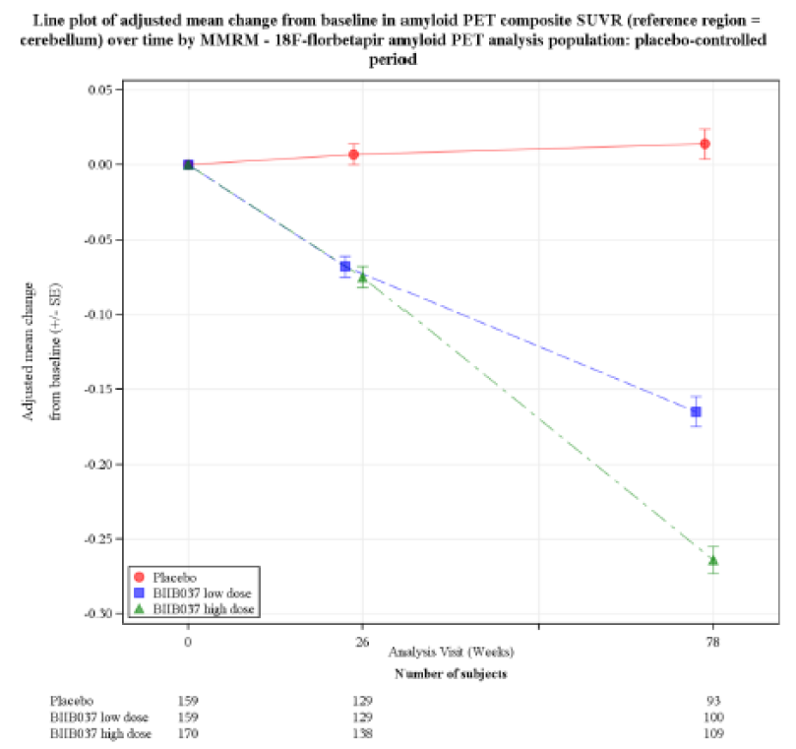

Tau positron emission tomography scan was also conducted in a subset of patients. Six patients in Study 302 and 31 patients in Study 301. A numerical dose dependent reduction in brain tau was reported in all composite brain regions.

A dose dependent increase in cerebrospinal fluid amyloid beta 1-42 was reported in the aducanumab group. The treatment difference was statistically significant. The levels of cerebrospinal fluid amyloid beta 1-40 was comparable between treatment groups.

A dose dependent decrease in cerebrospinal fluid phosphorylated tau levels relative to placebo was observed with aducanumab treatment (p = 0.0035 for low dose aducanumab and p = 0.0005 for high dose aducanumab) at Week 78.

Aducanumab group also experienced a dose dependent reduction in cerebrospinal fluid total tau levels relative to placebo at Week 78 (p = 0.0148 for low dose and p = 0.0088 for high dose).

##### Efficacy results from long term extension phase of pivotal studies (Studies 301 and 302)

###### Study 301

The clinical endpoints (CDR-SB, MMSE, ADAS-Cog 13, ADCS-ADL-MCI and Neuropsychiatric Inventory-10;[33]) of the long term extension of Study 301 did not show a treatment benefit that was statistically significant for the early start high dose group compared to the late start high dose group and changes in progression rates after switching from placebo to active treatment. The difference in change from Baseline in CDR-SB for the early start high dose group compared to the late start high dose group was an extra increase in CDR-SB of 0.04 (+3% compared to the late start high dose group, p = 0.8055), 0.06 (+3% compared to late start high dose, p = 0.8246), and 0.38 (+15% compared to late start high dose, p = 0.3043) for Week 78, Week 106, and Week 134, respectively.

Significant amyloid clearance was achieved with aducanumab in both dose groups, and in subjects who received aducanumab early or late. The magnitude of clearance (rate) was low, compared to the first 78 weeks of treatment.

The clinical evaluation considered these findings as a dissociation between the clinical endpoints and amyloid clearance.

###### Study 302

The change from Baseline on CDR-SB for the early start high dose group, compared to the late start high dose group was -0.44 (-25% compared to late start high dose group, p = 0.0212), -0.59 (-23% compared to late start high dose, p = 0.0475), and -0.51 (-16% compared to late start high dose, p = 0.202) for Week 78, Week 106 and Week 134, respectively.

The differences in change from Baseline on CDR-SB for the early start low dose group compared to the late start low dose group were -0.22 (-13% compared to late start low dose, p = 0.2424), 0.3 (+15% compared to late start low dose, p = 0.3105) and 0.42 (+19% compared to late start low dose, p = 0.2888) for Week 78, Week 106 and Week 134 respectively.

It appears that the treatment benefit achieved (or not achieved) during the placebo controlled phase largely persisted during the open label extension. The potential impact of withdrawal bias needs to be considered.

For secondary endpoints such as ADAS-Cog 13 and ADCS-ADL-MCI, there was no consistent pattern suggesting a benefit in switching to active treatment. Differences between the active and placebo groups achieved by Week 78 generally persisted over subsequent assessments, but statistical significance declined as patient numbers dropped.

###### Cerebral amyloid beta load

The long term extension provided evidence of continued reduction in amyloid load. However, from a safety perspective, the clinical evaluation has highlighted that these results should be interpreted with caution because of possible selection bias; patients who are doing well are more likely to enter and remain in a long term extension study.

The differences in change from Baseline in amyloid beta positron emission tomography composite standard uptake value ratio for the early start high dose group compared to the late start high dose group were -0.283 (p-value less than 0.0001) and -0.149 (p- value less than 0.0001) for Week 78 and Week 132, respectively. The differences in change from Baseline in standard uptake value ratio for the early start low dose group compared to the late start low dose group were -0.17 (p-value less than 0.0001), and -0.125 (p-value less than 0.0001) for Week 78 and Week 132, respectively. This suggests that amyloid clearance during the early phase of treatment (up to Week 78) is more extensive than in later stages (after Week 78). It should also be considered that the total amyloid content will also be reduced with ongoing treatment.

For both dose groups, the numerical differences between initial aducanumab recipients and initial placebo recipients, in terms of standard uptake value ratio changes relative to Baseline, became less marked when placebo recipients switched to active treatment. It is noted that this is suggestive of a greater treatment benefit, when commenced at an early stage of the disease (suggesting a narrow window of opportunity).

##### Other studies

###### Study 205

Study 205 was a Phase II, parallel group, double blind randomised controlled trial in Alzheimer’s disease patients with mild cognitive impairment or mild dementia.

This study was designed to assess the safety of continued aducanumab dosing in subjects with amyloid related imaging abnormalities, using a randomised, double blind, placebo controlled design.

The study began on 20 December 2018, with the first treatment. The termination of the Phase III program (Studies 301 and 302) was announced on 21 March 2019, based on the results of an interim futility analysis, and this study was therefore terminated at the same time. The study ended on 30 July 2019, with the last safety follow up, thus limiting long term safety data for repeat dose administration of aducanumab.

A total of 52 of the planned 500 participants were randomised. It was noted the maximum number of infusions of aducanumab that was administered was four. Due to the small sample size, short exposure time, and incomplete nature of the data, the primary endpoint and most secondary endpoints of the study were not evaluable.

#### Safety

Pooled analyses incorporating Phase III studies were presented to assess the safety of aducanumab.

##### Treatment exposure

The Delegate noted that the main dataset of interest is Pool A1, which represented placebo controlled exposure in the Phase III studies (Study 301 and 302). Pool A2 included the long term open label follow up of these pivotal studies. The lack of a placebo control limits the ability to know the background rate of events in this pool. Pool B included subjects across all of the major clinical studies.

###### Pool A1 population

Pool A1 represents placebo controlled exposure in the Phase III studies (Study 301 and 302).

In Pool A1, the mean duration of exposure to study treatment was 1.3 years for both the placebo and total aducanumab groups (within the placebo controlled period of the two Phase III studies). Approximately 80% of participants were exposed for at least 48 weeks and more than 70% were exposed for at least 60 weeks. The median number of infusions received was n = 17.

Table : Studies 301 and 302 Overall extent of exposure for Pool A1 population

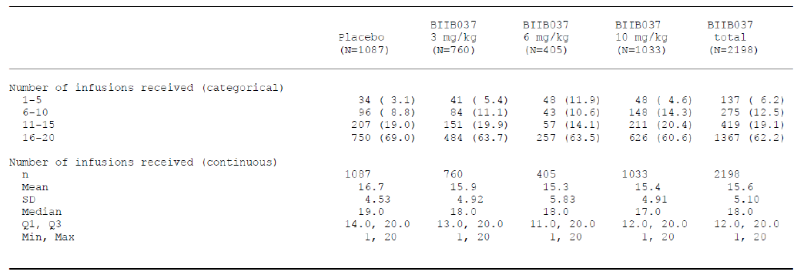

Abbreviations: SD = standard deviation, Q1 = first quartile, Q3 = third quartile.

Table : Studies 301 and 302 Treatment exposure for Pool A1 population

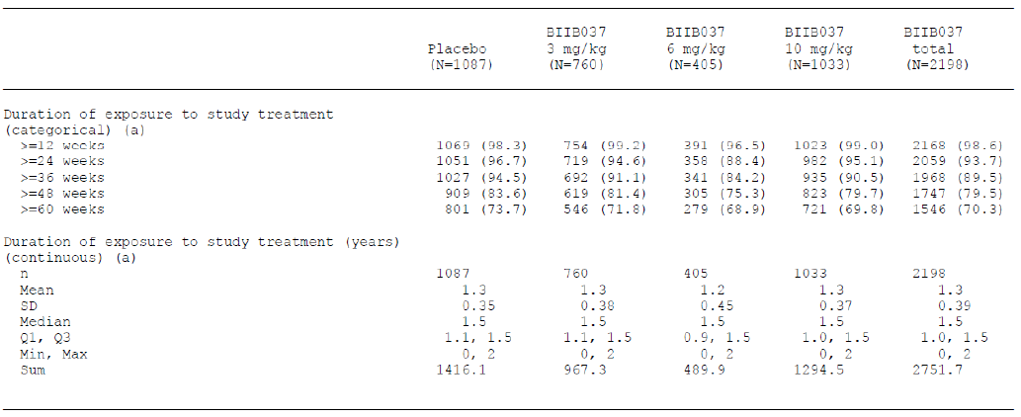

Abbreviations: SD = standard deviation, Q1 = first quartile, Q3 = third quartile.

###### Pool A2 population

In Pool A2, which includes the long term follow up of the original aducanumab recipients and several new exposures from original placebo recipients, the mean duration of exposure in the aducanumab treated period was 1.4 years. Of these 65.5% were exposed for at least one year and 24.2% were exposed for at least two years.

Exposure to the proposed dose of aducanumab (10 mg/kg) was limited to a mean number of 15 infusions.

###### Pool B population

Pool B included subjects across all of the major clinical studies.

##### Adverse events

The overall incidence of adverse events in Pool A1 was broadly similar in the placebo (86.9%) and total aducanumab (90.7%) groups. Serious adverse events also occurred at a broadly similar rate in the placebo group (13.9%) and the total aducanumab group (13.6%).

A total of 47.8% of the subjects in the aducanumab group experienced adverse events that were considered as related to study treatment by the investigators, compared to 25.1% for the placebo group. Adverse events that led to discontinuation of study treatment occurred in a higher proportion (9.1%) of the subjects in the aducanumab group, compared to 4.1% of the placebo group. The incidence of serious adverse events considered treatment related by the investigator was also higher for the aducanumab group (1.7%) than the placebo group (0.7%). Adverse events leading to withdrawal from the study were also more common in the aducanumab group (4.4%) than the placebo group (2.9%).

In Pool A2, the overall incidence of adverse events was comparable across 3, 6 and 10 mg/kg dose categories of aducanumab. In Pool B, the incidence of adverse events was comparable across less than 10 mg/kg and greater than 10 mg/kg aducanumab.

Amyloid related imaging abnormalities and related events were reported as adverse events (by preferred term and with an incidence greater than or equal to 5%) in the total aducanumab group of Pool A1:

* Amyloid related imaging abnormalities with oedema (33% at the proposed dose, versus 2.7% in the placebo group)
* Amyloid related imaging abnormalities with haemorrhage microhaemorrhage (19.1% versus 6.5%)
* Amyloid related imaging abnormalities with haemorrhage superficial siderosis (14.6% versus 2.2%)
* Headache (20.5% versus 15.2%)
* Fall (15% versus 11.8%).

For these events, the incidence rates per 100 person years for the total aducanumab and placebo groups were: 21.3 versus 1.9, respectively (amyloid related imaging abnormalities with oedema); 12.4 versus 4.6 (amyloid related imaging abnormalities with haemorrhage microhaemorrhage); 8.4 versus 1.5 (superficial siderosis); 13.7 versus 10.6 (headache); and 9.9 versus 8.2 (fall). For the adverse events related to amyloid related imaging abnormalities, the excess incidence over placebo was observed at all doses of aducanumab; there was no consistent dose trend, but the highest incidence was generally seen in the 10 mg/kg dose group.

When the same analysis was restricted to the aducanumab 10 mg/kg dose group, diarrhoea was also reported with a higher incidence in aducanumab arm, compared to placebo (aducanumab 8.9% versus placebo 6.8%).

Other adverse events in Pool A1 were ‘nervous system disorders’ (aducanumab 58.5% versus placebo 42.3%), ‘infections and infestations’ (40.7% versus 43.3%), ‘gastrointestinal disorders’ (26.7% versus 28.4%), ‘musculoskeletal and connective tissue disorders’ (26.3% versus 27.6%) and ‘injury, poisoning and procedural complications’ (26.3% versus 24.7%).

##### Treatment-related adverse events

Treatment-emergent adverse events were reported at a higher rate in aducanumab recipients (47.8%) than placebo recipients (25.1%) in Pool A1. Amyloid related imaging abnormalities with oedema was the most common reported across Pool A1 and A2.

Table : Studies 301 and 302 Incidence of treatment emergent adverse events in Pool A1 population

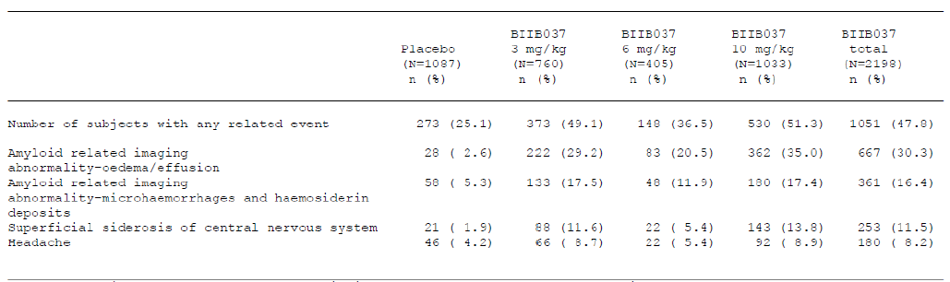

Note 1: A subject was counted only once within each preferred term (Medical Dictionary for Regulatory Activities (MedDRA) version 22.0).[34]

Note 2: Preferred terms are presented in decreasing frequency of the table’s rightmost column.

Note 3: Relationship to study drug per investigator assessment.

Note 4: Preferred terms are displayed if the incidence is at least 5% in the BIIB037 total column.

Table : Studies 301 and 302 Incidence of treatment emergent adverse events in Pool A2 population

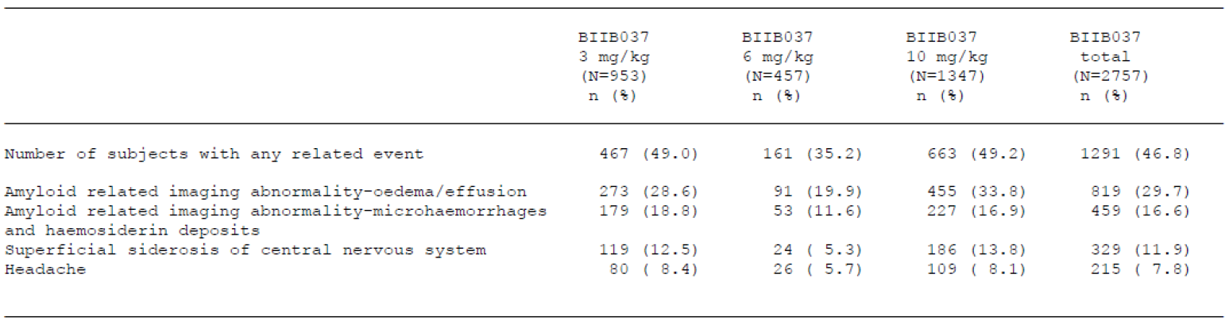

Note 1: A subject was counted only once within each preferred term (MedDRA version 22.0).34

Note 2: Preferred terms are presented in decreasing frequency of the table’s rightmost column.

Note 3: Preferred terms are displayed if the incidence is at least 5% in the BIIB037 total column.

##### Serious adverse events

Overall, in Pool A1, the incidence of serious adverse events was comparable across aducanumab (13.6%) and placebo arms (13.9%). The most common serious adverse event was fall, which occurred at a similar rate in recipients of aducanumab and placebo. The next most common serious adverse event was amyloid related imaging abnormalities, which had an increased incidence in the aducanumab group, compared to placebo (1% versus less than 0.1%).

Table : Studies 301 and 302 Incidence of serious adverse events in Pool A1 population

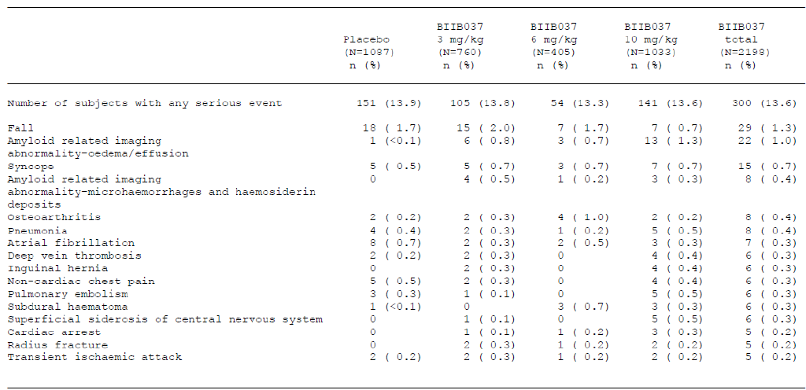

Note 1: A subject was counted only once within each preferred term (MedDRA version 22.0).34

Note 2: Preferred terms are presented in decreasing frequency of the table’s rightmost column.

Note 3: Preferred terms are displayed if the incidence is at least 5% in the BIIB037 total column.

##### Deaths

A total of 31 deaths (placebo: six; aducanumab: 25) were reported in the aducanumab clinical development program. Nineteen (19) deaths were reported in Phase III studies. It was noted that the rate of event (death) was comparable across aducanumab and placebo arms during placebo controlled period of the studies.

One event of death was considered as treatment related by the investigator. This event occurred in an aducanumab recipient in Study 103 who had a cerebral haemorrhage at the time of death.

‘One participant had a fatal event of cerebral haemorrhage (investigator term ‘acute left intraparenchymal haemorrhage’). The participant was an 84-year-old male (*ApoE* ε4 carrier) with mild Alzheimer’s disease dementia who had received 14 doses of aducanumab 1 mg/kg in the placebo-controlled period and 30 doses of aducanumab 3 mg/kg in the long term extension period prior to onset.

Questionable ARIA-E [amyloid-related imaging abnormalities, suggestive of cerebral oedema] (verbatim term on MRI report; investigator term [reported] ‘possible vasogenic oedema left occipital asymptomatic’ and coded as ARIA-E) had been noted in the left occipital region after 14 doses of 1 mg/kg and 12 doses of 3 mg/kg but resolved on the follow up MRI with no change in dosing.

Approximately 5 weeks before the onset of the fatal cerebral haemorrhage, the participant experienced an intra-abdominal SAE [serious adverse event] of vascular pseudoaneurysm ruptured (investigator term [reported] ‘pancreaticoduodenal artery pseudoaneurysm bleed’), which was considered severe and lasted for 8 days; the event of the event of pancreaticoduodenal artery pseudoaneurysm bleed was not considered related to aducanumab by the investigator and no action was taken with respect to study treatment due to the event.

The cause of death (cerebral haemorrhage) was considered related to aducanumab by the investigator.’

Overall, the TGA’s clinical evaluation concluded that the evidence provided did not suggest that this death was causally related to aducanumab.

The Delegate has noted the cerebral haemorrhage at the time of death. The preceding event of ruptured intraabdominal pseudoaneurysm that occurred five weeks prior to the event was also noted. Amyloid related imaging abnormality was reported six months prior to the event. Subjects (although rare) experiencing multiple episodes of amyloid related imaging abnormalities have been reported across clinical studies with aducanumab. This subject had *ApoE* ε4 genotype, which was associated with an increased incidence of amyloid related imaging abnormalities. Taken together, the Delegate considers that an association between the event of death and treatment with aducanumab cannot be ruled out.

The sponsor’s comment in relation to this event was as follows:

‘Upon central re-review of the brain MRI images, areas of low blood flow highly suggestive of underlying neurovascular pathology consistent with arteriovenous malformation/ arteriovenous fistula, present on screening MRIs, were noted.

An event of questionable amyloid related imaging abnormalities with oedema had resolved more than one year prior to the onset of cerebral haemorrhage.’

The Delegate noted that the sponsor has not concluded whether this event was treatment related or not.

The reason for the clinical investigator to determine this incident as treatment related is not provided in the dossier provided by the sponsor. The sponsor was requested to clarify. The Advisory Committee on Medicines (ACM) opinion was requested by the Delegate (see *Advisory Committee considerations*, below).

All the other deaths were assessed by the investigator as unrelated to study treatment.

##### Discontinuations, withdrawals, and dose reductions due to adverse events

In the Pool A1 population, the incidence of adverse events that led to discontinuation of treatment was higher in the total aducanumab group (9.1%) than the placebo group (4.1%). This was largely due to the increased incidence of amyloid related imaging abnormalities events, including amyloid related imaging abnormalities with haemorrhage microhaemorrhage (placebo 0% versus aducanumab 2.4%), amyloid related imaging abnormalities with haemorrhage superficial siderosis (placebo 0.2% versus aducanumab 2.3%), and amyloid related imaging abnormalities with oedema (placebo less than 0.1% versus aducanumab 1.3%).

In the Pool A1 population, the incidence of adverse events that resulted in withdrawal from the study was higher in the total aducanumab group (4.4%) than the placebo group (2.9%). Adverse events in the pooled aducanumab group that led to study withdrawal with an incidence greater than or equal to 0.5% were amyloid related imaging abnormalities with haemorrhage superficial siderosis (placebo 0% versus aducanumab 0.7%), amyloid related imaging abnormalities with haemorrhage microhaemorrhage (placebo 0% versus aducanumab 0.6%), and amyloid related imaging abnormalities with oedema (placebo less than 0.1% versus aducanumab 0.5%). The incidence of amyloid related imaging abnormalities events did not show a consistent trend across doses. Apart from amyloid related imaging abnormalities, cardiac arrest (placebo 0% versus aducanumab 0.1%) was the other adverse event that led to withdrawal in at least three aducanumab recipients.

In the Pool A1 population, the incidence of adverse events that led to a dose reduction was higher in the pooled aducanumab group (1.7%) than the placebo group (0.2%). The most common reasons for dose reduction in the pooled aducanumab group were amyloid related imaging abnormalities with oedema (1.5%) and amyloid related imaging abnormalities with haemorrhage superficial siderosis (0.2%).

##### Amyloid related imaging abnormalities (ARIA)

The possibility of amyloid related imaging abnormalities was anticipated in the design of the sponsor’s first single dose PK study (Study 101), and amyloid related imaging abnormalities issues were incorporated into the stopping criteria and dose escalation policies of that study.

It should be noted that most participants in the placebo and both aducanumab dose groups did not have amyloid related imaging abnormalities with haemorrhage microhemorrhages at Baseline (less than 85% in each group).

Amyloid related imaging abnormality was classified as shown in Table 17 below. Amyloid related imaging abnormality events were subdivided into those featuring oedema and those featuring haemorrhage. amyloid related imaging abnormalities with haemorrhage was further subdivided into microhaemorrhages or superficial siderosis.

Table : Radiographic severity of amyloid related imaging abnormalities (ARIA) with oedema and amyloid related imaging abnormalities with haemorrhage on magnetic resonance imaging

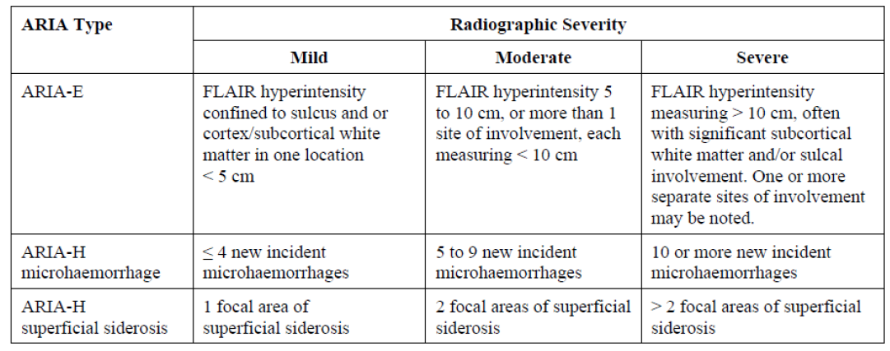

Abbreviations: ARIA = amyloid related imaging abnormalities, ARIA-E = amyloid related imaging abnormalities with oedema, ARIA-H = amyloid related imaging abnormalities with haemorrhage, FLAIR = fluid attenuated inversion recovery.

In the Pool A1 population, the combined incidence of amyloid related imaging abnormalities with oedema and amyloid related imaging abnormalities with haemorrhage was 36.9% of subjects across all active dose groups. It should be noted that 41.3% of subjects who received the proposed dose of 10 mg/kg experienced amyloid related imaging abnormalities. In comparison to aducanumab group, the incidence of amyloid related imaging abnormalities was lower in the placebo group (combined incidence of amyloid related imaging abnormalities with oedema and amyloid related imaging abnormalities with haemorrhage, 10.3%). For amyloid related imaging abnormalities with oedema, a greater difference in the incidence between the active group (30.7%) and the placebo group (2.7%) was noted. Concurrent amyloid related imaging abnormalities with oedema and amyloid related imaging abnormalities with haemorrhage had a greater incidence in aducanumab recipients (seen in 17.9% of the pooled aducanumab group and 21% of the 10 mg/kg group), compared to the placebo group (1.1%).

Table : Studies 301 and 302 Incidence of amyloid related imaging abnormality (ARIA) events in the Pool A1 population (safety magnetic resonance imaging population)

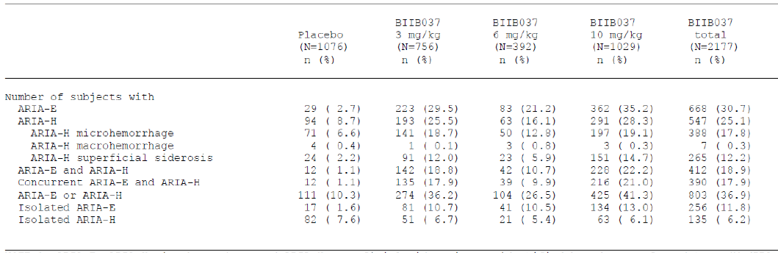

Abbreviations: ARIA-E = amyloid related imaging abnormalities with oedema, ARIA-H = amyloid related imaging abnormalities with haemorrhage

Note 1: ARIA-E, ARIA-H microhaemorrhage and ARIA-H superficial siderosis are identified based on preferred term (MedDRA 22.0);34. ARIA-H microhaemorrhage is identified based on electronic case report form reported term.

Note 2: Concurrent is defined as overlapping in MRI duration of two ARIA events.

Note 3: ARIA-E is defined as isolated if the subject experienced no ARIA-H during the placebo controlled period. ARIA-H is isolated if subject experiences no ARIA-E during the placebo controlled period.

As expected by the Delegate, a greater incidence of amyloid related imaging abnormality was reported among *ApoE* ε4 carriers. Majority of subjects homozygous for *ApoE* ε4 (73% of homozygotes exposed to 10 mg/kg) had amyloid related imaging abnormalities, compared to 41.6% of heterozygotes and 26.8% of non-carriers. A similar trend was seen for both amyloid related imaging abnormalities with oedema (66%) and amyloid related imaging abnormalities with haemorrhage (59.7%).

Most of the amyloid related imaging abnormalities with oedema events (82.8%) among subjects treated with aducanumab 10 mg/kg resolved radiographically within the first 16 weeks of treatment period.

Table : Studies 301 and 302 Incidence of amyloid related imaging abnormality (ARIA) events based on *ApoE* allele 4 genotype for the Pool A1 population (safety magnetic resonance imaging population)

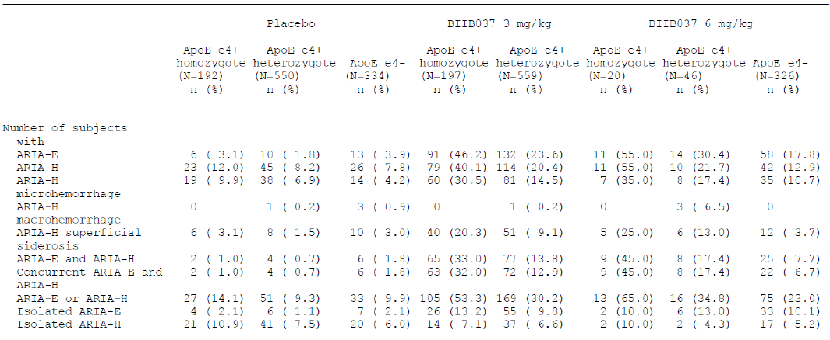

Abbreviations: ARIA-E = amyloid related imaging abnormalities with oedema, ARIA-H = amyloid related imaging abnormalities with haemorrhage, ApoE ε4 = apolipoprotein E allele 4.

Lack of dose dependent effect on the incidence of amyloid related imaging abnormalities is evident from the comparisons below.

Table : (Studies 301 and 302, long term extensions) Incidence of amyloid related imaging abnormality (ARIA) events in the Pool A2 population (safety magnetic resonance imaging population)

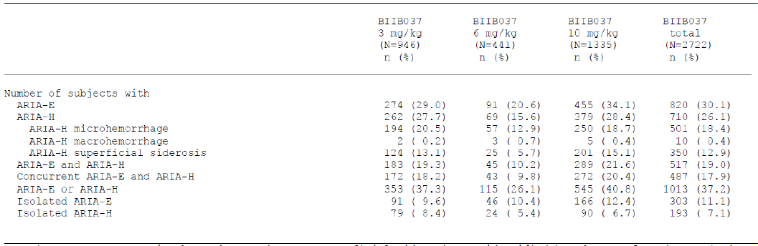

Abbreviations: ARIA-E = amyloid related imaging abnormalities with oedema, ARIA-H = amyloid related imaging abnormalities with haemorrhage.

Note 1: ARIA-E, ARIA-H microhaemorrhage and ARIA-H superficial siderosis are identified based on preferred term (MedDRA 22.0);34. ARIA-H microhaemorrhage is identified based on electronic case report form reported term.

Note 2: Concurrent is defined as overlapping in MRI duration of two ARIA events.

Note 3: ARIA-E is defined as isolated if the subject experienced no ARIA-H during the aducanumab treated period. ARIA-H is isolated if subject experiences no ARIA-E during the aducanumab treated period.

The sponsor used the Pool A2 amyloid related imaging abnormalities date (that is, the larger of the two Phase III databases) to analyse the symptoms of amyloid related imaging abnormalities and the relationship between the radiographic severity of amyloid related imaging abnormalities and the incidence and severity of amyloid related imaging abnormalities related symptoms.

Amyloid related imaging abnormality events were also classified as symptomatic or asymptomatic based on the investigator’s assessment. The clinical evaluation highlighted the possibility of this approach to cause unblinding. Most cases of amyloid related imaging abnormalities in the Pool A2 population (78%) were asymptomatic. Among those with symptomatic amyloid related imaging abnormalities, the most common symptoms were headache, dizziness, confusional state, fatigue and nausea. No apparent dose trend was noted.

For comparison, in the Pool A1 population, the incidence of these symptoms in the placebo group was: headache 15.2%; dizziness 9% confusional state less than 5%; fatigue 6.9%; and nausea 6.3%.

Table : Common symptoms related to amyloid related imaging abnormalities (ARIA)

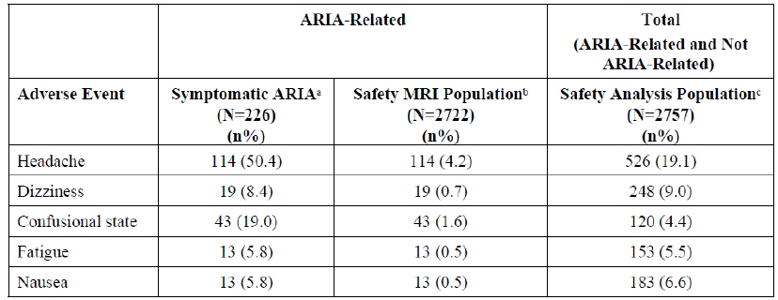

Abbreviations: ARIA = amyloid related imaging abnormalities.

a Number of participants in the safety MRI population with symptomatic ARIA.

b The safety MRI population is defined as all randomised participants who received at least one dose of study treatment and had at least one postbaseline MRI assessment.

c The safety analysis population is defined as participants who were randomised and received at least one dose of study treatment.

##### Amyloid related imaging abnormalities (ARIA) at the proposed dose

At 10 mg/kg, during the placebo controlled period, 41.3% of subjects experienced amyloid related imaging abnormalities. Amyloid related imaging abnormality related serious adverse events were reported in 1.4% of subjects.

Amyloid related imaging abnormality with oedema was the commonest reported (35.2%). A total 72.7% of events occurred within the first eight doses of aducanumab. A total 26% of subjects with amyloid related imaging abnormalities exhibited symptoms.

##### Magnitude of effect: amyloid related imaging abnormalities (ARIA)

Around 80% of the amyloid related imaging abnormality events were mild to moderate in severity. A total of 16.3% of aducanumab treated participants with amyloid related imaging abnormalities in the Pool A2 population discontinued study treatment due to an amyloid related imaging abnormality event. In the pooled aducanumab group of the Pool A1 population, the most common reason for dose reduction was amyloid related imaging abnormalities with oedema (1.5%), followed by amyloid related imaging abnormalities with haemorrhage superficial siderosis (0.2%).

Majority of amyloid related imaging abnormality events were asymptomatic. However, this assessment is confounded by the dose adjustment and treatment withdrawal at the time of detection of amyloid related imaging abnormalities in brain MRI.

The Delegate noted the higher rate of ‘asymptomatic’ amyloid related imaging abnormalities is limited by the rate of withdrawal and dose reductions of aducanumab due to amyloid related imaging abnormalities.

Table : Magnitude of effect, amyloid related imaging abnormalities (ARIA)

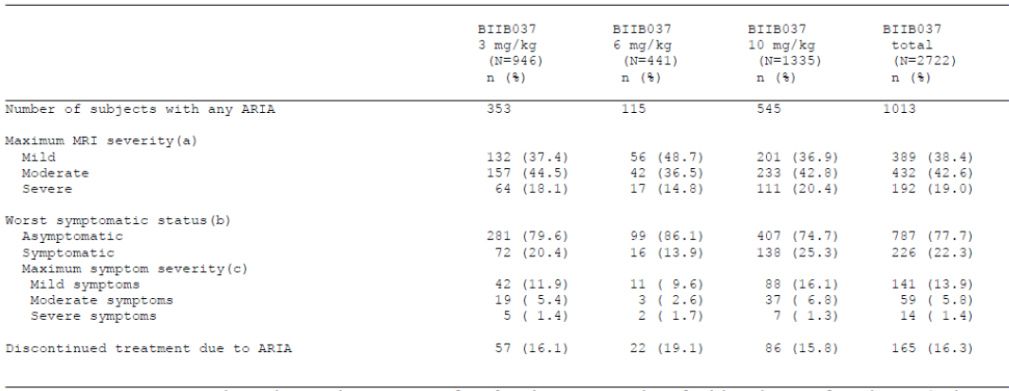

Abbreviations: ARIA = amyloid related imaging abnormalities, MRI = magnetic resonance imaging.

Note 1: ARIA-E, ARIA-H microhaemorrhage and ARIA-H superficial siderosis are identified based on preferred term (MedDRA 22.0);34. ARIA-H microhaemorrhage is identified based on electronic case report form reported term. Percentages are based on the number of subjects with the type of ARIA being analysed.

(a) The maximum MRI severity across all the events of the type of ARIA being analysed for each subject.

(b) The worst symptomatic status across all the events of the type of ARIA being analysed for each subject.

(c) The maximum symptom severity across all the symptomatic events of the type of ARIA being analysed for each subject.

The sponsor’s discussion of this issue included an assumption that the radiological resolution of amyloid related imaging abnormalities was a satisfactory endpoint. The clinical evaluation highlighted that the sponsor failed to consider the possibility that the same inflammatory processes that caused overt oedema or haemorrhage on MRI scans could themselves represent an ongoing reason for brain dysfunction, even after resolution of the overt oedema. The clinical evaluation supported this assumption with the higher rate of incidence of confusional state (19%) in subjects with symptomatic amyloid related imaging abnormalities, compared to 4.4% of the broader safety population. The clinical evaluation also considered that, from a clinical perspective, the recovery from confusional states in the elderly is often incomplete, with permanent changes in cognition occurring as a complication of delirium. This further asserts the importance of the data related to the long term cognitive outcomes in these patients. The Delegate considers that, based on the available data, the long term cognitive consequences of amyloid related imaging abnormalities remain unclear.

##### Immunogenicity and immunological events

Overall, the incidence of immunogenicity and hypersensitivity reactions were low. Nine subjects in the placebo group (0.8%) and 30 participants in the total aducanumab group (1.4%) were positive for anti-aducanumab antibodies at any time during the placebo controlled period. Most of the positive results were obtained at Baseline, prior to the first dose, and therefore do not represent a reaction to the treatment.

##### Other adverse events

Overall, haematology results of potentially clinical significance, abnormal liver function test and other elevated/abnormal clinical biochemistry parameters were reported infrequently in all treatment groups, and for similar proportions of participants in the placebo and aducanumab groups.

The incidence of electrocardiogram and vital sign abnormalities were broadly balanced across the active and placebo groups of the pivotal studies.

#### Clinical evaluation recommendation

The results of the TGA’s clinical evaluation has recommended rejection of this application for the following reasons: weak and uncertain efficacy data, substantial risk, and a substantial burden of treatment including infusions and monitoring requirements.

### Risk management plan

The sponsor has submitted European Union (EU) risk management plan (RMP) version 1.0 (dated 3 September 2020; data lock point (DLP) 4 May 2020) and Australia specific annex (ASA) version 1.0 (dated January 2021) in support of this application. As part of the sponsor’s response to the recommendations made in the first round evaluation report, the sponsor submitted an updated EU-RMP version 0.3 (dated 1 October 2021, DLP 6 November 2019) with ASA version 2.0 (dated November 2021). In response to the recommendations in the second round evaluation, the sponsor has submitted an updated ASA version 3.0 (dated February 2022).

The summary of safety concerns and their associated risk monitoring and mitigation strategies are summarised in Table 23. Further information regarding the TGA’s risk management approach can be found in [risk management plans for medicines and biologicals](https://www.tga.gov.au/publication/risk-management-plans-medicines-and-biologicals) and [the TGA's risk management approach](https://www.tga.gov.au/tgas-risk-management-approach).

Table : Summary of safety concerns

|  |  |  |  |  |  |
| --- | --- | --- | --- | --- | --- |
| Summary of safety concerns | | Pharmacovigilance | | Risk Minimisation | |
| Routine | Additional | Routine | Additional |
| **Important identified risks** | Amyloid-related imaging abnormalities-oedema (ARIA-E) | ✓1a | ✓2, 3, 6 | ✓ | ✓4, 5 |
| ARIA-H microhaemorrhage | ✓1a | ✓2, 3, 6 | ✓ | ✓4, 5 |
| ARIA-H superficial siderosis | ✓1a | ✓2, 3, 6 | ✓ | ✓4, 5 |
| **Important potential risks** | Cerebral haemorrhage > 1 cm | ✓1b | ✓2, 3, 6 | ✓ | – |
| **Missing information** | Long term safety profile in patients treated with aducanumab | ✓ | ✓2, 3, 6 | – | – |
| Use in patients with Alzheimer’s disease in more advanced stages | ✓ | ✓2, 3, 6 | – | – |

Abbreviations: ARIA-E = amyloid-related imaging abnormalities-oedema; ARIA-H = amyloid-related imaging abnormalities-microhaemorrhage or siderosis.

1a Specific adverse event follow-up form for serious and non-serious ARIA events

1b Specific adverse event follow-up form for CNS haemorrhage, including cerebral haemorrhage > 1 cm

2 Post-authorisation safety study (PASS)

3 Phase III clinical trial

4 Healthcare professional and radiologist guide

5 Patient card

6 Post-authorisation confirmatory study (US)

The proposed summary of safety concern has been updated as recommended in the first round RMP evaluation report.

The sponsor has added the randomised, controlled clinical trial required by the US FDA to the ASA as part of the additional pharmacovigilance activities. Updates on safety findings from this study should be submitted in the periodic safety update reports (PSURs) with a focus on the adverse events related to the safety concerns in the RMP.

The sponsor has updated the additional risk minimisation materials to meet the TGA’s requirements. The sponsor has added its plan to conduct an Australian healthcare professional survey to evaluate the effectiveness of additional risk minimisation activity.

### Risk-benefit analysis

#### Delegate’s considerations

Aducanumab is a high affinity, fully human monoclonal antibody that binds to aggregated forms of amyloid beta and preferentially binds to brain parenchymal amyloid over vascular amyloid. The proposed mechanism of action is the reduction of aggregated forms of existing brain amyloid beta by phagocytosis. Aducanumab has no effect on the further production of amyloid beta.

Across Studies 301 and 302, a dissociation between the magnitude of effect of aducanumab on brain amyloid beta level (on MRI) which was the sponsor’s chosen biomarker) and measures of cognition and function was evident. A significant reduction in brain amyloid beta levels (on MRI) was achieved by aducanumab groups in a sub-group of subjects across Studies 301 and 302 (the basis of inclusion of subjects in these sub-groups was not well defined). A greater magnitude of reduction in brain amyloid beta level was achieved by 10 mg/kg of aducanumab. However, the treatment effect of aducanumab on amyloid plaques was not associated with a similar magnitude (statistical significance) of improvement in both primary and secondary endpoints in Study 301. In contrast, in this study, the repeated additional analysis revealed a worsening of CDR-SB;29 by 2% and MMSE;23 by 3% were observed in high dose aducanumab, compared to placebo group. In contrast, Study 302, which was identical in terms of study design of Study 301, reported a greater treatment benefit for the high dose aducanumab group, compared to placebo. The p-value was considered as nominally significant. In both studies, low dose aducanumab group did not experience a similar finding. Taken together, the Delegate concludes that the isolated effects on diagnostic markers cannot be regarded as evidence to suggest disease modification.2,9,[35] These factors suggest critical deficiencies of brain amyloid levels as a biomarker to demonstrate the enduring treatment effect, extrapolate/predict the continued efficacy and ‘disease modifying effect’ of aducanumab.9,35 It also highlights the inadequacy of amyloid beta as a reliable surrogate endpoint to measure aducanumab's short term and long term efficacy.3,10

Critical methodological issues that are related to dose finding, sample size estimation, multiplicity and potential unblinding were identified in the clinical development program for aducanumab.

The pivotal studies constituted multiple protocol amendments that were related to change in dosing. The dosing changes were related to *ApoE* status and amyloid related imaging abnormalities. The role of *ApoE* allele genotype status in determining the clinical outcome and the possibility for amyloid related imaging abnormalities with aducanumab treatment were known to the sponsor prior to commencement of the pivotal studies. However, a Phase II study to identify the optimal dose of aducanumab, in consideration of these factors is lacking in this submission. It was noted that the proposed titrated dosing regimen up to 10 mg/kg of aducanumab for all patients with Alzheimer’s disease (irrespective of *ApoE* ε4 status) was not determined prior to the commencement on the pivotal studies. This resulted in identifying the optimal dose midway during the pivotal studies and a smaller study population being exposed to the proposed dosing regimen and for a shorter duration of time. The statistical implications are potential unblinding and multiplicity, which are not adequately addressed by the sponsor. Even though the Phase I Study 103 results suggested a lower rate than expected for amyloid related imaging abnormalities following titration of aducanumab up to 10 mg/kg irrespective of ApoE status, in larger Studies 301 and 302, a higher incidence of amyloid related imaging abnormalities was reported in *ApoE* carriers treated with 10 mg/kg dose, compared to *ApoE* non-carriers, lower dose and placebo groups. The optimal effective dose of aducanumab that could minimise the incidence of amyloid related imaging abnormalities in this population is not yet well defined.

After the pivotal studies were terminated, the sponsor conducted a *post-hoc* re-estimation of conditional power based on a statistical analysis plan addendum. The assumption for this re-estimation was different to that adopted for futility analysis. In contrast to the futility analysis, where the treatment effect in the two studies would be equal was required, the assumption for re-estimation was that the future unobserved effect would be equal to that estimated from each individual study. A non-pooled analysis and further a repeated analysis in a larger data set was also conducted. These tests were not pre-defined at the commencement of the pivotal studies. Hence these tests are considered as *post hoc*.[36] Moreover, the additional participants (data set) included in the repeated analysis and time points were also not pre-defined, instead chosen ad hoc. It should be noted that the larger data set for Studies 301 and 302 still excluded around 40% of the pre-specified intention to treat population of the pivotal studies and hence the findings lack internal validity. It could also result in a likelihood of exaggeration of observed treatment effects, which were even otherwise clinically insignificant. The repeated analysis that forms the basis of efficacy findings is more in line with an additional interim analysis in a subgroup of the intention to treat population. The findings of these analyses are unlikely to reflect a definitive treatment effect of aducanumab.

In Study 301, active treatment in the high dose group was associated with 2% more decline than seen with placebo (+0.03 CDR-SB points); in Study 302, active treatment in the high dose group was associated with 22% less decline (-0.39 CDR-SB points). These outcomes were achieved with a caveat of critical issues including, but not limited to the negative effects of multiplicity and potential unblinding due to amyloid related imaging abnormalities that were not adequately addressed, exemption of around 40% of intention to treat population in the primary dataset for repeated analyses and the primary dataset that was selected retrospectively. The sponsor’s assumptions are that the under dosing of aducanumab and greater proportion of rapid progressors might have contributed to the negative results for Study 301. Similarly, the relatively better treatment outcomes after repeated analysis, compared to futility analysis was attributed to greater proportion of subjects exposed to 10 mg/kg of aducanumab. These assumptions have not been prospectively tested and statistically validated. These critical issues limit the ability to make any conclusions regarding an enduring/persistent treatment effect for aducanumab to support the proposed indication.9 The Delegate considers that the efficacy and safety results from Studies 301 and 302 are hypothesis generating and requires prospective testing in a future Phase III study to assess the treatment benefit of aducanumab.

There is literature evidence to suggest that a treatment benefit of 1 to 2 points for CDR-SB would be clinically significant.32 Further to TGA’s request, the sponsor submitted pooled analysis for the primary endpoint, CDR-SB. The mean treatment benefit was 0.17 CDR-SB points. It should be considered that this outcome was from a total score of 18 points. The confidence intervals included zero, which suggests a lack of treatment benefit, particularly for the proposed higher dose. CDR-SB, as an exploratory endpoint in Phase I Study 103, achieved a greater magnitude of change (-1.26) within a shorter study duration than the pivotal studies and with 10 mg/kg of aducanumab administered as a fixed dose, in contrast to the proposed titrating regimen. This finding was limited by statistical flaws (multiplicity was not addressed). An acceptable scientific rationale/mechanistic basis for this isolated finding is lacking in the dossier supplied by the sponsor. The magnitude of change in CDR-SB across all of the clinical studies, considered individually or in the pooled analysis was below the threshold to be considered as clinically relevant.32

The safety data for aducanumab suggested a higher incidence of severe adverse events, treatment related adverse events, and adverse events leading to discontinuation in aducanumab group than in the placebo group. At the proposed dose, aducanumab arm experienced a higher incidence of headache, diarrhoea, confusion and falls (amyloid related imaging abnormality associated), compared to placebo. Across studies, at the proposed dose of aducanumab, the proportion of subjects who experienced amyloid related imaging abnormalities, particularly amyloid related imaging abnormalities with oedema was high (15 times), compared to placebo (35.2% versus 2.7%). An increased incidence was also reported for amyloid related imaging abnormalities with haemorrhage microhaemorrhage and amyloid related imaging abnormalities with haemorrhage superficial siderosis in the aducanumab arm versus placebo. The proposed dose of aducanumab was also associated an increased incidence of amyloid related imaging abnormalities with oedema reported among subjects with *ApoE* genotype (73%), compared to the rest of study population. Around 50% of these subjects discontinued treatment with aducanumab. This is despite the protocol amendment of change in dose of aducanumab in this subgroup and the treatment interruptions. It is unclear whether any additional treatments were administered to treat amyloid related imaging abnormalities. The optimal dose of aducanumab for Alzheimer’s disease patients with *ApoE* genotype is still not defined and the potential for developing amyloid related imaging abnormalities in this population is not prospectively tested. It appears that amyloid related imaging abnormalities with haemorrhage and superficial siderosis occurred more frequently in subjects already having amyloid related imaging abnormalities with oedema in the aducanumab arm, compared to placebo. The Study 205 that was planned to prospectively assess safety of continued dosing of aducanumab in relation to (asymptomatic) amyloid related imaging abnormalities included around 10% of the intention to treat population (population of 50, instead of 500) due to early termination and limits safety data for aducanumab.

There was an increased incidence of headache and fall in the aducanumab arm, with a plausible relationship with amyloid related imaging abnormalities.[37],[38] A total 26% of the subjects with amyloid related imaging abnormalities with oedema experienced symptoms that constituted of headache, nausea, confusion and dizziness. A total 40% of subjects with mild amyloid related imaging abnormalities with oedema, who continued treatment with aducanumab progressed radiographically on MRIs. The events of amyloid related imaging abnormalities were managed by clinical investigators and it is highly likely to contribute to unblinding, which is one of the critical issues. The unblinding has a potential negative impact on both internal and external validity of the study findings.

#### Proposed action

At this point in time, based on the data that has been provided, the Delegate is not convinced that the treatment benefit outweighs the risk for the use of Aduhelm for the proposed indication:

*Aduhelm has been demonstrated to slow the clinical decline associated with Alzheimer’s disease progression and is indicated for the treatment of Alzheimer’s disease.*

This conclusion is based on the following limitations and critical issues:

* Pivotal study findings limited by statistical and methodological flaws.
* Efficacy findings confounded by withdrawal bias, unknown effects of unblinding, results based on analyses in 40% reduced intention to treat population, findings based on retrospectively defined study population and time point and associated multiplicity issues.
* Except for the magnitude of improvement/worsening in CDR-SB, the direction of outcomes was comparable between the interim analysis and the subsequent analysis.
* Efficacy findings based on the repeated additional analysis is likely to be overestimated.
* Divergent efficacy results for the proposed 10 mg/kg dose of aducanumab across Studies 301 and 302.
* Dissociation between the sponsor’s chosen biomarker brain amyloid beta load (surrogate endpoint) and clinical outcomes.
* Higher incidence of amyloid related imaging abnormalities in subjects treated with aducanumab, compared to placebo, in spite of the MRI monitoring, treatment modification and interruption and withdrawal of subjects.
* Higher incidence of headache, diarrhoea, confusion among subjects treated with 10 mg/kg aducanumab, compared to placebo.
* One event of treatment related death in the aducanumab arm.
* Majority of amyloid related imaging abnormality events resolved radiographically; the long term cognitive outcomes are unknown.
* The ‘asymptomatic amyloid related abnormality’ events are confounded by withdrawal bias.
* The long term safety of the proposed dose of aducanumab (10 mg/kg) is unknown, particularly in relation to amyloid related imaging abnormalities.

#### Questions for the sponsor

The sponsor provided the following response to questions from the Delegate.

1. ***During conduct of the Study 302, the sample size was reassessed in a blinded manner, approximately 3 months before enrolment would have been completed, and the target enrolment was adjusted from 1350 to 1605 subjects (450 to 535 subjects per treatment).***

***Please provide the rationale/justification for this approach.***

As detailed in Study 302 Protocol Version 6, the study’s sample size was based, in part, on results from a protocol specified interim analysis from Study 103, which included 1 year data from 1, 3, and 10 mg/kg treatment groups.

A sample size of 450 subjects per treatment group (1350 in total) was planned to have approximately 90% power to detect a true mean difference of 0.5 in change from baseline CDR-SB at Week 78 between the two treatment groups. This power calculation was based on a 2-sided t-test assuming equal variance with a final significance level of 0.05, a standard deviation of 1.92, and a drop-out rate of 30%.

The assumed true mean difference of 0.5 between the two treatment groups represents an approximately 25% reduction in the placebo mean change from Baseline at Week 78 if the placebo mean change is estimated to be 2.

As defined in the prior versions of the protocol, the sample size for this study (and for the identically designed Study 301) was reassessed in a blinded manner approximately three months before enrolment completion. At the time of this reassessment (November 2017), about 10.6% of the data was available on the primary endpoint from Study 301 and Study 302 combined; based on the pooled blinded data (that is, treatment groups combined) from the two studies, the standard deviation for the primary endpoint was estimated. As a result of this analysis, the sample size was adjusted from 1350 to 1605 subjects (450 to 535 per treatment) to assure adequate power to detect a mean treatment effect of 0.5.

#### Advisory Committee considerations

The [Advisory Committee on Medicines (ACM)](https://www.tga.gov.au/committee/advisory-committee-medicines-acm), having considered the evaluations and the Delegate’s overview, as well as the sponsor’s response to these documents, advised the following.

##### Specific advice to the Delegate

1. ***What is the ACM’s opinion on the methodological and statistical aspects of the clinical studies?***

The ACM highlighted several concerns about the methodological and statistical aspects of the clinical studies.

The ACM noted that the 5 combinations of *ApoE* ε4 carrier or non-carrier and 3, 6, or 10 mg/kg dosage were analysed as either a ‘high dose’ or ‘low dose’ group, with 6 mg/kg positive carrier grouped in the high dose group and the 6 mg/kg non-carrier population grouped in the low dose group. The ACM commented that this grouping was performed *post hoc* and that a Phase II dosing study prior to the commencement of the pivotal study would have better informed such groupings prospectively.

The ACM commented that the initial sample size calculation of 450 subjects per group (in 3 groups) was adjusted up to 535 subjects during the studies. While the ACM was of the view that this adjustment was not a significant issue if performed blinded, they commented that this approach was suggestive of the lack of pilot data before the pivotal trials commenced, which would have fed into a more suitable sample size calculation. The ACM commented that a lack of care in the designing of the studies was evident.

The ACM agreed that the interim futility analysis calculations were performed correctly and was supportive of the conclusion that that efficacy was unlikely to be demonstrated and the subsequent termination of the trials.

The ACM noted that analysis following termination due to futility can be seen as unusual and could be considered *post hoc* analysis.

1. ***What is the ACM’s advice regarding the safety of aducanumab and whether the ACM consider that the submitted safety data support the use of Aduhelm for the proposed indication, specifically in view of the following:***
   1. ***Amyloid related imaging abnormality (ARIA) events?***

The ACM commented that amyloid related imaging abnormality events have been commonly reported in studies with anti-amyloid monoclonal antibodies and are related to amyloid angiopathy and treatment triggered disruption to vessel integrity (immune inflammatory response). While most monoclonal antibody induced amyloid related imaging abnormalities are asymptomatic, the ACM expressed concern that not enough is known about long term effects of amyloid related imaging abnormalities, especially on cognition. The ACM noted the poor correlation between visible magnetic resonance imaging (MRI) clearing of amyloid beta load and cognitive performance. The ACM commented that while the risks of amyloid related imaging abnormalities can be managed in a clinical trial setting, this risk would be unlikely to be adequately monitored in clinical practice given current imaging practices

* 1. ***An event of death was reported in the aducanumab arm in Study 103 following intra cerebral haemorrhage?***

The ACM noted that the single death was judged to be treatment related initially, but on review suspicion of arteriovenous malformations (AVM)/ arteriovenous fistula (AVF) was raised. The ACM commented that the potential for cerebral haemorrhage negatively impacts the safety profile of aducanumab.

1. ***What is the ACM’s advice regarding the efficacy of Aduhelm (aducanumab) and whether the ACM consider that the submitted efficacy data support the use of Aduhelm for the proposed indication?***

The ACM advised that the submitted clinical trials do not provide adequate evidence of efficacy.

While some of the results in Study 302 were statistically significant, the ACM was of the view that these results were not clinically meaningful. The ACM noted that a p-value of less than 0.05 is an arbitrary value that by convention excludes the null hypothesis but does not signify clinical meaningfulness or effect size.

The ACM discussed the findings of Andrews et al., (2019);32 and agreed that the sponsor’s nominated minimal clinically important difference (MCID) for CDR-SB of -0.5 is not clinically meaningful.

The ACM noted that psychological and behavioural impacts were not adequately studied in the trials and commented that these are clinically important endpoints for assessing efficacy in a treatment for Alzheimer’s disease.

1. ***Does the ACM consider the risks associated with the treatment with Aduhelm outweigh the benefits?***

The ACM advised that both the risks and benefits of treatment with Aduhelm are insufficiently quantified. Therefore, the ACM advised that the benefit-risk profile of Aduhelm is negative.

The ACM was of the view that there is no evidence of clinically meaningful efficacy. The ACM commented that the biological effect of amyloid reduction does not correlate with a clinical effect. The risk of greatest interest, amyloid related imaging abnormalities, is common and the long term consequences of this are unknown, which is of particular concern in patients with mild cognitive impairment who have an approximately 20 year life expectancy from this stage of Alzheimer’s disease.

1. ***Please comment on any other aspects of this submission that need to be considered.***

The ACM highlighted that Alzheimer’s disease is a complex disease manifested by numerous changes in brain metabolism, inflammation, neurotransmitters, gene expression and signalling.

Within deliberations the ACM did acknowledge the significant clinical need for safe and efficacious treatments for Alzheimer’s disease, however agreed that the safety and efficacy profile of Aduhelm has not been satisfactorily established to meet this need.

##### Conclusion

The proposed indication considered by the ACM was:

*Aduhelm is indicated for slowing clinical decline in subjects with Alzheimer’s disease at the mild cognitive impairment (MCI) or mild dementia stage.*

The ACM agreed that Aduhelm had an overall negative benefit-risk profile for the proposed indication as the evidence submitted did not satisfactorily establish the efficacy and safety of the product. In providing this advice the ACM cited the lack of clinically meaningful efficacy and the significant concern about amyloid related imaging abnormalities, long term effects of which are unclear.

## Outcome

The sponsor withdrew their submission on 6 May 2022 before a regulatory decision had been made by the TGA.

|  |
| --- |
| Therapeutic Goods Administration |
| PO Box 100 Woden ACT 2606 Australia  Email: [info@tga.gov.au](mailto:info@tga.gov.au) Phone: 1800 020 653 Fax: 02 6203 1605  [**https://www.tga.gov.au**](https://www.tga.gov.au) |
| Reference/Publication # |

1. Pini, L. et al. Brain atrophy in Alzheimer's Disease and aging, *Ageing Res Rev*, 2016; 30: 25-48.
2. Makin, S. The amyloid hypothesis on trial, *Nature*, 2018; 559(7715): S4-S7.
3. Cummings, J.L. Challenges to demonstrating disease-modifying effects in Alzheimer's disease clinical trials, *Alzheimer’s Dement*, 2006; 2(4): 263-271.
4. Cummings, J. et al. Defining Disease Modifying Therapy for Alzheimer's Disease, *The Journal of Prevention of Alzheimer’s Disease*, 2017; 4(2): 109-115.
5. Brothers, H.M. et al. The Physiological Roles of Amyloid-β Peptide Hint at New Ways to Treat Alzheimer's Disease, *Front Ageing Neuroscience,* 2018; 10: 118.
6. Veitch, D.P. et al. Understanding disease progression and improving Alzheimer's disease clinical trials: Recent highlights from the Alzheimer's Disease Neuroimaging Initiative, *Alzheimer’s Dementia*, 2019; 15(1): 106-152.
7. Imbimbo BP, Ippati S, Watling M. Should drug discovery scientists still embrace the amyloid hypothesis for Alzheimer's disease or should they be looking elsewhere? *Expert Opin Drug Discov.* 2020 Nov;15(11):1241-1251.
8. Scharre, D.W. Preclinical, Prodromal, and Dementia Stages of Alzheimer’s Disease, *Practical Neurology*, 2019; cover focus.
9. European Medicines Agency (EMA), Committee for Medicinal Products for Human Use (CHMP), Guideline on the clinical investigation of medicines for the treatment of Alzheimer’s disease CPMP/EWP/553/95 Rev.2, 2018.
10. Cummings, J. et al. Biomarker and Clinical Trial Design Support for Disease-Modifying Therapies: Report of a Survey of the EU/US: Alzheimer's Disease Task Force, *The Journal of Prevention of Alzheimer’s Disease*, 2018; 5(2): 103-109.
11. Livingston, G. et al. Dementia prevention, intervention, and care, *Lancet*, 2017; 390 (10113): 2673-2734.
12. Kirk-Sanchez, N.J. et al. Physical exercise and cognitive performance in the elderly: current perspectives, *Clinical Interventions in Aging*, 2014; 9: 51-62.
13. Donepezil was first registered in Australia on 30 March 1998. ARTG number: 60176.
14. Rivastigmine was first registered in Australia on 6 June 2000. ARTG number: 71445.
15. Galantamine was first registered in Australia on 19 May 2004. ARTG number: 97883.
16. Memantine was first registered in Australia on 17 November 2009. ARTG number: 152753.
17. US Food and Drug Administration, FDA Grants Accelerated Approval for Alzheimer’s Drug, 2021. Available from [FDA Grants Accelerated Approval for Alzheimer’s Drug | FDA](https://www.fda.gov/news-events/press-announcements/fda-grants-accelerated-approval-alzheimers-drug)
18. European Medicines Agency, Aduhelm: Withdrawal of the marketing authorisation application, 2022. Available from [Aduhelm: Withdrawn application | European Medicines Agency (europa.eu)](https://www.ema.europa.eu/en/medicines/human/withdrawn-applications/aduhelm)
19. The **Tg2576** mouse is a widely used model to study the efficacy of new compounds against Alzheimer’s disease. The Tg2576 model overexpresses human amyloid beta precursor protein isoform 695 (APP695) with the Swedish mutation (KM670/671NL) under the hamster prion promotor resulting in elevated amyloid beta levels and amyloid plaques.
20. European Medicines Agency (EMA), Committee for Medicinal Products for Human Use (CHMP), Preclinical safety evaluation of biotechnology-derived pharmaceuticals EMA/CHMP/ICH/731268/1998, December 2011.
21. Drugs which have been taken by only a limited number of pregnant women and women of childbearing age, without an increase in the frequency of malformation or other direct or indirect harmful effects on the human fetus having been observed. Studies in animals have not shown evidence of an increased occurrence of fetal damage.
22. Drugs which have been taken by only a limited number of pregnant women and women of childbearing age, without an increase in the frequency of malformation or other direct or indirect harmful effects on the human fetus having been observed. Studies in animals are inadequate or may be lacking, but available data show no evidence of an increased occurrence of fetal damage.
23. The **mini-mental state examination** (**MMSE**) is a brief 30-point questionnaire test that is used to screen for cognitive impairment. It is used to estimate the severity of cognitive impairment at a given point in time and to follow the course of cognitive changes in an individual over time, thus making it an effective way to document an individual's response to treatment.
24. The **Clinical Dementia Rating** (**CDR**) is a global rating scale for staging patients diagnosed with dementia. The CDR evaluates cognitive, behavioural, and functional aspects of Alzheimer disease and other dementias. CDR is calculated on the basis of testing six different cognitive and behavioural domains such as memory, orientation, judgment and problem solving, community affairs, home and hobbies performance, and personal care. The CDR is based on a scale of 0–3: no dementia (CDR = 0), questionable dementia (CDR = 0.5), mild cognitive impairment (CDR = 1), moderate cognitive impairment (CDR = 2), and severe cognitive impairment (CDR = 3).
25. Sponsor clarification: CDR-SB (Clinical Dementia Rating, sum of boxes score) was a pre-specified exploratory efficacy endpoint.
26. The six domains of the clinical dementia rating are often summed to create a 0-18 sum of boxes score.
27. The **Alzheimer’s Disease Assessment Scale–Cognitive Subscale** (**ADAS-Cog**) was developed to assess the level of cognitive dysfunction in Alzheimer’s disease. The 13 item **ADAS-Cog 13** identified cognitive domains hypothesized to be important treatment targets of antidementia drugs that are not assessed by the ADAS‑Cog 11: attention and concentration, planning and executive function, verbal memory, nonverbal memory, and praxis. ADAS-Cog 13 scores range from 0 to 85.
28. **The Alzheimer's Disease Cooperative Study – Activities of Daily Living Scale for use in Mild Cognitive Impairment** (MCI), the **ADCS-ADL-MCI,** is an evaluation scale with information provided by an informant/caregiver to describe the functional impairment of patients with MCI.
29. The **CDR global score** is different to the CDR-SB score that was used as the primary endpoint, though both scores are derived from the CDR assessment tool. The CDR global score is a composite score that combines the 6 box scores using a scoring algorithm that weights memory as the primary domain and all other domains as secondary. A score of 0.5 is consistent with mild impairment.
30. The **Repeatable Battery for the Assessment of Neuropsychological Status** (**RBANS**) was developed for the dual purposes of identifying and characterizing abnormal cognitive decline in the older adult and as a neuropsychological screening battery for younger patients.
31. A 18F radiolabelled positron emission tomography imaging agent that binds to amyloid plaques for the potential detection of Alzheimer's disease.
32. Andrews, J.S. et al. Disease severity and minimal clinically important differences in clinical outcome assessments for Alzheimer's disease clinical trials, *Alzheimer’s Dementia*, 2019; 5: 354-363.
33. The Neuropsychiatric Inventory (NPI) was developed to assess dementia-related behavioural symptoms which other measures did not sufficiently address. The NPI originally examined 10 sub-domains of behavioural functioning: delusions, hallucinations, agitation/aggression, dysphoria, anxiety, euphoria, apathy, disinhibition, irritability/lability, and aberrant motor activity. Two more sub-domains have been added since its development: night-time behavioural disturbances and appetite and eating abnormalities.
34. The Medical Dictionary for Regulatory Activities (MedDRA) is a single standardised international medical terminology, developed as a project of the International Council for Harmonisation of Technical Requirements for Pharmaceuticals for Human Use (ICH) which can be used for regulatory communication and evaluation of data pertaining to medicinal products for human use. As a result, MedDRA is designed for use in the registration, documentation and safety monitoring of medicinal products through all phases of the development cycle (that is, from clinical trials to post-marketing surveillance). Furthermore, MedDRA supports ICH electronic communication within the ICH’s Electronic Common Technical Document (eCTD) and the E2B Individual Case Safety Report. MedDRA Version 22, March 2019. Available from <https://www.meddra.org/>
35. FDA, Early Alzheimer’s Disease: Developing Drugs for Treatment Guidance for Industry, 2018. Available from [Early Alzheimer’s Disease: Developing Drugs for Treatment Guidance for Industry (fda.gov)](https://www.fda.gov/media/110903/download)
36. Sponsor clarification: The applicant explained that these were prespecified to the extent possible in collaboration with FDA to explore reasons for the partially discordant results, prior to conducting the analyses.
37. Sperling, R. A. et al. Amyloid-related imaging abnormalities in amyloid-modifying therapeutic trials: recommendations from the Alzheimer's Association Research Roundtable Workgroup, *Alzheimer’s and Dementia*, 2011; 7(4): 367-385.
38. Piazza, F. et al. Amyloid-Related Imaging Abnormalities (ARIA) in Immunotherapy Trials for Alzheimer's Disease: Need for Prognostic Biomarkers?, *Journal of Alzheimer’s Disease*, 2016; 52(2): 417-420.