|  |
| --- |
| Australian Public Assessment Report for Keytruda |
| Active ingredient: Pembrolizumab |
| Sponsor: Merck Sharp & Dohme (Australia) Pty Ltd |
| June 2023 |

About the Therapeutic Goods Administration (TGA)

* The Therapeutic Goods Administration (TGA) is part of the Australian Government Department of Health and Aged Care and is responsible for regulating therapeutic goods, including medicines, medical devices, and biologicals.
* The TGA administers the *Therapeutic Goods Act 1989* (the Act), applying a risk management approach designed to ensure therapeutic goods supplied in Australia meet acceptable standards of quality, safety, and efficacy.
* The work of the TGA is based on applying scientific and clinical expertise to decision-making, to ensure that the benefits to the Australian public outweigh any risks associated with the use of therapeutic goods.
* The TGA relies on the public, healthcare professionals and industry to report problems with therapeutic goods. The TGA investigates reports received to determine any necessary regulatory action.
* To report a problem with a therapeutic good, please see the information on the [TGA website](https://www.tga.gov.au).

About AusPARs

* The Australian Public Assessment Report (AusPAR) provides information about the evaluation of a prescription medicine and the considerations that led the TGA to approve or not approve a prescription medicine submission. Further information can be found in [Australian Public Assessment Report (AusPAR) guidance](https://www.tga.gov.au/australian-public-assessment-report-auspar-guidance).
* AusPARs are prepared and published by the TGA.
* AusPARs are static documents that provide information that relates to a submission at a particular point in time. The publication of an AusPAR is an important part of the transparency of the TGA’s decision-making process.
* A new AusPAR may be provided to reflect changes to indications or major variations to a prescription medicine subject to evaluation by the TGA.

Copyright

© Commonwealth of Australia 2023  
This work is copyright. You may reproduce the whole or part of this work in unaltered form for your own personal use or, if you are part of an organisation, for internal use within your organisation, but only if you or your organisation do not use the reproduction for any commercial purpose and retain this copyright notice and all disclaimer notices as part of that reproduction. Apart from rights to use as permitted by the *Copyright Act 1968* or allowed by this copyright notice, all other rights are reserved and you are not allowed to reproduce the whole or any part of this work in any way (electronic or otherwise) without first being given specific written permission from the Commonwealth to do so. Requests and inquiries concerning reproduction and rights are to be sent to the TGA Copyright Officer, Therapeutic Goods Administration, PO Box 100, Woden ACT 2606 or emailed to <[tga.copyright@tga.gov.au](mailto:tga.copyright@tga.gov.au)>.

Contents

List of abbreviations 4

Product submission 5

Submission details 5

Product background 6

Current treatment options 7

Regulatory status 7

Product Information 12

Registration timeline 12

Submission overview and risk/benefit assessment 12

Quality 13

Nonclinical 13

Clinical 13

Summary of clinical studies 13

Pharmacology 13

Efficacy 13

Safety 27

Other 32

Risk management plan 32

Risk-benefit analysis 32

Delegate’s considerations 32

Proposed action 36

Advisory Committee considerations 36

Outcome 37

Specific conditions of registration applying to these goods 40

Attachment 1. Product Information 41

## List of abbreviations

|  |  |
| --- | --- |
| Abbreviation | Meaning |
| ACM | Advisory Committee on Medicines |
| BICR | Blinded independent central review |
| CI | Confidence interval |
| CMI | Consumer Medicines Information |
| CPS | Combined positive score |
| ESCC | [O]esophageal squamous cell carcinoma |
| ESMO | European Society for Medical Oncology |
| FDA | Food and Drug Administration (United States of America) |
| GEA | Gastroesophageal adenocarcinoma |
| HER-2 | Human epidermal growth factor receptor 2 |
| ITT | Intent to treat |
| NCCN | National Comprehensive Cancer Network |
| ORR | Objective response rate |
| OSCC | Oesophageal squamous cell carcinoma |
| PI | Product Information |
| PSUR | Periodic safety update report |
| RMP | Risk management plan |
| SCC | Squamous cell carcinoma |
| TGA | Therapeutic Goods Administration |
| US | United States (of America) |

## Product submission

### Submission details

|  |  |
| --- | --- |
| *Type of submission:* | Extension of indication |
| *Product name:* | Keytruda |
| *Active ingredient:* | Pembrolizumab |
| *Decision:* | Approved |
| *Date of decision:* | 16 September 2021 |
| *Date of entry onto ARTG:* | 20 September 2021 |
| *ARTG numbers:* | 226597 and 263932 |
| [*Black Triangle Scheme*](https://www.tga.gov.au/black-triangle-scheme)  *for the current submission:* | No |
| *Sponsor’s name and address:* | Merck Sharp & Dohme (Australia) Pty Ltd  Level 1, Building A 26 Talavera Road Macquarie Park NSW 2113 |
| *Dose forms:* | Powder for injection and concentrated solution for injection |
| *Strengths:* | 50 mg power for injection 100 mg/4 mL concentrated solution for injection |
| *Containers:* | Vials |
| *Pack sizes:* | Single vial packs |
| *Approved therapeutic use for the current submission:* | ***Oesophageal Cancer***  *Keytruda (pembrolizumab), in combination with platinum and fluoropyrimidine based chemotherapy, is indicated for the first-line treatment of patients with locally advanced or metastatic carcinoma of the oesophagus or HER2 negative gastroesophageal junction adenocarcinoma (tumour centre 1 to 5 centimetres above the gastroesophageal junction) that is not amenable to surgical resection or definitive chemoradiation.* |
| *Route of administration:* | Intravenous infusion |
| *Dosage:* | ***Oesophageal Cancer***  Treatment must be initiated and supervised by specialised healthcare professionals experienced in the treatment of cancer.  **Recommended dosing**  Keytruda is administered as an intravenous infusion over 30 minutes. For oesophageal carcinoma, the recommended dose of Keytruda in adults is 200 mg every 3 weeks in combination therapy.  When administering Keytruda as part of a combination with intravenous chemotherapy, Keytruda should be administered first.  For further information regarding use in combination with other medicines, dosage and dose modifications refer to the Product Information. |
| *Pregnancy category:* | D  Drugs which have caused, are suspected to have caused or may be expected to cause, an increased incidence of human fetal malformations or irreversible damage. These drugs may also have adverse pharmacological effects. Accompanying texts should be consulted for further details.  The use of any medicine during pregnancy requires careful consideration of both risks and benefits by the treating health professional. This must not be used as the sole basis of decision making in the use of medicines during pregnancy. The TGA does not provide advice on the use of medicines in pregnancy for specific cases. More information is available from obstetric drug information services in your State or Territory. |

### Product background

This AusPAR describes the submission by Merck Sharp & Dohme (Australia) Pty Ltd (the sponsor) to register Keytruda (pembrolizumab) 50 mg powder for injection and 100 mg /4 mL concentrated solution for injection vials for the following proposed indication/extension of indications/change in dose regime:[1]

***Oesophageal Cancer***

*Keytruda (pembrolizumab), in combination with platinum and fluoropyrimidine based chemotherapy, is indicated for the first-line treatment of patients with locally advanced unresectable or metastatic carcinoma of the oesophagus or gastroesophageal junction.*

When considered together, gastric and oesophageal cancers were responsible for over 1.2 million deaths in 2018 worldwide. In Australia, oesophageal cancer was the 11th commonest cause of cancer related death in 2019, with 1,470 deaths recorded. In 2020, an estimated 1,587 people will be diagnosed with oesophageal cancer, and 1,351 people will die of this disease in Australia.[2],[3] Oesophageal cancers are histologically classified as squamous cell carcinoma or adenocarcinoma, which differ in their pathology, tumour location and prognosis. Prognosis in these patients is poor; the median overall survival in first-line clinical trials for non-Asian patients with human epidermal growth factor receptor 2 (HER2)-negative gastroesophageal cancer is less than one year, with similar survival seen for patients with oesophageal squamous cell carcinoma.[4]

#### Current treatment options

Platinum- and fluoropyrimidine-based chemotherapy is the current first-line standard of care for both advanced or metastatic gastroesophageal adenocarcinoma and oesophageal squamous cell carcinoma, with the addition of trastuzumab for patients with human epidermal growth factor receptor 2 (HER2) positive gastroesophageal carcinoma.[5] Specifically, the United States (US) National Comprehensive Cancer Network (NCCN) guidelines recommend a combination regimen of fluoropyrimidine (fluorouracil or capecitabine) with platinum (cisplatin or oxaliplatin) in the first line setting. The addition of trastuzumab is recommended in those with tumours with HER2 overexpression.5

Many patients with metastatic disease receive only one line of treatment; consequently, many do not have the opportunity to benefit from novel therapies registered for use in subsequent treatment settings, for example, ramucirumab (second-line therapy for gastroesophageal carcinoma), nivolumab (second-line therapy for oesophageal squamous cell carcinoma ) or trifluridine-tipiracil (third-line therapy for gastroesophageal carcinoma). For advanced oesophageal squamous cell carcinoma, no targeted or immunotherapy agents for use in the first-line setting have been approved to date in Australia.

Results presented at the European Society for Medical Oncology (ESMO) 2020 Virtual Congress from trials such as CheckMate 649,[6] ATTRACTION-4,[7] and KEYNOTE-590,[8] (the pivotal trial forming the basis of this submission) highlight recent advances for immunotherapy in this field and have the potential to change the standard of care for patients with gastroesophageal adenocarcinoma, oesophageal adenocarcinoma and oesophageal squamous cell carcinoma.

This evaluation was facilitated through [Project Orbis](https://www.tga.gov.au/project-orbis), an initiative of the United States Food and Drug Administration (FDA) Oncology Center of Excellence. Under this project, the FDA, Health Canada, Swissmedic (Switzerland), and the TGA collaboratively reviewed the submission. This evaluation process provided a framework for process alignment and management of evaluation issues in real-time across jurisdictions. Each regulator made independent decisions regarding approval (market authorisation) of the new medicine.

### Regulatory status

This product received [orphan drug designation](https://www.tga.gov.au/publication/orphan-drug-designation) on 9 November 2020 for the following indication:

*Keytruda (pembrolizumab), in combination with platinum and fluoropyrimidine based chemotherapy, is indicated for the first-line treatment of patients with locally advanced unresectable or metastatic carcinoma of the oesophagus and gastroesophageal junction.*

Keytruda (pembrolizumab) was first approved and registered on the Australian Register of Therapeutic Goods (ARTG) on 16 April 2015 for use ‘*as monotherapy for the treatment of unresectable or metastatic melanoma*’.[9]

Since initial registration, Keytruda (pembrolizumab) has been approved for use in multiple indications in different forms of cancer (see Table 1, below).

Table 1: Previously approved indications for Keytruda (pembrolizumab) in Australia

|  |  |
| --- | --- |
| Tumour type | Indication wording |
| Melanoma | *Keytruda (pembrolizumab) is indicated as monotherapy for the treatment of unresectable or metastatic melanoma in adults.*  *Keytruda (pembrolizumab) is indicated as monotherapy for the adjuvant treatment of patients with melanoma with lymph node involvement who have undergone complete resection.* |
| Non-small cell lung cancer (NSCLC) | *Keytruda (pembrolizumab), in combination with pemetrexed and platinum chemotherapy, is indicated for the first-line treatment of patients with metastatic non-squamous NSCLC, with no EGFR or ALK genomic tumour aberrations.*  *Keytruda (pembrolizumab), in combination with carboplatin and either paclitaxel or nab-paclitaxel, is indicated for the first-line treatment of patients with metastatic squamous NSCLC.*  *Keytruda (pembrolizumab) is indicated as monotherapy for the first-line treatment of patients with NSCLC expressing PD-L1 [tumour proportion score (TPS) ≥1%] as determined by a validated test, with no EGFR or ALK genomic tumour aberrations, and is*  *• stage III where patients are not candidates for surgical resection or definitive chemoradiation, or*  *• metastatic.*  *Keytruda (pembrolizumab) is indicated as monotherapy for the treatment of patients with advanced NSCLC whose tumours express PD-L1 with a ≥1% TPS as determined by a validated test and who have received platinum-containing chemotherapy. Patients with EGFR or ALK genomic tumour aberrations should have received prior therapy for these aberrations prior to receiving Keytruda.* |
| Head and Neck Squamous Cell Cancer (HNSCC) | *Keytruda (pembrolizumab), as monotherapy or in combination with platinum and 5- fluorouracil (5-FU) chemotherapy, is indicated for the first-line treatment of patients with metastatic or unresectable recurrent HNSCC, and whose tumours express PD-L1 [Combined Positive Score (CPS) ≥1] as determined by a validated test.*  *Keytruda (pembrolizumab) is indicated as monotherapy for the treatment of patients with metastatic or unresectable recurrent HNSCC with disease progression on or after platinum containing chemotherapy and whose tumours express PD-L1 [Combined Positive Score (CPS) ≥ 1] as determined by a validated test.* |
| Classical Hodgkin Lymphoma (cHL) | *Keytruda (pembrolizumab) is indicated as monotherapy for the treatment of adult patients with relapsed or refractory classical Hodgkin Lymphoma (cHL):*  *1. following autologous stem cell transplant (ASCT) or*  *2. following at least two prior therapies when ASCT or multi-agent chemotherapy is not a treatment option.*  *The approval of this indication is on the basis of objective response rate (ORR). See Section 5.1 Pharmacodynamic Properties, Clinical Trials.* |
| Primary mediastinal B-Cell Lymphoma (PMBCL) | *Keytruda (pembrolizumab) is indicated for the treatment of adult and paediatric patients with refractory primary mediastinal B-cell lymphoma (PMBCL), or who have relapsed after 2 or more prior lines of therapy. The approval of this indication is on the basis of objective response rate (ORR) and duration of response from non-randomised studies. See Section 5.1 Pharmacodynamic Properties, Clinical Trials.* |
| Urothelial carcinoma | *Keytruda (pembrolizumab) is indicated as monotherapy for the treatment of patients with locally advanced or metastatic urothelial carcinoma who are not eligible for cisplatin-containing therapy and whose tumours express PD-L1 [Combined Positive Score (CPS) ≥10] as determined by a validated test, or in patients who are not eligible for any platinum-containing chemotherapy regardless of PD-L1 status. This indication is approved based on overall response rate and duration of response in a single-arm study. Improvements in overall survival, progression-free survival, or health-related quality of life have not been established.*  *Keytruda (pembrolizumab) is indicated as monotherapy for the treatment of patients with locally advanced or metastatic urothelial carcinoma who have received platinum-containing chemotherapy.*  *Keytruda (pembrolizumab) is indicated for the treatment of patients with Bacillus Calmette- Guerin (BCG)-unresponsive, high-risk, non-muscle invasive bladder cancer (NMIBC) with carcinoma in-situ (CIS) with or without papillary tumours who are ineligible for or have elected not to undergo cystectomy. This indication was approved via the provisional approval pathway based on complete response rate and duration of response. Continued approval of this indication depends on verification and description of benefit in confirmatory trials.* |
| Microsatellite instability-high (MSI-H) or mismatch repair deficient (dMMR) cancer | *Colorectal (previously untreated)*  *Keytruda (pembrolizumab) is indicated for the first-line treatment of patients with unresectable or metastatic colorectal cancer (CRC) that is MSI-H or dMMR as determined by a validated test.*  *Colorectal (previously treated)*  *Keytruda (pembrolizumab) is indicated in adult and paediatric patients for the treatment of unresectable or metastatic CRC that is MSI-H or dMMR as determined by a validated test, and that has progressed following treatment with a fluoropyrimidine, oxaliplatin, and irinotecan. This indication was approved via the provisional approval pathway, based on objective response rate and response duration in a single-arm trial. Continued approval for this indication depends on verification and description of clinical benefit in the confirmatory trials.*  *Non-colorectal*  *Keytruda (pembrolizumab) is indicated in adult and paediatric patients for the treatment of unresectable or metastatic solid tumours that are MSI-H or dMMR as determined by a validated test, that have progressed following prior treatment and when there are no satisfactory alternative treatment options. This indication was approved via the provisional approval pathway, based on the pooling of data on objective response rate and response duration across multiple different tissue types in a single-arm trial. Sample sizes for individual tissue types were too small to provide data on clinical utility of the MSI-H/dMMR tests for each of the tissue types, individually. The assumption that MSI-H/dMMR-status is predictive of the treatment effect of Keytruda for every tissue type has not been verified. Continued approval for this indication depends on verification and description of clinical benefit in the confirmatory trials.*  *The safety and effectiveness of Keytruda in paediatric patients with MSI-H/dMMR central nervous system cancers have not been established.* |
| Endometrial carcinoma | *Keytruda (pembrolizumab), in combination with lenvatinib, is indicated for the treatment of patients with advanced endometrial carcinoma that is not MSI-H or dMMR as determined by a validated test, who have disease progression following prior systemic therapy and are not candidates for curative surgery or radiation. This indication was approved via the provisional approval pathway, based on objective response rate and duration of response in a single-arm trial. Full registration for this indication depends on verification and description of clinical benefit in confirmatory trials.* |
| Renal Cell Carcinoma (RCC) | *Keytruda (pembrolizumab), in combination with axitinib, is indicated for the first-line treatment of patients with advanced renal cell carcinoma (RCC).* |
| Cutaneous Squamous Cell Carcinoma | *Keytruda (pembrolizumab) is indicated as monotherapy for the treatment of adult patients with recurrent or metastatic cutaneous squamous cell carcinoma (cSCC) that is not curable by surgery or radiation. This indication was approved via the provisional approval pathway based on objective response rate and duration of response from a single-arm study. Improvements in overall survival, progression-free survival, or health-related quality of life have not been established. Full registration for this indication depends on submission of further clinical data to confirm the clinical benefit of the medicine.* |

At the time the TGA considered this submission, similar submissions for the treatment of locally advanced or metastatic oesophageal or gastroesophageal junction cancers, had been approved in the United States of America (USA), the European Union (EU), and Canada. A similar submission was under consideration in New Zealand and withdrawn in Switzerland. The following table summarises these submissions and provides the indications where approved.

Table 2: International regulatory status

|  |  |  |  |
| --- | --- | --- | --- |
| Region | Submission date | Status | Approved indications |
| United States of America | 13 October 2020 | Approved on  22 March 2021 | *Keytruda is indicated for the treatment of patients with locally advanced or metastatic esophageal or gastroesophageal junction (GEJ) (tumors with epicenter 1 to 5 centimeters above the GEJ) carcinoma that is not amenable to surgical resection or definitive chemoradiation in combination with platinum- and fluoropyrimidine-based chemotherapy.* |
| European Union (EMA,  Centralised procedure) | 10 November 2020 | Approved on 24 June 2021 | *Keytruda, in combination with platinum and fluoropyrimidine based chemotherapy, is indicated for the first-line treatment of patients with locally advanced unresectable or metastatic carcinoma of the oesophagus or HER-2 negative gastroesophageal junction adenocarcinoma in adults whose tumors express PD-L1 with a CPS ≥ 10).* |
| Canada | 30 November 2020 | Approved on 4 June 2021 | *Keytruda, in combination with platinum and fluoropyrimidine based chemotherapy, is indicated for the first-line treatment of adult patients with locally advanced unresectable or metastatic carcinoma of the esophagus or HER2 negative adenocarcinoma of the esophagogastric junction (tumour centre 1 to 5 centimetres above the gastric cardia).* |
| Switzerland | 17 November 2020 | Withdrawn on 23 June 2021 |  |
| New Zealand | 5 March 2021 | Under consideration |  |

### Product Information

The [Product Information](https://www.tga.gov.au/products/australian-register-therapeutic-goods-artg/product-information-one) ([PI](https://www.tga.gov.au/products/australian-register-therapeutic-goods-artg/product-information-one)) approved with the submission which is described in this AusPAR can be found as Attachment 1. For the most recent PI and [Consumer Medicines Information](https://www.tga.gov.au/products/australian-register-therapeutic-goods-artg/consumer-medicines-information-cmi) (CMI), please refer to the TGA [PI/CMI search facility.](https://www.tga.gov.au/picmi-search-facility)

## Registration timeline

The following table captures the key steps and dates for this submission.

This submission was evaluated under the [priority registration process](https://www.tga.gov.au/resources/publication/publications/priority-registration-process#process).

Table 3: Timeline for Submission PM-2020-06395-1-4

|  |  |
| --- | --- |
| Description | Date |
| Designation ([Orphan](https://www.tga.gov.au/publication/orphan-drug-designation)) | 9 November 2020 |
| Submission dossier accepted and first round evaluation commenced | 18 January 2021 |
| Second round evaluation completed | 4 July 2021 |
| Delegate’s Overall benefit-risk assessment and request for Advisory Committee advice | 26 May 2021 |
| Sponsor’s pre-Advisory Committee response | 13 July 2021 |
| Advisory Committee meeting | 5 and 6 August 2021 |
| Registration decision (Outcome) | 16 September 2021 |
| Administrative activities and registration on the ARTG completed | 20 September 2021 |
| Number of working days from submission dossier acceptance to registration decision* | 149 |

*Target timeframe for priority submissions is 150 working days from acceptance for evaluation to the decision.

## Submission overview and risk/benefit assessment

A summary of the TGA’s assessment for this submission is provided below.

This section is a TGA summary of wording used in TGA’s evaluation report, which discussed numerous aspects of overseas evaluation reports and included some information that was commercial-in-confidence.

### Quality

A new quality evaluation was not required for this submission as there are no proposed changes to the quality of the currently approved product in Australia. The quality of the currently approved product is suitable for the proposed changes in this submission. A full quality evaluation was conducted at the time this product received initial registration.

### Nonclinical

No new nonclinical data or further nonclinical evaluation were required for this submission. The TGA considers that previously submitted and evaluated data satisfactorily address nonclinical aspects of safety/efficacy relating to this submission.

### Clinical

#### Summary of clinical studies

The clinical dossier primarily consisted of the KEYNOTE-590 trial, a Phase III, randomised control trial comparing chemotherapy alone versus chemotherapy with pembrolizumab as first‑line therapy in oesophageal carcinoma.[10]

#### Pharmacology

No new pharmacology information was provided for evaluation in the current submission.

#### Efficacy

The evidence supporting this submission is derived from the pivotal stand-alone Phase III KEYNOTE-590 trial, which provides the primary efficacy data for assessment.

##### KEYNOTE-590 trial

The KEYNOTE-590 trial is an ongoing randomised 1:1, double blind, multi-site, Phase III trial of pembrolizumab in combination with cisplatin and 5-fluorouracil versus placebo in combination with cisplatin and 5-fluorouracil as first-line treatment in participants with locally advanced unresectable or metastatic oesophageal adenocarcinoma or oesophageal squamous cell carcinoma or advanced/metastatic Siewert Type 1 adenocarcinoma of the gastroesophageal junction.[11]

##### Study design

The KEYNOTE-590 trial study design schematic is shown in Figure 1 (below). The numbers of patients randomised to treatment arms were balanced.

Figure 1: KEYNOTE-590 trial; Study design schematic

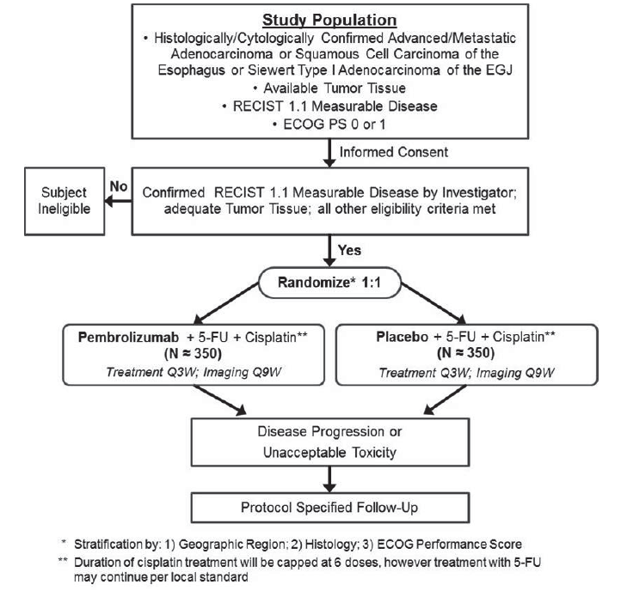

Abbreviations: 5-FU = 5-fluorouracil; ECOG = Eastern Cooperative Oncology Group; EGJ: oesophagogastric junction; RECIST = Response evaluation criteria in solid tumours; SCC = squamous cell carcinoma; Q3W = every 3 weeks; Q9W = every 9 weeks.

* stratified according to geographic region (Asia versues rest of world), histology (adenocarcinoma versus SCC), and Eastern Cooperative Oncology Group (ECOG) performance status (0 or 1). Pembrolizumab or placebo assignment will be masked to patients and investigators.

** Duration of cisplatin treatment will be capped at six cycles; however, treatment with 5-FU can continue per local standard.

The KEYNOTE-590 trial was initially designed to randomise 700 patients globally (population known as the ‘Global Cohort’).

Approximately 160 patients from China were to be randomised in the ‘Global Cohort’ during the global enrolment period, and additional patients enrolled in the ‘China Extension Study’ enrolment period.

The protocol was amended to merge ‘Global Cohort’ and ‘China Extension Study’, referred to as the ‘Global Study’ population with 749 patients randomised in total on which the primary analyses are based (pembrolizumab arm: n = 373; placebo arm: n= 376).

The study was conducted in 168 centres in 26 countries worldwide (Argentina, Australia, Brazil, Canada, Chile, China, Colombia, Costa Rica, Denmark, France, Germany, Guatemala, Hong Kong, Japan, Malaysia, Peru, Romania, Russia, South Africa, South Korea, Spain, Taiwan, Thailand, Turkey, the United Kingdom and the USA). Although disease characteristics and management of earlier stages of disease may vary between countries, the treatment backbone regimen selected in the first-line setting for these patients is used in Australia and results of this global study would generally be considered applicable to the Australian population.

###### Inclusion criteria

The key inclusion criteria were:

* Histologically or cytologically confirmed locally advanced unresectable or metastatic adenocarcinoma or squamous cell carcinoma of oesophagus or advanced/metastatic Siewert Type 1 adenocarcinoma of oesphagogastric junction.
* Measurable disease as per RECIST 1.1;[12]
* ECOG performance status (PS) score of 0 or 1;[13]
* Tissue sample for PD-L1 IHC;[14]
* Adequate organ function.

###### Exclusion criteria

The key exclusion criteria were:

* Prior therapy for advanced/metastatic oesophageal adenocarcinoma or oesophageal squamous cell carcinoma or advanced/metastatic Siewert Type 1 adenocarcinoma of oesophagogastric junction
* Active autoimmune disease requiring systemic treatment within past two years before the first dose of study treatment
* Immunodeficiency or known history of HIV, hepatitis B or C infection
* Known active central nervous system metastases/carcinomatous meningitis

###### Treatment arms

The intervention arm regime was:

* pembrolizumab as either:
  + 200 mg intravenously once every three weeks; or
  + 400 mg intravenously once every six weeks; with
* cisplatin 80 mg/m2 intravenously once every three weeks; and
* 5-fluorouracil 800 mg /m2/day continuous intravenous infusion on Days 1 to 5 once every three weeks (total of 4000 mg/m2 per three week cycle).

The control arm regime was:

* normal saline intravenously once every three weeks (placebo); with
* cisplatin 80 mg/m2 intravenously once every three weeks; and
* 5-fluorouracil 800 mg /m2/day continuous intravenous infusion on Days 1 to 5 once every three weeks (total of 4000 mg/m2 per three week cycle).

Control group rationale and comparator suitability.

The backbone chemotherapy regimen selected for KEYNOTE-590 trial (5-fluorouracil combined with cisplatin) is considered to be acceptable; within the Australian context, this regimen would be considered one of the standard of care combinations (as for any platinum- plus fluoropyrimidine-based combination) for first-line treatment of metastatic oesophageal cancer.

It is not expected that any of the specific agents within these platinum and fluoropyrimidine containing regimen to have a different outcome when combined with pembrolizumab.

###### Participant flow

There was one discontinuation due to a protocol violation in the placebo arm. Irrespective of underlying reason for discontinuation, the treatment arms were balanced in terms of reasons for discontinuation other than adverse events.

###### Study endpoints

Primary efficacy endpoints were:

* Overall survival (time from randomisation to death due to any cause)
* Progression free survival (time from randomisation to the first documented disease progression or death due to any cause, whichever occurred first)

Key secondary efficacy endpoints were:

* Objective response rate (proportion of participants who have a complete response or partial response per RECIST version 1.1 criteria);[15]
* Duration of response for participants who demonstrate a complete response or partial response

Other secondary and other relevant endpoints were:

* Safety measurements
* Health related quality of life using EORTC QLQ-30,[16] and 3 pre-specified disease related symptom scores (dysphagia, reflux and pain) from EORTC QLQ-OES18;[17]
* Health related quality of life using EQ-5D-5L;[18] progression free survival per irRECIST criteria;[19]

###### Follow up and treatment duration

The intervention and control arms continued for up to 35 administrations or approximately two years. Cisplatin was capped at six doses and 5-fluorouracil was capped at 35 cycles.

Treatment was continued until disease progression, unacceptable adverse events, inter-current illness, patient or physician’s decision or 35 cycles (approximately 2 years). Tumour assessments were planned to be performed once every nine weeks until disease progression, start of new anticancer therapy, withdrawal of consent or death.

###### Stratification

The study was stratified by geographic region (Asian versus rest of the world), histology (adenocarcinoma versus squamous cell carcinoma) and ECOG PS (0 versus 1).[20]

###### Statistical analysis plan

The key elements of the statistical analysis plan are outlined in Table 4 (below).

Table 4: KEYNOTE-590 trial; Key elements of the statistical analysis plan

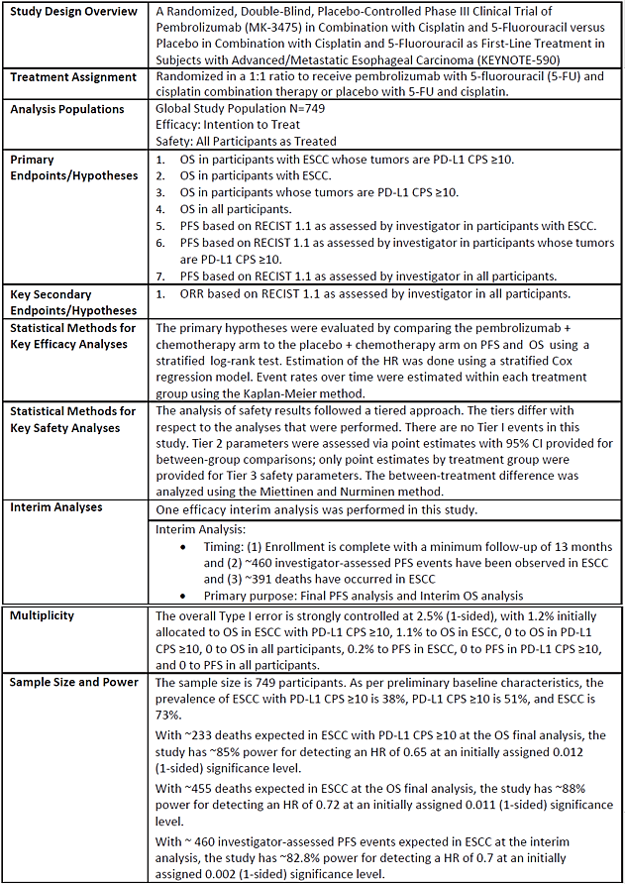

Abbreviations: ESCC = (O)esophageal squamous cell carcinoma; CPS = combined positive score; HR = hazard ratio; OS = overall survival; PD-L1 = programmed death-ligand 1; PFS = progression-free survival.

As noted in the evaluation, a division of the overall alpha of 0.025 (1 sided) between co-primary endpoints as well as a graphic approach was used to control overall study-wise Type 1 error rate for testing of multiple endpoints.

A sample size of 700 was planned to evaluate co-primary endpoints progression free survival (by RECIST 1.1, as per investigator) and overall survival.

* Progression free survival assumptions and analysis plan:
  + 460 progression free survival events for analysis assuming progression free survival hazard ratio (oesophageal squamous cell carcinoma) = 0.70; (median progression free survival 6.0 versus 8.6 months) with 83% power and one-sided alpha 0.002
  + Progression free survival to be tested hierarchically in the following populations in the order of (i) oesophageal squamous cell carcinoma, (II) PD-L1+, and (III) all-corners
* Overall survival assumptions and analysis plan:
  + 232 deaths for analysis assuming hazard ratio (oesophageal squamous cell carcinoma PD-L1+) = 0.65 (median overall survival 12.0 versus 18.5 months) with 85% power and one-sided alpha = 0.012.
  + 455 deaths for analysis assuming hazard ratio (oesophageal squamous cell carcinoma) = 0.72 (median overall survival 12.0 versus 16.7 months) with 88% power and one-sided alpha – 0.011.
  + One planned interim analysis for overall survival after 86% information (200 deaths in oesophageal squamous cell carcinoma PD-L1+, 391 deaths in ESCC).
  + Overall survival in PD-L1+ and in all-comer populations are planned to be tested hierarchically in the event overall survival in oesophageal squamous cell carcinoma PD‑L1+ or oesophageal squamous cell carcinoma is statistically significant.

The O’Brien and Fleming alpha spending method was used for the calculation of alpha boundaries for the interim and final efficacy analyses. This application is based on data from the time of the pre-specified final analysis of progression free survival and corresponding interim analysis of overall survival.

With respect to the statistical methods for key safety analyses, the data submitted for the reference population for more than 2799 patients previously exposed to pembrolizumab and comparison between treatment arms are sufficient.

The statistical analyses plans for efficacy and safety endpoints were considered acceptable by the TGA’s clinical evaluation.

###### Patient disposition

There were 1020 participants screened and 749 participants randomised to the pembrolizumab plus chemotherapy group (n = 373) or the placebo plus chemotherapy group (n = 376). As of data cut-off, 370 participants in the pembrolizumab arm had received at least one dose of study intervention, with 27 (7.3%) still receiving on-going pembrolizumab plus chemotherapy and 108 (29.0%) still in follow-up. In the placebo plus chemotherapy group, 370 participants had received at least one dose of study intervention, with ten (2.7%) were still receiving ongoing treatment and 65 (64.6%) were still in follow-up.

At the time of primary analysis, 71% and 83% of patients in the pembrolizumab and placebo arms respectively have discontinued treatment, mainly due to disease progression (55% progressive disease as per RECIST criteria;15 and 10% clinical progression in the pembrolizumab arm versus 65% progressive disease as per RECIST and 11% clinical progression in the placebo arm).

###### Protocol amendments

There was a total of nine protocol amendments since finalisation of protocol on 14 March 2017. Notable issues arising from the evaluation relate to Protocol Amendment 9 (17 June 2020):

* Amendment 9: Initial primary endpoint progression free survival as assessed by blinded independent central review was changed to progression free survival as assessed by investigator, due to higher than expected discordance rate in assessment of progressive disease between blinded independent central review and investigator and following input from the overseas regulatory agency on the second interim analysis.

###### Protocol violations and deviations

The majority of those with important protocol deviations had a reportable safety event and/or follow up safety event that was not reported as per protocol timelines. As per the clinical evaluation, no patient data were excluded from analyses due to a protocol deviation, and the reported protocol violations or deviations were unlikely to have had any important impact on the overall study results.

###### Demographic and baseline characteristics

Participant characteristics are shown in Table 5 (below).

Table 5: KEYNOTE-590 trial; Participant characteristics (intent to treat population)

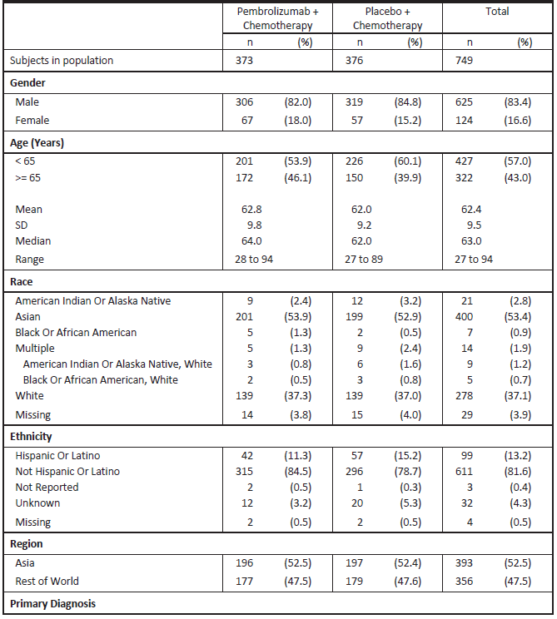

Table 5 (continued): KEYNOTE-590 trial; Participant characteristics (intent to treat population)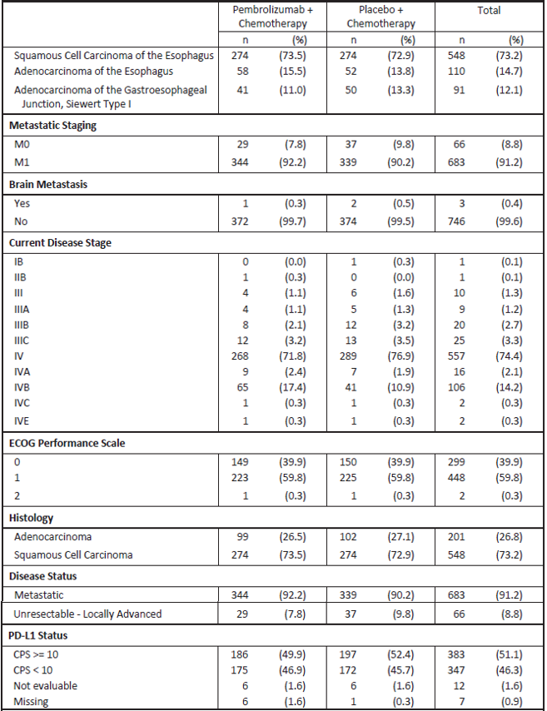

Abbreviations: CPS = combined positive score; ECOG = Eastern Cooperative Oncology Group; M0 = metastasis/metastases absent; M1 = metastasis/metastases present; PD‑L1 = programmed death ligand 1.

Staging as per AJCC Cancer Staging Manual, Eighth Edition (2017) criteria.

Baseline demographic and disease characteristics were balanced between arms, with minimal potential for bias in the safety population or confounders for efficacy outcomes.

Most participants were male (84%); squamous cell carcinoma was more common in participants than adenocarcinoma (73.2%) versus 26.8%). 53% of patients were enrolled in Asia versus 48% from rest of the world; 37% of patients were of White descent.

Half of the patients enrolled had a combined positive score (CPS) ≥ 10 tumour status (51%) and 46% had a CPS < 10. Combined positive score tumour status was balanced between arms. 2.5% of patients were not evaluable for CPS; this missing data is unlikely to influence efficacy outcomes due to the large overall sample size.

Microsatellite instability data were missing in 84% of patients (n = 627). It was agreed upon that as an alternative to testing tumour specimens for all patients, microsatellite instability testing would be performed on all those enrolled in clinical studies across the sponsor’s clinical development for oesophageal cancer who achieve a complete response or partial response as per RECIST version 1.1 criteria.15 Among patients who either achieved complete response or partial response or were continuing on study without disease progression, 112 patients were evaluable for microsatellite instability status and none were found to be microsatellite instability - high.

###### Efficacy results

Primary endpoint

At the data cut-off date of 2 July 2020, results after a minimum of 13 months follow-up were presented.

Following evaluation, several co-primary endpoints were formally tested and found to be statistically significant prior to the tests of overall survival and progression free survival in the intent-to-treat (ITT) population.

In the oesophageal squamous cell carcinoma PD-L1+ (CPS ≥ 10) population, participants in the pembrolizumab plus chemotherapy arm, compared to those in the placebo plus chemotherapy arm, demonstrated a statistically significant improvement in overall survival, with a median overall survival of 13.9 months (95% confidence interval (CI): 11.1, 17.7) versus 8.8 months (95% CI: 7.8, 10.5) and a hazard ratio of 0.57 (95% CI: 0.43, 0.75; p < 0.0001).

In the oesophageal squamous cell carcinoma population, a statistically significant overall survival improvement was demonstrated in those in the pembrolizumab plus chemotherapy group compared to those in the placebo plus chemotherapy group (12.6 months versus 9.8 months), hazard ratio 0.72 (95% CI: 0.60, 0.88; p = 0.0006). A statistically significant improvement in overall survival is also seen in the PD-L1+ (CPS ≥ 10) population, irrespective of histology, for those who received pembrolizumab plus chemotherapy (median overall survival 13.5 months, 95% CI: 11.1, 15.6) compared to placebo plus chemotherapy (median overall survival 9.4 months, 95% CI: 8.0, 10.7), with a hazard ratio of 0.62 (95% CI: 0.49, 0.78; p < 0.0001).

In the ITT population, participants in the pembrolizumab plus chemotherapy arm, compared to placebo plus chemotherapy, demonstrated a statistically significant improvement in overall survival, with a median overall survival of 12.4 months (95% CI: 10.5, 14.0) versus 9.8 months (95% CI: 8.8, 10.8), and a hazard ratio of 0.73 (95% CI: 0.62, 0.86; p < 0.0001). A statistically significant improvement in progression free survival as assessed by investigator, was also noted, with a hazard ratio of 0.65 (95% CI: 0.55, 0.76; p < 0.0001).

With respect to the alpha boundary for statistical significance for overall survival and interim analysis, it is noted that the evaluator calculates the alpha boundary to be 0.017 using a 91% observed information fraction the overall survival interim analysis was statistically significant using this efficacy boundary.

The following Kaplan-Meier plot of overall survival (ITT population) shows that the proportional hazards assumption hold for overall survival in this population.

Figure 2: KEYNOTE-590 trial; Kaplan-Meier plot of overall survival (intent to treat population)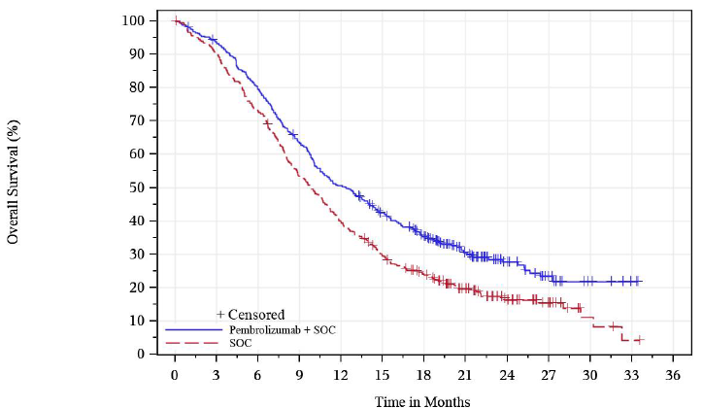

The evaluation of treatment effect of Blinded Independent Central Review -assessed progression free survival in the ITT population was supportive of the observed effect for investigator-assessed progression free survival. The median progression free survival per Blinded Independent Central Review was 6.5 months (95% CI: 6.2, 8.0) in the pembrolizumab plus chemotherapy group versus 6.0 months (95% CI: 5.7, 6.2) in the placebo arm, with a corresponding hazard ratio of 0.67 (95% CI: 0.56, 0.79). The overall discordance rate for Blinded Independent Central Review overall assessment of non-progressive disease for each patient with observed investigator assessed non-progressive disease was 18%; 13% in the pembrolizumab plus chemotherapy arm and 25% in the placebo plus chemotherapy arm. As noted in the evaluation, these discordance rates are considered acceptable. Given the effect on overall survival and double-blind design, the protocol specified analysis of investigator assessed progression free survival was acceptable.

The landmark rates of time-to-event endpoints such as progression free survival or overall survival rates at 12 months is considered to be exploratory only.

Secondary and exploratory endpoints

In the ITT population, the confirmed objective response rate based on investigator assessment was 45.0% and 29.3% for patients in the pembrolizumab plus chemotherapy arm versus placebo plus chemotherapy arm respectively. The median duration of response was 8.3 months in the pembrolizumab plus chemotherapy group and 6.0 months in the placebo plus chemotherapy group.

Patient reported outcome endpoints were not included in the formal testing plan for KEYNOTE‑590 trial. The results are considered exploratory given the lack of control for the Type 1 error rate for analyses, and that the protocol did not pre-specify clinically meaningful changes for the proposed patient reported outcome endpoints.

###### Additional analyses

The evaluation included an additional analysis of overall survival based on selected patient characteristics in the ITT population. Although these results are considered exploratory, there were no obvious outliers.

###### Statistical assessment of efficacy

The evaluation of the statistical assessment of efficacy concluded that there were no major statistical issues identified during the review process, with the study meeting statistical significance on all pre-specified primary endpoints and the key secondary endpoint objective response rate under the formal testing plan. The evaluation did, however, specifically comment on Amendment 9 and on the estimation of treatment effect on overall survival in patients with PD‑L1 CPS < 10 and in patients with adenocarcinoma.

##### Summary of efficacy

KEYNOTE-590 trial met its primary endpoints and key secondary endpoints (progression free survival, overall survival and objective response rate) in the ITT population of patients with locally advanced or metastatic oesophageal adenocarcinoma or oesophageal squamous cell carcinoma or advanced/metastatic Siewert Type 1 adenocarcinoma of the oesophagogastric junction (not amenable to surgical resection or definitive chemoradiation), with statistically significant and clinically meaningful results.

Participants in the pembrolizumab plus chemotherapy arm, compared to placebo plus chemotherapy, demonstrated an improvement in overall survival, with a median overall survival of 12.4 months (95% CI: 10.5, 14.0) versus 9.8 months (95% CI: 8.8, 10.8), and a hazard ratio of 0.73 (95% CI: 0.62, 0.86; p < 0.0001). The hazard ratio for progression free survival (as assessed by investigator) was 0.65 (95% CI: 0.55, 0.76; p < 0.0001) favouring the pembrolizumab arm, with a median progression free survival of 6.3 months (95% CI: 6.2, 6.9) in the pembrolizumab plus chemotherapy arm versus 5.8 months in the placebo plus chemotherapy arm (95% CI: 5.0, 6.0).

Secondary endpoints, subgroup analyses and sensitivity analyses were consistent with results of progression free survival and overall survival.

All pre-specified analyses of the study were statistically significant:

* In patients with oesophageal squamous cell carcinoma with tumours expressing PD-L1 CPS ≥ 10, those in the pembrolizumab plus chemotherapy group showed a statistically significant overall survival improvement compared to those in the placebo plus chemotherapy group, with a hazard ratio of 0.57 (95% CI: 0.43, 0.75; p < 0.0001) and a median overall survival of 13.9 months (95% CI: 11.1, 17.7) versus 8.8 months (95% CI: 7.8, 10.5). The progression free survival hazard ratio was 0.53 (95% CI: 0.40, 0.69) with a median progression free survival of 7.3 months (95% CI: 6.2, 8.2) for the pembrolizumab arm and 5.4 months (95% CI: 4.2, 6.0) for the placebo group.
* In patients with oesophageal squamous cell carcinoma, a statistically significant overall survival improvement was demonstrated in those in the pembrolizumab plus chemotherapy group compared to those in the placebo plus chemotherapy group with a hazard ratio 0.72 (95% CI: 0.60, 0.88; p=0.0006), and median overall survival of 12.6 months (95% CI: 10.2, 14.3) in the pembrolizumab arm versus 9.8 months (95% CI: 8.6, 11.1) in the placebo arm.
* In patients whose tumours express PD-L1 (CPS ≥ 10) irrespective of histology, an improvement in overall survival is also seen for those who received pembrolizumab plus chemotherapy (median overall survival 13.5 months, 95% CI: 11.1, 15.6) compared to placebo plus chemotherapy (median overall survival 9.4 months, 95% CI: 8.0, 10.7), with a hazard ratio of 0.62 (95% CI: 0.49, 0.78; p < 0.0001).

#### Safety

The safety review focusses on the data from participants in KEYNOTE-590 trial (pembrolizumab plus chemotherapy n = 370; placebo plus chemotherapy, n = 370) in addition to the reference safety dataset for pembrolizumab (n = 2799).[21] The clinical evaluation noted some differences between the as treated safety population and those in the reference safety dataset, however, this is unlikely to be clinically important given the heterogeneous patient populations represented in both groups. The size of the dataset is considered to be adequate to characterise the safety of pembrolizumab and 5-fluorouracil/cisplatin in the study population; the monitoring for safety as detailed in the protocol was adequate and consistent with the standard of care.

##### Patient exposure

In the participants exposed to pembrolizumab in KEYNOTE-590 trial (all subjects as treated), the median exposure was 5.7 months in the pembrolizumab plus chemotherapy group and 5.1 months in the placebo plus chemotherapy group (with mean exposure of 7.7 months versus 5.8 months respectively). This likely reflects the treatment effect on progression free survival of pembrolizumab in the treated population.

##### KEYNOTE-590 trial

###### Safety results

The adverse event results noted in particular are highlighted in Table 6.

Table 6: KEYNOTE-590 trial; Summary of adverse events

|  |  |  |
| --- | --- | --- |
| Participants | Pembrolizumab + chemotherapy  N = 370 (100%) | Placebo + chemotherapy  N = 370 (100%) |
| Drug related adverse events | 364 (98.4%) | 360 (97.3%) |
| Serious adverse events | 205 (55.4%) | 204 (55.1%) |
| Serious drug related adverse events | 117 (31.6%) | 97 (26.2%) |
| Death | 28 (7.6%) | 38 (10.3%) |
| Death due to drug related adverse events | 9 (2.4%) | 5 (1.4%) |
| Discontinued any drug due to adverse events | 90 (24.3%) | 74 (20.0%) |
| Discontinued pembrolizumab or placebo due to an adverse event | 54 (14.6%) | 45 (12.2%) |
| Discontinued any drug due to drug related adverse event | 72 (19.5%) | 43 (11.6%) |
| Discontinued any drug due to serious adverse event | 58 (15.7%) | 47 (12.7%) |
| Discontinued any drug due to drug related serious adverse event | 38 (10.3%) | 17 (4.6%) |

###### Deaths

The proportion of patients with adverse events resulting in deaths was similar in both arms (7.6% in the pembrolizumab plus chemotherapy group and 10.3% in the placebo plus chemotherapy group). In both arms, Preferred Terms that could be grouped as pneumonia (pneumonia, pneumonia aspiration, pulmonary sepsis) were the most common cause of death (3% in each arm).

As per the clinical evaluation, the causes of death in each arm could be related to the underlying oesophageal cancer or disease progression (for example, gastrointestinal haemorrhage and fistulas) and therefore it is not possible to determine whether treatment contributed to the patients’ deaths. The proportion of patients in the pembrolizumab arm of KEYNOTE-590 trial who experienced an adverse event leading to death was consistent with the reference safety dataset and no common toxicity cause of death could be identified.

###### Serious adverse events

Analysis of non-fatal serious adverse events that assessed 196 patients per arm (53%) hospitalised for treatment of event found that the most frequently reported serious adverse event in both arms was pneumonia (14% in the pembrolizumab plus chemotherapy group versus 10% in the placebo plus chemotherapy group). The incidence of serious adverse events did not differ appreciably between the two arms apart from pneumonitis, occurring in 3.2% versus 0.3%, respectively. Pneumonitis is an expected immune related adverse event to pembrolizumab and appears in the product information. The incidence of serious adverse events was consistent with the reference safety dataset.

###### Discontinuations due to adverse events

Pembrolizumab was discontinued due to an adverse event in 15% of patients, with the commonest of these adverse events being pneumonitis (1.6%), acute kidney injury (1.1%) and pneumonia (1.1%). The most common adverse events leading to chemotherapy discontinuation in the pembrolizumab plus chemotherapy group compared to placebo plus chemotherapy group were pneumonia (2.4% versus 2.2% respectively) and raised serum creatinine (1.9% versus 3.0%).

The treatment discontinuations reported in KEYNOTE-390 trial are consistent with the known safety profile of pembrolizumab and chemotherapy.

###### Dose interruption/reduction due to adverse events

Adverse events leading to interruption of pembrolizumab occurred in 67% of patients, with the most common of these adverse events being neutropenia (19%), fatigue/asthenia (8%), decreased white blood cell count (5%), pneumonia (5%), decreased appetite (4.3%), anaemia (3.2%) increased blood creatinine (3.2%), stomatitis (3.2%) thrombocytopenia (3.0%), malaise (3.0%), pneumonitis (2.7%), diarrhoea (2.4%), dysphagia (2.2%) and nausea (2.2%). The incidence of adverse events leading to interruption of pembrolizumab/placebo was comparable between those in the pembrolizumab plus chemotherapy group (67%) compared to those in the placebo plus chemotherapy group (63%). The incidence of adverse events leading to interruption of chemotherapy was higher in the pembrolizumab plus chemotherapy group (65%) compared to the placebo plus chemotherapy group (59%).

The treatment interruption, delays and dose modifications in KEYNOTE-590 trial as evaluated and noted by the evaluator are consistent with the known safety profile of pembrolizumab and chemotherapy.

###### Adverse event of special interest

The adverse event of special interest, including immune mediated adverse events and infusion related reactions are detailed in Table 7 and Table 8.

Table 7: KEYNOTE-590 trial; Adverse event summary for adverse events of special interest (all subjects as treated population)

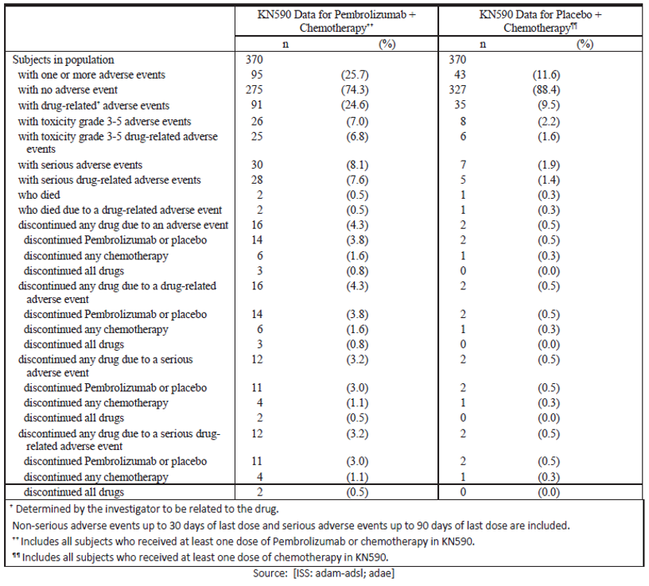

Table 8: KEYNOTE-590 trial; Subjects with adverse events of special interest (incidence more than 0% in either treatment group) by adverse events of special interest category (all subjects as treated population)

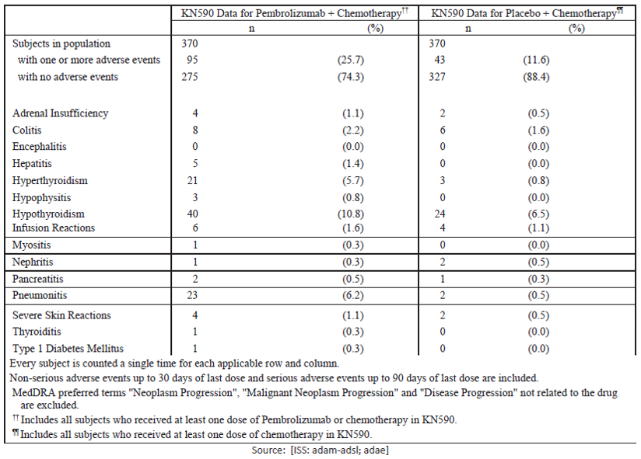

The incidence of adverse event of special interest was 25.7% in the pembrolizumab plus chemotherapy arm compared to 11.6% in the placebo plus chemotherapy arm. The most common adverse event of special interest in the pembrolizumab plus chemotherapy group were hypothyroidism (10.8%), pneumonitis (6.2%), and hyperthyroidism (5.7%); the most common adverse event of special interest in the placebo plus chemotherapy group was hypothyroidism (6.5%). The adverse event of special interest seen in the pembrolizumab plus chemotherapy group were mostly low grade, with more than half reported as resolving (12.6%) or resolved (40.0%) at the time of data cut-off. Grade 3 to 5 adverse event of special interest occurred in 7.0% of participants, including 0.5% with fatal adverse event of special interest.

Three participants in KEYNOTE-590 trial died from an adverse event of special interest (all due to pneumonitis), with two observed in the pembrolizumab plus chemotherapy arm and one in the placebo plus chemotherapy arm.

The evaluation noted that in a pooled analysis of more than 2799 patients;21 who have received pembrolizumab, the incidence of hyperthyroidism was 3.4% and hypothyroidism was 8%, with most being Grade 1 to 2 in severity. Given the high background rate of thyroid disorders in the control arm, the excess number of events observed with pembrolizumab would not be unexpected. The incidence and types of adverse event of special interest observed in KEYNOTE‑590 trial are consistent with the known safety profile of pembrolizumab.

###### Treatment emergent adverse events and adverse reactions

The TGA’s clinical evaluation replicated the findings of the sponsor’s analysis.

###### Laboratory findings and vital signs

No new safety concerns were observed based on laboratory findings, vital signs and ECG findings; specifically, there were no clinically meaningful effects on the corrected QT interval.[22]

###### Immunogenicity

No new information concerning immunogenicity was provided in this submission.

##### Post-market data

The evaluation noted that there are no records of any pembrolizumab registration being revoked or withdrawn for safety reasons in any country following review of the safety profile of pembrolizumab as summarised in the periodic safety update report of 4 September 2018 to 3 September 2019.

##### Integrated safety analysis

The adverse event profile observed in patients who received pembrolizumab in KEYNOTE-590 trial is consistent with the known pembrolizumab safety profile. Incidences of adverse events, Grade 3 to 5 adverse events, serious adverse events, discontinuation due to adverse events and serious adverse events were similar between treatment groups. Incidence rates of discontinuation of any drug due to drug-related adverse events and serious adverse events were higher in the pembrolizumab plus chemotherapy group (24%) than in the placebo plus chemotherapy group (20%). The incidence of adverse event of special interest was higher in the pembrolizumab plus chemotherapy group (26%) than in the placebo plus chemotherapy group (12%).

The evaluation noted that pembrolizumab has an acceptable safety profile in patients with advanced unresectable or metastatic oesophageal or gastroesophageal cancer with no prior therapy for advanced disease (given the improvement in overall survival). The safety of patients on KEYNOTE-590 trial were consistent with the reference safety dataset of more than 2799 study participants with melanoma or non-small cell lung cancer who have received pembrolizumab.21

##### Summary of Safety

Safety results from KEYNOTE-590 trial demonstrate that pembrolizumab in combination with 5‑fluorouracil/cisplatin has a tolerable safety profile that reflects the adverse reaction profiles of the components, with no new safety concerns identified. The addition of pembrolizumab does not appear to significantly increase the toxicity of the chemotherapy backbone, taking into consideration the different lengths of treatment exposure. Some patients can however experience severe and/or serious toxicity from pembrolizumab, generally due to immune related adverse events.

Specifically, the incidence of death was similar in both treatment arms, (pneumonia being he commonest cause of death). The incidence of serious adverse events was also similar in both arms, except for pneumonitis which was more common in combination arm (3.2% versus 0.3%); of note, pneumonitis is an expected immune related adverse event for pembrolizumab.

More serious drug-related adverse events and discontinuations were seen for those in the pembrolizumab plus chemotherapy arm compared to the placebo plus chemotherapy arm. The incidence of adverse event of special interest was higher in the pembrolizumab plus chemotherapy arm (compared to the placebo plus chemotherapy arm) as would be expected, with the adverse event of special interest generally consistent with the known pembrolizumab safety profile.

The risks of pembrolizumab are therefore largely manageable with patient surveillance, treatment delays and supportive care in most patients, and are considered acceptable given the life-threatening nature of metastatic or locally advanced oesophageal carcinoma.

#### Other considerations

There is no companion diagnostic for this indication. Enrolment into study KEYNOTE-590 trial was based on tumour location. Specified subpopulation analyses was based on PD-L1 status where data was provided by centrally determined assessments in all patients using the PD‑L1 IHC 22C3 kit.[23]

### Risk management plan

The sponsor is required to comply with product vigilance and risk minimisation requirements.

The TGA decided a risk management plan (RMP) was not required for this submission to expand the treatment population of pembrolizumab to include first line treatment, in combination with platinum and fluoropyrimidine based chemotherapy, of patients with advanced or metastatic carcinoma of the oesophagus. Pembrolizumab is currently indicated for use, in the same combination, in patients with metastatic carcinoma of the head and neck, and patients with oesophageal cancers to not represent a significantly different population (see [TGA’s guidance](https://www.tga.gov.au/resources/resource/guidance/risk-management-plans-medicines-and-biologicals/when-rmp-required) on ‘when an RMP is required’).

The TGA may request an updated RMP at any stage of a product's life-cycle, during both the pre-approval and post-approval phases. Further information regarding the TGA’s risk management approach can be found in [risk management plans for medicines and biologicals](https://www.tga.gov.au/publication/risk-management-plans-medicines-and-biologicals) and [the TGA's risk management approach](https://www.tga.gov.au/tgas-risk-management-approach). Information on the [Australia specific annex](https://www.tga.gov.au/resources/resource/guidance/risk-management-plans-medicines-and-biologicals/australia-specific-annex-eu-rmp) ([ASA](https://www.tga.gov.au/resources/resource/guidance/risk-management-plans-medicines-and-biologicals/australia-specific-annex-eu-rmp)) can be found on the TGA website.

### Risk-benefit analysis

#### Delegate’s considerations

The sponsor proposes the following extension of indications:

*Keytruda (pembrolizumab), in combination with platinum and fluoropyrimidine based chemotherapy, is indicated for the first line treatment of patients with locally advanced unresectable or metastatic carcinoma of the oesophagus and gastroesophageal junction.*

As discussed through the TGA’s clinical evaluation, the following factors are taken into consideration regarding the rationale for this submission, as supported by a single study, KEYNOTE-590 trial.

* Metastatic or locally advanced oesophageal carcinoma is a serious, life-threatening disease with poor prognosis, where median survival for patients with metastatic disease is less than a year.
* Although standard of care chemotherapy improves survival in patients with advanced unresectable or metastatic oesophageal or gastroesophageal carcinoma, there is a need for more effective treatment.
* Combination regimens are generally used; in Australia, a standard combination includes fluoropyrimidine and/or platinum agents (with the addition of trastuzumab for HER2‑positive gastroesophageal carcinoma). Selection is based on a patient’s general status, preferences, toxicity, institutional standards and so on.

The KEYNOTE 590 trial is an international, double-blind, placebo-controlled randomised trial in patients with metastatic or locally advanced oesophageal carcinoma or gastroesophageal junction adenocarcinoma who are not candidates for definitive chemoradiation and who have not received prior systemic therapy, with randomisation (1:1) to receive either pembrolizumab or placebo, in combination with 5-fluorouracil and cisplatin.

A total of 749 patients were randomised (373 to the pembrolizumab arm, 376 to placebo). Baseline demographics disease characteristics of the study population were balanced between the two arms. The primary efficacy outcomes were investigator assessed progression free survival per RECIST version 1.1 criterial;15 and overall survival. The statistical plan included hierarchical testing for the ITT population, oesophageal squamous cell carcinoma with PD-L1 combined positive score (CPS) ≥ 10, CPS ≥ 10 irrespective of histology, and oesophageal squamous cell carcinoma irrespective of PD-L1 expression. Secondary endpoints included objective response rate and duration of response.

The results of this study showed a statistically significant and meaningful improvement in overall survival and progression-free survival in those who received chemotherapy in combination with pembrolizumab compared to those who received placebo plus chemotherapy. These results were consistent across predefined subgroups and secondary endpoints.

* In the ITT population, the hazard ratio for overall survival was 0.73 (95% CI: 0.62, 0.86; p < 0.0001) favouring the pembrolizumab arm, with a median overall survival of 12.4 months (95% CI: 10.5, 14.0) in the pembrolizumab arm versus 9.8 months (95% CI: 8.8, 10.8) in the placebo arm.
* The hazard ratio for progression free survival (as assessed by investigator) was 0.65 (95% CI: 0.55, 0.76; p < 0.0001) favouring the pembrolizumab arm, with a median progression free survival of 6.3 months (95% CI: 6.2, 6.9) in the pembrolizumab arm versus 5.8 months in the placebo arm (95% CI: 5.0, 6.0).
* In patients with oesophageal squamous cell carcinoma (n = 286) with tumours expressing PD-L1 CPS ≥ 10, those in the pembrolizumab arm showed a statistically significant overall survival improvement with a hazard ratio of 0.57 (95% CI: 0.43, 0.75; p < 0.0001).
* In patients with oesophageal squamous cell carcinoma (n = 548), a statistically significant overall survival improvement was demonstrated in patients in the pembrolizumab arm with a hazard ratio 0.72 (95% CI: 0.60, 0.88; p=0.0006).
* In patients whose tumours express PD-L1 CPS ≥ 10, irrespective of histology (n = 383), an improvement in overall survival is also seen for those in the pembrolizumab arm with a hazard ratio of 0.62 (95% CI: 0.49, 0.78; p < 0.0001).

In exploratory analyses, the clinical evaluation team assessed the effect of pembrolizumab in combination with cisplatin/5-fluorouracil in the subpopulation of patients with CPS < 10. In 347 patients with PD-L1 CPS < 10, the median overall survival was 10.5 months (95% CI: 9.7, 13.5) for the pembrolizumab arm and 10.6 months (95% CI: 8.8, 12.0) for the placebo arm, with a hazard ratio of 0.86 (95% CI: 0.68, 1.10). Consequently, there is some uncertainty as to whether benefit in the ITT population is driven by patients with high PD-L1 expression levels. In addition, the exploratory analysis of pembrolizumab in combination with cisplatin/5‑fluorouracil in the subpopulation of patients with adenocarcinoma (n = 210, 72 randomised to pembrolizumab plus chemotherapy and 99 to placebo plus chemotherapy), demonstrated a hazard ratio of 0.74 (95% CI: 0.54, 1.02). This effect size appears similar to the ITT population, although the upper boundary of the 95% confidence interval crosses one.

In addition, the potential magnitude of clinical benefit in patients in pre-specified subgroups can be evaluated using the ESMO-Magnitude of Clinical Benefit Scale (ESMO-MCBS);[24],[25] as shown in Table 9.

Table 9: Evaluation of ESMO-Magnitude of Clinical Benefit Scale in pre-specified subsets of patients in the KEYNOTE-590 trial

|  |  |  |  |
| --- | --- | --- | --- |
| Population | Lower limit of 95% confidence interval, hazard ratio for overall survival* | Increased median overall survival in the experimental arm | ESMO Magnitude of Clinical Benefit Scale |
| Overall (n = 749) | 0.62 | 2.6 months | 3 |
| Oesophageal squamous cell carcinoma + PD-L1 CPS ≥ 10 (n = 286) | 0.43 | 5.1 months | 4 |
| PD-L1 CPS ≥ 10 (n = 383) | 0.49 | 4.1 months | 4 |
| Oesophageal squamous cell carcinoma (n = 548) | 0.60 | 2.8 months | 3 |
| PD-L1 CPS < 10** (n=347) | 0.68 | 0.1 months | Cannot be graded** |
| Oesophageal adenocarcinoma** (n = 201) | 0.54 | 1.7 months | Cannot be graded** |

Abbreviations: CPS = combined positive score; ESMO = European Society for Medical Oncology; PD-L1 = programmed death-ligand 1.

*Scoring is based on the inferior limit of the 95% CI for the overall survival hazard ratio, as well as the quantitative difference in months for median overall survival (results may change with further follow up).

**exploratory subsets

The benefit of pembrolizumab in combination with platinum/fluoropyrimidine based chemotherapy is substantial in patients with (1) oesophageal squamous cell carcinoma and PD‑L1 CPS ≥ 10, and (2) in those with tumours expressing PD-L1 CPS ≥ 10, as assessed using the ESMO-MCBS tool.

In short, as highlighted in the clinical evaluation report, based on exploratory analyses, there is insufficient data to properly characterise the effect of pembrolizumab when added to chemotherapy for the treatment of patients with adenocarcinoma or PD-L1 CPS < 10.

The evaluation concluded that:

‘while the estimation of treatment effect on overall survival endpoint in patients with PD-L1 CPS < 10 was numerically in the same direction and supportive of the overall survival results in PD-L1 CPS ≥ 10 and in the ITT population, the upper limit of the 95% CI of the estimate of overall survival hazard ratio in patients with PD-L1 CPS < 10 exceeded 1.0.’

The United States (US) Food and Drug Administration (FDA) label has incorporated this information into the pembrolizumab label in order to better support treatment decision, having approved the use of pembrolizumab in the ITT population. The Delegate considers this to be a reasonable approach, in place of restricting the indication to patients with tumours expressing PD-L1 CPS ≥ 10. The provision of these exploratory results within the Product Information is one option to highlight the uncertainty of clinical benefit for the addition of pembrolizumab in patients with low PD-L1 (CPS < 10) oesophageal squamous cell carcinoma which may help guide clinician and patient decision making as required.

The Delegate also notes the results of the CheckMate649 trial,[26] a randomised Phase III trial evaluating the addition of nivolumab to standard chemotherapy (FOLFOX regimen,[27] or Capox,[28]) in the first-line treatment of patients with advanced gastroesophageal adenocarcinomas (gastric, junctional and lower third oesophageal locations). The study met its dual primary endpoints, with a statistically significant improvement in progression free survival and overall survival in patients with tumours expressing PD-L1 CPS ≥ 5. In patients with tumours expressing PD-L1 CPS ≥ 5, the median overall survival was 14.4 months with nivolumab plus chemotherapy (95% CI: 13.1, 16.2) versus 11.1 months with chemotherapy alone (95% CI: 10.0, 12.1), with an overall survival hazard ratio of 0.71 (98.4% CI: 0.59, 0.86). In those with PD-L1 CPS ≥ 1, the overall survival hazard ratio was 0.77 (99.3% CI: 0.64, 0.92), and in all randomised patients, the overall survival hazard ratio was 0.80. As consistent with results of KEYNOTE-590 trial, there is clearly a greater benefit in those with higher PD-L1 CPS, with the benefit less convincing in unselected patients.[29]

The observed safety profile of pembrolizumab in patients with metastatic or locally advanced oesophageal or gastroesophageal junction carcinoma who are not candidates for definitive chemoradiation was consistent with the established safety profile of pembrolizumab in patients with other types of cancer. No new significant safety concerns were identified in this submission. The addition of pembrolizumab does not appear to significantly increase the toxicity of the chemotherapy backbone, taking into consideration the different lengths of treatment exposure in the study population. Some patients can however experience severe and/or serious toxicity from pembrolizumab, generally due to immune related adverse events.

More serious drug-related adverse events and discontinuations were seen for those in the pembrolizumab plus chemotherapy arm compared to the placebo plus chemotherapy arm. The incidence of adverse event of special interest was higher in the pembrolizumab plus chemotherapy arm (compared to the placebo plus chemotherapy arm) as would be expected, with the adverse event of special interest generally consistent with the known pembrolizumab safety profile.

The risks of pembrolizumab are therefore largely manageable with patient surveillance, treatment delays and supportive care in most patients, and are considered acceptable given the life-threatening nature of metastatic or locally advanced oesophageal or gastroesophageal junction carcinoma. Ongoing post-marketing surveillance for assessment of safety of pembrolizumab in patients with oesophageal and gastroesophageal junction carcinoma is recommended.

#### Proposed action

Pembrolizumab in combination with cisplatin and 5-fluorouracil shows a favourable benefit-risk profile compared to placebo in combination with cisplatin and 5-fluorouracil as first line treatment in patients with locally advanced or metastatic oesophageal carcinoma or HER2 negative gastroesophageal junction adenocarcinoma that is not amenable to surgical resection or definitive chemoradiation.

#### Advisory Committee considerations

The [Advisory Committee on Medicines (ACM)](https://www.tga.gov.au/committee/advisory-committee-medicines-acm), having considered the evaluations and the Delegate’s overview, as well as the sponsor’s response to these documents, advised the following.

##### Specific advice to the Delegate

1. ***It is unclear whether, and to what extent, the overall survival benefit in the intent to treat (ITT) population in KEYNOTE-590 trial is driven by patients with tumours expressing high programmed death-ligand 1 (PD-L1) levels (combined positive score (CPS) ≥ 10).***

***In the subpopulation of patients with CPS < 10, exploratory analysis showed a median overall survival of 10.5 months (95% confidence interval (CI): 9.7, 13.5) for those in the pembrolizumab arm and 10.6 months (95% CI: 8.8, 12.0) for those in the placebo arm, with an overall survival hazard ratio of 0.86 (95% CI: 0.68, 1.10).***

***The efficacy of pembrolizumab is therefore potentially reduced when compared to that of the pre-specified patient population whose tumours express PD-L1 CPS ≥ 10 (with overall survival hazard ratio of 0.57; 95% CI: 0.43, 0.75; p < 0.0001).***

***Should the indication under consideration be limited to patients with tumours expressing PD-L1 CPS ≥ 10 given this differential effect based on PD-L1 status, and the uncertainty of clinical benefit in the CPS < 10 population?***

The ACM advised that the indication should not be limited to patients with tumours expressing PD-L1 CPS ≥ 10. In providing this advice, the ACM considered that the proposed differential effect based on PD-L1 status is derived from an exploratory analysis and were of the view that PD-L1 cutoffs are quite arbitrary. The ACM advised that the hazard ratio, and not the absolute median, should guide the interpretation of these results and was of the view that the separation of the survival curves is clinically meaningful in the entire population. The ACM also spoke positively of the long tail in survival for a subset of patients. The ACM emphasised that the risk benefit balance based on PD-L1 CPS is a discussion that should occur between the treating clinican and individual patient.

1. ***There is uncertainty regarding the clinical benefit of pembrolizumab in combination with chemotherapy in patients with oesophageal adenocarcinoma, particularly those whose tumours express PD-L1 CPS < 10. In the exploratory analysis of the effect of pembrolizumab in combination with chemotherapy in patients with oesophageal adenocarcinoma (n = 201), the overall survival hazard ratio was 0.74 (95% CI: 0.54, 1.02).***

***Does the available evidence from KEYNOTE-590 trial support the use of pembrolizumab in combination with chemotherapy in those with oesophageal adenocarcinoma, and should the indication under consideration include this patient subgroup?***

The ACM advised that the data provided are sufficient to include patients with oesophageal adenocarcinoma in the indication. While the sample size from KEYNOTE 590 limits strict interpretation, the ACM were of the view that the data for patients with oesophageal adenocarcinoma follows the same trends as for the other subgroups, and that patients with oesophageal adenocarcinoma should not be excluded from the proposed indication based on an exploratory analysis. The ACM agreed that discussions regarding whether pembrolizumab is an appropriate treatment option for patients with oesophageal adenocarcinoma need to occur between the treating clinician and the patient.

1. ***The Advisory Committee is asked to provide any other advice applicable to this submission.***

The ACM advised that the survival and progression free survival curves with combined positive score > 10 versus < 10 should be shown prominently in the Product Information (PI) to assist discussions between clinicians and patients.

##### Conclusion

The ACM considered this product to have an overall positive benefit-risk profile for the indication:

*For the use of pembrolizumab, in combination with platinum- and fluoropyrimidine- based chemotherapy, for the first-line treatment of patients with locally advanced or metastatic, carcinoma of the oesophagus or HER2 negative gastroesophageal junction adenocarcinoma (tumour centre 1 to 5 centimetres above the gastroesophageal junction) that is not amenable to surgical resection or definitive chemoradiation.*

## Outcome

Based on a review of quality, safety, and efficacy, the TGA approved the registration of Keytruda (pembrolizumab) 50 mg powder for injection vial and 100 mg/4 mL concentrated solution for injection vial, for the following extension of indications:

***Oesophageal Cancer***

*Keytruda (pembrolizumab), in combination with platinum and fluoropyrimidine based chemotherapy, is indicated for the first-line treatment of patients with locally advanced or metastatic carcinoma of the oesophagus or HER2 negative gastroesophageal junction adenocarcinoma (tumour centre 1 to 5 centimetres above the gastroesophageal junction) that is not amenable to surgical resection or definitive chemoradiation.*

As such, the full indications at this time were:

***Melanoma***

*Keytruda (pembrolizumab) is indicated as monotherapy for the treatment of unresectable or metastatic melanoma in adults.*

*Keytruda (pembrolizumab) is indicated as monotherapy for the adjuvant treatment of patients with melanoma with lymph node involvement who have undergone complete resection.*

***Non-small cell lung cancer (NSCLC)***

*Keytruda (pembrolizumab), in combination with pemetrexed and platinum chemotherapy, is indicated for the first-line treatment of patients with metastatic non-squamous NSCLC, with no EGFR or ALK genomic tumour aberrations.*

*Keytruda (pembrolizumab), in combination with carboplatin and either paclitaxel or nab-paclitaxel, is indicated for the first-line treatment of patients with metastatic squamous NSCLC.*

*Keytruda (pembrolizumab) is indicated as monotherapy for the first-line treatment of patients with NSCLC expressing PD-L1 [tumour proportion score (TPS) ≥1%] as determined by a validated test, with no EGFR or ALK genomic tumour aberrations, and is*

* *Stage III where patients are not candidates for surgical resection or definitive chemoradiation, or*
* *metastatic.*

*Keytruda (pembrolizumab) is indicated as monotherapy for the treatment of patients with advanced NSCLC whose tumours express PD-L1 with a ≥1% TPS as determined by a validated test and who have received platinum-containing chemotherapy. Patients with EGFR or ALK genomic tumour aberrations should have received prior therapy for these aberrations prior to receiving Keytruda.*

***Head and Neck Squamous Cell Cancer (HNSCC)***

*Keytruda (pembrolizumab), as monotherapy or in combination with platinum and 5- fluorouracil (5-FU) chemotherapy, is indicated for the first-line treatment of patients with metastatic or unresectable recurrent HNSCC, and whose tumours express PD-L1 [Combined Positive Score (CPS) ≥1] as determined by a validated test.*

*Keytruda (pembrolizumab) is indicated as monotherapy for the treatment of patients with metastatic or unresectable recurrent HNSCC with disease progression on or after platinum containing chemotherapy and whose tumours express PD-L1 [Combined Positive Score (CPS) ≥ 1] as determined by a validated test.*

***Classical Hodgkin Lymphoma (cHL)***

*Keytruda (pembrolizumab) is indicated as monotherapy for the treatment of adult patients with relapsed or refractory classical Hodgkin Lymphoma (cHL):*

1. *following autologous stem cell transplant (ASCT) or*
2. *following at least two prior therapies when ASCT or multi-agent chemotherapy is not a treatment option.*

*The approval of this indication is on the basis of objective response rate (ORR). See Section 5.1 Pharmacodynamic Properties, Clinical Trials.*

***Primary mediastinal B-Cell Lymphoma (PMBCL)***

*Keytruda (pembrolizumab) is indicated for the treatment of adult and paediatric patients with refractory primary mediastinal B-cell lymphoma (PMBCL), or who have relapsed after 2 or more prior lines of therapy. The approval of this indication is on the basis of objective response rate (ORR) and duration of response from non-randomised studies. See Section 5.1 Pharmacodynamic Properties, Clinical Trials.*

***Urothelial carcinoma***

*Keytruda (pembrolizumab) is indicated as monotherapy for the treatment of patients with locally advanced or metastatic urothelial carcinoma who are not eligible for cisplatin-containing therapy and whose tumours express PD-L1 [Combined Positive Score (CPS) ≥10] as determined by a validated test, or in patients who are not eligible for any platinum-containing chemotherapy regardless of PD-L1 status. This indication is approved based on overall response rate and duration of response in a single-arm study. Improvements in overall survival, progression-free survival, or health-related quality of life have not been established.*

*Keytruda (pembrolizumab) is indicated as monotherapy for the treatment of patients with locally advanced or metastatic urothelial carcinoma who have received platinum-containing chemotherapy.*

*Keytruda (pembrolizumab) is indicated for the treatment of patients with Bacillus Calmette- Guerin (BCG)-unresponsive, high-risk, non-muscle invasive bladder cancer (NMIBC) with carcinoma in-situ (CIS) with or without papillary tumours who are ineligible for or have elected not to undergo cystectomy. This indication was approved via the provisional approval pathway based on complete response rate and duration of response. Continued approval of this indication depends on verification and description of benefit in confirmatory trials.*

***Microsatellite instability-high (MSI-H) or mismatch repair deficient (dMMR) cancer***

*Colorectal (previously untreated)*

*Keytruda (pembrolizumab) is indicated for the first-line treatment of patients with unresectable or metastatic colorectal cancer (CRC) that is MSI-H or dMMR as determined by a validated test.*

*Colorectal (previously treated)*

*Keytruda (pembrolizumab) is indicated in adult and paediatric patients for the treatment of unresectable or metastatic CRC that is MSI-H or dMMR as determined by a validated test, and that has progressed following treatment with a fluoropyrimidine, oxaliplatin, and irinotecan. This indication was approved via the provisional approval pathway, based on objective response rate and response duration in a single-arm trial. Continued approval for this indication depends on verification and description of clinical benefit in the confirmatory trials.*

*Non-colorectal*

*Keytruda (pembrolizumab) is indicated in adult and paediatric patients for the treatment of unresectable or metastatic solid tumours that are MSI-H or dMMR as determined by a validated test, that have progressed following prior treatment and when there are no satisfactory alternative treatment options. This indication was approved via the* ***provisional approval*** *pathway, based on the pooling of data on objective response rate and response duration across multiple different tissue types in a single-arm trial. Sample sizes for individual tissue types were too small to provide data on clinical utility of the MSI-H/dMMR tests for each of the tissue types, individually. The assumption that MSI-H/dMMR-status is predictive of the treatment effect of Keytruda for every tissue type has not been verified. Continued approval for this indication depends on verification and description of clinical benefit in the confirmatory trials.*

*The safety and effectiveness of Keytruda in paediatric patients with MSI-H/dMMR central nervous system cancers have not been established.*

***Endometrial carcinoma***

*Keytruda (pembrolizumab), in combination with lenvatinib, is indicated for the treatment of patients with advanced endometrial carcinoma that is not MSI-H or dMMR as determined by a validated test, who have disease progression following prior systemic therapy and are not candidates for curative surgery or radiation. This indication was approved via the provisional approval pathway, based on objective response rate and duration of response in a single-arm trial. Full registration for this indication depends on verification and description of clinical benefit in confirmatory trials.*

***Renal Cell Carcinoma (RCC)***

*Keytruda (pembrolizumab), in combination with axitinib, is indicated for the first-line treatment of patients with advanced renal cell carcinoma (RCC).*

***Cutaneous Squamous Cell Carcinoma***

*Keytruda (pembrolizumab) is indicated as monotherapy for the treatment of adult patients with recurrent or metastatic cutaneous squamous cell carcinoma (cSCC) that is not curable by surgery or radiation. This indication was approved via the* ***provisional approval*** *pathway based on objective response rate and duration of response from a single-arm study. Improvements in overall survival, progression-free survival, or health-related quality of life have not been established. Full registration for this indication depends on submission of further clinical data to confirm the clinical benefit of the medicine.*

***Oesophageal Cancer***

*Keytruda (pembrolizumab), in combination with platinum and fluoropyrimidine based chemotherapy, is indicated for the first-line treatment of patients with locally advanced or metastatic carcinoma of the oesophagus or HER2 negative gastroesophageal junction adenocarcinoma (tumour centre 1 to 5 centimetres above the gastroesophageal junction) that is not amenable to surgical resection or definitive chemoradiation.*

### Specific conditions of registration applying to these goods

* This approval does not impose any requirement for the submission of Periodic Safety Update reports [PSURs]. You should note that it is a requirement that all existing requirements for the submission of PSURs as a consequence of the initial registration or subsequent changes must be completed.

You are reminded that sections 29A and 29AA of the *Therapeutic Goods Act 1989* provide for penalties where there has been failure to inform the Secretary in writing, as soon as a person has become aware, of:

(a) information that contradicts information already given by the person under this Act;

(b) information that indicates that the use of the goods in accordance with the recommendations for their use may have an unintended harmful effect;

(c) information that indicates that the use of the goods in accordance with the information that indicates that the goods, when used in accordance with the recommendations for their use, may not be as effective as the application for registration or listing of the goods or information already given by the person under this Act suggests;

(d) information that indicates that the quality, safety or efficacy of the goods is unacceptable.

* For all injectable products the Product Information must be included with the product as a package insert.

## Attachment 1. Product Information

The PI for Keytruda approved with the submission which is described in this AusPAR is at Attachment 1. For the most recent PI, please refer to the TGA [PI/CMI search facility.](https://www.tga.gov.au/picmi-search-facility)

|  |
| --- |
| Therapeutic Goods Administration |
| PO Box 100 Woden ACT 2606 Australia  Email: [info@tga.gov.au](mailto:info@tga.gov.au) Phone: 1800 020 653 Fax: 02 6203 1605  [**https://www.tga.gov.au**](https://www.tga.gov.au) |
| Reference/Publication # |

1. This is the original indication proposed by the sponsor when the TGA commenced the evaluation of this submission. It may differ to the final indication approved by the TGA and registered on the Australian Register of Therapeutic Goods.
2. National Cancer Control Indicators - Cancer Australia; cancer incidence <https://ncci.canceraustralia.gov.au/diagnosis/cancerincidence/cancer-incidence>
3. National Cancer Control Indicators - Cancer Australia; cancer mortality https://ncci.canceraustralia.gov.au/outcomes/cancermortality/cancer-mortality
4. Lordick F, Mariette C, Haustermans K, et al. Oesophageal cancer: ESMO Clinical Practice Guidelines for diagnosis, treatment and follow-up. *Ann Oncol*. 2016;27:v50-v57
5. National Comprehensive Cancer Network. NCCN clinical practice guidelines in oncology: Esophageal and Esophagogastric Junction Cancers. Version 2.2021 – March 9, 2021. Fort Washington (PA): National

   Comprehensive Network (NCCN); 2021.
6. CheckMate 649 trial: Efficacy Study of Nivolumab Plus Ipilimumab or Nivolumab Plus Chemotherapy Against Chemotherapy in Stomach Cancer or Stomach/Esophagus Junction Cancer. ClinicalTrials.gov Identifier: NCT02872116
7. ATTRACTION-4 trial: Study of ONO-4538 in Gastric Cancer: ClinicalTrials.gov Identifier: NCT02746796
8. KEYNOTE-590 trial: First-line Esophageal Carcinoma Study With Chemo vs. Chemo Plus Pembrolizumab (MK-3475-590/KEYNOTE-590) ClinicalTrials.gov Identifier: NCT03189719
9. 2 Further information on the submission for initial registration of Keytruda (pembrolizumab) (as 50 mg powder for injection (vial)) can be found via the [AusPAR for Keytruda pembrolizumab (rch); submission PM-2014-01928-1-4](https://www.tga.gov.au/resources/auspar/auspar-pembrolizumab-rch).
10. KEYNOTE-590 trial: A first-line esophageal carcinoma study with chemotherapy versus chemotherapy with pembrolizumab; ClinicalTrials.gov Identifier: NCT03189719
11. Sieward classification Type 1 refers to adenocarcinoma of the [distal](https://en.wikipedia.org/wiki/Distal) part of the o[esophagus](https://en.wikipedia.org/wiki/Esophagus). The [tumour](https://en.wikipedia.org/wiki/Tumor) centre is located 1 to 5 cm above the gastric [cardia](https://en.wikipedia.org/wiki/Cardia).
12. New response evaluation criteria in solid tumours: Revised RECIST guideline (version 1.1), European Journal of Cancer (2009) 228 – 247
13. **Eastern Cooperative Oncology Group (ECOG) Performance Status**: The ECOG has developed criteria

    used by doctors and researchers to assess how a patient's disease is progressing, assess how the disease

    affects the daily living abilities of the patient, and determine appropriate treatment and prognosis. The

    following are used:

    0 - Fully active, able to carry on all pre-disease performance without restriction

    1- Restricted in physically strenuous activity but ambulatory and able to carry out work of a light or sedentary

    nature, for example, light house work, office work

    2 - Ambulatory and capable of all selfcare but unable to carry out any work activities. Up and about more than

    50% of waking hours

    3 - Capable of only limited selfcare, confined to bed or chair more than 50% of waking hours

    4 - Completely disabled. Cannot carry on any selfcare. Totally confined to bed or chair

    5 – Dead
14. Programmed death ligand-1 (PD-L1) testing by immunohistochemistry (IHC).
15. **Response evaluation criteria in solid tumours (RECIST) guideline (version 1.1)**Eisenhauer EA, Therasse P, Bogaerts J, et al. New response evaluation criteria in solid tumours: revised RECIST guideline (version 1.1). Eur J Cancer. 2009;45(2):228-247.

    Available at: [New response evaluation criteria in solid tumours: Revised RECIST guideline (version 1.1) (cancer.gov)](https://ctep.cancer.gov/protocoldevelopment/docs/recist_guideline.pdf)
16. **European Organisation for the Research and Treatment of Cancer (EORTC) Quality of Life in Cancer Patients Core Questionnaire (QLQ-C30)**

    Aaronson NK, et al. The European Organisation for Research and Treatment of Cancer QLQ-C30: A quality-of-life instrument for use in international clinical trials in oncology. *Journal of the National Cancer Institute* 1993; 85: 365-376.
17. **European Organisation for the Research and Treatment of Cancer (EORTC) Quality of Life Questionnaire - Oesophageal Cancer Module (EORTC QLQ-OES18)**

    Blazeby JM, et al.; European Organisation for Research and Treatement of Cancer Gastrointestinal and Quality of Life Groups. Clinical and psychometric validation of an EORTC questionnaire module, the EORTC QLQ-OES18, to assess quality of life in patients with oesophageal cancer. Eur J Cancer. 2003 Jul;39(10):1384-94
18. **European Quality of Life 5 Dimension 5 Level questionnaire (EQ-5D-5L)**

    Herdman, M., Gudex, C., Lloyd, A. et al. Development and preliminary testing of the new five-level version of EQ-5D (EQ-5D-5L). *Qual Life Res* 20, 1727–1736 (2011).
19. **Immune-related response evaluation criteria in solid tumours (irRECIST) criteria**

    Bohnsack O, Ludajic K, Hoos A. Adaptation of the immune-related response criteria: irRECIST. *Ann Oncol*. 2014;25(suppl 4):iv361, iv372.
20. **Eastern Cooperative Oncology Group** (**ECOG**) **Performance Status**: The ECOG has developed criteria used by doctors and researchers to assess how a patient's disease is progressing, assess how the disease affects the daily living abilities of the patient, and determine appropriate treatment and prognosis. The following are used: 0 - Fully active, able to carry on all pre-disease performance without restriction 1- Restricted in physically strenuous activity but ambulatory and able to carry out work of a light or sedentary nature, for example, light house work, office work 2 - Ambulatory and capable of all selfcare but unable to carry out any work activities. Up and about more than 50% of waking hours 3 - Capable of only limited selfcare, confined to bed or chair more than 50% of waking hours 4 - Completely disabled. Cannot carry on any selfcare. Totally confined to bed or chair 5 – Dead.  
    Oken MM, Creech RH, Tormey DC, Horton J, Davis TE, McFadden ET, Carbone PP. Toxicity and response criteria of the Eastern Cooperative Oncology Group. *Am J Clin Oncol.* 1982 Dec;5(6):649-655
21. Keytruda reference data set is based upon exposure to Keytruda as a single therapeutic agent in 2799 patients in three randomised, open-label, active-controlled trials (KEYNOTE-002, KEYNOTE-006, and KEYNOTE-010 trials), which enrolled 912 patients with melanoma and 682 patients with non-small cell lung cancer (NSCLC), and one single-arm trial (KEYNOTE‑001 trial), which enrolled 655 patients with melanoma and 550 patients with NSCLC.
22. The **QT interval** is the time from the start of the QRS wave complex to the end of the corresponding T wave. It approximates to the time taken for ventricular depolarisation and repolarisation, that is to say, the period of ventricular systole from ventricular isovolumetric contraction to isovolumetric relaxation.
23. The **PD-L1 IHC 22C3 pharmDx** by Agilent Technologies an *in vitro* diagnostic immunohistochemical assay to aid identifying patients with tumours expressing measurable concentrations of PD-L1 (programmed death-ligand 1) as a biomarker.
24. Cherny N, Dafni U, Bogaerts J et al. ESMO-Magnitude of Clinical Benefit Scale version 1.1. Ann Oncol. 2017; 28: 2340-2366.
25. ESMO-Magnitude of Clinical Benefits Scale (version 1.1) information is available from: [ESMO-Magnitude of Clinical Benefit Scale](https://www.esmo.org/guidelines/esmo-mcbs) (https://www.esmo.org/guidelines/esmo-mcbs)
26. CheckMate649 trial: Efficacy study of nivolumab plus ipilimumab or nivolumab plus chemotherapy against chemotherapy in stomach cancer or stomach/esophagus junction cancer; ClinicalTrials.gov Identifier: NCT02872116
27. The FOLFOX regimen is a combination chemotherapy of folinic acid, fluorouracil and oxaliplatin.
28. The CAPOX regimen is a combination chemotherapy of capecitabine and oxaliplatin.
29. Smyth EC, Gambardella V, Cervantes A, et al. Checkpoint inhibitors for gastroesophageal cancers: dissecting heterogeneity to better understand their role in first-line and adjuvant therapy. *Ann Oncol.* 2021; 32: 590-599.