|  |
| --- |
| Australian Public Assessment Report for Camzyos |
| Active ingredient: Mavacamten |
| Sponsor: Bristol-Myers Squibb Australia Pty Ltd |
| July 2023 |

About the Therapeutic Goods Administration (TGA)

* The Therapeutic Goods Administration (TGA) is part of the Australian Government Department of Health and Aged Care and is responsible for regulating therapeutic goods, including medicines, medical devices, and biologicals.
* The TGA administers the *Therapeutic Goods Act 1989* (the Act), applying a risk management approach designed to ensure therapeutic goods supplied in Australia meet acceptable standards of quality, safety, and efficacy.
* The work of the TGA is based on applying scientific and clinical expertise to decision-making, to ensure that the benefits to the Australian public outweigh any risks associated with the use of therapeutic goods.
* The TGA relies on the public, healthcare professionals and industry to report problems with therapeutic goods. The TGA investigates reports received to determine any necessary regulatory action.
* To report a problem with a therapeutic good, please see the information on the [TGA website](https://www.tga.gov.au).

About AusPARs

* The Australian Public Assessment Report (AusPAR) provides information about the evaluation of a prescription medicine and the considerations that led the TGA to approve or not approve a prescription medicine submission. Further information can be found in [Australian Public Assessment Report (AusPAR) guidance](https://www.tga.gov.au/australian-public-assessment-report-auspar-guidance).
* AusPARs are prepared and published by the TGA.
* AusPARs are static documents that provide information that relates to a submission at a particular point in time. The publication of an AusPAR is an important part of the transparency of the TGA’s decision-making process.
* A new AusPAR may be provided to reflect changes to indications or major variations to a prescription medicine subject to evaluation by the TGA.

Copyright

© Commonwealth of Australia 2023  
This work is copyright. You may reproduce the whole or part of this work in unaltered form for your own personal use or, if you are part of an organisation, for internal use within your organisation, but only if you or your organisation do not use the reproduction for any commercial purpose and retain this copyright notice and all disclaimer notices as part of that reproduction. Apart from rights to use as permitted by the *Copyright Act 1968* or allowed by this copyright notice, all other rights are reserved and you are not allowed to reproduce the whole or any part of this work in any way (electronic or otherwise) without first being given specific written permission from the Commonwealth to do so. Requests and inquiries concerning reproduction and rights are to be sent to the TGA Copyright Officer, Therapeutic Goods Administration, PO Box 100, Woden ACT 2606 or emailed to <[tga.copyright@tga.gov.au](mailto:tga.copyright@tga.gov.au)>.

Contents

List of abbreviations 4

Product submission 6

Submission details 6

Product background 7

Condition 7

Current treatment options 8

Regulatory status 10

Australian regulatory status 10

International regulatory status 10

Product Information 10

Registration timeline 10

Submission overview and risk/benefit assessment 11

Quality 12

Nonclinical 13

Clinical 14

Summary of clinical studies 14

Pharmacology 16

Efficacy 29

Safety 48

Risk management plan 56

Risk-benefit analysis 58

Delegate’s considerations 58

Proposed action 64

Advisory Committee considerations 64

Outcome 66

Specific conditions of registration applying to these goods 66

Attachment 1. Product Information 67

## List of abbreviations

|  |  |
| --- | --- |
| Abbreviation | Meaning |
| ACM | Advisory Committee on Medicines |
| ASA | Australia specific annex |
| AUC0-inf | Area under the concentration time curve from time zero to infinity |
| CI | Confidence interval |
| Cmax | Maximum concentration |
| CMI | Consumer Medicines Information |
| CMR | Cardiac magnetic resonance (imaging) |
| CPET | Cardiopulmonary exercise testing |
| CYP | Cytochrome P450 |
| eGFR | Estimated glomerular filtration rate |
| EMA | European Medicines Agency |
| EU | European Union |
| FDA | Food and Drug Administration (United States of America) |
| HCM | Hypertrophic cardiomyopathy |
| HCMSQ | Hypertrophic Cardiomyopathy Symptom Questionnaire |
| HCP | Health care professional |
| hERG | Human-ether-a-go-go-related gene |
| HPLC | High performance liquid chromatography |
| ICD | Implantable cardiac defibrillator |
| KCCQ-23 CSS | Kansas City Cardiomyopathy Questionnaire clinical summary score |
| LVEF | Left ventricular ejection fraction |
| LVOT | Left ventricular outflow tract |
| nHCM | Non-obstructive hypertrophic cardiomyopathy |
| NYHA | New York Heart Association |
| oHCM | Obstructive hypertrophic cardiomyopathy |
| PD | Pharmacodynamic(s) |
| PI | Product Information |
| PK | Pharmacokinetic(s) |
| PopPK | Population pharmacokinetic(s) |
| PSUR | Periodic safety update report |
| RMP | Risk management plan |
| SoB | Shortness of breath |
| TGA | Therapeutic Goods Administration |
| Tmax | Time of maximum concentration |
| TTE | Transthoracic echocardiography |
| UK | United Kingdom |
| US(A) | United States (of America) |
| VCO2 | Carbon dioxide production |
| VE | Minute ventilation/respiratory minute volume |
| VLVOT | Peak velocity of the left ventricular outflow tract |

## Product submission

### Submission details

|  |  |
| --- | --- |
| *Type of submission:* | New chemical entity |
| *Product name:* | Camzyos |
| *Active ingredient:* | Mavacamten |
| *Decision:* | Approved |
| *Date of decision:* | 15 September 2022 |
| *Date of entry onto ARTG:* | 19 September 2022 |
| *ARTG numbers:* | 373115, 386127, 386128 and 386129 |
| [*Black Triangle Scheme*](https://www.tga.gov.au/black-triangle-scheme)  *for the current submission:* | Yes  This product will remain in the scheme for 5 years, starting on the date the product is first supplied in Australia |
| *Sponsor’s name and address:* | Bristol-Myers Squibb Australia Pty Ltd  4 Nexus Court  Mulgrave, VIC, 3170 |
| *Dose form:* | Hard capsule |
| *Strengths:* | 2.5 mg, 5 mg, 10 mg and 15 mg |
| *Container:* | Blister pack |
| *Pack size:* | 28 |
| *Approved therapeutic use for the current submission:* | *Camzyos is indicated for the treatment of adults with symptomatic NYHA class II-III obstructive hypertrophic cardiomyopathy.* |
| *Route of administration:* | Oral |
| *Dosage:* | Treatment with mavacamten should be initiated and supervised by a specialist cardiologist, or consultant physician with experience in the management of obstructive hypertrophic cardiomyopathy (HCM).  Prior to initiating treatment with Camzyos, assess left ventricular ejection fraction (LVEF) by echocardiography. Treatment should not be initiated in patients with LVEF less than 55%.  The recommended starting dose of Camzyos is 5 mg orally once daily.  It is important to regularly monitor the patient’s symptoms of obstructive HCM, left ventricular outflow tract gradient with Valsalva manoeuvre and LVEF using echocardiogram assessments. Patients who initiate or modify treatment with weak cytochrome P450 (CYP) 2C19 inhibitors or moderate CYP3A4 inhibitors, consider additional monitoring of LVEF and adjust dose based on clinical assessment (see Section 4.4 Special warnings and precautions for use of the Product Information).  For further information regarding dosage, refer to the Product Information. |
| *Pregnancy category:* | D  Drugs which have caused, are suspected to have caused or may be expected to cause, an increased incidence of human fetal malformations or irreversible damage. These drugs may also have adverse pharmacological effects. Accompanying texts should be consulted for further details.  The use of any medicine during pregnancy requires careful consideration of both risks and benefits by the treating health professional. This must not be used as the sole basis of decision making in the use of medicines during pregnancy. The TGA does not provide advice on the use of medicines in pregnancy for specific cases. More information is available from obstetric drug information services in your State or Territory. |

### Product background

This AusPAR describes the submission by Bristol-Myers Squibb Australia (the sponsor) to register Camzyos (mavacamten), 2.5 mg, 5 mg, 10 mg and 15 mg, hard capsule, blister packs for the following proposed indication:[1]

*Camzyos is indicated for the treatment of symptomatic obstructive hypertrophic cardiomyopathy (oHCM) in adult patients.*

Mavacamten is a first-in-class, highly selective, small molecule inhibitor of cardiac myosin proposed for the treatment of symptomatic obstructive hypertrophic cardiomyopathy (oHCM) in adult patients. The clinical rationale for use of mavacamten in patients with oHCM is that inhibition of cardiac myosin by mavacamten reduces actin-myosin crossbridge formation and shifts the overall myosin population towards an energy sparing super relaxed state, leading to reduced hypercontractility, improved left ventricular compliance, reduced left ventricular outflow tract (LVOT) obstruction, and improved myocardial energy utilisation.

#### Condition

Hypertrophic cardiomyopathy (HCM) is a primary cardiac disorder characterised by left ventricular hypertrophy in the absence of other causes, such as hypertension or aortic stenosis. Although previously viewed as a rare disorder, population-based clinical studies suggest the prevalence of the condition may be as high as 1 in 500.[2],[3] A clinical diagnosis of HCM can be made using echocardiography or cardiac magnetic resonance (CMR) based on maximal left ventricle wall thickness of 15 mm or greater. Obstructive HCM (oHCM) and non‑obstructive HCM (nHCM) are subclassifications of HCM, based on the presence or absence of LVOT obstruction, defined as peak left ventricle outflow gradient 30 mmHg or greater at rest or with provocation. Both subtypes of HCM are characterised by left ventricle hypertrophy, hypercontractility, and reduced compliance.[4],[5]

Hypertrophic cardiomyopathy is inherited as an autosomal dominant disorder with variable penetrance. It is a genetically heterogeneous disorder (that is, a mutation in more than one gene can lead to HCM). At least 13 causative genes have been identified to date, which primarily encode sarcomere, or sarcomere related proteins, and include the cardiac beta (β)-myosin heavy chain (MYH7), myosin binding protein C (MYBPC3), cardiac troponin T, tropomyosin, cardiac troponin I, essential and regulatory myosin light chain, and more recently, titin and actinin-2 genes.[6]

The precise mechanisms by which sarcomere variants result in the clinical phenotype have not been fully elucidated. Mutant sarcomere genes trigger myocardial changes, leading to hypertrophy and fibrosis, which ultimately results in a small, stiff ventricle with impaired systolic and diastolic performance despite a preserved left ventricular ejection fraction (LVEF).[7]

The clinical course of HCM can range from no symptoms with a benign course, to the development of symptoms which may impact significantly on daily activities, to serious complications including heart failure and sudden cardiac death. Symptoms experienced by patients with HCM may include dyspnoea, fatigue, chest pain, limited exercise capacity, syncope/pre-syncope, and palpitations. Hypertrophic cardiomyopathy is the commonest structural cause of sudden cardiac death in individuals aged less than 35 years, including competitive athletes.6

#### Current treatment options

Treatment options for patients with oHCM may include lifestyle modifications (for example, avoiding competitive sports), pharmacological agents, septal reduction procedures (myectomy or alcohol septal ablation) for individuals with significant LVOT obstruction with symptoms unresponsive to drug therapy, and implantable cardiac defibrillator (ICD) for the prevention of sudden death. The pharmacologic management of patients with oHCM is described in international clinical guidelines (Table 1), but there are currently no approved disease specific or sarcomere targeted therapies for oHCM.

Table 1: AHA/ACC Guideline for the Diagnosis and Treatment of Patients with Hypertrophic Cardiomyopathy: A Report of the American College of Cardiology/American Heart Association Joint Committee on Clinical Practice Guidelines Recommendations for pharmacologic management of patients with obstructive hypertrophic cardiomyopathy

|  |  |  |
| --- | --- | --- |
| Class of recommendation | Level of evidence | Recommendations |
| **1** | **B-NR** | In patients with obstructive HCM and symptoms* attributable to LVOTO, nonvasodilating beta blockers, titrated to effectiveness or maximally tolerated doses, are recommended. |
| **1** | **Verapamil B-NR** | In patients with obstructive HCM and symptoms* attributable to LVOTO, for whom beta blockers are ineffective or not tolerated, substitution with non-dihydropyridine calcium channel blockers (for example, verapamil, diltiazem) is recommended. |
| **Diltiazem C-LD** |
| **1** | **B-NR** | For patients with obstructive HCM who have persistent severe symptoms* attributable to LVOTO despite beta blockers or non-dihydropyridine calcium channel blockers, either adding disopyramide in combination with one of the other drugs, or SRT performed at experienced centres,**†** is recommended. |
| **1** | **C-LD** | For patients with obstructive HCM and acute hypotension who do not respond to fluid administration, intravenous phenylephrine (or other vasoconstrictors without inotropic activity), alone or in combination with beta-blocking drugs, is recommended. |
| **2b** | **C-EO** | For patients with obstructive HCM and persistent dyspnoea with clinical evidence of volume overload and high left-sided filling pressures despite other HCM guideline-directed management and therapy, cautious use of low-dose oral diuretics may be considered. |
| **2b** | **C-EO** | For patients with obstructive HCM, discontinuation of vasodilators (for example, angiotensin-converting enzyme inhibitors, angiotensin receptor blockers, dihydropyridine calcium channel blockers) or digoxin may be reasonable because these agents can worsen symptoms caused by dynamic outflow tract obstruction. |
| **3:Harm** | **C-LD** | For patients with obstructive HCM and severe dyspnea at rest, hypotension, very high resting gradients (for example, > 100 mm Hg), as well as all children < 6 weeks of age, verapamil is potentially harmful. |

Adapted from: [2020 AHA/ACC Guideline for the Diagnosis and Treatment of Patients With Hypertrophic Cardiomyopathy: Executive Summary: A Report of the American College of Cardiology/American Heart Association Joint Committee on Clinical Practice Guidelines | Journal of the American College of Cardiology (jacc.org)](https://www.jacc.org/doi/10.1016/j.jacc.2020.08.044#bib214)

Abbreviations: COR = class of recommendation, LOE = level of evidence, HCM = hypertrophic cardiomyopathy, LVOTO = left ventricular outflow tract obstruction, SRT = septal reduction therapy, GDMT = guideline directed management and therapy.

∗ Symptoms include effort-related dyspnoea or chest pain; and occasionally other exertional symptoms (for example, syncope, near syncope) that are attributed to LVOTO and interfere with everyday activity or quality of life.

† Comprehensive or primary HCM centres with demonstrated excellence in clinical outcomes for these procedures (see Table 3 and Table 4 of original document).

Classes of recommendation: 1 = strong (benefit); 2A = moderate (benefit); 2B = weak (benefit); 3 = strong (harm).

Levels of evidence: B-NR = Level B (moderate), non randomised; C-LD = Level C (limited data); C‑EO = Level C (Expert opinion).

### Regulatory status

#### Australian regulatory status

This product is considered a new chemical entity for Australian regulatory purposes.

This is the first application to register mavacamten in Australia.

#### International regulatory status

At the time the TGA considered this submission, a similar submission had been approved in the United States of America (USA) on 28 April 2022. A similar submission was under consideration in the European Union (EU) (submitted on 24 June 2021), Canada (submitted on 18 November 2021) and Switzerland (submitted 18 October 2021).

In the USA, Camzyos is available only through a restricted program under a US Food and Drug Administration (FDA) Risk Evaluation and Mitigation Strategy (REMS) because of the risk of heart failure due to systolic dysfunction.

The following table summarises these submissions and provides the indications where approved.

Table 2: International regulatory status

|  |  |  |  |
| --- | --- | --- | --- |
| Region | Submission date | Status | Approved indications |
| United States of America (USA) | 28 January 2021 | Approved on 28 April 2022 | *Camzyos is indicated for the treatment of symptomatic New York Heart Association NYHA) class II-III obstructive hypertrophic cardiomyopathy (oHCM) in adults to improve functional capacity, NYHA class and symptoms.* |
| European Union (EU) | 24 June 2021 | Under consideration | Under consideration |
| Canada | 18 November 2021 | Under consideration | Under consideration |
| Switzerland | 18 October 2021 | Under consideration | Under consideration |

### Product Information

The [Product Information](https://www.tga.gov.au/products/australian-register-therapeutic-goods-artg/product-information-one) ([PI](https://www.tga.gov.au/products/australian-register-therapeutic-goods-artg/product-information-one)) approved with the submission which is described in this AusPAR can be found as Attachment 1. For the most recent PI and [Consumer Medicines Information](https://www.tga.gov.au/products/australian-register-therapeutic-goods-artg/consumer-medicines-information-cmi) (CMI), please refer to the TGA [PI/CMI search facility.](https://www.tga.gov.au/picmi-search-facility)

## Registration timeline

The following table captures the key steps and dates for this submission.

This submission was evaluated under the [standard prescription medicines registration process](https://www.tga.gov.au/how-we-regulate/supply-therapeutic-good-0/supply-prescription-medicine/application-process/prescription-medicines-registration-process).

Table 3: Timeline for Submission PM-2021-03751-1-3

|  |  |
| --- | --- |
| Description | Date |
| Submission dossier accepted and first round evaluation commenced | 30 September 2021 |
| First round evaluation completed | 29 March 2022 |
| Sponsor provides responses on questions raised in first round evaluation | 30 May 2022 |
| Second round evaluation completed | 2 August 2022 |
| Delegate’s Overall benefit-risk assessment and request for Advisory Committee advice | 6 July 2022 |
| Sponsor’s pre-Advisory Committee response | 20 July 2022 |
| Advisory Committee meeting | 5 August 2022 |
| Registration decision (Outcome) | 15 September 2022 |
| Completion of administrative activities and registration on the ARTG | 19 September 2022 |
| Number of working days from submission dossier acceptance to registration decision* | 195 |

*Statutory timeframe for standard submissions is 255 working days

## Submission overview and risk/benefit assessment

A summary of the TGA’s assessment for this submission is provided below.

Scientific advice was sought from international regulators, including United Kingdom (UK) Medicines and Healthcare products Regulatory Agency (MHRA), European Medicines Agency (EMA), national European agencies, and the United States (US) Food and Drug Administration (FDA), over the course of the clinical development program. The scientific advice, together with relevant regulatory guidelines, were considered in the product’s development.

The following guideline was referred to by the Delegate as being relevant to this submission:

* EMA: [Note for Guidance on Clinical Investigation of Medicinal Products for the Treatment of Cardiac Failure](https://www.ema.europa.eu/en/documents/scientific-guideline/note-guidance-clinical-investigation-medicinal-products-treatment-cardiac-failure-revision-1_en.pdf) (CPMP/EWP/235/95, Rev 1, June 2000).

TGA-adopted, effective date: 23 February 2001

In addition, the following non-TGA-adopted guidance was relevant to this submission:

* EMA: [Guideline on clinical investigation of medicinal products for the treatment of heart failure](https://www.ema.europa.eu/en/documents/scientific-guideline/guideline-clinical-investigation-medicinal-products-treatment-chronic-heart-failure-revision-2_en.pdf) (CPMP/EWP/235/95, Rev 2[,](https://www.ema.europa.eu/documents/scientific-guideline/guideline-clinical-investigation-medicinal-products-treatment-chronic-heart-failure-revision-2_en.pdf) 1 March 2018).
* EMA CPMP [Points to Consider on Application with 1. Meta-Analyses; 2. One Pivotal Study](https://www.ema.europa.eu/en/documents/scientific-guideline/points-consider-application-1meta-analyses-2one-pivotal-study_en.pdf). May 2001.

### Quality

The drug substance is produced by chemical synthesis. The quality of the mavacamten drug substance has been assessed in terms of appearance, identification (by infrared spectroscopy and high performance liquid chromatography (HPLC)), assay, enantiomeric purity, related substances, water content, residue on ignition, residual solvents, polymorphic form, particle size distribution and microbial purity. All test parameters and limits proposed for the drug substance specification are considered acceptable. The analytical methods used for the routine quality control assessment of the drug substance were all adequately validated and appropriate for use.

Figure 1: Structure of mavacamten

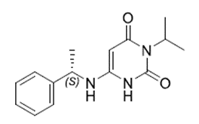

The proposed dosage form is a hard gelatin capsule. There are four strengths which are differentiated from one another in terms of colour and printed text:

* 2.5 mg: Size 2 hard gelatin capsule, light purple opaque cap imprinted with ‘2.5 mg’ in black and white opaque body imprinted with ‘Mava’ in black, containing white to off-white powder.
* 5 mg**:** Size 2 hard gelatin capsule, yellow opaque cap imprinted with ‘5 mg’ in black and white opaque body imprinted with ‘Mava’ in black, containing white to off-white powder.
* 10 mg: Size 2 hard gelatin capsule, pink opaque cap imprinted with ’10 mg’ in black and white opaque body imprinted with ‘Mava’ in black, containing white to off-white powder.
* 15 mg**:** Size 2 hard gelatin capsule, gray opaque cap imprinted with ’15 mg’ in black and white opaque body imprinted with ‘Mava’ in black, containing white to off-white powder.

The drug product is packaged in polyvinyl chloride/ polychlorotrifluoroethylene/ aluminium blisters within a cardboard carton (pack size of 28 capsules). The product labelling has been finalised from a pharmaceutical chemistry perspective and complies with the applicable requirements of TGO91.[8]

The quality of the drug product is controlled by specifications that include tests and limits for appearance, water content (by Karl Fischer titration), identification (by ultraviolet spectroscopy and HPLC), uniformity of dosage units (by content uniformity), dissolution, assay (by HPLC), impurities (by HPLC), and microbial purity.

Approval is recommended from a pharmaceutical chemistry and quality perspective.

### Nonclinical

The submitted nonclinical dossier was in accordance with the relevant International Council for Harmonisation (ICH) guideline for the nonclinical assessment of pharmaceuticals.[9] The overall quality of the nonclinical dossier was high.

*In vitro*, mavacamten reversibly inhibited cardiac myosin subfragments-1, slowed ATPase activity in an acto-myosin test system, and decreased the steady state enzymatic (adenosine triphosphate (ATP) turnover) activity of recombinant bovine and human cardiac myosin in reconstituted calcium ions (Ca2+) regulated soluble thin filament systems. In healthy animals, mavacamten significantly decreased systolic contractile indices, depressed systolic function, and increased ventricular chamber volumes. In animal models of HCM, mavacamten relieved LVOT obstruction, enhanced ventricular relaxation, and improved survival. *In vivo*, mavacamten did not affect skeletal muscle function in either the central nervous system safety pharmacology studies (assessment of grip strength and locomotor function in the functional observation battery), or the repeat dose toxicity studies.

Secondary pharmacodynamic (PD) studies showed no antagonist activity against 143 kinases, enzymes and binding receptors. Mavacamten did not inhibit myosin in smooth muscle. Mavacamten inhibited slow twitch skeletal muscle myosin and weakly inhibited fast twitch skeletal muscle myosin isoforms, but *in vivo*, mavacamten did not affect skeletal muscle function in either the central nervous system safety pharmacology studies (assessment of grip strength and locomotor function in the functional observation battery), or the repeat dose toxicity studies. Therefore, off target effects of mavacamten on skeletal muscle are not expected to occur *in vivo*.

Dedicated safety pharmacology studies investigated effects of oral mavacamten on the central nervous system, respiratory system and cardiovascular system. No adverse effects were seen on central nervous system function in rats, or respiratory function in dogs. *In vitro* studies did not identify significant inhibition of human-ether-a-go-go-related gene (hERG) channel tail current at clinically relevant concentrations of mavacamten. Sustained exposure to mavacamten caused shifts in early repolarisation currents rather than delayed repolarisation (hERG) currents, leading to QTc prolongation in normal animals.[10] This effect is not expected to be relevant to patients with HCM.

Mavacamten has moderate oral bioavailability (74.8% in rats, 87.1% in dogs, and 46.5% in monkeys (compared with approximately 85% estimated in patients)). Absorption was rapid in all nonclinical species (time of maximum concentration (Tmax) was approximately 0.5 to 2 h) and comparable to rate of absorption in patients (Tmax approximately 1 h). Exposures increased dose proportionally in rats and dogs, with some accumulation observed over six weeks of dosing in dogs. Plasma protein binding of mavacamten was high (83.6% in mice, 89.4% in rats, 91.1% in dogs, 95.1% in monkeys, and 93.1% for humans *in vitro*). Mavacamten distributed at high levels in cardiac and skeletal muscle. The highest peak concentrations were observed in the myocardium, diaphragm, liver, salivary gland, skeletal muscle, and oesophagus. Radioactivity penetration to the central nervous system was low. Mavacamten is primarily cleared via cytochrome P450 (CYP) mediated oxidative metabolism (74% CYP2C19, 18% CYP3A4/5 and 7.6% CYP2C9).[11]

In repeat dose toxicity studies, the major target organ for toxicity was the heart, consistent with its pharmacological activity, with secondary effects observed in other organs including the lungs, liver, spleen, pericardium, pancreas, gall bladder and thymus.

Mavacamten was not mutagenic in the bacterial mutation assay or clastogenic *in vitro* (in human lymphocytes) or *in vivo* (in the rat micronucleus test). There was no evidence of carcinogenicity in studies conducted in transgenic mice (6 months) and rats (2 years), though maximum exposures were low in mice and subclinical in rats.

Fertility was not affected in male and female rats treated with mavacamten at subclinical exposures. In embryofetal development studies, there was increased incidence of post‑implantation loss, decreased number of live fetuses, decreased fetal weight, and increased skeletal (rats and rabbits), external (rabbits), and visceral abnormalities (rats and rabbits). Exposure at the no observed adverse effect level for these effects was subclinical in rats and rabbits. There were no effects on litter sizes or other adverse developmental findings observed in the rat pre- and post-natal development study, which used the same dose levels and longer exposure periods than those used in the rat embryofetal development study. Following a detailed review of the nonclinical data, pharmacological mechanisms, biological plausibility, and effects on maternal health, the nonclinical evaluation concluded that the risk of embryofetal toxicity should be communicated by warning statements in the Product Information and Pregnancy Category D.[12]

The pharmacological effects of mavacamten on cardiac myosin provide support for the proposed indication. Findings of potential clinical relevance in animal safety studies include cardiac toxicity and embryofetal toxicity. There are no objections on nonclinical grounds to the proposed registration of Camzyos for the proposed indication.

### Clinical

#### Summary of clinical studies

The clinical dossier consisted of the following studies:

* Study MYK-461-014, a Phase I, randomised, open label, three way crossover study to assess the relative bioavailability of two mavacamten capsule formations and to assess the effect of food on the pharmacokinetics of the intended commercial mavacamten capsule formation.
* Study MYK-461-002, a Phase I, randomised, placebo controlled, sequential group, single ascending dose study to establish the preliminary safety and tolerability of a single oral dose of mavacamten in healthy volunteers.
* Study MYK-461-003, a Phase I, double blind, randomised, placebo controlled, multiple ascending dose study to evaluate the safety and tolerability of mavacamten following multiple oral doses in healthy volunteers.
* Study MYK-461-006, a Phase II, randomised, double blind, placebo controlled study to evaluate the safety and tolerability of a 16 week course of mavacamten in subjects with symptomatic nonobstructive hypertrophic cardiomyopathy (nHCM).
* Study MYK-461-013, a Phase I, open label, single dose study to assess the mass balance of total radioactivity following a single oral dose of carbon 14 labelled mavacamten, to determine the routes and rates of elimination of total reactivity from carbon 14 labelled mavacamten and to determine the pharmacokinetic parameters of mavacamten and total radioactivity following administration of a single oral dose of carbon 14 labelled mavacamten.
* Study MYK-461-001, a Phase I, sequential group, single ascending dose study to establish preliminary safety and tolerability of single oral doses of mavacamten in patient volunteers with clinically stable HCM.
* Study MYK-461-15, a Phase I, open label, nonrandomised, parallel group study to determine the effect of mildly and moderately impaired liver function versus normal liver function on the plasma pharmacokinetics of mavacamten following a single oral dose.
* Study MYK-461-012, a Phase I, open label, parallel group study to assess the pharmacokinetics of a single dose of mavacamten in healthy participants who were either normal CYP2C19 metabolisers or poor CYP2C19 metabolisers.
* Study MYK-461011, a Phase I, open label, parallel group study to assess the pharmacokinetics of a single dose of mavacamten in healthy Japanese and Caucasian subjects.
* Study MYK-461-009, a Phase I, open label, randomised, parallel group study to assess the effect of verapamil,[13] a moderate CYP3A4 inhibitor, on the pharmacokinetics of mavacamten.
* Study MYK-461-018, a Phase I, open label, randomised, parallel group to assess the effect of omeprazole,[14] a cytochrome CYP2C19 inhibitor on the pharmacokinetics of mavacamten.
* Study MYK-461-016, a Phase I, open label, fixed sequence study to determine whether a 16 day course of mavacamten affects the exposure to the CYP3A4 substrate midazolam in healthy subjects.[15]
* Study MYK-461-010, a Phase I, open label, two period, one sequence cross over study to determine whether mavacamten, after repeated administration, influenced the pharmacokinetics of 35 µg ethinyl estradiol and 1 mg norethindrone administered orally as a single dose of hormonal contraception.
* Study MYK-461-005, a Phase III, randomised, double blind, placebo controlled study to compare the effect of a 30 week course of mavacamten with a placebo in clinical response comprising of exercise capacity and clinical symptoms in subjects with oHCM.
* Study MYK-461-004, a Phase II, open label study to characterise the effect of 12 weeks of mavacamten treatment on post exercise peak LVOT gradient in subjects with symptomatic oHCM.
* Study MYK-461-007, a Phase II/III extension study to assess the long term safety and tolerability of mavacamten in participants with HCM previously enrolled in one of two placebo controlled trials (Study MYK-461-006 for nHCM or Study MYK-461-005 for oHCM).
* Study MYK-461-008, a Phase II, open label, extension study to assess the long term safety and tolerability of mavacamten in individuals with symptomatic oHCM.

Figure 2: Mavacamten clinical development program

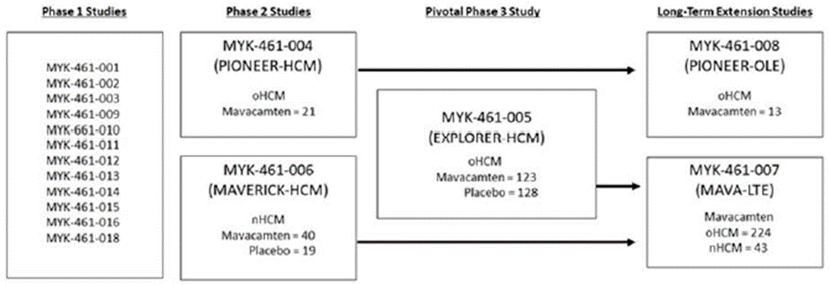

There is an ongoing randomised, double blind, placebo controlled Phase III study, Study MYK‑461-017 (the VALOR-HCM trial);[16] being conducted in patients with oHCM who were eligible for septal reduction therapy (surgical myectomy or alcohol septal ablation). The study commenced on 6 July 2020, the primary completion date was 7 February 2022, and the estimated study completion date is 10 June 2024. The sponsor provided a summary of this study including top‑line efficacy results which were presented at the American Cardiology Conference in April 2022.[17] The evaluation commented on these findings; however, the clinical study report has not been submitted for evaluation so the findings should not inform the benefit-risk assessment in this application.

#### Pharmacology

##### Pharmacokinetics

The pharmacokinetics (PK) of mavacamten were characterised in 12 clinical pharmacology studies (Table 4). The PK studies assessed single doses of mavacamten from 1 mg to 48 mg in healthy adults and 48 mg to 144 mg (in 8 aliquots 15 minutes apart) in adults with HCM, and multiple doses ranging from 1 mg twice daily to 25 mg once daily in healthy adults over 28 days.

Mavacamten is rapidly absorbed after oral administration (Tmax approximately 1 hour). Estimated oral bioavailability is approximately 85%. Mavacamten exposure is approximately linear over the proposed dose range of 2.5 to 15 mg. Food delays the absorption of mavacamten (Tmax 4 hours in the fed state compared to 1 hour in the fasted state) but does not have a clinically meaningful impact on exposure, so mavacamten may be taken with or without food.

The apparent volume of distribution is large (approximately 114 to 206 L in healthy subjects, approximately 257 L in oHCM patients). Plasma protein binding is 97 to 98%.

Mavacamten is extensively metabolised, primarily by CYP2C19 (74%), and to a lesser extent by CYP3A4 (18%) and CYP2C9 (7.6%). Mavacamten clearance occurs almost entirely through hepatic metabolism with urinary excretion of the metabolites. Less than 3% of mavacamten is excreted unchanged in the urine.

The effects of CYP2C19 genotype were examined in a dedicated PK study of a single 15 mg dose of mavacamten in healthy subjects who were CYP2C19 normal metabolisers or poor metabolisers based on genotype. Exposure was increased in poor metabolisers compared to normal metabolisers due to an extended elimination phase. After a single dose of 15 mg mavacamten, maximum concentration (Cmax) and area under the concentration time curve from time zero to infinity (AUC0-inf) increased by 47% and 241%, respectively, in poor metabolisers compared to normal metabolisers. The terminal half-life varies with CYP2C19 metabolic status: approximately 6 to 9 days in normal metabolisers and approximately 23 days in poor metabolisers.

Table 4: Mavacamten clinical pharmacology studies

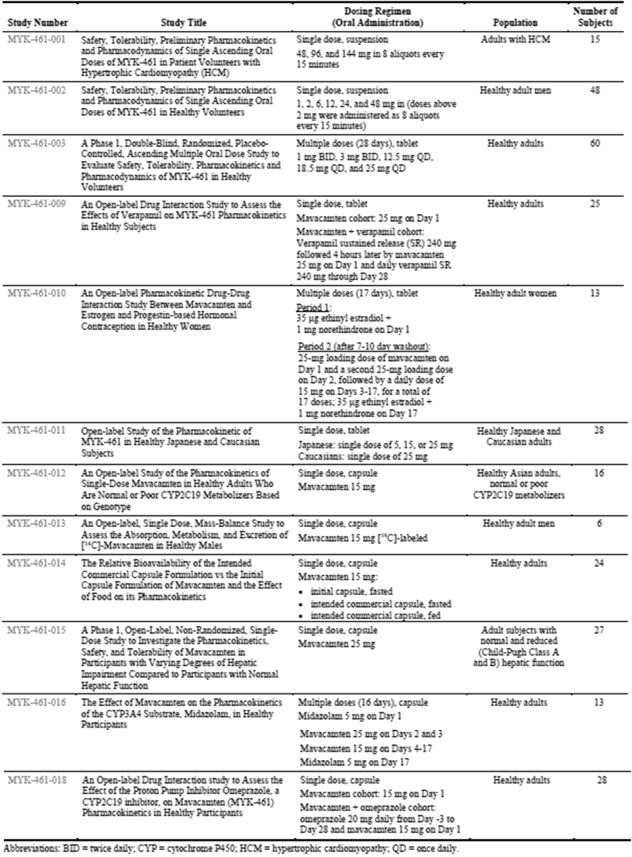

Abbreviations: BID = twice daily, CYP = cytochrome P450, HCM = hypertrophic cardiomyopathy, QD = once daily.

###### Hepatic impairment

In a dedicated pharmacokinetic (PK) study of subjects with mild (Child-Pugh Class A) and moderate (Child-Pugh Class B) hepatic impairment,[18] there was no meaningful effect of hepatic impairment on Cmax, but area under concentration-time curve from time zero to the time of last measurable concentration increased 3.2-fold and 1.8-fold in subjects with mild and moderate hepatic impairment, respectively, compared to subjects with normal hepatic function. No dose adjustment is proposed for patients with mild to moderate hepatic impairment on the basis that the reduced clearance in hepatic impairment is expected to be adequately addressed by individualised dose titration guided by echocardiographic monitoring. Mavacamten has not been studied in subjects with severe hepatic impairment.

###### Renal impairment

Renal clearance of unchanged drug is a very minor pathway of elimination for mavacamten, so there was no dedicated PK study in subjects with impaired renal function. A population pharmacokinetic (popPK) analysis of renal function (estimated glomerular filtration rate (eGFR) ranging from 29.5 to 145 mL/min/1.73m2) showed no meaningful impact of renal function on exposure. Mavacamten has not been studied in subjects with severe renal impairment.

###### Pharmacokinetic interactions

The effects of CYP2C19 and CYP3A4 inhibitors and inducers were assessed in dedicated PK studies as well as in physiologically based pharmacokinetic modelling.

Coadministration of mavacamten with omeprazole,14 a weak CYP2C19 inhibitor, resulted in a 48% increase in mavacamten exposure (AUC0-inf) with no change in Cmax. No studies were conducted with moderate or strong CYP2C19 inhibitors but, based on data for CYP2C19 poor metaboliser, up to a 3.4-fold increase in mavacamten exposure may be expected with coadministration of a strong CYP2C19 inhibitor.

Coadministration of mavacamten with verapamil,13 a moderate CYP3A4 inhibitor, increased mavacamten AUC0-inf and Cmax by 16% and 52%, respectively. Physiologically based pharmacokinetic modelling of coadministration of mavacamten with a strong CYP3A4 inhibitor (itraconazole;[19]) predicted no meaningful increase in exposure in CYP2C19 normal metaboliser and approximately 60% increase in mavacamten exposure in CYP2C19 poor metaboliser.

Physiologically based pharmacokinetic modelling of coadministration of mavacamten with rifampicin;[20] (a strong CYP2C19/CYP3A4 inducer) predicted decreases in mavacamten exposure of 61% in CYP2C19 normal metaboliser and 69% in CYP2C19 poor metaboliser. Physiologically based pharmacokinetic modelling of coadministration of mavacamten with carbamazepine;[21] (a strong CYP3A4 inducer) predicted decreases in mavacamten exposure of 13% and 30% in CYP2C19 normal metaboliser and CYP2C19 poor metaboliser, respectively.

A PK study assessing coadministration of mavacamten with midazolam,15 a CYP3A4 substrate, showed no meaningful effect of mavacamten on midazolam exposure. Similarly, coadministration of mavacamten had no meaningful effect on exposure of an oral contraceptive containing ethinyl estradiol and norethindrone.

##### Population pharmacokinetic data

A popPK model was developed using data from 12 clinical studies involving healthy subjects, oHCM patients, and nHCM patients. The analysis population included 497 subjects contributing a total of 9,251 mavacamten plasma concentration samples. A total of 59.8% of subjects were male, age ranged from 18 to 82 years, body mass index (BMI) ranged from 15.3 to 51.9 kg/m2, body weight ranged from 44.9 to 160 kg, and subjects exhibited varying degrees of renal function down to an eGFR of 29.5 mL/min/1.73 m2. CYP2C19 metaboliser phenotypes were distributed as poor metaboliser (3.4%), intermediate metabolisers (17.9%), normal metaboliser (39.8%), rapid metabolisers (19.1%), and ultrarapid metabolisers (3.2%).

The model was used to assess the variation in mavacamten exposure due to intrinsic factors including study population, CYP2C19 phenotype, body weight, age, sex, race, and renal function. It also included external factors such as dose level, formulation, fed status and coadministration of omeprazole;14 or esomeprazole.[22]

The average concentration during a dosing interval at steady state was influenced most by dose level and CYP2C19 phenotype, and to a lesser degree by body weight, and omeprazole/esomeprazole administration (Figure 3). There were no clinically significant effects of age, gender, race, or renal function on mavacamten PK.

Figure 3: Mavacamten plasma concentration at steady state (predicted median and 5th to 95th percentile)

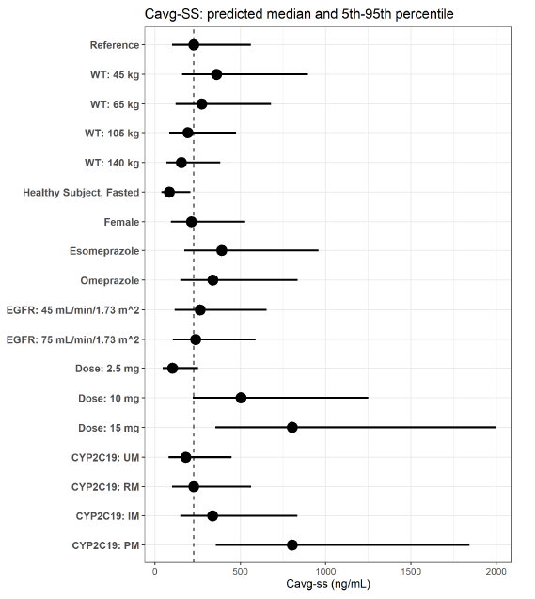

Note: Reference subject (vertical dashed line) is an 84 kg CYP2C19 normal metaboliser, oHCM subject taking 5 mg mavacamten once daily with fed status unknown for 30 weeks.

Abbreviations: Cavg-ss = average concentration at steady state, CYP = cytochrome P450, IM = intermediate CYP2C19 metaboliser, eGFR = estimated glomerular filtration rate, oHCM = obstructive hypertrophic cardiomyopathy, PM = poor CYP2C19 metaboliser, RM = rapid CYP2C19 metaboliser, UM = ultrarapid CYP2C19 metaboliser, WT = weight.

##### Pharmacodynamics

Pharmacodynamic outcomes, including measures of cardiac contractility (by transthoracic echocardiography) and handgrip strength, were exploratory endpoints in the Phase I studies. Study MYK-461-002 (single ascending dose in healthy adults) showed dose related reductions in LVEF for the 24 mg and 48 mg doses. The maximum decrease in LVEF (-3.71% in the mavacamten 24 mg group, -5.9% in the mavacamten 48 mg group, and -1.89% in the placebo group) was observed three hours post‑dose with a return to Baseline by six hours post-dose. There were no significant changes from Baseline in handgrip strength. Study MYK-461-001 (single ascending dose in HCM subjects) showed dose and time-dependent decreases in cardiac contractility. There were no significant changes from Baseline in handgrip strength. Study MYK‑461-003 (multiple ascending dose in healthy adults) showed dose and time‑dependent decreases in cardiac contractility. The maximum mean decreases for LVEF were ‑10.69% on Day 25 in the 18.5 mg group, and -11.25% on Day 25 in the 25 mg group. Pharmacodynamic outcomes in the pivotal study are discussed in the efficacy and safety sections.

##### QTc analyses

Data from nine mavacamten clinical studies (Studies MYK-461-002, MYK-461-003, MYK‑461‑010, and MYK-461-014 in healthy subjects; Studies MYK-461-004, MYK-461-005, MYK-461-007, and MYK-461-008 in subjects with oHCM, and Study MYK-461-006 in subjects with nHCM) were included in concentration-QTc;10 modelling to characterise the relationship between mavacamten concentration and the placebo corrected change from Baseline in QTc interval (ΔΔQTc). A total 460 subjects (118 healthy subjects, 285 subjects with oHCM and 57 subjects with nHCM) were included in the analysis dataset. Average Baseline QTcF was higher in oHCM and nHCM subjects (442 and 444 ms, respectively) compared to healthy subjects (399 ms, Figure 4).

The final model described the QTc results well in healthy subjects and patients with oHCM. The modelling showed a concentration dependent decrease in ΔΔQTcF in oHCM subjects, in contrast to a concentration dependent increase in ΔΔQTcF in healthy subjects (Figure 5). The predicted mean change in ΔΔQTcF for subjects with oHCM and baseline QTcF of 442 ms was -8.7 ms (90% confidence interval (CI): -6.7 ms, -10.8 ms) at the median steady state Cmax of 452 ng/mL.

Figure 4: QTcF and change from Baseline in QTcF versus plasma mavacamten concentration  
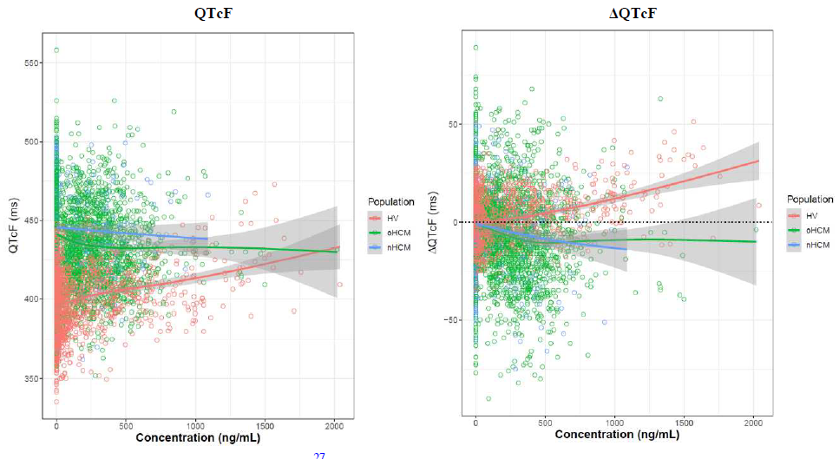

Note: circles are observed individual results, and lines are loess smooth curves for each population.

Abbreviations: HV = healthy volunteer, nHCM = nonobstructive hypertrophic cardiomyopathy, oHCM =obstructive hypertrophic cardiomyopathy, QTcF = corrected QT interval using Fridericia’s formula.

Figure 5: Exposure-response relationship of ΔΔQTcF in obstructive hypertrophic cardiomyopathy patients and healthy subjects

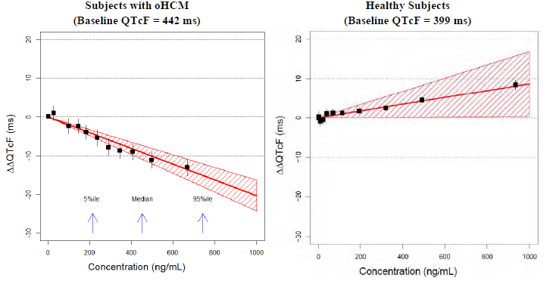

Note: The red line represents the model predicted mean values of ΔΔQTcF versus mavacamten concentration, and the shaded area indicates 90% confidence intervals (CIs). Simulation was done for median baseline QTcF of subjects with oHCM (442 ms, left panel) and healthy volunteers (399 ms, right panel). Squares are the means of observed ΔΔQTcF in subjects with oHCM (left panel) or healthy subjects (right panel) binned by plasma concentrations of mavacamten, and the error bars represent 90% CIs. Blue vertical arrows (left panel) indicate the 5th, 50th and 95th percentiles of steady-state Cmaxss (2 hours post dose) observed at Week 30 in Study MYK‑461-005 treated with a titrated dose of mavacamten once daily. Abbreviations: Cmaxss = maximum observed plasma concentration at steady state; QTcF = corrected QT interval using Fridericia’s formula.

##### Exposure-response analyses

Preliminary modelling of exposure-response was based on limited data from Study MYK‑461‑003 and Study MYK-461-004 and showed the relationship between trough plasma concentration and LVEF (Figure 6). The final exposure-response analysis datasets included 4175 measurable PD observations from 331 subjects for endpoint LVEF and 3597 observations from 272 subjects for endpoint left ventricular outflow tract gradient by Valsalva (VLVOT). The relationships between mavacamten concentration and LVEF and VLVOT gradient are shown in Figure 7 and Figure 8, respectively.

Figure 6: Left ventricular ejection fraction versus plasma mavacamten concentration in obstructive hypertrophic cardiomyopathy subjects (Study MYK-461-004) and healthy subjects (Study MYK-461-003)

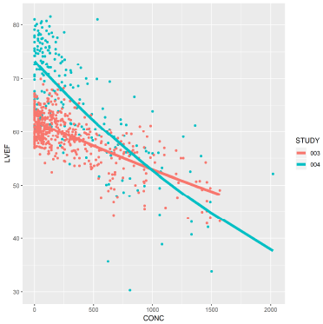

Note: Points are visit matched trough concentration (Ctrough)(ng/mL) LVEF (%).

Figure 7: Absolute change from Baseline in left ventricular ejection fraction versus observed plasma mavacamten concentration in hypertrophic cardiomyopathy subjects

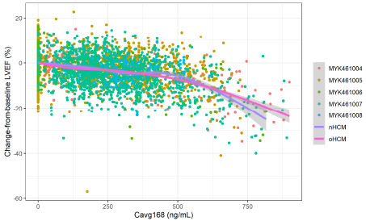

Note: Change from Baseline computed as baseline LVEF - LVEF. Truncation at 900 ng/mL results in 27 out of 4158 points ignored.

Abbreviations: Cavg168 = average concentration over 168-hour (1-week) period prior to LVEF observation; CFB = change from baseline; LVEF = left ventricular ejection fraction; nHCM = nonobstructive hypertrophic cardiomyopathy; oHCM = obstructive hypertrophic cardiomyopathy.

Figure 8: Change from Baseline in Valsalva left ventricular outflow tract gradient versus observed plasma mavacamten concentration

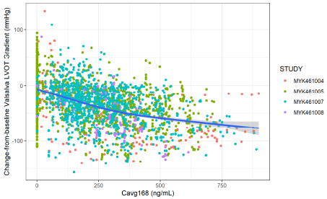

Note: Change from baseline computed as baseline VLVOT - VLVOT. Truncation at 900 ng/mL results in 24 out of 3610 points ignored.

Abbreviations: Cavg168 = average concentration over 168-hour (1-week) period prior to VLVOT observation; VLVOT = left ventricular outflow tract gradient by Valsalva.

##### Simulations of dose titration regimens

The popPK model and exposure-response models for LVEF and VLVOT were linked to facilitate simulations of echo‑based dose titration regimens. Simulations were performed for four different echo-based dose titration regimens, as well as the dose titration regimen used in Study MYK-461-005, to assess measures of efficacy and safety over the course of 40 weeks of dosing. In all regimens, the starting dose was 5 mg once daily and up or down titration to 2.5, 5, 10, or 15 mg was available in a step wise manner. The four simulated echo-based dose titration regimens differed with regard to the timing of reviews and VLVOT thresholds for dose titration:

* Echocardiogram: 4-8-12; LVOT30 - similar to the regimen used in the long term exposure Study MYK-461-007.
* Echocardiogram: 4-8-12; LVOT20 - similar to echocardiogram: 4-8-12; LVOT30 except for down-titration at Week 4 if VLVOT is less than 20 mmHg rather than less than 30 mmHg).
* Echocardiogram: 4-12-24 - similar to echocardiogram: 4-8-12; LVOT20 except for the timing of visits.
* Echocardiogram: 4-12+4/12 - similar to echocardiogram: 4-12-24 with:
  + Scheduled return visit at Week 4 for potential down titration (if VLVOT gradient is less than 20 mmHg) or temporary dose interruption (if LVEF is less than 50%) followed by restart at the next lower dose after LVEF equal to or greater than 50%.
  + Scheduled return visit at Week 12 for potential up titration (if VLVOT gradient is greater than or equal to 30 mmHg and LVEF is greater than or equal to 55%) or temporary dose interruption (if LVEF less than 50%) followed by restart at the next lower dose after LVEF is greater than or equal to 50%.
  + Subsequent visit timing is for a return visit every 12 weeks for the rest of the year and semi-annually thereafter (unless the visit resulted in up titration or dose interruption, in which case the return is scheduled for 4 weeks).

The time course of key safety and efficacy thresholds for LVEF, VLVOT, and concentration for the simulated echo-based dose titration regimens and the Study MYK-461-005 regimen are shown in Figure 9. The predicted percent of subjects reaching the key efficacy threshold of VLVOT less than 30 mmHg was similar for the simulated dosage regimens over 40 weeks. The predicted percent of subjects reaching the key safety threshold of LVEF less than 50% trended higher for the echo-based regimens compared to the Study MYK-461-005 regimen beyond Week 16, with the 4-12-24 regimens appearing to track higher than the 4-8-12 regimens. Figure 10 shows the distribution of VLVOT, LVEF, and mavacamten concentration at Week 30 for the simulated dose titration regimens. Simulations also examined longer term dosing with the echocardiogram: 4‑12 +4/12 regimen (Figure 11).

A further simulation evaluated the impact of delaying the first return visit from Week 4 until Week 6. The proportion of subjects with LVEF less than 50% (and LVEF less than 45%) at their first return visit increased from 0.325% (and 0.1%) to 0.7% (and 0.35%), respectively.

Figure 9: Time course of percent achieving key left ventricular ejection fraction, left ventricular outflow tract gradient by Valsalva, and concentration thresholds for each titration regimen

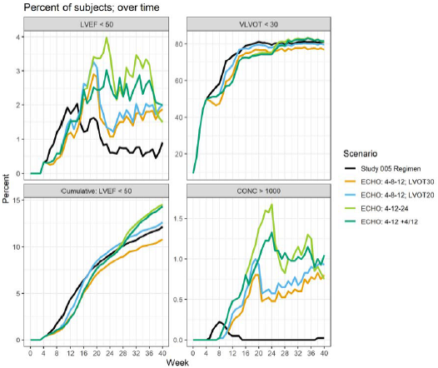

Cumulative LVEF less than 50 counts subjects only at their first instance of reaching that threshold. Abbreviations: CONC = concentration (ng/mL); LVEF = left ventricular ejection fraction (%); VLVOT = left ventricular outflow tract gradient by Valsalva (mmHg).

Figure 10: Distribution of predicted left ventricular outflow tract gradient by Valsalva, left ventricular ejection fraction, and concentration at Week 30 for each titration regimen

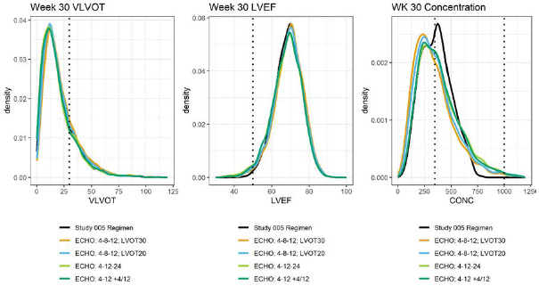

Abbreviations: CONC = concentration (ng/mL); ECHO = echocardiograph; LVEF = left ventricular ejection fraction (%); LVOT = left ventricular outflow; VLVOT = left ventricular outflow tract gradient by Valsalva (mmHg); WK = Week.

Figure 11: Time course of percent achieving key left ventricular ejection fraction, left ventricular outflow tract gradient by Valsalva, and concentration thresholds for long term dosing, echocardiogram: 4-12 +4/12 regimen compared to Study MYK-461-005 regimen

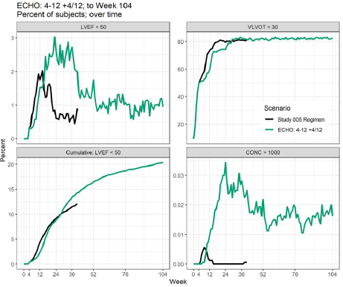

Notes: Cumulative LVEF less than 50 counts subjects only at their first instance of reaching that threshold.

Abbreviations: CONC = concentration (ng/mL); LVEF = left ventricular ejection fraction (%); VLVOT = left ventricular outflow tract gradient by Valsalva (mmHg).

#### Efficacy

The demonstration of the efficacy of mavacamten in patients with symptomatic oHCM is based primarily on pivotal Study MYK-461-005, supported by Phase II Study MYK-461-004 (Table 5). The application also includes interim data from two ongoing long term extension studies MYK‑461-007 and MYK-461-008 (Table 6), which recruited patients who completed studies MYK-461-005 and MYK-461-004, respectively.

##### Dose selection for efficacy studies

Findings from the Phase I clinical pharmacology Studies MYK-461-002, MYK-461-003, and MYK‑461-001 informed dose selection for the Phase II Study MYK-461-004 (the PIONEER HCM trial), a 12 week, open label, pilot study in patients with oHCM. In Part A, weight based initial mavacamten doses of 10 mg (less than or equal to 60 kg) or 15 mg once daily (over 60 kg) were used, and in Part B, mavacamten doses between 2 mg and 5 mg were used. Dose titration was guided by transthoracic echocardiography (TTE) criteria and mavacamten plasma concentrations. In Part A, there were marked reductions in LVOT gradient and increased peak oxygen uptake as measured by cardiopulmonary exercise testing (CPET). In Part B, a smaller reduction in LVOT gradient was observed, in keeping with the lower mavacamten doses used. Pharmacokinetic/pharmacodynamic modelling informed the 5 mg starting dose, the 15 mg maximum dose, and the dose adjustment criteria used in Study MYK-461-005.

Table 5: Summary of mavacamten efficacy studies

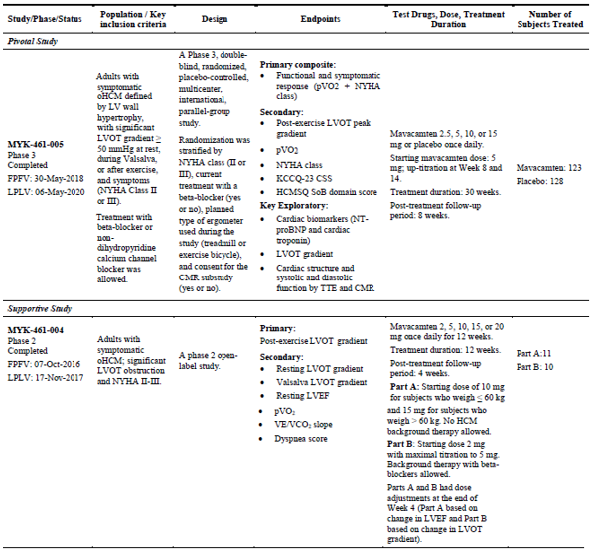

Abbreviations: CSS = clinical summary score; FPFV = first patient first visit; KCCQ-23 = Kansas City Cardiomyopathy Questionnaire 23-item version; LPLV = last patient last visit; LVEF = left ventricular ejection fraction; LVOT = left ventricular outflow tract; pVO2 = peak oxygen uptake; SoB = Shortness of breath; NYHA = New York Heart Association; OSS = overall summary score; NT-proBNP = N-terminal pro–B-type natriuretic peptide; VE/VCO2 = volume expired/carbon dioxide production slope.

Table 6: Summary of long term extension studies

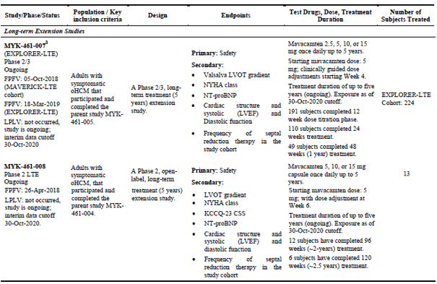

Abbreviations: CSS = clinical summary score; FPFV = first patient first visit; KCCQ-23 = Kansas City Cardiomyopathy Questionnaire 23-item version; LPLV = last patient last visit; LVEF = left ventricular ejection fraction; LVOT = left ventricular outflow tract; NYHA = New York Heart Association; NT-proBNP = N-terminal pro–B-type natriuretic peptide.

a Study MYK-461-007 enrolled subjects from the parent Phase II Study MYK-461-006 (nHCM population) and Phase III Study MYK-461-005 (oHCM population); in this summary of efficacy, data from Study MYK-461-007 is presented only for oHCM subjects enrolled from the parent Phase III Study MYK-461-005 (referred to as the EXPLORER-LTE cohort).

##### Study MYK-461-005 (EXPLORER-HCM)

The pivotal study was a Phase III, international, multicentre, randomised, double blind, placebo controlled study to evaluate the efficacy, safety, and tolerability of mavacamten in adults with symptomatic oHCM. It was conducted at 68 sites, including 31 sites in Europe, 29 sites in the USA, six sites in Israel, and two sites in the UK. The study started in May 2018 and finished in May 2020. Up to 220 patients were planned to be randomised in a 1:1 ratio to receive mavacamten or placebo once daily for 30 weeks with an 8 week post-treatment follow up period. Up to 80 subjects at selected sites were planned for an optional cardiac magnetic resonance (CMR) imaging sub study (CMR at Day 1 and Week 30).

The primary objective was to compare the effect of a 30 week course of mavacamten with placebo on clinical response comprising of exercise capacity and clinical symptoms in subjects with symptomatic oHCM. The secondary objectives were:

* To compare the effect of a 30 week course of mavacamten with placebo on symptoms and LVOT obstruction as determined by doppler echocardiography
* To compare the effect of a 30 week course of mavacamten with placebo on exercise capacity, clinical symptoms, and patient reported outcomes individually
* To assess the safety and tolerability of mavacamten
* To assess the PK characteristics of mavacamten

The exploratory objectives were to assess the effect of a 30 week course of mavacamten on LVOT obstruction; disease biomarkers; symptoms, health related quality of life, and work activity as assessed by patient reported outcomes; cardiac rhythm patterns as assessed by continuous cardiac rhythm monitoring; functional capacity as assessed by accelerometer; and risk for sudden cardiac death as assessed by the HCM risk prediction model. The objective of the CMR sub study was to assess the effect of mavacamten on cardiac mass and structure as evaluated by CMR.

After a screening period of up to 35 days, eligible patients were randomised in a 1:1 ratio to receive mavacamten or matching placebo once daily for 30 weeks with a post treatment follow up period of 8 weeks (Figure 12).

Figure 12: Study MYK-461-005 Schematic of study timeline

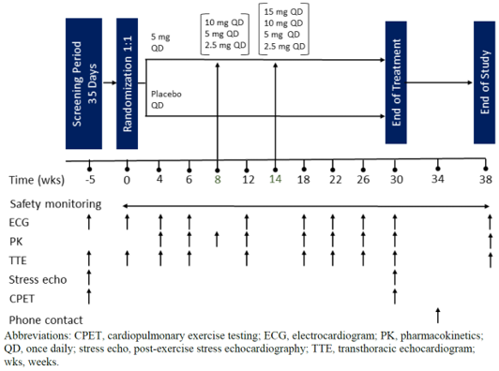

Abbreviations: CPET = cardiopulmonary exercise testing, ECG = electrocardiogram, PK = pharmacokinetics, QD = once daily, stress echo = post-exercise stress echocardiography, TTE = transthoracic echocardiogram, wks = weeks.

Key inclusion criteria included:

* age 18 years or older
* diagnosis of oHCM (left ventricular wall thickness 15 mm or greater or 13 mm or greater with a family history of HCM and LVOT peak gradient 50 mmHg or greater at rest, during Valsalva manoeuvre, or post-exercise)
* resting LVEF 55% or greater at screening TTE
* New York Heart Association (NYHA) Class II or III;[23]
* left ventricular outflow tract (LVOT) gradient with Valsalva manoeuvre at screening TTE 30 mmHg or greater
* resting oxygen saturation 90% or greater
* able to perform upright cardiopulmonary exercise testing (CPET) with a respiratory exchange ratio 1.0 or greater.

Key exclusion criteria included:

* history of syncope within six months of screening or sustained ventricular tachyarrhythmia with exercise within six months of screening
* history of resuscitated sudden cardiac arrest, or implantable cardiac defibrillator (ICD) shock for life threatening ventricular arrhythmia
* atrial fibrillation at screening
* current or planned treatment with disopyramide;[24] ranolazine;[25] or a combination of beta‑blockers and verapamil;13 or diltiazem;[26]
* successfully treated or planned invasive septal reduction within six months of screening
* currently taking, or had taken within 14 days prior to screening, a prohibited medication, such as those interacting with certain CYP enzymes,11 notably CYP2C19 inhibitors (for example, omeprazole;14 or esomeprazole;22), a strong CYP 3A4 inhibitor, or St. John’s Wort.

A total 251 patients were randomised into the study, 123 to mavacamten and 128 to placebo. All patients received at least one dose of study drug. Overall, 97.2% of patients completed 30 weeks of treatment.

The baseline patient demographics and disease characteristics were reasonably balanced across the mavacamten and placebo groups. The overall mean duration of oHCM was 7.7 years. Most patients were male (59.4%), and White (91.2%). Overall, the mean age was 58.5 years (range 18 to 82 years). At Baseline, 72.9% were NYHA class II and 27.1% were NYHA class III.23 Most were using beta-blockers (75.3%), and 16.7% of patients were using calcium channel blockers. Baseline peak oxygen uptake and TTE measures were similar across the treatment groups. Overall, mean left ventricular maximal wall thickness was 20 mm, mean LVEF was 74%, mean resting LVOT gradient was approximately 51 mmHg, mean LVOT gradient post-exercise was approximately 85 mmHg. A total 9.8% of subjects in the mavacamten group compared with 18% in the placebo group had a history of atrial fibrillation. A total 17.1% of subjects in the mavacamten group compared with 12.5% in the placebo group had a history of non-sustained ventricular tachycardia. The proportion of subjects in each group with ICD and/or pacemaker was similar (approximately 22%).

The study drugs were mavacamten (2.5 mg, 5 mg, 10 mg, or 15 mg capsules) and matching placebo. The starting dose of mavacamten was 5 mg once daily. Dose titration (up and down) was based on blinded assessments of mavacamten trough plasma concentration and TTE parameters according to pre-specified dose titration criteria. Pharmacogenetic status was assessed in all subjects but was not used to guide dosing during the course of the study.

The study protocol specified dose reduction by one dose level if a subject had a mavacamten plasma concentration 700 ng/mL or greater and less than 1000 ng/mL (Table 7). Seventeen (17) subjects had a total of 20 excursions of mavacamten plasma concentrations 700 ng/mL or greater and less than 1000 ng/mL (range: 703 to 844 ng/mL). Three of the 17 subjects had simultaneous LVEF less than 50%, one at Week 18 (triggering temporary discontinuation of dosing) and two at Week 30 (end of treatment). Eight of the 17 subjects had a dose reduction from 10 mg to 5 mg, five subjects had a dose reduction from 5 mg to 2.5 mg, and one subject had a second dose reduction from 2.5 mg to placebo (Table 8).

Subjects were assessed for dose up titration at Weeks 8 and 14 based on mavacamten concentration and TTE parameters at Weeks 6 and 12 (Table 9). Dose up titration in the mavacamten group is summarised in Table 10.

Study drug was temporarily discontinued in blinded fashion for plasma concentration 1000 ng/mL or greater, LVEF less than 50%, or QTcF prolongation. No subjects met the temporary treatment discontinuation criterion of mavacamten plasma concentration 1000 ng/mL or greater.

Table 7: Study MYK-461-005 Criteria for down titration of mavacamten dose

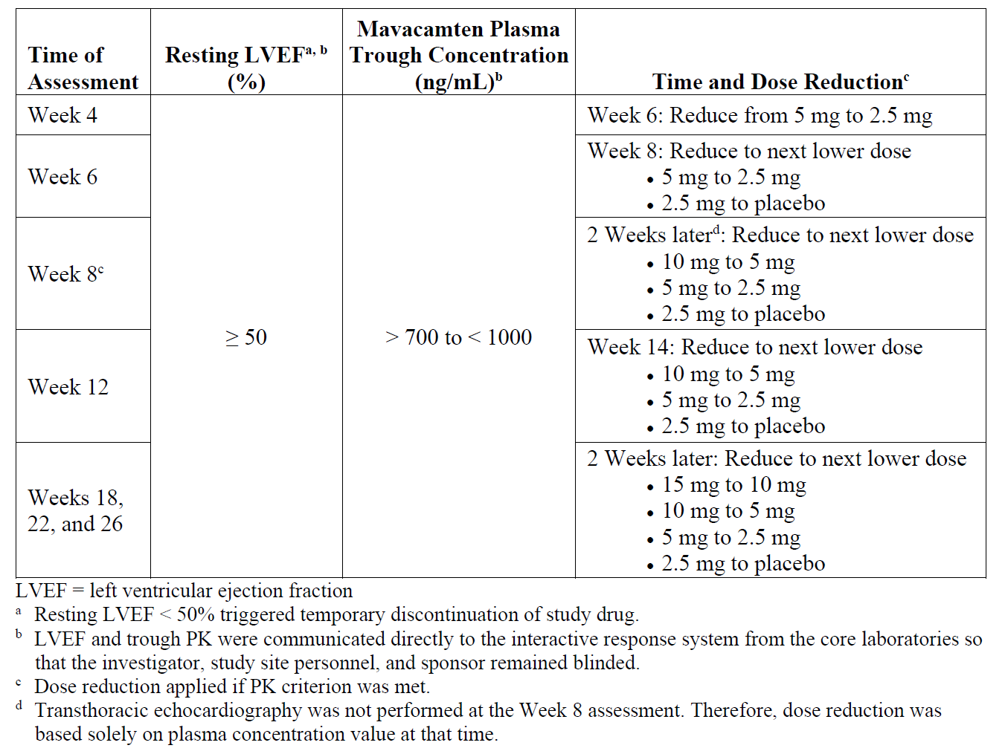

Abbreviations: LVEF = left ventricular ejection fraction.

a Resting LVEF less than 50% triggered temporary discontinuation of study drug.

b LVEF and trough PK were communicated directly to the interactive response system from the core laboratories so that the investigator, study site personnel, and sponsor remained blinded.

c Dose reduction applied if PK criterion was met.

d Transthoracic echocardiography was not performed at the Week 8 assessment. Therefore, dose reduction was based solely on plasma concentration value at that time.

Table 8: Study MYK-461-005 Mavacamten dose reductions resulting from mavacamten plasma trough concentrations 700 to 1000 ng/mL

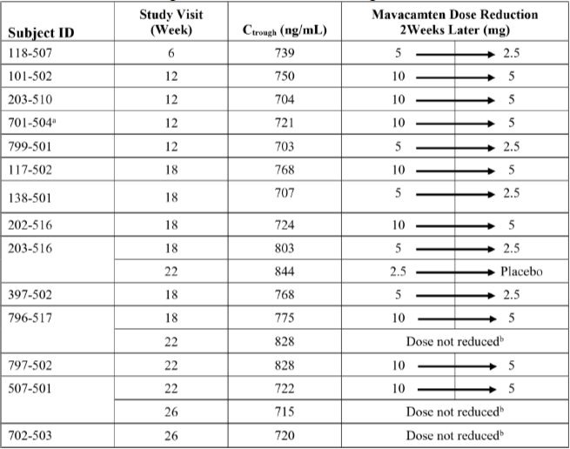

a Subject 701-504 took study drug prior to PK assessment. Therefore, mavacamten plasma concentration was considered a post-dose value.

b Mavacamten dose was not reduced due to unscheduled follow-up visits not being registered in the interactive response system (IXRS).

Table 9: Study MYK-461-005 Criteria for up titration of mavacamten dose

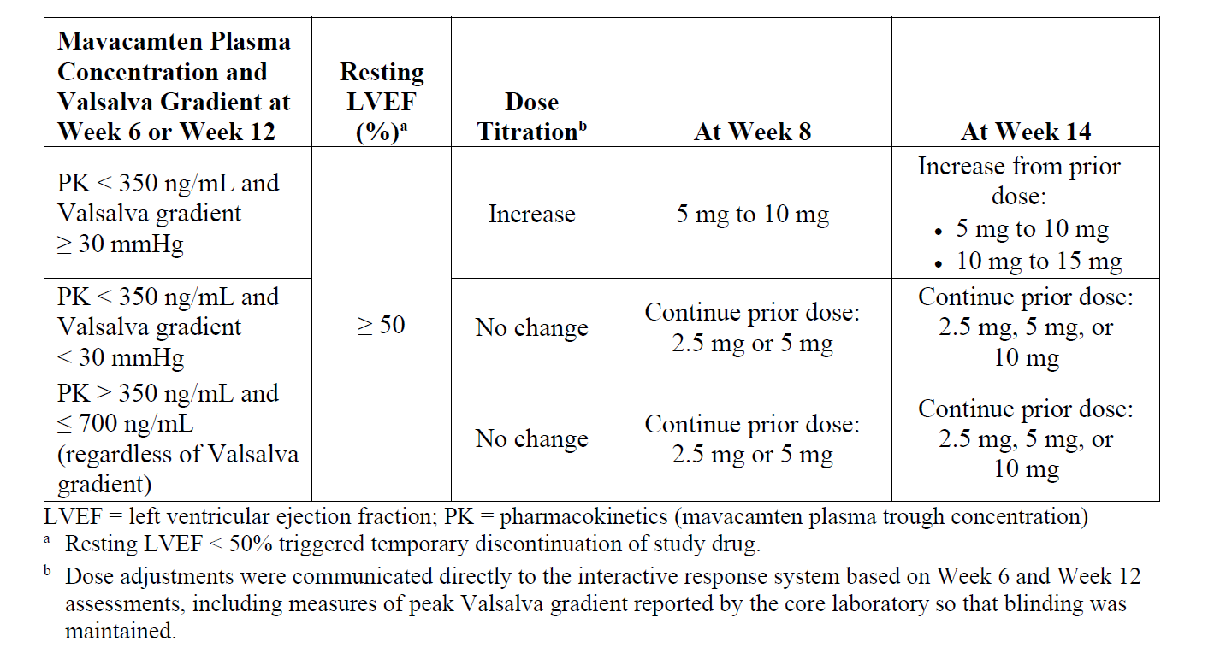

Abbreviations: LVEF = left ventricular ejection fraction, PK = pharmacokinetics (mavacamten plasma trough concentration)

a Resting LVEF less than 50% triggered temporary discontinuation of study drug.

b Dose adjustments were communicated directly to the interactive response system based on Week 6 and Week 12 assessments, including measures of peak Valsalva gradient reported by the core laboratory so that binding was maintained.

Table 10: Study MYK-461-005 Mavacamten dose increases during 30 weeks of treatment

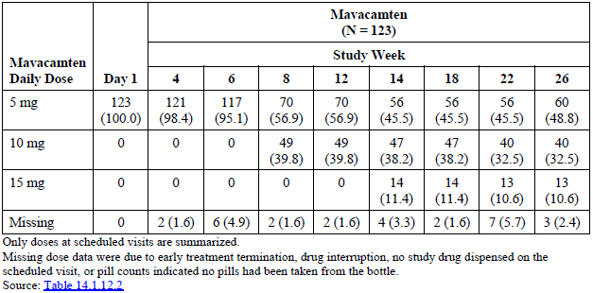

Only doses at scheduled visits are summarised.

Missing dose data were due to early treatment termination, drug interruption, no study drug dispensed on the scheduled visit, or pill counts indicated no pills had been taken from the bottle.

The primary efficacy endpoint was a composite functional endpoint at Week 30, defined as:

* an improvement of 1.5 mL/kg/min or greater in peak oxygen uptake as determined by cardiopulmonary exercise testing (CPET) and a reduction of 1 or greater NYHA class, or
* an improvement of 3 mL/kg/min or greater in peak oxygen uptake with no worsening in NYHA class.

The secondary efficacy endpoints were tested sequentially in the following order:

* change from Baseline to Week 30 in post-exercise LVOT peak gradient
* change from Baseline to Week 30 in peak oxygen uptake as determined by CPET
* proportion of subjects who had at least 1 class of improvement from Baseline in NYHA class at Week 30
* change from Baseline to Week 30 in subject reported quality of life as assessed by the Kansas City Cardiomyopathy Questionnaire clinical summary score (KCCQ-23 CSS);[27]
* change from Baseline to Week 30 in subject-reported severity of HCM symptoms as assessed by the Hypertrophic Cardiomyopathy Symptom Questionnaire (HCMSQ) shortness of breath (SoB) domain score;[28]

Efficacy analyses were performed on the intention to treat population, with sensitivity analyses also performed on the per-protocol population. All statistical tests were conducted at a 2-sided alpha level of 0.05. The primary analysis was stratified on NYHA class, beta-blocker use, and exercise type.

The study met its primary endpoint, with 45 (36.6%) patients in the mavacamten group compared with 22 (17.2%) patients in the placebo group achieving the composite endpoint at Week 30, a difference of 19.4% (95% CI: 8.67, 30.13; p = 0.0005). Each component of the composite endpoint favoured mavacamten over placebo:

* Forty-one (33.3%) in the mavacamten group versus 18 (14.1%) in the placebo group achieved an improvement in peak oxygen uptake greater than or equal to 1.5 mL/kg/min and reduction of one NYHA class or greater at Week 30, a difference of 19.3% (95% CI: 8.99, 29.55).
* Twenty-nine (23.6%) in the mavacamten group versus 14 (10.9%) in the placebo group achieved an improvement in peak oxygen uptake equal to or greater than 3.0 mL/kg/min and no worsening in NYHA class at Week 30, a difference of 12.6% (95% CI: 3.39, 21.89).

Statistically significant improvements were observed for mavacamten compared to placebo for each of the secondary efficacy endpoints:

* The change from Baseline to Week 30 in post-exercise LVOT peak gradient was -47 mmHg in the mavacamten group compared with -10 mmHg in the placebo group. The difference between treatment groups was -35 mmHg (95% CI: -43.2, -28.1; p < 0.0001).
* The change from Baseline to Week 30 in peak oxygen uptake was 1.4 mL/kg/min in the mavacamten group compared with -0.05 mL/kg/min in the placebo group. The difference between treatment groups was 1.4 mL/kg/min (95% CI: 0.59, 2.12; p < 0.0006).
* The proportion of patients who had at least 1 class of improvement from Baseline in NYHA class at Week 30 was 65% in the mavacamten group compared with 31.3% for placebo (p < 0.0001).
* Mean KCCQ-23 CSS scores were comparable at Baseline and improved in both treatment groups at Week 30 (13.6 mavacamten; 4.2 placebo). The difference between treatment groups was 9.1 (95% CI: 5.46, 12.66; p <0.0001).[29]
* Mean HCMSQ SoB scores were comparable at Baseline and improved in both treatment groups at Week 30 (-2.8 mavacamten; -0.9 placebo). The difference between treatment groups was -1.8 (95% CI: -2.40, -1.20; p < 0.0001).[30]

Exploratory efficacy findings included:

* Mean decrease in LVEF from Baseline to Week 30 (-4% mavacamten, -0.01% placebo).
* Proportion of subjects with Baseline post-exercise LVOT peak gradient 50 mmHg or greater who achieved post-exercise LVOT peak gradient less than 50 mmHg at Week 30 (74.3% mavacamten, 20.8% placebo).
* proportion of subjects with Baseline post-exercise LVOT peak gradient 30 mmHg or greater who achieved post-exercise LVOT peak gradient less than 30 mmHg at Week 30 (56.6% mavacamten, 7% placebo).
* proportion of subjects achieving complete response (defined as NYHA Class I and LVOT peak gradient less than 30 mmHg at rest, Valsalva, and post exercise) at Week 30 (27.4% mavacamten, 0.8% placebo).
* the proportion of subjects achieving a clinically meaningful KCCQ-23 CSS response at Week 30 (53.9% mavacamten, 33.8% placebo).
* the proportion of subjects achieving a clinically meaningful HCMSQ SoB response at Week 30 (50% mavacamten, 21.3% placebo).

Subgroup analyses of the primary endpoint by baseline characteristics and stratification factors were generally consistent with the primary analysis (Figure 13), though the magnitude of the treatment effect was greater in subjects not receiving beta-blocker at Baseline (between group difference 52.6%; 95% CI: 32.9, 72.2) compared to those receiving beta-blocker at Baseline (between group difference 8.7%; 95% CI: -3.6, 21.1). The sponsor attributed this finding to the blunting of heart rate and peak oxygen uptake by beta-blockers. Subgroup analyses of secondary efficacy endpoints showed similar outcomes across beta-blocker subgroups (Figure 14).

Figure 13: Study MYK-461-005 Between-group differences in the composite functional endpoint at Week 30 by Baseline characteristics and stratification factors (intention to treat population)

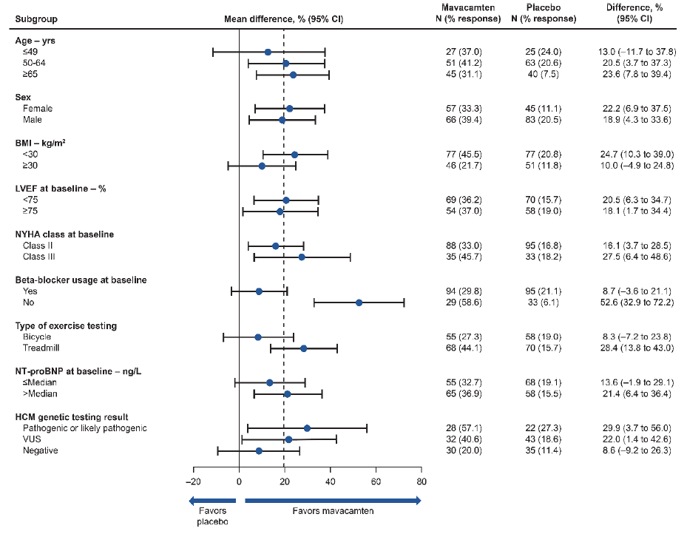

Abbreviations: BMI = body mass index, HCM = hypertrophic cardiomyopathy, LVEF = left ventricular ejection fraction, NT-proBNP = N-terminal pro b-type natriuretic peptide, NYHA = New York Heart Association, VUS = variant of uncertain significance.

The dotted vertical line represents the overall estimate. Missing NYHA class at Week 30 was imputed using available NYHA class at Week 26. After the imputation, the subjects whose response status at Week 30 was still missing were classified as non-responders. The 95% CIs of the response differences between mavacamten and placebo groups are based on normal approximation. The subgroups by stratification factors were determined using data in the eCRF.

Figure 14: Study MYK-461-005 Differences in key efficacy outcomes by beta-blocker use

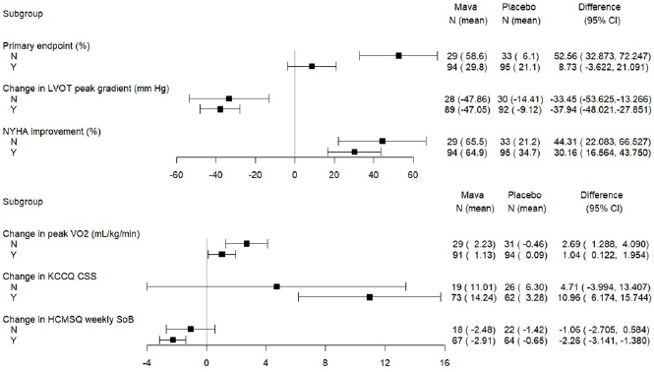

Abbreviations: CSS = clinical summary score, HCMSQ = Hypertrophic Cardiomyopathy Symptom Questionnaire, KCCQ = Kansas City Cardiomyopathy Questionnaire, LVOT = left ventricular outflow tract, N = subgroup not using beta-blockers, Y = subgroup using beta-blockers, NYHA = New York Heart Association, SoB = shortness of breath, VO2 = oxygen consumption.

95% CIs are based on normal approximation.

Of the 45 patients who achieved the primary endpoint in the mavacamten treatment arm, the dosage of mavacamten at the Week 30 assessment was 2.5 mg for two (4.4%) patients, 5 mg for 20 (44.4%) patients, 10 mg for 18 (40%) patients, 15 mg for four (8.9%) patients, and 0 mg (placebo) for one patient.

The primary efficacy endpoint in the CMR sub study involving 35 subjects (17 mavacamten, 18 placebo) was change from Baseline to Week 30 in left ventricular mass index. The mean (standard deviation) change from Baseline at Week 30 in left ventricular mass index was ‑17 (12) g/m2 for the mavacamten group and -2 (7.4) g/m2 for the placebo group, with a between group difference in the change from Baseline of -16 g/m2 (95% CI: -22.6, -9).

##### Study MYK-461-004 (PIONEER-HCM)

This was a Phase II, open label pilot study to evaluate the efficacy, PK, PD, safety, and tolerability of mavacamten in adults with symptomatic oHCM. It was conducted at seven sites in the USA from October 2016 to November 2017. Approximately 20 subjects with symptomatic HCM and LVOT obstruction were anticipated to be enrolled.

The primary objective was to characterise the effect of 12 weeks of mavacamten treatment on reducing post-exercise peak LVOT gradient in subjects with symptomatic HCM and LVOT obstruction. The secondary objectives were to assess the proportion of patients achieving post‑exercise peak LVOT gradient less than 30 mmHg, to assess the effects on dyspnoea symptom score, peak oxygen uptake, and ventilatory efficiency (volume expired/carbon dioxide production (VE/VCO2) slope), to evaluate the PK of mavacamten in subjects with oHCM, to evaluate the PD of mavacamten as assessed by a variety of echocardiographic parameters, to evaluate safety and tolerability, and to evaluate post-treatment reversibility of the effects of mavacamten after four weeks of washout.

The study consisted of a 12 week treatment phase and a 4 week washout phase (Figure 15). The study treatment was mavacamten (open label). Different dosing regimens were evaluated in Part A and Part B of the study.

Part A was designed to provide dose ranging information and PK/PD characterisation in patients with oHCM. Prior medications including beta-blockers and calcium channel blockers were discontinued at least 14 days before screening. The starting dose in Part A was mavacamten 10 mg once daily (body weight 60 kg or less) or 15 mg once daily (body weight greater than 60 kg). At the end of Week 4, the dose could be adjusted based on TTE criteria (Table 11), but a dose increase was not allowed if mavacamten plasma concentration at Week 2 exceeded 750 mg/mL.

Part B was designed to evaluate lower drug exposures than Part A. In Part B, the starting dose was mavacamten 2 mg once daily. Prior medications including calcium channel blockers were discontinued at least 14 days before screening, but subjects could continue stable beta-blocker therapy. At the end of Week 4, the dose could be increased to 5 mg based on TTE criteria (Table 12 and Table 11), but a dose increase was not allowed if mavacamten plasma concentration at Week 2 exceeded 300 mg/mL.

Figure 15: Study MYK-461-004 Schematic of study timeline

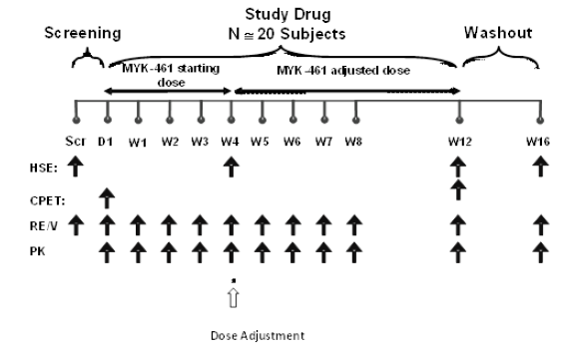

Abbreviations: CPET = cardiopulmonary exercise testing, D = day, HSE = haemodynamic stress echocardiography, PK = pharmacokinetic, RE/V = resting echocardiography/Valsalva, W = week.

Table 11: Study MYK-461-004 Part A dose adjustment criteria

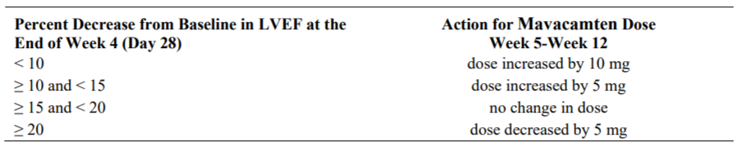Abbreviations: LVEF = left ventricular ejection fraction.

Table 12: MYK-461-004 Part B dose adjustment criteria

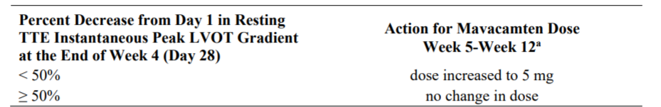

Abbreviations: TTE = transthoracic echocardiography, LVOT = left ventricular outflow tract.

a No dose increase allowed if plasma concentration of mavacamten is greater than 300 ng/mL at Week 2.

Key inclusion criteria included:

* age 18 to 70 years
* diagnosis of HCM (left ventricular wall thickness 15 mm or greater or 13 mm or greater with a family history of HCM)
* left ventricular ejection fraction (LVEF) 55% or greater at screening TTE
* resting LVOT gradient 30 mmHg or greater and post-exercise peak LVOT gradient 50 mmHg or greater at screening TTE
* New York Heart Association (NYHA) Class II or higher
* resting oxygen saturation 90% or greater
* able to perform upright cardiopulmonary exercise testing (CPET) with a respiratory exchange ratio 1.0 or greater.

Key exclusion criteria included:

* history of syncope with exercise within six months of screening, or sustained ventricular tachyarrhythmia
* atrial fibrillation at screening
* QTcF greater than 500 ms.

Of the 13 subjects enrolled in Part A, nine completed the study, two failed screening, and two discontinued (withdrew consent). Of the 12 subjects enrolled in Part B, 10 completed the study, and two failed screening. In Part A, 64% of patients were male, all were White, and mean age was 55.8 years. In Part B, 50% of patients were male, 90% were White, and mean age was 58.1 years. Baseline mean resting LVOT gradient was 60 in Part A and 86 in Part B. Baseline mean post-exercise LVOT gradient was 103 in Part A and 86 in Part B. In Part A, 64% were NYHA Class II and 36% were NYHA Class III. In Part B, 50% were NYHA Class II 50% were NYHA Class III.

The primary endpoint was change in post-exercise peak LVOT gradient from Baseline to Week 12. The secondary endpoints were:

* proportion of subjects achieving post-exercise peak LVOT gradient less than 30 mmHg
* change in dyspnoea symptom score from Baseline to Week 12
* change in peak oxygen uptake and VE/VCO2 from Baseline to Week 12
* change from Baseline in LVEF, global longitudinal strain, and left ventricular fractional shortening from Baseline to Week 12
* change from Week 12 to Week 16 in post-exercise peak LVOT gradient
* plasma PK profile of mavacamten.

The primary and secondary endpoints were analysed separately for Part A and Part B.

The primary endpoint of the study was met, with a statistically significant reduction in post‑exercise peak LVOT gradient from Baseline to Week 12 in both Part A and Part B (Table 13). In Part A, there was an 82% mean reduction of post-exercise peak LVOT gradient from 103 mmHg at Baseline to 19 mmHg at Week 12 (p = 0.008). In Part B, there was a 26% reduction in post-exercise peak LVOT gradient from 86 mmHg to 64 mmHg (p = 0.02).

Table 13: Study MYK-461-004 Left ventricular outflow tract gradient, efficacy set

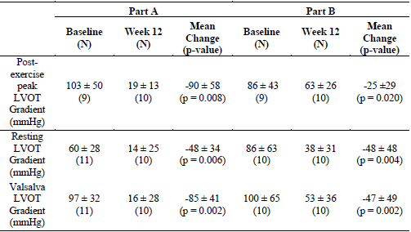

Abbreviations: LVOT = left ventricular outflow tract.

Note: The p-values are from Wilcoxon Signed-Rank tests evaluating the distribution of within subject 12-week changes from Baseline around a null of zero.

In Part A, eight of 11 (73%) subjects achieved post-exercise peak LVOT gradient less than 30 mmHg at Week 12 (Table 14). No subjects in Part B achieved post-exercise peak LVOT gradient less than 30 mmHg.

Table 14: Study MYK-461-004 Part A post-exercise peak left ventricular outflow tract gradient, efficacy set

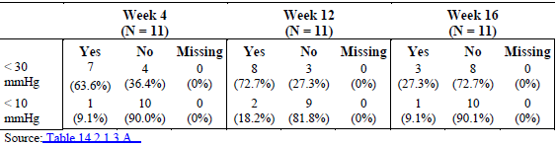

Subjects in Part A and Part B experienced statistically significant improvement in dyspnoea score at Week 12. In Part A, mean score on the dyspnoea scale decreased from 4.9 ± 1.6 (N = 11) at Baseline to 1.7 ± 1.8 (N = 10) at Week 12 (p = 0.002), and in Part B, mean score on the dyspnoea scale decreased from 40 ± 2.6 (N = 10) at Baseline to 1.0 ± 0.7 (N = 10) at Week 12 (p = 0.008). The effect of mavacamten on peak oxygen uptake and VE/VCO2 is shown in Table 15, and effect on LVEF is shown in Table 16.

Table 15: Study MYK-461-004 Effect of mavacamten on peak oxygen uptake and volume expired/carbon dioxide production, efficacy set

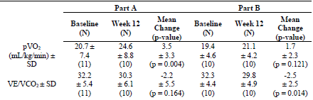

Abbreviations: pVO2 = peak oxygen uptake, SD = standard deviation, VE = volume expired, VCO2 = carbon dioxide production.

Table 16: Study MYK-461-004 Effect of mavacamten on left ventricular ejection fraction, efficacy set

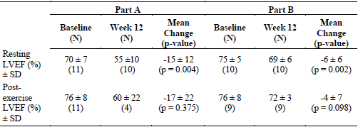

Abbreviations: LVEF = left ventricular ejection fraction, SD = standard deviation.

Note: The p-values are from Wilcoxon Signed-Rank tests evaluating the distribution of within subject 12-week changes from Baseline around a null of zero.

In Part A, drug concentrations greater than 350 ng/mL were associated with a reduction in LVOT gradient to less than 30 mmHg, a level considered clinically significant for obstruction. In Part B, only one patient achieved a drug concentration greater than 350 ng/mL and less reduction in resting LVOT gradient was observed.

##### Study MYK-461-006 (MAVERICK-HCM)

This was a randomised, double blind, placebo controlled, exploratory Phase II study in patients with symptomatic nHCM. It was conducted at 26 sites in the USA between March 2018 and January 2020. The primary objective was to evaluate the safety and tolerability of a 16 week course of mavacamten in patients with symptomatic nHCM.

A total 59 patients with symptomatic nHCM were randomised 1:1:1 to receive mavacamten (target trough concentration approximately 200 ng/mL or approximately 500 ng/mL), or placebo once daily for 16 weeks. The starting dose was 5 mg. At Week 4, plasma mavacamten concentrations were measured, and the dose was adjusted at Week 6 to achieve the target mavacamten concentration.

All efficacy endpoints were exploratory. Over the 16 week treatment period, there were no clinically meaningful differences between the mavacamten and placebo groups for peak oxygen uptake, NYHA class, or echocardiographic indices. This study does not support efficacy of mavacamten in patients with symptomatic nHCM and does not inform efficacy in the proposed oHCM indication.

##### Study MYK-461-007 (MAVA-LTE)

This is an ongoing, long term extension study of mavacamten in patients with HCM who completed the 38 week, Phase III Study MYK-461-005 (EXPLORER-HCM, patients with oHCM) or the 24 week, Phase II Study MYK-461-006 (MAVERICK-HCM, patients with nHCM). The long term extension study started in October 2018 and completed enrolment in October 2020. A total of 267 patients have been enrolled at 29 sites in the USA and 35 sites in Europe, Middle East and Africa.

The primary objective is to assess the long term safety and tolerability of mavacamten in HCM patients previously enrolled in EXPLORER-HCM or MAVERICK-HCM. The secondary objectives are to assess the long term effects of mavacamten on symptoms and echocardiographic measures of cardiac function; and to assess LVOT gradient in the EXPLORER-LTE cohort. Efficacy will be assessed separately for each cohort. The EXPLORER-LTE cohort (oHCM) is the relevant cohort for long term efficacy in the proposed indication. Exploratory objectives are to assess the long term effects of mavacamten on disease biomarkers.

The study (see Figure 16) includes a 28 day screening period and 104 weeks of treatment with mavacamten, with all subjects in the EXPLORER-LTE cohort starting on 5 mg once daily. All patients had an 8 week washout period in the parent study and then an interval of time before beginning the long term extension. Dose adjustments at Weeks 4, 8, and 12 were based on site read TTE assessment of VLVOT gradient and LVEF. In the EXPLORER-LTE cohort, a dose decrease to 2.5 mg was specified at Week 4 if VLVOT gradient was 30 mmHg or less. At Weeks 8 and 12, a dose increase by one level was specified if VLVOT gradient was greater than 30 mmHg and LVEF was 50% or greater.

A total 224 patients were enrolled in the EXPLORER-LTE cohort, including 112 (50%) who had received placebo in the parent study. At the interim data cut off date, 191 patients had completed dose titration through Week 12, 110 had completed the Week 24 visit, and none had completed the Week 104 visit. Echocardiograms were recorded for 49 patients at Week 48, 23 patients at Week 60, and three patients at Week 72.

Most patients were male (60.3%) and White (93.8%). The mean age was 60.3 years (range 19 to 83 years). A total 75.4% were receiving beta-blockers at Baseline.

Improvements in LVOT gradient (Figure 17, Figure 18) were observed from Week 4 and were sustained after 48 weeks of treatment (and also through Week 72, but the patient numbers were small). After dose titration was complete at Week 16, the mean Valsalva LVOT gradient was reduced from Baseline by 32 mmHg.

Mean LVEF was 74% at Baseline, a small decrease was observed at Week 4, and the absolute change from Baseline to Week 16 was -7% (Figure 19). Left ventricular ejection fraction remained stable to Week 48 and beyond at approximately 65%.

At Baseline, most subjects were NYHA Class II (65%) or Class III (29%). At Week 48, 35 of 49 (71%) subjects had an improvement of 1 NYHA class or greater, four (8%) subjects had a worsening of 1 level (three subjects from Class II to III and one subject from Class I to II), and 10 subjects were unchanged from Baseline (Figure 20). Five patients (10.2%) had improved by two NYHA classes at Week 48.

Figure 16: Study MYK-461-007 Schematic of study timeline (EXPLORER-LTE cohort)

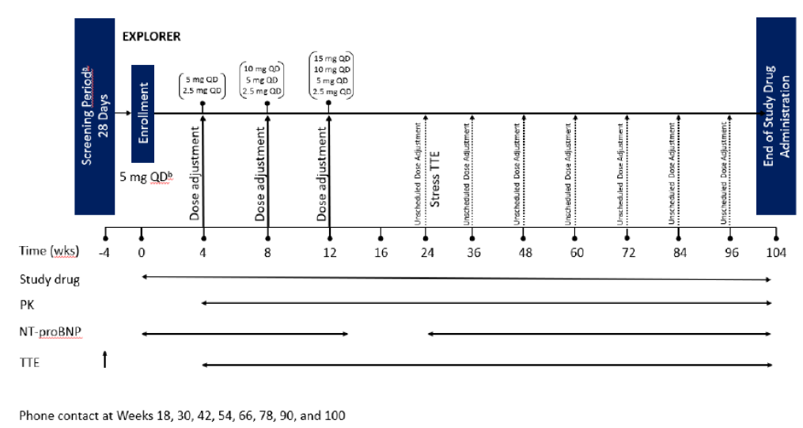

Abbreviations: NT-proBNP = N-terminal pro b-type natriuretic peptide, PK = pharmacokinetics, QD = once daily, TTE = transthoracic echocardiography (resting and with Valsalva manoeuvre), wks = weeks

a Assessments from EXPLORER-HCM Week 38 (end of study) visit may have served as screening assessments, if the subject began screening into Study MYK-461-007 within 28 days of the Week 38 visit.

b Subjects received mavacamten capsules at a starting dose of 5 mg once daily unless otherwise noted in protocol amendment 2.

Figure 17: Study MYK-461-007 (EXPLORER-LTE cohort) mean (standard deviation) resting left ventricular outflow tract gradient by visit (intention to treat population)

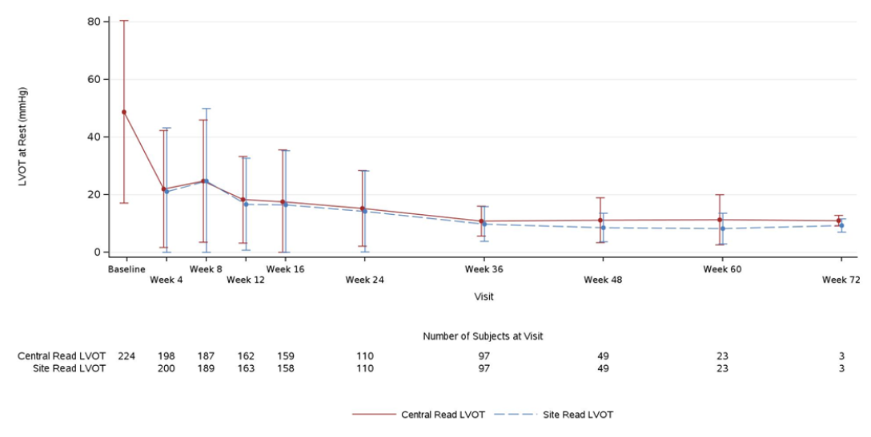

Abbreviations: LVOT = left ventricular outflow tract.

Bars indicate standard deviation.

Baseline is defined as last non-missing measurement prior to the first dose. For subject randomised but not treated, the date of randomisation was used to define the baseline value.

All assessments are summarized by analysis visits per statistical analysis plan.

Figure 18: Study MYK-461-007 (EXPLORER-LTE cohort) mean (standard deviation) Valsalva left ventricular outflow tract gradient by visit (intention to treat population)

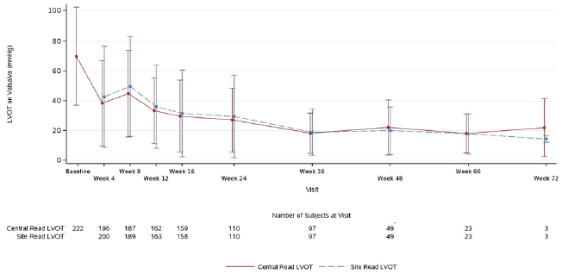

Abbreviations: LVOT = left ventricular outflow tract

Bars indicate standard deviation.

Baseline is defined as last non-missing measurement prior to the first dose. For subject randomised but not treated, the date of randomisation was used to define the baseline value.

All assessments are summarized by analysis visits per statistical analysis plan.

Figure 19: Study MYK-461-007 (EXPLORER-LTE cohort) mean (standard deviation) resting left ventricular ejection fraction by visit (intention to treat population)

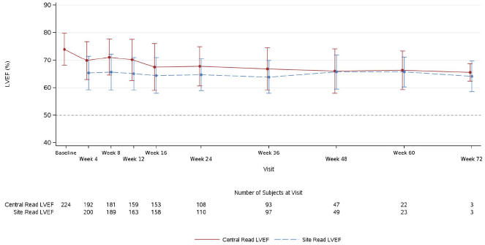

Abbreviations: LVEF = left ventricular ejection fraction

Bars indicate standard deviation.

Baseline is defined as last non-missing measurement prior to the first dose. For subject randomised but not treated, the date of randomisation was used to define the baseline value.

All assessments are summarized by analysis visits per statistical analysis plan.

Figure 20: Study MYK-461-007 (EXPLORER-LTE cohort) bar plot of New York Heart Association class over time (intention to treat population)

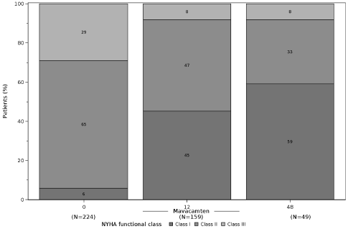

The percentage of subjects in a given NYHA class at each visit was calculated using the number of subjects with non-missing NYHA class at that visit. The intention to treat population included all randomized subjects regardless of whether they received study drug.

##### Study MYK-461-008 (PIONEER-LTE)

This is an ongoing open label, long term extension study of mavacamten in oHCM patients previously enrolled in Study MYK-461-004 (the main PIONEER-HCM trial). The study started in May 2018 and the last assessment for this interim report was conducted in October 2020. The primary endpoint is safety. Secondary efficacy endpoints include the effect of mavacamten on LVOT obstruction, NYHA class, and symptoms.

The study includes a 28 day screening period, 156 weeks of treatment, and an 8 week follow up period. Eligible patients had completed mavacamten treatment for 12 weeks in Study MYK‑461‑004 and were off treatment for approximately seven to 18 months before starting the extension study. A total of 13 patients were enrolled. Study drug was started at 5 mg once daily for all patients and could be increased to 10 mg once daily or 15 mg once daily based on TTE criteria (post-exercise LVOT gradient, and LVEF) and drug plasma concentration (target 250 to 500 ng/mL).

Left ventricular outflow tract (LVOT) gradient decreased from Baseline and was maintained to the interim cut off (Figure 21). At Week 72, 92% of patients had an LVOT gradient less than 30 mmHg at rest and similar results were observed at Week 120. Let ventricular ejection fraction (LVEF) was maintained at greater than 50% in all patients. Mean LVEF was 72% at Baseline with modest reductions at Week 4 (-2%), and Week 12 (-4%). At Week 8 and 24, 46.2% and 76.9% of patients, respectively, had improved NYHA classification by at least one class.

Figure 21: Study MYK-461-008 Effect of mavacamten on left ventricular outflow tract gradient (safety population)

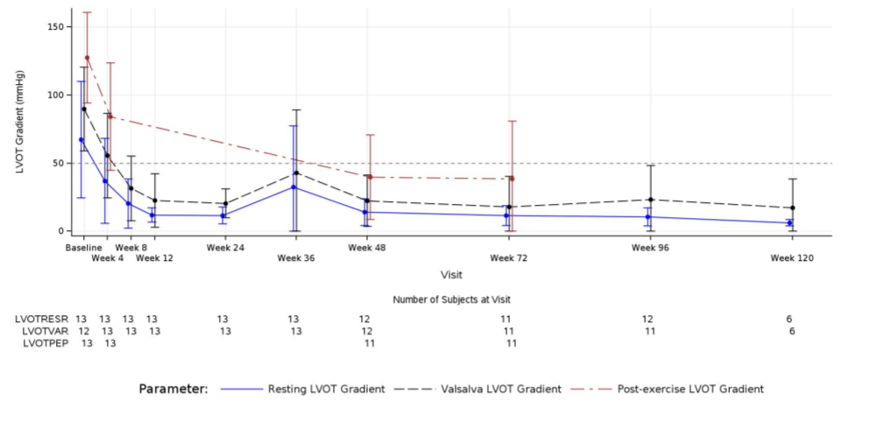

Abbreviations: LVOT = left ventricular outflow tract.

Note: One subject discontinued on Day 175 and early terminated from the study on Day 182; the subjects end of study visit occurred on day 265 (90 days after the subject’s last dose of study drug), within the visit window of Week 36. This subject’s Week 36 data is included in the Week 36 summary data, when the subject had been off study drug for 90 days.

Twelve subjects remain in the study, 6 of whom had completed Week 120 assessment by the 30 October 2020 data cut odd date for this interim analysis.

Bars represent standard deviation of the mean.

#### **Safety**

The submission presented safety data from the pivotal Phase III Study MYK-461-005 (the EXPLORER trial) as well as integrated analyses of pooled safety data from five clinical studies (see Table 17). The integrated safety database includes 310 patients who received at least one dose of mavacamten in the clinical studies (All-Mava combined population), comprising the All‑Mava oHCM population (N = 256) and the All-Mava nHCM population (N = 54).

Safety data from the pivotal study are presented as RCT-Mava oHCM (N = 123) and RCT-Placebo oHCM (N = 128). Key safety findings from the 12 Phase I studies were also reviewed.

Of the total 310 patients in the All-Mava population, 280 received mavacamten in an extension study, and 134 were exposed to mavacamten for greater than 12 months. In the All-Mava population, the mean average daily dose of mavacamten was 6.37 mg. In the All-Mava oHCM population, 73.4% were receiving concurrent beta-blocker treatment.

The overall profile of treatment-emergent adverse events in Study MYK-461-005 is summarised in Table 18. The most frequently reported treatment-emergent adverse events (5% or greater of mavacamten treated subjects and at least 2% higher than placebo) were dizziness, dyspnoea, headache, upper respiratory tract infection, cough, gastro-oesophageal reflux disease, arthralgia, and syncope. Most adverse events were mild (72.6%) or moderate (22.9%) in severity. Eleven patients (8.9%) in the mavacamten group and 13 patients (10.2%) in the placebo group had at least one severe adverse event. The only severe treatment-emergent adverse events reported in more than one subject were atrial fibrillation (mavacamten three subjects, placebo four subjects) and syncope (mavacamten three subjects, placebo one subject).

Table 17: Clinical studies contributing to the integrated analysis of safety

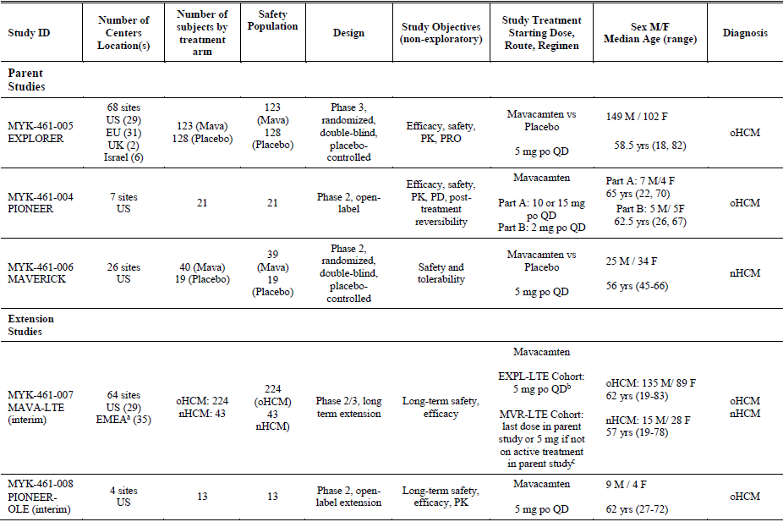

Abbreviations: EMEA = Europe, Middle East, and Africa, EOT = end of treatment, EU = Europe, F = female, LTE = long-term extension, M = male, Mava = mavacamten, nHCM = non-obstructive hypertrophic cardiomyopathy, oHCM = obstructive hypertrophic cardiomyopathy, OLE = open-label extension, PD = pharmacodynamics, PK=pharmacokinetics, po = per oral, PRO = patient reported outcomes, QD = once daily, UK = United Kingdom, US = United States.

a Includes Spain, Poland, Italy, Israel, France, Portugal, Czech Republic, Belgium, Netherlands, Germany, Denmark, and UK.

b For EXPLORER-LTE Cohort subjects with a parent study (EXPLORER-HCM) end of treatment visit dose of 5 mg and a mavacamten plasma trough concentration greater than 700 ng/mL the starting dose was 2.5 mg once daily in the MAVA-LTE study.

c For MAVERICK-LTE Cohort subjects with a parent study (MAVERICK-HCM) end of treatment visit mavacamten plasma trough concentration greater than 1000 ng/mL the starting dose was either 5 mg once daily (if end of treatment dose was 10 mg or 15 mg once daily) or 2.5 mg (if end of treatment dose was 5 mg once daily).

Table 18: Study MYK-461-005 Overall summary of adverse events (safety population)

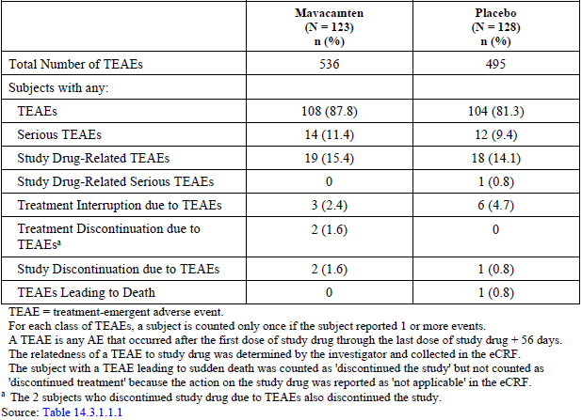

Abbreviations: TEAE = treatment-emergent adverse event

For each class of TEAEs, a subject is counted only once if the subject reported one or more events.

A TEAE is any adverse event that occurred after the first dose of study drug through the last dose of study drug plus 56 days.

The relatedness of a TEAE to study drug was determined by the investigator and collected in the eCRF.

The subject with a TEAE leading to sudden death was counted as ‘discontinued the study’ but not counted as ‘discontinued treatment’ because the action on the study drug was reported as ‘not applicable’ in the eCRF.

a The two subjects who discontinued study drug due to TEAEs also discontinued the study.

Table 19: Subject incidence of common adverse events by Preferred Term in 5% or greater of subjects in any treatment group

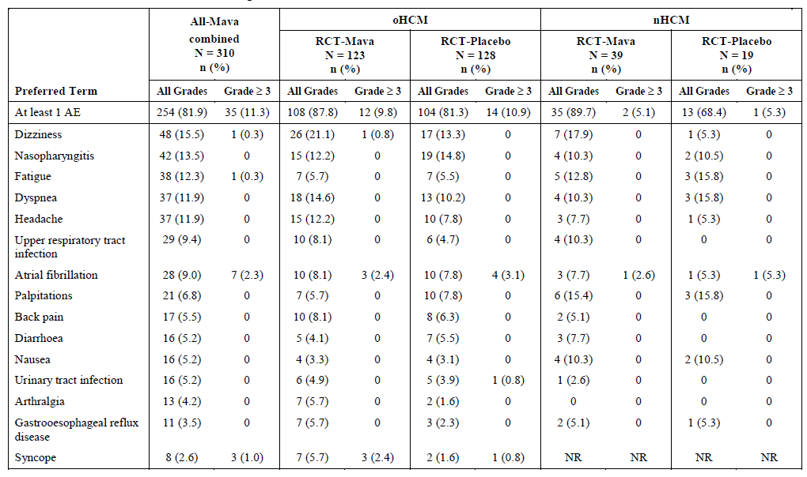

Abbreviations: AE = adverse event, Mava = mavacamten, nHCM = non-obstructive hypertrophic cardiomyopathy, NR = not reported, oHCM = obstructive hypertrophic cardiomyopathy, RCT = randomised controlled trial.

Data presented in this table are treatment emergent. Safety population includes all subjects who received at least one dose of study drug.

The All-Mava combined population includes 310 patients who received at least one dose of mavacamten in the clinical studies comprising the All Mava oHCM population (N = 256) and the All-Mava nHCM population (N = 54). Safety data from the pivotal study are presented as RCT-Mava oHCM (N = 123) and RCT-Placebo oHCM (N = 128).

In Study MYK-461-005, the proportion of patients who experienced at least one treatment‑emergent serious adverse event was higher in the mavacamten group than placebo (11.4% versus 9.4%). Serious adverse events reported in more than one subject in the pivotal study included atrial fibrillation, syncope, and stress cardiomyopathy (Table 20).

Two deaths were reported in the mavacamten clinical study program. One was a serious adverse event of sudden death of a 64 year old woman in the placebo group of the pivotal Study MYK‑461-005. This event was assessed as study drug related by the blinded investigator. The other death was reported as a Grade 5 serious adverse event;[31] of endocarditis bacterial in a 64 year old male with multiple medical comorbidities who was receiving mavacamten in the long term extension Study MYK-461-007 (placebo in the parent Study MYK-461-005). This event was assessed by the investigator as not related to study drug.

Table 20: Subject incidence of serious adverse events reported in two or more subjects by Preferred Term

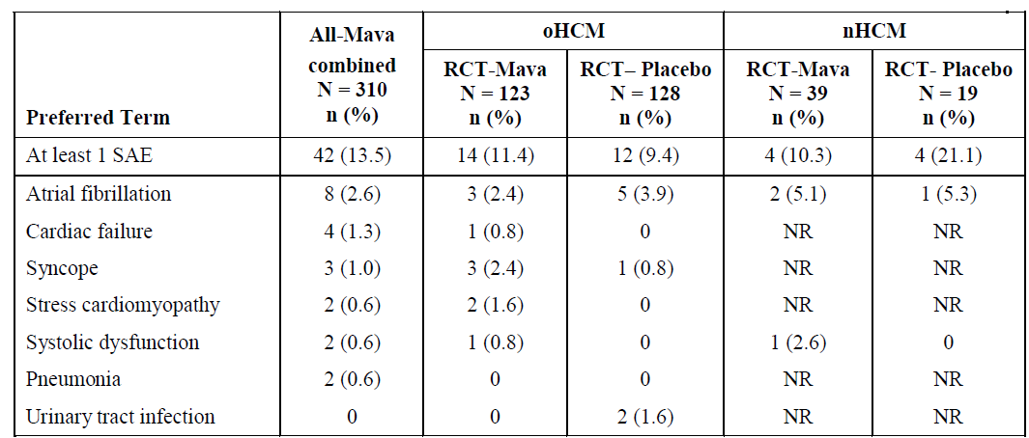

Abbreviations: Mava = mavacamten, nHCM = nonobstructive hypertrophic cardiomyopathy, oHCM = obstructive hypertrophic cardiomyopathy, NR = not reported in the analysis population, RCT = randomised controlled trial, SAE = serious adverse event.

Data presented in this table are treatment emergent.

The All-Mava combined population includes 310 patients who received at least one dose of mavacamten in the clinical studies comprising the All Mava oHCM population (N = 256) and the All-Mava nHCM population (N = 54). Safety data from the pivotal study are presented as RCT-Mava oHCM (N = 123) and RCT-Placebo oHCM (N = 128).

In Study MYK-461-005, temporary treatment interruptions due to treatment-emergent adverse events were reported for three subjects (2.4%) in the mavacamten group compared to six subjects (4.7%) in the placebo group (Table 21). Treatment-emergent adverse events leading to temporary discontinuation in the mavacamten group were:

* syncope (onset Day 68), assessed as serious adverse event not related to study drug. The subject resumed dosing on Day 70.
* joint swelling and dizziness (onset Day 45), assessed as not serious and related to study drug. The subject resumed dosing on Day 64.
* tinnitus from Day 1 to 238, assessed as mild and not related to study treatment. The subject interrupted dosing on Day 7 and resumed dosing on Day 11.

Table 21: Subject incidence of adverse events leading to study treatment interruption by Preferred Term

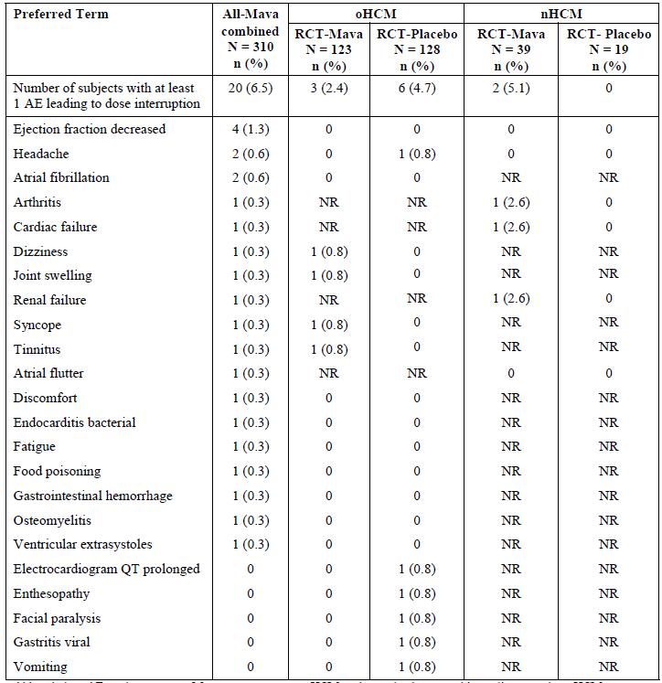

Abbreviations: AE = adverse event, Mava = mavacamten, oHCM = obstructive hypertrophic cardiomyopathy, nHCM = nonobstructive hypertrophic cardiomyopathy, NR = not reported in the analysis population, RCT = randomised control trial.

Data presented in this table are treatment emergent.

The All-Mava combined population includes 310 patients who received at least one dose of mavacamten in the clinical studies comprising the All Mava oHCM population (N = 256) and the All-Mava nHCM population (N = 54). Safety data from the pivotal study are presented as RCT-Mava oHCM (N = 123) and RCT-Placebo oHCM (N = 128).

The Study MYK-461-005 protocol specified temporary discontinuation of study drug if a subject met any of the following criteria: mavacamten plasma concentration 1000 ng/mL or greater, resting LVEF less than 50%, or QTcF prolongation. The initial criterion for temporary discontinuation for QTcF was any value greater than 500 ms, and a subsequent protocol amendment specified the following criteria for temporary discontinuation:

* If QRS;[32] was less than 120 ms, temporary discontinuation criterion was the smaller of 15% increase from Baseline in QTcF or QTcF 520 ms or greater.
* If QRS was 120 ms or greater, temporary discontinuation criterion was the smaller of 15% increase from Baseline QTcF or QTcF 550 ms or greater.

No subjects in Study MYK-461-005 met the temporary treatment discontinuation criterion of mavacamten plasma concentration 1000 ng/mL or greater.

Nine subjects (3.6%) had LVEF less than 50% (median 48%, range 35 to 49%) while on treatment, including seven subjects (5.7%) in the mavacamten group and two subjects (1.6%) in the placebo group. One mavacamten subject temporarily discontinued study drug due to LVEF less than 50% at Week 6, simultaneous with a diagnosis of stress cardiomyopathy. This subject subsequently resumed dosing after an 8 week interruption and completed the study. Two mavacamten subjects temporarily discontinued study drug due to LVEF less than 50% at Week 18. Neither subject had a contemporaneous treatment-emergent adverse event relating to heart failure or systolic dysfunction. Both subjects subsequently resumed dosing and completed the study. Four mavacamten subjects had LVEF less than 50% at the Week 30 visit when treatment ended. The four subjects had LVEF 48 to 49%, and none had treatment-emergent adverse events of heart failure or systolic dysfunction.

In Study MYK-461-005, six subjects (2.4%) met the temporary discontinuation criterion of QTcF prolongation at least once during 30 weeks of treatment, including three subjects (2.4%) in the mavacamten group and three subjects (2.3%) in the placebo group. Two subjects, one in each treatment group, had dual chamber pacemakers. None of the subjects had mavacamten plasma trough concentrations 700 ng/mL or greater at the time of the event. All three mavacamten subjects with QTcF prolongation had a relative increase in QTcF and not an absolute increase above the prespecified thresholds. Two of the three placebo subjects had prolongation of QTcF greater than the prespecified absolute thresholds. No malignant arrhythmias were reported for any of the six subjects with QTcF prolongation. All six subjects underwent temporary treatment discontinuation and subsequently resumed dosing and completed treatment.

Treatment-emergent adverse events leading to treatment discontinuation are summarised in Table 22. In Study MYK-461-005, two patients in the mavacamten group discontinued study drug due to treatment-emergent adverse events (atrial fibrillation and syncope, respectively).

Table 22: Subject incidence of adverse events leading to permanent discontinuation of study treatment by Preferred Term

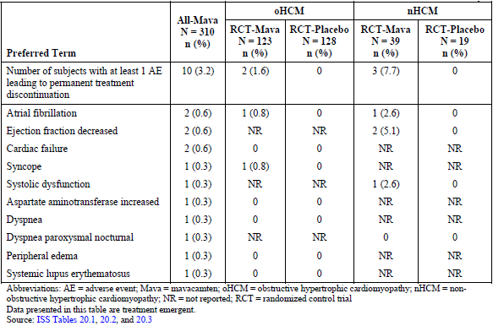

Abbreviations: AE = adverse event, Mava = mavacamten, oHCM = obstructive hypertrophic cardiomyopathy, nHCM = nonobstructive hypertrophic cardiomyopathy, NR = not reported, RCT randomised control trial.

Data presented in this table are treatment emergent.

The All-Mava combined population includes 310 patients who received at least one dose of mavacamten in the clinical studies comprising the All Mava oHCM population (N = 256) and the All-Mava nHCM population (N = 54). Safety data from the pivotal study are presented as RCT-Mava oHCM (N = 123) and RCT-Placebo oHCM (N = 128).

Protocol defined adverse events of special interest were LVEF 30% or less (based on site-read echocardiogram), symptomatic overdose (that is, associated with treatment-emergent adverse event), and pregnancy. In the integrated analysis, no subject with oHCM experienced LVEF 30% or less. One subject with nHCM had an adverse event of special interest of LVEF 30% or less in the long term extension Study MYK-461-007. Reversibility was demonstrated with recovery of LVEF following protocol specified discontinuation of mavacamten. No pregnancies were reported in subjects treated with mavacamten. No subjects in Study MYK-461-005 experienced an adverse event of special interest of symptomatic overdose. Three patients in the long term extension Study MYK-461-007 experienced an adverse event of special interest of symptomatic overdose, including one patient with oHCM who had mavacamten plasma trough concentration 1000 ng/mL or greater following incorrect dose titration decisions. Treatment with mavacamten was interrupted and subsequently discontinued due to a serious adverse event of heart failure. Asymptomatic overdose not associated with any treatment-emergent adverse event (identified retrospectively based on pill counts when subjects returned their pill bottles for reconciliation or resulting from subjects mistakenly taking an extra dose) was reported in 18 subjects (14.6%) in the mavacamten group and 29 subjects (22.7%) in the placebo group of Study MYK-461-005.

A clinical event adjudication committee provided standardised assessments of blinded, predefined study events/endpoints of interest, including major adverse cardiovascular events (comprised of myocardial infarction, stroke, cardiovascular death, and heart failure hospitalisation), cardiovascular and non-cardiovascular hospitalisations, and stress cardiomyopathy. In Study MYK-461-005, the incidence of adjudicated major adverse cardiovascular events was higher in the mavacamten group (4.1%) compared with the placebo group 2.3% over the course of the complete study from Day 1 to Week 38, but was similar in the mavacamten (three subjects, 2.4%) and placebo (three subjects, 2.3%) groups during the 30 week treatment period (Table 23). The adjudicated major adverse cardiovascular event exposure adjusted incidence rates for mavacamten and placebo were 5.75 versus 3.27 per 100 patient years, respectively. In the open label long term extension Study MYK-461-007, the incidence of adjudicated major adverse cardiovascular events was 2.2% (all patients with oHCM).

Table 23: Subject incidence of adjudicated cardiovascular events

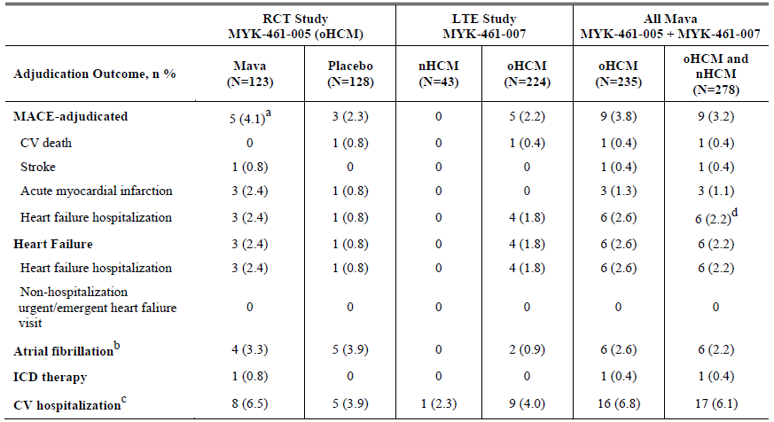

Abbreviations: MACE = major adverse cardiovascular event, CV = cardiovascular, ICD = implantable cardiac defibrillator, RCT = randomised control trial, Mava = mavacamten, oHCM = obstructive hypertrophic cardiomyopathy, nHCM = nonobstructive hypertrophic cardiomyopathy, LTE = long term extension.

a All adjudicated events in Study MYK-461-005 are included in the summary table. During the treatment period (through Week 30), a similar incidence of major adverse cardiovascular event adjudicated events was observed in the treatment arms (three subjects in each arm; 2.4% versus 2.3%, mavacamten versus placebo).

b As per clinical event adjudication committee charter, adjudicated atrial fibrillation is defined as new onset atrial fibrillation or strial flutter

c Includes adjudicated cardiovascular hospitalisations and adjudicated heart failure hospitalisations

d One subject had events in both Study MYK-461-005 and Study MYK-461-007.

The All-Mava combined population includes 310 patients who received at least one dose of mavacamten in the clinical studies comprising the All Mava oHCM population (N = 256) and the All-Mava nHCM population (N = 54). Safety data from the pivotal study are presented as RCT-Mava oHCM (N = 123) and RCT-Placebo oHCM (N = 128)

In Study MYK-461-005, cardiovascular and non-cardiovascular hospitalisations were similar overall across the treatment groups. Six mavacamten subjects were adjudicated as having six cardiovascular hospitalisations, two due to atrial fibrillation/atrial flutter, two due to syncope, and two due to stress cardiomyopathy. The two subjects who experienced serious adverse events of stress cardiomyopathy resumed treatment with mavacamten after temporary discontinuation, completed Study MYK-461-005, and enrolled in the long term extension Study MYK-461-007.

Overall, treatment-emergent adverse events of atrial fibrillation and ventricular arrhythmias were similar for patients treated with mavacamten and placebo. In Study MYK-461-005, atrial fibrillation was reported in 8.1% and 7.8% of the mavacamten and placebo groups, respectively, and events Grade 3 or greater in severity were reported in 2.4% and 3.1%, respectively.31 Serious adverse events due to atrial fibrillation were reported in fewer patients in the mavacamten group compared to placebo (2.4% versus 3.9%). In Study MYK-461-005, the incidence of ventricular arrhythmias was 2.4% in the mavacamten group compared to 2.3% in the placebo group.

The incidence of hepatic treatment-emergent adverse events was low overall, and similar between the mavacamten and placebo groups. Most events were reported in association with pre-existing hepatic steatosis. There was no evidence of on-treatment progressive changes in transaminases with increases in bilirubin. No subjects met protocol specified temporary discontinuation criteria for hepatotoxicity, and no patients met Hy’s Law criteria for drug-induced liver injury.[33]

There were no clinically important renal or haematology safety findings for mavacamten. Hypersensitivity reactions were numerically lower in the mavacamten group compared with the placebo group (7.3% versus 11.7%). Most events were mild in severity and nonserious. No severe cutaneous adverse reactions were reported in the integrated safety analysis.

There are no human data informing safety of mavacamten in pregnancy and/or lactation.

In the integrated safety dataset, there were six subjects (all with oHCM) with poor metaboliser genotype for CYP2C19, including five subjects in the pivotal Study MYK-461-005 (two randomised to mavacamten, three randomised to placebo) and one subject in the supportive Study MYK-461-004. Two of the three CYP2C19 poor metaboliser subjects randomised to placebo in the pivotal study received mavacamten in an extension study, so overall, five of the six CYP2C19 poor metaboliser subjects received mavacamten in the clinical study program. The risk of higher exposure in CYP2C19 poor metaboliser patients was managed through standard protocol specified dose titration.

All three of the CYP2C19 poor metaboliser subjects who received mavacamten in a parent study completed treatment in the parent study according to study design, and two enrolled in an extension study. No adverse events were reported for one subject (parent or extension study). One subject reported nonserious low grade (Grade 1 or 2;31) adverse events that have not led to actions taken with study treatment. Neither of these subjects had on-study measurement of LVEF less than 50% or QTcF greater than 500 ms. One subject had LVEF less than 50% concurrent with treatment completion in the parent (pivotal) study, and subsequently (during the follow up period) experienced a complex clinical scenario involving iatrogenic atrial septal defect and cardiogenic shock as complications of an ablation procedure for atrial fibrillation (all serious adverse events experienced by this subject recovered or resolved, and none were considered to be related to mavacamten); this subject did not participate in an extension study. Of the two CYP2C19 poor metaboliser subjects who received placebo in a parent study and then mavacamten in a long term extension, neither subject has reported an adverse event or measurements of LVEF less than 50%, QTcF greater than 500 ms, or mavacamten plasma concentration 1000 ng/mL or greater after exposure to mavacamten.

### Risk management plan

The sponsor has submitted draft European Union (EU) risk management plan (RMP) version 1.0 (dated 8 June 2021; data lock point 30 October 2020) and Australia specific annex (ASA) version 1.0 (dated 20 August 2021) in support of this application. The summary of safety concerns is shown in Table 24. Proposed additional pharmacovigilance activities include the long term safety extension Study MYK-461-007 (the MAVA-LTE trial), the open label extension Study MYK‑461-008 (PIONEER-OLE trial), and the randomised, double blind, placebo controlled Study MYK-461-017 (VALOR-HCM trial), as well as three planned studies: an observational, multicentre, prospective study in the USA (DISCOVER HCM trial), a post-authorisation long term observational study in Europe, and a pregnancy surveillance program. Proposed additional risk minimisation activities include health care professional (HCP) guide (which includes a checklist) and patient guide and card.

The summary of safety concerns and their associated risk monitoring and mitigation strategies are summarised in Table 24. The TGA may request an updated RMP at any stage of a product's life cycle, during both the pre-approval and post-approval phases.

Table 24: Summary of safety concerns

|  |  |  |  |  |  |
| --- | --- | --- | --- | --- | --- |
| Summary of safety concerns | | Pharmacovigilance | | Risk Minimisation | |
| Routine | Additional | Routine | Additional |
| **Important identified risks** | Heart failure due to systolic dysfunction defined as symptomatic LVEF less than 50% | ✓ | ✓1,2 | ✓ | ✓7 |
| **Important potential risks** | Heart failure due to interaction with CYP2C19 and potent 3A4 inhibitors | ✓ | ✓1,2 | ✓ | ✓7 |
| Embryofetal toxicity | ✓8 | ✓3 | ✓ | ✓7 |
| Arrhythmia due to QT prolongation | ✓ | ✓1,2,4,5,6 | ✓ | – |
| **Missing information** | Patients with Class IV NYHA | ✓ | ✓1,2,5 | ✓ | – |
| Patients being treated with disopyramide | ✓ | ✓1,2,5 | ✓ | – |
| Patients being treated with a combination of β-blockers and non-dihydropyridine calcium channel blockers (verapamil/diltiazem) | ✓ | ✓1,2,5 | ✓ | – |
| Long-term safety | ✓ | ✓1,2,4,5,6 | – | – |

1 Mavacamten Real-World Safety – EU post-authorisation long-term observational study

2 DISCOVER-HCM

3 Active Pregnancy Surveillance Program (Solicited and Spontaneous)

4 MAVALTE

5 VALOR-HCM

6 PIONEER-OLE

7 HCP Guide, Patient Guide, Patient Card

8 Pregnancy follow-up questionnaire

NYHA (New York Heart Association) Class IV (severe disease): symptoms occur at rest; any physical activity increases discomfort.

There are no differences in the summary of the safety concerns listed in draft EU RMP and summary of safety concerns proposed for Australia. The summary of safety concerns is considered acceptable from an RMP perspective.

Routine and additional pharmacovigilance activities are proposed. Routine pharmacovigilance includes a follow-up pregnancy questionnaire. Additional pharmacovigilance activities include: long term safety extension Study MYK-461-007 (MAVA-LTE), open label extension Study MYK 461-008 (PIONEER-OLE), randomised, double-blind, placebo controlled Study MYK 461-017 (VALOR‑HCM) which will all assess long term safety. There are also three planned studies: an observational, multicentre, prospective study in the USA (DISCOVER HCM), a post-authorisation long term observational study in Europe and a pregnancy surveillance program. These studies will provide further information on the long term safety of mavacamten as well as information on the important identified and potential risks and missing information in the summary of safety concerns. The pharmacovigilance plan is considered acceptable.

Routine and additional risk minimisation activities are proposed. Additional risk minimisation activities include a HCP Guide (which includes a checklist) and a patient guide and card. Routine pharmacovigilance activities including signal detection will be used to assess the effectiveness and understanding of the additional risk minimisation activities. The sponsor agreed to requested amendments to the Consumer Medicines Information (CMI) and additional risk minimisation materials. The sponsor has also provided an assessment on the adequacy of additional risk minimisation activities for Australia in relation to the risk of heart failure.

### Risk-benefit analysis

#### Delegate’s considerations

##### Efficacy

The evidence for the efficacy of mavacamten in the proposed indication was derived primarily from one Phase III Study, supported by a Phase II pilot study. The submission included a justification addressing regulatory guidance for applications based on a single pivotal study.[34]

The supportive Phase II Study MYK-461-004 (the PIONEER HCM trial) was a 12 week, open label, pilot pharmacokinetic/pharmacodynamic (PK/PD) study conducted in 21 oHCM patients with symptoms of heart failure. The primary endpoint was reductions in left ventricular outflow tract (LVOT) gradient. Part A evaluated weight based initial mavacamten doses of 10 mg once daily (for patients weighing 60 kg or less) or 15 mg once daily (for patients weighing greater than 60 kg). Subject to an upper limit mavacamten plasma concentration of 750 ng/mL, the dose could be increased, decreased, or remain unchanged based on prespecified left ventricular ejection fraction (LVEF) criteria at Week 4. Part B evaluated lower doses of mavacamten (starting dose 2 mg once daily rising to a maximum dose of 5 mg once daily based on LVOT criteria subject to a mavacamten plasma concentration upper limit of 300 ng/mL). The study demonstrated significant reductions in post-exercise peak LVOT gradient from Baseline to Week 12 in Part A (82% mean reduction) and Part B (26% mean reduction). In Part A, drug concentrations greater than 350 ng/mL were associated with a reduction in LVOT gradient to less than 30 mmHg. In Part B, only one patient achieved a drug concentration greater than 350 ng/mL.

The pivotal Phase III study was conducted in symptomatic (NYHA Class II or III)23 adult patients with a diagnosis of oHCM consistent with European Society of Cardiology guidelines. Patients were required to have resting LVEF 55% or greater and Valsalva LVOT gradient 30 mmHg or greater at screening. Stable concurrent treatment with beta-blockers and/or calcium channel blockers was permitted. A total 75.3% of the study population were receiving beta-blockers during the treatment period.

The starting dose of mavacamten was 5 mg once daily. Subsequent dosing was guided by blinded assessments of mavacamten trough plasma concentration and transthoracic echocardiography (TTE) parameters, according to prespecified dose titration criteria.

The primary endpoint was a composite functional endpoint at Week 30, defined as:

* An improvement of 1.5 mL/kg/min or greater in peak oxygen uptake as determined by cardiopulmonary exercise test (CPET) and a reduction of one NYHA class or greater, or
* An improvement of 3.0 mL/kg/min or greater in peak oxygen uptake with no worsening in NYHA class.

The sponsor provided a detailed justification of the primary endpoint. Secondary endpoints included changes in post-exercise LVOT peak gradient as measured by TTE, changes in peak oxygen uptake, improvement in NYHA class, and patient reported outcomes.

Cardiopulmonary exercise testing (CPET), with simultaneous measurement of respiratory gases, provides objective data on functional limitation in patients with HCM.[35],[36] The selection of functional outcomes as the primary endpoint for the pivotal study is supported by EMA/CHMP regulatory guidance;[37]:

*Exercise testing allows objective evaluation of functional status in patients with CHF [congestive heart failure]. In selected patient populations with high unmet medical need (e.g. patients with end stage CHF, CHF with cachexia or hypertrophic cardiomyopathies and other specific etiologies), the effect of the treatment on exercise capacity may be considered as a primary endpoint. The effect size should be clinically meaningful and consistent with an improvement in patient reported outcomes and the cardiovascular safety profile of the product should be adequately characterised. […]*

*Patient reported outcomes (PROs) may include improvement of symptoms (NYHA classification) and quality of life (QoL). Improvement in symptoms must be clinically relevant in magnitude, consistently achievable and sustained over an extended duration of treatment. PROs are usually measured as secondary endpoints in CHF studies and should be considered as supportive. In selected patient populations with high unmet medical need (see above) effects on PROs may be relevant in support of the effect on exercise capacity.*

The pivotal study was successful in demonstrating superiority of mavacamten compared to placebo for the primary endpoint. In the mavacamten group, 36.6% of subjects achieved the composite functional endpoint at Week 30 compared to 17.2% in the placebo group. The treatment difference between groups was 19.4% (95% CI: 8.67, 30.13, p < 0.0005). Each of the components of the composite endpoint contributed to the outcome.

Treatment with mavacamten also resulted in statistically significant improvements in all secondary endpoints. The change from Baseline to Week 30 in post-exercise LVOT peak gradient was -47 mmHg in the mavacamten group compared with -10 mmHg in the placebo group, a treatment difference of -35 mmHg (95% CI: -43.2, -28.1, p < 0.0001). There was a significant increase in peak oxygen uptake of 1.4 mL/kg/min (p = 0.0006) in the mavacamten group compared with placebo. An improvement of one NYHA class or greater was observed in 65% and 31% of patients in the respective groups, a treatment difference of 34% (95% CI: 22, 45, p < 0.0001). Mavacamten treatment was also associated with improvements in patient reported outcomes (KCCQ-23;27 HCMSQ;28).

Subgroup analyses of the primary endpoint by baseline characteristics and stratification factors were generally consistent with the primary analysis, though the magnitude of the treatment effect was greater in subjects not receiving beta-blocker at Baseline compared to those receiving beta-blocker. Subgroup analyses of secondary efficacy endpoints showed similar outcomes across beta-blocker subgroups.

Interim analyses of ongoing long term extension studies support a sustained efficacy benefit.

##### Safety

The safety profile of mavacamten was assessed in the pivotal Study MYK-461-005, as well as in integrated analyses of safety data from five studies in oHCM and nHCM patients. The overall safety database is relatively small, with 310 patients in the All-Mava combined population, including 123 patients who were randomised to receive mavacamten in the pivotal study. The two ongoing long term extension studies are evaluating longer term safety of mavacamten in patients with HCM. One hundred thirty four (134) patients in the mavacamten clinical program have had cumulative mavacamten exposure more than 12 months.

Mavacamten treatment was generally well tolerated in the clinical studies. In the pivotal study, more than 97% of patients completed the 30 week treatment period and treatment was discontinued permanently due to adverse events in 1.6% of patients. In the integrated analyses, permanent treatment discontinuation occurred in 3.2% of patients (All-Mava combined population).[38]

In the pivotal study, dizziness was the most frequently reported treatment-emergent adverse event in both treatment groups, with a higher incidence in the mavacamten group (21.1%) compared to the placebo group (13.3%). Other treatment-emergent adverse events reported in 5% or more of subjects (and 2% or more higher than placebo) included dyspnoea (14.6% versus 10.2%), headache (12.2% versus 7.8%), upper respiratory tract infection (8.1% versus 4.7%), cough (8.1% versus 3.1%), gastro-oesophageal reflux disease (5.7% versus 2.3%), arthralgia (5.7% versus 1.6%), and syncope (5.7% versus 1.6%). Serious adverse events reported in more than one subject in the pivotal study included atrial fibrillation, syncope, and stress cardiomyopathy. Treatment-emergent adverse events relating to atrial fibrillation, ventricular tachycardia, correct QT interval (QTc) prolongation, and adjudicated major adverse cardiovascular events were similar across the mavacamten and placebo groups. There were no meaningful differences in the incidence of severe adverse events and serious adverse events in patients stratified for beta‑blocker use.

Identified cardiac safety risks with mavacamten include reduced LVEF and heart failure. Regular clinical review with dosage adjustment based on echocardiographic parameters is proposed to support the safe use of mavacamten. The draft Australian Product Information has a precaution regarding these risks in section 4.4 (Special warnings and precautions for use), as well as detailed dose titration guidance in section 4.2 (Dose and method of administration). The US Product Information has a boxed warning addressing the risk of heart failure, including the risk of heart failure associated with CYP mediated drug interactions. At this stage, the sponsor has not included a boxed warning in the Australian Product Information. The sponsor was requested to address the issue raised in the risk management plan (RMP) evaluation. The Delegate was inclined to include a boxed warning addressing the risk of heart failure and requested advice from the Advisory Committee on Medicines (ACM) on this issue.

Mavacamten is extensively metabolised by CYP enzymes,11 primarily by CYP2C19 (74%), and to a lesser extent by CYP3A4 (18%) and CYP2C9 (7.6%). Mavacamten exposure is increased in CYP2C19 poor metabolisers compared to normal metabolisers due to an extended elimination phase. Safety data for CYP2C19 poor metabolisers are limited, but the available data suggest that mavacamten can be used safely in CYP2C19 poor metabolisers with regular monitoring and dose titration. Pharmacogenomic testing is not proposed prior to initiation of treatment with mavacamten.

There are safety risks associated with concurrent treatment with CYP2C19 or CYP3A4 inhibitors (or withdrawal of CYP2C19 or CYP3A4 inducers). CYP mediated drug interactions may produce substantial increases in mavacamten exposure, which may cause reduced LVEF and heart failure. In the pivotal study, potent and moderate CYP2C19 inhibitors and potent CYP3A4 inhibitors were prohibited from 14 days before screening through to end of study. The sponsor proposes to address risks of CYP mediated drug interactions with warnings/precautions in section 4.4 of the Product Information, dose adjustment guidance in section 4.2, and drug interaction guidance in section 4.5. However, it remains uncertain whether these measures will adequately address the safety risks. CYP mediated drug interactions represent a serious risk to patients being treated with mavacamten, so the Delegate was inclined to place a contraindication on concomitant use of moderate-strong CYP2C19 inhibitors, strong CYP3A4 inhibitors, moderate-strong CYP2C19 inducers, and moderate-strong CYP3A4 inducers, consistent with the approach taken by the FDA. Precautions and dose adjustment for concomitant use of a weak CYP2C19 inhibitor or moderate CYP3A4 inhibitor would be acceptable. Expert advice was requested from ACM on this issue.

There are no human data informing safety in pregnancy. Animal data indicate concerns with embryofetal toxicity (malformations) at subclinical systemic exposures. Embryofetal toxicity is addressed in the RMP/ASA under important potential risks. The Product Information includes a precaution regarding embryofetal toxicity in section 4.4, and precautionary guidance in section 4.6 advising not to use mavacamten during pregnancy, and for women of reproductive potential to confirm a negative pregnancy test prior to initiation of treatment and to use highly effective contraception during treatment and for at least 4 months after discontinuing treatment.

##### Proposed dosage

In the pivotal study, dose titration was based on mavacamten plasma concentration and transthoracic echocardiography (TTE) parameters (left ventricular ejection fraction (LVEF) and left ventricular outflow tract obstruction (VLVOT)). Following completion of the pivotal study, modelling and simulations were conducted to compare four echo-based dose titration regimens to the regimen used in the pivotal study with regard to key safety and efficacy thresholds for LVEF, VLVOT, and concentration. The rationale for exploring echo-based dose titration regimens was that an echo‑based dose titration regimen would be more practical to implement and manage in clinical practice than the dose titration regimen used in the pivotal study.

Initially, the sponsor proposed an echo-based dose titration regimen comprising a 5 mg once daily starting dose for all subjects followed by individualised dose adjustments based on TTE criteria:

* review at Week 4 to 6 to determine for the need for down titration (VLVOT less than 20 mmHg) or treatment interruption (LVEF less than 50%)
* review at Week 12 to determine the need for up titration (LVEF 55% or greater and VLVOT 30% or greater) or treatment interruption (LVEF less than 50%)
* then review every 12 weeks during the first year and every 6 months thereafter
* review 4 to 6 weeks after any dose increase
* if LVEF less than 50%, interrupt treatment for 4 to 6 weeks and until LVEF 50% or greater, then restart treatment at the same or a lower dose at the discretion of the clinician.

On 23 June 2022, following completion of the clinical evaluation, the sponsor submitted a revised dose titration regimen aligned to the regimen approved by the FDA and under consideration by the EMA. This regimen has a 5 mg once daily starting dose for all subjects followed by individualised dose adjustments based on TTE criteria:

* review at Week 4 to determine for the need for down titration (VLVOT less than 20 mmHg) or treatment interruption (LVEF less than 50%)
* review at Week 8 to determine for the need for down titration (VLVOT less than 20 mmHg) or treatment interruption (LVEF less than 50%)
* review at Week 12 to determine the need for up titration (LVEF 55% or greater and VLVOT 30% or greater) or treatment interruption (LVEF less than 50%)
* review every 12 weeks in the maintenance phase to determine the need for up titration (LVEF 55% or greater and VLVOT 30% or greater) or treatment interruption (LVEF less than 50%)
* review 4 weeks after any dose increase
* if LVEF less than 50%, interrupt treatment and recheck every 4 weeks until LVEF 50% or greater, then restart treatment at the next lower dose level.

The exposure-response modelling and simulations provide support for echo-based dose titration as an alternative to the dose titration regimen evaluated in the pivotal study. The revised regimen submitted on 23 June 2022 (with review at Weeks 4, 8, and 12, and at least every 12 weeks thereafter) is preferable to the originally proposed regimen based on key safety thresholds assessed in the simulations. The revised regimen provides an additional review at Week 8, as well as review at least every 12 weeks in the maintenance phase. The additional monitoring in the revised regimen is likely to provide an advantage in managing safety, particularly in subpopulations at risk of higher mavacamten exposure, including CYP2C19 poor metabolisers and patients with mild-moderate hepatic impairment.

##### Proposed indication

The sponsor’s initial proposed indication was:

*Camzyos is indicated for the treatment of symptomatic obstructive hypertrophic cardiomyopathy (oHCM) in adult patients.*

The clinical evaluation recommended the following modified indication:

*Camzyos is indicated for improvement in functional capacity in adult patients with obstructive hypertrophic cardiomyopathy (oHCM) and NYHA class II or III heart failure.*

In response, the sponsor proposed a revised indication:

*Camzyos is indicated for the treatment of symptomatic obstructive hypertrophic cardiomyopathy (oHCM) in adult patients to improve functional capacity, New York Heart Association (NYHA) class and symptoms.*

In addition, the sponsor clarified that the modified indication proposed as a result of the TGA’s clinical evaluation ‘is not consistent with the approved US indication, as the US indication notes improvements in functional capacity and symptoms and does not indicate that mavacamten has been studied for the treatment of heart failure’.

All of the patients evaluated in the pivotal study were symptomatic but none were NYHA class IV (severe), (all patients were NYHA class II (mild) or III (moderate)).23 The lack of efficacy and safety data in NYHA class IV patients raises concern as to whether efficacy and safety (particularly the risks of reduced LVEF and heart failure) have been adequately characterised in this subpopulation with more severe disease. Expert advice was requested from ACM regarding whether the indication should be restricted to NYHA class II or III patients, or whether the proposed indication for symptomatic oHCM (which would include NYHA class II, III or IV) is justified based on clinical principles.

Subject to advice from ACM, the Delegate was inclined to restrict the indication to NYHA class II or III patients, and describe the efficacy benefits in the clinical trials section rather than the indication:

*Camzyos is indicated for the treatment of adults with symptomatic NYHA class II – III obstructive hypertrophic cardiomyopathy (oHCM).*

##### Uncertainties and limitations of the data

This application to register mavacamten for the treatment of symptomatic obstructive hypertrophic cardiomyopathy (oHCM) is based on a single pivotal study, supported by a Phase II pilot study. The submission included a justification addressing the applicable regulatory guidance for an application based on one pivotal study.

No NYHA class IV,23 patients were enrolled in the studies presented in this submission. Patients enrolled in the pivotal study and the supportive Phase II study were NYHA class II or III. One NYHA class IV patient was enrolled in the VALOR-HCM trial, but the clinical study report has not been evaluated in this submission (only top-line data were presented).

The efficacy of mavacamten with regard to cardiovascular morbidity and mortality has not been assessed. The cardiovascular safety profile of mavacamten is acceptable in the context of the background morbidity and mortality associated with oHCM.

Long term safety data are limited. This is to be addressed in ongoing and proposed studies, as described in the risk management plan (see Risk management plan section, above).

Safety data related to CYP enzymes,11 notably for CYP2C19 poor metabolisers are limited. The available data suggest that mavacamten can be used safely in CYP2C19 poor metabolisers with regular monitoring and dose titration.

The proposed echo-based dose titration regimen was not evaluated in the pivotal study. Exposure-response modelling and simulations were performed to support the proposed dose titration regimen. Echo-based dose titration criteria are being evaluated in the ongoing long term extension Study MYK-461-007 but there are some differences to the proposed dose titration regimen.

There are no human data informing safety in pregnancy and/or lactation. Animal data indicate concerns with embryofetal toxicity (malformations) at subclinical systemic exposures [Pregnancy Category D is proposed].12

##### Proposed conditions of registration

* The Camzyos EU-Risk Management Plan (RMP) (version 1.0, dated 8 June 2021, data lock point 30 October 2020), with Australia specific annex (version 1.0, dated 20 August 2021), included with submission PM-2021-03751-1-3, and any subsequent revisions, as agreed with the TGA will be implemented in Australia.
* An obligatory component of risk management plans is routine pharmacovigilance. Routine pharmacovigilance includes the submission of periodic safety update reports (PSURs).  
  Unless agreed separately between the supplier who is the recipient of the approval and the TGA, the first report must be submitted to TGA no later than 15 calendar months after the date of the approval letter. The subsequent reports must be submitted no less frequently than annually from the date of the first submitted report until the period covered by such reports is not less than three years from the date of the approval letter. The annual submission may be made up of two PSURs each covering six months. If the sponsor wishes, the six-monthly reports may be submitted separately as they become available.  
  If the product is approved in the EU during the three years period, reports can be provided in line with the published list of EU reference dates no less frequently than annually from the date of the first submitted report until the period covered by such reports is not less than three years from the date of the approval letter.  
  The reports are to at least meet the requirements for PSURs as described in the European Medicines Agency’s Guideline on good pharmacovigilance practices (GVP) Module VII-periodic safety update report (Rev 1), Part VII.B Structures and processes. Note that submission of a PSUR does not constitute an application to vary the registration. Each report must have been prepared within ninety calendar days of the data lock point for that report.
* Camzyos (mavacamten) is to be included in the Black Triangle Scheme. The PI and CMI for Camzyos must include the black triangle symbol and mandatory accompanying text for five years, which starts from the date that the sponsor notifies the TGA of supply of the product.

#### Proposed action

The efficacy of mavacamten, a first-in-class, selective inhibitor of cardiac myosin, was evaluated in one Phase III study, supported by a Phase II pilot study. In the Phase III study, mavacamten improved functional capacity and symptoms in adults with symptomatic oHCM (NYHA class II or III).23 Improvements in functional capacity and symptoms are meaningful outcomes for patients with oHCM. The clinical relevance, statistical significance, and internal consistency of the efficacy findings are adequate to support an application based on one pivotal study.

Mavacamten was generally well tolerated in the clinical studies. Important safety risks include reduced LVEF and heart failure. Long term data are limited, but interim analyses of ongoing long term extension studies are supportive of safety and efficacy.

Mavacamten is extensively metabolised by CYP enzymes,11 primarily by CYP2C19, and to a lesser extent by CYP3A4 and CYP2C9. CYP2C19 genotype impacts on mavacamten exposure. Regular clinical review with dose adjustment based on echocardiographic criteria is proposed to manage efficacy and safety for individual patients. The proposed dose titration regimen was not evaluated in the pivotal study but is supported by exposure-response modelling and simulations. CYP-mediated drug interactions are important safety considerations.

Overall, the benefit-risk is favourable. Treatment with mavacamten should be initiated and supervised by a specialist cardiologist with expertise in the management of oHCM. Efficacy and safety in NYHA class IV oHCM remain uncertain. Advice from ACM was sought regarding restricting the indication to NYHA class II and III.

#### Advisory Committee considerations

The [Advisory Committee on Medicines (ACM)](https://www.tga.gov.au/committee/advisory-committee-medicines-acm), having considered the evaluations and the Delegate’s overview, as well as the sponsor’s response to these documents, advised the following.

##### Specific advice to the Delegate

1. ***What is the ACM’s view regarding the adequacy of the efficacy and safety data?***

The ACM was of view that the efficacy and safety data submitted is adequate. Both *in vivo* and *in vitro* data demonstrated safety of Camzyos over medium term usage. The ACM considered Camzyos’ safety profile satisfactory but there is concern regarding the risk of reduced left ventricular ejection fraction (LVEF), necessitating regular clinical review with echocardiographic monitoring and dose titration based on echocardiographic criteria.

1. ***Is the proposed indication in adults with symptomatic obstructive hypertrophic cardiomyopathy (oHCM) clinically justified, or should the indication be restricted to NYHA class II and III?***

The ACM noted that the sponsor has accepted the Delegate’s proposal to restrict the indication to NYHA class II (mild) and class III (moderate).23 The ACM advised that the NYHA classification system alone does not adequately reflect the target patient population, based on the population evaluated in the pivotal study. The ACM supported the inclusion of a criterion based on left ventricular outflow tract (LVOT) gradient and advised the following indication:

*For the treatment of adults with symptomatic NYHA class II-III obstructive hypertrophic cardiomyopathy with resting or dynamic LVOT peak gradient ≥ 50 mmHg.*

1. ***What is the ACM’s view regarding the proposed dosing regimen?***

The ACM noted the proposed dose regimen by sponsor does not match the regimen in the EXPLORER-HCM trial (Study MYK-461-005). The ACM supported the dosing regimen proposed by the sponsor on 23 June 2022.

The regimen starts with 5 mg once daily for all subjects followed by individualised dose adjustments based on transthoracic echocardiogram criteria:

* review at Week 4 to determine the need for down titration (peak velocity of the left ventricular outflow tract (VLVOT) less than 20 mmHg) or treatment interruption (LVEF less than 50%)
* review at Week 8 to determine the need for down titration (VLVOT less than 20 mmHg) or treatment interruption (LVEF less than 50%)
* review at Week 12 to determine the need for up titration (LVEF 55% or greater and VLVOT 30 mmHg or greater with ongoing symptoms) or treatment interruption (LVEF less than 50%)
* review every 12 weeks in the maintenance phase to determine the need for up titration (LVEF 55% or greater and VLVOT 30 mmHg or greater with ongoing symptoms) or treatment interruption (LVEF less than 50%)
* review 4 weeks after any dose increase
* if LVEF less than 50%, interrupt treatment and recheck every 4 weeks until LVEF 50% or greater, then restart treatment at the next lower dose level.

The ACM highlighted that the frequency of imaging required to ensure safe use is unusual and could have implications for patient management (for example, cost of testing). The need for repeated echocardiograms may limit prescribers to specialised centres.

1. ***What is the ACM’s view regarding a boxed warning in the Product Information addressing the risk of heart failure?***

The ACM was of the view that a boxed warning addressing the risk of reduced left ventricular ejection fraction (LVEF less than 50%) is required in the Product Information. The ACM considered the wording should highlight the importance and the need for regular follow up and echocardiographic monitoring in patients using Camzyos, based on occurrence of reduced ejection fraction.

1. ***What is the ACM’s view regarding the adequacy of the proposed strategies to manage CYP‑mediated*11 *drug interactions?***

The ACM was concerned regarding potential safety risks associated with drug interactions and considered that it is uncertain whether the proposed strategies would adequately mitigate the risks.

1. ***Do the safety risks warrant a contraindication for concurrent use of moderate-strong CYP2C19 inhibitors, strong CYP3A4 inhibitors, moderate-strong CYP2C19 inducers, and moderate-strong CYP3A4 inducers?***

The ACM agreed with the Delegate to contraindicate concomitant use of the following moderate‑strong CYP2C19 inhibitors, strong CYP3A4 inhibitors, moderate-strong CYP2C19 inducers, and moderate-strong CYP3A4 inducers. In addition, the ACM was of view that precautions and dose adjustment for concomitant use of a weak CYP2C19 inhibitor or moderate CYP3A4 inhibitor are required.

##### Conclusion

The ACM considered this product to have an overall positive benefit-risk profile for the indication:

*For the treatment of adults with symptomatic NYHA class II-III obstructive hypertrophic cardiomyopathy with resting or dynamic LVOT peak gradient ≥ 50 mmHg.*

## Outcome

Based on a review of quality, safety, and efficacy, the TGA approved the registration of Camzyos (mavacamten), 2.5 mg, 5 mg, 10 mg and 15 mg, hard capsule, blister packs indicated for:

*Camzyos is indicated for the treatment of adults with symptomatic NYHA class II-III obstructive hypertrophic cardiomyopathy.*

### Specific conditions of registration applying to these goods

* Camzyos (mavacamten) is to be included in the Black Triangle Scheme. The PI and CMI for Camzyos must include the black triangle symbol and mandatory accompanying text for five years, which starts from the date that the sponsor notifies the TGA of supply of the product.
* The Camzyos EU-Risk Management Plan (RMP) (version 1.0, dated 8 June 2021, data lock point 30 October 2020), with Australia specific annex (version 1.0, dated 20 August 2021), included with submission PM-2021-03751-1-3, and any subsequent revisions, as agreed with the TGA will be implemented in Australia.

An obligatory component of risk management plans is routine pharmacovigilance. Routine pharmacovigilance includes the submission of periodic safety update reports (PSURs).

Unless agreed separately between the supplier who is the recipient of the approval and the TGA, the first report must be submitted to TGA no later than 15 calendar months after the date of the approval letter. The subsequent reports must be submitted no less frequently than annually from the date of the first submitted report until the period covered by such reports is not less than three years from the date of the approval letter. The annual submission may be made up of two PSURs each covering six months. If the sponsor wishes, the six-monthly reports may be submitted separately as they become available.

If the product is approved in the EU during the three years period, reports can be provided in line with the published list of EU reference dates no less frequently than annually from the date of the first submitted report until the period covered by such reports is not less than three years from the date of the approval letter.

The reports are to at least meet the requirements for PSURs as described in the European Medicines Agency’s Guideline on good pharmacovigilance practices (GVP) Module VII-periodic safety update report (Rev 1), Part VII.B Structures and processes. Note that submission of a PSUR does not constitute an application to vary the registration. Each report must have been prepared within ninety calendar days of the data lock point for that report.

## Attachment 1. Product Information

The PI for Camzyos approved with the submission which is described in this AusPAR is at Attachment 1. For the most recent PI, please refer to the TGA [PI/CMI search facility.](https://www.tga.gov.au/picmi-search-facility)

|  |
| --- |
| Therapeutic Goods Administration |
| PO Box 100 Woden ACT 2606 Australia  Email: [info@tga.gov.au](mailto:info@tga.gov.au) Phone: 1800 020 653 Fax: 02 6203 1605  [**https://www.tga.gov.au**](https://www.tga.gov.au) |
| Reference/Publication # |

1. This is the original indication proposed by the sponsor when the TGA commenced the evaluation of this submission. It may differ to the final indication approved by the TGA and registered on the Australian Register of Therapeutic Goods.
2. Maron BJ, Gardin JM, Flack JM, Gidding SS, Kurosaki TT, Bild DE. Prevalence of hypertrophic cardiomyopathy in a general population of young adults. Echocardiographic analysis of 4111 subjects in the CARDIA Study. Coronary Artery Risk Development in (Young) Adults. *Circulation.* (1995) 92:785–9.
3. Husser D, Ueberham L, Jacob J, et al. Prevalence of clinically apparent hypertrophic cardiomyopathy in Germany-An analysis of over 5 million patients. *PLoS One*. 2018;13(5):e0196612. Published 2018 May 3.
4. Ommen SR, Mital S, Burke MA, et al. 2020 AHA/ACC Guideline for the Diagnosis and Treatment of Patients With Hypertrophic Cardiomyopathy: A Report of the American College of Cardiology/American Heart Association Joint Committee on Clinical Practice Guidelines [published correction appears in Circulation. 2020 Dec 22;142(25):e633]. *Circulation*. 2020;142(25):e558-e631.
5. CSANZ, Diagnosis and Management of Hypertrophic Cardiomyopathy – Position Statement <https://www.csanz.edu.au/wp-content/uploads/2017/07/Hypertrophic-Cardiomyopathy_ratified_25-Nov-2016.pdf>
6. Marian AJ, Braunwald E. Hypertrophic Cardiomyopathy: Genetics, Pathogenesis, Clinical Manifestations, Diagnosis, and Therapy. *Circ Res.* 2017;121(7):749-770.
7. Ommen S, et al. 2020 AHA/AHC Guideline for the Diagnosis and Treatment of Patients with Hypertrophic Cardiomyopathy.
8. Therapeutic Goods Order 91 (TGO 91) describes the standards required for labels of prescription and related medicines; made under Section 10 of the Therapeutic Goods Act (1989). This Order sets out what kinds of information are required to be included on the label of prescription and other related medicines. For further information, visit the TGA website: <https://www.tga.gov.au/therapeutic-goods-orders>.
9. ICH M3 (R2) Non-clinical safety studies for the conduct of human clinical trials for pharmaceuticals
10. The **QT interval** is the time from the start of the QRS wave complex to the end of the corresponding T wave. It approximates to the time taken for ventricular depolarisation and repolarisation, that is to say, the period of ventricular systole from ventricular isovolumetric contraction to isovolumetric relaxation.

    The **corrected QT interval** (QTc) estimates the QT interval at a standard heart rate. This allows comparison of QT values over time at different heart rates and improves detection of patients at increased risk of arrhythmias.

    The **QTcF** is the QT interval corrected for heart rate according to Fridericia’s formula.
11. **Cytochrome P450 (CYP)** enzymes are the major enzymes involved in drug metabolism, accounting for large part of the total metabolism. Most drugs undergo deactivation by CYPs, either directly or by facilitated excretion from the body. Also, many substances are bioactivated by CYPs to form their active compounds.

    Many drugs may increase or decrease the activity of various CYP isozymes either by inducing the biosynthesis of an isozyme (enzyme induction) or by directly inhibiting the activity of the CYP (enzyme inhibition). This is a major source of adverse drug interactions, since changes in CYP enzyme activity may affect the metabolism and clearance of various drugs. Such drug interactions are especially important to take into account when using drugs of vital importance to the patient, drugs with important side-effects and drugs with small therapeutic windows, but any drug may be subject to an altered plasma concentration due to altered drug metabolism.
12. **Pregnancy category D**: Drugs which have caused, are suspected to have caused or may be expected to cause, an increased incidence of human fetal malformations or irreversible damage. These drugs may also have adverse pharmacological effects. Accompanying texts should be consulted for further details.
13. Verapamil was first registered in Australia on 19 August 1991. ARTG number: 10681.
14. Omeprazole was first registered in Australia on 14 December 1998. ARTG number: 63414.
15. Midazolam was first registered in Australia on 23 August 1991. ARTG number: 13726.
16. ClinicalTrials.gov Identifier: NCT04349072
17. Desai MY, Owens A, Geske JB, et al. Myosin Inhibition in Patients With Obstructive Hypertrophic Cardiomyopathy Referred for Septal Reduction Therapy. *J Am Coll Cardiol.* 2022;80(2):95-108.
18. The **Child-Pugh score** is used to assess the prognosis of chronic liver disease. The score employs five clinical measures of liver disease. Each measure is scored 1 to 3, with 3 indicating most severe derangement. Class A: 5 to 6 points, least severe liver disease, one to five year survival rate of 95%. Class B: 7 to 9 points, moderately severe liver disease, one to five year survival of 75%. Class C: 10 to 15 points, most severe liver disease, 1 to 5 year survival rate 50%.
19. Itraconazole was first registered in Australia on 2 February 1994. ARTG number: 47012.
20. Rifampicin was first registered in Australia on 8 July 1991. ARTG number: 10113.
21. Carbamazepine was first registered in Australia on 20 September 1991. ARTG number: 17674.
22. Esomeprazole was first registered in Australia on 28 March 2001. ARGT number: 74133.
23. **New York Heart Association (NYHA) classification:**

    Class I: No limitations. Ordinary physical activity does not cause undue fatigue, dyspnoea or palpitations (asymptomatic left ventricular dysfunction). Metabolic equivalent (MET) > 7.  
    Class II: Slight limitation of physical activity. Ordinary physical activity results in fatigue, palpitation, dyspnoea or angina pectoris (mild congestive heart failure). MET = 5.  
    Class III: Marked limitation of physical activity. Less than ordinary physical activity leads to symptoms (moderate congestive heart failure). MET = 2–3.  
    Class IV: Unable to carry on any physical activity without discomfort. Symptoms of congestive heart failure present at rest (severe congestive heart failure). MET = 1.6.

    MET = metabolic equivalent of task, a measure of how much energy is expended compared to remaining at rest.
24. Disopyramide was first registered in Australia on 30 August 1991. ARTG: 13537.
25. Ranolazine was first registered in Australia on 13 October 2017. ARTG: 236108.
26. Diltiazem was first registered in Australia on 10 November 1993. ARTG: 46818.
27. The Kansas City Cardiomyopathy Questionnaire (KCCQ) is a 23 item self administered questionnaire developed to independently measure the patient’s perception of their health status, which includes heart failure symptoms, impact on physical and social function, and how their heart failure impacts their quality of life within a 2 week period.
28. The Hypertrophic Cardiomyopathy Symptom Questionnaire (HCMSQ) is designed to specifically measure HCM symptoms and yields four domain scores (shortness of breath, tiredness, cardiovascular symptoms, syncope) and a total score.
29. An increase of 10 points or greater in KCCQ-23 CSS is considered a clinically meaningful response.
30. A decrease of 2.5 points or greater in HCMSQ SoB is considered a clinically meaningful response.
31. Grades are based on Common Terminology Criteria for Adverse Events (CTCAE) available from [nih.gov](https://www.nih.gov/)
32. The **QRS complex** includes the Q wave, R wave, and S wave. These three waves occur in rapid succession. The QRS complex represents the electrical impulse as it spreads through the ventricles and indicates ventricular depolarization.
33. **Hy’s Law**: Evidence of hepatocellular injury with a rise in alanine aminotransferase (ALT) and/or aspartate aminotransferase (AST) > 3 x the upper limit of normal (ULN) and total bilirubin > 2 x ULN, and no other reason to explain rise in aminotransferases and total bilirubin. Hy's law is a rule of thumb that a patient is at high risk of a fatal drug-induced liver injury if given a medication that causes hepatocellular injury with jaundice.
34. EMA: Points to consider on application with 1. Meta-analyses; 2. One pivotal study [CPMP/EWP/2330/99](http://www.ema.europa.eu/docs/en_GB/document_library/Scientific_guideline/2009/09/WC500003657.pdf)
35. Sharma S, Firoozi S, McKenna WJ. Value of exercise testing in assessing clinical state and prognosis in hypertrophic cardiomyopathy. Cardiol Rev. 2001; 9 (2):70-6.
36. Ommen, S. et al. 2020 AHA/ACC Guideline for the Diagnosis and Treatment of Patients With Hypertrophic Cardiomyopathy.
37. Guideline on clinical investigation of medicinal products for the treatment of chronic heart failure - Revision 2
38. The All-Mava combined population includes 310 patients who received at least one dose of mavacamten in the clinical studies comprising the All Mava oHCM population (N = 256) and the All-Mava nHCM population (N = 54). Safety data from the pivotal study were presented as RCT-Mava oHCM (N = 123) and RCT-Placebo oHCM (N = 128).