Australian Public Assessment Report for Pemazyre
  - Active ingredient: Pemigatinib
  - Sponsor: Specialised Therapeutics Alim Pty Ltd
July 2023

About the Therapeutic Goods Administration (TGA)
- The Therapeutic Goods Administration (TGA) is part of the Australian Government Department of Health and Aged Care and is responsible for regulating therapeutic goods, including medicines, medical devices, and biologicals.
- The TGA administers the Therapeutic Goods Act 1989 (the Act), applying a risk management approach designed to ensure therapeutic goods supplied in Australia meet acceptable standards of quality, safety, and efficacy.
- The work of the TGA is based on applying scientific and clinical expertise to decision-making, to ensure that the benefits to the Australian public outweigh any risks associated with the use of therapeutic goods.
- The TGA relies on the public, healthcare professionals and industry to report problems with therapeutic goods. The TGA investigates reports received to determine any necessary regulatory action.
- To report a problem with a therapeutic good, please see the information on the TGA website.

About AusPARs
- The Australian Public Assessment Report (AusPAR) provides information about the evaluation of a prescription medicine and the considerations that led the TGA to approve or not approve a prescription medicine submission. Further information can be found in Australian Public Assessment Report (AusPAR) guidance.
- AusPARs are prepared and published by the TGA.
- AusPARs are static documents that provide information that relates to a submission at a particular point in time. The publication of an AusPAR is an important part of the transparency of the TGA’s decision-making process.
- A new AusPAR may be provided to reflect changes to indications or major variations to a prescription medicine subject to evaluation by the TGA.

Copyright
© Commonwealth of Australia 2023
This work is copyright. You may reproduce the whole or part of this work in unaltered form for your own personal use or, if you are part of an organisation, for internal use within your organisation, but only if you or your organisation do not use the reproduction for any commercial purpose and retain this copyright notice and all disclaimer notices as part of that reproduction. Apart from rights to use as permitted by the Copyright Act 1968 or allowed by this copyright notice, all other rights are reserved and you are not allowed to reproduce the whole or any part of this work in any way (electronic or otherwise) without first being given specific written permission from the Commonwealth to do so. Requests and inquiries concerning reproduction and rights are to be sent to the TGA Copyright Officer, Therapeutic Goods Administration, PO Box 100, Woden ACT 2606 or emailed to <tga.copyright@tga.gov.au>.

Contents
List of abbreviations 4
Product submission 6
Submission details 6
Product background 7
Regulatory status 8
Product Information 10
Registration timeline 11
Submission overview and risk/benefit assessment 11
Quality 12
Nonclinical 12
Clinical 13
Summary of clinical studies 13
Pharmacology 13
Efficacy 24
Safety 33
Risk management plan 44
Risk-benefit analysis 45
Delegate’s considerations 45
Proposed action 48
Advisory Committee considerations 48
Outcome 49
Specific conditions of registration applying to these goods 49
Attachment 1. Product Information 50

List of abbreviations
Abbreviation |  | Meaning
¹⁴C | Carbon 14
ACM | Advisory Committee on Medicines
AE | Adverse event
ARTG | Australian Register of Therapeutic Goods
ASA | Australia specific annex
AUC | Area under the plasma concentration-time curve
AUC_{0-24h} | Area under the plasma concentration-time curve from time zero to 24 hours
AUC_{0-inf} | Area under the plasma concentration-time curve from time zero to infinity
CI | Confidence interval
C_{max} | Maximum observed plasma concentration
CMI | Consumer Medicines Information
CV | Coefficient of variation
CYP3A4 | Cytochrome P450 3A4
DOR | Duration of response
ECOG-PS | Eastern Cooperative Oncology Group-Performance Status
EU | European Union
FDA | United States Food and Drug Administration (United States of America)
FGF | Fibroblast growth factor
FGFR | Fibroblast growth factor receptor
GVP | Good Pharmacovigilance Practices
IRC | Independent Review Committee
ORR | Overall response rate
PD | Pharmacodynamic(s)
PI | Product Information
PK | Pharmacokinetic(s)
PopPK | Population pharmacokinetic(s)
PSUR | Periodic safety update report
RECIST | Response Evaluation Criteria in Solid Tumours
RMP | Risk management plan
TEAE | Treatment-emergent adverse event
TGA | Therapeutic Goods Administration
T_{max} | Time of the maximum observed plasma concentration
μCi | Microcurie (units)

Product submission

Submission details
Type of submission: | New chemical entity
Product name: | Pemazyre
Active ingredient: | Pemigatinib
Decision: | Approved for provisional registration
Date of decision: | 12 September 2022
Date of entry onto ARTG: | 14 September 2022
ARTG numbers: | 373031, 375309 and 375314
Black Triangle Scheme  for the current submission: | Yes.  As a provisionally registered product, this medicine will remain in the Black Triangle Scheme for the duration of its provisional registration
Sponsor’s name and address: | Specialised Therapeutics Alim Pty Ltd  Level 2, 17 Cotham Road,  Kew VIC 3101
Dose form: | Tablet
Strengths: | 4.5 mg, 9 mg and 13.5 mg
Container: | Blister pack
Pack sizes: | 14 and 28
Approved therapeutic use for the current submission: | Pemigatinib has provisional approval in Australia for the treatment of adult patients with locally advanced or metastatic cholangiocarcinoma with a fibroblast growth factor receptor 2 (FGFR2) fusion or rearrangement that has progressed after at least one prior line of systemic therapy. The decision to approve this indication has been made on the basis of overall response rate (ORR) and duration of response (DOR). Continued approval of this indication depends on verification and description of benefit in confirmatory trial(s).
Route of administration: | Oral
Dosage: | Therapy should be initiated by a physician experienced in the diagnosis and treatment of patients with biliary tract cancer.  Fibroblast growth factor receptor 2 (FGFR2) fusion positivity status must be known prior to initiation of Pemazyre therapy.  The recommended dose is 13.5 mg Pemazyre taken once daily for 14 days followed by 7 days off-therapy.  Treatment should be continued as long as the patient does not show evidence of disease progression or unacceptable toxicity.  Dose modifications or interruption of dosing should be considered when Pemazyre is co-administered with strong or moderate cytochrome P450 3A4 (CYP3A4) inhibitors and for the management of toxicities. Treatment should be permanently discontinued if patient is unable to tolerate 4.5 mg Pemazyre once daily (see Sections 4.2 Dose and method of administration, Section 4.4 Special warnings and precautions for use and Section 4.5 Interactions with other medicines and other forms of interactions of the Product information).  For further information refer to the Product Information.
Pregnancy category: | D  Drugs which have caused, are suspected to have caused or may be expected to cause, an increased incidence of human fetal malformations or irreversible damage. These drugs may also have adverse pharmacological effects. Accompanying texts should be consulted for further details.  The use of any medicine during pregnancy requires careful consideration of both risks and benefits by the treating health professional. This must not be used as the sole basis of decision making in the use of medicines during pregnancy. The TGA does not provide advice on the use of medicines in pregnancy for specific cases. More information is available from obstetric drug information services in your State or Territory.

Product background
This AusPAR describes the submission by Specialised Therapeutics Alim Pty Ltd (the sponsor) to register Pemazyre (pemigatinib) 4.5 mg, 9 mg and 13.5 mg, tablet, blister pack for the following proposed indication:
Pemazyre is indicated for the treatment of adults with locally advanced or metastatic cholangiocarcinoma with a fibroblast growth factor receptor 2 (FGFR2) fusion or rearrangement that is relapsed or refractory after at least one line of systemic therapy.
Cholangiocarcinomas are tumours originating in cholangiocytes (cells forming the epithelial lining of the biliary tree) that account for approximately 10% to 15% of all primary liver cancers. They are subclassified as intrahepatic cholangiocarcinoma, originating from the biliary ducts contained within the liver, or extrahepatic cholangiocarcinoma, originating in the parts of the bile ducts outside the liver (including perihilar and distal tumours). The incidence of cholangiocarcinoma in Australia is low (0.3 to 3.5 cases per 100,000 population)., The 5-year survival rate as reported by American Joint Committee on Cancer stage is 50% for Stage I, 30% for Stage II, 10% for Stage III, and 0% for Stage IV. The majority of patients with cholangiocarcinoma have nonresectable disease at diagnosis (approximately 70%), and the rate of recurrence is high in those in the minority who are able to undergo potentially curative surgery. The prognosis of patients with advanced cholangiocarcinoma is poor, and the median survival for those undergoing supportive care alone is short.
For patients with advanced biliary tract cancers, there are limited treatment options in the second-line setting following progression on gemcitabine and cisplatin systemic therapy; the preferred chemotherapy regimen as per NCCN guidelines; is Folfox (folinic acid, fluorouracil (5-FU and oxaliplatin). Lamarca et al (2014) evaluated the evidence for use of second-line chemotherapy in a molecularly unselected population of 761 patients with advanced biliary tract cancers. The results of their systematic review showed median progression-free survival and overall survival durations of 3.2 (95% confidence interval (CI): 2.7, 3.7) and 7.2 months (95% CI: 6.2, 8.2), respectively.
Currently, there are no approved therapies for the proposed population (those with advanced cholangiocarcinoma with fibroblast growth factor receptor (FGFR) 2 fusion or rearrangement) whose disease has progressed following platinum-based chemotherapy, and response rates to second-line chemotherapy are low as documented above. Mutations in FGFR2 fusions have been found in approximately 13% of intrahepatic cholangiocarcinomas and may be associated with a more favourable prognosis. Results from Phase II studies of at least four different FGFR inhibitors in the second line or beyond setting have been promising; an overall response rate of 37.0% for pemigatinib and 26.9% for infigratinib have been reported; the United States Food and Drug Administration (FDA) granted accelerated approval of both agents (in 2020 and 2021 respectively), for the treatment of ‘adults with previously treated, unresectable locally advanced or metastatic cholangiocarcinoma with a FGFR2 fusion or other rearrangement as detected by an FDA-approved test’. Infigratinib; has provisional approval in Australia for the treatment of adults with previously treated, unresectable locally advanced or metastatic cholangiocarcinoma with a FGFR2 fusion or other rearrangement.
Pemazyre (pemigatinib) is a small molecule kinase inhibitor of fibroblast growth factor receptors 1 to 4 (FGFR1 to 4). Pemigatinib inhibits FGFR phosphorylation and signalling in cancer cell lines with constitutive activation of FGFR signalling due to activating FGFR amplifications and fusions. It is proposed as a targeted therapy for the treatment of the target population based on early clinical data from a Phase II single arm studies that indicates an improved response rate that compares favourably with response rates reported in historical studies of unselected cholangiocarcinoma patients treated with limited treatment options currently available in Australia.

Regulatory status
This product is considered a new chemical entity for Australian regulatory purposes.
This product received orphan drug designation on 21 April 2021 for the following indication:
for the treatment of cholangiocarcinoma.
At the time the TGA considered this submission, similar submissions had been approved in Canada on 17 September 2021, the European Union on 26 March 2021, Great Britain on 7 April 2021, Israel on 31 May 2022, Japan on 23 March 2021, Switzerland on 13 July 2021, the United States of America on 17 April 2020.
The following table summarises these submissions and provides the indications where approved.
Table 1: International regulatory status
Region | Submission date | Status | Approved indications
Canada | 10 September 2020 | Approved on 17 September 2021 | Pemazyre (pemigatinib) is indicated for the treatment of adults with previously treated, unresectable locally advanced or metastatic cholangiocarcinoma with a fibroblast growth factor receptor 2 (FGFR2) fusion or other rearrangement.
European Union | 21 November 2019 | Approved on 26 March 2021 | Pemazyre monotherapy is indicated for the treatment of adults with locally advanced or metastatic cholangiocarcinoma with a fibroblast growth factor receptor 2 (FGFR2) fusion or rearrangement that have progressed after at least one prior line of systemic therapy.
Great Britain | 5 February 2021 | Approved on 7 April 2021 | Pemazyre monotherapy is indicated for the treatment of adults with locally advanced or metastatic cholangiocarcinoma with a fibroblast growth factor receptor 2 (FGFR2) fusion or rearrangement that have progressed after at least one prior line of systemic therapy.
Israel | 7 June 2021 | Approved on 31 May 2022 | Pemazyre is a kinase inhibitor indicated for the treatment of adults with previously treated, unresectable locally advanced or metastatic cholangiocarcinoma with a fibroblast growth factor receptor 2 (FGFR2) fusion or other rearrangement as determined by a validated test.
Japan | 14 September 2020 | Approved on 23 March 2021 | Unresectable Biliary Tract Cancer with FGFR2 Fusion Gene Positive, Worsening After Cancer Chemotherapy
Switzerland | 22 January 2021 | Approved on 13 July 2021 | Pemazyre is indicated as monotherapy for the treatment of adults with locally advanced, unresectable or metastatic cholangiocarcinoma with a fibroblast growth factor receptor 2 (FGFR2) fusion or rearrangement that have progressed after at least one line of systemic therapy
United States of America | 30 September 2019 | Approved on 17 April 2020 | Pemazyre is a kinase inhibitor indicated for the treatment of adults with previously treated, unresectable locally advanced or metastatic cholangiocarcinoma with a fibroblast growth factor receptor 2 (FGFR2) fusion or other rearrangement as detected by an FDA-approved test.

Product Information
The Product Information (PI) approved with the submission which is described in this AusPAR can be found as Attachment 1. For the most recent PI and Consumer Medicines Information (CMI), please refer to the TGA PI/CMI search facility.

Registration timeline
The following table captures the key steps and dates for this submission.
This submission was evaluated under the provisional registration process.
Table 2: Timeline for Submission PM-2021-03777-1-4
Description | Date
Designation (Orphan) | 21 April 2021
Determination (Provisional) | 21 April 2021
Submission dossier accepted and first round evaluation commenced | 30 September 2021
First round evaluation completed | 4 March 2022
Sponsor provides responses on questions raised in first round evaluation | 4 May 2022
Second round evaluation completed | 2 June 2022.
Delegate’s Overall benefit-risk assessment and request for Advisory Committee advice | 30 June 2022
Sponsor’s pre-Advisory Committee response | 18 July 2022
Advisory Committee meeting | 4 and 5 August 2022
Registration decision (Outcome) | 12 September 2022
Administrative activities and registration on the ARTG completed | 14 September 2022
Number of working days from submission dossier acceptance to registration decision* | 194
*Statutory timeframe for standard submissions is 255 working days

Submission overview and risk/benefit assessment
A summary of the TGA’s assessment for this submission is provided below.
Relevant guidelines or guidance documents referred to by the Delegate are listed below:
- National Comprehensive Cancer Network (NCCN) NCCN Clinical Practice Guidelines in Oncology - Hepatobiliary Cancers, Version 5.2021; 2021.
- Valle, J.W. et al. Biliary Cancer: ESMO Clinical Practice Guidelines for Diagnosis, Treatment and Follow-up, Ann Oncol, 2016; 27(suppl 5): v28-v37.

Quality
Pemigatinib is a kinase inhibitor of FGFR1, 2 and 3 which inhibits FGFR phosphorylation and signalling and decreases cell viability in cells expressing FGFR genetic alterations, including point mutations, amplifications, and fusions or rearrangements. The chemical structure of pemigatinib is shown in Figure 1 below.
Figure 1: Chemical structure of pemigatinib
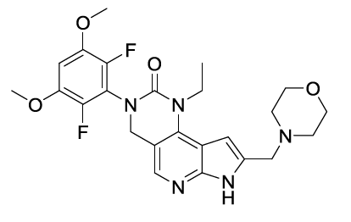
The drug product is available in 3 different strengths: 4.5 mg, 9 mg and 13.5 mg. The 4.5 mg tablets are round (5.8 mm), white to off-white tablet debossed on one side with ‘I’ and ‘4.5’ on the reverse. The 9 mg tablets are oval (10 × 5 mm), white to off-white tablet debossed on one side with ‘I’ and ‘9’ on the reverse. The 13.5 mg tablets are round (8.5 mm), white to off-white tablet debossed on one side with ‘I’ and ‘13.5’ on the reverse.
The proposed container was Alcar/polyvinyl chloride/aluminium blister, containing 14 tablets. Pack size of 14 or 28 tablets were proposed in a carton box.
Based on the long-term stability data, the requested shelf life of 36 months when stored below 25°C in blister is considered acceptable for the product.
Approval for registration of the proposed product is recommended as all outstanding quality issues have been satisfactorily resolved prior to approval.

Nonclinical
Provided the adverse effects are adequately monitored or managed during clinical use, there are no objections on nonclinical grounds to the proposed registration of pemigatinib for the proposed indications.
Conclusions from the nonclinical evaluation include:
- The primary pharmacology studies support the proposed clinical indication
- The following toxic effects observed in nonclinical studies are expected in patients:
  - perturbation to calcium or phosphorus homeostasis and tissue mineralisation,
  - bone and/or teeth toxicity,
  - ocular toxicity, and
  - reproductive toxicity.
- Pregnancy category D; is recommended. Pemigatinib should not be used in pregnancy
- Provided the adverse effects are adequately monitored or managed during clinical use, there are no objections on nonclinical grounds to the proposed registration of pemigatinib for the proposed indications
- The impurity [information redacted] may require toxicological qualification and an appropriate mutagenicity study with the impurity should be conducted as a post-marketing commitment.

Clinical

Summary of clinical studies
The clinical dossier consisted of:
- The pivotal study is Study INCB 54828-202 (also known as the FIGHT-202 trial), a Phase II open label uncontrolled study in adult participants with advanced or metastatic, or surgically unresectable cholangiocarcinoma who have disease progression after at least one previous systemic treatment (data cut-off date of 22 March 2019 in the interim clinical study report). Additional efficacy data from participants with FGFR2 rearranged cholangiocarcinoma is provided from Studies INCB 54828-101 and INCB 54828-102.
- Study INCB 54828-104 (open label, fixed sequence cytochrome P450 3A4 (CYP3A4) mediated drug-drug interaction study), Study INCB 54828-105 (open label, absorption, metabolism and excretion study), Study INCB 54828-106 (open label, fixed sequence, gastric pH modifying agents drug-drug interaction study), Study INCB 54828-107 (open label hepatic impairment study) and Study INCB 54828-108 (open label renal impairment study) are clinical pharmacology studies in healthy participants evaluated in this submission.
- Studies INCB 54828-102 (Phase I), INCB 54828-101 (Phase I/II), INCB 54828-201 (Phase II) and INCB 54828-203 (Phase II) providing data in participants with other malignancies or as part of different regimen has been considered primarily for pharmacokinetics (PK), pharmacodynamics (PD) and safety signals, and for efficacy data in patients with cholangiocarcinoma.

Pharmacology
The proposed dose of pemigatinib is 13.5 mg once daily orally (two weeks on and one week off) which was determined to be the recommended Phase II dose in the dose-finding study, Study INCB 54828-101; this was based on linear PK across the dose range 1 to 20 mg once daily and PD data confirming likely receptor saturation together with the anticipated on-target effect of elevated serum phosphate levels. No maximum tolerated dose was reached in this study. In Study INCB 54828-105 ID, 7 healthy male participants each received single dose of two 4.5 mg tablets and one 2 mg tablet of pemigatinib followed 10 minutes later by an oral dose solution of approximately 250 microcurie (μCi), or about 2 mg of carbon 14 [¹⁴C] pemigatinib. The concentrations of radioactivity in blood, plasma, urine, and faeces, and the percent of radioactive dose in urine and faeces were determined (see Table 3 below).
Table 3: Study INCB 54828-105 Mean pharmacokinetic parameters of radioactivity in blood or plasma and pemigatinib in plasma after a single oral dose of approximately 13 mg [¹⁴C] pemigatinib in healthy male volunteers in the fasted state
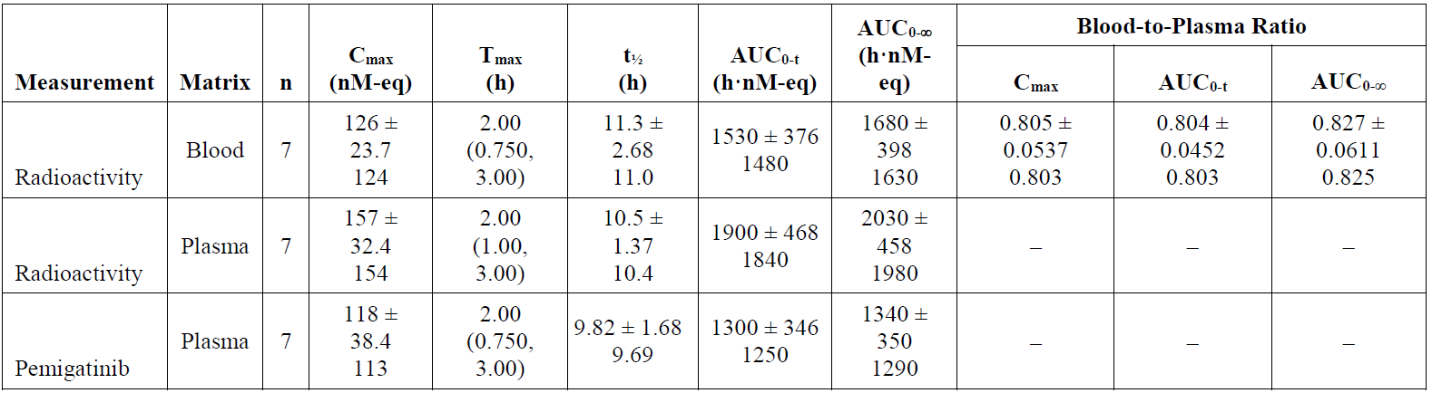
Abbreviations: AUC_{0-∞} = area under the plasma concentration-time curve from time zero to infinity; AUC_{0-t} = area under concentration time curve from time zero to last quantifiable concentration; C_{max} = maximum observed plasma concentration; n = number of subjects; T_{max} = time of the maximum observed plasma concentration,
Values are presented in the format of mean ± standard deviation and geometric mean except for T_{max}, which is reported as median (range).
Key PK parameters for the 13.5 mg once daily dose are as follows, noting a high inter-individual variation across all parameters:
- Time of the maximum observed plasma concentration (T_{max}) :1 to 2 hours
- Geometric mean maximum observed plasma concentration (C_{max}) at steady state: 236 nM (coefficient of variation (CV)% = 56.4%) for 13.5 mg once daily
- Geometric mean area under the plasma concentration-time curve from time zero to 24 hours (AUC_{0-24h}) at steady state AUC₀₋₂₄: 2620 nM*h (CV% = 54.1%) for 13.5 mg once daily
- Geometric mean accumulation ratio for AUC₀₋₂₄: 1.61
- Apparent oral dose volume of distribution: geometric mean of apparent oral dose volume of distribution in terminal elimination phase is 235 L (CV% = 60.8%)
- Percentage bound in plasma: mean percentage bound pemigatinib in plasma and serum in humans (ex vivo) is 90.6%
- Terminal half-life: the geometric mean half-life is 15.4 hours (CV% = 51.6%)
- Apparent total body clearance: the geometric mean apparent oral clearance is 10.6 L/h (CV% = 54.1%)
Pemigatinib is predominantly metabolised by CYP3A4 in vitro.¹⁰ The major drug related moiety in plasma was unchanged pemigatinib in a human [¹⁴C] mass balance study. There was low renal clearance and pemigatinib is almost exclusively eliminated by hepatic metabolic pathways.
Human absorption, distribution, metabolism, and excretion study (Study INCB 54828-105) showed that no major metabolites (≥ 10% of total compound related material) were detected in plasma.
- In urine, Phase II metabolites, M7 and M9 were the only metabolites detected at levels ≥ 1% of the administered dose (4.4% and 2.1%, respectively).
- In faeces, 44.4% of the dose was recovered as metabolite M2 (INCB056632, O-desmethyl-pemigatinib), while the intact parent pemigatinib accounted for 1.4% of the administered dose.
In Study INCB 54828-101, the food effect on pemigatinib PK was evaluated in 12 patients with advanced malignancies. although this was a small study, these PK data indicate that the PK of pemigatinib tablets are not significantly altered by administration with or without food, supporting the proposed dosing in the PI without regard to food.

Pharmacokinetics

Pharmacokinetics in special populations
Pharmacokinetics in participants with impaired hepatic function (Study INCB54828-107): Due to the small sample size in each group of the study, and inter-patient variability, the reliability in predicting exposure in an individual patient setting is limited and the effect of hepatic impairment on C_{max}, area under the plasma concentration-time curve from time zero to infinity (AUC_{0-inf}) and T_{max} remains uncertain. The clinical evaluation stated that the proposed starting dose reduction in patients with severe hepatic impairment is supported, but close monitoring would be required.
Pharmacokinetics in participants with impaired renal function (Study INCB54828-108): In patients with severe renal impairment, the longer half-life and higher exposure indicates that a starting dose reduction is required (see Table 4, Figure 2 and Figure 3 below). The clinical evaluation recommended that the starting dose in this population should be stated as 9 mg as supported by data. Those with mild, moderate renal impairment or end stage renal disease on dialysis (see Table 5, Figure 4 and Figure 5 below) do not need a dose reduction.
Table 4: Study INCB52848-108 Comparison of pemigatinib pharmacokinetic parameters following administration of 9 mg pemigatinib tablets in severe renal impairment and healthy matched participants
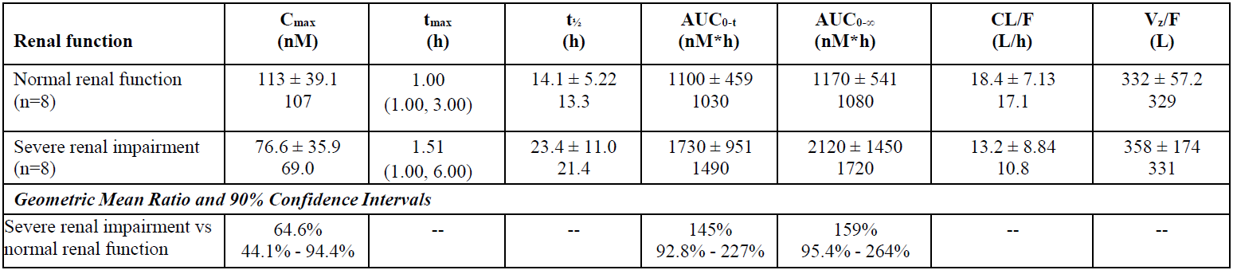
Abbreviations: AUC_{0-∞} = area under the plasma concentration-time curve from time zero to infinity; AUC_{0-t} = area under the plasma concentration-time curve from time zero to time of last quantifiable concentration; CL/F = apparent total body clearance; C_{max} = maximum observed plasma concentration; n = number of subjects; t_{½} = apparent plasma terminal elimination half-life; t_{max} = time of the maximum observed plasma concentration; V_{z}/F = apparent oral dose volume of distribution.
Values are presented in the format of mean ± standard deviation and geometric mean except that t_{max} is reported as median (range)
Figure 2: Study INCB52848-108 Plasma concentrations of pemigatinib (mean ± standard error) in severe renal impairment and healthy matched participants following administration of 9 mg of pemigatinib tablets
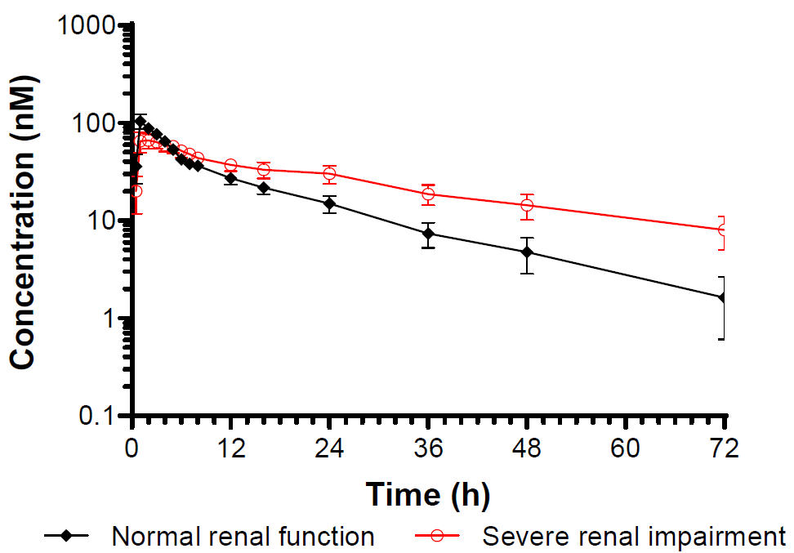
Figure 3: Study INCB52848-108 Pemigatinib maximum observed plasma or serum concentration and area under the plasma concentration-time curve values for individual participants following administration of 9 mg of pemigatinib tablets (severe renal impairment and healthy matched participants)
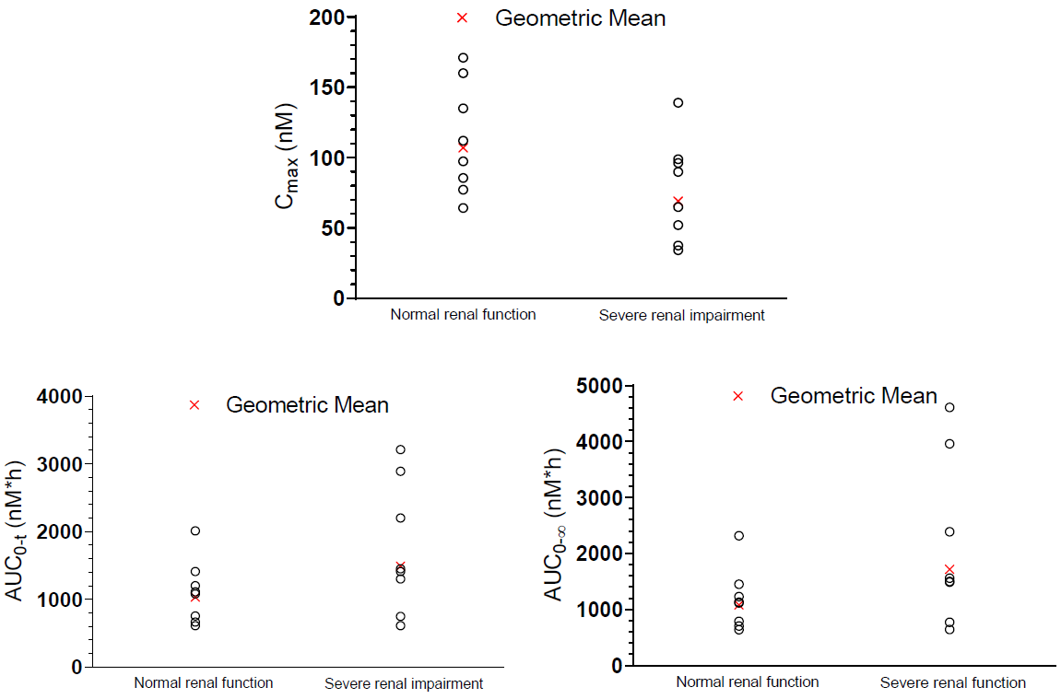
Abbreviations: AUC_{0-∞} = area under the plasma concentration-time curve from time zero to infinity; AUC_{0-t} = area under the plasma concentration-time curve from time zero to time of last quantifiable concentration; C_{max} = maximum observed plasma concentration.
Table 5: Study INCB52848-108 Comparison of pemigatinib pharmacokinetic parameters following administration of 9 mg pemigatinib tablets in end stage renal disease and healthy matched participants
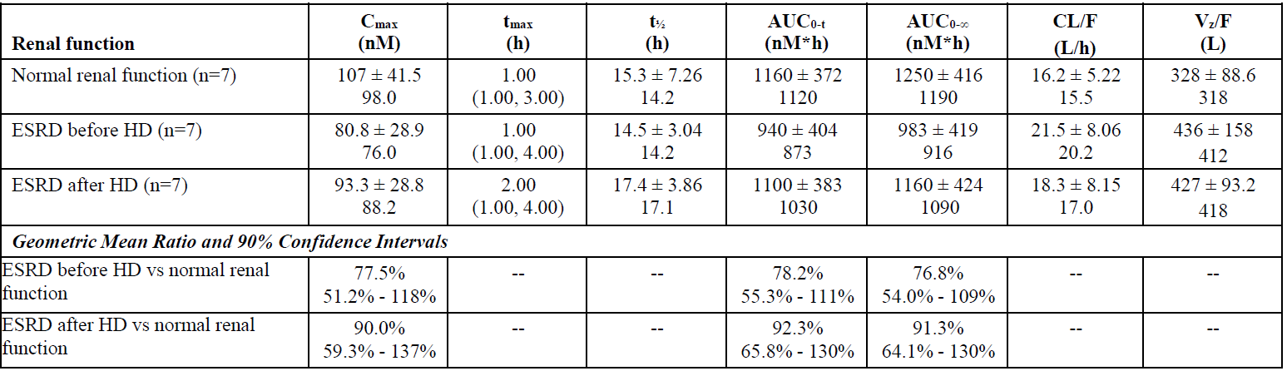
Abbreviations: AUC_{0-∞} = area under the plasma concentration-time curve from time zero to infinity; AUC_{0-t} = area under the plasma concentration-time curve from time zero to time of last quantifiable concentration; CL/F = apparent total body clearance; C_{max} = maximum observed plasma concentration; ESRD = end stage renal disease; HD = haemodialysis; n = number of subjects; t_{½} = apparent plasma terminal elimination half-life; t_{max} = time of the maximum observed plasma concentration; V_{z}/F = apparent oral dose volume of distribution.
Values are presented in the format of mean ± standard deviation and geometric mean except that t_{max} is reported as median (range)
Figure 4: Study INCB54828-108 Plasma concentrations of pemigatinib (mean ± standard error) in end stage renal disease and healthy matched participants following administration of 9 mg of pemigatinib tablets
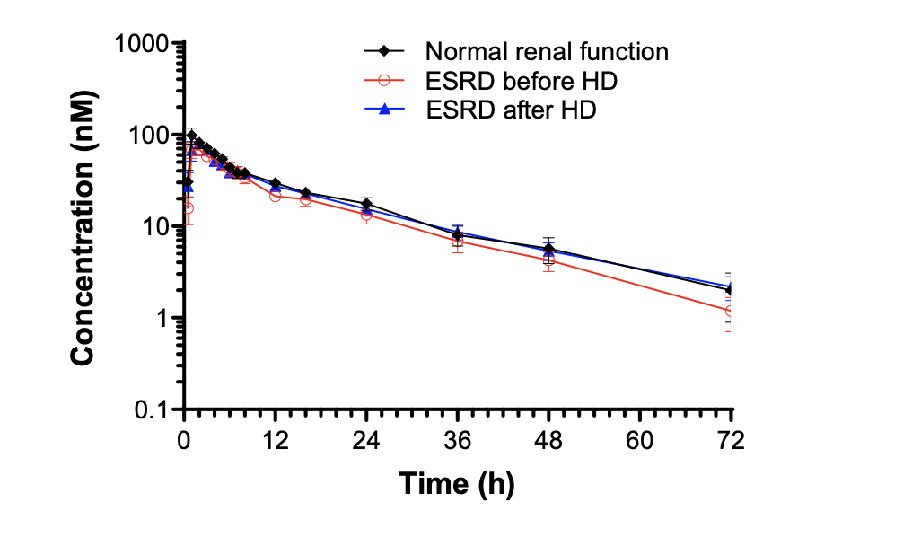
Abbreviations: ESRD = end stage renal disease; HD = haemodialysis.
Figure 5: Study INCB54828-108 Pemigatinib maximum observed plasma concentration and area under the plasma concentration-time curve values for individual participants following administration of 9 mg of pemigatinib tablets in end stage renal disease and healthy-matched participants
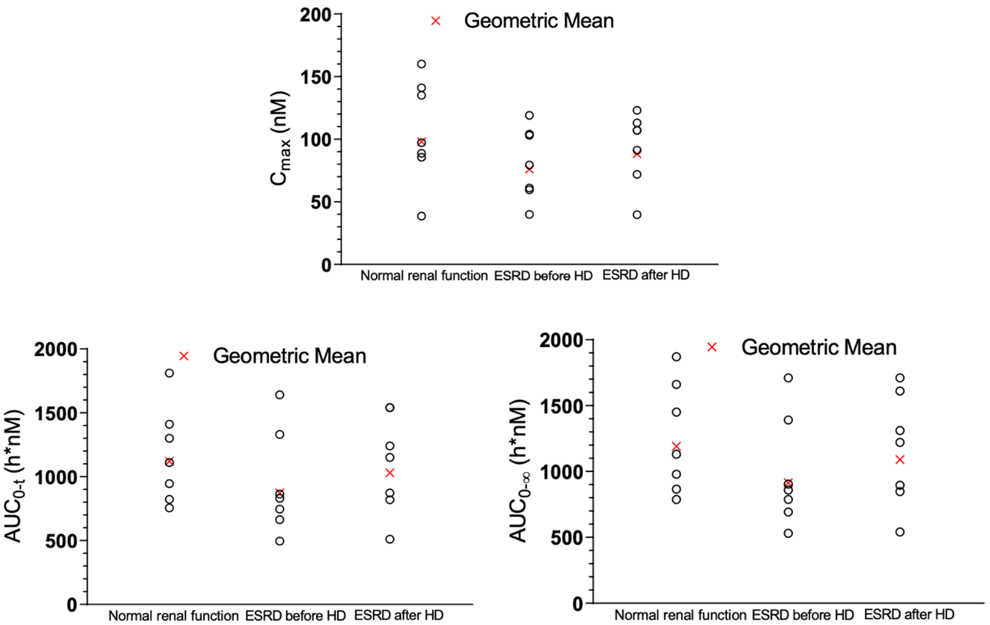
Abbreviations: AUC_{0-∞} = area under the plasma concentration-time curve from time zero to infinity; AUC_{0-t} = area under the plasma concentration-time curve from time zero to time of last quantifiable concentration; C_{max} = maximum observed plasma concentration; ESRD = end stage renal disease; HD = haemodialysis.

Effect of food on pharmacokinetics
- Study INCB 54828-101 (also known as the FIGHT-101 trial) is an ongoing Phase I/II, open label, dose escalation, safety and tolerability study of pemigatinib in participants with advanced malignancies; this study incorporated multiple objects, including dose finding (pharmacologically active dose and recommended phase II dose), efficacy, and safety in multiple tumour types, as well as investigating the effect of food and other drugs on pemigatinib PK.
- The T_{max} is delayed and C_{max} is slightly lowered in patients in the fed state, as would be expected, but is not of clinical importance (see Table 6 below). The substantial interindividual variability in PK parameters is once again notable, and some patients experienced a much higher exposure (+31%) based on the 90% CI reporting. Whether this represents an effect of food on the already established wide inter- or intra-individual variability is not clear.
- As noted above, in Study INCB 54828-101, the food effect on pemigatinib PK was evaluated in 12 patients with advanced malignancies, with PK data indicating that the PK of pemigatinib tablets is not significantly altered by administration with or without food.
Table 6: Study INCB 54828-101 Comparison of pemigatinib pharmacokinetic parameters following administration of 13.5 mg pemigatinib tablets in the fed and fasted state
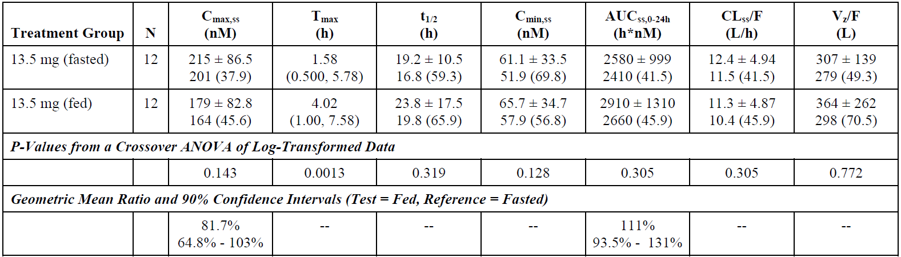
Abbreviations: AUC_{ss, 0-24h} = area under the plasma concentration-time curve from time zero to 24 hours at steady state; CL_{ss}/F = apparent total body clearance at steady state; C_{max,ss} = maximum observed plasma concentration at steady state; ; C_{min,ss} = minimum observed plasma concentration at steady state; N = number of subjects; t_{½} = apparent plasma terminal elimination half-life; T_{max} = time of the maximum observed plasma concentration; V_{z}/F = apparent oral dose volume of distribution.
Values are presented in the format of mean ± standard deviation and geometric mean (coefficient of variation %) except that T_{max} is reported as median (range).

Effect of CYP3A4 inhibition or induction on pharmacokinetics
The following studies provided information on cytochrome P450 (CYP)-mediated interactions:¹⁰
- Study INCB 54828-104 was an open-label study to assess the effect of itraconazole (potent inhibitor of CYP3A4) and rifampin (potent inducer of CYP3A4) on pemigatinib PK when administered orally in 36 healthy participants. There is evidence of a clinically significant effect on pemigatinib exposure when a strong CYP3A4 inhibitor or a strong CYP3A4 inducer is co-administered.
- No studies were conducted in patients with moderate or weak inhibitors or inducers of CYP3A4. Instead, PopPK modelling was developed to predict the impact of moderate and weak inducers of CYP3A4. However, the model performed poorly in predicting the impact of rifampin, undermining confidence in its ability to predict accurately whether weak inducers of CYP3A4 are likely to have any meaningful effect on pemigatinib exposure.
- There is a clinically significant increase in exposure noted with concomitant itraconazole (see Table 7 and Figure 6 below).
- No information has been provided regarding the impact of moderate CYP3A4 inhibitors, with the magnitude of change in exposure, a clinically relevant increase in exposure would be anticipated. There is substantial inter-individual variability in exposure noted. The clinical evaluation recommends that the use of strong and moderate CYP3A4 inhibitors should be avoided, or if used, then dose reduced (from 13.5 mg to 9 mg daily, or from 9 mg to 4.5 mg daily). The PI should also state the need to closely monitor for toxicity and consider further dose reduction if required, given the interindividual variability.
- There is a profound decrease in AUC noted with concomitant rifampicin (see Table 8 and Figure 7 below). No data are presented for moderate inducers of CYP3A4, but it is anticipated that there will be a clinically relevant reduction in exposure which may compromise efficacy. The clinical evaluation recommends that the use of moderate CYP3A4 inducers should be avoided and communicated in both the Special Warnings and Precautions section and Section 4.5 of the PI.
Table 7: Study INCB 54828-104 Comparison of pemigatinib pharmacokinetic parameters following 4.5 mg of pemigatinib tablets administration with and without concomitant itraconazole
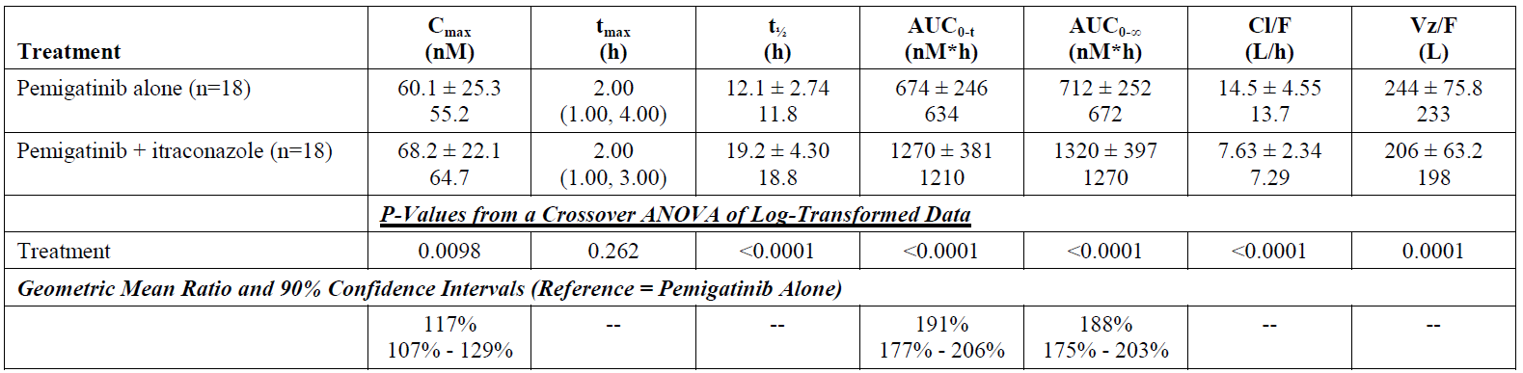
Abbreviations: AUC_{0-∞} = area under the plasma concentration-time curve from time zero to infinity; AUC_{0-t} = area under the plasma concentration-time curve from time zero to time of last quantifiable concentration; CL/F = apparent total body clearance; C_{max} = maximum observed plasma concentration; n = number of subjects; t_{½} = apparent plasma terminal elimination half-life; t_{max} = time of the maximum observed plasma concentration; Vz/F = apparent oral dose volume of distribution.
Values are presented in the format of mean ± standard deviation and geometric mean except that t_{max} is reported as median (range).
Figure 6: Study INCB 54828-104 Pemigatinib area under the plasma concentration-time curve values for individual participants following administration of 4.5 mg pemigatinib tablets with or without concomitant itraconazole
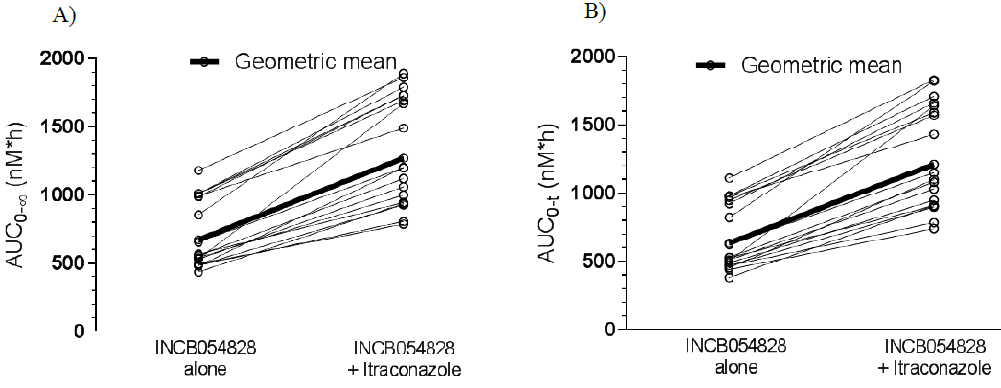
Abbreviations: AUC_{0-∞} = area under the plasma concentration-time curve from time zero to infinity; AUC_{0-t} = area under the plasma concentration-time curve from time zero to time of last quantifiable concentration.
Table 8: Study INCB 54828-104 Comparison of pemigatinib pharmacokinetic parameters following 13.5 mg of pemigatinib tablets administration with and without concomitant rifampin
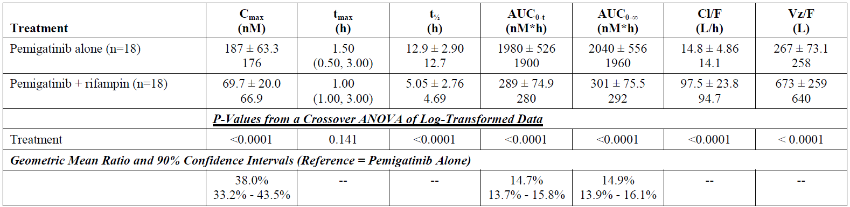
Abbreviations: AUC_{0-∞} = area under the plasma concentration-time curve from time zero to infinity; AUC_{0-t} = area under the plasma concentration-time curve from time zero to time of last quantifiable concentration; CL/F = apparent total body clearance; C_{max} = maximum observed plasma concentration; n = number of subjects; t_{½} = apparent plasma terminal elimination half-life; t_{max} = time of the maximum observed plasma concentration; V_{z}/F = apparent oral dose volume of distribution.
Values are presented in the format of mean ± standard deviation and geometric mean except that t_{max} is reported as median (range).
Figure 7: Study INCB 54828-104 Pemigatinib area under the plasma concentration-time curve values for individual participants following administration of 13.5 mg pemigatinib tablets with or without concomitant rifampin
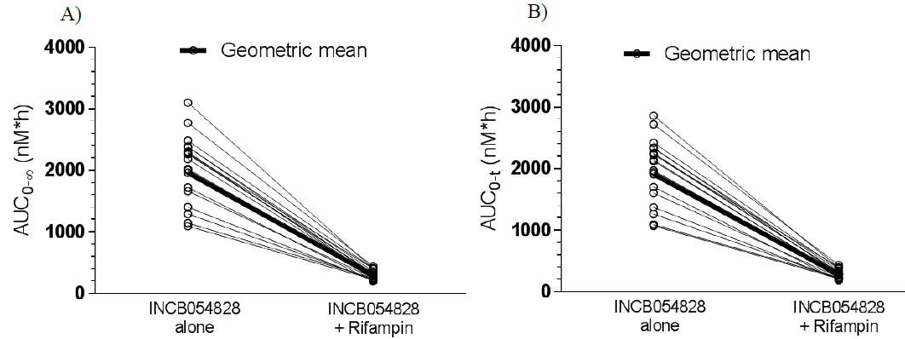
Abbreviations: AUC_{0-∞} = area under the plasma concentration-time curve from time zero to infinity; AUC_{0-t} = area under the plasma concentration-time curve from time zero to time of last quantifiable concentration.

Effect of gastric pH on pharmacokinetics
Effect of gastric pH was summarised through the following:
- Study INCB54828-106: The decrease in T_{max} and C_{max} when pemigatinib is taken with esomeprazole compared with pemigatinib alone would be consistent with the dissolution of the tablets being affected by gastric pH. The absence of a statistically significant decrease in AUC indicates there is no meaningful decrease in exposure, overall (see Table 9 and Figure 8 below).
- No clinically significant alteration in T_{max}, C_{max} or area under the plasma concentration-time curve (AUC) were evident with coadministration of ranitidine with pemigatinib.
Table 9: Study INCB 54828-106 Comparison of pemigatinib pharmacokinetic parameters following 13.5 mg of pemigatinib tablets administration with and without concomitant esomeprazole
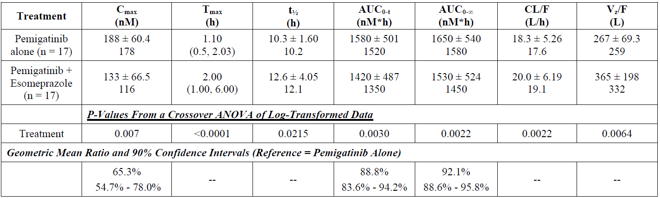
Abbreviations: AUC_{0-∞} = area under the plasma concentration-time curve from time zero to infinity; AUC_{0-t} = area under the plasma concentration-time curve from time zero to time of last quantifiable concentration; CL/F = apparent total body clearance; C_{max} = maximum observed plasma concentration; n = number of subjects; t_{½} = apparent plasma terminal elimination half-life; T_{max} = time of the maximum observed plasma concentration; V_{z}/F = apparent oral dose volume of distribution.
Values are presented in the format of mean ± standard deviation and geometric mean except that T_{max} is reported as median (range).
Figure 8: Study IMCB 54828-106 Pemigatinib area under the plasma concentration-time curve values for individual participants following administration of 13.5 mg pemigatinib tablets with or without concomitant esomeprazole
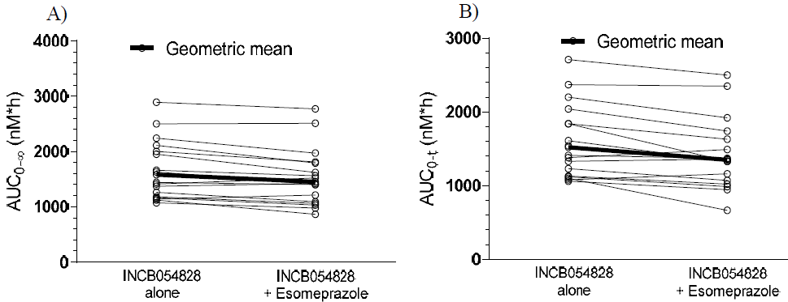
Abbreviations: AUC_{0-∞} = area under the plasma concentration-time curve from time zero to infinity; AUC_{0-t} = area under the plasma concentration-time curve from time zero to time of last quantifiable concentration.

Population pharmacokinetics
Two population pharmacokinetics (PopPK) reports were provided by the sponsor: Analysis DMB-19.120.1 (exposure response analyses) and Analysis DMB-19.25.1 (physiological based PK modelling and simulation development for evaluation of drug-drug interactions).
Following review of the two relevant PopPK reports, the clinical evaluation concluded that the actual simulations and data used to generate the reports cannot be adequately evaluated without some testing of the modelling with simulations and re-runs. The assumptions in these PopPK reports appear to lack clinical validity. Consequently, the reliability or validity of the evaluation’s comments or conclusions may be affected. The clinical evaluation also highlights that the sponsor has been asked by the European Medicines Agency to provide an updated version of the PopPK model and analysis in the European Union (EU) post-market authorisation setting, as the PopPK model was determined to be inadequate. Further pharmacometrics advice has been sought within TGA. It was noted that some anomalies in the reporting of PK findings of the submitted PopPK analysis reduces confidence in their validity.
The Delegate therefore notes that interpretation of the findings of the PopPK reports provided by the sponsor is limited due to the inadequate PopPK model; issues such as whether dosing adjustment may be needed in certain populations remain unresolved (for example, the apparent clearance in females is of uncertain validity and cannot be used to determine whether females require a lower starting dose adjustment; whether moderate CYP3A4 inhibitors may have clinical impact on pemigatinib exposure remains unclear).

Pharmacodynamics
Pharmacodynamic and PK/PD studies were not conducted in healthy participants; this is considered acceptable. Study INCB 54828-101 was conducted in participants with cancer, and phospho-FGFR2 inhibition and exposure-response relationship were evaluated in that study. The results were consistent with preclinical data generated using spiked blood samples from healthy participants. No disconnect was seen between the PK and PD for pemigatinib, indicating that there are no active drug metabolites affecting PD activity.

Conclusions on clinical pharmacology
- Overall, the PK and PD of pemigatinib has been adequately investigated and sufficiently characterised to support the proposed usage, given the substantial unmet need.
- No maximum tolerated dose was reached in the dose-finding Study INCB 54828-101, which identified pemigatinib administered orally at 13.5 mg once daily two weeks on, one week off as the recommended dose for Phase II studies.
- No clinical pharmacology studies were undertaken specifically to address differences in exposure to pemigatinib based on body weight, age, or gender. PopPK modelling identified a 19% lower clearance and typical acid dissociation constant value in females raises potential uncertainty about the need for different starting dose in females.
- The PopPK report and analysis is considered to be inadequate; interpretation of findings is therefore limited; this issue should be addressed in the post authorisation setting, with submission of an updated PK/PD modelling analysis by the sponsor for evaluation.

Dosage selection for pivotal study
Two studies were included in the dossier which aimed to identify the recommended Phase II dose level:
- Study INCB 54828-101 (the FIGHT-101 trial) a Phase I/II, open label, dose escalation, safety and tolerability study of pemigatinib in subjects with advanced malignancies
- Study INCB 54828-102 (the FIGHT-102 trial) a Phase I, open label, dose escalation, dose expansion, safety and tolerability study of pemigatinib in Japanese subjects with advanced malignancies
The safety profile of pemigatinib at doses of 1 to 20 mg once daily on an intermittent or continuous schedule was acceptable, and a maximum tolerated dose was not reached in either of the above studies. Pemigatinib 13.5 mg was selected as the recommended dose for Phase II studies for monotherapy based on safety, tolerability, PK and PD data.
The Delegate notes the following in relation to Study INCB 54828-102:
- Despite the small number of participants (25 in total, exclusively Asian-Japanese patients), the clinical evaluation highlighted that the adverse event (AE) findings suggested a higher risk of serous retinal detachment (16%) than for other populations, and that the potential for Asian patients to be at an increased risk of ocular toxicities cannot be overlooked.
- Based on the interim analyses, the PK profile of pemigatinib in Japanese participants (secondary objective of study) is similar to the profile in western populations and does not explain the potential increased risk of ocular disorders.
At the first round of evaluation, the clinical evaluation recommended inclusion of the potential risk of ocular AEs in Asian patients in the risk management plan (RMP; specific pharmacovigilance activity). As requested, the sponsor provided a breakdown of all of the events of ocular toxicity for Asian patients, and a comparison of the incidence of eye disorders between the Asian population and the full population. In Study INCB 54828-202, 39% of Asian participants reported an ocular AE, while in the full population, 53.7% reported an ocular AE. In Study INCB 54828-102, 44% of Asian participants reported an ocular AE. Following review of this data, the clinical evaluation concluded that:
- Overall, the rates of AEs, including serous retinal detachment, in the Asian population were not higher than the non-Asian population but there is no information about the duration of exposure to determine it this plays a part in the AE rates.
- Data from the larger, randomised controlled trial may be informative
- The issue regarding Asian patients and risk has largely been resolved in the response to a TGA request for information.

Efficacy

Study INCB 54828-202
The primary efficacy data considered in this submission are based on the results from the adult participants with advanced or metastatic, or surgically unresectable cholangiocarcinoma who have disease progression after at least one previous systemic treatment, in the pivotal Study INCB 54828-202 (also known as the FIGHT-202 trial), a Phase II, open label, uncontrolled study. Additional efficacy data from participants with FGFR2-rearranged cholangiocarcinoma in Studies INCB 54828-101 and INCB 54828-102 have also been considered.

Study design
Participants are assigned to one of the following cohorts based on tumour fibroblast growth factor (FGF)/fibroblast growth factor receptor (FGFR) gene status:
- Cohort A: FGFR2 rearrangements or fusions
- Cohort B: FGF/FGFR alterations other than FGFR2 rearrangements or fusions
- Cohort C (United States only): negative for FGF/FGFR alterations
Enrolment and initial cohort assignment were permitted based on genomic testing results from a local laboratory. Final cohort assignment for statistical analyses was based on next generation sequencing results from the central genomics laboratory.
The study consisted of a screening period lasting up to 28 days, a treatment period, and a 30-day safety follow-up period, after which participants were followed for disease status and overall survival (See Figure 9 below). During the treatment period, participants self-administered once daily oral doses of pemigatinib on two weeks on therapy, one week off schedule, with a starting dose of 13.5 mg.
Figure 9: Study INCB 54828-202 Study design
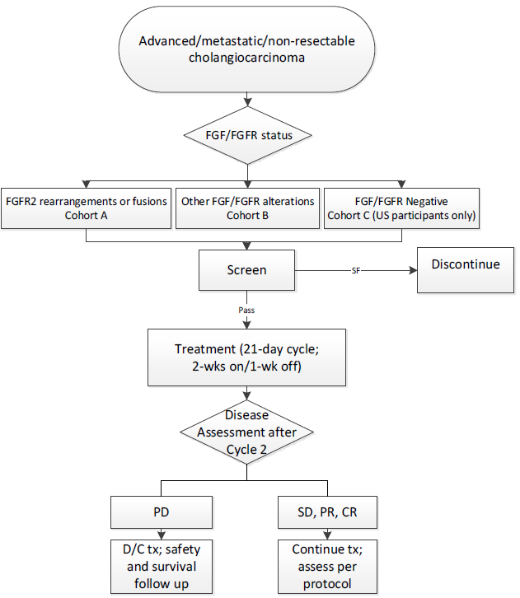
Abbreviations: CR = complete response; D/C = discontinue; FGF = fibroblast growth factor; FGFR = fibroblast growth factor receptor; PD = progressive disease; PR = partial response; SD = stable disease; SF = screen fail; tx = therapy; US = United States; wk = week(s).
The study was conducted at 67 study centres in United States, South Korea, United Kingdom, France, Italy, Thailand, Germany, Belgium, Israel, Spain, Japan, and Taiwan.
The data cut-off date for the interim clinical study report was 22 March 2019 (first patient dosed 17 January 2017, last patient completed 22 March 2019). A few protocol amendments were made; the clinical evaluation considered these to have potentially affected the conduct or results of the study; other amendments were made to reflect the emerging knowledge of the safety profile and PK of pemigatinib.

Statistical analysis plan
No formal statistical hypotheses were tested. The data were analysed in a descriptive manner.
The primary endpoint of the study is overall response rate in participants with tumour FGFR2 rearrangements or fusions (Cohort A). Secondary analyses of overall response rate in Cohorts A and B combined, Cohort B and Cohort C were performed, in addition to other secondary efficacy endpoints (duration of response, progression-free survival, disease control rate and overall survival).
Approximately 100 participants with tumours with FGFR2 rearrangements or fusions were planned for analysis of the primary endpoint. With the assumed rate of 33% for the intervention, a sample size of approximately 100 participants provides > 95% probability of having a 95% CI with lower limit > 15%, assuming 10% of participants are lost to follow up. It was predetermined that the study would be considered positive if the lower limit of the 95% CI for overall response rate exceeded 15%.

Key inclusion and exclusion criteria

Patients
Cohort A (proposed target population in this submission) are participants with tumours with FGFR rearrangements or fusions based on central genomics laboratory results (n = 107).
Key inclusion criteria:
- 18 years of age and older
- Histologically or cytologically confirmed advanced or metastatic, or surgically unresectable cholangiocarcinoma
- Documentation of FGF/FGFR gene alteration status
- Documented disease progression after at least one line of prior systemic therapy
- Eastern Cooperative Oncology Group-Performance Status (ECOG-PS) 0 to 2
Key exclusion criteria:
- Prior receipt of selective FGFR inhibitor
- Untreated brain or central nervous system metastases, or brain or central nervous system metastases that have progressed.
- Current evidence of clinically significant corneal or retinal disorder.

Intervention
Pemigatinib daily orally starting dose of 13.5 mg on 21-day cycle (two weeks on, one week off).

Comparator
No comparator as it is a single arm study.

Endpoints
Primary endpoint:
- Overall response rate in Cohort A, per Response Evaluation Criteria in Solid Tumours (RECIST) version 1.1, independently assessed
Secondary endpoints:
- Duration of response
- Progression-free survival
- Overall response rate in Cohort B; overall response rate in Cohorts A and B; overall response rate in Cohort C
- Disease control rate
- Overall survival
Additional efficacy endpoints:
- Largest % reduction in sum of diameters of target lesions
- Time to response
- Eastern Cooperative Oncology Group-Performance Status
- Quality of life

Study treatment
Participants self-administered pemigatinib (once daily, orally) on a 21-day cycle (two weeks on therapy, one week off schedule) with a starting dose of 13.5 mg. Pemigatinib was taken after a 2-hour fasting, and participants fasted for an additional hour after taking the study drug.

Efficacy outcomes
The primary endpoint was the overall response rate in participants with tumour FGFR2 rearrangements or fusions (Cohort A), as independently assessed.
The key secondary endpoint was duration of response (time from first overall response contributing to objective tumour response to the earlier of progressive disease or death).

Participant flow
At data-cut off for initial clinical study report, 107 patients were reported to be enrolled in cohort A (108 patients reported for cut-off date for Addendum 2, however, no summary baseline data was provided for evaluation by the clinical evaluation for this additional patient):
- There were 35 participants in Cohort A remained in study (32.4% of 108 patients).
- There were 10 participants continued to receive pemigatinib 13.5 mg daily (9.3% of patients).
- Most common reason for discontinuation of pemigatinib was progressive disease (67.6% of 108 patients).
- Most common reason for study withdrawal was death (55.6% of 108 patients).
- A total of 18% of 108 patients discontinued treatment due to AEs, patient withdrawal or physician decision.

Baseline characteristics
Cohort A:
- Male = 39.3%
- Median age = 56.0 years
- Race: White = 73.8%; Asian = 10.3%
- Baseline ECOG-PS 0 = 42.1%, ECOG-PS 1 = 53.5%, ECOG-PS 2 = 4.7%
- Normal baseline renal function = 39.3%
- Normal baseline hepatic function = 44.9%
- Intrahepatic cholangiocarcinoma = 98.1%, extrahepatic cholangiocarcinoma = 0.9%
- Prior therapies for advanced disease: 60.7% had one prior therapy, 27.1% had 2 prior therapies, 12.1% had 3 or more prior therapies.
All cohorts (n = 146):
- Male = 42.5%
- Median age = 59.0 years
- Race: White = 71.2%; Asian = 15.1%
- Baseline ECOG-PS 0 = 40.4%, ECOG-PS 1 = 52.1%, ECOG-PS 2 = 7.5%
- Normal baseline renal function = 37.7%
- Normal baseline hepatic function = 51.4%
- intrahepatic cholangiocarcinoma = 89.0%, extrahepatic cholangiocarcinoma = 8.2%
- Prior therapies for advanced disease: 61.0% had one prior therapy, 26.0% had 2 prior therapies, 13.0% had 3 or more prior therapies.

Results
As of 7 April 2020, the overall response rate for Cohort A was 37% (95% CI: 27.94, 46.86) based on Independent Review Committee (IRC) assessment. Four participants (3.7%) had complete response and 36 (33.3%) had partial response. There were no IRC assessed confirmed tumour responses in Cohort B or C.
Table 10: Study INCB 54828-202 Summary of best overall response and objective response rate in participants with fibroblast growth factor receptor 2 rearranged cholangiocarcinoma
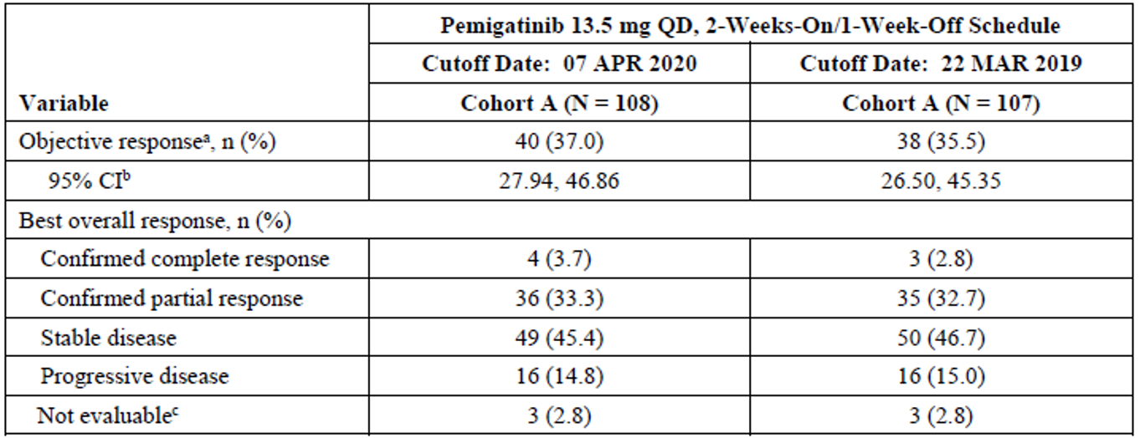
Abbreviations: APR = April; CI = confidence interval; MAR = March; N = total number of subjects; n = number of subjects in subcategory; QD = once daily.
Cohort assignment is based on tumour fibroblast growth factor/fibroblast growth factor receptors status from the central genomics laboratory. Data are from Independent Review Committee per Response Evaluation Criteria in Solid Tumours (RECIST) version 1.1.
a Participants who have best overall response of complete response or partial response according to RECIST version 1.1.
b The CI was calculated based on the exact method for binomial distribution.
c Post-baseline tumour assessment was not performed due to study discontinuation (2 participants) or was performed prior to the minimum interval of 39 days for an assessment of stable disease (one participant).
Figure 10: Study INCB 54828-202 Best percent change in sum of target lesion diameters from baseline in participants with fibroblast growth factor receptor 2 rearranged cholangiocarcinoma
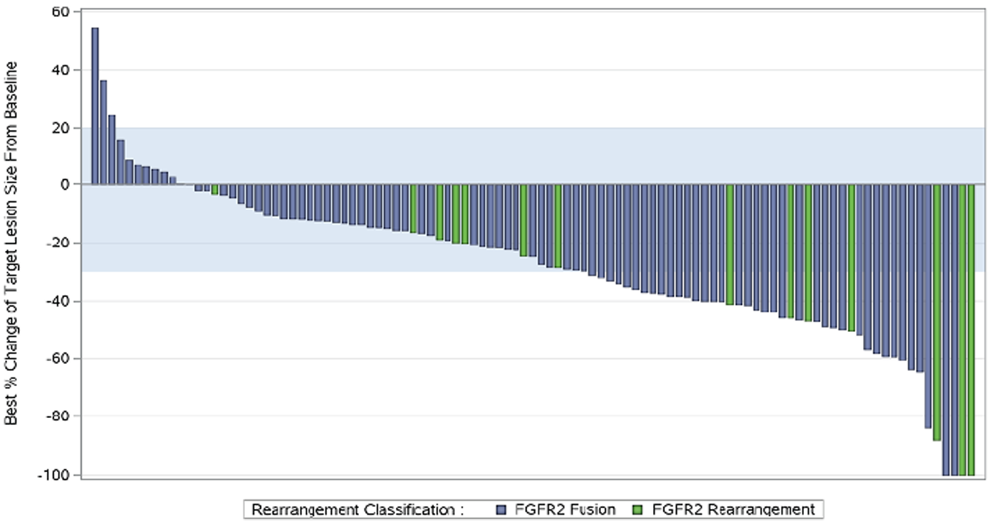
Abbreviation: FGFR = fibroblast growth factor receptor.

Secondary efficacy outcomes:
As of 7 April 2020, the median duration of response was 8.08 months (95% CI: 5.65, 13.14) in the 40 participants with FGFR2 rearranged cholangiocarcinoma who had a confirmed tumour response. Observed duration of response was at least 6 months in 23 responders (57.7%), at least 9 months in 15 responders (37.5%) and at least 12 months in 10 responders (25.0%).
In Cohort A, the median progression-free survival based on IRC assessment was 7 months (95% CI; 6, 10.5). Kaplan-Meier estimates are shown in Table 11 and Figure 11 below. In the absence of the comparator arm, interpretation of time dependent analyses such as progression-free survival is limited.
Table 11: Study INCB 54828-202 Summary of progression-free survival based on Independent Review Committee assessment according to Response Evaluation Criteria in Solid Tumours version 1.1 (Cohort A, efficacy evaluable population)
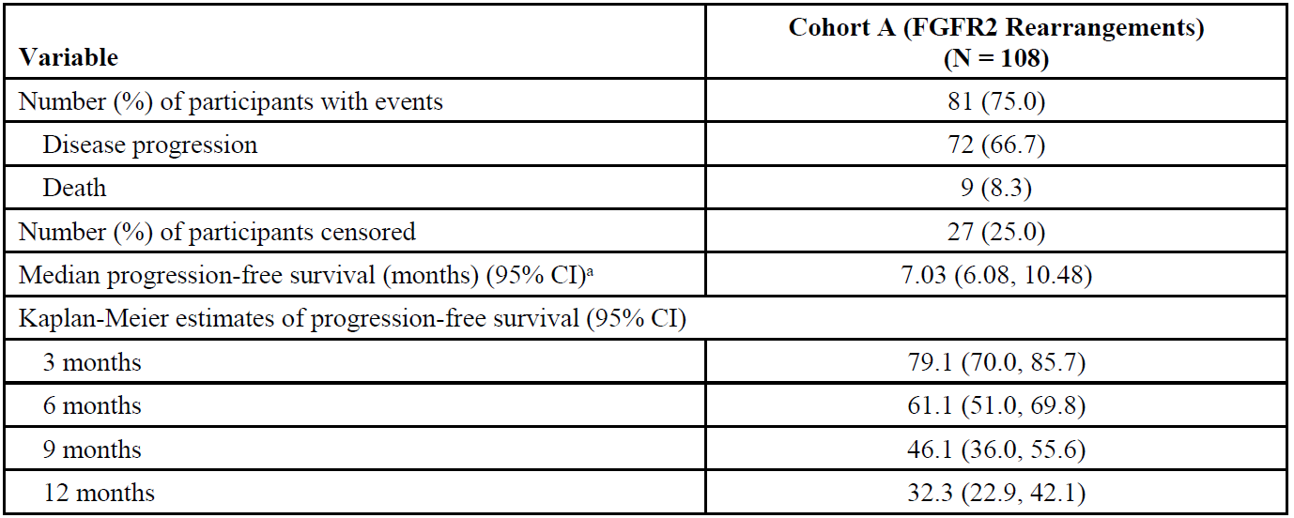
Abbreviations: CI = confidence interval; FGFR = fibroblast growth factor receptor; N = total number of subjects.
a The 95% CI was calculated using the Brookmeyer and Crowley's method (1982).
Figure 11: Study INCB 54828-202 Kaplan-Meier estimates of progression-free survival as of 7 April 2020 by Independent Review Committee assessment per Response Evaluation Criteria in Solid Tumours version 1.1 (Cohort A, efficacy evaluable population)
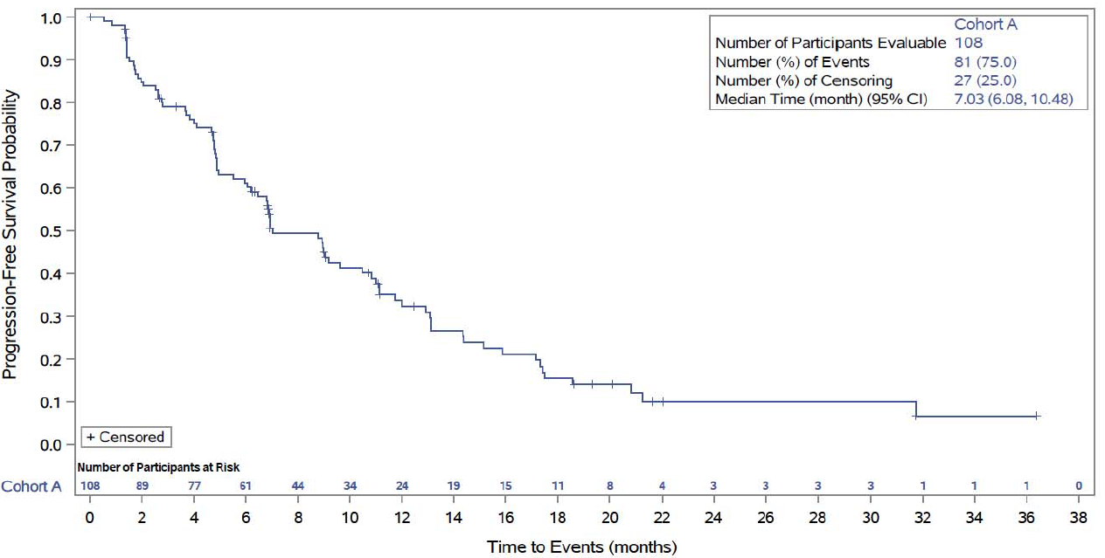
Abbreviation: CI = confidence interval.
In Cohort A, the median overall survival was 17.5 months (95% CI: 14.4, 23). Kaplan-Meier estimates are shown in Figure 12 below. In the absence of the comparator arm, interpretation of time dependent analyses such as overall survival is limited. It is notable however, that the longer overall survival in Cohort A compared to those in Cohort B/C are compelling and likely to be mostly due to the treatment effect of pemigatinib. A randomised Phase III study of pemigatinib versus the standard of care chemotherapy in patients with cholangiocarcinoma not previously treated in the metastatic setting is underway and will inform whether there is a progression-free survival or overall survival benefit in this population.
Cohort B: No participants achieved partial response or complete response.
Cohort C: No participants achieved partial response or complete response.
Figure 12: Study INCB 54828-202 Kaplan-Meier estimates of overall survival as of 7 April 2020 by Independent Review Committee assessment per Response Evaluation Criteria in Solid Tumours version 1.1 (Cohorts A, B and C, efficacy evaluable population)
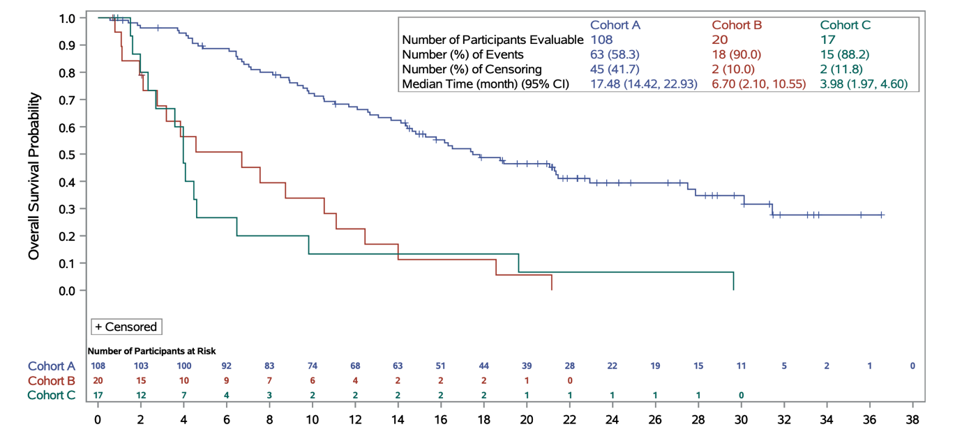
Abbreviation: CI = confidence interval.

Subgroup analyses:
Multiple exploratory subgroup analyses were performed for overall response rate, and while the 95% CI overlapped across all the subgroups, there was a tendency for lower response rates to be reported with worsening baseline renal or hepatic function, poorer ECOG-PS, increasing number of prior lines of therapy, as well as region of the world, that is North America, Western Europe versus rest of the world (See Figure 13 below).
Figure 13: Study INCB 54828-202 Objective response rates based on Independent Review Committee Assessment according to Response Evaluation Criteria in Solid Tumours version 1.1 by subgroup (Cohort A, efficacy evaluable population)
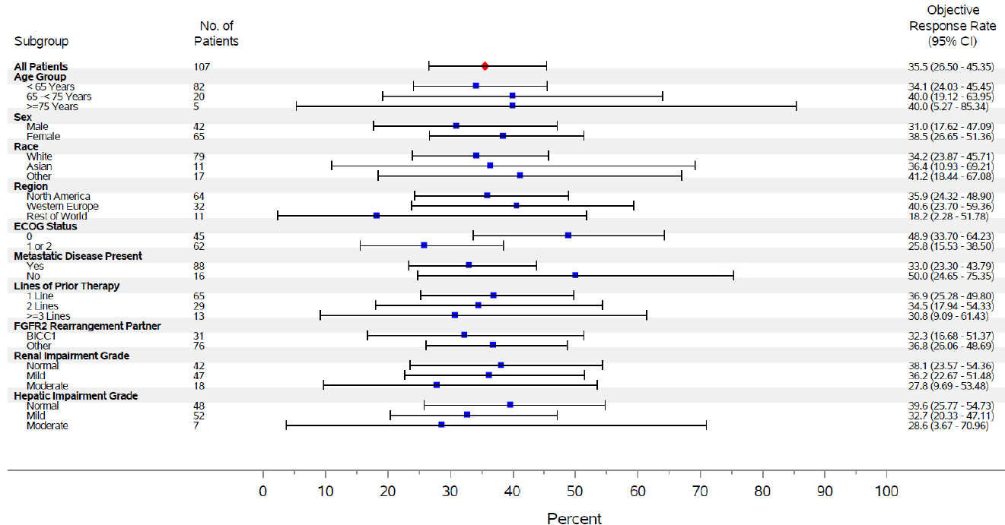
Abbreviation: CI = confidence interval.
Cohort assignment is based on tumour fibroblast growth factor/fibroblast growth factor receptor status from the central genomics laboratory: Cohort A = fibroblast growth factor receptor 2 rearrangements or fusions.
Other races include Black or African American, Hispanic, Latino, or Spanish, not reported, or missing. Rest of World includes Israel, Japan, South Korea, Taiwan, and Thailand.
In the duration of response subgroup analysis of responders with hepatic or renal impairment, many had a durable confirmed response (See Figure 14 below).
Figure 14: Study INCB 54828-202 Forest plot of duration of response by subgroups of renal and hepatic impairment grade on 22 March 2019 per Independent Review Committee (Cohort A, efficacy evaluable population)
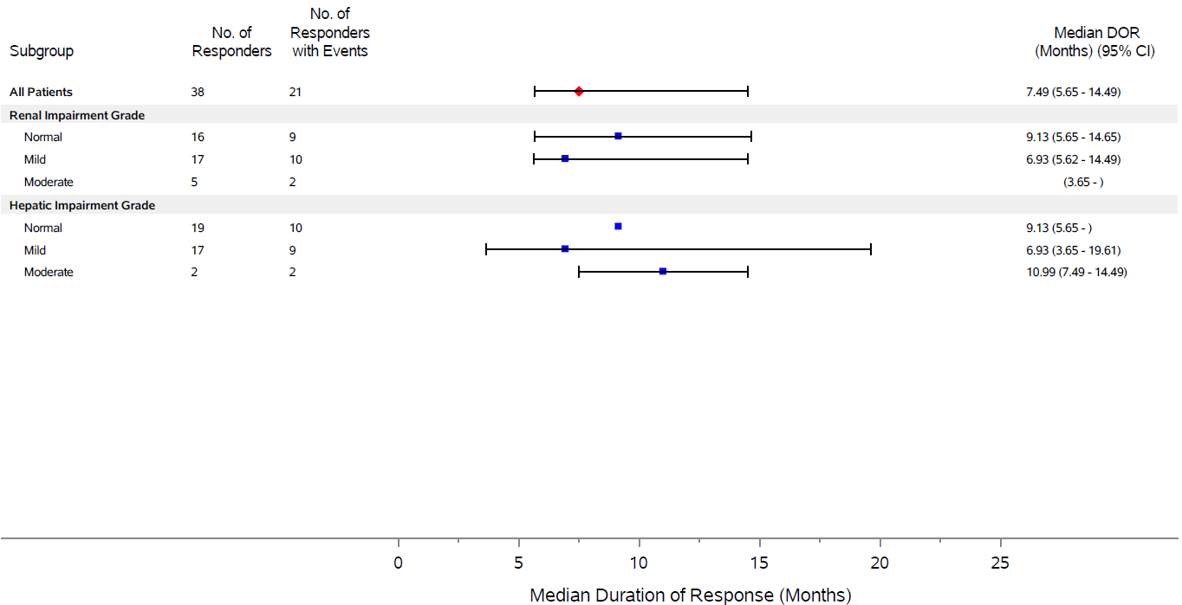
Abbreviations: CI = confidence interval; DOR = duration of response.
Data are from independent centralised radiological review committee per Response Evaluation Criteria in Solid Tumours (RECIST) version 1.1
Cohort determination is based on fibroblast growth factor/fibroblast growth factor receptor status from central genomic laboratory. Cohort A = fibroblast growth factor receptor 2 translocation.
The 95% confidence interval is calculated using the Brookmeyer and Crowley’s method (1982).¹¹

Exploratory endpoints:
Eastern Cooperative Oncology Group Performance Status: Interpretation is limited. It is not possible to determine whether any changes in ECOG-PS for the study population are due to some patients improving on treatment, and others deteriorating due to AEs, toxicity or progressive disease.
Quality of life: Interpretation is limited. In the absence of a comparator, it is not possible to determine whether this treatment has a greater negative impact on quality of life compared to other options.

Other efficacy studies
The findings of Studies INCB 54828-101 and INCB 54828-102 are supportive of a varying degree of anti-tumour activity in the proposed population.

Safety

Exposure
The database for the pooled safety analyses includes data from participants in Studies INCB 54828-101, INCB 54828-102, INCB 54828-201, INCB 54828-202, and INCB 54828-203 who received pemigatinib as monotherapy and are included in the modified safety population. The modified safety population is composed of those who completed at least one cycle of treatment, unless the participant experienced a toxicity considered at least possibly related to pemigatinib prior to the completion of Cycle 1.
The two pooled populations described in the dossier include the cholangiocarcinoma population (n = 161; participants in the modified safety population with cholangiocarcinoma regardless of FGF/FGFR status, who were treated with pemigatinib monotherapy) and all cancer population (n = 466; participants in the modified safety population with advanced malignancies who were treated with pemigatinib monotherapy). See Table 12 and Table 13 below for further details.
Table 12: Treatment groups for pooled analyses of safety
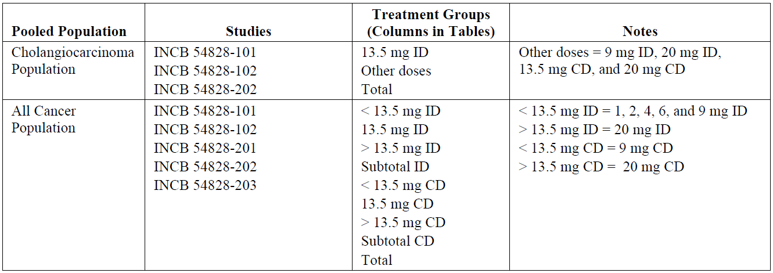
Abbreviations: ID = intermittent dose (once daily on a two weeks on, one week off schedule); CD = continuous dose (once daily).
Table 13: Summary of the number of participants with advanced malignancies (cholangiocarcinoma) who received at least one dose of pemigatinib as monotherapy by dose regimen
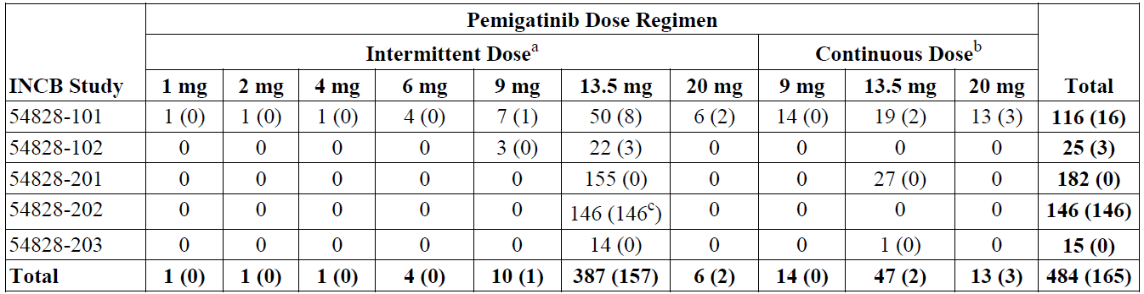
Presented as number of participants with advanced malignancies (number of participants with cholangiocarcinoma).
Treatment group determined according to the actual dose the participant received on Day 1.
a Pemigatinib was administered once daily on a two weeks on, one week off schedule.
b Pemigatinib was administered once daily.
c Includes 2 participants with gallbladder tumours and one participant with carcinoma of ampulla of vater.
The evaluation focussed primary on the safety data from the pivotal study Addendum clinical study report 2 (data from March 22 2019 cut-off of initial clinical study report) were also considered.

Study INCB 54828-202
As of 7 April 2020 cut-off date, 10 of 108 (0.9%) patients remained on treatment in Cohort A and 35 (32%) remained in the study; the median duration of exposure was 220 days (range: 7 to 1112 days).
Among the 108 patients in Cohort A, 60.1% were exposed for 6 months or longer, and 30.6% were exposed for longer than 12 months (see Table 14 below).
Table 14: Study INCB 54828-202 Summary of pemigatinib exposure as of 7 April 2020 (Cohort A, safety population)
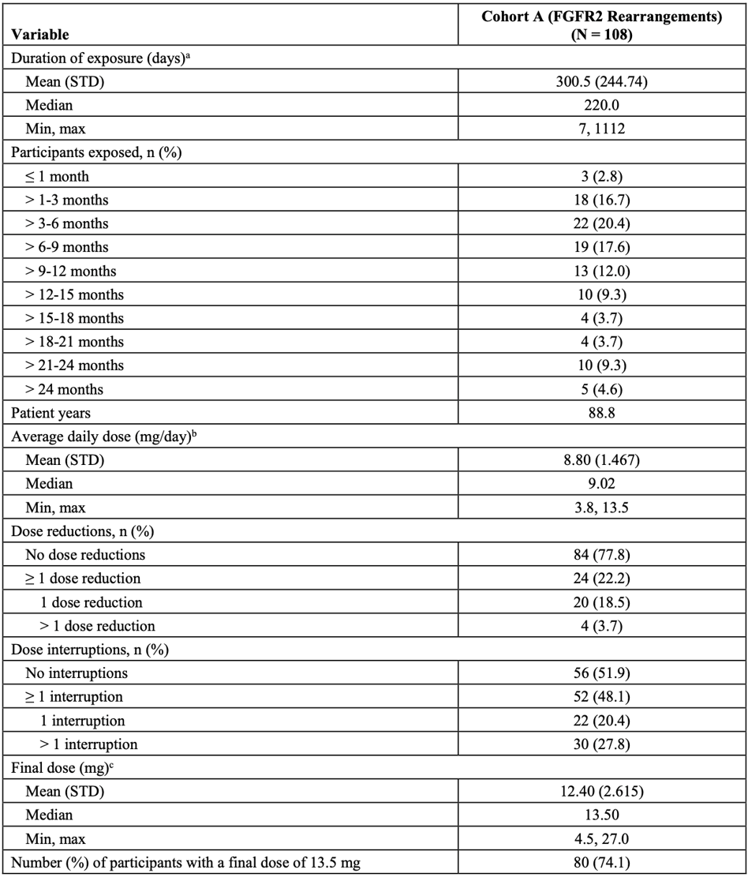
Abbreviations: FGFR = fibroblast growth factor receptor; N = total number of subjects; n = number of subjects in subcategory; STD = standard deviation.
a Duration of treatment (days) = date of the last dose - date of the first dose + 1.
b Average daily dose (mg/day) = total actual dose taken (mg) / duration of treatment including scheduled dose holds for intermittent schedule (days).
c Final dose was defined as last non-missing dose in the study or last non-missing dose prior to data cut-off.

Adverse events
All adverse events are given in Table 15 below.
- All 147 participants had at least one treatment-emergent adverse event (TEAE). 91.8% had at least one TEAE considered related to study drug.
- Grade 3 or higher TEAEs occurred in 64% of participants overall, most frequently gastrointestinal disorders (24.5%) and metabolism or nutrition disorders (23.8%); the most frequently reported Grade 3 or higher TEAE in Cohort A were hypophosphatemia (14.8%), stomatitis (8.3%), palmar-plantar erythrodysesthesia (6.5%), arthralgia (6.5%), abdominal pain (5.6%) and hyponatraemia (5.4%)
- Serious TEAEs occurred in 46.3% of participants
- 4.1% of participants had serious TEAEs with a fatal outcome
- The most frequent action taken with pemigatinib due to a TEAE was study drug interruption (42.2%)
- 9% of participants had TEAEs leading to discontinuation of pemigatinib
The most frequent AEs by Preferred Term in the pivotal study were hyperphosphatemia (59%), alopecia (50%), diarrhoea (47%), fatigue (44%), nausea (42%), dysgeusia (41%), stomatitis (37%), constipation (37%) decreased appetite and dry mouth (34% each).

Treatment-related adverse events (adverse drug reactions)
In the overall population of Study INCB 54828-202, 91.8% of participants had treatment-related AEs, and 94.4% experienced a treatment-related AE in Cohort A.
In Cohort A, the most frequently reported treatment-related TEAEs in 20% or more participants by Preferred Term were: alopecia (57%), hyperphosphatemia (51%), dysgeusia (44%), diarrhoea (41%), stomatitis (38%), fatigue (35%), dry mouth (35%), dry eye (31%), nausea (30%), decreased appetite (23%), dry skin (22%), and palmar-plantar erythrodysaesthesia (20%).
Treatment-related TEAEs of Grade 3 or higher were reported in 32.7% of participants overall in Study INCB 54828-202, and 37% in Cohort A; the most common in Cohort A were: hypophosphatemia (10.2%), stomatitis (7.4%), palmar-plantar erythrodysesthesia (5.6)%, arthralgia (4.6%) and diarrhoea (3.7%). QT; prolongation was noted in 3 patients and seizure in one patient in Study INCB 54828-202.
No deaths in Study INCB 54828-202 or the cholangiocarcinoma population appear attributable to pemigatinib on review of narratives by the clinical evaluation. In the all cancer population, only one fatal event was considered related to pemigatinib by the investigator (cerebrovascular accident). The clinical evaluation notes that whether thromboembolic events in this participant were caused by pemigatinib cannot be determined or ruled out. The presence of metastatic cancer is a significant risk factor for venous thromboembolism and a patent foramen ovale would increase the risk of a cerebrovascular accident.
Table 15: Study INCB 54828-202 Summary of treatment emergent adverse events occurring in at least 10% of participants overall by Medical Dictionary for Regulatory Activities Preferred Term as of 7 April 2020 (safety population)
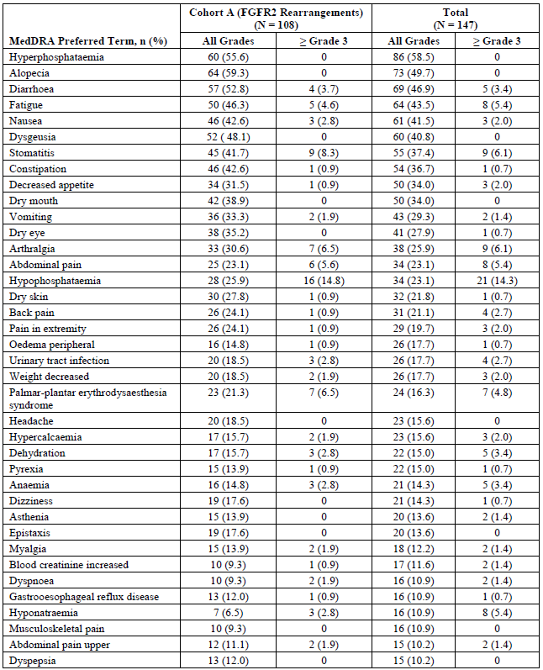
Abbreviations: FGFR = fibroblast growth factor receptor; MedDRA = Medical Dictionary for Regulatory Activities; N = total number of subjects; n = number of subjects in subcategory.

Serious adverse events
- 46.3% of the overall population had serious TEAEs
- The most frequently reported were abdominal pain (4.8%), pyrexia (4.8%), cholangitis (4.1%), and pleural effusion (3.4%)
- 4.1% of participants experienced a serious adverse event that was considered related to the study drug by the investigator: anaemia, acute kidney injury, hyponatraemia, abdominal pain, dysphagia, decreased appetite and thrombosis (in one participant each). The Phase III confirmatory study that is currently underway should be informative regarding the causality of these serious adverse events to pemigatinib.
Table 16: Study INCB 54828-202 Summary of serious adverse events occurring in at least 1% participants (Cohort A and overall safety population)
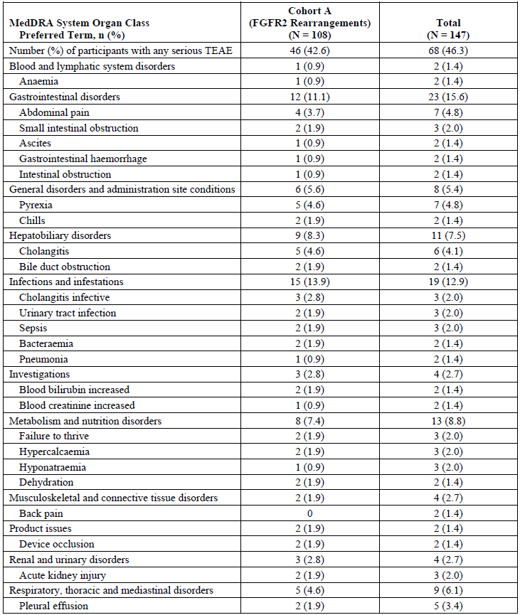
Abbreviations: FGFR = fibroblast growth factor receptor; MedDRA = Medical Dictionary for Regulatory Activities; N = total number of subjects; n = number of subjects in subcategory; TEAE = treatment-emergent adverse event.

Discontinuations due to adverse events
- A total of 10.2% of the overall population had TEAEs leading to discontinuation (intestinal obstruction 1.4%, acute kidney injury 1.4%). Acute kidney injury and hyperbilirubinemia in a single participant each were considered by the investigator to be related to pemigatinib.
- In the broader cholangiocarcinoma population and all cancer population, the clinical evaluation highlighted that patients discontinued pemigatinib due to TEAEs of keratitis, ulcerative keratitis, visual acuity reduced, chorioretinopathy, and trichiasis. Ocular toxicities are noted to be a considerable source of morbidity.
Table 17: Study INCB 54828-202 Summary of treatment emergent adverse events leading to pemigatinib discontinuation by Medical Dictionary for Regulatory Activities System Organ Class and Preferred Term as of 7 April 2020 (safety population)
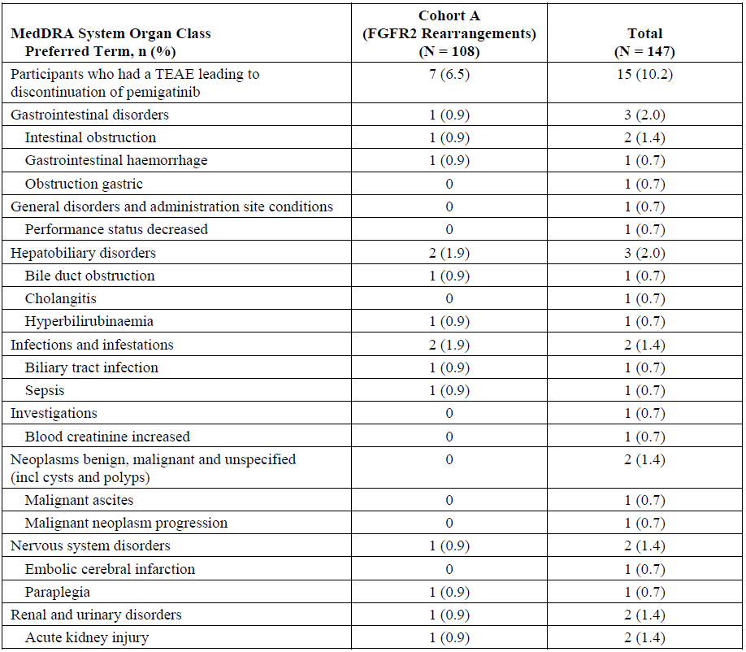
Abbreviations: FGFR = fibroblast growth factor receptor; MedDRA = Medical Dictionary for Regulatory Activities; N = total number of subjects; n = number of subjects in subcategory; TEAE = treatment-emergent adverse event.

Study drug interruption and dose reduction due to adverse events
- There were 48 of 108 (44.4%) patients in Cohort A and 62 (42.2%) overall in Study INCB 54828-202 had a TEAE leading to study drug interruption.
- There were 17 of 107 (15.9%) patients in Cohort A and 20 (13.7%) overall in Study INCB 54828-202 required a dose reduction. The most frequently reported events were stomatitis (3.4%), arthralgia (3.4%), palmar-plantar erythrodysaesthesia syndrome (3.4%), asthenia (1.4%) and onychomadesis (1.4%).

Adverse events of special interest
Clinically notable TEAEs (sponsor-defined) include nail toxicity, hyperphosphatemia, hypophosphatemia and serous retinal detachment.

Hyperphosphatemia
Laboratory abnormalities and clinical events reported as TEAEs were considered in combination; in the interim clinical study report, serum phosphate values were above the upper limit of normal in 89% and 88% of participants at Cycle 1 Day 8 and Cycle 1 Day 15 respectively.
As of cut-off date 7 April 2020, in the overall population, hyperphosphatemia was reported in 60.5% of participants (none were Grade 3 or higher in severity, serious, or led to discontinuation of pemigatinib). This led to dose interruption in 1.4% and dose reduction in 0.7%.
The clinical evaluation notes the following:
- Symptoms of hyperphosphatemia are non-specific and may be difficult to make adjustments to diets and introduce agents based on clinical events alone.
- As the protocol did not require sampling other than during cycle 1, this is likely to have resulted in substantial under-detection or under-reporting of events of increase serum phosphate during the two weeks on treatment of each cycle.
- The changes in phosphate levels have not been adequately characterised which impacts on PopPK modelling, as well as understanding the range of values experienced by patients during on and off weeks.
- Measuring serum phosphate levels after one week off pemigatinib from Cycle 2 onwards does not demonstrate changes in phosphate levels during on-drug active dosing treatment, and is biased towards obtaining lower phosphate levels due to a number of factors.
- Without phosphate level measurements taken while on active treatment, the proportion experiencing hyperphosphatemia in subsequent cycles remains unknown.
In particular, the clinical evaluation highlighted the following:
- The protocol presented clear management instructions and the PI includes sufficient information to advise treating oncologists less familiar with this unusual side-effect which is known to occur as a class effect of FGFR2 inhibitors. Consideration could be given to a patient information card advising health care providers of these events or risks and their management given many patients will present to other clinicians or specialties after hours, especially in regional or rural locations who would seldom encounter a patient with this rare cancer on active treatment.
In the all cancer population, there was a similar frequency of hyperphosphatemia noted, but greater severity. 5 participants had serious and/or Grade 3 or higher TEAEs of hyperphosphatemia, with potential clinical sequelae including muscle spasms (Grade 1) and corneal opacity (Grade 1) considered related to pemigatinib.
A signal of soft tissue mineralisation events in patients taking pemigatinib was identified following a cumulative review of safety data. Following review of all available data for soft tissue mineralisation AEs in association with FGFR inhibitors, it was determined that soft tissue mineralisation is a confirmed signal for pemigatinib and appropriate language was added to the proposed PI. The clinical evaluation has stated that this should be included as an important identified risk in the RMP, especially given the uncertainty about the characterisation of serum phosphate level changes while on active pemigatinib in the pivotal study.
The incidence of hypophosphatemia doubled in Study INCB 54828-202 and was also more severe in the Study INCB 54828-202 participants than in the all cancer population. This might suggest the hyperphosphatemia events being ‘overtreated’, triggering a risk of hypophosphatemia.
Currently the PI states the proportion of events of hypophosphataemia that were Grade 3 or higher and that ‘none of the events were serious’ This may be misconstrued by clinicians as discounting the potential seriousness of hypophosphataemia, rather than referring to the specific clinical trial reporting term of some AEs as ‘serious adverse events’ as a separate and distinct term. It is recommended this phrase be deleted to avoid clinical error.

Hypophosphatemia
Hypophosphatemia was reported in 27% of patients in Cohort A, with 15% of these Grade 3 or higher severity.
Hypophosphatemia led to dose interruption in 1.4% of participants. None led to discontinuation or dose reduction.
Worsening of serum phosphate levels in the low direction occurred in 78% of participants in Cohort A, Grade 3 worse post-baseline values in 44% and Grade 4 in 1.9%.
The clinical evaluation highlighted the following:
- Increased phosphate occurred in 89% of patients, and in the vast majority of patients prior to the development of hypophosphatemia.
- Even though these measurements occurred at the end of the one week off, and therefore may not represent the peak phosphate level during the two weeks on part of the cycle, the apparent reduction in the events of hyperphosphatemia has led to a dramatic increase in rebound hypophosphatemia which is a risk in itself and requires close monitoring. Approximately twice as many patients experienced any grade or severe hypophosphatemia in Study INCB 54828-202 compared with the all cancer population.
- Educational materials for clinicians should be provided as this is an unusual AE and not within the experience of most clinicians. Furthermore, this class of drugs is currently only approved for very rare cancers.

Nail toxicity
Nail toxicity was reported in 56% of patients in Cohort A and 44.9% of all Study INCB 54828-202 participants; most were Grade 1 or 2 in severity; 2.0% of these Grade 3 or higher severity.
None of these events led to discontinuation of pemigatinib, but dose interruption was required in 4.1% of patients and dose reduction in 3.4% of patients
Despite the prominence (and severity in some patients) of nail toxicity, this appears to be a largely manageable AE.

Serous retinal detachment and other eye disorders
In the overall Study INCB 54828-202 population, serous retinal detachment was reported in 4.8% of participants, mostly Grade 1 or 2. One participant (0.7%) had a Grade 3 event of retinal detachment. Serous retinal detachment led to pemigatinib dose interruption in 1.4% of participants; no events led to pemigatinib discontinuation or dose reduction.
Ocular toxicities were prominent (including important AEs other than serous retinal detachment, such as punctate keratitis and eyelash abnormalities, which led to discontinuations in the study) and should also be presented in the PI under an overarching term regarding ocular toxicities. The clinical evaluation has stated the following:
- the PI frequency for these events requires updating based on collated Preferred Terms for clinically related events. Given the frequency and potential severity, it is recommended there is a separate title of Ocular Toxicity in the Warnings and Precautions sections of the PI, listing the different issues and their management.
- As these events are clinically very significant for patients, and the rates were higher with the longer exposure in Cohort A. The PI contains information about dry eye and serous retinal detachment in the Warnings and Precautions section, but it would be better to have a heading of ‘Ocular Toxicity’ capturing the diverse range of events so these are monitored appropriately.

Other adverse events

Haematological parameters
No significant haematological toxicity was noted in the evaluation (see Table 18 below).
Table 18: Study INCB54828-202 Treatment emergent worsening of Common Terminology Criteria graded hematology parameters (safety population)
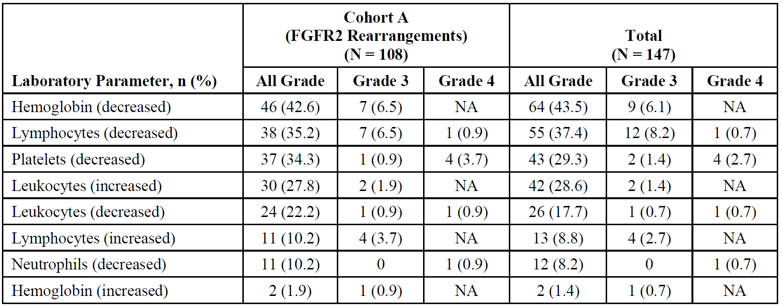
Abbreviations: FGFR = fibroblast growth factor receptor; N = number of subjects; n = number of subjects in subcategory; NA = Grade 4 Common Terminology Criteria grade is not applicable to the parameter.
Note: Worst Common Terminology Criteria grade post-Baseline. If baseline grade is missing, any post-baseline abnormality (Grade 1 to 4) is considered worsening from Baseline.

Clinical chemistry
TEAEs relating to chemistry parameters for Study INCB 54828-202 are shown in Table 19 and Table 20 below.
Table 19: Study INCB 54828-202 Treatment emergent worsening in Common Terminology Criteria graded clinical chemistry parameters (safety population)
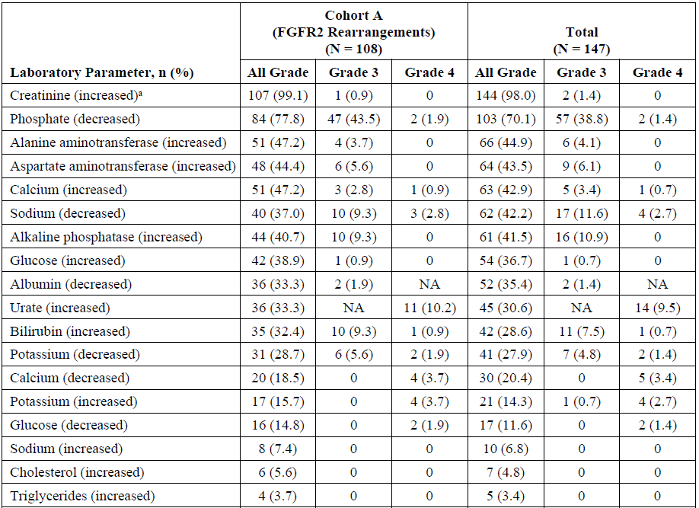
Abbreviations: FGFR = fibroblast growth factor receptor; N = total number of subjects; n = number of subjects in subcategory; NA = Common Terminology Criteria grade is not applicable to the parameter.
Worst Common Terminology Criteria grade post-Baseline. If baseline grade is missing, any post-baseline abnormality (Grade 1 to 4) is considered worsening from baseline.
a Common Terminology Criteria grade based on changes relative to the upper limit of normal and baseline values.
In the dossier, no new safety signals were seen in the wider cholangiocarcinoma and all cancer populations with respect to calcium, vitamin D or parathyroid hormone.
Clinically significant hyponatraemia occurred in 15% of patients in the pivotal study.
Monitoring of renal function would occur as a standard part of clinical management; it would appear that a mild elevation in creatinine during treatment is to be expected. The pattern of a rise in blood creatinine while on treatment which resolves off treatment was observed across all studies. In the other safety populations, particularly the all cancer population, any increased events of rise in blood creatinine or acute kidney injury are more likely to reflect the cancers being treated (for example, urothelial cancer) or concurrent AEs than drug-related toxicity.
Treatment-emergent worsening of alanine transaminase, aspartate transaminase, and bilirubin occurred in 44.9%, 43.5%, and 28.6% of participants, respectively.

Table 20: Study INCB 54828-202 Treatment emergent worsening of Common Terminology Criteria graded chemistry parameters in at least 10% (all grades) or at least 5% (Grade 3 or higher) of participants (cholangiocarcinoma population or all cancer population)
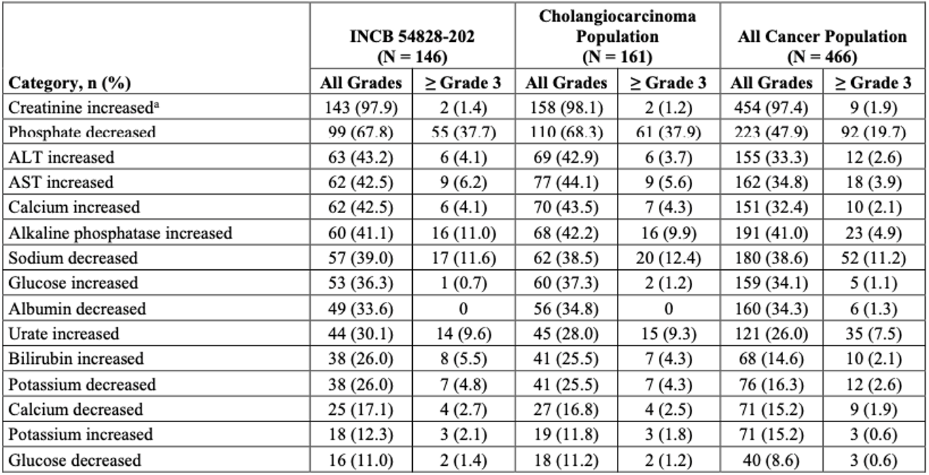
Abbreviations: N = total number of subjects; n = number of subjects in subcategory.
a. Uses Common Terminology Criteria for adverse events version 4.03 for creatinine increased.

Cardiovascular/electrocardiogram findings
There does not appear to be a safety signal for electrocardiogram abnormalities in patients receiving pemigatinib.

Risk management plan
The sponsor has submitted EU-RMP version 1.4 (dated 18 January 2021; data lock point 22 March 2019) and Australia specific annex (ASA) version 0.2 (date 2 October 2021) in support of this application. ASA version 0.3 (dated April 2022) was provided with the response to a TGA request for information.
The summary of safety concerns and their associated risk monitoring and mitigation strategies are summarised in Table 21. The TGA may request an updated RMP at any stage of a product's life-cycle, during both the pre-approval and post-approval phases.
Table 21: Summary of safety concerns
Summary of safety concerns |  | Pharmacovigilance |  | Risk minimisation
 |  | Routine | Additional | Routine | Additional
Important identified risks | Serous retinal detachment | ✓ | – | ✓ | –
Important identified risks | Hyperphosphatemia | ✓ | – | ✓ | –
Important potential risks | Embryo-Fetal Toxicity | ✓ | – | ✓ | –
Important potential risks | Acute kidney injury | ✓ | – | ✓ | –
- The summary of safety concerns aligns with the EU-RMP and is acceptable from an RMP perspective.
- Only routine pharmacovigilance activities are proposed for all safety concerns, in line with that proposed in the EU-RMP. No additional pharmacovigilance activities are proposed for this submission. This approach is acceptable from an RMP perspective.
- The clinical study plan to support provisional registration of pemigatinib is included in the ASA. The format and content of the plan is in line with TGA guidelines. Approval of clinical study plan is subject to Delegate’s final acceptance.
- Routine risk minimisation activities are proposed for all safety concerns. Changes to PI and CMI have been suggested at the first and second round of evaluation and have been resolved prior to approval. These have been referred to the Delegate for consideration. Additional risk minimisation activities have not been proposed for pemigatinib. Patient-directed material had been recommended at the first round of evaluation. To this sponsor states that international material is being adapted for Australian patients and have confirmed that these materials are similar to that provided to patients in the United States of America.

Risk-benefit analysis

Delegate’s considerations
The prognosis of patients with advanced cholangiocarcinoma is poor, and the median survival for those undergoing supportive care alone is short. In patients with advanced or metastatic cholangiocarcinoma who have progressed following platinum-based chemotherapy, there are few effective treatment options. The use of second-line chemotherapy was evaluated (Lamarca et al., 2014)⁶ in a molecularly unselected population of 761 patients with advanced biliary tract cancers. The results of this systematic review showed median progression-free survival and overall survival durations of 3.2 (95% CI: 2.7, 3.7) and 7.2 months (95% CI: 6.2, 8.2), respectively.
There is no satisfactory approved therapy in Australia for the proposed target population who have cholangiocarcinoma with a FGFR2 gene fusion or other rearrangement who have received at least one prior line of systemic treatment. Pemigatinib is a small molecule kinase inhibitor of FGFR1 to 4 that inhibits FGFR phosphorylation and signalling in cancer cell lines with constitutive activation of FGFR signalling due to activating FGFR amplifications and fusions. The sponsor proposes pemigatinib as a targeted therapy for the treatment of this population based on early clinical data from a Phase II single arm studies that have indicated an improved response rate, comparing favourably with response rates reported in historical studies of unselected cholangiocarcinoma patients treated with limited treatment options currently available in Australia.

Proposed indication
The sponsor proposes to register a new therapeutic entity, under the provisional approval pathway, for the following indication:
For the treatment of adults with locally advanced or metastatic cholangiocarcinoma with a fibroblast growth factor receptor 2 (FGFR2) fusion or rearrangement that is relapsed or refractory after at least one line of systemic therapy.
The proposed recommended pemigatinib dose is 13.5 mg orally, once daily, for 14 days followed by 7 days off therapy, until disease progression or unacceptable toxicity.

Benefits
The sponsor has provided substantial evidence of effectiveness to support provisional approval of pemigatinib for the treatment of adult patients with locally advanced or metastatic cholangiocarcinoma with an FGFR2 fusion or rearrangement that is relapsed or refractory after at least one line of systemic therapy. The recommendation for provisional approval is supported by results from Study INCB 54828-202, a Phase II, open label, uncontrolled study in adults with advanced or metastatic, or surgically unresectable cholangiocarcinoma who have disease progression after at least one previous systemic treatment.
An overall response rate of 37% (95% CI: 27.94, 46.86) in patients in Cohort A (with FGFR2 rearrangements or fusions; n = 107), and the absence of a meaningful response in patients with cholangiocarcinoma in Cohort B (FGF/FGFR alterations other than FGFR2 rearrangements or fusions) or Cohort C (negative for FGF/FGFR alterations), demonstrates a clinically meaningful effect of treatment with pemigatinib. Four participants (3.7%) had complete responses and 36 participants (33.3%) had partial responses at the latest data cut-off date of 7 April 2020.
The median duration of response was 8.1 months (95% CI: 5.7, 13.1) among those with a confirmed response, which also supports a robust treatment effect.

Uncertainties of benefit
There are limitations to deriving inference from a small, single arm or non-randomised study such as Study INCB 54828-202. In addition, the analyses of progression-free survival and overall survival are considered uninterpretable in the absence of a comparative arm. However, the progression-free survival and overall survival analyses in Cohort A, when compared with those for patients in Cohorts B and C, suggest that these are likely to be improved; a randomised study with a comparator arm would provide stronger evidence of an effect. A randomised Phase III study of pemigatinib versus the standard of care chemotherapy in patients with cholangiocarcinoma not previously treated in the metastatic setting is underway and will inform whether there is a progression-free survival or overall survival benefit in this population. Submission of this confirmatory study will be required post approval to confirm the clinical benefit of pemigatinib.
The quality of life data indicate a negative effect of the pemigatinib treatment side effects but whether this is worse than the currently very poor treatment alternatives (palliative chemotherapy or best supportive care) could not be demonstrated given that this was a single arm study; there was an intrinsic bias in the design of administering the questionnaires every 3 cycles, which will not capture responses from those discontinuing early due to toxicity or disease progression in this aggressive cancer. This will be addressed in the randomised Phase III study currently underway in the first-line setting, where patients with cholangiocarcinoma and FGFR rearrangement or fusions are randomised to receive either standard of care chemotherapy or pemigatinib.

Risks
The primary analysis of the safety of the proposed dose regimen of pemigatinib (13.5 mg once daily for two weeks on, followed by one week off schedule) in participants with previously treated advanced or metastatic, or surgically unresectable cholangiocarcinoma is based on results from Study INCB 54828-202. At the most recent cut-off date of April 2020, the median duration of exposure was 220 days (range: 7 to 1112 days) and 17.6% of participants had at least 6 months of exposure and 9% greater than 12 months exposure.
All 147 participants had at least one TEAE, and the majority (92%) had at least one TEAE that was considered related to study drug by the investigator.
- Grade 3 or higher TEAEs occurred in 69% of participants overall.
- Serious TEAEs occurred in 46% of participants, including 6 participants (4%) who had serious TEAEs with a fatal outcome.
- Treatment interruptions due to a TEAE were required in 42%, with 10% of the overall population discontinuing treatment due to a TEAE; these toxicities are generally considered to be manageable.
- The most frequent AEs were hyperphosphatemia (59%), alopecia (50%), diarrhoea (47%), fatigue (44%), nausea (42%), dysgeusia (41%), stomatitis (37%), constipation (37%) decreased appetite and dry mouth (34% each).
- Adverse events of Grade3 or higher severity included hypophosphatemia (15%), stomatitis (8%), palmar-plantar erythrodysaesthesia (7%), arthralgia (6.5%), abdominal pain (5.6%) and hyponatraemia (5%).
- Stomatitis, palmar-plantar erythrodysaesthesia syndrome, and arthralgia were the most frequent TEAEs leading to interruptions and dose reductions.
- Toxicities that are specific to the mechanism of action of pemigatinib include hyperphosphatemia, retinal pigment epithelial detachment and other ocular toxicities, and nail toxicities. Study INCB 54828-202 demonstrated that interventions to control the serum phosphate level generally reduced the rate of clinically significant increases, but there were substantial and potentially severe decreases in serum phosphate which may be related to overcorrection or another mechanism. This needs to be adequately addressed in the PI.
- The rates of hyperphosphatemia are likely to have been underestimated due to levels only be checked per protocol just prior to commencement of each cycle, that is, after a one week break from daily dosing. Hypophosphatemia was common, and sometimes severe, but this may not be representative of the levels while on active pemigatinib dosing.
- Ocular toxicities in the integrated safety were common, diverse and all related to pemigatinib (for example, retinal pigment epithelial detachment, dry eye, keratitis, and eyelash growth abnormalities), resulting in study discontinuations
- Nail toxicities were frequent and may be a distressing outcome for patients.

Uncertainties of risk
As this was a single arm study, there is no comparator to make confident attributions about AEs and relation to treatment, nor to demonstrate the toxicities relative to an alternate regimen that could be used in this population, such as Folfox (which is associated with substantial toxicity and does not provide high response rates or durable responses).
The relatively small number of participants in Study INCB 54828-202 and in the development studies to date limits the ability to fully characterise rare AEs, and to attribute causality to pemigatinib for some of the AEs. However, there are sufficient data to form a benefit-risk for this population, and the observed safety profile could be considered acceptable in the context of a rare and aggressive cancer with a very poor prognosis.

Benefit risk balance
Overall, the benefit-risk assessment for pemigatinib is considered to be favourable to support provisional registration for the proposed indication. The overall response rate and duration of response from Study INCB 54828-202 are considered to be clinically meaningful and reasonably likely to predict clinical benefit in the proposed population.
Although pemigatinib can cause serious toxicities, the safety profile demonstrated is acceptable when considered in the context of a life-threatening disease (that is, advanced cholangiocarcinoma), the significant unmet need in the intended patient population, and the lack of available targeted therapy options for the proposed population in Australia at present.
The study design limits interpretation of survival; although available evidence supports provisional approval, further data is required in order to confirm clinical benefit. The proposed confirmatory study is likely to address the uncertainties about relative toxicity compared with the other very limited treatment options, impact on quality of life and relative efficacy in a patient population with cholangiocarcinoma harbouring FGFR2 gene fusions or rearrangements. The sponsor will be required to submit final reports of the confirmatory study post-marketing.

Proposed action
The benefit risk assessment for pemigatinib in proposed population is considered to be favourable.
Provisional approval of pemigatinib is supported for the following indication providing that all outstanding concerns or recommendations outlined in the quality and RMP evaluation reports are satisfactorily addressed:
This medicine has provisional approval in Australia for the treatment of adults with locally advanced or metastatic cholangiocarcinoma with a fibroblast growth factor receptor 2 (FGFR2) fusion or rearrangement that is relapsed or refractory after at least one line of systemic therapy. The decision to approve this indication has been made on the basis of overall response rate (ORR) and duration of response (DOR). Continued approval of this indication depends on verification and description of benefit in confirmatory trials.
In addition to the standard conditions of registration, additional conditions of registration are proposed.

Advisory Committee considerations
The Advisory Committee on Medicines (ACM), having considered the evaluations and the Delegate’s overview, as well as the sponsor’s response to these documents, advised the following.

Specific advice to the Delegate
- Are the results from the Phase II Study INCB 54828-202 (the FIGHT-202 trial) sufficient to support the use of pemigatinib in the proposed population?
The ACM agreed that the data from the Phase II study, Study INCB 54828-202 (FIGHT-202 trial) sufficiently supports the use of pemigatinib in the proposed population as second line therapy.
The ACM noted the overall response rate of 37% and the median duration of response of 8.1 months, stating that early efficacy appears to be demonstrated within many of the participants on pemigatinib.
The ACM advised that careful management of the toxicity profile would be required, with specific monitoring given to hyperphosphataemia. The ACM advised that the PI and CMI should include clear information on monitoring of phosphate levels. The ACM also noted that screening and monitoring for serous retinopathy would be important and early intervention for ocular symptoms warranted.
The ACM noted that cholangiocarcinoma is a rare cancer with poor outcomes and limited treatment options as such, on balance the availability of this treatment as a provisional registration is warranted based on the early data.

Conclusion
The ACM considered this product to have an overall positive benefit-risk profile for the provisional registration of pemigatinib for the following indication:
For the treatment of adult patients with locally advanced or metastatic cholangiocarcinoma with a fibroblast growth factor receptor 2 (FGFR2) fusion or rearrangement who have received at least one prior systemic therapy for advanced disease.
The decision to approve this indication has been made on the basis of overall response rate (ORR) and duration of response (DOR). Continued approval of this indication depends on verification and description of benefit in confirmatory trials.

Outcome
Based on a review of quality, safety, and efficacy, the TGA approved the registration of Pemazyre (pemigatinib) 4.5 mg, 9 mg and 13.5 mg, tablet, blister pack, indicated for:
Pemigatinib has provisional approval in Australia for the treatment of adult patients with locally advanced or metastatic cholangiocarcinoma with a fibroblast growth factor receptor 2 (FGFR2) fusion or rearrangement that has progressed after at least one prior line of systemic therapy. The decision to approve this indication has been made on the basis of overall response rate (ORR) and duration of response (DOR). Continued approval of this indication depends on verification and description of benefit in confirmatory trial(s).

Specific conditions of registration applying to these goods
- Pemazyre (pemigatinib) is to be included in the Black Triangle Scheme. The PI and CMI for Pemazyre must include the black triangle symbol and mandatory accompanying text for five years, or the product’s entire period of provisional registration, whichever is longer.
- The Pemazyre EU-risk management plan (RMP) (version 1.4, dated 29 January 2021, data lock point 22 March 2019), with Australia specific annex (version 0.3, dated April 2022), included with Submission PM-2021-03777-1-4, and any subsequent revisions, as agreed with the TGA will be implemented in Australia.
An obligatory component of risk management plans is routine pharmacovigilance. Routine pharmacovigilance includes the submission of periodic safety update reports (PSURs).
Unless agreed separately between the supplier who is the recipient of the approval and the TGA, the first report must be submitted to TGA no later than 15 calendar months after the date of the approval letter. The subsequent reports must be submitted no less frequently than annually from the date of the first submitted report until the period covered by such reports is not less than three years from the date of this approval letter, or the entire period of provisional registration, whichever is longer.
The reports are to at least meet the requirements for PSURs as described in the European Medicines Agency’s Guideline on Good Pharmacovigilance Practices (GVP) Module VII-periodic safety update report (revision 1), Part VII.B structures and processes. Note that submission of a PSUR does not constitute an application to vary the registration. Each report must have been prepared within ninety calendar days of the data lock point for that report.
- [The sponsor to] submit the results of the confirmatory study, FIGHT-302 (INCB 54828-302), a Phase III study comparing the efficacy and safety of pemigatinib [versus] gemcitabine plus cisplatin chemotherapy in adults with unresectable or metastatic cholangiocarcinoma with FGFR2 rearrangement.
- [The sponsor to] submit an updated PK/PD modelling analysis for evaluation.

Attachment 1. Product Information
The PI for Pemazyre approved with the submission which is described in this AusPAR is at Attachment 1. For the most recent PI, please refer to the TGA PI/CMI search facility.

Therapeutic Goods Administration
PO Box 100 Woden ACT 2606 Australia
Email: info@tga.gov.au Phone: 1800 020 653 Fax: 02 6203 1605
https://www.tga.gov.au
Reference/Publication #

This is the original indication proposed by the sponsor when the TGA commenced the evaluation of this submission. It may differ to the final indication approved by the TGA and registered on the Australian Register of Therapeutic Goods.
Fritz, A. et al. eds. International Classification of Diseases for Oncology (ICD-O). 3rd ed. World Health Organization; 2000.
Mollah, T. et al. Epidemiological Trends of Gallbladder Cancer in Australia between 1982 to 2018: a Population-Based Study Utilizing the Australian Cancer Database, Ann Hepatobiliary Pancreat Surg, 2022; 26(3): 263-269.
Khan, S.A. et al. Cholangiocarcinoma: Epidemiology and Risk Factors, Liver Int, 2019; 39 Suppl 1: 19-31.
National Comprehensive Cancer Network (NCCN) NCCN Clinical Practice Guidelines in Oncology - Hepatobiliary Cancers, Version 5.2021; 2021.
Lamarca, A. et al. Second-Line Chemotherapy in Advanced Biliary Cancer: a Systematic Review, Ann Oncol, 2014 ; 25(12): 2328-2338.
Truseltiq (infigratinib as phosphate) was first registered on ARTG on 5 November 2021 (ARTG records: 348760, 348761, 348762, 348763, 348760, 348761, 348762, 348763, 348760, 348761, 348762, 348763, 348760, 348761, 348762 and 348763).
Pregnancy category D: Drugs which have caused, are suspected to have caused or may be expected to cause, an increased incidence of human fetal malformations or irreversible damage. These drugs may also have adverse pharmacological effects. Accompanying texts should be consulted for further details.
The sponsor has later requested to waive the requirement of conducting a mutagenicity study on this impurity. The reasoning is considered acceptable from a nonclinical perspective and therefore, the study is no longer required.
Cytochrome P450 (CYP) enzymes are the major enzymes involved in drug metabolism, accounting for large part of the total metabolism. Most drugs undergo deactivation by CYPs, either directly or by facilitated excretion from the body. Also, many substances are bioactivated by CYPs to form their active compounds. Many drugs may increase or decrease the activity of various CYP isozymes either by inducing the biosynthesis of an isozyme (enzyme induction) or by directly inhibiting the activity of the CYP (enzyme inhibition). This is a major source of adverse drug interactions, since changes in CYP enzyme activity may affect the metabolism and clearance of various drugs. Such drug interactions are especially important to take into account when using drugs of vital importance to the patient, drugs with important side-effects and drugs with small therapeutic windows, but any drug may be subject to an altered plasma concentration due to altered drug metabolism.
Brookmeyer, R. and Crowley, J. A. Confidence Interval for The Median Survival Time, Biometrics, 1982; 38: 29-41.
The QT interval is the time from the start of the QRS wave complex to the end of the corresponding T wave. It approximates to the time taken for ventricular depolarisation and repolarisation, that is to say, the period of ventricular systole from ventricular isovolumetric contraction to isovolumetric relaxation.

