|  |
| --- |
| Australian Public Assessment Report for Comirnaty COVID-19 Vaccine |
| Active ingredient/s: Tozinameran |
| Sponsor: Pfizer Australia Pty Ltd |
| August 2023 |

About the Therapeutic Goods Administration (TGA)

* The Therapeutic Goods Administration (TGA) is part of the Australian Government Department of Health and Aged Care and is responsible for regulating therapeutic goods, including medicines, medical devices, and biologicals.
* The TGA administers the *Therapeutic Goods Act 1989* (the Act), applying a risk management approach designed to ensure therapeutic goods supplied in Australia meet acceptable standards of quality, safety, and efficacy.
* The work of the TGA is based on applying scientific and clinical expertise to decision-making, to ensure that the benefits to the Australian public outweigh any risks associated with the use of therapeutic goods.
* The TGA relies on the public, healthcare professionals and industry to report problems with therapeutic goods. The TGA investigates reports received to determine any necessary regulatory action.
* To report a problem with a therapeutic good, please see the information on the [TGA website](https://www.tga.gov.au).

About AusPARs

* The Australian Public Assessment Report (AusPAR) provides information about the evaluation of a prescription medicine and the considerations that led the TGA to approve or not approve a prescription medicine submission. Further information can be found in [Australian Public Assessment Report (AusPAR) guidance](https://www.tga.gov.au/australian-public-assessment-report-auspar-guidance).
* AusPARs are prepared and published by the TGA.
* AusPARs are static documents that provide information that relates to a submission at a particular point in time. The publication of an AusPAR is an important part of the transparency of the TGA’s decision-making process.
* A new AusPAR may be provided to reflect changes to indications or major variations to a prescription medicine subject to evaluation by the TGA.

Copyright

© Commonwealth of Australia 2023  
This work is copyright. You may reproduce the whole or part of this work in unaltered form for your own personal use or, if you are part of an organisation, for internal use within your organisation, but only if you or your organisation do not use the reproduction for any commercial purpose and retain this copyright notice and all disclaimer notices as part of that reproduction. Apart from rights to use as permitted by the *Copyright Act 1968* or allowed by this copyright notice, all other rights are reserved and you are not allowed to reproduce the whole or any part of this work in any way (electronic or otherwise) without first being given specific written permission from the Commonwealth to do so. Requests and inquiries concerning reproduction and rights are to be sent to the TGA Copyright Officer, Therapeutic Goods Administration, PO Box 100, Woden ACT 2606 or emailed to <[tga.copyright@tga.gov.au](mailto:tga.copyright@tga.gov.au)>.

Contents

List of abbreviations 4

Product submission 5

Submission details 5

Product background 7

Drug class and therapeutic indication 8

Dosage forms and strengths 9

Current vaccine options 10

Regulatory status 10

Product Information 11

Registration timeline 11

Submission overview and risk/benefit assessment 11

Quality 12

Nonclinical 12

Clinical 12

Efficacy and Immunogenicity for primary vaccination 13

Efficacy and Immunogenicity for booster vaccination 36

Endorsement for early termination of clinical studies 45

Real world evidence 46

Risk management plan 51

Risk-benefit analysis 52

Delegate’s considerations 52

Proposed action 53

Questions for the sponsor 54

Advisory Committee considerations 60

Outcome 60

Specific conditions of registration applying to these goods 61

Attachment 1. Product Information 62

## List of abbreviations

|  |  |
| --- | --- |
| Abbreviation | Meaning |
| ACV | Advisory Committee on Vaccines |
| AE | Adverse event |
| ARTG | Australian Register of Therapeutic Goods |
| ASA | Australia specific annex |
| BNT162b2 | Drug development code for tozinameran |
| CDC | Centers for Disease Control and Prevention, United States of America |
| CI | Confidence interval |
| CMI | Consumer Medicines Information |
| COVID-19 | Coronavirus disease 2019 |
| DLP | Data lock point |
| EU | European Union |
| EU | European Union |
| FDA | Food and Drug Administration, United States of America |
| GMC | Geometric mean concentration |
| GMFR | Geometric mean fold rise |
| GMR | Geometric mean ratio |
| GMT | Geometric mean titre |
| IgG | Immunoglobin G |
| IRR | Incidence rate ratio |
| MIS-C | Multisystem inflammatory syndrome of children |
| PBS | Phosphate buffer saline |
| PI | Product Information |
| PSUR | Periodic safety update report |
| RMP | Risk management plan |
| SAE | Serious adverse event |
| SARS-CoV-2 | Severe acute respiratory syndrome coronavirus 2 |
| TGA | Therapeutic Goods Administration |
| US(A) | United States (of America) |

## Product submission

### Submission details

|  |  |
| --- | --- |
| *Type of submission:* | Provisional to full registration |
| *Product name:* | Comirnaty COVID-19 Vaccine |
| *Active ingredient:* | Tozinameran |
| *Decision:* | Approved |
| *Date of decision:* | 13 July 2023 |
| *Date of entry onto ARTG:* | 14 July 2023 |
| *ARTG number:* | 346290, 377110, 377111, 393433 |
| [*Black Triangle Scheme*](https://www.tga.gov.au/black-triangle-scheme)  *for the current submission:* | Yes  This product will remain in the scheme for 5 years, starting from the date that provisional approval was granted. |
| *Sponsor’s name and address:* | Pfizer Australia Pty Ltd  Level 17, 151 Clarence Street  Sydney NSW 2000 |
| *Dose forms:* | Suspension for injection and concentrate for suspension for injection |
| *Strengths:* | Aged 12 years of age and above: 30 µg/0.3 mL  Aged 5 to younger than 12 years of age: 10 µg/0.2 mL  Aged 6 months to younger than 5 years of age: 3 µg/0.2 mL |
| *Container:* | Multidose vial |
| *Pack size:* | 10 vials and 195 vials |
| *Approved therapeutic use for the current submission:* | For ARTG 346290  *Active immunisation to prevent coronavirus disease 2019 (COVID-19) caused by SARS-CoV-2, in individuals 12 years of age and older.*  *The use of this vaccine should be in accordance with official recommendations*  For ARTG 377110, 377111, 393433  *Active immunisation to prevent coronavirus disease 2019 (COVID-19) caused by SARS-CoV-2, in individuals 6 months of age and older.*  *The use of this vaccine should be in accordance with official recommendations*. |
| *Route of administration:* | Intramuscularly |
| *Dosage:* | Individuals 12 years of age and older  Comirnaty ready to use multidose (For age 12 years and above, do not dilute) is administered intramuscularly as a primary course of 2 doses (30 µg/0.3 mL) at least 21 days apart.  Booster dose in individuals 12 years of age and older  A booster dose of Comirnaty ready to use multidose (for age 12 years and above, do not dilute) may be administered intramuscularly at least 6 months after the completion of a COVID-19 vaccine primary series in individuals 12 years of age and older.  The decision when and for whom to implement a booster dose of Comirnaty ready to use multidose (for age 12 years and above, do not dilute) should be made based on available vaccine safety and effectiveness data (see Sections 4.4 Special warnings and precautions for use and 5.1 Pharmacodynamic properties), in accordance with official recommendations.  Severely immunocompromised aged 12 years and older  In accordance with official recommendations, a third dose may be given, as part of the primary series, at least 28 days after the second dose to individuals who are severely immunocompromised (see Section 4.4 Special warnings and precautions for use).  Individuals 5 to younger than 12 years of age  Comirnaty dilute to use multidose (for age 5 to younger than 12 years) is administered intramuscularly as a primary course of two doses (10 µg/0.2 mL each) at least 21 days apart.  Booster dose in individuals 5 to younger than 12 years of age  A booster dose of Comirnaty dilute to use multidose (for age 5 to younger than 12 years) may be administered intramuscularly at least 6 months after the second dose in individuals 5 to younger than 12 years of age.  Individuals 6 months to younger than 5 years of age  Comirnaty dilute to use multidose (for age 6 months to younger than 5 years) is administered intramuscularly as a primary course of three doses (3 µg/0.2 mL each). The initial two doses are administered three weeks apart followed by a third dose administered at least 8 weeks after the second dose (see sections 4.4 Special warnings and precautions for use and 5.1 Pharmacodynamic properties).  Children who will turn from 4 years to 5 years of age between their doses in the vaccination series should receive their age-appropriate dose at the time of the vaccination and the interval between doses is determined by the individual’s age at the start of the vaccination series.  Comirnaty dilute to use multidose (for age 6 months to younger than 5 years) cannot be used in individuals 5 years of age and older.  For further information regarding dosage, refer to the Product Information. |
| *Pregnancy category:* | B1  Drugs which have been taken by only a limited number of pregnant women and women of childbearing age, without an increase in the frequency of malformation or other direct or indirect harmful effects on the human fetus having been observed.  Studies in animals have not shown evidence of an increased occurrence of fetal damage.  The use of any medicine during pregnancy requires careful consideration of both risks and benefits by the treating health professional. This must not be used as the sole basis of decision making in the use of medicines during pregnancy. The TGA does not provide advice on the use of medicines in pregnancy for specific cases. More information is available from obstetric drug information services in your State or Territory. |

### Product background

This AusPAR describes the submission by Pfizer Australia Pty Ltd (the sponsor) to register Comirnaty (tozinameran) 30 µg/0.3 ml, 10 µg/0.2 mL, 3 µg/0.2 mL, suspension for injection, multidose vial for the following proposed indication:[1]

*Active immunisation to prevent coronavirus disease 2019 (COVID-19) caused by SARS-CoV-2, in individuals 6 months of age and older.*

*The use of this vaccine should be in accordance with official recommendations*

Severe acute respiratory syndrome coronavirus 2 (SARS-CoV-2) has spread rapidly and globally since its emergence in late 2019, causing the disease coronavirus disease 2019 (COVID-19). Globally, as of 22 May 2023, there have been about 767 million confirmed cases of COVID-19, including almost 7 million deaths.[2] Of these, approximately 11.5 million cases and 21, 917 deaths have been reported in Australia.2

Disease symptoms and severity vary, with many people presenting with asymptomatic or mild disease and some progressing to severe respiratory tract disease including pneumonia and acute respiratory distress syndrome, leading to multiorgan failure and possible death. All ages may present with the disease, but notably, case fatality rates are elevated in persons greater than 60 years of age. Comorbidities are also associated with increased case fatality rates, including cardiovascular disease, diabetes, hypertension, and chronic respiratory disease. Some people also develop long term sequelae following COVID 19 infections. Post-COVID conditions can include a wide range of ongoing health problems; these conditions can last weeks, months, or years.[3]

Vaccines to protect against COVID-19 are critical to prevent future disease outbreaks. SARS-CoV-2 is an RNA virus with four structural proteins. One of them, the spike protein is a surface protein which binds the angiotensin-converting enzyme 2 on host cells to initiate infection. Thus, the spike protein is a relevant antigen for vaccine development. COVID-19 mRNA vaccines were developed against the spike protein of the ancestral SARS-CoV-2 virus. Benefits of receiving COVID-19 vaccine has been well established.[4] These include protection from SARS-CoV-2 infection as well as progression to severe COVID-19 and death. Studies indicate that the risk of post–COVID symptoms in people who contract COVID-19 after their second dose of COVID-19 vaccine is approximately halved.[5]

The SARS-CoV-2 Omicron variant emerged in November 2021 and diversified into sublineages. The Omicron variant contained more than 30 mutations in the spike protein, including more than 15 mutations in the receptor-binding domain, the primary target of neutralising antibodies.[6] Whilst Omicron sublineages are associated with decreased protection from vaccination, SARS-CoV-2 variants haven’t evolved to resist the protection against severe disease offered by vaccination or previous infection.6 Booster doses have been implemented for approved COVID-19 vaccines to facilitate persistence of immunity and protection from COVID‑19 illness caused by SARS-CoV-2.

Active immunisation through vaccination represents the best means of preventing hospitalisation and deaths at an individual level and various measures have been aimed at controlling the pandemic at a societal level. In people with COVID 19, medications are available to reduce the risk of progression to serious disease, hospitalisation, and death.

Despite availability of vaccinations in Australia, COVID 19 continues to be a significant public health issue. In the last week of reporting (to 23 March, 2023), there were 41,188 cases of COVID-19 reported across Australia, (average of 5884 cases/day) hospitalisations remain high at almost 2,500, 63 of whom are in ICU, and approximately 2 deaths occur per day.[7]

#### Drug class and therapeutic indication

Comirnaty (tozinameran) is a mRNA vaccine for prevention of COVID-19. The vaccine made of a is a nucleoside-modified messenger RNA encoding a mutated form of the full length spike glycoprotein of SARS-CoV-2. The RNA is encapsulated in lipid nanoparticles, which enables entry into host cells, expression of the S protein, and elicitation of both antibody and cellular immune responses. The active ingredient in Comirnaty is a single stranded 5’-capped mRNA produced using a cell free *in vitro* transcription from the corresponding DNA template, encoding the full length viral spike protein of SARS-CoV-2. This active ingredient has most commonly been referred to as BNT162b2 (mRNA) and is also known as tozinameran.

#### Dosage forms and strengths

The details of the current provisionally approved products are shown in Table 1. This submission is a Category 1 (Type S) application for the proposed transition from provisional to full registrations for all products included in Table 1. Table 2 summarises the dosing and regimen for dosing for primary vaccination for COVID 19. A booster dose of Comirnaty may be administered intramuscularly at least six months after the completion of a COVID-19 vaccine primary series in individuals 5 years of age and older. The decision when and for whom to implement a booster dose of Comirnaty should be made based on available vaccine safety and effectiveness data in accordance with official recommendations.

Table : Current Comirnaty (tozinameran) COVID-19 vaccine which are provisionally approved.

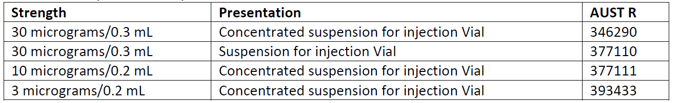

Table : Comirnaty (BNT162b2) dosing for primary vaccination

|  |  |  |
| --- | --- | --- |
| **Age Group** | **Dose mRNA** | **Regimen** |
| At least 12 years of age* | 30 µg (0.3 ml) | 2 doses (0, 3 weeks) |
| 5 to 11 years | 10 µg (0.2 ml) | 2 doses (0, 3 weeks) |
| 6 months to younger than 5 years | 3 µg (0.2 ml) | 3 doses (0, 3, ≥ 8 weeks) after second dose |

The tris/sucrose formulation (ARTG 377110) is equivalent to the phosphate buffer saline (PBS)/sucrose formulation (ARTG 346290) but with the following differences: formulation buffer system (Tris versus PBS), mRNA concentration (0.1 mg/mL versus 0.5 mg/mL) and with an advantage that the proposed tris/sucrose finished product does not require dilution upon administration (Table 3). The active substance used to manufacture the tris/sucrose finished product is identical to that used for the PBS/sucrose finished product. The lower strength doses (ARTG 377111, ARTG 393433) are tris/sucrose formulations.

Table : Comirnaty formulation

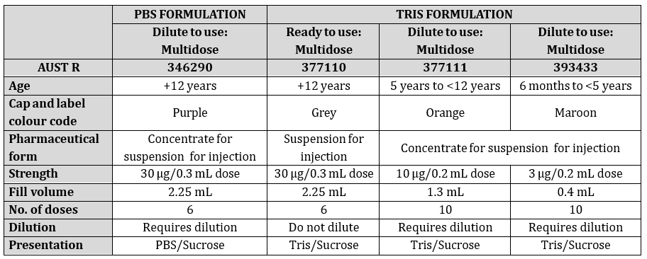

#### Current vaccine options

For a list of the COVID-19 vaccines that have been fully/provisionally approved by the TGA see: [COVID-19 vaccine regulatory status: |Therapeutic Goods Administration (TGA)](https://www.tga.gov.au/products/covid-19/covid-19-vaccines/covid-19-vaccines-regulatory-status)

### Regulatory status

The TGA provisionally approved Comirnaty (tozinameran), Pfizer/BioNTech mRNA vaccine for use in Australia on 25 January 2021 for people aged 16 years and over.[8] Subsequently provisional registrations have been granted as follows:

• For individuals at least 12 to 15 years (22 July 2021);[9]

• Booster dose for individuals at least 18 years old (26 October 2021);[10]

• For individuals aged 5 to 11 years old (3 December 2021);[11]

• Booster dose for individuals aged 16 to 17 years old (27 January 2022);[12]

• Booster dose for individuals aged 12 to 15 years old (7 April 2022);[13]

• Booster dose for individuals aged 5 to 11 years old (20 September 2022);[14]

• For individuals aged 6 months to 4 years old (29 September 2022);[15]

The TGA approved a Type T application, extension of provisional registration on 31 August 2022.

At the time the TGA considered this submission, a similar submission had been approved in European Union (EU) on 10 October 2022 for conversion of conditional marketing authorisation to standard marketing authorisation. In United States of America (USA), there is no process in place for conversation of Emergency Use Authorisation to full registration. Thu, a biological license application is in place as well as the Emergency Use Authorisation for Comirnaty monovalent vaccine in the USA. A similar submission was under consideration in Switzerland (submitted on 28 February 2023). A similar application has not been deferred, withdrawn, or rejected in any countries/jurisdictions.

### Product Information

The [Product Information](https://www.tga.gov.au/products/australian-register-therapeutic-goods-artg/product-information-one) ([PI](https://www.tga.gov.au/products/australian-register-therapeutic-goods-artg/product-information-one)) approved with the submission which is described in this AusPAR can be found as Attachment 1. For the most recent PI and [Consumer Medicines Information](https://www.tga.gov.au/products/australian-register-therapeutic-goods-artg/consumer-medicines-information-cmi) (CMI), please refer to the TGA [PI/CMI search facility.](https://www.tga.gov.au/picmi-search-facility)

## Registration timeline

The following table captures the key steps and dates for this submission.

Data were provided as a rolling submission. Under normal circumstances, TGA's assessment (for both provisional and general registration) begins once all information to support registration is available. As part of the Department of Health and Aged Care's response to the pandemic, the TGA has agreed to accept rolling data for COVID-19 vaccines and treatments, to enable early evaluation of data as it becomes available.

|  |  |
| --- | --- |
| Description | Date |
| Submission dossier accepted and first round evaluation commenced | 3 April 2023 |
| Evaluation completed | 19 June 2023 |
| Delegate’s Overall benefit-risk assessment | 20 June 2023 |
| Sponsor’s response | 26 June 2023 |
| Advisory Committee meeting | Not applicable |
| Registration decision (Outcome) | 13 July 2023 |
| Administrative activities and registration on the ARTG completed | 14 July 2023 |
| Number of working days from submission dossier acceptance to registration decision* | 69 |

*Statutory timeframe for standard submissions is 255 working days

## Submission overview and risk/benefit assessment

A summary of the TGA’s assessment for this submission is provided below.

Relevant guidelines or guidance documents referred to by the Delegate are listed below:

• ACCESS Consortium: Access consortium statement on COVID-19 vaccines evidence (4/12/2020)

• EMEA: Guidelines on clinical evaluation of new vaccines (EMEA/CHMP/VWP/164653/2005) (6/01/2009)

The Delegate referred to the following additional guidance:

• EMA: EMA considerations on COVID-19 vaccine approval (EMA/592928/2020) (19/11/2020)

• US FDA: Development and licensure of vaccines to prevent COVID-19: guidance for industry (June 2020)

• US FDA: Emergency use authorization for vaccines to prevent COVID-19: guidance for industry (25/05/2021)

• US FDA: COVID-19: developing drugs and biological products for treatment or prevention: guidance for industry (February 2021)

• WHO: Design of vaccine efficacy trials to be used during public health emergencies – points of consideration and key principles (no date)

### Quality

The quality evaluation has found there are no significant issues identified from the Quality Evaluation of the submitted data that would indicate the product should not be fully registered on the basis of quality, or safety-related issues arising from the quality of the product. The sponsor has not submitted any new quality data in the dossier for full registration. Overall, the post-approval commitments listed for the provisional registrations of the products have been fulfilled and/or found the information submitted acceptable from a manufacturing quality perspective.

### Nonclinical

Key nonclinical evaluations of Comirnaty included pharmacology (mouse immunogenicity studies, non-human primate immunogenicity and challenge studies) and toxicity (two Good Laboratory Practice rat repeat-dose toxicity studies) *in vitro* and *in vivo*. A developmental and reproductive toxicity study was completed in rats.

These nonclinical data supported the clinical development of Comirnaty and were previously submitted and evaluated as part of the original submission.8

The Delegate has confirmed the that the sponsor has provided adequate information to ensure there are no nonclinical objections to full registration for the products outlined in Table 1.

### Clinical

Pfizer and BioNTech have developed a vaccine that targets SARS-CoV-2, intended to prevent COVID-19. BioNTech initiated a first in human study in April 2020 in Germany (Study BNT162‑01). Pfizer initiated a Phase I/II/III trial (Study C4591001) shortly afterwards in the US; the study expanded to global sites upon initiation of the Phase II/III part of the study, followed by initiation of paediatric Phase I/II/III Study C4591007. Booster evaluations were undertaken in Study C4591001 (for adult), Study C4591007 (for paediatric), and Study C4591031 (for adult and adolescent).

This submission is a Type S application for the proposed transition from provisional to full registrations for products in Table 1. Due to changes in disease landscape, evolving variants and use of booster doses, the planned follow up period is no longer clinically relevant or feasible for Studies BNT162-01, C4591001 and C4591007. The sponsor requested amendments and TGA endorsement to the conditions of Comirnaty provisional registrations as discussed later in AusPAR.

Provisional fulfilment status and an overview of progress against the Specific Conditions of Registration set out in the approval letters dated 24 January 2021 (PM-2020-05461-1-2)8, 3 December 2022 (PM-2021-05012-1-2)11 and 29 September 2022 (PM-2022-03129-1-2)15 for Comirnaty vaccines for patients 6 months of age and older.

The clinical conditions of provisional registration for Comirnaty (tozinameran) COVID-19 vaccine in adult, adolescent and paediatric populations are listed in the Table 4.

Table : Clinical Provisional Approval Conditions and current status

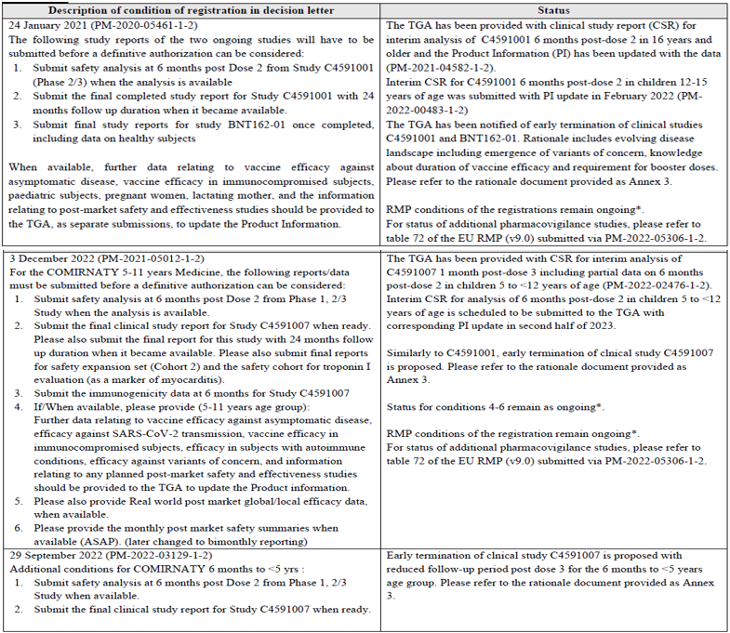

#### Efficacy and Immunogenicity for primary vaccination

##### Primary vaccination in subjects at least 16 years of age,8 and at least 12 to 15 years of age;9

###### Study BNT162-01

This study is a multi-site, Phase I/II, two part, dose escalation trial investigating the safety, and immunogenicity of four (BNT162a1, BNT162b1, BNT162b2, BNT162c2) prophylactic SARS‑CoV‑2 RNA vaccines against COVID-19 using different dosing regimens in healthy and immunocompromised adults. This first in human study, conducted in Germany, commenced in April 2020. Secondary and exploratory objectives were specified to describe the immune response, measured by functional antibody titre, antibody binding assay, and cell mediated immune responses (cytokines associated with T helper 1 and T helper 2 responses) at Baseline and various time points after vaccination, specifically 7 days post Dose 2. Two vaccines, BNT162b1 containing modified RNA encoding SARS-CoV-2 receptor binding domain and BNT162b2 containing modified RNA encoding SARS-CoV-2 spike glycoprotein emerged as candidate vaccines for further study.

Initially, adults aged 18 to 55 years of age were enrolled and included 120 participants (84 in BNT162b1 and 60 in BNT162b2 groups), but the protocol was later amended to allow inclusion of adults up to 85 years of age (36 in BNT162b1 and 36 in BNTb2 groups). This was an open label study, and thus no randomisation to treatment groups. The study population includes male and female adult participants deemed healthy and without COVID-19 symptoms or evidence of SARS-CoV-2 infection within 30 days prior to entering the study. Inclusion criteria allowed for pre-existing stable disease. Later immunocompromised participants 18 to 85 years of age were included.

For each candidate, participants received escalating dose levels (N = 12 per dose level) with progression to subsequent dose levels based on recommendation from a sponsor safety review committee.

Study BNT162-01 study design implemented a total of 14 cohorts including three expansion cohorts (Cohort 11, Cohort 12, and Cohort 13) that were intended to provide a more in depth characterisation of the adaptive immune responses induced by BNT162b.

Blood samples for evaluation of immunogenicity were to be collected at Baseline, at 7 and 21 days after first dose and 7, 14, 21, 28, 63, and 162 days after second dose. T-cell response data are available for all participants with evaluable data at Day 29 (7 days after second dose) and up to Day 184 for a subset of participants who received BNT162b2 at 10, 20, or 30 µg.

For both BNT162b1 and BNT162b2, data for SARS-CoV-2 serum 50% neutralising titres showed the need for two doses of vaccine. Only modest immune responses were apparent by 21 days after first dose, while second dose elicited rapid increases in neutralising titres, with maximal response levels achieved by 7 days after second dose (Day 29). The responses persisted in the majority of participants for up to six months after second dose. Additionally robust T-cell mediated immunity, with antigen induced interferon gamma expression demonstrating a T helper 1 CD4+ and CD8+ phenotype was observed following two doses of either BNT162b1 or BNT162b2. The magnitude of the T-cell responses did not show clear dose dependency.

Safety data up through the data cutoff date (23 October 2020) up to one month after second dose for both age groups were analysed during the submission.8 The frequency and severity of local and systemic reactogenicity across all dose levels was generally lower for BNT162b2 compared to BNT162b1. The frequency of local and systemic reactogenicity and treatment emergent adverse events was lower in the older participants group compared to the younger participants.

In this study, BNT162b2 was safe and well tolerated in healthy adults 18 to 85 years of age, with no unanticipated safety findings. Reactogenicity and AEs tended to increase in incidence and/or severity with increasing dose of BNT162b2. Reactogenicity was mostly mild/moderate and short lived, and the adverse event (AE) profile and clinical laboratory results did not suggest any safety concerns.

Thus, the immunogenicity results from Study BNT162-01 showed evidence of antibody mediated SARS-CoV-2 neutralisation and a T helper 1 polarisation in the cell mediated cellular immune responses in healthy adults, and the vaccines appeared to be safe and well tolerated. These findings supported the final dose selection for the enrolment of larger numbers of participants in Study C4591001.

The final study report submission for Study BNT162-01 is expected in first quarter of 2023.

###### Study C4591001

This is a Phase I/II/III, placebo controlled, randomised, observer blind, dose finding study to evaluate the safety, tolerability, immunogenicity, and efficacy of SARS-CoV-2 RNA vaccine candidates against COVID-19 in healthy individuals.

This pivotal study of prophylactic BNT162b2 vaccine against COVID-19 in healthy individuals at least 12 years of age was initiated in April 2020. This study started as a Phase I/II study in adults in the US, was expanded to a global Phase II/III study, and later included older (16 to 17 years of age), then younger (12 to 15 years of age in the US only) adolescents. There were many protocol amendments, that are considered justified and unlikely to affect the study conclusion. The TGA has previously evaluated Study C4591001 data in detail during previous submissions. A summary is included here.

The study consisted of the following (See Figure 1):

* Phase I (to identify preferred vaccine candidate and dose level in US sites only)
* Phase II (safety and immunogenicity in the first 360 participants who entered Phase II/III)
* Phase II/III (efficacy and safety evaluation of the selected vaccine in a larger population)

The study evaluated the safety, tolerability, and immunogenicity of two different SARS-CoV-2 RNA vaccine candidates and the Phase II/III efficacy of the selected candidate based on Phase I results:

* As a two dose (separated by 21 days) schedule
* At various dose levels in Phase I
  + BNT162b1 (dose levels: 10, 20, 30, 100 µg) containing modified RNA encoding SARS‑CoV‑2 receptor binding domain
  + BNT162b2 (dose levels: 10, 20, 30 µg) containing modified RNA encoding SARS-CoV-2 spike glycoprotein (candidate subsequently chosen as the proposed product)
* As a booster, (see Efficacy and Immunogenicity for booster vaccination)
* In various age groups:
  + Phase I: 18 to 55 and 65 to 85 years of age.
  + Phase II: at least 18 years of age (stratified as 18 to 55 years and older than 55 to 85 years).
  + Phase III: at least 12 years of age (stratified as 12 to 15, 16 to 55, or older than 55 years of age).

All participants were expected to remain in study follow up for approximately two years after second dose of randomised study intervention. However, this was not possible due to the changes in disease landscape, evolving variants and introduction of booster doses. (See Delegate’s considerations)

Figure : Study C4591001 Schema

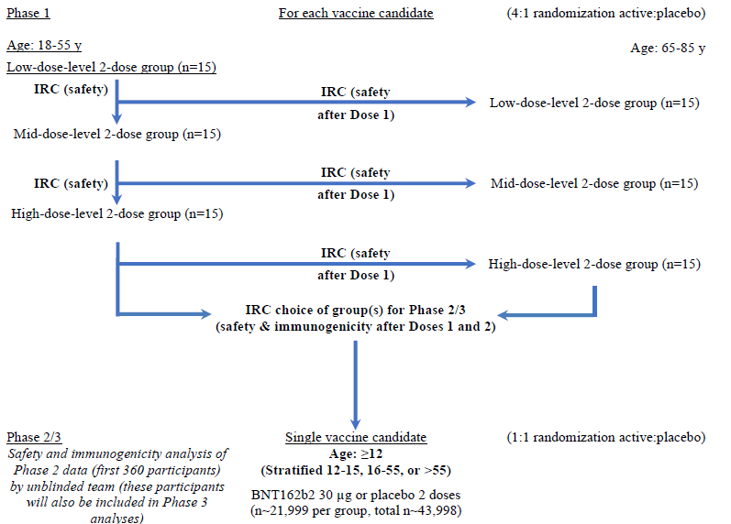

Phase I results

Overall, the immunogenicity responses were similar between the two vaccine candidates with robust SARS-CoV-2 neutralisation and antigen-specific immunoglobin G (IgG) antibody levels in both younger and older adults. Immune responses were generally stronger in the younger group. From before vaccination to seven days after second dose, all younger and most older participants at the 30 µg dose level who received BNT162b1 or BNT162b2 achieved a at least a 4-fold rise in SARS-CoV-2 50% neutralising titres. When selecting the dose for Phase II/III, the major driver was maximising SARS-CoV-2 neutralising antibody responses in the older age group, who are at highest risk of severe disease. Responses were evident after the first dose and substantially increased after the second dose. The results supported a two dose regimen for primary vaccination. The safety data demonstrated that the reactogenicity profile of BNT162b2 is more favourable than BNT162b1 in both younger and older adults. BNT162b2 at the 30 µg dose level was therefore selected for the Phase II/III part of the study.

Neutralising geometric mean titres (GMT) and S1-binding geometric mean concentrations (GMC) were evaluated at six months after second dose for the Phase I groups of participants who received BNT162b2 at 30 µg and corresponding placebo recipients. (Data cutoff of 13 March 2021). Among participants in both age groups, the observed SARS-CoV-2 serum 50% neutralising GMTs and S1-binding IgG GMCs declined from one month after second dose (Day 52) to six months after second dose (Day 202) but remained higher than placebo control levels. (Figure 2 and Figure 3) In the younger and older age groups, respectively, geometric mean fold rises (GMFR) of SARS-CoV-2 serum 50% neutralising titres from before vaccination with 30 µg BNT162b2 to each subsequent time point were 2.9 and 1.7 at Day 21 (before second dose); 17.9 and 15.2 at one month after second dose; 5.5 and 2.9 at six months after second dose. Results for GMFRs of S1-binding IgG concentrations reflected similar trends.

Figure : Geometric mean titres and 95% confidence intervals SARS-CoV-2 neutralisation assay Phase I, two doses, 21 days apart with BNT162b2 (30 µg) or placebo (evaluable immunogenicity population)

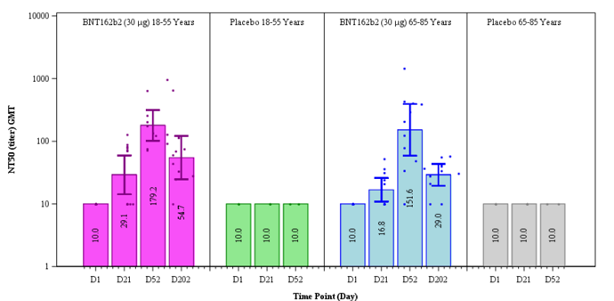

Figure : 50% neutralising titre and geometric mean concentrations and 95% confidence intervals S1-binding IgG level assay Phase I, two doses, 21 days apart with BNT162b2 (30 µg) or placebo (evaluable immunogenicity population)

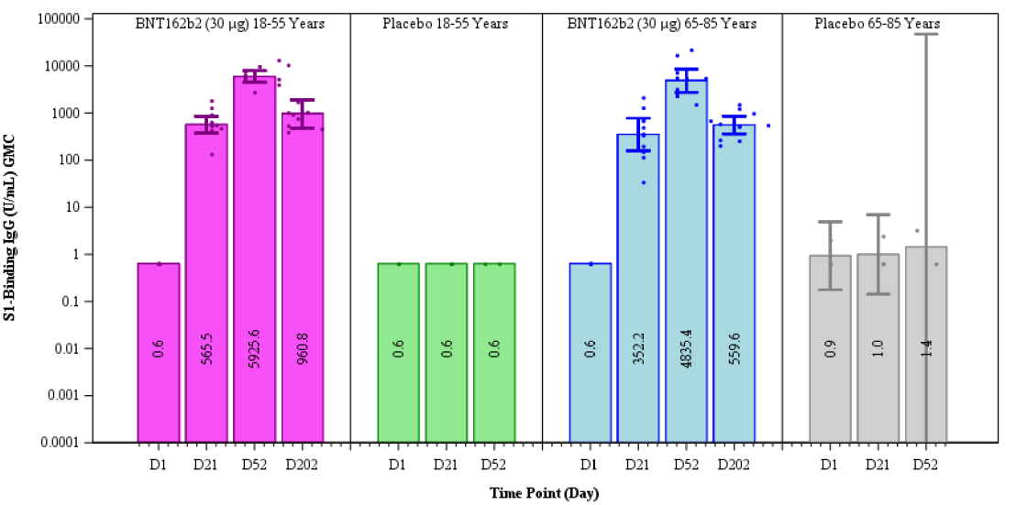

All participants who received 30 µg BNT162b2 completed the post second dose six months visit (most occurring during the open label follow up period). All those in the placebo group received both doses of BNT162b2 (third and fourth dose) during the open label period and completed the one month after fourth (as of 13 March 2021). Results in Phase I of Study C4591001 were similar to those from Study BNT162-01 with no new safety or tolerability concerns identified.

Phase II result

The 360 participants enrolled as part of Phase II were randomised equally to BNT162b2 and placebo groups (180 participants each). Among those in the BNT162b2 group, 88 participants were in the younger group (18 to 55 years of age) and 92 participants were in the older groups (56 to 85 years of age). Immunogenicity results demonstrated that BNT162b2 at 30 µg elicited robust SARS-CoV-2 neutralisation and S1-binding IgG antibody responses at one month after second dose, similar to those observed in Phase I part of the study. The neutralising titres and S1-binding GMCs were higher in the younger age cohort compared with the older age cohort. Phase II participants also contribute to the overall efficacy and safety assessments in the Phase III portion of the study.

Phase II/III vaccine efficacy analysis

Study C4591001 Phase II/III evaluated the safety and efficacy of BNT162b2 when administered as two doses of 30 µg given approximately 21 days apart. Study objectives and primary endpoints are shown in Table 5.

The trial included healthy participants of at least 12 years of age, stratified as follows: 12 to 15 years of age, 16 to 55 years of age, or older than 56 years of age. It was intended that a minimum of 40% of participants were to be enrolled in the older than 56 years of age stratum. Participants were randomised 1:1 to active vaccine or placebo.

Table : Phase II/III study objectives and primary efficacy endpoints

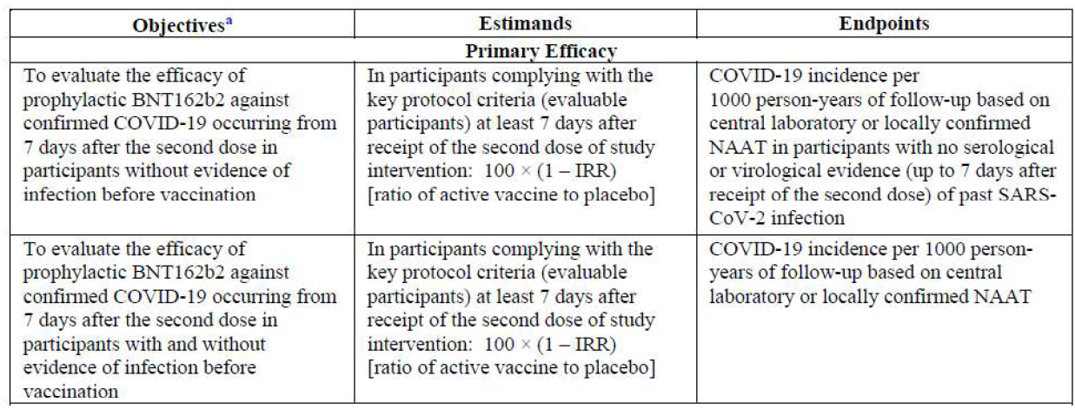

The prespecified interim analysis of efficacy was conducted after accrual of 94 confirmed COVID-19 cases (data cutoff: 4 November 2020), and the prespecified final analysis of efficacy was conducted once there were 170 confirmed COVID-19 cases (data cutoff date: 14 November 2020), based on cases in participants without prior evidence of SARS-CoV-2 infection before or during the vaccination regimen. These results were reported in the initial submission.8 Overwhelming efficacy success criteria were met on the first primary efficacy endpoint analysis timepoint (94 accrued COVID-19 cases). Analyses of 1165 confirmed cases in blinded placebo controlled follow up from first dose to data cutoff date (13 March 2021) evaluated duration of protection.

Given the demonstrated efficacy and subsequent authorisations/approvals granted in the US and elsewhere, unblinding to randomised treatment assignment occurred at such time that they became locally eligible for vaccination. For participants at least 16 years of age this commenced in December 2020, for those aged 16 or 17 years from May 2021. Recipients originally randomised to BNT162b2 continue to be followed in an open label manner. Those originally randomised to placebo were offered BNT162b2 vaccination and thereafter followed in an open label manner and moved to a new visit schedule to receive both doses of BNT162b2.

Key data groups (efficacy and safety) are as follows are outlined in Figure 4.

Blinded placebo controlled period, first dose to 1 month after second dose and to unblinding date:

* Phase I participants randomised to 30 µg BNT162b2 (to about six months after second dose)
* Phase II/III participants years of age (to about 5 months after second dose)

Open label observational period: from unblinding data to data cutoff date:

* Phase II/III participants originally randomised to BNT162b2
* Phase II/III participants originally randomised to placebo who received BNT162b2 after unblinding

Cumulative follow up first dose to six months after second dose (inclusive: blinded and open label data) comprised of at least 3000 in each age group (16 to 55 years of age, older than 55 years of age)

Figure :Study C4591001 Phase II/III safety analyses: time periods and analysis groups

Study C4591001 Phase II/III safety analyses: time periods and analysis groups

1 will vary by participant. Adverse event data analysed from first dose to unblinding data (on or after 14 December 2020), or from unblinding date to data cutoff date, are reported as incidence rates adjusted for exposure time

2 Up to about 6 months after second dose

3 Cumulative BNT162b2 follow up to at least 6 months after second dose.

Of 46,429 people randomised, 98% received at least one dose of vaccination, and at least 91% were included in the efficacy evaluation, having received two doses of vaccination and without (BNT162b2: n = 21069, placebo: n = 21175) or with or without (BNT162b2: n = 22166, placebo: n= 22320) evidence of infection prior to seven days after second dose. Most participants who were excluded from the evaluable efficacy population had not received vaccinations as randomised or did not receive second dose within the predefined window (19 to 42 days after first dose). There were 240 participants in the BNT162b2 group and 60 participants in the placebo group excluded, most of these deviations were related to improper administration of the investigational product (203 in BNT162b2 group; 23 in the placebo group).

The efficacy population include 83% White, 8.5 % Black or African American, 4.5 % Asian, and 24.8 % Hispanic/Latino participants. The median age was 50 years and participants were balanced for gender. There were 4.7% of participants aged 12 to 15 years of age, 55.6% aged 16 to 55 years of age and 39.5% over 55 years of age. There were 44.5% of participants who had baseline comorbidities. Demographic characteristics for the first dose all available efficacy population and for participants with or without evidence of infection prior to seven days after second dose (evaluable efficacy [seven days] population) were similar to the evaluable efficacy population and were similar in the BNT162b2 and placebo groups.

Among participants without evidence of SARS-CoV-2 infection before and during the vaccination regimen, the estimated vaccine efficacy against confirmed COVID-19 occurring at least seven days after second dose was 91.3%, with 77 COVID-19 cases in the BNT162b2 group compared to 850 cases in the placebo group. The two sided 95% confidence interval (CI) for vaccine efficacy was 89% to 93.2%. Among participants with or without evidence of SARS-CoV-2 infection before and during the vaccination regimen, estimated vaccine efficacy against confirmed COVID-19 occurring at least seven days after second dose was 91.1%, with 81 and 873 cases in the BNT162b2 and placebo groups. The two sided 95% CI for vaccine efficacy was 88.8% to 93%.

All reports of COVID-19 with onset at any time after first dose are shown in Table 6. The estimated vaccine efficacy against confirmed COVID-19 occurring after first dose was 87.8% (two sided 95% CI: 85.3%, 89.9%). Figure 5 shows the cumulative incidence for the first COVID-19 occurrence after first dose. Disease onset appears to track together for BNT162b2 and placebo until approximately 11 days after first dose.

Table : Vaccine efficacy, first COVID-19 occurrence after first dose blinded placebo controlled follow up period (first dose all available efficacy population)

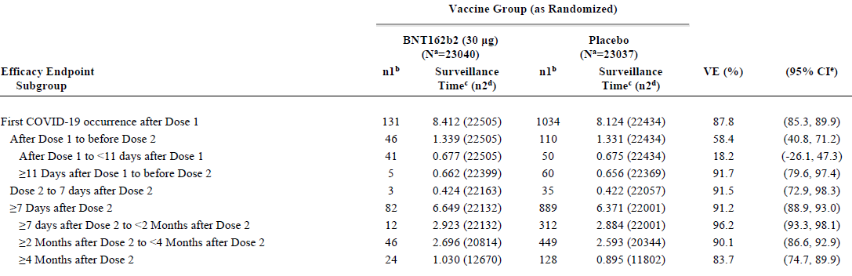

a N = number of subjects in the specified group. b n1 = Number of subjects meeting the endpoint definition. c Total surveillance time in 1000 person-years for the given endpoint across all subjects within each group at risk for the endpoint. Time period for COVID-19 case accrual is from Dose 1 to the end of the surveillance period. d n2 = Number of subjects at risk for the endpoint. e Confidence interval (CI) for vaccine efficacy is derived based on the Clopper and Pearson method adjusted for surveillance time.

Figure : Cumulative incidence curves for the first COVID-19 occurrence after first dose blinded placebo controlled follow up period (first dose all-available efficacy population)

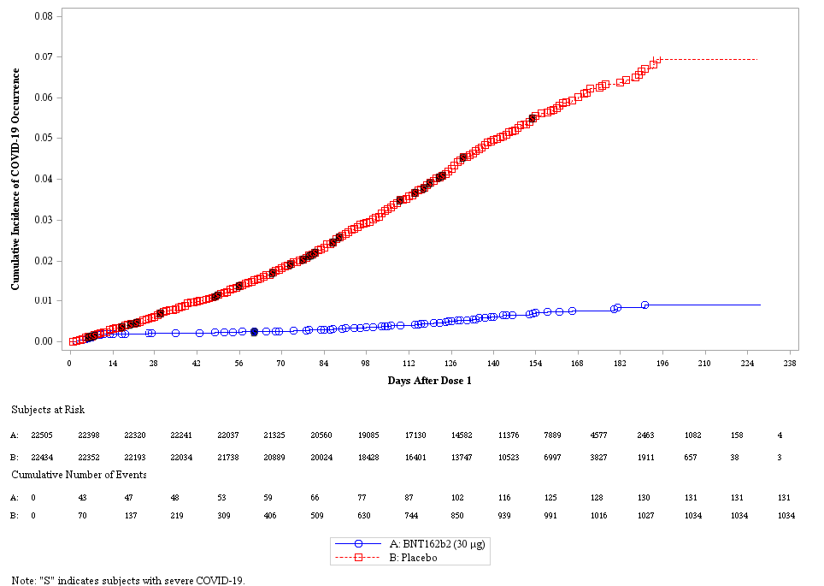

For both primary endpoints, vaccine efficacy was also evaluated for subgroups of participants by age, sex, race, ethnicity, country, baseline SARS-CoV-2 status, obesity, and comorbidity. Overall, the results show high vaccine efficacy across the subgroups. In the evaluable efficacy population among participants without and with or without evidence of SARS-CoV-2 infection before and during the vaccination regimen, the estimated vaccine efficacy was at least 90% in most subgroups, similar to the estimated overall vaccine efficacy.

Among participants without or with or without evidence of SARS-CoV-2 infection before and during the vaccination regimen, the estimated vaccine efficacy against Centers for Disease Control and Prevention (CDC) (United States of America) defined severe COVID-19 (hospitalisation, admission to the intensive care unit, intubation, mechanical ventilation, or death) occurring at least seven days after second dose was 100% (two sided 95% CI: 88.1%, 100%), with 0 and 32 cases in the BNT162b2 and placebo groups, respectively. One case of CDC defined severe COVID‑19 occurred after first dose in the BNT162b2 group (before second dose) compared to 45 cases in the placebo. The estimated vaccine efficacy against severe CDC-defined COVID-19 occurring after first dose was 97.8% (two sided 95% CI: 87.2%, 99.9%).

Immunogenicity

In Study C4591001, immunogenicity was evaluated in adults enrolled in Phase I and Phase II as described in the relevant sections above.

For the adolescent population 12 to 15 years of age (Phase III), an immunogenicity objective demonstrating non inferiority of the immune response to BNT162b2 in those 12 to 15 years of age compared to 16 to 25 years of age who had no serological or virological evidence of past SARS-CoV-2 infection was conducted. This occurred to support the extension of indication to this age group.

A random sample of 280 participants who received BNT162b2 and 50 participants who received placebo was selected for each of the two age groups (660 participants total) as an immunogenicity subset for immunogenicity assessment. Immune response to BNT162b2 in SARS-CoV-2 50% neutralising titres in adolescents 12 to 15 years of age was noninferior to the that in those 16 to 25 years of age. Substantial increases over baseline in neutralising GMTs and high seroresponse rates were observed at one month after second dose in both age groups, which were observed for participants with baseline SARS-CoV-2 positive and negative status. The majority of BNT162b2 recipients in both age groups achieved a at least 4-fold rises from before vaccination to one month after second dose.

Safety

Safety data were analysed and reported separately by age groups (adolescents 12 to 15 years of age, 16 to 55 years of age, over 55 years of age). The safety population for those at least 16 years of age included 44,050 participants (22,026 in BNT162b2 group, 22,021 in placebo group), and for those 12 to 15 years old included 2260 participants (1131 in BNT162b2 group, 1129 in placebo group). Table 7 and Table 8 summarises the duration of follow up.

Table : Follow-up time after second dose Phase II/III subjects safety population in at least 16 years of age (data cutoff: 25 March 2021)

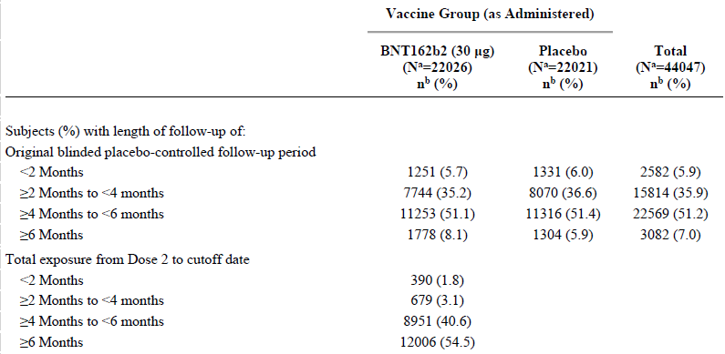

Table : Follow-up time after second dose Phase II/III subjects safety population in 12 to 15 years of age (data cutoff: 27 September 2021)

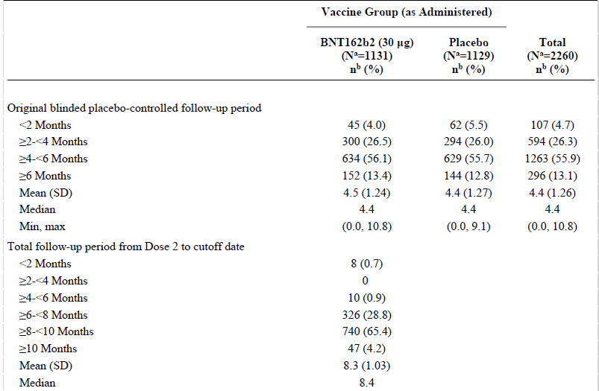

Findings from the safety data show that from the 44,050 participants at least 16 years of age, and 2260 participants 12 to 15 years of age with up to at least six months of follow up after second dose in Study C4591001, BNT162b2 at 30 µg was safe and well tolerated across age groups. Most AEs were reflective of reactogenicity events with low incidences of severe and/or related events. The most common prompted local reaction was injection site pain. The most common prompted systemic events reported in Phase II/III included fatigue, headache, muscle and joint pain, and chills. The incidence of serious adverse events (SAE) was low and similar in the vaccine and placebo groups. Few participants withdrew from the study due to AEs. Few deaths occurred overall in both the vaccine and placebo groups with no imbalance.

Reactogenicity and AEs were generally milder and less frequent in the older compared with the younger groups. Reactogenicity was mostly mild to moderate and short-lived (median onset 1 to 4 days, resolution 1 to 2 days). The AE profile did not suggest any serious safety concerns. The incidence of SAEs, deaths, and discontinuations due to AEs were generally low and comparable in BNT162b2 and placebo groups. Adolescent 12 to 15 years of age) safety data were generally concordant with reported adult safety data (at least 16 years of age) in Phases I to III of the study.

Safety analysis results for subgroups based on demographic (age, race, ethnicity, sex) or baseline SARS-CoV-2 status (positive/negative) did not show any clinically important differences in BNT162b2 safety profile for the duration of the blinded follow up. However younger participants experienced more AEs than older participants; females experienced more AEs than males; and Black or African American participants reported fewer AEs than White or Hispanic/Latino participants overall, but rates of SAEs, AEs/SAEs leading to withdrawals, and deaths were equivalent among sub-groups.

Post-authorisation safety data through to 28 February 2021, showed 42,086 case reports (25,379 medically, 16,707 non-medically confirmed) containing 158,893 events, from 63 countries. Consistent with Phase II/III of Study C4591001, most reported AEs were reactogenicity events and included: general disorders and administration site conditions (51,335), nervous system disorders (25,957), musculoskeletal and connective tissue disorders (17,283), and gastrointestinal disorders (14,096). Post-authorisation data has not revealed any new safety concerns except for anaphylaxis.

##### Primary vaccination in subjects at least 5 to 11 years, and at least 6 months to 4 years

###### Study C4591007

This randomised, placebo controlled, Phase I/II/III study, in healthy children was designed to evaluate BNT162b2 vaccination in an age de-escalation Phase I dose finding part, and Phase II/III selected dose part. The protocol defined age groups are: 5 to younger than 12 years of age, 2 to younger than 5 years of age, and 6 months to younger than 2 years of age. The immunogenicity, efficacy, and safety estimates and endpoints used in this study were consistent with those used in Study C4591001. The basis of demonstrating BNT162b2 effectiveness in children is immune response data, via immunobridging to young adult participants in Study C4591001.

In Study C4591007, efficacy against confirmed COVID-19 is assessed by continuous surveillance. For study schema see Figure 6. The first participants were randomised on 24 March 2021 (aged at least 5 to younger than 12 years of age) and 21 June 2021 (6 months to younger than 5 years of age). Data from these studies have been submitted and evaluated previously (PM 2022-03129-1-2 PM-2021-0501201-1-2). 9,15 A summary is provided here.

Figure : Study schema for Phase I dose finding and Phase II/III selected dose

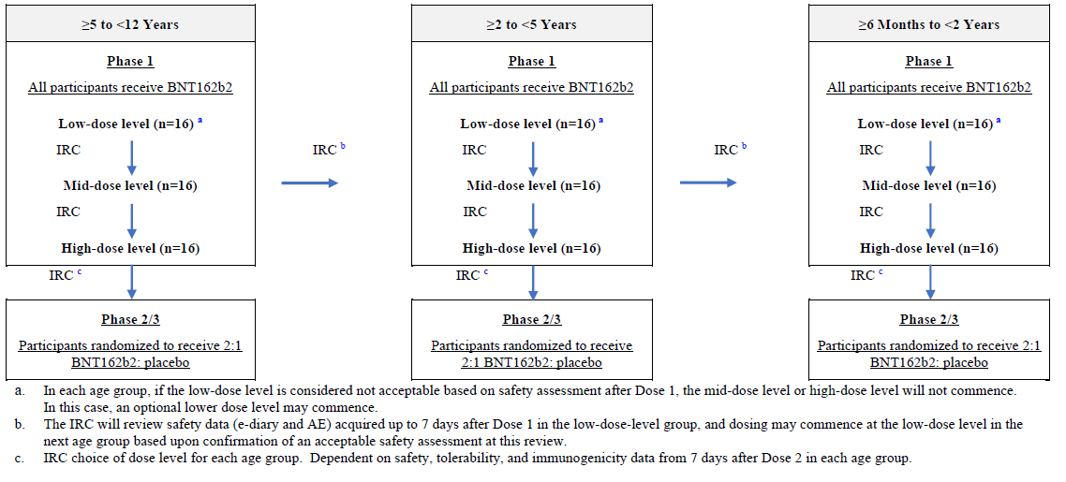

a In each age group, if the low dose level is considered not acceptable based on safety assessment after Dose 1, the mid-dose level or high dose will not commence. In this case, an optional lower dose level may commence.

b The IRC will review safety data (e-dairy and AE) acquired up to 7 days after first dose in the low-dose level group, and dosing may commence at the low dose level in the next age group based upon confirmation of an acceptable safety assessment at this review.

c IRC choice of dose level for each group. Dependent on safety, tolerability, and immunogenicity data from 7 days after second dose in each age group.

Phase I results

In the open label dose level finding part of the study, conducted in the US, dose levels were tested in healthy sentinel cohorts of children (16 participants per dose level) by age de‑escalation, starting with the lowest dose level in the oldest age group. This was a two dose schedule of up to three dose levels (10, 20 or 30 µg) of BNT162b2 mRNA given 21 days apart as a primary series. For each age group, the dose level identified as safe, tolerable, and immunogenic in Phase I was selected for Phase II/III. (Figure 6)

The doses tested in each age group during Phase I were as follows:

* 5 to younger than 12 years of age: dose levels 10, 20, 30 µg – selected dose level 10 µg
* 2 to younger than 5 years of age: dose levels 3, 10 µg – selected dose level 3 µg
* 6 months to younger than 2 years of age: dose level 3 µg – selected dose level 3 µg

In the at least 5 to younger than 12 years of age group, although 16 participants received a first dose at the 30 µg dose level, after four had received their second 30 µg dose, it was recommended that a second dose of 30 µg not be administered due to reactogenicity for these 4 participants. The remaining 12 participants in this group instead received a second dose of BNT162b2 at the 10 µg dose level.

In the 5 to younger than 12 years of age group, at Day 7 post second dose, the GMTs were similar across tested dose levels: 4162.6 (95% CI: 2584.7, 6704) in the 10 µg and 4583.4 (95% CI: 2802.9, 7494.8) in the 20 µg group.

In the 2 to younger than 5 years of age, at Day 7 post second dose, the GMTs were: 1350.4 (two sided 95% CI: 973.1, 1873.9) in the 3 µg group and 2059.5 (two sided 95% CI: 1679.1, 2526) in the 10 µg group.

In the 6 months to younger than 2 years of age group at Day 7 post second dose (3 µg dose), GMTs were: 1643.8 (two sided 95% CI: 1151.3, 2347.1).

Safety was the sole primary outcome for Phase I of this study and was assessed by dose level up, to one month after second dose and/or to the data cutoff date of 16 July 2021 for those at least 5 to younger than 12 years of age, and 29 April 2022 for those 6 months to younger than 5 years of age.

In the at least 5 to younger than 12 years of age cohort

For local reactogenicity, both the 10 and 20 µg doses were well tolerated with similar frequencies of reactions; however, the intensity of pain at the injection site was higher for the 20 µg dose post first and second dose. Frequencies and intensities were higher for the four participants given the 30 µg dosing for both doses compared to the lower dose as second dose. Median onset for most local reactions was within 1 to 2 days after first or second dose and most events resolved within one or two days of onset.

For systemic reactogenicity, there were generally higher frequencies and/or intensities in the 20 µg group compared to the 10 µg group, with frequencies and intensities slightly higher for fever, fatigue, headache, and chills post second dose in the 10 µg group; a similar pattern was seen following 20 µg, with the exception of fatigue

No serious adverse events, adverse events of special interest, deaths, or AEs leading to withdrawal were reported.

In the 6 months to younger than 5 years of age cohort

For children 2 to younger than 5 years of age, higher frequencies, and greater severity of reactogenicity to the 10 µg dose level in comparison to the 3 µg dose level was observed. Local and systemic reactions were generally mild or moderate in severity, and short-lived. No Grade 4 events were reported

Based on the reactogenicity profile observed in the 2 to younger than 5 years of age group, BNT162b2 at the 3 µg dose level only this dose was tested in the 6 months to younger than 2 years of age group. The 3 µg dose level was well tolerated with mild to moderate events, which were short lived.

No SAEs, AE of special interest, deaths, or AEs leading to withdrawal were reported in Phase I participants 2 to younger than 5 years or 6 months to younger than 5 years of age.

Phase II/III result

In Phase II/III of Study C4591007, conducted at sites in the US, Finland, Poland, and Spain participants were randomised 2:1 to receive vaccine or placebo. Phase II/III evaluated BNT162b2 at the selected dose levels for each age group for safety and tolerability, immunogenicity, and efficacy (depending on meeting success criteria for immunobridging and accrual of a sufficient number of COVID-19 cases).

An immunobridging analysis (non-inferiority) was designed to compare SARS-CoV-2 neutralising antibody responses in paediatric participants within each age group in Study C4591007 to a group of young adult participants 16 to 25 years of age in the Study C4591001 efficacy study (Table 9). A supportive vaccine efficacy analysis was planned following accrual of a suitable number of COVID 19 cases (19 in the 5 to younger than 12 years of age, 21 cases for the combined 2 to younger than 5 years, and 6 months to younger than 2 years of age groups) among participants without serological or virological evidence (prior to 7 days after receipt of second dose) of past SARS-CoV-2 infection and if success criteria for immunobridging had also been met.

In Phase II/III of the study a total of approximately 2250 subjects (1500 active, 750 placebo) in the 5 to younger than 12 years of age, and 4526 participants aged 6 months to younger than 5 years of age (6 to 23 months, n = 1776, 2 to 4 years of age, n = 2750) were randomised to receive two doses of vaccine (10 µg for subjects aged 5 to younger than 12 years of age, 3 µg for subjects aged 6 months to younger than 5 years of age) or placebo, 3 weeks apart. An additional 2250 subjects in the 5 to younger than 12 years of age group were to be enrolled and randomised (1500 active, 750 placebo) as safety expansion subset, and a further 750 participants will be enrolled to obtain serum samples for Troponin I testing (as a marker for myocarditis).

For the Phase II/III parts of the study participants with medical conditions such as stable Type 1 diabetes or hypothyroidism; stable and controlled human immunodeficiency virus, hepatitis C virus, or hepatitis B virus infection; and past serological or microbiological evidence of prior (not active) SARS-CoV-2 infection were included.

Table : Study C4591007 Efficacy and immunogenicity variables and outcomes

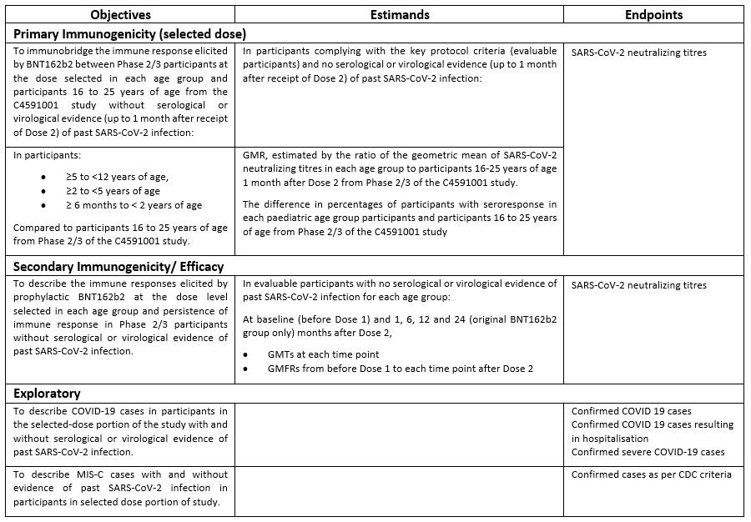

Blood samples for assessment of the immune response were to be collected from about 450 participants in each age group (300 in vaccine; 150 in placebo) immediately before first dose, one month after second dose (immunobridging analysis), and six months after second dose (persistence of the immune response). Blood samples are also to be collected from a subset of approximately 70 participants originally randomised to BNT162b2 for evaluation of antibody persistence at 12 and 24 months after second dose (Table 10).

Table : Study C4591007 Phase II/III participants, blood draws for immunogenicity/efficacy assessments

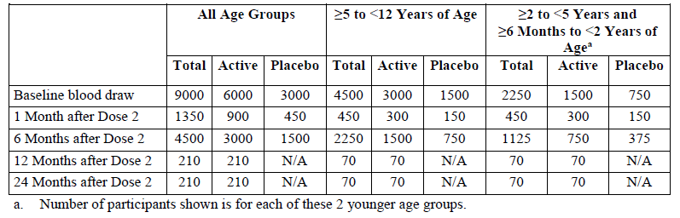

The paediatric vaccination series for children 6 months to younger than 5 years of age was initially planned as a two-dose series given three weeks apart; however, based on immunobridging, emerging clinical and real world data (including emergence of the Omicron variant), the protocol was amended to add a third dose given at least eight weeks after the second dose.

All Phase II/III study participants could be unblinded at the six month follow up visit. Participants who received placebo were offered the BNT162b2 (at the age appropriate dose at the time of vaccination).

Primary endpoints and statistical immunobridging success criteria were evaluated sequentially in the following order:

* Immunobridging success based on GMT was declared if the lower limit of the 95% CI for the GMT ratio (paediatric age group/16 to 25 years of age) was greater than 0.67, and the point estimate of the GMT ratio was at least 1.
* Immunobridging success based on the seroresponse rate was declared if the lower limit of the 95% CI for the difference in seroresponse rates (paediatric age group minus 16 to 25 years of age) was at least 10%.
* Seroresponse was defined as a at least 4-fold rise in SARS-CoV-2 50% neutralising titres from before vaccination (pre-first dose) to one month after second or third dose.

Vaccine efficacy is to be estimated by 100 x (1 – IRR) where incidence rate ratio (IRR) is the calculated ratio of confirmed COVID-19 per 1000 person-years of follow up in the BNT162b2 group to the corresponding rate in the placebo group at the specified time point of interest. Incidence rates for the first reported COVID-19 illness during a fixed calendar time interval were determined using the same approach, except unblinding was not considered as the end of the surveillance period.

Immunogenicity result

Among randomised participants most of received two doses of vaccine, and almost all received their second dose with the defined timeframe (19 to 23 days following first dose). In the participants younger than 5 years of age, the median timing of third dose administration after second dose of BNT162b2 for 6 to 23 months was 11 weeks (range: 8.6 to 20 weeks) and for 2 to 4 year old group was 10.7 weeks (range: 8.6 to 15.6 weeks), and approximately 33% had received three doses as of the 29 April 2022.

In all the groups of children, approximately half were male, most were White (greater than or equal to 69% in each group), and 11 to 19% were Hispanic/Latino. Most children were enrolled in the US. Obese children (based on age and sex-specific indices) made up 10.9% of the total evaluable efficacy population in the older children and 6% in those aged 2 to younger than 5 years of age. Comorbidities present at Baseline that increase the risk of severe COVID-19 disease were present in 20.1% of older, and 6 to 10% in the younger age groups. The overall demographics of Phase II/III paediatric participants in all groups were similar for the BNT162b2 and placebo groups in the evaluable efficacy population of participants with or without prior evidence of SARS-CoV-2 infection prior to 7 days after second dose, and in the All available efficacy populations.

Children: 5 to younger than 12 years of age

* *Primary immunogenicity*: The geometric mean ratio (GMR) of 5 to 11 years of age subjects’ GMTs relative to those of 16 to 25 years of age subjects was 1.04 (95% CI: 0.93, 1.18). This met the immunobridging objective for success, with the lower bound of the 95% CI being greater than 0.67 and the point estimate at least 0.8 (it was also at least 1 as preferred by the US FDA).
* *Difference in seroresponse rates:* Difference in seroresponse rates in children 5 to 11 years and young adults 16 to 25 years age was 0% (95% CI: -2%, 2%). The lower limit of the 95% CI for the difference in seroresponse rate was -2%, which is greater than the prespecified margin of -10%. Therefore, immunobridging based on seroresponse rate was achieved.
* *Seroresponse rates:* Among participants without prior evidence of SARS-CoV-2 infection up to one month after second dose, proportions of participants who achieved seroresponse in SARS-CoV-2 50% neutralising titres one month after second dose of BNT162b2 was the same (99.2%) in children 5 to younger than 12 years of age and young adults. Very few placebo participants (less than 1.5%) in either age group reached seroresponse at one month after second dose.
* *Geometric mean neutralising titres:* GMT responses were very similar in the 5 to 11 years age groups and 16 to 25 years age groups and are shown graphically in Figure 7. GMTs in the evaluable and all-available immunogenicity populations with or without evidence of infection up to one month post second dose were similar to those from the primary analysis population.
* *Geometric fold rises*: These were similar in the 5 to 11 years age and 16 to 25 age groups, when comparing rises from Baseline to one month post second dose (118.2 versus 111.4 respectively). In placebo recipients, there was no rise as expected (1.0 versus 1.1 respectively).

Children: 2 to younger than 5 years of age

* Primary immunogenicity:
  + *The* GMR of those who received 3 µg BNT162b2 to young adults 16 to 25 years of age who received 30 µg BNT162b2 at one month post second dose was 0.61 (two sided 95% CI: 0.53, 0.7). The lower bound of the two sided 95% CI for GMR was less than 0.67 and the GMR point estimate was less than 0.8, indicating the prespecified success criteria for the GMR were not met; therefore, immunobridging was not achieved.
  + Among participants 2 to younger than 5 years of age (at one month post third dose of 3 µg BNT162b2) compared to young adults 16 to 25 years of age (at one month post second dose of 30 µg BNT162b2) was 1.3 (two sided 95% CI: 1.13, 1.5). The lower bound of the two sided 95% CI for GMR was greater than 0.67 and the GMR point estimate was greater than 0.8 (protocol specified criterion) and greater than 1 indicating the prespecified immunobridging success criterion for the GMR was met.
* *Difference in seroresponse rates*
  + The difference in proportions who achieved seroresponse among children 2 to younger than 5 years of age (at one month post third dose of 3 µg BNT162b2) compared to young adults 16 to 25 years of age (at one month post second dose of 30 µg BNT162b2) was 1.2% (two sided 95% CI: -1.5%, 4.2%) The lower limit of the two sided 95% CI for the difference in seroresponse rate was greater than -10%, and the immunobridging success criterion based on the GMR was achieved, indicating the prespecified immunobridging success criterion was met.
* *Seroresponse rates*
  + Among children 2 to younger than 5 years of age in the evaluable immunogenicity population without evidence of prior SARS-CoV-2 infection, the seroresponse rate at one month post third dose was 100% (two sided 95% CI: 97.4%, 100%). In the comparator group 16 to 25 years of age, the seroresponse rate at one month post second dose was 98.8% (two sided 95% CI: 95.8%, 99.9%).
* *Geometric mean neutralising titres*: Among children 2 to younger than 5 years of age in the evaluable immunogenicity population without evidence of prior SARS-CoV-2 infection, the observed GMT before vaccination (20.7) was still robust at post second dose and prior to third dose (401.1), and then substantially increased at one month post third dose (1535.2) (Figure 8). In the 16 to 25 years of age, the GMT before vaccination (21.3) was substantial increased at one month post second dose (1180).
* *Geometric fold rises*: Among those 2 to younger than 5 years of age in the evaluable immunogenicity population without evidence of prior SARS-CoV-2 infection, the GMFR of SARS-CoV-2 50% serum neutralising titres from before vaccination to one month post third dose was 73.3 (two sided 95% CI: 66.3, 81.1) In the comparator group of young adults 16 to 25 years of age, the GMFR of SARS-CoV-2 50% serum neutralising titres from before vaccination to one month post second dose was 55.3 (two sided 95% CI: 49.6, 61.6).

Children: 6 Months to younger than 2 years of age

* Primary immunogenicity:
  + The GMR of children 6 months to younger than 2 years of age who received 3 µg BNT162b2 to young adults 16 to 25 years of age who received 30 µg BNT162b2 was 1.03 (two sided 95% CI: 0.9, 1.19). The lower bound of the two sided 95% CI for GMR was greater than 0.67 and the GMR point estimate was greater or equal to 0.8 (per protocol) and greater or equal to 1 meeting immunobridging success criteria.
  + Among participants at one month post third dose of BNT162b2 compared to young adults 16 to 25 years of age (at one month post second dose of 30 µg BNT162b2) was 1.19 (two sided 95% CI: 1, 1.42) indicating immunobridging success criterion for the GMR was met.
* Difference in seroresponse rates:
  + In this population, 98% of children 6 months to younger than 2 years of age and 96.2% of young adults 16 to 25 years of age achieved a at one month post second dose with a difference between age groups (children – young adults) of 1.7% (two sided 95% CI: -1.4%, 5.2%). At one month post third dose of 3 µg BNT162b2) compared to 16 to 25 years of age (at one month post second dose of 30 µg BNT162b2) was 1.2% (two sided 95% CI: -3.4%, 4.2%)
* Seroresponse rates
  + Among children 6 months to younger than 2 years of age in the evaluable immunogenicity population without evidence of prior SARS-CoV-2 infection, the seroresponse rate from before vaccination to one month post third dose was 100% (two sided 95% CI: 95.5%, 100%). In the comparator group of young adults, the seroresponse rate from before vaccination to one month post second dose was 98.8% (two sided 95% CI: 95.8%, 99.9%).
* Geometric mean neutralising titres:
  + Among those 6 months to younger than 2 years of age without evidence of prior SARS-CoV-2 infection, the observed GMT before vaccination (20.8) was increased at post second dose and prior to third dose (317.0), and then substantially increased at one month post third dose (1406.5). In the comparator group 16 to 25 years of age, the observed GMT before vaccination (21.3) was substantially increased at one month post second dose (1180). (Figure 9)
* Geometric fold rises
  + Among those 6 months to younger than 2 years of age in the evaluable immunogenicity population without evidence of prior SARS-CoV-2 infection, the GMFR of SARS-CoV-2 50% serum neutralising titres from before vaccination to one month post third dose was 68.4 (two sided 95% CI: 58.2, 80.4). The GMFR from before third dose to one month post third dose was 4.4 (2-sided 95% CI: 3.8, 5.2). In the comparator group the GMFR of SARS-CoV-2 50% serum neutralising titres from before vaccination to one month post second dose was 55.3 (two sided 95% CI: 49.6, 61.6).

Figure : Study C4591007 Phase II/III Geometric mean titres and 95% confidence intervals SARS-CoV-2 neutralisation assay, 50% neutralisation titre, participants without evidence of infection - immunobridging subset, 5 to 12 Years of age (1 month after second dose), and Study C4591001 Phase II/III 16 to 25 years of age (1 month after second dose) (evaluable immunogenicity population)

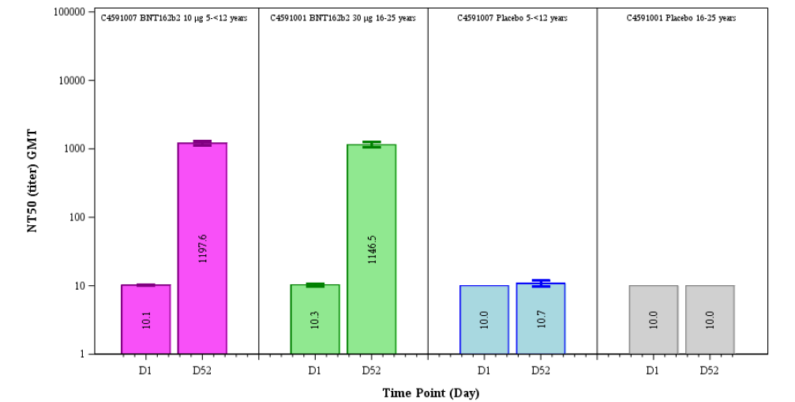 For the 5 to < 12 years of age, N= 264 subjects in the BNT162b2 group and 130 subjects in the placebo group, and for 16 to 25 years age, 253 subjects in the BNT162b2 group and 45 subjects in the placebo group.

Figure : Study C4591007 Phase II/III Geometric mean titres and 95% confidence intervals SARS-CoV-2 neutralisation assay, 50% neutralisation titre, participants without evidence of infection - immunobridging subset: 2 to younger than 5 years of age (one month after third dose) and Study C4591001 Phase II/III 16 to 25 years of age (1 month after second dose) (evaluable immunogenicity population)

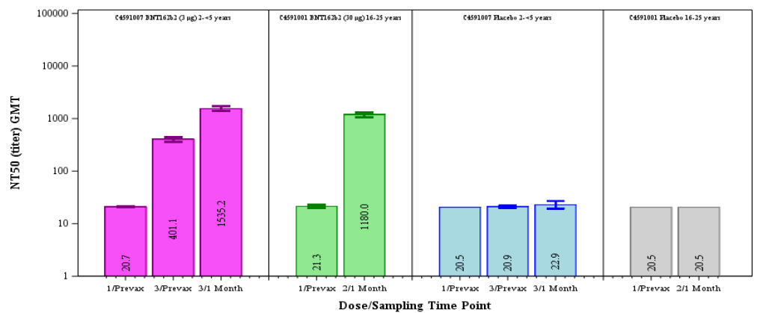

For the 2 to < 5 years of age who received 3 doses of vaccine, N = 143 subjects in the BNT162b2 group and 59 subjects in the placebo group, and for 16 to 25 years age, 170 subjects in the BNT162b2 group and 38 subjects in the placebo group.

Figure : Study C4591007 Phase II/III Geometric mean titres and 95% confidence intervals SARS-CoV-2 neutralisation assay, 50% neutralisation titre, participants without evidence of infection - immunobridging subset: 6 months to younger than 2 years of age (one month after third dose) and Study C4591001 Phase II/III 16 to 25 years of age (1 month after second dose) (evaluable immunogenicity population)

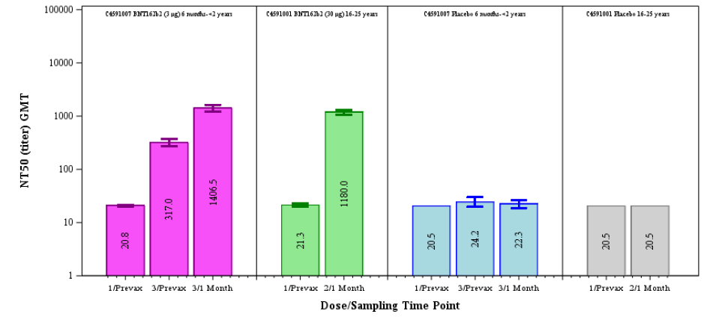 For the 6 months to < 2 years of age who received 3 doses of vaccine, N = 82 subjects in the BNT162b2 group and 49 subjects in the placebo group, and for 16 to 25 years age, 170 subjects in the BNT162b2 group and 38 subjects in the placebo group.

Generally, subgroup analyses based on demographic characteristics at Baseline generally showed no meaningful differences in the immunogenicity profile. The subgroup with evidence of prior SARS-CoV-2 infection at Baseline (‘baseline positive’) generally had higher neutralising titres both at Baseline (pre-vaccination) and post-vaccination compared with the ‘baseline negative’ subgroup, which is predictable in the setting of vaccinating after prior exposure. It is important to note that in some subgroups there were a limited number of participants.

##### SARS-CoV-2 neutralising titres for Omicron and Delta variants

A supplemental analysis of neutralising responses to Delta was conducted in 38 randomly selected subjects 5 to 11 years age from the immunogenicity subset of the Phase II/III study (n = 34 in the BNT162b2 group and n = 4 in the placebo group). GMTs increased for both the reference and Delta strains after two doses of 10 µg BNT162b2. The GMT at one month after second dose against the reference strain was 365.3 (95% CI: 279, 478.4), and against the Delta variant strain was 294.9 (95% CI: 214.6, 405.3). The pre-first dose GMT in both the BNT162b2 and placebo vaccinated groups was 10 (95% CI: 10, 10). The GMFR against reference strain was 36.5 (95% CI: 27.9, 47.8) and against Delta variant strain was 29.5 (95% CI: 21.5, 40.5). The GMR of responses against Delta variant versus reference strain was 0.81 (95% CI: 0.65, 1).

Among 34 children 2 to younger than 5 years of age without evidence of prior SARS-CoV-2 infection who received three doses of 3 µg BNT162b2, neutralising GMTs prior to vaccination with third dose against Delta (68) and Omicron (14) were increased at one month post third dose with respect to both Delta (471.4) and Omicron (82.5) Correspondingly, increases were also observed for the reference strain from before third dose (70.1) to one month post third dose (471.4). There was an observed 6.9-fold increase in Delta and 5.9-fold increase in Omicron neutralising titres from before third dose to one month post third dose. The GMFR for the reference strain from before third dose to one month post third dose was 6.7.

Among 32 children 6 months to younger than 2 years of age without evidence of prior SARS-CoV-2 infection who received three doses of 3 µg BNT162b2, neutralising GMTs prior to vaccination with third dose against Delta (94.1) and Omicron (16.3) were increased at one month post third dose with respect to both Delta (606.3) and Omicron (127.5) Increases were also observed for the reference strain from before third dose (103.7) to one month post third dose (640). There was a 6.4-fold increase in Delta and 7.8-fold increase in Omicron neutralising titres from before third dose to one month post third dose. The GMFR for the reference strain from before third dose to one month post third dose was 6.2.

Similar patterns were observed for 40 adults 18 to 55 years of age without evidence of prior SARS-CoV-2 infection who received three doses of 30 µg BNT162b2, for whom neutralising GMTs prior to vaccination with third dose against Delta (36.4) and Omicron (12.7) were increased at one month post third dose with respect to both Delta (1153.6) and Omicron (340) titres. Increases were also observed for the reference strain from before third dose (33.9) to one month post third dose (1067.1). (There was an observed 31.7-fold increase in Delta and 26.7-fold increase in Omicron neutralising titres.

##### Vaccine efficacy

Vaccine efficacy was estimated for age groups: 6 months to younger than 2 years of age, 2 to 4 years, for all aged 6 months to younger than 5 years, and for 5 to younger than 12 years of age. Data cut off was cutoff date 8 October 2021 for 5 to younger than 12 years of age and 29 April 2022 for those 6 months to younger than 2 years of age.

###### Children aged 5 to younger than 12 years of age

Vaccine efficacy analyses for this group were pre-specified to occur when at least 22 confirmed COVID-19 cases had accrued in subjects without serological or virological evidence of past SARS-CoV-2 infection prior to seven days post second dose.

A preliminary report of efficacy data (at data cutoff date) was provided after 19 confirmed cases of COVID-19 had accrued. In this population of 1910 participants, there was a vaccine effiacacy (at least seven days after second dose) of 90.7% (95% CI: 67.7%, 98.3%) in the evaluable efficacy population without prior evidence of SARS-CoV-2 infection before or during the vaccination regimen. As there were no additional COVID-19 cases in the population with or without prior evidence of SARS-CoV-2 infection the vaccine efficacy was the same. The observed vaccine efficacy of BNT162b2 10 µg against any confirmed COVID-19 from first dose through the data cutoff date was 91.4% (95% CI: 70.4%, 98.4%).

The Kaplan-Meier curve of case accrual shows a steady acquisition of the cases in the placebo (beginning about three weeks post-first dose) and sporadic occurrence in the vaccine group (Figure 10).

There were no cases of severe COVID-19 (per-protocol or per CDC definition) and no cases of multisystem inflammatory syndrome of children (MIS-C). All subgroups had observed vaccine efficacy greater than 85%, noting small numbers, with wide CIs (95%).

Figure : Cumulative incidence curves for the first COVID-19 occurrence after first dose Phase II/III initial enrolment group aged 5 to younger than 12 years of age (first dose all-available efficacy population)

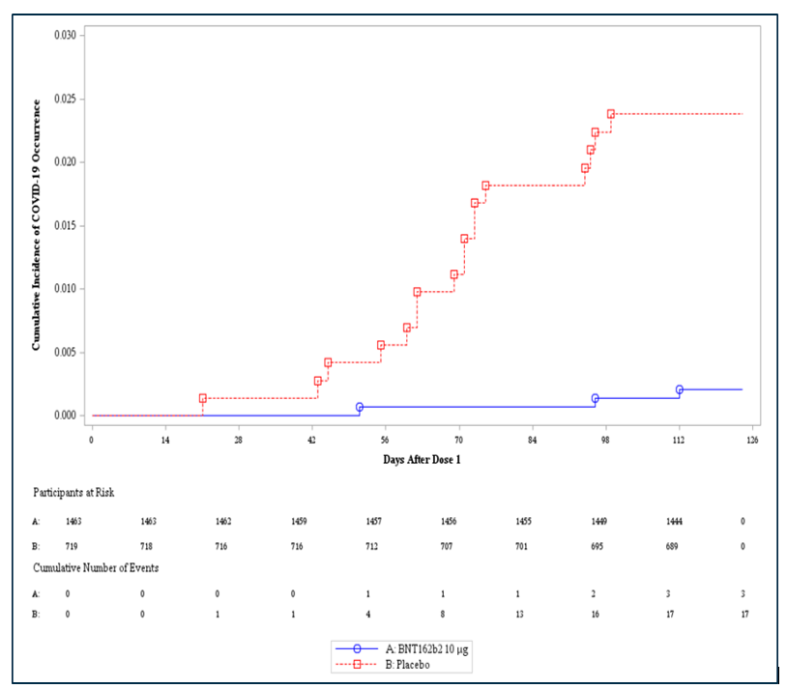

###### Children aged 6 months to 5 years of age

Vaccine efficacy analyses for combined group (6 months to younger than 5 years) were pre‑specified to occur when at least 21 confirmed COVID-19 cases had accrued in subjects without serological or virological evidence of past SARS-CoV-2 infection prior to seven days post-second dose. A preliminary report (at data cutoff date) was provided after 10 confirmed cases of COVID-19 had accrued.

Vaccine efficacy was based on cases confirmed among 992 participants in the combined BNT162b2 and 464 participants in the combined placebo group who received all three doses of study intervention during the blinded follow up period. The observed vaccine efficacy across the total population of children 6 months to younger than 5 years of age was 80.3% (two sided 95% CI: 13.9%, 96.7%) with three cases in the BNT162b2 group and seven cases in the placebo group, adjusted for surveillance time. Based on cases from first dose onwards, observed vaccine efficacy was 25.5% (two sided 95% CI: 7.7%, 39.6%).

Children aged 2 to younger than 5 years of age

Vaccine efficacy for children aged 2 to younger than 5 years of age was estimated from a population of 1835 BNT162b2 recipients and 915 placebo recipients of whom 606 and 280, respectively, received three doses. The observed vaccine efficacy was 82.3% (two sided 95% CI: -8.0%, 98.3%) based on two cases in the BNT162b2 group and five cases in the placebo group, adjusted for surveillance time. From first dose onwards, the observed vaccine efficacy of 32.6% (two sided 95% CI: 10.8%, 48.8%)

Children aged 6 months to younger than 2 years of age

Vaccine efficacy was estimated from 1178 BNT162b2 recipients and 598 placebo recipients of whom 386 and 184, respectively, received three doses. The observed vaccine efficacy of 75.5% (two sided 95% CI: -370.1%, 99.6%), based on one case in the BNT162b2 and two in the placebo group. From first dose onwards, observed vaccine efficacy of 14% (two sided 95% CI: -21.2%, 38.4%)

###### Relative vaccine efficacy of three versus two doses

Relative vaccine efficacy analysis compared cases confirmed at least seven days after third dose among participants in the original randomised BNT162b2 group who received third dose versus cases reported at least seven days after second dose among participants originally randomised to placebo who were unblinded and received two doses of BNT162b2, for cases accrued during the same fixed calendar period. This analysis was based total population of 3013 participants in the combined BNT162b2 group and 1513 participants in the combined placebo group who had received at least one dose of study intervention.

For all children 6 months to younger than 5 years of age, the relative vaccine efficacy of 3 µg BNT162b2 against symptomatic COVID-19 based on four cases reported at least seven days after third dose (original BNT162b2 group who received three doses) compared with six cases reported at least seven days after second dose (original placebo group who were unblinded and received two doses of BNT162b2) during the period of 7 February 2022 to 29 April 2022 was 76.2% (two sided 95% CI: -0.5%, 95.1%)

For those 2 to younger than 5 years of age, relative vaccine efficacy during the interval; 7 February 2022 to 29 April 2022 based on two cases reported at least 7 days after third dose (original BNT162b2 group) versus four cases reported at least seven days after second dose (original placebo group who received BNT162b2) was 84% (two sided 95% CI: -11.8%, 98.6%).

For children 6 months to younger than 2 years of age, relative vaccine efficacy during the interval; 7 February 2022 to 29 April 2022 based on two cases reported at least seven days after third dose (original BNT162b2 group) versus two cases at least seven days after second dose (original placebo group unblinded to receive BNT162b2) was 59.4% (two sided 95% CI: -459.5%, 97.1%).

For all children aged 6 months to younger than 5 years of age, the relative vaccine efficacy of 3 µg BNT162b2 against symptomatic COVID-19 based on four cases reported at least seven days after third dose (original BNT162b2 group who received three doses) compared with six cases reported at least seven days after second dose (original placebo group who were unblinded and received two doses of BNT162b2) during the period of 7 February 2022 to 29 April 2022 was 76.2% (two sided 95% CI: -0.5%, 95.1%)

The reported signs and symptoms associated with confirmed COVID-19 cases reflected predominantly mild to moderate illness and were generally similar in the BNT162b2 and placebo groups for both age groups. No MIS-C cases were reported in either age group.

###### Safety

For children 6 months to younger than 5 years of age, safety analyses are based on up to one month after third dose and up to the data cutoff date of 29 April 2022. For those aged 5 to younger than 12 years of age, the analyses are based on up to one month after second dose and up to the data cutoff date of 6 September 2021. Thus, the safety population included 2,268 (1518 BNT162b2, 750 placebo) children aged 5 to younger than 12 years of age, 2,750 (1,835 BNT162b2, 915 placebo) participants aged 2 to younger than 5 years, and 1,776 (1,178 BNT162b2, 598 placebo) participants 6 to 23 months of age. Of the 1,835 BNT162b2 recipients 2 to 4 years, and 6 to 23 months, 606 (33%) and 386 (32.8%) participants respectively received three vaccine doses.

Almost all randomised paediatric participants received two or three doses of vaccination as randomised, and most received their subsequent doses (second dose in older group, and second and third dose in the younger than 5 years of age groups) in the time protocol defined window (19 to 23 days after first dose, more than 8 weeks after second dose).

The duration of combined blinded and open label follow up for Phase II/III participants is as follows:

* Children 5 to younger than 12 years of age: at least two months after second dose for most participants. Almost all (95.1%) had two to less than three months of follow up after second dose.
* Children 2 to younger than 5 years of age: the median duration of follow up after third dose was 2.1 months (range: 0 to 3.2 months) and the median duration of follow up after second dose to third dose (or data cutoff) was 4.3 months (range: 0 to 10.4 months).

Children 6 months to younger than 2 years of age: the median duration of follow up after third dose was 2.1 months (range: 0 to 3.2 months), and the median duration of follow up after second dose to third dose (or data cutoff) was 6.3 months (range: 0.1 to 10.4 months).

Local Reactions

Pain/tenderness at the injection site was the most frequently reported local reaction in the three paediatric age groups within seven days after each dose, with swelling and redness at the injection site reported much less frequently. Incidences of local reactions after subsequent doses were generally similar or lower than incidences reported after first dose. Local reactions were more frequent after BNT162b2 than placebo. Most local reactions were mild or moderate, with no Grade 4 local reactions were reported after any dose. The median onset for all local reactions after any dose of BNT162b2 was 1 to 2 days, and all events resolved within a median duration of one day after onset.

Systemic Events

* In the participants 5 to younger than 12 years of age, the most common systemic events were fatigue, headache, muscle pain and chills, and generally showed slightly increased frequencies and severity after second dose. Most systemic events were less frequent in the placebo group compared to the BNT162b2 group.
* In those 2 to younger than 5 years of age, fatigue was the most frequent systemic event within seven days of dosing, and at similar frequencies in the BNT162b2 and placebo groups. All other events were reported at much lower frequencies and were mostly similar in the BNT162b2 and placebo groups.
* In those 6 months to younger than 2 years of age, irritability was the most frequent systemic event within seven days of dose. Fever was reported at similar or lower frequencies after each dose. Other systemic events were generally reported more frequently after BNT162b2 than placebo.

In all paediatric groups, the use of antipyretic/pain medication was generally similar or decreased after subsequent doses, and similar between the BNT162b2 and placebo groups. Most systemic events were mild or moderate, with severe systemic events infrequent after any dose (less than 1%). No Grade 4 events were reported. The median onset for systemic events after any dose of BNT162b2 was 1 to 4 days, and similar in BNT162b2 and placebo groups; most resolved within a median of one day after onset.

Adverse events/ Adverse Events of Special Interest

* The proportions of participants 5 to younger than 12 years of age with any AE were similar in the BNT162b2 (10.9%) and placebo (9.2%) groups. Any related AEs, any severe AEs, and any SAEs were reported across the BNT162b2 and placebo by less than or equal to 3%, 0.1%, and 0.1%, respectively. There were no withdrawals due to AEs and no participants died.
* The proportions of participants 2 to younger than 5 years of age with any AE were similar in the BNT162b2 (18.8%) and placebo (18.9%) groups. Any related AEs, any severe AEs, and any SAEs were reported across the BNT162b2 and placebo groups by less than or equal to 2%, less than or equal to 0.7%, and less than or equal to 0.9% of participants, respectively. Few withdrawals due to AEs were reported in either group (less than or equal to 0.2%). No study participants died.
* The proportions of participants 6 months to younger than 2 years of age with any AE were similar in the BNT162b2 (30.1%) and placebo (27.1%) groups. Any related AEs, any severe AEs, and any SAEs were reported across the BNT162b2 and placebo groups by less than or equal to 4.7%, less than or equal to 1.7%, and less than or equal to 2.3% of participants, respectively. Few withdrawals due to AEs were reported in either group (less than or equal to 0.3%). No study participants died.

There were few AEs of special interest reported in any paediatric age group, (primarily expected cases of lymphadenopathy and rash in BNT 162b2 group although less than 1% frequency), and no cases of vaccine-associated anaphylaxis, hypersensitivity, or myocarditis/pericarditis.

When comparing data from 401 older children 5 to younger than 12 years of age in Study C4591007 and 306 adults 18 to 55 years of age in Study C4591001 who received a third (booster) dose, incidences of the most commonly observed local reactions and systemic events after vaccination with BNT162b2 were overall markedly lower among 552 children 2 to younger than 5 years of age and 365 children 6 months to younger than 2 years of age who had post third dose reactogenicity data, as summarised in Table 11.

Table :Reactogenicity profile

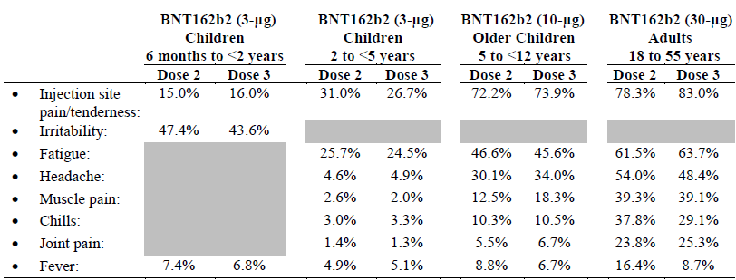

#### Efficacy and Immunogenicity for booster vaccination

##### Study C4591001

Phase I participants who received either BNT162b1 or BNT162b2 at dose levels of 10, 20, or 30 µg were offered booster vaccination (third dose) with BNT162b2 at 30 µg, approximately 6 to 12 months after their second vaccine dose. This provided data supportive data for booster efficacy.

Approximately 600 existing participants 18 to 55 years of age who were randomised to the active vaccine group in Phase III, completed the original BNT162b2 (30 µg) two dose series, and were randomised 1:1 to receive either receive a booster (third dose) at 30 µg of either BNT162b2 or a prototype based upon the B.1.351 (Beta), approximately 6 months after their second dose of BNT162b2. This occurred at selected sites in the US.

The aim of the booster aspect of this study was to describe the immunogenicity and safety of BNT162b2 given as a third dose to BNT162b2 experienced participants. Booster dose effectiveness was inferred through immunobridging: demonstration of noninferiority of immune responses (based on SARS-CoV-2 50% neutralising titres) between one month post third dose to one month post second dose. Vaccine efficacy was not examined.

Immunogenicity endpoints were:

* geometric mean titres and GMR of SARS-CoV-2 neutralising titre at one month after third dose to one month after second dose
* percentages and difference in percentages of participants with seroresponse at one month after third dose and one month after second dose, where seroresponse is defined as achieving a at least 4-fold rise from Baseline (before first dose); for baseline measurement less than lower limit of quantification, post vaccination measure at least four times the lower limit of quantification is considered seroresponse
* geometric mean fold rise from before third dose to one month after third dose.

Non-inferiority was assessed based on two measures:

* Non-inferiority was declared based on a 1.5-fold margin (that is, if the lower bound of the two sided 97.5% CI for the GMR was greater than 0.67) and the point estimate of the GMR was at least 0.8.
* Non-inferiority was declared if the lower limit of the two sided 97.5% CI for the difference in percentages of participants with seroresponse was greater than -10%.

###### Results

Of 312 participants randomised to receive a booster (third dose) of 30 µg BNT162b2, the third dose booster evaluable immunogenicity population included 268 participants, of whom 234 were without evidence of infection up to one month after third dose. The main reasons for exclusion from the evaluable immunogenicity population were issues with receiving vaccination within protocol defined timeframes, or not having a valid protocol defined immunogenicity result.

The median duration between second and third dose was 6.8 months (range: 4.8 to 8 months), with 49.7% of participants receiving booster between 6 and less than 7 months after second dose, 41 % receiving the booster at least seven months after second dose and the remainder (less than 10%) with the first dose less than 6 months following second dose.

Immunogenicity

Reference strain

* Noninferiority of booster response to initial regimen response: Among those without evidence of SARS-CoV-2 infection up to one month after booster (third dose), the SARS-CoV-2 neutralising GMT ratio of one month after third dose to one month after second dose was 3.29 (two sided 97.5% CI: 2.76, 3.91), which meets the 1.5-fold noninferiority criterion (that is, lower bound of the two sided 97.5% CI for GMR greater than 0.67) and point estimate of GMR greater or equal to 0.8. The lower bound of the two sided 97.5% CI for the GMR is greater than 1, indicating a statistically greater response following booster than after second dose.
* Difference in seroresponse rate to reference strain: Among participants without evidence of SARS-CoV-2 infection up to one month after the booster (third dose), a high proportion of participants (99.5%) had seroresponse (defined as greater than or equal to 4- fold rise from Baseline before first dose) at one month after third dose compared with 98% at one month after second dose. The difference in proportions of participants with a seroresponse one month after the booster (third dose) and one month after second dose (Dose 3 – Dose 2) was 1.5% (two sided 97.5% CI: -0.7, 3.7%), which meets the 10% noninferiority margin.
* Geometric mean titres to reference strain: GMTs had declined by the time of the booster (third dose). From second dose up to the day of third dose administration (before booster vaccination), GMTs were 136.2 (two sided 95% CI: 121.5, 152.6), a 5.59-fold reduction compared to that at one month after second dose. Following booster (third dose) vaccination, GMTs increased by seven days post third dose to 1418.7 (95% CI: 1263.3, 1593.3). By one month after third dose, GMTs were 2374.2 (95% CI: 2134.1, 2641.3), a level 17.4-fold that observed on the day of booster vaccination (prior to third dose) (see Figure 11)
* Geometric mean fold rise: Among participants without evidence of SARS-CoV-2 infection up to 1 month after the booster (third dose), the GMFR of SARS-CoV-2 50% serum neutralising titres from before third dose to seven days after third dose was 13.5 (two sided 95% CI: 11.3, 16.3). By one month after third dose, the GMFR from before third dose was 17.4 (two sided 95% CI: 15.2, 20).
* Seroresponse rate: At one month after second dose, the proportion of participants without prior evidence of SARS-CoV-2 infection up to one month after the booster (third dose) with seroresponse in the third dose booster evaluable population was 98% (two sided 95% CI: 95.0, 99.5). By the time of booster (third dose) administration (before booster vaccination), the proportion of participants with seroresponse had declined to 77.2% (two sided 95% CI: 70.7, 82.8). The proportion with seroresponse at one month after the booster (third dose) (that is seroresponse rate) increased further to 99.5% (two sided 95% CI: 97.4%, 100.0%).

Figure : Geometric mean titres and 95% confidence intervals, reference strain SARS-CoV-2 neutralisation assay, 50% neutralisation titre, Phase III, BNT162b2 experienced subjects without evidence of infection up to one month after booster dose) (third dose booster evaluable immunogenicity population)

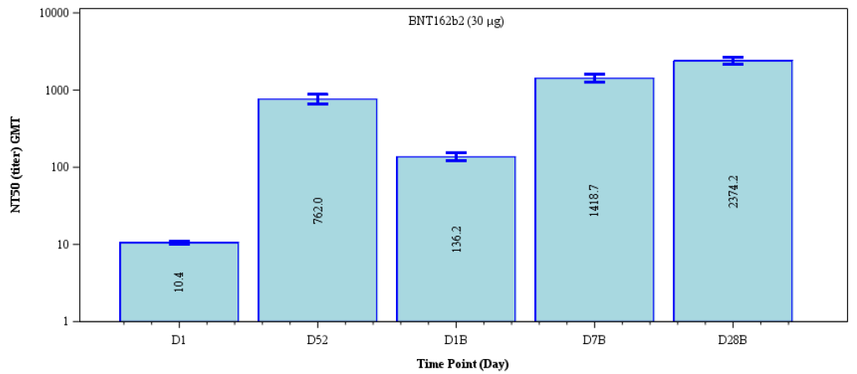

D = day, B = booster vaccination

Non reference strains

* Data in younger (18 to 55 years of age) and older (65 to 85 years of age) groups following third dose of 30 µg BNT162b2 (7 to 9 months after second dose) had boosted serum neutralising titres against recombinant SARS-CoV-2 with the B.1.351 (Beta) variant spike mutations (one month post third dose up to greater than 15-times those observed at one month post second dose).
* There were increased neutralising titres against recombinant SARS-COV-2 virus with the B.1.617.2 (Delta) spike variant (one month post third dose were 4.76- to 7.51-times titres seen after second dose)

###### Safety

There were 306 Phase II/III participants 18 through 55 years of age in the booster (third dose) safety population. Overall, reactogenicity frequencies and severities were similar to that following second dose of the primary series. There were few severe reactions (mainly involving systemic rather than local reactogenicity) and no Grade 4 reactions. Almost half required antipyretic/ pain medication. Most treatment related AEs represented ongoing reactogenicity events and there was an appreciable incidence of lymphadenopathy (5.2%) that was higher than that seen following second dose (0.4%). One of those cases was severe (Grade 3 - affected upper limb function); however, it resolved within five days of onset without sequalae. There was only one SAE (unrelated myocardial infarction), no immediate AEs, or AEs leading to discontinuation. No study participants in this Phase II/III booster group died.

##### Study C4591031

Study C4591031 is an ongoing, randomised, placebo controlled, observer blind substudy to evaluate the safety, tolerability, and efficacy of a booster dose of BNT162b2. Participants at least 16 years of age from the pivotal Study C4591001 who completed a two dose primary series of BNT162b2 at least six months prior to randomisation were enrolled, and participants were randomised at a ratio of 1:1 to receive either BNT162b2 or placebo. Randomisation was stratified by age, such that approximately 60% of participants enrolled would be at least 16 to 55 years of age and approximately 40% of participants older than 55 years of age. Approximately 10,000 participants were to be randomised. Assessments include safety evaluations and COVID-19 case surveillance for booster efficacy estimation after the booster dose.

This study was conducted 123 sites in Brazil (2), South Africa (4), and the US (117). The analyses presented are based on a study initiation of 1 July 2021 (first participant first visit) and a database cutoff date of 5 October 2021. The study was designed with interim efficacy analyses carried out after all participants reach two months of blinded follow up and every two months afterwards; and efficacy and safety analyses would be conducted when all participants complete blinded follow up (planned to be approximately 175 days after vaccination) and at the end of the study.

Whilst it was originally intended that all participants would remain blinded until the outcome of the protocol prespecified data analysis that was planned to be conducted once all participants reached two months after booster vaccination had been reviewed by the Data Monitoring Committee (DMC), in light of the observation of waning effectiveness and recommendation for booster doses in some countries, per the protocol, participants could be unblinded from 24 September 2021 onwards, and those who had been randomised to receive third dose of placebo were offered a dose of 30 µg BNT162b2 in order to receive a booster of active vaccine.

Efficacy analyses were conducted based on the evaluable and all available (modified intention to treat) efficacy populations. Vaccine efficacy was evaluated as follows:

* Primary efficacy endpoint: confirmed COVID-19 incidence from seven days after the booster dose per 1000 person-years of blinded follow up in participants without or with or without evidence of prior SARS-CoV-2 infection up to seven days after booster vaccination.
* Secondary efficacy endpoint: COVID-19: confirmed severe COVID-19 incidence from seven days after booster vaccination per 1000 person-years of blinded follow up.

Relative vaccine efficacy was estimated in participants without prior evidence of SARS-CoV-2 infection before or during the vaccine or booster vaccine regimen, and those with or without prior evidence of SARS-CoV-2 infection.

All participants had previously received the primary series of 30 µg BNT162b2, therefore relative vaccine efficacy compares a third dose of active vaccine (third dose following the two dose primary series) versus placebo (no third dose following the two dose primary series).

Subgroup analyses of relative vaccine efficacy were conducted based on demographics (age group, sex, race, and ethnicity), country, dose interval between second dose and booster dose, baseline SARS-CoV-2 status, and risk status based on Charlson Comorbidity Index or a body mass index greater or equal to 30 kg/m2.

###### Results

In total, 10,136 participants were randomised, (5088 to receive BNT162b2, and 5048 placebo). Most randomised participants received a booster (99.9%) and completed the one month blinded follow up period (99.1%). There were 9406 (4714 in BNT162b2, 4692 in placebo) participants included in the evaluable efficacy population. Reasons for exclusion from the evaluable efficacy population, were having important protocol deviations on or prior to seven days after booster vaccination (1.3%), not meeting eligibility criteria after randomisation (1.2%), or not receiving vaccine as randomised (0.1%).

Demographic characteristics for all in the safety population were similar in the BNT162b2 and placebo group. Overall, most were White (79%), with 9.2% Black or African American, 5.5% Asian, 4.0% multiracial, and other racial groups comprising less than 2%. There were 14.9% Hispanic/Latino participants. The median age at the time of study vaccination was 53 years, and 49.1% of participants were male. Most participants (85.9%) were enrolled in the US. The younger group (16 to 55 years of age) made up 55.5% of the safety population; this included 90 participants (0.8%) who were 16 to 17 years of age. Baseline comorbidities were reported by 23.6 % and were balanced across BNT162b2 and placebo groups.

The median time between second dose (in Study C4591001) to booster vaccination was 10.8 and 10.7 months in the BNT162b2 and placebo groups, respectively Most participants received the booster dose of BNT162b2 or placebo (96.1% or 96.3%, respectively) between 6 to less than 12 months after second dose. (65.3% of participants in both groups received the booster at least 10 to less than 12 months after second dose). The booster was received less than six months (a protocol deviation) by less than or equal to 0.3% of participants in either group, and greater than 12 months after second dose in less than or equal to 3.5% in either group.

As of the data cutoff date (5 October 2021), the median duration of blinded follow up after receipt of the booster dose for the evaluable efficacy population without evidence of prior infection with SARS-CoV-2 prior to seven days post-booster was 2.5 months (range 0 to 3.5 months). Most participants (97%) had at least 2 to less than 4 months of follow up post-booster.

Vaccine efficacy (data cut off 05 October 2021)

* The relative vaccine efficacy in the evaluable efficacy population without evidence of SARS-CoV-2 infection prior to seven days post-booster was observed as 95.3% (two sided 95% CI: 89.5%, 98.3%), based on six cases in the BNT162b2 group and 123 cases in the placebo group
* The relative vaccine efficacy in the evaluable efficacy population with or without evidence of SARS-CoV-2 infection prior to seven days post-booster was observed as 94.6% (two sided 95% CI: 88.5%, 97.9%), based on seven cases in the BNT162b2 group and 124 cases in the placebo group
* In the all-available efficacy (modified intention to treat) population, the relative vaccine efficacy from booster vaccination onwards was 89.8% (two sided 95% CI: 82.6%,94.4%), based on 15 cases in BNT162b2 and 141 cases in placebo

The Kaplan-Meier curves from booster vaccination onwards show a steady accumulation of COVID-19 cases in the placebo group including two severe cases compared with a relatively flat curve for the BNT162b2 group in which few cases accrued and no severe cases were reported (Figure 12).

For all subgroups, the COVID-19 cases were predominantly reported in the placebo group. Some subgroups had small numbers of participants, contributing to high confidence intervals.

Figure : Cumulative incidence curves for first COVID-19 occurrence after booster vaccination during blinded follow up period (all available efficacy population)

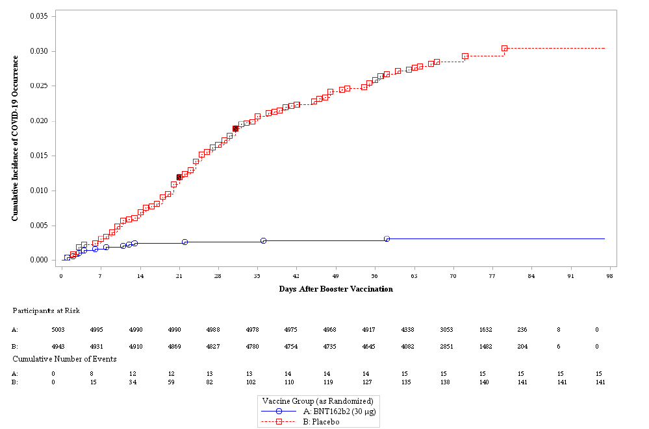

S – participants with severe COVID-19

###### Safety

The safety population included 5620 participants in the younger (16 to 55 years of age) and 4505 participants in the older group (older than 55 years of age) and balanced between the BNT162b2 and placebo booster groups. The median duration of blinded follow up after the booster vaccination for the safety population was 2.5 months with most (97%) having at least 2 to less than 4 months of follow up after booster vaccination. Follow up times were similar for both age groups. Most participants received the booster dose between 6 to less than 12 months after second dose, both in the BNT162b2 group (96.1%) and in the placebo group (96.3%).

From booster vaccination to one month post booster, a greater proportion of those in the BNT162b2 (25%) reported any AE compared with the placebo group (6.5%). This was mostly related to AEs considered by the investigator as related to study intervention, reported by 23.4 and 4.1% participants respectively. Most AEs reported during this period reflect reactogenicity events (injection site pain, fatigue, myalgia, pyrexia, and headache), which account for the imbalance between groups. This is similar to the AE profile previously observed, following second dose of the initial two dose regimen. Any severe or serious AEs were reported across the BNT162b2 and placebo groups by less than or equal to 0.7% and less than or equal to 0.3%, respectively. No study participants had any AEs leading to withdrawal and no participants died. Related AEs were reported in the BNT162b2 groups at a slightly higher frequency in younger (26.4%) compared to older (19.6%) adults. Low incidences of severe and serious AEs were reported after BNT162b2 in the younger (less than or equal to 0.5%) and older (less than or equal to 0.8%) age groups.

Similarly, from booster vaccination to the data cutoff date, a greater proportion of participants in the BNT162b2 group (25.2%) reported any AE compared with the placebo group (6.8%). One participant in the placebo group (older than 55 years of age group) had life threatening SAEs leading to withdrawal (metastatic cancer) and one other participant in the placebo group died due to an unrelated SAE (pulmonary embolism). Lymphadenopathy was reported at a higher frequency in Study C4591031 participants post booster vaccination with BNT162b2 (2.7%) compared with participants in C4591001 after the two dose primary series of BNT162b2 (0.4%). Regarding SAEs, these were reported in 16 participants (0.3%) in the BNT162b2 group and 24 participants (0.5%) in the placebo group and most of these were considered as not related to study intervention.

##### Study C4591031 booster dose for aged at least 12 to 15 years of age

Study C4591031 provided data for the first booster data for individuals aged 16 years of age and older.

The reduction in the age of the booster dose to include 12 to younger than 15 years of age, was based on the following which have been assessed by the TGA as part of submission\

Safety data from the Israel Ministry of Health showing that after administering a single booster dose to more than 6,000 participant aged 12 to 15 years of age, no new safety concerns were identified through 15 December 2021.

* Data showing that a single booster dose can greatly improve effectiveness against a range of SARS-CoV-2 outcomes compared to after only two doses administered at least five months ago;[16],[17],[18]
* Emerging evidence suggesting that three doses of vaccine may be especially necessary for preventing Omicron related disease;[19]
* published experience from USA supporting no new safety concerns in approximately 2.8 million adolescents;[20]
* Three publications from Israel reported a large improvement of vaccine efficacy for three doses compared to two doses in adults. The Delegate for this submission considered it reasonable to extrapolate efficacy of Comirnaty 30 µg booster in adolescents 12 to 15 years based on the demonstrated efficacy from age 16 and older.

###### Efficacy

The Delegate concluded that ‘publications from Israel have reported a large improvement of vaccine efficacy for three doses compared to two doses in adults and considered it reasonable to extrapolate efficacy of Comirnaty 30 µg booster in 12 to 15 years of age based on demonstrated efficacy in age 16 and older’.

###### Safety

The Delegate stated ‘post-marketing safety data from the Israel Ministry of Health showed that after administering a single booster dose of Pfizer-BioNTech Vaccine to more than 6,000 participants aged 12 to 15 years of age, no new safety concerns were reported’, but that data was ‘insufficient for assessment of risk of myocarditis’. The data from USA supports no new safety concerns in about 2.8 million adolescents.

Further data are expected from Study C4591031 Substudy B and C, which includes individuals at least 12 years of age in randomised, sub studies to evaluate the safety and tolerability of a booster (third) dose of BNT162b2. Participants aged at least 12 years of age to younger or equal to 30 years of age who have completed a two dose primary series of BNT162b2 (30 µg doses) at least 6 months (at least 8 months for those 12 to 17 years of age) prior to randomisation will be enrolled, at a ratio of 1:1. In substudy B participants will receive either BNT162b2 (30 µg dose or placebo) at Visit 1 and the alternative at Visit 3, four weeks later. In substudy C, participants will receive BNT162b2 at either a 10 µg or 30 µg dose with dose escalation based on immunogenicity results. Randomisation in both sub studies will be stratified by age (stratified as 12 to 17, 18 to 24, and 25 to 30 years of age). Data from these sub studies have not been submitted.

##### Study C4591031 booster dose for aged 5 to 11 years old

Study C4591007 is an ongoing, Phase I/II/III, randomised, placebo controlled study in healthy children aged 6 months to younger than 12 years of age. The primary series of BNT162b2 was a two dose series. Based on emerging clinical and real world data, a booster dose or third dose was provided for those aged 5 to younger than 12 years of age. The Phase II/III study commenced on 7 June 2021 and is ongoing. Data cutoff for the third dose analysis for children 5 to younger than 12 years of age was 22 March 2022.

Immunogenicity data include SARS-CoV-2 neutralising titres against the wild type strain and Omicron variant after a booster (third) dose of 10 µg BNT162b2, up to one month post third dose. Immunogenicity analyses were conducted for an immunogenicity set of participants based on all available and evaluable immunogenicity populations. The immunogenicity set was comprised of:

* Three dose set: up to 130 participants who received third dose and completed the one month post third dose. Up to 30 participants’ blood was also analysed for Omicron neutralisation.
* Two dose set: up to 70 additional participants randomly selected from the previously analysed second dose evaluable immunogenicity population who were without evidence of prior infection up to one month post second dose (that is included in the two dose immunobridging analysis).

The second and third dose evaluable immunogenicity populations included participants who received all doses of vaccine (that is second or third doses) within the protocol specified window for each dose, had at least one valid and determinate immunogenicity result within 28 to 42 days after vaccination, and did not have any important protocol deviations impacting evaluability.

Immunogenicity results were reported as:

* SARS-CoV-2 50% neutralising geometric mean titres
* Geometric mean ratio of SARS-CoV-2 50% neutralising titres
* Percentages/difference in percentages of participants who achieved seroresponse
* Geometric mean-fold rises of SARS-CoV-2 50% neutralising titres

Data were analysed combining the available results from the two dose set and three dose set to evaluate immune responses at each time point. The safety population included all who received third dose of 10 µg BNT162b2 by 22 March 2022.

The third dose evaluable immunogenicity population included 115 children 5 to younger than 12 years of age who received a booster (third) dose of 10 µg BNT162b2. All received the booster dose 7 to less than 9 months after second dose. Of these 67 participants were without evidence of SARS-CoV-2 infection up to one month after third dose.

Among these 67 participants (the third dose evaluable immunogenicity population) 52.2% were male, 74.6% were White and all were from the USA. The median age at first dose was 8 years. There were 4.5% participants reported as obese and 25.4% participants with comorbidities that increase the risk of severe COVID-19 disease (including obesity).

###### Results

Reference Strain:

* The observed GMTs increased from pre-vaccination of 20.5 (n = 146) to 1253.9 at one month post second dose (n = 96), had waned to 271 by the time of vaccination prior to receipt of third dose (n = 67), and were substantially boosted to 2720.9 at one month post third dose (n = 67) (Figure 13).

Figure : Geometric mean titres and 95% confidence intervals for SARS-CoV-2 neutralisation assay, 50% neutralising titre in participants aged 5 to younger than 12 years of age without infection, Phase II/III immunogenicity set (evaluable immunogenicity population)

**Geometric mean titres and 95% confidence intervals for SARS-CoV-2 neutralisation assay, 50% neutralising titre in participants aged 5 to younger than 12 years of age without infection, Phase II/III immunogenicity set (evaluable immunogenicity population)**

* In the immunogenicity population (regardless of evidence of prior infection; n = 112), the GMFR from third dose to one month after third dose was 6.2 (two sided 95% CI: 5, 7.6)
* The GMR comparing one month post third dose (n = 67) to one month post second dose (n = 96) was 2.17 (two sided 95% CI: 1.76, 2.68)
* The proportion of participants who achieved seroresponse at one month after second dose (n = 96) was 100% This rate had waned to 77.6% prior to receipt of third dose (n = 67) and was then increased at one month post third dose (n = 67) to 98.5%

Omicron strain:

Included n = 29 with assay results at one month post second dose and n = 17 with assay results up to one month post third dose, and without evidence of infection up to one month after second dose or third dose. The Delegate note the very small numbers in analysis.

* At one month post second dose, the GMTs for the Omicron variant and reference strain were 27.6 and 323.8, respectively. At one month post third dose, the observed neutralising GMTs for the Omicron variant and reference strain were 614.4 and 1702.8, respectively.
* The GMR against Omicron versus the reference strain was 0.09 (95% CI: 0.07, 0.1) at one month post second dose, and 0.36 (95% CI: 0.28, 0.47) at one month post third dose.

###### Safety

Safety data include reactogenicity and AE analyses after a booster (third) dose of 10 µg BNT162b2, up to one month post third dose and to 22 March 2022 (n = 401). As of the data cutoff date, 311 (77.6%) participants who received third dose of 10 µg BNT162b2 completed the visit at one month after third dose. No participants discontinued or were withdrawn from the study. The median (range) follow up time after third dose was 1.3 (1, 1.8) months.

Amongst local reactions, pain at the injection site was the most common within seven days following third dose (73.9%), with swelling and redness less common (16.4% and 15.6% respectively). These trends are generally in line with local reactions observed following previous doses.

The most common reported systemic events within seven days after third dose included fatigue (45.6%), headache (34%) and muscle pain (18.3%). Headache, muscle pain and use of antipyretic/pain medication occurred more frequently after each dose

The incidence of fever was lower after third dose than second dose (6.7% versus 8.8%).

Most reactogenicity events were mild or moderate in severity. No Grade 4 local or systemic reactions were reported after any dose. There were no deaths.

Lymphadenopathy is an AE of special interest with ten cases (2.5%) reported, all considered mild. The incidence of lymphadenopathy was higher following third dose than second dose.

There were no cases of AEs of interest as of data cut off including: anaphylaxis, myocarditis, pericarditis, Bell’s palsy (or facial paralysis/paresis), appendicitis, arthritis, thrombocytopenic events, thromboembolic or intravascular coagulation events, autoimmune or demyelination events, meningitis, encephalitis, neuritis, peripheral neuropathy, vasculitis, Kawasaki disease, MIS-C, or acute respiratory distress syndrome.

#### Endorsement for early termination of clinical studies

A document entitled ‘Comirnaty COVID-19 mRNA vaccine (BNT162, PF-07302048) early termination of Studies C4591001, C4591007, and BNT162-01’ and dated February 2023 was provided for TGA assessment and endorsement. The following studies were included in this assessment:

* Study C4591001, a Phase I/II/III, placebo controlled, randomised, observer blind, dose finding study to evaluate the safety, tolerability, immunogenicity, and efficacy of SARS-CoV-2 RNA vaccine candidates against COVID-19 in healthy individuals.
* Study C4591007, a Phase I, open label dose finding study to evaluate safety, tolerability, and immunogenicity and Phase II/III placebo controlled, observer blinded safety, tolerability, and immunogenicity study of a SARS-COV-2 RNA vaccine candidate against COVID-19 in healthy children and young adults.
* Study BNT162-01, a multi-site, Phase I/II, two part, dose escalation trial investigating the safety and immunogenicity of four prophylactic SARS-CoV-2 RNA vaccines against COVID-19 using different dosing regimens in healthy and immunocompromised adults.

As the pandemic has progressed, protocol amendments were required, which included unblinding, vaccination of the placebo participants, and provision of booster dosing. Further newer bivalent vaccines have also been developed.

Real world studies of both safety and effectiveness of BNT162b2 have also been extensive, and beyond what is possible within a clinical trial particularly as emerging real-world data relates to rare events. Furthermore, as the pandemic has progressed, variants of concern have emerged as has the knowledge of vaccine immunogenicity and duration of effectiveness.

##### Study C4591001

This study planned to follow study participants for two years after the second vaccine dose to collect data regarding persistence of humoral immune response and protection against COVID-19 disease. To date over 46,000 participants have received at least one dose of a BNT162b2 vaccine on Study C4591001. The study was initially due to be completed in second quarter of 2023 but has now finished with the last participant visit occurring on 10 February 2023.

##### Study C4591007

In line with Study C4591001, the study planned to follow study participants for 24 months after the second vaccine dose. To date over 11,000 participants have received at least one dose of the original BNT162b2 vaccine in Study C4591007. The original study protocol would have been completed by June 2024. It is now proposed to terminate Study C4591007 in third quarter of 2023.

##### Study BNT162-01

This study was initiated in April 2020, as the first in human dose finding study and evaluated four vaccine candidates (BNT162a1, BNT162b1, BNT162b2, and BNT162c2) and implemented a total of 14 cohorts including three expansion cohorts (Cohort 11, Cohort 12, and Cohort 13). Given the changing nature of the pandemic, this study is not able to be completed. The final study report for Study BNT162-01 expected in second quarter of 2023.

##### Outcome

TGA acknowledged the status of Studies C4591001 and BNT162-01 and agrees with the assessment for early termination of Study C4591007 in third quarter of 2023. This assessment was made on 23 February 2023.

#### Real world evidence

The below is a brief summary of real world evidence sourced by the Delegate. As of 22 February 2023, approximately 13.3 billion COVID-19 vaccinations have been administered globally, 65 million of which have been in Australia. Amongst countries that report the necessary data (Argentina, Canada, Chile, Ecuador, European Union, Hong Kong, Iceland, Japan, Nepal, Peru, South Africa, South Korea, Switzerland, Ukraine, United States and Uruguay), 664 million doses of the Pfizer-BioNTech COVID-19 vaccine have been administered.[21]

##### Effectiveness- primary course

Observational data from various countries following their national roll-outs of [Pfizer COVID-19 vaccine](https://www.uptodate.com/contents/covid-19-mrna-vaccines-drug-information?topicRef=129849&source=see_link) supported trial findings in adults and adolescents. Pfizer COVID-19 vaccine has been associated with approximately 90 percent or higher vaccine effectiveness in preventing COVID-19-related hospitalisation, intensive care unit admissions, and death among adolescents and adults.[22],[23],[24],[25]

Some, observational data show that vaccine effectiveness in children aged 5 through 11 years may be lower than that among older adolescents.[26] However, this may be related to reduced effectiveness against the Omicron variant, which dominated soon after introduction of vaccine for the children. Vaccination substantially reduces COVID-19 associated hospitalisations in this age group, even in the context of Omicron prevalence.

Randomised trials in young children have demonstrated a reduced risk of symptomatic and severe COVID-19 in the first several months after Pfizer COVID-19 vaccination. Post authorisation estimates of efficacy against symptomatic infection in young children indicate that complete primary series vaccination with either monovalent Moderna or Pfizer-BioNTech provides protection for children aged 3 to 5 and 3 to 4 years of age, for at least the first four months after vaccination. However, similar to adults and adolescents, efficacy has been observed to wane.[27]

Vaccine effectiveness wanes over time and may be decreased in protecting against infection with certain SARS-CoV-2 variants, although protection against severe disease due to variants remains substantial. Administration of a booster dose has been shown to restore vaccine effectiveness to levels comparable to that following that from the primary vaccine course.[28],[29],[30]

##### Safety

Local and systemic adverse effects are relatively common in adults, particularly after the second dose; most are of mild or moderate severity and are limited to the first two days after vaccination.[31] Injection site reactions (mainly pain, also redness, swelling, pruritus) occur in approximately 65%; fatigue, headache, and myalgias in approximately 40 to 50%; and fevers, chills, and joint pain in approximately 20%.[32] The initial safety findings of Pfizer-BioNTech vaccine administered to U.S. adolescents aged 12 to 17 years are similar to those described in the clinical trials, with the exception of myocarditis.[33] Early real world data for children aged 5 to 11 years are similar to those described in the clinical trials, with frequently reported local (86.2%) and systemic (66.6%) reactions.[34] Among young children, local and systemic reactions are expected after COVID-19 vaccination, and serious adverse events are rare. These findings are consistent with those from safety data from preauthorisation clinical trials for young children. Systemic reactions were more frequently reported for children aged 6 months to 2 years of age than those 3 to 5 years of age.[35],[36]

Possible anaphylaxis and other reported allergic reactions (pruritus, rash, scratchy sensations in the throat, and mild respiratory symptoms) have been reported, with rates between 2.5 to 7.9 events per million doses reported in different series. [37],[38],[39] Most occurred within 30 minutes and in individuals with a previous history of allergic reactions. Other major adverse events have not been consistently associated with [Pfizer COVID-19 vaccine](https://www.uptodate.com/contents/covid-19-mrna-vaccines-drug-information?topicRef=129849&source=see_link) receipt. Rare cases of Bell's palsy were noted in the Phase III trial in adults (four in vaccine and zero in placebo recipients)]; however, the rate did not exceed background rates found in the general population (15 to 30 cases per 100,000 people per year), and post-vaccine monitoring has not identified an association between vaccination and Bell’s palsy]. In a large cohort study from Israel, BNT162b2 receipt was most strongly associated with myocarditis, lymphadenopathy, appendicitis, and herpes zoster.39

##### Myocarditis and pericarditis

Myocarditis and pericarditis, mainly in male adolescents and young adults, have been reported more frequently than expected following receipt of the mRNA vaccines. Among cases reported, most are mild. Onset was generally within the first week after vaccine receipt. Most patients needing care responded well to treatment and had rapid symptom improvement.[40],[41]

In a review of the Vaccine Adverse Event Reporting System in USA, a passive surveillance system in the United States to which patients and providers can submit reports of events, among over 192 million people who had received an mRNA vaccine between December 2020 and August 2021, there were 1626 cases that met the definition of myocarditis following vaccine receipt.[42] The majority of these cases occurred after the second dose, the median age was 21 years, and 82 percent occurred in males. The estimated rate among males by age group was:

* 12 to 15 years old – 70.7 cases per million doses of BNT162b2
* 16 to 17 years old – 105.9 cases per million doses of BNT162b2
* 18 to 24 years old – 52.4 to 56.3 cases per million doses BNT162b2 and mRNA-1273, respectively

Among females of the same age groups, the estimated case rates ranged from 6.4 to 11 cases per million doses. The number of events observed exceeded the expected baseline rate among males aged 18 to 49 years and females aged 19 to 29 years.

The identified rates of myocarditis/pericarditis cases after the primary series in children 5-11 years of age are lower than those seen after the primary series in children 12-17 years of age.35

Studies from other countries have also suggested an increased rate of myocarditis following BNT162b2 vaccination compared with the expected background rate.41,[43],[44] The risk also appears to be higher following the second dose and with shorter intervals between doses (less than 30 days versus more than 60 days).44

##### Booster vaccination

Observational data in adults and adolescents demonstrated that local and systemic reactions were reported less frequently following a homologous booster dose than after receipt of the second COVID-19 mRNA vaccine dose) (Figure 14) Myocarditis was rarely reported following an mRNA vaccine booster dose. Safety findings for booster vaccination from real world settings are similar to those described in clinical trials. Among adolescents, adverse events after receipt of a booster dose were generally similar to those after a primary series dose. Among data for children 5 to 11 years, local and systemic reactions after third dose vaccination were similar in frequency to those after a primary series.36

Figure : Adverse reactions and health impacts reported by adults and adolescents who received a homologous Pfizer-BioNTech (N = 332,588) COVID-19 vaccine by dose — United States, 22 September 2021 to 6 February 2022

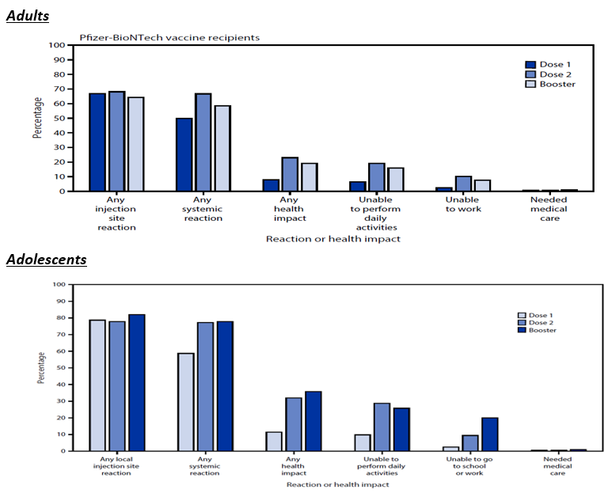

Source: Hause et al., 2022; 36

##### Pregnancy

Although pregnant and breastfeeding people were not included in the initial large vaccine trials, subsequent data from vaccinated pregnant people demonstrated safety and efficacy before pregnancy, during pregnancy, postpartum, and during lactation.[45],[46]. Meta-analyses of epidemiological studies of COVID-19 vaccination during pregnancy have not identified increased risks of any adverse outcome. There is no evidence of direct or indirect harmful effects on fertility, embryo/foetal development, pregnancy outcome, parturition, or short-term postnatal development of offspring.[47]

### Risk management plan

European Union-risk management plan (RMP) version 9.0 (dated 4 November 2022; data lock point (DLP) for Original/Omicron BA.4-5 vaccine - Module SIII 16 May 2022 (Study C4591031 Substudy E), 11 March 2022 (Study C4591031 Substudy D – Cohort 2); Module SVII.3 Sentinel cohort 05 April 2022 and expanded cohort cutoff date: 16 May 2022 (Pfizer Clinical Database Study C4591031 Substudy E). 11 March 2022 (Pfizer Clinical Database Study C4591031 Substudy D – Cohort 2) and Australia specific annex (ASA) version 0.7 (dated December 2022) have been considered in this report. These were the RMP and ASA versions that were evaluated for the Type A application for Comirnaty Original/ Omicron BA.4-5 COVID-19 Vaccine.8 The sponsor has stated that current RMP is the EU RMP version 9.0.

The summary of safety concerns and their associated risk monitoring and mitigation strategies are summarised in Table 12. The TGA may request an updated RMP at any stage of a product's life-cycle, during both the pre-approval and post-approval phases.

Table : Summary of safety concerns

|  |  |  |  |  |  |
| --- | --- | --- | --- | --- | --- |
| Summary of safety concerns | | Pharmacovigilance | | Risk Minimisation | |
| Routine | Additional | Routine | Additional |
| **Important identified risks** | Myocarditis and pericarditis | ✓ | ✓* | ✓ | – |
| **Important potential risks** | Vaccine-associated enhanced disease (VAED) including Vaccine-associated enhanced respiratory disease (VAERD) | ✓† | ✓* | – | – |
| **Missing information** | Use in pregnancy and while breast feeding | ✓ | ✓*≠ | ✓ | – |
| Use in immunocompromised patients | ✓ | ✓* | ✓ | – |
| Use in frail patients with co-morbidities (e.g., chronic obstructive pulmonary disease (COPD), diabetes, chronic neurological disease, cardiovascular disorders) | ✓ | ✓* | ✓ | – |
| Use in patients with autoimmune or inflammatory disorders | ✓ | ✓* | – | – |
| Interaction with other vaccines | ✓ | ✓* | ✓ | – |
| Long term safety data | ✓ | ✓* | – | – |

†Data Capture Aid (Adverse drug reaction follow-up forms)

≠Post-authorisation safety study

*Clinical trial

The summary of safety concerns is the same as the safety summary that was most recently evaluated and deemed acceptable. This summary of safety concerns continues to be acceptable from an RMP perspective.

The pharmacovigilance plan is acceptable from an RMP perspective. The sponsor is requesting ‘TGA’s acknowledgement of the early termination of Studies C4591001 and BNT162-01 as well as TGA’s endorsement of the termination of Study C4591007 earlier than had been initially planned’. The decision regarding these changes will be made by the Delegate.

There are risk minimisation measures implemented for COVID-19 vaccines by the Department of Health and Aged Care and State and Territory Governments. The changes proposed in this application do not warrant changes to the currently approved risk minimisation plan as part of the RMP.

### Risk-benefit analysis

#### Delegate’s considerations

SARS-CoV-2 continues to cause substantial morbidity and mortality globally. Australia is experiencing ongoing COVID-19 cases, and hospitalisations, and further deaths as a result of Omicron subvariants. This leads to significant disruption to the normal life and has health and economic implications for the country. Certain populations such as those aged at least 60 years of age and over, and people with immunosuppression and a range of comorbid conditions are at increased risk. The efficacy and clinical safety profile of the prophylactic COVID 19 vaccine, BNT162b2 has been comprehensively studied commencing in April 2020. Hundreds of millions of doses of this vaccine have been administered worldwide which has supported the extensive evidence base informing efficacy and safety outcomes, and decisions as to in whom and when to use this vaccine. Further large volumes of data regarding the vaccine efficacy with newer subvariants has been available and have facilitated decisions regarding a third dose in individuals.

##### Efficacy

The sponsor provided clinical trial data which together with large amounts of post authorisation and published observational data have demonstrate the efficacy of Pfizer COVID vaccine (BNT162b2) as a primary series across all aged groups, with early data showing at least 90% efficacy. This has included more vulnerable people such as older people. The high vaccine efficacy is particularly evident against important outcomes, such as death, severe disease, and hospitalisation. Whilst all ages have been shown to have protection from COVID 19 with primary vaccination, there is a lower vaccine effectiveness in children, although this may relate to the circulating variants rather than a true difference from adults and adolescents.

Vaccine effectiveness wanes over time and may be decreased in protecting against infection with certain SARS-CoV-2 variants, although protection against severe disease due to variants remains substantial. Administration of a booster dose in those aged older than 5 years of age, has been shown to restore vaccine effectiveness to levels comparable to that following that from the primary vaccine course.

Whilst with the emergence of mutations in the spike protein of SARS-CoV-2, and subsequent decline in the vaccine efficacy, although protection against severe disease due to variants remains substantial. This is especially noted where more recent vaccine dose has been administered.

##### Safety

The safety profile of 10 to 30 µg of BNT162b2 has been documented extensively when utilised as a primary vaccine series and as a first booster (third dose). Local and systemic reactogenicity adverse effects are relatively common in all ages and appear to be most common after the second dose of BNT162b2. Most of these events are mild and resolve quickly without any specific intervention.

Myocarditis and pericarditis, mostly in male adolescents and young adults, are a rare adverse event following BNT162b2 vaccination. These cases are generally mild and occur most frequently following second dose. Anaphylaxis and other allergic reactions are also rare, but potentially serious adverse events. Most occurred within 30 minutes and in individuals with a previous history of allergic reactions. Other major adverse events have not been consistently associated with [Pfizer COVID-19 vaccine](https://www.uptodate.com/contents/covid-19-mrna-vaccines-drug-information?topicRef=129849&source=see_link) receipt

**Transition to full registration**

The TGA guidance for Transition to full registration of provisionally registered prescription medicines outlines the requirements and states the following:[48]

‘The collection of confirmatory data on safety and efficacy should lead to submission of a Category 1 Type S application for transition to full registration. The benefit-risk profile of the medicine must be positive, and this must be maintained throughout the period of provisional registration to the transition to full registration. Evidence of having met your RMP obligations, including the dates when data were submitted and reasons for delays or failure to meet obligations All final results not previously submitted from confirmatory trials in the dossier should be included as per the current requirements for registering a prescription medicine. Clinical trials data must support the indication in the application for full registration.’

The sponsor has listed (Table 4) the availability of clinical data to meet the specific conditions (as per the provisional registration) and the current requirements for registering a prescription medicine to support this application. It is noted this table only provides information for the primary vaccination across age groups. All clinical study data outlined during the provisional registration processes has either been provided or reasons for lack of availability have been outlined. Providing adequate response from the sponsors questions, these conditions have been met. Similarly, it is anticipated that relevant information for the third dose is adequate to include the third dose, (first booster dose) for those aged at least 5 years of age (noting the primary vaccine series for those younger than 5 years of age includes three doses).

#### Proposed action

The benefit risk profile of BNT162b2 in individuals 6 months of age and older as a primary vaccination has been well established utilising extensive efficacy and safety data, with an overall positive benefit risk profile. Further data to support a third dose has been provided and also demonstrates a positive risk benefit outcome. Of particular importance it is noted that no new or unexpected adverse events emerged following a third dose of BNT162b2 vaccination in any age group.

The sponsor has adequately addressed the regulatory conditions specified for provisional registration, substantiating the benefit risk profile with longer term follow up data. The RMP and ongoing pharmacovigilance commitments are considered acceptable. This data supports a favourable benefit risk profile for Comirnaty (BNT162b2) vaccine transitioning from provisional registration to full registration in individuals 6 months of age and older.

At the present time it was also noted that the original Comirnaty vaccine has limited value as a booster dose but continues to have a potential role as a primary vaccine course. Importantly, the vaccine should be used ‘in accordance with official recommendations’, which are not static.

The Delegate is of the view that the Comirnaty COVID 19 BNT 162b2 vaccine should transition to full registration.

Proposed indication:

*Active immunisation to prevent coronavirus disease 2019 (COVID-19) caused by SARS-CoV- 2, in individuals 6 months of age and older.*

*Comirnaty booster dose (dose 3) may be administered to individuals 5 years of age and older at least 3 months after a previous dose of any COVID 19 vaccine.*

*The use of this vaccine should be in accordance with official recommendations*

The final decision will be made following the review of the further information requested from the sponsor, and the satisfactory negotiation of the Product Information and the Conditions of registration.

#### Questions for the sponsor

The sponsor provided the following response to questions from the Delegate.

1. ***Please update the status of the following: “When available, further data relating to vaccine efficacy against asymptomatic disease, vaccine efficacy in immunocompromised subjects, paediatric subjects, pregnant women, lactating mother, and the information relating to post-market safety and effectiveness studies should be provided to the TGA, as separate submissions. It would be appreciated if the sponsor could provide a summary of the relevant data to support the current submission. (NB – it is noted by the Delegate that paediatric data has been provided)***

Additional pharmacovigilance activities (interventional and non-interventional studies) are on going for the special populations (use in pregnancy, immunocompromised) listed in the condition.

Two clinical studies of the safety and immunogenicity of the COVID-19 vaccine in pregnant women are ongoing (Studies C4591009 and C4591015); three non-interventional studies (Studies C4591011, C4591051 and C4591052) to assess whether sub-cohorts of interest, such as pregnant women, experience increased risk of safety events of interest following receipt of the COVID-19 vaccines are planned and another two non-interventional studies, Studies C4591021 and C4591022 are ongoing.

Two non-interventional studies (Studies C4591021 and C4591024) to evaluate the safety, tolerability, and immunogenicity of vaccine candidate BNT162b2 in immunocompromised participants at least 2 years of age are ongoing. Non-interventional studies (Studies C4591009, C4591011 and C4591012) include immunocompromised patients as a sub-cohort of interest. The interventional study BNT162-01 Cohort 13 to assess potentially protective immune responses in immunocompromised adults is ongoing.

To date, only paediatric data (Study C4591007) have been submitted to support the extension of indication for the younger age groups and related clinical updates to the PI.

As the final clinical study reports for the studies become available, they will be submitted to the TGA with any associated PI update as required.

Table : Pharmacovigilance activities

|  |  |
| --- | --- |
| **Pharmacovigilance activities** | **Status** |
| C4591009 (US)  A non-interventional post approval safety study Pfizer-BioNTech COVID-19 vaccine in the United States. Post-approval observational study using real-world data. | Final CSR scheduled for first quarter of 2026 |
| C4591011 (US)  Non-interventional. Active safety surveillance of the Pfizer-BioNTech COVID-19 Vaccine in the United States Department of Defence population following Emergency Use Authorization. | Final CSR scheduled for first quarter of 2025 |
| C4591012 (US)  Non-interventional. Post-Emergency Use Authorization active safety surveillance study among individuals in the Veteran’s Affairs health system receiving Pfizer-BioNTech Coronavirus Disease 2019 (COVID-19) vaccine. | Final CSR scheduled for fourth quarter of 2023 |
| C4591015 (Global)  A Phase II/III, placebo controlled, randomised, observer-blinded study to evaluate the safety, tolerability, and immunogenicity of a SARS-CoV-2 RNA vaccine candidate (BNT162b2) against COVID-19 in healthy pregnant women 18 years of age and older. | Final CSR scheduled for third quarter of 2024 |
| C4591021 (EU)  Non-interventional. Post Conditional approval active surveillance study among individuals in Europe receiving the Pfizer BioNTech. Coronavirus Disease 2019 (COVID-19) vaccine. | Final CSR scheduled for third quarter of 2024 |
| C4591022 (US/Canada)  Pfizer-BioNTech COVID-19 Vaccine exposure during pregnancy: A non-interventional Post-approval safety study of pregnancy and infant outcomes in the Organization of Teratology Information Specialists (OTIS)/MotherToBaby Pregnancy Registry. | Final CSR scheduled for fourth quarter of 2024 |
| C4591024 (Global)  A Phase 2b, open-label study to evaluate the safety, tolerability, and immunogenicity of vaccine candidate BNT162b2 in immunocompromised participants ≥2 years of age. | Final CSR scheduled for third quarter of 2024 |
| BNT162-01 Cohort 13 (EU)  A multi-site, Phase I/II, 2-part, dose-escalation trial investigating the safety and immunogenicity of four prophylactic SARS-CoV-2 RNA vaccines against COVID-19 using different dosing regimens in healthy and immunocompromised adults. | Final CSR scheduled for fourth quarter of 2023 |
| C4591051 (US)  A Non-Interventional Post-Approval Safety Study of Pfizer-BioNTech Bivalent COVID-19 Vaccine in the United States | Final CSR scheduled for first quarter of 2028 |
| C4591052 (EU)  Post-Authorisation Safety Study of Comirnaty Original/Omicron BA.1 and Comirnaty Original/Omicron BA.4-5 in Europe | Final CSR scheduled for fourth quarter of 2025 |

1. ***Please provide a brief summary of post authorisation safety data.***

Pfizer monitors the safety profile of its products, evaluates issues potentially impacting product benefit-risk profiles in a timely manner, and ensures that appropriate communication of relevant safety information is conveyed in a timely manner to regulatory authorities and other interested parties as appropriate and in accordance with international principles and prevailing regulations. Pfizer gathers data for signal detection and evaluation commensurate with product characteristics. Information about adverse events is collected continuously and regularly analysed, including PSUR assessment so that immediate action can be taken as necessary. Signal detection activities for the COVID-19 mRNA vaccine occur on a weekly basis. Published literature is reviewed weekly for individual case reports and broader signal detection purposes. In addition, observed versus expected analyses will be conducted as appropriate as part of routine signal management activity.

For Comirnaty (original and bivalent) COVID-19 vaccines, there are nine interventional studies (Studies C4591001, C4591007, C4591015, BNT162-01 Cohort 13, C4591024, C4591031, C4591044, C4591048 and 1 study for vaccine interactions), three low-interventional studies (Studies C4591036, WI235284 and WI255886) and nine non-interventional studies (eight safety and one effectiveness).

Non-Interventional Post Approval Safety Studies:

There are nine complementary studies of real-world safety of COVID-19 mRNA vaccine that use multiple data sources and study designs. Study details are provided below with timeline for final clinical study report.

Table : Non-Interventional Post Approval Safety Studies

|  |  |
| --- | --- |
| Pharmacovigilance activities | Status |
| C4591009 (US)  A non-interventional post approval safety study Pfizer-BioNTech COVID-19 vaccine in the United States. Post-approval observational study using real-world data. | Final CSR scheduled for first quarter of 2026 |
| C4591011 (US)  Non-interventional. Active safety surveillance of the Pfizer-BioNTech COVID-19 Vaccine in the United States Department of Defence population following Emergency Use Authorization. | Final CSR scheduled for first quarter of 2025 |
| C4591012 (US)  Non-interventional. Post-Emergency Use Authorization active safety surveillance study among individuals in the Veteran’s Affairs health system receiving Pfizer-BioNTech Coronavirus Disease 2019 (COVID-19) vaccine. | Final CSR scheduled for fourth quarter of 2023 |
| C4591021 (EU)  Non-interventional. Post Conditional approval active surveillance study among individuals in Europe receiving the Pfizer BioNTech. Coronavirus Disease 2019 (COVID-19) vaccine. | Final CSR scheduled for third quarter of 2024 |
| C4591022 (US/Canada)  Pfizer-BioNTech COVID-19 Vaccine exposure during pregnancy: A non-interventional Post-approval safety study of pregnancy and infant outcomes in the Organization of Teratology Information Specialists (OTIS)/MotherToBaby Pregnancy Registry. | Final CSR scheduled for fourth quarter of 2024 |
| C4591036 (US/Canada)  Low-Interventional Cohort Study of Myocarditis/Pericarditis Associated With COMIRNATY in Persons Less Than 21 Years of Age with acute post-vaccine myocarditis over a 5-year period | Final CSR scheduled for fourth quarter of 2029 |
| C4591038 (EU)  Non-interventional. Post Conditional approval active surveillance study among individuals in Europe receiving the Pfizer BioNTech Coronavirus Disease 2019 (COVID-19) vaccine. Sub-study to investigate natural history of post-vaccination myocarditis and pericarditis. | Final CSR scheduled for third quarter of 2024 |
| C4591051 (US)  A Non-Interventional Post-Approval Safety Study of Pfizer-BioNTech Bivalent COVID-19 Vaccine in the United States | Final CSR scheduled for first quarter of 2028 |
| C4591052 (EU)  Post-Authorisation Safety Study of Comirnaty Original/Omicron BA.1 and Comirnaty Original/Omicron BA.4-5 in Europe | Final CSR scheduled for fourth quarter of 2025 |

Non-Interventional Post-Approval Safety Studies Assessing Myocarditis/Pericarditis

Studies C4591021(EU), C4591011 (US), C4591012 (US), C4591009 (US), C4501051 (US) and C4501052 (EU) will describe the incidence of myocarditis/pericarditis following Comirnaty vaccination overall, and stratified by age group, gender, race/ethnicity (if feasible), dose, and risk interval using structured information and following case confirmation via medical record review where feasible.

To evaluate long term outcomes, myocarditis/pericarditis-specific analytic endpoints in currently planned or ongoing Studies C4591009, C4591011, C4591012, C4591021 and C4591038 will assess the natural history of post-vaccination myo-/pericarditis, e.g., recovery status (medical record review) and/or identification of serious cardiovascular outcomes (structured data) within 1 year of myo-/pericarditis.

Non-Interventional Post-Approval Safety Studies that include paediatric subjects aged 5 to younger than 12 years old

Studies C4591021(EU), C4591038 (EU), C4591009 (US) C4591011 (US) and C4591036 (US and Canada) will assess the use of vaccine for the occurrence of safety events of interest, including myocarditis and pericarditis. Each of these studies includes individuals of all ages, including ages 5 to younger than 12, except for low-interventional study C4591036, which only includes individuals younger than 21 years of age.

Non-Interventional Post-Approval Safety Studies in Pregnancy

It is anticipated that initial use in pregnancy will be subject to local health authority recommendations regarding which individuals should be vaccinated and likely very limited intentional vaccination of pregnant women; therefore, initially this information will derive from 6 of the real-world safety studies (C4591009, C4591011, C4591021, C4591022, C4591051 and C4591052).

Please refer to the EU RMP for further information.

1. ***Please confirm when final clinical study reports for Studies C4591001, C4591007 and BNT162-01 will be provided to the TGA. If available already, please provide.***

Timeline for the availability of final clinical study reports for the three studies are provided below.

* C4591001: Final CSR scheduled to become available fourth quarter of 2023
* C4591007: Final CSR scheduled to become available second quarter of 2024
* BNT162-01 (cohort 13): Final CSR scheduled to become available third quarter of 2023

1. ***Please provide a table similar to Table 4 regarding the relevant booster dose provisional approvals and current status***
   * Booster dose for individuals ≥ 18 years old (26 October 2021): PM-2021-04582-1-2
   * Booster dose for individuals aged 16-17 years old (27 January 2022); PM-2021-04582-1-2
   * Booster dose for individuals aged 12-15 years old (7 April 2022) PM-2022-00483-1-2
   * Booster dose for individuals aged 5 to 11 years old (20 September 2022) PM-2022-02476-1-2

Status of the conditions of provisional approval of the booster dose applications listed above are provided below per request

Table : Conditions of provisional approval

|  |  |
| --- | --- |
| **Description of condition of registration in decision letter** | **Status** |
| * Booster dose for individuals ≥ 18 years old (26 October 2021): PM-2021-04582-1-2 * Booster dose for individuals aged 16-17 years old (27 January 2022); PM-2021-04582-1-2 * Booster dose for individuals aged 12-15 years old (7 April 2022) PM-2022-00483-1-2   **CLINICAL**  **Data relating to Booster dose**  • Submit the clinical study report of NCT04955626 (C4591031) study to Evaluate the Safety and Efficacy of a Booster Dose of BNT162b2 Against COVID-19 in Participants ≥16 Years of Age.  **Data relating to individuals 12-15 years old**  • Submit safety data for all adolescents 12 to 15 years of age in Study C4591001, 6 months post Dose 2, when the data becomes available.  • Submit study report of Study C4591001, including data up to 24 months after Dose 2 in adolescents 12 to 15 years of age, when the data becomes available.  **Data relating to individuals 16 years and older**  • Submit safety data in relation to follow-up at 6 months post-Dose 2 for all original COMIRNATY recipients and at 6 months post-Dose 4 for original placebo recipients subsequently vaccinated with COMIRNATY (ie, 6 months following their second dose), when the analysis is available.  • Submit final completed study report for Study C4591001, including data up to 24 months after Dose 2 for individuals 16 years and older, when the data becomes available. | **Data relating to Booster dose**  The TGA has been provided with clinical study report (CSR) for interim analysis of C4591031 (Substudy A) 2- and 6-months post-dose 3 in 16 years and older and the Product Information (PI) has been updated with the data (PM-2022-02476-1-2 and PM-2022-04970-1-2).  Final CSR for C4591031 (Substudy A) to be submitted to the TGA with any associated PI update.  **Data relating to individuals 12-15 years old**  Interim CSR for C4591001 6 months post-dose 2 in children 12-15 years of age was submitted with PI update in February 2022 (PM-2022-00483-1-2)  The TGA has been notified of early termination of clinical study C4591001. Please refer to the rationale document provided as Annex in initial submission.  **Data relating to individuals 16 years and older**  The TGA has been provided with clinical study report (CSR) for interim analysis of C4591001 6 months post-dose 2 in 16 years and older and the Product Information (PI) has been updated with the data (PM-2021-04582-1-2). |
| Submit final study reports for Study BNT162-01 once completed, including data on healthy subjects.  When available, further data relating to vaccine efficacy against asymptomatic disease, vaccine efficacy in immunocompromised subjects, paediatric subjects, pregnant women, lactating mothers, and the information relating to post-market safety and effectiveness studies should be provided to the TGA, as separate submissions, to update the Product Information. | The TGA has been notified of early termination of clinical studies C4591001 and BNT162-01. Please refer to the rationale document provided as Annex in initial submission.  Status for the Condition on data relating to special population remain ongoing. |
| • Booster dose for individuals aged 5-11 years old (20 September 2022) PM-2022-02476-1-2  The following additional conditions:  • Submit the final analysis of the pivotal Phase 2/3 Study C4591007 and the CSR(Clinical Study Report) when available.  • Confirmatory trial data (as identified in the sponsor’s plan to submit comprehensive clinical data on the safety and efficacy of the medicine before the end of the 6 years that would start on the day that registration would commence) must be provided. | The TGA has been notified of early termination of clinical study C4591007. Please refer to the rationale document provided as Annex in initial submission.  The clinical rational provided for early termination of the study C4591007 applies the same for the condition on confirmatory trial. |

#### Advisory Committee considerations

The [Advisory Committee on Vaccines (ACV)](https://www.tga.gov.au/committee/advisory-committee-vaccines-acv), having considered the evaluations and the Delegate’s overview, as well as the sponsor’s response to these documents, advised the following.

The Delegate did not refer this submission to the Advisory Committee on Vaccines (ACV) for advice.

## Outcome

Based on a review of quality, safety, and efficacy, the TGA approved the full registration of Comirnaty (tozinameran) 30 µg/0.3 ml, 10 µg/0.2 mL, 3 µg/0.2 mL, suspension for injection, multidose vial, indicated for:

For ARTG 346290

*Active immunisation to prevent coronavirus disease 2019 (COVID-19) caused by SARS-CoV-2, in individuals 12 years of age and older.*

*The use of this vaccine should be in accordance with official recommendations*

For ARTG 377110, 377111, 393433

*Active immunisation to prevent coronavirus disease 2019 (COVID-19) caused by SARS-CoV-2, in individuals 6 months of age and older.*

*The use of this vaccine should be in accordance with official recommendations.*

### Specific conditions of registration applying to these goods

* Comirnaty is to be included in the Black Triangle Scheme. The PI and CMI for Comirnaty must include the black triangle symbol and mandatory accompanying text for five years from the date that provisional approval was granted.
* The Comirnaty COVID-19 Vaccine EU-RMP version 9.0 (dated 4 November 2022), with Australia specific annex version 0.7 (dated December 2022), and any subsequent revisions, as agreed with the TGA will be implemented in Australia.
* The outstanding clinical data (clinical evaluation reports) should be submitted to the TGA for evaluation when available:
  + Study C4591001: Final clinical study report scheduled to become available by fourth quarter of 2023
  + Study C4591007: Final clinical study report scheduled to become available by second quarter of 2024
  + Study BNT162-01 (cohort 13): Final clinical study report scheduled to become available by fourth quarter of 2023

When available, further data relating vaccine efficacy in immunocompromised subjects, pregnant women, lactating mothers, and the information relating to post-market safety and effectiveness studies should be provided to the TGA, as separate submissions, to update the Product information.

* GMP clearance for listed manufacturers. All relevant manufacturing sites require approved and current GMP Clearances prior to Australian supply. A commitment is required from the sponsor that they maintain the validity of all manufacturer GMP Clearances for the duration of product supply to Australia. Additionally, that adherence to the conditions of GMP Clearance approval is upheld.
* Post-approval stability protocol and stability commitment. The manufacturer has provided commitment to continue the ongoing stability studies presented in the stability studies protocol. Additionally, one batch of drug product per year for all relevant products will be placed on long-term stability program and on accelerated stability testing where significant changes are made to the manufacturing process. The manufacturer has committed to communicate any out of specifications stability test results to the TGA.
* Batch Release Testing and Compliance. It is a condition of registration that all independent manufacturing batches of Comirnaty (tozinameran) COVID-19 Vaccine to be supplied in Australia are not released for supply by or on behalf of the sponsor until the manufacturer’s release data have been assessed by, and you have received notification acknowledging authorisation to release from, the Laboratories Branch, TGA. In complying with the above, the sponsor must supply the following for each independent batch of the product imported or proposed to be imported into Australia:
  + a completed Request for Release Form, available from vaccines@health.gov.au; and
  + complete summary protocols for manufacture and QC, including all steps in production in the agreed format
  + at least ten (10) vials (Samples) of each manufacturing batch of Comirnaty (tozinameran) COVID-19 Vaccine with the Australian approved labels, PI, and packaging (unless an exemption to supply these has been granted) representative of all batches of product seeking distribution in Australia.
  + at least five (5) vials (Samples) of any further consignments of a manufacturing batch of Comirnaty (tozinameran) COVID-19 Vaccine with the Australian approved labels, PI, and packaging (unless an exemption to supply these has been granted). Further consignments cover batches previously supplied to TGA for the purposes of batch release testing but are seeking to be supplied again.
  + if the manufacturing batch has been released in Europe or United Kingdom, a copy of the EU Official Control Authority Batch Release (OCABR) certificate (or equivalent from the UK) must also be provided; and
  + any reagents, reference material and standards required to undertake testing as requested by Laboratories Branch, TGA.

sponsors must provide all requested Samples and data in sufficient time (at least 5 business days) prior to any distribution date to allow the TGA to perform testing and review. Distribution of each batch of vaccine is conditional upon fulfilment of these conditions and receipt of a letter from the Laboratories Branch acknowledging release. Samples and data should be forwarded to the Biotherapeutics Section, Laboratories Branch before distribution of each batch and with sufficient lead time to allow for Laboratories Branch testing.

The shipments (including reagents) to TGA are the responsibility of the Australian sponsor/agent who will be required to facilitate the import and customs clearance process.

* Certified Product Details An electronic copy of the Certified Product Details (CPD) as described in Guidance 7: Certified Product Details of the Australian Regulatory Guidelines for Prescription Medicines (ARGPM) https://www.tga.gov.au/guidance-7-certified-product-details should be provided upon registration of the therapeutic good. In addition, an updated CPD, for the above products incorporating the approved changes is to be provided within one month of the date of approval letter. A template for preparation of CPD for biological prescription medicines and Vaccines can be obtained from the TGA website [https://www.tga.gov.au/form/certified-product-details-cpd-biological-prescription-medicines]. The CPD should be sent as a single bookmarked PDF document to Vaccines@health.gov.au as soon as possible after registration/approval of the product or any subsequent changes as indicated above.

## Attachment 1. Product Information

The PI for Comirnaty approved with the submission which is described in this AusPAR is at Attachment 1. For the most recent PI, please refer to the TGA [PI/CMI search facility.](https://www.tga.gov.au/picmi-search-facility)

|  |
| --- |
| Therapeutic Goods Administration |
| PO Box 100 Woden ACT 2606 Australia  Email: [info@tga.gov.au](mailto:info@tga.gov.au) Phone: 1800 020 653 Fax: 02 6203 1605  [**https://www.tga.gov.au**](https://www.tga.gov.au) |
| Reference/Publication # |

1. This is the original indication proposed by the sponsor when the TGA commenced the evaluation of this submission. It may differ to the final indication approved by the TGA and registered on the Australian Register of Therapeutic Goods.
2. WHO COVID-19 (coronavirus) dashboard. World Health Organization. Available at <https://covid19.who.int>. Accessed on 11 July 2023.
3. Centers for Disease Control and Prevention Long COVID or Post-COVID Conditions, available at <https://www.cdc.gov/coronavirus/2019-ncov/long-term-effects/index.html>. Accessed on 29 May 2023.
4. Centers for Disease Control and Prevention Benefits of Getting a COVID-19 Vaccine, available at <https://www.cdc.gov/coronavirus/2019-ncov/vaccines/vaccine-benefits.html>. Accessed on 29 May 2023.
5. Tsampasian V, et al. Risk Factors Associated With Post−COVID-19 Condition: A Systematic Review and Meta-analysis. *JAMA Intern Med*. 2023;183(6):566–580.
6. Offit, et al. Bivalent COVID-19 vaccine – A cautionary tale. *N Engl J Med* 2023; 388:481-483.
7. Australia Government Department of Health and Aged Care – Weekly COVID-19 reporting, available at <https://www.health.gov.au/health-alerts/covid-19/weekly-reporting?language=und>. Accessed on 20 May 2023.
8. AusPAR for Comirnaty primary series: for individuals aged 16 years and over. Available at https://www.tga.gov.au/resources/auspar/auspar-bnt162b2-mrna-comirnaty
9. AusPAR for Comirnaty primary series for individual aged 12 to 15 years old. Available at https://www.tga.gov.au/resources/auspar/auspar-bnt162b2-mrna-comirnaty
10. AusPAR for Comirnaty for booster dose: for individuals aged 18 years and over Available at https://www.tga.gov.au/resources/auspar/auspar-bnt162b2-mrna-0
11. AusPAR for Comirnaty for primary series: for individuals aged 5 years and over. Available at https://www.tga.gov.au/resources/auspar/auspar-tozinameran-mrna-covid-19-vaccine
12. AusPAR for Comirnaty for booster dose for individuals aged 16 to 17 years old. Available at https://www.tga.gov.au/resources/auspar/auspar-tozinameran-mrna-covid-19-vaccine
13. AusPAR for Comirnaty for booster dose: for individuals aged 12 to 15 years old. Available at https://www.tga.gov.au/resources/auspar/auspar-tozinameran-0
14. AusPAR for Comirnaty for booster dose: for individuals aged 5 to 11 years old. Available at https://www.tga.gov.au/resources/auspar/auspar-comirnaty
15. AusPAR for Comirnaty for primary series: individuals aged 6 months to 4 years old. Available at https://www.tga.gov.au/resources/auspar/auspar-tozinameran-1
16. Arbel R, et al. BNT162b2 vaccine booster and mortality due to Covid-19. *N Engl J Med* 2021;385:2413-20
17. Bar-on Y, et al. Protection against Covid-19 by BNT162b2 booster across age groups*. N Engl J Med* 2021;385:2421-30
18. Barda, N,a et al. Effectiveness of a third dose of the BNT162b2 mRNA COVID-19 vaccine for preventing severe outcomes in Israel: an observational study. *Lancet* 2021;398(10316):2093-100.
19. Andrews N, et al. Effectiveness of COVID-19 vaccines against the Omicron (B.1.1.529) variant of concern medRxiv2021 (updated December 14, 2021). Accessed 29 December 2021
20. Hause AM, Baggs J, Marquez P, et al. COVID-19 Vaccine Safety in Children Aged 5–11 Years — United States, November 3–December 19, 2021. *MMWR Morb Mortal Wkly Rep* 2021;70:1755–1760.
21. Ritchie H, et al. Coronavirus (COVID-19) vaccinations. OurWorldInData.org website. Available from: https://ourworldindata.org/covidvaccinations.Accessed: 1 June 2023
22. Thompson MG, et al, Effectiveness of Covid-19 Vaccines in Ambulatory and Inpatient Care Settings. *N Engl J Med*. 2021 Oct 7;385(15):1355-1371.
23. Haas EJ, et al. Impact and effectiveness of mRNA BNT162b2 vaccine against SARS-CoV-2 infections and COVID-19 cases, hospitalisations, and deaths following a nationwide vaccination campaign in Israel: an observational study using national surveillance data *Lancet*. 2021;397(10287):1819-1829.
24. Frenck RW Jr, et al. Safety, Immunogenicity, and Efficacy of the BNT162b2 Covid-19 Vaccine in Adolescents. *N Engl J Med*. 2021;385(3):239-250.
25. Olson SM, et al. Effectiveness of Pfizer-BioNTech mRNA Vaccination Against COVID-19 Hospitalization Among Persons Aged 12-18 Years - United States, June-September 2021. *MMWR Morb Mortal Wkly Rep*. 2021;70(42):1483-1488. Published 2021 Oct 22.
26. Klein NP, et al. Surveillance for Adverse Events After COVID-19 mRNA Vaccination. *JAMA*. 2021;326(14):1390-1399.
27. Fleming-Dutra KE, et al. Preliminary Estimates of Effectiveness of Monovalent mRNA Vaccines in Preventing Symptomatic SARS-CoV-2 Infection Among Children Aged 3-5 Years - Increasing Community Access to Testing Program, United States, July 2022-February 2023. *MMWR Morb Mortal Wkly Rep*. 2023;72(7):177-182. Published 2023 Feb 17.
28. Havers FP, et al. COVID-19-Associated Hospitalizations Among Vaccinated and Unvaccinated Adults 18 Years or Older in 13 US States, January 2021 to April 2022. *JAMA Intern Med*. 2022;182(10):1071-1081.
29. Link-Gelles R, et al. Estimation of COVID-19 mRNA Vaccine Effectiveness and COVID-19 Illness and Severity by Vaccination Status During Omicron BA.4 and BA.5 Sublineage Periods. *JAMA Netw Open*. 2023;6(3):e232598
30. Ferdinands JM, et al. Waning 2-Dose and 3-Dose Effectiveness of mRNA Vaccines Against COVID-19–Associated Emergency Department and Urgent Care Encounters and Hospitalizations Among Adults During Periods of Delta and Omicron Variant Predominance — VISION Network, 10 States, August 2021–January 2022. *MMWR Morb Mortal Wkly Rep* 2022;71:255–263.
31. Gee J, et al. First Month of COVID-19 Vaccine Safety Monitoring — United States, December 14, 2020–January 13, 2021. MMWR Morb Mortal Wkly Rep 2021;70:283–288.
32. Hause AM, et al. Safety Monitoring of COVID-19 Vaccine Booster Doses Among Adults — United States, September 22, 2021–February 6, 2022. *MMWR Morb Mortal Wkly Rep* 2022;71:249–254
33. Hause AM, et al. Safety Monitoring of COVID-19 Vaccine Booster Doses Among Persons Aged 12–17 Years — United States, December 9, 2021–February 20, 2022. *MMWR Morb Mortal Wkly Rep* 2022;71:347–351.
34. Hause AM, et al. COVID-19 Vaccine Safety in Children Aged 5–11 Years — United States, November 3–December 19, 2021. *MMWR Morb Mortal Wkly Rep* 2021;70:1755–1760
35. Hause AM, et al. COVID-19 mRNA Vaccine Safety Among Children Aged 6 Months-5 Years - United States, June 18, 2022-August 21, 2022. *MMWR Morb Mortal Wkly Rep*. 2022;71(35):1115-1120.
36. Hause AM, et al. Safety Monitoring of mRNA COVID-19 Vaccine Third Doses Among Children Aged 6 Months–5 Years — United States, June 17, 2022–May 7, 2023. *MMWR Morb Mortal Wkly Rep* 2023;72:621–626.
37. Banerji A, et al. mRNA Vaccines to Prevent COVID-19 Disease and Reported Allergic Reactions: Current Evidence and Suggested Approach. *J Allergy Clin Immunol Pract*. 2021;9(4):1423-1437
38. Greenhawt M, et al. The Risk of Allergic Reaction to SARS-CoV-2 Vaccines and Recommended Evaluation and Management: A Systematic Review, Meta-Analysis, GRADE Assessment, and International Consensus Approach. *J Allergy Clin Immunol Pract*. 2021;9(10):3546-3567.
39. Klein NP, et al. Surveillance for Adverse Events After COVID-19 mRNA Vaccination. *JAMA*. 2021;326(14):1390-1399.
40. Gargano JW, et al. Use of mRNA COVID-19 Vaccine After Reports of Myocarditis Among Vaccine Recipients: Update from the Advisory Committee on Immunization Practices - United States, June 2021. *MMWR Morb Mortal Wkly Rep*. 2021;70(27):977-982. 9 July 2021.
41. Mevorach D, et al. Myocarditis after BNT162b2 mRNA Vaccine against Covid-19 in Israel. *N Engl J Med.* 2021;385(23):2140-2149.
42. Oster ME, et al. Myocarditis Cases Reported After mRNA-Based COVID-19 Vaccination in the US From December 2020 to August 2021*. JAMA*. 2022;327(4):331-340.
43. Lai FTT, et al. Carditis After COVID-19 Vaccination With a Messenger RNA Vaccine and an Inactivated Virus Vaccine: A Case-Control Study. *Ann Intern Med*. 2022;175(3):362-370.
44. Buchan SA, et al. Epidemiology of Myocarditis and Pericarditis Following mRNA Vaccination by Vaccine Product, Schedule, and Interdose Interval Among Adolescents and Adults in Ontario, Canada. *JAMA Netw Open*. 2022;5(6):e2218505.
45. Prabhu M, Riley LE. Coronavirus Disease 2019 (COVID-19) Vaccination in Pregnancy. *Obstet Gynecol*. 2023;141(3):473-482.
46. Villar J, et al. Pregnancy outcomes and vaccine effectiveness during the period of Omicron as the variant of concern, INTERCOVID-2022: a multinational, observational study. *Lancet*. 2023;401(10375):447-457.
47. Hagrass AI, et al. Maternal and neonatal safety outcomes after SAR-CoV-2 vaccination during pregnancy: a systematic review and meta-analysis. *BMC Pregnancy Childbirth*. 2022;22(1):581.
48. Guidance for transition to full registration of provisionally registered prescription medicines. Available at https://www.tga.gov.au/resources/resource/guidance/provisional-registration-extension-and-transition-full-registration#transition-to-full