This vaccine is subject to additional monitoring in Australia. This will allow quick identification of new safety information. Healthcare professionals are asked to report any suspected adverse events at www.tga.gov.au/reporting-problems.
▼

AUSTRALIAN PRODUCT INFORMATION – COMIRNATY® (tozinameran) COVID-19 VACCINE [Tris/Sucrose Presentation]

1. NAME OF THE MEDICINE
Tozinameran

2. QUALITATIVE AND QUANTITATIVE COMPOSITION
Tozinameran is a single-stranded, 5’-capped messenger RNA (mRNA) produced using a cell-free in vitro transcription from the corresponding DNA templates, encoding the viral spike (S) protein of severe acute respiratory syndrome coronavirus 2 (SARS-CoV-2).
Doses of COMIRNATY (tozinameran) COVID-19 VACCINE [Tris/Sucrose Presentation] (30 micrograms/dose) – this preparation (GREY Cap) and COMIRNATY (tozinameran) COVID-19 VACCINE [PBS/Sucrose Presentation] (30 micrograms/dose) (PURPLE Cap) are considered interchangeable for age 12 years and above. If the CAP IS PURPLE please refer to AUSTRALIAN PRODUCT INFORMATION – COMIRNATY® (tozinameran) COVID-19 VACCINE.
 | COMIRNATY
 | Ready To Use Multidose  (For Age 12 Years and Above, Do Not Dilute) | Dilute To Use Multidose  (For Age 5 to <12 Years) | Dilute To Use Multidose  (For Age 6 months to <5 Years)
AUST R | 377110 | 377111 | 393433
Age | 12 years of age and older | 5 to <12 years of age | 6 months to <5 years of age
Cap & Label colour code | Grey | Orange | Maroon
Pharmaceutical form | Suspension for injection | Concentrate for suspension  for injection | Concentrate for suspension  for injection
Strength | 30 micrograms/0.3 mL dose | 10 micrograms/0.2 mL dose | 3 micrograms/0.2 mL dose
Fill volume | 2.25 mL | 1.3 mL | 0.4 mL
No. of doses | 6 | 10 | 10
Dilution | Do not dilute | Requires dilution | Requires dilution
Presentation | Tris/Sucrose | Tris/Sucrose | Tris/Sucrose

COMIRNATY Ready To Use Multidose (For Age 12 Years and Above, Do Not Dilute): This is a multidose vial with a grey cap. One vial (2.25 mL) contains 6 doses of 0.3 mL (see Section 4.2 Dose and method of administration). One dose (0.3 mL) contains 30 micrograms of COVID-19 mRNA Vaccine (embedded in lipid nanoparticles).
COMIRNATY Dilute To Use Multidose (For Age 5 to <12 Years): This is a multidose vial with an orange cap. It must be diluted before use. One vial (1.3 mL) contains 10 doses of 0.2 mL after dilution (see Section 4.2 Dose and method of administration). One dose (0.2 mL) contains 10 micrograms of COVID-19 mRNA Vaccine (embedded in lipid nanoparticles).For the full list of excipients, see Section 6.1 List of excipients.
COMIRNATY Dilute To Use Multidose (For Age 6 months to <5 Years): This is a multidose vial with a maroon cap. It must be diluted before use. One vial (0.4 mL) contains 10 doses of 0.2 mL after dilution (see Section 4.2 Dose and method of administration). One dose (0.2 mL) contains 3 micrograms of COVID-19 mRNA Vaccine (embedded in lipid nanoparticles).For the full list of excipients, see Section 6.1 List of excipients.

3. PHARMACEUTICAL FORM
COMIRNATY Ready To Use Multidose (For Age 12 Years and Above, Do Not Dilute): Suspension for injection
COMIRNATY Dilute To Use Multidose (For Age 5 to <12 Years): Concentrate for suspension for injection (sterile concentrate).
COMIRNATY Dilute To Use Multidose (For Age 6 months to <5 Years): Concentrate for suspension for injection (sterile concentrate).
COMIRNATY is a white to off-white frozen suspension.

4. CLINICAL PARTICULARS

4.1 Therapeutic indications
Active immunisation to prevent coronavirus disease 2019 (COVID-19) caused by SARS-CoV-2, in individuals 6 months of age and older.
The use of this vaccine should be in accordance with official recommendations.

4.2 Dose and method of administration

Dosage

Individuals 12 years of age and older
COMIRNATY Ready To Use Multidose (For Age 12 Years and Above, Do Not Dilute) is administered intramuscularly as a primary course of 2 doses (30 micrograms/0.3 mL) at least 21 days apart.

Booster dose in individuals 12 years of age and older
A first booster dose of COMIRNATY Ready To Use Multidose (For Age 12 Years and Above, Do Not Dilute) may be administered intramuscularly at least 6 months after the completion of a COVID-19 vaccine primary series in individuals 12 years of age and older.
Subsequent doses of COMIRNATY Ready To Use Multidose (For Age 12 Years and Above, Do Not Dilute) may be administered to individuals 18 years of age and older at least 3 months after a previous booster dose of COMIRNATY.
The decision when and for whom to implement a booster dose of COMIRNATY Ready To Use Multidose (For Age 12 Years and Above, Do Not Dilute) should be made based on available vaccine safety and effectiveness data (see Sections 4.4 Special warnings and precautions for use and 5.1 Pharmacodynamic properties), in accordance with official recommendations.

Severely immunocompromised aged 12 years and older
In accordance with official recommendations, a third dose may be given, as part of the primary series, at least 28 days after the second dose to individuals who are severely immunocompromised (see Section 4.4 Special warnings and precautions for use).

Elderly population
No dosage adjustment is required in elderly individuals ≥65 years of age.

Individuals 5 to <12 years of age
COMIRNATY Dilute To Use Multidose (For Age 5 to <12 Years) is administered intramuscularly as a primary course of 2 doses (10 micrograms/0.2 mL each) at least 21 days apart.

Booster dose in individuals 5 to <12 years of age
A first booster dose of COMIRNATY Dilute To Use Multidose (For Age 5 to <12 Years) may be administered intramuscularly at least 6 months after the second dose in individuals 5 to <12 years of age.

Individuals 6 months to <5 years of age
COMIRNATY Dilute To Use Multidose (For Age 6 months to <5 Years) is administered intramuscularly as a primary course of 3 doses (3 micrograms/0.2 mL each). The initial 2 doses are administered 3 weeks apart followed by a third dose administered at least 8 weeks after the second dose (see sections 4.4 Special warnings and precautions for use and 5.1 Pharmacodynamic properties).
Children who will turn from 4 years to 5 years of age between their doses in the vaccination series should receive their age-appropriate dose at the time of the vaccination and the interval between doses is determined by the individual’s age at the start of the vaccination series.
COMIRNATY Dilute To Use Multidose (For Age 6 months to <5 Years) cannot be used in individuals 5 years of age and older.

Interchangeability
Doses of COMIRNATY (tozinameran) COVID-19 VACCINE [Tris/Sucrose Presentation] (30 micrograms/dose) – (GREY Cap) and COMIRNATY (tozinameran) COVID-19 VACCINE [PBS/Sucrose Presentation] (30 micrograms/dose) – (PURPLE Cap) are considered interchangeable.
If the CAP IS PURPLE please refer to AUSTRALIAN PRODUCT INFORMATION – COMIRNATY® (tozinameran) COVID-19 VACCINE. This is a document separate to this document.
There are limited data on the interchangeability of COMIRNATY with other COVID-19 vaccines to complete the primary vaccination course or the booster dose. Individuals who have received 1 dose of COMIRNATY should continue to receive COMIRNATY to complete the primary vaccination course and for any additional doses.

Method of administration
In individuals 5 years of age and older, administer COMIRNATY intramuscularly in the deltoid muscle.
In individuals 1 to <5 years of age and older, administer COMIRNATY intramuscularly in the anterolateral aspect of the thigh or the deltoid muscle.
In individuals from 6 to <12 months of age, administer COMIRNATY intramuscularly in the anterolateral aspect of the thigh.
Do not inject COMIRNATY intravascularly, subcutaneously or intradermally.
COMIRNATY should not be mixed in the same syringe with any other vaccines or medicinal products.
For precautions to be taken before administering COMIRNATY, see Section 4.4 Special warnings and precautions for use.

COMIRNATY Ready To Use Multidose (For Age 12 Years and Above, Do Not Dilute) (Grey Cap)
Vials of COMIRNATY Ready To Use Multidose (For Age 12 Years and Above, Do Not Dilute) have a grey cap, contain six doses of 0.3 mL of vaccine and do not require dilution. In order to extract six doses from a single vial, low dead-volume syringes and/or needles should be used. The low dead-volume syringe and needle combination should have a dead volume of no more than 35 microlitres. If standard syringes and needles are used, there may not be sufficient volume to extract a sixth dose from a single vial. Irrespective of the type of syringe and needle:
- Each dose must contain 0.3 mL of vaccine.
- If the amount of vaccine remaining in the vial cannot provide a full dose of 0.3 mL, discard the vial and any excess volume.
- Do not pool excess vaccine from multiple vials.
For instructions on the handling, thawing and dose preparation of the vaccine before administration see Handling instructions.

Handling instructions
COMIRNATY Ready To Use Multidose (For Age 12 Years and Above, Do Not Dilute) for individuals 12 years of age and older should be prepared by a healthcare professional using aseptic technique to ensure the sterility of the prepared suspension.
COMIRNATY Ready To Use Multidose
(For Age 12 Years and Above, Do Not Dilute) (Grey Cap)
Dose Verification
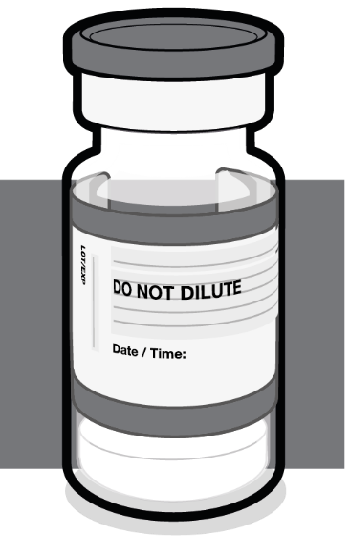  30 micrograms  Grey cap | - Verify that the vial has a grey plastic cap:  - If the vial has a purple plastic cap, refer to the AUSTRALIAN PRODUCT INFORMATION – COMIRNATY® (tozinameran) COVID-19 VACCINE for handling instructions of COMIRNATY 30 micrograms/0.3 mL concentrated suspension for injection vial. (AUST R 346290). This is a separate document to this PI.  - If the vial has an orange plastic cap, refer to the handling instructions for COMIRNATY Dilute To Use Multidose (For Age 5 to <12 Years) in this document.  - If the vial has a maroon plastic cap, refer to the handling instructions for COMIRNATY Dilute To Use Multidose (for age 6 months to <5 years) in this document.

COMIRNATY Ready To Use Multidose
(For Age 12 Years and Above, Do Not Dilute) (Grey cap)
Handling Prior To Use
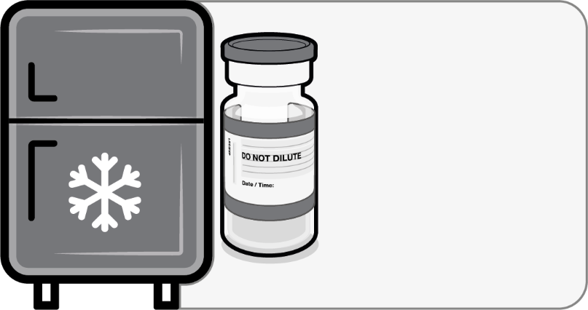  Store for up to 10 weeks at 2 °C to 8 °C | - If the multidose vial is stored frozen it must be thawed prior to use. Frozen vials should be transferred to an environment of 2°C to 8°C to thaw; a 10 vial pack may take 6 hours to thaw. Ensure vials are completely thawed prior to use.  - Update the expiry date on the carton.  - Unopened vials can be stored for up to 10 weeks at 2°C to 8°C.  - Alternatively, individual frozen vials may be thawed for 30 minutes at temperatures up to 30°C for immediate use.
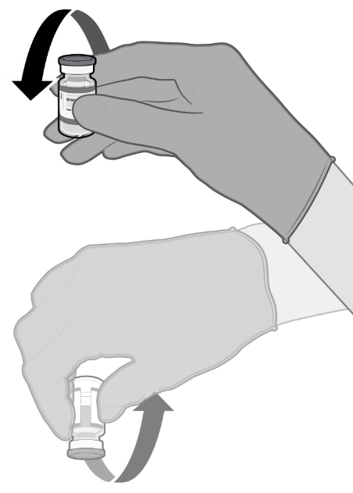  Gently × 10 | - Gently mix by inverting vial 10 times prior to use. Do not shake.  - Prior to mixing, the thawed suspension may contain white to off-white opaque amorphous particles.  - After mixing, the vaccine should present as a white to off-white suspension with no particulates visible. Do not use the vaccine if particulates or discoloration are present.

COMIRNATY Ready To Use Multidose
(For Age 12 Years and Above, Do Not Dilute) (Grey cap)
Preparation of Individual 0.3 mL Doses
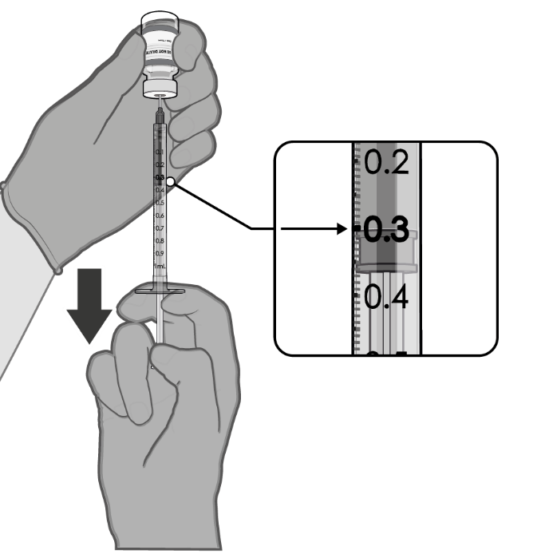  0.3 mL vaccine | Using aseptic technique, cleanse the vial stopper with a single-use antiseptic swab.  - Withdraw 0.3 mL of COMIRNATY (For Age 12 Years and Above).  Low dead-volume syringes and/or needles should be used in order to extract 6 doses from a single vial. The low dead-volume syringe and needle combination should have a dead volume of no more than 35 microlitres.  If standard syringes and needles are used, there may not be sufficient volume to extract a sixth dose from a single vial.  - Each dose must contain 0.3 mL of vaccine.  - Discard syringe and needle after administration to a single patient.  - Use a new, sterile needle and syringe to draw up each new dose.  - If the amount of vaccine remaining in the vial cannot provide a full dose of 0.3 mL, discard the vial and any excess volume.  - Discard any unused vaccine 12 hours after first puncture. Record the appropriate date/time on the vial.

COMIRNATY Dilute To Use Multidose (For Age 5 to <12 Years) (Orange cap)
Vials of COMIRNATY Dilute To Use Multidose (For Age 5 to <12 Years) have an orange cap and after dilution contain ten doses of 0.2 mL of vaccine. In order to extract ten doses from a single vial, low dead-volume syringes and/or needles should be used. The low dead-volume syringe and needle combination should have a dead volume of no more than 35 microlitres. If standard syringes and needles are used, there may not be sufficient volume to extract a tenth dose from a single vial. Irrespective of the type of syringe and needle:
- Each dose must contain 0.2 mL of vaccine.
- If the amount of vaccine remaining in the vial cannot provide a full dose of 0.2 mL, discard the vial and any excess volume.
- Do not pool excess vaccine from multiple vials.
For instructions on the handling, dilution and dose preparation of the vaccine before administration see Handling instructions.

Handling instructions
COMIRNATY Dilute To Use Multidose (For Age 5 to <12 Years) should be prepared by a healthcare professional using aseptic technique to ensure the sterility of the prepared diluted suspension.
COMIRNATY Dilute To Use Multidose (For Age 5 to <12 Years) (Orange cap)
Dose Verification
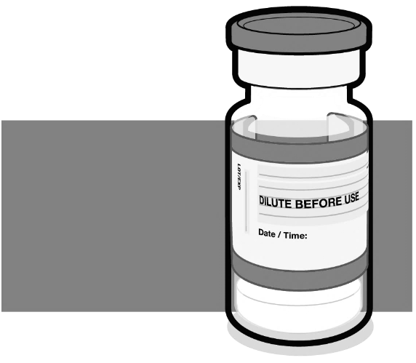  Orange cap  10 micrograms | - Verify that the vial has an orange plastic cap:  - If the vial has a purple plastic cap, refer to the AUSTRALIAN PRODUCT INFORMATION – COMIRNATY® (tozinameran) COVID-19 VACCINE for handling instructions of COMIRNATY 30 micrograms/0.3 mL concentrated suspension for injection vial. (AUST R 346290). This is a separate document to this PI.  - If the vial has a grey plastic cap, refer to the handling instructions for COMIRNATY Ready to Use Multidose (For Age 12 Years and Above, Do Not Dilute) in this document.  - If the vial has a maroon plastic cap, refer to the handling instructions for COMIRNATY Dilute To Use Multidose (for age 6 months to <5 years) in this document.
Handling Prior To Use
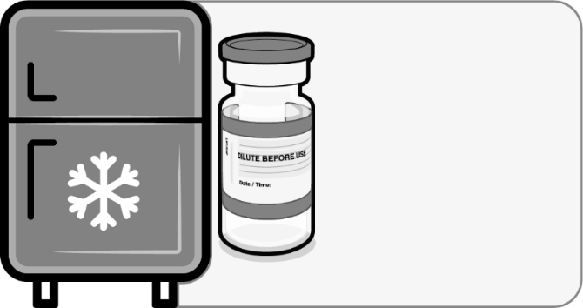  Store for up to 10 weeks at 2 °C to 8 °C | - If the multidose vial is stored frozen it must be thawed prior to use. Frozen vials should be transferred to an environment of 2°C to 8°C to thaw; a 10 vial pack may take 4 hours to thaw. Ensure vials are completely thawed prior to use.  - Unopened vials can be stored for up to 10 weeks at 2°C to 8°C.  - Alternatively, individual frozen vials may be thawed for 30 minutes at temperatures up to 30°C for immediate use.

COMIRNATY Dilute To Use Multidose (For Age 5 to <12 Years) (Orange cap)
Mixing Prior To Dilution
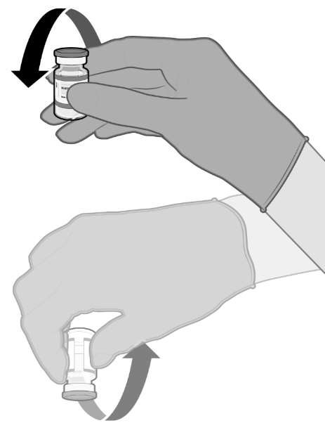  Gently × 10 | - Allow the thawed vial to come to room temperature and gently invert it 10 times prior to dilution. Do not shake.  - Prior to dilution, the thawed dispersion may contain white to off-white opaque amorphous particles.
Dilution
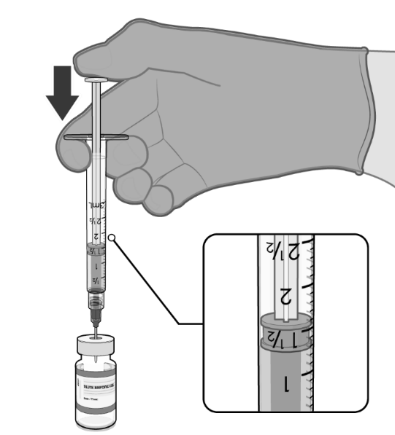  1.3 mL of 0.9% sodium chloride injection | - The thawed vaccine must be diluted in its original vial with 1.3 mL sodium chloride 9 mg/mL (0.9%) solution for injection, using a 21 gauge or narrower needle and aseptic techniques.

COMIRNATY Dilute To Use Multidose (For Age 5 to <12 Years) (Orange cap)
Dilution (continued)
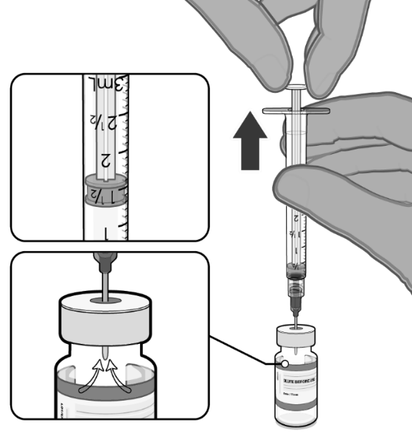  Pull back plunger to 1.3 mL to remove air from vial. | - Equalise vial pressure before removing the needle from the vial stopper by withdrawing 1.3 mL air into the empty diluent syringe.
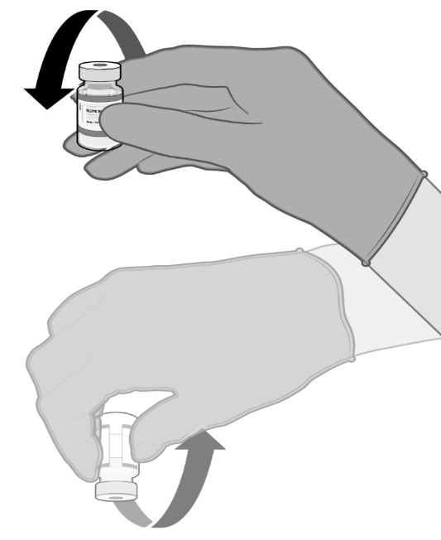  Gently × 10 | - Gently invert the diluted suspension 10 times. Do not shake.  - The diluted vaccine should present as a white to off-white suspension with no particulates visible. Do not use the diluted vaccine if particulates or discoloration are present.

COMIRNATY Dilute To Use Multidose (For Age 5 to <12 Years) (Orange cap)
Dilution (continued)
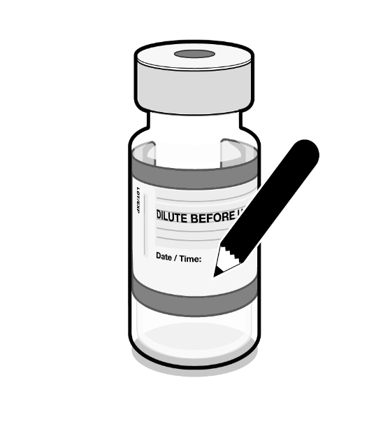  Record appropriate date and time.  Use within 12 hours after dilution. | - The diluted vials should be marked with the appropriate date and time.  - After dilution, store at 2°C to 30°C and use within 12 hours.  - Do not freeze or shake the diluted dispersion. If refrigerated, allow the diluted suspension to come to room temperature prior to use.
Preparation of Individual 0.2 mL Doses of COMIRNATY
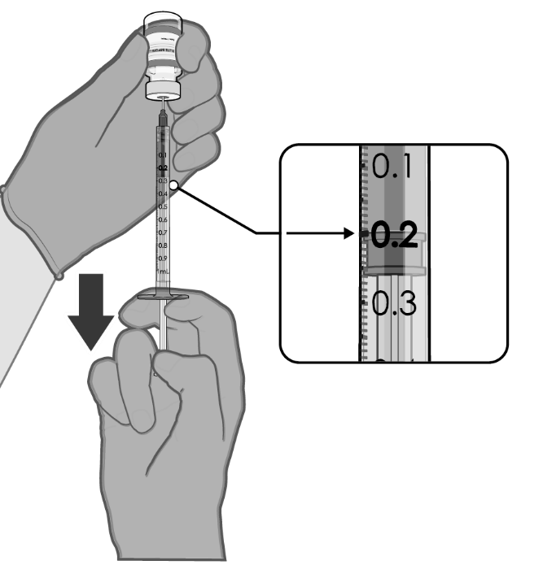  0.2 mL diluted vaccine | - Using aseptic technique, cleanse the vial stopper with a single-use antiseptic swab.  - Withdraw 0.2 mL of COMIRNATY (For Age 5 to <12 Years).  Low dead-volume syringes and/or needles should be used in order to extract 10 doses from a single vial. The low dead-volume syringe and needle combination should have a dead volume of no more than 35 microlitres.  If standard syringes and needles are used, there may not be sufficient volume to extract ten doses from a single vial.  - Each dose must contain 0.2 mL of vaccine.  - Discard syringe and needle after administration to a single patient.  - Use a new, sterile needle and syringe to draw up each new dose.  - If the amount of vaccine remaining in the vial cannot provide a full dose of 0.2 mL, discard the vial and any excess volume.  - Discard any unused vaccine within 12 hours after dilution.

COMIRNATY Dilute To Use Multidose (For Age 6 months to <5 Years) (Maroon cap)
Vials of COMIRNATY Dilute To Use Multidose (For Age 6 months to <5 Years) have a maroon cap and after dilution contain ten doses of 0.2 mL of vaccine. In order to extract ten doses from a single vial, low dead-volume syringes and/or needles should be used. The low dead-volume syringe and needle combination should have a dead volume of no more than 35 microlitres. If standard syringes and needles are used, there may not be sufficient volume to extract a tenth dose from a single vial. Irrespective of the type of syringe and needle:
- Each dose must contain 0.2 mL of vaccine.
- If the amount of vaccine remaining in the vial cannot provide a full dose of 0.2 mL, discard the vial and any excess volume.
- Do not pool excess vaccine from multiple vials.
For instructions on the handling, dilution and dose preparation of the vaccine before administration see Handling instructions.

Handling instructions
COMIRNATY Dilute To Use Multidose (For Age 6 months to <5 Years) should be prepared by a healthcare professional using aseptic technique to ensure the sterility of the prepared diluted suspension.
COMIRNATY Dilute To Use Multidose (For Age 6 months to <5 Years) (Maroon cap)
Dose Verification
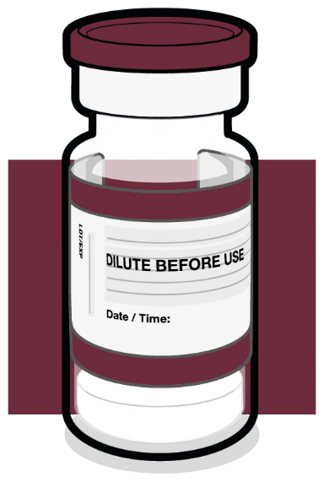  Maroon cap  3 micrograms | - Verify that the vial has a maroon plastic cap.  - If the vial has a purple plastic cap, refer to the AUSTRALIAN PRODUCT INFORMATION – COMIRNATY® (tozinameran) COVID-19 VACCINE for handling instructions of COMIRNATY 30 micrograms/0.3 mL concentrated suspension for injection vial. (AUST R 346290). This is a separate document to this PI.  - If the vial has a grey plastic cap, please make reference to the handling instructions for COMIRNATY Ready to Use Multidose (For Age 12 Years and Above, Do Not Dilute)(AUST R 377110) in this document.  - If the vial has an orange plastic cap, please make reference to the handling instructions for COMIRNATY Dilute to Use Multidose (For Age 5 to <12 Years)(AUST R 377111) in this document.
COMIRNATY Dilute To Use Multidose (For Age 6 months to <5 Years) (Maroon cap)
Handling Prior To Use
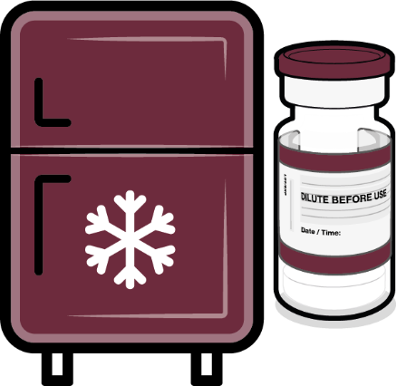  Store for up to 10 weeks at 2 °C to 8 °C | - If the multidose vial is stored frozen it must be thawed prior to use. Frozen vials should be transferred to an environment of 2 °C to 8 °C to thaw; a 10 vial pack may take 2 hours to thaw. Ensure vials are completely thawed prior to use.  - Upon moving vials to 2 °C to 8 °C storage, update the expiry date on the carton.  - Unopened vials can be stored for up to 10 weeks at 2 °C to 8 °C; not exceeding the printed expiry date (EXP).  - Alternatively, individual frozen vials may be thawed for 30 minutes at temperatures up to 30 °C.  - Prior to use, the unopened vial can be stored for up to 12 hours at temperatures up to 30 °C. Thawed vials can be handled in room light conditions.
Mixing Prior To Dilution
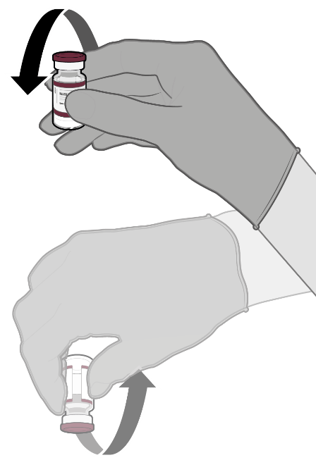  Gently × 10 | - Allow the thawed vial to come to room temperature and gently invert it 10 times prior to dilution. Do not shake.  - Prior to dilution, the thawed dispersion may contain white to off-white opaque amorphous particles.
COMIRNATY Dilute To Use Multidose (For Age 6 months to <5 Years) (Maroon cap)
Dilution
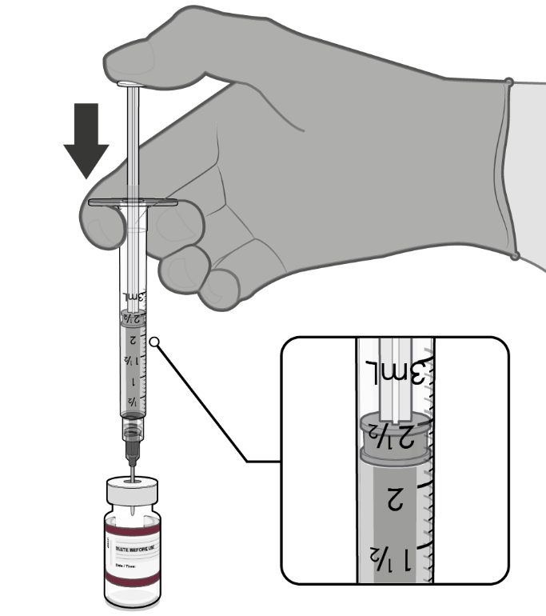  2.2 mL of 0.9% sodium chloride | - The thawed vaccine must be diluted in its original vial with 2.2 mL sodium chloride 9 mg/mL (0.9%) solution for injection, using a 21 gauge or narrower needle and aseptic techniques.
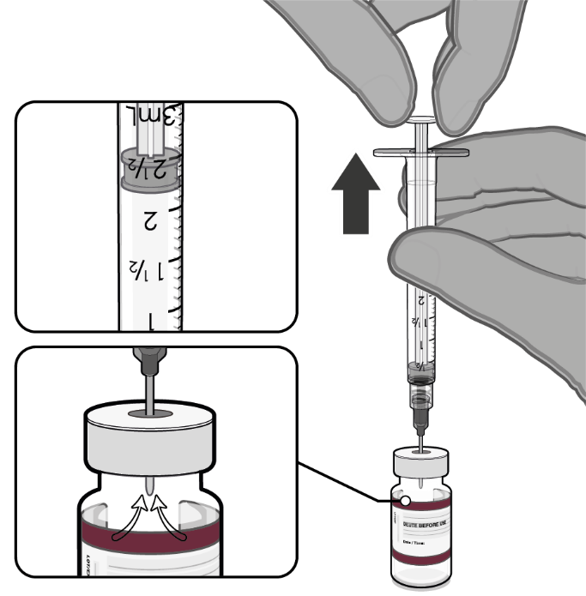  Pull back plunger to 2.2 mL to remove air from vial. | - Equalise vial pressure before removing the needle from the vial stopper by withdrawing 2.2 mL air into the empty diluent syringe.
COMIRNATY Dilute To Use Multidose (For Age 6 months to <5 Years) (Maroon cap)
Dilution (continued)
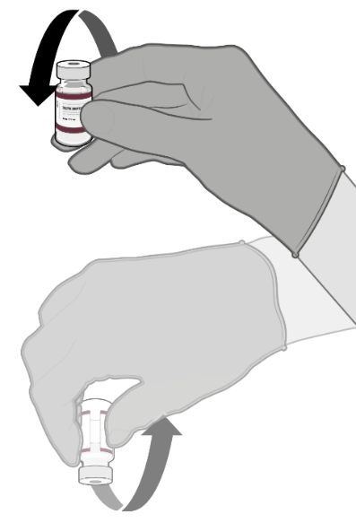  Gently × 10 | - Gently invert the diluted dispersion 10 times. Do not shake.  - The diluted vaccine should present as a white to off-white dispersion with no particulates visible. Do not use the diluted vaccine if particulates or discolouration are present.
Record appropriate date and time.  Use within 12 hours after dilution. | - The diluted vials should be marked with the appropriate date and time.  - After dilution, store at 2 ºC to 30 ºC and use within 12 hours.  - Do not freeze or shake the diluted dispersion. If refrigerated, allow the diluted dispersion to come to room temperature prior to use.
COMIRNATY Dilute To Use Multidose (For Age 6 months to <5 Years) (Maroon cap)
Preparation of Individual 0.2 mL Doses of COMIRNATY
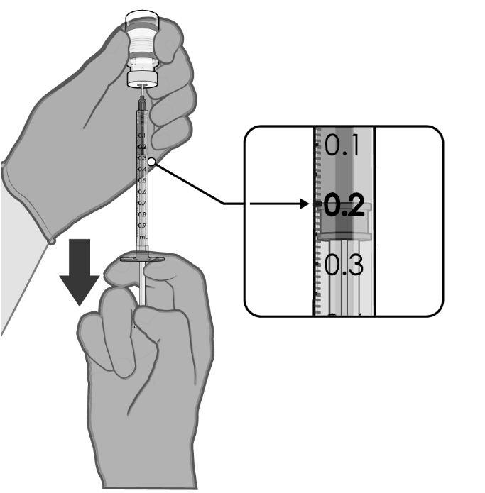  0.2 mL diluted vaccine | - After dilution, the vial contains 2.6 mL from which 10 doses of 0.2 mL can be extracted.  - Using aseptic technique, cleanse the vial stopper with a single use antiseptic swab.  - Withdraw 0.2 mL of COMIRNATY for infants and children age 6 months to <5 years.  Low dead-volume syringes and/or needles should be used in order to extract 10 doses from a single vial. The low dead-volume syringe and needle combination should have a dead volume of no more than 35 microlitres.  If standard syringes and needles are used, there may not be sufficient volume to extract ten doses from a single vial.  - Each dose must contain 0.2 mL of vaccine.  - Discard syringe and needle after administration to a single patient.  - Use a new, sterile needle and syringe to draw up each new dose.  - If the amount of vaccine remaining in the vial cannot provide a full dose of 0.2 mL, discard the vial and any excess volume.  - Discard any unused vaccine within 12 hours after dilution.

4.3 Contraindications
Hypersensitivity to the active substance or to any of the excipients listed in Section 6.1 List of excipients.

4.4 Special warnings and precautions for use

Traceability
In order to improve the traceability of biological medicinal products, the name and the batch number of the administered product should be recorded in the Australian Immunisation Register.

General recommendations

Hypersensitivity and anaphylaxis
Events of anaphylaxis have been reported. Appropriate medical treatment and supervision should always be readily available in case of an anaphylactic reaction following the administration of COMIRNATY.
The individual should be kept under close observation for at least 15 minutes following vaccination. A second dose of COMIRNATY should not be given to those who have experienced anaphylaxis to the first dose of COMIRNATY.

Myocarditis and pericarditis
Very rare cases of myocarditis and pericarditis have been observed following vaccination with COMIRNATY. Cases have occurred following first and second vaccinations and following booster doses. These cases have primarily occurred within 14 days following vaccination, more often after the second vaccination, and more often, but not exclusively in younger males. There have been reports in females. Based on accumulating data, the reporting rates of myocarditis and pericarditis after primary series in children ages 5 through <12 years are lower than in ages 12 through 17 years. Rates of myocarditis and pericarditis in booster doses do not appear to be higher than after the second dose in the primary series. Available data suggest that the course of myocarditis and pericarditis following vaccination is not different from myocarditis or pericarditis in general. Cases of myocarditis and pericarditis following vaccination have rarely been associated with severe outcomes including death.
Healthcare professionals should be alert to the signs and symptoms of myocarditis and pericarditis, including atypical presentations. Vaccinees should be instructed to seek immediate medical attention if they develop symptoms indicative of myocarditis or pericarditis such as (acute and persisting) chest pain, shortness of breath, or palpitations following vaccination. Non-specific symptoms of myocarditis and pericarditis also include fatigue, nausea and vomiting, abdominal pain, dizziness or syncope, oedema and cough. Healthcare professionals should consult guidance and/or specialists to diagnose and treat this condition.
For further details, please refer to the relevant clinical guidelines developed by the Australian Technical Advisory Group on Immunisation.

Anxiety-related reactions
Anxiety-related reactions, including vasovagal reactions (syncope), hyperventilation or stress-related reactions may occur in association with vaccination as a psychogenic response to the needle injection. It is important that precautions are in place to avoid injury from fainting.
Some individuals may have stress-related responses associated with the process of vaccination itself. Stress-related responses are temporary and resolve on their own. They may include dizziness, fainting, palpitations, increases in heart rate, alterations in blood pressure, feeling short of breath, tingling sensations, sweating and/or anxiety. Individuals should be advised to bring symptoms to the attention of the vaccination provider for evaluation and precautions should be in place to avoid injury from fainting.

Syncope
Syncope (fainting) may occur in association with administration of injectable vaccines. Procedures should be in place to avoid injury from fainting.

Concurrent illness
Vaccination should be postponed in individuals suffering from acute severe febrile illness or acute infection. The presence of a minor infection and/or low grade fever should not delay vaccination.

Thrombocytopenia and coagulation disorders
As with other intramuscular injections, COMIRNATY should be given with caution in individuals receiving anticoagulant therapy or those with thrombocytopenia or any coagulation disorder (such as haemophilia) because bleeding or bruising may occur following an intramuscular administration in these individuals.

Immunocompromised individuals
The efficacy, safety and immunogenicity of COMIRNATY has not been assessed in immunocompromised individuals, including those receiving immunosuppressant therapy. The efficacy of COMIRNATY may be lower in immunosuppressed individuals.

Duration of protection
The duration of protection afforded by COMIRNATY is unknown as it is still being determined by ongoing clinical trials and observational studies.

Limitations of vaccine effectiveness
As with any vaccine, vaccination with COMIRNATY may not protect all vaccine recipients. Individuals may not be fully protected until 7 days after their primary course of COMIRNATY.

Use in the elderly
Clinical studies of COMIRNATY include participants 65 years of age and older and their data contributes to the overall assessment of safety and efficacy. See Section 5.1 Pharmacodynamic properties, Clinical trials, Efficacy against COVID-19. No dosage adjustment is required in elderly individuals ≥65 years of age.
The data for use in the frail elderly (>85 years) is limited. The potential benefits of vaccination versus the potential risk and clinical impact of even relatively mild systemic adverse events in the frail elderly should be carefully assessed on a case-by-case basis.
The safety of a booster dose of COMIRNATY in individuals 65 years of age and older is based on safety data in 12 booster dose recipients 65 to 85 years of age in Study C4591001, 306 booster dose recipients 18 to 55 years of age in Study C4591001, and 1,175 booster dose recipients 65 years of age and older in Study C4591031. The effectiveness of a booster dose of COMIRNATY in individuals 65 years of age and older is based on effectiveness data in 306 booster dose recipients 18 to 55 years of age in Study C4591001, and an efficacy analysis from participants 16 years of age and older in 9,945 participants in Study C4591031.

Paediatric use
The safety and efficacy of COMIRNATY in infants aged less than 6 months of age have not yet been established.
Limited safety and effectiveness data is available for booster dose in adolescents 12 to 15 years of age and no immunogenicity data is available for booster dose in this age group. The safety and effectiveness of a booster dose of COMIRNATY in individuals 12 to 17 years of age is based on safety and effectiveness data in adults at least 18 to 55 years of age.
Real world evidence from the Ministry of Health of Israel and surveillance by CDC in USA on the administration of third doses of COMIRNATY given after the primary course revealed no new safety concerns in adolescents 12 to 17 years of age.
Very rare cases of myocarditis and pericarditis have been observed following vaccination with COMIRNATY in adolescents (see Section 4.4 Special warnings and precautions for use, Myocarditis and pericarditis).

Effects on laboratory tests
No data available.

4.5 Interactions with other medicines and other forms of interactions
No interaction studies have been performed.
Concomitant administration of COMIRNATY with other vaccines has not been studied.

4.6 Fertility, pregnancy and lactation

Effects on fertility
In a combined fertility and developmental toxicity study, female rats were intramuscularly administered COMIRNATY prior to mating and during gestation (4 full human doses of 30 μg each, spanning between pre-mating day 21 and gestation day 20). SARS CoV-2 neutralising antibodies were present in maternal animals from prior to mating to the end of the study on postnatal day 21 as well as in fetuses and offspring. There were no vaccine related effects on female fertility and pregnancy rate.

Use in pregnancy - Pregnancy Category B1
There is limited experience with use of COMIRNATY in pregnant women. Animal studies do not indicate direct or indirect harmful effects with respect to pregnancy, embryo/fetal development, parturition or post-natal development (see Section 4.6 Fertility, pregnancy and lactation, Effects on fertility). Administration of COMIRNATY in pregnancy should only be considered when the potential benefits outweigh any potential risks for the mother and fetus.

Use in lactation
It is unknown whether tozinameran is excreted in human milk. A combined fertility and developmental toxicity study in rats did not show harmful effects on offspring development before weaning (see Section 4.6 Fertility, pregnancy and lactation, Effects on fertility).

4.7 Effects on ability to drive and use machines
COMIRNATY has no, or negligible, influence on the ability to drive, cycle and use machines. However, some of the effects mentioned under Section 4.8 Adverse effects (undesirable effects) may temporarily affect the ability to drive, cycle or use machines.

4.8 Adverse effects (undesirable effects)

Summary of safety profile
The safety of COMIRNATY was evaluated in participants aged 6 months and older in clinical studies (comprised of 22,026 participants 16 years of age and older and 1,131 adolescents 12 to 15 years of age from Study C4591001, and 1,518 children 5 to <12 years of age, 1,835 participants 2 to <5 years of age and 1,178 participants 6 months to <2 years of age from Study C4591007) that have received at least one dose of COMIRNATY.
Additionally, 306 existing Phase 3 participants 18 to 55 years of age received a booster dose of COMIRNATY approximately 6 months after the second dose in the non-placebo-controlled booster dose portion of Study C4591001. The overall safety profile for the booster dose was similar to that seen after 2 doses.
In Study C4591031, a placebo-controlled booster study, 5,081 participants 16 years of age and older were recruited from Study C4591001 to receive a booster dose of COMIRNATY at least 6 months after the second dose. The overall safety profile for the booster dose was similar to that seen after 2 doses.
In a subset of C4591007 Phase 2/3 participants, 401 participants 5 to <12 years of age received a booster dose of COMIRNATY after completing the primary series. 399 of 401 participants in the safety population received the booster dose at 7 - < 9 months after Dose 2 (n = 51 [12.7%] at 7 - < 8 months and n = 348 [86.8%] at 8 - < 9 months). The overall safety profile for the booster dose was similar to that seen after the primary series.

Participants 16 years of age and older – after 2 doses
In Study C4591001, a total of 22,026 participants 16 years of age or older received at least 1 dose of COMIRNATY 30 micrograms and a total of 22,021 participants 16 years of age or older received placebo (including 138 and 145 adolescents 16 and 17 years of age in the COMIRNATY and placebo groups, respectively). A total of 20,519 participants 16 years of age or older received 2 doses of COMIRNATY.
At the time of the analysis of Study C4591001 with a data cut-off of 13 March 2021 for the placebo-controlled blinded follow-up period up to the participants’ unblinding dates, a total of 25,651 (58.2%) participants (13,031 COMIRNATY and 12,620 placebo) 16 years of age and older were followed up for ≥4 months after the second dose. This included a total of 15,111 (7,704 COMIRNATY and 7,407 placebo) participants 16 to 55 years of age and a total of 10,540 (5,327 COMIRNATY and 5,213 placebo) participants 56 years and older.
The most frequent adverse reactions in participants 16 years of age and older that received 2 doses were injection site pain (>80%), fatigue (>60%), headache (>50%), myalgia (>40%), chills (>30%), arthralgia (>20%), pyrexia and injection site swelling (>10%) and were usually mild or moderate in intensity and resolved within a few days after vaccination. A slightly lower frequency of reactogenicity events was associated with greater age.
The safety profile in 545 subjects receiving COMIRNATY, that were seropositive for SARS-CoV-2 at baseline, was similar to that seen in the general population.
Study C4591001 also included 200 participants with confirmed stable human immunodeficiency virus (HIV) infection. The safety profile of the participants receiving COMIRNATY (n=100) in the individuals with stable HIV infection was similar to that seen in the general population.

Adolescents 12 to 15 years of age – after 2 doses
In an analysis of long term safety follow-up in Study C4591001, 2,260 adolescents (1,131 COMIRNATY 30 micrograms; 1,129 placebo) were 12 to 15 years of age. Of these, 1,559 adolescents (786 COMIRNATY and 773 placebo) have been followed for ≥ 4 months after the second dose of COMIRNATY. The safety evaluation in Study C4591001 is ongoing.
The most frequent adverse reactions in adolescents 12 to 15 years of age that received 2 doses were injection site pain (>90%), fatigue and headache (>70%), myalgia and chills (>40%), arthralgia and pyrexia (>20%).

Children 5 to <12 years of age – after 2 doses
In an analysis of Study C4591007 Phase 2/3, 2,268 children (1,518 COMIRNATY 10 micrograms; 750 placebo) were 5 to <12 years of age. Of these, 2,158 (95.1%) (1,444 COMIRNATY 10 micrograms and 714 placebo) children have been followed for at least 2 months after the second dose. The safety evaluation in Study C4591007 is ongoing.
The most frequent adverse reactions in children 5 to <12 years of age that received 2 doses included injection site pain (>80%), fatigue (>50%), headache (>30%), injection site redness and swelling (>20%), myalgia and chills (>10%).

Children 2 to <5 years of age – after 3 doses
In an analysis of Study C4591007 (Phase 2/3), 2,750 children (1,835 COMIRNATY 3 micrograms and 915 placebo) were 2 to <5 years age. Based on data in the blinded placebo-controlled follow-up period up to the cutoff date of 29 April 2022, 886 children 2 to <5 years of age who received a 3-dose primary course (606 COMIRNATY 3 micrograms and 280 placebo) have been followed a median of 1.4 months after the third dose.
The most frequent adverse reactions in children 2 to <5 years of age that received any primary course dose included pain at injection site and fatigue (>40%), injection site redness and fever (>10%).

Infants 6 months to <2 years of age – after 3 doses
In an analysis of Study C4591007 (Phase 2/3), 1,776 infants (1,178 COMIRNATY 3 micrograms and 598 placebo) were 6 months to <2 years of age. Based on data in the blinded placebo-controlled follow-up period up to the cutoff date of 29 April 2022, 570 infants 6 months to <2 years of age who received a 3-dose primary course [386 COMIRNATY 3 micrograms and 184 placebo] have been followed for a median of 1.3 months after the third dose.
The most frequent adverse reactions in infants 6 months to <2 years of age that received any primary course dose included irritability (>60%), decrease appetite (>30%), tenderness at the injection site (>20%), injection site redness and fever (>10%).

Participants 12 years of age and older – after booster dose
A subset from Study C4591001 Phase 2/3 participants of 306 adults 18 to 55 years of age who completed the original COMIRNATY 2-dose course, received a booster dose of COMIRNATY approximately 6 months (range of 4.8 to 8.0 months) after receiving Dose 2. Of these, 301 participants have been followed for ≥4 months after the booster dose of COMIRNATY.
The most frequent adverse reactions in participants 18 to 55 years of age were injection site pain (>80%), fatigue (>60%), headache (>40%), myalgia (>30%), chills and arthralgia (>20%).
In Study C4591031, a placebo-controlled booster study, participants 16 years of age and older recruited from Study C4591001 received a booster dose of COMIRNATY (5,081 participants), or placebo (5,044 participants) at least 6 months after the second dose of COMIRNATY. Overall, participants who received a booster dose, had a median follow-up time of2.8 months (range 0.3 to 7.5 months) after the booster dose in the blinded placebo-controlled follow-up period to the cut-off date (8 February 2022). Of these, 1281 participants (895 COMIRNATY and 386 placebo) have been followed for ≥ 4 months after the booster dose of COMIRNATY.

Participants 18 years of age and older – after subsequent booster doses
A subset of 325 adults 18 to ≤55 years of age who had completed 3 doses of COMIRNATY received a booster (fourth dose) of COMIRNATY (30 micrograms) 90 to 180 days after receiving Dose 3. Participants who received a booster (fourth dose) of COMIRNATY (30 micrograms) had a median follow-up time of 1.4 months. The most frequent adverse reactions in these participants were injection site pain (>70%), fatigue (>60%), headache (>40%), myalgia and chills (>20%) and arthralgia (>10%).
In a subset from Study C4591031 (Phase 3), 305 adults greater than 55 years of age who had completed 3 doses of COMIRNATY, received a booster (fourth dose) of COMIRNATY (30 micrograms) 5.3 to 13.1 months after receiving Dose 3. Participants who received a booster (fourth dose) of COMIRNATY (30 micrograms) had a median follow-up time of at least 1.7 months up to a data cutoff date of 16 May 2022. The most frequent adverse reactions in participants greater than 55 years of age were injection site pain (60%), fatigue (>40%), headache (>20%), myalgia and chills (>10%).

Children 5 to <12 years of age – after booster dose
In a subset from C4591007, a total of 401 children 5 to <12 years of age received a booster dose of COMIRNATY 10 micrograms after completing the primary series. 399 of 401 participants in the safety population received the booster dose at 7 - < 9 months after Dose 2 (n = 51 [12.7%] at 7 - < 8 months and n = 348 [86.8%] at 8 - < 9 months). The analysis of the C4591007 Phase 2/3 subset is based on data up to the cut-off date of 22 March 2022 (median follow-up time of 1.3 months).
The most frequent adverse reactions in participants 5 to <12 years of age were injection site pain (>70%), fatigue (>40%), headache (>30%), myalgia, chills, injection site redness, and swelling (>10%). A higher frequency of lymphadenopathy was observed in C4591007 in participants receiving a booster dose compared to participants receiving 2 doses (2.5% vs. 0.9%).

Tabulated list of adverse reactions from clinical studies
Adverse reactions observed during clinical studies are listed below according to the following frequency categories:
Very common (≥1/10),
Common (≥1/100 to <1/10),
Uncommon (≥1/1,000 to <1/100),
Rare (≥1/10,000 to <1/1,000),
Very rare (<1/10,000),
Not known (cannot be estimated from the available data).
Table 1: Adverse reactions from COMIRNATY clinical trials: Individuals 12 years of age and older
System Organ Class | Very common  (≥1/10) | Common  (≥1/100 to <1/10) | Uncommon  (≥1/1,000 to <1/100) | Rare  (≥1/10,000 to <1/1,000) | Not known (cannot be estimated from the available data)
Blood and lymphatic system disorders |  |  | Lymphadenopathyª
Psychiatric disorders |  |  | Insomnia
Metabolism and nutrition disorders |  |  | Decreased appetite
Nervous system disorders | Headache |  | Lethargy | Acute peripheral facial paralysis^{b}
Gastrointestinal disorders |  | Nausea
Skin and subcutaneous disorders |  |  | Hyperhidrosis  Night sweats
Musculoskeletal and connective tissue disorders | Arthralgia; Myalgia
General disorders and administration site conditions | Injection site pain; Fatigue; Chills; Pyrexia^{c}; Injection site swelling | Injection site redness | Asthenia  Malaise |  | Facial swelling^{d}
ª higher frequency of lymphadenopathy (2.8% vs 0.4%) was observed in participants receiving a booster dose in Study C4591031 compared to participants receiving 2 doses.
^{b} Through the clinical trial safety follow-up period to 14 November 2020, acute peripheral facial paralysis (or palsy) was reported by four participants in the COMIRNATY group. Onset was Day 37 after Dose 1 (participant did not receive Dose 2) and Days 3, 9, and 48 after Dose 2. No cases of acute peripheral facial paralysis (or palsy) were reported in the placebo group.
^{c} A higher frequency of pyrexia was observed after the second dose compared to the first dose.
^{d} Facial swelling in vaccine recipients with a history of injection of dermatological fillers
The safety profile in 545 subjects receiving COMIRNATY, that were seropositive for SARS-CoV-2 at baseline, was similar to that seen in the general population.
Table 2. Adverse Reactions from COMIRNATY clinical trial: Individuals 5 to <12 Years of Age (06 September 2021 Data Cut-off Date)
System Organ Class | Very Common  ≥1/10 (≥10%) | Common  ≥1/100 to <1/10  (≥1% to <10%) | Uncommon  ≥1/1,000 to  <1/100  (≥0.1% to <1%) | Rare  ≥1/10,000 to  <1/1,000  (≥0.01% to <0.1%) | Very Rare  <1/10,000 (<0.01%) | Not known (cannot be estimated from the available data)
Blood and lymphatic system disorders |  |  | Lymphadenopathyª
Immune system disorders |  |  | Urticaria^{b,c};  Pruritus^{b,c};  Rash^{b,c} |  |  | Anaphylaxis^{b}
Metabolism and nutrition disorders |  |  | Decreased appetite
Nervous system disorders | Headache
Gastrointestinal disorders |  | Diarrhoea;^{b} Vomiting^{b} | Nausea
Musculoskeletal and connective tissue disorders | Myalgia | Arthralgia | Pain in extremity (arm)^{b}
General disorders and administration site conditions | Injection site pain;  Fatigue;  Chills;  Injection site swelling;  Injection site redness | Pyrexia | Malaise
a. A higher frequency of lymphadenopathy was observed in C4591007 (2.5% vs. 0.9%) in participants receiving a booster dose compared to participants receiving 2 doses.
b. These adverse reactions were identified in the post-authorisation period. The following events were not reported in participants 5 to <12 Years of Age in Study C4591007 but were reported in individuals ≥16 years of age in Study C4591001: angioedema, lethargy, asthenia, hyperhidrosis, and night sweats.
c. The following events are categorised as hypersensitivity reactions: urticaria, pruritus, and rash

Table 3. Adverse Reactions from COMIRNATY clinical trial: Individuals 2 to <5 Years of Age (29 April 2022 Data Cut-off Date)
System Organ Class | Very Common  ≥1/10  (≥10%) | Common  ≥1/100 to <1/10  (≥1% to <10%) | Uncommon  ≥1/1,000 to <1/100  (≥0.1% to <1%) | Rare  ≥1/10,000 to <1/1,000  (≥0.01% to <0.1%) | Very Rare  <1/10,000  (<0.01%) | Not known (cannot be estimated from the available data)
Blood and lymphatic system disorders |  |  | Lymphadenopathy
Immune system disorders |  |  | Rash^{a,b};  Urticaria^{a,b} |  |  | Anaphylaxisª
Metabolism and nutrition disorders |  |  | Decreased appetite
Nervous system disorders |  | Headache
Cardiac disorders |  |  |  |  | Myocarditisª  Pericarditisª
Gastrointestinal disorders | Diarrhoeaª | Vomitingª | Nausea
Musculoskeletal and connective tissue disorders |  | Myalgia Arthralgia | Pain in extremity (arm)ª
General disorders and administration site conditions | Injection site pain;  Fatigue; Injection site redness; Pyrexia | Injection site swelling; Chills | Asthenia
* CIOMS frequency categories are based on clinical trial C4591007 crude incidence and was reported to only one significant figure.
a. These adverse reactions were identified in the post-authorisation period. At the time of the data-lock, the following reactions were not reported in participants 2 to <5 Years of Age in Study C4591007: pruritus, angioedema, lethargy, myocarditis, pericarditis, hyperhidrosis, night sweats, and malaise.
b. The following events are categorised as hypersensitivity reactions: rash and urticaria

Table 4. Adverse Reactions from COMIRNATY clinical trial: Individuals 6 Months to <2 Years of Age (29 April 2022 Data Cut-off Date)
System Organ Class | Very Common  ≥1/10  (≥10%) | Common  ≥1/100 to <1/10  (≥1% to <10%) | Uncommon  ≥1/1,000 to <1/100  (≥0.1% to <1%) | Rare  ≥1/10,000 to <1/1,000  (≥0.01% to <0.1%) | Very Rare  <1/10,000  (<0.01%) | Not known (cannot be estimated from the available data)
Blood and lymphatic system disorders |  |  | Lymphadenopathy
Immune system disorders |  | Rash^{a,b} | Urticaria^{a,b}; |  |  | Anaphylaxisª
Metabolism and nutrition disorders | Decreased appetite
Cardiac disorders |  |  |  |  | Myocarditisª  Pericarditisª
Psychiatric disorders | Irritability
Nervous system disorders |  |  | Headache  Lethargy
Gastrointestinal disorders |  | Vomiting^{a,};  Diarrhoea^{a,}
General disorders and administration site conditions | Injection site tenderness; Injection site redness; Pyrexia | Injection site swelling | Fatigue;  Chills
* CIOMS frequency categories are based on clinical trial C4591007 crude incidence and was reported to only one significant figure.
a. These adverse reactions were identified in the post-authorisation period. At the time of data-lock, the following events were not reported in participants 6 months to <2 Years of Age in Study C4591007: pruritus, angioedema, nausea, hyperhidrosis, night sweats, myalgia, arthralgia, pain in extremity, malaise, and asthenia.
b. The following events are categorised as hypersensitivity reactions: rash and urticaria

Table 5. Adverse Reactions in Individuals 18 to 55 years old Who Received a subsequent Booster (Dose 4) of COMIRNATY in Study C4591031 Substudy D (SSD)
System Organ Class | Very Common  ≥1/10 (≥10%) | Common  ≥1/100 to <1/10 (≥1% to <10%) | Uncommon  ≥1/1,000 to <1/100  (≥0.1% to <1%) | Rare  ≥1/10,000 to  <1/1,000  (≥0.01% to <0.1%) | Very Rare  <1/10,000 (<0.01%) | Frequency not known (cannot be estimated from the available data)
Blood and lymphatic system disorders |  |  | Lymphadenopathy
Immune system disorders |  |  |  |  |  | Anaphylaxisª
Nervous system disorders | Headache
Cardiac disorders |  |  |  |  | Myocarditisª  Pericarditisª
Gastrointestinal disorders | Diarrhoeaª | Vomitingª
Musculoskeletal and connective tissue disorders | Arthralgia; Myalgia
General disorders and administration site conditions | Injection site pain;  Fatigue;  Chills | Pyrexia; Injection site swelling; Injection site redness
* CIOMS frequency categories are based on clinical trial C4591031 SSD crude incidence and was reported to only one significant figure.
a. These adverse reactions were identified in the post-authorisation period. At the time of the data cut-off date, the following reactions were not reported in the safety population in Study C4591031 SSD: rash, pruritus, urticaria, angioedema, decreased appetite, lethargy, nausea, hyperhidrosis, night sweats, pain in extremity, malaise, and asthenia but are still considered adverse reactions.

Table 6. Adverse Reactions in Individuals >55 years old Who Received a subsequent Booster (Dose 4) of COMIRNATY in Study C4591031 Substudy E (SSE)
System Organ Class | Very Common  ≥1/10 (≥10%) | Common  ≥1/100 to <1/10 (≥1% to <10%) | Uncommon  ≥1/1,000 to <1/100  (≥0.1% to <1%) | Rare  ≥1/10,000 to  <1/1,000  (≥0.01% to <0.1%) | Very Rare  <1/10,000 (<0.01%) | Frequency not known (cannot be estimated from the available data)
Blood and lymphatic system disorders |  |  | Lymphadenopathy
Immune system disorders |  |  |  |  |  | Anaphylaxisª
Nervous system disorders | Headache
Cardiac disorders |  |  |  |  | Myocarditisª  Pericarditisª
Gastrointestinal disorders |  | Diarrhoeaª; Vomitingª | Nausea
Musculoskeletal and connective tissue disorders | Myalgia | Arthralgia | Pain in extremityª
General disorders and administration site conditions | Injection site pain;  Fatigue;  Chills | Pyrexia; Injection site swelling; Injection site redness
* CIOMS frequency categories are based on clinical trial C4591031 SSE crude incidence and was reported to only one significant figure.
a. These adverse reactions were identified in the post-authorisation period. At the time of the data cut-off date, the following reactions were not reported in the safety population in Study C4591031 SSE: rash, pruritus, urticaria, angioedema, decreased appetite, lethargy, hyperhidrosis, night sweats, malaise and asthenia but are still considered adverse reactions.

Post-marketing experience
Although the events listed in Table 7 were not observed in the clinical trials, they are considered adverse drug reactions for COMIRNATY as they were reported in the post-marketing experience. As these reactions were derived from spontaneous reports, the frequencies could not be determined and are thus considered as not known.
Table 7: Adverse reactions from COMIRNATY post marketing experience
System Organ Class | Adverse Drug Reaction
Immune system disorders | Anaphylaxis  Hypersensitivity reactions (e.g. rash, pruritis, urticaria, angioedema, erythema multiforme)
Cardiac disorders | Myocarditis  Pericarditis
Gastrointestinal disorders | Diarrhoea  Vomiting
Musculoskeletal and connective tissue disorders | Pain in extremity (arm)
General disorders and administration site conditions | Extensive swelling of vaccinated limb
Nervous system disorders | Paraesthesia  Hypoaesthesia  Dizziness
Reproductive system and breast disorders | Non-sexually acquired genital ulceration  Heavy menstrual bleeding*
ª A higher frequency of pain in extremity (1.1% vs. 0.8%) was observed in participants receiving a booster dose in Study C4591031 compared to participants receiving 2 doses.
* Most cases appear to be non-serious and temporary in nature

Reporting suspected adverse effects
Reporting suspected adverse reactions after registration of the medicinal product is important. It allows continued monitoring of the benefit-risk balance of the medicinal product. Healthcare professionals are asked to report any suspected adverse reactions at www.tga.gov.au/reporting-problems.

4.9 Overdose
Overdose data is available from 52 study participants included in the clinical trial that due to an error in dilution received 58 micrograms of COMIRNATY. The COMIRNATY recipients did not report an increase in reactogenicity or adverse reactions.
In the event of overdose, monitoring of vital functions and possible symptomatic treatment is recommended.
For information on the management of overdose, contact the Poisons Information Centre on 131126 (Australia).

5. PHARMACOLOGICAL PROPERTIES

5.1 Pharmacodynamic properties
Pharmacotherapeutic group: vaccines, other viral vaccines, ATC code: J07BX03

Mechanism of action
The nucleoside-modified messenger RNA in COMIRNATY is formulated in lipid nanoparticles, which enable delivery of the non-replicating RNA into host cells to direct transient expression of the SARS-CoV-2 spike (S) antigen. The mRNA codes for membrane-anchored, full-length S with two point mutations within the central helix. Mutation of these two amino acids to proline locks S in an antigenically preferred prefusion conformation. COMIRNATY elicits both neutralising antibody and cellular immune responses to the antigen, which may contribute to protection against COVID-19.

Clinical trials

Efficacy
Study C4591001 is a multicentre, multinational, Phase 1/2/3 randomised, placebo-controlled, observer-blind dose-finding, vaccine candidate selection and efficacy study in participants 12 years of age and older. Randomisation was stratified by age: 12 to 15 years of age, 16 to 55 years of age, or 56 years of age and older, with a minimum of 40% of participants in the ≥56-year stratum. The study excluded participants who were immunocompromised and those who had previous clinical or microbiological diagnosis of COVID-19. Participants with pre-existing stable disease, defined as disease not requiring significant change in therapy or hospitalisation for worsening disease during the 6 weeks before enrolment, were included as were participants with known stable infection with HIV, hepatitis C virus (HCV) or hepatitis B virus (HBV).

Efficacy in participants 16 years of age and older – after 2 doses
In the Phase 2/3 portion of Study C4591001, based on data accrued through 14 November 2020, approximately 44,000 participants were randomised equally and were to receive 2 doses of COMIRNATY or placebo. The efficacy analyses included participants that received their second vaccination within 19 to 42 days after their first vaccination. The majority (93.1%) of vaccine recipients received the second dose 19 days to 23 days after Dose 1. Participants are planned to be followed for up to 24 months after Dose 2, for assessments of safety and efficacy against COVID-19. In the clinical study, participants were required to observe a minimum interval of 14 days before and after administration of an influenza vaccine in order to receive either placebo or COMIRNATY. In the clinical study, participants were required to observe a minimum interval of 60 days before or after receipt of blood/plasma products or immunoglobulins through to conclusion of the study in order to receive either placebo or COMIRNATY.
The population for the analysis of the primary efficacy endpoint included, 36,621 participants 12 years of age and older (18,242 in the COMIRNATY group and 18,379 in the placebo group) who did not have evidence of prior infection with SARS-CoV-2 through 7 days after the second dose. In addition, 134 participants were between the ages of 16 to 17 years of age (66 in the COMIRNATY group and 68 in the placebo group) and 1616 participants 75 years of age and older (804 in the COMIRNATY group and 812 in the placebo group).
At the time of the primary efficacy analysis, participants had been followed for symptomatic COVID-19 for in total 2,214 person-years for the COMIRNATY group and in total 2,222 person-years for the placebo group.
There were no meaningful clinical differences in overall vaccine efficacy in participants who were at risk of severe COVID-19 including those with 1 or more comorbidities that increase the risk of severe COVID-19 (e.g. asthma, body mass index (BMI) ≥30 kg/m², chronic pulmonary disease, diabetes mellitus, hypertension).
COMIRNATY efficacy information is presented in Table 8.
Table 8: Vaccine efficacy – First COVID-19 occurrence from 7 days after Dose 2, by age subgroup – participants without evidence of infection prior to 7 days after Dose 2 – evaluable efficacy (7 days) population
First COVID-19 occurrence from 7 days after Dose 2 in participants without evidence of prior SARS-CoV-2 infection*
Subgroup | COMIRNATY  Nª = 18,198  Cases  n1^{b}  Surveillance time^{c} (n2^{d}) | Placebo  Nª = 18,325  Cases  n1^{b}  Surveillance time^{c} (n2^{d}) | Vaccine efficacy % (95% CI)^{f}
All participants^{e} | 8  2.214 (17,411) | 162  2.222 (17,511) | 95.0  (90.0, 97.9)
16 to 64 years | 7  1.706 (13,549) | 143  1.710 (13,618) | 95.1  (89.6, 98.1)
65 years and older | 1  0.508 (3848) | 19  0.511 (3880) | 94.7  (66.7, 99.9)
65 to 74 years | 1  0.406 (3074) | 14  0.406 (3095) | 92.9  (53.1, 99.8)
75 years and older | 0  0.102 (774) | 5  0.106 (785) | 100.0  (-13.1, 100.0)
Note: Confirmed cases were determined by Reverse Transcription-Polymerase Chain Reaction (RT-PCR) and at least 1 symptom consistent with COVID-19 [*Case definition: (at least 1 of) fever, new or increased cough, new or increased shortness of breath, chills, new or increased muscle pain, new loss of taste or smell, sore throat, diarrhoea or vomiting.]
* Participants who had no serological or virological evidence (prior to 7 days after receipt of the last dose) of past SARS-CoV-2 infection (i.e., N-binding antibody [serum] negative at Visit 1 and SARS-CoV-2 not detected by nucleic acid amplification tests (NAAT) [nasal swab] at Visits 1 and 2), and had negative NAAT (nasal swab) at any unscheduled visit prior to 7 days after Dose 2 were included in the analysis.
a. N = number of participants in the specified group.
b. n1 = Number of participants meeting the endpoint definition.
c. Total surveillance time in 1000 person-years for the given endpoint across all participants within each group at risk for the endpoint. Time period for COVID-19 case accrual is from 7 days after Dose 2 to the end of the surveillance period.
d. n2 = Number of participants at risk for the endpoint.
e. No confirmed cases were identified in adolescents 12 to 15 years of age.
f. Two-sided confidence interval (CI) for vaccine efficacy (VE) is derived based on the Clopper and Pearson method adjusted to the surveillance time. CI not adjusted for multiplicity.
In the second primary analysis, efficacy of COMIRNATY in preventing first COVID-19 occurrence from 7 days after Dose 2 compared to placebo was 94.6% (95% credible interval of 89.9% to 97.3%) in participants 16 years of age and older with or without evidence of prior infection with SARS-CoV-2.
Additionally, subgroup analyses of the primary efficacy endpoint showed similar efficacy point estimates across genders, ethnic groups, and participants with medical comorbidities associated with high risk of severe COVID-19.
Updated efficacy analyses were performed with additional confirmed COVID-19 cases accrued during blinded placebo-controlled follow-up through 13 March 2021, representing up to 6 months of follow-up after Dose 2 for participants in the efficacy population.
The updated vaccine efficacy information is presented in Table 9.
Table 9: Vaccine efficacy – First COVID-19 occurrence from 7 days after Dose 2, by age subgroup – participants without evidence of infection prior to 7 days after Dose 2 – evaluable efficacy (7 days) population during the placebo-controlled follow-up period
First COVID-19 occurrence from 7 days after Dose 2 in participants without evidence of prior SARS-CoV-2 infection*
Subgroup | COMIRNATY  Nª=20,998  Cases  n1^{b}  Surveillance Time^{c} (n2^{d}) | Placebo  Nª=21,096  Cases  n1^{b}  Surveillance Time^{c} (n2^{d}) | Vaccine efficacy %  (95% CIe)
All participants^{f} | 77  6.247 (20,712) | 850  6.003 (20,713) | 91.3  (89.0, 93.2)
16 to 64 years | 70  4.859 (15,519) | 710  4.654 (15,515) | 90.6  (87.9, 92.7)
65 years and older | 7  1.233 (4192) | 124  1.202 (4226) | 94.5  (88.3, 97.8)
65 to 74 years | 6  0.994 (3350) | 98  0.966 (3379) | 94.1  (86.6, 97.9)
75 years and older | 1  0.239 (842) | 26  0.237 (847) | 96.2  (76.9, 99.9)
Note: Confirmed cases were determined by Reverse Transcription-Polymerase Chain Reaction (RT-PCR) and at least 1 symptom consistent with COVID-19 (symptoms included: fever; new or increased cough; new or increased shortness of breath; chills; new or increased muscle pain; new loss of taste or smell; sore throat; diarrhoea; vomiting).
* Participants who had no evidence of past SARS-CoV-2 infection (i.e., N-binding antibody [serum] negative at Visit 1 and SARS-CoV-2 not detected by NAAT [nasal swab] at Visits 1 and 2), and had negative NAAT (nasal swab) at any unscheduled visit prior to 7 days after Dose 2 were included in the analysis.
a. N = Number of participants in the specified group.
b. n1 = Number of participants meeting the endpoint definition.
c. Total surveillance time in 1000 person-years for the given endpoint across all participants within each group at risk for the endpoint. Time period for COVID-19 case accrual is from 7 days after Dose 2 to the end of the surveillance period.
d. n2 = Number of participants at risk for the endpoint.
e. Two-sided confidence interval (CI) for vaccine efficacy is derived based on the Clopper and Pearson method adjusted to the surveillance time.
f. Included confirmed cases in participants 12 to 15 years of age: 0 in the COMIRNATY group (both without and with or without evidence of prior SARS-CoV-2 infection); 16 and 18 in the placebo group (without and with or without evidence of prior SARS-CoV-2 infection, respectively).

Efficacy against severe COVID-19 in participants 12 years of age or older – after 2 doses
As of 13 March 2021, vaccine efficacy against severe COVID-19 is presented only for participants with or without prior SARS-CoV-2 infection (Table 10) as the COVID-19 case counts in participants without prior SARS-CoV-2 infection were the same as those in participants with or without prior SARS-CoV-2 infection in both the COMIRNATY and placebo groups.
Table 10. Vaccine Efficacy – First Severe COVID-19 Occurrence in Participants With or Without* Prior SARS-CoV-2 Infection Based on Food and Drug Administration (FDA)† Definition After Dose 1 or From 7 Days After Dose 2 in the Placebo-Controlled Follow-up
 | COMIRNATY  Cases  n1ª  Surveillance Time (n2^{b}) | Placebo  Cases  n1ª  Surveillance Time (n2^{b}) | Vaccine Efficacy %  (95% CI^{c})
After Dose 1^{d} | 1  8.439e (22,505) | 30  8.288e (22,435) | 96.7  (80.3, 99.9)
7 days after Dose 2^{f} | 1  6.522^{g} (21,649) | 21  6.404^{g} (21,730) | 95.3  (70.9, 99.9)
Note: Confirmed cases were determined by Reverse Transcription-Polymerase Chain Reaction (RT-PCR) and at least 1 symptom consistent with COVID-19 (symptoms included: fever; new or increased cough; new or increased shortness of breath; chills; new or increased muscle pain; new loss of taste or smell; sore throat; diarrhoea; vomiting).
* Participants who had no evidence of past SARS-CoV-2 infection (i.e., N-binding antibody [serum] negative at Visit 1 and SARS-CoV-2 not detected by NAAT [nasal swab] at Visits 1 and 2), and had negative NAAT (nasal swab) at any unscheduled visit prior to 7 days after Dose 2 were included in the analysis.
† Severe illness from COVID-19 as defined by FDA is confirmed COVID-19 and presence of at least 1 of the following:
- Clinical signs at rest indicative of severe systemic illness (respiratory rate ≥30 breaths per minute, heart rate ≥125 beats per minute, saturation of oxygen ≤93% on room air at sea level, or ratio of arterial oxygen partial pressure to fractional inspired oxygen <300 mm Hg);
- Respiratory failure [defined as needing high-flow oxygen, noninvasive ventilation, mechanical ventilation or extracorporeal membrane oxygenation (ECMO)];
- Evidence of shock (systolic blood pressure <90 mm Hg, diastolic blood pressure <60 mm Hg, or requiring vasopressors);
- Significant acute renal, hepatic, or neurologic dysfunction;
- Admission to an Intensive Care Unit;
- Death.
a. n1 = Number of participants meeting the endpoint definition.
b. n2 = Number of participants at risk for the endpoint.
c. Two-side confidence interval (CI) for vaccine efficacy is derived based on the Clopper and Pearson method adjusted to the surveillance time.
d. Efficacy assessed based on the Dose 1 all available efficacy (modified intention-to-treat) population that included all randomised participants who received at least 1 dose of study intervention.
e. Total surveillance time in 1000 person-years for the given endpoint across all participants within each group at risk for the endpoint. Time period for COVID-19 case accrual is from Dose 1 to the end of the surveillance period.
f. Efficacy assessed based on the evaluable efficacy (7 Days) population that included all eligible randomised participants who receive all dose(s) of study intervention as randomised within the predefined window, have no other important protocol deviations as determined by the clinician
g. Total surveillance time in 1000 person-years for the given endpoint across all participants within each group at risk for the endpoint. Time period for COVID-19 case accrual is from 7 days after Dose 2 to the end of the surveillance period.

Efficacy and immunogenicity in adolescents 12 to 15 years of age – after 2 doses
An analysis of Study C4591001 has been performed in adolescents 12 to 15 years of age up to a data cut-off date of 13 March 2021.
In an analysis of Study C4591001 in adolescents 12 to 15 years of age without evidence of prior infection, there were no cases in 1005 participants who received the vaccine and 16 cases out of 978 who received placebo. The point estimate for efficacy is 100% (95% confidence interval 75.3, 100.0). In participants with or without evidence of prior infection there were 0 cases in the 1119 who received vaccine and 18 cases in 1110 participants who received placebo. This also indicates the point estimate for efficacy is 100% (95% confidence interval 78.1, 100.0). No cases of severe disease occurred in adolescents.
In Study C4591001, an analysis of SARS-CoV-2 neutralising titres in a randomly selected subset of participants was performed to demonstrate non-inferior immune responses (within 1.5-fold) comparing adolescents 12 to 15 years of age to participants 16 to 25 years of age who had no serological or virological evidence of past SARS-CoV-2 infection. The immune response to COMIRNATY in adolescents 12 to 15 years of age (n = 190) was non-inferior to the immune response in participants 16 to 25 years of age (n = 170), based on results for SARS-CoV-2 neutralising titres at 1 month after Dose 2. The geometric mean titres (GMT) ratio of the adolescents 12 to 15 years of age group to the participants 16 to 25 years of age group was 1.76, with a 2-sided 95% CI of 1.47 to 2.10, meeting the 1.5-fold non-inferiority criterion (the lower bound of the 2-sided 95% CI for the geometric mean ratio [GMR] > 0.67).
An updated efficacy analysis of Study C4591001 has been performed in approximately 2,260 adolescents 12 to 15 years of age evaluating confirmed COVID-19 cases accrued up to a data cut-off date of 2 September 2021, representing up to 6 months of follow-up after Dose 2 for participants in the efficacy population. The dominant SARS-CoV-2 variant at the time of the efficacy study was B.1.1.7 (Alpha).
The updated vaccine efficacy information in adolescents 12 to 15 years of age is presented in Table 11.
Table 11: Vaccine Efficacy – First COVID-19 Occurrence From 7 Days After Dose 2: Without Evidence of Infection and With or Without Evidence of Infection Prior to 7 Days After Dose 2 – Blinded Placebo-Controlled Follow-up Period, Adolescents 12 to 15 Years of Age Evaluable Efficacy (7 Days) Population
First COVID-19 occurrence from 7 days after Dose 2 in adolescents 12 to 15 years of age without evidence of prior SARS-CoV-2 infection*
 | COMIRNATY  Nª=1057  Cases  n1^{b}  Surveillance Time^{c} (n2^{d}) | Placebo  Nª=1030  Cases  n1^{b}  Surveillance Time^{c} (n2^{d}) | Vaccine Efficacy %  (95% CIe)
Adolescents 12 to 15 years of age | 0  0.343 (1043) | 28  0.322 (1019) | 100.0  (86.8, 100.0)
First COVID-19 occurrence from 7 days after Dose 2 in adolescents 12 to 15 years of age with or without evidence of prior SARS-CoV-2 infection
 | COMIRNATY  Nª=1119  Cases  n1^{b}  Surveillance Time^{c} (n2^{d}) | Placebo  Nª=1109  Cases  n1^{b}  Surveillance Time^{c} (n2^{d}) | Vaccine Efficacy %  (95% CIe)
Adolescents 12 to 15 years of age | 0  0.362 (1098) | 30  0.345 (1088) | 100.0  (87.5, 100.0)
Note: Confirmed cases were determined by Reverse Transcription-Polymerase Chain Reaction (RT-PCR) and at least 1 symptom consistent with COVID-19 (symptoms included: fever; new or increased cough; new or increased shortness of breath; chills; new or increased muscle pain; new loss of taste or smell; sore throat; diarrhoea; vomiting).
* Participants who had no evidence of past SARS-CoV-2 infection (i.e., N-binding antibody [serum] negative at Visit 1 and SARS-CoV-2 not detected by NAAT [nasal swab] at Visits 1 and 2), and had negative NAAT (nasal swab) at any unscheduled visit prior to 7 days after Dose 2 were included in the analysis.
a. N = Number of participants in the specified group.
b. n1 = Number of participants meeting the endpoint definition.
c. Total surveillance time in 1000 person-years for the given endpoint across all participants within each group at risk for the endpoint. Time period for COVID-19 case accrual is from 7 days after Dose 2 to the end of the surveillance period.
d. n2 = Number of participants at risk for the endpoint.
e. Two-sided confidence interval (CI) for vaccine efficacy is derived based on the Clopper and Pearson method adjusted for surveillance time.

Efficacy in children 5 to <12 years of age – after 2 doses
A descriptive interim efficacy analysis of Study C4591007 has been performed in 1,968 children 5 to 11 years of age without evidence of infection prior to 7 days after Dose 2. This analysis evaluated confirmed symptomatic COVID-19 cases accrued up to a data cut-off date of 8 October 2021.
The descriptive vaccine efficacy results in children 5 to 11 years of age without evidence of prior SARS-CoV-2 infection are presented in Table 12. None of the cases accrued met criteria for severe COVID-19 or multisystem inflammatory syndrome in children (MIS-C). No cases of COVID-19 were observed in either the vaccine group or the placebo group in participants with evidence of prior SARS-CoV-2 infection.
Table 12: Vaccine Efficacy – First COVID-19 Occurrence From 7 Days After Dose 2: Without Evidence of Infection Prior to 7 Days After Dose 2 – Phase 2/3 – Children 5 To 11 Years of Age Evaluable Efficacy Population
First COVID-19 occurrence from 7 days after Dose 2 in children 5 to 11 years of age without evidence of prior SARS-CoV-2 infection*
 | COMIRNATY±  10 microgram/dose  Nª=1305  Cases  n1^{b}  Surveillance Time^{c} (n2^{d}) | Placebo  Nª=663  Cases  n1^{b}  Surveillance Time^{c} (n2^{d}) | Vaccine Efficacy %  (95% CI)
Children 5 to 11 years of age | 3  0.322 (1273) | 16  0.159 (637) | 90.7  (67.7, 98.3)
Note: Confirmed cases were determined by Reverse Transcription-Polymerase Chain Reaction (RT-PCR) and at least 1 symptom consistent with COVID-19 (symptoms included: fever; new or increased cough; new or increased shortness of breath; chills; new or increased muscle pain; new loss of taste or smell; sore throat; diarrhoea; vomiting).
* Participants who had no evidence of past SARS-CoV-2 infection (i.e., N-binding antibody [serum] negative at Visit 1 and SARS-CoV-2 not detected by NAAT [nasal swab] at Visits 1 and 2), and had negative NAAT (nasal swab) at any unscheduled visit prior to 7 days after Dose 2 were included in the analysis.
± Pfizer-BioNTech COVID-19 Vaccine (10 micrograms modRNA).
a. N = Number of participants in the specified group.
b. n1 = Number of participants meeting the endpoint definition.
c. Total surveillance time in 1000 person-years for the given endpoint across all participants within each group at risk for the endpoint. Time period for COVID-19 case accrual is from 7 days after Dose 2 to the end of the surveillance period.
d. n2 = Number of participants at risk for the endpoint.

Immunogenicity in children 5 to <12 years of age – after 2 doses
Study C4591007 is a Phase 1/2/3 study comprised of an open-label vaccine dose-finding portion (Phase 1) and a multicentre, multinational, randomised, saline placebo-controlled, observer-blind efficacy portion (Phase 2/3) that has enrolled participants 5 to <12 years of age.
In C4591007, an analysis of SARS-CoV-2 50% neutralising titres (NT50) 1 month after Dose 2 in a randomly selected subset of participants demonstrated effectiveness by immunobridging of immune responses comparing children 5 to <12 years of age in the Phase 2/3 part of Study C4591007 to participants 16 to 25 years of age in the Phase 2/3 part of Study C4591001 who had no serological or virological evidence of past SARS-CoV-2 infection up to 1 month after Dose 2, meeting the prespecified immunobridging criteria for both the geometric mean ratio (GMR) and the seroresponse difference with seroresponse defined as achieving at least 4-fold rise in SARS-CoV-2 NT50 from baseline (before Dose 1).
The ratio of the SARS-CoV-2 NT50 in children 5 to <12 years of age to that of young adults 16 to 25 years of age was 1.04 (2-sided 95% CI: 0.93, 1.18), as presented in Table 13.
Table 13: Summary of geometric mean ratio for 50% neutralising titre – Comparison of children 5 to <12 years of age (Study C4591007) to participants 16 to 25 years of age (Study C4591001) – participants without* evidence of infection up to 1 month after Dose 2 – evaluable immunogenicity population
 |  | COMIRNATY |  | 5 to <12 years/  16 to 25 years
 |  | 10 microgram/dose  5 to <12 years  nª=264 | 30 microgram/dose  16 to 25 years  nª=253
Assay | Time point^{b} | GMT^{c}  (95% CI^{c}) | GMT^{c}  (95% CI^{c}) | GMR^{d}  (95% CI^{d}) | Met immunobridging objective^{e}  (Y/N)
SARS-CoV-2 neutralisation assay - NT50 (titre)^{f} | 1 month after Dose 2 | 1197.6  (1106.1, 1296.6) | 1146.5  (1045.5, 1257.2) | 1.04  (0.93, 1.18) | Y
Abbreviations: CI = confidence interval; GMR = geometric mean ratio; GMT = geometric mean titre; LLOQ = lower limit of quantitation; NAAT = nucleic acid amplification test; NT50 = 50% neutralising titre; SARS-CoV-2 = severe acute respiratory syndrome coronavirus 2.
*Participants who had no serological or virological evidence (up to 1 month post-Dose 2 blood sample collection) of past SARS-CoV-2 infection (i.e., N-binding antibody [serum] negative at Visit 1 and 1 month after Dose 2, SARS-CoV-2 not detected by NAAT [nasal swab] at Visits 1 and 2, and negative NAAT (nasal swab) at any unscheduled visit up to 1 month after Dose 2 blood collection) and had no medical history of COVID-19 were included in the analysis.
a. n = Number of participants with valid and determinate assay results for the specified assay at the given dose/sampling time point.
b. Protocol-specified timing for blood sample collection.
c. GMTs and 2-sided 95% CIs were calculated by exponentiating the mean logarithm of the titres and the corresponding CIs (based on the Student t distribution). Assay results below the LLOQ were set to 0.5 × LLOQ.
d. GMRs and 2-sided 95% CIs were calculated by exponentiating the mean difference of the logarithms of the titres (Group 1[5 to < 12 years of age] - Group 2 [16 to 25 years of age]) and the corresponding CI (based on the Student t distribution).
e. Immunobridging is declared if the lower bound of the 2-sided 95% CI for the GMR is greater than 0.67 and the point estimate of the GMR is ≥0.8.
f. SARS-CoV-2 NT50 were determined using the SARS-CoV-2 mNeonGreen Virus Microneutralisation Assay. The assay uses a fluorescent reporter virus derived from the USA_WA1/2020 strain and virus neutralisation is read on Vero cell monolayers. The sample NT50 is defined as the reciprocal serum dilution at which 50% of the virus is neutralised.

Among participants without prior evidence of SARS-CoV-2 infection up to 1 month after Dose 2, 99.2% of children 5 to <12 years of age and 99.2% of participants 16 to 25 years of age had a seroresponse from before vaccination to 1 month after Dose 2. The difference in proportions of participants who had seroresponse between the 2 age groups (children – young adult) was 0.0% (2-sided 95% CI: -2.0%, 2.2%) as presented in Table 14.
Table 14: Difference in percentages of participants with seroresponse – participants without evidence of infection up to 1 month after Dose 2 – immunobridging subset – Phase 2/3 – comparison of 5 to <12 years of age to Study C4591001 Phase 2/3 16 to 25 years of age – evaluable immunogenicity population
 |  | COMIRNATY |  | 5 to <12 years/  16 to 25 years
 |  | 10 microgram/dose  5 to <12 years  Nª=264 | 30  microgram/dose  16 to 25 years  Nª=253
Assay | Time point^{b} | n^{c} (%)  (95% CI^{d}) | n^{c} (%)  (95% CI^{d}) | Difference %^{e}  (95% CI^{f}) | Met immunobridging objective^{g}  (Y/N)
SARS-CoV-2 neutralisation assay – NT50 (titre)^{h} | 1 month  after Dose 2 | 262 (99.2)  (97.3, 99.9) | 251 (99.2)  (97.2, 99.9) | 0.0  (-2.0, 2.2) | Y
Abbreviations: LLOQ = lower limit of quantitation; NAAT = nucleic acid amplification test; N-binding = SARS-CoV-2 nucleoprotein–binding; NT50 = 50% neutralising titre 50; SARS-CoV-2 = severe acute respiratory syndrome coronavirus 2.
Note: Seroresponse is defined as achieving a ≥4-fold rise from baseline (before Dose 1). If the baseline measurement is below the LLOQ, a postvaccination assay result ≥4 × LLOQ is considered a seroresponse.
Note: Participants who had no serological or virological evidence (up to 1 month post-Dose 2 blood sample collection) of past SARS-CoV-2 infection (i.e., N-binding antibody [serum] negative at Visit 1 and 1 month after Dose 2, SARS-CoV-2 not detected by NAAT [nasal swab] at Visits 1 and 2, and negative NAAT (nasal swab) at any unscheduled visit up to 1 month after Dose 2 blood collection) and had no medical history of COVID-19 were included in the analysis.
a. N = number of participants with valid and determinate assay results both before vaccination and at 1 month after Dose 2. These values are the denominators for the percentage calculations.
b. Protocol-specified timing for blood sample collection.
c. n = Number of participants with seroresponse for the given assay at the given dose/sampling time point.
d. Exact 2-sided CI based on the Clopper and Pearson method.
e. Difference in proportions, expressed as a percentage (Group 1 [5 to < 12 years of age] – Group 2 [16 to 25 years of age]).
f. 2-Sided CI, based on the Miettinen and Nurminen method for the difference in proportions, expressed as a percentage.
g. Immunobridging is declared if the lower bound of the 2-sided 95% CI for the difference in proportions is greater than -10.0%.
h. SARS-CoV-2 NT50 were determined using the SARS-CoV-2 mNeonGreen Virus Microneutralisation Assay. The assay uses a fluorescent reporter virus derived from the USA_WA1/2020 strain and virus neutralisation is read on Vero cell monolayers. The sample NT50 is defined as the reciprocal serum dilution at which 50% of the virus is neutralised.

Efficacy and immunogenicity in infants and children 6 months to <5 years of age – 3-dose primary course
A preliminary descriptive efficacy analysis was performed across the combined population of participants 6 months to <5 years of age based on cases confirmed among 992 participants in the COMIRNATY group and 464 participants in the placebo group who received all 3 doses of study intervention during the blinded follow-up period. The observed vaccine efficacy from at least 7 days after Dose 3 to the cutoff date (29 April 2022) was 80.3% (2-sided 95% CI: 13.9, 96.7) based on 3 cases in the COMIRNATY group and 7 cases in the placebo group, adjusted for surveillance time (noting 2:1 randomisation ratio). Vaccine efficacy analyses were associated with wide confidence intervals. In addition, the preliminary nature of the data (prespecified number of cases not yet reached in Study C4591007) may preclude any definitive vaccine efficacy conclusions.

Children 2 to <5 years of age – after 3 doses
A descriptive efficacy analysis of Study C4591007 has been performed in participants 2 to <5 years of age. This analysis evaluated confirmed symptomatic COVID-19 cases accrued up to a data cutoff date of 29 April 2022.

Dosing intervals: In the evaluable efficacy population, there was a wide dosing interval range between COMIRNATY Dose 2 and Dose 3 for participants 2 to <5 years of age was 6.0 to 34.1 weeks with a median interval of 11.0 weeks.
The descriptive vaccine efficacy results after Dose 3 in participants 2 to <5 years of age are presented in Table 15.

Table 15: Vaccine efficacy – First COVID-19 occurrence from 7 days after Dose 3 - Phase 2/3 – Participants 2 to <5 years of age – Dose 3 all-available efficacy population (blinded follow-up period)
 | COMIRNATY 3 micrograms/dose  Nª=606  Cases  n1^{b}  Surveillance time^{c} (n2^{d}) | Placebo  Nª=280  Cases  n1^{b}  Surveillance time^{c} (n2^{d}) | Vaccine efficacy (%)  (95% CIe)
First COVID-19 occurrence from 7 days after Dose 3 | 2  0.056 (481) | 5  0.025 (209) | 82.3  (-8.0, 98.3)
Abbreviation: VE = vaccine efficacy.
Note: Confirmed cases were determined by Reverse Transcription-Polymerase Chain Reaction (RT-PCR) and at least 1 symptom consistent with COVID-19 (symptoms included: fever; new or increased cough; new or increased shortness of breath; chills; new or increased muscle pain; new loss of taste or smell; sore throat; diarrhoea; vomiting; inability to eat/poor feeding).
a. N = Number of participants in the specified group.
b. n1 = Number of participants meeting the endpoint definition.
c. Total surveillance time in 1,000 person-years for the given endpoint across all participants within each group at risk for the endpoint. Time period for COVID-19 case accrual is from 7 days after Dose 3 to the end of the surveillance period.
d. n2 = Number of participants at risk for the endpoint.
e. Two-sided 95% confidence interval (CI) for VE is derived based on the Clopper and Pearson method adjusted for surveillance time.

Additional evaluation of vaccine efficacy for cases confirmed at least 7 days after Dose 2 and before Dose 3 was performed. In the evaluable efficacy population in participants without prior evidence of SARS-CoV-2 infection before or during the vaccination regimen the observed vaccine efficacy from at least 7 days after Dose 2 and before Dose 3 was 35.9% (2-sided 95% CI: 11.0, 53.7). The vaccine efficacy in participants with or without prior evidence of SARS-CoV-2 infection before or during the vaccination regimen was similar.
Analysis of COVID-19 cases that excluded those involving coinfection with other respiratory pathogens did not meaningfully impact the estimated vaccine efficacy in this population.
Severe COVID-19 criteria (as described in the protocol, based on FDA definition and modified for children) were fulfilled for 7 cases (6 COMIRNATY and 1 placebo) among participants 2 to <5 years of age, of which 5 of the 6 cases in the COMIRNATY group fulfilled a single criterion of increased heart rate or respiratory rate and 1 case in the placebo group fulfilled a single criterion of decreased peripheral oxygen saturation (88% on room air). None of the cases accrued met criteria for multisystem inflammatory syndrome in children (MIS-C).
Immunogenicity analyses have been performed in the immunobridging subset of 143 C4591007 participants 2 to <5 years of age without evidence of infection up to 1 month after Dose 3 based on a data cutoff date of 29 April 2022.
SARS-CoV-2 50% neutralising antibody titres (NT50) were compared between an immunogenicity subset of Phase 2/3 participants 2 to <5 years of age from C4591007 at 1 month after the 3-dose primary course and a randomly selected subset from C4591001 Phase 2/3 participants 16 to 25 years of age at 1 month after the 2-dose primary course, using a microneutralisation assay against the reference strain (USA_WA1/2020). The primary immunobridging analyses compared the geometric mean titres (using a geometric mean ratio [GMR]) and the seroresponse (defined as achieving at least 4-fold rise in SARS-CoV-2 NT50 from before Dose 1) rates in the evaluable immunogenicity population of participants without evidence of prior SARS-CoV-2 infection up to 1 month after Dose 3 in participants 2 to <5 years of age and up to 1 month after Dose 2 in participants 16 to 25 years of age. The prespecified immunobridging criteria were met for both the GMR and the seroresponse difference (Table 16 and Table 17, respectively).
Table 16: SARS-CoV-2 GMTs (NT50) at 1 month after vaccination course – immunobridging subset - participants 2 to <5 years of age (C4591007) 1 month after Dose 3 and participants 16 to 25 years of age (C4591001) 1 month after Dose 2 – without evidence of SARS-CoV-2 infection – evaluable immunogenicity population
 | COMIRNATY |  | GMR (95%CI)  (2 to <5 years of age/16 to 25 years of age)^{c,d}
 | 3 micrograms/dose  2 to <5 years  of age  (1 month after Dose 3)  nª=143 | 30 micrograms/dose  16 to 25 years  of age  (1 month after Dose 2)  nª=170
Assay | GMT^{b}  (95% CI^{b}) | GMT^{b}  (95% CI^{b})
SARS-CoV-2 neutralisation assay - NT50 (titre)^{e} | 1535.2 (1388.2, 1697.8) | 1180.0  (1066.6, 1305.4) | 1.30  (1.13, 1.50)
Abbreviations: CI = confidence interval; GMR = geometric mean ratio; GMT = geometric mean titre; LLOQ = lower limit of quantitation; NAAT = nucleic-acid amplification test; NT50 = 50% neutralising titre; SARS-CoV-2 = severe acute respiratory syndrome coronavirus 2.
Note: Participants who had no serological or virological evidence [(up to 1 month after Dose 2 (C4591001) or 1 month after Dose 3 (C4591007) blood sample collection)] of past SARS-CoV-2 infection [(i.e., N-binding antibody [serum] negative at Dose 1, Dose 3 (C4591007) and 1 month after Dose 2 (C4591001) or 1 month after Dose 3 (C4591007), SARS-CoV-2 not detected by NAAT [nasal swab] at Dose 1, Dose 2, and Dose 3 (C4591007) study visits, and negative NAAT (nasal swab) at any unscheduled visit up to 1 month after Dose 2 (C4591001) or 1 month after Dose 3 (C4591007) blood collection)] and had no medical history of COVID-19 were included in the analysis.
a. n = Number of participants with valid and determinate assay results for the specified assay at the given dose/sampling time point.
b. GMTs and 2-sided 95% CIs were calculated by exponentiating the mean logarithm of the titres and the corresponding CIs (based on the Student t distribution). Assay results below the LLOQ were set to 0.5 × LLOQ.
c. GMRs and 2-sided 95% CIs were calculated by exponentiating the mean difference of the logarithms of the titres (2 to <5 years of age minus 16 to 25 years of age) and the corresponding CI (based on the Student t distribution).
d. Immunobridging is declared if the lower bound of the 2-sided 95% CI for the GMR ratio is greater than 0.67 and the point estimate of the GMR is ≥0.8.
e. SARS-CoV-2 NT50 were determined using the SARS-CoV-2 mNeonGreen Virus Microneutralisation Assay. The assay uses a fluorescent reporter virus derived from the USA_WA1/2020 strain and virus neutralisation is read on Vero cell monolayers. The sample NT50 is defined as the reciprocal serum dilution at which 50% of the virus is neutralised.

Table 17: Difference in percentages of participants with seroresponse at 1 month after vaccination course – immunobridging subset – participants 2 to <5 years of age (C4591007) 1 month after Dose 3 and participants 16 to 25 years of age (C4591001) 1 month after Dose 2 without evidence of infection – evaluable immunogenicity population
 | COMIRNATY |  | Difference in seroresponse rates %^{d} (95% CIe)  (2 to <5 years of age minus 16 to 25 years of age)^{f}
 | 3 micrograms/dose  2 to <5 years  of age  (1 month after Dose 3)  Nª=141 | 30 micrograms/dose  16 to 25 Years  of age  (1 month after Dose 2)  Nª=170
Assay | n^{b} (%)  (95% CI^{c}) | n^{b} (%)  (95% CI^{c})
SARS-CoV-2 neutralisation assay - NT50 (titre)^{g} | 141 (100.0)  (97.4, 100.0) | 168 (98.8)  (95.8, 99.9) | 1.2 (-1.5, 4.2)
Abbreviations: LLOQ = lower limit of quantitation; NAAT = nucleic acid amplification test; N-binding = SARS-CoV-2 nucleoprotein–binding; NT50 = 50% neutralising titre 50; SARS-CoV-2 = severe acute respiratory syndrome coronavirus 2.
Note: Seroresponse is defined as achieving a ≥4-fold rise from baseline (before Dose 1). If the baseline measurement is below the LLOQ, a postvaccination assay result ≥4 × LLOQ is considered a seroresponse.
Note: Participants who had no serological or virological evidence (up to 1 month after Dose 2 [(C4591001) or 1 month after Dose 3 (C4591007) blood sample collection)[ of past SARS-CoV-2 infection [(i.e., N-binding antibody [serum] negative at pre-Dose 1, pre-Dose 3 (C4591007) and 1 month after Dose 2 (C4591001) or 1 month after Dose 3 (C4591007), SARS-CoV-2 not detected by NAAT [nasal swab] at pre-Dose 1, pre-Dose 2, and pre-Dose 3 (C4591007) study visits, and negative NAAT (nasal swab) at any unscheduled visit up to 1 month after Dose 2 (C4591001) or 1 month after Dose 3 (C4591007) blood collection)] and had no medical history of COVID-19 were included in the analysis.
a. N = number of participants with valid and determinate assay results both before vaccination and at 1 month after Dose 2. These values are the denominators for the percentage calculations.
b. n = Number of participants with seroresponse for the given assay at the given dose/sampling time point.
c. Exact 2-sided CI based on the Clopper and Pearson method.
d. Difference in proportions, expressed as a percentage (2 to <5 years of age minus 16 to 25 years of age).
e. 2-sided CI, based on the Miettinen and Nurminen method for the difference in proportions, expressed as a percentage.
f. Immunobridging is declared if the lower bound of the 2-sided 95% CI for the difference in proportions is greater than -10.0% provided that the immunobridging criteria based on GMR were met.
g. SARS-CoV-2 NT50 were determined using the SARS-CoV-2 mNeonGreen Virus Microneutralisation Assay. The assay uses a fluorescent reporter virus derived from the USA_WA1/2020 strain and virus neutralisation is read on Vero cell monolayers. The sample NT50 is defined as the reciprocal serum dilution at which 50% of the virus is neutralised.

Omicron and Delta variants
Using a non-validated fluorescence focus reduction neutralisation test assay against the Omicron variant of SARS-CoV-2 (BA.1), the NT50 GMT at 1 month after Dose 3 among a subset of 34 study participants without evidence of prior SARS-CoV-2 infection (82.5 [2-sided 95% CI: 55.4, 122.9]) was increased compared to the NT50 GMT before Dose 3 (14.0 [2-sided 95% CI: 10.6, 18.5]).
By comparison, in the same subset of 34 study participants without evidence of prior SARS-CoV-2 infection, there were notable higher NT50 GMTs at 1 month after Dose 3 against the Delta variant and wildtype SARS-CoV-2 (471.4 [2-sided 95% CI: 341.2, 651.1] and 471.4 [2-sided 95% CI: 344.6, 644.8], respectively). The NT50 GMTs before Dose 3 against the Delta variant and wildtype SARS-CoV-2 were 68 [2-sided 95% CI: 49.5, 93.3] and 70.1 [2-sided 95% CI: 51.1, 96], respectively.
An additional descriptive immunogenicity analysis was performed for participants 2 to <5 years of age who received a 3-dose course of COMIRNATY in Phase 2/3 C4591007, compared with a subset of participants 18 to 50 years of age in Phase 3 Study C4591017 who had received a 2-dose primary course followed by a booster dose of COMIRNATY 30 micrograms. The comparator group (participants 18 to 50 years of age) in this analysis had a similar interval between COMIRNATY Dose 2 and Dose 3 (median 13.0 weeks) as the participants 2 to <5 years of age (median 10.6 weeks). Among 34 participants 2 to <5 years of age without evidence of prior SARS-CoV-2 infection who received 3 doses of COMIRNATY 3 micrograms, neutralising GMTs were 114.3 at 1-month post-Dose 3. Among 27 participants 18 to 50 years of age without evidence of prior SARS-CoV-2 infection who received 3 doses of COMIRNATY 30 micrograms, Omicron neutralising GMTs were 164.2 at 1-month post Dose 3.
Infants 6 months to <2 years of age – after 3 doses
A descriptive efficacy analysis of C4591007 has been performed in participants 6 months to <2 years of age. This analysis evaluated confirmed symptomatic COVID-19 cases accrued up to a data cutoff date of 29 April 2022.
Dosing intervals: In the evaluable efficacy population, there was a wide dosing interval range between COMIRNATY Dose 2 and Dose 3 for participants 6 months to <2 years of age was 8.0 to 31.9 weeks with a median interval of 16.0 weeks.
The descriptive vaccine efficacy results after dose 3 in participants 6 months to <2 years of age are presented in Table 18.
Table 18: Vaccine efficacy – first COVID-19 occurrence from 7 days after Dose 3 – phase 2/3 – participants 6 months to <2 years of age – Dose 3 all-available efficacy population (blinded follow-up period)
 | COMIRNATY 3 micrograms/dose  Nª=386  Cases  n1^{b}  Surveillance time^{c} (n2^{d}) | Placebo  Nª=184  Cases  n1^{b}  Surveillance time^{c} (n2^{d}) | Vaccine efficacy (%)  (95% CIe)
First COVID-19 occurrence from 7 days after Dose 3 | 1  0.030 (277) | 2  0.015 (139) | 75.5  (-370.1, 99.6)
Abbreviation: VE = vaccine efficacy.
Note: Confirmed cases were determined by Reverse Transcription-Polymerase Chain Reaction (RT-PCR) and at least 1 symptom consistent with COVID-19 (symptoms included: fever; new or increased cough; new or increased shortness of breath; chills; new or increased muscle pain; new loss of taste or smell; sore throat; diarrhoea; vomiting; inability to eat/poor feeding).
a. N = Number of participants in the specified group.
b. n1 = Number of participants meeting the endpoint definition.
c. Total surveillance time in 1,000 person-years for the given endpoint across all participants within each group at risk for the endpoint. Time period for COVID-19 case accrual is from 7 days after Dose 3 to the end of the surveillance period.
d. n2 = Number of participants at risk for the endpoint.
e. Two-sided 95% confidence interval (CI) for VE is derived based on the Clopper and Pearson method adjusted for surveillance time.

Additional evaluation of vaccine efficacy for cases confirmed at least 7 days after Dose 2 and before Dose 3 was performed. In the evaluable efficacy population in participants without prior evidence of SARS-CoV-2 infection before or during the vaccination regimen the observed vaccine efficacy from at least 7 days after Dose 2 and before Dose 3 was 16.1% (2-sided 95% CI: -24.9, 43.1). The vaccine efficacy in participants with or without prior evidence of SARS-CoV-2 infection before or during the vaccination regimen was similar.
Analysis of COVID-19 cases that excluded those involving coinfection with other respiratory pathogens did not meaningfully impact the estimated vaccine efficacy in this population.
One participant in the placebo group, had confirmed COVID-19 which met a single severe case criterion described in the protocol (increased heart rate [172 bpm]). None of the cases accrued met criteria for multisystem inflammatory syndrome in children (MIS-C).
Immunogenicity analyses have been performed in the immunobridging subset of 82 C4591007 participants 6 months to <2 years of age without evidence of infection up to 1 month after Dose 3 based on a data cutoff date of 29 April 2022.
SARS-CoV-2 50% neutralising antibody titres (NT50) 1 month after the vaccination course were compared between an immunogenicity subset of Phase 2/3 participants 6 months to <2 years of age from C4591007 and a randomly selected subset from C4591001 Phase 2/3 participants 16 to 25 years of age, using a microneutralisation assay against the reference strain (USA_WA1/2020). The primary immunobridging analyses compared the geometric mean titres (using a GMR) and the seroresponse (defined as achieving at least 4-fold rise in SARS-CoV-2 NT50 from before Dose 1) rates in the evaluable immunogenicity population of participants without evidence of prior SARS-CoV-2 infection up to 1 month after Dose 3 in participants 6 months to <2 years of age and up to 1 month after Dose 2 in participants 16 to 25 years of age. The prespecified immunobridging criteria were met for both the GMR and the seroresponse difference (Table 19 and Table20, respectively).

Table 19: SARS-CoV-2 GMTs (NT50) at 1 month after vaccination course – immunobridging subset - participants 6 months to <2 years of age (C4591007) 1 month after Dose 3 and participants 16 to 25 years of age (C4591001) 1 month after Dose 2 – without evidence of SARS-CoV-2– evaluable immunogenicity population
 | COMIRNATY |  | GMR (95%CI)  (6 months to <2 years of age/16 to 25 years of age)^{c,d}
 | 3 micrograms/dose  6 months to <2 years of age  (1 month after Dose 3)  nª=82 | 30 micrograms/dose  16 to 25 years of age  (1 month after Dose 2)  nª=170
Assay | GMT^{b}  (95% CI^{b}) | GMT^{b}  (95% CI^{b})
SARS-CoV-2 neutralisation assay - NT50 (titre)^{e} | 1406.5 (1211.3, 1633.1) | 1180.0 (1066.6, 1305.4) | 1.19 (1.00, 1.42)
Abbreviations: CI = confidence interval; GMR = geometric mean ratio; GMT = geometric mean titre; LLOQ = lower limit of quantitation; NAAT = nucleic-acid amplification test; NT50 = 50% neutralising titre; SARS-CoV-2 = severe acute respiratory syndrome coronavirus 2.
Note: Participants who had no serological or virological evidence [(up to 1 month after Dose 2 (C4591001) or 1 month after Dose 3 (C4591007) blood sample collection)] of past SARS-CoV-2 infection (i.e., N-binding antibody [serum] negative at Dose 1, Dose 3 (C4591007) and 1 month after Dose 2 (C4591001) or 1 month after Dose 3 (C4591007), SARS-CoV-2 not detected by NAAT [nasal swab] at Dose 1, Dose 2, and Dose 3 (C4591007) study visits, and negative NAAT (nasal swab) at any unscheduled visit up to 1 month after Dose 2 (C4591001) or 1 month after Dose 3 (C4591007) blood collection)] and had no medical history of COVID-19 were included in the analysis.
a. n = Number of participants with valid and determinate assay results for the specified assay at the given dose/sampling time point.
b. GMTs and 2-sided 95% CIs were calculated by exponentiating the mean logarithm of the titre
titres and the corresponding CIs (based on the Student t distribution). Assay results below the LLOQ were set to 0.5 × LLOQ.
c. GMRs and 2-sided 95% CIs were calculated by exponentiating the mean difference of the logarithms of the titres (6 months to <2 years of age minus 16 to 25 years of age) and the corresponding CI (based on the Student t distribution).
d. Immunobridging is declared if the lower bound of the 2-sided 95% CI for the GMR ratio is greater than 0.67 and the point estimate of the GMR is ≥0.8.
e. SARS-CoV-2 NT50 were determined using the SARS-CoV-2 mNeonGreen Virus Microneutralisation Assay. The assay uses a fluorescent reporter virus derived from the USA_WA1/2020 strain and virus neutralisation is read on Vero cell monolayers. The sample NT50 is defined as the reciprocal serum dilution at which 50% of the virus is neutralised.

Table 20: Difference in percentages of participants with seroresponse at 1 month after vaccination course – immunobridging subset – participants 6 months to <2 years of age (C4591007) 1 month after Dose 3 and participants 16 to 25 years of age (C4591001) to 1 month after Dose 2 without evidence of infection – evaluable immunogenicity population
 | COMIRNATY |  | Difference in seroresponse rates %^{d} (95% CIe)  (6 months to <2 years of age minus 16 to 25 years of age)^{f}
 | 3 micrograms/dose  6 to 23 months  of age  (1 month after Dose 3)  Nª=80 | 30 micrograms/dose  16 to 25 years  of age  (1 month after Dose 2)  Nª=170
Assay | n^{b} (%)  (95% CI^{c}) | n^{b} (%)  (95% CI^{c})
SARS-CoV-2 neutralisation assay - NT50 (titre)^{g} | 80 (100.0)  (95.5, 100.0) | 168 (98.8)  (95.8, 99.9) | 1.2 (-3.4, 4.2,)
Abbreviations: LLOQ = lower limit of quantitation; NAAT = nucleic acid amplification test; N-binding = SARS-CoV-2 nucleoprotein–binding; NT50 = 50% neutralising titre 50; SARS-CoV-2 = severe acute respiratory syndrome coronavirus 2.
Note: Seroresponse is defined as achieving a ≥4-fold rise from baseline (before Dose 1). If the baseline measurement is below the LLOQ, a postvaccination assay result ≥4 × LLOQ is considered a seroresponse.
Note: Participants who had no serological or virological evidence [(up to 1 month after Dose 2 (C4591001) or 1 month after Dose 3 (C4591007) blood sample collection) of past SARS-CoV-2 infection (i.e., N-binding antibody [serum] negative at pre-Dose 1, Dose 3 (C4591007) and 1 month after Dose 2 (C4591001) or 1 month after Dose 3 (C4591007), SARS-CoV-2 not detected by NAAT [nasal swab] at pre-Dose 1, pre-Dose 2, and pre-Dose 3 (C4591007) study visits, and negative NAAT (nasal swab) at any unscheduled visit up to 1 month after Dose 2 (C4591001) or 1 month after Dose 3 (C4591007) blood collection)] and had no medical history of COVID-19 were included in the analysis.
a. N = number of participants with valid and determinate assay results both before vaccination and at 1 month after Dose 2. These values are the denominators for the percentage calculations.
b. n = Number of participants with seroresponse for the given assay at the given dose/sampling time point.
c. Exact 2-sided CI based on the Clopper and Pearson method.
d. Difference in proportions, expressed as a percentage (6 months to <2 years of age minus 16 to 25 years of age).
e. 2-sided CI, based on the Miettinen and Nurminen method for the difference in proportions, expressed as a percentage.
f. Immunobridging is declared if the lower bound of the 2-sided 95% CI for the difference in proportions is greater than -10.0% provided that the immunobridging criteria based on GMR were met.
g. SARS-CoV-2 NT50 were determined using the SARS-CoV-2 mNeonGreen Virus Microneutralisation Assay. The assay uses a fluorescent reporter virus derived from the USA_WA1/2020 strain and virus neutralisation is read on Vero cell monolayers. The sample NT50 is defined as the reciprocal serum dilution at which 50% of the virus is neutralised.

Omicron and Delta variants
Using a non-validated fluorescence focus reduction neutralisation test assay against the Omicron variant of SARS-CoV-2 (BA.1), the NT50 GMT at 1 month after Dose 3 among a subset of 32 study participants without evidence of prior SARS-CoV-2 infection (127.5 [2-sided 95% CI: 90.2, 180.1]) was increased compared to the NT50 GMT before Dose 3 (16.3 [2-sided 95% CI: 12.8, 20.8]).
By comparison, in the same subset of 32 study participants without evidence of prior SARS-CoV-2 infection, there were notable higher NT50 GMTs at 1 month after Dose 3 against the Delta variant and wildtype SARS-CoV-2 (606.3 [2-sided 95% CI: 455.5, 806.9] and 640.0 [2-sided 95% CI: 502.6, 815.0], respectively). The NT50 GMTs before Dose 3 against the Delta variant and wildtype SARS-CoV-2 were 94.1 [2-sided 95% CI: 67.9, 130.5] and 103.7 [2-sided 95% CI: 78.4, 137.3], respectively.
An additional descriptive immunogenicity analysis was performed for participants 6 months to <2 years of age who received a 3-dose course of COMIRNATY in Phase 2/3 C4591007, compared with a subset of participants 18 to 50 years of age in Phase 3 Study C4591017 who had received a 2-dose primary course followed by a booster dose of COMIRNATY 30 micrograms. The comparator group (participants 18 to 50 years of age) in this analysis had a similar interval between COMIRNATY Dose 2 and Dose 3 (median 13.0 weeks) as the participants 6 months to <2 years of age (median 12.9 weeks). Among 32 participants 6 months to <2 years of age without evidence of prior SARS-CoV-2 infection who received 3 doses of COMIRNATY 3 micrograms, Omicron neutralising GMTs were 128.8 at 1-month post-Dose 3. Among 27 participants 18 to 50 years of age without evidence of prior SARS-CoV-2 infection who received 3 doses of COMIRNATY 30 micrograms, Omicron neutralising GMTs were 164.2 at 1-month post Dose 3.

Immunogenicity in participants 18 years of age and older – after booster dose
Effectiveness of a booster dose of COMIRNATY was based on an assessment of 50% neutralising titres (NT50) against SARS-CoV-2 (USA_WA1/2020). In Study C4591001, analyses of NT50 1 month after the booster dose compared to 1 month after the primary series in individuals 18 to 55 years of age who had no serological or virological evidence of past SARS-CoV-2 infection up to 1 month after the booster vaccination demonstrated noninferiority for both GMR and difference in seroresponse rates. Seroresponse for a participant was defined as achieving a ≥4-fold rise in NT50 from baseline (before Dose 1), These analyses are summarised in Table 21.
Table 21. SARS-CoV-2 neutralisation assay - NT50 (titre)† (SARS-CoV-2 USA_WA1/2020) – GMT and seroresponse rate comparison of 1 month after booster dose to 1 month after primary series – participants 18 to 55 years of age without evidence of infection up to 1 month after booster dose* – booster dose evaluable immunogenicity population±
 | n | 1 month after booster dose  (95% CI) | 1 month after primary series  (95% CI) | 1 month after booster dose/- 1 month after primary series  (97.5% CI) | Met noninferiority objective  (Y/N)
Geometric mean 50% neutralising titre (GMT^{b}) | 212ª | 2466.0^{b}  (2202.6, 2760.8) | 755.7^{b}  (663.1, 861.2) | 3.26^{c}  (2.77, 3.86) | Y^{d}
Seroresponse rate (%) for 50% neutralising titre† | 200e | 199^{f}  99.5% (97.2%, 100.0%) | 190^{f}  95.0% (91.0%, 97.6%) | 4.5%^{g}  (1.0%, 7.9%^{h}) | Y^{i}
Abbreviations: CI = confidence interval; GMR = geometric mean ratio; GMT = geometric mean titre; LLOQ = lower limit of quantitation; N-binding = SARS-CoV-2 nucleoprotein-binding; NAAT = nucleic acid amplification test; NT50 = 50% neutralising titre; SARS-CoV-2 = severe acute respiratory syndrome coronavirus 2; Y/N = yes/no.
† SARS-CoV-2 NT50 were determined using the SARS-CoV-2 mNeonGreen Virus Microneutralisation Assay. The assay uses a fluorescent reporter virus derived from the USA_WA1/2020 strain and virus neutralisation is read on Vero cell monolayers. The sample NT50 is defined as the reciprocal serum dilution at which 50% of the virus is neutralised.
* Participants who had no serological or virological evidence (up to 1 month after receipt of a booster dose of Comirnaty) of past SARS-CoV-2 infection (i.e., N-binding antibody [serum] negative and SARS-CoV-2 not detected by NAAT [nasal swab]) and had a negative NAAT (nasal swab) at any unscheduled visit up to 1 month after the booster dose were included in the analysis.
± All eligible participants who had received 2 doses of Comirnaty as initially randomised, with Dose 2 received within the predefined window (within 19 to 42 days after Dose 1), received a booster dose of Comirnaty, had at least 1 valid and determinate immunogenicity result after booster dose from a blood collection within an appropriate window (within 28 to 42 days after the booster dose), and had no other important protocol deviations as determined by the clinician.
a. n = Number of participants with valid and determinate assay results at both sampling time points within specified window.
b. GMTs and 2-sided 95% CIs were calculated by exponentiating the mean logarithm of the titres and the corresponding CIs (based on the Student t distribution). Assay results below the LLOQ were set to 0.5 × LLOQ.
c. GMRs and 2-sided 97.5% CIs were calculated by exponentiating the mean differences in the logarithms of the assay and the corresponding CIs (based on the Student t distribution).
d. Noninferiority is declared if the lower bound of the 2-sided 97.5% CI for the GMR is > 0.67 and the point estimate of the GMR is ≥ 0.80.
e. n = Number of participants with valid and determinate assay results for the specified assay at baseline, 1 month after Dose 2 and 1 month after the booster dose within specified window. These values are the denominators for the percentage calculations.
f. Number of participants with seroresponse for the given assay at the given dose/sampling time point. Exact 2-sided CI based on the Clopper and Pearson method.
g. Difference in proportions, expressed as a percentage (1 month after booster dose – 1 month after Dose 2).
h. Adjusted Wald 2-sided CI for the difference in proportions, expressed as a percentage.
i. Noninferiority is declared if the lower bound of the 2-sided 97.5% CI for the percentage difference is > -10%.

Relative vaccine efficacy in participants 16 years of age and older – after booster dose
An interim efficacy analysis of Study C4591031, a placebo-controlled booster study, was performed in approximately 10,000 participants 16 years of age and older who were recruited from Study C4591001, evaluated confirmed COVID-19 cases accrued from at least 7 days after booster vaccination up to a data cut-off date of 8 February 2022 (a period when Delta and then Omicron was the predominant variant), which represents a median of2.8 months (range 0.3 to 7.5 months) post-booster follow-up. Vaccine efficacy of the COMIRNATY booster dose after the primary series relative to the placebo booster group who only received the primary series dose was assessed. The relative vaccine efficacy information for participants 16 years of age and older is presented in Table 22.
Table 22: Vaccine Efficacy – First COVID-19 Occurrence From 7 Days After Booster Vaccination – Participants 16 Years of Age and Older Without Evidence of Infection and Participants With or Without Evidence of Infection Prior to 7 Days After Booster Vaccination – Evaluable Efficacy Population
First COVID-19 occurrence from 7 days after booster dose in participants without evidence of prior SARS-CoV-2 infection*
 | COMIRNATY  Nª=4689  Cases  n1^{b}  Surveillance Time^{c} (n2^{d}) | Placebo  Nª=4664  Cases  n1^{b}  Surveillance Time^{c} (n2^{d}) | Relative Vaccine Efficacy^{e} %  (95% CI^{f})
First COVID-19 occurrence from 7 days after booster vaccination | 63  1.098 (4639) | 148  0.932 (4601) | 63.9  (51.1, 73.5)
First COVID-19 occurrence from 7 days after booster dose in participants with or without evidence of prior SARS-CoV-2 infection
 | COMIRNATY  Nª=4997  Cases  n1^{b}  Surveillance Time^{c} (n2^{d}) | Placebo  Nª=4942  Cases  n1^{b}  Surveillance Time^{c} (n2^{d}) | Relative Vaccine Efficacy^{e} %  (95% CI^{f})
First COVID-19 occurrence from 7 days after booster vaccination | 67  1.179 (4903) | 150  0.989 (4846) | 62.4  (49.5, 72.2)
Note: Confirmed cases were determined by Reverse Transcription-Polymerase Chain Reaction (RT-PCR) and at least 1 symptom consistent with COVID-19 (symptoms included: fever; new or increased cough; new or increased shortness of breath; chills; new or increased muscle pain; new loss of taste or smell; sore throat; diarrhoea; vomiting).
* Participants who had no serological or virological evidence (prior to 7 days after receipt of the booster vaccination) of past SARS-CoV-2 infection (i.e., N-binding antibody [serum] negative at Visit 1 and SARS-CoV-2 not detected by NAAT [nasal swab] at Visit 1, and had a negative NAAT [nasal swab] at any unscheduled visit prior to 7 days after booster vaccination) were included in the analysis.
a. N = Number of participants in the specified group.
b. n1 = Number of participants meeting the endpoint definition.
c. Total surveillance time in 1000 person-years for the given endpoint across all participants within each group at risk for the endpoint. Time period for COVID-19 case accrual is from 7 days after the booster vaccination to the end of the surveillance period.
d. n2 = Number of participants at risk for the endpoint.
e. Relative vaccine efficacy of the COMIRNATY booster group relative to the placebo group (non-booster).
f. Two-sided confidence interval (CI) for relative vaccine efficacy is derived based on the Clopper and Pearson method adjusted for surveillance time.

Immunogenicity in children 5 to <12 years of age – after booster dose
In a subset from C4591007, a total of 123 children 5 to <12 years of age received a booster dose of COMIRNATY 10 micrograms after completing the primary series. All participants in the 3-Dose immunogenicity subset, received the booster dose 7 - < 9 months after Dose 2, (n = 37 [30.1%] at 7 - < 8 months and n = 86 [69.9%] at 8 - < 9 months).
Effectiveness of a booster dose of COMIRNATY was based on an assessment of NT50 against the reference strain of SARS-CoV-2 (USA_WA1/2020). Analyses of NT50 1 month after the booster dose compared to before the booster dose demonstrated an increase in GMTs in individuals 5 to <12 years of age who had no serological or virological evidence of past SARS-CoV-2 infection up to 1 month after the booster dose. This analysis is summarised in Table 23.
Table 23: Summary of Geometric Mean Titres – NT50 – Participants Without Evidence of Infection – Phase 2/3 – Immunogenicity Set – 5 to <12 Years of Age – Evaluable Immunogenicity Population
 |  | COMIRNATY 10 micrograms/Dose
 |  | 3-Dose Set |  | 2-Dose Set |  | Total
Assay | Dose/  Sampling  Time Pointª | n^{b} | GMT^{c}  (95% CI^{c}) | n^{b} | GMT^{c}  (95% CI^{c}) | n^{b} | GMT^{c}  (95% CI^{c})
SARS-CoV-2 neutralisation assay - NT50 (titre) | Dose 1 Prevax | 79 | 20.5  (20.5, 20.5) | 67 | 20.5  (20.5, 20.5) | 146 | 20.5  (20.5, 20.5)
 | 1 month after Dose 2 | 29 | 1659.4  (1385.1, 1988.0) | 67 | 1110.7  (965.3, 1278.1) | 96 | 1253.9  (1116.0, 1408.9)
 | Dose 3 Prevax | 67 | 271.0 (229.1, 320.6) | - | - | 67 | 271.0  (229.1, 320.6)
 | 1 month after Dose 3 | 67 | 2720.9 (2280.1, 3247.0) | - | - | 67 | 2720.9  (2280.1, 3247.0)
Abbreviations: CI = confidence interval; GMT = geometric mean titre; LLOQ = lower limit of quantitation; NAAT = nucleic acid amplification test; N-binding = SARS-CoV-2 nucleoprotein–binding; NT50 = 50% neutralising titre; Prevax = before vaccination; SARS-CoV-2 = severe acute respiratory syndrome coronavirus 2.
Note: Three-dose immunogenicity set included the first 130 participants who received Dose 3 and completed 1-month post–Dose 3 visit prior to March 15, 2022. Among those, 30 had blood sample collection at 1-month post-Dose 2. Two-dose immunogenicity set included an extra 67 participants randomly selected from previous Dose-2 evaluable immunogenicity population and without evidence of infection up to 1-month post–Dose 2 subset used for 2-dose immunobridging analysis.
Note: Participants included in this analysis had no serological or virological evidence of past SARS-CoV-2 infection up to the 1-month post–Dose 2 (for 1-month post–Dose 2 time point) or 1-month post–Dose 3 (for pre–Dose 3 and 1-month post–Dose 3 time point) study blood sample collection. Having no evidence of past SARS-CoV-2 infection up to 1-month post–Dose 2 was defined as having a negative N-binding antibody (serum) result at the Dose 1 and 1-month post–Dose 2 study visits; a negative NAAT (nasal swab) result at the Dose 1 and Dose 2 study visits and any unscheduled visit prior to the 1-month post–Dose 2 blood sample collection; and no medical history of COVID-19. Having no evidence of past SARS-CoV-2 infection up to 1-month post-Dose 3 was defined as having a negative N-binding antibody (serum) result at the Dose 1, 1-month post–Dose 2 (if available), Dose 3, and 1-month post–Dose 3 study visits; a negative NAAT (nasal swab) result at the Dose 1, Dose 2, and Dose 3 study visits and any unscheduled visit prior to the 1-month post–Dose 3 blood sample collection; and no medical history of COVID-19.
a. Protocol-specified timing for blood sample collection.
b. n = Number of participants with valid and determinate assay results for the specified assay at the given dose/sampling time point.
c. GMTs and 2-sided 95% CIs were calculated by exponentiating the mean logarithm of the titres and the corresponding CIs (based on the Student t distribution). Assay results below the LLOQ were set to 0.5 × LLOQ.

5.2 Pharmacokinetic properties
Not applicable.

5.3 Preclinical safety data

Genotoxicity/Carcinogenicity
Neither genotoxicity nor carcinogenicity studies were performed. The components of COMIRNATY (lipids and mRNA) are not expected to have genotoxic potential.

6. PHARMACEUTICAL PARTICULARS

6.1 List of excipients
((4-hydroxybutyl)azanediyl)bis(hexane-6,1-diyl)bis(2-hexyldecanoate) (ALC-0315)
2-[(polyethylene glycol)-2000]-N,N-ditetradecylacetamide (ALC-0159)
Distearoylphosphatidylcholine (DSPC)
Cholesterol
Trometamol
Trometamol hydrochloride
Sucrose
Water for injections

6.2 Incompatibilities
This medicinal product must not be mixed with other medicinal products except those mentioned in Section 4.2 Dose and method of administration.

6.3 Shelf life
In Australia, information on the shelf life can be found on the public summary of the Australian Register of Therapeutic Goods (ARTG). The expiry date can be found on the packaging.

Unopened vial
24 months when stored at -90°C to -60°C.
COMIRNATY [Tris/Sucrose Presentation] may be received frozen at -90°C to -60°C or at -25°C to -15°C. Frozen vaccine can be stored either at -90°C to -60°C or 2°C to 8°C upon receipt.
Once removed from frozen storage, the unopened vial may be stored refrigerated at 2°C to 8°C for a single period of up to 10 weeks within the 24-month shelf life.
Upon moving the product to 2°C to 8°C storage, the updated expiry date must be written on the outer carton and the vaccine should be used or discarded by the updated expiry date. The original expiry date should be crossed out.
If the vaccine is received at 2°C to 8°C it should be stored at 2°C to 8°C. Check that the expiry date on the outer carton has been updated to reflect the refrigerated expiry date and that the original expiry date has been crossed out.
When stored frozen at -90°C to -60°C, the vaccine can be thawed at either 2°C to 8°C or at temperatures up to 30°C.
Vaccine may be stored at temperatures between 8°C to 30°C for up to 24 hours, including any time within these temperatures following first puncture.
Thawed vials can be handled in room light conditions.
Once thawed, the vaccine should not be re-frozen.

COMIRNATY Ready To Use Multidose (For Age 12 Years and Above, Do Not Dilute- Grey cap)

Opened vial
Chemical and physical in-use stability has been demonstrated for 12 hours at 2ºC to 30ºC. From a microbiological point of view, unless the method of opening precludes the risks of microbial contamination, the product should be used immediately after the first puncture. If not used immediately, in-use storage times and conditions are the responsibility of the user.

COMIRNATY Dilute To Use Multidose (For Age 5 to <12 Years – Orange cap) and (For Age 6 months to <5 Years – Maroon cap)

Diluted medicinal product
Chemical and physical in-use stability has been demonstrated for 12 hours at 2ºC to 30ºC, after dilution with sodium chloride 9 mg/mL (0.9%) solution for injection. From a microbiological point of view, unless the method of opening precludes the risks of microbial contamination, the product should be used immediately. If not used immediately, in-use storage times and conditions are the responsibility of the user.

6.4 Special precautions for storage
COMIRNATY [Tris/Sucrose Presentation]can be stored in a refrigerator at 2°C to 8°C for a single period of up to 10 weeks, not exceeding the original expiry date (EXP). Alternatively, the vaccine may be stored in a freezer at -90°C to -60°C. The expiry date for storage at -90°C to -60°C is printed on the vial and outer carton after “EXP”.
Store in the original package in order to protect from light.
During storage, minimise exposure to room light, and avoid exposure to direct sunlight and ultraviolet light.
When stored frozen at -90°C to -60°C, the vaccine can be thawed at either 2°C to 8°C or at room temperature (up to 30°C). For detailed instructions see Section 4.2 Dose and method of administration Handling instructions (Handling prior to use) for appropriate dosage form.
Once thawed, the vaccine cannot be re-frozen.
Thawed vials can be handled in room light conditions.
For storage conditions after thawing and dilution of the medicinal product, see Section 6.3 Shelf life.
For additional advice on storing COMIRNATY, contact Pfizer Australia on 1800 675 229.

6.5 Nature and contents of container
COMIRNATY Ready To Use Multidose (For Age 12 Years and Above, Do Not Dilute- Grey cap): 2 mL clear multidose vial (Type I glass) with a stopper (synthetic bromobutyl rubber) and a grey flip-off plastic cap with aluminium seal. Each vial contains 6 doses, see Section 4.2 Dose and method of administration.
COMIRNATY Dilute To Use Multidose (For Age 5 to <12 Years- Orange cap): 2 mL clear multidose vial (Type I glass) with a stopper (synthetic bromobutyl rubber) and an orange flip-off plastic cap with aluminium seal. Each vial contains 10 doses, see Section 4.2 Dose and method of administration.
COMIRNATY Dilute To Use Multidose (For Age 6 months to <5 Years-Maroon cap): 2 mL clear multidose vial (Type I glass) with a stopper (synthetic bromobutyl rubber) and an maroon flip-off plastic cap with aluminium seal. Each vial contains 10 doses, see Section 4.2 Dose and method of administration.
Pack size: 10 vials, 195 vials
If the CAP IS PURPLE please refer to AUSTRALIAN PRODUCT INFORMATION – COMIRNATY® (tozinameran) COVID-19 VACCINE product information.
Not all pack sizes may be marketed.

6.6 Special precautions for disposal
In Australia, any unused medicine or waste material should be disposed of in accordance with local requirements.

6.7 Physicochemical properties

CAS number
2417899-77-3

7. MEDICINE SCHEDULE (POISONS STANDARD)
S4 – Prescription Only Medicine.

8. SPONSOR
Pfizer Australia Pty Ltd
Level 17, 151 Clarence Street
Sydney NSW 2000
Toll Free Number: 1800 675 229
www.pfizermedinfo.com.au

9. DATE OF FIRST APPROVAL
25 January 2021

10. DATE OF REVISION
6 September 2023

COMIRNATY® is a registered trademark of BioNTech SE. Used under license.

Summary Table of Changes
Section changed | Summary of new information
4.2 | Inclusion of 16 years and older booster and 4th dose booster
4.4 | Update on myocarditis & pericarditis
4.8 | Inclusion of 16 years and older booster and 4th dose booster
6.3 | Unopened vial: Extension of shelf-life from 18 months to 24 months
6.3 | Opened vial: Correction made to Chemical and physical in-use stability for 12 hours at 2ºC to 30ºC

