|  |
| --- |
| Australian Public Assessment Report for Nuceiva |
| Active ingredient/s: Prabotulinum toxin A |
| Sponsor: PPD Australia Pty Ltd |
| September 2023 |

About the Therapeutic Goods Administration (TGA)

* The Therapeutic Goods Administration (TGA) is part of the Australian Government Department of Health and Aged Care and is responsible for regulating therapeutic goods, including medicines, medical devices, and biologicals.
* The TGA administers the *Therapeutic Goods Act 1989* (the Act), applying a risk management approach designed to ensure therapeutic goods supplied in Australia meet acceptable standards of quality, safety, and efficacy.
* The work of the TGA is based on applying scientific and clinical expertise to decision-making, to ensure that the benefits to the Australian public outweigh any risks associated with the use of therapeutic goods.
* The TGA relies on the public, healthcare professionals and industry to report problems with therapeutic goods. The TGA investigates reports received to determine any necessary regulatory action.
* To report a problem with a therapeutic good, please see the information on the [TGA website](https://www.tga.gov.au).

About AusPARs

* The Australian Public Assessment Report (AusPAR) provides information about the evaluation of a prescription medicine and the considerations that led the TGA to approve or not approve a prescription medicine submission. Further information can be found in [Australian Public Assessment Report (AusPAR) guidance](https://www.tga.gov.au/australian-public-assessment-report-auspar-guidance).
* AusPARs are prepared and published by the TGA.
* AusPARs are static documents that provide information that relates to a submission at a particular point in time. The publication of an AusPAR is an important part of the transparency of the TGA’s decision-making process.
* A new AusPAR may be provided to reflect changes to indications or major variations to a prescription medicine subject to evaluation by the TGA.

Copyright

© Commonwealth of Australia 2023  
This work is copyright. You may reproduce the whole or part of this work in unaltered form for your own personal use or, if you are part of an organisation, for internal use within your organisation, but only if you or your organisation do not use the reproduction for any commercial purpose and retain this copyright notice and all disclaimer notices as part of that reproduction. Apart from rights to use as permitted by the *Copyright Act 1968* or allowed by this copyright notice, all other rights are reserved and you are not allowed to reproduce the whole or any part of this work in any way (electronic or otherwise) without first being given specific written permission from the Commonwealth to do so. Requests and inquiries concerning reproduction and rights are to be sent to the TGA Copyright Officer, Therapeutic Goods Administration, PO Box 100, Woden ACT 2606 or emailed to <[tga.copyright@tga.gov.au](mailto:tga.copyright@tga.gov.au)>.

Contents

List of abbreviations 4

Product submission 5

Submission details 5

Product background 6

Condition 6

Current treatment options 7

Regulatory status 8

Product Information 8

Registration timeline 9

Submission overview and risk/benefit assessment 9

Quality 9

Nonclinical 10

Clinical 12

Summary of clinical studies 12

Pharmacology 13

Efficacy 14

Safety 22

Recommendation following the clinical evaluation 28

Risk management plan 28

Proposed wording of condition of registration 29

Risk-benefit analysis 30

Delegate’s considerations 30

Proposed action 32

Advisory Committee considerations 32

Outcome 33

Specific conditions of registration applying to these goods 33

Attachment 1. Product Information 33

## List of abbreviations

|  |  |
| --- | --- |
| Abbreviation | Meaning |
| ACM | Advisory Committee on Medicines |
| AE | Adverse event |
| AESI | Adverse event of special interest |
| ARTG | Australian Register of Therapeutic Goods |
| ASA | Australia specific annex |
| CMI | Consumer Medicines Information |
| DLP | Data lock point |
| EMA | European Medicines Agency |
| EU | European Union |
| FDA | Food and Drug Administration (United States) |
| GAIS | Global aesthetic improvement scale |
| GLP | Good Laboratory Practice |
| GLS | Glabellar line score |
| HADS | Hospital anxiety and depression scale |
| ICH | International Conference on Harmonisation |
| ITT | Intent to treat |
| mITT | Modified intent to treat |
| PI | Product Information |
| PP | Per protocol |
| PSUR | Periodic safety update report |
| RMP | Risk management plan |
| SAE | Serious adverse event |
| SSS | Subject satisfaction scale |
| TGA | Therapeutic Goods Administration |
| U | Unit |
| UK | United Kingdom |
| US(A) | United States (of America) |

## Product submission

### Submission details

|  |  |
| --- | --- |
| *Type of submission:* | New biological entity |
| *Product name:* | Nuceiva |
| *Active ingredient:* | PrabotulinumtoxinA |
| *Decision:* | Approved |
| *Date of decision:* | 13 January 2023 |
| *Date of entry onto ARTG:* | 25 January 2023 |
| *ARTG number:* | 381094 |
| [*Black Triangle Scheme*](https://www.tga.gov.au/black-triangle-scheme)  *for the current submission:* | Yes  This product will remain in the scheme for 5 years, starting on the date the product is first supplied in Australia |
| *Sponsor’s name and address:* | PPD Australia Pty Ltd  Level 5, 412, St Kilda Road VIC 3004 |
| *Dose form:* | Powder for solution for injection |
| *Strength:* | 100 units |
| *Container:* | Vial |
| *Pack size:* | One |
| *Approved therapeutic use for the current submission:* | *Nuceiva is indicated for the temporary improvement in the appearance of moderate to severe glabellar lines in adult patients.* |
| *Route of administration:* | Intramuscular |
| *Dosage:* | Nuceiva should only be administered by physicians with appropriate qualifications and expertise in the treatment of glabellar lines and the use of required equipment.  Once reconstituted, Nuceiva should only be used to treat a single patient, during a single session.  The units of biological activity of Nuceiva (prabotulinumtoxinA) are specific to the preparation and assay method utilized.  Botulinum toxin units are not interchangeable from one product to another. Doses recommended are different from other botulinum toxin preparations.  For further information regarding dosage, refer to the Product Information. |
| *Pregnancy category:* | B3  Drugs which have been taken by only a limited number of pregnant women and women of childbearing age, without an increase in the frequency of malformation or other direct or indirect harmful effects on the human fetus having been observed.  Studies in animals have shown evidence of an increased occurrence of fetal damage, the significance of which is considered uncertain in humans.  The use of any medicine during pregnancy requires careful consideration of both risks and benefits by the treating health professional. This must not be used as the sole basis of decision making in the use of medicines during pregnancy. The TGA does not provide advice on the use of medicines in pregnancy for specific cases. More information is available from obstetric drug information services in your State or Territory. |

### Product background

This AusPAR describes the submission by PPD Australia Pty Ltd (the sponsor) to register Nuceiva (prabotulinumtoxinA) 100 unit, powder for solution for injection, vial for the following proposed indication:[1]

*The temporary improvement in the appearance of moderate to severe glabellar lines associated with corrugator and/or procerus muscle activity in adult patients.*

#### Condition

Glabellar lines are short vertical lines between the eyebrows that extend up the central forehead. These lines are due to contraction of the procerus and corrugator supercilii muscles, which is initially a dynamic process which eventually occurs at rest. Glabellar lines contribute to the appearance of looking older and/or angry, and their reduction is a sought after aesthetic procedure.

Botulinum toxin first received marketing authorisation in the United States of America (USA) in 1989 for the treatment of strabismus. Since then a number of products have reached the market in multiple jurisdictions for an increasing range of indications.

Three botulinum toxin drugs are currently on the Australian Register of Therapeutic Goods (the indications similar to that of the current submission are in bold):

1. Botox (Botulinum toxin type A purified neurotoxin complex), indicated for *overactive bladder, neurogenic detrusor overactivity, chronic migraine, strabismus, blepharospasm, cervical dystonia, focal limb spasticity, primary hyperhidrosis, focal spasticity, spasmodic dysphonia and* ***temporary improvement in the appearance of upper facial rhytides (glabellar lines, Crow’s feet and forehead lines) in adults***.
2. Dysport (clostridium botulinum type A toxin – haemagglutinin complex), indicated for *focal spasticity of upper limbs, lower limbs, spasmodic torticollis blepharospasm, hemifacial spasm and* ***moderate to severe glabellar lines and/or lateral canthal lines (Crow’s feet)****.*
3. Xeomin (incobotulinum toxin A), indicated for *cervical dystonia, blepharospasm, spasticity of the upper limb,* ***upper facial lines (glabellar frown lines, lateral periorbital lines, Horizontal forehead lines).***

These three botulinum toxin drugs, as well as the current submission’s prabotulinumtoxin A, are type A toxins. Botulinum toxin consists of a heavy chain (which contains the binding domain and the translocation domain) linked through a disulfide bond to a light chain (which contains the catalytic domain). Surrounding this heavy chain and light chain structure are other proteins. The action of botulinum toxin involves its binding to the cell surface of the nerve terminal, internalisation and localisation within synaptic vesicles. Following this, the toxin is translocated to the cytoplasm, where the light chain is liberated and can then deactivate proteins (for example, SNAP25) essential for acetylcholine release. The pharmacological effects of preventing acetylcholine release is muscle paralysis, which is typically long lasting due to the half‑life of the light chain and turnover time of the affected proteins. Other neurotransmitter release can also be prevented, leading to certain effects beyond muscle paralysis.[2]

The available therapeutic botulinum toxins differ in various ways, including molecular weight (900 kDa for Botox; 500 kDa for Dysport; 150 kDa for Xeomin), formulation and dose (for the same indication, higher for Dysport compared with Botox). They are therefore not considered interchangeable.

The formation of neutralising antibodies against the therapeutic botulinum toxin have been suggested as a contributor to occasional poor efficacy. As the presence of human albumin may contribute to the formation of these antibodies, efforts have been made to reduce the amount of human albumin present in some newer products.

Prabotulinumtoxin A (tradename : Nuceiva) is a 900 kDa botulinum toxin produced using *Clostridium botulinum* organisms and has the same structural, physiochemical and pharmacological characteristics as botulinum toxin A. It was developed by Daewoong Pharmaceutical Co. Ltd (South Korea) and shares the same mechanism of action as other drugs in the class (for example, Botox).

The Nuceiva drug product is formulated with 0.5% human serum albumin and 0.9% NaCl.

During development, Botox was used as a comparator to Nuceiva in several studies, including clinical and nonclinical studies. Both products were found to have similar dose response and safety profiles. Thus, the approved dose of Botox in the relevant indication (that is glabellar lines) was selected as the clinical development dose for Nuceiva.

#### Current treatment options

The use of botulinum toxin drugs to temporarily paralyse the muscles responsible for glabellar lines (especially dynamic glabellar lines) is widespread given its safety and efficacy. In fact, the use of Botox to reduce glabellar lines is the leading aesthetic facial treatment.[3]

Other approaches to reducing glabellar lines are surgery and the injection of filler material (such as autologous fat or hyaluronic acid). Surgery interrupts the corrugator muscle. Important considerations are the permanent nature of the treatment, cost, recovery time and risk of complications such as infection and bleeding. Injection of filler material to the involved area can plump the tissue, reducing the depth of the lines. However, there are particular serious risks of injecting in this area, such retinal artery occlusion.

### Regulatory status

This product is considered a new biological entity for Australian regulatory purposes.

At the time the TGA considered this submission, a similar submission had been approved in USA on 1 February 2019 under tradename, Jeuveau; European Union (EU) on 27 September 2019, United Kingdom (UK) on 1 January 2022 and Canada on 16 August 2018.

The following table summarises these submissions and provides the indications where approved.

Table : International regulatory status

|  |  |  |  |
| --- | --- | --- | --- |
| Region | Submission date | Status | Approved indications |
| United States of America | 15 May 2017 | Approved on 1 February 2019 | *The temporary improvement in the appearance of moderate to severe glabellar lines associated with corrugator and/or procerus muscle activity in adult patients*. |
| European Union | 21 June 2017 | Approved on 27 September 2019 | *Nuceiva is indicated for the temporary improvement in the appearance of moderate to severe vertical lines between the eyebrows seen at maximum frown (glabellar lines), when the severity of the above facial lines has an important psychological impact in adults below 65 years of age*. |
| United Kingdom | 1 April 2021 | 1 January 2021 | *Nuceiva is indicated for the temporary improvement in the appearance of moderate to severe vertical lines between the eyebrows seen at maximum frown (glabellar lines), when the severity of the above facial lines has an important psychological impact in adults below 65 years of age.* |
| Canada | 17 August 2017 | 16 August 2018 | *The temporary improvement in the appearance of moderate to severe glabellar lines in adult patients < 65 years of age.* |

### Product Information

The [Product Information](https://www.tga.gov.au/products/australian-register-therapeutic-goods-artg/product-information-one) ([PI](https://www.tga.gov.au/products/australian-register-therapeutic-goods-artg/product-information-one)) approved with the submission which is described in this AusPAR can be found as Attachment 1. For the most recent PI and [Consumer Medicines Information](https://www.tga.gov.au/products/australian-register-therapeutic-goods-artg/consumer-medicines-information-cmi) (CMI), please refer to the TGA [PI/CMI search facility.](https://www.tga.gov.au/picmi-search-facility)

## Registration timeline

The following table captures the key steps and dates for this submission.

This submission was evaluated under the [standard prescription medicines registration process](https://www.tga.gov.au/how-we-regulate/supply-therapeutic-good-0/supply-prescription-medicine/application-process/prescription-medicines-registration-process).

Table 2: Timeline for Submission PM-2021-05441-1-1

|  |  |
| --- | --- |
| Description | Date |
| Submission dossier accepted and first round evaluation commenced | 31 January 2022 |
| First round evaluation completed | 26 July 2022 |
| Sponsor provides responses on questions raised in first round evaluation | 27 July 2022 |
| Second round evaluation completed | 28 October 2022 |
| Delegate’s Overall benefit-risk assessment and request for Advisory Committee advice | 3 November 2022 |
| Sponsor’s pre-Advisory Committee response | 17 November 2022 |
| Advisory Committee meeting | 1 and 2 December 2022 |
| Registration decision (Outcome) | 13 January 2023 |
| Administrative activities and registration on the ARTG completed | 25 January 2023 |
| Number of working days from submission dossier acceptance to registration decision* | 198 |

*Statutory timeframe for standard submissions is 255 working days

## Submission overview and risk/benefit assessment

A summary of the TGA’s assessment for this submission is provided below.

### Quality

The drug substance composition is per Table 3 and the excipients are per Table 4.

Table : Composition of drug substance

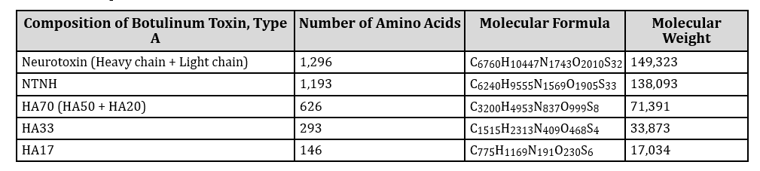

Abbreviation: NTNH=non-toxic, no haemagglutinin; HA = haemagglutinin

Table : Excipients used in drug product

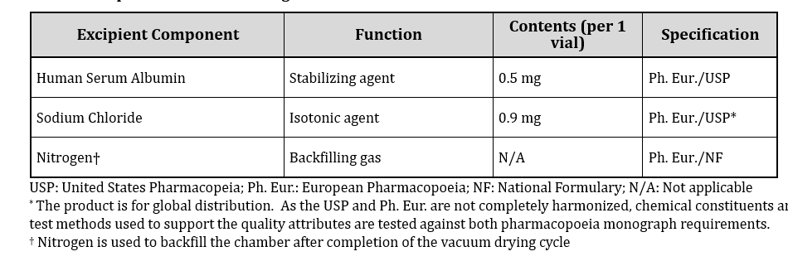

The quality evaluator commented that the sponsor has provided adequate information to ensure the product’s quality for registration. It is recommended that the following product is suitable for approval with regard to manufacturing quality. However, this recommendation is subject to resolution of the outstanding issue in relation to sterility aspect.[4]

The drug substance is produced from stocks of the working cell bank via fermentation in *Clostridium botulinum* cultures. It is stored at - 70oC until it is used to formulate the drug product.

The drug product is a sterile, white to yellowish, preservative free, vacuum dried powder. Drug product is reconstituted with commercially available, preservative free, 0.9% sodium chloride compliant with the USP and/or European Pharmacopoeia (Ph. Eur.) to form a clear, transparent solution.

The drug product has been appropriately characterised or controlled in accordance with International Conference on Harmonisation (ICH) guidelines. The manufacturing sites and responsibilities have been identified. The acceptance criteria data and validations methods are considered fit for purpose. Impurities have been characterised (product related, process related and related to forced degradation) and controlled.

The shelf life data submitted was acceptable and claims 36 months at ≤ - 70oC (drug substance) and 36 months at 5 +/- 3oC (drug product) and 72 hours for reconstituted drug product (maximum 24 hours actually recommended due to microbiological hazard).

Photodegradation was apparent after 150 hours under overall illumination > 1.2 million lux.hr.

Infectious diseases/viral safety – the risks related to this product have been controlled to an acceptable level.

The safety of the container closure system is acceptable. The endotoxin evaluation is acceptable.

### Nonclinical

There are no nonclinical objections to registration.

The scope of the nonclinical dossier was considered as adequate. Studies comparing prabotulinumtoxinA with Botox explored potential differences with another drug in the class with common clinical use. There were differences between the drug formulation used in various non-clinical studies (for example, lyophilised versus vacuum dried), but the drug substance was the same. Potential differences between these nonclinical formulations and between the clinical formulation were explored.

*In vivo* rat studies looking at muscle action potential following hindlimb injection, found similar pharmacological effects between lyophilised and vacuum-dried formulations of prabotulinumtoxin A and Botox.

Due to the nature of drug, the following studies were not conducted:

* Secondary pharmacodynamics
* Safety pharmacology (although a repeat-dose dog toxicity study did not observe ECG effects at ≤ 32 units/kg/week).
* Pharmacokinetics
* Drug interaction studies
* Genotoxicity
* Carcinogenicity

Single dose toxicity studies were performed nearly all in rat hindlimb injection had expected findings of dose dependent impaired limb function, paralytic gait, muscular atrophy, reduced food consumption and body weight. High doses in male rats led to atrophy/degermation of seminiferous tubules which were considered related to hindlimb paralysis and testicular hypothermia. Mortality occurred at ≥ 200 units/kg. The dog toxicology studies were considered of limited relevance given the insensitivity of the species.

Comparability studies suggested the proposed commercial product may be more potent than botox.

Seven repeat-dose toxicity studies were conducted (five in rats and two in dogs; all Good Laboratory Practice [GLP] except for one dog study). As well as 4 to 5 week studies (dosed weekly), there was a 6 month study (dosed monthly) in rats. The 6 month study was consistent with the relevant ICH guideline.

The dose ratio from the 6 month rat study indicate a minimum value of 30 compared to the proposed human dose. Overall, the findings were consistent with the expected toxicity of this product.

A GLP compliant embryo foetal study was conducted in rats. No significant toxicity was seen following intramuscular injection of up to 4 units/kg/day for 11 days during organogenesis. The nonclinical evaluator noted that studies with other botulinum toxin drugs have shown developmental effects (lower foetal weights, delayed ossification, abortions, embryo-foetal lethality) in the context of maternal toxicity. The Pregnancy Category B3;[5] is appropriate and consistent with other drugs in the class.

Placental transfer and milk excretion of prabotulinumtoxin A have not been evaluated. No fertility or pre/postnatal development toxicity studies were submitted. The nonclinical evaluator noted that the Botox Product Information references decreased fertility with higher doses.

### Clinical

#### Summary of clinical studies

The clinical data are obtained from five studies that were designed to meet the registration requirements of both the Food and Drug Administration (FDA) and European Union (EU). The five studies comprised three Phase III randomised, controlled single dose studies and two Phase II open label multiple dose studies of 12 months duration (Table 5).

Table : Listing of all clinical studies

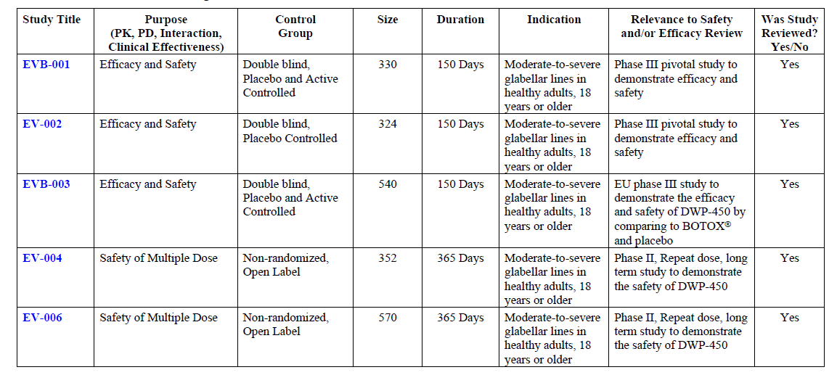

In all five studies, subjects received intramuscular injections into five target sites, namely the midline of the procerus, the inferomedial aspect of each corrugator and the superior middle aspect of each corrugator (Figure 1). Also in all the studies a dose of 4 units was given at each site (that is 20 units total per treatment).

Figure : Injection point

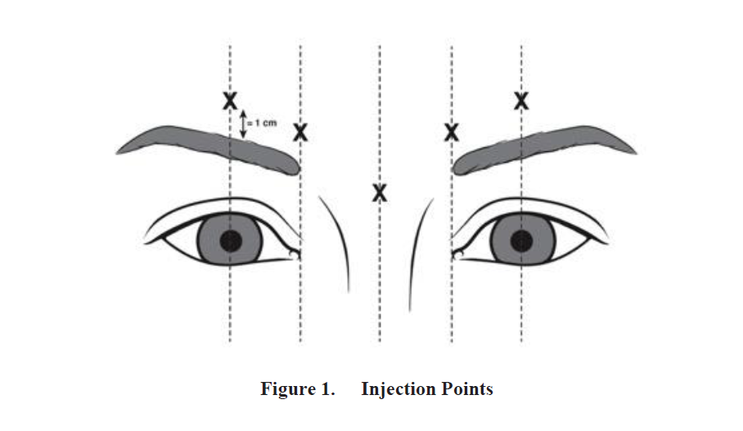

The inclusion criteria and primary efficacy measurement was based on the glabellar line score (GLS). GLS is a validated, static scale which can be scored at rest and at maximum frown. Other outcome measures were the global aesthetic improvement scale (GAIS, Table 6) and the subject satisfaction scale (SSS, Table 7).

Figure : Glabellar line scale, at rest and at maximum frown

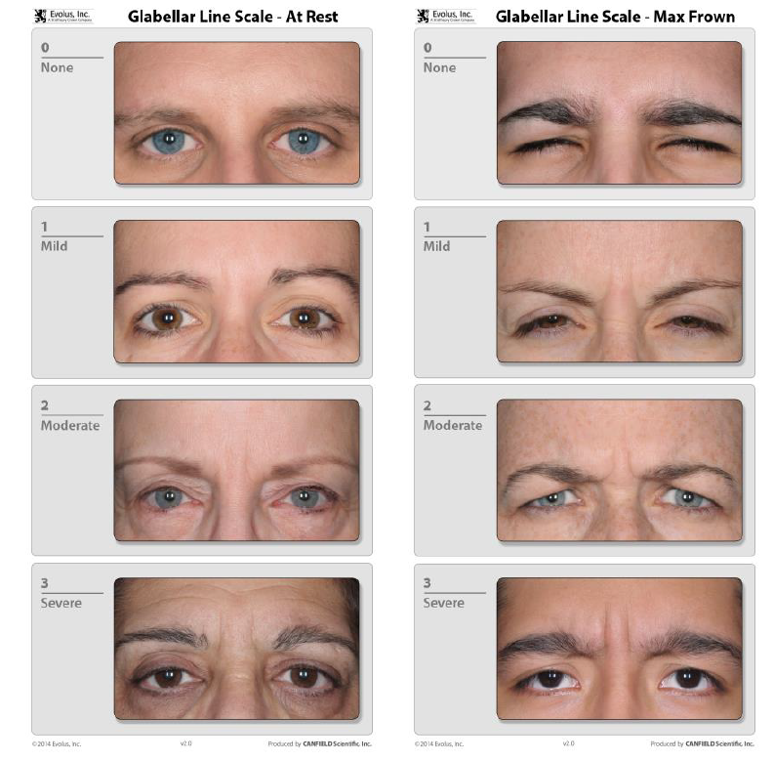

Table : Global aesthetic improvement scale

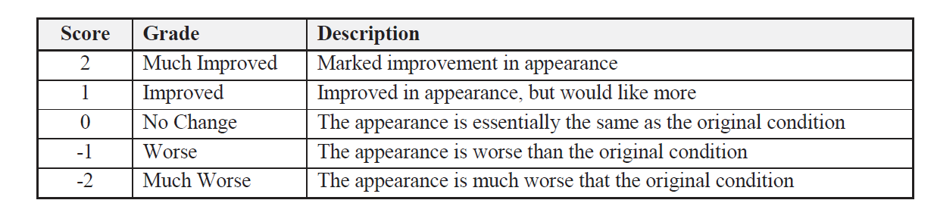

Table : Subject satisfaction scale

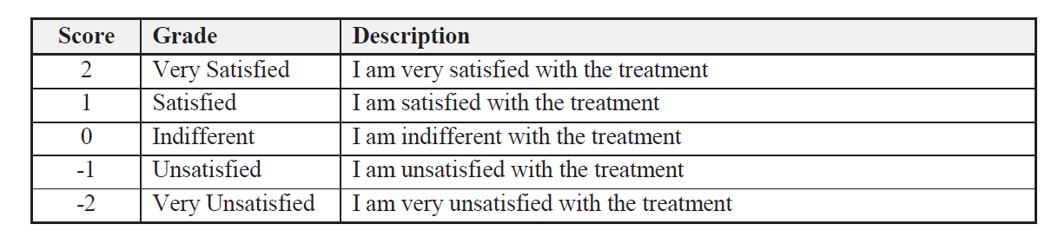

#### Pharmacology

No classical clinical pharmacology studies - dose escalation studies in healthy volunteers, bioavailability studies or drug interaction studies - have been conducted.

The drug substance is administered in extremely small quantities (a 20 units treatment is equivalent to approximately 1 ng) and any drug that reaches the systemic circulation is present at a concentration below what is possible to detect. This precludes the possibility of conducting studies dependant on measuring a Nuceiva plasma concentration.

#### Efficacy

##### Pivotal studies

###### Study EV-001

Study EV-001 was a Phase III randomised, double blind, placebo controlled study conducted at ten centres in the USA. The objectives were to demonstrate the safety and efficacy of DWP-450;[6] for moderate to severe glabellar lines at maximum frown following a single treatment.

Major inclusion criteria were age at least 18 years and moderate to severe glabellar lines (GLS score of 2 and 3) at maximum frown as assessed by both the investigator and the subject. Major exclusion criteria were treatment with any botulinum toxin product within six months, any facial aesthetic procedure within 12 months, previous glabellar surgery, a medical condition affecting neuromuscular function, pregnancy and not using acceptable contraception.

Treatment consisted of either 5 times 4 units/0.1mL prabotulinumtoxin A injections or 5 times 0.1 mL 0.9%NaCl at the sites described in Figure 1. The treatment was given via a 30G needle and topical anaesthetic was permitted. Subjects were followed for 150 days following treatment on (Days 2, 7, 14, 30, 90, 120 and 150).

The primary efficacy outcome was the proportion of subjects who were responders, defined by both investigator and subject agreement on at least 2 point GLS improvement at maximum frown on Day 30.

Secondary efficacy outcomes were at least 2 point GLS improvement at either different timepoints (Day 120 and Day 150 for the intention to treat [ITT] population) or in different study population (modified intent to treat [mITT] population, defined as having a moderate-severe GLS score at rest, that is by contrast to the inclusion criterion described above). There were multiple exploratory outcomes, which included changes in the GAIS and SSS scores and smaller improvements in GLS score.

As a large difference in efficacy was expected between the placebo and the active groups, the sample size was based on the ability to detect adverse effects. The sponsor calculated that treating 219 subjects with prabotulinumtoxin A would most likely detect an adverse event (AE) that occurred in at least 1.6%. This corresponds to a total of 324 subjects randomised 3:1 to active: placebo and includes a 10% dropout rate. In terms of the primary efficacy outcome, the null hypothesis was tested using the Cochran-Mantel-Haenszel test (stratified by site). The overall study wide Type 1 error rate was 0.05.

For the secondary endpoints, multiplicity was accounted for by commencing testing if the primary null hypothesis was rejected for the Day 120 outcome. If this result included p < 0.05, then the mITT Day 30 outcome was tested, at which point formal hypothesis testing stopped.

A total of 330 subjects were randomised, 246 to receive prabotulinumtoxin A and 84 to placebo. Of the 84 placebo subjects, 81 completed the study, with three subjects lost to follow up. Of the 246 prabotulinumtoxin A subjects, 236 completed, two subjects were unwilling/unable to complete the study, one subject underwent glabellar surgery, one subject became pregnant and one subject withdrew consent. No subject withdrew due to an AE.

The mean age was 50 years and most subjects were female (92.7%), White (81.2%). The most common GLS score at enrolment was severe.

In terms of the primary efficacy outcome in the ITT population, the percentage of responders (that is GLS score improved by at least 2 at Day 30 as assessed by both the investigator and the subject) was 67.5% in the prabotulinumtoxin A group and 1.2% in the placebo group. The absolute difference was 66.3% (p < 0.001).

Sensitivity analyses were conducted using different populations (mITT, per protocol (PP), ITT excluding outlier clinics), different scenarios accounting for a missing primary efficacy endpoint and excluding subjects treated out of randomisation order. All of these showed statistically significant differences and were consistent with the primary efficacy outcome.

When analysing based on age, subjects aged younger than 65 years receiving prabotulinumtoxin A (n = 215 were more likely to be responders than subjects aged at least 65 years (n = 25). 69.8% of those aged younger than 65 years and 48% of those aged at least 65 years were responders. The differences between placebo remained highly statistically significant for both age brackets.

In terms of the secondary efficacy outcomes, the absolute difference in responders between prabotulinumtoxin A and placebo remained statically significant at later time points, although the value did drop over time. The absolute difference between prabotulinumtoxin A and placebo at Day 90 was 25.2%, at Day 120 was 7% and at Day 150 was 4.6%. The other secondary outcome in the mITT population (that is at least a 2 point change in GLS at rest) found a 25.9% absolute difference between placebo and prabotulinumtoxin A (p < 0.001).

In terms of exploratory outcomes, there was a high percentage of subjects randomised to prabotulinumtoxin A rated as improved/much improved on the GAIS (Figure 3). There was a large difference between the prabotulinumtoxin A and placebo groups and the effect peaked at Day 14 and remained substantial at Day 150. Similarly, there was a high percentage of subjects randomised to prabotulinumtoxin A rated as satisfied/very satisfied on the SSS. There was a large difference between prabotulinumtoxin A and placebo groups and the effect remained substantial until Day 150 (Figure 4).

Figure : Study EV001 Percentage of subjects with a positive response (improved/much improved) on global aesthetic improvement scale by visit – intent to treat population

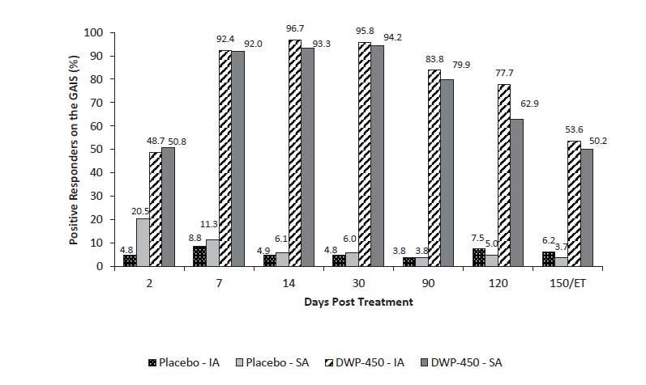

Figure : Study EV-001 Percentage of subjects with a positive response (satisfied/very satisfied) on the subject satisfaction scale by visit – intent to treat population

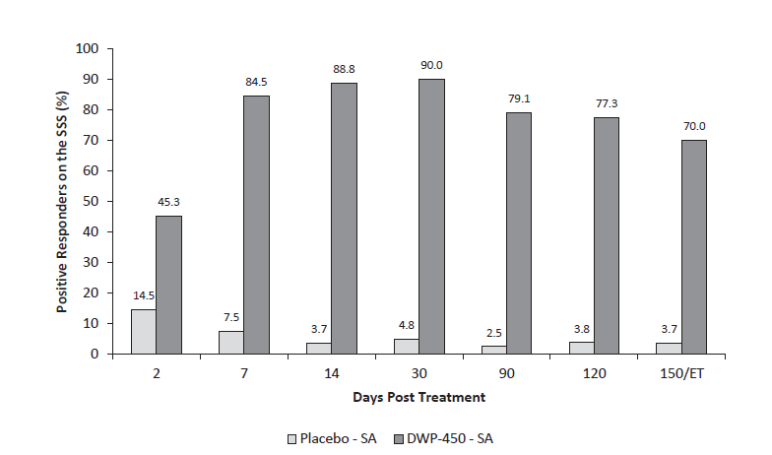

###### Study EV-002

Study EV-002 was a Phase III, randomised, double blind, placebo controlled, single dose trial to demonstrate the safety and efficacy of prabotulinumtoxin A in adult subjects for the treatment of moderate to severe glabellar lines. It was conducted at ten study sites in the USA. Study EV-002 design replicated that of Study EV-001.

Three hundred and twenty four subjects who were randomised. Out of 246 randomised to prabotulinumtoxin A, eight subjects were lost to follow up and one subject was withdrawn due to an serious adverse event (SAE) of transient ischaemic attack. Out of 78 randomised to placebo, one subject was lost to follow up.

The mean age was 51 years and 89.5% were female, 87.7% White and 89.8% younger than 65 years old.

In terms of the primary efficacy outcome in the ITT population, the percentage of responders was 70.4% in the prabotulinumtoxin A group and 1.3% in the placebo group. The absolute difference was 69.1% (p < 0.001).

Sensitivity analyses were conducted using different populations (mITT, PP, ITT excluding outlier clinics), different scenarios accounting for a missing primary efficacy endpoint and excluding subjects treated out of randomisation order. All of these showed statistically significant differences and were consistent with the primary efficacy outcome.

When analysing based on age, subjects aged younger than 65 years receiving prabotulinumtoxin A (n = 219) were more likely to be responders than subjects aged at least 65 years (n = 27). 72.4% of those aged younger than 65 years and 53.8% of those aged at least 65 years were responders. The differences between placebo remained highly statistically significant for the younger than 65 year old bracket (p < 0.001), but not for the at least 65 year brackets (p = 0.137).

In terms of the secondary efficacy outcomes, the absolute difference in responders between prabotulinumtoxin A and placebo remained statically significant at later time points, although the value did drop over time. The absolute difference at Day 90 was 25.8%, at Day 120 was 12.4% and at Day 150 was 4.6%. The other secondary outcome in the mITT population (that is at least 2 point change in GLS at rest) found a 32.7% absolute difference between placebo and prabotulinumtoxin A (p < 0.001).

In terms of exploratory outcomes, there was a high percentage of subjects randomised to prabotulinumtoxin A rated as improved/much improved on GAIS (Figure 5). There was a large difference between the prabotulinumtoxin A and placebo groups and the effect peaked at Day 14 and remained substantial at Day 150. Similarly, there was a high percentage of subjects randomised to prabotulinumtoxin A rated as satisfied/very satisfied on the SSS (Figure 6). There was a large difference between prabotulinumtoxin A and placebo groups and the effect remained substantial until Day 150.

Figure : Study EV-002 Percentage of subjects with a positive response (improved/much improved) on global aesthetic improvement scale by visit – intent to treat population

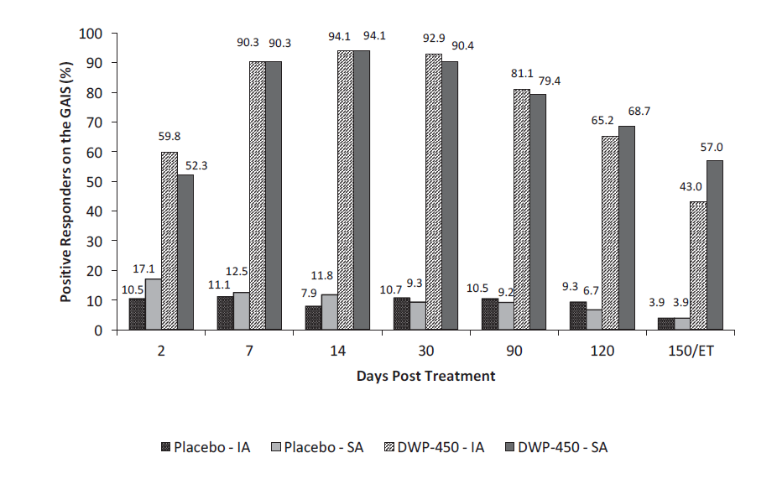

Figure : Study EV-002 Percentage of subjects with a positive response (satisfied/very satisfied) on the subject satisfaction scale by visit – intent to treat population

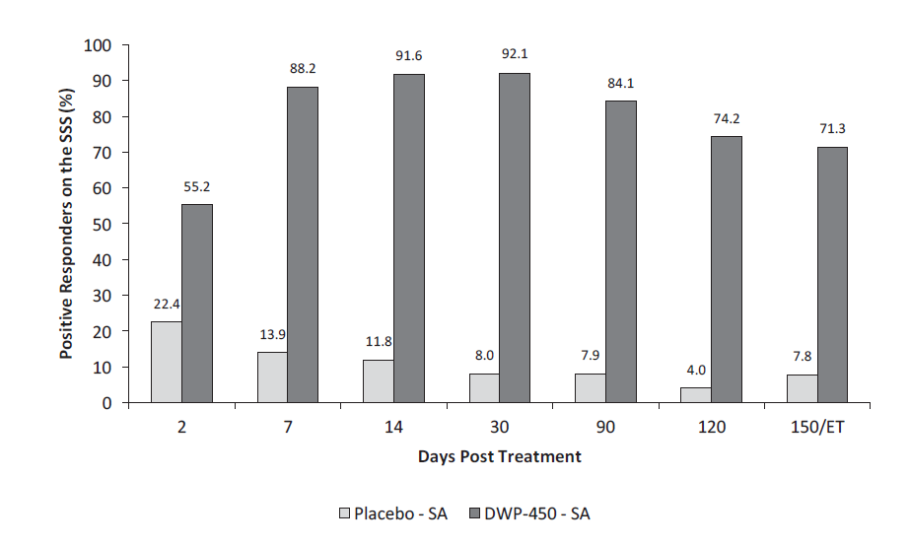

###### Study EVB-003

Study EVB-003 was a Phase III randomised, double blind, active and placebo control, single dose trial to demonstrate the efficacy and safety of prabotulinumtoxin A in adults for the treatment of moderate to severe glabellar lines. It was conducted at 19 sites in Canada, France, Germany, Sweden and the UK. This protocol was developed in consultation with Medicines and Healthcare products Regulatory Agency and European Medicines Agency (EMA).

Study EVB-003 replicated the inclusion and exclusion criteria and other methodology as Studies EV-001 and EV-002. An additional inclusion criterion stipulated that the participant should feel that their glabellar lines had an important impact on their psychological wellbeing. The active comparator group in the trial received Botox administered as 5 times 4 units/01.mL injections. The use of an active comparator allowed prabotulinumtoxin A to be simultaneously tested for non-inferiority (against Botox) as well as superiority (against placebo). Subjects were randomised in 5:5:1 ratio to prabotulinumtoxin A, Botox or placebo.

The primary efficacy outcome was the proportion of subjects classified as responders, which in this study was defined by a GLS score of 0 or 1 (Studies EV-001 and EV-002 were based on at least 2 point drop in GLS) as assessed by the investigator at maximum frown (Studies EV-001 and EV-002 required agreement between investigator and subject).

The secondary efficacy endpoints were:

* proportion of subjects with a GLS score of 0 or 1 on Day 30 at maximum frown by subject assessment
* proportion of subjects with at least a 1 point improvement on the SSS at Day 30 – that is a score of 1(satisfied) or 2 (very satisfied) on Day 30
* change from Baseline to Day 90 in mean Hospital Anxiety and Depression Scale (HADS) -Anxiety score
* change from Baseline to Day 90 in mean HADS-Depression score
* proportion of subjects with at least a 1 point improvement on the GLS from Day 0 to Day 2 at maximum frown by Investigator assessment
* proportion of subjects with at least a 1 point improvement on the GLS from Day 0 to Day 150 at maximum frown by Investigator assessment.

There were 12 exploratory endpoints, which included GAIS scores, SSS scores, different magnitudes of GLS change, changes in HADS-Anxiety and HADS-Depression score at various timepoints. These are detailed in the clinical evaluation report and in the relevant clinical study report.

For the non-inferiority analysis (PP population), the non-inferiority margin was set at 0.10 with a one-side Type 1 error rate of 2.5% and a power of 80%. For the superiority analysis (ITT population), responders were predicted to be 85% with active drug and 15% with placebo and a two-sided type 1 error of 2.5% and a power of 80% was used. The total study sample size was estimated to be 497.

The secondary endpoints were tested in a closed sequential process using gatekeeping methods to maintain the overall study Type 1 error rate of 0.05 (to control for multiplicity).

Five hundred and forty subjects were randomised, with 49 to placebo, 246 to Botox and 245 to prabotulinumtoxin A. These subjects represent the ITT and safety population. Thirteen participants in total were excluded from the PP analysis, mainly due to missing the primary efficacy measure or the Day 30 visit occurring out of window. Eight subjects were lost to follow up (one in placebo group, one in Botox and six in prabotulinumtoxin A) and one subjects in the Botox group was withdrawn due to an unrelated SAE requiring surgery.

The mean age was 49 years. Only 7.4% of subjects were at least 65 years of age and 88.1% were female and 71.1% were white. As assessed by the investigator, at Baseline 73.1% had severe glabellar lines and 26.9% had moderate glabellar lines.

For the primary efficacy outcome, the percentage of responders was 4.2% with placebo, 82.8% with Botox and 87.2% with prabotulinumtoxin A (this was the initial analysis on the PP population). The absolute difference compared with placebo, was 78.6% for Botox and 83.1% for prabotulinumtoxin A (p < 0.001 for both), confirming superiority of both active treatments. The 95% confidence interval for the difference between Botox and prabotulinumtoxin A was -1.9% to 10.8%. As the lower bound is greater than -10%, non-inferiority of prabotulinumtoxin A compared with Botox was confirmed.

The primary efficacy results above were presented for the PP population, however the ITT analysis produced very similar results. The responses were 4.2% with placebo, 82.9% with Botox and 86.7% with prabotulinumtoxin A. The absolute difference between prabotulinumtoxin A and placebo was 82.6% (p < 0.001). Sensitivity analyses (including using tipping point analysis to account for missing data points) confirmed the primary efficacy conclusions.

Looking at subjects at least 65 years of age, the proportion of responders in the placebo group (n = 4) was 0%, in the Botox group (n = 18) 66.7% and in the prabotulinumtoxinA group (n = 16) 81.3%. Superiority of both actives compared with placebo was confirmed, however non-inferiority of prabotulinumtoxin A compared with Botox was not confirmed (given the small numbers of subjects in this age group). There was a less pronounced difference between Botox and prabotulinumtoxin A in the younger than 65 year old group (84.1% and 87.7%, respectively, consistent with non-inferiority).

The secondary efficacy endpoints all showed statistically significant results for superiority of both active treatments compared with placebo:

* The proportion of subjects with a GLS score of 0 or 1 on Day 30 at maximum frown by subject assessment was 6.3% in placebo arm, 76.0% in Botox arm and 78.8% in prabotulinumtoxin A arm (ITT population).
* The proportion of subjects with at least a 1 point improvement on the SSS at Day 30 was 6.3% in the placebo arm, 86.6% in the Botox arm and 91.3% in the prabotulinumtoxin A arm.
* The change from Baseline to Day 90 in mean HADS-Anxiety score was of very similar magnitude and statistically significant across all three arms (that is including placebo).
* The change from Baseline to Day 90 in mean HADS-Depression score was of very similar magnitude and statistically significant across all three arms (that is including placebo).
* The proportion of subjects with at least a 1 point improvement on the GLS from Day 0 to Day 2 at maximum frown by investigator assessment was 12.2% in the placebo arm, 57% in the Botox arm and 54.2% in the prabotulinumtoxin A arm.
* The proportion of subjects with at least a 1 point improvement on the GLS from Day 0 to Day 150 at maximum frown by investigator assessment was 8.3% in the placebo arm, 34.4% in the Botox arm and 37.7% in the prabotulinumtoxin A arm.

A post-hoc analysis of the data was done using the same primary efficacy endpoint (that is at least 2 point improvement in GLS at Day 30 by both investigator and subject) as Studies EV-001 and EV-002, using the PP population. The percentage of responders was 0% in the placebo arm, 55.3% in the Botox arm and 61.7% in the prabotulinumtoxin A arm. The differences with placebo were statistically significant.

A post-hoc analysis of the data to assess duration of response was done by taking those subjects who were responders (at least 1 point improvement of the GLS at maximum frown at any time point) and estimating the time that it took for 50% to stop responding (that is less than1 point improvement of GLS). The duration of response was estimated as 52 days for placebo, 132 days for Botox and 139 days for prabotulinumtoxin A.

The sponsor provided a pooled analysis of the three studies described above. The pooled analysis was conducted for three groups – pooled placebo, pooled data from Studies EV001 + EV002 (both of these studies being identical) and pooled data from Studies EV001, EV002 and EVB-03 (the latter had a different primary endpoint and slightly different inclusion criteria as detailed earlier).

Table 8 shows the pooled data result for the primary efficacy outcome as defined for Studies EV001 and EV002. The pooled results remain similar when Study EVB-03 is included in the assessment.

Table : Study EVB-003 At least two point improvement on the GLS at maximum frown to Day 30 -intent to treat population, single dose studies

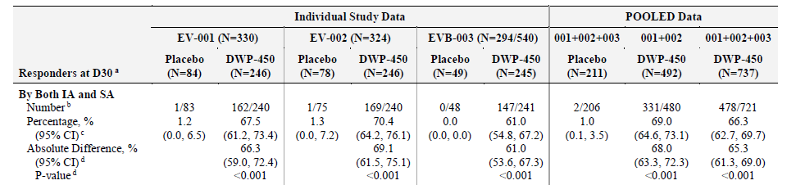

The time course of effect was also analysed in the pooled study. Figure 7 shows how the percentage of responders (that is at least 2 point improvement in GLS at maximum frown as assessed by both investigator and subject) changed over time for each individual study and then for the pooled assessments.

Figure : Percentage of subjects with at least 2 point improvement on the GLA at maximum frown, as agreed by Investigator and subject – intent to treat population

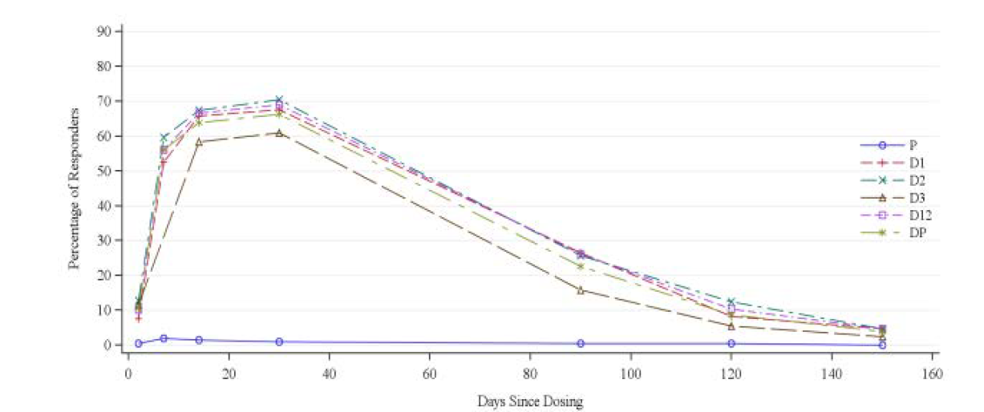

The pooled data was also presented as a Kaplan-Meier plot for time to stop responding (Figure 8). Fifty percent of subjects had stopped responding by approximately Day 85.

Figure : Duration of response based on at least a 2 point improvement on the GLS at maximum frown, as agreed by investigator and subject – intent to treat, single dose studies

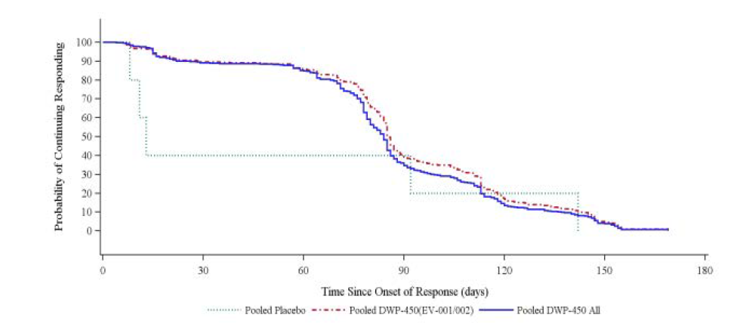

The two open label multiple dose studies (Studies EV-004 and EV-006) were primarily safety studies which included some efficacy measures in their protocols. The sponsor did not present either of these studies as evidence of efficacy and they are not included in the dossier’s summary of efficacy sections. The studies were not controlled but were consistent with the efficacy demonstrated in the previously described studies. There did not appear to be a decline in efficacy with repeated doses. The efficacy results for these studies are included in the clinical evaluation report.

#### Safety

Studies EV-004 and EV-006 were primarily safety studies.

The three efficacy studies previously described (Studies EV-001, EV-002 and EVB-03) also provided safety data.

These five studies were also pooled in various configurations to provide a safety overview across the clinical program.

Study EV-004 was a Phase II open label, multiple dose study to demonstrate the safety of prabotulinumtoxinA in adults for the treatment of moderate to severe glabellar lines. It was conducted at 11 sites in the USA.

The inclusion and exclusion criteria were the same as for Study EV-001 and the administration of prabotulinumtoxinA followed the same procedure. After the first treatment, subjects were followed on Days 3, 7, 14, 30 and 90. On or after Day 90 subjects were eligible for a repeat treatment if their GLS score was at least 2 at maximum frown (assessed by investigator). If the subject was not eligible for re-treatment, they were followed each month and re-treated if they became eligible. As the study ended at Day 365, subjects could receive a maximum of four treatments.

Safety was assessed by recording adverse events, directed questions to look for symptoms of distant toxin spread, physical examination, vital signs, laboratory testing and electrocardiogram.

The target sample size of 350 was based on the ability to detect an adverse event with 95% probability if the incidence rate was greater than 0.85%.

Although 352 subjects were dosed, only 350 contributed to the safety data as two subjects did not have any post-baseline assessments and were withdrawn and lost to follow up. Of those 350, 30 were lost to follow up, including two subjects who withdrew consent due to AEs that did not require intervention and a further 23 withdrew to various reasons such as travel or work scheduling.

Mean age was 50.8 years, 94% were female and 91.8% were White. Only 9.4% of subjects were at least 65 years. When including all subjects who were dosed, even if they did not complete the study, 9.4% received one treatment, 16.2% received two treatments, 30.7% received three treatments and 43.8% received four treatments. Thus, the most common level of exposure in the study was to four treatments.

Forty-two percent of subjects experienced at least one AE. Progressively lower percentages of subjects experienced AEs following each repeat treatment: 29.5% after the first treatment, 15.4% after the first re-treatment, 12.6% after the second re-treatment and 10.4% after the third re-treatment.

Two percent of subjects experienced a SAE, 3.1% an adverse event of special interest (AESI) (defined by 50 events suggestive of distant toxin spread based on the FDA guidance for industry) and 1.7% an AE of possible hypersensitivity reaction. 14.5% of subjects experienced a study drug related AE, 0.6% an AE that lead to discontinuation and no one experienced an AE leading to death. Only 2.6% of subjects experienced a severe AE.

By System Organ Class, only ‘Nervous System Disorders’ and ‘Infections/Infestations’ occurred in at least 5% of subjects (18.2% and 15.3% respectively). Headache was the only AEs occurring in at least 5% of subjects (15.3%).

In terms of AEs considered related, headache was the most frequent. Four subjects experienced eye disorders considered at least possibly related, one each for mild intermittent blepharospasm and mild eyelid ptosis and two for moderate eyelid ptosis.

Of the seven subjects who experienced one or more SAEs, none were considered drug related.

Of the 11 subjects who experienced an AESI, seven subjects had eye disorders, two subjects had dyspnoea and two subjects had a speech disorder. Of these, only two subjects with the speech disorder, one subject with blepharospasm and three subjects with ptosis were considered at least possibly related to study drug.

Of the six subjects who experienced an AE identified as possible hypersensitivity reaction, two subjects were considered as possibly related. Both of these subjects experienced an ‘influenza-like illness’.

Two subjects discontinued study treatments. One was due to worsening eyebrow wrinkling nine days after initial treatment and this subject had no further treatments. The other subject experienced intermittent, mild headache starting on the same day as the initial treatment and lasting for 27 days. Neither subject received additional doses of prabotulinumtoxin A.

There were no meaningful changes in laboratory parameters. Two subjects (0.6% of subjects) tested marginally positive (titres of 50) for botulinum toxin antibodies at a single timepoint: one at Day 30 and one at the end of the study.

Study EV-006 was an open label, multiple dose Phase II study to demonstrate the safety of prabotulinumtoxinA in adult subjects for treatment of moderate to severe glabellar lines. It was conducted at 18 sites in the USA. It had the same inclusion and exclusion criteria as Study EV-004.

A total of 570 subjects, 46 (8.1%) received one treatment, 93 (16.3%) received two treatments, 217 (38.1%) received three treatments and 214 (37.5%) received four treatments. Four subjects did not have any post-treatment follow due to being lost to follow up or not being able to continue for lifestyle reasons. Of those providing some post-treatment evaluable data but were withdrawn, 35 were lost to follow up, one was non-compliant and 43 experienced other issues such as moving away for pregnancy. One withdrawal was due to an SAE of drug overdose, which was not considered related.

The mean age was 50.8 years and only 8.9% were at least 65 years. Subjects were mostly female (89.5%), White (76%) and had severe glabellar lines at Baseline (73.3%).

Two hundred and thirty five (41.2%) subjects experienced 475 AEs during the study. Progressively lower rates of AEs occurred following each treatment. Six subjects received one treatment, 66 subjects received two treatments, 203 subjects received three treatments and 212 subjects received four treatments.

The only AE reported in at least 5% of subjects was headache (13.2% of subjects).

Seven subjects experienced eight SAEs during the study and none were considered drug related.

There was one death during the study and this was reported as an SAE (serious AE). This subject died from a drug overdose 138 days after her initial study treatment and the SAE was considered unrelated. This subject was the only one withdrawn from the study due to an AE.

There were 21 AESIs which were all of mild severity. Of these, 11 were considered as related to study drug and they were all eye disorders – eyelid ptosis (six AESIs), eyebrow ptosis (three AESIs), blepharospasm (one AESI) and blurred vision (one AESI).

Twelve subjects experienced 14 AEs that could represent hypersensitivity reactions, most of which were reported after the first treatment. Only one of these AESIs was considered as possibly related by the investigation (injection site pruritis which resolved without treatment within 12 days and did not occur following a second treatment). Although not considered related, other possible hypersensitivity AEs included drug hypersensitivity, hypersensitivity, seasonal allergy, pyrexia, eyelid oedema and pruritic rash.

One subject in EV-006 tested marginally positive for botulinum toxin antibodies (titre of 50) at the screening visit and was found to be negative at subsequent visits.

##### Pooled results

The three placebo controlled, single dose studies also provided safety data. These three studies showed results broadly in keeping with the safety studies just described and are presented here as part of a pooled analysis.

The safety population across the five clinical studies described above consists of 1659 subjects who received at least one dose of prabotulinumtoxin A. The mean dose received by each subject was 42.9 units (that is two treatments). There were 1508 females in the safety population and 151 males. Three were 1505 subjects aged younger than 65 years and 154 subjects aged at least 65 years.

Headache was the most frequent adverse event and occurred with similar frequency in the placebo and prabotulinumtoxin A groups. The second most frequent AE was nasopharyngitis which occurred in 1.4% of placebo subjects, 11.4% of Botox subjects and 2.6% of prabotulinumtoxin A subjects. No other AEs occurred at frequency at least 5% in any pooled treatment group (Table 9).

Table : Treatment emergent adverse events where preferred term is at least 1% - safety population

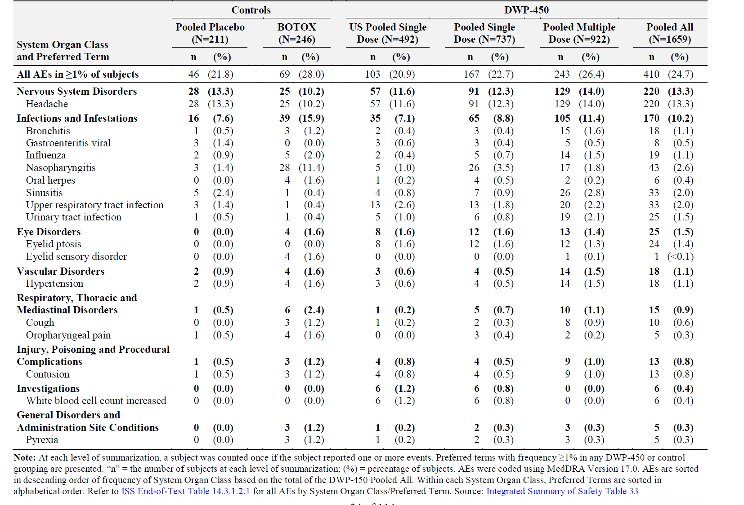

The single death out of all the studies was due to overdose, considered unrelated, and is described above.

There was one SAE in each of the control groups (placebo and Botox) and 24 SAEs in the prabotulinumtoxinA treated groups. No SAE in any study was considered study drug related. Note that the pooled prabotulinumtoxinA subjects were on study for longer than the control group (due to the multiple dose studies) which increases the likelihood of experiencing an SAE and should be taken into account when assessing the pooled data. There were also more subjects receiving prabotulinumtoxinA which increases the likelihood of seeing uncommon and unrelated SAEs. Table 10 shows that 1.4% of subjects who received prabotulinumtoxinA and 0.5% of placebo subjects experienced SAEs. All of the SAEs occurred in single participants except for breast cancer and basal cell carcinoma.

Table : Serious treatment-emergent adverse effects by System Organ Class and Preferred Term - Safety population

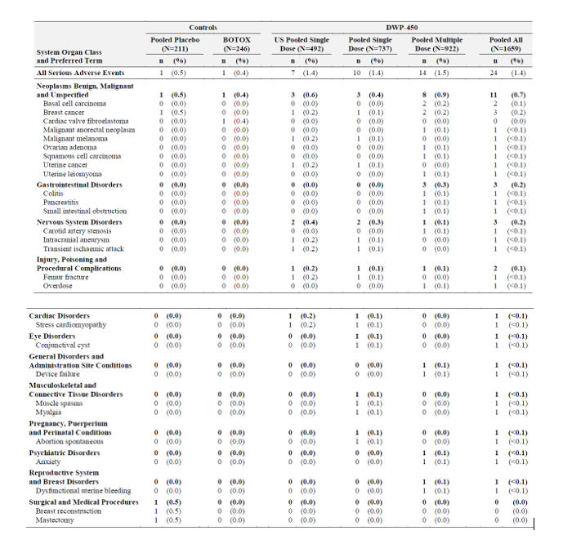

Four subjects discontinued prabotulinumtoxin A due to AEs of transient ischaemic attack, worsening of wrinkling about the eyebrow, headache and drug overdose death. Only the eyebrow wrinkling was assessed as drug related (probably). Whilst the transient ischaemic attack was considered an AE of special interest, the investigator did not consider it as drug related.

Adverse events of special interest were infrequent across all studies, with eye disorders being the only System Organ Class being reported with frequency less than 1%. As seen in Table 11 eyelid ptosis was the most frequent AESI, occurring in 24 prabotulinumtoxin A treated subjects and no placebo or Botox subjects. There were 25 events of eyelid ptosis, of which 22 were mild and 3 were moderate.

Table : Treatment emergent adverse events of special interest by System Organ Class and Preferred Term - Safety Population

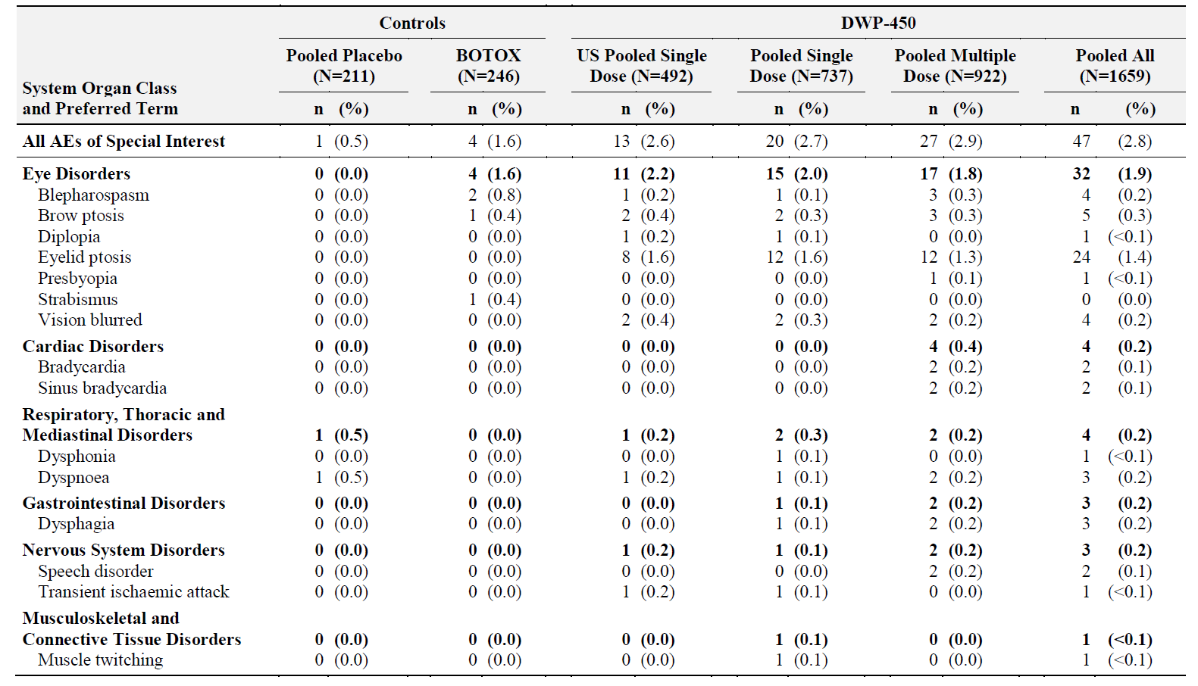

The overall frequency of hypersensitivity related AEs was similar across placebo (1.4%), Botox (2%) and prabotulinumtoxin A (1.8%). The most frequent hypersensitivity related AEs were eyelid oedema (0.4% prabotulinumtoxin A versus 0% placebo), seasonal allergy (0.4% prabotulinumtoxin A versus 0% placebo), pyrexia (0.3% prabotulinumtoxin A versus 0% placebo) and hypersensitivity (0.2% prabotulinumtoxin A versus 0.5% placebo). None of the three severe hypersensitivity related AEs reported in subjects receiving prabotulinumtoxin A were considered related.

In addition to the two subjects testing positive to botulinum toxin antibodies in the multiple dose studies as described above, only one subject in the single dose study, Study EV-001 tested positive to the antibody (at Baseline and at all subsequent assessments).

There were no significant findings in terms of other laboratory assessments vital signs or electrocardiogram.

##### Safety in special groups: at least 65 years old.

There were 154 subjects at least 65 year old were included in the safety analyses. Age did not appear to impact safety. However, there seemed to be some increase in the frequency of serious adverse events and AEs of special interest that were considered related (Table 12 and Table 13).Many of the AEs of special interest were eye related.

Table : Subgroup analysis of serious adverse event frequency

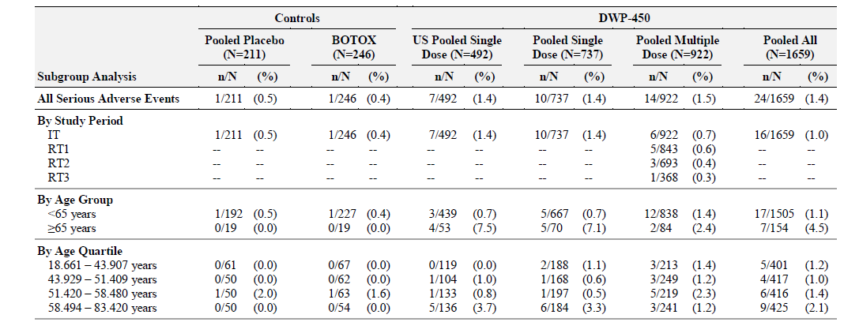

Table : Subgroup analysis of adverse event of special interest considered related

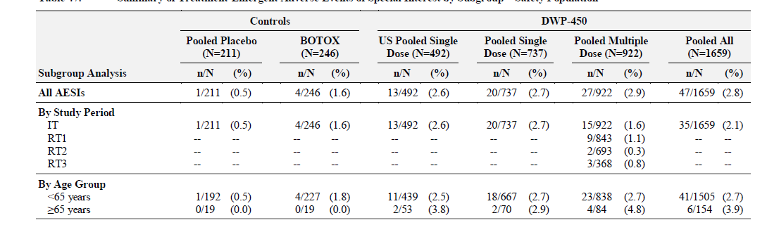

#### Recommendation following the clinical evaluation

Based on the clinical data submitted in clinical dossier approval of Nuceiva, (subject to revision to the draft PI incorporating the recommended changes to the PI), is recommended.

### Risk management plan

The sponsor has submitted EU-risk management plan (RMP) version 3.1 (date 4 February 2021; data lock point (DLP) 27 March 2017) and Australian specific annex (ASA) version 1.0 (date 19 October 2021) in support of this application. At second round of evaluation, the sponsor submitted ASA version 1.1 (date 19 October 2021).

The summary of safety concerns and their associated risk monitoring and mitigation strategies are summarised in Table 14. The TGA may request an updated RMP at any stage of a product's life-cycle, during both the pre-approval and post-approval phases.

Table : Summary of safety concerns

|  |  |  |  |  |  |
| --- | --- | --- | --- | --- | --- |
| Summary of safety concerns | | Pharmacovigilance | | Risk Minimisation | |
| Routine | Additional | Routine | Additional |
| **Important identified risks** | Eyelid ptosis | ✓ | ✓* | ✓ | – |
| Immunogenicity | ✓ | – | ✓ | – |
| Distant spread of toxin | ✓ | ✓* | ✓ | – |
| Development of or exacerbation of neuromuscular disorders | ✓ | – | ✓ | – |
| Hypersensitivity | ✓ | – | ✓ | – |
| **Important potential risks** | Incorrect drug administration due to 100U vial | ✓ | – | ✓ | – |
| Long-term use | ✓ | ✓* | ✓ | – |
| **Missing information** | Use during pregnancy and lactation | ✓ | – | ✓ | – |

*Non-interventional PASS

The proposed summary of safety concerns in the ASA aligns with the EU-RMP and are similar to those of other botulinum products. The summary of safety concerns is considered acceptable from an RMP perspective.

The sponsor has proposed routine pharmacovigilance for all safety concerns. Additional pharmacovigilance activities in the form of a non-interventional PASS have been proposed for eyelid ptosis, distant spread of toxin and long-term use. It is noted that a 50 unit vial is being developed and will be marketed in the EU to address the important potential risk of ‘incorrect drug administration due to 100 unit vial’. This is raised to the attention of the Delegate. The pharmacovigilance plan is acceptable from an RMP perspective.

The sponsor has proposed routine risk minimisation activities only for all safety concerns. Additional risk minimisation activities are not proposed. The risk minimisation plan aligns with the EU-RMP and with other similar products approved in Australia. The risk minimisation plan is acceptable.

The RMP evaluator has raised a number of issues to Delegate:

* The report considered the specific risk related to the only vial size planned for marketing in Australia currently being the 100 unit vial. The risks include the utilisation of a single vial for multiple patients and the use for non-registered indications (that would make use of a larger administered dose). Therefore the Australian safety specification should retain the important potential risk of ‘incorrect drug administration to 100 unit vial’. A 50 unit vial is planned for development and commercialisation in Europe. The RPM evaluator has raised this concern to the Delegate. The Delegate is satisfied that the 100 unit vial is acceptable.
* The proposed PI may be inadequate with regard to the risk of ‘eyelid ptosis’ on the basis that it does not provide advice on minimising this issue (whereas the EU SmPC is more detailed). The Delegate will request the sponsor to provide more information in the PI.
* The risk of ‘neuromuscular disorders’ has not been adequately conveyed in the PI. The Delegate considers it reasonably covered under ‘Contraindications’ and ‘Special Warnings and Precautions for Use’.
* The sponsor has referred to spasticity and cervical dystonia in relation to ‘spread of toxin effect’, neither of which are approved uses for Nuceiva. This has been escalated to the Delegate who considers the paragraph ‘Spread of Toxin Effect’ to be a general class discussion that is appropriate.

#### Proposed wording of condition of registration

* The Nuceiva EU-RMP (version 3.1, dated 4 February 2021, DLP 27 March 2017), with ASA (version 1.1, dated 19 October 2021), included with Submission PM-2021-05441-1-1, to be revised to the satisfaction of the TGA, and any subsequent revisions, will be implemented in Australia.
* An obligatory component of risk management plans is routine pharmacovigilance. Routine pharmacovigilance includes the submission of periodic safety update reports (PSURs). Reports are to be provided in line with the current published list of EU reference dates and frequency of submission of PSURs until the period covered by such reports is not less than three years from the date of this approval letter. The reports are to at least meet the requirements for PSURs as described in the European Medicines Agency’s Guideline on good pharmacovigilance practices (GVP) Module VII-periodic safety update report (Rev 1), Part VII.B Structures and processes. Note that submission of a PSUR does not constitute an application to vary the registration.
* Nuceiva (prabotulinumtoxinA) is to be included in the Black Triangle Scheme. The PI and CMI for Nuceiva must include the black triangle symbol and mandatory accompanying text for five years, which starts from the date that the sponsor notifies the TGA of supply of the product.

### Risk-benefit analysis

#### Delegate’s considerations

The quality evaluator is recommending approval pending the resolution of the issue raised by the Microbiology evaluator.4 The nonclinical, clinical and RMP evaluators are recommending approval.

The early clinical development program is appropriate as it is sensible not to conduct healthy volunteer clinical studies with botulinum toxin. This is on the basis that pre-existing knowledge (non clinical and clinical studies based on comparability of dosing between Botox and Nuceiva plus the long standing clinical experience using Botox for glabellar lines) permitted a high degree of certainty about the appropriate clinical dose. In addition, it is logical to conduct trials only in those with glabellar lines in order to observe the pharmacodynamic/clinical effect, especially when it is not possible to measure peripheral drug concentration (that is limited data would be obtained from a healthy volunteer trial).

The primary efficacy outcome uses a validated scale (GLS) and that is well suited to establishing efficacy for regulatory purposes. The magnitude of benefit required for Studies EV-001 and EV-002 is highly likely to be clinically meaningful (that is going from severe -> mild or none; going from moderate to none; see Figure 2). The primary outcome in Study EVB-003 was less stringent than the other Phase III studies due to not requiring agreement between the investigator and the subject on the GLS, and a subject could be moderate (GLS 3) at Baseline and mild (GLS 2) at Day 30 and still be considered a responder, despite only dropping 1 point on the GLS. The latter issue is potentially the most significant, as dropping down by a single GLS category can be a difficult assessment to make clinically. This leniency is balanced by a stringency in Study EV-003 which required psychological distress to be present. Additionally, given that the findings were so comparable across all three studies, the Delegate considers there to be a high degree of confidence in the efficacy of the product to provide clinically meaningful benefits.

It should also be borne in mind that the endpoints for all studies were agreed to following discussion with major regulatory bodies (FDA and EMA) thus further establishing their acceptability.

This efficacy and clinical benefit should be considered against the safety profile of the drug. The main safety issue appears to be localised unwanted facial muscle paralysis leading to issues such as ptosis. These events were manageable and there was little evidence for more distal toxin spread. There may also be some relatively infrequent localised hypersensitivity reactions. The multiple dose uncontrolled study also provides evidence of the safety of up to four doses over a one year period. The safety beyond this time has not been specifically addressed in the dossier. It would seem that further doses are likely to be well tolerated if the observable effect of the toxin has ceased (or at least reduced considerably) before retreatment. There are still some unknowns such as whether antidrug antibodies may increase in frequency and even become clinically relevant with repeat dosing. This issue can be addressed through pharmacovigilance.

The Delegate notes a discrepancy in indication worldwide with the product restricted to patients younger than 65 years in Canada, Europe and the UK, but not in the US. The US label contains the following statement about geriatric use: ‘The two clinical trials of Jeuveau included 68 subjects age 65 and greater. Although no differences in safety or efficacy were observed between older and younger subjects, clinical studies of Jeuveau did not include sufficient numbers of subjects aged 65 and over to determine whether they respond differently from younger subjects.’

The non-TGA adopted FDA Guidance;[7] recommends that ‘a sufficient number of subjects 65 years of age and older should be evaluated at the level of exposure (dose and duration) proposed for use to support conclusions regarding drug safety and efficacy in this population’. The FDA guidance also refers to the TGA-adopted ICH guidance ‘E7 Studies in Support of Special Populations: Geriatrics’. This latter document states that ‘for drugs used in diseases not unique to, but present in, the elderly a minimum of 100 patients would usually allow detection of clinically important differences’. In summary, the international guidance would suggest around 100 patients over 65 would be required to confirm safety and efficacy.

The Phase III studies included 68 patients who were at least 65 years old and the treatment appeared safe and efficacious. However in Study EV002 for patients aged at least 65 years, the difference between active and placebo for primary outcome lost statistical significance (p = 0.137). The Phase II studies – which were primarily safety studies – included a further 84 subjects exposed to at least one dose of prabotulinumtoxin A. The Phase II studies did not demonstrate significantly worse safety in the older age group. Efficacy appeared acceptable. The clinical evaluator did not recommend to exclude the at least 65 year old population. The pooled safety data did reveal increased frequency of SAEs in the at least 65 year old subjects. Most of these SAEs were clearly not related to study drug (for example, malignancies) and to be expected. There may have been a meaningful increase in mainly eye-related AEs of special interest. Most of these were mild.

During the course of the evaluation the sponsor was asked to explain the reason for the product being supplied in 100 units vials when the recommended dose is 20 units. This represents a potential safety issue as it may encourage using the same vial for multiple patients and it may also increase the chance of injecting a higher than recommended dose during treatment. The sponsor has explained that the product is designed for eventual use for indications that require higher doses such as post stroke upper limb spasticity. The 100 units vial was used during the clinical development program and is the currently approved presentation in the US, Canada and Europe. The sponsor has managed the potential safety issues through clear language in the PI to the effect that it is only for use for an individual patient. The sponsor also notes the opinion of the American Society for Dermatologic Surgery that using a single dial for several patients is actually consistent with accepted clinical practice.

#### Proposed action

The dossier supports the requested indication. The issues raised in Delegate’s overview, in the PI review and following ACM will need to be addressed for a satisfactory outcome.

#### Advisory Committee considerations

The [Advisory Committee on Medicines (ACM)](https://www.tga.gov.au/committee/advisory-committee-medicines-acm), having considered the evaluations and the Delegate’s overview, as well as the sponsor’s response to these documents, advised the following.

##### Specific advice to the Delegate

The ACM advised the following in response to the Delegate’s specific request for advice:

1. ***Do the data presented or other safety concerns provide any basis to restrict use to adults below 65 years of age?***

The ACM commented that the over 65 age group was not specifically excluded from Phase III studies with 68 participants from this age group included. Higher incidence of severe adverse events was recorded in this cohort but these events were not considered treatment related. The ACM noted that restricting the use of Nuceiva to adults below 65 years of age would be in line with indications in Europe and Canada.

The ACM was of the view that the over 65 age group is not uncommonly represented in contemporary clinical use of botulinum toxin A and although there was a small portion of patients in the over 65 age group included in Phase III studies, the ACM was unsure restricting the use of Nuceiva to adults below 65 years of age was appropriate. Further noting that this approach would differ from other botulinum toxins. The ACM agreed that the use of Nuceiva should not be restricted to use in adults below 65 years of age.

1. ***Are there any concerns with use of Nuceiva extending beyond 12 months? Is any further information regarding this required in the PI?***

The ACM noted that the duration of post-market surveillance for Nuceiva is limited compared to other botulinum toxin products. However, the use of Nuceiva beyond 12 months reflects the contemporary use of currently available forms of botulinum toxin A. The ACM agreed that there was no concern with the use of Nuceiva extending beyond 12 months and no further information is required in the PI.

The ACM commented that the PI is considered to be reasonably detailed for a single clinical indication.

The ACM expressed minor concern that possible clinical advice regarding the specific use of Epinephrine (adrenaline) in the instance of an anaphylactic event was given in the PI and suggested that more general advice should be provided (rather than specifying the use of adrenaline).

1. ***Should the indication include that the GLS score must be ‘at maximum frown’?***

The ACM noted that severity of the GLS score may not correspond with the patient’s need or desire to treat or the practitioner’s reason to treat, as well as any possible psychosocial factors for or against treatment. The ACM was of the view that it would be more relevant to determine treatment response and eligibility for repeat treatment than to determine eligibility based on pre-treatment severity of glabellar lines. The ACM agreed no written requirement that the GLS score must be at maximum frown is needed.

1. ***Other advice***

The ACM noted the inclusion of ‘associated with corrugator and/or procerus muscle activity’ within the proposed indication. The ACM noted that the method of administration section of the PI indicates injection sites and was of the view that this information is not required within the indication. The ACM further noted that exclusion of this statement ensures greater alignment with the indications for other medicines within this class.

##### Conclusion

The ACM considered this product to have an overall positive benefit-risk profile for the indication:

*Nuceiva is indicated for temporary improvement in the appearance of moderate to severe glabellar frown lines in adults*

## Outcome

Based on a review of quality, safety, and efficacy, the TGA approved the registration of Nuceiva (prabotulinumtoxin A) 100 unit, powder for solution for injection, vial, indicated for:

*Nuceiva is indicated for the temporary improvement in the appearance of moderate to severe glabellar lines in adult patients.*

### Specific conditions of registration applying to these goods

* Nuceiva (prabotulinumtoxin A) is to be included in the Black Triangle Scheme. The PI and CMI for Nuceiva must include the black triangle symbol and mandatory accompanying text for five years, which starts from the date that the sponsor notifies the TGA of supply of the product.
* The Nuceiva EU- RMP (version 3.1, dated 4 February 2021, DLP 27 March 2017), with ASA (version 1.1, dated 19 October 2021), included with submission PM-2021-05441-1-1, to be revised to the satisfaction of the TGA, and any subsequent revisions, will be implemented in Australia.

An obligatory component of risk management plans is routine pharmacovigilance. Routine pharmacovigilance includes the submission of periodic safety update reports (PSURs). Reports are to be provided in line with the current published list of EU reference dates and frequency of submission of PSURs until the period covered by such reports is not less than three years from the date of this approval letter. The reports are to at least meet the requirements for PSURs as described in the European Medicines Agency’s Guideline on good pharmacovigilance practices (GVP) Module VII-periodic safety update report (Rev 1), Part VII.B Structures and processes. Note that submission of a PSUR does not constitute an application to vary the registration.

## Attachment 1. Product Information

The PI for Nuceiva approved with the submission which is described in this AusPAR is at Attachment 1. For the most recent PI, please refer to the TGA [PI/CMI search facility.](https://www.tga.gov.au/picmi-search-facility)

|  |
| --- |
| Therapeutic Goods Administration |
| PO Box 100 Woden ACT 2606 Australia  Email: [info@tga.gov.au](mailto:info@tga.gov.au) Phone: 1800 020 653 Fax: 02 6203 1605  [**https://www.tga.gov.au**](https://www.tga.gov.au) |
| Reference/Publication # |

1. This is the original indication proposed by the sponsor when the TGA commenced the evaluation of this submission. It may differ to the final indication approved by the TGA and registered on the Australian Register of Therapeutic Goods.
2. Choudhury, S. (2021). Botulinum Toxin: An Update on Pharmacology and Newer Products in Devleopment. Toxins (Basel).
3. Dessy, L. (2011). Botulinum toxin for glabellar lines: a review of the efficacy and safety of currently available products. Am J Clin Dermatol, 377-88.
4. Sponsor clarification: Sponsor has provided response to the outstandind issues in relation to sterility aspect and it been accepted by the quality evaluator.
5. Drugs which have been taken by only a limited number of pregnant women and women of childbearing age, without an increase in the frequency of malformation or other direct or indirect harmful effects on the human fetus having been observed.

   Studies in animals have shown evidence of an increased occurrence of fetal damage, the significance of which is considered uncertain in humans.
6. Drug development code for Nuceiva or prabotulinumtoxinA
7. FDA. (2014). Guidance for Industry. Upper Facial Lines: Developing Botulinum Toxin Drug Products. Draft Guidance. August 2014. Retrieved Sep 2022, from FDA.gov: https://www.fda.gov/media/89195/download