|  |
| --- |
| Australian Public Assessment Report for Rybrevant |
| Active ingredient/s: Amivantamab |
| Sponsor: Janssen-Cilag Pty Ltd |
| August 2023 |

About the Therapeutic Goods Administration (TGA)

* The Therapeutic Goods Administration (TGA) is part of the Australian Government Department of Health and Aged Care and is responsible for regulating therapeutic goods, including medicines, medical devices, and biologicals.
* The TGA administers the *Therapeutic Goods Act 1989* (the Act), applying a risk management approach designed to ensure therapeutic goods supplied in Australia meet acceptable standards of quality, safety, and efficacy.
* The work of the TGA is based on applying scientific and clinical expertise to decision-making, to ensure that the benefits to the Australian public outweigh any risks associated with the use of therapeutic goods.
* The TGA relies on the public, healthcare professionals and industry to report problems with therapeutic goods. The TGA investigates reports received to determine any necessary regulatory action.
* To report a problem with a therapeutic good, please see the information on the [TGA website](https://www.tga.gov.au).

About AusPARs

* The Australian Public Assessment Report (AusPAR) provides information about the evaluation of a prescription medicine and the considerations that led the TGA to approve or not approve a prescription medicine submission. Further information can be found in [Australian Public Assessment Report (AusPAR) guidance](https://www.tga.gov.au/australian-public-assessment-report-auspar-guidance).
* AusPARs are prepared and published by the TGA.
* AusPARs are static documents that provide information that relates to a submission at a particular point in time. The publication of an AusPAR is an important part of the transparency of the TGA’s decision-making process.
* A new AusPAR may be provided to reflect changes to indications or major variations to a prescription medicine subject to evaluation by the TGA.

Copyright

© Commonwealth of Australia 2023  
This work is copyright. You may reproduce the whole or part of this work in unaltered form for your own personal use or, if you are part of an organisation, for internal use within your organisation, but only if you or your organisation do not use the reproduction for any commercial purpose and retain this copyright notice and all disclaimer notices as part of that reproduction. Apart from rights to use as permitted by the *Copyright Act 1968* or allowed by this copyright notice, all other rights are reserved and you are not allowed to reproduce the whole or any part of this work in any way (electronic or otherwise) without first being given specific written permission from the Commonwealth to do so. Requests and inquiries concerning reproduction and rights are to be sent to the TGA Copyright Officer, Therapeutic Goods Administration, PO Box 100, Woden ACT 2606 or emailed to <[tga.copyright@tga.gov.au](mailto:tga.copyright@tga.gov.au)>.

Contents

List of abbreviations 4

Product submission 6

Submission details 6

Product background 7

Condition 8

Current treatment options 10

Mechanism of action of amivantamab 18

Regulatory status 19

Product Information 21

Registration timeline 21

Submission overview and risk/benefit assessment 21

Quality 22

Nonclinical 22

Clinical 23

Pharmacology 23

Efficacy 25

Safety 33

Confirmatory data plan 43

Risk management plan 43

Risk-benefit analysis 45

Delegate’s considerations 45

Proposed action 46

Advisory Committee considerations 46

Outcome 46

Specific conditions of registration applying to these goods 46

Attachment 1. Product Information 47

## List of abbreviations

|  |  |
| --- | --- |
| Abbreviation | Meaning |
| ADA | Anti-drug antibody |
| AE | Adverse event |
| ARTG | Australian Register of Therapeutic Goods |
| ASA | Australia-specific annex |
| AST | Aspartate transaminase |
| CCO | Clinical cut-off |
| CI | Confidence interval |
| CMI | Consumer Medicines Information |
| CSR | Clinical study report |
| ctDNA | Circulation tumour DNA |
| DCO | Data cut-off |
| DLP | Data lock point |
| DLT | Dose limiting toxicity |
| DOR | Duration of response |
| ECOG | Eastern Cooperative Oncology Group |
| EGFR | Epidermal growth factor receptor |
| EGFRm | Mutations of the *EGFR* oncogene |
| eHR | Electronic health record |
| EMA | European Medicines Agency |
| EU | European Union |
| ex20ins | Exon 20 insertion |
| FDA | Food and Drug Administration (United States of America) |
| IgG1 | Immunoglobin G 1 |
| IRR | Infusion-related reactions |
| MET | Mesenchymal epithelial transition |
| MRD | Multi-disciplinary review |
| NCCN | National Comprehensive Cancer Network (United States of America) |
| NGS | Next generation sequencing |
| NSCLC | Non-small cell lung cancer |
| ORR | Objective response rate |
| OS | Overall survival |
| PCR | Polymerase chain reaction |
| PD | Pharmacodynamics |
| PD-L1 | Programmed cell death ligand 1 |
| PFS | Progression-free survival |
| PI | Product Information |
| PK | Pharmacokinetics |
| PSUR | Periodic safety update report |
| RMP | Risk management plan |
| RP2D | Recommended Phase II dose |
| RWE | Real world evidence |
| TEAE | Treatment-emergent adverse event |
| TGA | Therapeutic Goods Administration |
| TKI | Tyrosine kinase inhibitor |
| TRAE | Treatment-related adverse event |
| ULN | Upper limit of normal |
| VTE | Venous thromboembolic events |

## Product submission

### Submission details

|  |  |
| --- | --- |
| *Type of submission:* | New biological entity |
| *Product name:* | Rybrevant |
| *Active ingredient:* | Amivantamab |
| *Decision:* | Approved for provisional registration |
| *Date of decision:* | 28 November 2022 |
| *Date of entry onto ARTG:* | 1 December 2022 |
| *ARTG number:* | 376832 |
| [*Black Triangle Scheme*](https://www.tga.gov.au/black-triangle-scheme)  *for the current submission:* | Yes  As a provisionally registered product, this medicine will remain in the Black Triangle Scheme for the duration of its provisional registration |
| *Sponsor’s name and address:* | Janssen-Cilag Pty Ltd  1-5 Khartoum Road,  Macquarie Park, NSW 2113 |
| *Dose form:* | Concentrated injection |
| *Strength:* | 350 mg/7 mL |
| *Container:* | Vial |
| *Pack size:* | One |
| *Approved therapeutic use for the current submission:* | *Rybrevant has* ***provisional approval*** *for the treatment of patients with locally advanced or metastatic non-small cell lung cancer (NSCLC) that has an activating epidermal-growth factor receptor (EGFR) exon 20 insertion mutation, whose disease has progressed on or after platinum-based chemotherapy.*  *The decision to approve this indication has been made on the basis of objective response rate and duration of response in a single arm study. Continued approval of this indication depends on verification and description of benefit in a confirmatory study.* |
| *Route of administration:* | Intravenous injection |
| *Dosage:* | Rybrevant should be administered by a healthcare professional in a setting with appropriate medical support for the management of infusion-related reactions (IRRs), including equipment for cardiorespiratory resuscitation. See Section 4.4 Special warnings and precautions for use.  Administer pre-infusion medications (see Section 4.2 Pre-infusion medications).  When considering the use of Rybrevant, the presence of an EGFR exon 20 insertion mutation should be established using a validated test (see Section 5.1 [of Product Information] Clinical trials).  The recommended dose of Rybrevant is according to the body weight of patient. See section 4.2 for the recommended dose, dosing schedule and infusion rates of Rybrevant. Administer Rybrevant until disease progression or unacceptable toxicity.  For further information regarding dosage, refer to the Product Information. |
| *Pregnancy category:* | D  Drugs which have caused, are suspected to have caused or may be expected to cause, an increased incidence of human fetal malformations or irreversible damage. These drugs may also have adverse pharmacological effects. Accompanying texts should be consulted for further details.  The use of any medicine during pregnancy requires careful consideration of both risks and benefits by the treating health professional. This must not be used as the sole basis of decision making in the use of medicines during pregnancy. The TGA does not provide advice on the use of medicines in pregnancy for specific cases. More information is available from obstetric drug information services in your State or Territory. |

### Product background

This AusPAR describes the submission by Janssen-Cilag Pty Ltd (the sponsor) to register Rybrevant (amivantamab) 350 mg/7 mL, concentrated injection, vial for the following proposed indication:[1]

*Rybrevant has provisional approval for the indication:*

*Rybrevant as monotherapy is indicated for the treatment of patients with locally advanced or metastatic non-small cell lung cancer (NSCLC) with activating epidermal growth factor receptor (EGFR) Exon 20 insertion mutations as determined by a validated test, whose disease has progressed on or after platinum-based chemotherapy.*

*The decision has been made on the basis of short term efficacy and safety data. Continued approval is dependent upon the evidence of longer-term efficacy and safety from ongoing clinical trials and post-market assessment.*

Amivantamab (also known as amivantamab-vmjw) is a fully human, IgG1-based, bispecific, low fucose antibody that is directed against epidermal growth factor receptor (EGFR) and mesenchymal epithelial transition (MET) tyrosine kinase receptors (Figure 1).

Figure 1: High level schematic of amivantamab structure

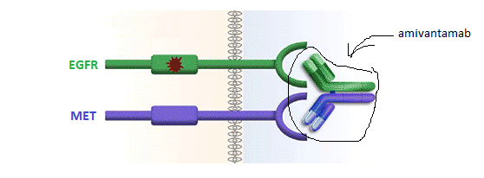

Source: Adapted from <https://oncotribune.com/storage/report/asco-2021/abstract9006/abstract9006_01.png>

#### Condition

This application proposes the registration of amivantamab for the treatment of adult patients who have received prior platinum-based chemotherapy for locally advanced or metastatic NSCLC harbouring an exon 20 insertion (ex20ins) mutation in the *EGFR* gene.

Lung cancer is the deadliest type of cancer, with an annual worldwide mortality of 1.8 million (18% of global cancer deaths) and the second most common (after female breast cancer), with an incidence of 2.2 million (11% of global cancers) in 2020.[2] In Australia, lung cancer is the most deadly and fifth most commonly diagnosed cancer, with an estimated age-standardised mortality rate of 26.5 per 100,000 (8,693 deaths), and an age-standardised incidence of 42 per 100,000.[3]

Non-small cell lung cancer is the most common type of lung cancer (around 85%).[4] The two predominant histological types of NSCLC are adenocarcinoma (around half) and squamous cell carcinoma (around 40%), while other less common types include large cell carcinoma.4

The mean age of diagnosis of NSCLC in Australia is around 70 years, and almost half of patients present with *de novo* metastatic disease.[5] Although survival has improved over past decades, the five-year relative overall survival (OS) rate remains very poor, at around 20% overall, and less than 5% for patients with distant metastases.[6]

Activating mutations of the *EGFR* oncogene (*EGFR*m) occur in a subset of NSCLC, and are associated with female sex, non-smoker status, and adenocarcinoma histology.[7] There is a higher incidence of *EGFR*m in Asian patient populations: the proportion of lung adenocarcinomas found to harbour an *EGFR*m was 46% in Southern Asia and 30% in Northern Asia, compared to 9% in North America and 13% in Europe.[8] In squamous tumours, *EGFR*m are much less common (2%-10%) and their clinical significance (including predictiveness of response to targeted therapy) is less clear.[9],[10]

Ex20ins mutations are a rare subset of *EGFR*m, comprising 3% to 12% of identified *EGFR*m.[11],[12],[13] The most common, ‘classical’ *EGFR*m are in-frame deletions in exon 19 (Del19) and L858R substitutions in exon 21. In an approximate 1:1 ratio, Del19 and L858R mutations comprise around 85 to 90% of *EGFR*m.8,[14],[15] The remainder of *EGFR*m are a highly heterogeneous group of molecular alterations but tend to occur within exons 18 to 21 (see Figure 2).[16],[17] In addition to ex20ins mutations, they include point mutations at G719X (that is, G719A, G719C, or G719S; exon 18; 3 to 5% of all *EGFR*m),16,[18] at L861Q/L861R (exon 21; 2 to 3% of all *EGFR*m) and at S768I (exon 20; 1% of all *EGFR*m).[19]

Unlike other *EGFR*m, there does not appear to be a clear difference in frequency of ex20ins mutations in NSCLC based on ethnicity.[20] They otherwise show similar demographic associations to other *EGFR*m, including the extreme rarity of co-occurrence with other oncogenic drivers (such as *KRAS*).12

Figure 2: The spectrum of described mutations in codons 18-21 of the EGFR gene (on chromosome 7), and their association with responsiveness to first generation EGFR tyrosine kinase inhibitors

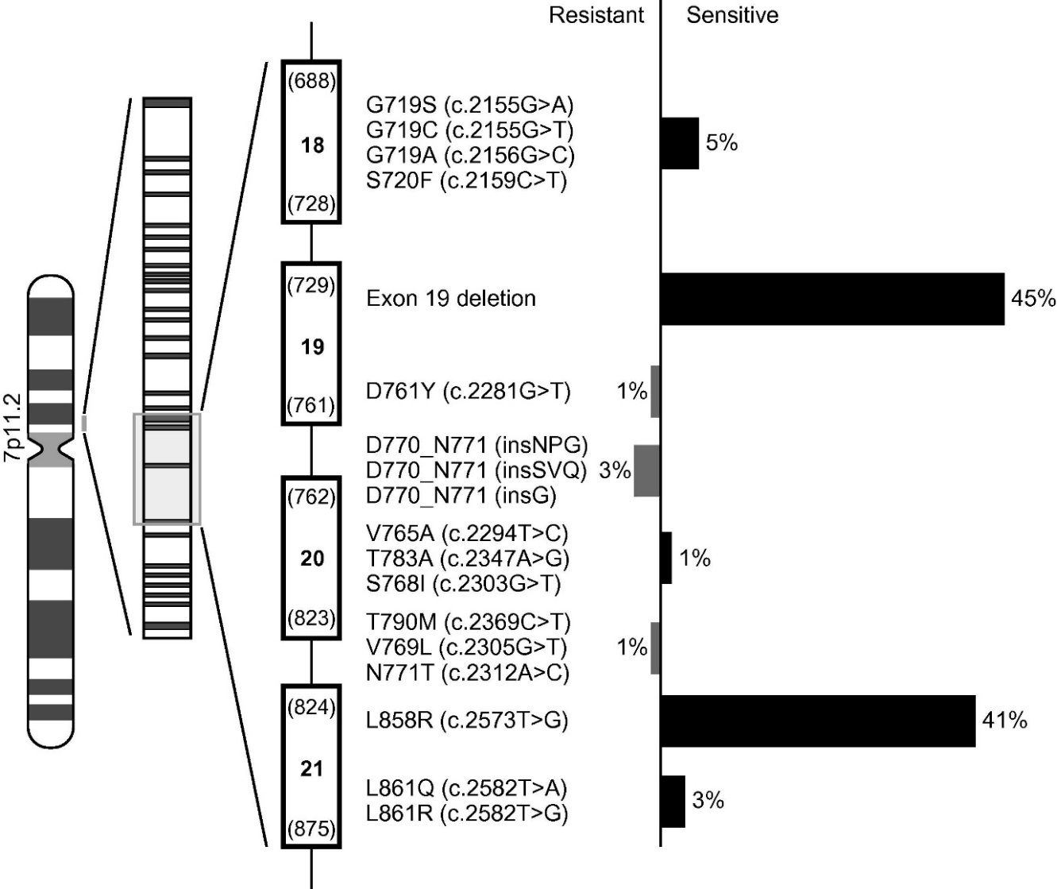

Source: Roengvoraphoj M, et al;16

#### Current treatment options

##### Early stage treatment

Patients with early stage NSCLC can be treated with curative intent, however, only a small proportion of patients (30%) present with localised disease amenable to such approaches.[21] Five-year recurrence rates after resection are approximately 45% for Stage IB, 62% for Stage II and 76% for Stage III patients.[22] Systemic therapy is indicated for patients with advanced (locally advanced or metastatic) disease, including patients with recurrence following initial definitive treatment.[23]

###### Systemic treatments registered in Australia

There are no therapeutic goods with full registration in Australia specifically for the treatment of patients with NSCLC whose tumours harbor *EGFR* ex20ins mutations. For such patients, standard-of-care first-line therapy is the same as for non-*EGFR* mutated NSCLC, that is, platinum-based chemotherapy plus checkpoint inhibition.[24] In the second-line (or later) setting, mobocertinib recently received provisional registration based on single-arm data:[25]

*Exkivity has provisional approval in Australia for the treatment of patients with locally advanced or metastatic non-small cell lung cancer (NSCLC) that has an exon 20 insertion mutation of the epidermal growth factor receptor (EGFR), who have received prior platinum-based chemotherapy.*

*The decision to approve this indication has been made on the basis of objective response rate and duration of response in a single arm study. Continued approval of this indication depends on verification and description of benefit in a confirmatory study.*

###### First line of systemic therapy in the advanced setting

Systemic treatment of metastatic NSCLC is guided by molecular testing.24,[26] In the absence of a ‘driver’ mutation for which a targeted therapy is available (such as activating mutations in *EGFR*, *ALK*, *ROS1* or *BRAF*), major international clinical guidelines recommend an anti-programmed cell death ligand 1(PD-L1) antibody, with or without histology-directed platinum doublet chemotherapy (depending on tumour PD-L1 expression level) [27],[28],[29],[30] as standard-of-care first-line treatment (see Table 1).[31] This change to standard care in Australia came with the approval of pembrolizumab for such indications in late 2018 and early 2019.

Table 1: Response rates, durations and survival seen in randomised studies of current standard-of-care first-line treatments for NSCLC in patients without driver mutations.

|  |  |  |  |  |  |  |
| --- | --- | --- | --- | --- | --- | --- |
| Population | Subgroup | Treatment (n) | ORR  %  [95% CI] | Median DOR  months  range | Median OS  months  [95% CI] | OS rate  %  [95% CI] |
| PD-L1 positive (TPS≥1%) NSCLC1 (histology-agnostic) | PD-L1 ≥50%5 | Pembro6  (n=299) | 39.1 | 28.1 | 20.0 | 22 (5-year) |
| [33.6, 44.9] | 2.1+ to 70.0+ | [15.9, 24.2] | [17.3, 26.9] |
| Chemo7  (n=300) | 32.3 | 10.8 | 12.2 | 10 (5-year) |
| [27.1, 37.9] | 1.8+ to 63.5+ | [10.4, 14.6] | [6.6, 13.7] |
| nsNSCLC2 | PD-L1 agnostic | Pembro+chemo8 (n=60) | 58 | 36.3 | 34.5 | 50 (3-year) |
| [45, 71] | 1.4+ to 49.3+ | [24.0, NR] | NS |
| Chemo9  (n=63) | 33 | 22.8 | 21.1 | 37 (3-year) |
| [22, 46] | 2.8+ to 47.2+ | [14.9, 35.6] | NS |
| nsNSCLC3 | PD-L1 agnostic | Pembro+chemo10 (n=410) | 48.3 | 12.5 | 22.0 | 46 (2-year) |
| [43.4, 53.2] | 1.1+ to 34.9+ | [19.5, 24.5] | NS |
| Chemo11  (n=205) | 19.9 | 7.1 | 10.6 | 27 (2-year) |
| [14.7, 26.0] | 2.4 to 27.8+ | [8.7, 13.6] | NS |
| sNSCLC4 | PD-L1 agnostic | Pembro+chemo12 (n=278) | 62.6 | 9.0 | 17.2 | 30 (3-year) |
| [56.6, 68.3] | 1.3+ to 45.0+ | [14.4, 19.7] | [24.5, 35.2] |
| Chemo13  (n=281) | 38.8 | 4.9 | 11.6 | 18 (3-year) |
| [33.1, 44.8] | 1.3+ to 44.8+ | [10.1, 13.7] | [13.8, 23.0] |

CI = confidence interval; DOR = duration of response; NR = not reached; NS = not stated; nsNSCLC = non-squamous non small cell lung cancer; ORR = objective response rate; OS = overall survival; sNSCLC = squamous non small cell lung cancer; + = ongoing response

1 Updated findings from KEYNOTE-042;[32]

2 Updated findings from KEYNOTE-021;[33]

3 Updated findings from KEYNOTE-189;[34]

4 Updated findings from KEYNOTE-407;[35]

5 Subgroup congruent with a randomisation stratum

6 Pembrolizumab monotherapy (200 mg every three weeks)

7 Investigator's choice of histology-directed, platinum-based chemotherapy for four to six cycles

8 Pembrolizumab (200 mg pembrolizumab every three weeks [one cycle]) in combination with chemotherapy (4 cycles of carboplatin plus pemetrexed, then pemetrexed maintenance)

9 Chemotherapy alone (4 cycles of carboplatin plus pemetrexed, then pemetrexed maintenance): 70% of patients in this arm subsequently received anti‒PD-(L)1 therapy

10 Pembrolizumab (200 mg pembrolizumab every three weeks [one cycle]) in combination with chemotherapy (4 cycles of cisplatin or carboplatin plus pemetrexed, then pemetrexed maintenance)

11 Chemotherapy alone (4 cycles of cisplatin or carboplatin plus pemetrexed, then pemetrexed maintenance): 56% of patients in this arm subsequently received anti‒PD-(L)1 therapy

12 Pembrolizumab (200 mg pembrolizumab every three weeks [one cycle]) in combination with chemotherapy for 4 cycles (carboplatin plus either paclitaxel or nab–paclitaxel)

13 Chemotherapy alone for 4 cycles (carboplatin plus either paclitaxel or nab–paclitaxel)

Where a NSCLC is found to harbour an *EGFR*m, choice of systemic treatment depends on the specific *EGFR*m.24 Four anti-EGFR tyrosine kinase inhibitors (EGFR TKIs) are currently registered in Australia for the treatment of NSCLC that harbours an *EGFR*m. These include ‘first generation,’ ATP-competitive inhibitors erlotinib;[36] and gefitinib;[37] the ‘second generation’ covalently-binding irreversible inhibitor, afatinib;[38] and the ‘third generation’ agent, osimertinib.[39] The latter has activity against tumours expressing a mutation (T790M) that confers resistance to earlier generation EGFR TKIs.[40] There is strong evidence to support these agents in the treatment of classical *EGFR*m, as the pivotal studies predominantly (or entirely) enrolled such patients. Treatment of tumours harbouring some uncommon mutations (particularly S768I, L861Q and/or G719X mutations) is supported by limited published data.[41],[42]

By contrast, the available data indicate that ex20ins mutations do not generally confer sensitivity to EGFR TKIs *in vitro* or *in vivo*, though there are exceptions such as p.A763_Y764insFQEA (and possibly p.A763_Y764insLQEA).[43],[44] Therefore, although the registered indications for erlotinib, gefitinib, afatinib and osimertinib do not explicitly exclude treatment of ex20ins-positive tumours, such treatment would not generally be undertaken and patients with ex20ins-mutated NSCLC have been generally excluded from clinical trials of drugs targeting the classical *EGFR*m.

For patients with ex20ins-positive NSCLC, major clinical guidelines recommend the same standard-of-care first line treatment that is recommended for tumours without a targetable mutation, although this effectiveness of these treatments have not been specifically studied in this subpopulation.24 Whilst data are limited, first-line studies of treatment with checkpoint inhibitors plus chemotherapy generally didn’t exclude ex20ins *EGFR* mutated NSCLC (though they may have excluded common/sensitive mutations).76

Two small retrospective studies suggest that patients with NSCLC with *EGFR* ex20ins mutations treated with immune checkpoint inhibitors have outcomes similar to wild-type historical controls and superior to those reported for patients with NSCLC harbouring the more common EGFR mutations.76,[45],[46]

###### Second line of therapy

Until very recently, for patients with ex20ins-positive NSCLC with progression of disease following platinum-based chemotherapy, treatment options in Australia reflected options in the USA:[47]

‘…treatment options include chemotherapy (single agent or docetaxel in combination with ramucirumab) associated with ORRs of 6-23% with median DORs in the range of 4-9 months, or single agent anti-PD-(L)1 antibodies if not received in the first-line setting, associated with ORRs of 14-20% and median DORs in the range of 16-17 months.’

Detailed tables summarising these standard-of-care options, including references, are contained in the publicly available multidisciplinary review (MDR) for mobocertinib published by the United Stated of America (USA) Food and Drug Administration (FDA).47

For patients with ex20ins-positive NSCLC, the current National Comprehensive Cancer Network (NCCN) guideline;24 recommends consideration of an ex20ins specific molecule (amivantamab or mobocertinib) on progression, based on durable responses in early phase studies.[48],[49] Amivantamab registration is the subject of the current application.

The primary efficacy population from the pivotal study (see Pivotal study – CHRYSALIS trial) comprised patients who had all received prior platinum-based chemotherapy for advanced NSCLC. During the course of the study, the standard-of-care, first-line, non-targeted treatment for NSCLC changed from (histology-directed) platinum-based chemotherapy alone to platinum based chemotherapy plus immunotherapy. A considerable proportion of patients (46%) in CHRYSALIS trial had received prior immunotherapy, though it was not reported for how many patients this was in the context of a first-line immunotherapy/chemotherapy combination. Results in this subgroup were consistent with the primary analysis (see Figure 9).

###### Resistance of ex20ins mutations to first to third generation anti-EGFR tyrosine kinase inhibitors

Structural differences between the mutant versions of the expressed EGFR protein underpin their differing responses to small molecule inhibitors (see “Current treatment options”).[50]

In the wild-type receptor, a key structural element called the C-helix regulates receptor activity. When rotated from an outward to an inward position, the C-helix opens up the active site and allows stable dimerisation to occur (see Figure 3).[51]

Figure 3: Illustration of the conformational change that occurs in wild type epidermal-growth factor receptor between the active and inactive receptor state, and the effects of deletion mutations in exon 19 or insertion mutations in exon 20

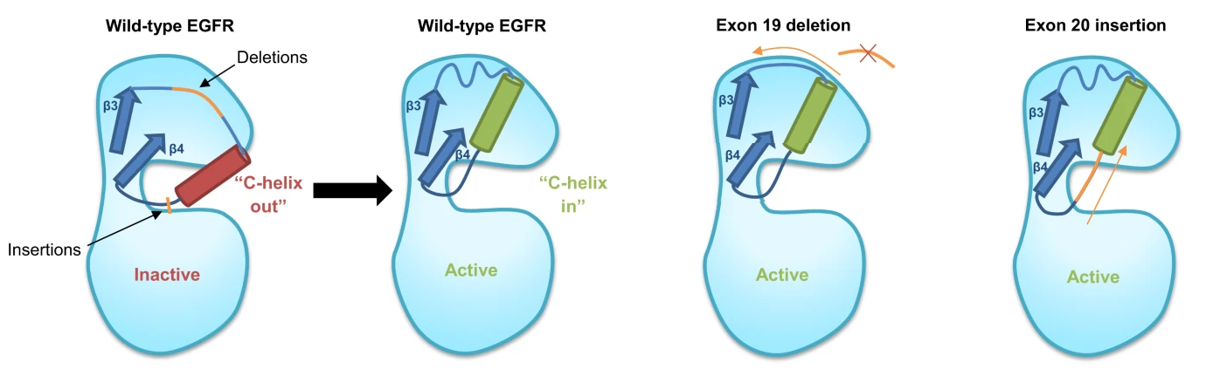

Source: Vyse, S, et al. (2019)[52]

The classical *EGFR*m cause destabilising conformational changes in the EGFR that allow ligand-independent dimerisation, and constitutive activation of downstream signalling pathways.52 Affected cells display sensitivity to EGFR inhibition consistent with an ‘oncogene addiction’ type dependency on such signalling for survival.[53] Deletions in exon 19, for example, shorten the N-terminal loop leading to the C-helix, and are hypothesised to ‘pull’ on it, restricting its ability to rotate outward, and promoting constitutive EGFR activation.52 The classical *EGFR*m also cause reduced affinity for ATP at its binding site, where it would otherwise compete with the first-generation EGFR TKIs.[54] A combination of these two effects is likely responsible for the sensitivity of classical *EGFR*m NSCLC to first-generation EGFR TKIs.52

When T790M mutations occur in clones previously only expressing the classical *EGFR*m, they restore the ATP binding affinity of the mutant EGFR to almost wild-type receptor levels.[55] The restored binding site competition reduces the efficacy of reversible ATP-competitive first-generation EGFR inhibitors, and removes their specificity for mutant EGFR (over wild-type).52

Exon 20 translates to the tyrosine kinase domain of the EGFR (Figure 4). Ex20ins mutations are a heterogeneous group of in frame insertions or duplications, clustered between residues 762 and 774, that is within the C-terminal of the C-helix or in the following loop. Studies of ex20ins mutation variant D770_N771insNPG revealed that, in contrast to Del19 mutations, ex20ins mutations ‘push’ the C-helix from the other direction, forcing it into an active conformation.[56] Unlike the classical EGFRm, D770_N771insNPG does not show reduced ATP affinity.56 Further, it shows poor affinity for first-generation EGFR TKIs, attributed to steric hindrance by a prominent shift of the C-helix into the drug binding pocket.[57] It is postulated that these are the reasons that ex20ins-positive NSCLC is not responsive to registered EGFR TKIs.

Whilst most ex20ins mutant NSCLC is not responsive to registered EGFR TKIs, there are some exceptions, and it is postulated that the location of an ex20ins mutation is related to its sensitivity to registered EGFR TKIs (Figure 5).52 In the case of the ex20ins variant A763_Y764insFQEA, the insertion occurs before residue 764, so it is located within the region that codes for the C-helix itself. Structural modelling suggests that this may confer an activation mechanism and structure that more closely resemble the classical EGFRm than other ex20ins mutations. This is congruent with multiple reports of partial responses to erlotinib in patients with tumours harbouring A763_Y764insFQEA insertions.56,[58],[59],[60]

Figure 4: The spectrum of described insertion mutations in exon 20 of the *EGFR* gene, and their location with respect to the C-helix (in the C-helix itself, light blue; or in the loop following the C-helix, dark grey)

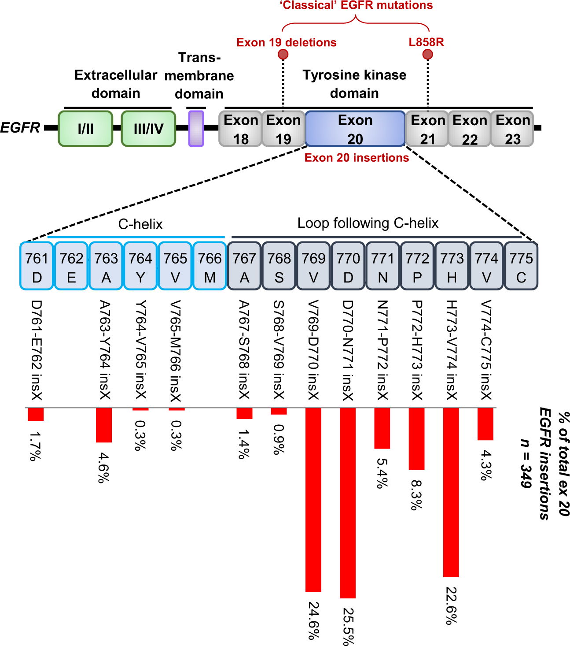

Source: Vyse, S., et al (2019)52

Figure 5: A putative general association between the location of described insertion mutations in exon 20 of the *EGFR* gene, and responsiveness to first generation EGFR tyrosine kinase inhibitors

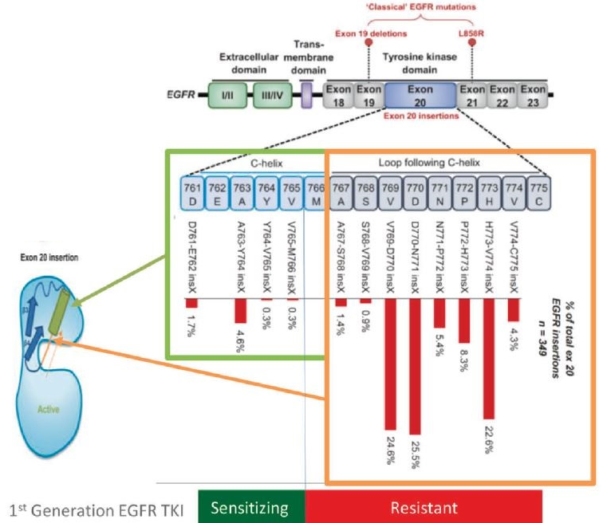

Source: Remon et al, (2020)20

Whilst generalisations such as these may be of some use, the structural heterogeneity among ex20ins mutations suggests variable biology, and the specific sequence of ex20ins variant must be considered when assessing treatment options. For example, there are published reports of EGFR TKI response with the rare exon 20 insertion variant D770delinsGY, noting that this is in the loop region that would be assumed resistant according to the theory outlined in Figure 5.[61]

To complicate matters further, uncommon mutations are often identified as compound mutations, with further heterogeneity of sensitivity to EGFR TKIs, making effects on survival very difficult to understand due to rarity.[62]

As ex20ins mutations generally do not sensitise NSCLC to treatment with the available EGFR TKIs, they are mostly treated with therapies for NSCLC without a targetable mutation, and the prognosis for these patients is in line with that of the EGFR wild-type population.20

There is therefore unmet medical need for targeted therapies for NSCLC with this type of molecular alteration. The recent approval of mobocertinib in Australia provides a new option, however, data to confirm the clinical benefit is pending and the indication remains provisional.25

#### Mechanism of action of amivantamab

Like other *EGFR*-mutated NSCLC, tumours with ex20ins *EGFR* mutations are considered ‘oncogene addicted:’ reliant on aberrant signalling of the constitutively active, mutated *EGFR* (see Figure 3) leading to downstream activation of cellular proliferation and survival pathways including MAPK and PI3K.[63]

*Mesenchymal epithelial transition* (also known as c-MET) is another proto-oncogene encoding a transmembrane tyrosine kinase receptor which, when activated, leads to pro-growth downstream signalling through convergence on a similar set of pathways.[64] MET is overexpressed in some NSCLCs at baseline, and is amplified in approximately 5 to 22% of NSCLC patients with acquired resistance to first-generation EGFR TKIs.[65] MET amplification drives EGFR-independent phosphorylation of ErbB3 and downstream activation of the *PI3K/AKT* pathway, providing a bypass pathway and causing resistance to EGFR TKIs.[66]

Amivantamab was developed with a view to overcoming MET-related EGFR TKI resistance. With a binding site for each of EGFR and MET, amivantamab is able to simultaneously bind the extracellular domains of these kinases, blocking ligand binding with similar potency to monospecific bivalent antibodies *in vitro*.[67] Whilst EGFR:MET heterodimers with the capacity to trans-phosphorylate may occur in lung and breast cancer,[68],[69]amivantamab-sequestered EGFR:MET heterodimers should not do so, as neither kinase can bind their ligand. Indeed, *in vitro* studies also demonstrated amivantamab inhibited the production of both phospho-ERK and phospho-AKT.67 Interestingly, the bivalent anti-EGFR/anti-MET antibody (amivantamab) inhibited phosphorylation of ERK and AKT more potently than a combination of parent, monovalent anti-EGFR and ant-MET antibodies.67

In addition to inhibition of oncogenic signalling, amivantamab was engineered with low core fucosylation, which increases FcgammaRIII binding and may augment Fc-dependent immunity.[70],[71]

Figure 6: Proposed mechanisms of amivantamab action

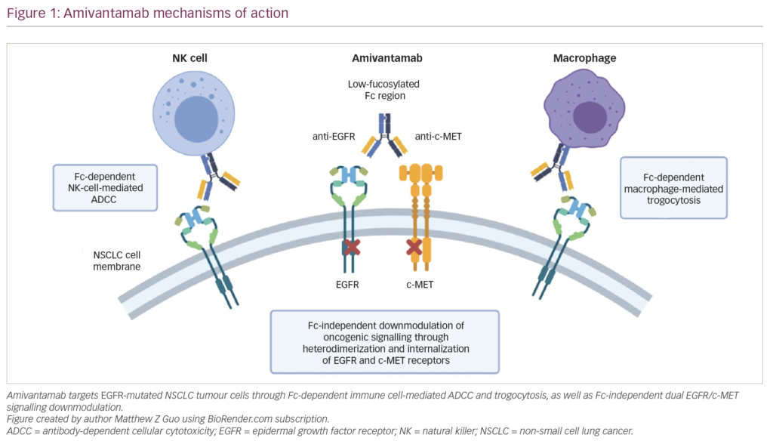

Source: Guo, et al. (2021)63

The proposed mechanism of action of amivantamab is not specific to ex20ins *EGFR* mutations. However, because it binds to the extracellular domain of the EGFR, rather than the intracellular TKI domain (like the EGFR TKIs), its efficacy may not be affected by mutations such as ex20ins (as the EGFR TKIs are).

Cetuximab is a monoclonal anti-EGFR antibody, and has been shown to have limited efficacy in ex20ins *EGFR* mutated NSCLC, with substantial toxicity.[72] The bivalency of amivantamab is hypothesised to increase avidity and specificity for tumour cells co-overexpressing both EGFR and MET, thereby increasing anti-growth activity and decreasing off-target effects, by comparison to monospecific anti-EGFR antibodies like cetuximab.63

### Regulatory status

This product is considered a new biological entity for Australian regulatory purposes.

The evaluation of this product was facilitated through [Project Orbis](https://www.tga.gov.au/project-orbis), an initiative of the FDA Oncology Center of Excellence. Under this project, regulators including the FDA and the TGA collaboratively review submissions. This evaluation process provides a framework for process alignment and management of evaluation issues in real-time across jurisdictions. Each regulator makes independent decisions regarding approval (market authorisation) of the new medicine or indication.

As a bispecific EGFR and MET-directed antibody, this is a first-in-class new biological entity in Australia. Whilst the submission was reviewed under Project Orbis,[73] TGA did not receive an application until October 2021, and was not actively part of the review, which FDA completed in May 2021.76

The Australian amivantamab application is based on the same clinical study that was reviewed under Project Orbis, and which is summarised in the FDA MDR document for amivantamab.76 The FDA approval for amivantamab was based on data from a clinical cut-off (CCO) date of 8 June 2020, with an update from 8 October 2020. The Australian submission additionally included a clinical study report (CSR) addendum from the more recent 30 March 2021 CCO.

Further, as supportive information, the sponsor has submitted real world evidence (RWE) in the form of results from a retrospective cohort study conducted in the USA using the Advanced NSCLC Flatiron Core Registry (Study 61186372NSC1002RWE).

During the time the TGA was considering this submission, amivantamab received accelerated approval from the FDA (on 21 May 2021), with the Guardant360 CDx (Guardant Health Inc.) test as a companion diagnostic device to select patients for treatment.[74] FDA approval was based on data from the multi-cohort CHRYSALIS trial, and the drug approval package is publicly available on the FDA website,[75] including the MDR which details the clinical review.[76] The approved accelerated indication was:[77]

*…indicated for treatment of adult patients with locally advanced or metastatic non-small lung cancer (NSCLC) with epidermal growth factor receptor (EGFR) exon 20 insertion mutations, as detected by an FDA-approved test, whose disease has progressed on or after platinum-based chemotherapy.*

The FDA postmarketing requirements and commitments are outlined in the approval letter, and include a final clinical study report from a randomised trial of amivantamab to confirm the clinical benefit in the approved indication, expected to be available in first quarter of 2023.77

Amivantamab received conditional marketing authorisation by the European Medicines Agency (EMA) on 9 December 2021.[78] The conditionally approved indication was:[79]

*Rybrevant as monotherapy is indicated for treatment of adult patients with advanced non-small cell lung cancer (NSCLC) with activating epidermal growth factor receptor (EGFR) Exon 20 insertion mutations, after failure of platinum-based therapy.*

Amivantamab received marketing authorisation with conditions from Health Canada on 30 March 2022.[80] The indication, issued a notice of compliance with conditions, was:

The treatment of adult patients with locally advanced or metastatic non-small cell lung cancer (NSCLC) with activating epidermal-growth factor receptor (EGFR) Exon 20 insertion mutations whose disease has progressed on or after platinum-based chemotherapy,

Approvals have also been made by the United Kingdom (15 November 2021),[81] Singapore (13 July 2022), and Switzerland (20 January 2022).

### Product Information

The [Product Information](https://www.tga.gov.au/products/australian-register-therapeutic-goods-artg/product-information-one) ([PI](https://www.tga.gov.au/products/australian-register-therapeutic-goods-artg/product-information-one)) approved with the submission which is described in this AusPAR can be found as Attachment 1. It may have changed since publication of this AusPAR document. For the most recent PI and [Consumer Medicines Information](https://www.tga.gov.au/products/australian-register-therapeutic-goods-artg/consumer-medicines-information-cmi) (CMI), please refer to the TGA [PI/CMI search facility.](https://www.tga.gov.au/picmi-search-facility)

## Registration timeline

The following table captures the key steps and dates for this submission.

This submission was evaluated under the [provisional registration process](https://www.tga.gov.au/provisional-approval-pathway-prescription-medicines).

Table 2: Timeline for Submission PM-2021-04814-1-4

|  |  |
| --- | --- |
| Description | Date |
| Determination (Provisional) | 5 October 2021 |
| Submission dossier accepted and first round evaluation commenced | 14 October 2021 |
| First round evaluation completed | 3 May 2022 |
| Sponsor provides responses on questions raised in first round evaluation | 31 May 2022 |
| Second round evaluation completed | 1 August 2022 |
| Delegate’s Overall benefit-risk assessment | 15 September 2022 |
| Sponsor’s pre-Advisory Committee response | Not applicable |
| Advisory Committee meeting | Not applicable |
| Registration decision (Outcome) | 28 November 2022 |
| Administrative activities and registration on the ARTG completed | 1 December 2022 |
| Number of working days from submission dossier acceptance to registration decision* | 213 |

*Statutory timeframe for standard submissions is 255 working days

## Submission overview and risk/benefit assessment

This section is a TGA summary of wording used in TGA’s evaluation report, which discussed numerous aspects of overseas evaluation reports and included some information that was commercial-in-confidence.

### Quality

Amivantamab is a human, low-fucose, immunoglobin G1 (IgG1) bispecific antibody against EGF and cMET receptors. Amivantamab is produced by cultivation of recombinant Chinese hamster ovary cells with specificity for EGFR and cMET. Amivantamab consists of 2 heavy chains and 2 light chains, joined by disulfide bonds.

Figure 7: Structure of amivantamab

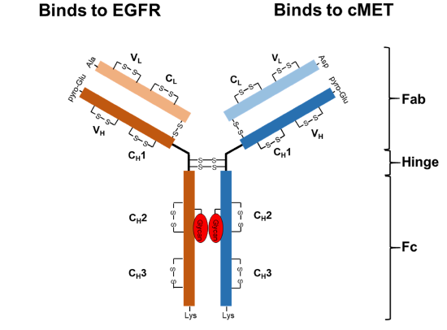

The finished product is supplied as a sterile, 50 mg/mL liquid concentrate for infusion, packaged in an 8 mL Type I glass vial with an elastomeric closure and an aluminium seal with a flip-off cap. Each 8 mL capacity vial contains 350 mg of amivantamab in a 7 mL nominal fill volume and an excess volume of 0.5 mL. The drug product is intended for administration by the intravenous route after dilution in commercially available 5% dextrose (glucose) or 0.9% normal saline. The final formulation intended for marketing was used in the Phase III clinical trials.

At the conclusion of the qualtiy reviews, there were no outstanding concerns from a pharmaceutical chemistry perspective, and standard quality-related conditions of registration were recommended. With respect to quality matters, the PI and Consumer Medicines Information (CMI) and labels were considered acceptable.

### Nonclinical

In mouse NSCLC tumour xenograft models bearing human exon 20 insertion mutation tumours and *EGFR* mutation tumours (including exon 19 deletions or mutations), amivantamab inhibited tumour growth and increased survival. Amivantamab also showed efficacy in tumour xenograft models resistant to anti-EGFR therapeutics due to primary resistance mutations in EGFR (for example, exon 20 insertions), additional mutations in *EGFR* acquired during therapy (for example, T790M and/or C797S) or MET pathway activation.

The nonclinical evaluation concluded with no objections to the provisional registration of Rybrevant for the proposed indication, and with the following comments:

* Primary pharmacology studies adequately demonstrated selectivity for human EGFR/MET receptors, nonclinical efficacy, and are generally supportive of the proposed use.
* No clinically relevant hazards related to off-target effects of amivantamab or exaggerated pharmacological actions on organ systems was identified.
* Treatment-related toxicities associated with amivantamab were mostly minimal to mild in severity, with a toxicological profile comparable with other EFGR and MET inhibitors.
* Detrimental effects on pregnancy, embryofetal development and postnatal development are anticipated in patients based on a weight of evidence assessment. The sponsor has proposed Pregnancy Category D which is appropriate.

The PI submitted by the sponsor was considered adequate with regard to nonclinical content.

### Clinical

#### Pharmacology

##### Formulation

The commercial presentation is identical to the 350 mg vial presentation used in Study EDI1001 (see Pivotal study – CHRYSALIS trial).

##### Dose

The recommended dose of amivantamab is weight dependent: 1050 mg (baseline body weight less than 80kg) or 1400 mg (baseline body weight of at least 80kg), administered intravenously (IV), once weekly for the first four weeks (induction phase) and once every two weeks thereafter (maintenance phase).

Weekly rather than fortnightly dosing during the induction phase is undertaken to reach a therapeutic concentration more quickly.

To minimise the risk of IRRS, the first dose of the first cycle (only) is split, with 350 mg on Day 1, and the remaining dose (700 mg for body weight less than 80 kg, and 1050 mg for body weight of at least 80 kg) on Day 2.

This was the recommended Phase II dose (RP2D), and was chosen based on assessment of pharmacokinetics (PK), pharmacodynamics (PD), safety, and efficacy data from the Phase I, first-in-human study (Study EDI1001/CHRYSALIS trial) in which 83 subjects were treated:

* 65 subjects from Korea who received:
  + 140 mg (n = 2)
  + 350 mg (n = 3)
  + 700 mg (n = 9)
  + 1050 mg (n = 44, 7 in Part 1 and 37 in Part 2) or
  + 1400 mg (n = 8)
* 18 subjects from the USA who received:
  + 1050 mg (n = 10) or
  + 1400 mg (n = 8)

There was no identifiable maximum tolerated dose, with doses tested up to 1750 mg, and a single adverse event (AE) met criteria for dose-limiting toxicity (DLT) (1050 mg cohort in US; post-DLT evaluation period).

Amivatamab exposure was approximately 30 to 40% lower in patients with body weight of at least 80 kg compared to patients with body weight less than 80 kg.

Comparable amivatamab exposure was observed with a dose of 1050 mg in patients with body weight less than 80 kg and a dose of 1400 mg in patients with body weight of at least 80 kg.

Weight-based dose adjustment for amivantamab was therefore chosen for the RP2D, supported by population PK modelling and simulation that indicated that tiered, weight-based dosing resulted in lower variances in PK parameters when compared with flat dosing without weight adjustment.

##### Pharmacokinetics and population pharmacokinetics

Amivantamab exhibits linear PK between doses of 350 mg and 1750 mg, with serum concentration over time described by a two-compartment model. The mean (standard deviation) volume of distribution was 5.13 (1.78) L, mean (standard deviation) non-specific linear clearance was 360 (144) mL/day, and mean (standard deviation) half-life associated with linear elimination was 11.3 (4.53) days.

Volume of distribution and clearance increase with body weight.

Age (32 to 87 yrs), race, creatinine clearance (29 to 276 mL/min) and mild hepatic impairment (total bilirubin ≤ upper limit of normal [ULN] and aspartate transaminase [AST] > ULN, or total bilirubin ≤ 1.5 times ULN and any AST)) did not demonstrate clinically significant effects on the PK of amivantamab. There was a statistically significant effect of sex on exposure, but although lower amivantamab systemic exposures were observed in men, subgroup analyses for the primary efficacy population suggests that the objective response rate (ORR) in men and women was similar (45.5% in men and 35.4% in women).

###### Hepatic and renal function

No formal studies of amivantamab in subjects with hepatic or renal impairment have been conducted. Being a protein, clearance is presumed to be by proteolytic degradation; interactions based on hepatic enzyme metabolism and changes in PK due to hepatic impairment are not anticipated. Similarly, the large molecular mass of amivantamab, makes it unlikely that changes in renal function would affect clearance.

Based on the population PK analysis, no dose adjustments are necessary for patients with mild hepatic impairment, or patients with mild to moderate renal impairment (creatinine clearance 30 to < 90 mL/min).

###### Exposure-response relationships

Over the range of the dose regimen investigated in CHRYSALIS trial (1050 and 1400 mg once weekly for four weeks and every two weeks thereafter for body weights of less than 80 and at least 80 kg, respectively), no apparent exposure response relationships were observed for efficacy (overall response rate, ORR), or for IRRs, nausea, and constipation. There were slightly increased rates of rash, paronychia and hypoalbuminaemia with increased amivantamab exposure, consistent with the proposed mechanism of action.

###### Immunogenicity

The incidence of immunogenicity to amivantamab was 1% (n = 3). There was no evidence of an effect on PK, safety or efficacy, with the rarity of immunogenicity precluding definitive conclusions.

###### Interactions

No formal clinical drug-drug interaction studies were performed. As above, renal excretion and hepatic enzyme mediated metabolism are unlikely to represent major elimination routes. As amivantamab binds to the extracellular domains of EGFR and MET with high specificity, it is also not anticipated to alter the activity of drug-metabolising enzymes. PK interactions with concomitant medications are therefore not expected. Due to its intravenous route of administration, proximity of dosing to food intake is not expected to affect amivantamab PK.

##### Pharmacodynamics

Exploratory pharmacodynamic analyses (serum levels of free soluble EGFR and MET) were submitted. Depletion of EGFR and MET started to occur after a single dose of 350 mg and 140 mg amivantamab, respectively.

#### Efficacy

##### Pivotal study – CHRYSALIS trial

The pivotal data supporting efficacy come from a single non-randomised clinical trial, Study EDI1001 (also known as CHRYSALIS trial). Multiple CSRs were submitted:

* Clinical study report dated 27 October 2020 (clinical data cutoff [DCO] 8 June 2020)
* Clinical study report dated 24 November 2020 (DCO 8 October 2020)
* Clinical study report dated 21 October 2021 (DCO 30 March 2021)

The main TGA review focussed on the CSR with DCO 8 October 2020 (the report underlined above, and the same data cut off reflected in the FDA MDR).

The CSR from the more recent 30 March 2021 DCO was not submitted to FDA during the review reflected in the MDR, as the FDA approval preceded its availability. It was submitted to FDA on 29 October 2021 as part of a postmarketing requirement.

###### Design

Study EDI1001 is an ongoing, global, Phase I/II, single arm, multi cohort study of amivantamab in the treatment of patients with advanced NSCLC. The study design is summarised in Table 3, Figure 7 and in the publicly available FDA label for amivantamab and is described in detail in the MDR.

The study incorporates a dose escalation phase (Part 1) and a dose expansion phase (Part 2) with six cohorts, two of which (Cohort A & Cohort D) included patients with advanced NSCLC harbouring an EGFR ex20ins mutation (see Figure 7).

The primary efficacy population (n = 81) included patients who had been treated on or before 5 February 2020 (corresponding to the clinical DCO of 8 October 2020) with the RP2D of amivantamab and had previously received chemotherapy for advanced NSCLC harbouring an EGFR ex20ins mutation. This included four patients from Part 1, four patients from Part 2 Cohort A, and 73 patients from Part 2 Cohort D of Study EDI1001. The main inclusion and exclusion criteria of Study EDI1001 relevant to the primary efficacy population for this submission are summarised in Table 4.

The primary efficacy outcome was the rate of confirmed ORR according to Response Evaluation Criteria in Solid Tumours version 1.1, by blinded independent central review, to be assessed approximately 12 weeks after the last subject received their first infusion (or at end of study). Disease status was assessed every 6 weeks or as clinically indicated.

Descriptive statistics were used to present results, with two-sided exact 95% binomial confidence intervals (CI) for all binary endpoints. Kaplan Meier estimates and exploratory landmark rates were generated for response duration (DOR). Other outcomes were included in the CSR but are considered exploratory.

Protocol amendments and deviations were reviewed, and are unlikely to have altered study conclusions. Compliance with Good Clinical Practice was also reviewed, and was considered adequate.

The end of study will occur when all subjects on study treatment have completed therapy with amivantamab and have at least 6 months of follow-up or have discontinued from the study.

Table 3: CHRYSALIS trial Summary of the two-part design

| **Part** | **Objective(s)** | **Design and population** | **Amivantamab treatment\*** | **Size (treated)** |
| --- | --- | --- | --- | --- |
| Part 1: dose escalation | Primary: RP2D, MTD  Secondary: PK, immunogenicity  Exploratory: PD and biomarkers | 3+3 design, refractory advanced NSCLC | Amivantamab 140 mg to 1750 mg, given IV weekly for four doses, then fortnightly thereafter | n=77 |
| Part 2: expansion | Primary: ORR by BICR (including in patients with EGFR ex20ins-positive NSCLC), safety and tolerability of the RP2D dose.  Secondary: PK, immunogenicity  Exploratory: PD and biomarkers | 6 cohorts, refractory advanced NSCLC | Amivantamab 1050 mg for baseline body weight <80 kg, or 1400 mg for baseline body weight ≥80 kg, given IV weekly** for four doses, then fortnightly thereafter | n=285*** |

* Treatment was continued until disease progression or unacceptable toxicity, unless patients completed/discontinued/withdrew.

** Starting with Protocol Amendment 4 (dated March 9, 2018), the protocol was modified to administer the initial dose as a split infusion on Week 1 Days 1 and 2 and to require infusion of amivantamab via a peripheral vein for all Cycle 1 doses, with infusion via central line allowed for subsequent dosing starting with the Cycle 2 Day 1 dose. Protocol amendment 4 was instituted after 31 patients had received amivantamab on study.

*** As at 08 June 2020.

EGFR = epidermal growth factor receptor; ex20ins = exon 20 insertion mutation; BICR = blinded independent radiological review committee; IV = intravenously; MTD = maximum tolerated dose; NSCLC = non-small cell lung cancer; ORR = objective response rate; PK = pharmacokinetics; RP2D = recommended Phase 2 dose.

Figure 8: Design of CHRYSALIS (monotherapy cohorts)

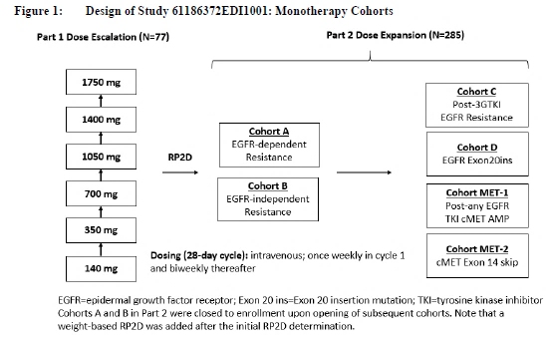

Table 4: CHRYSALIS trial Key eligibility criteria relevant to the primary efficacy population

|  |  |
| --- | --- |
| Included | Excluded |
| * Consenting, non-reproductive, non-breastfeeding adults with advanced (unresectable or metastatic) NSCLC (histology or cytology-confirmed) * ECOG performance status score <2 * Adequate organ function * Evaluable (Part 1) or measurable (Part 2) disease by RECIST v1.1 * (Part 2 only) EGFR ex20ins mutation according to local testing (see also “Ex20ins variant subgroups,” page 30) * Must have received prior treatment with (or been ineligible for or refused) standard of care therapy, i.e. platinum-based chemotherapy | * Leptomeningeal disease, untreated CNS metastases * Clinically significant cardiovascular disease (DVT, QT prolongation, uncontrolled hypertension, CHF, pericarditis, myocarditis) * Interstitial lung disease (including radiation induced) requiring immunosuppression within 2 years * Significant surgery, injury or medical illness including infection * Part 2 Cohort D only: prior TKI with known activity in ex20ins disease (e.g. poziotinib) |

CHF = congestive heart failure; DVT = deep vein thrombosis; ECOG = Eastern Cooperative Oncology Group; Ex20ins = exon 20 insertion mutation; RECIST = Response Evaluation Criteria in Solid Tumours; TKI = tyrosine kinase inhibitor

###### Population

Patients were enrolled from 53 sites across ten countries (Australia, Canada, China, France, Japan, Republic of Korea, Spain, Taiwan, US, and the United Kingdom), including seven Australian patients across two sites. The primary efficacy population (n = 81) received their first doses of amivantamab between 27 May 2016 (date first subject signed informed consent) and 5 February 2020 (cutoff date for eligibility for inclusion in that population).

*Epidermal growth factor receptor* ex20ins mutation testing results for the primary efficacy population are summarised in Table 5.

Demographics and baseline disease characteristics were generally in keeping with what would be expected for the intended recipient patient population in Australia, that is patients with locally advanced or metastatic NSCLC with *EGFR* ex20ins mutations whose disease has progressed on or after platinum-based chemotherapy.43 Characteristics of the primary efficacy population were also consistent with those of 181 American patients with ex20ins mutations who were included in a retrospective cohort study of real world data from the Flatiron database (see Supporting study NSC1002).

Amongst the primary efficacy population, the median age was 62 years (range 42 to 84); 41% were at least 65 years old and 9% were at least 75 years old; 59% were female; 53% had never smoked; 49% were Asian and 37% were White; baseline Eastern Cooperative Oncology Group (ECOG) performance status was 0 in 32%, 1 in 67%, and 2 in 1%; 74% had baseline body weight less than 80 kg; 95% had adenocarcinoma; 75% had metastatic disease at initial diagnosis, 100% had metastatic disease at study entry, 22% had a history of brain metastases. The median time from diagnosis of metastatic disease to the first dose of amivantamab was 14.2 months (range: 0.69 to 116.4). Patients had received a median of 2 (mean 2.3) and a range of 1 to 7 prior lines of therapy in the advanced setting. All patients had received prior platinum-based chemotherapy, 46% had received prior immunotherapy, and 23% (n = 19) had received prior TKI therapy (9% had received a first-generation EGFR TKI, 7% had received a second-generation EGFR TKI, 7% had received a third-generation EGFR TKI, and 1.2% had received both first and third generation EGFR TKIs).

Table 5: EGFR mutation status in CHRYSALIS (primary efficacy population) [DCO 8 OCT 2020]

|  | | **Amivantamab (n=81)** |
| --- | --- | --- |
| Ex20ins mutation present according to central ctDNA (Guardant data) analysis* | A763, n (%) | 1 (1) |
| A767, n (%) | 19 (23) |
| S768, n (%) | 13 (16) |
| V769, n (%) | 1 (1) |
| D770, n (%) | 9 (11) |
| N771, n (%) | 9 (11) |
| P772, n (%) | 3(3) |
| H773, n (%) | 8 (9) |
| Unknown,* n (%) | 18 (22) |

DCO = data cut-off date

* Locally identified ex20ins mutation not confirmed on central Guardant analysis. See also “Ex20ins variant subgroups,” page 30.

###### Disposition

As of the 8 October 2020 clinical cutoff date, the median follow up for the primary efficacy population was 9.7 months (range: 1.08 to 29.27). Some key patient disposition information for the primary efficacy population is summarised in Table 6

Table 6: Patient disposition in CHRYSALIS (primary efficacy population) [DCO 8 OCT 2020]

|  | | **Amivantamab (n=81)** |
| --- | --- | --- |
| Ongoing on study, n (%) | | 61 (75) |
| Not ongoing on study, n (%) | | 20 (25) |
| *Reason for study discontinuation* | *Died, n (%)* | *15 (19)* |
| *Lost to follow-up, n (%)* | *1 (1.2)* |
| *Withdrawal by patient, n (%)* | *4 (4.9)* |
| Ongoing on treatment, n (%) | | 34 (42) |
| Discontinued treatment, n (%) | | 47 (58) |
| *Reason for treatment discontinuation* | *Adverse event, n (%)* | *6 (7.4)* |
| *Death, n (%)* | *2 (2.5)* |
| *Withdrawal by patient, n (%)* | *3 (3.7)* |
| *Progressive disease, n (%)* | *35 (43)* |
| *Physician decision, n (%)* | *1 (1.2)* |

Percentages are rounded to nearest integer unless below 10%.

###### Outcomes

Key results for the primary efficacy population in CHRYSALIS are summarised in Table 7. At the DCO of 8 October 2020, the response was ongoing for 13 responders.

Table 7: Results of CHRYSALIS per blinded independent central review in the primary efficacy population [DCO 8 OCT 2020]

|  |  |
| --- | --- |
|  | Amivantamab  (n=81) |
| ORR* | |
| ORR, % (95% CI) | 40 (29, 51) |
| *Complete response (CR), n (%)* | *3 (3.7)* |
| *Partial response (PR), n (%)* | *29 (36)* |
| *Stable disease (SD), n (%)* | *39 (48)* |
| *Progressive disease (PD), n (%)* | *8 (9.9)* |
| *Not evaluable (NE), n (%)* | *2 (2.5)* |
| DOR* | |
| Median duration of responses, months [95% CI] | 11.1 (6.9, NE) |
| *Responses ≥6 months, n (%)* | *20 (63)* |

Based on Kaplan-Meier estimates. Percentages are rounded to nearest integer unless below 10%.

CI = confidence interval; DCO = data cut-off date; DOR = duration of confirmed responses per RECIST v1.1 by blinded independent central review; ORR = confirmed objective response rate per RECIST v1.1 by blinded independent central review

Sensitivity and subgroup analyses

Alternative efficacy cut-offs

At the DCO of 8 October 2020, in an efficacy population that was the same as the primary efficacy population except it included patients who received a first dose of amivantamab on or before a later date of 4 June 2020 (an additional 33 patients, for a total n = 114), similar results ORR and DOR results to the primary efficacy analysis were demonstrated. The median duration of follow up was 8.3 months for this group.

The ORR and DOR results were similar when assessed in the original primary efficacy population at a later DCO (30 March 2021). The median duration of follow up was 14.5 months, ORR was 43% (95% CI: 32, 55), and median DOR was 11 months (95% CI: 6.9, not estimable).

At the DCO of 30 March 2021, in an efficacy population that was the same as the primary efficacy population except it included patients who received amivantamab at the RP2D and had at least six months follow up available (an additional 43 patients, for a total n = 124), similar results ORR and DOR results to the primary efficacy analysis were demonstrated. The median duration of follow up was 11.9 months, ORR was 43% (34, 52) and median DOR was 8.7 months (95% CI: 5.5, 11.1).

Prespecified subgroups

Results were consistent across pre-specified subgroups, including age (younger than 65 versus at least 65 years; younger than 75 versus a t least 75 years), sex (male versus female), race (Asian versus non-Asian), baseline ECOG (0 versus 1 to 2), history of smoking (yes versus no), and prior immunotherapy (yes versus no). See Figure 9.

Figure 9: Forest plot of objective response rate in the primary efficacy population in CHRYSALIS trial by pre-specified subgroups (Data cutoff 8 October 2020)

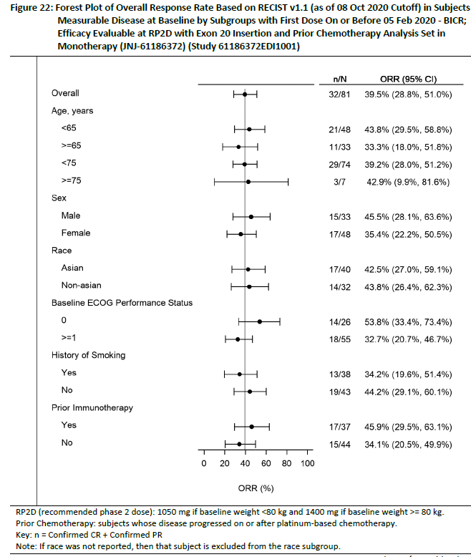

N = number of patients in subgroup; n = number of patients in that subgroup with a confirmed complete response (CR) or partial response (PR) per RECIST v1.1; ORR = objective response rate

A lower ORR was seen in patients with body weight less than 80 kg than those weighing 80 kg or more, but more of the heavier patients had a better ECOG performance status of zero, confounding interpretation. For patients with body weight less than 80 kg, there was a numerically higher ORR with the 1400 mg dose (43% [95%CI: 28, 59]) than the 1050 mg dose (34% [95%CI: 25, 45]), but interpretation is inconclusive due to the limited number of patients who received the 1400 mg dose.

Ex20ins variant subgroups

The presence of *EGFR* exon 20 insertion mutation was determined by local testing either by polymerase chain reaction (PCR) or next generation sequencing (NGS) either of tissue or blood samples, and was centrally tested following enrolment using a central, plasma-based NGS assay of circulating tumour DNA (ctDNA): the Guardant360 CDx diagnostic assay. A total of 25 unique *EGFR* exon 20 insertion variants occurring at eight different amino acid positions (referred as subtypes) were centrally confirmed in 63 of 81 patients (78%). The remaining 18 patients (22%) had central ctDNA analyses in which exon 20 insertions were not detected. Local test results for these 18 patients are described under Table 8 footnote.

Results of an FDA exploratory analysis of ORR by EGFR exon 20 insertion subtype are presented in Table 8, adapted from ‘Table 11’ of the FDA MDR for amivantamab.76 Responses (complete response or partial response) were observed across all *EGFR* exon 20 insertion subtypes except for V769, which only occurred in one patient based on ctDNA results. However, a patient with a V769 insertion subtype based on local test results (unkown status based on central ctDNA) achieved a complete response. Although treatment responses were observed across subtypes, small sample sizes preclude a definitive conclusion regarding variability in treatment response by insertion subtype.

Table 8: Objective response rate by *epidermal growth factor receptor* ex20ins mutation subtype in the primary efficacy population in CHRYSALIS trial (n = 81) at data cutoff 8 October 2020.

|  |  |  |  |
| --- | --- | --- | --- |
| Exon 20 insertion subtype | Exon 20 insertion variant | Subgroup size | Number of patients with a tumour response (ORR) |
| A763 | A763_Y764insFQEA* | 1 | 1 (100%) |
| A767 | A767_V769dup | 19 | 11 (57.9%) |
| S768 | S768_D770dup | 13 | 6 (46.2%) |
| V769 | V769_P772dup | 1 | 0 (0%) |
| D770 | D770_N771insG | 1 | 2 (22.2%) |
| D770_N771insGF | 2 |
| D770_N771insKD | 1 |
| D770_N771insY | 1 |
| D770_P772dup | 1 |
| D770delinsGY | 3 |
| N771 | N771_H773dup | 3 | 2 (22.2%) |
| N771_P772insH | 1 |
| N771_P772insT | 1 |
| N771_P772insV | 1 |
| N771delinsGF | 1 |
| N771delinsGY | 1 |
| N771delinsKG | 1 |
| P772 | P772_H773dup | 1 | 1 (33.3%) |
| P772_H773insDNP | 1 |
| P772_H773insPNP | 1 |
| H773 | H773_V774dup | 1 | 2 (25.0%) |
| H773_V774insAH | 2 |
| H773_V774insNPH | 1 |
| H773dup | 3 |
| H773delinsNPT | 1 |
| Unknown** | not available | 18 | 7 (38.9%) |
| Total |  | 81 | 32 (39.5%) |

ORR = overall response rate by blinded independent central review (DCO 8 OCT 2020);

* Occurs in the C-helix. Reported to be sensitive to EGFR TKIs.65, 67, 68, 69

** Unknown status (n=18): no insertion detected by central ctDNA analysis. Of these, the exon 20 insertion variant was identified by local NGS for 11 patients, as follows: A767_V769dup (N=3), S768_V769delinsIL (N=1), V769_D770insGVV (N=1), D770_N771insGD (N=1), N771_H773dup (N=1), P772_H773dup (N=1), H773_V774insNPH (N=1), H773_V774insPH (N=1), H773dup (N=1). For the remaining 7 patients, local PCR tests detected exon 20 insertions but did not identify the specific variants or additional mutations. Responses (CR or PR) were observed in patients with the following local test results: A767_V769dup (N=1), H773_V774insPH (N=1), V769_D770insGVV (N=1), S768_V769delinsIL (N=1), and not identified (N=3). Co- occurring EGFR mutations included T790M (in one patient with A767 subtype) and S768I (in one patient with unknown insertion based on central test, S768_V769delinsIL based on local test). Other uncommon or uncharacterised EGFR mutations are not listed.

Source: From ‘Table 11’ of the FDA MDR;76

##### Supporting study NSC1002

Due to the rarity of ex20ins mutation-positive NSCLC, a paucity of previous clinical trial data and lack of a specific standard of care for patients with this disease, analyses of real world data were submitted by the Sponsor to provide clinical context to the pivotal evidence.

Study 61186372NSC1002RWE (hereafter referred to as Study NSC1002) incorporated two parts:

* Part 1: a retrospective cohort study conducted in the US using longitudinal data from the Advanced NSCLC Flatiron Core Registry
* Part 2: an analysis of five electronic health record (eHR) and claim reimbursement datasets regarding commonly-used second-line regimens for *EGFR* ex20ins-positive NSCLC (including combination therapy with ramucirumab and docetaxel).

###### Design

Part 1

The study included 181 adults with advanced, *EGFR* positive NSCLC diagnosed between 1 January 2011 and 31 May 2020 who were included in the Advanced NSCLC Flatiron Registry (a de-identified database of eHR data from over 280 cancer clinics across the USA) and had started first-line therapy within 90 days of diagnosis.

The dual primary endpoints were real-world overall survival, defined as the time from start of first line therapy to death, and real-world progression free survival on first EGFR TKI treatment, in patients with ex20ins versus common *EGFR* mutations.

Part 2

Real world data was compiled from the following sources:

* MarketScan: A longitudinal database including inpatient and outpatient health care claims from over 100 large employers, health plans, and government and public organizations representing approximately 75 million covered individuals. This database does not include biomarker data, preventing subgroup analysis of *EGFR* mutated disease.
* Flatiron Health: An eHR-derived database with data from over 265 cancer clinics representing more than 2 million active US cancer patients. The database includes longitudinal patient-level data including variables such as biomarker status and treatment regimens curated via technology-enabled abstraction
* TEMPUS: A provider of next generation sequencing with an integrated clinical and genomic cancer database aggregated from National Cancer Institute designated centers, academic medical centers, and community-based hospitals comprised of over 2000 medical oncologists and 1 million patient records.
* IntrinsiQ: An eHR-derived database including longitudinal, patient-level data in approximately 69,400 oncology patients treated by over 650 academic and community hospitals and clinics. In addition to demographics and drug administration data, the database also captures staging, pathology, biomarkers, and reason for regimen changes.
* Ipsos Health: An eHR-derived database which captures longitudinal patient-level data, including biomarker status, and details usage of anti-cancer agents, utilizing 280,000 patient records from approximately 4,000 physicians. The EU sample includes data from outpatient centers, community and academic hospitals, as well as comprehensive cancer centers in France, Germany, Italy, Spain, and the United Kingdom.

The main aim of Part 2 was to address the real world usage of combination therapy with ramucirumab-docetaxel, as this been approved for use in the second-line setting in the USA, based on an absolute improvement in OS, progression free survival (PFS) and ORR over docetaxel +placebo at the cost of increased toxicity.

###### Results

The limitations of the data prevent firm conclusions, however, Study NSC1002 supports that

* There was no clear standard of care for advanced *EGFR* ex20ins-positive NSCLC after failure of first line therapy during the study period
* Outcomes were generally poor for patients treated in this setting
* Real world response rates of *EGFR* ex20ins mutation positive NSCLC to second line treatment options were in keeping with published literature reports of 10 to 15% generally, and up to 20% for second-line treatment with ramucirumab and docetaxel
* Ramucirumab and docetaxel in combination were not widely used in the second-line treatment of *EGFR* mutated NSCLC during the study period

The submitted real world evidence provide context for interpretation of the pivotal data and support the validity of a provisional registration approach to amivantamab based on single arm data, due to the poor outcomes with standard-of-care treatments in this setting that have randomised data to support their usage.

#### Safety

##### Safety database

The safety database for amivantamab consists entirely of data from CHRYSALIS trial (Study 61186372EDI1001). FDA’s analyses of safety are described in detail in the MDR, including a list of clinically rational MedDRA term groupings, and were based on data from a DCO of 8 October 2020 for the following safety analysis populations (abbreviations added for the purposes of this TGA overview):

* The primary safety population [PS-p] (n = 129): patients with *EGFR* ex20ins-mutation positive NSCLC previously treated with platinum-based chemotherapy who received at least one dose of amivantamab at the RP2D
* The RP2D safety population [R2PD-p] (n = 302): patients with advanced NSCLC who received at least one dose of amivantamab at the RP2D, regardless of mutation status or prior therapy
* The all-treated safety population [AT-p] (n = 411): patients who received any dose of amivantamab as a single agent

In the approved FDA label, the safety dataset used to inform the Warnings and Precautions section (Section 5) was the RP2D safety population described above, whilst the adverse reaction tables in Section 6 of the FDA label reflect the primary safety population, both at DCO 8 October 2020.

The dossier submitted to TGA included an additional CSR with the later DCO of 30 March 2021, reflecting additional follow up to CHRYSALIS trial. At this data cut, the population sizes were n = 153 (PS-p), n = 380 (RP2D-p) and n = 489 (AT-p), respectively. Amongst the AT-p are 17 subjects across three Australian sites.

The clinical study report with DCO 30 March 2021 did not identify new or worsening safety signals, and concluded that the overall safety profile was similar between the three populations at both the DCOs.

##### Patient characteristics

Among patients in the PS-p at the DCO of 30 March 2021, the median age was 61 years (range: 35 to 84 years); 61% were female; 62% were Asian and 29% were Caucasian; and median baseline body weight was 60 kg.

###### Exposure

Exposure at the 8 October 2020 DCO is described in the FDA MDR;76 and label.[82]

At DCO 30 March 2021, the median duration of study treatment for the 153 subjects in the PS-p was 5.6 months and the median number of treatment cycles per subject was 7 (range 1 to 27). The maximum duration of treatment was 23.9 months, and 71 subjects (46%) were exposed to amivantamab for at least six months. The mean relative dose intensity was 99% (range 20 to 100).

The percentage of patients in the PS-p with baseline body weight less than 80 kg was not reported in the 30 March 2021 DCO clinical study report, so it is unknown the proportion of patients in the PS-p at the 30 March 2021 DCO who had received the 1050 mg versus the 1400 mg dose. For the FDA’s PS-p dataset (DCO 8 October 2020), around one fifth of patients were 80 kg or more, and therefore received the 1400 mg dose. The FDA analysis found that the overall tolerability profile of amivantamab was generally consistent for subjects with a baseline body weight of less than 80 kg (treated with 1050 mg dose) and those weighing at least 80 kg (treated with 1400 mg dose), with the possible exception of higher rates (difference of greater than 10%) of treatment emergent adverse events (TEAE) leading to dose reduction or infusion modification in the at least 80 kg subgroup, and higher rates of TEAEs leading to dose interruption in the less than 80 kg subgroup.76

###### Deaths

At the 30 March 2021 DCO, in the PS-p, 45 out of 153 patients (29%) had died at any time during the study, with the most frequent reason for death being progressive disease (n = 31, 20%). Five deaths (3%) were categorised as ‘other’: one patient suicided (201 days after the last dose of amivantamab), one died of ‘clinical decline’ (subject went into hospice care following hospital discharge; 55 days after the last dose of amivantamab), one died of ‘natural causes’ (subject’s family called the investigator; 32 days after the last dose of amivantamab), and the causes were unknown for two deaths, which occurred 222 and 333 days after the last dose of amivantamab, respectively.

There were 12 (8%) patients who died on treatment or within 30 days of the last dose of amivantamab. Based on the FDA analysis to the DCO of 8 OCT 2020, causality attribution to amivantamab could not be ruled out two of these (one death [1.5%] due to pneumonia and one death [0.8%] reported as ‘sudden death’), and these are reflected in the approved FDA label. Case narratives are located on page 136-143 of the MDR.76 Two additional deaths on treatment or within 30 days of the last dose of amivantamab occurred in the PS-p up to the later DCO of 30 March 2021. Neither are considered likely to have a causal relationship to amivantamab.

##### Dose modifications and permanent discontinuations

The approved FDA label contains the following description of amivantamab dose modification and discontinuation in the PS-p at DCO 8 October 2020 (n = 129):82

‘Permanent discontinuation of Rybrevant due to an adverse reaction occurred in 11% of patients. Adverse reactions resulting in permanent discontinuation of Rybrevant in ≥1% of patients were pneumonia, IRR, pneumonitis/ILD, dyspnea, pleural effusion, and rash. Dose interruptions of Rybrevant due to an adverse reaction occurred in 78% of patients. Infusion-related reactions (IRR) requiring infusion interruptions occurred in 59% of patients.

Adverse reactions requiring dose interruption in ≥5% of patients included dyspnea, nausea, rash, vomiting, fatigue, and diarrhea.

Dose reductions of Rybrevant due to an adverse reaction occurred in 15% of patients. Adverse reactions requiring dose reductions in ≥ 2% of patients included rash and paronychia.’

The rates of dose modification and permanent discontinuations were similar between the first interim CSR, dated 27 October 2020, and the later interim CSR, dated DCO of 21 October 2021.

##### Common and most common high-grade adverse events

The approved FDA label contains the following description of common adverse events and laboratory abnormalities with amivantamab in the PS-p at DCO 8 October 2020 (n=129):82

‘In the safety population, the most common (≥ 20%) adverse reactions were rash, infusion-related reaction, paronychia, musculoskeletal pain, dyspnea, nausea, edema, cough, fatigue, stomatitis, constipation, vomiting and pruritus. The most common Grade 3 to 4 laboratory abnormalities (≥ 2%) were decreased lymphocytes, decreased phosphate, decreased albumin, increased glucose, increased gamma glutamyl transferase, decreased sodium, decreased potassium, and increased alkaline phosphatase.’

Tables of adverse events – using clinically rational term groupings – and of laboratory abnormalities are also included in the FDA label and reflect the 8 October 2020 DCO.

##### Most common serious adverse events

The approved FDA label contains the following description of common adverse events and laboratory abnormalities with amivantamab in the PS-p at DCO 8 October 2020 (n = 129):82

‘Serious adverse reactions occurred in 30% of patients who received Rybrevant. Serious adverse reactions in ≥ 2% of patients included pulmonary embolism, pneumonitis/ILD, dyspnea, musculoskeletal pain, pneumonia, and muscular weakness.’

##### Laboratory abnormalities

Laboratory result data was analysed by FDA and summarised based on change from baseline in the MDR. This analysis is presented in Table 9.

Table 9: FDA analysis of select laboratory abnormalities that worsened from baseline in at least 20% of patients in the PS-p (E20 ins mutations prior chemotherapy) and RP2D-p (RP2D) at DCO 8 October2020 (from page 169 of the MDR);76

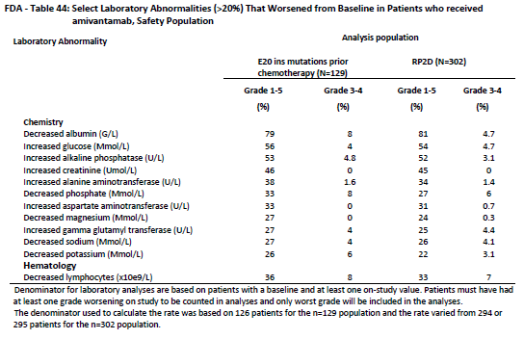

##### Immunogenicity

The approved FDA label contains the following description of immunogenicity with amivantamab at the PK and immunogenicity DCO of 31 March 2020:76

‘In CHRYSALIS, 3 of the 286 (1%) patients who were treated with Rybrevant and evaluable for the presence of anti-drug antibodies (ADA), tested positive for treatment-emergent anti-amivantamab-vmjw antibodies (one at 27 days, one at 59 days and one at 168 days after the first dose) with titers of 1:40 or less. There are insufficient data to evaluate the effect of ADA on the pharmacokinetics, safety, or efficacy of Rybrevant.’

The CSR with DCO 30 MAR 2021 contains an updated immunogenicity assessment, including data from 347 patients with evaluable samples. No additional anti-drug antibodies (ADA)-positive results were seen, and the total remained 3 (0.9%), however, 25 subjects were classified as ADA-inconclusive as all the serum samples contained drug concentration levels above the tolerance of the assay (> 400 μg/mL).

Table 10: Summary of anti-drug antibody status and titers by amivantamab dose (excluding inconclusive ADA status) for Part 1 and Part 2 combined of CHRYSALIS trial

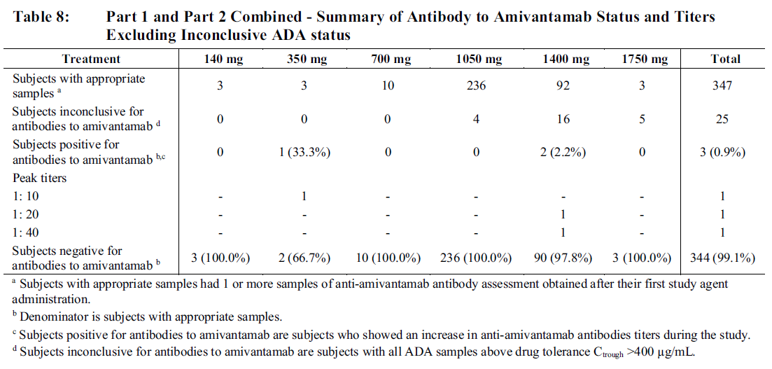

Source: ‘Table 8’ of the CSR dated 21 October 2021

##### QT prolongation

As a monoclonal antibody, amivantamab is too large to directly inhibit the human Ether-à-go-go-Related Gene channel and is highly specific to the extracellular epitope of the transmembrane EGFR and MET proteins. As such, amivantamab is unlikely to directly impact cardiac repolarisation and result in QTcF prolongation.

The CHRYSALIS trial excluded patients with a history of QT prolongation. In the PS-p described in the CSR dated 21 October2021 (n = 153), post-baseline QTc (Fridericia corrected) was > 480 to 500 msec in 1.4% of patients, and was > 500 msec in 0.7% of patients. Six of out 153 (4%) subjects had a maximum change from baseline in the QTcF interval that exceeded 60 msec.

##### Adverse events of special interest

In the PS-p at the 30 March 2021 DCO, the most frequent (at least 20%) amivantamab treatment-related (per investigator assessment) adverse events (TRAEs) were:

* Infusion related reactions (97 out of 153 patients [63%])
* Paronychia (77 out of 153 patients [50%])
* Rash (61 out of 153 patients [40%])
* Dermatitis acneiform (60 out of 153 [39%])
* Hypoalbuminemia (39 out of 153 patients [25%])
* Stomatitis (31 out of 153 patients [20%])

Pages 171-192 of the MDR contain a detailed analysis of submission-specific safety issues.76 The following events are included in the warnings and precautions section of the approved FDA label,82 with statistics referring to the RP2D-p (n = 302) at the 8 October 2020 DCO. Section 4.4 of the Australian PI should contain similar text.

###### Infusion reactions

The FDA label warning/precaution text is as follows:

‘Rybrevant can cause infusion-related reactions (IRR); signs and symptoms of IRR include dyspnea, flushing, fever, chills, nausea, chest discomfort, hypotension, and vomiting.

Based on the safety population [see Adverse Reactions (6.1)], IRR occurred in 66% of patients treated with Rybrevant. Among patients receiving treatment on Week 1 Day 1, 65% experienced an IRR, while the incidence of IRR was 3.4% with the Day 2 infusion, 0.4% with the Week 2 infusion, and cumulatively 1.1% with subsequent infusions. Of the reported IRRs, 97% were Grade 1-2, 2.2% were Grade 3, and 0.4% were Grade 4. The median time to onset was 1 hour (range 0.1 to 18 hours) after start of infusion. The incidence of infusion modifications due to IRR was 62% and 1.3% of patients permanently discontinued Rybrevant due to IRR.

Premedicate with antihistamines, antipyretics, and glucocorticoids and infuse Rybrevant as recommended [see Dosage and Administration (2.3)]. Administer Rybrevant via a peripheral line on Week 1 and Week 2 [see Dosage and Administration (2.6)].

Monitor patients for any signs and symptoms of infusion reactions during Rybrevant infusion in a setting where cardiopulmonary resuscitation medication and equipment are available. Interrupt infusion if IRR is suspected. Reduce the infusion rate or permanently discontinue Rybrevant based on severity [see Dosage and Administration (2.4)].’

The CSR dated 21 October 2021 reports the rate of IRRs in the RP2D-p to be 67%, and the rate of grade 3 or higher IRRs in the same population to be 2%.

###### Interstitial lung disease (ILD)/pneumonitis

The FDA label warning/precaution text is as follows:

‘Rybrevant can cause interstitial lung disease (ILD)/pneumonitis. Based on the safety population [see Adverse Reactions (6.1)], ILD/pneumonitis occurred in 3.3% of patients treated with Rybrevant, with 0.7% of patients experiencing Grade 3 ILD/pneumonitis. Three patients (1%) discontinued Rybrevant due to ILD/pneumonitis.

Monitor patients for new or worsening symptoms indicative of ILD/pneumonitis (e.g., dyspnea, cough, fever). Immediately withhold Rybrevant in patients with suspected ILD/pneumonitis and permanently discontinue if ILD/pneumonitis is confirmed [see Dosage and Administration (2.4)].’

###### Skin toxicities

The FDA label warning/precaution text is as follows:

‘Rybrevant can cause rash (including dermatitis acneiform), pruritus and dry skin. Based on the safety population [see Adverse Reactions (6.1)], rash occurred in 74% of patients treated with Rybrevant, including Grade 3 rash in 3.3% of patients. The median time to onset of rash was 14 days (range: 1 to 276 days). Rash leading to dose reduction occurred in 5% of patients, and Rybrevant was permanently discontinued due to rash in 0.7% of patients [see Adverse Reactions (6.1)].

Toxic epidermal necrolysis (TEN) occurred in one patient (0.3%) treated with Rybrevant.

Instruct patients to limit sun exposure during and for 2 months after treatment with Rybrevant. Advise patients to wear protective clothing and use broad-spectrum UVA/UVB sunscreen. Alcohol-free emollient cream is recommended for dry skin.

If skin reactions develop, start topical corticosteroids and topical and/or oral antibiotics. For Grade 3 reactions, add oral steroids and consider dermatologic consultation. Promptly refer patients presenting with severe rash, atypical appearance or distribution, or lack of improvement within 2 weeks to a dermatologist. Withhold, dose reduce or permanently discontinue Rybrevant based on severity [see Dosage and Administration (2.4)].’

The event of TEN is of particular note. The case narrative is as follows:

‘This subject, with a medical history of a Grade 3 rash on nivolumab, started the study with an ongoing Grade 1 rash AE (verbatim: papulo-erythematous lesions under nivolumab). This pre-existing rash worsened to Grade 3 on Day 29 and required hospitalization on Day 37 (2 weeks after the last dose of amivantamab). On the same day (Day 37), a nonserious AE of Grade 2 cheilitis was also reported. Amivantamab therapy (1050 mg) was interrupted. On Day 48, the subject was hospitalized a second time, and a skin biopsy on Day 49 revealed epidermal necrolysis (Grade 3), with involvement of approximately 50% of body surface area. Amivantamab was discontinued for this TEAE (last dose on Day 23). An autoimmunity evaluation on an unknown day demonstrated an elevated anti-nuclear speckle-type antibody, positive Sjogren syndrome A and B, and scleroderma (systemic sclerosis) antibodies, and a positive Coombs test for anti-immunoglobulin G. The subject also had positive serologies for cytomegalovirus, Epstein-Barr virus, and human herpesvirus 8. The subject was treated with oral antibiotics, subcutaneous filgrastim, methylprednisolone taper, and topical agents. On Day 60, cloxacillin and hydroxychloroquine were started, and valacyclovir was initiated on Day 79. The subject did not require intensive care unit admission. The toxic epidermal necrolysis resolved on Day 107. The TEAE of toxic epidermal necrolysis was considered serious and probably related to amivantamab (Mod5.3.5.2/61186372EDI1001/Study Report/AttNarratives).’

The CSR dated 21 OCT 2021 reports the rate of TRAEs in the system organ class of skin disorders in the RP2D-p to be 76%. No additional events of TEN were reported as at the later DCO.

###### Ocular toxicities

The FDA label warning/precaution text is as follows:

‘Rybrevant can cause ocular toxicity including keratitis, dry eye symptoms, conjunctival redness, blurred vision, visual impairment, ocular itching, and uveitis. Based on the safety population [see Adverse Reactions (6.1)], keratitis occurred in 0.7% and uveitis occurred in 0.3% of patients treated with Rybrevant. All events were Grade 1-2. Promptly refer patients presenting with eye symptoms to an ophthalmologist. Withhold, dose reduce or permanently discontinue Rybrevant based on severity [see Dosage and Administration (2.4)].’

The MDR describes FDA’s findings regarding ocular toxicity in the RP2D-p at the DCO of 8 OCT 2020:

‘Ocular toxicity occurred in 13.2% of patients. The most common events (≥ 1%) include dry eye (3%), vision blurred (1.7%), eye pruritus (1.3%), and visual impairment (1%). Keratitis was reported in 0.7% of patients and uveitis was reported in 0.3% (one patient). Patients may experience dry eye symptoms, conjunctival redness, blurred vision, ocular itching, periocular edema, and uveitis. The potential consequences of untreated keratitis or uveitis can include loss of vision, and therefore, ocular toxicity is included in the Warnings and Precautions section of the label.’

Whilst ocular toxicities were low grade, due to the known link between ocular toxicity and EGFR TKIs as a class, as well as the potential clinical seriousness (vision loss), ocular toxicities should be included as a warning in the Australian PI. Ocular toxicities should be reflected as a group term for ocular adverse events in the PI text and tables.

###### Peripheral oedema

Peripheral oedema is an adverse effect associated with MET inhibitors as a class and may be associated with hypoalbuminaemia. Hypoalbuminemia is a class effect of MET inhibitors, suspected to be a consequence of the effect on hepatocyte protein synthesis of MET inhibition.[83] Decrease in serum albumin levels was observed in around 80% of subjects receiving amivantamab in CHRYSALIS trial (see Table 9), and hypoalbuminaemia had been reported as an adverse event for 40% of patients in the PS-p at the 30 March 2021 DCO. Hypoalbuminaemia tended to stabilise after Cycle 4 (see Figure 10).

Figure 10: Mean albumin levels over time in the AT-p in CHRYSALIS trial

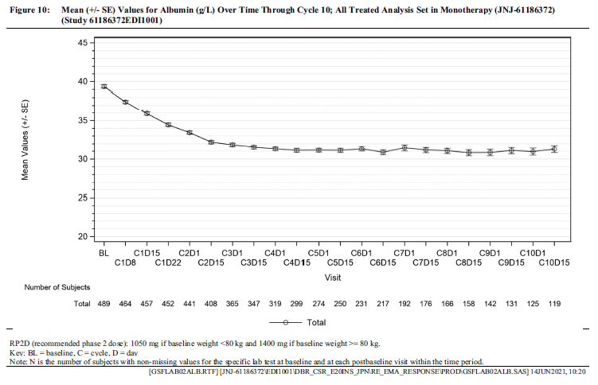

Source: ‘Figure 10’ of the CSR with 30 March 2021 DCO

FDA’s safety analysis included a grouped term for oedema, which occurred in 23% of the recommended Phase II dose-p and was Grade 3 or higher in 1%. In the PS-p, oedema led to interruption of amivantamab dosing in 2.3% of patients and dose reduction in 0.8% of patients.

The rate of peripheral oedema was 20% in the RP2D-p at DCO 8 June 2020, and was 12% in the RP2D-p at DCO 30 March 2021; an analysis of oedema as a grouped term was not presented by the Sponsor.

Oedema as a grouped term is included in the FDA product labelling but was not made a warning/precaution based on severity and manageability. This information should be included in the Australian PI in a similar manner.

###### Paronychia

Paronychia is known to occur with other EGFR TKIs. In the PS-p, at DCO 8 October 2020, the incidence of paronychia was 50% for all grades and 3.1% for Grade 3. Paronychia resulted in dose interruption in 3.1% of patients and dose reduction in 2.3%.

Paronychia is not included under warning/precautions in the FDA label based on frequency, severity and manageability. This is an appropriate approach and should be reflected in the Australian PI.

###### Diarrhoea

In the PS-p, at DCO 8 October 2020, the incidence of diarrhoea was 16% for all grades and 3.1% for grade 3. Diarrhoea resulted in dose interruption in 5% of patients; no patient had dose reduction for diarrhoea. Two patients experienced serious diarrhoea resulting in hospital admission, and amivantamab dosing was interrupted in both cases. Diarrhoea was ongoing at the end of study for one of these patients. Rates remained similar at the later DCO of 30 March 2021.

Diarrhoea is not included under warning/precautions in the FDA label based on frequency, severity and manageability. This is an appropriate approach and should be reflected in the Australian PI.

###### Hepatotoxicity (increased serum aminotransferases)

EGFR and MET signalling are involved in the maintenance of hepatic liver repair and regeneration.[84] Aminotransferase elevations, including rare reports of hepatic failure with fatal outcomes for some, have been observed with small-molecule EGFR TKIs, as reflected in the approved TGA product information documents for afatinib,[85] gefitinib;[86] and erlotinib.[87]

The sponsor states that:

‘In a 6-week toxicity GLP study in young male and female cynomolgus monkeys, amivantamab was well tolerated when administered IV once weekly for 5 weeks at 20, 60, or 120 mg/kg/week. Treatment-related findings included non-adverse, non-dose-dependent, transient increase in ALT at all dose levels and non-dose-dependent, minimal increases in AST at 20 and 120 mg/kg/week without histopathological correlates in the liver.’

In CHRYSALIS, hepatic transaminase elevation above baseline was common (see Table 9), but grade 3 elevation was not (< 2%). There was a single Grade 4 ALT and AST increase amongst the RP2D-p (n = 362), summarised in the CSR as follows:

‘This subject had a medical history of pleural effusion, diabetes mellitus, and hypertension. The subject experienced Grade 4 ALT increased and Grade 4 AST increased on Study Day 338. These transaminase elevations occurred concurrently with Grade 4 pulseless electrical activity, Grade 4 hypotension, Grade 4 dyspnea, Grade 3 hypocalcemia, Grade 2 acute kidney injury, Grade 2 nausea, Grade 2 anemia, and Grade 2 hypoalbuminemia. All these events were reported as unrelated by the investigator. The subject’s bilirubin was within normal limits, indicating no drug-induced liver injury.’

There were no cases of confirmed drug-induced liver injury or meeting Hy’s law criteria, and no discontinuations due to aminotransferase increase.

###### Venous thromboembolic events

On 25 July 2022, the sponsor contacted TGA with information regarding venous thromboembolic events (VTE) with combination treatment with amivantamab and lazertinib (a third generation EGFR TKI) in clinical trials. The sponsor provided TGA with communications being sent to investigators of all trials in which this combination was being studied, including CHRYSALIS trial as some of the cohorts studied this combination. None of the patients forming the primary efficacy population for the current submission received lazertinib in combination with amivantamab.

According to the communications, the independent data monitoring committee for the MARIPOSA trial (in which this combination is being studied):

‘… observed imbalance in venous thromboembolic event (VTE) incidence for participants receiving the combination of Amivantamab and Lazertinib. VTE include such Adverse Event preferred terms as pulmonary embolism, deep vein thrombosis, embolism, thrombosis, venous thrombosis limb, venous thrombosis, and pulmonary thrombosis. The majority of the events were observed in the first 4 months of therapy with only 1 participant has discontinued treatment due to VTE and no fatal VTE events were observed with the combination in the MARIPOSA study.’

The actual rates of VTE in MARIPOSA trial were not provided.

MARIPOSA trial is a different randomised control trial to PAPILLON trial (the confirmatory trial proposed in the clinical study plan). The clinical trials to which these communications were sent are being continued, but risk minimisation activities are being undertaken involving additional screening and management protocols in those combination studies.

In CHRYSALIS trial, in the PS-p at DCO 30 March 2021, there had been ten reports of pulmonary embolism (6.5%), one report of pulmonary thrombosis (0.7%), one report of cerebrovascular accident (0.7%, three reports of deep vein thrombosis (2%), one report of embolism (0.7%), one report of jugular vein thrombosis (0.7%), one report of peripheral embolism (0.7%) and one report of thrombosis (0.7%). If all of these reports are mutually exclusive, the total incidence of these would be 19 out of 153 (12%), however it is not known whether this is the case.

A rate of 12% would not be out of keeping with rates published in the literature for invasive adenocarcinoma (10%)[88] and EGFR-positive NSCLC (21%).[89]

##### Companion diagnostic considerations

No molecular eligibility criteria were required for enrolment in Part 1 of the pivotal CHRYSALIS trial. *EGFR* ex20ins mutation status for Part 2 eligibility was determined by local testing (PCR or NGS) of tumour tissue or of blood. Mutation status across both parts of the study was then tested following enrolment using a central, plasma based NGS assay of ctDNA: the Guardant360 CDx diagnostic assay.

Central laboratory plasma-based and tissue-based diagnostics were utilised in bridging studies to compare to the local testing, with results reported in the literature.[90]

The plasma based diagnostic test, Guardant360 CDx, has been approved by FDA as a companion diagnostic for the selection of patients with EGFR ex20ins mutation-positive NSCLC for treatment with amivantamab.[91]

#### Confirmatory data plan

A Phase III study (61186372NSC3001, PAPILLON trial) is underway that is expected to confirm clinical benefit of amivantamab in the treatment of EGFR ex20ins-mutation positive NCSLC. The sponsor proposes that this study should fulfil the clinical study plan requirement for provisional registration.

The PAPILLON trial is a Phase III, open label, multicentre, randomised, controlled study to evaluate the efficacy and safety of carboplatin pemetrexed chemotherapy with or without amivantamab, in the first line treatment of patients with *EGFR* ex20ins-mutation positive NCSLC.[92] The study design is summarised in Figure 11, PFS has been selected as the primary endpoint, which is appropriate, given the potential for crossover to affect OS.

The PAPILLON trial commenced in 2020, at which time the comparator arm (chemotherapy alone) may not have been considered standard of care in Australia. Enrolment is ongoing, with 283 of an anticipated 300 participants as of 9 September 2022. Enrolment has been impacted by the COVID-19 pandemic, and the evolving conflict impacting study sites in Russia and Ukraine. Completion of enrolment is anticipated by October 2022. Primary completion (clinical cut-off date for primary PFS analysis) is estimated for September 2023, with an estimated final study report date in March 2024.

Figure 11: PAPILLON trial Schematic overview of the study design

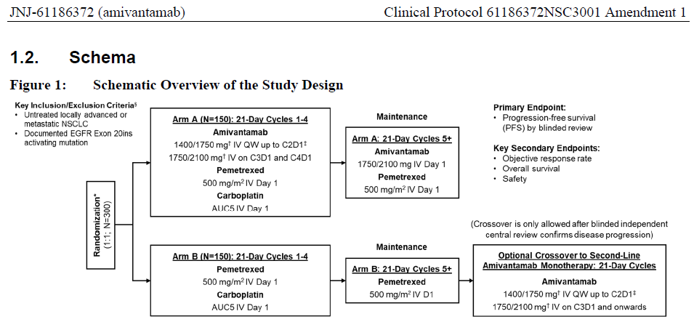

### Risk management plan

The sponsor submitted European Union (EU)-risk management plan (RMP) version 1.2 (dated 9 December 2021; data lock point (DLP) 30 March 2021) and Australia specific annex (ASA) version 2.0 (dated 28 September 2022) were reviewed. The summary of safety concerns (which comes from the European RMP) is presented in Table 11, and was considered adequate by the reviewer, noting that further data from ongoing Phase III trials is expected to provide further information on long term safety.

The summary of safety concerns and their associated risk monitoring and mitigation strategies are summarised in Table 11. The TGA may request an updated RMP at any stage of a product's life-cycle, during both the pre-approval and post-approval phases.

Table 11: Summary of safety concerns

|  |  |  |  |  |  |
| --- | --- | --- | --- | --- | --- |
| Summary of safety concerns | | Pharmacovigilance | | Risk Minimisation | |
| Routine | Additional | Routine | Additional |
| **Important identified risks** | Infusion-related reaction | ✓ | – | ✓ | – |
| **Important potential risks** | Hepatotoxicity | ✓ | – | ✓ | – |
| Impaired fertility and embryofetal toxicity | ✓ | – | ✓ | – |
| **Missing information** | None | ✓ | – | ✓ | – |

The safety concerns in the EU-RMP and ASA are identical. The summary of safety concerns is adequate.

Routine risk minimisation activities only have been proposed which is acceptable

The Delegate noted that ocular toxicity, skin toxicity and interstitial lung disease/pneumonitis have not been included in the summary of safety concerns. These toxicities are well known with EGFR/MET inhibitors.

##### Proposed wording for conditions of registration

The following wording for conditions of registration is recommended:

RMP condition:

‘The Rybrevant EU-Risk Management Plan (RMP) (version 1.2, dated 9 December 2021, data lock point 30 March 2021), with Australian Specific Annex (version 2.0, dated 28 September 2022), included with submission PM-2021-04814-1-4, and any subsequent revisions, as agreed with the TGA will be implemented in Australia.’

PSUR condition:

‘An obligatory component of risk management plans is routine pharmacovigilance. Routine pharmacovigilance includes the submission of periodic safety update reports (PSURs).

Unless agreed separately between the supplier who is the recipient of the approval and the TGA, the first report must be submitted to TGA no later than 15 calendar months after the date of this approval letter. The subsequent reports must be submitted no less frequently than annually from the date of the first submitted report until the period covered by such reports is not less than three years from the date of the approval letter, or the entire period of provisional registration, whichever is longer.

The reports are to at least meet the requirements for PSURs as described in the European Medicines Agency’s Guideline on good pharmacovigilance practices (GVP) Module VII-periodic safety update report (Rev 1), Part VII.B Structures and processes. Note that submission of a PSUR does not constitute an application to vary the registration. Each report must have been prepared within ninety calendar days of the data lock point for that report.’

Black Triangle Scheme condition (provisional registration):

‘Rybrevant (amivantamab)] is to be included in the Black Triangle Scheme. The PI and CMI for Rybrevant must include the black triangle symbol and mandatory accompanying text for five years, or the product’s entire period of provisional registration, whichever is longer.’

### Risk-benefit analysis

#### Delegate’s considerations

Amivantamab is a bispecific monoclonal antibody with specificity for the extracellular domain of both the EGFR and the MET transmembrane tyrosine kinase receptors. Scientific literature supports mechanistic rationale for dual blockade of these receptors in cancer harbouring *EGFR* mutations, particularly where it is not responsive to small molecule EGFR TKIs.

Exon 20 insertion (ex20ins) mutations of the *EGFR* are a class of mutation which generally confer primary resistance to EGFR TKIs. As a result, treatment options for most patients with *EGFR* ex20ins mutation positive NSCLC are the same as those for patients with no ‘driver’ mutation. After failure of first line platinum based chemotherapy containing regimens, there is no standard of care treatment that has full registration. The efficacy of treatments that have been studied in randomised trials is limited, with response rates of about 10 to 15% and significant toxicity.

Amivantamab has been studied in a single arm, dose escalation and expansion study (CHRYSALIS trial) in patients with previously treated advanced NSCLC. The efficacy population for this submission includes a cohort of 81 patients from CHRYSALIS trial whose NSCLC harboured an ex20ins mutation of the *EGFR*, and who received amivantamab at the recommended dose (1050 mg for patients with baseline body weight less than 80 kg, and 1400 mg otherwise given intravenously once a week for 4 weeks, then fortnightly thereafter). In this population, blinded independent central radiological review found an objective response rate of 40% (95% CI 29, 51), with a median duration of 11.1 months.

In this clinical context, such a size and duration of treatment effect are considered likely to predict clinical benefit. The results from CHRYSALIS trial are therefore considered preliminary evidence of clinically meaningful and durable anti-tumour activity with the use of amivantamab in patients with advanced NSCLC with *EGFR* ex20ins mutations whose disease has progressed on or after platinum-based chemotherapy. Confirmation of disease responsiveness to amivantamab and correlation of this with time-to-event clinical benefit in a randomised setting against an internal comparator is expected to be available within the provisional registration period from a Phase III study (PAPILLON trial) comparing outcomes with first-line chemotherapy (carboplatin plus pemetrexed) with versus without the addition of amivantamab. The comparator arm in this study is no longer standard-of-care in Australia, but this would not impact interpretation of the results with regard to the repeatability of the response rate and durability findings, and the contribution of effect of amivantamab to a time-to-event clinical benefit in this setting.

The risks of amivantamab are well described and consistent with those of monovalent EGFR and MET inhibitors (for example, rash, paronychia, stomatitis, diarrhoea, and peripheral oedema). Adverse events were mainly Grade 1 or 2, with around a tenth of patients discontinuing permanently due to AEs overall. IRRs were common but primarily limited to the first administration and rarely prevented subsequent therapy with amivantamab. Skin toxicities were very common, but not often grade 3 or above (3%). An individual case of toxic epidermal necrolysis is of particular note but was not fatal. Incidence of interstitial lung disease was 3%, consistent with the EGFR inhibitor class. Other notable toxicities included ocular toxicity occurring in around a tenth of patients, and hypoalbuminaemia and paronychia which were common but mostly low-grade.

The safety profile demonstrated in this study is acceptable for a drug treating a life-threatening illness, and includes events known to be associated with EGFR/MET inhibition. Potential toxicities must be adequately described in the product information to assist informed consent discussions.

#### Proposed action

The risk-benefit balance, incorporating the uncertainty, is positive for the provisional registration of amivantamab.

#### Advisory Committee considerations

The Delegate did not refer this submission to the Advisory Committee on Medicines/Vaccines (ACM/ACV) for advice.

## Outcome

Based on a review of quality, safety, and efficacy, the TGA approved the registration of Rybrevant (amivantamab) 350 mg/7 mL, concentrated injection, vial, indicated for:

*Rybrevant has provisional approval for the treatment of patients with locally advanced or metastatic non-small cell lung cancer (NSCLC) that has an activating epidermal-growth factor receptor (EGFR) exon 20 insertion mutation, whose disease has progressed on or after platinum-based chemotherapy.*

*The decision to approve this indication has been made on the basis of objective response rate and duration of response in a single arm study. Continued approval of this indication depends on verification and description of benefit in a confirmatory study.*

### Specific conditions of registration applying to these goods

* Rybrevant (amivantamab) is to be included in the Black Triangle Scheme. The PI and CMI for Rybrevant must include the black triangle symbol and mandatory accompanying text for five years, or the product’s entire period of provisional registration, whichever is longer.
* The Rybrevant EU-RMP (version 1.2, dated 9 December 2021, DLP 30 March 2021), with ASA (version 2.0, dated 28 September 2022), included with submission PM-2021-04814-1-4, and any subsequent revisions, as agreed with the TGA will be implemented in Australia.

An obligatory component of risk management plans is routine pharmacovigilance. Routine pharmacovigilance includes the submission of periodic safety update reports (PSURs). Unless agreed separately between the supplier who is the recipient of the approval and the TGA, the first report must be submitted to TGA no later than 15 calendar months after the date of the approval letter. The subsequent reports must be submitted no less frequently than annually from the date of the first submitted report until the period covered by such reports is not less than three years from the date of the approval letter, or the entire period of provisional registration, whichever is longer.

The reports are to at least meet the requirements for PSURs as described in the European Medicines Agency’s Guideline on good pharmacovigilance practices (GVP) Module VII-periodic safety update report (Rev 1), Part VII.B Structures and processes. Note that submission of a PSUR does not constitute an application to vary the registration. Each report must have been prepared within ninety calendar days of the data lock point for that report.

* Confirmatory trial data (as identified in the sponsor’s plan to submit comprehensive clinical data on the safety and efficacy of the medicine before the end of the 6 years that would start on the day that registration would commence) must be provided.

Specifically the sponsor must conduct studies as described in the clinical study plan in version 2.0 (dated 28 September 2022) of the Australia specific annex. The following study reports should be submitted to TGA:

* + The final clinical study report for Study 61186372EDI1001 (CHRYSALIS trial), if it changes the data reflected in the TGA approved product information to a clinically relevant extent.
  + The final clinical study report for Study 61186372NSC3001 (PAPILLON trial), anticipated to be available for submission in Q1 2024.

Further guidance for sponsors is available on the TGA website.

## Attachment 1. Product Information

The PI for Rybrevant approved with the submission which is described in this AusPAR is at Attachment 1. For the most recent PI, please refer to the TGA [PI/CMI search facility.](https://www.tga.gov.au/picmi-search-facility)

|  |
| --- |
| Therapeutic Goods Administration |
| PO Box 100 Woden ACT 2606 Australia  Email: [info@tga.gov.au](mailto:info@tga.gov.au) Phone: 1800 020 653 Fax: 02 6203 1605  [**https://www.tga.gov.au**](https://www.tga.gov.au) |
| Reference/Publication # |

1. This is the original indication proposed by the sponsor when the TGA commenced the evaluation of this submission. It may differ to the final indication approved by the TGA and registered on the Australian Register of Therapeutic Goods.
2. Sung H, et al. Global Cancer Statistics 2020: GLOBOCAN Estimates of Incidence and Mortality Worldwide for 36 Cancers in 185 Countries. *CA Cancer J Clin*. 2021 May;71(3):209-249.
3. Australian Institute of Health and Welfare (2021) Cancer in Australia 2021, AIHW, Australian Government, accessed 25 February 2022.
4. Chen Z, et al. Non-small-cell lung cancers: a heterogeneous set of diseases. Nat Rev Cancer. 2014 Aug;14(8):535-46. Erratum in: Nat Rev Cancer. 2015 Apr;15(4):247.
5. Walters S, et al. Lung cancer survival and stage at diagnosis in Australia, Canada, Denmark, Norway, Sweden and the UK: a population-based study, 2004-2007. Thorax. 2013;68(6):551-64.
6. Lu T, et al. Trends in the incidence, treatment, and survival of patients with lung cancer in the last four decades. Cancer Manag Res. 2019;11:943-953. Published 2019 Jan 21.
7. Shi Y, et al. A prospective, molecular epidemiology study of EGFR mutations in Asian patients with advanced non-small-cell lung cancer of adenocarcinoma histology (PIONEER). J Thorac Oncol. 2014 Feb;9(2):154-62
8. Graham RP, et al. Worldwide Frequency of Commonly Detected EGFR Mutations. Arch Pathol Lab Med. 2018 Feb;142(2):163-167
9. Joshi A, Zanwar, et al. EGFR mutation in squamous cell carcinoma of the lung: does it carry the same connotation as in adenocarcinomas?. Onco Targets Ther. 2017;10:1859-1863. Published 2017 Mar 28.
10. Jin R, et al. EGFR-Mutated Squamous Cell Lung Cancer and Its Association With Outcomes. Front Oncol. 2021 Jun 14;11:680804.
11. Kosaka T, et al. Mutations of the epidermal growth factor receptor gene in lung cancer: biological and clinical implications. Cancer Res. 2004 Dec 15;64(24):8919-23
12. Riess JW, et al. Diverse EGFR Exon 20 insertions and co-occurring molecular alterations identified by comprehensive genomic profiling of NSCLC. J Thorac Oncol 2018;13:1560–8
13. Cheng L, et al. Molecular pathology of lung cancer: key to personalized medicine Mod Pathol, 25 (3) (2012), pp. 347-369
14. Shigematsu H and Gazdar AF, Somatic mutations of epidermal growth factor receptor signaling pathway in lung cancers, Int. J. Cancer 118 (2006) 257–262.
15. Sharma, S., et al. Epidermal growth factor receptor mutations in lung cancer. Nat Rev Cancer 7, 169–181 (2007).
16. Roengvoraphoj M, et al. Epidermal growth factor receptor tyrosine kinase inhibitors as initial therapy for non-small cell lung cancer: focus on epidermal growth factor receptor mutation testing and mutation-positive patients. Cancer Treat Rev. 2013 Dec;39(8):839-50.
17. Jordan EJ, et al. Prospective comprehensive molecular characterization of lung adenocarcinomas for efficient patient matching to approved and emerging therapies. Cancer Discov. 2017;7:596–609.
18. Li K, et al. Determining EGFR-TKI sensitivity of G719X and other uncommon EGFR mutations in non-small cell lung cancer: Perplexity and solution (Review). Oncol Rep. 2017;37(3):1347-1358.
19. O'Kane GM, et al. Uncommon EGFR mutations in advanced non-small cell lung cancer. Lung Cancer. 2017 Jul;109:137-144.
20. Remon J, et al. EGFR exon 20 insertions in advanced non-small cell lung cancer: A new history begins. Cancer Treat Rev. 2020 Nov;90:102105.
21. Walters S, Maringe C, Coleman MP, Peake MD, Butler J, Young N, et al. Lung cancer survival and stage at diagnosis in Australia, Canada, Denmark, Norway, Sweden and the UK: a population-based study, 2004-2007. Thorax. 2013;68(6):551-64.
22. Pignon JP, Tribodet H, Scagliotti GV, Douillard JY, Shepherd FA, Stephens RJ, Dunant A, Torri V, Rosell R, Seymour L, Spiro SG, Rolland E, Fossati R, Aubert D, Ding K, Waller D, Le Chevalier T; LACE Collaborative Group. Lung adjuvant cisplatin evaluation: a pooled analysis by the LACE Collaborative Group. J Clin Oncol. 2008 Jul 20;26(21):3552-9.
23. Lilenbaum RC (2020). Systemic chemotherapy for advanced non-small cell lung cancer. Last updated 4 Feb 2020. Accessed at: https://www.uptodate.com/contents/systemic-chemotherapy-for-advanced-non-small-cell-lung-cancer
24. National Comprehensive Cancer Network (NCCN). NCCN Clinical Practice Guidelines in Oncology. Non-Small Cell Lung Cancer. Version 3.2022. 16 Mar 2022. Fort Washington (PA): National Comprehensive Cancer Network; 2022. Accessed 15 Aug 2022 at: https://www.nccn.org/professionals/physician_gls/pdf/nscl.pdf
25. Australian Prescription Medicine Decision Summary for mobocertinib dated 1 Aug 2022. Accessed 15 Aug 2022 at: https://www.tga.gov.au/apm-summary/exkivity
26. Hanna NH, et al. Therapy for Stage IV Non-Small-Cell Lung Cancer With Driver Alterations: ASCO and OH (CCO) Joint Guideline Update. J Clin Oncol. 2021 Mar 20;39(9):1040-1091. doi: 10.1200/JCO.20.03570
27. Langer CJ, et al, Raftopoulos H, Gandhi L; KEYNOTE-021 investigators. Carboplatin and pemetrexed with or without pembrolizumab for advanced, non-squamous non-small-cell lung cancer: a randomised, phase 2 cohort of the open-label KEYNOTE-021 study. Lancet Oncol. 2016 Nov;17(11):1497-1508.
28. Paz-Ares L, et al; KEYNOTE-407 Investigators. Pembrolizumab plus Chemotherapy for Squamous Non-Small-Cell Lung Cancer. N Engl J Med. 2018 Nov 22;379(21):2040-2051
29. Gandhi L, et al; KEYNOTE-189 Investigators. Pembrolizumab plus Chemotherapy in Metastatic Non-Small-Cell Lung Cancer. N Engl J Med. 2018 May 31;378(22):2078-2092
30. Mok TSK, et al; KEYNOTE-042 Investigators. Pembrolizumab versus chemotherapy for previously untreated, PD-L1-expressing, locally advanced or metastatic non-small-cell lung cancer (KEYNOTE-042): a randomised, open-label, controlled, phase 3 trial. Lancet. 2019 May 4;393(10183):1819-1830
31. Hanna NH, et al. Therapy for Stage IV Non-Small-Cell Lung Cancer Without Driver Alterations: ASCO and OH (CCO) Joint Guideline Update. J Clin Oncol. 2020 May 10;38(14):1608-1632.
32. Castro GD, et al. 363 KEYNOTE-042 5-year survival update: pembrolizumab versus chemotherapy in patients with previously untreated, PD-L1–positive, locally advanced or metastatic non–small-cell lung cancerJournal for ImmunoTherapy of Cancer 2021;9
33. Awad MM, et al. Long-Term Overall Survival From KEYNOTE-021 Cohort G: Pemetrexed and Carboplatin With or Without Pembrolizumab as First-Line Therapy for Advanced Nonsquamous NSCLC. J Thorac Oncol. 2021 Jan;16(1):162-168.
34. Rodríguez-Abreu D, etal. Pemetrexed plus platinum with or without pembrolizumab in patients with previously untreated metastatic nonsquamous NSCLC: protocol-specified final analysis from KEYNOTE-189. Ann Oncol. 2021 Jul;32(7):881-895
35. Robinson AG, et al. 97o First-Line Pembrolizumab Plus Chemotherapy for Patients With Advanced Squamous NSCLC: 3-Year Follow-Up From KEYNOTE-407. J Thorac Oncol (2021) 16(4):S748–S9.
36. Australian Product Information (PI) for erlotinib. Accessed 28/02/2022 at: https://www.ebs.tga.gov.au/ebs/picmi/picmirepository.nsf/pdf?OpenAgent&id=CP-2010-PI-03464-3&d=20220228172310101
37. Australian Product Information (PI) for gefitinib. Accessed 28/02/2022 at: https://www.ebs.tga.gov.au/ebs/picmi/picmirepository.nsf/pdf?OpenAgent&id=CP-2010-PI-05270-3&d=20220228172310101
38. Australian Product Information (PI) for afatinib. Accessed 28/02/2022 at: https://www.ebs.tga.gov.au/ebs/picmi/picmirepository.nsf/pdf?OpenAgent&id=CP-2013-PI-02417-1&d=20220228172310101
39. Australian Product Information (PI) for osimertinib. Accessed 28/02/2022 at: https://www.ebs.tga.gov.au/ebs/picmi/picmirepository.nsf/pdf?OpenAgent&id=CP-2016-PI-02334-1&d=20220228172310101
40. John T, Akamatsu H, Delmonte A, et al. EGFR mutation analysis for prospective patient selection in AURA3 phase III trial of osimertinib versus platinum-pemetrexed in patients with EGFR T790M-positive advanced non-small-cell lung cancer. Lung Cancer 2018;126:133-138.
41. Yang JC, et al. Clinical activity of afatinib in patients with advanced non-small-cell lung cancer harbouring uncommon EGFR mutations: a combined post-hoc analysis of LUX-Lung 2, LUX-Lung 3, and LUX-Lung 6. Lancet Oncol. 2015 Jul;16(7):830-8
42. Cho JH, et al. Osimertinib for Patients With Non-Small-Cell Lung Cancer Harboring Uncommon EGFR Mutations: A Multicenter, Open-Label, Phase II Trial (KCSG-LU15-09). J Clin Oncol. 2020;38(5):488-495
43. Oxnard GR, et al. Natural history and molecular characteristics of lung cancers harboring EGFR exon 20 insertions. J Thorac Oncol 2013;8:179–84
44. Sousa AC, et al. Detection of rare and novel EGFR mutations in NSCLC patients: Implications for treatment-decision. Lung Cancer. 2020 Jan;139:35-40
45. Negrão M, Reuben A, Robichaux J, Le X, Nilsson M, Wu T, Zhang J, Landry L, Roarty E, Rinsurongkawong W, Swisher S, Simon G, Futreal A, Glisson B and Heymach J. Association of EGFR and HER-2 exon 20 mutations with distinct patterns of response to immune checkpoint blockade in non-small cell lung cancer. J Clin Oncol. 2018;36:9052-9052
46. Lau SCM, Fares AF, Le LW, Mackay KM, Soberano S, Chan SW, Smith E, Ryan M, Tsao MS, Bradbury PA, Pal P, Shepherd FA, Liu G, Leighl NB, Sacher AG. Subtypes of EGFR- and HER2-Mutant Metastatic NSCLC Influence Response to Immune Checkpoint Inhibitors. Clin Lung Cancer. 2021 Jul;22(4):253-259.
47. FDA multi-disciplinary review for EXKIVITY. Accessed 04/03/2022 at: https://www.accessdata.fda.gov/drugsatfda_docs/nda/2021/215310Orig1s000MultidisciplineR.pdf
48. Ramalingam SS, Zhou C, Kim TM, et al. . Mobocertinib (TAK-788) in EGFR exon 20 insertion (ex20ins)+ metastatic NSCLC (mNSCLC): additional results from platinum-pretreated patients (pts) and EXCLAIM cohort of phase 1/2 study [abstract]. J Clin Oncol. 2021;39(15)(suppl):9014.
49. Park K, et al. Amivantamab in EGFR Exon 20 Insertion-Mutated Non-Small-Cell Lung Cancer Progressing on Platinum Chemotherapy: Initial Results From the CHRYSALIS Phase I Study. J Clin Oncol. 2021 Oct 20;39(30):3391-3402.
50. Landau, M. & Ben-Tal, N. Dynamic equilibrium between multiple active and inactive conformations explains regulation and oncogenic mutations in ErbB receptors. Biochim. Biophys. Acta 1785, 12–31 (2008).
51. Eck, M. J. & Yun, C. H. Structural and mechanistic underpinnings of the differential drug sensitivity of EGFR mutations in non-small cell lung cancer. Biochim. Et. Biophys. Acta 1804, 559–566 (2010).
52. Vyse, S., Huang, P.H. Targeting EGFR exon 20 insertion mutations in non-small cell lung cancer. Sig Transduct Target Ther 4, 5 (2019).
53. Weinstein, I. B. & Joe, A. Oncogene addiction. Cancer Res. 68, 3077–3080 (2008).
54. Carey, K. D. et al. Kinetic analysis of epidermal growth factor receptor somatic mutant proteins shows increased sensitivity to the epidermal growth factor receptor tyrosine kinase inhibitor, erlotinib. Cancer Res. 66, 8163–8171 (2006).
55. Yun, C.-H. et al. The T790M mutation in EGFR kinase causes drug resistance by increasing the affinity for ATP. Proc. Natl Acad. Sci. 105, 2070–2075 (2008).
56. Yasuda H, et al. Structural, biochemical, and clinical characterization of epidermal growth factor receptor (EGFR) exon 20 insertion mutations in lung cancer [published correction appears in Sci Transl Med. 2014 Feb 26;6(225):225er1]. Sci Transl Med. 2013;5(216):216ra177
57. Robichaux, J. P. et al. Mechanisms and clinical activity of an EGFR and HER2 exon 20-selective kinase inhibitor in non-small cell lung cancer. Nat. Med. 24, 638–646 (2018).
58. Arcila, M. E. et al. EGFR exon 20 insertion mutations in lung adenocarcinomas: prevalence, molecular heterogeneity, and clinicopathologic characteristics. Mol. Cancer Ther. 12, 220–229 (2013).
59. Voon, P. J., Tsui, D. W. Y., Rosenfeld, N. & Chin, T. M. Letter to Editor: EGFR Exon 20 Insertion A763-Y764insFQEA and response to Erlotinib. Mol. Cancer Ther. 12, 20–25 (2013).
60. Wu J-Y, Yu C-J, Shih J-Y. Effectiveness of treatments for advanced non-small-cell lung cancer with exon 20 insertion epidermal growth factor receptor mutations. Clin Lung Cancer 2019;20:e620–30
61. Yang GJ, Li J, Xu HY, Sun Y, Liu L, Li HS, Yang L, Zhang Y, Li GH, Wang Y. Osimertinib for Chinese advanced non-small cell lung cancer patients harboring diverse EGFR exon 20 insertion mutations. Lung Cancer. 2021 Feb;152:39-48.
62. Cai Y, Wang Y, Sun J, et al. Successful treatment of a patient with NSCLC carrying uncommon compound EGFR G719X and S768I mutations using osimertinib: A case report. J Int Med Res. 2020;48(6):300060520928793
63. Guo M, et al. Amivantamab: A Potent Novel EGFR/c-MET Bispecific Antibody Therapy for EGFR -mutated Non-small Cell Lung Cancer. touchREVIEWS in Oncology & Haematology. 2021;17(1):42-47
64. Guo B, et al. Prognostic value of MET gene copy number and protein expression in patients with surgically resected non-small cell lung cancer: a meta-analysis of published literatures. PLoS One. 2014 Jun 12;9(6):e99399
65. Wang Q, et al. MET inhibitors for targeted therapy of EGFR TKI-resistant lung cancer. J Hematol Oncol. 2019 Jun 21;12(1):63
66. Engelman JA, et al. MET amplification leads to gefitinib resistance in lung cancer by activating ERBB3 signaling. Science. 2007 May 18;316(5827):1039-43.
67. Moores SL, et al. A Novel Bispecific Antibody Targeting EGFR and cMet Is Effective against EGFR Inhibitor-Resistant Lung Tumors. Cancer Res. 2016 Jul 1;76(13):3942-53
68. Tanizaki J, Okamoto I, Sakai K. Differential roles of trans-phosphorylated EGFR, HER2, HER3, and RET as heterodimerisation partners of MET in lung cancer with MET amplification. Br J Cancer 105, 807–813 (2011)
69. Mueller KL, et al. EGFR/Met association regulates EGFR TKI resistance in breast cancer. Journal of Molecular Signaling. 2010;5:Art. 8
70. Grugan KD, et al. Fc-mediated activity of EGFR x c-Met bispecific antibody JNJ-61186372 enhanced killing of lung cancer cells. MAbs. 2017 Jan;9(1):114-126
71. Shields RL, et al. Lack of fucose on human IgG1 N-linked oligosaccharide improves binding to human Fcgamma RIII and antibody-dependent cellular toxicity. J Biol Chem. 2002 Jul 26;277(30):26733-40.
72. Hasegawa H, Yasuda H, Hamamoto J, et al. Efficacy of afatinib or osimertinib plus cetuximab combination therapy for non-small-cell lung cancer with EGFR exon 20 insertion mutations. Lung Cancer. 2019;127:146–52
73. TGA Project Orbis information page. Accessed 15 Aug 2022 at: <https://www.tga.gov.au/project-orbis>
74. FDA press announcement of approval for amivantamab. Accessed 15 Aug 2022 at: <https://www.fda.gov/news-events/press-announcements/fda-approves-first-targeted-therapy-subset-non-small-cell-lung-cancer>
75. Drug Approval Package web page for Rybrevant. Accessed 15 Aug 2022 at: <https://www.accessdata.fda.gov/drugsatfda_docs/nda/2021/761210Orig1s000TOC.cfm>
76. FDA multi-disciplinary review for Rybrevant. Accessed 15 Aug 2022 at: <https://www.accessdata.fda.gov/drugsatfda_docs/nda/2021/761210Orig1s000MultidisciplineR.pdf>
77. FDA approval letter for Rybrevant. Accessed 15 Aug 2022 at: <https://www.accessdata.fda.gov/drugsatfda_docs/nda/2021/761210Orig1s000Approv.pdf>
78. EMA human medicine web page for Rybrevant. Accessed 15 Aug 2022 at: <https://www.ema.europa.eu/en/medicines/human/EPAR/rybrevant>
79. EMA product information document (including summary of product characteristics). Accessed 15 Aug 2022 at: <https://www.ema.europa.eu/en/documents/product-information/rybrevant-epar-product-information_en.pdf>
80. Health Canada product monograph, via the product information page for Rybrevant. Accessed 15 Aug 2022 at: <https://health-products.canada.ca/dpd-bdpp/info.do?lang=en&code=101529> 🡪 <https://pdf.hres.ca/dpd_pm/00065221.PDF>
81. UK product information page. Accessed 15 Aug 2022 at: <https://mhraproducts4853.blob.core.windows.net/docs/a2e801d03c625e532295234fe99d408e2bac82da>
82. FDA approved label for Rybrevant. Updated December 2021. Accessed 31/08/2022 at: https://www.accessdata.fda.gov/drugsatfda_docs/label/2021/761210s001lbl.pdf
83.
84. Komposch K, Sibilia M. EGFR signaling in liver disease. Int J Mol Sci. 2016;17:30.
85. Australian Product Information for GIOTRIF. Accessed 15 SEP 2022 at: https://www.ebs.tga.gov.au/ebs/picmi/picmirepository.nsf/pdf?OpenAgent&id=CP-2013-PI-02417-1
86. Australian Product Information for IRESSA. Accessed 15 SEP 2022 at: https://www.ebs.tga.gov.au/ebs/picmi/picmirepository.nsf/pdf?OpenAgent&id=CP-2010-PI-05270-3
87. Australian Product Information for TARCEVA. Accessed 15 SEP 2022 at: https://www.ebs.tga.gov.au/ebs/picmi/picmirepository.nsf/pdf?OpenAgent&id=CP-2010-PI-03464-3
88. Wang J, et al. The EGFR-rearranged adenocarcinoma is associated with a high rate of venous thromboembolism. Ann Transl Med. 2019 Dec;7(23):724
89. Roopkumar J, et al. Risk of thromboembolism in patients with ALK- and EGFR-mutant lung cancer: A cohort study. J Thromb Haemost. 2021 Mar;19(3):822-829. Epub 2021 Jan 24. Erratum in: J Thromb Haemost. 2021 Nov;19(11):2902.
90. Jatkoe T, et al. Clinical Validation of Companion Diagnostics for the Selection of Patients with Non-Small Cell Lung Cancer Tumors Harboring Epidermal Growth Factor Receptor Exon 20 Insertion Mutations for Treatment with Amivantamab. J Mol Diagn. 2022 Aug 10:S1525-1578(22)00202-1
91. FDA companion diagnostic approval page. Accessed 14 September 2022 at: https://www.accessdata.fda.gov/scripts/cdrh/cfdocs/cfpma/pma.cfm?id=P200010S001
92.