|  |
| --- |
| Australian Public Assessment Report for Vaxneuvance |
| Active ingredients: Pneumococcal 15-valent conjugate vaccine (CRM197 protein), adsorbed |
| Sponsor: Merck Sharp & Dohme (Australia) Pty Ltd |
| September 2023 |

About the Therapeutic Goods Administration (TGA)

* The Therapeutic Goods Administration (TGA) is part of the Australian Government Department of Health and Aged Care and is responsible for regulating therapeutic goods, including medicines, medical devices, and biologicals.
* The TGA administers the *Therapeutic Goods Act 1989* (the Act), applying a risk management approach designed to ensure therapeutic goods supplied in Australia meet acceptable standards of quality, safety, and efficacy.
* The work of the TGA is based on applying scientific and clinical expertise to decision-making, to ensure that the benefits to the Australian public outweigh any risks associated with the use of therapeutic goods.
* The TGA relies on the public, healthcare professionals and industry to report problems with therapeutic goods. The TGA investigates reports received to determine any necessary regulatory action.
* To report a problem with a therapeutic good, please see the information on the [TGA website](https://www.tga.gov.au).

About AusPARs

* The Australian Public Assessment Report (AusPAR) provides information about the evaluation of a prescription medicine and the considerations that led the TGA to approve or not approve a prescription medicine submission. Further information can be found in [Australian Public Assessment Report (AusPAR) guidance](https://www.tga.gov.au/australian-public-assessment-report-auspar-guidance).
* AusPARs are prepared and published by the TGA.
* AusPARs are static documents that provide information that relates to a submission at a particular point in time. The publication of an AusPAR is an important part of the transparency of the TGA’s decision-making process.
* A new AusPAR may be provided to reflect changes to indications or major variations to a prescription medicine subject to evaluation by the TGA.

Copyright

© Commonwealth of Australia 2023  
This work is copyright. You may reproduce the whole or part of this work in unaltered form for your own personal use or, if you are part of an organisation, for internal use within your organisation, but only if you or your organisation do not use the reproduction for any commercial purpose and retain this copyright notice and all disclaimer notices as part of that reproduction. Apart from rights to use as permitted by the *Copyright Act 1968* or allowed by this copyright notice, all other rights are reserved and you are not allowed to reproduce the whole or any part of this work in any way (electronic or otherwise) without first being given specific written permission from the Commonwealth to do so. Requests and inquiries concerning reproduction and rights are to be sent to the TGA Copyright Officer, Therapeutic Goods Administration, PO Box

100, Woden ACT 2606 or emailed to <[tga.copyright@tga.gov.au](mailto:tga.copyright@tga.gov.au)>.

Contents

List of abbreviations 4

Product submission 6

Submission details 6

Product background 8

Regulatory status 10

Product Information 11

Registration timeline 11

Submission overview and risk/benefit assessment 12

Quality 12

Nonclinical 12

Clinical 13

Summary of clinical studies 13

Immunogenicity 15

Safety 41

Risk management plan 41

Risk-benefit analysis 42

Delegate’s considerations 42

Proposed action 43

Questions for the sponsor 43

Advisory Committee considerations 45

Outcome 46

Specific conditions of registration applying to these goods 47

Attachment 1. Product Information 47

## List of abbreviations

|  |  |
| --- | --- |
| Abbreviation | Meaning |
| 7vPCV | 7-valent pneumococcal conjugate vaccine (previously available in Australia as Prevenar) |
| 10vPCV | 10-valent pneumococcal conjugate vaccine (previously available in Australia as Synflorix) |
| 13vPCV | 13-valent pneumococcal conjugate vaccine (available in Australia as Prevenar 13; in USA, Prevnar 13) |
| 15vPCV | 15-valent pneumococcal conjugate vaccine (Vaxneuvance) |
| 20vPCV | 20-valent pneumococcal conjugate vaccine (available in Australia as Prevenar 20) |
| 23vPPV | 23-valent pneumococcal polysaccharide vaccine (available in Australia as Pneumovax 23) |
| 2+1 | Two dose primary series followed by a toddler dose |
| 3+1 | Three dose primary series followed by a toddler dose |
| ACV | Advisory Committee on Vaccines |
| AE | Adverse event |
| ARTG | Australian Register of Therapeutic Goods |
| ASA | Australian specific annex |
| CI | Confidence interval |
| COVID-19 | Coronavirus disease 2019 |
| CMI | Consumer Medicines Information |
| CRM197 | Cross reactive material 197 |
| DLP | Data lock point |
| ELISA | Enzyme-linked immunosorbent assay |
| EMA | European Medicines Agency (European Union) |
| EU | European Union |
| FDA | Food and Drug Administration (United States of America) |
| GMC | Geometric mean concentration |
| GMFR | Geometric mean fold rise(s) |
| GMT | Geometric mean titre |
| GVP | Good Pharmacovigilance Practices |
| HIV | Human immunodeficiency virus |
| IgA | Immunoglobulin A |
| IgG | Immunoglobulin G |
| mIU | Milli-international unit(s) |
| MOPA | Multiplexed opsonophagocytic assay |
| NCIRS | National Centre for Immunisation Research and Surveillance |
| NIP | National Immunisation Program |
| OPA | Opsonophagocytic activity |
| PCV | Pneumococcal conjugate vaccine(s) |
| PI | Product Information |
| Pn ECL | Pneumococcal electrochemiluminescence |
| PnP | Pneumococcal polysaccharide |
| PSUR | Periodic safety update report |
| RMP | Risk management plan |
| RNA | Ribonucleic acid |
| *S. pneumoniae* | *Streptococcus pneumoniae* |
| SAE | Serious adverse event |
| TGA | Therapeutic Goods Administration |
| US(A) | United States (of America) |
| V114 | Sponsor’s product development code for Vaxneuvance |
| WHO | World Health Organization |

## Product submission

### Submission details

|  |  |
| --- | --- |
| *Type of submission:* | Extension of indication |
| *Product name:* | Vaxneuvance |
| *Active ingredients:* | Pneumococcal 15-valent conjugate vaccine (CRM197 protein), adsorbed |
| *Decision:* | Approved |
| *Date of decision:* | 22 March 2023 |
| *Date of entry onto ARTG:* | 27 March 2023 |
| *ARTG number:* | 350791 |
| [*Black Triangle Scheme*](https://www.tga.gov.au/black-triangle-scheme)  *for the current submission:* | Yes  This product will remain in the scheme for 5 years, starting on the date the new indication was approved. |
| *Sponsor’s name and address:* | Merck Sharp & Dohme (Australia) Pty Ltd  Level 1, Building A, 26 Talavera Road  Macquarie Park, NSW, 2113 |
| *Dose form:* | Suspension for injection |
| *Strength:* | Each 0.5 mL dose contains 32 µg of total pneumococcal purified capsular polysaccharide.  Each dose comprises of 2 µg each of serotypes 1, 3, 4, 5, 6A, 7F, 9V, 14, 18C, 19A, 19F, 22F, 23F, and 33F, and 4 µg of serotype 6B. |
| *Container:* | Prefilled syringe |
| *Pack sizes:* | 1 and 10 |
| *Approved therapeutic use for the current submission:* | *Vaxneuvance is indicated for active immunisation for the prevention of pneumococcal disease caused by Streptococcus pneumoniae serotypes (1, 3, 4, 5, 6A, 6B, 7F, 9V, 14, 18C, 19A, 19F, 22F, 23F and 33F) in adults and children from 6 weeks of age.* |
| *Routes of administration:* | Intramuscular |
| *Dosage:* | The vaccination schedule for Vaxneuvance should be based on official recommendations.  **Adult population**  Administer a single dose of Vaxneuvance.  **Paediatric population (routine vaccination)**  *Dosing regimens for infants and toddlers*  The following 2 dosing regimens are recommended for routine vaccination of infants and toddlers:  *Three dose regimen (two dose primary series followed by a toddler dose):* The vaccination regimen consists of 3 doses of Vaxneuvance, with the first dose given as early as 6 to 12 weeks of age, and a second dose administered 8 weeks later. The third dose should be administered at approximately 11 through 15 months of age.  *Four dose regimen (three dose primary series followed by a toddler dose):* The vaccination regimen consists of 4 doses of Vaxneuvance, with the first dose given as early as 6 to 12 weeks of age, with an interval of 4 to 8 weeks between doses in the primary series. The fourth dose should be administered at approximately 11 through 15 months of age and at least 2 months after the third dose.  *Preterm infants*  Preterm infants (less than 37 weeks gestation at birth) should receive a 4-dose regimen (three dose primary series followed by a toddler dose) of Vaxneuvance, with the first dose given as early as 6 to 12 weeks of age, with an interval of 4 to 8 weeks between doses in the primary series. The fourth dose should be administered at approximately 11 through 15 months of age and at least 2 months after the third dose. (See Section 4.4 Special Warnings and Precautions for Use, Section 4.8 Adverse effects (undesirable effects) and Section 5.1 Pharmacodynamic properties - Clinical trials of the Product Information).  **Paediatric population (catch-up vaccination)**  For children 7 months through 17 years of age who are pneumococcal vaccine naïve or not fully vaccinated or completed a dosing regimen with lower valency pneumococcal conjugate vaccines, the following catch-up schedule should be considered:  *Infants 7 through 11 months of age*  Administer 3 doses of Vaxneuvance, with the first two doses given at least 4 weeks apart. The third dose is given after 12 months of age, separated from the second dose by at least 2 months.  *Children 12 through 23 months of age*  Administer 2 doses of Vaxneuvance, with an interval of 2 months between doses.  *Children and adolescents 2 through 17 years of age*  Administer a single dose of Vaxneuvance.  **Paediatric population (prior vaccination with pneumococcal conjugate vaccine)**  If a previous pneumococcal conjugate vaccine was administered, at least 2 months should elapse before receiving Vaxneuvance.  The vaccination regimen can be completed with Vaxneuvance if initiated with another pneumococcal conjugate vaccine.  For further information regarding dosage, refer to the Product Information. |
| *Pregnancy category:* | B1  Drugs which have been taken by only a limited number of pregnant women and women of childbearing age, without an increase in the frequency of malformation or other direct or indirect harmful effects on the human fetus having been observed.  Studies in animals have not shown evidence of an increased occurrence of fetal damage.  The use of any medicine during pregnancy requires careful consideration of both risks and benefits by the treating health professional. This must not be used as the sole basis of decision making in the use of medicines during pregnancy. The TGA does not provide advice on the use of medicines in pregnancy for specific cases. More information is available from obstetric drug information services in your state or territory. |

### Product background

This AusPAR describes the submission by Merck Sharp & Dohme (Australia) Pty Ltd (the sponsor) to register Vaxneuvance (pneumococcal 15-valent conjugate vaccine (CRM197 protein), adsorbed) 0.5 mL suspension for intramuscular injection for the following extension of indications:

*Vaxneuvance is indicated for active immunisation for the prevention of pneumococcal disease (including invasive disease, pneumonia and acute otitis media) caused by Streptococcus pneumoniae serotypes (1, 3, 4, 5, 6A, 6B, 7F, 9V, 14, 18C, 19A, 19F, 22F, 23F and 33F) in infants, children and adolescents from 6 weeks to less than 18 years of age.*

*Streptococcus pneumoniae* (abbreviated *S. pneumoniae*) continues to be a major cause of vaccine preventable disease worldwide in infants, children, and adults, despite the significant reduction in burden of pneumococcal disease resulting from implementation and widespread use of currently available pneumococcal conjugate vaccines (PCV).

Clinical manifestations in children include invasive pneumococcal disease, consisting of meningitis, bacteraemia, sepsis, bacteraemic pneumonia, and septic arthritis, and non-invasive pneumococcal disease (acute otitis media, sinusitis, and non-invasive pneumonia).

After the implementation of universal pneumococcal vaccination of children less than 5 years of age, the distribution of pneumococcal serotypes has evolved. With the exception of serotype 3, the overall incidence of pneumococcal disease due to serotypes included in currently licensed paediatric PCV has decreased significantly in all age groups in countries and regions where PCV are routinely used in infant immunisation schedules.

The current National Immunisation Program (NIP) schedule for pneumococcal vaccination in children less than 5 years of age includes 3 doses of 13vPCV at 2, 4 and 12 months respectively. Additionally:

* Aboriginal and Torres Strait Islander children living in the Northern Territory, Queensland, South Australia or Western Australia and children with risk conditions receive 4 doses of 13vPCV at 2, 4, 6 and 12 months respectively. These children are also advised to receive 2 doses of 23-valent pneumococcal polysaccharide vaccine (23vPPV), at 4 years of age and at least 5 years later.[1]
* Children in high risk groups, Australia wide, should receive 4 doses of 13vPCV and 2 doses of 23vPPV: for 13vPCV, Dose 1 at age 2 months, Dose 2 at age 4 months, Dose 3 at age 6 months and Dose 4 at age 12 months; for 23vPPV, Dose 1 at age 4 years and Dose 2 at least 5 years later.[2]

Other pneumococcal vaccines registered for supply in Australia are:

* Prevenar 13,[3] a 13-valent pneumococcal conjugate vaccine that the Australian Immunisation Handbook refers to as ‘13vPCV’, which is indicated for active immunisation for the prevention of pneumococcal disease caused by *S. pneumoniae* serotypes 1, 3, 4, 5, 6A, 6B, 7F, 9V, 14, 18C, 19A, 19F and 23F in adults and children aged more than 6 weeks of age.
* Prevenar 20,[4] a 20-valent pneumococcal conjugate vaccine that the Australian Immunisation Handbook refers to as ‘20vPCV’ (20-valent pneumococcal conjugate vaccine), which is indicated for the active immunisation for the prevention of pneumococcal disease caused by *S. pneumoniae* serotypes 1, 3, 4, 5, 6A, 6B, 7F, 8, 9V, 10A, 11A, 12F, 14, 15B, 18C, 19A, 19F, 22F, 23F, and 33F in adults 18 years of age and older.
* Pneumovax 23,[5] a 23-valent pneumococcal polysaccharide vaccine that the Australian Immunisation Handbook refers to as ‘23vPPV’, which immunises against 23 serotypes (1, 2, 3, 4, 5, 6B, 7F, 8, 9N, 9V, 10A, 11A, 12F, 14, 15B, 17F, 18C, 19A, 19F, 20, 22F, 23F and 33F), for various groups including persons aged 65 years and over, Aboriginal and Torres Strait Islander people 50 years and over, and people with specified immunocompromised conditions.

Two serotypes, 22F and 33F, not included in any currently licensed paediatric PCV, have increased in frequency in children 5 years of age or under in several regions and countries including the United States of America, Canada and European Union and Australia. *S. pneumoniae* infections caused by these two serotypes have been associated with clinical presentations with high morbidity and mortality such as meningitis and bacteraemia and have shown resistance to several classes of antibiotics.[6],[7] In paediatric studies, disease caused by serotype 3 has also showed multidrug resistance which complicates antimicrobial management.[8]

Vaxneuvance was designed to address this unmet medical need by maintaining protection against pneumococcal disease caused by *S. pneumoniae* serotypes included in PCV13, improving the immune response to serotype 3, and expanding coverage against pneumococcal disease caused by serotypes 22F and 33F. Vaxneuvance contains serotype specific pneumococcal capsular polysaccharides each of which is conjugated to a carrier protein (CRM197), and elicits antibodies that enhance opsonisation, phagocytosis, and killing of pneumococci to protect against pneumococcal disease. Vaxneuvance is also expected to elicit a T cell dependent immune response. Carrier protein specific helper T cells support specificity, functionality and maturation of serotype specific B cells.

### Regulatory status

The product received initial registration on the [Australian Register of Therapeutic Goods](https://www.tga.gov.au/products/australian-register-therapeutic-goods-artg) ([ARTG](https://www.tga.gov.au/products/australian-register-therapeutic-goods-artg)) on 17 January 2022. At the time that this submission was considered it was approved for the following indications:

Vaxneuvance is indicated for active immunisation for the prevention of pneumococcal disease caused by Streptococcus pneumoniae serotypes (1, 3, 4, 5, 6A, 6B, 7F, 9V, 14, 18C, 19A, 19F, 22F, 23F and 33F) in adults 18 years of age and older.

Vaxneuvance may not prevent disease caused by S. pneumoniae serotypes that are not contained in the vaccine.

The use of Vaxneuvance should be guided by official recommendations.

At the time the TGA considered this submission, similar submissions had been approved in the United States of America on 17 June 2022, European Union on 21 October 2022, Canada on 8 July 2022, and United Kingdom on 24 October 2022.Similar submissions were under consideration in New Zealand (submitted on 22 April 2022).

The following table summarises these submissions and provides the indications where approved.

Table 1: International regulatory status

|  |  |  |  |
| --- | --- | --- | --- |
| Region | Submission date | Status | Approved indications |
| United States of America | 30 September 2021 | Approved on 17 June 2022 | *Vaxneuvance is indicated for active immunization for the prevention of invasive disease caused by Streptococcus pneumoniae serotypes 1, 3, 4, 5, 6A, 6B, 7F, 9V, 14, 18C, 19A, 19F, 22F, 23F and 33F in individuals 6 weeks of age and older.* |
| European Union | 20 December 2021 | Approved on 21 October 2022 | *Vaxneuvance is indicated for active immunisation for the prevention of invasive disease, pneumonia and acute otitis media caused by Streptococcus pneumoniae in infants, children and adolescents from 6 weeks to less than 18 years of age.* |
| Canada | 17 December 2021 | Approved on 8 July 2022 | *Vaxneuvance (Pneumococcal 15- valent Conjugate Vaccine [CRM197 Protein], adsorbed) is indicated for active immunization of infants, children and adolescents from 6 weeks through 17 years of age (prior to the 18th birthday) and adults 18 years of age and older for the prevention of invasive disease (including sepsis, meningitis, bacteremic pneumonia, pleural empyema and bacteremia) caused by Streptococcus pneumoniae serotypes (1, 3, 4, 5, 6A, 6B, 7F, 9V, 14, 18C, 19A, 19F, 22F, 23F and 33F).*  *Vaxneuvance may not prevent disease caused by S. pneumoniae serotypes that are not contained in the vaccine.* |
| New Zealand | 22 April 2022 | Under consideration | Under consideration |
| United Kingdom | 20 September 2022 | Approved on 24 October 2022 | *Vaxneuvance is indicated for active immunisation for the prevention of invasive disease, pneumonia and acute otitis media caused by Streptococcus pneumoniae in infants, children and adolescents from 6 weeks to less than 18 years of age* |

### Product Information

The [Product Information](https://www.tga.gov.au/products/australian-register-therapeutic-goods-artg/product-information-one) ([PI](https://www.tga.gov.au/products/australian-register-therapeutic-goods-artg/product-information-one)) approved with the submission which is described in this AusPAR can be found as Attachment 1. For the most recent PI and [Consumer Medicines Information](https://www.tga.gov.au/products/australian-register-therapeutic-goods-artg/consumer-medicines-information-cmi) (CMI), please refer to the TGA [PI/CMI search facility.](https://www.tga.gov.au/picmi-search-facility)

## Registration timeline

The following table captures the key steps and dates for this submission.

This submission was evaluated under the [standard prescription medicines registration process](https://www.tga.gov.au/how-we-regulate/supply-therapeutic-good-0/supply-prescription-medicine/application-process/prescription-medicines-registration-process).

Table 2: Timeline for Submission PM-2022-00382-1-2

|  |  |
| --- | --- |
| Description | Date |
| Submission dossier accepted and first round evaluation commenced | 31 March 2022 |
| First round evaluation completed | 12 September 2022 |
| Sponsor provides responses on questions raised in first round evaluation | 14 November 2022 |
| Second round evaluation completed | 5 December 2022 |
| Delegate’s Overall benefit-risk assessment and request for Advisory Committee advice | 6 January 2023 |
| Sponsor’s pre-Advisory Committee response | 23 January 2023 |
| Advisory Committee meeting | 9 February 2023 |
| Registration decision (Outcome) | 22 March 2023 |
| Administrative activities and registration on the ARTG completed | 27 March 2023 |
| Number of working days from submission dossier acceptance to registration decision* | 196 |

*Statutory timeframe for standard submissions is 255 working days

## Submission overview and risk/benefit assessment

A summary of the TGA’s assessment for this submission is provided below.

### Quality

Quality evaluation is not required for this submission as there are no proposed changes to the quality of the currently approved product in Australia. The quality of the currently approved product is suitable for the proposed changes in this submission. A full quality evaluation was conducted at the time this product received initial registration.[9]

### Nonclinical

No new nonclinical data or further nonclinical evaluation were required for this submission. The TGA considers that previously submitted and evaluated data satisfactorily address nonclinical aspects of safety/efficacy relating to this submission.

### Clinical

#### Summary of clinical studies

The clinical dossier consisted of:

* one Phase II study: Study V114-008: double blind, randomised, multicentre trial to evaluate the safety, tolerability, and immunogenicity of Vaxneuvance compared to Prevnar 13 in healthy infants.
* seven Phase III immunogenicity and safety studies.

See Table 3 below for overview of Phase III studies.

No efficacy data were provided.

Table 3: Overview of Phase III studies

|  |  |  |  |
| --- | --- | --- | --- |
| Study population | Study number | Randomisation ratio  Number of participants in study: vaccine versus comparator(s) group | Dosing regimen  Study scope |
| Healthy infants (included preterm infants) a,b  42 to 90 days old  Pneumococcal vaccine naïve | V114-025 | 1:1  591 in V114 group  593 in 13vPCV group | 3-dose regimen  Concomitant administration with Infanrix hexa and Rotarix  4-dose regimen for preterm infants |
| V114-027 | 1:1:1:1:1  179 in Group 1 (P/P/P/P)  181 in Group 2 (P/P/P/V)  180 in Group 3 (P/P/V/V)  180 in Group 4 (P/V/V/V)  180 in Group 5 (V/V/V/V) | 4-dose regimen  Examine interchangeability with 13vPCV |
| V114-029 | 1:1  860 in V114 group  860 in 13vPCV group | 4-dose regimen  Concomitant administration with Pentacel or Pentavac, Vaqta, M‑M‑R II, Varivax or Hiberix vaccines |
| V114-031 | 5:1 for term infants  1972 in V114 group  437 in 13vPCV group  1:1 for preterm infants | 4-dose regimen  Included premature infant sub‑study |
| Healthy children  7 to 11 months old; pneumococcal conjugate vaccine naïve  12 to 23 months old; pneumococcal conjugate vaccine naive  2 to 17 years old; could have received: a partial regimen of Prevnar, Synflorix, or Prevnar 13 or a full regimen of Prevnar or Synflorix based on local guidelines. | V114-024 c | 1:1  303 in V114 group  303 in 13vPCV group | Catch up vaccination |
| **Children with sickle cell disease d**  5 to 17 years old  No prior pneumococcal vaccination within 3 years | V114-023 | 2:1  70 in V114 group  34 in 13vPCV group | Single dose regimen |
| **Children living with HIV d**  6 to 17 years old | V114-030 | 1:1  203 in V114 group  204 in 13vPCV group | Single dose of pneumococcal conjugate vaccine followed by 23vPPV 8 weeks later |

Abbreviations: 13vPCV = 13-valent pneumococcal conjugate vaccine; 23vPPV = 23-valent pneumococcal polysaccharide vaccine; HIV = human immunodeficiency virus; P = 13vPCV; V = V114; V114 = sponsor’s product development code for Vaxneuvance.

a Two different dosing regimens were evaluated for the infant cohort: a 3-dose regimen (2 infant doses followed by a toddler dose) and a 4-dose regimen (3 infant doses followed by a toddler dose).

b Immunogenicity in preterm infants (less than 37 weeks gestational age at birth) and safety in healthy (term and preterm) infants were evaluated in an integrated analysis across Studies V114-025, V114-027, V114-029, V114-031. Several reports of integrated statistical analyses of safety and immunogenicity were included in the dossier.

c Published as Banniettis et al.[10]

d Paediatric populations at high risk for pneumococcal disease

#### Immunogenicity

##### Study V114-023

Study V114-023 was a Phase III, randomised, double blind, active comparator controlled, parallel group, multicentre study to evaluate the safety, tolerability, and immunogenicity of Vaxneuvance in children aged 5 to 17 years with sickle cell disease.

###### Objectives

Primary objectives

Safety: To evaluate safety and tolerability of Vaxneuvance with respect to the proportion of participants with AEs.

Immunogenicity: To evaluate the anti-pneumococcal polysaccharide (PnP) serotype specific Immunoglobulin G (IgG) geometric mean concentration (GMCs) at 30 days following vaccination (Day 30) for each vaccination group.

Secondary objectives

Immunogenicity: To evaluate the anti-PnPs serotype specific opsonophagocytic activity (OPA) geometric mean titres (GMTs) at 30 days following vaccination (Day 30) for each vaccination group; to evaluate the anti-PnPs serotype specific geometric mean fold rises (GMFRs) from pre-vaccination (Day 1) to 30 days following vaccination (Day 30) for both OPA and IgG responses for each vaccination group.

###### Inclusion and exclusion criteria

*Key inclusion criteria:* Documented diagnosis of sickle cell disease in their medical record; male or female, from 5 to 17 years of age (inclusive), at the time of obtaining the informed consent or assent.

*Key exclusion criteria:* History of invasive pneumococcal disease within 3 years of Visit 1 (Day 1); immunocompromised, including HIV positive; had received any PCV or PnPs vaccine less than 3 years before Visit 1 (Day 1).

###### Endpoints

Primary endpoints

Safety: Solicited injection site AEs from Day 1 to Day 14 following vaccination; solicited systemic AEs from Day 1 to Day 14 following vaccination; vaccine related SAEs through to completion of study participation.

Immunogenicity: Anti-PnPs serotype specific IgG responses for the 15 serotypes in Vaxneuvance at Day 30.

Secondary endpoint

Anti-PnPs serotype specific OPA responses for the 15 serotypes in Vaxneuvance at Day 30; Anti-PnPs serotype specific OPA and IgG responses for the 15 serotypes in Vaxneuvance at Day 1 and Day 30.

###### Participants

In the Vaxneuvance group, 70 participants were randomised, 69 (98.6%) were vaccinated with Vaxneuvance, 65 (92.9%) completed the study, and 5 (7.1%) discontinued from the study.

In the 13vPCV group, 34 participants were randomised and vaccinated with 13vPCV and all participants completed the study.

Among the total of 103 vaccinated participants:

* median age (range): 11 years (5 to 17 years)
* sex: 56 (54.4%) male, 47 (45.6%) female
* race: 62 (60.2%) Black or African American, 17 (16.5%) multiple, 12 (11.7%) American Indian or Alaska Native, and 12 (11.7%) White.

###### Results

Primary immunogenicity endpoint

Vaxneuvance was immunogenic in children 5 to 17 years of age with sickle cell disease as assessed by serotype specific IgG GMCs at 30 days following vaccination for all 15 serotypes in the vaccine, including the 13 serotypes in common with 13vPCV and the 2 serotypes unique to Vaxneuvance (22F and 33F).

Serotype specific IgG GMCs (see Table 4 below) were generally comparable between recipients of Vaxneuvance and 13vPCV for the 13 shared serotypes between the 2 vaccines and higher in recipients of Vaxneuvance than 13vPCV for serotypes 22F and 33F.

Table 4: Study V114-023 Summary of immunoglobulin G geometric mean concentration at Day 30 (per protocol population)

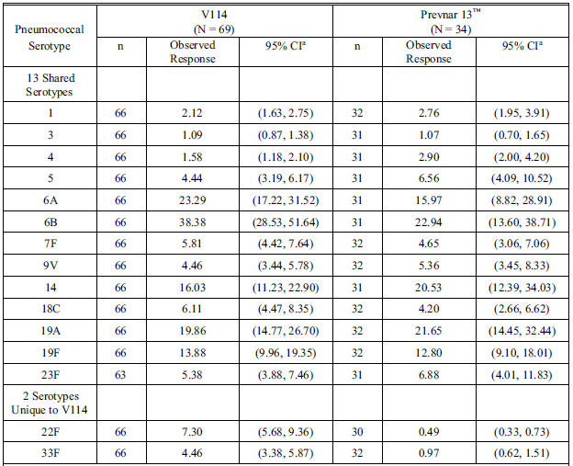

Abbreviations: CI = confidence interval; N = number of participants randomised and vaccinated; n = number of participants contributing to the analysis; V114 = sponsor’s product development code for Vaxneuvance.

a The within-group 95% CIs are obtained by exponentiating the CIs of the mean of the natural log values based on the t-distribution.

Note: Per-protocol, Day 30 is 30 days following vaccination with pneumococcal conjugate vaccine (V114 or Prevnar 13).

Secondary immunogenicity endpoints

Vaxneuvance was immunogenic in children 5 to 17 years of age with sickle cell disease as assessed by serotype specific OPA GMTs (see Table 5 below) at 30 days following vaccination for all 15 serotypes in the vaccine, including the 13 serotypes in common with 13vPCV and the 2 serotypes unique to Vaxneuvance (22F and 33F).

Serotype specific OPA GMTs were generally comparable between recipients of Vaxneuvance and 13vPCV for the 13 shared serotypes between the 2 vaccines and higher in recipients of Vaxneuvance than 13vPCV for serotypes 22F and 33F.

Vaxneuvance was immunogenic as assessed by increases in serotype specific IgG GMCs and OPA GMTs between Day 1 and Day 30 (by GMFRs) for all 15 serotypes in the vaccine, including the 13 serotypes in common with 13vPCV and the 2 serotypes unique to Vaxneuvance (22F and 33F).

Table 5: Study V114-023 Summary of opsonophagocytic activity geometric mean titres at Day 30 (per-protocol population)

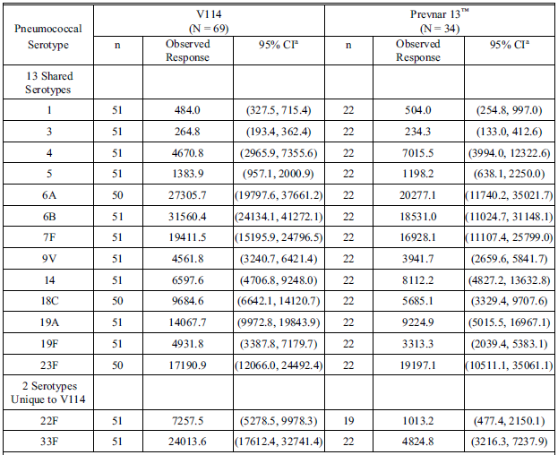

Abbreviations: CI = confidence interval; N = Number of participants randomised and vaccinated; n = number of participants contributing to the analysis; V114 = sponsor’s product development code for Vaxneuvance.

a The within-group 95% CIs are obtained by exponentiating the CIs of the mean of the natural log values based on the t-distribution.

Note: Per protocol, Day 30 is 30 days following vaccination with pneumococcal conjugate vaccine (V114 or Prevnar 13).

Safety

In both intervention groups, the most frequently reported AEs were solicited injection site and systemic events. The 5 most common AEs in each group were injection site pain, injection site swelling, headache, myalgia, and fatigue. Of the participants with solicited AEs, the majority had events with a maximum intensity of mild or moderate or a maximum size of 5.1 cm and were of short duration. The proportion of participants with SAEs was comparable in both intervention groups. No vaccine related discontinuations, SAEs, or deaths were reported.

The clinical evaluation concluded: In children with sickle cell disease, a very high risk for invasive pneumococcal disease, 5 to 17 years of age: Vaxneuvance was well tolerated, with a safety profile generally comparable to 13vPCV; Vaxneuvance induces immune responses for all 15 pneumococcal serotypes, and these Day 30 antibody levels were comparable between recipients of Vaxneuvance and 13vPCV for the 13 serotypes in common, and as expected, were higher in recipients of Vaxneuvance than 13vPCV for serotypes 22F and 33F, the 2 serotypes unique to Vaxneuvance.

This study in children with sickle cell disease was limited to older children and adolescents, aged 5 to17 years. A total of 69 children with sickle cell disease received Vaxneuvance and 34 received 13vPCV, as a single dose.

As described in the clinical study report, most children in this study would have received prior vaccination with a PCV, therefore the safety and immunogenicity data from this study provide information on catch-up vaccination in children receiving a PCV containing fewer than 15 serotypes, or who are PCV naïve.

There are no available data from this study for an infant schedule in patients with sickle cell disease with Vaxneuvance. In Australia, children in high-risk groups, including sickle cell disease, receive 4 doses of 13vPCV, from 2 months of age, and 2 doses of 23vPPV from 4 years of age.2

There was a higher proportion of vaccine related systemic AEs in the Vaxneuvance group compared to the Prevenar 13 group; see Table 6 below.

Table 6: Study V114-023 Summary of adverse events following pneumococcal conjugate vaccine (all participants as treated population)

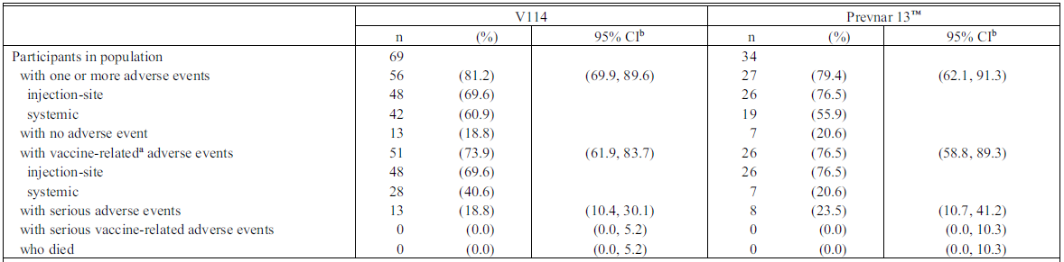

Abbreviations: CI=confidence interval; n=number of participants contributing to the analysis; V114 = sponsor’s product development code for Vaxneuvance.

a Determined by the investigator to be related to the vaccine.

b Estimated CIs are calculated based on the exact binomial method proposed by Clopper and Pearson and are provided in accordance with the statistical analysis plan.

Reported adverse events include nonserious adverse events that occurred within 14 days of vaccination and serious adverse events that occurred from Day 1 (following vaccination with pneumococcal conjugate vaccine (V114 or Prevnar 13)) through completion of study participation.

##### Study V114-024

Study V114-024 was a Phase III, randomised, double blind, active comparator controlled, parallel group multicentre study to evaluate the safety, tolerability, and immunogenicity of catch-up vaccination regimens of Vaxneuvance in healthy infants, children, and adolescents.

###### Objectives

Immunogenicity and safety objectives were evaluated by age at randomization (that is, 7 to 11 months of age, 12 to 23 months of age, and 2 to 17 years of age).

Primary objectives

Safety: To evaluate the safety and tolerability of Vaxneuvance with respect to the proportion of participants with AEs.

Immunogenicity: To evaluate the anti-PnPs serotype specific IgG GMCs at 30 days following vaccination following the last dose for each vaccination group.

Secondary objectives

Immunogenicity: To evaluate the anti-PnPs serotype specific IgG response rates (proportion of participants meeting serotype specific IgG threshold value of at least 0.35 μg/mL) at 30 days following the last dose for each vaccination group.

###### Endpoints

Primary endpoint

Safety: Following any vaccination with Vaxneuvance: Solicited injection site AEs from Day 1 to Day 14 inclusive following vaccination; Solicited systemic AEs from Day 1 to Day 14 inclusive following vaccination; Vaccine related SAEs through to completion of study participation.

Immunogenicity: Anti-PnPs serotype specific IgG responses for the 15 serotypes in Vaxneuvance at 30 days after the last dose of study vaccine.

Secondary endpoints

Anti-PnPs serotype specific IgG responses for the 15 serotypes in Vaxneuvance at 30 days after the last dose of study vaccine.

###### Participants

Participants were either pneumococcal vaccine naïve or had previously received a partial regimen of licensed PCV (7vPCV, 10vPCV, or 13vPCV), or a full regimen of 7vPCV or 10vPCV. Stratification was by age at randomisation (7 to 11 months, 12 to 23 months, from 2 to less than 6 years, and from 6 to 17 years (inclusive)). Participants from 2 years of age were further stratified based on their history of prior PCV vaccination status (yes and no). Participants less than 2 years of age were to be PCV naïve. Table 7 outlines the catch-up vaccination schedule.10

Table 7: Study V114-024 Catch-up vaccination schedule

|  |  |  |
| --- | --- | --- |
| Age at randomisation | Pneumococcal conjugate vaccine status | V114 / 13vPCV dose schedule |
| 7 to 11 months  (n=128) | Naïve | Dose 1: At randomisation  Dose 2: 4 to 8 weeks after Dose 1  Dose 3: 8 to 12 weeks after Dose 2 or after the first birthday |
| 12 to 23 months  (n=126) | Naïve | Dose 1: At randomisation  Dose 2: 4 to 8 weeks after Dose 1 |
| 2 to 17 years  (n=352) | Naïve  Partial regimen of 7vPCV (Prevnar), 10vPCV (Synflorix) or 13vPCV (Prevnar 13)  Complete regimen of 7vPCV or 10vPCV | Dose 1: At randomisationa |

Abbreviations: n = number of participants contributing to the analysis; 7vPCV = 7-valent pneumococcal conjugate vaccine; 10vPCV = 10-valent pneumococcal conjugate vaccine; 13vPCV= 13-valent pneumococcal conjugate vaccine; V114 = sponsor’s product development code for Vaxneuvance (a 15-valent pneumococcal conjugate vaccine).

a At least 8 weeks after the previous dose of pneumococcal conjugate vaccine.

###### Results

Immunogenicity (in healthy participants 7 months to 17 years of age)

Primary immunogenicity endpoint

Catch-up vaccination with Vaxneuvance elicited serotype specific immune responses, as assessed by IgG GMCs at 30 days following the last dose of study intervention, for all 15 serotypes in the vaccine.

Serotype specific IgG GMCs at 30 days following the last dose of study intervention were generally comparable between the intervention groups for the 13 shared serotypes.

Immunoglobulin G (IgG) GMCs for the 2 serotypes unique to Vaxneuvance (22F and 33F) at 30 days following the last dose of study intervention were higher in the Vaxneuvance group than in the 13vPCV group.

Secondary immunogenicity endpoints

The majority (83.9% to 100.0%) of participants in the Vaxneuvance group achieved the IgG threshold value of at least 0.35 µg/mL at 30 days following the last dose of study intervention for each of the 15 serotypes in the vaccine.

Serotype specific IgG response rates at 30 days following the last dose of study intervention were generally comparable between the intervention groups for the 13 shared serotypes.

Immunoglobulin G (IgG) response rates for the 2 serotypes unique to Vaxneuvance (22F and 33F) at 30 days following the last dose of study intervention were higher in the Vaxneuvance group than in the 13vPCV group.

Safety

The proportions of participants with AEs were generally comparable between the intervention groups for participants 7 to 11 months of age, except for solicited injection site pain (higher proportion in the Vaxneuvance group). The proportions of participants with AEs were higher in the Vaxneuvance group compared with the 13vPCV group for participants 12 to 23 months of age, mainly due to a higher proportion of participants with solicited injection site pain and irritability. The proportions of participants with AEs were generally comparable between the intervention groups for participants 2 to 17 years of age.

The clinical evaluation concluded: In healthy participants 7 months to 17 years of age, catch-up vaccination with Vaxneuvance induces serotype specific immune responses for all 15 pneumococcal serotypes, including 13 serotypes shared with 13vPCV and the 2 unique serotypes (22F and 33F) in Vaxneuvance, as assessed by IgG GMCs and IgG response rates at 30 days following the last dose of study intervention. Overall, the catch-up vaccination with Vaxneuvance was well tolerated.

The current NIP schedule for pneumococcal vaccination in infants includes 13vPCV. Results from this study for children receiving a complete course of 7vPCV or 10vPCV are of limited relevance in Australia, except for children who may have received these vaccines overseas.

In the published paper of this study,10 the following points were noted.

* A relatively lower response against serotype 6A was seen in participants 12 to 23 months of age who received 2 doses of Vaxneuvance or 13vPCV, a trend not observed in the other age cohorts, acknowledging that the sample size was small.
* Over 70% of participants 2 to 17 years of age in the Vaxneuvance group had at least a4 fold rise in IgG GMCs from Day 1 to Day 30 for all serotypes except serotype 5.
* Differences were observed in subgroup analyses of safety and immunogenicity based on prior history of PCV vaccination between the 2 age cohorts (2 to 5 years and 6 to 17 years of age). ‘While no differences were observed when comparing frequencies of injection site and systemic AEs between PCV naïve and PCV experienced children 6–17 years of age, PCV naïve children 2–5 years of age reported lower rates than PCV experienced children for these AEs.’
* Vaxneuvance induced opsonophagocytic activity to all 15 serotypes was not measured in this study, due to limited quantities of blood for measurement of all pneumococcal serotypes.

##### Study V114-025

Study V114-025 was a Phase III, randomised, double blind, active comparator controlled, parallel group, multicentre study to evaluate the safety, tolerability, and immunogenicity of a 3-dose regimen (two dose primary series followed by a toddler dose (2+1) schedule) of Vaxneuvance in healthy infants enrolled at approximately 2 months of age (from 42 to 90 days).

Vaxneuvance or Prevenar 13 was administered to full term participants at approximately 2, 4, and 11 to 15 months of age and to preterm infants at approximately 2, 3, 4, and 11 to 15 months of age. All participants were also administered concomitant paediatric vaccines (Infanrix hexa[11] and Rotarix[12]) during the study.

Participants enrolled at sites in the Russian Federation were not concomitantly vaccinated with Rotarix and no preterm participants were enrolled at sites in the Russian Federation. The study was conducted during the coronavirus disease 2019 (COVID-19) pandemic.

###### Objectives

Primary objectives

Safety: To evaluate the safety and tolerability of Vaxneuvance with respect to the proportion of participants with AEs.

Immunogenicity: To compare the anti-PnPs serotype specific IgG response rates (proportion of participants meeting serotype specific IgG threshold value of at least 0.35 μg/mL) at 30 days following the toddler dose (following Dose 3 for full term infants; following Dose 4 for preterm infants) for participants administered Vaxneuvance versus participants administered 13vPCV.

* Hypothesis (H1): Vaxneuvance is non-inferior to 13vPCV for the 13 shared serotypes between Vaxneuvance and 13vPCV based on response rates at 30 days following the toddler dose.
* Hypothesis (H2): Vaxneuvance is superior to 13vPCV for the 2 serotypes unique to Vaxneuvance based on the response rates at 30 days following the toddler dose.

To compare anti-PnPs serotype specific IgG GMCs at 30 days following the toddler dose for participants administered Vaxneuvance versus participants administered 13vPCV.

* Hypothesis (H3): Vaxneuvance is non-inferior to 13vPCV for the 13 shared serotypes between Vaxneuvance and 13vPCV based on anti-PnPs serotype specific IgG GMCs at 30 days following the toddler dose.
* Hypothesis (H4): Vaxneuvance is superior to 13vPCV for the 2 serotypes unique to Vaxneuvance based on anti-PnPs serotype specific IgG GMCs at 30 days following the toddler dose.

Secondary objectives

Immunogenicity: To compare the antigen specific response rate to each antigen included in Infanrix hexa at 30 days following the toddler dose for participants administered Vaxneuvance concomitantly with Infanrix hexa versus participants administered 13vPCV concomitantly with Infanrix hexa.

* Hypothesis (H5): Infanrix hexa administered concomitantly with Vaxneuvance is non inferior to Infanrix hexa administered concomitantly with 13vPCV at 30 days following the toddler dose for each antigen included in Infanrix hexa.

To compare anti-rotavirus immunoglobulin A (IgA) GMTs at 30 days after the completion of the primary series (following Dose 2 for full term infants; following Dose 3 for preterm infants) for participants administered Vaxneuvance concomitantly with Rotarix versus participants administered 13vPCV concomitantly with Rotarix.

* Hypothesis (H6): Rotarix administered concomitantly with Vaxneuvance is non-inferior to Rotarix administered concomitantly with 13vPCV based on GMTs at 30 days after the completion of the primary series.

To evaluate the anti-PnPs serotype specific IgG response rates and GMCs at 30 days after the completion of the primary series by each vaccination group.

Opsonophagocytic activity subset: To evaluate the anti-PnPs serotype specific OPA GMTs and response rate at 30 days following the toddler dose by each vaccination group.

To evaluate the anti-PnPs serotype specific IgG response rates to the 2 unique serotypes in Vaxneuvance compared with the lowest IgG response rate in any of 13 shared serotypes in 13vPCV at 30 days following the toddler dose.

Exploratory objectives

Immunogenicity: To evaluate the anti-PnPs serotype specific IgG GMCs immediately prior to the toddler group by each vaccination group; To evaluate the antigen-specific response rate to each antigen included in Infanrix hexa at 30 days after the completion of the primary series for participants administered Vaxneuvance concomitantly with Infanrix hexa versus participants administered 13vPCV with Infanrix hexa.

Opsonophagocytic activity subset: to evaluate the anti-PnPs serotype specific OPA GMTs and response rate 30 days after the completion of the primary series and immediately prior to the toddler dose by each vaccination group.

###### Endpoints

Primary endpoints

Safety: Following any vaccination with Vaxneuvance: Solicited injection site AEs from Day 1 to Day 14 following vaccination; solicited systemic AEs from Day 1 to Day 14 following vaccination; vaccine related SAEs through to completion of study participation.

Immunogenicity: Anti-PnPs serotype specific IgG responses for the 15 serotypes in Vaxneuvance at 30 days following the toddler dose.

Secondary endpoints

* Antibody responses to diphtheria toxoid; tetanus toxoid; pertussis toxin; pertussis filamentous hemagglutinin; pertussis pertactin; *Haemophilus influenzae* type b polyribosylribitol phosphate; hepatitis B surface antigen; poliovirus serotypes 1, 2, and 3, at 30 days following the toddler dose of Vaxneuvance or 13vPCV.
* Anti-rotavirus IgA response at 30 days post primary series of Vaxneuvance or 13vPCV
* Anti-PnP serotype specific IgG responses for the 15 serotypes in Vaxneuvance at 30 days post primary series.
* Anti-PnPs serotype specific OPA responses for the 15 serotypes in Vaxneuvance at 30 days following the toddler dose.
* Anti-PnPs serotype specific IgG responses for the 2 unique serotypes in Vaxneuvance at 30 days following the toddler dose.

Exploratory endpoints

* Anti-PnP serotype specific IgG responses for the 15 serotypes in Vaxneuvance immediately prior to the toddler dose (pre-toddler dose).
* Antibody responses to diphtheria toxoid; tetanus toxoid; pertussis toxin; pertussis filamentous hemagglutinin; pertussis pertactin; *Haemophilus influenzae* type b polyribosylribitol phosphate; hepatitis B surface antigen; poliovirus serotypes 1, 2, and 3, at 30 days post primary series of Vaxneuvance or 13vPCV.
* Opsonophagocytic activity subset. Anti-PnPs serotype specific OPA responses for the 15 serotypes in Vaxneuvance at 30 days post primary series and pre-toddler dose.

###### Participants

Intervention allocation or randomisation occurred centrally using an interactive response technology system. There were 2 study intervention arms. Participants were assigned randomly in a 1:1 ratio to Vaxneuvance study intervention or 13vPCV and stratified by gestational age, except in Russia. A double blinding technique was used.

Among 591 participants randomised to the Vaxneuvance group, 588 (99.5%) were vaccinated with at least one dose of Vaxneuvance; 569 (96.3%) completed the study; and 22 (3.7%) discontinued the study.

Among 593 participants randomised to the 13vPCV group, 591 (99.7%) were vaccinated with at least one dose of 13vPCV; 570 (96.1%) completed the study; and 23 (3.9%) discontinued the study.

Demographic and baseline characteristics were generally comparable between intervention groups. The median age of participants at the time of consent was 8.0 weeks (range: 6 to 12 weeks). Approximately 6% of participants were preterm infants (less than 37 weeks gestational age at birth).

###### Results

Serotype specific IgG response rates and GMCs at 30 days following the toddler dose for all 15 serotypes in participants by gestational age (less than 37 weeks, and 37 weeks and older) were consistent with the results observed in the overall population.

Primary and secondary immunogenicity outcomes

Vaxneuvance met non-inferiority criteria for the 13 shared serotypes, as assessed by the proportions of participants meeting the threshold value of at least 0.35 µg/mL (response rate) and serotype specific IgG GMCs at 30 days following the toddler dose.

Vaxneuvance met superiority criteria for the 2 serotypes (22F and 33F) unique to Vaxneuvance, as assessed by response rate and serotype specific IgG GMCs at 30 days following the toddler dose; see Table 8 and Table 9.

Table 8: Study V114-025 Proportions of participants with immunoglobulin G at least 0.35 µg/mL at 30 days following the toddler dose (per protocol population)

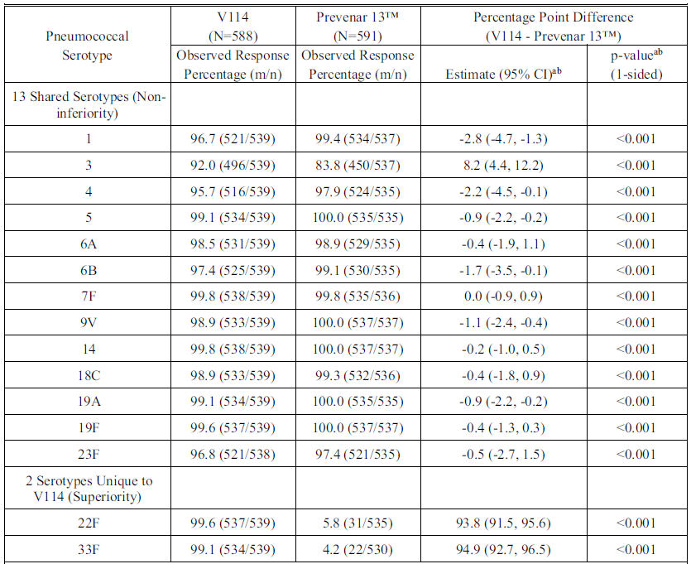

Abbreviations: CI = confidence interval; m = number of participants with the indicated response; N = number of participants randomised and vaccinated; n = number of participants contributing to the analysis; V114 = sponsor’s product development code for Vaxneuvance.

a Estimated difference, CI, and p-value are based on the Miettinen and Nurminen method.

b For the 13 shared serotypes, a conclusion of non-inferiority of V114 to Prevenar 13 is based on the lower bound of the 95% CI for the difference in percentages (V114/Prevenar 13) being more than 10 percentage points (one-sided p-value less than 0.025). For the 2 serotypes unique to V114, a conclusion of superiority of V114 to Prevenar 13 is based on the lower bound of the 95% CI for the difference in percentages (V114/Prevenar 13) being more than 10 percentage points (one-sided p-value less than 0.025).

Note: Per protocol, the toddler dose was administered at approximately 11 to 15 months of age.

Table 9: Study V114-025 Analysis of immunoglobulin G geometric mean concentration at 30 Days following the toddler dose (per-protocol population)

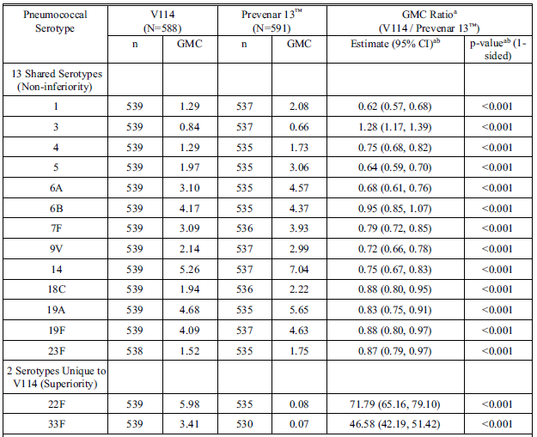

Abbreviations; CI = confidence interval; GMC = geometric mean concentration (µg/mL); IgG = immunoglobulin G; N = number of participants randomised and vaccinated; n = number of participants contributing to the analysis; V114 = sponsor’s product development code for Vaxneuvance.

a Geometric mean concentration (GMC) ratio, CI, and p-value are calculated using the t-distribution with the variance estimate from a serotype specific linear model utilising the natural log transformed antibody concentrations as the response and a single term for vaccination group.

b For the 13 shared serotypes, a conclusion of non-inferiority of V114 to Prevenar 13 is based on the lower bound of the 2-sided 95% CI for the GMC ratio (V114/Prevenar 13) being more than 0.5 (one-sided p‑value less than 0.025). For the 2 serotypes unique to V114, a conclusion of superiority of V114 to Prevenar 13 is based on the lower bound of the 2-sided 95% CI for the GMC ratio (V114/Prevenar 13) being more than 2.0 (one‑sided p-value less than 0.025).

Note: Per protocol, the toddler dose was administered at approximately 11 to 15 months of age.

Secondary immunogenicity endpoints

Immune responses to Infanrix hexa administered concomitantly with Vaxneuvance met non-inferiority criteria, as assessed by the proportions of participants meeting antigen specific response rate to each antigen in Infanrix hexa at 30 days following the toddler dose.

Immune response to Rotarix administered concomitantly with Vaxneuvance met non‑inferiority criteria, as assessed by anti-rotavirus IgA GMTs at 30 days post primary series.

Serotype specific IgG response rates and IgG GMCs were comparable for most of the 13 shared serotypes between the intervention groups and were higher for the 2 unique serotypes (22F and 33F) in Vaxneuvance recipients compared with 13vPCV recipients at 30 days post primary series.

Serotype specific OPA response rates and OPA GMTs were generally comparable for the 13 shared serotypes between the intervention groups and were higher for the unique serotype 22F and 33F in Vaxneuvance recipients compared with 13vPCV recipients at 30 days following the toddler dose.

Safety

The proportions with AEs, including injection site, systemic, and vaccine related AEs, and SAEs, were comparable between the intervention groups. The most frequently reported AEs following vaccination with Vaxneuvance were irritability, somnolence, and injection site erythema. Solicited AEs following any dose of study intervention were comparable between intervention groups (see Table 10 below).

Statistically significantly higher proportions of participants in the Vaxneuvance group compared with the 13vPCV group were observed with solicited AEs of injection site pain and irritability following any dose of study intervention.

Table 10: Study V114-025 Participants with adverse events by descending frequency in the Vaxneuvance group (incidence at least 5% in one or more vaccination groups) (all participants as treated population; following any dose)

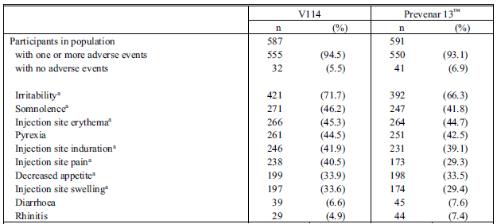

Abbreviations; CI=confidence interval; V114 = sponsor’s product development code for Vaxneuvance.

Every participant is counted a single time for each applicable row and column.

A specific adverse event appears on this report only if its incidence in one or more of the columns meets the incidence criterion in the report title, after rounding.

Reported adverse events include nonserious adverse events that occurred within 14 days of any vaccination and serious adverse events that occurred after Dose 1 (approximately 2 months of age) through completion of study participation.

a Injection site erythema, injection site induration, injection site pain, injection site swelling, decreased appetite, irritability, somnolence, and urticaria were solicited from Day 1 through Day 14 following each vaccination.

Medical Dictionary for Regulatory Activities (MedDRA) version 24.0 was used in the reporting of this study.

The proportions of participants with SAEs were generally comparable between both intervention groups. No vaccine related SAEs were reported in Vaxneuvance recipients.

Similar results were observed for the subset of preterm participants, who accounted for approximately 6% of the overall infant population. In this group of preterm participants, 32 were in the Vaxneuvance group and 36 were in the Prevenar 13 group.

The clinical evaluator commented that the results of this study are relevant to the NIP routine 2+1 schedule for children less than 5 years of age, which includes 3 doses of 13vPCV at 2,4 and 12 months respectively.

Some information is provided for a three dose primary series followed by a toddler dose (3+1) schedule in premature infants, although the sample size was small for this subset.

The concomitant administration results for Infanrix hexa and Rotarix are relevant, given they are also given at 2 and 4 months of age.

As noted by the clinical evaluation, immunogenicity results for many of the shared individual serotypes in Vaxneuvance were not markedly better than 13vPCV, although the study was not powered to detect this.

##### Study V114-027

Study V114-027 was a Phase III, randomised, double blind, active comparator controlled, parallel group, multicentre study to evaluate the interchangeability of Vaxneuvance and Prevenar 13 with respect to safety, tolerability, and immunogenicity in healthy infants approximately 2 months of age.

###### Objectives

Primary Objectives

Safety: To evaluate the safety and tolerability of complete Vaxneuvance (Group 5) and mixed 13vPCV / Vaxneuvance dosing schedules (Groups 2, 3, and 4) compared with a complete dosing schedule of 13vPCV (Group 1) with respect to the proportion of participants with AEs.

Immunogenicity: To evaluate the anti-PnPs serotype-specific IgG GMCs at 30 days following Dose 4 for participants administered mixed dosing schedules of 13vPCV / Vaxneuvance (Groups 2, 3, and 4) compared with participants administered a complete dosing schedule of 13vPCV (Group 1).

Secondary Objectives

Immunogenicity: To compare the proportion of participants with an anti-HBsAg concentration of at least 10 mIU/mL at 30 days following Dose 3 for participants administered a complete primary infant series dosing schedule of Vaxneuvance (Group 5) concomitantly with Recombivax HB versus participants administered a complete primary infant series dosing schedule of 13vPCV (Groups 1 and 2) concomitantly with Recombivax HB; To compare the anti-rotavirus IgA GMT at 30 days following Dose 3 for participants administered a complete primary infant series dosing schedule of Vaxneuvance (Group 5) concomitantly with RotaTeq versus participants administered a complete primary infant series dosing schedule of 13vPCV (Groups 1 and 2) concomitantly with RotaTeq; To evaluate the anti-PnPs serotype-specific IgG GMCs and the anti-PnPs serotype-specific IgG response rates (proportion of participants meeting serotype-specific IgG threshold value of at least 0.35 μg/mL) at 30 days following Dose 3 separately for each vaccination group (Groups 1, 2, 3, 4 and 5); To evaluate the anti-PnPs serotype-specific IgG GMCs at 30 days following Dose 4 for participants administered a complete dosing schedule of Vaxneuvance (Group 5) compared with participants administered a complete dosing schedule of 13vPCV (Group 1).

###### Endpoints

Primary endpoint safety

Following any vaccination with Vaxneuvance or 13vPCV: Solicited injection-site AEs from Day 1 through Day 14 postvaccination; Solicited systemic AEs from Day 1 through Day 14 postvaccination; Vaccine-related SAE through completion of study participation.

Primary endpoint Immunogenicity

Anti-PnPs serotype-specific IgG responses for the 13 shared serotypes in Vaxneuvance and 13vPCV at 30 days following Dose 4.

Secondary endpoints

Anti-HBsAg response at 30 days following Dose 3 of Vaxneuvance or 13vPCV; Anti-rotavirus IgA response at 30 days following Dose 3 of Vaxneuvance or 13vPCV; Anti-PnPs serotype-specific IgG responses for the 15 serotypes in Vaxneuvance at 30 days following Dose 3; Anti-PnPs serotype-specific IgG responses for the 13 shared serotypes in Vaxneuvance and 13vPCV at 30 days following Dose 4.

###### Participants

In 2 intervention groups, infants received a 4-dose series of either Prevnar 13 (Group 1) or Vaxneuvance (Group 5). In 3 other intervention groups, the immunisation series was initiated with Prevenar 13 and changed to Vaxneuvance at Dose 2, 3 or 4 (Groups 4, 3, and 2, respectively). See Table 11 for detailed Vaxneuvance and Prevenar 13 dosing schedule.

Infants also received other licensed paediatric vaccines administered concomitantly with the PCV, including Recombivax HB[13] and RotaTeq.[14]

Eligible participants were randomly assigned in a 1:1:1:1:1 ratio to 1 of 5 intervention groups. Part of this study was conducted during the COVID-19 pandemic.

Table 11: Study V114-027 Vaxneuvance and Prevenar 13 dosing schedule

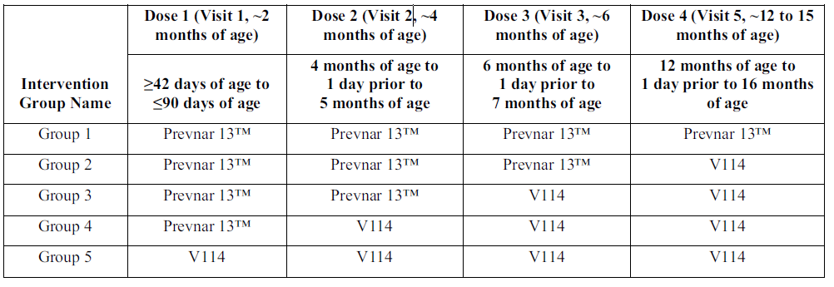

Abbreviation: V114 = sponsor’s product development code for Vaxneuvance.

###### Results

Primary immunogenicity endpoint

Serotype specific IgG GMCs at 30 days following Dose 4 for the 13 shared serotypes were generally comparable for participants administered mixed regimens and for participants administered a complete dosing regimen of 13vPCV as assessed by IgG GMC ratios.

Secondary immunogenicity endpoints

* Responses to Recombivax HB administered concomitantly with Vaxneuvance met non‑inferiority criteria as assessed by proportions of participants with Hepatitis B surface antibodies (HepBSAb) at least 10 milli-international units (mIU)/mL at 30 days following Dose 3.
* Responses to RotaTeq administered concomitantly with Vaxneuvance met non‑inferiority criteria as assessed by anti-rotavirus IgA GMTs at 30 days following Dose 3.
* Serotype specific immune responses at 30 days following Dose 3 for the 13 shared serotypes were generally comparable across intervention groups as assessed by the proportions of participants meeting the IgG threshold value of at least 0.35 µg/mL (response rates) and IgG GMCs.
* Serotype-specific immune responses at 30 days following Dose 3 for serotype 22F were higher after one dose of Vaxneuvance in the infant series (Group 3); similar responses were observed in Groups 4 and 5, which received additional Vaxneuvance doses in the infant series as assessed by response rates and IgG GMCs.
* Serotype-specific immune responses at 30 days following Dose 3 for serotype 33F were higher after one dose of Vaxneuvance in the infant series (Group 3) and increased incrementally with additional Vaxneuvance primary series doses administered (Groups 4 and 5) as assessed by response rates and IgG GMCs.
* Serotype-specific IgG GMCs at 30 days following Dose 4 for the 13 shared serotypes were generally comparable for participants administered a complete 4-dose regimen of Vaxneuvance and for participants administered a complete 4-dose regimen of 13vPCV as assessed by serotype-specific IgG GMC ratios.

Safety

Complete Vaxneuvance and mixed Prevenar 13 and Vaxneuvance dosing regimens are generally well tolerated with safety profiles generally comparable to a complete dosing regimen of Prevenar 13.

The Delegate noted that the statistical analysis by the FDA reached similar conclusions.[15]

##### Study V114-029

Study V114-029 was a Phase III, randomised, double blind, active comparator controlled, parallel group, multicentre study to evaluate the safety, tolerability, and immunogenicity of a 4-dose regimen (3+1 schedule) of Vaxneuvance in healthy infants enrolled at approximately 2 months of age (from 42 to 90 days (inclusive)).

Vaxneuvance or Prevnar 13 was administered at approximately 2, 4, 6, and 12 to 15 months of age. Participants also received the following paediatric vaccines: RotaTeq,14 Pentacel,[16] Recombivax HB,13 Vaqta,[17] M‑M‑R II,[18] Varivax,[19] and Hiberix.[20]

There were 2 pentavalent vaccines administered in Study V114-029, Pentacel and Pentavac.16

Part of this study was conducted during the COVID-19 pandemic.

###### Objectives

Primary objectives

Safety: To evaluate the safety and tolerability of Vaxneuvance with respect to the proportion of participants with AEs.

Immunogenicity: To compare the anti-PnPs serotype specific IgG response rates (proportion of participants meeting serotype specific IgG threshold value of at least 0.35 μg/mL) at 30 days following Dose 3 for participants administered Vaxneuvance versus participants administered 13vPCV; To compare anti-PnPs serotype specific IgG GMCs at 30 days following Dose 3 and at 30 days following Dose 4 for participants administered Vaxneuvance versus participants administered 13vPCV.

Secondary objectives

Immunogenicity: To compare the antigen specific response rate to each antigen included in Pentacel at 30 days following Dose 3 for participants administered Vaxneuvance concomitantly with Pentacel versus participants administered 13vPCV concomitantly with Pentacel; To compare the response rate to anti-hepatitis A antigen at 30 days following Dose 4 for participants administered Vaxneuvance concomitantly with Vaqta versus participants administered 13vPCV concomitantly with Vaqta; To compare the response rate to each antigen included in M‑M‑R II at 30 days following Dose 4 for participants administered Vaxneuvance concomitantly with M‑M‑R II versus participants administered 13vPCV concomitantly with M‑M‑R II; To compare the response rate to anti-varicella antigen at 30 days following Dose 4 for participants administered Vaxneuvance concomitantly with Varivax versus participants administered 13vPCV concomitantly with Varivax; To compare the response rate to anti-PRP antigen at 30 days following Dose 4 for participants administered Vaxneuvance concomitantly with Hiberix versus participants administered 13vPCV concomitantly with Hiberix; To evaluate the anti-PnPs serotype-specific opsonophagocytic activity (OPA) GMTs and response rates at 30 days following Dose 3 by each vaccination group included in the OPA subset.

###### Endpoints

Primary endpoints

Safety: Following any vaccination with Vaxneuvance: Solicited injection site AEs from Day 1 to Day 14 following vaccination; solicited systemic AEs from Day 1 to Day 14 following vaccination; vaccine related SAEs through to completion of study participation.

Immunogenicity: Anti-PnPs serotype specific IgG responses for the 15 serotypes in Vaxneuvance at 30 days following Dose 3 and 30 days following Dose 4.

Secondary endpoints

* Antibody responses to diphtheria toxoid; tetanus toxoid; pertussis toxin; pertussis filamentous hemagglutinin; pertussis fimbrae types 2/3; pertussis pertactin; poliovirus serotypes 1, 2, and 3; *Haemophilus influenzae* type b polyribosylribitol phosphate, at 30 days following Dose 3 of Vaxneuvance or 13vPCV
* Antibody responses to hepatitis A antigen at 30 days following Dose 4 of Vaxneuvance or 13vPCV
* Antibody responses to measles, mumps, and rubella virus at 30 days following Dose 4 of Vaxneuvance or 13vPCV
* Antibody responses to varicella-zoster virus at 30 days following Dose 4 of Vaxneuvance or 13vPCV
* Antibody responses to PRP at 30 days following Dose 4 of Vaxneuvance or 13vPCV
* Anti-PnPs serotype-specific OPA responses for the 15 serotypes contained in Vaxneuvance at 30 days following Dose 3.

###### Participants

In the Vaxneuvance group, 860 participants were randomised, 858 (99.8%) were vaccinated with at least one dose of Vaxneuvance, and 758 (88.1%) completed the study; 102 (11.9%) discontinued from the study.

In the 13vPCV group, 860 participants were randomised, 856 (99.5%) were vaccinated with at least one dose of 13vPCV, and 734 (85.3%) completed the study; 126 (14.7%) discontinued from the study.

Demographic and baseline characteristics were generally comparable between intervention groups. Median age of participants at the time of consent was 8 weeks (range: 6 to 12 weeks). Approximately 9% of participants were preterm infants (gestational age less than 37 weeks).

###### Results

Primary immunogenicity endpoints

Following the 3-dose infant series

* Vaxneuvance met non‑inferiority criteria for the 13 shared serotypes, as assessed by the proportions of participants meeting the IgG threshold value of at least 0.35 µg/mL (response rate (see Table 12 below).
* Vaxneuvance met non‑inferiority criteria for the 2 unique Vaxneuvance serotypes, as assessed by the response rate for serotypes 22F and 33F compared with the response rate for serotype 23F (lowest response rate of the shared serotypes in 13vPCV, excluding serotype 3).
* Vaxneuvance met non‑inferiority criteria for 12 of the 13 shared serotypes (narrowly missing non‑inferiority for serotype 6A), as assessed by serotype specific IgG GMCs (see Table 13 below).
* Vaxneuvance met non‑inferiority criteria for the 2 unique Vaxneuvance serotypes, as assessed by IgG GMCs for serotypes 22F and 33F compared with IgG GMC for serotype 4 (lowest IgG GMC of the shared serotypes in 13vPCV, excluding serotype 3).

Following the toddler dose

* Vaxneuvance met non‑inferiority criteria for the 13 shared serotypes, as assessed by serotype specific IgG GMCs; Vaxneuvance met non‑inferiority criteria for the 2 unique Vaxneuvance serotypes, as assessed by IgG GMCs for serotype 22F and 33F compared with IgG GMC for serotype 4 (lowest IgG GMC of the shared serotypes in 13vPCV, excluding serotype 3).

Table 12: Study V114-029 Analysis of the proportions of participants with immunoglobulin G at least 0.35 µg/mL for the 13 shared serotypes at 30 Days following Dose 3 (per-protocol population)

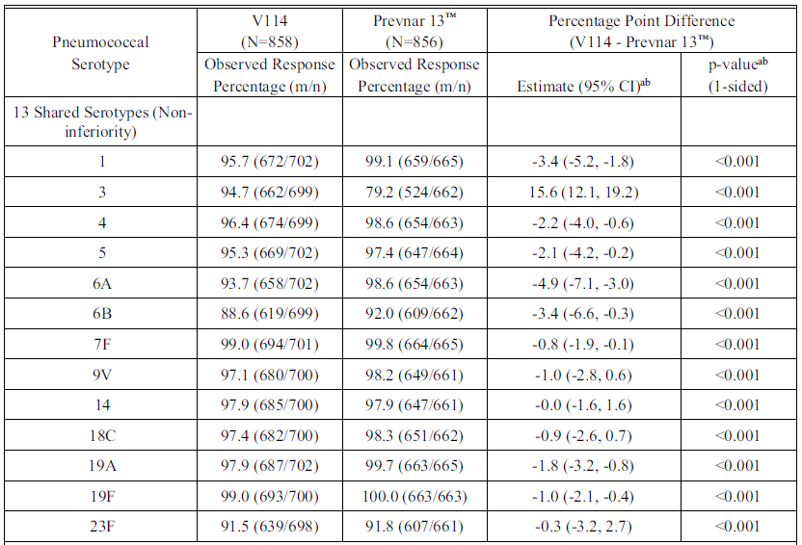

Abbreviations: CI = confidence interval; m = number of participants with the indicated response; N = Number of participants randomised and vaccinated; n = number of participants contributing to the analysis; V114 = sponsor’s product development code for Vaxneuvance.

a Estimated difference, CI, and p-value are based on the Miettinen and Nurminen method.

b A conclusion of non-inferiority of V114 to Prevnar 13 is based on the lower bound of the 2-sided 95% CI for the difference in percentages (V114/Prevnar 13) being more than10 percentage points (one-sided p-value less than 0.025).

Note: Per protocol, Dose 3 was administered at approximately 6 months of age.

Table 13: Study V114-029 Analysis of immunoglobulin G geometric mean concentration for the 13 shared serotypes at 30 Days following Dose 3 (per-protocol population)

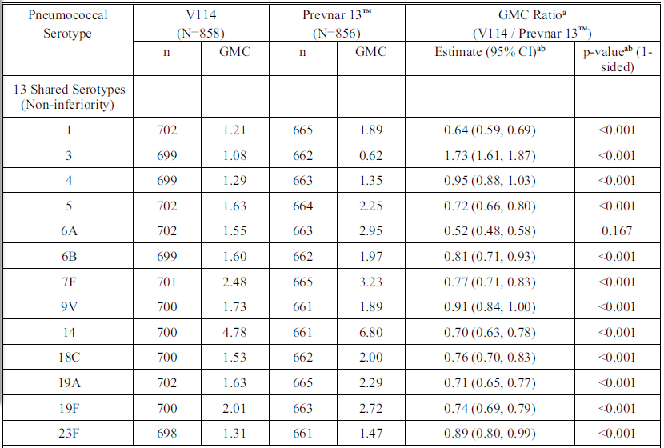

Abbreviations: CI = confidence interval; GMC = geometric mean concentration (µg/mL); N = number of participants randomised and vaccinated; n = number of participants contributing to the analysis. V114 = sponsor’s product development code for Vaxneuvance

a Geometric mean concentration (GMC) ratio, CI, and p-value are calculated using the t-distribution with the variance estimate from a serotype-specific linear model utilising the natural log transformed antibody concentrations as the response and a single term for vaccination group.

b A conclusion of non-inferiority of V114 to Prevnar 13 is based on the lower bound of the 2-sided 95% CI for the GMC ratio (V114/Prevnar 13) being more than 0.5 (one-sided p-value less than 0.025).

Note: Per protocol, Dose 3 was administered at approximately 6 months of age.

Secondary immunogenicity endpoints

Responses to vaccines administered concomitantly with V114

* Pentacel met non‑inferiority criteria for antibody responses to each antigen in Pentacel, as assessed by the proportions of participants meeting specified antibody responses to antigens included in Pentacel and the antigen specific GMCs of pertussis antigens in Pentacel at 30 days following Dose 3.
* Vaqta met non‑inferiority criteria for antibody responses to Hepatitis A antigen, as assessed by the proportions of participants with antibody concentration at least 10 mIU/mL to anti-hepatitis A antigen at 30 days following Dose 4.
* M‑M‑R II vaccine met non‑inferiority criteria for antibody responses to each antigen in M‑M‑R II, as assessed by the proportions of participants meeting specified antibody responses to M‑M‑R II antigens at 30 days following Dose 4.
* Varivax met non‑inferiority criteria for antibody responses to varicella zoster virus, as assessed by the proportions of participants with antibody concentration at least 5 glycoprotein enzyme-linked immunosorbent assay (ELISA) units/mL to anti-varicella antigen at 30 days following Dose 4.
* Hiberix met non‑inferiority criteria for antibody responses to polyribosylribitol phosphate capsular polysaccharide of *Haemophilus influenzae* type b, as assessed by the proportions of participants with antibody concentration at least 0.15 µg/mL at 30 days following Dose 4.

Following the 3-dose infant series

* Vaxneuvance met superiority criteria for the 2 unique Vaxneuvance serotypes, as assessed by serotype specific response rates and IgG GMCs.
* Vaxneuvance met superiority criteria for serotype 3 as assessed by serotype specific response rates and IgG GMCs.
* Vaxneuvance elicited functional antibodies (OPA) generally comparable to 13vPCV for the 13 shared serotypes, and higher than 13vPCV for the 2 unique serotypes, as assessed by serotype specific OPA responses.

Following the toddler dose

* Vaxneuvance met superiority criteria for the 2 unique Vaxneuvance serotypes, as assessed by serotype specific IgG GMCs; Vaxneuvance met superiority criteria for serotype 3, as assessed by serotype specific IgG GMCs.

Safety

Vaccine related AEs and SAEs were generally comparable between intervention groups. The 3 most commonly reported AEs following any dose of study intervention were irritability, somnolence, and injection site pain.

Table 14: Study V114-029 Adverse event summary (all participants as treated population; following any dose)

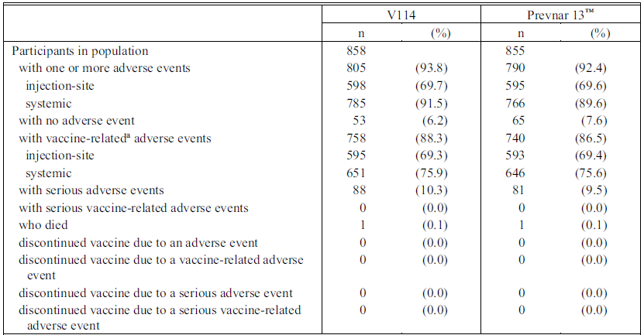

Abbreviation: V114 = sponsor’s product development code for Vaxneuvance.

a Determined by the investigator to be related to the vaccine.

Reported adverse events include nonserious adverse events that occurred within 14 days of any vaccination and serious adverse events that occurred from approximately 2 months of age (following Dose 1) through completion of study participation.

The clinical evaluation concluded: In healthy infants and toddlers, Vaxneuvance is well tolerated with a safety profile generally comparable to 13vPCV. Vaxneuvance elicits serotype specific immune responses (IgG and OPA) to all 15 serotypes in the vaccine in healthy infants and toddlers. Vaxneuvance is noninferior to 13vPCV for 14 of the 15 serotypes (narrowly missed non‑inferiority margin for serotype 6A) after the 3-dose infant series, as assessed by serotype specific IgG GMCs. Vaxneuvance is noninferior to 13vPCV for all 15 serotypes after the toddler dose, as assessed by serotype specific IgG GMCs. Vaxneuvance is superior to 13vPCV for serotypes 3, 22F, and 33F. Vaxneuvance induces functional antibodies (OPA) capable of bactericidal killing of *S. pneumoniae* after the 3-dose infant series and after the toddler dose.

For infants and children less than 2 years of age, Vaxneuvance can be given concomitantly with any of the following vaccine antigens, either as monovalent or combination vaccines: diphtheria, tetanus, pertussis, poliomyelitis (serotypes 1, 2 and 3), hepatitis A, hepatitis B, *Haemophilus influenzae* type b, measles, mumps, rubella, varicella and rotavirus vaccines.

The superior response in recipients of Vaxneuvance to serotype 3 might be of clinical significance in so much as despite the widespread use of 13vPCV, serotype 3 remains one of the most frequent causes of invasive pneumococcal disease in children less than 5 years old.

The results of this study are more relevant overseas, including the US, where the routine schedule includes 4 doses of pneumococcal vaccination in infants. Many of the concomitant vaccines studied are not part of the NIP schedule, although the results for concomitant administration with the M‑M‑R II vaccine are relevant, given it is given at 12 months of age with the pneumococcal vaccine. The FDA statistical reviewhighlighted that the responses to the mumps antigen ‘slightly missed the prespecified non‑inferiority margin of -5% (the lower bound of the 2-sided 95% CI for the difference in response rates was -5.4%)’.15

Concomitant administration of Vaxneuvance with meningococcal ACWY and meningococcal B vaccines has not been studied.

In Australia, the 3+1 schedule is recommended for Aboriginal and Torres Strait Islander children and children with a risk condition for pneumococcal disease. This study did not include children with a risk condition for pneumococcal disease, except for premature infants.

##### Study V114-030

Study V114-030 was a Phase III, randomised, double blind, active comparator controlled, multicentre study to evaluate the safety, tolerability, and immunogenicity of Vaxneuvance in children 6 to 17 years of age (inclusive) living with HIV (CD4+ T-cell count of at least 200 cells/μL and a plasma HIV ribonucleic acid (RNA) value less than 50,000 copies/mL tested at screening) followed by 23vPPV 8 weeks later.

###### Eligibility criteria

Children aged 6 to 17 years (inclusive) living with HIV (CD4+ T-cell count of at least 200 cells/μL and a plasma HIV RNA value less than 50,000 copies/mL tested at screening) without a prior history of invasive pneumococcal disease and were:

* Pneumococcal polysaccharide vaccine naïve, previously vaccinated with a less than 13-valent PCV, partially vaccinated with Prevenar 13, or had a history of previous Prevenar 13 vaccination 3 years or longer before Day 1; and
* Pneumococcal polysaccharide vaccine naïve or had a history of one previous pneumococcal polysaccharide vaccine vaccination 5 years or longer before Day 1.

###### Objectives

Primary objectives

Safety: To evaluate the safety and tolerability of Vaxneuvance with respect to the proportion of participants with AEs.

Immunogenicity: To evaluate the anti-PnPs serotype specific IgG GMCs at 30 days following vaccination (Day 30) with Vaxneuvance or Prevnar 13 by each vaccination group.

Secondary objectives

Safety: To evaluate the safety and tolerability of Pneumovax 23 administered 8 weeks following Vaxneuvance with respect to the proportion of participants with AEs.

Immunogenicity: To evaluate the anti-PnPs serotype specific OPA geometric mean titres at 30 days following vaccination (Day 30) with Vaxneuvance or Prevnar 13 by each vaccination group; to evaluate the anti-PnPs serotype specific OPA GMTs and IgG GMCs at 30 days following vaccination with Pneumovax 23 (Week 12) by each vaccination group.

###### Endpoints

Primary endpoint safety following vaccination with Vaxneuvance: Solicited injection-site AEs from Day 1 through Day 14 post-vaccination; Solicited systemic AEs from Day 1 through Day 14 post-vaccination; vaccine-related SAEs through completion of study participation.

Primary endpoint Immunogenicity: Anti-PnPs serotype-specific IgG responses for the 15 serotypes in Vaxneuvance at Day 30.

Secondary endpoint Safety: Following vaccination with 23vPPV: Solicited injection-site AEs from Day 1 through Day 14 postvaccination; Solicited systemic AEs from Day 1 through Day 14 postvaccination.

Secondary endpoints: Immunogenicity. Anti-PnPs serotype-specific OPA responses for the 15 serotypes in Vaxneuvance at Day 30; Anti-PnPs serotype-specific OPA and IgG responses for the 15 serotypes in Vaxneuvance at Week 12.

###### Results

In the Vaxneuvance group, 203 participants were randomised and vaccinated with Vaxneuvance and 23vPPV. All participants completed the study.

In the 13vPCV group, 204 participants were randomised and vaccinated with 13vPCV, 202 (99.0%) were vaccinated with 23vPPV, and 201 (98.5%) completed the study.

Demographic characteristics were generally comparable in both intervention groups. Median age of participants was 13 years (range: 6 to 17 years). The majority of participants (91.6%) had CD4+ T-cells of at least 500 cells/μL at screening. The proportions of participants in both CD4+ T-cell count categories were generally comparable in both intervention groups. The majority of participants (92.6%) in both groups were PCV naïve, and all but one participant was 23vPPV naïve.

Primary immunogenicity endpoints

Vaxneuvance was immunogenic for all 15 serotypes in the vaccine in children 6 to 17 years of age living with HIV, as assessed by serotype specific IgG GMCs at 30 days following vaccination.

Serotype specific IgG GMCs were generally comparable for the 13 shared serotypes and higher for the 2 serotypes unique to Vaxneuvance (22F and 33F) for participants in the Vaxneuvance group compared with the 13vPCV group at 30 days following vaccination.

Secondary immunogenicity endpoints

Vaxneuvance was immunogenic for all 15 serotypes in the vaccine in children 6 to 17 years of age living with HIV, as assessed by serotype specific OPA GMTs at 30 days following vaccination.

Serotype-specific OPA GMTs were generally comparable for the 13 shared serotypes and higher for the 2 serotypes unique to Vaxneuvance (22F and 33F) for participants in the Vaxneuvance group versus Prevnar 13 group at 30 days following vaccination.

In the Vaxneuvance group, Pneumovax 23 was immunogenic for all 15 serotypes in Vaxneuvance, as assessed by IgG GMCs and OPA GMTs at 30 days postvaccination with Pneumovax 23 (Week 12).

Serotype-specific IgG GMCs and OPA GMTs at 30 days postvaccination with Pneumovax 23 (Week 12) were generally comparable in both intervention groups for the 15 serotypes in Vaxneuvance.

Vaccination with Pneumovax 23 elicited an immune response as assessed by IgG GMCs and OPA GMTs at 30 days postvaccination with Pneumovax 23 (Week 12) for serotypes 22F and 33F in the Prevnar 13 group.

Safety

Following vaccination with PCV

* Proportions of participants with one or more AEs were generally comparable in both intervention groups. Vaccine related injection site and systemic AEs were reported for a higher proportion of participants in the Vaxneuvance group following vaccination with PCV. AEs were reported for the majority (more than 69%) of participants in both intervention groups. In both intervention groups, the most frequently reported AEs were injection site pain, myalgia, and injection site swelling.

Following vaccination with 23vPPV

* Proportions of participants with AEs, including injection site, systemic, and vaccine related AEs, and SAEs were generally comparable in both intervention groups following vaccination with 23vPPV (see Table 15 below). In both intervention groups, the most frequently reported AEs were injection site pain, injection site swelling, and myalgia.

Table 15: Study V114-030 Summary of adverse events following Pneumovax 23 (all participants as treated population)

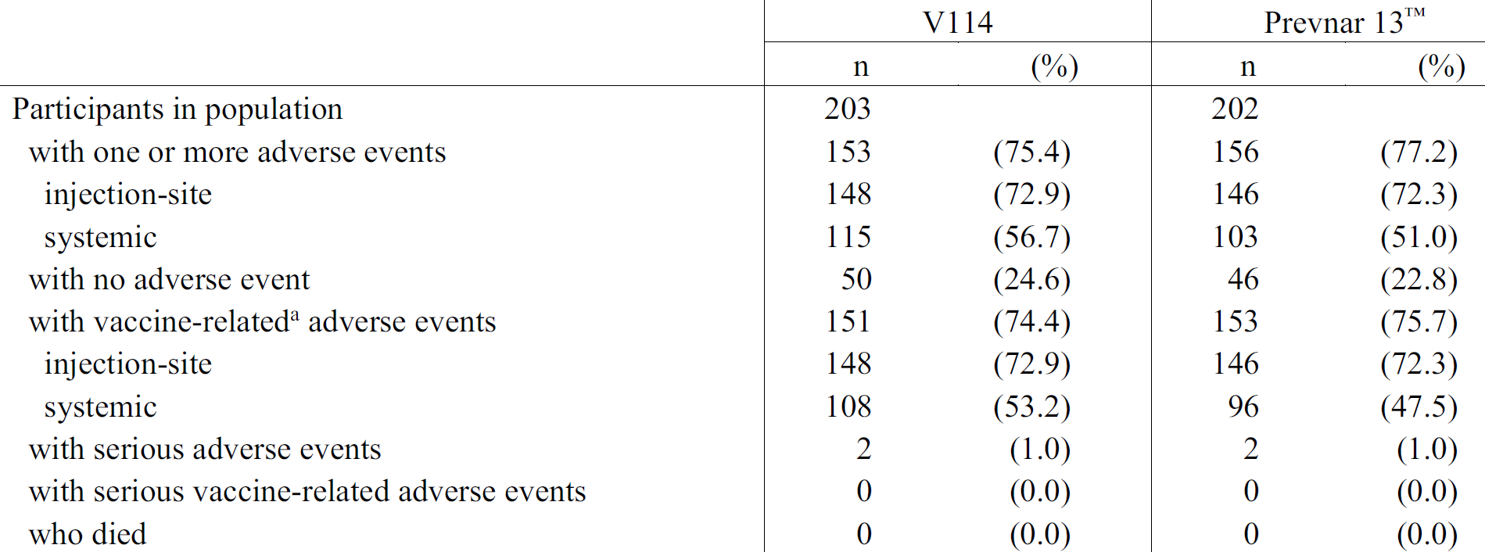

Abbreviation: V114 = sponsor’s product development code for Vaxneuvance.

a Determined by the investigator to be related to the vaccine.

Reported adverse events include nonserious adverse events that occurred within 14 days of vaccination and serious adverse events that occurred from Week 8 (following vaccination with Pneumovax 23) through completion of study participation.

The clinical evaluation concluded: In children 6 to 17 years of age (inclusive) living with HIV, most of whom had a CD4+ T‑cell count in the normal range, Vaxneuvance induces immune responses for all 15 pneumococcal serotypes as assessed by IgG GMCs and OPA GMTs at 30 days following vaccination. Moreover, Vaxneuvance elicits IgG and OPA responses comparable to 13vPCV for the 13 shared serotypes and higher than 13vPCV for the 2 serotypes unique to Vaxneuvance at Day 30. Vaccination with Vaxneuvance was generally well tolerated.

The FDA reached similar conclusions.15 The statistical review highlighted that vaccine related injection site and systemic AEs were reported for a higher proportion of participants in the Vaxneuvance group following vaccination with PCV (injection site 71.4% Vaxneuvance versus 59.8% Prevnar 13; systemic 47.8% Vaxneuvance versus 37.7% Prevnar 13).

##### Study V114-031

Study V114-031 was a Phase III, randomised, double blind, active comparator controlled, multicentre study to evaluate the safety and tolerability of Vaxneuvance (3+1 schedule) in healthy infants of approximately 2 months (42 to 90 days) of age.

Eligible participants were randomly assigned to receive Vaxneuvance or Prevenar 13 in the following ratios based on gestational age:

* full term infants (gestational age 37 weeks or older) 5:1 to Vaxneuvance or Prevenar 13
* preterm infants (gestational age less than 37 weeks) 1:1 to Vaxneuvance or Prevenar 13

###### Objectives

Primary objectives

* To evaluate the safety and tolerability of Vaxneuvance with respect to the proportion of participants with AEs.

Secondary objectives - premature infant immunogenicity sub‑study only

* To evaluate the anti-PnPs serotype specific IgG GMCs at 30 days following Dose 3, prior to Dose 4 and at 30 days following Dose 4 for each vaccination group.
* To evaluate the anti-PnPs serotype specific IgG response rates (proportion of participants meeting serotype specific IgG threshold value of at least 0.35 μg/mL) at 30 days following Dose 3 for each vaccination group.

###### Endpoints

Primary endpoint safety

Following any vaccination with Vaxneuvance: Solicited injection-site AEs from Day 1 through Day 14 postvaccination; Solicited systemic AEs from Day 1 through Day 14 postvaccination; vaccine-related SAEs through completion of study participation.

Secondary endpoints - Immunogenicity (premature infant sub-study only

Anti-PnP serotype-specific IgG responses for the 15 serotypes in Vaxneuvance at 30 days following Dose 3, prior to Dose 4 (Predose 4) and at 30 days following Dose 4; Anti-PnP serotype-specific IgG response rates for the 15 serotypes in Vaxneuvance at 30 days following Dose 3.

###### Participants

There were 2,409 participants enrolled and randomised (1,972 in the Vaxneuvance group; 437 in the 13vPCV group).

Among 1,972 participants randomised to the Vaxneuvance group, 1,967 (99.7 %) were vaccinated with at least one dose of Vaxneuvance; 1,847 (93.7%) completed the study.

Among 437 participants randomised to the Prevnar 13 group, 436 (99.8%) were vaccinated with at least one dose of Prevnar 13; 400 (91.5%) completed the study.

Demographic characteristics were generally comparable for vaccinated participants in both groups. Median age of participants was 9 weeks (range: 6 to 12 weeks). Approximately 4% of participants were preterm infants (gestational age less than 37 weeks). Median gestational age of preterm infants (less than 37 weeks) enrolled in the study was 36 weeks (range: 32 to 37 weeks).

###### Results

Safety (primary objective)

The proportions of participants with AEs, including injection site, systemic, and vaccine related AEs, and SAEs were generally comparable between the intervention groups.

Secondary endpoints - Immunogenicity (health premature infant sub-study

* Vaxneuvance elicited serotype specific immune responses as assessed by IgG GMCs to each of the 15 serotypes in the vaccine at each timepoint.
  + Serotype specific IgG GMCs generally comparable between intervention groups for the 13 shared serotypes.
  + Serotype specific IgG GMCs for the 2 serotypes unique to Vaxneuvance (22F and 33F) were higher in the Vaxneuvance group compared with the 13vPCV group.
* For each of the 15 serotypes in the vaccine, the majority (more than 86%) of participants in the Vaxneuvance group met the IgG threshold value of at least 0.35 µg/mL at 30 days following Dose 3.
  + Serotype specific IgG response rates at 30 days following Dose 3 generally comparable between intervention groups for each of the 13 shared serotypes.
  + Serotype specific IgG response rates for the 2 serotypes unique to Vaxneuvance were higher in the Vaxneuvance group compared with the 13vPCV group.

The FDA clinical review[21] highlighted the following points regarding Study V114‑031: ‘This study was conducted in response to a CBER [FDA Center for Biologics Evaluation and Research] request to provide a safety database of at least 3000 PCV15 recipients. The study also evaluated the immunogenicity of PCV15 in premature infants born before 37 weeks EGA [estimated gestational age] to provide supportive data for use in this demographic.’ Australia was one of the included sites for the study.

Study V114-031 included a premature infant immunogenicity sub‑study. Full-term infants (gestational age at least 37 weeks) were randomised 5:1 to Vaxneuvance or Prevnar 13; preterm infants (gestational age less than 37 weeks) were randomised 1:1 to Vaxneuvance or Prevnar 13. The 99 preterm infants randomised and vaccinated in this study included 51 Vaxneuvance recipients and 48 13vPCV recipients.

Other studies (Studies V114-029, V114-025 (4 dose for preterm infants), and V114-027) evaluating a 4-dose infant series did not include restrictions on enrolment based on predefined minimum gestational age and therefore included preterm infants less than 37 weeks.

#### Safety

Safety results have been discussed individually for each of the included studies and patient populations. The clinical evaluation considered the safety data arising from these studies as reassuring, and comparable to that of 13vPCV, the current ‘gold standard’ for infant pneumococcal vaccination.

In healthy infants receiving 3 or 4 doses as part of a routine vaccination schedule, the safety profile of Vaxneuvance after each dose was generally consistent.

The safety profile of Vaxneuvance in preterm infants was generally consistent with the safety profile in the overall healthy infant population.

The safety profiles of mixed 4-dose regimens of Vaxneuvance and 13vPCV were generally comparable to those of complete 4-dose regimens of either Vaxneuvance or 13vPCV.

The FDA analysis reached similar conclusions, with the statistical review highlighting the following points:15

* In children 5 through to 17 years of age with sickle cell disease, there was a higher proportion of vaccine related systemic AEs reported in the Vaxneuvance group compared to the Prevnar 13 group.
* In children 6 through to 17 years of age with HIV, vaccine related injection site and systemic AEs were reported for a higher proportion of participants in the Vaxneuvance group compared with the Prevnar 13 group.

For Study V114-025 (2+1 schedule, not included in the FDA analysis), statistically significantly higher proportions of participants in the Vaxneuvance group compared with the 13vPCV group were observed with solicited AEs of injection site pain and irritability.

### Risk management plan

The most recently evaluated EU-risk management plan (RMP) was version 0.1 (dated 2 November 2020; data lock point (DLP) 16 September 2020) and Australia specific annex (ASA) version 0.1 (dated 1 December 2020). In support of the extended indications, the sponsor submitted EU‑RMP version 1.1 (dated 24 November 2021; DLP 24 August 2021) and ASA version 1.1 (dated 1 February 2022).

The sponsor subsequently submitted approved EU-RMP version 2.0 (dated 7 September 2022; DLP 24 August 2021) and ASA version 1.2 (dated 31 October 2022) with responses to questions raised by the TGA. A further updated ASA, version 2.0 (dated 14 December 2022) was provided later in the evaluation process.

The summary of safety concerns and their associated risk monitoring and mitigation strategies are summarised in Table 16. The TGA may request an updated RMP at any stage of a product's life-cycle, during both the pre-approval and post-approval phases.

Table 16: Summary of safety concerns

|  |  |  |  |  |  |
| --- | --- | --- | --- | --- | --- |
| Summary of safety concerns | | Pharmacovigilance | | Risk Minimisation | |
| Routine | Additional | Routine | Additional |
| Important identified risks | None | _ | _ | _ | _ |
| Important potential risks | None | _ | _ | _ | _ |
| Missing information | Use in adult hematopoietic stem cell transplant recipients | ü | ü* | _ | _ |

*Clinical study

### Risk-benefit analysis

#### Delegate’s considerations

This was a complex submission which evaluated a number of aspects of pneumococcal vaccination in the paediatric population including different dosing regimens, catch-up vaccination, concomitant vaccination and high-risk groups, including premature infants, children living with HIV and children with sickle cell disease.

Some of the included studies were less relevant to Australia, as they utilised different dosing schedules and reviewed concomitant vaccines which are not currently listed on the NIP. The 3+1 schedule is recommended for Aboriginal and Torres Strait Islander children and children with a risk condition for pneumococcal disease, however the largest studies of the 3+1 schedule did not include children with a medical risk condition for pneumococcal disease, except for premature infants. The clinical evaluation also expressed concerns that immunocompromised children were excluded from all of the studies except Study V114-030 which specifically enrolled children living with HIV.

The clinical evaluation acknowledged the uncertainty with current data regarding the dominant pneumococcal strains, given the unreliability of global surveillance data during the COVID-19 pandemic. Most of the included trials were conducted, at least in part, during the COVID-19 pandemic and the sponsor has stated in their study reports that they continued to follow the standard operating procedures for study conduct, monitoring, and oversight during the pandemic.

The comparator vaccine for the trials was Prevenar 13. Comparative data in the paediatric population were not available for the more recently registered Prevenar 20.

Efficacy data were not provided. The sponsor used a validated pneumococcal electrochemiluminescence assay bridged to the World Health Organization (WHO) reference enzyme linked immunosorbent assay for all studies. Validated multiplexed opsonophagocytic assay was measured in some studies. The sponsor has been requested to comment on the strengths and limitations of these assays in assessing immunogenicity as a bridge to efficacy in the paediatric population.

While non-inferiority was demonstrated overall for the common serotypes between Vaxneuvance and 13vPCV, many of the individual serotypes favoured 13vPCV, noting that the studies were not powered to detect this. It is known that 13vPCV has not performed well against serotype 3 and the FDA Clinical review21 highlighted that for the 2 serotypes unique to 15vPCV, predetermined success criteria compared the IgG responses in 15vPCV recipients to the lowest shared serotype response in 13vPCV recipients, excluding the response to serotype 3.

The place of Vaxneuvance in the National Immunisation Program for children will ultimately be recommended by the Australian Technical Advisory Group on Immunisation. Vaxneuvance will provide an additional 2 serotypes, 22F and 33F, however in the absence of efficacy data, ongoing surveillance of pneumococcal disease will be critical in determining the impact of these additional 2 serotypes, as well as the performance of Vaxneuvance against serotype 3 and other shared serotypes with Prevenar 13.

#### Proposed action

The submitted data are sufficient to recommend approval of Vaxneuvance in Australia in infants, children and adolescents from 6 weeks of age. Approval is subject to satisfactory implementation of the risk management plan and resolution of the product information.

#### Questions for the sponsor

The sponsor provided the following response to questions from the Delegate.

1. ***Please provide information on the strengths and limitations of the Pneumococcal electrochemiluminescence (Pn ECL) assay versus the*** ***multiplexed opsonophagocytic assay (MOPA) used in the submitted studies for the paediatric development program.***

***The Clinical Overview states that vaccine induced, serotype specific immune responses for the 15 serotypes included in V114 were measured using the*** ***validated Pn ECL assay bridged to the WHO reference enzyme linked immunosorbent assay for all studies. While it is acknowledged that the test level of 0.35 µg/mL was chosen based on the WHO recommendation as an immunogenicity bridge to the efficacy against invasive pneumococcal disease as demonstrated for 7vPCV, how does this assay perform for the serotypes not included in 7vPCV and for non-invasive pneumococcal disease in children?***

The V114 paediatric program utilises 2 key measures of immunogenicity to demonstrate comparable immune responses to 13vPCV in children: an electrochemiluminescence (ECL)-based detection method to measure serotype specific IgG concentrations and an OPA to measure serotype specific functional antibodies. The intent of measuring functional activity in children, in addition to quantifying levels of IgG, is to demonstrate that vaccine induced antibodies have functional activity, that is, the antibodies can opsonize and kill pneumococcus in culture. As such, serotype specific IgG concentration (ECL) was used to test the primary immunogenicity hypotheses for all children in the program, with functional activity (OPA) serving as a supportive secondary objective evaluated descriptively, in accordance with WHO[22] and regulatory requirements.

The OPA assay requires large volume of serum, which is challenging in young children, especially when also evaluating immune responses to other routine paediatric vaccines given concomitantly to infants and toddlers. Conversely, the ECL has higher throughput and requires less serum than the OPA assay. Given the established correlation of IgG responses and functional antibody levels in young children,[23] OPA data were generated for a subset of vaccinated infants with sufficient volume of serum for both ECL and OPA assays, in accordance with WHO recommendations.22

The sponsor’s Pn ECL assay was formally bridged to the WHO reference ELISA to assess the threshold values that correspond to 0.35 µg/mL measured via the WHO reference ELISA for each of the 15 serotypes in V114 individually. The study included 116 paediatric infant serum samples selected with antibody concentrations that spanned the entire range of response, with a concerted effort to secure samples with serotype specific IgG concentrations near the WHO ELISA threshold value for all 15 serotypes. The results confirmed that a single threshold value of 0.35 µg/mL should be applied to each of the 15 serotypes when comparing the serotype specific response rates between V114 and licensed PCVs in children.

The use of 0.35 µg/mL as the threshold value measured by the WHO reference ELISA has been recommended by a WHO expert panel as an acceptable threshold value for evaluating the clinical performance of PCVs following a routine childhood vaccination regimen.22 This pooled correlate of protection against invasive pneumococcal disease of 0.35 µg/mL was derived from a meta-analysis of 3 efficacy trials based on the ranking of serotypes by their epidemiologic and clinical significance.[24] Current correlates of protection refer only to protection against invasive pneumococcal disease, and not to non-invasive disease endpoints. The concentration of circulating serum antibody sufficient to protect infants against pneumococcal disease during the following vaccination period is not well defined but is generally higher for mucosal endpoints (non-invasive pneumococcal disease) than invasive pneumococcal disease and varies between serotypes.[25],[26],[27],[28]

The results of the paediatric clinical program demonstrate that V114 induces robust immune responses, both quantitatively (IgG response rates and GMCs as measured by ECL) and qualitatively (OPA GMTs), to all 15 vaccine serotypes; responses in V114 were generally comparable to 13vPCV for the 13 shared serotypes without significant loss of immunogenicity, and higher for the 2 unique serotypes with statistical superiority demonstrated in the pivotal studies (3+1 and 2+1 schedules). Therefore, it is the sponsor’s position that V114 is expected to be protective against both invasive and non-invasive disease caused by all 15 serotypes included in the vaccine. As a result, V114 will help sustain the progress achieved to date with licensed PCVs, providing a better immune response to serotype 3 and expanding protection to 2 additional serotypes which are important contributors to paediatric invasive pneumococcal disease globally and in Australia.

1. ***Does the sponsor intend to conduct studies with concomitant administration of meningococcal vaccines, which are currently administered at 12 months of age with pneumococcal conjugate vaccines on the NIP?***

Concomitant administration of V114 with meningococcal vaccines was not evaluated in the paediatric V114 program, in part given the variability of the recommended meningococcal vaccination schedules in children globally. The program evaluated many other routine paediatric vaccines and was limited by the volume of serum obtained from infants to test for responses to PCV serotypes as well as the other paediatric vaccines. The sponsor does not intend to conduct concomitant administration studies of V114 with meningococcal vaccines at this time.

#### Advisory Committee considerations

The [Advisory Committee on Vaccines (ACV)](https://www.tga.gov.au/committee/advisory-committee-vaccines-acv), having considered the evaluations and the Delegate’s overview, as well as the sponsor’s response to these documents, advised the following.

##### Specific advice to the Delegate

1. ***Please comment on the wording of the indication. The Delegate is inclined to simplify the wording of the indication, consistent with Prevenar 13 and Prevenar 20:***

***Vaxneuvance is indicated for active immunisation for the prevention of pneumococcal disease caused by Streptococcus pneumoniae serotypes (1, 3, 4, 5, 6A, 6B, 7F, 9V, 14, 18C, 19A, 19F, 22F, 23F and 33F) in adults and children from 6 weeks of age.***

***Vaxneuvance may not prevent disease caused by S. pneumoniae serotypes that are not contained in the vaccine.***

***The use of Vaxneuvance should be guided by official recommendations.***

The ACV advised that immunogenicity and safety data support the registration of Vaxneuvance for administration to children from 6 weeks of age.

The ACV supported the Delegate’s wording of the indication and noted that the sponsor has agreed to this wording.

In the absence of clinical efficacy data, a more general reference to the prevention of pneumococcal disease is preferred over particular presentations of *S. pneumoniae* infection.

1. ***Please comment on the findings of Study V114- 025, given the relevance of the 2+1 schedule for children less than 5 years of age in Australia.***

The ACV noted that [Study] V114-025 was designed to evaluate the safety, tolerability, and immunogenicity of V114 [Vaxneuvance] when administered as a 3-dose regimen (2-dose primary series at 2 and 4 months of age, followed by a toddler dose) in full-term infants, and a 4-dose regimen (3-dose primary series at 2, 3, and 4 months of age, followed by a toddler dose) in preterm infants (6% of participants).

The findings are relevant for the standard 2+1 schedule for pneumococcal vaccine in Australia, although there were limited data from this study for preterm infants and no data for infants at high risk of pneumococcal infection or Aboriginal and Torres Strait Islander infants.

V114 elicited immune responses that were comparable to 13vPCV for the 13 shared serotypes and higher for the 2 unique serotypes (22F and 33F), meeting non-inferiority criteria for the 13 shared serotypes and superiority criteria for serotypes 22F and 33F. Superiority was not a study endpoint for serotype 3 in this study.

V114 was well tolerated with a safety profile generally comparable to 13vPCV. Solicited adverse events of injection site pain and irritability were statistically higher in V114 in this study; most of these events were mild or moderate in intensity, and with a duration of up to 3 days.

There was no evidence of immunologic interference with concomitantly administered routine infant vaccines Infanrix hexaand Rotarixwhich are relevant to the Australian context.

1. ***The ACV is requested to comment on the findings of Study V114-029, including the results for serotype 3. Does the ACV agree with the presentation of the results for serotype 3 for this study in the PI?***

The ACV noted that [Study] V114-029 was designed to evaluate the safety, tolerability, and immunogenicity of V114 when administered as a 4-dose regimen (3-dose primary series at 2, 4, and 6 months of age, followed by a toddler dose). In healthy infants and toddlers, V114 was well tolerated with a safety profile generally comparable to 13vPCV. V114 was non-inferior to 13vPCV for all 15 serotypes after the toddler dose, as assessed by serotype specific IgG GMCs and seroresponse rate. As a secondary endpoint V114 met superiority in these criteria for serotype 3.

This study did not include groups at high risk for pneumococcal disease (except small numbers of preterm infants).

Many of the concomitant vaccines permitted in this study are not part of the current National Immunisation Program. Conversely concomitant use with meningococcal ACWY and meningococcal B vaccines was not studied.

Serotype 3 responses were consistently higher in the V114 studies compared to 13vPCV with statistical superiority over 13vPCV demonstrated in [Study] V114-029, however the clinical significance of this is currently unknown. For inclusion in the Product Information, the ACV favoured ‘*statistically significantly greater/increased*’ in lieu of text indicating superiority as this could be misinterpreted as clinically significant, which has not been demonstrated. The ACV acknowledged that this wording is consistent with the US Prescribing Information.

1. ***The ACV is requested to provide advice on any other issues that it thinks may be relevant.***

The ACV noted that post-marketing data will be critical in determining the impact of inclusion of the additional 2 serotypes, 22F and 33F, and also the performance of Vaxneuvance against serotype 3 compared to currently available vaccines.

##### Conclusion

The ACV considered this product to have an overall positive benefit-risk profile for the indication:

*Vaxneuvance is indicated for active immunisation for the prevention of pneumococcal disease caused by Streptococcus pneumoniae serotypes (1, 3, 4, 5, 6A, 6B, 7F, 9V, 14, 18C, 19A, 19F, 22F, 23F and 33F) in adults and children from 6 weeks of age.*

*Vaxneuvance may not prevent disease caused by S. pneumoniae serotypes that are not contained in the vaccine.*

*The use of Vaxneuvance should be guided by official recommendations.*

## Outcome

Based on a review of quality, safety, and efficacy, the TGA approved the registration of Vaxneuvance (pneumococcal 15-valent conjugate vaccine (CRM197 protein), adsorbed) 0.5 mL suspension for intramuscular injection in prefilled syringe, for the following extension of indication:

*Vaxneuvance is indicated for active immunisation for the prevention of pneumococcal disease caused by Streptococcus pneumoniae serotypes (1, 3, 4, 5, 6A, 6B, 7F, 9V, 14, 18C, 19A, 19F, 22F, 23F and 33F) in adults and children from 6 weeks of age.*

As such, the full indications at this time were:

*Vaxneuvance is indicated for active immunisation for the prevention of pneumococcal disease caused by Streptococcus pneumoniae serotypes (1, 3, 4, 5, 6A, 6B, 7F, 9V, 14, 18C, 19A, 19F, 22F, 23F and 33F) in adults and children from 6 weeks of age.*

*Vaxneuvance may not prevent disease caused by S. pneumoniae serotypes that are not contained in the vaccine.*

*The use of Vaxneuvance should be guided by official recommendations.*

### Specific conditions of registration applying to these goods

* Vaxneuvance (pneumococcal 15-valent conjugate vaccine (CRM197 protein), adsorbed)) is to be included in the Black Triangle Scheme. The PI and CMI for Vaxneuvance must include the black triangle symbol and mandatory accompanying text for five years, which starts from the date the new indication is registered.
* The Vaxneuvance EU-risk management plan (RMP) (version 2.0, dated 7 September 2022, data lock point 24 August 2021), with Australian specific annex (version 2.0, dated 14 December 2022), included with Submission PM‑2022‑00382‑1‑2, and any subsequent revisions, as agreed with the TGA will be implemented in Australia.

An obligatory component of risk management plans is routine pharmacovigilance. Routine pharmacovigilance includes the submission of periodic safety update reports (PSURs).

Reports are to be provided in line with the current published list of EU reference dates and frequency of submission of PSURs until the period covered by such reports is not less than three years from the date of the approval letter.

The reports are to at least meet the requirements for PSURs as described in the European Medicines Agency’s Guideline on Good Pharmacovigilance Practices (GVP) Module VII-periodic safety update report ([Revision] 1), Part VII.B Structures and processes. Note that submission of a PSUR does not constitute an application to vary the registration.

* For all injectable products the Product Information must be included with the product as a package insert.

## Attachment 1. Product Information

The PI for Vaxneuvance approved with the submission which is described in this AusPAR is at Attachment 1. For the most recent PI, please refer to the TGA [PI/CMI search facility.](https://www.tga.gov.au/picmi-search-facility)

|  |
| --- |
| Therapeutic Goods Administration |
| PO Box 100 Woden ACT 2606 Australia  Email: [info@tga.gov.au](mailto:info@tga.gov.au) Phone: 1800 020 653 Fax: 02 6203 1605  [**https://www.tga.gov.au**](https://www.tga.gov.au) |
| Reference/Publication # |

1. NCIRS Fact Sheet: Pneumococcal vaccines for Australians. Available at: <https://ncirs.org.au/sites/default/files/2020-07/Pneumococcal-fact-sheet_1%20July%202020_FINAL.pdf>.
2. Australian Technical Advisory Group on Immunisation (ATAGI). Australian Immunisation Handbook, Australian Government Department of Health and Aged Care, Canberra, 2022. Available at: <https://immunisationhandbook.health.gov.au/>.
3. Prevenar 13 was first registered on the ARTG on 29 March 2010 (ARTG number: 158450).
4. Prevenar 20 was first registered on the ARTG on 2 December 2022 (ARTG number: 376353).
5. Pneumovax 23 was first registered on ARTG on 29 July 1991 (ARTG number: 10507).
6. Gonzalez, B.E. et al. Streptococcus Pneumoniae Serogroups 15 And 33 an Increasing Cause of Pneumococcal Infections in Children in the United States after the Introduction of the Pneumococcal 7-valent conjugate vaccine. *Pediatr Infect Dis J,* 2006; 25(4): 301-305. doi: 10.1097/01.inf.0000207484.52850.38.
7. Golden, A.R. et al. Invasive Streptococcus Pneumoniae in Canada, 2011-2014: Characterization of New Candidate 15-valent Pneumococcal Conjugate Vaccine Serotypes 22F and 33F, *Vaccine,* 2016; 34(23): 2527-2530. doi: 10.1016/j.vaccine.2016.03.058.
8. Hackel, M. et al. Serotype Prevalence and Antibiotic Resistance in Streptococcus Pneumoniae Clinical Isolates Among Global Populations, *Vaccine*, 2013; 31: 4881-4887. doi: 10.1016/j.vaccine.2013.07.054.
9. AusPAR for Vaxneuvance as a new biological entity. Available at [Vaxneuvance | Therapeutic Goods Administration (TGA)](https://www.tga.gov.au/resources/auspar/auspar-vaxneuvance).
10. Banniettis, N. et al. A phase III, multicenter, randomized, double-blind, active comparator-controlled study to evaluate the safety, tolerability, and immunogenicity of catch-up vaccination regimens of V114, a 15-valent pneumococcal conjugate vaccine, in healthy infants, children, and adolescents (PNEU-PLAN). *Vaccine,* 2022; 40(44): 6315-6325. doi: 10.1016/j.vaccine.2022.09.003.
11. Infanrix hexa was first registered on the ARTG on 9 January 2007 (ARTG number: 132881).
12. Rotarix was first registered on the ARTG on 27 August 2008 (ARTG number: 146776).
13. The tradename for Recombivax HB is ‘H-B-VAX II’ in Australia. H-B-Vax II was first registered on the ARTG on 1 February 2000 (ARTG number: 72347).
14. Rotateq was first registered on the ARTG on 11 May 2006 (ARTG number: 120245).
15. Food and Drug Administration (FDA), Center for Biologics Evaluation and Research, Statistical Review STN 125741/6, Vaxneuvance vaccine, no stamped date. Available at: [Statistical Review (STN 125741/6) - VAXNEUVANCE (fda.gov)](https://www.fda.gov/media/160172/download).
16. Pentacel is not registered in Australia. In the USA, Pentacel is approved for active immunisation against diphtheria, tetanus, pertussis, poliomyelitis and invasive disease due to *Haemophilus influenzae* type b. A similar vaccine, Pentavac, was used in study sites in Turkey and Thailand. In this AusPAR, ‘Pentacel’ includes ‘Pentavac’ unless otherwise noted.
17. Vaqta was first registered on the ARTG on 8 January 1997 (ARTG number: 58534).
18. M‑M‑R II was first registered on the ARTG on 14 February 2006 (ARTG number: 118449).
19. Varivax was first registered on the ARTG on 3 January 2003 (ARTG number: 90140).
20. Hiberix was first registered on the ARTG on 28 October 1997 (ARTG number: 60881).
21. Food and Drug Administration (FDA), Center for Biologics Evaluation and Research, Clinical Review Memorandum STN 125741/6, Vaxneuvance vaccine, review completed on 17 June 2022. Available at: [June 17, 2022 Clinical Review (STN 125741/6) - VAXNEUVANCE (fda.gov)](https://www.fda.gov/media/160171/download).
22. WHO Expert Committee on Biological Standardization, sixtieth report. Geneva: World Health Organization; c2013. Annex 3: Recommendations to assure the Quality, Safety and Efficacy of Pneumococcal Conjugate Vaccines, 91-151.
23. Frenck, R. Jr, et al. 13-Valent Pneumococcal Conjugate Vaccine in Older Children and Adolescents either Previously Immunized with or naïve to 7-valent Pneumococcal Conjugate Vaccine, *Pediatr Infect Dis J*, 2014; 33: 183-189. doi: 10.1097/INF.0000000000000056.
24. Siber, G.R. et al. Estimating the Protective Concentration of Anti-pneumococcal Capsular Polysaccharide Antibodies, *Vaccine*, 2007; 25: 3816-3826. doi: 10.1016/j.vaccine.2007.01.119.
25. Andrews, N.J. et al. Serotype-specific Effectiveness and Correlates of Protection for the 13-valent Pneumococcal Conjugate Vaccine: a Postlicensure Indirect Cohort Study, *Lancet Infect Dis*, 2014; 14: 839-846. doi: 10.1016/S1473-3099(14)70822-9.
26. Dagan R, et al. Serum serotype-specific pneumococcal anticapsular immunoglobulin G concentrations after immunization with a 9-valent conjugate pneumococcal vaccine correlate with nasopharyngeal acquisition of pneumococcus. *J Infect Dis*, 2005; 192: 367-376. doi: 10.1086/431679.
27. Dagan, R. et al. Modeling Pneumococcal Nasopharyngeal Acquisition as a Function of Anticapsular Serum Antibody Concentrations after Pneumococcal Conjugate Vaccine Administration, *Vaccine*, 2016; 34: 4313-4320. doi: 10.1016/j.vaccine.2016.06.075.
28. Voysey, M. et al. Serotype-specific Correlates of Protection for Pneumococcal Carriage: an Analysis of Immunity in 19 Countries, *Clin Infect Dis*, 2018; 66(6X): 913-920. doi: 10.1093/cid/cix895.