This medicinal product is subject to additional monitoring in Australia. This will allow quick identification of new safety information. Healthcare professionals are asked to report any suspected adverse events at https://www.tga.gov.au/reporting-problems.
▼
AUSTRALIAN PRODUCT INFORMATION – VAZKEPA
(icosapent ethyl)

1. Name of the Medicine
Icosapent ethyl

2. Qualitative and Quantitative Composition
Each soft capsule contains 998 mg of icosapent ethyl.
Excipients with known effect:
Maltitol, sorbitol and soya bean products (see section 4.4 Special warnings and precautions for use)
For the full list of excipients, see section 6.1 List of excipients.

3. Pharmaceutical Form
Soft capsule
Oblong soft capsule, 25 x 10 mm, printed with “IPE” in white ink, with a light yellow to amber shell containing a colourless to pale yellow liquid.

4. Clinical Particulars

4.1 Therapeutic indications
VAZKEPA is indicated to reduce the risk of cardiovascular events in adult statin-treated patients at high cardiovascular risk with elevated triglycerides (≥ 1.7 mmol/L) and
- established cardiovascular disease, or
- diabetes, and at least one other cardiovascular risk factor.

4.2 Dose and method of administration
The recommended daily oral dose is 4 capsules taken as two 998 mg capsules twice daily.
If a dose is missed, patients should take it as soon as they remember. However, if one daily dose is missed, the next dose should not be doubled.

Method of administration
Oral use.
VAZKEPA should be taken with or following a meal.
To ensure the full intended dose is received, patients should be advised to swallow the capsules whole and not to break, crush, dissolve, or chew them.

Dosage adjustment in:

Renal impairment
No dose reduction is recommended (see section 5.2 Pharmacokinetic properties).

Hepatic impairment
No dose reduction is recommended (see sections 4.4 Special warnings and precautions for use and 5.2 Pharmacokinetic properties).

Elderly
No dose adjustment is necessary based on age (see section 5.2 Pharmacokinetic properties).

4.3 Contraindications
Hypersensitivity to the active substance, soya or to any of the excipients listed in section 6.1 List of excipients.

4.4 Special warnings and precautions for use

Allergies to fish and/or shellfish
Icosapent ethyl is obtained from the oil of fish. It is not known whether patients with allergies to fish and/or shellfish are at increased risk of an allergic reaction to icosapent ethyl. Icosapent ethyl should be used with caution in patients with known hypersensitivity to fish and/or shellfish.

Atrial fibrillation or flutter
Icosapent ethyl was associated with an increased risk of atrial fibrillation or flutter requiring hospitalisation in a double-blind placebo-controlled trial. The incidence of atrial fibrillation was greater in patients with a previous history of atrial fibrillation or flutter (see section 4.8 Adverse effect (Undesirable effects)). Patients, particularly those with a relevant medical history, should be monitored for clinical evidence of atrial fibrillation or atrial flutter (e.g., dyspnoea, palpitations, syncope/dizziness, chest discomfort, change in blood pressure, or irregular pulse). Electrocardiographic evaluation should be performed when clinically indicated.

Bleeding
Treatment with icosapent ethyl has been associated with an increased incidence of bleeding. Patients taking icosapent ethyl along with antithrombotic agents, i.e., antiplatelet agents, including acetylsalicylic acid, and/or anticoagulants, may be at increased risk of bleeding and should be monitored periodically (see section 4.8 Adverse effects (Undesirable effects)).

Use in hepatic impairment
In patients with hepatic impairment, alanine aminotransferase (ALT) and aspartate aminotransferase (AST) concentrations should be monitored as clinically indicated before the start of treatment and at appropriate intervals during treatment.

Use in the elderly
See sections 4.2 Dose and method of administration and 5.2 Pharmacokinetic properties.

Paediatric use
There is no relevant use of icosapent ethyl in children aged <18 years of age in reducing the risk of cardiovascular events in statin-treated patients at high cardiovascular risk with elevated triglycerides and other risk factors for cardiovascular disease.

Excipients content

Sorbitol
This medicinal product contains 83 mg of sorbitol in each capsule. The additive effect of concomitantly administered medicinal products containing sorbitol (or fructose) and dietary intake of sorbitol (or fructose) should be taken into account.
The content of sorbitol in medicinal products for oral use may affect the bioavailability of other medicinal products for oral use administered concomitantly.
Patients with hereditary fructose intolerance (HFI) should not take this medicinal product.

Maltitol
This medicinal product contains 30 mg of maltitol in each capsule.
Patients with rare hereditary problems of fructose intolerance should not take this medicinal product.

Soya lecithin
This medicinal product contains soya lecithin. Patients who are allergic to soya or peanut should not use this medicinal product.

Effects on laboratory tests
No data available.

4.5 Interactions with other medicines and other forms of interactions
Icosapent ethyl was studied at the dose level of four 998 mg capsules/day with the following medicinal products which are typical substrates of cytochrome P450 enzymes: omeprazole, rosiglitazone, warfarin and atorvastatin. No interactions were observed.
In vitro studies show that the free acid form of icosapent ethyl, eicosapentaenoic acid (EPA), is a weak inhibitor of CYP1A2, CYP2B6, CYP2C8, CYP2C9, CYP2C19, CYP2D6, CYP2E1, and CYP3A. In a separate in vitro study, EPA was found not to induce CYP isoforms CYP3A, CYP2C9, and CYP1A2. Additional in vitro studies showed that EPA at a concentration of 1 μM did not significantly inhibit P-gp, BCRP, OAT1, OCT2, OATP1B1 and OATP1B3, but did mildly inhibit the transport of OAT3.

4.6 Fertility, pregnancy and lactation

Effects on fertility
There are no data on fertility in humans from the use of icosapent ethyl. A rat fertility study at doses up to 3000 mg/kg/day indicated no effect on female or male fertility in up to 3000 mg/kg/day (approximately 8-fold the clinical AUC at the MRHD).

Use in pregnancy
Category B1
There is a limited amount of data from the use of icosapent ethyl in pregnant women. Animal studies do not indicate direct or indirect harmful effects with respect to reproductive toxicity (see Effects on fertility). As a precautionary measure, it is preferable to avoid the use of icosapent ethyl during pregnancy unless the benefit of use outweighs the potential risk to the fetus.
Animal studies indicate that icosapent ethyl crosses the placenta and is found in fetal plasma.
In pregnant rats (up to 2000 mg/kg/day) or rabbits (up to 1000 mg/kg/day) orally administered icosapent ethyl from gestation through organogenesis revealed no adverse visceral and skeletal findings up to 8- or 7-fold the clinical dose (relative to clinical exposures based on AUC and BSA, respectively) respectively. While reduced 13th rib, additional liver lobes, and medially displaced testes were reported in rat embryos no dose correlation was noted.
In a multigenerational developmental study in pregnant rats given doses up to 3000 mg/kg/day orally from gestation day 7-17, icosapent ethyl did not affect viability in fetuses (F1 or F2) at approximately 8-fold the clinical dose (based on exposures of comparative studies). Non-dose-related findings included absent optic nerves and unilateral testes atrophy. Additional variations consisting of early incisor eruption and increased percent cervical ribs were observed at the same exposures. Pups from high dose treated dams exhibited decreased copulation rates, delayed estrus, decreased implantations and decreased surviving fetuses (F2) suggesting potential multigenerational effects of icosapent ethyl at 8-times human systemic exposure.

Use in lactation
It is not known whether icosapent ethyl is excreted in human milk. Studies from the literature have shown that the active metabolite eicosapentaenoic acid (EPA) is excreted in human milk at levels which correlated to maternal diet. Animal studies indicate that icosapent ethyl is excreted in milk. Available toxicological data in rats have shown excretion of icosapent ethyl in milk.
A risk to the suckling child cannot be excluded.
A decision must be made whether to discontinue breast-feeding or to discontinue/abstain from icosapent ethyl therapy considering the benefit of breast-feeding for the child and the benefit of therapy for the woman.

4.7 Effects on ability to drive and use machines
On the basis of its pharmacodynamic profile and clinical study adverse reaction data, icosapent ethyl is expected to have no or negligible influence on the ability to drive and use machines.

4.8 Adverse effects (Undesirable effects)

Adverse events in the REDUCE-IT trial
In the pivotal Phase 3 study, REDUCE-IT, 81.8% (3343/4089) and 81.3% (3326/4090) of patients in the VAZKEPA and placebo groups, respectively, experienced at least one treatment-emergent adverse event (TEAE). The proportions of patients who experienced TEAEs, treatment-related TEAEs, serious adverse events (SAEs), or discontinuations due to TEAEs were similar between the VAZKEPA and placebo groups. The most frequent TEAE in both treatment groups was diarrhoea, with a lower incidence in the VAZKEPA group than in the placebo group (9.0% [367/4089] versus 11.1% [453/4090], respectively). Other frequently reported TEAEs included back pain, hypertension, nasopharyngitis and arthralgia where similar incidence was seen in the VAZKEPA and placebo groups. Common adverse events with a higher incidence (>1%) in the VAZKEPA group versus placebo are provided in Table 1.

Table 1 Treatment Emergent Adverse Events of ≥5% Incidence in Either Treatment Arm in REDUCE-IT
System Organ Class  Preferred Term | VASCEPA  N=4089  n (%) | Placebo  N=4090  n (%)
Infections and infestations
Nasopharyngitis | 314 (7.7) | 300 (7.3)
Upper respiratory tract infection | 312 (7.6) | 320 (7.8)
Bronchitis | 306 (7.5) | 300 (7.3)
Pneumonia | 263 (6.4) | 277 (6.8)
Influenza | 263 (6.4) | 271 (6.6)
Urinary tract infection | 253 (6.2) | 261 (6.4)
Musculoskeletal and connective tissue disorders
Back pain | 335 (8.2) | 309 (7.6)
Arthralgia | 313 (7.7) | 310 (7.6)
Osteoarthritis | 241 (5.9) | 218 (5.3)
Pain in extremity | 235 (5.7) | 241 (5.9)
Gastrointestinal disorders
Diarrhoea | 367 (9.0) | 453 (11.1)
Constipation | 221 (5.4) | 149 (3.6)
General disorders and administration site conditions
Chest pain | 273 (6.7) | 290 (7.1)
Oedema peripheral | 267 (6.5) | 203 (5.0)
Fatigue | 228 (5.6) | 196 (4.8)
Nervous system disorders
Dizziness | 235 (5.7) | 246 (6.0)
Respiratory, thoracic and mediastinal disorders
Dyspnoea | 254 (6.2) | 240 (5.9)
Cough | 241 (5.9) | 241 (5.9)
Cardiac disorders
Atrial fibrillation | 215 (5.3) | 159 (3.9)
Angina pectoris | 200 (4.9) | 205 (5.0)
Vascular disorders
Hypertension | 320 (7.8) | 344 (8.4)
Eye disorders
Cataract | 233 (5.7) | 208 (5.1)
Blood and lymphatic system disorders
Anaemia | 191 (4.7) | 236 (5.8)

Summary of the safety profile
The most frequently reported adverse reactions associated with icosapent ethyl were bleeding (11.8%), peripheral oedema (7.8%), atrial fibrillation (5.8%), constipation (5.4%), musculoskeletal pain (4.3%), gout (4.3%) and rash (3.0%).

Tabulated list of adverse reactions
Adverse reactions are classified according to frequency and system organ class. Reporting frequencies for adverse reactions have been estimated from a long-term cardiovascular outcomes study in which subjects were observed for a median follow-up duration of 4.9 years (Table 2). Frequency categories are defined according to the following conventions: very common (≥1/10), common (≥1/100 to <1/10), uncommon (≥1/1,000 to <1/100), rare (≥1/10,000 to <1/1,000), very rare (<1/10,000) and not known (cannot be estimated from the available data).
Table 2: Adverse reactions

MedDRA System organ class | Adverse reaction | Frequency
Immune system disorders | Hypersensitivity | Uncommon
 | Pharyngeal swelling | Not known
Metabolism and nutrition disorders | Gout | Common
Nervous system disorders | Dysgeusia¹ | Uncommon
Cardiac disorders | Atrial fibrillation or flutter² | Common
Vascular disorders | Bleeding² | Very common
Gastrointestinal disorders | Constipation² | Common
 | Eructation | Common
Skin and subcutaneous tissue disorders | Rash | Common
Musculoskeletal and connective tissue disorders | Musculoskeletal pain | Common
General disorders and administration site conditions | Peripheral oedema | Common
¹ Dysgeusia describes the “verbatim” term: Fishy taste
² See section Description of selected adverse reactions

Description of selected adverse reactions

Bleeding
Bleeding occurred in 11.8% of subjects receiving icosapent ethyl in a placebo-controlled cardiovascular outcomes trial compared with 9.9% in subjects receiving placebo. Serious bleeding events were reported more frequently in subjects receiving icosapent ethyl than in those receiving placebo when administered in combination with concomitant antithrombotic medication (3.4% vs. 2.6%), but occurred at the same rate (0.2%) in subjects not taking concomitant anticoagulant/antiplatelet medication (see section 4.4 Special warnings and precautions for use).
The bleeding events most frequently observed with icosapent ethyl were gastrointestinal bleeding (3.1%), contusion (2.5%), haematuria (1.9%), and epistaxis (1.5%).

Atrial fibrillation/ flutter
Atrial fibrillation or atrial flutter occurred in 5.8% of subjects receiving icosapent ethyl in a placebo-controlled cardiovascular outcomes trial compared with 4.5% in subjects receiving placebo. Atrial fibrillation or atrial flutter requiring hospitalisation for 24 hours or more occurred in 3% of subjects treated with icosapent ethyl compared with 2% in subjects receiving placebo. Atrial fibrillation and atrial flutter were reported more frequently in subjects with a previous history of atrial fibrillation or atrial flutter receiving icosapent ethyl than in those receiving placebo (12.5% vs. 6.3%) (see section 4.4 Special warnings and precautions for use).

Constipation
Constipation occurred in 5.4% of subjects receiving icosapent ethyl in a placebo-controlled cardiovascular outcomes trial compared with 3.6% of subjects receiving placebo. Serious constipation was less common for icosapent ethyl (0.1%) and placebo (0.2%). The relative incidence of constipation in this study may have been confounded by a residual laxative effect for placebo, which comprised a subtherapeutic dose of light mineral oil (4 mL).
The following adverse reactions have been identified from global post-marketing use of icosapent ethyl. Because these reactions are reported voluntarily from a population of uncertain size, it is generally not possible to reliably estimate their frequency or establish causal relationship to drug exposure: blood triglycerides increased, arthralgia, diarrhoea, abdominal discomfort, and pain in the extremities.

Reporting suspected adverse effects
Reporting suspected adverse reactions after registration of the medicinal product is important. It allows continued monitoring of the benefit-risk balance of the medicinal product. Healthcare professionals are asked to report any suspected adverse reactions at www.tga.gov.au/reporting-problems.

4.9 Overdose
There is no specific treatment for icosapent ethyl overdose. In the event of an overdose, the patient should be treated symptomatically, and supportive measures instituted as required.
For information on the management of overdose, contact the Poison Information Centre on 131126 (Australia).

5. Pharmacological Properties

5.1 Pharmacodynamic properties

Mechanism of action
Icosapent ethyl is a stable ethyl ester of the omega-3 fatty acid, eicosapentaenoic acid (EPA). The mechanisms of action contributing to reduction of cardiovascular events with icosapent ethyl are not completely understood. The mechanisms are likely multi-factorial including improved lipoprotein profile with reduction of triglyceride-rich lipoproteins, anti-inflammatory, and antioxidant effects, reduction of macrophage accumulation, improved endothelial function, increased fibrous cap thickness/stability, and antiplatelet effects. Each of these mechanisms can beneficially alter the development, progression, and stabilisation of atherosclerotic plaque, as well as the implications of plaque rupture, and preclinical and clinical studies support such benefits with EPA. Systemic and localised anti-inflammatory effects of EPA may result from displacement of pro-inflammatory arachidonic acid (AA), directing catabolism away from eicosanoids (2-series prostaglandins and thromboxanes, and 4-series leukotrienes) to non- or anti-inflammatory mediators. However, the direct clinical meaning of individual findings is not clear.
Icosapent ethyl improves the lipoprotein profile by suppressing cholesterol-, fatty acid- and triglyceride (TG)-synthesising enzymes, increasing fatty acid β-oxidation, and reducing microsomal triglyceride transfer (MTP) protein, resulting in decreased hepatic TG and very low-density lipoprotein (VLDL) synthesis and release. Icosapent ethyl also increases expression of lipoprotein lipase leading to increased TG removal from circulating VLDL and chylomicron particles. In patients with elevated TG levels, icosapent ethyl lowers TG, VLDL, remnant lipoprotein cholesterol, and levels of inflammatory markers such as C-reactive protein. However, TG reduction appears to provide only a minor contribution to the reduction in risk of cardiovascular events with icosapent ethyl.

Clinical trials
REDUCE-IT was a multinational, double-blind, randomised, placebo-controlled, event-driven trial in 8,179 (4,089 icosapent ethyl, 4,090 placebo) statin-treated adult patients enrolled with low-density lipoprotein cholesterol (LDL-C) >1.03 mmol/L (40 mg/dL) and ≤2.59 mmol/L (100 mg/dL) and moderately elevated triglyceride (TG) levels (≥1.53 mmol/L and <5.64 mmol/L [≥135 mg/dL and <500 mg/dL] as measured during patient screening, i.e. qualifying visits pre-enrolment) and either established cardiovascular disease (70.7%) or diabetes and other risk factors for cardiovascular disease (29.3%). Patients with established cardiovascular disease were defined as being at least 45 years of age and having a documented history of coronary artery disease, cerebrovascular or carotid disease, or peripheral artery disease. Patients in the other risk group were defined as being at least 50 years of age with diabetes requiring medical treatment and at least one additional risk factor i.e., hypertension or on an antihypertensive medicinal product; age at least 55 years (men) or at least 65 years (women); low high-density lipoprotein cholesterol levels; smoking; raised high-sensitivity C-reactive protein levels; renal impairment; micro or macroalbuminuria; retinopathy; or reduced ankle brachial index. Patients were randomly assigned 1:1 to receive either icosapent ethyl or placebo (as 4 capsules daily). The median follow-up duration was 4.9 years. Overall, 99.8% of patients were followed for vital status until the end of the trial or death.
The baseline characteristics were balanced between the groups, median age at baseline was 64 years (range: 44 years to 92 years), with 46% being at least 65 years old; 28.8% were women. The trial population was 90.2% White, 5.5% Asian, 4.2% identified as Hispanic ethnicity, and 1.9% were Black. Regarding prior diagnoses of cardiovascular disease, 46.7% had prior myocardial infarction, 9.2% had symptomatic peripheral arterial disease, and 6.1% prior unknown stroke or transient ischemic attack (TIA). Selected additional baseline risk factors included hypertension (86.6%), diabetes mellitus (0.7% type 1; 57.8% type 2), eGFR <60 mL/min per 1.73 m2 (22.2%), congestive heart failure (17.7%), and current daily cigarette smoking (15.2%). Most patients were taking moderate-intensity (63%) or high-intensity (31%) statin therapy at baseline. Most patients at baseline were taking at least one other cardiovascular medicinal product including antiplatelet and/or antithrombotic agents (85.5%), beta blockers (70.7%), antihypertensives (95.2%), angiotensin converting enzyme (ACE) inhibitors (51.9%), or angiotensin receptor blockers (ARB; 26.9%); 77.5% were taking an ACE inhibitor or ARB. The protocol excluded patients taking PCSK9 inhibitors. On stable background lipid-lowering therapy, the median [Q1, Q3] LDL-C at baseline was 1.9 [1.6, 2.3] mmol/L (75.0 [62.0, 89.0] mg/dL); the mean (SD) was 2.0 (0.5) mmol/L (76.2 [20.3] mg/dL). On stable background lipid-lowering therapy, the median [Q1, Q3] fasting TG was 2.4 [2.0, 3.1] mmol/L (216.0 [176.0, 272.5] mg/dL); the mean (SD) was 2.6 (0.9) mmol/L (233.2 [80.1] mg/dL).
Icosapent ethyl significantly reduced the risk for the primary composite endpoint (time to first occurrence of cardiovascular death, myocardial infarction, stroke, coronary revascularisation, or hospitalisation for unstable angina; p<0.0001) and the key secondary composite endpoint (time to first occurrence of cardiovascular death, myocardial infarction, or stroke; p<0.0001). The results of the primary and secondary efficacy endpoints are shown in Table 3. The Kaplan-Meier estimates of the cumulative incidence of the key secondary composite endpoint over time are shown in Figure 1.
Table 3: Effect of icosapent ethyl on time to first occurrence of cardiovascular events in patients with elevated triglyceride levels and cardiovascular disease or diabetes and other risk factors in REDUCE-IT

 | Icosapent ethyl  N = 4,089  n (%) | Placebo  N = 4,090  n (%) | Icosapent ethyl vs Placebo  Hazard Ration  (95% CI)
Primary composite endpoint
Cardiovascular death, myocardial infarction, stroke, coronary revascularisation, hospitalisation for unstable angina (5-point MACE) | 705  (17.2) | 901  (22.0) | 0.75  (0.68, 0.83)
Key secondary composite endpoint
Cardiovascular death, myocardial infarction, stroke (3-point MACE) | 459  (11.2) | 606  (14.8) | 0.74  (0.65, 0.83)
Other secondary endpoints
Cardiovascular death^{[1]} | 174  (4.3) | 213  (5.2) | 0.80  (0.66, 0.98)
Death by any cause^{[2]} | 274  (6.7) | 310  (7.6) | 0.87  (0.74, 1.02)
Fatal or non-fatal myocardial infarction | 250  (6.1) | 355  (8.7) | 0.69  (0.58, 0.81)
Fatal or non-fatal stroke | 98  (2.4) | 134  (3.3) | 0.72  (0.55, 0.93)
Emergent or urgent coronary revascularisation | 216  (5.3) | 321  (7.8) | 0.65  (0.55, 0.78)
Coronary revascularisation^{[3]} | 376  (9.2) | 544  (13.3) | 0.66  (0.58, 0.76)
Hospitalisation for unstable angina^{[4]} | 108  (2.6) | 157  (3.8) | 0.68  (0.53, 0.87)
[1] Cardiovascular death includes adjudicated cardiovascular deaths and deaths of undetermined causality.
[2] Death by any cause, or total mortality, is not a component of either the primary composite endpoint or key secondary composite endpoint.
[3] The predefined composite secondary endpoint included emergent or urgent revascularisation (p<0.0001); coronary revascularisations is the composite of all revascularisation and was predefined as a tertiary endpoint.
[4] Determined to be caused by myocardial ischemia by invasive/non-invasive testing and requiring emergent hospitalisation.

Figure 1: Kaplan-Meier estimated incidence of key secondary composite endpoint in REDUCE-IT
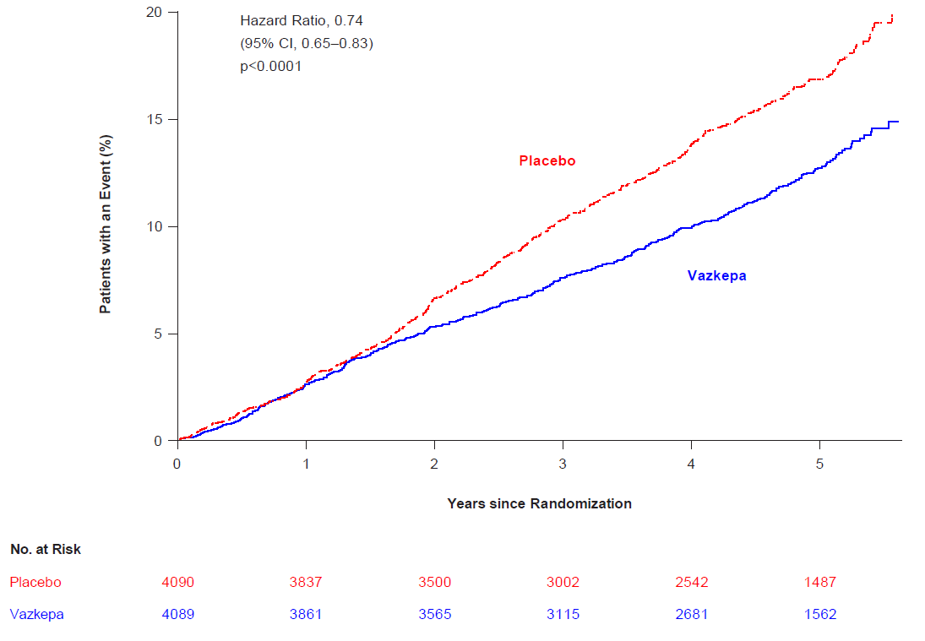
Key secondary composite endpoint consisted of cardiovascular death, myocardial infarction, or stroke (3-point MACE)
Abbreviations: CI confidence interval

The median TG and LDL-C baseline values were similar between the icosapent ethyl group and placebo group. The median change in TG from baseline to Year 1 was -0.4 mmol/L (-39 mg/dL, -18%) in the icosapent ethyl group and 0.1 mmol/L (5 mg/dL, 2%) in the placebo group. The median change in LDL-C from baseline to Year 1 was 0.1 mmol/L (2 mg/dL, 3%) in the icosapent ethyl group and 0.2 mmol/L (7 mg/dL, 10%) in the placebo group. Prespecified analyses of the effect of icosapent ethyl on cardiovascular outcomes in the REDUCE-IT trial showed little to no correlation between either TG or LDL-C response and cardiovascular effect based on baseline or on-study achieved TG or LDL-C levels. See section 5.1 Pharmacodynamic properties – Mechanism of action for more information.

5.2 Pharmacokinetic properties

Absorption
After oral administration, icosapent ethyl is de-esterified during the absorption process and the active metabolite EPA is absorbed in the small intestine and enters the systemic circulation mainly via the thoracic duct lymphatic system. Peak plasma concentrations of EPA were reached approximately 5 hours following oral doses of icosapent ethyl.
Icosapent ethyl was administered with or following a meal in all clinical studies; no food effect studies were performed (see section 4.2 Dose and method of administration).

Distribution
The mean volume of distribution at steady-state of EPA is approximately 88 liters. The majority of EPA circulating in plasma is incorporated in phospholipids, triglycerides and cholesteryl esters, and <1% is present as the unesterified fatty acid. Greater than 99% of unesterified EPA is bound to plasma proteins.

Metabolism
EPA is mainly metabolised by the liver via beta-oxidation similar to dietary fatty acids. Beta oxidation splits the long carbon chain of EPA into acetyl Coenzyme A, which is converted into energy via the Krebs cycle.

Excretion
Cytochrome P450-mediated metabolism is a minor pathway of elimination of EPA. The total plasma clearance of EPA at steady-state is 684 mL/hr. The plasma elimination half-life (t1/2) of EPA is approximately 89 hours. Icosapent ethyl does not undergo renal excretion.

Pharmacokinetic/ pharmacodynamic relationship(s)

Triglycerides level/ reduction in hypertriglyceridemia
A linear relationship between EPA levels in plasma or red blood cells (RBCs) and TG reduction was observed in two Phase III studies.

Cardiovascular risk reduction
Analyses of the primary (5-point) and key secondary (3-point) MACE endpoints suggest that on-treatment lipoprotein changes had limited influence on cardiovascular risk reductions, while on- treatment steady-state serum EPA levels accounted for the majority of the relative risk reduction observed in REDUCE-IT. Baseline serum EPA level was 26 μg/mL; compared to patients with an on-treatment steady-state serum EPA level below 100 μg/mL, patients with on-treatment EPA levels ≥175 μg/mL had a >50% reduced risk of a cardiovascular event.

Renal and hepatic impairment
The pharmacokinetics of icosapent ethyl has not been studied in patients with renal or hepatic impairment. Patients did not require routine dose adjustment due to hepatic or renal impairment in a well-controlled cardiovascular outcomes study of icosapent ethyl.

Elderly (≥ 65 years)
The pharmacokinetics of icosapent ethyl has not been studied in elderly patients. Elderly patients did not require routine dose adjustment in well-controlled clinical studies of icosapent ethyl.

Paediatric population
The pharmacokinetics of icosapent ethyl has not been studied in paediatric subjects.

5.3 Preclinical safety data

Genotoxicity
Nonclinical data reveal no special hazard for humans based on conventional genotoxicity studies.
Icosapent ethyl was not mutagenic with or without metabolic activation in the bacterial mutagenesis (Ames) assay or in the in vivo mouse micronucleus assay. A chromosomal aberration assay in Chinese Hamster Ovary (CHO) cells was positive for clastogenicity with and without metabolic activation, which appeared to be a class effect.

Carcinogenicity
Nonclinical data reveal no special hazard for humans based on conventional studies of carcinogenic potential.
In a 2-year rat carcinogenicity study with oral gavage doses of 90, 270 and 910 mg/kg/day icosapent ethyl, respectively, did not result in drug-related neoplasms (up to ~7-fold the clinical exposure based on AUC). While haemangiomas and haemangiosarcomas of the mesenteric lymph node were noted, overall incidence in all vascular tissues did not increase with treatment.
In a 6-month carcinogenicity study in Tg.rasH2 transgenic mice with oral gavage doses of 500, 1000, 2000 and 4600 mg/kg/day icosapent ethyl did not result in test-article related neoplasms (up to 4-fold the clinical exposure based on AUC). However, benign squamous cell papilloma in the skin and subcutis of the proximal tail were observed at the highest dose which appeared to be secondary to chronic irritation of the proximal tail associated with faecal excretion of oil.

6. Pharmaceutical Particulars

6.1 List of excipients
Capsule fill: dl-alpha-tocopherol
Capsule shell: Gelatin, glycerol, maltitol solution, sorbitol solution (70 per cent) (non-crystallising), purified water, medium chain triglycerides, lecithin
Printing ink: Titanium dioxide, propylene glycol, hypromellose.

6.2 Incompatibilities
Not applicable.

6.3 Shelf Life
In Australia, information on the shelf life can be found on the public summary of the Australian Register of Therapeutic Goods (ARTG). The expiry date can be found on the packaging.

6.4 Special precautions for storage
Store below 30°C.
Bottles: Keep bottle tightly close in order to protect from moisture.
Blisters: Store in the original package in order to protect from moisture.

6.5 Nature and contents of container
High density polyethylene (HDPE) bottle with child-resistant polypropylene heat induction sealed closure containing 120 soft capsules.
PVC/PCTFE/Al perforated unit dose blisters containing 4x2 soft capsules (sample only).
Not all pack sizes may be marketed.

6.6 Special precautions for disposal
In Australia, any unused medicine or waste material should be disposed of by taking to your local pharmacy.

6.7 Physicochemical properties

Chemical structure:
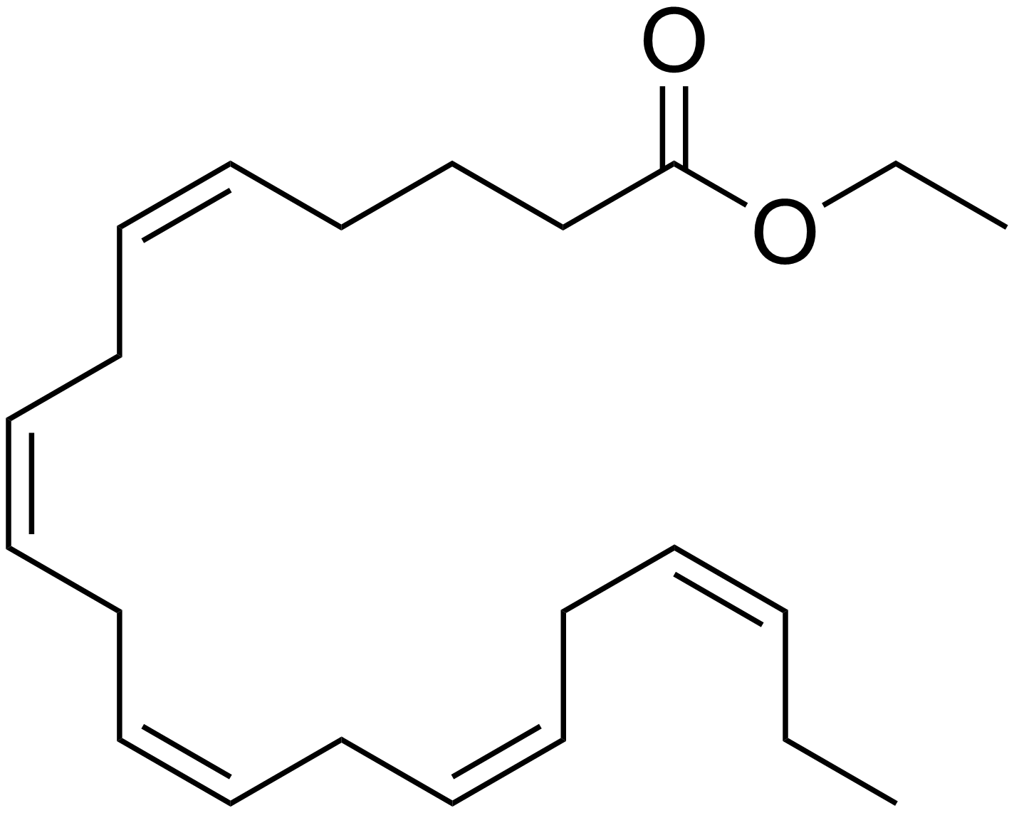

CAS number:
73310-10-8

7. Medicine Schedule (Poisons standard)
S4 – Prescription Only Medicine

8. Sponsor
AA-Med Pty Ltd
Suite 4, Level 10/ 1 Chandos Street
St Leonards NSW 2065

9. Date of First Approval
08 November 2022

10. Date of REVISION
Not applicable

Summary table of changes
Section changed | Summary of new information
All | New

Australian Pregnancy Category B1: Drugs which have been taken by only a limited number of pregnant women and women of childbearing age, without an increase in the frequency of malformation or other direct or indirect harmful effects on the human fetus having been observed. Studies in animals have not shown evidence of an increased occurrence of fetal damage.

