Australian Public Assessment Report for Welireg
  - Active ingredient: Belzutifan
  - Sponsor: Merck Sharp & Dohme (Australia) Pty Ltd
September 2023

About the Therapeutic Goods Administration (TGA)
- The Therapeutic Goods Administration (TGA) is part of the Australian Government Department of Health and Aged Care and is responsible for regulating therapeutic goods, including medicines, medical devices, and biologicals.
- The TGA administers the Therapeutic Goods Act 1989 (the Act), applying a risk management approach designed to ensure therapeutic goods supplied in Australia meet acceptable standards of quality, safety, and efficacy.
- The work of the TGA is based on applying scientific and clinical expertise to decision-making, to ensure that the benefits to the Australian public outweigh any risks associated with the use of therapeutic goods.
- The TGA relies on the public, healthcare professionals and industry to report problems with therapeutic goods. The TGA investigates reports received to determine any necessary regulatory action.
- To report a problem with a therapeutic good, please see the information on the TGA website.

About AusPARs
- The Australian Public Assessment Report (AusPAR) provides information about the evaluation of a prescription medicine and the considerations that led the TGA to approve or not approve a prescription medicine submission. Further information can be found in Australian Public Assessment Report (AusPAR) guidance.
- AusPARs are prepared and published by the TGA.
- AusPARs are static documents that provide information that relates to a submission at a particular point in time. The publication of an AusPAR is an important part of the transparency of the TGA’s decision-making process.
- A new AusPAR may be provided to reflect changes to indications or major variations to a prescription medicine subject to evaluation by the TGA.

Copyright
© Commonwealth of Australia 2023
This work is copyright. You may reproduce the whole or part of this work in unaltered form for your own personal use or, if you are part of an organisation, for internal use within your organisation, but only if you or your organisation do not use the reproduction for any commercial purpose and retain this copyright notice and all disclaimer notices as part of that reproduction. Apart from rights to use as permitted by the Copyright Act 1968 or allowed by this copyright notice, all other rights are reserved and you are not allowed to reproduce the whole or any part of this work in any way (electronic or otherwise) without first being given specific written permission from the Commonwealth to do so. Requests and inquiries concerning reproduction and rights are to be sent to the TGA Copyright Officer, Therapeutic Goods Administration, PO Box 100, Woden ACT 2606 or emailed to <tga.copyright@tga.gov.au>.

Contents
List of abbreviations 4
Product submission 6
Submission details 6
Product background 7
Regulatory status 9
Product Information 10
Registration timeline 10
Submission overview and risk/benefit assessment 11
Quality 11
Nonclinical 12
Clinical 14
Summary of clinical studies 14
Pharmacology 14
Efficacy 17
Safety 24
Risk management plan 29
Risk-benefit analysis 30
Delegate’s considerations 30
Proposed action 33
Independent expert advice 33
Proposed action post-independent expert advice 34
Advisory Committee considerations 34
Outcome 34
Specific conditions of registration applying to these goods 34
Attachment 1. Product Information 35

List of abbreviations
Abbreviation | Meaning
AE | Adverse event
ARTG | Australian Register of Therapeutic Goods
ASA | Australia specific annex
AUC | Area under the concentration time curve
AUC_{0-tau} | Area under the concentration time curve from time zero to the end of the dosing period
AUC_{0-24h} | Area under the concentration time curve from time zero to24 hours
BCRP | Breast cancer resistant protein
CI | Confidence interval
C_{max} | Maximum concentration
CMI | Consumer Medicines Information
CNS | Central nervous system
CYP2C19 | Cytochrome P450 isoenzyme 2C19
CYP3A | Cytochrome P450, family 3, subfamily A
CYP3A4 | Cytochrome P450 isoenzyme 3A4
DOR | Duration of response
ECOG | Eastern Cooperative Oncology Group
ESA | Erythropoietin stimulating agents
FDA | Food and Drug Administration (United States of America)
GVP | Good Pharmacovigilance Practices
HIF-1α | Hypoxia-inducible factors 1 alfa
HIF-2α | Hypoxia-inducible factors 2 alfa
HIF-1β | Hypoxia-inducible factors 1 beta
IC₅₀ | Half maximal inhibitory concentration
IRC | Independent Review Committee
MATE | Multidrug and toxin extrusion protein
MK-6482 | Sponsor’s code for belzutifan
MRP | Multi-drug resistance protein
OATP | Organic anion transporting polypeptide
OCT | Organic cation transporter
ORR | Overall response rate
PD | Pharmacodynamic(s)
PFS | Progression free survival
PI | Product Information
PK | Pharmacokinetic(s)
pNET | Pancreatic neuroendocrine tumour
popPK | Population pharmacokinetic(s)
PSUR | Periodic safety update report
RCC | Renal cell carcinoma
RECIST | Response Evaluation Criteria In Solid Tumours
RMP | Risk management plan
SAE | Serious adverse event
TGA | Therapeutic Goods Administration
TTR | Time to Response
TTS | Time to surgery
UGT2B17 | Uridine 5’-diphosphoglucuronosyltransferase 2B17
VHL | Von Hippel-Lindau disease
US(A) | United States (of America)

Product submission

Submission details
Type of submission: | New chemical entity
Product name: | Welireg
Active ingredient: | Belzutifan
Decision: | Approved
Date of decision: | 20 December 2022
Date of entry onto ARTG: | 22 December 2022
ARTG number: | 355338
Black Triangle Scheme  for the current submission: | Yes  This product will remain in the scheme for 5 years, starting on the date the product is first supplied in Australia.
Sponsor’s name and address: | Merck Sharp & Dohme (Australia) Pty Limited  North Ryde Post Business Centre, Locked Bag 2234  North Ryde BC NSW 1670
Dose form: | Film-coated tablet
Strength: | 40 mg
Container: | Bottle
Pack size: | 90
Approved therapeutic use for the current submission: | Welireg (belzutifan) is indicated for the treatment of adult patients with von Hippel Lindau (VHL) disease who require therapy for associated renal cell carcinoma (RCC), central nervous system (CNS) haemangioblastomas, or pancreatic neuroendocrine tumours (pNET), not requiring immediate surgery.
Route of administration: | Oral
Dosage: | The recommended dose is 120 mg (three 40 mg tablets) administered orally once daily, with or without food.  Dosage modifications for Welireg for adverse reactions are summarised in Section 4.2 of the Product Information.  For further information regarding dosage, refer to the Product Information.
Pregnancy category: | D  Drugs which have caused, are suspected to have caused or may be expected to cause, an increased incidence of human fetal malformations or irreversible damage. These drugs may also have adverse pharmacological effects. Accompanying texts should be consulted for further details.  The use of any medicine during pregnancy requires careful consideration of both risks and benefits by the treating health professional. This must not be used as the sole basis of decision making in the use of medicines during pregnancy. The TGA does not provide advice on the use of medicines in pregnancy for specific cases. More information is available from obstetric drug information services in your state or territory.

Product background
This AusPAR describes the submission by Merck Sharp & Dohme (Australia) Pty Ltd (the sponsor) to register, via the provisional pathway, Welireg (belzutifan) 40 mg tablets for the following proposed indication:
Welireg is indicated for treatment of adult patients with von Hippel-Lindau (VHL) disease who require therapy for associated renal cell carcinoma not requiring immediate surgery.
After evaluation commenced, and with the consent of the TGA. the sponsor amended the regulatory pathway from the provisional pathway to the standard pathway, obtained orphan designation for an expanded indication, and extended the proposed indication for registration to:
Welireg is indicated for treatment of adult patients with von Hippel-Lindau (VHL) disease who require therapy for associated renal cell carcinoma, central nervous system (CNS) haemangioblastomas, or pancreatic neuroendocrine tumours (pNET), not requiring immediate surgery.
Von Hippel-Lindau (VHL) disease is an inherited autosomal dominant condition caused by deletion or mutation in the VHL gene. The VHL gene is on chromosome 3p25. Individuals have 2 copies of the gene. A ‘two-hit’ model for VHL disease is understood. Often, one gene copy is affected by germline loss of function, with the other copy also affected through somatic changes or deletion of the second allele or through hypermethylation of its promotor. Somatic pathogenic variants in both alleles have been reported.
The VHL protein forms stable complexes with other proteins, which together target certain proteins for proteasomal degradation. In addition, the VHL protein is important for other cellular functions including maintenance of the primary cilium, regulation of cytokinesis, control of microtubule function, extracellular matrix integrity, and regulation of the cell cycle.
Regulation of hypoxia-inducible factors 1α and 2α (HIF-1α and HIF-2α) is another important function of the VHL protein that may contribute to a microenvironment conducive to tumour formation. In conditions of normal oxygen tension and normal VHL gene expression HIF-1α and HIF-2α undergo hydroxylation, bind to the VHL protein complex, and are degraded by proteasomes. In conditions of low oxygen tension, the hydroxylation does not occur, proteasome degradation does not occur, and these factors produce a physiological angiogenic response to local hypoxia. Loss of function of the VHL gene and the protein in the complex may result by various mechanisms in increased levels of HIF-1α and HIF-2α.
Von Hippel-Lindau disease, phenotypically, is characterised by the growth of both benign and malignant tumours in various organs. Tumours usually first appear in young adults. Tumours commonly associated with VHL include clear cell renal cell carcinoma (RCC), pancreatic neuroendocrine tumours (pNET), central nervous system (CNS) haemangioblastomas, retinal angiomas, phaeochromocytomas, kidney cysts and endolymphatic sac tumours., Signs and symptoms vary depending on tumour location and size.
Renal cell carcinoma occurs in approximately 70% of patients with VHL by age 60 years and is the leading cause of death in this patient population.³ VHL associated RCC is characteristically multifocal and bilateral. Tumours larger than 3 cm may increase in grade as they grow, and metastases may occur. VHL associated hemangioblastomas are often multifocal. The mean age of onset is 29.1 years. In a prospective study, 72% of the 225 patients studied developed new CNS hemangioma lesions. The mean age of VHL associated pNET diagnosis is 38 years. The tumours tend to be non-functional but can metastasise. The risks are lower with primary lesions up to 3 cm, patients without an exon 3 pathogenic variant, and with slow doubling time (over 500 days).
Families with VHL disease are divided into two types, types 1 and 2, based on the likelihood of developing phaeochromocytoma. Patients with VHL disease type 1 have a low incidence of phaeochromocytoma. VHL type 1 disease is further classified into type 1A with a substantially lower risk of a phaeochromocytoma, and type 1B, due to a specific type of deletion near the BRTK1 gene and associated with a lower risk of both phaeochromocytoma and RCC, but at higher risk for other VHL associated lesions. Patients with VHL disease type 2 have a high risk of developing phaeochromocytoma. VHL disease type 2 is further classified into types 2A, 2B, and 2C based on the risk of developing RCC.² The incidence of RCC is low in type 2A and high in type 2B VHL disease. Patients with type 2C VHL disease only develop phaeochromocytoma.
At the time of submission of the application there was no medicine approved for use for the tumours associated with VHL in Australia. The clinical management of VHL disease associated tumours requires a skilled and dedicated multidisciplinary team committed to lifelong management of patients affected with this disorder.
Current management of patients with VHL disease most often involves extensive lifelong surveillance and multiple surgeries on the kidneys, pancreas, adrenal glands, brain, and/or spinal cord, with the aim of tumour management and reduction in the risk of tumour related complications while minimising loss of unaffected tissue with the aim of preservation of organ function for as long as possible.
Management of VHL disease associated RCC requires active monitoring of tumour size. Nephron-sparing surgery for RCC is generally considered when the largest tumour reaches 3 cm in size. For patients with metastatic disease, treatment is similar to that for non-VHL RCC, and may include systemic therapies such as tyrosine kinase inhibitors and checkpoint inhibitors.
For pNETs, surgical removal is recommended for larger tumours (diameters 3 cm and greater in the pancreatic body and 2 cm and greater in the head) due to risk of malignancy. For VHL disease associated CNS haemangioblastomas, surgical resection or radiotherapy techniques may be considered, depending on symptoms, rate of tumour growth, and risk of compromise due to mass effect or haemorrhage.²
Belzutifan is an inhibitor of HIF-2α, a transcription factor that plays a role in oxygen sensing by regulating genes that promote adaptation to hypoxia. Under normal oxygen levels, HIF-2α is targeted for ubiquitin-proteasomal degradation by VHL protein. Lack of functional VHL protein results in stabilisation and accumulation of HIF-2α. Upon stabilisation, HIF-2α translocates into the nucleus and interacts with HIF-1β domains to form a transcriptional complex that induces expression of downstream genes, including genes associated with cellular proliferation, angiogenesis, and tumour growth. Belzutifan binds to HIF-2α, and in conditions of hypoxia or impairment of VHL protein function, belzutifan blocks the HIF-2α-HIF-1β interaction, leading to reduced transcription and expression of HIF-2α target genes.
This evaluation was facilitated through Project Orbis, an initiative of the United States Food and Drug Administration (FDA) Oncology Center of Excellence. Under this project, the FDA, Health Canada, the United Kingdom’s Medicines and Healthcare products Regulatory Agency and the TGA collaboratively reviewed the submission. This evaluation process provided a framework for process alignment and management of evaluation issues in real-time across jurisdictions. Each regulator made independent decisions regarding approval (market authorisation) of the new medicine.

Regulatory status
This product is considered a new chemical entity for Australian regulatory purposes.
This product received orphan drug designation on 9 February 2021 for the following indication:
treatment of von Hippel-Lindau (VHL) disease
At the time the TGA considered this submission, a similar submission had been approved in the United States of America on 13 August 2021, Great Britain on 31 May 2022 and Canada on 11 July 2022. A similar submission was under consideration in Brazil (submitted on 7 June 2021).
The following table summarises these submissions and provides the indications where approved.
Table 1: International regulatory status
Region | Submission date | Status | Approved indications
United States of America | 15 January 2021 | Approved on 13 August 2021 | Welireg is a hypoxia-inducible factor inhibitor indicated for treatment of adult patients with von Hippel-Lindau (VHL) disease who require therapy for associated renal cell carcinoma (RCC), central nervous system (CNS) haemangioblastomas, or pancreatic neuroendocrine tumours (pNET), not requiring immediate surgery.
Great Britain | 24 February 2021 | Approved on 31 May 2022 | Welireg is indicated for the treatment of adult patients with von Hippel-Lindau (VHL) disease who require therapy for VHL-associated renal cell carcinoma (RCC) central nervous system (CNS) haemangioblastomas, or pancreatic neuroendocrine tumours (pNET), and for whom localised procedures are unsuitable or undesirable.
Canada | 6 July 2021 | Approved on 11 July 2022 | Welireg is indicated for:  The treatment of adult patients with von Hippel-Lindau (VHL) disease who require therapy for associated non-metastatic renal cell carcinoma (RCC), not requiring immediate surgery.  Efficacy in patients with VHL-disease-associated RCC was based on objective response rate and duration of response in a single-arm study (see 14 Clinical Trials).
Brazil | 7 June 2021 | Under consideration | Under consideration

Product Information
The Product Information (PI) approved with the submission which is described in this AusPAR can be found as Attachment 1. For the most recent PI and Consumer Medicines Information (CMI), please refer to the TGA PI/CMI search facility.

Registration timeline
The following table captures the key steps and dates for this submission.
This submission was evaluated under the standard prescription medicines registration process.
Table 2: Timeline for Submission PM-2021-00644-1-4
Description | Date
Designation (Orphan) | 9 February 2021†  2 February 2022‡
Submission dossier accepted and first round evaluation commenced | 31 March 2021
First round evaluation completed | 14 September 2021
Sponsor provides responses on questions raised in first round evaluation | 15 November 2021
Second round evaluation completed | 14 January 2022
Delegate’s Overall benefit-risk assessment | 14 October 2022
Sponsor’s pre-Advisory Committee response | Not applicable
Advisory Committee meeting | Not applicable
Registration decision (Outcome) | 20 December 2022
Administrative activities and registration on the ARTG completed | 22 December 2022
Number of working days from submission dossier acceptance to registration decision* | 247
*Statutory timeframe for standard submissions is 255 working days.
† Orphan designation related to initial (narrower) indication sought by sponsor.
‡ Orphan designation related to later (broader) indication amended during course of evaluation.

Submission overview and risk/benefit assessment
This section is a TGA summary of wording used in TGA’s evaluation reports, which discussed numerous aspects of overseas evaluation reports and included some information that was commercial-in-confidence.
Relevant guidelines or guidance documents referred to by the Delegate are listed below:
- European Medicines Agency (EMA), Committee for Human Medicinal Products (CHMP), Guideline on the Investigation of Drug Interactions, CPMP/EWP/560/95/Rev. 1 Corr. 2, 21 June 2012.
- National Comprehensive Cancer Network (NCCN) Guidelines Neuroendocrine and Adrenal Tumors.

Quality
The quality evaluation concluded there was no objection to the registration of belzutifan 40 mg film coated tablets in a bottle based on the pharmaceutical chemistry aspects.
The drug substance (belzutifan) contains three chiral stereocentres. It is chemically synthesised and manufactured as a white to light brown powder. Belzutifan is considered as a Biopharmaceutics Classification System (BCS) low soluble drug substance. Stability data were provided to support a retest period of 24 months when stored below 25°C.
The structure of belzutifan is shown in Figure 1.
Figure 1: Chemical structure for belzutifan
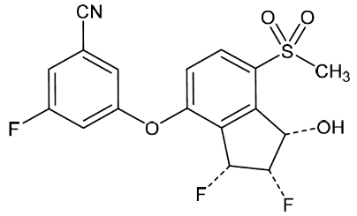

The stereochemistry is adequately controlled. The starting materials are satisfactorily defined, and the manufacturing process is adequately controlled. The drug substance specification is adequate to control the quality of the drug substance. All impurity limits are acceptable.
The drug product is a film-coated, blue, oval shaped tablet, debossed with markings ‘177’ on one side. The excipients are conventional for the dosage form. The stability data provided support the proposed shelf-life of 24 months when stored below 30°C.
The drug product specification adequately controls the quality of the tablets.

Nonclinical
The nonclinical evaluation found that the pharmacology studies support the proposed indication and do not raise any safety concerns. Key findings of the evaluation are as follows.
Belzutifan is a small molecule, first-in-class hypoxia-inducible factor (HIF-2α) inhibitor. Belzutifan bound to the Per-ARNT-Sim-B domain of HIF-2α with a half maximal inhibitory concentration (IC₅₀) ≤ 15 nM. It interfered with heterodimerisation of HIF-2α and inhibited hypoxia-response elements driven luciferase activity with an IC₅₀ ≤ 18 nM and expression of HIF-2α downstream genes in vitro and in vivo. Belzutifan did not interrupt dimerisation of HIF-1α or inhibit transcription of HIF-1α genes. Belzutifan also demonstrated anti-tumour activity in mouse VHL-deficient RCC xenograft models. The major human glucuronide metabolite, PT3317, is not pharmacologically active. Nonclinical pharmacology studies support the use of belzutifan for the proposed clinical indication.
In secondary pharmacology studies, belzutifan at concentrations up to [information redacted]did not show off-target activity against screening panels consisting of 78 receptors, 8 ion channels, 40 protein kinases, and 2 protein phosphatases. Potential secondary target effects cannot be excluded.
Belzutifan was mainly metabolised via glucuronidation by UGT2B17, and via oxidative metabolism by cytochrome P450 isoenzyme 2C19 (CYP2C19) and to a lesser extent by CYP3A4. In vitro data showed no unique human metabolites in nonclinical and human liver microsomes or hepatocytes. Drug-related material was mainly excreted via faeces in all species and bile in bile duct-cannulated rats with low renal clearance across species. Therefore, metabolism and possibly hepatobiliary elimination is the mechanism of clearance of belzutifan and its metabolites.
Belzutifan is mainly metabolised by UGT2B17 and CYP2C19: inhibitors and inducers of these enzymes may increase and decrease belzutifan exposure, respectively. Belzutifan in vitro was a weak substrate of P-glycoprotein, organic anion transporting polypeptide (OATP)1B1 and OATP1B3, not a substrate of breast cancer resistant protein (BCRP) or multi-drug resistance protein (MRP) 2, and highly permeable across Lewis Lung Carcinoma and Madin-Darby canine kidney cell monolayers. It was considered unlikely that inhibition of P-glycoprotein or OATP will have clinically relevant impact on belzutifan exposures. Belzutifan was an inducer of CYP3A4 in vitro and may reduce the exposure of CYP3A4 substrates on co-administration. Belzutifan, as well as the glucuronide metabolite, inhibit multidrug and toxin extrusion protein 2K (MATE2K) in vitro with IC₅₀ of 0.7 μM (below the clinical free maximum concentration, C_{max}) and 15 μM, respectively, and is expected to increase exposure of drugs that are predominantly eliminated by MATE2K. It also inhibits multidrug and toxin extrusion protein 1 (MATE1) in vitro with IC₅₀ 39 μM and might reduce the clearance of MATE1 substrates. Inhibition of the hepatocyte uptake transporter organic cation transporter (OCT)1 was also observed in vitro (IC₅₀ 47 μM, approximately 8 times the estimated hepatic inlet concentration), and thus it could reduce the hepatic clearance of OCT1 substrates. Belzutifan is not an inhibitor of CYP450, UGT enzymes, or major uptake (OATP1B1, OATP1B3, OCT2, organic anion transporter 1, and organic anion transporter 3) or efflux (P-glycoprotein, BCRP and bile salt export pump) transporters in vitro at clinically relevant concentrations. The major human glucuronide metabolite PT3317 was a substrate of both OATP1B1 and OATP1B3 and efflux transporters MRP2 and MRP3.
No acute toxicity studies were conducted. In the repeat dose toxicity studies in dogs and rats dose exposure was limited by toxicity. Major toxicities included reversible decreases in red blood cell parameters (for example, red blood cell counts, haemoglobin concentration, and haematocrit) in both rats and dogs, and reproductive organs were affected in male rats. Anaemia observed in the toxicity studies is consistent with findings in HIF-2α knockout mice and in human clinical studies. Testes and epididymis were the major target organs in the rat studies and suggest male fertility is likely to be affected. Belzutifan had no adverse effects on male reproductive organs in repeat-dose studies in dogs. No specific fertility studies were conducted. No ocular or dermal toxicity was demonstrated.
Belzutifan was not genotoxic but was teratogenic, with embryo-fetal lethality in rats. Belzutifan was associated with post implantation loss in pregnant rats at doses at and above 60 mg/kg/day (exposure ratio based on AUC approximately 1) in the pilot embryo-fetal development study. Pregnancy category D has been accepted.
Carcinogenicity studies were not included in the submission. Patients will be at a relatively young age when commencing therapy, and therapy is intended to be long-term, if tolerated. The evaluation notes that carcinogenicity studies in mice and rats will therefore be required, post-approval.
The proposed limit for 8 impurities in the drug substance was adequately qualified in the submitted nonclinical data.

Clinical

Summary of clinical studies
The clinical dossier consisted of:
- eight Phase I studies:
  - Study MK-6482-001 (referred to as Study 001 hereafter) is a dose escalation and expansion study in patients with advanced solid tumours that progressed or were intolerant to standard of care. This study provides pharmacokinetics (PK), pharmacodynamics (PD) and supportive safety data
  - Study P002: A single-dose, open-label, randomised, food-effect study in healthy volunteers
  - Protocol P014: A study to assess the effect of food on the PK of belzutifan in healthy volunteers – planned
  - Study P006: A phase 1, randomised, open-label, single-centre, 3-way cross-over study to compare the bioavailability, PK, and safety of belzutifan for formulations A and B in healthy volunteers
  - Study P008: A study to investigate the absorption, metabolism, excretion, and mass balance of belzutifan in healthy adults – ongoing
  - Study P007: A single-dose clinical study to evaluate the PK of belzutifan in healthy Japanese and Caucasian female patients
  - Study P009: A study to evaluate the effect of multiple doses of belzutifan on the PK of midazolam in healthy participants – ongoing
  - Protocol P017: A study to evaluate the effect of multiple doses of rifampin (strong CYP2C19 inducer) on the PK of belzutifan in healthy participants – planned
- one Phase II study:
  - Study MK-6482-004 (referred to as Study 004 hereafter) is the pivotal study for this submission. It is an ongoing, single arm, open label study designed to evaluate the safety and efficacy of belzutifan in patients with VHL disease and at least one measurable RCC tumour (as defined by RECIST 1.1)
- a natural history study
- a population pharmacokinetics (popPK) analysis based on 5,291 measurable observations from 239 subjects.

Pharmacology
Hypoxia-inducible factors 2α (HIF-2α) is overexpressed in many tumours. Belzutifan inhibits HIF-2α by binding to it and preventing heterodimerisation and subsequent binding to DNA. This decreases transcription and expression of HIF-2α genes that regulate hypoxic signalling and promote tumour survival.
The pivotal Study 004 and supportive Study 001 provide the main pharmacology data for belzutifan. Study 001 was a Phase I, dose escalation and expansion trial of belzutifan in patients with advanced solid tumours. The study included 95 patients with solid tumours who received multiple daily belzutifan doses ranging from 20 mg to 240 mg, and 83 healthy participants who received single doses of belzutifan up to 200 mg.
The Study 004 is a Phase II, single arm, open label study to evaluate the efficacy and safety of belzutifan in patients with VHL disease associated RCC, not requiring immediate surgery.

Pharmacokinetics

Absorption
Belzutifan is a substrate of P-glycoprotein.
Belzutifan maximum plasma concentrations were reached within 1 to 2 hours of administration of the 120 mg dose to advanced solid tumour patients. The C_{max} and area under the concentration time curve from time zero to the end of the dosing period (AUC_{0-tau}) increased with increasing doses from 20 mg to 120 mg. At 240 mg, the values for C_{max} and AUC_{0-tau} were similar to these parameters at 120 mg, suggesting a plateau of exposure at higher doses. Single dose observed mean C_{max} and AUC values were generally similar between healthy participants, those with VHL disease, and those with non-VHL disease.
Absolute bioavailability has not been determined.

Distribution
Belzutifan is extensively distributed to the tissues (apparent volume of distribution (using non-compartmental analysis) is 138 L (coefficient of variation 28%)). Protein binding is 45%. The popPK analysis found the total apparent volume of distribution to be 130 L in VHL RCC patients after a 120 mg oral dose.

Metabolism
In vitro, belzutifan is metabolised via the polymorphic enzymes UGT2B17 and CYP2C19. The impact of functional variants of these enzymes on belzutifan PK was assessed in Study 007 and using the population pharmacokinetic data. The absorption, distribution, metabolism and excretion study (Study 008) in healthy adults is ongoing and is expected to provide further data.
Accumulation of belzutifan shown by the ratio of area under the concentration time curve from time zero to 24 hours (AUC_{0-24h}) values ranged from 1.27 to 1.54 on Day 15 relative to Day 1.

Elimination
Mean half-life at steady state ranged from 12.9 to 21.5 hours across the 20 to 240 mg dose range. At 120 mg, the mean terminal half-life is 14 hours. Routes of elimination have not yet been established; a mass balance study (Study 008) is ongoing.

Dose selection
Dose selection was based on the PK, PD, and safety information from Study 001. The plateauing of exposure at doses higher than 120 mg once daily, PD response, and suppression of erythropoietin at higher doses justified the selection of the 120 mg once daily dose.

Drug interactions
Study 009 examined the effect of belzutifan, a CYP3A inducer, on the PK of midazolam. Midazolam exposure decreased by 40% when co-administered with belzutifan. Physiologically based PK modelling predicted midazolam exposure may decrease by up to 70% in the patients with high exposure to belzutifan (for example, in dual UGT2B17 and CYP2C19 poor metabolisers).
The efficacy of oral hormonal contraceptives, which are CYP3A4 substrates, may be reduced by belzutifan. The proposed PI contains a warning about the potential for contraceptive failure.
There was no clinically significant food effect on belzutifan PK.

Population pharmacokinetic data
A popPK analysis evaluated the effect of intrinsic factors (age, sex, weight, mild to moderate renal impairment, hepatic impairment) and extrinsic factors (inhibition of UGT2B17 or CYP2C19) on belzutifan exposures. These factors were found to increase belzutifan exposure by 30% to 60%, however, this did not have a clinically significant effect on the efficacy of belzutifan. In terms of safety, the primary adverse reaction was anaemia, which occurred weeks after treatment initiation (median onset approximately 10 weeks) and can be clinically monitored. Therefore, no dose modifications were recommended for safety or efficacy reasons.
The popPK analysis shows that patients who are dual UGT2B17 and CYP2C19 poor metabolisers are predicted to have significantly higher exposures to belzutifan (3.2-fold), compared to normal UGT2B17 metabolisers and CYP2C19 non-poor metabolisers. Thus, dual poor metabolisers should be monitored closely for adverse reactions. The sponsor has added a warning in the PI.
The sponsor states that approximately 0.5% of the US population are estimated to be dual UGT2B17 and CYP2C19 poor metabolisers. Table 3 summarises the estimated frequency of each phenotype in particular ethnic groups.
Table 3: CYP2C19 and UGT2B17 expected poor metaboliser frequency
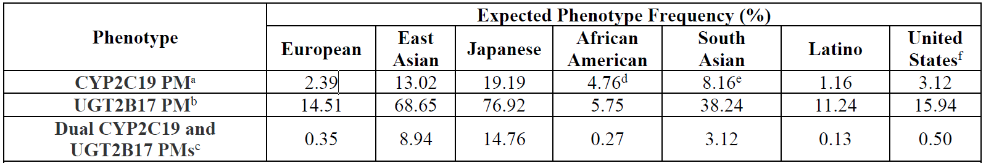
Abbreviations: CYP2C19=cytochrome P450 enzyme 2C19; PM=poor metaboliser; UGT2B17=uridine diphosphate glucuronosyltransferase 2B17.
a CYP2C19 Frequencies and phenotype definitions from PHARMGKB (2020), except for Japanese column derived from Man et al (2010).
b Frequencies from 1000 genomes Phase3v5. Frequencies for Latinos taken from ‘Admixed American’ category; frequencies for African Americans taken from ‘African’ category.
c Expected frequency for dual-PMs is calculated by multiplying frequency of CYP2C19 and UGT2B17 PM, assuming the incidence of each is independent in each population.
d Frequency is calculated across both African-American and Afro-Caribbean populations, however the majority of subjects used to generate the estimate are African-American.
e Frequency is calculated across both South and Central Asians, however the majority of subjects used to generate the estimate are South Asian.
f Derived from CYP2C19 frequencies and phenotype definitions from PHARMGKB (2020), UGT2B17 frequencies from 1000 Genomes Phase 3v5, weighted by expected frequencies of each race/ethnic group from the American Community Survey 2018 1-Year estimates: 60.2% White, 18.3% Hispanic or Latino, 12.3% Black or African-American, 4.3% East Asian, 1.3% Asian Indian (imputed as South Asian), and 3.6% Other (assume phenotype frequencies for Other category is the average of the reported frequencies for Europeans, East Asians, African Americans, South Asians and Latinos).
It is possible that the proportion of dual poor metabolisers may differ between the Australian and US populations, due to the higher proportion of people identifying as having Southeast and East Asian descent in Australia. CYP2C19 poor metaboliser status has also been identified among Australian Aboriginal and Torres Strait Islander peoples.

Pharmacodynamics
Circulating erythropoietin levels represent an on-target PD marker of belzutifan activity, as HIF-2α is the main transcription factor responsible for regulating erythropoietin synthesis in the kidney and liver. In patients with advanced solid tumours, serum erythropoietin levels decreased within hours after the first dose of belzutifan, and continued to decrease, plateauing at 2 to 3 weeks after the start of treatment. Erythropoietin reduction ranged from -36% to -76% from Baseline and was generally dose dependent up to 120 mg. Between 120 mg and 240 mg, the reductions in erythropoietin were of similar magnitude. In contrast to solid tumour patients, VHL RCC patients experienced an initial decline in erythropoietin levels, but then a gradual increase back to Baseline after 12 weeks of treatment.
Linear logistic regression modelling predicted a greater risk of Grade 3 anaemia with a baseline haemoglobin of 10 g/dL, than 12 g/dL (median for Study 001) and markedly higher than 14 g/dL (median for Study 004).
Data from Study 004 were used to assess the effect of belzutifan concentrations on QTc interval and did not demonstrate a QTc prolongation of over 20 msec within the observed plasma concentrations (at the 120 mg daily dose).

Efficacy

Study MK-6482-004
This is an ongoing, single arm, Phase II, open label study, and the pivotal study for this submission. Sixty-one (61) patients with VHL disease and at least one measurable RCC tumour (not requiring immediate surgery) were enrolled. Patients who had had prior systemic anti-cancer therapy or a history of metastatic disease were excluded. Subjects received belzutifan 120 mg orally once daily until unacceptable toxicity or disease progression. Radiological evaluation of RCC tumours by an Independent Review Committee (IRC) took place every 12 weeks. Radiographic assessments of other non-RCC VHL associated lesions present at screening were also undertaken by IRC.
The primary endpoint was overall response rate (ORR) for VHL disease associated RCC (per RECIST 1.1). Secondary endpoints included ORR for non-RCC tumours, and duration of response (DOR), time to response (TTR), progression free survival (PFS) and time to surgery (TTS) for all VHL associated tumours.
The sponsor initially submitted a report with a data cut-off date of 1 June 2020, and later provided updated ORR results with a data cut-off date of 1 December 2020. Relevant results from both data sets are discussed in this report.

Participants
Key inclusion criteria were: diagnosis of VHL disease based on germline VHL alteration; one or more measurable solid RCC tumour and no RCC tumour wider than 3 cm that requires immediate surgical intervention (histological diagnosis not needed); Von Hippel-Lindau disease associated disease in other organs permitted; Eastern Cooperative Oncology Group (ECOG) Performance Status 0 to 1.
Key exclusion criteria were: any systemic anticancer therapy (anti-vascular endothelial growth factor or any systemic investigational agent); surgical procedure for VHL disease or any major surgical procedure within or 4 weeks prior to enrolment; radiotherapy within 4 weeks prior to enrolment; immediate need for surgery for tumour; metastatic disease on screening imaging; malabsorption due to prior gastrointestinal surgery or disease; major cardiovascular event within or 6 months prior to enrolment.
The study enrolled 61 participants. Five participants discontinued as at the 1 June 2020 data cut-off: 3 due to patient decision, and one each due to death and adverse event. Table 4 below describes baseline patient characteristics.
The sample size was based on a plan to enrol around 50 patients. No formal hypothesis testing was planned but the sample size was based on a null hypothesis that the ORR is 15% and that for the alternative hypothesis the ORR is 30%. A sample size of 50 would give the study an 80% power to reject the null under the alternative hypothesis using a one-sided test to 0.05 significance.
There were 7 major amendments to the protocol, of which 4 related to pregnancy testing and contraception. Protocol version 3 and 4 included additional information on tablet formulation changes, and protocol 4 added PK sampling to confirm exposure with the new tablet formulation. Major protocol variations were identified for 3 patients; one patient had an ECOG Performance Status of 2,²⁰ one had treatment delays related to coronavirus disease of 2019 and one had delayed treatment due to an adverse event (AE) of abdominal pain. None resulted in patient exclusion from the study.
Of the 61 participants, most were white, and most had an ECOG Performance Status of 0. Ages ranged from 19 to 66 years. Most (83.6%) participants had type 1 VHL, and all participants had other non-RCC VHL associated tumours in addition to the RCC required for inclusion in the study.
Table 4: Study 004 Baseline patient characteristics
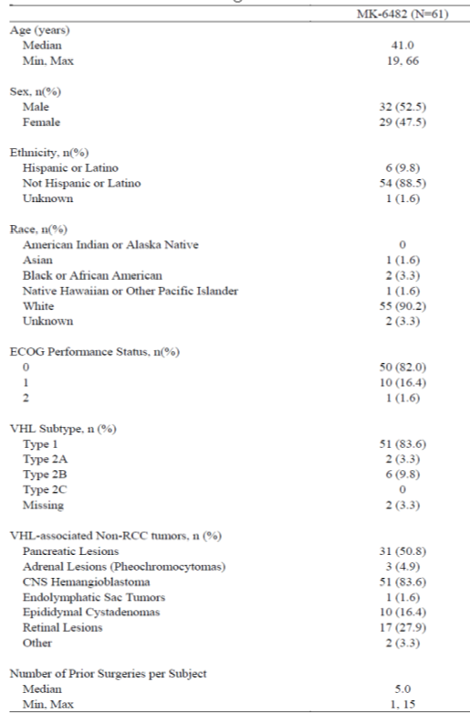
Abbreviations: CNS = central nervous system; ECOG = Eastern Cooperative Oncology Group;²⁰ max = maximum; min = minimum; MK-6482 = sponsor’s code for belzutifan; N = number of participants in cohort; n = number of participants contributing to the analysis.
Date of data cut-off: 1 June 2020
As per IRC assessment, all 61 patients had pancreatic lesions (cysts, adenomas and pNET) in addition to RCC; 22 patients had pNET; 50 patients had CNS haemangioblastomas; and 17 patients had retinal haemangioblastomas. By the 1 December 2020 data cut, 57 participants (93.4%) had received belzutifan for 12 months or longer and 55 participants (90.2%) for 18 months or longer.

Results

Overall response rate for renal cell carcinoma
For VHL associated RCC, the ORR was 36.1% (95% confidence interval (CI): 24.2, 49.4%) at the 1 June 2020 data cut. Of the 22 patients who responded, all had partial response. Table 5 below summarises best overall response for RCC tumours.
Table 5: Study 004 Efficacy results at 1 June 2020
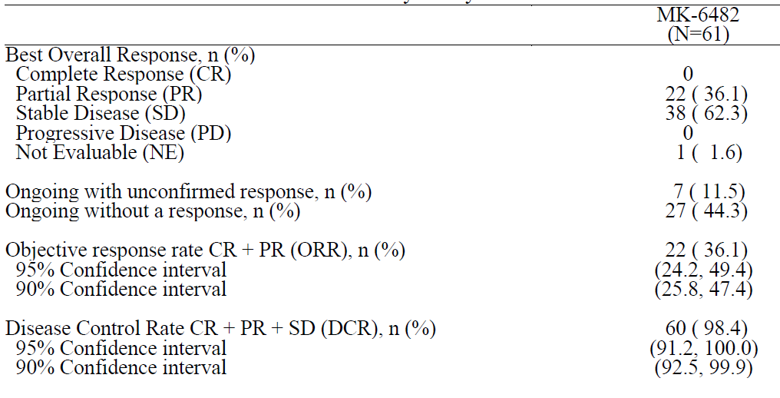
Abbreviations: MK-6482 = sponsor’s code for belzutifan; N = number of participants in cohort; n = number of participants contributing to the analysis.
Note: 95% and 90% confidence intervals are constructed using two-sided Clopper-Pearson method. Best overall response of RCC CR and PR should be confirmed by a second assessment at least 4 weeks after the initial response.
Date of data cut-off: 1 June 2020
Results from the updated data with a cut-off date of 1 December 2020 show an improved ORR for RCC of 49% (95% CI: 36, 62%). These data are shown in Table 6 below.
Table 6: Study 004 Efficacy results at 1 December 2020
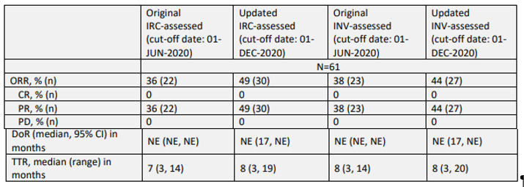
Abbreviations: CR = complete response; DoR = duration of response; INV = investigator; IRC = Independent Review Committee; n = number of participants contributing to the analysis; NE = not evaluable; ORR = objective response rate; PD = progressive disease; PR = partial response; TTR = time to response.
Source: the above table is extracted from FDA Multi-disciplinary Review and Evaluation.

Duration of response for renal cell carcinoma
Of the 22 patients with a confirmed response, median duration of response was not reached for RCC (range: 11.9+, 62.3+ weeks). Duration of response data are summarised in Table 7 below.
Table 7: Study 004 Efficacy results duration of response at 1 June 2020
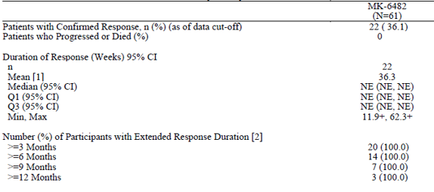
Abbreviations: CI = confidence interval; MK-6482 = sponsor’s code for belzutifan; N = number of participants in cohort; n = number of participants contributing to the analysis; NE = not estimable; Q1 = quartile 1; Q3 = quartile 3.
Duration of Response is analysed using the Kaplan-Meier estimator. Median, first and third quartiles of Duration of Response are reported along with 95% Brookmeyer-Crowley confidence intervals.
[1] Arithmetic mean.
[2] % is calculated by Kaplan-Meier method.
+ indicates there was no progressive disease by the time of last disease assessment.
Date of data cut-off: 1 June2020
In the updated analysis based on the 1 December 2020, median DOR has not been reached, but 17 of the 30 responders had a DOR of 12 months or longer.

Other secondary endpoints for renal cell carcinoma
At the 1 June 2020 data cut, the median TTR among the 22 confirmed responders was 31.1 weeks (range: 11.6, 61.0) and had increased to a median of 35.8 weeks among the 30 responders in the 1 December 2020 data cut.
Median PFS was not reached at either data cut, with only 3 events by the 1 December 2020 data cut (one death not related to disease or treatment, and two disease progression events). Median time to surgery was also not estimable at either data cut as only one participant had undergone surgery.
At the 1 December 2020 data cut the RCC linear growth rate before treatment was 3.59 mm/year (range: -3.06, +18.57) and after treatment was -3.73 mm/year (range: -9.48, +10.08).

Overall response rate for pancreatic neuroendocrine tumour and central nervous system haemangioblastomas (secondary endpoints)
At the 1 June 2020 data cut, the ORR for the 20 patients with pNET detected at Baseline was 80.0% (95% CI: 56.3, 94.3%) including one complete response and 15 partial responses. The other 4 participants had stable disease with no progressive diseases reported.
For CNS haemangioblastomas, the ORR was 32.0% (95% CI: 19.5, 46.7%), including one complete response and 15 partial responses of the 50 patients with CNS haemangioblastomas at Baseline. Nineteen (19) participants had stable disease and 2 had progressive diseases. Table 8 below summarises best overall response for pancreatic lesions, CNS haemangioblastomas, and pancreatic neuroendocrine tumours.
Table 8: Study 004 Best overall tumour response for tumours other than renal cell carcinoma
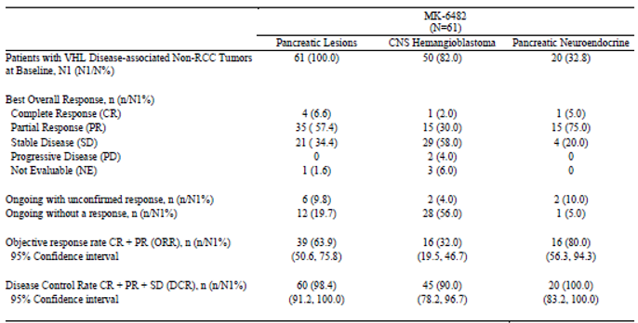
Abbreviations: MK-6482 = sponsor’s code for belzutifan; N = number of participants in cohort; n = number of participants contributing to the analysis.
Note: 95% confidence intervals are constructed using two-sided Clopper-Pearson method.
Best overall response of RCC complete response and partial response should be confirmed by a second assessment at least 4 weeks after the initial response.
Patients evaluable at Baseline per Independent Review Committee are included. Pancreas tumour assessments followed RECIST 1.1 criteria¹¹ and thus measurable solid lesions or the measurable solid component of a mixed solid/cystic lesion could have been chosen as target tumours such as pNETs or cystadenomas respectively.
Date of data cut-off: 1 June 2020

Duration of response for pancreatic neuroendocrine tumours and central nervous system haemangioblastomas
For pNET, median DOR was not reached by the 1 June 2020 data cut, and by Kaplan-Meier estimate, 90% of patients had a response lasting 12 months or longer. Median DOR was also not reached for CNS haemangioblastomas, and 4 participants remained in response at 12 months; see Table 9.
Table 9: Study 004 Duration of response for tumours other than renal cell carcinoma
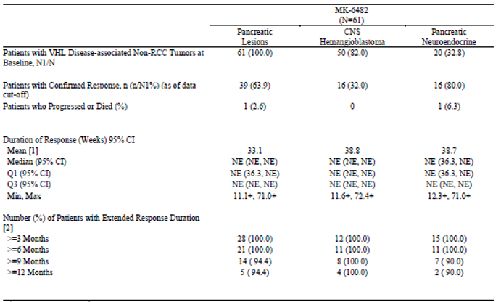
Abbreviations: CI – confidence interval; MK-6482 = sponsor’s code for belzutifan; max = maximum; min = minimum; N = number of participants in cohort; n = number of participants contributing to the analysis; NE = not estimable; Q1 = quartile 1; Q3 = quartile 3.
Duration of Response is analysed using the Kaplan-Meier estimator. Median, first and third quartiles of Duration of response are reported along with 95% Brookmeyer-Crowley confidence intervals.
[1] Arithmetic mean.
[2] % is calculated by Kaplan-Meier method.
+ indicates there was no progressive disease by the time of last disease assessment.
Date of data cut-off: 1 June 2020
The updated data with a cut-off date of 1 December 2020 included ORR and DOR results for pNETs. During the evaluation it was noted there was concordance between the blinded radiologists assessing these tumours for 12 patients. Using the sponsor’s analysis the ORR was 90% at the 1 December 2020 update but using only the data from the patients with concordance the ORR (83%) also remains high (95% CI: 52, 98%).
The updated data with a cut-off date of 1 December 2020 included ORR and DOR results for patients with CNS haemangioblastomas. The sponsor’s analysis of all CNS haemangiomas by IRC the ORR was 30% (95% CI: 17.9%, 44.6%), and similar to results from 1 June 2020. In the evaluation, a focus on a subset of 24 of the tumours with a solid component showed an ORR for those patients was 62.5% (95% CI: 40.6, 81.2%).

Top line data from sponsor meeting of August 2022
At a meeting with the TGA in August 2022 the sponsor provided top-line results from a data cut-off of 15 July 2021, with a median follow up of 29.2 months (range: 4.2, 37.5 months). These data have not been submitted for evaluation but are presented for completeness only. The ORR for RCC was 59.0% (95% CI: 45.7%, 71.4%), for CNS haemangioblastoma 38.0% (95% CI: 24.7%, 52.8%), and for pNET 90% (95% CI: 68.3%, 98.8%).
The sponsor also presented a swimmer’s plot (see Figure 2 below). The zero bar represents the time of enrolment of each patient. Three surgeries (red dots in the figure below) have been reported, consisting of two partial nephrectomies and one brain surgery.
Figure 2: Study 004 Surgeries in patients prior to and after belzutifan at 15 July 2021
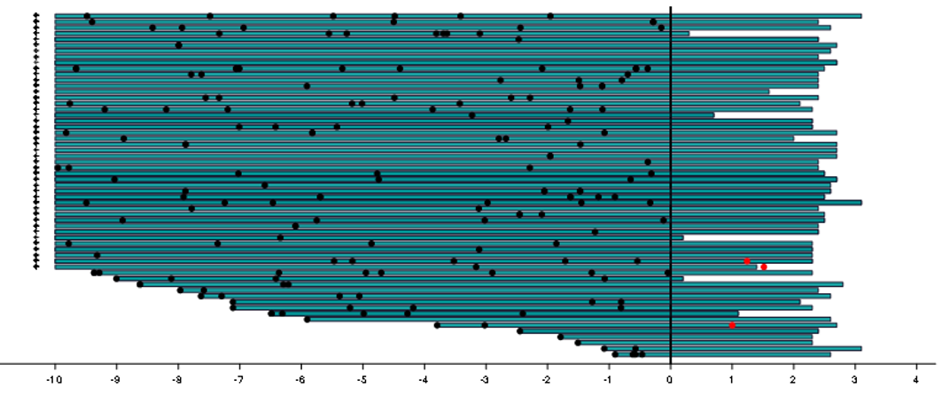
The horizontal axis is years. The black dots represent surgeries prior to enrolment. The red dots represent surgeries following enrolment. The arrows indicate patients with at least one surgery 10 years prior to enrolment.

Natural history study (real world evidence)
This was a retrospective, non-interventional study of patients with VHL associated RCC using National Cancer Institute registry data from the USA and Canada. Patients with VHL and one or more renal tumours were included. An additional analysis of subset of patients with no investigational therapy, oncologic therapy or renal tumour reduction procedures within 30 days of the index date that more closely resembled Study 004 population was included. This trial population subgroup included a further subset of patients with at least 3 serial tumour measurements.
Patients from the trial population subgroup were mostly (53.4%) male, with a median age of 41.1 years (range: 32, 51.4). All had a genetic confirmation of VHL, 59.9% had type 1 VHL. In this population 19.8% and 58.3% had a phaeochromocytoma or retinal angioma, respectively.
The primary outcome was linear growth rate and other outcomes included rates of surgery and time to surgery. The median tumour-level linear growth rate for renal solid tumours in the trial population subgroup was 3.69 mm/year, which was within the range observed in published literature. Almost all (99%) tumours had an increase in maximal tumour diameter. This study using real world data was provided as supportive information, and results supported the sponsor’s position there is a low likelihood of spontaneous regression of VHL renal tumours.

Companion diagnostic
No companion diagnostic is proposed.

Safety
The safety database consisted of data from the pivotal Study 004, which enrolled 61 patients with RCC, and Study 001, which included 58 patients with solid tumours. There were significant differences between the two study populations, with patients in Study 001 being generally older, with more advanced disease and more comorbidities and thus safety data from the two studies are presented separately. Results are also provided for the pooled population who received the 120 mg dose (n = 119), and for the pooled population who received any dose ranging from 20 mg to 240 mg (n = 177). The main safety data for this submission are from the 1 June 2020 data cut. Additional safety data from the 1 December 2020 data cut are provided where relevant. Data from Study 004 are most relevant to the proposed indication and were therefore given the most weight in the safety assessment of belzutifan.
In Study 004, median duration of exposure to belzutifan was 68.0 weeks (range: 8.4, 104.7) at the 1 June 2020 cut-off and 94.14 weeks (range: 8.4, 130.9) at the 1 December 2020 data cut. Most patients (57 of 61 (93.4%)) received treatment for 12 months or longer at the 1 June 2020 data cut.
In Study 001, the median duration of exposure was 25.4 weeks (range: 1.1, 145.9).

Summary of adverse events
Table 10 below summarises AEs occurring in both studies, and the pooled safety populations.
Table 10: Overall summary of adverse events
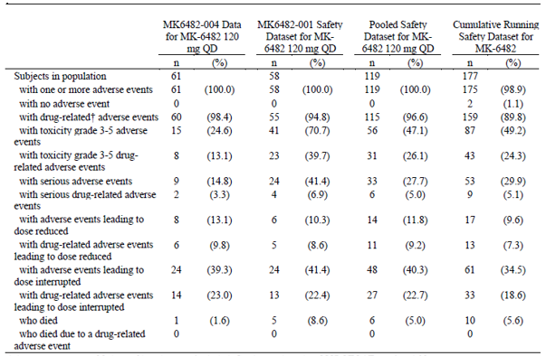
Abbreviations: MK-6482 = sponsor’s code for belzutifan; n = number of participants contributing to the analysis: QD = once daily.
Adverse events up to 28 days of last dose are included. Grades are based on National Cancer Institute (US) Common Terminology Criteria for Adverse Events (CTCAE) version 4.03.
† Determined by the investigator to be related to the drug.
All patients in Studies 004 and 001 experienced at least one adverse event. Drug related AEs were reported by 60 of 61 (98.4%) patients in Study 004; and 15 (24.6%) of patients experienced a Grade 3 to 5 AE.
There was one death in Study 004 not related to treatment, and there were 5 deaths in Study 001 due to adverse events, none of which were assessed to be drug related. One additional death occurred in Study 001 in the additional 6 months of data to 1 December 2020. This death was not related to study treatment. There were no additional deaths in Study 004 in the additional 6 months.
Serious adverse events (SAEs) occurred in 9 (14.8%) patients in Study 004, the majority of which were Grade 3 in severity. There were no SAEs that occurred in more than one patient in Study 004. In Study 001, 24 participants (41.1%) experienced SAEs, of which hypoxia was the most common. In the additional 6 months of safety data, there were an additional two patients who experienced three SAEs in Study 004 and one in Study 001.
In Study 004, there were 2 (2.3%) AEs leading to discontinuation, compared with 6 (10.2%) in Study 001. There were no discontinuations in the additional 6 months of data provided to 1 December 2020.
In Study 004, 24 patients (39.3%) experienced dose interruptions due to AE, most commonly due to fatigue, anaemia, nausea, influenza-like illness, abdominal pain and headache. Dose reductions were reported in 8 (13.1%) patients, most commonly due to fatigue (6.6%). In Study 001, 6 patients (10.3%) experienced AEs leading to dose reductions. In the additional 6 months of data to 1 December 2020, 2 additional patients experienced 2 AEs that led to treatment interruption. There were no additional events in Study 001.
The most frequently reported AEs in Study 004 were anaemia, fatigue, headache, dizziness, nausea, dyspnoea and arthralgia, as shown in Table 11 below.
Table 11: Studies 001 and 004 Adverse events occurring in 20% or more patients
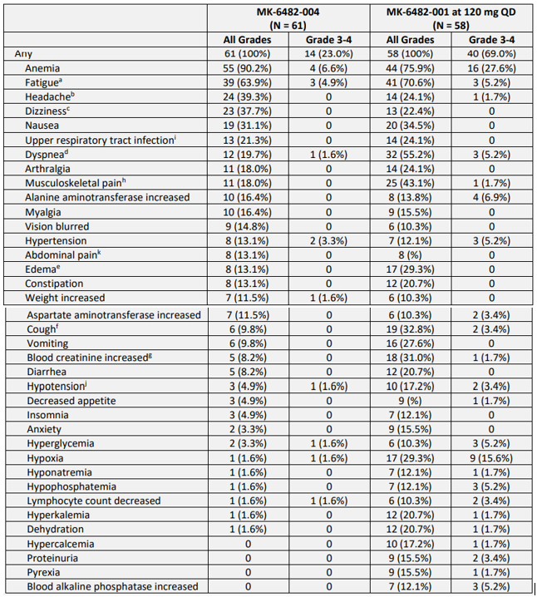
Abbreviations: MK-6482 = sponsor’s code for belzutifan; n = number of participants contributing to the analysis: QD = once daily.
a includes fatigue and asthenia
b includes headache and migraine
c includes dizziness and vertigo
d includes dyspnoea, dyspnoea exertional, and orthopnoea
e includes face oedema, generalised oedema, oedema genital, oedema peripheral, periorbital oedema, and scrotal oedema
f includes cough, haemoptysis, productive cough, and upper airway cough syndrome
g includes acute renal failure, blood creatinine increased, and chronic renal failure
h includes back pain, bone pain, musculoskeletal pain, musculoskeletal chest pain, neck pain, pain, and pain in extremity
i includes bronchitis, sinusitis, upper respiratory tract infection, viral upper respiratory tract infection
j includes hypotension and orthostatic hypotension
k includes abdominal discomfort, abdominal pain, abdominal pain lower, and abdominal pain upper.
Source: the above table is extracted from FDA Multi-disciplinary Review and Evaluation.²¹

Drug-related adverse events
Anaemia, fatigue and dizziness were the most commonly reported adverse drug reactions in the safety datasets. Most adverse drug reactions were Grade 1 to 2, and most patients experienced at least one adverse drug reaction. Eight patients (13.1%) in Study 004 had at least one Grade 3 or higher adverse drug reaction, as did 23 (39.7%) patients in Study 001.
The sponsor identified anaemia due to decreased erythropoietin, hypoxia, fatigue, nausea, dizziness and dyspnoea as adverse drug reactions of belzutifan.

Anaemia
Anaemia was the most commonly reported AE in both Studies 004 and 001. Anaemia is an expected AE of belzutifan, given the mechanism of action of the drug (HIF-2α inhibition reduces erythropoietin levels, which leads to reduced haemoglobin levels). In Study 004 the maximum reduction in erythropoietin occurred in Week 3 and appeared to recover by Weeks 9 and 13.
In Study 001, 75.9% of patients experienced Grade 3 anaemia, and 27.6% experienced Grade 4 anaemia. The risk of anaemia appeared to be dose-related at lower doses and then to plateau at the 120 mg dose, which is consistent with the PopPK analysis (see Table 12 below).
Table 12: Study 001 Treatment emergent adverse events of anaemia by dosing cohort
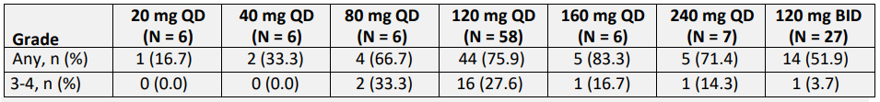
Abbreviations: BID = twice daily; N = number of participants in cohort; n = number of participants contributing to the analysis; QD = once daily.
Source: the above table is extracted from FDA Multi-disciplinary Review and Evaluation.²¹
In Study 004, 90.2% of patients experienced anaemia, and 6.6% of these were Grade 3 to 4 in severity. Anaemia was managed with dose interruptions or reductions, erythropoietin stimulating agents (ESAs) and blood transfusions. There were no discontinuations due to anaemia. The risk of anaemia was greatest in patients with lower baseline haemoglobin levels; see Table 13 below.
Table 13: Study 004 Anaemia by Tertile of baseline haemoglobin
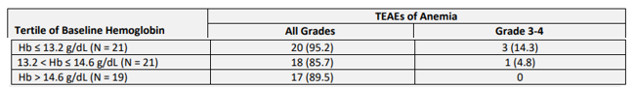
Abbreviations: Hb = haemoglobin; N = number of participants in cohort; TEAE = treatment-emergent adverse event.
Source: the above table is extracted from FDA Multi-disciplinary Review and Evaluation.²¹
Erythropoietin stimulating agents (ESAs) were used in both trials to manage anaemia. In Study 004, 12 patients received an ESA, 5 were prescribed as needed. Five patient received red cell transfusions. The median time to first dose of ESA was 21.6 weeks, and the median time to first transfusion was 30.1 weeks. Erythropoietin has growth promoting actions on normal and malignant cells, and the ESAs have been associated with increased mortality in cancer patients. In the safety data set, there was a case of vulvar cancer in a patient on Study 004 at Day 109 who had been treated with one dose of darbepoetin on Day 73. Three patients on ESAs in Study 001 experienced progression of their underlying RCC.

Hypoxia
Hypoxia-inducible factors 2 alfa (HIF-2α) may play a role in hypoxic pulmonary vasoconstriction; therefore, hypoxia is an expected AE of belzutifan. There was one case of hypoxia in Study 004 (1.6%), which was Grade 3 in severity and managed by dose interruption and reduction. Overall, there was no clinically significant change in oxygen saturation levels over time in patients in Study 004.
In Study 001, 17 patients (29.3%) experienced hypoxia, 9 of whom had Grade 3 hypoxia. Twelve of the 17 patients (20.6%) were treated with supplemental oxygen. There were 2 study discontinuations due to hypoxia. Fifteen of 17 patients (88%) experiencing hypoxia had pre-existing pulmonary conditions, thus causality was difficult to determine. There did not appear to be a dose-response relationship for hypoxia.

Updated safety from sponsor meeting of August 2022
As noted above, data from July 2021 have not been evaluated by the TGA and are presented in Table 14 below for completeness.
Table 14: Study 004 Overview of Safety at 15 July 2021
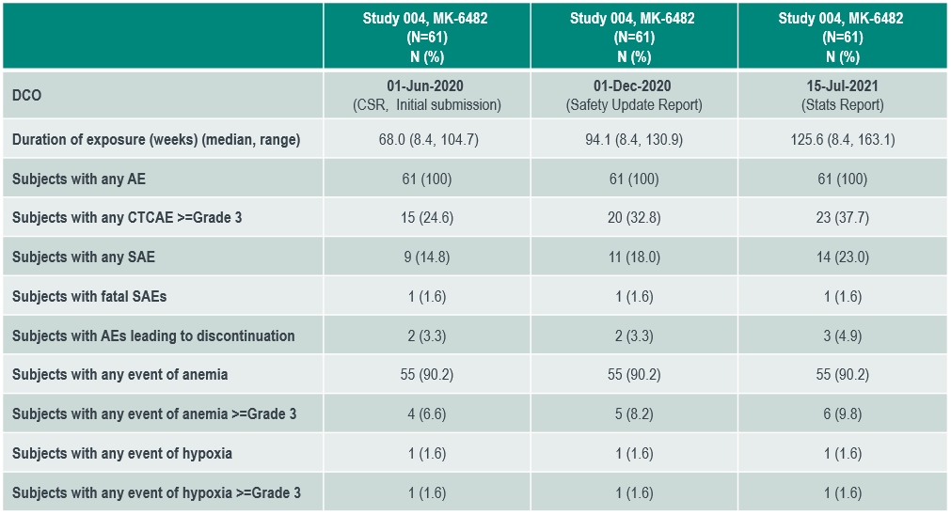Abbreviations: AE = adverse event; CSR = clinical study report; CTCAE = Common Terminology Criteria for Adverse Events; DCO = data cut-off date; N = number of participants in cohort; SAE = serious adverse event.

Risk management plan
For full registration, the sponsor submitted Core RMP version 3.0 (date 26 October 2021; data lock point 1 June 2020) and Australia specific annex (ASA) versions 0.3 (date 21 February 2022), 0.4 (date 25 March 2022) and 0.5 (date 16 May 2022), with ASA version 0.6 (date September 2022) submitted in the fourth evaluation round.
The summary of safety concerns and their associated risk monitoring and mitigation strategies are summarised in Table 15. The TGA may request an updated RMP at any stage of a product's life-cycle, during both the pre-approval and post-approval phases.
Table 15: Summary of safety concerns
Summary of safety concerns |  | Pharmacovigilance |  | Risk minimisation
 |  | Routine | Additional | Routine | Additional
Important identified risks | Anaemia due to decreased erythropoietin |  | - |  | -
Important identified risks | Hypoxia | ² | - |  | -
Important potential risks | Embryofetal toxicity |  | - |  | -
Missing information | Long term safety |  | ³ | - | -
Missing information | Moderate or severe hepatic impairment¹ |  | - |  | -
Missing information | Severe renal impairment |  | - |  | -
1 Australian specific safety concern
2 Targeted follow-up questionnaire
3 Evaluation of long-term safety in a 3-year minimum follow-up of patients in ongoing MK-6482-Study 004 (AU)
- The summary of safety concerns was evaluated for the VHL RCC indication and was considered to be acceptable. From an RMP perspective, no further safety concerns have been identified for inclusion in the VHL CNS hemangioblastoma and VHL pNET treatment indication setting. The summary of safety concerns is considered acceptable from an RMP perspective.
- There are no changes to the safety specification in ASA version 0.6 submitted for full registration for the following indication: the treatment of adult patients with VHL disease who require therapy for RCC, CNS hemangioblastomas, or pNET, not requiring immediate surgery.
- The sponsor has proposed routine pharmacovigilance for all safety concerns including a targeted follow up form for hypoxia as part of enhanced routine pharmacovigilance. Evaluation of the long-term safety for patients enrolled in an ongoing, open label Phase II Study 004 is agreed as an Australian-specific additional pharmacovigilance activity in the ASA to address missing information on ‘long-term safety’. The sponsor was asked to provide an updated ASA for this submission which included additional pharmacovigilance activities. In response to the second round of evaluation, the sponsor appropriately updated the ASA with the additional pharmacovigilance activities and the pharmacovigilance plan is considered acceptable.
- The clinical study plan has been removed in ASA version 0.6 as the sponsor is seeking full registration for belzutifan. The pharmacovigilance plan is acceptable from an RMP perspective.
- Routine risk minimisation activities only are considered acceptable to manage the risks as belzutifan is given orally under specialist supervision. The Consumer Medicines Information (CMI) will be included in the packaging.

Risk-benefit analysis

Delegate’s considerations
Von Hippel-Lindau (VHL) disease is a seriously debilitating disease associated with significant morbidity and mortality. It has a profound impact on patients, as they undergo multiple surgical procedures from an early age and throughout their lives. Belzutifan is the first targeted therapy specifically for VHL disease and offers a non-surgical treatment option for selected patients. The key issues for this submission are discussed below.

Pharmacology
Belzutifan is metabolised by UGT2B17 and CYP2C19. Patients who are dual UGT2B17 and CYP2C19 poor metabolisers are predicted to have significantly higher exposures (3.2-fold), compared to normal UGT2B17 metabolisers and CYP2C19 ultrarapid, rapid, normal and intermediate metabolisers. Thus, dual poor metabolisers should be monitored closely for adverse reactions.
Pharmacokinetic data demonstrated a plateauing of exposure at doses of belzutifan greater than 120 mg. Higher doses were tested in Study 001; however, these were not associated with a significant increase in exposure. The higher doses also come with an increased risk of adverse effects. Thus, the 120 mg dose was an appropriate choice for Study 004 and is the dose recommended in the PI.
The potential for drug interactions, particularly between belzutifan and oral hormonal contraceptives is of concern in a population of VHL patients, which will include many patients of child-bearing age. The potential for contraceptive failure is an important consideration as belzutifan is teratogenic. The proposed PI for Australia recommends using an additional barrier method or an alternative non-hormonal method of contraception.
Some PK studies, including food effect with the new formulation and mass balance studies to characterise elimination pathway, are incomplete. The full study reports should be provided for evaluation on completion.

Efficacy
The pivotal study for this submission, Study 004, was a single arm study with endpoints of ORR and DOR. The lack of a comparator group is considered acceptable in the context of a rare and serious disease for which there is no systemic therapy established as a standard of care. The natural history study supports that spontaneous shrinkage of a tumour that meets RECIST criteria is unlikely,¹¹ therefore, tumour shrinkage can be attributed to belzutifan. The small sample size of 61 is acceptable in this setting and is accounted for in the statistical analysis plan.
In Study 004, the majority of the study population (83.6%) had type 1 VHL disease, with only a small proportion of patients having type 2 VHL disease. The study population also excluded patients who did not have RCC but may have had CNS haemangioblastomas or pNET. There were very few patients aged over 65 years. The proportion of patients with various tumour types differed from the natural history study and the literature. It is unclear how this affects generalisability to the Australian population, and advice will be sought on this issue.
The primary endpoint of Study 004 was ORR for RCC. Results demonstrated that belzutifan confers a significant benefit in terms of tumour response, and that the ORR improves significantly with time. As of 1 June 2020, the ORR for RCC was 36.1% (95% CI: 24.2, 49.4%), which increased to 49% (95% CI: 36, 62%) with an additional 6 months of treatment. Median duration of response was not reached at the 1 December 2020 data cut (range: 3+, 14+ months).
The additional data are critical in supporting the efficacy of belzutifan and provide essential information about time to response. Median time-to-response was relatively long, at 31.1 weeks. Belzutifan is not suitable for patients requiring immediate surgery. It will be important for patients and clinicians to understand that results may not be seen immediately.
Study 004 also collected data for other tumours as secondary endpoints including pNET and CNS haemangioblastomas. While there are limitations to the interpretation of these secondary endpoints, the mechanism of action of belzutifan supports that it will be effective in a variety of VHL tumours and this, combined with the secondary endpoint data from a reasonable number of participants with pNET and CNS haemangioblastomas, is considered sufficient for inclusion in the indication. In addition, the magnitude of benefit was clinically meaningful and appears to be increasing with further follow-up.
Longer follow-up is particularly important in this patient cohort for whom RCC is generally slow growing, and who may live for many years with their disease. The additional data from the presentation to the TGA (data cut-off 1 December 2020) are top-line data only and have not been fully evaluated. The final clinical study report is expected to be available in 2023.
While PFS was listed as a secondary endpoint, time-to-event endpoints cannot be reliably interpreted in a single arm setting. It is unlikely that a randomised trial will be feasible, however, due to a lack of viable comparator to randomise against and a lack of clinical equipoise based on the magnitude of durable responses observed in the single arm setting and the known natural history of the disease. In reflection of this, belzutifan is now mentioned as a treatment option for VHL-related tumours in some international clinical guidelines.
Overall, the magnitude of the ORR benefit and length of DOR demonstrated in the pivotal trial are clinically meaningful and sufficient to support approval despite the small sample size and single arm design of the pivotal study.

Safety
The total safety population consisted of 61 patients from Study 004 and 58 from Study 001. All patients received the 120 mg once daily dose. Although the safety population is small, the duration of exposure was relatively long (median 68 weeks in Study 004 and 25.36 weeks in Study 001), and considering the rarity of the disease, this population is considered a sufficient number of patients to characterise common adverse events in the intended population.
In general, the safety profile of belzutifan is acceptable, with most AEs able to be managed by dose interruption or reduction. The low numbers of AEs (n = 2, 3.3%) leading to study discontinuation in Study 004 suggests that belzutifan is well tolerated in the majority of patients.
The most common treatment-emergent adverse event occurring at frequencies above 20% were anaemia, fatigue, headache, dizziness and nausea. The most serious safety concerns were anaemia, hypoxia, secondary malignancies and embryofetal toxicities.
Anaemia occurred commonly in the study population and is an expected AE of belzutifan associated with its mechanism of action. The risk of anaemia seemed to be dose proportional at lower doses, and plateaued around the 120 mg dose level, consistent with other pharmacology parameters. The risk of anaemia was also highest for patients with lower baseline haemoglobin levels, potentially placing older, more heavily pre-treated patients at more risk. The PI provides dose reduction information for anaemia and lists it in the special warnings and precautions section.
Erythropoietin stimulating agents (ESAs) were used to treat anaemia in trial patients. The use of ESAs raises concerns of secondary malignancies, which are a known AE of ESAs. This is particularly relevant in a population of VHL patients who are relatively young and already at heightened risk of many different types of malignancies. Advice will be sought on this aspect.
Hypoxia is an expected AE due to the mechanism of action of belzutifan. Most cases in the trials could be managed effectively with supplemental oxygen and/or dose interruption or reduction. Anaemia and hypoxia occurring in the same patient at the same time are of particular concern, as each can worsen the clinical manifestations of the other.
The trial population was relatively young, with a median age of 41 years, which is consistent with the broader population of VHL patients. The impact of belzutifan on the risk of secondary malignancies is uncertain. There are currently no animal carcinogenicity studies but the conduct and provision of such studies was a recommendation of the nonclinical evaluation and may provide insights for human risk.
The risk of embryofetal toxicity is important in a population of VHL patients, which is likely to include women of child-bearing potential and male partners. Belzutifan may interact with some hormonal contraceptives and cause contraceptive failure and so further complicates this issue. The PI contains this information in the body of the text.

Indication
The final wording of the indication will be proposed pending specialist advice.

Conditions of approval
A program of further studies has been imposed as post-marketing requirements and agreed as post-marketing commitments to the US FDA. It is considered these studies and analyses will be relevant in Australia and it is proposed these will be imposed as conditions of registration.

Proposed action
The benefits of belzutifan in VHL associated RCC, pNET and CNS haemangioblastomas include substantial tumour responses that may offer patients significant delays in the need for surgical procedures. In a disease where many surgical procedures are needed throughout life, this is a clinically significant benefit for patients. The risks of belzutifan include anaemia, hypoxia and embryofetal toxicities. These can generally be managed in clinical practice and are mitigated to some extent by information in the PI. Uncertainties arise from the small data set, its limitation to patients with a RCC component of their disease. Considering VHL is a life-long disease without a cure, the duration of exposure remains relatively short, and there are uncertainties about the optimal management of anaemia. However, based on the data the benefits of belzutifan appear to outweigh the risks and uncertainties and, subject to specialist advice, approval is proposed.

Independent expert advice
The Delegate received the following independent expert advice.
- Is the population in the Study 004 representative of the population of VHL patients in Australia?
- Are there any concerns with the extrapolation of the results of Study 004 to type 1 and 2 VHL disease, given the low proportion of patients with type 2 disease in the study population?
- Given that the ORRs for CNS haemangioblastomas and pNET were secondary endpoints, are there any concerns about the efficacy data for these tumours?
- How would anaemia be managed in Australian clinical practice in patients with VHL? Should the PI include a warning about the risks of associated with ESAs, including secondary malignancies, or recommend avoidance of this treatment?
- Will prescribers of belzutifan understand what is intended by the restriction to patients ‘not requiring immediate surgery’?
Independent expert advice was generally supportive of the approval of belzutifan for the proposed indication.
The Delegate was advised the management of VHL is dependent on the state/territory in which the patient lives. Centres of excellence have been established, and these centres are often consulted from specialists managing patients with VHL from other states.
The Study 004 population was felt to be broadly representative of Australian patients with VHL and renal cell cancer in Australia. Physicians involved in the care of patients with VHL focus on the specific tumour burden of the individual patient rather than the specific subtypes as there can be overlap in tumour phenotype between types 1 and 2. The extrapolation of the results of Study 004 should be limited to efficacy against VHL associated renal cell cancer, CNS hemangioblastoma and pNETs, independent of VHL subtype status. This is also supported by the understanding of the biology of HIF-2α across different VHL-altered tumours, re-reviewing of imaging, and the durable and clinically meaningful ORR.
The expert was of the view that the anaemia arising from belzutifan was most likely to be managed by dose interruption/reduction and/or packed red cell transfusion rather than the use of ESAs. Nevertheless, a warning in the Welireg PI was supported.

Proposed action post-independent expert advice
Independent expert advice supported the approval of belzutifan for the proposed indication. Approval is therefore proposed.

Advisory Committee considerations
The Delegate did not refer this submission to the Advisory Committee on Medicines for advice.

Outcome
Based on a review of quality, safety, and efficacy, the TGA approved the registration of Welireg (belzutifan) 40 mg film-coated tablets in bottle, indicated for:
Welireg (belzutifan) is indicated for the treatment of adult patients with von Hippel-Lindau (VHL) disease who require therapy for associated renal cell carcinoma (RCC), central nervous system (CNS) haemangioblastomas, or pancreatic neuroendocrine tumours (pNET), not requiring immediate surgery.

Specific conditions of registration applying to these goods
- Welireg (belzutifan) is to be included in the Black Triangle Scheme. The PI and CMI for Welireg must include the black triangle symbol and mandatory accompanying text for 5 years, which starts from the date that the sponsor notifies the TGA of supply of the product.
- The Welireg Core-risk management plan (RMP) (version 3.0, dated 26 October 2021, data lock point 1 June 2020), with Australia specific annex (version 0.6, dated September 2022), included with Submission PM-2021-00644-1-4, to be revised to the satisfaction of the TGA, and any subsequent revisions, will be implemented in Australia.
An obligatory component of risk management plans is routine pharmacovigilance. Routine pharmacovigilance includes the submission of periodic safety update reports (PSURs).
Unless agreed separately between the supplier who is the recipient of the approval and the TGA, the first report must be submitted to TGA no later than 15 calendar months after the date of the approval letter. The subsequent reports must be submitted no less frequently than annually from the date of the first submitted report until the period covered by such reports is not less than three years from the date of the approval letter. The annual submission may be made up of two PSURs each covering six months. If the sponsor wishes, the six monthly reports may be submitted separately as they become available.
If the product is approved in the EU during the three years period, reports can be provided in line with the published list of EU reference dates no less frequently than annually from the date of the first submitted report until the period covered by such reports is not less than three years from the date of the approval letter.
The reports are to at least meet the requirements for PSURs as described in the European Medicines Agency’s Guideline on Good Pharmacovigilance Practices (GVP) Module VII-periodic safety update report (Revision 1), Part VII.B Structures and processes. Note that submission of a PSUR does not constitute an application to vary the registration. Each report must have been prepared within ninety calendar days of the data lock point for that report.
- [The sponsor is to] submit for evaluation carcinogenicity studies conducted in mouse and rat models.
- [The sponsor is to] submit for evaluation any interim analyses and the final analysis of Study MK-6482-004.
- [The sponsor is to] submit for evaluation the final study report for Study MK-6482-015.

Attachment 1. Product Information
The PI for Welireg approved with the submission which is described in this AusPAR is at Attachment 1. For the most recent PI, please refer to the TGA PI/CMI search facility.

Therapeutic Goods Administration
PO Box 100 Woden ACT 2606 Australia
Email: info@tga.gov.au Phone: 1800 020 653 Fax: 02 6203 1605
https://www.tga.gov.au
Reference/Publication #

This is the original indication proposed by the sponsor when the TGA commenced the evaluation of this submission.
Clinical features, diagnosis and management of von Hippel Lindau disease. Available from UpToDate website. Accessed 29 May 2022.
Von Hippel-Lindau Syndrome. Available from the Cancer.Net website: Accessed 17 Dec 2021.
Von Hippel-Lindau Disease. Available from the Genetic and Rare Diseases Information Centre website. Accessed 17 Dec 2021.
Lonser RR, et al.: Prospective natural history study of central nervous system hemangioblastomas in von Hippel-Lindau disease. J Neurosurg 2014; 120: 1055-1062. doi: 10.3171/2014.1.JNS131431.
Blansfield JA, et al. Clinical, Genetic and Radiographic Analysis of 108 patients with von Hippel-Lindau Disease (vHL) manifested by pancreatic neuroendocrine tumours (PNETs). Surgery 2007; 142(6): 814-818.e2. doi: 10.1016/j.surg.2007.09.012.
The Biopharmaceutics Classification System (BCS) is a guidance for predicting the intestinal drug absorption provided by the US FDA. According to the BCS, drug substances are classified as follows: Class I = high permeability, high solubility; Class II = high permeability, low solubility; Class III = low permeability, high solubility; Class IV = low permeability, low solubility.
Cytochrome P450 (CYP) enzymes are the major enzymes involved in drug metabolism, accounting for a large part of total metabolism. Most drugs undergo deactivation by CYPs, either directly or by facilitated excretion from the body. Also, many substances are bioactivated by CYPs to form their active compounds. Many drugs may increase or decrease the activity of various CYP isozymes either by inducing the biosynthesis of an isozyme (enzyme induction) or by directly inhibiting the activity of the CYP (enzyme inhibition). This is a major source of adverse drug interactions, since changes in CYP enzyme activity may affect the metabolism and clearance of various drugs. Such drug interactions are especially important to take into account when using drugs of vital importance to the patient, drugs with important side-effects, and drugs with small therapeutic windows, but any drug may be subject to an altered plasma concentration due to altered drug metabolism.
Assessment is based on the EMA guideline on the investigation of drug interactions (CPMP/EWP/560/95/Rev.1 Corr.2), using values of 383.34 for molecular weight, 120 mg for dose, 1,263.7 ng/mL for clinical plasma C_{max}, 45% for plasma protein binding, 0.25 L for intestinal volume, 2.4 h⁻¹ for absorption rate constant, 1 for fraction absorbed from gut to portal vein, and 1,617 mL/min for total hepatic blood flow.
Pregnancy Category D: Drugs which have caused, are suspected to have caused or may be expected to cause, an increased incidence of human fetal malformations or irreversible damage. These drugs may also have adverse pharmacological effects. Accompanying texts should be consulted for further details.
The Response Evaluation Criteria In Solid Tumours (RECIST) is a voluntary international standard with unified and easily applicable criteria to define when a patient's tumour has improved ('respond'), stayed the same ('stabilise'), or worsened ('progress') during treatment. The criteria were developed and published in February 2000, and subsequently updated in 2009, by an international collaboration including the European Organisation for Research and Treatment of Cancer (EORTC), the National Cancer Institute (NCI) of the United States, and the National Cancer Institute of Canada Clinical Trials Group. The majority of clinical trials evaluating cancer treatments for objective response in solid tumours use RECIST.
Available from PharmGKB website.
Man M, Farmen M, Dumaual C, et al Genetic Variation in Metabolizing Enzyme and Transporter Genes: Comprehensive Assessment in 3 Major East Asian Subpopulations with Comparison to Caucasians and Africans., J Clin Pharmacol 2010;50:929-940. doi: 10.1177/0091270009355161.
Available from The International Genome Sample Resource website.
Available from United States Census Bureau website.
Shankar AJ, Jadhao S, Hoy W, et al. Pharmacogenomic analysis of a genetically distinct Indigenous population Pharmacogenomics J. 2022; 22: 100-108. doi: 10.1038/s41397-021-00262-4.
The Common Terminology Criteria for Adverse Events (CTCAE) is a standardised classification of side effects used in assessing drugs, for cancer therapy in particular. Specific conditions and symptoms may have values or descriptive comment for each level but are generally classified as follows: Grade 1 = Mild; Grade 2 = Moderate; Grade 3 = Severe; Grade 4 = Life threatening; Grade 5 = Death related to adverse event.
The QT interval is the time from the start of the QRS wave complex to the end of the corresponding T wave on an electrocardiogram. It approximates the time taken for ventricular depolarisation and repolarisation, the period of ventricular systole from ventricular isovolumetric contraction to isovolumetric relaxation. The corrected QT interval (QTc) estimates the QT interval at a standard heart rate. This allows comparison of QT values over time at different heart rates and improves detection of patients at increased risk of arrhythmias.
Independent Review Committees (IRCs) provide blind review of clinical trials to ensure consistency and minimise bias in clinical trials.
Eastern Cooperative Oncology Group Performance Status: The ECOG has developed criteria used by doctors and researchers to assess how a patient's disease is progressing, assess how the disease affects the patient’s daily living, and to determine appropriate treatment and prognosis. The ECOG Performance Status Scale is as follows: Grade 0 = Fully active, able to carry on all pre-disease performance without restriction; Grade 1 = Restricted in physically strenuous activity but ambulatory and able to carry out work of a light or sedentary nature, for example, light house work, office work; Grade 2 = Ambulatory and capable of all selfcare but unable to carry out any work activities. Up and about more than 50% of waking hours; Grade 3 = Capable of only limited selfcare, confined to bed or chair more than 50% of waking hours; Grade 4 = Completely disabled. Cannot carry on any selfcare. Totally confined to bed or chair; Grade 5 = Dead.
FDA, Center for Drug Evaluation and Research, Multi-disciplinary Review and Evaluation, Welireg 40 mg belzutifan, January 2020. Available from FDA website.
NCCN Guidelines Neuroendocrine and Adrenal tumors. Available from NCCN website.

