|  |
| --- |
| Australian Public Assessment Report for Gavreto |
| Active ingredient/s: Pralsetinib |
| Sponsor: Roche Products Pty Ltd |
| October 2023 |

**About the Therapeutic Goods Administration (TGA)**

* The Therapeutic Goods Administration (TGA) is part of the Australian Government Department of Health and Aged Care and is responsible for regulating therapeutic goods, including medicines, medical devices, and biologicals.
* The TGA administers the *Therapeutic Goods Act 1989* (the Act), applying a risk management approach designed to ensure therapeutic goods supplied in Australia meet acceptable standards of quality, safety, and efficacy.
* The work of the TGA is based on applying scientific and clinical expertise to decision-making, to ensure that the benefits to the Australian public outweigh any risks associated with the use of therapeutic goods.
* The TGA relies on the public, healthcare professionals and industry to report problems with therapeutic goods. The TGA investigates reports received to determine any necessary regulatory action.
* To report a problem with a therapeutic good, please see the information on the [TGA website](https://www.tga.gov.au).

**About AusPARs**

* The Australian Public Assessment Report (AusPAR) provides information about the evaluation of a prescription medicine and the considerations that led the TGA to approve or not approve a prescription medicine submission. Further information can be found in [Australian Public Assessment Report (AusPAR) guidance](https://www.tga.gov.au/australian-public-assessment-report-auspar-guidance).
* AusPARs are prepared and published by the TGA.
* AusPARs are static documents that provide information that relates to a submission at a particular point in time. The publication of an AusPAR is an important part of the transparency of the TGA’s decision-making process.
* A new AusPAR may be provided to reflect changes to indications or major variations to a prescription medicine subject to evaluation by the TGA.

**Copyright**

© Commonwealth of Australia 2023  
This work is copyright. You may reproduce the whole or part of this work in unaltered form for your own personal use or, if you are part of an organisation, for internal use within your organisation, but only if you or your organisation do not use the reproduction for any commercial purpose and retain this copyright notice and all disclaimer notices as part of that reproduction. Apart from rights to use as permitted by the *Copyright Act 1968* or allowed by this copyright notice, all other rights are reserved and you are not allowed to reproduce the whole or any part of this work in any way (electronic or otherwise) without first being given specific written permission from the Commonwealth to do so. Requests and inquiries concerning reproduction and rights are to be sent to the TGA Copyright Officer, Therapeutic Goods Administration, PO Box 100, Woden ACT 2606 or emailed to <[tga.copyright@tga.gov.au](mailto:tga.copyright@tga.gov.au)>.

**Contents**

List of abbreviations 5

Product submission 7

Submission details 7

Product background 8

Condition 8

Current treatment options 8

Regulatory status 9

Product Information 12

Registration timeline 12

Submission overview and risk/benefit assessment 12

Quality 13

Nonclinical 13

Clinical 14

Pharmacology 14

Efficacy 19

Safety 28

Risk management plan 37

Proposed wording for condition of registration 38

Risk-benefit analysis 40

Delegate’s considerations 40

Proposed action 42

Advisory Committee considerations 43

Outcome 43

Specific conditions of registration applying to these goods 44

Attachment 1. Product Information 45

## List of abbreviations

|  |  |
| --- | --- |
| Abbreviation | Meaning |
| ACM | Advisory Committee on Medicines |
| AE | Adverse event |
| ARTG | Australian Register of Therapeutic Goods |
| ASA | Australia specific annex |
| AUC | Area under the plasma concentration time curve |
| BICR | Blinded independent central reviews |
| CBR | Clinical benefit rate |
| CI | Confidence interval |
| Cmax | Maximum concentration |
| CMI | Consumer Medicines Information |
| CNS | Central nervous system |
| CR | Complete response |
| ctDNA | Circulation tumour DNA |
| Ctrough | Trough concentration |
| DCR | Disease control rate |
| DLP | Data lock point |
| DOR | Duration of response |
| ECOG | Eastern Cooperative Oncology Group |
| EMA | European Medicine Agency |
| FDA | Food and Drug Administration (United States of America) |
| GLP | Good Laboratory Practices |
| ICH | International Conference on Harmonisation of Technical Requirements |
| MRD | Multi-disciplinary review |
| MTD | Maximum tolerated dose |
| NDA | New drug application |
| NSCLC | Non-small cell lung cancer |
| ORR | Overall response rate |
| OS | Overall survival |
| PD L1 | Programmed cell death ligand 1 |
| PFS | Progression free survival |
| PI | Product Information |
| PK | Pharmacokinetic(s) |
| PMC | Postmarketing commitment |
| PMR | Postmarketing requirement |
| PR | Partial response |
| PRO | Patient reported outcome |
| PSUR | Periodic safety update report |
| PT | Preferred Term |
| QoL | Quality of life |
| RET | Rearranged during transfection |
| RMP | Risk management plan |
| RP2D | Recommended Phase II dose |
| SAE | Serious adverse event |
| SD | Stable disease |
| T1/2 | Half life |
| TEAE | Teatment emergent adverse event |
| TGA | Therapeutic Goods Administration |
| TKI | Tyrosine kinase inhibitor |
| Tmax | The time after administration of a drug when the maximum plasma concentration is reached |
| US(A) | United States (of America) |

## Product submission

### Submission details

|  |  |
| --- | --- |
| *Type of submission:* | New chemical entity |
| *Product name:* | Gavreto |
| *Active ingredient:* | Pralsetinib |
| *Decision:* | Approved for provisional registration |
| *Date of decision:* | 29 March 2023 |
| *Date of entry onto ARTG:* | 29 March 2023 |
| *ARTG number:* | 380812 |
| ▼[*Black Triangle Scheme*](https://www.tga.gov.au/black-triangle-scheme)  *for the current submission:* | Yes  As a provisionally registered product, this medicine will remain in the Black Triangle Scheme for the duration of its provisional registration |
| *Sponsor’s name and address:* | Roche Products Pty Limited  Level 8, 30 – 34 Hickson Road  Sydney NSW 2000 |
| *Dose form:* | Capsule |
| *Strength:* | 100 mg |
| *Container:* | Bottle |
| *Pack sizes:* | 60, 90 and 120 capsules |
| *Approved therapeutic use for the current submission:* | *Non-Small Cell Lung Cancer (NSCLC)*  *Gavreto has provisional approval in Australia for the treatment of adult patients with locally advanced or metastatic rearranged during transfection (RET) fusion-positive non-small cell lung cancer (NSCLC).*  *The decision to approve this indication has been made on the basis of overall response rate (ORR) and duration of response (DOR) in single-arm trials. Continued approval of this indication depends on verification and description of benefit in confirmatory trials.* |
| *Route of administration:* | Oral |
| *Dosage:* | The recommended dose of Gavreto for adults is 400 mg given orally, once daily.  For further information regarding dosage, refer to the Product Information. |
| *Pregnancy category:* | D  Drugs which have caused, are suspected to have caused or may be expected to cause, an increased incidence of human fetal malformations or irreversible damage. These drugs may also have adverse pharmacological effects. Accompanying texts should be consulted for further details.  The use of any medicine during pregnancy requires careful consideration of both risks and benefits by the treating health professional. This must not be used as the sole basis of decision making in the use of medicines during pregnancy. The TGA does not provide advice on the use of medicines in pregnancy for specific cases. More information is available from obstetric drug information services in your State or Territory. |

### Product background

This AusPAR describes the submission by Roche Products Pty Limited (the sponsor) to register Gavreto (pralsetinib) 100 mg, capsule, bottle for the following proposed indication:[1]

*Non-small cell lung cancer (NSCLC)*

*Gavreto is indicated for the treatment of adult patients with RET-fusion positive, locally advanced or metastatic NSCLC.*

#### Condition

Metastatic non-small cell lung cancer (NSCLC) is a fatal, incurable disease, with a 5 year survival of less than 10%. Gene rearrangements (fusions) in RET (rearranged during transfection) have been identified as oncogenic drivers in metastatic non-small cell lung cancer (NSCLC), at an incidence of 1 to 2%. RET fusions are most often found in adenocarcinoma histology and have been found to be associated with poor differentiation, solid subtype and smaller T stage (at least 3 cm) with N2;[2] disease. Patients with RET fusion positive NSCLC tend to be non-smokers and younger than the general population with NSCLC. RET fusion is usually mutually exclusive to the mutations or rearrangements of other genes including *EGFR*, *KRAS*, *ALK* and *ERBB2*.

#### Current treatment options

International treatment guidelines recommend routine molecular testing and targeted agents as first line therapy for patients with actionable oncogenic drivers. In Australia, there are currently no therapies approved specifically for the treatment of patients with metastatic RET fusion positive NSCLC; treatment options for such patients include regimens used in an unselected population of patients with advanced NSCLC (that is, platinum doublet based chemotherapy and/or anti-programmed cell death ligand 1 (PD L1) antibody)

For treatment naïve patients, the highest overall response rates (ORRs) reported for platinum-based chemotherapy plus pembrolizumab (regardless of histology), and platinum-based chemotherapy plus atezolizumab (non-squamous NSCLC) range from 46% to 58%, with median DOR of approximately 11 months. For those who progress following platinum based chemotherapy, options include chemotherapy (for example, docetaxel) with reported ORR to 23% with median DOR in the range of 4 to 9 months, or single agent anti-PD L1 antibody if not received in the first line setting, associated with ORR of 14 to 20% with median DOR range of 16 to 17 months. Poor responses have been seen with checkpoint inhibitors in patients with *ALK*/*EGFR*/*ROS* mutation positive and *RET* fusion positive NSCLC, with an ORR of 0 to 6%, a best response of PD in 62% to 72% of patients, and progression free survival (PFS) of 2.1 to 3.4 months have been reported.

*RET* tyrosine kinase inhibitors such as selpercatinib and pralsetinib have been approved in the US for the treatment of adult patients with *RET* fusion positive metastatic NSCLC; both are also European Medicine Agency (EMA) approved (selpercatinib is indicated as monotherapy for the treatment of adults with advanced *RET* fusion positive NSCLC following prior treatment with immunotherapy and/or platinum based chemotherapy, and pralsetinib for the treatment of adult patients with *RET* fusion positive advanced metastatic NSCLC not previously treated with a *RET* inhibitor).

Pralsetinib is an oral *RET* tyrosine kinase inhibitor, with a proposed dose of 400 mg orally once daily on an empty stomach. The sponsor’s proposed indication for pralsetinib is ‘*for the treatment of adult patients with RET-fusion positive, locally advanced or metastatic NSCLC*’.

This evaluation was facilitated through [Project Orbis](https://www.tga.gov.au/project-orbis), an initiative of the United States Food and Drug Administration (FDA) Oncology Center of Excellence. Under this project, the FDA, Health Canada and the TGA collaboratively reviewed the submission. This evaluation process provided a framework for process alignment and management of evaluation issues in real-time across jurisdictions. Each regulator made independent decisions regarding approval (market authorisation) of the new medicine.

### Regulatory status

This product is considered a new chemical entity medicine for Australian regulatory purposes.

At the time the TGA considered this submission, a similar submission had been approved in United States of America on 4 September 2020, European Union on 17 November 2021, Canada on 30 June 2021 and Switzerland on 12 August 2021. A similar submission was under consideration in Singapore.

The following table summarises these submissions and provides the indications where approved.

**Table 1: International regulatory status**

|  |  |  |
| --- | --- | --- |
| Region | Status | Approved indications |
| United States of America | Approved on 4 September 2020 | *Gavreto is indicated for the treatment of patients with metastatic RET fusion-positive non-small cell lung cancer (NSCLC)* |
| European Union | Approved on 17 November 2021 | *Gavreto is indicated as monotherapy for the treatment of adult patients with rearranged during transfection (RET) fusion-positive advanced non-small cell lung cancer (NSCLC) not previously treated with a RET inhibitor.* |
| Canada | Approved on 30 June 2021 | *Gavreto is indicated for the treatment of adult patients with rearranged during transfection (RET) fusion-positive locally advanced unresectable or metastatic non-small cell lung cancer (NSCLC).* |
| Switzerland | Approved 12 August 2021 | *Gavreto is indicated for the treatment of adult patients with metastatic RET fusion-positive (RET = REarranged during Transfection) non-small cell lung cancer (NSCLC) who require systemic therapy and who have experienced progression after prior treatment (see ‘Clinical efficacy’).* |
| Singapore | Under consideration | Under consideration |

The following Post-marketing Requirements and commitments are noted in the new drug application (NDA) Multi-disciplinary Review (MRD)and evaluation at <https://www.accessdata.fda.gov/drugsatfda_docs/nda/2020/213721Orig1s000MultidisciplineR.pdf> (nb. conditions of registration for this submssion will be in alignment with these):

Clinical postmarketing requirements (PMRs):

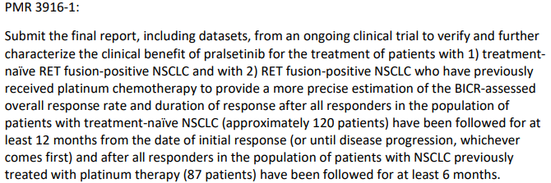

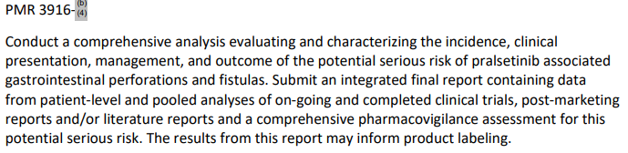

Clinical Pharmacology PMRs:

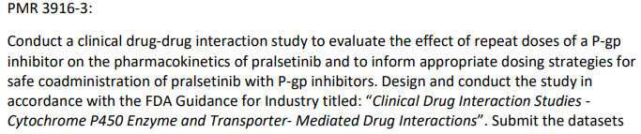

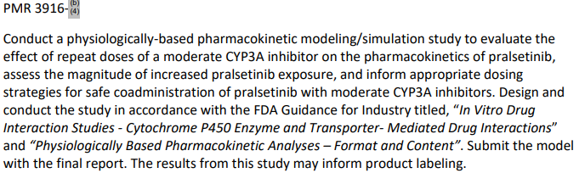

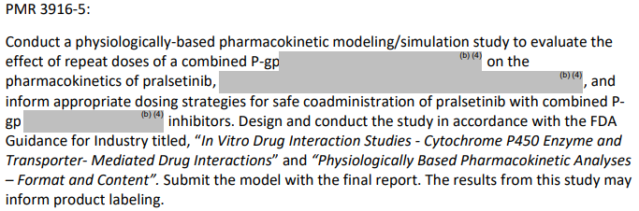

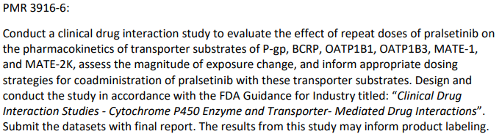

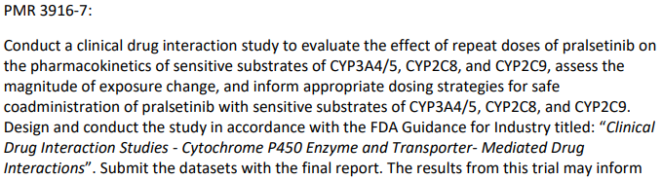



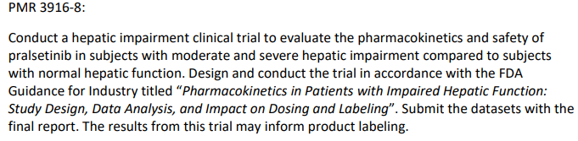

Clinical Postmarketing commitments(PMC):

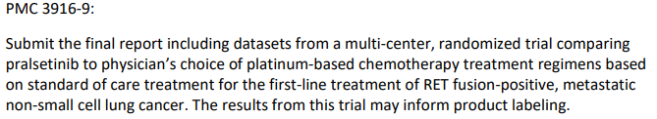

Clinical Pharmacology PMC:

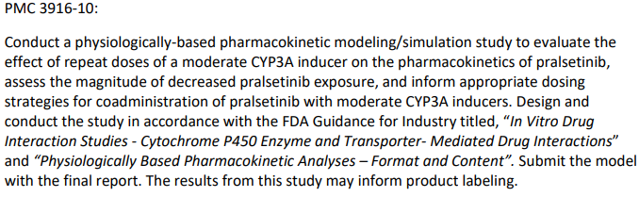

### Product Information

The [Product Information](https://www.tga.gov.au/products/australian-register-therapeutic-goods-artg/product-information-one) ([PI](https://www.tga.gov.au/products/australian-register-therapeutic-goods-artg/product-information-one)) approved with the submission which is described in this AusPAR can be found as Attachment 1. For the most recent PI and [Consumer Medicines Information](https://www.tga.gov.au/products/australian-register-therapeutic-goods-artg/consumer-medicines-information-cmi) (CMI), please refer to the TGA [PI/CMI search facility.](https://www.tga.gov.au/picmi-search-facility)

## Registration timeline

The following table captures the key steps and dates for this submission.

This submission was evaluated under the [provisional registration process](https://www.tga.gov.au/provisional-approval-pathway-prescription-medicines).

**Table** 2**: Timeline for Submission PM-2021-05760-1-4**

|  |  |
| --- | --- |
| Description | Date |
| Determination (Provisional) | 29 November 2021 |
| Submission dossier accepted and first round evaluation commenced | 31 January 2022 |
| First round evaluation completed | 30 June 2022 |
| Sponsor provides responses on questions raised in first round evaluation | 30 August 2022 |
| Second round evaluation completed | 5 October 2022 |
| Delegate’s Overall benefit-risk assessment and request for Advisory Committee advice | 25 October 2022 |
| Sponsor’s pre-Advisory Committee response | 15 November 2022 |
| Advisory Committee meeting | 1 December 2022 |
| Registration decision (Outcome) | 29 March 2023 |
| Administrative activities and registration on the ARTG completed | 29 March 2023 |
| Number of working days from submission dossier acceptance to registration decision* | 242 |

*Statutory timeframe for standard submissions is 255 working days

## Submission overview and risk/benefit assessment

This section is a TGA summary of wording used in TGA’s evaluation report, which discussed numerous aspects of overseas evaluation reports and included some information that was commercial-in-confidence.

### Quality

Pralsetinib is an oral tyrosine kinase inhibitor, targeting *RET* fusions and mutations. It is structurally related to other tyrosine kinase inhibitors such as imatinib, mobocertinib (succinate) and ceritinib(not registered in Australia).

The maximum daily dose is 400 mg (4 x 100 mg) orally once daily. They are taken in the fasted state with the Product Information (PI) instructing ‘*not to eat for at least 2 hours before and 1 hour after taking Gavreto*’. The capsules must be swallowed whole and must not be opened or chewed. The capsules will be packaged in bottles with child-resistant closures. Pack sizes are 60, 90 and 120 capsules.

There are no monographs for pralsetinib in the british pharmacopoeia or United States Pharmacopeia. The tradename Gavreto is acceptable.

Figure 1: Chemical structure of pralsetinib

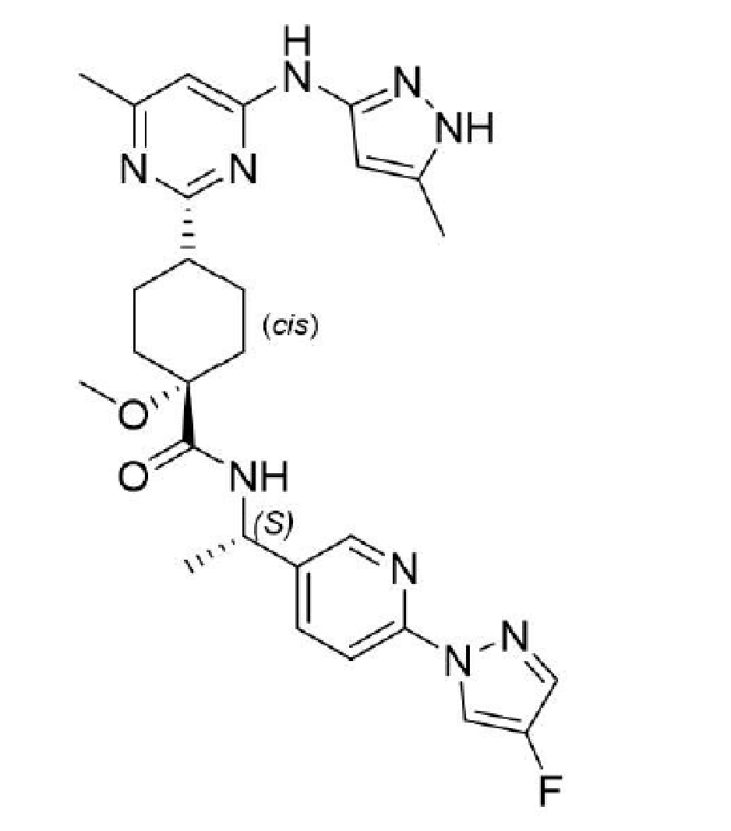

### Nonclinical

The submitted nonclinical dossier was in accordance with the relevant International Conference on Harmonisation of Technical Requirements (ICH) guideline for the nonclinical assessment of anticancer pharmaceuticals.[3] The overall quality of the nonclinical dossier was high. All pivotal safety-related studies were Good Laboratory Practices (GLP) compliant.

No major nonclinical deficiencies were identified.

Primary pharmacology studies demonstrated nonclinical efficacy for the intended target of *RET*-related kinases and support the use of pralsetinib for the proposed indications.

Off-target inhibitory activity of pralsetinib was observed against a number of other kinases at clinically relevant concentrations – notably JAK2, FGFR1, FLT1/VEGFR1 and MLK2/MAP3K10 – which explain some of the toxicities observed in animal studies.

Major targets of pralsetinib-related toxicity included:

* Gastrointestinal tract
* Bone and teeth (which may have clinical relevance to patients younger than 18 years).
* Lungs
* Lymphoid tissue (bone marrow, thymus, spleen)
* Reproductive tissue

There are no nonclinical objections to the registration of Gavreto for the proposed indications.

### Clinical

#### Pharmacology

##### Key findings from clinical pharmacology assessment

The clinical pharmacology package provided has been reviewed, including the following studies and data analyses: single- and repeat-dose pharmacokinetics (PK) studies of pralsetinib in healthy subjects and cancer patients, a mass balance study, a food effect study, drug-drug interaction studies with itraconazole, rifampin and esomeprazole, a QTc prolongation assessment,[4] exposure response analyses for efficacy and safety, and population PK analyses.

Clinical pharmacology studies (food effect, mass-balance, drug-drug interaction) in healthy subjects together with results from the pivotal study in patients with NSCLC were used to describe absorption, distribution, metabolism, and excretion properties and effects of intrinsic and extrinsic factors that may impact on pralsetinib PK, as follows:

###### Pharmacokinetics

* Absorption:
  + median time after administration of a drug when the maximum plasma concentration is reached (Tmax) = 4hrs (single dose administration, steady state)
* Distribution:
  + plasma protein binding = 97.1%
  + geometric mean Vz/F = 228 L after single dose administration and 268 L at steady state
* Metabolism and elimination:
  + Metabolism is mainly mediated by CYP3A4,[5] and to a lesser extent by CYP2D6 and CYP1A2 (Phase I) and UGT1A4 (Phase II).
  + Unchanged pralsetinib is the predominant component in plasma, urine and faeces, while its metabolites from oxidation and glucuronidation are detected in small amounts (about 5%)
  + Excretion in faeces (72.5%) is major elimination pathway for pralsetinib potentially via hepatobiliary and gastrointestinal secretion
  + Mean elimination half life (t1/2) = 14.7 hours after single dose administration
  + Mean elimination t1/2 = 22.2 hours at steady state (400 mg daily)
  + Geometric mean CL/F = 9.10 L/hour after administration of 400 mg daily at steady state
* Steady state:
  + Estimated to be reached after 3 to 5 days
* Accumulation:
  + Minor accumulation (less than 2-fold) at steady state
* Dose Proportionality:
  + Dose dependent increases in systemic exposure were observed over the dose range of 60 to 600 mg in patients with NSCLC
  + Dose dependent increases in systemic exposure could be concluded over the dose range of 200 to 400 mg once daily in healthy subjects
* Inter-individual variability:
  + About 50% to 70% for maximum concentration (Cmax) and area under the plasma concentration time curve (AUC) parameters
* Healthy subjects versus patients:
  + Population PK analysis estimates that the bioavailability of pralsetinib was 43% higher in patients with NSCLC than in healthy subjects, possibly due to differences between the populations analysed in terms of fasting status (healthy subjects fasted 10 hours before and up to 4 hours after pralsetinib, compared to patients with NSCLC fasting for 2 hours before and 1 hour after pralsetinib)

###### Effect of intrinsic factors

* Age, sex, race, body size descriptors:
  + No clinically relevant effect on PK of pralsetinib
* Hepatic impairment:
  + Mild hepatic impairment has no statistically significant effect on the PK of pralsetinib
* Renal impairment:
  + Mild to moderate renal impairment has no statistically significant effect on the PK of pralsetinib

###### Effect of extrinsic factors

* Food drug interactions:
  + Food has a significant effect on pralsetinib exposure (greater than 2-fold increase following high fat meal, compared to fasted conditions)
* Drug drug interaction:
  + Concomitant treatment with drugs that are CYP3A inhibitors or inducers can increase (with inhibitors) or decrease (with inducers) the exposure to pralsetinib respectively
  + Concomitant administration of pralsetinib with itraconazole (combined P-gp and strong CYP3A inhibitor) led to a 3.5-fold increase in pralsetinib AUC
  + Concomitant administration of pralsetinib with rifampin (strong CYP3A inducer) led to a 68% decrease in pralsetinib AUC
  + Population PK analysis predicts no relevant effect of weak CYP3A4 inhibitor on pralsetinib AUC; a CYP3A4 weak inducer has a 26% decrease in pralsetinib AUC
  + pralsetinib is a dual P-gp/BCRP substrate; P-gp or BCRP inhibitors may decrease the gastrointestinal secretion of pralsetinib and potentially increase the plasma concentration of pralsetinib
  + the effect of gastric acid reducing agents on the bioavailability of pralsetinib is not clinically relevant

###### Pharmacology

* Cardiac repolarisation:
  + Treatment with pralsetinib (400 mg daily) in patients with *RET*-fusion NSCLC, thyroid cancer and other *RET*-altered advanced solid tumours was not associated with evidence of QTc prolongation. Mean change from Baseline in QTcF was -0.9 ms at the observed mean Cmax for pralsetinib; no effect on HR, PR interval or QRS duration was observed.

###### Exposure-response analyses

* Efficacy endpoints
  + Treatment with pralsetinib 400 mg once daily demonstrated efficacy in patients with NSCLC
  + The mean steady state trough concentration (Ctrough,ss) value observed with 400 mg once daily compared with lower doses was closer to the predicted brain 90% inhibitory concentration (IC90) of pralsetinib for RET inhibition in humans (1514 ng/mL). The geometric mean (range) Ctrough,ss value with 400 mg once daily was 1150 ng/mL (179 to 4280 ng/mL). Initiating pralsetinib 400 mg once daily was associated with a rapid decline in brain lesion size
* Safety endpoints
  + Increases in pralsetinib exposure appeared to correlate with the time to at least Grade 3 anaemia or pneumonia AEs, and with decreases in Hb and ANC, and minor increases in AST and ALT.

The clinical pharmacology evaluator noted the following:

* No dose adjustment is needed on the basis of age, sex, race, total or lean body weight, BSA or mild or moderate renal impairment.
* Markers of hepatic function (ALT, AST, albumin, bilirubin) in patients with mild hepatic impairment had no significant effect on PK parameters. No dose adjustment is recommended for patients with mild hepatic impairment.
* Increased pralsetinib exposure seen under fed conditions is clinically relevant; patients should therefore be instructed to take pralsetinib at least 1 hour before or 2 hours after a meal.
* Concomitant treatment with a strong CYP3A inhibitor or inducer affected the exposure to pralsetinib; strong CYP3A4 inhibitors and inducers should be avoided, and if not, the pralsetinib dose should be reduced.
* No dose adjustment of pralsetinib is needed with the co-administration of gastric acid reducing drugs.
* Co-administration of pralsetinib with combined (that is, dual) P-gp and strong CYP3A inhibitors should be avoided based on the observed 3.5-fold increase in pralsetinib exposure when co-administered with itraconazole. If this co-administration cannot be avoided, the current pralsetinib dose should be reduced by half.
* Co-administration of pralsetinib with strong CYP3A inducers should be avoided based on the observed 68% decrease in pralsetinib exposure when co-administered with rifampin. If this co-administration cannot be avoided, the current pralsetinib dose should be doubled starting on Day 7 of co-administration.
* The proposed dosing regimen was the maximum tolerated dose (MTD) in the dose finding study BLU-667-1101 (n = 62). The efficacy results from the dose expansion phase of this study using the proposed dosing regimen showed that ORR in the *RET* fusion positive NSCLC population was 57% (95% confidence interval (CI): 46%, 68%; n = 87) in patients with prior platinum treatment and 70% (95% CI: 60%, 86%; n = 27) in treatment naïve patients.
* The exposure efficacy analysis suggested that no association was evident between pralsetinib exposure and PFS, DOR or best ORR in the primary efficacy population.
* The exposure safety analysis suggested that a 400 ng/mL increase in average concentration at steady state appeared to correlate with the time to Grade 3 + anaemia and pneumonia, and with decreases in haemoglobin and neutrophil counts, as well as minor increases in ALT and AST.
* A number of pharmacology studies are outstanding and will need to be conducted as conditions of registration (as aligned with FDA post-marketing requirements, see below).

##### Summary and recommendations of pharmacology evaluation

Overall, no major concerns were identified in the clinical pharmacology evaluation that would preclude authorization. Pralsetinib is considered approvable from a clinical pharmacology perspective, providing the following studies are conducted as part of post-marketing conditions of registration, (these are in alignment with the Post Marketing Requirements/Commitments outlined in the NDA Multi-disciplinary Review and Evaluation (213721) Pralsetinib;[6]

1. Conduct a hepatic impairment clinical trial to evaluate the pharmacokinetics and safety of pralsetinib in subjects with moderate and severe hepatic impairment compared to subjects with normal hepatic function. Design and conduct the trial in accordance with FDA guidance and submit the datasets with the final report.
2. Conduct a clinical drug-drug interaction study to evaluate the effect of a P-gp inhibitor on the pharmacokinetics of pralsetinib and to inform appropriate dosing strategies for safe co-administration of pralsetinib with P-gp inhibitors. Design and conduct the trial in accordance with FDA guidance and submit the datasets with the final report.
3. Conduct a physiologically-based pharmacokinetic modeling/simulation study to evaluate the effect of repeat doses of a moderate CYP3A inhibitor on the pharmacokinetics of pralsetinib, assess the magnitude of increased pralsetinib exposure, and inform appropriate dosing strategies for safe co-administration of pralsetinib with moderate CYP3A inhibitors. Design and conduct the trial in accordance with FDA guidance and submit the model with the final report.
4. Conduct a physiologically-based pharmacokinetic modeling/simulation study to evaluate the effect of repeat doses of a combined P-gp and moderate CYP3A inhibitor on the pharmacokinetics of pralsetinib, assess the magnitude of increased pralsetinib exposure, and inform appropriate dosing strategies for safe co-administration of pralsetinib with combined P-gp and moderate CYP3A inhibitors. Design and conduct the trial in accordance with FDA guidance, and submit the model with the final report.
5. Conduct a clinical drug interaction study to evaluate the effect of repeat doses of pralsetinib on the pharmacokinetics of transporter substrates of P-gp, BCRP, OATP1B1, OATP1B3, MATE-1 and MATE-2K, assess the magnitude of exposure change, and inform appropriate dosing strategies for co-administration of pralsetinib with these transporter substrates. Design and conduct the trial in accordance with FDA guidance and submit the datasets with the final report.
6. Conduct a clinical drug interaction study to evaluate the effect of repeat doses of pralsetinib on the pharmacokinetics of sensitive substrates of CYP3A4/5, CYP2C8, and CYP2C9, assess the magnitude of exposure change, and inform appropriate dosing strategies for safe co-administration of pralsetinib with sensitive substrates of CYP3A4/5, CYP2C8 and CYP2C9. Design and conduct the trial in accordance with FDA guidance and submit the datasets with the final report.
7. Conduct a physiologically-based pharmacokinetic modeling/simulation study to evaluate the effect of repeat doses of a moderate CYP3A inducer on the pharmacokinetics of pralsetinib, assess the magnitude of decreased pralsetinib exposure, and inform appropriate dosing strategies for co-administration of pralsetinib with moderate CYP3A inducers. Design and conduct the trial in accordance with FDA guidance and submit the model with the final report.

#### Efficacy

A list of clinical trials relevant to the evaluation of efficacy and safety of pralsetinib to support the proposed indication is as outlined in NDA Multi-disciplinary Review and Evaluation report,6

Data provided in this submission:

* Interim clinical study report (CSR 1) for ARROW trial – 26 February 2020; data cutoff date 18 November 2019. This includes efficacy results for 132 patients with *RET* fusion positive NSCLC who received pralsetinib 400 mg once daily by 11 July 2019, and safety results for 404 patients who received at least one dose of pralsetinib
* 90-day safety update and 90-day efficacy update of ARROW trial – 11 June 2020; data cutoff 13 February 2020. Includes analysis of efficacy population of patients with NSCLC treated at 400 mg once daily, enrolled as of 11 July 2019 (n = 132), and additional efficacy analyses for patients with ‘*RET-*altered measurable disease’ (n = 125, treated at 400 mg once daily).
* Revised dataset package, with 90-day data update based on cutoff date of 13 February 2020.

##### Efficacy/safety data sets

The efficacy of pralsetinib in patients with *RET* fusion positive NSCLC was evaluated in the pivotal Phase I/II Study BLU-667-1101 (ARROW trial), NCT03037385.

Primary efficacy evaluated in this submission is based on the subpopulation of patients with measurable metastatic RET fusion positive NSCLC who had received prior platinum-based chemotherapy treated at 400 mg once daily, (n = 87) and those with measurable metastatic RET fusion positive NSCLC who had not received prior treatment for their metastatic disease (n = 27). The efficacy analyses submitted by the sponsor represents data from the 132 patients with RET fusion positive NSCLC treated at 400 mg once daily (enrolled by 11 July 2019) with measurable and non-measurable disease.

###### Study BLU-667-1101 (ARROW trial)

Study BLU-667-1101, also known as ARROW trial is a Phase I/II study of the highly selective RET inhibitor, pralsetinib, in patients with thyroid cancer, NSCLC and other advanced solid tumors. It is an open label, first in human study designed to evaluate the safety, tolerability, PK, pharmacodynamic and antineoplastic activity of pralsetinib in patients with advanced, unresectable, *RET*-altered NSCLC, MTC and other *RET*-altered solid tumours.

The study included a Phase I dose escalation part (to determine MTD and recommended Phase II dose [RP2D] of pralsetinib) followed by a Phase II expansion part to assess the clinical efficacy of pralsetinib in specific tumour types and treatment settings, measured primarily by ORR, and further define the safety and tolerability at the RP2D.

Figure 2: Study BLU-667-1101 design

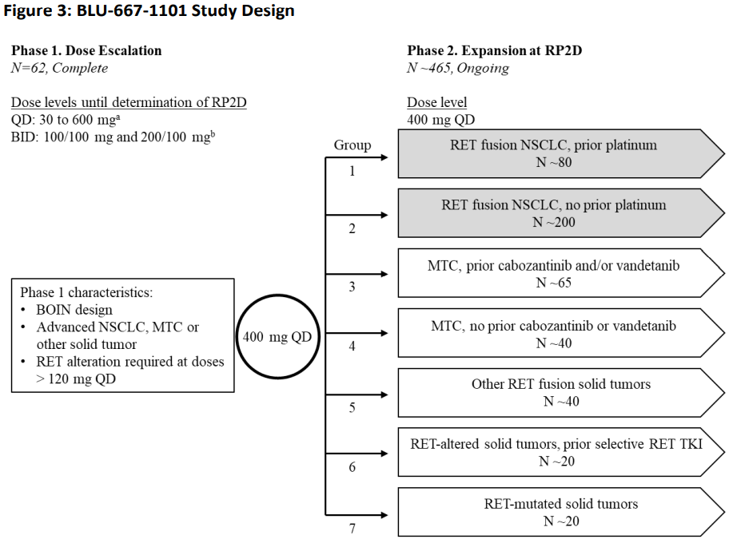

*Trial location*

Phase I: 6 centres across North America and Europe

Phase II: 53 centres across North America, Europe and Asia

There were no study sites in Australia.

*Diagnostic criteria*

Patients with confirmed oncogenic *RET* fusion as determined by local testing of tumour of circulation tumour DNA (ctDNA)

**Table 3: Study BLU-677-1101 key inclusion and exclusion criteria**

|  |  |
| --- | --- |
| Patients | Efficacy evaluation   * treatment naïve (n = 27) * pre-treated with platinum-based chemotherapy (n = 87)   *Key inclusion criteria*  Phase I:   * Pathologically documented, definitively diagnosed unresectable advanced solid tumour * At least 18 years * ECOG: 0 or 1 * Progressed on, or inadequate response to, intolerant of, or inappropriate for standard therapy, or no accepted standard therapy.   Phase II:  Group 1:   * Men or women, at least 18 years with unresectable, pathologically documented, definitively diagnosed locally advanced or metastatic NSCLC with a *RET* fusion previously treated with a platinum-based chemotherapy   Group 2:   * Men or women at least 18 years with unresectable, pathologically documented, definitively diagnosed locally advanced or metastatic NSCLC with a *RET* fusion not previously treated with a platinum-based chemotherapy. (Up until Amendment 9, treatment naïve patients were only allowed if standard therapy was inappropriate. With Amendment 9, prior platinum chemotherapy in the neoadjuvant and adjuvant settings were permitted if the last dose of platinum was at least 4 months before the first dose of pralsetinib.)   Both groups:   * *RET* fusion, as determined by local testing of tumour or ctDNA in blood * Measurable disease per RECIST v1.1 * ECOG 0 or 1   *Key exclusion criteria*   * Primary driver alteration other than RET * History of myocardial infarction or unstable angina within previous 6 months; clinically significant cardiovascular disease, uncontrolled hypertension or uncontrolled arrhythmias * Previous treatment with selection RET inhibitor (except Group 6) or any systemic anticancer therapy and all forms of radiotherapy within 14 days or 5 half lives before first dose of pralsetinib; immunotherapy or other antibody therapy within 28 days before first dose of pralsetinib, or neutrophil growth factor support within 14 days of the first dose of pralsetinib * Inadequate haematology and clinical chemistry values within 14 days before first dose of pralsetinib * QTcF > 470ms and history of prolonged QTS or TdP * Presence of CNS metastases or primary CNS tumour that is associated with progressive neurological symptoms or requiring increasing doses of corticosteroids to control CNS disease * Symptomatic interstitial lung disease or interstitial pneumonitis * Pregnancy and breastfeeding |
| Intervention | Phase I: pralsetinib once daily (30 to 600 mg) or twice daily (100/100 mg or 200/100 mg) to determine MTD and RP2D  Phase II: pralsetinib 400 mg once daily (as per RP2D) |
| Comparator | Nil, single-arm study |
| Endpoints | *Phase II*  *Primary endpoint*   * ORR (confirmed complete response [CR] or partial response [PR]): blinded independent review committee (BIRC) determined according to RECIST 1.1.   *Secondary endpoints*   * DOR * PFS* * OS* * CNS metastases activity analysis in patients with *RET*-fusion positive NSCLC who had measurable CNS/brain lesion/s at Baseline   *Exploratory efficacy endpoints*  Phase I:   * Correlation of *RET* gene status in plasma and/or tumour tissue with ORR, CBR, DOR, PFS, OS and DCR   Phase II:   * CBR * DCR * Correlation of RET gene status in plasma and/or tumour tissue with ORR, CBR, DOR, PFS, OS and DCR * QOL per EORTC QLQ-C30 questionnaire   *The time to event endpoints of PFS and OS are difficult to interpret in a single arm study. |

*Dose selection*

Based on Phase I data, a pralsetinib dose of 400 mg once daily was determined to be the RP2D

*Study treatments*

Pralsetinib was administered continuously daily without interruption (unless due to interruption and/or discontinuation due to toxicity, progression or other)

Phase I: pralsetinib once daily (30 to 600 mg) or twice daily (100/100 mg or 200/100 mg) to determine MTD and RP2D

Phase II: pralsetinib 400 mg once daily (as per RP2D)

No randomisation/blinding, as this was an open label study.

*Dose modification*

The oversea regulator report states ‘*Concurrent medications apart from the following were permitted: other anticancer therapies, investigational therapeutic agents, neutrophil growth factor within 14 days before C1D1 and throughout cycle 1 (unless patient experienced DLT of neutropenia), strong inhibitors and inducers of CYP3A4, strong dual P-gp and CYP3A4 inhibitors. Sensitive substrates of CYP2C9, strong CYP2D6 inhibitors and strong CYP1A2 inhibitors were permitted but use with caution advised’*.6

*Study endpoints*

The study endpoints are listed below:

* Primary efficacy endpoint for Phase I: n/a
* Primary efficacy endpoint for Phase II: ORR (per RECIST v1.1 as assessed by Blinded independent central reviews (BICR) of local imaging)
* Secondary efficacy endpoints for Phase I:
  + ORR based on RECIST v1.1 as assessed by BICR of local imaging
* Secondary efficacy endpoints for Phase II:
  + Duration of response
  + Progression free survival*
  + Overall survival (OS)*
  + Central nervous system (CNS) metastases activity analysis in patients with *RET*-fusion positive NSCLC who had measurable CNS/brain lesion/s at Baseline

*The time to event endpoints of PFS and OS are not interpretable in a single arm study.

Exploratory efficacy endpoints are listed below:

* Exploratory efficacy endpoints Phase I:
  + Correlation of *RET* gene status in plasma and/or tumour tissue with ORR, clinical benefit rate (CBR), DOR, PFS, OS and disease control rate (DCR)
* Exploratory efficacy endpoints Phase II:
  + CBR
  + DCR
  + Correlation of RET gene status in plasma and/or tumour tissue with ORR, CBR, DOR, PFS, OS and DCR
  + Quality of life (QoL) per EORTC core quality of life questionnaire

*Statistical analysis plan and amendments*

Efficacy analysis was conducted based on two separate data cutoffs, the original data cutoff date of 18 November 2019 and one corresponding to the 90-day efficacy update (data cutoff date of 13 February 2020).

A further update for DOR was based on data cutoff of 22 May 2020, for patients who had a confirmed response by the time of the 90-day efficacy update.

Timing of final analysis was not pre-specified in the protocol.

Primary analysis of efficacy was conducted separately in patients who had received prior platinum based chemotherapy and in those who were treatment naïve.

The final version of the statistical analysis plan of 30 October 2019, included assumptions for sample size calculation in the expansion phase for prior platinum therapy and the treatment naïve cohorts.

In cohort 1 (includes patients with *RET* fusion positive NSCLC previously treated with platinum based chemotherapy), assuming a null hypothesis that ORR = 0.23 against an alternative hypothesis of ORR = 0.5 with two sided Type 1 error rate of 0.05, a sample size of 80 provides more than 95% power.

In cohort 2 (includes treatment naïve patients with *RET* fusion positive NSCLC), assuming a null hypothesis that ORR = 0.48 against an alternative hypothesis of ORR = 0.61 with two sided Type 1 error rate of 0.05, a sample size of 170 provides more than 90% power.

For a single arm study, efficacy analysis is based on ORR of adequate magnitude and a clinically meaningful DOR.

The study protocol amendments are detailed in the oversea regulator report.6

*Study results*

Based on the 90-day efficacy update of the patient population with measurable disease (n = 125):

* 78.4% had received prior systemic treatment
* 69.6% had received prior platinum treatment
* 30.4% had no prior platinum treatment
* 8.8% had received prior non-platinum systemic treatment
* 21.6% had no prior systemic treatment

The treatment history is similar to that of the efficacy population (n = 132), see following table:

Table 4: Analysis populations (NSCLC patients treated at 400 mg once daily)

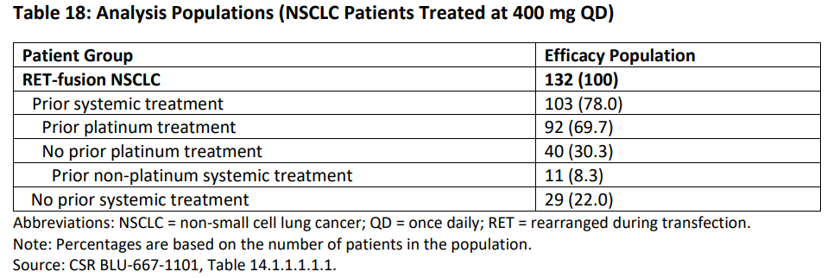

Table 5 presents the treatment history of patients with NSCLC who were treated with pralsetinib at 400 mg once daily based on the 90-day efficacy update.

Table 5: Treatment history of patients with NSCLC who were treated with pralsetinib at 400 mg once daily based on the 90-day efficacy update

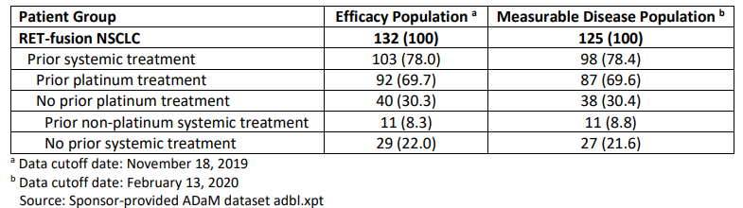

*Patient disposition*

Patient disposition for the subpopulations (prior platinum treatment n = 87, and treatment naïve n = 27) are as shown in the following table:

Table 6: Study BLU-667-1101 patient disposition

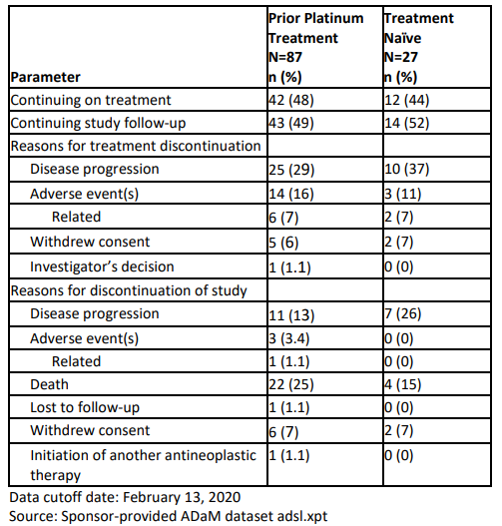

*Protocol violations*

Overall, the types of protocol deviation reported in the efficacy population are unlikely to impact on the overall efficacy results of the population of patients with *RET* fusion positive metastatic NSCLC with measurable disease treated at 400 mg once daily dose of pralsetinib.

*Key demographic and other baseline characteristics*

Efficacy population, overall;6

* median age (min, max) = 60.0 (28, 87)
* female = 52.3%
* race: White = 56.8%; Asian = 32.6%, unknown =8.3%
* Eastern Cooperative Oncology Group (ECOG) performance status 0 = 37.9%; ECOG 1 = 57.6%;[7]
* TNM stage at screening: IIIB = 2.3%; IV = 53.8%;[8]
* Central nervous system metastasis (history or current) = 41.7%
* *RET* fusion = 100%

Prior platinum treatment (n=87) in RET altered measurable disease population,6

* median age (min, max) = 60 (28, 85)
* female = 49%
* race: White = 53%; Asian = 35%, unknown =10%
* ECOG 0 = 36%; ECOG 1 = 59%
* TNM stage at screening: IIIB = 1.1%; IV = 49%
* Central nervous system metastasis (history or current) = 43%
* *RET* fusion = 100%

Treatment naïve (n=27) in RET altered measurable disease population;6

* median age (min, max) = 65 (30, 87)
* female = 52%
* race: White = 59%; Asian = 33%, Native Hawaiian or other Pacific Islander = 3.7%; unknown =3.7%
* ECOG 0 = 41%; ECOG 1 = 56%
* TNM stage at screening: IIIB = 0%; IV = 67%
* Central nervous system metastasis (history or current) = 33%
* *RET* fusion = 100%

*Results*

Primary endpoint

The efficacy results for the primary endpoint of ORR as assessed by BICR provided by the sponsor is based on the data cut-off of 18 November 2019. The ORR analysis for this evaluation was based on the data cut-off of 13 February 2020, and is considered the primary analysis for this submission.

Subpopulation with prior platinum treatment (n = 87)

* ORR = 57% (95% CI: 46, 68) (n = 50)
* CR = 6%
* PR = 52%

Treatment naïve (n = 27)

* ORR = 70% (95% CI: 50, 86) (n=19)
* CR = 11%
* PR = 59%

An exploratory subgroup analysis of 39 patients previously treated with an anti-PD-1 or anti-PD-L1 therapy either sequentially or concurrently with platinum-based chemotherapy demonstrated an ORR of 59% (95% CI: 42, 74).

Secondary and exploratory endpoints

DOR in patients with measurable metastatic *RET* fusion positive NSCLC, data cutoff 22 May 2020:

* Prior platinum treatment subgroup (n = 87)
  + Number of responders = 50
  + Median DOR in months = NE (95% CI: 15.2, NE)
  + DOR at least 6 months = 80%
* No prior systemic treatment (n = 27), data cutoff 22 May 2020
  + Number of responders = 19
  + Median DOR in months = 9.0 (95% CI: 6.3, NE)
  + DOR at least 6 months = 58%

As per regulatory guidelines;[9] time-to-event endpoints, such PFS and OS, are difficult to interpret in single arm trials, given the lack of internal contemporaneous controls.

For completeness in efficacy population (n = 132):

* CBR = 68.2%, with 90 patients having CR, PR or stable disease (SD) for at least four cycles.
* DCR = 87.9%, with 116 patients having CR, PR or SD.
* PFS = estimated median PFS was 12.7 months (95% CI: 9.1, -)
* OS = Kaplan-Meier estimate for median OS could not be determined at a median follow up of 10.5 months.

Analyses of PFS and OS under Study BLU-667-1101 are considered descriptive and were not verified during clinical evaluation, nor were analyses related to CBR and DCR.

Quality of life

As this study was open-label, knowledge of treatment assignment may induce bias in the completion of patient reported outcome (PRO) instruments; there was no pre-specified analysis plan for PROs, and therefore no control of Type 1 error threshold for a clinically meaningful difference for these analyses. In addition, since there are no comparative analyses for this non-randomised study, it is difficult to attribute any reported within-patient differences of PROs to the experimental arm, as the results cannot be put into context for this patient population or disease without a control arm.

Pralsetinib versus Intracranial metastases

Among the 87 patients in the prior platinum-based chemotherapy subgroup, eight had measurable central nervous system metastases at baseline (per BICR); no patient received cerebral RT within two months prior to study entry. Responses in intracranial lesions were observed in 4 of these 8 patients, including two patients with a central nervous system CR; 75% of responders had a DOR of at least 6 months. One patient who had received prior PD-1/PD-L1 inhibitor and had measurable central nervous system metastases at baseline (per BICR) achieved a CR.

Subgroup analyses

Exploratory ORR analysis by age, sex, and race in the prior platinum therapy subgroup and treatment naïve subgroup are shown in the oversea regulator report.6 There were no obvious outliers observed in these analyses.

#### Safety

The safety analysis population consisted of 438 patients (for the Day 90 safety update data; n = 354 patients treated at 400 mg once daily in the initial new drug application), including all patients (n = 404) in Study BLU-667-1101 who received at least one dose of pralsetinib (354 patients received starting dose of 400 mg once daily, and 179 patients with NSCLC who received starting dose of 400 mg once daily), and additional patients who received a starting dose of 400 mg once daily available after the 90-day safety update (data cutoff 13 February 2020).

The most common AEs in all patients treated at 400 mg once daily (in at least 20% of patients) by Preferred Term (PT) included:

* AST increased
* Constipation
* Anaemia
* Hypertension
* ALT increased
* Diarrhea
* Fatigue
* WBC count decreased
* Neutropenia
* Pyrexia

##### Exposure to pralsetinib

Among the 438 patients treated at 400 mg once daily (based on 90-day safety update, including 220 (50%) patients with *RET* fusion positive NSCLC), median duration of treatment was 5.24 months (range: less than 1 month to 25.1 months). 47% were exposed to pralsetinib for at least 6 months and 23% were exposed for at least 12 months.

Patient disposition for NSCLC patient population (n = 220) is as follows:

* End of treatment status – off treatment = 36%
* End of treatment status – on treatment = 64%
* Reason for treatment discontinuation:
  + Adverse event (AE) = 11%
  + Other = 0.5%
  + Physician decision = 0.5%
  + Absence of progression = 21%
  + Withdrawal by subject = 3.2%

##### Demographics of safety population:

The 90-day update data demographics and baseline characteristics in patients with RET fusion positive NSCLC and all patients treated is as follows:

Patients with NSCLC – treated at 400 mg (n = 220)

* Median age = 60 (26-87)
* Female = 52%
* Race: white = 50%; Asian = 41%; unknown = 7%
* Region: Asia = 39%; Europe = 35%; US = 26%
* ECOG 0 = 31%, ECOG 1 = 66%
* Systemic therapy = 71%
* Radiation = 38%
* Surgery/procedures = 49%

All patients - treated at 400 mg (n = 438)

* Median age = 59 (18 to 87)
* Male = 55%
* Race: white = 58%; Asian = 24%; unknown = 6%
* Region: Asia = 31%; Europe = 36%; US = 33%
* ECOG 0 = 36%, ECOG 1 = 62%
* Systemic therapy = 69%
* Radiation = 37%
* Surgery/procedures = 69%
* Disease type: NSCLC = 53%; MTC = 37%; PTC = 4.6%; colon = 1.1%

##### Deaths

Among all patients treated at 400 mg once daily in the initial new drug application (n = 354), death due to an serious adverse event (SAE) was reported in 8.2% (n = 29) of patients, including one patient due to a related SAE (pneumocystis jirovecii pneumonia). Since the data cutoff of 18 November 2019, five additional deaths were reported through the late-breaking data cutoff date of 18 December 2019; one event of pneumonitis was considered related to pralsetinib treatment.

Fatal adverse reactions occurring in more than 1 patient in the NSCLC safety population (n = 220):

* Pneumonia = 3
* Sepsis = 2

##### Serious Adverse Events

Among all patients treated at 400 mg once daily in the initial new drug application (n = 354), SAEs were reported in 44.1% of patients (n = 157); 16.4% (n = 58) had treatment related SAEs.

In patients with NSCLC treated at 400 mg once daily, SAEs were reported in 50.8% of patients (n = 91); 20.1% (n = 36) had treatment related SAEs.

The most common SAEs (occurring in at least 2 patients in all patients treated at 400 mg) were:

* Pneumonia = 8.2%
* PD = 5.1%
* Pneumonitis = 4.0%
* Sepsis = 2.5%
* Urinary tract infection = 2.8%
* Pyrexia = 2.5%

The incidence of SAE was similar in the subgroup of patients with NSCLC and in the all patients treated at 400 mg once daily safety population.

###### Serious adverse events - off target effects associated with VEGFR, JAK1/2 and FGFR pathways & other

*VEGFR pathway*

Haemorrhagic events = 16%.

* 2.5 patients were Grade 3 or higher. Dose modifications occurred as a result of these events.
* One fatal haemorrhagic event was reported.
* All SAEs of haemorrhagic events were associated with potential confounders/risk factors, however, based on the inhibition of the VEGF pathway by pralsetinib, it remains possible that pralsetinib may contribute to the risk of such events. The Delegate noted that this should be included in the PI.

Hepatotoxicity: serious hepatic events (Grade 3 or higher) = 1.6%

* Of these seven patients, five required dose modifications.
* No fatalities attributed to hepatic events were identified
* No events met Hy’s law criteria
* Hepatotoxicity and recommended dose modifications for relevant patients should be included in the PI.

GI perforations/fistulas – 11 events in 8 patients

* Based on currently available information, the potential for pralsetinib to impact on the VEGF pathway, and the limited available data from a single arm study, further characterisation of the incidence, presentation, management and outcome of GI perforations/fistulas will be required as a condition of registration.

Impaired wound healing – four events in four patients

* Grade 3 event (n = 1) and Grade 1 event (n = 3)
* None required dose modification
* Based on review of preclinical data for pralsetinib and clinical data for multiple drugs that inhibit the VEGF pathway, this may be a class effect; the risk of Impaired Wound Healing and instructions to withhold pralsetinib for at least two weeks following surgery until adequate wound healing should be included in the PI.

Cardiac failure

* Analyses for cardiac failure and cardiomyopathy were reviewed and concluded that given the confounding factors associated with the events, it is unlikely that pralsetinib contributed to the occurrence of the reported events of cardiac dysfunction.

Thromboembolic events

* Analyses for thrombotic and embolic events (11 Grade 3 or higher events, including pulmonary embolism, deep vein thrombosis, portal vein thrombosis, thrombophlebitis superficial, and superior vena cava syndrome) were reviewed and do not suggest a safety signal for pralsetinib for thromboembolic events.

*FGFR pathway*

Hyperphosphataemia

* Generally moderate; no serious cases were reported, and no patients had phosphate values of > 9mg/dL
* In patients with abnormal phosphate value (≥ 5.5 mg/dL) by ‘*Phosphate Binder Treated Status Safety Population*’ – all patients treated at 400 mg once daily and normal or missing phosphate value at Baseline and abnormal phosphate value at post-Baseline
  + N = 93
  + Approximately 50% were not treated with phosphate binders; these patients did not have worsening hyperphosphataemia over time and administration of phosphate binders did not appear to decrease the duration of hyperphosphataemia
* Hyperphosphataemia should be included in the PI as a potentially clinically significant adverse reaction of pralsetinib

Vision disorders

* Analyses of vision disorders were reviewed and do not suggest a safety signal for pralsetinib for vision disorders

*JAK1/2 pathway*

Infections/myelosuppression

* Analysis revealed 13 SAEs of sepsis
  + Grade 3: n = 7
  + Grade 4: n = 5
  + Grade 1: n = 1
* In all events, baseline absolute neutrophil count were normal
* Six events occurred in association with decreased neutrophil counts
* the primary infection was urinary tract infection in five events and pneumonia in two events
* Evaluation of this analysis concluded that as infections are commonly reported in patients with cancer, and in ARROW trial these events were not consistently associated with neutropenia, this does not warrant inclusion in the PI.

*Dropouts and/or Discontinuation due to Adverse Effects*

Among all patients treated at 400 mg once daily at initial new drug application (n = 354), AEs that were the primary or contributing reasons for permanent treatment discontinuation were reported in 16.4%, and in 19.6% of patients with NSCLC treated at 400 mg once daily. This was similar to the results based on the 90 day safety update (n = 438) with treatment discontinuation in 14% in all patients treated at 400mg, and 19% in all patients with NSCLC treated at 400 mg.

The most common AEs leading to permanent discontinuation were pneumonia and pneumonitis.

*Dose interruption/reduction due to Adverse Effects*

In patients with NSCLC treated with pralsetinib 400 mg once daily (90-day update data, n = 220):

* Dose interruption due to AE = 60%
  + Most commonly due to neutropenia, hypertension, pneumonitis, anaemia, pneumonia, decreased absolute neutrophil count, AST increase, CK increase, pyrexia and diarrhoea
* Dose reduction due to AE = 36%
  + Most commonly due to neutropenia, anaemia, pneumonitis, hypertension, decreased absolute neutrophil count, fatigue, and pneumonia

*Significant adverse events*

Neutropenia

* Among all patients treated at 400 mg once daily (n = 354), neutropenia events were reported in 33% of patients (n = 115); 30% of patients (n = 105) reported neutropenia events that were related to study drug
* 4 patients experienced febrile neutropenia; no patient had pralsetinib permanently discontinued for febrile neutropenia

Thrombocytopenia

* Among all patients treated at 400 mg once daily (n = 354), thrombocytopenia events were reported in 14.1% of patients (n = 50); 13% of patients (n = 45) reported thrombocytopenia events that were related to study drug

Hypertension

* Among all patients treated at 400 mg once daily (n = 354), hypertension was reported in 28% of patients (n = 99); 14% experienced grade 3 events, none were Grade 4 or 5 events. 20% of patients (n = 72) reported hypertension events that were related to study drug
* Pralsetinib was interrupted for hypertension in 7% of patients, 3.2% had dose reduction of pralsetinib for hypertension, and one patient discontinued treatment due to hypertension.
* The Delegate noted that hypertension should be included in the PI as appropriate management will be required to mitigate any adverse outcomes.

*Treatment emergent adverse events*

Table 7: Summary of adverse events (safety population)

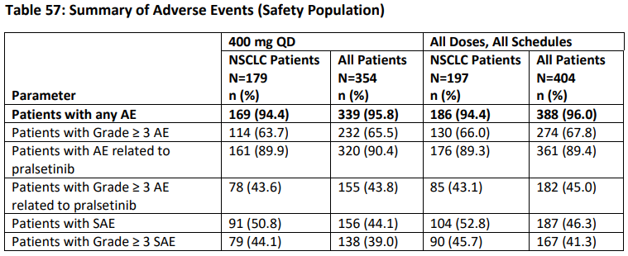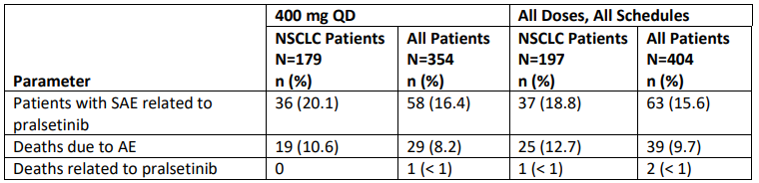

Among all patients treated at 400 mg once daily at initial new drug application (n = 354):

* AEs = 95.8%
* AEs related to pralsetinib = 90.4%
* AE of at least Grade 3 = 65.5%
* At least Grade 3 related AEs = 43.8%
* SAEs = 44.1%
* Related SAEs = 16.4%
* Discontinuation due to AEs = 11.6%

The safety profile of patients with NSCLC treated at 400 mg once daily was generally similar to that of all patients treated at 400 mg once daily.

The most common AEs (reported in more than 20% of patients treated at 400 mg once daily) were:

* AST increased = 38.7%
* Constipation = 32.4%
* Anaemia = 31.9%
* Diarrhea = 27.7%
* ALT increased = 27.1%
* Hypertension = 28.0%
* Fatigue = 21.5%

The AE profile based on the 90-day update data of patients with NSCLC was similar to the results of the initial analysis.

The most common AEs of at least Grade 3 reported (in more than 10% of patients treated at 400 mg once daily) were:

* Hypertension = 13.8%
* Anaemia = 12.1%
* Neutropenia = 10.5%

The most common related AEs of at least Grade ≥ 3 (in patients treated at 400 mg once daily) were:

* Hypertension = 10.5%
* Neutropenia = 9.6%
* Anaemia = 7.9%
* Decreased neutrophil count = 4.0%
* Decreased WBC = 3.1%
* Lymphopenia = 3.1%
* Increased CK = 3.1%
* Increased AST = 2.0%

Among patients with NSCLC treated at 400 mg once daily (treatment emergent adverse events (TEAE) within 30 days of last treatment, 90 day update; n = 220):

* Fatigue = 35%
* Constipation = 35%
* Musculoskeletal pain = 32%
* Hypertension = 28%
* Diarrhea = 24%
* Cough = 23%
* Pyrexia = 20%
* Oedema = 20%
* Pneumonia = 17%
* Dry mouth = 16%

*Laboratory findings*

Among patients with NSCLC treated at 400 mg once daily (n = 220), the following laboratory abnormalities were observed:

Table 8: Laboratory findings

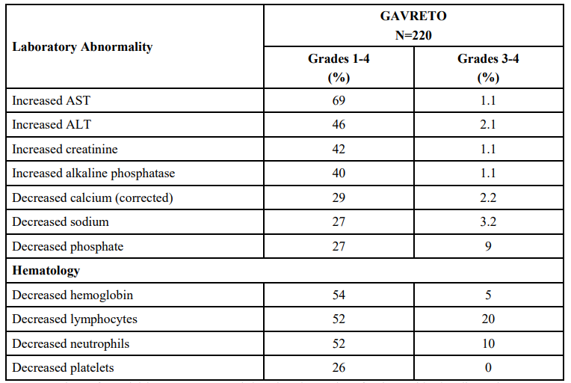

*ECG findings*

QT prolongation as an AE was reported in 5.3% of patients (all patients treated at 400 mg once daily).

An analysis of data from Phase II of ARROW trial was performed, consisting of 34 patients in the QT/QTc population. Analysis of the regression relationship between ΔQTcF and the plasma concentration of pralsetinib at matching times post-dose showed that pralsetinib had no significant effect on QT prolongation with a linear slope of -0.0003 ms/ng/mL (p-value = 0.841), and no patients had a QTcF value > 500ms

*Submission specific safety issues*

Pneumonia

Among all patients treated at 400 mg once daily (n = 354), pneumonia was reported in 13% of patients (n = 47):

* Related to study drug = 4%
* Serious grouped pneumonia events = 10%
* Serious grouped pneumonia events related to study drug = 3%

In the safety population of 438 patients treated with pralsetinib at 400 mg once daily, the incidence of pneumonia = 14%. In those with an adverse event of pneumonia, 1.4% permanently discontinued pralsetinib, 6% had treatment interruptions, and 1.6% had dose reductions. Five deaths due to pneumonia were reported.

Pneumonitis

Among all patients treated at 400 mg once daily at initial new drug application submission (n = 354), pneumonitis was reported in 10% of patients (n = 35); 9% were related to study drug.

* At least Grade 3: n = 9
* Serious pneumonitis events = 4%
* Serious grouped pneumonitis events related to study drug = 3%

In the safety population of 438 patients treated with pralsetinib at 400 mg once daily, the incidence of pneumonitis was 10% (n = 43):

* Grade 3 to 4 events = 2.7%
* Deaths attributed to pneumonitis = 0.5%

Pneumonitis/interstitial lung disease is a known serious adverse event of tyrosine kinase inhibitors (TKIs) and requires appropriate management. The sponsor was asked to complete additional analyses of patients who experienced Grade 1 to 2 pneumonitis events to explore if continuing pralsetinib after dose reduction would be appropriate (see following table):

Table 9: Pneumonitis dose modifications and rechallenge for all patients treated with pralsetinib at 400 mg daily (N = 438)

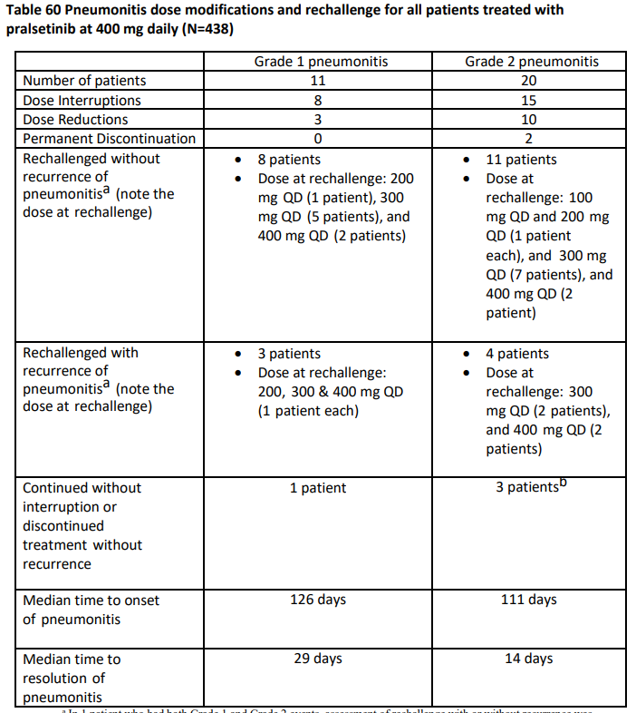

Review of these results suggested that it would be acceptable to withhold pralsetinib until resolution of pneumonitis and re-challenge at a reduced dose if they experience Grade 1 or 2 pneumonitis; pralsetinib should be discontinued if pneumonitis recurs.

Tumour lysis syndrome

This occurred in three patients and 2 out of 3 patients experienced a Grade 3 event.

Safety analyses by demographic subgroups

The incidence of at least Grade 3 TEAEs and serious TEAEs were approximately 20% higher in the subgroup of patients age at least 65 years old than in those under 65 years of age, and the incidence of pralsetinib for TEAE was about 10% higher.

### Risk management plan

The sponsor has applied to register a new chemical entity, pralsetinib (Gavreto) through Project Orbis and the Provisional Approval Pathway. The Regulators involved in this Project Orbis submission are US FDA, the TGA and Health Canada.

Gavreto is proposed to be used for the treatment of adult patients with *RET*-fusion positive, locally advanced or metastatic.The proposed dosing regimen involves oral administration of four capsules (4 x 100 mg) once daily. The dose is the same for each indication as well as for paediatric patients (12 years and older) and adults. Patients should receive treatment with Gavreto until disease progression or unmanageable toxicity.

The sponsor has submitted EU-risk management plan (RMP) version 1.0 (dated 15 September 2021; data lock point (DLP) 6 November 2020) and Australia specific annex (ASA) version 1.0 (dated 20 December 2021) in support of these applications. In its Section 31 response, the sponsor has submitted EU-RMP version 1.2 (dated 3 February 2022; DLP January 2022) and ASA version 1.1 (dated 26 August 2022) in support of its application

The summary of safety concerns and their associated risk monitoring and mitigation strategies are summarised in Table 10. The TGA may request an updated RMP at any stage of a product's life-cycle, during both the pre-approval and post-approval phases.

Table 10: Summary of safety concerns

|  |  |  |  |  |  |
| --- | --- | --- | --- | --- | --- |
| Summary of safety concerns | | Pharmacovigilance | | Risk Minimisation | |
| Routine | Additional | Routine | Additional |
| **Important identified risks** | Pneumonitis | ✔ | – | ✔ | – |
| Hypertension | ✔ | – | ✔ | – |
| Haemorrhage | ✔ | – | ✔ | – |
| Transaminase Elevations | ✔ | – | ✔ | – |
| **Important potential risks** | Embryo-foetal toxicity | ✔ | – | ✔ | – |
| Severe Infections | ✔ | – | ✔ | – |
| QT prolongation | ✔ | – | ✔ | – |
| **Missing information** | Use in patients with severe hepatic impairment | ✔ | ✔* | ✔ | – |
| Drug-drug Interactions | ✔ | ✔† | ✔ | – |

*Study GP43163

†Study GP43162

No new safety concerns have been identified and the summary of safety concerns is acceptable.

Routine and additional pharmacovigilance activities are proposed. Additional pharmacovigilance activities include a drug-drug interaction study (Study GP43162) and a pharmacokinetic study in patients with severe hepatic impairment (Study GP43163). This will provide information on the Missing Information (as listed in the table above). This is acceptable.

Routine risk minimisation activities only are proposed which is acceptable as pralsetinib is an oral medicine prescribed by specialists.

#### Proposed wording for condition of registration

Any changes to which the sponsor has agreed should be included in a revised RMP and ASA. However, irrespective of whether or not they are included in the currently available version of the RMP document, the agreed changes become part of the risk management system.

The suggested wording is:

‘The Gavreto EU-Risk Management Plan (RMP) (version 1.2, dated 3 February 2022 data lock point January 2022), with Australian Specific Annex (version 1.1, dated 26 August 2022), included with submission PM-2021-05760-1-4; PM-2021-05761-1-4 and PM-2021-05762-1-4, and any subsequent revisions, as agreed with the TGA will be implemented in Australia.’

The following wording is recommended for the PSUR requirement:

‘An obligatory component of risk management plans is routine pharmacovigilance. Routine pharmacovigilance includes the submission of periodic safety update reports (PSURs).

Unless agreed separately between the supplier who is the recipient of the approval and the TGA, the first report must be submitted to TGA no later than 15 calendar months after the date of this approval letter. The subsequent reports must be submitted no less frequently than annually from the date of the first submitted report until the period covered by such reports is not less than three years from the date of this approval letter, or the entire period of provisional registration, whichever is longer.

The reports are to at least meet the requirements for PSURs as described in the European Medicines Agency’s Guideline on good pharmacovigilance practices (GVP) Module VII-periodic safety update report (Rev 1), Part VII.B Structures and processes. Note that submission of a PSUR does not constitute an application to vary the registration. Each report must have been prepared within ninety calendar days of the data lock point for that report.’

As Gavreto is being considered for a provisional registration it should be included in the Black Triangle Scheme as a condition of registration. The following wording is recommended for the condition of registration:

‘Gavreto (pralsetinib) is to be included in the Black Triangle Scheme. The PI and CMI for Gavreto must include the black triangle symbol and mandatory accompanying text for five years, or the product’s entire period of provisional registration, whichever is longer.’

As Gavreto is being considered for a provisional registration, confirmatory trial data is recommended for the condition of registration. The following wording based on the proposed clinical study plan is provided as a preliminary suggestion for the TGA Delegate to consider. The final condition of registration is to be determined by the TGA Delegate:

‘Specifically the sponsor must conduct studies as described in the clinical study plan in version 1.1 (dated 26 August 2022) of the Australia specific annex. The following study report(s) should be submitted to TGA:

* ARROW trial (Study BO42863) by fourth quarter of 2022
* AcceleRET-Lung by fourth quarter of 2026
* AcceleRET-MTC Study by fourth quarter of 2028
* TAPISTRY (Tumour-Agnostic Precision Immuno-Oncology and Somatic Targeting Rational For You) by second quarter of 2025

Further [guidance](https://www.tga.gov.au/publication/provisional-registration-extension-and-transition-full-registration) for sponsors is available on the TGA website.’

### Risk-benefit analysis

#### Delegate’s considerations

##### Proposed indication

The sponsor proposes to register a new therapeutic entity under the provisional approval pathway for the following:

*For the treatment of adult patients with RET-fusion positive, locally advanced or metastatic NSCLC.*

##### Benefits/Uncertainties of benefit

Based on clinical data from Study BLU-667-1101 (ARROW trial), substantial evidence of effectiveness of pralsetinib has been provided by the sponsor to support provisional approval of pralsetinib in adult patients with treatment naïve *RET* fusion positive metastatic NSCLC and adult patients with *RET*-fusion positive metastatic NSCLC who have previously received platinum-based chemotherapy.

Key efficacy data from ARROW trial demonstrated an ORR of 57% (95% CI: 46, 68) in patients with RET fusion positive metastatic NSCLC who have previously received platinum-based chemotherapy (n = 87), with durable responses (80% having responses lasting at least 6 months. In the population of patients with treatment naïve *RET* fusion positive NSCLC (n = 27), the ORR was 70% (95% CI: 50, 86), with 58% having responses lasting at least 6 months.

Overall response rate of sufficient magnitude in conjunction with a clinically meaningful duration of response is considered reasonably likely to predict clinical benefit in patients with rare NSCLC mutations.

##### Uncertainties

Given the small sample size, in particular for the population of patients with treatment naïve *RET* fusion positive NSCLC (n = 27), the magnitude of ORR and duration of response with pralsetinib is associated with some uncertainty.

No direct head-to-head comparison of pralsetinib with standard treatment in the proposed population is available. Consequently, additional data from the ongoing Study BLU-667-1101 (ARROW trial) are warranted to verify benefit in this population. Submission of data from Study BLU-667-2303 (AcceleRET Lung trial), a randomized controlled trial of pralsetinib compared to platinum-based chemotherapy with or without pembrolizumab as first line treatment for patients with metastatic *RET* fusion positive NSCLC will be requested as a condition of registration.

##### Risks/Uncertainties of risk

In the safety population of all patients (n = 354, data from initial new drug application) with *RET* fusion positive tumours treated with 400 mg once daily oral pralsetinib, the most common AEs were: increased AST (38.7%), constipation (34.2%), anaemia (31.9%), diarrhea (27.7%), increased ALT (27.1%) and hypertension (28.0%).

90.4% of patients experienced AEs related to pralsetinib. The most common treatment related AEs (at least 20% of patients) were:

* Increased AST = 31.4%
* Increased ALT = 21.5%
* Anaemia = 21.8%
* Hypertension = 20.3%

65.5% of patients experienced TEAEs of at least Grade 3.

43.8% of patients experienced treatment related TEAEs of at least Grade 3.

44.1% of patients experienced any SAEs. The most common SAEs (more than 2% of patients) were:

* Pneumonia = 8.2%
* Disease progression = 5.1%
* Pneumonitis = 4%
* UTI = 2.8%
* Sepsis = 2.5%
* Pyrexia = 2.5%

16.4% of patients experienced treatment related SAEs. The most common treatment related SAEs (more than 2 patients) were:

* Pneumonitis = 3.1%
* Pneumonia = 2%
* Anaemia < 1%
* Hypertension < 1%
* Neutropenia < 1%
* Pneumocystis jirovecii pneumonia < 1%
* Sepsis < 1%
* Thrombocytopenia < 1%

9.1% of patients died due to an AE during the study (less than 1% due to related AE).

60.7% of patients had at least 1 dose reduction or interruption due to an AE during the study; a total of 16.4% patients had AEs leading to treatment discontinuation.

The safety profile for patients with NSCLC treated at 400 mg was similar to the overall safety profile of all patients in the study.

The safety data from the Day 90 Safety Update period was consistent with that reported in the initial new drug application submission.

While pralsetinib is a selective RET inhibitor, there are other kinases it can inhibit at lower levels resulting in some ‘off target’ toxicities. Some of these effects seen in non-clinical studies were the result of off-target effects involving VEGFR, JAK2 and/or FGFR pathways. AE profiles seen in humans (as reported in Study BLU-667-1101) include hypertension and abnormal haematological parameters, consistent with non-clinical findings.

Overall, pralsetinib appears to have an acceptable safety profile in view of the seriousness of the disease in the proposed population, the high activity of pralsetinib observed, and also the toxicity generally associated with alternative treatment options.

Clinical evaluation highlighted that in the following should be included in the Warnings and Precautions section of the PI, in addition to interstitial lung disease/pneumonitis: hepatotoxicity, haemorrhagic events, hypertension, and risk of impaired and/or delayed wound healing.

##### Uncertainties

Uncertainty remains regarding the long-term safety profile, including that in the elderly subgroup. In addition, the single arm study design of ARROW trial precludes the direct comparison of safety/toxicity profile of pralsetinib with the standard of care.

##### Benefit/Risk balance

Overall, the benefit risk assessment for pralsetinib is favourable in the proposed population based on the high response rate and durable responses seen in a patient population with a life-threatening disease and unmet medical need. The ORR and DOR are considered to be clinically meaningful and reasonably likely to predict clinical benefit in the proposed population. Although pralsetinib can cause serious toxicities, the safety profile demonstrated is generally manageable and considered acceptable in the context of the life threatening nature of advanced NSCLC and the lack of available targeted therapy options in Australia for the intended patient population at present.

The study design limits interpretation of survival; given the limited duration of follow up for other cohorts and the small number of treatment-naïve patients in the primary efficacy analysis population for this submission, only provisional approval is supported at present. Further data is required in order to confirm clinical benefit, including additional data from study BLU-667-1101, and Study BLU-667-2303 (AcceleRET Lung trial). The sponsor will be required to submit final reports of post-marketing requirement studies as per conditions of registration (see International Regulatory Status section, and RMP section).

#### Proposed action

The benefit risk assessment for pralsetinib is considered to be favourable in the proposed population to support provisional registration. The Delegate therefore supports provisional registration of pralsetinib for the following indication:

*Gavreto has provisional approval in Australia “for the treatment of adult patients with locally advanced or metastatic rearranged during transfection (RET) fusion-positive non-small cell lung cancer (NSCLC).*

*The decision to approve this indication has been made on the basis of overall response rate (ORR) and duration of response (DOR). Continued approval of this indication depends on verification and description of benefit in confirmatory trials.*

In addition to the standard conditions of registration, additional conditions of registration are proposed as discussed in the body of this overview, that is the sponsor will be required to provide confirmatory data in the form of:

* Confirmatory data from the ongoing AcceleRET study (BLU-667-2303), an open-label, randomised, controlled multi-centre Phase III study in RET fusion-positive NSCLC patients; this study is designed to assess the efficacy of pralsetinib as compared to Investigator’s choice platinum-based chemotherapy regimen for patients with metastatic NSCLC harbouring an oncogenic RET fusion and who have not received prior systemic therapy. Submission of the final report is expected by fourth quarter of 2026.
* Longer follow up of efficacy evaluable patients (116 treatment naïve patients and more follow up of the 136 NSCLC previously treated with platinum therapy) from the relevant cohorts from study ARROW (BLU-667-1101).
* Comprehensive analysis evaluating and characterising the incidence, clinical presentation, management and outcome of the potential serious risk of pralsetinib associated gastrointestinal perforations and fistulas. Submit an integrated final report containing data from patient-level and pooled analyses of ongoing and completed clinical trials, post-marketing reports and/or literature reports and a comprehensive pharmacovigilance assessment for this risk.
* Other conditions of registration as outlined under ‘Clinical Pharmacology’

#### Advisory Committee considerations

The [Advisory Committee on Medicines (ACM)](https://www.tga.gov.au/committee/advisory-committee-medicines-acm), having considered the evaluations and the Delegate’s overview, as well as the sponsor’s response to these documents, advised the following.

##### Specific advice to the Delegate

The ACM advised the following in response to the Delegate’s specific request for advice:

1. ***Are the results from the Phase I/II Study BLU-667-1101 (ARROW) sufficient to support the use of pralsetinib in the proposed population?***

The ACM advised that data from the ARROW trial is sufficient to support the use of pralsetinib in the proposed population.

Given the unmet need in *RET* fusion NSCLC, the ACM considered that pralsetinib has a positive risk benefit profile for provisional registration for *RET* fusion NSCLC indication. The ACM also advised that there is benefit for use of pralsetinib in first line treatment and after prior treatment.

##### Conclusion

The ACM considered this product to have an overall positive benefit-risk profile for the indication:

*Gavreto is provisionally indicated for the treatment of adult patients with locally advanced or metastatic rearranged during transfection (RET) fusion-positive non-small cell lung cancer (NSCLC).*

*The decision to approve this indication has been made on the basis of overall response rate (ORR) and duration of response (DOR). Continued approval of this indication depends on verification and description of benefit in confirmatory trials.*

## Outcome

Based on a review of quality, safety, and efficacy, the TGA approved the registration of Gavreto (pralsetinib) 100 mg, capsule, bottle, indicated for:

*Non-Small Cell Lung Cancer (NSCLC)*

*Gavreto has provisional approval in Australia for the treatment of adult patients with locally advanced or metastatic rearranged during transfection (RET) fusion-positive non-small cell lung cancer (NSCLC). The decision to approve this indication has been made on the basis of overall response rate (ORR) and duration of response (DOR) in single-arm trials. Continued approval of this indication depends on verification and description of benefit in confirmatory trials.*

### Specific conditions of registration applying to these goods

* Gavreto (pralsetinib) is to be included in the Black Triangle Scheme. The PI and CMI for Gavreto must include the black triangle symbol and mandatory accompanying text for five years, or the product’s entire period of provisional registration, whichever is longer.
* The Gavreto EU-RMP (version 1.2, dated 3 February 2022 DLP January 2022), with ASA (version 1.1, dated 26 August 2022), included with submission PM-2021-05760-1-4; PM-2021-05761-1-4 and PM-2021-05762-1-4, and any subsequent revisions, as agreed with the TGA will be implemented in Australia.

An obligatory component of risk management plans is routine pharmacovigilance. Routine pharmacovigilance includes the submission of periodic safety update reports (PSURs).

Unless agreed separately between the supplier who is the recipient of the approval and the TGA, the first report must be submitted to TGA no later than 15 calendar months after the date of the approval letter. The subsequent reports must be submitted no less frequently than annually from the date of the first submitted report until the period covered by such reports is not less than three years from the date of the approval letter, or the entire period of provisional registration, whichever is longer.

The reports are to at least meet the requirements for PSURs as described in the European Medicines Agency’s Guideline on good pharmacovigilance practices (GVP) Module VII-periodic safety update report (Rev 1), Part VII.B Structures and processes. Note that submission of a PSUR does not constitute an application to vary the registration. Each report must have been prepared within ninety calendar days of the data lock point for that report.

* Longer follow up of efficacy evaluable patients (116 treatment naïve patients and more follow up of the 136 NSCLC previously treated with platinum therapy) from the relevant cohorts from study ARROW (BLU-667-1101).
* Confirmatory data from the ongoing AcceleRET Lung study (BLU-667-2303), an open-label, randomized, controlled multi-centre phase III study in RET fusion-positive NSCLC patients; this study is designed to assess the efficacy of pralsetinib as compared to Investigator’s choice platinum-based chemotherapy regimen (with or without pembrolizumab) for patients with metastatic NSCLC harbouring an oncogenic RET fusion and who have not received prior systemic therapy. Submission of the final report is expected by fourth quarter of 2026.
* Comprehensive analysis evaluating and characterising the incidence, clinical presentation, management and outcome of the potential serious risk of pralsetinib associated gastrointestinal perforations and fistulas. Submit an integrated final report containing data from patient-level and pooled analyses of ongoing and completed clinical trials, post-marketing reports and/or literature reports and a comprehensive pharmacovigilance assessment for this risk.
* Conduct a hepatic impairment clinical trial to evaluate the pharmacokinetics and safety of pralsetinib in subjects with moderate and severe hepatic impairment compared to subjects with normal hepatic function. Design and conduct the trial in accordance with FDA guidance and submit the datasets with the final report.
* Conduct a clinical drug-drug interaction study to evaluate the effect of a P-gp inhibitor on the pharmacokinetics of pralsetinib and to inform appropriate dosing strategies for safe co-administration of pralsetinib with P-gp inhibitors. Design and conduct the trial in accordance with FDA guidance and submit the datasets with the final report.
* Conduct a physiologically-based pharmacokinetic modelling/simulation study to evaluate the effect of repeat doses of a moderate CYP3A inhibitor on the pharmacokinetics of pralsetinib, assess the magnitude of increased pralsetinib exposure, and inform appropriate dosing strategies for safe co-administration of pralsetinib with moderate CYP3A inhibitors. Design and conduct the trial in accordance with FDA guidance and submit the model with the final report.
* Conduct a physiologically-based pharmacokinetic modelling/simulation study to evaluate the effect of repeat doses of a combined P-gp and moderate CYP3A inhibitor on the pharmacokinetics of pralsetinib, assess the magnitude of increased pralsetinib exposure, and inform appropriate dosing strategies for safe co-administration of pralsetinib with combined P-gp and moderate CYP3A inhibitors. Design and conduct the trial in accordance with FDA guidance and submit the model with the final report.
* Conduct a clinical drug interaction study to evaluate the effect of repeat doses of pralsetinib on the pharmacokinetics of transporter substrates of P-gp, BCRP, OATP1B1, OATP1B3, MATE-1 and MATE-2K, assess the magnitude of exposure change, and inform appropriate dosing strategies for co-administration of pralsetinib with these transporter substrates. Design and conduct the trial in accordance with FDA guidance and submit the datasets with the final report.
* Conduct a clinical drug interaction study to evaluate the effect of repeat doses of pralsetinib on the pharmacokinetics of sensitive substrates of CYP3A4/5, CYP2C8, and CYP2C9, assess the magnitude of exposure change, and inform appropriate dosing strategies for safe co-administration of pralsetinib with sensitive substrates of CYP3A4/5, CYP2C8 and CYP2C9. Design and conduct the trial in accordance with FDA guidance and submit the datasets with the final report.
* Conduct a physiologically-based pharmacokinetic modelling/simulation study to evaluate the effect of repeat doses of a moderate CYP3A inducer on the pharmacokinetics of pralsetinib, assess the magnitude of decreased pralsetinib exposure, and inform appropriate dosing strategies for co-administration of pralsetinib with moderate CYP3A inducers. Design and conduct the trial in accordance with FDA guidance and submit the model with the final report.

## Attachment 1. Product Information

The PI for Gavreto approved with the submission which is described in this AusPAR is at Attachment 1. For the most recent PI, please refer to the TGA [PI/CMI search facility.](https://www.tga.gov.au/picmi-search-facility)

|  |
| --- |
| Therapeutic Goods Administration |
| PO Box 100 Woden ACT 2606 Australia  Email: [info@tga.gov.au](mailto:info@tga.gov.au) Phone: 1800 020 653 Fax: 02 6203 1605  [**https://www.tga.gov.au**](https://www.tga.gov.au) |
| Reference/Publication # |

1. This is the original indication proposed by the sponsor when the TGA commenced the evaluation of this submission. It may differ to the final indication approved by the TGA and registered on the Australian Register of Therapeutic Goods.
2. N2 disease in non–small cell lung cancer (NSCLC) is the presence of ipsilateral mediastinal nodal metastases.
3. International Conference on Harmonisation of Technical Requirements for Registration of Pharmaceuticals for Human Use Harmonised Tripartite Guideline , Nonclinical evaluation for anti-cancer pharmaceuticals.
4. The QT interval is the time from the start of the QRS wave complex to the end of the corresponding T wave. It approximates to the time taken for ventricular depolarisation and repolarisation, that is to say, the period of ventricular systole from ventricular isovolumetric contraction to isovolumetric relaxation. The corrected QT interval (QTc) estimates the QT interval at a standard heart rate. This allows comparison of QT values over time at different heart rates and improves detection of patients at increased risk of arrhythmias.
5. Cytochrome P450 (CYP) enzymes: CYPs are the major enzymes involved in drug metabolism, accounting for large part of the total metabolism. Most drugs undergo deactivation by CYPs, either directly or by facilitated excretion from the body. Also, many substances are bioactivated by CYPs to form their active compounds. Many drugs may increase or decrease the activity of various CYP isozymes either by inducing the biosynthesis of an isozyme (enzyme induction) or by directly inhibiting the activity of the CYP (enzyme inhibition). This is a major source of adverse drug interactions, since changes in CYP enzyme activity may affect the metabolism and clearance of various drugs. Such drug interactions are especially important to take into account when using drugs of vital importance to the patient, drugs with important side-effects and drugs with small therapeutic windows, but any drug may be subject to an altered plasma concentration due to altered drug metabolism.
6. New drug application multi-disciplinary review and evaluation {213721} Pralsetinib. Available at https://www.accessdata.fda.gov/drugsatfda_docs/nda/2020/213721Orig1s000MultidisciplineR.pdf
7. ECOG Performance Status: The Eastern Cooperative Oncology Group (ECOG) has developed criteria used by doctors and researchers to assess how a patient's disease is progressing, assess how the disease affects the daily living abilities of the patient, and determine appropriate treatment and prognosis. The following are used:

   0 - Fully active, able to carry on all pre-disease performance without restriction

   1- Restricted in physically strenuous activity but ambulatory and able to carry out work of a light or sedentary nature, for example, light house work, office work

   2 - Ambulatory and capable of all selfcare but unable to carry out any work activities. Up and about more than 50% of waking hours

   3 - Capable of only limited selfcare, confined to bed or chair more than 50% of waking hours

   4 - Completely disabled. Cannot carry on any selfcare. Totally confined to bed or chair

   5 – Dead
8. The TNM Staging System includes the extent of the tumor (T), extent of spread to the lymph nodes (N), and presence of metastasis (M)
9. FDA guidance, Clinical trial endpoints for the approval of cancer drugs and biologics, Guidance for Industry. Available at https://www.fda.gov/media/71195/download