|  |
| --- |
| Australian Public Assessment Report for Spikevax XBB.1.5 COVID‑19 Vaccine |
| Active ingredient: Andusomeran |
| Sponsor: Moderna Australia Pty Ltd |
| October 2023 |

About the Therapeutic Goods Administration (TGA)

* The Therapeutic Goods Administration (TGA) is part of the Australian Government Department of Health and Aged Care and is responsible for regulating therapeutic goods, including medicines, medical devices, and biologicals.
* The TGA administers the *Therapeutic Goods Act 1989* (the Act), applying a risk management approach designed to ensure therapeutic goods supplied in Australia meet acceptable standards of quality, safety, and efficacy.
* The work of the TGA is based on applying scientific and clinical expertise to decision-making, to ensure that the benefits to the Australian public outweigh any risks associated with the use of therapeutic goods.
* The TGA relies on the public, healthcare professionals and industry to report problems with therapeutic goods. The TGA investigates reports received to determine any necessary regulatory action.
* To report a problem with a therapeutic good, please see the information on the [TGA website](https://www.tga.gov.au).

About AusPARs

* The Australian Public Assessment Report (AusPAR) provides information about the evaluation of a prescription medicine and the considerations that led the TGA to approve or not approve a prescription medicine submission. Further information can be found in [Australian Public Assessment Report (AusPAR) guidance](https://www.tga.gov.au/australian-public-assessment-report-auspar-guidance).
* AusPARs are prepared and published by the TGA.
* AusPARs are static documents that provide information that relates to a submission at a particular point in time. The publication of an AusPAR is an important part of the transparency of the TGA’s decision-making process.
* A new AusPAR may be provided to reflect changes to indications or major variations to a prescription medicine subject to evaluation by the TGA.

Copyright

© Commonwealth of Australia 2023  
This work is copyright. You may reproduce the whole or part of this work in unaltered form for your own personal use or, if you are part of an organisation, for internal use within your organisation, but only if you or your organisation do not use the reproduction for any commercial purpose and retain this copyright notice and all disclaimer notices as part of that reproduction. Apart from rights to use as permitted by the *Copyright Act 1968* or allowed by this copyright notice, all other rights are reserved and you are not allowed to reproduce the whole or any part of this work in any way (electronic or otherwise) without first being given specific written permission from the Commonwealth to do so. Requests and inquiries concerning reproduction and rights are to be sent to the TGA Copyright Officer, Therapeutic Goods Administration, PO Box 100, Woden ACT 2606 or emailed to <[tga.copyright@tga.gov.au](mailto:tga.copyright@tga.gov.au)>.

Contents

List of abbreviations 4

Product submission 5

Submission details 5

Product background 6

Condition 6

Current COVID-19 vaccine options 7

Spikevax XBB.1.5 COVID-19 vaccine 7

Regulatory status 7

Australian regulatory status 7

International regulatory status 8

Product Information 9

Registration timeline 9

Submission overview and risk/benefit assessment 10

Quality 10

Quality related proposed conditions of registration 10

Nonclinical 12

Clinical 13

Summary of clinical studies 13

Safety 18

Risk management plan 21

Risk-benefit analysis 21

Delegate’s considerations 21

Proposed action 23

Advisory Committee considerations 23

Outcome 25

Specific conditions of registration applying to these goods 25

Attachment 1. Product Information 27

## List of abbreviations

|  |  |
| --- | --- |
| Abbreviation | Meaning |
| ACV | Advisory Committee on Vaccines |
| ARTG | Australian Register of Therapeutic Goods |
| CI | Confidence interval |
| CMI | Consumer Medicines Information |
| CPD | Certified Product Details |
| COVID-19 | Coronavirus disease 2019 |
| EM(E)A | European Medicines Agency (European Union) |
| FDA | Food and Drug Administration (United States of America) |
| GMFR | Geometric mean fold rise |
| IgG | Immunoglobin G |
| mRNA | Messenger ribonucleic acid |
| PI | Product Information |
| SARS-CoV-2 | Severe acute respiratory syndrome coronavirus 2 |
| S-2P | Spike ectodomain with two proline substitutions |
| TGA | Therapeutic Goods Administration |
| US(A) | United States (of America) |
| WHO | Word Health Organization |

## Product submission

### Submission details

|  |  |
| --- | --- |
| *Type of submission:* | Major variation (change in dosage) and change in formulation |
| *Product name:* | Spikevax XBB.1.5 |
| *Active ingredient:* | Andusomeran |
| *Decision:* | Approved |
| *Date of decision:* | 6 October 2023 |
| *Date of entry onto ARTG:* | 10 October 2023 |
| *ARTG numbers:* | 418910 and 418911 |
| [*Black Triangle Scheme*](https://www.tga.gov.au/black-triangle-scheme)  *for the current submission:* | Yes.  This product will remain in the scheme for 5 years, starting on the date the product is first supplied in Australia. |
| *Sponsor’s name and address:* | Moderna Australia Pty Ltd  Level 6, 60 Martin Place Sydney, NSW, 2000 |
| *Dose form:* | Suspension for injection |
| *Strength:* | 0.1 mg/mL (50 µg/0.5 mL dose) |
| *Containers:* | Prefilled syringe and single dose vial |
| *Pack size:* | 10 |
| *Approved therapeutic use for the current submission:* | *Spikevax XBB.1.5 (andusomeran) COVID-19 vaccine is indicated for:*  *Active immunisation to prevent coronavirus disease 2019 (COVID-19) caused by SARS-CoV-2 in individuals 12 years of age and older.*  *The use of this vaccine should be in accordance with official recommendations.* |
| *Route of administration:* | Intramuscular |
| *Dosage:* | Each dose (0.5 mL) of Spikevax XBB.1.5 contains 50 µg of andusomeran.  **Primary series**  To complete the two-dose series, it is recommended to administer Spikevax XBB.1.5 28 days after the first COVID‑19 vaccine.  **Additional dose**  If previously vaccinated, Spikevax XBB.1.5 should be administered at least 3 months after the most recent dose of a COVID-19 vaccine.  **Immunocompromised individuals**  If previously vaccinated, additional age-appropriate dose(s) may be administered in severely immunocompromised at least 2 months following the most recent dose of a COVID-19 vaccine at the discretion of the healthcare provider, taking into consideration the individual’s clinical circumstances.  The use of this vaccine should be in accordance with clinical recommendations in the Australian Immunisation Handbook.  For further information regarding dosage, refer to the Product Information. |
| *Pregnancy category:* | B1  Drugs which have been taken by only a limited number of pregnant women and women of childbearing age, without an increase in the frequency of malformation or other direct or indirect harmful effects on the human fetus having been observed. Studies in animals have not shown evidence of an increased occurrence of fetal damage.  The use of any medicine during pregnancy requires careful consideration of both risks and benefits by the treating health professional. This must not be used as the sole basis of decision making in the use of medicines during pregnancy. The TGA does not provide advice on the use of medicines in pregnancy for specific cases. More information is available from obstetric drug information services in your state or territory. |

### Product background

This AusPAR describes the submission by Moderna Australia Pty Ltd (the sponsor) to register Spikevax XBB.1.5 (andusomeran) COVID-19 vaccine 0.1 mg/mL, suspension for injection, prefilled syringe and single dose vial.

This submission is to register a new monovalent strain update for Spikevax XBB.1.5 (andusomeran) COVID-19 vaccine following the full registration of Spikevax (elasomeran) COVID-19 vaccine.[1] The sponsor proposed changes to the Product Information (PI) Section 4.2 Dosing and Administration to implement a one dose approach or ‘simplified schedule’.[2]

#### Condition

Coronavirus disease 2019 (COVID-19) is a disease caused by infection with the pandemic virus, severe acute respiratory syndrome coronavirus 2 (SARS-CoV-2), which was first recognised internationally in late 2019 and in Australia by early 2020. It is manifested by respiratory, systemic, and other organ-related symptomatology. Disease severity is mainly related to respiratory presentations, and generally increases with age. Mortality in unvaccinated individuals with untreated disease is rare in childhood but increases steeply beyond 60 years of age.

In the absence of highly effective prophylactic or therapeutic medicines, active immunisation through vaccination represents the best means of preventing hospitalisation and deaths at an individual level and controlling the pandemic at a societal level.

Emerging mutated SARS-CoV-2 variants of concern pose challenges for current vaccination strategies, which until recently have been based on inducing immunity to the non-mutated spike protein that was sequenced in the original wild-type virus. In November 2021, the Omicron variant (B.1.1.529 or BA.1) emerged as the most antigenically divergent variant at the time with more than 30 mutations in the spike protein, granting it transmissibility advantages. Soon after its emergence, Omicron rapidly became dominant worldwide. This was followed by emergence of various Omicron subvariants (BA.2, BA.2.75.2, BA.2.12.1, BA.4, BA.5, BQ.1.1, XBB.1 and others). As of January 2023, BA.5 subvariant remains one of the major lineages in the United States of America (USA) but has been largely taken over by BQ and XBB subvariants.

Benefits of receiving COVID-19 vaccine has been well established.[3] These include protection from SARS-CoV-2 infection as well as progression to severe COVID-19 and death. However, COVID-19 continues to be a significant public health issue to Australians. As of 29 September 2023, the 7-day rolling averages are as follows:[4]

* 5,474 cases identified
* 782 cases in hospital and intensive care unit (ICU)
* 4 case of death.

#### Current COVID-19 vaccine options

For COVID-19 vaccine options approved and registered in Australia, please refer to [COVID-19 Vaccines Regulatory Status](https://www.tga.gov.au/products/covid-19/covid-19-vaccines/covid-19-vaccines-regulatory-status) page on the Australian Government website.

#### Spikevax XBB.1.5 COVID-19 vaccine

Spikevax XBB.1.5 (andusomeran) COVID-19 vaccine is a single-stranded, 5’-capped messenger ribonucleic acid (mRNA) produced using a cell-free *in vitro* transcription from the corresponding deoxyribonucleic acid (DNA) templates, encoding the viral spike protein of SARS‑CoV-2 (Omicron XBB.1.5).

### Regulatory status

#### Australian regulatory status

Spikevax (ARTG number: 370559, the original vaccine) was initially provisionally registered for use in adults 18 years of age and older by the TGA on 9 August 2021. Subsequently, it was provisionally registered:

* for individuals 12 years of age and older on 3 September 2021
* as booster dose for individuals 18 years of age and older on 7 December 2021
* for individuals 6 years of age and older on 17 February 2022
* for individuals aged 6 months and older 19 July 2022
* as booster dose for individuals 12 years of age and older on 19 October 2022.

Spikevax monovalent vaccine (the original vaccine) transitioned from provisional approval to full registration for use in individuals 6 years of age and older following TGA approval on 21 April 2023.

The sponsor’s first bivalent vaccine (Spikevax Original/Omicron BA.1) was provisionally registered in Australia on 29 August 2022. Then the Spikevax Bivalent Original/Omicron BA.4‑5 vaccine in individuals 12 years of age and older was provisionally registered on 17 February 2023, and fully registered by the TGA on 14 August 2023.

#### International regulatory status

At the time the TGA considered this submission, similar submissions had been approved in the United States of America on 11 September 2023, Canada on 12 September 2023, Japan on 12 September 2023, European Union on 14 September 2023, Great Britain on 14 September 2023, and Switzerland on 27 September 2023. A similar submission was under consideration in Singapore (submitted on 18 August 2023).

The following table summarises these submissions and provides the indications where approved.

Table 1: International regulatory status

|  |  |  |  |
| --- | --- | --- | --- |
| Region | Submission date | Status | Approved indications  (relevant age group) |
| United States of America | 22 June 2023 | Approved on 11 September 2023 | Biologics License Application: individuals 12 years of age and older.  Emergency Use Authorization: individuals 6 months through 11 years of age. |
| Canada | 28 June 2023 | Approved on 12 September 2023 | Individuals 6 months of age and older. |
| Japan | 7 July 2023 | Approved 12 September 2023 | Individuals 6 years through 11 years of age, as booster dose, one dose of a 0.25 mL volume.  Individual 12 years of age and older, as booster dose, one dose of a 0.5 mL volume. |
| European Union | 30 June 2023 | Approved on 14 September 2023 | Individuals 6 months of age and older |
| Great Britain | 22 June 2023 | Approved on 14 September 2023 | Individuals 6 months of age and older |
| Switzerland | 7 July 2023 | Approved on 27 September 2023 | Individuals 18 years of age and older |
| Singapore | 18 August 2023 | Under consideration | Under consideration |

### Product Information

The [Product Information](https://www.tga.gov.au/products/australian-register-therapeutic-goods-artg/product-information-one) ([PI](https://www.tga.gov.au/products/australian-register-therapeutic-goods-artg/product-information-one)) approved with the submission which is described in this AusPAR can be found as Attachment 1. For the most recent PI and [Consumer Medicines Information](https://www.tga.gov.au/products/australian-register-therapeutic-goods-artg/consumer-medicines-information-cmi) (CMI), please refer to the TGA [PI/CMI search facility.](https://www.tga.gov.au/picmi-search-facility)

## Registration timeline

The following table captures the key steps and dates for this submission.

This submission was evaluated under the [standard prescription medicines registration process](https://www.tga.gov.au/how-we-regulate/supply-therapeutic-good-0/supply-prescription-medicine/application-process/prescription-medicines-registration-process).

Data were provided as a rolling submission. Under normal circumstances, TGA's assessment (for both provisional and general registration) begins once all information to support registration is available. As part of the Department of Health and Aged Care's response to the pandemic, the TGA has agreed to accept rolling data for COVID-19 vaccines and treatments, to enable early evaluation of data as it becomes available.

Table 2: Timeline for Submission PM-2023-03611-1-2

|  |  |
| --- | --- |
| Description | Date |
| Submission dossier accepted and first round evaluation commenced | 23 August 2023 |
| Evaluation completed | 29 September 2023 |
| Delegate’s Overall benefit-risk assessment and request for Advisory Committee advice | 29 September 2023 |
| Sponsor’s pre-Advisory Committee response | 2 October 2023 |
| Advisory Committee meeting | 4 October 2023 |
| Registration decision (Outcome) | 6 October 2023 |
| Administrative activities and registration on the ARTG completed | 10 October 2023 |
| Number of working days from submission dossier acceptance to registration decision* | 32 |

*Statutory timeframe for standard submissions is 255 working days

## Submission overview and risk/benefit assessment

A summary of the TGA’s assessment for this submission is provided below.

Relevant guidelines or guidance documents referred to by the Delegate are listed below:

* Department of Health and Aged Care, [Access Consortium Statement On Covid-19 Vaccines Evidence](https://www.tga.gov.au/access-consortium-statement-covid-19-vaccines-evidence), 4 December 2020. (TGA-adopted guidance)
* Department of Health and Aged Care, [ACCESS Consortium: Alignment with ICMRA consensus on immunobridging for authorising new COVID-19 vaccines](https://www.tga.gov.au/access-consortium-alignment-icmra-consensus-immunobridging-authorising-new-covid-19-vaccines), 14 September 2021. (TGA-adopted guidance)
* European Medicines Agency (EMEA), Committee for Medicinal Products for Human Use (CHMP), [Guidelines on Clinical Evaluation of New Vaccines](https://www.ema.europa.eu/en/documents/scientific-guideline/guideline-clinical-evaluation-new-vaccines_en.pdf), EMEA/CHMP/VWP/164653/2005, 18 October 2006. (TGA-adopted guidance)
* European Medicines Agency (EMEA), Committee for Medicinal Products for Human Use (CHMP), [EMA considerations on COVID-19 vaccine approval](https://www.ema.europa.eu/en/documents/other/ema-considerations-covid-19-vaccine-approval_en.pdf), EMA/592928/2020, 16 November 2020.
* United States Food and Drug Administration (FDA), [Development and Licensure of Vaccines to Prevent COVID-19: Guidance for Industry](https://www.fda.gov/media/139638/download), June 2020.
* United States Food and Drug Administration (FDA), [Emergency Use Authorization for Vaccines to Prevent COVID-19: Guidance for Industry](https://www.fda.gov/media/142749/download), 25 May 2021.
* United States Food and Drug Administration (FDA), [COVID-19: Developing Drugs and Biological Products for Treatment or Prevention: Guidance for Industry](https://www.fda.gov/media/137926/download), February 2021.
* World Health Organization (WHO): [Design of Vaccine Efficacy Trials to Be Used During Public Health Emergencies – Points of Consideration and Key Principles](https://www.who.int/docs/default-source/blue-print/working-group-for-vaccine-evaluation-(4th-consultation)/ap1-guidelines-online-consultation.pdf), not dated.

### Quality

The quality evaluation has confirmed that the sponsor has provided adequate information to ensure the product’s quality under the registration. It is recommended that the following products are suitable for approval with regard to manufacturing quality, however there are specific conditions for approval:

* Spikevax XBB.1.5 (andusomeran) COVID-19 vaccine 0.1 mg/mL suspension for injection pre‑filled syringe (ARTG number: 418911)
* Spikevax XBB.1.5 (andusomeran) COVID-19 vaccine 0.1 mg/mL suspension for injection single dose vial (ARTG number: 418910).

#### Quality related proposed conditions of registration

* GMP [Good Manufacturing Practice][5] clearance for listed manufacturers: All relevant manufacturing sites require approved and current GMP clearances prior to Australian supply. A commitment is required from the sponsor that they maintain the validity of all manufacturer GMP clearances for the duration of product supply to Australia. Additionally, that adherence to the conditions of GMP clearance approval is upheld.
* Post-approval stability protocol and stability commitment: The manufacturer has provided commitment to continue the ongoing stability studies presented in the stability studies protocol. Additionally, one (1) batch of drug product per year for all relevant products will be placed on long‑term stability program and on accelerated stability testing where significant changes are made to the manufacturing process. The manufacturer has committed to communicate any out of specifications stability test results to the TGA.
* Batch release testing and compliance

It is a condition of registration that all independent batches of Spikevax XBB.1.5 (andusomeran) COVID-19 vaccine 0.1 mg/mL suspension for injection pre-filled syringe (AUST R[6] 418911) and Spikevax XBB.1.5 (andusomeran) COVID-19 vaccine 0.1 mg/mL suspension for injection vial ‒ single-dose (AUST R 418910) vaccine imported into Australia are not released for sale until samples and the manufacturer’s release data have been assessed and you have received notification acknowledging release from the Laboratories Branch, TGA.

For each independent batch of the product imported into Australia, the sponsor must supply the following:

* + A completed Request for Release Form, available from [vaccines@health.gov.au](mailto:vaccines@health.gov.au).
  + Complete summary protocols for manufacture and QC [quality control], including all steps in production in the agreed format.
  + At least thirty (30) (samples) of each manufacturing batch of Spikevax XBB.1.5 (andusomeran) COVID-19 vaccine 0.1 mg/mL suspension for injection pre-filled syringe (AUST R 418911) and Spikevax XBB.1.5 (andusomeran) COVID-19 vaccine 0.1 mg/mL suspension for injection vial ‒ single-dose (AUST R 418910) with the Australian approved labels, PI and packaging (unless an exemption to supply these has been granted) representative of all batches of product seeking distribution in Australia.
  + At least five (5) vials (samples) of any further consignments of a manufacturing batch of Spikevax XBB.1.5 (andusomeran) COVID-19 vaccine 0.1 mg/mL suspension for injection pre-filled syringe (AUST R 418911) and Spikevax XBB.1.5 (andusomeran) COVID-19 vaccine 0.1 mg/mL suspension for injection vial ‒ single-dose (AUST R 418910) vaccine with the Australian approved labels, PI and packaging (unless an exemption to supply these has been granted). Further consignments cover batches previously supplied to TGA for the purposes of batch release testing but are seeking to be supplied again.
  + If the manufacturing batch has been released in Europe or United Kingdom a copy of the EU Official Control Authority Batch Release (OCABR) certificate (or equivalent from the UK) must be provided.
  + Any reagents, reference material and standards required to undertake testing, as requested by Laboratories Branch, TGA.

Sponsors must provide all requested samples and data in sufficient time (at least 5 business days) prior to any distribution date to allow the TGA to perform testing and review. Distribution of each batch of vaccine is conditional upon fulfilment of these conditions and receipt of a letter from the Laboratories Branch acknowledging release.

Samples and data should be forwarded to the Biotherapeutics Section, Laboratories Branch before release of each batch and with sufficient lead time to allow for Laboratories Branch testing.

* + The shipments (including reagents) to TGA are the responsibility of the Australian sponsor/agent who will be required to facilitate the import and customs clearance process.
* Certified Product Details

An electronic copy of the Certified Product Details (CPD) as described in Guidance 7: Certified Product Details of the Australian Regulatory Guidelines for Prescription Medicines (ARGPM) <https://www.tga.gov.au/guidance-7-certified-product-details> should be provided upon registration of the therapeutic good. In addition, an updated CPD, for the above products incorporating the approved changes is to be provided within one month of the date of approval letter. A template for preparation of CPD for biological prescription medicines and Vaccines can be obtained from the TGA website <https://www.tga.gov.au/form/certified-product-details-cpd-biological-prescription-medicines>. The CPD should be sent as a single bookmarked PDF document to [vaccines@health.gov.au](mailto:vaccines@health.gov.au) as soon as possible after registration/approval of the product or any subsequent changes as indicated above.

### Nonclinical

The nonclinical evaluation has no nonclinical objections to the approval of the Spikevax XBB.1.5 COVID-19 vaccine.

The new monovalent vaccine (Spikevax XBB.1.5) is manufactured using the same mRNA platform and manufacturing method as the approved Original/provisionally approved Original/Omicron BA.1 bivalent vaccine.

The nonclinical evaluation comprised of 3 *in vivo* pharmacology studies conducted in BALB/c mice. The submitted studies evaluated immunogenicity of XBB-containing mRNA vaccines given as a primary series, or as a booster dose following primary series vaccination with mRNA-1273.[7] The route of administration of the mRNA vaccines used in the nonclinical *in vivo* pharmacology studies was intramuscular, consistent with the clinical route. No T-cell characterisation and pharmacology protection studies for Spikevax XBB.1.5 were submitted. This is acceptable as there are no changes to the original vaccine formulation except for replacement of a serotype strain ribonucleic acid (RNA). Cellular responses and proof of protection from an *in vivo* challenge with SARS-CoV-2 virus, were characterised previously with the initial Spikevax vaccine.

A two-dose primary series vaccination with the monovalent mRNA-1273.8157 and bivalent mRNA‑1273.2317 induced high S-2P (spike ectodomain with two proline substitutions) binding antibody titres and elicited high neutralising antibodies against the Omicron subvariant XBB strains, XBB.1.5 and XBB.1.16. The neutralisation titres were more than 45-fold higher than those elicited by monovalent mRNA‑1273.0457 or bivalent mRNA-1273.222.7 Compared to the monovalent mRNA-1273.815, the bivalent mRNA-1273.231 had higher titres against the ancestral and BA.4/BA.5 strains (due to the inclusion of BA.4/BA.5 in the bivalent vaccine). Elicited neutralising antibody titres against XBB.1.5 ad XBB.1.16 were comparable, indicating that the two strains are antigenically similar.

Monovalent mRNA-1273.815 or bivalent mRNA-1273.231 as a booster following a primary series of mRNA-1273 vaccination induced high S-2P binding antibody titres and high neutralising antibody responses against the Omicron subvariant XBB strains, XBB.1.5 and XBB.1.16. Higher neutralising antibody response was achieved with mRNA-1273.815 than mRNA-1273.231. mRNA-1273.231 had higher titres against ancestral and BA.4/BA.5 strains compared with mRNA-1273.815 (due to the inclusion of BA.4/BA.5 in the bivalent vaccine). Comparable neutralising antibody titres were observed for against XBB.1.5 and XBB.1.16, indicating that the two strains are antigenically similar.

Monovalent mRNA-1273.1167 or bivalent mRNA-1273.2347 as a booster following a primary series of mRNA-1273 vaccination induced high S-2P binding antibody titres as well as neutralising titres against the Omicron subvariant XBB strains, XBB.1.16 and XBB.1.5.

Overall, boosting with mRNA-1273.815 enhanced immunoglobin G (IgG) responses and neutralising activity against Omicron subvariant XBB strains compared to boosting with mRNA‑1273.

No toxicity studies were submitted. This is acceptable since the new mRNA (andusomeran) uses the same backbone and manufacture platform as elasomeran and imelasomeran, with no changes to vaccine formulation except for the additional mRNA.

There are no nonclinical objections to the approval of the Spikevax XBB.1.5 COVID-19 vaccine.

### Clinical

#### Summary of clinical studies

The clinical dossier is based on a Phase II/III study: Study mRNA-1273-P205, also known as Study P205.

##### Study P205 Part J

###### Study P205 Day 15 interim analysis results for the Omicron XBB.1.5-containing vaccines mRNA-1273.815 and mRNA-1273.231

Study design and objectives

Study P205 is an open-label study in adults to evaluate the safety and immunogenicity of SARS‑CoV-2 variant-containing vaccine candidates against COVID-19.

Part J of this study evaluates the safety, reactogenicity and immunogenicity of a 50 µg dose of the mRNA-1273.815 vaccine which contains 50 µg mRNA of the Omicron XBB.1.5 spike protein and of the mRNA-1273.231 vaccine which contains equal amounts of mRNA of the Omicron XBB.1.5 (25 µg) and Omicron BA.4/BA.5 spike proteins (25 µg). The vaccines were administered as a fifth dose to adults who previously received a two-dose primary series and a booster dose of an original COVID-19 vaccine and a booster dose of a bivalent (Original plus Omicron BA.4/BA.5) vaccine.

The two groups were randomised 1:1 in an open-label fashion. Objectives of Study P205 Part J are included in the study protocol version 10. The evaluation of the safety and reactogenicity of mRNA-1273.815 and mRNA-1273.231 was a primary objective. In addition, the evaluation of the Day 15 immunogenicity (neutralising antibody responses) against variants contained in the vaccines was also a primary objective. All analyses were descriptive; there was no hypothesis testing pre-specified with respect to the immune responses. Lastly, per the study protocol, surveillance for COVID-19 events as an exploratory objective begins 14 days after the booster dose and it is therefore not applicable to the Day 15 interim analysis.

Study population

Study P205 Part J participants enrolled between 25 April 2023 and 27 April 2023 and their baseline characteristics (including age, gender, interval between prior doses and evidence of prior SARS-CoV-2 infection) are shown in Table 3 below. Overall, a total of 101 adult participants were randomised between two arms. Of these, 50 participants received mRNA‑1273.815 and 51 participants received mRNA-1273.231. The mean age was 51.6 and 48.4 years in the mRNA-1273.815 and mRNA-1273.231 groups, respectively. Eleven of 50 (22%) mRNA-1273.815 and 7 of 51 (13.7%) were above 65 years of age. The interval between the fourth dose (Spikevax BA.4/BA.5 bivalent vaccine) and the investigational vaccine dose in Study P205 Part J was a median of 8.2 months and 8.3 months for the mRNA-1273.815 and mRNA-1273.231 groups, respectively. Intervals between prior doses (second and third, third and fourth doses) were also balanced between the two groups. Lastly, 34 of 50 (68%) and 40 of 51 (78.4%) participants in the mRNA-1273.815 and mRNA-1273.231 groups, respectively, had evidence of SARS-CoV-2 infection (positive SARS-CoV-2 anti-nucleocapsid antibody test or positive baseline SARS-CoV-2 polymerase chain reaction (PCR) test) prior to receiving the investigational vaccine.

Table 3: Study P205 Part J Select demographics and study participants characteristics (safety set)

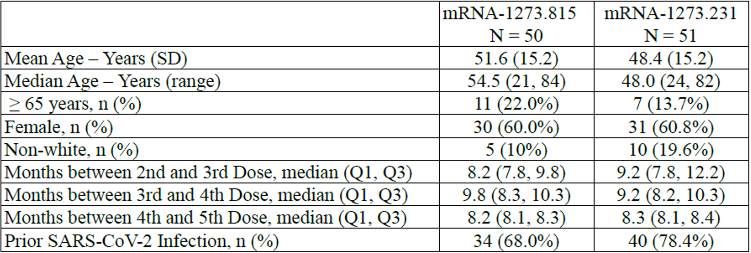

Abbreviations: N = total number of subjects; SD = standard deviation.

###### Immunogenicity

There was no pre-specified hypothesis on the immune responses elicited by the mRNA‑1273.815 and mRNA-1273.231 vaccines and no statistical testing was performed for an immunogenicity comparison between the two randomised groups, and all analyses are descriptive. The Baseline, Day 15 neutralising antibody responses (geometric mean titres and the geometric mean fold rises (GMFRs) after the mRNA-1273.815 and mRNA-1273.231 doses are shown in Table 4 below. In addition, seroresponse (at least 4-fold rise from Baseline) rates are provided for BA.4/BA.5 and D614G in this section. Seroresponse rate are calculated only when the pseudovirus assay has an established lower limit of quantification in a validated assay (D614G, BA.4/BA.5). The XBB.1.5, XBB.1.16 and BQ.1.1 are qualified assays. All assays are performed at the Duke University laboratories using consistent methods.

Table 4: Study P205 Part J Neutralising antibody titres at Day 15 (per-protocol immunogenicity set)

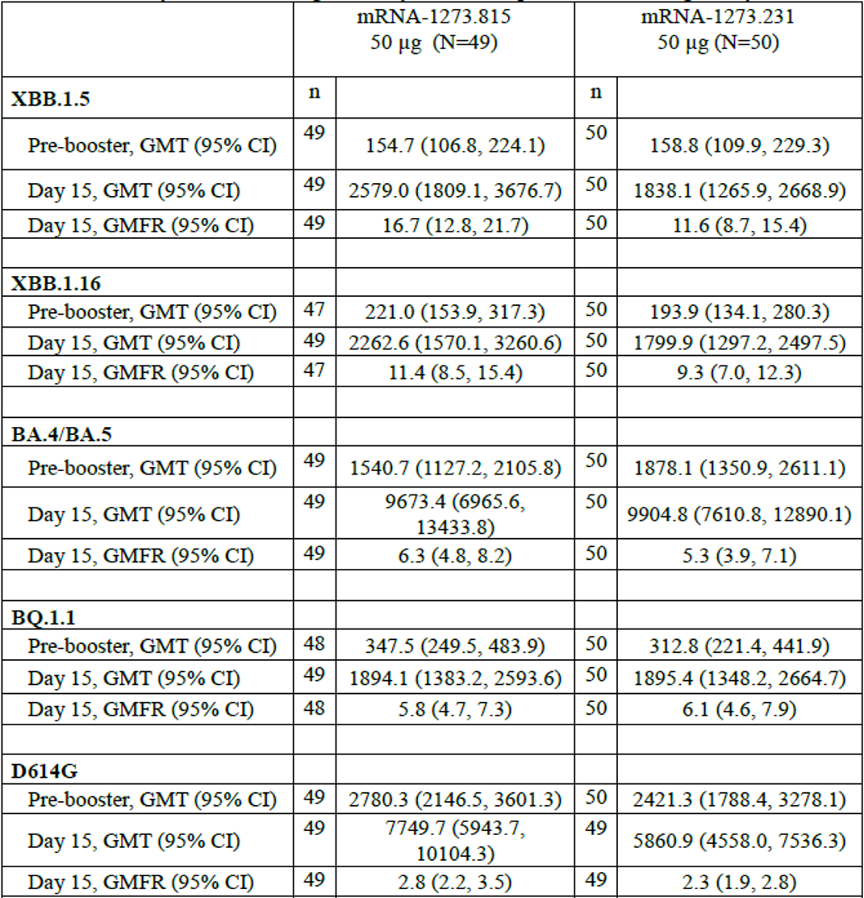

Abbreviations: CI = confidence interval; GMT = geometric mean titre; GMFR = geometric mean fold rises; N = total number of subjects; n = number of observations at corresponding timepoint.

Antibody values reported as below the lower limit of quantification (LLOQ) are reported by 0.5 × LLOQ. Values greater than the upper limit of quantification (ULOQ) are replaced by the ULOQ if the actual values are not available. Antibody values reported as below the lower limit of detection (LOD) are replaced by 0.5 × LOD.

In the per-protocol[8] immunogenicity set which includes all participants, with and without prior SARS-CoV-2 infection (49 participants for the mRNA-1273.815 and 50 participants for mRNA‑1273.231 groups), the Day 15 GMFR (95% confidence interval (CI)) for mRNA-1273.815 and mRNA-1273.231 was 16.7 (12.8, 21.7) and 11.6 (8.7, 15.4), respectively, against XBB.1.5 and 6.3 (4.8, 8.2) and 5.3 (3.9, 7.1) against BA.4/BA.5. Additionally, for variants not contained in the vaccines, the Day 15 GMFR (95% CI) for mRNA-1273.815 and mRNA-1273.231 was 11.4 (8.5, 15.4) and 9.3 (7.0, 12.3) against XBB.1.16; 5.8 (4.7, 7.3) and 6.1 (4.6, 7.9) against BQ.1.1 and 2.8 (2.2, 3.5) and 2.3 (1.9, 2.8) against D614G. Overall, the XBB.1.5 monovalent mRNA-1273.815 and the XBB.1.5 plus BA.4/BA.5 bivalent mRNA-1273.231 elicited potent neutralising responses at Day 15 against all variants evaluated (XBB.1.5, XBB.1.16, BA.4/BA.5, BQ.1.1 and D614G).

For mRNA-1273.815 and mRNA-1273.231 the Day 15 D614G seroresponse rate (95% CI) was 32.7% (19.9%, 47.5%) and 22.4% (11.8%, 36.6%), respectively; and the BA.4/BA.5 seroresponse rate was 69.4% (54.6%,81.7%) and 62.0% (47.2%, 75.3%), respectively. It should be noted that for BA.4/BA.5 and D614G the pre-booster titres were numerically higher than the pre-booster titres of (XBB.1.5, XBB.1.16 and BQ.1.1) given that all participants had been previously vaccinated with the original Spikevax and the Spikevax Bivalent Original/Omicron BA.4-5 vaccines.

###### Variant monitoring and risk assessment of emerging variants

Variant EG.5.1

The sponsor has confirmed that as part of their ongoing variant monitoring and risk assessment of emerging variants predicts that monovalent XBB.1.5-containing vaccine (mRNA-1273.815) will continue to neutralise current SARS-CoV-2 variants, including EG.5.1(the predominant subvariant of the EG.5 subfamily-classified recently as ‘variant of interest’ by the World Health Organization). The EG.5.1 variant differs from XBB.1.5 by only two amino acids in the receptor binding domain:

* In mice receiving (primary or booster) dose of mRNA 1273.815, neutralising antibody titres against XBB.1.5, XBB.1.16, XBB.2.3.2, and EG.5.1 are comparable.
* In clinical sera from subjects boosted with mRNA 1273.815, neutralising antibody titres against XBB.1.5, XBB.1.16, XBB.2.3.2, EG.5.1, and FL.1.5.1 are comparable.

Study P205 Part J samples were collected 2 weeks after mRNA-1273.815 booster dose was administered.

Methodology

Table 5: Study P205 Part J Dosing regimen

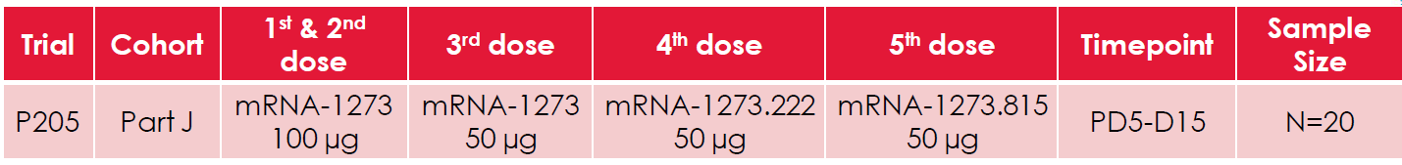

Abbreviations: D15 = Day 15; N = total number of subjects; PD5 = post-Dose 5.

Figure 1: Study P205 Part J Neutralising antibody profile

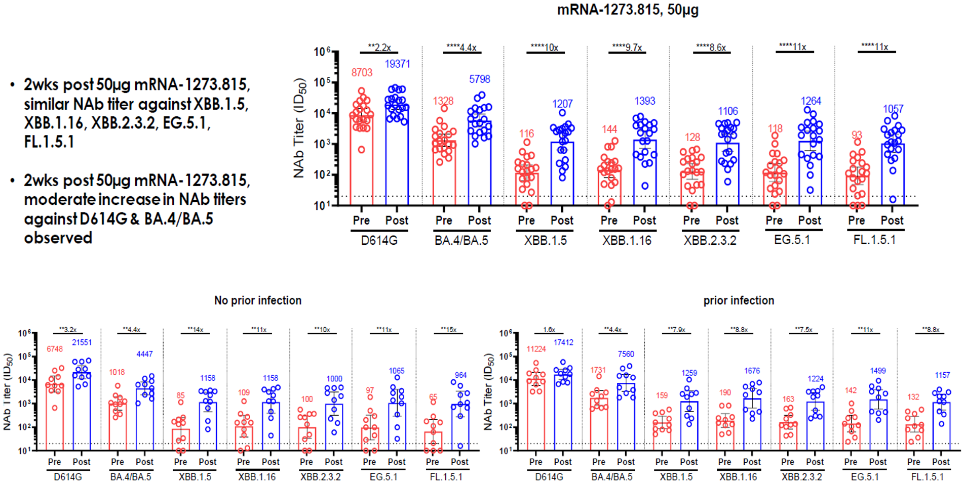

Abbreviations: NAb = neutralising antibody; wks= weeks.

Variant BA.2.86

The sponsor conducted a clinical study of the mRNA-1273.815 vaccine (Study P205 Part J).

* Of a total of 20 participants, 10 participants were with no evidence of prior infection, 10 participants were with evidence of prior SARS-CoV-2 infection.
* Sponsor’s research vesicular stomatitis virus-based pseudovirus neutralisation assay was used for the assessment.

In clinical sera from subjects boosted with mRNA-1273.815, neutralising antibody titres against XBB.1.5, XBB.1.16, XBB.2.3.2, EG.5.1, FL.1.5.1, and BA.2.86 are comparable.

Based on these preliminary results humans vaccinated with mRNA-1273.815, the monovalent XBB.1.5-containing vaccine, is anticipated to effectively protect against BA.2.86. Additional BA.2.86 neutralising antibody assay results from Duke University laboratories, the primary neutralisation assay used for sponsor’s clinical trials from mRNA-1273.815 vaccinated individuals are now included herein. Assay subsequently validated for each variant.

Figure 2: Study P205 Part J Cross naturalisation results from Duke University laboratories pseudovirus naturalising assay (Day 29) after Spikevax XBB.1.5 vaccine administered in adults (per-protocol immunogenicity set, all participants)

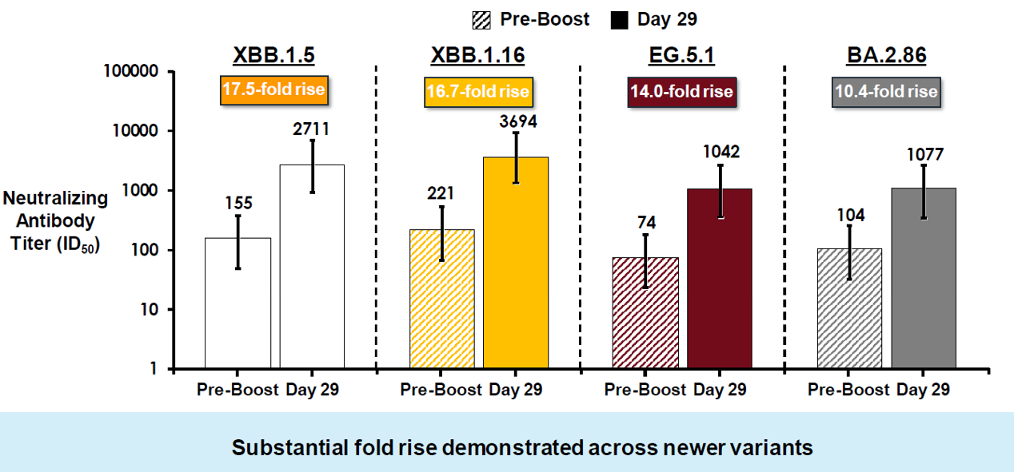

Abbreviation: ID50 = median infectious dose.

Figure 3: Study P205 Part J Cross naturalisation results from Duke University laboratories pseudovirus naturalising assay (Day 29) after Spikevax XBB.1.5 vaccine administered in adults by baseline SARS-CoV-2 serostatus (per-protocol immunogenicity set)

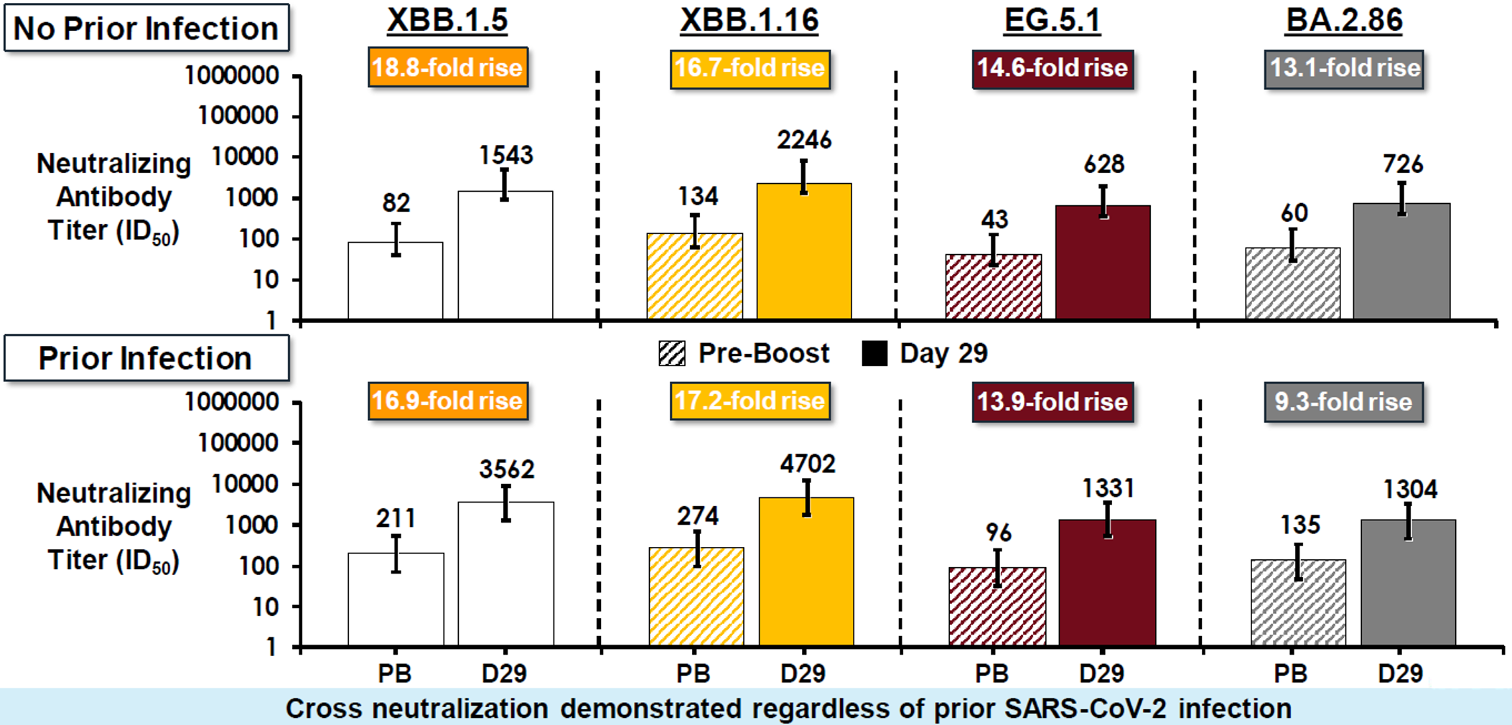

Abbreviations: ID50 = median infectious dose; SARS-CoV-2 = severe acute respiratory syndrome coronavirus 2.

#### Safety

The median follow-up time for both vaccine groups in this interim analysis was 20 days (range: 20 to 22 days, data cut-off date: 16 May 2023). The percentage of participants reporting any solicited local (68% for mRNA-1273.815 group and 84.3% for mRNA-1273.231 group) and systemic adverse reactions (58% for mRNA-1283.815 group and 64.7% for mRNA-1273.231) within seven days after vaccination is shown in Table 6 below and it was overall similar to that previously reported for the original mRNA-1273 50µg. vaccine and the bivalent Spikevax BA.4/BA.5 vaccine mRNA-1273.222.[9] The percentage of participants with any unsolicited adverse events within the follow-up time for this interim analysis is shown in Table 7 below; there were no fatal or serious adverse events and no adverse events of special interest. Unsolicited adverse events were Grade 1 or Grade 2 in severity; no Grade 3 or higher events were reported.

Table 6: Study P205 Part J Solicited local and systemic adverse reactions (solicited safety set)

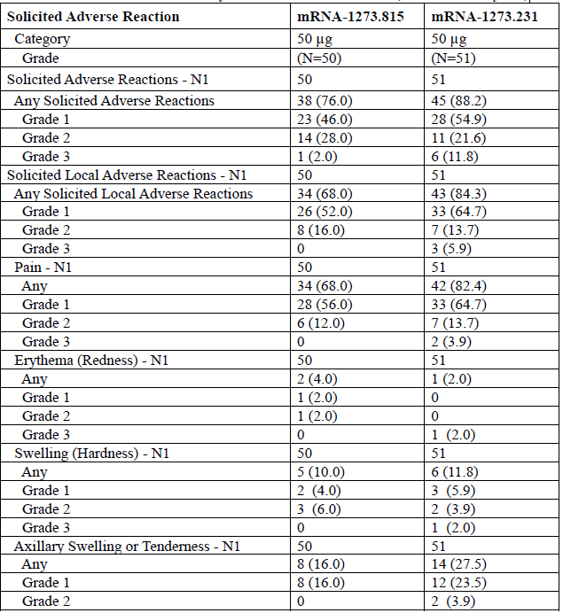

Abbreviations: N = total number of subjects; N1 = number of exposed subjects with data for that event.

Table 6 continued: Study P205 Part J Solicited local and systemic adverse reactions (solicited safety set)

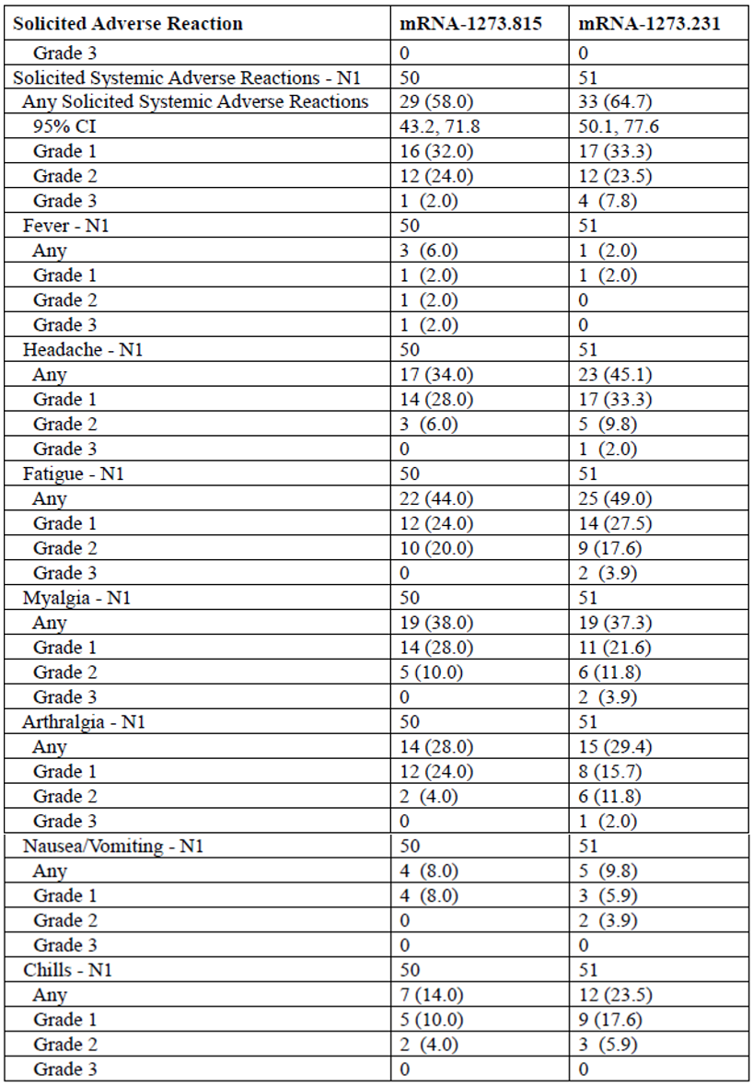

Abbreviations: CI = confidence internal; N = total number of subjects; N1 = number of exposed subjects with data for that event.

Table 7: Study P205 Part J Unsolicited adverse events (safety set)

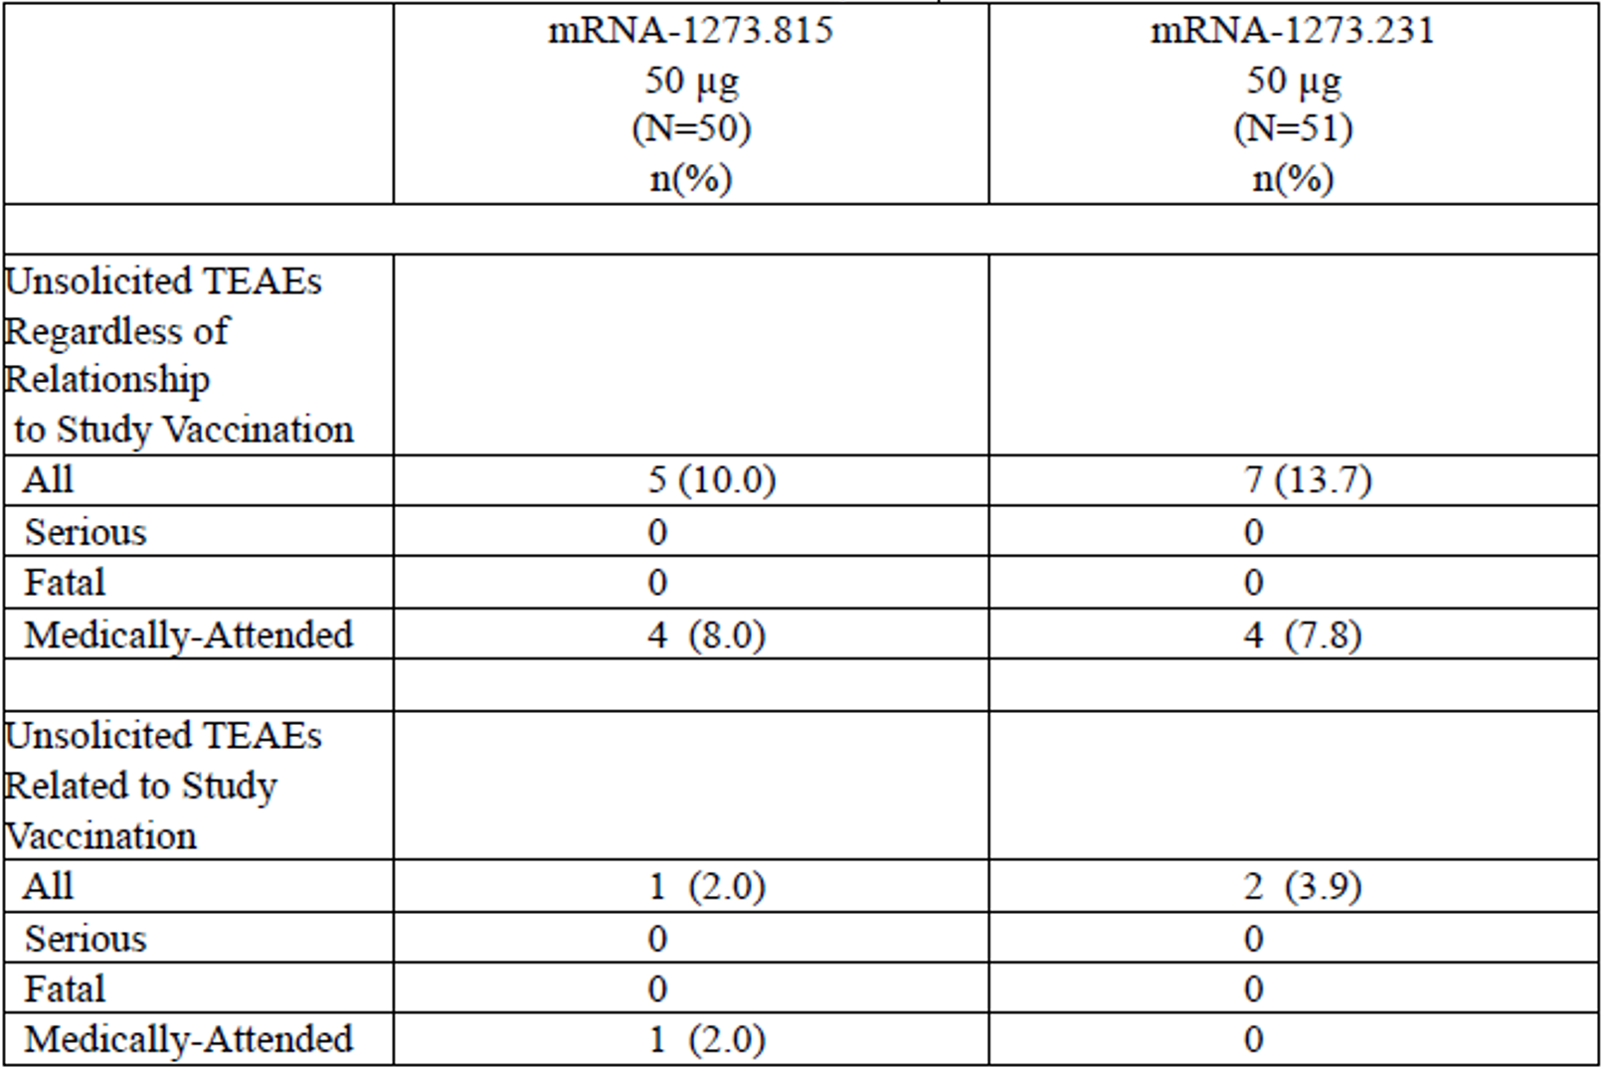

Abbreviations: N = total number of subjects; n = number of subjects in subgroup; TEAE = treatment-emergent adverse event.

### Risk management plan

The sponsor is required to comply with product vigilance and risk minimisation requirements.

The TGA decided a RMP was not required (see [TGA’s guidance](https://www.tga.gov.au/resources/resource/guidance/risk-management-plans-medicines-and-biologicals/when-rmp-required) on ‘when an RMP is required’)

The TGA may request an updated RMP at any stage of a product's life-cycle, during both the pre-approval and post-approval phases. Further information regarding the TGA’s risk management approach can be found in [risk management plans for medicines and biologicals](https://www.tga.gov.au/publication/risk-management-plans-medicines-and-biologicals) and [the TGA's risk management approach](https://www.tga.gov.au/tgas-risk-management-approach). Information on the [Australia specific annex](https://www.tga.gov.au/resources/resource/guidance/risk-management-plans-medicines-and-biologicals/australia-specific-annex-eu-rmp) ([ASA](https://www.tga.gov.au/resources/resource/guidance/risk-management-plans-medicines-and-biologicals/australia-specific-annex-eu-rmp)) can be found on the TGA website.

### Risk-benefit analysis

#### Delegate’s considerations

This Spikevax XBB1.5 COVID-19 vaccine submission is considered within the scope of the [TGA COVID-19 vaccine strain updates guidance](https://www.tga.gov.au/resources/resource/guidance/covid-19-vaccine-strain-updates). This registration of a new monovalent strain update for Spikevax XBB.1.5 (andusomeran) COVID-19 vaccine is based on the full registration of Spikevax (elasomeran) COVID-19 vaccine.

##### Quality

There are no significant issues identified from the quality evaluation of the submitted data that would indicate the product should not be registered on the basis of quality, or safety-related issues arising from the quality of the product. The manufacturing quality information submitted by the sponsor support the registration of Spikevax XBB.1.5 (andusomeran) COVID-19 vaccine.

Immunogenicity

Effectiveness of Spikevax XBB1.5 COVID-19 vaccine (50 µg) in individual 12 years and older, is based on:

* immunogenicity of Spikevax XBB1.5 COVID-19 vaccine (50 µg) from Study P205 Part J
* immunogenicity of Spikevax (original) (50 µg) COVID-19 vaccine in individual 12 years and older
* supportive non-clinical studies data.

###### Immunogenicity of Spikevax XBB1.5 from Study P205 Part J

Spikevax XBB.1.5 monovalent mRNA-1273.815 and the Spikevax XBB.1.5 plus Spikevax BA.4/BA.5 bivalent mRNA-1273.231 elicited potent neutralising responses at Day 15 against subvariants XBB.1.5, XBB.1.16, BA.4/BA.5, BQ.1.1 and D614G.

In the per-protocol immunogenicity set which includes all participants, with and without prior SARS-CoV-2 infection (49 participants for the mRNA-1273.815 group and 50 participants for the mRNA-1273.231 group), the Day 15 GMFR (95% CI) for mRNA-1273.815 and mRNA-1273.231 was 16.7 (12.8, 21.7) and 11.6 (8.7, 15.4), respectively, against XBB.1.5 and 6.3 (4.8, 8.2) and 5.3 (3.9, 7.1) against BA.4/BA.5.

Cross-neutralisation titres for XBB.1.16 were similar to XBB.1.5 for both vaccines, mRNA‑1273.815 and mRNA-1273.231.

For variants not contained in the vaccines, the Day 15 GMFR (95% CI) for Spikevax XBB.1.5 and bivalent Spikevax XBB.1.5 plus Spikevax BA.4/BA.5 was 11.4 (8.5, 15.4) and 9.3 (7.0, 12.3) against XBB.1.16; 5.8 (4.7, 7.3) and 6.1 (4.6, 7.9) against BQ.1.1 and 2.8 (2.2, 3.5) and 2.3 (1.9, 2.8) against D614G.

The sponsor has confirmed that as part of their ongoing variant monitoring and risk assessment of emerging variants, it was found in the clinical sera from subjects boosted with mRNA‑1273.815, significant boost in neutralising antibody titres against subvariants XBB.1.5, XBB.1.16, XBB.2.3.2, EG.5.1, FL.1.5.1, and BA.2.86.

###### Immunogenicity of Spikevax (original) in individual 12 years and older

The effectiveness and the benefit-risk profile of Spikevax (original) in individuals 12 years of age and older appears well established from the clinical data obtained so far. The post-authorisation safety data also supports the continued favourable benefit-risk of Spikevax in individuals 12 years of age and older.

###### Supportive nonclinical data

The nonclinical data comprised of 3 *in vivo* pharmacology studies conducted in BALB/c mice. The submitted studies evaluated immunogenicity of XBB-containing mRNA vaccines given as a primary series, or as a booster dose following primary series vaccination with mRNA-1273. The route of administration of the mRNA vaccines used in the nonclinical *in vivo* pharmacology studies was intramuscular, consistent with the clinical route.

A two-dose primary series vaccination with the monovalent mRNA-1273.815 and bivalent mRNA-1273.231 induced high S-2P binding antibody titres and elicited high neutralising antibodies against the Omicron subvariant XBB strains, XBB.1.5 and XBB.1.16.

Monovalent mRNA-1273.116 or bivalent mRNA-1273.234 as a booster following a primary series of mRNA-1273 vaccination induced high S-2P binding antibody titres as well as neutralising titres against the Omicron subvariant XBB strains, XBB.1.16 and XBB.1.5. In mice receiving (primary or booster) dose of mRNA 1273.815, neutralising antibody titres against subvariants XBB.1.5, XBB.1.16, XBB.2.3.2, and EG.5.1 are comparable.

Overall, boosting with mRNA-1273.815 enhanced IgG responses and neutralising activity against Omicron subvariant XBB strains compared to boosting with mRNA-1273.

##### Safety

Safety data of Spikevax XBB1.5 COVID-19 vaccine (50 µg) in individual 12 years and older, is based on:

* safety data of Spikevax XBB1.5 COVID-19 vaccine (50 µg) from Study P205 Part J
* safety data of Spikevax (original) (50 µg) COVID-19 vaccine in individuals 12 years and older.

###### Safety data of Spikevax XBB1.5 from Study P205 Part J

Spikevax XBB.1.5-containing vaccines (monovalent mRNA-1273.815 and bivalent mRNA‑1273.231) given as a fifth dose were well tolerated. Reactogenicity was similar to prior doses of the original mRNA-1273 vaccine and the bivalent BA.4/BA.5 vaccine mRNA-1273.222.9 There were no Grade 4 local or systemic reactions and no fatal events or serious adverse events in this interim analysis.

###### Safety data of Spikevax (original) in individuals 12 years and older

The safety and the benefit-risk profile of Spikevax (original) in individuals 12 years of age and older appears well established from the clinical data obtained so far. The post-authorisation safety data also supports the continued favourable benefit-risk of Spikevax in individuals 12 years of age and older.

#### Proposed action

Based on the totality of data, described above, to support the effectiveness and safety of Spikevax XBB1.5 COVID-19 vaccine the Delegate considers the benefit-risk profile Spikevax XBB1.5 COVID-19 vaccine for use in individuals 12 years of age and older as positive.

#### Advisory Committee considerations

The [Advisory Committee on Vaccines (ACV)](https://www.tga.gov.au/committee/advisory-committee-vaccines-acv), having considered the evaluations and the Delegate’s overview, as well as the sponsor’s response to these documents, advised the following.

##### Specific advice to the Delegate

1. ***Please comment on the sponsor proposal for registration of Spikevax XBB.1.5 (andusomeran) COVID-19 vaccine in individuals 12 years and older with the above proposed indication and dose.***

The ACV supported the proposed indication:

*Active immunisation to prevent coronavirus disease 2019 (COVID-19) caused by SARS‑CoV‑2 in individuals 12 years and older.*

*The use of this vaccine should be in accordance with official recommendations.*

The ACV agreed with the proposed dose of 50 µg andusomeran for individuals 12 years and older.

The ACV acknowledged that the epidemiology of COVID-19 supports a need for a vaccine targeted to protect against the currently-circulating variant of concern, Omicron XBB.1.5 and related emerging subvariants. The ACV noted that the main objective of an update to COVID-19 vaccine target variant is to achieve a wider breadth of immunity.

The ACV noted the proposed indication is for use in individuals 12 years and older. The ACV noted that regulatory agencies in Europe and Canada have approved use for individuals from 6 months of age, and in the USA use in individuals from 6 months of age is authorised (under Emergency Use Authorization) and approved (under a Biologics License Application) in individuals 12 years and older. The ACV highlighted the need for a vaccine for infants from 6 months of age and young children who are at risk of severe COVID-19 using a vaccine relevant to currently-circulating strains rather than against the original wild-type virus and advised that availability of updated vaccines in this age group is a current gap in Australia.

The ACV agreed that information regarding how to administer a primary (that is, multi-dose) series, when clinically indicated, should be included in the dosage section of the PI and include details specific for use in such individuals, such as those who are vaccine-naive and immunocompromised individuals. Reference should be made to use of the vaccine in accordance with clinical recommendations in Australia, that is, as made by the ATAGI [Australian Technical Advisory Group on Immunisation] in the Australian Immunisation Handbook.

Reference to ‘one dose’ (previously, a booster dose) in the dosing schedule could be replaced with the terms ‘subsequent dose’ or ‘additional dose’ where needed. General reference to ‘booster’ doses in the product information is no longer useful or accurate. Andusomeran is a different active ingredient to the elasomeran used in the original Spikevax vaccine, with nucleoside modified mRNA (modRNA) adapted to target Omicron XBB.1.5, and Spikevax XBB.1.5 vaccine is not boosting the immune response against the wild-type virus (which is no longer circulating). The ACV agreed that subsequent doses could be administered at least 3 months after the most recent COVID-19 vaccine.

The ACV noted that the simplified dosing schedule aligns with that approved by the European Medicines Agency.

The ACV noted this submission is supported by quality data and that manufacture uses the same well-characterised mRNA platform as for earlier versions of Spikevax COVID-19 vaccines. The ACV noted the submission was supported by preclinical (pharmacology studies conducted in mice) data and limited direct clinical data. The preliminary clinical data is from 50 subjects aged 21 to 84 years and provided information demonstrating immunogenicity of the XBB.1.5 vaccine against this and a number of other newly emerged SARS-CoV-2 variants.9,[10] Reactogenicity and the adverse event profile were similar to other Spikevax vaccines.

The ACV noted that safety and immunogenicity has been inferred from extensive clinical studies and real-world experience with earlier Spikevax vaccines.

Overall, the ACV supported the Delegate’s view in favour of registration.

##### Conclusion

Overall, the ACV supported the Delegate’s view in favour of registration.

## Outcome

Based on a review of quality, safety, and efficacy, the TGA approved the registration of Spikevax XBB.1.5 COVID-19 vaccine (andusomeran) 0.1 mg/mL, suspension for injection, prefilled syringe and single dose vial, change in dose regime and formulation:

Each dose (0.5 mL) of Spikevax XBB.1.5 contains 50 µg of andusomeran.

**Primary series**

To complete the two-dose series, it is recommended to administer Spikevax XBB.1.5 28 days after the first COVID‑19 vaccine.

**Additional dose**

If previously vaccinated, Spikevax XBB.1.5 should be administered at least 3 months after the most recent dose of a COVID-19 vaccine.

**Immunocompromised individuals**

If previously vaccinated, additional age-appropriate dose(s) may be administered in severely immunocompromised at least 2 months following the most recent dose of a COVID-19 vaccine at the discretion of the healthcare provider, taking into consideration the individual’s clinical circumstances.

The use of this vaccine should be in accordance with clinical recommendations in the Australian Immunisation Handbook.

For further information regarding dosage, refer to the Product Information.

### Specific conditions of registration applying to these goods

* Spikevax XBB.1.5 (andusomeran) COVID-19 vaccine is to be included in the Black Triangle Scheme. The PI and CMI for Spikevax XBB.1.5 must include the black triangle symbol and mandatory accompanying text for five years, which starts from the date that the sponsor notifies the TGA of supply of the products.
* **Quality conditions**

**Batch release testing and compliance**

It is a condition of registration that all independent batches of Spikevax XBB.1.5 (andusomeran) COVID-19 vaccine 0.1 mg/mL suspension for injection pre-filled syringe (AUST R 418911) and Spikevax XBB.1.5 (andusomeran) COVID-19 vaccine 0.1 mg/mL suspension for injection vial – single-dose (AUST R 418910) vaccine imported into Australia are not released for sale until samples and the manufacturer’s release data have been assessed and you have received notification acknowledging release from the Laboratories Branch, TGA.

For each independent batch of the product imported into Australia, the sponsor must supply the following:

* + A completed Request for Release Form, available from vaccines@health.gov.au.
  + Complete summary protocols for manufacture and QC, including all steps in production in the agreed format.
  + At least thirty (30) (samples) of each manufacturing batch of Spikevax XBB.1.5 (andusomeran) COVID-19 vaccine 0.1 mg/mL suspension for injection pre-filled syringe (AUST R 418911) and Spikevax XBB.1.5 (andusomeran) COVID-19 vaccine 0.1 mg/mL suspension for injection vial – single-dose (AUST R 418910) with the Australian approved labels, PI and packaging (unless an exemption to supply these has been granted) representative of all batches of product seeking distribution in Australia.
  + At least five (5) vials (Samples) of any further consignments of a manufacturing batch of Spikevax XBB.1.5 (andusomeran) COVID-19 vaccine 0.1 mg/mL suspension for injection pre-filled syringe (AUST R 418911) and Spikevax XBB.1.5 (andusomeran) COVID-19 vaccine 0.1 mg/mL suspension for injection vial – single-dose (AUST R 418910) vaccine with the Australian approved labels, PI and packaging (unless an exemption to supply these has been granted). Further consignments cover batches previously supplied to TGA for the purposes of batch release testing but are seeking to be supplied again.
  + If the manufacturing batch has been released in Europe or United Kingdom a copy of the EU Official Control Authority Batch Release (OCABR) certificate (or equivalent from the UK) must be provided.
  + Any reagents, reference material and standards required to undertake testing, as requested by Laboratories Branch, TGA.

Sponsors must provide all requested samples and data in sufficient time (at least 5 business days) prior to any distribution date to allow the TGA to perform testing and review. Distribution of each batch of vaccine is conditional upon fulfilment of these conditions and receipt of a letter from the Laboratories Branch acknowledging release.

Samples and data should be forwarded to the Biotherapeutics Section, Laboratories Branch before release of each batch and with sufficient lead time to allow for Laboratories Branch testing.

The shipments (including reagents) to TGA are the responsibility of the Australian sponsor/agent who will be required to facilitate the import and customs clearance process.

**Certified Product Details**

An electronic copy of the Certified Product Details (CPD) as described in Guidance 7: Certified Product Details of the Australian Regulatory Guidelines for Prescription Medicines (ARGPM) <https://www.tga.gov.au/guidance-7-certified-product-details> should be provided upon registration of the therapeutic good. In addition, an updated CPD, for the above products incorporating the approved changes is to be provided within one month of the date of approval letter. A template for preparation of CPD for biological prescription medicines and Vaccines can be obtained from the TGA website <https://www.tga.gov.au/form/certified-product-details-cpd-biological-prescriptionmedicines>]. The CPD should be sent as a single bookmarked PDF document to vaccines@health.gov.au as soon as possible after registration/approval of the product or any subsequent changes as indicated above.

* **Post approval commitments**
  + **GMP clearance for listed manufacturers:**

All relevant manufacturing sites require approved and current GMP clearances prior to Australian supply. A commitment is required from the sponsor that they maintain the validity of all manufacturer GMP clearances for the duration of product supply to Australia. Additionally, that adherence to the conditions of GMP clearance approval is upheld.

* + **Post-approval stability protocol and stability commitment:**

The manufacturer has provided commitment to continue the ongoing stability studies presented in the stability studies protocol. Additionally, one (1) batch of drug product per year for all relevant products will be placed on long-term stability program and on accelerated stability testing where significant changes are made to the manufacturing process. The manufacturer has committed to communicate any out of specifications stability test results to the TGA.

## Attachment 1. Product Information

The PI for Spikevax XBB.1.5 approved with the submission which is described in this AusPAR is at Attachment 1. For the most recent PI, please refer to the TGA [PI/CMI search facility.](https://www.tga.gov.au/picmi-search-facility)

|  |
| --- |
| Therapeutic Goods Administration |
| PO Box 100 Woden ACT 2606 Australia  Email: [info@tga.gov.au](mailto:info@tga.gov.au) Phone: 1800 020 653 Fax: 02 6203 1605  [**https://www.tga.gov.au**](https://www.tga.gov.au) |
| Reference/Publication # |

1. [AusPAR: Spikevax (elasomeran) Moderna Australia Pty Ltd, PM-2022-05374-1-2](https://www.tga.gov.au/resources/auspar/auspar-spikevax-1), transition from provisional registration to full registration, published on 11 May 2023.
2. This is the original dose regime proposed by the sponsor when the TGA commenced the evaluation of this submission. It may differ to the final dose regimen approved by the TGA.
3. Centers for Disease Control and Prevention (CDC), [Benefits of Getting A COVID-19 Vaccine](https://www.cdc.gov/coronavirus/2019-ncov/vaccines/vaccine-benefits.html), Updated 22 September 2023.
4. Department of Health and Aged Care, [Weekly COVID-19 Reporting](https://www.health.gov.au/health-alerts/covid-19/weekly-reporting?language=und), updated 6 October 2023, accessed 6 October 2023.
5. **Good Manufacturing Practice (GMP)** is a code of standards that describes a set of principles and procedures that when followed helps ensure that therapeutic goods are of high quality.
6. **AUST R** identifies the product on the Australian Register of Therapeutic Goods (ARTG). It is also known as the ARTG ID or the registration or listing number. All medicines included in the ARTG must include the relevant AUST R.
7. mRNA-1273: Spikevax (original) monovalent vaccine (Registered on ARTG)

   mRNA-1273.045: Omicron BA.4/5

   mRNA-1273.116: Omicron XBB.1.16

   mRNA-1273.222: Spikevax Bivalent Original/Omicron BA.4-5 (Registered on ARTG)

   mRNA 1273.231: Omicron BA.4/5 and XBB.1.5/XBB.1.9.1 bivalent vaccine

   mRNA-1273.234: Omicron BA.4/5 and XBB.1.16.

   mRNA-1273.815: Omicron XBB.1.5
8. The **per-protocol (PP)** analysis is restricted to the participants who strictly adhered to the protocol. Also known as ‘on-treatment’ analysis.
9. S Chalkias et al, ‘Safety and Immunogenicity of Omicron BA.4/BA.5 Bivalent Vaccine Against Covid-19’, *MedRxiv*, 2022, <https://doi.org/10.1101/2022.12.11.22283166>.
10. S Chalkias et al, ‘Safety and Immunogenicity of XBB.1.5-Containing mRNA Vaccines’, *MedRxiv*, 2023, doi: https://doi.org/10.1101/2023.08.22.23293434.