|  |
| --- |
| Australian Public Assessment Report for Tavneos |
| Active ingredient: Avacopan |
| Sponsor: Vifor Pharma Pty Ltd |
| October 2023 |

About the Therapeutic Goods Administration (TGA)

* The Therapeutic Goods Administration (TGA) is part of the Australian Government Department of Health and Aged Care and is responsible for regulating therapeutic goods, including medicines, medical devices, and biologicals.
* The TGA administers the *Therapeutic Goods Act 1989* (the Act), applying a risk management approach designed to ensure therapeutic goods supplied in Australia meet acceptable standards of quality, safety, and efficacy.
* The work of the TGA is based on applying scientific and clinical expertise to decision-making, to ensure that the benefits to the Australian public outweigh any risks associated with the use of therapeutic goods.
* The TGA relies on the public, healthcare professionals and industry to report problems with therapeutic goods. The TGA investigates reports received to determine any necessary regulatory action.
* To report a problem with a therapeutic good, please see the information on the [TGA website](https://www.tga.gov.au).

About AusPARs

* The Australian Public Assessment Report (AusPAR) provides information about the evaluation of a prescription medicine and the considerations that led the TGA to approve or not approve a prescription medicine submission. Further information can be found in [Australian Public Assessment Report (AusPAR) guidance](https://www.tga.gov.au/australian-public-assessment-report-auspar-guidance).
* AusPARs are prepared and published by the TGA.
* AusPARs are static documents that provide information that relates to a submission at a particular point in time. The publication of an AusPAR is an important part of the transparency of the TGA’s decision-making process.
* A new AusPAR may be provided to reflect changes to indications or major variations to a prescription medicine subject to evaluation by the TGA.

Copyright

© Commonwealth of Australia 2023  
This work is copyright. You may reproduce the whole or part of this work in unaltered form for your own personal use or, if you are part of an organisation, for internal use within your organisation, but only if you or your organisation do not use the reproduction for any commercial purpose and retain this copyright notice and all disclaimer notices as part of that reproduction. Apart from rights to use as permitted by the *Copyright Act 1968* or allowed by this copyright notice, all other rights are reserved and you are not allowed to reproduce the whole or any part of this work in any way (electronic or otherwise) without first being given specific written permission from the Commonwealth to do so. Requests and inquiries concerning reproduction and rights are to be sent to the TGA Copyright Officer, Therapeutic Goods Administration, PO Box 100, Woden ACT 2606 or emailed to <[tga.copyright@tga.gov.au](mailto:tga.copyright@tga.gov.au)>.

Contents

[List of abbreviations 4](#_Toc147390235)

[Product submission 6](#_Toc147390236)

[Submission details 6](#_Toc147390237)

[Product background 7](#_Toc147390238)

[Regulatory status 8](#_Toc147390239)

[Product Information 10](#_Toc147390240)

[Registration timeline 10](#_Toc147390241)

[Submission overview and risk/benefit assessment 11](#_Toc147390242)

[Quality 11](#_Toc147390243)

[Nonclinical 12](#_Toc147390244)

[Clinical 14](#_Toc147390245)

[Summary of clinical studies 14](#_Toc147390246)

[Pharmacology 15](#_Toc147390247)

[Efficacy 17](#_Toc147390248)

[Safety 25](#_Toc147390249)

[Risk management plan 31](#_Toc147390250)

[Risk-benefit analysis 32](#_Toc147390251)

[Delegate’s considerations 32](#_Toc147390252)

[Proposed action 33](#_Toc147390253)

[Advisory Committee considerations 33](#_Toc147390254)

[Outcome 34](#_Toc147390255)

[Specific conditions of registration applying to these goods 35](#_Toc147390256)

[Attachment 1. Product Information 35](#_Toc147390257)

## List of abbreviations

|  |  |
| --- | --- |
| Abbreviation | Meaning |
| AAV | Anti-neutrophil cytoplasmic (auto)antibody (ANCA) associated vasculitis |
| AC | Adjudication Committee |
| ACM | Advisory Committee on Medicines |
| AE | Adverse event |
| ALT | Alanine aminotransferase |
| ANCA | Anti-neutrophil cytoplasmic (auto)antibody |
| ARTG | Australian Register of Therapeutic Goods |
| ASA | Australia specific annex |
| AST | Aspartate transaminase |
| AUC | Area under the plasma drug concentration-time curve |
| AUC0-t | Area under the plasma drug concentration-time curve (AUC) from time zero to the time of last measurable concentration |
| AUC0-tau | Area under the plasma drug concentration-time curve (AUC) to the end of the dosing period |
| BVAS | Birmingham Vasculitis Activity Score |
| C5a | Complement 5a |
| C5aR | Complement 5a receptor |
| Cmax | Maximum concentration |
| CMI | Consumer Medicines Information |
| CYP | Cytochrome P450 |
| DLP | Data lock point |
| eGFR | Estimated glomerular filtration rate |
| ERAUC (avacopan+M1) | Exposure ratio based on area under the plasma drug concentration-time curve (AUC) for avacopan and metabolite M1 |
| GPA | Granulomatosis with polyangiitis |
| GTI | Glucocorticoid toxicity index |
| Ig | Immunoglobulin |
| MPA | Microscopic polyangiitis |
| PI | Product Information |
| PK | Pharmacokinetic(s) |
| PSUR | Periodic safety update report |
| RMP | Risk management plan |
| SD | Standard deviation |
| SUSAR | Suspected, unexpected serious adverse reaction |
| TEAE | Treatment emergent adverse event |
| TGA | Therapeutic Goods Administration |
| Tmax | Time taken to reach the maximum concentration (Cmax) |
| UACR | Urine albumin to creatinine ratio |

## Product submission

### Submission details

|  |  |
| --- | --- |
| *Type of submission:* | New chemical entity |
| *Product name:* | Tavneos |
| *Active ingredient:* | Avacopan |
| *Decision:* | Approved |
| *Date of decision:* | 17 January 2023 |
| *Date of entry onto ARTG:* | 31 January 2023 |
| *ARTG number:* | 381053 |
| [*Black Triangle Scheme*](https://www.tga.gov.au/black-triangle-scheme)  *for the current submission:* | Yes.  This product will remain in the scheme for 5 years, starting on the date the product is first supplied in Australia. |
| *Sponsor’s name and address:* | Vifor Pharma Pty Ltd  655 Elizabeth Street,  Melbourne, VIC, 3000 Australia |
| *Dose form:* | Capsule |
| *Strength:* | 10 mg |
| *Container:* | Bottle |
| *Pack size:* | 30 and 180 |
| *Approved therapeutic use for the current submission:* | *Tavneos, in combination with a rituximab or cyclophosphamide based regimen, is indicated for the treatment of adults with anti-neutrophil cytoplasmic autoantibody (ANCA)-associated vasculitis (granulomatosis with polyangiitis [GPA] and microscopic polyangiitis [MPA]).* |
| *Route of administration:* | Oral |
| *Dosage:* | The recommended dose of Tavneos is 30 mg (3 hard capsules of 10 mg each) taken orally twice daily, morning and evening, with food.  Tavneos should be administered in combination with rituximab or cyclophosphamide. Suitable dosing regimens for these combinations include:   * rituximab for 4 weekly intravenous doses or, * intravenous or oral cyclophosphamide for 13 or 14 weeks, followed by oral azathioprine or mycophenolate mofetil and, * glucocorticoids as clinically indicated.   For further information regarding dosage, refer to the Product Information. |
| *Pregnancy category:* | D  Drugs which have caused, are suspected to have caused or may be expected to cause, an increased incidence of human fetal malformations or irreversible damage. These drugs may also have adverse pharmacological effects. Accompanying texts should be consulted for further details.  The use of any medicine during pregnancy requires careful consideration of both risks and benefits by the treating health professional. This must not be used as the sole basis of decision making in the use of medicines during pregnancy. The TGA does not provide advice on the use of medicines in pregnancy for specific cases. More information is available from obstetric drug information services in your State or Territory. |

### Product background

This AusPAR describes the submission by Vifor Pharma Pty Ltd (the sponsor) to register Tavneos (avacopan) 10 mg, capsule, bottle for the following proposed indication:[[1]](#footnote-2)

*Tavneos, in combination with other immunosuppressant therapies, is indicated for the treatment of patients with anti-neutrophil cytoplasmic autoantibody (ANCA)-associated vasculitis (granulomatosis with polyangiitis [GPA] and microscopic polyangiitis [MPA]).*

Granulomatosis with polyangiitis (GPA, also known as Wegener’s granulomatosis) and microscopic polyangiitis (MPA) are two of a range of systemic non-infectious conditions affecting the blood vessels (vasculitides) that manifest with inflammatory change in the walls of the blood vessels, with a range of consequences including local necrosis and bleeding, or distal obstruction and ischaemia causing end-organ damage.

Various approaches have been taken to classifying the vasculitides, the most recent of which is based on the size of the most affected vessels and reflects current understanding of the pathophysiological mechanisms. The 2012 Revised International Chapel Hill Consensus Conference grouped MPA and GPA, along with eosinophilic GPA (formerly Churg-Strauss syndrome), as ‘antineutrophil cytoplasmic antibody (ANCA) associated vasculitides (AAV)’, which predominantly affect the small blood vessels. The AAV typically present with ANCA specific for myeloperoxidase (myeloperoxidase-ANCA) or proteinase 3 (proteinase 3-ANCA), although ANCA-negative presentations may occur. While most patients with GPA or MPA will test positive for either myeloperoxidase-ANCA or proteinase 3-ANCA, less than half of patients with eosinophilic GPA will have positive ANCA tests. AAV may affect one or more organ systems, subsequently causing glomerulonephritis, pulmonary haemorrhage, intestinal ischaemia, sight threatening eye disease, upper airway (ear, nose, and throat) pathology, neuropathy or other severe disease. AAV can also present with signs and symptoms limited to a single organ, particularly a subset referred to as renal limited AAV.

The pathogenesis of GPA and MPA is thought to be related to the presence of ANCA positive leukocytes in the small to medium vessels triggering inflammation, subsequently activating the complement system to produce swelling and damage of vessel wall structures. Vessel wall necrosis with or without granulomata can develop. The complement system has also been implicated in a range of other vasculitides including urticarial vasculitis, anti-glomerular basement membrane disease, cryoglobulinaemic vasculitides, Henoch-Schönlein purpura/immunoglobulin (Ig)A nephropathy, and Kawasaki disease. The pathogenesis of eosinophilic GPA is widely considered to differ from GPA and MPA, although it is included in the Chapel Hill classification of AAV, and the treatment and prognosis of eosinophilic GPA are often considered separately from GPA and MPA.

The incidence of AAV is estimated to be between 13 and 20 per million population per year in Europe and Japan, with increasing rates of GPA and eosinophilic GPA with increased distance from the equator. Incidence also varies with ethnicity. Chinese and Japanese populations almost exclusively experience myeloperoxidase-ANCA disease, whereas proteinase 3-ANCA and myeloperoxidase-ANCA occur approximately equally in Western European populations. The prevalence of AAV in Europe is estimated to be between 150 and 250 per million population. Reports of AAV in children are rare. A recent review confirms that there is a dearth of information regarding the prevalence of paediatric AAV, and that treatment in this very small group tends to be extrapolated from adult studies.

The current accepted treatment approach to GPA and MPA, as described in the Australian Therapeutic Guidelines[[2]](#footnote-3), is to induce remission of the disease with high dose corticosteroids. Cyclophosphamide, or rituximab in those patients who are intolerant of cyclophosphamide or in women contemplating future pregnancy, is added for patients with or at risk of severe organ disease. Methotrexate or mycophenolate may be used as adjunct therapy for those who do not have life-threatening or organ-threatening disease. Maintenance therapy will usually involve tapering corticosteroid therapy, with or without rituximab or mycophenolate. Rituximab in combination with glucocorticoids was registered by the TGA for the induction of remission in patients with severely active GPA and MPA in May 2013. Notwithstanding the advice in the Therapeutic Guidelines, use of rituximab in maintenance therapy, while accepted practice internationally, is currently not registered in Australia.

Other proposed therapies with less robust supporting evidence include combination cyclophosphamide and rituximab, and plasma exchange in renal disease. Alternative immunomodulatory options have been trialled in patients who are intolerant of cyclophosphamide or rituximab.

Avacopan (Tavneos) is a selective antagonist of the human complement 5a receptor (C5aR1 or CD88) and competitively inhibits the interaction between C5aR1 and the anaphylatoxin Complement 5a (C5a). This blockade of C5aR1 is said to reduce the pro-inflammatory effects of C5a, which include neutrophil activation, migration, and adherence to sites of small blood vessel inflammation, vascular endothelial cell retraction and permeability. Avacopan does not affect the formation of the membrane attack complex (C5b-9) or the terminal complement complex, which is involved in fighting infections with encapsulated bacteria such as *Neisseria meningitidis*.

### Regulatory status

This product is considered a new chemical entity for Australian regulatory purposes.

This product received [orphan drug designation](https://www.tga.gov.au/publication/orphan-drug-designation) on 26 November 2021 for the following indication:

*Tavneos, in combination with other immunosuppressant therapies, is indicated for the treatment of patients with anti-neutrophil cytoplasmic autoantibody (ANCA)-associated vasculitis (granulomatosis with polyangiitis [GPA] and microscopic polyangiitis [MPA])*

At the time the TGA considered this submission, a similar submission had been approved in United States of America on 7 October 2021, Japan on 27 September 2021, European Union on 11 January 2022, Great Britain on 6 May 2022, Canada on 14 April 2022 and Switzerland on 19 September 2022. A similar submission (on Conditional Marketing Authorisation) had been withdrawn from the European Union in January 2019.

The following table summarises these submissions and provides the indications where approved.

Table 1: International regulatory status

|  |  |  |  |
| --- | --- | --- | --- |
| Region | Submission date | Status | Approved indications |
| European Union | 4 October 2017 | Withdrawal on 23 January 2019 | Not applicable |
| United States of America | 7 July 2020 | Approved on 7 October 2021 | *Tavneos is indicated as an adjunctive treatment of adult patients with severe active antineutrophil cytoplasmic autoantibody (ANCA)-associated vasculitis (granulomatosis with polyangiitis [GPA] and microscopic polyangiitis [MPA]) in combination with standard therapy including glucocorticoids. Tavneos does not eliminate glucocorticoid use.* |
| Japan | 26 February 2021 | Approved on 27 September 2021 | *Microscopic polyangiitis, granulomatosis with polyangiitis* |
| European Union | 9 October 2020 | Approved on 11 January 2022 | *Tavneos, in combination with a rituximab or cyclophosphamide regimen, is indicated for the treatment of adult patients with severe, active granulomatosis with polyangiitis (GPA) and microscopic polyangiitis (MPA).* |
| Great Britain | 14 November 2021 | Approved on 6 May 2022 | *Tavneos, in combination with a rituximab or cyclophosphamide regimen, is indicated for the treatment of adult patients with severe, active granulomatosis with polyangiitis (GPA) and microscopic polyangiitis (MPA).* |
| Canada | 9 April 2021 | Approved on 14 April 2022 | *Tavneos (avacopan capsules) is indicated for the adjunctive treatment of adult patients with severe active anti-neutrophil cytoplasmic autoantibody (ANCA)-associated vasculitis (granulomatosis with polyangiitis [GPA] and microscopic polyangiitis [MPA]) in combination with standard background therapy including glucocorticoids. Tavneos does not eliminate glucocorticoid use.* |
| Switzerland | 9 April 2021 | Approved on 19 September 2022 | *Tavneos, as an adjunctive treatment to standard immunosuppressive treatment that includes rituximab or cyclophosphamide with glucocorticoids, is indicated for the treatment of adult patients with severe, active antineutrophil cytoplasmic antibody (ANCA)-associated vasculitis (granulomatosis with polyangiitis (GPA) and microscopic polyangiitis (MPA)).* |

### Product Information

The [Product Information](https://www.tga.gov.au/products/australian-register-therapeutic-goods-artg/product-information-one) ([PI](https://www.tga.gov.au/products/australian-register-therapeutic-goods-artg/product-information-one)) approved with the submission which is described in this AusPAR can be found as Attachment 1. For the most recent PI and [Consumer Medicines Information](https://www.tga.gov.au/products/australian-register-therapeutic-goods-artg/consumer-medicines-information-cmi) (CMI), please refer to the TGA [PI/CMI search facility.](https://www.tga.gov.au/picmi-search-facility)

## Registration timeline

The following table captures the key steps and dates for this submission.

This submission was evaluated under the [standard prescription medicines registration process](https://www.tga.gov.au/how-we-regulate/supply-therapeutic-good-0/supply-prescription-medicine/application-process/prescription-medicines-registration-process).

Table 2: Timeline for Submission PM-2021-05913-1-3

|  |  |
| --- | --- |
| Description | Date |
| Designation (Orphan) | 26 November 2021 |
| Submission dossier accepted and first round evaluation commenced | 31 January 2022 |
| First round evaluation completed | 13 July 2022 |
| Sponsor provides responses on questions raised in first round evaluation | 31 August 2022 |
| Second round evaluation completed | 4 October 2022 |
| Delegate’s Overall benefit-risk assessment and request for Advisory Committee advice | 1 November 2022 |
| Sponsor’s pre-Advisory Committee response | 15 November 2022 |
| Advisory Committee meeting | 1 and 2 December 2022 |
| Registration decision (Outcome) | 17 January 2023 |
| Administrative activities and registration on the ARTG completed | 31 January 2023 |
| Number of working days from submission dossier acceptance to registration decision\* | 202 |

\*Statutory timeframe for standard submissions is 255 working days

## Submission overview and risk/benefit assessment

A summary of the TGA’s assessment for this submission is provided below.

Relevant guidelines or guidance documents referred to by the Delegate are listed below:

European Medicines Agency (EMA), Committee for Human Medicinal Products (CHMP), [ICH guideline E8 (R1) on general considerations for clinical studies](https://www.ema.europa.eu/en/documents/regulatory-procedural-guideline/ich-guideline-e8-r1-general-considerations-clinical-studies_en.pdf), EMA/CHMP/ICH/544570/1998, 14 October 2021.

European Medicines Agency (EMA), Committee for Human Medicinal Products (CHMP), [Guideline on Clinical Trials in Small Populations](https://www.ema.europa.eu/en/documents/scientific-guideline/guideline-clinical-trials-small-populations_en.pdf), CHMP/EWP/83561/2005, 27 July 2006.

European Medicines Agency (EMA), Committee for Proprietary Medicinal Products (CPMP), [ICH guideline M3(R2) on non-clinical safety studies for the conduct of human clinical trials and marketing authorisation for pharmaceuticals](https://www.ema.europa.eu/en/documents/scientific-guideline/ich-guideline-m3r2-non-clinical-safety-studies-conduct-human-clinical-trials-marketing-authorisation_en.pdf#:~:text=The%20purpose%20of%20this%20document%20is%20to%20recommend,duration%20as%20well%20as%20marketing%20authorization%20for%20pharmaceuticals.), EMA/CPMP/ICH/286/1995, December 2009.

European Medicines Agency (EMA), Committee for Proprietary Medicinal Products (CPMP), [ICH Topic E 1 Population Exposure: The Extent of Population Exposure to Assess Clinical Safety, Note for Guidance on Population Exposure: The Extent of Population Exposure to Assess Clinical Safety](https://www.ema.europa.eu/en/documents/scientific-guideline/ich-e-1-population-exposure-extent-population-exposure-assess-clinical-safety-step-5_en.pdf), CPMP/ICH/375/95, June 1995.

### Quality

The administrative, product usage, chemical, pharmaceutical, microbiological and biopharmaceutic data submitted in support of this application were evaluated in accordance with Australian legislation and relevant technical guidelines adopted by the TGA.

The drug substance of avacopan ((2R,3S)-2-[4-(cyclopentylamino)phenyl]-1-(2-fluoro-6-methylbenzoyl)-N-[4-methyl-3-(trifluoromethyl)phenyl]piperidine-3-carboxamide) is chemically synthesised initially using separate manufacturing pathways through multiple intermediates for the molecule, finishing with the final structure shown in Figure 1.

Figure 1: Chemical structure of avacopan

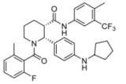

Tavneos is a white to pale yellow solid with three polymorphic forms. Polymorphic form 1 (the most thermodynamic form) is manufactured. As the drug substance is fully dissolved during the manufacture of the drug product, control of polymorphic form and particle size is not required.

The sponsor proposes to register 10 mg capsules which contain avacopan fully dissolved in an excipient mix. The hard gelatin capsules are opaque bicoloured light orange and yellow and printed with ‘CCX168’ in black ink with a clear gelatin sealing band. The capsules are packaged in high density polyethylene 250 mL and 75 mL bottles with child-resistant polypropylene closures, containing 180 and 30 capsules, respectively.

The stability data supported a shelf-life of 36 months when stored below 30°C. No additional storage conditions are required.

Approval for registration of the proposed product was recommended following resolution of minor issues. There are no manufacturing related conditions of registration.

### Nonclinical

Based on the nonclinical data evaluated, there were no nonclinical objections to the registration of avacopan. The nonclinical evaluation was in parts based on the US FDA review available in the public domain.[[3]](#footnote-4) Efforts were made to verify the accuracy of statements in the review, where possible.

The nonclinical evaluation provided the following summary of the evaluation.

* The submitted nonclinical dossier was in accordance with the relevant ICH guideline.[[4]](#footnote-5) The overall quality of the nonclinical dossier was high. All pivotal safety related studies were Good Laboratory Practice[[5]](#footnote-6) compliant.
* *In vitro*, avacopan bound the C5a receptor on U937 cells with nanomolar affinity half maximal inhibitory concentration (IC50) 0.45 nM. Avacopan and metabolite M1 (product of methyl hydroxylation of avacopan) were both found potent for C5aR in functional chemotaxis assays in humans, hamster and monkey, but minimally active against C5aR in mice, rats and rabbits. Avacopan also reduced the potency of exogenous human C5a to upregulate the adhesion molecule CD11b on blood neutrophils in human C5aR knock-in transgenic mice. *In vivo*, avacopan inhibited human C5a-induced neutropenia in cynomolgus monkeys. Therefore, animal studies adequately support the proposed clinical indication.
* Avacopan (10 μM) did not exhibit significant inhibitory activity against a panel of 55 receptors and membrane associated proteins and the glucocorticoid receptor. Metabolite M1 (10 μM) exhibited weak activity at the human CB1 receptor (53% inhibition), sodium channel (site 2) (65% inhibition), and the γ-Aminobutyric acid type A (GABAA) receptor (51% inhibition). These effects are not likely to be clinically relevant.
* Safety pharmacology studies assessed effects of avacopan on the cardiovascular, respiratory, renal, and central nervous systems. Neither avacopan nor metabolite M1 (3 µM) inhibited human ether-a-go-go (hERG) channel currents at clinically relevant concentrations. Thus, avacopan is not predicted to prolong the QT interval[[6]](#footnote-7) in patients. No treatment related adverse effects were observed on the central nervous system, cardiovascular, respiratory, or renal organ systems in repeat dose toxicity studies following oral administration of avacopan in hamsters and cynomolgus monkeys (pharmacologically relevant species).
* Overall, the pharmacokinetic (PK) profile in animals was qualitatively similar to that of humans. Avacopan was readily and rapidly absorbed with a comparable Tmax (time taken to reach the maximum concentration (Cmax)) in all species. Half-life of avacopan following oral dosing was 2.3 hours in rats and 4.5 hours in monkeys (in comparison to longer median effective half-life of 1.5 days predicted in patients). Plasma protein binding of avacopan and metabolite M1 was high (> 99%) in all animal species and humans. Tissue distribution of avacopan in rats was wide but penetration into brain and spinal cord was limited. Metabolite M1 was a major metabolite in humans and animals and there were no metabolites specific to humans. Drug related material was predominantly excreted *via* the faecal route in humans and animal species. While unchanged avacopan was the main circulating species in plasma, direct excretion of unchanged avacopan was minimal. Faecal and urine radioactivity profiles showed extensive metabolism of avacopan.
* Avacopan is metabolised in the liver, predominately by cytochrome P450 (CYP)[[7]](#footnote-8)3A4. Given the primary role of CYP3A4 in the metabolism of avacopan, concomitant use of a CYP3A inhibitor or inducer may alter avacopan exposures. Strong and moderate inducers and inhibitors of CYP3A may significantly alter plasma avacopan concentration.
* Avacopan was well tolerated in rats up to 100 mg/kg *via* the oral route, with no observed mortality or treatment related effects. A maximum non-lethal dose was not established.
* Repeat dose toxicity studies by the oral route were conducted in rats (26 weeks), hamsters (up to 13 weeks) and Cynomolgus monkeys (up to 44 weeks). Maximum exposures (area under the plasma drug concentration-time curve (AUC)) for avacopan and metabolite M1 were adequate in rats, hamsters, and monkeys. Saturation of exposures were achieved at 100 mg/kg/day in rats and hamsters and at 50 mg/kg/day in monkeys. There were no observed treatment related mortalities and findings. No target organs for toxicity were identified.
* Avacopan was not mutagenic in the bacterial reverse mutation assay (also known as the Ames test), the *in vitro* mouse lymphoma assay and in an *in vivo* micronucleus assay (in rats). No treatment related increase in tumour incidence was observed in 2-year oral carcinogenicity studies in rats and hamsters. Increased mineralisation in the ovaries of female hamsters at 30 mg/kg/day (exposure ratio based on AUC for avacopan and metabolite M1 (ERAUC (avacopan+M1), 2.6) or 100 mg/kg/day (ERAUC (avacopan+M1), 4.4) was noted. The toxicological significance of this is uncertain.
* Fertility was not affected in male and female hamsters treated with avacopan at exposure levels ≥ 5.8 times (ERAUC (avacopan+M1)) the clinical AUC. In embryofetal development studies in hamsters, no treatment related fetal malformations were observed, although, an increase in skeletal variation (supernumerary ribs) was noted in all litters (40 fetuses) at 1000 mg/kg/day (ERAUC (avacopan+M1), 4.0). In rabbits, increased number of abortions were observed at the highest dose, 200 mg/kg/day (ERAUC (avacopan+M1), 0.52). No treatment related effects were observed on caesarean parameters or fetal malformations or variations. In a prenatal and postnatal development study in hamsters, no treatment related effects were observed up to the highest dose1000 mg/kg/day (ERAUC (avacopan+M1), 3.6).
* No studies were submitted for placental transfer of avacopan and/or its metabolites, and excretion in milk. However, in the pre- and postnatal development study in hamsters, avacopan and metabolite M1 were present in nursing pups following once or twice daily administration of avacopan to maternal hamsters on LD 15, suggesting secretion of avacopan and metabolite M1 in milk.
* Based on assessment of anti-keyhole limpet hemocyanin induced IgM/IgG antibody production and immunophenotyping of lymphocytes, avacopan did not induce immunotoxicity in monkeys. However, due to its mechanism of action and its proposed conditions of clinical use, immunomodulatory effects are expected with treatment.
* Avacopan was not phototoxic *in vitro* and is not expected to exert phototoxic effects on patients.
* The primary pharmacology studies support the proposed clinical indication.
* Proposed Pregnancy Category D[[8]](#footnote-9) is considered acceptable. Avacopan should not be used during pregnancy.

The sponsor accepted several recommended changes to the PI.

### Clinical

#### Summary of clinical studies

The clinical dossier consisted of:

* seven Phase I clinical studies:
  + Studies CL001\_168, CL004\_168, CL007\_168, CL008\_168, CL013\_168, CL014\_168 and CCX1101 addressed pharmacokinetics and pharmacodynamics, mass balance, food effect, drug/drug interactions, effects of hepatic impairment, and cardiovascular safety.
* two Phase II studies:
  + Study CL002\_168 and Study CL003\_168 were randomised, double blind and placebo controlled trials that supported the pivotal study to evaluate the safety and efficacy of avacopan in subjects with AAV on background rituximab or cyclophosphamide treatment.
* one pivotal Phase III study:
  + Study CL010\_168 was a randomised, double blind, double dummy, active controlled study over 52 weeks in 331 patients with newly diagnosed or relapsed AAV (GPA or MPA) receiving avacopan or weaning doses of prednisone concurrently with a rituximab based or cyclophosphamide/azathioprine regimen. The primary objective was to compare the ability of avacopan and weaning prednisone to achieve and sustain remission at 26 weeks in subjects with active AAV, when used with a standard care regimen. Disease remission was defined as a Birmingham Vasculitis Activity Score (BVAS)[[9]](#footnote-10) of 0 and not taking glucocorticoids for AAV within 4 weeks prior to Week 26. The key secondary objective was sustained remission, defined as remission at weeks 26 and 52, without having a relapse between these times.

The clinical evaluation considered the submitted data sufficient to support the application for registration of avacopan.

#### Pharmacology

##### Pharmacokinetics

After oral administration of avacopan, as a solution or in gelatin capsules depending on dose, Tmax of avacopan in healthy adults occurred at a median time of 1 to 2 hours. Subsequently there was biphasic exponential decline in plasma levels. The mean calculated terminal half-life varied with dose. Mean terminal half-life ranged from 64.0 to 71.8 hours after 30 and 100 mg single doses and from 120 to 162 hours after 10 mg once daily for one week, and 30 or 50 mg twice daily doses given for one week. The apparent clearance of avacopan ranged from 51.7 to 195 L/hr (single dose) and from 4.05 and 86.3 L/hr (multiple doses).

Based on AUC to the end of the dosing period (AUC0-tau), 1 or 3 mg avacopan once daily for seven days resulted in moderate accumulation (28% and 52%, respectively) of avacopan while 10mg once daily and 30 mg or 50 mg twice daily resulted in 71%, 132% and 185% accumulation of avacopan, respectively. Steady state was achieved after three to four days of dosing. Cmax and AUC0-tau increased more than proportionately with dose at doses over 10 mg once daily. Formulation differences had minimal impact on PK.

The mean apparent volume of distribution of avacopan after 30 mg twice daily doses in healthy subjects is approximately 5600 L. Avacopan binds reversibly to human plasma proteins (for example, albumin and α1-acid glycoprotein) at > 99.9%.

Following single doses of 100mg radiolabelled avacopan, the drug was extensively metabolised in the liver through Phase I biotransformations, the directly excreted parent compound accounting for only 6.7% of the total dose, nearly entirely recovered in faeces. Most metabolites were mono-oxidation or bis-oxidation products. The major circulating metabolite, CCX168-M1 was a monohydroxylated product and accounted for 11.9% of the total plasma radioactivity and metabolite M26 (a subsequent oxidation product of M1) represented 9.0% of total plasma radioactivity. Several other metabolites were identified at small amounts (< 3% of total plasma radioactivity).

A mean of 77.2% of the administered radioactivity was recovered in faeces and 9.5% recovered in urine up to the last collection interval (336 hours post-dose). Most of the administered radioactivity was recovered in the first 144 hours post-dose. The mean (+ standard deviation (SD)) overall total recovery of radioactivity in urine and faeces was 86.7 (4.04) % of the administered dose.

A high-fat high-calorie meal delayed Tmax after a single 30mg dose of avacopan, Tmax is approximately 4 hours later in the fed state (6 hours) versus the fasted state (2 hours). However, food increased the overall exposure to avacopan. The geometric mean Cmax of plasma avacopan after administration of 30mg under fed conditions and fasted conditions were comparable but measures of AUC were greater by about 1.7-fold under fed versus fasted conditions (geometric mean AUC from time zero to the time of last measurable concentration (AUC0-t of 1410 ng.hr/ml and 826 ng.hr/ml, respectively). The extent of exposure (AUC0-t) and total extent of exposure (AUC from time zero to infinity) of the M1 metabolite following administration of 30 mg avacopan under fed conditions were approximately 11% to 13% lower when the drug was given under fasted conditions, while the peak exposure was approximately 51% lower.

Drug-drug interaction studies confirmed that avacopan is both metabolised by and a moderate inhibitor of CYP3A4, and a weak inhibitor of CYP2C9. Inhibition of CYP3A4 by itraconazole increased overall exposure to avacopan and induction of CYP3A4 by rifampicin decreased overall exposure to avacopan.

In adults with AAV, the PK of avacopan were not affected by co-administration with prednisone, cyclophosphamide or rituximab, and similarly avacopan did not affect exposure to prednisone, prednisolone, rituximab, cyclophosphamide or 4-ketocyclophosphamide.

The results of a Phase I, open label, single dose (30mg after overnight fast) study to evaluate the effect of mild or moderate hepatic impairment (using Child-Pugh classification)[[10]](#footnote-11) on the PK of avacopan were mildly confounded by measures of Cmax and AUC0-t in one participant with mild hepatic impairment being almost twice as high as exposure parameters measured in any other participant in the normal, mildly or moderately impaired hepatic function groups. The ratios of AUC0-t were 1.2367 and 1.0161 for the mild and moderate impairment groups, respectively compared to the healthy group. With the exclusion of [patient ID redacted], the ratio of AUC0-t for the mildly impaired group was 1.0941. Similar ratios of Cmax were seen for the mild and moderately impaired groups with or without inclusion of [patient ID redacted], compared to the healthy group. Exposure measures for M1 were unaffected by hepatic impairment with exclusion of the subject. Participants with severe hepatic dysfunction were not included in clinical trials.

There were no dedicated PK studies involving subjects with varying degrees of renal impairment although a population PK study (Study CMR\_168\_Pop\_PK2) suggests small changes in avacopan PKs with renal impairment. Avacopan is minimally excreted renally, and it is not anticipated that renal impairment would likely have a major impact on the PKs of avacopan.

A cardiac electrophysiology study did not identify any effect of avacopan on cardiac conduction.

##### Pharmacodynamics

Pharmacodynamic endpoints were examined in a Phase I study examining the PK of single doses of 10, 30 and 100 mg avacopan, as well as after 30 mg avacopan twice daily for seven days. *Ex vivo* assays assessing the expression of CD11b by C5aR bearing neutrophils and C5a-mediated chemotaxis of neutrophils from whole blood were performed to evaluate the effects of avacopan on C5a-mediated activation of neutrophils.

The CD11b study reported an A2 value (the concentration of avacopan that produces a two-fold right shift of the C5a dose-response curve) of 4.8 nM in healthy volunteers, confirming that avacopan inhibited C5aR upregulation of CD11b in response to exogenous C5a. The 30 mg twice daily dose of avacopan resulted in extended (> 12 hours) inhibition of C5aR, suggesting that this regimen provides a more durable effect. The 30 mg twice daily dosing was thus selected as the regimen in subsequent clinical trials in patients with AAV. Results of the chemotaxis study were supportive.

#### Efficacy

##### Study CL010\_168

The pivotal study was a Phase III, randomised, double blind, active control trial evaluating the safety and efficacy of avacopan and weaning doses of prednisone in patients with AAV treated concomitantly with rituximab or cyclophosphamide/azathioprine. The primary objective was to evaluate the efficacy of avacopan to induce remission by Week 26 and sustain remission at Week 52. The controlled period of the study lasted 52 weeks although per the protocol prednisone was administered only for the first 20 weeks. After weaning, patients in the prednisone arm received avacopan matched placebo until 52 weeks. The active treatment phase was followed by an 8‑week follow-up period. The study schema is presented in

Figure 2 below.

Figure 2: Study CL010\_168 Study schema

Figure 2: Study CL010_168 Study schema

Study CL010_168 consisted of three periods: screening, treatment, and follow-up.

Screening evaluations were performed to determine subject eligibility for study. Subjects had scheduled one or more visits to complete screening procedures. The screening period was up to 14 days.

Prior to randomisation, subjects were stratified to ensure balance across treatment groups.

Following stratification, approximately 300 subjects were randomised in a 1:1 ratio to one of two study treatment groups:
Group A: prednisone group or Group B: avacopan group. The treatment period was 364 days in duration. Subjects had scheduled visits during the screening period, on Day 1 and at Weeks 1, 2, 3, 4, 7, 10, 13, 16, 20, 23, 26, 29, 32, 35, 39, 42, 45, 48, and 52.

The 52 week double blind portion of the study was followed by an 56 days follow-up Period, which no avacopan treatment was given. Subjects had scheduled visits at Week 60.

Subjects were discharged from the study when all the Study Week 60 visit procedures had been completed.

Abbreviations: N = total number of subjects in the analysis population.

Participants were randomised to the prednisone or avacopan groups stratified by concomitant therapy (rituximab, intravenous cyclophosphamide or oral cyclophosphamide), antibody positivity (anti-proteinase 3 or anti-myeloperoxidase) and stage of disease (newly diagnosed or relapsed).

###### Major inclusion criteria

* Adult (aged at least 18 years)[[11]](#footnote-12) males and females who had a clinical diagnosis of GPA or MPA according to Revised International Chapel Hill Consensus Conference definitions, who had newly diagnosed or relapsed AAV requiring treatment with cyclophosphamide or rituximab.
* Diagnosis must have been confirmed with either current or historical positive tests for anti‑proteinase 3 or anti-myeloperoxidase antibodies.
* Birmingham Vasculitis Activity Score (BVAS) at screening positive for
  + at least one major item, or
  + at least three minor items,[[12]](#footnote-13) or
  + at least renal findings of proteinuria and haematuria confirmed to be a result of active vasculitis.
* Estimated glomerular filtration rate (eGFR) ≥ 15 mL/min/1.73 m2.
* Female participants of child-bearing potential and male participants with partners of child bearing potential were required to use adequate contraception (detailed in the criteria); those who received cyclophosphamide during the study were required to be using contraception for at least six months post the last dose, and patients who received rituximab during the study were required to be using contraception at least 12 months post the last dose.
* Considered medically and physically fit for the study based on history, physical examination, electrocardiogram, and clinical laboratory assessments.

###### Major exclusion criteria

* Pregnancy or breastfeeding.
* History of pulmonary alveolar haemorrhage requiring invasive ventilation support that was likely to be required beyond the screening period.
* Any other known multi-system autoimmune disease with features of vasculitis.
* Requirement for dialysis or plasma exchange within 12 weeks prior to screening.
* Kidney transplant.
* cyclophosphamide within 12 weeks of screening.
* Intravenous glucocorticoids equivalent to > 3 g methylprednisolone within four weeks prior to screening.
* Daily oral glucocorticoids equivalent to > 10 mg prednisone for more than six continuous weeks prior to screening.
* Rituximab or other anti B-cell antibody within 52 weeks of screening; or within 26 weeks if B-cell reconstitution was confirmed.
* Anti-tumour necrosis factor, abatacept, alemtuzumab, intravenous immunoglobulin, belimumab, tocilizumab, or eculizumab within 12 weeks prior to screening.
* Other immunosuppressive drugs not approved after discussion with the medical monitor.
* Current use of strong inducers of CYP3A4.
* Significant heart disease, history of cancer (other than fully treated non-melanoma skin cancer or other cancer in situ) in the previous five years, evidence of active or latent TB, evidence of active or chronic hepatitis B, hepatitis C virus and human immunodeficiency virus infection, neutropenia, lymphopenia, aspartate transaminase (AST) / alanine aminotransferase (ALT) / alkaline phosphatase / bilirubin > 3 times the upper limit of normal and other significant conditions.

In the prednisone group, participants weighing 55 kg or over commenced treatment with 60 mg prednisone once daily, and participants weighing under 55 kg commenced treatment with 45 mg prednisone once daily, which was weaned over 20 weeks to 0 mg (if tolerated) and avacopan matching placebo for 52 weeks. The avacopan group (Group B) received continuous treatment with 30 mg avacopan twice daily for 52 weeks and prednisone matching placebo for 20 weeks.

Participants in both groups were also treated with one of

* intravenous cyclophosphamide 15 mg/kg intravenous up to 1.2 g maximum on Day 1 and at Weeks 2, 4, 7, 10 and 13 study visits (the cyclophosphamide dose was adjusted based on the subject’s age, eGFR and white blood cell count).
* Oral cyclophosphamide 2 mg/kg/day (maximum 200 mg/day) on Day 1 and up to the day before Week 15 (adjusted according to age, eGFR and white blood cell count).
* In both cyclophosphamide regimens, all participants received oral azathioprine from Week 15 at a starting dose of 1 mg/kg/day with titration up to a target dose of 2 mg/kg/day after two weeks. If azathioprine was not tolerated, mycophenolate mofetil at a target dose of 2 g/day may have been given. If mycophenolate mofetil was not tolerated or not available, enteric-coated mycophenolate sodium may have been given, at a target dose of 1440 mg/day.
* intravenous rituximab on Day 1 and then Weeks 1, 2 and 3 at a dose of 375 mg/m2 at each visit for a total of 4 weekly infusions. Glucocorticoid pre-medication for rituximab intravenous infusions was allowed.

Participants who experienced worsening of disease during the study that involved a major item in the BVAS may have been treated with intravenous glucocorticoids (typically 0.5 to 1 g methylprednisolone per day for 3 days) and/or oral glucocorticoids, tapered according to clinical status. Worsening disease not involving a major item in the BVAS may have been treated with a short course (not more than 2 weeks) of oral glucocorticoids, at a maximum dose of 20 mg/day prednisone equivalent and participants had to reduce this to zero over the first 4 weeks of the treatment period. Participants who experienced worsening of disease were able to continue study drug treatment and continue in the study. Participants who had one or more major items in the BVAS before study entry, and who did not show an improvement or stabilisation of these items within the first four weeks of the study, may have received additional intravenous or oral glucocorticoids, tapered according to the clinical status.

###### Primary efficacy endpoints

* The proportion of study participants achieving disease remission at Week 26. Disease remission at Week 26 was defined as:
  + achieving a BVAS of 0 as determined by the Adjudication Committee (AC);
  + no administration of glucocorticoids for treatment of AAV within 4 weeks prior to Week 26; and
  + no BVAS > 0 during the 4 weeks prior to Week 26 (if collected for an unscheduled assessment).
* The proportion of study participants achieving sustained disease remission at Week 52. Sustained remission at Week 52 was defined as:
  + disease remission at Week 26 as defined above;
  + disease remission at Week 52 defined as a BVAS of 0 at Week 52 as determined by the AC and no administration of glucocorticoids for treatment of ANCA associated vasculitis within 4 weeks prior to Week 52; and
  + no disease relapse between Week 26 and Week 52, as determined by the AC.

###### Secondary efficacy endpoints

* Glucocorticoid-induced toxicity as measured by change from Baseline over the first 26 weeks in the glucocorticoid toxicity index (GTI).
* Birmingham Vasculitis Activity Score (BVAS) of 0 at Week 4, regardless of whether the participants received glucocorticoids during this period of time and based on assessment by the blinded AC.
* Change from Baseline over 52 weeks in health related quality of life (QoL) as measured by the domains and component scores of the 36-Item Short Form Health Survey version 2 (SF‑36v2)[[13]](#footnote-14) and EuroQuality of Life-5 domains-5 levels (EQ-5D-5L)[[14]](#footnote-15) Visual Analogue Scale (VAS) and index.
* Proportion of participants and time to experiencing a relapse after previously achieving remission at Week 26 in the study. Relapse was defined as:
  + occurrence of at least one major item in the BVAS, or
  + occurrence of at three or more minor items in the BVAS, or
  + occurrence of one or two minor items in the BVAS recorded at two consecutive visits,

after having achieved remission at Week 26 in the study.

* In participants with renal disease at Baseline (based on the BVAS renal component), the change in eGFR from Baseline over 52 weeks.
* In participants with renal disease at Baseline (based on the BVAS renal component), the percent change in urinary albumin to creatinine ratio (UACR) from Baseline over 52 weeks.
* In participants with renal disease at Baseline (based on the BVAS renal component), the percent change in urinary monocyte chemoattractant protein-1 to creatinine ratio from Baseline over 52 weeks.
* Change in the vasculitis damage index from Baseline over 52 weeks, including the Week 26 and Week 52 time points.

Statistical analysis was performed after all participants had completed at least 52 weeks of the study or discontinued. Hierarchical testing was applied to test first for non-inferiority of avacopan to weaning prednisone on the first primary endpoint, non-inferiority of avacopan to prednisone on the second primary endpoint, superiority of avacopan to prednisone on the second primary endpoint, then superiority of avacopan to prednisone on the first primary endpoint. A non-inferiority margin of -20% points was derived from the difference between avacopan and prednisone groups and a one-sided alpha level of 0.025, based on previous literature and on Stone et al (2010).[[15]](#footnote-16) Analyses of the secondary endpoints were not controlled for multiplicity.

Overall, 386 adults were screened and 331 randomised 1:1 to weaning prednisone (n = 165) or avacopan (n = 166) groups. In the prednisone group, 154 participants completed Week 26, 152 participants completed Week 52 and 150 participants completed the safety follow up at 60 weeks. The most frequent reason for discontinuing study drug was adverse event (AE)(n = 29), and for discontinuing the study were adverse event (n = 6) and investigator decision (n = 4). In the avacopan group, 155 participants completed Week 26, and 151 participants completed both Week 52 and the safety follow up at Week 60. The most frequent reason for discontinuing study drug was adverse event (n = 26) and for discontinuing from the study were withdrawal by subject (n = 6), adverse event (n = 3) and investigator decision (n = 3). Protocol deviations affected around 18% of the total population in the 26-week analyses, these were most frequently use of an excluded medication (7.3% in the prednisone group, 4.2% in the avacopan group) and non-compliance with study medication (7.3% in the prednisone group, 9.6% in the avacopan group) and about 28% of the total population in the 52-week analyses, again predominantly use of excluded medications or non-compliance with study medications.

###### Results

Baseline demographic, disease features and treatment history were comparable in the two treatment groups. The mean age at screening was 60.9 years, with approximately one third of participants aged between 51 and 64 years and between 65 and 75 years respectively, and approximately 14% aged over 75 years. There was a slight preponderance of males in the study (56.5% overall), and most participants were White (84.3%) or Asian (9.7%) race.

Approximately 70% of participants had newly diagnosed AAV, 55% were diagnosed with GPA, and 57% had tested anti-myeloperoxidase positive. The median duration of AAV was 0.23 months, reflecting the higher proportion of newly diagnosed AAV, but maximum duration of AAV was 212.5 months in the prednisone group and 362.3 months in the avacopan group. Most participants satisfied the inclusion criteria of one or more major BVAS item (62.4%); and of three or more minor items (87.3%); about one third reported both proteinuria and haematuria (35.5%). The mean (SD) BVAS at Baseline in the prednisone group was 16.2 (5.69), and the median (range) score was 15.5 (5, 33). In the avacopan group the mean (SD) BVAS was 16.3 (5.87) and the median (range) score was 15 (5, 37).

Most participants received concomitant treatment with rituximab (64.8%, overall), with the balance predominantly receiving concomitant treatment with intravenous cyclophosphamide (30.9%) and only a small number receiving oral cyclophosphamide (4.2%). Glucocorticoid use during the screening period was reported for 82.3% of participants in the prednisone group compared to 75.3% in the avacopan group. Throughout the study period use of concomitant non-study supplied glucocorticoids was comparable in both treatment groups with a slightly higher use in the prednisone group than in the avacopan group at most time points, and particularly between Day 184 (approximately 26 weeks) and the end of the treatment period.

Total doses of study supplied and non-study supplied (for worsening disease) glucocorticoids were converted to equivalent doses of prednisone to compare total exposure to glucocorticoids in avacopan and prednisone arms. Over the full length of the study (Day 1 to end of treatment), the median (range) total prednisone-equivalent dose received in the prednisone group was 2939.4 (760, 12033) mg (mean ± SD, 3654.5 ± 1709.83 mg) to which non-study supplied prednisone equivalent dose contributed a median 482.5 (0, 8488) mg (mean ± SD, 1265.3 ± 1650.64 mg). In the avacopan group the median prednisone equivalent dose for the full study period was 400 (0, 9612) mg (mean ± SD, 1348.9 ± 2040.29 mg). Not surprisingly owing to the study design, most glucocorticoid use occurred in the first 26 weeks of the trial. From Day 1 to Day 184 the median (range) total prednisone-equivalent dose received in the prednisone group was 2846.9 (760, 10465) mg (mean ± SD, 3192.5 ± 1173.76 mg), of which non-study supplied glucocorticoid treatment contributed 400 (0, 6098) mg of prednisone-equivalent dose (mean ± SD, 803.3 ± 1082.64 mg). In the avacopan group, all glucocorticoid use was for worsening disease, with a median (range) total dose of 400 (0, 8555) mg (mean ± SD, 1072.9 ± 1668.51 mg).

In the avacopan group, 120 of 166 participants (72.3%) achieved remission at Week 26 of the study, compared to 115 of 164 participants (70.1%) in the prednisone treatment group, confirming that statistically, avacopan was non-inferior to weaning prednisone in inducing remission by 26 weeks (see Table 3 below).

Table 3: Study CL010\_168 Disease remission at 26 weeks (intent-to-treat populations)

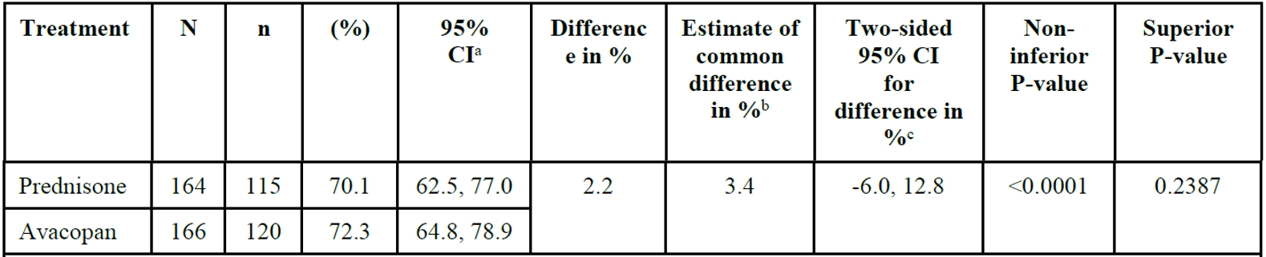

Abbreviations: CI = confidence interval; N = number of subjects in the analysis population for the treatment group; n = number of subjects with disease remission.

a Clopper and Pearson exact CI

b Summary score estimate of the common difference in remission rates (Agresti 2013)[[16]](#footnote-17) using inverse-variance stratum weights

c Miettinen-Nurminen (score) confidence limits for the common difference in remission rates

Results were comparable in avacopan and prednisone treatment groups in all pre-defined subgroups. Specifically, there was no difference in the response rates to AAV and prednisone irrespective if BVAS at Baseline was < 15 or ≥ 15.

Similarly, 109 of 166 participants in the avacopan group (65.7%) sustained remission at Week 52 compared to 90 of 164 (54.9%) participants in the prednisone group, confirming statistical superiority of avacopan to weaning prednisone in maintaining remission at 52 weeks (see Table 4 below).

Table 4: Study CL010\_168 Maintenance of remission at 52 weeks

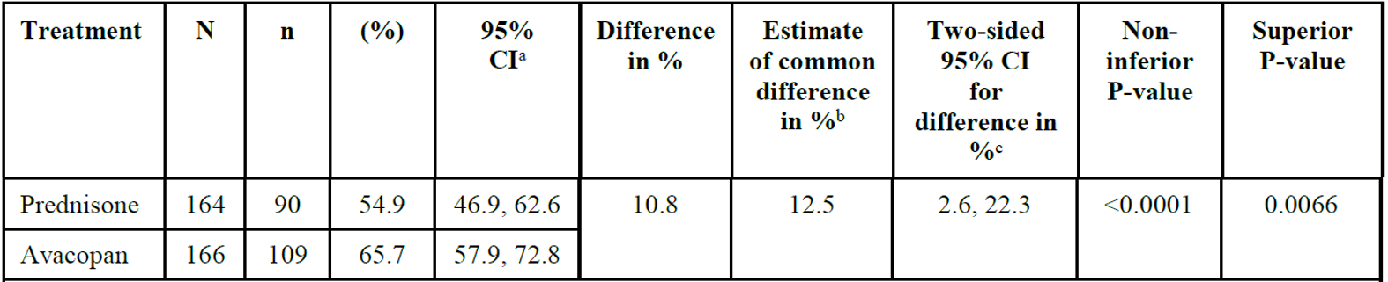

Abbreviations: CI = confidence interval; N = number of subjects in the analysis population for the specified treatment group; n = number of subjects with sustained disease remission

a Clopper and Pearson exact CI

b Summary score estimate of the common difference in remission rates (Agresti 2013)16 by using inverse-variance stratum weights

c Miettinen-Nurminen (score) confidence limits for the common difference in remission rates

Most of the additional secondary efficacy outcomes were nominally supportive of the primary and key secondary outcomes. There was no indication that avacopan had a more rapid effect on inducing remission than prednisolone. BVAS of 0 at Week 4 was observed in 68.9% of participants in the prednisone group and 62.7% in the avacopan group.

At both Weeks 13 and 26, the GTI-cumulative worsening score indicated fewer glucocorticoid related toxicity symptoms (including high mean body mass index, glucose intolerance, lipid elevations, steroid myopathy, skin toxicity, neuropsychiatric toxicity and infection) in the avacopan group compared to the prednisone group. The least square mean of the GTI-aggregate improvement score at Week 13 was 23.2 in the prednisone group compared to 9.9 in the avacopan group and at Week 26 was 23.4 and 11.2, respectively, indicating better results in the avacopan group.

The incidence of relapses after remission was achieved at Week 26 was 12.2% in the prednisone group and 7.5% in the avacopan group; the incidence of relapses at any time during the study after BVAS of 0 had been achieved was lower in the avacopan group, where participants continued treatment with avacopan (10.1%), than in the prednisone (21.0%) group, where participants received placebo.

Regarding health related quality of life measures, the change from Baseline SF-36 physical component score at Week 26 was 1.344 in the prednisone group compared to 4.445 in the avacopan group, and at Week 52 was 2.626 and 4.980 respectively, again supporting greater improvement in the avacopan group. Some aspects of the mental component score also indicated greater improvement in the avacopan group.

Assessments of renal function suggested while there may have been greater improvements in the avacopan group at early time points (greater increases in eGFR at Weeks 26 and 52 with avacopan and reduction in UACR at Week 4 with avacopan), there was not much difference in renal function measures between the groups by Week 52. There were similar increases in the vasculitis damage index from Baseline to Week 52 in both treatment groups.

Comparable numbers of participants in the prednisone and avacopan groups relapsed in the 8‑week follow-up period, and there were no differences in quality of life parameters, eGFR, UACR and urine monocyte chemoattractant protein-1 to creatinine ratios.

Efficacy outcomes for the three adolescent patients were presented descriptively. A 13‑year old white female with relapsing myeloperoxidase positive AAV was treated with a weight adjusted dose of 20 mg avacopan twice daily on a background of rituximab. She discontinued study medication on Day 91 with worsening renal function following initial improvement from Baseline. Her baseline BVAS of 10 had improved to 6 by Day 92. She did not achieve remission. A 16‑year old white female with newly diagnosed myeloperoxidase positive AAV was treated with 30 mg avacopan twice daily on a background of intravenous cyclophosphamide. The dose was decreased to 20 mg twice daily on Day 30 owing to high plasma concentrations of avacopan. Baseline eGFR improved from 44 mL/min/1.73 m2 to 68 mL/min/1.73 m2 at end of treatment, and her baseline BVAS of 13 had improved to 0 by Week 4, she achieved remission at Week 26 and sustained remission at Week 52. A 15-year old white female with newly diagnosed myeloperoxidase positive AAV received weaning doses of prednisone to Week 20 on a background of rituximab. She was withdrawn from the study at Day 349 for poor adherence to contraceptive treatment. Baseline eGFR was 20 mL/min/1.73 m2 and did not improve during the study. Her baseline BVAS was 16, improved to 0 by Week 16. She did not achieve remission as glucocorticoids were required to control AAV within four weeks of Week 26.

##### Study CL002\_168

This supportive Phase II study enrolled 67 adults with GPA, MPA or renal limited vasculitis, applying essentially similar inclusion and exclusion criteria to those listed for Study CL010\_168, but excluding patients with severe manifestations of disease including rapidly progressive glomerulonephritis, rapid onset mononeuritis multiplex, central nervous system involvement and severe alveolar haemorrhage. Participants were sequentially enrolled in three ‘steps’ of the study, into three treatment groups.

In Step 1, 12 participants were randomised to treatment with 30 mg avacopan twice daily for 84 days, with low dose prednisone (20 mg or 15 mg depending on weight at Baseline), weaning to 0 mg over 84 days, or to treatment with standard dose (60 mg or 45 mg depending on weight at Baseline) prednisone, weaning to 0 mg over 84 days. Both groups were placebo controlled and received concomitant treatment with intravenous cyclophosphamide. The study moved to Step 2 if more than half of patients receiving avacopan achieved a disease response and no more than one suspected unexpected serious adverse reaction (SUSAR) related to avacopan was reported.

In Step 2, 14 participants were randomised to treatment with avacopan 30 mg twice daily for 84 days with no prednisone, or to treatment with standard dose prednisone weaning to 0 mg over 84 days. Both groups were placebo controlled and received concomitant treatment with intravenous cyclophosphamide. The study moved to Step 3 if more than half of patients receiving avacopan achieved a disease response and no more than one SUSAR related to avacopan was reported.

In Step 3, 41 participants were randomised to three groups, one receiving avacopan 30 mg twice daily for 84 days with no prednisone, one receiving avacopan 30 mg twice daily with low dose prednisone weaning to 0 mg and one receiving standard dose prednisone weaning to 0 mg. All groups were provided with placebo matching the other treatments and received concomitant treatment with intravenous cyclophosphamide or rituximab.

The primary efficacy objective was change from Baseline of the BVAS. Multiple secondary objectives were also listed. The study reported that a greater proportion of patients receiving avacopan with or without low dose prednisone achieved a 50% reduction from baseline BVAS at 85 days (19 of 22, 86.4% and 17 of 21, 81.0%, respectively) than patients on standard dose prednisone alone (14 of 20, 70.0%, see Table 5 below). Subgroup analyses were supportive but small numbers in some groups limited interpretation.

Table 5: Study CL002\_168 Change from baseline Birmingham Vasculitis Activity Score at Day 85 (intent-to-treat population)

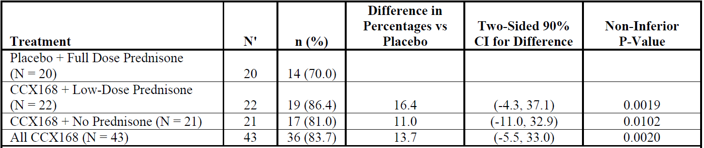

Abbreviations: CCX168 = avacopan; CI = confidence interval; N = number of subjects in the analysis population for the specified treatment group; N’ number of subjects with evaluation; n = number of subjects who responded; vs = versus.

Birmingham Vasculitis Activity Score (BVAS) response was defined as achieving a 50% reduction from Baseline in the BVAS plus no worsening in any body system component.

##### Study CL003\_168

This supportive Phase II study enrolled 42 adults with GPA, MPA or renal limited vasculitis, applying essentially similar inclusion and exclusion criteria as in the pivotal trial, but excluding patients with rapidly progressive glomerulonephritis and severe alveolar haemorrhage. Participants were randomised to treatment with avacopan 30 mg twice daily, avacopan 10 mg twice daily or placebo for 84 days and standard of care therapy with cyclophosphamide or rituximab. All participants also received weaning doses of prednisone starting at 60 mg/day on Day 1 and weaning over 20 weeks. The primary efficacy endpoint of the study was the proportion of subjects achieving disease response at Day 85, defined as BVAS percentage reduction from Baseline of at least 50% plus no worsening in any body system component. Irrespective of treatment, a similar proportion of patients in all treatment groups achieved a clinical response (see Table 6 below).

Table 6: Study CL003\_168 Change from baseline Birmingham Vasculitis Activity Score at Day 85 (intent-to-treat population)

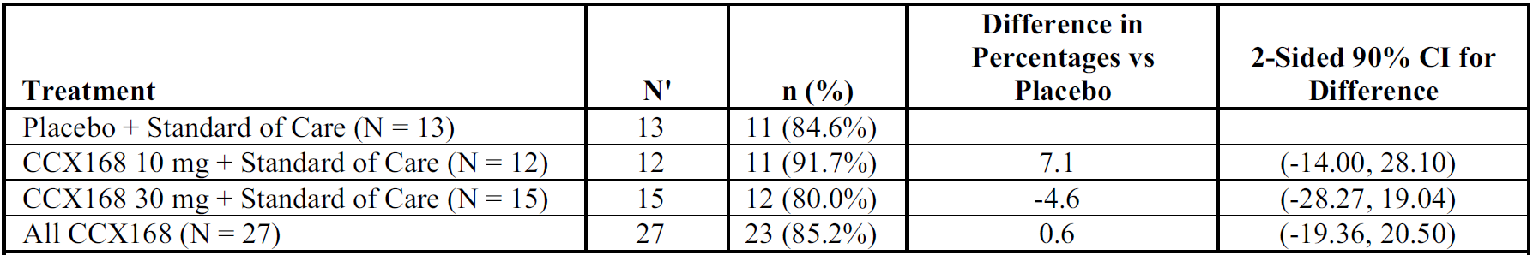

Abbreviations: CCX168 = avacopan; CI = confidence interval; N = number of subjects in the analysis population for the specified treatment group; N’ = number of subjects with post-baseline, on-treatment BVAS data; n = number of responders; % = 100\*n/N’; vs = versus.

Birmingham Vasculitis Activity Score (BVAS) response was defined as achieving a 50% reduction from baseline in the BVAS plus no worsening in any body system component.

While treatment groups were stratified by several factors including type of AAV, ANCA antibody positivity and disease status (newly diagnosed or relapsed), the groups were too small for meaningful subgroup analysis.

#### Safety

In the submitted dataset, 264 participants were included in the Phase I clinical pharmacology studies and of these 206 participants received at least one dose of avacopan. Most of the Phase I participants were healthy volunteers, except in the study examining the effects of mild or moderate impairment of liver function. The avacopan dose given in these studies ranged from 1 mg to 200 mg (total daily dose), and the dosing period ranged from 1 to 17 days. A total of 440 adults with AAV participated in the Phase II and Phase III studies, of these 239 participants received at least one dose of avacopan (10 mg or 30 mg).

Exposure in the pivotal study is summarised in Table 7, and in the Phase II studies in Table 8 below.

Table 7: Study CL010\_168 Exposure by duration (intent-to-treat population)

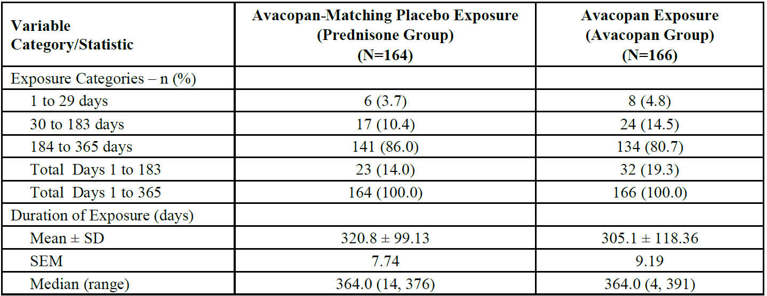

Abbreviations: N = number of subjects randomised to treatment group in the safety population; n = number of subjects or events in specified category; SD = standard deviation; SEM = standard error of mean.

Table 8: Phase II studies Exposure by duration (pooled safety population)

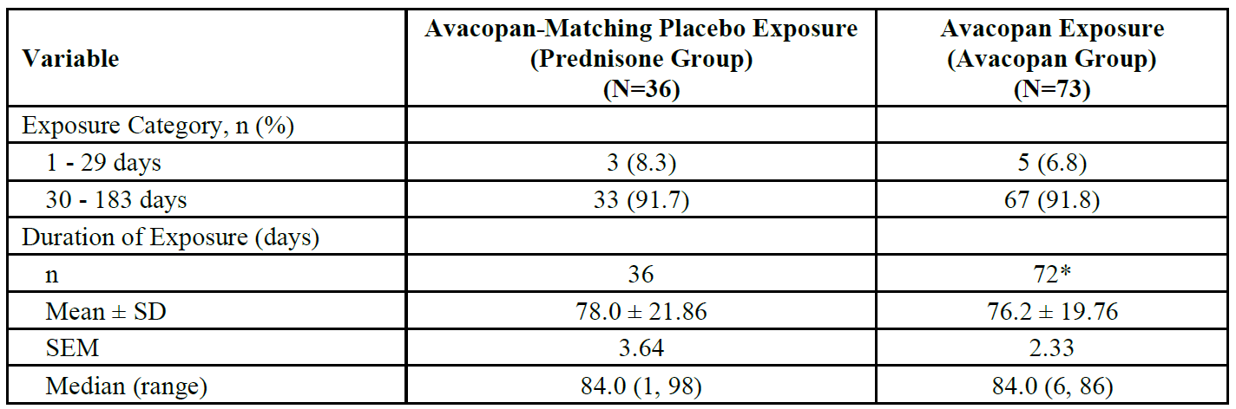

Abbreviations: N = number of subjects randomised to treatment group in the safety population; n = number of subjects or events in specified category; SD = standard deviation; SEM = standard error of mean.

\* One subject in study CL003\_168 had missing drug accountability data and is not included.

In the pivotal study CL010\_168, 2,139 treatment emergent adverse events (TEAEs) were seen in 161 participants (98.2%) in the prednisone group and 1,779 TEAEs in 164 participants (98.8%) in the avacopan group. Of these, most TEAEs in the 2 groups were moderate in severity (41.5% and 49.4% with prednisone and avacopan respectively) and approximately 25% of subjects in both treatment groups had severe TEAEs (see Table 9 below).

Table 9: Study CL010\_168 Summary of treatment emergent adverse events (safety population)

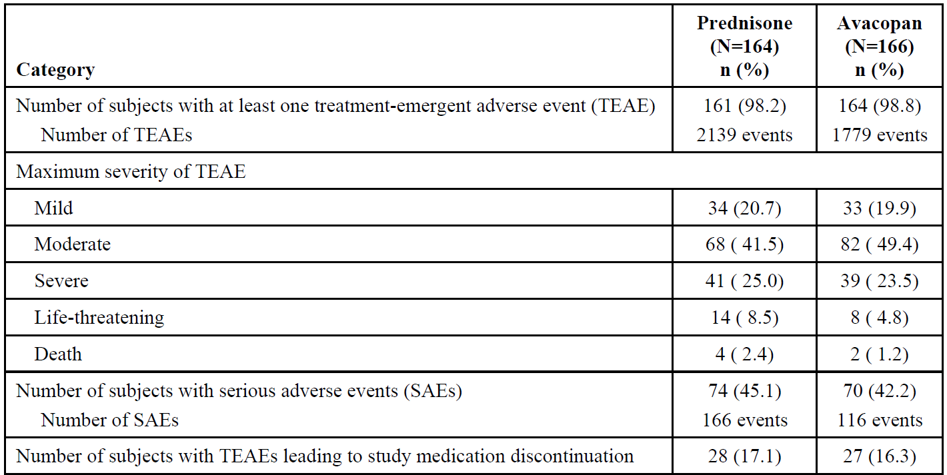

Abbreviations: N = number of subjects randomised to treatment group in the safety population; n = number of subjects in specified category; SAE = serious adverse event; TEAE = treatment emergent adverse event.

Note: An adverse event was considered treatment emergent if the start date or time of the event was on or after the date or time of first dose of study medication.

One participant randomised to avacopan died with acute myocardial infarction before commencing treatment. Two patients in this group died 79 and 110 days respectively after discontinuing avacopan. One died of GPA and one died of pneumonia. Four deaths were reported in the prednisone group, recorded as diarrhoea, vomiting or fungal infection; unknown cause; acute myocardial infarction; and infectious pleural effusion. Reports of life threatening TEAE in the prednisone group included neutropaenia, small bowel haemorrhage, myocardial infarction, hyperglycaemia, pulmonary embolism, lymphopaenia and sepsis; and in the avacopan group included diabetic ketoacidosis, myocardial infarction (prior to drug treatment), pulmonary haemorrhage, GPA, metastatic pancreatic cancer and hepatitis B.

In the smaller Phase II trials, safety reports were available for the 84-day clinical trial period and to a total of 164 days. TEAEs were equally common among the various treatment groups, and predominantly mild or moderate. No deaths were recorded in either study. In Study CL003\_168, two life threatening events were reported. In the 10 mg avacopan twice daily + prednisone group one participant had a life threatening event of neutropenia assessed as probably not related to study medication, but possibly related to rituximab. In the 30 mg avacopan twice daily + prednisone group one participant had a life-threatening event of sepsis originally assessed as possibly related to study medication but later considered to be a result of bile duct stricture. Serious TEAE reported in the pivotal study are summarised in Table 10 below.

Table 10: Study CL010\_168 Serious treatment emergent adverse events by Preferred Term (at least 1% in either treatment group) by decreasing frequency in the avacopan treatment group (safety population)

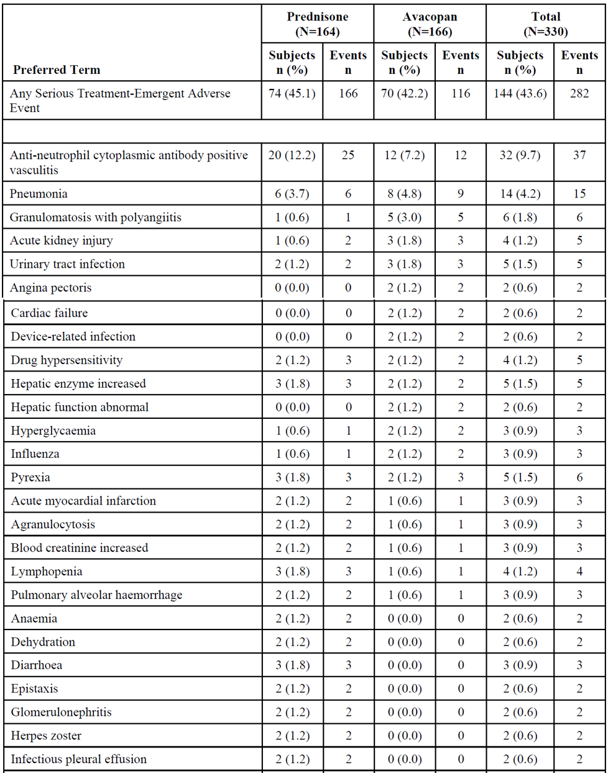

Table 10 continued: Study CL010\_168 Serious treatment emergent adverse events by Preferred Term (at least 1% in either treatment group) by decreasing frequency in the avacopan treatment group (safety population)

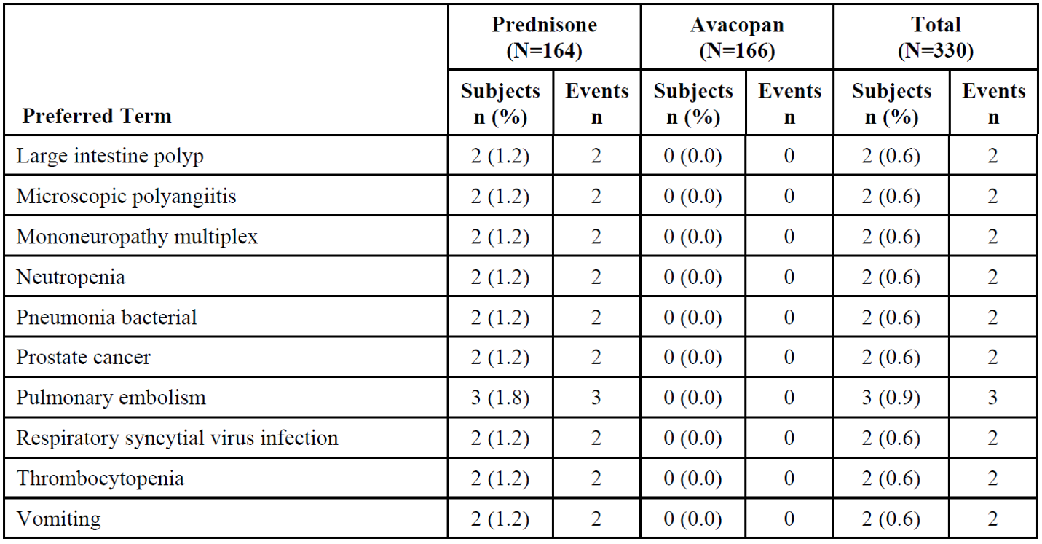

Abbreviations: N = number of subjects randomised to treatment group in the safety population; n = number of subjects or events in specified category.

While overall, reports of serious TEAE were similar in the avacopan and prednisone groups, and reports of AAV (serious worsening disease) were most common in both groups; pneumonia, GPA, acute kidney injury and urinary tract infection were more common in the avacopan group whereas a range of other serious TEAE appeared more common in the prednisolone group.

In the pivotal study nausea was the most frequently reported TEAE in the avacopan group and peripheral oedema the most frequently reported TEAE in the prednisone group. Those TEAEs with an incidence of > 2% higher in the avacopan compared to the prednisone group for TEAEs > 5% in either treatment group were nausea, headache, vomiting and rash. Comparable TEAEs with an incidence of > 2% higher in the prednisone group compared to avacopan for TEAEs > 5% in either group were peripheral oedema, arthralgia, ANCA positive vasculitis (worsening of vasculitis), nasopharyngitis, muscle spasms, back pain, myalgia, pyrexia, epistaxis, anaemia, insomnia, hypercholesterolaemia, urinary tract infection, alopecia, lymphopaenia, oropharyngeal pain, bronchitis, dyspepsia, Cushingoid and weight increase. Nausea was also the overall most common TEAE in the Phase II studies, affecting around 20% of participants in any treatment group. Commonly reported (≥ 10% of subjects in any treatment group) TEAEs that occurred in a higher (≥ 2%) proportion of subjects in the avacopan group were nausea (21.9% compared to 19.4% in the prednisone group), hypertension (20.5% versus 16.7%), nasopharyngitis (16.4% versus 13.9%), vomiting (15.1% versus 2.8%), arthralgia (13.7% versus 5.6%), and diarrhoea (11.0% versus 8.3%). Commonly reported TEAEs that occurred in a higher proportion of subjects in the prednisone group included fatigue, constipation, cough, back pain, and muscle spasm.

Pre-defined adverse events of special interest in the clinical studies included infections, hepatic enzyme elevations, neutropaenia, lymphopaenia and hypersensitivity or angioedema. Infections were very common in both treatment groups in the pivotal study, predominantly nasopharyngitis, upper respiratory tract infection and urinary tract infections. Nasopharyngitis and upper respiratory tract infections were also very common in the Phase II studies, while other infections of the respiratory tract, urinary tract, gastrointestinal tract and skin were common. ‘Elevated hepatic enzymes’ were reported for similar proportions of participants in prednisone and avacopan groups in the pivotal study, although reports for individual enzyme elevations were reported by only two or three participants (1.2% to 1.8%) in the avacopan treatment arm and up to four participants (2.4%, AST elevated) and six participants (3.7%, ALT elevated, one Grade 4) in the prednisone arm. Elevated transaminases (usually ALT) were reported in 1 of 36 participants receiving prednisone in the Phase II studies and 5 of 73 participants receiving avacopan (one also receiving prednisone). Regarding neutropaenia and lymphopaenia, in the pivotal study 39 participants (23.8%) in the prednisone group and 31 participants (18.7%) in the avacopan group had TEAEs associated with low white cell count. Lymphopaenia was seen in 18 participants (11.0%) in the prednisone group and 6 participants (3.6%) in the avacopan group, neutropaenia in 4 participants (2.4%) in each treatment group and febrile neutropaenia in one participant (0.6%) in each group. Most reported cytopaenias were Grades 1 to 3. There were no reports of neutropaenia or lymphopaenia in the Phase II studies.

By Preferred Term, several skin and subcutaneous disorders (24 patients), and respiratory, thoracic and mediastinal disorders (9 patients), were grouped with fewer Preferred Terms from the System Organ Classes gastrointestinal disorders (3 patients), immune system disorders (3 patients), infections and infestations (2 patients), blood and lymphatic system disorders (one patient), eye disorders (one patient) and general disorders (2 patients) to capture reports of TEAE ‘associated with hypersensitivity’ in the pivotal study. Overall, there were 70 reports (42.7%) in the prednisone group and 68 reports (41.0%) in the avacopan group, most (33.5% and 30.7% of all reports, in prednisone and avacopan groups respectively) in the skin and subcutaneous disorders System Organ Class including rash, pruritis, dermatitis acneiform and pruritis generalised. Other frequent reports in the prednisone group included ‘erythema’ (3.0%), ‘swelling face’ (3.7%) and ‘drug hypersensitivity’ (3.0%). There was one report of ‘localised oedema’ in the prednisone group. In the avacopan group, other frequent reports included ‘mouth ulceration’ (4.8%); ‘drug hypersensitivity’ was reported by three participants (1.8%) and ‘face oedema’ by one participant.

Adverse events potentially related to glucocorticoid use were specifically reported for the pivotal study. Using European Alliance of Associations for Rheumatology (EULAR)[[17]](#footnote-18) recommended search terms to identify glucocorticoid associated AEs, the investigators reported that the total incidences of these AEs were 80.5% with prednisone and 66.3% with avacopan. By preferred term, higher incidences with prednisone compared to avacopan respectively were reported for weight gain (10.4% versus 0.6% respectively), insomnia (15.2% versus 7.8%), hyperlipidaemia (2.4% versus 0.0%), adrenal insufficiency (4.9% versus 0.6%), blood glucose increase (3.0% versus 0.0%) and irritability (2.4% versus 0.0%). By System Organ Class, a higher incidence of events probably related to glucocorticoid use in the prednisone group compared to the avacopan group was seen in infections and infestations (35.4% versus 25.3%, respectively), skin and subcutaneous tissue disorders (22.6% versus 10.8%, respectively), investigations (15.9% versus 9.0%, respectively), psychiatric disorders (18.9% versus 7.2%, respectively), metabolism and nutrition disorders (17.1% versus 8.4%, respectively), vascular disorders (11.0% versus 5.4%, respectively), blood and lymphatic system disorders (13.4% versus 4.8%, respectively), eye disorders (7.9% versus 3.6%, respectively), and endocrine disorders (7.3% versus 1.8%, respectively). The safety reports align with the results of the secondary efficacy endpoint, the glucose toxicity index, and are consistent with higher overall exposures to glucocorticoids in the prednisone arm of the pivotal study.

The clinical evaluation summarised the following additional safety findings for noting:

* In the Phase III Study CL010\_168, avacopan was well tolerated with lower proportions of patients in the avacopan group experiencing infection, life threatening infection and infections resulting in death. Gastroenteritis however was more common in the avacopan than in the prednisone group.
* There were slightly more participants in the avacopan group versus prednisone with signs or symptoms of hepatic dysfunction. Most of the ALT and AST elevations in both treatment groups were of Grade 1 severity.
* There were fewer AEs potentially related to glucocorticoid use with avacopan versus prednisone groups. These included weight gain, insomnia, hyperlipidaemia, adrenal insufficiency, blood glucose increase and irritability.
* Episodes of elevated creatine phosphokinase were seen with avacopan versus prednisone although these were within the normal range and there were no episodes of rhabdomyolysis.
* Follow-up renal biopsy was not mandated per protocol, although small numbers (< 10%) in each group had follow-up biopsies at either Week 52 or at other visits. Improvement in active renal disease was seen in both groups.

### Risk management plan

The sponsor has submitted European-risk management plan (RMP) version 1.5 (dated 3 November 2021; data lock point (DLP) 24 March 2020) and Australia specific annex (ASA version 1 (dated 1 December 2020) in support of this application.

The sponsor has submitted approved European-RMP version 1.6 (dated 17 January 2022; DLP 24 March 2020) with the response to a TGA request for information.

The summary of safety concerns and their associated risk monitoring and mitigation strategies are summarised in Table 11. The TGA may request an updated RMP at any stage of a product's life-cycle, during both the pre-approval and post-approval phases.

Table 11: Summary of safety concerns

|  |  |  |  |  |  |
| --- | --- | --- | --- | --- | --- |
| Summary of safety concerns | | Pharmacovigilance | | Risk minimisation | |
| **Routine** | **Additional** | **Routine** | **Additional** |
| Important identified risks | Liver injury | ü | ü† | ü | - |
| Important potential risks | Cardiovascular safety | ü | ü† | ü | - |
| Serious infection | ü | ü† | ü | - |
| Malignancy | ü | ü† | ü | - |
| Missing information | None | | | | |

† Post-approval safety study

The summary of safety concerns in the ASA aligns with the EU-RMP and is acceptable from an RMP perspective, subject to the comments of the clinical and nonclinical evaluations. No concerns on the safety specification were raised by the clinical evaluation in the first round report. The Summary of safety concerns is considered acceptable from the RMP perspective.

The sponsor has proposed routine pharmacovigilance for all safety concerns. The sponsor has proposed additional pharmacovigilance in the form of a post-approval safety study. The pharmacovigilance plan is acceptable from an RMP perspective.

The sponsor has proposed only routine risk minimisation activities, through draft PI and CMI, for all safety concerns. No additional risk minimisation activities have been proposed. Routine risk minimisation is considered acceptable to manage the risks. At the second round of evaluation, requested revisions to CMI have all been satisfactorily addressed by sponsor.

### Risk-benefit analysis

#### Delegate’s considerations

Avacopan provides an alternative, oral, treatment approach to the relatively rare but frequently life-threatening conditions GPA and MPA. The sponsor reported that 30 mg avacopan twice daily is as effective as a typical induction protocol with prednisone, in combination with acknowledged standard of care immunomodulatory treatments, in inducing remission by 26 weeks of treatment. This non-inferiority was consistent for all pre-defined sub-groups. Ongoing use of avacopan to 52 weeks (compared to no regular prednisolone) also appeared to be successful in maintaining remission. Several secondary endpoints supported the medium term effect, notwithstanding the relatively small study population and the decision not to control for multiplicity in the analysis of numerous secondary endpoints. Very limited efficacy results were provided for the adolescent population. This population group is significantly smaller than adults and it is not unusual to apply efficacy results from adults to direct therapy in younger patients. In the opinion of this delegate, the data provided from this study is inadequate to support regulatory approval for use of avacopan in adolescents.

The toxic effects of long term glucocorticoid treatment and intermittent high dose glucocorticoid treatment are also well described. Reduction in glucocorticoid toxicity was a secondary efficacy outcome in the pivotal study. Some reductions in the typical signs and symptoms of glucocorticoid excess were seen at up to 52 weeks, which are suggestive of a potential longer term benefit from avacopan. In both the avacopan and prednisone treatment arms, additional glucocorticoid therapy for worsening disease was required at comparable doses during the 26 to 52 week period. Further evidence is required to confirm whether in the longer term avacopan can decrease the requirement for multiple prednisone induction courses for relapsed AAV.

The clinical programme for avacopan in AAV flagged a number of potential safety issues. These included a marked increase in the risk for frequent, serious and or severe infections, most commonly of the respiratory tract, but also potentially in other organ systems. Glucocorticoids and other immunomodulatory treatments are known to contribute to infectious risks and physicians and patients requiring immunomodulatory treatment are well aware of these risks and the actions required to manage them. The potential for avacopan to contribute to neutropenia and lymphopaenia has also been noted.

Use of avacopan has also been associated with disordered hepatic function and elevated concentrations of transaminases and other liver enzymes. While most cases of elevated enzymes and hepatic dysfunction reported in the trial were mild or moderate and possibly transient, the PI includes appropriate advice for discontinuing avacopan until results normalise, or permanently. Avacopan has also been associated with a range of symptoms of hypersensitivity, including angioedema. Appropriate warnings are included in the PI.

#### Proposed action

Avacopan, in combination with rituximab or cyclophosphamide based treatment regimens for GPA and MPA, has been shown to be non-inferior to induction protocols of prednisone in inducing remission, based on appropriate outcome measures. There is also weaker evidence that avacopan, in combination with a rituximab or cyclophosphamide based regimen can maintain remission for up to 52 weeks, compared to use of the background therapies alone following induction with prednisone. There is supportive evidence that avacopan may decrease overall requirements for glucocorticoids, as suggested by improvements in the GTI. Safety concerns are comparable to, or fewer than for other immunomodulators. The sponsor has committed with the European Medicines Agency, to a post-approval safety study to monitor for important known and potential risks.

Avacopan does not appear to provide a significant breakthrough for the treatment of AAV. It may, however, provide an alternative approach to high dose glucocorticoids in inducing remission in new onset or relapsed GPA or MPA. It may also, in the longer term, prove successful in maintaining remission with a decreased requirement for glucocorticoid rescue treatment. On the balance of the evidence, the Delegate is inclined to approve registration of avacopan for a modified therapeutic indication:

*Tavneos, in combination with a rituximab or cyclophosphamide based regimen, is indicated for the treatment of adults with severe active anti-neutrophil cytoplasmic autoantibody (ANCA)-associated vasculitis (granulomatosis with polyangiitis [GPA] and microscopic polyangiitis [MPA]).*

#### Advisory Committee considerations

The [Advisory Committee on Medicines (ACM)](https://www.tga.gov.au/committee/advisory-committee-medicines-acm), having considered the evaluations and the Delegate’s overview, as well as the sponsor’s response to these documents, advised the following.

##### Specific advice to the Delegate

1. ***What is the opinion of the Committee regarding the evidence of efficacy and safety of avacopan in adolescents with anti-neutrophil cytoplasmic autoantibody (ANCA)-associated vasculitis (AAV)?***

The ACM noted the low numbers of adolescents included within the studies. Four female adolescents were enrolled in the Phase III study, 3 within the avacopan arm and one within the prednisone (control) arm.[[18]](#footnote-19) One adolescent completed treatment with remission at 26 weeks sustained at Week 52. Noting these low numbers, the ACM indicated there are limited data on the use of avacopan in adolescents with AAV.

The ACM considered the mechanism of action for avacopan and was of the view that the pathological mechanisms are unlikely to differ between adults and adolescents.

The ACM also considered the rareness of the condition within this population, and the harms of ongoing glucocorticoid steroids usage in this age range.

1. ***Should the study outcomes in the limited adolescent studies be included in the product information?***

The ACM was of the view that the study outcomes in the limited adolescent studies should be included within the product information (PI) and advised that this information will assist prescribers to make informed treatment decisions.

The ACM also encouraged the sponsor to undertake larger studies within this population.

1. ***What is the opinion of the Committee regarding restriction of avacopan to use in patients with severe AAV?***

The ACM was of the view that there was no need to restrict the use of avacopan to patients with severe AAV and suggested that ‘severe’ be removed from the indication. The pivotal clinical study enrolled patients with Birmingham Vascular Activity Scores (BVAS) at Baseline ranging from 5 to 37, representing a range of severity.

The ACM noted the inclusion of in combination with a rituximab or cyclophosphamide based regimen within the indication and advised that treatment with these agents indicates a level of severity requiring treatment to restrict disease progression or impact on organ(s).

The ACM also commented on the challenges in defining AAV as severe in addition to determining the severity of disease particularly if the patient has had previous treatment.

The ACM further acknowledged the steroid sparing ability of avacopan and advised that using avacopan in ‘moderate’ disease would also be appropriate as it may spare the long taper and toxicity associated with prednisone.

1. ***Please discuss whether measures of AAV severity, other than the Birmingham Vascular Activity Scores (BVAS),9 would impact specialist physicians when choosing treatment options?***

The ACM advised that clinical signs and renal markers are often useful for directing treatment. However, the ACM noted the variability of disease and that the markers and measures utilised will often depend on which organs are affected.

The ACM advised that AAV treatment is generally tailored to the individual patient and is closely managed by specialist physicians.

The ACM noted that due to the varying AAV presentations it is difficult to construct a prescriptive list of measures in a clear manner.

##### Conclusion

The ACM considered this product to have an overall positive benefit-risk profile for the indication:

*Tavneos, in combination with a rituximab or cyclophosphamide based regimen, is indicated for the treatment of active anti-neutrophil cytoplasmic autoantibody (ANCA)-associated vasculitis (granulomatosis with polyangiitis [GPA] and microscopic polyangiitis [MPA]).*

## Outcome

Based on a review of quality, safety, and efficacy, the TGA approved the registration of Tavneos (avacopan) 10 mg, capsule, bottle, indicated for:

*Tavneos, in combination with a rituximab or cyclophosphamide based regimen, is indicated for the treatment of adults with anti-neutrophil cytoplasmic autoantibody (ANCA)-associated vasculitis (granulomatosis with polyangiitis [GPA] and microscopic polyangiitis [MPA]).*

### Specific conditions of registration applying to these goods

* Tavneos (avacopan) is to be included in the Black Triangle Scheme. The PI and CMI for Tavneos must include the black triangle symbol and mandatory accompanying text for five years, which starts from the date that the sponsor notifies the TGA of supply of the product.
* The Tavneos EU-risk management plan (RMP) (version 1.6, dated 17 January 2022; data lock point 24 March 2020), with Australian specific annex (version 1, dated 1 December 2020), included with Submission PM-2021-05913-1-3, and any subsequent revisions, as agreed with the TGA will be implemented in Australia.

An obligatory component of risk management plans is routine pharmacovigilance. Routine pharmacovigilance includes the submission of periodic safety update reports (PSURs).

Reports are to be provided in line with the current published list of EU reference dates and frequency of submission of PSURs until the period covered by such reports is not less than three years from the date of the approval letter.

The reports are to at least meet the requirements for PSURs as described in the European Medicines Agency’s Guideline on Good Pharmacovigilance Practices (GVP) Module VII-periodic safety update report [Revision 1], Part VII.B Structures and processes. Note that submission of a PSUR does not constitute an application to vary the registration.

## Attachment 1. Product Information

The PI for Tavneos approved with the submission which is described in this AusPAR is at Attachment 1. For the most recent PI, please refer to the TGA [PI/CMI search facility.](https://www.tga.gov.au/picmi-search-facility)

|  |
| --- |
| Therapeutic Goods Administration |
| PO Box 100 Woden ACT 2606 Australia  Email: [info@tga.gov.au](mailto:info@tga.gov.au) Phone: 1800 020 653 Fax: 02 6203 1605  [**https://www.tga.gov.au**](https://www.tga.gov.au) |
| Reference/Publication # |

1. This is the original indication proposed by the sponsor when the TGA commenced the evaluation of this submission. It may differ to the final indication approved by the TGA and registered on the Australian Register of Therapeutic Goods. [↑](#footnote-ref-2)
2. Therapeutic Guidelines, [*Systemic Vasculitides*](https://tgldcdp.tg.org.au/viewTopic?etgAccess=true&guidelinePage=Rheumatology&topicfile=systemic-vasculitides&guidelinename=Rheumatology&sectionId=toc_d1e47#toc_d1e47)*,* Published March 2017, accessed 17 October 2022. [↑](#footnote-ref-3)
3. Food and Drug Administration (FDA), [*NDA Multi-Disciplinary Review and Evaluation, application number214487, avacopan*](https://www.accessdata.fda.gov/drugsatfda_docs/nda/2021/214487Orig1s000MultidisciplineR.pdf), Version date: 12 October 2018. [↑](#footnote-ref-4)
4. European Medicines Agency (EMA), Committee for Proprietary Medicinal Products (CPMP), ICH guideline M3(R2) on non-clinical safety studies for the conduct of human clinical trials and marketing authorisation for pharmaceuticals, EMA/CPMP/ICH/286/1995, December 2009. [↑](#footnote-ref-5)
5. **Good Laboratory Practice (GLP)** is a code of standards following the International Council on Harmonisation (ICH) relevant to testing of medicines in laboratories during drug development. [↑](#footnote-ref-6)
6. The **QT interval** is the time from the start of the QRS wave complex to the end of the corresponding T wave. It approximates to the time taken for ventricular depolarisation and repolarisation, that is to say, the period of ventricular systole from ventricular isovolumetric contraction to isovolumetric relaxation. [↑](#footnote-ref-7)
7. **Cytochrome P450 (CYP)** enzymes are the major enzymes involved in drug metabolism, accounting for large part of the total metabolism. Most drugs undergo deactivation by CYPs, either directly or by facilitated excretion from the body. Also, many substances are bioactivated by CYPs to form their active compounds.

   Many drugs may increase or decrease the activity of various CYP isozymes either by inducing the biosynthesis of an isozyme (enzyme induction) or by directly inhibiting the activity of the CYP (enzyme inhibition). This is a major source of adverse drug interactions, since changes in CYP enzyme activity may affect the metabolism and clearance of various drugs. Such drug interactions are especially important to take into account when using drugs of vital importance to the patient, drugs with important side-effects and drugs with small therapeutic windows, but any drug may be subject to an altered plasma concentration due to altered drug metabolism. [↑](#footnote-ref-8)
8. **Pregnancy Category D**: Drugs which have caused, are suspected to have caused or may be expected to cause, an increased incidence of human fetal malformations or irreversible damage. These drugs may also have adverse pharmacological effects. Accompanying texts should be consulted for further details. [↑](#footnote-ref-9)
9. The **Birmingham Vasculitis Activity Score (BVAS)** is a validated scoring system for symptoms of active vasculitis in the preceding four weeks, in nine organ system domains: general, cutaneous, mucous membranes/eyes, ears/nose/throat, chest, cardiovascular, abdominal, renal, neuropsychiatric. It also allows physicians to add up to four ‘other’ symptoms. [↑](#footnote-ref-10)
10. The **Child-Pugh score** is used to assess the prognosis of chronic liver disease. The score employs five clinical measures of liver disease. Each measure is scored 1 to 3, with 3 indicating most severe derangement. Class A: 5 to 6 points, least severe liver disease, one to five year survival rate of 95%. Class B: 7 to 9 points, moderately severe liver disease, one to five year survival of 75%. Class C: 10 to 15 points, most severe liver disease, 1 to 5 year survival rate 50%. [↑](#footnote-ref-11)
11. The protocol also made provision for the enrolment of eligible adolescents and three adolescents aged 12 to 17 were also enrolled following parental consent, and had specific dosage adjustments applied to prednisone, cyclophosphamide, and azathioprine. [↑](#footnote-ref-12)
12. If ‘other’ items were included in the Birmingham Vasculitis Activity Score (BVAS), this had to be confirmed with the medical monitor. [↑](#footnote-ref-13)
13. The **36-Item Short Form Health Survey (SF-36)** is a multi-purpose, short-form health survey with only 36 questions. It yields an 8-scale profile of functional health and well-being scores as well as psychometrically based physical and mental health summary measures and a preference based health utility index. It measures eight domains of health: physical functioning, role limitations due to physical health, bodily pain, general health perceptions, vitality, social functioning, role limitations due to emotional problems, and mental health. It yields scale scores for each of these eight health domains, and two summary measures of physical and mental health. It is a generic measure, as opposed to one that targets a specific age, disease, or treatment group. The SF-36 is available for two recall periods: standard (4-week recall) and acute (1-week recall). [↑](#footnote-ref-14)
14. **EuroQuality of Life-5 domains (EQ-5D)** (developed by EuroQol) is a standardised instrument for use as a measure of health outcome. Applicable to a wide range of health conditions and treatments, it provides a simple descriptive profile and a single index value for health status. [↑](#footnote-ref-15)
15. JH Stone, et al., ‘Rituximab versus cyclophosphamide for ANCA-associated vasculitis’, New England Journal of Medicine, 2010, 363:221-232, doi: 10.1056/NEJMoa0909905. [↑](#footnote-ref-16)
16. A Agresti, *Categorical Data Analysis*. 3rd Edition, John Wiley & Sons, Inc., New Jersey, 2013. [↑](#footnote-ref-17)
17. The **European League against Rheumatism (EULAR) response criteria** are based on the assessment of disease activity using the Disease Activity Score (DAS), a statistically-derived index consisting of number of tender joints, number of swollen joints, erythrocyte sedimentation rate, and global disease activity. [↑](#footnote-ref-18)
18. Sponsor clarification: three female adolescents were enrolled in the Phase III study, two within the avacopan arm and one within the prednisone (control) arm. [↑](#footnote-ref-19)