▼This medicinal product is subject to additional monitoring in Australia. This will allow quick identification of new safety information. Healthcare professionals are asked to report any suspected adverse events at [https://www.tga.gov.au/reporting-problems.](https://www.tga.gov.au/reporting-problems)

AUSTRALIAN PRODUCT INFORMATION – TERIPARATIDE LUPIN

**(teriparatide) solution for injection**

# NAME OF THE MEDICINE

Teriparatide.

# QUALITATIVE AND QUANTITATIVE COMPOSITION

One pre-filled pen of Teriparatide Lupin of 2.4 mL contains 600 micrograms of teriparatide (corresponding to 250 micrograms per mL).

For the full list of excipients, see **Section 6.1 List of Excipients**.

# PHARMACEUTICAL FORM

Solution for injection.

Teriparatide Lupin is a sterile, colourless, clear, isotonic solution in pre-filled pens.

# CLINICAL PARTICULARS

## 4.1 Therapeutic Indications

Teriparatide Lupin is indicated for the treatment of osteoporosis in postmenopausal women and the treatment of primary osteoporosis in men when other agents are considered unsuitable and when there is a high risk of fractures.

Teriparatide Lupin is indicated for the treatment of osteoporosis associated with sustained systemic glucocorticoid therapy in women and men at high risk for fracture.

## 4.2 Dose and Method of Administration

Each dose of 80 microlitres contains 20 micrograms of teriparatide.

The recommended dose of Teriparatide Lupin is 20 micrograms administered once daily by subcutaneous injection in the thigh or abdomen.

Based on clinical experience, treatment with Teriparatide Lupin is recommended for a lifetime duration of 24 months treatment (for post-treatment efficacy, see **Section 5.1 Pharmacodynamic Properties - Clinical Trials**). Teriparatide Lupin should be prescribed to patients with a full explanation and their informed consent on the lifetime duration of 24 months treatment.

Calcium and vitamin D supplements are advised in patients with a low dietary intake of these nutrients.

**Use in Males** – Primary or secondary hypogonadism should first be excluded and, if relevant, be treated (see **Section 5.1 Pharmacodynamic Properties - Clinical Trials**)

### Instructions for Use/Handling

To prevent the possible transmission of disease, each pen must be used by one patient only, even if the needle is changed.

Following cessation of Teriparatide Lupin therapy, patients may be continued on other osteoporosis therapies.

The pen delivers 20 micrograms per dose and contains dosing for 28 treatment days. Patients must be educated to use the proper injection techniques. Please refer to the User Manual for instructions for the pen.

Teriparatide Lupin is a clear and colourless liquid. Do not use if solid particles appear or if the solution is cloudy or coloured. The Teriparatide Lupin pen should not be used after the stated expiration date.

Data are not available on the safety or efficacy of intravenous or intramuscular injection of Teriparatide Lupin.

## 4.3 Contraindications

* Teriparatide Lupin should not be given to patients with hypersensitivity to teriparatide or to any of its excipients.
* Pregnancy and breast-feeding (see **Section 4.6 Fertility Pregnancy and Lactation**)
* Pre-existing hypercalcaemia
* Severe renal impairment
* Metabolic bone diseases (including hyperparathyroidism and Paget’s disease of the bone) other than primary osteoporosis or glucocorticoid-induced osteoporosis.
* Unexplained elevations of alkaline phosphatase
* Prior external beam or implant radiation therapy to the skeleton
* Patients with skeletal malignancies or bone metastases should be excluded from treatment with teriparatide

## 4.4 Special Warnings and Precautions for Use

### Duration of treatment

The maximum lifetime exposure to teriparatide for an individual patient is 24 months (see **Section 4.2 Dose and Method of Administration**). For post-treatment efficacy, see **Section 5.1 Pharmacodynamic Properties** **- Clinical trials**.

### Risk of Osteosarcoma

In male and female rats, teriparatide caused an increase in the incidence of osteosarcoma (a malignant bone tumour) that was dependent on dose and treatment duration. The effect was observed at systemic exposures to teriparatide ranging from 3 to 60 times the exposure in humans given a 20 microgram dose.

However no increased risk was identified in a study in which 30 monkeys were treated with teriparatide for 18 months and then observed for a further 3 years. Post-marketing data in humans has not identified an increased risk.

**To minimise the potential risk of osteosarcoma (seen in the life-time rat studies):**

1. **the maximum lifetime exposure to Teriparatide Lupin for an individual patient is 24 months (see Section 4.2 Dose and Method of Administration and Section 5.1 Pharmacodynamic Properties);**
2. teriparatide should not be prescribed to patients where there is an increased background risk of osteosarcoma (such as Paget’s disease of bone, prior radiation therapy involving the skeleton, open epiphysis, unexplained elevations of alkaline phosphatase). (See **Section 4.3** **Contraindications** and **Section 5.3 Preclinical Safety Data - Carcinogenicity**).

Teriparatide Lupin should be prescribed to patients with a full explanation and their informed consent on the lifetime duration of 24 months treatment.

#### Information for Patients

For safe and effective use of Teriparatide Lupin, the physician should inform the patient on the following:

* *General* – Patients will need to read the Consumer Medicine Information leaflet and pen User Manual before starting therapy with Teriparatide Lupin and re-read them each time the prescription is renewed.
* *Osteosarcoma in Rats* – Patients should be made aware that Teriparatide Lupin caused osteosarcoma in rats and that the clinical relevance of these findings is unknown.
* Consent form – **Use of Teriparatide Lupin is restricted to 24 months lifetime duration**. To access or download a copy of the consent form, visit: <https://www.generichealth.com.au/>

### Hypercalcaemia

* Teriparatide has not been studied in patients with pre-existing hypercalcaemia. Patients with pre-existing hypercalcaemia should be excluded from treatment with teriparatide because of the possibility of exacerbating hypercalcaemia (see **Section 4.3 Contraindications**).
* In normocalcaemic patients, slight and transient elevations of serum calcium concentrations have been observed following teriparatide injection. Serum calcium concentrations reach a maximum between 4 and 6 hours and return to baseline by 16 to 24 hours after each dose of teriparatide. Routine calcium monitoring during therapy is not required.

### Bone Disorders Other Than Osteoporosis

Patients with metabolic bone diseases other than primary osteoporosis (including hyperparathyroidism and Paget’s disease of the bone) (see **Section 4.3 Contraindications**) and those with otherwise unexplained elevations of alkaline phosphatase, should generally be excluded from treatment with teriparatide. Patients with skeletal malignancies or bone metastases should also be excluded from treatment with teriparatide.

### Urolithiasis

Teriparatide has not been studied in patients with active urolithiasis. Teriparatide should be used with caution in patients with active or recent urolithiasis because of the potential to exacerbate this condition.

### Hypotension

In short-term clinical studies with teriparatide, isolated episodes of transient orthostatic hypotension were observed. Typically, an event began within 4 hours of dosing and spontaneously resolved within a few minutes to a few hours. When transient orthostatic hypotension occurred, it happened within the first several doses, was relieved by placing subjects in a reclining position and did not preclude continued treatment.

### Use in the Elderly

No differences in teriparatide pharmacokinetics were detected with regard to age (range 31 to 85 years). Dosage adjustment based on age is not required.

### Paediatric Use

Teriparatide has not been studied in paediatric populations. Teriparatide should not be used in paediatric patients or young adults with open epiphyses.

### Effects on Laboratory Tests

#### Serum Calcium

Teriparatide transiently increases serum calcium, with the maximal effect observed at approximately 4 to 6 hours post-dose. By 16 hours post-dose, serum calcium generally has returned to, or near, baseline. These effects should be kept in mind because serum calcium concentrations observed within 16 hours after a dose may reflect the pharmacologic effect of teriparatide. Persistent hypercalcaemia was not observed in clinical trials with teriparatide. If persistent hypercalcaemia is detected, treatment with teriparatide should be discontinued pending further evaluation of the cause of hypercalcaemia. Patients known to have an underlying hypercalcaemic disorder, such as primary hyperparathyroidism, should not be treated with teriparatide (see **Section 4.4 Special Warnings and Precautions for Use - Hypercalcaemia**).

Teriparatide has not been studied in non-ambulant patients, thus monitoring of serum calcium may be appropriate when a previously ambulant patient is confined to bed.

#### Urinary Calcium

Teriparatide may cause small increases in urinary calcium excretion. However, in the clinical trials, the incidence of hypercalciuria in teriparatide patients did not differ from that in the placebo-treated patients.

#### Use in Renal Impairment

* No significant adverse renal effects were observed in long-term clinical studies. Assessments included creatinine clearance, measurements of blood urea nitrogen (BUN), creatinine, and electrolytes in serum, urine specific gravity and pH and examination of urine sediment. Long-term evaluation of patients with severe renal insufficiency, patients undergoing acute or chronic dialysis, or patients who have a functioning renal transplant has not been performed.
* Caution should be exercised in patients with moderate renal impairment.
* Contraindicated for use in severe renal impairment.

#### Younger adult population

Experience in the younger adult population, including premenopausal women, is limited

(see **Section 5.1 Pharmacodynamic Properties**). Treatment should only be initiated if the benefit clearly outweighs risks in this population.

#### Contraception and women of childbearing potential

Women of childbearing potential should use effective methods of contraception during treatment with teriparatide. If pregnancy occurs, teriparatide should be discontinued (see **Section 4.6 Fertility, Pregnancy and Lactation**).

#### Serum Uric Acid

Teriparatide may cause small increases in serum uric acid concentrations. In clinical trials, 2.8% of teriparatide patients had an elevated serum uric acid concentration compared to 0.7% of placebo patients. However, the hyperuricaemia did not result in an increase in gout, urolithiasis or arthralgia.

#### Anti-PTH Antibody Formation

Anti-PTH antibodies, while apparently clinically irrelevant and only occurring in a small number of treated individuals, have the potential to interfere with serum PTH estimations.

#### PTH Receptors

As is generally known, PTH/PTH-related peptide receptors are on multiple tissues. There was no increase in non-osseous tumours in the two 24-month (lifetime) rat studies and in the two 18-month primate studies. There was no increase in incidence of any specific cancer or cancer overall in 2,074 patients in long-term clinical studies or in follow-up studies conducted in a number of these patients for a median of 18 months after teriparatide treatment. Osteosarcoma is a very rare cancer that occurs in 4 out of every million people each year. None of the patients in the clinical trials or post-treatment follow-up developed osteosarcomas.

#### Other

New or worsened spinal stenosis was observed in 2 (0.3%) patients who received placebo, 3 (0.4%) patients who received teriparatide 20 micrograms, and 3 (0.4%) patients who received teriparatide 40 micrograms. One patient who received teriparatide 20 micrograms had worsening conductive hearing loss. One patient who received teriparatide 40 micrograms required removal of a bone spur and another patient receiving teriparatide 40 micrograms required surgical removal of a hyperostosis.

## 4.5 Interactions with Other Medicines and Other Forms of Interactions

No clinically relevant drug interactions have been identified in studies administering teriparatide 40 micrograms (twice the recommended dose of teriparatide).

### Hydrochlorothiazide

In a study of healthy subjects, the co-administration of 25 mg hydrochlorothiazide with teriparatide did not affect the serum calcium response to teriparatide 40 micrograms. The 24-hour urine excretion of calcium was reduced by a clinically insignificant amount (15%).

### Frusemide

In a study of healthy subjects and patients with mild, moderate and severe renal insufficiency (creatinine clearance 13 to 72 mL/min), co-administration of intravenous frusemide (20 to 100 mg) with teriparatide 40 micrograms resulted in small, clinically insignificant increases in serum calcium (2%) and in 24-hour urine calcium (37%).

### Calcium Channel Antagonists

In a study of women with hypertension treated with an extended release preparation of either diltiazem, nifedipine or felodipine, the blood pressure observed after injection of teriparatide 40 micrograms was similar when administered alone or in combination with the long-acting calcium channel antagonists.

### Atenolol

In a study of women with hypertension treated with atenolol, the blood pressure observed after injection of teriparatide 40 micrograms was similar when administered alone or in combination with atenolol.

### Digoxin

In a study of 15 healthy people administered digoxin daily to steady state, a single teriparatide dose did not alter the effect of digoxin on the systolic time interval (from electrocardiographic Q-wave onset to aortic valve closure, a measure of digoxin’s calcium-mediated cardiac effect). However, sporadic case reports have suggested that hypercalcaemia may predispose patients to digitalis toxicity. Because teriparatide transiently increases serum calcium, teriparatide should be used with caution in patients taking digoxin.

### Raloxifene

In a study of healthy postmenopausal women, the co-administration of raloxifene with teriparatide 40 micrograms did not alter the effects of teriparatide on serum or urine calcium or on clinical adverse events.

### Anti-coagulants

While this has not been studied, co-administration of anti-coagulants would not be expected to alter the effects of teriparatide. Patients co-administering anticoagulants and teriparatide need to be advised to take appropriate precautions against the formation of haematomas at the injection sites.

## 4.6 Fertility, Pregnancy and Lactation

### Effects on Fertility

Teriparatide had no adverse effects on fertility of male or female rats at doses up to 300 micrograms/kg/day SC (about 120 times the human dose based on body surface area). In juvenile rats, treatment with teriparatide was associated with degeneration of the testes at doses ≥10 micrograms/kg/day SC (about 4 times the human dose based on body surface area). Teriparatide should not be used in paediatric patients or young adults (see **Section also 4.4 Special Warnings and Precautions for Use**).

### Use in Pregnancy

**Category B3**

In pregnant rats given subcutaneous teriparatide doses up to 1000 micrograms/kg/day, there were no findings. In pregnant mice given subcutaneous doses of ≥30 micrograms/kg/day (6 times the human dose based on body surface area) from gestation Day 6 through 15, the fetuses showed an increased incidence of skeletal deviations or variations (interrupted rib, extra vertebra or rib).

Developmental effects in a perinatal/postnatal study in pregnant rats given subcutaneous doses of teriparatide from gestation Day 6 through postpartum Day 20 included mild growth retardation in female offspring at doses of 225 micrograms/kg/day (approximately 95 times the human dose based on BSA) and in male offspring at 1000 micrograms/kg/day (420 times the human dose based on BSA). There was also reduced motor activity in both male and female offspring at 1000 micrograms/kg/day. There were no developmental or reproductive effects in rats at a dose of 30 micrograms/kg (12 times the human dose based on BSA).

The effects of teriparatide on the human fetus have not been studied. Teriparatide should not be used in pregnant women (see Section 4.3 Contraindications).

### Contraception and women of childbearing potential

Women of childbearing potential should use effective methods of contraception during use of teriparatide. If pregnancy occurs, teriparatide should be discontinued (see **Section 4.3 Contraindications**).

### Use in Lactation

It is not known whether teriparatide is excreted in human milk. Teriparatide should not be administered to women who are breast-feeding their children (see **Section 4.3 Contraindications**).

## 4.7 Effects on Ability to Drive and Use Machines

Teriparatide has no or negligible influence on the ability to drive and use machines. Transient, orthostatic hypotension or dizziness was observed in some patients. These patients should refrain from driving or the use of machines until symptoms have subsided.

## 4.8 Adverse Effects (Undesirable Effects)

Clinical trials were conducted with the reference medicine FORTEO. The safety of teriparatide has been evaluated in 21 clinical trials in over 2,800 women and men. Four long-term, Phase 3 clinical trials included one large placebo-controlled, double-blind multinational trial with 1,637 postmenopausal women, one placebo-controlled, double-blind multinational trial with 437 men and two active-controlled trials including 393 postmenopausal women. Teriparatide doses ranged from 5 to 100 micrograms/day in short-term trials and 20 to 40 micrograms/day in the long-term trials. A total of 1,970 of the patients studied received teriparatide, including 738 patients at 20 micrograms/day and 1,107 patients at 40 micrograms/day. In the long-term clinical trials, 1,137 patients were exposed to teriparatide for greater than 1 year (500 at 20 micrograms/day and 637 at 40 micrograms/day). The maximum exposure duration to teriparatide was 2 years. Adverse events associated with teriparatide were usually mild and generally did not require discontinuation of therapy.

In the two Phase 3, placebo-controlled clinical trials in men and postmenopausal women, early discontinuation due to an adverse event occurred in 5.6% of patients on placebo and 7.1% of patients on teriparatide. Adverse events considered to be related to teriparatide therapy were nausea and leg cramps.

**Table 1** lists adverse events occurring in the Phase 3, placebo-controlled clinical trials in postmenopausal women and in men at a frequency ≥2.0% in the teriparatide groups and in more teriparatide-treated patients than in placebo-treated patients. Adverse events are shown without attributing causality.

**Table 1: Adverse events that occurred in placebo-controlled osteoporosis clinical trials at a frequency of at least 2% in the teriparatide-treated patients (20 micrograms/day) and in more teriparatide-treated patients than placebo-treated patients. Adverse events are shown without attributing causality.**

|  |  |  |
| --- | --- | --- |
| **Event Classification** | **Teriparatide**  **N=691**  **(%)** | **Placebo**  **N=691**  **(%)** |
| **BODY AS A WHOLE** | | |
| Pain | 21.3 | 20.5 |
| Headache | 7.5 | 7.4 |
| Asthenia | 8.7 | 6.8 |
| Neck Pain | 3.0 | 2.7 |
| **CARDIOVASCULAR** | | |
| Hypertension | 7.1 | 6.8 |
| Angina Pectoris | 2.5 | 1.6 |
| Syncope | 2.6 | 1.4 |
| **DIGESTIVE SYSTEM** | | |
| Nausea | 8.5 | 6.7 |
| Constipation | 5.4 | 4.5 |
| Diarrhoea | 5.1 | 4.6 |
| Dyspepsia | 5.2 | 4.1 |
| Vomiting | 3.0 | 2.3 |
| Gastrointestinal Disorder | 2.3 | 2.0 |
| Tooth Disorder | 2.0 | 1.3 |
| **MUSCULOSKELETAL** | | |
| Arthralgia | 10.1 | 8.4 |
| Leg Cramps | 2.6 | 1.3 |
| **NERVOUS SYSTEM** | | |
| Dizziness | 8.0 | 5.4 |
| Depression | 4.1 | 2.7 |
| Insomnia | 4.3 | 3.6 |
| Vertigo | 3.8 | 2.7 |
| **RESPIRATORY SYSTEM** | | |
| Rhinitis | 9.6 | 8.8 |
| Cough Increased | 6.4 | 5.5 |
| Pharyngitis | 5.5 | 4.8 |
| Dyspnoea | 3.6 | 2.6 |
| Pneumonia | 3.9 | 3.3 |
| **SKIN AND APPENDAGES** | | |
| Rash | 4.9 | 4.5 |
| Sweating | 2.2 | 1.7 |
| **LABORATORY VALUES** | | |
| Hyperuricaemia | 2.8 | 0.7 |

NOTE: The incidence of hypertension, syncope, dyspepsia, rhinitis and pharyngitis in patients treated with teriparatide 40 micrograms/day (twice the recommended dose) was lower than the incidence in placebo-treated patients.

### Immunogenicity

In a large clinical trial, antibodies that cross-reacted with teriparatide were detected in 2.8% of female patients receiving teriparatide. Generally, antibodies were first detected following 12 months of treatment and diminished after withdrawal of therapy. There were no hypersensitivity reactions, allergic reactions, effects on serum calcium or effects on BMD response, which indicates that the antibodies did not cause any clinically significant adverse effects.

### Spontaneous Data

The following table of adverse reactions is based on post-marketing spontaneous reports since market introduction. The following convention has been used for the classification of the adverse reactions: very common (>1/10), common (>1/100, <1/10), uncommon (>1/1000, <1/100), rare (>1/10,000. <1/1000), very rare (<1/10,000).

**Table 2: Tabulated List of Spontaneously Reported Adverse Reactions**

| **System Organ Class** | **Adverse Reactions** |
| --- | --- |
| Blood and lymphatic system disorders | *Common*: Anaemia. |
| General Disorders and Administration Site Conditions | *Common*: Mild and transient injection site events, including pain, swelling, erythema, localised bruising, pruritus and minor bleeding at injection site.  *Rare*: Possible allergic events soon after injection: acute dyspnoea, oro/facial oedema, generalised urticaria, chest pain, anaphylaxis. |
| Metabolism and Nutrition Disorders | *Uncommon*: Hypercalcaemia greater than 2.76 mmol/L (11 mg/dL).  *Rare*: hypercalcaemia greater than 3.25 mmol/L (13 mg/dL). |
| Musculoskeletal and Connective Tissue and Bone Disorders | *Common*: Muscle spasms, such as leg or back, sometimes shortly after the first dose.  *Uncommon*: myalgia, arthralgia.  *Very Rare*: Serious back spasms. |
| Renal and urinary disorders | *Rare*: Renal failure/impairment. |

There has been a report of metastatic osteosarcoma with subsequent fatal outcome in a 72 year old woman with osteoporosis and low back pain who had received teriparatide for 14 months prior to presentation. Causality cannot be established on the basis of this single case and a surveillance program continues. Osteosarcoma occurs at a rate of approximately 4 in one million per year (1 in 250,000 per year) in the general population over 60 years old and at the same rate in women over the age of 70 years. At present it is not known if humans treated with teriparatidehave an increased risk of osteosarcoma. However, post-marketing data in humans has not identified an increased risk.

### Reporting Suspected Adverse Effects

Reporting suspected adverse reactions after registration of the medicinal product is important. It allows continued monitoring of the benefit-risk balance of the medicinal product. Healthcare professionals are asked to report any suspected adverse reactions at [www.tga.gov.au/reporting-problems](http://www.tga.gov.au/reporting-problems).

## 4.9 Overdose

No cases of overdose were reported during clinical trials. Teriparatide has been safely administered in single doses of up to 100 micrograms. In a clinical study, doses of 60 micrograms/day for 6 weeks were safely tolerated. The effects of overdose that might be expected include delayed hypercalcaemia and risk of orthostatic hypotension. Nausea, vomiting, dizziness and headache might also occur.

In post-marketing spontaneous reports, there have been cases of medication error in which the entire contents (up to 800 micrograms) of the teriparatide pen have been administered as a single dose. Transient events reported have included nausea, weakness/lethargy and hypotension. In some cases, no adverse events occurred as a result of the overdose. No fatalities associated with overdose have been reported.

In single-dose rodent studies using subcutaneous injection of teriparatide, no mortality was seen in rats given doses of 1000 micrograms/kg (526 times the human dose based on body surface area) or in mice given 10000 micrograms/kg (2,635 times the human dose).

### Overdose Management

There is no specific antidote for teriparatide. Treatment of suspected overdose should include discontinuation of teriparatide, monitoring of serum calcium, and implementation of appropriate supportive measures, such as hydration.

For information on the management of overdose, contact the Poisons Information Centre on 13 11 26 (Australia).

# PHARMACOLOGICAL PROPERTIES

## 5.1 Pharmacodynamic Properties

Osteoporosis is characterised by low bone mass and microarchitectural deterioration of bone tissue, leading to bone fragility and an increase in the risk of vertebral and non-vertebral fractures. The diagnosis of osteoporosis may be confirmed by the finding of low bone mass or the presence or history of osteoporotic fracture. While non-vertebral fractures are usually clinically apparent, vertebral fractures also may be manifested by back pain, height loss or kyphosis.

### Mechanism of Action

Endogenous 84-amino-acid parathyroid hormone (PTH) is the primary regulator of calcium and phosphate metabolism in bone and kidney. Physiological actions of PTH include regulation of bone metabolism, renal tubular reabsorption of calcium and phosphate, and intestinal calcium absorption. The biological actions of PTH and teriparatide are mediated through binding to specific PTH cell surface receptors. Teriparatide is the synthetic active fragment (1-34) of endogenous human PTH. The proposed teriparatide product is not manufactured using recombinant DNA technology. Teriparatide binds to these receptors with similar affinity as PTH, and has the same actions in bone and kidney as PTH. Like endogenous PTH, teriparatide is not expected to accumulate in bone or other tissues.

### Pharmacodynamic Effects

The skeletal effects of teriparatide depend upon the pattern of systemic exposure. Once-daily administration of teriparatide increases apposition of new bone on trabecular and cortical (endosteal and periosteal) bone surfaces by preferential stimulation of osteoblastic activity over osteoclastic activity. In contrast, continuous excess of endogenous PTH, as occurs in hyperparathyroidism, may be detrimental to the skeleton because bone resorption may be stimulated more than bone formation. In monkey studies, teriparatide improved trabecular microarchitecture and increased bone mass and strength by stimulating new bone formation in both cancellous and cortical bone.

In humans, teriparatide affects calcium and phosphorus metabolism in a pattern consistent with the known actions of endogenous PTH.

### Clinical Trials

Clinical trials were conducted with the reference medicine FORTEO. The clinical program included treatment studies in women and men with osteoporosis. Postmenopausal women were treated for up to 24 months to evaluate effects on vertebral fractures. Men were treated for up to 14 months to evaluate the effect on BMD. Of the women and men who participated in the teriparatide treatment studies, 1,930 have been systematically observed for 18 months in a post-treatment follow-up study.

#### Treatment of Postmenopausal Women with Osteoporosis

The pivotal study included 1,637 postmenopausal women (mean age 69.5 years). At baseline, ninety percent of the patients had one or more vertebral fractures. All patients received 1000 mg of calcium per day and at least 400 IU of vitamin D per day. Results from a treatment period of up to 24 months (median 19 months), with teriparatide, demonstrate significant anti-fracture efficacy.

##### Effect on Vertebral Fractures

Teriparatide, relative to placebo, given for a median of 19 months, significantly reduced the risk and severity of new vertebral fractures in postmenopausal women with osteoporosis. The relative risk for the incidence of 1 or more new vertebral fractures was reduced by 65% and multiple fractures by 77% with teriparatide treatment (**Table 3** includes data on absolute risk reduction). Eleven women would need to be treated with teriparatide for a median of 19 months to prevent one or more new vertebral fractures.

##### Effect on Non-vertebral Fractures

Teriparatide significantly reduced (by 53%) the overall incidence of non-vertebral fragility fractures including wrist, ribs, ankle, humerus, hip, foot, pelvis and others (see **Figure 1**).

**Figure 1: Effects of Teriparatide on New Non-vertebral Fragility Fractures in Postmenopausal Women with Osteoporosis**

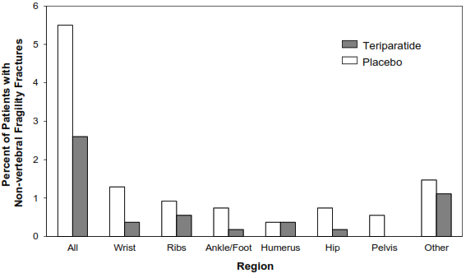

##### Effect on BMD

Teriparatide rapidly increased lumbar spine BMD. Significant increases were seen as early as 3 months and continued throughout the treatment period, as shown in **Figure 2**. After a median treatment period of 19 months, BMD had increased 9% and 4% in the lumbar spine and total hip, respectively, compared with placebo (p<0.001). Teriparatide was effective regardless of age, baseline rate of bone turnover and baseline BMD.

**Figure 2: Time Course of Change in Lumbar Spine BMD in Postmenopausal Women Treated with Teriparatide 20 micrograms vs Placebo**

(p<0.001 for Teriparatide compared with placebo at each post-baseline time point)

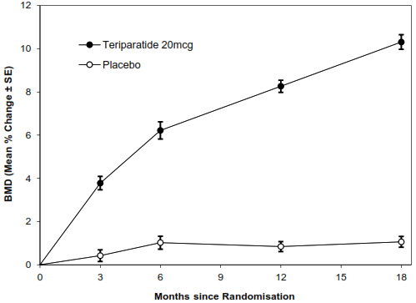

##### Effect on Back Pain

Teriparatide significantly reduced the incidence and severity of back pain. In women with postmenopausal osteoporosis, there was a significant (p=0.017) 26% reduction in the spontaneous reports of new or worsened back pain compared to placebo.

##### Effects on Height Loss

For the 86 postmenopausal women who experienced vertebral fractures, those treated with teriparatide had significantly less height loss when compared to placebo (p=0.001).

##### Bone Histology

The effects of teriparatide on bone histology were evaluated in iliac crest biopsies of 61 postmenopausal women treated for up to 24 months with placebo or teriparatide 20 micrograms or 40 micrograms per day. The increases in BMD and resistance to fracture achieved with teriparatide occurred without evidence of cellular toxicity or adverse effects on bone architecture or mineralisation. The findings in human bone samples paralleled those seen in preclinical primate studies.

**Table 3: Vertebral Fracture Incidence in Postmenopausal Women**

|  |  |  |  |
| --- | --- | --- | --- |
| **Vertebral Fracture Incidence in Postmenopausal Women:** | | | |
|  | **Placebo**  **(N=448)**  **(%)** | **Teriparatide**  **(N=444)**  **(%)** | **Abs.**  **Risk Reduction**  **(%)** |
| New fracture (≥1) | 14.3 | 5.0 a | 9.3 |
| Multiple fractures (≥2) | 4.9 | 1.1 a | 3.8 |
| Moderate or severe fracture (≥1) | 9.4 | 0.9 a | 8.5 |

a p≤0.001 compared with placebo

*Post-treatment Fracture Efficacy*

Following treatment with teriparatide, 1,262 postmenopausal women from the pivotal trial enrolled in a post-treatment follow-up study. After 18 months, approximately 50% of the women in each former treatment group had begun an approved osteoporosis therapy (not including teriparatide) at the discretion of their physician. All women were offered 1000 mg of calcium per day and at least 400 IU of vitamin D per day.

During a median of 18 months following discontinuation of teriparatide treatment, there was a significant 40% reduction in relative risk for new vertebral fractures in women previously treated with teriparatide, compared to placebo. (The relative risk reduction was similar for women with and without osteoporosis treatment, 41% and 37%, respectively.) During the same observation period, there was a 42% risk reduction for non-vertebral fragility fractures in women previously treated with teriparatide, compared with placebo.

Data from this study demonstrate that regardless of the follow-up treatment options, fracture risk was reduced for women previously treated with teriparatide.

A 24-month, randomised, double-blind, comparator-controlled Phase 4 study included 1,360 postmenopausal women with established osteoporosis. 680 subjects were randomised to teriparatide and 680 subjects were randomised to oral risedronate 35 mg/week. At baseline, the women had a mean age of 72.1 years and a median of 2 prevalent vertebral fractures; 57.9% of patients had received previous bisphosphonate therapy and 18.8% took concomitant glucocorticoids during the study. 1,013 (74.5%) patients completed the 24-month follow-up. The mean (median) cumulative dose of glucocorticoid was 474.3 (66.2) mg in the teriparatide arm and 898.0 (100.0) mg in the risedronate arm. The mean (median) vitamin D intake for the teriparatide arm was 1408.4 IU/day (1380.4 IU/day) and for the risedronate arm was 1206.4 IU/day (900 IU/day). For those subjects who had baseline and follow-up spine radiographs, the incidence of new vertebral fractures was 28/516 (5.4%) in teriparatide and 64/533 (12.0%) in risedronate-treated patients, relative risk (95% CI) = 0.44 (0.29-0.68), p<0.0001. The cumulative incidence of pooled clinical fractures (clinical vertebral and non-vertebral fractures) was 4.8% in teriparatide and 9.8% in risedronate-treated patients, hazard ratio (95% CI) = 0.48 (0.32-0.74), p=0.0009.

In an open-label study, 503 postmenopausal women with severe osteoporosis and a fragility fracture within the previous 3 years (83% had received previous osteoporosis therapy) were treated with teriparatide for up to 24 months. At 24 months, the mean increase from baseline in lumbar spine, total hip and femoral neck BMD was 10.5%, 2.6% and 3.9% respectively. The mean increase in BMD from 18 to 24 months was 1.4%, 1.2% and 1.6% at the lumbar spine, total hip and femoral neck, respectively.

#### Male Osteoporosis

The efficacy of teriparatide was demonstrated in a double-blind, placebo-controlled clinical study in 437 men with either hypogonadal or idiopathic osteoporosis. All patients received 1000 mg of calcium per day and at least 400 IU of vitamin D per day and were treated for up to 14 months.

In this study, teriparatide rapidly increased lumbar spine BMD in men, with significant increases as early as 3 months. This increase continued throughout the treatment period, as shown in **Figure 3**. After a median treatment period of 11 months, BMD in the spine had (on average) increased by 5% and in the hip by 1%, compared to placebo. Increases in BMD were similar in men with hypogonadal or idiopathic osteoporosis. Teriparatide was effective regardless of age, baseline rate of bone turnover and baseline BMD.

All male patients presenting with osteoporosis should be checked for primary or secondary hypogonadism, investigated and treated appropriately as a prerequisite.

**Figure 3: Time Course of Change in Lumbar Spine BMD in Osteoporotic Men Treated with Teriparatide 20 µg or Placebo**

(p<0.001 for teriparatide compared with placebo at each post-baseline time point)

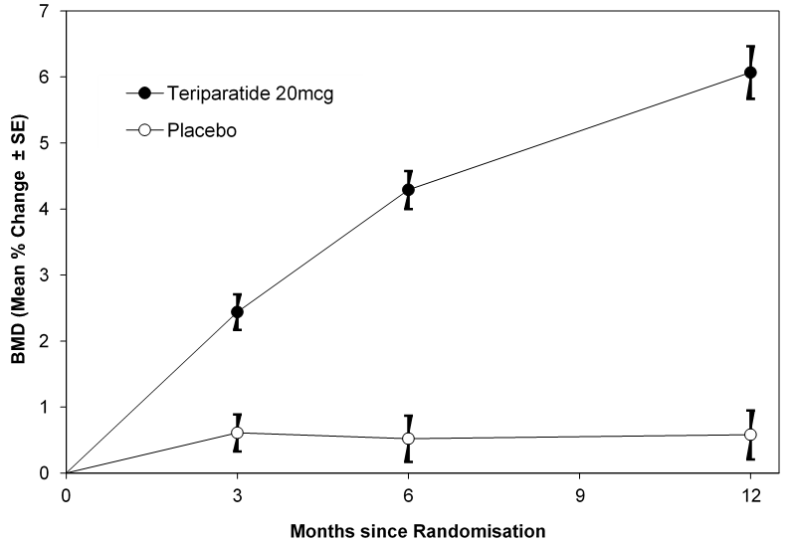

#### Glucocorticoid-induced Osteoporosis

The efficacy of teriparatide in men and women (N=428) receiving sustained systemic glucocorticoid therapy (equivalent to 5 mg or greater of prednisone for at least 3 months) was demonstrated in a 36 month (18-month primary phase plus 18-month continuation phase), randomised, double-blind, comparator-controlled study (alendronate 10 mg/day). Twenty-eight percent of patients had one or more radiographic vertebral fractures at baseline. All patients were offered 1000 mg calcium per day and 800 IU vitamin D per day.

This study included postmenopausal women (N=277), premenopausal women (N=67), and men (N=83). At baseline, the postmenopausal women had a mean age of 61 years, mean lumbar spine BMD T score (number of standard deviations above or below the mean in healthy young women) of −2.7, median prednisone equivalent dose of 7.5 mg/day, and 34% had one or more radiographic vertebral fractures; premenopausal women had a mean age of 37 years, mean lumbar spine BMD T score of −2.5, median prednisone equivalent dose of 10 mg/day, and 9% had one or more radiographic vertebral fractures; and men had a mean age of 57 years, mean lumbar spine BMD T score of −2.2, median prednisone equivalent dose of 10 mg/day, and 24% had one or more radiographic vertebral fractures.

##### Effects on Vertebral and Non-vertebral BMD

The primary objective was the change in lumbar spine BMD from baseline to the 18-month endpoint (last observation carried forward) in men and women combined. Sixty-nine percent of patients completed the 18-month primary phase. At the 18-month endpoint (men and women combined), teriparatide increased lumbar spine BMD (7.2%) significantly more than alendronate (3.4%) (p<0.001).

**Figure 4** shows the time course of mean percent change from baseline in lumbar spine BMD through 36 months for men and women combined. There was a significant difference between groups at all measured timepoints and endpoint. At 36 months (Figure 4) the mean percent change from baseline in lumbar spine BMD was 11.0% in the teriparatide group versus 5.3% in the alendronate group, a difference of 5.7% (p<0.001).

**Figure 4: Percent Change in Lumbar Spine BMD (LS Mean ± SE) in Men and Women with Glucocorticoid-Induced Osteoporosis**

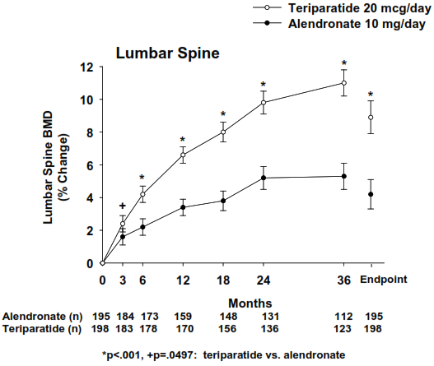

**Table 4** presents the mean percent change in lumbar spine BMD in the women only subgroup.

**Table 4: Mean Percent Change from Baseline in Lumbar Spine BMD in Women with Glucocorticoid-induced Osteoporosis**

|  |  |  |  |
| --- | --- | --- | --- |
| **Timepoint**  **(% change from baseline at)** | **Teriparatide**  **LS Mean ± Std Error** | **Alendronate**  **LS Mean ± Std Error** | **p-Value** |
| Endpoint | 8.6 ± 0.9 | 4.0 ± 0.9 | <0.001 |
| Month 36 | 10.3 ± 0.8 | 4.9 ± 0.8 | <0.001 |
| Month 24 | 9.3 ± 0.7 | 5.0 ± 0.7 | <0.001 |
| Month 18 | 7.8 ± 0.6 | 3.4 ± 0.6 | <0.001 |
| Month 12 | 6.5 ± 0.5 | 3.0 ± 0.5 | <0.001 |
| Month 6 | 4.0 ± 0.5 | 2.0 ± 0.5 | <0.001 |
| Month 3 | 2.3 ± 0.5 | 1.6 ± 0.5 | 0.118 |

In men and women combined, changes from baseline in femoral neck BMD were significantly greater in the teriparatide compared with the alendronate group at all timepoints and at endpoint (**Figure 5**). The mean percent change in femoral neck BMD from baseline to endpoint was 5.1% in the teriparatide group compared with 2.6% in the alendronate group, (p<0.001).

**Figure 5: Mean Percent Change from Baseline in Femoral Neck BMD (LS Mean ± SE) in Men and Women with Glucocorticoid-Induced Osteoporosis**

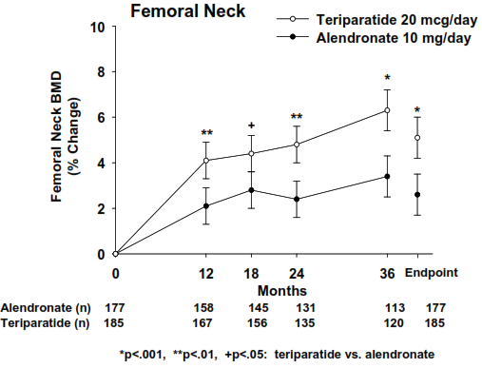

In men and women combined, changes from baseline in total hip BMD were significantly greater in the teriparatide group compared with the alendronate group at all timepoints and at endpoint (**Figure 6**). The mean increase in total hip BMD from baseline to endpoint was 4.4% in the teriparatide group versus 2.2% in the alendronate group (p<0.001).

**Figure 6: Mean Percent Change from Baseline in Total Hip BMD (LS Mean ± SE) in Men and Women with Glucocorticoid-Induced Osteoporosis**

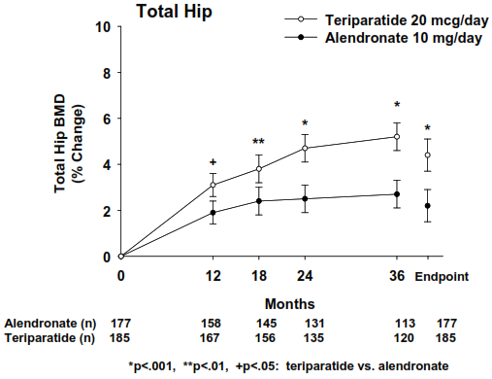

In premenopausal women, the increase in BMD from baseline to endpoint at 36 months was significantly greater in the teriparatide group compared with the alendronate group at the lumbar spine (4.6% versus −0.9%; p=0.017) and total hip (4.8% versus 1.5%; p=0.026). However, no significant effect on fracture rates was demonstrated in premenopausal women.

Analysis of vertebral and non-vertebral fractures: At 18 months, analysis of spinal X-rays from 165 alendronate patients and 171 teriparatide patients showed that 10 patients in the alendronate group (6.1%) had experienced a new vertebral fracture compared with 1 patient in the teriparatide group (0.6%). In addition, 9 patients in the alendronate group (4.2%) had experienced a non-vertebral fracture compared with 12 patients in the teriparatide group (5.6%).

**Table 5** below summarises the incident fractures at 36 months in men and women combined.

**Table 5: Incident Fractures at 36 Months in Men and Women Combined**

|  |  |  |  |
| --- | --- | --- | --- |
|  | **PTH20**  **n/N (%)** | **ALN10**  **n/N (%)** | **p-value** |
| ≥1 Vertebral and/or non-vertebral fracture a | 19/214 (8.9%) | 27/214 (12.6%) | 0.212 |
| ≥1 Vertebral fracture | 3/173 (1.7%) | 13/169 (7.7%) | 0.007 |
| ≥1 Clinical vertebral fracture b | 0 | 4/169 (2.4%) | 0.037 |
| ≥1 Non-vertebral fracture | 16/214 (7.5%) | 15/214 (7.0%) | 0.843 |

Note: For vertebral fractures only those patients with baseline and post-baseline spinal radiographs were included in the analysis.

a One alendronate patient experienced both a vertebral fracture and a non-vertebral fracture.

b Clinical vertebral fracture was defined as a radiographically confirmed fracture that was associated with symptoms such as back pain.

##### Effects on Markers of Bone Turnover

In patients with glucocorticoid-induced osteoporosis, daily administration of teriparatide stimulated new bone formation as shown by increases from baseline in the serum concentration of biochemical markers of bone formation including bone-specific alkaline phosphatase (BSAP), procollagen I carboxyterminal propeptide (PICP), and amino-terminal propeptide of type I collagen (PINP) (see **Table 6**). Teriparatide also stimulated bone resorption as shown by increases from baseline in serum concentrations of C-terminal telopeptide of type I collagen (CTX). Alendronate 10 mg/day induced decreases from baseline in the serum concentration of BSAP, PICP, PINP and CTX (see **Table 6**). The effects of teriparatide on bone turnover markers in patients with glucocorticoid-induced osteoporosis were qualitatively similar to the effects in postmenopausal women with osteoporosis not taking glucocorticoids.

**Table 6: Median Percent Changesa,b from Baseline in Bone Biomarkers in Patients with Glucocorticoid-Induced Osteoporosis**

|  |  |  |  |  |  |  |  |  |
| --- | --- | --- | --- | --- | --- | --- | --- | --- |
|  | **PINP µcg/L** | | **BSAP µcg/L** | | **PICP µcg/L** | | **CTX pmol/L** | |
| **Treatment Duration** | **Teriparatide** | **ALN** | **Teriparatide** | **ALN** | **Teriparatide** | **ALN** | **Teriparatide** | **ALN** |
| 1 month | 65 | -18 | 19 | -5 | 36 | -12 | 12 | -46 |
| 6 month | 67 | -50 | 31 | -20 | 0 | -27 | 45 | -56 |
| 18 month | 36 | -48 | 16 | -21 | -11 | -28 | 9 | -64 |
| 36 month | 38 | -40 | 22 | -18 | -11 | -26 | 5 | -55 |

a The median percent changes in teriparatide-treated patients were significantly different (p<0.01) compared with alendronate-treated (ALN) patients for each biomarker at all time points.

b Values represent median percent changes with n=44 to 99 among the 4 biomarkers at the different time points.

## 5.2 Pharmacokinetic Properties

### Absorption

After subcutaneous (SC) injection, teriparatide has an absolute bioavailability of 95% (95% CI 0.824‑1.07). Absorption and elimination are rapid. The half-life of teriparatide in serum is 5 minutes when administered by intravenous injection and approximately 1 hour when administered by subcutaneous injection. The longer half-life following subcutaneous administration reflects the time required for absorption from the injection site.

Following a subcutaneous injection of a 20 microgram dose, peak molar concentrations of teriparatide briefly exceed the upper limit of normal for endogenous PTH [65 pg/mL (7.0 pM)] by 4- to 5-fold for about 30 minutes and then decline to non-quantifiable concentrations within 3 hours. The mean systemic exposure (endogenous PTH and teriparatide) over 24 hours does not exceed the upper limit of normal and is below the levels found in patients with mild hyperparathyroidism.

### Distribution

Volume of distribution is approximately 1.7 L/kg. Between-subject variability in systemic clearance and volume of distribution is 25% to 50%.

### Metabolism

No metabolism studies have been performed with teriparatide. However, the mechanisms of metabolism of PTH (1-34) and intact PTH have been extensively described. Metabolism of parathyroid hormone is believed to occur predominantly in liver and kidney.

### Excretion

Teriparatide is eliminated through hepatic and extra-hepatic clearance (approximately 62 L/hr in women and 94 L/hr in men). No excretion studies have been performed with teriparatide. However, the mechanism of elimination of PTH (1-34) and intact PTH have been extensively described.

### Patient characteristics

#### Geriatrics

No differences in teriparatide pharmacokinetics were detected with regard to age (range 31 to 85 years). Dosage adjustment based on age is not required.

#### Gender

Systemic exposure to teriparatide is approximately 20% to 30% lower in men than in women. There were, however, no gender differences with respect to safety, tolerability or pharmacodynamic responses. Dosage adjustment based on gender is not required.

#### Renal Impairment

No clinically relevant pharmacokinetic or safety differences were identified in patients with mild, moderate or severe chronic renal impairment administered a single dose of teriparatide. Dosage adjustment, based on renal function, is not required.

However, patients with renal impairment had reduced calcaemic and calciuric responses to teriparatide. Long-term safety and efficacy have not been evaluated in patients with serum creatinine concentrations >177 µmol/L.

#### Heart Failure

No clinically relevant pharmacokinetic, blood pressure, pulse rate or other safety differences were identified in patients with stable heart failure (New York Heart Association Class I to III and additional evidence of cardiac dysfunction) administered two 20 microgram doses of teriparatide. Dosage adjustment based on the presence of mild or moderate heart failure is not required. There are no data from patients with severe heart failure.

#### Hepatic impairment

Safety and efficacy have not been evaluated in patients with hepatic impairment. Preclinical data indicate that hepatic Kupffer cells are the primary site of metabolism for teriparatide. It is unlikely that disease states in which hepatocyte function is impaired will have a clinically significant effect on systemic exposure to teriparatide).

## 5.3 Preclinical Safety Data

### Genotoxicity

Teriparatide was not genotoxic in assays for gene mutations (Ames test and mouse lymphoma assay *in vitro*) and chromosomal damage (Chinese hamster ovary cells *in vitro* and the mouse micronucleus test *in vivo*).

### Carcinogenicity

Two carcinogenicity bioassays were conducted in rats. In the first study, male and female rats were given daily subcutaneous teriparatide injections of 5, 30, or 75 micrograms/kg/day for 24 months from 2 months of age. These doses resulted in systemic exposures that were, respectively, 3, 20, and 60 times higher than the systemic exposure observed in humans following a subcutaneous dose of 20 micrograms (based on AUC comparison). Teriparatide treatment resulted in a marked dose-related increase in the incidence of osteosarcoma, a rare malignant bone tumour, in both male and female rats. Osteosarcomas were observed at all doses, occurred after 17 to 20 months of treatment, and reached an incidence of 38% to 52% in the high-dose groups. Teriparatide also caused increased incidences of osteoblastoma and osteoma in both sexes. No osteosarcomas, osteoblastomas or osteomas were observed in untreated control rats. The bone tumours in rats occurred in association with a large increase in bone mass and focal osteoblast hyperplasia.

The second 2-year study was carried out in order to determine the effect of treatment duration and animal age on the development of bone tumours. Female rats were treated for different periods between 2 and 26 months of age with subcutaneous doses of 5 and 30 micrograms/kg (equivalent to 3 and 20 times the human exposure at the 20 microgram dose, based on AUC). The study showed that the occurrence of osteosarcoma, osteoblastoma and osteoma was dependent upon dose and duration of exposure. Bone tumours were observed when immature 2-month old rats were treated with 30 micrograms/kg/day for 6 or 24 months. Bone tumours were also observed when mature 6-month old rats were treated with 30 micrograms/kg/day for 6 or 20 months. Tumours were not detected when mature 6-month old rats were treated with 5 micrograms/kg/day for 6 or 20 months. The results did not demonstrate a difference in susceptibility to bone tumour formation, associated with teriparatide treatment, between mature and immature rats. The relevance of these rat findings to humans is uncertain.

No bone neoplasms or preneoplastic lesions were found in monkeys treated with teriparatide SC for 18 months, and then observed for a further 3 years, at a dose yielding 5-fold clinical exposure levels (based on AUC data).

# PHARMACEUTICAL PARTICULARS

## 6.1 List of Excipients

* Glacial acetic acid
* Sodium acetate
* Mannitol
* Metacresol
* Water for injections
* Hydrochloric acid (for pH adjustment)
* Sodium hydroxide (for pH adjustment)

## 6.2 Incompatibilities

Incompatibilities were either not assessed or not identified as part of the registration of this medicine.

In the absence of compatibility studies, this medicinal product must not be mixed with other medicinal products.

## 6.3 Shelf Life

In Australia, information on the shelf life can be found on the public summary of the Australian Register of Therapeutic Goods (ARTG). The expiry date can be found on the packaging.

Each Teriparatide Lupin pen can be used for up to 28 days after the first injection.

## 6.4 Special Precautions for Storage

Store at 2oC to 8oC. Refrigerate. Do not freeze.

Chemical, physical and microbiological in-use stability has been demonstrated for 28 days at 2-8°C. Once opened, the product may be stored for a maximum of 28 days at 2oC to 8oC.

The dose may be delivered immediately following removal from the refrigerator. Do not allow Teriparatide Lupin to freeze. Do not use Teriparatide Lupin if it has been frozen. During the use period, minimise the time the pen remains out of the refrigerator.

Close the pen with the pen cap after use (due to light sensitivity of the solution for injection). The pen should be returned to the refrigerator immediately after use. Do not store the injection device with the needle attached.

## 6.5 Nature and Contents of Container

Teriparatide Lupin pre-filled injection pen contains 2.4 mL solution in a cartridge (siliconised Type I glass) with a plunger, rubber disc and aluminium cap assembled into a disposable pen.

Teriparatide Lupin is available in the following pack sizes:

* 1 pen;
* 3 pens.

Each pen contains 28 doses of 20 micrograms (per 80 microlitres).

Not all pack sizes may be marketed.

## 6.6 Special Precautions for Disposal

In Australia, any unused medicine or waste material should be disposed of by taking to your local pharmacy.

## 6.7 Physicochemical Properties

### Chemical Structure

Teriparatide, synthetically derived, is identical to the 34 N-terminal amino acid sequence of endogenous human parathyroid hormone.

Teriparatide is a polypeptide which molecular weight, molecular formula and molecular structure are as

follows:

Molecular weight: 4117.72 g/mol (average mass of the isotopes)

Molecular Formula: C181H291N55O51S2 (as free base)

Molecular Structure:

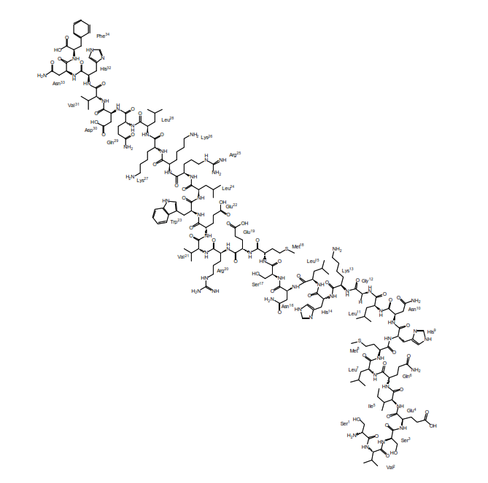

### CAS Number

The CAS number for teriparatide is 52232-67-4.

# MEDICINE SCHEDULE (POISONS STANDARD)

Schedule 4 - Prescription Only Medicine

# SPONSOR

Generic Health Pty Ltd

Suite 2, Level 2

19-23 Prospect Street

Box Hill, VIC, 3128

Email: ghinfo@generichealth.com.au

Phone: +61 3 9809 7900

Website: www.generichealth.com.au

# DATE OF FIRST APPROVAL

06 April 2023.

# DATE OF REVISION

Not applicable.

SUMMARY TABLE OF CHANGES

|  |  |
| --- | --- |
| Section Changed | Summary of New Information |
|  |  |